Major floods in Victoria in 2010, 2011 and 2012 resulted in significant damage to, or loss of, fences installed close to rivers and creeks.
Guidelines for riparian fencing in flood-prone areas have been developed to assist land managers to minimise future flood damage. The guidelines help to select the most appropriate fence type, design, location and building technique.

Guidelines for riparian fencing in
flood-prone areas

The need for riparian fencing guidelines
Each year private landholders and catchment management authorities (CMAs) across the state invest substantially in the construction and maintenance of fences along waterways. During times of flood, the force of water and debris can be significant, resulting in costly repairs and even complete replacement of some fences.
While it is not feasible to design fences to withstand the force of every flood, the guidelines aim to assist in minimising the risks of flood damage to fences and increase infrastructure longevity.
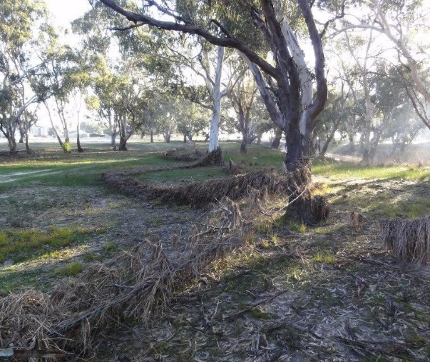
Riparian fence damaged by 2011 flood, Wimmera River
(photo credit: Wimmera CMA)

Three main steps
The process of planning a fencing project in a flood-prone environment can be broken up into three main steps. The guidelines walk you through:
- understanding site characteristics and floodplain behaviour
- determining the appropriate fencing strategy for your floodplain
- selecting the most appropriate fence type and location.
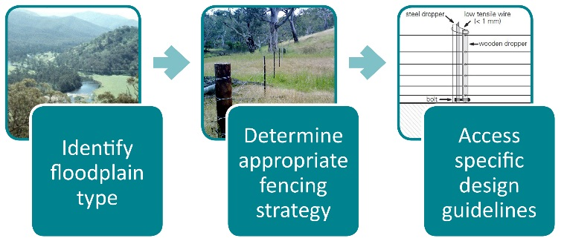
The three main steps when planning your riparian fencing project
Source: Ian Rutherfurd, the University of Melbourne; Glenelg Hopkins CMA; & Staton, J. and O'Sullivan, J. (2006). Stock and Waterways: A Manager's Guide. Canberra: Land and Water Australia.
Strategies for fencing in flood-prone areas
The guidelines outline three strategies for minimising floodwater and debris damage to fencing:
1. avoidance 2. resistance 3. resilience.
Knowing the type of floodplain you will be working on will help determine the most suitable strategy. The other key factor will be cost: installation, maintenance and repair.
The guidelines provide the tools and information to help you decide which fence is suitable for your site.
Avoiding flood damage
Flood damage can be avoided by reducing the likelihood that your fence will encounter a flood. The guidelines take you through:
The appropriate positioning of fence lines:
well back from the main channel and
flood-prone areas
parallel to the main direction of flow
outside the line of most floods
- as far up-slope as possible
Alternatives to permanent fencing on the floodplain:
- use of a controlled grazing regime
- provision of water, shade and shelter away from the waterway
- provision of crossings in areas where livestock naturally cross water.
Increasing fence resistance
Where fencing within flood-prone areas can’t be avoided, the guidelines explain how to:
Align fences in relation to flows:
work with terrain and contours
align no greater than 45º to the flood flow path
- in high risk areas, fences should be parallel to
flood flows
Identify key components that require extra strength:
select the best strainer (end) design for your soil conditions
compare the cost and durability of materials
- space and set posts correctly for maximum strength
Prevent wires from pulling a fence down:
keep wires to a minimum through the use of electric fencing
- position wires so they pop their staples.
Increasing fence resilience
Where fences can’t be aligned to flood flows, or in areas prone to regular flood events, fences can be designed to absorb flood impact and make repair quick and straight-forward post-flood. The guidelines take you through:
Collapsible fences
- fences that give way, or are folded down manually, from their anchor points under flood pressure to lay flat on the ground
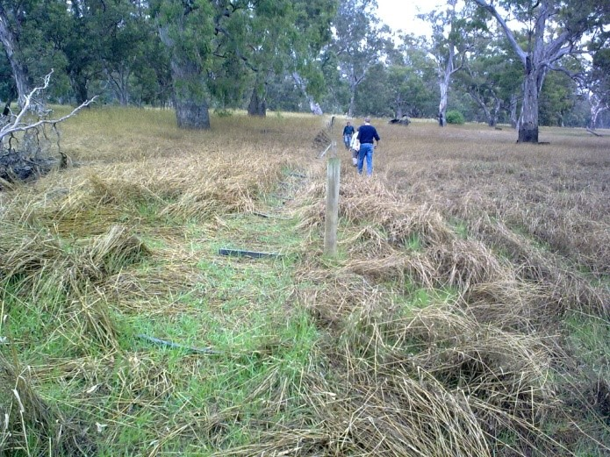
Strained fence length in drop down position (photo credit: Glenelg Hopkins CMA)
Sacrificial fences
- electric or conventional fences where the end assemblies are strong but the wire and inline posts (or isolated high-risk sections) are designed to be sacrificed
Effective fences across waterways
cross at natural high points
keep independent of other fences
- build in straight sections of channel or at the crossover point in the middle of a meander
Alternatives to fences across waterways
- such as electric fencing, suspended hanging floodgates and hinged floodgates.
More information
The Guidelines for riparian fencing in flood-prone areas are available via the Department of Environment, Land, Water and Planning website.

