**Background**

To maintain and improve the important values that riparian land supports, management actions (e.g. livestock management, revegetation, weed control, willow removal) are undertaken across Victoria.

An ongoing challenge is to evaluate the outcomes of this investment to guide improved practice and inform state and regional waterway planning, evaluation and reporting.

Light Detection and Ranging (LiDAR) was first used to assess riparian vegetation at broad spatial scales in Victoria for the 2010 Index of Stream Condition (ISC). The ISC provided snapshots of the condition of Victoria’s rivers in 1999, 2004 and 2010. In 2010, aerial LiDAR replaced on-ground sampling to assess the Streamside Zone ISC sub-index across the state, which provided a more consistent and comprehensive data collection method.

The Stream Change Assessment project (SCA) re-sampled a subset of ISC river reaches using LiDAR from 2018 to 2020, to assess changes in woody vegetation since the 2010 ISC capture.

**Methods Overview**

Methods for LiDAR capture and processing are described in DELWP (2022), but involved five steps:

Steps for using LiDAR to map and quantify riparian vegetation

LiDAR was recaptured at 141 of the 1,040 reaches included in the 2010 ISC. This represents ~3,424 km of stream length, or ~13% of the ISC network. These reaches are located across nine catchment management authority (CMA) regions (Melbourne Water is undertaking its own LiDAR assessment for the Port Phillip and Westernport region). Areas for recapture were selected in consultation with CMAs guided by their needs for information to evaluate change due to their past riparian management and/or to guide their planning.

Results were summarised for fractional canopy cover, canopy height, vegetation width and fragmentation. These represent a subset of the metrics that were derived as part of the SCA project. ISC Streamside Zone scores were also calculated and compared between the two assessment periods.

Notably, the woody weeds component of the Streamside Zone score was not updated for the second assessment, so results do not account for any changes due to woody weed loss or expansion. Incorporation of woody weeds into the new data will require substantial further work, drawing on CMA woody weed management data and manual interpretation of aerial imagery.

**Key results**

Streamside Zone ISC scores remained unchanged at 81% of reaches, and only changed by more than one unit at a single reach (on the Macalister River in West Gippsland).

Changes in individual woody vegetation metrics were variable, but more pronounced than changes in ISC Streamside Zone scores:

* Increases were evident in fractional canopy cover, especially in areas with higher rainfall (Gippsland) or where flooding and/or water management had occurred (Mallee).
* Corresponding increases in vegetation width and canopy height were also apparent as were decreases in fragmentation.

**Summary of changes in vegetation metrics. Boxplots show the mean change between times across all ISC reaches in each CMA region. The red dashed line designates no change between assessment periods.**

*Change in riparian woody vegetation between 2010 and 2020 at the scale of river reaches was generally minor and variable, however substantial improvements were evident along smaller stretches of river where management has occurred*

While some substantial changes at certain reaches were evident, they were generally small at statewide and regional extents.

This was not unexpected because:

* Changes in vegetation due to management are likely to occur over longer-time frames than the ~8-10 year period between assessments
* Changes in riparian vegetation are likely to vary at a range of spatial scales, so when data are aggregated, increases at some locations are likely to be masked by decreases at others.
* LiDAR was recaptured at reaches for a range of reasons (including some reaches where no or minimal riparian management was undertaken), so results should be viewed within this local context.

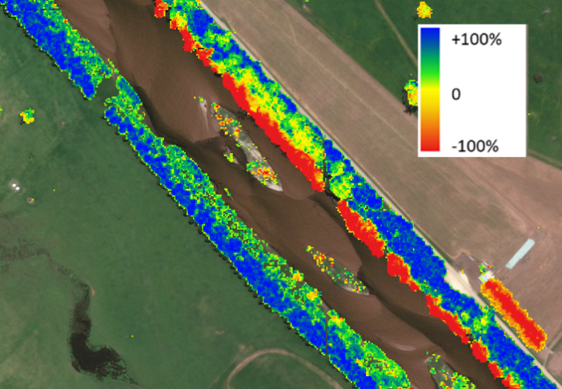

**Snowy River. Changes in fractional canopy cover between 2010-2018 are shown as a gradient from red (100% decrease – likely woody weed removal), yellow (no change), to blue (100% increase – due to revegetation).**

The largest changes were observed at smaller sections of stream within ISC reaches. These were usually several kilometres long and areas where substantial and/or sustained riparian management had been undertaken.

Preliminary work suggests that rainfall is an important driver of variability in woody vegetation responses across the state, with canopy cover increasing by >10% at all ISC reaches with >800 mm median annual rainfall.

**Relationship between increases in fractional canopy cover and rainfall at ISC reaches. Each point represents the mean increase in canopy cover at an ISC reach, with 95% confidence intervals. Blue line is the average increase (grey shading 95% confidence interval) from a generalised additive model.**

**Contact and further reading**

Dr Paul Reich.

Waterways Programs, Catchments, Waterways, Cities and Towns. [paul.reich@delwp.vic.gov.au](mailto:paul.reich@delwp.vic.gov.au)

DELWP (2022) *Stream Change Assessment: detecting change in riparian woody vegetation using LiDAR derived data.* Department of Environment, Land Water and Planning, East Melbourne Victoria

|  |  |
| --- | --- |
| © The State of Victoria Department of Environment, Land, Water and Planning 2022  LogoThis work is licensed under a Creative Commons Attribution 4.0 International licence. You are free to re-use the work under that licence, on the condition that you credit the State of Victoria as author. The licence does not apply to any images, photographs or branding, including the Victorian Coat of Arms, the Victorian Government logo and the Department of Environment, Land, Water and Planning (DELWP) logo. To view a copy of this licence, visit http://creativecommons.org/licenses/by/4.0/  ISBN 978-1-76105-922-3  Disclaimer  This publication may be of assistance to you but the State of Victoria and its employees do not guarantee that the publication is without flaw of any kind or is wholly appropriate for your particular purposes and therefore disclaims all liability for any error, loss or other consequence which may arise from you relying on any information in this publication. | Accessibility  If you would like to receive this publication in an alternative format, please telephone the DELWP Customer Service Centre on 136186, email [customer.service@delwp.vic.gov.au](mailto:customer.service@delwp.vic.gov.au) or via the National Relay Service on 133 677 [www.relayservice.com.au](http://www.relayservice.com.au). This document is also available on the internet at [www.delwp.vic.gov.au](http://www.delwp.vic.gov.au). |