Industry Water Connection Guide

  - May 2026
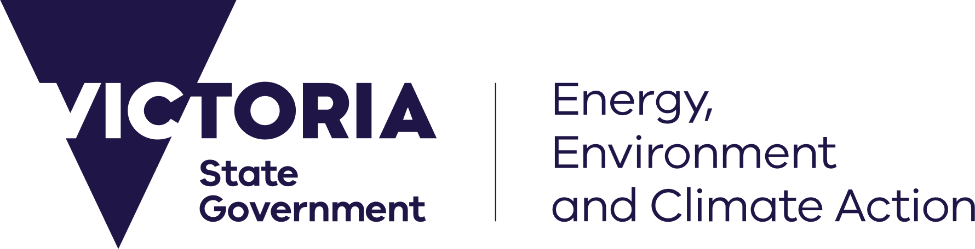



We acknowledge and respect Victorian Traditional Owners as the original custodians of Victoria’s land and waters, their unique ability to care for Country and deep spiritual connection to it. We honour Elders past and present whose knowledge and wisdom has ensured the continuation of culture and traditional practices. DEECA is committed to genuinely partnering with Victorian Traditional Owners and Victoria’s Aboriginal community to progress their aspirations.
Cover photograph: Kororoit Creek, Altona Coastal Park. Image shows Kororoit Creek in the middle ground flowing to the bay, with tree plantings in the Altona Coastal Park on the right bank and industrial buildings on the left bank. The Melbourne Central Business District skyline can be seen in the far distance.
Credit: Colin Page Photography
ISBN 978-1-76176-731-9 (pdf/online/MS word)
© The State of Victoria Department of Energy, Environment and Climate Action December 2026
Creative Commons
This work is licensed under a Creative Commons Attribution 4.0 International licence, visit the Creative Commons website (http://creativecommons.org/licenses/by/4.0/).
You are free to re-use the work under that licence, on the condition that you credit the State of Victoria as author. The licence does not apply to any images, photographs or branding, including the Victorian Coat of Arms, and the Victorian Government and Department logos.
Disclaimer
This publication may be of assistance to you but the State of Victoria and its employees do not guarantee that the publication is without flaw of any kind or is wholly appropriate for your particular purposes and therefore disclaims all liability for any error, loss or other consequence which may arise from you relying on any information in this publication.
Accessibility
To receive this document in an alternative format, phone the Customer Service Centre on 136 186, email customer.service@delwp.vic.gov.au, or contact National Relay Service on 133 677. Available at DEECA website (www.water.vic.gov.au).

Contents

Background 2
Purpose of the Guide 2
Support and Advice 2
Large non-residential urban water users in Victoria 3
Who is this Guide for? 3
Why are they important to Victoria? 3
Understanding this unique demand type 3
Supporting emerging industries through a strong and resilient water system 4
Applying for access to urban water services 6
Approval pathway if within a reticulated urban water network 6
Approval pathway outside of an urban water network 8
Policy and Regulation 10
Urban Water Planning Framework 10
Trade waste regulation 12
Economic regulation of the water sector 13
Protecting our water system and ensuring transparency for large users 14
Best practice for large urban water users 15
Early engagement with your local urban water corporation 15
Consider water efficient opportunities 16
Consider rainwater, recycled water and stormwater use opportunities 18
Decision guidelines 19
Programs and supports available 20
Leak detection and network efficiency programs 20
Invest Victoria 20
Smart meter and data insights initiatives providing real-time monitoring and benchmarking 20
WaterSmart 20
Offsetting your water use 20
Glossary 22
Appendix A – Urban water corporation contact information & application references 24
Appendix B –Urban water corporation high water use data request form 26

Background
In November 2025, the Victorian Government announced the Sustainable Data Centre Action Plan, to leverage our state’s land, energy and talent to unlock projects valued at up to $25 billion, establishing the state as the Asia-Pacific hub for sustainable data centres.
As part of the Action Plan, this Guide was commissioned, including a new dedicated data request form, to support data centres and other large industrial water users to sustainably access the water they need to grow Victoria’s economy from within urban networks. This will ensure a smoother process for proponents to get projects moving faster- and unlock the economic benefits for our state.
This guidance makes clear the Government’s position that large non-residential users should prioritise the use of non-drinking water, to minimise the impact on our state’s precious drinking water supply.
This Guide is consistent with the National Data Centre Expectations, released in March 2026, outlining the importance of sustainable and efficient water use.
A water sector executive working group was also established to ensure Victoria’s water policies keep pace with this emerging sector and remain fit for purpose. The first task of this group was to support development of this Guide.

Purpose of the Guide
The Guide outlines the key policies, processes and obligations that apply to large non-residential water users in Victoria’s urban areas, including emerging sectors such as data centres.
The Guide will help proponents clearly understand how to access and connect to water, sewerage and recycled water services, what requirements they need to meet, and the steps involved in working with their local water corporation.
This guidance also sets standards that proponents must meet to ensure their urban developments do not compromise water security, environmental outcomes or the reliability of supply for existing and future customers.
Victoria’s water supplies are under growing pressure from climate change, reduced rainfall and strong population and industrial growth. Against this backdrop, the guidance emphasises the importance of efficient and sustainable water use and reiterates that Victoria’s urban water corporations will work with new large customers, to incorporate best-practice water efficient designs and supply them with non-potable water, such as recycled water, rather than drinking water, wherever feasible.
Before providing approval, water corporations must be satisfied that water security and supply can be met, without negatively impacting communities and other users.
This Guide also outlines how proponents can fund new infrastructure required to meet water demand, and how water corporations publicly report if their large customers are engaged in a water conservation program.
These measures are essential to protect Victoria’s water supplies and enable new industries to grow sustainably. The Guide provides proponents with greater certainty while reinforcing the need for responsible water stewardship. It supports economic growth, long-term water security, and community values.

Support and Advice
Why early engagement matters:
- Helps confirm whether the site is suitable and allows water efficiency measures and non-potable water options to be built into project design.
- Identifies potential infrastructure constraints or upgrades early and reduces the risk of redesigns or unexpected costs later.
- Provides clarity on timelines, technical requirements and approval pathways.
What your urban water corporation can provide:
- Guidance on system performance, servicing options and regulatory requirements.
- Templates, checklists and technical documents to support a complete and high-quality application.
- Advice on demand management, water efficiency and opportunities for non-potable water use.
- Ongoing support through a dedicated contact or business partner for large or complex applications.
Proponents are encouraged to reach out to their urban water corporation using the new form, which can be found at Appendix B, and online at water.vic.gov.au/for-agriculture-and-industry/industry-water-connection-guide.

Large non-residential urban water users in Victoria

Who is this Guide for?
This Guide is aimed at large non-residential, industrial and commercial businesses and facilities that use more than 20ML/yr and are located within urban areas. The needs of these users require more detailed servicing assessments, infrastructure planning and regulatory oversight. These users cover a spectrum of sectors central to Victoria’s economy, from manufacturing, food and beverage processing and advanced industrial operations, to hospitals, laboratories, logistics hubs, commercial precincts and, increasingly, digital infrastructure such as data centres. Water supply for these industries is an essential input that supports safety, productivity, cooling, sanitation, product quality or business continuity.

Why are they important to Victoria?
Manufacturers, energy and other industrial water users account for around 13% of the state’s total water use, yet their overall contribution to Victoria’s Gross State Product is disproportionately higher. This reflects the high economic value generated per litre of water consumed across many industrial sectors.

Understanding this unique demand type
In Victoria, non-residential demand forms an important part of overall system consumption, underpinning thousands of jobs and supporting the functioning of key supply chains and services. Large non-residential users sit within this broader non-residential category and often exhibit unique demand profiles which require tailored servicing approaches from water corporations.
Business models depend on efficiency: reducing water consumption reduces costs, minimises exposure to operational risks and aligns with corporate environmental, social and governance commitments. Many large users participate voluntarily in water efficiency programs, invest in high-efficiency plant and equipment, and prioritise leak detection and demand optimisation because it delivers both financial and reputational benefits.
Nonetheless, there remains ongoing opportunity for continuous improvement, and the water sector plays an important role in supporting businesses to identify further efficiencies, adopt new technologies and consider alternative water sources that lower reliance on drinking water.

Table 1 - Forecast Demands Across Greater Melbourne & Geelong Customer Base Source: High water demand growth scenario from 2024 Melbourne Water update to DEECA
Financial Year Ending | Residential Potable | Non-Residential Potable | Non-Revenue Water | Potable Water Demand
2025 | 342 GL | 118 GL | 54 GL | 514 GL
2030 | 368 GL | 128 GL | 57 GL | 554 GL
2050 | 508 GL | 173 GL | 81 GL | 762 GL

Supporting emerging industries through a strong and resilient water system

Victoria’s Track Record of Supporting Large Water Users
Victoria’s water sector has a strong history of adapting to support large non-residential users. Over several decades, the sector has worked closely with major industrial customers to respond to changing market conditions, facilitate expansions and help new industries establish themselves in urban areas.
Examples include:
- Enabling growth in food manufacturing through recycled water schemes.
- Supporting high-tech medical and research precincts with enhanced system reliability.
- Helping commercial and industrial hubs integrate on-site reuse and efficiency systems.
Responding to a Changing Water Environment
The sector is actively strengthening its position to continue meeting the needs of emerging industries. While Victoria faces challenges from climate variability, population growth and pressure on water resources, the state has a robust policy and planning framework that manages these pressures sustainably.
Long-Term Security Through the Water Security Plan
The Victorian Water Security Plan provides a clear, long-term strategy to secure water for households, businesses and the environment. It outlines actions to:
- Diversify water sources
- Improve system resilience
- Optimise existing assets
- Prepare for more variable water availability
This gives industry and government confidence that Victoria is planning not just for today, but for the next several decades of growth and innovation.
Strong Regulatory and Planning Foundations
Victoria’s urban water corporations are well placed to assess and integrate new large-scale demands, ensuring system reliability and long-term sustainability.
Key enablers include:
- Strong regulatory protections for existing customers and the environment.
- A coordinated planning framework for water, sewerage and recycled water networks.
- Flexibility to service emerging sectors such as data centres, advanced manufacturing and technology precincts.
Adapting to Emerging Industries
Emerging sectors require tailored servicing approaches, and Victoria is already adapting to meet this need. The sector is prioritising:
- Water efficiency
- Non-potable water sources, such as recycled water
- System optimisation
- Regulatory reform
These measures enable new large urban water users to be supported without creating undue impacts on existing customers.
A Collaborative and Sustainable Approach
Victoria’s water management approach is grounded in long-term planning, transparency and collaboration. As partnerships between the water sector, government and industry mature, the state is well positioned to accommodate economic growth while ensuring strong protections for communities, the environment and future water security.

Case study: Viva Energy Geelong Refinery & Northern Water Plant — Barwon Water
Context
The Geelong region was experiencing growing water demand for residential, municipal and industrial users while water security challenges were increasing. The large industrial demand from the Geelong Refinery made it critical to find a sustainable water solution.
Challenge
- The refinery’s processes required significant volumes of water, leading to a high demand on the urban potable water supply.
- Discharge of industrial and domestic wastewater required effective treatment to avoid environmental harm, and traditional disposal would result in large volumes of water being wasted.
- The region’s sewerage and water planning needed to accommodate industrial demand without compromising community water security or discharging excessive treated effluent to ocean outfalls.
Solution: Collaboration & Infrastructure
Barwon Water and the Geelong Refinery (then Shell, now Viva Energy) partnered to develop the Northern Water Plant (NWP). Key features include:
- Construction of a purpose-built wastewater treatment and reuse facility (NWP) combining domestic sewage from northern suburbs and industrial wastewater from the refinery, enabling industrial-scale water recycling.
- High-quality recycled water (Class A standard) supplied back to the refinery for its industrial processes, replacing potable water demand.
Outcomes and Achievements
- Significant drinking water savings: Reclaimed and recycled water saves around 2 billion litres per year, equivalent to around 5% of greater Geelong’s yearly drinking water needs.
- Reduced environmental discharge: Approximately 10% less treated water is discharged to ocean outfalls, reducing the ecological impact.
- Demonstrated viability of industrial-scale recycled water: Heavy-industry water demand can be met sustainably through well-designed recycled-water infrastructure, offering a model for other large users.
- Reinforced collaborative models: This was a public–private–government partnership (refinery, water corporation, state/federal support), illustrating how cooperation can deliver mutually beneficial environmental, social and economic outcomes.
What This Demonstrates
- Large industrial water users can be supported without compromising water security, by collaborating and leveraging recycled water.
- Well-structured recycled water and wastewater treatment can offer mutually beneficial outcomes.
- Policy frameworks in the guidance have on-ground precedents, giving proponents confidence to pursue sustainable servicing pathways.
- Urban water corporation’s role is crucial: through planning, infrastructure investment, regulatory compliance and partnership, they enable sustainable industry growth while protecting shared resources.

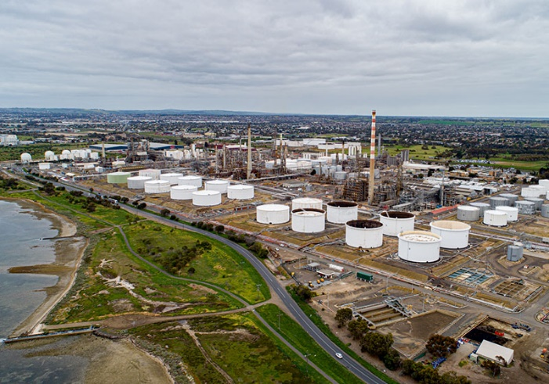
Image 1. Geelong Energy Hub. Credit Viva Energy Australia

Applying for access to urban water services

Approval pathway if within a reticulated urban water network

There is a clear, staged pathway to ensure that new connections to water, wastewater and recycled water services are managed in a way that protects existing customers, supports future growth, and maintains the long-term reliability and sustainability of the water system.
The new dedicated data request form can be found online www.water.vic.gov.au/for-agriculture-and-industry/large-urban-water-user-guidance.
Protection of existing and future customers
Urban water corporations carefully assess all connection and expansion requests to ensure that existing customers will not be adversely affected. Planned future customers are also considered, ensuring that network upgrades or allocation decisions today do not limit the ability to meet anticipated urban growth. This approach ensures fairness and reliability across the system while supporting strategic planning objectives.
Connection pathway
Applicants typically follow a structured process to connect new customers under Section 145 of the Water Act 1989 that may include:
- Preliminary Servicing Advice (PSA): Initial review of the proposed site to identify available water sources, potential infrastructure requirements, and feasibility considerations.
- Design and Infrastructure Planning: Water corporations assess if additional infrastructure (e.g. pipelines, pumps, storage, recycled water connections) is required and outline the scope, timing, and New Customer Contributions with imposed conditions of servicing.
Satisfaction of the water corporation requirements for servicing and connection will permit Consent to Connect (BPC/PIC number) to be issued.
Throughout this process, water-efficient design and the incorporation of non-potable water sources (e.g. recycled water) are strongly emphasised. Water corporations will work with proponents to supply recycled water wherever feasible to reduce the reliance on potable water, and enhance environmental and sustainability outcomes. Early adoption of these practices can also reduce approval timelines and overall project costs.
Business support and account management
Large non-residential applicants may be assigned a dedicated business partner or case manager within the urban water corporation to guide them through the connection process. This contact helps manage the technical, regulatory, and financial aspects of the connection, provides updates on the progress of approvals, and maintains the ongoing relationship between the water corporation and the customer once the connection is active.
By following this pathway, urban water corporations ensure that new or expanded connections are delivered efficiently, safely, and equitably, while maintaining strong protections for existing customers and supporting the long-term sustainability of Victoria’s urban water networks.

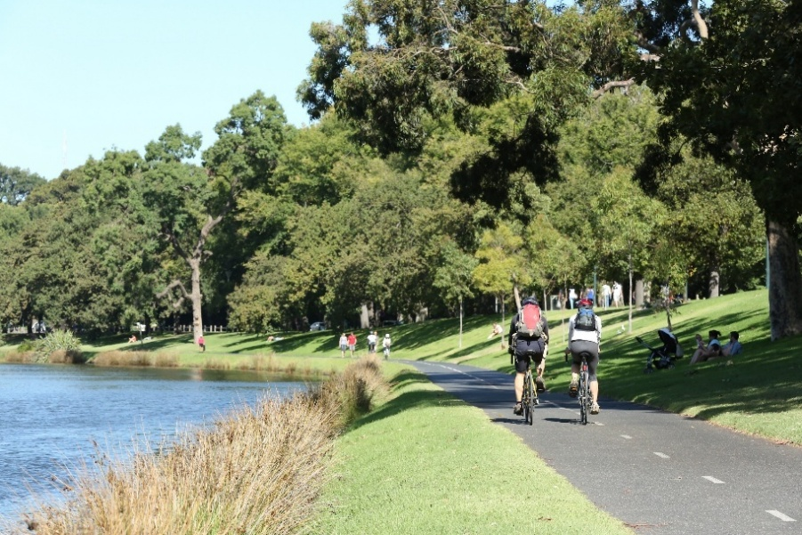
Image 2 Birrarung (Yarra River), Melbourne. Credit DEE

Case study: Amazon Web Services Data Centre in Western Melbourne

Context
Amazon Web Services (AWS) does not need water to cool its Melbourne data centres for 96% of the year, instead using “free-air cooling”, which involves using outside air to cool its servers. During the hottest summer temperatures, it uses a direct evaporative cooling system, which uses (and continues to reuse) water to cool the air before it enters the data centre, removing heat from its servers.
In both cases AWS's goal is to move just enough air through its servers to keep them from overheating and to use the lowest amount of energy and water to do that.
This combination of cooling systems enabled AWS to achieve a Water Usage Effectiveness (WUE) of 0.02 litres of water withdrawn per kilowatt-hour of IT Load (L/kWh) across its Melbourne data centres in 2024. That is equivalent to one tablespoon of water per kilowatt hour and below the Australian industry average, which is estimated to be 1.8 L/kWh (Mandala, 2025).
In addition to reducing how much water its data centres use, AWS seeks to use more sustainable sources of water, with plans to quadruple the use of recycled water in data centres by 2030. This is part of AWS’s global commitment to become water positive by 2030, meaning it will return more water to communities than it consumes across its data centre operations. As of 2024, AWS is more than 53% of the way toward meeting its global commitment to become water positive by 2030, having invested in 23 water replenishment projects globally and 4.3 billion litres of water being returned to communities from active replenishment projects around the world.
Challenge
AWS wanted to source recycled water for its data centre operations in Melbourne that will support increasing customer cloud and artificial intelligence (AI) demand. It sought a confirmed recycled water source to supply data centre operations from day one, reserving potable water for cooling only during recycled water supply shortages. The nearest source of recycled water was Greater Western Water’s (GWW) Melton Recycled Water Plant, but it was not clear if this plant could provide the required capacity within the required timeframe.
Solution
GWW worked closely with AWS to understand its water and servicing objectives, water quality requirements, short- and long-term water demand, and how seasonal weather changes would impact this over time. This collaborative approach identified an opportunity to connect to the existing recycled water network and supply recycled water from the Melton Recycled Water Plant to AWS’s data centre from the first day of operations, with potable water serving as backup. As required of all new customers, AWS is funding all the necessary upgrades to both GWW's water and recycled water network that are necessary to deliver recycled water to the AWS data centre.
Outcomes and Benefits
This collaborative approach will deliver the first data centre to be connected to and supplied with recycled water in Victoria. This will also be the first AWS data centre to be connected to recycled water in Australia.
The water will be sourced from the Melton Recycled Water Plant where it will undergo advanced treatment processes to meet the stringent operational and health requirements of Class A recycled water for use in data centre cooling systems.
AWS and GWW continue to work closely together to identify opportunities to partner on water replenishment projects in the community as part of AWS’s commitment to return more water to the community and the environment than it uses by 2030.
What This Demonstrates
- The benefits of siting data centres near recycled water sources to enable non-potable water use for cooling requirements.
- What a collaborative approach to sustainable water management in data centres can look like.

Approval pathway outside of an urban water network

For large industrial users located outside of an urban water corporation’s reticulated urban network, accessing water requires a different approach than connections within the standard service area. Urban water corporations can advise if you fit into this category, for example in a regional or peri-urban context, and the options for accessing water. Options could include a Section 51 licence, water shares, or a supply agreement depending on your circumstance. (More information on the various entitlements is available at https://www.water.vic.gov.au/about-us/water-entitlements-and-the-water-act)
Generally, a supply agreement will be the way water supply is arranged. This is a contractual arrangement between the water corporation and the user. A supply agreement sets out the terms and conditions under which water will be provided and is tailored to the specific circumstances of the site. Key elements that may be included in a supply agreement are:
- Volume and flow rates: The maximum amount of water that can be delivered and the timing of supply, ensuring that operational requirements are met without exceeding network or environmental limits.
- Water quality: Standards for water delivered, particularly where recycled, raw, or untreated water is involved.
- Duration: The period over which water will be supplied, including renewal or review provisions.
- Purpose of use: Clarifying the intended applications of the water (e.g., industrial processes, cooling, irrigation, or other non-potable uses).
- Infrastructure requirements: Where a private pipeline or other delivery infrastructure is required, responsibilities for construction, operation, and maintenance are detailed.
Supply agreements are commonly required in scenarios such as:
- Sites outside a declared Water Supply District, where water is not automatically available under standard service obligations.
- Situations requiring private pipelines or other bespoke infrastructure to deliver water to the site.
- Accessing raw (untreated) water or recycled water within an urban water system where standard reticulated supply is unavailable.
It is important for proponents to engage early with their local urban water corporation when planning projects in an urban area but outside an urban water network. Early discussions help identify the most appropriate water source, assess feasibility, and clarify the commercial and technical obligations under a supply agreement. Unlike standard connections within an urban water corporation’s service area, these agreements are contractual and not governed by customer service charters or standard regulatory obligations, so clarity and mutual understanding are critical to ensure that the water supply meets operational needs, reliably and sustainably.
The supply agreement pathway allows large non-residential urban users to secure water for their operations outside conventional urban networks, while providing flexibility for bespoke arrangements that suit site-specific conditions and ensure environmental and network safeguards.

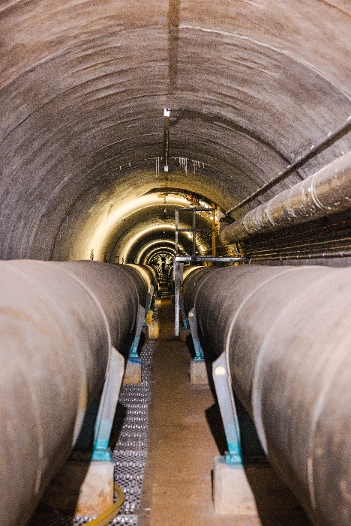
Image 3 Moondarra pipes, Gippsland Water. Credit: Annelise Answerth

Case study: Gippsland Water Industrial Water Use
Context
Gippsland Water is the state’s major industrial water supplier and for decades has supported critical industry including power generation, paper mill production and food manufacturing.
Challenge
Most systems are not set up to supply large quantities of high-quality raw water to customers, resulting in the reticulated network water being used which has very limited capacity.
They may also require bespoke infrastructure that is not readily available in all locations and requires regulatory approvals and considerable construction time.
Arrangement and experience
Gippsland Water has significant water resources available and major raw water infrastructure in place to support large scale supply to key industrial zones.
The organisation has extensive experience in establishing supply agreements for major industrial customers (refer to Image 4 for example) and can support a range of tailored service models suited to site-specific conditions, including access to raw water. There is also a range of large-scale wastewater management options.
Outcomes and Benefits
For decades, Gippsland Water has supported and adapted to major customer needs and changing industrial conditions. The region’s natural resources and digital connectivity have allowed energy, manufacturing, tourism and food and fibre sectors to thrive.
The organisation also has a proven track record of treating and managing the state’s biggest and most complex industrial waste streams.
As industrial transitions occur, the organisation is responding to change and exploring new opportunities that maximise the value of the Latrobe Valley’s water resources and support long-term financial sustainability.
What This Demonstrates
The Latrobe Valley is unique with its significant water resources and established major industry infrastructure for both water supply and waste treatment, co-located with appropriately zoned land and highway access. Power infrastructure and dark cable communication channels are within close proximity making the area attractive for strategic investment.
It provides opportunity for large non-residential water users to invest and establish industry outside of metropolitan areas.
Image 4 Latrobe Valley water resources and industrial customers Credit Gippsland Water

Policy and Regulation

Urban Water Planning Framework

Water planning in Victoria is a fundamental part of ensuring that both current and future demands for water are met in a sustainable, reliable, and cost-effective manner. The urban water planning framework combines long-term forecasts, strategic infrastructure planning, and demand management to safeguard the security of water supplies for all users, including residential, agricultural, environmental, and non-residential sectors.
How Forecasts Shape Planning
Forecasting plays a central role in this framework. During five-yearly Urban Water Strategy processes, water corporations develop detailed projections of demand for both residential and non-residential users, including industrial, commercial, and emerging sectors. Forecasts help determine:
- Expected growth in demand
- Where and when infrastructure will be required
- Whether existing systems can support new developments
- How to maintain water security for existing and future communities
- The role of recycled water, stormwater and efficiency opportunities
When an application falls within forecasted demand, servicing is usually more straightforward because the system has been planned to accommodate this growth.
When Demand Exceeds Forecasts
If a proposed water demand exceeds what has been planned for, additional assessment is required. Urban water corporations will consider:
- Resource availability, network performance and any risks to pressure, reliability or water quality
- Impacts on environmental flows and bulk entitlement limits
- Whether infrastructure upgrades are feasible within required timeframes
- Opportunities to reduce potable water demand through efficiency or alternative water sources
In some cases, urban water corporations may require:
- Water-efficient design improvements
- Use of recycled water where available

Figure 1: The interconnected nature of the urban water planning framework

The Urban Water Strategy Guidelines are listed here - https://www.water.vic.gov.au/__data/assets/pdf_file/0027/775413/guidelines-for-the-development-of-urban-water-strategies-and-drought-preparedness-plans.pdf
Each urban water corporation’s UWS must provide detail about demand from major industrial customers serviced by the system/s and major demands for water and sewerage services (Core Requirement 7.5).
The Urban Water Strategy Guidelines also reiterate that water corporations should engage early with proponents, and that ‘water corporations should work with new large industrial customers such as data centres, to supply them with recycled water, instead of drinking water, wherever feasible.’
In addition to Urban Water Strategies, each urban water corporation is responsible for creating a Drought Preparedness Plan that outlines how they will manage limited water resources in the event of a drought or emergency event.
Urban water corporations are required to supply water for critical human needs at all times.
Drought Preparedness Plans outline long-term planning and short-term mitigations that will determine how each urban water corporation manages reliable water supply for all users. By working with the local water corporation to identify climate-independent water sources, applicants can mitigate the impacts of future dry conditions on water availability for their own operations and for the community.
What This Means for Applicants
To support timely assessment, applicants should engage early with urban water corporations and provide accurate demand information to identify options and inform project planning and approval.

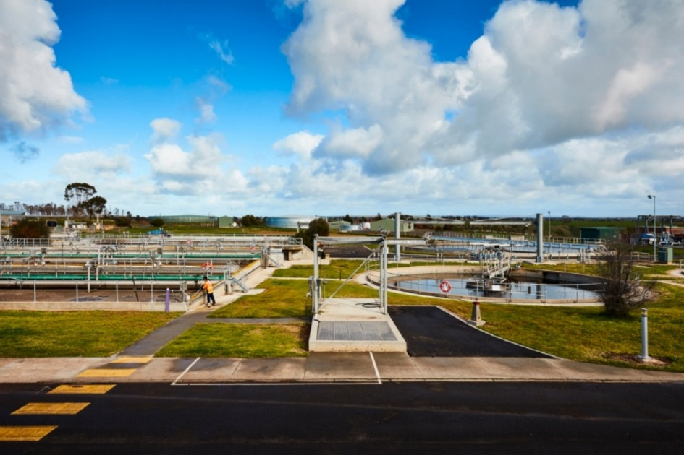
Image 5 Melton Recycled Water Plant. Credit Craig Moodie

Trade waste regulation

Trade waste regulation is a critical component of Victoria’s urban water management framework. Trade waste refers to any liquid waste discharged to the sewerage system from non-residential premises that is not purely domestic in nature. This can include process water, cleaning water, cooling water, or other wastewater streams from industrial, commercial, or institutional activities.
Trade waste regulation protects:
- The sewerage network from damage, blockages and corrosion
- Treatment plants and downstream processes
- Public health and the environment
- Service reliability for all customers
Urban water corporations are required to manage trade waste carefully because industrial discharges can be highly variable and may contain substances that impact the sewer system.

Trade Waste Agreements
Most non-residential customers who discharge anything other than domestic wastewater require a trade waste agreement, which outlines:
- Conditions for discharge
- Acceptable quality limits (e.g. pH, temperature, contaminants)
- Monitoring and reporting obligations
- Any pre-treatment or on-site control requirements
- Responsibilities for maintenance and compliance
These conditions are tailored to the industry and nature of the wastewater, recognising that different industries have varying waste profiles and potential impacts on the sewerage network. The framework is designed to be both protective and enabling, ensuring that large non-residential users can operate effectively while meeting their environmental and legal obligations.
Typical Considerations in Assessment
Urban water corporations will assess:
- Whether the proposed discharge meets trade waste acceptance criteria
- Impacts on sewer capacity and downstream treatment assets
- Safety and environmental risks
- Whether pre-treatment or process changes are required
- The applicant’s ability to monitor and manage wastewater reliably
For large non-residential users, trade waste requirements form one component of the overall servicing assessment undertaken by the urban water corporation. Trade waste considerations are assessed in parallel with water supply, recycled water, sewerage capacity and broader system impacts to ensure a coordinated and consistent decision-making process. This avoids creating multiple approval pathways and ensures that all elements of the application are evaluated together as a single, integrated case. Proponents can support this process by providing clear information about their expected wastewater characteristics, which helps the water corporation determine any treatment, monitoring or compliance requirements without implying or predetermining the outcome of the overall connection assessment.

Supporting Compliance and Best Practice
Applicants can support the assessment process by:
- Providing accurate descriptions of industrial processes
- Sharing chemical inventories and safety data sheets
- Identifying opportunities to minimise wastewater generation or reuse water internally
- Designing processes that avoid harmful substances entering the sewer
This enables a smoother assessment and ensures that wider servicing decisions consider the full operational footprint of the site.

Economic regulation of the water sector

Victoria’s water sector is economically regulated by the Essential Services Commission (ESC), which ensures prices, service standards and reliability are fair, efficient and in the long-term interests of customers. The ESC’s powers come from the Essential Services Commission Act 2001 and the Water Industry Regulatory Order (WIRO) under the Water Industry Act 1994. This regulation provides transparency and predictability for all water users, including large non-residential customers.
New Customer Contributions (NCCs)
Large non-residential customers can place significant additional demand on water, sewerage or recycled water networks. When new or upgraded infrastructure is required to service that demand, NCCs ensure the costs are recovered from the applicant and not subsidised by existing customers.
Important points for applicants:
- NCCs operate on a causer-pays principle.
- NCCs allow urban water corporations to recover the present-day cost of works required to connect new customers.
- Early understanding of NCC obligations is critical for realistic project budgeting and timing.
- NCCs can apply to potable water, sewerage and recycled water infrastructure.

Types of NCCs
The ESC regulates two types of NCC charges:
1. Standard NCCs
These apply in areas with predictable growth and established Development Servicing Plans. They Provide clarity on maximum charges for applicants.

2. Negotiated NCCs (most common for large users)
These are used for large-scale, unique or bespoke developments. They allow tailored, site-specific arrangements that reflect actual infrastructure needs. They typically involve more detailed engagement between the applicant and water corporation.
Gifted Assets
Proponents undertaking infrastructure works to enable new connection will typically design and construct required infrastructure themselves as agreed with the urban water corporation. These assets are at the cost of the proponent that can then be transferred (“gifted”) to the urban water corporation for ongoing ownership and operation.
- This can support faster delivery or alignment with project timelines.
- Applicants must meet the urban water corporation’s technical, quality and compliance standards.
Early Engagement on NCCs Is Essential
Understanding NCC implications early helps proponents:
- Accurately forecast project capital costs
- Plan construction sequencing
- Assess feasibility of non-potable water or demand-management options
- Avoid delays caused by unexpected infrastructure requirements
The ESC’s NCC framework ensures that large developments are supported transparently, equitably and sustainably, without shifting costs to existing customers.
More information is available at:
www.esc.vic.gov.au/water/industry-standards-codes-and-guidelines/new-customer-contributions-guiding-resources

Protecting our water system and ensuring transparency for large users

Urban water corporations play a central role in ensuring that Victoria’s water and sewerage services are delivered reliably, safely, and equitably to all customers, including large non-residential users. Their responsibilities are underpinned by legislation, regulatory standards, and ministerial obligations, all of which establish clear protections for existing customers and the environment while providing a pathway for new sustainable connections.
Stewardship and Responsible Water Management
Urban water corporations have a duty to manage water sustainably and equitably, ensuring new large user connections:
- Do not reduce reliability or service levels for existing customers
- Do not negatively impact environmental outcomes
- Do not place undue pressure on limited water supplies
This stewardship role underpins all decisions relating to servicing large customers and ensures that growth occurs responsibly and in line with long-term water security goals.
Service Standards and Legislative Obligations
Urban water corporations follow established principles when assessing large customer connections. These obligations are reinforced through:
- The Water Act 1989, The Water Industry Act 1994, The Minister’s Statements of Obligations, The Essential Services Commission’s Water Industry Standards – Urban Customer Service (Part E), which sets minimum service levels and reliability expectations
Connection Refusal or Conditional Approval
To protect customers and network integrity, urban water corporations assess the feasibility of every new connection. Where capacity constraints exist, they may:
- Require infrastructure upgrades
- Impose conditions on the connection
- Defer the connection or refuse the application entirely
Section 145(3) of the Water Act 1989 gives urban water corporations clear authority to refuse or condition a connection to ensure resource availability and customer service levels are not compromised. If a connection would reduce network capacity to the point that existing customers are impacted or deemed to have adverse impacts, it cannot be approved.
Transparency and Monitoring of Large Users
Water corporations have a role in ensuring transparency for large water users. Water Act 1989, Section 122ZJ requires water corporations to report the water users whose annual use exceeds a range specified by the Minister, and in particular, if they are participating in a water conservation program.
The range/s is specified each year by the Minister, via the Letter of Expectations issued to water corporations prior to each annual reporting period.
In 2025-26, the range specified for reporting on number of customers was from >50ML, while reporting on customer name and participation in a water conservation program was from >100ML.
Ensuring a Sustainable and Reliable System
Through strong regulatory powers, rigorous assessment processes and proactive engagement with proponents, water corporations ensure that large non-residential customers can be serviced in a way that is:
- Reliable
- Equitable
- Environmentally responsible
- Consistent with long-term water security planning
This integrated approach safeguards the interests of existing customers, supports responsible industry growth and protects Victoria’s shared water resource.

Best practice for large urban water users

Early engagement with your local urban water corporation

Proponents are strongly encouraged to engage with their local urban water corporation early in the planning process. See www.water.vic.gov.au/for-agriculture-and-industry/large-urban-water-user-guidance for appropriate contact information. Proponents are also encouraged to engage early with other utility providers to ensure that all of their infrastructure needs can be met at their selected site.
Early engagement provides the opportunity to identify suitable sites where water supply, sewerage, and recycled water services can be reliably provided to meet operational requirements. By starting discussions at the outset, proponents can understand the constraints and opportunities of the water system, assess the feasibility of different locations, and make informed decisions that align with both their business objectives and the long-term sustainability of the water network.
A key consideration in site selection is the type and availability of water at the proposed location. Different water sources have distinct characteristics that affect suitability for particular uses. For example:
- Potable water may come at a higher cost and carry stricter regulatory requirements for use and conservation.
- Recycled water can offer a cost-effective, sustainable option for non-potable water applications such as cooling, irrigation, or process water, but availability may be limited depending on the location and network capacity.
- Surface water or groundwater access may be possible in certain urban or peri-urban areas, but these sources can be variable in volume, subject to licensing and environmental constraints, and require treatment to meet quality standards.
- Raw (untreated) water may be available for industrial supply from urban water corporations in some areas and may require dedicated infrastructure to enable this.
By engaging early, proponents can work with the relevant water corporation to understand the availability, cost, reliability, and environmental implications of each water source.
This enables more informed site selection and development design, reduces the risk of delays or redesign later in the process, and helps identify opportunities to integrate water efficiency measures, non-potable water sources, and recycling into the project from the outset.
Early collaboration also allows water corporations to provide guidance on required infrastructure, potential system upgrades, and any regulatory approvals, ensuring that new large water users can be accommodated without compromising service to existing customers or the environment.

Image 6 Bendigo Reservoir, Coliban Water. Credit: Craig Moodie

Consider water efficient opportunities

Integrating water-efficiency measures into large non-residential sites can deliver a wide range of benefits.
By integrating efficiency measures early, businesses can reduce operating costs, improve resilience and enhance sustainability outcomes, while supporting broader water system reliability.
Some of the key benefits include:
- Cost savings: Reducing water use lowers water bills, and where hot water is involved, can also reduce energy costs. Water efficiency measures can also contribute to deferred infrastructure upgrades, reduced maintenance, lower asset replacement costs, and savings on wastewater treatment, chemical use, and pumping energy.
- Business continuity: Efficient water use reduces the risk of operational disruption during periods of water scarcity or supply constraints.
- Simplified approvals: Keeping site consumption low can streamline approval processes, reducing administrative burden and delays.
- Emissions reductions: Saving water reduces greenhouse gas emissions, supporting industries striving for net zero carbon targets and potentially reducing compliance or operational costs.
- Community and stakeholder confidence: Demonstrating water efficiency and sustainable practices can strengthen brand reputation, increase community acceptance and provide a competitive advantage.
- Sustainability performance: Efficient water use helps businesses meet shareholder and corporate sustainability expectations, including green building certifications such as the National Australian Built Environment Rating System (NABERS).

Water-efficient technologies:
When exploring water-efficiency opportunities, proponents should consider a range of measures and technologies, depending on site characteristics and operational needs. Examples include:
- High-efficiency fixtures and appliances, such as the Water Efficiency Labelling and Standards scheme rated taps (4–6 stars), toilets (4–5 stars), and showerheads (4–5 stars). Commercial dishwashers and laundry systems with 4 stars or above are also effective for reducing water consumption. More information is available at Water Rating.
- Cooling systems: Replace single-pass cooling with recirculating systems, implement water treatment to reduce blowdown, and optimise cooling tower bleed setpoints.
- Digital sub-metering and monitoring to quickly identify leaks, overuse, or inefficiencies.
Benchmarking and assessment tools:
- Utilise tools such as NABERS to compare a site’s water use against similar industries, helping to identify opportunities for improvement and track efficiency progress over time.
For more practical examples, case studies and guidance on saving water in commercial and industrial operations, visit Smart Water Advice. https://smartwateradvice.org/
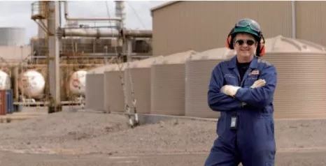
Image 7 Mobil Alterna Refinery, Altona. Credit - Smart Water Advice

Case Study: WaterSmart Business Program – Barwon Water

Context
Barwon Water’s Sustainable Water Use Plan (SWUP) sets an ambitious target to save approximately 200 ML per year and up to 1,000 ML by June 2028 through a suite of demand-management and water-efficiency initiatives. These actions support regional water security in the face of growth, climate variability and increasing commercial and industrial water demand.
Challenge
Many large customers operate complex sites with ageing infrastructure, extensive plumbing networks, or variable occupancy patterns. Common challenges include:
- Undetected leaks resulting in extremely high-water losses
- Limited visibility of usage trends or consumption anomalies
- Inefficient fixtures and ageing water-using assets
- Lack of internal expertise to identify, quantify or prioritise water-saving opportunities
- Competing operational budgets that make water efficiency investment difficult without support
At the same time, these sites often hold high community value, meaning water waste can have broader social and environmental impacts.
Approach and Solution
Barwon Water’s WaterSmart Business Program provides proactive, hands-on support to help large customers reduce water use and strengthen their operational efficiency. The program’s approach includes:
- Targeting high-usage, high-community-value sites using consumption data and risk indicators
- Offering free installation of digital data loggers to provide customers with real-time usage data
- Providing customers with access to real-time data, enabling them to track usage, identify leaks and receive automated alerts
- Conducting water audits to identify efficiency improvements, quantify water loss and evaluate upgrade opportunities
- Partnering with councils and coastal committees to deliver water-saving projects such as:
  - Irrigation system reviews
  - Fixture replacements in public facilities
- Providing business grants and rebates to support implementation of recommended water-saving projects in the commercial and industrial sector
- Offering education and behaviour-change guidance to empower customers to actively monitor and manage water use
Outcomes and Achievements
Barwon Water’s WaterSmart Business Program has delivered demonstrable benefits across the region:
- High volumes of water previously lost to unregistered leaks have been prevented, translating directly into avoided operational costs for businesses and improved regional water security.
- Water audits have led to implementation of efficiency upgrades across a range of sectors, reducing potable water use and extending asset life.
- Community-focused organisations have realised immediate and ongoing efficiency gains.
What This Demonstrates
- Proactive partnerships work. Targeting high-usage sites delivers outsized benefits for both customers and the broader system.
- Data is a powerful tool. Providing real-time information empowers customers to take ownership of water use and respond quickly to leaks.
- Water corporations can influence large user behaviour through structured programs, grants and education.

Consider rainwater, recycled water and stormwater use opportunities

Large non-residential users should prioritise the use of non-drinking water, to minimise the impact on our state’s precious drinking water supply. This can include alternative sources such as rainwater, recycled water, stormwater, and internal wastewater streams.
Integrating these sources into site design and operations not only supports sustainability goals but can also reduce costs, improve resilience, and help businesses meet regulatory and community expectations.
Rainwater and stormwater harvesting
Large non-residential developments with large roof areas are prime candidates for rainwater harvesting. Capturing rainwater or stormwater on-site can provide a sustainable supply for non-potable water applications such as toilet flushing, irrigation, cooling, or cleaning operations.
Properly designed harvesting systems can significantly reduce demand for drinking water while also helping manage excess stormwater runoff and protecting the local waterways.
Internal wastewater and greywater recycling
Reusing wastewater generated on-site — including greywater from sinks, showers, or process water — can support industrial processes, manufacturing, and cleaning operations. This approach reduces the volume of potable water required, improves operational efficiency, and can provide resilience against temporary supply constraints.
Recycled water
Where available, urban water corporations can supply recycled water to non-residential sites for a range of uses. Proponents should engage with their local water corporation early to understand availability, quality, and cost.
DEECA is currently developing a Recycled Water Data Dashboard which, once published, will be included here. The Dashboard will provide a snapshot of the locations of recycled water availability, helping proponents identify feasible options.
Sewer mining
Some large sites may be able to establish on-site treatment systems that extract and treat wastewater from the urban water corporation sewer network for reuse on-site. Sewer mining can provide a reliable alternative water source, particularly for industrial or high-demand facilities, and may be suitable where recycled water networks are not available.
Utilising non-potable water sources can complement water efficiency initiatives, reduce reliance on potable water, and demonstrate proactive environmental stewardship.
Early engagement with the water corporation is essential to explore these options, understand technical and regulatory requirements, and ensure integration with broader water management planning.

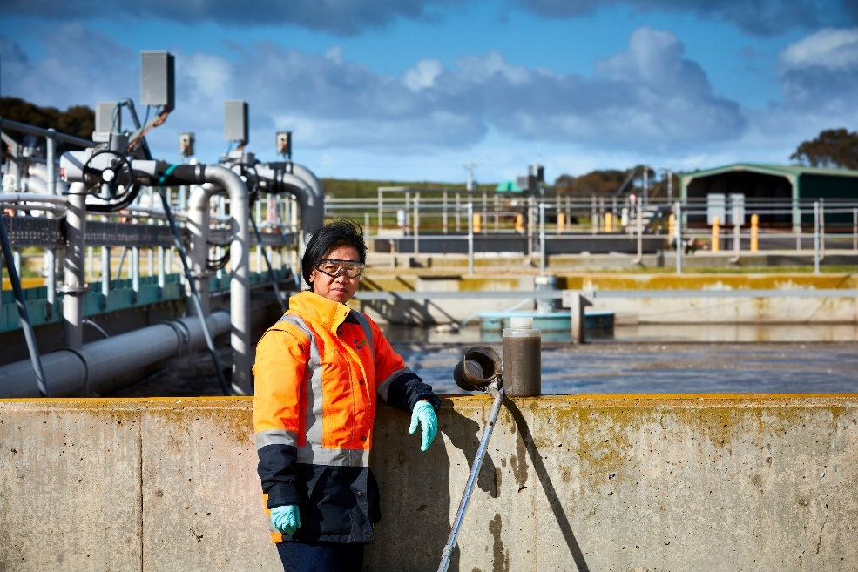
Image 8 Melton Recycled Water Plant. Credit: Craig Moodie

Decision guidelines

When making decisions about connecting or expanding large non-residential urban users, urban water corporations follow decision guidelines that ensure network reliability, protect existing customers, and support sustainable growth. A key element of this process is the use of potable water demand forecasts.
Urban water corporations develop detailed forecasts for different customer types, including residential, commercial, and industrial (non-residential) users. These forecasts are based on historical consumption, planned developments, emerging industries, and anticipated changes in technology or water efficiency. For further information on forecasts and the urban water planning framework, refer to section 2.3.
When an application falls within the parameters of these forecasts, the water corporation can generally approve the connection more efficiently, as the network is planned to accommodate this level of demand without compromising service to existing or future customers.
Where a connection request exceeds forecasted demand, additional assessment is required to ensure that network capacity, water security, and service levels are not compromised. In these cases, water corporations will carefully evaluate:
- Whether the existing infrastructure can support the additional demand.
- Potential impacts on pressure, reliability, and quality for other customers.
- Environmental considerations, including compliance with bulk entitlement limits.
Applicants in these situations are encouraged to demonstrate water-efficient design, non-potable water use, or to consider offsets (refer to section 5.5) as part of their application. Measures such as high-efficiency fixtures, recycled water use, rainwater or stormwater harvesting, and internal wastewater reuse can reduce overall potable water demand, making it easier for water corporations to accommodate large users within the network safely and sustainably.
Early engagement with the local water corporation is essential in these cases. Discussing design options, efficiency measures, and potential alternative water solutions helps proponents understand the feasibility of their application, identify necessary infrastructure upgrades, and develop solutions that align with both operational needs and the long-term sustainability of the urban water system.

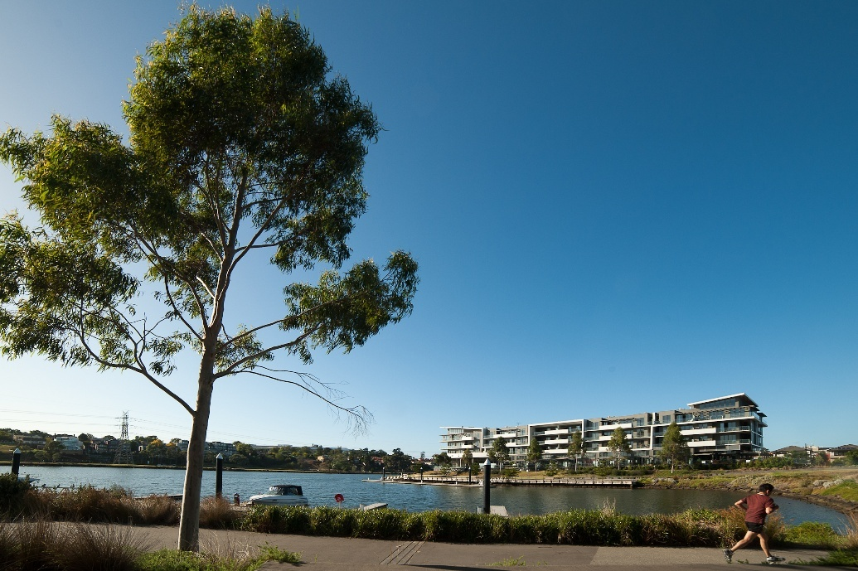
Image 9 Edgewater Lake, Maribyrnong River

Programs and supports available

Leak detection and network efficiency programs
Efficient use of water begins with ensuring that water losses are minimised at both the network and customer level. While customers are responsible for detecting and repairing leaks within their own property boundary, urban water corporations actively manage their networks to identify leaks, reduce losses and improve system efficiency. These programs help safeguard water security, reduce costs for customers and support the sustainable use of Victoria’s limited water resources.
Urban water corporations employ a range of industry-leading tools and practices to monitor their networks and identify emerging issues before they affect customers. These may include district metering areas (DMAs), smart meter analytics, acoustic monitoring, pressure management zones and targeted leak detection surveys. These programs allow water corporations to quickly detect system inefficiencies, prioritise repairs and optimise network performance in real time.
Identifying and repairing leaks early helps businesses reduce operating costs, prevent service disruptions and lower the risk of exceeding consumption thresholds that may trigger additional regulatory requirements. Efficient water use is also a visible demonstration of responsible water stewardship, supporting broader sustainability goals and community expectations.
Through a combination of urban water corporation programs and proactive customer actions, leak minimisation forms a critical component of ensuring Victoria’s water resources are used efficiently, supporting long-term water security and enabling emerging industries to grow sustainably.

Invest Victoria
Invest Victoria provides a range of services from market insights, business case support and set up guidance to help international and domestic businesses enter and expand in Victoria. Companies are encouraged to utilise the services of the Victorian Government’s Investment Front Door and Invest Victoria to assist with the streamlining of investment related engagements - https://www.invest.vic.gov.au/get-tailored-support/investment-front-door.

Smart meter and data insights initiatives providing real-time monitoring and benchmarking
Digital monitoring, either through data loggers or digital water meters, helps businesses to understand how water is being used, establish a water use baseline, identify options and make more informed and data-driven decisions around water use. Data from smart metering can be used for NABERS assessments and benchmarking against other sites within the same industry.

WaterSmart
WaterSmart provides eligible non-residential customers with support to understand their water use, detect leaks and identify opportunities to reduce water-related operating costs, through digital water use monitoring and/or a one-off water efficiency audit.
Water efficiency audits help organisations identify where they are using the most water and make recommendations on how to use water more efficiently.
WaterSmart is funded by the Victorian Government and delivered by water corporations.

Offsetting your water use
In areas where non-potable water, such as recycled water, is not supplied and available, proponents can discuss funding or contributing to new infrastructure that enables non-potable water use elsewhere in the network. Doing so minimises the overall impact on potable water resources by ‘offsetting’ their potable water use.
The concept of offsetting is an emerging space which can be discussed with your local urban water corporation.

Case study: Recycled Water offsets for major infrastructure projects – Yarra Valley Water
Context
Yarra Valley Water (YVW) has introduced a recycled-water offset scheme so projects can “offset” their impact on drinking-water supplies by helping fund new recycled-water infrastructure where it’s needed.
Challenge
Large infrastructure projects often require substantial volumes of water during construction. Using our limited drinking water resources can put pressure on available reserves, but many projects are too far away from existing recycled-water networks to be cost effective or logistically possible.
Solution: Recycled-Water Offset Program
YVW launched one of Australia’s first recycled-water offset schemes:
- Gives projects an option to fund new recycled-water infrastructure when a direct connection is not viable.
- Builds new recycled water infrastructure to supply Class A recycled water for non-drinking uses, including irrigating parks, sporting fields or landscaping.
Example:
For a level-crossing removal project, YVW offset the drinking water used during construction by extending ~300 metres of a recycled-water main to supply a nearby reserve and sporting oval. This supports ongoing recycled-water supply for the community, turning the need for water during construction into a long-term alternative water supply.
Outcomes and Benefits
- Offset drinking-water use: Practical option for projects to compensate for their drinking water use by funding new recycled-water infrastructure.
- Long-term infrastructure for the community: Recycled-water assets installed for community projects remain in place, supplying non-drinking water for parks, sporting fields, and other public open spaces.
- Demonstrates innovation and leadership: Showing nationwide leadership in managing water use for large projects.
- Community benefit: Ongoing use of recycled water supports local open spaces and contributes to public amenity.
- Regulatory and planning alignment: The program aligns with the principles of efficient water use, alternative water sourcing, and strategic planning that underpin Victoria’s broader water security and sustainability goals.
What This Demonstrates
- Alternative water offsets offer a practical approach for managing large or temporary water demands, with ongoing community benefits.
- Water corporations can act as enablers of sustainable growth. Through partnership and innovative program design, water corporations can support infrastructure, construction and emerging industries while protecting potable water supply and environmental outcomes.
- The scheme provides a practical model for future large users, with similar recycled-water approaches to help manage demand on potable water supplies and support system resilience.
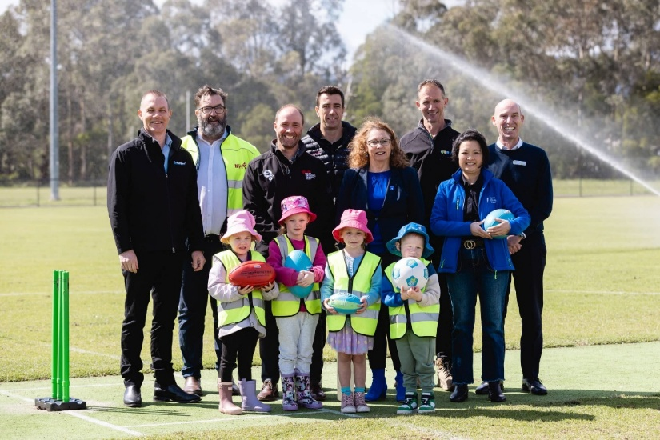
Image 10. YVW unveiling new recycled water main. Credit Utility Magazine

Glossary

Term | Definition
Alternative water | Any water source other than potable drinking water, including recycled water, stormwater, rainwater and sewer-mined water.
Bulk entitlement | A legal right held by a water corporation under the Water Act 1989 to take and store water from a river, reservoir or aquifer under specified limits and conditions.
Causer-pays principle | The regulatory requirement that new customers must pay for the infrastructure upgrades needed to service them, preventing costs from being passed on to existing customers.
Climate variability | Natural and human-induced variations in rainfall, temperature and water availability over time, influencing water security and system planning.
Connection approval | Formal approval issued by a water corporation allowing a customer to connect to water, sewerage or recycled water networks, subject to conditions.
Declared Water Supply District (DWSD) | A geographic area where a water corporation has statutory obligations to supply drinking water services. Areas outside a DWSD require supply agreements.
Demand forecasting | The process of estimating future water needs across residential, commercial and industrial sectors to inform planning, infrastructure investment and allocation decisions.
Development Servicing Plan (DSP) | A published plan outlining future servicing needs, growth assumptions and standard NCC charges for specific growth areas.
Digital sub-metering | Technology used to monitor water consumption at a granular level to detect leaks and inefficiencies.
Essential Services Commission (ESC) | Victoria’s independent economic regulator responsible for water pricing, service standards and oversight of New Customer Contributions.
Gifted asset | Infrastructure that is funded and built by a developer but transferred to a water corporation for ongoing ownership, maintenance and operation.
Greywater | Wastewater from showers, basins and laundry systems that can be treated for reuse in non-potable water applications.
Infrastructure upgrades | Water, sewerage or recycled water system improvements required to support new customer demand.
Large non-residential water user | Industrial or commercial customers whose water demand is significant enough to require detailed assessment of system capacity, water security and infrastructure impacts.
Minister’s Statement of Obligations (SoO) | A regulatory document outlining obligations water corporations must meet in planning, service delivery and environmental management.
NABERS | The National Australian Built Environment Rating System, used to benchmark water, energy and waste performance of buildings.
New Customer Contributions (NCCs) | Charges applied to new customers to recover the cost of system augmentations required to service their development. Includes standard and negotiated NCCs.
Negotiated NCC | A site-specific NCC charge used where infrastructure needs or growth patterns are unique or unpredictable.
Non-residential demand | Water use from commercial, industrial, institutional and other non-residential sectors.
Potable water | Drinking-quality water supplied through a reticulated urban network.
Preliminary Servicing Advice (PSA) | Early, high-level assessment used to identify feasibility, servicing options and potential constraints for a proposed development.
Raw water | Untreated water sourced directly from rivers, dams or aquifers, typically requiring treatment before use.
Recycled water | Treated wastewater suitable for non-potable water uses such as irrigation, cooling or industrial processes.
Sewer mining | Extraction and treatment of wastewater directly from a sewer pipe for reuse on-site.
Standard NCC | A fixed, maximum NCC charge set by the ESC for areas with predictable growth and published Development Servicing Plans.
Stormwater harvesting | Collection and treatment of stormwater runoff for reuse on-site, typically for irrigation or industrial cooling.
Trade waste | Liquid waste discharged from non-residential premises into the sewer system, requiring regulation to protect infrastructure and the environment.
Trade Waste Agreement (TWA) | A legal agreement governing conditions for trade waste discharge, including quality, pre-treatment, monitoring and compliance obligations.
Urban Water Corporation | A government-owned entity responsible for supplying water, sewerage and recycled water services in urban areas of Victoria.
Victorian Water Security Plan | The state’s long-term strategy for managing water resources, ensuring resilience to climate change, population growth and emerging industry demand.
Water Act 1989 | Primary legislation governing water entitlements, allocation, licensing and management in Victoria.
Water efficiency | Measures that reduce the volume of water needed to operate a site, including technology upgrades, process optimisation and behaviour changes.
Water Industry Act 1994 | Legislation establishing responsibilities for water corporations, including service delivery, customer rights and regulatory obligations.
Water Industry Standards (ESC) | Standards set by the ESC that govern service quality, reliability and customer protection for water corporations.
WELS Rating | Australia’s Water Efficiency Labelling and Standards scheme for fixtures and appliances.
Works (Infrastructure) | Physical assets required to connect a development to water, sewerage or recycled water services, including pipes, pumps, storage and treatment systems.

Appendix A – Urban water corporation contact information & application references

Urban water corporation | Website | New connection / development information | New development enquiries contact*
Greater Western Water | gww.com.au | Building & development hub – includes “Connecting a property” and “Property development” pages for new connections and larger developments: Building & development → Building → Connecting a property / Property development | General customer and technical enquiries via Contact us, or phone 13 44 99 (includes “Connections & Technical Services” as contact point for building approvals and property development).
South East Water | southeastwater.com.au | Building and development portal, including PropertyConnect for online connection and development applications: Building and development → Developers (technical standards and process) | Online enquiry / complaint forms via Contact us and Send us an enquiry. General enquiries phone 131 694 / 131 851.
Yarra Valley Water | yvw.com.au | Develop and build applications via easyACCESS portal for plumbing, connection and land development approvals: Develop and build applications | General and development-related enquiries via online form and enquiry@yvw.com.au, phone 1300 304 688 (see Customer Charter / enquiries section).
Barwon Water | barwonwater.vic.gov.au | Land development – process and forms for water/sewer servicing and subdivision: Apply for a development | development@barwonwater.vic.gov.au listed for development-related contact / enquiries.
Central Highlands Water | chw.net.au | Land development page with land development manual, forms, and process for connecting developments: Land development | For subdivision / development enquiries, contact Property Services via the “Contact property services” / general Contact us channels on the CHW site.
Coliban Water | coliban.com.au | Builders & Developers hub and connection pages: Builders & Developers → Connect a property and Land Development Manual / Quick Guides for new developments and subdivisions. | Development / subdivision enquiries via the Builders & Developers contact options and general Contact us channels on the Coliban Water website.
East Gippsland Water | egwater.vic.gov.au | Land development and subdivision forms and process (e.g. plan application form) under: Land development and subdivision | General and development enquiries via East Gippsland Water, phone 1300 720 700 (listed on building/development guidance) or via the website contact details.
Gippsland Water | gippswater.com.au | Building and development section including Developing land, New Customer Contribution and developer works forms/manual: Building and development → Developing land | General / development enquiries via Gippsland Water’s contact channels, phone 1800 050 500 (customer contact centre) and online forms.
Goulburn Valley Water | gvwater.vic.gov.au | Development hub for developers, plumbers and builders, including “Application to connect water and sewer”: Development → Developers → Application to connect water and sewer | Development and connection enquiries via GVW’s Development contacts (phone 1800 454 500) and forms listed on the Development pages.
GWMWater (Grampians Wimmera Mallee Water) | gwmwater.org.au | Developers & land development information is provided through GWMWater’s development and connection pages (e.g. land development manuals / application guidance for new water and sewer assets). | New development enquiries via GWMWater’s general Contact us channels (phone and online forms) noting specific development contact details referenced in their land development documentation.
Lower Murray Water | lmw.vic.gov.au | Building and developing hub, incl. Land development and New developments and subdivisions pages and Urban water and sewer connections page for connection approvals: Building and developing → Land development / New developments and subdivisions / Urban water & sewer connections | Development and connection enquiries via LMW’s Contact / Building & Developing contact routes (phone and forms) listed on the building and developing pages.
North East Water | newater.com.au | Developers & Plumbers: Developers & Plumbers → Plumbers → Property connections / Water & sewer connection information | Property development enquiries can be directed to North East Water’s Property Development Department – development@newater.com.au, phone 02 6055 8480, as noted on water tappings / connections application forms.
South Gippsland Water | sgwater.com.au | Building & development / Land development pages giving process, manuals and forms for connecting new developments and land subdivisions. | Development enquiries via South Gippsland Water’s Contact us channels (phone and online form) as referenced on the website contact page.
Wannon Water | wannonwater.com.au | Building and development section, including Building and renovating and Land development – Apply for a development and Water and sewerage connections information: Building and development → Land development – Apply for a development | New development enquiries via Wannon Water’s Contact / Building & Development contact points (phone and email) listed on the building and development pages.
Westernport Water | westernportwater.com.au | Development section, supported by a Land Development Manual and online forms that outline processes and requirements for provision of water, sewerage and recycled water services to new developments: Customers → Development and associated Land Development Manual. | Development enquiries via Westernport Water’s development documentation and general Contact us channels (phone and online form) referenced in the Land Development Manual / permit information.

Appendix B –Urban water corporation high water use data request form
