Western Region Sustainable Water Strategy Working Group Expression of Interest
Working Group Expression of Interest Form
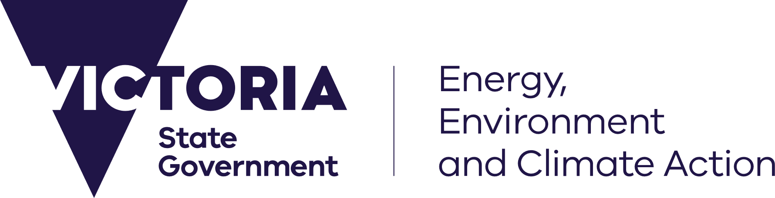


Details
Name
Address
Occupation
Gender/age (optional)
Phone
Email
In expressing your interest in becoming a member of a Western Region Sustainable Water Strategy working group, please provide the following information.
- Why are you interested in becoming a working group member?

- What are some of the key issues affecting water resources in Western Victoria?

- Please describe your links with the community and ability to relay interests and concerns of others in the community.

- In what ways will you seek to contribute to the working group?

- Please describe your water use and locality (e.g. groundwater irrigator near Warrnambool, stock and domestic water user near Avoca, recreational user of Taylors Lake).

Optional Demographic Questions - these questions do not affect the decision making of who is selected
What is your gender identity?
A. Female
B. Male
C. Transgender
D. Nonbinary
E. Other (please specify)
F. Prefer not to say

How old are you?
A. Under 18
B. 18-24 years old
C. 25-34 years old
D. 35-44 years old
E. 45-54 years old
F. 55-64 years old
G. 65+ years old

Please return this Expression of Interest by Monday 16 March 2026 to sws.team@deeca.vic.gov.au or Western Region Sustainable Water Strategy Team, DEECA, PO Box 500, East Melbourne, East Melbourne VIC 8002.

