Traditional Owner-led IWM Projects

Grant Application Guidelines 2025-28

Acknowledgment
We acknowledge and respect Victorian Traditional Owners as the original custodians of Victoria's land and waters, their unique ability to care for Country and deep spiritual connection to it. We honour Elders past and present whose knowledge and wisdom has ensured the continuation of culture and traditional practices.
We are committed to genuinely partner, and meaningfully engage, with Victoria's Traditional Owners and Aboriginal communities to support the protection of Country, the maintenance of spiritual and cultural practices and their broader aspirations in the 21st century and beyond.
© The State of Victoria Department of Energy, Environment and Climate Action 2023
This work is licensed under a Creative Commons Attribution 4.0 International licence. You are free to re-use the work under that licence, on the condition that you credit the State of Victoria as author. The licence does not apply to any images, photographs or branding, including the Victorian Coat of Arms, the Victorian Government logo and the Department of Energy, Environment and Climate Change (DEECA) logo. To view a copy of this licence, visit http://creativecommons.org/licenses/by/4.0/
ISBN 978-1-76176-667-1 (pdf/word/online)
Disclaimer
This publication may be of assistance to you but the State of Victoria and its employees do not guarantee that the publication is without flaw of any kind or is wholly appropriate for your particular purposes and therefore disclaims all liability for any error, loss or other consequence which may arise from you relying on any information in this publication.
Accessibility
If you would like to receive this publication in an alternative format, please telephone the DEECA Customer Service Centre on 136186, email customer.service@deeca.vic.gov.au or via the National Relay Service on 133 677 www.relayservice.com.au. This document is also available on the internet at www.deeca.vic.gov.au.

Contents
Traditional Owner-led IWM Projects 1
Grant Application Guidelines 2025-28 1
1. What is the Integrated Water Management Program? 2
2. What is the IWM Grant Program 2025-28? 3
3. What are the objectives of the Traditional Owner-led IWM Projects stream? 4
4. Who can apply? 4
5. What might be funded? 4
6. What will not be funded? 5
7. What are the funding details? 5
8. What are the assessment criteria? 6
9. What are the key dates? 7
10. What supporting documents will need to be provided? 8
11. What is the application process? 8
12. How will the applications be assessed? 8
13. How will I be notified of the outcome? 8
14. Where do I go for questions and assistance? 8
15. What conditions apply to applications and funding? 9
16. Checklist 11
Appendix 1a: Metropolitan Melbourne IWM Strategic Outcomes, Indicators & Measures 12
Appendix 1b: Regional Victoria IWM Strategic Outcome Areas & Example Indicators 14
Appendix 2: Assessment Scoring Table 16

What is the Integrated Water Management Program?
The Integrated Water Management (IWM) Program was established by the Victorian Government in 2017 to embed a more collaborative and place-based approach to the way we plan for, manage, and invest in water management across the state. The IWM approach brings together all organisations with a role or interest in the water cycle — including Traditional Owners, local government, water corporations, and catchment management authorities—to deliver optimised solutions that deliver shared environmental, social, cultural, and economic benefits.
Traditional Owners hold deep knowledge, responsibility, and connection to Country, and have communicated that the IWM approach is more aligned with their own principles of caring for Country than conventional approaches to water management. While this alignment presents an important opportunity, Traditional Owner groups have also highlighted that meaningful participation in IWM has been constrained by systemic and structural barriers, as well as continuing to face the impacts of colonisation on communities. These include under-resourcing, inflexible government processes, and a lack of mechanisms that support culturally grounded, self-determined ways of working. Addressing these challenges is essential to realising the full potential of IWM.
What is IWM?
IWM is a holistic and collaborative approach to the way we plan for and manage all elements of the water cycle —including water supply, wastewater, and stormwater—to deliver broader benefits for people, places, and the environment.
By aligning water, land use, and urban planning, IWM helps create more resilient, liveable and sustainable communities. It changes how we think about and deliver water services—shifting from siloed to integrated solutions.
As Victoria faces climate change, population growth, environmental pressures, and other complex challenges, IWM ensures we all work together to meet our current and future water needs.

At its heart, IWM is about delivering more sustainable, liveable and resilient communities by planning for and managing water in a way that reflects the values, needs, and responsibilities of all partners. To be effective, this approach must be inclusive of Traditional Owner groups and enable their meaningful and self-determined participation in water planning and decision-making.
The Victorian Government is committed to working in partnership with Traditional Owners and Aboriginal Victorians to plan for and manage all elements of the water cycle. This commitment is reflected in several key policies and legislative frameworks including:
Water for Victoria (2016) recognises the values that water has for Traditional Owners and Aboriginal Victorians and the importance of self-determination.
The Water and Catchment Legislation Amendment Act 2019 incorporates obligations to ‘Recognise Aboriginal cultural values and knowledge in water and catchment planning and management and include Traditional Owners in these processes’ into the Water Act 1989.
Pupangarli Marnmarnepu ‘Owning our Future’ Aboriginal Self-Determination Reform Strategy, 2020- 2025.
The IWM Program is also developed in alignment with the following actions from Water for Victoria:
- Action 5.6: work across government for healthy and resilient urban landscapes.
- Action 5.7: represent community values and local opportunities in planning.
- Action 5.8: put integrated water management into practice.
- Action 6.1: to recognise Aboriginal values and objectives of water.
- Action 6.2: to include Aboriginal values and traditional ecological knowledge in water planning.
- Action 6.4: to build capacity to increase Aboriginal participation in water management.
- Action 10.8: to increase Aboriginal inclusion in the water sector.

What is the IWM Grant Program 2025-28?
The next phase of the IWM Grant Program builds on insights and lessons from previous rounds. Stakeholder feedback, project outcomes, and an evolving policy and planning context have shaped a refreshed approach aimed at accelerating IWM adoption across Victoria.
The IWM Grant Program 2025-28 will continue to provide co-investment for collaborative, place-based projects aligned with IWM Forum priorities. It will also strengthen Traditional Owner leadership and participation in water planning and enable strategic investment in time-sensitive, high-impact opportunities identified by the sector.
The 2025–2028 Program will be delivered through three funding streams:
- IWM Partnership Projects (metropolitan and regional).
- Traditional Owner-led IWM Projects.
- IWM Strategic Directed Investments (SDI).
Traditional Owner organisations are eligible to apply for any of the above funding streams, provided they meet the relevant eligibility criteria.
This document outlines the arrangements for the Traditional Owner-led IWM Projects funding stream.

What are the objectives of the Traditional Owner-led IWM Projects stream?
The Traditional Owner-led IWM Projects stream supports Traditional Owner-led projects through a negotiated Expression of Interest (EOI) process.
The objective of this dedicated funding stream is to provide funding for Traditional Owner-led Projects that:
- Build cultural water knowledge and/or experience sharing cultural water knowledge in the context of IWM and caring for Country.
- Increase Traditional Owner capacity to engage in IWM.
- Demonstrate the benefits of IWM through practical delivery of IWM outcomes.

Who can apply?
This stream is open to all Victorian Traditional Owner groups including Registered Aboriginal Parties (RAPs) and non-RAPs. Consistent with DEECA’s Traditional Owner and Aboriginal Community Engagement Framework 2024:
Only RAPs can apply for projects on their formally recognised Country.
RAPs and non-RAPs can apply for projects on Country in which they have an interest and over which Traditional Owners are not formally recognised.
The funding applicants must:
- be an incorporated body, cooperative or association, or have an auspice/ organisation who can manage funding on their behalf
- be financially solvent.

What might be funded?
Projects that might be funded include:
- IWM-related cultural events and gatherings supporting capacity, strengthening and knowledge sharing
- IWM activities that progress Aboriginal cultural values and uses, recommendations and/ or economic purposes of waterways
- feasibility studies and/ or business cases for IWM-related projects
- water-related resources, such as funding for a short-term IWM Officer or co-contribution to a Regional IWM Officer position
- cultural flows research studies and methodologies relating to IWM
- progressing a Country Plan or self-determination plan with water objectives that relate to IWM
- contribution to another Forum organisation led IWM Project.
To be eligible for funding, projects must meet all of the following criteria:
- satisfy one or more purposes of Victoria’s Environmental Contribution levy, namely to:
  - promote the sustainable management of water, or
  - address adverse water-related environmental impacts
- support Traditional Owner self-determination
- support increased participation in IWM by Traditional Owners
- be scheduled to begin in 2025/2026 or 2026/2027 financial years
If an applicant is unsure whether a proposed project meets the eligibility requirements, they are encouraged to contact their relevant DEECA IWM Project Officer.

What will not be funded?
The Program will not fund the following:
- Projects that are not scheduled to begin in 2025-26 or 2026-27 financial years.
- The purchase of land or water entitlement.
- Routine or ongoing maintenance activities (outside of justified establishment-phase maintenance for capital works).
- activities that are solely for meeting legislative requirements of another organisations Project (e.g. Cultural Heritage Management Plans)
- where duplicate services are in operation or planned for in a targeted community
- Activities for which funding is fully provided through another source
- Recurrent operating costs, including rent, staffing, utility costs, and/or activities establishing expectation of ongoing funding.
- Projects located outside the State of Victoria.
- Political campaigning or advocacy activities for political parties.
Note: Reasonable, time-limited maintenance associated with the establishment of capital works (e.g. vegetation establishment or erosion control) is eligible if clearly justified. Time-limited project staff are also eligible if directly tied to project delivery and the co-contribution threshold is met.

What are the funding details?
A total of $2 million is available for the Traditional Owner-led IWM Projects stream over three financial years, from 2025-26 to 2027-28.
A cap will be applied to the amount of grant funding provided to each successful applicant, irrespective of the number of projects for which funding is sought throughout the period, as follows:
- A maximum of $150,000.00 (GST exclusive) will be available for each successful Registered Aboriginal Party (RAP).
- A maximum of $50,000.00 (GST exclusive) will be available for each successful non-registered party (non-RAP).
DEECA intends to award the majority of this funding to successful applicants within the first year of these financial years. As such, EOIs will remain open for the first year or until all funding has been allocated (whichever occurs first).

Funding flexibility
Section 5 describes eligibility requirements and types of activities that can be funded via these grants. Traditional Owner groups can also choose to use the funding secured through this EOI process to contribute to a project led by another IWM Forum member organisation. For example, a Catchment Management Authority (CMA) may be leading an IWM project that aligns with Traditional Owner objectives for water. Using funding secured through this EOI process, a Traditional Owner group may then contribute this funding to partner with the CMA on the Project. The project must still align with IWM outcomes.

What are the assessment criteria?
First, EOIs will be checked for eligibility to make sure that the applicant and their activity are eligible for funding. After that, eligible EOIs will be assessed using the criteria listed below. Each criterion is given a percentage weighting to indicate its relative importance in the assessment process. Applications should address all relevant criteria.
Assessment Criteria 1: Strategic alignment with IWM outcomes (50%)
Explain how the proposed project aligns with, and contributes to, relevant IWM strategic outcomes. The project must contribute to at least 2 IWM strategic outcomes. See Appendix 1 for the IWM strategic outcomes and list of example indicators.
Supporting evidence can be included to strengthen your application. This might include, but is not limited to:
- Modelling, data or scenario comparison
- Case studies of similar projects
- Environmental impact studies
- Economic analysis
- Community surveys
- Water quality sampling and analysis
Assessment Criteria 2: Readiness to deliver (50%)
Show that your organisation is prepared and equipped to successfully deliver the proposed project. This includes demonstrating:
- project planning appropriate to the scale of the project
- effective risk management and contingency strategies
- a realistic delivery schedule with clear milestones
- any preparatory work completed prior to submitting this application
- the skills, resources, and experience needed to carry out the proposed activities
Supporting evidence must include:
- Details of risks and mitigations, completed on the template provided in the application document pack
- A budget overview, completed on the template provided in the application document pack
- Project key milestones and delivery dates
Supporting evidence may also include, but is not limited to:
- A comprehensive project plan including a more detailed project schedule and budget
- Feasibility study
- Business case
- Design documents
- Relevant approvals
- Resourcing or staffing plan

What are the key dates?
Timeline | Date
EOI open date | 3 November 2025
EOI close date | 1 September 2026
Application assessment and approval | Up to three months from receipt of EOI, subject to any clarifications
Notification of funding outcomes | Within 7 days of assessment outcome approval
Funding agreements for successful applicants | Within one month from the date of notification of successful funding outcome
As the Victorian State election will be held on Saturday 28 November 2026, the Victorian Government will assume a caretaker role from 6:00 pm on 3 November 2026 until such time that either it becomes clear that the incumbent government will be returned, or when a new government is commissioned.
In line with the caretaker conventions, the incoming government will determine whether to proceed with this grant process and award grants after the caretaker period.
Applicants should be aware that:
- the current government will be unable to approve funding or enter into funding agreements during caretaker period
- all information about this grant process represents the position of the current government only, and is subject to change
- the incoming government may decide to not proceed with this grant process.
For information and key dates on the parallel competitive IWM Grant Program, please visit https://www.water.vic.gov.au/grants/integrated-water-management-grants.

What supporting documents will need to be provided?
The following documents must be submitted with the application form:
- A project budget overview, completed on the template provided
- Description of risks and mitigations, completed on the template provided
Templates required to support your application are available to download from the DEECA website.
Supporting evidence can be included to strengthen the application but is not mandatory.

What is the application process?
- Reach out to the relevant DEECA IWM Project Officer for your region and let them know of your intention to submit an EOI. The Project Officer is available throughout the application process to provide support and guidance.
- Go to the IWM Grant Program web page: https://www.water.vic.gov.au/grants/integrated-water-management-grants and download a copy of the EOI form and associated templates.
- Complete the EOI form, ensuring it is authorised by an appropriate delegate from your organisation(s).
- OPTIONAL: Submit the draft EOI to your region’s DEECA IWM Project Officer via email for review and feedback.
- Submit the finalised EOI to the IWM Program shared inbox at iwm.branch@deeca.vic.gov.au.
If you do not know the relevant DEECA IWM Project Officer for your region, please contact the IWM Program at iwm.branch@deeca.vic.gov.au and we will put them in touch with you.

How will the applications be assessed?
Once the final EOI is submitted it will be assessed by a panel.
In addition to meeting the eligibility requirements, applications need to demonstrate that the proposed project will meet the assessment criteria to an acceptable standard, by scoring 5 or above (out of 10) for each criterion, outlined in Appendix 2.
Projects that meet this standard will be recommended for funding.

How will I be notified of the outcome?
All EOI applicants will be notified of the assessment outcome via email once the assessment process is completed. All decisions are final and are not subject to further review. Successful and unsuccessful applicants can request feedback on their application.

Where do I go for questions and assistance?
If you have any questions about your application or require further support or advice, please contact the relevant DEECA IWM Project Officer for your region or the IWM Program shared inbox at iwm.branch@deeca.vic.gov.au.

What conditions apply to applications and funding?

Funding agreements
Successful applicants must enter into a funding agreement with DEECA.
The Victorian Common Funding Agreement is used for funding agreements with all other applicable entities.
Information about the Victorian Common Funding Agreement is available on https://www.vic.gov.au/victorian-common-funding-agreement
It is recommended that applicants review the terms and conditions before applying.
Funding agreements must be signed within one month of notification of successful grant application. Failure to execute agreements within this timeframe may result in the offer of grant funding being withdrawn and funding reallocated.

Legislative and regulatory requirements
In delivering the activity grant recipients are required to comply with all relevant Commonwealth and state/territory legislations and regulations, including but not limited to:
- The Privacy Act 1988 (Commonwealth)
- The Freedom of Information Act 1982 (Vic)
- Occupational Health and Safety Act 2004
- Water Act 1989
- Planning and Environment Act 1987
- Aboriginal Heritage Act 2006
- Flora and Fauna Guarantee Act 1988.

Tax implications
Applicants should consult the Australian Taxation Office or seek professional advice on any taxation implications that may arise from this grant funding.
When determining funding amounts, applicants should consider GST payments they may be obliged to pay to suppliers for goods and services.

Acknowledging the Victorian Government’s support
Successful applicants are required to acknowledge that the Victorian Government’s support of the funded project. Promotional guidelines (https://www.deeca.vic.gov.au/grants) will form part of the funding agreement. Successful applicants must liaise with the departmental Program area to coordinate any public events or announcements related to the project in accordance with the terms and conditions of the executed funding agreement.

Payments
Grant payments will be made to recipients provided:
- the funding agreement has been signed by both parties;
- milestone obligations are met; and
- other terms and conditions of funding continue to be met.

Monitoring
Grant recipients are required to comply with project monitoring and reporting requirements as outlined in the funding agreement.
This may include progress reports, site inspections, completion reports, measurement of outcomes, and acquittal documentation.

Cost
DEECA is not liable for any costs, expenses, losses, claims or damages that may be incurred by applicants in connection with the application process, including in preparing or submitting an application, providing further information to DEECA, or participating in negotiations with DEECA.

Probity
The applicant and any of its associates must not offer any incentive to or otherwise attempt to influence any of the persons who are either directly or indirectly involved in the application process, or in awarding any subsequent contract. If DEECA determines that the applicant or any of its associates have violated this condition, the applicant may be disqualified from further consideration, at DEECA’s absolute discretion.
By submitting an application, the applicant consents to DEECA performing probity and financial investigations and procedures in relation to the applicant or any of its associates. The applicant agrees, if requested by DEECA, to seek consents from individuals to allow such probity checks.

Privacy
Any personal information about you or a third party in your application will be collected by the department for the purposes of administering your grant application and informing Members of Parliament of successful applications.
Personal information may also be disclosed to external experts, such as members of assessment panels, or other Government Departments for assessment, reporting, advice, comment or for discussions regarding alternative or collaborative grant funding opportunities.
If you intend to include personal information about third parties in your application, ensure that they are aware of the contents of this privacy statement.
Any personal information about you or a third party in your correspondence will be collected, held, managed, used, disclosed or transferred in accordance with the provisions of the Privacy and Data Protection Act 2014 and other applicable laws.
DEECA is committed to protecting the privacy of personal information. You can find the DEECA Privacy Policy online at www.deeca.vic.gov.au/privacy
Requests for access to information about you held by DEECA should be sent to the Manager Privacy, P.O. Box 500 East Melbourne 8002 or contact by emailing Foi.unit@deeca.vic.gov.au.

Checklist
Read these guidelines and the information about this Grant Program at https://www.water.vic.gov.au/grants/integrated-water-management-grants before applying and complete the following checklist.
Have you:
 carefully read these guidelines in full?
 checked if your organisation is eligible for this grant funding?
 checked if your project/activity is eligible for this grant funding?
 checked that you understand the assessment criteria?
 checked that you understand the key dates?
 prepared the appropriate supporting documents?
 checked that you would be able to comply with all relevant laws and regulations in delivery of your activity?

Appendix 1a: Metropolitan Melbourne IWM Strategic Outcomes, Indicators & Measures
The measures outlined below apply to the Metro Melbourne IWM region and are derived from the agreed CSIWM framework. Some measures have been refined to incorporate recent insights from the MERI process.
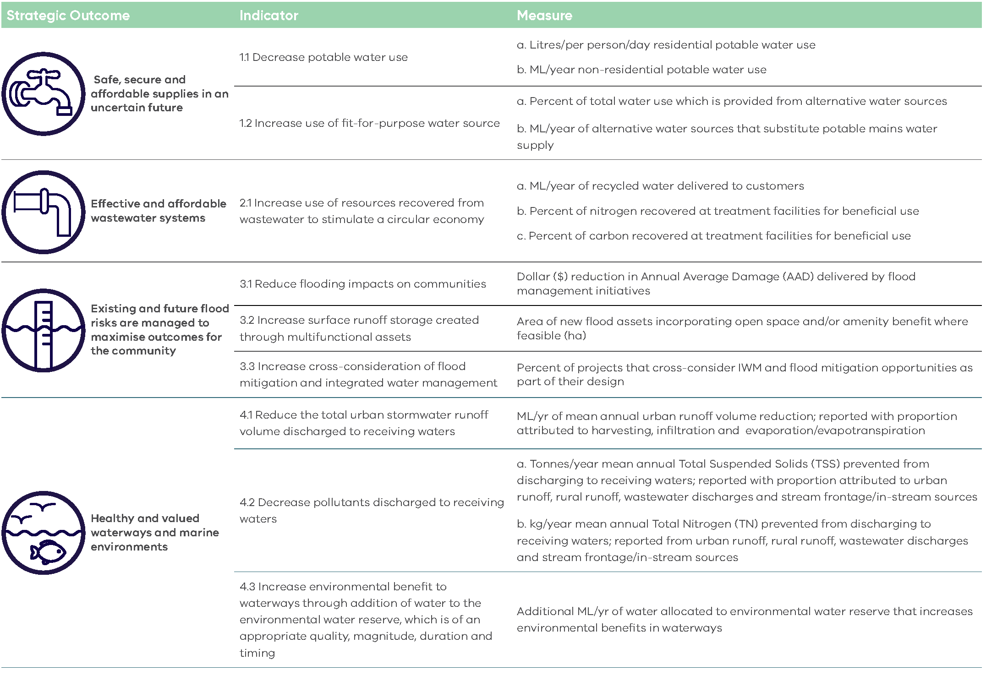
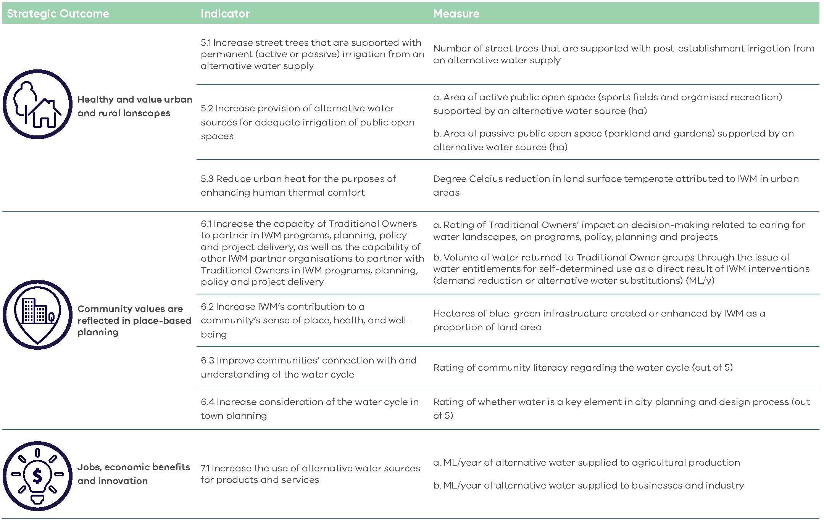

Appendix 1b: Regional Victoria IWM Strategic Outcome Areas & Example Indicators
There are minor variations in outcomes across IWM Forums. The version below reflects common elements. While some Forums identify Traditional Owner partnerships as a distinct outcome, others incorporate this within the broader community values outcome.
The outcome indicators provided in this guidance are examples only; they are intended to help applicants think about and clearly articulate how their project contributes to one or more of the eight IWM Outcomes.
These examples are not exhaustive, and applicants are encouraged to use indicators that best reflect the nature and intent of their specific project.
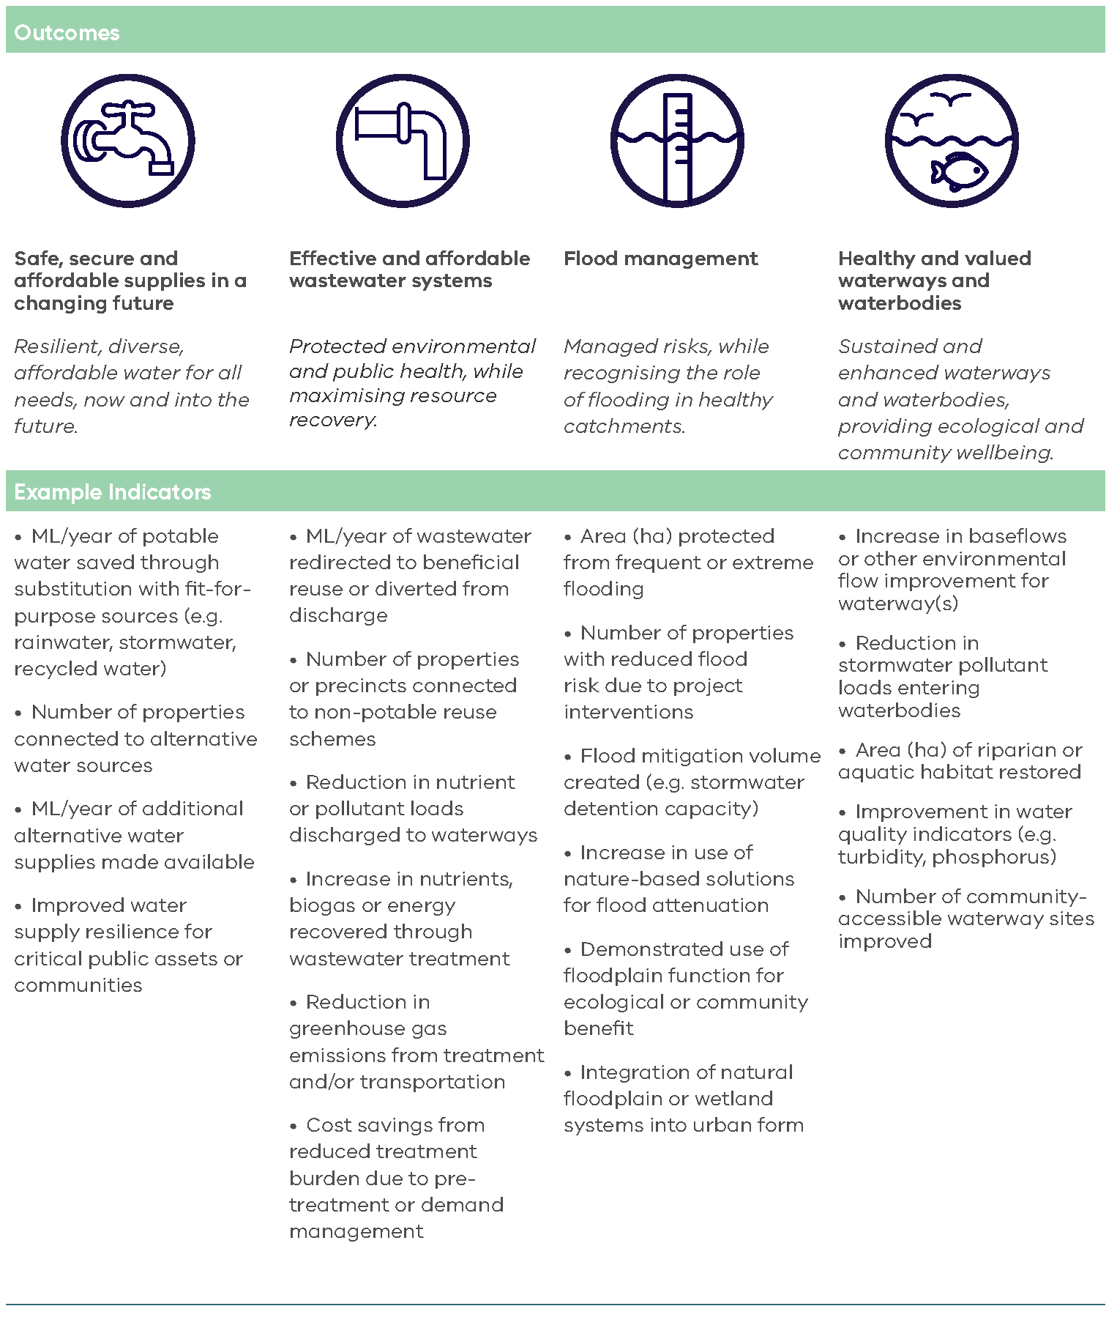
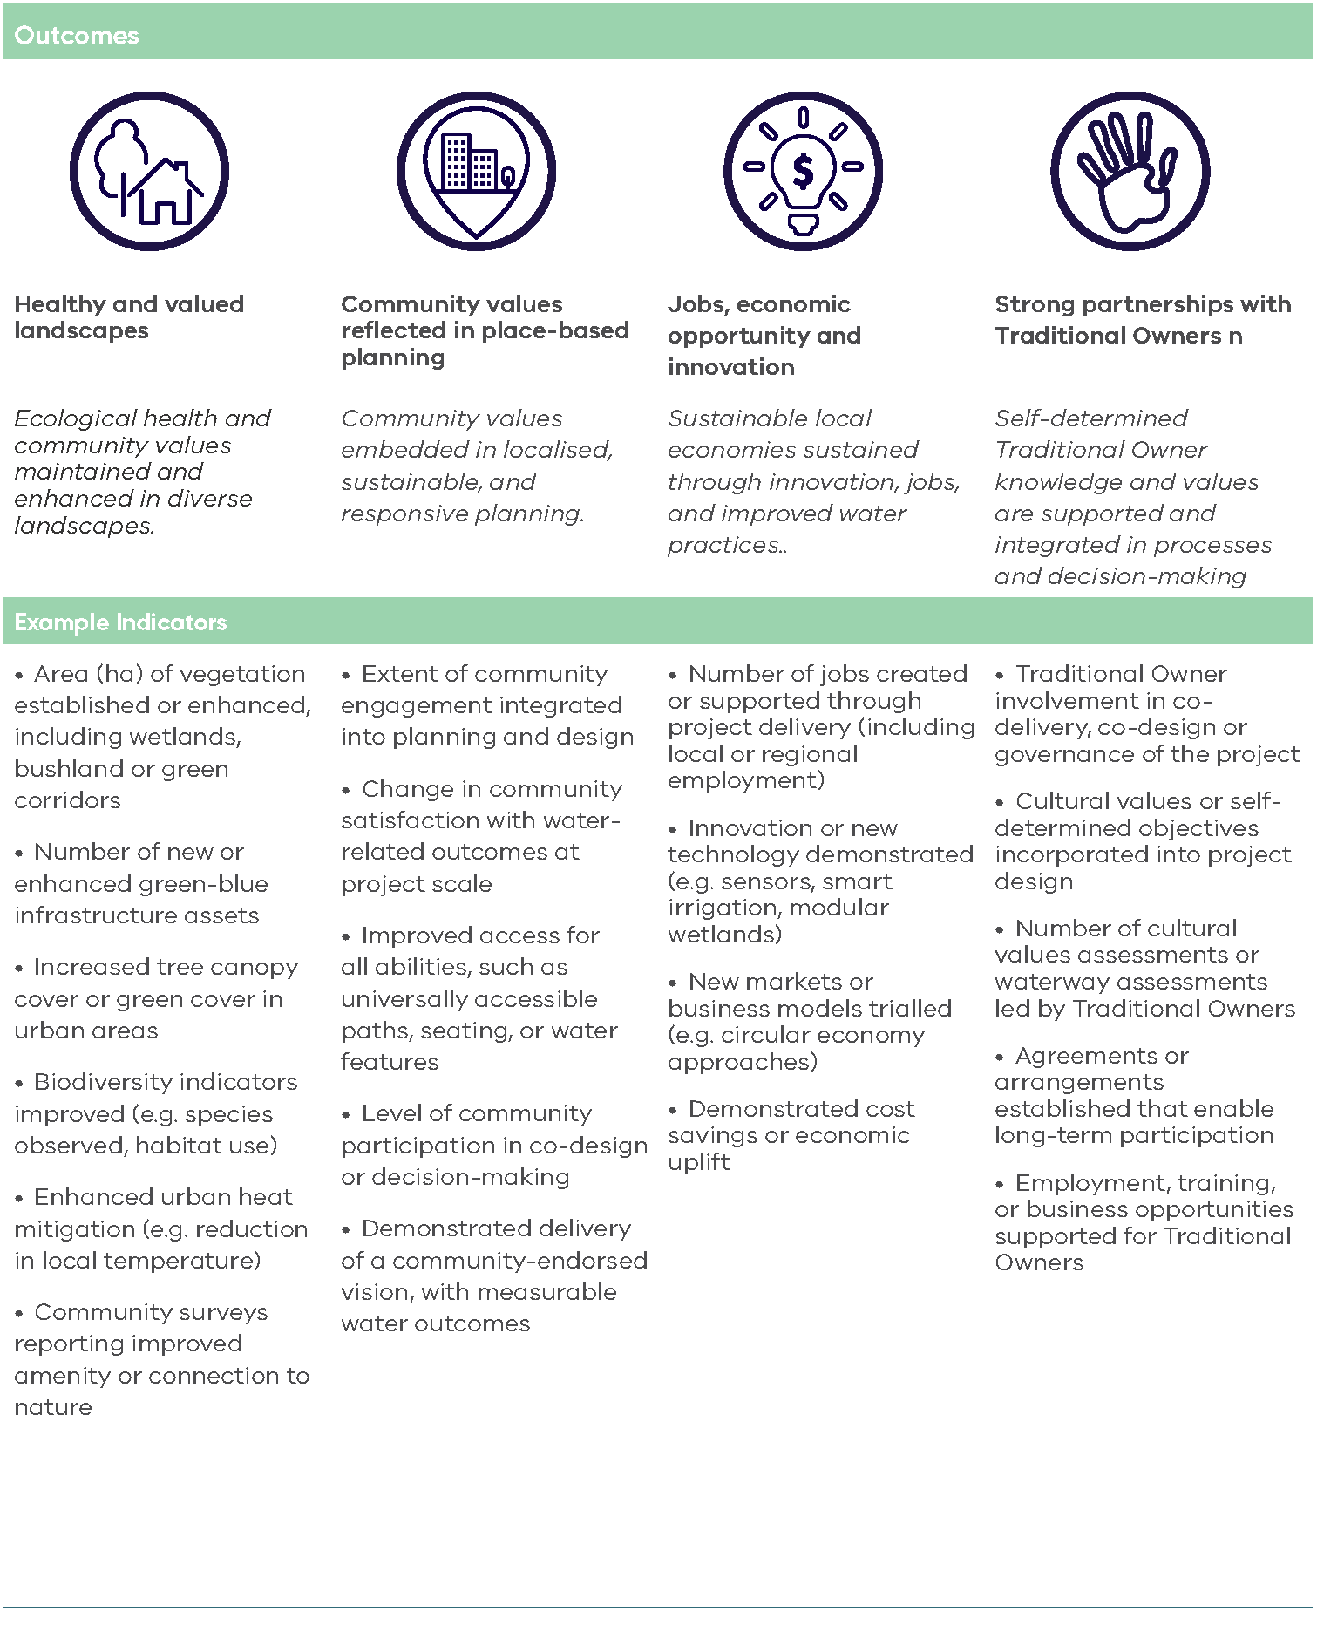

Appendix 2: Assessment Scoring Table
Assessment Scoring Table
 | Rating = 10 | Rating = 7.5 | Rating = 5 | Rating = 2.5 | Rating = 0 | Requirements and examples of evidence
Strategic alignment with IWM outcomes (50%) | The applicant has demonstrated that the proposed project very strongly contributes to relevant IWM outcomes and indicators, relative to the project location, size and cost | The applicant has demonstrated that the proposed project strongly contributes to relevant IWM outcomes and indicators, relative to the project location, size and cost | The applicant has demonstrated that the proposed project moderately contributes to relevant IWM outcomes and indicators, relative to the project location, size and cost | The applicant has demonstrated that the proposed project has minor contribution to relevant IWM outcomes and indicators, relative to the project location, size and cost | The applicant has not demonstrated that the proposed project contributes to relevant IWM outcomes and indicators, relative to the project location, size and cost | Explain how the proposed project aligns with, and contributes to, relevant IWM strategic outcomes. The project must contribute to at least 2 IWM strategic outcomes.  Supporting evidence may include, but is not limited to:  - Modelling, data or scenario comparison  - Case studies of similar projects  - Environmental impact studies  - Economic analysis  - Community surveys  - Water quality sampling and analysis
Readiness to deliver (50%) | The applicant has demonstrated to a very strong degree:  - What will be delivered with grant funding  - Work undertaken to date in the lead up to the proposed activity  - Capability and capacity to deliver the proposed activity  - Delivery risks and treatments  - Delivery schedule and milestones | The applicant has demonstrated to a strong degree:  - What will be delivered with grant funding  - Work undertaken to date in the lead up to the proposed activity  - Capability and capacity to deliver the proposed activity  - Delivery risks and treatments  - Delivery schedule and milestones | The applicant has demonstrated to a moderate degree:  - What will be delivered with grant funding  - Work undertaken to date in the lead up to the proposed activity  - Capability and capacity to deliver the proposed activity  - Delivery risks and treatments  - Delivery schedule and milestones | - The applicant has demonstrated to a weak degree:  - What will be delivered with grant funding  - Work undertaken to date in the lead up to the proposed activity  - Capability and capacity to deliver the proposed activity  - Delivery risks and treatments  - Delivery schedule and milestones | The applicant has not demonstrated:  - What will be delivered with grant funding  - Work undertaken to date in the lead up to the proposed activity  - Capability and capacity to deliver the proposed activity  - Delivery risks and treatments  - Delivery schedule and milestones | Show that your organisation is prepared and equipped to successfully deliver the proposed project. This includes demonstrating:  - Detailed project planning appropriate to the scale of the project  - Effective risk management and contingency strategies  - A realistic delivery schedule with clear milestones  - Any preparatory work completed prior to submitting this application  - The skills, resources, and experience needed to carry out the proposed activities  Supporting evidence must include:  - Details of risks and mitigations, completed on the template provided in the application document pack  - Budget overview, completed on the template provided in the application document pack  - Project key milestones and delivery dates  Supporting evidence may also include, but is not limited to:  - Comprehensive project plan including a more detailed project schedule and budget  - Relevant approvals  - Resourcing or staffing plan

deeca.vic.gov.au

