delwp.vic.gov.au

Overview of pre-requisite policy measures in Victoria

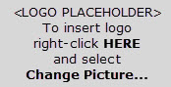 | 

Photo credit
Lake Hattah, Will Johnston Photography
© The State of Victoria Department of Environment, Land, Water and Planning 2019
This work is licensed under a Creative Commons Attribution 4.0 International licence. You are free to re-use the work under that licence, on the condition that you credit the State of Victoria as author. The licence does not apply to any images, photographs or branding, including the Victorian Coat of Arms, the Victorian Government logo and the Department of Environment, Land, Water and Planning (DELWP) logo. To view a copy of this licence, visit http://creativecommons.org/licenses/by/4.0/
ISBN 978-1-76077-714-2 (pdf/online/MS word)
Disclaimer
This publication may be of assistance to you but the State of Victoria and its employees do not guarantee that the publication is without flaw of any kind or is wholly appropriate for your particular purposes and therefore disclaims all liability for any error, loss or other consequence which may arise from you relying on any information in this publication.
Accessibility
If you would like to receive this publication in an alternative format, please telephone the DELWP Customer Service Centre on 136186, email customer.service@delwp.vic.gov.au, or via the National Relay Service on 133 677 www.relayservice.com.au. This document is also available on the internet at www.delwp.vic.gov.au.

Contents
1. Background 2
1.1 What are PPMs? 2
1.2 Why are PPMs important? 2
1.3 PPM implementation assessment 2
1.4 Scope of PPM requirements for Victoria 3
2. Overview of PPMs in Victoria 4
2.1 Victorian water entitlement framework 5
2.2 Water entitlements 5
2.3 Environmental water management 6
3. Call water from storage 8
3.1 Ability to make releases from headwater storages on top of other in-stream flows, including during unregulated events 8
3.2 Accounting of environmental water use reflects addition to flow height, not everything above system requirements 8
4. Return flows 10
4.1 Ability to ensure flows throughout the length of, and between, rivers 10
4.2 Protection of environmental water from re-regulation or extraction 11
5. Secure and enduring 13
6. Fully operable 15
6.1 Planning 15
6.2 Ordering 15
6.3 Accounting 15
6.4 Reporting 17
6.5 Review 17
7. Transparent 19
8. Risk management 20
9. References 21

Background
This document describes how pre-requisite policy measures (PPMs) have been implemented in Victoria. It covers the regulated water supply systems of northern Victoria and aligns with documentation prepared by the Murray-Darling Basin Authority (MDBA) describing how it implements PPMs in the River Murray system at the wholesale level on behalf of Victoria, New South Wales and South Australia.

What are PPMs?
PPMs are policy measures designed to maximise the beneficial outcomes of the water recovered for the environment under the Basin Plan. Previously referred to as ‘unimplemented policy measures’, PPMs are defined in section 7.15 of the Basin Plan as measures consisting of a policy to:
  - Credit environmental return flows for downstream environmental use; and
  - Allow the call of held environmental water from storage during unregulated flow events
PPMs reflect the assumptions that were made by the MDBA in developing the Basin Plan Sustainable Diversion Limit (SDL) about how recovered environmental water could be used to maximise environmental outcomes without impacting on the reliability for other water users. The Pre-requisite Policy Measures Assessment Guidelines (MDBA, April 2015) clarify that the intended outcomes for PPMs are:
- Environmental water flows throughout the length of the river, and between rivers; and
- To protect environmental water from extraction, re-regulation or substitution; and
- To allow the release of environmental water on top of other in-stream flows, including unregulated events.

Why are PPMs important?
Without the implementation of PPMs, more water would need to be recovered for the environment to meet the environmental outcomes of the Basin Plan. The supply measure projects under the SDL adjustment mechanism are dependent on the states’ commitments to implement PPMs by 30 June 2019.

PPM implementation assessment
The MDBA is required to assess the effectiveness of state PPMs as part of the SDL adjustment mechanism process. The Pre-requisite Policy Measures Assessment Guidelines (MDBA, April 2015) provided guidance to states on implementing PPMs and the criteria that MDBA would use to assess their implementation. In accordance with these guidelines, states are required to demonstrate that arrangements to implement PPMs:
- Are secure and enduring
- Are fully operable
- Are transparent
- Provide for release of held environmental water from storages on other in-stream flows, including unregulated flows (i.e. call water from storage); and
- Allow environmental water to flow throughout the length of a river, and between rivers, and be protected from extraction, re-regulation or substitution (i.e. return flows)
The Pre-requisite Policy Measures Implementation Plan for Victoria (DELWP, April 2016) identified the remaining actions necessary for Victoria to fully implement PPMs in accordance with the guidelines. These were:
- Investigate return flow provision for Loddon River
- Investigate amending return flow provision for the Living Murray entitlements
- Investigate enabling use of Victorian return flows at NSW sites
- Finalise operating arrangements
The MDBA approved Victoria’s implementation plan in 2016.

Scope of PPM requirements for Victoria
PPMs apply to held environmental water in the southern-connected Murray-Darling Basin that provide water to environmental assets throughout the system, including, contributing flows to the River Murray Mouth.
While policies akin to PPMs are in place throughout Victoria, this document is focussed on how PPMs have been enabled in northern Victoria’s regulated supply systems to meet the Basin Plan requirements. This document excludes rules-based environmental water, environmental water set aside in unregulated systems, and entitlements held for the environment in the Wimmera-Mallee system and southern Victoria.

Overview of PPMs in Victoria
Victoria’s water entitlement framework provides the legislative arrangements that enable environmental water holders and water system managers (or river operators) to implement PPMs in Victoria.
These arrangements are supported by Victorian policies that were developed in consultation with the community as part of the Northern Region Sustainable Water Strategy (DSE, 2009) to facilitate efficient use of water for the environment. As a result, PPM arrangements are now well-established in the large regulated systems of northern Victoria. For example, in 2017/18 these mechanisms were used to release environmental water from storages in the Goulburn, Campaspe and Murray rivers on top of operational water, providing environmental benefit at multiple sites along the downstream river network. Figure 1 demonstrates the coordinated watering actions in northern Victoria in 2017/18, highlighting the annual volumes of:
- environmental use (total water delivered for the environment at each site)
- return flow-recredits (water returned to the Murray following an upstream environmental delivery)
- return flow use (water returned that was then used to meet a downstream environmental demand).
The colours in Figure 1 represent connected deliveries, i.e. the green shows 322 GL of return flow credits from the Goulburn River were re-used in Gunbower Forest (8 GL), Gunbower Creek (3 GL), Hattah Lakes (77 GL), Lake Wallawalla (2 GL) and delivered to South Australia (232 GL).
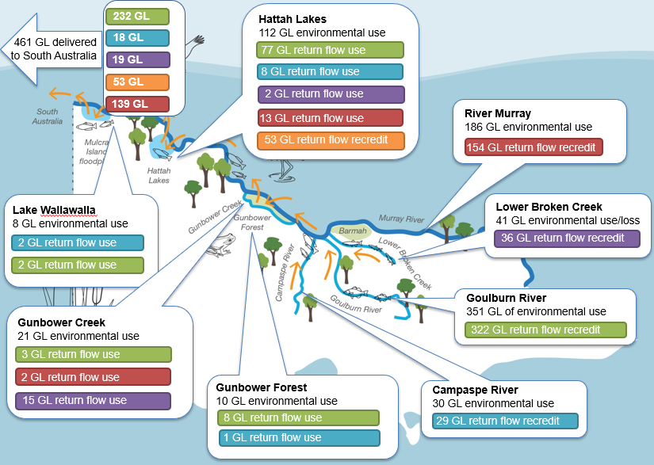
Figure 1. Delivery of environmental water in Victoria in accordance with PPMs in 2017-18
Transactions to record the use of environmental water in northern Victoria are maintained in the Victorian Water Register, which is the definitive record of water accounting for water available under held environmental water entitlements across the state. These records support accounting to determine compliance with PPMs, entitlements, and support public transparency in the use and deployment of held environmental water.

Victorian water entitlement framework
In Victoria, the Water Act 1989 (the Act) sets out the framework for water resource management, provides a secure system of rights and entitlements, and makes it an offence to take water unless authorised to do so. The Minister responsible for administering the Act (the Minister) is responsible for oversight of activities empowered by the Act. In particular, the Minister is responsible for:
- Issuing water entitlements
- Appointing suitable authorities to undertake system management functions
- Overseeing compliance with entitlements.

Water entitlements
Water is authorised to be taken under a water entitlement issued by the Minister or allowed for under a statutory right. Water entitlements issued under the Act set out the conditions under which a holder is authorised to take water. The water entitlement framework is designed to ensure that individual entitlements to water are explicit, enforceable, and where appropriate, tradeable.
The held environmental water entitlements in northern Victoria that relate to PPMs include bulk entitlements, environmental entitlements, and water shares.
A bulk entitlement is a legally recognised, ongoing right to take a volume of water subject to any conditions specified in the entitlement. The Act specifies who can hold a bulk entitlement, which in northern Victoria includes water corporations, such as Goulburn-Murray Water (GMW), and the Victorian Environmental Water Holder (VEWH). Like a bulk entitlement, an environmental entitlement is an ongoing right to take water, but it must only be used to maintain the environmental water reserve and improve the environmental values and health of the water ecosystems. Environmental entitlements can only be held by the VEWH.
Bulk and environmental entitlements are broad in application and can, among other things, specify:
- Authorisation for, and conditions on, diverting allocated water from rivers;
- Conditions on how, where, and why water may be used, and arrangements for determining the volume of water taken (which implements the ‘call from storage’ PPM); and
- Provisions enabling the re-use of water that has been returned to the system (which implement the ‘return flows’ PPM)
The VEWH’s northern Victorian bulk and environmental entitlements require the VEWH and GMW to agree on operating arrangements for the supply of entitlement water. Further details are included in Section 6.
A water share is a legally recognised, ongoing entitlement to a share of the water available in a system. It authorises the taking of water under the allocation for the water share but does not include any authorisation to divert or apply that water to land. Water shares were created in northern Victoria on 1 July 2007 when the existing water entitlements were converted (or unbundled) into a share of the available water in the system (water share), an authorisation to use water on land (water-use licence for irrigation or water-use registration for uses other than irrigation) and an authorisation to divert water (directly from rivers under a works licence, or directly from water corporation infrastructure under a delivery share).
Allocation made available to bulk entitlements, environmental entitlements, or water shares can be traded or carried over for use in a subsequent year in accordance with relevant trade and carryover rules. Allocation can only be taken when it is associated with the appropriate authorisations to use and divert water. Since the bulk and environmental entitlements held by the VEWH include provision to use and divert water, allocation made available during the year to these entitlements can be taken in accordance with the specified entitlement conditions. Allocation made to water shares held for the environment can be traded to a relevant bulk or environmental entitlement for delivery in accordance with the conditions of that entitlement.
The VEWH holds bulk and environmental entitlements with provisions that enable PPMs in the Goulburn, Murray, Campaspe and Loddon regulated systems. The Commonwealth Environmental Water Holder (CEWH) only holds water shares in these systems and delivers its water through bilateral agreement with the VEWH. Allocation held by the CEWH can be traded to the VEWH’s entitlement and delivered in accordance with PPMs.
No bulk or environmental entitlements have been granted to the VEWH in the Broken or Ovens systems, however environmental water holders have small volumes of water shares in these systems. Allocations available under these water shares have historically been delivered through special arrangements as the volumes are small and do not warrant granting a bulk or environmental entitlement. The volume of entitlement held for the environment in the Broken system has increased slightly in recent years and Victoria is investigating whether the creation of an environmental entitlement in this system is appropriate.

Environmental water management
Water held for the environment in northern Victoria includes all the water held by the VEWH, CEWH and by the MDBA on behalf of The Living Murray Program (TLM). Each of these environmental water holders is obligated to use the water available to them to improve the environmental health of rivers and waterways.
Managing and delivering water for the environment involves careful planning and collaboration across a range of individuals and organisations (both within Victoria and interstate). Victoria’s approach to environmental water management is founded on the relationships between local communities, traditional owners, waterway managers, water corporations, environmental water holders, land managers, and scientists. This includes consideration of both local and wider system environmental objectives. Obligations on each agency relating to environmental water management are set out in legislation and government policy and carry associated risks. Arrangements recognise that the risks are, to varying extents, shared. The key responsibilities of each of the agencies involved in this environmental water management are set out below.
Environmental water holders
Environmental Water Holder | Responsibilities
VEWH | - Responsible under the Act for holding and managing the water held for the environment by Victoria  - Collaborates with other environmental entitlement holders and delivery partners to plan, manage, deliver, and evaluate environmental water use  - Responsible for preparing metering programs and reporting against its bulk and environmental entitlements  - Makes decisions on the most effective use of its water holdings, including use, carryover, and trade  - Authorises waterway manager to implement watering decisions  - Convenes some operation advisory groups to track progress and adapt operations as needed
CEWH | - Responsible for holding and managing the Commonwealth’s water holdings consistent with its responsibilities under the Basin Plan, the Commonwealth Water Act 2007 and the Commonwealth Public Governance, Performance and Accountability Act 2013.  - Collaborates with other entitlement holders and delivery partners  - Delivers water in Victoria in partnership with the VEWH, by agreement. This includes trading allocation to the VEWH’s bulk and environmental entitlements for delivery in accordance with the provisions of the VEWH’s bulk and environmental entitlements
MDBA (TLM Team) | - Oversees the use of jointly managed entitlements held for The Living Murray Program (TLM)  - Convenes the Southern Connected Basin Environmental Watering Committee (SCBEWC), which has been established to facilitate the coordinated delivery of water for the environment through the connected Murray system and includes NSW and South Australian environmental water holders

Delivery Partners
Delivery Partner | Responsibilities
Waterway managers | Includes North East, Goulburn-Broken, North Central, and Mallee catchment management authorities (CMA)  - Responsible for the integrated planning and coordination of land, water, and biodiversity management in each catchment and land protection region in Victoria  - Engages communities and traditional owners to identify regional priorities and develop watering proposals for VEWH consideration  - Orders and manages the delivery of environmental water in line with VEWH decisions
Land managers | Includes Parks Victoria, Traditional Owners, and private land owners  - Responsible for managing the sites to which water is applied (includes a variety of responsibilities such as controlling infrastructure and ensuring appropriate public signage)  - Provides input to relevant planning and proposals prepared by waterway managers to inundate public or private land
DELWP | - Oversees environmental water policy framework
Rural water corporations | Includes GMW and Lower Murray Water (LMW) as operators of delivery infrastructure  - Manages and operates delivery infrastructure to supply water to users  - Measures and reports on delivery (for most sites)
GMW (Storage Manager, Resource Manager) | - Performs the roles of Resource Manager, Storage Manager, and state constructing authority  - Receives and actions as appropriate, orders for delivery under the VEWH’s bulk and environmental entitlements  - Authorises re-credits for eligible flows returned to a system  - Reports to the VEWH on volumes used and returned  - Reports to MDBA on environmental flows delivered to the River Murray from Victorian tributaries
MDBA (River Murray Operations Team) | - Coordinates operation of the River Murray system to provide water to the River Murray states (Victoria, NSW and South Australia) in accordance with the Murray-Darling Basin Agreement  - Receives and actions as appropriate, orders from the GMW (as Victoria’s State Constructing Authority – with responsibilities defined in the Murray-Darling Basin Agreement) to deliver states’ water, including water for the environment, in the River Murray  - Convenes specific operational advisory groups to track progress and adapt the delivery of environmental water on the Murray as needed  - Reports to states on the volumes of water for the environment delivered in and returned to the River Murray  - Works with water holders and delivery partners to develop and implement measures for the delivery of environmental water

Call water from storage
This section describes how the PPM requirement to call water from storage is implemented in Victoria.

Ability to make releases from headwater storages on top of other in-stream flows, including during unregulated events
The VEWH has been granted bulk and environmental entitlements that authorise it to apply target flows to specified or nominated delivery points along designated rivers. This authorisation enables the VEWH to order a target flow downstream of a headwater storage during delivery of other system demands, including during unregulated flow events, with agreement from GMW on matters such as the rates of releases, accounting arrangements, and flood/water quality risk mitigation measures. GMW is obliged under its bulk entitlements (and Resource Manager appointment in the Murray System) to meet these orders subject to operating constraints of the system. For calls from Murray storages, GMW approves orders placed by VEWH, following consultation with MDBA where necessary. GMW then directs the MDBA to release them in accordance with the Murray-Darling Basin Agreement and the objectives and outcomes specified by River Murray states (Objectives and Outcomes for River Operations in the River Murray System, updated yearly).
The VEWH’s authorisation is described differently in the various bulk and environmental entitlements, reflecting that the entitlements were granted over several years and that preferences and styles changed over that period. The different wording has no impact on the fundamental provision, which is implemented consistently for all the relevant bulk and environmental entitlements in accordance with arrangements agreed to by the VEWH and GMW. An example of how this provision is enabled for the VEWH in the River Murray System is clause 15 of Bulk Entitlement (River Murray – Flora and Fauna) Conversion Order 1999:
The Water Holder may take the water to which he or she is entitled under sub-clause 6.1(a) of this Order at any nominated delivery point on the River Murray, the distribution system, or, subject to relevant water trading rules, another declared system.

Accounting of environmental water use reflects addition to flow height, not everything above system requirements
The principle adopted across Victoria for calculating the volume to be debited from an environmental account is to determine the difference between releases made with the environmental water holder’s order and the releases that would have been made without the environmental water holder’s order. Releases that would have been made without environmental water delivery take into consideration forecast net tributary inflows (or diversions) between the storage and nominated delivery points, and include water released to meet downstream passing flow obligations, in-system consumptive demands, system transfers such as Inter-valley Transfer (IVT) and any pre-releases. Figure 2 demonstrates how this approach is applied, with the green area representing the volume debited from environmental water holder accounts.
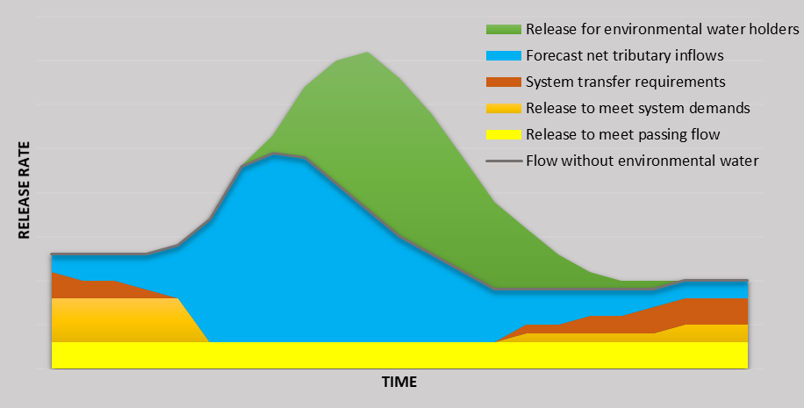
Figure 2: Accounting approach for releases associated with in-stream environmental water delivery
For environmental deliveries in the Murray system, this accounting approach is reflected in calculation methods agreed to between states and documented in the Objectives and Outcomes for River Operations in the River Murray System. This includes a Specific Objective and Outcome for determining assumed use of directed releases from Hume Dam that take effect from 1 June 2019.
For all northern Victorian environmental deliveries, methods for determining use have always been based on this accounting approach. Site specific calculation methods have been developed by river operators (GMW) in consultation with the VEWH (and its predecessors). The VEWH and GMW are currently in the process of documenting these methods in operating arrangements (explained further in Section 6 of this document).

Return flows
This section describes how the PPM requirement to credit environmental return flows downstream of environmental use is implemented in Victoria.

Ability to ensure flows throughout the length of, and between, rivers
The ability for environmental water to be delivered in-stream, on top of operational water and shepherded through the length of a river, is well-established in Victorian policy and legislative instruments. The Victorian Government made a specific policy commitment in the Northern Region Sustainable Water Strategy (DSE, 2009) to maximise the productive and environmental outcomes of water entitlements by allowing return flows to be used again downstream or traded by entitlement holders (refer policy 4.8, pages 83-84).
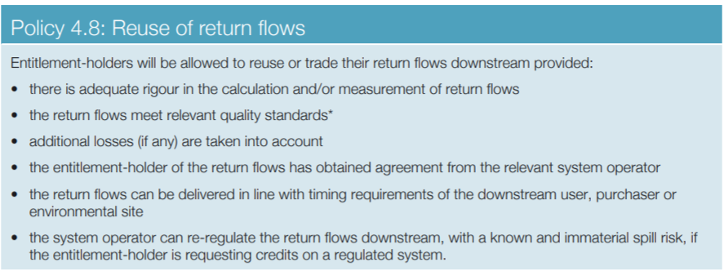

The VEWH’s bulk and environmental entitlements authorise it to apply flows to specified or nominated delivery points along designated rivers. This authorisation enables the VEWH to place an order that targets flow rates at various points along the length of a river, subject to delivery capacity and operating constraints. To ensure flows throughout the length of a river, the VEWH may order target flows at both the upstream and downstream reaches of the river system.
Since the release of the Northern Region Sustainable Water Strategy, bulk and environmental entitlements held by the VEWH in northern Victoria have progressively been amended to authorise credits of return flows for downstream environmental use. The VEWH has this right under its bulk and environmental entitlements in the Murray, Goulburn, Campaspe, and Loddon systems.
This return flow provision is almost identical in each bulk and environmental entitlement (refer for example to clause 15A of Bulk Entitlement (River Murray – Flora and Fauna) Conversion Order 1999). The provision enables the VEWH to apply to GMW, as the Storage Manager, to reuse or be credited for water used and then returned to the system. This requires agreement on the volume, timing and location of return flows with GMW after demonstrating:
- Water supplied to and used by the VEWH will subsequently be returned to a system;
- The volume of water so returned will either be measured by a meter that complies with Australian Technical Standard (ATS) 4747; or be calculated by a method that has been agreed with GMW;
- Any water reused by the VEWH or another person will be used downstream of the place where the return flow will occur and within a reasonable time of the return flow;
- The Storage Manager (or MDBA when relating to the River Murray) can re-regulate the return flows downstream, with no material impact on other entitlement holders;
- The volume of any water credited to the VEWH does not exceed the volume of returned water which was able to be used or stored; and
- Approval is consistent with any rules regarding the supply, use and accounting of return flows issued by the Minister from time to time (the Minister has not issued any rules for return flows to date).
In accordance with these provisions, the VEWH can seek approval from GMW to reuse or be credited for water that it used and then subsequently returned to the supply system. For example, this applies when water is returned to the system after being diverted to an environmental site (such as Gunbower Creek), or when it has been delivered into a downstream river system (e.g. from the Goulburn to the River Murray).
Where return flows for the environment are included in inflows to the River Murray from a Victorian tributary, GMW advises MDBA of the volumes of inflow held by the VEWH as return flows and requests these be protected through to a downstream site for reuse. Where the downstream site for reuse is in South Australia, the water is delivered to the South Australian border under Victoria’s water entitlement framework and the VEWH’s bulk entitlement which is reflected in a re-credit and associated trade of allocation from the VEWH’s bulk entitlement to a nominated South Australian account.
Only water that meets the above conditions for reuse or re-regulation is credited to the environmental water account. All volumes of water used, returned and reused are recorded in the Victorian Water Register and published in annual reports, including the VEWH’s Annual Report and the Victorian Water Accounts.
Complementary to the return flow right, the Murray-Darling Basin Agreement (Schedule D — Adjusting Valley Accounts and State Transfer Accounts) Protocol 2010 enables the VEWH to trade returned water for immediate delivery to South Australia to protect, or ‘shepherd’, environmental flows as they make their way across the border.
Environmental water holders can reuse Victorian returned flows at NSW sites in the River Murray System (and vice versa) using mechanisms introduced in the ‘Instream trade adjustments for return flows trial’ which commenced on 1 July 2019 (https://www.mdba.gov.au/managing-water/water-markets-trade/interstate-water-trade/bulk-water-trade-adjustments-trials). This trial was developed by the MDBA, Victoria and NSW as part of the ‘Bulk water trade adjustment trials’ and has been endorsed by the Basin Officials Committee for a period of three years. The MDBA, Victoria and NSW will provide monitoring and undertake formal reviews at the end of the second and third years of the trial.
The ‘Instream trade adjustments for return flows trial’ allows environmental water holders to trade return flows (as an allocation trade) between Victoria and NSW for immediate delivery in the receiving state, by changing the location of inter-state trade adjustments for return flows to move them in-stream, closer to the source and timing of such trades and. For each specific watering action using this mechanism, the environmental water holders will require approval from GMW, Water NSW and NSW Department of Planning, Industry and Environment to ensure that the proposed delivery complies with the relevant trading and entitlement rules and guidelines, and that, under the prevailing conditions, it is unlikely to have detrimental impacts on other water users. The trial arrangements note that if issues arise with the in-stream trade adjustment for return flows, states and the MDBA will collaborate to identify a resolution and will aim to facilitate the objectives of the watering action.

Protection of environmental water from re-regulation or extraction
Environmental water is protected from re-regulation or extraction through the real-time delivery of target flows in line with agreed event delivery arrangements. Delivery is carried out by GMW and/or MDBA. It requires ongoing monitoring of flows along the river reach and changes in operations to ensure flow targets continue to be met if conditions fluctuate from planned.
GMW is responsible for monitoring compliance with all entitlements in northern Victoria, not just those held by environmental water holders. GMW draws on a network of flow gauges, verified models, and advice from the MDBA (for relevant River Murray deliveries) to determine how much environmental water has been delivered in-stream or diverted into wetlands. This includes enabling the VEWH to reuse or be credited for water that it has used and subsequently returned to the water supply system based on either metering or a method agreed with GMW.
Any return flows requested to be reused in South Australia are delivered to the state border under Victoria’s water entitlement framework, then traded as allocation from the VEWH’s bulk entitlement to a South Australian account to reflect the change of ownership of this water (from the VEWH to its South Australian counterpart). Victorian agencies are currently investigating opportunities to streamline the re-credit and trade process to assist both MDBA and GMW in timely reconciliation of bulk and retail level accounts.

Secure and enduring
PPMs in Victoria are secure and enduring because provisions are codified in the ongoing, legally recognised rights held by the VEWH and protected by the Act. For the River Murray, these are supported by provisions in the Murray-Darling Basin Agreement. These instruments support an ongoing adaptive management approach to improving operational arrangements as described in Section 6.
The following bulk and environmental entitlements issued under the Act and held by the VEWH enable PPMs to be implemented in northern Victoria:
- Bulk Entitlement (River Murray - Flora and Fauna) Conversion Order 1999
- Environmental Entitlement (River Murray - NVIRP Stage 1) 2012
- Goulburn River Environmental Entitlement 2010
- Environmental Entitlement (Goulburn System - NVIRP Stage 1) 2012
- Environmental Entitlement (Goulburn System - Living Murray) 2007
- Campaspe River Environmental Entitlement 2013
- Environmental Entitlement (Campaspe River - Living Murray Initiative) 2007
- Bulk Entitlement (Loddon River - Environmental Reserve) Order 2005
The obligations to deliver orders placed under the VEWH’s bulk and environmental entitlements, subject to operating constraints, are contained in GMW’s relevant source bulk entitlements and the instruments appointing GMW as the Storage Manager and Resource Manager, including:
- Bulk Entitlement (Eildon - Goulburn Weir) Conversion Order 1995
- Bulk Entitlement (Campaspe System - Goulburn-Murray Water) Conversion Order 2000
- Bulk Entitlement (Loddon System - Goulburn-Murray Water) Conversion Order 2005
- Appointment of Goulburn-Murray Rural Water Authority as Resource Manager for Bulk Entitlements in the Campaspe Basin
- Appointment of Goulburn-Murray Rural Water Corporation as Resource Manager for the River Murray
- Appointment of Goulburn-Murray Rural Water Corporation as Resource Manager for the Goulburn basin
- Appointment of Goulburn-Murray Rural Water Corporation as Resource Manager for the Loddon basin
- Appointment of Goulburn-Murray Rural Water Corporation as Storage Manager for the Goulburn System
- Appointment of Goulburn-Murray Water as storage operator for bulk entitlements in the Loddon Headworks System
- Appointment of Goulburn-Murray Rural Water Corporation as storage operator for bulk entitlements in the Lake Eppalock Headworks System
Bulk and environmental entitlements are recorded in the Victorian Water Register. You can access copies of the entitlement orders on the Victorian Water Register website (http://waterregister.vic.gov.au). The instruments of appointment are expected to be publicly available on the same website in the near future.
While existing as ongoing legal entitlements, bulk and environmental entitlements can be amended by the Minister in accordance with sections 44 and 48K of the Act respectively. An entitlement holder can apply to the Minister to amend their existing bulk or environmental entitlement. When the Minister receives a request to amend a bulk or environmental entitlement, the administrative procedure set out in the Act must be followed. Key steps include:
- Applications are advertised in local newspapers and on the DELWP website (https://www.water.vic.gov.au/planning-and-entitlements/bulk-entitlements and https://www.water.vic.gov.au/planning-and-entitlements/victorias-entitlement-framework/environmental-entitlements);
- Depending on the nature of the proposal, the application process may involve consultation with stakeholders and local communities, as well as submissions to the DELWP or the applicant. The purpose of this consultation is to identify the potential impacts of the proposal, including any adverse impacts on existing water users and the environment;
- The Minister will consider any submissions received before deciding on the application; and
- Amendments are granted through an order from the Minister or the Governor in Council and published in the Victoria Government Gazette. Amendments are recorded in the Victorian Water Register and subsequently published on the Victorian Water Register website
Figure 4. outlines the steps required under the Act to amend a bulk entitlement.
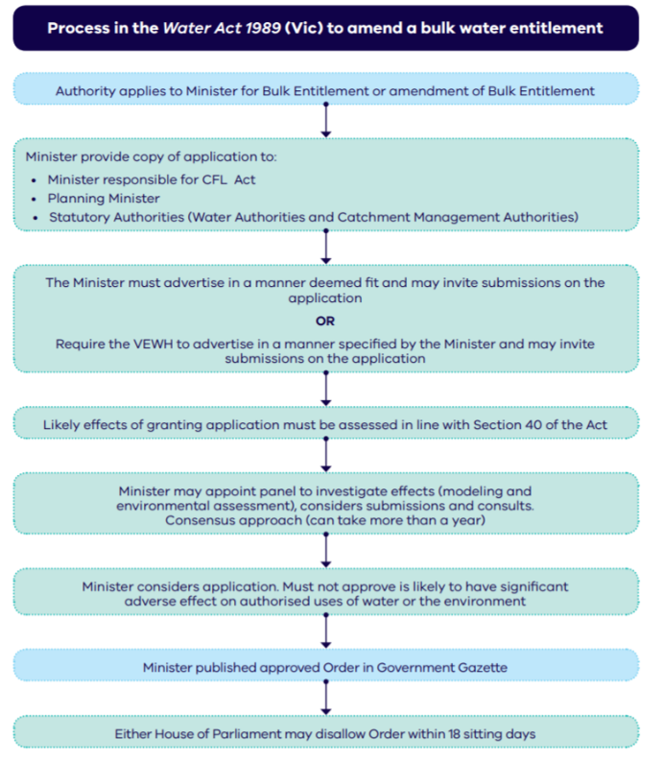
Figure 3: Steps to amend a bulk entitlement

Fully operable
The delivery of environmental water in accordance with PPMs occurs under the guidance of Victorian environmental water policy, the entitlements outlined above, and the VEWH’s and GMW’s planning processes. Policy provides certainty the PPMs can be applied, while the conditions of the entitlements ensure that implementation occurs within reasonable limits. The manner by which parties operate is purposefully not captured in legislation to enable environmental water holders and river operators to learn and adapt, improving operability.
Within this framework, the options and processes to deliver standard environmental watering events, which incorporate PPMs, are well understood between waterway managers, environmental water holders, and river operators. More complex and/or new watering events are planned on a case-by-case basis if required. This approach facilitates continuous improvement for the most effective and efficient delivery of water for the environment.
The VEWH and GMW are jointly required, as an obligation under the VEWH’s bulk and environmental entitlements, to agree on operating arrangements for the delivery of environmental water. Each entitlement includes a clause, such as clause 15B of Bulk Entitlement (River Murray – Flora and Fauna) Conversion Order 1999, which sets out what these arrangements must cover and the criteria they must meet. They include clarity around the planning, ordering, delivery, accounting, reporting, risk management, and review processes. These arrangements have evolved in Victoria with the recovery of water for the environment. VEWH and GMW are currently in the process of consolidating documentation of their current operating arrangements in consultation with relevant delivery partners including waterway managers, land managers and other environmental entitlement holders. Operating arrangements for the Campaspe and Loddon systems were finalised by 30 June 2019 and have been shared with the relevant delivery partners. Operating arrangements for the Goulburn and Murray systems are on track for completion by 30 June 2020 and when finalised, these operating arrangements will be also shared with the relevant delivery partners.

Planning
Each year, waterway managers prepare seasonal watering proposals which identify desired environmental water use for a range of different scenarios. The waterway managers work closely with the environmental water holders and river operators in the planning phase to ensure river operators can integrate large scale environmental deliveries and return flows into system operations planning.

Ordering
Orders are placed by VEWH as the bulk or environmental entitlement holder (or by a delegated waterway manager) with GMW for all systems, including River Murray deliveries. Orders may include requests for water returned to the system after an initial use to be credited for reuse at a downstream site. For River Murray deliveries, GMW places orders and directs the MDBA how to deliver Victoria’s allocated water, including environmental water deliveries and return flows. Prior to placing a formal order, there is usually some communication between key stakeholders to confirm whether there are any operational constraints, special conditions, or details required in an order. Prior to placing an order there must be sufficient allocation in the relevant bulk or environmental entitlement account; this means that if the water is being sourced from a CEWH or MDBA account the allocation must be traded to the VEWH’s account.

Accounting
GMW is responsible for determining and recording volumes of water debited from and re-credited to the VEWH as a result of all environmental watering actions in northern Victoria.
Wherever practical, environmental deliveries are measured with accurate meters. However, where environmental deliveries cannot practically be metered, fit-for-purpose methods for determining use and return flows have been developed in consultation with environmental water holders. The methods used to measure and determine compliance with the VEWH’s entitlements are documented in the Northern Victorian Environmental Metering Program (VEWH, 2014). For in-stream deliveries in the River Murray (including both in-channel and floodplain deliveries), GMW receives advice from the MDBA (River Murray Operations Team), who calculate the required debits and re-credits in accordance with agreed interstate accounting arrangements as documented in the Objectives and Outcomes for River Operations in the River Murray System.
Accounting methods are always agreed prior to each environmental watering event. However, the calculations themselves are conducted after the delivery is complete as there can be discrepancies between targeted flow rates and what is actually delivered due to the unpredictability of other system demands and inflows.
Reviews of accounting arrangement are led by GMW (as described in Section 6.5) in consultation with the VEWH and relevant delivery partners such as CMAs and the CEWH. For accounting arrangements relating specifically to the River Murray, reviews are led by the WLWG in consultation with the relevant state agencies and environmental water holders. GMW and the VEWH can agree to review the arrangements at any time. The governance underpinning reviews of accounting methods is established in the operating arrangements between GMW and the VEWH.
The existing calculation methods for northern Victoria have been developed over time based on river operator and environmental water holder knowledge and experience. Key principles that have been adopted are that calculation methods must:
- Be consistent with legal instruments, including bulk entitlements and the Murray-Darling Basin Agreement
- Facilitate bulk and retail level accounting
- Be developed in consultation with NSW to ensure consistent methods are applied for River Murray in-channel and floodplain deliveries
- Draw on accurate measurements when available
- Be fit-for-purpose – balancing appropriate rigour with practicality of implementation (including cost-effectiveness and timeliness)
- Recognise the rights to water delivery recovered for the environment without generating material adverse impacts to other water entitlement holders
- Where confidence in the calculation method is low, a factor of ‘safety’ is applied to mitigate the potential impacts on other water entitlement holders
- Be reviewed over time – drawing on improved experience and knowledge as it becomes available and at least every five years
In practice this has resulted in calculation methods in northern Victoria which adopt the following rules:
Releases from storage for in-stream delivery
Volume debited = calculated as the difference between releases made with environmental orders, and the releases that would have been made without environmental orders (to ensure the environmental water holder is only debited for the water delivered in addition to all other water in the river).
- Release volumes are determined based on anticipated diversions and inflows between the storage and the nominated flow target
- Volumes that would have been released without the environmental water order typically include passing flows specified in bulk or environmental entitlements and water required to supply other entitlement holders
Return flow re-credits
Volume eligible for re-credit = the volume debited minus loss deemed in the provision of environmental flows, adjusted for travel times (to ensure all water that is eligible for return flows can be credited to the environmental water holder for downstream reuse).
- Re-credit must be consistent with the conditions of the relevant VEWH bulk and environmental entitlement
- Re-credit eligibility depends on a demonstrated downstream use or re-harvesting (offsetting a downstream use)
Loss
Loss = incremental loss that is associated with component of an environmental water delivery that is in excess of “normal rates of delivery prior to environmental water recovery” (to ensure the environmental water holder is only debited for losses associated with the environmental delivery).
- Flow rates that constitute “normal rates of delivery prior to environmental water recovery” specific to each system have been identified
- This means at low flow rates, all losses are covered by system resources
- When environmental flow rates exceed the specified flow rate, the VEWH is debited for the losses associated with the additional flow rate
- I.e. if the “normal rates of delivery prior to environmental water recovery” specified is 100 ML and has an estimated loss of 10 ML, and the order by the VEWH is for 160 ML and the actual loss is 25 ML, the losses assigned to the VEWH will be 15 ML
- Loss factors are calculated using water balances where possible, and hydrological models where otherwise appropriate
Real-time adjustments to avoid over or under debiting due to river operations forecasts
Adjustments to the above calculations may be made in any of the following scenarios, to ensure a correct volume of environment water is accounted for (avoid over or under debiting):
- The actual loss is less than the estimated loss
- Actual diversions are not the same as estimated diversions
- Unexpected rain and associated tributary inflows resulted in higher than planned flows

Reporting
Authoritative records of all Victorian entitlement holders’ accounts, including environmental water holders, are maintained in the Victorian Water Register. This includes records of volumes delivered (debited) and volumes returned (re-credited).
Reporting on environmental water deliveries and return flows occurs at weekly, monthly, and annual scales. GMW provides environmental water holders and the MDBA (River Operations Team) with weekly reporting on deliveries and return flows for operational and planning purposes only. Monthly reporting contains verified estimates which are reflective of final annual reporting.

Review
VEWH and GMW may agree to vary the operating arrangements at any time. Continuous improvement of processes is part of ‘business as usual’ environmental water management in Victoria. VEWH and GMW are expected to ensure the arrangements remain contemporary and effective by updating the arrangements in consultation with delivery partners on an as needs basis. Arrangements for in-stream deliveries in the River Murray (including both in-channel and floodplain deliveries), will be reviewed in coordination with the MDBA and other River Murray states to make sure continued alignment.
Recent improvements in operability include:
- Amendments to the return flow provisions in the Living Murray environmental entitlements in the Goulburn and Campaspe systems to ensure consistency with the provisions in other VEWH entitlements. The original provisions were created prior to the Northern Region Sustainable Water Strategy and required the VEWH to obtain agreement from the Minister, rather than the Storage Manager, which is considered onerous and no longer necessary
- Confirmation that existing legislation enables return flows credited to the VEWH to be transferred to NSW and vice versa, and identification of a high-level process to facilitate this if and when it is requested by environmental water holders
- Streamlined processes for determining and authorising re-credits for eligible return flows to improve the timeliness and efficiency of verifying return flow volumes and where necessary trading associated allocation
Formal reviews of the operating arrangements are also required to be undertaken periodically, ideally at least every 5 years, and when there is a significant change to operations due to a bulk or environmental entitlement amendment or the implementation of a Sustainable Diversion Limit Adjustment Mechanisms project.
While the operating arrangements rely on agreement between GMW and VEWH, the delivery of water must be consistent with the entitlements, the Act and Victorian policy. The bulk and environmental entitlements include a legally defined process for resolving any disputes relating to the interpretation and application of the entitlements (for example refer clause 18 of Bulk Entitlement (River Murray – Flora and Fauna) Conversion Order 1999).

Transparent
Victoria has managed transparent processes to recover water for the environment, establish bulk and environmental entitlements for the VEWH and develop and implement its return flow policy. The legislative arrangements that enable environmental water to be delivered in Victoria in accordance with PPMs are publicly available at the following locations:

Water Act 1989 | Victorian legislation and parliamentary documents  www.legislation.vic.gov.au
Bulk and environmental entitlements (including amendment orders, and a consolidated current version of each entitlement) | Victorian Water Register website  waterregister.vic.gov.au
Information about recent and current proposals to amend bulk entitlements | DEECA web site (bulk entitlements page)  www.water.vic.gov.au/about-us/water-entitlements-and-the-water-act/bulk-entitlements
Information about recent and current proposals to amend an environmental entitlement | DEECA web site (environmental entitlements page)  www.water.vic.gov.au/about-us/water-entitlements-and-the-water-act/environmental-entitlements
Instruments appointing GMW to act as the Storage Manager and Resource Manager | *Not currently publicly available, however plans are in place to make these available on the Water Register website.

Also publicly available is the Northern Region Sustainable Water Strategy (https://www.water.vic.gov.au/__data/assets/pdf_file/0018/63270/NRSWS-Full-Document.pdf) which further describes Victoria’s return flow credit policy (refer Chapter 4).
The operating arrangements described in Section 6, will not be made publicly available as these are non-static, live documents capturing the arrangements agreed to and varied adaptively by the GMW and VEWH. The arrangements, however will be developed in consultation with, and shared with, all relevant delivery partners.
The VEWH is also required under each of its bulk and environmental entitlements to propose to the Minister a metering program which determines how water is taken and returned by the VEWH. The VEWH has prepared, in consultation with GMW, a single metering program for northern Victoria, the Northern Victorian Environmental Metering Program (2018), which sets out how the VEWH’s water use and return flows are measured and calculated.
Information about the volumes of environmental water delivered each year in accordance with PPMs is publicly available in several documents, including:
VEWH’s Annual Report | www.vewh.vic.gov.au/planning-and-reporting/annual-report
Victorian Water Accounts | waterregister.vic.gov.au/water-availability-and-use/victorian-water-accounts
Basin Plan Annual Report | www.mdba.gov.au/water-management/basin-plan/basin-plan-annual-reports

Risk management
The Basin Plan (sections 6.14 and 7.15) specifically identifies that PPMs be implemented without causing detrimental impacts on the reliability of supply to water entitlement holders. Risks considered in implementing PPMs include impacts on the reliability of water allocation and delivery to water entitlement holders and impacts to the efficient use of environmental water.
In assessing potential risks, Victoria recognises that large-scale environmental watering is still relatively new in the Murray-Darling Basin. New environmental watering actions are being developed and implemented every year, and additional implications may become evident over time. Clear processes to review delivery arrangements provide an opportunity to review and reassess risks over time.
Historically, the supply of water orders in regulated systems was first met, where practical, from flows already in the river. This is particularly relevant to PPMs. This meant releases from headwater storages were used as a last resort in order to maximise efficiency and reliability of entitlements, at the expense of the health of the environment. The concept of environmental water holders directing releases from a specified headwater storage changes this practice, which in turn could affect the reliability of entitlements. Analysis undertaken by the MDBA found there can be both positive and negative impacts on the reliability of entitlements in the River Murray system depending on several factors (Technical Report No. 2015/05: Implementing Pre-requisite Policy Measures in the River Murray System, 2015). While there are currently no specific limits on environmental water delivery to manage this risk, Victoria will continue to monitor and review these arrangements. When the Sustainable Diversion Limit Adjustment Mechanism Projects are complete (particularly the Constraints Projects) all states will need to reassess whether the significant change in river operations results in any detrimental impacts. This aligns with the review process proposed to be documented in the Objectives and Outcomes for River Murray Operations by 30 June 2019.
Strategies for managing risks consider both impacts on water entitlement holders and enabling efficient use of water to achieve environmental outcomes. To mitigate the risk of a negative impact on the reliability of water allocation and delivery to water entitlement holders, the VEWH’s bulk and environmental entitlements include some limits on how PPMs can be used. As described under the “return flows” section of this document, this includes clear conditions about when the VEWH can be credited with return flows and requires GMW to only authorise re-credits when there are no material impacts on other entitlement holders, as well as agreed methods for determining environmental water use that are appropriately practical.

References
Appointments of GMW as Resource Manager and Storage Manager:

Appointment of Goulburn-Murray Rural Water Authority as Resource Manager for Bulk Entitlements in the Campaspe Basin
Appointment of Goulburn-Murray Rural Water Corporation as Resource Manager for the River Murray
Appointment of Goulburn-Murray Rural Water Corporation as Resource Manager for the Goulburn basin
Appointment of Goulburn-Murray Rural Water Corporation as Resource Manager for the Loddon basin
Appointment of Goulburn-Murray Rural Water Corporation as Storage Manager for the Goulburn System
Appointment of Goulburn-Murray Water as storage operator for bulk entitlements in the Loddon Headworks System
Appointment of Goulburn-Murray Rural Water Corporation as storage operator for bulk entitlements in the Lake Eppalock Headworks System

Bulk and environmental entitlements in northern Victoria held by VEWH and GMW (http://waterregister.vic.gov.au/water-entitlements/bulk-entitlements):

Bulk Entitlement (River Murray - Flora and Fauna) Conversion Order 1999
Environmental Entitlement (River Murray - NVIRP Stage 1) 2012
Goulburn River Environmental Entitlement 2010
Environmental Entitlement (Goulburn System - NVIRP Stage 1) 2012
Environmental Entitlement (Goulburn System - Living Murray) 2007
Campaspe River Environmental Entitlement 2013
Environmental Entitlement (Campaspe River - Living Murray Initiative) 2007
Bulk Entitlement (Loddon River - Environmental Reserve) Order 2005
Bulk Entitlement (Eildon - Goulburn Weir) Conversion Order 1995
Bulk Entitlement (Campaspe System - Goulburn-Murray Water) Conversion Order 2000
Bulk Entitlement (Loddon System - Goulburn-Murray Water) Conversion Order 2005

Department of Environment, Land, Water & Planning (DELWP), 2016, Victorian Pre-requisite Policy Measures Implementation Plan
Department of Sustainability & Environment (DSE), 2009, Northern Region Sustainable Water Strategy
Murray Darling Basin Authority (MDBA), 2015, Pre-requisite Policy Measures Assessment Guideline
Murray Darling Basin Authority (MDBA), 2018, Objectives and Outcomes for River Murray Operations
Victorian Environmental Water Holder (VEWH), 2018, Northern Victorian Environmental Metering Program

The Basin Plan refers to ‘unimplemented policy measures’, however the MDBA and states agreed to refer to these as ‘pre-requisite policy measures’ in 2014 as this better reflects that these were a pre-requisite assumed in the Basin Plan modelling to achieve environmental outcomes, and that some had already been implemented.
This means that PPMs do not apply to held environmental water that is set aside for other purposes such as the Snowy River. This does not mean that all the water must be delivered to the River Murray Mouth, it may be used anywhere in the connected Murray System, however it has the ability that it could be used for that purpose.
VEWH 2019. Note complexities of accounting with travel times mean annual volumes are best available, indicative data only.
In this context ‘land’ here includes land covered by rivers (waterways), floodplains and wetlands.
At the time of writing CEWH is the only environmental water holder with water shares in the Ovens basin. The CEWH and VEWH hold water shares in the Broken basin.
In the River Murray, the VEWH applies to GMW as the Resource Manager (as there is no Storage Manager in the River Murray System given the MDBA carries out most of these functions under the Murray-Darling Basin Agreement).
At the time of writing Victoria is preparing to amend the Living Murray environmental entitlements in the Goulburn and Campaspe systems to make the return flow provisions in them consistent with those in other bulk and environmental entitlements held by the VEWH. This is on track to be completed by 30 June 2019.

