delwp.vic.gov.au

Client Report for

|  |
| --- |
| Algal Management Framework  Victorian Blue Green Algae Circular |
|  |
|  |

|  |  |
| --- | --- |
|  |  |

|  |  |  |  |
| --- | --- | --- | --- |
|  |  |  |  |
|  |  |  |  |

Photo credit

A blue-green algae species – *Cylindrospermum sp* – under magnification at the Adelaide laboratories of CSIRO Land and Water, 1993. By CSIRO, CC BY 3.0, <https://commons.wikimedia.org/w/index.php?curid=35480947>

|  |
| --- |
| Acknowledgment  We acknowledge and respect Victorian Traditional Owners as the original custodians of Victoria's land and waters, their unique ability to care for Country and deep spiritual connection to it. We honour Elders past and present whose knowledge and wisdom has ensured the continuation of culture and traditional practices.  We are committed to genuinely partner, and meaningfully engage, with Victoria's Traditional Owners and Aboriginal communities to support the protection of Country, the maintenance of spiritual and cultural practices and their broader aspirations in the 21st century and beyond. |
| © The State of Victoria Department of Energy, Environment and Climate Action 2023  LogoThis work is licensed under a Creative Commons Attribution 4.0 International licence. You are free to re-use the work under that licence, on the condition that you credit the State of Victoria as author. The licence does not apply to any images, photographs or branding, including the Victorian Coat of Arms, the Victorian Government logo and the Department of Energy, Environment and Climate Action (DEECA) logo. To view a copy of this licence, visit <http://creativecommons.org/licenses/by/4.0/>  Disclaimer  This publication may be of assistance to you but the State of Victoria and its employees do not guarantee that the publication is without flaw of any kind or is wholly appropriate for your particular purposes and therefore disclaims all liability for any error, loss or other consequence which may arise from you relying on any information in this publication.  Accessibility  If you would like to receive this publication in an alternative format, please telephone the Customer Service Centre on 136186, email  <mailto:>[customer.service@delwp.vic.gov.au](mailto:customer.service@delwp.vic.gov.au) or via the National Relay Service on 133 677 [www.relayservice.com.au](http://www.relayservice.com.au). This document is also available on the internet at [www.deeca.vic.gov.au](http://www.deeca.vic.gov.au). |

|  |
| --- |
| Algal Management Framework  Victorian Blue Green Algae Circular |

|  |
| --- |
|  |

**Water and Catchments Group**

Contents

Abbreviations i

1. Overview 2

2. Algal Management Framework 3

2.1 Mandatory notifications 4

2.2 Level 1 - Local Algal Bloom 7

2.3 Level 2 - Regional Algal Bloom 7

2.4 Level 3 - Class 2 Emergency 7

2.5 Transfer of Control 7

3. Waterways Included in the Algal Management Framework 8

3.1.1 Murray River 8

4. Responsibilities 9

4.1 Department of Energy, Environment, and Climate Action 9

4.2 Department of Health 10

4.3 Agriculture Victoria 10

4.4 Regional Coordinator 11

4.5 Local Water Managers 12

4.6 Other Agencies 13

4.7 Response Groups 13

5. Management of Water Bodies 14

5.1 Regional Coordination Plan 14

5.2 Algal Risk Management Plan 14

5.3 Monitoring Water Bodies 14

6. Reporting of Algal Blooms 15

6.1 Algal Blooms Module 15

6.2 Biovolume versus Cell Counts 16

6.3 Notification to DEECA and the Regional Coordinator 17

6.4 Additional Notifications 17

6.4.1 Drinking Water 17

6.4.2 Regulated Water 18

6.4.3 Recreational Water 18

6.4.4 Other Water Supplies 18

7. Laboratory Testing of Samples 19

8. Use of Algaecides 19

9. References 20

List of tables

Table 1: Triggers for notifications 4

Table 2: Incident Level Triggers 5

Table 3: Emergency management arrangements for algal incidents and blooms 6

Table 4: Department of Department of Energy, Environment and Climate Action Responsibilities 9

Table 5: Department of Health Responsibilities 10

Table 6: Agriculture Victoria Responsibilities 10

Table 7: Regional Coordinator Responsibilities 11

Table 8: Local Water Managers Responsibilities 12

Table 9: Other Agencies Responsibilities 13

List of figures

Figure 1: Algal bloom incident - information flow 6

Figure 2: Water Corporation Transfer of Control 7

Figure 3: Water Intelligence Platform – Algal Module 15

Abbreviations

|  |  |
| --- | --- |
| **ADWG** | Australian Drinking Water Guidelines |
| **AIIMS** | Australasian Inter-service Incident Management System |
| **ANZECC** | Australian and New Zealand Environment and Conservation Council |
| **APVMA** | Australian Pesticides & Veterinary Medicines Authority |
| **ARMCANZ** | Agriculture and Resource Management Council of Australia and New Zealand |
| **BGA** | Blue-green Algae |
| **CMA** | Catchment Management Authorities |
| **DEECA** | Department of Energy, Environment and Climate Action |
| **DH** | Department of Health |
| **DJSIR** | Department of Jobs, Skills, Industry and Regions |
| **EM-COP** | Emergency Management - Common Operating Picture |
| **EMLO** | Emergency Management Liaison Officer |
| **EMV** | Emergency Management Victoria |
| **EPA** | Environment Protection Authority |
| **IMT** | Incident Management Team |
| **NATA** | National Association of Testing Authorities |
| **NHMRC** | National Health and Medical Research Council |
| **NSW** | New South Wales |
| **RACC** | Regional Algal Coordinating Committee |
| **RCC** | Regional Control Centre |
| **SA** | South Australia |
| **SCC** | State Control Centre |
| **SDWA**  **SEMP** | Safe Drinking Water Act 2003  State Emergency Management Plan |
| **SoO** | Statement of Obligations |
| **VEWH** | Victorian Environmental Water Holder |
| **WDO** | Water Duty Officer |
| **WIP** | Water Intelligence Platform |

# Overview

This circular provides guidance on the preparedness and response arrangements for harmful algal bloom coordination within Victoria.

Blue-green algae (BGA) or cyanobacteria are photosynthetic bacteria. They are a natural part of most aquatic environments and are found in streams, lakes, estuaries and the sea. Significant levels of BGA in water bodies can affect the natural ecosystem and potentially impact on human health.

Some species of BGA can produce chemical compounds that can taint the drinking water supply by causing discoloration and a musty odour and taste. More significantly, some species produce toxins that could cause serious health outcomes for humans, animals, birds and livestock if they are consumed, inhaled or come into contact with skin.

As environmental conditions become favourable, typically in the warmer months, algae numbers can increase rapidly resulting in a bloom. Blooms can make recreational water unappealing and possibly unsafe for activities such as swimming and fishing. While algal blooms are more prevalent in the warmer months, with favourable conditions, blooms can occur all year round and without warning.

Algal blooms require a prompt response in the form of monitoring and communication with the public to minimise health and environmental impacts and risks they could place on humans, animals, birds, livestock and crops. Algal blooms should be managed by cooperation amongst all relevant stakeholders in Victoria.

A separate document titled Algal Bloom Response Plan is available with details of the Victorian arrangements for response to algal blooms. This plan will be used in the case of a Level 2 Regional Bloom. This plan is available through Emergency Management - Common Operating Picture (EM-COP) <https://cop.em.vic.gov.au> and via the Algal Blooms Module <https://www.floodzoom.vic.gov.au>

Algal Management Framework

The response to BGA blooms in Victoria is managed through the coordination framework outlined within the Victorian BGA Circular. The objectives of this framework are for parties to work together to effectively manage BGA blooms through:

* minimising the impact of BGA blooms on waterways, public health and safety and local amenity;
* providing a coordinated response;
* communicating potential risk to water and waterway users and the broader community promptly and effectively;
* if possible, investigating the likely cause of the bloom and identifying what actions to take to minimise future occurrences; and
* where appropriate, providing timely and effective briefings and communication to the relevant Minister.

The SEMP Roles and Responsibilities section of the State Emergency Management Plan details the roles of different organisations regarding emergency management arrangements. The Department of Energy, Environment and Climate Action (DEECA) has been identified as the Control Agency for blue-green algae blooms and has developed the Algal Bloom Response Plan to manage operational response to these events.

Figure 1 from the Algal Bloom Response Plan summarises how algal bloom incident management and reporting relationships interact at local, regional and state level.

Table 2 outlines the difference between a local, regional and state-wide bloom and defines incident trigger levels.

The Victorian BGA Circular Algal Framework is updated not less than every three years in line with the BGA Response Plan.

## Mandatory notifications

Table 1: Triggers for notifications lists the mandatory notifications to DEECA (via the Water Intelligence Platform (WIP) Algal blooms module) and the Regional Coordinator. They should also be used to trigger decision-making regarding appropriate warnings to the public.

The notifications must be made by the local water manager and updated as status changes in the WIP – Algal blooms module. Similarly, the Incident Controller will confirm and update in the event that the incident

escalates to a Class 2 Emergency.

Under the *Safe Drinking Water Act 2003* (the Act), the Department of Health (the department) must be made aware of non-complying water or known or suspected contamination. These obligations are set out in sections 18 and 22 of the Act. Further information is available on the Department of Health Website: [www.health.vic.gov.au/water/drinking-water-notifications](http://www.health.vic.gov.au/water/drinking-water-notifications)

Table 1: Triggers for notifications

| **Triggers** | **Recipient** |
| --- | --- |
| **Any water body** - BGA at or in excess of a biovolume of 0.2mm3/L.  Notification will be made via the [Algal Blooms Module](http://www.floodzoom.vic.gov.au/). | DEECA, Regional Coordinator |
| **Water supplied for drinking**[1]with any one or more of the following:   * Total *microcystins* detected at ≥1.3 ug/L (*microcystin*-LR toxicity equivalents); * *Microcystis aeruginosa* is present at ≥ 6,500 cells/mL; * Total combined bio-volume of known toxic *cyanobacterial* species ≥ 0.6 mm3/L; * Taste and odour compounds from BGA are present in drinking water at levels that may cause widespread public complaint. * BGA is present in concentrations that the water agency believes may pose a risk to public health | DEECA, Regional Coordinator, DH (Water Unit) |
| **Recreational water bodies** when any one or more of the following occurs:   * ≥10 µg/L total microcystins; * *Microcystis aeruginosa* is present at ≥ 50,000 cells/mL; * Total combined biovolume of known toxic *cyanobacterial* species is ≥ 4 mm3/L; * Total combined biovolume of all *cyanobacterial* species is ≥ 10 mm3/L; or * *Cyanobacterial* scums are consistently present[2]. | DEECA, Regional Coordinator, DH (Water Unit) |

Table 2: Incident Level Triggers

| **Bloom thresholds**[3] |  | **Incident level triggers** |  | **De-escalation triggers** |
| --- | --- | --- | --- | --- |
|  | Level 1  Local bloom | Level 2  Regional bloom[4] | Level 3  Class 2 Emergency |  |
| The presence of algae is considered a bloom when any of the following are met:  **In water supplied for drinking** - when any one or more of the following:   * Total *microcystins* detected at ≥1.3 ug/L (*microcystin*-LR toxicity equivalents); * *Microcystis aeruginosa* is present at ≥ 6,500 cells/mL; * Total combined bio-volume of known toxic *cyanobacterial* species ≥ 0.6 mm3/L; * Total combined bio-volume of all *cyanobacterial* species ≥ 10 mm3/L; or * BGA is present in drinking water at levels that may cause widespread public complaint, eg through taste and odour.   **In recreational water bodies** - when any one or more of the following occurs:   * ≥10 µg/L total microcystins; * *Microcystis aeruginosa* is present at ≥ 50,000 cells/mL; * Total combined biovolume of known toxic *cyanobacterial* species is ≥ 4 mm3/L; * Total combined biovolume of all *cyanobacterial* species is ≥ 10 mm3/L; or * *Cyanobacterial* scums[5] are consistently present.   **For non BGA species –** any algal concentration that raises concerns regarding community health, environmental impact or impacts on local economies. | * confined to a single water body; and * unlikely to spread to another water body; and * unlikely to have consequences beyond the immediate vicinity; and * under the management or ownership of a single entity; and * most appropriately managed within the water manager or land owner’s business as usual” arrangements; and * does not meet the definition of regional bloom. | * affects multiple interconnected water bodies; or * has the potential to escalate to a *Class 2 Emergency*; or * when a decision is made by DEECA Agency Command (in consultation with the Algal Bloom Regional Coordinator and State Coordinator) that a local bloom or blooms should be managed as a regional bloom. | * large and complex; or * it has the potential to cause or is causing extensive damage to the environment; or * it has the potential to have or is having significant adverse consequences for the Victorian community or a part of the Victorian community; or * a decision is made by the DEECA State Agency Commander (in consultation with the RAC, the Algal Bloom Regional Coordinator and State Coordinator) that a *Regional bloom* should be managed as a *Class 2 Emergency*; or * at the request of the Emergency Management Commissioner. | Response arrangements (including warnings) for any water body or part of any water body will remain in place until at least two consecutive test results, not less than 5 working days, confirm levels below bloom thresholds.  Subject to above, the Class 2 State Controller will decide when to deescalate a *Class 2 Emergency* to a *Regional bloom* and similarly, the Algal Bloom Regional Coordinator will decide when to deescalate a *Regional bloom* to a *Local bloom* as the incident level triggers are no longer met resulting from:   * a contraction of the geographic extent of the bloom; * reduced potential consequences of the bloom; and * recovery arrangements are in place. |

**Communication Channels**

**Deputy Secretary Water and Catchments Group may notify**:

* Office of Minister for Water
* Secretary DEECA
* Deputy Secretary, Forest Fire and Regions

Emergency Management Commissioner

State Response Controller/State Controller

Chief Fire Officer

**DEECA stakeholders**

* Deputy Secretary, Water and Catchments Group
* Executive Director, Partnerships and Sector Performance
* Executive Director, Statewide Infrastructure & Rural Strategy
* Director, Sector Governance and Support
* Director, Sector Resilience and Emergency
* Senior Manager, Water Emergency Management
* DEECA Communications

DEECA State Agency Commander

DEECA Regional Agency Commander

Follow triggers for notifications table

Local water manager

DEECA State Duty Officer-Water

Mobile: 0436 693 498

Incident is identified by:

* Member of the community
* Waterway manager
* Department of Health
* Forest Fire Management Victoria (FFMVic)
* DEECA State Agency Commander
* Others.

Yes

Yes

Level 3

Class 2 Emergency

Level 2

Regional Bloom

Level 1

Local Bloom

Yes

No

**Is it a:**

No

Figure 1: Algal bloom incident - information flow

Table 3: Emergency management arrangements for algal incidents and blooms in recreational water

| Incident Level (see Table 2) | Responsibility for response | Arrangements |
| --- | --- | --- |
| Level 1 | Local Water Manager | Local Water Manager to activate the risk management plan |
| Level 2 | Algal Bloom Regional Coordinator  Local Water Manager | Regional Coordinator to activate the Regional Coordination Plan |
| Level 3 (Class 2 emergency) | DEECA is the control agency responsible for leading emergency response. | DEECA Secretary may appoint a Class 2 State Controller  DEECA, supported by emergency services, establish response arrangements at the local, regional and state level. |

## Level 1 - Local Algal Bloom

A bloom is a Local bloom while remaining within the incident level triggers defined in Table 2: Incident Level Triggers. A Local bloom is managed by the local land / water manager or owner as part of business as usual arrangements.

## Level 2 - Regional Algal Bloom

A bloom is a Regional bloom while remaining within the triggers defined in Table 2: Incident Level Triggers. A Regional bloom is coordinated by the Regional Coordinator – see role statement below. Regional Coordinators are nominated by the Secretary of DEECA (Appendix A). For a Level 2 regional bloom please contact the Water Duty Officer (WDO).

## Level 3 - Class 2 Emergency

A bloom is a Class 2 Emergency when the triggers listed in Table 2: Incident Level Triggers are met. The SEMP, detail roles and responsibilities for command and control of Class 2 emergencies. DEECA is the control agency for algal blooms and the Secretary may establish a State Controller. Figure 2 describes these arrangements. For a Level 3 – Class 2 Emergency please contact the WDO.

## Transfer of Control

In cases where a water corporation incident escalates to a Level 3 - Class 2 emergency for recreational water bodies, a transfer of control from the water corporation to the Emergency Services Incident Controller will need to occur. This process is illustrated in Figure 2 below. Key steps include the:

* Water corporation Incident Controller communicates with the emergency services about the incident and the response arrangements in place;
* Emergency services establish response arrangements that include the appointment of an Incident Controller and stand-up an Incident Management Team;
* Water corporation Incident Controller transfers control to emergency services Incident Controller;
* Water corporation Incident Controller becomes Incident Commander
* Emergency services Incident Management Team (IMT) can include a Water Services Specialist (WSS);
* Water corporation should mobilise an Emergency Management Liaison Officer (EMLO) to the IMT / Regional Control Centre (RCC) / State Control Centre (SCC).

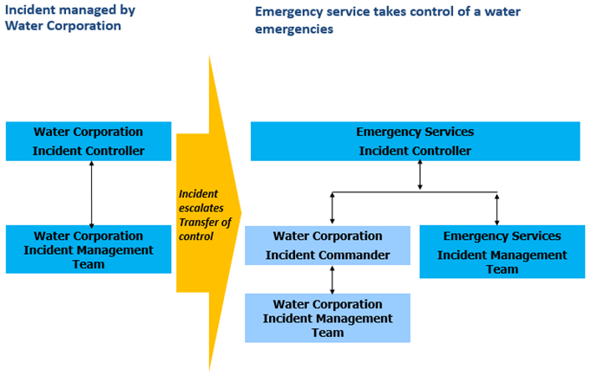

Figure 2: Water Corporation Transfer of Control

# Waterways Included in the Algal Management Framework

This plan applies to all Victorian water bodies accessible to the public or waterways that discharge into publicly accessible water bodies such as rivers, streams, wetlands (including Ramsar wetlands), lakes, estuaries, water supply storages, irrigation channels and drains, wastewater treatment plant storages, ornamental lakes, marinas, stormwater and recycled water storages and treatment wetlands. For example, while a bloom in an off-stream drinking water supply storage may not be part of a wider issue or pose risk of a regional bloom, it is subject to this Plan and is therefore reportable to DEECA (via Water Intelligence Platform (Algal Bloom portal) and to Department of Health (DH).

Excluded waterways include closed water storages/tanks and lakes, storages and marinas on private land unless there is discharge to other waterways or the water body is used by the public for primary contact recreational purposes. An example of an excluded waterway would be a wastewater lagoon that is not discharging: a bloom in the lagoon would not be reportable.

Response to Marine Algae blooms in Port Phillip Bay are covered in the “*Port Phillip Bay Marine Algal Bloom Response Plan*” available on the [Algal Blooms Module](http://www.floodzoom.vic.gov.au). Marine Algae blooms outside of Port Phillip Bay, in the absence of a response plan, should follow the “*Port Phillip Bay Marine Algal Bloom Response Plan*” until one exists.

### Murray River

Management of the Murray River falls under the jurisdiction of New South Wales (NSW) WaterNSW. However, as the Murray River is the water supply source to many Victorian towns and regional cities and receives flows from Victorian waterways, the NSW Murray and Sunraysia Regional Algal Coordinating committees include representatives from the Regional Coordinators and Local Water managers in Victoria. Likewise, if an algal bloom in Victoria poses a risk to the Murray River, the relevant agencies in NSW must be included in the Regional Response Group. Local Water Managers are to keep relevant Interstate Coordinators up-to-date with algae results when available for shared waterways or sites that discharge into waterways in other State jurisdictions

NSW has produced a “Guidelines to Management response to harmful algal blooms” for application in the Murray and Sunraysia Region.

When BGA levels in the Murray River are above the trigger level, Water NSW will inform all stakeholders.

Victorian management of a BGA bloom in the Murray River, will be guided by the Algal Bloom Response Plan and local response plans.

If an algal bloom is likely to impact South Australian waters, the relevant water manager must notify South Australia (SA) Health through [public.health@health.sa.gov.au](mailto:public.health@health.sa.gov.au).

For shared waterways or samples sites including offtakes or waterbodies that discharge into waterways in other State jurisdictions (e.g. Goulburn River discharges into Murray River), Victorian Local Waterway Manager will provide National Association of Testing Authorities (NATA) accredited algae reports, when available, to the relevant interstate Algae Coordinators.

Interstate Algae Coordinators shall be provided authorised access to additional notifications via the algae module. The level of authorised access shall be determined by DEECA and shall be relevant to the delegated authority within the interstate Jurisdictions.

# Responsibilities

## Department of Energy, Environment, and Climate Action

DEECA is the Control Agency for BGA management and develops the policy for the overall algal management in Victoria. DEECA collects data on BGA to monitor trends throughout the State which helps to manage BGA blooms. During an algal bloom, DEECA will co-ordinate management activities so that all relevant stakeholders can perform their respective roles and responsibilities at the regional level.

Table 4: Department of Energy, Environment and Climate Action

| Key Area | Roles |
| --- | --- |
| Planning and Preparedness | Supports relevant research and development.  Identifies sources of BGA knowledge and expertise.  Identifies high risk water bodies/reaches based on water sampling data collected, in consultation with Regional Coordinators.  Maintains a database of BGA blooms to monitor trends.  Review the DEECA Algal Bloom Response Plan.  Review the Victorian BGA Circular.  Convenes the State-wide/regional coordinators meeting.  Allocates Regional Coordinators.  Ensures Regional Coordinators have prepared and updated Regional Coordination Plans.  Monitor the Algal Blooms Module at www.floodzoom.vic.gov.au  Sets the triggers in the algae module appropriate to the water usage.  Liaises with interstate and other agencies to maintain and disseminate information to provide best practice in managing BGA.  Assists Regional Coordinators in allocation of Local Water Managers if required.  Facilitates a mediation process with respective parties and relevant government agency/body in the event of a dispute over roles and responsibilities of Regional Coordinators and Local Water Managers. |
| Response | Participates as a member of Response Groups.  Develops response arrangements consistent with SEMP and outlined in the *Algal Blooms Response Plan*.  Develops systems to report and analyse algal blooms.  Monitor the Algal Blooms Module at [www.floodzoom.vic.gov.au](http://www.floodzoom.vic.gov.au)  Liaises with DH.  Liaises with the Department of Jobs, Skills, Industry and Regions (DJSIR) – Agriculture Victoria.  In the event of a dispute between Regional Coordinators or Local Water Managers regarding if a bloom is Regional in nature, decides through consultation with DH and all impacted parties if a regional bloom is to be declared.  Ensures the Regional Coordinators inform all relevant stakeholders of the reasons why a regional bloom has or has not been declared.  Obtains technical advice and information/advice for Local Water Managers.  Advises the relevant Minister, where required. |
| Recovery | Attends debrief meetings and ensures that a debrief report is prepared for regional BGA blooms. |

## 

## Department of Health

The Department of Health (DH) provides advice about the potential public health impacts of BGA blooms and is a support agency to DEECA under the Emergency Management Victoria (EMV) arrangements.

DH administers the Victorian *Safe Drinking Water Act 2003* (SDWA). Under the *Safe Drinking Water Act 2003*, water agencies have obligations to notify the department of non-complying water supplied and report known or suspected contamination. This includes water supplied or to be supplied for drinking purpose that:

1. may be the cause of an illness; or
2. may be the means by which an illness is being, has been or will be, transmitted; or
3. may contain any pathogen, substance, chemical or blue-green algae toxin, whether alone or in combination, at levels that may pose a risk to human health; or
4. May cause widespread public complaint.

These obligations are set out in Section. 18 and 22 of the *Safe Drinking Water Act 2003*.

Information on harmful algal blooms including advice relating to seafood contaminated with algal toxin(s) can be found on the Better Health Channel: <https://www.betterhealth.vic.gov.au/health/healthyliving/Harmful-algal-blooms>

Table 5: Department of Health Responsibilities

| Key Area | Roles |
| --- | --- |
| Planning and Preparedness | Assists DEECA to review the *Algal Bloom Response Plan* and the Victorian BGA Circular.  Liaises with national, interstate government departments and other agencies to maintain, disseminate and manage information on the health effects of harmful algae.  Supports Local Waterway Managers that provide Drinking and Regulated Water.  Adjudicates disputes arising between water storage managers and water suppliers under section 24 of the *Safe Drinking Water Act 2003*. |
| Response | Participates as a member of Response Groups.  Provides advice on public health issues relating to BGA including advice on seafood safety on the Better Health Channel ([https://www.bettnoterhealth.vic.gov.au/](https://www.betterhealth.vic.gov.au/)).  Is the control agency for retail food contamination and drinking water contamination.  Provides advice to the Minister for Health, where required. |
| Recovery | Assists with the assessment of social impacts in accordance with the SEMP.  May direct Waterway Managers/Regional Coordinators to undertake debriefs regardless of if a regional bloom is declared. |

## Agriculture Victoria

Agriculture Victoria within DJSIR provides advice about the potential agricultural impacts of BGA blooms. Agriculture Victoria is a support agency to DEECA under the Emergency Management Victoria arrangements.

Table 6: Agriculture Victoria Responsibilities

| Key Area | Roles |
| --- | --- |
| Planning and Preparedness | Assists DEECA to review the Algal Bloom Response Plan and the Victorian BGA Circular.  Provides advice to producers on the management of BGA on farms. |
| Response | Participates as a member of Response Groups.  Provides advice on agricultural issues relating to BGA.  Provides advice for producers with respect to the irrigation of crops and water supply to livestock.  Provides advice for owners of companion animals.  Provides advice to the Minister of Agriculture as required. |
| Recovery | Assists the control agency in assessing agricultural impacts of BGA blooms. |

## Regional Coordinator

The Regional Coordinator is responsible for coordinating the management of local BGA blooms, as well as coordinating planning and preparedness for managing regional BGA blooms.

Under the *Water Industry Act 1994* a Statement of Obligations (SoO) (2015) was issued by the Minister for Water to all Victorian water corporations. Part 5 Risk Management, 5-4 Blue Green Algal Blooms sets out the responsibilities for all water corporations with respect to reporting blue-green algae events.

Nine water corporations, together with DEECA in Gippsland have been nominated as a Regional Coordinator by the Secretary and must:

* develop and maintain on an annual basis a contingency plan for regional blue-green algal blooms; and
* undertake its duties as a Regional Coordinator in accordance with that contingency plan.

For the Regional Coordinator boundaries please refer to Appendix A.

Table 7: Regional Coordinator Responsibilities

| Key Area | Roles |
| --- | --- |
| Planning and preparedness | Liaises with Catchment Management Authorities, Water Corporations, Local Government and others to encourage river and catchment improvement works are carried out in areas that may reduce risks of blooms.  Nominates Local Water Managers (refer to Appendix B for further information).  Annually prepares updates and distributes the Algal Regional Coordination Plan, before the start of summer and provides copy to DEECA.  Convenes the pre-season coordination meeting.  Monitor the Algal Blooms Module at www.floodzoom.vic.gov.au  Checks that local water managers have prepared and updated Risk Management Plans.  Ensures that Local Water Managers and themselves have capabilities to enact the Coordination Plans.  Identifies sources of algal knowledge and expertise. |
| Response | Is informed of local blooms.  Declares when an algal bloom is regional.  May appoint an Incident Controller during a regional bloom.  Manage regional blooms in accordance with the Regional Coordination Plan and the *Algal Blooms Response Plan.*  Monitor the Algal Blooms Module at www.floodzoom.vic.gov.au  Convenes and chairs the Response Group meetings during a regional BGA bloom.  Reports to DEECA and DH on the management of regional BGA blooms.  Coordinates ongoing monitoring of regional BGA blooms.  Directly informs the State Coordinator when made aware of a bloom that has a potential to escalate from a local bloom to a regional bloom.  Informs all relevant stakeholders of the reasons why a regional bloom has or has not been declared. |
| Recovery | Conducts a debrief meeting and prepares a debrief report on regional blooms. This report may include likely cause of bloom (if known), management actions taken, and any improvements that can be made with future responses. |

## Local Water Managers

Local Water Managers are responsible for managing BGA blooms in their local water body. The main role of the Local Water Manager is to minimise impacts of the bloom including public health risks.

A Local Water Manager in the context of this management framework relates only to managing algal blooms in a section of a waterway or a water body. It does not imply any other waterway/water body management responsibilities, although many Local Water Managers in the algal context may have other roles in water body management.

A Local Water Manager is generally the agency with on ground management responsibilities for a particular water body. In areas where no management arrangement exists, the local water manager is usually the agency responsible for public health in that area.

Table 8: Local Water Managers Responsibilities

| Key Area | Roles |
| --- | --- |
| Planning and preparedness | Reviews the algal risk for the water body, determines and implements any risk mitigation measures (see Section 5.2 Algal Risk Management Plan).  Develops and updates the Risk Management Plan annually to guide monitoring and response activities.  Monitors and takes samples for testing.  Enter and update algal data into the Algal Blooms Module at www.floodzoom.vic.gov.au  Organises local water management staff training.  Participates in the Regional Coordinators pre-season meeting.  Ensures that sufficient preparedness training has been undertaken to enact the Regional Coordination Plans. |
| Response | Informs the regional coordinator, DEECA, DH and where necessary Interstate Coordinators of local BGA blooms.   * Advises DH of blooms that exceed BGA triggers that pose a risk to the public through drinking water or primary contact.   Enter and update algal data into the Algal Blooms Module at www.floodzoom.vic.gov.au  Manages local algal blooms in accordance with the Algal Risk Management Plan including monitoring, signage and media releases.  Documents and records all actions taken.  Notifies the Regional Coordinator and State Coordinator if a local BGA bloom could become a regional BGA bloom.  Manages local blooms in accordance with the BGA Circular and *Algal Bloom Response Plan* |
| Recovery | Considers preparing a debrief report for internal purposes.  Provides feedback to DEECA relating to the Victorian BGA Circular. |

## Other Agencies

Many other agencies, work together to manage BGA blooms in water bodies. The key agencies are Environment Protection Authority (EPA) Victoria, PrimeSafe, Local Government, Catchment Management Authorities, Emergency Services, Victorian Environmental Water Holder (VEWH), Seafood Industry Victoria, DJSIR and Agriculture Victoria.

Table 9: Other Agencies Responsibilities

| Key Area | Roles |
| --- | --- |
| Planning and preparedness | **Catchment Management Authorities** (CMA) undertake water quality activities including testing and catchment improvement works through implementing their Regional Waterway Strategies |
| Response | **EPA, Local Government, Parks Victoria and CMAs** may participate as members of Response Groups, as required.  **DJSIR and Agriculture Victoria,** may participate as members of Response Groups; providing relief and recovery activities for the impacts and consequences of emergencies for primary producers and Animal Health and Welfare, as well as providing advice on impact of BGA blooms in farm dams, irrigation networks and on agriculture usage.  Emergency service providers can be involved if a BGA bloom becomes an emergency as defined in the SEMP.  **PrimeSafe** is responsible for the regulation of seafood safety of commercial seafood under the *Seafood Safety Act 2003*. |

## Response Groups

Response Groups are formed to manage a regional BGA bloom on behalf of the Regional Coordinator. The Regional Coordinator is responsible for convening and chairing the Response Groups, which should include stakeholder agencies that have responsibilities or an interest in the area affected by a regional BGA bloom.

Further advice on Response Groups is provided in the sample BGA Regional Coordination Plan found on the [blue-green algae resources](https://www.water.vic.gov.au/waterways-and-catchments/rivers-estuaries-and-waterways/blue-green-algae) page of DEECA website and on the [Algal Blooms Module](http://www.floodzoom.vic.gov.au). Details include information on a preferred structure and potential members of a Response Group, based on the SEMP and Australasian Inter-Service Incident Management System (AIIMS).

# Management of Water Bodies

## Regional Coordination Plan

Regional Coordinators must have in place a BGA Regional Coordination Plan for their area outlining the approach to protect public health and minimise social, environmental and economic impacts.

The BGA Regional Coordination Plan details the methodology of preparing for and managing a regional algal bloom including the roles and responsibilities of the Regional Coordinator, Local Water Manager and other agencies to ensure a consistent and effective response before, during and after an algal bloom.

The plan should identify stakeholder agencies as local water managers and identify potential agencies as a Response Group to manage a regional BGA bloom. The Regional Coordination Plan should be reviewed and updated at the start of each algal season. A copy of the plan shall be sent to DEECA [bluegreen.algae@delwp.vic.gov.au](mailto:bluegreen.algae@delwp.vic.gov.au) or uploaded to Algal Blooms Module at www.floodzoom.vic.gov.au.

A sample BGA Regional Coordination Plan incorporating the principles of risk management and broadly consistent with the SEMP framework can be found on the [Algal Blooms Module](http://www.floodzoom.vic.gov.au).

Regional Coordinators are requested to consider this template when preparing or updating BGA Regional Coordination Plans.

Local Water Managers should be familiar with the BGA Regional Coordination Plans for managing regional algal blooms in their area and be aware of the extent of their roles and responsibilities in the plan.

## Algal Risk Management Plan

Local Water Managers should develop BGA Risk Management Plans for water bodies under their responsibility and monitor the water bodies for BGA accordingly, to ensure early detection and management of algal blooms. BGA Risk Management Plans should link to the Regional Coordination Plan established by the regional coordinators. These plans should be reviewed and updated on an annual basis.

Where a water body is used to supply drinking water, BGA Risk Management Plans must interface with, or be included in the Risk Management Plan that has been developed to comply with the *Safe Drinking Water Act 2003*.

A [Sample BGA Risk Management Plan](https://www.water.vic.gov.au/__data/assets/word_doc/0033/65598/Sample-BGA-Risk-Managment-Plan-2014.docx) which incorporates principles of risk management and is compatible with the SEMP framework can be found on the Algal Blooms Module. Local Water Managers are requested to consider using this template when preparing or updating plans.

The sample BGA Risk Management Plan also provides advice for Local Water Managers on how to conduct risk-based planning for algal management.

Local Water Managers should update their algal Risk Management Plans annually and take account any changes to organisations both within and outside of the water sector and linkages to state-wide and municipal emergency management planning strategies and developments. They should also consider the best way for their BGA Risk Management Plans to be linked to the SEMP, municipal Emergency Management Plans and any other related planning instruments.

For more information about, or to obtain copies of the SEMP visit the [Emergency Management Victoria’s Policies](https://www.emv.vic.gov.au/policies/emmv/) webpage.

## Monitoring Water Bodies

Water bodies shall at a minimum be monitored in accordance with the BGA Risk Management Plan.

Monitoring results shall be inputted into the Algal Blooms Module to provide situational awareness and triggers for action. This data can also be used for future research in algal blooms, trend analysis and reporting.

# Reporting of Algal Blooms

## Algal Blooms Module

The Algal Blooms Module is a web-based system that provides a central location for algal management in Victoria. Local Water managers can record algal test results for a water body using this module.

The Algal Blooms Module provides user with the following capabilities;

* Spatial Mapping of the Blooms
* Geo-locating waterbodies and their sampling sites
* Automated system notifications when a new bloom is reported or is overdue
* Revised reporting
* Algal blooms related document storage, including site photos and toxin analysis reports
* Renaming waterbodies and their sampling sites
* Incorporation of algal bloom information along the Murray River from NSW Water
* Ability to incorporate sample results from the labs directly into the system (still in development)

Functionality includes sending notification to DEECA, DH and Regional Coordinators when a bloom is created. The dashboard page lists all the current blooms and they are represented via a mapping function.

Access to the Algal Blooms Module is at [www.floodzoom.vic.gov.au](http://www.floodzoom.vic.gov.au)

New users accounts are created on request via email [accounts@floodzoom.vic.gov.au](mailto:accounts@floodzoom.vic.gov.au)

The documentation tab provides access to a library of Algal reference material which may include local, regional and state plans.

If you are experiencing problems with the Algal Blooms Module website, please use the “provide feedback” button at the bottom right side of the dashboard screen.

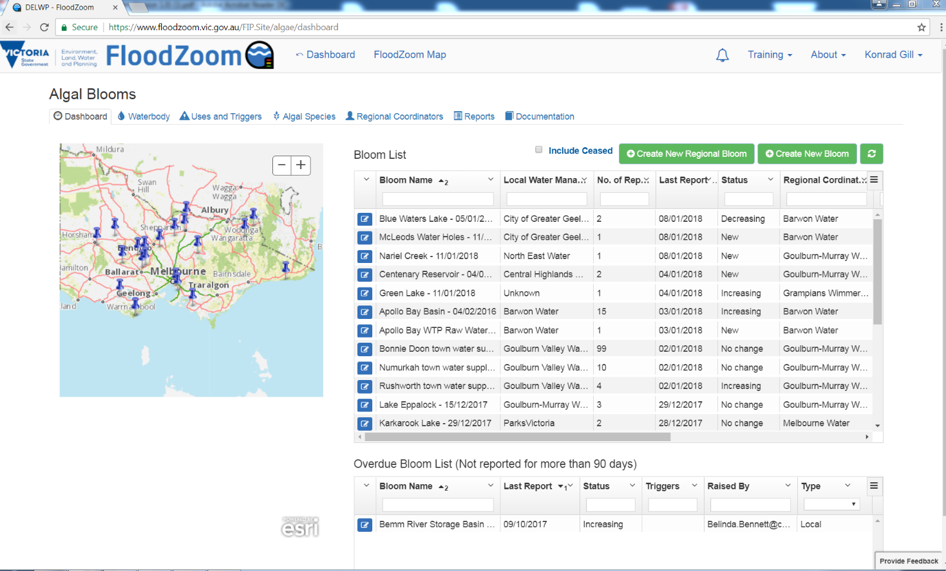

Figure 3: Water Intelligence Platform – Algal Module

## Biovolume versus Cell Counts

Because BGA is a diverse group of organisms, that range dramatically in size, shape and toxicity, their identification is a specialised service provided by skilled professionals. Quantifying BGA in terms of cell numbers alone does not account for variability in the size between different species, and this can lead to inappropriate management actions, particularly in circumstances where there may be large numbers of a species with a very small cell size. Measurement of biovolume is therefore used as a means of providing a more accurate description of cell density, as it is more closely related to toxin concentrations than total cell numbers.

Biovolume can either be directly measured by analytical laboratories, or alternatively if analysed in-house by trained specialists the biovolume calculation tool can be used. DEECA has developed a biovolume calculator to estimate the biovolume of BGA species, based on the cell counts that are reported by analytical laboratories. Standard reference BGA cell volumes within the biovolume calculation tool are based on BGA from Australian freshwaters and are taken from the National Protocol for the Monitoring of Cyanobacteria and their Toxins in Surface Fresh Waters. This is not intended to replace laboratory analysis and where a NATA accredited laboratory that is listed in the current circular is engaged to undertake the analysis, the biovolume as reported by the laboratory shall be used for reporting in precedence to the biovolume calculator. The biovolume calculator can be found on the [Algal Blooms Module](http://www.floodzoom.vic.gov.au).

Risk-based trigger values for BGA in water bodies used for drinking and recreation are provided in the following section. These trigger values have been derived from Management Strategies for Cyanobacteria (BGA): A Guide for Water Utilities (Water Quality Research Australia 2010) and the Guidelines for Managing Risks in Recreational Water (National Health and Medical Research Council (NHMRC) 2008, Australian and New Zealand Environment and Conservation Council (ANZECC) (2000), Agriculture and Resource Management Council of Australia and New Zealand (ARMCANZ) (2000) water quality guidelines and Guidelines on Recreational Water Quality- Volume 1 Coastal and Fresh Waters (WHO 2021).

Microcystis aeruginosa is the only BGA species currently characterised sufficiently to provide a trigger value based on cell counts alone. Trigger values for all other species are based on biovolume.

Where the dominate species, or the total combined potentially toxic species in a bloom, are listed as known toxic in the DEECA calculator and exceed the drinking water trigger, samples shall be taken for quantitative toxin analysis and analysed by a NATA accredited laboratory. Consideration shall be given to toxin analysis for all blooms in excess of biovolumes of 4 mm3/L in consultation with the relevant Government stakeholder. Alternative emerging technology, such as quantitative PCR gene analysis should be considered when assessing toxicity.

## Notification to DEECA and the Regional Coordinator

When sampling and testing has confirmed the existence of all BGA at or in excess of a biovolume of 0.2mm3/L Local Water Managers are required to advise the Regional Coordinator and DEECA.

When recording new algal data on a waterbody directly into the [Algal Blooms Module](http://www.floodzoom.vic.gov.au/) for the first time, it will automatically notify DEECA and the designated regional coordinator.

When reporting local BGA blooms, Local Water Managers are requested to provide the following details:

* Species (if known);
* Biovolume;
* Name of water body; and
* Actions taken to date.

When updating existing blooms Local Water Managers are asked to enter BGA bloom updates as new results become available and when the BGA bloom has ceased.

When logging blooms also consider:

* Whether the bloom is likely to become a regional problem;
* If the bloom has caused a water supply to be interrupted, public warnings to be issued or water bodies to close; and
* Whether treatment is required.

## Additional Notifications

In some circumstances, other organisations, groups or individuals will need to be notified of BGA blooms. This will depend on the use of the water body and density and nature of the BGA bloom.

### Drinking Water

Under the *Safe Drinking Water Act 2003* *(SDWA)* DH must be notified of circumstances where drinking water supplied to the public do not meet water quality standards, and when there is known or suspected contamination of water. These are under section 18 and section 22 respectively.

This requirement is in place to protect public health and to ensure that relevant corrective and preventative actions are taken, to provide the public with safe drinking water.

Under the *Safe Drinking Water Act 2003*, water agencies have obligations to notify the department of non-complying water supplied and report known or suspected contamination. This includes water supplied or to be supplied for drinking purpose that:

1. may be the cause of an illness; or
2. may be the means by which an illness is being, has been or will be, transmitted; or
3. may contain any pathogen, substance, chemical or blue-green algae toxin, whether alone or in combination, at levels that may pose a risk to human health; or
4. May cause widespread public complaint.

Water agencies risk management plans are required to include the management of harmful algae blooms. This includes communication protocols between water storage managers and water suppliers, and reporting arrangements to DH.

A recommended framework for monitoring and managing BGA in drinking water supplies can be found in [Management Strategies for Cyanobacteria (Blue-Green Algae): A Guide for Water Utilities](http://www.waterra.com.au/publications/document-search/?download=106) (Water Quality Research Australia 2010). Available at Waterra.com.au

### Regulated Water

Regulated water, as defined under *SDWA*, is water supplied by water agencies that is not drinking water but may be mistaken as being drinking water. Water agencies supplying regulated water are required to take all reasonable steps to ensure that recipients of the water are aware of the health risk that may arise from use of the water.

Water agencies risk management plans must detail how public health risk is managed in relation to the water supplied, including regulated water. This may include advising recipients of potential dermal irritation risk when harmful algae are present in regulated water supplies. As this water may be the only supply to these households and private water treatment processes may be in-place but potentially inadequate to deal with toxic BGA, notifications to the users of regulated water shall occur at toxic biovolumes equal to or greater than 0.6 and notifications issued regarding the escalating risk for total biovolumes of 4.0 and 10 mm3/L.

### Recreational Water

Notifications are required when a BGA bloom poses a public health risk in water bodies used for primary contact recreation.

BGA blooms in recreational water bodies are considered to pose a potential public health risk, for primary contact recreation (NHMRC 2008). The Department of Health must be notified when one or more of the following occurs:

* Total microcystins are detected at ≥10 ug/L (microcystin-LR toxicity equivalents)
* *Microcystis aeruginosa* is present at ≥ 50,000 cells/mL
* Total combined biovolume of known toxic cyanobacterial species is ≥ 4 mm3/L
* Total combined biovolume of all cyanobacterial species is ≥ 10 mm3/L
* Cyanobacterial scums are consistently present[6]

In the case of these BGA blooms, the following groups should be notified:

* Recreational users of the water body (for example, through signage (refer to Appendix C) or media (refer to Appendix D), as appropriate);
* DH via the Algal Blooms Module including details of actions taken to inform recreational users of the waterbody; and
* Relevant stakeholders (such as local government, tourism bodies and recreation clubs).
* EPA 1300 372 842 and WQForcasting@epa.vic.gov.au

Additional information on monitoring and managing BGA risks in recreational water bodies can be found in the [Guidelines for Managing Risks in Recreational Water](https://nhmrc.gov.au/about-us/publications/guidelines-managing-risks-recreational-water) *(NHMRC 2008).*

During a BGA bloom, warning signs (refer to Appendix C) should remain in place until two consecutive results from representative samples confirm that levels of BGA have fallen below the alert levels. Sample results should be taken at a minimum of seven to ten days apart for testing. *Guidelines for Managing Risks in Recreational Water (NHMRC 2008)* and the Guidelines on Recreational Water Quality – Volume 1 Coastal and Fresh Waters (*WHO 2021*).

Warning signs should not be removed if scum continues to be present.

### Other Water Supplies

The Local Waterway Manager should undertake risk assessments for algal blooms in other waterbodies to determine whether the water is potentially hazardous. If it is considered that a risk may be posed due to presence of algae, then all relevant users of water must be notified.

As there is a mix of usage risks for other water supplies from domestic primary contact to Livestock drinking water, the following triggers are adopted for notifications in the algae module to provide early warning and planning in the event of a bloom.

In other Water Supplies – When any one or more of the following occurs:

* Total toxins detected at >1.0ug/L;
* Total combined biovolume of known cyanobacterial species >0.6mm3/L;
* Total combined biovolume of all cyanobacterial species is >4mm3/L; or
* Cyanobacterial scums are consistently present[7]

# Laboratory Testing of Samples

When local monitoring and field testing indicate the presence of BGA in a water body it is recommended that samples be tested by a competent testing laboratory. National Association of Testing Authorities (NATA) accredited laboratories that can assist with algae identification, toxicity and toxin testing.

# Use of Algaecides

Use of algaecide in any water body that is used for drinking water supply must not occur before consultation with the relevant drinking water supply agency and DH Water Unit.

Local Water Managers should only use appropriately registered (or permitted) products for the control of BGA. Provided the product is used in accordance with the Approved label instructions no permit is required. If not in accordance with the approved label instructions refer to [Australian Pesticides & Veterinary Medicines Authority](http://www.apvma.gov.au/index.asp)*(*APVMA*)* website for information relating to registration and issue of permits for algicides

Local Water Managers who are water suppliers or water storage managers under the *SDWA* are also reminded that their risk management plan under this Act must include details of procedures to control any residue or chemical by-products imparted to drinking water, as a result of the addition of chemicals to water supplied for drinking purposes *(Regulation Part 3, s.8(e)(ii) of the Safe Drinking Water Regulations 2015)*.

This means that where an algaecide has been applied in any water body normally used as a source of drinking water, the Local Water Manager needs to ensure that their procedure for returning the water body to supply includes an assessment of safe levels of any algaecide residue or chemical by-products that could be transferred to the drinking water supply.

Information on the use of agricultural chemicals registered for the control of algal blooms is available from Agriculture Victoria Chemicals Standards Officers on 138 186 or [Managing blue-green algae in farm water supplies | Blue-green algae in water | Water | Farm management | Agriculture Victoria](https://agriculture.vic.gov.au/farm-management/water/blue-green-algae-in-water/managing-bluegreen-algae-in-farm-water-supplies)

# References

Gayle Newcombe, Jenny House, Lionel Ho, Peter Baker and Michael Burch, [Management Strategies for Cyanobacteria: A guide for water utilities](https://www.researchgate.net/profile/Lionel_Ho/publication/242740698_Management_Strategies_for_Cyanobacteria_Blue-Green_Algae_A_Guide_for_Water_Utilities/links/02e7e52d62273e8f70000000/Management-Strategies-for-Cyanobacteria-Blue-Green-Algae-A-Guide-for-Water-Utilities.pdf). Water Quality Research Australia, 2010

National Health and Medical Research Council, [Guidelines for Managing Risks in Recreational Water](https://nhmrc.gov.au/about-us/publications/guidelines-managing-risks-recreational-water), Australian Government, 2008.

[Safe Drinking Water Act (Vic) 2003](http://www.legislation.vic.gov.au/Domino/Web_Notes/LDMS/PubStatbook.nsf/51dea49770555ea6ca256da4001b90cd/8fa3de3c8565c844ca256e5b002140a5/$FILE/03-046a.pdf)

[Safe Drinking Water Regulations (Vic) 2015](http://www.legislation.vic.gov.au/Domino/Web_Notes/LDMS/PubStatbook.nsf/93eb987ebadd283dca256e92000e4069/5D8AE33439EB5B2CCA257E7B00146316/$FILE/15-088sra%20authorised.pdf)

DEECA Blue-Green Algae webpage - <https://www.water.vic.gov.au/waterways-and-catchments/rivers-estuaries-and-waterways/blue-green-algae> DEECADEECA Blue-Green Algae webpage - <https://www.water.vic.gov.au/waterways-and-catchments/rivers-estuaries-and-waterways/blue-green-algae>

DH Blue-Green Algae webpage - <https://www2.health.vic.gov.au/public-health/water/blue-green-algae-cyanobacteria>

State Emergency Management Plan - <https://www.emv.vic.gov.au/responsibilities/semp>

Australian Pesticides & Veterinary Medicines Authority website - <https://apvma.gov.au/>

Port Phillip Bay Marine Algal Bloom Response Plan - [www.floodzoom.vic.gov.au](http://www.floodzoom.vic.gov.au) or <https://cop.em.vic.gov.au>

Algal Bloom Response Plan - [www.floodzoom.vic.gov.au](http://www.floodzoom.vic.gov.au) or <https://cop.em.vic.gov.au>

World Health Organization 2021. Guidelines on Recreational Water Quality – Volume 1 Coastal and Fresh Waters - [WHO guidelines on recreational water quality: volume 1: coastal and fresh waters](https://apps.who.int/iris/handle/10665/342625)

1. Regional Coordinator Boundaries

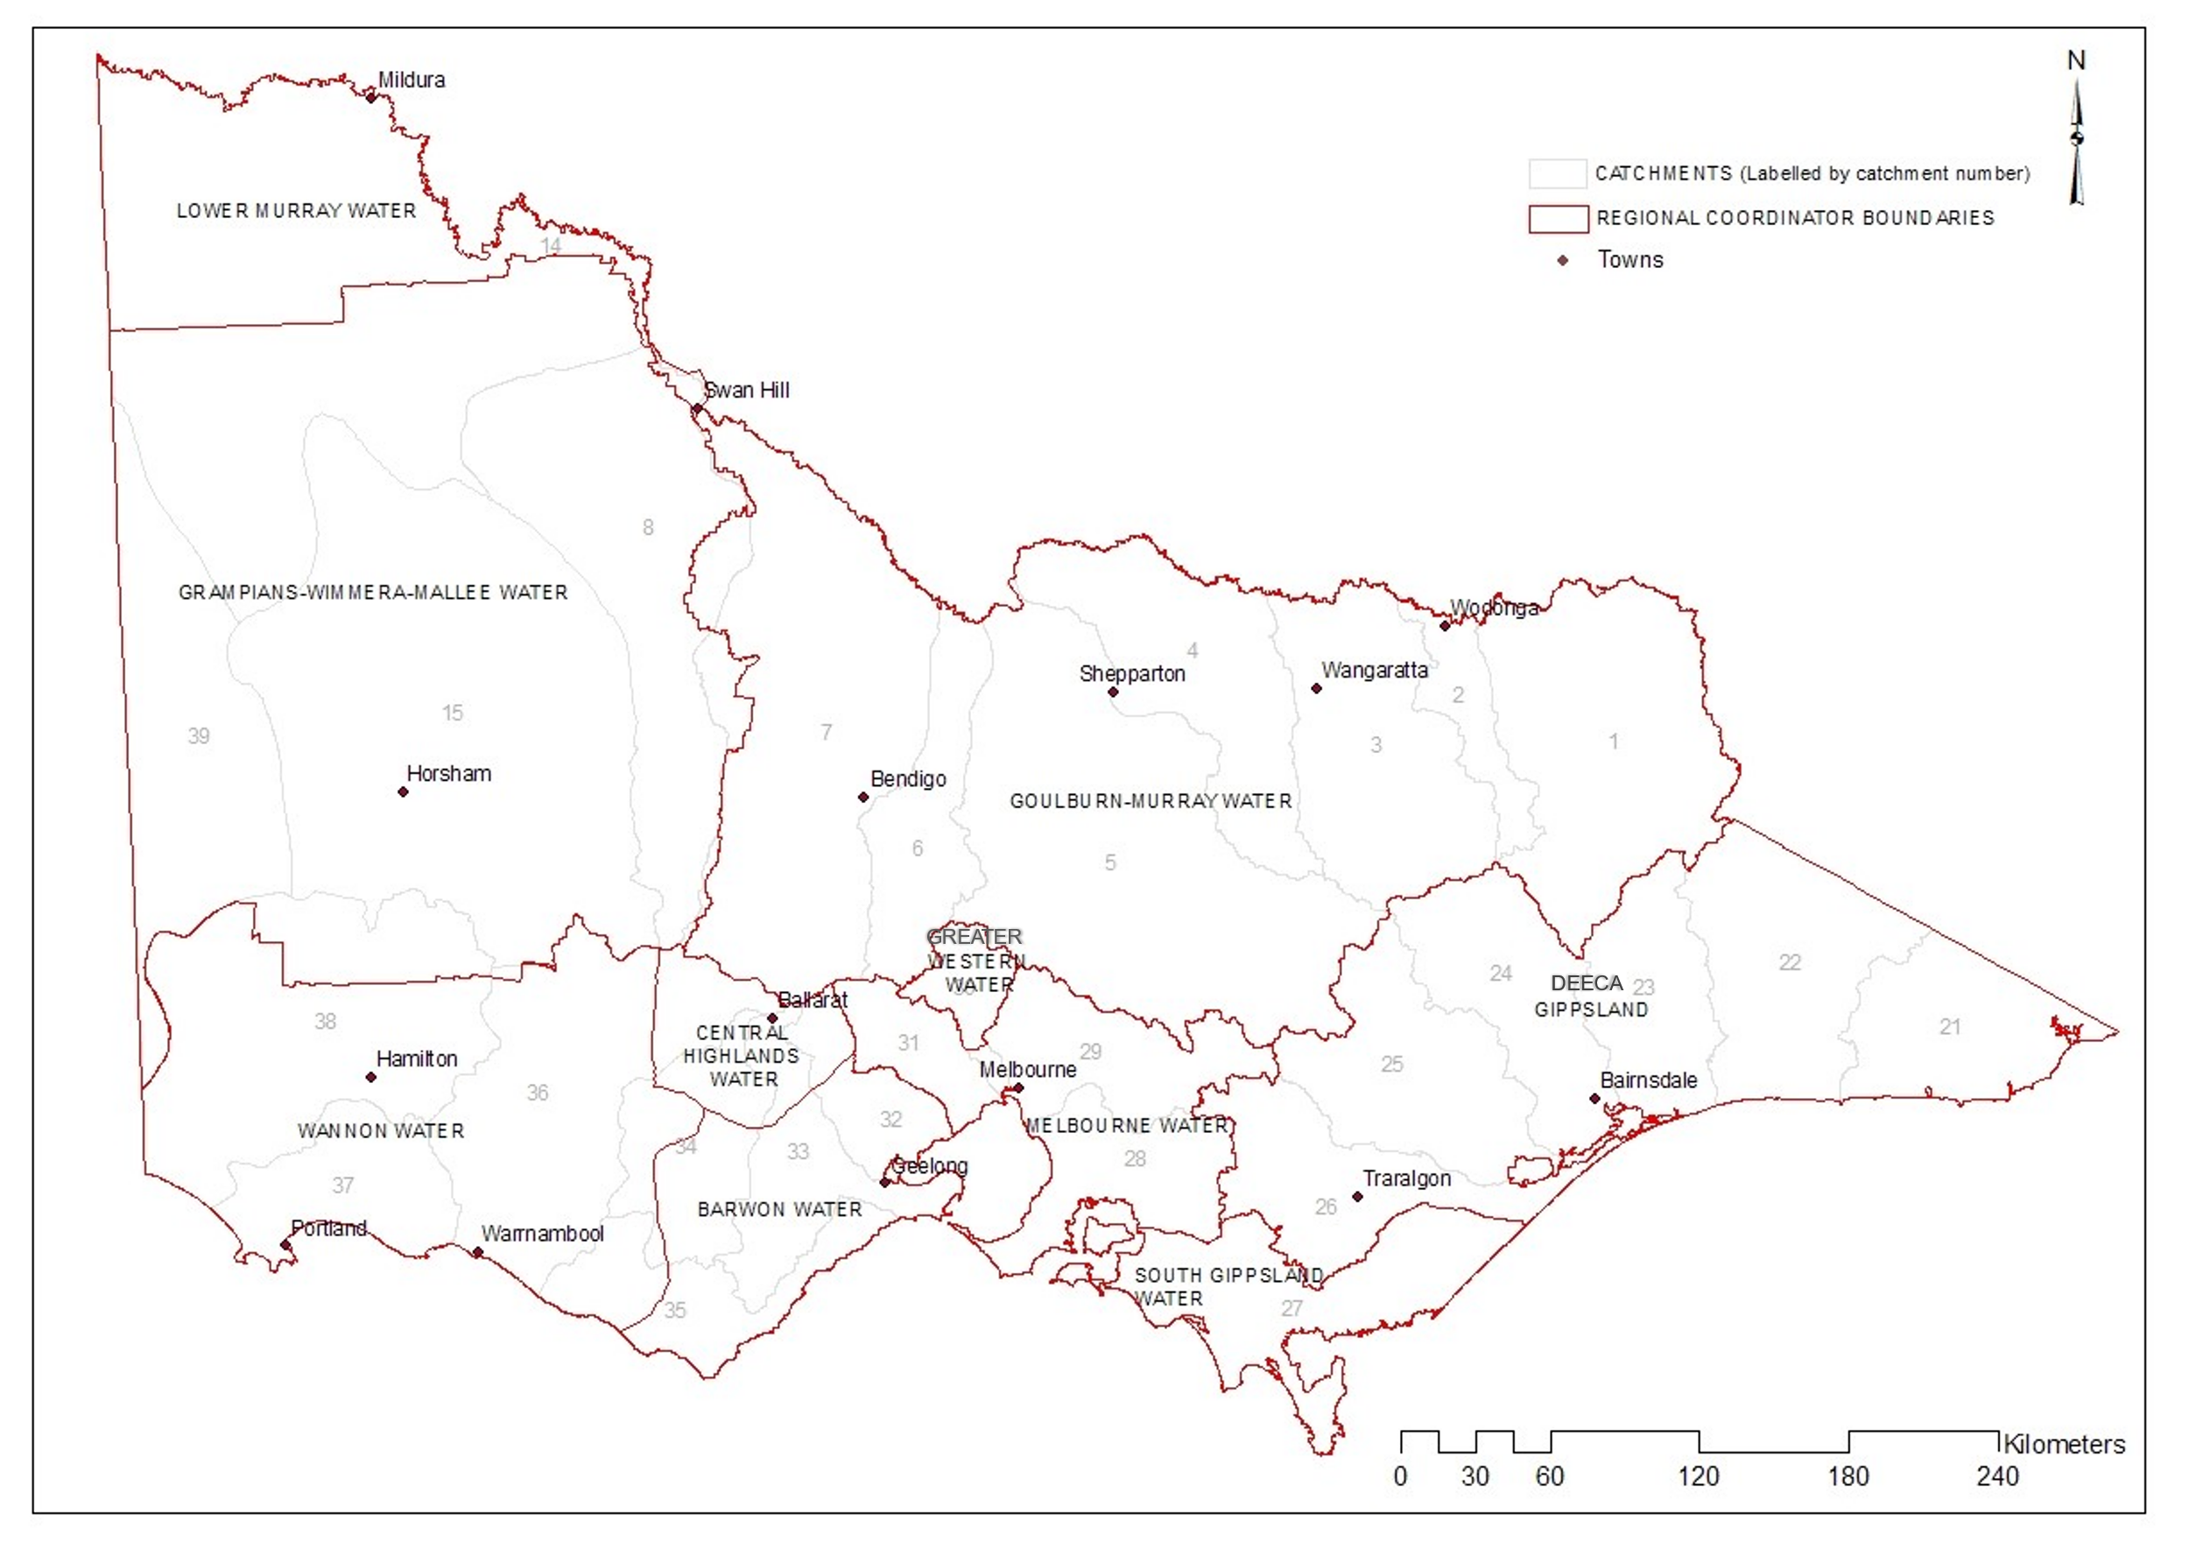Figure A1: Regional Coordinator Boundaries

Table A1: Regional Coordinator Boundaries

| Regional Coordinator | Drainage Basin or Area |
| --- | --- |
| Goulburn-Murray Water | 1, 2, 3, 4, 5, 6, 7, Pt 8 |
| Grampians Wimmera Mallee Water | Pt 8, Pt 14, 15, Pt 38, 39 |
| Lower Murray Urban & Rural Water | Pt 14 |
| DEECA, Gippsland | 21, 22, 23, 24, Gippsland Lakes, 25, 26 |
| South Gippsland Water | 27 |
| Melbourne Water | 28, 29, Pt 30, 31 |
| Greater Western Water | Pt 30 |
| Barwon Water | Pt 32, Pt 33, Pt 34, Pt 35 |
| Central Highlands Water | Pt 32, Pt 33, Pt 34, Pt 36 |
| Wannon Water | Pt 34, Pt 35, Pt 36, 37, Pt 38 |

1. Allocation of Local Water Managers

## Guidance for Regional Coordinators

The BGA framework is a cooperative framework designed to minimise the health and environmental risk from BGA. One of the roles of the regional coordinator is to allocate local water managers. The following advice is a guide to assist with the allocation process.

Within the BGA coordination framework, the following agencies are options for local water managers:

* Water Corporations;
* Catchment Management Authorities;
* Local councils;
* Parks Victoria;
* Department of Energy, Environment and Climate Action;
* Coastal – Committee of Management;
* Alpine Resort Management Boards; and
* Private Companies (e.g. AGL for Hydro-power Lakes such as Rocky Valley at Falls Creek).
* Botanical Gardens

A local water manager should fulfil the criteria below for allocation to a waterway:

* Management responsibility for the waterway at a location. If there are multiple responsibilities, consider:
  + Who is the appointed/designated/legislated manager of the water body and/or foreshore where recreational access occurs?
  + Which organisation(s) benefit most economically, socially and environmentally, from the maintenance of acceptable water quality in the water body(ies) that may be subject to BGA blooms?
  + Who has legislated and/or perceived responsibility and duty of care for addressing public health risks attributed to blue-green algae blooms?
  + Which organisation(s) is/are at most risk socially, economically and environmentally from a blue-green algae bloom?
* Local presence (office and field crew).
* Adequate resources both in experience and number (i.e. does the delegated manager have the financial and technical capability to manage BGA?).

In the event that an agreement on an allocation of local water manager cannot be reached with a regional coordinator, DEECA, (as state-wide coordinator) will facilitate a dispute resolution process with the respective parties.

1. Sample Blue-Green Algae Warning Sign

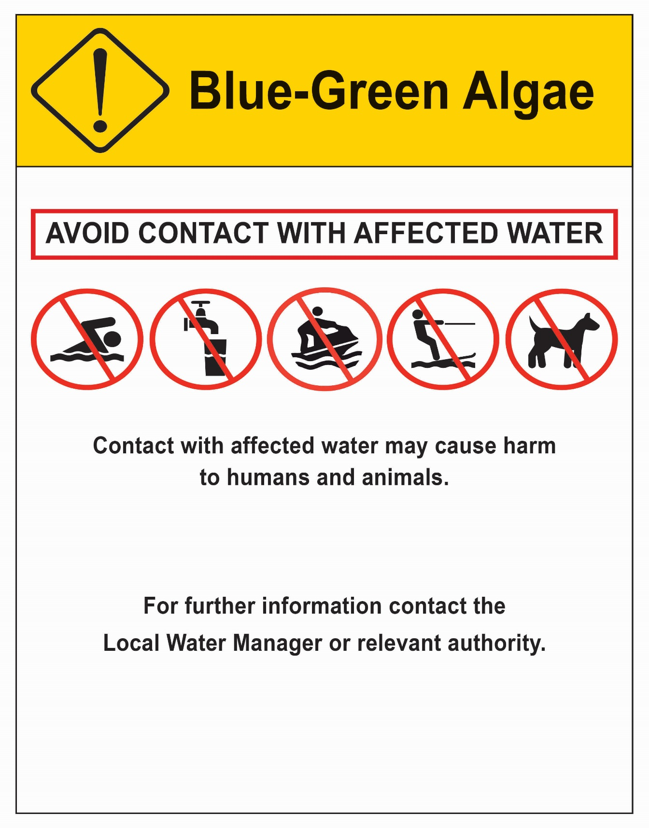

Figure C1: Sample Blue-Green Algae Warning Sign

1. **Media Release**

Date:

Media Contact:

**blue-green algae Warning for *(INSERT Water Body Name)***

*(Insert Local Water Manager Name)* announced that a blue-green algae (BGA) bloom is currently affecting *(insert Water body name)*.

The public is warned not to swim in and to avoid any direct contact with blue-green algae affected water.

Direct contact with blue-green algae can cause allergic reactions such as skin rashes or itchiness; sore eyes ears and nose or if swallowed gastroenteritis, nausea or vomiting.

People who come in to contact with contaminated water should wash immediately in fresh water. Seek medical advice if experiencing illness after contact with BGA affected water.

Any fish harvested from BGA affected water should have gills and guts removed prior to cooking. People should not eat whole fish, or shellfish or crustaceans collected from the (Insert water body name). The type of algae affecting *(insert water body name)* produces toxins that can concentrate in shellfish and crustaceans and accumulate in the liver and internal organs of fish. Ingesting BGA toxins can lead to serious illness.

Water from the affected water body should not be used for drinking, cooking or other domestic uses. Boiling the affected water will not make it safe for use.

For any health issues experienced after contact with BGA affected water please seek medical advice immediately.

Irrigators are encouraged to take extra care to avoid spray drift, the pooling of water and inhaling mist from BGA affected water. Affected water should not be sprayed onto leafy vegetables or florets or allowed to flood pastures.

Pet owners should prevent pets from drinking or having direct contact with contaminated water.

Visitors to the area are advised that they can still enjoy other recreational activities such as bushwalking, boating and sightseeing around the water body.

There are many land-based activities in the region to try. Please contact or visit local tourist information outlets for more information.

Members of the public are asked to report any potential BGA blooms to their local water manager on *(insert telephone number)*

Media please note:

For media enquiries please contact *(insert name)* on *(insert phone number)*

deeca.vic.gov.au

1. . Drinking Water triggers are based on algae sampling from the Raw Water Source, not the treated water. Treated Drinking Water contaminated by algae or algal toxins is to be reported to DH as per section 22 of the *Safe Drinking Water Act 2004*.
2. . Decisions should be based on the extent of scum; whether the scum is a known toxic cyanobacterial species; and whether scum are present in close proximity to a known major recreational area.
3. . BGA between biovolume 0.2mm3/L and Level 1 – Local Bloom Trigger, may require an increase in the monitoring regime and initiate formal reporting, reported in the algal bloom module as ‘no trigger’, blooms <0.2mm3/L are reported in the algal bloom module as ‘below threshold’.
4. . When biovolume exceed either the Drinking or Recreational triggers and meet any of the criteria for a Regional bloom, the Regional Coordinator shall convene a meeting with DEECA, DH, Local Water Managers (LWM), Agriculture Victoria (AgVic) and other relevant stakeholders to facilitate the declaration of a Regional Bloom.
5. . Decisions informed by the extent of scum; whether the scum is a known toxic cyanobacterial species; and whether scum is present in close proximity to a known major recreational area.
6. . Decisions should be based on the extent of scum; whether the scum is a known toxic cyanobacterial species; and whether scum are present in close proximity to a known major recreational area.
7. . Decisions should be based on the extent of scum; whether the scum is a known toxic cyanobacterial species; and whether scum are present in close proximity to a known major recreational area.