Snowy River
Sustaining an iconic and living river system

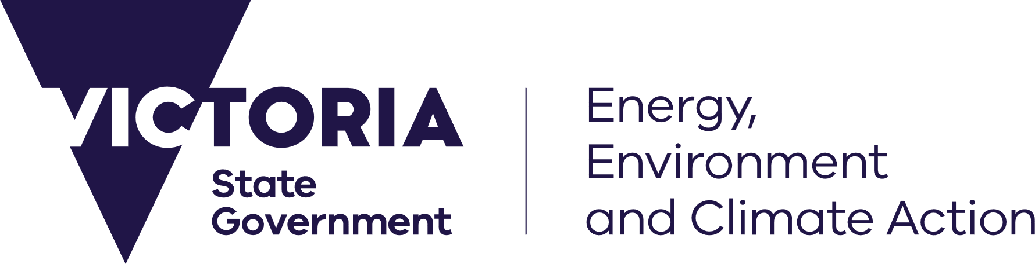


The Commonwealth Government is currently undertaking an independent review of the Snowy Water Inquiry Outcomes Implementation Deed (the Snowy Deed).
Consistent with the Snowy Deed, there is a continued need for governments to invest in the Snowy River’s health and the environmental, cultural, social and economic values it supports.

Why is the Snowy River important?
The Snowy River is one of Australia’s most iconic river systems, deeply connected to the nation’s history, environment and identity. Shaped by the Snowy Mountains Scheme, the river has played a key role in Australia’s economic development and inter-state water management. The Snowy has experienced significant environmental change as a result of this nation-building project. Over time, governments have responded through major investment to improve the health of the Snowy and associated wetlands. This has been supporting environmental recovery hand-in-hand with productive floodplains, working farms and regional communities that rely on the river system.
Australians value the Snowy River as the subject of Banjo Paterson’s famous poem. The river is connected to nationally important wetlands. The river and its Traditional Owners have been connected in a reciprocal relationship for countless generations. The Snowy plays a pivotal role in supporting agriculture, grazing, and regional livelihoods. Recreational activities such as whitewater rafting, kayaking and fishing in the estuary and freshwater reaches underpin local tourism and regional businesses.
The Snowy Deed reflects arrangements for balancing energy production and environmental outcomes under the Snowy Scheme. For further information on the Snowy Deed see www.water.vic.gov.au/our-programs/murray-darling-basin/snowy-deed-review.
Continued, coordinated investment in the environmental condition of the Snowy River is essential to protect these values and ensure the Snowy River remains a river of national importance for generations to come.

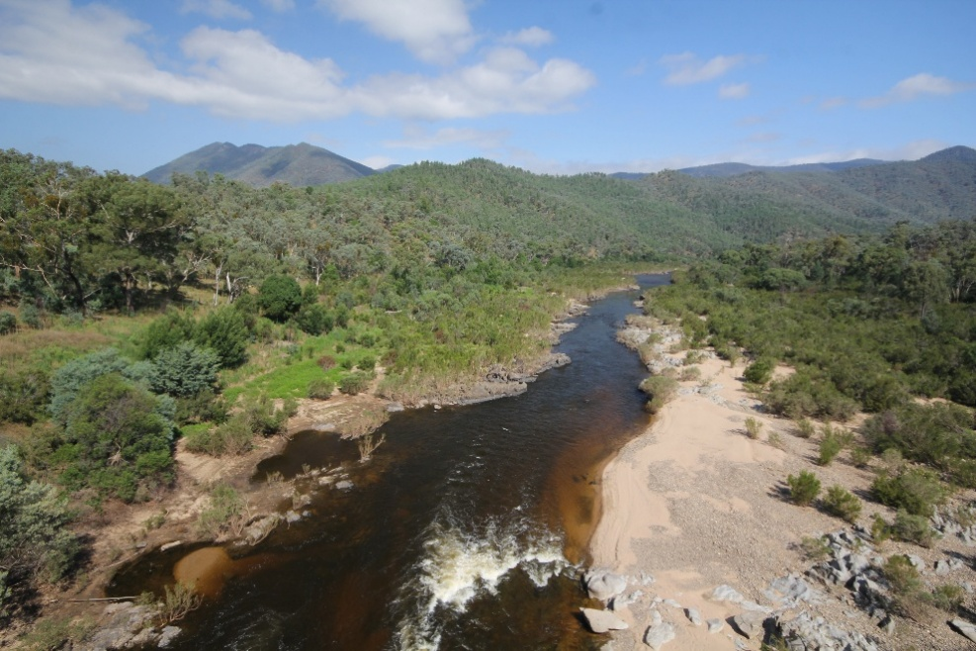
Condition of the Snowy River catchment
The Snowy River is highly modified by the Snowy River Scheme and other catchment activities. The Snowy Scheme plays a vital role in securing water supplies for the Victorian Murray and underpinning energy security of supply for Victorian communities and businesses. With active management, the Snowy River can continue to support ecological processes and the values that rely on environmental condition.

The Snowy Deed places requirements on Snowy Hydro to deliver environmental flows. Water for the environment alone cannot restore the health of the Snowy River, but it is critical to restore some components of the natural flow regime and support critical ecological processes. For further information on environmental flows, see www.vewh.vic.gov.au/healthy-waterways/gippsland-region/snowy-river.
The damming of the river’s headwaters has greatly reduced the amount and changed the timing of water reaching downstream areas. This is disrupting natural river processes and altering landscapes that communities depend upon. Along with past land clearing, these changes have led to a decline in river health. Reduced flows have contributed to sand building up in the Snowy River estuary. This increases the frequency of the river mouth closing, impacting water quality, fish movement, cultural practices and recreational use.
These impacts are felt by Traditional Owners, businesses and communities. This highlights the importance of ongoing investment in activities that support river and estuary health, in conjunction with the delivery of environmental flows through the Snowy Deed.

Investment in waterway health
The Victorian Government has been investing to improve waterway health across the Snowy catchment for more than 20 years, through the work of the East Gippsland Catchment Management Authority (CMA) as the regional catchment and waterway manager. The CMA works in partnership with landholders, public land managers, Traditional Owners and communities. It has delivered significant improvements for the Snowy River and established a strong foundation to sustain this living and lifegiving system for the future.
Following the corporatisation of Snowy Hydro in 2002, the Victorian Government invested $40 million over 10 years in rehabilitating the Snowy River. Victoria has continued to invest, with over $1m since 2018 and the Australian Government has also invested an additional $500,000 over 2021-2023. This has focussed on improving the health of the lower Snowy River through targeted on-ground works. Activities included river and estuary monitoring, removal of invasive willows, restoration of riverbanks and floodplains, creation of in-stream habitat and fish stocking.

We know what works
Lower Snowy River riparian recovery
Since 2000, the CMA has worked with landholders on fencing, combined with the installation of off stream watering systems along the lower Snowy River floodplain and estuarine reaches. This ensured permanent removal of stock access to the river. Once stock was excluded, large-scale revegetation along all floodplain river frontages was completed, with staged willow removal where necessary. This has protected revegetation outcomes and created a riparian corridor.
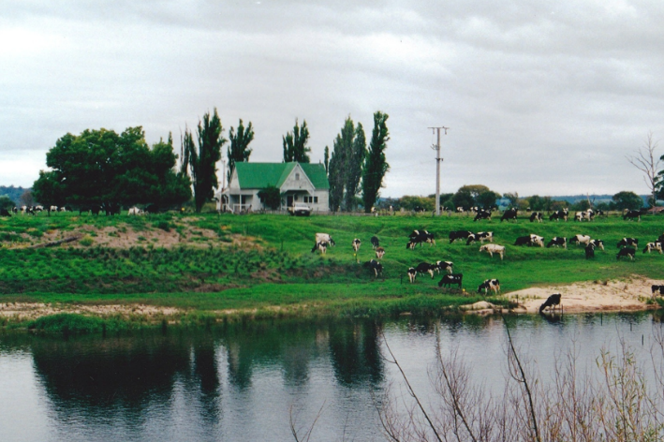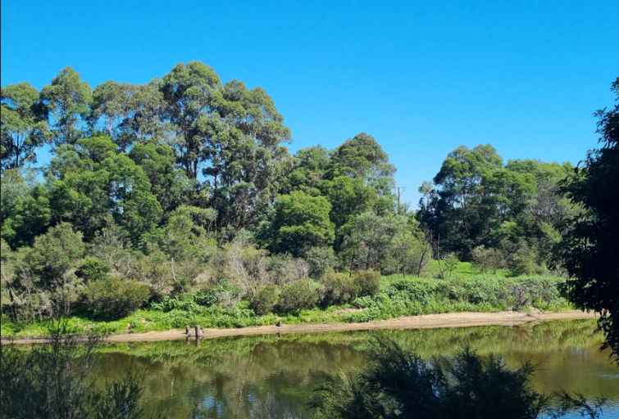
Figure 1. The Snowy River Demonstration Site (Orbost) 2002 (left) and 2024 (right).

Making the best use of environmental water
Water for the environment is delivered to meet ecological management objectives in the Victorian reaches of the Snowy River. This includes the critical need for summer and autumn base flows, and in-channel freshes. Baseflows promote the deposition of sediments and maintains in-channel habitats. Periodic freshes mobilise carbon and nutrients, boosting productivity and providing food resources for fauna, and when delivered at the right time of the year. Freshes also provide spawning and migration cues for many native fish. Maintaining flows above key thresholds in late summer and early autumn help maintain open estuary entrance conditions which benefits the ecosystem, recreation users and agriculture on the lower Snowy floodplain.

Instream habitat restoration
The CMA has also improved the river channel form and diversity and improve fish habitat availability with the re-introduction of in-stream wood. This work was completed throughout the Jarrahmond floodplain reach and in the Snowy River estuary. In the floodplain reach the structures create scour pools, trap sediment, help maintain channel form, and aid in the establishment of vegetation in the channel. In the estuary, submerged timber provides shelter and resting places for fish and other aquatic species.

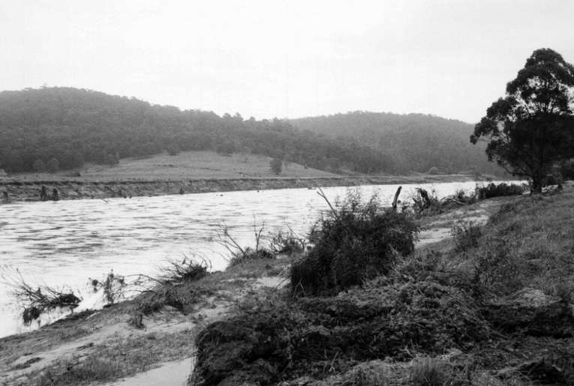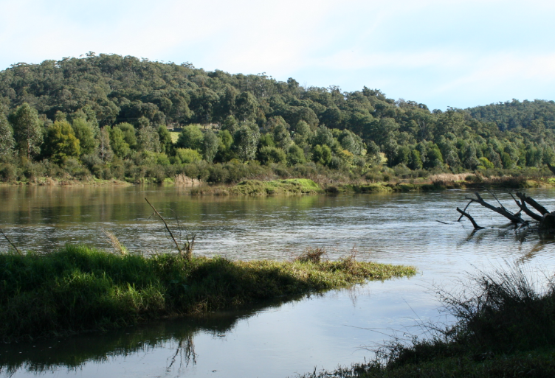
Figure 2. The Snowy River at Jarrahmond following the 1971 flood (left) and following rehabilitation works 2015 (right).

Building on past investment
As a result of past investment, we know what works for the river, and we have a stronger understanding of estuary and wetland condition to guide future management. Across the Snowy system, proven approaches include riparian fencing and revegetation to improve and diversify habitat; targeted willow and weed control with follow-up maintenance to prevent reinfestation; and strategic placement of large wood to create habitat complexity and support river channel recovery. Whilst the riparian corridor is largely restored, there remains a need for ongoing pest and weed management and greater fish habitat to enhance connectivity along the river channel.
The table below outlines potential projects in the Snowy River catchment that build on past investment and support ongoing waterway health outcomes. Weed and pest control works are best planned and delivered in conjunction with NSW to ensure long-term outcomes for the Snowy system.

Table 1: Potential projects (Snowy River Basin) Indicative budgets shown as $M p/a.
Outcome: Connectivity and waterway health
Action | Indicative budget ($M p/a) | Implementation timeframe
Introduce woody debris to the Snowy River channel to provide fish habitat and connectivity through the floodplain reach | 1.25 | 4 years
Maintain and improve riparian vegetation communities along the lower Snowy River through revegetation | 1.5 | 10 years
Protect waterway and riparian habitats through weed control maintenance (including willows) along the Victorian Snowy River to enhance vegetation communities and reduce sources of infestation | 1.0 | 10 years
Pest plant and animal control along the Victorian Snowy River corridor to support key species habitat | 2.0 | 5 years
Outcome: Climate adaptation and transition
Action | Indicative budget ($M p/a) | Implementation timeframe
Support landholders to protect and enhance floodplain wetlands | .0.5 | 10 years
Manage and maintain critical drought refuge river corridor and channel habitat during dry periods | 1.0 | 4 out of 10 years
Influence estuary entrance dynamics to maintain the health of the lower Snowy | 0.75 | 3 years
Outcome: Iconic and keystone species
Action | Indicative budget ($M p/a) | Implementation timeframe
Stock key native fish species to enhance recovery and maintain populations | 0.75 | 5 years
Research and monitoring to inform environmental water delivery and threatened species recovery | 0.75 | 5 years
Total | $58.75M | Over 10 years

References
East Gippsland Catchment Management Authority (EGCMA). East Gippsland Waterway Strategy 2014–2022. (Published 2013).
East Gippsland Catchment Management Authority (EGCMA). Improving East Gippsland Rivers: Priorities for River Health 2007–2012. (Published 2009).
East Gippsland Catchment Management Authority (EGCMA). Snowy River Rehabilitation Program Summary. (Published 2018).

