Groundwater Sustainable Yield Assessment: Overview Report
  - Groundwater Management 2030
Table of Contents
List of Figures 3
List of Tables 3
Acknowledgements 4
Glossary 5
Who should read this report? 10
At a glance 11
1. Introduction to groundwater 16
1.1. About groundwater 16
1.2. Groundwater levels 18
1.3. How we manage our groundwater 20
1.4. Things to avoid 21
2. Groundwater sustainable yield 24
2.1. The Sustainable Yield Assessment 24
2.2. Calculating groundwater sustainable yields 25
2.3. Groundwater availability and risk to sustainability 27
3. Summary of results 29
Risk to sustainability 32
4. Suitability of the output – fit for purpose 44
5. Get involved 45
Appendix A 46
Publication information 53

List of Figures
Figure 1: How groundwater is stored 17
Figure 2: How groundwater levels respond to pumping 18
Figure 3: Confined aquifer: response of groundwater levels development to
constant annual volume with seasonal pumping. 19
Figure 4: Unconfined aquifer response includes (a) natural fluctuation in
groundwater level and (b) response to climate and seasonal pumping. 20
Figure 5: Impacts of regional groundwater decline on water users as
groundwater levels continue to decline 21
Figure 6: Impacts of regional groundwater decline on the environment
(waterways) as groundwater levels continue to decline 22
Figure 7: (a) Confined aquifer: 10m metric, (b) Unconfined aquifer: 2m metric. 23
Figure 8: Groundwater annual licensed entitlement and use in Victoria (1969-2023). 27
Figure 9: Sustainable Yield and uncertainty band for confined aquifer GMUs 31
Figure 10: Sustainable Yield and uncertainty band for unconfined aquifer GMUs 32
Figure 11: Impacts of uncertainty on current risk to sustainability for confined aquifer GMUs 33
Figure 12: Current risk to sustainability for confined aquifer GMUs 34
Figure 13: Impacts of uncertainty on current risk to sustainability for unconfined aquifer GMUs 35
Figure 14: Current risk to sustainability for unconfined aquifer GMUs 36
Figure 15: Impacts of uncertainty on future risk to sustainability for confined aquifer GMUs 38
Figure 16: Future risk to sustainability for confined aquifer GMUs 39
Figure 17: Impacts of uncertainty on future risk to sustainability for unconfined aquifer GMUs 40
Figure 18: Future risk to sustainability for unconfined aquifer GMUs 41

List of Tables
Table 1: Number of areas assessed in the Sustainable Yield Assessment 30
Table A- 1: Confined aquifer GMU sustainable yield, Permissible
Consumptive Volume, entitlement and use 46
Table A- 2: Unconfined and semi-confined aquifer GMU sustainable yield,
Permissible Consumptive Volume, entitlement and use 49

Acknowledgements
The Sustainable Yield Assessment for Victoria was undertaken by DEECA in collaboration with Southern Rural Water, Goulburn–Murray Water, Grampians Wimmera Mallee Water and Lower Murray Water corporations.
A technical advisory panel provided specialist advice in the development of the assessment method. The panel comprised specialists from Deakin University (Prof. Wendy Timms), Jacobs (Dr Richard Evans) and HydroGeoLogic (Mr Hugh Middlemis).
The Sustainable Yield Assessment was completed with contributions from external industry specialists, who developed the technical details of the methodology and carried out assessments of groundwater resources. These included Jacobs Pty Ltd, GHD Pty Ltd, CDM Smith Pty Ltd, HARC Pty Ltd and Monash University (Dr Tim Peterson).

Authors
Groundwater Assessment and Modelling team, Water Resources Strategy, Department of Energy, Environment and Climate Action. 8 Nicolson Street, East Melbourne 3002.

Editor
Scientel Pty Ltd, 8 Latrobe Street, Melbourne 3000

Glossary
Glossary of terms used in this report and their definitions
Term | Definition
Allocation | The assignment of water within a given water year against a water entitlement held by a person or authority, determined by a water corporation and expressed as a percentage of the entitlement. Most groundwater allocations are triggered by declines in groundwater level.
Assessment | A systematic evaluation of groundwater resources. Groundwater assessments often involve hydrogeological investigations, modelling, and data analysis to support water management decisions, and policy development.
Cap | A colloquial/general term for an upper limit for total water entitlements that can be issued from a waterway, catchment basin or groundwater area for a set time period. This includes Permissible Consumptive Volumes (under the Water Act 1989) and Permissible Annual Volumes and Allowable Annual Volumes (under the Groundwater (Border Agreement) Act 1985).
Consumptive use | Water removed from the available supply without return to the water resource system. All extractive uses, including water used for agriculture, industry and commerce, including stock and domestic purposes.
Domestic and stock | Water taken for household use, kitchen garden, fire prevention and watering of livestock. Victorians have basic rights to water for under section 8 of the Victorian Water Act 1989. These rights allow a person to take water from a bore, dam, river or stream to use for domestic and stock purposes.
Entitlement | A right to use water in a waterway, water in storage works of a water corporation, and groundwater. It also includes the right to water corporations to supply water. Water entitlements include bulk entitlements (generally issued to water corporations), environmental entitlements, water rights, surface water and groundwater licences. The term also can be used to mean the volume of water authorised to be taken and used by the holder.
Groundwater drawdown | It is the decline in hydraulic head or water table elevation resulting from groundwater extraction or natural discharge processes. It is quantitatively expressed as the difference between the static (pre-development) water level and the dynamic (post- development) water level.
Groundwater level | It refers to the potentiometric surface or the water table position within an aquifer, typically measured as the hydraulic head in a bore relative to a specified datum (e.g., mean sea level, or metres above Australian Height Datum (mAHD)). It represents the equilibrium state of groundwater under natural or disturbed conditions and is influenced by recharge, discharge, and external stresses such as pumping and climate variability.
Groundwater level restrictions trigger | A new term defined as – “A defined groundwater level for a system that triggers restrictions on use”, generally implemented through water shortage declarations, approved management plans for a Water Supply Protection Area, Local Management Plans and in some cases through licences or Bulk Entitlements.
Groundwater Management Area (GMA) | An area where groundwater has been intensively developed or has the potential to be. Groundwater Management Areas generally have a Permissible Consumptive Volume set by Minister for Water through statutory declaration.
Groundwater Management Unit (GMU) | Refers to both Groundwater Management Areas and Water Supply Protection Areas.
Licensed use (water) | The volume of water taken under a licence(s) to take and use water for consumptive use. It excludes the volume of water taken for domestic and stock purposes under Section 8, Water Act 1989.
Licensed entitlement | A right to use water (and supply) in a waterway, water in storage works of a water corporation, and groundwater. Water entitlements include bulk entitlements (issued to water corporations), environmental entitlements, surface water and groundwater licences.  The term also can be used to mean the volume of water authorised to be taken and used by the holder.
Licence to take and use | A fixed-term entitlement under section 51 of the Water Act 1989 to take and use water from a waterway, catchment dam, spring, soak or aquifer. Each licence is subject to conditions set by the Minister for Water and specified on the licence.
Limits of take under licence | Refers to both caps on entitlements and any management prescriptions that limit take and entitlements such as groundwater level restrictions triggers that restrict use in a particular season.
Megalitre (ML) | One million litres.
Permissible Consumptive Volume (PCV) | The maximum volume of water entitlements that can be allocated in an area or a water system.
Recharge | The natural or managed process of water moving into the ground and replenishing groundwater aquifers
Recovered groundwater level | The level of groundwater that has been restored after a period of decline. Groundwater levels can decline due to pumping, seasonal drought, or other factors.
Sustainable yield | The groundwater extraction regime measured over a 20-year planning timeframe, allowing for acceptable levels of impact that protect dependent values.
Sustainable yield metric | A measure that defines the acceptable level of impact that protects dependent ‘values’ for the assessed sustainable yield volume.
Throughflow | The lateral movement of groundwater in an aquifer.
Unincorporated Area (UA) | Groundwater areas which are not defined as Groundwater Management Units and do not have a defined Permissible Consumptive Volume.
Use (water) | The volume of water taken (such as groundwater extracted) for consumptive use.
Water Supply Protection Area (WSPA) | An area declared under section 27 the Victorian Water Act 1989 to protect the groundwater or surface water resources or both through the development of a statutory management plan.
Waterway | A river, creek, stream or watercourse, a natural channel in which water regularly flows (whether the flow is continuous or not), a lake lagoon, swamp, or marsh.

Who should read this report?
This report is designed to provide a high-level summary of the Sustainable Yield Assessment. Whether you are a water resource manager, a groundwater user, or simply interested in water sustainability, this report will help you understand key findings of the Sustainable Yield Assessment.
- Water resource managers – Gain insights into sustainable yield estimates, risk classifications, and how they can guide groundwater management decisions.
- Groundwater users – Understand how sustainable yield volumes may affect groundwater availability and future groundwater use.
Community members – Discover how groundwater sustainability is assessed and what it means for water resources and ecosystems.
For more details on how to engage with groundwater management decisions, see the “Get Involved” section.

At a glance

About Groundwater Management 2030
Groundwater Management 2030 (GM2030) is a statement of priorities to 2030 for the Department of Energy, Environment and Climate Action (DEECA) and the rural water corporations (Lower Murray Water, Goulburn–Murray Water, Grampians Wimmera Mallee Water and Southern Rural Water). It is the Victorian water sector’s commitment to strong groundwater management that can adjust to meet opportunities and challenges as water use and industry transform in the future.
GM2030 aims to deliver three outcomes:
- an improved, shared understanding of groundwater and its uses for evidence-based management
- modern tools in the statewide framework for flexible and cost-effective groundwater management
streamlined and effective licensing, trade rules and controls on groundwater use that support changing water uses.
The Sustainable Yield Assessment is Priority Area 1 under GM2030. Priority Area 1 under GM2030 states “Water availability and limits on take: DEECA working with the rural water corporations will carry out a state-wide technical assessment and review of the limits of take under licences”. The Sustainable Yield Assessment addresses Priority Area 1, and the information gained will inform broader groundwater reform initiatives under the GM2030”.

Groundwater sustainable yields
The Sustainable Yield Assessment is a simple and cost-effective statewide generic method for evaluating sustainable yield volumes and their uncertainties. In areas where simple or generic methods may not be appropriate, more specific methods are to be developed.
It provides a consistent way to assess the risk from licensed groundwater extraction across the state, which means we can focus our efforts where they matter most, checking whether current management is working and, where needed, exploring other ways to manage the risk.
A groundwater sustainable yield is defined as “the groundwater extraction regime measured over a 20-year planning timeframe, allowing for acceptable levels of impact that protect dependent values”. For the purpose of this assessment this is defined as the change in regional groundwater levels since the take of groundwater (development level) and is 10m for confined aquifers and 2m for unconfined aquifers. These are called sustainable yield metrics.
The Sustainable Yield Assessment was conducted statewide – over 1,000 areas were assessed for sustainable yield, considering both confined and unconfined aquifers.
Most groundwater use (90%) occurs in Groundwater Management Units (GMUs) as opposed to Unincorporated Areas (UAs) (10%). GMUs have defined caps on the total licensed entitlements that can be issued. Statewide usage is distributed 60% in unconfined aquifer GMUs and 40% in confined aquifer GMUs. All GMUs were assessed for a sustainable yield and some GMUs were assessed at a subzone level. The sustainable yield estimates were then compared to the volume of licensed entitlements, the cap on licensed entitlements and the average use in each GMU/GMU zone.
Sustainable yield volumes range from 120 ML/yr to 43,500 ML/yr, with an average of 8,600 ML/yr across all GMUs/GMU Zones. Groundwater use (average use from 2016 to 2021) in most of the GMUs/GMU Zones across Victoria is less than the estimated sustainable yield. Regional groundwater level decline associated with that use are within the adopted sustainable yield metrics.
In six GMUs/GMU zones, groundwater use exceeds the sustainable yield volumes. Three of these areas have defined “groundwater level restriction triggers” in place to manage groundwater levels sustainably, and the remaining three have implemented restrictions on occasions in recent years, based on assessment at the time. A review of the triggers has not been undertaken but is recommended to ensure these triggers are appropriate.
Climate change does not directly affect the future availability and sustainability of groundwater in confined aquifers. However, unconfined aquifers may be significantly influenced, with the range of projected changes in sustainable yields spanning up to a 50% decrease (drier climate) to more than 200% increase (wetter climate) based on plausible scenarios of future climate.
Licence entitlement volumes are greater than the sustainable yield in 27 GMUs/GMU zones, and the existing licence volume caps exceed the sustainable yield in 39 GMUs/GMU zones. Currently, groundwater use is approximately 35% of licensed entitlements, indicating the potential for increased use to occur. This may occur through licence holders increasing take up to 100% of their entitlement and/or trading the unused part of their entitlements. Therefore, the future availability and sustainability of groundwater could be at risk if use increases. The future demand for groundwater use has not been assessed in the Sustainable Yield Assessment.
Caps manage the volume of entitlement that is allocated in an area and pre-defined groundwater level restriction triggers have been put in place in some areas to manage use in a particular year to ensure groundwater levels are sustainable. Fifty-nine of the sixty-six GMUs/GMU zones do not have pre-defined groundwater level restriction triggers, highlighting a gap in the current limits of take. Moreover, in unincorporated areas, use could increase through issuing new entitlements as no caps are currently in place.
The assessment did not assign study areas based on salinity which ranges up to 35,000 mg/L total dissolved solids. While sustainable yield volumes could give the impression that more groundwater is available for use, salinity is a major determinant of usability of groundwater and salinisation of existing usable aquifers can be caused by excessive use.
Further work may be required to:
- classify groundwater resources and sustainable yield study areas according to salinity ranges
- review the effectiveness of existing groundwater level restriction triggers against their objectives to inform improved future management
undertake specific studies where sustainable yield estimates are under review.

Further resources
Two companion reports on the Sustainable Yield Assessment can be found on the Groundwater Management 2030 website. The first report, the Methodology Report, provides the technical basis of the method, including how the sustainable yield volumes are estimated. The technical assessment provides a broader picture to support the conclusions discussed in this report.
The second report, the Synthesis Results Report, details the findings for each of the 66 GMUs and GMU sub zones assessed in Victoria, as well as results for areas outside of the GMUs. This report is a useful reference for the specifics of how groundwater availability may change and the key risks to the resource.
Together, these three reports provide a comprehensive assessment of groundwater availability and associated risks in Victoria.

Next steps
The outcomes of the Sustainable Yield Assessment will inform GM2030, and the work being carried out by DEECA and the rural water corporations. The Sustainable Yields Assessment has been undertaken as a foundational piece of work under Groundwater Management 2030 (GM2030). GM2030 is working towards a groundwater licensing and management framework that can adjust to meet future opportunities and challenges and make the best, sustainable use of available water in a drying climate.
The GM2030 team will work with water users, Traditional Owners, stakeholders and the community on continued implementation of GM2030. Anyone can register to be involved or receive future communication on GM2030 by emailing GM.2030@deeca.vic.gov.au. At a local level, there will be no immediate changes to local management as a result of this assessment. Rural water corporations will continue to manage groundwater in consultation with licence holders and the community. These activities include implementing and regularly reviewing management plans. Rural water corporations will use the Sustainable Yield Assessment to help prioritise and inform reviews of local management, alongside the other available information they currently consider in making management decisions.

Introduction to groundwater
- This is the first statewide assessment of the impact of extraction on groundwater levels across all of Victoria.
- The Sustainable Yield Assessment identifies whether there are any risks to groundwater from use or climate change. This assessment is outlined in Priority Area 1 of GM2030.

About groundwater
Groundwater is fundamental for our economy, environment, communities and cultural values. It is consumed in many ways and is essential for drinking, cleaning, manufacturing, generating power and irrigation. Our waterways and their surrounds also rely on groundwater to support baseflows to allow them to stay healthy, provide habitats for plants and animals (including fish and birds), and be the green, cool, natural places that Victorians value so highly. Cultural sites and values of significance to Traditional Owners can also depend on groundwater.
Groundwater is stored in aquifers, underground layers of rock or unconsolidated material (gravel, sand or silt), which can store and yield volumes of usable water. Sedimentary aquifers are layered on top of each other and are separated by low-permeability aquitards, which restrict the flow of groundwater (Figure 1). The Victorian Aquifer Framework defines 11 aquifers, and 4 aquitards across Victoria. The sedimentary aquifers and basaltic aquifers are grouped into lower, middle and upper aquifers with bedrock (or basement) aquifer underlying all of these aquifers, as illustrated in Figure 1.
Figure 1: How groundwater is stored
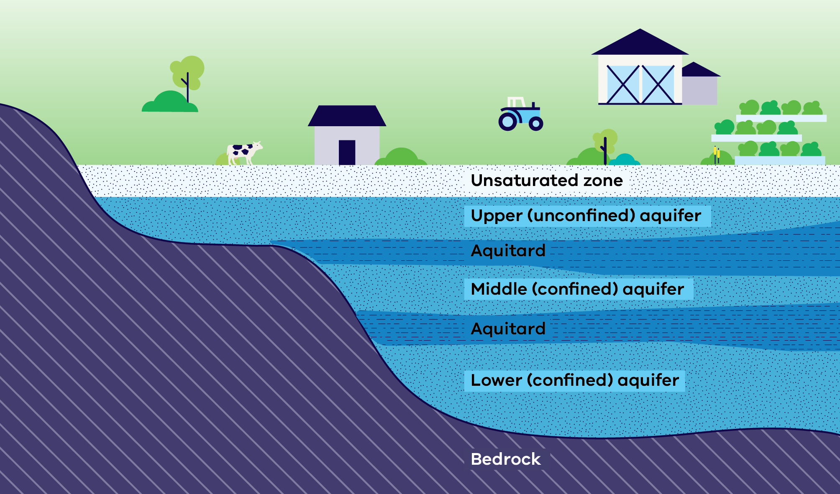
Aquifers will respond to climate and groundwater processes differently, depending on whether they are confined or unconfined. The main processes that affect groundwater availability for different aquifers are:
Unconfined aquifers are recharged by water seeping from the surface down to the watertable from rainfall, irrigation and connection to waterways, and discharge to waterways and coastal systems.
In confined aquifers, the groundwater is isolated from the atmosphere by low permeable geologic formations (aquitards). Confined aquifers are generally subjected to pressure greater than the atmosphere and respond more slowly to changes in recharge. As a result, groundwater levels in confined aquifers are more responsive to groundwater pumping than to rainfall.
Semi-confined aquifers are transition areas where a confined aquifer starts to become unconfined due to thinning of the overlying aquitard. Responses in semi-confined aquifers may reflect the overlying unconfined aquifer or the confined aquifer responses.

Groundwater levels
The depth to groundwater varies according to the locality and the aquifer. When a bore is pumped, it lowers the water level in the bore, followed by the area in the aquifer adjacent to the bore. This lowering of the water level is called a “cone of depression”.
Figure 2: How groundwater levels respond to pumping
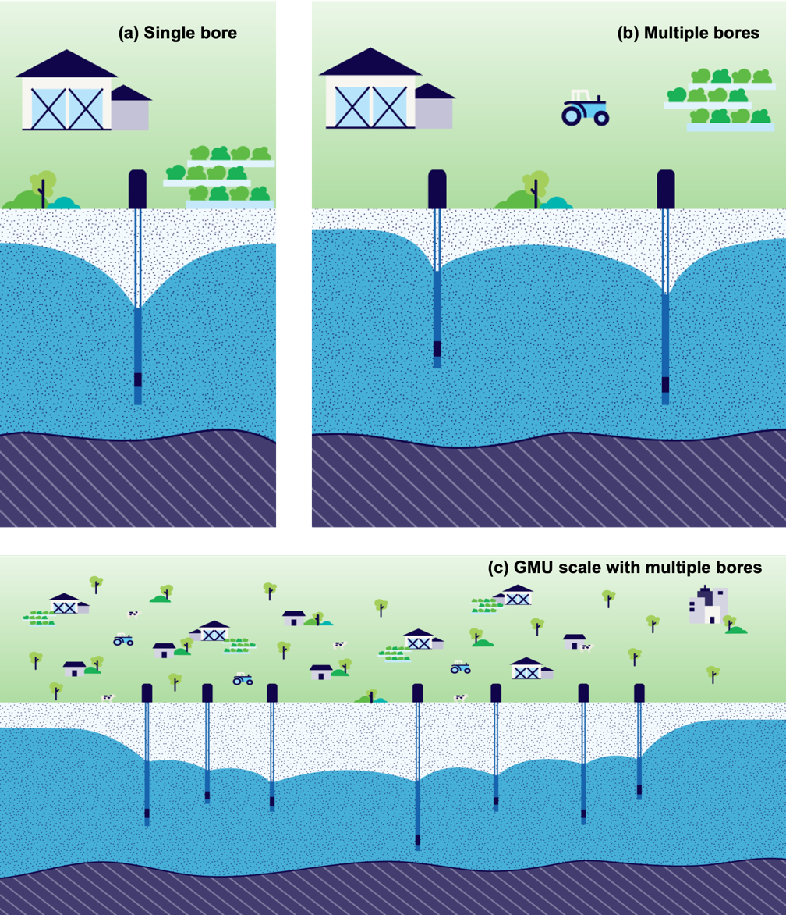
If two pumping bores are located nearby, the cones of depression can merge. If the bores exhibit sufficient density, the cones of depression from multiple bores can merge, causing a regional cone of depression (Figure 2).
The regional cones of depression may recover when pumping ceases. The rate depends on the type of aquifer and locality and tends to be unique for each groundwater resource or system. Most groundwater in Victoria is used over summer for irrigation. Regional cones of depression tend to recover in the non-pumping season, a term known as the “regional groundwater recovered level”. The regional groundwater recovered level is one of the measures used to monitor the trends and conditions of groundwater resources.
Unconfined aquifers are connected to the atmosphere and respond to pumping, discharge and recharge (for example, rainfall, flooding, irrigation, waterways). Confined aquifers generally have a weak connection with the atmosphere, and their groundwater levels primarily respond to pumping. These groundwater levels respond differently over time for confined and unconfined aquifers (Figure 3 and Figure 4).
Figure 3: Confined aquifer: response of groundwater levels development to constant annual volume with seasonal pumping.
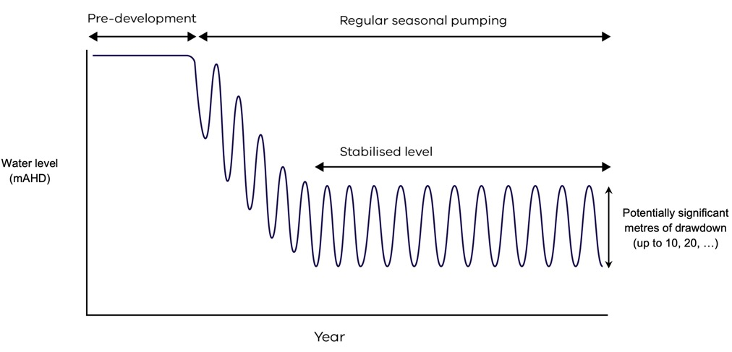

Figure 4: Unconfined aquifer response includes (a) natural fluctuation in groundwater level and (b) response to climate and seasonal pumping.
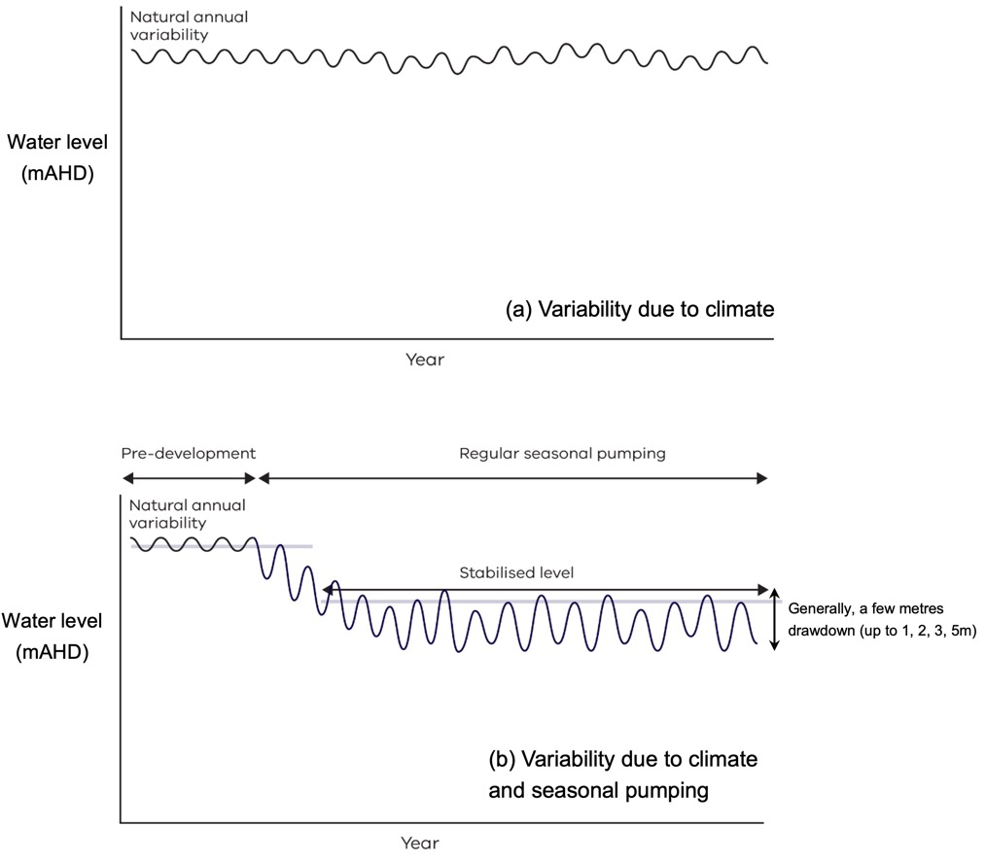

How we manage our groundwater
The Victorian Water Act 1989 and associated water entitlements framework provides for how surface water and groundwater are shared and managed.
Access to groundwater is managed through take and use licences, which provide limits on how much water can be taken from an aquifer and when. In areas where there are many groundwater users, management areas are defined, and caps are set on the total volume of entitlement that can be issued.
Most groundwater use (90%) occurs in Groundwater Management Units that have defined caps on the total licensed entitlements that can be issued. Statewide, usage is distributed 60% in unconfined aquifer GMUs and 40% in confined aquifer GMUs. Use is only restricted under certain circumstances, such as through groundwater level restriction triggers that may be defined in management plans for Water Supply Protection Areas (WSPAs), seasonal allocations, or water shortage declarations during periods of drought, or less formally in local management plans (LMPs). Most groundwater users are not in areas where limits on use through groundwater level restriction triggers may be applied.

Things to avoid
Uncontrolled declines in regional groundwater levels can impact groundwater users and environments. While a small decline in groundwater levels may have negligible impacts, moderate declines may lead to supply interruptions and reduced flow to environments. Large or ongoing declines in groundwater level may lead to permanent loss of supply to users and environment (Figure 5 and Figure 6). Groundwater resource managers seek to avoid the resulting economic and environmental consequences.
Figure 5: Impacts of regional groundwater decline on water users as groundwater levels continue to decline
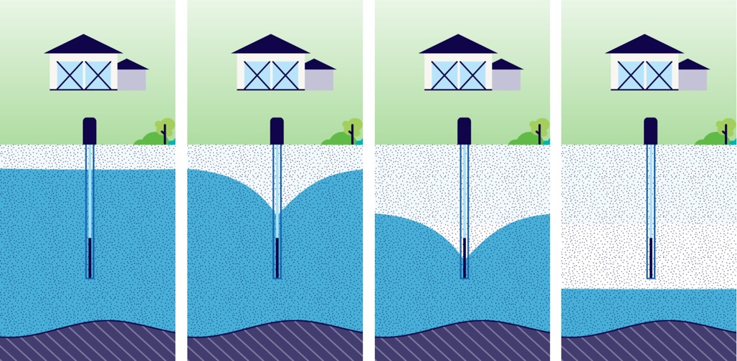
Figure 6: Impacts of regional groundwater decline on the environment (waterways) as groundwater levels continue to decline
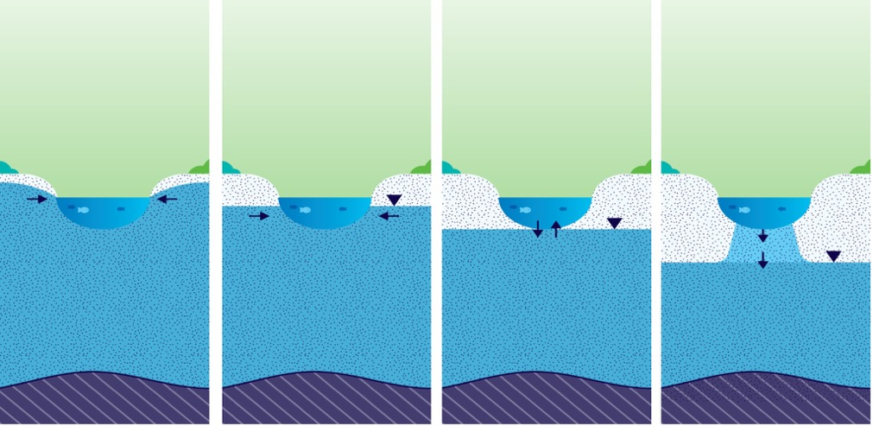
It is important for resource managers to understand the acceptable regional groundwater drawdown level. Current challenges faced by resource managers result from a lack of defined acceptable levels of drawdown. There is no standard or nationally agreed position on acceptable levels of drawdown, and information on licenced bores (for example pump depths and screen intervals) is not readily available to inform acceptable limits. In the absence of a standard or nationally agreed position, the Sustainable Yield Assessment has adopted acceptable regional drawdowns as follows (Figure 7):
- 10 m for confined aquifers
2 m for unconfined aquifers.
The 2 m and 10 m drawdowns represent the difference between the recovered water levels as compared to the predevelopment levels (Figure 7). These levels of drawdown are termed sustainable yield metrics.
For confined aquifers, 10m metric is based on groundwater management plans. The assessors agreed that the existing 10m metric currently used in groundwater management plans had been successful for maintaining the health of confined aquifers. For unconfined aquifers, the 2 m metric approximately equates to 10% of the available drawdown, which uses 10% interference rule based on standard practice for licensing applications. These levels of drawdown are what the scientific panel agreed would establish sustainable yield metrics, that when met would give the best chance of healthy groundwater landscapes over the next 20 years.
Figure 7: (a) Confined aquifer: 10m metric, (b) Unconfined aquifer: 2m metric.
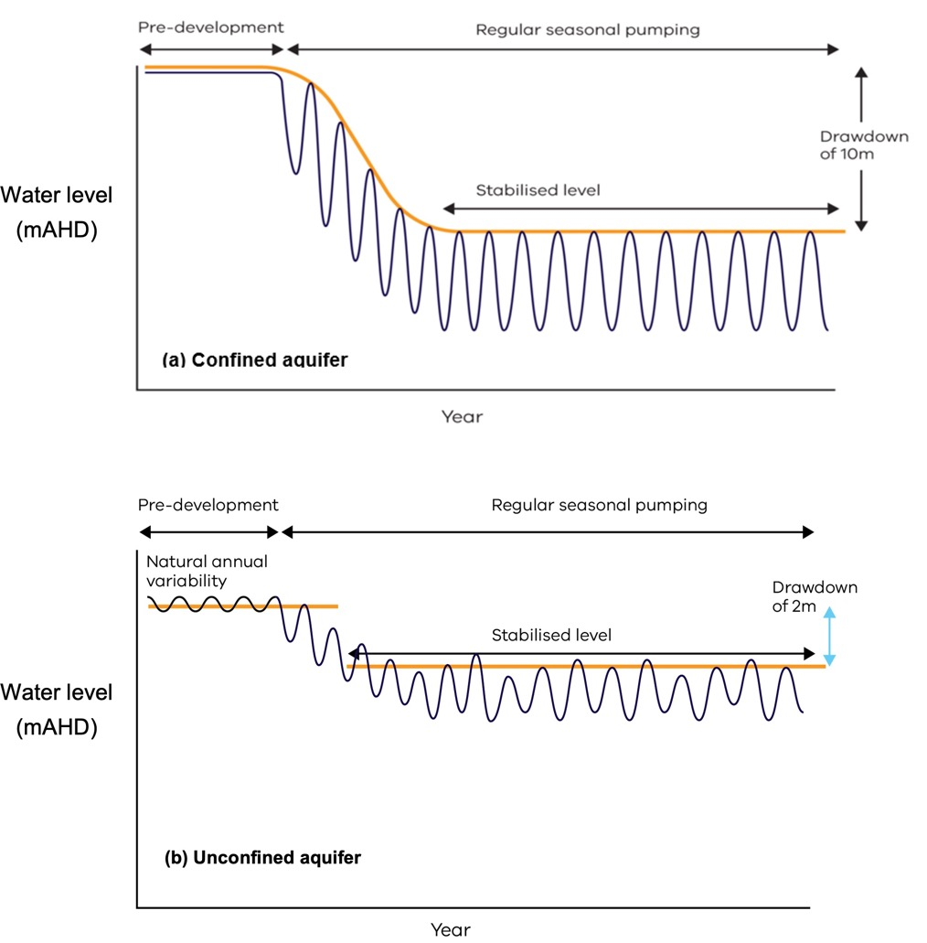

Groundwater sustainable yield
Key Points
- For the purpose of this assessment, groundwater sustainable yield is defined as “the groundwater extraction regime measured over a 20-year planning timeframe, allowing for acceptable levels of impact (10m in confined aquifers and 2m in unconfined aquifers) that protect groundwater dependent values”.
- The method used to calculate sustainable yield volumes prioritised simplicity and cost-effectiveness tailored to address uncertainties that affect decision making.
- In areas where simple or generic methods may not be appropriate more specific methods are to be developed.

The Sustainable Yield Assessment
The Sustainable Yield Assessment responds to the need to have up-to-date data to enable us to understand groundwater availability and sustainability. Victorian government agencies must be able to act if the assumptions regarding available groundwater become outdated or inaccurate.
The Sustainable Yield Assessment provides a new information source that will support the next evolution in groundwater management, including in managing risks from climate change, now and into the future. It is the first time we have done a statewide assessment of groundwater availability across all Victoria.
The Sustainable Yield Assessment provides important information to water managers and users, improving transparency and a shared understanding. It will enable more informed and adaptive decision making to support sustainable groundwater use, where reliability of supply and groundwater-dependent ecosystems are protected.
The Sustainable Yield Assessment was applied to all aquifer types across Victoria. It used all existing information known about historical and current use and management in local and regional groundwater landscapes to determine potential for future adverse impacts from climate change and increased groundwater use.
The objectives of the Sustainable Yield Assessment are to develop simple and cost-effective statewide generic methods for evaluating sustainable yield volumes and their uncertainties. In areas where simple or generic methods may not be appropriate more specific methods are to be developed.
Groundwater sustainable yield is defined as the groundwater extraction regime measured over a 20-year planning timeframe, allowing for acceptable levels of impact that protect dependent values. This is defined as change in regional groundwater levels since groundwater development and is 10m for confined aquifers and 2m for unconfined aquifers. These are called sustainable yield metrics.
The Sustainable Yield Assessment utilises extensive data sets and hydrogeological information that has been obtained since the last state-wide assessments for caps in the 1990s. In addition to an expanded groundwater level observation network established in the 1970s, this includes metered groundwater use since 2004, and many hydrogeological studies and assessments. Technological advances in computing contribute significantly to this assessment, with new modelling and statistical analyses, information systems (databases, geographic information systems (GIS)) used for the analysis of these statewide data sets, and presentation of outputs statewide.
The specific outputs of the assessed sustainable yields are expressed as ML/yr for the current GMUs, with some GMUs assessed as multiple GMU zones, and for the UAs (new project study areas). Some GMUs have been assessed at a sub-zone level, which means one GMU will have multiple sustainable yields.

Calculating groundwater sustainable yields
Sustainable yield volumes, expressed as ML/yr, were calculated based on the relationship of groundwater level declines from use (and climate for unconfined aquifers) for each GMU. The drawdown–use relationships were derived from statistical models. These models used statewide data of groundwater level observations and metered use, as well as climate data for unconfined aquifers. Each sustainable yield volume comes with a measure of the uncertainty of the assessment.
For confined aquifer GMUs, the calculated sustainable yield volume is the annual volume extracted that results in the regional 10 m drawdown over 20 years (Figure 7a).
For unconfined aquifer GMUs, the calculated sustainable yield volume is the annual volume extracted that results in a 2m average recovered drawdown over the 20-year period 2021–40 (Figure 7b). The modelled scenario is based on historic rainfall from 1975 to 2020, with a high greenhouse emissions scenario (RCP8.5), and modelling low, medium and high scenarios for 2040 and 2065. The 2040 no climate change scenario was used to estimate the sustainable yield volume. The no climate change scenario provides the baseline to assess the impact of future use and climate change and enables the verification of results against historical use and climate conditions.
In areas outside of GMUs, there is limited information on groundwater use and level. In these areas, the sustainable yield volumes are calculated from a percentage of throughflow for confined aquifers, and a percentage of recharge for unconfined aquifers. The percentages are calculated based on the average values across GMUs with accepted drawdown–use relationships. For confined aquifer UAs, a state-wide area-weighted average of 30% of throughflow was used to estimate sustainable yield volumes. For unconfined aquifer UAs, the percentage applied was based on the average across GMUs with accepted drawdown–use relationships, resulting in a value of 3% of recharge.
Semi-confined aquifer GMUs have been identified in northern and central Victoria. Most of these GMUs are unconfined with part of the aquifer confined or identified as having inter-aquifer leakage/connection. The degree of connection can be highly variable. For the purposes of reporting sustainable yield volumes, the semi-confined aquifer GMUs are reported with unconfined aquifer GMUs.

Groundwater availability and risk to sustainability
The risk to groundwater sustainability (that potential for groundwater level decline below acceptable levels) is assessed through comparison of groundwater use against sustainable yield volumes to identify current risk. The uncertainty in the sustainable yield volume, represented by the upper and lower bounds of sustainable yield, can increase or decrease this risk to sustainability.
The future risk to sustainability is assessed by reviewing the potential for increases in use up to the limits of take and/or due to climate change reducing groundwater recharge in unconfined aquifers. The potential for future use to increase up to the limits of take is the most significant risk as current statewide use is at around 35% of licensed entitlements (Figure 8).
Figure 8: Groundwater annual licensed entitlement and use in Victoria (1969-2023).
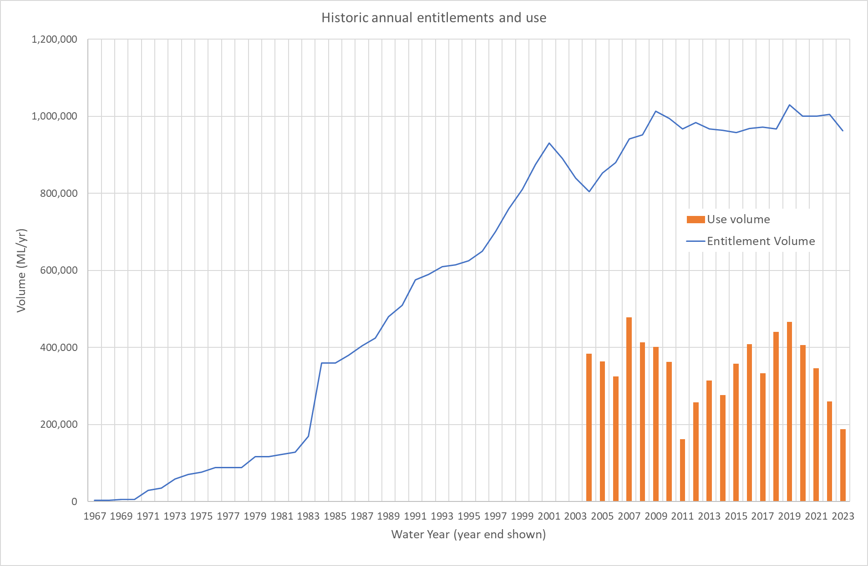

Summary of results
Key findings:
- Over 1000 areas have been assessed for sustainable yield.
- Most groundwater use in Victoria is less than the sustainable yield. In six of the 66 GMUs/GMU zones, use exceeds the sustainable yield volumes.
- Three of these areas have some form of groundwater level restriction triggers already in place to manage groundwater levels.
- Climate change is a potential risk to groundwater sustainability for unconfined aquifer GMUs given their connection to surface water.
- The future availability and sustainability of groundwater could be at risk if use increases, particularly where licence entitlement volumes are greater than the sustainable yield in 27 GMUs/GMU zones, and the existing licence volume caps exceed the sustainable yield in 39 GMUs/GMU zones, and no groundwater level restriction triggers are in place.
- There are risks in Unincorporated Areas where caps are not in place.
The Sustainable Yield Assessment was conducted statewide – over 1000 areas were assessed for sustainable yield, considering both confined and unconfined aquifers (Table 1).
The Sustainable Yield Assessment did not assign study areas based on salinity which ranges up to 35,000 mg/L total dissolved solids. While the sustainable yield could give the impression that more groundwater is available for use, salinity is a major determinant of usability of groundwater with most licensed groundwater use less than 1800 mg/L total dissolved solids.
A summary of the estimated sustainable yield volumes, including current use and licensed entitlements for each of Victoria’s 66 GMUs/GMU zones are presented in Appendix A. Results for the UAs are provided in the Sustainable Yield Assessment Synthesis Results Report.
Fourteen of the assessed GMUs/GMU zones do not have a derived SY volume as it was either not suitable for the assessed area (i.e. method was not appropriate or there were data constraints) or it is under review with further work required.
Table 1: Number of areas assessed in the Sustainable Yield Assessment
Aquifer type | GMUs/GMU Zones | UAs
Confined | 22 | 33
Unconfined | 44 | 1,182
Sustainable yield volumes for the confined aquifer GMUs/GMU zones range from 900 ML/yr to 23,900 ML/yr, with an average of 5,900 ML/yr (Figure 9). The average uncertainty for confined aquifer GMUs/GMU zones is in the order of - 42% to + 36% of the sustainable yield volumes (Figure 9).
Figure 9: Sustainable Yield and uncertainty band for confined aquifer GMUs
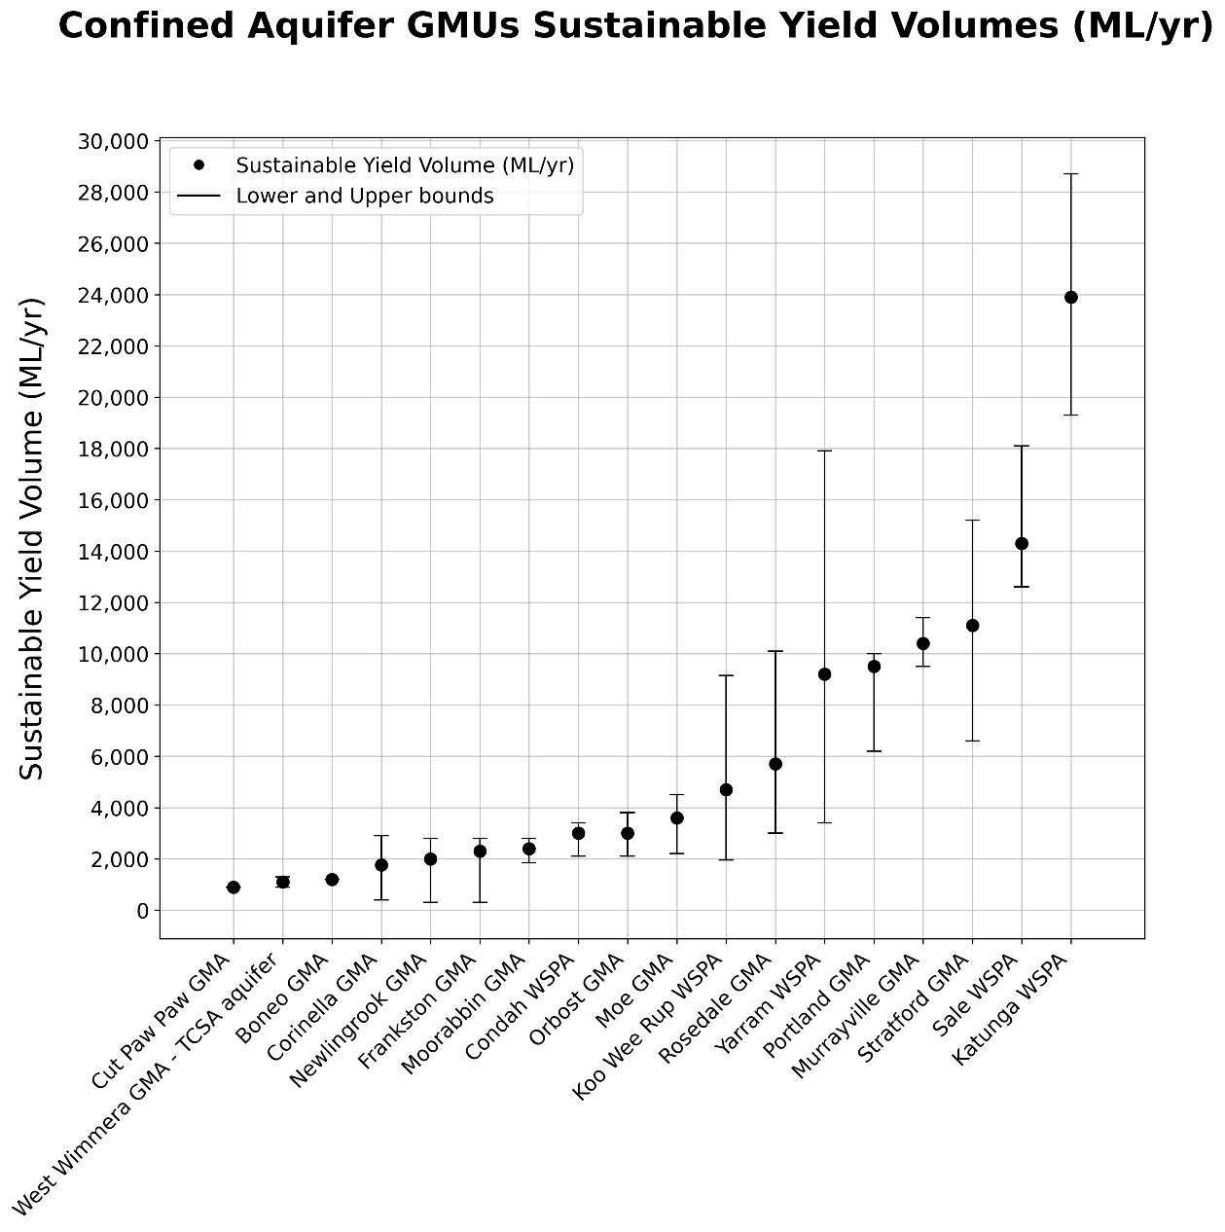
Sustainable yield volumes for the unconfined aquifer GMUs/GMU Zones range from 200 ML/yr to 43,500 ML/yr, with an average of 7,000 ML/yr. The average uncertainty for unconfined aquifer GMUs/GMU Zones ranges from -50% to +200% of the sustainable yield volumes (Figure 10).

Figure 10: Sustainable Yield and uncertainty band for unconfined aquifer GMUs
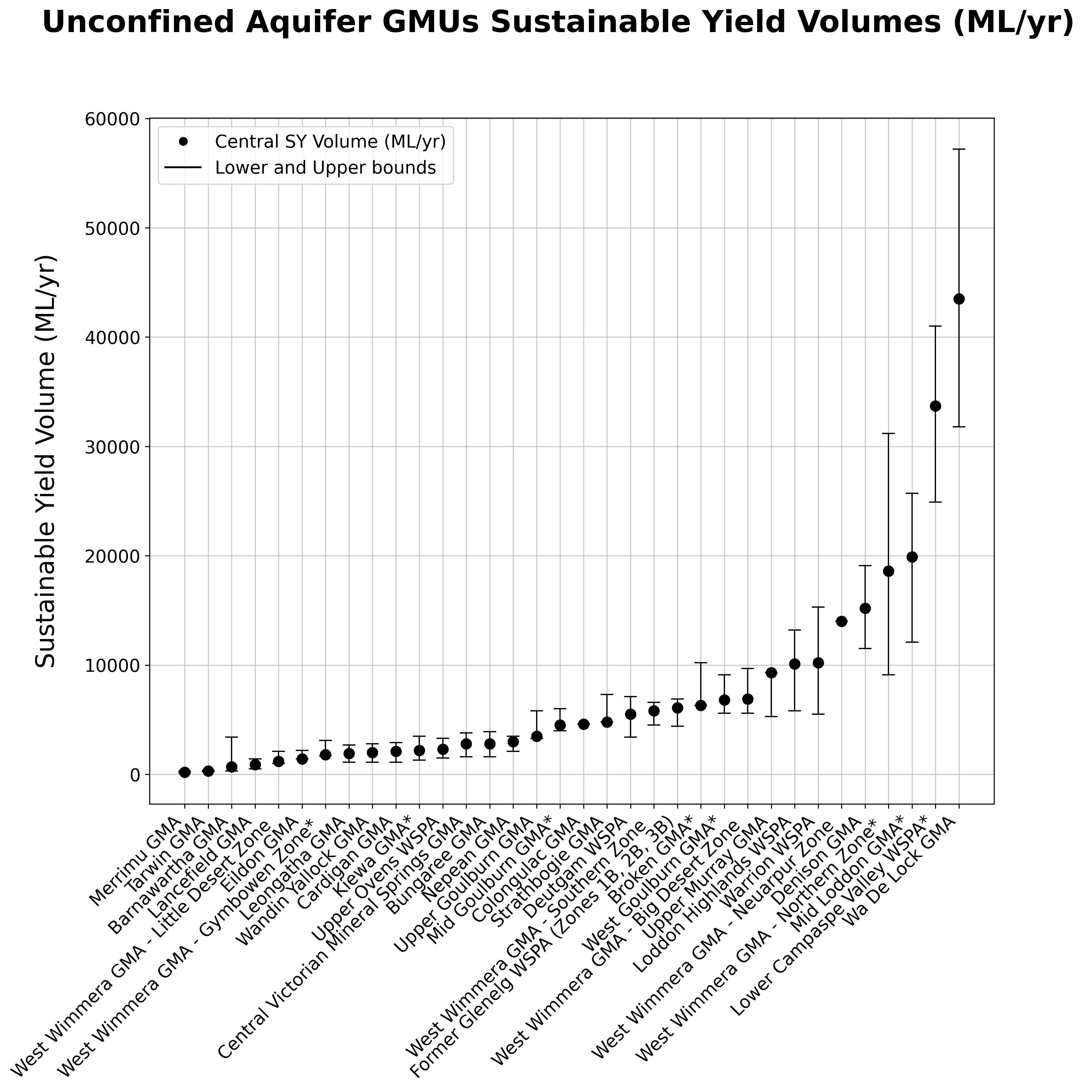

Risk to sustainability
Groundwater use in most of the GMUs/GMU Zones across Victoria is less than the estimated sustainable yield. Regional groundwater level decline associated with that use is within the adopted sustainable yield metrics for most GMUs/GMU Zones.
In six GMUs/GMU zones, groundwater use exceeds the sustainable yield volumes (Figure 11 to Figure 14) Three of these areas have “groundwater level restriction triggers” in place to manage groundwater levels sustainably and three have implemented restrictions on occasions in recent years. A review of the triggers has not been undertaken but is recommended to ensure these triggers are effective.
Figure 11: Impacts of uncertainty on current risk to sustainability for confined aquifer GMUs
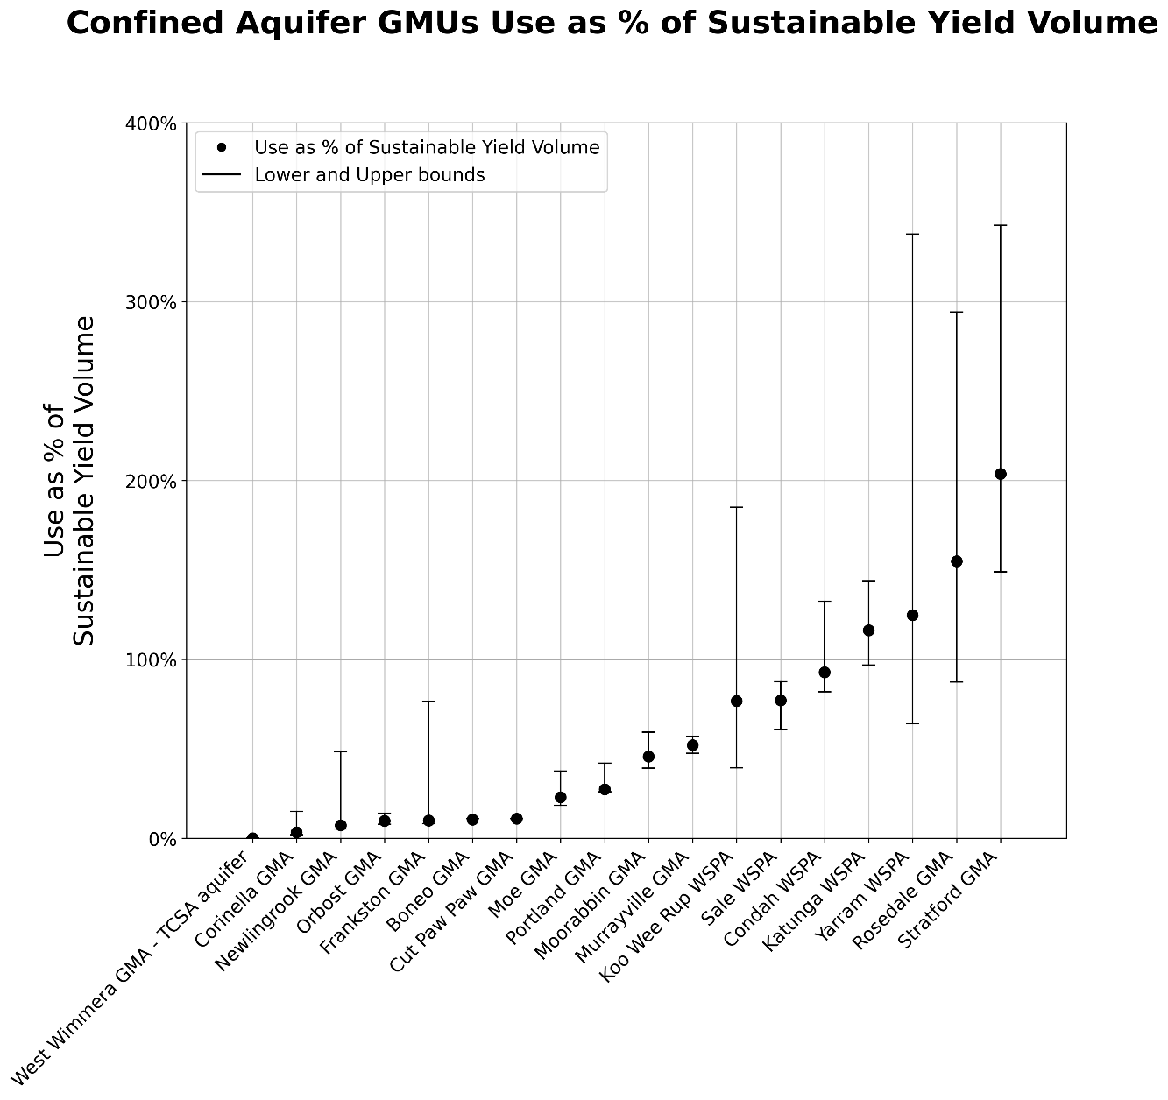
Figure 12: Current risk to sustainability for confined aquifer GMUs
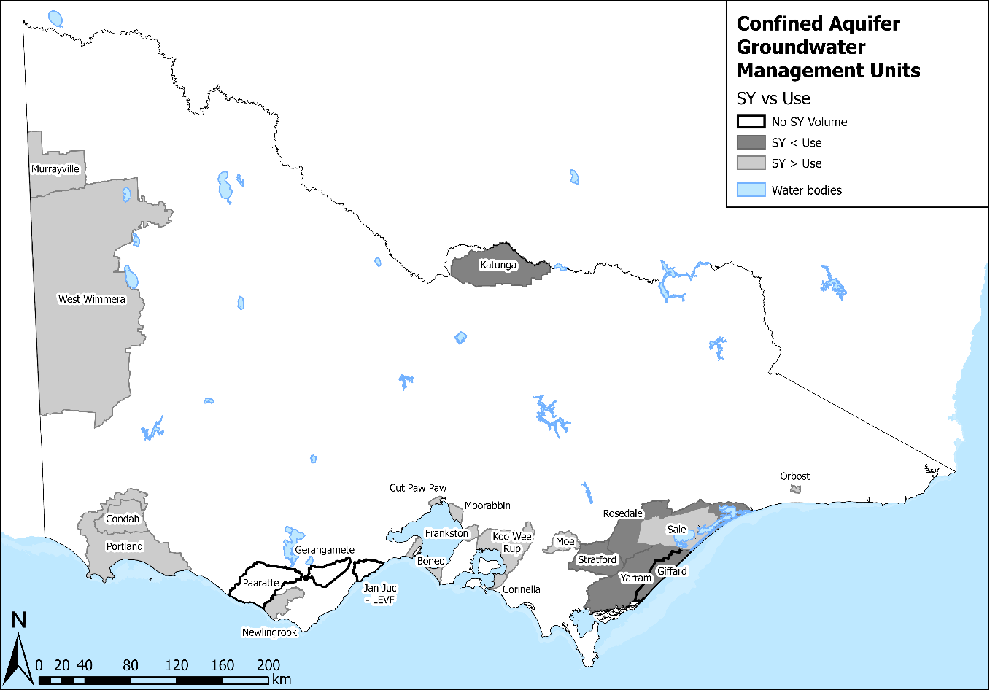

Figure 13: Impacts of uncertainty on current risk to sustainability for unconfined aquifer GMUs
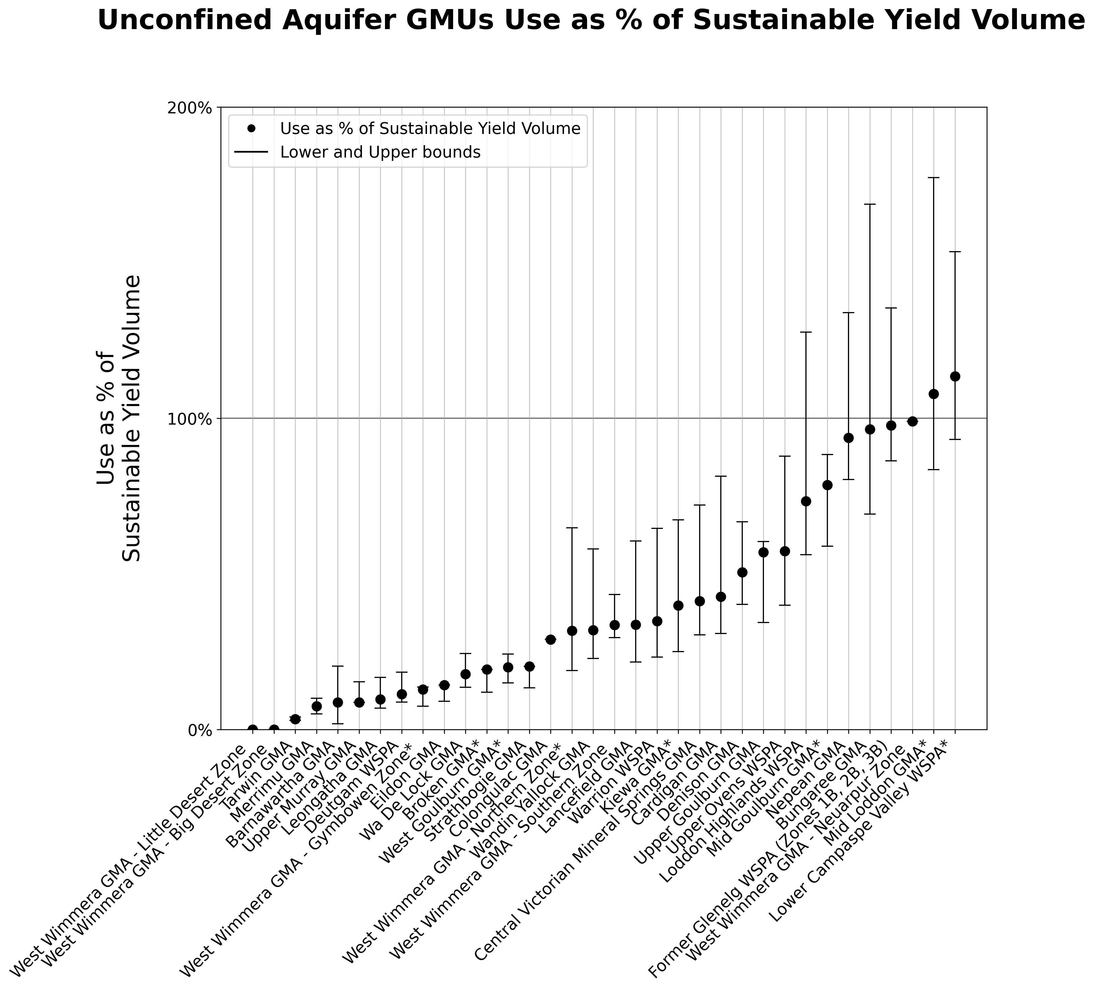

Figure 14: Current risk to sustainability for unconfined aquifer GMUs
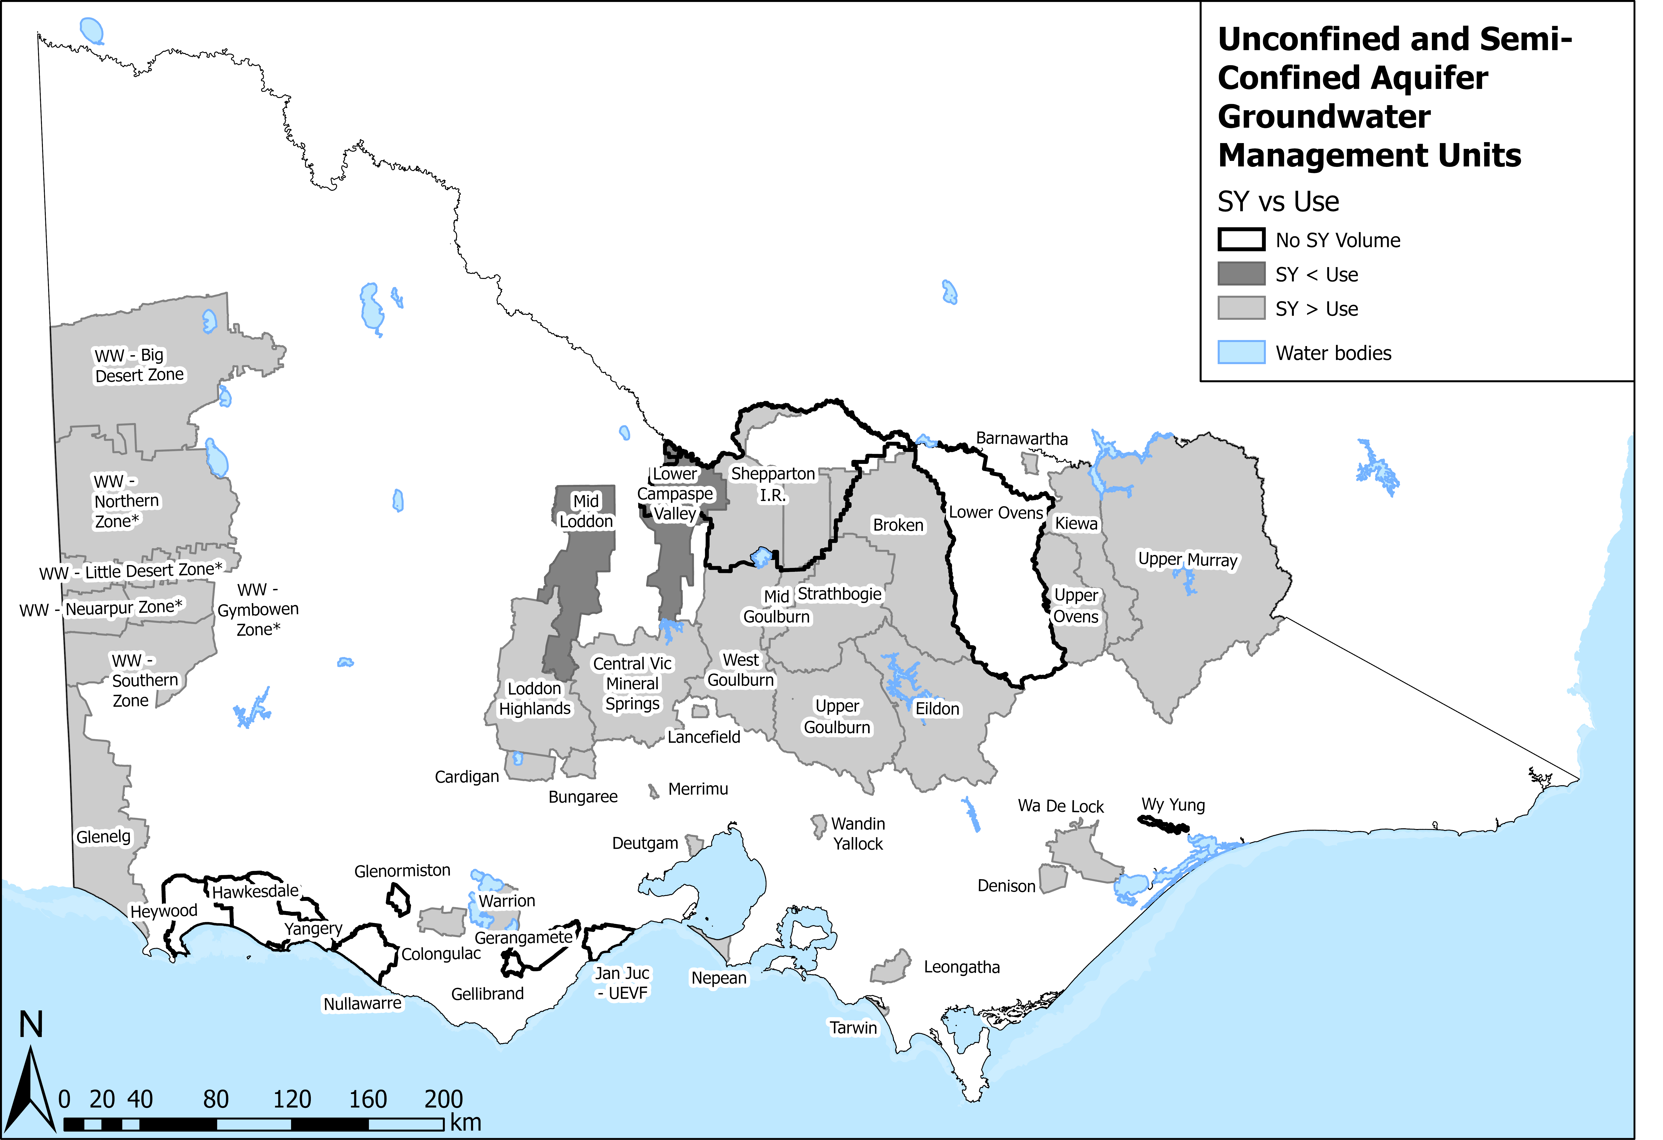
In respect to future risks to sustainability, climate change does not directly affect the future availability and sustainability of groundwater in confined aquifers due to lack of connection to the atmospheric environment. However, unconfined aquifers may be significantly influenced, with the range of projected changes in sustainable yields spanning up to a 50% decrease (drier climate) to more than 200% increase (wetter climate) based on plausible scenarios of future climate (Figure 10).
Licence entitlements are greater than the sustainable yield in 27 GMUs/GMU Zones and in 39 GMUs/GMU Zones the caps exceed the sustainable yield. The future availability and sustainability of groundwater could be at risk if use increases. The future demand for groundwater use has not been assessed in the Sustainable Yield Assessment. However, since current use is approximately 35% of licensed entitlement, there is potential for increased use. This may occur through licence holders increasing take up to 100% of their entitlement and/or trading their unused part of their entitlement which may be used by the new entitlement holder.
Caps manage the volume of entitlement that is allocated in an area and groundwater level restriction triggers are sometimes used to help manage use in a particular year to ensure groundwater levels are sustainable. Fifty nine of the sixty-six GMUs/GMU zones do not have any form of groundwater level restriction triggers. This highlights a gap in the current limits of take, particularly in 27 GMUs/GMU Zones where licence entitlement volumes exceed the sustainable yield, and in 39 GMUs/GMU Zones where existing licence volume caps are higher than the sustainable yield (Figure 15 to Figure 18). Moreover, in UAs use could increase through issuing new entitlements as no caps are currently in place. However, in most UAs, use and entitlements are minimal and less than the sustainable yield volumes.
Figure 15: Impacts of uncertainty on future risk to sustainability for confined aquifer GMUs
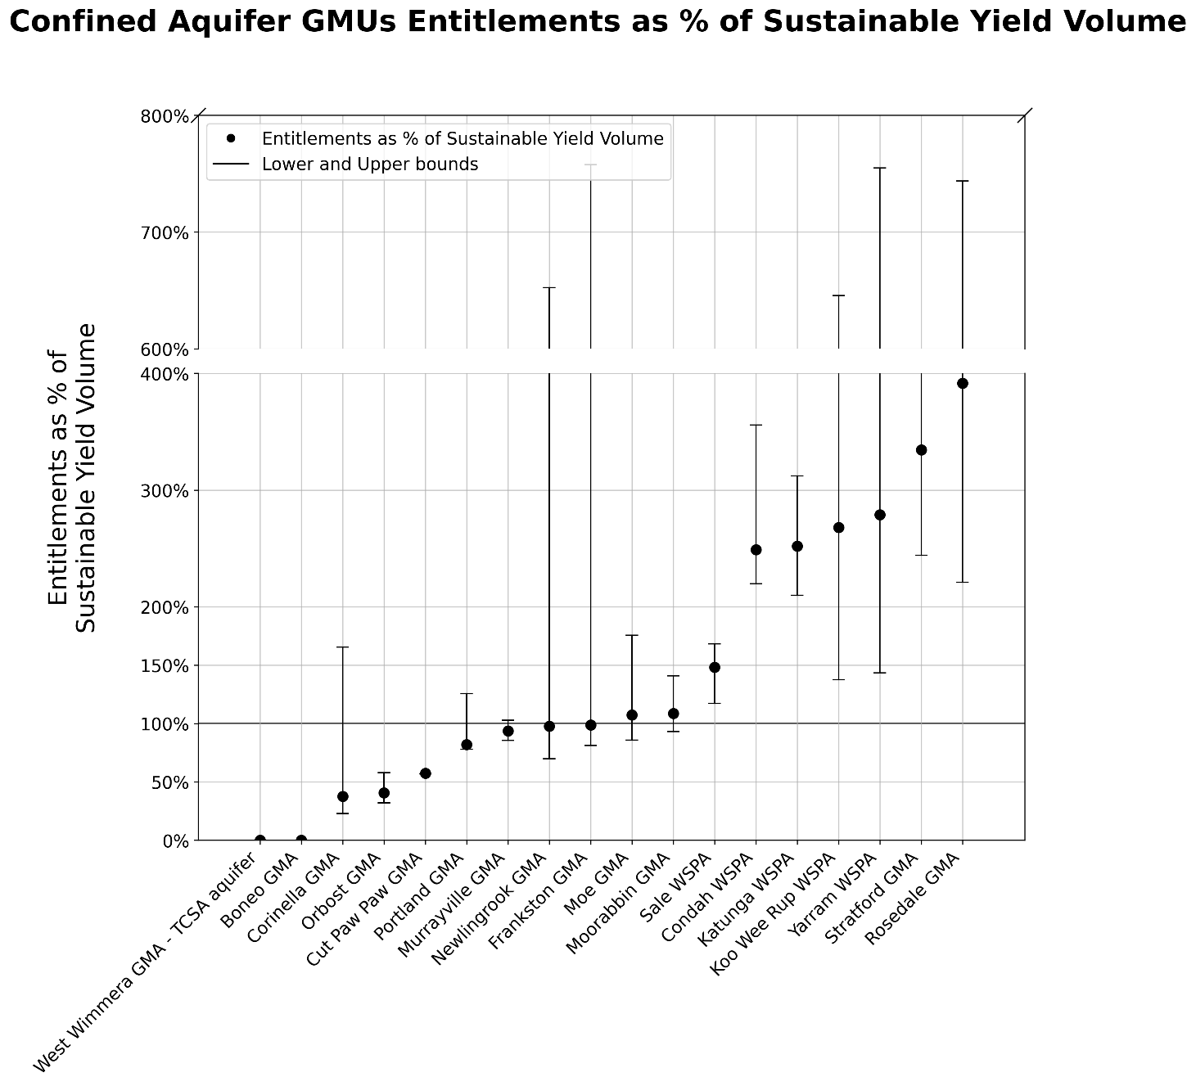

Figure 16: Future risk to sustainability for confined aquifer GMUs
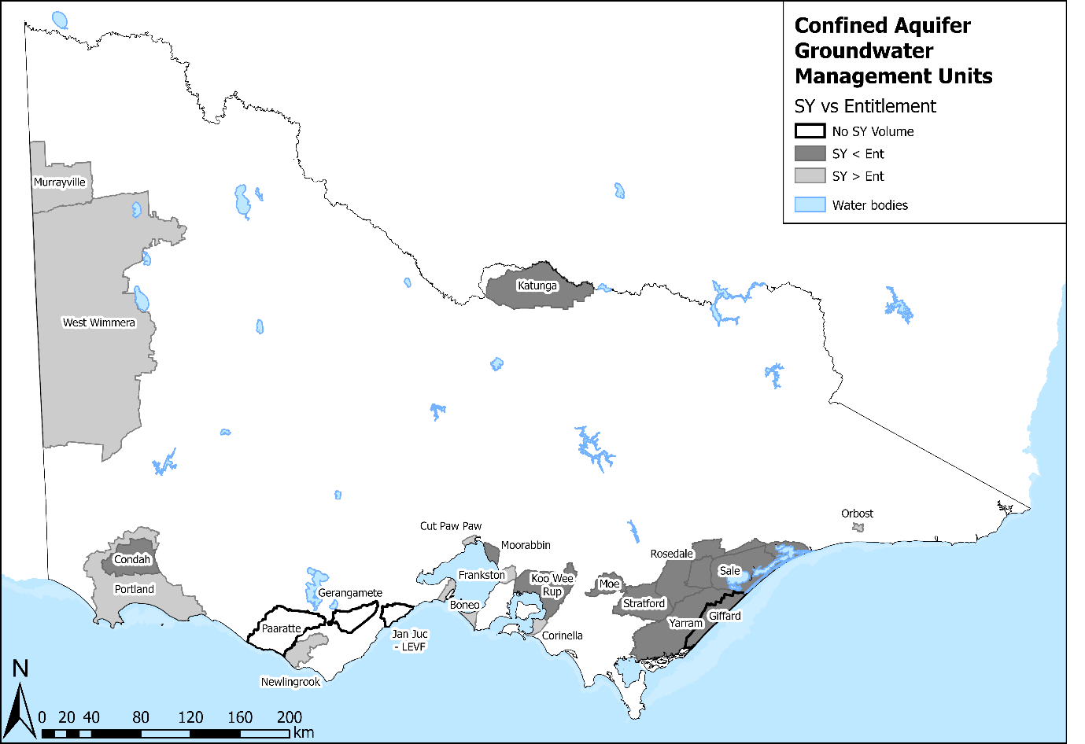
Figure 17: Impacts of uncertainty on future risk to sustainability for unconfined aquifer GMUs
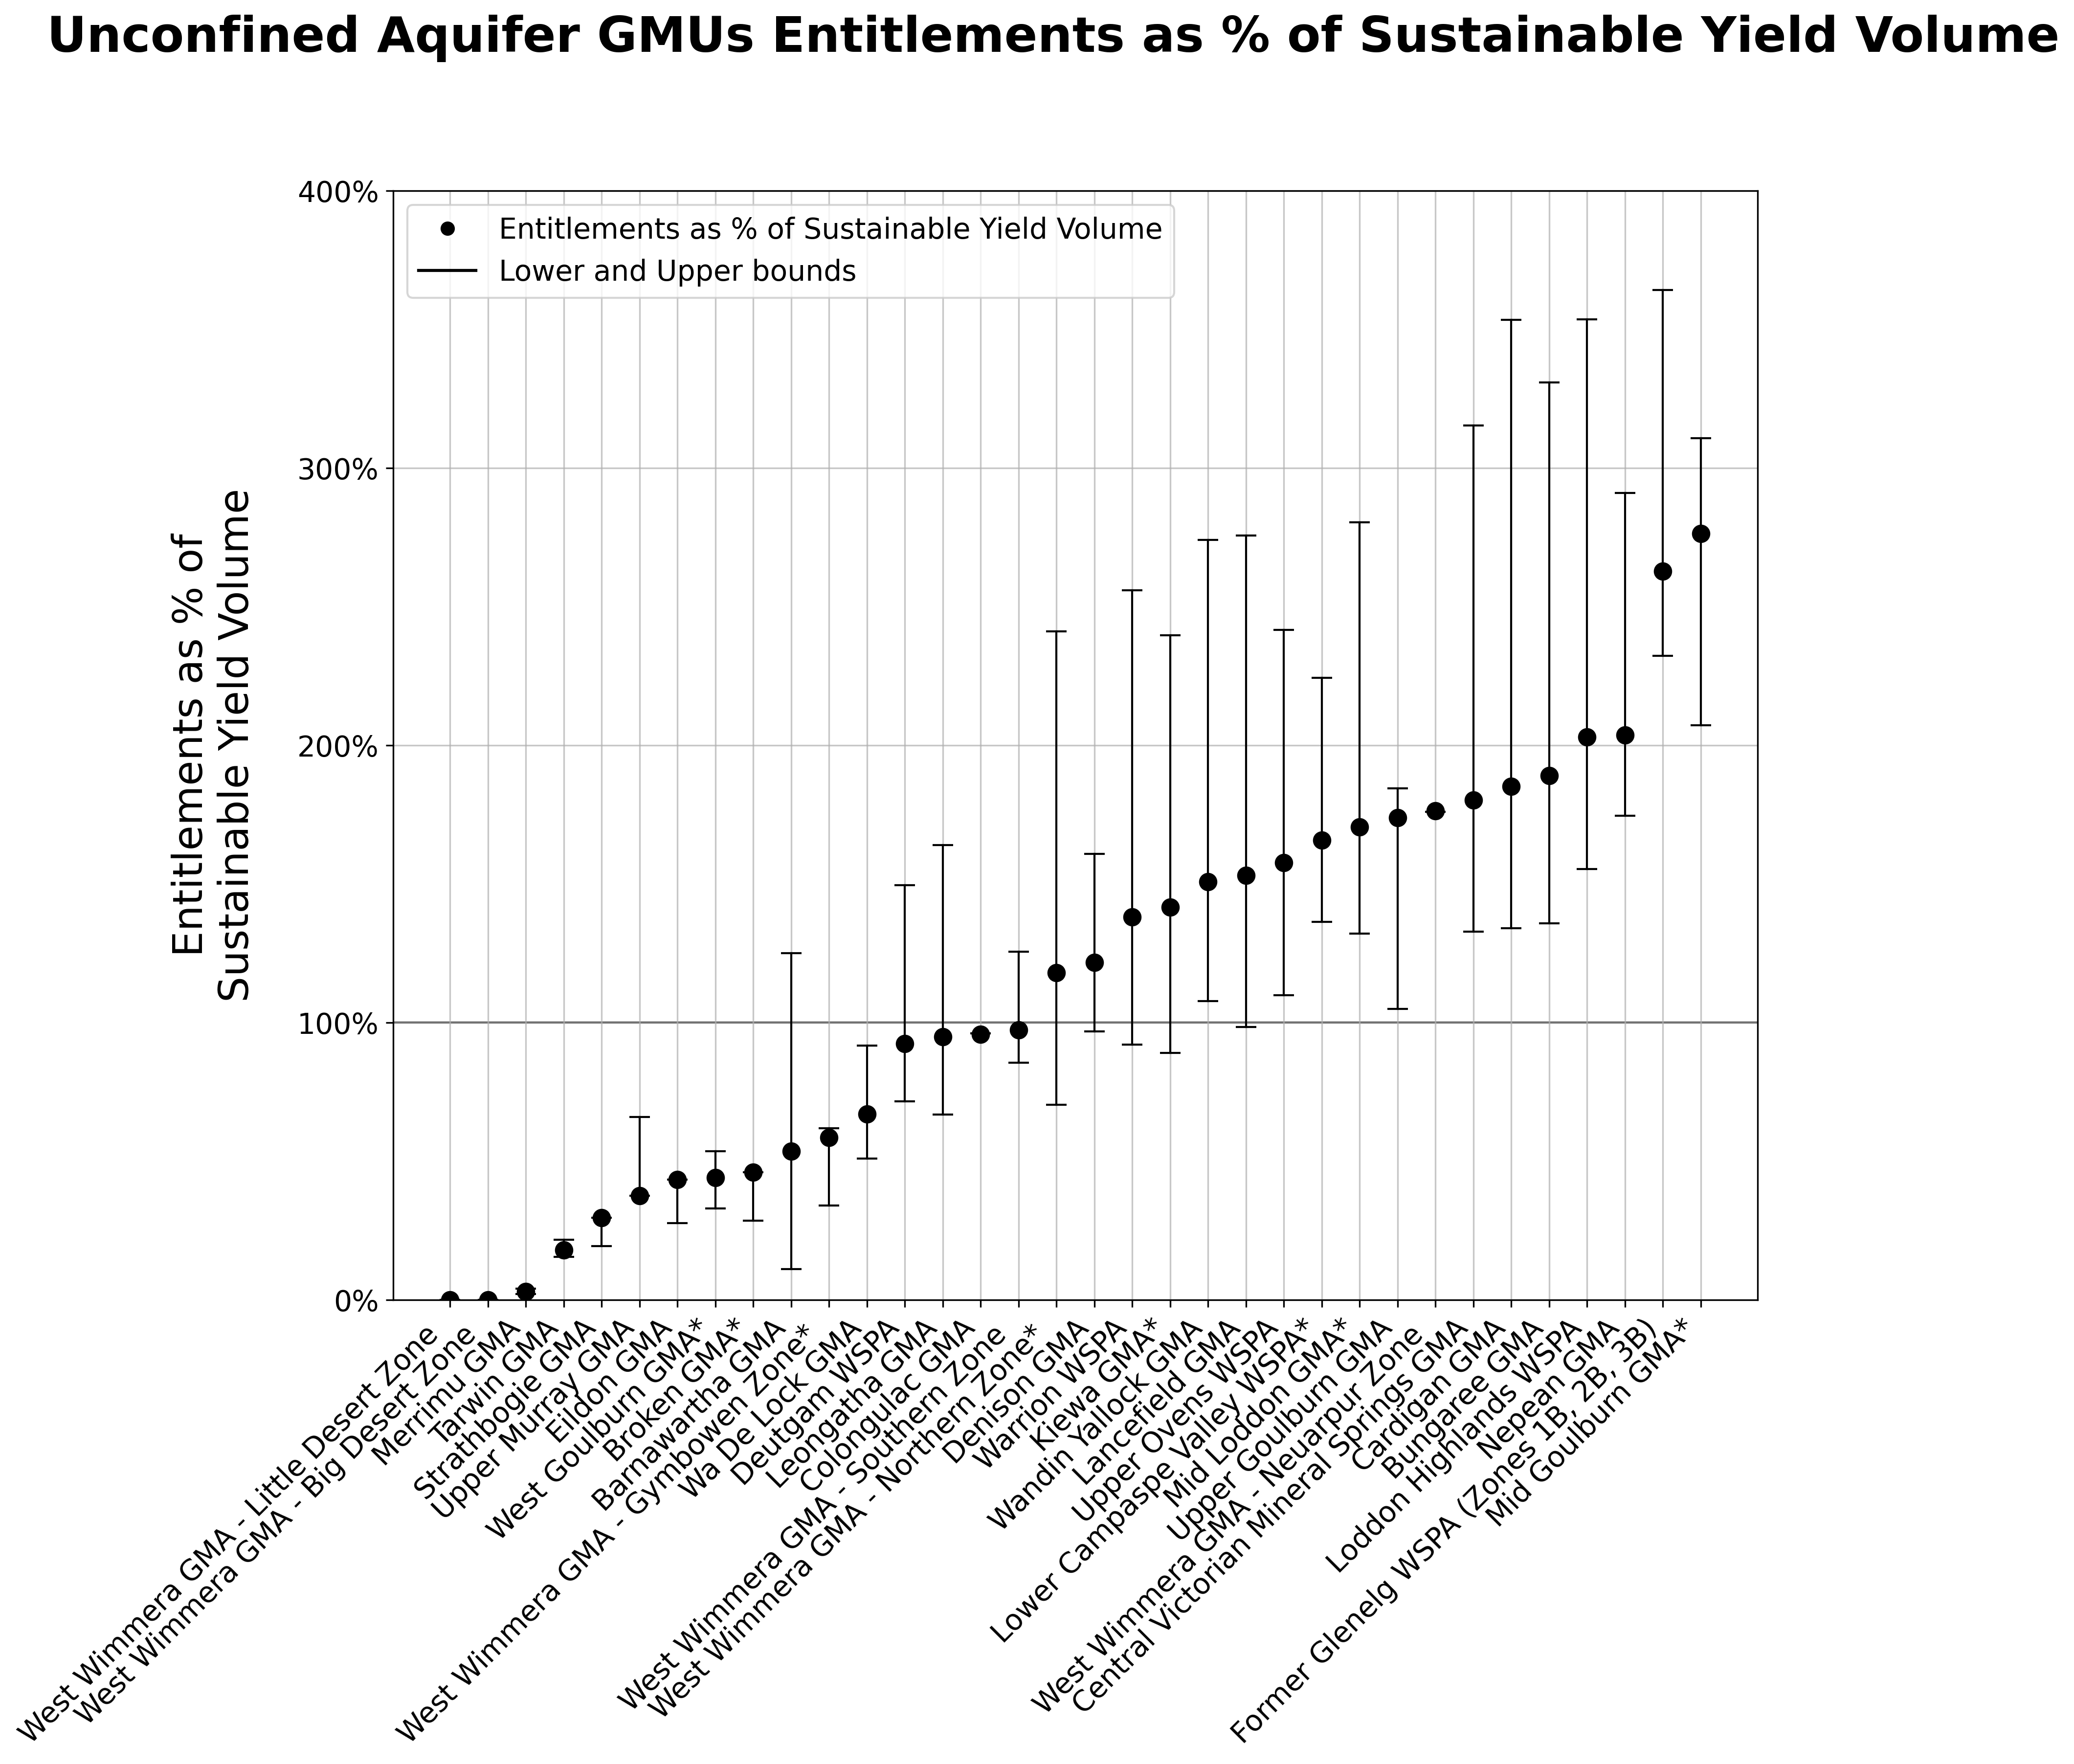

Figure 18: Future risk to sustainability for unconfined aquifer GMUs
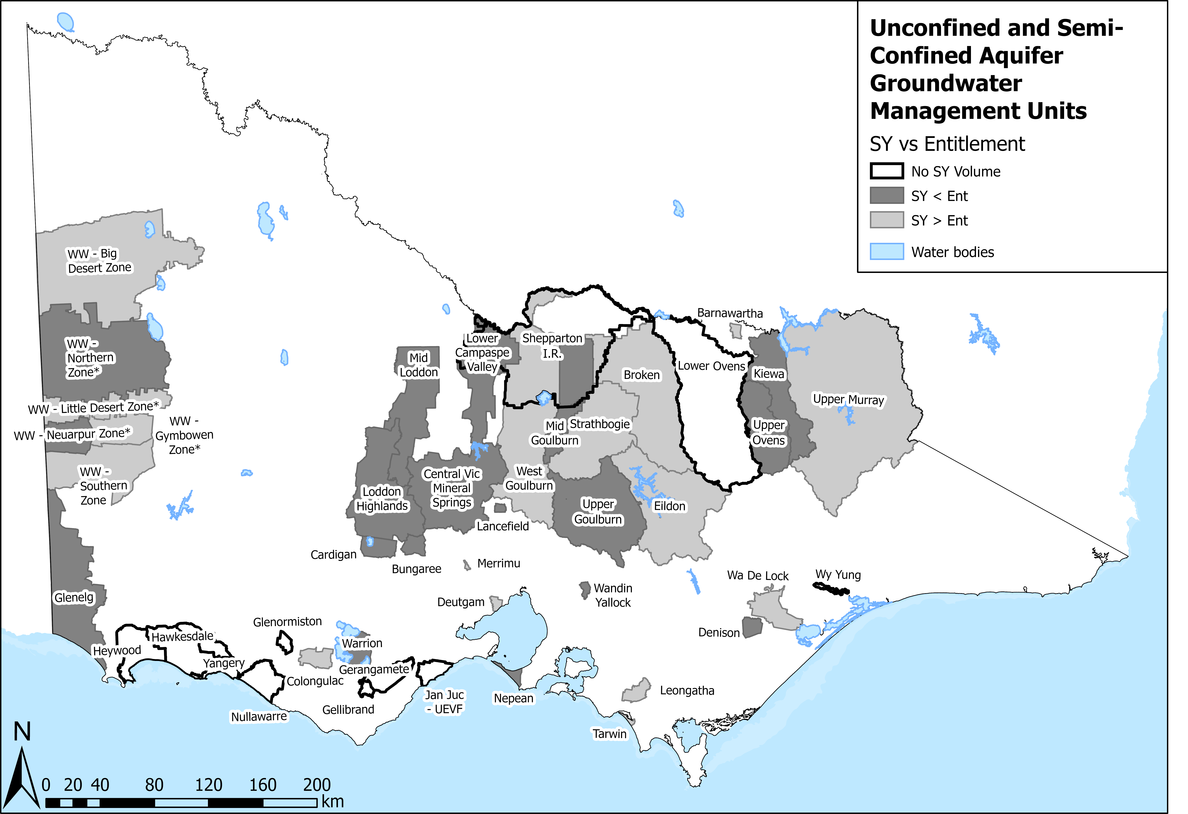

DEECA carried out a thorough quality assurance process to interrogate the assessment done for every system. In some cases, the sustainable yield estimate was not accepted, due to limited reliable monitoring and use data sets, results that were inconsistent with more detailed technical information or issues with the technical assessment itself. For these systems, we’re taking one of two approaches: either recommending the results be re-assessed using improved methods, more data, or more appropriate assumptions, or holding off on using the results for now as we already have detailed local information that is the “best available information” to guide groundwater management:
- Under review: The Sustainable Yield Assessment model outputs do not align with historic observations, monitoring data, other empirical evidence, or prior detailed studies from the area. This typically means the results are uncertain and require reassessment using an improved method, additional data, or a more appropriate metric. Re-assessment of these systems is proposed/being considered.
Not suitable: Sustainable Yield Assessment model outputs do not align with historic observations, monitoring data, other empirical evidence, or prior detailed studies from the area but re-assessment of the sustainable yield is not proposed. This is due to management objectives that cannot be considered by the sustainable yield assessment but can be considered by more detailed local information that is already available. No further action is proposed.
GMUs where the sustainable yield is under review, for the following reasons:
- Lower Ovens GMA – use-drawdown relationship was developed based on three observation bores, but only two were accepted through the quality assurance process. The third was found to not align with the known characteristics of the system.
- Wy Yung GMA – the use–drawdown relationship did not align with observed historical drawdown. The recharge method produced recharge volumes that significantly exceed historical use and the likely capacity of the aquifer, given its shallow base.
- Giffard GMA – the use-drawdown relationship was not accepted as the complexities of factors influencing groundwater drawdown in the GMA were not properly considered in the modelled relationship.
- Paaratte GMA – the sustainable yield was calculated using use-drawdown relationship, however, due to deep confined nature of aquifer, the sustainable yield metric may not be suitable - Process underway to better understand local context to inform a more suitable metric.
- Hawkesdale GMA, Heywood GMA, Nullawarre WSPA, and Yangery WSPA - the use-drawdown relationships developed did not align with historical data. The recharge volumes for these GMUs were also not accepted.
- Glenormiston GMA - the use–drawdown relationship was not accepted due to a lack of sufficient data to validate the sustainable yield volume. In addition, the recharge volumes assessed for the limestone and volcanics aquifers across the Southwest region were not accepted, with further work required to estimate the sustainable yield volume.
The derived sustainable yield was not suitable for the following GMUs for the reasons outlined below:
- Shepparton Irrigation Region – there was not enough use data to validate a use-drawdown relationship. This management area promotes use of groundwater to suppress water table rise and salinisation, which cannot be considered through the sustainable yield assessment.
- Jan Juc GMA - the sustainable yield methodology does not consider acid generation, which is a feature of this region. More detailed studies are currently underway (outside of sustainable yield) which can better consider the range of management objectives for the area.
Gerangamete and Gellibrand GMAs - sustainable yield does not align with prior metric for Boundary Creek - More detailed local studies are applied to management decisions through the Barwon Downs Remediation and Environmental Protection Plan
Further work may be required to:
- classify groundwater resources and study areas according to salinity ranges.
- review the effectiveness of existing triggers to inform improved future management.

Suitability of the output – fit for purpose
The sustainable yield volumes, whilst having a level of uncertainty, are considered fit-for-purpose to:
- inform risks to groundwater resources and groundwater-dependent values
- inform groundwater resource management planning
inform the setting and/or review of caps on entitlements for groundwater resources, where applicable.
The sustainable yield volumes are not considered suitable for implementing restrictions on use due to the uncertainty range in the assessed volumes. Instead, restrictions based on observed groundwater levels are preferred as they are simpler to implement and more accepted by the community. This is the approach currently used in some GMUs.

Get involved
The Sustainable Yield Assessment for Victoria is part of GM2030, a statement of priorities for DEECA and the rural water corporations (Lower Murray Water, Goulburn–Murray Water, Grampians Wimmera Mallee Water and Southern Rural Water).
The results of Sustainable Yield Assessment will inform GM2030, and the work being carried out by DEECA and the rural water corporations to support more informed decision-making for groundwater management licensing in the future under a changing climate. This will ensure we continue to protect the environment and living cultural landscapes from unacceptable impacts, support economic development opportunities and continued access to groundwater for all users. This work will occur right up until 2030.
DEECA’s GM2030 team will continue working with water users, Traditional Owners, stakeholders and the community. Anyone can register to be involved or receive future communication on GM2030 by emailing GM.2030@deeca.vic.gov.au.

Appendix A
Table A- 1: Confined aquifer GMU sustainable yield, Permissible Consumptive Volume, entitlement and use
Region | GMU | Sustainable Yield Method | SY  volume (ML/yr) | SY  Lower band (ML/yr) | SY  Upper band (ML/yr) | PCV (ML/yr) | Average Entitlement (2016-2021) (ML/yr) | Average use  (2016-2021) (ML/yr)
Western Victoria | Murrayville GMA | Confined use-drawdown method | 10,400 | 9,500 | 11,400 | 11,005 | 9,755 | 5,408
Western Victoria | West Wimmera GMA – Tertiary Confined Sand Aquifer | Percentage of throughflow flux | 1,100 | 900 | 1,300 | 1,550 | 0 | 0
Northern Victoria | Katunga WSPA | Confined use-drawdown method | 23,900 | 19,300 | 28,700 | 60,577 | 60,209 | 27,785
Gippsland | Corinella GMA | Confined use-drawdown method an  Unconfined percentage of recharge | 1,760 | 400 | 2,900 | 2,550 | 662 | 60
Gippsland | Moe GMA | Confined use-drawdown method an  Unconfined use-drawdown method | 3,600 | 2,200 | 4,500 | 8,200 | 3,861 | 826
Gippsland | Orbost GMA | Confined use-drawdown method | 3,000 | 2,100 | 3,800 | 1,217 | 1,216 | 294
Gippsland | Giffard GMA | – | No SY volume | NA | NA | 5,689 | 5,688 | 2,475
Gippsland | Rosedale GMA | Confined use-drawdown method | 5,700 | 3,000 | 10,100 | 23,373 | 22,312 | 8,828
Gippsland | Sale WSPA | Confined use-drawdown method | 14,300 | 12,600 | 18,100 | 21,238 | 21,205 | 11,029
Gippsland | Yarram WSPA | Confined use-drawdown method | 9,200 | 3,400 | 17,900 | 25,690 | 25,665 | 11,482
Gippsland | Stratford GMA | Percentage of throughflow flux | 11,100 | 6,600 | 15,200 | 27,686 | 37,119 | 22,625
Central Victoria | Frankston GMA | Confined use-drawdown method | 2,300 | 300 | 2,800 | 3,200 | 2,273 | 230
Central Victoria | Koo Wee Rup WSPA | Confined use-drawdown method for 2m drawdown for UTAF/UMTA and  Percentage of throughflow flux for LTA | 4,700 | 1,950 | 9,150 | 12,915 | 12,589 | 3,610
Central Victoria | Moorabbin GMA | Confined use-drawdown method for 2m drawdown for UTAF and  Percentage of throughflow flux for LTA | 2,400 | 1,850 | 2,800 | 2,700 | 2,606 | 1,096
Central Victoria | Boneo GMA | Percentage of throughflow flux | 1,200 | NA | NA | No PCV | Extraction: 2700  Injection: 2700 | Extraction (2011-2021): 448  Injection (2011-2021): 322  Net extraction (2011-2021): 126
South West Victoria | Condah WSPA | Confined use-drawdown method | 3,000 | 2,100 | 3,400 | 7,475 | 7,469 | 2,782
South West Victoria | Cut Paw Paw GMA | Percentage of throughflow flux | 900 | NA | NA | 3,650 | 517 | 99
South West Victoria | Gerangamete GMA | NA | No SY volume | NA | NA | 239 | 12,142 | 3,524
South West Victoria | Portland GMA | Confined use-drawdown method | 9,500 | 6,200 | 10,000 | 7,795 | 7,794 | 2,606
South West Victoria | Newlingrook GMA | Confined use-drawdown method | 2,000 | 300 | 2,800 | 1,977 | 1,957 | 145
South West Victoria | Paaratte GMA | NA | No SY volume | NA | NA | 4,606 | 3,190 | 321
South West Victoria | Jan Juc GMA – Lower Eastern View Formation | NA | No SY volume | NA | NA | 7,000 | 7,000 | 2,801
NA = not applicable
Table A- 2: Unconfined and semi-confined aquifer GMU sustainable yield, Permissible Consumptive Volume, entitlement and use
Region | GMU | Sustainable Yield Method | SY  volume  ML/yr) | SY Lower band (ML/yr) | SY Upper band (ML/yr) | PCV (ML/yr) | Average Entitlement (2016-21) (ML/yr) | Average use (2016-21) (ML/yr)
West Wimmera | West Wimmera GMA - Big Desert Zone | Percentage of recharge volume | 6,900 | 5,600 | 9,700 | 25 | 0 | 0
West Wimmera | West Wimmera GMA - Gymbowen Zone* | Percentage of recharge volume | 1,800 | 1,700 | 3,100 | 2,000 | 1,052 | 232
West Wimmera | West Wimmera GMA - Little Desert Zone | Percentage of recharge volume | 1,200 | 1,000 | 2,100 | 25 | 0 | 0
West Wimmera | West Wimmera GMA - Neuarpur Zone | Prior studies | 14,000 | NA | NA | 24,750 | 24,691 | 13,860
West Wimmera | West Wimmera GMA - Northern Zone* | Unconfined use-drawdown method | 18,600 | 9,100 | 31,200 | 22,390 | 21,932 | 5,900
West Wimmera | West Wimmera GMA - Southern Zone | Percentage of recharge volume | 5,800 | 4,500 | 6,600 | 6,469 | 5,648 | 1,950
Northern Central | Barnawartha GMA | Unconfined use-drawdown method | 700 | 300 | 3,400 | 2,100 | 375 | 61
Northern Central | Broken GMA* | Percentage of recharge volume excluding highlands | 6,300 | 6,300 | 10,200 | 3,732 | 2,902 | 1,217
Northern Central | Cardigan GMA | Unconfined use-drawdown method | 2,100 | 1,100 | 2,900 | 3,967 | 3,888 | 895
Northern Central | Central Victorian Mineral Springs GMA | Unconfined use-drawdown method | 2,800 | 1,600 | 3,800 | 6,024 | 5,044 | 1,154
Northern Central | Eildon GMA | Percentage of recharge volume excluding highlands | 1,400 | 1,400 | 2,200 | 1,496 | 607 | 200
Northern Central | Kiewa GMA* | Unconfined use-drawdown method | 2,200 | 1,300 | 3,500 | 3,852 | 3,115 | 876
Northern Central | Loddon Highlands WSPA | Unconfined use-drawdown method | 10,100 | 5,800 | 13,200 | 20,697 | 20,503 | 7,407
Northern Central | Lower Campaspe Valley WSPA* | Unconfined use-drawdown method | 33,700 | 24,900 | 41,000 | 55,875 | 55,860 | 38,225
Northern Central | Lower Ovens GMA* | NA | No SY volume | NA | NA | 25,200 | 19,888 | 8,948
Northern Central | Mid Goulburn GMA* | Percentage of recharge volume excluding highlands | 4,500 | 4,000 | 6,000 | 12,470 | 12,432 | 3,535
Northern Central | Mid Loddon GMA* | Unconfined use-drawdown method | 19,900 | 12,100 | 25,700 | 34,037 | 33,917 | 21,450
Northern Central | Shepparton Irrigation GMA | NA | No SY volume | NA | NA | No PCV | 187,114 | 86,860
Northern Central | Strathbogie GMA | Percentage of recharge volume excluding highlands | 4,800 | 4,800 | 7,300 | 1,660 | 1,417 | 974
Northern Central | Upper Goulburn GMA | Percentage of recharge volume excluding highlands | 3,500 | 3,300 | 5,800 | 8,568 | 6,086 | 1,992
Northern Central | Upper Murray GMA | Percentage of recharge volume excluding highlands | 9,300 | 5,300 | 9,300 | 7,674 | 3,496 | 814
Northern Central | Upper Ovens WSPA | Unconfined use-drawdown method | 2,300 | 1,500 | 3,300 | No PCV | 3,625 | 1,317
Northern Central | West Goulburn GMA* | Percentage of recharge volume excluding highlands | 6,800 | 5,600 | 9,100 | No PCV | 2,997 | 1,359
Gippsland | Denison GMA | Unconfined use-drawdown method | 15,200 | 11,500 | 19,100 | 18,502 | 18,499 | 7,679
Gippsland | Leongatha GMA | Unconfined use-drawdown method | 1,900 | 1,100 | 2,700 | 6,500 | 1,803 | 184
Gippsland | Tarwin GMA | Percentage of recharge volume | 300 | 250 | 350 | 1,300 | 54 | 10
Gippsland | Wa De Lock GMA | Unconfined use-drawdown method | 43,500 | 31,800 | 57,200 | 30,735 | 29,131 | 7,750
Gippsland | Wy Yung GMA | NA | No SY volume | NA | NA | 7,463 | 7,462 | 970
Central Victoria | Bungaree GMA | Unconfined use-drawdown method | 2,800 | 1,600 | 3,900 | 5,334 | 5,293 | 2,700
Central Victoria | Deutgam WSPA | Unconfined use-drawdown method | 5,500 | 3,400 | 7,100 | 5,100 | 5,082 | 625
Central Victoria | Lancefield GMA | Unconfined use-drawdown method | 900 | 500 | 1,400 | 1,485 | 1,378 | 303
Central Victoria | Merrimu GMA | Unconfined use-drawdown method | 200 | 150 | 300 | 451 | 6 | 15
Central Victoria | Nepean GMA | Unconfined use-drawdown method | 3,000 | 2,100 | 3,500 | 6,110 | 6,110 | 2,812
Central Victoria | Wandin Yallock GMA | Unconfined use-drawdown method | 2,000 | 1,100 | 2,800 | 3,027 | 3,015 | 638
South West Victoria | Colongulac GMA | Unconfined use-drawdown method | 4,600 | NA | NA | 4,695 | 4,405 | 1,331
South West Victoria | Jan Juc GMA - Upper Eastern View Formation | NA | No SY volume | NA | NA | 4,250 | 4,000 | 591
South West Victoria | Gellibrand | NA | No SY volume | NA | NA | 0 | 0 | 0
South West Victoria | Former Glenelg WSPA (includes Zones 1B, 2B and parts of 3B of the South Australia – Victoria Designated Area) | Confined use-drawdown method for 2m drawdown | 6,100 | 4,400 | 6,900 | 33,262 | 16,025 | 5,957
South West | Glenormiston GMA | NA | No SY volume | NA | NA | 2,698 | 2,636 | 1,273
South West Victoria | Hawkesdale GMA | NA | No SY volume | NA | NA | 16,161 | 12,451 | 5,040
South West Victoria | Heywood GMA | NA | No SY volume | NA | NA | 8,500 | 7,011 | 1,688
South West Victoria | Nullawarre WSPA | NA | No SY volume | NA | NA | 22,741 | 22,741 | 10,909
South West Victoria | Yangery WSPA | NA | No SY volume | NA | NA | 14,352 | 13,978 | 4,295
South West Victoria | Warrion WSPA | Unconfined use-drawdown method | 10,200 | 5,500 | 15,300 | 14,086 | 14,077 | 3,555
* (asterisk) shows semi-confined aquifer GMUs.
NA = not applicable

Publication information

Acknowledgement of Victorian Traditional Owners
We acknowledge and respect Victorian Traditional Owners as the original custodians of Victoria’s land and waters, their unique ability to care for Country and deep spiritual connection to it.
We honour Elders past and present whose knowledge and wisdom has ensured the continuation of culture and traditional practices.
DEECA is committed to genuinely partnering with Victorian Traditional Owners and Victoria’s Aboriginal community to progress their aspirations.

Copyright
© The State of Victoria Department of Energy, Environment and Climate Action, 2024.

Creative Commons
This work is licensed under a Creative Commons Attribution 4.0 International licence, visit the Creative Commons website (http://creativecommons.org/licenses/by/4.0/).
You are free to re-use the work under that licence, on the condition that you credit the State of Victoria as author. The licence does not apply to any images, photographs or branding, including the Victorian Coat of Arms, and the Victorian Government and Department logos.
ISBN 978-1-76176-765-4 (Pdf/Online/MS Word)

Disclaimer
This publication may be of assistance to you but the State of Victoria and its employees do not guarantee that the publication is without flaw of any kind or is wholly appropriate for your particular purposes and therefore disclaims all liability for any error, loss or other consequence which may arise from you relying on any information in this publication.

Accessibility
To receive this document in an alternative format, phone the Customer Service Centre on 136 186, email customer.service@delwp.vic.gov.au, or contact National Relay Service on 133 677 or visit http://www.accesshub.gov.au/. Available at DEECA website (www.deeca.vic.gov.au).
End of document.

https://www.water.vic.gov.au/water-sources/groundwater/groundwater-management-2030/sustainable-yield-assessment/?a=777719
https://www.water.vic.gov.au/water-sources/groundwater/groundwater-management-2030/sustainable-yield-assessment/?a=777716

