IWM Strategic Directed Investment Grants

Grant Application Guidelines 2025-28

Acknowledgment
We acknowledge and respect Victorian Traditional Owners as the original custodians of Victoria's land and waters, their unique ability to care for Country and deep spiritual connection to it. We honour Elders past and present whose knowledge and wisdom has ensured the continuation of culture and traditional practices.
We are committed to genuinely partner, and meaningfully engage, with Victoria's Traditional Owners and Aboriginal communities to support the protection of Country, the maintenance of spiritual and cultural practices and their broader aspirations in the 21st century and beyond.
© The State of Victoria Department of Energy, Environment and Climate Action 2023
This work is licensed under a Creative Commons Attribution 4.0 International licence. You are free to re-use the work under that licence, on the condition that you credit the State of Victoria as author. The licence does not apply to any images, photographs or branding, including the Victorian Coat of Arms, the Victorian Government logo and the Department of Energy, Environment and Climate Change (DEECA) logo. To view a copy of this licence, visit http://creativecommons.org/licenses/by/4.0/
ISBN 978-1-76176-670-1 (pdf/word/online)
Disclaimer
This publication may be of assistance to you but the State of Victoria and its employees do not guarantee that the publication is without flaw of any kind or is wholly appropriate for your particular purposes and therefore disclaims all liability for any error, loss or other consequence which may arise from you relying on any information in this publication.
Accessibility
If you would like to receive this publication in an alternative format, please telephone the DEECA Customer Service Centre on 136186, email customer.service@deeca.vic.gov.au or via the National Relay Service on 133 677 www.relayservice.com.au. This document is also available on the internet at www.deeca.vic.gov.au.

Contents

1. What is the Integrated Water Management Program? 2
2. What is the IWM Grant Program 2025-28? 3
3. What are the objectives of the IWM SDI stream? 3
4. Who can apply? 5
5. What might be funded? 5
6. What will not be funded? 6
7. What are the funding details? 7
8. What are the assessment criteria? 8
9. What are the key dates? 11
10. What should I do to prepare? 11
11. What supporting documents will need to be provided? 12
12. What is the application process? 12
13. How will the applications be assessed? 12
14. How will I be notified of the outcome? 13
15. Where do I go for questions and assistance? 13
16. What conditions apply to applications and funding? 13
17. Checklist 15
Appendix 1a: Metropolitan Melbourne IWM Strategic Outcomes, Indicators & Measures 17
Appendix 1b: Regional Victoria IWM Strategic Outcome Areas & Example Indicators 19
Appendix 2: Assessment Scoring Table 21

What is the Integrated Water Management Program?
The Integrated Water Management (IWM) Program was established by the Victorian Government in 2017 to shift the way we plan for and manage water across the state. Administered by the Department of Energy, Environment and Climate Action (DEECA), the Program brings together organisations with responsibilities or interests in the water cycle—such as local governments, Traditional Owners, water corporations, Catchment Management Authorities, state agencies and other partners—to work together to deliver shared outcomes.
The IWM Program is guided by the IWM Framework for Victoria (2017). It sets out how partners can work together to make better use of all water sources, embed local values and Traditional Owner knowledge, and deliver multiple benefits—such as healthier waterways and landscapes, greater climate resilience, water security, and more liveable, connected communities.
To put the Framework into action, DEECA facilitated the establishment of 15 IWM Forums—five in metropolitan Melbourne and ten in regional Victoria. These Forums function as collaborative governance platforms, enabling cross-sector organisations to identify shared priorities, align planning and investment, and coordinate integrated water solutions.
What is IWM?
IWM is a holistic and collaborative approach to the way we plan for and manage all elements of the water cycle —including water supply, wastewater, and stormwater—to deliver broader benefits for people, places, and the environment.
By aligning water, land use, and urban planning, IWM helps create more resilient, liveable and sustainable communities. It changes how we think about and deliver water services—shifting from siloed to integrated solutions.
As Victoria faces climate change, population growth, environmental pressures, and other complex challenges, IWM ensures we all work together to meet our current and future water needs.

Each Forum has developed a Strategic Directions Statement (SDS) that captures the region’s context, collective vision, and priority outcomes. These SDSs provide the strategic foundation for advancing priority projects that respond to local needs while contributing to statewide IWM outcomes.
While the IWM Forum partners across the state have made significant progress in transitioning to an Integrated Water Management approach, DEECA’s leadership is now focussing on accelerating the transition. The Program delivers a range of activities to support system-wide change—fostering partnerships, aligning planning processes, building capability, policy reform, and supporting on-ground delivery. The IWM Grant Program is a key element of the transition.
The IWM Grant Program provides targeted funding to support the design and delivery of IWM projects across Victoria. The Grant Program has been central to progressing the Program’s long-term aim by building capability, strengthening relationships, and demonstrating the social, environmental, cultural, and economic value of IWM. It continues to play a vital role in supporting the transition to IWM as standard practice.

What is the IWM Grant Program 2025-28?
The next phase of the IWM Grant Program builds on insights and lessons from previous rounds. Stakeholder feedback, project outcomes, and an evolving policy and planning context have shaped a refreshed approach aimed at accelerating IWM adoption across Victoria.
The IWM Grant Program 2025-28 will continue to provide co-investment for collaborative, place-based projects aligned with IWM Forum priorities. It will also strengthen Traditional Owner leadership and participation in water planning and enable strategic investment in time-sensitive, high-impact opportunities identified by the sector.
The 2025–2028 Program will be delivered through three funding streams:
- IWM Partnership Projects (metropolitan and regional).
- Traditional Owner-led IWM Projects.
- IWM Strategic Directed Investments (SDI).
This document outlines the arrangements for the IWM SDI stream.

What are the objectives of the IWM SDI stream?
The SDI stream is a new component of the IWM grant program, designed to support high-impact IWM initiatives that align with Victorian Government priorities. It targets large-scale, time-critical projects in Greater Melbourne and the Barwon IWM Forum region, as well as IWM planning in regional areas that are forecast to experience rapid growth.
Greater Melbourne and the Barwon IWM Forum region encompass the fastest growing and largest area of planned urban development. As a result, they present the greatest time-critical and high-impact opportunities for IWM.
These grants aim to:
- Support investment in IWM planning and infrastructure in rapidly growing areas of Victoria (particularly the Melbourne and Barwon IWM Forum regions) to ensure sustainable urban development and water resilience.
- Enable timely and proactive government investment in initiatives that would otherwise miss critical windows for influence, integration, or co-investment.
- Support high-impact, system-scale projects where early intervention can address major water system risks or unlock significant social, cultural, environmental or economic benefits.
- Deliver infrastructure and planning responses that prevent greater future costs or irreversible failures, such as environmental degradation, fragmented infrastructure delivery, or inefficient retrofitting.
- Strengthen alignment between water investments and broader government priorities, including housing delivery, climate adaptation, and Traditional Owner self-determination.
- Demonstrate the value of IWM through the practical delivery of IWM outcomes.

Differences between SDI and partnership Projects streams
Table 1: SDI vs Partnership Projects Streams
Funding Stream | Partnership Projects | SDI
Objectives | Implement priorities identified by the IWM forums.  Build capacity and local leadership in the design and delivery of IWM outcomes, and  Demonstrate the benefits of IWM | Enable timely and proactive government investment  Support high-impact, system scale Projects where early intervention is critical  Deliver infrastructure and planning responses that prevent greater future costs or irreversible failures
Grant model | Competitive | Negotiated
Process | - Any eligible applicant can apply  - Applications are assessed once all applications are received by the application close date  - Funding outcomes are known once all applications are assessed | - Applications are by invitation from DEECA  - Applications are assessed as they are received  - Funding outcome is known after each application is assessed

Who can apply?
The lead applicant must:
- be a member organisation of a metropolitan or regional IWM Forum
- be an incorporated body, cooperative or association (including business associations)
- be financially solvent
- have the capacity to manage the grant funding directly, including any procurement (e.g. consultancies or works).
While projects are expected to be undertaken in collaboration, there can be only one lead applicant for each application. If successful, the lead applicant will be:
- the sole party to the funding agreement
- responsible for managing all grant funds directly, including those allocated to consultancies or subcontractors.
It is not acceptable for the lead applicant to act as a financial intermediary and transfer the funds to another organisation for management. The State requires a clear line of accountability for public funding and cannot fund projects where it does not maintain direct financial oversight.

What might be funded?
Given the time-sensitive and targeted nature of projects under the SDI stream, applications are accepted through a non-competitive, merit-based process.
Participation is by invitation only, with projects identified throughout the application open period.
The project identification process is as follows:
- Project identification: Projects can be identified at any point during the application period through two main pathways:
  - Forum-member initiated: An eligible IWM Forum member may approach DEECA to propose a project aligned with the SDI stream objectives.
  - DEECA initiated: DEECA may contact an eligible IWM Forum member to explore a potential project opportunity.
- Scoping and suitability discussion: once a potential project is identified, DEECA and the IWM Forum member will meet to discuss the project’s scope and alignment with funding objectives.
- If a project is determined to be suitable, DEECA will invite the Forum member to submit a formal application
To be eligible for funding, projects must:
- clearly support the objectives of the SDI funding stream.
- be delivered collaboratively with one or more IWM Forum member organisation.
- meet the co-contribution threshold.
- satisfy one or more purposes of Victoria’s Environmental Contribution levy, namely to:
  - promote the sustainable management of water, or
  - address adverse water-related environmental impacts
- be either a capital or feasibility project, defined as:
  - Capital project: Involves on-ground works and may include design and construction (D&C) or construction only. For D&C projects, a suitably detailed design and feasibility assessment (appropriate to the scale of the project) must be completed prior to applying for grant funding.
  - Feasibility project: Involves investigation or planning to support future IWM delivery. Feasibility projects may include a feasibility study or needs analysis, development of an IWM plan, preparation of a business case, creation of a functional design or research and development.
If an applicant is unsure whether a proposed project meets the eligibility requirements, they are encouraged to contact DEECA for clarification prior to the application close date.

What will not be funded?
The Program will not fund the following:
- Projects that are not scheduled to begin in 2025-26 or 2026-27 financial years.
- Projects and activities that are able to proceed without this grant funding.
- The purchase of land or water entitlement
- Routine or ongoing maintenance activities (outside of justified establishment-phase maintenance for capital works).
- Recurrent operating costs, including rent, staffing, utility costs, and/or activities establishing expectation of ongoing funding.
- Projects and activities already fully funded through another source, including other grants Programs.
- Applications that exceed the funding caps outlined for the type of project.
- Projects and activities located outside the State of Victoria.
- Political campaigning or advocacy activities for political parties.
Note: Reasonable, time-limited maintenance associated with the establishment of capital works (e.g. vegetation establishment or erosion control) is eligible if clearly justified. Time-limited project staff are also eligible if directly tied to project delivery and the co-contribution threshold is met.

What are the funding details?
A total of $7 million is available for the IWM SDI stream over three financial years, from 2025-26 to 2027-28.
DEECA intends to allocate this funding with the following geographic allocations:
- $5.5 million will be available for projects in metropolitan Melbourne and areas experiencing significant growth in the Barwon Forum area. A maximum of $5 million is available per project.
- $1.5 million will be available for projects in planning in high-growth regional areas. A maximum of $500,000 is available per project.
Any unallocated funding reserved for one geographical location can be used for other geographical locations within the SDI Projects stream.

Co-contribution
Funding will be provided on a co-contribution basis, which can be financial or in-kind.
Financial contribution refers to monetary contribution to the project costs, which may include grant funding from other appropriate sources.
In-kind contribution refers to a provision of goods or services that are not in the form of cash, and may include donated goods, volunteer labour or free services.
Applications that demonstrate a higher overall co-contribution, whether financial, in-kind, or both, will be viewed more favourably during the merit assessment process.
Metropolitan Melbourne and Barwon Forum rapidly changing areas
At a minimum applicants must contribute:
- A financial co-contribution of at least 20% of the total project value
- A combined co-contribution (financial + in-kind) of at least 30% of the total project value.
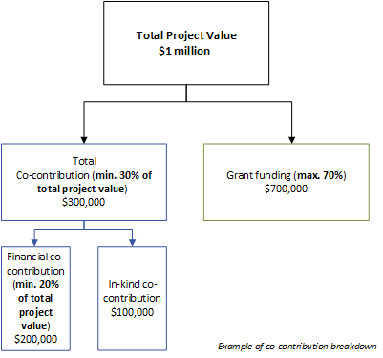
Figure 1: Funding Co-Contribution Illustration
High-growth regional areas
At a minimum applicants must contribute 20% of the total project value.
Co-contribution can be financial or in-kind.
When determining project costs and funding needs, applicants should consider the impact of cost escalation over time (e.g. Consumer Price Index and Wage Price Index), and should consider the time required for design and approvals when delivering capital Projects.

What are the assessment criteria?
First, applications will be checked for eligibility to make sure that the applicant and their activity are eligible for funding. After that, eligible applications will be assessed using the criteria listed below. Each criterion is given a percentage weighting to indicate its relative importance in the assessment process. Applications should address all relevant criteria.
Assessment Criteria 1: Strategic alignment with IWM outcomes (30%)
Explain how the proposed project aligns with, and contributes to, relevant IWM strategic outcomes. The project must contribute to at least 2 IWM strategic outcomes. See Appendix 1 & 2 for the IWM strategic outcomes
Supporting evidence may include, but is not limited to:
- Modelling, data or scenario comparison
- Case studies of similar projects
- Environmental impact studies
- Economic analysis
- Community surveys
- Water quality sampling and analysis
Assessment Criteria 2: Scale, significance of impact and alignment with broader Government initiatives (20%)
- Demonstrate the scale and longevity of the benefits of the proposed project.
- Demonstrate that the project is aligned with broader State Government priorities (e.g. housing, food security, flooding, climate adaptation, Traditional Owner Self-determination)
Supporting evidence may include, but is not limited to:
- Business case, modelling or other evidence to support benefit estimates.
- References to relevant strategies or policy commitments (e.g. Housing Statement).
- Support from other government departments.
- Evidence of other investment programs (e.g, National Water Grid).

Assessment Criteria 3: Timeliness and future cost avoidance (30%)
Demonstrate the time-sensitive nature of the project by:
- Explaining how delays in investment may reduce impact or result in missed opportunities
- Providing evidence that timely investment will prevent significant future cost
Supporting evidence may include, but is not limited to:
- Description of timing alignment with broader infrastructure or planning projects
- Lost opportunity analysis.
- Dependencies with other projects.
- Reference to IWM Planning Guidelines recommended timelines.
- Forecasted cost comparisons.
- Avoided retrofit analysis.
- Environmental degradation projections.
- Benefit-cost narrative.
- Risk avoidance or value uplift justification.
- Modelling or scenario comparison.
Assessment Criteria 4: Readiness to deliver, partnership and stakeholder engagement approach (20%)
Show that your organisation is prepared and equipped to successfully deliver the proposed project, including sound collaborative governance and stakeholder engagement approach. This includes demonstrating:
- Detailed project planning appropriate to the scale of the project
- Effective risk management and contingency strategies
- A realistic delivery schedule with clear milestones
- A collaborative delivery approach
- Stakeholder engagement planning
- Any preparatory work completed prior to submitting this application
- The skills, resources, and experience needed to carry out the proposed activities

Supporting evidence must include:
- Details of risks and mitigations, completed on the template provided in the application document pack
- A budget overview, completed on the template provided in the application document pack
- Project key milestones and delivery dates
- Written agreement between partners or letters of endorsement from collaborative partners
Supporting evidence may also include, but is not limited to:
- A comprehensive project plan
- Feasibility study
- Business case
- Design documents
- Relevant approvals
- Project partner organisation chart, including defined roles and responsibilities
- Collaborative governance arrangements, including structured processes for decision-making, monitoring and approvals
- Stakeholder engagement plan

What are the key dates?
Timeline | Date
Applications open | 3 November 2025
Applications close | 30 June 2027 or until funding allocation is exhausted (whichever occurs first)
Applications assessment and approval | Up to three months from receipt of application
Notification of funding outcomes | Within 7 days of assessment outcome approval
Funding agreements for successful applicants | Within one month from the date of notification of successful funding outcome

As the Victorian State election will be held on Saturday 28 November 2026, the Victorian Government will assume a caretaker role from 6:00 pm on 3 November 2026 until such time that either it becomes clear that the incumbent government will be returned, or when a new government is commissioned.
In line with the caretaker conventions, the incoming government will determine whether to proceed with this grant process and award grants after the caretaker period.
Applicants should be aware that:
- the current government will be unable to approve funding or enter into funding agreements during caretaker period
- all information about this grant process represents the position of the current government only, and is subject to change
- the incoming government may decide to not proceed with this grant process.

What should I do to prepare?
To ensure your project is eligible, compelling, and ready for funding, applicants are encouraged to read this guidance in detail and review the additional support documents provided on the IWM Grant Program portal page.
Applicants are strongly encouraged to start early to ensure their application is complete, well-evidenced, and clearly presented.
Applicants should be aware that some preparatory actions are required prior to applying for funding, including:
- Engaging and forming agreements with project partners.
- Obtaining IWM Forum endorsement where a Project is not listed in a Strategic Direction Statement.
- Obtaining or, at a minimum, identifying and working towards obtaining any statutory or landholder approvals for the proposed activities.
- Engaging with any other key stakeholders.

What supporting documents will need to be provided?
- The following documents must be submitted with the application form:
- Written agreement between partners or letters of endorsement from collaborative partners
- A project budget overview, completed on the template provided
- Description of risks and mitigations, completed on the template provided
- Templates required to support your application are available to download from https://www.water.vic.gov.au/grants/integrated-water-management-grants .
- Applicants are encouraged to include supporting evidence to strengthen their application, as outlined in Section 8 of these guidelines.
Applications that do not include the required information or documentation may be deemed incomplete, which could affect their merit assessment and significantly reduce the likelihood of success.

What is the application process?
Following the project identification and scoping process outlined in section 5 of these guidelines, suitable applicants will be invited to submit a formal application and will be provided an application form.
Applicant are asked to submit a draft application for review and feedback. They will then have an opportunity to make any revisions they consider necessary before submitting the final application for assessment.
Applications are submitted via email to DEECA at iwm.branch@deeca.vic.gov,au.
Please note that no hard copy of applications will be accepted.

How will the applications be assessed?

A summary of the assessment process is provided below:
1. DEECA will review the application for completeness and determine whether it meets the eligibility criteria set out in these guidelines.
2. Applications that do not meet the eligibility criteria will not be considered further in the assessment process.
3. All eligible applications will be assessed as they are received, against the criteria set out in Section 8. Applications that achieve a minimum assessment score of 50% (i.e. 5 out of 10) across each criterion will be recommended for funding.
4. Following the requisite approval of the funding recommendation, the applicant will be notified of the outcome set out in Section 14.
Please see Appendix 2 for the Assessment Scoring Table.

How will I be notified of the outcome?
Successful and unsuccessful applicants will be notified in writing after the assessment process is complete and the funding decision has been finalised. All decisions are final and are not subject to further review. Successful and unsuccessful applicants will be offered feedback on their application.

Where do I go for questions and assistance?
If you have questions about the grants Program, the criteria or the assessment process, please refer to the Frequently Asked Questions (FAQs) at: https://www.water.vic.gov.au/grants/integrated-water-management-grants
If your question is not answered in the FAQs, you can contact the IWM Program team by emailing your question to iwm.branch@deeca.vic.gov.au.
Responses to questions may be published on the IWM Grant Program webpage to assist all applicants. Any identifying or commercially sensitive information will be removed.
If you need technical assistance submitting your application online, please email: grantsinfo@deeca.vic.gov.au.

What conditions apply to applications and funding?

Funding agreements
Successful applicants must enter into a funding agreement with DEECA.
The DEECA Transfer Payment Funding Agreement is used for Victorian public entities, as defined under section 5 of the Public Administration Act 2004.
The Victorian Common Funding Agreement is used for funding agreements with all other applicable entities.
Information about the Victorian Common Funding Agreement is available on https://www.vic.gov.au/victorian-common-funding-agreement
It is recommended that applicants review the terms and conditions before applying.
Funding agreements must be signed within one month of notification of successful grant application. Failure to execute agreements within this timeframe may result in the offer of grant funding being withdrawn and funding reallocated.

Legislative and regulatory requirements
In delivering the activity grant recipients are required to comply with all relevant Commonwealth and state/territory legislations and regulations, including but not limited to:
- The Privacy Act 1988 (Commonwealth)
- The Freedom of Information Act 1982 (Vic)
- Occupational Health and Safety Act 2004
- Water Act 1989
- Planning and Environment Act 1987
- Aboriginal Heritage Act 2006
- Flora and Fauna Guarantee Act 1988.

Tax implications
Applicants should consult the Australian Taxation Office or seek professional advice on any taxation implications that may arise from this grant funding.
When determining funding amounts, applicants should consider GST payments they may be obliged to pay to suppliers for goods and services.

Acknowledging the Victorian Government’s support
Successful applicants are required to acknowledge that the Victorian Government’s support of the funded project. Promotional guidelines (https://www.deeca.vic.gov.au/grants) will form part of the funding agreement. Successful applicants must liaise with the departmental Program area to coordinate any public events or announcements related to the project in accordance with the terms and conditions of the executed funding agreement.

Payments
Grant payments will be made to recipients provided:
- the funding agreement has been signed by both parties;
- milestone obligations are met; and
- other terms and conditions of funding continue to be met.

Monitoring
Grant recipients are required to comply with project monitoring and reporting requirements as outlined in the funding agreement.
This may include progress reports, site inspections, completion reports, measurement of outcomes, and acquittal documentation.

Cost
- DEECA is not liable for any costs, expenses, losses, claims or damages that may be incurred by applicants in connection with the application process, including in preparing or submitting an application, providing further information to DEECA, or participating in negotiations with DEECA.

Probity
- The applicant and any of its associates must not offer any incentive to or otherwise attempt to influence any of the persons who are either directly or indirectly involved in the application process, or in awarding any subsequent contract. If DEECA determines that the applicant or any of its associates have violated this condition, the applicant may be disqualified from further consideration, at DEECA’s absolute discretion.
- By submitting an application, the applicant consents to DEECA performing probity and financial investigations and procedures in relation to the applicant or any of its associates. The applicant agrees, if requested by DEECA, to seek consents from individuals to allow such probity checks.

Privacy
Any personal information about you or a third party in your application will be collected by the department for the purposes of administering your grant application and informing Members of Parliament of successful applications.
Personal information may also be disclosed to external experts, such as members of assessment panels, or other Government Departments for assessment, reporting, advice, comment or for discussions regarding alternative or collaborative grant funding opportunities.
If you intend to include personal information about third parties in your application, ensure that they are aware of the contents of this privacy statement.
Any personal information about you or a third party in your correspondence will be collected, held, managed, used, disclosed or transferred in accordance with the provisions of the Privacy and Data Protection Act 2014 and other applicable laws.
DEECA is committed to protecting the privacy of personal information. You can find the DEECA Privacy Policy online at www.deeca.vic.gov.au/privacy
Requests for access to information about you held by DEECA should be sent to the Manager Privacy, P.O. Box 500 East Melbourne 8002 or contact by emailing Foi.unit@deeca.vic.gov.au.

Checklist
Read these guidelines and the information about this Grant Program at https://www.water.vic.gov.au/grants/integrated-water-management-grants before applying and complete the following checklist.
Have you:
 carefully read these guidelines in full?
 checked if your organisation is eligible for this grant funding?
 checked if your project/activity is eligible for this grant funding?
 checked that you understand the assessment criteria?
 checked that you understand the funding availability and co-contribution requirements?
 checked that you understand the key dates?
 engaged the relevant project partners to obtain evidence of partnership/collaboration (e.g. letters of endorsement)?
 prepared the appropriate supporting documents?
 checked that you would be able to comply with all relevant laws and regulations in delivery of your activity?

Appendix 1a: Metropolitan Melbourne IWM Strategic Outcomes, Indicators & Measures
The measures outlined below apply to the Metro Melbourne IWM region and are derived from the agreed CSIWM framework. Some measures have been refined to incorporate recent insights from the MERI process
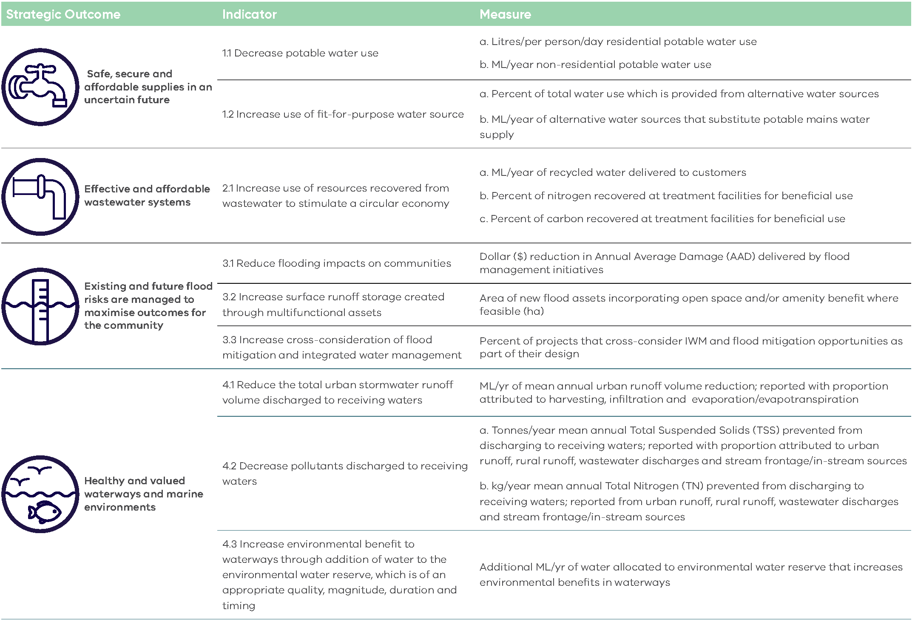
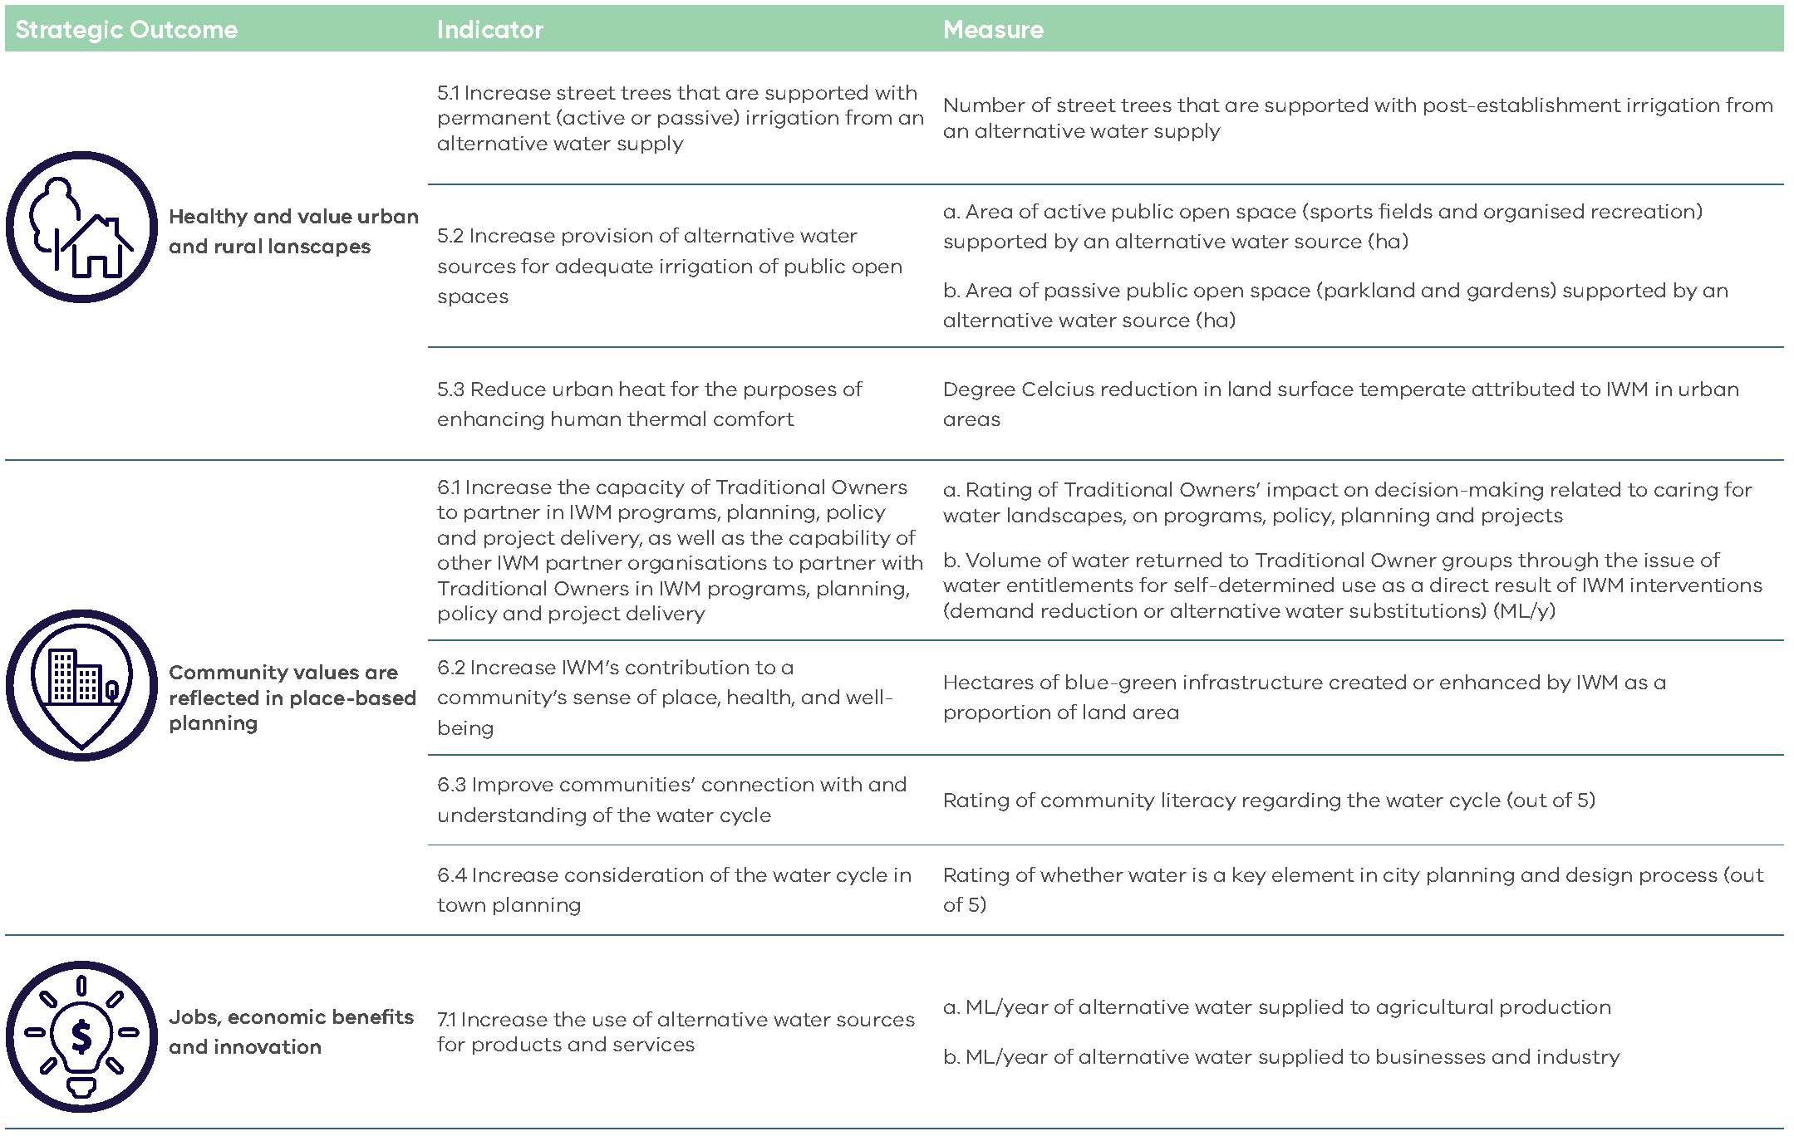

Appendix 1b: Regional Victoria IWM Strategic Outcome Areas & Example Indicators
There are minor variations in outcomes across IWM Forums. The version below reflects common elements. While some Forums identify Traditional Owner partnerships as a distinct outcome, others incorporate this within the broader community values outcome.
The outcome indicators provided in this guidance are examples only; they are intended to help applicants think about and clearly articulate how their project contributes to one or more of the eight IWM Outcomes.
These examples are not exhaustive, and applicants are encouraged to use indicators that best reflect the nature and intent of their specific project.
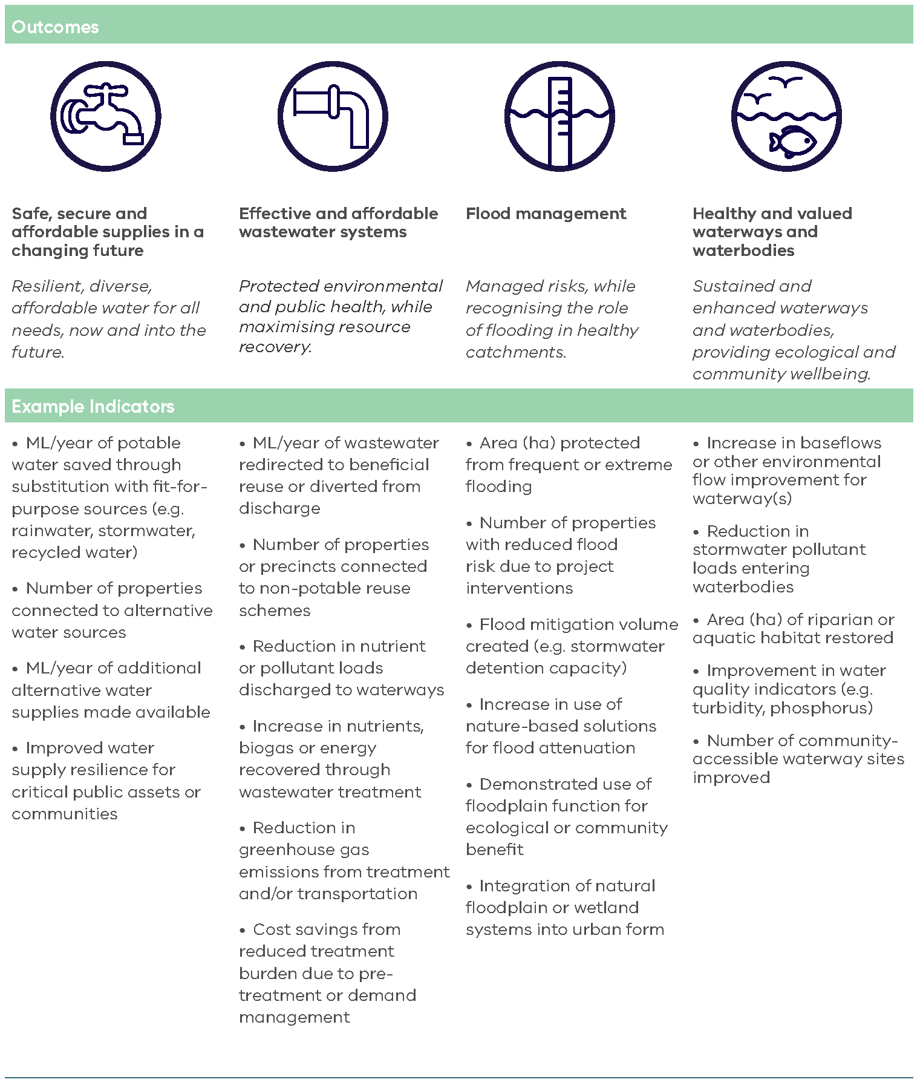
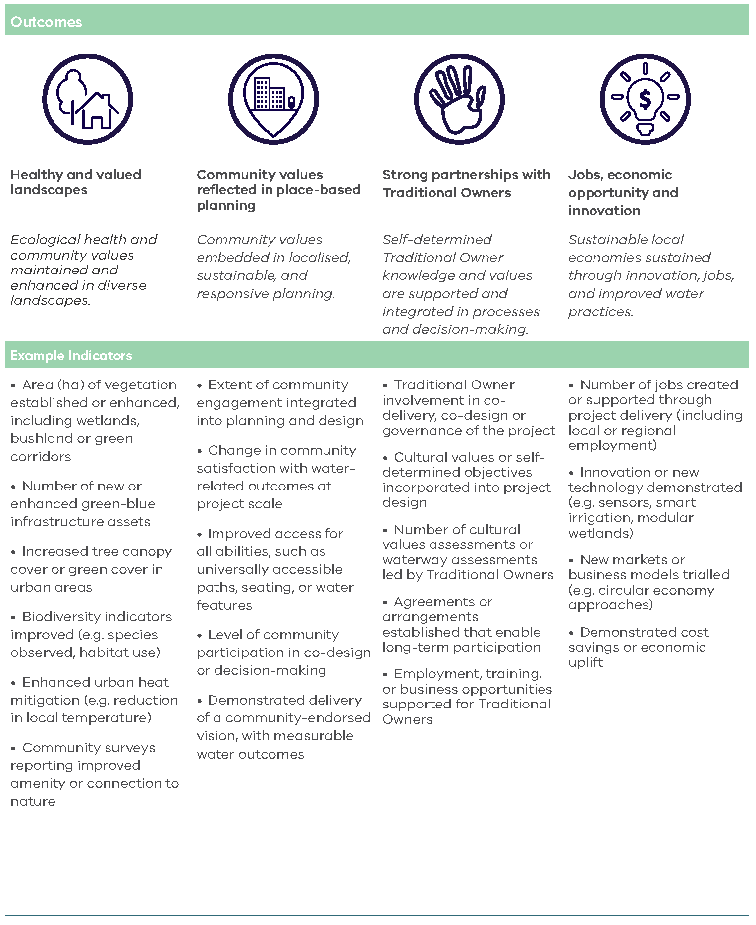

Appendix 2: Assessment Scoring Table
Assessment Scoring Table
 | Rating = 10 | Rating = 7.5 | Rating = 5 | Rating = 2.5 | Rating = 0 | Requirements and examples of Evidence
STRATEGIC ALIGNMENT WITH IWM OUTCOMES (30%) | The applicant has demonstrated that the proposed project very strongly contributes to relevant IWM outcomes and indicators, relative to the project location, size and cost | The applicant has demonstrated that the proposed project strongly contributes to relevant IWM outcomes and indicators, relative to the project location, size and cost | The applicant has demonstrated that the proposed project moderately contributes to relevant IWM outcomes and indicators, relative to the project location, size and cost | The applicant has demonstrated that the proposed project has minor contribution to relevant IWM outcomes and indicators, relative to the project location, size and cost | The applicant has not demonstrated that the proposed project contributes to relevant IWM outcomes and indicators, relative to the project location, size and cost | Explain how the proposed project aligns with, and contributes to, relevant IWM strategic outcomes. The project must contribute to at least 2 IWM strategic outcomes.  Supporting evidence may include, but is not limited to:  - Modelling, data or scenario comparison  - Case studies of similar projects  - Environmental impact studies  - Economic analysis  - Community surveys  - Water quality sampling and analysis
SCALE, SIGNIFICANCE OF IMPACT AND ALIGNMENT WITH BROADER GOVERNMENT INITIATIVES (20%) | Benefits and impacts are:  - realised at a state- or region-scale.  - enduring, with long-term value or impact.  - Strongly aligned with multiple government priorities (e.g., housing, climate adaptation, Traditional Owner self-determination, food security, flooding). | Benefits and impacts are:  - realised at a regional or sub-regional scale.  - sustained (lasts beyond 10 years).  - well aligned with at least two relevant government priorities. | Benefits and impacts are:  - realised at a regional or sub-regional scale.  - of moderate longevity.  - partially aligned with government priorities. | Benefits and impacts are:  - limited in geographic scale.  - short-lived.  - weakly or indirectly aligned with government priorities. | Benefits and impacts are:  - Unclear and/or negligible.  - Not aligned with government priorities. | - Demonstrate the scale and longevity of the benefits of the proposed project.  - Demonstrate that the project is aligned with broader State Government priorities (e.g. housing, food security, flooding, climate adaptation, Traditional Owner Self-determination)  Supporting evidence may include, but is not limited to:  - Business case, modelling or other evidence to support benefit estimates.  - References to relevant strategies or policy commitments (e.g. Housing Statement).  - Support from other government departments.  - Evidence of other investment programs (e.g, National Water Grid).
TIMELINESS AND FUTURE COST AVOIDANCE (30%) | The applicant has demonstrated a clear and compelling time-sensitive window including:  - strong case for why delay would reduce impact or result in missed opportunity.  - strong evidence that investment will prevent significant future cost, failure, or missed integration. | The applicant has demonstrated time-sensitive elements including:  - benefits likely reduced if delayed. opportunity still potentially viable over time  - clear narrative of future cost avoidance (economic, social, environmental), with moderate supporting detail. | The applicant has demonstrated some timing rationale, but weak justification for urgency; general reference to cost avoidance (economic, social, environmental) without specific quantification | The applicant has demonstrated weak or inconsistent rationale for why the project must occur now; vague or unsubstantiated cost avoidance (economic, social, environmental) claims | The applicant has demonstrated no justification for time sensitivity or urgency; no discussion of future risk or cost avoidance | Demonstrate the time-sensitive nature of the project by:  - Explaining how delays in investment may reduce impact or result in missed opportunities  - Providing evidence that timely investment will prevent significant future cost  Supporting evidence may include, but is not limited to:  - Description of timing alignment with broader infrastructure or planning projects  - Lost opportunity analysis.  - Dependencies with other projects.  - Reference to IWM Planning Guidelines recommended timelines.  - Forecasted cost comparisons.  - Avoided retrofit analysis.  - Environmental degradation projections.  - Benefit-cost narrative.  - Risk avoidance or value uplift justification.  - Modelling or scenario comparison.
READINESS TO DELIVER, PARTNERSHIP AND STAKEHOLDER ENGAGEMENT APPROACH (20%) | The applicant has demonstrated to a very strong degree its:  - Approach to partnering with IWM Forum members and Traditional Owners.  - Approach to engaging with key stakeholders such as non-partner forum members, non-member Traditional Owner groups, regulatory authorities, special interest groups and communities.  - Work undertaken to date in the lead up to the proposed activity.  - Capability and capacity to deliver the proposed activity.  - Delivery risks and treatments.  - Delivery schedule and milestones. | The applicant has demonstrated to a strong degree its:  - Approach to partnering with IWM Forum members and Traditional Owners.  - Approach to engaging with key stakeholders such as non-partner forum members, non-member Traditional Owner groups, regulatory authorities, special interest groups and communities.  - Work undertaken to date in the lead up to the proposed activity.  - Capability and capacity to deliver the proposed activity.  - Delivery risks and treatments  - Delivery schedule and milestones. | The applicant has demonstrated to a moderate degree its:  - Approach to partnering with IWM Forum members and Traditional Owners.  - Approach to engaging with key stakeholders such as non-partner forum members, non-member Traditional Owner groups, regulatory authorities, special interest groups and communities.  - Work undertaken to date in the lead up to the proposed activity.  - Capability and capacity to deliver the proposed activity.  - Delivery risks and treatments.  - Delivery schedule and milestones. | The applicant has demonstrated to a weak degree its:  - Approach to partnering with IWM Forum members and Traditional Owners.  - Approach to engaging with key stakeholders such as non-partner forum members, non-member Traditional Owner groups, regulatory authorities, special interest groups and communities.  - Work undertaken to date in the lead up to the proposed activity.  - Capability and capacity to deliver the proposed activity.  - Delivery risks and treatments.  - Delivery schedule and milestones. | The applicant has not demonstrated its:  - Approach to partnering with IWM Forum members and Traditional Owners.  - Approach to engaging with key stakeholders such as non-partner forum members, non-member Traditional Owner groups, regulatory authorities, special interest groups and communities.  - Work undertaken to date in the lead up to the proposed activity.  - Capability and capacity to deliver the proposed activity.  - Delivery risks and treatments.  - Delivery schedule and milestones. | Show that your organisation is prepared and equipped to successfully deliver the proposed project. This includes demonstrating:  - detailed project planning appropriate to the scale of the project  - effective risk management and contingency strategies  - a realistic delivery schedule with clear milestones  - a collaborative delivery approach  - sound stakeholder engagement planning  - any preparatory work completed prior to submitting this application  - the skills, resources, and experience needed to carry out the proposed activities  Supporting evidence must include:  - Details of risks and mitigations, completed on the template provided in the application document pack  - A budget overview, completed on the template provided in the application document pack  - Project key milestones and delivery dates  - Written agreement between partners or letters of endorsement from collaborative partners  Supporting evidence may also include, but is not limited to:  - A comprehensive project plan  - Feasibility study  - Business case  - Design documents  - Relevant approvals  - Project partner organisation chart, including defined roles and responsibilities  - Collaborative governance arrangements, including structured processes for decision-making, monitoring and approvals  - Stakeholder engagement plan

deeca.vic.gov.au

