IWM Partnership Projects – Metropolitan Melbourne

Grant Application Guidelines 2025-28

Acknowledgment
We acknowledge and respect Victorian Traditional Owners as the original custodians of Victoria's land and waters, their unique ability to care for Country and deep spiritual connection to it. We honour Elders past and present whose knowledge and wisdom has ensured the continuation of culture and traditional practices.
We are committed to genuinely partner, and meaningfully engage, with Victoria's Traditional Owners and Aboriginal communities to support the protection of Country, the maintenance of spiritual and cultural practices and their broader aspirations in the 21st century and beyond.
© The State of Victoria Department of Energy, Environment and Climate Action 2023
This work is licensed under a Creative Commons Attribution 4.0 International licence. You are free to re-use the work under that licence, on the condition that you credit the State of Victoria as author. The licence does not apply to any images, photographs or branding, including the Victorian Coat of Arms, the Victorian Government logo and the Department of Energy, Environment and Climate Change (DEECA) logo. To view a copy of this licence, visit http://creativecommons.org/licenses/by/4.0/
ISBN 978-1-76176-668-8 (pdf/word/online)
Disclaimer
This publication may be of assistance to you but the State of Victoria and its employees do not guarantee that the publication is without flaw of any kind or is wholly appropriate for your particular purposes and therefore disclaims all liability for any error, loss or other consequence which may arise from you relying on any information in this publication.
Accessibility
If you would like to receive this publication in an alternative format, please telephone the DEECA Customer Service Centre on 136186, email customer.service@deeca.vic.gov.au or via the National Relay Service on 133 677 www.relayservice.com.au. This document is also available on the internet at www.deeca.vic.gov.au.

Contents
IWM Partnership Projects – Metropolitan Melbourne 1
Grant Application Guidelines 2025-28 1
1. What is the Integrated Water Management Program? 2
2. What is the IWM Grant Program 2025-28? 3
3. What are the objectives of the IWM Partnership Projects Metropolitan Melbourne stream? 4
4. Who can apply? 4
5. What might be funded? 4
6. What will not be funded? 5
7. What are the funding details? 6
8. What are the assessment criteria? 7
9. What are the key dates? 8
10. What should I do to prepare? 8
11. What supporting documents will need to be provided? 9
12. What is the application process? 9
13. How will the applications be assessed? 10
14. What is the clarification process? 10
15. How will I be notified of the outcome? 10
16. Where do I go for questions and assistance? 10
17. What conditions apply to applications and funding? 11
18. Checklist 13
Appendix 1: IWM Strategic Outcomes, Indicators & Measures – Metropolitan Melbourne 14
Appendix 2: Assessment Scoring Table 16

What is the Integrated Water Management Program?
The Integrated Water Management (IWM) Program was established by the Victorian Government in 2017 to shift the way we plan for and manage water across the state. Administered by the Department of Energy, Environment and Climate Action (DEECA), the Program brings together organisations with responsibilities or interests in the water cycle—such as local governments, Traditional Owners, water corporations, Catchment Management Authorities, state agencies and other partners—to work together to deliver shared outcomes.
The IWM Program is guided by the IWM Framework for Victoria (2017). It sets out how partners can work together to make better use of all water sources, embed local values and Traditional Owner knowledge, and deliver multiple benefits—such as healthier waterways and landscapes, greater climate resilience, water security, and more liveable, connected communities.
To put the Framework into action, DEECA facilitated the establishment of 15 IWM Forums—five in metropolitan Melbourne and ten in regional Victoria. These Forums function as collaborative governance platforms, enabling cross-sector organisations to identify shared priorities, align planning and investment, and coordinate integrated water solutions.
What is IWM?
IWM is a holistic and collaborative approach to the way we plan for and manage all elements of the water cycle —including water supply, wastewater, and stormwater—to deliver broader benefits for people, places, and the environment.
By aligning water, land use, and urban planning, IWM helps create more resilient, liveable and sustainable communities. It changes how we think about and deliver water services—shifting from siloed to integrated solutions.
As Victoria faces climate change, population growth, environmental pressures, and other complex challenges, IWM ensures we all work together to meet our current and future water needs.
Each Forum has developed a Strategic Directions Statement (SDS) that captures the region’s context, collective vision, and priority outcomes. These SDSs provide the strategic foundation for advancing priority projects that respond to local needs while contributing to statewide IWM outcomes.
The 5 metropolitan Melbourne IWM Forums have built on the foundations laid by the SDSs by developing Catchment Scale IWM (CSIWM) Action Plans. These plans outline outcome-driven actions across multiple scales, which are complementary and reinforcing, to improve the resilience, liveability and sustainability of our urban areas and the environment. While the IWM Forum Partners across the state have made significant progress in transitioning to an Integrated Water Management approach, DEECA’s leadership is now focussing on accelerating the transition. The Program delivers a range of activities to support system-wide change—fostering partnerships, aligning planning processes, building capability, policy reform, and supporting on-ground delivery. The IWM Grant Program is a key element of the transition.
While the IWM Forum Partners across the state have made significant progress in transitioning to an Integrated Water Management approach, DEECA’s leadership is now focussing on accelerating the transition. The Program delivers a range of activities to support system-wide change—fostering partnerships, aligning planning processes, building capability, policy reform, and supporting on-ground delivery. The IWM Grant Program is a key element of the transition.
The IWM Grant Program provides targeted funding to support the design and delivery of IWM projects across Victoria. The Grant Program has been central to progressing the Program’s long-term aim by building capability, strengthening relationships, and demonstrating the social, environmental, cultural, and economic value of IWM. It continues to play a vital role in supporting the transition to IWM as standard practice.

What is the IWM Grant Program 2025-28?
The next phase of the IWM Grant Program builds on insights and lessons from previous rounds. Stakeholder feedback, project outcomes, and an evolving policy and planning context have shaped a refreshed approach aimed at accelerating IWM adoption across Victoria.
The IWM Grant Program 2025-28 will continue to provide co-investment for collaborative, place-based projects aligned with IWM Forum priorities. It will also strengthen Traditional Owner leadership and participation in water planning and enable strategic investment in time-sensitive, high-impact opportunities identified by the sector.
The 2025–2028 Program will be delivered through three funding streams:
- IWM Partnership Projects (metropolitan and regional).
- Traditional Owner-led IWM Projects.
- IWM Strategic Directed Investments (SDI).
This document outlines the arrangements for the IWM Partnership Projects stream, specifically for projects in any of the 5 metropolitan Melbourne IWM Forum regions.

What are the objectives of the IWM Partnership Projects Metropolitan Melbourne stream?
The IWM Partnership Projects Metropolitan Melbourne stream provides co-funding to support the delivery of place-based projects that have been collaboratively developed through IWM Forum processes.
These grants aim to:
- Implement priorities identified through metropolitan IWM Forum collaboration.
- Build awareness, capacity and local leadership in the design and delivery of IWM outcomes.
- Demonstrate the benefits of IWM through practical delivery of IWM outcomes.
These projects support the IWM Program’s long-term goal of embedding IWM as standard practice across Victoria by strengthening the enabling environment, showcasing effective approaches, and fostering collaborative ways of working across the sector.

Who can apply?
The lead applicant must:
- be a member organisation of a metropolitan Melbourne IWM Forum
- be an incorporated body, cooperative or association (including business associations)
- be financially solvent
- have the capacity to manage the grant funding directly, including any procurement (e.g. consultancies or works).
While projects are expected to be undertaken in collaboration, there can be only one lead applicant for each application. If successful, the lead applicant will be:
- the sole party to the funding agreement
- responsible for managing all grant funds directly, including those allocated to consultancies or subcontractors.
It is not acceptable for the lead applicant to act as a financial intermediary and transfer the funds to another organisation for management. The State requires a clear line of accountability for public funding and cannot fund projects where it does not maintain direct financial oversight.

What might be funded?
To be eligible for funding, projects must meet all of the following criteria:
- be located within any of the 5 metropolitan Melbourne IWM Forum regions.
- be either a capital or feasibility project, defined as:
  - Capital project: Involves on-ground works and may include design and construction (D&C) or construction only. For D&C projects, a suitably detailed design and feasibility assessment (appropriate to the scale of the project) must be completed prior to applying for grant funding.
  - Feasibility project: Involves investigation or planning to support future IWM delivery. Feasibility projects may include a feasibility study or needs analysis, development of an IWM plan, preparation of a business case, creation of a functional design or research and development.
- directly align with the priorities of a metropolitan Melbourne IWM Forum(s). This includes:
  - Priority projects listed in, or clearly derived from priority projects listed in a Catchment Scale IWM Action Plan, or
  - Newly endorsed priority projects that have been formally supported by a metropolitan IWM Forum(s)
- be delivered collaboratively with one or more IWM Forum member organisation.
- meet the co-contribution threshold.
- satisfy one or more purposes of Victoria’s Environmental Contribution levy, namely to:
  - promote the sustainable management of water, or
  - address adverse water-related environmental impacts
- clearly support the objectives of this grant program.
If an applicant is unsure whether a proposed project meets the eligibility requirements, they are encouraged to contact DEECA for clarification prior to the application close date.

What will not be funded?
The Program will not fund the following:
- Projects and activities that are not scheduled to begin in 2025-26 or 2026-27 financial years.
- Projects and activities that are able to proceed without this grant funding.
- The purchase of land or water entitlement
- Routine or ongoing maintenance activities (outside of justified establishment-phase maintenance for capital works).
- Recurrent operating costs, including rent, staffing, utility costs, and/or activities establishing expectation of ongoing funding.
- Projects and activities already fully funded through another source, including other grants Programs.
- Applications that exceed the funding caps outlined for the type of project.
- Projects and activities located outside the State of Victoria.
- Political campaigning or advocacy activities for political parties.
Note: Reasonable, time-limited maintenance associated with the establishment of capital works (e.g. vegetation establishment or erosion control) is eligible if clearly justified. Time-limited project staff are also eligible if directly tied to project delivery and the co-contribution threshold is met.

What are the funding details?
A total of $7.5 million is available for the IWM Partnership Projects Metropolitan Victoria stream over three financial years, from 2025-26 to 2027-28.
Funding caps apply as follows:
- A maximum of $2.5 million per capital project; and
- A maximum of $250,000 per feasibility project.

Co-contribution
At a minimum applicants must contribute:
- A financial co-contribution of at least 25% of the total project value
- A combined co-contribution (financial + in-kind) of at least 50% of the total project value.
Applications with a higher percentage of co-contribution will be assessed more favourably in the merit assessment.
Financial contribution refers to a monetary contribution to the project costs, which may include grant funding from other appropriate sources. In-kind contribution refers to a provision of goods or services that are not in the form of cash, and may include donated goods, volunteer labour or free services.

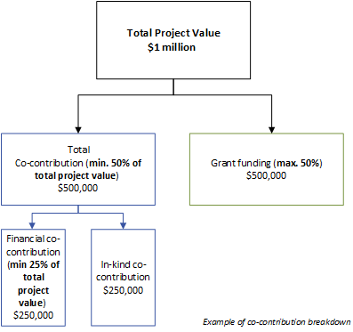
Figure 1: Co-contribution breakdown illustration
When determining project costs and funding needs, applicants should consider the impact of cost escalation over time (e.g. Consumer Price Index and Wage Price Index) and should consider the time required for design and approvals, especially when delivering capital projects.

Funding flexibility
There is no limit to the number of applications an applicant can submit, provided that each meets all eligibility criteria set out in these Guidelines.

What are the assessment criteria?
First, applications will be checked for eligibility to make sure that the applicant and their activity are eligible for funding. After that, eligible applications will be assessed using the criteria listed below. Each criterion is given a percentage weighting to indicate its relative importance in the assessment process. Applications should address all relevant criteria.
Assessment Criteria 1: Strategic alignment with IWM outcomes (50%)
Explain how the proposed project aligns with, and contributes to, relevant IWM strategic outcomes. The project must contribute to at least 2 IWM strategic outcomes. See Appendix 1 for the IWM strategic outcomes and list of example indicators. Note that the indicators are examples only and not an exhaustive list.
Supporting evidence may include, but is not limited to:
- Modelling, data or scenario comparison
- Case studies of similar projects
- Environmental impact studies
- Economic analysis
- Community surveys
- Water quality sampling and analysis
Assessment Criteria 2: Readiness to deliver (20%)
Show that your organisation is prepared and equipped to successfully deliver the proposed project. This includes demonstrating:
- detailed project planning appropriate to the scale of the project
- effective risk management and contingency strategies
- a realistic delivery schedule with clear milestones
- any preparatory work completed prior to submitting this application
- the skills, resources, and experience needed to carry out the proposed activities
Supporting evidence must include:
- Details of risks and mitigations, completed on the template provided in the application document pack
- A budget overview, completed on the template provided in the application document pack
- Project key milestones and delivery dates
Supporting evidence may also include, but is not limited to:
- A comprehensive project plan including a more detailed project schedule and budget
- Feasibility study
- Business case
- Design documents
- Relevant approvals
- Resourcing or staffing plan
Assessment Criteria 3: Delivery and partnership approach (20%)
Describe how you will ensure that the project is delivered collaboratively with one or more IWM Forum member organisations.
Collaborative partner organisations are organisations that actively participate in shared decision-making, contribute resources or expertise, and take joint responsibility for achieving outcomes within a collaborative governance framework.
Supporting evidence must include:
- Written agreement between partners or letters of endorsement from collaborative partners
Supporting evidence may also include, but is not limited to:
- Project / partner organisation chart.
- Defined roles, responsibilities and communication channels.
- Structured processes for decision-making and approvals.
- Project monitoring and control processes.
Assessment Criteria 4: Stakeholder engagement approach (10%)
Demonstrate a sound and well-thought-out approach to stakeholder engagement.
Supporting evidence may include, but is not limited to:
- A stakeholder list
- A matrix of stakeholder needs
- A report on stakeholder engagement already performed
- A stakeholder engagement plan to be implemented for the project

What are the key dates?
Timeline | Date
Applications open | 3 November 2025
Applications close | 16 February 2026
Applications assessment and approval | February – April 2026
Notification of funding outcomes | April 2026
Funding agreements for successful applicants | April - June 2026

What should I do to prepare?
To ensure your project is eligible, competitive, and ready for funding, applicants are encouraged to read this guidance in detail and review the additional support documents provided on the IWM Grant Program portal page.
Applicants are strongly encouraged to start early to ensure their application is complete, well-evidenced, and clearly presented.
Applicants should be aware that some preparatory actions are required prior to applying for funding, including:
- Engaging and forming agreements with project partners.
- Obtaining IWM Forum endorsement where a Project is not listed in a Strategic Direction Statement.
- Obtaining or, at a minimum, identifying and working towards obtaining any statutory or landholder approvals for the proposed activities.
- Engaging with any other key stakeholders.

What supporting documents will need to be provided?
The following documents must be submitted with the application form:
- Written agreement between partners or letters of endorsement from collaborative partners
- A project budget overview, completed on the template provided
- Description of risks and mitigations, completed on the template provided
Templates required to support your application are available to download from the DEECA website.
Applicants are encouraged to include supporting evidence to strengthen their application, as outlined in Section 8 of these guidelines.
Applications that do not include the required information or documentation may be deemed incomplete, which could affect their merit assessment and significantly reduce the likelihood of success.

What is the application process?
Applications are submitted online using the Grants Online portal.
To apply, go to the Grant Program web page: https://www.water.vic.gov.au/grants/integrated-water-management-grants and click on the ‘Start New Application’ button. To return to a saved draft application, click on the ‘Access Saved Application’ button.
Please note that no hard copy applications will be accepted
An offline version of the application form is available on the DEECA website for applicants to use in drafting and sharing content with collaborative partner organisations during the development of their application. This version is provided for ease of communication only and cannot be submitted in place of the online form.
Applicants are strongly encouraged to commence their application early to allow sufficient time to complete all sections and upload required attachments. If you encounter technical issues or require support, please contact DEECA substantially prior to the submission deadline.

Late applications
Late or incorrectly submitted applications will only be accepted at DEECA’s discretion if doing so aligns with probity principles and does not compromise the integrity of the application process.
Applicants should not assume that they will be given any further opportunity to amend their application. The original application lodged should be considered final.

How will the applications be assessed?
After eligibility checks are conducted and completed, applications deemed eligible will be assessed by an Assessment Panel, supported by subject matter Technical Advisors and overseen by an independent Probity Advisor.
The assessment process for each round will follow these steps:
- DEECA will review the applications for completeness and determine whether they meet the eligibility criteria set out in these guidelines
- Applications that do not meet the eligibility criteria will not proceed to assessment and will not be considered for funding
- All eligible applications will be assessed on a competitive, merit-based basis against the criteria set out in Section 8, and using the Assessment Scoring Table in Appendix 2
- Applications demonstrating the greatest merit across all metropolitan IWM Forums will be recommended for funding, subject to available budget
- Applications recommended for funding will be submitted for Ministerial approval. Once approved, all applicants will be notified of the outcome in accordance with the process set out in Section 15.

What is the clarification process?
In limited circumstances, DEECA may contact applicants during the assessment process to clarify specific aspects of the application where:
- Minor ambiguities or inconsistencies are identified, and
- Clarification is necessary to ensure a fair and transparent assessment
This process will be conducted in accordance with probity principles and will not provide an opportunity to revise or materially alter the application.

How will I be notified of the outcome?
Successful and unsuccessful applicants will be notified in writing after the assessment process is complete and the funding decision has been finalised. All decisions are final and are not subject to further review. Successful and unsuccessful applicants will be offered feedback on their application.

Where do I go for questions and assistance?
If you have questions about the grants Program, the criteria or the assessment process, please refer to the Frequently Asked Questions (FAQs) at: https://www.water.vic.gov.au/grants/integrated-water-management-grants
If your question is not answered in the FAQs, you can contact the IWM Program team by emailing your question to iwm.branch@deeca.vic.gov.au.
Responses to questions may be published on the IWM Grant Program webpage to assist all applicants. Any identifying or commercially sensitive information will be removed.
If you need technical assistance submitting your application online, please email: grantsinfo@deeca.vic.gov.au.

What conditions apply to applications and funding?

Funding agreements
Successful applicants must enter into a funding agreement with DEECA.
The DEECA Transfer Payment Funding Agreement is used for Victorian public entities, as defined under section 5 of the Public Administration Act 2004.
The Victorian Common Funding Agreement is used for funding agreements with all other applicable entities.
Information about the Victorian Common Funding Agreement is available on https://www.vic.gov.au/victorian-common-funding-agreement
It is recommended that applicants review the terms and conditions before applying.
Funding agreements must be signed within one month of notification of successful grant application. Failure to execute agreements within this timeframe may result in the offer of grant funding being withdrawn and funding reallocated.

Legislative and regulatory requirements
In delivering the activity grant recipients are required to comply with all relevant Commonwealth and state/territory legislations and regulations, including but not limited to:
- The Privacy Act 1988 (Commonwealth)
- The Freedom of Information Act 1982 (Vic)
- Occupational Health and Safety Act 2004
- Water Act 1989
- Planning and Environment Act 1987
- Aboriginal Heritage Act 2006
- Flora and Fauna Guarantee Act 1988.

Tax implications
Applicants should consult the Australian Taxation Office or seek professional advice on any taxation implications that may arise from this grant funding.
When determining funding amounts, applicants should consider GST payments they may be obliged to pay to suppliers for goods and services.

Acknowledging the Victorian Government’s support
Successful applicants are required to acknowledge that the Victorian Government’s support of the funded project. Promotional guidelines (https://www.deeca.vic.gov.au/grants) will form part of the funding agreement. Successful applicants must liaise with the departmental Program area to coordinate any public events or announcements related to the project in accordance with the terms and conditions of the executed funding agreement.

Payments
Grant payments will be made to recipients provided:
- the funding agreement has been signed by both parties;
- milestone obligations are met; and
- other terms and conditions of funding continue to be met.
Alternate approaches may be considered for specific projects and will be formalised in each funding agreement.

Monitoring
Grant recipients are required to comply with project monitoring and reporting requirements as outlined in the funding agreement.
This may include progress reports, site inspections, completion reports, measurement of outcomes, and acquittal documentation.

Cost
DEECA is not liable for any costs, expenses, losses, claims or damages that may be incurred by applicants in connection with the application process, including in preparing or submitting an application, providing further information to DEECA, or participating in negotiations with DEECA.

Probity
The applicant and any of its associates must not offer any incentive to or otherwise attempt to influence any of the persons who are either directly or indirectly involved in the application process, or in awarding any subsequent contract. If DEECA determines that the applicant or any of its associates have violated this condition, the applicant may be disqualified from further consideration, at DEECA’s absolute discretion.
By submitting an application, the applicant consents to DEECA performing probity and financial investigations and procedures in relation to the applicant or any of its associates. The applicant agrees, if requested by DEECA, to seek consents from individuals to allow such probity checks.

Privacy
Any personal information about you or a third party in your application will be collected by the department for the purposes of administering your grant application and informing Members of Parliament of successful applications.
Personal information may also be disclosed to external experts, such as members of assessment panels, or other Government Departments for assessment, reporting, advice, comment or for discussions regarding alternative or collaborative grant funding opportunities.
If you intend to include personal information about third parties in your application, ensure that they are aware of the contents of this privacy statement.
Any personal information about you or a third party in your correspondence will be collected, held, managed, used, disclosed or transferred in accordance with the provisions of the Privacy and Data Protection Act 2014 and other applicable laws.
DEECA is committed to protecting the privacy of personal information. You can find the DEECA Privacy Policy online at www.deeca.vic.gov.au/privacy
Requests for access to information about you held by DEECA should be sent to the Manager Privacy, P.O. Box 500 East Melbourne 8002 or contact by emailing Foi.unit@deeca.vic.gov.au.

Checklist
Read these guidelines and the information about this Grant Program at https://www.water.vic.gov.au/grants/integrated-water-management-grants before applying and complete the following checklist.
Have you:
 carefully read these guidelines in full?
 checked if your organisation is eligible for this grant funding?
 checked if your project/activity is eligible for this grant funding?
 checked that you understand the assessment criteria?
 checked that you understand the funding availability and co-contribution requirements?
 checked that you understand the key dates?
 engaged the relevant project partners to obtain evidence of partnership/collaboration (e.g. letters of endorsement)?
 obtained endorsement for your project by your IWM Forum and have record as evidence (applicable only if project not included in CSIWM Action Plan)
 prepared the appropriate supporting documents?
 checked that you would be able to comply with all relevant laws and regulations in delivery of your activity?

Appendix 1: IWM Strategic Outcomes, Indicators & Measures – Metropolitan Melbourne
The measures outlined below apply to the Metro Melbourne IWM region and are derived from the agreed CSIWM framework. Some measures have been refined to incorporate recent insights from the MERI process.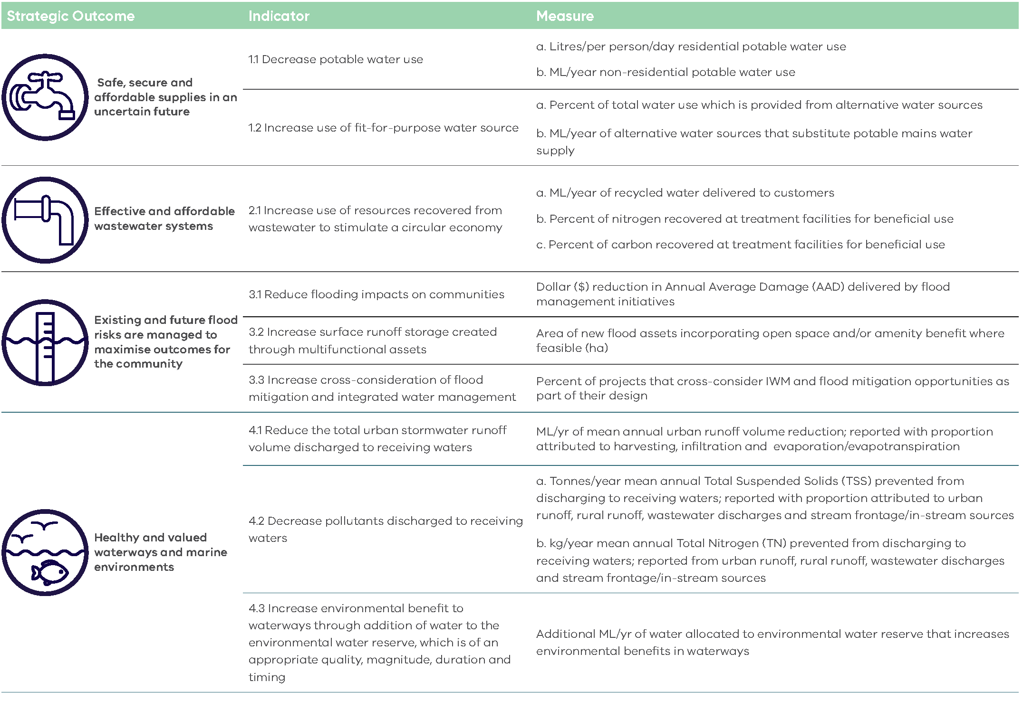

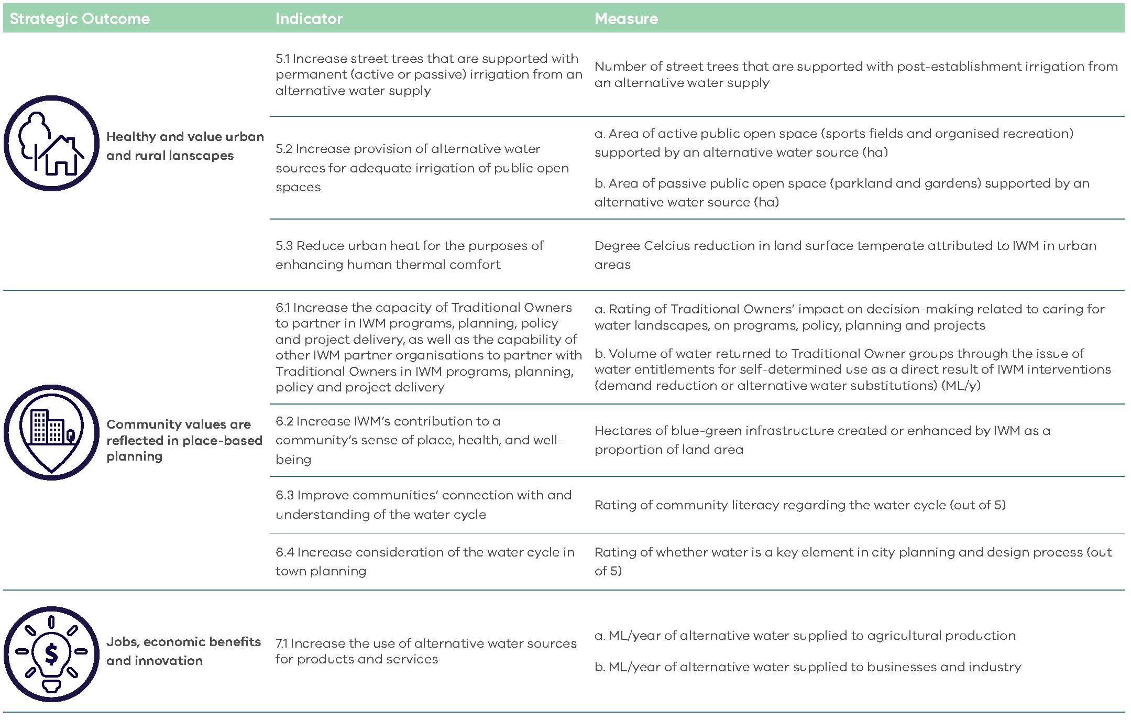

Appendix 2: Assessment Scoring Table
Assessment Scoring Table
 | Rating = 10 | Rating = 7.5 | Rating = 5 | Rating = 2.5 | Rating = 0 | Requirements and examples of evidence
Strategic alignment with IWM outcomes (50%) | The applicant has demonstrated that the proposed project very strongly contributes to relevant IWM outcomes and indicators, relative to the project location, size and cost | The applicant has demonstrated that the proposed project strongly contributes to relevant IWM outcomes and indicators, relative to the project location, size and cost | The applicant has demonstrated that the proposed project moderately contributes to relevant IWM outcomes and indicators, relative to the project location, size and cost | The applicant has demonstrated that the proposed project has minor contribution to relevant IWM outcomes and indicators, relative to the project location, size and cost | The applicant has not demonstrated that the proposed project contributes to relevant IWM outcomes and indicators, relative to the project location, size and cost | Explain how the proposed project aligns with, and contributes to, relevant IWM strategic outcomes. The project must contribute to at least 2 IWM strategic outcomes.  Supporting evidence may include, but is not limited to:  - Modelling, data or scenario comparison  - Case studies of similar projects  - Environmental impact studies  - Economic analysis  - Community surveys  - Water quality sampling and analysis
Readiness to deliver (20%) | The applicant has demonstrated to a very strong degree:  - What will be delivered with grant funding  - Work undertaken to date in the lead up to the proposed activity  - Capability and capacity to deliver the proposed activity  - Delivery risks and treatments  - Delivery schedule and milestones | The applicant has demonstrated to a strong degree:  - What will be delivered with grant funding  - Work undertaken to date in the lead up to the proposed activity  - Capability and capacity to deliver the proposed activity  - Delivery risks and treatments  - Delivery schedule and milestones | The applicant has demonstrated to a moderate degree:  - What will be delivered with grant funding  - Work undertaken to date in the lead up to the proposed activity  - Capability and capacity to deliver the proposed activity  - Delivery risks and treatments  - Delivery schedule and milestones | - The applicant has demonstrated to a weak degree:  - What will be delivered with grant funding  - Work undertaken to date in the lead up to the proposed activity  - Capability and capacity to deliver the proposed activity  - Delivery risks and treatments  - Delivery schedule and milestones | The applicant has not demonstrated:  - What will be delivered with grant funding  - Work undertaken to date in the lead up to the proposed activity  - Capability and capacity to deliver the proposed activity  - Delivery risks and treatments  - Delivery schedule and milestones | Show that your organisation is prepared and equipped to successfully deliver the proposed project. This includes demonstrating:  - Detailed project planning appropriate to the scale of the project  - Effective risk management and contingency strategies  - A realistic delivery schedule with clear milestones  - Any preparatory work completed prior to submitting this application  - The skills, resources, and experience needed to carry out the proposed activities  Supporting evidence must include:  - Details of risks and mitigations, completed on the template provided in the application document pack  - Budget overview, completed on the template provided in the application document pack  - Project key milestones and delivery dates  Supporting evidence may also include, but is not limited to:  - Comprehensive project plan including a more detailed project schedule and budget  - Relevant approvals  - Resourcing or staffing plan
Readiness to deliver (20%) | Total applicant contribution comprises more than 90% of Project cost | Total applicant contribution comprises 80-90% of Project cost | Total applicant contribution comprises 70-80% of Project cost | Total applicant contribution comprises 60-70% of Project cost. | Total applicant contribution comprises 50-60% of Project cost. | Evidence may include:  - Confirmation of funding amount and source.  - Calculation of financial and in-kind contributions.
DELIVERY AND PARTNERSHIP APPROACH (20%) | The applicant will partner with two or more formal partners, or the project involves cross-Forum collaboration.  Partnerships have been formalised and clearly documented.  A robust governance model is in place for project delivery. | The applicant proposes to partner with two IWM Forum members within their region.  Partnerships have been agreed.  A governance model is in place for project delivery. | The applicant proposes to partner with one IWM Forum member within their region.  Partnerships have been discussed.  Governance arrangements will be developed. | The applicant proposes to partner with another organisation within their region.  Governance arrangements will be developed. | The applicant does not propose to partner with any other organisations. | Describe how you will ensure that the project is delivered collaboratively with one or more IWM Forum member organisations.  Supporting evidence must include:  - Written agreement between partners or letters of endorsement from collaborative partners  Supporting evidence may include, but is not limited to:  - Project / partner organisation chart.  - Defined roles, responsibilities and communication channels.  - Structured processes for decision-making and approvals.  - Project monitoring and control processes.
STAKEHOLDER ENGAGEMENT APPROACH (10%) | Key stakeholders such as non-partner IWM Forum members, non-member Traditional Owner groups, regulatory authorities, special interest groups and communities have been identified and a detailed engagement plan has already been developed | Key stakeholders such as non-partner IWM Forum members, non-member Traditional Owner groups, regulatory authorities, special interest groups and communities have been identified and a basic engagement plan has already been developed | Key stakeholders such as non-partner IWM Forum members, non-member Traditional Owner groups, regulatory authorities, special interest groups and communities have been identified and an engagement plan is proposed to be developed | Key stakeholders such as non-partner IWM Forum members, non-member Traditional Owner groups, regulatory authorities, special interest groups and communities have been identified | Key stakeholders have not been identified | Demonstrate a sound and well-thought-out approach to stakeholder engagement.  Supporting evidence may include, but is not limited to:  - A stakeholder list  - A matrix of stakeholder needs  - A report on stakeholder engagement already performed  - A stakeholder engagement plan to be implemented for the project

deeca.vic.gov.au

