East Gippsland
Strategic directions statement
September 2018

Department of Health
Acknowledgement of Victoria’s Aboriginal communities
The Victorian Government proudly acknowledges Victoria's Aboriginal communities and their rich culture and pays its respects to their Elders past and present. The government also recognises the intrinsic connection of Traditional Owners to Country and acknowledges their contribution to the management of land, water and resources.
We acknowledge Aboriginal people as Australia’s first peoples and as the Traditional Owners and custodians of the land and water on which we rely. We recognise and value the ongoing contribution of Aboriginal people and communities to Victorian life and how this enriches us. We embrace the spirit of reconciliation, working towards the equality of outcomes and ensuring an equal voice.
© The State of Victoria Department of Environment, Land, Water and Planning 2018
This work is licensed under a Creative Commons Attribution 4.0 International licence. You are free to re-use the work under that licence, on the condition that you credit the State of Victoria as author. The licence does not apply to any images, photographs or branding, including the Victorian Coat of Arms, the Victorian Government logo and the Department of Environment, Land, Water and Planning (DELWP) logo. To view a copy of this licence, visit Creative Commons <creativecommons.org/licenses/by/4.0/>
Printed by Finsbury Green, Melbourne
ISBN 978-1-76077-343-4 (Print)
ISBN 978-1-76077-344-1 (pdf/online/MS word)
Disclaimer
This publication may be of assistance to you but the State of Victoria and its employees do not guarantee that the publication is without flaw of any kind or is wholly appropriate for your particular purposes and therefore disclaims all liability for any error, loss or other consequence which may arise from you relying on any information in this publication.
Accessibility
If you would like to receive this publication in an alternative format, please telephone the DELWP Customer Service Centre on 136 186 or email the DELWP Customer Service Centre <customer.service@delwp.vic.gov.au> or via the National Relay Service on 133 677, or at the National Relay Service website <www.relayservice.com.au>.
This document is also available on the internet at the DELWP website <www.delwp.vic.gov.au>

Contents
Foreword 7
At a glance 8
IWM opportunities 9
Chapter 1 The way forward 11
Introduction 11
Enduring collaboration 12
Chapter 2 IWM in the Region 16
Vision and outcome areas for the East Gippsland IWM Forum Region 17
Regional context 19
The case for IWM in the Region 21
Success stories 23
Chapter 3 IWM opportunities 24
State-wide and region specific initiatives 24
IWM opportunities: How were they selected? 25
Impact of IWM opportunities on the Forum's strategic outcomes 26
IWM project & strategy opportunities – overview 27
IWM project and strategy opportunities – in depth 29
Chapter 4 Evaluation and review 45
Appendix A 46
Region specific plans and strategies enabling IWM 46
References 48

Integrated Water Management is a collaborative approach to water planning and management that brings together organisations with an interest in all aspects of the water cycle.
It has the potential to provide greater value to our communities by identifying and leveraging opportunities to optimise outcomes.

Foreword
The East Gippsland Integrated Water Management (IWM) Forum was established in 2017 to guide the identification and implementation of IWM projects in the region. This Strategic Directions Statement (SDS) captures the Forum’s vision for the region and identifies the priority
IWM projects at this time.
The Forum and this Statement builds on existing collaborative networks established to share and incubate ideas on environmental, water and traditional owner issues. The East Gippsland IWM Forum has been supported by a practitioner working group, bringing together a depth of knowledge across organisations that influence the water cycle. A series of workshops and many individual meetings with project sponsors have been held to develop IWM initiatives from ideas into mature project themes. Collaboration and cross-pollination has been a key outcome of the Forum, with ideas being shared and improved by input from project partners.
This Strategic Directions Statement provides a vision and plan for implementing IWM projects across the region. Rather than being an end in itself, the Statement is a key step in the ongoing journey to develop and implement IWM. The opportunity list and action plan in particular will be continually up-dated as IWM projects are progressively implemented and new ideas are discussed and developed.
Bruce Hammond
Chair of the East Gippsland IWM Forum
This East Gippsland IWM Strategic Directions Statement has been developed in collaboration with:
- Bairnsdale Regional Health
- Department of Environment, Land, Water and Planning
- East Gippsland Catchment Management Authority
- East Gippsland Shire Council
- East Gippsland Water
- Gippsland Ports
- Gunaikurnai Land and Water Aboriginal Corporation
- Southern Rural Water

At a glance
The East Gippsland IWM Strategic Directions Statement highlights the key water management challenges for the region and identifies collaborative IWM opportunities that can improve resilience and liveability in cities and towns in the region.

Vision
Innovative and collaborative water management to maximise the resilience, liveability and economic prosperity of our East Gippsland communities and connected waterways, wetlands and Gippsland Lakes.

Strategic outcomes:
- Safe, secure and affordable supplies
- Effective and affordable wastewater systems
- Reduced flood risks
- Healthy and valued waterways and Gippsland Lakes
- Healthy and valued urban landscapes
- Community values reflected in place-based planning
- Jobs, economic growth and innovation

IWM opportunities
Partners of the Forum are committing their best endeavours to ensure priority projects and strategies are progressed in line with the shared vision and strategic outcomes of the East Gippsland IWM Forum. The priority IWM projects are:
Bairnsdale IWM Plan
An IWM plan is proposed for the Bairnsdale area with a strong focus on integrating the outcomes and multiple benefits of a number of identified IWM project ideas in the area including but not limited to:
- Wetland development to capture and treat stormwater in the Crooke Street and McMillan Street region of East Bairnsdale
- Opportunities for water sensitive urban design, stormwater harvesting and re-use at Calvert Street Educational Precinct; and,
- Water and vegetation management in the vicinity of Magees Gully, Bairnsdale Livestock Exchange and the Bairnsdale Oval (see Project 2.)
Bairnsdale Livestock Exchange, Bairnsdale Oval and Magees Gully water management
The project will involve the continuation of current investigations into the supply of treated wastewater from the Bairnsdale Wastewater Treatment Plant to the nearby Bairnsdale Livestock Exchange and Bairnsdale Oval plus review management of the complex interface between Magees Gully, the Bairnsdale Livestock Exchange and Macleod Morass. Although part of the Bairnsdale IWM Plan, this project is sufficiently advanced to warrant a separate description in this plan.
Lakes Entrance IWM Plan
An IWM Plan for the Lakes Entrance township is proposed to address the complex interface between urban and natural systems. The Plan will consider opportunities and risks associated with development (including the Lakes Entrance Northern Growth Area), rising lake levels and local alternative water resources. This project will include input to and use of Lakes Entrance Growth and Adaptation Strategy currently being developed.
Place-based planning in East Gippsland
This project will leverage existing community engagement processes through the East Gippsland Shire Council’s place-based planning process to identify community preferences for IWM projects commencing with Omeo and Cann River in 2018/19.
Planning guidelines for new developments in East Gippsland
IWM principles will be embedded into existing relevant planning and guidelines documents to set an expectation on developers to think creatively about water management. Examples include the current review of the East Gippsland Planning Scheme’s Municipal Strategic Statement.
Dinner Plan Recycled Water Scheme
A business case will be developed to assess the costs and benefits of upgrading the Dinner Plain wastewater treatment plant to provide recycled water for snow making. The business case will take a broader perspective than the previous assessment in the 2015 Dinner Plain Integrated Water Cycle Management Plan taking into account new technology developments and a strong social appetite for such a scheme.
Paynesville re-use of treated wastewater
A feasibility assessment will be undertaken into the potential for discharging treated wastewater from the Paynesville Wastewater Treatment Plant to nearby Lower Macleod Morass to achieve an environmental benefit for the wetland and address issues with current disposal of saline wastewater.

Maintenance of community assets
Communities will be consulted on the highest priority community assets to be exempt from water restrictions to maintain liveability (e.g. sporting ovals, public gardens and swimming pools.) Alternative water sources to such assets will also be explored as a substitute for current reticulated water supplies.
Tambo River improvement at Swifts Creek township
Fencing and re-vegetation is proposed in and up-stream of the Swifts Creek town off-take on the Tambo River to improve riparian vegetation and raw water quality.
Supporting aboriginal water values in East Gippsland
The East Gippsland IWM Forum process provides the opportunity to acknowledge and develop aboriginal values for water, include aboriginal values in water planning, support aboriginal access to water for economic development and build capacity to increase aboriginal participation in water management. The project will support, utilise and build on information on aboriginal water values obtained from the current GLaWAC Aboriginal Water project.

Chapter 1
The way forward
An unprecedented opportunity to progress water cycle planning and management in East Gippsland through collaboration.

Introduction
Integrated Water Management is a collaborative approach to water planning that brings together organisations that influence all aspects of the water cycle. It has the potential to provide greater value to our communities by identifying and leveraging opportunities to optimise the outcomes of the water cycle.

Overview
The Integrated Water Management (IWM) Framework for Victoria (September 2017) is designed to help regional stakeholders to work together, ensuring the water cycle contributes to the liveability of towns and cities in Victoria, with communities at the centre of decision making.
The central premise of an IWM approach is the overall acceptance that managing urban liveability and resilience is a shared responsibility and that water is a key enabler to achieving these shared aims.
To facilitate this, IWM Forums have been established across the state to identify, prioritise and oversee the implementation of critical collaborative opportunities. This Strategic Directions Statement has been produced by the East Gippsland IWM Forum.
IWM seeks to build on existing partnerships and planning processes. In the East Gippsland region regional stakeholders - such as Local Government Authorities, Catchment Management Authorities and Water Corporations, engage with their communities regularly to improve service delivery and urban planning. Community aspirations are embedded in organisational Strategic Plans (such as the East Gippsland Urban Water Strategy, the East Gippsland Regional Catchment Strategy and the Gunaikurnai Whole of Country Plan) which reflect a desire for liveable and productive places and vibrant communities. The way in which we plan and use water is fundamental to ensuring these aspirations are realised.
IWM in the region is also underpinned by the East Gippsland Catchment Partnerships Agreement, an initiative under the Government’s Our Catchments, Our Communities Integrated Catchment Management Strategy for Victoria (2016-19).

What is a Strategic Directions Statement?
This Strategic Directions Statement (SDS) articulates the regional context, the shared vision and the strategic water-related outcomes for the East Gippsland IWM Forum region.
This SDS includes a list of IWM opportunities, including projects and strategies, developed in collaboration by the East Gippsland IWM Forum partners.
Partners of the Forum are committing their organisations to apply their best endeavours to:
- Ensure priority projects and strategies are progressed in line with the shared vision and strategic outcomes of the East Gippsland IWM Forum; and to
- Support DELWP to progress priority strategic enablers for IWM in Victoria.
It is envisaged that the SDS will be a living document which will be updated to reflect the current East Gippsland IWM Forum’s priorities and opportunities. A review of the SDS is planned every two years and as necessary to incorporate changes in community needs, outcomes of IWM planning or organisational directions.

Scope of East Gippsland IWM Forum
The scope of the East Gippsland IWM Forum is confined to collaborative water management within our regional communities including peri-urban boundaries. The focus is on the urban water cycle consisting of natural and constructed assets including waterways, groundwater, water supply, sewerage systems and storm water.
Although the scope includes the impact of urban communities on connected environmental assets
such as rivers, wetlands and the Gippsland Lakes, it excludes the management of these assets in their own right. The management of such assets are comprehensively covered by separate processes (e.g. $12.5 million allocated over 4 years for Gippsland Lakes Projects managed by the Gippsland Lakes Co-ordinating Committee). However, the IWM Forum will co-ordinate activities with other overlapping processes and management bodies.

Enduring collaboration

How we’re working together
The East Gippsland IWM Forum and Strategic Direction Statement builds on existing collaborative networks established to share and incubate ideas on environmental, water and traditional owner issues including:
the Managing Director’s Forum involving environmental agencies, the Gunaikurnai Land and Waters Aboriginal Corporation (GLaWAC) and Bairnsdale Regional Health,
- the Catchment Partnership Agreement between local environmental agencies (first in the State) and
- the Environmental Agencies Agreement with GLaWAC.
The East Gippsland IWM Forum identifies, coordinates and prioritises areas that would most benefit from collaborative and place-based water management planning and delivery.
To ensure IWM is successful and enduring across the region, the East Gippsland IWM Forum partners have committed to the promotion of a collaborative and shared values culture within their own organisations and beyond through their work with key water cycle delivery partners and local communities.
The East Gippsland IWM Forum is governed by an open and transparent IWM planning process (Figure 1). This process assumes a holistic, whole-of-cycle approach to determining water cycle solutions, considering regulatory accountabilities and service delivery responsibilities.
Each organisation has an important role to play in the decision-making and management of the water, resources and assets for the entire catchment.
Collaboration among IWM Forum partners will ensure balanced consideration of the complex economic, environmental, cultural and community benefits and impacts associated with the range of proposed IWM projects and work programs.
The East Gippsland IWM Forum partners will continue to work together to build inter-organisational trust and develop productive, enduring relationships to realise the shared vision for the region.
Further information on the IWM Forum’s governance and planning framework is outlined in the Integrated Water Management Framework for Victoria, available at the DELWP website <www.delwp.vic.gov.au>.
Figure 1 IWM planning governance structure.

Phase I | Phase I Outcomes | Phase I Participants
Establish  Organisational leaders come together in collaborative IWM Forums and Practitioner Workshops to discuss integrated water management challenges, opportunities and priorities for each region | Preliminary work on regional characterisation and collaborative governance  Agree vision, objectives and goals  Agree criteria for selection and prioritisation of IWM opportunities  IWM opportunities identified and prioritised  Collaboratively develop and endorse Strategic Directions Statement for each region | Local governments  Catchment Management Authorities  Water corporations  Traditional Owners  Department of Environment, Land, Water and Planning  Chair  Others as relevant

Phase II | Phase II Outcomes | Phase II Participants
Plan and Develop  IWM Project Groups form to develop an implementation approach for prioritised projects | IWM Project Groups determine a pathway to collaboratively deliver prioritised opportunities  Technical and economic analysis; cost allocation; business case development as required  IWM Project Groups report progress to IWM Forums | Collaborative Partners  DELWP  Relevant stakeholders
Incorporate  Collaborative Partner organisations incorporate relevant elements of IWM in their own plans, guidelines or frameworks | IWM Project Groups to take IWM commitments (projects and strategies) to their Board or Councils for endorsement  IWM Project Groups to incorporate elements into their own organisational planning systems, e.g. Council and corporate plans, Construction Guidelines, etc.  Report back to IWM Forum and prepare for delivery | Individual organisations who have committed to a project

Phase III | Phase III Outcomes | Phase III Participants
Deliver  IWM Project Groups progress with delivery of projects and strategies | IWM projects, strategies/plans are implemented  Additional community value added through participatory planning  Monitoring and evaluation of key measures and outcomes  Application of practical IWM tools and innovative approaches  Economic savings through shared resources, costs, etc.  Improved resilience and liveability of cities and towns  IWM Project Groups prepare for next round of opportunity identification and prioritisation | Individual organisations who have committed to a project  Community representatives  DELWP  Others as relevant

Chapter 2
IWM in the Region
Understanding why an integrated approach to water planning and management is critical for the East Gippsland IWM Region now and for the future.
Figure 2 The East Gippsland IWM Forum region
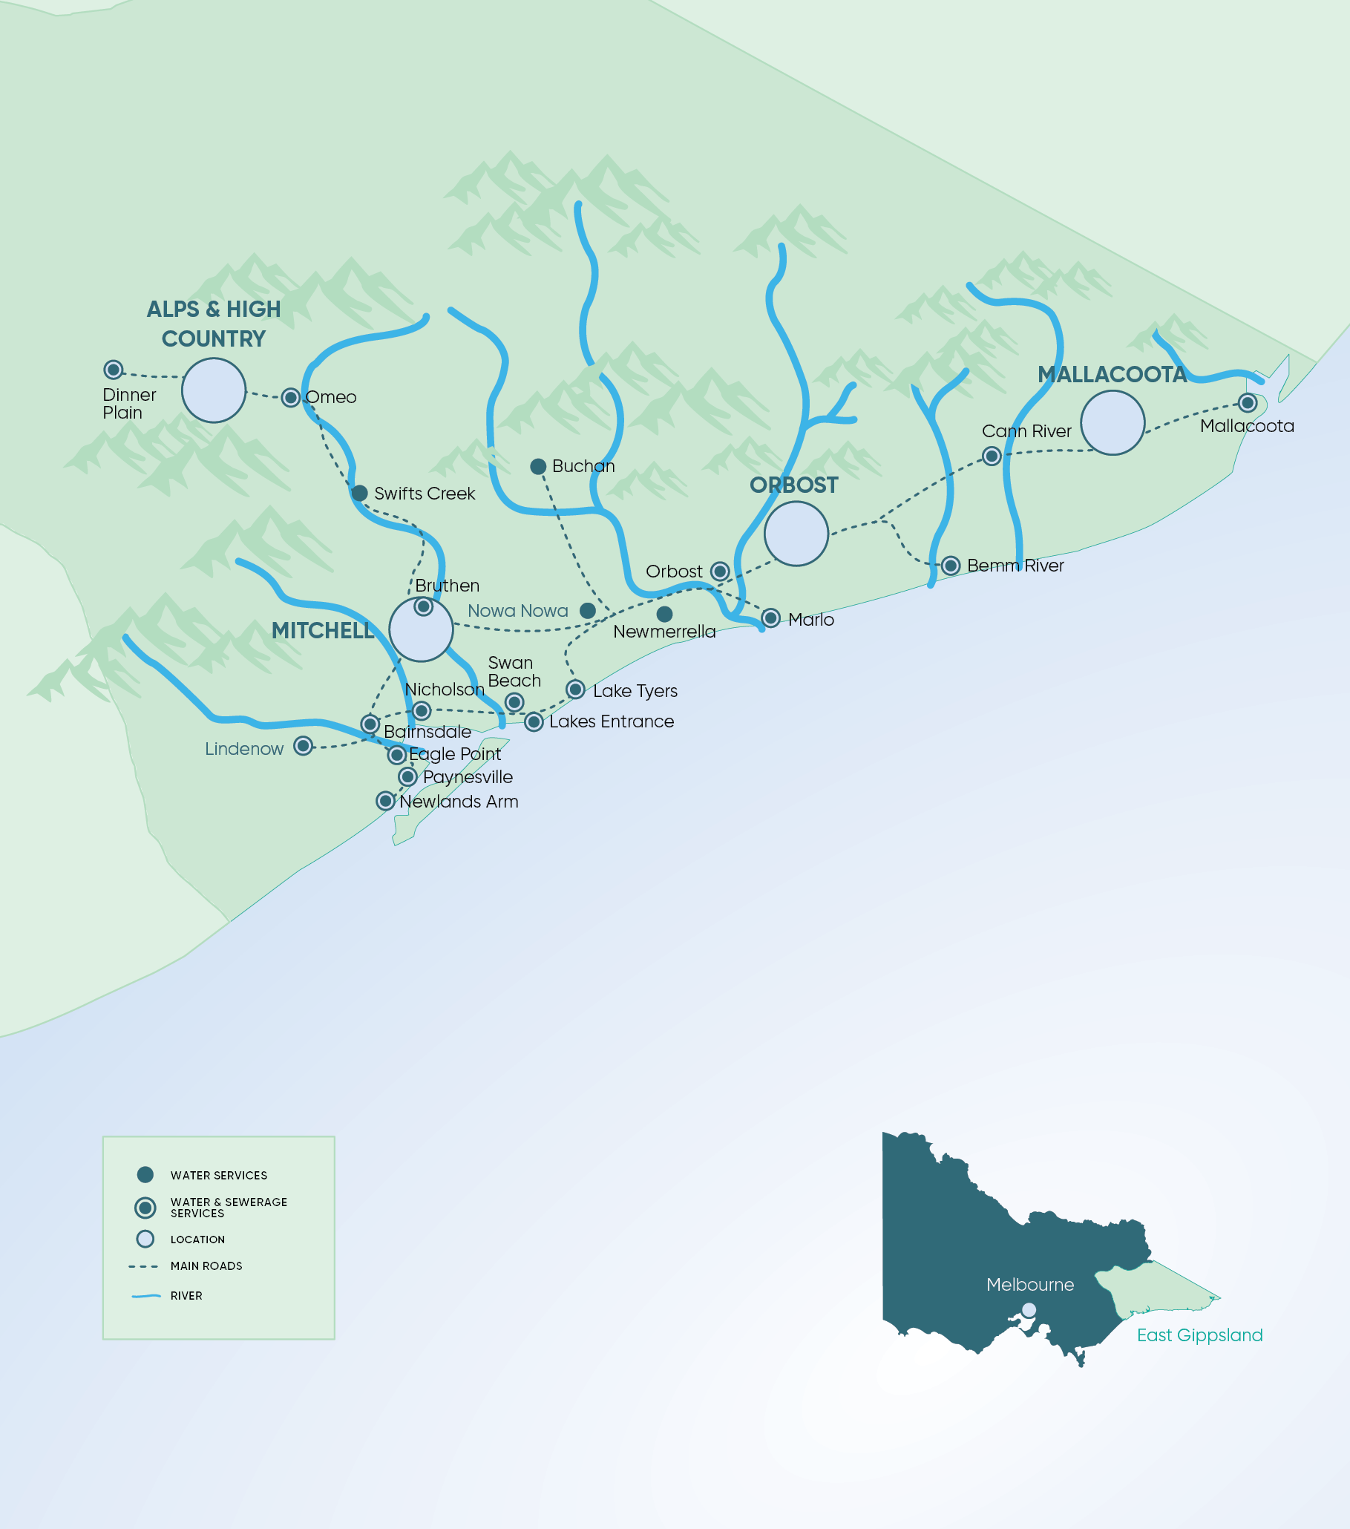

Vision and outcome areas for the East Gippsland IWM Forum Region

Vision
Innovative and collaborative water management to maximise the resilience, liveability and economic prosperity of our East Gippsland communities and connected waterways, wetlands and Gippsland Lakes.

IWM Outcome Areas
The region is seeking to achieve seven key outcomes through IWM. Each of these will have a significant role in shaping the liveability, prosperity and resilience of our cities and towns.
These outcome areas provide indicators to assess the effectiveness of the various IWM opportunities.
Low-emission solutions
IWM opportunities that minimise the release of greenhouse gas (GHGs) emissions will be considered by the Forum as solutions are evaluated for implementation.
 | Outcomes  Safe, secure and affordable supplies | Outcomes  Effective and affordable wastewater systems | Outcomes  Reduced flood risks | Outcomes  Healthy and valued waterways and Gippsland Lakes | Outcomes  Healthy and valued urban landscapes | Outcomes  Community values are reflected in place-based planning | Outcomes  Jobs, economic growth and innovation
Objectives | A diverse range of water supplies and resources | Meets public health and environmental standards | Appropriate levels of flood protection in urban areas | Waterway health is maintained and improved | Active and passive recreation supported by water | Diverse urban landscapes that reflect local conditions and community values | Jobs and economic growth supported by water
Objectives | Water quality meets regulatory standards and community expectations | Effective sewerage systems | Community and property resilient to local flood risk | Health of Gippsland Lakes and other marine environments is maintained and improved | Improved connectivity and access for active transport links | Empowered and engaged community | Innovative planning and operation
Objectives | Efficiently managed water and demand | Optimised onsite  domestic systems |  |  | Urban landscapes retain moisture for cooler, greener cities and towns | Local water related risks and issues understood and managed | Strong governance, collaboration and performance
Objectives | Secure water supply for industry and economy | Waste-to-resource opportunities are maximised |  |  | Waterways and coastal environments accessible as valuable open space |  | Seek to identify economic pathways to support traditional owner groups
Objectives | Water available to maintain valued green community assets |  |  |  | Aboriginal cultural values associated with waterways protected

Regional context
The East Gippsland IWM Forum region covers an area of approximately 21,000 square kilometres including a diverse and spectacular landscape of mountains, lakes and beaches. Over 80% of the land in East Gippsland is publicly owned and vested in state forests, national and coastal parks and marine national parks.
The region includes a number of rural and regional centres stretching from Lindenow in the west through to the region’s main business centre, Bairnsdale and holiday centres of Paynesville, Metung, Lakes Entrance and Mallacoota in the east and the alpine resort of Dinner Plain in the highlands.

Population
The region has an estimated population of 45,000, spread across upwards of 100 communities. The population is expected to grow to over 55,000 by 2036^{i}. The majority of population growth is expected in and around the existing settlements of Metung, Paynesville, Lucknow, Bairnsdale, Lakes Entrance and Mallacoota.
The region’s liveability attracts an older population with the area identified as being one of the highest per capita ageing populations in Victoria. Almost 40% of the population is predicted to be over 60 by 2020^{ii}.

Environmental assets
Most of the region’s urban centres and towns are clustered around the major rivers and associated flood plains and/or the Gippsland Lakes. The rivers and lakes provide recreational, environmental and aesthetic values for residents and visitors and the protection and restoration of riparian vegetation and waterway health is a strong contributor to the region’s liveability. The Gippsland Lakes in particular are an iconic local feature central to tourism for the region, supporting commercial and recreational fisheries, boating, camping and visitation with important Aboriginal and European cultural values. Much of the stormwater in regional centres drains to the Gippsland Lakes. Nutrient inputs to the Gippsland Lakes from a variety of sources combined with climatic conditions has resulted in historical algal blooms. Reduction in nutrient loads to the Gippsland Lakes is a key focus of natural resource management programs in the area including runoff from urban and peri-urban areas.

Climate Change
By 2070, daily temperatures across the region are projected to rise by an average of 1.6°C to 2.6°C (median projection). This will be amplified in urban centres due to the prevalence of darker and harder surfaces, leading to environmental and human health impacts. Ensuring the provision of fit for purpose water for the region’s urban greening will be a key priority in enhancing liveability and resilience for the community and environment.
The annual rainfall in the region is predicted to decrease by approximately 4.25 per cent by 2030 – primarily impacting the spring and winter seasons – while there is also an expectation of a year-round increase in temperatures. This presents a challenge for the region, as there will be an increased demand for urban water resulting from population growth together with a hotter drier climate.
East Gippsland will also be impacted by sea level rise, with levels expected to rise by 0.33 – 0.45m by 2070.^{iii}

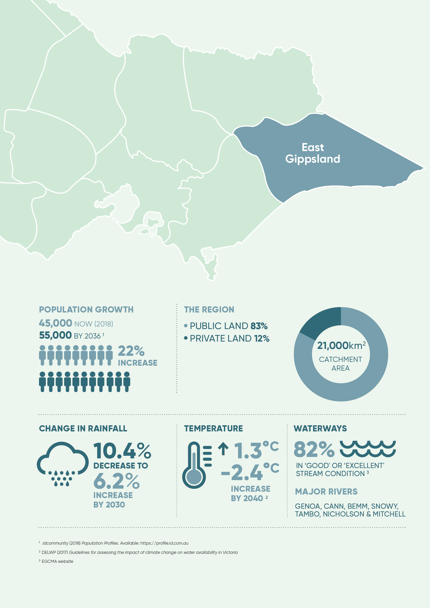

The case for IWM in the Region
Safe, secure and affordable supplies in an uncertain future
IWM provides the opportunity to identify and investigate new uses of alternative sources of water such as treated wastewater and stormwater as a substitute for current reticulated supplies to deliver economic, social and environmental outcomes.
The region’s towns and urban centres are serviced by nine separate water supply systems using a range of river and groundwater supplies. None of the water systems are connected to each other or to the Victorian Water Grid meaning there is a need for self-sufficiency in each system.
A total volume of 4,663 ML of reticulated water was delivered to approximately 25,993 customers in the region in 2016/17 with a projected annual growth rate of approximately 1.5% p.a. for residential customers and 0.5% p.a. for non-residential customers in the future^{iv}. Water use follows a seasonal pattern with high summer demand in coastal holiday destinations and high winter demand in the Dinner Plain snow fields. The temporary influx of tourists during peak holiday periods is a particular challenge in the continued supply of reliable potable water to customers.

Effective and affordable wastewater systems
The region has already demonstrated significant progress in IWM by achieving 100% re-use of treated wastewater for a variety of economic, recreational and environmental purposes. Beneficial uses of treated wastewater include irrigation of golf courses (e.g. Lakes Entrance), environmental water for wetlands (e.g. Macleod Morass, Bairnsdale), irrigated agricultural land (e.g. Paynesville) and irrigated treelots (e.g. Orbost and Mallacoota).
While 100% of treated wastewater is already utilised, there are opportunities to pursue higher value end-uses and achieve multiple benefits. An example is the current discussion between East Gippsland Water and East Gippsland Shire Council on the opportunity to provide treated wastewater to the Bairnsdale Livestock Exchange and the adjacent Bairnsdale City Oval.

Reduced flood risks
Floodplains are a valued part the ecosystem in the East Gippsland region. The ‘flooding’ process provide essential nutrients to the region’s forests and agriculture.
In an urban context, flooding is more of a challenge. Many urban areas such as Lakes Entrance, Paynesville, Metung, Bairnsdale and Orbost are located on the floodplains of the Gippsland Lakes and its rivers. It is essential to manage the economic, social, environmental and cultural values of floodplains in a balanced way whilst also having regard for their inherent disadvantages and risks. This will be particularly relevant in the context of increased extreme rainfall events, sea level rise, urban growth and increased imperviousness in catchments. The East Gippsland Floodplain Strategy^{v} has been developed to prioritise flood management actions in the region.

Healthy and valued waterways and Gippsland Lakes
Healthy waterways, wetlands and the Gippsland Lakes are not only important for local environmental values but are also core to the local tourism and fishing industry. Integrated water management is essential to protect and enhance environmental values of our pristine rivers, Ramsar listed wetlands and Gippsland Lakes.
The waterways of East Gippsland are generally in much better condition than in other regions of Victoria. Some 82% of total stream length is in ‘Excellent’ or ‘Good’ condition. The East Gippsland Waterway Strategy^{vi} outlines the current health of waterways in the region and priority actions for the future. Threats to waterways which are influenced by the urban water cycle include water quality impacts, erosion and changed river flow regimes.
The supply of environmental water to Macleod Morass from the adjacent Bairnsdale Wastewater Treatment Plant is a recent example of harnessing alternative water sources to support waterway outcomes. There are further opportunities to be explored in the region including potential for decommissioning the Nicholson River Dam to improve natural flows.

Healthy and valued urban landscapes
Healthy urban landscapes are highly valued in the East Gippsland region. There are particular challenges around maintaining water supplies during water shortages to protect key recreational facilities and spaces. The region is learning from existing examples such as the supply of recycled water to the Bairnsdale Racecourse and various golf courses.
Opportunities to exempt certain high value community assets from water restrictions such as sporting ovals, gardens and pools will be explored in the future as recommended in the East Gippsland Urban Water Strategy^{vii}. The retention of moisture in the urban landscape for cooler, greener environments is also a priority (e.g. efficient irrigation of public gardens and sports grounds).

Community values are reflected in place-based planning
Community engagement will ensure urban landscapes reflect community values and local conditions. The needs of an ageing population are an important consideration and water provides an opportunity to support enhanced well-being and health by enhancing local natural and recreational facilities.
Of particular importance will be engagement with the traditional owner community to understand and enhance local aboriginal water values. The region has a rich aboriginal heritage centred on the local forests, Gippsland Lakes and rivers. The Gunaikurnai Traditional Owners have a strong affinity with the area’s water resources and associated ecosystems. At the 2016 census, 2.9% of people living in East Gippsland identified as Aboriginal and/or Torres Strait Islander (1,288 people) which is high compared to Victoria overall (0.8%)^{viii}. The IWM process provides significant opportunity to acknowledge and develop aboriginal values for water, include aboriginal values in water planning, support aboriginal access to water for economic development and build capacity to increase aboriginal participation in water management.

Jobs, economic growth and innovation
The economic prosperity of the region is very dependent on meeting the water demands of local business and industry (both quality and quantity). There are a range of opportunities to encourage industry and business to consider a range of supply options to drive business efficiency, jobs and economic growth. There is also an opportunity to expand current discussions with local industry on water efficiency measures to reduce consumption.

Success stories
Significant progress on integrated water management has already occurred in the region involving collaboration with stakeholders.
Recent case studies are outlined below.

Re-use of treated wastewater
All of the approximately 3,200ML per year of treated sewage in the region is re-used for a variety of economic, recreational and environmental purposes including watering golf courses (e.g. Lakes Entrance), environmental water for wetlands (e.g. Macleod Morass, Bairnsdale), irrigated pasture (e.g. Paynesville) and irrigated treelots (e.g. Orbost).
East Gippsland Water in collaboration with landholders, Parks Victoria and sporting clubs.

East Bairnsdale Stormwater Enhancement Project
An existing low-lying area in the Lanes Rd region of Lucknow has been developed into the East Bairnsdale Wetlands to treat stormwater runoff before discharge into the Gippsland Lakes. Landscaping and the development of a shared trail around the wetland have enhanced the recreational values of the area.
East Gippsland Shire Council in collaboration with the East Gippsland CMA.

Managed Aquifer Recharge
Five deep bores in the Woodglen area are used to store water from the Mitchell River in an underground aquifer during high flow winter periods for later extraction to meet high demand town water use.
East Gippsland Water

Dinner Plain IWM Plan
The Dinner Plain Integrated Water Cycle Management Plan was developed in 2015 to assess options for the use of treated wastewater including snow making, irrigation, discharge to waterways and firefighting.
East Gippsland Water in collaboration with the Alpine Shire Council.

Chapter 3
IWM opportunities
A portfolio of IWM projects and strategies for which IWM collaborative partners have committed themselves to applying their best endeavours to progress.

State-wide and region specific initiatives
This document outlines priority IWM opportunities for the East Gippsland region. These include both strategies that will direct IWM in the region and specific projects that will deliver on-the-ground outcomes. To ensure IWM opportunities are successful and delivered efficiently, work is also being done at a state-wide level.
Across Victoria, IWM Forum members are identifying a range of strategic policy and framework enablers to address barriers to integrated water management and planning and achieve water related benefits in priority areas. A prioritised list of enabling policies and frameworks is being consolidated by DELWP. A list of local plans and strategies enabling IWM projects is provided in Appendix A.
A Resilient Cities and Towns (RCT) Reference Group has been established to support the implementation of integrated water management and planning across the state. The Reference Group provides advice to DELWP on the development and implementation of key initiatives in relation to policy, processes or knowledge gaps.

IWM opportunities: How were they selected?
IWM opportunities that link to and address IWM challenges for the region were identified and developed by the nominated practitioners of participating organisations. The process was an iterative, transparent and inclusive approach, as outlined in Figure 3.
Local population centres do not have the economies of scale that some of the State’s more populous regions have making it more difficult to justify expensive water infrastructure for integrated water management projects. For instance, purple pipe treated storm water or wastewater systems are generally not economically viable even in the larger new greenfield developments in Bairnsdale. Therefore, the scale and types of integrated water management projects considered is commensurate with population demographics and willingness to pay.
This list of opportunities is dynamic and will be reviewed and updated as required to reflect the Forum’s priorities.
Figure 3 The IWM opportunity prioritisation process

Impact of IWM opportunities on the Forum's strategic outcomes
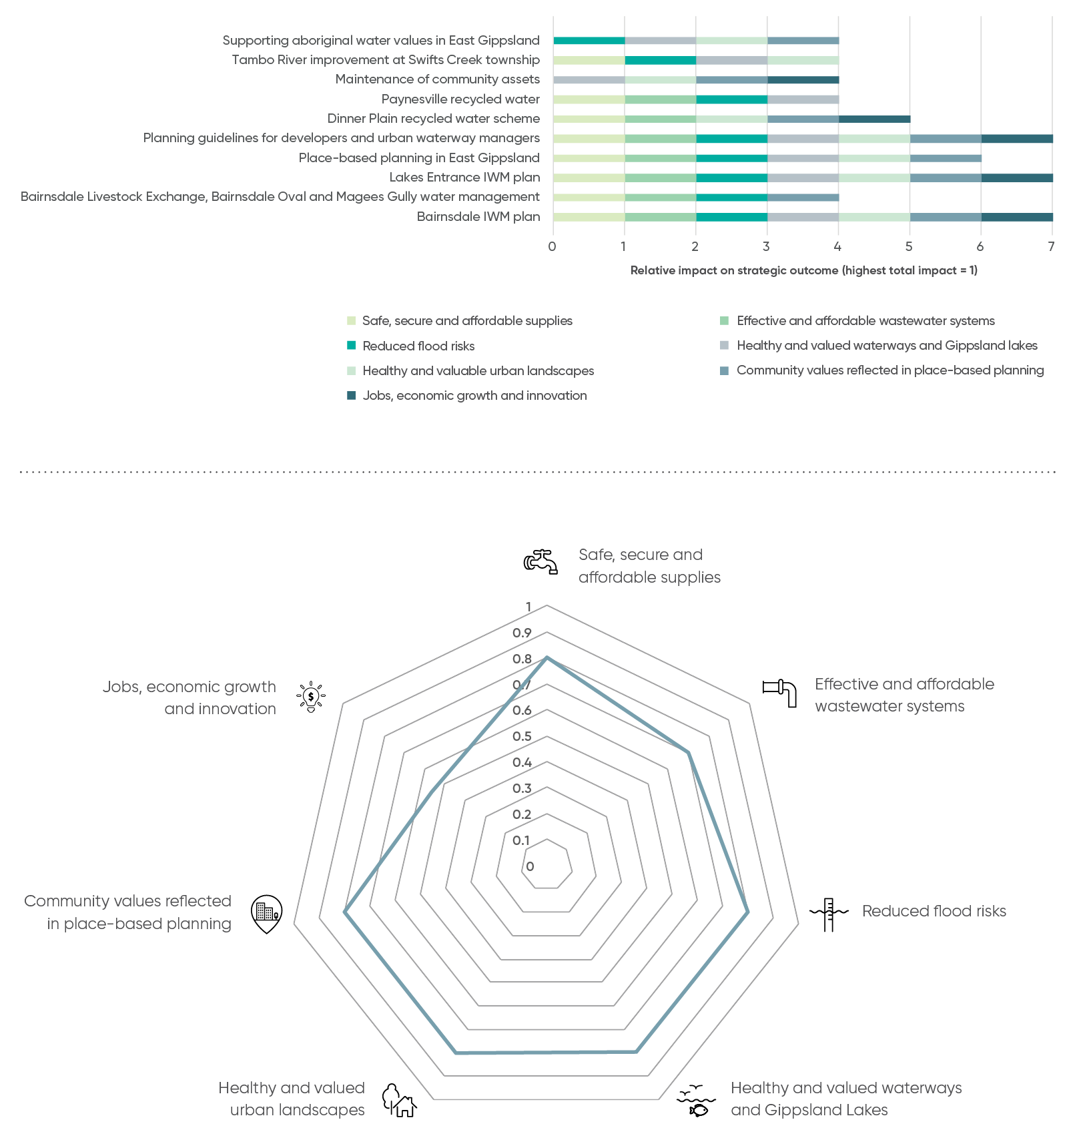

IWM project & strategy opportunities – overview
A summarised list of priority IWM opportunities is shown in the table below, with more detail in the following section. Please note that this list is dynamic and will continue to be updated to reflect the current Forum’s priorities and opportunities.
Partners of the Forum are committing their best endeavours to ensure priority projects and strategies are progressed in line with the shared vision and strategic outcomes of the East Gippsland IWM Forum.
IWM opportunity | Strategic outcome  Safe, secure and affordable supplies | Strategic outcome  Effective and affordable wastewater systems | Strategic outcome  Reduced flood risks | Strategic outcome  Healthy and valued waterways and Gippsland Lakes | Strategic outcome  Healthy and valued urban landscapes | Strategic outcome  Community values are reflected in place-based planning | Strategic outcome  Jobs, economic growth and innovation | Location | Scale | Lead agency for collaborative opportunity | Status | Timing
Bairnsdale IWM plan | Impact | Impact | Impact | Impact | Impact | Impact | Impact | Bairnsdale | Town | East Gippsland Water | 1 | 2019/20
Bairnsdale Livestock Exchange, Bairnsdale Oval and Magees Gully water management | Impact | Impact | Impact | No impact | No impact | Impact | No impact | Bairnsdale | Town | East Gippsland Water, East Gippsland Shire Council | A | 2018/19: Business Case  2019/20: Implementation
Lakes Entrance IWM plan | Impact | Impact | Impact | Impact | Impact | Impact | Impact | Lakes Entrance | Town | East Gippsland Water | 1 | 2020/21
Place-based planning in East Gippsland | Impact | Impact | Impact | Impact | Impact | Impact | No impact | East Gippsland Region | Forum area | East Gippsland Shire Council | A,B,C,D | Commencing 2018/19
Planning guidelines for developers and urban waterway managers | Impact | Impact | Impact | Impact | Impact | Impact | Impact | East Gippsland Region | Sub-catchment | East Gippsland Shire Council | 1 | 2018/19
Dinner Plain recycled water scheme | Impact | Impact | No impact | No impact | Impact | Impact | Impact | Dinner Plain | Town | East Gippsland Water, Alpine Shire | 1 | 2018/19 Business Case
Paynesville recycled water | Impact | Impact | Impact | Impact | No impact | No impact | No impact | Paynesville | Sub-catchment | East Gippsland Water | 1 | 2019/20 feasibility assessment
Maintenance of community assets | No impact | No impact | No impact | No impact | Impact | Impact | Impact | East Gippsland Region | Forum area | East Gippsland Shire Council | A | Commencing 2018/19
Tambo River improvement at Swifts Creek township | Impact | No impact | Impact | Impact | Impact | No impact | No impact | Swifts Creek | Sub-catchment | East Gippsland Catchment Management Authority | A | 2018/19
Supporting Aboriginal water values in East Gippsland | No impact | No impact | Impact | Impact | Impact | Impact | No impact | East Gippsland | Forum area | East Gippsland Catchment Management Authority | 1 | On-going
The status of each IWM opportunity included in the Priority Portfolio reflects the phase of work to be undertaken in this time period.
Project opportunity status
Concept & feasibility = A, Business case = B, Detailed design + C, Implementation = D, Commission = E, Benefit realisation = F.
Strategy opportunity status
Concept = 1, Commitment = 2, Prepare draft = 3, Consult & finalise = 4, Implement = 5, Evaluate = 6.

IWM project and strategy opportunities – in depth

Action EG1

Bairnsdale IWM plan
There is a complex relationship between the private and public assets within the Bairnsdale urban landscape and between the urban landscape and the adjacent wetlands and Gippsland Lakes. Reviewing IWM opportunities of the system as a whole allows exploration of the synergies and conflicts between built and natural assets and the social, economic, political and environmental systems in which they are contained.
A single IWM plan is proposed for the Bairnsdale area with a strong focus on integrating the outcomes and multiple benefits of IWM projects in the area including:
- Supply of treated wastewater from the Bairnsdale Wastewater Treatment Plant to the nearby Bairnsdale Livestock Exchange and the adjacent Bairnsdale City Oval to supplement the existing rainwater harvesting at the site.
- Re-vegetation of Magee’s Gully from south of the Princes Highway to Macleod Morass to supplement the proposed walking track, the recently installed aboriginal art work at the Dalmahoy Sewage Pump Station and the current EGCMA funded project to restore the Magee’s Gully waterway.
- Wetland development to capture and treat stormwater in the Crooke Street and McMillan Street region of East Bairnsdale, which is currently discharging to Jones Bay, to reduce nutrient loads to the Gippsland Lakes. The McMillan Street project has recently received funding from the Gippsland Lakes Co-ordinating Committee.
- Opportunities for water sensitive urban design, stormwater harvesting and re-use at Calvert Street Educational Precinct.
- Actions identified in the East Gippsland Shire Council’s Urban Waterway Management Strategy.
Given the current knowledge and actions already occurring in the area, such a plan can be a pragmatic review of the synergies and conflicts between existing and proposed projects to identify the greatest benefit projects for the least cost.

Potential outcomes
- Integrated plan for developing Bairnsdale IWM opportunities including initial business case, potential timing and costs
- Aligns stakeholder interests
- Business cases to leverage funding

Next steps
- Review funding opportunities for the IWM plan including potential cost share arrangements with interested stakeholders
- Continue to progress discrete opportunities (e.g. supply of treated wastewater to the Bairnsdale Livestock Exchange and Bairnsdale Oval – see action EG2)
- Use plan to leverage funding for project implementation
 | Strategic outcome  Safe, secure and affordable supplies | Strategic outcome  Effective and affordable wastewater systems | Strategic outcome  Reduced flood risks | Strategic outcome  Healthy and valued waterways and Gippsland Lakes | Strategic outcome  Healthy and valued urban landscapes | Strategic outcome  Community values are reflected in place-based planning | Strategic outcome  Jobs, economic growth and innovation
Impact status | Impact | Impact | Impact | Impact | Impact | Impact | Impact

Subject | Details
Status | 1
Lead Agency | East Gippsland Water
Implementation Partners | East Gippsland Water, East Gippsland Shire Council, East Gippsland Catchment Management Authority, Bairnsdale Regional Health, GLaWAC, DELWP.
Location | Bairnsdale
Timeframe | 2019/20
Scale | Town/City
Project opportunity status
Concept & feasibility = A, Business case = B, Detailed design + C, Implementation = D, Commission = E, Benefit realisation = F.
Strategy opportunity status
Concept = 1, Commitment = 2, Prepare draft = 3, Consult & finalise = 4, Implement = 5, Evaluate = 6.

Action EG2

Bairnsdale Livestock Exchange, Bairnsdale Oval and Magees Gully water management

Problem
The Bairnsdale Livestock Exchange and adjacent Bairnsdale Oval are the highest water using council assets across the East Gippsland Shire Council region. Most of the water is currently supplied through the town’s reticulated supply supplemented with collected rainfall stored in recently installed rainwater tanks. The high dependency on the reticulated water supply is a significant expense for ratepayers.
There are also issues with the open pond storage of effluent runoff from the Bairnsdale Livestock Exchange which can overflow to the adjacent Macleod Morass during wet periods.
Magees Gully is a natural waterway running through West Bairnsdale and discharging to Macleod Morass near the Bairnsdale Livestock Exchange. Recent re-vegetation initiatives are beginning to improve the environmental value of this otherwise degraded waterway.

Solution
There is an opportunity to improve the water management in the local area to improve water efficiency and improve the environmental amenity of Magees Gully and Macleod Morass. For instance, the supply of treated wastewater from the Bairnsdale Wastewater Treatment Plant to the nearby Bairnsdale Livestock Exchange and the adjacent Bairnsdale City Oval could eliminate or reduce the reliance on the expensive reticulated town water supply for the sites. Such a scheme would supplement the recently installed rainwater harvesting at the site by the East Gippsland Shire Council. Given the close proximity of these two sites to the wastewater treatment plant and the existing pipework between them, supply of Class B treated wastewater is a potentially viable option to supply these two high water using public assets. This would require additional treatment to improve the quality of the wastewater to Class B from the current Class C. East Gippsland Water have provided the East Gippsland Shire Council with a high level conceptual proposal for the scheme including indicative costs.
There is potential to improve the water management around the interface between Magees Gully, Bairnsdale Livestock Exchange and Macleod Morass to reduce nutrient discharge to the Macleod Morass and improve the environmental and recreational amenity of the area. The current community lead re-vegetation project for Magees Gully could be expanded to include this interface and the enhancement of traditional owner water values. Such a project would require collaboration between a variety of stakeholders including the East Gippsland Shire Council, the EPA, community groups and traditional owners.

Potential outcomes
- Higher value use of treated wastewater to replace potable water
- Lower water bills for East Gippsland Shire Council ratepayers
- Better effluent management from the Bairnsdale Livestock Exchange
- Improved recreational and environmental amenity of Magees Gully
- Enhanced traditional owner water values

Next steps
Undertake a water balance study to determine the potential demand for treated wastewater at both sites by reviewing the difference between combined demand and the supply of collected rainfall.
Use the results of the water balance study and the indicative costs provided by East Gippsland Water as input to a business case for the supply of treated wastewater to the sites. The business case should include consultation with key stakeholders including the managers of both sites.
Convene a working group of interested stakeholders to develop a plan of works to improve the environmental and recreational amenity of the interface between Magees Gully, the Bairnsdale Livestock Exchange and Macleod Morass and review funding options.
 | Strategic outcome  Safe, secure and affordable supplies | Strategic outcome  Effective and affordable wastewater systems | Strategic outcome  Reduced flood risks | Strategic outcome  Healthy and valued waterways and Gippsland Lakes | Strategic outcome  Healthy and valued urban landscapes | Strategic outcome  Community values are reflected in place-based planning | Strategic outcome  Jobs, economic growth and innovation
Impact status | Impact | Impact | Impact | No impact | No impact | Impact | No impact

Subject | Details
Status | A
Lead Agency | East Gippsland Water/ East Gippsland Shire Council
Implementation Partners | East Gippsland Shire Council
Location | Bairnsdale
Timeframe | 2018/19: Water balance and business case 2019/20: Project implementation
Scale | Town/City
Project opportunity status
Concept & feasibility = A, Business case = B, Detailed design + C, Implementation = D, Commission = E, Benefit realisation = F.
Strategy opportunity status
Concept = 1, Commitment = 2, Prepare draft = 3, Consult & finalise = 4, Implement = 5, Evaluate = 6.

Action EG3

Lakes Entrance IWM plan
The Lakes Entrance area is a sufficiently complex urban and natural system to undertake a separate IWM planning process. For instance, greenfield development sites such as the Lakes Entrance Northern Growth Area (LENGA) present an opportunity for the application of water sensitive urban design principles to conserve water, protect and enhance local waterways and reduce the footprint of development. Also, the impact of climate change on rising lake levels also presents a particular challenge for urban water planning.
There is an opportunity to incorporate IWM principles into the current development of the Lakes Entrance Growth and Adaptation Strategy and use the outcomes of the Strategy to help develop the IWM Plan. The Lakes Entrance Growth and Adaptation Strategy is an East Gippsland Shire Council initiative to develop a 35 year plan to take Lakes Entrance from feeling like the most targeted vulnerable community on the Victorian coast to one that has the most effective plan to adapt to the anticipated climate change and urban growth pressures.
There are also opportunities to explore the use of recycled water as a substitute for potable water supply for some public assets close to treated wastewater infrastructure such as the Lake Bunga public toilets. IWM Plan would also incorporate some of the key actions assigned to Lakes Entrance catchments in the East Gippsland Shire Council’s Urban Waterway Management Strategy (e.g. actions for Merrangbaur Heights and Lake Bunga detailed in Section 5 of the strategy).

Potential outcomes
- Integrated plan for developing IWM opportunities
- Aligns stakeholder interests
- Business cases to leverage funding

Next steps
Approach the East Gippsland Shire Council regarding the mechanism for incorporating IWM principles
into the Lakes Entrance Growth and Adaptation Strategy
Investigate the opportunity to build IWM principles into the retarding basin currently being designed by the East Gippsland Shire Council in the LENGA
Review funding opportunities for the IWM plan including potential cost share arrangements with interested stakeholders
Develop the Lakes Entrance IWM Plan including the outcomes of: 1) the Lakes Entrance Growth and Adaptation Strategy; 2) actions identified in the East Gippsland Shire Council’s Urban Waterway Management Strategy 3) relevant actions identified in the “Maintenance of Community Assets” project (see page 37).
 | Strategic outcome  Safe, secure and affordable supplies | Strategic outcome  Effective and affordable wastewater systems | Strategic outcome  Reduced flood risks | Strategic outcome  Healthy and valued waterways and Gippsland Lakes | Strategic outcome  Healthy and valued urban landscapes | Strategic outcome  Community values are reflected in place-based planning | Strategic outcome  Jobs, economic growth and innovation
Impact status | Impact | Impact | Impact | Impact | Impact | Impact | Impact

Subject | Details
Status | 1
Lead Agency | East Gippsland Water
Implementation Partners | East Gippsland Water, East Gippsland Shire Council, East Gippsland Catchment Management Authority, Bairnsdale Regional Health, GLaWAC, DELWP.
Location | Lakes Entrance
Timeframe | 2020/21
Scale | Town
Project opportunity status
Concept & feasibility = A, Business case = B, Detailed design + C, Implementation = D, Commission = E, Benefit realisation = F.
Strategy opportunity status
Concept = 1, Commitment = 2, Prepare draft = 3, Consult & finalise = 4, Implement = 5, Evaluate = 6.

Action EG4

Place-based planning in East Gippsland
Current local government place-based planning processes being undertaken across the region provide an opportunity to embed IWM concepts into the planning of local communities. For instance, the East Gippsland Shire Council will be undertaking place-based planning in Omeo and Cann River including a structured public consultation process. The process will develop a plan for and with the people of each District, as well as strengthening connections between council, its officers and the community. Omeo and Cann River can be used as a template for embedding IWM into other community plans. There is an opportunity to leverage existing community engagement processes to educate the community on the benefits of IWM concepts which can then be built into local plans. Place-based planning is also an opportunity to identify priority community assets to be exempt from water restrictions which is a key task of the Drought Preparedness Plan.

Potential outcomes
- Community driven decisions on local water management
- Educated community
- Leverage existing funding and processes
- Mutual information gathering and sharing
- Identification of priority community assets to be exempt from water restrictions (action of the Drought Preparedness Plan).

Next steps
- Educate the facilitator of placed based planning on IWM principles and practical applications
- Include IWM principles into the facilitation of community based planning
- Incorporate community driven IWM project ideas into placed based plans
 | Strategic outcome  Safe, secure and affordable supplies | Strategic outcome  Effective and affordable wastewater systems | Strategic outcome  Reduced flood risks | Strategic outcome  Healthy and valued waterways and Gippsland Lakes | Strategic outcome  Healthy and valued urban landscapes | Strategic outcome  Community values are reflected in place-based planning | Strategic outcome  Jobs, economic growth and innovation
Impact status | Impact | Impact | Impact | Impact | Impact | Impact | No Impact

Subject | Details
Status | A,B,C,D
Lead Agency | East Gippsland Shire Council
Implementation Partners | East Gippsland Water, Developers
Location | Omeo and Cann River initially
Timeframe | Commencing 2018/19
Scale | Town/City
Project opportunity status
Concept & feasibility = A, Business case = B, Detailed design + C, Implementation = D, Commission = E, Benefit realisation = F.
Strategy opportunity status
Concept = 1, Commitment = 2, Prepare draft = 3, Consult & finalise = 4, Implement = 5, Evaluate = 6.

Action EG5

Planning guidelines for developers and urban waterway managers
Embedding IWM principles into existing relevant planning and guidelines documents sets an expectation on developers and land and water managers to think creatively about water management. For instance, there are opportunities to include IWM principles in the following guideline documents:
- the East Gippsland Planning Scheme, Municipal Strategic Statement (currently being reviewed)
- the East Gippsland Shire Council Urban Waterway Guidelines
There is also an opportunity to review Western Water’s recently completed IWM Guidelines for Developers to determine the appropriateness and appetite for a similar document for East Gippsland.

Potential outcomes
- IWM principles embedded into planning guidelines
- Developers and waterway managers thinking creatively about urban water management

Next steps
- Develop an inventory of potential planning guidelines or policies where IWM principles could be included
- Include IWM principles in the current review of the East Gippsland Shire Council’s Municipal Strategic Statement
- Include IWM principles in the East Gippsland Shire Council’s Urban Waterway Guidelines
- Review Western Water’s IWM Planning Guidelines for Developers to determine applicability for East Gippsland region
 | Strategic outcome  Safe, secure and affordable supplies | Strategic outcome  Effective and affordable wastewater systems | Strategic outcome  Reduced flood risks | Strategic outcome  Healthy and valued waterways and Gippsland Lakes | Strategic outcome  Healthy and valued urban landscapes | Strategic outcome  Community values are reflected in place-based planning | Strategic outcome  Jobs, economic growth and innovation
Impact status | Impact | Impact | Impact | Impact | Impact | Impact | Impact

Subject | Details
Status | 1
Lead Agency | East Gippsland Shire Council
Implementation Partners | East Gippsland Water, East Gippsland CMA
Location | Forum Area
Timeframe | Commencing 2018/19
Scale | Sub-catchment
Project opportunity status
Concept & feasibility = A, Business case = B, Detailed design + C, Implementation = D, Commission = E, Benefit realisation = F.
Strategy opportunity status
Concept = 1, Commitment = 2, Prepare draft = 3, Consult & finalise = 4, Implement = 5, Evaluate = 6.

Action EG6

Dinner Plain Recycled Water Scheme
The use of treated wastewater for snow making and firefighting was considered in the 2015 Dinner Plain Integrated Water Cycle Management Plan but was not recommended mainly due to the significant cost of up-grading the wastewater treatment plant to treat water to Class A standard. However, there is an opportunity to revisit this recommendation based on advances in technology, a stronger government and community appetite for use of recycled water and increased demand for snow making. There is also opportunity to undertake a more holistic cost-benefit assessment that considers possible social, environmental and broader economic benefits.

Potential outcomes
- Higher value use of treated wastewater to replace potable water
- Lower recurrent cost of snow production
- Social benefit of knowing Dinner Plain in step with other nearby resorts for using recycled water for snow making instead of potable reticulated water supply
- Reduced need for winter storage of treated wastewater
- Expansion of snow making to toboggan slope and increased snow making on ski slopes leading to increased economic benefit for the resort and connected businesses

Next steps
- Identify funding opportunities to revisit the business case for using recycled water for snow making developed in the 2015 Dinner Plain Integrated Water Cycle Management Plan taking into account the broader environmental, social and economic costs and benefits.
 | Strategic outcome  Safe, secure and affordable supplies | Strategic outcome  Effective and affordable wastewater systems | Strategic outcome  Reduced flood risks | Strategic outcome  Healthy and valued waterways and Gippsland Lakes | Strategic outcome  Healthy and valued urban landscapes | Strategic outcome  Community values are reflected in place-based planning | Strategic outcome  Jobs, economic growth and innovation
Impact status | Impact | Impact | No impact | No impact | Impact | Impact | Impact

Subject | Details
Status | 1
Lead Agency | Alpine Shire Council or East Gippsland Water
Implementation Partners | Alpine Shire Council, East Gippsland Water
Location | Dinner Plain
Timeframe | 2018/19
Scale | Town
Project opportunity status
Concept & feasibility = A, Business case = B, Detailed design + C, Implementation = D, Commission = E, Benefit realisation = F.
Strategy opportunity status
Concept = 1, Commitment = 2, Prepare draft = 3, Consult & finalise = 4, Implement = 5, Evaluate = 6.

Action EG7

Paynesville re-use of treated wastewater

Problem
Although all of the treated wastewater from the Paynesville Wastewater Treatment Plant is currently re-used for pasture irrigation, the water salinity is only marginally suitable for irrigation. The high salinity is due to the infiltration of saline lake water and groundwater into the sewerage network.

Potential solution
The issue is being partially addressed in the long term through reducing infiltration of saline water into the sewerage network. Another possible solution is to discharge treated wastewater into the nearby lower Macleod Morass providing fresher environmental water to the saline portion of the wetland. Additional nutrient stripping processes would need to be added to the treatment process to comply with EPA requirements. An investigation is required to determine the technical feasibility of such a proposal and the potential capital costs and benefits to allow comparison with other options.

Potential outcomes
- Feasibility study provides a basis for comparing options to address the relatively high salinity of treated wastewater
- Potential discharge to the Lower Macleod Morass provides fresher environmental water to the saline part of the wetland and reduces the risk of permanent salinisation of soils currently irrigated with treated wastewater.

Next steps
- Review funding opportunities for a feasibility assessment including potential cost share arrangements with interested stakeholders
 | Strategic outcome  Safe, secure and affordable supplies | Strategic outcome  Effective and affordable wastewater systems | Strategic outcome  Reduced flood risks | Strategic outcome  Healthy and valued waterways and Gippsland Lakes | Strategic outcome  Healthy and valued urban landscapes | Strategic outcome  Community values are reflected in place-based planning | Strategic outcome  Jobs, economic growth and innovation
Impact status | Impact | Impact | Impact | Impact | No impact | No impact | No impact

Subject | Details
Status | 1
Lead Agency | East Gippsland Water
Implementation Partners | East Gippsland CMA, Parks Victoria, Gippsland Lakes Co-ordinating Committee
Location | Paynesville
Timeframe | 2019/20 feasibility assessment
Scale | Sub-catchment
Project opportunity status
Concept & feasibility = A, Business case = B, Detailed design + C, Implementation = D, Commission = E, Benefit realisation = F.
Strategy opportunity status
Concept = 1, Commitment = 2, Prepare draft = 3, Consult & finalise = 4, Implement = 5, Evaluate = 6.

Action EG8

Maintenance of community assets

Problem
Community assets such as public gardens, sporting grounds, pools and public toilets are significant users of water. Most of these assets are currently supplied through the reticulated potable network even though a lesser quality of water could potentially be used.

Solution
Exemption from water restrictions
To maintain liveability, the East Gippsland Water Urban Water Strategy and Drought Preparedness Plan recommends that high value community facilities be exempt from water restrictions during periods of water shortage. Such exemption would require community consultation and agreement on the specific sites to be exempt. Such consultation could be incorporated into “place-based planning” for individual communities (see project above) but may also need a separate consultation process.
Increased water efficiency
The East Gippsland Shire Council’s Sustainable Water Use Plan details a series of actions to reduce water consumption at the highest water using council managed assets. The plan could be reviewed and up-dated to include IWM principles, works already completed and new water saving ideas including use of alternative water sources.
The East Gippsland Water Urban Water Strategy and Drought Preparedness Plan identified and prioritised possible uses of treated wastewater in high value community assets such as public gardens, recreational facilities and toilets. For instance, the Lindenow Sports Ground, Amy Shand Rec Reserve, and Lindenow Memorial Hall Reserve were identified as potentially benefiting from the supply of Class B treated wastewater from the nearby Lindenow wastewater treatment plant. This proposal is to extend this preliminary work to pursue the business case for the use of treated wastewater and treated storm water for high value community assets as a substitute for current reticulated potable water supplies.

Potential outcomes
- Enhanced liveability through the continued supply of potable reticulated water to high value community assets during periods of water shortage or the use of an alternative water source such as treated wastewater or stormwater.

Next steps
Develop and implement a plan to consult communities on priority community assets to be exempt from water restrictions including the use of existing consultation processes as a priority;
Undertake preliminary business cases for the supply of treated wastewater to priority community sites identified in the East Gippsland Water Urban Water Strategy and Drought Preparedness Plan
Up-date and implement the East Gippsland Shire Council’s Sustainable Water Use Plan especially in light of business case outcomes for the supply of alternative water sources
Identify funding sources for the above.
 | Strategic outcome  Safe, secure and affordable supplies | Strategic outcome  Effective and affordable wastewater systems | Strategic outcome  Reduced flood risks | Strategic outcome  Healthy and valued waterways and Gippsland Lakes | Strategic outcome  Healthy and valued urban landscapes | Strategic outcome  Community values are reflected in place-based planning | Strategic outcome  Jobs, economic growth and innovation
Impact status | No impact | No impact | No impact | No impact | Impact | Impact | Impact

Subject | Details
Status | A
Lead Agency | East Gippsland Water
Implementation Partners | East Gippsland Shire Council
Location | East Gippsland Region
Timeframe | Commencing 2018/19
Scale | Forum Area
Project opportunity status
Concept & feasibility = A, Business case = B, Detailed design + C, Implementation = D, Commission = E, Benefit realisation = F.
Strategy opportunity status
Concept = 1, Commitment = 2, Prepare draft = 3, Consult & finalise = 4, Implement = 5, Evaluate = 6.

Action EG9

Tambo River improvement at Swifts Creek township

Problem
East Gippsland Water have an offtake on the Tambo River at Swifts Creek that provides potable water to the township of Swifts Creek and surrounds. The offtake is situated just above the Swifts Creek township and is surrounded by farms, predominately grazing stock. Currently stock have access to the river at the offtake and upstream, polluting the raw water source and causing damage to the riparian vegetation.

Potential solution
East Gippsland Water and East Gippsland CMA to work with the local farming community to fence and revegetate the Tambo River at the town offtake and upstream.

Potential outcomes
- Improved water quality, bank stability and quality of riparian vegetation in the Tambo River upstream of the Swifts Creek offtake.
- Community ownership of issue, solution and improved environmental outcomes.

Next steps
EGW and EGCMA to develop and implement engagement, fencing and re-vegetation plan.
 | Strategic outcome  Safe, secure and affordable supplies | Strategic outcome  Effective and affordable wastewater systems | Strategic outcome  Reduced flood risks | Strategic outcome  Healthy and valued waterways and Gippsland Lakes | Strategic outcome  Healthy and valued urban landscapes | Strategic outcome  Community values are reflected in place-based planning | Strategic outcome  Jobs, economic growth and innovation
Impact status | Impact | No impact | Impact | Impact | Impact | No impact | No impact

Subject | Details
Status | A
Lead Agency | East Gippsland Catchment Management Authority
Implementation Partners | East Gippsland Water
Location | Tambo River at Swifts Creek
Timeframe | 2018/19
Scale | Sub-catchment
Project opportunity status
Concept & feasibility = A, Business case = B, Detailed design + C, Implementation = D, Commission = E, Benefit realisation = F.
Strategy opportunity status
Concept = 1, Commitment = 2, Prepare draft = 3, Consult & finalise = 4, Implement = 5, Evaluate = 6.

Action EG10

Supporting Aboriginal water values in East Gippsland
The East Gippsland IWM Forum process provides the opportunity to acknowledge and develop aboriginal values for water, include aboriginal values in water planning, support aboriginal access to water for economic development and build capacity to increase aboriginal participation in water management. Each of the above project areas has the opportunity to incorporate aboriginal water values in the project planning.
The first step in this process is to gain a stronger understanding of the aboriginal cultural values of water in our landscape. The East Gippsland and West Gippsland CMAs along with the Gunaikurnai Land and Waters Aboriginal Corporation (GLaWAC) are currently in the planning stages of the “Aboriginal Water project” to gather such information. For each specific region across the GLaWAC controlled region, the project will undertake a regional wide assessment of the cultural values of the waterways; and explore and capture the cultural values/stories of 1 or 2 specific waterways. The role of the IWM Forum in this process will be to support and provide resources to this important project. Once there is a sufficient body of knowledge, then IWM activities can begin to take into account aboriginal water values in project ideas and business case decisions. The process will utilise existing networks and processes as much as possible including:
- The recently signed partnership agreement between GLaWAC and a range of environmental and water agencies.
- The Gunaikurnai Whole of Country Plan
Given that the GLaWAC region covers most of South, Central and East Gippsland, there will be a need to co-ordinate the approach to this issue with the neighbouring IWM Forum area.

Potential outcomes
- Aboriginal values for water acknowledged and enhanced, including aboriginal values in water planning, supporting aboriginal access to water for economic development and building capacity to increase aboriginal participation in water management.

Next steps
- Support the GLaWAC aboriginal water project to gain a deeper understanding of aboriginal water values in our landscape;
- Use the outcomes of the GLaWAC aboriginal water project to build in aboriginal water values to IWM projects
- Co-ordinate with the neighbouring Gippsland IWM Forum area on the mechanism for incorporating aboriginal consultation and water values into IWM projects.
 | Strategic outcome  Safe, secure and affordable supplies | Strategic outcome  Effective and affordable wastewater systems | Strategic outcome  Reduced flood risks | Strategic outcome  Healthy and valued waterways and Gippsland Lakes | Strategic outcome  Healthy and valued urban landscapes | Strategic outcome  Community values are reflected in place-based planning | Strategic outcome  Jobs, economic growth and innovation
Impact status | No impact | No impact | Impact | Impact | Impact | Impact | No impact

Subject | Details
Status | 1
Lead Agency | East Gippsland Catchment Management Authority
Implementation Partners | East Gippsland Water, East Gippsland Shire Council, East Gippsland Catchment Management Authority, Southern Rural Water
Location | East Gippsland
Timeframe | On-going
Scale | Inter-Forum area
Project opportunity status
Concept & feasibility = A, Business case = B, Detailed design + C, Implementation = D, Commission = E, Benefit realisation = F.
Strategy opportunity status
Concept = 1, Commitment = 2, Prepare draft = 3, Consult & finalise = 4, Implement = 5, Evaluate = 6.

Chapter 4
Evaluation and review
Chapters 1 and 2 of this document outlining the regional context and vision for IWM in the region will be reviewed and up-dated every 2 years or more frequently to accommodate changes in community needs, outcomes of IWM planning or organisational directions. Chapter 3 detailing the opportunities and action plan will be continually up-dated as new opportunities arise and actions are completed.

Appendix A

Region specific plans and strategies enabling IWM
Strategy | Author¹ | Description | Strategic outcome  Safe, secure and affordable supplies | Strategic outcome  Effective and affordable wastewater systems | Strategic outcome  Reduced flood risks | Strategic outcome  Healthy and valued waterways and Gippsland Lakes | Strategic outcome  Healthy and valued urban landscapes | Strategic outcome  Community values are reflected in place-based planning | Strategic outcome  Jobs, economic growth and innovation
Urban Water Strategy (2017) | EGW | 50 year plan for ensuring future water supply meets growth in urban water demand to 2065 | Impact | Impact | No impact | No impact | Impact | Impact | Impact
Water and Sewerage Network Master Plans (various) | EGW | 20 year plans to ensure future growth is catered for in each of the 9 separate water networks and 11 separate sewerage networks across the East Gippsland region | Impact | Impact | No impact | No impact | No impact | No impact | Impact
Dinner Plain Integrated Water Cycle Management Plan | EGW | Analysis of IWM opportunities at Dinner Plain | Impact | Impact | No impact | Impact | Impact | No impact | Impact
Regional Catchment Strategy (2013) | EGCMA | Provides an integrated planning framework for managing land, water and biodiversity in the East Gippsland region for the period 2013 to 2019 | No impact | No impact | Impact | Impact | Impact | Impact | No impact
East Gippsland Waterway Strategy (2013) | EGCMA | Framework for improving the health of waterways in the East Gippsland region over the period 2014 to 2022 | No impact | No impact | Impact | Impact | Impact | Impact | No impact
East Gippsland Regional Floodplain Management Strategy | EGCMA | Provides a single, regional planning document for floodplain management in the East Gippsland Catchment Management Region. | No impact | No impact | Impact | Impact | Impact | Impact | No impact
Municipal Strategic Statements for EGSC and ASC regions | EGSC and ASC | Plan for managing land use change and development in the East Gippsland Shire and Alpine Shire Council regions through various Planning Scheme provisions. | No impact | No impact | Impact | Impact | Impact | Impact | Impact
Sustainable Water Use Plan (2014) | EGSC | Plan to reduce water consumption for council owned or managed assets | Impact | Impact | No impact | No impact | Impact | Impact | Impact
Health and well-being plan 2017 to 2021 | EGSC | Plan to increase the health and wellbeing of the East Gippsland community | No impact | No impact | No impact | No impact | Impact | Impact | Impact
Environmental Sustainability Strategy 2014 to 2017 | EGSC | Plan to protect, preserve and enhance the natural environment under the management of the East Gippsland Shire Council. | No impact | No impact | Impact | Impact | Impact | Impact | No impact
Development structure plans (various) | EGSC | Structure plans for various growth areas (e.g. Lakes Entrance Northern Growth Area, Eagle Point Low Density Residential Zone) | No impact | No impact | Impact | Impact | Impact | Impact | Impact
Gunaikurnai Whole of Country Plan | GLaWAC | Goals to enhance aboriginal values over the Gunaikurnai region extending from Wilsons Promontory in the west to the Orbost/Marlo region in the east | No impact | No impact | No impact | Impact | Impact | Impact | Impact
Memorandum of Understanding with Traditional Owners | EGCMA et. al | Signatories commit to work together towards shared objectives and mutual opportunities that meet respective goals. To achieve the shared objectives agencies will walk together to share strengths, build opportunity and develop a close working relationship that benefits all partners.  Planned to be signed by end of June 2018 | No impact | No impact | Impact | Impact | Impact | Impact | Impact
1 Authors: EGW = East Gippsland Water, EGCMA = East Gippsland Catchment Management Authority, EGSC = East Gippsland Shire Council, ASC = Alpine Shire Council, GLaWAC = Gunaikurnai Land and Water Aboriginal Corporation

References
        - idcommunity (2018) Population Profiles. Available: https://profile.id.com.au
        - East Gippsland Shire Council (2017) Well placed for wellbeing – partnering for healthier and more connected communities in East Gippsland (2017-2022). Available: https://www.eastgippsland.vic.gov.au/files/content/public/about_us/publications_and_policies/east_gippsland_community_health_and_wellbeing_plan/health_wellbeing_plan_web.pdf
        - State Government of Victoria (2016) Climate Ready Victoria. Department of Environment, Land, Water and Planning. Available: https://www.climatechange.vic.gov.au/information-and-resources
        - East Gippsland Water (2017) East Gippsland Water 2018 Pricing Submission. EGW Doc No. DOC/17/26576
        - EGCMA (2017) East Gippsland Floodplain Management Strategy, East Gippsland Catchment Management Authority, Bairnsdale.
        - EGCMA (2013) East Gippsland Waterway Strategy, East Gippsland Catchment Management Authority, Bairnsdale.
        - East Gippsland Water (2017) Urban Water Strategy
        - East Gippsland Shire Council (2017) Well placed for wellbeing – partnering for healthier and more connected communities in East Gippsland (2017-2022). Available: https://www.eastgippsland.vic.gov.au/About_Us/Publications_and_Policies/Community_Health_and_Wellbeing_Plan

