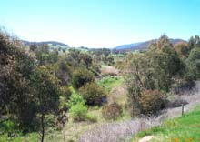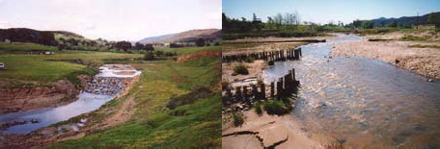

Technical Guidelines
for Waterway

Management

www.dse.vic.gov.au/riverhealth/waterwayguidelines

ACKNOWLEDGMENTS
The Technical Guidelines for Waterway Management have been developed for the Department of Sustainability and Environment (DSE) by a steering committee comprising representatives of the DSE, Waterway Managers Forum of Catchment Management Authorities (CMAs) and Alluvium Consulting Pty Ltd.
Funding support for the production of these Guidelines has been provided by the Australian Government’s National Action Plan for Water Quality and Salinity.
Steering Committee
Kishor Melvani – DSE , Bill O’Connor - DSE, Wayne Tennant - Goulburn Broken CMA, Reiner Kammler – Glenelg Hopkins CMA, and Ross Hardie - Consultant.
Principal Editor
Ross Hardie
Project Consultant
Earth Tech Engineering Pty Ltd
Review
Overall specialist review by Dr John Tilleard and Dr Ian Rutherfurd.
Additional technical review by Dr Nick Bond - Monash University, Ed Thexton - Riparian Australia, Assoc. Prof. Bob Keller - Monash University, Peter Vollebergh - DSE, Mark Turner - Corangamite CMA, Terry McCormack - North East CMA and Merryn Kelly - DSE.
Editorial assistance by Sam Marwood - DSE and Carol Roberts - DSE.
Front Cover Photographs
Main image: Flow over rock chute – lower Bunyip River/drain. Small images left to right: Rock Chute in Barwidgee Creek (1992) - Ovens River Catchment; Pile field in Black Range Creek – Ovens River Catchment; Rock Chute in Barwidgee Creek (2002) - Ovens River Catchment.
Note
The Guidelines provide hyperlinks and references to external related information, current at the time of publication. Information includes relevant waterway management related topics/reports by other agencies or persons in the context of the use of these Guidelines. It is the responsibility of users to check the currency and suitability of information for its intended purpose.
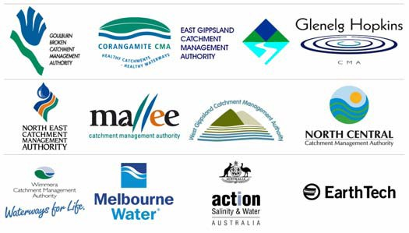
Citation: This document should be cited as: Department of Sustainability and Environment 2007, Technical Guidelines for Waterway Management, Department of Sustainability and Environment, Victoria.
Published by the Victorian Government Department of Sustainability and Environment, Melbourne, July 2007.
© State of Victoria, Department of Sustainability and Environment 2007.
This publication is copyright. No part may be reproduced by any process except in accordance with then provisions of the Copyright Act 1968.
Authorised by the Victorian Government 8 Nicholson Street, East Melbourne. Printed by Typo Corporate Services, South Melbourne.
Printed on 100% recycled paper.
ISBN 978 1 74152 794 0
For more information about Department of Sustainability and Environment contact the DSE Customer Service Centre 136 185 or visit www.dse.vic.gov.au.

Disclaimer
This publication may be of assistance to you but the State of Victoria and its employees do not guarantee that the publication is without flaw of any kind or is wholly appropriate for your particular purposes and therefore disclaims all liability for any error, loss or other consequence which may arise from you relying on any information in the publication.

ACKNOWLEDGMENTS

FOREWORD
Rivers are a vital part of Victoria’s landscape. Aside from providing safe drinking water, Victoria’s rivers underpin the State’s economy, sustaining agriculture and industry, while supporting recreation and attracting tourism. It is clear that our rivers warrant protection to the highest standard and in the best possible manner.

As caretakers of river health, Catchment Management Authorities are the key State Government service delivery agencies for regional waterway, floodplain, drainage and environmental water reserve management. As such, CMAs develop and implement river protection and restoration programs in accordance with the priorities of Government- endorsed Regional Catchment Strategies and River Health Strategies and in partnership with local communities.

In 2006/2007, combined investment by the Australian and State Governments for the protection and restoration of the health of Victoria’s regional waterways amounted to
$30M.

To achieve the most effective river health outcomes for this level of investment, Victoria’s river health programs must utilise best management practice, recognising the underlying geomorphologic and ecological processes operating within our rivers.

Technical Guidelines for Waterway Management (Guidelines) represents that current best management practice and incorporates advances in environmental and technical practice for river health restoration and protection since the publication in 1991 of the Guidelines for Stabilising Waterways.

The Guidelines have been developed and reviewed by highly experienced waterway management specialists to assist regional waterway managers in delivering Victoria’s river heath program to the highest standard.

The Guidelines emphasise that successful programs and projects will rely on the establishment and communication of clear objectives, the development of an understanding of the underlying stream processes at work and the selection and implementation of management options based on ’greatest and most sustainable progress at least cost’. However, the design and construction of specific works is also dependent on the judgement and experience of the waterway management professional.

I gratefully acknowledge the funding support from the Australian Government’s National Action Plan for Water Quality and Salinity, the contribution of the project steering committee and the various reviewers of these Guidelines.

I would encourage all waterway management professionals to use Technical Guidelines for Waterway Management, which will also be available on the web, for the planning, design and implementation of river health programs.
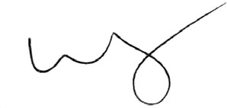

Peter Harris
Secretary
Department of Sustainability and Environment

CONTENTS

Part 1 Introduction 1
  - Background 3
  - Scope 3
    - Spatial scale 4
    - Temporal scale 4
  - How to Use these Guidelines 4
    - Structure 4
    - Using the technical guidelines 5
  - Philosophy For Waterway Management 5
Part 2 Planning 7
  - Introduction 9
  - Project Purpose 11
    - Project context 11
    - Related resource management programs 12
    - Waterway assets 13
    - Establishing a vision and targets for the reach and the assets 15
  - Understanding the Stream System 18
    - Assessment of stream condition 19
    - Assessment of stream processes 21
    - Development of conceptual models 22
    - Threatening activities and processes 24
  - Strategy Development 28
    - Management options 29
    - Priorities for management 30
    - Implementation targets and responsibilities 34
    - Documentation 35
  - Design and Implementation 36
    - Levels of service for analysis, design and construction 37
    - Design of activities and works 37
    - Implementation planning and assessment 37
    - Monitoring and evaluation 38
Part 3 Threats and Options 41
  - Threatening Activities and Processes 43
    - Vegetation decline 45
    - Hydrologic change 47
    - Water quality decline 49
    - Invasion by exotic fauna 51
    - Loss of instream timber 53
    - Stream bed aggradation 55
    - Stream bed degradation 57
    - Bank instabilities 59
    - Instream barriers 61
  - Intervention Option Guide 63
  - Onground Management Options 70
    - Inflow and runoff management 71
    - Constructed wetlands 72
    - Provision of environmental flows 74
    - Water sensitive urban design 76
    - Vegetation management 78
    - Stock control 79
    - Vegetation establishment 81
    - Vegetation management 83
    - Weed management 85
    - Willow control 87
    - Instream physical management 89
    - Alignment training 91
    - Bank battering 93
    - Bed seeding 95
    - Channel reconstruction – geomorphic channel design 97
    - Engineered log jams 99
    - Fish ladders or fishways 101
    - Lock fishways 103
    - Fish passage through culverts 105
    - Grass chutes 107
    - Infrastructure decommissioning 109
    - Large wood installation 111
    - Log sills 113
    - LUNKERS (constructed undercut banks) 115
    - Pile fields 117
    - Rock beaching 119
    - Rock chutes 121
    - Rock groynes 123
    - Sediment extraction 125
    - Silt fences and sediment traps 127
    - Wetland and floodplain engagement 129
Part 4 Materials 131
  - Commonly Used Materials 133
    - Vegetation 133
    - Timber (and large wood) 133
    - Rock 135
  - Field Rock 137
  - Quarry Rock 138
  - Plantation Timber 139
  - Field Timber 140
  - Geotextile – Filter Fabric 141
Part 5 Design Guidelines 143
  - Philosophy for Design 145
  - Inflow and Runoff Design 147
  - Vegetation Design 148
  - Instream Physical Intervention Design 149
    - Geomorphic design of stream reconstructions 150
    - Stream bank erosion control 152
    - Design of pile field retards 154
    - Design of rock beaching 173
    - Management of incised streams 181
    - Rock chute based grade control strategy design 187
    - Instream scour hole and habitat design 196
Part 6 Design Aids 197
  - Waterway Design Parameters 200
    - Introduction 200
    - Floodplain velocity 201
    - Stream velocity 202
    - Shear stress 205
    - Unit stream power 209
    - Channel dimensions - width and depth 212
    - Channel dimensions – bed grade 216
  - Design of Timber Piles 217
    - Introduction 217
    - Required equations and parameters 218
    - Example table of minimum pile diameter and embedment depths 222
  - Stability Analysis for Large Wood and Engineered Log Jams 224
    - Single log 224
    - Drag force 225
    - Uplift force 225
    - Force of gravity 226
    - Calculation of resultant force 226
    - Engineered log jam 227
    - Horizontal force due to water 228
    - Force due to uplift 229
    - Horizontal force per pile 229
  - Methods for Estimating the Size and Grading of Rock 230
    - Ring grading 230
    - Other methods 231
  - Procedure for Estimating Scour Depth 232
    - Degradation / aggradation 232
    - General and local scour 233
    - Safety margins against scour 235
    - Natural armouring as a limit to scour 236
Part 7 Worked Example and Checklists 237
  - Worked Example 239
    - Project purpose 239
    - Understanding the system 242
    - Strategy development 248
    - Design and implementation 253
    - Worked example appendix 256
  - Planning Checklist 261
  - Waterway Activity – Community/ Environment/ Public Health Checklist 264
  - Unit Rates for Waterway Management Activities. 268
Part 8 References and Resources 271
  - References and Further Reading 273
  - Useful Web Links 279

DEFINITIONS
A set of definitions for a selection of common terms is provided below. The definitions were developed to define the project scope and assist with the application of these Technical Guidelines.

River health Refers to the combined hydrologic, physical, vegetation, water
quality, and ecological condition of a river or waterway. Also referred to in these Technical Guidelines as waterway health.

Programs Activities and works undertaken over a medium to long term
(5 to 10 years) within a sub catchment, catchment or region, consisting of a combination of education engagement, regulation onground works and monitoring activities.

Projects A limited selection of activities and/or works undertaken over a short period (1 or 2 seasons) at a site or within a reach or sub catchment.

Catchment management The development and implementation of programs and
projects of education, engagement, regulation, onground works and monitoring on land, riparian and instream zones aimed at achieving a balanced outcome for the catchment.

River health management The development and implementation of programs and
projects of education, engagement, regulation, onground works and monitoring on land, and within riparian and instream zones seeking to achieve river health outcomes for the waterways of a catchment.

River basin management The development and implementation of programs and
projects of education, engagement, regulation, onground works and monitoring on land, and within riparian and instream zones seeking to achieve a set of outcomes for the waterways of a catchment, balancing environmental protection and consumptive demands.

Waterway management The development and implementation of programs and
projects of onground works and monitoring focussed within the riparian and instream zones seeking to achieve agreed river health and other outcomes for the waterways of a catchment.

Table of Contents

BACKGROUND
These Technical Guidelines for Waterway Management (Technical Guidelines) have been developed by the Department of Sustainability and Environment (DSE) in association with Victoria’s Catchment Management Authorities (CMAs), for professional waterway managers working in Victoria’s waterway and catchment management industry. The Technical Guidelines provide guidance to the selection, design and implementation of a range of onground options that are available to assist in the management and protection of waterway health in Victoria.

The Technical Guidelines have been developed to update the document Guidelines for Stabilising Waterways (Standing Committee on Rivers and Catchments 1991) and the Environmental Guidelines for River Management Works (Standing Committee on Rivers and Catchments 1990), capturing developments in the waterway management industry over the past 15 years.

SCOPE
These Technical Guidelines provide guidance to assist the selection, design and implementation of options for intervening in the ongound physical and/or biological condition of waterways. The guidelines include sections on:

    - waterway management planning – by reference to existing planning frameworks developed by others;
    - discussion of the threats that trigger management intervention and the management intervention options that are available to address these threats;
    - description of the materials used in waterway management and guidelines for their use;
    - guidelines for design of a selection of intervention options; and
    - an ad-hoc collection of useful design aids.
In addition, the Technical Guidelines include a worked example and a comprehensive set of references, related reading and web sites. Where appropriate the Technical Guidelines provide references and links to other sources rather than repeating detailed information that is available elsewhere.

The Technical Guidelines address technical aspects of onground intervention options of river health management. As a consequence the Technical Guidelines deal only with a subset of the suite of options available to influence waterway condition. For example, these guidelines consider how the waterway manager can directly influence river health by manipulating the:

    - inflows of water and sediment
    - extent and condition of riparian vegetation
    - physical form of the channel and floodplain.
On the other hand, the Technical Guidelines do not address in detail other important techniques for achieving river health outcomes such as:

    - Community engagement. Successful stream management programs rely on successful long term partnerships with adjoining landholders and the local community. A technically correct action, without reference to the social context invites failure.
    - Statutory planning and advocacy. Achieving waterway health objectives will often depend on influencing the opinions or actions of other groups, agencies or individuals.

Table of Contents

- Monitoring. Predicting the ecological response to intervention is often uncertain in the natural environment. Detailed monitoring of response is a vital part of developing and validating ecological response models.

SPATIAL SCALE
These Technical Guidelines have been developed to assist the development of programs and projects at the management unit scale based on strategies already identified at a broader scale in regional scale planning documents such as regional river health strategies. The management unit scale includes a site, a reach of stream or a sub catchment. These Technical Guidelines have not been developed for regional and catchment scale, planning and prioritisation.

TEMPORAL SCALE
These Technical Guidelines have been produced to assist the development of long term programs and shorter term projects. Long term programs could include a reach scale waterway rehabilitation program or a sub catchment scale willow management program. Shorter term projects may include a fencing and revegetation project at a particular property.

HOW TO USE THESE GUIDELINES

STRUCTURE
These Technical Guidelines have been structured in eight parts as follows:

Part 1 Introduction: This section provides an introduction to the project, the background and structure to the document and a philosophy for waterway management that is reflected through the Technical Guidelines.

Part 2 Planning: This section provides a discussion on recommended river health and waterway management planning frameworks and provides discussion on a number of aspects of river health planning with specific reference to waterway management programs in Victoria.

Part 3 Threats and Options: This section provides details of and a discussion on a range of processes that generate threats to river health. In addition this section provides details on a range of onground intervention options to address threats and move systems toward agreed river health targets.

Part 4 Materials: This section provides details on a range of materials commonly used in waterway management programs and projects.

Part 5 Design Guidelines: This section provides design guidelines for a selection of waterway management options.

Part 6 Design Aids: This section provides ad hoc information and recipes that may assist with the design of waterway management options.

Part 7 Worked Example and Checklists: This section provides a worked example on the use of these Technical Guidelines. In addition this section includes reference to and examples of useful planning and implementation checklists.

Part 8 References and Resources: This section provides references, further reading and access to resources such as useful links for the assessment and design of waterway management programs and projects.

Table of Contents

USING THE TECHNICAL GUIDELINES
These Technical Guidelines have also been prepared and are intended to be used in both hardcopy and electronic format. The hard copy version has been provided to assist navigation and ease of reading, while the electronic version provides access to an extensive range of existing references available in this field. The electronic version is available at www.dse.vic.gov.au/riverhealth/waterwayguidelines.

The Technical Guidelines have been developed in a format that enables users to enter at any point. In this respect users may seek options for addressing a particular issue or problem, or may seek more specific information on a particular design approach. Users may also choose to read the document from cover to cover.

Figure 1.1 provides a document structure to assist navigation.

PHILOSOPHY FOR WATERWAY MANAGEMENT
The following management philosophy is reflected throughout these guidelines.
Management intervention in waterways is purpose driven by a clear set of desired waterway health outcomes that reflect community aspirations and strike a balance between competing demands. This requires effective stakeholder consultation and engagement.

A clear understanding of the physical, ecological and social processes that dominate in the system allows threats to the desired waterway management outcomes to be identified. Options for management intervention will be those that directly or indirectly address the threats. This requires development of a model of ecological response based on detailed knowledge and understanding of the interaction between processes.

The most appropriate strategies for management will be those that achieve an agreed set of waterway health outcomes for a least cost while retaining maximum flexibility for the future. These guidelines aim to assist in understanding and selection of intervention options.

Effective outcomes rely on skill and experience in design and implementation of intervention options. These guidelines are designed to assist this outcome.

TabTleabolef Coof nCtoentesnts

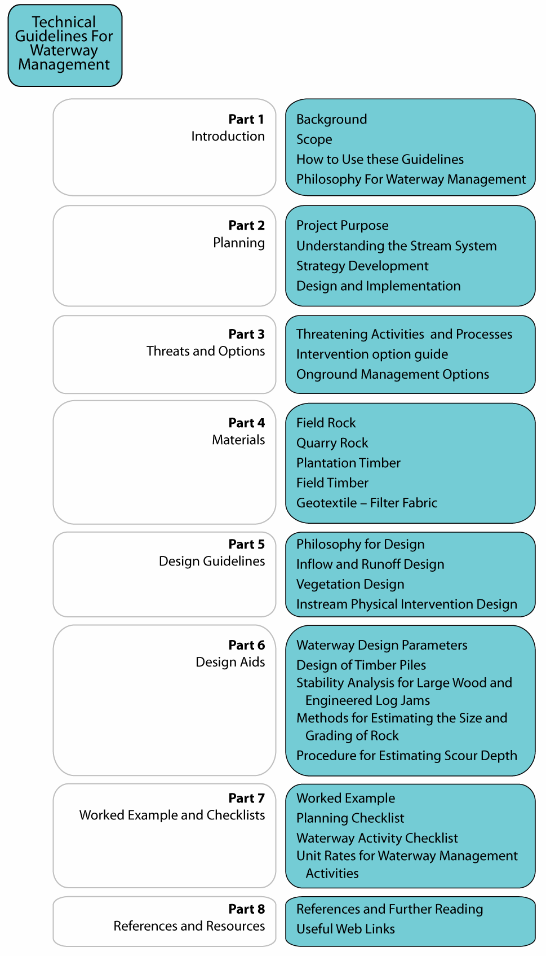

Figure 1.1 Document Map

2.1 INTRODUCTION

INTRODUCTION
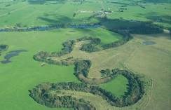
Waterway management programs and projects are best undertaken within a clearly articulated and communicated framework. Such a framework should include provision for establishment of a vision for the subject stream, identification of key assets (such as river health), assessment of stream condition and trajectory, development of priorities, and the design, implementation, monitoring and evaluation of works, projects and programs.
Importantly, the framework should include

provision for stakeholder consultation and engagement.
Oblique aerial photograph of meandering stream in north east Victoria

A number of management frameworks have been developed to assist the implementation of river health and waterway management programs in Australia. These frameworks include but are not limited to:
Table of Contents

    - a 12 step stream rehabilitation process contained in A Rehabilitation Manual for Australian Streams (Rutherfurd et al. 2000); and
    - a 6 step process described in River Restoration Framework (Koehn et al. 2001). These frameworks are illustrated below.
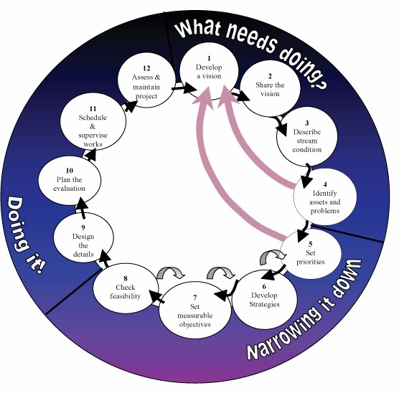
Figure 2.1 A 12 step stream rehabilitation process (Adapted from Rutherfurd et al. 2000)

Table of Contents

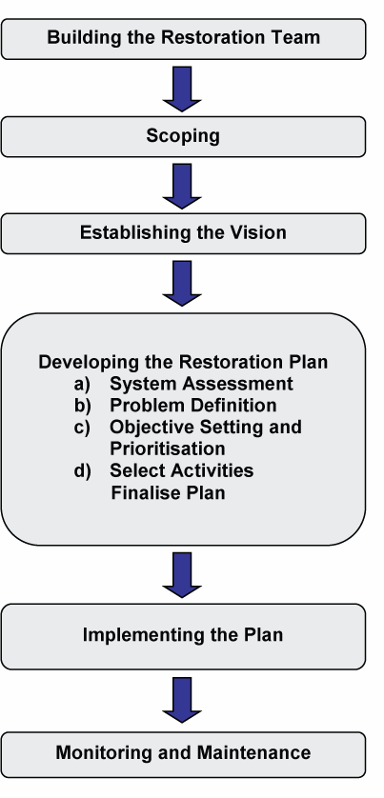

Figure 2.2 A six step river restoration process (Extract from Koehn et al. 2001)

A planning checklist developed by Koehn et al. (2001), is provided in Section 7.2.
All waterway management projects in Victoria should be implemented within an agreed and clearly communicated planning framework. The framework could be the 12 steps for stream rehabilitation developed by Rutherfurd et al. (2000), the framework for stream restoration developed by Koehn et al. (2001), or a hybrid framework comprising the elements contained within these existing planning frameworks.

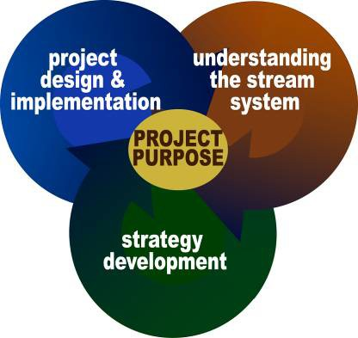
Reflecting the “Philosophy of Management” outlined in Part 1, the remainder of this Part 2 has been structured in four sections. These sections provide information and discussion on a number of the elements contained within the above frameworks, with particular relevance to Victoria and to these Technical Guidelines. The four sections comprise the stages of simplified planning framework:

  - Project purpose
  - Understanding the stream system
  - Strategy development
  - Design and implementation.

Table of Contents

PROJECT PURPOSE
The first stage in the development of a waterway management project requires assessment and documentation of the project background and context, recognition of related legislation, policy and strategy, identification of assets and establishing a vision for the project and the waterway.

This section relates to steps 1 and 2 and part of step 4 of the process developed by Rutherfurd et al. (2000). This section also relates to the first three steps contained within the River Restoration Framework (Koehn et al. 2001).
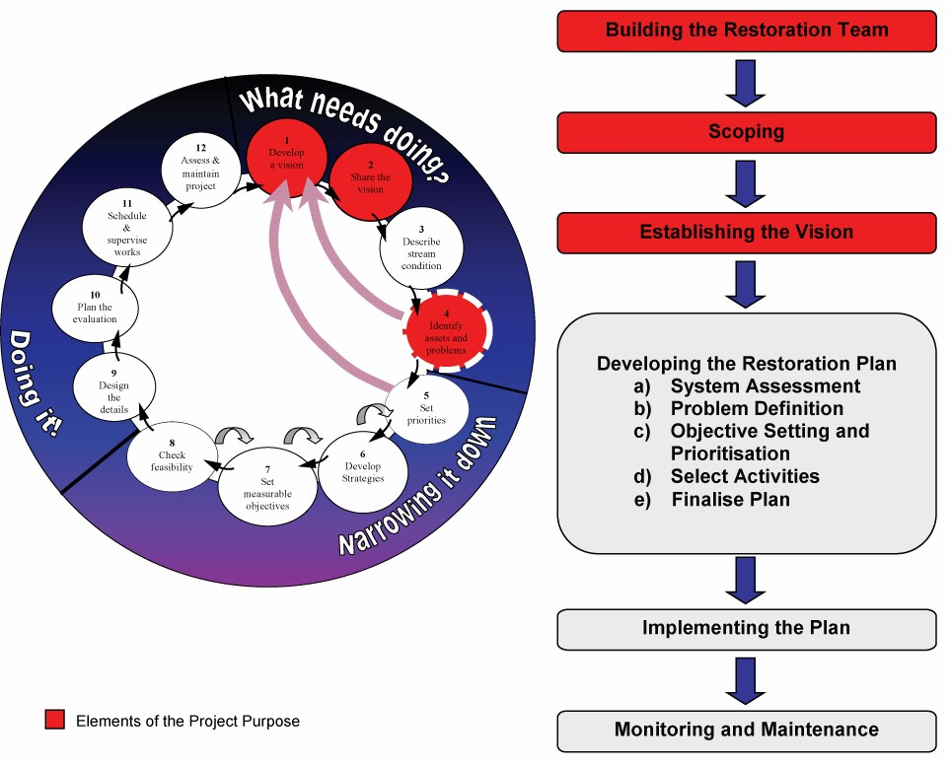
Figure 2.3 Elements of the Project Purpose

PROJECT CONTEXT
Key questions to be asked in this stage include:

      - Who is funding the project? What are they expecting?
      - Are there other project stakeholders and what do they expect?
      - What has led to this site, reach or sub catchment having been identified for management attention?
      - What existing legislation, policy, strategies and investigations have been undertaken that may inform the plan and impact on its implementation?

The process of identifying and documenting the project background and context will include but not be limited to:

      - review of relevant legislation and policy
      - review of related strategies and investigations
      - consultation with project stakeholders.

Table of Contents

A key to this process will be to provide a local link to State and regional planning and any attached funding. The process should also lead to an understanding of the legislative and policy framework within which the project can be implemented and the identification of constraints and opportunities that impact on the selection of options for management.

RELATED RESOURCE MANAGEMENT PROGRAMS
Identifying options for management and developing effective management programs relies on the waterway manager's awareness of related catchment and waterway management programs, projects and plans, legislation and policy. A selection of relevant Victorian legislation, policy, strategies and plans that may assist to inform and guide the development of waterway management programs are provided below. Legislation and policy is changing rapidly so readers should make their own assessment of the validity of this information.

EXAMPLE LEGISLATION

Victorian
    - Water Act 1989
    - Environment Effects Act 1978
    - Coastal Management Act 1995
    - Catchment and Land Protection Act 1994
    - Environment Protection Act 1970
    - Flora and Fauna Guarantee Act 1988
    - Crown Land (Reserves) Act 1987
    - Heritage Act 1995
    - Heritage Rivers Act 1992

Commonwealth
    - Native Title Act 1993
    - Environment Protection and Biodiversity Conservation Act 1999

EXAMPLE POLICY
    - State Environmental Planning Policies (including Waters of Victoria)
    - Securing our Water Future Together (Government of Victoria 2004)

EXAMPLE STRATEGIES
    - Victorian River Health Strategy (DNRE 2002)
    - Regional Catchment Strategies as developed and updated from time to time
    - Regional River Health Strategies as developed and updated from time to time

EXAMPLE PLANS
Threatened species action statements and recovery plans have been prepared under the provisions of the Flora and Fauna Guarantee Act 1988 for the protection and enhancement of endangered species. These action statements and recovery plans can inform and guide the development of waterway management programs and projects, alerting waterway managers to potential assets and conflicts. Examples of action statements and recovery plans are provided below. This is not a complete listing of relevant action statements and recovery plans. Further information and additional statements and plans can be found at www.dse.vic.gov.au > Plants and Animals > Native Plants and Animals > Threatened Species & Communities > Flora & Fauna Guarantee Act.

Example Action Statements
    - No. 65 Barred Galaxias, Galaxias olidus var. fuscus
    - No. 38 Trout Cod, Maccullochella macquariensis

Table of Contents

Example Recovery Plans
      - Recovery Plan for the Trout Cod (Maccullochella macquariensis)
      - The Recovery Plan for the Swift Parrot (Lathamus discolour) 2001 – 2005
      - Spotted Tree Frog Recovery Plan 1999 - 2003

WATERWAY ASSETS

INTRODUCTION
The success of waterway management projects relies on identifying the assets that are the subject of the proposed program and project. Is the project aimed at protecting the local shire bridge from ongoing stream incision or is the project aimed at protecting the health of one of Victoria’s Heritage Rivers? The answer to such questions can lead to very different programs and projects.

Rutherfurd et al. (2000) described stream and related assets as being either cultural, infrastructure, environmental or recreational. These are shown in Figure 2.4.

Cultural and social significance
Heritage
Water Supply
Morphological diversity
Grazing Land
Asset Protection and Economic Production
History
Waste Removal
Access
Vegetation
Amenities
Water Weeds Quality
Aesthetics
Flood Frequency and Duration
Water Stability
Depth
Habitat Wildlife
Hydraulic Diversity
Recreation
Environment
Morphological Diversity
Fish barriers Large Woody Debris
Figure 2.4 Stream related assets (Source: A Rehabilitation Manual for Australian Streams (Rutherfurd et al. 2000))

Assets for which waterways are managed include but may not necessarily be limited to:

      - Environment assets: these can include individual species of plants and animals, whole ecological communities, morphological assets such as a geomorphic feature or process, ecosystem services (e.g. nutrient cycling) and associated habitat.
      - Cultural assets: this can include historic features, and landscape and cultural values.
      - Recreation assets: this could include fishing and canoeing sites and opportunities.
      - Economic values and physical structures: public and private assets that are at risk as a result of ongoing stream processes. These can include quality of water supply, bridges, roads, telecommunications infrastructure, fences and so on.

Table of Contents

These can also include the assets of an authority or agency constructed to protect other assets. These may also include grade control structures, bank protection works and so on. The assets may relate to a single feature at a site such as the habitat for a particular endangered species, through to an entire river reach such as a Heritage River.

RIVER HEALTH AS A WATERWAY ASSET
There has been a substantial shift in State and Federal funding allocations to river projects over the past 15 years. This shift reflects a greater scientific and community awareness of the importance of river health. Funding has moved from the protection of infrastructure assets (roads, bridges, water supply systems) to the protection and improvement of river health as an asset. The description and communication of the assets, to which the project funding is directed, will be essential for project success and avoiding disappointment associated with misunderstandings and false expectations.

These Technical Guidelines reflect this shift in funding emphasis and community expectation and are focussed on river health as an asset, the processes that threaten river health and target conditions, and the activities that can be undertaken to achieve river health targets.

For the purpose of these Technical Guidelines and as set out in the Victorian River Health Strategy (DNRE 2002), stream health is the combination of a number of elements, including:

    - hydrology
    - physical form
    - instream ecology
    - riparian and instream vegetation
    - water quality
    - floodplain linkages.
Further discussion on these elements can be found in the Victorian River Health Strategy
(DNRE 2002) and numerous other references.
WHAT IS A HEALTHY RIVER?
According to the Victorian River Health Strategy a healthy river can be defined as:

“A river which retains the major ecological features and functioning of that river prior to European settlement and which would be able to sustain these characteristics into the future.

A healthy river need not be pristine. There may be exotic species present. In some areas along the river, the riparian zone may be significantly reduced. Some areas of the floodplain may be disconnected from the river. It is a river where some aspects of river condition may have been traded off to provide for human use. However, overall, the major natural features, biodiversity and/or functions of the river are still present and will continue into the future.”

The components of a healthy stream are not independent and a decline in one component may see a decline in other components. A range of threatening activities and processes such as alteration to the flow regime, excess sediment inflows, vegetation removal and stock access can all lead to declines in one or all the elements of stream health.

While some processes that threaten stream health are quite obvious, others are more subversive and it is therefore important to regularly complete assessments of the condition of streams. The Index of Stream Condition (ISC) (DNRE 1997a & b) is the most commonly applied stream condition assessment tool in Victoria. However other standardised assessments are available. The Index of Stream Condition and other standardised stream condition assessment methods are discussed in Section 2.3 Understanding the Stream System.

Table of Contents

ESTABLISHING A VISION AND TARGETS FOR THE REACH AND THE ASSETS

VISION
Establishing a vision or a clearly defined goal is paramount to the success of any waterway management project. The vision establishes a focal point for the project, something for all stakeholders to agree upon and aim for and something that we can measure our success against. In many instances this vision will be something that can unite a community and achieve strong support for the project. Engaging all stakeholders in the development and subsequent commitment to the vision will increase the level of support for the project and improve its chances of success.

The vision for any particular reach of stream should be developed from a number of sources and planning levels. The vision should be drawn from State, regional and local levels such as the state and regional river heatlh strategies, weed strategies and endangered species strategies and the aspirations of the local community.

The vision for Victoria’s waterways as set out in the Victorian River Health Strategy (DNRE 2002) is provided below. This vision has been further developed and incorporated into regional river health strategies. Together these can be used to assist the development of visions for reach and sub catchment scale programs and projects.
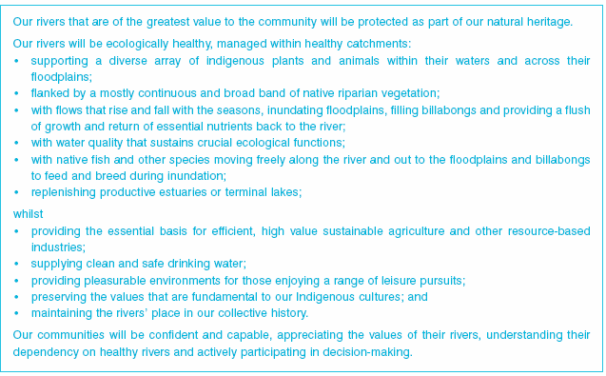
Source: Victorian River Health Strategy (DNRE 2002)

Further information on establishing a vision for a stream can be found in A Rehabilitation Manual for Australian Streams (Rutherfurd et al. 2000). An example vision for a reach of stream with timescales and target outcomes might read:
AN EXAMPLE VISION FOR A REACH OF STREAM
To return White Creek to a condition where our kids can swim and catch fish, where it supports an abundance of instream indigenous flora and fauna and provides a habitiat corridor between the estuary and the forested upper catchment.

This vision provides both a desired outcome for the waterway and a timescale for attainment of that outcome i.e.the vision provides resource condition targets in terms of instream and riparian assets and attainment of the desired condition within the childhood years of the author’s offspring.

Table of Contents

The establishment of a vision should be accompanied by the development of performance criteria and targets and timescales that can be used to measure the success of the project. Preliminary performance criteria suitable for the establishment of targets for the above vision may include:

    - Physical form: the presence, size and persistence of scour holes in the bed of the stream.
    - Ecology: the presence, size, species composition and abundance of fish and macro invertebrates in the stream.
    - Hydrology: the presence of suitable flows for fish passage and habitat.
    - Vegetation: the presence of suitable shading vegetation, and longitudinal and lateral connectivity.
    - Water quality: the presence of suitable water quality for consumptive supplies, recreation and instream ecological processes. Note that water quality objectives may already be set for the stream under the State Environment Protection Policy (Waters of Victoria) (EPA 2003).

The establishment of quantifiable targets for the vision and these critera is discussed below.

QUANTIFIABLE REACH OUTCOME TARGETS
Quantifiable outcome (or resource condition) targets have been established for Victoria’s waterways, within the State and regional river health strategies, using a number of metrics including indices from the Index of Stream Condition. Quantifiable condition targets should be established for the reach of stream based on the criteria that reflect the vision, the method to be adopted for assessing the stream condition and the method to be adopted for ongoing monitoring and evaluation.

The adoption of quantifiable outcome targets based on the metrics used in the adopted stream condition assessment method provides a transparent link between current condition, desired future condition and an ongoing monitoring program. In addition to the benefit to reach based planning, the adoption of targets, at the reach scale, using the ISC or an adaptation of it, provides a transparent link between outcomes at the site and reach scale and the outcomes sought at the regional and State scale. The concept of identifying a future or target resource condition is shown in the following figure.
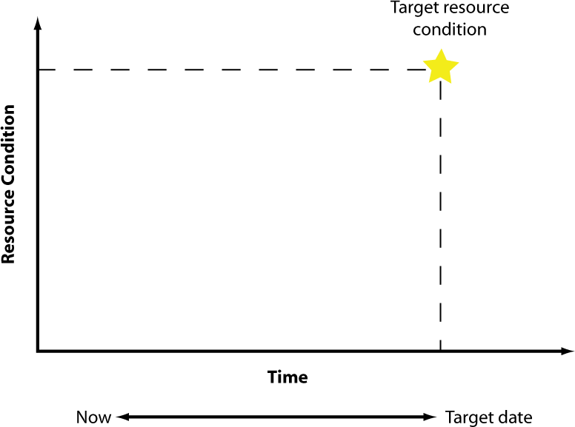

Figure 2.5 Target resource condition

Table of Contents

The stream condition scoring adopted as the means of setting a target for the reach of stream should reflect the vision for the stream and any regional targets that may have been established. Vegetation scores can be used to define and reflect the extent of longitudinal and lateral vegetation connectivity to be achieved in order to meet wildlife corridor objectives. Stream physical form scores can be used to define outcomes in terms of stream bed diversity and to provide suitable habitat for fish species.

Table of Contents

UNDERSTANDING THE STREAM SYSTEM
The development of an understanding of the stream system falls within steps 3 and 4 of the 12 steps for stream rehabilitation (Rutherfurd et al. 2000), and the “System Assessment” and “Problem Definition” steps of the River Restoration Framework (Koehn et al. 2001).
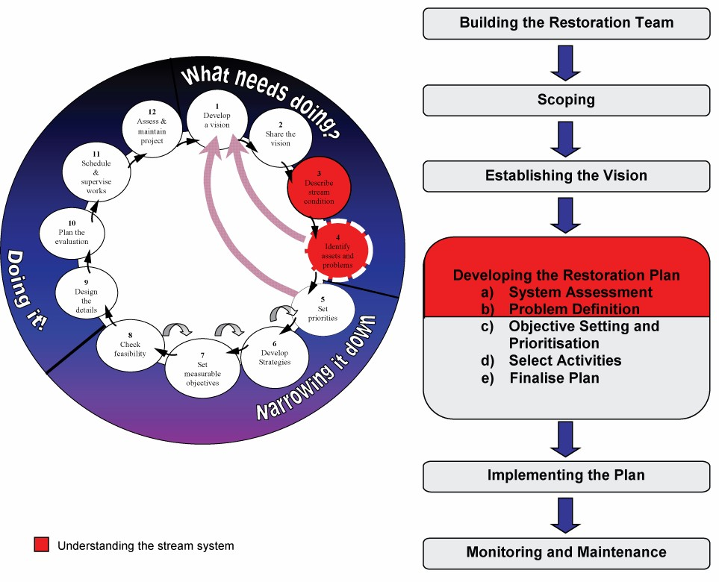

Figure 2.6 Understanding the stream system

An understanding of the stream system can be used to refine the project purpose and is essential for the development of an effective waterway management strategy for the site, reach or sub catchment.

The understanding of the stream system will be aided by the development of conceptual models of ongoing stream processes and the development of a trajectory for the stream into the future. The investigations and outcomes will prove to be invaluable resources serving as benchmarks against which future stream condition and stream processes can be assessed.

The development of an understanding of the stream system will typically involve:

    - assessments of stream condition;
    - assessments of stream process;
    - development of conceptual models of physical and ecological processes; and
    - identification of threatening activities and processes and the trajectory for stream assets and condition.

These assessments and their outcomes will also provide a first chance to review the appropriateness or otherwise of the proposed vision and targets for the waterway.

ASSESSMENT OF STREAM CONDITION

OVERVIEW
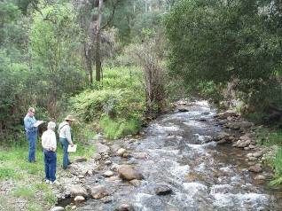
An understanding of current stream condition is essential for any stream management project. Stream condition information can assist with the setting of long term management targets, the development of priorities and can provide a reference point against which progress can be measured.

A number of approaches to measuring stream condition have been developed for Australian streams. For the purpose of programs and projects the condition assessment should be repeatable,

quantifiable, and scaleable.
Stream condition assessments, north east Victoria

The approach should be repeatable so that it can be undertaken in the future to assess movement towards a target. The method should be quantifiable so that it can be used for target setting and performance monitoring. Finally the method should be scaleable so that it can be used as part of a reach and regional based target setting and performance monitoring.
Table of Contents

The approach to stream condition assessments will be reflected in the:

- metrics adopted for resource condition targets
- establishment of the current condition
- monitoring of future stream condition.
In this respect the approach to stream condition assessments should be established and agreed from the project inception and continued as far as practicable through the life of the project.

The concept of identifying current stream or resource condition and comparing this against the target condition is illustrated in the following figure.

Table of Contents

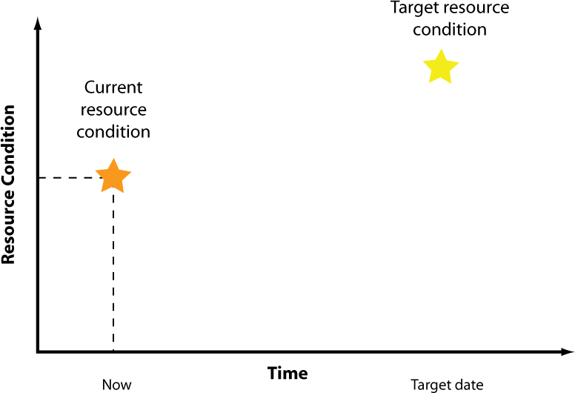

Figure 2.7 Current and target resource conditions

INDEX OF STREAM CONDITION
The Index of Stream Condition (ISC) and/or an adaptation of it has the potential to fulfil most of these criteria. The ISC is a semi quantitative, and repeatable approach for identifying and documenting river condition. The ISC was developed in Victoria in the late 1990s (DNRE 1997) and applied across Victoria in 1999. The approach has since been modified and adapted to reflect an improved understanding of stream systems and the knowledge base on Victoria’s streams. The ISC comprises both field and desk based assessments of the elements of stream health:

    - hydrology
    - physical form
    - riparian vegetation and floodplain linkages
    - aquatic life
    - water quality.
The ISC approach has been adopted at the State and regional levels in Victoria for the reporting on stream and riparian catchment condition. Further, ISC condition ratings have been adopted as resource condition targets at the State and regional levels. These ISC ratings serve as performance indicators for Catchment Management Authorities throughout the State. Adoption of the ISC or a modification of it, for reach and site scale condition assessments and target setting, could establish a defined and transparent link between onground actions at the site and reach scale to the broader scale regional and State river health strategies and program funding. However the ISC was not developed for this purpose and some refinement and development of the method may be required.

Stream condition assessments used for waterway management planning should be undertaken to a level of detail and distribution commensurate with the scale of the waterway management project. There are a number of references that may assist with the identification of the type, frequency, distribution of condition assessments such as Rutherfurd et al. (2000) and North Central CMA (2003). The density of condition sampling undertaken for the Statewide assessment of stream condition is insufficient for reach scale project planning and an increased sampling density will be required.

Table of Contents

Desktop investigations can be undertaken for water quality, hydrology and aquatic life. These desktop assessments should be based on existing sampling sites. The assessment of hydrology should be based on the recently developed index of flow stress. Additional instream ecological sampling may be appropriate.

Further information on the Index of Stream Condition can be obtained at www.dse.vic.gov.au/riverhealth/isc.

OTHER APPROACHES TO STREAM CONDITION ASSESSMENTS
Other approaches are available to assess river condition. These include but are not limited to AUSRIVAS (www.ausrivas.canberra.edu.au) developed by the Cooperative Research Centre (CRC) for Freshwater Ecology, the Pressure Biota Habitat (PBH) Method developed by the Government of New South Wales (NSW) and the Anderson Method developed for the government of Queensland. One of many internationally developed approaches is the United States of America Environmental Protection Agency (US EPA) Habscore method.

There is generally a trade-off between the level of detail of the rapid assessment technique and the cost and training required to complete assessments. As the assessment technique becomes more involved and delivers improved data quality, the number of sites that can be assessed within a fixed budget decreases. Hence a balance must be struck to provide sufficient information on the stream condition for an available budget without compromising the purpose of the assessment.

The Murray Darling Basin Commission is currently embarking on a project, The Sustainable Rivers Audit, to assess the condition of all streams in the Murray Darling Basin. This Audit requires agreement on a consistent approach for stream condition assessments throughout the basin. Finalisation of this approach had not been achieved at the time of publication of these Technical Guidelines.

ASSESSMENT OF STREAM PROCESSES
Critical to the successful planning and implementation of stream management programs will be an assessment and understanding of the stream processes at work. These processes include but are not limited to hydrologic, water quality, ecological, geomorphic and vegetation processes. The understanding of stream processes within the subject stream reach can be developed through:

- Understanding of fundamental stream processes. Knowledge of stream hydrologic, hydraulic, geomorphic and ecological processes is a prerequisite to the effective use of these Technical Guidelines. These guidelines do not provide readers with details of fundamental stream processes. Further reading on fundamental stream processes can be found in A Rehabilitation Manual for Australian Streams (Rutherfurd et al. 2000), the Federal Interagency Stream Restoration Working Group (FISRWG 1998), Guidelines for Stabilising Waterways (Standing Committee on Rivers and Catchments 1991) and numerous other texts.

- Understanding of specific processes within the reach. Development of an understanding of the specific processes at work within an individual reach of stream can be achieved through site inspections and commissioning of specific investigations. Specific investigations and data gathering that may assist the identification of processes include:

  - water quality sampling and analysis;
  - hydrologic analysis;
  - geomorphic assessments including investigations into sediment sources, transport and fate;
  - topographic surveys including initial and repeat longitudinal and cross-section surveys;
  - vegetation surveys and investigations into vegetation dynamics; and
  - flora and fauna studies including fish surveys.

Table of Contents

Information gathering and analysis should be undertaken in a staged approach with initial assessments providing an overview of processes. More detailed data collection and investigations should only be commissioned to address identified high risk processes and assets and those processes likely to influence the success or otherwise of the project.
These investigations may form a component of the stream condition assessment or may be part of separate commissions.

Particular effort should be placed in the understanding of processes that have potential to impact on the vision and target outcomes. Such processes might include weed invasion, sediment transport and deposition, ongoing channel incision or barriers to fish movement. These are discussed in the next section under threatening activities and processes.

A number of software tools have been developed by the former the Cooperative Research Centre for Catchment Hydrology (CRCCH) for the hydrologic and geomorphic assessment of stream systems. These tools can be found at www.toolkit.net.au. These tools are largely directed at catchment scale planning. However they may be of some assistance for the reach and sub catchment scale.

Additional information on the assessment of ecological processes in stream systems can be found at eWater CRC at www.ewatercrc.com.au.

The technique of stream geomorphic categorisation or classification based on the controls on stream physical processes such as River StylesTM developed at Macquarie University with funding from Land and Water Australia, and the Rosgen (1998) classification, may also assist in the identification of stream processes and features, the rarity of remnant stream types within a region may also serve to assist the identification of template streams. Template streams are those that can be used as a reference to guide stream rehabilitation projects.

A suggested list of analysis tools, their description and their application can be found in Koehn et al. (2001).

DEVELOPMENT OF CONCEPTUAL MODELS
The purpose of the assessment of stream processes is to develop an understanding of ongoing stream processes that have the potential to impact on the future condition and outcome for the river and related assets. Integral to this is the development of a conceptual model of the ongoing stream processes. This model should be as simple or complex as necessary to describe the ongoing ecological and physical processes at work for the purpose of the waterway program or project.

The model can be provided as a narrative description of processes, or could be illustrated through line diagrams. Alternatively the model may be a more complex physical or numerical model. In the first instance it is suggested that this model be kept as simple as possible and additional complexity be incorporated as necessary into those aspects that are most likely to impact on the vision and proposed future resource condition and targets. Once developed the conceptual mode can be used to assist the development, analysis and communication of management options to achieve the intended waterway outcomes.

While ecological response models should be the basis of decision making, our knowledge of river systems is incomplete and existing ecological response models are limited. There is a need for improved ecological response models to be researched and developed and that these models become the basis for decision making. Such models may need to be further developed and modified for specific applications.

Table of Contents

Two examples of ecological and physical response models are provided below. Further information on ecological models can be found at www.ewatercrc.com.au. An application of the ecological response models shown below is provided in the worked example within Worked Example and Checklists of these Technical Guidelines.

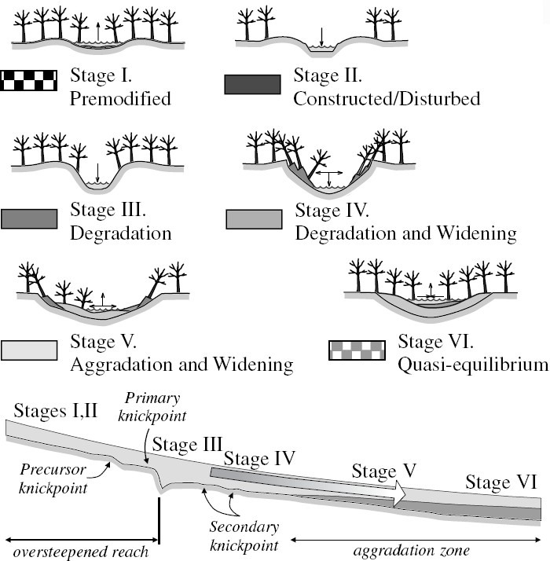

Figure 2.8 Example ecological response model: Process of channel incision and recovery (Source: Simon 1989)

Table of Contents

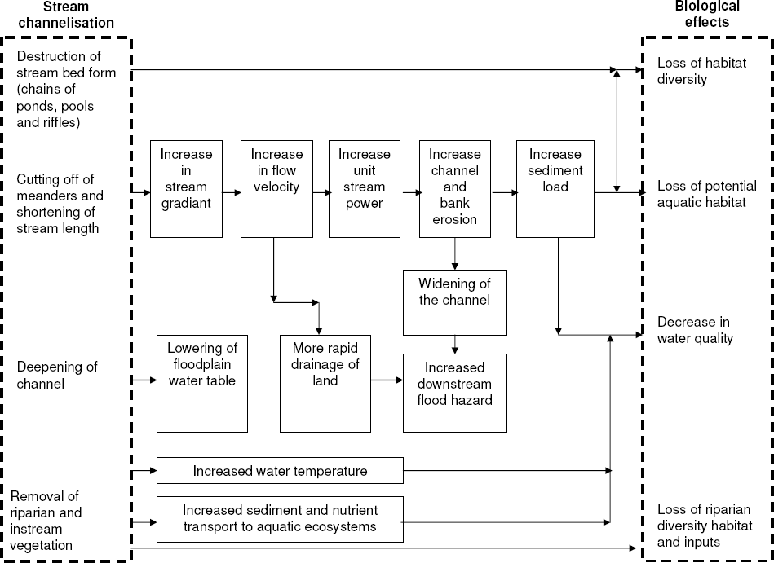

Figure 2.9 Example ecological response model: Effects of channelisation on the physical environment and ecology of streams (Adapted from Schumm, Harvey, and Watson 1988)

THREATENING ACTIVITIES AND PROCESSES
A key step in developing an understanding of the stream system is the identification of activities and processes that threaten assets and the attainment of the intended stream vision or target. The identification of threatening activities and processes enables the identification of a trajectory for the stream and related assets. The impact of threatening activities and processes on the attainment of resource condition targets is illustrated in Figure 2.10.

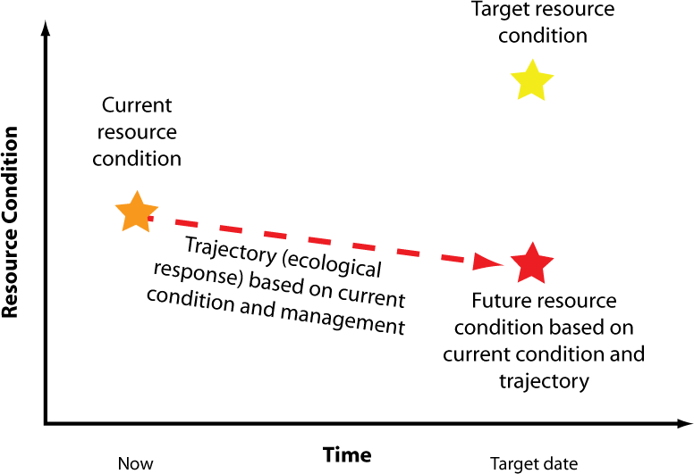

Figure 2.10 Trajectory (ecological response) for resource condition based on current condition and continuance of existing activities and processes
The Victorian River Health Strategy (DNRE 2002) describes threatening activities and processes as either:

      - catchment management activities
      - riparian management activities
      - river channel management activities.
A summary of threatening activities identified in the Victorian River Health Strategy
(DNRE 2002) is provided in the following table.

Table 2.1 Threatening activities (DNRE 2002)

Management focus Threatening activity

Catchment

Riparian land

River channel
Catchment clearing including urbanisation Poor land management
Disposal of poor quality effluent Grazing banks
Clearing banks Promotion of exotics
Levees and floodplain development Recreation, camping
Snag removal
Culverts and regulators Onstream storages
Low level releases on storages Recreation (boating, fossicking) Weed removal
Flow diversion and management

Table of Contents

Table of Contents

A selection of threatening processes, identified under Victoria’s Flora and Fauna Guarantee Act, that are likely to have a direct impact on waterways include the following:

    - alteration to the natural flow regimes of rivers and streams;
    - alteration to the natural temperature regimes of rivers and streams;
    - degradation of native riparian vegetation along Victorian rivers and streams;
    - habitat fragmentation as a threatening process for fauna in Victoria;
    - increase in sediment input into Victorian rivers and streams due to human activities;
    - input of toxic substances into Victorian rivers and streams;
    - introduction of live fish into waters outside their natural range within a Victorian river catchment after 1770;
    - invasion of native vegetation by "environmental weeds";
    - prevention of passage of aquatic biota as a result of the presence of instream structures;
    - reduction in biomass and biodiversity of native vegetation through grazing by the rabbit (Oryctolagus cuniculus);
    - removal of wood debris from Victorian streams; and
    - soil erosion and vegetation damage and disturbance in the alpine regions of Victoria caused by cattle grazing.

The RiVERS database, developed by Victoria’s CMAs in association with DSE, for the purpose of river health program priority setting (refer Section 2.4 Strategy Development), includes the following set of threats to waterway values:

    - loss of bank stability
    - loss of bed stability
    - barriers to native fish migration
    - channel modification
    - changes to flow
    - water quality trends
    - water quality attainment
    - water quality signal
    - changes to water temperature
    - occurrence of algal blooms
    - introduced exotic flora
    - degraded riparian vegetation
    - introduced exotic fauna
    - loss of instream habitat
    - loss of wetland connectivity
    - uncontrolled stock access.
In addition to current threatening activities, past land uses and management activities that are no longer practiced may also pose an ongoing threat to stream health and aquatic ecosystem assets. Many ongoing processes within waterways across Victoria are the result of past management practices, no longer undertaken in the catchment. Past mining, and in particular hydraulic sluice mining, is a prime example. Past hydraulic sluice mining has led to substantial release of sediment into many stream systems in Victoria.
While the mining activity that led to this sediment release has ceased, ongoing processes of sediment transport continue. These ongoing processes are leading to intact reaches of river being threatened by stream bed aggradation and the loss of stream bed features, such as the smothering of large wood and infilling of holes. Other examples of past activities, no longer practiced, that continue to threaten stream systems include desnagging and wetland drainage.

Table of Contents

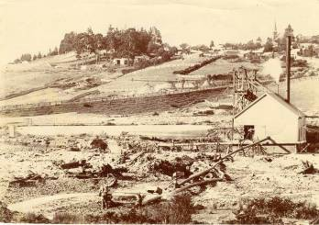

Hydraulic sluice mining, Wombat Hill, Daylesford, Victoria, circa 1860 (Image courtesy of the estate of Florence Cant)

A selection of threatening processes reflecting the threats included in the RiVERS database is expanded upon in Section 3.1 of these Technical Guidelines. These threats are described briefly, explaining the common causes that lead to the development of the specific threat and the range of interventions that might be applied to address each threat.

Not all the threats listed above and included in Section 3.1 are necessarily “bad” all the time. Many threatening processes can be employed, with caution, as components of effective waterway management programs. Grazing pressure can degrade the stream riparian corridor. However grazing can also form part of a weed management program. Barriers to fish passage can threaten some species. However, barriers may also prevent the movement of introduced pest species such as carp. Understanding the scale of the threat and the adverse and beneficial outcomes of the ongoing stream processes will be important to the acceptance and success of waterway projects.
Part 3 of these Technical Guidelines provides further details on a selection of activities and processes that threaten stream health and related assets.

Table of Contents

STRATEGY DEVELOPMENT
The development of a waterway management strategy for a reach or sub catchment is contained within the “Narrowing Down” phase of the 12 steps for stream rehabilitation (Rutherfurd et al. 2000) and the “Objective Setting”, “Select Activities” and “Finalise Plan” steps of the River Restoration Framework (Koehn et al. 2001).
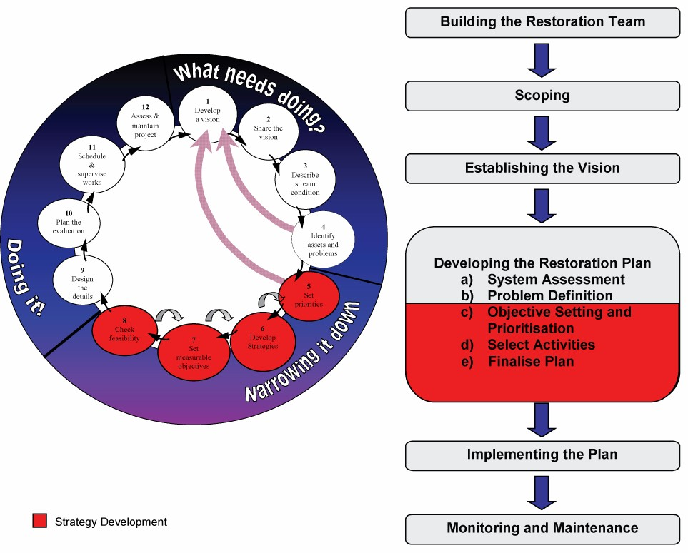

Figure 2.11 Strategy Development

The waterway management strategy for the reach of stream or sub catchment should identify and describe a program of management aimed at achieving the target future stream condtiion. This concept is illustrated in Figure 2.12.

Table of Contents

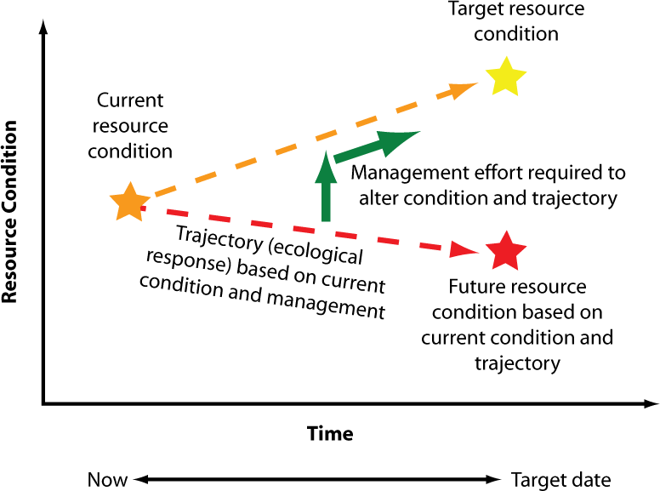

Figure 2.12 Management effort required to alter trajectory and attain target resource condition
The waterway management strategy should reflect the project purpose and should be undertaken following the development of an understanding of the stream system.
Components of the strategy development include the:

- identification of management options
- development of priorities
- documentation of the strategy.

MANAGEMENT OPTIONS
Three tiers of management are available to address the activities and processes that threaten river health and agreed target outcomes. These tiers are ranked in terms of their relative impact on the threats and the protection and maintenance of stream health.

- Halting the threatening activity. Clearly cessation or removal of the threatening activities that have a direct impact on stream health will be the most effective means of protecting stream health. Cessation of de-snagging, cessation of pollutant discharges to streams, cessation of summer low flow extractions, cessation of vegetation clearing and preventing the construction of barriers to fish passage will all have immediate beneficial outcomes to stream health and the attainment of river health targets.

Table of Contents

- Modification of threatening activities. In many circumstances, the cessation of the threatening activity will not be an option and modification of the practice will be necessary. Adoption of industry best management practices such as water sensitive urban design and adoption of the forest industry code of practice will assist to reduce the impacts of urbanisation and forestry. Fitting of a fish ladder to an existing or potential fish barrier may be possible where removal or halting the construction of a structure is not viable. Similarly, modification of grazing practice to enable vegetation establishment may be a more realistic outcome with some landholders and regions than permanent and total stock exclusion from riparian zones.
- Modification or intervention to instream processes. Modification to instream processes may be appropriate where removal or modification of the threatening processes is not viable or possible. Modification of the stream system may be necessary to address residual impacts of past practices or where the modification or removal of the threat is not financially viable. As an example grade control works may be required to address channel incision caused by past drainage activities. Instream interventions should only be applied once all other avenues for the cessation and modification of threatening activities have been fully explored and alternate options for these and threatening processes have been considered.

Halting threatening activities, modification of threatening activities and the modification and intervention to instream processes can be addressed through a suite of management options. These options for management include:

    - regulation
    - education and capacity building
    - coordination with other agencies
    - onground works
    - monitoring and evaluation.
Part 3 of these Technical Guidelines provides details on a selection of these onground intervention techniques. However this should not be interpreted that onground works provide the highest priority for management. This is certainly not the case. Regulation, education and capacity building, coordination with other agencies and ongoing monitoring and evaluation will provide as high and potentially greater returns on investment, moving a stream toward an agreed future outcome, than direct onground works. Waterway managers are referred to other sources such as A Rehabilitation Manual for Australian Streams (Rutherfurd et al. 2000) and Guidelines for Assessment of Works Permits and Licences on Waterways (SKM 2001) for further information.
Part 3 of these Technical Guidelines provide details on a number of the commonly applied onground options available to the waterway manager. Part 3 also includes a guide to the selection of appropriate onground interventions.

PRIORITIES FOR MANAGEMENT

RISK ASSESSMENT
Risk based approaches have been adopted in Victoria as the preferred means of priority setting and planning of stream management programs and projects. According to Standards Australia (2004) “Risk management is the term applied to a logical and systematic method of establishing the context, identifying, analysing, evaluating, treating, monitoring and communicating the risks associated with any activity, function or process in a way that will enable organisations to minimise losses and maximise opportunities”.

Risk is identified by Standards Australia (2004) as “the product of the likelihood and consequence of an event impacting on an asset or objective” and as such it is as much about identifying opportunities as avoiding and mitigating losses.

Table of Contents

Objectives or targets for streams and their attributes may comprise the maintenance of current condition or an improvement in condition. The proposed waterway targets should be identified through the vision for the waterway. To capture the opportunities associated with attainment of future targets, it is suggested that the risk analysis, adopted for waterway planning, focus on the attainment of waterway management targets rather than protection of existing assets and their condition. Based on this concept, the risk based approach to management would suggest that those targets of greatest importance, and at greatest threat of not being achieved, are the targets at greatest risk. These targets and the threatening activities and processes that generate the risk become priority issues for management.

This approach to priority setting requires an assessment of the relative value of stream assets and their targets (consequence) and an assessment of the activities and processes that may prevent attainment of that target (likelihood). There are many means of scoring the consequence and likelihood of failure to attain a target. One component of such scoring is to value waterway assets.

Valuing waterway assets provides a means of identifying risk (risk being a function of asset value and the likelihood and extent of that asset being impacted by a threatening process). Identifying stream values helps to identify those streams, stream assets and targets at greatest risk and therefore those streams, assets and processes that might be the highest priority for management attention. The Victorian River Health Strategy (DNRE 2002) recommends adoption of the following criteria for determining the ecological value of a river. ISC condition assessments (naturalness valuation) and stream categorisation (rarity valuation) can assist in the valuation process.
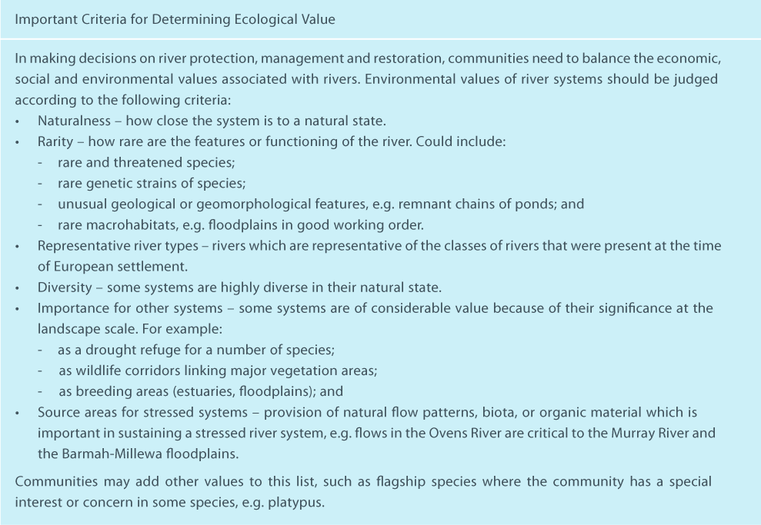
Source: Victorian River Health Strategy (DNRE 2002)

Table of Contents

Examples of semi-quantitative scores for waterway management assets and processes are provided in the following tables.

Table 2.2 Waterway health and infrastructure target importance/consequence example

Level | Consequence (of failure) | Example species protection target | Example waterway infrastructure target | Example species population target
1 | Insignificant | Protection of a single | Protection of an asset of | Maintain species above
 |  | representative of a | limited value ($1,000) | 1,000,000 individuals
 |  | common species | (e.g. farm bridge/crossing)
2 | Low | Protection of a small | Protection of an asset of | Maintain species above
 |  | group of a species of | low value ($10,000) | 100,000 individuals
 |  | common occurrence | (e.g. local footbridge)
3 | Moderate | Protection of local | Protection of an asset of | Maintain species above
 |  | population of a species | medium value ($100,000) | 10,000 individuals
 |  | of local significance | (e.g. local road bridge)
4 | High | Protection of local | Protection of an asset of | Maintain species above
 |  | population of a species | high value ($1m) | 1000 individuals
 |  | of regional significance | (e.g. highway bridge)
5 | Extreme | Protection of a local | Protection of an asset of | Maintain species above
 |  | population of a species | extensive value ($10m +) | 100 individuals
 |  | of State, National or | (e.g. large town water
 |  | International | supply system or a set of
 |  | significance | freeway bridges)

Table 2.3 Likelihood and probability of events example

 | Likelihood | Description | Frequency | Example flood frequency
A | Almost certain | Expect that event will | > 95% chance of | 1 year ARI event
 |  | occur within planning | occurrence in the | occurring within a 10 year
 |  | horizon | planning horizon | planning horizon
B | Highly likely | Highly likely that the | 80% to 95% chance of | 5 year ARI event
 |  | event will occur within the | occurrence in planning | occurring within a 10 year
 |  | planning horizon | horizon | planning horizon
C | Likely | Likely that the event will | 50 to 80% chance of | 10 year ARI event
 |  | occur within the planning | occurrence in planning | occurring within a 10 year
 |  | horizon | horizon | planning horizon
D | Possible | The event may occur | 5 to 50% chance of | 50 year ARI event
 |  | within the planning | occurrence in planning | occurring within a 10 year
 |  | horizon | horizon | planning horizon
E | Unlikely | It is unlikely that the event | < 5% chance of | 500 year ARI event
 |  | will occur in the planning | occurrence in planning | occurring within a 10 year
 |  | horizon | horizon | planning horizon

Assignment of quantitative and semi-quantitative scores to the consequence and likelihood of failure to meet the target outcome enables the development of risk profiles for target outcomes. Example risk profiles are provided in the following table.

Table 2.4 Risk profile example

Importance of target/consequence of failure

1
Insignificant
2
Low
3
Moderate
4
High
5
Extreme

Likelihood of failure to meet target outcomes | Certain  A | Moderate Moderate |  | High | Extreme Extreme
 | Almost Certain  B | Moderate Moderate |  | High | High | Extreme
 | Likely  C | Moderate Moderate Moderate |  |  | High | High
 | Possible  D | Low | Moderate Moderate Moderate |  |  | High
 | Unlikely  E | Low | Low | Moderate Moderate Moderate

Tolerable. A level of risk  that is low and easily managed | As low as reasonably  practical (Actions required to reduce risk further) | Major risk requiring  significant intervention to reduce risk | Intolerable risk requiring  highest priority (immediate) attention

The risk profiles assist with the identification and analysis of priority issues and processes for management.

Importantly this semi quantitative risk analysis and priority setting should not become an all consuming task for reach scale planning. Sufficient analysis should be undertaken to identify the high risk targets and threats. Large, time consuming spreadsheets and tables, requiring the input of subjective scores, may be no more accurate or indeed useful as that provided by a simple narrative. However these spreadsheet based approaches do provide an excellent means of documenting the outcomes of “gut feeling” or community perceptions and can be used in this manner. Care should be taken to not describe such subjective, semi-quantitative assessments as anything more than just that.

Table 2.5 Risk assessment example

Reach vision and resource condition and targets
Threats Risk Rating

Vision
Condition and
Importance
Threat to target Likelihood of

30 year planning horizon
target for reach of vision
and target
threat impacting on target within planning horizon

Establishment of vegetated habitat corridor from downstream heritage reach to the mountains
The protection of remnant endangered species (Trout Cod) habitat
Establishment of swimming holes in the creek
Index of stream condition target vegetation score of 7 over full length

Index of stream condition target score of 8

Index of stream condition physical form score of 7
High Decline in vegetation condition, (ongoing grazing)

Extreme Sediment transport
from subject reach infilling holes

Moderate Infilling of holes as a
result of upstream sediment mobilisation
Certain Extreme

Likely High

Likely Moderate

Table of Contents

Table of Contents

WATERWAY MANAGEMENT RISK AND PRIORITY SETTING MODELS
A number of risk based models have been developed for priority setting. Two database driven models have been developed to assist with waterway management priority setting in Victoria. These models are:

    - RiVERS. The RiVERS model has been developed to assist Victoria’s Catchment Management Authorities develop priorities for waterway management programs. Further information on RIVERS can be obtained within the Victorian River Health Strategy.
    - STREAMS. The STREAMS model has been developed within Melbourne Water and is used by that authority to develop priorities for waterway management within the Port Phillip and Western Port Catchments. Further information on STREAMS can be obtained from Melbourne Water.

These models have been developed to assist with the development of region wide and catchment scale priority setting. The models may also assist with planning at the management unit scale. The models do not provide for the inclusion of intervention options and constraints and as a consequence additional analysis will be required to develop an effective management unit scale strategy.

PRIORITY ACTIVITIES AND WORKS
The risk assessment process discussed within these Technical Guidelines identifies the risk of a failure to meet a target and enables comparison of risk profiles between a range of targets and threatening activities and processes. This risk assessment process enables identification of targets at risk, and the risk associated with threatening activities and processes. However the process does not necessarily identify high priority programs, projects, activities and works that may need to be implemented to address the threat and attain the target.

Priority projects, activities and works should be identified based on achieving greatest return on investment. The highest priority programs, projects, activities and works will be those that achieve greatest risk reduction and/or greatest movement toward the agreed targets for the least cost while retaining greatest flexibility i.e. those projects, activities and works that provide the greatest return on investment, or “bang for buck”.

Inevitably it will be those activities and works that contribute to multiple outcomes and targets that will fit into this category. Stock control and vegetation management fall into this category for most stream reaches and sub catchments. Stock control and vegetation management provide direct returns in terms of improvement in riparian vegetation condition. However stock control and vegetation management will also contribute to reduced rates of bank erosion, contributing to improved stream physical condition.
Further improved riparian vegetation condition will also contribute to improved water quality, and instream habitat. It is for this reason that broad scale low cost revegetation programs may be identified as a high priority activity alongside more expensive one off projects such as construction of a fish ladder to widen the geographic range and protect an endangered species.

IMPLEMENTATION TARGETS AND RESPONSIBILITIES
Implementation targets should be developed for the priority activities and works. The implementation targets should set out the timing, location, and extent of works and how these activities and works and the implementation targets will contribute to the attainment of the intended vision and resource condition targets. The implementation targets should include responsibilities for management. The implementation targets should be sufficiently detailed to enable review and agreement by stakeholders. However the targets should not be so prescriptive to prevent adaptation and individual judgements at the site scale. This site scale assessment and “design” should be the subject of more detailed assessment. Design is discussed in Section 2.5 Design and Implementation and in Part 5 Design Guidelines.

Table of Contents

Responsibilities for implementation will require assessment and understanding of existing policy, legislation and institutional arrangements. Establishment of responsibilities and attainment of the vision and target will require team work and coordination among the project partners.

DOCUMENTATION
A management unit (stream reach or sub catchment) based plan should be documented within a concise report that sets out:

      - a description of the stream, its condition and processes and its related stream health assets;
      - project funding, partners and stakeholders;
      - a vision for the stream and the related assets including more specific resource condition targets including time scales;
      - threats to that vision and those targets;
      - identification of targets at highest risk of not being achieved;
      - identification of options to manage risks;
      - identification of priority activities and works that achieve greatest risk reduction or movement toward the target outcomes for the least cost; and
      - details of implementation targets, responsibilities costs and timeframes.
The documentation should clearly detail who will be responsible for implementation of the plan, project partners, funding sources, contributions and the basis for funding of landholder works. Further, the documentation must set out the timeframes over which the plan will be implemented and the means, by which the outcomes will be monitored, reviewed and reported back to stakeholders. Details of the proposed ongoing monitoring and evaluation program should be established as a component of the design and implementation phase and documented within a subsequent design and implementation report.

Table of Contents

DESIGN AND IMPLEMENTATION
The design and implementation phase of waterway management programs projects falls within the “Doing it” phase of the 12 steps to stream rehabilitation developed by Rutherfurd et al. (2000) and the “Implementing the Plan” and “Monitoring and Maintenance” steps contained within developed by Koehn et al. (2001).
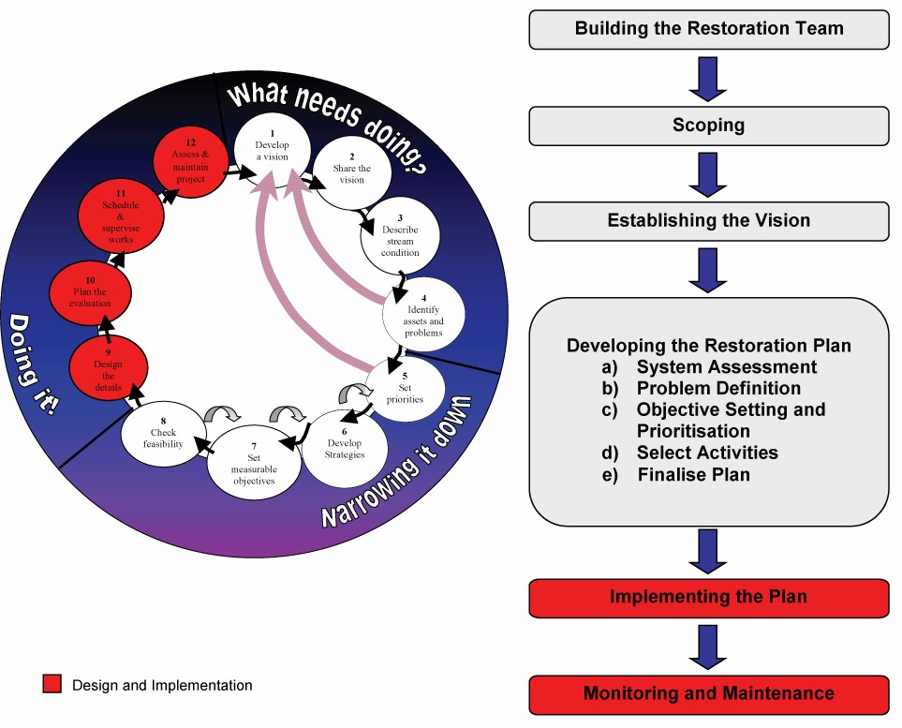

Figure 2.13 Design and implementation

The design and implementation of activities and works should reflect both the outcomes from the strategy development and the intent of the project purpose. Key tasks and steps include:

    - design of works to appropriate and applicable standards
    - implementation of activities and works
    - monitoring and evaluation.

Table of Contents

LEVELS OF SERVICE FOR ANALYSIS, DESIGN AND CONSTRUCTION
The level of service (also referred to as the rigour or level of effort) adopted for the analysis, design and implementation of waterway management projects should be a function of the importance of the project and the risks associated with project failure. While these Technical Guidelines can provide guidance, it is not possible to prescribe the most appropriate design standard for any particular project, organisation or circumstance. This is the role and responsibility of the waterway professional.

The risk management approach discussed within Strategy Development of these Technical Guidelines can be used to assist development of appropriate levels of service for a project. Projects aimed at protecting river assets of greatest value, river processes posing the greatest threat, projects with the highest level of public profile, or projects with the highest level of expenditure may warrant the highest levels of analysis, design and construction. Conversely lower levels of analysis and design may be appropriate for those projects with the lowest risk for and associated with failure.

DESIGN OF ACTIVITIES AND WORKS
The design of onground activities and works requires the assessment of available and appropriate materials and detailed analysis of the selected options. The design process may be aided by software packages and other design aids.
A selection of materials commonly used in onground works is discussed in Part 4 of these Technical Guidelines. Design guidelines for a selection of onground options are provided in Part 5 and a number of design aids are provided in Part 6 of these Technical Guidelines.

IMPLEMENTATION PLANNING AND ASSESSMENT
The implementation of successful onground works relies on thorough planning. This will require development of a construction schedule, engagement of suitable contractors and staff, and the supervision of works. It is not the intent of these guidelines to provide details of construction management techniques and approaches. Readers are referred to specific construction management texts. However this publication can provide some guidance that may assist to minimise the potential adverse impacts of onground construction works.

A thorough assessment of potential impacts should be undertaken prior to the implementation of any onground works. The assessments should be undertaken to identify whether works should proceed and to identify whether remedial measures are required to reduce or mitigate potential impacts. Construction works can have temporary and long term impacts such as:

      - noise
      - water quality impacts
      - weed transferral
      - damage to vegetation
      - damage to sites of heritage value.
As well as assessing the impacts of construction, it is the responsibility of those implementing works to provide a safe workplace and to develop occupational health and safety (OH&S) systems that include establishment of safe work practices and construction sites.

The assessment of potential impacts and establishment of safe worksites are best undertaken in a methodical and repeatable manner. This reduces subjectivity and the potential to inadvertently omit issues. A number of catchment management authorities have established construction, environmental, archaeological and health and safety

Table of Contents

check sheets. An example checklist, adapted from that developed and used by Melbourne Water is provided in Part 7 Worked Example and Checklists of these Technical Guidelines.

Information that can assist with the avoidance and management of impacts at construction sites can also be found in Environmental Guidelines for Major Construction Sites (EPA 1996).

MONITORING AND EVALUATION
Monitoring and evaluation should be considered to be an integral and mandatory component of waterway management programs, providing feedback on the success or otherwise of projects, activities and works. This feedback will provide information that can help “steer” efforts towards those activities that will lead to the desired stream outcomes. Further, the monitoring and evaluation may reveal unintended outcomes that necessitate adjustments to the targets, plan or activities and works.

LEVEL OF MONITORING
There has been considerable effort made in recent years to develop and document suggested monitoring and evaluation programs for waterway management programs. Recent publications and useful resources include:

    - Environmental Flows Monitoring and Assessment Framework (Cottingham et al. 2005);
    - Monitoring and Evaluation Framework for Waterways Onground Works (North Central CMA 2003); and
    - A Rehabilitation Manual for Australian Streams (Rutherfurd et al. 2000).
These and similar publications often refer to before, after, control and impact/intervention (BACI) design of monitoring programs. Full implementation of this method of monitoring would enable identification of those outcomes that are the direct result of the interventions applied to a site or reach. However full BACI design is difficult to achieve. In particular the establishment of effective control sites, and/or reaches is very difficult.

A simpler monitoring program may be appropriate for some projects. This will be dependent on the importance of understanding the impact of the component interventions on the target outcome. A simpler monitoring program that identifies whether activities and works have been implemented and are operating as intended and whether the stream is moving toward the intended outcomes may be sufficient for many projects. Such monitoring would not allow identification of the role of the interventions in moving the stream toward the agreed target. However such a program may be more likely to meet the requirements of CMAs and waterway managers.

COMPONENTS
Components of a Monitoring and Evaluation Program should include, but may not be limited to:

Monitoring of target outcomes (Resource condition targets): Monitoring of the target outcomes should be undertaken using the method adopted for the waterway condition assessment as part of developing an understanding of the stream system. This approach should include the metrics adopted for target setting. If stream condition was assessed using the Index of Stream Condition (and /or an adaptation thereof) and targets set using ISC scores, then the ISC or an adaptation thereof would be an appropriate method for ongoing monitoring of program outcomes.

Monitoring of activities and works (Implementation targets): The individual elements making up the stream management project should be the subject of an ongoing monitoring program. The monitoring should be undertaken to ensure that:

    - works have been undertaken in accordance with the design intent; and
    - the ongoing operational performance is in accordance with the design intent.

Table of Contents

Evaluation and reporting on monitoring data: It is not sufficient to just monitor activities and works and outcomes. Some level of evaluation and reporting is also required. Evaluation of monitoring results includes checking of results against base conditions and targets. It also involves the investigation and analysis of why outcomes may or may not have been achieved. Finally the evaluation should be compiled into a report suitable for future reference and for making adjustments to ongoing activities and works and potentially target outcomes.

ASSOCIATED ISSUES
A number of issues will need to be resolved as a component of the development and implementation of a monitoring and evaluation program. These will include:

      - responsibilities for the delivery of the monitoring and evaluation program;
      - the timing of monitoring and reporting including development of scheduled and event based monitoring; and
      - storage and retrieval of data and reporting.

Table of Contents

This Part 3 of the Technical Guidelines is divided into three sections:

- The first section provides a compendium of threatening processes (threats) that generate demand for waterway management intervention. Some threatening activities are also discussed. This section also introduces a selection of onground intervention options that may apply to each threat.

- The second section provides a simple intervention option guide. This guide is limited to a selection of intervention options aimed at addressing threats that cannot be addressed by the removal of the causal activity.

- The third section provides compendium of onground intervention options that can be used to manage waterway health outcomes. These intervention options may be applied to influence the inflow of water and sediment, the extent and condition of riparian (and in-stream) vegetation and the physical characteristics of the channel.

THREATENING ACTIVITIES AND PROCESSES
River assets and waterway management targets can be at risk from threatening activities and ongoing stream processes.

In streams, like most other things in life, prevention is better than cure. Controlling and reducing the extent of threatening activities will have the most direct positive impact on stream health. The cessation or modification of threatening activities should therefore be considered as the highest priority actions for the protection of stream assets. However in many instances the threatening activities can not be completely halted, removed or adequately modified to protect stream health. In these instances and to address on going stream processes associated with past threatening activities, instream interventions may be required.

This section focuses on threatening processes rather than threatening activities. Most threatening activities are self explanatory, (removal of large wood, construction of barriers to fish passage, grazing of frontage vegetation), and can be effectively addressed through the management of the activity. However, threatening processes can be more complex and can be addressed through a number of intervention options.

A selection of threatening processes reflecting the threats included in the RiVERS database is expanded upon in the following pages. The following table cross-references the threats included in the RiVERS database and the related threatening processes included in these Technical Guidelines.

Table of Contents

Table 3.1 Threatening processes included in these Technical Guidelines

RiVERS threats Threatening processes

Degraded riparian vegetation Vegetation decline Introduced exotic flora Vegetation decline
Water quality trends Water quality decline
Water quality attainment Water quality decline

Water quality signal Water quality decline Changes to water temperature Water quality decline Occurrence of algal blooms Water quality decline Introduced exotic fauna Introduced exotic fauna
Loss of instream habitat Loss of instream timber
Loss of bed stability Stream bed degradation Stream bed aggradation
Loss of bank stability Bank Instabilities Barriers to native fish migration Instream barriers Channel modification Instream barriers
Stream bed degradation
Changes to flow Hydrologic change Loss of wetland connectivity Hydrologic change Uncontrolled stock access Vegetation decline
Bank instabilities Water quality decline

These threats are described briefly in the following pages, explaining common causes that lead to development of the specific threat and the range of interventions that might be applied to address each threat.

The threats are discussed in a random order and not in order of importance to any one or group of streams. Further, the threats are interrelated. Some threats may be a result of other threatening activities or processes. As a consequence some threats may be nested within other threats.

Not all the threats listed are necessarily “bad” all the time. Many threatening processes can be employed, with caution, as components of effective waterway management programs. Grazing pressure can degrade the stream riparian corridor. However grazing can also form part of a weed management program. Barriers to fish passage can threaten some species. However, barriers may also prevent the movement of introduced pest species such as carp. Understanding the scale of the threat and the adverse and beneficial outcomes of the ongoing stream processes will be important to the acceptance and success of stream projects.

In most cases a number of techniques could be used to address each threat. The most appropriate technique or suite of techniques to address a threat or number of threats, will be that which achieve the greatest reduction in risk to (protection of) assets or attainment of stream condition target for the least cost and perhaps the highest level of confidence. Those waterway management techniques that directly address the cause of a threatening process are likely to rank highly as management options.

VEGETATION DECLINE

DESCRIPTION
The ongoing loss of native riparian vegetation and decline in native vegetation condition is a significant threat to stream system health. This decline can include increased fragmentation, reduced condition of remnant vegetation, weed invasions and the loss of vegetation diversity.

WHAT IS THE THREAT?
A decline in vegetation condition results in a loss of riparian condition, and related declines in instream habitat through loss of shading, and loss of timber source for instream structure.
Decline in vegetation condition can lead to an increase in bank erosion and bed degradation and associated decline in river health values.

CAUSES
Decline in riparian vegetation may be caused by one or a combination of the following: Human related causes Natural causes

Clearing
Stock access and grazing pressure
Flow regulation and a lack of floodplain flows to initiate regeneration
Channel enlargement (refer bank instabilities and stream bed degradation)
Weed invasion
As a response to floods or droughts
Lateral migration in naturally active streams
Natural widening in newly formed avulsion channels

Table of Contents

OPTIONS FOR MANAGEMENT
One or a combination of the following options may address a decline in riparian vegetation:

Inflow and runoff options Environmental flows Water sensitive design

Vegetation options Vegetation management Vegetation establishment Stock control
Weed (including willow) management

Instream physical options Pile fields Rock chutes

Table of Contents

WHICH TECHNIQUE TO USE?
A decline in riparian vegetation can be addressed through education, regulation and onground interventions. Onground interventions can include vegetation management or a range of physical or inflow and runoff interventions aimed at addressing the cause of the decline in the vegetation condition.

Vegetation options
Stock control will be most appropriate where stock access has been the primary cause of the vegetation decline. Stock control may need to be supplemented with vegetation establishment using one of a number of techniques such as plantings or direct seeding. Where the invasion of exotic species is causing a decline in vegetation, willow control and weed management should be considered.

Inflow and runoff options
Floodplain and riparian vegetation decline may be the result of changes in the flow regime or levee construction. These may be addressed through the provision of environmental flows. Alternatively this may require wetland and floodplain engagement and/or infrastructure decommissioning.

Instream physical options
Instream physical interventions may be appropriate where accelerated channel change has led to a decline in the vegetation condition and where vegetative alone is unlikely to reduce the rate of channel change. Where channel deepening is causing loss of vegetation consider techniques such as grade control through rock chutes, bed seeding, grass chutes and log sills. Refer Section 3.1.7 Stream bed degradation.

Where channel widening is causing deterioration in vegetation consider techniques such as pile fields and rock riprap to reduce the rate of vegetation loss. Refer Section 3.1.8 Bank instabilities.

HYDROLOGIC CHANGE

DESCRIPTION
Changes to the flow regime refer to modifications to the timing, duration, frequency and volume of flow in a stream system.

WHAT IS THE THREAT
Changes in the flow regime can cause a decline in waterway health by adversely impacting flora and fauna communities including fish migration, spawning and habitat. Changes in the flow regime may result in changes in water temperature and changes in flow regime can change the frequency of floodplain inundation and the health of the floodplain. Changes in the flow regime can change the rate of sediment production, transport and deposition and can result in increased rates of erosion or bed aggradation with consequent waterway health impacts.

CAUSES
Changes to the flow regime are usually the result of:

Human related causes Natural causes

Streamflow regulation associated with storage
construction and operation
Extraction of water for consumptive purposes Catchment urbanisation
Forestry operations
Natural climatic variability
Fire

Table of Contents

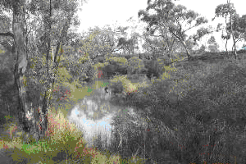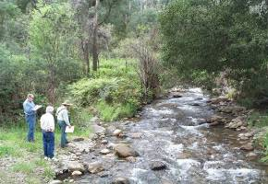

Lower Wimmera River, Victoria Environmental flow assessments in north east,
Victoria

Table of Contents

OPTIONS FOR MANAGEMENT
One or a combination of the following options may address a decline in river health associated with changes in the hydrologic regime:

Inflow and runoff options Environmental flows
Water sensitive urban design

Vegetation options Vegetation establishment

Instream physical options Pile fields Rock groynes

WHICH TECHNIQUE TO USE?
There is a range of institutional, regulatory, and educational options available to address changes in the flow regime.

One or a combination of the following onground intervention options may address adverse changes to the flow regime:

Inflow and runoff options
In most instances changes to the flow regime will most effectively be addressed through the management and modification of the underlying cause of the changed flow.

Provision of specific allocation of water as an environmental flow including provision of controls on extraction of flow events (such as summer base flow) will be the most effective means of addressing changes to the flow regime associated with extraction of water for consumptive use.

Adoption of industry best practice and codes of conduct such as those for forest management, fire management and water sensitive urban design would reduce the hydrologic impacts associated with these land uses and management.

Vegetation and instream physical options to managing the impacts of changes in the flow regime are available. However such alternate management approaches can only mitigate the adverse impacts on changes to the flow regime. Such mitigation measures would seek to assist the stream to adjust to the modified flow regime and protect other features of the stream such as water quality (temperature) and physical habitat availability. These approaches will be applicable where modification of the altered flow regime is an unrealistic expectation.

Vegetation options
In instances where a return to intact flow regimes is an unlikely outcome, changes in the flow regime can be mitigated through vegetation management. For flow stressed systems vegetation management could include planting arrangements, using native species, to provide local channel encroachments and reduce channel dimensions, to initiate local scour and establish a deep flow paths.

Instream physical options
Management options could also include provision of physical channel encroachments using pile fields or rock groynes to reduce channel dimensions, initiate local scour and establish a deep flow path.

WATER QUALITY DECLINE

DESCRIPTION
Water quality decline is an adverse change in water quality parameters such as water temperature, pH, dissolved oxygen, turbidity, pathogens, nutrients, pesticides, chemicals and heavy metals.

WHAT IS THE THREAT?
Changes to water quality outside the bounds of natural variability for the stream system can reduce waterway health by adversely impacting on aquatic life and vegetation.

CAUSES
Deteriorating water quality may be caused by one or a combination of the following:

Human related causes

On waterways Catchment wide
Natural causes

Loss of riparian vegetation Reduced flows
Cold water releases from dams
Stream erosion Willow colonisation
Urbanisation
Clearing the catchment Forestry
Agriculture
Industrial waste discharge
As a response to floods or droughts
Natural channel change and subsequent erosion
Fires

Table of Contents

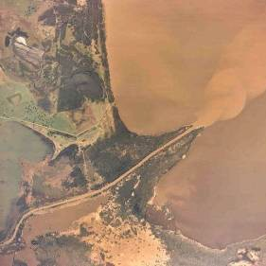

Sediment releases from the Latrobe River into Lake Wellington, part of the Gippsland Lakes in Victoria

Table of Contents

OPTIONS FOR MANAGEMENT
One or a combination of the following options may address a decline in water quality:

Inflow and runoff options Environmental flows
Water sensitive urban design

Vegetation options Vegetation management Vegetation establishment Willow control
Stock control

Instream physical options Pile fields Rock chutes

WHICH TECHNIQUE TO USE?
Declining water quality can be managed through regulation, education and a range of onground interventions. The most effective interventions will be those that address the underlying cause of the declining water quality.

Inflow and runoff options
Where local runoff through the stream verge from urban and agricultural land use is causing deterioration in water quality, techniques such as vegetation establishment and stock control may be appropriate. However these should be complemented by adoption of industry best practice such as water sensitive urban design including techniques such as constructed wetlands and swale drains. A lack of flow may result in an increase in the concentration of pollutants or an increase in the temperature of pools and could be addressed through provision of environmental flows.

Vegetation options
Where a lack of vegetation results in more extreme in-stream water temperature fluctuations, vegetation establishment should be considered. Similarly willow management may be required to reduce the adverse impacts of autumn leaf fall on instream dissolved oxygen concentrations. Stock control can be used to limit adverse water quality impacts associated with stock access to streams.

Instream physical options
Where channel incision and release of sediment is causing deterioration in water quality consider intervention with techniques such as rock chutes, bed seeding, grass chutes and log sills. Where channel widening is causing release of sediments and deterioration in water quality consider intervention with techniques such as pile fields and rock beaching in association with revegetation.
Water temperature changes particularly those associated with storage operational releases can be addressed through the modification of infrastructure such as the retrofitting and operation of variable level off take structures. Increases in temperature as a result of vegetation loss can be addressed through replacement of vegetation.

INVASION BY EXOTIC FAUNA

DESCRIPTION
The invasion of stream systems by exotic instream fauna refers to the colonisation of natural and modified habitat by non indigenous species. In its simplest form, this refers to the colonisation of streams by non Australian species such as carp, trout, redfin and gambusia. However, the process could also be relevant to the introduction of Australian species into streams not known for those species prior to European settlement.

WHAT IS THE THREAT?
Introduced species are blamed as a major contributor to the decline of native fish populations in stream systems through Victoria. In particular carp have been identified as a major cause of native fish decline through their explosive spread and abundance in the late 1960s-early 1970s. However, native fish had already suffered declines in range and abundance before the introduction of carp, largely through the impact of humans on the aquatic habitat.

CAUSES
The colonisation of stream systems with exotic species may be caused by one or a combination of the following:

Human related causes

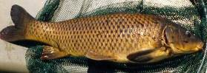
Population translocation
Reduced populations and viability of native species through:
- changes to the flow regime
- changes in water quality

      - desnagging
      - loss of stream structure and diversity
Carp (Cyprinus carpio)

Table of Contents

OPTIONS FOR MANAGEMENT
One or a combination of the following options may address invasion by exotic species: Inflow and runoff options Environmental flows

Vegetation options Vegetation management Vegetation establishment
Instream physical options Large wood Engineered log jams Fish ladders
Fish locks

Table of Contents

WHICH TECHNIQUE TO USE?
The prevention and control of exotic fish colonisation in stream systems can be addressed through education, regulation and onground interventions. Onground interventions are likely to include biological controls (i.e. the Daughterless carp project (www.csiro.au/pubgenesite/research/environment/carpControl.htm), outside the scope of these Technical Guidelines. However improvements in other components of river health will lead to improved viability of native fish species and reduced opportunity for colonisation by exotic species. Intervention options aimed at addressing the cause of the invasions can include:

Inflow and runoff options
The provision of environmental flows and in particular flow variability and diversity can be used to provide Australian native species with a competitive advantage over exotic species.
Provision of runoff management and industry best practices will assist with declines in instream ecology resulting from runoff related water quality.

Vegetation options
Vegetation management including stock control, vegetation establishment and willow management will assist to protect the habitat of native species and reduce the opportunity for the establishment of niches for exotic fish.

Instream physical options
Instream physical options could be applied to provide improvements in instream habitat. Some interventions such as the introduction of barriers may limit the movement of exotic fish.
However, any project to introduce barriers to stream systems will require significant investment in research and approvals to ensure that such work does not have a greater adverse impact on native fish populations. Other interventions that may have a beneficial impact on native populations could include the reintroduction of habitat diversity such as large wood, and undercut banks (LUNKERS, see Section 3.3.24). Modification to infrastructure such as wetland watering controls may assist with riparian, floodplain and wetland ecology impacted by flow modifications.

LOSS OF INSTREAM TIMBER

DESCRIPTION
The loss of instream timber refers to short and long term removal and burial of timber; and the failure to recruit timber to waterways.

WHAT IS THE THREAT?
Instream timber is a characteristic feature of streams in Australia and Victoria. Timber provides direct and indirect habitat by creating flow diversity and local scour. The loss of instream timber results in the loss of the major form of instream habitat in lowland river systems.

CAUSES
The loss of instream timber can be caused by:

Human related causes Natural causes

Desnagging (removal of large timber)
Accelerated rates of bed aggradation (sedimentation)
Clearing and grazing of riparian zones, preventing the establishment of recruits
Long term decay

Table of Contents

Note: When saturated, Australian hardwood timber has greater density than water and as a
consequence does not float. If instream hardwood timber is partially submerged on a permanent basis and partially buried or locked in place, it is unlikely to be mobilised by flood events. As a consequence, flood events are rarely the cause of the loss of instream timber. Timber observed to be floating down rivers in flood events, will often be catchment or floodplain sourced.
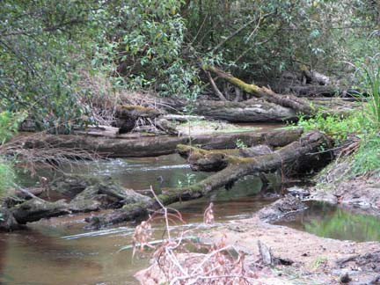
Instream timber, Bunyip River, Victoria

Table of Contents

OPTIONS FOR MANAGEMENT
One or a combination of the following options may address the loss of instream timber:

Inflow and runoff options Environmental flows for the watering of upper bank and floodplain vegetation

Vegetation options Vegetation management Vegetation establishment

Instream physical options Large wood Engineered log jams

WHICH TECHNIQUE TO USE?
The loss of instream timber can be addressed through a range of regulation, education and onground options. Onground options include:

Inflow and runoff options
The provision of environmental flows can be used to water riparian and floodplain vegetation providing a long term source of timber to the stream system. In addition options that limit sediment release to stream systems will reduce the potential for loss of instream timber through bed aggradation.

Vegetation options
Vegetation management including stock control, and native vegetation establishment will assist with the long term recruitment of timber to the stream system.

Instream physical options
Instream physical interventions could include the installation of instream large wood and engineered log jams. These can be used to replace timber lost through desnagging and other instream processes.

Other interventions could include those options that halt ongoing processes that have the potential to cause the loss of timber. Options such as sediment management, and programs aimed at halting upstream sediment production such as grade control may be useful where the cause of timber loss is sediment production, transport and deposition.

STREAM BED AGGRADATION

DESCRIPTION
Stream bed aggradation is a process of net sediment deposition within the stream channel that results in an ongoing rise in the bed elevation.

WHAT IS THE THREAT
Stream bed aggradation leads to a decline in waterway health by smothering of bed forms and associated loss of bed diversity including pools, riffles, and instream structure. Ongoing aggradation can accelerate channel avulsion development.

CAUSES
Aggradation of the bed may be caused by one or a combination of the following: Human related causes Natural causes

Reduction of in-channel flows
Increase in bed load as a proportion of total sediment load (perhaps due to upstream bed degradation but often due to past mining activity)
Lengthening of the river channel
Sediment transport discontinuity/sediment trap Invasive exotic flora colonising the channel
As a response to droughts
Lateral migration in naturally active streams Natural abandonment of anabranches
A reduction in confinement or gradient, a flood out

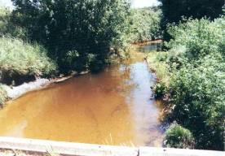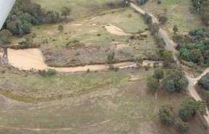

Stream bed aggradation, Glenelg River, south west Victoria
Table of Contents
Stream bed aggradation, Reedy Creek, north east Victoria

Table of Contents

OPTIONS FOR MANAGEMENT
One or a combination of the following options may address stream bed aggradation: Inflow and runoff options Environmental flows

Vegetation options Vegetation management Vegetation establishment Willow control
Stock control

Instream physical options Large wood Engineered log jams Sediment extraction Stream reconstructions Pile fields

WHICH TECHNIQUE TO USE?
Often bed aggradation will be a result of upstream sediment release. Strategies for the control of bed aggradation should first look at the source of the sediment and address these if they are still present (refer Section 3.1.7 Stream bed degradation and 3.1.8 Bank instabilities).
The control of bed aggradation may be possible via sediment extraction. However, if the cause of sediment deposition remains this operation will be ongoing, further the volume of sediment requiring removal may be extensive resulting in the establishment of a long term commitment to ongoing extractions. Finally and as discussed in the instream management options this technique may result in some unintended adverse outcomes that have a significant adverse impact on stream health.
If the aggradation is associated with anabranch development, abandonment of the aggrading stream could be delayed by allowing natural chute and neck cut-offs to develop and implementing works to roughen or reduce the cross-section of the adjacent anabranch.
If a constructed lengthening of the channel has induced aggradation, consideration could be given to the channel reconstruction using the principles of geomorphic channel design.
If bank instabilities are increasing the sediment load and causing aggradation, techniques such as pile fields and revegetation may need to be considered upstream. Refer Section 3.1.8 Threatening processes – bank instabilities. Further, these techniques can also be used to anchor sediment in place.
Where aggradation is due to a reduction to in-channel flows, consideration should be given to the provision of environmental flows that can transport the bed load in the channel.
Alternate strategies that comprise the reformation of channel diversity within an aggrading system can be considered. These might include provision of channel roughness/structure (large wood and engineered log jams) to induce local scour.

STREAM BED DEGRADATION

DESCRIPTION
Stream bed degradation is the lowering of the stream bed elevation through ongoing erosion processes. Most often the process is headward progressing (moving in an upstream direction) associated with the movement of nick points or headcuts.

WHAT IS THE THREAT?
Stream bed degradation impacts on waterway health through the loss of existing instream features such as intact stream and wetland systems. The process results in bank destabilisation and the production of sediment that may have adverse downstream impacts (refer Section 3.1.6 Stream bed aggradation).

CAUSES
Degradation of the bed may be caused by one or a combination of the following: Human related causes Natural causes

Loss of riparian vegetation Increased in-channel flows
Reduction in bed load as a proportion of total sediment load
Drainage works or straightening/ channelisation of the river channel
Removal of large woody debris from the stream
Sediment transport discontinuity/sediment trap upstream
Sediment extraction
Large downstream increase in conveyance
As a response to floods
Natural deepening of newly formed avulsion channels
Avulsion of a reach downstream onto a shorter course

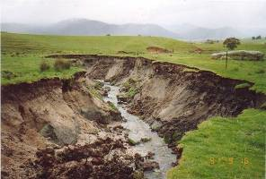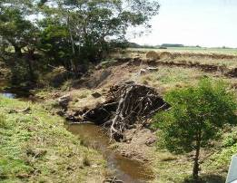

Stream bed incision, Barwidgee Creek catchment, a tributary of the Ovens River, north east Victoria
Table of Contents
Stream bed incision, Mathews Creek, a tributary of the Barwon River near Deans Marsh,
south west Victoria

Table of Contents

OPTIONS FOR MANAGEMENT
One or a combination of the following options may address stream bed incision: Inflow and runoff options Environmental flows

Vegetation options Vegetation management Vegetation establishment Stock control
Instream physical options Large wood/engineered log jams Grade stabilisation/rock chutes

WHICH TECHNIQUE TO USE?
Where local bed instabilities or head-cuts are migrating upstream, resulting in bed deepening, these can be addressed through a grade control program such as rock chutes coupled with revegetation. Rock chutes coupled with revegetation have proved to be one of the most successful incised stream rehabilitation techniques.
If these bed instabilities are of only a minor nature, log sills or engineered log jams may be considered. However these have a lower success ranking than rock chutes for grade control management.
Deepening can be induced by a large downstream increase in conveyance due to a wider/deeper/less rough channel feature downstream. The high conveyances gives low water levels downstream and high energy gradients and hence shear stresses upstream. This can be managed by using vegetation, large wood and pile fields to roughen and contract the downstream reach, reducing erosion forces upstream. Bed seeding, large wood and vegetation can be used upstream to reduce shear stresses on the bed and protect the bed. Bed seeding should be applied with care, as layers that meet with headward erosion or are of insufficient thickness will unravel.
The remaining techniques outlined below are generally used in the specific circumstances as described.
Grass chutes should only be used to carry small, intermittent flows down a short slope.
If channelisation has induced deepening consider channel reconstruction and meander reinstatement.
Where channel deepening is due to flow regulation consider implementing an environmental flow that more closely mimics the natural flow regime. Implementation of water sensitive urban design may reduce the rate of incision resulting from urbanisation. However, once started flow management alone may not halt the incision process.
If deepening is a symptom of past removal of large wood (desnagging), consider returning large wood to the stream or constructing engineered log jams. However once bed degradation processes have been initiated, the replacement of timber or vegetation may not be sufficient to halt the ongoing process.

BANK INSTABILITIES

DESCRIPTION
Bank instabilities are accelerated rates of bank erosion associated with either channel enlargement or meander development. These could be the result of direct impacts or more indirect processes such as channel incision.

WHAT IS THE THREAT?
Bank instabilities threaten remnant riparian vegetation and provide a source of sediment that can have an adverse impact on the stream system. Bank instabilities may also threaten adjoining infrastructure assets.

CAUSES
Bank instabilities may be caused by one or a combination of the following: Human related causes Natural causes

Loss of riparian vegetation Uncontrolled stock access Increased in-channel flows
Straightening/channelisation of the river channel
Removal of large woody debris from the stream
A response to deepening
Sediment transport discontinuity/sediment trap
As a response to floods
Lateral migration in naturally active streams
Increase in bed load as a proportion of total sediment load
Natural widening in newly formed avulsion channels

Table of Contents

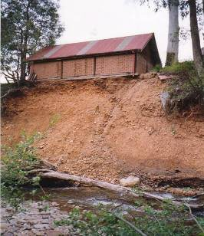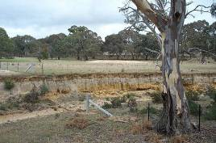

Stream bank erosion, Wimmera River catchment

Stream bank erosion, Ovens River catchment

Table of Contents

OPTIONS FOR MANAGEMENT
One or a combination of the following options may address stream bank instabilities: Inflow and runoff options Environmental flows

Vegetation options Vegetation management Vegetation establishment Willow control
Stock control

Instream physical options Large wood Engineered log jams Rock beaching
Pile fields Bank battering
Grade stabilisation/rock chutes

WHICH TECHNIQUE TO USE?
The techniques of vegetation establishment, stock control, rock riprap, pile fields, rock groynes are generally used to address the threatening process of bank instabilities.
Should a stream lack vegetation or should stock have access to the stream, the techniques of vegetation establishment and stock control should be the highest priority. Rock beaching may be used if a bank needs to be held in a specific location. However, such an objective is not compatible with the laterally migrating behaviour of many rivers. Rock riprap is also expensive, and is likely to reduce habitat and aesthetic values.
Pile fields are an alternative to rock riprap that is more sympathetic to the environment. Pile fields are a preferred technique where there is lateral space for driving the piles and revegetation.
Rock groynes are generally not recommended for bank erosion control as they can induce turbulence and hence initiate localised bed and bank erosion. Implementation may be considered where hydraulic modelling can demonstrate their utility.
The remaining techniques are generally only used in the specific circumstances listed below:
    - Bank battering may be used where an incised stream has vertical banks and battering is likely to accelerate vegetation establishment.
    - If channelisation has induced widening, channel reconstruction may be appropriate.
    - Where widening is due to increased in-channel flows consider implementing an environmental flow that spills a large proportion of flows onto the floodplain.
    - If widening is a symptom of past removal of large wood (desnagging), consider return of large wood to the stream or constructing engineered log jams.
    - Where deepening is causing bank erosion techniques such as rock chutes, bed seeding and log sills should be considered. Refer Section 3.1.7 Stream bed degradation.

INSTREAM BARRIERS

DESCRIPTION
Instream barriers prevent the movement of instream detritus and can prevent the passage of fish. Example barriers include storages and weirs. However road culverts and causeways can have a similar impact on fish passage.

WHAT IS THE THREAT?
Instream barriers can prevent the passage of instream sediments, detritus, macro invertebrates and fish. Such barriers can halt ongoing stream processes downstream of the barrier, can prevent the recolonisation of stream reaches with species following disturbance (fire, flood, etc) can result in the isolation of fish populations and can prevent completion of fish breeding cycles. The barriers to fish migration can result in the loss of fish populations from streams and potential loss of species.

CAUSES
Instream barriers may be caused by one or a combination of the following: Human related causes Natural causes

Reduction of in-channel flows and thereby depth of flow over riffles
Changes in the timing and duration of flows Decline in water quality
Installation of instream barriers such as weirs, culverts, storage dams, causeways
Loss of available instream habitat
Natural rock bars
Natural water quality variability Natural stream flow variability

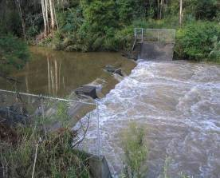
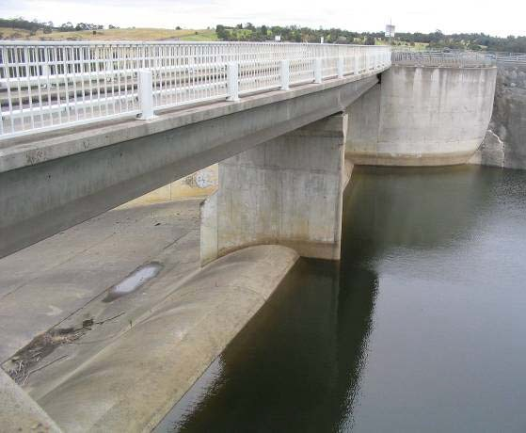

Instream barrier on the Tyers River, a tributary of the Latrobe River in Gippsland, Victoria
Table of Contents
Instream barrier, Blue Rock Dam on the Tanjil River, a tributary of the Latrobe River in Gippsland, Victoria

Table of Contents

OPTIONS FOR MANAGEMENT
One or a combination of the following options may address instream barriers: Inflow and runoff options Environmental flows

Vegetation options Vegetation management Vegetation establishment Willow control
Stock control

Instream physical options Large wood Engineered log jams Fish ladders
Fish locks
Decommissioning of infrastructure Culvert modification

WHICH TECHNIQUE TO USE?
For the most part the modification to the infrastructure such as storage decommissioning, provides the most complete means of addressing the loss of longitudinal drift associated with instream barriers. However decommissioning of structures may not always be possible or appropriate. Manual transport of material may be possible although time consuming.

A combination of the removal of structures and the construction of fish ladders may be appropriate for fish passage over small instream weirs and other barriers up to 10 metres in height.

For larger structures decommissioning or provision of fish lifts/locks will be appropriate.

Other forms of barrier such as water quality (temperature) may be best addressed by dealing with the source of the issue. The provision of suitable environmental flows may address flow related barriers.

Table of Contents

INTERVENTION OPTION GUIDE
The following intervention option guide is provided to assist with the selection of an onground option to address a selection of waterway management threats. The threats and related management interventions included in this Intervention Option Guide are limited to those that are associated with ongoing physical processes that cannot be addressed through direct management of the threatening activity. Example threats included are stream bed degradation and aggradation, resulting from past causal activities such as drainage or vegetation clearance that may have initiated the process, but no longer play a part in the ongoing threat and indeed may no longer be practiced. However, despite the activity no longer having a role in the ongoing process, the threatening process remains.

Threats that can be addressed through the direct management of the causal activity should be addressed through the cessation or modification of the causal activity. These are not included in the Intervention Option Guide. Examples of such threats not included in this table are vegetation decline as a result of grazing, water quality decline as a result of urban stormwater input.

The intervention options are qualitatively ranked in terms of expected performance based on past experience. This ranking includes cost, success and adverse impacts. The ranking applied to these attributes is summarised in the following table. Options with the least cost, greatest likelihood of success and least adverse impacts are afforded the highest ranking.

Option Rankings
Economy | Least cost approach to address process for given underlying cause | EEE
 | Most expensive approach to address process for given underlying cause | E
Success | Most successful approach to address process for given underlying cause | SSS
 | Least successful approach to address process for given underlying cause | S
Adverse impact | Option with the least unintended adverse river health outcomes | XXX
 | Option with the most unintended adverse river health outcomes | X

INTERVENTION OPTION GUIDE NOTES
The following points should be considered when using this Intervention Option Guide:

- Options for management that are unsuited to process given underlying cause have not been included in the following table.
- Management options are indicative only and not exhaustive. Additional options may also be available to address processes for given underlying cause.
- This guide provides options to address ongoing physical processes and related threats.

ble of Contents
64
Process and impacts Approach to management
Process to be managed | Related impacts | Cause of processes | Management option | Option ranking to address process given underlying cause | Comment
Stream bed degradation | Sediment production and related downstream | Channel modifications including drainage , removal | Vegetation | Economy: EEE  Success: SS | The success of vegetation establishment in the absence of other intervention measures,

impacts
Loss of upstream stream form and habitat Change to downstream
hydrologic regime
Damage to infrastructure (roads, bridges, fencing)
of large wood and sediment extractions
Land use change resulting in an increase in the occurrence of flows that exceed the threshold of motion of bed and bank sediments
Reduced vegetation density Sediment starvation
Note: once initiated, modification to the original cause may not prevent ongoing incision
Adverse impact:
Large wood Economy: Success:
Adverse impact:
Pile fields and vegetation Economy:
Success: Adverse impact:
XXX

E S
XXX

EE S XX
in controlling ongoing incision, will be a function of the phase of incision.

The introduction of large wood will contribute to increased channel roughness. However this will be comparatively expensive against vegetation establishment.
Pile fields and vegetation establishment can be an effective means of providing short term and long term roughness to incised systems. However these may not halt ongoing incision and will only be effective if the deepening phase has ceased.

Grade
Rock chutes and
Economy: E
Rock chute and vegetation based grade

stabilisation vegetation
Success:
Adverse
SSS XX
control programs are one of the most effective means of controlling and managing stream

impact: bed incision.

Grass chutes and vegetation
Economy: Success: Adverse
EE S XXX
Grass chutes will only be useful in ephemeral systems with infrequent and short duration flow events.

impact:

Log sills and vegetation
Economy: EE
Success: S
Adverse XX
impact:
Log sills can be less expensive than rock chutes. However they may adversely impact fish passage.

Flow modification through best Economy: E May not halt incision once it has been

practice management
Success: Adverse
S XXX
initiated.

impact:
PART 3 THREATS AND OPTIONS

Accelerated bank erosion (meander migration and channel widening)
Process and impacts Approach to management
Process to be managed | Related impacts | Cause of processes | Management option | Option ranking to address process given  underlying cause | Comment
Bank | Sediment production | Flow regulation increasing | Flow modification | Economy: E | Modification of the flow release patterns that
instabilities/ | and related downstream | occurrence of events that | (environmental flows) | Success: SSS | result in stream bank instabilities address the

impacts Accelerated rate of habitat change
Damage to infrastructure (roads, bridges, fencing)

exceed the threshold of motion of bank material

Adverse impact:
Rock beaching Economy: Success:
Adverse impact:
Pile fields and vegetation Economy:
Success: Adverse impact:

XXX

E SSS X

EE SS XXX

cause of the problem and have a high potential for success.
Rock beaching is an effective means of controlling bank erosion. However it is an expensive approach to management and can destroy undercut bank habitat.
Pile fields and vegetation establishment can be an effective means of protecting meander form with reduced adverse impacts than rock beaching.

Alignment training
Pile fields and vegetation
Economy: EE
Success: SS
Adverse XX
impact:
Alignment training works are an effective means of restoring and protecting meander form with fewer adverse impacts than rock beaching.

Rock groynes Economy:
Success: Adverse
E S
XXX
Impermeable rock groynes require careful design to prevent scour and failure.

impact:

Catchment land use increasing occurrence of events that exceed the threshold of motion of bank material
Best practice catchment management
e.g. water sensitive urban design, forestry best practice management
Economy: Success:
Adverse impact:
EEE SSS XXX
Modification of land management practices that cause a change in runoff characteristics would address the cause of the problem and as a result have a high success ranking.

Rock Beaching Economy: Success:
Adverse impact:
E SSS X
Rock beaching is an effective means of controlling bank erosion. However it is an expensive approach to management and can destroy undercut bank habitat.

Reduction and/or loss of instream and riparian vegetation
65
Vegetation establishment and management
Economy: Success:
Adverse impact:
EEE SSS XXX
Modification of riparian land management practices can provide the most cost effective means of controlling stream bank erosion caused by uncontrolled stock access.

3.2 INTERVENTION OPTION GUIDE

ble of Contents
66
Process and impacts Approach to management
Process to be managed | Related impacts | Cause of processes | Management option | Option ranking to  address process given underlying cause | Comment
Bank instabilities/ |  |  | Rock beaching | Economy: E  Success: SSS | Rock beaching is an effective means of controlling bank erosion. However it is an

Accelerated bank erosion (meander migration and channel widening)
Cont.

Removal of large wood (desnagging)
Adverse impact:
Pile fields and vegetation Economy:
Success: Adverse impact:
Installation of large wood Economy:
Success: Adverse impact:
X

E SS XX

EE SSS XXX
expensive approach to management and can destroy undercut bank habitat.
Pile fields and vegetation establishment can be an effective means of protecting meander form with reduced adverse impacts than rock beaching.
Installation of large wood can increase channel roughness and in sufficient density could reduce velocities to have a significant impact on erosion processes.

Channelisation Stream reconstruction/ meander reinstatement
Economy: Success:
Adverse impact:
E SSS XX
An effective albeit, high cost, means of reducing excess energy in highly modified systems.

Stream bed incision
Bank battering Economy: Success:
Adverse impact:
E SSS XX
Bank battering can reduce the rate of bank erosion and sediment production in incised systems. However this should only be applied in conjunction with grade control.

Bed

Loss of pool habitat

Increase in catchment
Refer Process to be managed: Bed degradation in this table
Best practice catchment

Economy:

EEE

Catchment management addresses the cause

aggradation/ Infilling of scour holes
Increased occurrence of sourced sediment supply overbank inundation
Waterlogging and resultant changes to
management
e.g. water sensitive urban design, forestry best practice management
Success: Adverse impact:
SSS XXX
of the problem and is an effective means of addressing sediment production.

vegetation structure
Increase in instream sediment
Refer Process to be managed: Economy:
EEE
Addressing the cause of excess sediment

Sediment accumulations around and subsequent loss of some vegetation
production (bed and bank erosion)
bed degradation and bank instabilities in this table
Success: Adverse impact:
SSS XXX
supply is most likely to be an effective means of addressing the problem.

PART 3 THREATS AND OPTIONS

Infilling of scour holes
Process and impacts Approach to management
Process to be managed | Related impacts | Cause of processes | Management Option | Option ranking to address process given  underlying cause | Comment
Bed aggradation/ |  | Increase in catchment sourced sediment supply | Large wood | Economy: EE  Success: S | Provision of additional large wood will not address the cause of the problem. Further,

and/or an increase in instream sediment production (bed and bank erosion)

Adverse impact:
Engineered log jams Economy: Success:
Adverse impact:
Bed seeding and rock groynes Economy:
Success: Adverse impact:
Pile field and revegetation Economy:
Success: Adverse impact:

XXX

E SS XXX

E SS XX

EE SS XXX

such wood may become buried in sediment.

Engineered log jams have potential to initiate local scour of greater scale and are therefore more likely to be effective than single pieces of timber.
Large rock or rock groynes have significant potential to initiate local scour.

Pile fields and revegetation can be used to “nail” existing excess instream sediment in place and prevent local movement into scour holes.

Flow modifications (reducing the occurrence of events with the capacity to transport sediment)
Sediment traps and sediment extraction

Environmental flows/flow modification

Sediment traps and sediment extraction
Economy: Success:
Adverse impact:
Economy: Success:
Adverse impact:
Economy: Success:
Adverse impact:
EE SS XX

EE SSS XXX

EE SS XX
Sediment traps don’t address the supply of sediment to the system. However sediment traps can be an effective means of addressing excess sediment once in a stream system.
Addressing the cause of reduced sediment transport has high potential for success.

Sediment traps don’t address the supply of sediment to the system. However sediment traps can be an effective means of addressing excess sediment once in a stream system.

Large wood Economy: Success: Adverse
67
EE S XXX
Provision of additional large wood will not address the cause of the problem. Such wood may become buried in sediment.

impact:
3.2 INTERVENTION OPTION GUIDE

ble of Contents
68
Process and impacts Approach to management
Process to be managed | Related impacts | Cause of processes | Management option | Option ranking to address process given underlying cause | Comment
Bed aggradation/ |  |  | Engineered log jams | Economy: E  Success: SS | Engineered log jams have potential to initiate local scour of greater scale than that of single

Infilling of
Adverse
XXX
pieces of timber.

scour holes
impact:

Bed seeding and rock groynes Economy: E
Success: SS
Adverse XX
Large rock or rock groynes also have potential to initiate local scour.

impact:

habitat
 |  |  | Pile field and revegetation | Economy: | EE | Pile fields and revegetation can be used to
 |  |  |  | Success: | SS | “nail” sediment in place and prevent local
 |  |  |  | Adverse impact: | XXX | movement into scour holes.
Loss of | Reduced fish habitat | Channel bank battering | Large wood | Economy: | EE | Placement of large wood adjacent to battered
undercut bank | availability |  |  | Success: | SSS | banks has the potential to initiate local scour

Adverse X

and bank undercutting.

impact:

Rock beaching LUNKERS Economy: EE Success: SS
Adverse XX
LUNKERS can be an effective means of creating undercut banks in battered and rock beached stream banks.

impact:

Barrier to fish passage
Prevention of breeding cycles
Reduced aerial extent
Accelerated bed aggradation/sediment deposition
Modified flow regime preventing movement of fish over natural barriers
Refer Process to be managed: bed aggradation
Environmental flow Economy: Success: Adverse
EEE SSS XXX
Addresses the cause of the problem.

of available habitat
impact:

Instream structures that prevent fish movement
Fish locks Economy: E Success: SS
Adverse XX
Effective approach for high walls.

impact:

Fish ladders Economy: EE Success: SS
Adverse XX
impact:
Effective approach for providing passage over structures of low to moderate height.

PART 3 THREATS AND OPTIONS

impact:
Process and impacts Approach to management
Process to be managed | Related impacts | Cause of processes | Management option | Option ranking to address process given  underlying cause | Comment
Barrier to fish passage |  |  | Culvert modification | Economy: EEE  Success: SSS | Only effective if road crossings are the cause of the fish barrier.
 |  |  |  | Adverse XXX

Infrastructure modification and decommissioning
Economy: Success: Adverse
EE SSS XX
Decommissioning infrastructure addresses the cause of the problem. An expensive exercise often driven by other economic

3.2 INTERVENTION OPTION GUIDE
69
 |  |  | impact: |  | issues.
 | Sedimentation within and loss  of deep channel and pools used during and for migration | Refer Process to be managed: Bed aggradation
Floodplain | Levee construction | Infrastructure | Economy: | EE | An effective means of floodplain engagement,
disconnection |  | decommissioning | Success: | SSS | addressing the cause of the problem.
 |  |  | Adverse impact: | XXX
 | Blockage of effluent streams | Infrastructure | Economy: | EE | An effective means of floodplain engagement,
 |  | decommissioning and/or | Success: | SSS | addressing the cause of the problem.
 |  | modification | Adverse impact: | XXX
 | Flow regulation | Environmental flows | Economy: | EE | An effective means of floodplain engagement,
 |  |  | Success: | SSS | addressing the cause of the problem.
 |  |  | Adverse impact: | XXX
 | Channel Incision | Refer Process to be managed: Bed degradation

Table of Contents

ONGROUND MANAGEMENT OPTIONS
A diverse range of management options are available to the waterway manager. This section provides an introduction to a subset of that range, the onground intervention options. As previously discussed it should not be inferred that these onground interventions are the highest priority for implementation. This is certainly not the case. Education, regulatory control of threatening, activities, monitoring and evaluation, not described in this section will provide an important, if not a more important role in achieving the target outcomes for waterway systems.

The onground management options discussed in these Technical Guidelines have been grouped to reflect the three broad options available for intervention:

- inflow and runoff options
- vegetation options
- instream physical options.

The vegetation options and in particular “Vegetation management” (refer Section 3.3.8) and complementary works, including stock control, weed management and vegetation establishment, are worthy of special note.

Vegetation management should be considered an essential element of all waterway management programs. In terms of return on investment, native vegetation protection, establishment and management are the most cost effective onground techniques that can be applied to the management of Victoria’s waterways. The condition of stream reaches can be improved and further degradation prevented at a fraction of the cost of structural interventions through vegetation management programs. However, establishing long term partnerships with adjoining landholders to achieve the vegetation management outcomes is not a simple process. Significant resources will be required to initiate and maintain these relationships.

Further, most of the other intervention options included in these Technical Guidelines rely on instream and riparian vegetation to achieve the intended project outcomes. Broad scale native vegetation establishment will be an essential component of management interventions such as grade stabilisation and alignment training projects. Similarly native vegetation is required as a component of fish passage and fish ladder projects providing shading necessary to enable migration to and through fish ladders. As a consequence vegetation management can be found as a complementary technique to most of the instream physical interventions discussed in these Technical Guidelines. In this respect the instream physical options should not be considered as an alternative to vegetation establishment, protection and management. Instream physical options will most often form a component of vegetation establishment, either assisting vegetation establishment or complementing the outcomes from vegetation establishment and management programs.

Table of Contents

INFLOW AND RUNOFF MANAGEMENT
A range of inflow and runoff based management interventions are available to assist attainment of river health objectives. The range of techniques includes but is not limited to:

      - provision of environmental flows;
      - whole farm planning;
      - soil conservation works; and
      - adoption of industry best practice such as water sensitive urban design, forest industry codes of practice and irrigation industry codes of practice.

The techniques listed and detailed in the following pages represent approaches most commonly applied in Victoria by waterway managers with greatest degrees of success. These techniques are:

      - constructed wetlands
      - environmental flows
      - water sensitive urban design.
The following pages provide discussion on the positive and adverse river health outcomes associated with these techniques, where the techniques may be applied, some success factors, demonstration sites where the techniques can be inspected, likely ranges of costs (based on 2006 values) and information on where to access design information.

Additional information on inflow and runoff management includes:

      - Water quality management. The Goulburn Broken Catchment Management Authority has compiled a selection of Current Recommended Practices for water quality management in the Goulburn Broken Catchment. An electronic form of this manual is included in the electronic versions of these Technical Guidelines. The manual can also be found at www.gbcma.vic.gov.au. In addition further information on water quality related best management practices can be found at www.dse.vic.gov.au/riverhealth.
      - Stormwater drainage connections. Information on the range of stormwater drainage connections available to the waterway manager can be found in Guidelines - Stormwater Outlets in Parks and Waterways (Brisbane City Council 2003).
      - Gully erosion control. Some limited information on gully erosion control works can be found in the Instream Physical Options section (Sections 3.3.11 – 3.3.31) of these Technical Guidelines. In particular the techniques of grass chutes and rock chutes may be relevant. Additional discussion on soil conservation measures can be found in related texts.

CONSTRUCTED WETLANDS

DESCRIPTION
Wetlands are shallow bodies of water colonised by aquatic plants. They can be constructed as free surface or sub-surface features. Constructed wetlands typically comprise sedimentation ponds, open water and permanently submerged or partially inundated plantings. Sub-surface zones can consist of porous gravels or sands supporting surface aquatic plants.

WHY IMPLEMENT?
Constructed wetlands are designed to remove stormwater pollutants such as settleable solids, nitrogen, phosphorus and fine particulates. Wetlands may also be designed to provide habitat for aquatic flora and fauna.
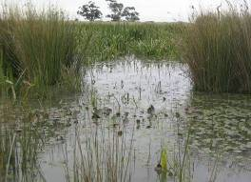
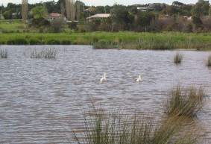
“The Waterways” residential development, Carrum Downs Eumemmering Creek
(Photos courtesy of Earth Tech)

Beneficial river health outcomes

Adverse river health outcomes

Associated works Sediment ponds Vegetation
Weirs
Rock chutes Swales
Provision of instream habitat in modified drainage systems, such as urban environments and regulated streams
Improvement of the water quality of receiving waters
Reduce sedimentation rates in receiving water, protecting benthic habitat and stream morphology
Detains flows, reducing the artificially high flow peaks in urban catchments
During construction they involve mass disturbance adjacent to and/or in the waterway, risking water quality and sedimentation issues in receiving waters if not managed carefully or if a large flow event occur
On stream constructed wetlands can obstruct fish passage
Wetland systems may require regular maintenance to ensure weed species from urban areas do not flourish. They also require infrequent sediment removal to prevent carry through to the receiving waters

Information requirements
Design intent (water quality/aesthetic)
Design flows, and catchment flows and seasonality Physical site constraints e.g. fall, services Catchment water quality

Success ranking
No. of applications in Victoria
Estimated to be fewer than 100 applications over past 15 years

Structural success in Australia
High level of success where well designed and implemented

Success in achieving intended outcome
Moderate to high where the structural success and revegetation has been achieved

Table of Contents

Success factors

Failure mechanisms
Appropriate hydrologic and hydraulic design of the wetland
Treatment cells being appropriately designed for the water quality objectives
Wetlands being a natural part of the landscape and the design conforms to the stream and floodplain morphology
Vegetation and maintenance programs

Process Management

Sedimentation Regular inspection of sediment accumulations and
implementation of maintenance as required Vegetation survival Assess ephemeral regime
Monitor and management of weed species

Mosquito breeding Provide for circulation of water and fauna habitat in
design

Scour Ensure high flow bypass operation Litter accumulation Regular inspection and maintenance
Algal blooms Increase regular flow through wetland/assess
hydrodynamic characteristics and extent of vegetation

DEMONSTRATION SITES
Site 1 Traralgon Wetland Stream: Traralgon Creek Basin: Latrobe
Contact: Latrobe City Council Internet: www.latrobe.vic.gov.au

Site 2 Sydenham Wetland
Stream: Main Drain Basin: Maribyrnong Contact: Melbourne Water
Internet: www.melbournewater.com.au

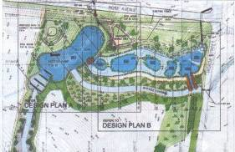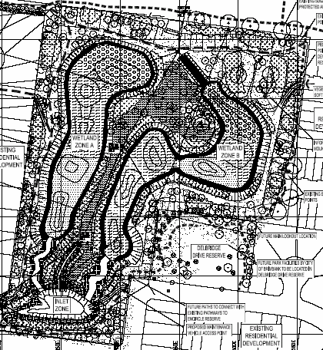
Table of Contents
Traralgon Creek conceptual design
Sydenham wetland conceptual design

DESIGN GUIDELINES AND RELATED INFORMATION SOURCES
Melbourne Water 2005, Water Sensitive Urban Design, Engineering Procedures – Stormwater,
Melbourne Water, Victoria.
Melbourne Water undated, Constructed Wetland Systems Design Guidelines for Developers,
Melbourne Water, Victoria.

CONSTRUCTION COSTS
$ Full construction/vegetation – $100,000-$400,000/hectare.

PROVISION OF ENVIRONMENTAL FLOWS

DESCRIPTION
The provision of environmental flows involves the allocation and provision of a flow regime to a stream and the control of extractions for consumptive use. The provision of environmental flows is as much about restoring high, overbank flows as ensuring low flow or dry spells when they are needed.

WHY IMPLEMENT?
Environmental flows are provided to meet the ecological requirements of the stream and maintain geomorphic processes. In Victoria, environmental flows are part of the Environmental Water Reserve of a river system. The environmental water reserve is the share of the water set aside to maintain the environmental values of the stream system and other services dependent on the environmental condition of the stream system.
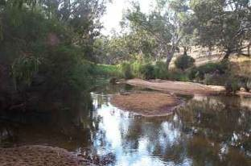

Environmental flow release in Glenelg River, upstream of Harrow

Beneficial river health outcomes

Adverse river health outcomes
Associated works
Fish ladder
Provision of instream habitat
Provision of instream habitat
Provision of fish migration and spawning cues and passage Maintenance of bed diversity (including pools) through scour Control of exotic aquatic species
Water quality maintenance and improvement Watering of riparian and floodplain vegetation
Can provide advantage to exotic flora and fauna if poorly applied

Information requirements
Hydrologic data Survey
Habitat requirements
Refer to the FLOWS method for determination of environmental flow requirements

Success ranking
No. of applications in Victoria
Structural success in Australia
Success in achieving intended outcome

Increasing number of applications
Not assessed Potentially high

Table of Contents

Success factors Application of a comprehensive understanding of the flow regime, hydraulics and their affect on important habitat features
Community support for the proposed allocation

Failure Process Management

mechanisms
Poor water quality and temperature, absence of instream habitat features and barriers to fish migration limit beneficial impacts
Resolution of catchment management issues impacting on water quality
Provision of variable level off-takes from storages supplying flows to streams
Provision of fish passage over barriers

Table of Contents

Implementation Develop operation plans for storages and other
water allocation infrastructure that will enable the flow regime to be implemented
Address where water can be sourced from for the flow regime

DEMONSTRATION SITE

Site 1 Thomson River environmental flow determination
Stream: Thomson River Basin: Thomson
Contact: West Gippsland CMA
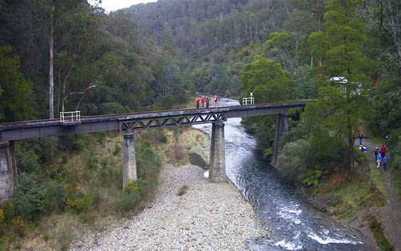
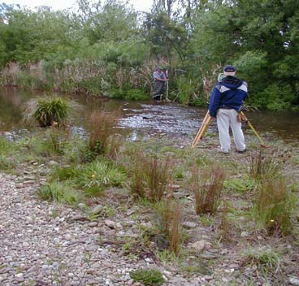
Environmental flow assessments Thomson River, Victoria (Photos courtesy of Earth Tech 2003)

DESIGN GUIDELINES AND RELATED INFORMATION SOURCES
SKM 2002, FLOWS – a method for determining environmental water requirements in Victoria,
Department of Natural Resources and Environment Victoria.
Victoria’s Environmental Flow Program: www.dse.vic.gov.au/riverhealth
> River Health Program > Our Programs

COSTS
FLOWS assessment: approximately $15,000 to $25,000 per stream reach. Provision of water: approximately $10-30 per ML.

WATER SENSITIVE URBAN DESIGN

DESCRIPTION
Water Sensitive Urban Design (WSUD) encompasses a wide range of elements that aim to manage water more efficiently and to maximise water quality in the urban environment. These elements include reduction in mains water consumption through the use of rainwater and treated wastewater.
However, the WSUD elements that affect waterways more directly are devices constructed in the urban environment to detain and treat stormwater runoff, such as constructed wetlands or swale drains.
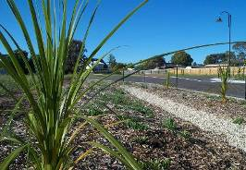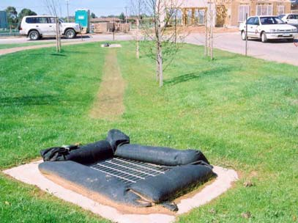

Sharland Park, Geelong (Image courtesy of Earth Tech)
Kialla Lakes, Shepparton (Image courtesy of Earth Tech)

Beneficial river health outcomes

Adverse river health outcomes

Associated works
Improvement of the water quality of receiving water
Reduced litter load, minimising adverse impacts on fauna
Reduce sedimentation rates in receiving water, protecting benthic habitat and stream morphology
Reduced of algal blooms in receiving waters from nutrient uptake Can provide instream habitat in modified urban drainage systems
Detains flows, reducing the artificially high flow peaks in urban catchments
Construction of WSUD elements involves excavation on drainage lines leading to waterways, risking water quality and sedimentation issues in receiving waters if not managed carefully or if a large flow event occurs
Can be more prone to erosion than traditional pipe drains, increasing sediment loads to waterways
Poorly maintained litter traps or basins can leach increased nutrient loads to waterways

Information requirements

Litter and gross pollutant traps Sediment basins
Bioretention systems Swale drains Constructed wetlands Infiltration systems
Design intent (water quality/urban design) Design flows
Physical site constraints e.g. fall, services Catchment flows and seasonality Catchment water quality
Management responsibility

Table of Contents

Success ranking
No. of applications in Victoria
Estimated to be fewer than 1000 applications, but increasing rapidly

Structural success in Australia
Moderate to high level of structural success

Success in achieving intended outcome
Estimated success to range from moderate to high

Success factors The hydrologic and hydraulic design is workable
The WSUD element is appropriately designed for the water quality objectives Maintenance programs are effective

Failure mechanisms
Process Management

Scour Ensure high flow bypass operation. Provide additional rock protection if required

Sedimentation Regular inspection of sediment accumulations in
basins and removal as required
Checking infiltration of subsurface elements and infrequent resetting

Litter and organic accumulation
Regular inspection and maintenance of traps and basins

Vegetation survival Assess flow regime and management of weed
species

DEMONSTRATION SITES

Site 1 Sharland Park, Geelong
Basin: Barwon Contact: Barwon Water

Site 2 Lynbrook Estate
Basin: Bunyip Contact: City of Casey

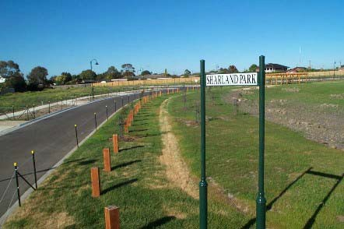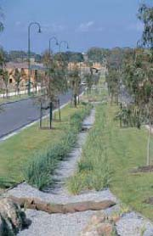
Table of Contents

Sharland Park Geelong (Image courtesy of Earth Tech) Lynbrook Estate (Image courtesy of
Melbourne Water)

DESIGN GUIDELINES AND RELATED INFORMATION SOURCES
Melbourne Water 2005, Water Sensitive Urban Design, Engineering Procedures – Stormwater,
Melbourne Water, Victoria.

CONSTRUCTION COSTS
NA – determined from a wide range of WSUD elements.

Table of Contents

VEGETATION MANAGEMENT
A range of riparian vegetation management options are available to assist waterway managers achieve the river health objectives sought for their programs and projects. The range of techniques includes but is not limited to those listed below and detailed in the following pages:

- stock control
- vegetation establishment
- vegetation management
- weed management
- willow control.
The techniques listed and detailed in the following pages represent those approaches most commonly applied in Victoria with greatest degrees of success. The following pages provide discussion on the positive and adverse river health outcomes associated with these techniques, where the techniques may be applied, some success factors, demonstration sites where the techniques can be inspected, likely ranges of costs (based on 2006 values) and information on where to access design information.

STOCK CONTROL

DESCRIPTION
Stock control is the act of managing the access of livestock to riparian lands. Stock typically congregate in riparian vegetation as these areas provide water, shade and protection from the wind – this has several adverse impacts on river health. Permanent stock exclusion from the riparian zone is often not necessary if the timing, intensity and frequency of grazing is well controlled. Riparian fencing is the simplest and most common form of stock control, although the installation of alternative shaded watering points and/or supplementary feeding stations has been successfully applied in arid to semi arid regions to the same effect.

WHY IMPLEMENT?
Stock control is implemented to retain or enhance the health of riparian and aquatic environments adjacent to grazed pastures. Stock control can provide both direct and indirect improvements to several key aspects of river health. These include physical form e.g. reduced stream bank erosion; water quality e.g. reduced turbidity, nutrient input and algal growth; streamside zone e.g. increased floristic and structural diversity; and aquatic life e.g. increased fish numbers and species composition.
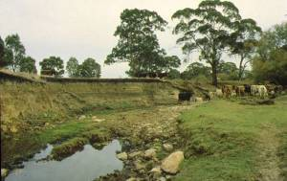
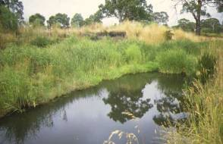
Before (left) and after (right) images of revegetation site Adelaide Hills, South Australia
(Images courtesy J. Carter)

Beneficial river health outcomes

Adverse river health outcomes
Associated works
Fencing
Reduced stream bank erosion Improved water quality
Enhanced biodiversity of riparian vegetation Improved terrestrial and aquatic ecosystem health
Total stock exclusion without alternate weed management programs can lead to increased weed problems

Information requirements
Flood frequency and flooding level

Off stream water supply installation
Establishment of alternate shaded areas
Land use characteristics Topography and pumping capacity

Table of Contents

Success ranking
No. of applications in Victoria
Structural success in Australia
Success in achieving intended outcome

Over 10,000 sites NA Very high

Success factors Fence sufficient distance from top of bank to minimise damage from flooding and bank erosion (generally at least 10-20 m is recommended)
e.g. consideration of expected flood height when choosing fence design Placement of watering points well away from waterways and drainage lines Timing, intensity and frequency of any permitted grazing

Failure Process Management
mechanisms Flooding Installation in flood prone areas of fences that are
either cheap to repair (e.g. electric fences) or structurally unaffected (e.g. drop and lay-down fences)

Stock bypassing fence lines
Installation of hanging fences across narrow streams to prevent stock access to stream bed

DEMONSTRATION SITES

Site 1
Stream: Barwidgee Creek Basin: Ovens River Contact: North East CMA

Site 2
Stream: Black Range Creek Basin: King River
Contact: North East CMA

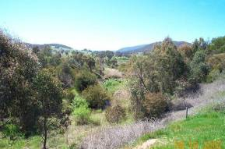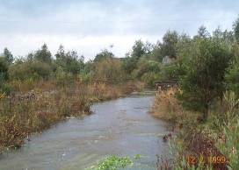
Table of Contents

Barwidgee Creek, north east Victoria Black Range Creek, north east Victoria

DESIGN GUIDELINES AND RELATED INFORMATION SOURCES
Askey-Doran, M. 1999, ‘Managing stock in the riparian zone’ in Lovett, S. & Price, P. (eds). Riparian Land Management Guidelines, Vol. II: On-ground Management Tools and Techniques, Land and Water Australia, Canberra.
Price, P. and Lovett, S. 2002, Managing stock, Fact Sheet 6, Land and Water Australia, Canberra.

CONSTRUCTION COSTS
$4,000 per km (supply and installation of typical electric fencing).
$6,000 per km (supply and installation of typical 5 wire barbed fencing).

VEGETATION ESTABLISHMENT

DESCRIPTION
Vegetation establishment involves the planting of vegetation in the riparian zone. The vegetation preferably consists of plants representative of the full indigenous structure and diversity.
Vegetation establishment comes about by either replanting or regeneration.

Vegetation establishment will be complemented by stock exclusion, controlled grazing and weed and exotic fauna management works. Vegetation establishment is one component of vegetation management.

WHY IMPLEMENT?
Vegetating a riparian zone improves channel stability. Re-establishing vegetation along stream banks also provides many other benefits including habitat provision, improved water quality and increased aesthetic values.
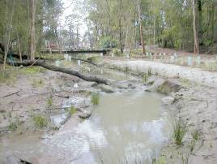
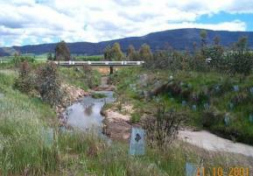

Revegetation works Blackburn Creek, Blackburn
(Image courtesy of Earth Tech)
Revegetation after willow removal – Barwidgee
Creek (Image courtesy of North East CMA)

Beneficial river health outcomes

Adverse river health outcomes
Reduced stream bank erosion
Habitat provision and enhancement for aquatic fauna Improved water quality
Shade and shelter provided to the stream to manage water temperature and maintain water quality
Refer Land and Water Australia
Clearing and preparing the site for revegetation can allow weed invasion
Clearing site before revegetation, can produce short term decrease in stability, habitat and shading of the waterway

Associated works Stock management Weed management Willow control Exotic fauna control Off stream watering
Information requirements Soil type and condition Climate
Pre-1750s EVC benchmark
Weed and vermin control requirements

Table of Contents

Success ranking
No. of applications in Victoria
Estimated to be over 1,000 applications

Structural success in Australia
High level of success with maintenance

Success in achieving intended outcome
High where the implementation success has been achieved

Success factors Providing a diverse range of plant species will help combat the impact of plant disease and help natives compete with weeds
Techniques to minimise sedimentation impacts during site establishment should be implemented
Stock must be excluded from revegetation areas to enable plants to establish

Failure Process Management

mechanisms
Drought/ waterlogging
Eaten by stock/ wildlife
Inappropriate species selection
Plant at times suitable for area and water if needed

Install plant guards and fence out stock from area

Always plant endemic species in correct location relative to water/bank with consideration given to altered flow regimes if applicable

DEMONSTRATION SITES

Site 1
Stream: Black Range Creek, Edi Upper Basin: Ovens
Contact: North East CMA

Site 2
Stream: Wannon River Basin: Wannon
Contact: Glenelg-Hopkins CMA

Table of Contents
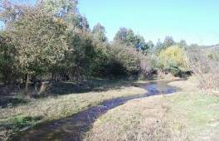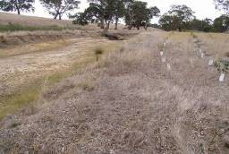
Back Range Creek, north east Victoria Wannon River, western Victoria

DESIGN GUIDELINES AND RELATED INFORMATION SOURCES
While some guidelines have been developed for riparian vegetation establishment, many of these are site or region specific. Other references include:
- Abernathy, B. and Rutherfurd, I.D. 1999, Guidelines for Stabilising Streambanks with Riparian Vegetation, Technical Report 99/10, CRC for Catchment Hydrology.
- Greening Australia 2003, Revegetation Techniques – A guide for establishing native vegetation in Victoria, Greening Australia, Victoria. www.greeningaustralia.org.au.
- Native Vegetation Regional Management Plans.

CONSTRUCTION COSTS
$3,750 per 1,000 plants (plants, stakes and guards only).
$5,000 per 1,000 plants (plants, stakes, guards and planting crew - labour).
$400 per km (10 m wide zone direct seeding).

VEGETATION MANAGEMENT

DESCRIPTION
Vegetation management includes the management of the complex of plant species growing on or in a site, reach or waterway. Plants may be exotic or indigenous, terrestrial aquatic, annual or perennial. Management maybe direct or indirect, physical, animal, mechanical or chemical or more usually a combination. Management implies ongoing action, although no intervention is also part of management. Vegetation management over time is typically decentralised and for this reason, as well as the time scale involved, requires addressing issues of social capacity. Management for stabilisation will also include the selection of plants best fitted for river heath. There is no end to vegetation management as all plants have a finite lifecycle.

WHY IMPLEMENT?
Vegetation management is undertaken to improve the condition or structure of vegetation at a site or within a reach. This can provide a direct improvement in the riparian condition of a stream and provide indirect and related benefits of increased stream stability, provision of habitat corridors, shading of water and providing a long term source of timber for instream structure. Management of vegetation for stabilisation is undertaken to create the site conditions over time that will favour the germination growth and reproduction of the suite of plants with the most desirable set of stabilisation characteristics.
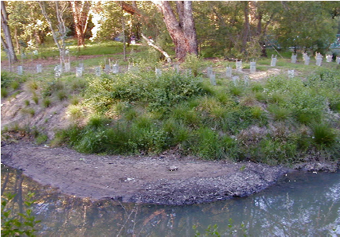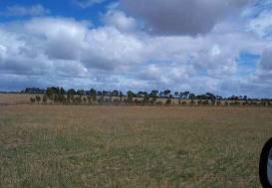

Revegetation works at Gardiners Creek
(Photo courtesy of Earth Tech)
Vegetation management undertaken by landholder, Kangaroo Creek (Photo courtesy of Earth Tech)

Beneficial river health outcomes

Adverse river health outcomes

Associated works
Vegetation management is the long term solution to stabilisation, complementing in time other techniques. The intensity, combination and timing of vegetation management actions contribute to river heath outcomes in both the short and long term. In Victoria we usually seek to move vegetation to an indigenous dominated with a strong woody component
Intentional intensive or the opposite, ‘do nothing’ management decisions can diminish stream health values. The former having immediate impacts the later generally longer term. The vast array of different techniques available to the vegetation manager means that adverse river health outcomes are likely without planning and consideration of wider implications

Information requirements

Vegetation establishment Stock management Willow control
Exotic fauna control Off stream watering
Determine management responsibility Determine habitat requirements Determine landholder requirements Identify species to be controlled
Identify species to be protected or assisted
Determine and minimise environmental impact of works

Table of Contents

Success ranking
No. of applications in Victoria
Structural success in Australia
Success in achieving intended outcome

Common to successful stream management projects
Success factors Assessment
Planning
Community engagement Ongoing implementation
NA High when time in years and ongoing inputs are put into the management

DEMONSTRATION SITES

Site 1
Stream: Barwidgee Creek Basin: Ovens
Contact: North East CMA

Site 2
Stream: Wannon River Basin: Glenelg
Contact: Glenelg-Hopkins CMA

Table of Contents
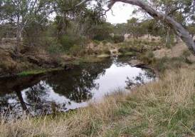
Barwidgee Creek north east Victoria Wannon River, western Victoria

DESIGN GUIDELINES AND RELATED INFORMATION SOURCES
There are innumerable guidelines for vegetation management and the many inherent actions. Many of these are site and/or region specific. References include:
- Greening Australia 2003, Revegetation Techniques – A guide for establishing native vegetation in Victoria, Greening Australia, Victoria. www.greeningaustralia.org.au.
- Native Vegetation Regional Management Plans.
- Land and Water Australia: www.rivers.gov.au/manage/is13riparianwidths.htm.

CONSTRUCTION COSTS
Refer individual elements.

WEED MANAGEMENT

DESCRIPTION
Weed management usually involves the control or eradication of invasive exotic or non-endemic native plant species. Chemical control is the most widely used method while other techniques include cultivation or lopping.

WHY IMPLEMENT?
Weed management is implemented to eradicate or control the spread of pest plant species. It can also be undertaken to facilitate the re-establishment of native species by reducing competition.
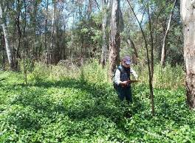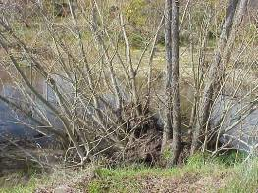

Site assessment, North East CMA Pest species - Willow

Beneficial river health outcomes

Adverse river health outcomes

Associated works
Can improve the structure, diversity and extent of native vegetation and natural habitats
Subsequent improvements in native vegetation can result in enhancement of habitat and structural integrity of the bank
If works result in more native vegetation, water quality may improve due to a more natural supply of leaf litter, stream shading, etc
Chemicals used can adversely affect native terrestrial or aquatic flora and fauna
The removal of weed species and an absence of other flora may reduce habitat values and shading on streams
Poisoning or removal of weeds may increase bank erosion rates with subsequent potential sedimentation and affects on water quality

Information requirements

Vegetation establishment Stock management Willow control
Exotic fauna control Off stream watering
Available/registered chemicals and affect on weeds/waterways. Extent of weed problem
Affect of weeds on issues such as bank erosion, native and exotic fauna, stream temperature, etc

Table of Contents

Success ranking
No. of applications in Victoria
Common to successful stream management projects

Structural success in Australia
High level of success where ongoing management is in place

Success in achieving intended outcome
High where the implementation success has been achieved.

Success factors Chemicals are correctly applied
Seed bank or adjacent infestations are also considered
Native species are planted to compete with regeneration and replace minor potential benefits of weeds such as shading and erosion control

Failure mechanisms
Process Management

Regeneration Seed bank or adjacent infestation addressed. Natives planted to compete with weeds

Invasion by other
weeds
Considers all weed species that threaten to colonise the
area

Table of Contents

DEMONSTRATION SITE
Stream: Upper Goulburn River Basin: Goulburn
Contact: Goulburn Broken CMA
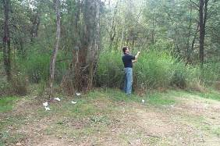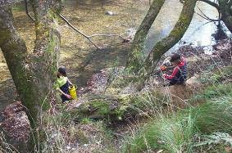
Vegetation assessments, upper Goulburn River Willow control, upper Goulburn River

DESIGN GUIDELINES AND RELATED INFORMATION SOURCES
Native Vegetation Regional Management Plans. CRC for Weed Management: www.weeds.crc.org.au.

CONSTRUCTION COSTS
$1,000 per km (riparian weed management for site preparation, ground cover).
$1,000 per km (riparian weed management for site preparation, woody weeds).
$7,500 per km (woody weed management, heavy).
$5,000 per km (aquatic weeds, medium – light).
$20,000 per km (aquatic weeds, heavy).

WILLOW CONTROL

DESCRIPTION
Willow control is the physical removal, pruning or poisoning of Salix taxa. Poisoning willows involves the use of herbicide via stem injection, drill and fill, foliar spraying and cutting and painting the stump. Physical methods involve whole of tree removal, lopping and pollarding. The selection of technique is dependent on site conditions and available equipment. There are numerous occupational health and safety hazards encountered during willow removal. Willows that have been poisoned and allowed to die become brittle and provide a high risk to operators in densely vegetated areas.

WHY IMPLEMENT?
Most species of willow in Australia have been found to be highly invasive and have significant adverse impacts on stream health. Willow can have an adverse impact on riparian vegetation condition, instream physical form and water quality. Willow control is undertaken to mitigate the adverse impacts that willows have on Australian streams.
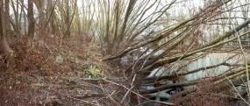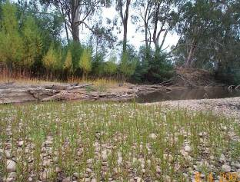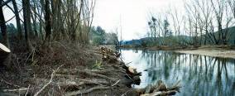
Willows on Ovens River, north east Victoria Three generations of Black Willow on the Ovens
River at Tarrawingee, north east Victoria

Beneficial river health outcomes

Adverse river health outcomes

Associated works Fencing Revegetation
Bank Stabilisation
Preventing channel change due to willows colonising the stream channel Habitat provision if replaced by native vegetation
Allows light in for other plants to establish
Willow removal may reduce shading to the stream too much during summer months
May result in a reduction in riparian habitat if not done in a staged manner with replacement native vegetation
Foliar spraying may affect other riparian vegetation
Species that spread via vegetative means may be dispersed downstream if physical methods are used

Information requirements
Access provision and site conditions Type of willow species
Density of willows Equipment availability

Table of Contents

Success ranking
No. of applications in Victoria
Common to successful stream management projects

Structural success in Australia
High level of success with ongoing maintenance

Success in achieving intended outcome
High where the implementation success has been achieved

Success factors Replacement native vegetation is established
Other seed or vegetative sources are addressed

Failure Process Management

mechanisms
Reseeding or vegetative spread
Mass removal adversely affecting habitat, bank stability or water temperature
Continued monitoring of site allowing quick treatment of re-emerging willow species
Staged removal or willows and revegetation over a number of years

DEMONSTRATION SITES

Site 1
Stream: Ovens River
Basin: Ovens
Contact: North East CMA

Site 2
Stream: Upper Goulburn River Basin: Goulburn
Contact: Goulburn Broken CMA

Table of Contents
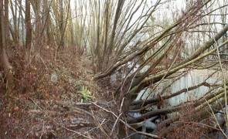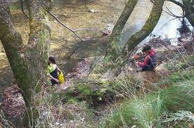

Willows on Ovens River, north east Victoria Willow control, upper Goulburn River

DESIGN GUIDELINES AND RELATED INFORMATION SOURCES
Ladson, A., Gerrish, G., Carr, G., Thexton, E. and Brizga, S. 1997, Willows along Victorian Waterways – Towards a willow management strategy, Waterways Unit, Department of Natural Resources and Environment Victoria.
CRC for Weed Management: www.weeds.crc.org.au.

CONSTRUCTION COSTS
$10,000 per km (light willow management).
$30,000 per km (heavy willow management).

INSTREAM PHYSICAL MANAGEMENT
A range of instream physical waterway intervention options or techniques are available to assist waterway managers achieve the outcomes sought for waterway programs and projects.

A primary management option that should be considered is “do nothing”. In most instances, adoption of appropriate best practice land management and vegetation management accompanied by a monitoring and evaluation program will achieve the desired stream management outcome, without the necessity for instream physical interventions. In this respect and in most instances instream physical interventions should be considered a last resort.

However, where alternate management will not provide the desired stream outcome, some instream physical interventions may be appropriate. The range of instream physical intervention options available to the waterway manager includes but is not limited to those listed below and detailed in the following pages:

      - Alignment training
      - Bank battering
      - Bed seeding
      - Channel reconstruction
      - Engineered log jams
      - Fish ladders
      - Fish locks
      - Fish passage through culverts
      - Grade stabilisation
      - Grass chutes
      - Infrastructure decommissioning
  - Large wood installation
  - Log sills
  - Lunkers
  - Pile fields
  - Rock beaching
  - Rock chutes
  - Rock groynes
  - Sediment extraction
  - Silt fences and sediment traps
  - Wetland and floodplain engagement

Table of Contents
The techniques listed and detailed in the following pages represent those instream physical intervention options most commonly applied in Victoria with the greatest degrees of success. In addition emerging techniques have been included where their success has been validated by significant overseas experience.

The following pages provide discussion on the positive and adverse river health outcomes associated with these techniques, where the techniques may be applied, some success factors, demonstration sites where the techniques can be inspected, likely ranges of costs (based on 2006 values) and information on where to access design information.

The techniques discussed are not typically applied in isolation. In most instances a combination of techniques will be appropriate. Further the techniques identified may be nested together to form a larger consolidated approach. Some of these nested approaches such as grade stabilisation, requiring the combined techniques of rock chutes and revegetation are included in the list. A hierarchy of techniques has not been provided and techniques are listed in alphabetic order.

The technique, “Vegetation Management”, and the complementary works including weed management and revegetation are discussed in Sections 3.3.5 to 3.3.10 and are worthy of special note. Vegetation management should be considered an essential element of all instream waterway management programs.

INSTREAM TECHNIQUES NOT RECOMMENDED
There are many waterway management techniques, that have been used in the past and are sometimes still used, that are not listed above and have not been included in these Technical Guidelines. A selection of such techniques is listed below together with reasons for their exclusion from these Technical Guidelines.

Technique Reason for exclusion from these Technical Guidelines

Desnagging/ removal of large wood
Instream timber is a fundamental component of Australian stream systems. There are few sound reasons for ongoing removal of timber from stream systems. This technique should be avoided and only applied in exceptional circumstances, following extensive investigations and with extreme caution.

Wetland drainage A large proportion of Victoria’s wetlands have now been drained. Those wetlands that remain are often of high conservation significance. Further drainage of wetlands is inconsistent with the management of these high valued systems.

Floodways and low flow pipes
Low flow pipes are an instream barrier that severely impact stream processes and prevent fish passage. Low flow pipes and accompanying floodways are inconsistent with current river health objectives.

Wire baskets Wire baskets have and continue to be used for some erosion control works. These baskets are effective for retaining wall construction and some limited clear water drainage applications. However, in river systems, wire baskets can be susceptible to failure through sediment abrasion and corrosion and through damage from timber loads.

Concrete lining Concrete lining of creek systems has been undertaken in urban areas to improve hydraulic performance (increase velocity of flow) and thereby reduce flooding, and to control erosion. Concrete lining destroys most other beneficial stream processes and is inconsistent with river health objectives.

Revetment fencing including log coils
Revetment fencing has been used as a means of erosion control. Revetment fencing has a low success rating and is susceptible to premature failure. Revetment fencing does not address the cause of erosion, does not induce deposition, is susceptible to failure associated with bed scour, and is not effective at providing a barrier between scour producing flows and bank material. Alternative higher success options are available to the waterway manager.

Table of Contents

These techniques are not considered to be part of best practice waterway management and have not been included in these Technical Guidelines.

ALIGNMENT TRAINING

DESCRIPTION
Alignment training is a form of instream physical intervention to modify the current and/or developing plan form of a waterway. The technique commonly incorporates hydraulic resistance techniques (such as pile fields) and/or flow diversion techniques (such as rock groynes) to realign the waterway.

WHY IMPLEMENT?
Alignment training works are most often undertaken to protect infrastructure such as roads and bridges from bank instabilities associated with meander development and stream migration.
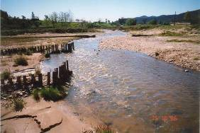
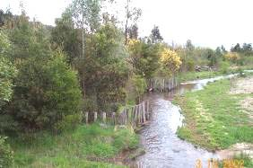

Black Range Creek, north east Victoria, immediately following pie field based alignment training to manage sediment loads and channel instabilities
Black Range Creek, north east Victoria, 6 years following works alignment training works

Beneficial river health outcomes

Adverse river health outcomes

Associated works
Revegetation Rock beaching Rock groynes Pile fields
Reduced bank erosion Improved bank vegetation
Lower long term impact than rock beaching
Construction impacts such as sediment relocation and equipment access to stream bed

Information requirements
Refer Part 4 Materials of these Technical Guidelines. Other information requirements include:
    - estimation of stream flow (hydrology)
    - stream cross-section survey of existing waterway
    - aerial photograph and stream feature survey
    - identification of existing ecological assets

Success ranking
No. of applications in Victoria
Estimated to be in excess of 50 applications in Victoria over past 20 years

Structural success in Australia
Moderate level of structural success. Refer success factors and failure mechanisms

Success in achieving intended outcome
High where structural success has been achieved

Table of Contents

Success factors

Failure mechanisms
The presence of an instream sediment supply to the site
Inclusion of vegetation establishment as a component of the works
Adoption of design approach reported in Guidelines for Stabilising Waterways (Standing Committee on Rivers and Catchments 1991)
Inclusion of scour depth analysis into the structural pile field design

Process Management

Outflanking Provision of suitable abutment protection
Selection of an alignment that is consistent to the plan form of the larger pattern of the waterway

Undermining Inclusion of scour depth analysis in design
Provision of rock beaching at toe of piles Provision of returns or tails on pile fields

Timber failure Selection of resistant hardwood timbers
Design of timbers to resist impact loads

DEMONSTRATION SITES

Site 1
Stream: Wodonga Creek Basin: Kiewa Basin Contact: North East CMA

Site 2
Stream: Black Range Creek Basin: Ovens River Contact: North East CMA

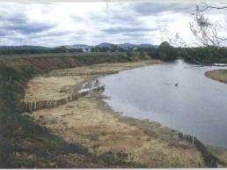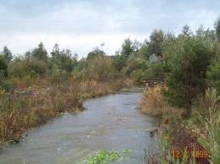

Pile fields, Wodonga Creek, north east Victoria
Pile and rail alignment training (in background) and revegetation, Black Range Creek, north east Victoria

Table of Contents

DESIGN GUIDELINES AND RELATED INFORMATION SOURCES
There are limited design guidelines available for alignment training works:
- Refer Part 5 of these Technical Guidelines.
- Federal Interagency Stream Restoration Working Group 1998, Stream Corridor Restoration: Principles, Processes and Practices,
- Refer also to techniques described in sections 3.3.16 Engineered log jams, 3.3.22 Large wood 3.3.25 Pile fields and 3.3.28 Rock groynes.

CONSTRUCTION COSTS
Approximately $50,000 per site also refer individual design elements for other methods.

BANK BATTERING

DESCRIPTION
Bank battering involves modification of the stream bank to a design bank angle. It can be undertaken to reduce erosion and provide conditions suitable for vegetation establishment. However there are only a limited range of erosion mechanisms that can be addressed through bank battering. Failure of bank battering is often a result of the inappropriate application of the technique.

WHY IMPLEMENT?
Bank battering is implemented to provide a relatively stable surface on which vegetation can be established. Bank battering can be used to accelerate the rate of recovery from past channel incision (where the deepening process has halted and the dominant process is widening). Battering can also be used to increase the safety of a steep bank in the urban environment.
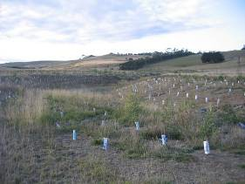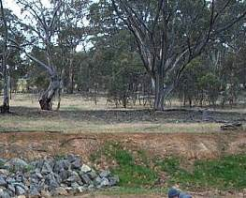

Battered banks combined with a grass chute and revegetation, Retreat Creek, western Victoria
Battering combined with rock beaching, Wattle Creek, tributary of Wimmera River, western Victoria

Beneficial river health outcomes

Adverse river health outcomes

Associated works
Revegetation
The process can increase the rate of recovery and reduce the downstream impact of an incised stream system. Depending on the hydrology and hydraulics of the stream, the approach can be used to reduce erosion rates and downstream sediment release by increasing channel cross-sectional area, reducing flow velocity, shear stress and stream power
The approach can be applied to reduce rill erosion and increase the success rate for vegetation establishment. Jute or similar matting can be used to improve stability
The approach can remove bank diversity by creating a uniform surface
The approach can destroy undercut banks, overhanging vegetation and other habitat features associated with steep stream banks
The approach may remove features such as vegetation that may be providing some stability to the stream banks
The high level of disturbance and removal of all vegetation can increase bank erosion rates
Unconsolidated material on a lower bank will in most cases be removed during post-battering flow events increasing sediment loads downstream, further destabilising the bank

Information requirements
Estimation of stream flow (hydrology)
Stream cross-section survey of existing waterway Identification of existing ecological assets

Table of Contents

Success ranking
No. of applications in Victoria
Estimated to be over 1,000 applications in Victoria over past 20 years

Structural success in Australia
Moderate level of success where no bed instabilities are present and shear stress at toe is below the threshold of motion

Success in achieving intended outcome
Moderate where the structural success has been achieved

Success factors

Failure
No ongoing stream bed instabilities being present
Vegetation establishment is successfully implemented as part of works
Battering at the toe of the bank consists of existing consolidated material, or constructed compacted material

Process Management

mechanisms
Ongoing widening, ongoing deepening
Ensure a stable stream system is present by incorporating other techniques such as beaching, pile fields or rock chutes

Undermining Manage ongoing bed instabilities

Rill Erosion Provision of contour drains on banks over 10 metres in elevation

Scour associated with high flows soon after completion
Complement longer term revegetation with an immediate short term stabilisation technique, construct toe from consolidated material

Table of Contents

DEMONSTRATION SITE
Stream: Wodonga Creek Basin: Murray River Contact: North East CMA
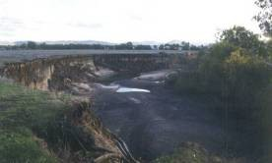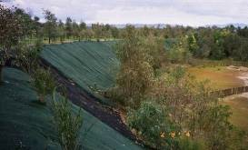
Wodonga Creek prior to bank battering Wodonga Creek following bank battering

DESIGN GUIDELINES AND RELATED INFORMATION SOURCES
Refer Part 5 of these Technical Guidelines.

CONSTRUCTION COSTS
Approximately $20 per linear metre of bank. Cost is a function of site including bank height.

BED SEEDING

DESCRIPTION
Bed seeding refers to the introduction of sediments or rock to the bed of a waterway. The material may be sourced from the adjacent floodplain, other reaches of the same stream, other streams or from off stream sources.

WHY IMPLEMENT?
Bed seeding can be undertaken to increase sediment load, armour the bed or provide instream habitat. Increasing habitat could comprise placement of individual large boulders or a formal rock structure forming a riffle (refer rock chutes). Bed seeding may also be implemented in conjunction with full stream width pile fields to provide armouring, raise the bed level and reduce the cross-sectional area of a stream.
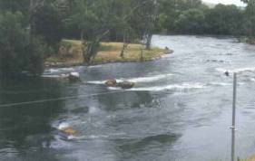
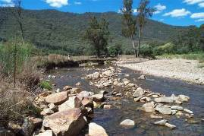
Goulburn River (Photo courtesy Earth Tech) Ovens River (Photo courtesy Earth Tech)

Beneficial river health outcomes

Adverse river health outcomes

Associated works
Instream habitat
This approach can increase bed diversity, can increase the resistance of the bed to incision and can address issues associated with sediment starvation downstream of instream storages and weirs. In conjunction with full stream width pile fields, bed seeding may also modify stream hydraulics. Injecting unsorted gravels will allow the stream to naturally sort and armour during high flow events
This approach can result in the translocation of weed or non-indigenous species into streams. Fine sediments in the material can add to the suspended load of the stream, reducing water quality (increasing turbidity). The material added may not be a natural substrate for native benthic organisms, reducing available habitat. Excessive sediment inputs may reduce the morphologic diversity and available habitat within the stream

Information requirements Hydrology of the stream Stream survey
Location of sediment erosion and deposition zones within the reach Knowledge of instream ecological values

Success ranking
No. of applications in Victoria
Structural success in Australia
Success in achieving intended outcome

Table of Contents

Limited in Victoria Not assessed Potentially high

Success factors Success of bed seeding can be aided by the design of sediment grading to prevent or facilitate transport

Failure Process Management

mechanisms
Armour layers of inadequate thickness will be eroded

Deposition buries works or migrating degradation undermines works
Plan form of river changes making works redundant or in the wrong location
Sediment transport imbalance is long term
Provide a layer of a number of particles thick to prevent undermining
Inspection after major flow events, particularly on the upstream and downstream edges
Identify and design works to fit with or address the process

Identify risk and design works to address this

Long term erosion zones, for example, downstream of dams, will require ongoing sediment supply to address the imbalance

DEMONSTRATION SITES

Site 1 Bed seeding combined with rock groynes
Stream: Snobs Creek
Basin: Upper Goulburn catchment Contact: Goulburn Broken CMA

Site 2 Bed seeding combined with pile fields
Stream: Dights Creek Basin: River Murray
Contact: NSW Department of
Infrastructure, Planning and Natural Resources (DIPNR)

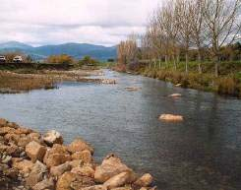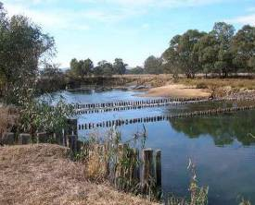

Bed seeding (right) combined with rock groynes for alignment training, Snobs Creek (Photo courtesy Paul Brown, Department of Primary Industries, Victoria)
Avulsion management works including pile field and bed seeding Dights Creek, anabranch of the River Murray, NSW

DESIGN GUIDELINES AND RELATED INFORMATION SOURCES
Table of Contents
NA

CONSTRUCTION COSTS
Variable dependent on rock size and density of placement.

CHANNEL RECONSTRUCTION – GEOMORPHIC CHANNEL DESIGN

DESCRIPTION
Channel reconstruction refers to the part or full replacement of an existing (often modified) waterway. The technique comprises major physical intervention to stream systems and requires significant investment in investigations, design and management. The technique is best suited to the replacement of existing modified (piped and concrete lined) waterways in urban environments and to the remediation of waterways within severely disturbed environments such as mine sites. The technique has been used to enable access to open cut mineral resources, and may be suited to address major changes to the hydrologic regime associated with river regulation and urbanisation. Alternate, less interventionist approaches to address issues should be considered prior to embarking on channel reconstruction projects.

WHY IMPLEMENT?
Channel reconstruction is generally implemented to change the course of a stream for economic development or to improve health of a constructed stream (e.g. replace a pipe or concrete lined waterway).
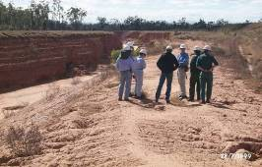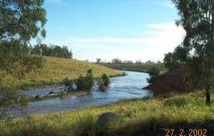

Constructed stream in central Queensland pre- rehabilitation using geomorphic channel design (Image courtesy of Earth Tech)
Constructed stream post rehabilitation using geomorphic channel design (Image courtesy of Earth Tech)

Beneficial river health outcomes
Adverse river health outcomes
The approach, when combined with other appropriate features such as revegetation and large wood installation, can return waterway habitat, connectivity and processes to degraded stream systems
The technique can result in significant reduction in stream condition when used to replace an existing natural waterway. It may take many years and perhaps decades to replace the riparian corridor and stream condition may not fully recover in the long term
The technique can result in short term increases in suspended sediment loads if commissioned prior to the establishment of riparian vegetation
Refer also to potential adverse outcomes associated with inclusions such as fish passage, and large wood

Associated works
Table of Contents
Revegetation
Large wood installation Riffle construction

Information requirements
Refer Section 5.4.1 Geomorphic design of stream reconstruction Estimation of stream flow (hydrology)
Stream cross-section survey of existing waterway Identification, characterisation and survey of template reach Topographic survey over proposed alignment
Geotechnical survey of proposed alignment Identification of existing ecological assets

Success ranking
No. of applications in Victoria
Limited examples in Victoria using principles of Geomorphic Channel Design

Structural success in Australia
High where principles of geomorphic channel design have been applied.

Success in achieving intended outcome
High where principals of geomorphic channel design have been applied and stream features such as large wood, vegetation, and benches have been included.

Success factors

Failure
The application of principles of natural channel design (refer Part 5 of these Technical Guidelines)
The level of detail applied to the investigation and design
The likelihood of structural success is increased with increased vegetative cover. Establishment of vegetation prior to the commissioning of works has potential to reduce construction costs and increase the channel robustness

Process Management

mechanisms
Excess bed and/or bank scour
Excess sedimentation
Appropriate level of design incorporating principles of natural channel design
Appropriate level of design incorporating principles of natural channel design

Table of Contents

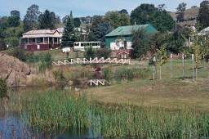
DEMONSTRATION SITE
Stream: Livingstone Creek, Omeo
Basin: Mitta Mitta Contact: North East CMA

Livingstone Creek Omeo. Channel reconstructed following 1999 flood event to protect sewer main

DESIGN GUIDELINES AND RELATED INFORMATION SOURCES
Refer Part 5 of these Technical Guidelines.
Brisbane City Council (2000), Natural Channel Design Guidelines, Brisbane City Council, Queensland.
Rutherfurd, I., Jerie, K and Marsh, N. 2000. A Rehabilitation Manual for Australian Streams, Land and Water Research and Development Corporation, Canberra, ACT.
Federal Interagency Stream Restoration Working Group (1998), Stream Corridor Restoration: Principles, Processes and Practices, by the (FISRWG – 15 Federal agencies of the US government).

CONSTRUCTION COSTS
Construction costs are highly variable between projects, dependent on site constraints, geology, scale of construction and specific channel features.

ENGINEERED LOG JAMS

DESCRIPTION
Engineered log structures comprise the construction of large timber amalgams from individual pieces of timber. The purpose of the structures is to create greater hydraulic and habitat influence than that achieved with individual pieces of timber.

WHY IMPLEMENT?
Engineered log jams are implemented to provide habitat and to influence the erosion and deposition of sediment.
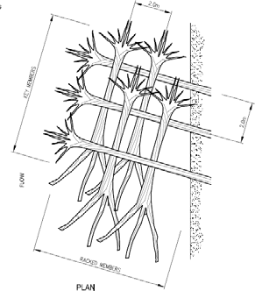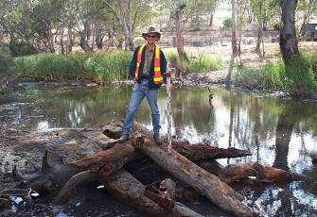

Engineered log structure schematic sketch (left) and in Glenelg River at Harrow (right)
(Images courtesy of Earth Tech)

Beneficial river health outcomes

Adverse river health outcomes
Provision of direct physical instream habitat
Maintenance of bed diversity by causing local scour and deposition
Successful implementation can, over time, increase the channel complexity (such as meander geometry, bed diversity)
Successful implementation may increase hydraulic roughness and reduce system wide stream power
May slightly increase occurrence of overbank flooding
Works can result in stream bank instabilities in the immediate vicinity of structure
Timber elements may be dislodged and mobilised in flood events
Increased occurrence of overbank flooding may not accord with adjoining landholder’s objectives

Associated works Revegetation Fencing
Bank Restoration

Information requirements
Longitudinal profile survey
Stream cross-section survey or estimate Estimation of stream flow (hydrology) Channel hydraulic and scour analysis Geomorphic analysis
Available timber species and log size

Success ranking
No. of applications in Victoria
Structural success in Australia
Success in achieving intended outcome

Limited applications to date
Table of Contents
Not assessed Potentially high

Success factors

Failure
The engineered log jam complements the existing stream environment
The log jam is correctly designed to interact with the flow and sediment in terms of stability and sites of sediment scour and deposition
Provision of adequate ballast and embedment to prevent mobilisation while timber becomes fully waterlogged
Control of accompanying bank erosion

Process Management

mechanisms
Sedimentation and subsequent burial of log jam
Sediment transport and deposition issues to be addressed as component of assessment and design

Vandalism/ burning Community acceptance of structures through
investigation and communications of beneficial and adverse outcomes including occurrence of overbank flooding

Timber mobilisation Design of embedment and/or ballast to prevent
mobilisation of timber in short and long term

Bank erosion and outflanking of structure
Provision of suitable complementary bank erosion control works

DEMONSTRATION SITES

Site 1
Stream: Glenelg River
Basin: Glenelg
Contact: Glenelg Hopkins CMA

Site 2
Stream: Tambo River
Basin: East Gippsland Contact: East Gippsland CMA

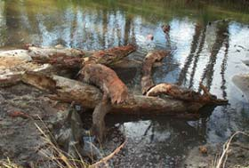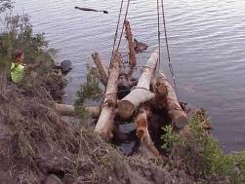
Table of Contents
Engineered log jam on Glenelg River at Harrow Engineered log jam Tambo River, East
Gippsland

DESIGN GUIDELINES AND RELATED INFORMATION SOURCES
Refer Part 5 of these Technical Guidelines.
Brooks, A. et al. 2006. Design guideline for the reintroduction of wood into Australian streams, Land & Water Australia, Canberra.

Rutherfurd, I., Marsh, N., Price, P. and Lovett, S. 2002, Managing Woody Debris in Rivers, Fact Sheet 7, Land Water Australia, Canberra.

CONSTRUCTION COSTS
Approximately $5,000 to $10,000 per structure.

FISH LADDERS OR FISHWAYS

DESCRIPTION
Fish ladders or fishways are structures constructed over or adjacent to instream structures such as weirs, through which part or all of the stream discharge passes in a manner that allows fish to swim upstream through the ladder and around the barrier. Fish ladders can be in the form of either rock ramps (refer rock chutes) or slotted fishways. They are generally installed on or adjacent to the wall of a dam or weir.

WHY IMPLEMENT?
Many of our native fish species migrate as part of their life cycle. Artificial barriers such as locks and weirs limit fish migration, isolate habitat and can interfere with or prevent fish spawning. Fish ladders are installed to allow fish passage around or over in-stream barriers such as weirs.
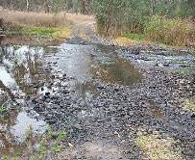
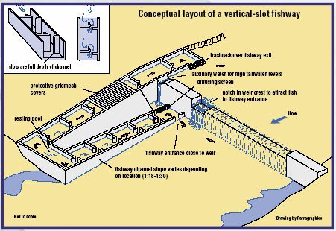

Fishway downstream of road crossing, Harrow
Conceptual layout for vertical slot fishway
(Source: MDBC)

Beneficial river health outcomes
Adverse river health outcomes
Can improve breeding opportunities for native fish
Can increase the geographic distribution of desired fish species

Fish ladders may allow exotic species to colonise new reaches of the river

Associated works
Revegetation

Information requirements
Hydrology
Migratory and life cycle characteristics of fish Swimming ability or fish burst speed
Fish body depth and minimum flow depth for passage Survey of the site

Success ranking
No. of applications in Victoria
Estimated to be up to 100 specific applications in Victoria

Structural success in Australia
High level of structural success

Success in achieving intended outcome
Moderate to high where the structural success has been achieved

Success factors
Hydraulic design and physical dimensions must suit the physiology and migratory behaviour of native fish
Hydrology of the stream is compatible with migration and provides the hydraulic conditions at the structure necessary for migration
Ongoing monitoring and maintenance of structures

Table of Contents

Failure Process Management

mechanisms
Fish are unable or unwilling to swim up structure

Exotic species migrate to new areas
Fish cannot find the ladder
Ensure water velocity, depth and turbulence is such that fish at required stages of life cycle can and will utilise the structure. For slotted fishways a minimum water depth of
1 m, maximum velocity of 1.4 m/s and turbulence of less than 100 W/m3 are recommended, depending on species (Mallen-Cooper 1993). Calmer resting zones are also important
For rock chutes a maximum chute grade of 1:15 and preferred grade of 1:20 should be adopted with depth greater than 0.3 m
Install a fish trap at the upstream end of the ladder to allow removal of exotic species. New fish trap designs can separate exotic species such as carp from natives
For slotted fishways, the entrance should be located near the barrier and flow patterns, such as turbulence, should encourage fish to move toward and enter the ladder.
Additional “attraction” water may be required in some flow conditions

DEMONSTRATION SITES
Site 1 Torrumbarry Weir Stream: River Murray Basin: Murray
Contact: Goulburn Murray Water

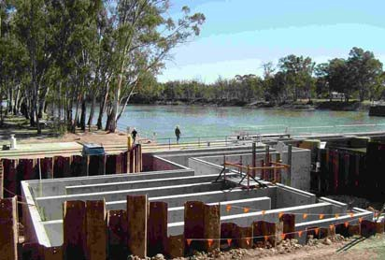
Vertical slot fishway construction at Torrumbarry Weir, River Murray

Site 2 Dights Falls Stream: Yarra River Basin: Yarra
Contact: Melbourne Water
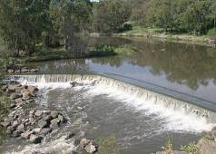
Rock fishway at Dights Falls, Yarra River, Melbourne (Source: http://en.wikipedia.org/wiki/)

DESIGN GUIDELINES AND RELATED INFORMATION SOURCES
Table of Contents
Detailed design guidelines for fish ladders are not available for Victorian streams and fish species. However various design advice for fish friendly rock chutes and other fishways are provided in:
- Mallen-Cooper, M. 1993, Fishways in Australia; Past Problems, Present Successes & Future Opportunities, Bulletin No. 93, Australian National Committee on Large Dams (ANCOLD).
- Thorncroft, G. and Harris, J. 1996, Assessment of Rock-Ramp Fishways, NSW Fisheries Research Institute and the Cooperative Research Centre for Freshwater Ecology.
- Gaboury, M., Newbury, R. and Erickson, C. 1995, Pool and Riffle Fishways for Small Dams, Manitoba Natural Resources Fisheries Branch.

CONSTRUCTION COSTS
Approx $3,000 per metre channel width per vertical metre for rock chute style construction.
$100,000 to $150,000 per vertical metre of barrier for a vertical slot fishway.

LOCK FISHWAYS

DESCRIPTION
A lock fishway attracts fish through an entrance into a “holding area”. Periodically the holding area is sealed off by a gate, and fills with water until the upstream water level is reached, allowing the fish to swim out of the lock.

WHY IMPLEMENT?
Lock fishways are constructed to allow fish to migrate upstream through structures that are otherwise an obstruction to fish passage. Such fish passage is often sought to allow fish to complete their life cycle. Lock fishways are used where the elevation to be scaled is in excess of that which could be addressed with a fish ladder. Generally in the range of
4–12 metres.
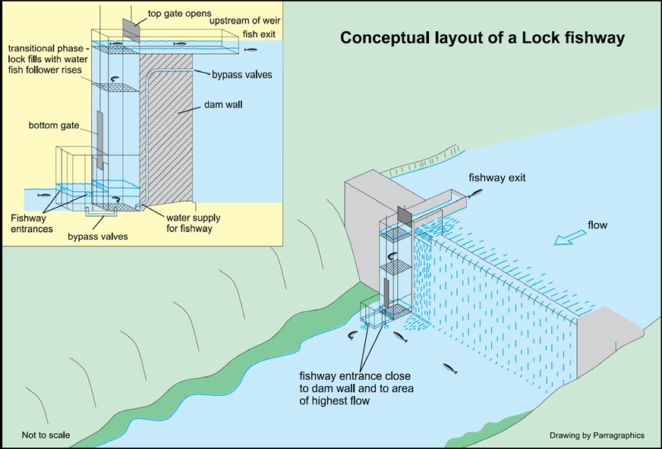
Conceptual layout of fish lock fishway (Diagram from Thorncraft, G. and Harris, J.H. 2000. Fish Passage and Fishways in New South Wales: A Status Report. Cooperative Research Centre for Freshwater Ecology Technical Report 1/2000.)

Beneficial river health outcomes
May increase the geographic distribution of fish species
May allow fish to complete their lifecycle and improve breeding

Adverse river health outcomes May allow exotic species to colonise new reaches of the
river

Associated works
Water temperature management Provision of instream habitat

Information requirements
Hydrology
Migratory and life cycle characteristics of fish Swimming ability of fish
Survey of the site

Table of Contents

Success ranking
No. of applications in Victoria
None, but examples in NSW/QLD

Structural success in Australia
High level of structural success

Success in achieving intended outcome
Moderate – operation and exit arrangements can be problematic

Success factors

Failure
Hydraulic design and physical dimensions are sympathetic to the physiology and migratory behaviour of fish
Hydrology of the stream is compatible with migration and facilitates the hydraulic conditions at the structure necessary for migration

Process Management

mechanisms
Fish do not enter or exit the structure

Exotic species migrate to new areas
Fish cannot find the lock
A combination of attraction flows and crowding screens can be used

Install a fish trap at the upstream end of the lift such that species can be managed
Ensure the entrance to the structure provides the correct migratory signals to the fish

DEMONSTRATION SITES

Site 1
Stream: Burnett River, Qld Basin: Burnett
Contact: SunWater
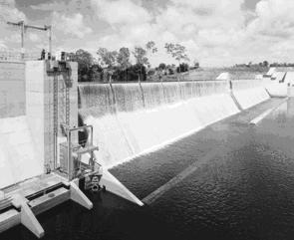
Walla Weir on the Burnett River near Bundaberg, QLD.

Site 2
Stream: Murray River, Yarrawonga Basin: Murray
Contact: Murray-Darling Basin Commission
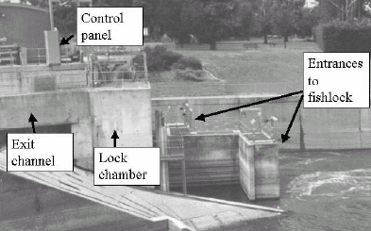
Fish lock Yarrawonga Weir, River Murray
(Photo: Lindsay White 3ASM 3 Brisbane 2001)

Table of Contents

DESIGN GUIDELINES AND RELATED INFORMATION SOURCES
White, L.J., Keller, R., Katopodis, C. and Ladson, A.R. 2002, ‘An approach to maximising fish passage through a fish lock: an Australian case study’, In Fish Migration and Passage: Physiology and Behaviour Symposium, International Congress on the Biology of Fish July 21- 26, 2002, University of British Columbia, Vancouver Canada.

CONSTRUCTION COSTS
$0.5M - $10M per lock.

FISH PASSAGE THROUGH CULVERTS

DESCRIPTION
Culverts are generally pipes or box culverts installed in the bed of a waterway to provide for the passage of vehicles, stock or pedestrians. Culverts are normally designed to carry low flows with high flows over topping or bypassing the structure. Standard design and construction can block fish passage. Culverts can be modified and/or designed to provide conditions suitable for fish passage.

WHY IMPLEMENT?
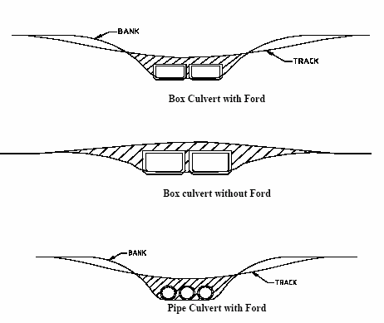
Many native fish species migrate as part of their life cycle. Culverts can represent a barrier to fish preventing fish migration, isolating habitat and interfering with or prevent fish spawning.
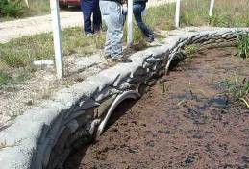
Twin pipe culvert, Wannon River catchment Types of culverts

Beneficial river health outcomes
Adverse river health outcomes
Can improve breeding opportunities and allow fish to complete their lifecycle Can increase the geographic distribution of desired fish species
May allow exotic species to colonise new reaches of the river

Associated works
Rock chutes Rock riprap
Vegetation establishment

Information requirements
Hydrology of the stream
Slope and dimensions of the stream
Dimensions and hydraulics of the culvert structure

Success ranking
No. of applications in Victoria
Estimated to be less than 50 specific applications in Victoria

Structural success in Australia
High level of structural success

Success in achieving intended outcome
Moderate where the structural success has been achieved

Success factors
Some fish species won’t enter dark spaces. Culverts should be constructed to provide light, encouraging fish to enter and pass through the culvert
Culverts should not reduce the stream cross-section to the extent that flow velocities are in excess of the fish burst speed
Culverts should contain flow velocity diversity and depth suited to target species
Culverts should have a natural substrate (bed material)

Table of Contents

Failure Process Management

mechanisms
Culvert is too dark and fish won’t enter

Downstream bed deepening creates a free overfall at the downstream end of the culvert
Flow velocities are too high and uniform

Culvert base is not natural
Maximise the height/diameter of the culvert openings to allow more light to enter the space
Allow light to enter long culverts by including skylights or grated stormwater inlets in the median strip of roads
Culverts for pedestrian or light vehicles can use steel mesh decking in lieu of concrete slabs
Stabilise any headcuts downstream of the culvert such that fish passage is still provided
Set the invert of the culvert at least 150 mm below the stream bed
Consider installing a stabilised energy dissipation pool at the downstream end of the culvert
Do not use pipe culverts. Box culverts should extend across at least 75% of the bed for permanent streams and 50% for ephemeral streams
Install galvanised iron flow deflectors (baffles) within culvert
Provide rough bed to culvert through natural material or grouted boulders
Provide depth of 0.5 m and flow velocity ideally no more than
  - m/s
Set the invert of the culvert at least 150 mm below the stream bed to allow sediments to accumulate

DEMONSTRATION SITES

Site 1
Stream: Barwon River Basin: Barwon
Contact: Corangamite CMA

Site 2
Stream: Unnamed (near Coleraine) Basin: Wannon
Contact: Glenelg-Hopkins CMA

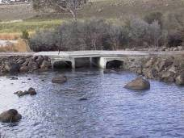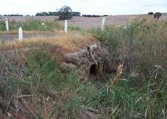

Modified culvert arrangement at road crossing, Barwon River near Deans Marsh
Modified culvert arrangement at road crossing, Unnamed Creek near Coleraine

DESIGN GUIDELINES AND RELATED INFORMATION SOURCES
Table of Contents
Fairfull, S. and Witheridge, G. 2003, Why do Fish Need to Cross the Road? Fish Passage Requirements for Waterway Crossings. NSW Fisheries, Cronulla (available on line at www.fisheries.nsw.gov.au).
Cotterell, E. 1998, Fish Passage in Streams – Fisheries Guidelines for Design of Steam Crossings, Fish Habitat Guideline FHG001, Fisheries Group, Queensland Department of Primary Industries (available on line at www.dpi.qld.gov.au).

CONSTRUCTION COSTS
Approximately $10,000 – accurate determination based on site characteristics.

GRASS CHUTES

DESCRIPTION
Grass chutes comprise a relatively steep, grassed, earthen swale or drain. The structures can be built using native or exotic grasses. While native grasses are preferred from an ecological perspective, the structures may comprise a combination of exotic and native ground covers to enable satisfactory establishment and operation.

WHY IMPLEMENT?
Grass chutes can be used as an alternative to rock chutes within incised systems and to provide for the discharge of overland flow into incised creek systems, where flows are infrequent and of short duration (less than 3 days).
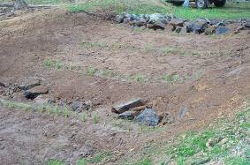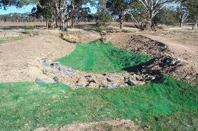

Grass chute near Landsborough, Wimmera River
Grass chute construction near Stawell catchment

Beneficial river health outcomes
Adverse river health outcomes
Acts to reduce the incision of the stream banks and floodplain by tributary inflows to incised streams, thereby reducing sediment supply to downstream reaches
May be more prone to failure than rock structures and thereby more prone to releasing sediment into the stream system

Associated works Fencing Revegetation Weed control
Rock riprap Bank battering

Information requirements
Survey Hydrology
Soil type and proposed vegetation type and related non scour velocities

Table of Contents

Success ranking
No. of applications in Victoria
Estimated to be over 100 applications during past 20 years

Structural success in Australia
Moderate level of success where flow is not competent to scour the chute

Success in achieving intended outcome
High where the structural success has been achieved

Success factors

Failure
Vegetation provides sufficient shear resistance to flow Duration and frequency of flow does not kill vegetation Vegetation is successfully established

Process Management

mechanisms
Rilling within grass area

Failure of revegetation
Jute matting/geotextile reinforcement, design of structure such that maximum velocity does not exceed threshold of vegetation stability
Appropriate vegetation selection

DEMONSTRATION SITES

Site 1
Stream: Retreat Creek Basin: Barwon
Contact: Corangamite CMA

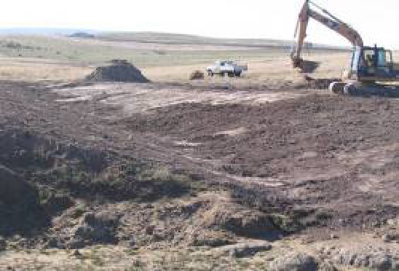

Grass chute construction retreat Creek, near Deans Marsh

Site 2
Stream: Wattle Creek Basin: Wimmera River Contact: Wimmera CMA
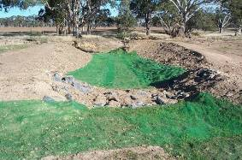

Grass chute near Landsborough, Wimmera River catchment

DESIGN GUIDELINES AND RELATED INFORMATION SOURCES
Table of Contents
Information on threshold shear stress and velocity for a range of vegetation types are provided within Section 6.2 of these Technical Guidelines.

CONSTRUCTION COSTS
Approximately $15/m² of chute surface. Final cost determined by site characteristics and performance required.

INFRASTRUCTURE DECOMMISSIONING

DESCRIPTION
Infrastructure decommissioning refers to the removal of storages, weirs, diversions and other instream structures that adversely impact on the health of waterways.

WHY IMPLEMENT?
The decommissioning of storages and other infrastructure is becoming an increasingly important component of programs of waterway management. Storages and weirs are decommissioned to reduce water loss through evaporation, to enable fish passage, because they have exceeded their design life and/or because investment in their upgrade to meet current operating standards exceeds the cost of alternate water supply arrangements or operational requirements.
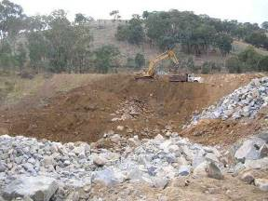
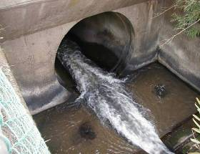

Decommissioning of Honeysuckle Reservoir
(Image courtesy of Earth Tech)
Morwell River Diversion Pipeline to be removed
(Image courtesy of Earth Tech)

Beneficial river health outcomes

Adverse river health outcomes
Provision of longitudinal connectivity including drift, fish passage and riparian corridor
Improved downstream hydrologic regime Reduced downstream sediment starvation
Potential release of toxic substances held in sediments of existing storages
Loss of high trap efficiency and accompanying increase in downstream sediment loads
Potential for loss of some types of aquatic habitat Potential for increased distribution of exotic aquatic fauna

Table of Contents

Associated works Removal of Infrastructure Site remediation
Geomorphic channel design and construction
Weed control
Native vegetation establishment and management
Information requirements Stream hydrology Topographic survey Geotechnical analysis Aerial photography Original design plans Vegetation survey
Fauna survey
Contaminated soil assessment

Success ranking
No. of applications in Victoria
Structural success in Australia
Success in achieving intended outcome

Less than 10 High Significant benefit to the river health is expected but insufficient length of monitoring to quantify

DEMONSTRATION SITES

Site 1 Decommissioning of the Honeysuckle Creek Reservoir
Stream: Honeysuckle Creek Basin: Goulburn
Contact: Goulburn Valley Regional Water Authority
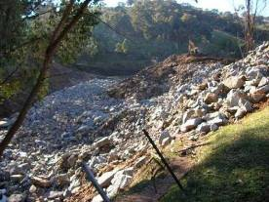
Decommissioning of Honeysuckle Reservoir
(Image courtesy of Earth Tech)

Site 2 Decommissioning of the Morwell River Diversion
Stream: Morwell River Basin: Latrobe
Contact: West Gippsland CMA
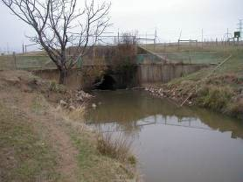
Morwell River diversion near Morwell

Table of Contents

DESIGN GUIDELINES AND RELATED INFORMATION SOURCES
Limited specific design guidelines exist.
Refer Part 5 of these Technical Guidelines for design guidelines on individual components.
Australian National Committee on Large Dams 2003, Guidelines on Dam Safety Management, for general information on dam safety.

CONSTRUCTION COSTS
Variable, refer individual components.

LARGE WOOD INSTALLATION

DESCRIPTION
Large wood installation, also known as the provision of instream structure, comprises the installation and management of single or multiple pieces of timber in the stream system.

WHY IMPLEMENT?
The purpose of the large wood installation is to initiate local scour and establish flow diversity to improve habitat. Alternatively it may be used in a reach to increase hydraulic roughness and reduce overall velocity and to encourage sedimentation within a reach.
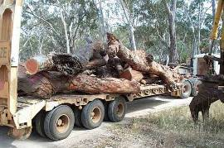
Large wood for installation, Glenelg River at Harrow

Beneficial river health outcomes

Adverse river health outcomes
Associated works
Revegetation Bank protection
Provision of stable instream structure in mobile bed systems Establishment of habitat and flow diversity
Reduced sediment transport through a reach May increase occurrence of overbank flooding Local scour may cause local bank instability

Information requirements
Longitudinal profile and stream cross-section survey Design flow rates
Channel hydraulic and scour analysis Timber size and species availability

Success ranking
No. of applications in Victoria
Over 50 applications over past 15 years

Structural success in Australia
Moderate level of structural success

Success in achieving intended outcome

Moderate where the structural success has been achieved. Habitat utilisation is dependent on many other factors

Table of Contents

Success factors Physical in-stream processes are amenable to the introduction of timber
Role of introduced habitat is not limited by other factors such as water quality, hydrology, etc
Large wood is a natural habitat feature of the stream
Scour hole formation, size and persistence should be assessed through time series analysis coupled with identification of species requirements for depth, timing duration

Failure Process Management

mechanisms
Mobilisation of the timber in flood events

Burial of timber by sediment
Bank erosion and outflanking
Decomposition of log
Other stream health issues limiting habitat utilisation
Use of Australian hardwood timber
Maintenance of timber moisture by ensuring timber is partially buried in stream bed
Mobilisation force analysis
Provision of additional anchoring if and as needed Assessment of hydrology and sediment transport

Provision of suitable complementary bank erosion control works
Use appropriate timber and monitor

Assess river health and address all limitations on stream health

Table of Contents

DEMONSTRATION SITE
Site 1 Harrow Stream: Glenelg River Basin: Glenelg
Contact: Glenelg Hopkins CMA
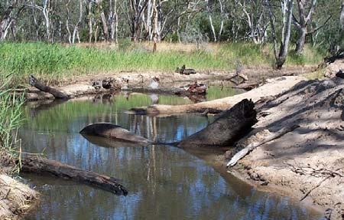
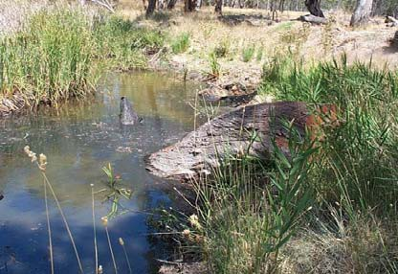
Large wood installation, Glenelg River at Harrow Large wood installation, Glenelg River at
Harrow

DESIGN GUIDELINES AND RELATED INFORMATION SOURCES
Refer Part 5 Design Guidelines within these Technical Guidelines.
Brooks, A. et al. 2006. Design guideline for the reintroduction of wood into Australian streams, Land & Water Australia, Canberra.

Rutherfurd, I., Marsh, N., Price, P. and Lovett, S. 2002. Managing woody debris in rivers, Fact Sheet 7, Land and Water Australia, Canberra www.rivers.gov.au/acrobat/facts07.pdf.

CONSTRUCTION COSTS
$400 to $1,000 per log for transport and installation depending on total number and transport distance.

LOG SILLS

DESCRIPTION
Log sills are single or multiple pieces of large wood anchored to the stream bed and bank. Consisting of logs usually larger than 200 mm in diameter, they are usually placed perpendicular to the flow and across the channel.

WHY IMPLEMENT?
Log sills are used to create pool habitat, assist fish migration through the provision of a range of flow velocities, provide instream timber habitat and to control bed erosion by trapping and holding gravel.
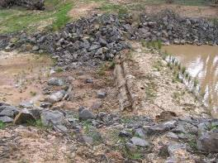
Log sill, with accompanying rock beaching, Wattle Ck, tributary of the Wimmera River

Beneficial river health outcomes

Adverse river health outcomes

Associated works
Revegetation Rock beaching
Create physical and hydraulic diversity in uniform channels Control bed erosion
Collect and retain gravel Create pool habitat
Outflanking, erosion and sediment generation may become a problem if logs are not keyed into stream banks correctly
Prone to undermining and outflanking without accompanying rock beaching
They have the potential to become barriers to fish migration at low flow

Information requirements
Longitudinal profile survey
Stream cross-section survey or estimate Available timber type
Estimation of stream flow (hydrology)

Success ranking
No. of applications in Victoria
Estimated to be less than 50 applications in Victoria

Structural success in Australia
Low level of success for grade control without rock beaching. Prone to outflanking and undermining

Success in achieving intended outcome
High where the structural success has been achieved.
Moderate where habitat provision is the objective.

Table of Contents

Success factors That physical processes are complementary to the introduction of log sills. Presence of process such as knickpoint migration may undermine such structures
That the utilisation or value of introduced habitat is not limited by other factors such as water quality, hydrology, etc
That large woody debris is a natural habitat feature of the stream

Failure mechanisms
Process Management

Movement of log Key logs into banks, anchor to stream
bank/bed

Burial within sediment Upstream sediment management Decomposition of log Use appropriate timber and monitor

Sedimentation within pool
Undermining and outflanking of sill
Monitor

Key an adequate distance into the stream bank. Provide rock beaching to protect bank at point of key in. Provide low point in the sill to direct low flows away from the stream bank. Monitor

Table of Contents

DEMONSTRATION SITE

Site 1
Stream: Wattle Creek Basin: Wimmera Contact: Wimmera CMA
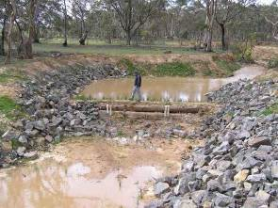

Log sill and rock beaching at Wattle Creek,
Wimmera River catchment
(Image courtesy of Earth Tech)

DESIGN GUIDELINES AND RELATED INFORMATION SOURCES
NA

CONSTRUCTION COSTS
Dependent on availability of logs and rock beaching. Generally cheaper than rock chutes.

LUNKERS (CONSTRUCTED UNDERCUT BANKS)

DESCRIPTION
LUNKERS (Little Underwater Neighbourhood Keepers Encompassing Rheotactic Salmonids) are a form of constructed undercut bank. The term and technique were developed in the USA. Undercut banks are an important habitat component of meandering stream systems, however stream bank stabilisation works (such as rock riprap and bank battering) can result in the destruction of undercut banks.

WHY IMPLEMENT?
LUNKERS are a means of providing undercut bank habitat in stream systems modified by bank stabilisation works such as battering and rock beaching.

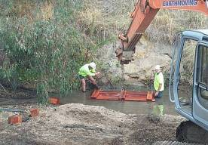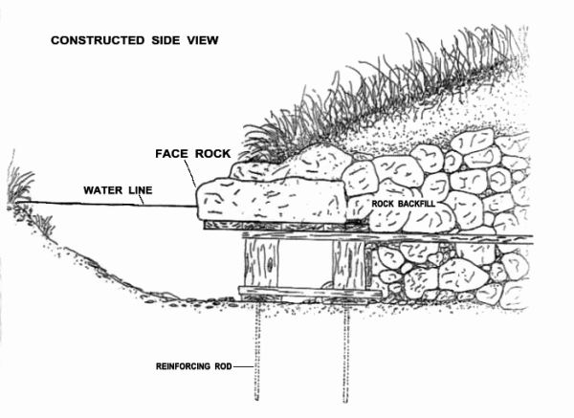

LUNKERS installation upper Goulburn River (Photo courtesy of Goulburn Broken CMA)

Conceptual drawing
(Source: http://lwcd.org/lunkers.htm)

Beneficial river health outcomes

Adverse river health outcomes

Associated works
Revegetation Fencing
Bank restoration
Provision of instream undercut bank habitat for fish and other aquatic species in modified system, such as urban streams and regulated streams with extensive rock beaching, and sites with battered and otherwise “stabilised” banks
Construction works can involve significant bank disturbance and may result in vegetation damage and/or removal
Bank disturbance can result in a short term increase in turbidity and potential longer term bank instabilities
Localised stream bed and bank scour where construction of LUNKER has resulted in encroachment into the stream channel

Information requirements
Estimation of stream flow (hydrology) Stream cross-section survey or estimate Stream bed scour estimate
Ground conditions (to determine anchor requirements)
Identification of aquatic species likely to inhabit undercut banks and details of body size and their habitat preferences

Table of Contents

Success ranking
No. of applications in Victoria
Uncommon - less than 10 sites within Victoria

Structural success in Australia

Uncertain - existing structures have been in place for less than 5 years

Success in achieving intended outcome

Not confirmed for Australia. Dependent on design being based on species likely to inhabit undercut bank habitat

Success factors

Failure
LUNKERS are not recommended where sediment is likely to be deposited Most successfully used in streams with gravel-cobble beds
Enhanced success subject to soil bioengineering systems and vegetative plantings to stabilise the upper bank and ensure a regenerative source of stream bank vegetation

Process Management

mechanisms
Marine borers in timber LUNKERS in coastal streams
Adopt recycled plastic or concrete material to construct LUNKERS

Sedimentation Adopt suitable width of LUNKERS to maintain
normal/base flow water level above structure Monitor for sediment accumulations

Bed scour and LUNKERS
collapse

DEMONSTRATION SITES

Site 1
Stream: Acheron River Basin: Goulburn
Contact: Goulburn-Broken CMA
Estimation of scour depth and provision of suitable protection to structure

Site 2
Stream: Mitchell River Basin: Mitchell
Contact: East Gippsland CMA

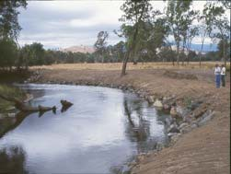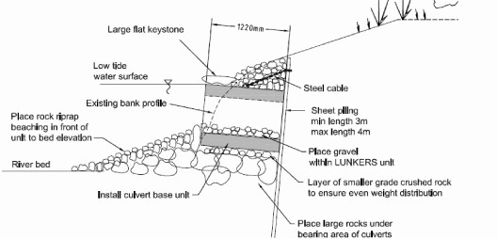

Upper Goulburn River following lunker installation (Photo taken by Paul Brown, MAFRI - Snobs Creek)
Design Drawing LUNKER installation, Mitchell River
(courtesy Earth Tech 2003),

Table of Contents

DESIGN GUIDELINES AND RELATED INFORMATION SOURCES
Refer: http://lwcd.org/lunkers.htm

CONSTRUCTION COSTS
Estimated at $500 for small timber structures built by volunteers, up to $5,000 for major structures in estuarine environments.

PILE FIELDS

DESCRIPTION
Pile fields, also known as pin groynes, are lines of timber logs generally driven vertically into the bed. Pile fields have replaced the use of timber pile and rail structures. The structures are intentionally porous, with through flow of low velocity, resulting in sediment deposition both upstream and downstream of the structure. These structures vary from the less porous systems such as rock groynes and engineered log jams that can be used to create scour holes.

WHY IMPLEMENT?
Pile fields are a means of using timber to achieve stream bank protection, channel encroachments and alignment training. The approach is well suited to sites where no long term evidence of stream intervention works is sought.
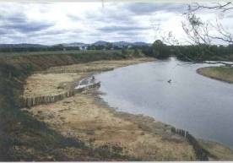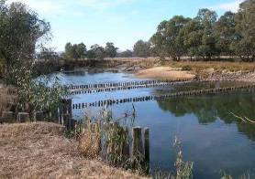

Pile fields for alignment training, Wodonga Ck, north east Victoria
Pile fields combined with bed seeding, Dights Ck, River Murray, NSW

Beneficial river health outcomes

Adverse river health outcomes
Stream bank erosion control through alignment training
Channel encroachments for initiation of scour Capture of part of the sediment load
No long term visual evidence of channel intervention works
The approach requires access to the stream bank and stream bed by machinery and field crews. Further, the approach can require relocation of stream bed sediments. Access to sites and sediment relocation can create significant instream and stream bank disturbance that will take some time to recover

Associated works
Fencing Weed control Revegetation
Off stream watering Fencing across creeks Rock beaching

Information requirements
Aerial photograph
Design sediment size and settling velocity Available timber size
Estimation of stream flow (hydrology) Stream velocity assessment

Success ranking
No. of applications in Victoria
Estimated to be in excess of 50 applications in Victoria

Structural success in Australia

Moderate level of structural success. Refer success factors and failure mechanisms

Success in achieving intended outcome

High where the structural success has been achieved

Table of Contents

Success factors

Failure mechanisms
Approach relies on vegetation establishment to succeed timber piles.
Failure to establish vegetation will result in failure of project
Approach relies on sediment deposition within pile field. Therefore the approach has only been successful where sediment is being transported through the reach
Adoption of design approach reported in Guidelines for Stabilising Waterways (Standing Committee on Rivers and Catchments 1991)
Inclusion of scour depth analysis into design

Process Management

Outflanking Provision of timber or rock cut off into bank
Selection of an alignment that is consistent to the plan form of the larger pattern

Undermining of pile
Inclusion of scour depth analysis in design Provision of rock beaching at toe of piles Provision of returns or tails on pile fields

Timber breakage Selection of resistant hardwood timbers
Design of timbers to resist impact loads
Borer and decay Use of hardwood and provision of revegetation to take over role of piles

DEMONSTRATION SITES

Site 1 Braithwaite Plantation
Stream: Ovens River Basin: Ovens
Contact: North East CMA

Site 2 Pratts Lane Stream: Black Range Creek Basin: Ovens
Contact: North East CMA

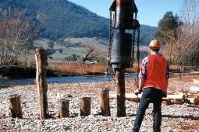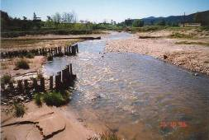

Pile field installation Ovens River, north east Victoria
Pile field Black Range Creek, north east Victoria

DESIGN GUIDELINES AND RELATED INFORMATION SOURCES
Table of Contents
Refer Section 6.3 Design of timber piles in these Technical Guidelines.

CONSTRUCTION COSTS
Typically $80 to $140 per pile driven based on:
- supply and delivery of timber piles - $20-$60 per pile based on up to 300 mm diameter and 8 m length;
- pitching rate for timber pile up to 300 mm diameter – approximately $5.00 per m of pile length;
- driving rate for timber pile up to 300 mm diameter - $5.00 per m of pile length; and
- Significant increase in supply and installation costs accrue with timber sizes in excess of 400 mm diameter and 10 m in length.

ROCK BEACHING

DESCRIPTION
Rock beaching involves the placement of quarried rock on stream banks. The rock is founded on the bed of the stream and generally extends up the portion of the bank threatened by erosion. The technique provides localised protection of stream banks and does not address system wide processes. The technique is also known as rock revetment or rock riprap.

WHY IMPLEMENT?
Rock beaching is used as a form of armouring of stream banks against erosion. This technique is often undertaken to protect economic assets such as bridges. It is also often used in conjunction with techniques such as alignment training and rock chutes to reduce the risk of these structures failing due to bank erosion.

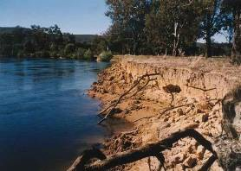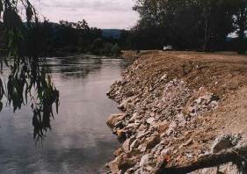

Eroding bank prior to placement of rock beaching, Murray River (Photo courtesy Tony Crawford, DIPNR)
Rock beaching covering battered bank, Murray River (Photo courtesy Tony Crawford, DIPNR)

Beneficial river health outcomes
Adverse river health outcomes
Stream bank erosion control and associated reduction in sediment loads

The approach does not address the cause of erosion and as a consequence excess energy within the system may still cause erosion elsewhere
Approach is not sympathetic to the plan form evolution of meandering rivers. Hence, likely to cause plan form instabilities and hence continuing erosion in the long term
Approach limits opportunities for species of fauna (birds, mammals, reptiles, macro invertebrates and fish) that burrow into stream bank
Destroys undercut bank habitat

Associated works
Fencing Weed control Revegetation
Off stream watering Fencing across creeks LUNKERS

Information requirements
Longitudinal profile survey
Stream cross-section survey or estimate Available rock size
Estimation of stream flow (hydrology)

Table of Contents

Success ranking
No. of applications in Victoria
Estimated to be over 1,000 applications of varying lengths

Structural success in Australia

High level of success where well designed and implemented

Success in achieving intended outcome

High where the structural success and revegetation has been achieved

Success factors

Failure mechanisms
Size and grading of beaching is designed to withstand shear stress
Application of sound engineering judgement regarding suitability of bank material (foundation) and placement of filter material between bank material and rock rip-rap (refer discussion in section 5.4.4)
The rock beaching is designed to fit within the planform development of the stream
The stream is not subject to ongoing deepening as it has potential to undermine the rock beaching
Revegetation program is successful

Process Management

Outflanking Key rock into bank. Assess plan form development of the stream

Undermining of toe Make provision for bed scour at the toe. Address any ongoing degradation of the stream bed

Loss of rock from face
Sliding failure of rock mass

DEMONSTRATION SITES

Site 1
Stream: Ovens River Basin: Ovens
Contact: North East CMA
Analysis of rock size using RIP RAP software

Failures associated with use of geotextile under rock riprap (refer discussion in section 5.4.4)

Site 2
Stream: Mitta Mitta River Basin: Upper Murray, Victoria Contact: North East CMA

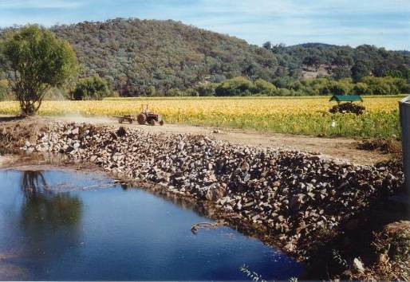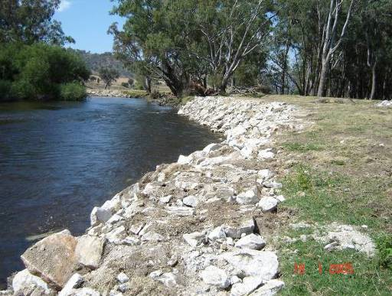
Table of Contents

Ovens River, north east Victoria Mitta Mitta River, north east Victoria

DESIGN GUIDELINES AND RELATED INFORMATION SOURCES
CRC for Catchment Hydrology 2005, Guidelines for the Design of River Bank Stability and Protection using RIP-RAP, CRC for Catchment Hydrology: www.toolkit.net.au/riprap.
Refer Part 5 of these Technical Guidelines.

CONSTRUCTION COSTS
$5,000 to $10,000 per site for minor rock beaching.
$10,000 to $20,000 per site for major rock beaching.

ROCK CHUTES

DESCRIPTION
Rock chutes are also known as rock riffles and rock ramps. They generally involve the excavation of the bed and banks of a stream and the placement of graded (quarried) rock often forming a small weir in the stream.

WHY IMPLEMENT?
Rock chutes are largely constructed to control the gradient of stream beds. However, they can be used to address other stream management issues such as the provision of fish passage, diversion weirs, sediment stabilisation, flow control structures within constructed wetlands or the creation of riffle and pool habitat.
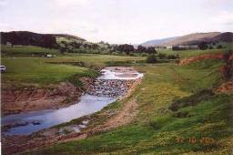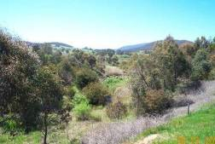

Rock chute in Barwidgee Creek (Ovens River Catchment) 1992
Rock chute in Barwidgee Creek (Ovens River Catchment) 2002

Beneficial river health outcomes

Adverse river health outcomes
More stable bed substrate and banks which will in turn benefit flora and fauna seeking to establish in this reach
Provision of fish passage through existing weirs
Establishment of pool habitat and pool-riffle sequences by using multiple chutes
Gully erosion control
Storage of eroded sediment thereby reducing sediment inputs downstream
Successful implementation will result in reduction in downstream sediment supply, and may initiate downstream sediment starvation, and in the absence of complementary downstream vegetation establishment program, can initiate downstream progressing bed degradation
Poorly designed and constructed structures can have an adverse impact on fish passage

Associated works
Fencing Weed control Revegetation
Off stream watering Inclusion of fish passage

Information requirements
Longitudinal profile survey
Stream cross-section survey or estimate Available rock size, grading and density Estimation of stream flow (hydrology)

Success ranking
No. of Applications in Victoria
Estimated to be over 500 applications over
past 20 years

Structural success in Australia
High level of success where well designed and implemented

Success in achieving intended outcome
High where the structural success and revegetation has been achieved

Table of Contents

Success factors

Failure mechanisms
The chute is designed to fit with the plan form development of the stream
The development of the longitudinal profile is understood and the chute controls this development without being threatened by it
Stream power within system has been reduced through chute construction, bank battering and revegetation to within threshold limits.
Revegetation and maintenance programs are effective. In particular reeds and sedges such as Phragmites australis are used to assist in stabilising bed material
Application of sound engineering judgement regarding suitability of bed material (foundation) and placement of filter material between the bed material and rock rip-rap (refer discussion in section 5.4.6)
Regular inspections and undertaking necessary maintenance

Process Management

Outflanking Consider plan form processes. Construct an appropriate cut- off into the crest of the chute. Always provide filter cloth in this trench
Periodic inspection

Undermining of toe

Loss of rock from face

Loss of rock due to willow growth

DEMONSTRATION SITES

Site 1
Stream: Barwidgee Creek
Consideration of downstream deepening. Design of hydraulic jump to occur on the chute or apron for all flows – use CHUTE program www.toolkit.net.au/chute
As a result of undersized rock or development of a failure plane between rock and either bed material or filter fabric Design of rock size for chute – use CHUTE program
Cautious use of filter fabric (refer discussion in section 5.4.6) Monitoring and maintenance of structure

Site 2
Stream: Wormbete Creek

Basin: Ovens River, North East Victoria Contact: North East CMA
Basin: Barwon
Contact: Corrangamite CMA

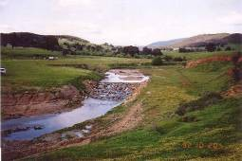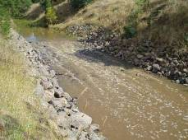
Table of Contents
Rock chute Barwidgee Creek, north east Victoria Rock chute Wormbete Creek, Barwon River catchment

DESIGN GUIDELINES AND RELATED INFORMATION SOURCES
CRC for Catchment Hydrology 2003, Guidelines for the Design of Rock Chutes using CHUTE, CRC for Catchment Hydrology: www.toolkit.net.au/chute.

Natural Resources Conservation Service 1985, Grade Stabilization Structure, Conservation Practice Standard, Code 410, US Dept of Agriculture.

Refer Section 5.4.6 in these Technical Guidelines.

CONSTRUCTION COSTS
$10,000 small chute $15,000 moderate chute $20,000+ major chute

ROCK GROYNES

DESCRIPTION
Rock groynes are largely impermeable deflectors placed into stream systems to prevent bank erosion, create deposition and alter the local planform of the stream. Rock groynes provide some erosion protection and result in small scale deposition, however they do not encourage deposition at the same rate as pile field retards and are more suited to establishment of localised scour rather than for erosion control. Rock beaching is generally needed in conjunction with the groynes to prevent erosion between groynes.

WHY IMPLEMENT?
Rock groynes have been used for both erosion control through the deflection of water away from an eroding bank and for initiation of scour through the acceleration and deflection of flow.

Beneficial river health outcomes

Adverse river health outcomes

Associated works Rock beaching Fencing
Weed control Revegetation
Off stream watering
Can be used with limited success for stream bank erosion control,
however deposition and subsequent vegetation establishment at the toe of the bank increases stability
Can create localised instream scour and accompanying habitat formation
Rock groynes are not well suited to erosion control works. Rock riprap (revetment/beaching) are better applications of rock for erosion control. Permeable structures are preferred over rock groynes for alignment training style erosion control projects. Poorly designed and/or constructed rock groynes might exacerbate bank erosion

Information requirements
Aerial photograph
Design sediment size and settling velocity Available timber size
Estimation of stream flow (hydrology) Estimation of design water levels (hydraulics)

Fencing across creeks

Success ranking
No. of applications in Victoria
Estimated to be less than 50 applications in Victoria over past 20 years

Structural success in Australia
Moderate level of structural success (they remain in place)

Success in achieving intended outcome
Low level of success for erosion control

Table of Contents

Success factors Rock is founded on a stable substrate
Groynes fit with the plan form development of the stream Inclusion of vegetation establishment in works
Inclusion of scour depth analysis into design Inclusion of necessary associated works i.e. beaching
Quality (size and rock type) of material and construction

Failure mechanisms
Process Management

Outflanking Provision of adequate rock cut off into bank
Selection of an alignment that is consistent to the plan form of the larger pattern within the stream.
Provision of rock beaching adjacent the groynes Undermining of toe Make provision for bed scour at toe

Mobilisation of rock Compare threshold of motion and applied shear
stresses during design

Table of Contents

DEMONSTRATION SITE
Site 1 Great Alpine Way Stream: Tambo River Basin: Tambo
Contact: East Gippsland CMA
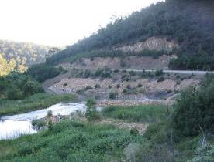
Rock groynes, Tambo River, East Gippsland

DESIGN GUIDELINES AND RELATED INFORMATION SOURCES
NA

CONSTRUCTION COSTS
$50-100/tonne for supply and placement of rock.

SEDIMENT EXTRACTION

DESCRIPTION
Sediment extraction involves the removal of bed load sand and gravel sediments from the river channel. It should only be used in rare circumstances and in streams that have been aggraded with slugs of sediment from outside of the reach resulting from human disturbance. Sediment extraction may involve removing sediment from the full width of the bed or from bars of accumulated material.

WHY IMPLEMENT?
Sediment extraction is undertaken to remove accumulated sediment from within the channel and hence encourage channel rejuvenation.
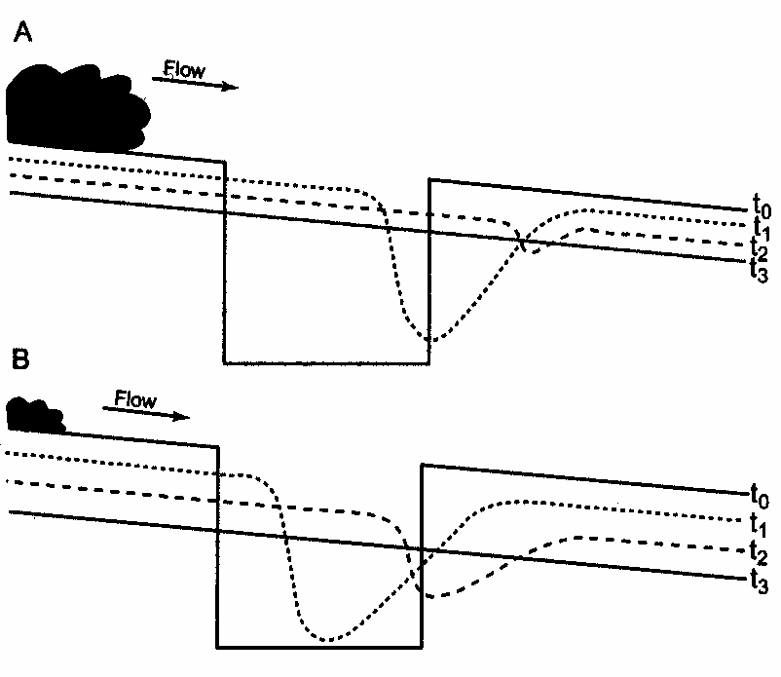
Schematic effects of extracting sediments from a stream bed (Source: Rutherfurd et al. 2000)

Beneficial river health outcomes

Adverse river health outcomes
Protection of downstream reaches of stream from excess sediment transport and deposition
Initiation of channel rejuvenation through stream bed deepening in aggraded systems
Can result in substantial responses and changes to physical form both upstream and downstream
Instream and floodplain assets such as wetlands may be destroyed by channel deepening resulting from sediment extraction
Sediment extraction may reduce habitat diversity, destroy riverbed and associated habitat and may cause a decline in the local fish population
Extraction may cause re-suspension of sediment with consequent adverse downstream impacts

Associated works
Revegetation
Large woody debris
Information requirements Depth of sediment Hydrology
Annual bedload transport rates Stream bed longitudinal profile

Table of Contents

Success ranking
No. of applications in Victoria
Estimated to be in excess of 50 applications in Victoria

Structural success in Australia
Moderate level of structural success. Refer success factors and failure mechanisms below

Success in achieving intended outcome
High where the structural success has been achieved

Success factors

Failure
Rate of extraction brings sediment transport and deposition processes more in balance
Sediment extraction helps restore more natural physical form
Implementation is sympathetic to river health. Minimising impacts on water quality and benthic habitat

Process Management

mechanisms
Sediment
re-suspension
Period of operation needs to be governed by the need to minimise effect of turbidity on downstream values.
Sediment is extracted from the downstream face of the bar not exposed to currents

Bank collapse Can cause deepening and therefore bank collapse upstream and downstream
Damage to habitat Only work and stockpile sediment on one bank
Deep or repeated excavation at one site is preferable to minor excavations over a long stretch of stream
Introduce irregularities in the excavated channel bed or banks by leaving some areas of shallow flow amongst the deeper areas
Reinstate snags after excavation is complete, or create artificial obstructions

DEMONSTRATION SITES

Site 1
Stream: Reedy Creek Basin: Ovens
Contact: North East CMA

Site 2
Stream: Glenelg River Basin: Glenelg
Contact: Glenelg-Hopkins CMA

Table of Contents
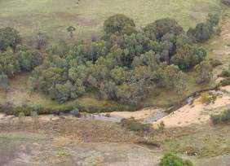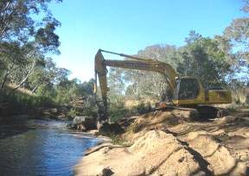
Sand in Reedy Creek near Wangaratta Sand extraction Glenelg River near Casterton

DESIGN GUIDELINES AND RELATED INFORMATION SOURCES
Rutherfurd I.D., Jerie, K. and Marsh, N. 2000, A Rehabilitation Manual for Australian Streams, Land and Water Australia, Canberra, pp. 326-27.

CONSTRUCTION COSTS
$100-150 per hour of sediment extraction (excluding cartage).

SILT FENCES AND SEDIMENT TRAPS

DESCRIPTION
Silt fences and sediment traps are structures designed to physically capture sediment or slow down flow to cause sediment deposition. The structures are simple to construct and generally not used as a permanent solution or to control large erosion issues. The structures are best suited to small streams or used to control sediment inputs to the channel. The structures are built using materials which are prone to decay or movement such as hay bales, silt fence and stakes. More permanent variations involve driving wooden posts with wire mesh attached to cables.

WHY IMPLEMENT?
Silt fences may be used to stabilise small erosion heads (less than 0.6 m drop) or minor bed deepening, to trap sediment and reverse minor bed deepening processes and/or be placed on features such as the floodplain or benches to capture sediment and accelerate the recovery of these features. They may also be used to prevent sediment entering the stream from works sites or other potential sources.
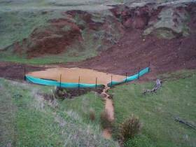
Instream sediment trap, Adelaide Hills, South Australia

Beneficial river health outcomes

Adverse river health outcomes
Control minor bed deepening processes
Accelerate the recovery of natural features and habitat
Reduce elevated sediment loads entering and moving through the stream Materials used may visually or physically pollute the stream

Associated works
Revegetation

Information requirements
Stream hydrology Survey information Sediment grading
Sediment transport behaviour

Success ranking
No. of applications in Victoria
Estimated to be over 1,000 applications

Structural success in Australia

Moderate level of success where well designed and implemented

Success in achieving intended outcome

High where the structural success has been achieved
The structures are more effective in shallow flows

Table of Contents

Success factors

Failure
Structures are correctly orientated to the flow
Structures are designed to accommodate the prevailing flow conditions
There is sufficient sediment of the right grading to facilitate the desired outcome

Process Management

mechanisms
Fences washed away
Sediment accumulation or structural decay
Lack of sediment trapping
Design fences for the flow and sediment regime

With time and sediment accumulation these structures will require reinforcing, repair or replacement
Consider grading and quantities of sediment in transport

Table of Contents

DESIGN SUGGESTIONS
    - In effect these structures act as small weirs. When multiple structures are placed in series they can greatly improve conditions for revegetation, through reducing stream power and providing sediment for vegetation to grow in.
    - As a general rule, when placed in series the structures should be spaced so that a horizontal line from the crest of a structure carries to the toe of the next structure upstream
    - The structures should be 30 – 60 cm high. The lowest point of the structure should be located at the centre of the watercourse so that flows are concentrated in the centre of the stream.
    - Care should be taken where the structures meet the stream banks to minimise the threat of flows passing around the edges of the structure.
    - Hay bales can be used to form a notched weir. The structure may be one hay bale wide in the centre and two hay bales wide against the banks to encourage most flow to stay away from the banks. Extra stakes should be driven through the hay bales provide extra strength to the structure.
    - The structures are best suited to small streams with coarse bed sediments (sands and gravels). The structures can be used in quite steep streams providing the spacing between structures is small.
    - Other materials such as sand or cement filled bags can be used as alternatives to hay bales.
    - These structures will require regular monitoring and maintenance.

DESIGN GUIDELINES AND RELATED INFORMATION SOURCES
Earth Tech 2003, Manual for Small Scale Watercourse Erosion Control Works, Onkaparinga Catchment Water Management Board, South Australia.

John Botting and Associates, and Bellette, K. 1999, Stormwater Pollution Prevention, Code of Practice for the building and construction industry, Environmental Protection Authority, South Australia.

CONSTRUCTION COSTS
Construction costs vary depending on materials and size of structures. Simple sediment traps can be implemented for minimal cost, while more permanent structures will be more expensive.

WETLAND AND FLOODPLAIN ENGAGEMENT

DESCRIPTION
Wetland and floodplain engagement comprises a suite of activities and works to provide hydrologic and ecological connection between the stream and the adjoining floodplain and wetlands.

WHY IMPLEMENT?
Floodplains and floodplain wetlands are integral components of the stream system. Healthy floodplains and floodplain wetlands rely on hydrologic and ecological connectivity with the river and vice versa, healthy rivers rely on connectivity with the floodplain and floodplain wetlands.
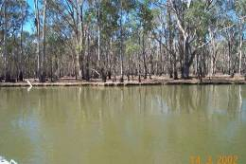
Barmah Choke, Murray River (Photo courtesy of Earth Tech)

Beneficial river health outcomes

Adverse river health outcomes
Improved wetland health including increased recruitment of some floodplain vegetation e.g. red gum, and increased secondary production of floodplain fauna
Improved river health through improved nutrient cycling and carbon exchange
Provision of breeding opportunities for fish and birds
Increased wetland watering may reduce availability of available environmental flows to other water dependent ecosystems
Insufficient flushing of inundated areas may lead to “blackwater” events in which deoxygenation occurs in carbon rich water, leading to fish kills
Increased flooding of social and economic assets

Associated works
Provision of appropriate environmental water allocation to wetland
Provision of appropriate environmental flow (wetting and drying) regime
Removal of levees and other impediments to flow
Native vegetation establishment and management
Provision of alternate wetland watering arrangements as required

Information requirements
Aerial photography
Wetland watering requirements Estimation of stream flow (hydrology) Hydraulic processes for wetland watering Vegetation condition and dynamics

Table of Contents

Success ranking
No. of applications in Victoria
Less than 20 specific projects

Structural success in Australia
Moderate success in Barmah Forest and Dowds Morass

Success in achieving intended outcome

Ongoing monitoring suggests improvements in wetland health. Benefit to the river health is expected but insufficient length of monitoring to quantify benefits

DEMONSTRATION SITES
Site 1 Barmah Forest Stream: Murray River Basin: Murray
Contact: Goulburn Broken CMA

Site 2 Heart Morass Stream: Latrobe River Basin: Latrobe
Contact: West Gippsland CMA

Table of Contents
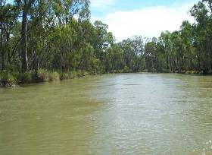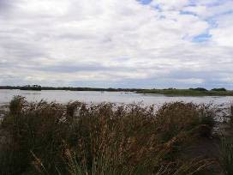
Barmah forest, River Murray, Victoria Heart Morass, Latrobe River, West Gippsland

DESIGN GUIDELINES AND RELATED INFORMATION SOURCES
Refer Part 5 Design Guidelines for individual components.

CONSTRUCTION COSTS
NA - refer individual components.

Table of Contents

This Part 4 of the Technical Guidelines provides waterway managers with access to information that may assist with the selection and use of materials employed in the implementation of waterway management projects.

COMMONLY USED MATERIALS
Basic materials used in waterway management project include:

    - vegetation
    - timber
    - rock
    - geotextiles.
These materials are discussed below. Other materials not discussed include, but may not be limited to, concrete and steel, herbicides, pesticides and fencing materials.

VEGETATION
Native vegetation is the most useful and effective material available to the waterway manager. Native vegetation is an essential component of riparian habitat, assists in the provision of instream habitat and is a primary form of instream sediment management. Vegetation provides both armouring of stream bed and bank material and can increase channel roughness, reducing the bed shear component of total shear. Vegetation management can include but may not be limited to stock control, revegetation, and weed management. Vegetation establishment and management are essential components of all stream management projects. Further information on vegetation establishment and management can be found in Section 5.3 of these Technical Guidelines and at www.greeningaustralia.org.au.

TIMBER (AND LARGE WOOD)

BACKGROUND TO TIMBER APPLICATIONS
Timber can be successfully used in a number of stream management applications. However a clear understanding of the issues and of the success factors for the proposed design arrangements are necessary to ensure a successful outcome.

Timber can be used in stream systems to:

      - induce sedimentation, by increasing roughness
      - induce stream bed scour by local flow acceleration
      - provide a stable stream substrate
      - provide instream, riparian and floodplain habitat.

SEDIMENTATION
Timber is a form of roughness in stream systems. As such timber acts to reduce stream velocity. Its removal has been attributed to increasing stream power, shear stress and velocity in stream systems. This was the basis of much of the timber removal from stream systems throughout Victoria up until the early 1980s. The increase in stream velocity following the removal of timber reduced flooding. In addition, the increased stream power and velocity associated with the removal of the timber also resulted in channel enlargements. Such enlargements further reduced flooding. Significant channel changes have been attributed to the removal of timber, this includes channel enlargements in the Ovens and King River systems in north east Victoria and channel incision through the Cann River in East Gippsland.

The strategic introduction of timber can be used to increase channel roughness and reduce stream power, shear stress and velocity at a site or within a reach. The reduction in these hydraulic parameters can lead to sediment deposition. This process has been

Table of Contents

applied to waterway management to reduce bank erosion and create preferential sediment deposition. This roughness based approach to erosion control has most commonly been applied as pile fields. Substantial trial and error has gone into the development of pile field arrangements and the approach is successfully adopted by waterway designers for a limited range of stream bank erosion situations.

SCOUR
Research into the use of timber in stream systems for the initiation of local scour has been undertaken and continues. Much of the research has been undertaken to identify arrangements for timber installations to maximise temporal and spatial scour hole formation.

The factors and arrangements that have been found to be associated with scour hole formation include:

- alignment of bank attached timber in an upstream direction
- horizontal timber placement
- placement of timber at or immediately above stream bed elevation
- maximisation of blockage ratio i.e. 0% permeability of structure
- maximising scour will result in tradeoffs with some other outcomes.

ARMOURING
Timber can be used to provide local and more general bed and bank armouring examples include log sills and the bank erosion technique known as “brushing”. However alternate approaches to armouring such as the use of rock will provide more effective armouring based management, enabling higher value uses for limited timber resources.

INSTREAM HABITAT
Instream timber forms an essential component of Australian lowland river systems. Instream timber is often the primary form of instream diversity. Instream timber can assist in the initiation of scour holes, and provide stable substrate in sand bed systems. Timber can be introduced into stream systems to provide direct habitat, separate from any hydraulic influence it may have.

TIMBER APPLICATIONS
Substantial trial and error and experimentation has been undertaken into waterway management timber applications in Victoria. It is interesting but not surprising to note that the trial and error efforts to improve the design of timber applications for the encouragement of sediment deposition have lead to pile field designs that are diametrically opposed to the developing arrangements for timber installations that maximise scour. Factors associated with successful waterway interventions for sedimentation and scour are provided in Table 4.1.

WORK OPTION USING TIMBER

PILE FIELDS RETARDS
Pile fields are used to reduce energy in a range of flow events converting sites of scour to create depositional environments suitable for vegetation establishment. In the longer term as the timber structures decay it will be the established vegetation that provides the stability to the site. Design guidelines for pile field retards are provided in Section 5.4.3 of these Technical Guidelines.

Table of Contents

Table 4.1 Factors associated with successful scour and deposition

Feature of stream or structure Success factors

 | Maximisation of sedimentation (minimisation of scour)  e.g. pile field | Maximisation of scour (minimisation of deposition)  e.g. large wood
Sediment load | Excess sediment load | Low sediment load
Alignment of bank attached | Structure aligned with direction | Structure aligned upstream into
structures | of flow | flow
Tail on bank attached structure/vortex reducing tail | Presence of tail/wing | No tail/wing
Density of obstruction | Permeable | Impermeable

LARGE WOOD
Single pieces of large wood can be used to increase channel roughness in a similar manner to pile fields. However the installation of large wood is often better applied as:

  - solid substrate in streams where such substrate has been lost or is absent such as sand bed streams;
  - direct physical habitat through the creation of hydraulic diversity; or
  - indirect physical habitat through the creation of scour holes.
An approach for the analysis of timber stability is provided in Section 6.4 of these Technical Guidelines.

ENGINEERED LOG JAMS
Engineered log jams work in a similar manner to single pieces of large wood. The difference lying in the large hydraulic impact and potential scour holes that can be created through the installation of the log jam.

An approach for the analysis of engineered log jam stability is provided in Section 6.4 of these Technical Guidelines.

LOG SILLS
Log sills are a form of grade control structure that can be applied to small stream systems. Log sills are less robust than other forms of grade control than rock chutes and may present a barrier to fish passage. Log sills should be used with caution.

ROCK
Rock is one of the most common and widely used materials in waterway management projects. Rock can be used in bank erosion control and rock chute grade control structures. However rock can also be used for the provision of localised instream habitat and flow diversity through bed seeding. Both quarry rock and field rock can be used for a range of applications. A discussion on the type of rock and its applicability is provided in this section. A brief description of works options follow.

Table of Contents

ROCK CHUTES
Rock chute style grade control structures assist in the management of incising stream systems. Rock chutes can be built to reduce energy in low flows to provide depositional environments suitable for vegetation establishment. The vegetation established as a result of the provision of the structures provides the stability in these larger flood events.

Rock chute style structures can also be used as a form of fish ladder over existing instream weirs and to pond water through culverts to assist fish passage.

Further information on rock chutes can be found in Section 3.3.27 and within the discussion in Section 5.4.5 of these Technical Guidelines.

ROCK BEACHING
Rock beaching is one of the most successful structural interventions for stream bank erosion control associated with meander migration and channel widening. The benefit and drawbacks with this approach are discussed in Section 3.3.26 of these Technical Guidelines. The design approach to rock beaching is detailed within Section 5.4.2 Stream bank erosion control of these Technical Guidelines.

ROCK GROYNES
Rock groynes have proved successful for some stream bank erosion and alignment training applications. However they are more particularly suited as a localised channel encroachment creating localised scour and channel deepening. The benefit and drawbacks with this approach are discussed in Section 3.3.28.

FIELD ROCK

Applicable instream intervention techniques
Bed seeding Rock chutes Rock beaching Rock groynes
Particularly used in urban areas where a higher aesthetic outcome is required.

Purpose Field rock can be used for rock structures where a more natural “look” is required. The rounded shape of field rock provides less interlocking than quarry rock and as a result may be subject to movement at lesser forces than that applied to structures comprising quarry rock.

Materials selection criteria
Rock used for rock chutes, bank protection and abutment protection should be well graded, hard, durable, and free from cracks, overburden, shale and organic matter. Thin, slab-type stones, and flaking rock should not be used.

Rock used for abutment protection should meet the durability requirement listed below, when tested in accordance with the specified procedures. Service records of the proposed material may also be useful in determining the acceptability of the rock.

Classifications and gradations for the rock are shown below. The maximum stone size shall not be larger than the thickness of the designed rock layer. Neither breadth nor thickness of a single stone should be less than one third its length.

Specification Rock durability requirements
Test Requirements

Relative density (density of dry solid rock relative to water)
Abrasion (Abrasive Grading A) Los Angeles Abrasion Test
(AS 1141.23)
Minimum of 2.6

Less than 40% loss of weight after 500 revs

Table of Contents

Size specification for rock
Equivalent “sieve” size Percentage smaller (by weight)

2 times D₅₀ 90%

D₅₀ 50%

0.3 D₅₀ 10%

D₅₀ = Median particle size (50% of the mass shall consist of stones with an equivalent spherical diameter equal to or larger than this dimension)

Approximate cost Variable dependent on source.

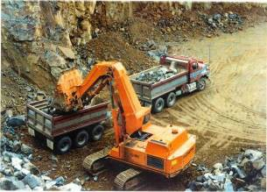
QUARRY ROCK

Applicable instream intervention techniques
Rock chutes Rock beaching Rock groynes

Purpose Quarry rock is used in the construction of rock structures.
Quarry material may also be used as a filter material.

Materials selection criteria
Everton Quarry north east Victoria
Rock used for rock chutes, bank protection and abutment protection should be hard, durable, angular in shape, and free from cracks, overburden, shale and organic matter. Thin, slab-type stones, rounded stones, and flaking rock should not be used.

Rock used for abutment protection should meet the durability requirement listed below, when tested in accordance with the specified procedures. Service records of the proposed material may also be useful in determining the acceptability of the rock.

Classifications and gradations for the rock are shown below. The maximum stone size shall not be larger than the thickness of the designed rock layer. Neither breadth nor thickness of a single stone should be less than one third its length.

Specification Rock durability requirements
Test Requirements

Relative density (density of dry solid rock relative to water) Abrasion (Abrasive Grading A)
Los Angeles Abrasion Test
(AS 1141.23)
Minimum of 2.6

Less than 40% loss of weight after 500 revs

Table of Contents

Size specification for rock
Equivalent “sieve” size Percentage smaller (by weight)
2 times D₅₀ 90%

D₅₀ 50%
0.3 D₅₀ 10%

D₅₀ = Median particle size (50% of the mass shall consist of stones with an equivalent spherical diameter equal to or larger than this dimension)

Approximate cost $25-35/m³ at the Quarry.

  - PLANTATION TIMBER

PLANTATION TIMBER

Applicable instream intervention techniques
Pile fields Large wood
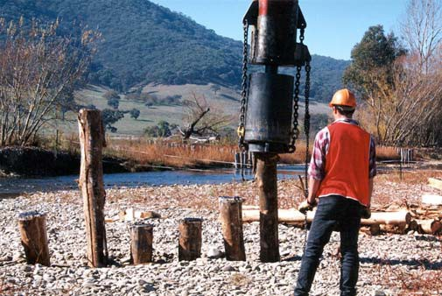
Engineered log jams
LUNKERS

Timber piles in north east Victoria (Photo courtesy of North East CMA)
Purpose Plantation timber is used where uniform timber shape is required. This typically comprises piles and pile fields. Milled timber can be used for construction of LUNKERS.

Materials selection criteria
Design life of timber Diameter
Density
Resistance to borer (Toredo).

Specification The minimum diameter of the timber poles used in pile fields (without bark) should be 150 mm.

Timber poles shall taper naturally and uniformly. Deviations from straightness may be permitted provided that a line adjoining the mid-point of the butt and of the head shall not depart from the centre of the timber pole at any point by more than 50 mm.

The timber poles should be free from live insects that would cause deterioration of the timber poles (e.g. termites), short crooks, kinks, shakes of all descriptions, fractures, splits at the head, and decay pockets.

Individual defects can be permitted as follows:

- grub holes, unless clustered;
- borer holes, provided the sapwood is not extensively damaged;
- termite galleries, provided that the total area at the butt does not exceed 50 mm². Enclosed termite galleries shall not be permitted;
- bull end splits not exceeding 3% of the length, provided they extend in one direction only;
- sound knots, in the third nearest the head; and
- knot holes in the third nearest the head, less than 10 mm in diameter.

Related information sources
Crossman, M. and Simm, J. 2004, Manual on the Use of Timber in Coastal and River Engineering, Wallingford, England.

CSIRO Forestry and Forestry Products: www.ffp.csiro.au.

Table of Contents
Approximate cost $20-50/pole.

FIELD TIMBER

Applicable instream intervention techniques
Large wood
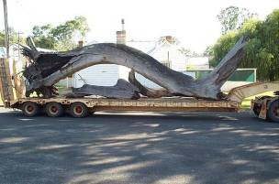
Engineered log jams

Purpose Field timber is used for the establishment of instream diversity, creation of habitat and stream bed scour holes.

Large wood for installation at Harrow, Victoria
(Photo courtesy of Earth Tech)

Materials selection criteria
Design life of timber Diameter
Density
Resistance to borer (Toredo) Handling and transport constraints.

Specification Field timber pieces should have the root ball attached where possible and branches should be retained where practicable.

Hollow and broken timber is suitable for use as large wood and engineered log jams, subject to anchorage by embedment as discussed below.

Preference should be given to the use of larger debris where possible as it is more stable, more durable and provides generally better habitat but this should not preclude the use of branches down to approximately 150 mm diameter.

Native species are to be used as they provide many benefits in addition to their ecological benefits. They are more dense, less likely to move and have a much longer life span than that of exotic timber.

Exotic species should not be used. They may only be used when the supply of native species is exhausted and there is a significant shortfall in field timber supply. Willows, poplars and declared weed species shall not be used as large wood and engineered log jams.

Related information sources
Crossman, M. and Simm, J. 2004, Manual on the Use of Timber in Coastal and River Engineering, Wallingford, England.

CSIRO Forestry and Forestry Products: www.ffp.csiro.au.

Table of Contents
Approximate cost $500/piece.

GEOTEXTILE – FILTER FABRIC

Applicable instream intervention techniques

Purpose

Materials selection and placement criteria
Rock chutes on fill

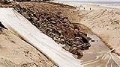
Geotextile is used as a filter layer to prevent the movement of fine soil materials through
the rock matrix. Application of geotextiles
(Source: Geotextile Supplies and Engineering)
Geotextiles should be 100% insect, rodent, mildew and rot resistant. Geotextiles should meet the physical requirements specified below.
Geotextiles should be loosely laid (not stretched) in such a manner to avoid rupture of the cloth.

The Geotextiles should be anchored in place with “U” shaped securing pins placed at 2 m intervals.

Overlaps of the Geotextiles should be 500 mm, and have the uphill layer on top.

Full rolls of Geotextiles should be used wherever possible in order to minimise overlaps.

Specification Physical requirements for non-woven, needle punched polyester geotextile fabric used in rock chute construction:

Test | Unit | Standard | Minimum requirement
Wide strip tensile strength | KN/m | AS3706.2
Elongation | % | AS3706.2 | 50%
CBR burst strength | N | AS3706.4
Trapezoidal tear strength | N | AS3706.3 | 200
Pore size | Micron | AS3706.7 EOS | 130
Flow rate | L/m²/s | AS3706.9 | 200
Grab tensile strength | N | ASTM4632.86 | 600
Mullen burst | KPa | AS2001.2.4 | 2,100
Drop cone | mm | AS3706.5H₅₀D₅₀₀ | 1,900
G rating |  | AS3706.4 | 2,000

Related information sources
Geotextile Supplies and Engineering: www.geotextile.com.au Geofabrics Australasia Pty Ltd: www.geofabrics.com.au

Approximate cost Variable dependent on product.
Table of Contents

Table of Contents

This Part 5 of the Technical Guidelines provides access to guidelines for the design of a selection of waterway management techniques. Included are design approaches for both larger temporal and spatial scale programs and more discrete individual projects.

The section comprises:

- links to existing design guidelines covering a range of waterway management techniques;
- revised and updated documentation on grade control programs, and stream bank erosion management; and
- new guidelines covering the geomorphic design of stream reconstruction projects.

These design guidelines have been structured to reflect the structure of the management options within Threats and Options:

- inflow and runoff design
- vegetation design
- instream physical intervention design.

PHILOSOPHY FOR DESIGN
Four broad philosophies of management are proposed for the design of waterway management works:

Identify and communicate the process, the issue arising and the desired stream outcomes.

The stream processes at work, the issues arising from these processes and the desired outcome from any works must be identified, and clearly communicated and documented. This philosophy is the basis for Parts 1, 2 and 3 of these Technical Guidelines. Long term commitments are required for long term success. Long term commitments from stakeholders require their engagement in the project. This requires development and communication of a clear understanding of the processes, issues and desired outcomes.

Development of solutions to issues should be based on an understanding of the fundamental underlying stream processes.

The solution to most stream management problems lies in the development of an understanding of the processes leading to the problems. Strategies and designs should seek to address these underlying causes. As an example and as previously discussed in these guidelines a decline in instream ecology arising from the absence of some flow components may be best addressed through the provision of an environmental flow regime that includes these flow components. Similarly, actively eroding stream banks arising from the absence of stream bank vegetation may be most simply and effectively addressed through revegetation programs.

However more than just developing an understanding of the problem, the understanding of the fundamental processes at work will help the development of appropriate solutions.

Development of solutions that harness ongoing processes to attain the desired stream outcome ─ let “nature” do the work!

Timber and vegetation applications in particular lend themselves to harnessing stream hydraulic, geomorphic and biological processes. Timber can be installed in a manner that creates a shear stress gradient, reduces transport capacity and promotes sediment deposition, reducing erosion and providing more stable stream conditions.

This installed timber will decay through time. Vegetation can be planted and direct seeded into this depositional environment and through biological processes, mature to

Table of Contents

replace the installed timber that has been subject to ongoing decay. Much of the work is supplied “free of charge” through gravity and sunlight!

Vegetation management is essential to long term success.

Vegetation provides for long term success of projects.

For projects aimed at erosion control, instream and riparian vegetation increases the channel roughness and thereby reduces velocity and scour. Vegetation can replace roughness provided by timber as this timber decays. As such vegetation can provide for the longer term stabilisation of systems beyond the life of constructed works.

For projects aimed at scour hole establishment, riparian vegetation establishment provides material for longer term recruitment of timber into the stream system and complements the ecological outcomes from the works.

For grade stabilisation projects, grade control structures provide short term and low flow stability to the system, enabling (with stock control and other vegetation management techniques) vegetation establishment providing roughness to reduce velocity and armouring of the bed and banks, protecting the system against ongoing scour.

INFLOW AND RUNOFF DESIGN
There are a number of excellent publications available that can assist the waterway manager with the design of interventions for stream inflows and runoff. These existing design guidelines are of a standard beyond that which could be developed here and readers are referred to these publications for design guidance. These existing design guidelines include but are not limited to the following:

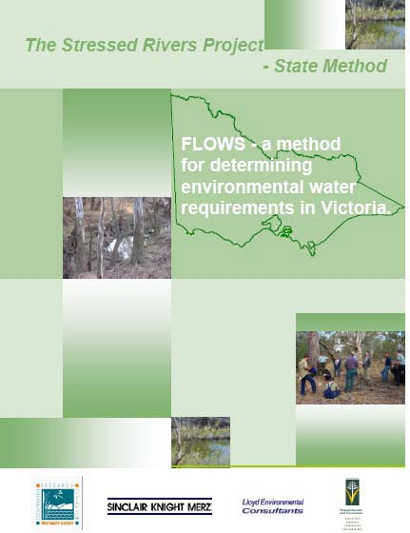
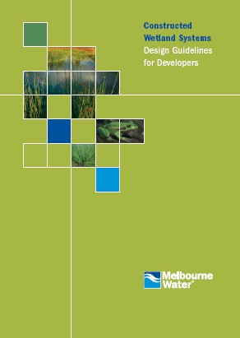

SKM 2002, FLOWS – a method for determining environmental water requirements in Victoria, Department of Natural Resources and Environment
Table of Contents

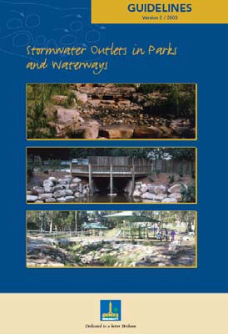

Brisbane City Council 2003, Guidelines - Stormwater Outlets in Parks and Waterways, Brisbane City Council, Queensland
Melbourne Water undated, Constructed Wetland Systems Design Guidelines for Developers, Melbourne Water, Victoria

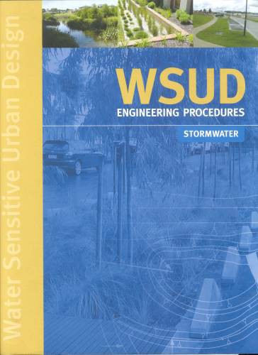

Melbourne Water 2005, Water Sensitive Urban Design – Engineering Procedures – Stormwater, Melbourne Water, Victoria

VEGETATION DESIGN
Successful vegetation management is critical to successful waterway management. Effective riparian vegetation establishment and management can:

- directly addresses the condition of riparian and instream vegetation;
- directly resolve most of the stream stability issues confronting Victoria’s waterways; and
- have a significant beneficial impact on instream ecology, floodplain ecology and water quality.

To be successful, the riparian corridor should be of adequate width to meet the design intent. The design intent could include sediment control, avian habitat and corridors, together with the provision of instream erosion control and long term source of instream timber. Attainment of these outcomes will require a substantial corridor width. Further information on appropriate corridor widths can be found in the references and further reading detailed below.

The issues of vegetation management are too important and too extensive to fully address within the limited scope of these Technical Guidelines. The reference, Revegetation Techniques A Guide for Establishing Native Vegetation in Victoria (Greening Australia 2003), is recommended to waterway managers. These guidelines address the issues of vegetation planning, design, site selection, ground preparation, weed control and planting and maintenance techniques and are available as a download from www.greeningaustralia.org.au. Waterway managers are also referred to the Guidelines for Stabilising Streambanks with Riparian Vegetation (Abernethy and Rutherfurd 1999).

- Other approaches and guidelines for vegetation establishment are available
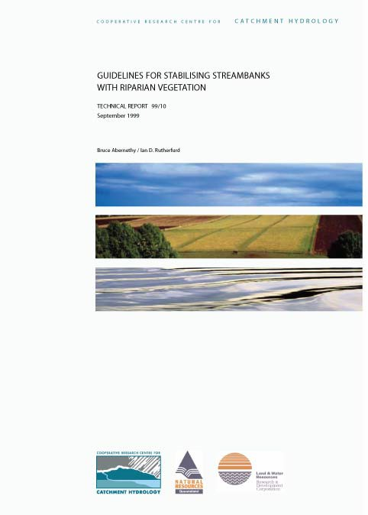
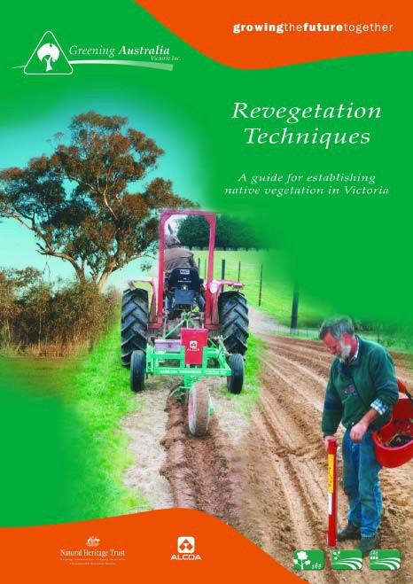

Cooperative Research Centre for Catchment Hydrology 1999, Guidelines for stabilising Streambanks with riparian vegetation, Technical Report 99/10, Bruce Abernethy & Ian Rutherfurd
Table of Contents
Greening Australia 2003, A guide for establishing native vegetation in Victoria, Greening Australia, Victoria

INSTREAM PHYSICAL INTERVENTION DESIGN
The physical interventions described in these Technical Guidelines are based on a philosophy of harnessing and managing excess energy associated with the movement of sediment and water under the force of gravity. Fundamental to this approach is an understanding of physical stream processes at work. Approaches to management can comprise the armouring of the system against excess energy, the provision of channel or hydraulic roughness to reduce and harness excess energy and/or a combination of both. Approaches to management of streams using the principles of armouring, roughness or a combination of both are listed in the following table.

Table 5.1 Armouring and roughness approaches to waterway management

Process to be managed Approach to management Armouring Roughness Other

Stream bed incision

Bank erosion
Rock chutes Instream timber Pile fields
Vegetation Vegetation
Rock beaching Pile fields
Flow modification

Flow modification

(meander migration and Vegetation Vegetation
channel widening)

Sediment mobilisation
Bed seeding Pile field
Flow modification

and transport Vegetation

Infilling of scour holes NA Large timber Engineered log jams
Vegetation (as a long term source of timber)
Sediment traps and extraction
Flow modification Sediment traps

Table of Contents

In many instances the most successful approach to management will comprise a combination of armouring and roughness. Vegetation provides both armouring and roughness as well as ecological outcomes and as a consequence is the most important tool available to the waterway manager. A number of the instream physical approaches discussed in these Technical Guidelines rely on vegetation establishment as an integral component of the management solution. Examples include:

- Large wood: installation of imported large wood should be considered an interim measure. Long term recruitment of timber to the stream system should come from the riparian zone through ongoing stream (erosion) and vegetation (vegetation dynamics) processes.
- Pile fields: pile fields rely on vegetation establishment to increase roughness through time and to replace the timbers as they decay.
- Grade control: grade control strategies rely on rock chutes to provide short term and low flow stability enabling vegetation establishment. However it is the roughness and armouring provided by the vegetation that provides for the long term stability of the system. One component without the other will have low likelihood of success.

In addition to stream flow (water) and stream sediments, the principal materials used in the armouring and roughness approaches to management are timber, rock and vegetation. Further information on these materials and the philosophies of their use can be found within Part 4 Materials of these Technical Guidelines.

Table of Contents

A number of design aids have been developed to assist with the design of instream interventions and are provided in Part 6 Design Aids of these Technical Guidelines. These design aids include:

- stability analysis for large timber and engineered log jams
- stability analysis for timber piles
- scour depth estimation
- parameters for waterway design.

GEOMORPHIC DESIGN OF STREAM RECONSTRUCTIONS
There are cases where the complete reconstruction of a stream channel is necessary. Reconstruction will often be necessary as a component of the decommissioning of infrastructure such as storages and stream diversions and the rehabilitation of channelised streams in urban and rural areas. Fortunately these occasions are infrequent. However where such reconstructions are necessary, a high level of analysis and design is required.

A process has been developed for the design of stream reconstructions. The approach is largely consistent with that detailed in the publication Hydraulic Design of Stream Restoration Projects (Copeland et al. 2001).

APPROACH

VISION FOR THE STREAM
The establishment of an agreed outcome for the proposed reconstructed stream forms an essential first step in the design process. Example design outcomes include:

      - No change in upstream or downstream flooding regimes.
      - The reconstructed channel to be in as good or better condition than adjoining upstream and downstream reaches.
      - The stream is not to be a barrier to stream processes or fish passage.
      - The stream is to have a natural appearance and provide for ongoing stream processes.

This list of outcomes is by no means complete and additional site constraints and outcomes may be desired.

ASSESSMENT OF CURRENT CONDITION AND PROCESSES
An assessment of existing stream condition and processes will be an essential step in developing an understanding of the system and for the development of design criteria and targets necessary to meet the intended stream outcomes or vision. Assessments of the system should include:

      - Condition of adjoining reaches. This should comprise a standardised stream condition assessment such as an Index of Stream Condition assessment of adjoining reaches.
      - Barriers. Identification of existing and potential fish species inhabiting the system, a topographic survey, and hydraulic modelling to identify depth and velocity of water over natural barriers (such as riffles) for a range of flow events.
      - Ongoing processes. Document dependent hydraulic variables of existing system (stream bed grade, meander wavelength, sinuosity, width, depth, width depth ratio and existing channel roughness) document stream form and controls.
      - Flooding. Model the existing flood levels to identify existing flood heights and extents. This will require:
        - topographic survey of the existing stream system
        - hydrologic analysis of the system
        - hydraulic modelling and analysis of the subject reach and reference reaches
        - geomorphic assessment of the stream system and ongoing processes.

Table of Contents

IDENTIFICATION AND DOCUMENTATION OF RESOURCE CONDITION CRITERIA AND TARGETS
Based on the above investigations a set of design criteria should be developed. For each criterion, design targets should be established. Typically each design criteria will have a range of acceptable outcomes or targets. Design criteria are likely to include:

          - target vegetation condition (ISC score)
          - vegetation lateral and longitudinal connectivity
          - density of instream timber
          - meander wavelength and sinuosity
          - stream bed form
          - channel and floodplain roughness coefficients commensurate with the above
          - bed grade
          - channel width, depth
          - target flood impacts.
Design parameters for a number of hydraulic variables are provided in Design Aids within these Technical Guidelines.

FUNCTIONAL DESIGN
The functional design of the reconstructed stream is an iterative process aimed at attaining the target outcome for each design criteria. Several options may be generated that have different costs outcomes while meeting the targets for the design criteria. The functional design process requires:

          - identification of a proposed stream alignment;
          - topographic survey over the proposed alignment;
          - geotechnical survey over the proposed alignment;
          - creation of a digital terrain model of a trial stream arrangement with proposed channel sinuosity, meander wavelength, bed grade, and channel and floodplain roughness meeting the design criteria targets;
          - modelling of the proposed arrangement with a range of floodplain widths;
          - adoption of a floodplain width arrangement that meets the flood level, stream power, velocity and shear stress design criteria; and
          - documentation of alternate arrangements and recommendation of a preferred option.

Alternate outcomes may be developed that may or may not include structural works such as grade control structures and rock beaching.

Further, consideration will need to be given as to whether the reconstructed stream will be opened to stream flows prior to the establishment of vegetation. Opening the reconstructed stream to flows prior to the establishment of vegetation will necessitate a design arrangement that provides a low risk of scour under bare soil conditions. This will require excavations in excess of that required for a vegetated system. This additional work is likely to result in some additional cost.

DETAIL DESIGN
The detail design phase comprises the development and documentation of design details for floodplain and channel features, rock placement (if necessary), timber placement and vegetation design. Discussion on these elements can be found in Part 3 of these Technical Guidelines. This detail design phase will typically include the development of a design report, design drawings and construction specifications and the development of a monitoring and evaluation program.

Table of Contents

STREAM BANK EROSION CONTROL

THE STREAM BANK EROSION PROCESS
Stream bank erosion is a natural process associated with most alluvial stream systems. Ongoing erosion and deposition are features of most river systems. However the processes of erosion can be accelerated through human activities such as riparian vegetation clearing stock access to waterways, removal of instream timber, alteration of stream flows, channelisation and associated stream bed incision. Different interventions will be required to address the underlying processes causing the bank erosion. These processes include:

      - channel widening
      - meander migration
      - channel incision.
Further, some localised and isolated bank erosion may be the result of the orientation of fallen timber. This will most often be minor in nature and not require management intervention. Similarly there may be evidence of bank erosion associated with stock tracks and other direct disturbance to the bank.

Understanding the cause and process of stream bank erosion will assist with the identification of an appropriate management strategy.

PHILOSOPHY AND OPTIONS FOR STREAM BANK EROSION MANAGEMENT
Management of stream bank erosion involves management of excess energy expenditure on exposed bed and bank material. The highest energy expenditure and greatest scour will be at the toe of the stream bank. This is the zone of maximum shear stress.
Management of most stream bank erosion therefore lies at management of excess energy near the toe of the bank.

Clearly the “do nothing” option should be considered as a primary option for management. In many instances the bank erosion will be minor and/or will not require management intervention.

However, if the decision for intervention is made there are a range of alternate management options available to the designer. Options for the management of excess energy near the toe of the bank include:

      - armouring the bank material to increase its resistance of the bank material and/or separate the moving water from bed and bank material;
      - reducing the shear stress and velocity of the moving water by increasing the channel roughness; and
      - combinations of both of the options.
There are many intervention techniques that have been applied to control stream bank erosion. However only a limited number of approaches can be applied with a high level of confidence in the outcome. These approaches include:

      - vegetation establishment (incorporating stock control and weed management)
      - rock beaching combined with revegetation
      - pile field style alignment training combined with revegetation
      - grade control strategies.

Table of Contents

VEGETATION ESTABLISHMENT
Vegetation establishment including stock management can address most of the stream bank erosion issues faced by the waterway manager. Vegetation provides for both the separation of high velocity water from bed and bank material and reduces total velocity through increased roughness. In addition, vegetation provides habitat corridors, nutrient assimilation, and shading.

Further information on the use of vegetation in stream bank erosion control can be found in Guidelines for Stabilising Streambanks with Riparian Vegetation (Abernethy and Rutherfurd 1999).

Further information on vegetation establishment can be found at Greening Australia: www.greeningaustralia.org.au and in Revegetation Techniques A Guide for Establishing Native Vegetation in Victoria (Greening Australia 2003).

However vegetation establishment alone may not address and halt the erosion processes. Additional works may be necessary to enable vegetation establishment. In these instances the following techniques may be required.

ROCK BEACHING AND REVEGETATION
Rock beaching and accompanying revegetation remains one of the most successful structural interventions for stream bank erosion control associated with meander migration and channel widening. The benefit and drawbacks with this approach are discussed in Part 3 of these Technical Guidelines. The design approach to rock beaching is detailed in Section 5.4.4 of the Technical Guidelines.

PILE FIELD RETARDS AND REVEGETATION
Pile field retards accompanied by revegetation provide effective stream bank erosion management without some of the adverse impacts associated with an armouring approach to waterway management. The design approach to pile field retards is provided within Section 5.4.3 of these Technical Guidelines.

GRADE CONTROL STRATEGIES
Grade control strategies will be most useful where the stream bank erosion is associated with channel incision and accompanying channel widening. Grade control strategies most often comprise grade control structures accompanied by revegetation. Grade control structures reduce energy in low flows to provide a depositional environment suitable for vegetation establishment. However such structures will often drown out in larger flood events.

In these larger events, the stream hydraulic gradient approaches the eroding incised stream longitudinal gradient and as a consequence the grade control structures provide no direct benefit to the system. In the longer term, and through these larger storm events, it will be the vegetation established as a result of the provision of the structures that provide the system stability.

As a consequence, the construction of grade control works, designed to drown out in large flood events, will be wasted effort without the provision of long term stabilising vegetation. Adopt the motto: no vegetation, no works.

Further information on the design of grade control strategies can be found in Section
5.4.5 of these Technical Guidelines.

Table of Contents

DESIGN OF PILE FIELD RETARDS
Design guidelines for retards and groynes were first published in 1991 within Guidelines for Stabilising Waterways (Standing Committee on Rivers and Catchments 1991). The Guidelines for pile fields were based on the experience and knowledge of the authors. While the approach, based on notional lines of attack, has proved successful, the approach does not have a sound theoretical basis.

The design of retards has improved through trial and error undertaken over the intervening 15 year period since the publication of Guidelines for Stabilising Waterways, through a research project carried out by Dyer (1995) from the Centre for Environmental Applied Hydrology at the University of Melbourne and through additional research undertaken for these Technical Guidelines. This section brings together the original basis for retard design with these improvements in design.

The results of the research by Dyer (1995) update the Retards and Groynes section of the Guidelines for Stabilising Waterways (Standing Committee on Rivers and Catchments 1991). The update addressed the spacing of timber within a pile field retard and the spacing between retards. The recommendations on the spacing of retards included in the update have been tested in the field. However no formal monitoring and evaluation of works using the results of Dyers investigations has been undertaken.

RETARDS
Retards are long, low, permeable vertical fences constructed in the stream bed and normally projecting from the stream bank across the line of flow. In the past these fences may have been constructed of:

      - timber or steel piles and horizontal rails;
      - piles or posts supporting cables and wire mesh;
      - lines of lightweight post and wire structures known as "jacks";
      - piles or posts supporting logs or brush;
      - open timber or steel pile structures without rails or other material between them (these are generally referred to as pile fields); or
      - live cuttings of trees or shrubs supported by piles and cables (generally referred to as vegetative retards).

Timber pile fields are now almost exclusively used for this purpose, replacing pile and rail and alternate design arrangements.

Retards work by increasing flow resistance, decelerating flow, and causing deposition of material in the space between the retards. The space between two retards is referred to as an embayment. Establishing vegetation in the embayments between retards is an essential adjunct to the design technique. The vegetation increases the hydraulic roughness within the embayments, assists the retards in reducing the flow velocity, stabilises deposited sediment and provides for the replacement of timbers used in the pile field, lost through decay and breakage.

Retards are normally used to:

      - remove attack from an eroding bank;
      - correct an alignment which has developed to the point where it is difficult or expensive to impose stability without re-alignment;
      - create a false bankline;
      - prevent formation of undesirable alignments (e.g. point bar cutoffs);
      - create a depositional environment to allow revegetation establishment;
      - increase the resistance of a reach of channel;
      - confine excessive bed width and hold excess sediment in place; and
      - encourage a single thread character in a braided channel.

Table of Contents

GROYNES
Groynes are short (in length), tall (in height) fences or structures constructed in the stream bed projecting from the stream bank into the flow. The distinction between retards and groynes is that groynes extend a shorter distance into the stream than retards with a primary function of protecting an eroding bankline without major stream realignment.
Groynes have been constructed from the same range of materials as listed for retards. Groynes are now commonly constructed using pile fields.

The purpose of groynes is to protect an eroding bank by interrupting flow lines adjacent to the bank, creating a zone of decelerated flow. Similar to a retard, the long term success of a groyne field will rely on deposition of sediment at the toe of an eroding bank and the establishment of vegetation.

For the purpose of this part of the Technical Guidelines the single term retard has been adopted to cover both retards and groynes.

DESIGN PRINCIPLES
Design principles for retards and groynes are similar and are to ensure a set of structures which:

        - are of a length and height to maximise their effectiveness;
        - are located and oriented to maximise their effectiveness;
        - are able to withstand bed scour adjacent to the structures; and
        - have sufficient structural strength to withstand hydraulic and debris forces without catastrophic failure.

Rigid design rules for groynes and retards do not exist. The range of conditions, functions and construction materials means that design becomes a judgemental process which must rely heavily on the experience and common sense of the designer. The design instructions given in this document must be used as guidelines, and not interpreted as a strict code of practice. Flexibility in the design process can lead to innovative implementations and major cost savings without sacrificing effectiveness, providing the major principles are recognised and incorporated.

TYPE OF STRUCTURE
The comments in this section are very site dependent. Choice of materials will depend on:

        - availability
        - economics
        - environmental considerations
        - aesthetics
        - construction considerations
        - functionality.
The designer must compromise between these considerations on a case by case basis.

PERMEABLE OR IMPERMEABLE STRUCTURES
Permeable retards or groynes are generally preferred to impermeable structures. Permeable structures increase the resistance to flow through the groyne or retard field, without completely blocking the flow. This has considerable advantages with respect to the hydraulic characteristics of the structure, with the flow through the structure reducing turbulence and scour at the tip of the structure.

Increasing the ratio of the solid area (i.e. the timber piles) to the open area (i.e. the gaps between the piles) in a retard or groyne leads to less permeable structures which are prone to:

        - significantly greater head loss across the structure with correspondingly greater hydraulic forces on the structure itself;

Table of Contents

      - weir type overtopping which can lead to significant scour on the downstream side of the structure;
      - severe acceleration of flow at the river end of the structure which can lead to major vortices and scour adjacent to and under the structure;
      - acceleration of flow along the upstream face of the groyne or retard which may cause scour along the upstream length of the structure;
      - abutment failure (at the bank end) associated with scour from overtopping eroding the bank;
      - structural failures associated with these scours; and
      - collecting debris which further decreases the porosity and exacerbates the above effects.

Figure 5.1 illustrates successful pile field retard establishment for sediment stabilisation on Black Range Creek in north east Victoria. Images show the same site immediately following and six years following implementation of works to prevent reworking of mobile sediments deposited in the system in the 1993 flood event.

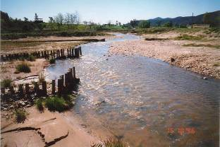
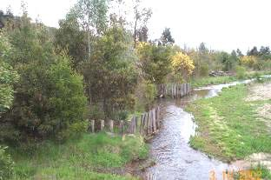
Figure 5.1 Pile field 1996 (left) and 2002 (right), Black Range Creek, north east Victoria (Images courtesy of T. McCormack, North East CMA)

DESIGN ALIGNMENT
This section applies to the use of retards or groynes (usually retards) to achieve a modified stream alignment. The section describes the choice of a design stream alignment to form the basis of a groyne or retard layout.

Alignment design requires detailed planimetric information over the site and less detailed information up and downstream for a total distance of at least 2.5 meander wavelengths or 25 channel widths.

Suitable planimetric information is available from aerial photographs and aerial photograph enlargements and field survey.

AERIAL PHOTOGRAPHS
Aerial photographs are an invaluable source of information for any river related undertaking and as a permanent record for future reference.

Table of Contents

For alignment training work it is preferable that suitable points can be located on the photograph to allow an accurate scale to be established. If no obvious reference (such as a bridge) exists then targets should be placed at the site before the photographs are taken. Photographic enlargements can then be made of the main area of interest to exact scales for alignment design work. Suitable scales, depending on the size of the job, are between 1:500 and 1:5,000. Beware of severe distortion which occurs toward the edge of aerial photographs and always have targets and the main areas of interest centred within the photograph. For large jobs orthophoto correction techniques may be employed to produce corrected mosaics.

Scales of from 1:5,000 to 10,000 are suitable for overview of areas upstream and downstream of the main area of interest.

In some cases, suitable aerial photography will already exist, but where special photography is being flown, it will normally be found that coverage can be extended upstream and downstream for several kilometres for little extra expense. This information is invaluable to the designer.

FIELD SURVEY
Field survey information can complement or replace aerial photography. Planimetric information may include the:

        - location of all man-made features and controls
        - bank line
        - water line
        - areas of vegetation
        - areas of erosion or scour
        - limits of floodplain
        - longitudinal bed profile and cross-sections (these are used in determining the elevation of the retards and may be necessary for use in hydraulic analysis to estimate the velocity of flow).

ALIGNMENT DESIGN
Selection of an appropriate design alignment is essentially an exercise in compromise between a number of aims and constraints including:

        - removing attack from vulnerable banks;
        - aligning or constricting flow in a bridge approach to reduce attack on abutments;
        - the need to use bend radii which are large enough to be stable;
        - a recognition of the severe adverse effects of over straightening a river reach;
        - the requirement to match entry and exit angles of the realigned reach to existing conditions; and
        - limitations on cost.
For a realigned section to achieve long term stability without major heavy engineering work, the realigned stream should depart as little as possible from the characteristics of the stream in stable reaches upstream and downstream. Major straightening must be avoided.

The following guidelines are given to assist in selecting an appropriate design alignment through a trial and error procedure:

        - establish basic constraints on the alignment (e.g. bridge orientation, natural rock outcrops);
        - choose a range of suitable bend radii from an overview of stable bends upstream and downstream or on similar streams;
        - choose a design width on the basis of width in stable reaches upstream and downstream;

Table of Contents

      - using circular curves for convenience, attempt trial fits of curves within the constraints already established;
      - ensure curves are tangent to existing alignment or to bridge abutments, at upstream and downstream limits;
      - in general try to move bends back upstream to counteract the tendency for bends to migrate downstream and crowd natural channel controls or bridge sites; and
      - review proposals by comparisons upstream and downstream. Figure 5.2 illustrates these guidelines by example.

HYDRAULIC CONSIDERATIONS
Hydraulic and other information that is of assistance to the design engineer is outlined below:

      - Stage recurrence interval relationship. A relationship between stage and flood recurrence interval. Preference is for the use of a calibrated hydraulic model. Local knowledge from landholders can be of considerable assistance in determining this relationship. This information is useful in determining the height of the berm and the height of the retards.
      - Velocities at different points through the section. Again this can be determined from the hydraulic model or measured in flow events.
      - Sediment size information. Basic visual inspection or sieve analysis of the bed and deposited material will allow the designer to determine suitable velocities within the retard field. When considering sediment it is also worth considering sediment loads. If the sediment load is small then the embayments will fill slowly and it may be necessary to give greater consideration to the construction of a berm to retain the low flow channel away from the area to be rehabilitated and provide a location on which revegetation can commence.

The hydraulic information can be used to determine the annual exceedence probability of the failure flood and hence obtain an estimate of the risk of failure associated with a given design.

LOCATION AND ORIENTATION OF RETARDS AND GROYNES
This section applies to the use of retards or groynes to remove high velocity and high shear stress flow from the toe of an eroding bank. Design can be undertaken via two approaches: the notional line of attack reported in Guidelines for Stabilising Waterways and an alternate shear stress method developed for these Technical Guidelines. While there is strong anecdotal evidence of the success of the notional lines of attack approach, the method has no basis in stream hydraulic or geomorphic processes. As a consequence there is limited scope to provide a sound basis for variations in the approach for a range of alternate applications, arrangements or site conditions. The alternate approach outlined in these Technical Guidelines is based on experimental data and developments in the understanding of stream processes. It is recommended that both approaches be adopted for design and the most conservative results and arrangement be adopted for implementation.

APPROACH NO. 1 NOTIONAL LINES OF ATTACK
This approach based on Notional Lines of Attack has been found to provide an economical and successful solution in moderate to steep gravel and sand bed rivers. The method is neither precise nor determinate. It involves an iterative process which relies on the judgement of the designer and an understanding of the processes occurring in the river system. The results from the research by Dyer (1995) may be of use to the designer in determining the effect of a given retard and how its response will vary for different flow conditions.

Table of Contents

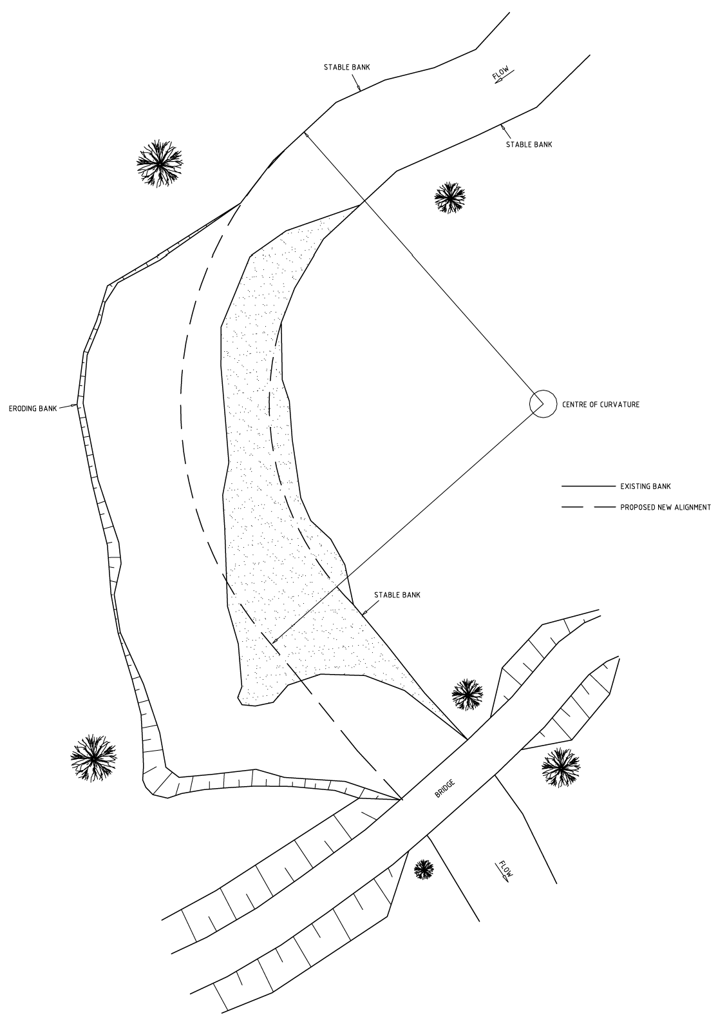
Figure 5.2 Pile field retard – existing site layout

Table of Contents

Retards or groynes are seldom uniform in length through a river reach. They are spaced such that the flow passing around and downstream from the riverward end of the structure intersects the next retard or groyne prior to intersecting the eroding bankline. Realistically, the spacing and length of retards or groynes do not conform to a pre-set formula but should account for items such as stream width, direction of maximum flow velocity or attack, velocity of approach, desired velocity in the retard embayments, and the radius of curvature of the bend.

The estimated critical line of attack is a matter of judgement for the designer. It incorporates many factors including width and radius of curvature, existence of point bars, vegetation or channel controls.

The following procedure is provided as a guideline to establishing length and spacing requirements given a proposed new alignment:

- Establish the progression of critical attack lines around the bend or through the reach, as indicated in Figure 5.3. A review of aerial photos or plans supplemented by information gained from a full reconnaissance of the site during various flow conditions is necessary to establish the notional lines of attack.

- Locate the landward end of the first retard or groyne just downstream of the start of the re-aligned section. Additional direct bank protection will often be needed upstream of the first retard. Determine if the influence of a single retard will be sufficient to provide suitable hydraulic conditions for stable sediment.

If more than one retard is required to obtain suitable downstream hydraulic conditions, then the minimum distance between the retards is to be at least 5 times the height of the upstream retard. This is to minimise the scour, resulting from the turbulence from the upstream retard, undermining the downstream retard.

If one retard is sufficient to provide suitable hydraulic conditions for stable sediment then identify the worst case flow line or the critical line of attack on the first retard or groyne. The angle of the retard or groyne can then be set based on this critical line of attack. The retards should be are angled 5 degrees to 15 degrees downstream of the perpendicular to this line of critical attack. The angle does not affect the hydraulic performance of the retard and thus the angle may be varied to suit the design conditions.

However the retard should not be angled upstream as the retard could become blocked with debris.

The retard is then located along this angle from the bank to the desired flow alignment. This concept is illustrated in Figures 5.2 to 5.6.

- The second retard should be located such that the landward end of the second retard or groyne is located upstream of the intersection of the critical line of attack from the first retard or groyne and the eroding bankline.

- The remaining retards or groynes should be located and spaced as described in step 3. The last retard is often awkward to place. In addition to the last retard, a complementary form of bank protection can be utilised to further stabilise the downstream limit. Figure 5.5 illustrates placement of the remaining retards and Figure 5.6 illustrates the completed retard field.

It is rare that the procedures described above will result in the best geometry for a given site during the first attempt. An iterative technique is required where the geometry is re- evaluated in upstream and downstream directions. The purpose of the iterations is to select the layout which best conforms the retard or groyne system to the upstream and downstream boundary conditions and takes into account site specific irregularities in the channel bank.

Table of Contents

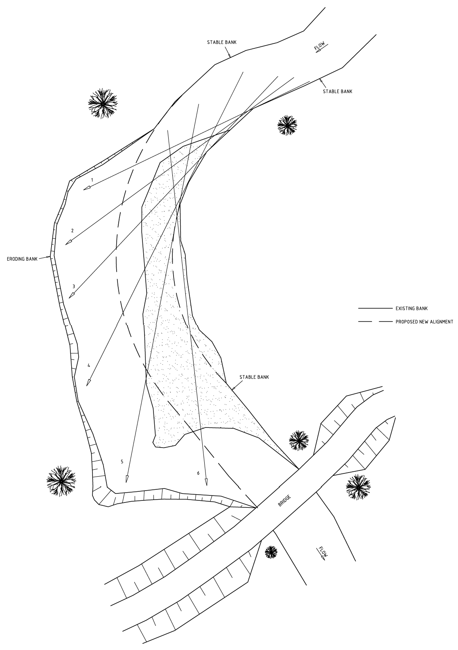

Figure 5.3 Pile field retard – notional lines of attack

Table of Contents

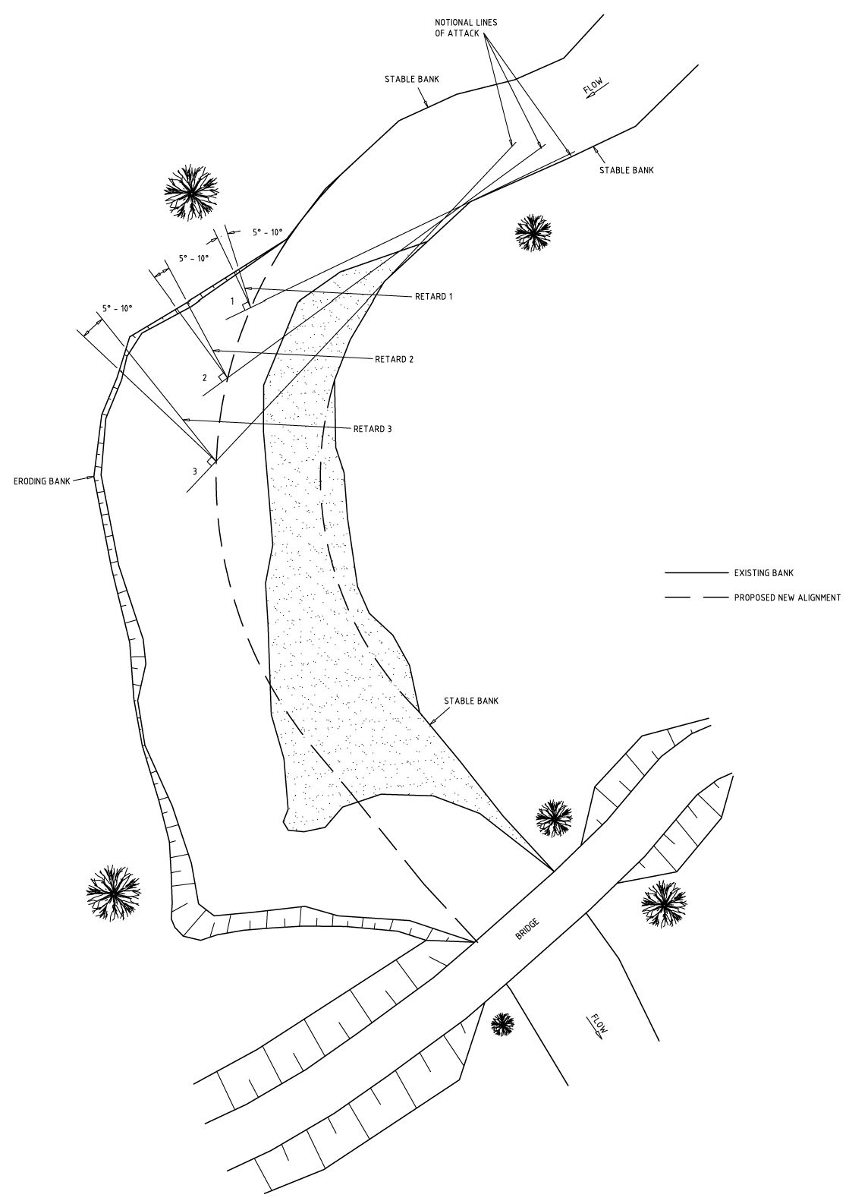
Figure 5.4 Pile field retards – 1 to 3 layout

Table of Contents

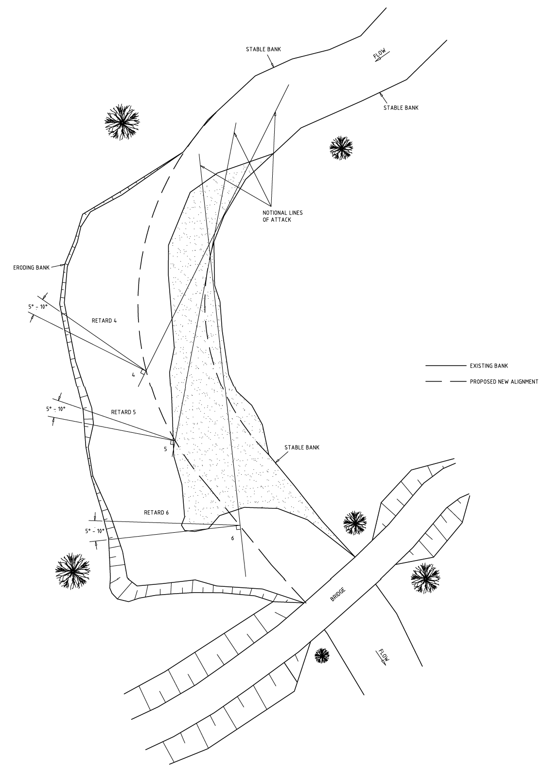
Figure 5.5 Pile field retard – 4 to 6 layout

Table of Contents

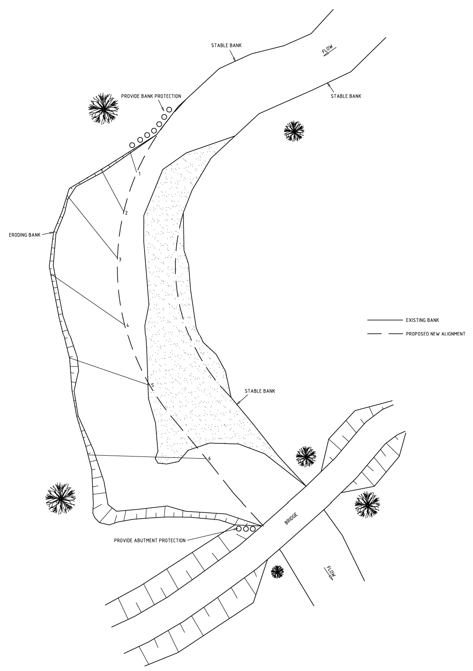
Figure 5.6 Pile field retard – proposed site layout

Table of Contents

APPROACH NO. 2 SHEAR STRESS APPROACH
The following shear stress approach to the design of retards has been developed based on the combination of results of Dyer (1995) using a straight flume and results of research into the effective energy gradient on meander bends in stream meanders of varying radius of curvature. The approach has been developed based on a recognition that the Notional Line of Attack approach, while lacking a substantial basis in science has been largely successful in practice.

This alternate approach may be used in conjunction with the Notional Angle of Attack approach to produce a conservative design arrangement.

As discussed earlier, retards or groynes are seldom uniform in length throughout a river reach. The spacing and length of retards or groynes do not conform to a pre-set formula but accounts for items such as stream width and depth, the radius of curvature of the bend, direction of maximum flow velocity, velocity of approach, and desired velocity in the retard embayments.

Key points to consider when determining the location of retards include:

- The channel end of the retard will always be exposed to the full velocity of the flow. As such it may not slow the flow sufficiently to create the necessary conditions for sediment deposition. This means that the new bank line may form some distance back from the end of the retard.
- The desired velocity can be achieved by using more than one retard. This can be seen in Figure 5.7.

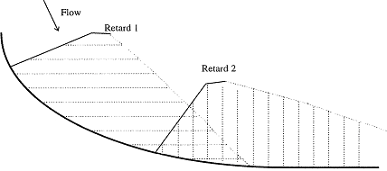

Figure 5.7 Cumulative impact of pile field retards

This figure shows the cumulative effect of retards. The area that is double shaded is influenced by both retards and as such has a lower velocity than the areas that are only singly shaded.

The shear stress approach to the design of retards proceeds as follows:

  - Identify the design risk appropriate for the site e.g. 10% or less chance of an event occurring in the 5 year vegetation establishment period. In this example there would be a 10% likelihood of an event occurring in the vegetation establishment phase that has the potential to mobilise sediment and potentially cause failure of the proposed works.

Table of Contents

  - Identify the flow event associated with the design criteria: for the above example this would be something approximating the 50 year event, a 20 year ARI event would have a 20% chance of occurrence over this time frame.

  - Identify target shear stress for the design flow event: this should be based on the critical shear stress for the bed and bank sediments. Critical shear stresses appropriate for a range of sediment sizes are provided in the following table.

Table 5.2 Critical shear stress for a range of sediment sizes

Particle size Critical shear stress
mm | m | N/m2
0.1 | 0.0001 | 0.08
0.2 | 0.0002 | 0.15
0.5 | 0.0005 | 0.38
1 | 0.001 | 0.76
2 | 0.002 | 1.52
5 | 0.005 | 3.80
10 | 0.01 | 7.61
20 | 0.02 | 15.22
50 | 0.05 | 38.04
100 | 0.1 | 76.08
Note: Critical shear stress based on shields entrainment factor of 0.047 and sediment density of
2.65 tonnes m³.
  - Estimate shear stress for the design event: this can be undertaken using a simple one dimensional model for the site. It is suggested that as a minimum the 2, 5, 20, and 50 year ARI events be analysed.

  - Adjust the effective shear stress for the meander based on Figure 5.8.

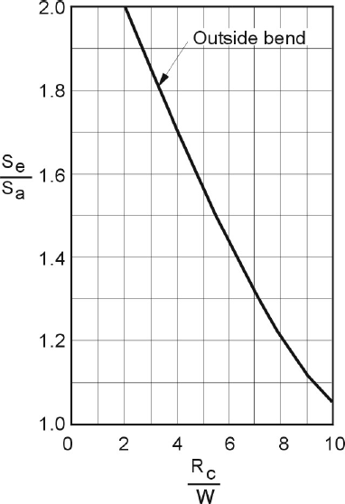
Se/Sa: Ratio of effective energy slope on the outside of a bend relative to the average energy slope for a reach

Rc/W: Ratio of the radius of curvature of the channel centreline of the bend to the base width of the channel

Figure 5.8 Effect of channel bend on effective energy slope (Adapted from US Soil Conservation Service 1971)

  - Identify target shear stress reduction: this will be a function of the current effective shear stress for the design event and the target shear stress for the design event.

  - Select target alignment for outside of bank: this should be based on aerial photograph analysis of upstream and downstream reaches and the radius of curvature of identified stable meanders.

  - Select site for first retard based on proposed stream alignment.

  - Select trial height of retard: it is suggested that retards not be higher than 50% of bank full depth and preferably at or below one third bank height.

  - Use Table 5.3 to identify the downstream extent of shear stress reduction achieved through retard No. 1 and therefore the preliminary distance to and location of the next downstream retard.

  - Adopt retard alignment based on retard angle being at 30 degrees to the realigned flow to aid shedding of debris.

  - Move onto analysis of next downstream retard using final downstream shear stress reduction at the proposed next retard for analysis.

Table 5.3 Downstream relative shear stress as a function of retard porosity, height and distance from bank (Adapted from Dyer 1995)

Downstream distance as a multiple of retard height H (where retard height is the lessor of depth of flow and retard
Distance from bank as multiples of retard length (L)

40% Porosity 50% Porosity 60% Porosity

height) 0.2L 0.4L 0.6L 0.8L 0.2L 0.4L 0.6L 0.8L 0.2L 0.4L 0.6L 0.8L
Table of Contents

2H | 0.25 | 0.25 | 0.25 | 0.25 | 0.36 | 0.36 | 0.36 | 0.36 | 0.49 | 0.49 | 0.49 | 0.49
5H | 0.25 | 0.25 | 0.25 | 0.25 | 0.36 | 0.36 | 0.36 | 0.36 | 0.49 | 0.49 | 0.49 | 0.49
10H | 0.30 | 0.36 | 0.42 | 0.49 | 0.42 | 0.49 | 0.56 | 0.64 | 0.56 | 0.64 | 0.72 | 0.81
20H | 0.49 | 0.56 | 0.72 | 0.90 | 0.49 | 0.56 | 0.72 | 0.90 | 0.64 | 0.72 | 0.90 | 1.10
30H | 0.64 | 0.72 | 0.81 | 1.00 | 0.64 | 0.72 | 0.81 | 1.00 | 0.81 | 0.90 | 1.00 | 1.21
40H | 0.72 | 0.81 | 0.90 | 1.10 | 0.72 | 0.81 | 0.90 | 1.10 | 0.90 | 1.00 | 1.10 | 1.32

ELEVATION OF RETARDS
Retards for alignment training and bank protection, as described in these guidelines, are generally low structures about 1 to 2 metres high. They function, not by providing direct protection to the entire profile of a vulnerable bank, but by stabilising the toe of that bank, preventing failure by undermining. Correctly designed retards will, over time, collect sediment within the embayments and hence form a new bank line. The long term stability of this new bank line is dependent upon some form of mechanical protection, either by maintained retards or vegetation.

ELEVATION OF AN INDIVIDUAL RETARD
The following guidelines are provided to assist in determining appropriate structure height:

- For the range of applicable river types, the top of the retard would normally be at least 1 m above typical bed or bar level in the vicinity of the structure.

Table of Contents

- The height of the retard should be related to the expected range of flow conditions. As a guide, retard height is expected to be around one third of the annual flood stage, or one third of the annual bankfull stage, whichever is less.
- The height of the retard affects the downstream distance over which the retard has an influence. As such the height of the retard is a design parameter linked to the longitudinal spacing of the retards.
- For the range of applicable river types, retards should be less than 1.5 m above typical bed or bar level in the vicinity of the fence.
- The elevation of the top of the retard may be level or angled or stepped slightly downward toward the stream. There should be no high or low spots along the retard.
- Minor excavation may be necessary to install retards of a more or less constant height on an uneven bed or bar.
- The height of the retard may increase toward the bank to provide some additional protection and prevent premature overtopping adjacent to the bank.
- If the retard is constructed on a berm then the retard should be recessed into the berm to allow for localised scour due to the high velocity flow between the rails. At the channel end, the retard needs to be recessed deeper into the berm to allow for scour at the tip.

ELEVATION WITHIN A FIELD OF RETARDS
Within the retard field, retard elevations should reflect the expected hydraulic grade of the channel. Over a reach the top of the retards should form a line of constant gradient. The gradient of this line is best determined by considering the longitudinal section of the bed. This allows the gradient to reflect the overall topography of the reach and not be unduly influenced by the location of pools, riffles, or scour holes and provides a uniform slope between the retards within the river reach.

The use of the longitudinal section also assists in determining the correct elevation of the bottom of the retard, especially on riffles.

An example is shown in Figure 5.9.

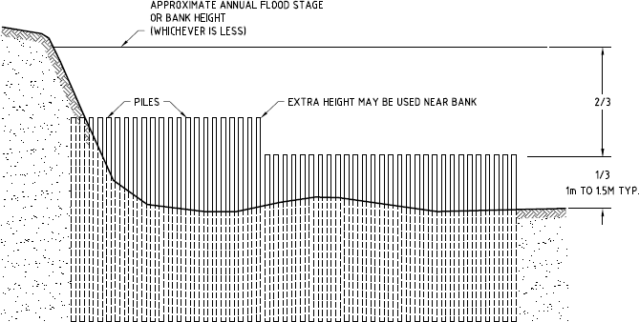

Figure 5.9 Cross-section of typical pile field retard

Table of Contents

Some additional notes to assist the design and layout of retards include:
- Retards are typically only 1 m high.
- Their function is not to provide direct protection to the entire bank but to provide toe protection by creating deposition and a false bank line.
- Excessive height increases vulnerability of structure to damage by debris and undermining by overtopping.
- Opportunities for concentrated overflows at any point must be avoided.

STRUCTURAL DESIGN OF GROYNES AND RETARDS
The structure must resist the following main loads:

  - Dynamic load: direct impact from waterborne debris.
  - Hydraulic load: pressure forces resulting from hydraulic head across the structure (static and dynamic).
  - Hydrodynamic load: drag of flowing water on components of the structure.
Of the three, the dynamic load and hydraulic load are the most important. Hydrodynamic loads are always relatively insignificant. For the design conditions investigated for this manual, dynamic loads are generally more significant than hydraulic loads. The resistance of the structure to dynamic loads depends on its flexibility, or its capacity to absorb shock loadings by temporary deformation. For this reason, computations show that wherever debris impact loads are a possibility, then structures based on timber piling are considerably more resilient than those based on steel piling of comparable cost. For this reason, design details given in the rest of this section concentrate on timber pile structures.

STRUCTURAL DESIGN CONDITIONS
Retard structures should be designed to resist dynamic and hydraulic loads based on design flow conditions.

The designer must choose an appropriate design debris loading condition for the river in question.

These criteria must remain flexible, with the final selection of design conditions dependent on the designer's assessment of site specific conditions.

SIZE OF TIMBER PILES AND EMBEDMENT
A design method for the estimation of timber pile size and embedment is provided in Part 6 Design Aids of these Technical Guidelines.

SCOUR AT RIVERWARD END OF RETARD
The riverward end of a permeable retard is subject to scour. The magnitude of that scour is difficult to predict, but various methods have been put forward and a selection is summarised in Part 6 of these Technical Guidelines. Having regard to the importance of scour depth to the integrity of the structure, and the uncertainties in its prediction, the following prescription is recommended:

  - It is recommended that a tail be provided on pile field retards to reduce the extent of scour and hence the depth of embedment and length of pile required.
  - Using the methods provided in Part 6 of these Technical Guidelines, calculate likely scour depths for the design flow event. Retards with a tail, are likely to have scour depths of approximately half that for structures without a tail.
  - If these scour depths are such that structural criteria become difficult to meet then consider provision of a rock riprap apron, at the end of the retard as illustrated in Figure 5.10. If the rock riprap apron is used, it can be assumed that scour is effectively prevented at the retard.

Table of Contents

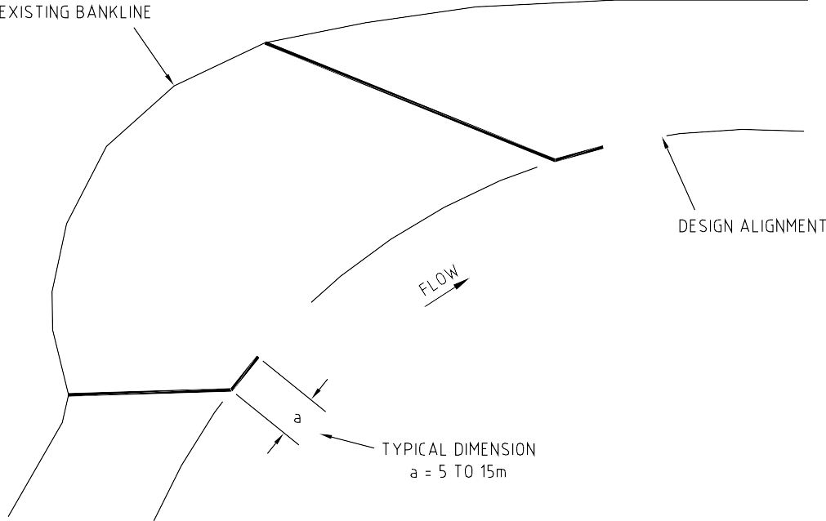

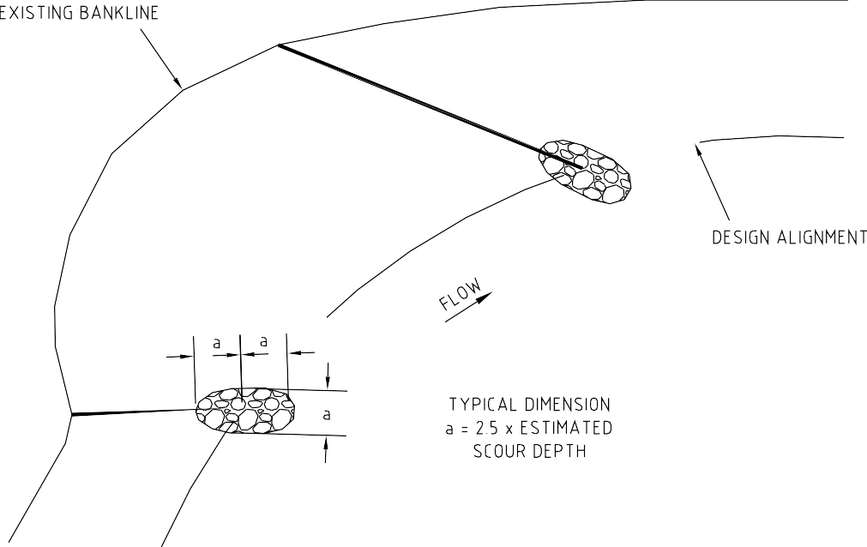

Figure 5.10 Pile field scour protection

Table of Contents

Where scour depths of greater than two metres are predicted, the unsupported structure height will be greater than 3 m (assuming a minimum 1 metre high retard) and the structural integrity of the retard is uncertain. It is a question of the designer's judgement as to what course of action is chosen. One of the main advantages of permeable retard structures is that localised undermining of the riverward end of the structure can occur without rendering the whole structure ineffective. The designer will need to consider the material that the retard is constructed on and its angle of repose under saturated conditions to determine how much of the berm may be removed by the formation of a scour hole at the end of the retard. For example for a material with an angle of repose of 30 degrees and a 2 m deep scour hole, the hole will extend 3.5 m into the berm. This design scour hole size and shape should be used to design embedment depths and pile stability within the pile field retard.

STRUCTURAL DESIGN
An iterative design approach is required for the design of the pile diameter, height and embedment. Iterations must be undertaken with pile field location and orientation discussed within the shear stress approach to pile field design.

- Estimate scour depth at nose of pile: refer Section 6.6 Procedure for Estimating Scour Depth in these Technical Guidelines.

- Select trial pile diameter based on available timber.

- Check pile stability and embedment depth based on design velocity and impact loads: refer Section 6.4 for design of pile stability within these Technical Guidelines.

- Identify total pile length required (retard height + scour depth + embedment).

- Modify piles and/or retard arrangement if, and as, necessary based on available timber.

VEGETATION DESIGN
Vegetation plays an essential role in the success of pile field based strategies:

- The pile field may be designed to provide sediment deposition and a stable substrate in the short term, within which there is a low likelihood of extreme flow events exceeding the design event, enabling vegetation establishment. Using this approach it may be adequate to adopt a design flow event of the 2 to 5 year ARI event to cover the period within which vegetation is becoming established. The established vegetation can then be used to provide stability in the long term over which there is a higher likelihood of more extreme flow events. The stability of the system for more extreme events can be tested based on the presence of the increased roughness associated with vegetation colonisation of the embayments.

- The timber piles will decay through time and depending on their size and species and the local environment will have a useful life of between 10 and 20 years. Beyond this time, the stability of the site will be wholly reliant on the vegetation established within the embayments.

As a consequence the pile field based approaches to sediment and erosion management should not be undertaken without a complementary vegetation establishment and management program.

OTHER DESIGN CONSIDERATIONS
  - Emphasis has been given in these guidelines to the most common uses of retards and groynes. The principles described will have application to other situations. However no definitive guidance can be given for aspects such as spacing of retards to prevent point bar cutoff. In these circumstances the best guide to practice is experience.
  - Where retards are built of impermeable material or are likely to become impermeable through debris accumulation, consideration may be given to

Table of Contents

constructing the retard so that it is angled downstream of the vertical. This has the effect of moving any plunge pool, resulting from weir type overtopping, away from the foundation of the structure.
- Where the retard abuts the existing bank line, it should be excavated into the bank to a distance at least twice the retard height. The excavation should be backfilled with selected material and compacted. Where practical, rock riprap protection upstream and downstream is desirable.
- Riprap or other means of direct bank protection may also be required at the upstream and downstream limits of the retard field to ensure stability of the approach or departure alignment.
- Situations will exist where pile driving is difficult or impossible, although this will not be common in most streams suited to alignment training by permeable retards. Where pile driving is not a realistic possibility other forms of anchorage could be installed. Remember that the loads being designed for are typically horizontal and not vertical.
- Vegetation is a vital aspect in the long term stabilisation of the channel bank and area protected by the retards. Appropriate steps should be taken to promote vegetation in conjunction with retard implementation. The faster the vegetation becomes established the less chance there is of failure of the retards.

FIELD NOTES

CONSTRUCTION
Excavation of a pilot channel may be the first stage of construction to divert water away from the works area. To minimise turbidity downstream:

- Commence near the downstream end excavating a pilot channel to form an island. Leave downstream intact, and work upstream. Before making top cut, remove downstream block and finally upstream section to allow flow down the cut.
- Block flow between island and bank at most convenient place and complete building of construction platforms.
- Try not to shift material in flowing water.
- Use the material excavated from the pilot channel to form a berm.
- Piles for groynes are often driven from the top of the bank, piles for retards usually require access to the bed.
- Benches of bed material (berms) may be constructed along or adjacent to the line of a retard to facilitate access during construction. Upon completion these should be modified to have some minor topography as this will assist in the revegetation of the embayments. Small hollows of 0.3 m are recommended. These should be isolated hollows and not form a line which might concentrate flow during an event.

Set out requirements include:

- location and height of toe of each retard or groyne; and
- location and height of abutment of each retard or groyne (excess bed material from the pilot channel can be placed between the retards or groynes).

MAINTENANCE AND MONITORING
- Check for accumulation of debris which may either overload the structure or reduce its permeability. Clear debris if necessary.
- Check for evidence of scour at the structure which may indicate that the structure is not sufficiently permeable. Adjust if necessary or place scour protection.
- Check for signs of abutment failure and correct as necessary.
- Encourage vegetation in embayments between structures. This should take the form of planting or direct seeding upon completion of construction with follow up planting to fill areas where the vegetation did not become established initially.

Table of Contents

  - Check the structural integrity of the retard. This includes broken piles and scour holes. These have proven to be areas that require a systematic check at regular intervals.

DESIGN OF ROCK BEACHING
A recommended approach to the design of stream bank erosion control using rock beaching is set out below. The approach and much of the discussion provided in this section is based on that developed for and included in Guidelines for Stabilising Waterways (Standing Committee on Rivers and Catchments 199). The approach comprises the use of blasted quarry or field rock known as riprap (or rock riprap). The design approach is based on inclusion of vegetation within the system to provide for complementary outcomes and reduce the total cost of works.

For the purpose of these Technical Guidelines rock beaching is a layer of sized and graded rock which is placed on a stream bank to protect it from erosion. A typical rock beaching application of the type covered by these guidelines is illustrated in Figure 5.11.

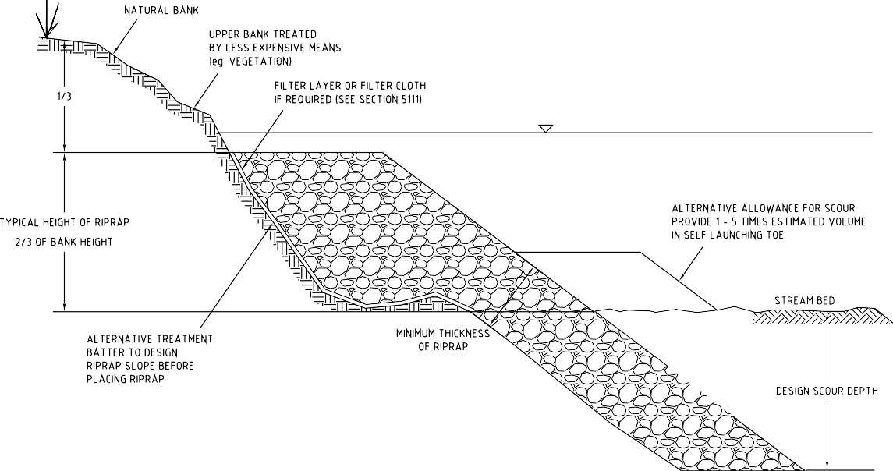

Figure 5.11 Typical rock beaching arrangement

OBJECTIVES OF ROCK BEACHING DESIGN
The objective of rock beaching design is to ensure that:

      - the rock is of sufficient size to resist movement by the action of flowing water;
      - the grading of sizes within the rock riprap minimises the presence of voids within the protective layer and minimises the area of individual rocks exposed to forces from the flow;
      - a filter layer is provided where necessary to prevent bank material washing out through the protective riprap layer;
      - the rock riprap extends a distance upstream and downstream which is appropriate to the level of security to be achieved, and the cost of the protection;
      - the rock riprap covers a proportion of the bank height which is appropriate to the level of security to be achieved, and the cost of the protection;
      - the rock riprap extends below estimated scour depth; and
      - the rock is of suitable quality.

Table of Contents

APPLICABILITY OF DESIGN TECHNIQUE
These design guidelines apply to protection of the bank against removal of bank material by the action of flowing water. They do not apply to protection of banks against mass failure of the bank material as the result of soil processes occurring within the bank material. Banks which may be subject to mass failure. Mass failure mechanisms may need to be analysed to assist identification of appropriate stabilisation measures to address the mass failure modes. Once mass stability is confirmed, the procedures described herein may be applied to prevent erosion due to flowing water.

Experience has shown that in most stream bank applications, once the stability of the toe of the bank is ensured by riprap or other means, catastrophic slip circle failure is unlikely. Notable exceptions are very high banks, and saturated bank conditions such as in a draw down condition associated with the recession limb of floods and regulated river operations, or where water ponds on the top of the bank or in the adjacent floodplain.
These design guidelines provide general rules for economical design of riprap as a measure against bank erosion based on experience principally in rural areas. They will be in conflict with some practices which have been developed for treatments in special situations. For instance, Melbourne Water has historically adopted bank treatment techniques using individually placed, predominantly single sized rock, which will demand far more rigorous attention to filter layers than is suggested herein.

SIZE OF ROCK RIPRAP
The size distribution of rock riprap can be determined through the application of the Riprap software package. The original MS-DOS based RIPRAP software package developed for and included in Guidelines for Stabilising Waterways (Standing Committee for Rivers and Catchments 1991), has been updated and included in the CRC for Catchment Hydrology’s “Toolkit”. The software package and users guide (CRC for Catchment Hydrology 2005) are available as a download from www.toolkit.net.au/cgi- bin/WebObjects/toolkit. The users guide provides a background to the software, the theory for rock movement, and design examples.

Input parameters for the software package include rock density, rock riprap angle of repose, maximum depth of flow, energy gradient and factor of safety for design. Critical among these is the estimation of the energy gradient.

DESIGN HYDRAULIC ENERGY SLOPE
The design hydraulic energy slope or energy gradient is crucial to the determination of the required riprap size. The theoretical basis for the computation of the D₅₀ rock size provides for a direct proportional relationship between rock size and the adopted energy gradient.

The adopted value must represent the local energy gradient adjacent to the rock beaching. The local slope will vary significantly from the reach-averaged energy gradient at constrictions, bridges, other in-stream structures and at channel bends. Only in straight channels of reasonably prismatic cross-section will the local energy gradient approximate the reach-averaged value. One dimensional hydraulic backwater modelling such as HEC- RAS can be used to assist the determination of the local energy gradient.

The accuracy of the estimate will be a reflection of the detail provided within the modelling. While such modelling may provide for increased energy gradient associated with local constrictions such as bridges it may not be appropriate for increases in energy gradient associated with channel bends.

On channel bends, the multiplying factor, Se/Sa, to be applied to the reach-averaged energy gradient may be estimated as a function of the ratio of the bend radius of curvature (centreline radius) to the channel base width from Figure 5.12, adapted from US Soil Conservation Service (1971).

For the nose of groynes and at bridge abutments, work by Maynard (1978) suggests that a design energy gradient of 4 times the reach-averaged value in the channel is appropriate.

Table of Contents

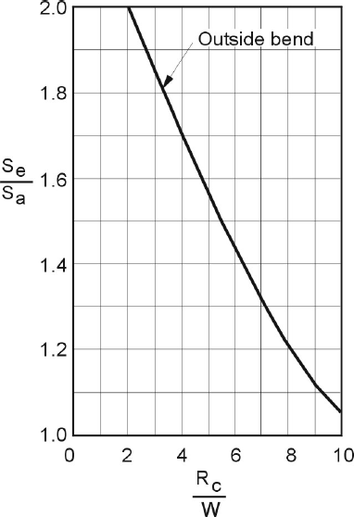
Se/Sa: Ratio of effective energy slope on the outside of a bend relative to the average energy slope for a reach

Rc/W: Ratio of the radius of curvature of the channel centreline of the bend to the base width of the channel

Figure 5.12 Effect of channel bend on effective energy slope (Adapted from US Soil Conservation Service 1971)

LENGTH OF BANK TO BE PROTECTED
There are no universally applicable rules to determine the extent of bank protection appropriate to a particular site. It is the responsibility of the designer to assess such factors as cost of protection, acceptable degree of risk, and consequences of failure, for each design case.

A site inspection and an understanding of the mechanisms causing erosion will assist in determining the appropriate length of bank to be treated. Aerial photographs will assist in understanding alignment development at the site. The following guidelines should also assist:

      - Flow lines and corresponding points of attack will vary significantly with the flow level. In a meandering stream the main current lines tend to straighten with increasing flow, and the point of attack on a bend moves downstream. Braided streams are less predictable.
      - Aerial photographs or local knowledge will often assist in determining the history of erosion at the site. A knowledge of past erosion episodes is a valuable indicator of likely future developments.
      - Erosion on the outside of bends will also move downstream with time. It is desirable to continue erosion protection downstream beyond the limit of existing erosion. An extension of at least two channel widths is suggested as an appropriate guide for treatment of major meander developments. (Channel width is the distance between banks, not the low flow channel.) Generous location of the downstream limit is essential to successful riprap protection.
      - The upstream limit of erosion protection is generally easier to locate. As a guide, for treatment of major meander developments, erosion protection should extend at least one channel width upstream of any existing instability.

Table of Contents

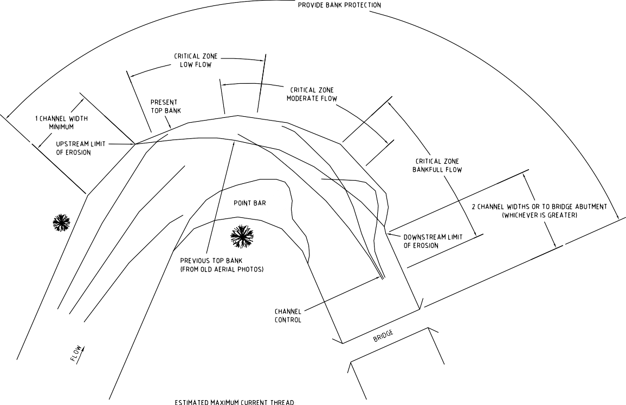
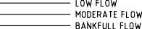

Figure 5.13 Typical upstream and downstream limits to bank protection

Figure 5.13 illustrates the above guidelines for treatment of major meander developments. Note that the extent of bank protection shown here may be extravagant for minor protection works to minor erosion developments.

PROPORTION OF BANK HEIGHT TO BE PROTECTED
It is generally not necessary to extend riprap protection to the top of the bank unless dictated by special considerations such as the presence of strong over bank flows, upper bank erosion by action of standing waves or prolonged high flows, or high consequences of failure. As a general rule, experience has shown that protection of the lower two thirds of a bank generally offers optimum protection. The upper one third of the bank can, if appropriate, be treated by less resistant and less expensive techniques (e.g. vegetation).

The one-third – two-third suggestion should always be reviewed in the light of local knowledge and conditions. For instance, if a stream bank is extremely high, such that flows reach bankfull only very rarely (say less than once every second or third year), then the height of protection may be reduced; and conversely a very low bank relative to the annual flood may need full protection. An understanding of the mode of failure will also assist in this assessment. For example, if the bank is failing through undermining of the toe and subsequent collapse, then protection of the toe is crucial. However, if the mode of erosion is by fretting at high water levels, then protection at that water level is the most important. In designing major rock beaching works it will be desirable to supplement this guideline with a consideration of the stream longitudinal profile. This will give the designer the additional options of either:

- ensuring that the height of rock beaching protection represents an average bank profile through the reach; or
- allowing rock beaching height to vary along the reach to reflect variations in the water surface profile.

Table of Contents

ALLOWANCE FOR SCOUR AT TOE OF RIPRAP
Many riprap failures are caused by undermining of the toe of the riprap by scour of the stream bed during high flow events. A method for the estimation of scour depth is provided in Part 6 of these Technical Guidelines.

Riprap design can allow for bed scour either by:

  - extending rock beaching protection below the bed level by placing riprap in an excavated trench; or
  - providing extra riprap at the toe of the bank which can drop down and provide necessary protection following local scour.

These techniques are illustrated in Figure 5.11.

Care must be taken in using the second alternative. The response of the riprap to settling is unpredictable, and is not covered in the theory used for determining rock size. If a graded rock source is being used (as is recommended), the finer material will be susceptible to loss during settlement and allowance should be made for at least 50% loss of rock if this technique is considered.

The importance of allowing for bed scour in rock beaching design varies with the type of river. The designer must rely on judgement of the likely severity of bed scour in the particular design situation. This judgement may be aided by using the techniques for estimating scour depths (refer Section 6.6). The following guidelines may also assist:

  - In meandering gravel bed rivers in Victoria, allowance for scour on the outside of bends would generally be made by ensuring generous provision of rock at the toe of the protection works. Additional scour depths beyond the deep holes typical of this situation are likely to be reasonably small.
  - In sand bed streams, scour depths can be several metres in magnitude, particularly if the channel is steep. Allowance for scour is fundamental to successful design.
  - Deep scour requiring particular attention will also occur at constrictions, groynes, bridge abutments or other areas of flow disturbance.
  - The importance of scour (and the scour depth) increases with increasing channel grade and with increasing depth of flow. It also increases with decreasing bed material size.
  - In severe cases, in-channel scour control techniques may be an alternative means of providing riprap security.

THICKNESS OF RIPRAP PROTECTION
The thickness of rock riprap protection should be at least twice the median riprap diameter or equal to the largest rocks in the riprap mixture, whichever is the greater (see Figure 5.11.

ROCK RIPRAP GRADATION
Riprap should not be single-sized, but should be a well graded mixture designed to ensure that all interstices between large rocks are filled with rock of progressively smaller size. This has the combined effect of:

  - ensuring that no significant voids occur in the riprap blanket through which underlying material could be washed out;
  - creating an interlocking mass of rock in which no individual rock is free to move by itself; and
  - creating a shielding effect on the surface of the riprap that avoids high drag forces which occur when individual rocks protrude into the flow.

Table of Contents

Experience suggests a riprap gradation summarised as follows:

Equivalent spherical diameter* Percent (by weight) of riprap of smaller size
1.5 – 2.0 times D₅₀ ** 100%
D₅₀ 50%
0.5 D₅₀ 10 – 20%
* The diameter of a sphere with an equivalent volume to the individual rock
** D₅₀ is the median riprap diameter of the rock mix (i.e. 50% (by weight) is smaller and 50% (by weight) is larger)

When specifying riprap gradation to field staff and contractors, it has been found helpful to transform this grading by weight into an equivalent grading by number. This greatly assists in visualising and testing the riprap mixture to be achieved. Methods for the identification of rock size are provided in Section 6.5 of these Technical Guidelines.

ROCK QUALITY AND SHAPE
Rock for riprap should be hard, tough and durable. It should have a crushing strength of a least 25 MPa. The rock should be free of defined cleavage planes and should not be adversely affected by repeated wetting and drying.

Rock should preferably be predominantly angular in shape with not more than 25% of rocks, distributed through the gradation, having a length more than twice the breadth or thickness. No rock should have a length exceeding 2.5 times its breadth or thickness.

Where rock fails to meet this specification it may still be used in some cases at the designer's discretion provided allowance is made in the design for its shortcomings.

Rock to meet size and strength criteria will normally be won from a hard rock quarry by drilling and blasting. If available, an hydraulic rock breaker mounted on an hydraulic excavator provides an excellent means of producing rock to design size gradation.

A material guide for rock riprap is provided in Part 4 of these Technical Guidelines.

FILTER LAYER
Filter materials may be necessary to stabilise riprap protection over fine material. The filter layer prevents material being washed from behind the riprap through residual interstices in the riprap layer.

It is common practice in rural Victoria for rock rip rap, graded and sized in accordance with these guidelines to be placed directly onto eroding bank surfaces. Such work has been completed with high levels of success. As a consequence it has been found from experience that a dedicated filter layer has not always been necessary.

If well graded riprap is designed according to the procedures outlined in these guidelines then filter material should only be necessary where:

- the underlying material is largely non-cohesive such as a uniform sand or silt;
- there is evidence of high groundwater levels or seepage areas in the bank profile; or
- an unusually high factor of safety is required.
Where one or more of these conditions exists, the need for a filter layer can be further tested using the following criteria:

Table of Contents

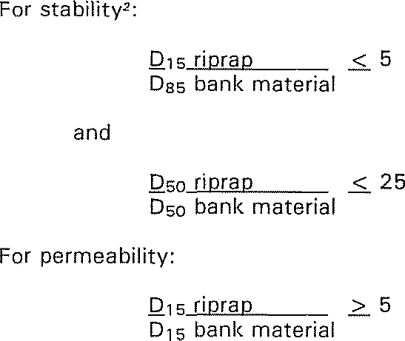

Where the bank and riprap materials do not satisfy the above criteria the use of a granular or geotextile filter layer may be justified. Note that the importance of the filter layer will be far greater if the design riprap grading exhibits a tighter range of sizes than that recommended herein.

GRANULAR FILTER LAYER
Design of a granular filter layer is based on the above three conditions applied twice: once between the bank material and the filter layer; and once between the filter layer and the riprap.

USE OF GEOTEXTILE
Geotextile fabric has been used as an alternative to the use of a granular filter layer. However, several failures including partial failures have been observed where rock has slid on the geotextile. This occurs where the friction between the rock and the filter cloth is less than the internal friction of the rock mix. The most vulnerable designs will be those in which hydraulic forces are not particularly great, allowing the bank angle to be steep, probably close to the natural angle of repose of the rock riprap.

For designs where a flat batter is required to ensure riprap stability against hydraulic forces, then the risk of failure by sliding of the rock on the filter cloth is diminished.

In addition to the above some geotextiles have been found to inhibit vegetation establishment through the rock matrix and into the underlying soil.

The failure mechanism and inhibitor to vegetation establishment have rendered geotextiles to be a less robust and a less desirable filter layer than the granular material. As a consequence, geotextile based filter layers should be avoided and only used in exceptional circumstances.

None the less there will be applications where geotextiles are appropriate. In such circumstances care must be taken to ensure maximum resistance is developed between the riprap and the cloth. This can be achieved by:

  - avoiding preparation of the bank to a smooth and even batter before placing the cloth;
  - not stretching cloth tightly over the underlying bank; and
  - avoiding cloths with low friction surfaces.

VEGETATION ESTABLISHMENT
While vegetation establishment is not required to achieve the structural intent of the works at the toe of the bank, vegetation can be used to provide protection to the upper bank. Further vegetation can be incorporated into the design to achieve some ecological outcomes from the works. Information on vegetation establishment can be found in Revegetation Techniques - A guide for establishing native vegetation in Victoria

Table of Contents

(Greening Australia 2003). Vegetation (grasses, sedges, rushes and small shrubs) can generally be successfully established in the voids in riprap. This may be further assisted by placement of topsoil over the top of the riprap shortly after placement.

FIELD NOTES

CONSTRUCTION
- Do not tip riprap directly over the bank from dump trucks unless a flat batter is required. Rock should normally be carefully pushed over the bank or placed by the bucketful with a front end loader or excavator/dragline.
- Placing rock from the river side of the bank from a barge or by loader gives very successful results for the protection of the lower bank and toe.
- Riprap should be handled and placed to avoid segregation of size fractions.
- Variations in rock quality and size must be monitored and compensated for.
- If banks which are very uneven can be battered before rock is placed, major savings in rock volumes can be achieved. Be sure to place rock on cut surfaces only, fill must be removed from channel.

MAINTENANCE AND MONITORING
- Check regularly for excessive settling of riprap along the bank.
- Check regularly for evidence of scour along the toe of the riprap.
- Pay particular attention to the stability of the bank at the downstream end of the riprap.
- Check for evidence of bank slumping associated with overbank flood waters re- entering the channel.

MANAGEMENT OF INCISED STREAMS
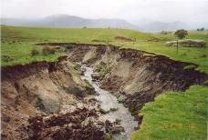
This section of the Technical Guidelines documents a process for the analysis of incised stream systems, and the design of stream bed grade stabilisation works.

Incised streams are a natural feature of the south east Australian landscape. These streams are part of what are known as cut and fill stream systems. However, the temporal and spatial distribution of stream incision has increased as a result of European settlement and development. Stream bed incision (also known as stream bed degradation) is often a response to changes in land use and in-channel

management. Much of the incision in Victoria can be attributed to removal of the stabilising vegetation. However extensive areas have
Incised tributary of Barwidgee Creek, Ovens River catchment, north east Victoria

been subject to incision as a result of channelisation to reduce waterlogging (Bunyip Creek and Fifteen Mile Creek) and to reduce the impacts of sedimentation associated with mining (Hodgson Creek and Bendigo Creek). Stream bed incision in the Cann River has been attributed to the removal of instream wood. In some areas of metropolitan Melbourne (Gardiners Creek) incision has been attributed to changes in catchment hydrology associated with catchment urbanisation. However stream incision can also be the result of entirely natural processes.
Table of Contents

This design guideline provides an overview of the causes of stream bed incision, the processes and phases of stream bed incision, objectives for management, and options for the assessment, design and management of incising streams.

STAGES OF INCISION
There are a number of distinct stages associated with the process of channel incision. These phases were illustrated and described by Simon 1989. Simon’s model of the incision process is shown in Figure 5.14. An understanding of the processes of incision and knowledge of the stage of incision will assist the development of a stream bed incision management program. The stages of incision are outlined below.

Stage Processes
- Relatively stable system
Comprises cut and fill system subject to geological timescale incision and infill processes

Initiation of instabilities
Swamp drained Channel excavated

Degradation
Channel bed degrades
Sand stripped from bed and moved downstream

Degradation and widening
Channel degradation steepens the banks
Banks begin to fail and collapse and channel widens Sediment begins to accumulate in the channel bed

Table of Contents

Stage Processes
- Aggradation and widening
Banks continue to fail
Channel widens by basal undercutting

Low flow channel formation - recovery commences
Sand starts to accumulate in the channel bed A sinuous low flow channel forms

VI Bench formation
Grasses begin to stabilise the channel bed
Sediment accumulates either side of the sinuous low flow channel

VI Recovery
Extensive bench formation Vegetation stabilisation
Sinuous low flow channel below benches

Figure 5.14 Process of channel incision and recovery (Simon 1989)

Table of Contents

INCISED CHANNEL MANAGEMENT
Incising stream systems can have a significant adverse impact on the health of streams and the integrity of adjoining infrastructure. Stream bed incision can release large volumes of sediment into downstream waterways, smothering bed forms and adversely impacting on water quality. Headward erosion associated with incising streams can lead to the loss of upstream intact stream forms including remnant wetlands. Further, ongoing incision processes such as resultant channel widening can lead to the loss of remnant riparian vegetation. Incising streams can intercept saline groundwater and can result in water quality decline.

In addition to the impacts on stream health, incising systems can adversely impact on infrastructure assets such as roads, bridges and buildings and other economic assets such as agricultural land. Land can be lost through erosion or through downstream deposition of sand sized sediments on pasture.

However, incised streams can be managed to reduce or prevent these adverse impacts.

PHILOSOPHY OF INCISED STREAM MANAGEMENT
Management of incising streams requires management of energy expenditure on exposed bed and bank material. The approach to management lies in part in the identification of which stage of incision the subject system or reach is located. With this understanding, consideration can be given to whether effort should be invested in either:

- Reversing the process. This approach is based on reducing the expenditure of energy that flowing water exerts on the bed and banks of the channel by reducing the in-channel capacity and increasing the occurrence of overbank flooding and proportion of flow on the floodplain.

- Accelerating the process or completion of the cycle. This approach recognises that often the incision process is not reversible and that all flow events are likely to be contained within the incised channel. This approach comprises the modification of the channel dimensions (bed grade and channel width) to reduce in-channel unit stream power (stream power per unit channel width), to levels below the threshold required for channel change and sediment mobilisation.

Increasing the robustness of the channel can also be applied with both approaches. Additionally, both approaches may incorporate grade control structures and other structures to assist vegetation colonisation.

OBJECTIVES
Typically an incised stream management program would be undertaken to either limit the progression of headward erosion or limit downstream sediment transport. This may be undertaken to protect remnant upstream habitat, protect remnant or established downstream habitat. Complementary objectives could include:

- establishment of instream and riparian vegetation and habitat connectivity
- creation of pool habitat
- creating no adverse impact on fish passage
- managing the impacts of flooding.

SYSTEM ANALYSIS
Analysis of incised systems can typically comprise four components:

- Visual analysis
- Stream bed longitudinal profile analysis
- Hydraulic analysis
- Historic data collection and literature review.

Table of Contents

These analyses can be used to provide increased level of understanding of the stream system and processes. Combined, these analyses comprise a comprehensive assessment of an incising stream system.

VISUAL ANALYSIS
A visual inspection should be included in any assessment of stream processes. The intent of the field inspection is to identify:

- reaches of sediment erosion and deposition
- presence and absence of vegetation
- the stage of channel incision. The analysis should include:
- a walk along the stream system
- photographs of the creek for later reference
- collection of stream bed and bank sediments
- a preliminary division of the stream into reaches based on the stages of incision.

STREAM BED LONGITUDINAL PROFILE ANALYSIS
The purpose of stream bed longitudinal analysis is to assist the development of an understanding of the stream processes. The analysis enables identification of stream bed grades associated with intact and template reaches of stream, and those that are subject to ongoing instabilities. The analysis also allows identification of knick points and steep reaches within the system.

The process of longitudinal stream bed analysis comprises:

- Stream bed longitudinal survey. There should be sufficient survey upstream and downstream of any apparent instabilities to enable identification of stable stream bed gradients for reaches subject to channel recovery.

- Analysis of the longitudinal stream bed profile data. The analysis can involve visual or analytical approaches to the identification of representative and stable bed grades for the stream. Analytical procedures may involve techniques such as moving average analysis.

- Visual identification of knick points and over steep reaches.

HYDRAULIC ANALYSIS
Hydraulic analysis can be undertaken to identify the velocity, shear stress and unit stream power within the subject stream and its reaches for a range of flow events.

The analysis can be used to compare stream power, shear stress and velocity parameters for the incised reaches with template reaches of the system, and design parameters (refer Part 6 Design Aids).

The process for hydraulic analysis typically comprises:

- Hydrologic analysis using either a rainfall runoff approach (e.g. Rational computation or RORB Model), or flood frequency analysis. Flood frequency analysis is preferable where stream gauging data is available. Flood frequency analysis should be undertaken using the approach set out in Australian Rainfall and Runoff (The Institution of Engineers, Australia 2001).
- Longitudinal and cross-sectional survey of the incised and template reaches for comparative analysis.
- Development of a hydraulic model of the stream system. Typically this would comprise a one-dimensional, steady state, hydraulic model (e.g. HEC-RAS). A more sophisticated modelling package may be appropriate depending on the complexity of the system.

Table of Contents

- Sediment size and composition analysis incorporating either:
  - visual soil assessment; or
  - analytical soil properties analysis, i.e. sediment size and dispersion analysis.
- Comparison of the analysis results of incised reaches with a template reach and design parameters developed and adopted for other similar sites.

HISTORIC DATA COLLECTION AND LITERATURE REVIEW
Historic data and literature reviews can provide insight into the stream processes at the site, not observable with a current snapshot. Information sources can include, but may not be limited to, historic photographs, extracts from explorer’s diaries, newspaper articles, parish plans and bridge design surveys.

Collation and review of this information can often reveal the dates and causes of channel change. This assists in estimating the rate of channel change.

INCISED STREAM MANAGEMENT TECHNIQUES
A combination of management techniques will often be required to achieve the overall management objective for an incised system.

REVEGETATION/VEGETATION ESTABLISHMENT
Vegetation establishment should be a part of all incised stream management programs. Implementation of programs without commitment to vegetation establishment and management reduces success and can increases costs by an order of magnitude.

Vegetation establishment provides stability by:

- binding soils;
- altering the channel velocity profile so the velocity at the channel boundary (i.e. soil surface) is reduced; and
- reducing the overall velocity of water.
In addition vegetation provides additional benefits including habitat, nutrient assimilation, and shading. However vegetation establishment alone may not address and halt the incision processes. Additional works may be necessary to enable vegetation establishment.

GRADE CONTROL STRUCTURES
Grade control structures reduce energy in low flows to provide a depositional environment suitable for vegetation establishment. However structures will often drown out in larger flood events. In these events the stream hydraulic gradient approaches the gradient of the eroding incised stream and provides no benefit to the system. The vegetation established as a result of the provision of these structures provides the stability in these larger flood events.

Consequently grade control structures that are designed to drown out in large flood events will be ineffective without the provision of long term stabilising vegetation. Grade control design is discussed in detail in the next section.

CHANNEL LENGTHENING (CHANNEL/WETLAND RECONSTRUCTION)
The process of reinstating meanders and/or constructing additional channel length can be an effective long term approach to incision management. This technique reduces the stream bed grades and hence reduces stream power. Like all techniques this technique also requires vegetation establishment.

Using a geomorphic approach to channel design will provide a solution with the lowest long term maintenance requirements and is therefore recommended where minimal long term maintenance is a design objective. Further information on the geomorphic design of stream channels can be found in:

Table of Contents

- Section 3.3.15: Channel reconstruction - geomorphic channel design;
- Section 5.4.1: Geomorphic design of stream reconstructions; and
- the related reference Hydraulic Design of Stream Restoration Projects (Copeland et al. 2001).

BANK BATTERING
In the absence of intervention, ongoing stream processes in an incising stream system will result in the over-widening of the channel bed. A battered bank profile will develop through the establishment of instream benches and fretting of the upper bank. This process can take decades and will result in ongoing sediment delivery to the stream system.

The process of channel recovery and bank battering can be accelerated through physical bank battering. Physical bank battering can reduce sediment release to the channel.
Battering will only be successful if the underlying bed instabilities have ceased (i.e. excess stream power is being expended in bed widening rather than bed degradation). Battering of banks can be used in conjunction with grade control works to achieve stabilisation. Bank battering works also require complementary revegetation. The provision of complementary revegetation will increase the thresholds of stream power and shear stress required for sediment mobilisation and will reduce the extent of bank battering required to halt the widening process.

INCREASE OF CHANNEL ROUGHNESS – REINTRODUCTION OF INSTREAM WOOD
Instream wood can be used to increase channel roughness. In many instances existing instream wood controls in-channel hydraulics and limits the opportunity for the initiation of the incision process. However, once the incision process has progressed beyond stage II (see Figure 5.14) it is unlikely that there will be sufficient timber available to enable its use as the sole means of preventing further channel incision.

However the reintroduction of instream wood will assist with channel recovery. The introduction of large wood can be considered a component of a broader suite of techniques aimed at increasing channel roughness to reduce instream velocity and stream power. These techniques include vegetation establishment, and could also include the application of pile fields.

An additional benefit of the installation of instream wood is the provision of local habitat comprising both immobile substrate and local scour holes. Further information on the reintroduction of wood can be found in:

- Section 3.3.22 Large wood installation
- Section 5.4.7 Instream scour hole and habitat design
- Section 6.4 Stability Analysis for Large Wood and Engineered Log Jams
- Land and Water Australia; www.lwrrdc.gov.au

MODIFICATION OF CATCHMENT HYDROLOGY
There is potential to address some of the issues associated with channel incision with modification of the flow regime. However as with the reintroduction of wood, modification of the flow regime is unlikely to be a viable single approach (even if combined with revegetation) to manage the incision process once the process of incision has commenced and progressed beyond stage II (see Figure 5.14). However modifying channel hydrology through approaches such as Water Sensitive Urban Design may assist in incised channel management, as part of a suite of management interventions.

Reduction of in-channel flow by reducing channel capacity and increasing the occurrence of overbank flows will be an effective technique in reducing in-channel stream power and therefore reducing incision.

Table of Contents

ROCK CHUTE BASED GRADE CONTROL STRATEGY DESIGN
A rock chute is a relatively short and steep section of the bed of a channel which has been armoured with rock. It is normally intended to either stabilise an erosion head and prevent it from moving upstream in the channel or reduce the overall grade of a channel by providing a weir within the channel bed.

A rock chute offers a form of drop structure that can provide for fish passage, and minor channel adjustments without complete failure. Rock chutes are a preferred means of grade control within incising stream systems. Typical applications are illustrated in Figure 5.16.

A recommended approach to the design of a grade control program for an incised channel using rock chutes is set out below. The strategy design is based on inclusion of vegetation within the system to provide for the long term stability of the system. The design approach includes the assessment and design of system stability based on stream bed gradient and a selection of hydraulic parameters.
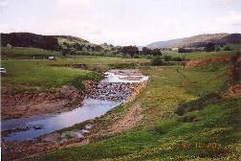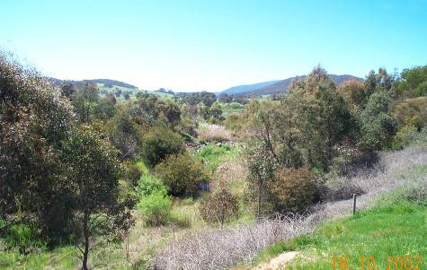
Figure 5.15 Barwidgee Creek, north east Victoria, six months (left) and 10 years (right) after rock chute construction and revegetation (Images courtesy of T. McCormack, North East CMA)

DESIGN BED GRADIENT
A design bed gradient (grade) for the stream can be identified by:

- reviewing bed grades in adjoining reaches observed as not subject to erosional instabilities;
- calculating design grades based on incipient motion or sediment transport theory; and
- comparison with other stream bed grades found for similar streams.
This analysis relies on the results of the stream bed longitudinal analysis undertaken for the stream. Stream bed longitudinal gradients identified by Hardie (1993) for approximately 30 sand and gravel bed streams in north east Victoria are provided in Figure 5.17.

The stream bed gradients in Figure 5.17 are plotted against streamflow, where streamflow is the lesser of bankfull and the two year ARI flood event identified using the Rational Method as set out in Australian Rainfall and Runoff (The Institution of Engineers, Australia 2001).

Table of Contents

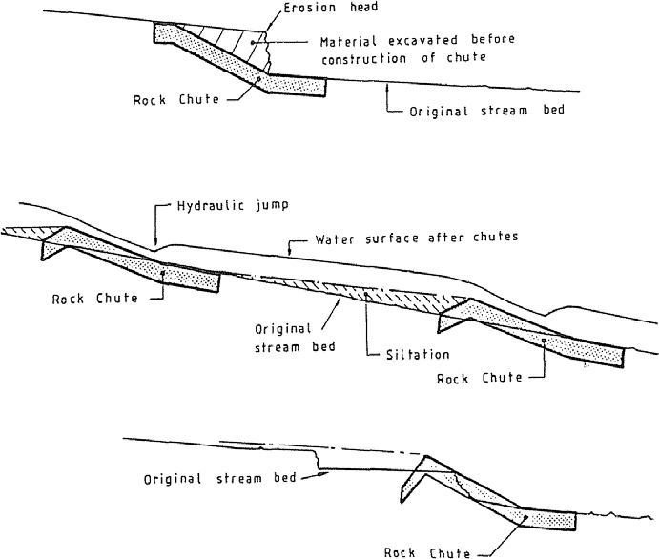

Figure 5.16 Typical applications of rock chutes

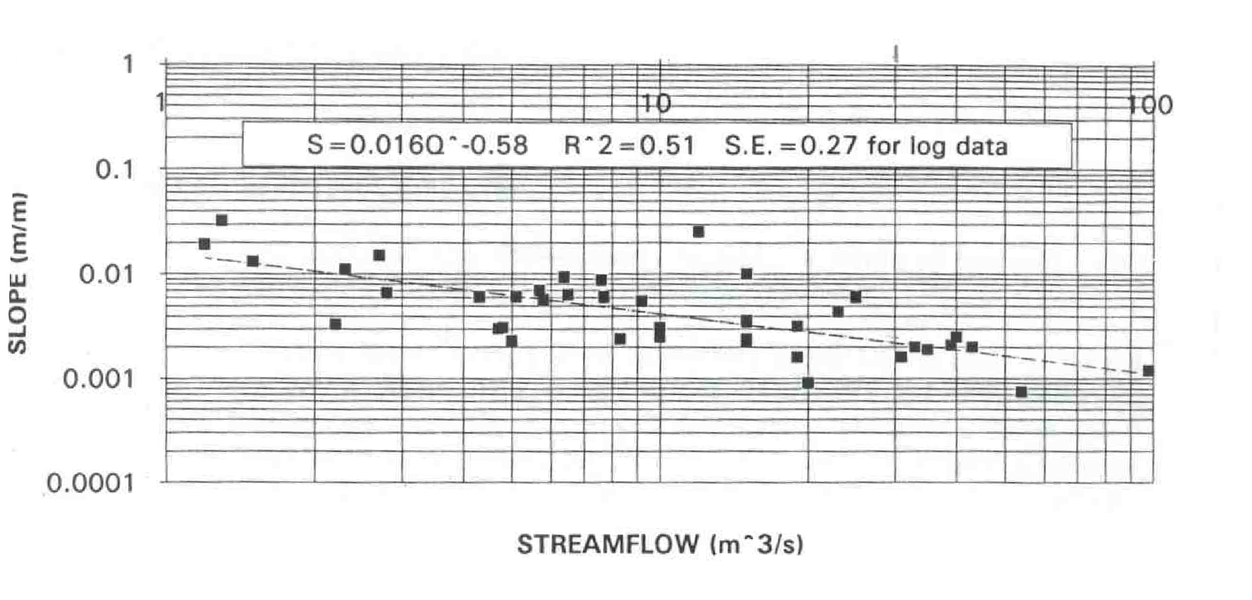
Figure 5.17 Stream bed longitudinal profiles for north east Victoria (Source: Hardie 1993)

Table of Contents

GRADE CONTROL STRUCTURE NECESSITY AND LOCATION
Grade control structures will be necessary to address knick points, erosion heads and reaches with bed grades steeper than the design bed grade. Structures could comprise rock chutes, log sills, grass chutes and other drop structures. These options are discussed in Section 3.3 of these Technical Guidelines. However, the rock chute structure is considered the most robust structure for grade control programs and the remainder of this discussion is based on this technique.

Once a design bed grade has been adopted a range of chute height and location options can be explored to identify the most economical solution. The site selection and arrangements for structures should include consideration of the following:

- As a minimum, individual structures should be located and sized such that the grade between the crest of one structure and the apron of the next upstream structure is at or below the design bed grade.
- Preferably structures should not be located on bends.
- Structures in wide cross-sections may attract additional expense of embankments to confine flow.
- Structures in narrow cross-sections may require greater excavation volumes.
- Suitable abutment conditions must be available to allow secure abutment construction.
- Access and other construction considerations may place major cost penalties on some sites.
- Bridges, crossings, pump sites and existing vegetation may place further restrictions on sites.
- Location of tributaries and overland flow inlets must be considered.
- Sites must allow provision of bypass for flows which exceed the design flow event.

An example chute layout for an incised stream system is shown in the following figure.

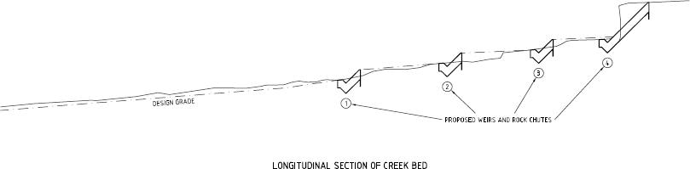

Figure 5.18 Example trial rock chute layout

DESIGN HYDRAULIC PARAMETERS
The grade control structures are intended to provide a level of stability for low flow events, enabling the establishment of vegetation to provide stability in larger events and through the long term. A shear stress and in-channel unit stream power analysis can be undertaken to increase the level of confidence in the design. The analysis be used to assess whether shear stress and unit stream powers are sufficiently low to cease scour, enable vegetation establishment and ensure that such vegetation is not destroyed in more extreme flood events. Changes in vegetation density can be modelled through manipulation of the Manning’s “n” hydraulic roughness coefficient adopted for the system.

Table of Contents

Guidance on appropriate Manning’s roughness coefficient can be found in Hicks and Mason (1991) and from An Australian Handbook of Stream Roughness Coefficients at: www.rivers.gov.au/roughness.

A design shear stress and in-channel unit stream power should be identified for the incising system for a range of flow events. The design shear stress and in-channel unit stream power can be identified by:

- Calculating the shear stress and in-channel unit stream power in adjoining stable incised reaches, within stages V or VI (refer Figure 5.14) of channel of evolution.
- Calculating design shear stress and in-channel unit stream power based on incipient motion or sediment transport theory.
- Comparison with the shear stress and in-channel unit stream power of other incised streams in stages V or VI (refer Figure 5.14) of channel of evolution.

This analysis relies on the results of the hydraulic analysis undertaken for the system. Parameters that may assist with the design are provided in Part 6 of these Technical Guidelines.

Example shear stress and in-channel unit stream power parameters reported in Fisher Stewart (2002), for non eroding, alluvial, sand bed, vegetated, incised channels, in central Queensland are provided in Table 5.4. These parameters should be tested against non eroding incised alluvial stream reaches adjoining the subject stream prior to their application to the subject site.

Table 5.4 Design parameters for non eroding, sand bed, alluvial, vegetated, incised channels in central Queensland (from Fisher Stewart 2002)
Parameter Flow event (ARI)
 | 2 year | 50 year
In-channel unit stream power (N/m.s) | 60 | 150
Shear stress (N/m²) | 40 | 100
Velocity (m/s) | 1.5 | 2.5

A development of this approach is an annual average excess energy assessment. This approach predicts stream bed incision using the cumulative total of shear stress or stream power that is excess of that required to initiate motion of bed and bank material, over an extended (greater than 20 year) time series. Similar to the approaches outlined above, this approach requires comparison between the subject site and neighbouring “stable” incised systems to identify an acceptable average annual excess energy on which the design of the proposed incised stream system should be based. This approach provides a more complete and complex analysis of the range of flows that can initiate channel change than the 2 and 50 year ARI events adopted by Fisher Stewart (2002).

MODIFICATION OF FLOW, CHANNEL DIMENSIONS AND ROCK CHUTE ARRANGEMENTS
The flow regime, channel dimensions and chute arrangements may need to be modified to bring the incised stream within the design parameters set for the system.

Structural management options for the reduction of shear stress and in-channel unit stream power include:

- provision of additional channel roughness through construction of pile fields and additional vegetation establishment;
- increased occurrence of overland flow to reduce energy expenditure within the channel;
- channel bank battering; and

Table of Contents

  - increased height of grade control structures and reduction in bed grade (unlikely to have significant impact on shear stress and stream power for large flood events).

Combinations of these options should be explored until the most economical design solution is achieved. Options should be tested through hydraulic modelling of the modified incised system using the hydraulic model established for the system analysis.

DESIGN OF INDIVIDUAL ELEMENTS – ROCK CHUTES
The final stage of the design approach comprises the design of individual elements such as rock chutes, vegetation establishment and channel roughness. Some iteration of the design steps may be required to meet rock size limitations and other constraints identified through the design of the individual elements.

OBJECTIVES OF ROCK CHUTE DESIGN
The objective of individual chute rock chute design is to ensure that:

  - chute geometry and rock size are matched with expected flow conditions so that the rock remains stable under the design conditions;
  - abutment treatment prevents the chute failing by outflanking at the crest;
  - the grading of sizes within the rock mixture minimises the presence of voids and minimises the area of individual rocks exposed to forces from the flow; and
  - chutes are located where they can serve their function most efficiently and effectively.

ROCK SIZE AND CHUTE DIMENSIONS
The software package CHUTE has been developed for the design of rock chute structures. The DOS based software package developed for and included in Guidelines for Stabilising Waterways (Standing Committee of Rivers and Catchments 1991) has been updated into a Microsoft Excel format and is included in the CRC for Catchment Hydrology “Toolkit”. The software package and Users Guide is available as a download from www.toolkit.net.au/cgi- bin/WebObjects/toolkit. The Users Guide provides a background to the software, the theory for rock movement, and design examples.

The software package provides a means to determine the rock chute dimensions (length, width and drop), bank angle and D₅₀ rock size required for a stable structure. Design is based on maintaining a hydraulic jump on the structure for all events up to, and preferably beyond, the design event. The design input parameters for the software package include:
  - rock density and angle of repose
  - factor of safety for design
  - hydrology
  - downstream channel depth
  - trial dimensions of the chute (width, length and drop) and apron (length and rise).

DESIGN FLOW EVENT
The flow event adopted for the design of the chute will be a function of the level of security required against rock movement and chute failure. Highest design flow events may be adopted where failure has a high consequence, such as in urban areas with difficult access for reconstruction and with high public visibility. It is not uncommon for chutes with high consequence of failure being designed for all flow events up to the 100 year ARI event. A lower design flow event may be adopted for structures of lower consequence of failure. It is not uncommon for rock chutes in rural areas to be designed for flows up to and including the 20 year ARI event.

However it is worthwhile noting that the design flow event may be governed by the upstream channel capacity. A limited upstream channel capacity may limit the maximum flow in the subject waterway and over the subject grade control structure to a flow considerably less than the 20 or 100 year ARI design event. In such circumstances it may be appropriate to design the grade control structure for the maximum capacity of the

Table of Contents

upstream channel. Care should be taken to ensure that overland flows that by pass the grade control structure do not create scour at any points of re-entry to the main channel. Additional grade control or gully control structures may be required to assist control of scour at entry points for overland flow.

FISH PASSAGE
Rock chutes should be designed and constructed to provide fish passage. Rock chutes should be constructed at a grade no greater than 1:15 (V:H) and preferably at a grade of 1:20 to enable fish passage. In addition chutes should be constructed with a low flow channel within which deeper flow depth and resting pools can form to enable fish passage. Gaboury, Newbury and Erickson (1995) provides some specific advice on the design of rock ramps for fish passage.

OTHER DESIGN DETAILS
Typical plan and section views of a rock chute are shown in Figure 5.19. Considerations for design include:
- specification for rock quality and grading
- thickness of the rock layer
- possible incorporation of a fixed crest within the rock structure
- details of filters required
- details of cut offs
- treatment of abutments.

ROCK GRADATION
Rock used in chute construction should not be single sized, but should be a well graded mixture designed to ensure that all interstices between large rocks are filled with rock of a progressively smaller size. This has the combined effect of:

- ensuring that no significant voids occur in the riprap blanket through which underlying material could be washed out;
- ensuring an interlocking mass of rock in which no individual rock is free to move by itself; and
- creating a shielding effect on the surface of the riprap to avoid high drag forces that occur when individual rocks protrude into the flow.

Experience suggests a riprap gradation summarised as follows:

Equivalent spherical diameter* Percent (by weight) of riprap of smaller size
1.5 – 2.0 times D50 ** 100%
D50 50%
0.5 D50 10 – 20%
* The diameter of a sphere with an equivalent volume to the individual rock.
** D₅₀ is the median riprap diameter of the rock mix (i.e. 50% (by weight) is smaller and 50% (by weight) is larger).

The above grading has been found through experience to produce a rock matrix within rock structures with a high robustness against hydraulic forces and rock loss. This grading enables the interlocking of individual rocks, reducing mobilisation. Further, the grading has been found to work well with granular filter materials, preventing the loss of such filter material through the rock matrix.

When specifying riprap gradation to field staff and contractors, it has been found helpful to transform this grading by weight into an equivalent grading by number. This greatly assists in visualising and testing the riprap mixture to be achieved. Methods for the identification of rock size are provided in Section 6.5 of these Technical Guidelines.

Table of Contents

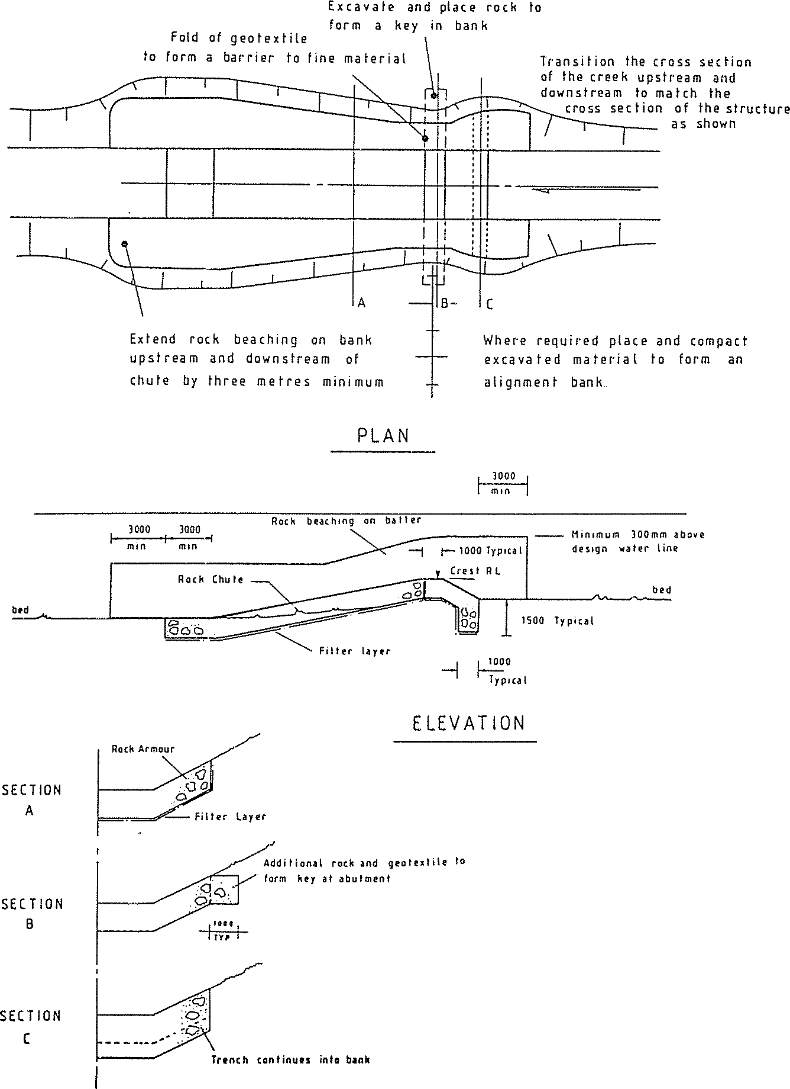

Figure 5.19 Typical rock chute plan and sections

Table of Contents

ROCK QUALITY AND SHAPE
Rock for chute construction should be hard, tough and durable. It should have a crushing strength of a least 25 Mpa. The rock should be free of defined cleavage planes and should not be adversely affected by repeated wetting and drying.

Rock should preferably be predominantly angular in shape with not more than 25% of rocks, distributed through the gradation, having a length more than twice the breadth or thickness. No rock should have a length exceeding 2.5 times its breadth or thickness. Where rock fails to meet this specification it may still be used in some cases at the designer's discretion provided allowance is made in the design for its shortcomings.

Rock to meet size and strength criteria will normally be won from a hard rock quarry by drilling and blasting. If available, a hydraulic rock breaker mounted on a hydraulic excavator provides an excellent means of producing rock to design size gradation.

A material guide for rock riprap is provided in Part 4 of these Technical Guidelines.

ROCK PLACEMENT
The placement of rock during construction has been found to be an important determinant in the structural integrity of rock chutes. Tightly packed rock structures built through the careful and selected placement of individual rocks have been found to be more robust than structures built through mass rock dumping and spreading. Further discussion on the robustness of a trial rock chute can be found in ID&A (1996b).

FILTER LAYER
Filter materials may be necessary to stabilise riprap protection over fine material. The filter layer prevents material being washed from behind the riprap through residual interstices in the riprap layer.

An increasing proportion of rock chutes are being constructed in Victoria without dedicated filter layers. These have been built with high levels of success where sound engineering judgement has been applied. If well graded riprap is designed according to the procedures outlined in these guidelines then filter material should only be necessary where:

- the underlying material is largely non-cohesive such as a uniform sand or silt;
- the underlying material comprises fill
- there is evidence of high groundwater levels or seepage areas in the bank profile; or
- an unusually high factor of safety is required.
Note that the importance of the filter layer will be far greater if the rock grading exhibits a tighter range of sizes than that recommended herein. Design of a granular filter layer is based on the above three conditions applied twice: once between the bank material and the filter layer; and once between the filter layer and the riprap.

Several failures and partial failures have been observed where rock has “slid” on the filter cloth. This occurs where the friction between the rock and the filter cloth is less than the internal friction of the rock mix. The most vulnerable arrangements will be those chutes with particularly steep slopes. Further, some geotextiles have been found to inhibit vegetation establishment.

This failure mechanism and the limitation to vegetation establishment have resulted in increased use of granular filters and reduced reliance on geotextiles as a filter layer in rock chutes. None the less geotextile based filter material can and should continue to have a role in rock chute construction in Victoria. Engineering judgement should be applied to ensure maximum resistance is developed between the rock matrix and the filter material.

Table of Contents

FIELD NOTES

CONSTRUCTION
  - Chutes can be constructed in wet conditions but construction is simpler if water can be diverted around the site or by-passed using a pump or syphon.
  - Excavation by hydraulic excavator is generally favoured.
  - Set out requirements include: crest location, crest level, apron location, apron level, or batter pegs.
  - Spoil from excavation can be spread in the upstream channel, used to form guide banks, or disposed of off-site.
  - Variation in rock quality and size must be monitored and compensated for.
  - Rock is best placed by hydraulic excavator or equivalent, with care taken to avoid excessive segregation of size fractions, and with the larger rocks at the surface interlocked and bedded with the smaller rock.
  - Geotextile will be difficult to handle in wet conditions. Ample spare cloth must be allowed for folding into abutment keys and cutoff trenches where required.
  - Ensure that care is taken with abutment treatment.
  - The entire works area should be fenced against stock and revegetated.

MAINTENANCE AND MONITORING
  - Initial high flows will remove some of the smaller material from the chute surface. Ensure that no significant voids, surface irregularities or loose rocks concentrate flow and threaten the integrity of the rock layer.
  - Place additional rock where necessary.
  - Some settlement of the rock mass sometimes occurs. Excavate and replace additional rock if the integrity of the rock layer is threatened or where differential settlement creates rills or low areas.
  - Guard against vegetation establishing in the chute itself where it may cause acceleration of flow around the obstruction or dislodge rock if it is dragged out during a flood.
  - Inspect the chute during high flows to ensure it is performing according to design expectations.
  - Carefully inspect abutments for any sign of tunnelling or piping of bank material. Excavate and repair if necessary.
  - Regularly inspect the chute face and crest for loss of material and potential unintended channelisation or concentration of flow.
  - Monitor bed levels immediately downstream of the chute for scour at the end of the apron. Place additional rock as required.
  - Ensure stock are excluded from the site and from reaches of stabilising channel.
  - Encourage a range of vegetation including grasses, sedges, reeds, together with shrub and upper storey species to assist in ultimate stability of channel.
  - Maintain plantations.

Table of Contents

INSTREAM SCOUR HOLE AND HABITAT DESIGN
The establishment of instream scour holes and related habitat can be achieved through the establishment of a local shear stress gradient. This can be achieved through the placement of some form of localised obstruction to stream flow. Such obstructions could comprise:

LARGE WOOD
Single pieces of large wood can be used to initiate local scour. The installation of large wood can also provide solid substrate in streams where such substrate has been lost or is absent, such as sand bed streams and physical habitat through the creation of hydraulic diversity.

An approach for the analysis of timber stability and the estimation of scour hole depth can be found within Part 6 of these Technical Guidelines.

ENGINEERED LOG JAMS
Engineered log jams (ELJs) work in a similar manner to single pieces of large wood. The difference lying in ELJs providing a larger hydraulic impact and potential scour hole than that which can be created through the installation of single pieces of timber.

An approach for the analysis of engineered log jam stability and the estimation of scour hole depth can be found in Part 6 Design Aids of these Technical Guidelines.

PILE FIELDS
Pile fields can be used to provide local channel encroachments and as a result can initiate local scour and channel deepening.

An approach for the analysis and design of pile fields, pile stability and scour hole depth can be found within Part 6 Design Aids of these Technical Guidelines.

BED SEEDING
Large boulders can be installed in stream systems to create localised scour. Similar to the concept of an engineered log jam, a larger influence can be created through the construction of a structure comprising a rock matrix. Unlike a rock chute which is designed to ensure hydraulic jumps occur on the structure, a scour inducing structure might be designed to ensure the hydraulic jump occurs beyond the structure.

An alternative approach to the creation of pool habitat is through the construction of a rock chute style structures. This approach to habitat design and establishment is promoted in Newbury and Gaboury (1993).

Table of Contents

This section of the Technical Guidelines provides information on, and access to a selection of tools and design aids that may assist the waterway manager with the design of intervention activities and works. This section provides information that may assist with the selection of activities and options and may assist with the design of activities and works.

The design aids included in these Technical Guidelines include:

- A selection of design parameters and criteria that may assist with the design of intervention works including non scour velocities, critical shear stress, design stream power, and stream bed grade, width and depth relationships.

- Methods for the design of:

  - timber piles as components of retards
  - engineered log jams
  - estimation of rock size in structures and stockpiles
  - estimation of scour depth.
A selection of software design tools that may assist with the design of activities and works is provided in the table below. This selection is not a complete listing. Alternate software tools may be available and be more suited to the individual program or project. It is the responsibility of the waterway professional to assess the validity and usefulness of software and design tools for their intended purpose.

Table 6.1 Selection of available software design tools

Category | Design aid | Description | Supplier | Web site
Structural | CHUTE | Software for the design | CRC for | www.toolkit.net.au/cgi-
design |  | of rock chute style | Catchment | bin/WebObjects/toolkit
 |  | grade control | Hydrology/
 |  | structures and fish | eWater
 |  | ladders
 | RIPRAP | Software for the design | CRC for | www.toolkit.net.au/cgi-
 |  | of rock riprap beaching | Catchment | bin/WebObjects/toolkit
 |  |  | Hydrology/
 |  |  | eWater
Hydraulic | HEC-RAS | Industry Standard | US Army | www.hec.usace.army.mil/
modelling |  | hydraulic modelling | Corps of
 |  | software | Engineers
Hydrologic | RORB | Industry Standard | Monash
modelling |  | event based hydrologic | University
 |  | software
 | RAFTS | Event based | XP Software
 |  | hydrologic software
 | AWBM/ | Time series hydrologic | CRC for | www.toolkit.net.au/cgi-
 | MUSIC | software | Catchment | bin/WebObjects/toolkit
 |  |  | Hydrology/
 |  |  | eWater
Sediment | HEC-RAS | Reach-based hydraulic | US Army | www.hec.usace.army.mil/
transport |  | analysis of sediment | Corps of
 |  | transport capacity | Engineers
 | Sed Net | Catchment based | CRC for | www.toolkit.net.au/cgi-
 |  | sediment source and | Catchment | bin/WebObjects/toolkit
 |  | transport analysis | Hydrology/
 |  |  | eWater
Environmental | RAP | Hydrologic and | CRC for | www.toolkit.net.au/cgi-
flow |  | hydraulic viewing, | Catchment | bin/WebObjects/toolkit
 |  | manipulation and | Hydrology/
 |  | interrogation software | eWater

Table of Contents

WATERWAY DESIGN PARAMETERS

INTRODUCTION
This section provides results from a number of investigations that may assist waterway designers with the development and selection of waterway design criteria for the geomorphic design of stream systems. It includes information on stream hydraulic parameters such as non scour velocity for a range of vegetation and soil types, shear stress and stream power associated with stream systems not subject to erosional adjustments. The section also includes results from a limited number of investigations on dependent stream criteria, stream bed gradient, and channel width and depth.

The parameters and criteria come from a number of sources. While some guidance is provided on where and how some parameters and criteria may be applied, no definitive recommendation is made on the most appropriate criteria or source of information for any one application. It is the responsibility of waterway managers and designers to use their professional judgement on the applicability of the information provided.

The information supplied is not a substitute for the development of a thorough understanding of the stream system through hydrologic, hydraulic, geomorphic and ecological investigations. In this respect the information provided can serve as a guide only. The information provided should be used to supplement more detailed geomorphic and ecological investigations, such as template stream analysis, to assist identification of target conditions, and related design criteria.

There is a developing knowledge base of ecological parameters and criteria that can be used to assist design of stream rehabilitation projects. Examples include large wood densities for Australian streams, and fish migration and habitat preference data. While there would be some significant benefit in the compilation and publication of such data, this is beyond the scope of these Technical Guidelines.

Finally it is recommended that analysis and design of stream systems not be based on any one single parameter. Design should be based on a selection of criteria such as, but not limited to velocity, shear stress, stream power, bed grade, channel width, and channel depth. Designs based on a suite of parameters provide increased confidence that the final outcome will operate in accordance with the design intent.

Table of Contents

FLOODPLAIN VELOCITY

Title Recommended limiting values for erosion resistance of plain and reinforced grass
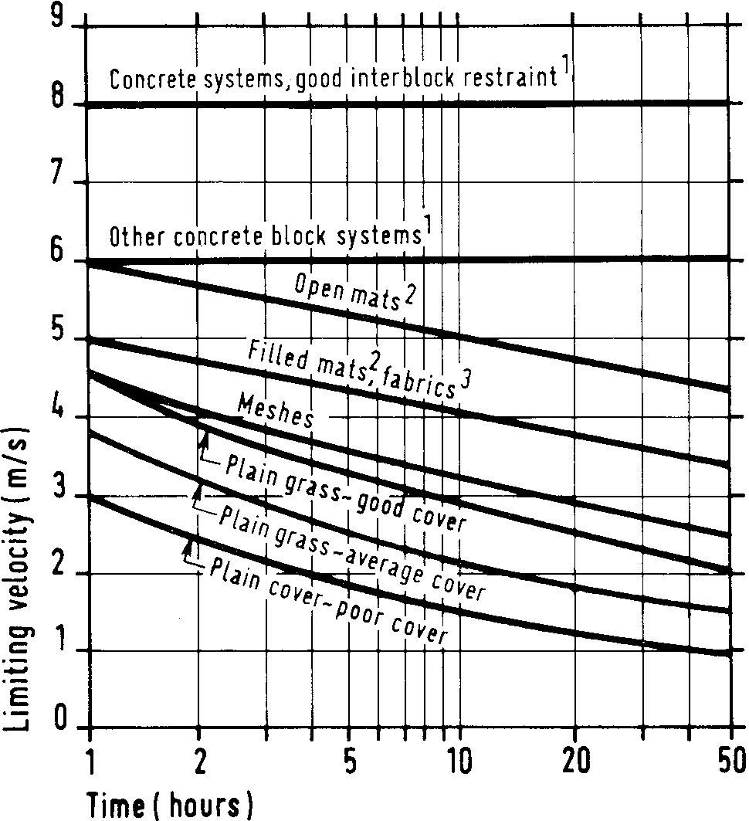

Notes 1. Minimum superficial mass 135 kg/m².
- Minimum nominal thickness 20 mm.
- Installed within 20 mm of soil surface, or in conjunction with a surface mesh.
- All reinforced grass values assume well established, good grass cover.
Source Hewlett, H. W. M., Boorman, L.A. and Bramley, M.E. 1987. “Design of Reinforced Grass Waterways,” Construction Industry Research and Information Association, Report No. 116, London, England.

Application

This graph can be useful in the analysis and design of floodplains, floodways and grass chutes where period of inundation or time of concentration (time) has been estimated.

Table of Contents

STREAM VELOCITY

Title Recommended maximum velocity for various Manning’s roughness to avoid significant vegetation damage

Average Manning’s n roughness Recommended maximum velocity
during bankfull flow and 1 in 50 year flood event

n = 0.03 2.0 m/s

n = 0.06 1.7 m/s

n = 0.09 1.5 m/s

n = 0.15 1.0 m/s

Notes As the vegetation density increases, and thus the channel roughness increases, it becomes harder for flood flows to pass around or through the vegetation without causing significant damage. A Manning’s roughness of
0.03 represents typical, deep water, grass channel where high flow velocities of around 2.0 m/s are expected to cause only minor damage.
The 1 in 50 year flood event is chosen because it represents an extreme flood event during which some vegetation damage would be expected, but it is desirable to minimise this damage where possible. It is considered that a 1 in 20 year flood event would in most cases be too small to act as the design event for vegetation damage. The 1 in 100 year flood can be chosen, but it may be considered unrealistic to have minimal vegetation damage during such an extreme event.

Source Brisbane City Council 2000, Natural Channel Design Guidelines, Brisbane City Council, Queensland.

Application

These design criteria were compiled for and included within Natural Channel Design Guidelines (Brisbane City Council 2000). Some caution should be used in applying the recommendations to other regions. However, the non scour velocities are reasonably consistent with other sources. The information could be used in the design of grass floodplains, floodways and grass chutes where protection of vegetation from damage is sought.

Title Maximum allowable flow velocities for open soil (non-vegetated) low flow channels

Soil description Allowable flow velocity (m/s)
Extremely erodible soils 0.3

Highly erodible soils (black earth, fine surface texture soils)
0.5

Moderately erodible soils 0.6
Table of Contents
Low erodible soils (krasnozems, red earth) 0.7
Sandy soils (Manning’s n = 0.04) 0.45
Fine colloidal sand (n = 0.02) 0.45
Sandy loam, non-colloidal (n = 0.02) 0.5
Alluvial silts or silt loam, non-colloidal (n = 0.02) 0.6
Fine gravel or firm loam (n = 0.02) 0.7
Graded loam to cobble, non-colloidal (n = 0.03) 1.1
Alluvial silts, colloidal (n = 0.025) 1.1
Stiff clay, very colloidal (n = 0.025) 1.1
Coarse gravel, non-colloidal (n = 0.025) 1.2
Graded silts to cobbles when colloidal (n = 0.03) 1.2
Loose rock, nominal size around 200 mm 1.5

Cohesive soils | Lean clayey soils (m/s) | Heavy clayey soils (m/s)
Loose | 0.34 | 0.46
Fairly compact | 0.6 | 0.7
Compact | 0.9 | 1.0
Very compact | 1.2 | 1.5
Notes

Source Brisbane City Council 2000, Natural Channel Design Guidelines, Brisbane City Council, Queensland.

Application

These design criteria were compiled for and included in the Natural Channel Design Guidelines (Brisbane City Council 2000). Some caution should be used in applying the recommendations to other regions. However, the non-scour velocities are reasonably consistent with other sources. The information could be used for analysis and design of systems for interim periods prior to vegetation establishment.

Title Results of 2 year and 50 year ARI stream velocity analysis

Stream type
Approximate stream velocity (m/s) 2 year ARI event 50 year ARI event

Incised
Bankfull ARI > 5 years
Typically,
1.0 < Velocity < 1.5
Typically,
1.5 < Velocity < 2.5

Limited capacity Bankfull ARI < 5 years
Typically,
0.5 < Velocity < 1.1
Typically,
0.9 < Velocity < 1.5

Bedrock controlled As identified in field
1.3 < Velocity < 1.8 2.0 < Velocity < 3.0

Table of Contents

Notes It is not recommended that the information drawn from this investigation be extrapolated to streams with a bed sediment size larger than approximately 1 mm.
Derived from analysis of a range of ephemeral sand bed streams in the Bowen Basin coal field of central Queensland. Stream bank material comprised mud drapes with dense grass cover.

Source Fisher Stewart 2002, Bowen Basin River Diversions, Design and Rehabilitation Criteria, Report for Australian Coal Association Research Program (ACARP), Queensland.

Application

These criteria were developed for sand bed streams with vegetated mud drape banks in central Queensland. Some caution should be used in applying the criteria to other regions. The criteria are not non-scour velocities. The criteria are typical velocities found for naturally incised streams not subject to ongoing erosion adjustments. It should not be implied that these systems are not subject to scour in flood events. Scour in flood events is likely in these systems. However such scour is expected to be short term and not result in broad-scale changes in the stream systems.

The criteria may assist the geomorphic design of stream rehabilitation projects, providing information against which template stream data for the subject stream can be compared. Systems designed using such criteria could be expected to undergo some limited scour in large flood events.

Table of Contents

SHEAR STRESS

Title Relationships between the tractive forces on the stream bed and size of bed material that will erode
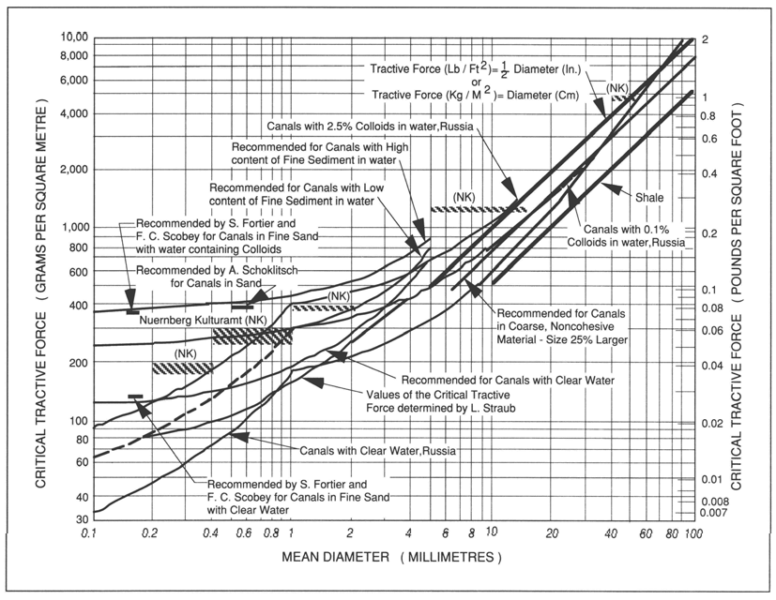

Notes In the figure above, tractive force is related to the size of material at incipient motion. The field observations and recommended design guidelines were originally compiled for a wide range of canals and river channels.

For non-cohesive bed materials > 1 cm in diameter (fine gravel), the relationship can be approximated as: tractive force (N/m²) = incipient diameter (mm).

Source Newbury, R. and Gaboury, M. 1993, Stream Analysis and Fish Habitat Design – A Field Manual, Newbury Hydraulics Ltd and The Manitoba Habitat Heritage Corporation, Gibsons, British Columbia, Canada.

Application

The information is based on field and flume experiments from a number of sources. This figure can be used to identify the approximate critical shear stress for a range of stream bed sediment types.

Table of Contents

Title Allowable mean shear stress for channels with boundaries of non- cohesive material larger than 5 mm carrying negligible bed material load
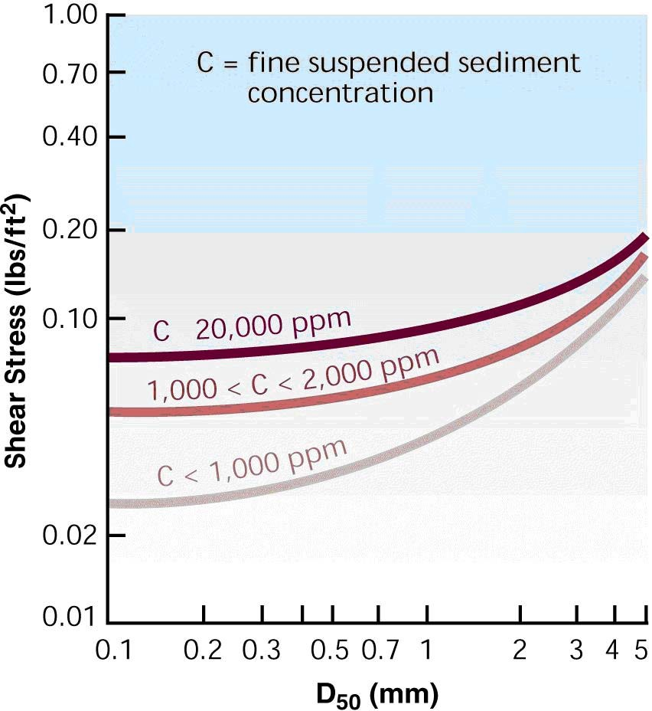

Notes Non-SI units.

Source Federal Interagency Stream Restoration Working Group (FISRWG) 1998, Stream Corridor Restoration: Principles, Processes, and Practices, By the (FISRWG – 15 Federal agencies of the US government).

Application

The figure is based on sands and gravels. While the non SI unit vertical axis limits the usefulness of the figure for general application in Australia the inclusion of sediment concentrations provides a level of complexity absent in most other available critical shear stress information. This figure can be used to identify the approximate critical shear stress for a range of stream bed sediment types larger than fine sand, based on the estimated fine suspended sediment concentration.

Table of Contents

Title Maximum shear stress resistance thresholds for herbaceous vegetation in gully initiation studies

Vegetation type | Threshold erosion data (N/m²)
Aquatic (swampy) vegetation | 105
Tussock and sedge | 240
Disturbed tussock and sedge | 180
Bunch grass 20-25 cm high | 184
Bunch grass 2-4 cm high | 104
Bunch grass | 80-170*
Bermuda grass | 110-200*
Buffalo grass, Kentucky bluegrass | 110-200*

Notes * These ranges summarise data for a variety of soil types/hillslopes.

Source Adapted from Blackham, D.M. 2005, 'The erosion resistance of herbaceous vegetation: implications for stream geomorphology', unpublished PhD thesis, The University of Melbourne.

Application

This shear stress information was compiled by Blackham for a range of vegetation conditions. The information includes both Australian and overseas research. The information can assist the selection of vegetation and the geomorphic design of stream systems.

Title Results of 2 year and 50 year ARI shear stress analysis

Stream type
Approximate shear stress (N/m²)

Table of Contents
 | 2 year ARI event | 50 year ARI event
Incised  Bankfull ARI > 5 years | Typically, shear < 40 | Typically, shear < 100
Limited capacity Bankfull ARI < 5 years | Typically, shear < 40 | Typically, shear < 50
Bedrock controlled As identified in field | Typically, shear < 55 | Typically, shear < 120

Notes It is not recommended that the information drawn from this investigation be extrapolated to streams with a bed sediment size larger than approximately 1 mm.

Derived from analysis of a range of ephemeral sand bed streams in the Bowen Basin coal field of central Queensland. Stream bank material comprised mud drapes with dense grass cover.

Source Fisher Stewart 2002, Bowen Basin River Diversions, Design and Rehabilitation Criteria, Report for Australian Coal Association Research Program (ACARP), Queensland.

Application

These criteria were developed for sand bed streams with vegetated mud drape banks in central Queensland. Some caution should be used in applying the criteria to other regions. The parameters and related criteria are not critical shear stresses. The parameters and criteria are typical shear stress found for naturally incised streams not subject to ongoing erosion adjustments. It should not be implied that these systems are not subject to scour in flood events. Scour in flood events is likely in these systems.
However such scour will be short term and not result in broad scale changes in the stream systems.

The criteria may assist the geomorphic design of stream rehabilitation projects, providing information against which template stream data for the subject stream can be compared. Systems designed using such criteria could be expected to undergo some scour in large flood events.

Table of Contents

UNIT STREAM POWER

Title Channel stability of Danish streams related to specific stream power
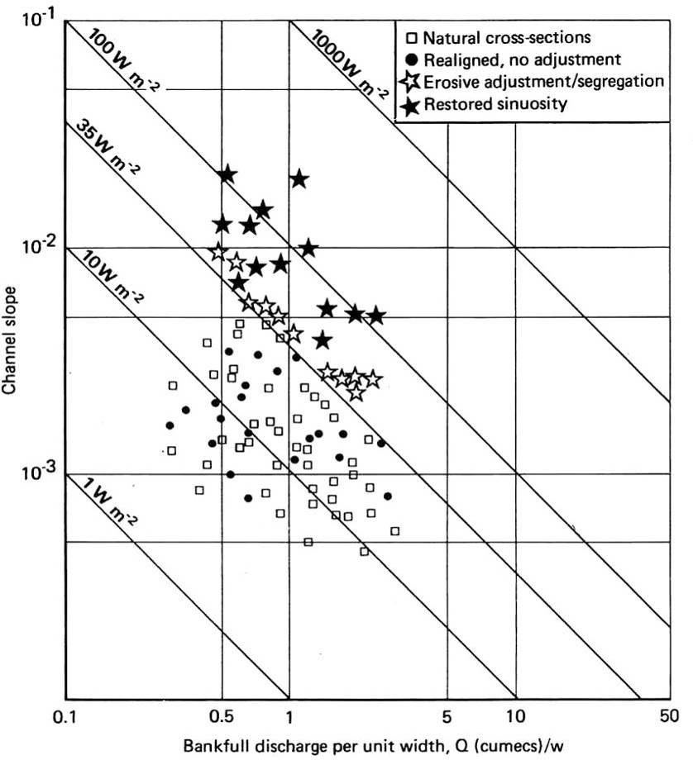

Source Brookes, A. 1987, ‘The distribution and management of channelized streams in Denmark’, Regulated Rivers, vol.1, pp. 3-16, John Wiley & Sons, United Kingdom.

Application

This figure is based on channelised streams in Denmark. The results associate channelised streams subject to erosional adjustments with bankfull stream power of greater than 35 w/m². The results may be conservative for streams with bed and banks with any clay fraction. The data can be used with some caution to assist the geomorphic assessment and design of stream systems.

Title Results of 2 year and 50 year ARI stream power analysis

Stream type
Approximate stream power (W/m²)

Table of Contents
 | 2 year ARI event | 50 year ARI event
Incised  Bankfull ARI > 5 years | 20 < stream power < 60 | Typically, 50 < stream power < 150
Limited capacity | Typically, stream power < 60 | Stream power < 100
Bankfull ARI < 5 years
Bedrock controlled | 50 < stream power < 110 | 100 < stream power < 220
As identified in field

Notes It is not recommended that the information drawn from this investigation be extrapolated to streams with a bed sediment size larger than approximately 1 mm.
Derived from analysis of a range of ephemeral sand bed streams in the Bowen Basin coal field of central Queensland. Stream bank material comprised mud drapes with dense grass cover.

Source Fisher Stewart 2002, Bowen Basin River Diversions, Design and Rehabilitation Criteria, Report for Australian Coal Association Research Program (ACARP), Queensland.

Application

These criteria were developed for sand bed streams with vegetated mud drape banks in central Queensland. Some caution should be used in applying the criteria to other regions. The criteria are not non scour stream power. The criteria are the typical unit stream power found for naturally incised streams not subject to ongoing erosion adjustments. It should not be implied that these systems are not subject to scour in flood events. Scour in flood events is likely in these systems. However such scour will be short term and not result in broad scale changes in the stream systems.

The criteria may assist the geomorphic design of stream rehabilitation projects, providing information against which template stream data for the subject stream can be compared. Systems designed using such criteria could be expected to undergo some scour in large flood events.

Table of Contents

Title Brookes’ stream power stability criteria with additional Coldwater River Basin data

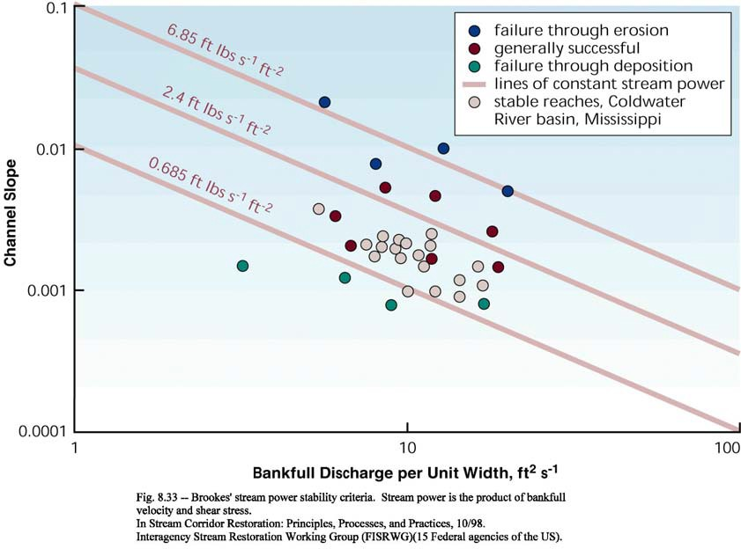

Notes Non SI units.

Source Federal Interagency Stream Restoration Working Group (FISRWG) 1998, Stream Corridor Restoration: Principles, Processes, and Practices, By the (FISRWG – 15 Federal agencies of the US government).

Application

This figure is based on channelised streams in Denmark with additional data compiled from the Coldwater River Basin in the USA. The inclusion of additional data is beneficial however, the use of non SI units limits the ready application of the figure in Australia. The data can be used with some caution to assist the geomorphic assessment and design of stream systems.

Table of Contents

CHANNEL DIMENSIONS - WIDTH AND DEPTH

Title Hey and Thorne equations for gravel bed streams

W = 4.33 x (Q_{f}) ^{0.5} for vegetation type 1 – grassed riparian zone, no trees and shrubs, Manning’s n typically 0.03 to 0.035

W = 3.33 x (Q_{f}) ^{0.5} for vegetation type 2 – scattered trees and shrubs, dense grass and weeds, Manning’s n typically 0.04 to 0.06

W = 2.73 x (Q_{f}) ^{0.5} for vegetation type 3 – light to medium stand of trees and shrubs, Manning’s n typically 0.07 to 0.09

W = 2.34 x (Q_{f}) ^{0.5} for vegetation type 4 – medium to dense stand of trees and shrubs, Manning’s n typically 0.1 to 0.15

Notes Q_{f} = bankfull discharge
W = bankfull width

Source Brisbane City Council 2000, Natural Channel Design Guidelines, Brisbane City Council, Queensland.

Application

The relationships presented are based on gravel bed streams and may assist with the analysis and design of similar systems. While the information has been sourced from Natural Channel Design Guidelines (Brisbane City Council 2000), the original data is based on overseas research and is as applicable to Victoria as it is to Queensland.

The equations suggest that the channel width is significantly greater for an open canopy (e.g. grassed channel) than for a closed canopy channel with a dense stand of bank vegetation. This may be the case for streams with little or no bed vegetation, such as rivers and streams fed by snow melts, but local conditions will vary and may be contradicted by recent research from Queensland.

Table of Contents

Title Brisbane’s clay-based creek systems with significant sand and gravel bed deposits

Q_{f} ≥ 100 m³/s ➔ typical bank width, W = 2.41 (Q_{f} ) ^{0.5} and typical depth, D = 0.75 (Q_{f} )^{0.5}
Q_{f} < 100 m³/s ➔ typical bank width, W = 4.37 (Q_{f} ) ^{0.373} and typical depth, D = 1.07 (Q_{f} )^{0.224} The typical range of bank widths: 4.33 (Q_{f} ) ^{0.5} > W > 1.78 (Q_{f} ) ^{0.5} for all flow rates
The typical range of bank depths: 0.598 W ^{0.6} > D > 0.295 W ^{0.6}

Notes Q_{f} = bankfull discharge (m³/s)
D = channel depth from bankfull water level to channel invert (m)

W = channel top width measured at the height of the lower bank (m)

Source Brisbane City Council 2000, Natural Channel Design Guidelines, Brisbane City Council, Queensland.

Application

The information was compiled for and included in the Natural Channel Design Guidelines (Brisbane City Council 2000), for Brisbane’s clay-based creek systems. The information may be a useful reference for the analysis and design of streams in similar settings.

Table of Contents

Title Simons and Albertson equations for sand bed waterways For sand bank (sandy loam)
Bed width (m) = 5.72.Q_{f} ^{0.512}
Mean depth (m) = 0.504.Q_{f} ^{0.361}

For cohesive banks (some clay content or internal strength)

Bed width (m) = 4.29.Q_{f} ^{0.512}
Mean depth (m) = 0.59.Q_{f} ^{0.361}
Surface width (m) = 1.1 x Bed width + 2. This should yield bank batters in the range 2H:1V for cohesive banks and 3H:1V for sandy banks.

For sand and cohesive banks

Meander arc length (m) = 6.31.W

Notes Q_{f} = bankfull discharge (m³/s)

Source Brisbane City Council 2000, Natural Channel Design Guidelines, Brisbane City Council, Queensland.

Application

The information was compiled for the Natural Channel Design Guidelines (Brisbane City Council 2000). The equations are those of Simons and Albertson for sand bed waterways. The equations may not be suited to the analysis and management of incised systems with very high bank full discharge. However the information may be a useful reference for the geomorphic design of streams in meandering alluvial stream settings.

Table of Contents

Title Equations for river width and depth
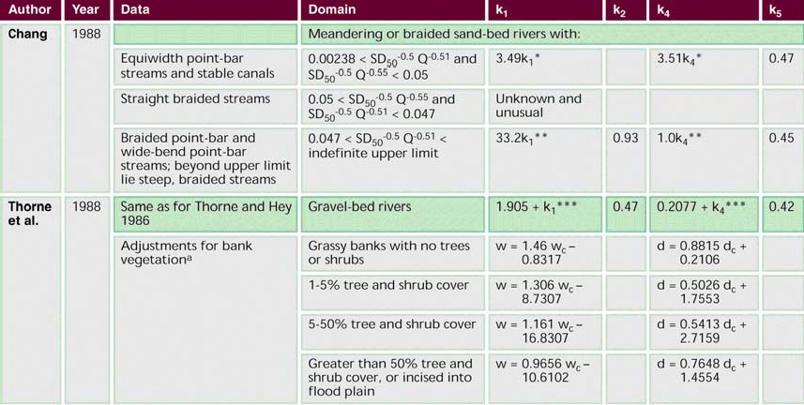

Chang equations for determining river width and depth. Coefficients for equations of the form w = k₁Q^{K2}; d = K₄Q^{K5}; where w is mean bankfull width (ft), Q is the bankfull or dominant discharge (ft³/_{s}), d is mean bankfull depth (ft), D₅₀ is median bed-material size (mm), and S is slope (ft/ft).

ª w_{c} and d_{c} in these equations are calculated using exponents and coefficients from the row labelled “gravel-bed rivers”.. k1* = (S D50^{-0.5} - 0.00238Q^{-0.51})^{0.02}.
k4* = exp[-0.38 (420.17S D₅₀^{-0.5}Q^{-0.51} -1)^{0.4}]. k1** = (S D50 -0.5 )0.84.
k4** = 0.015 - 0.025 In Q - 0.049 In (S D₅₀^{-0.5}). k1***= 0.2490[ ln(0.0010647D₅₀^{1.15}/SQ^{0.42} )]². k4***= 0.0418 ln(0.0004419D₅₀ 1.15/SQ^{0.42} ).

Source Federal Interagency Stream Restoration Working Group (FISRWG) 1998, Stream Corridor Restoration: Principles, Processes, and Practices, By the (FISRWG – 15 Federal agencies of the US government).

Application

The information can assist with the assessment and geomorphic design of stream systems. However the equations are in non SI units, limiting their ready application in Victoria. Waterway designers are referred to the original data source for an improved understanding of the application and limitations of these equations.

Table of Contents

CHANNEL DIMENSIONS – BED GRADE

Title Stream bed grade versus stream flow
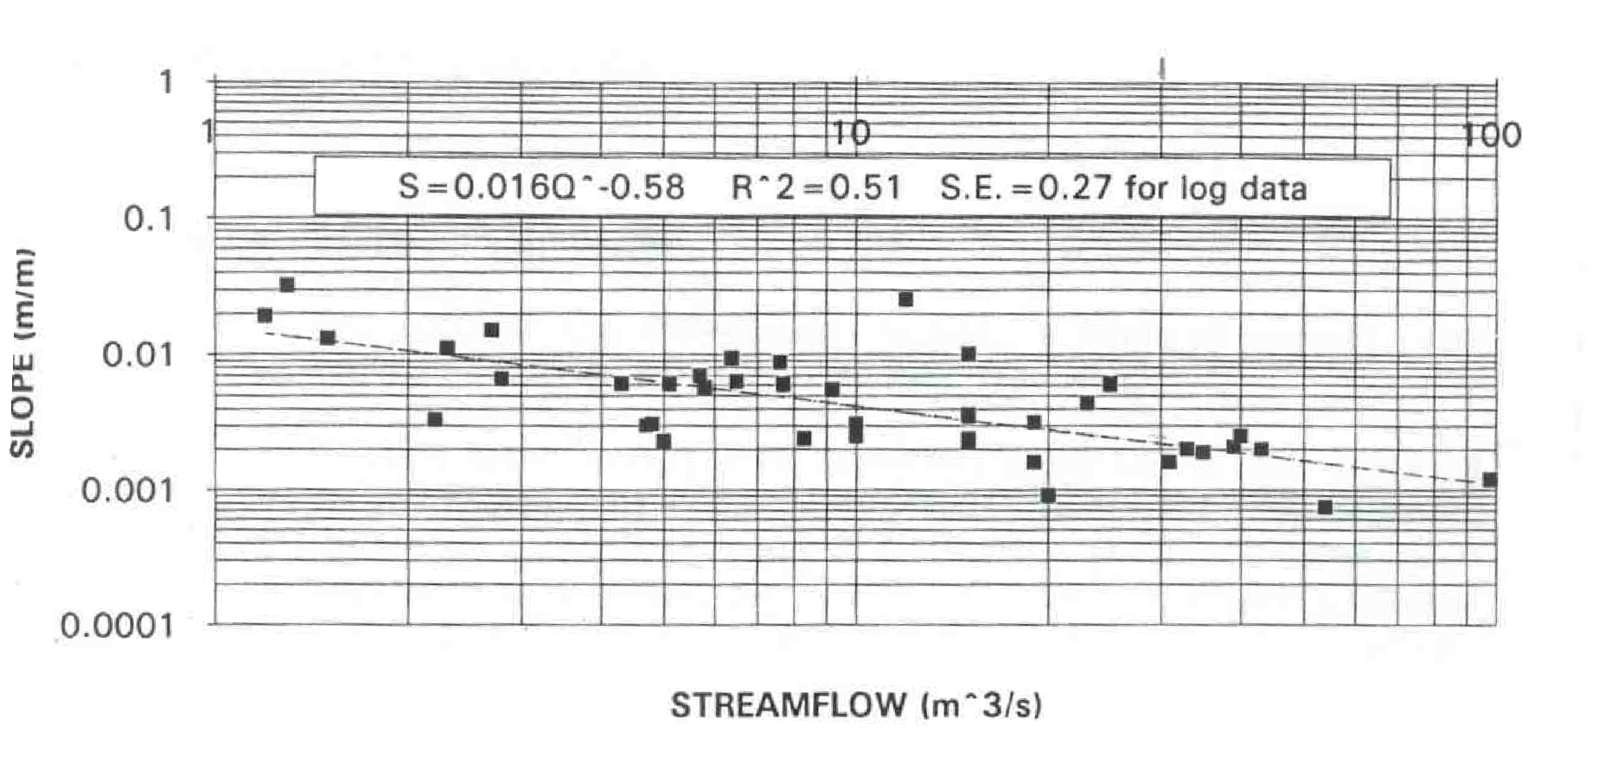

Notes Streamflow in graph refers to the lesser of the 2 year ARI and bankfull flows.

From analysis of streams in north east Victoria.

Source Hardie, R. 1993, Review of Stream Profile Information for Catchments of North East Victoria, Masters Thesis, University of New England, New South Wales.

Application

The information was compiled for approximately 40 sand and gravel bed streams in north east Victoria. The data set was largely based on incised streams. The investigation sought to identify a stable or design bed grade downstream of active incision or within reaches of active incision between “nick” points.

The information may assist with the identification of design bed grades from stream longitudinal profile surveys by providing a range of bed grades found for other stream systems in Victoria. Design bed grades identified from stream bed longitudinal profile surveys with the aid of this data set can be used for incised stream management programs and the geomorphic design of stream systems.

Table of Contents

DESIGN OF TIMBER PILES

INTRODUCTION
This design method enables the determination of pile diameter and depth of embedment based on the estimated drag, impact and resistant forces applied to a pile within a waterway. It is suitable for the design of small timber piles used in stream management applications. Note that the method does not allow for dissipating factors including deflection, impact load applied to multiple piles, shock adsorption by the bed material and cushioning by smaller trapped debris. However these could be accommodated into the analysis by the designer. The forces acting on a timber pile are shown in the following diagram. The method is based on that provided in Bridge Design Specifications (NAASRA 1976).
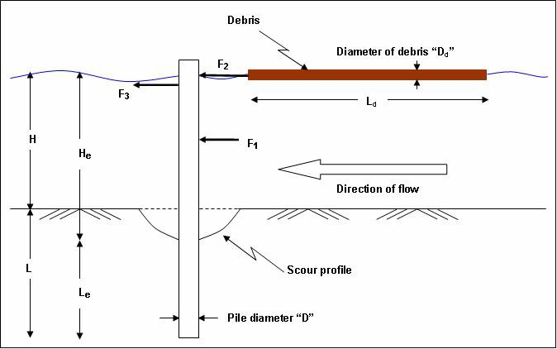

H | Pile height above ground
H_{e} | Effective pile height | Allows for exposure due to scour
L | Pile embedment | Minimum required length
L_{e} | Effective pile embedment | Minimum required length allowing for scour
D | Diameter of pile | Minimum required diameter
V | Velocity of water | Design velocity
L_{d} | Length of debris | Estimated
F₁ | Drag force on pile | No accumulation or impact
F₂ F₃  D_{d} | Debris impact force on pile Drag due to accumulated debris Diameter of debris | Assumed debris mass  Debris assumed to be circular

Table of Contents

REQUIRED EQUATIONS AND PARAMETERS

LOAD DUE TO RIVER FLOW - F₁
Determine the horizontal force (F₁) due to the velocity of the water in the river.
If a scour profile is assumed, substitute the effective length and height of the pile for the actual in all of the calculations. A method for the estimation of scour depth is provided in Section 6.6.

F₁ |  | = | C_{d} A ρ V² Eq. 1
 |  |  | 2
Where: | C_{d} | = | Coefficient of Drag (1.2 for a cylinder)
 | A | = | area over which the force acts. In this case it acts along the entire exposed length of the pile
 |  |  | H_{e}*D
 |  |  | H_{e} = height of pile above the soil/water interface
= H + estimated scour depth
ρ = Unit weight of water 1,000 kg/m³
V = Velocity of flow (m/s)
Note: It is assumed that head loss at the pile is negligible and water deflects at 45° to the flow around either side of the pile.

LOAD DUE TO IMPACT FROM DEBRIS – F₂
Pile design should allow for impact due to debris where anticipated and has been based on the National Association of Australian State Road Authorities (1976). The equation assumes elastic deformation of a pile on debris impact and is described below. The greater the flexion, the greater the stopping distance of the debris and therefore the lesser the force experienced by the pile and the supporting bed material.

F₂ |  | = | m V² | Eq. 2
 |  |  | 2 S (kN)
Where: | S | = | Stopping distance (pile deflection) (m)
 | m | = | Mass of debris (tonne)
 | V | = | Velocity of debris (m/s)
 |  |  | Assume to be the same as the velocity of the water
Note: Assumes debris velocity is equal to water velocity.

LOAD DUE TO DRAG FROM TRAPPED DEBRIS – F₃
Flow conditions and pile height and spacing may encourage debris to become trapped and an additional drag force to be imposed. For design purposes, debris may be assumed to become trapped to create a near impervious barrier to flow within the top 1 m of an exposed pile. Pile spacing may be assumed to be equal to two pile diameters. The resulting equation is outlined below:

F₃ |  | = | C_{d} A ρ V² | Eq. 3
 |  |  | 2
Where: | C_{d} | = | Coefficient of drag (1.2 for a cylinder)
 | A | = | area over which the force acts. In this case it is assumed to act only on the top 1 m of the pile
 |  |  | A = 1m*2*D
 | ρ | = | Unit weight of water  1,000 kg/m³
 | V | = | Velocity of flow (m/s)

MOMENT AT POINT OF RIGIDITY – M₁
The point of rigidity may be assumed to be at a depth of 2 pile diameters beneath the bed surface after maximum expected scouring has occurred.

M₁ = F₁(H_{e}+2D) + F₂(H_{e}+2D) + F₃(H_{e}+2D-0.5) 2
Eq. 4

ECCENTRICITY OF TOTAL FORCE ABOVE THE POINT OF RIGIDITY
Determine the eccentricity of the combined horizontal loads above the point of rigidity.

e = M₁
F₁+F₂+F₃
Eq. 5

EMBEDMENT DEPTH
The simplified Brom’s Method provided in The Civil Engineering Handbook (Chen and Liew 2002) can be used for determining the capacity of a laterally loaded pile in a cohesionless soil and the required embedment depth. Typical values for internal angle of friction and material are provided in Table 6.2.

Qh = π φ

GDL³ tan ² ( + )

Eq. 6

4 2 2(e + L)
Where: G = Saturated density of the foundation soil
Typical dry density values are provided in Table 6.2 Increase these by 40% for saturated density
D = Assumed diameter of pile
L = Assumed length of pile embedded in the river
φ = Angle of internal friction of soil Typical values in Table 6.2
e = Eccentricity of total force above the soil/water interface Calculated from Equation 5

Table 6.2 Typical values of soil internal friction angle and densities

Typical Values Material condition Angle of internal friction
Φ°
Density kg / m³

 | Compact | 40 | 2242
Coarse sand or sand and gravel | Loose | 35 | 1441
Medium sand | Compact | 40 | 2082
 | Loose | 30 | 1441
Fine silty sand or sandy silt | Compact | 30 | 2082
 | Loose | 25 | 1361
Uniform silt | Compact | 30 | 2162
 | Loose | 25 | 1361
Clay-silt | Soft to medium | 20 | 1440-1922
Silty clay | Soft to medium | 15 | 1440-1923
Clay | Soft to medium | 0-10 | 1440-1924
(Source: Standard Handbook for Civil Engineers (Merritt 1995))
Table of Contents

CALCULATE MAXIMUM BENDING MOMENT IN THE PILE
The maximum bending moment occurs when the level of shear is zero. In an unrestrained pile this is at a depth equivalent to approximately two pile diameters.

M₂ |  | = | (F₁+F₂)(e+2D)s Eq. 7
Where: | e | = | Eccentricity of total force above the point of rigidity, from Equation 5
 | D | = | Assumed diameter of pile (m)
 | s | = | Loading factor (assume equal to 1.25)

CHECK ACTUAL MODULUS OF SECTION
The “modulus of section” (Z_{xx}) of the selected timber pile must be greater than that required to withstand impacting loading of the debris.

SOLID CIRCULAR SECTION
Act Z_{xx} = πD³

32
Where: D = Actual diameter of pile

SOLID SQUARE SECTION
Act Z_{xx} = bd² 6
Note Refer Equation 11 for b and d

Eq. 8

Eq. 9

SECOND MOMENT OF INERTIA – I_{XX}
It is assumed that generally the piles will have circular cross-sections, but the equations for rectangular sections are also provided.

CIRCULAR SECTION
Ixx = πD⁴
64
Where: D = Actual diameter of pile

Eq. 10

SOLID SQUARE SECTION
I_{xx} = bd³
12

Plan view

Eq. 11

Table of Contents

Direction of Flow
b

MAXIMUM DEFLECTION
Determine the maximum deflection assuming the pile is a cantilevered structure loaded at the end by the debris and in the middle by the river.

Given that the pile is not acting as a structural member, there are no recommendations for maximum deflection so long as the deflection does not render the pile ineffective.

Def = F H ³
e
3 E I_{xx}
Where: F = Force causing the deflection (N) I_{xx} = Second moment of inertia (mm⁴)
H_{e} = Height of pile above point of rigidity (m)
E = Modulus of elasticity of the pile material (MPa)
Refer Table 6.3 for relevant Standards Australia timber code for strength group for Australian hardwood timber.

Table 6.3 Minimum values for Australian hardwood timber

Minimum values (MPa) for green (unseasoned) timber

Eq. 12

Table of Contents
Strength group | S1 | S2 | S3 | S4 | S5 | S6 | S7
Rupture modulus | 103 | 86 | 73 | 62 | 52 | 43 | 36
Elastic modulus | 16,300 | 14,200 | 12,400 | 10,700 | 9,100 | 7,900 | 6,900

Minimum values (MPa) for seasoned timber

Strength group | SD1 | SD2 | SD3 | SD4 | SD5 | SD6 | SD7 | SD8
Rupture modulus | 150 | 130 | 110 | 94 | 78 | 65 | 55 | 45
Elastic modulus | 21,500 | 18,500 | 16,000 | 14,000 | 12,500 | 10,500 | 9,100 | 7,900

(Source: www.fpc.wa.gov.au/content/species/species_notes.asp)

EMBEDMENT DEPTH CALCULATION METHOD
Determining to what depth the selected timber must be buried to withstand the loading of the river is an iterative calculation. It is recommended that a spreadsheet is set up so that results are automatically updated as different lengths are trialed for suitability.

BENDING CAPACITY OF THE PILE
The Brom’s method used to determine the required size of the pile assumes that the pile can bend. This series of calculations check the bending capacity of the selected timber pile.

From the Australian Timber Code (AS1720.1 1997) Equation 2.1, Maximum Bending Moment in a timber member is:

M = φk k k k k k [f’ Z]
1 4 6 9 11 12 b

Where :

Factor Value from AS1720
φ 0.7
k₁ 1.14
k₄ 1.00
k₆ 1.00
k₉ 1.00
k₁₁ See Table 6.4
k₁₂ 1.00

□ Permissible design stress in bending
Table of Contents
f
b
Z Modulus of section – from Equation 8 or 9

Table 6.4 Values for k₁₁
Diameter of timber  (or depth in a square member) | k11
70-140 mm | 1.0
170 mm | 0.96
190 mm | 0.93
240 mm | 0.86
290 mm | 0.79

EXAMPLE TABLE OF MINIMUM PILE DIAMETER AND EMBEDMENT DEPTHS
Example pile diameters and embedment depths have been developed for a range of exposed pile lengths, stream velocity and impact loads (refer Table 6.5). The following values were assumed for the estimation of pile diameter and embedment depth given in Table 6.5:

      - factor of safety of 1.5 on embedment depth analysis
      - factor of safety of 1.4 (approx) on pile diameter analysis
      - dry bed material density of 1,450 kg/m³
      - bed material internal angle of friction of 35°
      - modulus of elasticity of timber pile of 12,000 MPa
      - timber rupture strength of 62 MPa
      - minimum pile embedment (after scour) of 1 m
      - minimum pile diameter of 100 mm (excluding sapwood).
The table provided is a guide only under the conditions listed above. Where these conditions vary, site specific design should be undertaken.

Table of Contents

Table 6.5 Minimum pile diameters (grey, mm) and embedment depths (m) for given loadings, exposed lengths and flow velocities

Load on pile Exposed pole Velocity (m/s)

 | (m) | 1 | 1.5 | 2 | 3
Flow only | 1 | 100 | 100 | 100 | 100
 |  | 1.0 | 1.0 | 1.0 | 1.5
 | 2 | 100 | 100 | 100 | 100
 |  | 1.0 | 1.5 | 1.5 | 2.0
 | 3 | 100 | 100 | 100 | 100
 |  | 1.5 | 1.5 | 2.0 | 2.5
Flow + Debris | 1 | 100 | 100 | 100 | 100
 |  | 1.0 | 1.5 | 2.0 | 2.5
 | 2 | 100 | 100 | 100 | 150
 |  | 1.5 | 2.0 | 2.0 | 3.0
 | 3 | 100 | 100 | 100 | 150
 |  | 1.5 | 2.0 | 2.5 | 3.5
Flow + Debris | 1 | 100 | 150 | 200 | 350
+ 100 kg debris impact |  | 2.5 | 3.0 | 4.0 | 5.0
 | 2 | 100 | 150 | 200 | 300
 |  | 2.0 | 3.0 | 3.5 | 4.5
 | 3 | 100 | 150 | 200 | 300
 |  | 2.0 | 3.0 | 3.5 | 4.5
Flow + Debris | 1 | 350 | 500 | 600 | NA*
+ 1,000 kg debris impact |  | 5.0 | 6.5 | 7.5 | NA*
 | 2 | 250 | 400 | 550 | 700
 |  | 4.0 | 5.0 | 6.0 | 6.5
 | 3 | 200 | 400 | 450 | 650
 |  | 3.5 | 4.5 | 5.5 | 7.0
(* Exceeds practical design limits)

Table of Contents

STABILITY ANALYSIS FOR LARGE WOOD AND ENGINEERED LOG JAMS
This section of the Technical Guidelines provides a method for the stability analysis of large wood and engineered log structure installations. The method is suitable for one log and engineered log jam configurations.

The calculation method for each of these is similar and is described below. The method identifies the load on the timber and when combined with the Pile stability analysis provided in Section 6.3 can be used to identify the depth of embedment of timber elements necessary to prevent movement of the timber.

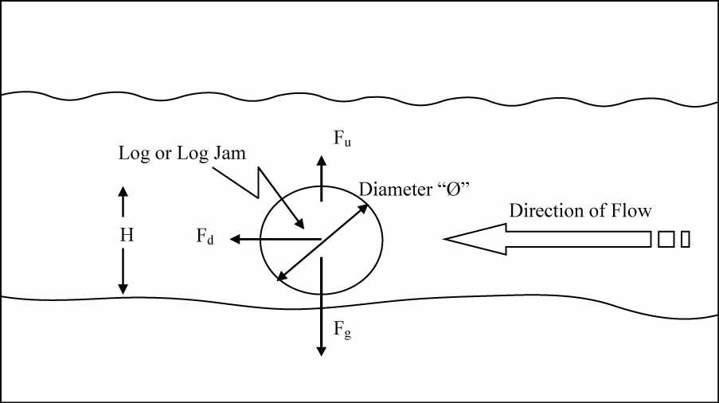
SINGLE LOG

Ø | Diameter of log | Use the average diameter
A | Area of log | Where the log is less circular
L | Length of log/log jam
H | Height of log jam
V | Velocity of water flow
F_{g} F_{u} F_{d} | Force due to gravity Force due to uplift Force due to drag

In these calculations it is assumed that while the log is resting on the river bed, water can still flow underneath it as well as above it.

DRAG FORCE
F_{d} = C_{d}V²LØ

2
Where: C_{d} = Co-efficient of drag Typical values in Table 6.6
Assume 1.2 for field timber
V = Velocity of flow
LØ = Area of the log jam perpendicular to the flow.
If the logs are not round, but more oval, this equation should become length x height where height refers to the height of the log or log jam

Eq. 13

Table 6.6 Typical values for coefficient of drag
Shape |  | Value C_{d}
Circular cylinder |  | 1.2
Eliptical cylinder | 2:1 | 0.6-0.46
 | 4:1 | 0.23-0.29
Triangular cylinders 2.0

(With Apex =120º)

(With Apex =120º)

1.72

Square 2.0

(Solid Square)

1.2

Square Lattice Source: Fluid Mechanics (Streeter and Wylie 1979)

UPLIFT FORCE
Table of Contents
F_{u} = C_{u}V²LØ
2
Where: C_{u} = Co-efficient of uplift
Assume a worst case value of 1 V = Velocity of flow
LØ = Area of the log jam parallel to the flow.
If the logs are not round, but more oval, this equation should become L*W (where W is the width of the log)

Eq. 14

FORCE OF GRAVITY
F_{g} = G*A*L Eq. 15

Where: G = Saturated density of timber Typical values in Table 6.7
A = Cross-sectional area of log For circular logs
πφ ²
=

4
L = Length of log

Table 6.7 Typical density of material

Timber | Density  (kg/m³)
 | Green | Air
York Gum | 1185 | 1060
Stringybark | 1100 | 870
Sugar Gum | 1105
Spotted Gum | 1150 | 970

Assume that the saturated density of the timber is about 20% greater than the selected density. If the log is Stringybark (green) then density = 1.2*1100.

CALCULATION OF RESULTANT FORCE

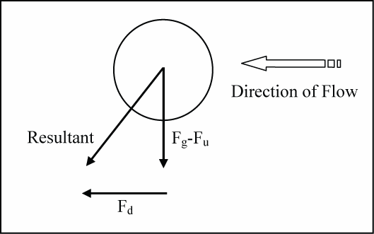

Where:

Resultant = 2√{F 2+(F -F )2} Eq. 16
d g u

Table of Contents
This calculated resultant force can be used in the pile stability analysis provided within Section 6.3 to determine the depth of embedment required to restrain the timber.

It is anticipated that no additional restraint will be required for individual pieces of timber that remain wet and partially buried within most stream systems.

Table of Contents

ENGINEERED LOG JAM
When multiple logs are used to construct an engineered log jam, they may not always be keyed into the bank. This calculation determines the depth of piles required to restrain an engineered log jam.
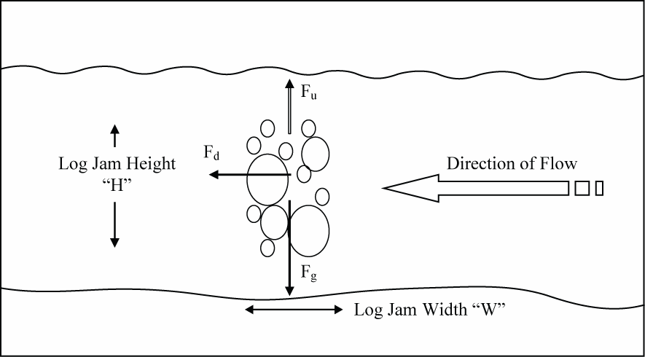

W | Width of log jam | Use the average width
H | Height of log jam
A | Area of log jam | This is the total area occupied by logs and does not include the voids
L | Length of log jam
V | Velocity of water flow
F_{g} | Force due to gravity
F_{u} | Force due to uplift
F_{d} | Force due to drag

In this case an equivalent structure should be determined with:

      - equivalent height of the log jam
      - equivalent cross-sectional area.

Table of Contents

The resulting structure for calculation purposes is shown as follows:
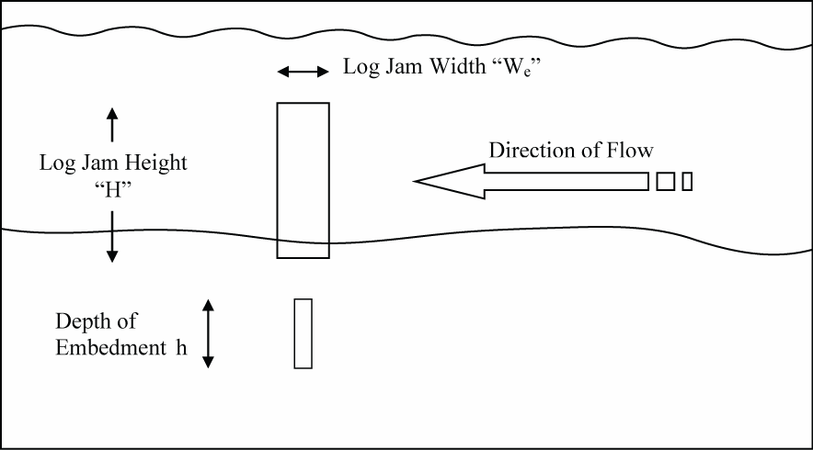

W_{e} | Equivalent width of log jam | Determine the actual cross-sectional area
 |  | of the log jam and create an equivalent structure such that A=H*W_{e}
H | Height of log jam
L | Length of log jam
h | Depth of embedment
V | Velocity of water flow

HORIZONTAL FORCE DUE TO WATER
Determine the horizontal force (P₁) due to drag. Retaining the water behind the engineered log jam.

If a scour profile is assumed, substitute the effective length and height of the pile for the actual in all of the calculations.

F_{d} is the horizontal force on the log jam per lineal metre of log-jam.

F_{d} |  | = | C_{d}V²H Eq. 17
 |  |  | 2 (kN/m)
Where:
 | C_{d} | = | Co-efficient of drag  Typical values in Table 6.6
 | V | = | Velocity of flow
 | H | = | Area of the log jam perpendicular to the flow.

FORCE DUE TO UPLIFT
While there will be an uplift force associated with an engineered log jam, for simplicity it is assumed to be negligible.

HORIZONTAL FORCE PER PILE
F_{h}
Spacing “S_{p}”
Direction of Flow

F_{h} = F_{d}*L
(number of piles)
Eq.18

Table of Contents

CALCULATION METHOD
This calculated horizontal force can be used in the pile stability analysis provided in Section 6.3 Design of Timber Piles to determine the depth of embedment required to restrain the engineered log jam.
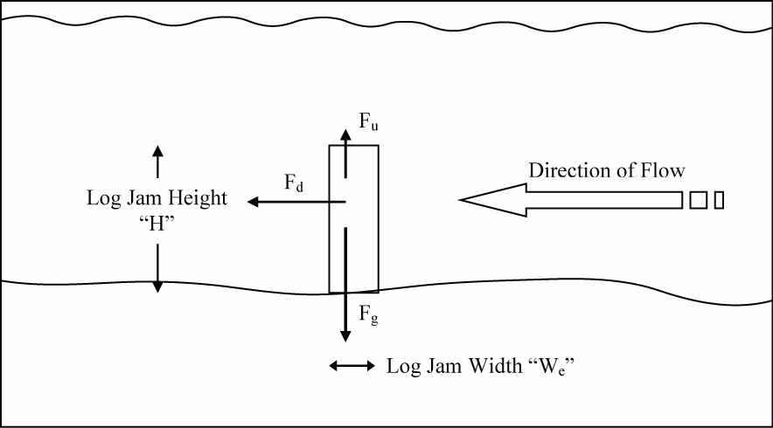

Table of Contents

METHODS FOR ESTIMATING THE SIZE AND GRADING OF ROCK
It will often be necessary for waterway management practitioners to estimate the size of rock proposed for or used in waterway management projects. There are three methods used in the estimation of rock sizes in stockpiles and structures. They are:

- Ring grading – commonly used in a quarry
- Visual guide – used once rock is delivered to site
- Walk over method – applicable when rock is already placed in a structure or still in piles.

RING GRADING
Ring grading as a method for determining rock sizes and grading involves categorising rocks according to size by passing them through metal rings of fixed diameters.

The test procedure involves:

- Selection of a suitable stockpile of rock for testing. Rock sample is selected for test that is representative of that proposed for or has been supplied for construction.

- Loading and transporting of 16 to 18 m³ of rock to the test site. The test sample is photographed in the truck and trailer and the loaded combination is taken to a weighbridge. After weighing, each sample is tipped onto the ground at the site and the mass of the empty truck and trailer checked on the weighbridge.

- Sorting of the rock into size ranges. Samples are then broken into their component size rages with the assistance of an excavator. Eight size ranges are commonly used. Rock would be classified and sorted into size range by comparing their size to a set of standard sized steel test rings.

- Determining the mass of rock in each of the size ranges. Once sorted, each rock size range is heaped, photographed and its mass determined by transporting it over a weighbridge.

- Determining overall rock grade. At the conclusion of each test, all of the rock sample would be re-loaded into the truck and trailer and run over the weighbridge to check the total mass of the rock.

Some difference between initial and final total mass values will most likely occur. For each sample, the final or corrected mass is used as a basis for calculation of mass distribution and size grading.

  - METHODS FOR ESTIMATING THE SIZE AND GRADING OF ROCK
Table of Contents

Ring sizes adopted for rock size ranges are:

Rock size ranges | Ring size
Less than 90 mm | 90 mm
90 to 145 mm | 145 mm
145mm to 190 mm | 190 mm
190mm to 300 mm | 300 mm
300mm to 450 mm | 450 mm
450mm to 600 mm | 600 mm
600mm to 900 mm | 900 mm
Larger than 900 mm | 900 mm

OTHER METHODS
Other methods for estimating rock size and grading can be found in:

- Rock Size Grading ‘A Visual Guide’ (ID&A 1996c) which provides photographs of rock from a number of quarries in Victoria.

- Investigation into Sampling Methods for the Measurement of Rock Riprap in Rock Chutes (Balshaw 1999) which provides a field based method for the estimation of rock size on an existing chute.

Table of Contents

PROCEDURE FOR ESTIMATING SCOUR DEPTH
This section provides procedures for the estimation of scour depth. Scour depth is a function of stream bed degradation or aggradation, general scour and local scour.

Numerous approaches to the estimation of scour depth have been developed by researchers including Farraday and Charlton (1983), and Blench (1969). Many of the approaches have been built into hydraulic modelling software packages enabling their use for scour estimation. These hydraulic packages include HEC-RAS, Mike 11 and Mike 21. In addition 3-dimensional hydraulic modelling packages have become available, and at some cost, can be used to estimate scour depth. These packages can be used by designers to estimate scour depth for the purpose of design of large wood installations, engineered log jams and pile field retards. However scour depth can also be estimated “long hand” based on an understanding of stream processes and using the original equations, now contained within some of these software packages.

The “long hand” approach to the estimation of scour outlined below is taken from the approach detailed in Guidelines for Stabilising Waterways (Standing Committee on Rivers and Catchments 1991).

DEGRADATION / AGGRADATION
Degradation and aggradation are the lowering and raising of the bed, respectively over relatively long reaches and long time periods. Quantification of the degradation and aggradation component of the estimated scour depth relies on estimating the sediment supply or transport capacity of the upstream reach and is beyond the scope of this manual. A qualitative determination however, can be accomplished and should be based the collection and comparison of all historic data relating to the site. In particular, historic bed profiles should be studied, if available, to detect any trend in degradation or aggradation. Less detailed information may be available from elevation data of pipeline crossings and highway bridges. With knowledge of the elevation of these structures, it is relatively simple to make field measurements of present bed elevations. Additionally, the construction plans for these structures can provide valuable historical information. The invert elevations at the time of construction are usually provided on the plans or can be deduced from the given information.

Field inspections should be conducted upstream and downstream of the construction site. Special attention should be directed to the existence of gravel mining operations or changes in the sediment inflow from tributaries. For example, gravel mining operation may induce a headcut (lowering of the channel bed) which can potentially migrate upstream through the construction site. Alternatively, an upstream tributary heavily laden with sediment due to recent land use changes may cause aggradation through the construction site.

The results of this qualitative determination can be used to temper the limits of protection. If long term degradation of the channel bed is noted, the estimated scour depth resulting from the summation of the local and general scour components should be increased.
Should the channel be experiencing aggradation, the height of the protection may need to be reviewed and increased.

Table of Contents

GENERAL AND LOCAL SCOUR
General scour refers to a more localised vertical lowering of the channel bed over relatively short time periods. For the purpose of these Technical Guidelines, general scour will be restricted to scour resulting from the contraction of the channel due to the encroachment of bridges or protection works. Local scour results from local disturbances in the flow such as the scour occurring at bridge piers, groynes and abutments.

Two methods are presented for estimating general and local scour:

      - Method 1: Farraday and Charlton 1983
      - Method 2: Blench 1969
Both methods compute the total scour resulting from the summation of general scour and local scour. These methods are restricted to the scour which occurs along banks, abutments and river training structures. No methods have been presented for estimating the scour adjacent to bridge piers or piles. HEC-RAS includes a module for the estimation of scour depth at bridge piers.

METHOD 1: FARRADAY AND CHARLTON EQUATION

Basic equations:

y₂ = 0.38(V₁y₁)^{0.67}D₅₀^{-0.17} (Sand bed channels) Y₂ = 0.47(V₁y₁)^{0.8}D₉₀^{-0.12} (Gravel bed channels)
Y = 51.4n^{0.86} (V y )o.86T -0.43 (Cohesive bed channels)
2 c11
where:

y₂ is the average depth of general scour measured from the water surface, in metres

y₁ is the design depth equal to A₁ /T₁ , in metres V₁ is the design flow velocity, in metres/second
D₅₀ is the size of the bed material, in metres, such that 50% of the stones by weight are smaller

D₅₀ is the size of the bed material, in metres, such that 90% of the stones by weight are smaller

n is Manning’s roughness coefficient

T_{c} is the critical tractive stress for scour to occur, in Newtons/square metres, as indicated in Table 6.8

T₁ is the average top width for the design flow, in metres
A₁, is the average bankfull flow area for the design flow in square metres.

Table 6.8 Critical tractive stress for cohesive bed material

Voids ratio | 2.0 – 1.2 | 1.2 – 0.6 | 0.6 – 0.3 | 0.3 – 0.2
Dry bulk density  (kg/m³) | 880 - 1220 | 1200 - 1650 | 1650 - 2030 | 2030 - 2210
Saturated bulk density (kg/m³) | 1550 - 1740 | 1740 - 2030 | 2030 - 2270 | 2270 - 2370
Types of soil Critical tractive stress N/m²
Sandy clay | 1.9 | 7.5 | 15.7 | 30.2
Heavy clay | 1.5 | 6.7 | 14.6 | 27.0
Clay | 1.2 | 5.9 | 13.5 | 25.4
Loam clay | 1.0 | 4.6 | 10.2 | 16.8
Procedure:
- Determine the nature of the bed material as either sand bed, gravel bed or cohesive bed.

- Select the appropriate equation and compute y₂ may be obtained by factoring the depth y₂ by the multiplier in Table 6.9.
- The depth of total scour, y_{s}, below the channel bed becomes:

Table 6.9 Multipliers for estimating total local scour
Nature of Location Multiplier
Nose of groynes and abutments 2.0 - 2.75
Flow impinging at right angles on bank 2.25
Flow parallel to bank 1.5 – 2.0

METHOD 2: BLENCH EQUATION

Basic equation:

where:
Table of Contents

Y₂ is the average depth of scour measured from the water surface, in metres

q is the average design unit discharge, in cubic metres/second/metre adjacent to the subject section

F_{b} is the Blench's "zero bed factor" determined from Figure 6.1.

Table of Contents

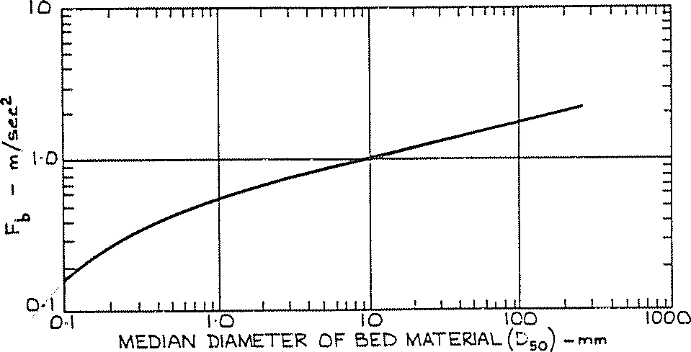

Figure 6.1 Relationship between Blench zero bed factor and bed material size Procedure:
- Given the channel cross-sectional geometry, determine the average depth of flow y₁ for the design discharge by y₁=A₁/T₁.
- Determine the design velocity.

- Determine q = V₁ y₁.
- From a sieve analysis of the bed material, determine the D₅₀ (mm).
- Determine F_{b} using Figure 6.1.
- Determine y₂ using the Blench equation.
- Estimate the maximum scoured depth by multiplying y₂, by the appropriate factor in Table 6.9.

- The depth of total scour, y_{s}, below the channel bed becomes:

SUMMARY
It is advisable to compute the total scour by both methods and compare the results. When large differences are obtained, knowledge of the erosion characteristics of the river and engineering judgement will be the determining factor. In extreme conditions, scour depths may be excessive as computed by the methods discussed above. Nevertheless the computed scour depths should be used as the guide. Scour depths in excess of 2 to
- metres are not uncommon in alluvial rivers.

SAFETY MARGINS AGAINST SCOUR
The equations provided in the preceding section are considered to provide conservative estimates of scour. However because of the inherent uncertainty of scour estimates and the complex considerations involved, it is difficult to give general guidance on safety margins against scour. Hence, the following factors should be taken into account in the final analysis:

      - long term trend in aggradation or degradation;
      - reliability of the basic data, especially hydrologic and geotechnical;
      - probability that extreme flows might exceed limits selected for design estimates;

Table of Contents

- seriousness of the consequence of total or partial failure of the protection measures;
- experience of the designer in comparable situations; and
- additional cost of providing more security.

NATURAL ARMOURING AS A LIMIT TO SCOUR
Natural armouring may limit the scour in a gravel bed stream. The armouring process begins as the non-moving coarser particles segregate from the finer material in transport. The coarser particles are gradually worked down into the bed, where they accumulate in a sub layer. Fine bed material is leached up through this coarse sub layer to augment the material in transport. As movement continues and degradation and scour progresses, an increasing number of non-moving particles accumulate in the sub layer. Eventually enough coarse particles accumulate to shield or "armour" the entire bed surface. When fines can no longer be leached from the underlying bed, degradation and scour is arrested.

The potential for the development of an armour layer can be assessed using a representative bed material composition and Shield's criteria for incipient motion:
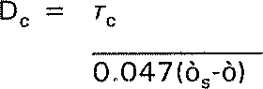

where:

D_{c} is the diameter of the sediment particles in metres for conditions of incipient motion

T_{c} is the critical boundary shear stress

□ and Ò_{s} are the specific weights of sediment and water.

Assuming a specific gravity of 2.65, the above equation reduces to:

To determine the size of the armouring particle for a given set of conditions, the critical shear stress is determined by:
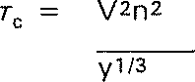

where:

V is the design flow velocity in metres/second n is Manning's roughness coefficient
y is the design flow depth in metres.

PART7 ORKED EXAMPLE AND CHECKLISTS

Table of Contents

This Part 7 of the Technical Guidelines illustrates the application of these Technical Guidelines with the provision of a worked example. Also included are two example checklists that may assist waterway managers and designers with the development and implementation of their waterway management programs and projects. Part 7 includes:

- a worked example of a waterway management project in Central Victoria, using a number of the elements contained within these Technical Guidelines;
- an example planning checklist;
- an example community/environmental/public health assessment checklist; and
- a table of unit rates for waterway management activities.
In addition, the worked examples and case studies included in A Rehabilitation Manual for Australian Streams (Rutherfurd et al. 2000) and available at www.lwrrdc.gov.au will be of assistance.

WORKED EXAMPLE
This worked example has been developed to illustrate the role of planning, development and application of ecological response models, system assessments, template stream reach assessments, assessment of options, identification of available materials and the design of works. The worked example has been presented in the format of a report illustrating how such an investigation and design may be compiled and reported.

The worked example focuses on the planning, assessment and design of a project. Limited detail is provided on the design of individual elements. Further, the example does not illustrate all necessary components in the development and delivery of a waterway management project. Components, such as the methods for the communication of the project, have not been detailed. Similarly, the example does not include details of relevant legislation and policy that may impact on the development and delivery of the project.

The worked example for Noname Creek is fictitious. However the survey, hydrologic and hydraulic investigations and results, ISC data and some images are from investigations undertaken on a waterway in north central Victoria. The worked example is for illustration purposes only and the data applied to this example may not be applicable to other sites.

PROJECT PURPOSE

INTRODUCTION
Noname Creek has been the subject of extensive channel modification including drainage and ongoing stream bed incision. The incision process continues to provide a source of sediment to downstream intact reaches of stream. The headward migration of the incision process threatens upstream infrastructure and ongoing instabilities within the reach are inconsistent with intended river health targets for the region.

It is proposed that a program of activities and works be developed and implemented to limit the ongoing instabilities improve the health of the stream.

This report provides a description of the investigations, results and recommendations for Noname Creek including functional design arrangements for proposed works.

SCOPE OF INVESTIGATIONS
The tasks undertaken for this project comprise the following:

- review and documentation of project purpose and background
- development of options for management
- development of recommendations and design review

Table of Contents

      - finalisation of design and documentation.
It is proposed that the program of activities in Noname Creek focus on the currently incising reach of Noname Creek over a length of 2 km downstream of the Three Chain Road. It is proposed that the program of works be implemented over two works seasons.

PROJECT TEAM
Noname Creek traverses public lands under the management of Parks Victoria. Project stakeholders include the Noname Catchment Management Authority, Parks Victoria, and the Department of Sustainability and Environment. The land adjoining the creek is currently leased and used for cattle grazing. Other interest groups include the Friends of Noname Creek and the Rural City of Noname, responsible for the Three Chain Road bridge threatened by ongoing channel incision.

The project has been developed by a team from the Noname Catchment Management Authority.

PROJECT BUDGET
A preliminary budget of $400,000 has been made available for the proposed project. The funding has been provided by the Noname Catchment Management Authority under the Regional River Health Program.

LITERATURE REVIEW
The investigation has included a limited literature review. The review has revealed information on the subject reach including, but not limited to:

      - the Regional River Health Strategy;
      - Index of Stream Condition data for the site;
      - existing (1996) survey data for the reach;
      - hydrologic information from the gauging station located upstream of the subject reach; and
      - historical information, including photographs, from the Noname Historical Society.

SITE CONDITION AND HISTORY
A review of the site and literature revealed Noname Creek to have been subject to significant modification, post European settlement. It has not been possible to identify the intact form of the subject reach of Noname Creek. However, based on available information and the site inspection it is likely that the subject reach comprised an ephemeral, continuous alluvial meandering sand bed channel with stream banks comprised of silty sands. Large wood would have dominated the stream channel. Review of the ecological vegetation class for the subject reach reveals that the stream and riparian zone are within the Creekline Grassy Woodland EVC. This EVC has an “Endangered” bioregional conservation status. Some remnants of this EVC are present upstream, downstream and within the subject reach.

A preliminary review of historical information has revealed the following:

- Past mining: the Noname Creek catchment was subject to mining from 1850 to 1890. Historic records indicate that hydraulic mining was undertaken in the catchment releasing significant volumes of sediment into the waterway.

- Downstream channel aggradation, loss of stream form, water logging, flooding: the release of sediment into the stream system resulted in stream bed aggradation. Associated with this bed aggradation was loss of instream diversity (filling of pools and inundation of large wood), increased occurrence of overbank flows and water logging.

- Drainage and channelisation through sediment: drainage works were undertaken in Noname Creek between 1910 and 1920. The works were undertaken to improve agricultural production in the subject reach by reducing the extent of waterlogging.

- Initiation of stream bed incision: the drainage works initiated a phase of channel incision that continues through the creek system.

Review of the Regional River Health Strategy has revealed the intent for all streams within the region to be ecologically healthy by 2020 and that Noname Creek be rehabilitated to provide habitat and migration opportunities for indigenous species.

VISION FOR NONAME CREEK
The following vision was developed by the project stakeholders for Noname Creek.
Vision

Noname Creek will be rehabilitated to an ecologically healthy waterway, providing protection for the remnant EVC, habitat and a corridor for aquatic and riparian species, and providing current and future generations with recreation opportunities such as fishing, swimming, and observation of native species.

PROJECT OUTCOMES
Following discussions with the project stakeholders, and in accordance the vision, outlined above, the following are the aspirational outcomes for the subject reach of Noname Creek:

  - To protect the downstream reaches of Noname Creek from the adverse impacts of ongoing sediment production.
  - To protect upstream infrastructure from the adverse impacts associated with ongoing stream bed incision.
  - To improve the condition of the subject reach to:
- meet the regional river health targets set for Noname Creek;
- provide instream and riparian habitat and longitudinal and lateral connectivity within the subject reach, commensurate with a healthy waterway;
- that equivalent to or better than adjoining upstream and downstream reaches; and
- provide opportunities for recreational pursuits.

The above targets should be met within the current generation and therefore should be achieved within a 10 to 15 year time frame.

PROJECT TARGETS
Outcome Target Timeframe

- Protect upstream and downstream reaches and associated habitat from the
Halt headward incision
Reduce rate of erosion within the
5 year

adverse impacts associated with ongoing subject reach to that equivalent to intact

incision and sediment production
- Protect upstream infrastructure from the adverse impacts associated with ongoing stream bed incision
or stable reaches
Halt all headward incision 2 year

- Protect remnant Creekline Grassy Woodland EVC
ISC vegetation score of 6 or better through reach
2 year

- Achieve good condition in the streamside ISC vegetation score of 7 or better 10 year

zone and physical form

- Provide ecologically healthy stream in good or better condition
through reach
ISC physical form score of 7 or better
Composite ISC score > 37 10 year

- Provide access opportunities for individuals and groups
5 group and 20 individual visits to the subject site per annum
2 year

Table of Contents

Table of Contents

UNDERSTANDING THE SYSTEM

ASSESSMENTS

VISUAL INSPECTION
A visual inspection of the stream was undertaken on 5 March 2006. The inspection was undertaken with representatives of the CMA.

Streamside zone vegetation: The site contains some isolated weeping willow (Salix babylonica). The willows are not spreading and provide some limited additional stability to the system. However the willow does not add value to the vegetation condition and may have some adverse water quality and ecological attributes.

The reach is subject to grazing under a license agreement with Parks Victoria. No riparian fencing exists to exclude or limit stock access to the riparian zone or stream channel. As a consequence of grazing pressure and ongoing accelerated channel instabilities, the subject reach was found to have limited instream and riparian vegetation.

The existing streamside zone vegetation condition could be classed as very poor.

Physical form: The stream has evidence of active instream erosion in the form of bed deepening and widening. The most active erosion is in the subject reach. The extent of active erosion decreases in a downstream direction where the channel appears wider with zones of sediment deposition.

Noname Creek has limited habitat available in the subject reach with deep holes largely absent. Remnant deep pool habitat remains in the reach upstream of the Three Chain Road. Some limited pool habitat was observed to be re-establishing in the reaches downstream of the subject reach of Noname Creek.

Large wood is absent from the subject reach.

ISC ASSESSMENT
Stream condition assessments have been undertaken for the subject reach using the Index of Stream Condition method. Assessments were undertaken in 1999 and 2004. The results of the assessment are:

ISC Parameter | 1999 | 2004
Hydrology | 9 | 5
Physical form | 4 | 3
Streamside zone | 4 | 4
Water quality | 6 | 4
Aquatic Life | 8 | 3
Total | 26 | 17
Condition | Moderate | Poor

The ISC results are in accord with the visual inspection and confirm the relatively poor condition of the subject reach of stream. The changes in the hydrology, water quality and aquatic life between 1999 and 2004, most likely reflect a change in the assessment methods used rather than a change in the condition of Noname Creek.

Table of Contents

TOPOGRAPHIC SURVEY
A cross-section survey of the subject reach and downstream reaches was undertaken in 1996. A repeat cross-sectional survey was commissioned for this investigation. In addition, the survey commissioned for this investigation included a longitudinal profile.
The repeat survey only covered the subject reach, identified as being subject to ongoing instabilities.

The survey data was compiled in a digital terrain modelling software package to create a 3-dimensional digital terrain model of the reach.

The results of the topographic survey have been used in a stream bed longitudinal profile analysis, hydraulic analysis, and the design and set-out of proposed works.

LONGITUDINAL AND CROSS-SECTIONAL SURVEY ASSESSMENT
A comparison of survey data for the subject reach for 1996 was made with the survey of current conditions. This revealed evidence of deepening and widening of the channel form, evident as bed incision, bank slumping and widening and new channel base formation.

An example of the change in cross-section between 1996 and 2005 is illustrated below. The figure shows both widening and deepening of Noname Creek at cross-section
54.78 m.

174
1996 survey
2005 survey

172

170
E lev at io n ( m )

168

166
-60 -40 -20 0 20 40 60
Station (m)

Figure 7.1 Comparative cross-section survey Noname Creek at cross section
54.78 m

A stream bed longitudinal section of the water course alignment (based on the survey data) was used to undertake a stream bed grade analysis of the reach. Table 7.1 below compares stream grades within the subject reach with design stream grades identified for reaches of stream with similar catchment area and hydrology in north east Victoria.

The results indicate that the stream bed grade within the subject reach are typically equivalent to or steeper than the design grades identified for a selection of incised streams in north east Victoria (refer Section 6.2 Waterway Design Parameters). The longitudinal profile for the subject reach can be found in the Appendix to this report. The bed grade within the recovering reach downstream from the subject reach has a bed grade, identified from the 1996 survey, of 0.001 m/m (1 in 1,000).

Table 7.1 Comparison of stream bed grades

Chainage
Typical range of bed grade
Overall bed grade
Design stream bed grades*

 | From | To
CH0-CH500 | 0.00136 | 0.0131 | 0.00233 | 0.001- 0.003
CH500- CH1000 | 0.00462 | 0.0154 | 0.00373 | 0.001- 0.003
CH1000- CH1500 | 0.00156 | 0.0236 | 0.00525 | 0.001- 0.003
CH1500- CH2000 | 0.00413 | 0.0274 | 0.00276 | 0.001- 0.003
CH2000- CH2360 | 0.00255 | 0.0609 | 0.00606 | 0.001- 0.003
* Identified design grades based on a Review of Stream Profile Information for Catchments of North East Victoria (Hardie 1993)
Table of Contents

HYDROLOGIC AND HYDRAULIC ANALYSIS
A hydraulic analysis of the reach in its existing condition was undertaken using HEC- RAS, a one-dimensional hydraulic modelling program.

The hydraulic model was created via the use of a digital terrain modelling package and a HEC-RAS design interface. Stream flows for a range of flow events were developed using a flood frequency analysis and available gauging station data.

Output from the hydraulic modelling included water surface elevations and unit stream power.

The results of the hydraulic analysis reveal that the subject reach (comprising reach 3 on the 1996 survey) contains unit stream powers in excess of that found for downstream reaches (reaches 1 and 2 on the 1996 survey). This is in accord with observations of the site with significantly greater instabilities observed in the subject reach than the downstream reaches. Further, the results for the subject reach were found to be in excess of that found for stable, naturally incised streams in central Queensland (refer Section 6.2 Waterway Design Parameters), while those reaches observed to be in more advanced stages of evolution with developing stability and recovery and limited to absent erosion, were found to have unit stream power results typically below that for naturally incised streams of central Queensland.

Reach 1 from the 1996 survey, appears stable, with limited erosion and a developing plan form and pool riffle system. The hydraulic results for this downstream reach (reach 1) in the 1996 survey can be used as a template for analysis and design of the subject reach.

The results of the analysis using the 2004 survey revealed unit stream power in excess of that for the template reach ongoing instability is expected.

CURRENT STREAM CONDITION PROCESSES AND TRAJECTORY
The following discussion on the current stream condition and the likely trajectory of the channel are based on the two conceptual models. The first of these models is that of the process of channel incision and recovery. This model is shown below as Figure 7.2.

The second model included as Figure 7.3, illustrates the physical and biological responses to channel incision.

These models together with the findings of the investigations have been used to provide a discussion on the current condition and expected trajectory of Noname Creek.

Table of Contents

Figure 7.2 Process of channel incision and recovery (Simon 1989)

HYDROLOGY
The majority of the catchment is rural with some urbanisation in the upper reaches. Some wastewater discharges have increased base flow

The urbanisation represents less than 5% of the catchment and is considered unlikely to have an impact on the geomorphic form of the stream. Some water quality and ecological impacts may be present.

The ongoing incision will have some impacts on downstream flooding as illustrated in the model of the effects of channelisation.

Table of Contents

Figure 7.3 Example ecological response model: Effects of channelisation on the physical environment and ecology of streams (Adapted from Schumm, Harvey, and Watson 1988)

STREAMSIDE ZONE VEGETATION
The streamside zone vegetation of the subject reach is in poor condition. The ground and shrub layer vegetation are severely altered and depleted as a result of ongoing grazing pressure. Instream vegetation in the subject reach has been impacted by the ongoing incision process (refer Figure 7.3) and grazing pressure. Some isolated willow is present on the stream banks.

PHYSICAL FORM
The stream bed grade analysis has found the stream bed grade within the subject reach to be equal to or steeper than the range of stream bed grades for similar catchments in north east Victoria. This coupled with observed nick points and headcuts in the system suggest that ongoing channel incision can be expected in the reach.

The hydraulic analysis of the 1996 survey data suggests that the central Queensland data set (refer Section 6.2 Design Parameters) provides a useful guide to the stability in the system. Those reaches of Noname Creek with limited evidence of instability had unit stream power below that for incised streams in central Queensland. The subject reach of stream, with observed ongoing channel instability was found to have had unit stream power in excess of that found for the central Queensland data set.

The investigation has revealed that the subject reach of stream is subject to ongoing instability. The unit stream power analysis based on the 2005 survey is consistent with the results for the 1996 survey, with high stream powers in excess of that found to be associated with stable incised stream systems in central Queensland. Similar results were obtained for the shear stress and velocity assessment.

Table of Contents

Based on the investigations the subject reach of stream is considered to be in stages III and IV of evolutionary development (refer Figure 7.2) with ongoing incision and channel widening. Downstream reaches are in later stages of evolution (stage V and VI). The most downstream reach included in the 1996 survey is within stage VI of evolution and can provide a template for channel recovery.

There is no large wood within the subject reach and the existing incised form of the stream and absence of deep pools results in the subject reach being a barrier to effective fish migration.

WATER QUALITY
The water quality within the system is impacted, to some extent, by the upstream urban development. However water quality is likely to be impacted to a far greater extent by the ongoing incision process. The effects of ongoing incision on water quality are illustrated in Figure 7.3.

AQUATIC LIFE
The aquatic life of the subject reach is severely impacted by the ongoing incision and grazing. The mechanism for the impact of the channelisation on aquatic life is shown in model of the effects of channelisation. The upstream urbanisation may have some limited impact on the aquatic life.

SUMMARY
A summary of existing condition and expected trajectory, based on continuation of the current levels of management, for the subject reach of stream is provided below:

ISC Parameter | Current | Expected 15 year trajectory
Hydrology | 5 | 5
Physical form | 3 | 3
Streamside zone | 4 | 2
Water quality | 4 | 4
Aquatic life | 3 | 3
Total | 17 | 15
Condition | Poor | Very poor

THREATS TO TARGET OUTCOMES
Assessment of the site has revealed that the channel incision will continue. The ecological response to this incision is shown in the model of the effects of channelisation (Figure 7.3). Based on the investigations and the model of the effects of channelisation, the following threats to target outcomes have been identified. The threats are based on continuation of the current management for Noname Creek.

- The ongoing instabilities in the form of channel incision and the subsequent and ongoing widening will continue to supply sediment to and threaten downstream habitat.
- The ongoing channel incision threatens the bridge at Three Chain Road and the relatively intact reach of stream upstream of the Three Chain Road.
- Grazing and ongoing incision and widening will limit vegetation establishment.
- The absence of streamside zone vegetation and instream structural diversity in the subject reach will prevent the attainment of the intended river health targets for Noname Creek.

Table of Contents

STRATEGY DEVELOPMENT
A number of management interventions are proposed to accelerate the rate of recovery, to stabilise the system and to move the subject reach toward the intended river health targets. Options for intervention are discussed under the broad headings of Inflow and Runoff Options, Vegetation Options and Instream Interventions. Discussions include the likely physical and ecological responses to the proposed interventions. These responses are based on the conceptual models provided in this report.

INFLOW AND RUNOFF OPTIONS
Water sensitive urban design can be applied to achieve improvements in urban stormwater quality. However WSUD can also be applied to achieve modification of catchment hydrology and subsequent geomorphic benefits. Improvements in hydrology, water quality and geomorphology can be combined to improve ecological outcomes.
However, as the urban area is small it is unlikely that retrofitting WSUD will have any significant impact on the subject reach. The retrofitting on WSUD to the urban area is likely to be a high cost option with limited return for the subject reach. Retrofitting WSUD to the subject catchment is likely to provide a lower return on investment than other options.

The retrofitting of WSUD is not recommended for inclusion in this project. However retrofitting WSUD may provide a higher return on investment for other reaches of Noname Creek beyond the scope of this project.

RIPARIAN AND INSTREAM VEGETATION OPTIONS
Riparian and instream vegetation will be an essential component to the success of the project. Vegetation within the channel bed and banks in the subject reach will be necessary to:

- Reduce unit stream power through the reach to reduce the rate of channel change and instability. A target roughness for the channel of Manning’s n= 0.08 could be achieved by direct seeding and planting of tube stocks of native species on the banks of the river channel. This may require additional roughness by the installation of large wood within the stream.

- Protect the stream bed and banks from scour by increasing the critical shear stress for the subject reach (refer to Section 6.2.4 for the role of vegetation on critical shear stress).

- Improve the vegetation condition and habitat opportunities through the reach.

However based on the ongoing incision process it is unlikely that vegetation alone will address the instabilities in the system.

STOCK CONTROL
Stock control will be required to enable vegetation establishment. This will entail provision of fencing and off stream watering. This will be a relatively low cost and high return activity.

VEGETATION ESTABLISHMENT AND MANAGEMENT
In addition to stock control, the establishment of riparian and instream vegetation will require weed control, direct seeding, planting of tube stock, and maintenance of the system.

Vegetation establishment and maintenance including, weed control, planting and maintenance will be moderate cost for a high return.

Table of Contents

WILLOW CONTROL
There are some isolated willows in the subject reach. These are not spreading and not causing significant stream management problems. However, the presence of willow will limit the attainment of the river health targets.

The willow could be removed following establishment of alternate vegetation. The removal of willow will be of low cost and low return and moderate return.

INSTREAM PHYSICAL INTERVENTIONS

GRADE CONTROL
Grade control structures will be required to address nick points and headcuts within the subject reach to halt the ongoing incision process. It is proposed that the grade control structures comprise rock chutes. Alternate structures such as log sills, and grass chutes will not be suited to the site and conditions. Log sills will not provide for fish passage through the reach. The permanent flow would result in failure of a grass chute. From the investigations, four new rock chute structures will be required. These will be in addition to the single existing chute within the reach.

WIDENING AND BATTERING
It is likely that there will be remnant high stream power following completion of grade control and revegetation works. This will result in ongoing widening and sediment production. While the grade control and revegetation will address the cause of widening. Some ongoing widening will occur as the stream adjusts to the incised form.

Widening and battering of the stream bank will reduce the rate of ongoing widening and sediment production.

Rock beaching may be used instead of the battering and widening works, where such battering and widening may infringe on existing significant vegetation. The size of rock required for beaching will be dependent on the energy slope and the proposed bank angle. This should be determined in the detailed design phase.

LARGE WOOD
Installation of large wood would assist to increase roughness, reducing stream velocity and unit stream power. Provision of instream timber will also increase instream habitat and flow and substrate diversity.

COMPONENT CONFIGURATION OPTIONS
The above components can be compiled into a selection of alternate programs configurations. A discussion on these configurations and a summary of costs are provided below.

REVEGETATION AND MANAGEMENT
A revegetation only program would provide for the long term stability of the system. However the recovery phase would be slow . Adoption of this strategy would result in failure to meet the project outcomes and targets within the desired timeframe. Further the strategy would result in ongoing downstream sediment deposition and bed aggradation and the likely failure of existing upstream infrastructure.

REVEGETATION AND GRADE CONTROL
This arrangement provides for the construction of rock chutes and the revegetation of the channel and riparian zone. However the arrangement would not fully address areas of high stream power and would allow some ongoing widening to occur. This arrangement would address the cause of ongoing sediment production and accelerate the rate of recovery of the system, moving the subject reach to stage V, aggradation and widening (refer Figure 7.2) of the incision process. The strategy would not halt all sediment production from the reach. However the strategy would serve to protect upstream infrastructure. The strategy would provide more rapid recovery toward stage VI, quasi

Table of Contents

equilibrium (refer Figure 7.2) than the vegetation only option. However the strategy would not result in immediate attainment of stage VI.

The results of a hydraulic analysis of this option is provided in Section 7.1.5 Worked example appendix.

REVEGETATION, GRADE CONTROL AND ADDITIONAL WIDENING
This arrangement would seek to reduce all unit stream power within the subject reach to levels commensurate with a stable incised system in quasi equilibrium (Phase VI). This arrangement would result in the cessation of incision, cessation of widening in the subject reach and cessation of elevated sediment transport from the reach. However the arrangement would not provide optimal instream diversity until vegetation matures and collapses in the stream.

The results of a hydraulic analysis are provided in Section 7.1.5 Worked example appendix.

REVEGETATION, GRADE CONTROL, ADDITIONAL WIDENING AND HABITAT (LARGE WOOD) INSTALLATION
This arrangement addresses all threats to target outcomes. The arrangement would result in the cessation of incision, the cessation of widening, and the provision of instream and riparian vegetation and instream habitat.

OTHER COMPONENTS
Other components of the program should include monitoring and evaluation. A monitoring and evaluation program should be undertaken for the project. The monitoring and evaluation should check and report on both implementation and outcome targets.

PROJECT COSTS
Estimated costs for the implementation of onground works are shown in the following tables:

Table 7.2 Revegetation

Item Description of works Quantity Units Rate Amount
Stock control and revegetation
1 Fencing and off stream watering | 4,000 | m | $5 | $20,000
2 Weed control and planting (tube stock) | 8,000 | unit | $5 | $40,000
3 Direct seeding | 4 | km | $4000 | $16,000
15% contingency (for unforeseen costs) |  |  |  | $11,400
Total |  |  |  | $87,400

Table 7.3 Rock chutes and revegetation

Item Description of works Quantity Units Rate Amount
 | Rock chutes
1 | Supply and deliver rock chute material (D₅₀ = 400 mm) | 2,000 m³ $70 $140,000
2 | Direct seeding of cover at construction sites | 2 | ha | $4,000 | $8,000
 | 15% contingency |  |  |  | $22,200
 | Sub total |  |  |  | $170,200
 | Revegetation |  |  |  | $87,400
 | Total |  |  |  | $257,600

Table of Contents

Table 7.4 Bank battering, rock chutes and revegetation

Item Description of works Quantity Units Rate Amount Earthworks
1 | Widening of channel | 8,800 | m3 | $2 | $17,600
2 | Uniform re-spreading of excavated material over floodplain | 8,800 | m3 | $2 | $17,600
15% contingency |  | $5,280
Sub total |  | $40,480
Rock chute and revegetation |  | $257,600
Total |  | $298,080

Table 7.5 Large wood installation, bank battering, rock chutes, and revegetation

Item | Description of works | Quantity | Units | Rate | Amount
1 | Supply and installation of timber | 30 | units | $500 | $15,000
 | 15% Contingency |  |  |  | $2,250
 | Sub total |  |  |  | $17,250
 | Rock chutes, revegetation & widening |  |  |  | $298,080
 | Total |  |  |  | $315,330

Additional project items and costs will include:

  - Design and supervision of the activities and works. Design and supervision of works can be expected to cost approximately 10% of the project budget. A sum of $35,000 should be allocated for this task.

  - Development and implementation of a monitoring and evaluation program. The development and implementation of a monitoring program should be budgeted at approximately 5 to 10% of project costs. A sum of $15,000 should be allocated to the development and implementation of a long term monitoring and evaluation program for the Noname Creek Project.

  - Development and Implementation of project signage and access. The development and installation of project signage and provision of access to the site for public and groups including gates, and stiles is not anticipated to exceed
$10,000.

  - Maintenance. Ongoing maintenance will be required. Ongoing maintenance will be required for the rock chutes and for weed control. An annual allocation of 5% of project costs should be made for ongoing maintenance.

RISK ASSESSMENT
A risk ranking has been applied to the threats to the target outcomes. This risk ranking is shown in the following table.

The risk ranking has been based on discussions with project stakeholders. Those activities that seek to protect instream ecological assets from ongoing processes have been afforded greatest importance or weighting. Projects aimed at protection on infrastructure and improving stream condition have been given a lower level of importance. The risk assessment identifies the protection of upstream and downstream reach conditions as the highest priority for attention, together with the protection of remnant patches of Creekline Grassy Woodland EVC. Activities and works aimed at improving stream condition to meet target outcomes achieved high ranking. Works directly aimed at the protection of infrastructure and increasing community access to the site were given a moderate risk ranking.

Table of Contents

Table 7.6 Target outcomes risk ranking
Outcome | Target | Importance of | Likelihood of | Risk ranking
 |  | target/outcome | failure to
 |  |  | meet target in
 |  |  | planning
 |  |  | horizon
1. Protect upstream and | Halt headward incision | High | High | Very high
downstream reaches of stream from adverse impacts associated with  ongoing incision and | Reduce rate of erosion to that equivalent to
sediment production
2. Protect upstream | Halt all headward | Moderate | Moderate | Moderate
infrastructure from the | incision
adverse impacts
associated with
ongoing stream bed
incision
3. Protect remnant | ISC vegetation score | High | High | Very high
Creekline Grassy | of 6 or better through
Woodland EVC | reach
4. Achieve good | ISC vegetation score | Moderate | High | High
condition in the | of 7 or better through
streamside zone and | reach
physical form | ISC physical form score
 | of 7 or better
5. Provide ecologically | Composite ISC score | Moderate | High | High
healthy stream in good | > 37
or better condition
6. Provide access | 5 group and 20 | Moderate | Moderate | Moderate
opportunities for | individual visits to the
individuals and groups | subject site per annum

within the subject reach intact or stable reaches

ASSESSMENT OF PRIORITY OPTIONS
The proposed option configurations have been developed reflecting priorities for management. The anticipated response of the system to the proposed interventions has been based on the two response models used for this investigation.

Greatest return on investment will be achieved through a vegetation establishment and management program. A vegetation only program will achieve target outcome no. 3, the protection of the Creekline Grassy Woodland EVC. A vegetation management program will result in partial attainment of all other outcomes.

The combination of grade control and vegetation establishment will address most threats and move the system toward most of the proposed targets. Some target outcomes will be met in the nominated timeframe including the protection of upstream infrastructure.
However the combination of vegetation and rock chutes will not prevent ongoing sediment production as a result of ongoing widening within the proposed timeframe and will not result in the attainment of the first outcome.

Attainment of outcome no. 1, the protection of upstream and downstream intact reaches, will require a combination of vegetation, grade control and strategic widening (bank battering). A program of grade control, vegetation and widening will also result in the attainment of outcomes 2 and 3.

Full attainment of outcomes 1, 2, 3 and 4 will require vegetation, rock chutes, widening and installation of large wood. This will result in near attainment of outcome no. 5. This arrangement together with anticipated design and supervision, signage (outcome no. 6), and monitoring and evaluation can be undertaken within the nominated project budget of
$400,000.

Table of Contents

The full attainment of outcomes 1, 2, 3, 4, 5 and 6 will require the above and additional inflow and runoff interventions and management such as WSUD to protect water quality and catchment hydrology. These additional activities can be undertaken at considerable expense and low return for the subject site. WSUD could provide considerable benefits to the wider system and should be assessed as a component of a wider water quality program for Noname Creek.

PROPOSED STRATEGY

COMPONENTS
It is proposed that the final program of activities and works comprise stock control vegetation establishment, rock chutes, widening (bank battering) and large wood installations. It is proposed that the program include appropriate levels of design and supervision, installation of signage and access provisions and a monitoring and evaluation program.

RESPONSIBILITIES
It is proposed that the program of works be undertaken by the Noname Catchment Management Authority in association with Parks Victoria and the adjoining landholder. All instream works would be funded by the CMA with the CMA making a contribution towards stock control and vegetation establishment in accordance with existing policy. Long term vegetation management agreements will be required with adjoining landholders prior to the commencement of works.

TIMEFRAME
It is proposed that all works be undertaken over two work seasons. This includes stock control, vegetation establishment, rock chute construction, strategic widening, and large wood installations.

BUDGET
It is anticipated that the program of works could be undertaken within a budget of
$400,000.

DESIGN AND IMPLEMENTATION

WORKS DESIGN AND DOCUMENTATION

DESIGN PARAMETERS
It is proposed that the program of onground works comprise a vegetation and rock chute based grade stabilisation program coupled with additional widening and large wood installation.

The design process for these arrangements comprised the following steps:

- Identification of preferred chute sites
- Development of a preliminary chute configuration with survey data
- Modelling of the proposed system using HEC-RAS
- Confirmation proposed sites in the field
- Finalisation of design.

Parameters and criteria adopted for the design of the proposed arrangements are set out in the following table.

Table of Contents

Table 7.7 Critical parameters and design criteria

Parameter | Units | Adopted criteria | Basis for selection
Bed gradient | m/m | 0.001 | Developing grade within the subject reach
 |  |  | Bed grade within template reach
 |  |  | Within range found for north east Victoria
Unit stream power 2 year ARI | N/ms | 60 | Upper limit of unit stream power for template reach  Upper limit of range of naturally incised sand bed streams in central Queensland
Unit stream power 50 year ARI | N/ms | 150 | Upper limit of unit stream power for template reach  Upper limit of range of naturally incised sand bed streams in central Queensland
Channel roughness | Manning “n” | 0.08 | Roughness associated with dense instream  vegetation and timber (www.rivers.gov.au/roughness)

ROCK CHUTE ARRANGEMENTS
Attainment of the proposed bed grade can be achieved with 5 grade control structures. There is one existing rock chute structure. Four additional structures will be required. The proposed location for these rock chutes is shown in the Appendix (refer Section 7.1.5).
The proposed chutes have been located at sites of high stream powers. Proposed chute locations and preliminary dimensions are shown in the following table. Rock chute designs should be undertaken as a component of detail design and supervision of works using the Chute design program available through eWater (refer www.toolkit.net.au/cgi- bin/WebObjects/toolkit).

Table 7.8 Critical details of rock chutes

Chute Number | Chute width | Chute length | Crest elevation | Crest chainage
1 | 14 | 42 | 173.9 | 2077
2 | 9 | 31 | 170.5 | 1473
3 | 9 | 30 | 168.91 | 703
4 | Existing structure
5 | 9 | 20 | 167.2 | 422

VEGETATION
The attainment of the target river health outcomes for the reach will require attainment of vegetation width, longitudinal connectivity, diversity and composition outcomes associated with an ISC score of 7 to 8. This will require:

- a continuous vegetation corridor with a total width of at least 50 metres;
- a riparian vegetation community comprising the species reflective of a Creekline Grassy Woodland; and
- an absence of weeds woody weeds, and limited presence of weeds in the ground cover.

The details of the vegetation program including the set out of fencing, and off stream watering and the development of the weed control program and planting schedule should be the subject of additional detailed design (refer Greening Australia 2003).

INSTREAM TIMBER
Instream timber should be placed to maximise local scour without compromising the integrity of the system and the attainment of a stage VI incised channel evolution.
Instream timber should be located in pools and remain saturated. Timber should be sourced from road clearings and other sites of approved vegetation clearance.

The detail of instream timber installations should be the subject of detail design.

Table of Contents

MONITORING EVALUATION AND MAINTENANCE
The proposed activities and works should be subject to a monitoring and evaluation program.

It is not proposed that the monitoring and evaluation program comprise a full BACI design. As a consequence it will not be possible to fully identify whether the proposed interventions have been the cause of any improvement or change in stream condition. However the proposed program should identify whether the intended targets are likely to be met.

The details of the program are beyond the scope of this investigation. However components of the program are briefly outlined below.

IMPLEMENTATION TARGETS
The monitoring and evaluation of implementation targets should include assessment to ensure all nominated works are completed within two work seasons.

The monitoring should include visual inspections and checks on implementation against designs and design intent.

The program should include ongoing monitoring and evaluation of the ongoing structural performance of rock chutes, stock control, vegetation establishment and weed invasion.

OUTCOMES
The monitoring and evaluation of outcomes comprises the assessment of whether the intended outcomes have been met. This will require:

  - repeat stream bed and cross-section survey to assess ongoing channel change;
  - fixed photo points to assess change;
  - visual inspection of the reach; and
  - repeat ISC condition assessments to assess movement toward intended river health outcomes.

MAINTENANCE
Ongoing maintenance will be required. This will require ongoing review of the structures and vegetation and an ongoing program of management to ensure that structures and other works are operating as intended. Ongoing maintenance will be required for the rock chutes, fencing and weed control.

Table of Contents

WORKED EXAMPLE APPENDIX

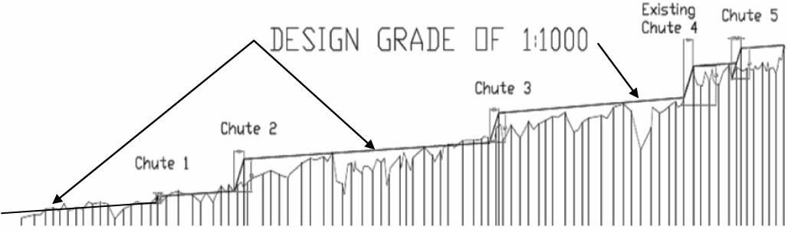
LONGITUDINAL STREAM BED PROFILE
Figure 7.4 Noname Creek longitudinal profile and functional design rock chute layout

HYDROLOGIC AND HYDRAULIC INVESTIGATIONS
An hydrologic and hydraulic assessment has been undertaken on Noname Creek to identify the range of unit stream power, shear stress and velocity with the subject and adjoining reaches. The analysis has been undertaken to assess channel stability and assist selection of design criteria.

HYDROLOGIC ASSESSMENT
An annual and partial series, flood frequency analysis was undertaken for the subject reach using gauging station data from two sites on Noname Creek located upstream and downstream from the subject reach. The analysis was undertaken using the AQUAPAK software package. A summary of the flood frequency results is provided in the table below.

Table 7.9 ARI flows derived from gauging station data
ARI flow rates (m³/s)
 | Confidence | Station 1 | Station 2
2 year | 95% | 29 | 23
 |  | 37 | 30
 | 5% | 48 | 39
50 year | 95% | 44 | 52
 |  | 68 | 90
 | 5% | 105 | 156

As the gauging station has operated for a short period of time, and this period has been characterised by dry conditions, the results for the 5% confidence limit were adopted for analysis and design. Adoption of these flow events will result in a relatively conservative design.

TOPOGRAPHIC SURVEY
The subject reach of stream was surveyed in 1996 and a repeat survey was commissioned by for this investigation. The repeat survey only covered the subject reach identified as being subject to ongoing instabilities.

The survey data was compiled in the 12D digital terrain software package to create a 3- dimensional digital terrain model of the reach.

The results of the topographic survey have been used in a stream bed longitudinal profile analysis, hydraulic analysis, and the design and set-out of proposed works.

HYDRAULIC MODELLING
An hydraulic analysis of the reach in its existing condition was undertaken using HEC- RAS, a one-dimensional hydraulic modelling program. The hydraulic model was created via the use of a 12D/HEC-RAS design interface, which allowed the geometry of the reach to be input. Stream flows representing the standard ARI events, derived from gauging station data, were also input into HEC-RAS to determine water surface elevations at various flow rates.

Stream power was then analysed in HEC-RAS to determine the stability of the reach at various chainages.

ANALYSIS RESULTS

CHANNEL FORM ASSESSMENT
A comparison of survey data for the subject reach from 1996 was made with the 2005 survey of existing conditions. This revealed evidence of deepening and widening of the channel form, evident as bed incision, bank slumping and widening and new channel base formation. Locations of specific changes coincide with locations of high stream power, as do locations where there is little change in channel form coincide with areas of low stream power.

STREAM BED GRADE ANALYSIS
A stream bed longitudinal section of the water course alignment (based on the survey data) was used to undertake a stream bed grade analysis of the reach. The following table below compares stream grades within the subject reach with design stream grades identified for reaches of stream through north east Victoria.

Table 7.10 Comparison of stream bed grades

Chainage
Typical range of bed grade
Overall bed
Design stream

 | From | To | grade | bed grades*
CH0-CH500 | 0.00136 | 0.0131 | 0.00233 | 0.002
CH500- CH1000 | 0.00462 | 0.0154 | 0.00373 | 0.002
CH1000- CH1500 | 0.00156 | 0.0236 | 0.00525 | 0.002
CH1500- CH2000 | 0.00413 | 0.0274 | 0.00276 | 0.002
CH2000- CH2360 | 0.00255 | 0.0609 | 0.00606 | 0.002
* Identified design grades based on a Review of Stream Profile Information for Catchments of North East Victoria (Hardie 1993)
Table of Contents

The results indicate that the stream bed grade within the subject reach remains steeper than the design grade identified for a selection of incised streams in north east Victoria (refer Section 6.2 Waterway Design Parameters). The longitudinal profile for the subject reach can be found in the Appendix to this report.

Table of Contents

1996 SURVEY STREAM POWER ANALYSIS
A unit stream power analysis was undertaken using the 1996 survey data. The results of the analysis are provided in the following figure. The upper limit of preliminary design criteria for the 2 and 50 year ARI are shown.

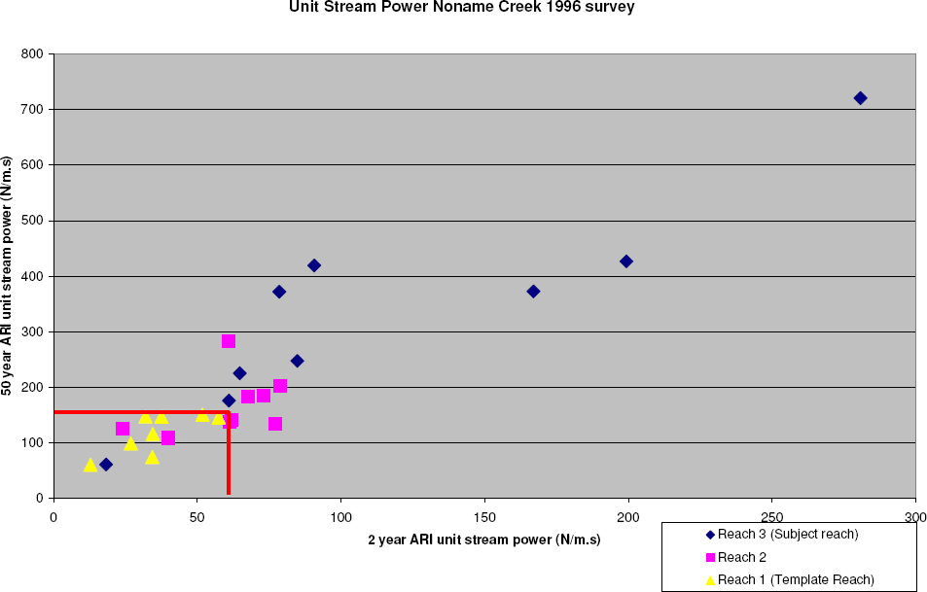

Figure 7.5 Analysis of unit stream power
The results of the hydraulic analysis reveal that the subject reach (comprising reach 3 on the 1996 survey) contains unit stream powers in excess of that found for downstream reaches (reaches 1 and 2 on the 1996 survey). This is in accord with observations of the site with significantly greater instabilities observed in the subject reach than the downstream reaches. Further, the results for the subject reach were found to be in excess of that found for stable, naturally incised sand bed streams in central Queensland (refer Section 6.2.5), while Reach 1 observed to be in a more advanced stage of evolution with developing stability and recovery was found to have unit stream power results typically below that for naturally incised sand bed streams of central Queensland.

The results suggest that Reach 1 from the 1996 survey could be adopted as a template reach for design of recovery works within the subject reach.

Table of Contents

2005 SURVEY UNIT STREAM POWER ANALYSIS
Stream power within the subject reach of the creek was analysed for the 2 year and 50 year ARI events. These stream powers are plotted in the following figure. The results have been compared with parameters found for non-eroding incised streams in central Queensland.

The results indicate that there are reaches of the subject stream where the stream power is in excess of that for the template reach and the unit stream power criteria adopted for design.
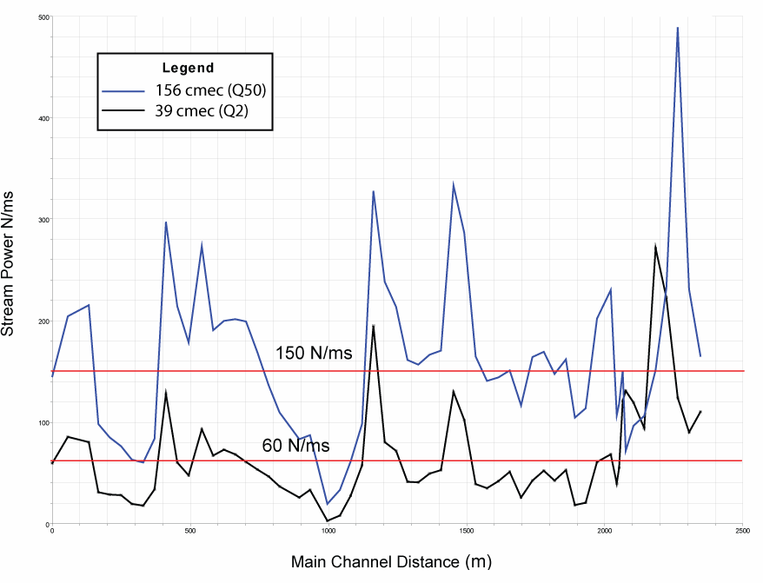

Figure 7.6 Existing stream power for 2 year and 50 year ARI events 2005 survey

Table of Contents

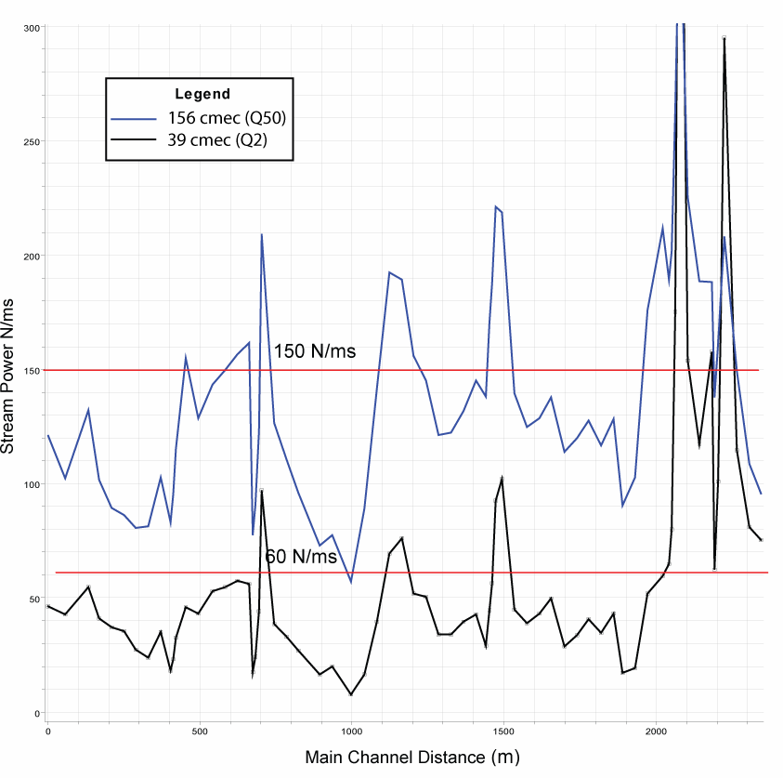
UNIT STREAM POWER ANALYSIS OF OPTIONS
Figure 7.7 Unit stream power in Noname Creek with rock chutes and proposed instream vegetation. Remnant high stream power at sites of rock chutes and narrow sections of channel
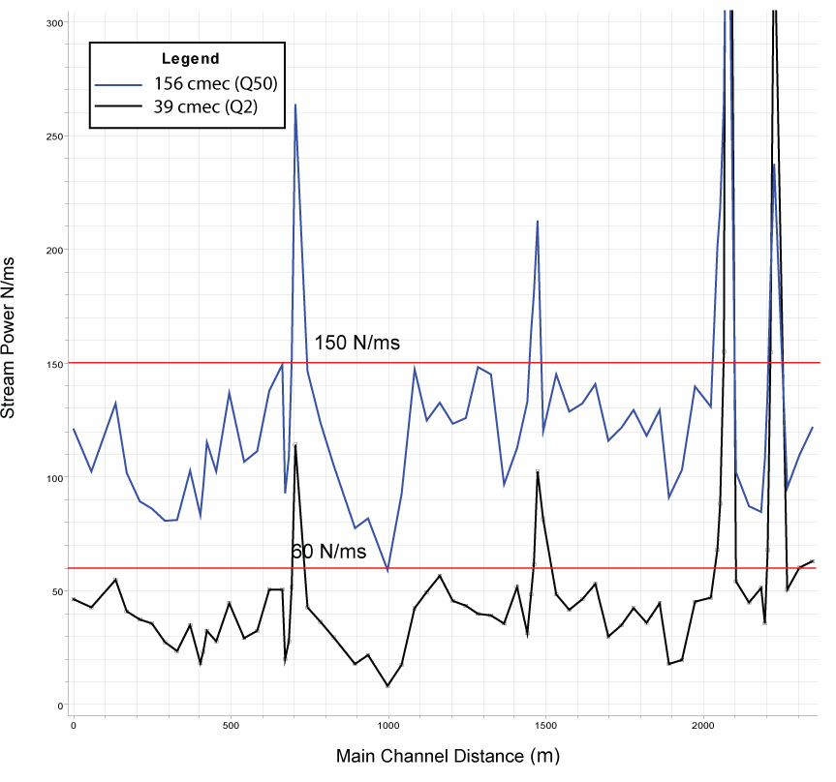

Figure 7.8 Unit stream power in Noname Creek with rock chutes, proposed instream vegetation and strategic battering/widening. Remnant high stream power at sites of proposed rock chutes and related rock riprap abutment and bank treatments

Table of Contents

PLANNING CHECKLIST
The following waterway management checklist is an extract from A River Restoration Framework (Koehn et al. 2001). The checklist is provided to assist waterway managers ensure that appropriate steps have been undertaken in the planning and delivery of the waterway management project. The checklist is based on the steps contained within A River Restoration Framework (Koehn et al. 2001). The checklist should be used as a guide only and may need to be refined to suit the specific requirements of the planning framework adopted for any one organisation, program or project. An alternate checklist should be developed and adopted to reflect any alternate framework adopted.

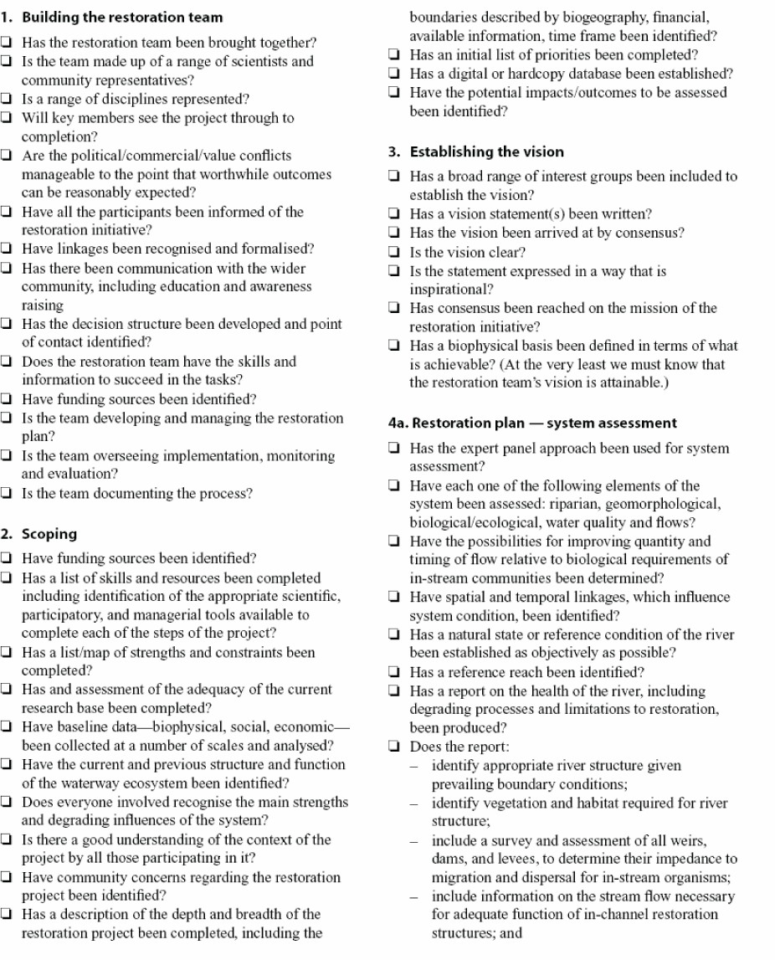

Table of Contents

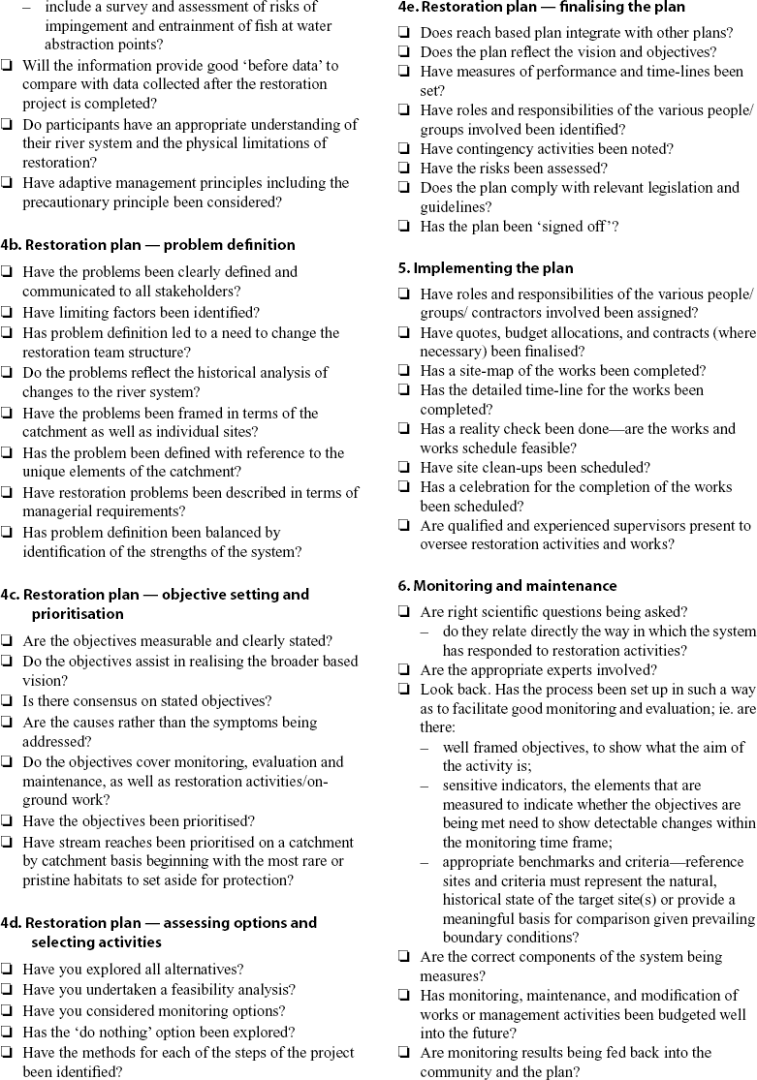

Table of Contents
7.2 PLANNING CHECKLIST
263

Table of Contents

WATERWAY ACTIVITY – COMMUNITY/ ENVIRONMENT/ PUBLIC HEALTH CHECKLIST
The following waterway activity - community/environment/public health checklist has been developed by Melbourne Water. The checklist is provided to assist waterway managers ensure that appropriate steps have been undertaken prior to the implementation of any onground works. The checklist should be used as a guide only and may need to be refined to suit the specific requirements of programs, projects, waterway managers and organisations as appropriate.
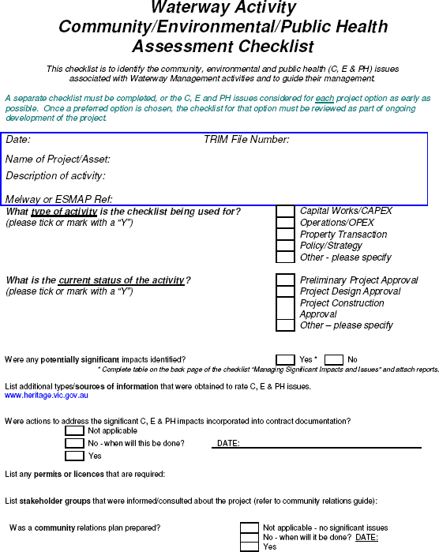

Table of Contents

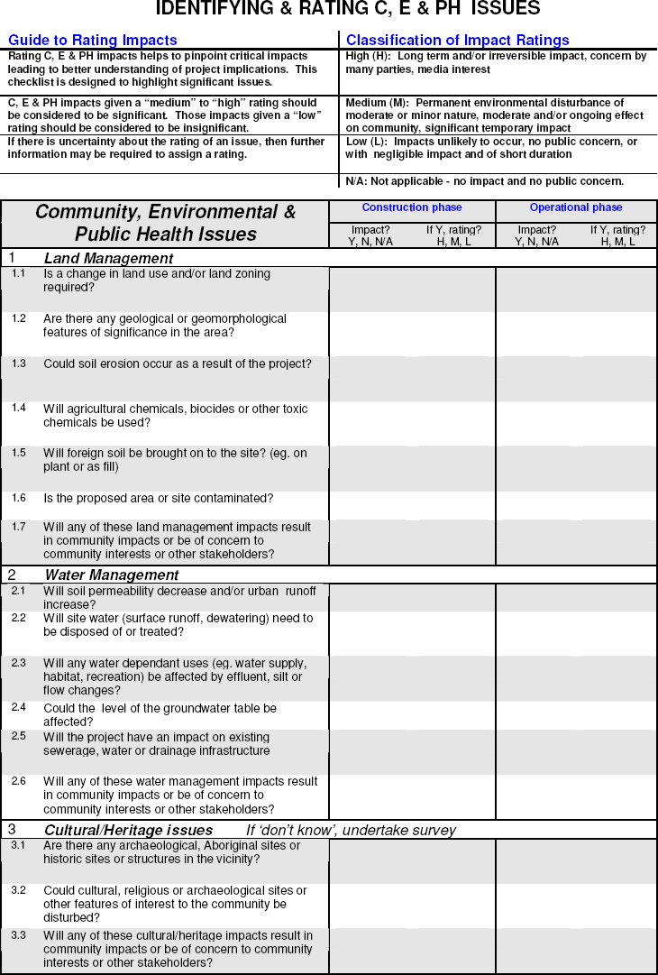

Table of Contents

Table of Contents

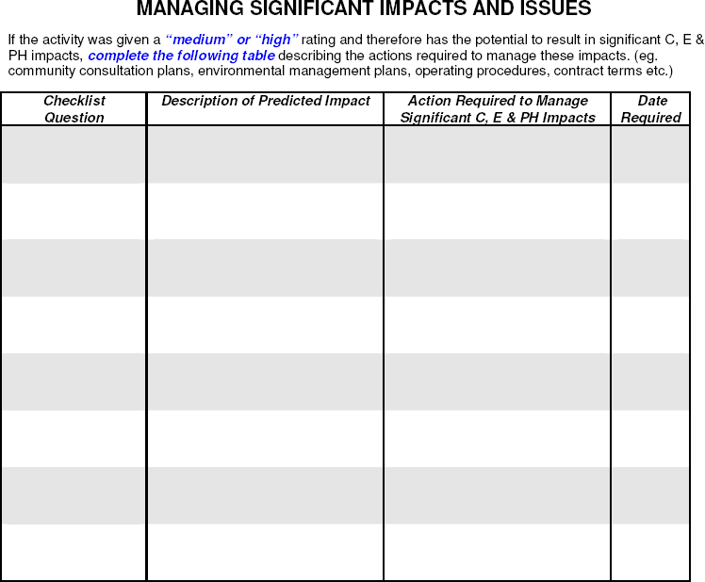

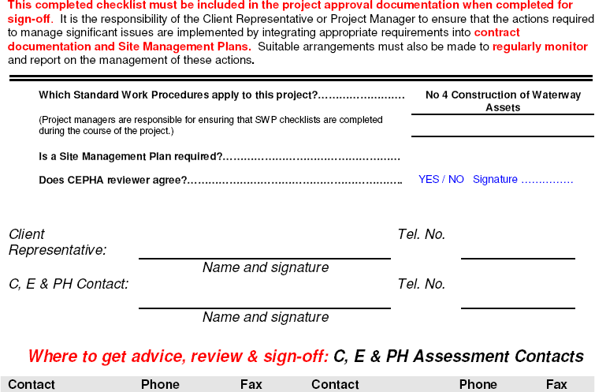

UNIT RATES FOR WATERWAY MANAGEMENT ACTIVITIES
The unit rates for a selection of waterway management activities are provided below. These rates are based on typical costs for projects in the period 2005 to 2006 and are adapted from information provided by the Corangamite CMA.

Item | $ min | $ max | Unit
INSTREAM AQUATIC RESTORATION
Construction of fish ladder 100,000 150,000 vertical metre
 |  |  | of barrier
Rock ramp ladder | 10,000 | 25,000 | structure
Removal of moderate barrier | 5,000 | 25,000 | structure
Reinstatement of large wood | 50,000 | 75,000 | km
Native fish stocking (for conservation) | 7,500 | 10,000 | 1000 fish
RIPARIAN MANAGEMENT
Fencing (materials only) | 2,500 | 4,000 | km
Fencing (construction only ) | 2,500 | 4,000 | km

(ground cover e.g. bathurst burr, phalaris)
Riparian weed management for site preparation 1,000  Riparian weed management for site preparation 1,000 |  | 2,000  2,000 | km  km
(woody weeds e.g. gorse, blackberry)
Aquatic weeds (heavy) | 15,000 | 25,000 | km
Aquatic weeds (medium - light) | 5,000 | 10,000 | km
Woody weed management (heavy) | 5,000 | 10,000 | km
Willow management (light) | 5,000 | 15,000 | km
Willow management (heavy) | 20,000 | 40,000 | km
Off stream watering | 2,500 | 5,000 | km
Revegetation (plants, stakes and guards only) | 2,000 | 4,000 | 1000 plants
Revegetation (plants, stakes, guards and planting crew - labour) | 3,500 | 5,000 | 1000 plants
Direct seeding | 300 | 500 | km
Stock crossing | 15,000 | 20,000 | crossing

Weed maintenance in high rainfall areas (after revegetation)

5,000 10,000 km

Table of Contents

Table of Contents

Waterway catchment
EROSION CONTROL
Gully stabilisation - rock chute (minor) | 7,500 | 12,500 | site
Gully stabilisation - rock chute (major) | 15,000 | 20,000 | site
Stream stabilisation - rock chute (minor) | 10,000 | 20,000 | site
Stream stabilisation - rock chute (major) | 20,000 | 30,000 | site
Stream stabilisation - rock beaching (minor) | 5,000 | 10,000 | site
Stream stabilisation - rock beaching (major) | 10,000 | 20,000 | site
Alignment training | 25,000 | 50,000 | site
PLANNING
Development of streamflow management plan | 40,000 | 150,000 | each
Environmental flow determination | 15,000 | 25,000 | reach
Development of restoration plan for specific 30,000 |  | 60,000 | each
Development of waterway action plan for sub 50,000 |  | 100,000 | each
CAPACITY BUILDING

Workshop)
Half day workshop (CMA lead e.g. Riparian 1,500  Half day workshop (Expert lead e.g. Freshwater 2,500 |  | 2,000  3,000 | each  each
Circus)
Media Release | 200 | 500 | each
Forum (e.g. River Health Forum) | 2,000 | 2,500 | each
Educational material | 1,000 | 1,500 | 1000 units
Curriculum aids for schools - water quality/waterway related topics | 10,000 | 15,000 | topic
Special event (e.g. World Environment Day) | 20,000 | 30,000 | each
MONITORING
Monitoring (ISC) | 250 | 400 | site
Macro invertebrate survey | 2,500 | 4,000 | site
Monitoring (fish) | 7,500 | 12,500 | km
Longitudinal and cross-sectional survey | 2,500 | 7,500 | km
Fish survey | 7,500 | 12,500 | km
Bird survey | 250 | 750 | km

PARTS REFERENCES AND RESOURCES

Table of Contents

REFERENCES AND FURTHER READING
Abernethy, B. and Rutherfurd, I.D. 1999, Guidelines for Stabilising Streambanks with Riparian Vegetation, Technical Report 99/10, CRC for Catchment Hydrology.

Askey-Doran, M. 1999, ‘Managing stock in the riparian zone’ in Lovett, S. & Price, P. (eds). Riparian Land Management Guidelines, Vol. II: On-ground Management Tools and Techniques, Land and Water Australia, Canberra.

Australian National Committee on Large Dams 2003, Guidelines on Dam Safety Management, Australian National Committee on Large Dams.

Balshaw, D.1999, Investigation into Sampling Methods for the Measurement of Rock Riprap in Rock Chutes, unpublished thesis, The University of Melbourne.

Bennett, J., Sanders, N., Moulton, D., Redfern, F. and Phillips, N. 2002, Guidelines for Protecting Australian Waterways, Land and Water Australia, Canberra.

Blackham, D.M. 2005, The erosion resistance of herbaceous vegetation: implications for stream geomorphology, unpublished PhD thesis, The University of Melbourne.

Blench, T. 1969, Mobile bed fluviology, University of Alberta Press, Edmonton, Canada.

Booth, D.B. 2001, Urban stream rehabilitation in the Pacific northwest, Final report of EPA Grant Number R82-5284-010.

Botting, J., & Associates, and Bellette, K. 1999, Stormwater Pollution Prevention, Code of Practice for the building and construction industry, Environmental Protection Authority, South Australia.

Breen, P., Walsh, C., Nichols, S., Norris, R., Metzeling, L. and Gooderham, J. 1999, Urban AUSRIVAS: An evaluation of the use of AUSRIVAS models for urban stream assessment, CRC for Freshwater Ecology Report No.5, LWRRDC Occasional Paper 12/99.

Brierley, G.J. and Fryirs, K.A. 2005, Geomorphology and River Management. Applications of the River Styles Framework, Blackwell Science Ltd., Melbourne.

Brisbane City Council 1997, Erosion Treatment for Urban Creeks – Guidelines for Selecting Remedial Works, Brisbane City Council, Queensland.

Brisbane City Council 2000, Natural Channel Design Guidelines, Brisbane City Council, Queensland.

Brisbane City Council 2003, Guidelines - Stormwater Outlets in Parks and Waterways, Brisbane City Council Brisbane, Queensland.

Brookes, A. 1987, ‘The distribution and management of channelized streams in Denmark’,
Regulated Rivers, vol. 1, pp. 3-16, John Wiley & Sons, United Kingdom.

Brookes, A. 1990, ‘Restoration and Enhancement of Engineered River Channels: Some European Experiences’, Regulated Rivers: Research and Management 5(1): 45-56.

Brooks, A. et al. 2006. Design guideline for the reintroduction of wood into Australian streams, Land & Water Australia, Canberra.

Carter, J.J. 1995, Watercourse processes: A guide for managers in the Mount Lofty Ranges, Department of Environment and Natural Resources, South Australia.

Carter, J.J. and Collingham, E. 1995, Erosion control measures for small watercourses, Department of Environment and Natural Resources, South Australia.

Table of Contents

Chessman, B. 2002, Assessing the conservation value and health of New South Wales rivers, The PBH (Pressure-Biota-Habitat) project, DLWC NSW.

Chen W.F and Liew J.W.R. 2002, The Civil Engineering Handbook, 2nd edn, CRC Press.
Construction Industry Research and Information Association (CIRIA) 1987, Report 116 - Design of Reinforced Grass Waterways.

Copeland, R., McComas, D., Thorne, C., Soar, P., Jonas, M. and Fripp, J. 2001, Hydraulic Design of Stream Restoration Project, US Army Corps of Engineers.

Costermans, L.F. 1996, Native trees and shrubs of south-eastern Australia, Lansdowne Press, Sydney.

Cotterell, E. 1998, Fish Passage in Streams – Fisheries Guidelines for Design of Steam Crossings, Fish Habitat Guideline FHG001, Fisheries Group, Department of Primary Industries, Queensland.

Cottingham, P., Anderson, J., Breen, P. et al., 2001, Outcomes of the NRHP Urban Sub– Program, LWRRDC, Report No 14, LWRRDC Occasional Paper 21/99.

Cottingham, P., Quinn, G., Norris, R., King, A., Chessman, B. and Marshall C. 2005, Environmental Flows Monitoring and Assessment Framework, Technical Report, CRC for Freshwater Ecology, Canberra.

Crossman, M. and Simm, J. 2004, Manual on the Use of Timber in Coastal and River Engineering, Wallingford, England.

CRC for Catchment Hydrology 2005, Guidelines for the Design of River Bank Stability and Protection using RIP-RAP, CRC for Catchment Hydrology.

CRC for Catchment Hydrology 2003, Guidelines for the Design of Rock Chutes using CHUTE, CRC for Catchment Hydrology

DNRE 2002, Healthy Rivers, Healthy Communities and Regional Growth - Victorian River Health Strategy, Department of Natural Resources and Environment, Victoria.

DNRE 1997a, Index of stream condition (ISC): A reference manual, Department of Natural Resources and Environment, Victoria.

DNRE 1997b, Index of stream condition (ISC): Users manual, Department of Natural Resources and Environment, Victoria.

Dyer, B. 1995, Retards and Groynes Design Guidelines, Guidelines for Stabilising Waterways, Victoria, Melbourne.

Earth Tech 2003, Manual for Small Scale Watercourse Erosion Control Works, Onkaparinga Catchment Water Management Board, South Australia.

EPA 2003, State Environment Protection Policy (Waters of Victoria), Government Gazette No. S 107, Victoria.

EPA 1996, Environmental Guidelines for Major Construction Sites, Environmental Protection Authority, Victoria.

Farraday, R.V. and Charlton, F.G. 1983, Hydraulic factors in bridge design, Hydraulics Research Station Limited, Wallingford, England.

Fairfull, S. and Witheridge, G. 2003, Why do Fish Need to Cross the Road? Fish Passage Requirements for Waterway Crossings, NSW Fisheries, Cronulla,.

Fairley, A. and Moore, P. 1995, Native Plants of the Sydney District, Kangaroo Press, Sydney.

Table of Contents

Federal Interagency Stream Restoration Working Group (FISRWG) 1998, Stream Corridor Restoration: Principles, Processes, and Practices, FISRWG.

Fisher Stewart 2002, Bowen Basin River Diversions, Design and Rehabilitation Criteria, Report for Australian Coal Association Research Program (ACARP), Queensland.

French, R. 1994, Open Channel Hydraulics, McGraw Hill Book Co, Singapore.

Gaboury, M., Newbury, R. and Erickson, C. 1995, Pool and Riffle Fishways for Small Dams, Manitoba Natural Resources Fisheries Branch.

Government of Victoria 2004, Our Water Our Future. Securing our Water Future Together, Department of Sustainability and Environment, Victoria.

Greenwood-Smith, S.L. 2002, ‘The use of rapid environmental assessment techniques to monitor the health of Australian rivers’, Water Science Technology, vol. 45, no. 11, pp. 155-160.

Greening Australia 2003, Revegetation Techniques - A guide for establishing native vegetation in Victoria, Greening Australia Victoria.

Harden, G. 1990, Flora of New South Wales Volume 1, NSW University Press, Kensington.

Hardie, R. 1993, Review of Stream Profile Information for Catchments of North East Victoria, Masters thesis, University of New England, New South Wales

Henshaw, P. and Booth, D.B. 2000, Natural restabilisation of stream channels in urban watersheds, Journal of the American Water Resources Association, v.36, no. 6, p.1219-1236

Heron Environmental Consulting and AS One Consulting 2004, River Values and Environmental Risk System (RiVERS): A priority setting tool for Victorian Waterways, Background and basic users guide, Victorian Waterway Managers Forum.

Hicks, D. and Mason, P. 1991, Roughness Characteristics of New Zealand Rivers. Water Resources Survey, Water Resources Survey, DSIR Marine and Freshwater.

Hobart City Council (undated), An Information Manual for Local Government in Urban Stream Remediation, Hobart City Council, Tasmania.

ID&A Pty Ltd. 1996a, Hydraulic Geometry of Brisbane Streams, Guidelines for Natural Channel Design, Brisbane City Council, Brisbane, Queensland.

ID&A Pty Ltd. 1996b, Improvements in the design and construction of rock chutes, Unpublished report to Department of Natural Resources and Environment and the Mitchell River Management Board Victoria.

ID&A Pty Ltd. 1996c, Rock Size Grading ‘A Visual Guide’, Department of Natural Resources and Environment and Mitchell River Management Board, Victoria.

The Institution of Engineers, Australia (IEAUST) 2001, Australian Rainfall and Runoff - A Guide to Flood Estimation, IEAust.

Koehn, J., Brierley, G., Cant, B. and Lucas, A. 2000, River Restoration Framework, Occasional Paper 01/01, Land and Water Australia, Canberra.

Ladson, A., Gerrish, G., Carr, G., Thexton, E. and Brizga, S. 1997, Willows along Victorian Waterways – Towards a willow management strategy, Waterways Unit, Department of Natural Resources and Environment, Victoria.

Lovett, S. and Price, P. (eds) 2002, Riparian Land Management Guidelines, Vol. I: Principles of Sound Management, Land and Water Resources Research and Development Corporation, Canberra, ACT.

Table of Contents

Lovett, S. and Price, P. (eds) 2002, Riparian Land Management Guidelines, Vol. II: On- ground Management Tools and Techniques, Land and Water Resources Research and Development Corporation, Canberra, ACT.

Mallen-Cooper, M. 1993, Fishways in Australia; Past Problems, Present Successes & Future Opportunities, Bulletin no. 93, Australian National Committee on Large Dams (ANCOLD).

Mary Maher and Associates 2000, Australian River Management and Restoration. Criteria for the Legislative Framework for the Twenty-first Century, Occasional Paper 02/00, Land and Water Australia, Canberra.

Maynard, S.T. 1978, Practical Rip Rap Design, U.S. Army Corps of Engineers, Vicksburg, Mississippi.

Melbourne Water 2002, Standard Work Procedure Construction of Waterways and Drainage Assets, Melbourne, Victoria.

Melbourne Water 2005, Water Sensitive Urban Design, Engineering Procedures – Stormwater, Melbourne Water, Victoria.

Melbourne Water (undated), Constructed Wetland Systems Design Guidelines for Developers, Melbourne Water, Victoria.

Merritt, F.S. (ed.) 1995, Standard Handbook for Civil Engineers, 4th edn, McGraw Hill.
National Association of Australian State Road Authorities 1976, Bridge Design Specification, 5th edn, NAASRA.
Newbury, R. and Gaboury, M. 1993, Stream Analysis and Fish Habitat Design – A Field Manual, Newbury Hydraulics Ltd and The Manitoba Habitat Heritage Corporation, Gibsons, British Columbia, Canada.

North Central Catchment Management Authority 2003, Monitoring and Evaluation Framework for Waterways Onground Works, NCCMA.

NPWS 2002, Threatened Species of the Upper North Coast of NSW, NSW National Parks and Wildlife Service.

NSW Department of Sustainable Natural Resources 2003, Draft Riparian Corridor Management Study, Department of Sustainable Natural Resources, NSW.

NSW Environment Protection Authority 1998, Water Quality and River Flow, Interim Environmental Objectives, Environment Protection Authority, NSW.

NSW Fisheries 1999, Policy and Guidelines – Aquatic Habitat Management and Fish Conservation, NSW Fisheries.

NSW Fisheries 2004, Policy and Guidelines – Fish Friendly Road Crossings, NSW Fisheries.

NSW Healthy Rivers Commission 2000, Securing Healthy Coastal Rivers: A Strategic Perspective, Healthy Rivers Commission, NSW.

Ormerod, L. 1993, Guide to Creek Assessment Sheets, Newcastle City Council, Newcastle.

Phillips, N. 2001, Principles and Tools for Protecting Australian Waterways, Land and Water Australia, Canberra.

Price, P. and Lovett, S. 2002, Managing stock, Fact Sheet 6, Land and Water Australia, Canberra.

Raine, A.W. and Gardener, J.N. 1995, Rivercare: Guidelines for ecologically sustainable management of rivers and riparian vegetation, Land and Water Research and Development Corporation, Canberra.

Table of Contents

Robinson, L. 1994, Field Guide to the Native Plants of Sydney, 2nd edn, rev. Kangaroo Press, Kenthurst.
Robinson, R. and Anderson, K. 2005, Risk and Reliability - An Introductory Text, 5th edn, Rosgen, D. 1998, ‘The Reference Reach – A Blueprint for Natural Channel Design’,
Proceedings ASCE Wetlands Engineering and River Restoration Conference, Denver, March 1998.

Rutherfurd, I., Jerie, K. and Marsh, N. 2000, A Rehabilitation Manual for Australian Streams, Land and Water Research and Development Corporation, Canberra.

Rutherfurd, I., Marsh, N., Price, P. and Lovett, S. 2002, Managing woody debris in rivers, Fact Sheet 7, Land and Water Australia, Canberra.

Schumm, S.A., Harvey, M.D. and Watson, C.C. 1988, Incised channels; Morphology, dynamics and control, Water Resources Publications, Colorado, USA.

Simon, A 1989, Graduation processes and channel evolution in modified West Tennessee streams: Process Response and Form, U.S. Geological Survey Professional Paper 1470, pp.1-63.

SKM 2001, Guidelines for Assessment of Works Permits and Licences on Waterways, Catchment Management Authorities of Victoria.

SKM 2002, FLOWS – a method for determining environmental water requirements in Victoria,
Department of Natural Resources and Environment, Victoria.

SKM 2003, Guidelines for Riparian Land Management, Report to the Department of Sustainability and Environment, Victoria.

Standards Australia/Standards New Zealand 2004, Risk Management, AS/NZ 4360:2004.

Standing Committee on Rivers and Catchments 1990, Environmental Guidelines for River Management Works, Department of Conservation and Environment, Victoria.

Standing Committee on Rivers and Catchments 1991, Guidelines for Stabilising Waterways, Rural Water Commission, Victoria.

Streeter, V.L. and Wylie, E.B. 1979, Fluid Mechanics, 7th edn, McGraw-Hill.
Sydney Water 2003, Development and Testing of Methodology for the Restoration of Degraded Rivers and Streams (draft), Sydney Water.

Thorncroft, G. and Harris, J. 1996, Assessment of Rock-Ramp Fishways, NSW Fisheries Research Institute and the CRC for Freshwater Ecology, Canberra.

Tilleard, J.W. 2001, River channel adjustment to hydrologic change, PhD thesis, University of Melbourne.

Total Environment Centre Inc. 2002, Identifying Opportunities for Restoring Degraded Rivers and Streams within Sydney, Total Environment Centre, Sydney.

U.S. Soil Conservation Service 1971, Design of Open Channels, USSCS.

Natural Resources Conservation Service 1985, Grade Stabilization Structure, Conservation Practice Standard, Code 410, US Dept of Agriculture

Vanoni, V.E. (ed.) 1975, Sedimentation Engineering, American Society of Civil Engineers, New York.

Water and Rivers Commission 2000, Water Notes, Advisory notes for land managers on river and wetland restoration, Water and Rivers Commission, Western Australia.

Table of Contents

Water and Rivers Commission 2001, “River Restoration Reports”, Water and Rivers Commission, Western Australia.

White, L.J., Keller, R., Katopodis, C. and Ladson, A.R. 2002, ‘An approach to maximising fish passage through a fish lock: an Australian case study’, Fish Migration and Passage: Physiology and Behaviour Symposium. International Congress on the Biology of Fish July 21-26, 2002, University of British Columbia, Vancouver Canada.

  - USEFUL WEB LINKS
Table of Contents

8.2 USEFUL WEB LINKS
An Australian Handbook of stream roughness coefficients: www.rivers.gov.au/roughness AUSRIVAS: www.ausrivas.canberra.edu.au
Bureau of Meteorology: www.bom.gov.au

Cooperative Research Centre for Catchment Hydrology: www.catchment.crc.org.au

Cooperative Research Centre for Catchment Hydrology Toolkit: www.toolkit.net.au/cgi- bin/WebObjects/toolkit

Cooperative Research Centre for Freshwater Ecology: http://enterprise.canberra.edu.au Coastal Cooperative Research Centre: www.coastal.crc.org.au
CSIRO Division of Land and Water: www.clw.csiro.au

Cooperative Research Centre for Weed Management: www.weeds.crc.org.au

Daughterless Carp Project: www.csiro.au/pubgenesite/research/environment/carpControl.htm

Department of the Environment and Heritage, National River Health Program: http://www.deh.gov.au/water/rivers/nrhp

Department of the Environment and Heritage, Environment Protection and Biodiversity Conservation Act home page: www.deh.gov.au/epbc
Department of Conservation and Environment Environmental Guidelines for River Management Works 1990: www.dse.vic.gov.au/riverhealth/waterwayguidelines
Department of Sustainability and Environment: www.dse.vic.gov.au

Department of Sustainability and Environment Technical Guidelines for Waterway Management 2007: www.dse.vic.gov.au/riverhealth/waterwayguidelines
Department of Sustainability and Environment Victoria Ecological Vegetation classes Benchmarks: www.dse.vic.gov.au > conservation and environment > native vegetation information for Victoria

Department of Sustainability and Environment Victorian Ecological Vegetation classes interactive maps: www.dse.vic.gov.au > Online Services and Resources > Interactive Maps

Department of Sustainability and Environment Victorian River Health Program: www.dse.vic.gov.au/riverhealth/isc

Department of Sustainability and Environment Victorian Water Resources Data Warehouse: www.vicwaterdata.net/vicwaterdata

Dial before you dig: www.dialbeforeyoudig.com.au Enhanced Meteorological Data: www.nrm.qld.gov.au/silo
Environmant Protection Authority Victoria: www.epa.vic.gov.au

Environmental Flows Victoria: www.dse.vic.gov.au/riverhealth > River Health Program > Our Programs

Table of Contents

eWater Cooperative Research Centre: www.ewatercrc.com.au

Flora and Fauna Guarantee Act: www.dse.vic.gov.au > Plants and Animals > Native Plants and Animals > Threatened Species & Communities > Flora & Fauna Guarantee Act

Greening Australia: www.greeningaustralia.org.au

Guidelines for the Design of Riverbank Stability & Protection using Rip Rap: www.toolkit.net.au/riprap

Index of Stream Condition Victoria: www.dse.vic.gov.au/riverhealth/isc

Land and Water Australia., Australian Handbook of Stream Roughness Coefficients, www.rivers.gov.au/roughness

Land and Water Australia: www.lwrrdc.gov.au

Land and Water Australia – Managing riparian widths: www.rivers.gov.au/manage/is13riparianwidths.htm

Melbourne Water: www.melbournewater.com.au Murray Darling Basin Commission: www.mdbc.gov.au
New South Wales Department of Primary Industries Fisheries and Aquaculture: www.dpi.nsw.gov.au/fisheries

Queensland Department of Primary Industries Fisheries Group: www.dpi.qld.gov.au River Landscapes: www.rivers.gov.au/index.htm
Rural Water Commission Guidelines for Stabilising Waterways 1991: www.dse.vic.gov.au/riverhealth/waterwayguidelines

US Geological Survey: water.usgs.gov/osw

United States Environment Protection Agency: www.epa.gov

United States Army Corps of Engineers Hydrologic Engineering Centre: www.hec.usace.army.mil/

United States Federal Interagency Stream Restoration Working Group: www.nrcs.usda.gov/technical/stream_restoration/newgra.html

Victorian Catchment Management Authorities: www.dse.vic.gov.au/riverhealth > Rivers in Your Region

