How sustainable yields are calculated
  - Sustainable Yield Assessment Fact Sheet
The Sustainable Yield Assessment is a simple and cost-effective statewide generic method for evaluating sustainable yield volumes and their uncertainties.

The Sustainable Yield Assessment difference
The Sustainable Yield Assessment simplifies previous approaches that relied on complex models and numerous assumptions and estimates, by focussing on measurable parameters to assess sustainable levels of take into the future.
These parameters, metered use and monitored groundwater levels, are observable and use data already collected. This makes it cost effective for state-wide use and easily repeatable to correct historic assumptions and inform adaptive management.
For the first time, this statewide data has been used to run statistical models to analyse and better understand the relationship between use, groundwater levels and potential climate scenarios across the state.
Complex numerical models may provide a more complete picture, but they require long lead times, as well as comprehensive and expensive data sets. It is difficult, costly and time consuming to keep these large models updated with changes in climate and groundwater use patterns, so they are only used for high-use systems in some parts of the state.

The Sustainable Yield Assessment methodology
The Sustainable Yield Assessment methodology applies data from metered water use and monitored groundwater levels to build a statistical model for each aquifer or management area. These models establish relationships between water use, groundwater level changes (drawdown), and, where relevant, climate influences.
The methodology has been applied across the state, leveraging comprehensive statewide data sets made possible by decades of sustained investment in large-scale metering and monitoring.
The assessment identifies how much groundwater can be used on an annual basis without exceeding a targeted groundwater level over the next 20 years.
For the purposes of the Sustainable Yield Assessment, this has been set at:
- 2 metres in unconfined aquifer systems (which are shallower and more connected to surface water environments – see Figure 1); and
10 metres in confined aquifer systems (which are deeper and have little connection to surface water environments) .
The 2m and 10m drawdown benchmarks serve as reference points for defining acceptable regional groundwater decline over a 20-year period in the absence of national standards.
For unconfined aquifers, the 2m drawdown aligns with the 10% interference rule reflecting current licensing policy on bore interference between users and the environment. This level helps protect surface water connections and groundwater-dependent ecosystems.
For confined aquifers, the 10m drawdown is based on values that have been successfully applied in groundwater management plans to maintain aquifer health and limit interference between users.
Figure 1: How groundwater is stored
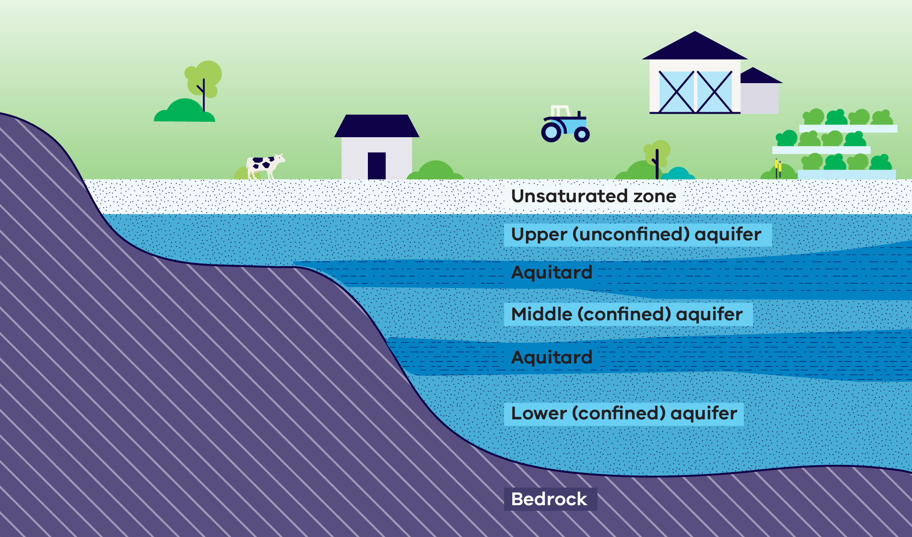
In some areas, insufficient data on groundwater use or monitored levels prevents the development of a reliable drawdown–use relationship. These are generally the low-use, unincorporated areas. For these areas, a method has been used that derives sustainable yield estimates based on:
- throughflow volumes (the lateral movement of groundwater in an aquifer) for a confined system; or
recharge volumes (the process of water moving into the ground and replenishing groundwater aquifers) for an unconfined system.
For all the confined and unconfined systems with reliable sustainable yield estimates, it was found that the statewide sustainable yield estimates were on average 30% of throughflow for confined aquifers and 3% of recharge for unconfined aquifers. These were applied to the known throughflow and recharge volumes for each of the areas without reliable use-drawdown relationships to provide a sustainable yield estimate.
An Independent Technical Review Panel (ITRP) provided an external check on the work, giving confidence in the technical quality and suitability of the assessment. The ITRP concluded that the Sustainable Yield Assessment is a significant achievement for groundwater management in Victoria and provides a robust, science-based foundation to identify sustainability risks, inform future management decisions, guide adaptive restrictions on use, and support the review of entitlement caps.

Why are there systems without sustainable yield estimates?
A quality assurance process was undertaken to confirm the reliability of the results. In some instances where the model revealed issues such as high levels of uncertainty or insufficient reliable data, the results were not accepted. Consequently, sustainable yield estimates are not available for 13 systems.
A number of these systems are ‘under review’ and will be re-assessed over the next 6-12 months. A smaller number have been assessed as ‘not suitable’ for a sustainable yield estimate. For these systems, re-assessment is not proposed because existing, more detailed local information and management objectives already provide a stronger basis for decision-making and the generic Sustainable Yield Assessment methodology will not add value to management decisions.

What will the Sustainable Yield Assessment be used for?
While the Sustainable Yield Assessment provides a technical basis for better managing risk based on observable metrics, it does not automatically trigger changes to management settings.
Like all assessments, the Sustainable Yield Assessment holds its own degree of uncertainty, and the results must be interpretated with an understanding of the assumptions and limitations in each system, as well as ground-truthed with local inputs. More information about what the Sustainable Yield Assessment will be used for can be found in the How the Sustainable Yield Assessment will be used fact sheet.

Additional information:
- Groundwater Management 2030
- Sustainable Yield Assessment Overview Report
- Fact Sheet: How is groundwater is managed?
- Fact Sheet: What is the Sustainable Yield Assessment?

Publication information

Acknowledgements
We acknowledge and respect Victorian Traditional Owners as the original custodians of Victoria’s land and waters, their unique ability to care for Country and deep spiritual connection to it.
We honour Elders past and present whose knowledge and wisdom has ensured the continuation of culture and traditional practices.
DEECA is committed to genuinely partnering with Victorian Traditional Owners and Victoria’s Aboriginal community to progress their aspirations.

Copyright
© The State of Victoria Department of Energy, Environment and Climate Action, 2026.

Creative Commons
This work is licensed under a Creative Commons Attribution 4.0 International licence, visit the Creative Commons website (http://creativecommons.org/licenses/by/4.0/).
You are free to re-use the work under that licence, on the condition that you credit the State of Victoria as author. The licence does not apply to any images, photographs or branding, including the Victorian Coat of Arms, and the Victorian Government and Department logos.
ISBN 978-1-76176-764-7 (pdf/online/MS word)

Disclaimer
This publication may be of assistance to you but the State of Victoria and its employees do not guarantee that the publication is without flaw of any kind or is wholly appropriate for your particular purposes and therefore disclaims all liability for any error, loss or other consequence which may arise from you relying on any information in this publication.

Accessibility
To receive this document in an alternative format, phone the Customer Service Centre on 136 186, email customer.service@delwp.vic.gov.au, or contact National Relay Service on 133 677 or visit http://www.accesshub.gov.au/. Available at DEECA website (www.deeca.vic.gov.au).
End of document.

