

Water is Life: Traditional Owner Access to Water Roadmap
  - Progress Report 31 August 2025
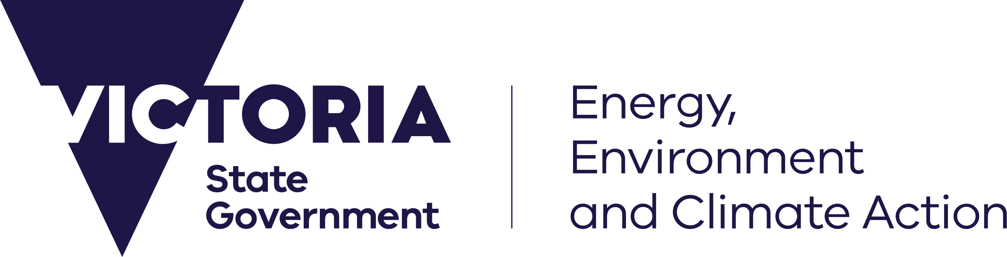




deeca.vic.gov.au

Design credit
Front page graphic design by Mazart Communications. Supply Nation and Kinaway certified.
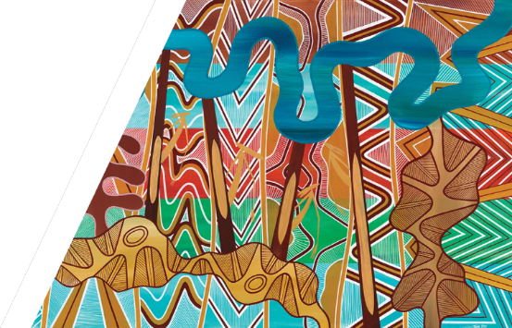
We acknowledge and respect Victorian Traditional Owners as the original custodians of Victoria’s land and waters, their unique ability to care for Country and deep spiritual connection to it.
We honour Elders past and present whose knowledge and wisdom
has ensured the continuation of culture and traditional practices.
DEECA is committed to genuinely partnering with Victorian Traditional Owners and Victoria’s Aboriginal community to progress their aspirations.
© The State of Victoria Department of Energy, Environment and Climate Action September 2025.
WARNING: Aboriginal and Torres Strait Islander readers are warned that the following document may contain images, quotes or views of deceased persons.

Contents
Water is Life: Introduction 2
Summary of Progress 3
Progressing water returns 13
Completed water returns: 13
Water returns currently in progress: 13
Work being undertaken to support future water returns: 14
Lessons Learnt 15
Yoorrook Justice Commission 15
Returning Unallocated Water to Traditional Owners: A Small but Important Step in a Long Journey 16
Case Study 17
Aboriginal Water Officer Case Study 17

Water is Life: Introduction
Released in September 2022, Water is Life: Traditional Owner Access to Water Roadmap (Water is Life) sets out the Victorian Government’s commitments and policy pathways in the short-, medium-, and long-term to increase decision-making and resources for Traditional Owners in the management of water landscapes, as well as increasing Traditional Owner access to water.

Development of Water is Life was led by Traditional Owners over 2021 and 2022. It includes 27 Nation Statements prepared by Traditional Owner groups, expressing their cultural and water-related values, goals, aspirations, outcomes, and any other relevant information deemed important by each Nation in their own words.

Water is Life is founded in the Victorian Government’s recognition of Traditional Owner sovereignty, self-determination, and the need for a restorative justice approach to the way water is managed in Victoria. Implementing the 12 Targeted Outcomes within Water is Life is a long-term commitment, and one that requires enduring, sustainable change.

Three years since its release, this September 2025 Progress Report provides an update on implementation progress being made and includes lessons learnt. This is the third progress report on Water is Life implementation with previous reports in April 2024 and September 2024.
In January 2025, the Department of Energy, Environment and Climate Action’s (DEECA) Water and Catchments Group (WCG) established a new First Nations Water Branch, bringing together several functions into one branch across four teams:
- Aboriginal Water Unit
- Self-Determination Support
- Birrarung Council Executive Support
- Aboriginal Water Reforms
For any queries relating to the oversight and implementation of Water is Life, please contact the Aboriginal Water Reforms Team by email at: aboriginalwaterreforms@deeca.vic.gov.au.

Summary of Progress
Implementation of Water is Life is progressing positively overall, with almost all actions on track. The 2024-25 State Budget included an investment over four years of:
- $21.192m to continue the Aboriginal Water Program; and
- $7.72m of funding to support Traditional Owners’ involvement in pilot and research projects with a focus on activities designed to deliver short- and medium-term targeted outcomes. The funding will also ensure the payment of fees and charges associated with water returned to Traditional Owners.
The table below provides an update on all actions in Water is Life. The status descriptions are:
- Not yet started: This action is due to be delivered in future years
- Behind schedule (action needed): This action requires attention, unlikely to be fulfilled within committed timeframes
- Behind schedule (progressing): This action may not be fulfilled within committed timeframes, but action is being taken to either get this action back on track or modify the timeframe
- Started: Collaboration or a scope of work has commenced
- Progressing: The action has been partially achieved and still has remaining tasks to complete
- Achieved and completed: The action has been completed in full
- Achieved and ongoing: The action has been achieved, and the strategy’s requirements have been met, but ongoing effort is needed to ensure the intended outcome of the action continues to be maintained.
Almost all short- and medium-term outcomes are progressing, and initial stages of work have commenced on three long-term outcomes; Living Entity and Voice (Outcome 1), Recognition of Traditional Owners as waterway managers (Outcome 5) and Traditional Owners can hold and manage water in culturally appropriate ways (Outcome 11).
Work continues to develop a legislative proposal to recognise waterways in Victoria as living entities (Outcome 1) for government consideration. The Urban Waterways Team, Catchment Programs and Rural Policy has worked with a First Nations engagement consultant and engaged widely with Traditional Owners across Victoria, attending community meetings, holding online drop-in sessions and attending water governance meetings to seek input into the law proposal and further develop it in line with this feedback.
Progress on coverage of fees and charges (Outcome 9) and progressive cost recovery for purely commercial uses of water (Outcome 10) has slowed and are behind schedule. Both are short-term outcomes in Water is Life and have been delayed due to staff vacancies in the First Nations Water Branch. The First Nations Water Branch is recruiting to fill these vacancies to continue to progress Outcome 9 and Outcome 10.

Table 1: Summary of Progress on Water is Life implementation
Outcome​ |  | Action​ |  | Action Lead | Timeframe​ | Implementation status​ | Update 31 August 2025
1​ | Living entity and voice​ | 1.1​ | Develop new legislative proposals to recognise waterways as living entities through engagement with Traditional Owners and wider stakeholders for Government consideration | Catchment Programs and Rural Policy, WCG | Due 2025 (short-term action) | Progressing | - Consultation is underway with Traditional Owners statewide to develop the proposal, through meetings and workshops.
1​ | Next steps:  - Late 2025: Statewide engagement with Traditional Owners. This will be followed by consultation with stakeholders and wider community.  - Late 2025-early 2026: Presentation of the law reform proposal to government for decision.
2​ | Partnerships with the water sector  ​ | 2.1​ | Develop new provision in Statements of Obligation for Ministerial consideration requiring formal partnerships between Traditional Owners and Catchment Management Authorities (CMAs) and water corporations | Portfolio Governance and Compliance, WCG | Due 2025 (short-term action) | Behind Schedule (Progressing) | - Amendments to Statement of Obligations (SoO) (General) for water corporations have been drafted and are ready for Ministerial consideration.  - A limited review of the two Statements of Obligations for CMAs have been drafted and are ready for Ministerial consideration.  - VEWH’s Ministerial Rules are in the initial preparatory stages.  - DEECA WCG, in collaboration with Traditional Owners and the water sector, will shortly commence development of guidelines on formal partnerships.
2​ | Partnerships with the water sector  ​ | 2.2​ | Develop new provision in Ministerial rules for the Victorian Environmental Water Holder (VEWH) requiring formal partnerships with Traditional Owners for Ministerial consideration | Portfolio Governance and Compliance, WCG | Due 2027 (medium-term action) | Started
2​ | Next steps:  Action 2.1  - Late 2025: Ministerial consideration of the proposed new SoO (General) for water corporations and legislative consultation requirements undertaken.  - Late 2025: Ministerial consideration of the two SoO’s for CMAs and legislative consultation requirements undertaken.  - Late 2025: Subject to Ministerial consideration, gazettal of new SoO (General) for water corporations and new SoOs for CMAs.  - Late 2025: DEECA WCG will work with Traditional Owner groups and the water sector to develop appropriate guidelines to support formal partnership agreements with Traditional Owners.  Action 2.2  - October 2027: Ministerial rules for the VEWH will be developed, implementing learnings from changing the SoO (General) for water corporations and informed by the development of the third Victorian Waterway Management Strategy.
3​ | Traditional Owners have increased role in environmental water management​ | 3.1​ | Develop new guidelines for Traditional Owners to submit seasonal watering proposals to the VEWH | VEWH | Due 2025 (short-term action) | Achieved and ongoing | - Five Traditional Owner groups led the development of Water for Country – Guidance provided by and for Traditional Owners Making Proposals for the Use of Environmental Water in Victoria. This collaborative process was supported by the VEWH and DEECA, with guidance from an independent facilitator. Through this process, Traditional Owner–led proposals were developed for Molesworth Billabongs and Musk Duck Wetland. Both proposals have been included as pilot watering projects in the VEWH’s 2025–26 Seasonal Watering Plan, released on 30 June 2025.
3​ |  | 3.2​ | Undertake localised pilot environmental watering projects | Waterway Policy and Programs, WCG | Due 2025 (short-term action) | Progressing
3​ |  | 3.3​ | Develop framework for agreements for transfer of environmental water allocation to Traditional Owners for dual environmental and cultural benefit in accordance with environmental water requirements | Waterway Policy and Programs, WCG | Due 2027 (medium-term action) | Progressing
3​ | Next steps:  - Ongoing: Engagement is ongoing by the VEWH with Nations not involved in the Traditional Owner-led seasonal watering proposal trials and guideline development, and with CMAs on the guidelines and the two new pilot watering projects.  - By June 2026: Pilots for two Traditional Owner-led environmental watering projects, as confirmed in the VEWH’s 2025-26 Seasonal Watering Plan, will be undertaken.  - Ongoing: DEECA WCG, VEWH and partners to collaborate on developing a case study to work through the legal and practical barriers to the transfer of environmental water allocation to Traditional Owners, informed by preliminary legal advice which has been received by DEECA WCG.
4​ | Traditional Owners have increased involvement in public land management​ | 4.1​ | Explore a range of public land management opportunities for Traditional Owners through the renewal of Victoria's public land legislation​ | Marine, Coast and Land Policy, Regions, Environment, Climate Action and First Peoples (RECAFP) | Due 2027 (medium-term action) | Progressing | - New Public Land Act being prepared.  - First Peoples’ Assembly of Victoria and Traditional Owner Corporation Caucus have been provided with further updates on reforms and will continue to be engaged.
4​ | Next steps:  - Late 2025: Work to continue to finalise draft Bill.  - Early-mid 2026: Further engagement with Traditional Owners on implementation of new legislation.  - Late 2026: Legislation anticipated to commence.
5​ | Recognition of Traditional Owners as waterway managers for specific locations ​ | 5.1​ | Identify and address barriers to Traditional Owners taking on sole management of waterways and develop new legislative proposals through engagement with Traditional Owners and wider stakeholders for Government consideration | Waterway Policy and Programs, WCG | Due after 2027 (long-term action)  2027+ | Started | - Preliminary work completed to understand current Water Act 1989 mechanisms to enable Traditional Owners to take on specific waterway management responsibilities and what legislative barriers remain.  - This is a long-term outcome that will build on the learnings from Outcomes 1, 2 and 3, and opportunities identified in the Victorian Waterway Management Strategy.
5​ | Next steps:  - Post-2025: Options analysis to be developed for addressing current mechanisms and legislative barriers and tested with Traditional Owners.  - Post-2025: Once Outcome 1, 2 and 3 have been completed, lessons learnt during their implementation will be collected and used to inform the delivery of Outcome 5.  - Post-2025: Traditional Owners will be supported to work with DEECA WCG and other stakeholders to develop legislative proposals.
6​ | Recognition of Traditional Owners as environmental  water holders​ | 6.1​ | Identify barriers to Traditional Owner management of environmental water and consider any potential new legislative proposals through engagement with Traditional Owners and wider stakeholders for Government consideration | Waterway Policy and Programs, WCG | Due after 2027 (long-term action)  ​ | Not yet started | - Planned activity – this is a long-term outcome that will build on the lessons from Outcome 3.
6​ | Next steps:  - Post-2027: Once Outcome 3 is completed, lessons will be collated and barriers identified to inform potential changes needed, including legislative change.
7​ | Water is returned to Traditional Owner groups across Victoria​ | 7​.1 | Enable water to be returned to Traditional Owners across the state by:​  - Acting quickly on existing opportunities within the current entitlement framework ​  - Developing guidance for unallocated water​  - Developing guidelines for water infrastructure projects​  - Developing future opportunities as part of infrastructure projects and regional management plans (Water Grid)​  - Developing future opportunities as part of infrastructure projects and regional management plans (excl. Water Grid)  - Developing a framework to support Traditional Owners entering the water market for when no alternative pathways to water for economic development are available​ | First Nations Water Branch (coordination role); Water Entitlements, Licensing and Groundwater; Water Security Policy and Planning; Water Infrastructure Projects, WCG | Due 2025 (short-term action) | Progressing | As at 31 August 2025:  - 9,778 megalitres held by Traditional Owner and Aboriginal Organisations of which 7,160 megalitres was returned to Traditional Owners through government commitments.  - Nine water licences issued through unallocated water and other water return projects.  - Detailed updates on water returns currently being progressed are found on page 13 below.  - DEECA WCG will continue to provide guidance to Traditional Owner groups and water corporations on existing policy and legislation in issuing unallocated water on a case-by-case basis considering the volume of water available, the objectives of each Traditional Owner group, and whether there are other potential applicants.  - Guidelines for water infrastructure projects are being delivered through updated guidelines issued by the Federal National Water Grid Fund for states and territories to follow in developing large scale projects with federal co-funding. This includes requirements to engage with First Nations in project development and Indigenous Participation Plans (where applicable).
7​ | Next steps:  - Ongoing: DEECA WCG will continue working with licensing delegates and Traditional Owners to progress water returns across the state, including applications for unallocated water and providing guidance on policy and legislation in assessing these applications.  - Ongoing: DEECA WCG will continue to provide guidance on existing policy and legislation in issuing unallocated water on a case-by-case basis considering the volume of water available, the objectives of each Traditional Owner group, and whether there are other potential applicants.  - Ongoing: DEECA WCG will continue to assist water corporations in developing projects compliant with federal funding guidelines.
8​ | Access to land will not be a barrier to Traditional Owners water returns​ | 8.1​ | Work with public land managers to identify available land ​ | Water Entitlements, Licensing and Groundwater, WCG | Due 2025 (short-term action) | Complete | - DEECA WCG has written to Registered Aboriginal Parties advising that parcels of Crown land can be nominated in their section 51 take and use licence applications.  - This process has been successfully applied to support the return of unallocated water, working with Traditional Owners, land managers and licensing delegates.  - A shorter, fit-for-purpose application form is available in southern Victoria for applications where Traditional Owners wish to hold the water in-stream/in-aquifer.
8​ |  | 8.2​ | Work with water corporations as licensing authorities to streamline licence application processes ​ | Water Entitlements, Licensing and Groundwater, WCG | Due 2025 (short-term action) | Progressing
8​ | Next steps:  - Ongoing: DEECA WCG will continue working with Traditional Owners, public land managers and water corporations to identify suitable Crown land parcels as a ‘point of take’ on section 51 take and use licence applications and will notify new Registered Aboriginal Parties with this advice as formal recognition is awarded.  - Ongoing: DEECA WCG will continue working with Traditional Owners and licensing delegates to identify licensing improvements.
9​ | Coverage of fees and charges​ | 9.1​ | Provide funding to pay for fees and charges associated with water entitlements held by Traditional Owners unless water corporations can waive the fees and charges ​ | First Nations Water Branch, WCG | Due 2025 (short-term action) | Behind schedule (progressing) | - Budget allocation to cover fees and charges for expected water returns during July 2024 to June 2028 has been secured.  - The allocated budget covers all water purposes, including commercial use for this period.  - Work has started to develop funding options for a long-term framework to cover fees and charges for water returns post-2028.
9​ | Next steps:  - Late 2025: The First Nations Water Branch (WCG) to fill staff vacancies in the Aboriginal Water Reforms Team and as a priority to progress this work. New dates for completion will be communicated in due course.  - Ongoing: DEECA WCG to develop and release a guidance note for water corporations that provides guidance on how covering fees and charges will be operationalised.  - Ongoing: Continue to progress the development of long-term funding options to cover fees and charges associated with water entitlements held by Traditional Owners.
10​ | Progressive cost recovery for purely commercial uses of water ​ | 10.1​ | Undertake pilot commercial project funding agreements with Traditional Owners to inform framework ​ | First Nations Water Branch, WCG | Due 2025 (short-term action) | Behind schedule (progressing) | - Funding for pilot projects has been secured.
10​ |  | 10.2​ | Develop a framework for identifying commercial use and timelines to transition to full cost recovery ​ | First Nations Water Branch, WCG | Due 2027 (medium-term action) | Behind schedule (progressing) | - Funding for pilot projects has been secured.
10​ | Next steps:  - Late 2025: DEECA WCG will call for expressions of interest for a grants program for Traditional Owners, which includes an option to undertake pilot projects for Outcome 10.
11​ | Traditional Owners can hold and manage water in culturally appropriate ways​ | 11.1​ | Identify barriers to culturally appropriate use of water and develop new legislative proposals through engagement with Traditional Owners and wider stakeholders for consideration by Government if needed ​ | Water Entitlements, Licensing and Groundwater, WCG | Due after 2027 (long-term action) | Started | - Water returns to Traditional Owners to date have involved section 51 take and use licences in southern Victoria.  - Lessons learned from water returns are being progressively collated to inform identification of barriers to Traditional Owners holding and managing water returned to them.
11​ | Next steps:  - Late 2025: DEECA WCG will continue exploring barriers to the ownership and use of water including in southern Victoria, and will commence exploring barriers in northern Victoria, and will include section 51 take and use licences in unregulated and groundwater systems and water shares in declared water systems.  - Ongoing: DEECA WCG will continue to support Traditional Owners interested in water returns to identify opportunities and address barriers – in parallel to exploring options for potential legislative reform.  - Ongoing - post-2027: DEECA WCG will continue to progress internal policy matters and engage with Traditional Owners to better understand their views and experiences of barriers encountered in the entitlement framework during water returns processes and to consider potential options and priorities for reform.
12​ | Oversight of Water is Life  implementation​ | 12.1​ | Traditional Owners have oversight of the implementation of Water is Life ​ | First Nations Water Branch, WCG | Due 2025 (short-term action) | Progressing | - In March 2025, the Water is Life Traditional Owner Oversight Forum was held on Taungurung country. 57 Traditional Owner organisation representatives met with DEECA’s First Nations Water Branch and DEECA decision makers provided an opportunity for oversight of Water is Life.  - In April 2025, a progress paper was circulated to the Statewide Caring for Country Partnership Forum.  - In July 2025, a What we Heard Report was sent to all participants which included status of actions arising from the Water is Life Traditional Owner Oversight Forum.
12​ | Next steps:  - Late 2025: This Report will be circulated to Traditional Owners by the First Nations Water Branch, WCG.  - Ongoing: DEECA WCG will continue to report through existing forums and meetings, respond to requests for oversight and be adaptive in ensuring its delivery.

Progressing water returns

Completed water returns:
As at 31 August 2025, 9,778 megalitres of water is held by Traditional Owner and Aboriginal Organisations of which the total volume of water returned to Traditional Owners through government policy and commitments is 7,160 megalitres.
Of this amount, several of these water returns have been publicly announced by Traditional Owners. This includes a ceremony to mark the return of a 1,405 megalitre licence from the Birrarung (Yarra River) to Wurundjeri Woi-Wurrung Traditional Owners. For more information, see the media release here: 241018-Returning-Water-In-The-Birrarung-To-Traditional-Owners.pdf.

Water returns currently in progress:
DEECA is working with Traditional Owners and water corporations to progress a number of water returns already in progress and this section provides more information.

- Work is well underway to return water from the Moorabool system to the Wadawurrung Traditional Owners Aboriginal Corporation (WTOAC) and the environment (Actions 4.3 and 4.4 of the Central and Gippsland Region Sustainable Water Strategy (CGRSWS)). This includes discussion of entitlement options, water resource modelling, water sharing and a separate project led by the WTOAC trialling water delivery in the Moorabool Yaluk (Moorabool River). A video documenting WTOAC’s first self-determined trial water delivery to Wadawurrung Dja (Country) can be found here: A Flowing Future: Water releases back to Wadawurrung Dja (Country).
  - The Latrobe 3-4 Bench Bulk Entitlement was a 25 gigalitre bulk entitlement in the Latrobe River system set aside for future coal-fire power generation and no longer needed for this purpose. The Victorian Government has delivered Action 4-8 of the CGRSWS to reallocate 16 gigalitres of the Latrobe 3-4 Bench Bulk Entitlement. The Latrobe 3-4 Bench Bulk Entitlement was originally intended to support the expansion of coal-fired electricity generation, and Victoria’s transition away from coal-fired electricity generation has enabled this reallocation. After extensive consultation with industry stakeholders and community members, and the completion of the statutory process in March 2025, three new bulk entitlements have been created, including a 5.333 gigalitre bulk entitlement that will support cultural values and self-determined outcomes for the Gunaikurnai people. Bulk entitlements have also been created to underpin the resilience and growth of agriculture and to provide additional water for environmental flows to improve the health of the Latrobe River as well as the Gippsland Lakes system downstream. The remainder of the original Latrobe 3-4 Bench Bulk Entitlement (9 gigalitres) has been retained by government to provide continued flexibility to respond to emerging needs, including Victoria’s future energy needs. The Gunaikurnai Land and Waters Aboriginal Corporation (GLaWAC) can now apply to Southern Rural Water Corporation (SRW) for a section 51 take and use licence to enable access to water from the bulk entitlement. DEECA WCG continues to work with GLaWAC and SRW to navigate water licence application processes and the barriers to Traditional Owners holding water in culturally appropriate ways. For more information, see the media release here: Benefits Of Reallocated Water To Flow Across Gippsland | Premier.
- The federally funded Sunraysia Water Efficiency Project (SWEP) is on track for completion in 2026. Irrigation modernisation works are complete, and work has commenced on the process to audit water savings. This will be followed by the statutory process, to allow a total water savings of 1.8 gigalitres to be issued as entitlement to the Commonwealth for the environment as part of the Murray-Darling Basin Plan. Any water savings above 1.8 gigalitres (which is the contracted volume between the state and Commonwealth) will be shared equally between Traditional Owners and improving urban water security for Mallee towns. If the additional water savings are realised, DEECA WCG will identify and work with relevant Traditional Owner groups on water returns.
- DEECA WCG is working through barriers to progress the return of 1.36 gigalitres in northern Victoria and acknowledges the delays in progressing this return. The return of this water is complex as the water was recovered across different river systems that cover the Country of many Traditional Owner groups. Staff vacancies in the First Nations Water Branch have further contributed to delays in progressing this return. The First Nations Water Branch will contact Traditional Owners on whose Country this return covers in late 2025 to discuss preferences and perspectives for how the water should be returned to Traditional Owners.
- Applications for the return of unallocated water to Traditional Owners in various water systems in southern Victoria have been supported as per the actions in the CGRSWS. Some water has been allocated, other applications are in progress, and DEECA WCG will continue to support applications as guided by each Traditional Owner Group.

Work being undertaken to support future water returns:
- DEECA WCG continues to work with water corporations in the Central and Gippsland region to assess and progress projects that could return water to Traditional Owners and the environment from river entitlements held by Melbourne’s water corporations. Feasibility studies are underway for some proposed options in the Werribee and Maribyrnong catchments (Action 4.2 of the CGRSWS).
- Action 4-1 of the CGRSWS commits to investigate options to return water to Traditional Owners and the environment as manufactured water supplies are planned for Greater Melbourne and Geelong. DEECA WCG has considered opportunities to return water to Traditional Owners and the environment in the development of the Water Grid Plan (Action 9.2 of the CGRSWS) which is yet to be finalised for public release.
- In line with existing Victorian Government policies regarding Traditional Owner engagement and collaboration at the localised level through the development of water infrastructure projects (including Water is Life), the Victorian Government developed the Planning our Basin future together prospectus in response to changes to the Basin Plan. Victoria’s Planning our Basin future together sets out principles that will guide further water recovery for any purpose in northern Victoria. These principles – updated after consultation including with Traditional Owners – include the principle that Victoria `Meet our legal obligations and support progress towards Traditional Owner self-determination in water access and management.’ In addition, the Federal National Water Grid Fund has issued updated guidelines for states and territories to follow in developing large scale projects with federal co-funding. This includes requirements to engage with First Nations as projects are developed, plus Indigenous Participation Plans where applicable. DEECA WCG has communicated these expectations to Victorian water corporations as part of their projects seeking federal funding and meeting their requirements.

Lessons Learnt
Water is Life embeds the principle of ‘learning by doing’ into its scope of work. Long-term outcomes are designed to be built on the lessons learnt and progress of short-term and medium-term outcomes. It is a staged process of change. Within DEECA, work is being undertaken to capture these lessons and ensure they are shared both internally and externally. DEECA WCG is committed to working with Traditional Owners and the water sector to ensure everyone is learning and progressing together. This section includes a number of these lessons and reflections on how they are reshaping the work.

Yoorrook Justice Commission
The Yoorrook Justice Commission’s (Commission) final two reports – Yoorrook Truth Be Told and Yoorrook for Transformation – were tabled in the Victorian Parliament and made public on 1 July 2025, marking a historic moment on Victoria’s path to truth-telling and Treaty.
The delivery of these reports concludes the groundbreaking work of the Commission which will help all Victorians better understand our past, how it impacts our present, and how we can build a stronger, shared future.
As Australia’s first formal truth-telling process, the Commission has gathered evidence on the historical and ongoing injustices experienced by First Peoples in Victoria since colonisation.
The Commission’s hearings have been an opportunity to hear of the strength, resilience and lived experience of First Peoples – of unbroken connection to culture and Country for tens of thousands of years.
The Commission’s final reports are now publicly available on the Yoorrook Justice Commission website, including Yoorrook for Transformation – the Commission’s third and final report which contains 100 recommendations over five volumes.
Chapter 14 of Yoorrook for Transformation is specifically about water and reflects Traditional Owner evidence heard throughout the Commission’s work as part of the land injustice inquiries. It reflects that water is a vital living part of Country and documents evidence heard related to water including Water is Life – both the positive policy developments and the limitations and criticisms of Water is Life. This included concerns about the lack of transparency and speed in its implementation. There were five recommendations in the water chapter, several of which relate to Water is Life outcomes and reflect work already being progressed to achieve these.
The Victorian Government shares the Commission’s goals of truth and justice and will now carefully consider the Commission’s findings and recommendations before delivering a formal response. For more information, see the media release here: Historic Yoorrook Justice Commission reports tabled | Premier.

Returning Unallocated Water to Traditional Owners: A Small but Important Step in a Long Journey
In 2022, the Victorian Government committed to returning unallocated water to Traditional Owners in the region as part of the CGRSWS. This water offered an opportunity to support Traditional Owners' rights and connection to Country while also supporting delivery of Water is Life.
Early Challenges
SRW, the licensing delegate in southern Victoria, worked with several Traditional Owner Corporations to progress water returns and faced several hurdles in this process. The first is acknowledging that the legislative and water entitlement framework within which SRW operates is very different to Traditional Owners’ relationship with water. Water landscapes are part of cultural landscapes that Traditional Owners have cared for and managed for tens of thousands of years.
The current system of water entitlements in Victoria was not set up to meet cultural needs and, in many instances, does not align with Traditional Owner perspectives on water. The legal and policy frameworks for the ownership, management, and administration of Victorian water entitlements can be complex and confusing for people not familiar with it. Understanding the different types of licences and how they are issued was an important first step to ensure discussions were productive.
Standard application processes were not designed with cultural uses in mind. SRW staff needed to build their understanding of what cultural uses meant for different Traditional Owner groups and adapt their processes in response to this. For example, Traditional Owners were often not seeking to extract water (at least in the short term) and instead leave it in-stream or in-aquifer to care for Country. The standard application processes include notifying neighbours and/or public notification and conducting environmental assessments to understand the impact of any extraction — steps that didn’t align with Traditional Owners’ intent to keep water in-stream. SRW worked with Traditional Owner groups to streamline these aspects of the licensing process, while still ensuring their statutory obligations were met.
Licence application forms also require land ownership or access to be confirmed. It is acknowledged that land ownership is a barrier for Traditional Owners as a result of colonisation and dispossession. DEECA worked with Parks Victoria to get their authorisation for Crown land to be nominated by Registered Aboriginal Parties in their licence applications.
Collaborative Solutions
SRW, with policy support from DEECA WCG, worked closely with Traditional Owners in southern Victoria to understand their needs and navigate the licensing system. Together, they developed a new approach to build a shared knowledge of terms, water licensing framework and legislative requirements and issue licences for ‘instream’ use. This allowed Traditional Owners to hold water without extracting it, with the option to amend the licence later if needed for other cultural purposes that involved the extraction of water.
After careful review, SRW determined that many information requirements weren’t necessary for in-stream use licences. This led SRW to develop an application form specifically relating to applications by Traditional Owners, and the development of multiple process pathway options for consideration by Traditional Owners. These process changes led to significantly reduced processing times for water returns to Traditional Owners.
A Meaningful Outcome
It is acknowledged that the process to issue licences has been slow – taking over two years in some instances. During the process of issuing these licences, there have been many valuable lessons. SRW has since streamlined its application process meaning licences can now be issued more efficiently and are working collaboratively with Traditional Owners to progress outstanding licensing applications from Traditional Owners.
This is a small but significant step toward broader reform under Outcome 11 of Water is Life. It highlights the importance of listening, adapting, and working together to support Traditional Owners’ rights to water and self-determined care for Country.

Case Study
Traditional Owners continue to lead projects that increase decision-making and participation in the management of water across Victoria. These projects are a continuation of their cultural responsibility to care for Country. The example below highlights the importance of intergenerational knowledge sharing between Elders past, present and emerging.

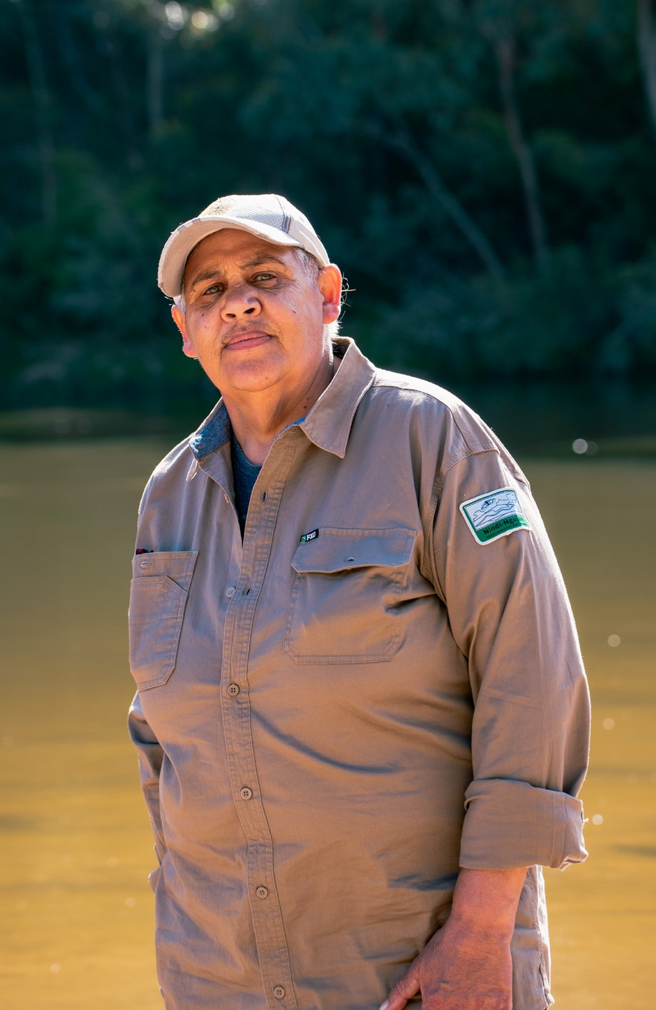
Aboriginal Water Officer Case Study
What started as a small spark in her belly grew into a flame that now burns strong. Ivy Solomon – better known as Bubbles – is a Ngarigo Monero woman who has always held a deep reverence for Country. Since starting her role as an Aboriginal Water Officer (AWO), Bubbles has tapped into her passion and appreciation for traditional knowledge in a way she likens to a bushfire that burns inside of her.
Bubbles’ work as an AWO centres on caring for waterways on Ngarigo Monero Country in the Snowy River region of Victoria. Collaborating with Traditional Owners, DEECA and other stakeholders, she works towards restoring and maintaining a vibrant and healthy Country. Her other priorities include building her own knowledge, reinforcing the presence and expertise of local Mob and creating more opportunities for future generations to connect to Country.
As a self-proclaimed water baby, Bubbles sees time spent on Country as a form of connection, healing and education. For her, the landscape is a living teacher holding stories and wisdom waiting to be learnt.
If it wasn’t for her role as an AWO, Bubbles acknowledges that she wouldn’t have the same opportunity to learn from and care for Country as she does now. “This is stuff you can’t learn in books. It’s about being on Country and learning from each other. It’s about respecting what’s been passed down and continuing that cycle,” Bubbles says. “I get to come home to Country, I get
to work with my Mob. I get to learn stuff that I didn’t learn before. And then hopefully I can pass it on.”
“I can’t get enough of it,” Bubbles says. “I never looked at the river before the way I do now. There are reasons we have to look after the water and the only way to learn is that you have to go out to the land, the Country, the water.”
Bubbles works in collaboration with her mentors and fellow Ngarigo Monero Traditional Owners Tim Paton and Sam Pender. Together, they share knowledge and work with Community to care for Country.
For Bubbles, Tim and Sam, caring for Country and waterways is much more than a job. They see it as a responsibility with great meaning, an opportunity to continue cultural knowledge and implement learnings from their Elders.
“This is part of our history of where our Mob lay their footprints here. You know, they come from Jindabyne all the way down to here [to the mouth of the Snowy River]. It’s a long trip,” Bubbles says.
Historically, the river systems were used as passageways. It’s a method of travelling through Country that Bubbles, Tim and Sam would like to see
revitalised. A key aspiration is to have men’s and women’s camps, bringing Mob together to travel through the Snowy River system and get back into the high country.
There are reasons we have to look after the water and the only way to learn is that you have to go out to the land, the Country, the water
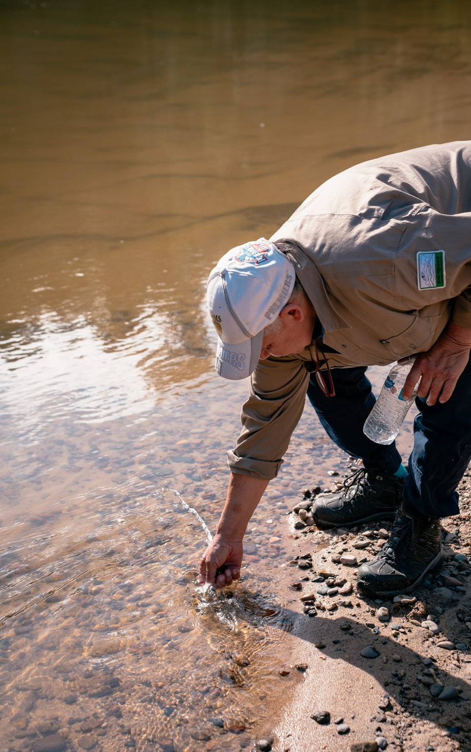
Bubbles’ learnings have emphasised the importance of asking questions of Elders and passing on cultural knowledge before it’s too late. She often reflects on the missed opportunity to ask her own Elders these questions before they were gone, and so she makes sure to bring her nieces and nephews with her when she’s working with Tim and Sam.
“My passion at the moment is to get the younger ones to get that little fire, that little spark, because we’re not going to be around forever and we need the younger ones to step up and take over and get that passion,” Bubbles says.
There are reasons we have to look after the water and the only way to learn is that you have to go out to the land, the Country, the water
For Bubbles, her spark was first ignited when she was a kid camping on Country with her family near Jindabyne. Since then, she has been open to learning. Now as an AWO, Bubbles gets to learn in a way that extends beyond her own experience. Her work, with colleagues like Tim and Sam, ensures that cultural knowledge is learnt and passed on to future generations.

