|  |
| --- |
| Collaboration lays foundation for effective domestic wastewater management |
|  |



Mornington Peninsula Shire Council and South East Water are testing options to more effectively manage domestic wastewater and onsite systems in the region.

Mornington Peninsula Shire Council and South East Water are continuing their partnership to improve domestic wastewater management across the Mornington Peninsula, which has the highest number of onsite systems in Victoria.

This collaboration is leading to more efficient monitoring of the performance, servicing, maintenance, and compliance of unsewered properties. It is also highlighting alternative funding models for onsite system management, and ways to promote connection to available reticulated sewerage.

## The problem

Victoria’s Mornington Peninsula is home to the highest number of onsite systems for domestic wastewater management in the state, with over 22,000 properties without reticulated sewerage.

This is problematic for Mornington Peninsula Shire Council (MPSC) and South East Water, as polluted runoff and infiltration from poorly performing onsite systems poses risks to public health, and can cause contamination of the Peninsula’s beaches, waterways and groundwater.

While progressive management improvements have been made since the mid-2000s, significant information gaps continue to exist which hinders the effective monitoring and management of onsite systems in the region, particularly in high risk areas. Additional improvements can also be made in the awareness of owners and operators of onsite systems and their maintenance obligations.

These issues were highlighted in the 2018 Victorian Auditor-General’s Office (VAGO) audit *Managing the Environmental Impacts of Domestic Wastewater*, with specific recommendations provided to MPSC and South East Water.

## The steps taken to address the problem

In 2016, seed funding through a Melbourne Water Living Rivers Grant was provided to establish a pilot program including a wastewater management officer. In 2017, South East Water and MPSC signed a three-year Memorandum of Understanding (MoU) on agreed measures to better manage domestic wastewater. A key output from this agreement was the funded wastewater management officer position operating within MPSC.

The position implements Council’s Domestic Wastewater Management Plan (DWMP), inspects and monitors compliance of onsite systems with permit conditions, and increases awareness about maintaining onsite systems.

### Data management system

A key feature of the MoU is the introduction of an improved septic tank data management system, known as Septic Track, to electronically collect and record the servicing and maintenance of onsite systems.

Septic Track allows information on the overall compliance and maintenance of onsite systems to be submitted by MPSC, pump out contractors and treatment plant service agents in real time.

In future, this electronic platform may replace the existing paper-based form of reporting, which has proved impractical due to the high number of onsite systems across the Mornington Peninsula. The system also has the capacity to issue invoices, reminder notices and information on data trends.

### Cost recovery model

In order to fund a wastewater officer, South East Water adopted a new funding model, charging a levy from septic tank pump out contractors to dispose of septic wastewater at Boneo Water Recycling Plant. Co-funding was provided from MPSC.

This approach is an example of a creative solution for other councils to fund officers to implement DWMPs.

## Results

### Increased awareness and education

The wastewater management officer has worked closely with all local wastewater contractors and was able to respond to reports on Septic Track of unsatisfactory septic systems from contractors. The officer also encouraged onsite system owners to upgrade failing systems.

A comprehensive education program has been rolled out through regular industry forums, an updated website, brochures, newsletters for summer residents and the broader wastewater industry, and via media releases.

The wastewater officer also promotes the benefits of connecting to sewer and is collaborating with South East Water’s Peninsula ECO program, which aims to transfer more than 16,000 Mornington Peninsula properties to a sewerage system, particularly when onsite systems are failing.

### Target inspections in high risk areas

The wastewater management officer works closely with South East Water to target inspections of onsite systems in high risk areas, which are difficult to connect to sewer, and may be better suited to alternative systems that effectively manage wastewater onsite. These areas include Arthurs Seat, Cape Schanck, Portsea Lagoon, Tyabb and Watsons Creek Somerville.

The high-risk areas were identified in MPSC’s DWMP and were based on wastewater profiles and localised township audits and sampling. Waterway sampling is conducted by the wastewater management officer to determine the impacts of failing onsite systems and inform improvements in some townships. This also complements South East Water’s waterway sampling results as part of its sewer backlog program.

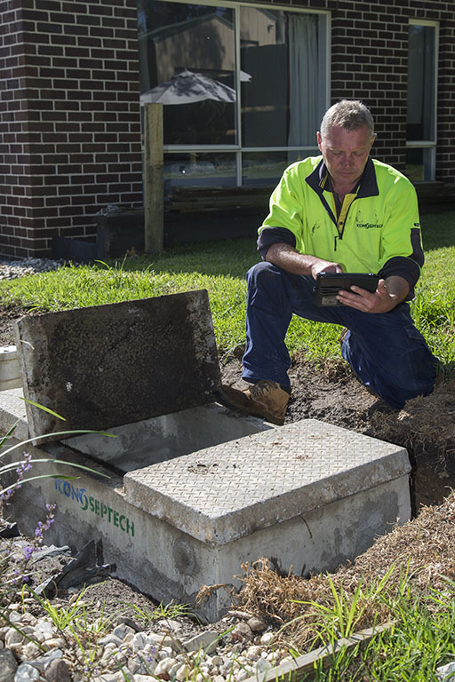

### Impact and recognition

There has been good uptake of the data management system by some pump out contractors which has contributed to improved management of septics where connection to sewer is not practical.

An increase in septage received at the Boneo Wastewater Recycling Plant also demonstrates management of septics has improved.

The MPSC and South East Water MoU has been extended to 2025, which will result in funding for an additional officer.

The program was formally recognised through the following awards:

* Stormwater VIC Awards 2018 – MPSC and South East Water Addressing the Impact of Septic Tank Systems on the Mornington Peninsula (Highly Commended in two categories)
* Tidy Town VIC State Finalist 2018 – Addressing the Impacts of Septic Tank Systems on the Mornington Peninsula
* Tidy Town VIC State Finalist 2020 – Addressing the Impacts of Septic Tank Systems in Watsons Creek Somerville.

## The challenges and how they were met

### Addressing knowledge gaps

Significant knowledge gaps exist for many owners of onsite systems across the Mornington Peninsula. A 2011 South East Water benchmarking survey of Nepean Peninsula septic system owners found that 88% had never had their system replaced and 74% were not aware that septic systems could impact the environment. Shire inspection programs show that up to 55% of systems are either not maintained or not accessible.

To combat this challenge, clear and consistent community education has been essential. MPSC will develop a new communications plan to help raise awareness of the obligations of owners and operators of onsite systems following changes to the Environment Protection Regulations in July 2021. Wider community engagement will also be undertaken through annual household surveys and increased online engagement (e.g. social media and websites).

### Overestimating stakeholder support for initiatives

The absence of a waste tracking system has made it difficult for MPSC to monitor maintenance of systems and management of septage. It had been hoped that all key stakeholders, particularly septic tank pump out contractors, would use the data management system but this has not been the case.

There was also reluctance from contractors to support the additional levy to fund the wastewater management officer position. This was possibly due to a lack of understanding of the benefits and objectives of the program, as well as privacy concerns.

This highlights the importance of further investigation to uncover barriers to improve engagement with key stakeholders, particularly pump out contractors. MPSC plans to develop targeted education about the data management system and the role of the wastewater management officer.

### Complex nature of onsite system inspections

Most onsite systems in the Mornington Peninsula can be very time consuming to inspect given their age. The next five-year iteration of the MoU will contribute funds for resourcing one additional wastewater management officer to continue conducting inspections and follow-up compliance. It will also be essential for MPSC to update its Wastewater Management Policy to provide a transparent and consistent framework that deals with non-compliance and resolves failing onsite systems.

## Lessons learnt

### 1. Be clear on goals and objectives and monitor their performance

To improve collaboration and accountability in the next iteration of the MoU, MPSC and South East Water have outlined clearer goals and specific objectives, particularly around improved data management. Key Performance Indicators (KPIs) have been incorporated into the MoU’s objectives and the position descriptions of the wastewater management officers to help monitor performance and effectiveness. MPSC will report on its KPIs every three months, while a mid-term evaluation of the MoU will be scheduled to provide an opportunity for any necessary changes.

### 2. A data management system needs to be understood and supported to work effectively

There are clear benefits from using technology to efficiently manage data gaps around onsite systems. However, adequate understanding from all key stakeholders about why these systems are necessary is essential to support their continued success. In future, MPSC and South East Water will aim to develop a more comprehensive data management system that closes the loop on tracking waste, with the ability to communicate with both organisations’ systems.

### 3. Invest in stakeholder engagement

There is an opportunity to better engage with a wider range of key stakeholders in the next iteration of the MoU, particularly the local wastewater treatment industry and contractors. The new Environment Protection Regulations also provided a strong trigger to organise industry forums, communicating the changes in regulations. There may be further avenues in existing industry forums to provide updates on the program, and to advocate on issues of importance to MPSC, South East Water and the Environment Protection Authority.

## Beyond results

Importantly, this work will contribute to strategies outlined in MPSC’s DWMP and the broader integrated water management (IWM) approach of MPSC and South East Water to mitigate the adverse environmental impacts of poorly performing onsite systems across the Mornington Peninsula.

As a priority project in the *Western Port IWM Strategic Direction Statement* (DELWP, 2018), it supports broader IWM outcomes particularly in regard to more effective and affordable wastewater systems. This is also detailed in the *Dandenong IWM Strategic Directions Statement* (DELWP, 2018) and *Water for Victoria – Water Plan* (DELWP, 2016).

It is important to note that changes to the Environment Protection Regulations from July 2021 are expected to address a range of challenges faced by the project so far. Specifically, it will support greater efficiency in domestic wastewater management with the obligation on all system owners to maintain their onsite systems (regardless of whether they have a permit or not).

## Conclusion

This project demonstrates that strong and continued collaboration between councils and water corporations can be an effective driver to achieve long-term wastewater management solutions and connections to sewer where appropriate.

The success of the collaboration is evident in the extension of the MoU between MPSC and South East Water for another five years, which will more effectively address recommendations from the VAGO audit.

This agreement has also underpinned a new cost recovery model, where funding is generated from domestic wastewater disposal and re-invested into inspection and education systems to better manage onsite wastewater systems into the future.

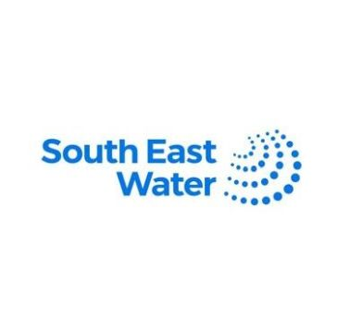

|  |
| --- |
| **Key messages**   * A dedicated wastewater management officer and data management system can more efficiently address issues around monitoring, compliance and education of onsite systems – but stakeholders need to understand why these roles are necessary * New funding models to support the implementation of Domestic Wastewater Management Plans can be developed based on cost recovery principles for wastewater disposal * Septage disposal contractors play an important role in the management of domestic wastewater, and should be engaged to support adaptive management programs. |

## Further reading

* [*Mornington Peninsula Shire Council Domestic Wastewater Management Plan*](https://www.mornpen.vic.gov.au/Your-Property/Environment/Water/Wastewater-Sewage/Domestic-Wastewater-Management-Plan)
* [*Western Port IWM Strategic Directions Statement*](https://www.water.vic.gov.au/__data/assets/pdf_file/0019/417412/IWM_Western-Port_web_Updated-April-2019.pdf) *(DELWP, 2018)*
* [*Dandenong IWM Strategic Directions Statement*](https://www.water.vic.gov.au/__data/assets/pdf_file/0017/412442/Dandenong_SDS_web_UPDATED-FEB-2019.pdf) *(DELWP, 2018)*
* [*Water for Victoria – Water Plan (DELWP, 2016)*](https://www.water.vic.gov.au/water-for-victoria)
* [*Managing the Environmental Impacts of Domestic Wastewater (VAGO, 2018)*](https://www.audit.vic.gov.au/report/managing-environmental-impacts-domestic-wastewater?section=)
* [*Guide to the proposed final Environment Protection Regulations (EPA, 2020)*](https://www.epa.vic.gov.au/about-epa/laws/new-laws)

|  |  |
| --- | --- |
| © The State of Victoria Department of Environment, Land, Water and Planning 2021  LogoThis work is licensed under a Creative Commons Attribution 4.0 International licence. You are free to re-use the work under that licence, on the condition that you credit the State of Victoria as author. The licence does not apply to any images, photographs or branding, including the Victorian Coat of Arms, the Victorian Government logo and the Department of Environment, Land, Water and Planning (DELWP) logo. To view a copy of this licence, visit http://creativecommons.org/licenses/by/4.0/  Printed by  ISBN (print) [How to obtain an ISBN or an ISSN](https://library.intranet.vic.gov.au/client/en_AU/vglsweb-depi/?rm=ISBN0%7c%7c%7c1%7c%7c%7c0%7c%7c%7ctrue)  Disclaimer  This publication may be of assistance to you but the State of Victoria and its employees do not guarantee that the publication is without flaw of any kind or is wholly appropriate for your particular purposes and therefore disclaims all liability for any error, loss or other consequence which may arise from you relying on any information in this publication. | Accessibility  If you would like to receive this publication in an alternative format, please telephone the DELWP Customer Service Centre on 136186, email [customer.service@delwp.vic.gov.au](mailto:customer.service@delwp.vic.gov.au) , or via the National Relay Service on 133 677 [www.relayservice.com.au](http://www.relayservice.com.au). This document is also available on the internet at [www.delwp.vic.gov.au](http://www.delwp.vic.gov.au). |