|  |
| --- |
| Impacts of Carp in Wetlands |
| Fact Sheet 4 |

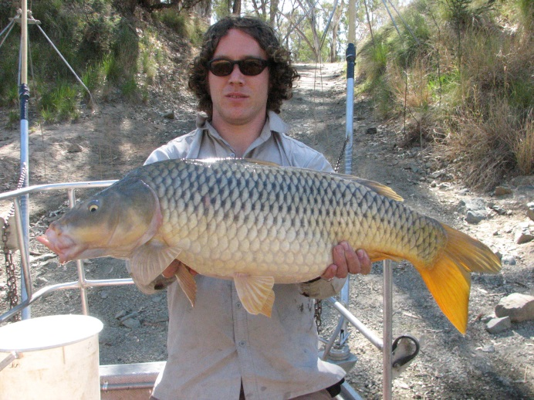

## Victorian distribution

Carp (*Cyprinus carpio*) are native to eastern Europe and central Asia and have been widely introduced across much of Europe, Asia, Africa, America and Oceania. Although first introduced into Australia in the mid-1800s, Carp only became widespread in the Murray-Darling system after large scale flooding in the mid-1970s facilitated the spread of the ‘Boolarra’ strain (named after the Boolarra fish farm they are believed to have originated from). Carp have now invaded much of the Murray-Darling Basin, and the species is the most abundant large freshwater fish in south east Australia1.

In Victoria, Carp are present in all northern tributaries of the Murray-Darling Basin. In coastal areas, Carp are absent from the East Gippsland, Snowy, Otway and Portland Coast River Basins, and are quite restricted in the Hopkins, Glenelg and South Gippsland River Basins. However, Carp are highly mobile within river systems and thus can quickly spread to new areas. They can also spread through inter-basin transfers of water, as well as deliberate and accidental releases by humans. The geographic range of Carp is continuing to expand.

Carp is listed as a "noxious aquatic species" in Victoria under the *Fisheries Act 1995*. It is an offence to possess, transport or release live carp, or use live Carp (including all forms of Carp and Goldfish) as fishing bait.

## A successful invader

Carp have many of the attributes that make invasive species successful: a broad tolerance to a range of environmental conditions, rapid growth, early maturity, high reproductive capacity, generalised diet, ability to modify habitats to their advantage by muddying the water and removing aquatic plants and are highly dispersive at all sizes1. The species’ broad environmental tolerances include:

* temperature ranges from 2 to 40.6°C
* salinity up to about 14 ppt (0.4 seawater)
* pH from 5.0 to 10.5
* oxygen levels as low as 7% saturation at 50C.

**Figure 1: Carp are commonly 2-3kg, although can grow much larger** (Photo: ARI)

## Diet

Carp are omnivores and detritivores. Their diet can include phytoplankton, zooplankton, benthic and pelagic invertebrates, detritus, fish eggs and fishand aquatic plants including seeds and leaves2. At early growth stages, Carp feed predominantly on zooplankton, and as they grow larger, feed on a wide variety of foods, including an increasing amount of benthic and epibenthic macroinvertebrates38.

Carp feed by ingesting food from the substrate as well as the water column. When feeding from the substrate, they suck sediment into the mouth, food is filtered through the gills and unwanted material is expelled into the water column. This feeding behaviour can uproot plants and re-suspend sediments, reducing water clarity and hence light available for submerged aquatic plants and visual feeding fish.

## Growth and longevity

Carp can exhibit rapid growth; eggs hatch within several days, and larvae can grow quickly1. While they average 400-500 mm (fork length), and 2-3 kg, Carp can reach a maximum size of about 900 mm and up to 15 kg. Growth rates of Carp can be highly variable across locations, habitats and years. Growth is influenced by numerous factors including water temperature, food availability and fish density3. Growth tends to be faster in warm water, particularly following flooding.

Carp commonly reach 15 years of age4 with a maximum age recorded of 32 years in Australia5.Survival of different age groups is not well understood, although high mortality rates of eggs, larvae and young-of-year is likely. Carp are vulnerable to predation by terrestrial animals, birds, as well as larger native fish; although have few predators once they are >400 mm long. Whole Carp populations are killed during wetland drying events, where fish become concentrated and stranded.

**Figure 2: Carp can become isolated as wetlands dry out** (Photo: ARI).

## Habitat use

Carp are considered habitat generalists, and are found in rivers, wetlands, floodplain habitats and irrigation channels. While they are typically found in mid-latitude (<600 m asl), slow flowing rivers, they have been recorded entering estuaries3. Their generalist habitat requirements have especially enabled them to thrive in disturbed environments6. Carp exhibit some preference for regulated rivers and weir pools, with juveniles being more abundant in stable warm water conditions6.

In rivers, Carp select areas close to the riverbank where water velocities are slower3. Adult Carp tend to congregate in deep parts of the main river channels and lakes during colder months, and then undertake spawning migrations into backwaters and floodplain habitats in spring and summer7.

## Movement

Carp are highly mobile, which enables rapid population expansion and recolonization of seasonal floodplain habitats8. Adults and juveniles can move up and down rivers, and in and out of anabranches and wetlands throughout the year9. Larvae can drift significant distances downstream from spawning habitats. Movement can be very variable, with adults moving a few to hundreds of kilometres9. Monitoring of fishways commonly record Carp moving at water temperatures >18oC10.

## Breeding

Carp exhibit early sexual maturity (one year for males, two years for females) 11. Females can release batches of eggs throughout the spawning season12, with larger females carrying more eggs and producing larger eggs. They can be highly fecund, with up to 25% of their body mass comprising eggs. For example, a 5 kg fish can contain 1 million eggs.

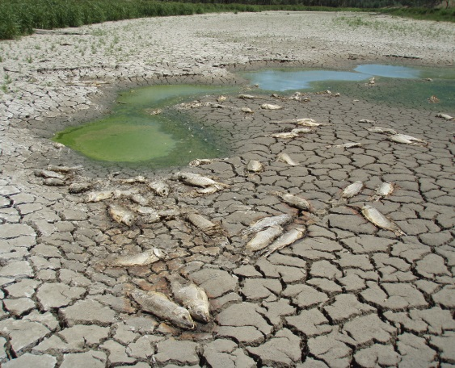

Carp eggs mature when water temperatures rise above 15-16oC in early spring, with >10 h of daylight. Fish spawn in water temperatures between 15-24°C13. The spawning season usually stretches from August to January14. While Carp can spawn on a variety of substrates, they prefer to lay their adhesive eggs on submerged and emergent vegetation, in shallow littoral habitats.

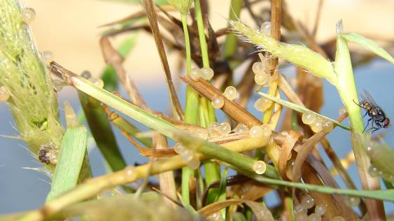

**Figure 3: Carp lay adhesive eggs on vegetation** (Photo: Ivor Stuart).

## Recruitment sites

While Carp can spawn within the main river channel, they prefer well-vegetated floodplain and wetland habitats with shallow, warm, still or slow flowing waters13,14,15,16.

Carp spawning is stimulated by rising water temperatures and inundation of floodplain habitats in spring and summer. Floodplain inundation appears linked to increased spawning and greater abundances of larval and juvenile Carp18,19,20. Such sites may have fewer predators because of environmental instability including periods of hypoxia and wetting and drying cycles21. Floodplain habitats are also used as nurseries18,19.

Dispersal from floodplain and wetland habitats can provide significant sources of recruits into the main river channels19,22. Carp do not reproduce uniformly throughout the river system, and there are a small number of ’recruitment hotspots’; most juvenile Carp originate from these wetlands. In Victoria, the Barmah-Millewa Forest is a recruitment hotspot along with Gunbower Forest and the Hattah Lakes floodplain.

## Impacts on ecosystems

Carp can exert substantial effects on ecosystem structure and function due to their foraging activities and influence on physical features of habitats23. They have been described as ‘habitat modifiers’, shifting shallow lakes from the clear to turbid-water stable state24.

A recent global review assessed the experimental evidence for impacts of Carp on abiotic and biotic components7, summarising 129 laboratory and field experiments in 19 countries. The strength of evidence varied for different ecological components (see Figure 5, Table 1).

|  |  |  |
| --- | --- | --- |
| Component | Trajectory | Strength of evidence |
| **Water quality** |  |  |
| * Turbidity | Increase | High |
| * Nitrogen | Increase | Very high |
| * Phosphorous | Increase | Very high |
| **Vegetation** |  |  |
| * Phytoplankton/ cholophyll a | Increase | Moderate |
| * Aquatic macrophytes | Decrease | Very high |
| **Invertebrates** |  |  |
| * Zooplankton | Change | Inconsistent evidence |
| * Benthic invertebrates | Decrease | High |
| **Vertebrates** |  |  |
| * Fish | Decrease | High |
| * Amphibians | Decrease | Moderate |
| * Waterfowl | Decrease | Insufficient evidence |

**Table 1**. Summary of the effects of Carp on freshwater ecosystems (Results of causal criteria analysis for hypotheses – taken from Vilizzi et al. 2015).

Detrimental impacts can be particularly significant in shallow off-stream habitats where congregations can occur26. Much of the research undertaken in Australia has focussed on the impacts of Carp on floodplain wetlands.

## Impacts on turbidity, suspended sediments and nutrients

Increases in turbidity has been observed at Carp densities of 50–75 kg/ha27,28, with noticeable shifts from clear to turbid water state at 200–300 kg/ha26,29,30,31. Increased turbidity reduces benthic light which can also affect water temperature32, as well as plant growth.

Increases in nutrient levelsare caused by excretion, as well as damage and breakdown of macrophytes, and suspension of nutrients from sediments26.

## Impacts on phytoplankton

Carp can increase phytoplankton production through resuspension of bottom sediments, reductions in zooplankton and increased nutrients24.

## Impacts on aquatic vegetation

Carp uproot and eat aquatic vegetation. Declines in aquatic vegetation cover have been observed at densities of 68-450 kg/ha 24,28,33-37.

Impacts of Carp on aquatic vegetation can vary between species27. In experimental ponds, submerged species were more susceptible to Carp foraging compared to emergent species32. Species with floating leaves, large rhizomes and overwintering carbohydrate reserves (e.g. rhizomes/tubers) can cope with poor light conditions caused by Carp, as well as tolerate uprooting by Carp37. These species are not affected by reduced light created by more turbid water. Species with tuber/rhizomes have sufficient carbohydrate reserved to persist over periods where photosynthesis is limited by reduced light. Species with rhizomes or tubers may recover from dislodgement as plants can regenerate from rhizome or tubers.

***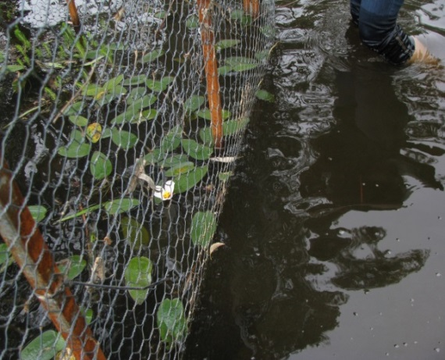*Figure 4: An exclusion zone on the left highlights how Carp can play a role in the loss of aquatic macrophytes** (Photo: Kate Bennetts).

## Impacts on zooplankton and aquatic invertebrates

Declines in zooplankton and benthic invertebrate communitiescan occurby direct predation and competition, and through degradation of habitat condition and available resources.

Increased turbidity can reduce the amount of submerged vegetation which provides structural refuge, feeding resources and oviposition microhabitats for invertebrates.

## Impacts on fish

Carp have been suspected as a contributor to the decline of native fish in Australia, although the impacts are not well quantified1.

Impacts may include:

* competition with native fish species for food and space 39, 40
* smothering of fish eggs by sedimentwhich may affect survival
* inhibition of visual feeding by some fish species through increased turbidity41, 42
* preying on native fish, eggs and larvae.

Understanding the level of overlap in habitat use with other species may provide insights into the potential significance of competition with Carp. Habitat use of Carp is similar to Golden Perch, although in comparison to Murray Cod and Trout Cod, they appear to use slower waters, closer to the bank and with wood higher in the water column43.

Carp are susceptible to a range of parasites and diseases, some of which also occur in native fish and thus pose a risk of transmission3.

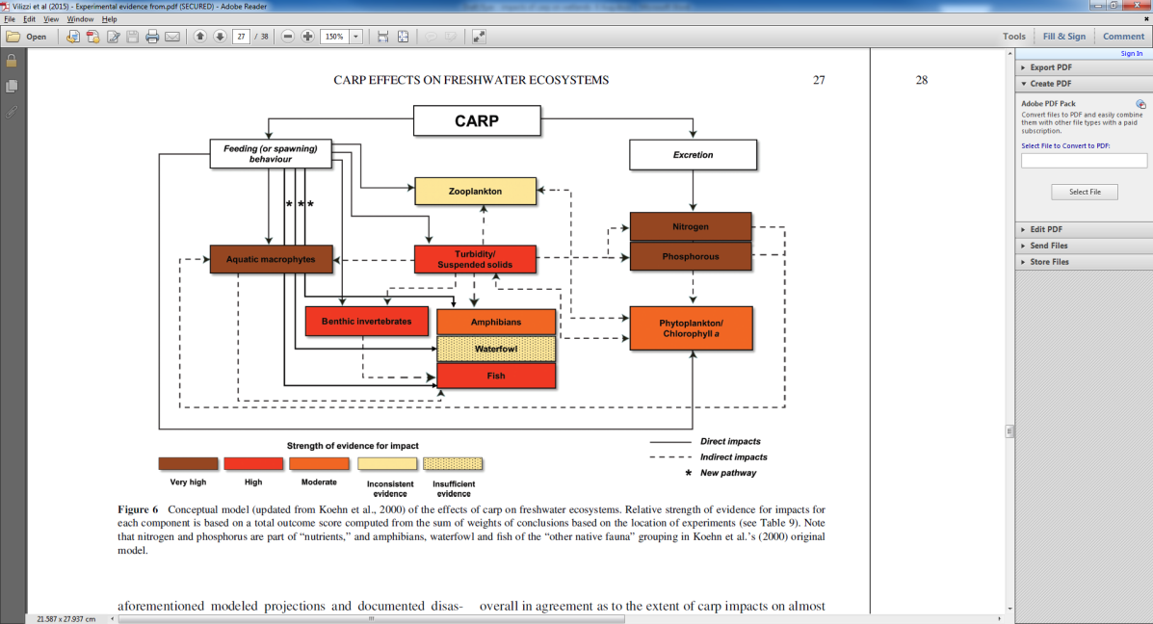

**Figure 5:** Taken from Vilizzi et al. (2015). Conceptual model (updated from Koehn et al. 2000) of the effects of Carp on freshwater ecosystems. Relative strength of evidence for impacts for each component is based on a total outcome score computed from the sum of weights of conclusions based on the location of experiments. Note that nitrogen and phosphorus are part of ‘nutrients’ and amphibians, waterfowl and fish of the ‘other native fauna’ grouping in Koehn et al.’s (2000) original model

## Impacts on birds

Declines in native waterfowlhave been observedas a result of declines in aquatic vegetation and associated invertebrates30,37. Impacts in a shallow lake were observed once Carp reached densities of ~100 kg/ha37. A size dependent mixture of competition and predatory interactions between fish such as Carp and piscivorous birds may occur41.

## Impacts on amphibians

Some field and laboratory studies have investigated impacts of Carp on amphibians. Declines of amphibians can occur through predation of tadpoles44,45, and potentially through associated habitat degradation.

## Density thresholds and impacts

A key component of Integrated Pest Management is managing a species below a predetermined density threshold, below which its impacts on environmental values is acceptable46.

Identifying critical biomass values for Carp impacts can be problematic when relying on experimental examples7. A large range of values have been described in field and mesocosm experiments. Recent evidence suggests biomass levels lower than previously thought may cause detrimental effects (i.e. 100–174 kg/ha)30,31,37.

Carp are estimated to comprise up to 90% of the fish biomass in many areas within the MDB; equating to a total biomass as high as 3144 kg/ha and densities of up to 1000 individuals/ha6.

A target of 70-90% reduction in pre-control biomass of Carp has been suggested to either minimise impacts or result in long-term population control44. Modelling suggests average biomass should be reduced to about 88 kg/ha47. For sensitive environments, even low Carp densities may cause detrimental effects.

|  |
| --- |
| For managers, defining an acceptable Carp density based on their impact threshold e.g.   * 88 kg/ha   provides a very important guide for setting both a clear objective for control and a recovery vision for the waterway. |

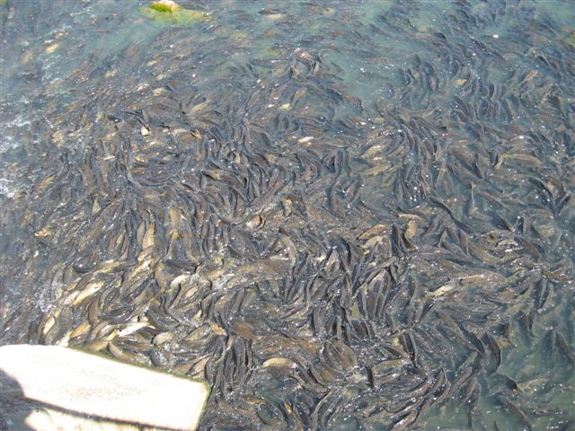

**Figure 6: Carp can congregate in large numbers** (Photo: Ivor Stuart).

## References

1. Koehn et al. (2016). *Managing flows and Carp.* Arthur Rylah Institute for Environmental Research Technical Report Series No. 255. Arthur Rylah Institute for Environmental Research, Department of Environment, Land, Water and Planning, Heidelberg, Victoria.

2. Pietsch, C. and Hirsch, P. (2015). Biology and ecology of Carp. CRC Press, Taylor and Francis Group, Science Publishers. USA.

3. Koehn, J., et al. (2000). Managing the Impacts of Carp. Bureau of Rural Sciences (Department of Agriculture, Fisheries and Forestry – Australia), Canberra.

4. Brown, P. et al. (2005). Population biology of Carp *Cyprinus carpio* in the mid-Murray River and Barmah Forest wetlands, Australia. *Marine and Freshwater Research* **56**, 1151-1164.

5. Jones, M.J. and Stuart, I.G. (2008). Regulated floodplains – a trap for unwary fish. *Fisheries Management and Ecology* **15**, 71–79.

6. Gehrke, P.C. and Harris, J.H., (2000). Large scale patterns in species richness and composition of temperate riverine fish communities. *Marine and Freshwater Research* **51**, 165–182.

7. Vilizzi et al. (2015). Experimental evidence from causal criteria analysis for the effects of Common Carp *Cyprinus carpio* on freshwater ecosystems: A global perspective. *Reviews in Fisheries Science and Aquaculture* **23**, 253–290, 2015.

8. Koehn, J.D. and Nicol, S.J. (1998). Habitat and movement requirements of fish. In: Banens, R.J. and Lehane, R. (Eds) 1996 Riverine Environment Research Forum, Proceedings of the Inaugural Riverine Environment Research Forum, Brisbane,1996, pp. 1–6. Murray–Darling Basin Commission, Canberra, ACT.

9. Jones, M. and Stuart, I. (2006). Large, regulated forest floodplain is an ideal recruitment zone for non-native Common carp (*Cyprinus carpio* L.) *Marine and Freshwater Research* **57**, 333-347,

10. Mallen-Cooper, M. (1999). Developing fishways for nonsalmonid fishes; a case study from the Murray River in Australia. In: Odeh, M. (Ed.) Innovations in Fish Passage Technology, pp. 173–195. American Fisheries Society, Bethesda, USA.

11. Brumley, A. R. (1996). Cyprinids. In: McDowall, R.M. (Ed.) Freshwater Fishes of South-Eastern Australia, 2nd edn, pp. 99–106. Reed Books, Sydney, NSW.

12. Sivakumaran, K.P. et al. (2003). Maturation and reproductive biology of female wild Carp, *Cyprinus carpio*, in Victoria, Australia. *Environmental Biology of Fishes* **68**, 321–332.

13. Smith, B.B. and Walker, K.F. (2004). Reproduction of the common carp in South Australia, shown by young-of-the-year samples, gonadosomatic index and the histological staging of ovaries. *Transactions of the Royal Society of South Australia* **128**, 249–257.

14. Stuart, I. and Jones, M. (2006). Large, regulated forest floodplain is an ideal recruitment zone for non-native common carp (*Cyprinus carpio* L.). *Marine and Freshwater Research* **57**, 333–347.

15. Gilligan, D. et al. (2010). Identifying and implementing targeted Carp control options for the Lower Lachlan catchment. Fisheries Final Report Series No. 118, Industry & Investment NSW, Sydney, NSW.

16. Conallin, A. J. et al. (2012). Environmental water allocations in regulated lowland rivers may encourage offstream movements and spawning by common carp, *Cyprinus carpio*: implications for wetland rehabilitation. *Marine and Freshwater Research* **63**, 865–877.

17. Vilizzi, L. and Walker, K. F., (1999). Age and growth of the common carp, *Cyprinus carpio* L. (Cyprinidae), in the River Murray, Australia: validation, consistency of age interpretation and growth models*. Environmental Biology of Fishes* **54**, 77–106.

18. King, A.J. et al. (2003). Fish recruitment on floodplains: the roles of patterns of flooding and life history characteristics. *Canadian Journal of Fisheries and Aquatic Sciences* **60**, 773–786.

19. Stuart, I.G. and Jones, M.J. (2006a). Movement of common Carp, *Cyprinus carpio*, in a regulated lowland Australian river: implications for management. *Fisheries Management and Ecology* **13**, 213–219.

20. Humphries, P. et al. (2008). Flow-related patterns in abundance and composition of the fish fauna of a degraded Australian lowland river. *Freshwater Biology* **53**, 789–813.

21. Bajer, P.G. and Sorensen, P.W. (2010). Recruitment and abundance of an invasive fish, the common Carp, is driven by its propensity to invade and reproduce in basins that experience winter-time hypoxia in interconnected lakes. *Biological Invasions* **12**,1101–1112.

22. Crook, D.A. and Gillanders, B.M. (2006). Use of otolith chemical signatures to estimate Carp recruitment sources in the mid-Murray River, Australia. *River Research and Applications* **22**, 871–879.

23. Kaemingk, M. A. et al. (2016). Common carp disrupt ecosystem structure and function through middle-out effects. Marine and Freshwater Research - <http://dx.doi.org/10.1071/MF15068>

24. Weber, M.J. and Brown, M.L. (2015). Biomass-dependent effects of age-0 common carp on aquatic ecosystems. *Hydrobiologia* **742**, 71–80. doi:10.1007/210750-014-1966-6

25. Weber, M.J. and Brown, M.L. (2009). Effects of common carp on aquatic ecosystems 80 years after ‘Carp as a dominant’: ecological insights for fisheries management. *Reviews in Fisheries Science* **17 (4)**, 524–537. doi:10.1080/10641260903189243

26. Parkos, J.J. III et al. (2003). Effects of adult common Carp (*Cyprinus carpio*) on multiple trophic levels in shallow mesocosms. *Canadian Journal of Fisheries and Aquatic Sciences* **60**, 182–192.

27. Zambrano, L. and Hinojosa, D. (1999). Direct and indirect effects of Carp (*Cyprinus carpio*) on macrophytes and benthic communities in experimental shallow ponds in central Mexico. *Hydrobiologia* **408/409**, 131–138.

28. Vilizzi, L. et al. (2014). Ecological effects of common Carp (*Cyprinus carpio*) in a semi-arid floodplain wetland. *Marine and Freshwater Research* **65**, 802–817. doi:10.1071/MF13163.

29. Williams, A.E. et al. (2002). Fish induced macrophyte loss in shallow lakes: top-down and bottom-up processes in mesocosm experiments. *Freshwater Biology* **47**, 2216–2232.

30. Haas, K. et al. (2007). Influence of fish on habitat choice of water birds: a whole-system experiment. *Ecology* **88**, 2915–2925.

31. Matsuzaki, S. et al. (2009). Contrasting impacts of invasive engineers on freshwater ecosystems: an experiment and meta-analysis*. Oecologia* **158**, 673–686.

32. Roberts, J. et al. (1995). Effects of carp, Cyprinus carpio L., an exotic benthivorous fish, on aquatic plants and water quality in experimental ponds. *Marine and Freshwater Research* **46**, 1171–1180.

33. Hume, D.J. et al. (1983). Carp Program Report No. 10. Final Report. Arthur Rylah Institute for Environmental Research, Fisheries and Wildlife Division, Ministry for Conservation, Melbourne, Victoria.

34. Fletcher, A. R. et al. (1985). Effects of Carp (*Cyprinus carpio* L.) on communities of aquatic vegetation and turbidity of waterbodies in the lower Goulburn River basin. *Australian Journal of Marine and Freshwater Research* **36**, 311–327.

35. Osborne, M. W. et al. (2005). Abundance and movement of koi carp (*Cyprinus carpio* haematopterus) in the lower Waikato River system. In: Proceedings of the 13th Australasian Vertebrate Pest Conference, Te Papa, Wellington, New Zealand, 2–6 May 2005, pp. 56.

36. Pinto, L. et al. (2005). Managing invasive Carp (*Cyprinus carpio* L.) for habitat enhancement at Botany Wetlands, Australia. *Aquatic Conservation: Marine and Freshwater Ecosystems* **15**, 447–462.

37. Bajer, P. G. et al. (2009). Effects of a rapidly increasing population of common Carp on vegetative cover and waterfowl in a recently restored Midwestern shallow lake. *Hydrobiologia* **632**, 235–245. doi:10.1007/s10750-009-9844-3

38. Nieoczym, M. and Kloskowski, J. (2015). Responses of epibenthic and nektonic macroinvertebrate communities to a gradient of fish size in ponds. *Journal of Limnology* **74(1)***,* 50-62.

39. Carey, M. P. and Wahl, D. H. (2010). Native fish diversity alters the effects of an invasive species on food webs. [*Ecology*](https://www.researchgate.net/journal/0012-9658_Ecology) **91(10),** 2965-74.

40. Zambrano, L. et al. (2010). Food web overlap among native axolotl (Ambystoma mexicanum) and two exotic fishes: Carp (Cyprinus carpio) and tilapia (Oreochromis niloticus) in Xochimilco, Mexico City. *Biological Invasions* **12(9)**,3061-3069.

41. King, A. et al. (1997). Experimental manipulations of the biomass of introduced Carp (*Cyprinus carpio*) in billabongs. I. Impacts on water-column properties. *Marine and Freshwater Research* **48**, 435–443.

42. Wolfe, M. D. et al. (2009). Effects of Common Carp on Reproduction, Growth, and Survival of Largemouth Bass and Bluegills. *Transactions of the American Fisheries Society* **138 (5)**, 975-983.

43. Koehn, J.D. and Nicol, S.J. (2014). Comparative habitat use by large riverine fishes. *Marine and Freshwater Research* **65**, 164–174.

44. Kloskowski, J. (2011). Fish farms as amphibian habitats: factors affecting amphibian species richness and community structure at carp ponds in Poland. *Environmental Conservation* **37**, 187–194 (2010).

45. Hunter et al. (2011). Experimental examination of the potential for three introduced fish species to prey on tadpoles of the endangered Booroolong Frog, Litoria booroolongensi. *Journal of Herpetology* **45 (2)**, 181–185.

46. Braysher, M. and Saunders, G. (2003). PESTPLAN – a guide to setting priorities and developing a management plan for pest animals. Bureau of Rural Sciences and the National Heritage Trust, Canberra, ACT.

47. Brown, P. and Gilligan, D. (2014). Optimising an integrated pest-management strategy for a spatially structured population of common carp (Cyprinus carpio) using meta-population modelling. *Marine and Freshwater Research* **65**, 538–550. doi:10.1071/MF13117.

## Websites

|  |  |
| --- | --- |
| © The State of Victoria Department of Environment, Land, Water and Planning 2017  LogoThis work is licensed under a Creative Commons Attribution 4.0 International licence. You are free to re-use the work under that licence, on the condition that you credit the State of Victoria as author. The licence does not apply to any images, photographs or branding, including the Victorian Coat of Arms, the Victorian Government logo and the Department of Environment, Land, Water and Planning (DELWP) logo. To view a copy of this licence, visit http://creativecommons.org/licenses/by/4.0/  ISBN 978-1-76047-424-9 (print)  ISBN 978-1-76047-425-6 (pdf)  Disclaimer  This publication may be of assistance to you but the State of Victoria and its employees do not guarantee that the publication is without flaw of any kind or is wholly appropriate for your particular purposes and therefore disclaims all liability for any error, loss or other consequence which may arise from you relying on any information in this publication. | Accessibility  If you would like to receive this publication in an alternative format, please telephone the DELWP Customer Service Centre on 136186, email [customer.service@delwp.vic.gov.au](mailto:customer.service@delwp.vic.gov.au), or via the National Relay Service on 133 677 [www.relayservice.com.au](http://www.relayservice.com.au). This document is also available on the internet at [www.delwp.vic.gov.au](http://www.delwp.vic.gov.au). |

Invasive Animal CRC -

<http://www.pestsmart.org.au/pest-animal-species/european-carp/>

Department of Economic Development, Jobs, Transport and Resources - <http://agriculture.vic.gov.au/fisheries/education/fish-species/carp>