Water & Catchments Regulatory Framework

Table of Contents
Foreword 2
Introduction 3
Scope 4
Purpose 6
Regulatory Roles and Responsibilities 7
Victoria’s Water Authorities 8
Importance of Water Regulation 10
Regulatory Principles 12
Overview of our Regulatory Approach 14
Collaborate and Engage 16
Our Partners and Stakeholders 17
Define Regulatory Outcomes 18
Identify Risks and Priorities: Regulatory Risks 20
Identify Risks and Priorities: Regulatory Priorities 22
Design Regulatory Interventions 23
Implement Regulatory Interventions 28
Measuring Outcomes and Assessing Impact 30
More Information and Support 31
Publication information 33

Foreword
Water is one of Victoria’s most precious resources. Managing it responsibly is not just a legal obligation, it is a shared commitment to the communities, environments, and industries that depend on it. This Regulatory Framework sets out the role of the Department of Energy, Environment and Climate Action (the Department) and our urban and rural water corporations and catchment management authorities (CMAs) (collectively referred to as Water Authorities) in delivering strong, transparent, and fair regulation.
Regulation of our water and catchments is essential to safeguard public resources and assets, protect ecosystems, and ensure equitable and safe access to water. Through this framework, we outline how Victoria’s Water Authorities carry out their responsibilities and the principles that underpin good regulatory practice. These principles reflect the Department’s broader vision: stewardship of water for the benefit of all Victorians, sustainability for future generations, and integrity in every action.
Together, through this framework, we affirm our commitment to protecting Victoria’s water resources and ensuring they are managed fairly and responsibly.
Dr Kirsten Shelly
Deputy Secretary, Water and Catchments
Department of Energy, Environment and Climate Action

Introduction
Water is essential to Victoria’s community, environment, and economy. It must be shared safely, fairly and efficiently. Our waterways and aquifers underpin water supplies across the state and hold significant environmental, cultural, economic, Traditional Owner and social value.
Water can also pose risks. Floods can inundate low-lying areas, cause erosion and damage infrastructure such as dams and creek crossings. Across Victoria, water corporations manage dams, pipes, bores and channels to keep water moving safely and effectively and oversee important environmental and recreational areas. Catchment management authorities work to protect and improve waterways and manage our floodplains to reduce risks to communities and the environment.
The Water Act 1989 Vic (the Water Act) provides the legal framework for managing water supplies for households, farms and businesses. It also sets out provisions for waterways, aquifers and water infrastructure. Many activities can threaten these systems. Regulation helps reduce these risks and safeguard water for communities, industry and the environment. We all share responsibility to comply with regulations and protect these finite resources now and into the future.

Scope
The Water and Catchments Regulatory Framework outlines the regulatory responsibilities of the Department and Water Authorities that are set out within the Water Act and related legislation. Other matters such as pollution of water outside storages, cultural heritage protection, invasive species control, land management and financial obligations of Water Authorities are primarily administered by other regulators, although Water Authorities may still have statutory responsibilities under relevant legislation.

Core Legislation – Water Act 1989

In-scope Legislation:

Subordinate Legislation
Water Authorities are the primary regulator
Examples include:
- Water (Drillers’ Licences) Regulations 2022 (Vic)
- Water (General) Regulations 2021 (Vic)
- Water (Infringements) Regulations 2020 (Vic)
- Water (Lake Eildon Recreational Area) (Houseboats) Regulations 2024 (Vic)
- Water (Recreational Area) Regulations 2023 (Vic)
- Water (Resource Management) Regulations 2017 (Vic)
- Water (Tagged Water Allocations) Regulations 2021 (Vic)
- Water Authority by-laws made under section 160 of the Water Act (Vic)

Supporting Legislation
Water Authorities have statutory responsibilities or duties, but are not the primary regulator
Examples include:
- Environment Protection Act 2017 (Vic)
- Catchment and Land Protection Act 1994 (Vic)
- Groundwater (Border Agreement) Act 1985 (Vic)
- Marine Safety Act 2010 (Vic)
- Safe Drinking Water Act 2003 (Vic)
- Security of Critical Infrastructure Act 2018 (Cth)
- Traditional Owner Settlement Act 2010 (Vic)
- Water (Commonwealth Powers) Act 2008 (Vic)
- Water Act 2007 (Cth)
- Water Industry Act 1994 (Vic)

Out-of-scope Legislation
Water Authorities have an interest, but no statutory responsibilities or duties (activities may be constrained or influenced by them)
Examples include:
- Aboriginal Heritage Act 2006 (Vic)
- Environment Protection and Biodiversity Conservation (EPBC) Act 1999 (Cth)
- Heritage Rivers Act 1992 (Vic)
- Planning and Environment Act 1987 (Vic)
- Pollution of Waters by Oil and Noxious Substances Act 1986 (Vic)

Purpose
This Regulatory Framework explains how the Department and Water Authorities carry out their regulatory responsibilities under the Water Act and related legislation. It provides clarity for the water sector and the Victorian community on the roles, functions and expectations of regulators, and outlines how water resources and waterways are managed in a consistent, transparent and accountable way.
- The whole-of-department Regulatory Framework, published in 2019, sets out the department’s overarching regulatory responsibilities.
This Water and Catchments Regulatory Framework builds on that foundation by providing more detailed guidance specific to the regulation of Victoria’s water, waterways and catchment systems.
- This framework recognises that the Department and Water Authorities operate within a multi-layered regulatory environment and hold a range of responsibilities that are regulated by others and have established compliance, assurance and risk management systems (e.g., safe drinking water quality and emergency management).
These systems serve distinct functions and are not replaced by this framework, which is intended to operate alongside them.

Regulatory Roles and Responsibilities

The Minister for Water
The Minister for Water is accountable to Parliament and responsible for the development of water policy and governance of the water sector under the Water Act and Catchment and Land Protection Act 1994. Under the Act, the Minister for Water has delegated certain regulatory functions to Water Authorities.

The Department
The Department supports the Minister and Water Authorities in establishing policies and strategies and supports and oversees Water Authorities in delivering regulatory functions.

Water Authorities
Water Authorities have powers, functions and responsibilities under the Act for the compliance and enforcement of rules and legislative requirements, and they are empowered to investigate and prosecute breaches of the Act.

Victoria’s Water Authorities
Victoria’s water sector consists of 27 Water Authorities:
Urban water corporations:

- Barwon Water
- Central Highlands Water
- Coliban Water
- East Gippsland Water
- Gippsland Water
- Goulburn Valley Water
- Greater Western Water
- GWM Water
- Lower Murray Water
- North East Water
- South East Water
- South Gippsland Water
- Wannon Water
- Westernport Water
- Yarra Valley Water

Rural water corporations:

- Coliban Water
- Goulburn-Murray Water
- GWM Water
- Lower Murray Water
- Melbourne Water
- Southern Rural Water

Catchment management authorities:
- Corangamite Catchment Management Authority
- East Gippsland Catchment Management Authority
- Glenelg Hopkins Catchment Management Authority
- Goulburn Broken Catchment Management Authority
- Mallee Catchment Management Authority
- Melbourne Water
- North Central Catchment Management Authority
- North East Catchment Management Authority
- West Gippsland Catchment Management Authority
- Wimmera Catchment Management Authority
These Water Authorities are public entities established under Victorian legislation and must operate in accordance with the values and governance principles of the Public Administration Act 2004.
In recognition of differing operational and regional requirements, some Water Authorities perform multiple primary functions.

Importance of Water Regulation
Activities relating to the taking, use and management of water can create risks to water resources, the environment and other users. Water regulation supports the management and mitigation of these risks by regulating activities associated with water and waterways, including the following:

Taking of water
People must only take water where and when they are authorised
- Protection of other users, the environment and cultural values
Funding for water services and infrastructure, with costs shared equitably

Usage of Water
People must use water safely and appropriately
- Sustainably manage urban water supplies during drought or water shortage
Protect against risks of salinisation, waterlogging, and damage to property and assets

Water Infrastructure
People must avoid activities affecting water infrastructure
- Protect pipes, dams, channels, storages, pump stations and treatment infrastructure to ensure water can be supplied and delivered safely and reliably
Managing and advising on works and development in flood-prone areas to reduce risks to people, property and infrastructure

Waterways
People must protect waterway values and water quality for all users
- Protecting environmental, cultural and recreational values of rivers, floodplains and wetlands
- Maintaining waterway health and resilience by managing activities so they don’t impact on essential processes, habitat and water quality

Regulatory Principles
The following regulatory principles define how we regulate. They set clear expectations for our conduct and decision-making and align with Australian and international best practice regulatory approaches.

Outcomes-focused
The regulatory approach is driven by clear outcomes which are articulated, measured and evaluated to show progress and make improvements.

Risk-based
Effort is focused on addressing the most significant risks in order to maximise the outcomes achieved. These risks may be static (e.g. compliance with standard licence conditions) or dynamic (e.g. reduced water availability during droughts).

Intelligence-led and evidence based
Knowledge and evidence such as information from the community or water metering data is effectively and efficiently gathered. It is then used to determine which risks to focus on and how to design and implement regulatory interventions.

Proportionate and graduated
Decision-making considers factors such as whether non-compliance was intentional or repeated, and its impacts. This means that the approach will shift depending on the circumstances from providing information and advice about how to comply with the law through to imposing fines, suspending or cancelling licences and permits or prosecuting for serious offending.

Collaborative
Collaboration with the Victorian community, Traditional Owners, stakeholders and with other regulators is pivotal, providing opportunities to shape the approach to achieving regulatory outcomes.

Transparent
There is a need to be as transparent as possible about the regulatory policies, priorities, action and outcomes. Being transparent works to hold the Department and Water Authorities accountable to the Victorian community and encourages regulated parties to comply with the law. Public release of information about regulatory activities however does not undermine the ability to prosecute or impose sanctions.

Safe
Regulatory activities must be undertaken in a manner that prioritises the safety of staff and the community. Staff will operate within their training, capability and authorisations, and will not engage in situations that present elevated personal safety or security risks. Such matters will be escalated to appropriate staff, agencies or specialist responses.

Overview of our Regulatory Approach
Our regulatory mission is to become effective, trusted and best practice regulators.
We will realise our mission, by:
- Collaborating and engaging with the community, our customers and our regulatory partners
- Being outcomes-focused and risk-based.

Five-step cycle
To identify and address our priority risks, we carefully plan how to regulate effectively through applying the following five-step cycle:
Figure 1: The Five-step cycle
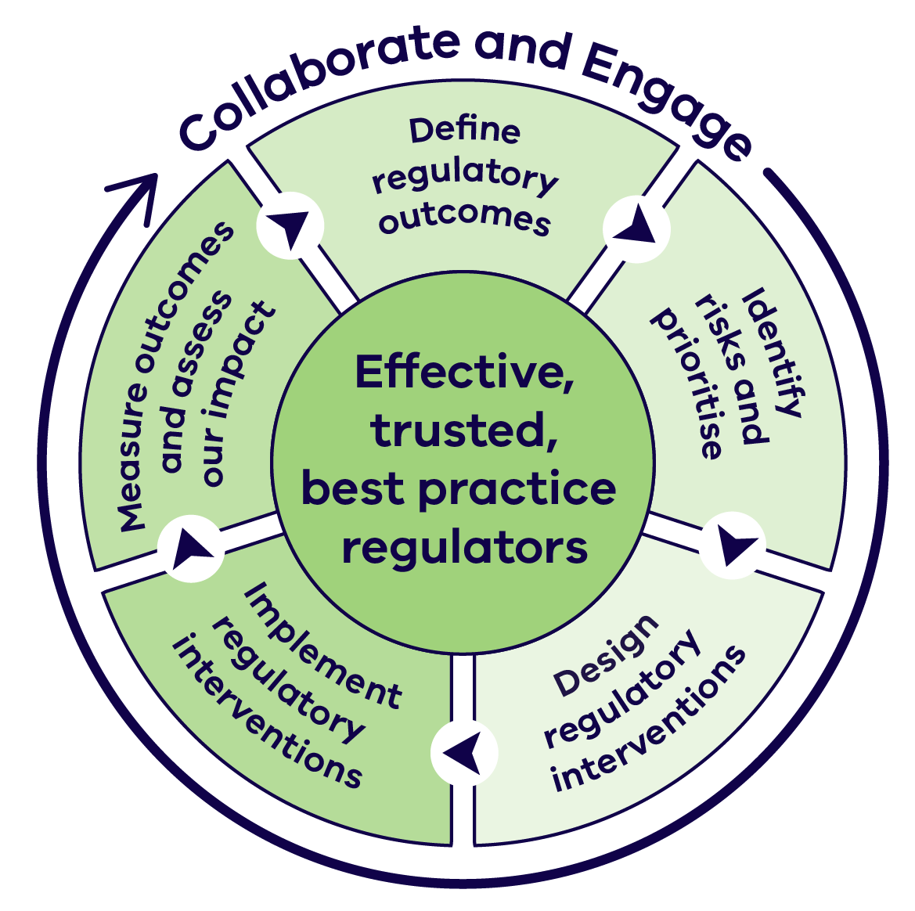
The five steps in the cycle are:
- Define regulatory outcomes
- Identify risks and prioritise
- Design regulatory interventions
- Implement regulatory interventions
- Measure outcomes and assess our impact

Collaborate and Engage
Effective collaboration and engagement builds trust and supports the development and delivery of effective regulatory practices.
The Department and Water Authorities work with communities, partners and stakeholders to deliver services and create opportunities (including through regulation) that support thriving, productive and sustainable communities, environments and industries.
This engagement is guided by:
- The Department’s Customer Charter and relevant Water Authority Customer Service Charters
- The Victorian Public Engagement Framework, which supports consistent and meaningful engagement practice
The Department’s guidance supporting engagement with Traditional Owners and Aboriginal communities, recognising existing relationships and partnerships
Collaboration and engagement throughout the regulatory process enables:
- Understanding diverse perspectives on water access, use and waterway management
- Identification and management of risks (static and dynamic)
- Development of practical solutions, informed by local and broader contexts
Clear and transparent decision‑making
Engagement will be undertaken in a way that:
- Is proportionate and fit-for-purpose, reflecting who is affected and how
- Has a clear purpose, with feedback considered and applied where appropriate

Our Partners and Stakeholders
There are a range of parties involved in water regulation and the ways they can shape its development and implementation, and their context and involvement are summarised below.
Table 1: Parties involved in water regulation and shaping its development and implementation
Stakeholder | Role and Involvement
Traditional Owners | Custodians of Country with ancestral rights and obligations. Hold Traditional Ecological Knowledge and cultural values.  Involved in caring for water landscapes.
Environment Protection  Authority (EPA) | Regulates pollution and water quality under the EP Act. Enforces environmental standards and investigates incidents.
Essential Services  Commission (ESC) | Regulates water corporation business functions. Approves pricing, sets service standards, and monitors performance.
Local Government | Manages stormwater, domestic wastewater systems, and some drainage schemes. Acts as planning authority.
Urban Water Users | Use metered drinking water and sewerage services. Must comply with water-saving rules and pay tariffs approved by the ESC.
Rural Water Users | Use water for domestic/agricultural/commercial purposes. Must obtain approvals based on water source and use. Participate in drainage schemes and pay ESC-approved tariffs.
Environmental Water Managers | The Victorian Environmental Water Holder (VEWH) and the Commonwealth Environmental Water Holder hold and/or manage Victoria’s environmental water entitlements.
Rural Landholders | Must manage land to prevent environmental harm. Require permits/licences for works on waterways or other activities  (e.g. rural drainage).
General Community | Responsible for respectful recreation at waterways and storages. Must avoid damaging water infrastructure or land.

Define Regulatory Outcomes
The outcomes within the Regulatory Framework define what we are here to achieve. These outcomes make it clear what we are working towards and enable us to assess how well we are protecting and managing our water resources and waterways.
These outcomes are directly informed by the strategic direction set in Water for Victoria and our regulatory mission.
In addition, Water Authorities will have outcomes specific to their regions and compliance risks. These can be found in relevant documents such as
- Compliance and enforcement strategies
- Corporate Plans
Regulatory Impact Statements

Vision and Mission

Water for Victoria
Water is fundamental to our communities. We will manage water to support a healthy environment, a prosperous economy and thriving communities, now and into the future.

Regulatory Mission
To be effective, trusted and best practice regulators.

Regulatory Outcomes

Taking of water
Water users access water when and where they are authorised

Usage of Water
Water is used safely and efficiently

Water Infrastructure
Infrastructure is maintained and used reliably and safely

Waterways
Activities that affect waterways are managed in a way that maintains their environmental, cultural, social and economic values.

Identify Risks and Priorities: Regulatory Risks
Victoria has thousands of water users and waterways, and the Water Act covers a broad range of regulatory matters. To protect communities and the environment, the Department and Water Authorities focus on areas with the highest risk of harm.
Risks are identified through:
- Community Reports
- Co-regulator input
- Compliance inspections and monitoring
- Environmental scanning
Analysis of past breaches
Risk assessment considers both likelihood and consequences of harm. Risks can be static (linked to established legal requirements) or dynamic (changing with conditions such as location, climate or user behaviour). The Department and Water Authorities periodically reassess risks as new information emerges. High‑risk situations may involve:
- High proportion of water users breaching permanent water saving rules; or urban water restrictions during a drought or water shortage
- Inadequate maintenance by a dam owner of a dam that could endanger life and property if it failed
- A single water user taking large volumes of water from a small waterway or aquifer without authorisation
- An unauthorised low-level river crossing that impedes the movement
of threatened migratory fish
Figure 2: Risk matrix
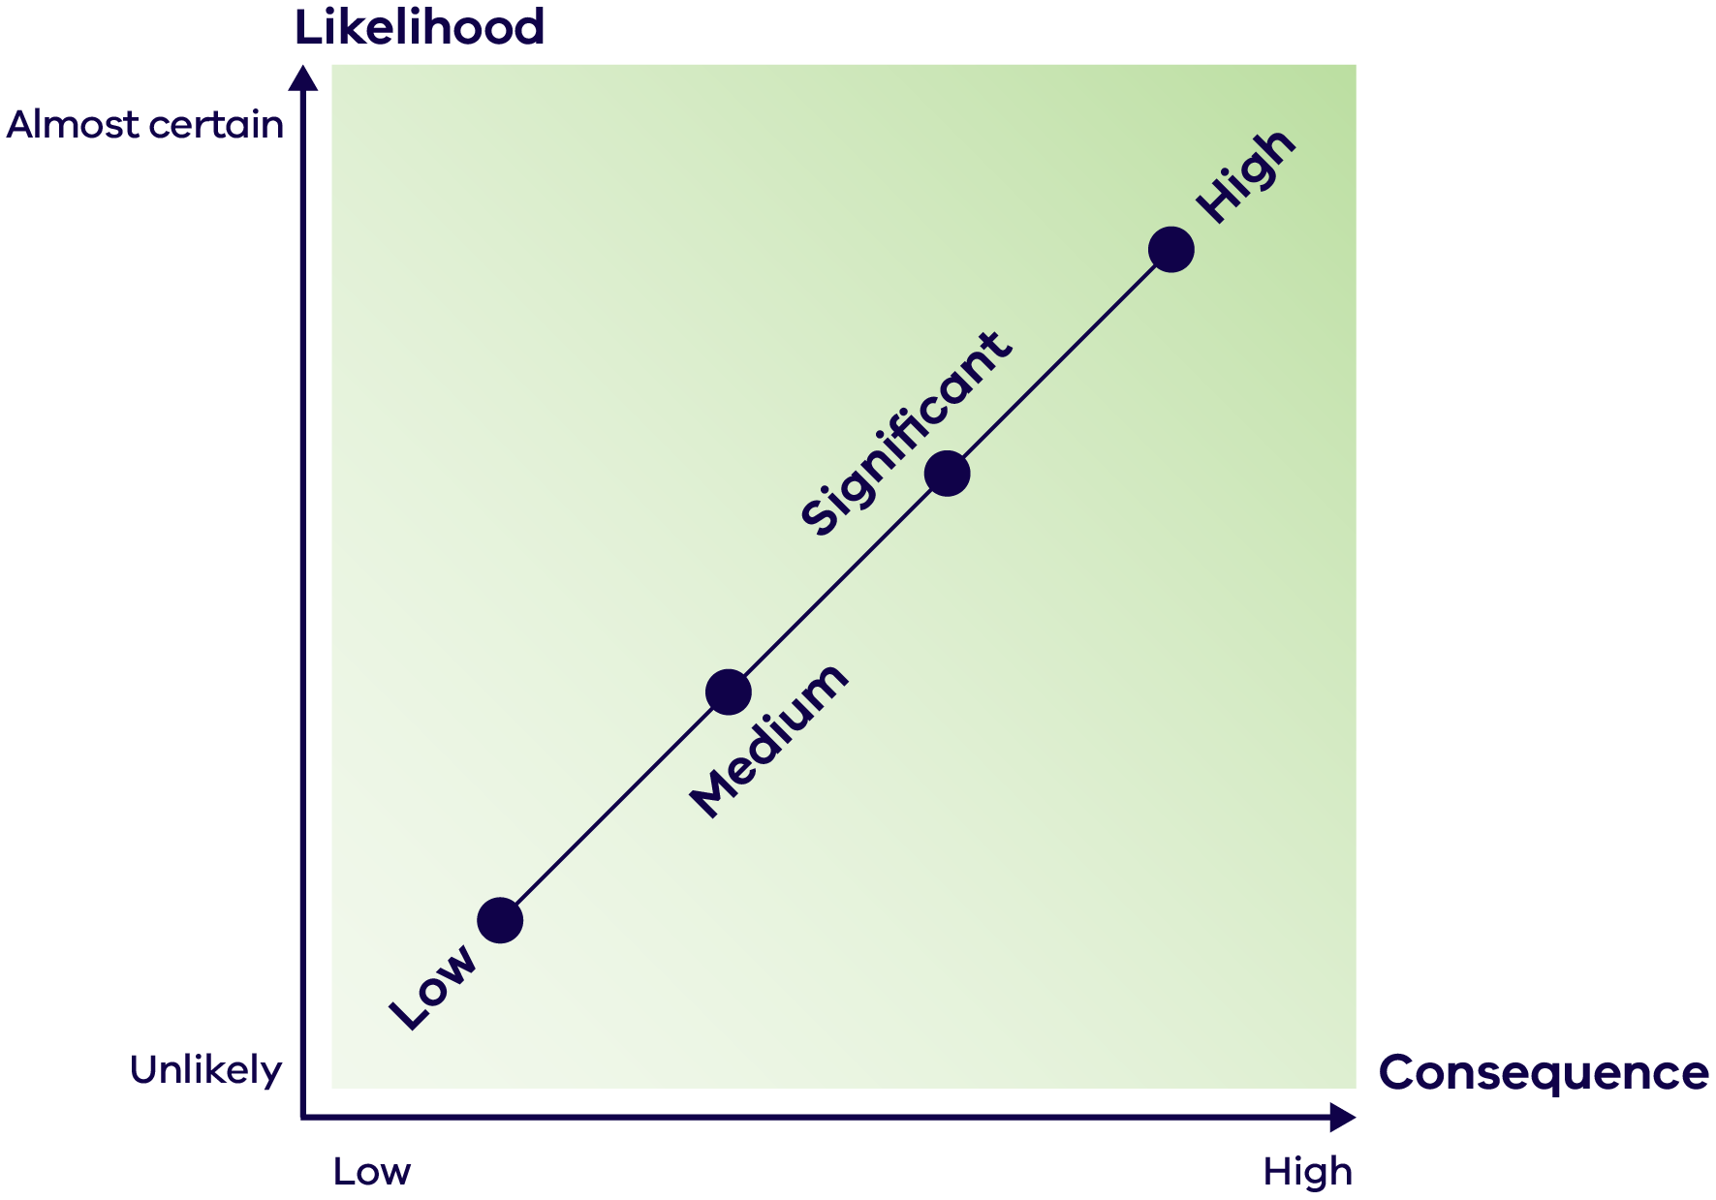

Identify Risks and Priorities: Regulatory Priorities
Once risks are identified and assessed, they inform how the Department and Water Authorities set priorities in a transparent and principled way.
They also consider the values regulation seeks to protect which guides decisions on the best approach and how resources are allocated. Some key values criteria include:
- Maintaining urban water supplies for critical human needs
- Supporting valuable agricultural production and the operation of water markets
- Protecting cultural heritage and Traditional Owner priorities
- Safeguarding environmental and recreational values
- Minimising risks to priority infrastructure
- Considering potential harms across multiple value types
- Using adaptable and cost-effective approaches
Meeting Ministerial obligations and legislative obligations
Water Authorities may publish annual priorities or statements of regulatory intent to share this information with partners, stakeholders and the community.
All reported non-compliance is assessed to determine the most appropriate response. While resources do not allow enforcement in every case, prioritisation ensures effort is directed where it prevents the greatest harm.

Design Regulatory Interventions
A broad range of tools is available to help the Department and Water Authorities minimise risks to water supplies, infrastructure and waterways.
Designing regulatory interventions that effectively address a priority risk has three key elements:
- Identifying the drivers of activities that may cause harm
- Understanding the available regulatory tools
- Selecting regulatory tools

Identifying the drivers of activities that may cause harm
Understanding why activities occur that may harm water resources, infrastructure or waterways is critical to choosing the right regulatory response. Common drivers include:
- Activities that pose new or emerging risks (e.g., drone use at storages, or online content promoting misuse or interference with water infrastructure)
- Lack of awareness of requirements (e.g., landholders working near waterways, greywater from houseboats, permanent water saving rule breaches)
- Financial gain (e.g., tampering with meters, using water for unauthorised purposes, water theft)
- Refusal to comply due to entrenched attitudes or misconceptions (e.g. ‘making good’ at the end of the irrigation season by purchasing water to account for unauthorised take during the season)

Design Regulatory Interventions: Understanding the available regulatory tools
There are multiple regulatory tools available to enable water users to remain compliant with regulations, particularly ensuring licence and permit holders comply with conditions.
Table 2: Regulatory tools available to ensure compliance
Regulatory Tool | Description
Set standards and clarify how we will apply the law | Publish standards and guidelines to clearly outline how to comply with the Water Act and related regulations or  by-laws and explain how Water Authorities interpret and apply the law.
Informing and educating | Provide clear and accessible information to help water and waterway users understand the law and what compliance looks like.
Supporting compliance | Offer practical advice and constructive support (customer water use portals or education campaigns) to encourage compliance with the law, interpret standards, and where required, provide assistance to remedy non-compliance.
Licences, permits and authorisations | Legal instruments that allow a person or organisation to undertake regulated activities subject to specified conditions. This includes water shares, take and use licences, and permits for works and activities on waterways.
Management rules | Legal instruments that specify requirements, conditions or restrictions related to regulated activities (e.g. statutory management plans).
Monitoring compliance | Use intelligence such as community reports, water meters, streamflow gauges, inspections, aerial imagery and audits to monitor compliance with the Water Act and licence conditions.
Enforcing the law by requiring compliance | Issue enforceable directions to change behaviour so water users comply with the law.
Enforcing the law by punishing non‑compliance | Apply sanctions (e.g., fines or prosecution) to punish and deter future breaches.
Communicating outcomes | Publicly report compliance and non-compliance with regulatory requirements, and share outcomes achieved by regulatory work.

Design Regulatory Interventions
At the highest level, primary legislation such as the Water Act set out what activities are regulated and when they may be permitted. Parliament can amend legislation to introduce or modify provisions, specify offences and provide enforcement powers.
Subordinate legislation such as regulations and instruments can also be made that form the basis for determining what compliance, detection and enforcement tools are available and how they can be applied.
The Department and Water Authorities work with stakeholders to ensure regulation is evidence‑based, transparent and proportionate. This includes assessing impacts through tools such as Legislative Impact Assessments and Regulatory Impact Statements and advising government to amend or develop regulatory approaches. Consultation opportunities for new or amended legislation are typically available through Engage Victoria, with targeted engagement for those most affected.

Selecting regulatory tools
Regulatory tools should be selected to reflect the drivers behind activities and the harms that may result from them.
Graduated responses build trust by ensuring penalties deter non-compliance and protect those who do the right thing. Other considerations include:
- Broader deterrence value
- Resourcing and implementation requirements
- Consistency with other regulatory approaches (e.g. activities such as littering or vegetation removal)
Having a suite of tools enables Water Authorities to respond effectively and fairly.

Implement Regulatory Interventions
Once tools and approaches have been selected, implementation needs to be consistent, transparent and proportionate.
This ensures compliance activities build trust and deliver the intended outcomes.

Implementation Overview

Plan and Prioritise
Apply risk-based priorities established previously to focus effort where harm is greatest.

Communicate Expectations
Provide clear information to water users and the community about requirements, obligations and consequences of non-compliance.

Coordinate with Partners
Work with co-regulators, Traditional Owners and stakeholders to ensure consistent approaches and share information and intelligence.

Apply Compliance and Enforcement Approach
Use proportionate actions based on the nature and the severity of the breach:
- Minor, inadvertent breaches with low harm would result in education and support
- Serious and/or deliberate breaches would result in enforcement and penalties

Document and Report
Record decisions, action and outcomes to maintain accountability and enable public reporting.

Implement Regulatory Interventions
Figure 3: Compliance and enforcement approach
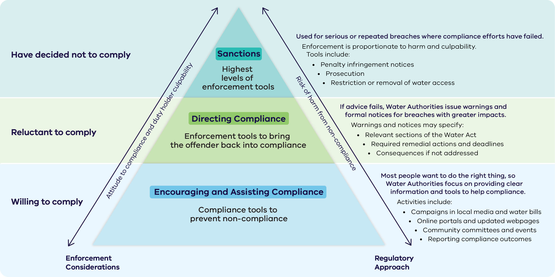

Text description of Figure 3: Compliance and enforcement approach
The compliance and enforcement approach is shown as a pyramid with a wide base and a narrow top. The wide base reflects that most regulatory activity happens at the lowest level. The pyramid has three levels. Two factors increase as you move from the base to the top:
- Attitude to compliance and duty holder culpability increases from ‘willing to comply’ at the base, to ‘reluctant to comply’ in the middle, to ‘have decided not to comply’ at the top.
Risk of harm from non-compliance increases from the base to the top.
The three levels, described from the base of the pyramid upwards, are:

Level 1 (base of pyramid) – Encouraging and Assisting Compliance
Duty holder attitude: Willing to comply.
Purpose: Compliance tools to prevent non-compliance.
Most people want to do the right thing, so Water Authorities focus on providing clear information and tools to help compliance. Activities include:
- Campaigns in local media and water bills
- Online portals and updated webpages
- Community committees and events
Reporting compliance outcomes

Level 2 (middle of pyramid) – Directing Compliance
Duty holder attitude: Reluctant to comply.
Purpose: Enforcement tools to bring the offender back into compliance.
If advice fails, Water Authorities issue warnings and formal notices for breaches with greater impacts. Warnings and notices may specify:
- Relevant sections of the Water Act
- Required remedial actions and deadlines
Consequences if not addressed

Level 3 (top of pyramid) – Sanctions
Duty holder attitude: Have decided not to comply.
Purpose: Highest levels of enforcement tools.
Used for serious or repeated breaches where compliance efforts have failed. Enforcement is proportionate to harm and culpability. Tools include:
- Penalty infringement notices
- Prosecution
- Restriction or removal of water access

Measuring Outcomes and Assessing Impact
Measuring outcomes and assessing impact is essential to improving regulation and building trust. The Department and Water Authorities continually evaluate effectiveness, seek feedback from the community, and commit to transparency. Practical measures and monitoring help identify what works and where improvements are needed.

What we collect
Qualitative: Field observations, feedback from customers and landholders, reports of issues and trends.
Quantitative: Water meter data, aerial imagery and compliance activity reports.

How we use it
Information is collated and assessed to identify improvements and confirm what is working well. Monitoring and evaluation processes may include plans such as Monitoring, Evaluation, Reporting and Improvement (MERI) frameworks, regional waterway strategies and local management rules.

Key steps
- Define evaluation questions and program logic to guide monitoring and reviews.
- Use quality management systems (e.g., ISO 9001) to embed continuous improvement.
- Publicly report on compliance and enforcement activities annually.
Measuring impact can be challenging, but practical measures and ongoing learning help ensure regulatory approaches remain effective, adaptable and responsive to emerging risks.

More Information and Support
Managing water and waterways is a shared responsibility.
The Department, Water Authorities, and the community all play a role in protecting Victoria’s water resources.

Reviews, Appeals and Complaints
If you receive a warning, direction to remediate, or a sanction from your Water Authority and would like to discuss the decision, contact your water corporation or catchment management authority directly.
The Department and Water Authorities do not provide legal advice. If you wish to seek a review or appeal of a decision, you should obtain independent legal advice.

Officer Conduct
Water Authority staff are accountable for their actions and decisions during investigations. They are required to act ethically, make informed decisions, and demonstrate professionalism and accountability.
If you believe staff have not acted fairly or reasonably, you can:
- Contact your relevant Water Authority, or
- Contact the Energy and Water Ombudsman Victoria (EWOV), an independent dispute resolution service.

For more information
For more information or to find your local water corporation or catchment management authority visit: Find your Water Authority
You can also explore:
- Water and Catchments web page – learn more about water management in Victoria
Engage Victoria website – opportunities to provide feedback on water‑related policies and regulations
If you have questions about compliance requirements, contact your local water corporation or catchment management authority.

Publication information

Acknowledgement of Victorian Traditional Owners
We acknowledge and respect Victorian Traditional Owners as the original custodians of Victoria’s land and waters, their unique ability to care for Country and deep spiritual connection to it.
We honour Elders past and present whose knowledge and wisdom has ensured the continuation of culture and traditional practices.
DEECA is committed to genuinely partnering with Victorian Traditional Owners and Victoria’s Aboriginal community to progress their aspirations.

Copyright
© The State of Victoria Department of Energy, Environment and Climate Action, July 2026.

Creative Commons
This work is licensed under a Creative Commons Attribution 4.0 International licence, visit the Creative Commons website (http://creativecommons.org/licenses/by/4.0/).
You are free to re-use the work under that licence, on the condition that you credit the State of Victoria as author. The licence does not apply to any images, photographs or branding, including the Victorian Coat of Arms, and the Victorian Government and Department logos.
ISBN 978-1-76176-902-3 (pdf/online/MS word)

Disclaimer
This publication may be of assistance to you but the State of Victoria and its employees do not guarantee that the publication is without flaw of any kind or is wholly appropriate for your particular purposes and therefore disclaims all liability for any error, loss or other consequence which may arise from you relying on any information in this publication.

Accessibility
To receive this document in an alternative format, phone the Customer Service Centre on 136 186, email customer.service@deeca.vic.gov.au, or contact National Relay Service on 133 677 or visit the National Relay Service website. This document is available on the DEECA website.
End of document.

