Western Region Sustainable Water Strategy
Developing a new strategy for the sustainable use of water resources across western Victoria




What is a sustainable water strategy?
Having a reliable and safe water supply is essential for the wellbeing and prosperity of all Victorians.
Our waterways also provide an enormous range of economic, cultural, environmental, and social values. Changes to our climate, landscape, and communities all impact our water supplies and water quality.
The development of a sustainable water strategy (SWS) is an important opportunity for water agencies, partners, stakeholders and the community to shape plans to secure our water supplies, improve efficient use of water, and protect waterways and water values into a drier and warmer future.

What is the area of the Western Region SWS?
The Western Region (Figure 1) extends from the southern Mallee in the north to the south-west coast, and from the Victoria/South Australia border in the west to the Avoca, Woady Yaloak and Gellibrand rivers to the east.
deeca.vic.gov.au
It includes the extensive Wimmera plains, the Grampians Ranges, the Western District plains and the coastal draining section of the Otway Ranges.
Figure 1: Map of Western Region SWS area

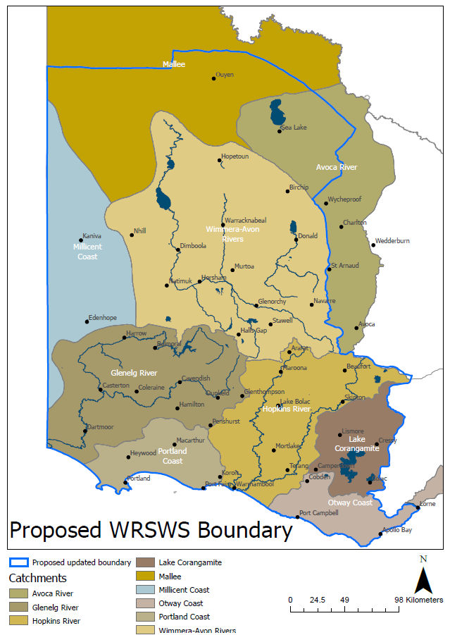

Why is the Western Region SWS being developed now?
The current Western Region SWS was finalised in 2011, following the Millennium Drought and completion of the Wimmera Mallee Pipeline Project.
Persistent drought and dry conditions, particularly in south-west Victoria, have created challenges to farmers and communities in western Victoria. The region’s community and economy are also changing, with shifts in agriculture, population, and industries all posing new challenges and opportunities for water use.
There’s been significant progress in water policy since 2011, including integrated water management and increasing Traditional Owner involvement in water and waterway management. Our understanding of future threats to water supplies from droughts, climate and land use change has improved, informed by additional monitoring and modelling data.
We have also seen advances in water infrastructure in parts of western Victoria such as roof water harvesting and reuse schemes and new pipelines supplying water for stock and domestic use. A new Western Region SWS provides the opportunity to understand these challenges and changes, consider new information, and set clear long-term directions for water policy and infrastructure with community across the region.

What is a new Western Region SWS likely to consider?

The new Western Region SWS is likely to consider:
- water supplies for livestock farms (including dairy industry), especially during droughts.
- access to water for Traditional Owners.
- alternative water supplies such as stormwater and recycled wastewater.
- flows for waterways during dry conditions.
- efficient water infrastructure to reduce losses from seepage and evaporation.
- trends in water availability and likely water demands.
- water licencing and trade.

Who is involved in developing a SWS?
There are statutory requirements to develop a SWS under the Water Act 1989 such as having:
- a consultative committee technical knowledge and Traditional Owner interests.
- a draft SWS that is open for public feedback for at least two months.
- an independent panel to provide advice to the Minister for Water on feedback on the draft SWS.
Community input is an important part of understanding local feedback, concerns, opportunities, and water values. Working groups, open to public expressions of interest, will also be established to provide technical and policy input to the new Western Region SWS.
This is expected to include:
- Key agencies with roles in managing water and waterways such as water corporations, catchment management authorities and Traditional Owner groups.
- Farming and other relevant industry groups.
- Environmental groups.
- Recreational groups focused on waterways (e.g. recreational fishing).
- Local governments and regional development bodies.

What is the timeline for a new Western Region SWS?
Figure 2: Indicative timeline of key steps in the Western Region SWS process. *Involves public consultation.

What has the current Western Region SWS led to?
Reporting on the implementation of the current Western Region SWS is available at water.vic.gov.au.
55 of the 69 actions from the 2011 Western Region SWS have been completed or are ongoing, leading to outcomes such as:
- Ministerial guidelines for groundwater-dependent ecosystems
- updated the operating rules of the Wimmera Mallee headworks system.
- rules to divert river flows for recreation in wet years
- revised urban water demand strategies
- protecting flows in the Millicent Coast Basin and Merri River
Lessons learnt through implementing the 2011 Western Region SWS identified challenges not contemplated in the current SWS and the necessity of additional guidance to deliver actions so that they effectively meet their original intent.
Overall, the Western Region SWS was an important step for the management of western Victoria’s water resources, helping to build knowledge and understanding and improving clarity of policy and management.

Interested in updates on the Western Region SWS and having your say?

Contact the Western Region SWS team at sws.team@deeca.vic.gov.au or 136 186 to be registered for updates on key milestones on the Western Region SWS.
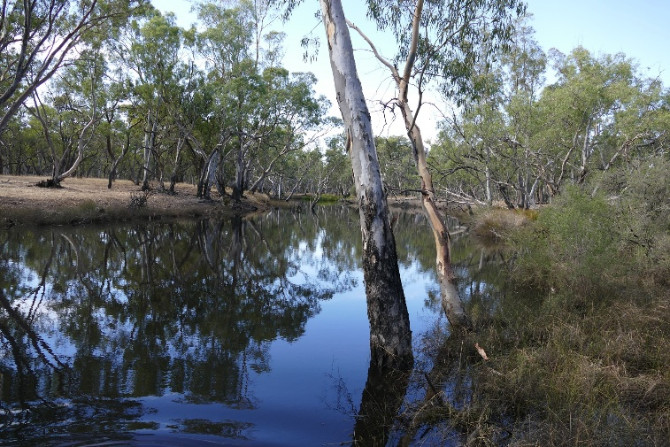

We acknowledge Victorian Traditional Owners and their Elders past and present as the original custodians of Victoria’s land and waters and commit to genuinely partnering with them and Victoria’s Aboriginal community to progress their aspirations.
© The State of Victoria Department of Energy, Environment and Climate Action, November 2025.
Creative Commons
This work is licensed under a Creative Commons Attribution 4.0 International licence, visit the Creative Commons website (http://creativecommons.org/licenses/by/4.0/).
You are free to re-use the work under that licence, on the condition that you credit the State of Victoria as author. The licence does not apply to any images, photographs or branding, including the Victorian Coat of Arms, and the Victorian Government and Department logos.
Disclaimer
This publication may be of assistance to you but the State of Victoria and its employees do not guarantee that the publication is without flaw of any kind or is wholly appropriate for your particular purposes and therefore disclaims all liability for any error, loss or other consequence which may arise from you relying on any information in this publication.
Accessibility
To receive this document in an alternative format, phone the Customer Service Centre on 136 186, email customer.service@deeca.vic.gov.au, or contact National Relay Service on 133 677. Available at DEECA website (www.deeca.vic.gov.au).

