MDBA’s Menindee Lakes Review
The importance of the Menindee Lakes to Victoria
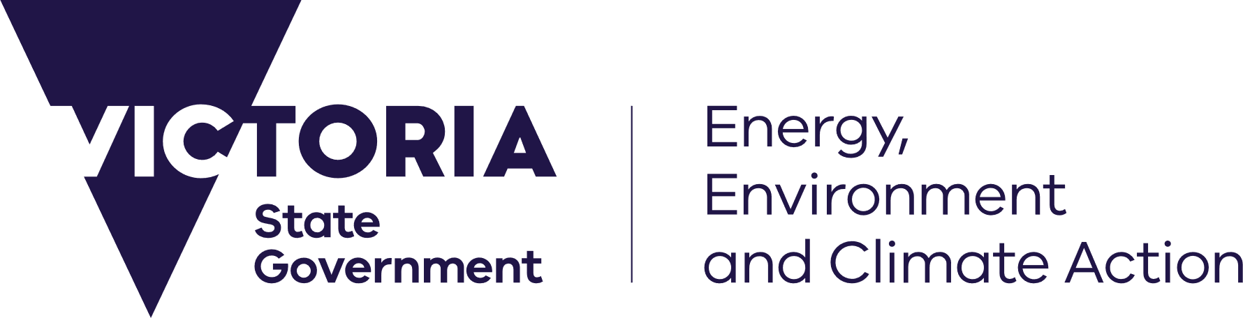








deeca.vic.gov.au

The Menindee Lakes play a crucial role in the southern Murray–Darling Basin, providing water resources, supporting river operations, and underpinning values for First Nations, environmental outcomes and local communities.
The Murray-Darling Basin Authority (MDBA) is currently undertaking a review of the operations and management of the Menindee Lakes System on behalf of Murray River Governments (Victoria, New South Wales, South Australia and the Commonwealth).

The Menindee Lakes
The Menindee Lakes, located on the Lower Darling (Baaka) River in far western New South Wales, are a series of interconnected lakes that play a crucial role in the Murray–Darling Basin.
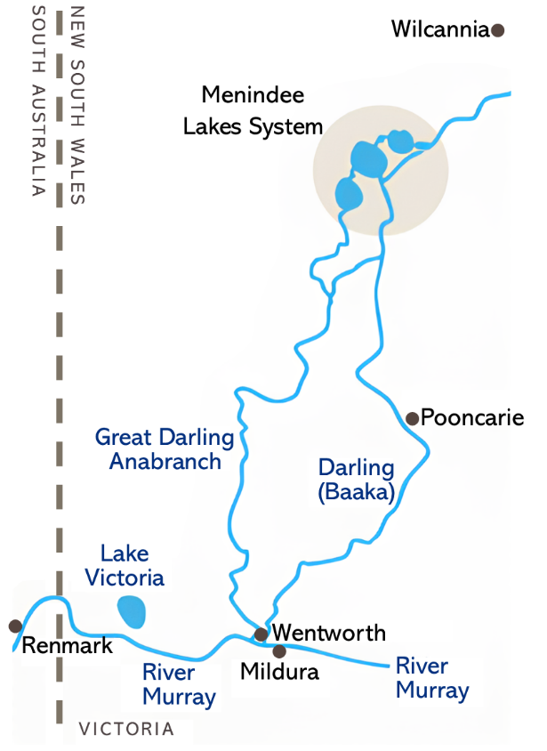

© Murray-Darling Basin Authority (MDBA) – ‘Menindee Review’

The importance of the Menindee Lakes to Victoria

How is water in the Lakes shared?
The Menindee Lakes were converted by NSW into a regulated water storage in the 1950s and 1960s to improve water security and develop the local irrigation industry. In 1963, joint Murray River Governments agreed to sharing arrangements under the Murray–Darling Basin Agreement to supply water to the Murray. Under the Agreement, joint governments pay a lease fee and contribute to operation and maintenance costs.
Under the Agreement all inflows to the Menindee Lakes System are shared 50:50 between Victoria and NSW when the volume of water in storage in the lakes is above 480 GL.
When the volume in the lakes drops below 480 GL control of the lakes and all inflows become exclusively available to NSW for drought management, until the volume in the lakes increases to above 640 GL.
More information about how water in the Menindee Lakes is shared is available on the MDBA’s website.

Why are the Menindee Lakes important for Victoria?
The Menindee Lakes are critical to Victoria and support a range of outcomes that benefit entitlement holders and communities in the Murray, including:

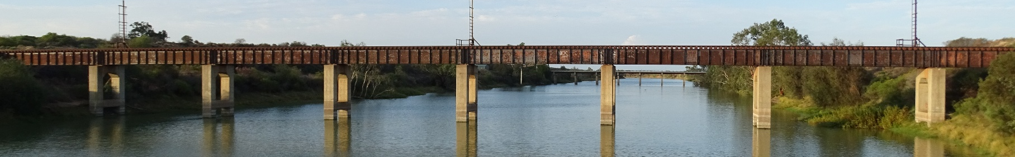
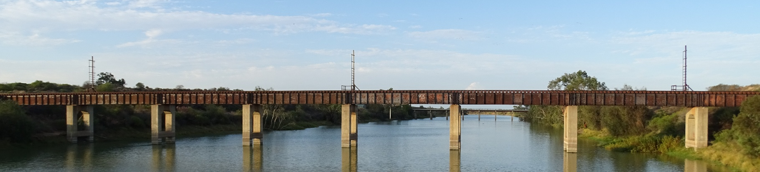
Reviewing the Menindee Lakes System
© State of Victoria, DEECA.

Why are operating arrangements at the

Menindee Lakes being reviewed?
Over recent years, the Menindee Lakes System has faced major challenges including severe drought, reduced inflows, water quality problems and large fish death events, with debate continuing about how water should be shared and managed.
Early parts of the review sought to identify key issues and challenges associated with the Menindee Lakes, including:



The review aims to explore operational, infrastructure and other management options for the best path forward for managing the Menindee Lakes for the long-term health and resilience of Basin communities, industries and the environment.
The current stage of the review looks to establish desired outcomes for the future operating arrangements of the Lakes and explore change options.
The sharing arrangements at Menindee mean that options to change the operations of the Lakes require Murray River governments’ support, including Victoria.
More information is available on the MDBA’s website.

How can I provide input to the review?
You can have your say on what the Menindee Lakes Review should consider during consultation being led by the MDBA throughout February-April 2026.
You can find more information, including engagement opportunities in Victoria, via the MDBA’s website.

Next Steps

What happens next?
Based on the feedback received in the first half of 2026, the MDBA will work with Murray River governments to prepare options for further consideration in late 2026.
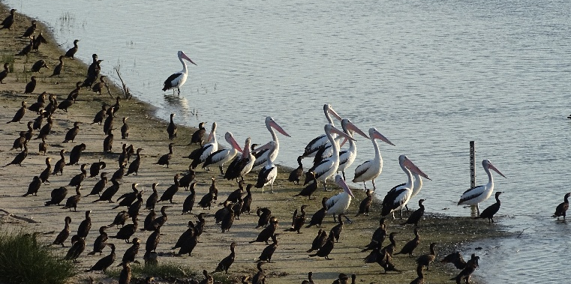
© State of Victoria, DEECA.

