What is the Sustainable Yield Assessment?
  - Sustainable Yield Assessment Fact Sheet
The Sustainable Yield Assessment provides important information to water managers and users, improving transparency and a shared understanding. It will enable more informed and adaptive decision making to support sustainable groundwater use, where reliability of supply and groundwater-dependent ecosystems are protected.
It is a consistent way to assess the risk from licensed groundwater extraction across the state, which means we can focus our efforts where they matter most, checking whether current management is working and, where needed, exploring other ways to manage the risk.

What is the Sustainable Yield Assessment?
The Sustainable Yield Assessment is an innovative approach with a strong technical underpinning that has been successfully trialled in Victorian groundwater systems, drawing on more than 50 years of groundwater level monitoring data.
It uses cost-effective, measurable parameters and it is easily repeatable so it can support adaptive management.
It is a simple but consistent way of comparing groundwater use against the sustainable yield to assess the relative risk in every groundwater system state-wide. This approach improves our shared understanding to inform sustainable groundwater management.
This is the first time DEECA has done an assessment of the impact of extraction on groundwater levels across all of Victoria and it has included assessment of over 1000 groundwater systems.
The Sustainable Yield Assessment uses monitoring data and historic use volumes, as well as climate change scenarios, to estimate the volume of groundwater that can be extracted while limiting drawdown to:
- 2 metres in unconfined systems which are shallow and more connecting to the surface environment; and,
- 10 metres in confined systems, which are much deeper and have little connection to the surface environment.
These drawdown limits may not be appropriate for all systems, however they provide a consistent statewide starting point to understand risk.

What is drawdown?
Drawdown is the drop in groundwater levels when water is pumped out or naturally flows away. Drawdown is a natural part of the water cycle and it is normal to see groundwater levels fluctuate seasonally, especially in unconfined systems. However, excessive or ongoing drawdown can increase risks to other users, surface water systems and groundwater-dependent ecosystems.
Figure 1: The Drawdown effect on groundwater levels
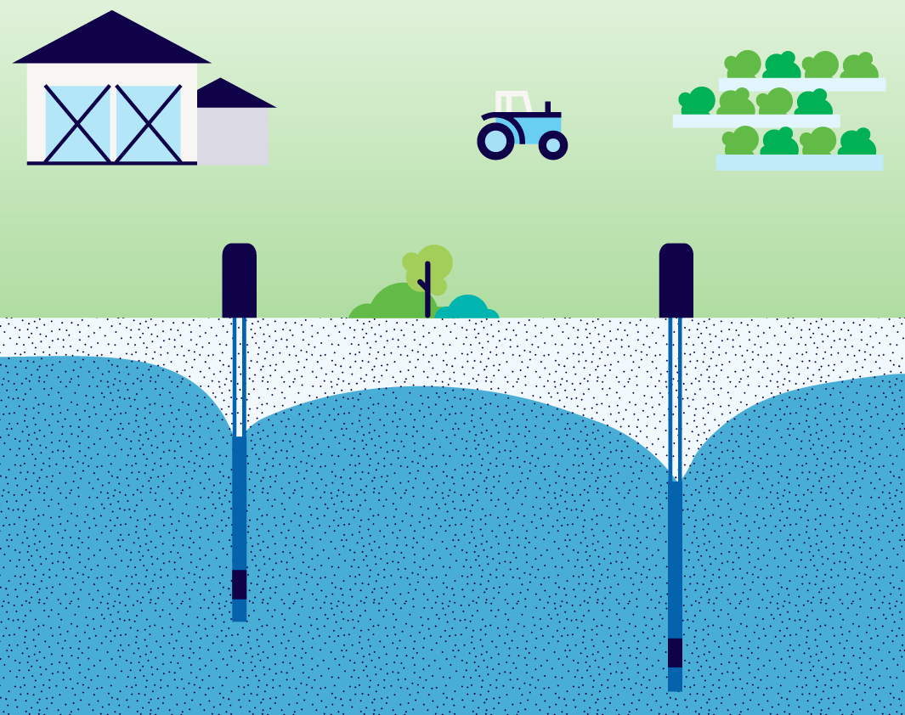

Why did we do the Sustainable Yield Assessment?
We know water users are already facing challenges as they face drying conditions and there is a growing interest in access to groundwater. We are responding to emerging challenges, such as climate change, while also exploring new opportunities, including the growing interest in utilising saline groundwater. This makes it even more important to ensure management decisions are based on the best available information.
A range of parameters are used to calculate the volume of available groundwater in groundwater systems. Complex numerical models often provide a more complete picture, but they require long lead times, as well as comprehensive and expensive data sets. These models are costly and take years to develop and keep updated, so they are only available for high-use systems in some parts of the state.
Additionally, most groundwater entitlement caps were set nearly 20 years ago, based on the volume of licences on issue at the time and limited technical information. The Sustainable Yield Assessment uses the information gathered over the past 20 years to provide a cost effective, and generic method that can be applied statewide and helps us to understand where risk may need to be more effectively managed, especially in the context of climate change.
Currently, groundwater use across the state is only around 35% of licensed entitlements, however, increased licensed use could put future sustainability and reliability of groundwater at risk. It is therefore important we use the best available information now to ensure we can manage groundwater sustainably into the future, before we see unacceptable levels of groundwater drawdown.

What did the Sustainable Yield Assessment find?
The Sustainable Yield Assessment found that in most groundwater systems, the volume of use is lower than the sustainable yield volume, which means most systems are not currently at risk.
There are a small number of systems where use is at, or above, the sustainable yield estimate. The Sustainable Yield Assessment found that ‘at risk’ systems are already well understood locally and being actively managed effectively by groundwater managers using existing management tools.
The Sustainable Yield Assessment also identifies systems which, while not at any immediate risk, may be at risk in the future as a result of increased legal use and climate impacts.

How did we ensure the assessment was technically robust?
An Independent Technical Review Panel (ITRP) provided an external check on the Sustainable Yield Assessment, giving confidence in the technical quality and suitability of the work. The ITRP concluded that the Sustainable Yield Assessment is a significant achievement for groundwater management in Victoria and provides a robust, science-based foundation to identify sustainability risks, inform future management decisions, guide adaptive restrictions on use and support the review of entitlement caps.
Find out more about how the Sustainable Yield Assessment will be used below

Additional information:
- Fact Sheet: How the Sustainable Yield Assessment be used
- Sustainable Yield Assessment Overview Report
- Fact Sheet: How groundwater is managed
- Fact Sheet: How sustainable yields are calculated

Publication information

Acknowledgements
We acknowledge and respect Victorian Traditional Owners as the original custodians of Victoria’s land and waters, their unique ability to care for Country and deep spiritual connection to it.
We honour Elders past and present whose knowledge and wisdom has ensured the continuation of culture and traditional practices.
DEECA is committed to genuinely partnering with Victorian Traditional Owners and Victoria’s Aboriginal community to progress their aspirations.

Copyright
© The State of Victoria Department of Energy, Environment and Climate Action, 2026.

Creative Commons
This work is licensed under a Creative Commons Attribution 4.0 International licence, visit the Creative Commons website (http://creativecommons.org/licenses/by/4.0/).
You are free to re-use the work under that licence, on the condition that you credit the State of Victoria as author. The licence does not apply to any images, photographs or branding, including the Victorian Coat of Arms, and the Victorian Government and Department logos.
ISBN 978-1-76176-762-3 (pdf/online/MS word)

Disclaimer
This publication may be of assistance to you but the State of Victoria and its employees do not guarantee that the publication is without flaw of any kind or is wholly appropriate for your particular purposes and therefore disclaims all liability for any error, loss or other consequence which may arise from you relying on any information in this publication.

Accessibility
To receive this document in an alternative format, phone the Customer Service Centre on 136 186, email customer.service@delwp.vic.gov.au, or contact National Relay Service on 133 677 or visit http://www.accesshub.gov.au/. Available at DEECA website (www.deeca.vic.gov.au).
End of document.

