|  |
| --- |
| Digitising historic records for effective domestic wastewater management |
|  |

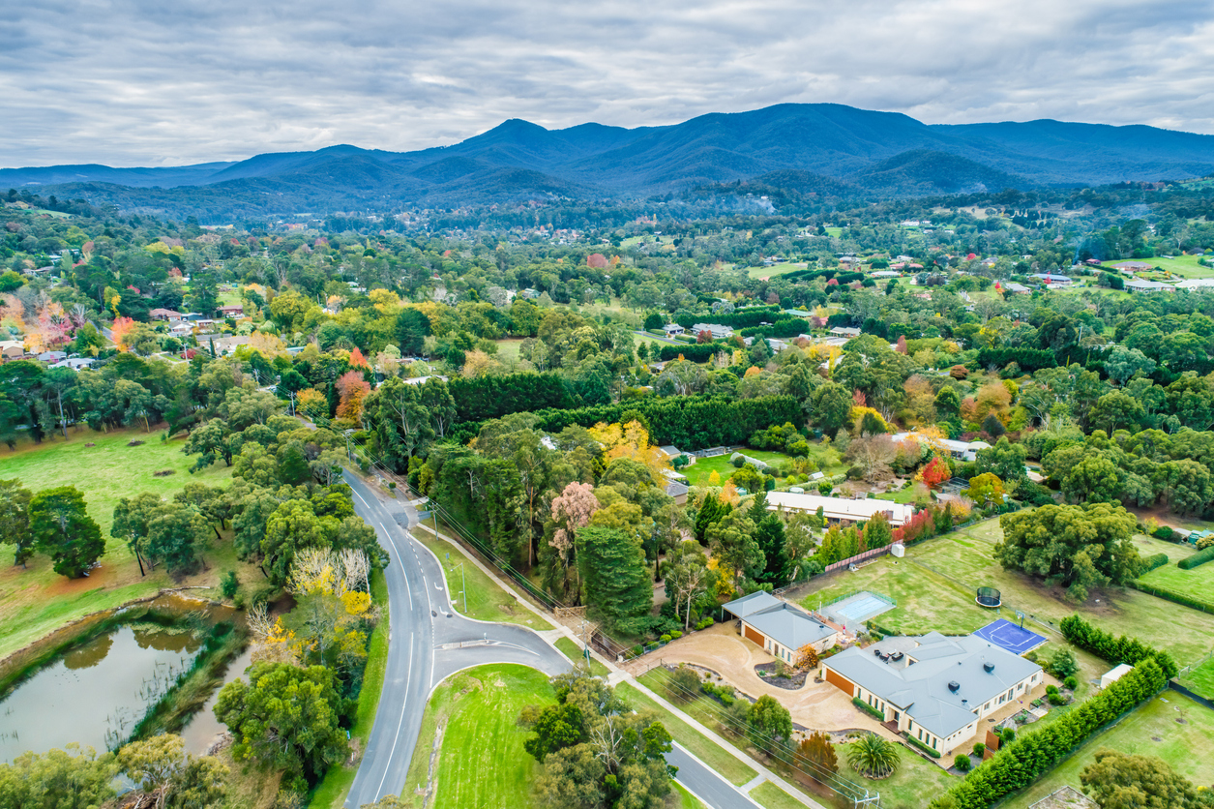

Yarra Ranges Council, which includes Healesville (pictured), hosts around 22,000 active onsite systems.

With the second highest number of active onsite systems for domestic wastewater in Victoria, Yarra Ranges Council is undertaking a major digitisation program of historic records for these systems.

The partnership project with Yarra Valley Water will have both immediate and longer-term benefits, including more effective compliance and risk management of active onsite systems and a platform to investigate areas for potential sewer connection.

## The problem

Onsite systems that are poorly maintained can cause significant public health and environmental risks through the contamination of surface and groundwater resources as well as soils.

The Yarra Ranges in Melbourne’s east has around 22,000 active onsite systems for domestic and commercial properties. This represents around 8% of all active systems within Victoria and is the second highest for any municipality in the state.

The active systems in Yarra Ranges Council vary in age, level of treatment and service history. The majority of systems are believed to be more than 30 years old and provide minimal treatment of effluent prior to offsite disposal to an easement or roadside drain. They pose a serious risk to public health and the environment, which is a major concern for the Yarra Ranges given it is popular with visitors, has many local businesses and has a unique natural environment consisting of drinking water catchment areas and a portion of the Yarra River.

The issue is further compounded by unknown service conditions, due to system information or permit conditions not being readily available. Council has had an effective system to collect and record data for current permit applications, but for older, legacy systems it was a different story. Internal and external requests for information about legacy systems (including permits or plans that are not available in Council’s current data management system) can take on average 3-4 working days to access because hard copy record archives are kept in an offsite location. Also, much of the archived data is out of date.

The issue was highlighted in the 2018 Victorian Auditor-General’s Office (VAGO) audit *Managing the Environmental Impacts of Domestic Wastewater*. The Department of Environment, Land, Water and Planning (DELWP), Environment Protection Authority (EPA), local government and water corporations are responding to the audit’s recommendations. Five recommendations were made to Yarra Ranges Council, including the need for an effective data management system to collect accurate information about the number, location and performance of onsite systems within the municipality.

## The steps taken to address the problem

Yarra Ranges Council is undertaking a digitisation project in partnership with Yarra Valley Water to document legacy onsite systems, including any original files recorded before Council amalgamation in 1994 and current data in its management system.

The term ‘legacy system’ has been incorporated from the language used in the VAGO audit to describe older onsite systems. For this project, a ‘legacy’ system refers to:

* Systems that have reached or exceeded their recognised life expectancy; and
* Systems that don’t meet the current requirements outlined in Australian Standards and the Code of Practice including sizing, treatment level and point of effluent disposal.

Since November 2020, two data entry officers were tasked with identifying and documenting approximately 12,760 individual wastewater system records within the Yarra Ranges, with the aim to complete 600 records per week (depending on the information available for property and system identification).

The digitisation process includes two stages of operation which are running concurrently.

### Stage 1: Identify the property

The first stage involves identifying the subject property using information from the onsite system plans, Council records and external mapping systems.

### Stage 2: Add file to the electronic records

Once the subject property has been confirmed, the file is digitised and added to the electronic records of the identified property.

### Next steps

Following the completion of Stages 1 and 2, the information will be entered into Council’s current data management system (Stage 3). These entries will be determined by the availability of information from the historic files on legacy systems and future reporting requirements for domestic wastewater management.

The digitisation project will assist Council to meet two additional recommendations of the VAGO audit, including the development of an education program for owners and operators of active onsite systems and a rolling inspection program for active systems in high-risk areas.

## The results

Beyond core business, the digitisation project is the largest investment in active onsite systems Yarra Ranges Council has undertaken to date. Good progress has been made with 52% of the 12,760 known properties identified (Stage 1) and 88% of those files registered electronically (Stage 2) as at April 2021.

Progress of Stage 1 and Stage 2 of the digitisation project as at 23 April 2021.

As multiple records have been found within individual files, the actual total of legacy system records has increased to around 17,000 records. It is expected to continue to increase as Stage 1 progresses.

The finalisation of the digitisation project will assist Council in:

* Confirming properties for which onsite system records exist
* Enabling authorised Council officers to access information in real time when dealing with internal planning referrals, requests for information and wastewater complaints
* Providing detailed information to Yarra Valley Water to assist with risk assessment and community sewerage program development.

## The challenges and how they were met

### Limited or missing information on legacy systems

A major challenge for Council includes limited information within some historic files, and the risk that not all records of active onsite systems are available. This is largely due to the amalgamation of four Shires (Sherbrooke, Lilydale, Healesville and Upper Yarra) in 1994 to create the Yarra Ranges Council, as each Shire had different ways of recording their active systems.

Other barriers that have arisen when accessing records have included changes in property ownership and further amendments to property dwellings and property boundaries since the files were originally recorded.

To help combat this, Council is identifying as many properties as possible in Stage 1 to create a shortlist of unidentified properties. As the project progresses, further discussion will be required to manage this list, including the use of alternative mapping systems (such as Google Maps).

### Transition to Stage 3

Further challenges are expected to arise as the project transitions to Stage 3, including interpreting documents that have insufficient information or labelling of existing onsite systems. There are also limitations in adding information to existing property records on the current data management system.

## Lessons learnt

### 1. You can’t manage what you don’t measure

At the core of this project is a lack of knowledge around the type and location (within property boundaries) of active onsite systems within Yarra Ranges Council.

The first step to more effective management of active systems, particularly those that are performing poorly, starts with clear records and documentation to help Council oversee these systems and develop actions aimed at achieving more effective domestic wastewater management.

### 2. Strategic projects progress when there is strong momentum and investment

Domestic wastewater management has been a challenge for Yarra Ranges Council in the past. The digitisation project stopped and started many times but gained significant momentum in 2021.

While the VAGO audit was the catalyst for this progress, there has been a stronger commitment from Council towards effective domestic wastewater management through the recognition of potential issues. The community supported this focus in public submissions to the draft Yarra Strategic Plan in 2020. This resulted in the employment of a wastewater officer within Council and two business support officers to complete the digitisation work.

This progress underscores the organisational support, resourcing and commitment required for effective domestic wastewater management.

### 3. Behaviour change starts with increased awareness and understanding

Yarra Ranges Council found that residents and business operators were often surprised when they learnt that onsite systems have limited capacity for treatment and disposal of effluent and that it is still a common occurrence for wastewater to be discharged to the environment despite the recognised public health risk.

This underlines the importance of effective education to raise awareness of domestic wastewater and onsite systems, with an emphasis on how owners and operators can better manage their systems.

## Beyond results

Once completed, the project will provide Council with valuable wastewater information including:

* The location of active onsite systems such as treatment tank, pipework and effluent fields
* The size of treatment tanks and effluent fields
* The age, level of treatment and point of discharge of systems
* The number and type of active systems within the municipality for inspection and reporting requirements
* Permit conditions including maintenance requirements
* The potential effluent loading on individual systems
* Where best to invest Council resources and funding for domestic wastewater management to respond to high risks
* The potential to examine domestic wastewater management requirements of collective suburbs and streets rather than individual properties.

In the future, the project will support and inform other programs and initiatives, such as combining spatial locations with the digitisation data, and linking information to dedicated water sub-catchment areas within the municipality.

There is potential for the information to support collaborative opportunities, particularly with Yarra Valley Water around data sharing and investigation of areas to target for potential sewer connections.

The project also supports broader integrated water management (IWM) outcomes, particularly regarding more effective and affordable wastewater systems as detailed in the *Yarra IWM Strategic Directions Statement* (DELWP, 2018) and *Water for Victoria – Water Plan* (DELWP, 2016).

## Conclusion

The digitisation project will provide a more effective data management system for Yarra Ranges Council to record current information and access historic information on its active onsite systems, including the system types and where they are located. This will provide a more complete data set to assist in Council’s responses to relevant enquiries and overall management.

It will act as a strong platform to provide more relevant and targeted information to owners and operators of onsite systems, and better target high risk areas through a rolling inspection program. It will also provide collaborative opportunities for Yarra Ranges Council to work with partner organisations such as Yarra Valley Water.

The digitisation project currently employs two full time business support officers with funding received from the Working for Victoria program (January to June 2021) and Yarra Ranges Council (July to December 2021).

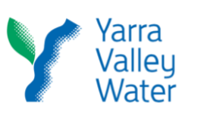 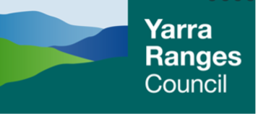

|  |
| --- |
| **Key messages**   * The digitisation of historic onsite system files can assist in more effective domestic wastewater management, particularly for Councils with a high number of active systems * The data can enable better responses to enquiries, risk management of onsite systems and a targeted approach to compliance, regulation and education of owners and operators. * A digitisation platform can provide opportunities for future collaboration with water corporations to investigate potential areas for sewer connections. |

## Further reading

* [*Yarra IWM Strategic Directions Statement (DELWP, 2018*](https://www.water.vic.gov.au/__data/assets/pdf_file/0018/412416/10696_DEL_IWMF_Yarra_SDS_web_UPDATED-FEB-2019.pdf)*)*
* [*Water for Victoria*](https://www.water.vic.gov.au/__data/assets/pdf_file/0030/58827/Water-Plan-strategy2.pdf) *– Water Plan (DELWP, 2016)*
* [*Managing the Environmental Impacts of Domestic Wastewater (VAGO, 2018)*](https://www.audit.vic.gov.au/report/managing-environmental-impacts-domestic-wastewater?section=)
* [*Guide to the proposed final Environment Protection Regulations (EPA, 2020)*](https://www.epa.vic.gov.au/about-epa/publications/1753-1)*.*

|  |  |
| --- | --- |
| © The State of Victoria Department of Environment, Land, Water and Planning 2021  LogoThis work is licensed under a Creative Commons Attribution 4.0 International licence. You are free to re-use the work under that licence, on the condition that you credit the State of Victoria as author. The licence does not apply to any images, photographs or branding, including the Victorian Coat of Arms, the Victorian Government logo and the Department of Environment, Land, Water and Planning (DELWP) logo. To view a copy of this licence, visit http://creativecommons.org/licenses/by/4.0/  Printed by  ISBN (print) [How to obtain an ISBN or an ISSN](https://library.intranet.vic.gov.au/client/en_AU/vglsweb-depi/?rm=ISBN0%7c%7c%7c1%7c%7c%7c0%7c%7c%7ctrue)  Disclaimer  This publication may be of assistance to you but the State of Victoria and its employees do not guarantee that the publication is without flaw of any kind or is wholly appropriate for your particular purposes and therefore disclaims all liability for any error, loss or other consequence which may arise from you relying on any information in this publication. | Accessibility  If you would like to receive this publication in an alternative format, please telephone the DELWP Customer Service Centre on 136186, email [customer.service@delwp.vic.gov.au](mailto:customer.service@delwp.vic.gov.au) , or via the National Relay Service on 133 677 [www.relayservice.com.au](http://www.relayservice.com.au). This document is also available on the internet at [www.delwp.vic.gov.au](http://www.delwp.vic.gov.au). |