|  |
| --- |
| Engaging communities  on dam safety  A guide for dam owners  August 2015 |

|  |
| --- |
| Image size |

|  |
| --- |
| *Imagery*  Front cover: Toorourrong Reservoir, Whittlesea. *Image courtesy of Melbourne Water.*  *Acknowledgements*  DELWP would like to thank all contributors who have offered their time, knowledge and expertise in the development of this guide. In particular, DELWP would like to recognise the organisations listed below, the Dam Safety Advisory Committee and Davwil Designs & Management Services.    © The State of Victoria Department of Environment, Land, Water and Planning 2015    This work is licensed under a Creative Commons Attribution 4.0 Australia licence. You are free to re-use the work under that licence, on the condition that you credit the State of Victoria as author. The licence does not apply to any images, photographs or branding, including the Victorian Coat of Arms, the Victorian Government logo and the Department of Environment, Land, Water and Planning (DELWP) logo. To view a copy of this licence, visit <http://creativecommons.org/licenses/by/4.0/>  ISBN 978-1-74146-752-9 (print) ISBN 978-1-74146-753-6 (pdf)  **Accessibility**  If you would like to receive this publication in an alternative format, please telephone the DELWP Customer Service Centre on 136 186, email [customer.service@delwp.vic.gov.au](mailto:customer.service@delwp.vic.gov.au) or via the National Relay Service on 133 677 [www.relayservice.com.au](http://www.relayservice.com.au). This document is also available on the internet at [www.delwp.vic.gov.au](http://www.delwp.vic.gov.au)  **Disclaimer**  This publication may be of assistance to you but the State of Victoria and its employees do not guarantee that the publication is without flaw of any kind or is wholly appropriate for your particular purposes and therefore disclaims all liability for any error, loss or other consequence which may arise from you relying on any information in this publication. |

Contents

Dams in Victoria 2

About this guide 3

IAP2 public participation spectrum 4

Planning and managing effective engagement 5

Engaging your communities on dam safety 6

Where to find further information 16

Appendix: Table 1 - Engagement techniques overview 17

Dams in Victoria

Victoria has about 450,000 dams – this number shows how important dams are to the economy and our way of life. Dams have multiple uses including farming, water supply, hydro-power and recreation. Some dams in Victoria play an incidental role in reducing flooding.

Dam safety management is fundamental to minimising risks to communities who live within their footprint. Effective engagement about the safe operation and maintenance of dams is a vehicle that can be used to develop trusted relationships and create understanding and awareness as part of building more resilient communities.

The importance of dam safety

Dam safety is about managing dams to an acceptable level of safety that takes into account risks to life, property, essential services and the environment.

Australia has a good dam safety record and the likelihood of a major dam failure is very low. Nevertheless, the history of serious dam failures internationally is testimony to the importance of maintaining comprehensive dam safety management programs.

Under the *Water Act 1989* dam owners are responsible for dam safety and accountable for the damage their dams may cause if they fail.

To ensure the safety of dams, owners are required to implement certain controls, such as safety management programs, monitoring and operational measures.

About the role of the Department

The Department of Environment, Land, Water and Planning (DELWP) provides policy, guidelines and oversight to dam owners for the safety of dams in Victoria.

DELWP, licensing authorities and the Emergency Management Commissioner have powers to undertake emergency action where there is an immediate dam safety risk to the community.

Dam safety governance

Dam safety management in Victoria occurs within a hierarchy of interconnected activities guided by State legislation and policy regulated through delegated licensing authorities (see Figure 1).

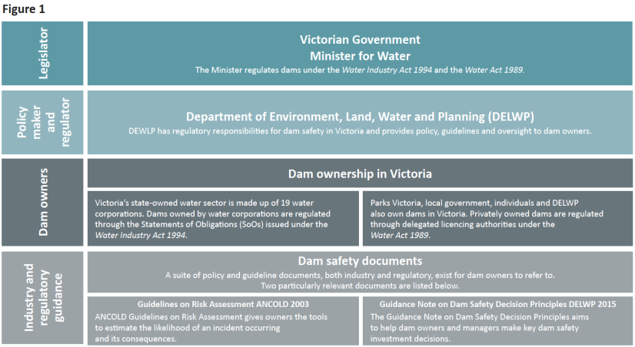

About this guide

With the responsibility of owning and maintaining a dam comes the responsibility of engaging with the community about safety.

The objective of this guide is to set out the drivers and principles for engaging communities on dam safety. This guide draws together techniques and case studies so that dam owners can prioritise, develop and apply strategies to engage with their communities.

|  |
| --- |
| **Five key drivers for engaging on dam safety** |
| 1. **Due diligence** **and duty of care**.   Dam owners have a legal obligation to demonstrate due diligence and a duty of care to communities living near dams.   1. **Meeting industry expectations**.   Current industry guidelines expect communities are made aware of dam safety practices and risk management.   1. **Government policy**.   Dam owners are responsible for the safety of their dams. Community engagement is also an integral part of emergency management.   1. **Being a good neighbour**.   Dam owners have a social responsibility to build community awareness about the risks posed by dams and how these risks are managed.   1. **Good business practice**.   Good relationships with the community will be critical in the event of a dam safety incident and may help to keep people safe. Strong relationships also help to reduce reputational and corporate risks. |

|  |
| --- |
| **Dam safety engagement principles**   * Every dam owner should be able to simply and clearly explain their role and responsibility in managing dams and provide an overview of their safety management program to the community. * Dam owners should be open to explaining the risk based approach to dam safety management together with their decision making processes to the community. * Engagement programs should be developed based on best practices set by the International Association for Public Participation (IAP2) and the National Strategy for Disaster Resilience: Community Engagement Framework Handbook 6. * Developing effective engagement strategies should take a partnership approach with government, businesses and the community, and may require specialist assistance from communication and engagement practitioners. * A progressive approach to engagement is recommended, from using tools and techniques to create general awareness about dam safety to involving specific stakeholders and community groups in programs and initiatives. |

IAP2 public participation spectrum

The IAP2 Federation has developed the spectrum to help groups define the public’s role in any public participation process (see Figure 2). Moving through the spectrum from left to right – inform through to empower – there is a corresponding increase in expectation for public participation and impact. While ‘inform’ represents a relatively low level of public participation, ‘empower’ represents an increase in expectations and an increased level of public impact.

Effective engagement is about selecting the most appropriate level of participation relative to the purpose. It is not uncommon for agencies to promise the public more potential influence than is actually possible. For instance, most agencies are not legally able to promise decision making authority. Empowering stakeholders and communities to make decisions requires a rigorous capacity building program. Therefore, agencies typically focus efforts on the first four levels - inform, consult, involve, and collaborate.

A model for engagement

A broad range of information and guidance exists about community engagement and public participation.

Many Victorian Government departments and agencies reference the International Association for Public Participation (IAP2) spectrum of public participation to decide how to work with stakeholders and communities. The IAP2 Federation is an internationally recognised organisation for advancing public involvement and participation in government programs and services. Australian Government departments at all levels use IAP2 as the industry guideline for community engagement.

The National Strategy for Disaster Resilience: Community Engagement Framework Handbook 6 and DEWLP’s Effective Engagement resource booklets are strongly informed by the IAP2 model, as is this guide. The IAP2 spectrum is used in this guide to assist dam owners in determining the level of participation relevant to their projects and activities, taking into account specific factors and desired outcomes. These levels are accompanied by a promise of what the community can expect through their engagement.

**Figure 2**

|  |  |  |  |  |  |
| --- | --- | --- | --- | --- | --- |
|  | INFORM | CONSULT | INVOLVE | COLLBABORATE | EMPOWER |
| Public participation goal | To provide the public with balanced and objective information to assist them in understanding the problem, alternatives, opportunities and/or solutions. | To obtain public feedback on analysis, alternatives and/or decisions. | To work directly with the public throughout the process to ensure that public concerns and aspirations are consistently understood and considered. | To partner with the public in each aspect of the decision including the development of alternatives and the identification of the preferred solution. | To place final decision making in the hands of the public. |
| Promise to the public | We will keep you informed. | We will keep you informed, listen to and acknowledge concerns and aspirations, and provide feedback on how public input influenced the decision. We will seek your feedback on drafts and proposals. | We will work with you to ensure that your concerns and aspirations are directly reflected in the alternatives developed and provide feedback on how public input influenced the decision. | We will work together with you to formulate solutions and incorporate your advice and recommendations into the decisions to the maximum extent possible. | We will implement what you decide. |

**International Association of Public Participation, IAP2 Spectrum retrieved from** [**https://www.iap2.org.au/resources/iap2s-public-participation-spectrum**](https://www.iap2.org.au/resources/iap2s-public-participation-spectrum)

Planning and managing effective engagement

Different dams will have different safety requirements based on their size, location, age and construction type. Just like planning your dam safety management program, you will need to consider your specific requirements as part of tailoring an effective engagement program. This may involve using a mix of different tools and techniques and scaling the level of participation to support projects and programs over time. Your community engagement program will need to be flexible, sustainable and continually reviewed.

As part of planning your engagement program, we recommend you think about the following steps.

Steps to start engaging

1. **Understand your community – its values, strengths and priorities.**

|  |  |
| --- | --- |
| Understanding communities is the first step in determining your engagement approach. Ask the community about their level of understanding, interests, perceptions and values as part of determining their engagement needs. | Questions to think about:  What stakeholders or community groups might be interested or impacted?  What are the things that are important to them?  How does this project or issue look from where they stand? |

1. **Recognise the complexity – dam safety can be hard for the community to understand.**

|  |  |
| --- | --- |
| Develop easy and familiar ways of talking about your activities, projects and programs. Agree on consistent language and messaging – these are foundational elements of clear communication. | Questions to ask:  What are we trying to communicate?  Is the language we’re using easy to understand and relate to?  Could we use graphics or pictures to help us explain this? |

1. **Prioritise your engagement efforts – determine the goals and measures of success**

|  |  |
| --- | --- |
| Choose the level of participation to suit your objectives. Refer to the IAP2 spectrum (see Figure 2) to help you determine the right level of participation. Dam owners should prioritise their engagement efforts to reflect risk across their dam portfolio. Don’t promise ‘collaboration’ if you only want to inform. | Questions to ask:  What is the focus of engagement?  What are we trying to achieve through engagement?  What aspects of the decision or project could the community influence in some way? |

1. **Identify partners – tap into existing networks and use local knowledge and experience.**

|  |  |
| --- | --- |
| Identify potential partners and existing networks, including local councils and emergency services, to support your program. Consider working with existing and emerging community groups. | Questions to ask:  Who can help us to deliver the work that we need to do?  Who can help us share knowledge and information?  How can engagement lead to more effective outcomes for all? |

1. **Determine the right techniques – plan, design and manage.**

|  |  |
| --- | --- |
| It is rare to use just one technique or tool. Instead methods must work together, be integrated and timely. When selecting techniques, consider how they will be scheduled and what resources you might need. Each technique should build on the one before. | Questions to ask:  What mix of techniques will meet the objectives?  Do we need extra resources or specialist advice or assistance?  Do we have commitment and support from the top of our organisation? |

Engaging your communities on dam safety

This guide establishes a framework for ‘why’ and ‘how’ dam owners should communicate and engage with the community about aspects of dam safety. Building on industry and regulatory guidance, this framework encourages dam owners to develop a progressive approach to community engagement, from choosing to provide information about dam safety practices, to seeking community participation in emergency management and planning infrastructure investment for the future.

Dam safety engagement framework

The following framework identifies objectives for engaging on the four identified aspects of dam safety and provides examples of techniques that might be used (see Figure 3).

The techniques listed are to be considered and used based on the needs of individual programs. Just as different techniques can be designed to be effective at different levels on the IAP2 spectrum, techniques can also be used for different aspects. For instance, online information can be used to support engagement across all aspects of dam safety.

**Figure 3**

|  |  |  |  |
| --- | --- | --- | --- |
| Aspects of dam safety | | | |
|  | | | |
| Objectives for engaging | | | |
| Provide clear and balanced information to the community.  Connect with the community to understand their needs and expectations.  Make information available. | Share information, questions and positions to obtain ideas, feedback and knowledge or an understanding of objectives and expectations.  Seek out and facilitate the involvement of those potentially affected by or interested in works. | Partner with agencies and communities to support action and work collectively.  Build and share the capacity to understand risk, accept responsibility and implement initiatives. | Share information with and between communities.  Come to a mutual understanding about priorities and ensure responsibility for decisions and actions. |
| Techniques for engaging | | | |
| Online information  Printed information  Social media  Briefings and presentations  Surveys  Polls  Interviews  Focus groups | Online information  Printed information  Information hotline  Briefings and presentations  Site tours and field trips  Community drop-in sessions  Forums and workshops  Reference and advisory groups  Door knocks  Media releases  Social media | Online information  Printed information  Social media  Briefings and presentations  Forums and workshops  Reference and advisory groups  Doorknocks  Expert panels | Online information  Printed information  Briefings and presentations  Forums and workshops  Site tours and field trips  Community drop-in sessions  Reference and advisory groups  Expert panels  *.* |

For more information about techniques that can be used when engaging with stakeholders and communities see Table 1 on page 23.

Engaging to build knowledge and awareness

Why engage?

Dams provide drinking water, hydroelectric power, flood control, recreation and many other benefits to people and economies. But if they fail, dams can pose significant risks to people, property and the environment down stream.

Engaging with the community about dam safety, including inspection plans and monitoring programs, can help build awareness about the vital role dams play while improving community knowledge and understanding about dam safety management practices. Building awareness also creates the opportunity to proactively address important topics and issues, such as how dams operate during flood events.

Providing information about dam management practices will help to give the community more confidence about their safety. It also sets the context for more complex concepts including the risk based approach and planning for dam infrastructure investment, which owners may want to engage the community on as part of a progressive approach.

Engagement level

* Inform

Engagement objectives

* To provide clear and balanced information to the community about dam safety and the risks associated with living near dams.
* Connecting with the community to understand their needs and expectations.
* Making information about dam safety programs available to the public.

Potential techniques

* Online information
* Printed information
* Social media
* Briefings and presentations
* Surveys
* Polls
* Interviews
* Focus groups

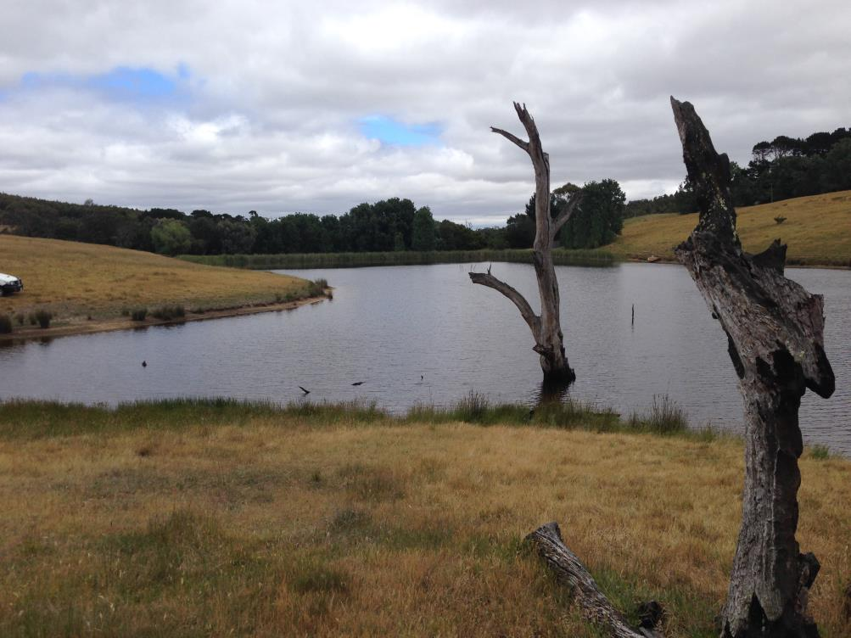

Engaging for upcoming projects

Why engage?

Victoria has a good dam safety record but some old dams were built as far back as the 1860s. Although these dams were constructed to the best standards of the day, design standards and understanding of natural events have improved significantly, and owners need to identify what work can be done to improve dam safety.

In practice, the timeframe for implementing a major dam safety upgrade from identification of risk through to investigations, approvals, design, implementation and commissioning can range from a few years to up to about ten years.

The more you engage with your community and stakeholders about your dam safety management practices, the easier it will be to communicate with them if or when works need to take place. Stakeholder and community input can valuably contribute to the design and construction phases of new and dam upgrade projects.

Engagement level

* Consult
* Involve
* Collaborate

Engagement objectives

* Sharing information, questions and positions to obtain ideas feedback, knowledge or an understanding of objectives and expectations about proposed dam upgrade works.
* Seeking out and facilitating the involvement of all who are potentially affected by or interested in the proposed dam upgrade works.

Potential techniques

You may want to consider using:

* Online information
* Printed information
* Information hotline
* Briefings and presentations
* Site tours and field trips
* Community drop-in sessions
* Forums and workshops
* Reference and advisory groups
* Door knocks
* Media releases
* Social media

Case study – Upgrading a heritage reservoir

Context

A large reservoir was required to be upgraded to meet contemporary standards and to reduce community risk. The reservoir, which was a heritage site, needed significant upgrades to structures including spillways and embankments. The upgrades had the potential to change park environs and the heritage structures of the site.

The reservoir’s surrounding park was very popular with park users because of its historic nature and well maintained grounds. The park had been closed for a number of years as a result of bushfire damage and the park manager was running a parallel community engagement process to inform its restoration.

The community had been greatly impacted by fire and the loss of the reservoir park and reacted very negatively to the proposed dam upgrade, particularly in relation to the loss of the reservoir’s heritage aspects. A community action group was formed and they campaigned to stop the upgrade works.

Engagement approach

A key challenge for the owner was to find ways to help the community understand the complexities of the project, the heritage site and the safety risks posed by potential dam failure. As part of engaging the community during this difficult period, site walks, town hall meetings and drop-in sessions were held.

Engagement events were advertised in local newspapers and media and bulletins focussed on reinforcing messages about the essential nature of upgrade works. A community reference group was formed to help advise the project team about how to restore the site and heritage aspects to the community’s satisfaction.

Although dam engineers were available for the community to speak with, the level of technical information presented was hard for the community to understand. While dam managers have a language of their own which is technically correct, this language is often difficult for the community to comprehend.

Outcomes

Following on from the engagement process, the dam owner opted to revise the design and construction methodology to incorporate the community’s feedback. The upgrade works and reinstated reservoir area now echo the aspirations of the community, with the restoration of heritage elements and reinterpretation of the site to complement its history and connection with the local community.

Since this project, the dam owner has continued to build community understanding, establishing ways of talking to property owners and local residents about complex dam safety concepts. Language is critical and the owner’s regular communications now include clear and consistent messages about dam safety.

Key tips

* Take the opportunity to engage early before changes or upgrades are required. This will help to build the community’s understanding well before any physical works take place.
* Early engagement should include a process of understanding your community and stakeholders, including their different interests and perspectives. It is important to acknowledge community values, especially for sites of community significance.
* Silence shouldn’t be interpreted as community support. Silence could mean the community needs help with understanding the information they’ve been given and the impacts of the project.
* Technical expertise and information needs to be presented to the community in a relatable form, including visual representations and schematics that are easy to explain and engage with.
* Use consistent language with a balance of technical detail and relatable information. Focus on getting the messages across in a way that the community will understand.

Engaging for emergency management

Why engage?

Communities affected by dams, especially those downstream, have a significant stake in the responsible management of dams and the preparedness of dam owners and emergency agencies to respond to floods. An informed and prepared community can provide valuable input to dam owners and enhance the ability of emergency managers to reduce the impacts of flooding.

Through effective engagement the community should be supported to express their concerns, share experiences, influence solutions and, most importantly, have access to timely and relevant information. Dam owners should develop their emergency engagement strategies based on the principles of the National Strategy for Disaster Resilience: Community Engagement Framework Handbook 6.

Engagement level

* Involve
* Collaborate

Engagement objectives

* Dam owners partner with agencies and communities to support action and work collectively to ensure they are prepared in the event of an incident.
* Dam owners and communities have the capacity to understand risk and accept appropriate levels of responsibility for taking actions as part of emergency planning.

Potential techniques

* Online information
* Printed information
* Social media
* Briefings and presentations
* Forums and workshops
* Reference and advisory groups
* Door knocks
* Expert panels

In addition to these tools and techniques, you should consider involving community representatives in emergency exercises and keep a managed database of downstream residents for targeted engagement.

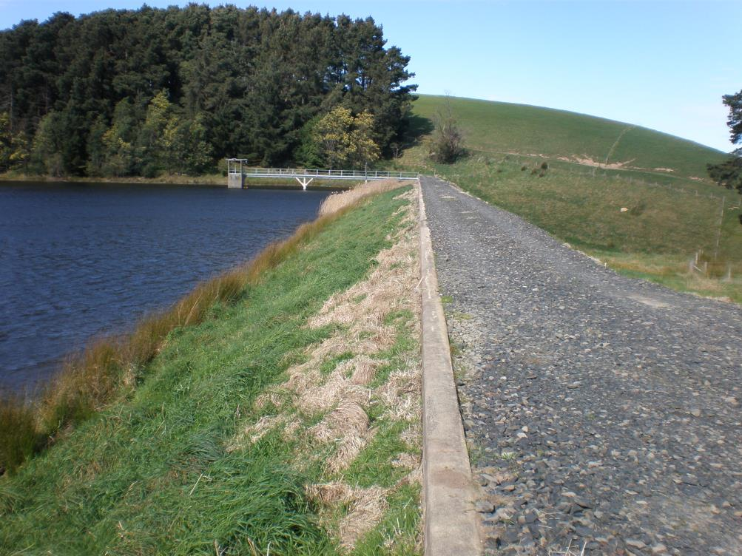

Case study – Improving engagement after a flood event

Context

Leading up to a flood event there had been severe drought, bushfires and no major flood in the area for over a decade. Over this time, awareness of flood preparedness and response had diminished in the community and a number of residents were unaware they were living on a floodplain.

Prior to flooding occurring, the dam was less than half full. This combined with early releases from the dam helped to provide some flood attenuation. Nevertheless, the peak outflow was much greater than the previous flood on record, and severe flooding occurred downstream. The town and its people had to be evacuated.

The dam owner had provided emergency information to response agencies and some downstream landowners but many community members received only short notice or none at all. In addition to anger over warning times, the community thought better dam management practices could have reduced the severity of flooding.

Engagement approach

Every year, Australian communities face devastating losses caused by disasters. Engagement plays a key role in building disaster resilience and connecting the knowledge, strengths and experience of the community with the expertise, resources and capabilities of emergency management agencies.

The challenge for this dam owner was two-fold. They had to engage about the operational constraints related to managing water levels and the risks associated with holding water back, while also involving the community in improving emergency management to better prepare for future potential flood events.

Outcomes

Proactive engagement became a focus for this dam owner. Since this incident the owner has renewed their flood warden system and they now hold regular meetings to facilitate the flow of timely information to the community. Updates about managing storage levels are regularly posted on their website and social media.

To supplement formal warnings, the dam owner has established a well-understood process for providing information to the community. The result is a community that is much better informed and more supportive of the dam operator’s efforts in upholding good dam management practices while protecting public safety.

Key tips

* Effective community engagement should be part of day-to-day business in the prevention, preparedness, response and recovery phases of emergency management for dam owners.
* The community should be involved in decisions or actions that potentially affect or interest them. Over time you can build connected networks and trusted relationships through active involvement.
* Understanding and responding to community needs and expectations is a continuous exercise and engagement approaches and tools need to be tested and evaluated against changing dynamics.
* Developing efficient ways of sharing and distributing information is essential to ensuring coordinated communication with organisations and individuals especially in relation to emergency management.
* Identifying and addressing barriers to engagement is crucial to ensuring information is accessible to audiences in diverse situations and participation is accessible to all.

Case study – Engaging downstream residents in emergency planning

Context

This dam owner has implemented a number of cost effective, non-structural, safety risk reduction measures at their dam sites. In realising the potential risk to downstream properties, the dam owner had a focus on emergency management.

Measures implemented included developing site specific emergency response plans, sourcing rockfill and sand filter stockpile materials, identifying local contractors with suitable plant and equipment to contact in case of emergency, and improving monitoring technology and surveillance activities.

In particular, the owner focussed on developing site specific emergency warning plans that incorporated the contact details of downstream residents. The aim of these plans was to engage the local community in emergency preparedness and strengthen the dam owner’s emergency management plans.

Engagement approach

Building community resilience and raising awareness of the site specific emergency response plans was a focus for the dam owner. To achieve these objectives, the dam owner held one-on-one meetings with property owners located within the identified inundation areas of each dam.

The aim of meeting individually with residents was to educate property owners about the potential risks, to outline how these risks were being managed, and to discuss the shared role in emergency response – dam owner, emergency services and the community.

A toolkit was developed to guide each conversation as part of ensuring the information presented was consistent and accessible. For most meetings, staff members were invited inside the resident’s home to talk through the information and answer any questions.

Each meeting focused on five key areas:

* History of dam management at the site
* Monitoring and surveillance
* Potential risks
* Site specific emergency response
* Emergency warning procedures

At the end of each discussion, the dam owner took the resident’s details to add to the site specific emergency response plan and gave them further information about how they would be contacted if an emergency situation was to occur.

Outcomes

The engagement approach succeeded in building community understanding of dam safety risks. Additionally, the one-on-one approach contributed to building local resilience by raising awareness of the community’s role in preparing for, responding to and recovering from an emergency incident.

Key tips

* Meet stakeholders at a time and location that is convenient for them. Holding meetings and events during standard working hours is not always the best time to engage with people.
* Ensure you understand the sensitivities of the topic you are talking about and present the information in a way that informs and alerts but does not alarm the community.
* Tailor the information to your audience. What the community need to know will differ from what government, emergency services and other organisations need to know.

Engaging about planning for the future

Why engage?

Planning for future infrastructure investment for upgrades and remediation works involves making decisions on ‘if’ and ‘when’ to undertake projects. Engaging on long term planning can therefore be challenging for any dam owner.

Alongside the responsibility for dam safety, owners should assume that neighbours surrounding dams expect that these assets will be well maintained to ensure their ongoing safety.

The risk based approach ensures continuous and progressive safety improvements to dams and is supported by industry and regulatory guidelines. Dam owners should identify acceptable investment and pricing pathways to achieve life safety and economic risk reduction, and have robust justification for making decisions not to pursue further risk reduction.

As part of the risk based approach, owners should talk to the community about their safety decision principles and processes for making dam safety investments. Where appropriate, dam owners could also consider where seeking feedback could assist them in making these decisions.

Engagement level

* Inform
* Consult
* Involve

Engagement objectives

* Sharing information with and between communities and agencies about the risk based approach to dam safety and plans for infrastructure investment.
* Coming to a better understanding about how dam safety priorities are determined and ensuring owners are able to take responsibility for decisions and actions.

Potential techniques

You may want to consider using:

* Online information
* Printed information
* Briefings and presentations
* Forums and workshops
* Site tours and field trips
* Community drop-in sessions
* Reference and advisory groups
* Expert panels

Case study – Involving stakeholders in decision making

Context

As part of a dam improvement program, the owner undertook design reviews of its top five priority dams. The aim of the review process was to identify any deficiencies in the dams when measured against contemporary engineering standards.

The knowledge of required improvements to the dams coupled with funding constraints and limited resources demanded a process for prioritising future works. The dam owner commenced a risk assessment process to quantify the risk posed by each dam and to determine a program of improvement works.

Engagement approach

To assist in determining a priority list of future improvement works, the dam owner chose to assemble a stakeholder reference panel as part of their engagement program. Members of the panel were drawn from regulatory agencies, local government, emergency services and local user groups.

Before the panel’s first meeting most members knew very little about dams or the risk assessment process. A program of meetings and site visits for the panel initially focussed on education in relation to dam operation, design aspects of dams and risk assessment concepts.

As the process developed, results from design reviews and risk assessments were presented for the panel to review and comment on. The process was an iterative one, requiring the panel to feedback on the range and calculation of consequences being used to revise risk assessments.

Outcomes

The process succeeded in bringing panel members to a common understanding on risks associated with dams. The need for improvement was recognised, as was the requirement to rank improvement works in descending order of societal risk.

The consultative process informed decision making, allowing stakeholders and the dam owner to consider a diverse range of assumptions, perspectives, requirements and objectives. Feedback from the panel helped the dam owner to prioritise and commit to a substantial ongoing program of upgrade works.

Key tips

* Education plays a key role in any engagement process. Make sure your participants have all the information they will need to contribute to the engagement process in a meaningful way.
* Effective engagement is built around the premise that the feedback provided by stakeholders and community will contribute to the decision making process.
* Effective engagement promotes sustainable decisions by recognising and communicating the needs and interests of all participants, including decision makers.
* Good engagement requires an investment in time and money, but it can save money in the long run. Consult with those who are most affected by your decisions and allow ample time for this to be done.
* A robust decision making process can mitigate or reduce risk factors. Being transparent about your decision making processes will help the community see the reasoning behind your investment program.

**Case study – Working collaboratively to reduce population at risk**

As part of looking at non-structural ways to reduce population at risk for communities downstream of one of its dams, the owner detailed survey work and hydraulic modelling to scope dam break flooding extents. The data gathered showed areas of a local camping site in a caravan park were at risk of inundation in the event of a dam break incident.

Although the risk of a dam break was low, proactive engagement with the caravan park owner was key to implementing a potential solution. The solution would involve planting out areas of the park to definitively prevent camping in these areas. Meetings were held with the park owner to discuss the results of the survey and the potential safety risks.

The caravan park owner was receptive to the solution and discussions were held about the types of plants that would be used. Based on the feedback received, the dam owner agreed to plant out the camping areas with native trees and shrubs, enhancing the natural aesthetics of the site. It is now no longer possible to pitch a tent or park a car or caravan within the estimated inundation area.

This outcome shows the importance of working collaboratively with stakeholders to manage dam safety risks.

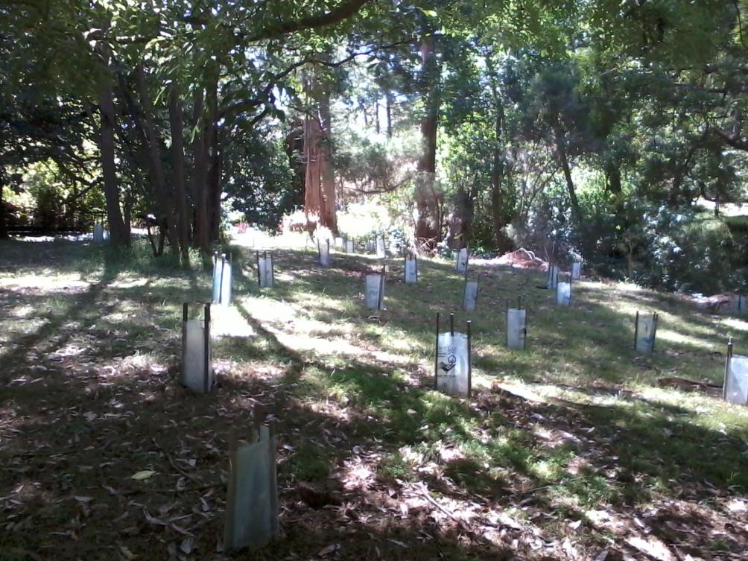

Where to find further information

Websites

*International Association for Public Participation*

[www.iap2.org.au](http://www.iap2.org.au)

*Department of Environment, Land, Water and Planning: Effective Engagement (resource website)*

<http://www.dse.vic.gov.au/effective-engagement>

*Attorney General’s Department – Emergency Management – Community Awareness and Education*

[*http://www.em.gov.au/Emergencymanagement/communityengagement/Pages/default.aspx*](http://www.em.gov.au/Emergencymanagement/communityengagement/Pages/default.aspx)

Documents

Attorney General’s Department – National Strategy for Disaster Resilience: Building the resilience of our nation to disasters – Council of Australian Governments – February 2011

[*https://www.em.gov.au/Documents/1National%20Strategy%20for%20Disaster%20Resilience%20-%20pdf.PDF*](https://www.em.gov.au/Documents/1National%20Strategy%20for%20Disaster%20Resilience%20-%20pdf.PDF)

Attorney General’s Department – Emergency Management Australia – National Strategy for Disaster Resilience: Community Engagement Framework Handbook 6

<https://www.em.gov.au/Publications/Australianemergencymanualseries/Documents/National%20Strategy%20for%20Disaster%20Resilience%20Community%20Engagement%20Framework.PDF>

Department of Environment, Land, Water and Planning – Guidance Note on Dam Safety Decision Principles 2015

[*http://www.depi.vic.gov.au/__data/assets/pdf_file/0006/176946/FINAL-Guidance-Note-4-June2012.pdf*](http://www.depi.vic.gov.au/__data/assets/pdf_file/0006/176946/FINAL-Guidance-Note-4-June2012.pdf)

Engagement techniques overview

This provides an overview of some techniques that can be used when engaging with stakeholders and communities.

**Table 1**

|  |  |  |  |  |  |  |  |
| --- | --- | --- | --- | --- | --- | --- | --- |
| Technique | Useful for | Key tips | IAP2 Spectrum level most suitable for the technique | | | | |
| **Information hotline**  A toll free, well publicised telephone number the community can call to seek information, ask questions and provide feedback. Hotlines may include recorded messages. | * Supporting any large or complex initiative. * Providing a ready source of information. | Determine who will have responsibility in the team for answering calls.  Designated team contacts must be committed to providing prompt and accurate responses in a timely manner.  Minimum response times for enquiries can be used as a key indicator to measure engagement performance. | **Inform**  **✔** | **Consult**  **✔** | **Involve** | **Collaborate** | **Empower** |
| **Printed materials**  Examples include letters, fact sheets, bulletins, newsletters, brochures, FAQs and reports. Involves any printed material directly mailed, emailed or other wise delivered to the community. | * Keeping the community informed about a project or issue. * Reaching community members who may not come to meetings or go online. * Making sure community members receive important information including status reports, meeting notices and comment forms. * Reaching larger target audiences across geographically dispersed locations. * Facilitating the communication of the public involvement process. | Keep written materials short and simple to ensure readability.  Focus on making them easy for the reader to engage with using images and visuals to help explain complex concepts.  Include comment forms with progress reports, newsletters and other mailings, using them to get feedback.  Better return rates will be achieved if you include a postage-paid, addressed envelope or design the mail-back portions as postage paid self mailers. | **✔** |  |  |  |  |
| **Online information**  Examples include a website or an electronically based information repository or web-based platform. | * Creating an information repository available anywhere at anytime to anyone with an internet connection. * Reaching larger target audiences across geographically dispersed locations. * Supporting other communication tools. | Determine who will be responsible for keeping online materials up-to-date and relevant.  Gather feedback on the layout of online materials prior to publishing. Make sure the information can be easily accessed.  Use a mixture of text, images, video and audio to engage your audience.  Keep file sizes small so materials can be easily downloaded.  Promote the website through other communication materials.  For websites with a comments section, determine who in the team is responsible for retrieving comments and responding to issues and queries.  Monitor how much traffic the site receives and the type of information people are looking at. This will help you identify what people are most interested in. | **✔** | **✔** |  |  |  |
| **Online forum**  Includes any web-based platform where participants can post messages or comments. | * Reaching larger target audiences across geographically dispersed locations. Can be accessed at anytime by anyone with an internet connection. * Providing less vocal community members with an opportunity to share their views. * Gathering feedback from a range of different perspectives. | Clearly outline the rules for participation – e.g. monitoring inappropriate comments.  If you are collecting personal information, you will need to include a privacy statement about how the data will be used, stored and disclosed.  Outline how feedback will be used in the consultation and decision making process.  Determine who will have responsibility for monitoring and responding to comments.  Minimum response times for enquiries can be used as a key indicator to measure engagement performance. | **Inform**  **✔** | **Consult**  **✔** | **Involve**  **✔** | **Collaborate** | **Empower** |
| **Comment forms**  Also includes surveys, questionnaires and polls. | * Collecting community feedback – both quantitative and qualitative. * Providing less vocal community members with an opportunity to share their views. | Be careful not to use leading questions to shape public opinion.  Present the information in creative ways to encourage the community to engage with the form, poll or questionnaire.  Be clear on the purpose of the form, timing for collecting comments and how the feedback will be used.  If you are collecting personal information, you will need to include a privacy statement about data will be used, stored and disclosed.  Establish a clear process for collecting and analysing the information to ensure it can be used strategically. | **Inform** | **Consult**  **✔** | **Involve** | **Collaborate** | **Empower** |
| **Interviews**  One-on-one style meetings or a small group focussed discussion designed for a specific objective with selected community members or representatives. | * Building rapport and trust with the community. * Understanding individual perspectives on an issue. * Bringing out solutions or ideas. * Getting feedback on specific issues. | Provide background information to the participant beforehand so they can formulate questions.  Hold the meeting at a convenient time, at a safe and neutral location. You want the participant to feel comfortable.  Ensure the interviewer has a thorough understanding of the project or issue.  Be on time, polite and neutral.  Inform the participant about how their feedback will be used and what follow-up information they will receive. | **Inform**  **✔** | **Consult**  **✔** | **Involve** | **Collaborate** | **Empower** |
| **Focus groups**  A small group facilitated discussion/interview, used to gauge public opinion. Groups can be randomly selected or hand picked, and usually contain 4-12 members. | * Engaging with under-represented community members. * Understanding community attitudes or values about a particular issue or project. | Clearly communicate the purpose of the focus group and intended outcome.  Use a skilled facilitator who has a good understanding of the project or issue.  Hold the discussion in a safe and neutral location. | **Inform** | **Consult**  **✔** | **Involve** | **Collaborate** | **Empower** |
| **Briefings and presentations**  Presentation to organised groups to raise awareness, impart information, answer questions and generate interest in participation. | * Creating awareness about a project or issue. * Building rapport and trust with the community. * Identifying interested community members and their issues. | Understand your audience beforehand to anticipate likely issues or concerns.  Ensure the presenter has a good understanding of the presentation material so they can answer questions.  Make sure the presentation is not too long and the content is presented creatively. Use a mix of text, video and audio, if possible.  Bring information you can leave behind or promote online materials. | **Inform**  **✔** | **Consult**  **✔** | **Involve** | **Collaborate** | **Empower** |
| **Drop-in sessions**  An informal setting where community members can drop in at their convenience to ask questions, gather information or talk to team members about their issues or concerns. | * Providing specific information to interested community members. * Understanding individual issues. * Providing less vocal community members with an opportunity to share their views and ask questions. | Prepare information and materials beforehand and anticipate any likely questions or concerns.  Make sure you hold the session at a convenient time and location.  Bring additional communications materials such as fact sheets, information graphics and 3D models.  Better representation will be achieved if you hold the session at an existing community event e.g. school fete, local markets. | **Inform**  **✔** | **Consult**  **✔** | **Involve** | **Collaborate** | **Empower** |
| **Door knocks**  Team members visit local residents to offer information relevant to them. | * Providing specific information to a target audience. * Understanding individual issues. * Building rapport with the community. | Ensure the responsible team members have a good understanding of the project or issue.  Bring additional communication materials to help project teams communicate key information.  Take two members of the team for safety and support.  Make sure you record the issues raised in an appropriate format. | **Inform**  **✔** | **Consult**  **✔** | **Involve** | **Collaborate** | **Empower** |
| **Forums and workshops**  A public forum where participants break off from the larger group to work in smaller groups. | * Reaching audiences from culturally diverse backgrounds. * Promoting different ideas and perspectives. Community members are encouraged to share their individual points of view and listen to those of others. * Exploring sensitive issues or overcoming barriers. * Gathering specific information from community members that can feed directly into the decision making process. | Use facilitators that have a good understanding of the project or issue.  Make sure the forum is well structured and tightly facilitated to achieve the desired level of participation.  Use a variety of activities to keep the groups engaged.  Allocate time for the smaller groups to report back to the larger group. This will allow the community to understand different perspectives and common themes.  Establish a clear process for collecting and analysing the information, as this can be time consuming. | **Inform**  **✔** | **Consult**  **✔** | **Involve**  **✔** | **Collaborate**  **✔** | **Empower** |
| **Site tours and field trips**  Opportunities for members of the public to learn about or see a particular topic first-hand by going on a tour or visiting a site. | * Building rapport and trust. * Providing a visual of the project or issue. * Understanding individual issues. | Determine who in the team will lead the site tour. Use a team member with a comprehensive understanding of the project or issue.  Make sure the site tour is well structured and guided. Clearly communicate when feedback or questions can be received.  Establish a clear process for collecting and recording questions raised. | **Inform**  **✔** | **Consult** | **Involve** | **Collaborate** | **Empower** |
| **Reference and advisory groups**  A body of representatives convened to meet on a regular basis over time to provide advice to the decision maker. | * Understanding a diverse range of perspectives. * Involving community members in the decision making process. * Overcoming conflicts of interest. | Make sure you have a diverse representation of the community. It is important to include community members who will have a direct influence on the decision making process.  Establish clear terms of reference for the group. Consider involving the group in the development of the terms of reference and circulate at the initial meeting.  Clearly outline the level of influence the group will have on final project decisions.  Use a senior member of the project team to facilitate the group. Make sure they have a strong understanding of the project and its issues.  Use a range of tools and techniques to communicate and engage with the group. This will ensure attendance remains consistent over the project lifecycle.  Determine the frequency of the meetings with the group. Frequency of the meetings may change depending on where you are in the project lifecycle.  Capture feedback and questions in the meeting minutes. Circulate a copy of the minutes with an agenda prior to each meeting. |  | **✔** | **✔** | **✔** | **✔** |
| **Expert Panel**  A meeting or conference to discuss a particular topic involving multiple speakers or experts in the field. | * Providing an opportunity for experts to share their views. * Promoting different ideas and perspectives. * Gathering expert feedback on a particular issue. | Make sure you have a range of presenters who will provide balanced views.  Determine clear governance and meeting expectations for the panel, including terms of reference.  Outline how the feedback will be used in the decision making process.  Determine who will have responsibility for responding to comments.  Establish a process for capturing ideas and issues. Issue a summary of the discussion to all participants. | **✔** | **✔** |  |  |  |
| **Media including social media**  Includes media releases and updates to social media channels including Facebook and Twitter. | * Keeping the community informed about a project or issue. * Reaching community members who may not come to meetings or go online (media only). * Reaching larger target audiences across geographically dispersed locations. * Supporting other communication tools. | Used to provide information but also drive engagement by directing the community to engagement activities including forums, workshops, information sessions etc.  Use a combination of text, photos, audio and video to engage your audience.  Determine the level of engagement for social media platforms. They can be used to both inform and gather feedback.  Determine who is responsible for updating and monitoring social media platforms.  Minimum response times for enquiries can be used as a key indicator to measure engagement performance. | **✔** |  |  |  |  |