delwp.vic.gov.au

|  |
| --- |
| Water Sector Climate Change Adaptation Business Cases  A guide to developing adaptation business cases for use in the Victorian water sector |

|  |  |
| --- | --- |
|  |  |

|  |
| --- |
| Acknowledgment  We acknowledge and respect Victorian Traditional Owners as the original custodians of Victoria's land and waters, their unique ability to care for Country and deep spiritual connection to it. We honour Elders past and present whose knowledge and wisdom has ensured the continuation of culture and traditional practices.  We are committed to genuinely partner, and meaningfully engage, with Victoria's Traditional Owners and Aboriginal communities to support the protection of Country, the maintenance of spiritual and cultural practices and their broader aspirations in the 21st century and beyond. |
| © The State of Victoria Department of Environment, Land, Water and Planning 2020  LogoThis work is licensed under a Creative Commons Attribution 4.0 International licence. You are free to re-use the work under that licence, on the condition that you credit the State of Victoria as author. The licence does not apply to any images, photographs or branding, including the Victorian Coat of Arms, the Victorian Government logo and the Department of Environment, Land, Water and Planning (DELWP) logo. To view a copy of this licence, visit <http://creativecommons.org/licenses/by/4.0/>  **ISBN** 978-1-76105-340-5 **(pdf/online/MS word)**  Disclaimer  This publication may be of assistance to you but the State of Victoria and its employees do not guarantee that the publication is without flaw of any kind or is wholly appropriate for your particular purposes and therefore disclaims all liability for any error, loss or other consequence which may arise from you relying on any information in this publication. |

|  |
| --- |
| Water Sector Climate Change Adaptation Business Cases  A guide to developing adaptation business cases in the Victorian Water Sector |

Acknowledgements

|  |  |  |  |
| --- | --- | --- | --- |
|  |  |  |  |

The input from water agencies and other stakeholders during the development of these guidelines is greatly appreciated.

Please address any ongoing feedback to the Manager, Water Sector Climate Change Mitigation and Adaptation, Water and Catchments | Department of Environment, Land, Water and Planning at water.climatechange@delwp.vic.gov.au.

Disclaimer

|  |  |  |  |
| --- | --- | --- | --- |
|  |  |  |  |

The content of this document is considered general guidance, based on best practice at the time of writing.

As outlined in the [Pilot Water Sector Climate Change Adaptation Action Plan](https://www.water.vic.gov.au/__data/assets/pdf_file/0019/410851/WSAAP-Web-version-FINAL_v2.pdf), the Department of Treasury and Finance (DTF) and local government entities are required to be engaged on this action. DTF were engaged on the preparation of this Guidance Note, however due to unique circumstances relating to COVID-19 pandemic and subsequent resource and time restrictions, were unable to provide input at the time of its preparation. Persons from local government entities in Victoria were engaged on the preparation of this Guidance Note, however there was the perspective that some of this work was already being captured in existing work such as the Integrated Water Management Forums, as well as the unique circumstances presented by the COVID-19 pandemic and subsequent limited resources. Both DTF and local government entities will have access to the final version of this document and any outcomes that may prove useful and have applicability to organisations other than just Victorian water entities.

It was also required that this guidance share the common traits of successful and unsuccessful business cases. Through research, it was determined there was little accessible examples of successful and also unsuccessful business cases particularly, however there is significant information shared on successful business cases. It was also found business cases just for adaptation were rare, however there were many successful examples of business cases with adaptation elements.

Table of Contents

1. Executive Summary 4

2. Introduction 5

This guidance note addresses a key action in Victoria’s Pilot Water Sector Climate Change Adaptation Action Plan 5

Responding to key challenges relating to the preparation of adaptation business cases as identified by water sector stakeholders 5

2.1 This Guidance Note 6

2.1.1 How has this Guidance Note been prepared? 6

2.1.2 Who should use this Guidance Note? 6

2.2 Why an adaptation business case? 6

2.3 Further information: the policy context and latest climate science and projections 7

Policy context 7

Climate Science and Projections 8

Legislative and policy drivers for climate change adaptation 9

2.4 Overview: Structure of this Guidance Note 11

3. Adaptation business cases: key challenges 12

4. Elements of a successful adaptation business case 14

4.1 Step 1 – Problem and benefit articulation 16

4.2 Step 2 - Information gathering 17

4.3 Step 3 - Economic analysis of options 19

4.4 Step 4 – Decision Making 21

5. Economic Assessment Techniques 23

5.1 Multi Criteria Assessment (MCA) 28

5.2 Cost Effectiveness Analysis (CEA) 30

5.3 Rapid Cost Benefit Analysis (rapid CBA) 31

5.4 Cost benefit analysis (CBA) 34

5.5 CBA with Monte Carlo simulation (Monte Carlo analysis) 35

5.6 Real options analysis 37

6. Successful business case examples from Victorian water entities 39

6.1 North East Water (NEW) Bright Off-river Water Storage 39

6.2 West Gippsland Catchment Management Authority (WGCMA) infrastructure options for the lower Latrobe River wetlands 41

7. Appendices 43

Appendix A Existing resources relating to climate change adaptation business cases in the water sector 44

National Climate Change Adaptation Research Facility (NCAARF) study 45

Key elements of a business case for climate change adaptation 46

How to mount a business case for climate change adaptation 48

Water Service Association of Australia (WSAA) Climate Change Adaptation Guidelines 49

Managing Climate Change Risk: Guidance for Directors and Executives of Water Corporations and Catchment Management Authorities, DELWP (2019) 51

AS 5534-2013 Climate Change Adaptation for settlements and infrastructure - a risk-informed approach 51

Department of Treasury and Finance (DTF) Sustainable Investment Guidelines – for release in 2020 54

Summary 54

Appendix B Summary of climate risks and adaptation strategies 55

Appendix C Business Case Template 56

Appendix D Pilot Water Sector Climate Change Adaptation Action Plan – List of Actions 62

# Executive Summary

Victorian Water Corporations and Catchment Management Authorities (‘water entities’) can expect the challenges associated with climate change, such as protecting assets and providing consistency and quality of service, to increase in both frequency and magnitude as our climate continues to change. Victorian water entities will need to adapt if they are to continue to provide reliable services under an increasingly challenging climate. This includes adapting our approach to business cases. As the risks to our infrastructure, assets, and processes change, our approach to the assessment of those risks, and how we present those risks in businesses cases, must change too.

This Guidance Note is focused on sharing learnings on adaptation business case planning and providing guidance on best-practice economic tools and methods most appropriate for use in business cases seeking investment in adaption or investments with adaptation components.

It contains the outcomes of several best practice activities (p.12-22), including a research paper by the National Climate Change Adaptation Research Facility (NCCARF) of Griffith University (2016), Queensland, and the Climate Change Adaptation Guidelines developed by the Water Services Association of Australia (2016). These documents have been synthesised into this guide, which also includes a template modelled on the Business Case Template developed by NCCARF from their study for CoastAdapt (p. 55-60). This template should be used as additional to existing DTF guidance on business cases, and should not replace existing guidance.

The document outlines the key challenges faced by water entities in undertaking adaptation business cases (p.10-12). These challenges have been used to inform the guidance provided in the remainder of the report. Itoutlines the key elements of the investment decision-making cycle (p.23-25) and introduces economic analysis of investment options within this context. Key elements included are; developing a compelling narrative, identifying and applying appropriate economic assessment techniques, and supporting an iterative approach to business case development that enables ongoing improvement (p.35-34). Additionally, simple guidance is provided that can assist users to develop a successful adaptation business case.

Finally, the Guidance Note provides further guidance on six specific economic assessment techniques that can be used to undertake an economic analysis of adaptation investments (p.34-39). It provides a summary of each tool as well as providing guidance on why, when, and how each tool should be applied to assess the value of adaptation investment options.

This Guidance Note has been prepared for those persons within water entities who develop, review and ultimately approve business plans for climate change adaptation projects. While this Guidance Note focusses on these water entities, it should have applicability for other water sector stakeholders, such as local government entities. Some examples of successful adaptation projects from Victorian water entities have been included, with key enabling success factors identified.

This Guidance Note was developed under Action 16 of the Pilot Water Sector Climate Change Adaptation Action Plan. It should be read in conjunction with the suite of climate change guidance material prepared by the Department of Environment, Land, Water and Planning (DELWP).

1. Introduction

### This guidance note addresses a key action in Victoria’s Pilot Water Sector Climate Change Adaptation Action Plan

In August 2018, the Minister for Water, the Hon Lisa Neville MP, released the *Pilot Water Sector Climate Change Adaptation Action Plan* (Pilot WSAAP). The development of the Pilot WSAAP was a key action in Victoria’s *Climate Change Adaptation Action Plan 2017-2020* to strengthen and drive adaptation planning and action within the water sector, with key lessons learned informing the development and implementation of the first mandatory adaptation action plans required under the *Climate Change Act 2017* (the Act) by October 2021. The Act requires seven ‘systems’ to prepare climate change adaptation plans. The ‘water cycle system’, referred to herein as the ‘water sector’ is identified in the Act as requiring an adaptation action plan.

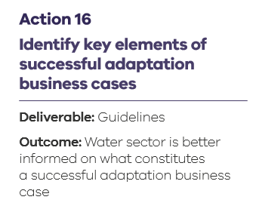

This Guidance Note addresses Pilot WSAAP Action 16: *Identify key elements of successful adaptation business cases*. Action 16 relates to a key objective of the Pilot WSAAP: to enhance the capability and capacity of water entity staff to apply climate change adaptation to business decisions. See Appendix C of this document for the full list of actions in the Pilot WSAAP.

### Responding to key challenges relating to the preparation of adaptation business cases as identified by water sector stakeholders

During the development of the Pilot WSAAP, key water sector stakeholders were engaged as part of a process to identify gaps in effective climate change adaptation in the water sector, and the pilot actions to address those gaps. Through this process, water entities identified various challenges to developing successful business cases for climate adaptation, these challenges are identified in this document.

To reduce the vulnerability of the public to climate change it is necessary to invest in programs or infrastructure that can perform under a wider variety of climatic conditions than have been experienced in the past.Adaptation business cases can be difficult to prepare because of the high levels of risk and uncertainty; the difficulty in quantifying benefits and costs; and the long, and often uncertain, payback period for investment in more climate resilient infrastructure. Currently, guidance is available on undertaking business cases for investment in adaptation; however, this is not tailored to the water industry. Similarly, guidance exists on undertaking climate change adaptation within the water sector, and separately on how to develop business cases, but there is no guidance specifically for the water industry on undertaking climate change adaptation business cases.

This Guidance Note is focused on sharing learnings on adaptation business case planning and providing guidance on best-practice economic tools and methods most appropriate for use in business cases seeking investment in adaption or investments with adaptation components. The guidance provided is deliberately high-level, providing information on key elements of successful adaptation business cases, identifying appropriate economic assessment tools, when and why you might use certain tools, and the inputs required to use the tools. It does not provide detailed technical guidance on how to use the tools, however where possible, further references are identified.

## This Guidance Note

### How has this Guidance Note been prepared?

In the preparation of this Guidance Note, DELWP has drawn upon existing resources and water entity expertise relating to climate change adaptation. Aither Pty Ltd (Aither) was engaged to provide independent specialist expertise relating to best practice decision-making and guidance for economic assessment techniques. The process is summarised as follows:

* Background research was conducted on existing resources available relating to climate change adaptation business planning involving the water sector. Key resources were identified, as well as gaps, which informed the guidance provided later in the document.
* Input was sought from persons within Victorian water entities involved in adaptation business planning to; identify key challenges, identify elements of successful adaptation business cases and draw on existing expertise in water entities to share learnings.
* Aither provided expertise seen in Section 3,4,5 of this Guidance Note. The scope of this guidance was defined by building on existing guidance available, and using stakeholder input to address challenges identified by water entities.

### Who should use this Guidance Note?

The intended users for this Guidance Note include;

* water entity project managers with responsibility for developing business cases for investment in adaption;
* water entity project managers with responsibility for engaging consultants to assist with economic analysis of adaptation options for investment decision making (including for business cases); and
* internal decision-makers with responsibility for reviewing businesses cases.

While water entity staff are the intended primary users of this guidance, the Guidance Note should have applicability for other water sector stakeholders, such as local government authorities and other adaptation projects more broadly.

## Why an adaptation business case?

Victoria is already experiencing the impacts of climate change[1][2][3][4]. These changes are presenting Victorian water entities with significant challenges. Climate change is expected to further amplify the risks faced from more likely, more intense, more frequent, and overlapping climate change impacts.

Water entities can expect the challenges associated with climate change, such as protecting assets and providing consistency and quality of service, to increase in both frequency and magnitude as our climate continues to change. Victorian water entities will need to adapt if they are to continue to provide reliable services under an increasingly challenging climate.

A business case for climate change adaptation enables organisations to respond to current and predicted impacts of climate change on the organisation and its stakeholders.[5] Although organisations in various sectors (e.g. finance, water, local government etc.) have developed and implemented business cases for climate change adaptation, they have done so without sector specific guidance on developing strong and successful adaptation business cases. Similarly, no sector specific guidance exists outlining how adaptation business cases differ from the standard approach to business cases. This Guidance Note attempts to address these gaps.

Legend:

1. Sea level rises
2. More heat waves
3. Temperature increases
4. Lower average rainfall
5. More frequent and severe storms
6. More intense storms
7. More frequent bushfires
8. More frequent and severe droughts
9. More frequent and extreme flash flooding
10. Heavier rainfall may lead to sewer overflows, impacting receiving water
11. Limited access to water for agriculture, parks, gardens and recreation areas during drought.

**Figure 1: Impacts of climate change on the water sector**

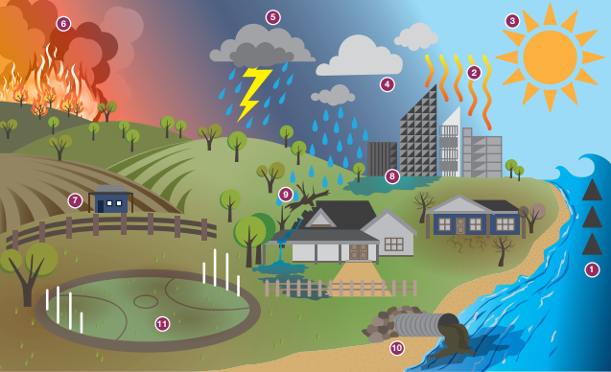

## Further information: the policy context and latest climate science and projections

### Policy context

**Pilot Water Sector Climate Change Adaptation Action Plan**

As outlined in Section 2: Introduction of this Guidance Note, the Pilot Water Sector Climate Change Adaptation Action Plan released by the Minister for Water in August 2018 includes 20 actions to assist the water sector as it continues to adapt to climate change. The delivery of those actions is to take place between September 2018 and December 2020. This work is being undertaken to improve the collective knowledge on the risks associated with climate change which can be integrated into water agencies’ decision-making processes. Until these projects are completed, however, water agencies will be expected to exercise due diligence in determining the best course of action.

**Water Sector Climate Change Adaptation Action Plan – for release in 2021**

DELWP is commencing preparation of the first statutory water sector Climate Change Adaptation Action Plan which the Climate Change Act 2017 requires be finalised by October 2021, and will be required every five years. This plan will build on the actions and work done during the Pilot WSAAP. Consultation will be undertaken with water entities in the development of the final Plan and actions to further improve the ability of water entities to discharge their duty to manage the risk of climate change will be included.

### Climate Science and Projections

**Climate Science Report 2019**

Victoria’s Climate Science Report 2019 provides a synthesis of the best available climate change science and its implications for Victoria. The report helps the Victorian community understand the likely impacts of climate change. The report summarises the knowledge gained from the Victorian Government’s ongoing investment in climate science, such as the Victorian Climate Projections 2019 and the Victorian Water and Climate Initiative, as well as research from our leading academic institutions.

<https://www.climatechange.vic.gov.au/climate-science-report-2019>

**Victorian Climate Projections 2019 (VCP19) Publications**

The VCP19 publications present a comprehensive assessment of Victoria’s changing climate. For the purposes of the analysis of past and future climate, Victoria was divided into ten regions. The publications include: a technical report, easy to read summaries of projected climate changes for each region, and a range of Fact Sheets developed to address particular topics of relevance to Victoria’s changing climate.

It is important to note that the new VCP19 projections complement rather than replace or supersede existing projections. Using a range of projections increases the robustness of climate change planning. Some sets of projections are particularly suited to certain purposes, such as the [Victorian Climate Initiative](https://www.water.vic.gov.au/climate-change/climate-and-water-resources-research/victorian-climate-initiative) projections for water supply planning.

<https://www.climatechangeinaustralia.gov.au/en/climate-projections/future-climate/victorian-climate-projections-2019/vcp19-publications/>

**Victorian Water and Climate Initiative**

The Victorian Water and Climate Initiative supports research into the impact of climate change and climate variability on Victoria’s water resources. This includes three distinct, but related research projects undertaken with the University of Melbourne, the Bureau of Meteorology and CSIRO:

* Researchers from the University of Melbourne are increasing understanding of where runoff rates across Victoria have reduced, and the reasons for the decline.
* Researchers from the Bureau of Meteorology are working to improve understanding of different weather types and their influence on rainfall. They will also look at ways to better characterise Victoria’s current climate, and the influence of tropical expansion on Victorian rainfall.
* CSIRO researchers are developing improved methods for generating rainfall and streamflow projections for Victoria. This includes looking at approaches to better understand and communicate the range of future projections, which will help inform long-term climate change adaptation planning for the water sector.

<https://www.water.vic.gov.au/climate-change/climate-and-water-resources-research/the-victorian-water-and-climate-initiative>

**Guidelines for Assessing the Impact of Climate Change on Water Supplies in Victoria**

Based on the results of the Victorian Climate Initiative research, DELWP, along with water sector stakeholders developed these guidelines to equip the sector with the most up-to-date understanding of climate change and associated risks to water resources. The guidelines update the climate change scenarios and associated projections, and provide guidance for long term temperature, potential evaporation, rainfall, runoff and recharge to be used across the Victorian water sector. These guidelines are being reviewed with an updated version due for release in late 2020.

<https://www.water.vic.gov.au/__data/assets/pdf_file/0014/52331/Guidelines-for-Assessing-the-Impact-of-Climate-Change-on-Water-Availability-in-Victoria.pdf>

## Legislative and policy drivers for climate change adaptation

See Table 1 for legislation and policy relevant to the Victorian Water Sector and Climate Change adaptation. Please note this is not an exhaustive list, there may be additional legislative and policy drivers for adaptation that will support business cases depending on the type of project.

Table 1: Legislative and policy drivers for climate change adaptation

|  |  |  |  |
| --- | --- | --- | --- |
| *Alignment category* | *Policy/Act name* | *Section/ Action* | *Alignment statement* |
| Legislative | *Climate Change Act 2017* | S34 | Prepare an adaptation action plan [for the water cycle system] on or before 31 October 2021 |
| Legislative | *Climate Change Act 2017* | S6 | Meet the long-term emissions reduction target for the State of net-zero greenhouse gas emissions by the year 2050 |
| Legislative | *Water Act 1989* | S93 | Ensure that water resources are conserved and properly managed for sustainable use and for the benefit of present and future generations |
| Legislative | *Water Act 1989* | S93 | Integrate both long term and short term economic, environmental, social and equitable considerations |
| Legislative | *Water Industry Act 1994* | S194 | Promote the sustainable management of water |
| Legislative | *Water Industry Act 1994* | S194 | Address adverse water-related environmental impacts |
| Legislative | *Public Administration Act 2004* | S81 | Boards of public entities must manage risks to the effective operation of the entity |
| Legislative | *Financial Management Act 1994* | S44 | Develop, implement and keep under review a risk management strategy |
| Policy | *Water for Victoria* | Action 2.3 | Lead climate change adaptation across Victoria’s water system |
| Policy | *Victoria's Climate Change Adaptation Plan 2017-2020* | Chapter 5.5 | Prepare an adaptation action plan for the water cycle system |
| Policy | *United Nations Sustainable Development Goals* | Goal 9 | 9.1 Develop quality, reliable, sustainable and resilient infrastructure, including regional and transborder infrastructure, to support economic development and human well-being, with a focus on affordable and equitable access for all  9.4 Upgrade infrastructure and retrofit industries to make them sustainable, with increased resource-use efficiency and greater adoption of clean and environmentally sound technologies and industrial processes |
| Policy | *United Nations Sustainable Development Goals* | Goal 13 | 13.1 Strengthen resilience and adaptive capacity to climate-related hazards and natural disasters in all countries  13.2 Integrate climate change measures into national policies, strategies and planning |

## Overview: Structure of this Guidance Note

* **Section 3: Adaptation business case challenges.** Outlines the key challenges faced by water entities in undertaking adaptation business cases. These challenges have been used to inform the guidance provided in Sections 4 and 5.
* **Section 4: Elements of a successful business case.** Outlines the key elements of the investment decision-making cycle and introduces economic analysis of investment options within this context. This section provides simple guidance that can assist users to develop a successful adaptation business case.
* **Section 5: Economic assessment techniques.** Provides further guidance on six specific economic assessment techniques that can be used to undertake an economic analysis of adaptation investments. It provides a summary of each tool as well as providing guidance on why, when, and how each tool should be applied to assess the value of adaptation investment options.
* **Section 6: Case study examples of climate change adaptation by water sector entities.** Examples of recent, successful adaptation projects in the Victorian water sector. Key elements of the planning approach and learnings from the case study examples are summarised.
* **Appendix: A) Existing Resources relating to climate change adaptation business cases in the water sector.** Shares lessons, summarises and provides commentary on existing resources relating to adaptation business cases that can assist users in the preliminary stages of business case planning;  
  **B) Summary of risks and climate adaptation strategies** – five case studies relevant to the Victorian water sector; **C) CoastAdapt business case template**, to be used with existing DTF guidance; **D)** **Pilot Water Sector Adaptation Action Plan** – List of Actions.

1. Adaptation business cases: key challenges

Undertaking a business case for investment in climate change adaptation can be challenging. Some specific issues faced by water entities have been identified by Victorian water entity staff through engagement on this project and through the Pilot WSAAP. The **key challenges identified** include;

* high levels of risk and uncertainty, both scientific and socio-political;
* insufficient data or information (e.g. long-run forecast data, biophysical or hydrological data, or quantified non-market values associated with environmental/social benefits);
* difficulties in quantifying the benefits and costs of adaptation; and
* potentially long pay back periods for investments.

One or more of these challenges may occur when developing an adaptation business case, which can provide additional difficulties when faced with multiple overlapping issues. There are also **additional specific challenges** given the nature of the water sector. These include, but are not limited to;;

* the need for corporate businesses to meet financial outcomes while also facing expectations to deliver wider environmental and social outcomes, all within economic regulatory timeframes;
* long-lived assets, meaning decisions made today can have a significant effect on future outcomes;
* large-scale, intermittent investments;
* specific challenges for decision makers (e.g. lack of understanding, knowledge or experience);
* multiple sources of drivers of uncertainty in supply and demand – climate, rainfall, population growth, technology, policy/regulation; and
* multiple objectives and users – urban, environmental, agriculture, water quality, water security.

Other challenges may exist, however the above have been identified as key, consistent challenges. Water entities should look to conduct their own analysis of challenges specific to the business case being prepared.

*Toolern Stormwater Harvesting Project, Western Water* Source: DELWP

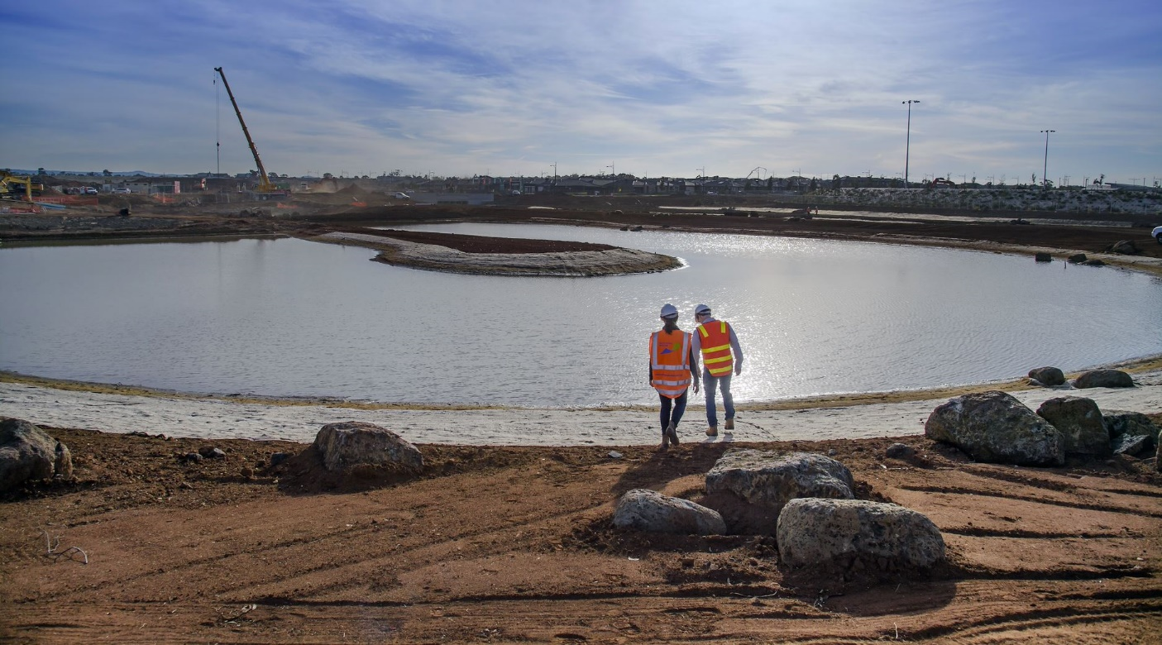

These challenges can be broadly addressed through transparent and consistent communication, the use of appropriate economic assessment techniques, and by reducing knowledge and information gaps, as described in Figure 2.

Guidance in Section 4 sets out a framework for understanding the investment decision-making cycle and understanding the key elements of a successful adaptation business case. Each stage of the framework is aligned to address the challenges identified in this chapter.

Further challenges were identified through engagement on this project by water entity staff which were out of the scope of this Guidance Note. While not addressed in this guidance, the challenges and outcomes (along with other engagement) from the survey will inform the legislated Water Sector Climate Change Adaptation Action Plan, which is due for release in 2021.

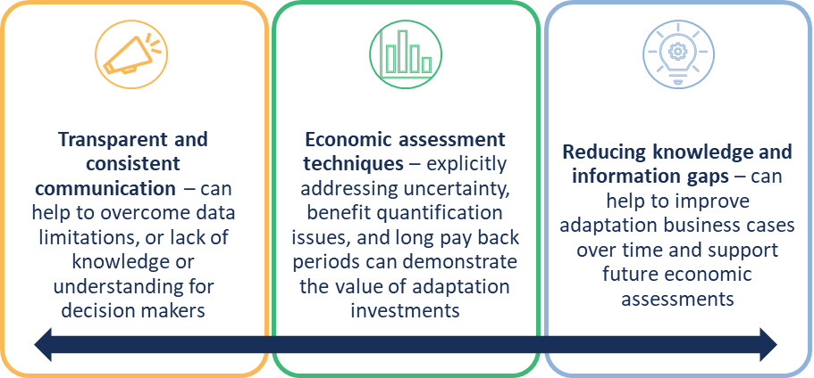

**Figure 2: Options for addressing the challenges associated with climate change adaptation business cases**

1. Elements of a successful adaptation business case

This section sets out a framework for understanding the investment decision-making cycle. Actively considering the investment cycle can help to overcome the challenges inherent in adaptation investments through:

* Developing a compelling narrative which can be used to communicate the value of investment transparently and consistently through clearly identifying and communicating the problem or opportunity, and the benefits and costs of investment.
* Identifying and applying appropriate economic assessment techniques that can explicitly account for uncertainty, non-market benefits and costs, and long pay back periods, or that can be used to communicate the value of investment when data or information is limited.
* Supporting an iterative approach to business case development that enables ongoing improvement in proposed investments by drawing on new information and previous findings.

There are four ongoing and iterative stages in the investment decision-making cycle, as shown in Figure 3.

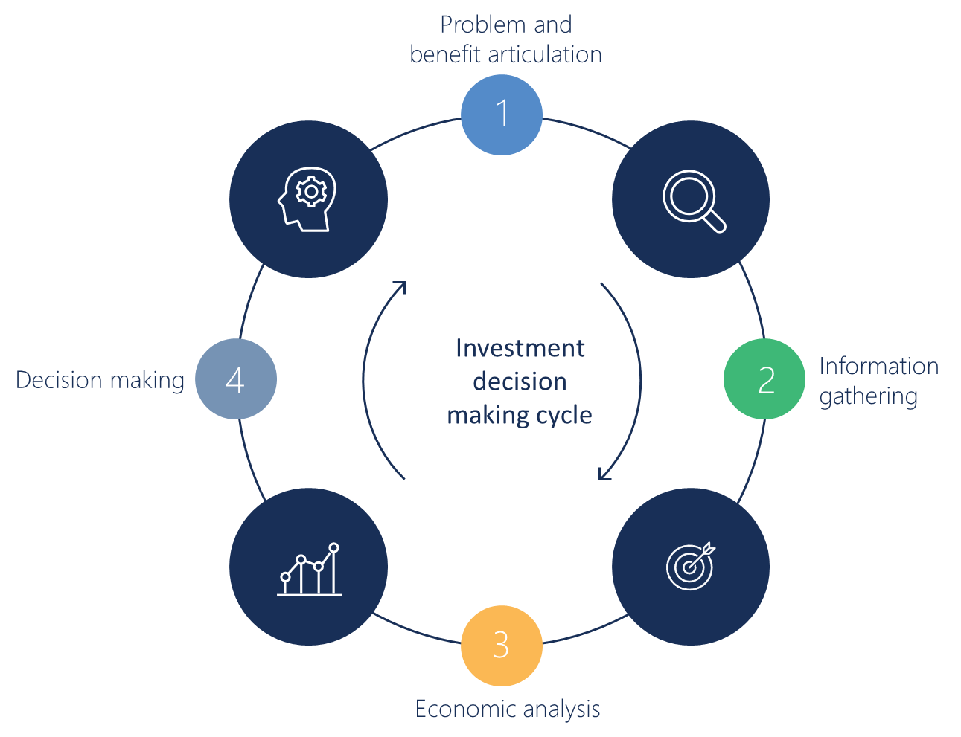

Figure 3: Investment decision making cycle

The four stages of the investment decision-making cycle include:

* **Step 1: Problem and benefit articulation** – developing a clear understanding and scope of the problem and the economic, social, environmental, and financial benefits and costs associated with addressing the problem. Identifying potential investment options to address the problem.
* **Step 2: Information gathering** – identifying and engaging with key stakeholders, gathering data and evidence of costs and benefits, and refining possible investment options that can address the problem and achieve the benefits.
* **Step 3: Economic analysis of options** – assessing the economic, social, environmental, and financial costs and benefits of different investment options.
* **Step 4: Decision-making** – deciding on whether or not to develop a business case, or to spend time further refining investment options, gathering additional information, or undertaking more detailed economic analysis.

The cycle supports development of a robust yet proportionate evidence base of the costs and benefits of investment options through ongoing knowledge building and data and information gathering. This process ensures that proposed investment options only proceed to the business case stage when:

* the benefits of the investment options are clearly identified and articulated; and
* the level of analysis within the business case is sufficient to allow decision-makers to confidently make a decision given the scale and complexity of the investment and future uncertainty.

This enables decision makers to appropriately assess and prioritise investments in climate change adaptation. As previously identified, adaptation business cases have additional challenges related to communicating or assessing value under uncertainty, and difficult to quantify benefits. Following this approach helps to address these challenges and specifically can drive:

* **Early preparation** ensuring there is sufficient time available to build a robust, evidence-based business case. This is particularly important for adaptation business cases which can be relatively complex, and often deliver benefits (e.g. environmental and social) which are difficult to clearly communicate and quantify.
* **Increased understanding of the data and information requirements required** to support a business case. This is vital for adaptation business cases which may require more complex economic assessment techniques with associated technical data requirements to demonstrate value.
* **Development of relationships with stakeholders**, including internal finance managers and key contacts at the relevant funding agency to ensure that the business case is targeted and contains the relevant information.

Following the investment cycle is an ongoing and iterative process which can enable progression from a high-level to a more detailed assessment depending on the business case requirements. If a business case is not developed after step 4, then further refinement of the problems and benefits, additional data gathering, and more detailed economic assessments can be undertaken.

The remainder of this section provides an overview of the investment decision-making cycle and how it can help to overcome some of the challenges in undertaking a business case for adaptation. Section 5 provides information on the different economic assessment techniques that can be used for the economic analysis in step three.

## Step 1 – Problem and benefit articulation

|  |
| --- |
| Key challenges to step 1 - communicating the value of adaptation investments  As outlined in Section 3, developing a business case for investment in climate change adaptation can be particularly challenging as there is a need to appreciate and clearly communicate:   * high levels of risk and uncertainties - the value of investments under a range of future risks or uncertainties * difficulties in quantifying the benefits and costs of adaptation - can often include difficult-to-quantify environmental and social benefits, as well as avoided costs, which can be difficult to communicate * potentially long pay back periods for investments - the need for and value of investing in projects today that have potentially long pay back periods relative to standard infrastructure investments.   The challenges of understanding and communicating the value of adaptation investments can also lead to additional challenges in gathering data and information, undertaking economic analysis of options, and decision making. |
|  |

Clearly articulating the strategic need and benefit of an investment is crucial to overcoming the challenges in communicating the value of adaptation investments, and to building a strong business case narrative with a clear purpose and scope. This involves defining:

* the problem to be addressed, including the root cause(s) of the problem
* the role for the water business / sector in addressing the problem
* the agreed goals and climate ready objectives, outcomes, and benefits to be achieved from solving the problem
* the expected distributional effects (who benefits and who may face costs)
* the customer or community values that are affected by the investment
* the outcome if there was no intervention (the baseline)
* potential intervention options for addressing the problem and achieving the benefits.

Providing sufficient time to properly frame the problem and strategic context ensures that the business case narrative and investment options are well defined. This is a particular risk for investments in adaptation given the challenges in articulating the benefits of managing future risk and uncertainty. Additionally, water entities may be less experienced developing and making decisions on climate change adaptation investments and may require a more robust narrative before there is confidence to move forward.

Investment Logic Mapping and Outcome Logic Mapping (also known as Program Logic) are common approaches to strategic planning. They express how change is expected to occur within a system. Importantly they capture the rationale behind a program or initiative, and the anticipated cause-and-effect relationships between the problem to be solved, the intervention option and the outcomes and benefits to be achieved.

This approach provides the basis for all proceeding steps. Clearly identifying and defining the costs and benefits facilitates the information gathering, economic assessment and decision-making process.

Further guidance on Investment Logic Mapping can be found at in the DTF Investment management standard guidance[6].

|  |
| --- |
| **Assessing Interdependencies**  Identification and management of interdependencies of critical infrastructure systems and services is important in building resilience in an all hazards environment. Additionally, not considering interdependencies can result in a narrow problem statement that leads to a narrow solution, which ignores the risks of exacerbating existing problems or societal challenges. Likewise, not understanding upstream and downstream interdependencies could result in not identifying at what level the best adaptation intervention should be. E.g. the biggest risk in your business case may be shared or ‘belong’ to another organisation and jointly investing could result in a less costly and more effective outcome.  Business case authors should assess each ‘problem’ and identify benefits, disbenefits, organisational priorities and governmental priorities. For more commentary and guidance on assessing interdependencies and disbenefits, refer to DTF Sustainable Investment Guidelines. |

|  |
| --- |
|  |
| Key outcomes from step 1 - articulating the problem and benefits  Clearly articulating the problem and benefits for an adaptation business case supports transparent and consistent communication, and facilitates data and information gathering and robust economic assessment of costs and benefits. |

## Step 2 - Information gathering

|  |
| --- |
|  |
| Key challenges to step 2 - insufficient data or information  As outlined in Section 3, a challenge for development of a business case for investment in climate change adaptation is the need for a range of information and data that may be required for other types of investments or that may not be readily available, including:   * long-run forecast data (i.e. climate change, population, energy prices) * biophysical or hydrological data relating to future climate change impacts * quantified non-market values associated with environmental or social benefits.   A lack of familiarity with information requirements or a lack of readily available information can further exacerbate the challenges in undertaking an adaptation business case relating to uncertainty, quantification of benefits and costs, and long pay back periods. |
|  |

Gathering data and information to support adaptation investments can often be challenging and time consuming. Therefore, it is important to start identifying and gathering information at an early stage of the investment decision-making cycle. This might include:

* engagement with appropriate stakeholders
* identification of data required for an economic assessment of options
* identification of any relevant data gaps.

Stakeholder engagement is particularly important for adaptation investments as the types of benefits, including avoided costs and non-financial benefits, can be harder to communicate than for more traditional infrastructure investments. Developing a robust business case therefore requires engaging with multiple parties including:

* internal stakeholders, including internal decision-makers
* funding agencies (i.e. DTF)
* potential delivery partners, including community groups.

Early and ongoing engagement with these stakeholders helps to build a strong case for investment through understanding and responding to their views, perceptions, and needs. Finance managers within water businesses may not regularly assess adaptation business cases that include material non-financial benefits or long pay back periods. Engaging early with financial managers and funding agencies can build understanding of these benefits and ensure the value of investment is understood.

Information gathering and stakeholder engagement are also important for improving understanding of the nature and scale of the problem and benefits identified in Step 1, and in identifying data or knowledge gaps for future assessments. This can assist to refine and short-list investment options.

The types of data that might be required for an adaptation business case, and some potential sources of information are identified in Table 2.

Table 2: List of indicative data types and sources

|  |  |
| --- | --- |
| **Data** | **Source** |
| Climate projections or scenarios | DELWP, CSIRO, BOM |
| Biophysical or hydrological data | Water entities, DELWP, CSIRO |
| Demographic data | ABS, DELWP, Local council |
| Infrastructure cost data | Water entities |
| Long run supply and demand data (including long run marginal costs) | Water entities |
| Environmental and social benefit values | WSC CRC[7], Environmental Value Reference Inventory (EVRI)[8] |
|  |  |

|  |
| --- |
|  |
| Key outcomes from step 2 - information gathering  Information gathering and stakeholder engagement supports robust economic assessment of the costs and benefits of investment under a range of future uncertainties or risks. It can also support identification of data or information gaps that can be used to identify future areas of focus under an iterative process. |

## Step 3 - Economic analysis of options

|  |
| --- |
|  |
| Key challenges to step 3 - assessing the costs and benefits of adaptation investments  As outlined in Section 3, undertaking an economic analysis of options for investment in climate change can be particularly challenging as there is a need to assess:   * high levels of risk and uncertainty - the impacts of future risks or uncertainties on the value of the investment, and the benefits of flexibility in the face of uncertainty * difficulties in quantifying the benefits and costs of adaptation - including difficult-to-quantify environmental and social benefits * potentially long pay back periods for investments - the value of investments that deliver benefits over a much longer period.   These challenges can be further exacerbated by potential data limitations identified in the previous step. Different economic assessment techniques can be used to overcome these challenges in different ways, by either qualitatively or quantitatively demonstrating the value of investments. |
|  |

Economic analysis of investment options can take several forms, from simple qualitative analysis to detailed and complex quantitative assessment with significant data requirements. Section 5 provides more detailed guidance on different economic assessment techniques to use for an adaptation investment assessment, and when and how they should be applied. While each technique is designed to address a specific need, all economic analysis has the same overarching purpose – to provide an understanding of the value of an investment to the broader community. Economic analysis is broader than financial analysis as it explicitly considers the social and environmental effects, as well as the financial implications, of an investment upon broader society.

Undertaking an economic assessment as part of a business case for investment in adaptation can require relatively complex analysis to account for environmental or social benefits, as well as future risk and uncertainty. Therefore, it is particularly important to ensure that any analysis undertaken is robust and transparent, and that this is clearly communicated and accessible for decision makers.

There are a few common issues or pitfalls in undertaking an economic assessment which lead to difficulties in identifying, quantifying, and communicating the benefits of investment. These issues should be carefully considered when undertaking an assessment of options for investment in adaptation. These pitfalls summarised in Table 3, and further described in Section 5 against each economic assessment technique.

|  |
| --- |
|  |
| Key outcomes from step 3 - economic analysis of options  Economic analysis of options can be used to overcome the challenges of adaptation business cases. This can include quantitatively assessing the net benefits of investment accounting for uncertainty, long pay back periods, or non-market values, or using qualitative or rapid assessments to support transparent communication of the costs and benefits. |

|  |  |
| --- | --- |
| Issue | Description |
| Establishing the base case | To understand the expected net benefits of an investment it is necessary to understand the base case i.e. the hypothetical situation that would occur in the absence of investment. The base case is not a static assessment of the current situation but should also account for any expected changes over time in the absence of the intervention. This is particularly important for adaptation investments, with longer term benefits and a focus on managing future risks or uncertainties. |
| Including distributional analysis | For adaptation investments, particularly those delivering wider community benefits, it will be important to understand who bears the costs and benefits, and the number of people affected, as well as understanding the total net benefits. An in-depth assessment of project impacts and their distribution will support stakeholders to better understand the implications of the project across multiple values. Distributional analysis can also be used to inform potential financing or cost sharing arrangements or co-governance models. |
| Defining the scope of analysis | An important consideration for the analysis in an adaptation business case is the geographical scope. Generally, the appropriate spatial area to account for costs and benefits is based on the expected scope of the investment. Most business case guidance recommends using the State as the minimum geographical area for identifying the costs and benefits. Whatever the choice of spatial scale, the analysis should be consistent. That is, if benefits are assessed at the State level, so too should costs to realise these benefits. |
| Using non-market valuation approaches | A challenge for assessing adaptation investments can be quantifying non-financial benefits; in particular, non-market benefits associated with environmental and social impacts. Although these benefits are often seen as challenging to quantify, there are a range of techniques available to estimate non-market values. Non-market valuation techniques are not perfect, but they represent best-practice for ensuring the full range of costs and benefits of a proposed action are captured in economic appraisal. |
| Using an appropriate discount rate | Applying a discount rate allows for future costs and benefits to be compared consistently over time. This is particularly important when assessing investments with long pay back periods. Guidance on the use of discount rates can be found in the DTF business case guidance[9]. |
| Reporting assumptions and methods | For any business case, it is important that the results of the quantitative analysis are not overstated and that the approach is clearly communicated. This requires outlining the key assumptions driving the results and their implications, the limitations of the analysis including any costs and benefits not quantified, and any areas of uncertainties. This transparency is essential and will help to build support for the analysis. This is particularly important for investments in adaptation, given the potential complexity of the analysis. It is also important for adaptation business cases to capture all ongoing costs and funding streams, not just capital funding streams. |

**Table 3: Common pitfalls or issues in economic analysis of options**

## Step 4 – Decision Making

|  |
| --- |
|  |
| Key challenges to step 4 - decision-making with confidence  As outlined in Section 3, the challenges outlined in the previous steps can also affect climate change adaptation investments decision-making. A lack of clarity or understanding of the problem or benefits, limited data, and challenges in economic assessment can make it difficult to create a clear and compelling case that provides sufficient confidence to decision-makers. There may be additional challenges for decision-makers, including:   * a lack of knowledge or understanding of how to make decisions under future uncertainty * a lack of experience in investments with a focus on wider social and environmental benefits rather than financial benefits.   These challenges may further affect the confidence of decision-makers, reducing the likelihood of climate change adaptation investment proposals being successful. |
|  |

These challenges can be addressed through using a clear and consistent decision-making process that builds upon the previous steps in the investment decision-making cycle. The key purpose of Steps 1-3 of the investment cycle is therefore to inform appropriate decision-making. At this stage of the cycle decision makers should be presented with:

* A clear articulation of the problem and benefit and the rationale behind a program or initiative, the anticipated cause-and-effect relationships between the problem to be solved, the intervention option, and the outcomes and benefits to be achieved.
* Evidence that appropriate stakeholder consultation and information review has been undertaken (if necessary) to ensure the process undertaken and information provided is appropriate and robust.
* Transparent and clearly communicated economic analysis, including reporting on assumptions and limitations, that is suitable for the nature and scale of the specific investment.

The economic analysis has the overarching purpose of providing an understanding of the value of an investment to the broader community. At this point of the analysis there should be broadly three pathways to follow:

1. Proceed to investment approval through the development of a business case – if the benefits of the investment are considered to outweigh the costs and any associated risks and uncertainty.
2. Not to proceed any further – if the costs of the investment outweigh the benefits.
3. Continue with additional analysis – if there are risks or uncertainty associated with the investment that may be reduced with refinement of the investment strategy, additional data and information or more detailed economic analysis.

The decision-making process above is commonly used in adaptation strategies and assessments. The inherent uncertainty associated with adaptation investment options necessitates multiple levels of analysis, each building upon the information and knowledge of the previous. Extending this process to adaptation business cases within water entities is a natural progression and ensures decision makers are provided with the information and confidence required to make investments of the right scale at the right time.

It should also be noted that an economic assessment is only one input to the decision-making process, which also needs to consider any equity or distributional implications, as well as strategic and political issues.

|  |
| --- |
|  |
| Key outcomes from step 4 - decision making  Decision making under uncertainty can be supported by an iterative process that builds information and knowledge over time, and makes use of transparent and consistent communication, and robust economic assessment techniques. |

*Captain Creek, Kinglake National Park* Source: DELWP

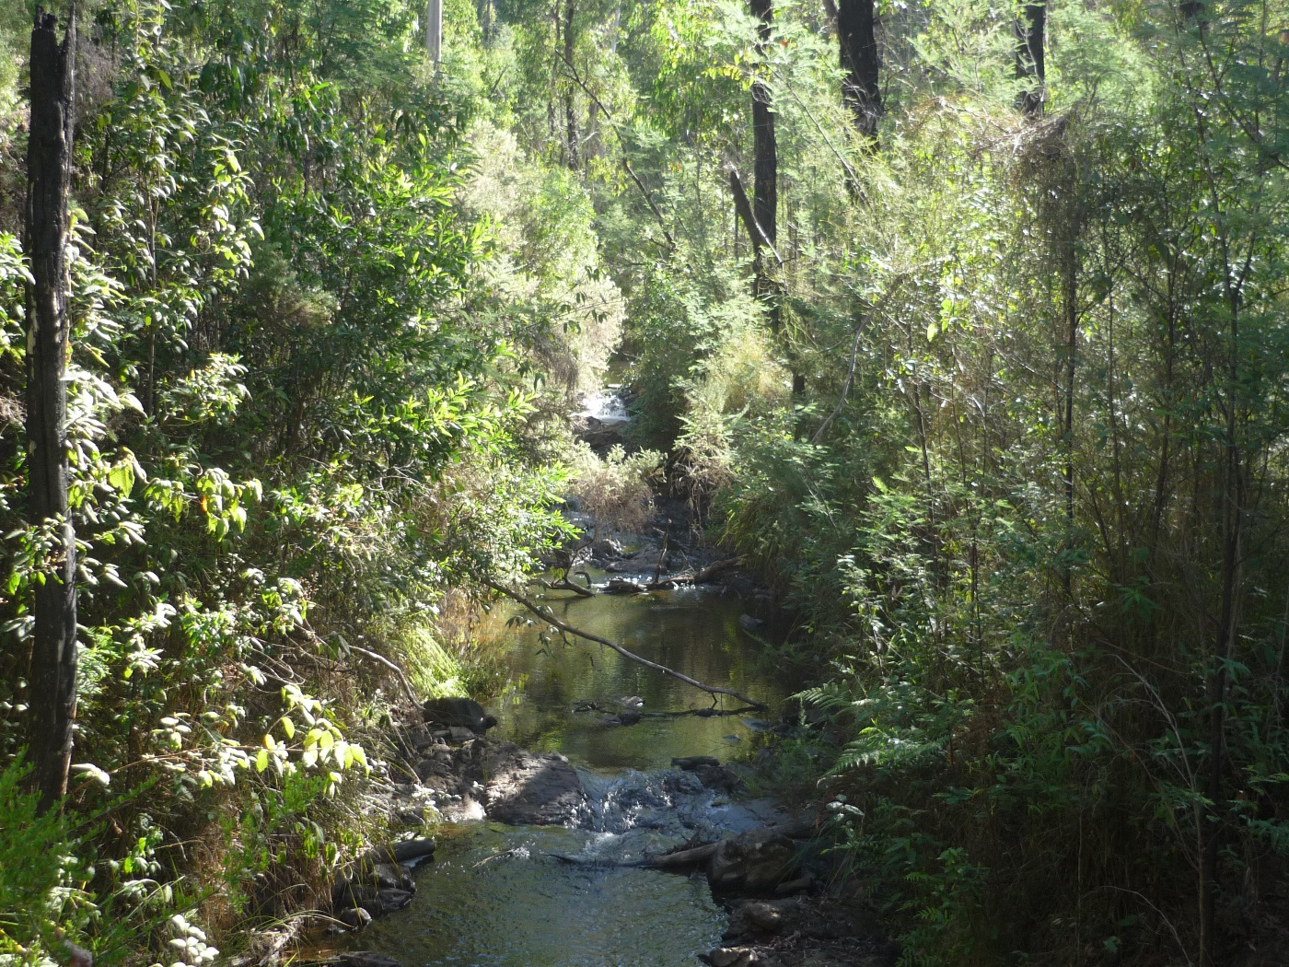

1. Economic Assessment Techniques

This section provides guidance on the economic assessment techniques that can be used to undertake step 3 of the investment decision-making cycle – economic analysis of options. It provides a summary of the different techniques that are available for economic analysis, and guidance on their use under a range of circumstances specific to adaptation investments.

The economic analysis of options for an adaptation business case can be undertaken using any of these techniques, however, the assessment method utilised should be:

* *Fit-for-purpose* – the approach should follow best practice guidance in economic appraisal evaluation.
* *Pragmatic* – the method used should be appropriate to the scale and importance of the project being undertaken without adding unnecessary administrative burden.
* *Transparent* – the method should be shared, understood and replicable by others.

The six economic assessment techniques included in the guidance are:

**Multi Criteria Assessment (MCA)** - involves applying scoring and weighting to criteria to establish a score as a basis for comparing each single option. It is most appropriate for small scale, low risk projects with wider community benefits, or for shortlisting of options for further assessment.

**Cost Effectiveness Analysis (CEA)** - involves comparing the total cost of different options which deliver common and comparable outcomes (e.g. demand reduction measures). It is most appropriate for small scale, low risk projects with a focus on cost effectiveness, or for shortlisting of options for further assessment.

**Rapid Cost Benefit Analysis (rapid CBA)** – involves identifying and quantifying the most significant costs and benefits including non-financial benefits. It is most appropriate for small to medium scale, moderate risk projects with wider community benefits, or for shortlisting of options for further assessment.

**Cost Benefit Analysis (CBA)** **including sensitivity and scenario analysis** – involves identifying and quantifying all costs and benefits and undertaking sensitivity and scenario analysis to identify key risks and uncertainties. It is most appropriate for medium to large scale projects with moderate risk and wider community benefits, or for identifying priority options for further assessment.

**Cost Benefit Analysis with Monte Carlo Simulation (Monte Carlo analysis)** – involves further developing the CBA to explicitly account for risk and uncertainty by specifying probability distributions for uncertain parameters. It is most appropriate for large scale projects where accounting for risk and uncertainty is an important outcome.

**Real options analysis** – this technique further extends CBA and Monte Carlo simulation techniques by introducing investment flexibility, or the ability to learn about uncertainties over time and act appropriately on that knowledge. It is most appropriate for large scale projects where accounting for risk and uncertainty is an important outcome.

A summary of the potential methods, their usefulness in dealing with the challenges of developing climate change adaptation business cases (see Section 3), and when they are most appropriate for use in a business case is provided in Table 4.

Table 4: Summary of economic assessment techniques

|  |  |  |  |  |  |  |
| --- | --- | --- | --- | --- | --- | --- |
| Technique | Multi-criteria assessment (MCA) | Cost effectiveness analysis (CEA) | Rapid Cost benefit analysis (CBA) | CBA including sensitivity analysis | CBA using Monte Carlo simulation | Real options analysis |
| Description | Applying scoring and weighting to criteria (and sub-criteria) to establish a score as a basis for comparing each single option | Comparing the total cost of different options which deliver common and comparable outcomes (e.g. demand reduction measures), with a focus on identifying the least costly option. | Identifying and quantifying the most material costs and benefits including non-financial benefits | Identifying and quantifying all costs and benefits. Undertaking sensitivity and scenario analysis to identify key risks and uncertainties | Further developing the CBA to explicitly account for risk and uncertainty through specifying probability distributions for uncertain parameters | Further extending CBA and Monte Carlo simulation by introducing investment flexibility, or the ability to learn about uncertainties over time and act appropriately on that knowledge |
| Investment scale | Appropriate for small scale projects only | Appropriate for small scale projects only | Appropriate for small to medium scale projects | Appropriate for medium to large projects | Appropriate for large projects with significant future uncertainty | Appropriate for large projects with significant future uncertainty |
| Data requirements | Limited quantitative data required | Data on costs only | Data on costs and most material outcomes | Robust data on costs and expected outcomes | Robust data on costs, expected outcomes, probabilities of future risk/uncertainty | Robust data on costs, expected outcomes, probabilities, flexible options |
| Assessment of value accounting for future risk/uncertainty | Does not quantitatively assess benefits under different risks and uncertainties | Does not quantitatively assess benefits under different risks and uncertainties | Can include some assessment of risk/uncertainty through sensitivities | Can include assessment of individual risks/uncertainties through sensitivities/ scenarios | Explicitly includes assessment of value accounting for multiple risks/ uncertainties | Explicitly includes assessment of value accounting for multiple risks/ uncertainties |
| Wider community (social, environmental, and financial) benefits | Can include qualitative assessment of community benefits | Does not include any quantification of the value of community benefits | Includes quantification of the most material community benefits, and qualitative description of others | Includes quantification of all major community benefits | Includes quantification of all major community benefits | Includes quantification of all major community benefits |
| Demonstrates value of adaptive approaches | Does not quantitatively assess the value of adaptive approaches | Assesses the value of a single, fixed strategy | Assesses the value of a single, fixed strategy | Assesses the value of a single, fixed strategy | Can assess the value of adaptive approaches | Can assess the value of adaptive approaches |
| Demonstrates value even under long pay back periods | Does not quantitatively assess value of projects with long pay back periods | Does not support understanding of value under long payback periods | Provides understanding of value under long pay back periods | Provides understanding of value under long pay back periods | Provides understanding of value under long pay back periods | Provides understanding of value under long pay back periods |
| Most appropriate use | Small scale, low risk projects with wider community benefits, or for shortlisting options for future analysis | Small scale, low risk projects with focus on cost effectiveness, or for shortlisting options for future analysis | Small to medium scale, moderate risk projects with wider community benefits, or for shortlisting options for future analysis | Medium to large scale, moderate to high risk projects with wider community benefits, or for identifying priority options for further assessment | Large scale, management of risk and uncertainty is central to benefits | Large scale, management of risk and uncertainty is central to benefits, options include flexibility/ trigger points |

Different techniques can be appropriate for different scales of assessment, or different levels of risk and uncertainty. Additionally, different techniques can be used at different stages of the options development and assessment process. This can help to refine options over time and build on previous assessments to start to better account for risk and uncertainty as better information and data becomes available. Figure 4 provides a summary diagram showing how the different techniques can be used to progress from a rapid assessment of a long list of options towards a full assessment of a pathway of options under risk or uncertainty. At any stage throughout this process the outputs of the assessment techniques can be used to develop a business case. However, there should be sufficient confidence that the analysis is appropriate for the scale and risk of the assessment and can therefore be used for decision making.

*Edge of Rocklands Reservoir* Source: DELWP

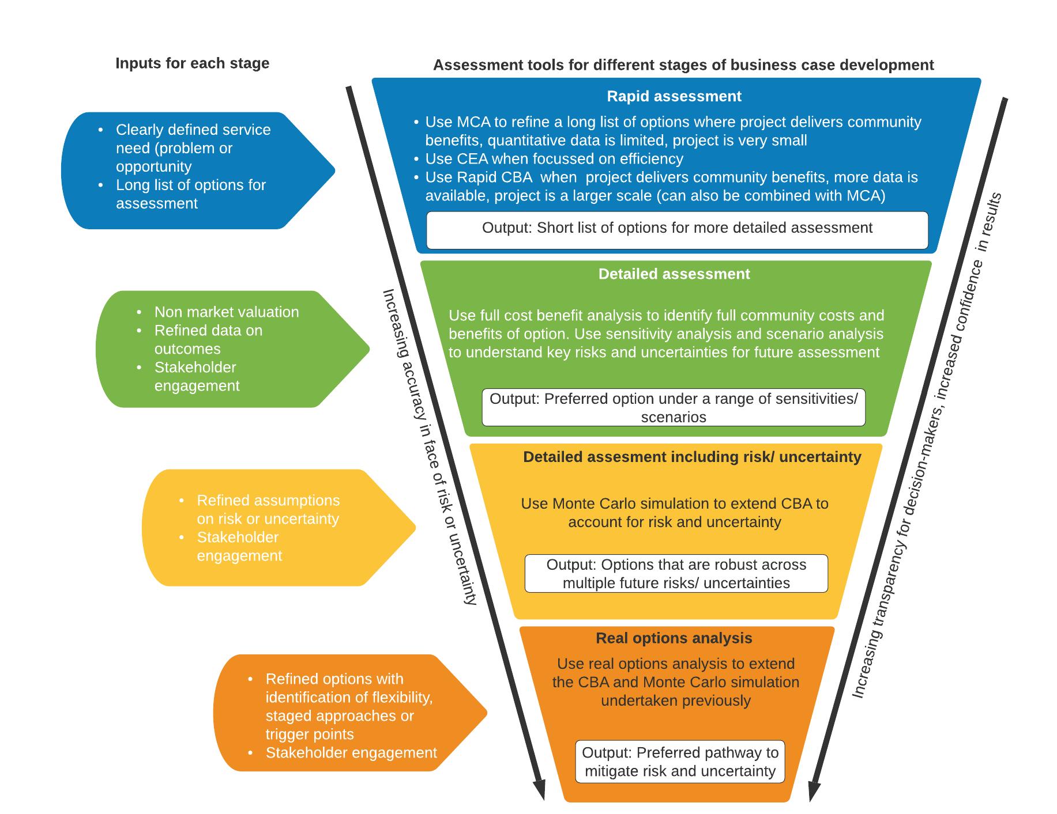

**Figure 4: Diagram of economic assessment techniques for use in adaptation investment planning**

The remainder of this section provides an overview of six different techniques for the economic assessment of investments in adaptation. This is not intended to provide detailed technical guidance but rather provides a summary of the potential uses, benefits, and limitations of each technique. References to more detailed technical guidance on each technique are also provided.

## Multi Criteria Assessment (MCA)

#### Introduction

The basis of an MCA is to identify criteria against which a proposed investment is to be assessed, and then assess the investment against these criteria using value judgements. Value judgements should be informed by evidence where possible (e.g. previous project outcomes, data and modelling). The use of numerical values to assess the performance against the criteria allows for consistent assessment between criteria and across different options. Criteria can also be weighted to demonstrate differences in relative importance.

An example of how an MCA might be undertaken is provided in Table 5. The various criteria have been identified and categorised as either social or environmental outcomes and weighted according to their relative importance. The performance against the criteria has been assessed for two options, the relevant project, and the base case (where the project does not occur).

Table 5: Example MCA

|  |  |  |  |
| --- | --- | --- | --- |
| *Criteria* | *Weighting* | *Base case* | *Project* |
| **Social** | **50%** | **5.4** | **7.3** |
| Reduced health care costs associated with poor water quality | 40% | 6 | 7 |
| Increased amenity value of waterways | 30% | 5 | 7 |
| Improved community health and wellbeing from increased recreation | 30% | 5 | 8 |
| **Environmental** | **50%** | **5.6** | **7.9** |
| Improved waterway health | 70% | 6 | 8 |
| Improved biodiversity | 20% | 5 | 8 |
| Reduced GHG emissions | 10% | 4 | 7 |
| **Total** |  | **5.5** | **7.6** |

MCA should generally be limited to smaller investments or used to shortlist options for more detailed future assessments. It can be used for comparing different options for investment which are expected to deliver difficult to quantify environmental and social benefits. It can be used to identify and communicate the benefits of different options for adaptation investment, and to support decision-making. For adaptation business cases, MCA should generally be limited to the assessment of smaller investments, where the main costs and benefits cannot be valued (or it is impractical to do so), and where mitigation of risk does not change significantly across outcomes. It can also be used to supplement a quantitative assessment of financial benefits. MCA is also used to short-list a larger set of adaptation investment options to be assessed in more detail using another economic analysis tool (for example a cost benefit analysis).

#### Benefits

MCA can help facilitate a wider understanding of the expected relative benefits of different proposed investments, as well as identifying those benefits which may be the most material. This can be useful in understanding trade-offs and increasing transparency in decision-making. Where there is a lack of data or outcomes are difficult to value MCA can be used in the absence of more robust techniques. However, it should only be used for lower cost, lower risk investments.

The major strengths of MCA are its ability to handle performance measures in any units (either quantitative or qualitative) and its ability to provide decision makers with a logical structure for complex problems. Multi-criteria analysis is most effective when there is a very clear basis for scoring project options against criteria and where this evaluation framework is agreed and documented before the analysis has commenced.

#### Limitations

MCA does not have the same grounding in economic theory as cost-benefit analysis. Because MCA involves subjective judgements on values to assign scores, consistency of analysis and like-for-like comparisons can be challenging. Importantly, MCA does not tell the decision-maker whether individual proposals are of net social benefit. MCA has limitations when considering adaptation investments as it cannot explicitly account for risk and uncertainty, although it is often an implicit assumption (and therefore not transparent) of this type of assessment.

#### Input requirements

To undertake an MCA a proponent should have:

* an understanding of expected benefits and outcomes
* an understanding of relative likelihood of different benefits being delivered
* engagement from experts who can provide value judgements on the expected benefits and costs.

#### Common pitfalls

There are several pitfalls to be cautious of when undertaking an MCA including:

* Over engineering the analysis to give the appearance of quantitative rigour and thereby obscuring the reliance on value judgements and the lack of data on the net benefits of each option.
* Starting the analysis with a ‘preferred option’ which is then most highly rated throughout the process.
* Bias from by those involved in an MCA when undertaken in a workshop setting.

#### References for further guidance

Multi criteria analysis: a manual, UK Department of Communities and Local Government <http://eprints.lse.ac.uk/12761/1/Multi-criteria_Analysis.pdf>

|  |
| --- |
|  |
| MCA example – riparian revegetation  A proposal for an investment of $100,000-$200,000 into environmental management activities over 5 years such as revegetation or in-stream stabilisation erosion works. There is limited quantitative data on the expected outcomes however there is expert knowledge that can be drawn on to undertake a qualitative assessment. All proposed options help to manage future climate change risks but also deliver short term environmental and social benefits which can be clearly described and communicated. An MCA can help rank the different management options by the expected costs and benefits, to help prioritise investment. |

## Cost Effectiveness Analysis (CEA)

#### Introduction

Cost effectiveness analysis (CEA) is a partial cost-benefit approach that compares the relative costs of different options in reference to a specific outcome that has been agreed upon (e.g. wetland restoration). A cost-effectiveness analysis expresses the result in terms of the average cost per unit of effectiveness (e.g. the average cost per hectare of wetland restored).

#### When to use this approach

Cost-effectiveness analysis is useful when the main benefits cannot be easily valued in dollar terms or when it would be unduly expensive to undertake the valuation. In such cases, benefits are expressed in terms of physical units (e.g. the number of trees planted) while costs are expressed in dollar terms. Cost effectiveness offers a priority ranking of options based on the comparative 'cost per unit of outcome'. Cost-effectiveness analysis should generally only be used where the decision to target a specific outcome has already been agreed upon by decision-makers. In adaptation business cases it should only be used to compare different options for achieving a specific adaptation outcome rather than to compare adaptation and non-adaptation options.

#### Benefits

There are benefits to undertaking a cost effectiveness analysis given that it does not require extensive data on benefits. It can provide a sufficient understanding of the preferred option where there are a limited number of benefits, there is some data on the expected outcomes of interest (e.g. ML of water supplied), and the focus is on achieving a cost-effective outcome. CEA can also be undertaken internally and is not time or resource intensive. CEA may be useful for adaptation business cases where there are several options which are expected to achieve the same adaptation outcomes, for example demand reduction measures.

#### Limitations

Whilst CEA is sometimes used when the main benefits cannot be easily valued, it cannot demonstrate if the preferred option is of net benefit to society. In addition, the results cannot be used to find or compare alternative projects that could achieve greater net social benefits by targeting different outcomes. Therefore, these methods should generally only be used where the decision to target a specific outcome has already been made. CEA does not explicitly account for risk or uncertainty thereby limiting its use for assessing adaptation investments.

#### Input requirements

To undertake a cost effectiveness analysis data is needed on the expected capital and operating or maintenance costs of each option. Information is also need on the expected outcomes under each option.

#### Common pitfalls

A major challenge with CEA is that it overstates the benefits of cost-effective options compared to options that may deliver greater net benefits to society. It is important to clearly communicate this when presenting the results of a CEA.

#### References for further guidance

Boardman, A., Greenberg, D., Vining, A., & Weimer, D. (2018). Cost–Effectiveness Analysis and Cost–Utility Analysis. In Cost-Benefit Analysis: Concepts and Practice (pp. 511-536). Cambridge: Cambridge University Press.

|  |
| --- |
|  |
| CEA example – off-river storages  A proposal for investment in off-river storages to support ongoing security of supply and drought resilience. It is difficult to place a dollar value on the additional water supply as it is used for a range of agricultural and environmental purposes, and use is expected to vary significantly from year to year. Data is available on the expected volume of each proposed off-river storage site, as well as on the costs to develop and maintain. A CEA can provide an understanding of the $/ML cost of each proposed site to identify which is the most cost effective. However, it does not include an assessment of the other factors that may be important in site selection (which could be addressed through MCA), or demonstrate which site will deliver the greatest value (which could be determined through CBA). |
|  |

## Rapid Cost Benefit Analysis (rapid CBA)

#### Introduction

Cost-benefit analysis is a method of economic assessment that attempts to estimate and compare the total benefits or costs of a particular action compared to a base case. Its objective is to provide the final decision-maker with as much information as is required and relevant for the decision-making process. It is the most broadly accepted appraisal and evaluation technique that estimates the economic, social, and environmental costs and benefits of policies, programs, and projects.

Despite common misconceptions, a cost-benefit-analysis is broader than a financial analysis in that it also incorporates the non-market social and environmental values that are of importance to various groups in society. While some of these values are difficult to quantify, economists have developed and gradually refined a range of valuation techniques to quantify these values.

Rapid cost benefit analysis does not attempt to quantify all costs and benefits but instead focuses on the quantification of those costs and benefits that are most material and can be more readily and defensibly quantified. Rapid CBA also makes use of the benefit transfer approach where appropriate to quantify any non-market values. This approach, whilst not demonstrating the full net benefits of a project, helps to provide an understanding of the potential scale of the benefits in comparison to the costs.

#### When to use this approach

Rapid CBA is appropriate for small to medium scale investments where there are important non-financial benefits that should be quantified, and where it is necessary to demonstrate benefits to the whole community. Rapid CBA is particularly useful to undertake an assessment of a long list of options and to provide an understanding of the priority options for further assessment. It can also help to identify key assumptions and data limitations that can be improved prior to further analysis.

Rapid CBA is less accurate than a full cost benefit analysis and should therefore not be used when making final investment decisions for large scale projects. It can be used at an early stage for larger investments to prioritise options for future CBA.

#### Benefits

Undertaking a rapid CBA is more analytically rigorous than an MCA or CEA, as it attempts to explicitly quantify the value of investment outcomes and benefits. Whilst there are still limitations in rapid CBA it allows for an explicit understanding of assumptions which are often implicitly included but not reported in an MCA or CEA. Undertaking a rapid CBA can also be useful in providing context and understanding of the key risks and uncertainties that are driving the results and can therefore provide useful insights into what data and assumptions need to be refined or improved prior to a more detailed CBA. Rapid CBA can also be undertaken relatively rapidly and without significant time and resource commitments. However, it should still be undertaken by an economist with experience in CBA.

#### Limitations

Although rapid CBA is useful for demonstrating benefits at a low cost and effort for smaller scale projects, it is less accurate than undertaking a full CBA. It will not provide a full assessment of all the costs and benefits of each option, which may lead to some projects having quantified costs which outweigh the quantified benefits. A rapid CBA is often accompanied by a qualitative description of the benefits (and costs) that have not been quantified. When the quantified costs exceed the benefits, a decision to proceed may still be made if stakeholders perceive the value of both the quantified and unquantified benefits to be greater than the costs.

#### Input requirements

To undertake a rapid CBA, it is necessary to have:

* an understanding of costs and benefits of each option
* some physical data on the changes expected under the investment for the key outcomes, for example changes in water supply
* an understanding of appropriate non-market values from the literature.

*Birds and vegetation in the Elsternwick wetlands filtering water before it reaches the bay* Source: DELWP



#### Common pitfalls

Undertaking a rapid CBA can be relatively straightforward however there are common issues that can occur, which those undertaking CBA should be aware of and seek to avoid.

* **Attribution** – There needs to be a clear link between the investment and the benefit to attribute the change in value to a particular option. It is important to consider which costs and benefits would have occurred in the absence of the project, and to understand the net impact of the project options.
* **Double counting** - A key risk is the potential for double counting of an investment’s benefits. For example, the benefits of improved water quality from better catchment management and the avoided cost of other water quality treatments are the same effect articulated differently, therefore risk double-counting if both are included in an analysis as benefits. Similarly, where any avoided infrastructure costs are included, reduced costs to customers cannot also be included as this is double counting the benefits.
* **Negative outcomes** - It may be that investment will not just provide benefits to the wider community but will also impose costs, for example increases in GHG emissions or other environmental impacts might occur during capital works. These should also be identified where they are expected to occur.
* **Appraisal period and residual values** - When quantifying the costs and benefits it is necessary to decide over what period the costs and benefits should be assessed. Most cost-benefit analysis will use a minimum of a 30-year appraisal period, however longer or shorter periods may be used depending on the type of project. Where the benefits or costs include long lived assets, it may be necessary to calculate the residual value of the asset beyond the length of the appraisal period.
* **Optimism bias** - The assessment of costs and benefits should use a conservative approach. It is likely that the benefits of research may be lower than expected, and that the costs and time to realise the benefits may be longer. Being aware of potential for optimism bias will help to provide a more plausible and defendable benefits assessment.

#### References for further guidance

Some CBA tools have been developed for the water industry that may be suitable for undertaking a rapid CBA to avoid undertaking a bespoke analysis. These tools are designed to support economic evaluation of projects quickly, cost-effectively, and transparently. There have been several tools developed which are relevant to the water industry. A review of these tools suggests that there are two that are potentially useful for rapid CBA:

* the INFFEWS Benefit Cost Analysis Tool, developed by the WSC CRC and available to WSC CRC participants[10]
* the Catchment Management Investment Standard developed by WSAA and publicly available[11].

Both tools also include databases of values for use in benefit transfer, which can be used to support quantification of intangible benefits.

|  |
| --- |
| Rapid CBA example – waterway naturalisation  A proposal for a $5m investment to convert a section of a waterway from a concrete-lined channel into a naturalised waterway that provides urban cooling to reduce risks from extreme heat events. Data on the expected economic, social, and environmental benefits of naturalisation are available from previous case studies and benefit values are available from the literature. Rapid CBA can identify which options are most likely to deliver net benefits to the community. |

## Cost benefit analysis (CBA)

#### Introduction

Cost-benefit analysis is a method of economic assessment that attempts to estimate and compare the total benefits or costs of a particular action compared to a base case. Its objective is to provide the final decision-maker with as much information as is required and relevant for the decision-making process. It is the most broadly accepted appraisal and evaluation technique that estimates the economic, social, and environmental costs and benefits of policies, programs, and projects.

A comprehensive cost-benefit analysis will provide information that allows decision-makers to have the confidence and understanding to make efficient investment decisions. Also, it will provide internal and external stakeholders with clarity and confidence that the decision is backed by a sound independent analysis – making the decision more defensible against future criticism.

A comprehensive CBA should attempt to quantify the majority of community benefits identified including difficult to quantify environmental and social business. It should also include sensitivity testing of key input assumptions (for example testing a range of potential capital costs or discount rates), as well as using scenario analysis to test outcomes under different futures. For example, scenario analysis might assess outcomes under high and low population growth or climate change induced rainfall scenarios. However, CBA by itself does not explicitly account for risk or uncertainty, it can only provide one expected outcome under each scenario or sensitivity test.

#### When to use this approach

A CBA should be undertaken for any larger scale project with significant non-financial benefits. It is likely to be most appropriate where options have already been shortlisted and only a few options are being assessed. It is also useful to test findings under a range of possible future scenarios (for example climate change scenarios) which are independent and do not have an expected probability.

For a full cost benefit analysis, it is necessary to have a good understanding of the expected costs and benefits, and good physical data on the expected outcomes of investment. A CBA is also likely to require non-market valuation, whether through benefit transfer techniques or through new research.

#### Benefits

A comprehensive CBA approach provides a thorough assessment of the net community benefits of different options. It can also be used to compare results across different projects given the use of consistent decision metrics, and the use of dollar values to estimate benefits. Unlike financial analysis, CBA can be used to assess the value of benefits over the longer term, rather than focusing on short term gains, which is particularly important for most adaptation investments. CBA can also be used to understand the distributional or equity impacts of a given option or project, which may be particularly relevant under climate change impacts.

CBA is a widely accepted economic evaluation technique and is the preferred economic assessment tool of DTF.

#### Limitations

The key limitation with CBA when assessing adaptation investment is that is does not explicitly account for risk and uncertainty across multiple futures. It can only provide one estimated outcome. Although sensitivity analysis and scenario analysis can be used to assess whether an option is robust given different assumptions, it cannot provide information on the probability or likelihood of an outcome being achieved.

#### Input requirements

Undertaking a robust CBA requires:

* good data on expected benefits and costs
* a short list of clearly defined options for assessment
* use of non-market valuation
* economics expertise.

#### Common pitfalls

A comprehensive CBA has the same common pitfalls as a rapid CBA. See the overview of rapid CBA for a list of the pitfalls CBA practitioners should be aware of and seek to avoid.

A full CBA also faces additional challenges from attempting to further value non-market benefits, including challenges in getting robust physical data on expected outcomes, and in finding relevant studies from the literature on non-market values, or undertaking primary research into non-market valuation.

#### References for further guidance

Victorian Guide to Regulation, Toolkit 2: Cost benefit analysis

<https://www.dtf.vic.gov.au/funds-programs-and-policies/victorian-guide-regulation>

|  |
| --- |
|  |
| CBA example – water supply security  A proposal for several options (ranging from $50-$200m) to improve water supply security to mitigate future water supply risks under climate change is being considered. Sensitivity analysis and scenario analysis identifies that a new desalinisation plant provides the greatest net benefit under a high-risk climate scenario. The results of the CBA can be used to identify the options that are robust to a range of future climate change outcomes. |
|  |

## CBA with Monte Carlo simulation (Monte Carlo analysis)

#### Introduction

Monte Carlo analysis can be used to extend a CBA to explicitly account for risk or uncertainty. It involves specifying probability distributions for uncertain parameters. In each simulation, the model draws a value from each probability distribution, runs the model, and records the net present value and benefit-cost ratio. This is repeated many times to estimate the probability distributions of net present value and benefit-cost ratio for an option across multiple future outcomes.

Monte Carlo analysis can therefore be used to rigorously explore the performance of options over many possible futures. For example, water demand growth might be anywhere from 1 to 3 per cent with equal probability, whilst expected annual changes in rainfall over time might be anywhere from -5% to +5% with equal probability. These assumptions can then be used to assess the impact of thousands of potential future scenarios. Monte Carlo analysis allows a set of 1,000 or even 10,000 possible net present values and benefit-cost ratios to be produced, which can then be used to identify the options which are robust across a range of future uncertainties.

#### When to use this approach

Monte Carlo analysis can be a significant exercise. It is most useful where risk is a major issue, and where the expected impacts of the proposal justify additional analysis. It is therefore an important tool for adaptation business cases dealing with multiple risks and uncertainties, across large investments such as water supply upgrades. It is most appropriate to use it to expand on cost benefit analysis of a short list of well-defined options that are being seriously considered for investment.

#### Benefits

Monte Carlo analysis is an extremely useful tool for making decisions in the face of future uncertainties. It can be used to assess whether options are robust under future risk or uncertainty and can be used to further refine and develop options to manage risk and uncertainty. Monte Carlo simulation can also demonstrate the relative importance of different risks and uncertainty for different options, which can be used to develop better risk mitigation strategies. Monte Carlo simulation can be a key tool in demonstrating the value of flexibility, and the benefits of investments in adaptation.

#### Limitations

Monte Carlo analysis techniques provide an assessment of the value of options under a range of risks and uncertainties and can be used to develop options that are robust to all futures. However, by itself it cannot provide an understanding of the best option when a certain future does eventuate, which requires real options analysis.

#### Input requirements

Monte Carlo simulation does not need significant additional data compared to a full cost benefit analysis. However, it is dependent on understanding future outcomes, and the probabilities of these outcomes occurring.

#### Common pitfalls

A common challenge in undertaking Monte Carlo simulation is that it can be difficult to communicate how the method works, and the results the method produces, in particular to those who are not familiar with probabilistic analysis.

#### References for further guidance

Department of Infrastructure, Regional Development and Cities, Guidance Note 3A: Probabilistic Contingency Estimation <https://investment.infrastructure.gov.au/files/cost_estimation_guidance/Guidance-Note-3A-Version-1.0.pdf>

|  |
| --- |
| CBA with Monte Carlo simulation example – water supply security  A proposal for several options (ranging from $100-$200m) to improve water supply security to mitigate future water supply risks under climate change is being considered. A previous CBA has identified that two options, desalination and increasing water restrictions delivered the greatest net benefits under a range of scenarios. Using Monte Carlo analysis demonstrates that water restrictions are the optimal solution under 90 per cent of possible futures and assumptions. The results of the Monte Carlo analysis can be used to demonstrate the best option across all expected future outcomes. |

## Real options analysis

#### Introduction

Real options analysis further extends CBA and Monte Carlo simulation tools by introducing investment flexibility, or the ability to learn about uncertainties over time and act appropriately on that knowledge.

Understanding investment flexibility or diversification is central to improved planning in the face of uncertainty. This is particularly important for adaptation investments by water entities which face scientific, technological, economic, political, and social uncertainty. Water entity investments are also typically planned and developed over several years and exhibit flexibility that is not adequately captured in other tools. Examples of flexibility include the ability to delay, or to choose a staged or modular design.

Overall, real options can produce a more comprehensive and more insightful analysis than other tools.

##### **When to use this approach**

Real options analysis should be used for significant investments, with fully developed options that have been through a short-listing process. Real options analysis is most useful when the proposal involves:

* uncertainty about the investment and its ability to best deliver the desired outcomes
* significant sunk costs that cannot be reversed
* flexibility for decision-makers to incorporate new information as uncertainties become more certain.

Real options analysis can then be used to develop adaptation pathways that fully reflect future risks and uncertainties and demonstrate the value of flexibility.

#### Benefits

When water entities apply this approach, it has potential benefits given significant uncertainties in relevant future outcomes such as climate change, population growth, energy costs, and technological changes. It can also provide benefits given the need for water businesses to undertake long term capital expenditure planning at regular intervals, and with high levels of uncertainty, due to the price determination process. Real options analysis therefore provides an approach where a mix or pathway of options can be assessed under a range of possible futures, and the value of flexibility or diversification can be demonstrated.

#### Limitations

Real options analysis techniques provide an assessment of the value of staging options in readiness for changes in conditions. It can be used to develop pathways that can deliver value under a range of possible future outcomes. However, to undertake real options analysis it is necessary to have options that can be altered in the face of future changes, for example choosing a staged-development design and then developing in stages. It also requires ongoing management and assessment of risk over time to ensure that the correct actions are taken in response to changes in conditions.

#### Input requirements

In order to undertake a real options assessment it is necessary to have an understanding of how the options can be altered in the face of future changes for example, choosing a modular design and then developing module-by-module, or choosing a staged-development design, and then developing in stages. Other input requirements are the same as under a CBA with Monte Carlo simulation.

#### Common pitfalls

One challenge in undertaking real options analysis for a business case is that it will require ongoing funding commitments for projects to allow for flexibility, rather than one upfront funding request. It may also be difficult to communicate the findings of real options analysis.

#### References for further guidance

Water Services Association Australia (WSAA), Real Options and urban water resource planning in Australia <https://www.waterportal.com.au/images/hostedcontent/WSAA_Occasional_Papers/200807_WSAA_Occasional_Paper_20_PP037_Real_options_and_urban_water_resource_planning_in_Australia.pdf>

Department of Treasury and Finance Victoria, Real Options Analysis Technical Supplement

<https://www.dtf.vic.gov.au/investment-lifecycle-and-high-value-high-risk-guidelines/stage-1-business-case>

|  |
| --- |
| Real options analysis example – water supply security  Two options, desalinisation and water restrictions, have been identified to improve water supply security to mitigate future water supply risks under climate change. A previous CBA and Monte Carlo analysis has identified increasing water restrictions are the best option across 90% of futures and assumptions, whilst desalinisation is required under the most severe climate change outcomes. Real options analysis can be used to develop a cost-effective pathway that applies increasing water restrictions and invests in keeping open the option of building a desalinisation plant if the worst-case climate scenario eventuates. The results demonstrate the optimal pathway to manage future risk and uncertainty. |

# Successful business case examples from Victorian water entities

The below case study examples of successful climate change adaptation in the Victorian water sector were identified through surveying Victorian water entities. Common themes of key critical success elements of business planning are identified, and are consistent with best practice principles and guidance provided in Section 5 and 6 of this Guidance Note.

## North East Water (NEW) Bright Off-river Water Storage

The planning for this project has enabled NEW to continue to provide reliable and secure water supply to its customers. Along with addressing water security needs, benefits to the environment have also been realised, with more water in the Ovens River during periods of low flow, leading to improved river health and aquatic life.

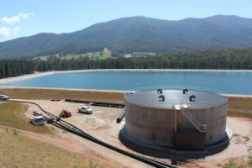

*Bright Storage tank and Off-river storage* Source: North East Water, waterstory website

**Overview:**

The construction of the Bright Off-river Water Storage in Freeburgh, Victoria commenced in early 2014. The $14 million project included; a new pumping station on the Ovens River, a 520 megalitre off-river water storage reservoir, a new water treatment facility, treated water storage tank and new pipeline to Bright.

**Key success elements:**

NEW has recently developed its second version of its Climate Resilience Framework which establishes a way for NEW to systemically identify climate change impacts, assess vulnerability to those impacts, and design responses to build resilience to climate change. Importantly, the framework recognises that this is not a once-through process but an ongoing one, with a regular cycle of annual and multi-year actions. The Bright Off-river project planning and its benefits are measured against NEW’s Climate Adaptation Principles in Table 6 below.

Table 6: NEW Climate Adaptation Principles and Bright Off-river Water Storage

|  |  |
| --- | --- |
| Climate Adaptation Principle | Bright Off-river Water Storage Project |
| Decisions and actions should be based on the best available science about climate change and projected impacts. | Stream-flow reliability and its impact to the Ovens System were identified in NEW’s 2007 and 2012 Water Supply Demand Strategy. This was a key driver for the project. |
| Adaptation and resilience planning and action should be iterative and reflexive. | NEW made changes to the fill and use of the storage after two years of operation, using current consumption and climate change scenarios. A need for a one-off fill to better balance the storage capacity was identified. Subsequently, an application to DELWP was made, and a trade from the Myrtleford Bulk Entitlement resulted in an operational profile better suited to the changing early hotter spring periods Victoria is seeing. |
| Adaptation and resilience building should do no harm and as much as possible foster co-benefits | The storage was originally designed to be 320ML, however after consultation with users of the Ovens System it was identified by DELWP, North East Catchment Management Authority (NECMA) and local users that increasing the storage to 520ML and introducing passing flow rules could see significant environmental and social benefits during drought conditions. |
| As far as possible, adaptation and resilience building activities and processes should be integrated into NEW’s business-as-usual operations. | NEW uses Bushfire Attack Level (BAL) rating as its new standard benchmark for its assets {including Bright Water Treatment Plant (WTP)}. NEW Operators monitor water quality during and after a flood and fire event, and only extract when water quality parameters are met. |
| Adaptation and resilience building should be understood as a shared responsibility | The project design and placement involved significant cooperation between DELWP, NECMA and the local community. |
| Adaptation and resilience building should be undertaken in partnership with the community | A community reference group was formed that had regular input into the design and placement of the storage. |

## West Gippsland Catchment Management Authority (WGCMA) infrastructure options for the lower Latrobe River wetlands

**Overview:**

*Ariel shot of the Dowd Morass Wetlands*  
Source: WGCMA

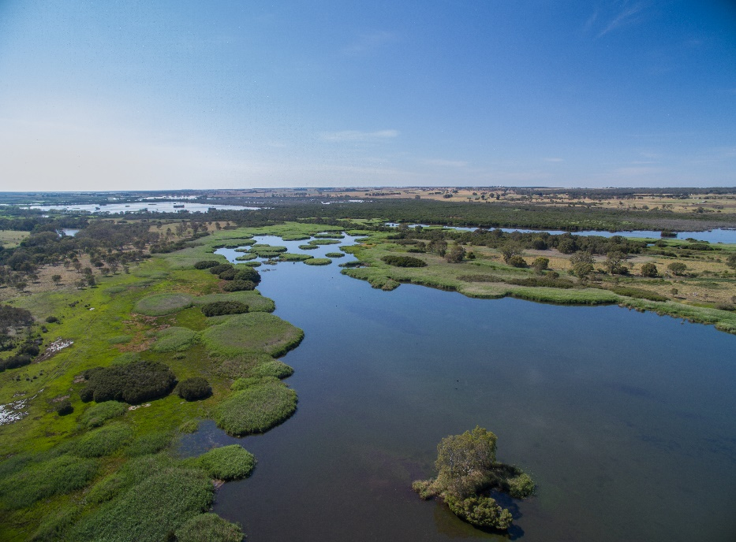

WGCMA, with funding from DELWP, undertook a project to investigate how freshwater inflows could be better provided into the internationally significant Heart and Dowd Morass wetlands. The wetlands are located on the floodplain of the Latrobe River below its confluence with the Thomson River, and they form part of the Gippsland Lakes system.

It was important the project not only considered solutions to the current inflow problem, but also factored in future climate change impacts, to ensure any solutions met long-term challenges. Climate change modelling and water quality monitoring were used to identify the best location and size of the proposed new water control gates to combat the effects of sea level rise and consequent increased inundation of saline water to the wetlands.

**Key success elements:**

WGCMA’s Natural Resource Management (NRM) Climate Change Strategy identifies climate change adaptation and mitigation management options for its region, including options for better environmental protection, planning and decisions about future environmental flows. The investigation on the wetlands is part of the strategy. The investigation of infrastructure options against climate change adaptation principles is in Table 7 below.

Table 7: Climate Adaptation Principles and the Lower Latrobe River Wetlands investigation

|  |  |
| --- | --- |
| **Climate Adaptation Principle** | **Lower Latrobe River wetlands investigation** |
| Using the most **up to date and appropriate data** to meet **current needs and anticipate future risks** | WGCMA used climate change predictions and sea level rise modelling and data from the WGCMA Natural Resource Management Climate Change Strategy. To quantify the risks and assess mitigation options, WGCMA used short-term and long-term modelling. |
|  |  |
| **Iterative approach** to business case development that **enables ongoing improvement** in planning | WGCMA reviewed its modelling data and adjusted planning accordingly in light of new information. It was found that impacts of sea level rise on the wetlands were being experienced much earlier than those predicted in 2014. This updated modelling found the infrastructure at one of the wetlands would not provide for long-term objectives over the entire wetland, however it would still protect part of the wetland and provide benefits to the remaining parts over the long-term. |
| Developing **shared value for adaptation** with **stakeholders and the wider community** | WGCMA with funding from DELWP, undertook the project to investigate how freshwater inflows could be better provided to these wetlands. Protecting these wetlands is important to the community and stakeholders, as the wetlands have significant social, recreational, cultural and economic value. |
|  |  |

# Appendices

1. Existing resources relating to climate change adaptation in the water sector
2. Summary of climate risks and adaptation strategies (of five case studies relevant to the water sector)
3. Business Case Template (provided as a high-level guide only)
4. Pilot Water Sector Climate Change Adaptation Action Plan – List of Actions

Appendix A Existing resources relating to climate change adaptation business cases in the water sector

Work on climate change adaptation business cases to date has focused on coastal adaptation in Australia and has been largely produced by the National Climate Change Adaptation Research Facility (NCCARF) at Griffith University (QLD). This section provides an overview of a study undertaken by the NCCARF and published in 2016. The study examined 10 “exemplary” business cases for climate change adaptation in coastal Australia. The key elements and lessons learnt from this study can be considered as critical success factors that can inform future practice of coastal climate change adaptation and, while focused on coastal adaptation, are considered relevant for water entities’ business case planning.

This section also provides commentary on the Water Services Association of Australia (WSAA) Climate Change Adaptation Guidelines also published in 2016. The guidelines draw upon the experience of the water industry, identify current best practice, and provide clear principles to guide the industry forward in a pragmatic and defensible approach to adaptation.

AS 5534-2013 *Climate change adaptation for settlements and infrastructure – a risk based approach* is consistent with AS/NZS ISO 31000:2009, Risk management – Principles and guidelines, and provides a consistent approach to managing risks associated with climate change with regard to effective adaptation and is useful for applying a climate change risk lens to long-term decision making**.**

A summary is provided at the end of this section to identify common themes of successful adaptation business cases and adaptation business planning resources.

*Bendigo Reservoir Coliban Water*, Source: DELWP

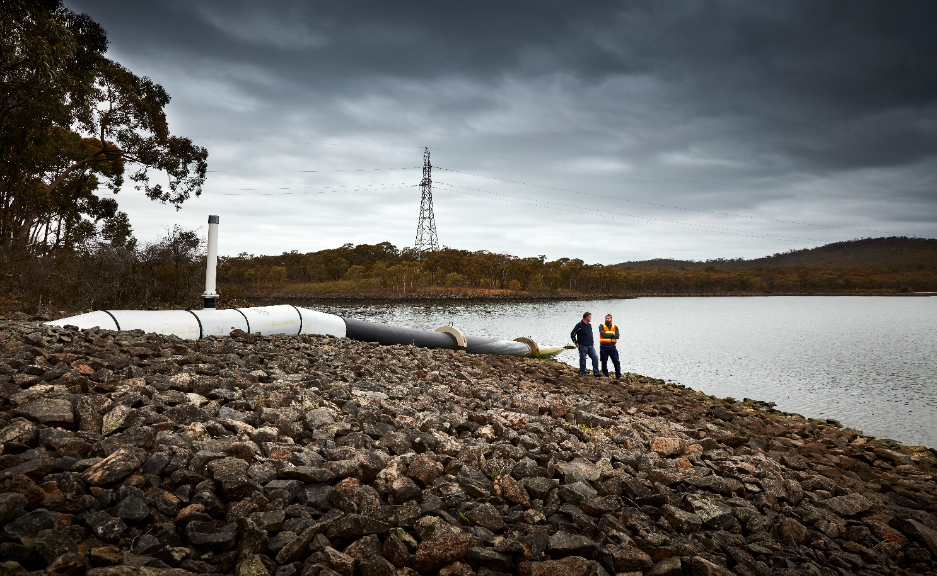

## National Climate Change Adaptation Research Facility (NCAARF) study

A National Climate Change Adaptation Research Facility (NCCARF)[12] study published in 2016[13] sought to fill this gap in knowledge by reviewing climate change adaptation literature from around the world and then, based on criteria developed from the literature review, examining a selection of business cases for climate change adaptation in coastal Australia.

The primary objectives of the study were:

* To identify and describe exemplary business cases that have been effective in adapting to climate change across business and local government in the coastal zone.
* To examine and document the critical success factors (including monetary and nonmonetary values), and the enabling processes, for coastal organisations to adapt to climate change.
* To provide appropriate and innovative guidance materials for the CoastAdapt Tool developed by NCCARF.
* To disseminate the outcomes of the project through industry networks, academic conferences and publications.

The study identified 10 “exemplary” business cases on the topic of the climate change adaptation in coastal areas. Analysis of the business cases revealed the critical factors for success (including monetary and non-monetary values) in terms of the elements of the business case and the process of building such a case.

The key elements and lessons learnt from this study were considered as *critical success factors* to inform future practice of coastal climate change adaptation and, while focused on coastal adaptation, are considered relevant for water sector business case planning.

|  |
| --- |
| **Key lessons learned from the NCAARF study include:**   1. Mounting a business case for climate change was primarily motivated by risks (and associated economic costs) that have been identified in the present governance systems of the organisation. 2. Integration of the business case for climate change adaptation into overall business decision-frameworks was an important element in mounting a business case. For example, a strong business case for climate change adaptation was associated with the presence of sustainability systems and practices in an organisation. 3. Developing shared value for adaptation with stakeholders and the wider community was an important element for both public and private enterprise. 4. Business cases involved the identification and consideration of adaptation pathways (already used by some Victorian water entities) – where future options for action to respond to climate risks are identified and met through manageable stages triggered by a change in environmental and social conditions (see Barnett el al. 2014).[14] 5. Use of collaborative approaches, often with external experts and organisations to formulate tools that can assist with obtaining organisational buy-in for the business case. For example, visual tools were developed to help communicate the impacts of climate change and make it more relevant and tangible for decision-makers. 6. Planned monitoring of adaptation outcomes will be vital in successfully adapting to future conditions as adjustments may be needed in the future (see no. 4 above). 7. Planning for infrastructure for the short- and long-term helps ensure that adaptation can be supported and implemented now and in the future. In this sense, use of a range of scenarios (mostly current, 2030 and 2070 projections) was widespread among the cases that were examined. |

### Key elements of a business case for climate change adaptation

|  |
| --- |
| **The following key elements were consistent across all 10 of the adaptation business cases analysed in the NCAARF study:**   * Using evidence to support that climate change is impacting the organisation, project or initiative. * Framing climate change as a threat risk and also recognising it as an opportunity. * Ability to incorporate climate change threat risks and/or the opportunities climate change presents to the organisation’s existing processes (such as standard risk management practices), thus becoming part of the ‘normal business operations’. * Linking the business case for climate change adaptation to sustainability planning. * Strategically aligning adaptation objectives with the mission and objectives of the organisation. * Collaboration and partnership with a range of organisations, including researchers, public sector (several levels of government) and private sector organisations to identify strategic shared benefits. * Monitoring individual initiatives to measure benefits to stakeholders and to minimise risk. * Long-term time frame for return on investments measured by strategic shared benefits. |

Expanding on the above key elements:

**All organisations analysed in this study either assumed climate change was already occurring or that the business case identified presently occurring risk factors within the case.** This is a fundamental element of a business case for climate change adaptation. Whilst it is difficult to attribute any one disaster or extreme event with climate change, analysis suggests the risks of extreme events are rising. The nature of extreme weather events, such as cyclones in the northern half of Australia, and the movement of these events (and associated risks) further south made a business case more feasible in the relevant cases.

**Mounting a business case for climate change was primarily motivated by the understanding of present risks for the organisations.** Important to all cases was the incorporation of present climate change risk into existing risk management practices and, thus, climate change becoming part of the normal system of governance of the organisation. There is a greater tendency in the private sector to interpret adaptation as a risk and manage it by incorporating it into organisations’ risk management processes.

**Linkage of the business case for climate change adaptation to sustainability planning** was also a way of justifying the business case for climate change. All organisations exhibited this feature of needing to consider sustainability as part of governance and some organisations realised, they needed to strengthen this relationship to ensure improved climate change adaptation.

**Strategic alignment of business case objectives with the mission and objectives of the organisation** was seen to be a key element of the business cases**.** The integration of the business case for climate change adaptation into overall business decision-making frameworks was an important element in mounting a business case. Developing a shared value with stakeholders including the wider community was an important element for both local government and private enterprise. Considering the impacts beyond the organisation and the reciprocal relations with stakeholders were important in the case studies presented.

**Identification of strategic benefits to the organisation and stakeholders** was an important element. In some cases, lifecycle analysis and cost benefit analysis were used. However, it appeared to be more important for the organisation and its stakeholders to identify strategic benefits that result from the implementation of the business case.

**The long-term time frame of the business case** was also a key element**.** The return on investment was difficult to measure and as a result of this, the strategic benefits and current risks became more important in the justification of the business case.

The planned monitoring of adaptation outcomes was important in risk management and also demonstrating benefits to the organisation and stakeholders.

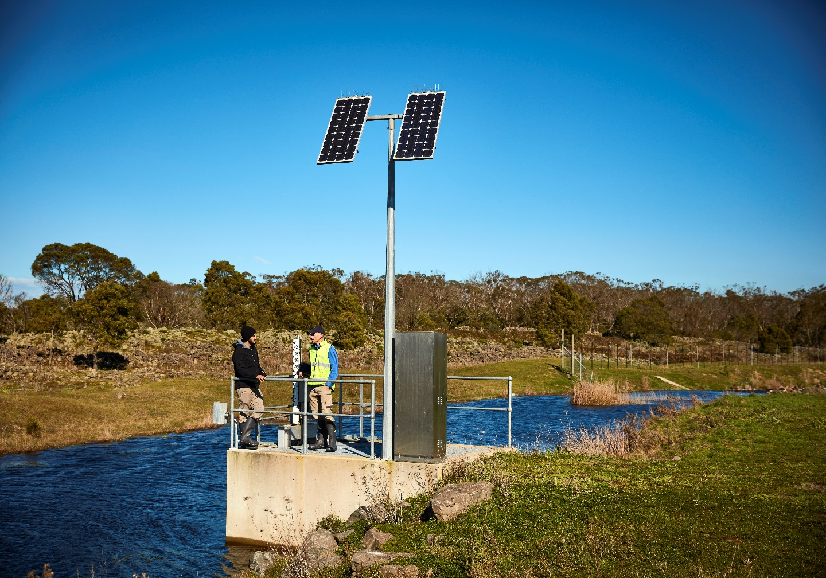

*Glenelg Hopkins Catchment* Source: DELWP

### How to mount a business case for climate change adaptation

Features of the *exemplary* case studies provide valuable lessons for practitioners who seek to build a business case for adaptation. The study identified important lessons that are being passed onto other organisations in order to successfully mount a business case for climate change adaptation. The template at Appendix B should be used as additional to existing DTF guidance on business cases, and should not replace existing guidance.

The following lessons have been incorporated into the template at Appendix B:

1. **Use extreme events as a critical moment to propose the business case**. Critical moments can shift organisations view on climate change and in many cases, these critical moments were extreme weather events (e.g. floods, heat waves, cyclones, storm surges). This lesson is necessary in seizing opportunities to create momentum and mounting a case for adaptation in the first place, as quite often external events (e.g. disasters and economic changes) allow for certain elements of a business case to become more relevant in the decision-making process of the business case. This lesson was also seen to be a continuous process to elevate the business case towards policy adoption and implementation, as opposed to a one–off process.
2. **Leadership involved within the organisation and external to the organisation is important** for progressing the business case through the decision-making process in an organisation.
3. **The use of visuals and local context was important to demonstrate the need for adaptation measures.** This point is also emphasized by the literature on climate change communication.
4. **It was important to ensure there is long-term staffing for key positions in order to wait for possible delays in initiation or delivery of the proposal.** It was also important to have a continuing climate change planner position in an organisation because of the long-time frames for the implementation of measures. Most of the participants who championed adaptation business cases had several years of experience in the organisation, so they possessed a more sophisticated knowledge of the organisation, internal systems, and the key risks for the organisation and decision-making processes. Coupled with critical moments was the presence of strategic actions of personnel in an organisation to implement the adaptation plan.
5. **The staged implementation of projects within the business case appeared to lead to greater success.**
6. **Providing relevant climate impacts on the business is important** and, thus, any irrelevant information, such as impacts on regions where the organisation does not operate, or processes/products that are not part of the business should not be included. **However**, it should be noted that especially in the water sector, impacts in other regions natural systems will sometimes affect an organisations region.
7. **Identifying key climate and weather risks as opportunities for the organisation and identifying business relevance will increase the justification of the business case.** The use of positive framing of key impacts of climate change on the organisation is important in implementing a successful business case for climate change adaptation. Often, climate change is framed as a non-specific threat in the future. The cases in this study, however, address the risks that are currently experienced by the organisation.
8. **The linkage of climate change adaptation measures with climate change mitigation is important in the justification of the business case.** An emphasis on the risks to the organisation of not mitigating for climate change being linked to the risks of not adapting to climate change.
9. **Engagement with other organisational commitments** (e.g. voluntary environmental or carbon initiatives) and the stakeholders involved with these commitments is important.

|  |
| --- |
| **‘Policy Window’ theory**  Dr David Christian Rose’ paper describes four ways in which organisations can constructively engage with the concept of ‘policy windows[15]. A ‘policy window’ is described as a scenario in which the ground is fertile for the uptake of an idea, in this case it would be a business case. The business case idea may have been proposed for a long time before suddenly finding it is taken up by an organisation.  While it is not possible to know what a policy agenda will be in the future, members of organisations can prepare, build on existing work, ensuring that previous work is not lost, to respond effectively when a policy window does occur.  Further commentary and access to the 4-stage framework on this process can be found in the Environmental Science and Policy journal, and online at ScienceDirect. |

## Water Service Association of Australia (WSAA) Climate Change Adaptation Guidelines

In 2016, the Water Services Association of Australia (WSAA) released the Climate Change Adaptation Guidelines, the purpose of which is to provide the Australian and New Zealand water industry with consistent, clear and authoritative guidance in building climate resilience across all aspects of water entity businesses. The guidelines draw upon the experience of the water industry, identify current best practice [at the time] and provide clear principles to guide the industry forward in a pragmatic and defensible approach to adaptation.

These guidelines are designed to help water entities with all stages of the adaptation process, from initial appreciation of the issues, through to the implementation, monitoring and improvement of response actions. While these guidelines do not attempt to analyse the science, they do recognise that the impact of climate change will vary significantly from region to region across Australia and New Zealand.

For utilities approaching the issue for the first time, the guidelines will help lay the foundation for a structured organisational strategy and response. Conversely, for those utilities that have appraised their climate risks and are implementing adaptation actions, the guidelines can provide a benchmark for best practice and can facilitate continuous improvement.

Key to these guidelines is the conduct of a vulnerability assessment against the six core functions of:

Source waters and demand Built assets

Natural environment People and workplace

Interdependencies Customer and product delivery

The WSAA guidelines are informed by the risk management process of ***AS 5534-2013 Climate Change Adaptation for settlements and infrastructure - a risk-based approach***. They are deliberately non-prescriptive in the core of the document so as to remain easily adaptable to different situations, although they do provide principles to help to achieve a level of consistency across the industry.

Guidelines section 1.4 - ***Define robust decision-making processes*** states:

*“Uncertainty is a key characteristic of climate change; a fact that no amount of investigation will alter. However, because the risks of climate change are broadly known, this creates the responsibility to address them. It is important to ensure that decision-making processes can deal with the inherent uncertainties caused by the changing climate.”*

|  |
| --- |
| **Key Message Snapshot**  Decision-making processes need to be critically analysed and changed to;   * incorporate climate change into all existing decisions, as an additional variable, rather than a discrete issue to be tackled in isolation; * integrate scenario planning, or planning for extremes, rather than just planning for ‘average’ conditions; * plan over multiple planning horizons, taking into account both the time when a risk will reach a critical trigger point and the time-lag required to implement effective responses; and * favour flexible solutions, which may require definition of multiple pathways. |

As budgetary constraints are central to long term investment decisions, it is essential to build robust business cases to justify capital and operational expenditure and bring the topic into discussions with Ministers, regulators and other key decision-makers.

While this guidance note focuses on developing successful business cases for climate change adaptation, the WSAA guidelines provide an effective framework and process for an overall climate change adaptation strategy.

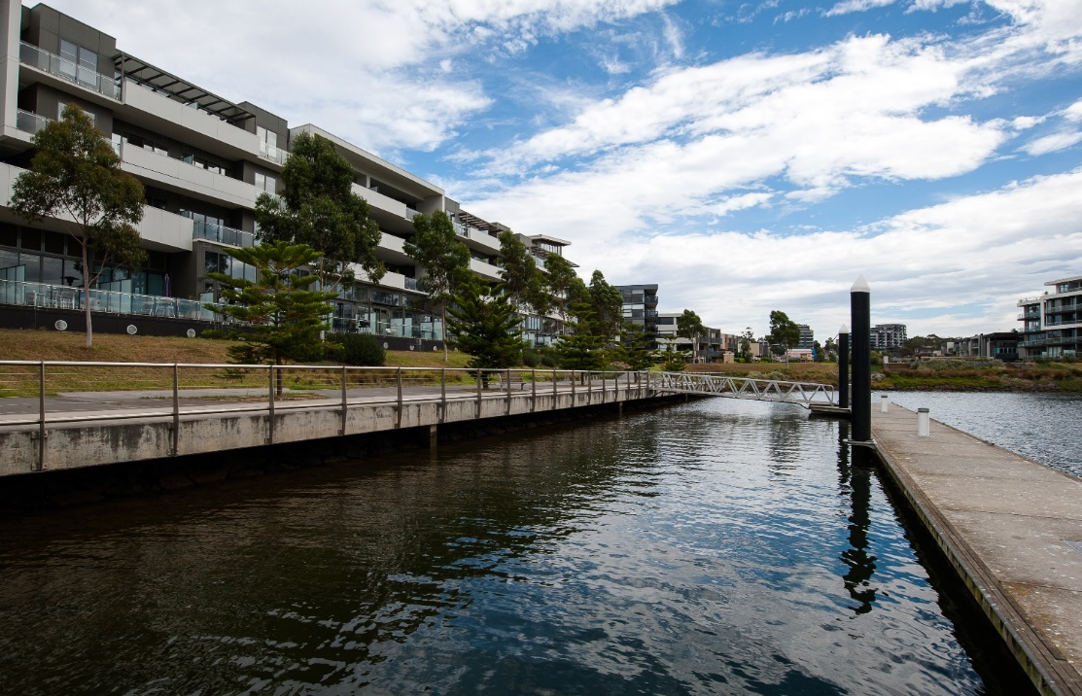

*Edgewater lake high rise development, Maribyrnong River,* Source: DELWP

## Managing Climate Change Risk: Guidance for Directors and Executives of Water Corporations and Catchment Management Authorities, DELWP (2019)

This guidance note sets out Victorian water entities’ duty of care in relation to climate change and describes the process to discharge that duty with due diligence, given the inherent uncertainties. It also provides clear steps and further guidance for effective decision making, noting continuing projects at both department and sector level. It was also prepared to provide guidance to the senior executives in water agencies who report to those boards.

Risk is defined as “the effect of uncertainty on objectives”.[16] Managing risk is about managing the uncertainty. It should be noted that an “effect” is a deviation from the expected which can be either negative (threat risk) or positive (opportunity risk). While the threat risks are those most associated with climate change, there are also opportunities.

Uncertainty within the context of climate change arises because:

1. the rate of greenhouse gas emissions over the coming years is unknown and the consequential extent of climate change, especially in the long-term;
2. the understanding of the effects of climate change is based on models, which are inexact due to being based on hypotheses;
3. the link between changes in the climate (tipping points and feedback loops) adds an additional layer of uncertainty to predicting climate futures.

Imperfect information and uncertainty, however, is an insufficient reason for inaction; decisions are still required even when information is incomplete, so long as those making those decisions have endeavoured to examine and consider as much information as is reasonably possible in the circumstances. This is often referred to as the “Precautionary Principle” and is widely applied in environmental science as a common-sense approach that avoids unreasonable delays in taking action to prevent serious or irreversible harm to the environment. Gathering as much information as is available and acknowledging the uncertainty relating to your project can actually support your business case. Indeed, the *precautionary principle* is implied in s.25 (2) of the Climate Change Act 2017 – “Principle of Risk Management”.

## AS 5534-2013 Climate Change Adaptation for settlements and infrastructure - a risk-informed approach

AS 5534-2013 is consistent with AS/NZS ISO 31000:2009, Risk management – Principles and guidelines and provides a consistent approach to managing risks associated with climate change for effective adaptation. The Standard was developed by Committee BD-103, Climate Change Adaptation, which comprised representatives from key infrastructure and ‘community’ stakeholders, including WSAA.

According to the Standard, climate change risks should be considered within the context of other risks that may affect the organization within a similar timeframe, as multiple risks may combine and result in a more severe risk. For example, Water Corporations are affected both by population growth, which increases water demand, and declining rainfall, which decreases water availability. The two factors together multiply the risk.

A useful element of the Standard is the use of a long-term risk likelihood measure as an alternative to the traditional ‘recurrent or event risk’ measure. See Table 1 for how a long-term risk assessment assists with climate change risk.

An overview of the AS 5534-2013 approach to developing a plan for climate change adaptation action is included as Figure 1.

**Table 1: Long term risk assessment and climate change risk**

|  |  |  |
| --- | --- | --- |
| **Descriptor** | **Recurrent or Event Risks** | **Long-Term Risks** |
| *Almost certain* | The event is expected to occur once a year or more frequently. (1.0 events p.a.) | Greater than 90% chance of event / situation occurring in the identified time period if the risk is not mitigated. |
| *Likely* | Has or would probably occur once in every 1 - 5 years. (0.25 events p.a.) | 60 - 90% chance of event / situation occurring in the identified time period if the risk is not mitigated |
| *Possible* | Might occur at some time; 5 – 30 years. (0.1 events p.a.) | 30 - 60% chance of event / situation occurring in the identified time period if the risk is not mitigated |
| *Unlikely* | The event does occur somewhere from time to time. Could occur at some time; 30 - 100 years. (0.033 events p.a.) | 10 - 30% chance of event / situation occurring in the identified time period if the risk is not mitigated |
| *Rare* | Have heard of something like this event happening elsewhere. May occur once in 100 years or more. (0.01 events p.a.) | Less than 10% chance of event / situation occurring in the identified time period if the risk is not mitigated |

|  |
| --- |
| **Long-term risk assessment in practice**  A risk associated with climate change may result from circumstances that are expected to be experienced in 2070; i.e.: 50+ years away. Under a traditional measure of likelihood, this may be confused with “could occur at some time 30 – 100 years” and be classed as unlikely and the risk level assessed accordingly. However, considering the context of a long-term decision, if the climate models show an 80% confidence rating of the circumstances occurring within that time period, then the likelihood is classed as likely and the resultant risk level is much higher and thus demanding of more action / visibility within the entity. |

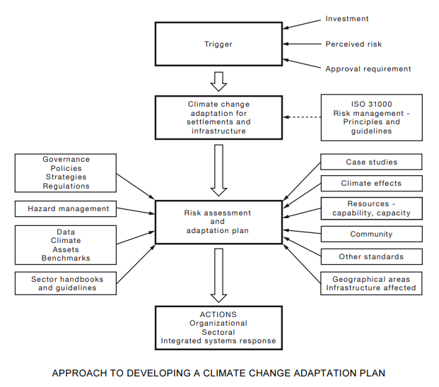

**Figure 1: AS 5534-2013 Approach to developing a plan for climate change adaptation action**

Uncertainty is part of the intrinsic nature of complex systems. As the quality, quantity and communication of climate change information improves over time, the knowledge gap is expected to reduce. However, filling the knowledge gap will not remove all uncertainties when dealing with climate change information and data.

It is likely that significant levels of uncertainty with regard to climate change projections will remain and adaptation planning processes will have to be flexible enough to cope with this uncertainty. The lack of incontrovertible data should not be considered as a reason not to implement climate change adaptation measures.

Adaptation plans should be reviewed on a regular basis to take new data into account. They should be seen as ‘live documents’ that are updated and modified to take changing circumstances into account. The West Gippsland Catchment Management Authority (WGCMA) case study in Section 6 is a good example of this.

## Department of Treasury and Finance (DTF) Sustainable Investment Guidelines – for release in 2020

These guidelines aim to guide consistent implementation of best practice in sustainable investment in Victoria. They are designed to support agencies to meet their obligations, including those relating to the Climate Change Act 2017.

These guidelines are complementary to the DTF Investment Lifecycle and High Value High Risk Guidelines, and are for use by government agencies that are involved in the planning and delivery of building and infrastructure projects. They support and build upon the Social Procurement Framework, providing more detailed guidance on ecological sustainability.

## Summary

It is clear there is guidance available on undertaking business cases for investment in adaptation. While that guidance provides some valuable lessons for water sector entities to assist in the preparation of strong adaptation business cases, those lessons and key learnings are not specifically tailored to addressing the sector specific challenges the water entities face.

Guidance on climate change adaptation business cases to date has focused on coastal adaptation in Australia and has been largely produced by NCARRF. This guidance, while helpful, is not tailored to water professionals. While the Climate Change Adaptation Guidelines prepared by WSAA and the risk-based approach AS 5534-2013 can assist practitioners in developing adaptation approaches and projects, they do not provide advice on the different economic evaluation techniques suited to climate adaptation business cases.

Selecting and applying the most effective financial assessment methodologies is critical to the success of adaptation business cases. However, there is little practical and accessible guidance on how to do this. Section 4 and 5 of the Guidance Note address this.

Appendix B Summary of climate risks and adaptation strategies

**Summary of climate risks and adaptation strategies of five case studies relevant to the water sector**

|  |  |  |
| --- | --- | --- |
| **Organisation** | **Risks and impacts** | **Strategy** |
| Melbourne City Council | * Increased temperature * Urban tree loss * Storm water flooding * Decreased visual amenity | Urban Forest Strategy |
| Parramatta City Council | * Increased temperature * Community affected * Flooding impact on assets | Range of planning Initiatives:   * Parramatta Ways * Bring back swimming to the * Parramatta River * Cool Parramatta |
| Douglas Shire Council | * Increased exposure to storm surge * Flooding due to rainfall events * Evacuation routes flooding * Potable water shortage in dry season * Turbidity of flood waters affects wastewater treatment * Beach erosion | Range of initiatives:   * Flood monitoring * Water and transport * Infrastructure upgrades * Coastal management |
| AustralianSuper | * Financial risk to value of assets impacted by climate change | Assessment of investments for  climate resilience |
| Sydney Opera House | * Due to its location, the Sydney Opera House could be impacted by sea level rise, while heat waves, strong winds and increased heavy rainfall pose risk to visitors, particularly to outdoor events and retail areas. * Warmer winters present an opportunity. | Adaptation through the  building renewal scheme,  events planning and retail  operations |

Appendix C Business Case Template

General guidelines for developing a business case

This template should be used as additional to existing DTF guidance on business cases, and should not replace existing guidance.

This template has been adapted directly from the CoastAdapt business case template and can be used to develop a business case report for climate change adaptation.

**How to use this template:**

A number of different text styles have been used within the template, as follows:

* Text in *italics* font is intended to stay in the final document
* Text in normal font provides general guidelines for the section and should be omitted
* Text enclosed in <angle brackets> and italics is intended to be a guide and to be replaced by your own text.

1. Carefully select and only include information that is directly relevant to and supports the proposed adaptation action. Be critical in judging what information to omit and what to leave in! Omit all information that would be irrelevant to the decision-maker (even if it is interesting).
2. The business case is supposed to guide decision-makers through steps from recognising climate change as a potential local threat to the preferred adaptation action proposed in the business case document.
3. Consider what decision-makers (Board) already know about the risks posed by climate change to the region. Illustrate problems using tangible examples and evidence such as visuals (maps, photos, etc.). For example, use flood maps to show areas that will be affected by rising sea levels and urban heat maps to demonstrate the impact high temperatures will have on roads, parks and houses and how different built and natural environmental features (e.g. tree cover, pavement) will be affected.
4. Take care to use information from credible sources. Consider investing in collecting local data and generating local maps. Local information has been shown to illustrate problems much more effectively than borrowing data or maps from another town or city. (Again, make sure this information is relevant to the impacts of climate change that the adaptation project will manage.)
5. Harnessing support for a business case prior to presenting it to decision-makers has been shown to be vital for success. In some entities, it may be common practice, or indeed a consideration, to propose an action firstly at a formal workshop that is organised by the team or department proposing the project or action.

**Executive summary**

This section should be no more than two pages long and should be completed last.

It should read as a stand-alone document and should not include any new information that does not appear in the business case document.

Consider including the following headings/information:

* *Climate risk assessment*
* *Recommendation of top option*
* *Cost benefit analysis of options*
* *Stakeholder engagement and benefits*
* *Cost of inaction*

1. **Introduction**

This section provides background information, describing the rationale for the project and the business case. It should include select, preferably quantitative data and figures from credible sources to demonstrate the need for the project.

*<The introduction should describe:*

* *the threats that climate change poses to the local community and the entity (including threats to its built and natural assets) – reference to a vulnerability assessment*[17] *will be useful*
* *what action has been taken to address these threats in the past*
* *the current status of adaptation planning and implementation*
* *the cost of inaction (this can be deduced from a risk assessment)*
* *purpose of the business case.>*

1. **Objective and scope**

*<Include a statement that describes how the adaptation project will assist the entity to respond to the problems presented by climate change within its jurisdiction. In other words include a ‘statement of need’.>*

*<Align the proposed adaptation project business case with the entity’s strategic objectives/ organizational goals, outlining how the project will help meet them.>*

**The objective of the project/initiative is to ….**

**The project will assist *<the entity>* with meeting the following strategic objectives:**

*<Objective 1, describe how/what component of the project will meet the objective within a timeframe>*

*<Objective 2, describe how/what component of the project will meet the objective within a timeframe>*

*<Objective 3, describe how/what component of the project will meet the objective within a timeframe>*

*<Etc. >*

Following the objectives, state the relationship of the proposed project to other local/state/ federal processes, if applicable:

**The adaptation project aligns with the following existing or planned processes:**

*< Insert the name of existing process and describe what part of the adaptation project applies>*

*< Insert the name of existing process and describe what part of the adaptation project applies>*

*<Etc.>*

Scope: Define the scope of the project business case by discussing what the project will entail and also what it will not include. For instance, does the project include planning and approvals, other preparation, capacity building etc.? Is completion of an Adaptation Plan part of the project?

Include a comprehensive list of all the elements of the adaptation proposal. This should include monitoring and evaluation/assessment.

**This project will include the following components and activities:**

<Outline the various project components and activities, including approaches for monitoring and evaluating performance.>

* *<insert component/activity>*
* *<insert component/activity>*
* *<etc.>*
* *<monitoring>*
* *<evaluation>*

1. **Adaptation options**

A vital part of any business case is the demonstration that a number of different adaptation options were considered. Only then can one justify why a particular alternative is the best course of action to take.

*<Start by briefly restating the current state and the problem(s) with the status quo.>*

*<As a minimum, discuss the following three options:>*

1. ***Loss acceptance alternative***

*<Describe what ‘loss acceptance’ would entail and the risks involved with taking no action. For example, reflect on regulatory responsibilities (state and federal), community expectations, the implications to reputation, etc.>*

1. ***Desired option***

*<Describe the desired option and provide reasons as to why this option should be implemented. How is this option better than the alternatives?>*

1. ***Other project options***

*<List the possible options that are not desirable and state the reasons. These could include high capital costs, lack of funds to cover operational/maintenance costs, lack of knowledge and experience in the region to implement a new or complex technological solution, etc.>*

1. **Cost benefit analysis**

This section will set out the financial argument for undertaking the recommended adaptation option. All costs and benefits must be captured, and described, and should be quantified if possible. The cost of the project normally appears first and must extend to the costs incurred during all stages of the project, including construction, operation and planning (if applicable). Project planning documents, such as the feasibility study that accurately describes what will be undertaken should provide sufficient information to complete this part.

Cost benefit analyses usually appear in a spreadsheet. It is advisable to contact the accounting or finance services department for advice on what methodology should be used.

**Costs of the adaptation project by stage:**

1. ***Planning (if applicable)***

*<List the planning activities that need to be undertaken and the costs associated with each activity. These could include completion of feasibility studies, costs associated with gaining approval, consultant fees, legal fees, etc.>*

1. ***Construction/implementation***

*<List construction activities, providing as accurate detail as possible about, for example, length of road, volume of sand, etc. It may be easier to list each item individually, such as new road, new bridge, removal of existing structure, extension of pavement, etc.>*

1. **Operation (including maintenance)**
2. **Monitoring**
3. **Evaluation/assessment**
4. **Other (such as adaptive capacity measures)**
5. **Total costs.**

**Benefits of the adaptation project:**

The savings and/or income generated by the project should be outlined next.

In many cases, it is difficult to envisage that adaptation projects will generate income in the traditional sense and benefits may not be realized for decades. But the benefits of adaptation projects can accrue as cost savings. For example, beach nourishment does not generate revenue per se but it does reduce the cost of damages from storm surge events, which materialises as cost savings for property owners. In other words, the savings and benefits from adaptation projects may not be traditional. It is important to keep this in mind when completing or commissioning the cost benefit analysis. In many cases the cost benefit analysis is completed by an external financial advisor/advisory firm and the consultants should be comfortable with the concept of shared value creation. This concept recognises a wider range of adaptation benefits than traditional approaches.

1. **Savings achieved**

Savings could stem from various activities and may be directly or indirectly related to the adaptation project. It may be appropriate to list benefits by stakeholders, such as savings realized (such as reduced maintenance costs of the entity’s assets), the general community, tourists, businesses, etc. Or it may be better to list them by saving type, such as decreased maintenance costs or insurance cost savings.

1. **Income generated**

State any income from the project, if appropriate. This could include income from rates (by all or selected property owners) and levies or charges earmarked for adaptation (such as part of broader ‘environmental levies’). Any proposal for new charges should be described and supported in detail.

1. **Community benefit**

Community benefits should include direct and indirect benefits.

1. **Reputational benefit to the organisation**

Reputational benefit can be a very important factor for decision-makers. Framing adaptation action as a risk management response can create the image of a responsible organisation concerned with long-term as well as short-term planning. It would be a valuable exercise to frame the adaptation project as a responsible action and highlight potential reputational benefits.

1. **Total benefits**

This section should conclude with a statement describing how the benefits outweigh the costs.

1. **Risk assessment**

Risk assessment should be tailored to the needs of the entity. There are many different ways to conduct a risk assessment and the approach used will be case specific. The WSAA guidelines will be useful in this step – in particular undertaking and demonstrating a vulnerability assessment and detailed risk assessment.[18]

Some general principles of what to include in a risk assessment:

* Describe the risks the project will help mitigate. Consider risks to the entire organization, relevant departments/units and individuals (if applicable)
* Describe the risks each option poses to the organisation and demonstrate how the recommended action is the best option to pursue.
* The potential of high or unacceptable harm to the system concerned (infrastructure or people) when all impacts including cumulative risks are considered.
* The immediacy of the risk (eg: heatwaves will be more immediate than sea level rise).

1. **Recommendation**

The entire business case should build towards demonstrating that the preferred (recommended) option provides a solution to the adaptation challenge of the organisation.

1. **Implementation plan**

Inclusion of a realistic (rather than idealistic) implementation plan will help to gain support from decision-makers. Understanding the attitudes, capacity for action and the social licence of decision makers is vital for pitching the business case.

A plan of implementation should include the following:

* A project timeline that sets out key milestones and time anticipated to reach them
* Costs associated with reaching each milestone (a simple version of the project budget)
* Factors that may inhibit reaching milestones (e.g. delays due to climate/weather, construction of other projects such as roads)
* Key performance indicators that will allow monitoring of implementation. These should be quantifiable indicators.
* Any consideration of ***no regret investments*** and potential for ‘deferred projects’

Appendix D Pilot Water Sector Climate Change Adaptation Action Plan – List of Actions

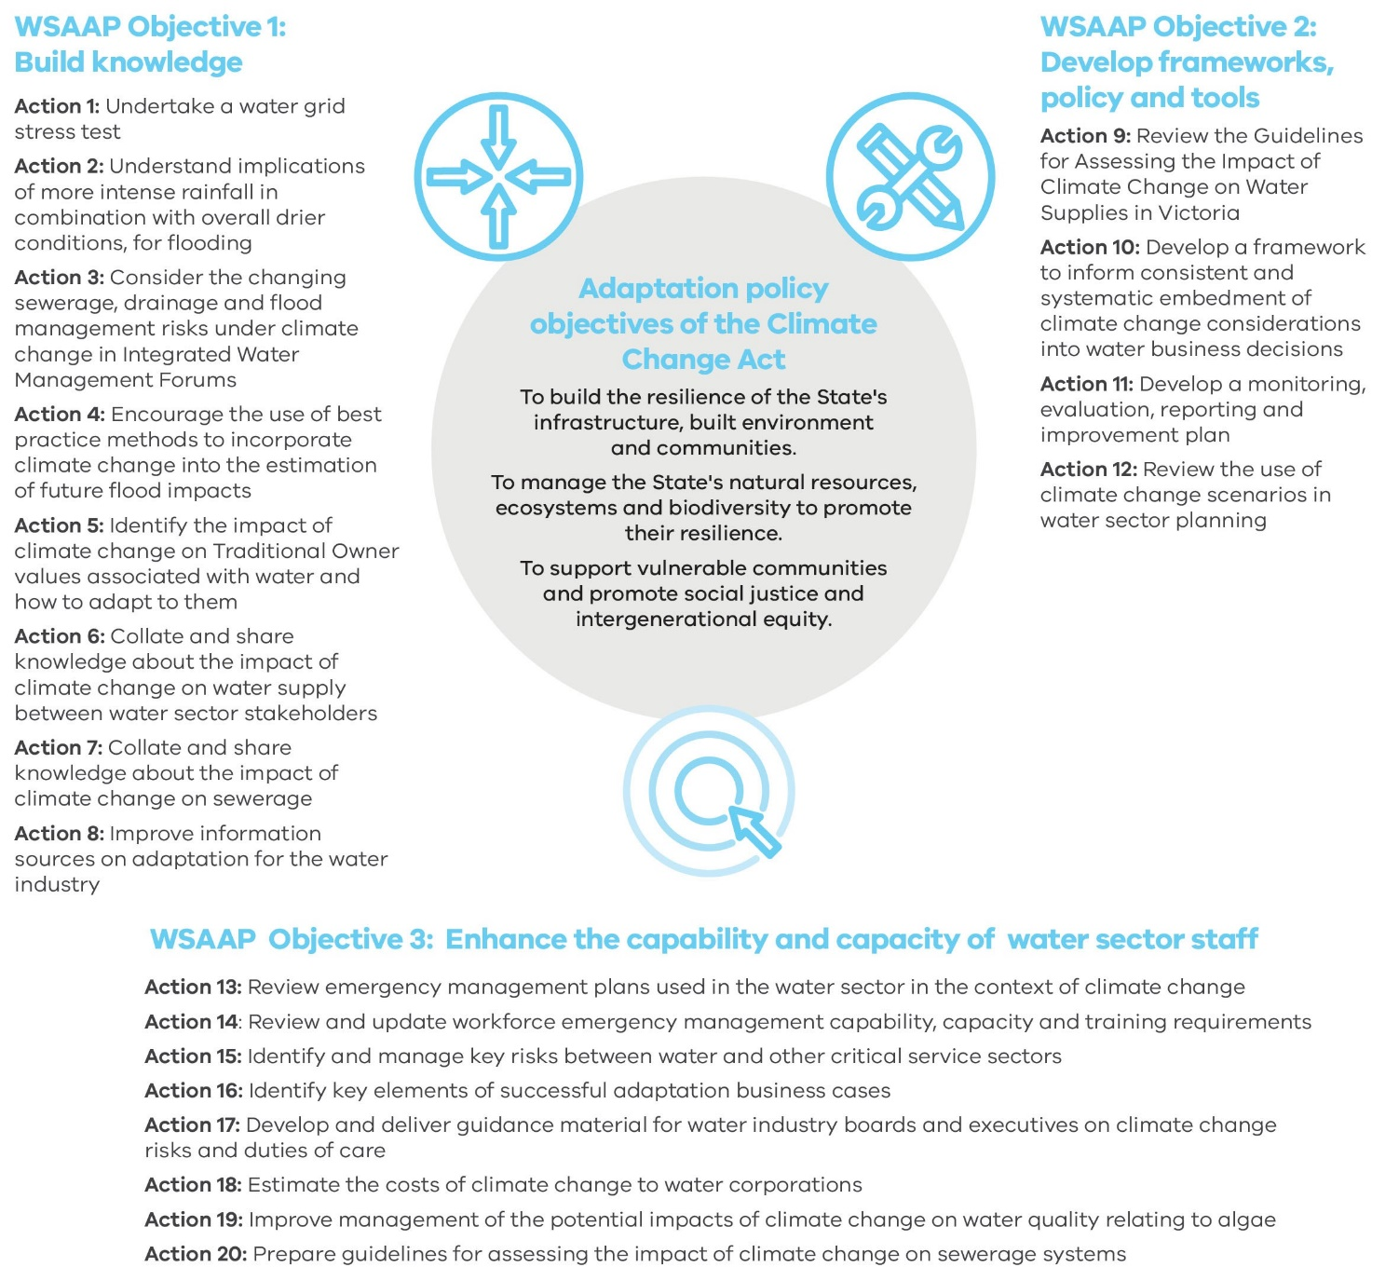

delwp.vic.gov.au

1. Clarke JM, Grose M, Thatcher M, Hernaman V, Heady C, Round V, Rafter T, Trenham C & Wilson L. Victorian Climate Projections 2019 Technical Report. CSIRO, 2019
2. Steffen, W, Hughes, L, Perkins, S. Heatwaves: Hotter, Longer, More Often. The Climate Council, 2014
3. Hope, P, Timbal, B, Hendon, H, Ekström, M, Potter, N. A synthesis of findings from the Victorian Climate Initiative (VicCI). Bureau of Meteorology, 2017
4. Bureau of Meteorology & CSIRO. State of the Climate 2018.
5. Hales, R., Banhalmi-Zakar, Z., Sarker, T., Lo, A., Chai, A., Whittlesea, E., Fleming, C., Kelly, K., and Bun, M., 2016: Building the business case for climate change adaptation. National Climate Change Adaptation Research Facility, Gold Coast.
6. <https://www.dtf.vic.gov.au/infrastructure-investment/investment-management-standard>, <https://www.dtf.vic.gov.au/investment-management-standard/ims-workshops-and-examples>
7. <https://watersensitivecities.org.au/content_type/resources/?fwp_topic=economics-and-business-case>
8. <http://evri.ca/en>
9. https://www.dtf.vic.gov.au/investment-lifecycle-and-high-value-high-risk-guidelines/stage-1-business-case
10. https://watersensitivecities.org.au/research/our-research-focus-2016-2021/integrated-research/irp2-wp3/
11. <https://www.wsaa.asn.au/publication/source-catchments-water-quality-treatment-assets>
12. National Climate Change Adaptation Research Facility, Griffith University, Queensland
13. Hales, R et al loc. cit.
14. 8 This is also consistent with the “no regret investments” approach used in Kalra, Nidhi Rajiv; Groves, David G.; Bonzanigo, Laura; Molina Perez, Edmundo; Ramos, Cayo; Brandon, Carter J.; Rodriguez Cabanillas, Iván. 2015. *Robust decision-making in the water sector: a strategy for implementing Lima’s long-term water resources master plan (English)*. Policy Research working paper; no. WPS 7439. Washington, D.C. : World Bank Group.
15. . D.C. Rose, N Mukherjee, B.I. Simmons, E R. Tew, R.J. Rovertson, A.B.M. Vadrot, R Doubleday, W.J. Sutherland 2017, *Policy windows for the environment: Tips for improving the uptake of scientific knowledge*, Environmental Science and Policy Journal, Volume 7, ScienceDirect.
16. AS/NZS ISO 31000:2009 *Risk Management – principles and guidelines*
17. . See WSAA Climate Change Adaptation Guidelines, part 2.2
18. . See WSAA Climate Change Adaptation Guidelines, parts 2.2 - 2.4