North East
Strategic directions statement
May 2019

Department of Health
Acknowledgement of Victoria’s Aboriginal communities
The Victorian Government proudly acknowledges Victoria's Aboriginal communities and their rich culture and pays its respects to their Elders past and present. The government also recognises the intrinsic connection of Traditional Owners to Country and acknowledges their contribution to the management of land, water and resources.
We acknowledge Aboriginal people as Australia’s first peoples and as the Traditional Owners and custodians of the land and water on which we rely. We recognise and value the ongoing contribution of Aboriginal people and communities to Victorian life and how this enriches us. We embrace the spirit of reconciliation, working towards the equality of outcomes and ensuring an equal voice.
© The State of Victoria Department of Environment, Land, Water and Planning 2019
This work is licensed under a Creative Commons Attribution 4.0 International licence. You are free to re-use the work under that licence, on the condition that you credit the State of Victoria as author. The licence does not apply to any images, photographs or branding, including the Victorian Coat of Arms, the Victorian Government logo and the Department of Environment, Land, Water and Planning (DELWP) logo. To view a copy of this licence, visit Creative Commons <creativecommons.org/licenses/by/4.0/>
Printed by Finsbury Green, Melbourne
ISBN 978-1-76077-422-6 (Print)
ISBN 978-1-76077-423-3 (pdf/online/MS word)
Disclaimer
This publication may be of assistance to you but the State of Victoria and its employees do not guarantee that the publication is without flaw of any kind or is wholly appropriate for your particular purposes and therefore disclaims all liability for any error, loss or other consequence which may arise from you relying on any information in this publication.
Accessibility
If you would like to receive this publication in an alternative format, please telephone the DELWP Customer Service Centre on 136 186 or email the DELWP Customer Service Centre <customer.service@delwp.vic.gov.au> or via the National Relay Service on 133 677, or at the National Relay Service website <www.relayservice.com.au>.
This document is also available on the internet at the DELWP website <www.delwp.vic.gov.au>

Contents
Foreword 7
Acknowledgements 8
At a glance 9
Vision 9
Purpose 9
Scope 9
North East Region Focus Areas: 9
Strategic outcomes: 10
At a glance – IWM ready to advance projects 11
Chapter 1 The way forward 15
Introduction 16
Enduring collaboration 17
Chapter 2 IWM in the Region 21
Strategic Directions Framework for North East IWM 21
Regional context 23
The case for IWM in the Region 25
IWM Case Studies 29
Chapter 3 IWM opportunities 31
State-wide and region specific initiatives 31
IWM opportunities: How were they selected? 32
Ready to Advance IWM Opportunities – overview 33
Ready to Advance IWM Project Opportunities – In Depth 35
Appendix 1 54
North East IWM Opportunities that require further work 54

Integrated Water Management is a collaborative approach to water planning and management that brings together organisations with an interest in all aspects of the water cycle.
It has the potential to provide greater value to our communities by identifying and leveraging opportunities to optimise outcomes.

Foreword
It is with much pleasure that we present the Strategic Directions Statement for Integrated Water Management (IWM) for North East Victoria.
This Strategic Directions Statement is a true collaboration of Traditional Owners, local governments, state government agencies, our rural water authorities, our urban water authority and our catchment management authority. These agencies came together to form the North East IWM Forum, one of 16 IWM Forums established across Victoria.
The North East IWM Forum has met to consider how the focus on IWM can meet the challenges of the region, and continue to focus on healthy, resilient and prosperous communities and environment. Our region is defined by natural beauty and liveability. We love living where we live, and value our lifestyle and amenity. The Strategic Directions Statement aims to keep these ideals at the forefront, whilst acknowledging water-related challenges facing the region particularly through climate change. As a region, and as a forum, we have discussed and deliberated how best to meet our challenges, and make great opportunities work for us, our landscape, our environment and our communities.
Deep discussions and deliberations have occurred through the IWM Forum, focused on embedding the principles of IWM into the everyday planning and work of agencies. We have agreed, for our region, that there are three primary outcome areas: Climate Resilient and Liveable Communities; Healthy Waterways and Landscapes; and Planning for Sustainable Growth. The priorities and projects identified within this Strategic Directions Statement are truly collaborative projects – involving multiple partners – always with a clearly defined lead agency.
Our region values public education and meaningful engagement about water. It helps improve our understanding of what is important to communities and can lead to innovative solutions to problems. Engaging with the community is a key part of delivering projects. We look forward to making these ideas become a reality, and seeing great outcomes as a result.
My thanks go to all of the IWM Forum members for your engagement, consideration and for working with each other. It takes all levels of an agency to develop these ideas, liaise with key partners and make sure the ideas are aligned with other strategic priorities and projects. It is not just sitting at a meeting that creates the value and the outcomes, the work behind the scenes from all partners is much appreciated. I would also like to acknowledge and thank North East Water for taking the lead role in providing support for the IWM Forum.
Susan Benedyka
North East Integrated Water
Management Forum Chair

Acknowledgements
This North East IWM Strategic Directions Statement has been developed in collaboration with*:
Alpine Shire Council
Benalla Rural City
Department of Environment, Land, Water and Planning
Goulburn Broken Catchment Management Authority
Goulburn Murray Water
Indigo Shire Council
Moira Shire Council
North East Catchment Management Authority
North East Water
Towong Shire Council
Rural City of Wangaratta
Wodonga City Council
Yorta Yorta Nation Aboriginal Corporation
Taungurung Land and Waters Council
*Including other relevant Traditional Owners and Aboriginal communities.

At a glance
The North East region has many unique characteristics compared to other parts of regional Victoria. It is Victoria’s entry point for the nationally significant Murray River and contains the entire course of the Ovens, Kiewa, Mitta Mitta and King Rivers. The region also contains two significant water storages, Lake Hume and Dartmouth Dam.
The region comprises only two per cent of the geographic area of the Murray Darling Basin yet it provides 38 per cent of its water. Moreover, the region has highly valued water resources that provide a range of important economic, environmental and social benefits.
It has a distinct and dispersed settlement pattern that requires tailored servicing needs. Our regional cities and centres service sub regions comprised of peri-urban and smaller towns.
Significantly, this wide landscape is the country of many Traditional Owner groups as well as Aboriginal communities that identify a connection to land. It is in this context that the region also faces challenges.
Principal amongst them is the impact of climate change. IWM will assist in monitoring and adapting to climate change as a shared responsibility. IWM is a way to extend responses to climate change by considering other economic and social issues and harness the power of collaboration.
The North East IWM Strategic Directions Statement (SDS) highlights the key challenges in the region and also identifies collaborative IWM opportunities that can address climate change and other key drivers to improve resilience and liveability in cities and towns in the region.

Vision
Healthy, resilient and prosperous communities and environment.

Purpose
To work creatively in partnership across the water cycle to plan and deliver sustainable and holistic outcomes.

Scope
The SDS vision and outcome intent is focused on an urban perspective and any associated interface with rural waterways and communities.

North East Region Focus Areas:
- Climate Resilience and Liveable Communities
- Healthy Waterways and Landscapes
- Planning for Sustainable Growth

Strategic outcomes:
- Safe, secure and affordable supplies in an uncertain future
- Effective and affordable wastewater systems
- Avoided or minimised existing and future flood risks
- Healthy and valued waterways, wetlands and lakes
- Healthy and valued urban and rural landscapes
- Community values reflected in place based planning
- Jobs, economy and innovation

At a glance – IWM ready to advance projects
Partners of the Forum have committed to applying their best endeavours to progress the Ready to Advance projects detailed in this statement in alignment with the shared vision and focus areas of the North East IWM Forum. The suite of project opportunities, described briefly below, are organised in order of scale (regional then local) and alphabetically by lead agency.
Engaging Aboriginal Communities in Integrated Water Management in the North East Region (NE Aboriginal Water Policy Officers)
This project aims to generate knowledge and develop a deeper understanding around the complexities of engaging with different Traditional Owners and broader Aboriginal communities in the North East. The aim of the project is to develop a tool that sets out guidance on protocols and approaches to undertaking respectful and meaningful engagement with Aboriginal leaders. In particular, where activities related to IWM and urban water planning more broadly re taking place on country.
Water Sensitive Urban Design (WSUD) Guidelines by Council Region (NECMA)
This project seeks to develop a WSUD guideline for each local government area, which would specify preferred input data (including rainfall and design parameters), preferred treatment type (for example wetlands, swales or raingardens) and which plant species should be used in the area. The guidelines are expected to enable consistent water treatment across each local government area, certainty of requirements for developers and reduced maintenance costs for councils.
Climate Resilient Open Spaces (NEW)
This project will identify green spaces across the region that are highly valued by communities for recreation, wellbeing and liveability, and investigate ways to improve the resilience of these areas to changes in water availability. In addition to activities at the regional level, town-based projects in Bright, Corryong, Tallangatta and Mt Beauty have been identified to investigate more localised opportunities to harvest alternative sources of water for use on public land.
Region wide opportunities
Place based opportunities.
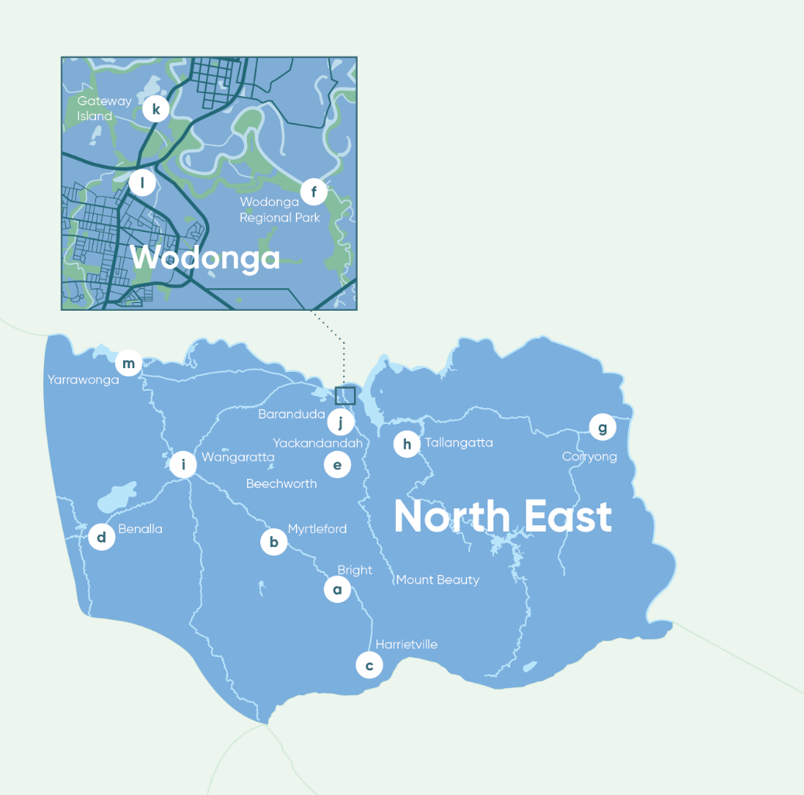
    - Bright Alternative Water (Alpine Shire Council)
This project focuses on Howitt and Centenary Parks, which are the top priority open spaces in Bright. A feasibility study is needed to investigate options to replace potable water currently being used for irrigation purposes. The study will explore the possibility of using excess groundwater currently being used in the Splash Park, or raw water from the Ovens, to irrigate the parklands, rather than potable water.
    - Myrtleford Integrated Water Plan (Alpine Shire Council)
This project aims to take a catchment approach to flood mitigation. The first phase will investigate the integrated water aspects of the Happy Valley Creek Catchment, to better understand where stormwater flows can be slowed through the catchment as well as where stakeholders may stand to benefit from water capture that also serves to reduce flood events. The first phase will also consider any linkages with town stormwater infrastructure and with amenity of Happy Valley Creek. The second phase of the project would implement infrastructure recommended in the Catchment Strategy to slow water flows through the catchment.
    - Cluster Wastewater Management in Harrietville (Alpine Shire Council)
A proposed solution to housing pressures in Harrietville is to develop an area of Council land known as ‘the Tailings’. If the development is approved by Council, this project would comprise a full feasibility study and design of a ‘cluster’ wastewater system to enable the land to be sold to a developer, with an established design ready for construction. This project could provide a precedent for the introduction of cluster wastewater systems in other small communities.

    - Water Sensitive Industrial Land for Benalla (Benalla Rural City)
This project aims to direct stormwater away from Benalla from the eastern catchment into the Winton Wetlands inlet channel. This additional water supply would add to the resilience of Winton Wetlands to projected drier conditions under climate change, and enhance overall environmental values and visitor experiences at the site. In addition, the proposed changes will relieve the current shortfall in capacity within Benalla’s stormwater drainage network.
    - Yackandandah – Bells Flat Wetland (Indigo Shire Council)
This project involves the enhancement of Bell’s Flat wetland to enable collection and filtration of increased amounts of stormwater resulting from planned subdivisions for residential development. The project will also explore options for harvesting stormwater as an alternative irrigation source for the nearby sports park to prepare for a drier future under climate change.
    - Culture and Liveability at the Kiewa – Murray Confluence (NECMA)
This project will develop and implement an interactive, educational and inspiring cultural heritage river walk. The walking trail would highlight historic and current site features, and encourage the community to become involved with their public places.
    - Corryong Reclaimed Water Reuse (Towong Shire Council)
This project aims to deliver climate resilient water supply solutions for priority public spaces in Corryong. Priority open spaces have been identified, where an alternative water supply would deliver significant benefits for the community. Preliminary designs have been prepared with funding provided from an earlier State Government Water for Growth program. Use of recycled water in Corryong will expand beneficial reuse and enhance recreational and community values associated with public spaces.
    - Tallangatta Reclaimed Water Reuse (Towong Shire Council)
This project aims to deliver climate resilient water supply solutions for priority public spaces in Tallangatta. Similar to the Corryong project, preliminary designs have been prepared with funding provided from an earlier State Government Water for Growth program. Use of recycled water in Tallangatta will provide additional capacity for beneficial reuse and enhance recreational and community values associated with public spaces.
    - Wangaratta North West Growth Corridor (Rural City of Wangaratta)
This project aims to embed IWM planning into growth areas in Wangaratta. The areas identified for development are large greenfield sites that provide the opportunity to initiate and demonstrate innovation in IWM for new residential development. The Council is well advanced in planning for this growth corridor through its planning scheme processes. The project will support the Council’s proposed structure plan for the growth corridor by the identification and scoping of the IWM opportunities that can enhance the resilience and liveability of the growth area.
    - Baranduda Fields (City of Wodonga)
This project aims to embed IWM planning and delivery into a significant sporting and recreational development to be constructed at a greenfield site in the Leneva/Baranduda Growth Corridor. A Water Use Plan and associated infrastructure will provide water resilience and ensure public spaces are appropriately maintained, even during drought conditions.
    - Gateway Island Master Plan (City of Wodonga)
This project seeks to identify potential IWM initiatives as part of the process of reviewing and updating the Gateway Island Master Plan. This could include improvements in how stormwater is managed; enhancement of amenities; green infrastructure and ecological values; and overall activation of the space. Once finalised, the Master Plan will be used as a blue print for potential future initiatives at the site.
    - Sumsion Gardens (City of Wodonga)
This project seeks to capture the latest ideas and opportunities for stormwater treatment and reuse to enhance the Sumsion Gardens/Belvoir Park area. A series of connected wetlands and an enhanced filtration system are proposed to expand recreational use of the main lake and improve ecological outcomes.
    - *Murray River Connect (Moira and Campaspe Shire Councils)
This project will build on the successful River Connect project in Shepparton and surrounds to determine a similar model can be applied to the Moira and Campaspe sections of the Murray River. The output will be a scoped proposal for the Murray River Connect to seek ongoing funding. There are three major urban environments along this stretch of the river: Cobram, Yarrawonga and Echuca, with rural areas in between. The current River Connect program has four main objectives: Connecting Community, Connecting Environment, Connecting Aboriginal People and Connecting Education.
*Moira Shire Council is bisected by the Goulburn Broken and North East IWM Forum areas. While Yarrawonga is a settlement in the North East region, Moira Shire Council has elected to focus its input to the GB IWM Forum with IWM opportunities listed in the GB Strategic Directions Statement. The NE IWM Forum supports Moira Shire Council in advancing the River Connect opportunity by referencing it in this SDS.
The North East region-wide Ready to Advance projects are expected to act as enablers for more locally focussed projects. The IWM opportunities are further described later in the document.

Chapter 1
The way forward
An unprecedented opportunity to progress water cycle planning and management in Victoria through collaboration.

Introduction
The Integrated Water Management (IWM) Framework for Victoria (September 2017) is designed to help regional stakeholders work together, ensuring the water cycle contributes to the liveability of towns and cities in Victoria, with communities at the centre of decision making.

Overview
The central premise of an IWM approach is the overall acceptance that managing urban liveability and resilience is a shared responsibility and that water is a key enabler to achieving these shared aims.
To facilitate this, IWM Forums have been established across the state to identify, prioritise and oversee the implementation of critical collaborative opportunities. This Strategic Directions Statement (SDS) has been produced by the North East IWM Forum to capture and communicate those opportunities. IWM seeks to build on existing partnerships and planning processes.
In the North East, regional stakeholders - including Local Government Authorities, Catchment Management Authorities and Water Corporations, engage with their communities regularly to improve service delivery and urban planning. Community aspirations are embedded in the overarching natural resource management strategy for the Region (the North East Regional Catchment Strategy), and in strategies and operational plans for organisations throughout the region. These aspirations reflect a desire for liveable and productive places and vibrant communities. The way in which we plan and use water is fundamental to ensuring these aspirations are realised.
IWM in the region is also strengthened by the formation of the North East Catchment Partnership area under the Government’s Our Catchments, Our Communities Integrated Catchment Management Strategy for Victoria (2016-19).
Integrated Water Management
Integrated Water Management is a collaborative approach to water planning that brings together organisations that influence all aspects of the water cycle. It has the potential to provide greater value to our communities by identifying and leveraging opportunities to optimise the outcomes of water cycle management.

What is a Strategic Directions Statement?
This SDS articulates the regional context, the shared vision and the strategic water-related objectives for the North East IWM Forum region.
This SDS includes a list of IWM opportunities as Ready to Advance projects developed in collaboration by the North East IWM Forum partners.
Partners of the Forum are committing the best endeavours of their organisations to:
- Ensure Ready to Advance projects are progressed in line with the shared vision, focus areas and objective of the North East IWM Forum; and
- Work with the Department of Environment, Land, Water and Planning (DELWP) in delivering IWM opportunities.
It is envisaged that the SDS will be a living document which will be updated as required to reflect the current North East IWM Forum’s priorities and opportunities.

Enduring collaboration

How we’re working together
The North East IWM Forum identifies and coordinates opportunities that would most benefit from collaborative and place-based water management planning and delivery.
To ensure IWM is successful and enduring across the region, the North East IWM Forum partners have committed their best endeavours to the promotion of a collaborative and shared values culture within their own organisations and beyond through their work with key water cycle delivery partners and local communities. The partners include, but are not limited to:
- Alpine Shire Council
- Benalla Rural City
- Department of Environment, Land, Water and Planning
- Goulburn Broken Catchment Management Authority
- Goulburn Murray Water
- Indigo Shire Council
- Moira Shire Council
- North East Catchment Management Authority
- North East Water
- Towong Shire Council
- Rural City of Wangaratta
- Wodonga City Council
- Yorta Yorta Nation Aboriginal Corporation
- Taungurung Land and Waters Council
- Other relevant Traditional Owners and Aboriginal communities
The North East IWM Forum is governed by an open and transparent IWM planning process (Figures 1 and 2).
This process assumes a holistic, whole-of-water cycle approach to determining water cycle solutions, considering regulatory accountabilities and service delivery responsibilities.
Each organisation has an important role to play in the decision-making and management of the water, resources and assets for the entire catchment.
The region is comprised of a number of Traditional Owner groups who have been recognized as Registered Aboriginal Parties (RAPs) as well as other groups who identify a connection to country. An ongoing priority for the region is facilitating the active, meaningful and respectful involvement of Traditional Owners as well as Aboriginal leaders and communities more broadly through the IWM process.
Collaboration occurs at different scales – regional, sub-regional and local. Working with multiple IWM Forum partners will ensure balanced consideration of the complex economic, environmental, cultural and community benefits and impacts associated with the range of proposed IWM projects and work programs.
The North East IWM Forum partners will continue to work together to build inter-organisational trust and develop productive, enduring relationships to realise the shared vision for the region.
Further information on the IWM Forum’s governance and planning framework is outlined in the Integrated Water Management Framework for Victoria, available at the Department’s website <https://www.water.vic.gov.au/liveable/resilient-and-liveable-cities-and-towns/iwm-framework>
Figure 1: IWM planning governance structure.
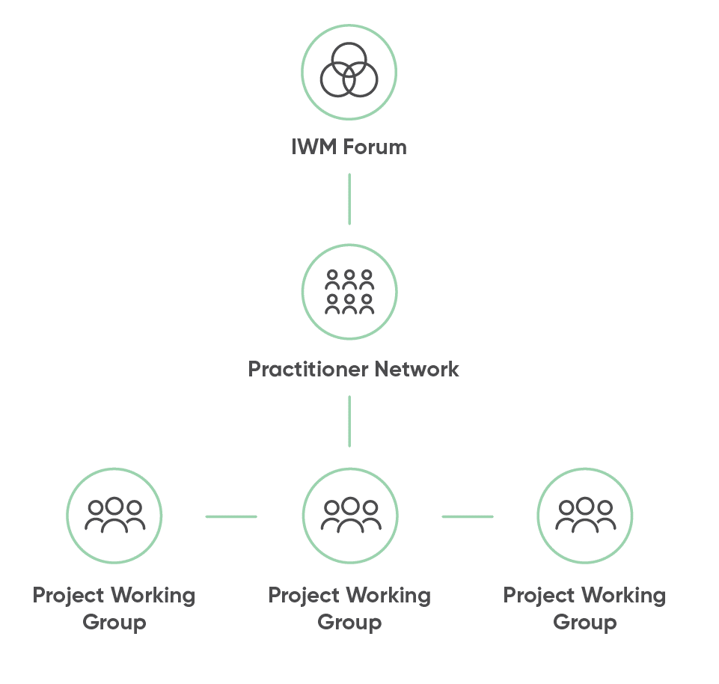

Figure 2: Overview of IWM process
Phase I | Phase I Outcomes | Phase I Participants | Phase I  ongoing
Establish  Organisational leaders come together in collaborative IWM Forums to discuss integrated water management opportunities and priorities for each region | Preliminary work on regional characterisation (offline, where necessary)  Agree vision and objectives, goals & targets (where appropriate)  Agree criteria for selection and prioritisation of opportunities  Opportunities identified and prioritised  IWM Plan Working Groups form to progress priority projects and build intra-organisational support (offline) | Local governments  Catchment Management Authorities  Water corporations  Department of Environment, Land, Water and Planning  Chair  Others as relevant | IWM Forums collaborate and oversee ongoing IWM planning

Phase II | Phase II Outcomes | Phase II Participants | Phase II  ongoing
Develop  Working groups will form to develop IWM Plans for prioritised projects | IWM Plan Working Groups develop objectives, place-based outcomes, and service levels for each project  Technical and economic analysis, cost allocation; business case development into a 'prospectus' to attract investment  IWM Plan Working Groups plan project delivery; report progress to IWM Forums | Relevant organisations who are a part of a sub group | IWM Forums collaborate and oversee ongoing IWM planning
Incorporate  Organisations incorporate relevant elements of IWM Plans in their own planning system, e.g. Council and corporate plans | IWM Plan Working Groups to take commitments to their Board or Councillors for endorsement  IWM Plan Working Grounds to incorporate elements into their own organisational planning systems  Report back to IWM Forum and prepare for next round of opportunity identification and prioritisation | Individual organisations who have committed to a project | IWM Forums collaborate and oversee ongoing IWM planning

Phase III | Phase III Outcomes | Phase III Participants
Deliver  IWM Forums prepare to refresh the Strategic Directions Statement | IWM Plans implemented  Additional community value added through collaborative planning  Economic savings through shared costs  Improved resilience and liveability of cities and towns | Individual organisations who have committed to a project

Chapter 2
IWM in the Region
Understanding why an integrated approach to water planning and management is critical for the North East IWM Region now and for the future.

Strategic Directions Framework for North East IWM

Our Vision
Healthy, resilient and prosperous communities and environment.

Our Purpose
We work creatively in partnership across the water cycle to plan and deliver sustainable and holistic outcomes.

Our Focus Areas
The North East IWM Forum has identified three focus areas for integrated water planning within the North East region:
- Climate Resilience and Liveable Communities
- Healthy Waterways and Landscapes
- Planning for Sustainable Growth
Our focus areas respond to the seven State IWM outcomes identified in the government’s Integrated Water Management Framework for Victoria and shown earlier on page 3. Figure 3 frames the strategic directions for the North East Region, our three focus areas (outer circle) and eight objectives (inner circle).
Figure 3: Strategic Directions Framework for North East IWM
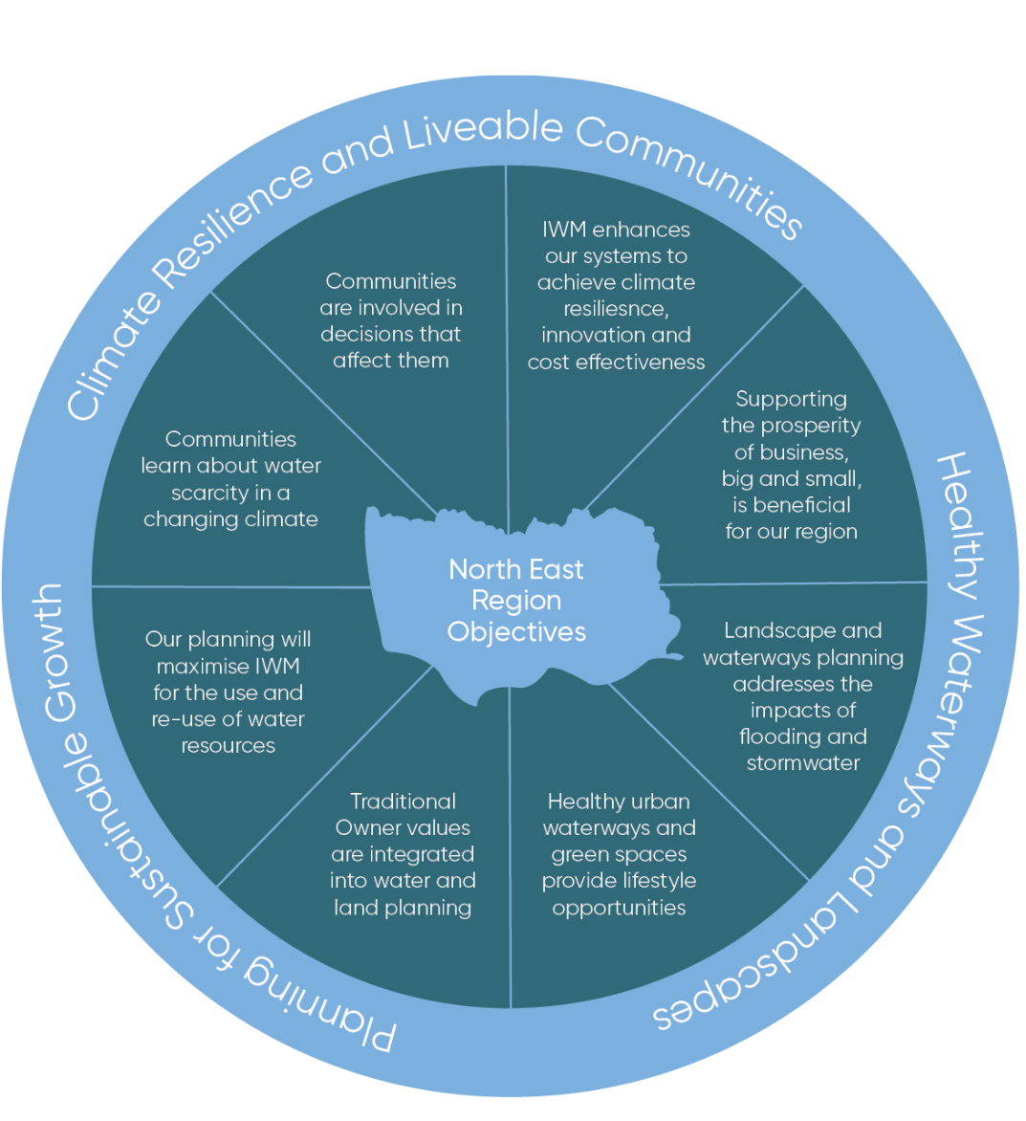

Regional context
The North East IWM Forum region covers an area of approximately 20,000 square kilometres, extending east from Benalla to Corryong, and from the Victorian Alps in the south to the Murray River on the border with New South Wales in the north.
The landscape and climate of the region varies significantly between the alpine country and the floodplains along the Murray River. A majority of the land in the North East catchment area is used for agricultural purposes, with other primary industries including forest products, tourism, processing and manufacturing.
While there are many challenges, the North East IWM Forum identified three areas to focus on for the region as key challenges; climate resilient and liveable communities, healthy waterways and landscapes and planning for sustainable growth.

Climate Resilient and Liveable Communities
The North East Region faces a warmer and drier future. By 2065, projections indicate average annual temperatures to rise by 1.4° to 2.5°¹ (median value). This will be amplified in urban centres due to the prevalence of darker and harder surfaces, leading to possible environmental and human health impacts. As mentioned earlier, the North East region provides about 38 per cent of inflows to the Murray-Darling Basin, which support ecosystems, agriculture and communities. Therefore, impacts of climate change, such as increased frequency and intensity of fires and changes in snow cover in the Alps, will have implications for the region and affect downstream communities who also rely on the Murray River system.
Ensuring the provision of fit for purpose water for the region’s urban green spaces will be a key priority for enhancing liveability and resilience for the community and environment. Average annual rainfall is projected to decrease by up to 3.7 per cent by 2065 (median value), primarily impacting the ‘cool’ season. This presents a challenge for the region, as there will be an increased demand for urban water supply due to population growth together with a hotter, drier climate.
Recent work by the North East Greenhouse Alliance (NEGHA) identified that climate change is a vital issue for rural and regional communities across Victoria and Australia. Climate variability has always been a fact of life for these communities. The prolonged drought in much of eastern and southern Australia through the 2000s, followed by severe flooding, heightened awareness of the potential for greater variability in the future. Projections are for more frequent and severe droughts interspersed by periods of intense rainfall. There is a recognised need for region wide planning to account for reduced water availability and increased rainfall variability.
From a water supply perspective, North East Water’s Urban Water Strategy demonstrates that in particular there will be higher risks to water resource availability during drought conditions on unregulated streams such as the Upper Ovens and other smaller steams. By way of example, runoff into streams above North East Water’s offtakes in the Ovens River Basin could decrease by as much as 43.9 per cent by 2065 under a high emissions scenario, while a low climate change scenario could see the region experience an increase in inflows by up to 1.2 per cent.
IWM can provide solutions that aids preparedness for climate change impacts, and supports the liveability of towns in the region. In particular, by increasing local water supply diversity, reducing flood risk and providing heat wave relief by integrating and irrigating more green areas.

Healthy Waterways and Landscapes
The health of the region’s waterways and landscapes underpins the character and success of the region as a whole. Rivers and landscapes in the North East have particular significance for Aboriginal communities, while also providing places for recreation, tourism, social and spiritual connection and a wide range of other community values. The natural landscapes and waterways of the region are rich in variety, ranging from alpine areas, to the Murray River floodplains. The waterways of the North East, in particular, are hotspots for biodiversity within the landscape.
The region’s catchment also plays a crucial role in supporting natural resources for the wider basin. The North East IWM forum area is located in the upstream catchment area of the Murray River system within the Murray-Darling Basin. The region’s catchment area is recognised as producing around 38 per cent of the annual inflows into the Murray-Darling Basin system. Large areas of the region are located in declared water catchment areas which can result in high expectations for protection of water quality particularly when new developments are proposed. The importance of healthy waterways and landscapes to the region and the need to protect water quality and waterway values is recognised by the Forum objectives as is the need to support and enhance liveability, business and tourism in the region.

Planning for Sustainable Growth
The Hume Regional Growth Plan (RGP) provides the blueprint for managing growth in the North East region. The region has an estimated population of 125,000, which is forecast to grow to 150,000 by 2040. The government’s long term plan for Melbourne, Plan Melbourne, has an outcome for regional Victoria to be productive, sustainable and support jobs and economic growth. Wodonga and Wangaratta are designated in planning as Regional Cities with recognition of the need for improved transport connections making it easier to live and do business in regional areas.
The settlements experiencing medium to high growth presently are Wodonga, Wangaratta and Yarrawonga. Moderate growth is forecast for many other North East settlements such as Benalla and other communities due to lifestyle appeal and or close proximity to larger centres. These smaller towns include Wahgunyah, Rutherglen, Bright, Yackandandah, Beechworth, Bellbridge, Tallangatta, Bundalong, Kiewa and Tangambalanga.
Growth and change in urban areas can provide opportunities to integrate IWM solutions and harness new resources such as stormwater and recycled water. The Forum outcomes and objectives for the region seek to support planning for growth via opportunities available to be identified within the IWM Framework.
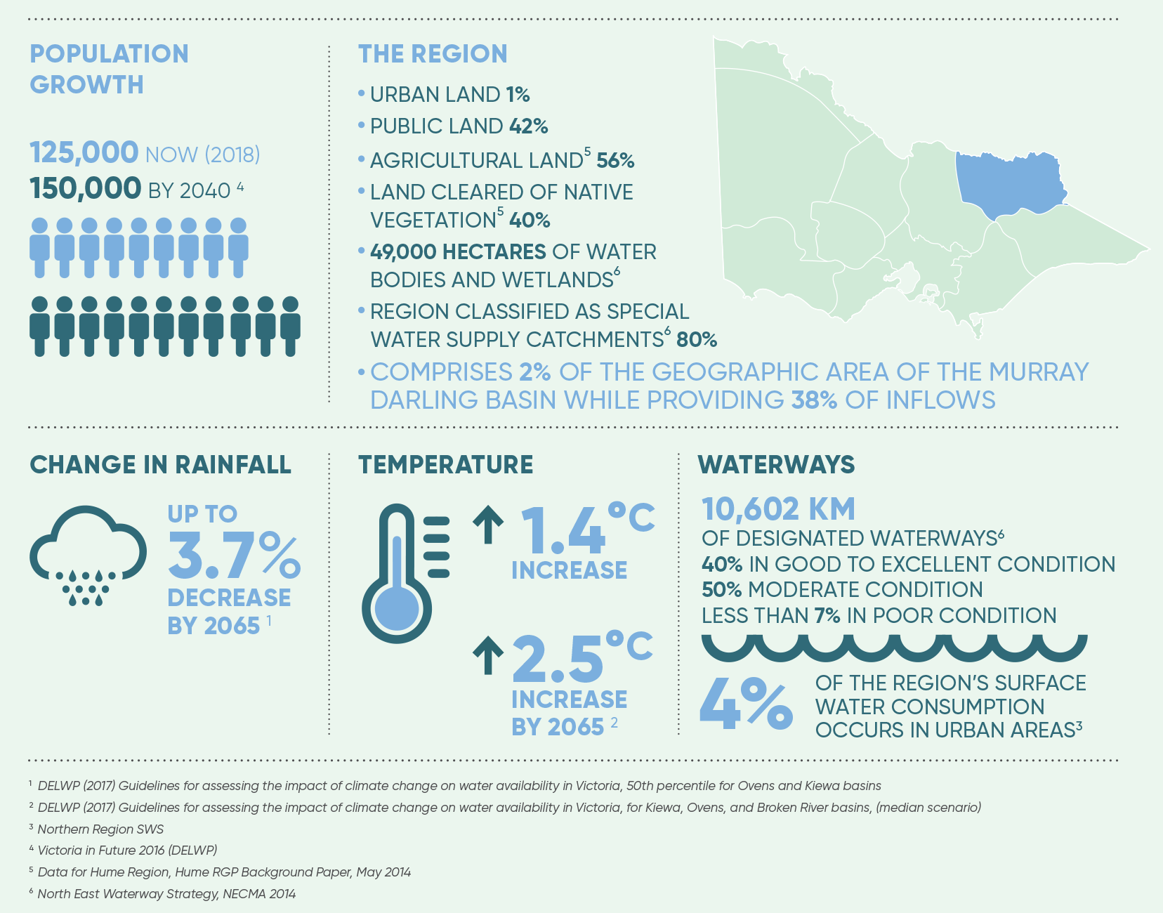

The case for IWM in the Region
The following section outlines the case for IWM in the North East by relating our set of objectives to the seven State IWM outcomes identified in the government’s Integrated Water Management Framework for Victoria. The relevant regional objectives for the North East are highlighted under each State outcome.
Traditional Owner, Aboriginal and community values are reflected in place based planning
The North East region covers the lands of many Traditional Owner groups as well as Aboriginal people who identify a connection to land. The many rivers in the area contain a rich and diverse range of important cultural heritage sites. The beneficial relationships held between Aboriginal people and country is embraced, and there is a focus on developing meaningful and respectful relationships with recognised Traditional Owner and Aboriginal groups and communities more broadly in relation to the cultural value of water and management of heritage.
The relationship between public health and wellbeing, and the environment is becoming increasingly recognised as an area of importance. The creation of greener neighbourhoods and providing residents with access to green space has the potential to support environmental, social and economic outcomes.
North East IWM objectives:
- Traditional Owner values are integrated into water and land planning
- Communities are involved in decisions that affect them

Healthy and valued waterways, wetlands and lakes
The Murray and Ovens basin areas encompass over 15,000 km of waterways. These waterways and waterbodies are embraced by the urban communities for their aesthetic, recreational, cultural, tourism and restorative appeal.
The region’s riverine assets also support a large range of biodiversity, including threatened species such as the Murray Cod, Silver Perch and Macquarie Perch. Increased water demands from a range of users may impact on the amount of water that is available to maintain and enhance ecosystem health in some river systems.
Waterways are also being impacted by polluted runoff from urban areas and agricultural activities. These pressures are further intensified by climate change. Ensuring that waterways can continue to support a variety of values will be a key challenge for the region.
Key tourism and recreation locations include the Murray, Mitta Mitta, Ovens, King and Kiewa Rivers, Lake Dartmouth, Lake Hume, Lake Benalla, Lake Mulwala, Lake Buffalo and Lake William Hovell. Winton Wetlands, a former dam site, is now the focus of a significant environmental and social renewal project, focussing on restoring ecological integrity and cultural values while creating new visitor experiences.
North East IWM objective:
- Healthy urban waterways and green spaces provide lifestyle opportunities

Healthy and valued urban and rural landscapes
Healthy urban landscapes are valued in the North East region. More than 55 per cent of the North East region consists of public land encompassing over 200 parks and reserves. Outdoor and sporting precincts are a critical part of the region’s social fabric. The region will need to manage the sharing of water in an equitable manner during times of drought, including aspects such as the irrigation of public open space.
The Rural City of Wangaratta evaluated the contribution of the city’s 12,664 trees in public space and found they provide benefits equivalent to $62.5 million dollars. A Greening Wodonga strategy is planned for the City of Wodonga, recognising the importance of greener landscapes.
Healthy landscapes are a key attraction for both visitors and residents in the region. The region’s rivers and streams offer some of the best recreational fishing opportunities in Victoria and the alpine region has two of Australia’s major ski fields; Falls Creek and Mount Hotham.
North East IWM objective:
- Communities learn about water scarcity in a changing climate

Safe, secure and affordable supplies in an uncertain future
Average annual rainfall varies significantly across the region. The high country to the south of the region receives approximately 1600 mm annually, while in the north west of the region it is as low as 400 mm.
The North East Water Urban Water Strategy assessed the security of water supply under various climate change scenarios. The findings indicated that urban water supply in the region is relatively secure. The major regulated supplies from the Murray systems are secure until 2065. Supply shortfalls are expected in the short to medium term in Yackandandah and in the King Valley towns. Where supply is taken from unregulated waterways, there can also be limited opportunity to access additional water entitlements to meet growth needs and this may, in the longer term, lead to shortfalls in meeting demand.
Currently drinking water services are provided to 41 communities in the region from 21 water supply systems. Many of these are supplied from waterways in the area, primarily the Murray, Mitta Mitta, Ovens, King, Kiewa and Broken catchments, which also provide water for agriculture. Average annual demand for urban water in the North East is forecast to increase from 15,720ML in 2015 to 18,019ML by 2030 under standard growth conditions.
The North East region is the head waters for south-eastern Australia and plays a vital role in providing downstream water resources for Victoria, New South Wales and South Australia. While the North East comprises only two per cent of the geographic area of the Murray-Darling basin, it provides 38 per cent of its water.
North East IWM objectives:
- Our planning will maximise IWM for the use and re-use of water resources
- IWM enhances our systems to achieve climate resilience, innovation and cost effectiveness

Effective and affordable wastewater systems
There are reticulated sewage systems in 24 communities in the region. These systems collect and treat approximately 9,800ML of sewage at 20 wastewater management facilities. In addition to these facilities there are many small towns in the region which typically use on-site wastewater management systems. Management of wastewater in small towns is a common issue across the region from an environmental, health, technical, governance and financial perspective.
There are currently 16 recycled water schemes in the region, delivering up to 2,600ML of recycled water to sites operated both by North East Water and third-party customers. These schemes range from pasture and cropping ventures to community-benefit applications such as school grounds and golf courses.
North East IWM objective:
- Our planning will maximise IWM for the use and re-use of water resources

Avoided or minimised existing and future flood risks
Floodplains are a highly valued part of the North East region, providing critical ecosystem functions that contribute to the ecological, economic and social sustainability of the region. Floodplains, by nature, are places of rich soil and thus provide highly valuable agricultural land. They also offer access to recreational activities associated with rivers and wetlands.
In an urban context, flooding is more of a challenge. Most of the major urban centres are located on river floodplains and are therefore vulnerable to potential flooding. It is essential to manage the economic, social, environmental and cultural values from floodplains in a balanced way whilst also having regard for their inherent disadvantages and risks. This will be particularly relevant in the context of increased extreme rainfall events, urban growth and increased imperviousness in catchments.
North East IWM objective:
- Landscape and waterways planning addresses the impacts of flooding and stormwater

Jobs, economic growth and innovation
The regional economy is projected to grow through investment in agriculture, food and fibre processing, tourism and the transport sectors. There is also a significant tourism and recreation economy in the region which is strongly linked to the health and amenity provided by the region’s waterways, lakes and towns.
While the region has a dispersed settlement structure, it has economic strength, quality infrastructure and services, as well as natural assets of major value. One strength that makes the region attractive to industries, especially those associated with agriculture, food/fibre and transport, is high water security.
Boutique food and wine production plays a dual role in the region in terms of tourism and agriculture. The Ovens Valley, King Valley, Kiewa Valley, Rutherglen, Yarrawonga and Corryong areas provide high value locations for boutique agriculture and tourism and should be supported. Provision of suitable water services is important to support these growing industries.
North East IWM objective:
- Supporting the prosperity of business, big and small, is beneficial for our region

IWM Case Studies
Previous work in the North East has seen collaboration between state and local government, regional agencies, communities, planning bodies and boards to build knowledge and identify actions to address the challenges and opportunities in the region.

North East Greenhouse Alliance – Regional Climate Change Adaption Strategy for North East Victoria: Water and Beyond
This case study relates to the North East focus area of Climate Resilience and Liveable Communities.
The ‘Regional Climate Change Adaptation Strategy for North East Victoria: Water and Beyond’ was the culmination of extensive research and consultation undertaken by the North East Greenhouse Alliance (NEGHA). It included local governments (Alpine Shire Council, Benalla Rural City, Indigo Shire Council, Towong Shire Council, Rural City of Wangaratta and the City of Wodonga), educational institutions and industry partners (North East Water, North East Catchment Management Authority and Goulburn-Murray Water) and State government agencies including the Department of Sustainability and Environment (now DELWP) and the Department of Primary Industries. The Strategy was informed by two projects - Adapting to a Low Water Future and, Socioeconomic Adaptation Planning, both of which were completed between 2010 and 2012, after the region experienced a series of bushfires and in the midst of severe drought. The work was supported by funding from the Australian Government’s Water for the Future Initiative. The Strategy identifies recommendations to reduce risk and proactively improve resilience in advance of the impacts of climate change. The outcomes of the strategy included:
- A comprehensive analysis of climate change risks and how they will impact stakeholders in the North East
- Development of an adaptation plan with recommendations for participating organisations at the regional level
- Community engagement and consultation with stakeholders to overcome behavioural and communication barriers to adaptation
- Review of existing Council plans to include climate change, and identification of training and development needs
- Audits of small to medium sized businesses to identify potential water savings
- Identification of innovative approaches for dealing with septic in small towns which are currently not serviced
- Vulnerability and resilience planning to improve the skills, knowledge and capacity of targeted vulnerable industries and businesses

Rehabilitation of the Bakers Gully Dams, Bright
The second case study highlights the focus area of Healthy Waterways and Landscapes.
The Bakers Gully rehabilitation project focused on two dams on Bakers Gully Creek (Lower and Upper Reservoirs) in the township of Bright. Both dams were built more than 100 years ago and were removed from service several decades ago. These dams posed the highest risk in North East Water’s dam portfolio, due to the threat of dam failure causing flooding of downstream communities. The major stakeholders who collaborated in this case study were the Bright community, North East Water and State government regulatory agencies in DELWP.
The first concept design proposed dewatering the upper dam and lowering the water in the lower dam, which was rejected by the community in 2014. Further engagement with the Bright community identified their key values associated with the site, which were the presence of platypus and opportunities for recreation and conservation in the area.
North East Water engaged an ecologist to conduct a platypus habitat survey. The detailed design of the project incorporated findings from further flora and fauna studies, cultural heritage studies and community engagement. The final concept design maintained the water level in the upper dam to a minimum level, lowered the water level in the lower dam and widened the spillways of both dams.
Thus, a balance was struck where the risks associated with the dam were reduced, while maintaining the habitat requirements of the platypus. In addition, construction of the project was scheduled to occur outside of platypus breeding season where possible. Landscaping and re-vegetation of the site occurred following the civil works, in order to enhance opportunities for recreation and biodiversity conservation at the site.
This case study illustrates how engagement with stakeholders and community can lead to improved social and environmental outcomes for waterways and landscapes in the North East. The major success of this project is that it significantly improved dam safety, while preserving and enhancing the community values associated with the site.

Leneva Baranduda Whole of Water Cycle Management Plan
The final case study highlights the focus area of Planning for Sustainable Growth.
In July 2013, a grant was made available from the Victorian Government’s Local Water Management Fund to develop an Integrated Water Cycle Management (IWM) Plan for the Leneva-Baranduda growth corridor in Wodonga. Key stakeholders in this project included the City of Wodonga, North East Water, North East Catchment Management Authority, Metropolitan Planning Authority, DELWP, and Goulburn Murray Water, representatives of which comprised the project group.
The purpose of the project was to apply whole of water cycle planning in a regional context. The final report for the project was completed in March 2016. The final report informs planning in the Leneva-Baranduda growth corridor and has become a reference document in the Wodonga Planning Scheme, representing the views of all stakeholders. The outcomes of the plan were to:
- Enable future development in the Leneva–Baranduda growth corridor to proceed in a collaborative manner with respect to decisions about the different water cycle aspects that affect the precinct
- Provide a long term reference for key stakeholders responsible for the critical water cycle aspects
- Ensure the whole-of-system approach contributes to multiple community outcomes
- Provide the framework for developers and consultants to work with relevant agencies
- Incorporate WOWCM principles early in the development process
- Provide recommendations on the preferred WOWCM plan combination
- Provide recommendations for the next steps with the relevant stakeholders.

Chapter 3
IWM opportunities
A portfolio of IWM projects for which IWM collaborative partners have committed themselves to applying their best endeavours to progress is now presented in greater detail.

State-wide and region specific initiatives
This document outlines Ready to Advance IWM opportunities for the North East region. They include projects that will deliver on-the-ground outcomes. To ensure IWM opportunities are successful and delivered efficiently, work is also being done at a state-wide level.
Across Victoria, IWM Forum members are identifying a range of strategic policy and framework enablers to address barriers to IWM and planning, and achieve water related benefits in priority areas. A prioritised list of enabling policies and frameworks is being consolidated by DELWP. A Resilient Cities and Towns (RCT) Reference Group was established to support the implementation of IWM and planning across the state.
The Reference Group provides advice to DELWP on the development and implementation of key initiatives in relation to policy, processes or knowledge gaps.
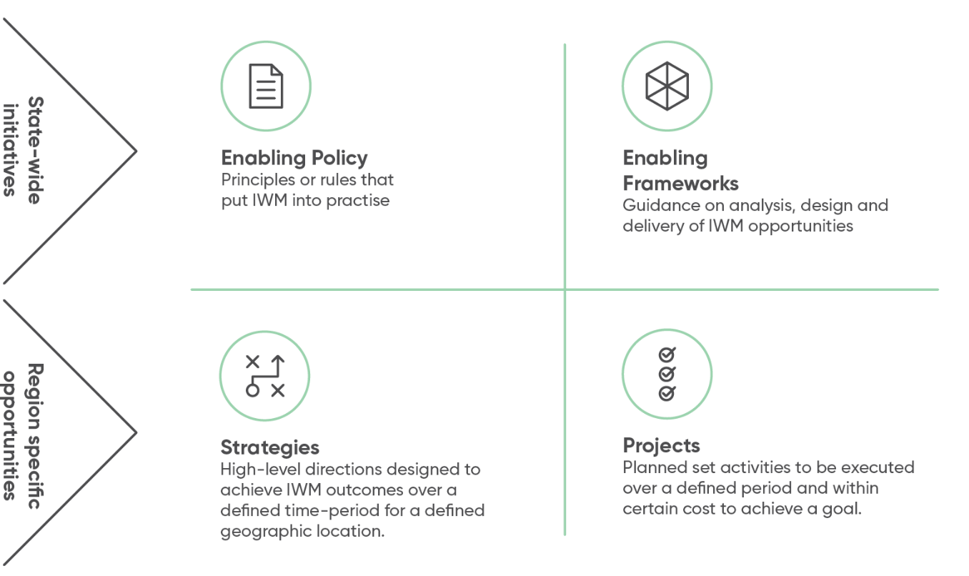

IWM opportunities: How were they selected?
Ready to Advance IWM opportunities that link to and address IWM challenges for the region were identified and developed by practitioners of participating organisations. The process was an iterative, transparent and inclusive approach, as outlined below.
Throughout the process, several opportunities which are not as developed, or are not considered ready to advance at this stage, were identified and are included in Appendix 1.
This list of opportunities is dynamic and will be reviewed and updated, as a minimum annually, or as required to reflect the Forum’s priorities. As new opportunities arise, they will be subjected to the same level of rigour as those originally identified and included within this document.
Figure 4: Identifying Ready to Advance IWM Opportunities
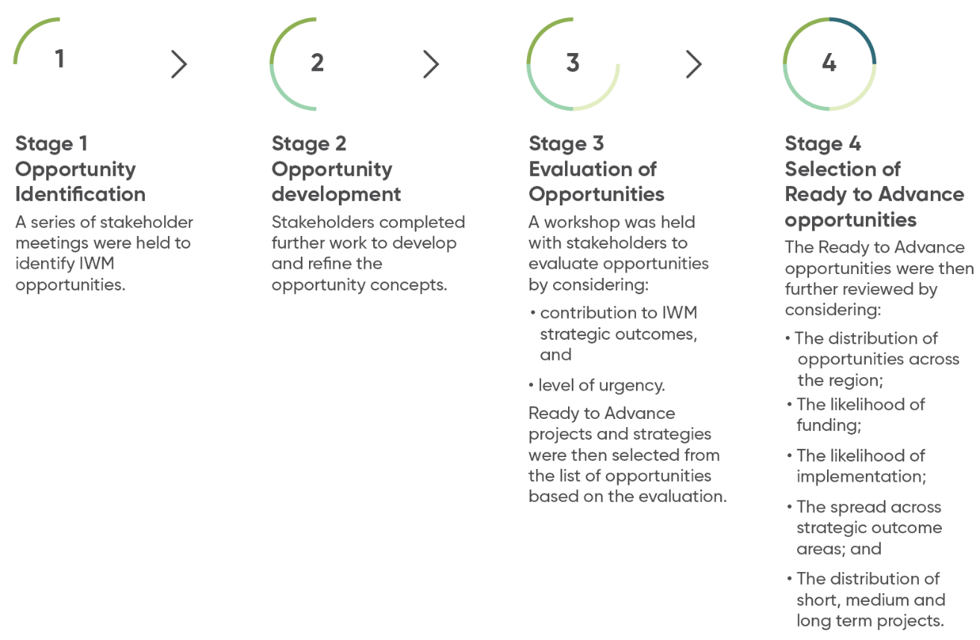

Ready to Advance IWM Opportunities – overview
Table 1 shows a suite of Ready to Advance opportunities, which are organised by scale and alphabetically based on lead agency. Opportunities range from being region-wide, to town-based. The following section describes the IWM opportunities that are Ready to Advance in detail. Please note that this list is dynamic and will continue to be updated to reflect current North East IWM Forum priorities and opportunities. Partners of the Forum are committing their best endeavours to ensure projects are progressed in line with the shared vision and strategic outcomes of the North East IWM Forum. Other project opportunities identified that require further work are contained in Appendix 1.
Table 1 – North East IWM Ready to Advance Opportunities
IWM opportunity | Strategic outcome  Safe, secure and affordable supplies in an uncertain future | Strategic outcome  Effective and affordable wastewater systems | Strategic outcome  Avoided or minimised existing and future flood risks | Strategic outcome  Healthy and valued waterways, wetlands and lakes | Strategic outcome  Healthy and valued urban and rural landscapes | Strategic outcome  Community values reflected in place based planning | Strategic outcome  Jobs, economy and innovation | Location | Scale | Lead agency for collaborative opportunity | Status | Timing
Engaging Aboriginal Communities in Integrated Water Management in the North East Region | No impact | No impact | No impact | Impact | Impact | Impact | Impact | Region | Forum area | North East Aboriginal Water Policy Officers – Hume Region & IWM (Regional) | Concept | Phase 1: 2018-19 Phase 2-4: 2019 onwards
WSUD Guidelines by Council Region | No impact | No impact | Impact | Impact | Impact | No impact | No impact | Region | Forum area | North East Catchment Management Authority (NECMA) | Concept | 12 months
Climate Resilient Open Spaces | Impact | No impact | No impact | No impact | Impact | Impact | No impact | Region | Forum area | North East Water | Concept | Phase 1: 2018-19 Phase 2: Ongoing
Bright Alternative Water | Impact | No impact | No impact | No impact | Impact | Impact | Impact | Bright | Town/City | Alpine Shire Council | Concept & feasibility | 12 months (2018-2019)
Myrtleford Integrated Water Plan | No impact | No impact | Impact | Impact | Impact | Impact | Impact | Myrtleford | Town/City | Alpine Shire Council | Concept | 12-18 months (2018-2019)
Cluster Wastewater Management in Harrietville | No impact | Impact | Impact | Impact | Impact | Impact | No impact | Harrietville | Lot Scale | Alpine Shire Council | Concept & feasibility | 12 months (2018-2019)
Water Sensitive Industrial Land for Benalla | Impact | No impact | Impact | Impact | Impact | Impact | Impact | Benalla | Town/City | Benalla Rural City Council | Concept | 2–3 years
Yackandandah – Bells Flat Wetland | Impact | No impact | Impact | Impact | Impact | Impact | No impact | Yackandandah | Town/City | Indigo Shire Council | Detailed design | 12 months (2018-2019)
Culture and Liveability at the Kiewa – Murray Confluence | No impact | No impact | No impact | Impact | Impact | Impact | Impact | Wodonga | Town/City | North East Catchment Management Authority (NECMA) | Concept | To be defined
Corryong Reclaimed Water Reuse | Impact | Impact | No impact | No impact | Impact | No impact | Impact | Corryong | Town/City | Towong Shire Council | Preliminary design | 18 months (2018-2020)
Tallangatta Reclaimed Water Reuse | Impact | Impact | No impact | No impact | Impact | Impact | Impact | Tallangatta | Town/City | Towong Shire Council | Preliminary design | 18 months (2018-2020)
Wangaratta North West Growth Corridor | Impact | Impact | Impact | Impact | Impact | Impact | Impact | Wangaratta | Town/City | Rural City of Wangaratta | Concept | Commence 2019
Baranduda Fields | Impact | Impact | No impact | No impact | Impact | Impact | Impact | Wodonga | Town/City | City of Wodonga | Implementation | 5 years (2018-23)
Gateway Island Master Plan | Impact | No impact | Impact | Impact | Impact | Impact | Impact | Wodonga | Town/City | City of Wodonga | Concept | To be defined
Sumsion Gardens Wodonga | Impact | No impact | Impact | Impact | Impact | Impact | No impact | Wodonga | Town/City | City of Wodonga | Concept | 12-24 months
Murray River Connect* | No impact | No impact | No impact | Impact | Impact | Impact | No impact | Yarrawonga | Forum area | Moira Shire Council – Goulburn Broken IWM Forum | Commitment | 12 months
The status of each IWM opportunity included in the Priority Portfolio reflects the phase of work to be undertaken in this time period.
* The Murray River Connect project is a priority IWM opportunity listed in the GB SDS. It is acknowledged in the NE IWM SDS and supported as it will partly take place within this region’s district.

Ready to Advance IWM Project Opportunities – In Depth

Engaging Aboriginal Communities in Integrated Water Management in the North East Region
The NE IWM Forum partners have agreed that an opportunity presents for a project in relation to how to undertake respectful and meaningful engagement with Aboriginal communities in the North East region. The preliminary objectives of the project are to:
- Examine and capture key information relating to community
- Understand the Aboriginal community landscape in the region
- Develop and build a shared understanding of community
- Determine what is important with respect to IWM outcomes
Central to the project is knowledge, so that the nature of the different and distinct Traditional Owners as well as Aboriginal community interests more broadly in this region can be understood. This knowledge will then be translated into a tool that provides guidance as to protocols for engagement.
The project will document the different layers of social structure that exist across the region. In this way, the project output – the tool for engagement – is designed to equip non-Aboriginal people working in government and agencies with advice on who to engage with. It will also provide guidance on how to engage respectfully and meaningfully with acknowledged Aboriginal leaders where integrated water related activities takes place on country.
While we see overt success as the tool, more importantly the project will apply a grounded methodology in seeking to work directly with local community and leaders. By implementing the project, it provides an opportunity to develop relationships and ultimately, create value in capacity building for regional practitioners.
In addition, this project will build on and connect with councils’ Aboriginal inclusion plans, NECMA’s Aboriginal engagement process, North East Water’s work on Aboriginal Reconciliation and DELWP’s Munganin Gadhaba ‘Achieve Together’ Plan. Munganin Gadhaba is the name of DELWP’s plan to build a more collaborative approach to engagement with Traditional Owners and other Aboriginal Victorians. A working group is being established to oversee implementation of Munganin Gadhaba in the region. It will be critical to ensure the Munganin Gadhaba Working Group is consulted regarding the progression of the ‘Engaging Aboriginal Communities in IWM in the North East Region’ opportunity. The project will occur in four phases as outlined in ‘next steps’.

Next steps
- Socialise project scoping proposal with key stakeholders and refine based on feedback
- Secure commitment to participate
- Develop detailed project brief and secure sign off
- Deliver project

 | Strategic outcome  Safe, secure and affordable supplies in an uncertain future | Strategic outcome  Effective and affordable wastewater systems | Strategic outcome  Avoided or minimised existing and future flood risks | Strategic outcome  Healthy and valued waterways, wetlands and lakes | Strategic outcome  Healthy and valued urban and rural landscapes | Strategic outcome  Community values reflected in place based planning | Strategic outcome  Jobs, economy and innovation
Impact status | No impact | No impact | No impact | Impact | Impact | Impact | Impact

Subject | Details
Status | Concept
Lead Agency | NE Aboriginal Water Policy Officers – Hume Region & IWM (Regional), Support, in-kind and financial, will be provided by other agencies and organisations
Implementation Partners | Traditional Owner groups, RAP’s, Aboriginal communities in the North East region. DELWP - all councils, NEW and NECMA.
Location | North East Region
Timeframe | Phase 1: 2018-19  Phase 2-4: 2019 onwards
Scale | Forum area

WSUD Guidelines by Council Region
WSUD is a requirement for subdivision development; however, the treatment is generally left to the developer, resulting in poor design solutions for ongoing operation and maintenance, inconsistent treatment types and products which increase council costs and lower the effectiveness of maintenance.
This project seeks to develop a WSUD implementation guideline for each Council, which would specify preferred input data (including rainfall and design parameters), preferred treatment type (for example wetlands, swales or raingardens) and which plant species should be used in the area.
The project links to the broader Environmentally Sustainable Design (ESD) regional policy work being led by Wodonga City Council on behalf of seven of the region’s councils. The ESD policy work is developing changes for incorporation into both the planning scheme and Infrastructure Design Manual. The ESD policy supports the need for further work in relation to WSUD guidelines.
The guidelines are expected to enable consistent treatment across each local government area, certainty of requirements for developers and reduced maintenance costs for councils. As a result, the WSUD treatment assets will be highly valued and will ensure the protection of water quality throughout the region. In addition, there is an education opportunity, building community understanding and capacity where developments incorporating these WSUD guidelines could display interpretive signage to inform and engage the community.

Next steps
- NECMA to lead collaborative scoping of project
- Secure commitment and funding for project
 | Strategic outcome  Safe, secure and affordable supplies in an uncertain future | Strategic outcome  Effective and affordable wastewater systems | Strategic outcome  Avoided or minimised existing and future flood risks | Strategic outcome  Healthy and valued waterways, wetlands and lakes | Strategic outcome  Healthy and valued urban and rural landscapes | Strategic outcome  Community values reflected in place based planning | Strategic outcome  Jobs, economy and innovation
Impact status | No impact | No impact | Impact | Impact | Impact | No impact | No impact

Subject | Details
Status | Concept
Lead Agency | NECMA
Implementation Partners | All councils and DELWP
Location | Region-wide
Timeframe | 12 months
Scale | Forum area

Climate Resilient Open Spaces
During the last drought the health of public open spaces severely deteriorated due to lack of water. This impacted communities’ wellbeing through reducing their ability to play sport and use open spaces for other forms of passive and active recreation. Enabling some priority open spaces to remain resilient to climate impacts would alleviate the chance of these impacts occurring during the next drought.
This project will build on the “Rec-Less*” project work previously undertaken by Benalla Rural City and Alpine Shire Council in relation to the identification of key green spaces and a hierarchy of watering in water constrained events. Across the region there are important community assets for recreation, wellbeing and liveability. There is potential to capture places that have particular significance for Aboriginal communities during this process. Community assets will be examined according to their resilience, and ranked as having either low, medium or high resilience.
Ways to improve resilience will be investigated. This could include a range of measures such as, but not limited to, exploring the best use of water market arrangements, groundwater, recycled water, drought resistant plantings, raw water entitlement and pumps and stormwater harvesting. Four opportunities have already been identified to create climate resilient open spaces: Bright Alternative Water, Corryong Reclaimed Water, Tallangatta Reclaimed Water Reuse and Greening Mount Beauty, which are described as separate town-based projects.
This project has linkages to other projects currently being undertaken in the region. The Urban Design Framework for Wangaratta considers increasing green space, lessening hard surfaces and provision of shade in public spaces. Another linkage is the Environmentally Sustainable Design Project that seven Councils are involved with and Wodonga is the lead. A report on the draft ESD is being presented to Wangaratta Council at its September meeting.
Climate Resilient Open Spaces will occur in two phases:
Phase 1: Research, Assessing Resilience & Prioritisation
Phase 2: Project Implementation

Next steps
- Socialise proposal with key stakeholders and refine based on feedback
- Secure commitment to participate
- Commence study
* Rec-Less link http://www.benalla.vic.gov.au/Your-Community/Environment-Sustainability/Project-Initiatives/Rec-Less-Less-Water-Less-Often

 | Strategic outcome  Safe, secure and affordable supplies in an uncertain future | Strategic outcome  Effective and affordable wastewater systems | Strategic outcome  Avoided or minimised existing and future flood risks | Strategic outcome  Healthy and valued waterways, wetlands and lakes | Strategic outcome  Healthy and valued urban and rural landscapes | Strategic outcome  Community values reflected in place based planning | Strategic outcome  Jobs, economy and innovation
Impact status | Impact | No impact | No impact | No impact | Impact | Impact | No impact

Subject | Details
Status | Concept
Lead Agency | North East Water (lead and undertake assessment. In kind support provided by other agencies and organisations)
Implementation Partners | All councils and NECMA
Location | North East Region
Timeframe | Phase 1: 2018-19  Phase 2: Ongoing
Scale | Forum area

Bright Alternative Water
Howitt and Centenary Parks are the top priority open spaces in Bright. The area forms a central meeting point for the community, with picnic and BBQ facilities, a large playground, Splash Park and several cafes and eateries. A number of events use both parks throughout the year. In addition, the Alpine Shire receives 500,000 visitors annually, many of whom visit the Howitt/Centenary Park River Precinct. These areas are vulnerable to the impacts of climate change, in particular, drought. As a result, there is a strong need for a feasibility study to investigate replacement of potable water currently being used for irrigation purposes in the parks, in order to improve their resilience and capacity to adapt to changes in water availability.
There are sources of non-potable water that could potentially be used for irrigation. The adjacent Splash Park currently uses groundwater, which may provide an opportunity to use excess allocation for irrigation, or to divert water used in the Splash Park after use to irrigation. Groundwater is the form of raw water most likely to be feasible to replace potable water, however, stormwater and river water could also be considered. As the parks are a low point, there are a number of stormwater assets in the area that discharge into the Ovens River and Morses Creek, which are adjacent to the parks. The Ovens River is the source of potable water for Bright and so it may be possible to replace water used for irrigation of these parks with raw water directly from the Ovens. The feasibility study will include a design and plan for changes to infrastructure for either or both of these two options and an engineering plan.
Alpine Shire Council is about to embark on two projects that may have some relevance to the Feasibility Study. In September 2018 irrigation infrastructure in Centenary Park is being replaced. Existing irrigation infrastructure is not fit for purpose and has numerous maintenance issues, which, together, result in inefficient irrigation of these spaces. Irrigation infrastructure is being replaced with potential future changes to water source in mind. In addition, the toilet block in Centenary Park will be renovated in the 2018/2019 financial year. The renovation will include thought around capacity to harvest rain water and stormwater for use in the toilets. These two projects are outside the scope of this feasibility study but will consider potential future work defined in the feasibility study.
Alpine Shire Council has assessed the water use needs of public spaces more broadly in Bright. There are no other public spaces currently being irrigated apart from streetscapes with multiple infrastructure access points. As a result, the project will focus on Howitt and Centenary Parks.

Next steps
- Feasibility study and design
- Confirm funding
- Implement

 | Strategic outcome  Safe, secure and affordable supplies in an uncertain future | Strategic outcome  Effective and affordable wastewater systems | Strategic outcome  Avoided or minimised existing and future flood risks | Strategic outcome  Healthy and valued waterways, wetlands and lakes | Strategic outcome  Healthy and valued urban and rural landscapes | Strategic outcome  Community values reflected in place based planning | Strategic outcome  Jobs, economy and innovation
Impact status | Impact | No impact | No impact | No impact | Impact | Impact | Impact

Subject | Details
Status | Concept & feasibility
Lead Agency | Alpine Shire Council
Implementation Partners | GMW, NEW, User groups
Location | Bright
Timeframe | 12 months (2018-2019)
Scale | Town/City

Myrtleford Integrated Water Plan
Increased flood events associated with climate change will cause increased damage to infrastructure and increased socio-economic disruptions. This project would take a catchment approach to flood mitigation by first investigating the integrated water cycle of the Happy Valley Creek Catchment to better understand where stormwater flows can be slowed through the catchment and where stakeholders may stand to benefit from water capture that also serves to reduce flood events in the catchment. Part of this work would include incorporation of NECMA flood levels into the Alpine Shire Council planning scheme. This phase will also consider town stormwater infrastructure and amenity value of Happy Valley Creek.
The second phase of the project would be to implement infrastructure recommended in the Catchment Strategy to slow water flows through the catchment. Critically, flood mitigation works are needed in response to increasingly intense weather events, growth in the upper catchment, and deteriorating infrastructure. Some key factors to consider including as opportunities are:
- Amenity works around Happy Valley Creek such as small wetland areas and landscaping to slow water flows through the area.
- Up-stream agricultural stakeholders, HVP plantations, and Carter Holt Harvey Mill that may benefit from extracting stormwater from the catchment.
- Incorporation of Aboriginal cultural heritage as part of any waterway and catchment assessment.

Next steps
- Refine and agree of scope of project and timing
- Secure commitment and funding for project
 | Strategic outcome  Safe, secure and affordable supplies in an uncertain future | Strategic outcome  Effective and affordable wastewater systems | Strategic outcome  Avoided or minimised existing and future flood risks | Strategic outcome  Healthy and valued waterways, wetlands and lakes | Strategic outcome  Healthy and valued urban and rural landscapes | Strategic outcome  Community values reflected in place based planning | Strategic outcome  Jobs, economy and innovation
Impact status | No impact | No impact | Impact | Impact | Impact | Impact | Impact

Subject | Details
Status | Concept
Lead Agency | Alpine Shire Council
Implementation Partners | NECMA, Hancocks, CHH, Landcare, Agricultural community
Location | Myrtleford
Timeframe | 12-18 months (2018-2020)
Scale | Town/City

Cluster Wastewater Management in Harrietville
A possible solution to housing pressures in the Alpine Shire is for Council to develop an area of Council land in Harrietville known as ‘the Tailings’. Harrietville currently does not have a town wastewater treatment system and currently all households have on-site wastewater disposal. A development on the Tailings, if approved, could include a ‘cluster’ wastewater management system for the new development in lieu of on-site wastewater management. Previous investigations indicated that a ‘cluster’ wastewater management system could be appropriate for such a development and would be supported by North East Water and Goulburn Murray Water in principle. A cluster system would ensure the best environmental protections for the site with regards to wastewater management, and would provide certainty for buyers that management of wastewater is approved for future house builds. This project will comprise a full feasibility study and design of a cluster wastewater system so the system is ready for construction and the site is ready for sale to a developer giving confidence to potential buyers.

Next steps
- Feasibility study
- Detailed Investigation and Design for Scheme
- Staged construction over a longer timeframe
 | Strategic outcome  Safe, secure and affordable supplies in an uncertain future | Strategic outcome  Effective and affordable wastewater systems | Strategic outcome  Avoided or minimised existing and future flood risks | Strategic outcome  Healthy and valued waterways, wetlands and lakes | Strategic outcome  Healthy and valued urban and rural landscapes | Strategic outcome  Community values reflected in place based planning | Strategic outcome  Jobs, economy and innovation
Impact status | No impact | Impact | Impact | Impact | Impact | Impact | No impact

Subject | Details
Status | Concept & feasibility
Lead Agency | Alpine Shire Council
Implementation Partners | GMW, NEW, EPA, NECMA
Location | Harrietville
Timeframe | 12 months (2018-2020)
Scale | Lot scale

Water Sensitive Industrial Land for Benalla
This project seeks to support the development of the Enterprise Park land, Benalla Airport and surrounds, while also using the already established inlet channel known as the Benalla Mokoan Discovery Trail to send the increased runoff from impervious surfaces to the Winton Wetlands. The channel will provide a ready-made lawful point of discharge that directs this additional water away from the centre of the town where extensive flooding regularly occurs.
Based on climate change scenarios the Winton Wetlands is at risk of becoming a much drier and less diverse environmental asset in the North East. A secure source of stormwater could enhance the habitat and visitor experience at Winton Wetlands.
The Benalla Community Plan, Council Plan and Environment Strategy all promote the protection of water quality and enhancement of Winton Wetlands, and recognise the importance of publicly accessible green space for the physical and mental health of the community.
The Climate Adaptation Action Plan and more recent planning for a low water future note the importance of keeping public places activated and resilient to changes in water availability.
The Winton Wetlands Future Land Use Study also notes the need to protect and enhance the water quality on the site to benefit the environment and economy. This project seeks to design and deliver the necessary infrastructure to ensure the water quality at the Wetlands will not cause siltation or other impacts on the site.
Initial works have not moved beyond what is theoretically possible. The disturbed physical environment of the old borrow pits would need to be investigated to establish if this area could be developed with pondages to protect fish habitat and enhance water quality. Other alternatives exist if this location proves unsuitable.

Next steps
- Benalla to confirm commitment
- Scoping of project with collaborative partners
 | Strategic outcome  Safe, secure and affordable supplies in an uncertain future | Strategic outcome  Effective and affordable wastewater systems | Strategic outcome  Avoided or minimised existing and future flood risks | Strategic outcome  Healthy and valued waterways, wetlands and lakes | Strategic outcome  Healthy and valued urban and rural landscapes | Strategic outcome  Community values reflected in place based planning | Strategic outcome  Jobs, economy and innovation
Impact status | Impact | No impact | Impact | Impact | Impact | Impact | Impact

Subject | Details
Status | Concept
Lead Agency | Benalla Rural City Council
Implementation Partners | GMW, GBCMA, EPA, Vicroads, Winton Wetlands COM
Location | Benalla
Timeframe | 2-3 years
Scale | Town/City

Bells Flat Wetland – Yackandandah
Bells Flat Wetland, Yackandandah was created as a planning permit condition. It acts as a stormwater harvesting point for the upslope greenfield residential subdivision. Further subdivisions are planned for the surrounding area, which will increase the volume of stormwater flowing down to this wetland area. The wetland is needed to clean the water before entering the Yackandandah creek catchment, as well as potentially providing an alternative irrigation source for the nearby sports park in a lower water future. The wetland area needs weed control and native vegetation planting for weed control.
This site is on the Yackandandah tourist trail and links to the Gorge walk. It is traversed by residents of Yackandandah as well as tourists to access the Gorge walk, as well as the sports park. The current access to the site is unsafe both for vehicles and pedestrians, with steep loose gravel. It is proposed to create a safer access, as well as a graded path that circumnavigates the wetland, which will provide recreational and environment-educational opportunities.
Sports park irrigation was identified as a risk in the climate change adaptation action plan, with an action to consider alternative sources of irrigation to prepare for a lower water future. This project enables security of water supply to the Yackandandah sports park, by collecting and cleaning the stormwater from the subdivision. A pipeline and associated infrastructure will be needed to connect the wetland to the sports park irrigation supply.
Enhancing the wetland will improve its ability to clean the stormwater before it enters Yackandandah creek, which is a pristine natural environment and major tourist and recreational attraction of the area.

Next steps
- Refine scope and secure funding
 | Strategic outcome  Safe, secure and affordable supplies in an uncertain future | Strategic outcome  Effective and affordable wastewater systems | Strategic outcome  Avoided or minimised existing and future flood risks | Strategic outcome  Healthy and valued waterways, wetlands and lakes | Strategic outcome  Healthy and valued urban and rural landscapes | Strategic outcome  Community values reflected in place based planning | Strategic outcome  Jobs, economy and innovation
Impact status | Impact | No impact | Impact | Impact | Impact | Impact | No impact

Subject | Details
Status | Detailed design
Lead Agency | Indigo Shire Council
Implementation Partners | NEW, NECMA, Yackandandah Sports Park Committee and user groups, friends of Yackandandah Creek, Landcare Group
Location | Yackandandah
Timeframe | 12 months (2018-2019)
Scale | Town/City

Culture and Liveability at the Kiewa – Murray Confluence
The development of residential estates adjacent to the confluence of the Kiewa and Murray Rivers provides an opportunity to enhance recreation and social connection along these rivers. An influx of new residents into the area creates strong impetus to rehabilitate the rivers, and enable greater access for the new community to explore and interact with these significant riparian zones. The proposal contains three sub-projects:
- A cultural heritage walk with interpretive art work;
- A wetland river exploration trail; and
- Invasive weed control along the river corridor.
The project is an opportunity to establish a natural and cultural trail for recreational and educational use on Wodonga’s city fringe. The project would be an interactive, educational and inspiring cultural heritage river walk. A walking trail would be educational based on historic and current site features, with the added benefit of providing an avenue for people to be active in, take responsibility for, and have pride in sharing with the broader community. Ideally the interpretive signage, designed by local Aboriginal community in consultation with the elders, would cover floodplain features, cultural heritage features and flora and fauna.
There is further potential to link this project to Aboriginal cultural interpretative work being considered by North East Water in relation to its nearby Baranduda Wastewater Treatment Plant.

Next steps
- Finalise commitment and funding from project partners to complete study
- Commission Detailed Design of Integrated Water Management Solution
- Implementation of Final Recommendations
 | Strategic outcome  Safe, secure and affordable supplies in an uncertain future | Strategic outcome  Effective and affordable wastewater systems | Strategic outcome  Avoided or minimised existing and future flood risks | Strategic outcome  Healthy and valued waterways, wetlands and lakes | Strategic outcome  Healthy and valued urban and rural landscapes | Strategic outcome  Community values reflected in place based planning | Strategic outcome  Jobs, economy and innovation
Impact status | No impact | No impact | No impact | Impact | Impact | Impact | Impact

Subject | Details
Status | Concept
Lead Agency | NECMA
Implementation Partners | City of Wodonga, Traditional Owners, GMW, NEW, AAV
Location | Wodonga
Timeframe | To be defined
Scale | Town/City

Corryong Reclaimed Water Reuse
This project proposes to construct climate resilient water supply solutions for priority public spaces in Corryong including the events and sports ground location for the regionally significant “Man from Snowy River Festival”. Preliminary designs have previously been prepared with funding provided from an earlier state government Water for Growth program.
Use of recycled water in Corryong will provide additional capacity for beneficial re-use by diverting treated wastewater from the Corryong wastewater storage, supplementing existing re-use for agriculture. The additional re-use capacity will reduce the need for occasional discharges to waterways during wet periods and would support growth opportunities in Corryong with the additional wastewater capacity.
It is estimated that annually up to 60ML of recycled water could be used to irrigate around 20 ha of urban recreational areas including a sporting oval and golf course.

Next steps
- Finalise commitment and funding from project partners
- Revise design plans for delivery infrastructure
- Implementation
 | Strategic outcome  Safe, secure and affordable supplies in an uncertain future | Strategic outcome  Effective and affordable wastewater systems | Strategic outcome  Avoided or minimised existing and future flood risks | Strategic outcome  Healthy and valued waterways, wetlands and lakes | Strategic outcome  Healthy and valued urban and rural landscapes | Strategic outcome  Community values reflected in place based planning | Strategic outcome  Jobs, economy and innovation
Impact status | Impact | Impact | No impact | No impact | Impact | Impact | Impact

Subject | Details
Status | Preliminary design
Lead Agency | Towong Shire Council
Implementation Partners | NEW, Sports ground user groups
Location | Corryong
Timeframe | 18 months (2018-2020)
Scale | Town/City

Tallangatta Reclaimed Water Reuse
This project proposes to construct climate resilient water supply solutions for priority public spaces in Tallangatta. The town is considered peri-urban to Wodonga and has been identified as an important growth area in the Towong Shire area. Preliminary designs have previously been prepared with funding provided from an earlier state government Water for Growth program.
Use of recycled water in Tallangatta will provide additional capacity for beneficial reuse by diverting treated wastewater from the Tallangatta wastewater storage, supplementing existing reuse for agriculture. The additional reuse capacity will reduce the need for occasional discharges to water ways during wet periods and would support growth opportunities in Tallangatta with the additional wastewater capacity.
It is estimated that annually up to 35ML of recycled water could be used to irrigate around 12 ha of urban recreational areas including a showgrounds area and golf course.

Next steps
- Finalise commitment and funding from project partners
- Revise design plans for delivery infrastructure
- Implementation
 | Strategic outcome  Safe, secure and affordable supplies in an uncertain future | Strategic outcome  Effective and affordable wastewater systems | Strategic outcome  Avoided or minimised existing and future flood risks | Strategic outcome  Healthy and valued waterways, wetlands and lakes | Strategic outcome  Healthy and valued urban and rural landscapes | Strategic outcome  Community values reflected in place based planning | Strategic outcome  Jobs, economy and innovation
Impact status | Impact | Impact | No impact | No impact | Impact | Impact | Impact

Subject | Details
Status | Preliminary design
Lead Agency | Towong Shire Council
Implementation Partners | NEW, Sports ground user groups
Location | Tallangatta
Timeframe | 18 months (2018-2020)
Scale | Town/City

Wangaratta North West Growth Corridor
There is an identified need for more residential development around Wangaratta to cater for growth. The North West Growth Corridor areas identified are large greenfield sites that provide the opportunity to initiate and demonstrate innovation in integrated water management for new residential development. The project aims to incorporate IWM into existing planning activities in order to encourage financially and environmentally sustainable residential development, which considers impacts on water quality and provides options for reuse of stormwater and other alternative water supplies.
The Wangaratta North West Residential Growth Area is generally bounded by Wangandary Road to the north, Christensen Lane, Worland Road and the Three Mile Creek to the east, farming land immediately north of 474 Reith Road and Reith Road to the west. It is approximately 215 hectares in size and includes approximately 12 hectares of significant areas comprising native vegetation and drainage lines.
The proposed development addresses the majority of Wangaratta’s residential growth requirements over the next 10-15 years. The introduction of Developer Contribution Plans as part of this project will also assist in its progress, as costs will be shared for required infrastructure. The current planning amendment process seeks to implement the findings of the North West Area Structure Plan and Development Contribution Plans.
This project will evaluate IWM opportunities and make recommendations for optimised IWM actions and provide IWM design principles to support developers in the preparation of development planning for precinct areas within the growth area. As all of the initial design work is at the concept level there is significant opportunity to incorporate IWM into the detailed design.

Next steps
- Wangaratta to confirm commitment
- Scoping of project with collaborative partners
 | Strategic outcome  Safe, secure and affordable supplies in an uncertain future | Strategic outcome  Effective and affordable wastewater systems | Strategic outcome  Avoided or minimised existing and future flood risks | Strategic outcome  Healthy and valued waterways, wetlands and lakes | Strategic outcome  Healthy and valued urban and rural landscapes | Strategic outcome  Community values reflected in place based planning | Strategic outcome  Jobs, economy and innovation
Impact status | Impact | Impact | Impact | Impact | Impact | Impact | Impact

Subject | Details
Status | Concept
Lead Agency | Rural City of Wangaratta
Implementation Partners | North East Water, DELWP, NECMA, GMW
Location | Wangaratta
Timeframe | Panel report received July 2018, Report to Council August then to Minister for Planning for Approval - Construction could commence early to mid-2019
Scale | Town/City

Baranduda Fields
Baranduda Fields is a significant sporting and recreational development, to be located on undeveloped land within the Leneva/Baranduda growth area, approximately 7 kilometres south east of Wodonga. The precinct will encompass a broad range of sporting and community facilities to be constructed under a staged approach.
Grass playing fields require large amounts of water to maintain the playing surface at a satisfactory standard. Traditionally this has been achieved by using potable water, but considering population growth, climate change and drought a better and smarter use of this resource needs to be considered.
Irrigating the grassed playing fields with water obtained through stormwater harvesting and wastewater reuse, will provide water resource resilience and ensure that public spaces are appropriately maintained, even during drought. A Water Use Plan needs to be developed for Baranduda Fields.

Next steps
- Project is ready for Stage 1 implementation subject to funding
- Secure external funding to match internal funding availability
 | Strategic outcome  Safe, secure and affordable supplies in an uncertain future | Strategic outcome  Effective and affordable wastewater systems | Strategic outcome  Avoided or minimised existing and future flood risks | Strategic outcome  Healthy and valued waterways, wetlands and lakes | Strategic outcome  Healthy and valued urban and rural landscapes | Strategic outcome  Community values reflected in place based planning | Strategic outcome  Jobs, economy and innovation
Impact status | Impact | Impact | No impact | No impact | Impact | Impact | Impact

Subject | Details
Status | Implementation
Lead Agency | City of Wodonga
Implementation Partners | NEW, NECMA, DELWP
Location | Baranduda
Timeframe | 5 years (2018-23 FY)
Scale | Town/City

Gateway Island Master Plan - Wodonga
The City of Wodonga is undertaking a project which seeks to review and update the previous Master Plans (first version in 1997 and revision in 2002) to capture the latest ideas and opportunities and ensure any future initiatives are appropriate and well-considered. Once finalised, the Master Plan will be used as a blueprint for the potential future initiatives at the site. The Master Plan recommendations include to:
- Provide for increased and enhanced seating and viewing locations along the riverside trails;
- Provide picnic, safe swimming and water vehicle launching locations;
- Provide for additional pedestrian and bicycle bridge crossings to Albury;
- Enhance the native vegetation and eradicate invasive environmental weeds;
- Provide wayfinding and interpretative signage, celebrating the Indigenous history of the island;
- Enhance, extend and improve walking and bicycle paths throughout the island;
- Provide vehicle parking in appropriate areas;
- Provide for a range of accommodation facilities such as for caravanning, camping and glamping;
- Increase visitor attraction and major events;
- Develop a riverine native botanic park.
Gateway Island Master Plan (and the associated projects) is one of the highest priority projects under the current council plan. It is also one of the key actions in the Two Cities One Community Action Plan recently adopted by both the City of Wodonga and Albury City Council, to ‘review and implement the Gateway Island and Murray River Experience Master Plans’. The City of Wodonga’s objective is to promote Gateway Island as a key regional event and recreational space, as well as a significant cultural and nature destination for the community members from both sides of the border.
One of the key long-term objectives for Gateway Island is to become a major regional event and open space destination. This requires an innovative solution from water management perspective to tackle a series of challenges at once, including: how to minimise the flooding risks given the anticipated increasing frequency of extreme weather events in the future; reduce water consumption while maintaining the amenity value of the venues at a high standard; how to ensure the constant and desired level of activation to the venues; how to minimise the potential impact to the existing environmental land given the anticipated increased level of space activation, as well as to enhance the quality of the native vegetation in the long term.

Next steps
- The Final Recommendations Report is scheduled for consideration by the Council in October/November 2018
- An Implementation Plan will be included in the final adopted Master Plan

 | Strategic outcome  Safe, secure and affordable supplies in an uncertain future | Strategic outcome  Effective and affordable wastewater systems | Strategic outcome  Avoided or minimised existing and future flood risks | Strategic outcome  Healthy and valued waterways, wetlands and lakes | Strategic outcome  Healthy and valued urban and rural landscapes | Strategic outcome  Community values reflected in place based planning | Strategic outcome  Jobs, economy and innovation
Impact status | Impact | No impact | Impact | Impact | Impact | Impact | Impact

Subject | Details
Status | Concept
Lead Agency | City of Wodonga
Implementation Partners | City of Wodonga, DELWP, Tourism Vic, NECMA, RDV, Heritage Vic, Albury CC, Aboriginal Affairs Vic, Parklands Albury Wodonga, GMW, NEW
Location | Wodonga
Timeframe | Adoption is expected to occur within 6 months. Implementation will be over a longer time period
Scale | Town/City

Sumsion Gardens Wodonga
The City of Wodonga is seeking to undertake a project which seeks to capture the latest ideas and opportunities for stormwater treatment and reuse to enhance the Sumsion Gardens/Belvoir Park area.
Sumsion Gardens is a key event and recreational space for the region, highlighting cultural and natural links. It provides a regional playground space and pizza oven for community gatherings. There is an opportunity to develop tourism and provide a venue for major events, such as a triathlon event, through using WSUD to improve water quality in the major lake.
Development of a series of connected wetlands and storage facilities is proposed to enable the main lake to be used for swimming events and also for irrigation of green spaces. A modern filtration system will make water suitable for these uses as well as enhancing the ecological outcomes in the river system.
Interventions to improve water quality in the main lake will enhance ecological conditions in the river system, as this water is ultimately discharged into the river. The outcomes of the project will be enhanced stormwater management, green infrastructure and amenities, resulting in activation of the site and improved social and environmental values.
Stakeholders from various authorities and agencies will be engaged at different stages throughout the project, to ensure their involvement and that their ideas are captured into project development. Stormwater from the Central Business Area (CBA) is discharged into Sumsion lake system and eventually discharges at the outlet to the river system.

Next steps
- Incorporate IWM principles into a water sensitive Master Plan
- Secure funding and commitment to implement Master Plan
 | Strategic outcome  Safe, secure and affordable supplies in an uncertain future | Strategic outcome  Effective and affordable wastewater systems | Strategic outcome  Avoided or minimised existing and future flood risks | Strategic outcome  Healthy and valued waterways, wetlands and lakes | Strategic outcome  Healthy and valued urban and rural landscapes | Strategic outcome  Community values reflected in place based planning | Strategic outcome  Jobs, economy and innovation
Impact status | Impact | No impact | Impact | Impact | Impact | Impact | No impact

Subject | Details
Status | Concept
Lead Agency | City of Wodonga
Implementation Partners | NEW, NECMA
Location | Wodonga
Timeframe | 12-24 months
Scale | Forum area

Appendix 1

North East IWM Opportunities that require further work
IWM opportunity | Lead agency | Strategic outcome  Safe, secure and affordable supplies in an uncertain future | Strategic outcome  Effective and affordable wastewater systems | Strategic outcome  Avoided or minimised existing and future flood risks | Strategic outcome  Healthy and valued waterways, wetlands and lakes | Strategic outcome  Healthy and valued urban and rural landscapes | Strategic outcome  Community values reflected in place based planning | Strategic outcome  Jobs, economy and innovation
Broaden community understanding of Water Issues | North East Water | Impact | Impact | Impact | Impact | Impact | Impact | Impact
Water and Wastewater Solutions for Small towns | North East Water | Impact | Impact | No impact | Impact | No impact | No impact | Impact
Greening Mount Beauty | Alpine Shire Council | Impact | Impact | No impact | No impact | Impact | Impact | No impact
Upper Murray Water Quality Offset Strategy | Towong Shire Council | No impact | Impact | No impact | Impact | Impact | Impact | No impact

Broaden Community Understanding of Water Issues
The opportunities and application of IWM is not yet part of most organisations’ operating protocols. Therefore, there is a need to increase the understanding and commitment to Integrated Water Management opportunities, to drive improved outcomes for the North East region.
In addition, community engagement conducted by North East Water showed that education programs to improve the public’s understanding of water systems and problems is highly valued by the community.
The project will develop communication and education tools that are relevant to the North East Region.

Next steps
- Set up working group to determine scope and approach to issue
 | Strategic outcome  Safe, secure and affordable supplies in an uncertain future | Strategic outcome  Effective and affordable wastewater systems | Strategic outcome  Avoided or minimised existing and future flood risks | Strategic outcome  Healthy and valued waterways, wetlands and lakes | Strategic outcome  Healthy and valued urban and rural landscapes | Strategic outcome  Community values reflected in place based planning | Strategic outcome  Jobs, economy and innovation
Impact status | Impact | Impact | Impact | Impact | Impact | Impact | Impact

Subject | Details
Status | Concept
Lead Agency | North East Water (Engagement Team)
Implementation Partners | NECMA  Traditional Owners  Community Groups
Location | North East Region
Timeframe | 0-18 months
Scale | Forum area

Water and Wastewater Solutions for Small Towns
This project is proposed to be elevated through the IWM Chairs group for consideration as a state level concern.
Broadly, the proposition is about developing a Small Town Servicing Framework and assessment guidelines. The project will draw on the experiences of previous servicing proposals and investigations in the region. The project will include both reticulated and decentralised servicing options.
The servicing of small townships and villages with conventional water and wastewater services is both expensive and often not affordable for the communities desiring services. In the absence of an agreed process, lack of understanding or appreciation of stakeholder expectations can result in frustration and little progress being made to address issues.
The drivers for servicing may be health, amenity, environmental improvement, economic development or a combination. A framework or relevant guidelines is needed to assist stakeholders in the collaboration and development of appropriate options that can be evaluated to address individual situations.
The final framework would include:
- Innovative case studies that others can learn from
- Principles, clearly defined thresholds and a transparent decision-making process for introducing waste services to small communities
- An exploration of how to overcome affordability issues

 | Strategic outcome  Safe, secure and affordable supplies in an uncertain future | Strategic outcome  Effective and affordable wastewater systems | Strategic outcome  Avoided or minimised existing and future flood risks | Strategic outcome  Healthy and valued waterways, wetlands and lakes | Strategic outcome  Healthy and valued urban and rural landscapes | Strategic outcome  Community values reflected in place based planning | Strategic outcome  Jobs, economy and innovation
Impact status | Impact | Impact | No impact | Impact | Impact | No impact | No impact

Subject | Details
Status | Concept
Lead Agency | State level - DELWP
Implementation Partners | At the regional level – NEW, GMW (household wastewater management), NECMA & EPA (treated water discharge), DELWP Hume region
Location | State-wide
Timeframe | 24 months
Scale | Forum area

Greening Mt Beauty
Wastewater in Mt Beauty is currently treated to Class A recycled water due to the need to discharge into the Kiewa River. As such, it is ready for alternative uses without upgrade to the treatment facility itself.
Recycled wastewater is currently piped to two Ovals in Mt Beauty for irrigation. Recycled water could be used for other irrigation requirements if pipe infrastructure were extended. For example, it could also be used at the Mt Beauty Airport.
This project would analyse recycled water availability, pipe infrastructure, and potential users and identify other locations that could use recycled water.
The project would put together an implementation plan for expanding recycled water use in Mt Beauty. It would then implement the necessary pipe infrastructure needed to transport recycled water to site.

Next steps
- Develop plan for expanded reuse in Mt Beauty
- Secure funding
- Implementation
 | Strategic outcome  Safe, secure and affordable supplies in an uncertain future | Strategic outcome  Effective and affordable wastewater systems | Strategic outcome  Avoided or minimised existing and future flood risks | Strategic outcome  Healthy and valued waterways, wetlands and lakes | Strategic outcome  Healthy and valued urban and rural landscapes | Strategic outcome  Community values reflected in place based planning | Strategic outcome  Jobs, economy and innovation
Impact status | Impact | Impact | No impact | No impact | Impact | Impact | No impact

Subject | Details
Status | Detailed design
Lead Agency | Alpine Shire Council
Implementation Partners | NEW, User groups
Location | Mt Beauty
Timeframe | Before 2020
Scale | Town/City

Upper Murray Water Quality Offset Strategy
The Towong Shire is fully encumbered by declared water supply catchments that provide significant water resources for the Murray-Darling river system. This project would involve developing a strategy and program to assist in maintenance and improvement of water quality in the Upper Murray Catchment areas.
The project envisages the development of a water quality offset program that will facilitate lower catchment organisation and agency investment in an environmental offset program.
Projects such as tree planting, sediment control works and domestic wastewater management would be funded by downstream beneficiaries of improved water quality or water quality offsets.

Next steps
- Finalise commitment and funding from project partners
- Commission work and undertake strategy
- Final Recommendations Report delivered
 | Strategic outcome  Safe, secure and affordable supplies in an uncertain future | Strategic outcome  Effective and affordable wastewater systems | Strategic outcome  Avoided or minimised existing and future flood risks | Strategic outcome  Healthy and valued waterways, wetlands and lakes | Strategic outcome  Healthy and valued urban and rural landscapes | Strategic outcome  Community values reflected in place based planning | Strategic outcome  Jobs, economy and innovation
Impact status | No impact | Impact | No impact | Impact | Impact | Impact | No impact

Subject | Details
Status | Concept
Lead Agency | Towong Shire Council
Implementation Partners | NEW, NECMA, GMW
Location | Upper Murray Catchment Areas
Timeframe | To be determined
Scale | Town/City

