delwp.vic.gov.au

|  |
| --- |
| Multi-dwelling residential buildings and works (such as townhouses)  Stormwater planning requirements: development scenario |

|  |  |
| --- | --- |
|  |  |

|  |
| --- |
| Acknowledgment  We acknowledge and respect Victorian Traditional Owners as the original custodians of Victoria's land and waters, their unique ability to care for Country and deep spiritual connection to it. We honour Elders past and present whose knowledge and wisdom has ensured the continuation of culture and traditional practices.  We are committed to genuinely partner, and meaningfully engage, with Victoria's Traditional Owners and Aboriginal communities to support the protection of Country, the maintenance of spiritual and cultural practices and their broader aspirations in the 21st century and beyond. |
| © The State of Victoria Department of Environment, Land, Water and Planning 2020  LogoThis work is licensed under a Creative Commons Attribution 4.0 International licence. You are free to re-use the work under that licence, on the condition that you credit the State of Victoria as author. The licence does not apply to any images, photographs or branding, including the Victorian Coat of Arms, the Victorian Government logo and the Department of Environment, Land, Water and Planning (DELWP) logo. To view a copy of this licence, visit <http://creativecommons.org/licenses/by/4.0/>  **ISBN** 978-1-76105-234-7 **(pdf/online/MS word)**  Disclaimer  This publication may be of assistance to you but the State of Victoria and its employees do not guarantee that the publication is without flaw of any kind or is wholly appropriate for your particular purposes and therefore disclaims all liability for any error, loss or other consequence which may arise from you relying on any information in this publication.  Accessibility  If you would like to receive this publication in an alternative format, please telephone the DELWP Customer Service Centre on 136186, email [customer.service@delwp.vic.gov.au](mailto:customer.service@delwp.vic.gov.au) or via the National Relay Service on 133 677 [www.relayservice.com.au](http://www.relayservice.com.au). This document is also available on the internet at [www.delwp.vic.gov.au](http://www.delwp.vic.gov.au). |

Contents

Introduction 1

Planning requirements 1

Objectives of Clause 55.03-4 3

Standards 3

Worked example 4

A: Proposed development description 4

B: Site layout plan, catchment areas and WSUD treatment systems 5

C: Modelling and compliance 8

D: Functional design considerations 10

E: Site management plan 13

F: Asset maintenance program 16

Introduction

This development scenario is a support tool for those complying with stormwater planning requirements. The intended audience is both design practitioners submitting applications, as well as council planners assessing development applications.

A checklist indicates the minimum information that should be included in a stormwater report lodged with the planning application. This worked example for a multi-unit townhouse development demonstrates how a ‘buildings and works’ planning application for multi-dwelling residential development should be designed to satisfy the objectives and standards of the relevant clauses. The right column of the example (green boxes ) indicate which sections of the report respond to which checklist items. The call out text boxes (blue boxes ) offer resources and links for both designers and assessors.

## Planning requirements

This example is in a residential zone, for the development of the site for townhouses. These requirements apply irrespective of the site being subdivided in the future. The stormwater management response is required to comply with Clause 55.03-4 (Permeability and stormwater management objectives) under the Victoria Planning Provisions (VPP).

This example can be used for townhouses and similar residential development proposals. In this example the site is large enough to provide on-site car parking for four townhouses. It can be adapted for smaller or larger developments with these features.

The development will need to meet all planning scheme requirements for the land and the development type. This may include local controls. Applicants are encouraged to check with their local council if they are not sure which planning scheme provisions apply and complete a site layout plan before starting the stormwater report.

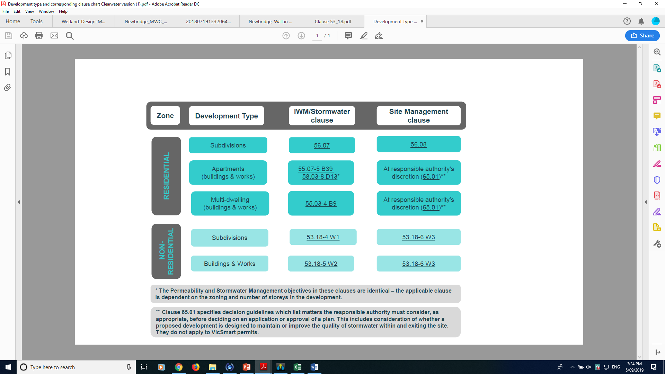

## 

## Objectives of Clause 55.03-4

### 55.03-4 Permeability and stormwater management objectives

* To reduce the impact of increased stormwater run-off on the drainage system.
* To facilitate on-site stormwater infiltration.
* To encourage stormwater management that maximises the retention and reuse of stormwater.

## Standards

The requirements for Standard B9 are listed below.

| CLAUSE | Standards |
| --- | --- |
| **55.03-4** | **Standard B9:**  The site area covered by the pervious surfaces should be at least:   * The minimum area specified in a schedule to the zone, or * If no minimum is specified in a schedule to the zone, 20 percent of the site.   The stormwater management system should be designed to:   * Meet the current best practice performance objectives for stormwater quality as contained in the Urban Stormwater - Best Practice Environmental Management Guidelines (Victorian Stormwater Committee, 1999). * Contribute to cooling, improving local habitat and providing attractive and enjoyable spaces. |

All applications must be accompanied by details of the proposed stormwater management system, including drainage works and retention, detention and discharges of stormwater to the drainage system.

Worked example

The stormwater summary report presented by the applicant should provide all the information listed in the checklist.

This example aims to demonstrate how a townhouse development (or similar) could satisfy Clause 55.03-4 (Standard B9). Some local councils may require more detail for some aspects of the design than presented here. The schematic is not intended as an accurate representation of all other planning requirements for a development of this nature.

## A: Proposed development description

The site is an existing 911 m2 residential block, to be developed into four townhouses, of two-storeys and three bedrooms each. The development has 498m2 total impervious area making an impervious fraction of 55%. Each townhouse has external parking space surfaced with permeable pavement.

The stormwater management response is summarised as:

* Part of each dwelling’s roof drains to a rainwater harvesting tank which is supplied to toilets for flushing.
* Remaining parts of the dwellings’ roofs are directed to either raingardens (Dwellings 1 and 3) or the Council drainage network without treatment (Dwellings 2 and 4).
* Permeable paving is used for the vehicle driveways.
* 45% of the site is pervious, including the open space areas provided in front and rear yards (meeting the minimum 20% requirement).
* This site has generous green space allocation for the creation of green recreational areas for residents. Planting of trees and native ground covers are proposed to contribute towards cooling and providing attractive and enjoyable spaces.

**Figure 1** shows the WSUD assets and their required drainage connections. Please refer to concept design drawings for further details of each WSUD asset.

|  |
| --- |
| A: Proposed development description: |
| * **A1**: Describe the proposed development e.g. describe the land use, anticipated tenancy, buildings and works, number of car parking spaces, expected number of occupants, etc. |

## B: Site layout plan, catchment areas and WSUD treatment systems

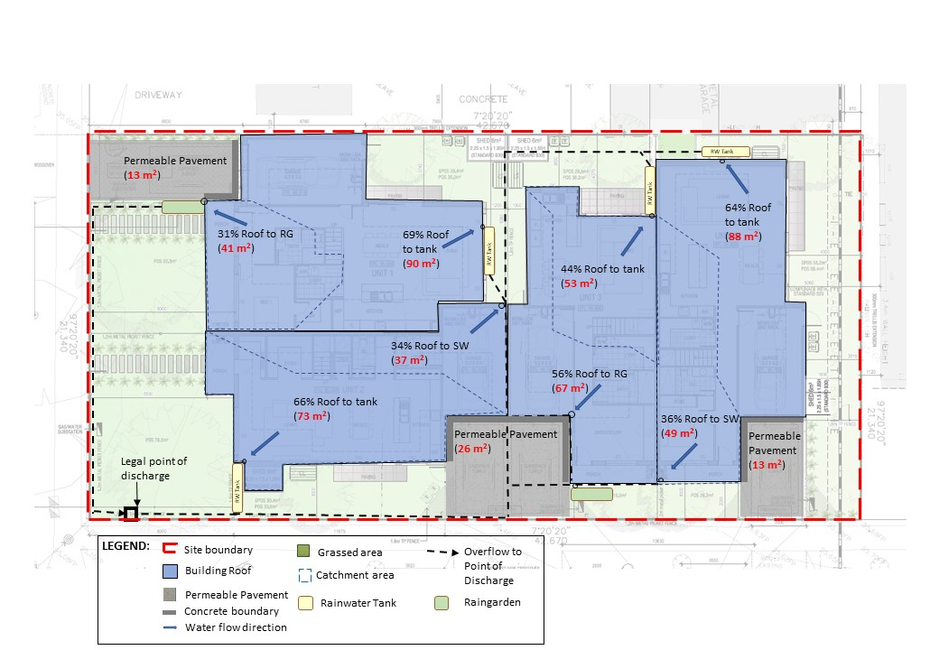

Figure 1: Site layout plan

|  |
| --- |
| B: Site layout plan, catchment areas and WSUD treatment systems: |
| * **B1:** Provide a site layout plan showing all building roofs and covered areas, pervious (unsealed) surface areas and impervious (sealed) surface areas with dimensions. These details must be consistent with the plans and other documents lodged with the planning application. * **B2:** Show thesite boundary, dimensions, and total site area on the site layout plan. * **B3:** Show the legal point of discharge (see checklist for further description). * **B4:** Specify the area draining to each downpipe, treatment and legal point of discharge – includes both impervious and pervious areas (see checklist for further description). |

### Stormwater treatment strategy

A summary of the surface areas and treatments can be seen in **Table 1**. The site was assessed using the online STORM tool calculator.

It is assumed that very little litter will be generated from the site, as residents will make use of the existing rubbish collection service provided by Council.

Table 1: Catchment type or WSUD asset surface area

| Surface type | Catchment area (m2) |  | Area treated by: |
| --- | --- | --- | --- |
| Townhouse 1 |  |  |  |
| Roof to Tank | 90 |  | 2kL tank, toilet demand for 3 bedrooms |
| Roof to Raingarden | 41 |  | 2m2 above-ground raingarden |
| Permeable Pavement | 13 |  |  |
| Pervious/Garden | 90 |  |  |
| Townhouse 2 |  |  |  |
| Roof to Tank | 73 |  | 2kL tank, toilet demand for 3 bedrooms |
| Roof to Drainage | 37 |  |  |
| Permeable Pavement | 13 |  |  |
| Pervious/Garden | 102 |  |  |
| Townhouse 3 |  |  |  |
| Roof to tank | 53 |  | 1.5kL tank, toilet demand for 3 bedrooms |
| Roof to raingarden | 67 |  | 2m2 above-ground raingarden |
| Permeable pavement | 13 |  |  |
| Pervious/garden | 85 |  |  |
| Townhouse 4 |  |  |  |
| Roof to tank | 88 |  | 2kL tank, toilet demand for 3 bedrooms |
| Roof to drainage | 49 |  |  |
| Permeable pavement | 13 |  |  |
| Pervious/garden | 84 |  |  |
| Total site area: 911m2 Total impervious area: 498m2 Site permeability: 55% | | | |

|  |
| --- |
| B: Site layout plan, catchment areas and WSUD treatment systems: |
| * + - **B5:** Show the location, type and surface area (m2) of the proposed WSUD treatment systems on a plan, including how each internal catchment area to be treated will be connected to a WSUD element (e.g. roof to rainwater tank, driveway to raingarden). Show how piped connections will be made within the site and to the LPOD and clearly annotate any impervious areas not being treated by a WSUD element.     - **B6:** Indicate the expected volume of on-site stormwater reuse and how this has been calculated. |

|  |
| --- |
| Relevant links  * Urban Stormwater Best Practice Environmental Management Guidelines (BPEM) (Victorian Stormwater Committee): <http://www.publish.csiro.au/book/2190> * Options for treating stormwater using WSUD (Melbourne Water): <https://www.melbournewater.com.au/planning-and-building/stormwater-management/options-treating-stormwater> * WSUD Engineering Procedures Stormwater (Melbourne Water): <https://www.publish.csiro.au/book/4974/#contents> * Infrastructure Design Manual (IDM) (Local Government Infrastructure Design Association): <https://www.designmanual.com.au/download-idm> * Adoption Guidelines for Stormwater Biofiltration Systems (CRC for Water Sensitive Cities): <https://watersensitivecities.org.au/content/stormwater-biofilter-design/> * Raingarden Instruction Sheets (Melbourne Water): <https://www.melbournewater.com.au/water-data-and-education/environmental-issues/why-we-need-save-water/tips-saving-water/raingardens> |

|  |
| --- |
| B: Site layout plan, catchment areas and WSUD treatment systems: |
| * **B7**: If relevant to the development type, identify potential toxicants generated by the business, where they will be located on the premises, and what structural isolation is required to prevent the runoff draining to a WSUD treatment system or stormwater drain. * **B8**: Describe how the stormwater management design contributes to local cooling, improving local habitat outcomes and providing attractive/ enjoyable spaces. * **B9:** Table summarising the internal drainage catchment areas shown on the site layout plan, the size of the catchment area, the percentage of the site this represents and information about the corresponding WSUD treatment system. The table should equal 100% of total site area. The information should correspond to the information shown on the site layout plan. | |

## C: Modelling and compliance

The STORM tool was used to estimate the treatment size requirements for the proposed site design to meet best practice requirements. The input details and compliance results are shown in the output from the STORM tool in **Figure 2** below.

The site has 45% pervious area (meeting the minimum 20% requirement under Standard B9), and raingardens and tree plantings also provide the combined benefits of cooling and improving amenity for inhabitants and visitors to the complex.

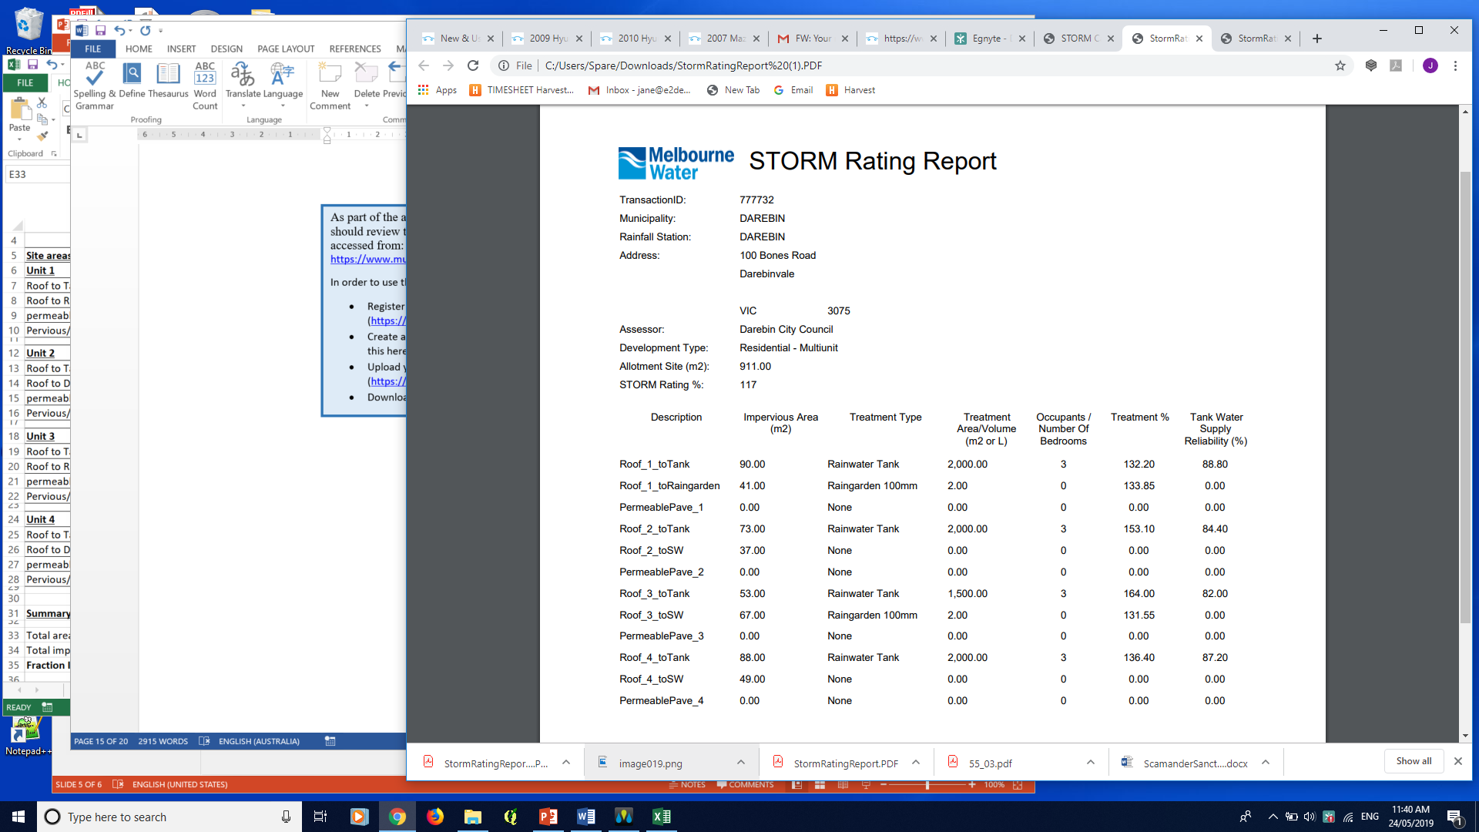

Figure 2: STORM model inputs and output

|  |
| --- |
| C: Modelling and compliance |
| * **C1:** Compliance summary with objectives outlined in Clause 55.03 – including compliance with minimum permeable area requirement. * **C2**: STORM report with a minimum 100% rating or MUSIC (or other acceptable modelling) results that meets best practice performance for stormwater pollutant load reductions: TSS 80%; TP 45%; TN 45%; Litter 70%. * Summary of model input parameters, including each WSUD treatment system. * Screen print of model analysis (e.g. STORM report) or a schematic of the model (e.g. MUSIC). * If MUSIC: Check MUSIC file using the MUSIC auditor (https://www.musicauditor.com.au/). * The applicant should submit a copy of the MUSIC file (.sqz) used to generate treatment performance. |

Theeffectiveness of the treatment systems is summarised in **Figure 2**, indicating 117% STORM rating and thereby demonstrating compliance with water quality improvement requirements outlined in Urban Stormwater Best Practice Environmental Management Guidelines (BEPM) – as 100% STORM rating corresponds to the minimum 45% reduction in Total Nitrogen required by BPEM. The raingardens and tree plantings also provide the combined benefits of cooling and adding enjoyable aesthetics for inhabitants and visitors to the complex.

In this example the STORM tool has been used, which is appropriate for a residential development of this size and complexity (i.e. where each catchment area drains to no more than one treatment type). Alternatively, other appropriate modelling software (e.g. MUSIC or Insite Water) could be used to demonstrate compliance with the BPEM requirements, if acceptable to Council.

References and resources for STORM (as used in this example) and alternative models can be found in the text box below.

|  |
| --- |
| Relevant links – STORM  * STORM Calculator (Melbourne Water):<https://storm.melbournewater.com.au/>   To use the STORM Calculator,   * Enter your email address to be taken to the STORM calculator page * Enter rows in the calculator until all impervious areas in the catchment and their treatments are included (enter ‘none’ if no treatment exists for an impervious area) * Press the ‘Calculate’ button to view the performance of the design. * In order to meet best practice, a STORM Rating of at least 100% must be achieved.   Other relevant links  * MUSIC software (eWater): <https://ewater.org.au/products/music/> * MUSIC Guidelines (Melbourne Water): <https://www.melbournewater.com.au/sites/default/files/2018-02/Music-tool-guidelines-2018.pdf> * MUSIC Auditor tool (Melbourne Water): <https://www.musicauditor.com.au/> * InSite Water (Organica Engineering): <https://insitewater.com.au/> |

|  |
| --- |
| C: Modelling and compliance |
| * **C3:** Minimises impact of chemical pollutants and other toxicants, as relevant. |

## D: Functional design considerations

Note: This section may be required for inclusion with the planning application, or else the information may be required as a condition of permit. Check with your council for advice on which applies.

### Rainwater tank

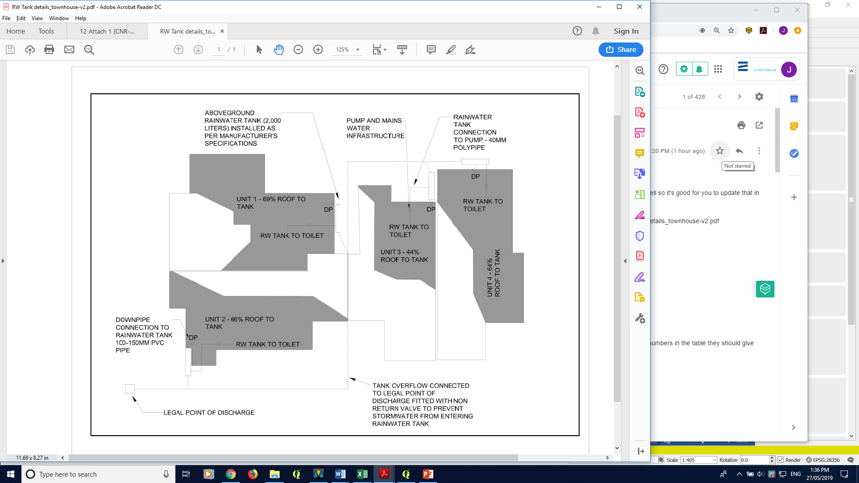

Figure 3: Rainwater tank concept design plan

|  |
| --- |
| D: Functional design considerations |
| * **D1:** Plan from Checklist item B or amended plan required by permit. * **D2**: Sectional view of each WSUD treatment showing indicative levels. * **D3**: Size of treatment elements, e.g. tank volume, raingarden width and length, extended detention depth, etc. * **D4**: Details of pipe connections between any rainwater tank and end uses, e.g. toilet/s, laundry, hot/cold water and irrigation, as applicable. |

**Raingarden**

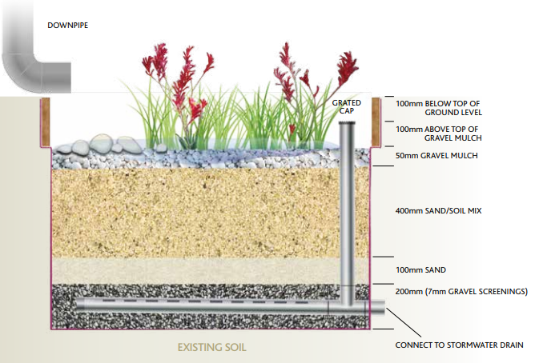

**Figure 4:** **Raingarden cross section**

Table 2: Plant species preferences

| Recommendations for plant types* | |
| --- | --- |
| **Vegetation for raingarden** | *Ficinia nodosa* (Knobby Club Rush)  *Anigozanthus spp.* (Kangaroo Paw) |

*These are only two of many species which could be used. For purposes of aesthetics other species may also be used to add variety – refer to the resources below. For a development of this size a density of 6-10 plants/m2 is proposed.

|  |
| --- |
| D: Functional design considerations |
| * **D5:** Levels for each WSUD treatment including surface level, extended detention depth, filter layers and depth, under drain system, legal point of discharge. * **D6**: Plant species and planting densities to be used in any vegetated treatment systems. Refer to checklist. * **D7**: For vegetated treatment systems, management of the interface between the WSUD treatment and immediately surrounding areas, e.g. car parking spaces, walkways, lawns, so that the WSUD elements and public safety are protected. |

|  |
| --- |
| Relevant links  * WSUD Engineering Procedures Stormwater (Melbourne Water): <https://www.publish.csiro.au/book/4974/#contents> * Adoption Guidelines for Stormwater Biofiltration Systems (CRC for Water Sensitive Cities): <https://watersensitivecities.org.au/content/stormwater-biofilter-design/> * Infrastructure Design Manual (IDM) (Local Government Infrastructure Design Association): <https://www.designmanual.com.au/download-idm>   A useful reference for suitable streetscape WSUD plant species is Moreland City Council’s *WSUD streetscape raingarden and tree pit design package* (refer to *Planting Palette Extract*) located at:  <https://www.moreland.vic.gov.au/environment-bins/environment/water/wsud-design-package/> |

## E: Site management plan

Many Victorian councils require a site management plan to be submitted and approved before site works begin, so check with council on specific requirements. Site management plans help you record the way you manage risk and may help with your planning. If a pollution incident happens, they may also help demonstrate to Environment Protection Authority (EPA) Victoria what steps you have taken to meet your [general environmental duty (GED)](https://www.epa.vic.gov.au/about-epa/laws/new-laws/general-environmental-duty) (from 1 July 2021) by reducing or eliminating the risk of harm to human health and the environment.

The following site management plan (refer to **Figure 5**) outlines the consideration and measures taken to contain sediment and litter from construction on-site and to protect the receiving drain and downstream waterways. The measures include such things as covering stockpiles, designated wash-down areas, stabilised gravel entrance and protection to all receiving drains.

The EPA Victoria website also provides information about following a risk-based approach to preventing and minimising impacts from erosion and sedimentation.

|  |
| --- |
| E: Site management plan |
| * **E1:** Statement outlining the environmental protection measures to protect the stormwater system during construction (e.g.. sediment, dust, waste, chemicals management). |

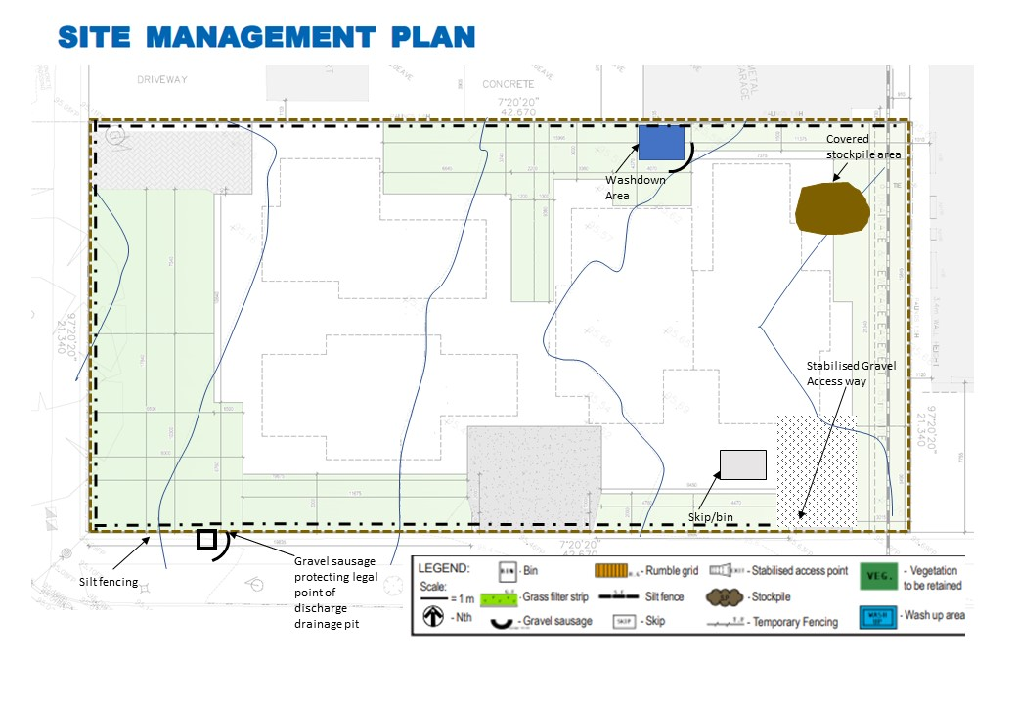

Figure 5: Proposed site management plan

*Note: Where the access way slopes down toward the road, a diversion hump should be installed across the stabilised access to direct stormwater runoff to the side where it can be filtered by the silt fence.*

|  |
| --- |
| E: Site management plan |
| * **E2:** Site management measures shown on a plan. |

|  |
| --- |
| Relevant links For larger scale developments (10 or more dwellings or over 1000m2), consider developing a site management plan that addresses environmental risk, or an Environmental Management Plan (EMP) – guidelines are available at:   * Environmental Management Plan Guidelines (Commonwealth of Australia): <https://www.environment.gov.au/system/files/resources/21b0925f-ea74-4b9e-942e-a097391a77fd/files/environmental-management-plan-guidelines.pdf>   Other useful resources include:   * Site Environmental Management Plan kit (Melbourne Water): <https://www.melbournewater.com.au/planning-and-building/developer-guides-and-resources/standards-and-specifications/develop-site> * Guidance on reducing erosion and sedimentation risk (EPA Victoria): <https://www.epa.vic.gov.au/for-business/find-a-topic/erosion-and-sediment/advice-for-businesses> * Assessing and controlling risk: A guide for business – EPA publication 1695 (EPA Victoria): <https://www.epa.vic.gov.au/about-epa/publications/1695-1> This guide is also available in languages other than English. * Construction techniques for sediment pollution control – EPA publication 275 (EPA Victoria): <https://www.epa.vic.gov.au/about-epa/publications/275> * Construction – Guide to preventing harm to people and the environment – EPA publication 1820 (EPA Victoria):   [https://www.epa.vic.gov.au/about-epa/publications/1820](https://www.epa.vic.gov.au/about-epa/publications/1820%0d)  Outlines how to manage risks in construction, provides an outline of your legal obligations, what actions you can take to comply with the new laws, and contains a list of common hazards and information about how to manage waste. The guide does not tell you about the controls to put in place to suit your circumstances.   * Civil construction, building and demolition guide – EPA publication 1834 (EPA Victoria):   <https://www.epa.vic.gov.au/about-epa/publications/1834>  Supports industry to eliminate or reduce the risk of harm to human health and the environment through good environmental practice. It provides an overview of the duties under the new laws, outlines a risk based approach for assessing and managing risks, and includes information on controls that you can put in place to manage your risks. |

## F: Asset maintenance program

Note: This section may be required by your council. Check with your council for further advice on what is required. A suggested list is provided in the checklist.

Although an asset maintenance program is not a requirement under this standard, some councils may require maintenance schedule detailing, including inspection of WSUD assets, schedule of maintenance, and responsibilities (i.e. future tenant, owner, body corporate, etc).

In order to protect our waterways and enhance the function, aesthetics and amenity associated with WSUD, it is important that these assets are maintained so they continue to operate as designed.

In this case, in order to maintain the aesthetics and function of the raingarden, any litter/debris/sediment will need to be removed at regular intervals (approximately monthly, as required). The management of the raingardens and tanks will be the responsibility of the landowner.

*Note: It is suggested that councils recommend to property owners that they record the location and details of their buried on-site stormwater devices and attach it to property title documents. Councils should also consider recording information about the location of buried stormwater infrastructure on private land where required as part of a planning permit, to support future asset management and/or enforcement.*

|  |
| --- |
| Relevant links  * WSUD Maintenance Guidelines (Melbourne Water): <https://www.melbournewater.com.au/media/636/download> * WSUD Audit Guidelines (Stormwater Victoria): <https://www.musicauditor.com.au/node/36> * WSUD Maintenance Manuals (City of Port Phillip): * Rainwater tanks: <https://manualzz.com/doc/7441220/rainwater-tanks---city-of-port-phillip> * Raingardens: <https://www.portphillip.vic.gov.au/media/dd1n33yv/maintenance_manual_raingarden.pdf> |

delwp.vic.gov.au