|  |
| --- |
| Penshurst rides the winds of change to test adaptive wastewater solutions |

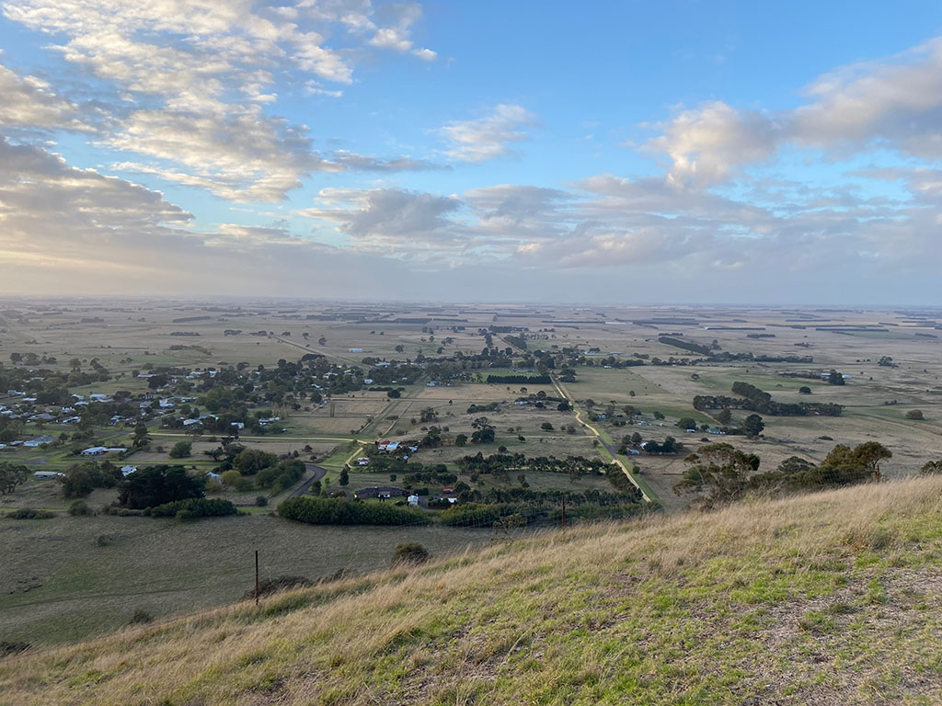The township of Penshurst in south-west Victoria will test an adaptive wastewater solution to measure its effectiveness in overcoming some of the challenges and risks faced by small unsewered towns.

A combination of poorly performing onsite systems, environmental constraints, regulatory change and a desire for growth have led local authorities to challenge and adapt the approach to domestic wastewater management for the township of Penshurst in south-west Victoria.

Wannon Water and Southern Grampians Shire Council have partnered to explore and test the suitability of an alternative option through a targeted pilot project.

## The problem

### Impacts of poorly performing onsite systems

Unsewered towns have onsite systems which, if not adequately maintained or upgraded, can be a significant risk to public health and the environment.

The township of Penshurst in the Southern Grampians Shire Council region of south-west Victoria is the most densely populated unsewered town within the municipality, and is situated on a sensitive groundwater setting near an extinct volcano.

A Council audit of Penshurst’s septic systems found 93% (approximately 190 systems) were not performing satisfactorily and did not adhere to current public health and environmental standards. In addition, around 95% of owners did not maintain their systems, leading to a high risk of contamination of the groundwater and local water bodies. A natural spring of significance to the region’s Traditional Owners, the Eastern Maar, is also experiencing elevated nutrients which could risk triggering a future blue-green algae outbreak.

### Appetite for growth

Both Council and the community of Penshurst are keen for the township to grow and develop.

Penshurst is centrally located to the larger regional centres of Hamilton, Warrnambool and Portland. It is a thoroughfare for tourists and has a local training base for the Country Fire Authority (CFA). However, there are currently limited accommodation options.

Penshurst is increasingly becoming a location of choice due to housing affordability, access to work and schools in Hamilton, and having a dedicated aged care facility. The local hospital and other businesses are also looking to develop and expand but are limited by the absence of a reticulated sewerage system.

### Traditional reticulated sewerage is not feasible

Penshurst’s current approach to domestic wastewater management limits growth as the lot sizes within the town already provide insufficient land area to effectively treat and dispose of effluent via onsite systems. In addition, a reticulated sewerage system is also not suitable for the Penshurst area given the prohibitive costs of installation and distance from established systems in Hamilton.

### Changing regulations and mindsets

Integrated water management (IWM) has been a key driver for the Victorian Government over the last decade and regional water corporations and councils are becoming more involved in this approach in line with the objectives of *Water for Victoria* (DELWP, 2016). In Penshurst, this has included the Great South Coast IWM Forum and development of the *Great South Coast IWM Strategic Directions Statement*.

This has enabled new adaptive sewerage technologies and servicing approaches to be considered and implemented, and these are further supported through the Environment Protection Act 2017 which came into force in July 2021.

The Victorian Auditor-General’s Office (VAGO) 2018 audit *Managing the Environmental Impacts of Domestic Wastewater* has also enabled change by spotlighting issues with onsite systems and domestic wastewater management as a whole.

Continuation of the ‘business as usual’ approach to wastewater management through poorly performing onsite systems will not meet regulatory or community expectations in the long-term. It will likely lead to a population decline, as well as increased costs through the monitoring and maintenance of existing systems.

It is therefore essential to identify alternative, safe and sustainable wastewater management strategies for locations such as Penshurst to support sustainable population increases and employment opportunities.

## Steps taken to address the problem

Through the Great South Coast IWM Forum, Wannon Water, Southern Grampians Shire Council, Moyne Shire and the Department of Environment, Land, Water and Planning (DELWP) engaged an independent consultant to investigate a range of adaptive wastewater management solutions for Penshurst.

Four potential options were presented to the community and stakeholders and analysed based on their cost-benefit ratio and level of protection to the environment and public health.

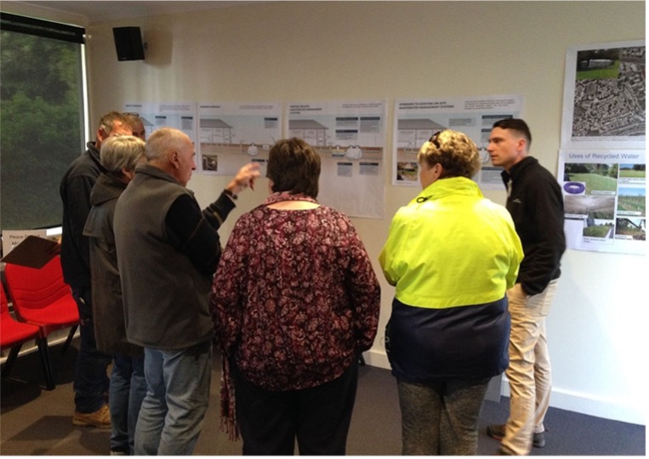

Adaptive wastewater management options were discussed with the Penshurst community to increase awareness and understanding. Image: Brad Clingin.

A functional design report was then developed for the preferred option – the Penshurst Recycled Water Scheme by Decentralised Water Consulting (DWC). This neighbourhood-scale solution divides 270 properties across Penshurst into 12 precincts based on topography and the nature of the land use.

Under the preferred option, for each precinct, existing onsite systems would be decommissioned and separate gravity all-waste sewers would be installed. These sewers would direct raw sewage from properties to a local precinct water recycling system, which would conduct primary treatment of wastewater, then disposal through evapotranspiration “pods”. These natural pod systems provide further treatment in the soil and allow water to be taken up by plants and evaporated. They also allow water to be stored within the pods during cooler, wetter periods.

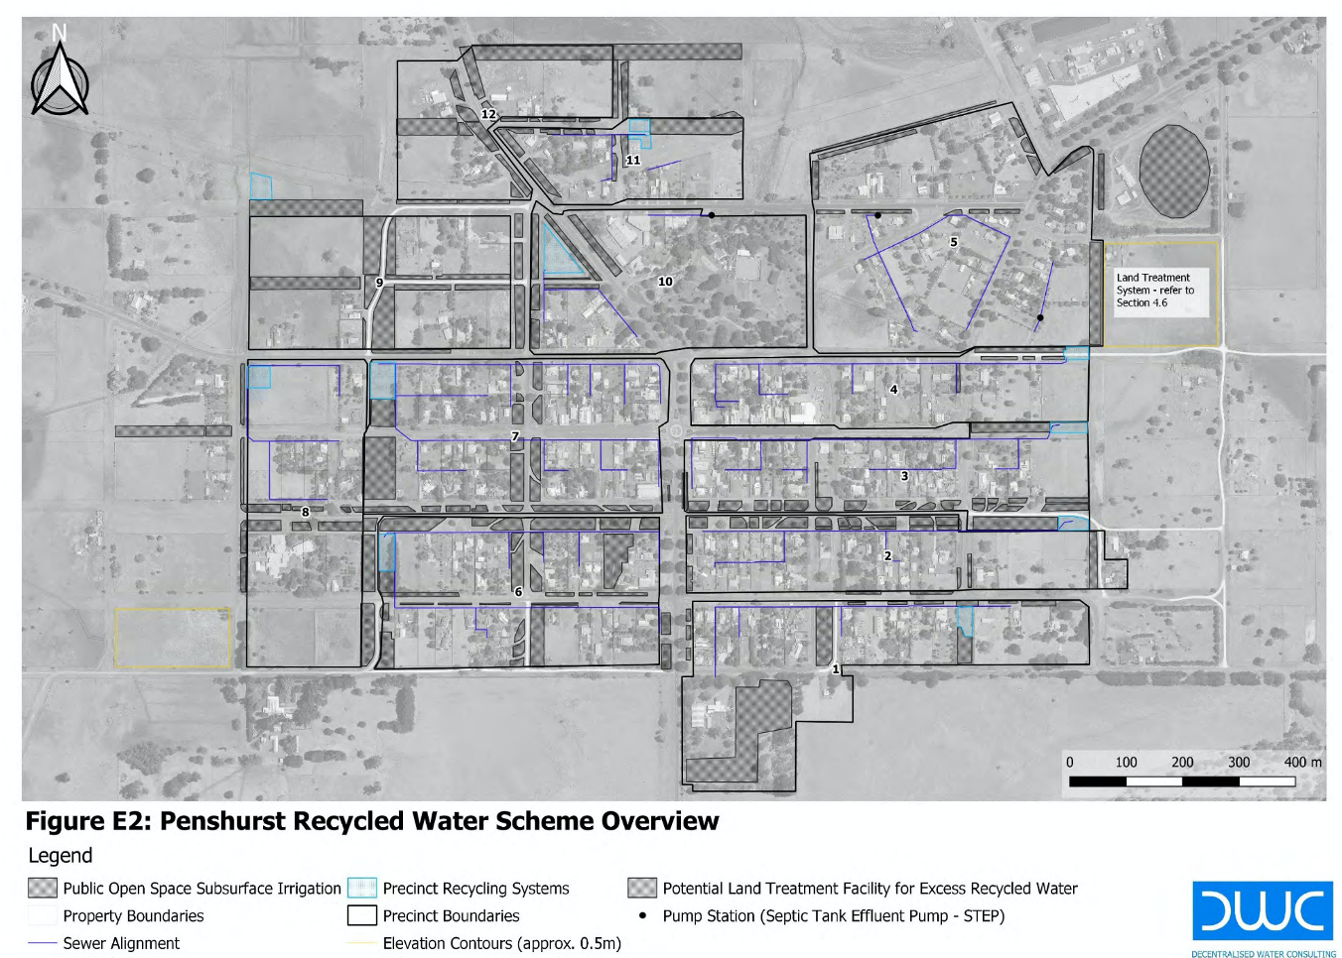Recycled water can be stored for public irrigation of open spaces when necessary, such as during warmer months. This open space irrigation would occur underground, via sub-surface drippers.

Below: The Penshurst Recycled Water Scheme includes 12 precincts where gravity sewer lines will be installed and wastewater treated through recycling systems. Excess recycled water can be used to irrigate public open spaces. Image: DWC.

To test the effectiveness and suitability of the Penshurst Recycled Water Scheme, a pilot project is proposed where two precincts are to be chosen to develop a proof of concept and adaptive pathways approach to wastewater management.

A governance arrangement has been developed between the water corporation and Council, where Wannon Water is responsible for the gravity sewer, wastewater treatment and sub-surface irrigation infrastructure, and Southern Grampians Shire Council is responsible for above ground maintenance and upkeep of public open space. Plantings used for the pods will be negotiated between the two organisations with input from the community.

## Results

The Penshurst Recycled Water Scheme concept uses small scale, natural technology to treat and manage recycled water locally in a simple and cost-effective manner. The precinct-based systems have been designed to be modular and offer flexibility by being built to service each precinct as needed, with the ability to cater for a 75% increase in Penshurst’s population.

It is expected that the systems can be adapted to residential, commercial or industrial settings, with the majority of infrastructure located underground and offsite on public land. It is envisaged that this solution will deliver a greater equity of service for Penshurst. Anticipated benefits include enabling economic development, preventing environmental pollution and providing opportunities for improved community engagement around wastewater management issues.

An economic analysis of the full scheme concept (12 precincts) has been conducted to estimate community costs over 25 years, as outlined below:

* **Capital expenditure:** $13.5-15.7 million
* **Operational expenditure:** $187,000 per year
* **Renewal:** $754,000
* **Life Cycle Cost (NVP):** $15.6-17.7 million
* **Expected economic value:** $41.6 million.

## Challenges and how they were met

### Previous regulatory framework offered limited options for domestic wastewater management

Wannon Water and Southern Grampians Shire Council have challenged the traditional approach to domestic wastewater management – the binary choice between a reticulated sewerage system or onsite system – and thought creatively to investigate and trial a different option for adaptive wastewater management in Penshurst.

Revisions to the Environment Protection Act 2017, where ‘Pilot’ licences can be issued for wastewater management and water recycling systems that test and measure new technologies and servicing approaches, has enabled the project to take place.

### Relevant parties working together to progress change

Through the IWM forums, Wannon Water and Southern Grampians Shire Council have established a strong and collaborative working relationship which set the foundation to progress investigations into adaptive wastewater solutions for Penshurst.

Part of this collaboration has ensured clear project governance from the outset. This includes making sure that both organisations respect each other’s strengths and roles in the development of the pilot project, with an ability to recognise and effectively address any technical or skills gaps that may exist.

## Lessons learnt

### 1. Understand the real cost of a ‘business as usual’ approach to wastewater management

There are significant costs for Penshurst – including property owners, Council and the broader regional community if a ‘business as usual’ approach is continued using poorly performing onsite systems.

This is estimated to be $1,000 per property every year which equates to around $7 million over a 25-year period. There is also a cost associated with a missed opportunity, as the town can’t grow. It also delivers a scenario that falls short of acceptable environmental and health targets, including those set by the World Health Organisation, whereas an adaptive wastewater solution is better placed to meet those targets.

### 2. Adaptive wastewater solutions must consider the unique context of different locations

Functional design for adaptive wastewater solutions requires consideration of local conditions, existing development and community expectations and desired outcomes. A ‘cookie cutter’ approach where standard sewerage designs are applied is unlikely to lead to an effective or affordable solution.

This also extends to community engagement and governance approaches which may need to be adapted to suit other townships facing similar domestic wastewater management issues.

### 3. Difficult conversations, dedicated resourcing and shared goals are essential to challenge the status quo

Previous attempts at adaptive wastewater projects in the region failed to gain traction beyond a consultant’s report, but Wannon Water and Southern Grampians Shire Council persisted with having the conversations necessary to develop an unconventional approach to wastewater management in Penshurst. The EPA also showed willingness and cooperation in the early stages of the project to investigate alternative solutions.

It is important that interested parties are committed to working towards the same outcome and have plans in place to ensure they can be realised. For instance, the pilot project is listed as an outcome in Southern Grampian Shire Council’s updated Council Plan.

Dedicated personnel who share the same passion and commitment to achieving an outcome is key to ensuring recommendations transform into actions and opportunities to challenge the norm are realised.

## Beyond results

Wannon Water and Southern Grampians Shire Council will work with DELWP and EPA to examine the outcomes of the pilot project, and will consider pathways for funding more affordable and effective wastewater management practices for Penshurst.

If the pilot project achieves its objectives and the Penshurst community is supportive, the scheme could provide flexibility and development opportunities in the town, additional liveability benefits and protect environmental and cultural values as well as public health. The Penshurst pilot supports broader IWM outcomes in the *Great South Coast IWM Strategic Directions Statement* and *Water for Victoria – Water Plan*, particularly in regard to adaptive wastewater solutions for small towns.

## Conclusion

A collection of drivers provided the opportunity for Penshurst to investigate alternative and unconventional wastewater management approaches.

Wannon Water and Southern Grampians Shire Council worked closely to identify and test an innovative, neighbourhood-scale technical solution to manage the impacts associated with small town wastewater management, particularly where sewerage is not available or too expensive.

This is a successful example of a collaborative approach to developing an alternative wastewater system to limit the impacts of poorly performing onsite systems. This should achieve significant improvements in protection of the environment and public health, and enable growth.

The results from this pilot precinct scale wastewater management project will have potential for adoption or adaptation for other towns and regions across Victoria facing similar challenges.



|  |
| --- |
| **Key messages**   * Regulatory updates are enabling change where unconventional and adaptive wastewater solutions can be tested in small unsewered towns * Adaptive wastewater management solutions can allow townships to achieve more commercial and urban development, and better environmental and public health outcomes * This is a great example of local government and a water corporation collaborating to achieve integrated water management (IWM) outcomes in Victoria. |

## Further reading

* [*Adaptive Wastewater for Solutions for Small Towns – Penshurst and Cudgee: Options Analysis Report*](https://www.sthgrampians.vic.gov.au/files/Public_Documents/Report-Adaptive-Wastewater-Solutions-for-Penshurst-and-Cudgee-Options-Analysis-Report-Version-2.pdf)
* [*Great South Coast IWM Strategic Directions Statement (DELWP, 2019)*](https://www.water.vic.gov.au/__data/assets/pdf_file/0026/445841/10696_DEL_IWMF_GSC_SDS_WEB_LR.pdf)
* [*Water for Victoria – Water Plan (DELWP, 2016)*](https://www.water.vic.gov.au/water-for-victoria)
* [*Managing the Environmental Impacts of Domestic Wastewater (VAGO, 2018)*](https://www.audit.vic.gov.au/report/managing-environmental-impacts-domestic-wastewater?section=)
* [*Guide to the proposed final Environment Protection Regulations (EPA, 2020)*](https://www.epa.vic.gov.au/about-epa/laws/new-laws)

|  |  |
| --- | --- |
| © The State of Victoria Department of Environment, Land, Water and Planning 2021  LogoThis work is licensed under a Creative Commons Attribution 4.0 International licence. You are free to re-use the work under that licence, on the condition that you credit the State of Victoria as author. The licence does not apply to any images, photographs or branding, including the Victorian Coat of Arms, the Victorian Government logo and the Department of Environment, Land, Water and Planning (DELWP) logo. To view a copy of this licence, visit http://creativecommons.org/licenses/by/4.0/  Printed by  ISBN (print) [How to obtain an ISBN or an ISSN](https://library.intranet.vic.gov.au/client/en_AU/vglsweb-depi/?rm=ISBN0%7c%7c%7c1%7c%7c%7c0%7c%7c%7ctrue)  Disclaimer  This publication may be of assistance to you but the State of Victoria and its employees do not guarantee that the publication is without flaw of any kind or is wholly appropriate for your particular purposes and therefore disclaims all liability for any error, loss or other consequence which may arise from you relying on any information in this publication. | Accessibility  If you would like to receive this publication in an alternative format, please telephone the DELWP Customer Service Centre on 136186, email [customer.service@delwp.vic.gov.au](mailto:customer.service@delwp.vic.gov.au) , or via the National Relay Service on 133 677 [www.relayservice.com.au](http://www.relayservice.com.au). This document is also available on the internet at [www.delwp.vic.gov.au](http://www.delwp.vic.gov.au). |

Keep all content above this instruction text line. Delete only when document formatting is complete.