Water Security Plan for Greater Melbourne, Geelong and connected towns

Table of Contents

Minister’s foreword 2

Introduction 5

Aims of the Water Security Plan 7

Reliability for growing population and demands 8

Climate change impacts 9

Growing our water supplies 10

Potential water supply options 15

Case study: Barwon Water sustainable water network 19

Considered water supply options 20

Getting the timing right for investments 22

Returning water and supporting regional prosperity 24

Next steps 25

More information 27

Publication information 28

# Minister’s foreword

**Safe, reliable and affordable water is essential to the future prosperity of our State, including the jobs, communities and industries that rely on it. As our population grows, we are proactively responding to water and climate uncertainty.**

Victoria remains one of Australia’s fastest growing states. At the same time, our climate is changing.

To help manage the expected population growth, the Victorian Government has committed to an ambitious goal of delivering 800,000 new homes over the next decade – homes that will need water for gardens, drinking, showers and toilet flushing. Expected population growth will increase future demand on the South-Central Water Grid in 2050 by 60%.

Victoria is also experiencing unreliable rainfall and worsening climate conditions. In the future, our climate will have more extremes and variability from heavy rainfall and floods, drought and catastrophic bushfires. Seasonal conditions remain challenging across many areas of the state. Drought conditions experienced since June 2023 have not improved in south west Victoria and have extended to a wider footprint. We’ve seen urban water restrictions being required in parts of Victoria for the first time since 2019–20.

This past summer was the driest in Victoria since 2013–14, and the fourth warmest on record for all summers since 1910. By the end of summer 2025 Melburnians were using a total of 5.5% more water compared to the same time last year which is 83 million litres per day more compared to 2024. By contrast Geelong was using a total of 14% more water compared to the same time last year – 16 million litres per day more compared to 2024 – reflecting the extreme dry conditions being experienced in the south-west.

To meet future demand, we must act now to investigate new water supplies that don’t rely on rainfall.

Timing is important. New large scale water supplies can take a decade to plan and deliver so the best time to start planning is when water storage levels are healthy.

Early investment in readiness activities reduce the time and cost of delivering new water supplies in the future. Failure to plan and deliver new water supplies in time puts us at risk of extended and severe water restrictions.

Victoria’s desalination plant is a core part of our supply system, giving us the flexibility in any one year to increase our annual system inflow by up to 150 billion litres of drinking water, providing an essential buffer against dry conditions and severe droughts. By the end of 2025 the desalination plant will have delivered half a trillion litres of drinking water, or 28% of Melbourne’s total water storage capacity.

Options to further increase water efficiency, the Victorian Government’s significant investment in integrated water management, expanded desalination, and maximising use of recycled water and harvested stormwater must all be considered as part of a portfolio of options to secure Victoria’s water future.

Purified or ‘triple treated’ recycled water and stormwater is also already being used in many cities around the world to recharge their rivers, groundwater or reservoirs to supplement their drinking water supplies.

Currently in Victoria, our understanding of desalination is more developed than purified recycled water. But good water planning means looking at all options, without a foregone conclusion. Desalination, purified recycled water, stormwater and water efficiency should all be considered.

This includes considering not only how these water supply options can support the 80% of Victorians who rely on the South-Central Water Grid, but how they may be applied beyond the current South-Central Grid to support our regional communities too.

Community consultation in decision making is also vital to identify and leverage the full range of potential benefits.

This Water Security Plan is the start of a conversation on how we will continue to deliver a reliable, safe source of drinking water that is affordable, and supports economic opportunity.

The Water Security Plan outlines how the Victorian Government is working with the water sector and the community to meet future water demand and growth so we can continue to enjoy everything that makes Victoria a great place to live.

**The Hon. Gayle Tierney MP**Minister for Water

# Introduction

Safe, reliable and affordable water is essential for our health and wellbeing, and for the economic prosperity of our State. Yet climate change, declining rainfall, and population growth are putting increasing pressure on South-Central Water Grid supplies.

The South-Central Water Grid works much like our road network, connecting sources such as dams, reservoirs, and the desalination plant via infrastructure including pipes and pumps, and natural elements like rivers.

Melbourne’s water supply system, which includes the Victorian Desalination Project, services over 80% of Victoria’s population via the South-Central Water Grid.

To meet the region’s future water needs, the Victorian Government, in collaboration with urban water corporations, has developed this Water Security Plan for the South-Central region, which includes Greater Melbourne, Geelong, and connected towns (refer to   
**Figure 1**).

This plan will progress detailed investigation into options to sustainably grow our water supplies and build our resilience to drought and other disruptions.

To offset declining inflows into our dams, we will continue to support gains in water efficiency in homes and businesses and make better use of all water sources. We also need to investigate options for additional supply that do not rely on rainfall, such as use of purified recycled water and stormwater to replenish our rivers, groundwater or reservoirs; and expansion of our seawater desalination capability.

We must also consider the infrastructure required to move water from where it is sourced to where it is needed, via the South-Central Water Grid.

The Victorian Government is working with urban water corporations and other agencies to ensure coordinated responses to water security challenges.

This plan highlights near-term options that can be implemented within the next 10 years, and also longer-term options which may take 20 years or more to investigate and implement.

Planning and investment to improve water security must consider options that both reduce demand and increase supplies.

Figure 1: Map of the South-Central Water Grid

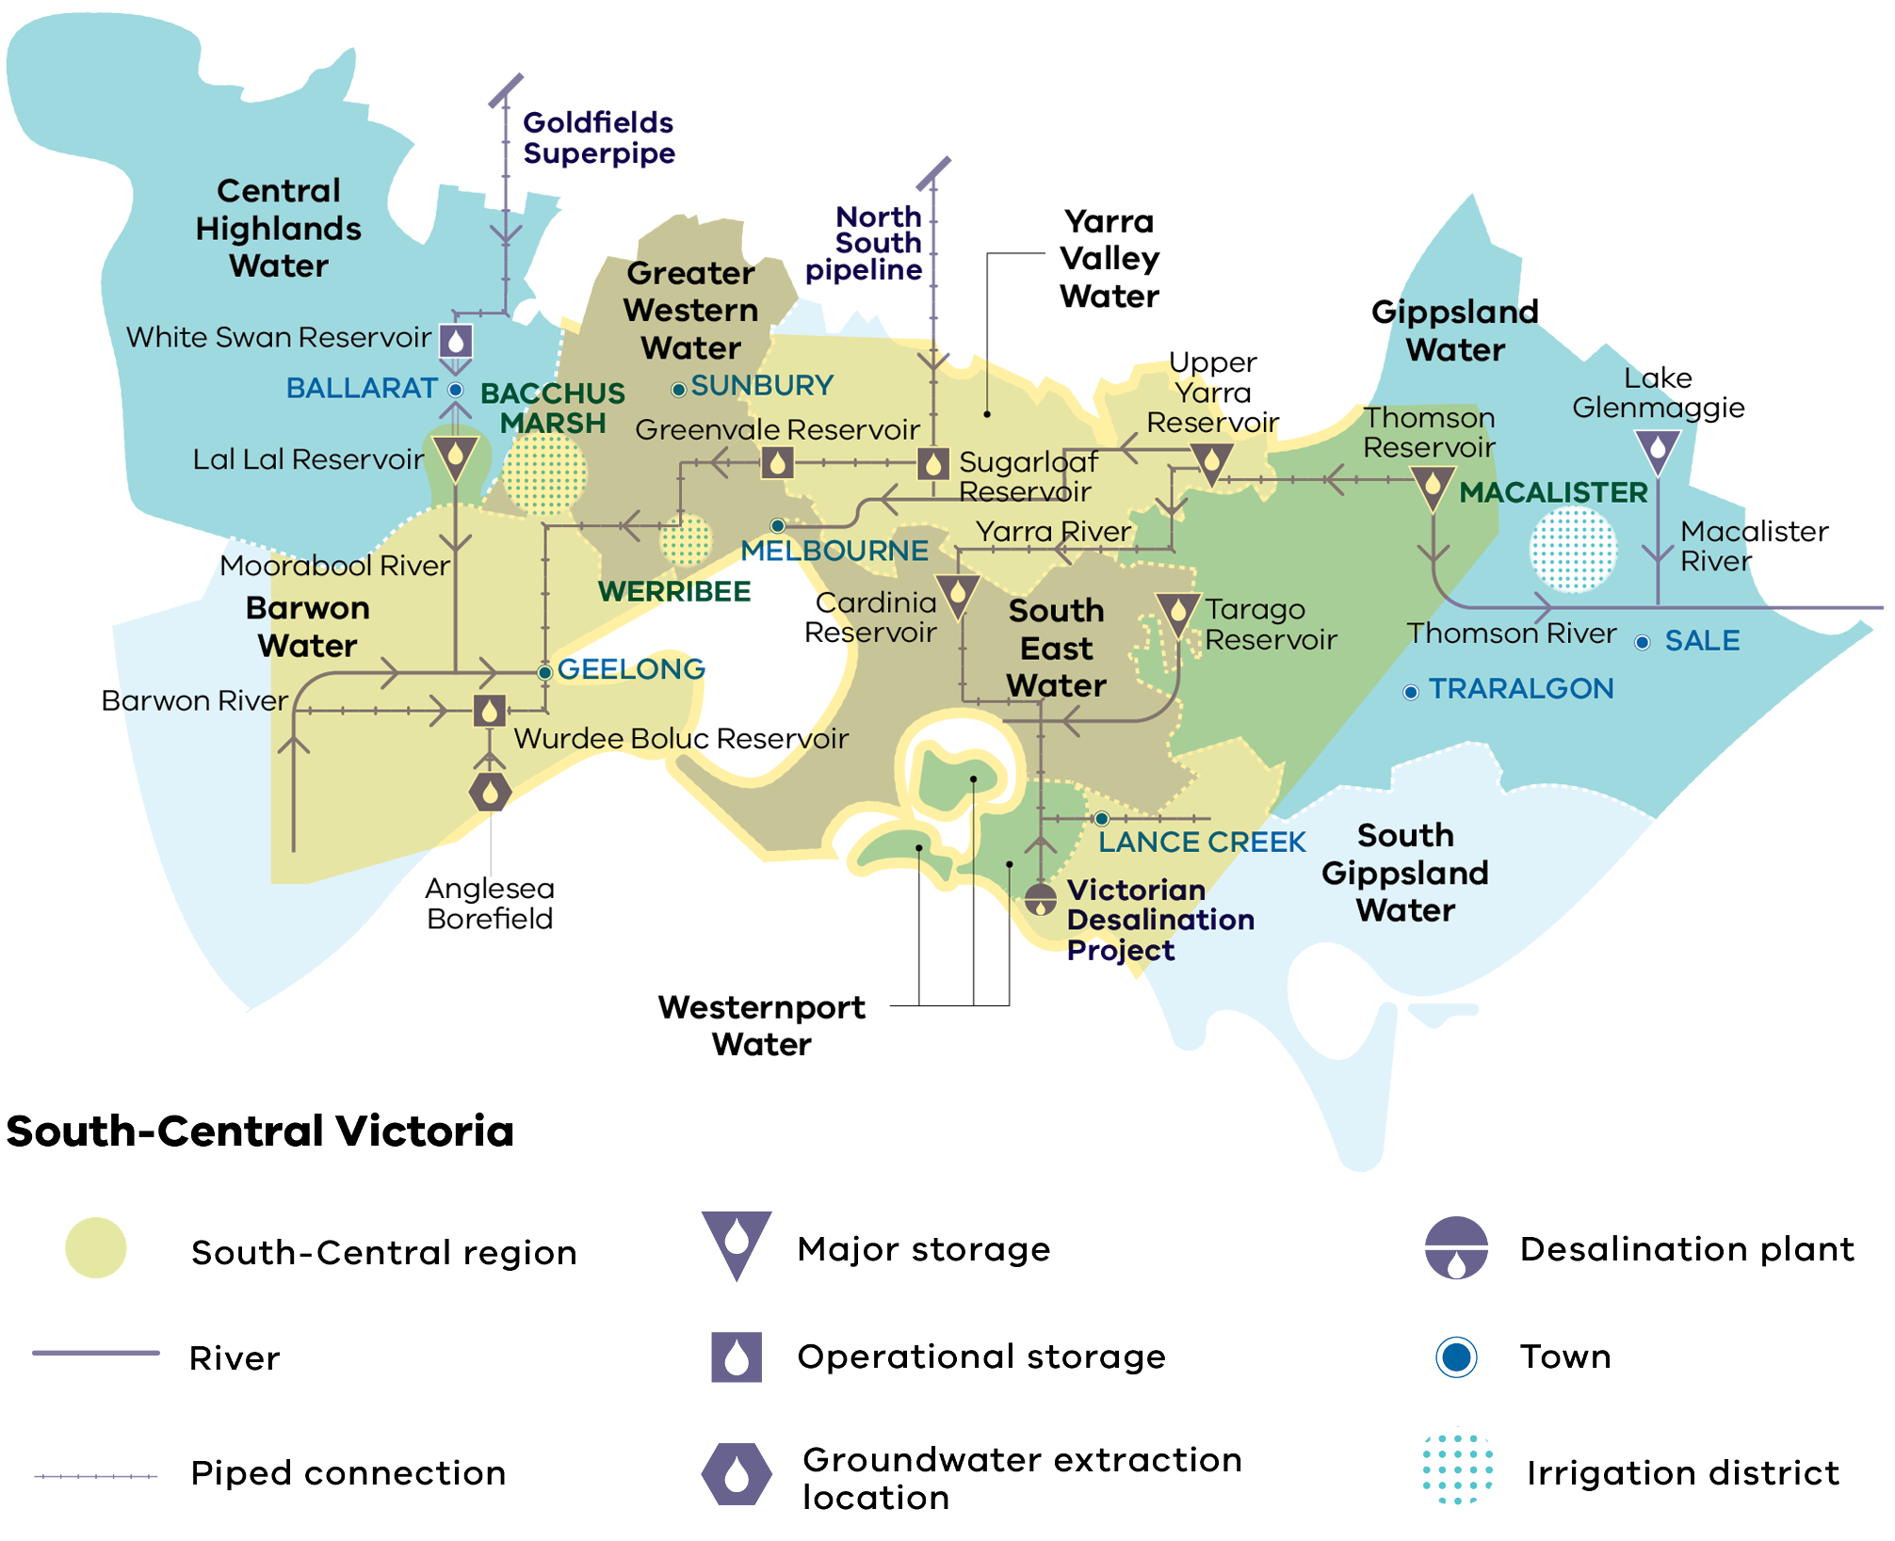

# Aims of the Water Security Plan

## Aim 1: Access to reliable, high-quality water

**Water is essential to human life and all Victorians should have access to reliable,   
high-quality water.**

To ensure this, water security planning is designed to avoid severe restrictions.

Urban water security means ensuring that cities and towns have enough safe and reliable water supplies to meet customer expectations, in the face of uncertainty about future supply availability and demand. This means that people have access to clean and safe water to support public health, green parks and gardens for community wellbeing, healthy environment and waterways, and a prosperous economy.

## Aim 2: Affordability

**Victorian households currently have some of the lowest water bills in the country.**

By planning for long-term water security now, we avoid sudden increases in household bills, avoid higher costs from fast-tracking investments, protect our economy, and ensure the best combination of options can be progressed at the lowest cost to the community.

## Aim 3: Support prosperity and wellbeing

**Ensuring secure and adequate supply of water ensures we can capitalise on new and emerging opportunities for jobs and growth in Victoria, such as data centres, as well as returning water to the environment and Traditional Owners.**

It also avoids severe restrictions, which have a significant and lasting impact on our everyday lives, economy and jobs, and the environment. Water restrictions can reduce the number of quality parks, gardens and sporting ovals which impacts on community health and wellbeing.

Melbourne Water estimate that a very extreme water shortage event requiring households and businesses to cut their water use by 50%, could cost the Victorian economy tens of billions of dollars in just 12 months.

# Reliability for growing population and demands

The Victorian Housing Statement has set a target for 800,000 new homes over the next decade, but demand for water is already overtaking our current supply.

Water security planning is designed to avoid **severe** restrictions.

By 2030, Melbourne, Geelong, and towns connected to the South-Central water grid could need **an extra 95 gigalitres of water per year, and up to 220 gigalitres per year by 2040** (High climate change, high water demand growth scenario from 2024 Melbourne Water update to DEECA.), to ensure secure water supplies (refer to **Figure 2**).

Figure 2: Forecast of supply and demand (under a ‘high climate, high demand’ scenario) showing additional water security needs to avoid severe restrictions

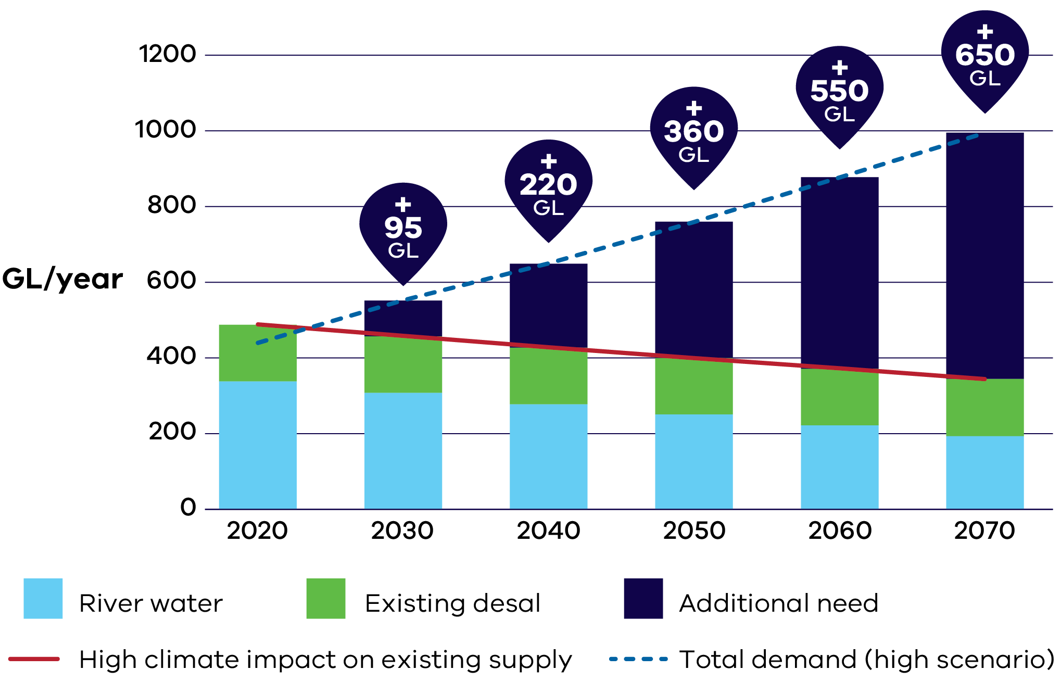

In addition to these volumes for cities and towns, we also need to return water to flow-stressed rivers, and for Traditional Owners to address historic water injustices.

Some urban areas are growing faster than others, with significant population growth occurring in Melbourne’s west and north, and in Geelong.

In areas on existing South-Central Water Grid supply like Wyndham, Melton and Sunbury, the population is projected to almost quadruple during the next 50 years. Much of Melbourne’s water supply is sourced from the east, including from dams in the Yarra and Thomson River basins, and the existing desalination plant near Wonthaggi.

# Climate change impacts

## Climate change is affecting our water supplies.

Long-term trends show that winter and spring are becoming drier, with more unpredictable rainfall. Inflows into dams have decreased by 17%[1], and this trend is expected to worsen over time due to changes in Victoria’s climate.

Wetter than average conditions occurred from 2020 to 2023, and over this time Melbourne’s storage levels increased by 30%. The summer of 2024/25 was our driest summer in more than a decade, and Melbourne’s water supplies had their largest annual decrease since the peak of the Millennium Drought, dropping by 12%.

We know that Melbourne’s storage levels can drop quickly. For example, if a repeat of the Millennium Drought was to occur from 2025, even with full use of the existing desalination plant, storages would decline rapidly and could trigger severe water restrictions in less than four years. That’s why early readiness work is underway on a range of water supply options to meet future demand under a range of climate scenarios.

# Growing our water supplies

The following options to reduce our reliance on rainfall were assessed for volume, reliability, confidence in concept, policy alignment, cost, lead-time, and application beyond the South-Central Water Grid (**Table 1** and **Table 2**).

Table 1: Options assessment

**Grouping 1:** Potential water supply options for South-Central Victoria

|  | Assessment criteria for long term water security | | | | |
| --- | --- | --- | --- | --- | --- |
| Option | Significant volume | Reliability of supply | Confidence in delivering  concept at scale | Consistency with current government policies and regulations | Application beyond current South-Central Water Grid |
| Desalination –  Wonthaggi expansion | Yes /  full benefit | Yes /  full benefit | Yes /  full benefit | Yes /  full benefit | No /  negligible benefit |
| Desalination – new site | Yes /  full benefit | Yes /  full benefit | Yes /  full benefit | Yes /  full benefit | Maybe /  partial benefit |
| Non-drinking use of recycled water and stormwater (integrated water management) | Maybe /  partial benefit | Yes /  full benefit | Maybe /  partial benefit | Yes /  full benefit | Yes /  full benefit |
| Water efficiency | Maybe /  partial benefit | Yes /  full benefit | Maybe /  partial benefit | Yes /  full benefit | Yes /  full benefit |
| Purified recycled water or stormwater into rivers, groundwater or reservoirs | Yes /  full benefit | Yes /  full benefit | Maybe /  partial benefit | Maybe /  partial benefit | Yes /  full benefit |

**Grouping 2:** Options unlikely to form part of future water supply in South Central Victoria

|  | Assessment criteria for long term water security | | | | |
| --- | --- | --- | --- | --- | --- |
| Option | Significant volume | Reliability of supply | Confidence in delivering  concept at scale | Consistency with current government policies and regulations | Application beyond current South-Central Water Grid |
| North-south pipeline | Yes /  full benefit | Maybe /  partial benefit | Maybe /  partial benefit | Maybe /  partial benefit | No /  negligible benefit |
| New dams | Maybe /  partial benefit | No /  negligible benefit | No /  negligible benefit | No /  negligible benefit | No /  negligible benefit |
| Evaporation reduction | No /  negligible benefit | No /  negligible benefit | Maybe /  partial benefit | Yes /  full benefit | Yes /  full benefit |
| Surface water upgrades | Maybe /  partial benefit | No /  negligible benefit | Yes /  full benefit | No /  negligible benefit | Yes /  full benefit |
| Environmental water substitution – (transfer  from ETP to Yering) | Maybe /  partial benefit | No /  negligible benefit | Maybe /  partial benefit | Maybe /  partial benefit | No /  negligible benefit |
| Groundwater | No /  negligible benefit | Maybe /  partial benefit | No /  negligible benefit | No /  negligible benefit | Yes /  full benefit |

Table 2: Assessment criteria and scoring metrics for regional-scale augmentation

|  |  |  |  |  |
| --- | --- | --- | --- | --- |
| Criteria | Description | Yes / full benefit | Maybe / partial benefit | No / negligible benefit |
| **Significant volume** | Can the option provide a substantial volume of water (i.e. 50 GL per year by 2040)? | Greater than 50 GL of additional water is considered possible by 2040 | Greater than 10 GL of additional water is considered possible by 2040 | Less than 10 GL of additional water is considered possible by 2040 |
| **Reliability of supply** | Can the option provide a reliable climate independent yield (i.e. will still be available when it is not raining)? | 50–100% of the security provided is climate independent | 0–50% of the security provided is climate independent | Security benefits in a drying climate are considered likely to be negligible |
| **Confidence in delivering concept at scale** | Is there confidence the option is technically feasible and can be implemented to deliver the estimated yield? | Option has already been done at-scale in the South-Central region and/or there is great confidence that the concept can work as intended | Option has been implemented before at a smaller scale in the South-Central region and/or concept/functional level engineering provides some confidence that the option will work as intended. | Option is considered unlikely to be implemented and/or work as intended |
| **Consistency with current government policies and regulations** | Does the option align with current government policy and/or is permitted under relevant guidelines & regulations? | Source/end-us combination is permitted by government policy AND supports key objectives of climate independence and does not place further stress on waterways | Source/end-use combination is not explicitly permitted by current government policy BUT supports key objectives of climate independence and does not place further stress on waterways | Option is either explicitly prohibited by current government policy OR would take water away from rivers, making it harder to achieve CGRSWS objectives |
| **Application beyond current  South-Central  Water Grid** | Does the option have promise in other parts of Victoria? | Yes, currently available data suggests the option may be promising in other areas. | Option is likely to have some promise in specific circumstances, such as in a drought response. | Option is unlikely to be promising in any areas of Victoria. |

# Potential water supply options

## Desalination – Wonthaggi expansion

Desalination involves extracting freshwater from saltwater. Victoria’s desalination plant in Wonthaggi is rainfall independent provides an essential buffer to top up our reservoirs, with the ability to go on standby in heavy rainfall years, ensuring water is only ordered when needed.

The existing Victorian Desalination Plant can be expanded from its current capacity of 150 GL to produce a further 50 GL of water a year.

## Desalination – new site

Many states across Australia are investing in secondary desalination plants.

A new desalination plant could deliver up to an additional 150–200 GL of water per year.

## Non-drinking use of recycled water and stormwater reuse (integrated water management)

Expanding non-drinking use of recycled and stormwater, also known as integrated water management, finds further ways to utilise fit-for-purpose water. Examples include using recycled water to water sports ovals, gardens, wash cars, and flush toilets.

Investments in increasing the non-drinking use of recycled water, stormwater and rainwater will continue. Current estimates by water corporations suggest that efficiency and integrated water management (recycled water and stormwater projects for non-drinking purposes) can realistically make an additional 17 GL to 40 GL contribution to a 220 GL shortfall at 2040.

## Water efficiency

Water efficiency differs from integrated water management in that it focuses on reducing waste of water, not switching supply.

Households and businesses will continue to be supported to use more water efficient appliances and fixtures, improve how they track usage, identify water savings through digital meters and find new ways to adopt water saving behaviours. Many water behaviours improved following the Millennium drought, meaning further gains to be made through efficiency are limited, but should form part of any combination of solutions.

## Purified recycled water or stormwater (for supplementation of rivers, groundwater or reservoirs)

Purified recycled water is water recycled from industry and homes that has been purified to meet strict Australian Guidelines for Drinking Water, before supplementing rivers, groundwater or reservoirs.

Advanced technologies are used to clean the water like reverse osmosis which is the same treatment used to make seawater drinkable at the Victorian Desalination Plant in Wonthaggi. The clean water is then piped into rivers, streams or reservoirs, or used to replenish groundwater to continue the water cycle. Eventually it re-enters the urban water system where it is treated at a water treatment plant again before being delivered to homes and businesses, which earns the description “triple-treated”.

Providing this highly treated water into rivers, groundwater and reservoirs can create significant opportunity to support environmental outcomes during dry periods, while also supporting town water security at the same time.

Purified recycled water is part of the water supply mix in over 35 cities around the world. Across Australia, Perth already has an active groundwater replenishment scheme and Seqwater’s Western Corridor purified recycled water scheme is available to be turned on as part of their drought response plan. New South Wales, South Australia and Canberra are all exploring the role purified recycled water can play in their urban water supply systems.

The Victorian Government is **not** contemplating any options that involve direct injection of this purified water into town water supply pipes.

## North-south pipeline

The North–south pipeline can transfer a portion of Lake Eildon’s water that is set aside for Melbourne, called the Northern water reserve. The Victorian Government's system management rules (*Statement of Obligations (System Management) 2023)* limit the use of the Lake Eildon allocation to times of critical human need: when Melbourne’s total water storages are less than 30% full on 30 November of any year, recognising the significant need for this water in Northern Victorian communities to support Lake Eildon and local firefighting efforts.

## Perth’s full-scale groundwater replenishment scheme

Perth’s groundwater replenishment scheme, commissioned by Water Corporation in 2017, is a globally recognised initiative helping to secure Western Australia’s water future in the face of climate change. With a recharge capacity of 28 GL/year, the scheme plays a crucial role in offsetting the impact of declining rainfall and falling groundwater levels, which have dropped by up to 10 metres since 1980. Groundwater currently supplies around 40% of Perth’s drinking water, as well as supporting industry, irrigation, and public green spaces.

The scheme purifies recycled water from the Beenyup Water Resource Recovery Facility in Craigie using advanced processes – ultrafiltration, reverse osmosis, and ultraviolet disinfection. This water, which exceeds drinking water standards, is then recharged into deep aquifers via bores. Over time, it is naturally filtered underground before being extracted, further treated, and added to Perth’s drinking water supply. The scheme is four times more energy-efficient than seawater desalination.

A key factor in the scheme’s success was the strong collaboration between Water Corporation and Western Australia’s Department of Health, in the development of robust processes, regulations and oversight to ensure safety.

As part of community engagement Water Corporation ran an extensive outreach program, including public tours of the Advanced Water Recycling Plant, school education sessions, and a dedicated visitor centre. Transparent communication and early involvement helped build trust and secure broad public support for the use of recycled water – a critical step in implementing innovative water solutions in urban settings.

## Victoria’s current recycled water use

In Victoria, recycled water plays a vital role in enhancing water security, particularly as the state faces increasing climate variability and population growth.

Victoria classifies recycled water into three categories – Class A, B, and C – based on treatment levels and suitable applications. Class A, being the highest quality, is suitable for a wide range of non-drinking uses, including to flush toilets, wash clothes and water gardens.

During the 2023–24 period, approximately 18% of the wastewater produced by water corporation treatment plants – equating to around 94 GL – was reused. This figure highlights the state’s commitment to sustainable water management.

Recycled water usage in Victoria is influenced by annual rainfall patterns. In drier years, demand for recycled water typically increases, with reuse rates reaching around 21%. Conversely, in wetter years, the demand and subsequent reuse rates tend to be lower.

The majority of recycled water use is currently Class B and C and is used to support irrigated agriculture.

The amount of Class A recycled water (including stormwater) being used to meet urban demands currently across the state (for non-drinking purposes), is estimated to be in the order of 18 GL. This is provided via ‘purple pipe’ non-drinking supply systems to homes for toilets and private gardens, industrial processes, and irrigation of council public open space or golf courses.

Recycled water cannot be incorporated into existing drinking water supply networks, so it requires separate pipes and fixtures, as well as tailored arrangements with customers to pay for the water. This means the benefits of recycled water are often limited to residents and businesses located near wastewater treatment plants.

# Case study: Barwon Water sustainable water network

## Expanding Integrated Water Management

The Barwon region’s population is expected to increase from 370,000 to more than 500,000 over the next 15 years. Amid this growth, there’s been an up to 50% drop in inflows to our catchments over the last 20 years. This increases reliance on the South-Central Water Grid to supplement local drinking water supply.

The sustainable water network is an innovative option that would enable Barwon Water to manufacture and move large volumes of recycled water and treated stormwater across the region.

It will create healthier environments and communities by:

* supporting investment in new housing by saving up to 4.9 GL per year in drinking water by reducing future urban demands on the South-Central Water Grid from population growth, and also

supporting investment in agriculture, horticulture and industrial ventures through the availability of up to 14 GL per year of sustainable water.

# Considered water supply options

## New dams

Our existing dams will continue to be a critical part of our water supplies, however building new dams is not a viable option, as new dams do not create new  water.

Due to climate change, over time, there will be less reliable rainfall on average to refill dams. There is no spare water in the rivers, which are already flow-stressed. New dams would make this worse as they divert water from other users, Traditional Owners and the environment.

## Surface water upgrades (increasing harvest from existing dams)

Surface water upgrades include increasing existing dam size, altering waterway diversions, or changing the configuration or operation of the water supply transfer network.

As above for new dams, due to climate change, over time, there will be less reliable rainfall on average to refill dams. There is no spare water in the rivers, which are already flow-stressed. Surface water upgrades would make this worse as they divert water from other users, Traditional Owners and the environment.

## Evaporation reduction

Common evaporation reduction options include shade cloths and floating modular systems. While this can be beneficial, it suited to smaller dams and can only contribute small volumes of water.

## Environmental water substitution

There are certain locations where high quality recycled water can be sustainably transferred into rivers to meet environmental flow requirements. Meeting environmental flow releases using recycled water would, in these circumstances, mean that a water corporation can reduce the amount of environmental water released from upstream dams, therefore increasing the river water available in storages for cities and towns.

This option is not preferred in the South-Central region, because it still relies on a climate dependent source of water and the infrastructure costs to move recycled water from Eastern Treatment Plant to the relevant reaches of the Yarra River are significant.

## Groundwater

In the proximity of Melbourne, there are 5 notable concepts, using ground water from aquifers near Lang Lang, Werribee, Boneo, Powelltown/ Baw Baw Region and Romsey. Each scheme is estimated to yield less than 5 GL. Groundwater is not a climate independent source and involves taking water away from the environment.

# Getting the timing right for investments

New large scale water supplies can take 10 years to plan and deliver so the best time to start planning is when water storage levels are high.

That is why we are taking a ‘readiness approach’ and starting early planning to determine a preferred combination of water supply options for the future.

Early investment in readiness activities such as feasibility studies on multiple supply options reduce the time and cost of delivering new water supplies in the future.

Failure to plan and deliver new water supplies in time puts us at risk of extended and severe water restrictions. Severe restrictions can have a significant and lasting impact on our everyday lives, economy and jobs, and the environment.

New water supplies will be planned using the best available data such as storage levels, population growth, water use and climate trends over time. This reduces the risk of investing too early and increasing costs unnecessarily, or too late, which can lead to extended periods of severe water restrictions.

The water security planning framework has four key stages:

* **Adaptive planning** – identification of conceptual options for water supplies
* **Readiness** – development of pre-feasibility studies of potentially viable options for additional water supplies
* **Detailed investigations** – development of functional or detailed design, and associated costs & benefits, for all feasible options, including assessing sites
* **Implementation** – business case, procurement, construction and operation of new water supply infrastructure

Indication to proceed with ‘**readiness**’:

**Decision Point #1:** This applies when future water demand is anticipated to exceed forecast available supplies, at the point in time when new water supplies could be delivered (based on current levels of readiness).

Requirements to proceed with ‘**detailed investigations**’**:**

* **Decision Point #2:** This applies when a ‘projected level of service failure’ is expected, equivalent to a greater than 1% chance of severe restrictions each year, at the point in time when new water supplies could be delivered (based on current levels of readiness)

**and**

when the time needed for new water supply infrastructure to come online (based on current levels of readiness) is greater than the time it would take for water storages to deplete to critical levels under a repeat of Millennium Drought climate conditions.

Requirements to proceed with ‘**implementation**’:

* **Decision Point #3:** After the completion of detailed investigations, a business case would be required to (a) test if Decision Point #1 and #2 are all still active, and conduct an analysis to determine whether the cost of inaction is greater than the cost of action, and (b) select the preferred mix of actions.

Figure 3: Decision points framework

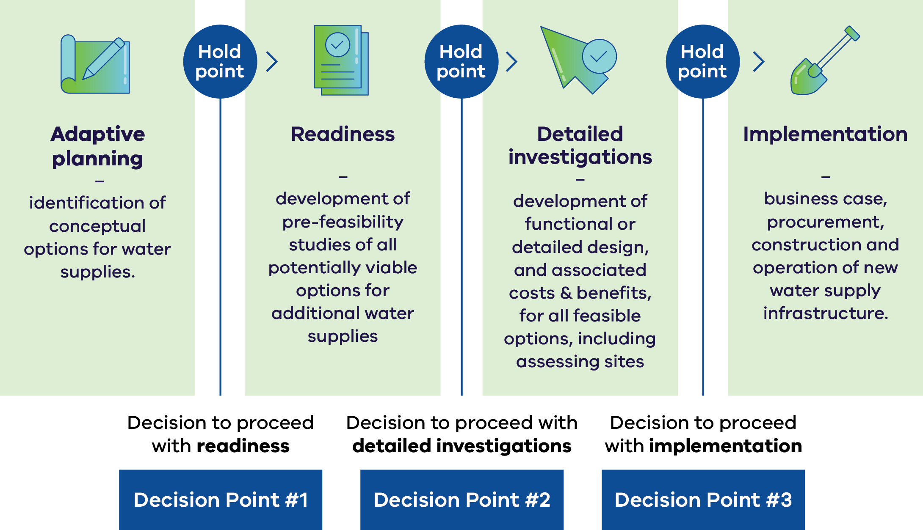

# Returning water and supporting regional prosperity

**Increasing water efficiency, making the best use of all water sources through integrated water management, investigating purified recycled water or stormwater, and additional desalination capacity, diversifies our water sources and will allow Victoria to reduce the reliance on river water for urban supplies across the connected South-Central region.**

This will provide an opportunity for some river water to be re-purposed from urban supply to improve the health of the rivers or be returned to Traditional Owners for self-determined uses within the region, without compromising overall water supply security.

It will also increase the resilience of our supply system to drought and support the prosperity of the region, enabling further growth in jobs, housing and the broader economy in a sustainable way.

Decisions on future supply options, volumes to be returned, and public co-investment for returning water will be made holistically at a program level, through a future business case.

This will consider benefits for Traditional Owners, the environment and communities by applying a quadruple-bottom-line and cultural benefits framework. This means we consider cultural, economic, environmental, and social benefits and costs, including the need to manage affordability of water bills. Water returned to Traditional Owners would be available for self- determined uses. Water returned to the environment would be held by the Victorian Environmental Water Holder for environmental releases.

All options within the Water Security Plan have the potential to enable water to be returned to Traditional Owners and the environment if implemented. More information

# Next steps

## Benefits of a readiness approach

Starting planning now, rather than waiting for a crisis, saves money and leads to better whole of community outcomes because:

* severe water restrictions will be less likely (and all the benefits this provides, including maintaining economy and supporting parks and gardens)
* the best options can be progressed at the lowest possible cost to the community
* no-regrets investments avoid decisions being taken in a crisis, which often incur higher costs from fast-tracking tenders and construction
* avoids sudden increases in household water bills

allows time for the community to participate in decisions about future water supplies

## Where to now?

DEECA’s 2025 assessment has revealed that the decision points for both readiness and detailed investigations have been met and therefore that the near-term augmentation options require further preparation to reduce their implementation lead-time (currently up to 10–15 years depending on the preferred option(s)).

We are now exploring the optimised combination of near-term water supply options and are progressing towards the detailed investigation phase of the framework (see **Figure 3**).

Detailed investigations will develop the best mix of options including water efficiency initiatives, integrated water management, replenishing water sources with purified recycled water and stormwater; and expanding desalination water capacity, to meet the forecast gap between supply and demand. There is no commitment to a particular outcome or mix of options at this stage.

The Minister for Water will establish a Water Security Taskforce to consider the findings of the detailed investigation and report to the Minister for Water before March 2027. The Terms of Reference for this work will progress the investigation of all water security options (including Purified Recycled Water, desalination, integrated water management and water efficiency) that could viably address Greater Melbourne and Geelong’s water security.

To complement water supply option development, work will be done to understand if changes to the water supply network (how water moves around) are needed so that water can be delivered efficiently and meet demand where it is needed now and into the future.

This work will include options around mix and sequencing implementation, site investigations, initial environmental surveys and design development. This will reduce the lead times for bringing on new supplies, enabling a business case to be deferred to the selection and implementation phase of the framework and closer to when water will be needed.

**The Water Security Plan will be updated annually and published alongside the Annual Water Outlook each December. Updates on progress of any investigations will be provided in these annual updates.**

## Complementary Actions

Ongoing focus on maximising the use of existing sources and reducing demands, including:

* Public awareness campaigns on using water wisely (voluntary changes in community behaviour).
* Continuing water efficiency and conservation initiatives (such as audits and rebates).
* Continuing integrated water management projects (including where existing drinking water use can be substituted with other sources such as stormwater and recycled water).
* Continued use of the Victorian Desalination Plant to keep our storages at a healthy level.

Water Security Taskforce to consider detailed investigations work and provide advice to the Minister for Water.

# More information

* [Central and Gippsland Region Sustainable Water Strategy, 2022](https://www.water.vic.gov.au/our-programs/long-term-water-resource-assessments-and-strategies/sustainable-water-strategies/central-and-gipps-sws)
* [Greater Melbourne Urban Water & System Strategy, 2023](https://waterforlifestrategy.com.au/)
* [Barwon Water 2022 Urban Water Strategy, 2022](https://www.barwonwater.vic.gov.au/__data/assets/pdf_file/0021/307506/Water-for-our-Future-Strategy_updated-as-of-Feb-2023-Final.pdf)

## Contact the team

If you have any further questions or would like to know more, please get in touch with us [watersecurityplan@deeca.vic.gov.au](mailto:firstname.surname@vccmhw.vic.gov.au)

[deeca.vic.gov.au](http://www.deeca.vic.gov.au/)

# Publication information

## Acknowledgements

We acknowledge and respect Victorian Traditional Owners as the original custodians of Victoria’s land and waters, their unique ability to care for Country and deep spiritual connection to it.

We honour Elders past and present whose knowledge and wisdom has ensured the continuation of culture and traditional practices.

DEECA is committed to genuinely partnering with Victorian Traditional Owners and Victoria’s Aboriginal community to progress their aspirations.

DEECA is grateful for the input and the provision of data of Melbourne Water, South East Water, Yarra Valley Water, Greater Western Water, Barwon Water, Gippsland Water, South Gippsland Water and Westernport Water.

Cover photograph: Pykes Creek Reservoir at Myrniong outside Bacchus Marsh  
Credit: Darryl Whitaker

**ISSN** 2982-3692 - **Online (pdf/word)**

## Copyright

All images are © State of Victoria, DEECA. Credit: Darryl Whitaker except where noted.

© The State of Victoria Department of Energy, Environment and Climate Action, September 2025.

## Creative Commons

This work is licensed under a Creative Commons Attribution 4.0 International licence, visit the [Creative Commons website](http://creativecommons.org/licenses/by/4.0/) (<http://creativecommons.org/licenses/by/4.0/>).

You are free to re-use the work under that licence, on the condition that you credit the State of Victoria as author. The licence does not apply to any images, photographs or branding, including the Victorian Coat of Arms, and the Victorian Government and Department logos.

## Disclaimer

This publication may be of assistance to you but the State of Victoria and its employees do not guarantee that the publication is without flaw of any kind or is wholly appropriate for your particular purposes and therefore disclaims all liability for any error, loss or other consequence which may arise from you relying on any information in this publication.

## Accessibility

To receive this document in an alternative format, phone the Customer Service Centre on 136 186, email [customer.service@delwp.vic.gov.au](mailto:customer.service@delwp.vic.gov.au), or contact National Relay Service on 133 677. Available at DEECA website (<http://www.deeca.vic.gov.au/>).

**End of document.**

1. Comparing 1913–1996 inflows data with 1997–2024 inflows data.