Aboriginal Water Officer

Case Study

**What started as a small spark in her belly grew into a flame that now burns strong. Ivy Solomon – better known as Bubbles – is a Ngarigo Monero woman who has always held a deep reverence for Country. Since starting her role as an Aboriginal Water Officer (AWO), Bubbles has tapped into her passion and appreciation for traditional knowledge in a way she likens to a bushfire that burns inside of her.**

Bubbles’ work as an AWO centres on caring for waterways on Ngarigo Monero Country in the Snowy River region of Victoria. Collaborating with Traditional Owners, the Department of Energy, Environment and Climate Action (DEECA) and other stakeholders, she works towards restoring and maintaining a vibrant and healthy Country. Her other priorities include building her own knowledge, reinforcing the presence and expertise of local Mob and creating more opportunities for future generations to connect to Country.

As a self-proclaimed water baby, Bubbles sees time spent on Country as a form of connection, healing and education. For her, the landscape is a living teacher holding stories and wisdom waiting to be learnt.

If it wasn’t for her role as an AWO, Bubbles acknowledges that she wouldn’t have the same opportunity to learn from and care for Country as she does now. “This is stuff you can’t learn in books. It’s about being on Country and learning from each other. It’s about respecting what’s been passed down and continuing that cycle,” Bubbles says. “I get to come home to Country, I get

to work with my Mob. I get to learn stuff that I didn’t learn before. And then hopefully I can pass it on.”

“I can’t get enough of it,” Bubbles says. “I never looked at the river before the way I do now. There are reasons we have to look after the water and the only way to learn is that you have to go out to the land, the Country, the water.”

Bubbles works in collaboration with her mentors and fellow Ngarigo Monero Traditional Owners Tim Paton and Sam Pender. Together, they share knowledge and work with Community to care for Country.

For Bubbles, Tim and Sam, caring for Country and waterways is much more than a job. They see it as a responsibility with great meaning, an opportunity to continue cultural knowledge and implement learnings from their Elders.

“This is part of our history of where our Mob lay their footprints here. You know, they come from Jindabyne all the way down to here [to the mouth of the Snowy River]. It’s a long trip,” Bubbles says.

Historically, the river systems were used as passageways. It’s a method of travelling through Country that Bubbles, Tim and Sam would like to see

revitalised. A key aspiration is to have men’s and women’s camps, bringing Mob together to travel through the Snowy River system and get back into the high country.

Bubbles’ learnings have emphasised the importance of asking questions of Elders and passing on cultural knowledge before it’s too late. She often reflects on the missed opportunity to ask her own Elders these questions before they were gone, and so she makes sure to bring her nieces and nephews with her when she’s working with Tim and Sam.

“My passion at the moment is to get the younger ones to get that little fire, that little spark, because we’re not going to be around forever and we need the younger ones to step up and take over and get that passion,” Bubbles says.

For Bubbles, her spark was first ignited when she was a kid camping on Country with her family near Jindabyne. Since then, she has been open to learning. Now as an AWO, Bubbles gets to learn in a way that extends beyond her own experience. Her work, with colleagues like Tim and Sam, ensures that cultural knowledge is learnt and passed on to future generations.

**Ivy Solomon “Bubbles”**

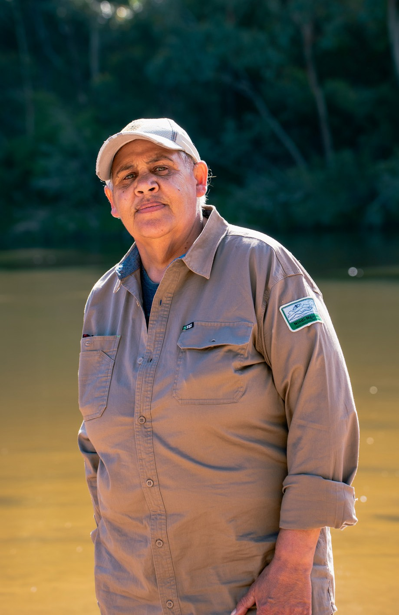

Nindi-Ngujarn Ngarigo Monero Aboriginal Corporation

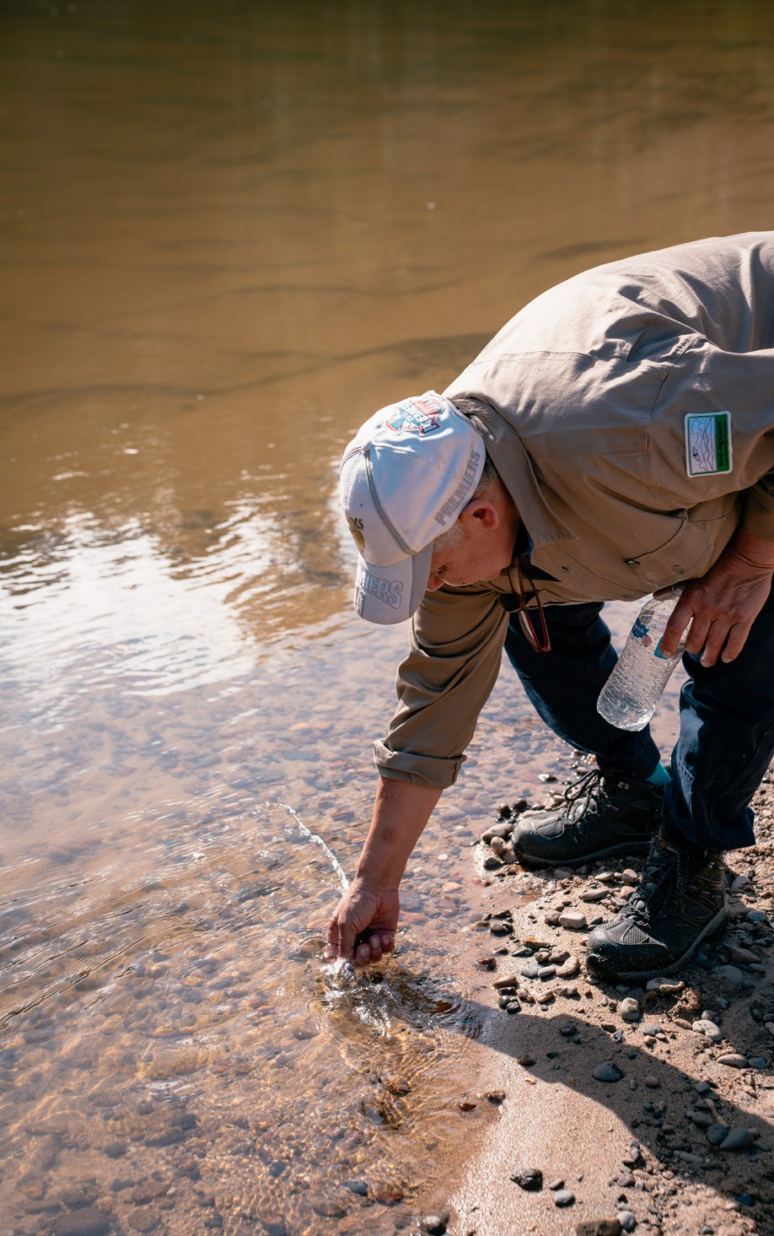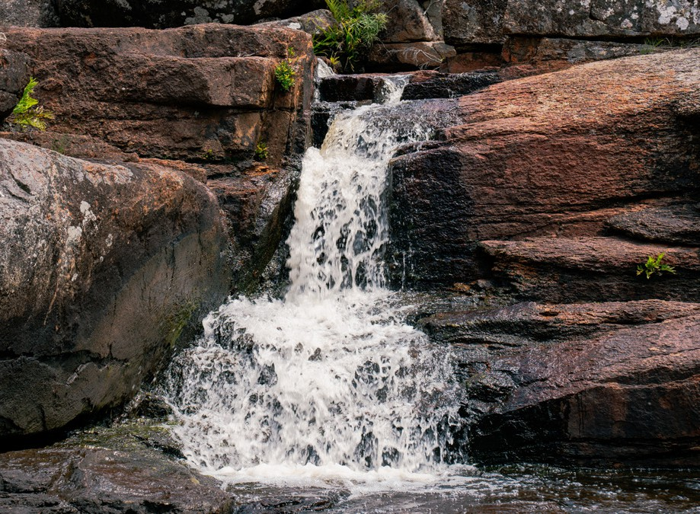

There are reasons we have to look after the water and the only way to learn is that you have to go out to the

land, the Country, the water

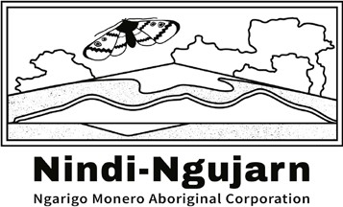

OFFICIAL