delwp.vic.gov.au

|  |
| --- |
| Medium to high-density residential  buildings and works  Stormwater requirements for urban developments: development scenario |

|  |  |
| --- | --- |
|  |  |

|  |
| --- |
| Acknowledgment  We acknowledge and respect Victorian Traditional Owners as the original custodians of Victoria's land and waters, their unique ability to care for Country and deep spiritual connection to it. We honour Elders past and present whose knowledge and wisdom has ensured the continuation of culture and traditional practices.  We are committed to genuinely partner, and meaningfully engage, with Victoria's Traditional Owners and Aboriginal communities to support the protection of Country, the maintenance of spiritual and cultural practices and their broader aspirations in the 21st century and beyond. |
| © The State of Victoria Department of Environment, Land, Water and Planning 2020  LogoThis work is licensed under a Creative Commons Attribution 4.0 International licence. You are free to re-use the work under that licence, on the condition that you credit the State of Victoria as author. The licence does not apply to any images, photographs or branding, including the Victorian Coat of Arms, the Victorian Government logo and the Department of Environment, Land, Water and Planning (DELWP) logo. To view a copy of this licence, visit <http://creativecommons.org/licenses/by/4.0/>  ISBN 978-1-76105-236-1 (pdf/online/MS word)  Disclaimer  This publication may be of assistance to you but the State of Victoria and its employees do not guarantee that the publication is without flaw of any kind or is wholly appropriate for your particular purposes and therefore disclaims all liability for any error, loss or other consequence which may arise from you relying on any information in this publication.  Accessibility  If you would like to receive this publication in an alternative format, please telephone the DELWP Customer Service Centre on 136186, email [customer.service@delwp.vic.gov.au](mailto:customer.service@delwp.vic.gov.au) or via the National Relay Service on 133 677 [www.relayservice.com.au](http://www.relayservice.com.au). This document is also available on the internet at [www.delwp.vic.gov.au](http://www.delwp.vic.gov.au). |

Contents

Introduction 1

Planning requirements 1

Objectives of Clause 58.03-8 1

Standards 1

Worked example 2

A: Proposed development description 2

B: Site layout plan and WSUD treatment systems 3

C: Modelling and compliance 7

D: Functional design considerations 9

E: Site management plan 13

F: Asset maintenance program 16

Introduction

This development scenario is a support tool for those complying with stormwater planning requirements. The intended audience is both design practitioners submitting applications, as well as council planners assessing development applications.

A checklist indicates the minimum information that should be included in a stormwater report lodged with the planning application. This worked example for an apartment building and works development demonstrates how a development application should be designed to satisfy the objectives and standards of the relevant clauses. The right column of the example (green boxes ) indicate which sections of the report respond to which checklist items. The call out text boxes (blue boxes ) offer resources and links for both designers and assessors.

## **Planning requirements**

The development in this example is for buildings and works associated with an apartment, irrespective of whether the building is subdivided. The required provisions for the works are at Clauses: 55.07-5 (Integrated water and stormwater management objectives) where the development is less than five storeys in a residential zone, and 58.03-8 (Integrated water and stormwater management objectives) where the development is five storeys or greater within a residential zone (or any height within particular commercial/activity/special zones). Note, the requirements of these clauses are identical, and the clause applied is dependent on the number of storeys of the development. In this example, the development is 48 storeys, so Clause 58.03 applies. The clause objectives and required standard are outlined below.

This example can be used for apartment complexes and potentially similar built form proposals, depending on the occupancy and resultant water demand within the building and site (i.e. medium density apartments, office buildings, etc). In this example, the application consists of two apartment buildings with basement car parking below. The example can be adapted for similar developments with these features.

A buildings and works application for apartment or mixed-uses will need to meet all planning scheme requirements for the land and the development type. This may include local controls. Applicants are encouraged to check with their local council if they are not sure which planning scheme provisions apply and complete a site layout plan before commencing the stormwater report.

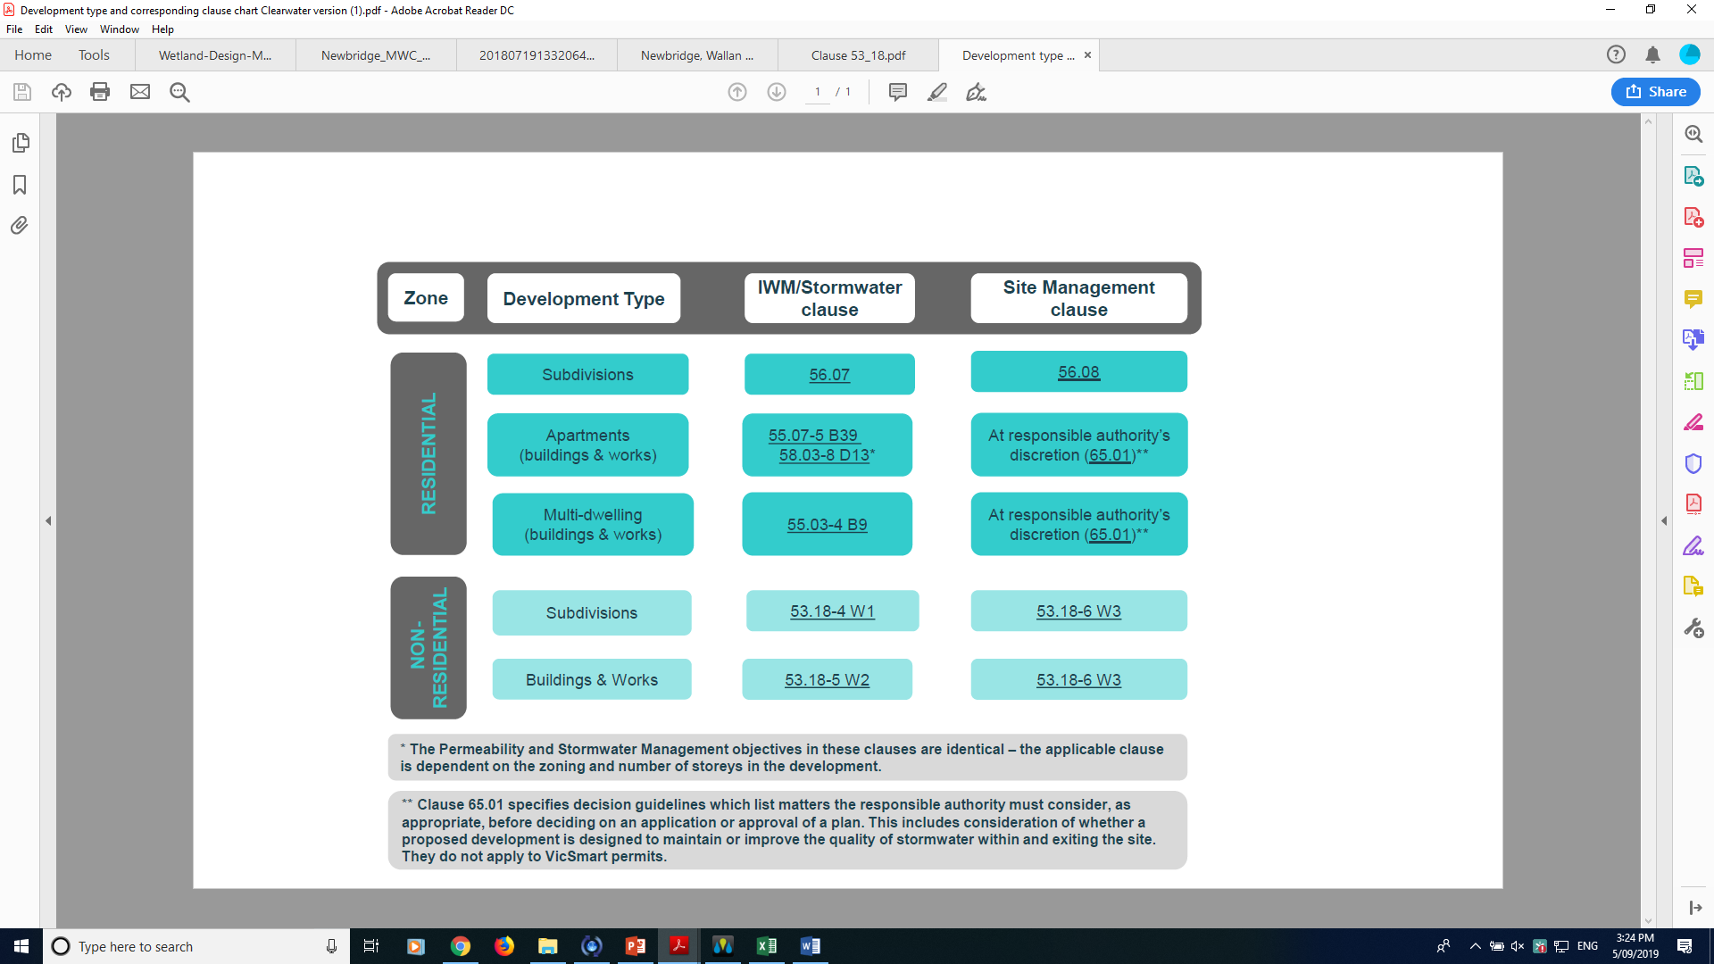

## 

## 

## Objectives of Clause 58.03-8

### 58.03-8 Integrated water and stormwater management objectives

* To encourage the use of alternative water sources such as rainwater, stormwater and recycled water.
* To facilitate stormwater collection, utilisation and infiltration within the development.
* To encourage development that reduces the impact of stormwater run-off on the drainage system and filters sediment and waste from stormwater prior to discharge from the site.

## Standards

The requirements for Standard D13 are listed below.

|  | Clause | **Standards** |
| --- | --- | --- |
| For apartment buildings 5 stories or more excluding the basement | 58.03-8 | * Buildings should be designed to collect rainwater for non-drinking purposes such as flushing toilets, laundry appliances and garden use. * Buildings should be connected to a non-potable dual pipe reticulated water supply, where available from the water authority. * The stormwater management system should be: * Designed to meet the current best practice performance objectives for stormwater quality as contained in the Urban Stormwater - Best Practice Environmental Management Guidelines (Victorian Stormwater Committee, 1999). * Designed to maximise infiltration of stormwater, water and drainage of residual flows into permeable surfaces, tree pits and treatment areas. |

All applications must be accompanied by details of the proposed stormwater management system, including drainage works and retention, detention and discharges of stormwater to the drainage system.

Worked example

The stormwater report presented by the applicant should provide all the information listed in the checklist.

This example is a conceptual level development and aims to focus on the information required within Clause 58.03-8. Some local councils may require more detail for aspects of the design than presented here. The schematic is not intended as an accurate representation of all other planning requirements for a development of this nature.

## A: Proposed development description

The development site has an area of 8,850 m2. The application proposes two 48-storey mixed-use buildings, comprising of six podium levels and two 42-storey residential apartment towers above, with associated access and landscaping. The development has commercial/retail enterprises in the podium levels below the towers, such as restaurants, cafes, cinemas and other recreational venues as well as car parking. There is approximately 4,075m2 of combined building roof area and 1,829m2 of pervious grounds for residents.

The residential towers include 550 studio apartments and 360 two-bedroom apartments, with an estimated occupancy rate of 1,270 people (based on each studio having one occupant and each two-bedroom apartment having two occupants).

The Water Sensitive Urban Design (WSUD) response includes the following:

* The whole roof area of both towers draining to rainwater harvesting tanks to supply internal toilet flushing demand, with overflows directed to the street drainage.
* 80% of the podium roof draining to a rainwater harvesting tank for irrigating the vegetation on both the podium and the ground level gardens (an estimated demand of 36kL/year). Any overflows are discharged to the street drainage.
* Runoff from the carparks, driveway and walkway are directed to a series of tree pit bioretention swales 80m2 in area. The tree pit bioretention is 80m long by 1m wide, running along the entrance driveway. In-ground tree pit raingardens have been chosen to maximise greening to the site. They provide passive irrigation to trees via a linear bioretention basin to which surrounding hard surfaces are drained.
* Trees and native tussock grasses to be planted in the bioretention basin, contributing towards cooling and providing an attractive and enjoyable entrance way to the complex.

|  |
| --- |
| A: Proposed development description |
| * **A1**: Describe the proposed development e.g. describe the land use, anticipated tenancy, buildings and works, number of car parking spaces, expected number of occupants, etc. |

## B: Site layout plan and WSUD treatment systems

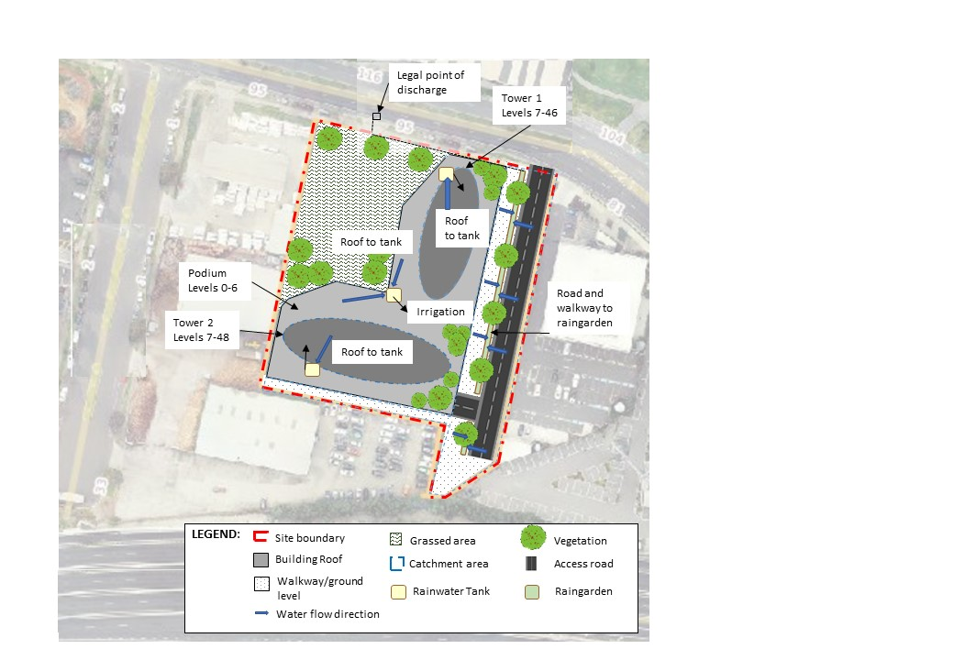

**888**

Figure 1: Site layout plan

|  |
| --- |
| B: Site layout plan, catchment areas and WSUD treatment systems |
| * **B1:** Provide a site layout plan showing all building roofs and covered areas, pervious (unsealed) surface areas and impervious (sealed) surface areas with dimensions. These details must be consistent with the plans and other documents lodged with the planning application. * **B2:** Show the site boundary, dimensions, and total site area on the site layout plan. * **B3:** Show the legal point of discharge (see checklist for further description). * **B4:** Specify the area draining to each downpipe, treatment and legal point of discharge – includes both impervious and pervious areas (see checklist for further description). * **B5:** Show the location, type and surface area (m2) of the proposed WSUD treatment systems on plan, including how each internal catchment area to be treated will be connected to a WSUD element (e.g. roof to rainwater tank). Show how piped connections will be made within the site and to the LPOD and clearly annotate any impervious areas not being treated by a WSUD element. * **B8**: Describe how the stormwater management design contributes to local cooling, improving local habitat and providing attractive spaces. |

|  |
| --- |
| B: Site layout plan, catchment areas and WSUD treatment systems |
| * **B6:** Indicate the expected volume of on-site stormwater reuse and how this has been calculated. * **B9:** Table summarising the internal drainage catchment areas shown on the site layout plan, the size of the catchment area, the percentage of the site this represents and information about the corresponding WSUD treatment system. The table should equal 100% of total site area. The information should correspond to the information shown on the site layout plan. |

Table 1: Catchment type or WSUD asset surface area

| Catchment type | Area (m2) | Area treated by | Demands |
| --- | --- | --- | --- |
| Roof tower 1 (100%) | 805 | Tank (15kL) to toilet flushing | 510 pp @ 20L/day: 10.2kL/d |
| Roof tower 2 (100%) | 903 | Tank (15kL) to toilet flushing | 760 pp @ 20L/day: 15.2kL/d |
| Roof podium (80%) | 1,894 | Tank (3kL) to irrigation | 36kL/year – seasonally distributed |
| Roof podium (20%) | 473 | No treatment | - |
| Driveway and walkway | 2,866 | Raingarden (80m2) | - |
| Garden | 1,829 | - | - |
| Raingarden | 80 | - | - |
| Total area (m2) | 8,850 | - | - |
| Total impervious (m2) | 6,941 | - | - |
| Fraction impervious | 78% | - | - |

To meet the best practice stormwater management objectives of Clause 58.03-8, the development WSUD response will include:

* Tower roof areas (100%) to harvest and supply toilet flushing (demand well exceeds supply so yield % is very high).
* Podium roof area (80%) to harvest rainwater for irrigation re-use.
* Driveway and walkway surfaces to be treated by a raingarden.

The litter generated from the site will be drained to raingardens, which are a highly effective gross litter trap. In order to maintain the aesthetic and function of the raingarden, the litter will need to be removed at regular intervals (approximately monthly, as required).

**Figure 2** shows the WSUD assets and their catchments and required drainage connections. Please refer to concept design drawings for further details of each WSUD asset.

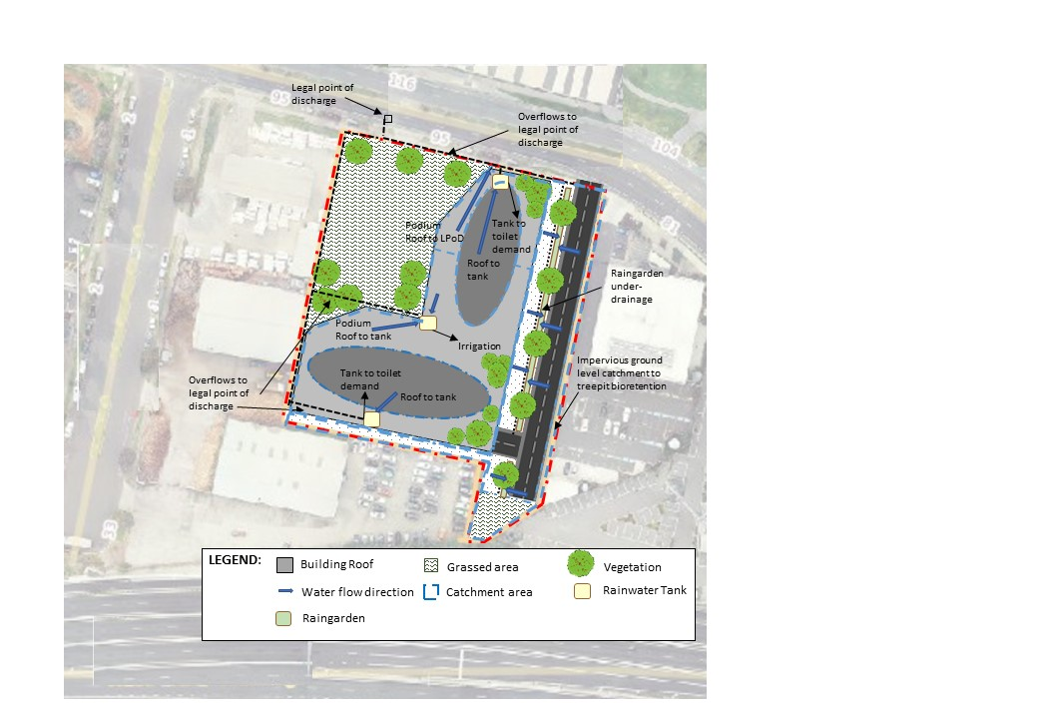

Figure 2: Required drainage connections for assets and their catchments

|  |
| --- |
| B: Site layout plan, catchment areas and WSUD treatment systems |
| * **B7:** If relevant to development type, identification of potential toxicants generated by the business to be located on the premises requiring structural isolation from the runoff draining to a WSUD treatment system or stormwater drain. |

|  |
| --- |
| Relevant links  * Urban Stormwater Best Practice Environmental Management Guidelines (Victorian Stormwater Committee): <http://www.publish.csiro.au/book/2190> * Options for treating stormwater using WSUD (Melbourne Water): <https://www.melbournewater.com.au/planning-and-building/stormwater-management/options-treating-stormwater> * WSUD Engineering Procedures Stormwater (Melbourne Water): <https://www.publish.csiro.au/book/4974/#contents> * Infrastructure Design Manual (IDM) (Local Government Infrastructure Design Association): <https://www.designmanual.com.au/download-idm> * Designing for a cool city – Guidelines for passively irrigated landscapes (CRC for Water Sensitive Cities): <https://watersensitivecities.org.au/content/designing-for-a-cool-city-guidelines-for-passively-irrigated-landscapes/> |

## C: Modelling and compliance

The raingardens/tree pits and irrigated rooftop gardens contribute to achieving water quality benefits as well as providing the combined benefits of cooling and adding enjoyable aesthetics for inhabitants and visitors to the complex. There are no toxicants or chemicals generated on-site.

MUSIC software was used to model the treatment performance of the proposed site design as shown in the model schematic in **Figure 3**. The modelling details are summarised in **Table 2** and **Table 3**.

The climate data was chosen according to the recommended pluvio-data for the Melbourne city region (10 years of data with mean annual rainfall between 650 and 750mm/year).

Table 2: MUSIC modelling parameters

| MUSIC Model Inputs | |
| --- | --- |
| Site location | Melbourne regional |
| Rainfall data used | 086071 MELBOURNE (1952-1961) |
| Modelling timestep | 6 mins |
| PET data | Melbourne Average Monthly PET |
| Pollutant characteristics | Defined according to surface types as per Table 3 in Melbourne Water MUSIC Guidelines 2018 |

Table 3: Raingarden parameters

|  |  |
| --- | --- |
| Raingarden | |
| Combined area | 80m2 |
| Extended detention depth (EDD) | 150mm |
| Tree media depth | 700mm |
| Tree media hydraulic conductivity | 50mm/hr |
| Saturated zone | 200mm |

|  |
| --- |
| C: Modelling and compliance |
| * **C1:** Compliance summary with objectives outlined in relevant Clause (55.03, 55.07 and/or 58.03) . * **C2**: STORM report with a minimum 100% rating or MUSIC (or other acceptable modelling) results that meets best practice performance for stormwater pollutant load reductions: TSS 80%; TP 45%; TN 45%; Litter 70%. * Summary of model input parameters, including each WSUD treatment system. * Screen print of model analysis (e.g. STORM report) or a schematic of the model (e.g. for MUSIC). * If MUSIC: Check MUSIC file using the MUSIC auditor (https://www.musicauditor.com.au/). * The applicant should submit a copy of the MUSIC file (.sqz) used to generate treatment performance. |

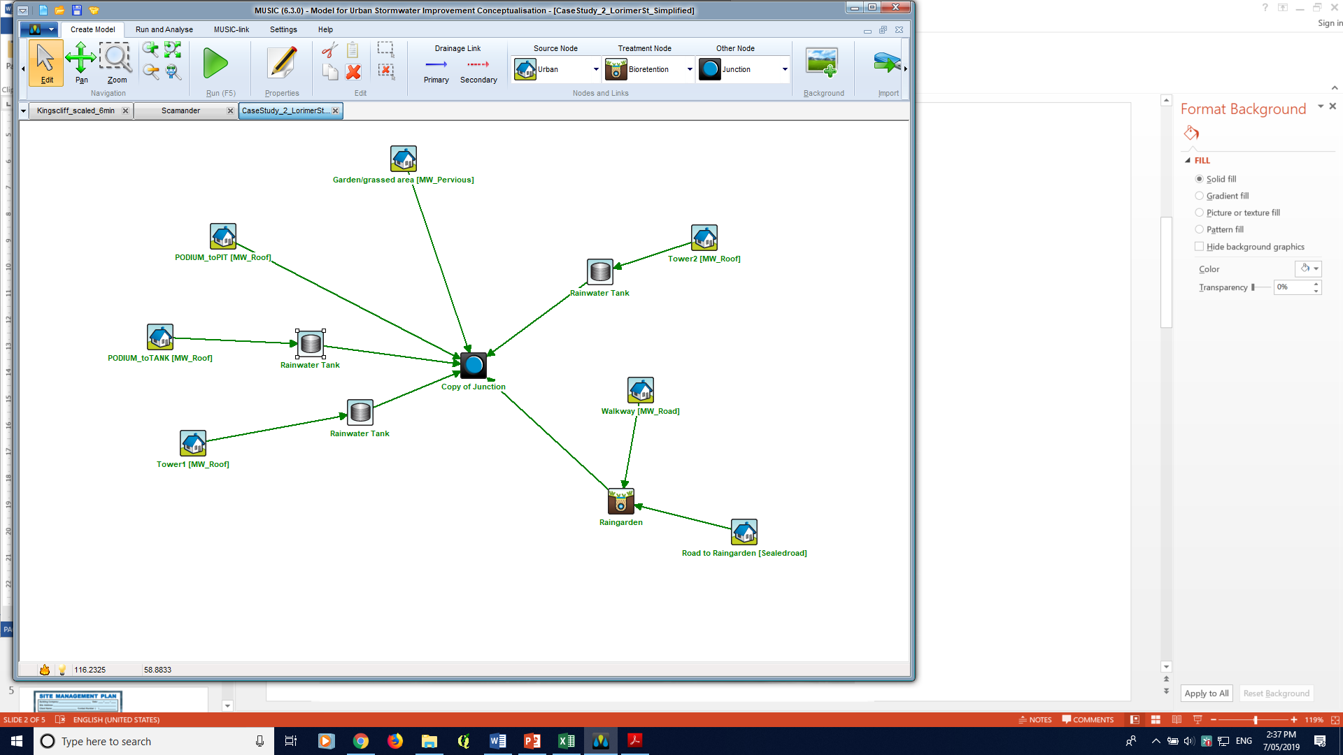

Figure 3: MUSIC model schematic

The effectiveness of the treatment systems is summarised in **Table 4** demonstrating compliance with water quality improvement requirements outlined in Best Practice Environmental Management Guidelines (minimum 80% reduction in total suspended solids, 45% reduction in total phosphorus, 45% reduction in total nitrogen and 70% reduction in litter). Gross pollutants are effectively removed from the stormwater by the raingardens.

|  |
| --- |
| C: Modelling and compliance |
| * **C3:** Minimises impact of chemical pollutants and other toxicants, as relevant. |

Table 4: MUSIC modelling compliance results

|  | Sources | Residual load | % Reduction |
| --- | --- | --- | --- |
| **Flow (ML/year)** | 4.32 | 3.26 | 24.5 |
| **Total suspended solids (kg/year)** | 682 | 95.9 | 85.9 |
| **Total phosphorus (kg/year)** | 1.43 | 0.569 | 60.1 |
| **Total nitrogen (kg/year)** | 10.3 | 5.57 | 46.1 |
| **Gross pollutants (kg/year)** | 149 | 12.7 | 91.5 |

|  |
| --- |
| Relevant links  * MUSIC software (eWater): <https://ewater.org.au/products/music/> * MUSIC Guidelines (Melbourne Water): <https://www.melbournewater.com.au/sites/default/files/2018-02/Music-tool-guidelines-2018.pdf>   As part of the assessment of the planning application the assessor should review the MUSIC file submitted.   * The MUSIC Auditor tool can be accessed at: [https://www.musicauditor.com.au/ /](https://www.musicauditor.com.au/%20/)   In order to use the MUSIC Auditor tool:   * Register as a user or login at <https://www.musicauditor.com.au/user/register> * Create a summary report from your MUSIC model – find help on how to do this at <https://musicauditor.com.au/FAQ> * Upload your summary report file by using the ‘Choose File’ radio button and press ‘Submit’. * Download the pdf report to review. |

## 

## D: Functional design considerations

Note: This section may be required for inclusion with the planning application, or else the information may be required as a condition of permit. Check with your council for advice on which applies.

Note: Under Clause 53.18 all applications must be accompanied by details of the proposed stormwater management system, including drainage works and retention, detention and discharges of stormwater to the drainage system

### Rainwater tank

Figure 4: Rainwater tank concept design plan

|  |
| --- |
| D: Functional design considerations |
| * **D1:** Plan from Checklist item B or amended plan required by permit. * **D2**: Sectional view of each WSUD treatment showing indicative levels. * **D3**: Size of treatment elements, e.g. tank volume, raingarden width and length, extended detention depth, etc. * **D4**: Details of pipe connections between any rainwater tank and end uses, e.g. toilet/s, laundry, hot/cold water and irrigation, as applicable. |

**Tree pit raingarden**

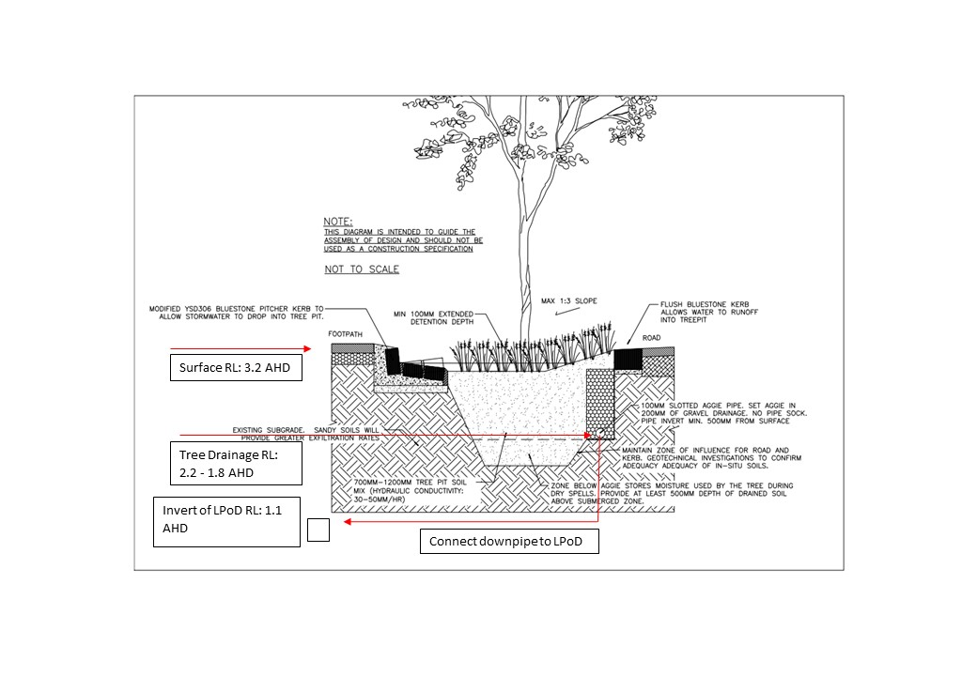

**5**

**Figure 5: Tree pit raingarden cross section – for all raingardens**

|  |
| --- |
| D: Functional design considerations |
| * **D5:** Levels for each WSUD treatment including surface level, extended detention depth, filter layers and depth, under drain system, legal point of discharge. * **D6**: Plant species and planting densities to be used in any vegetated treatment systems. Refer to checklist. * **D7**: For vegetated treatment systems, management of the interface between the WSUD treatment and immediately surrounding areas, e.g. car parking spaces, walkways, lawns, so that the WSUD elements and public safety are protected. |

Table 5: Plant species preferences

| Recommendations for plant types* | |
| --- | --- |
| **Tree type** | *Lophostemon confertus* (Brush Box Tree) |
| **Vegetation for raingarden** | *Ficinia nodosa* (Knobby Club Rush) |

*These are only two of many species which could be used. For purposes of aesthetics other species may also be used to add variety – refer to the resources below. For a development of this size a density of 6-10 plants/m2 is proposed.

Notes to applicants:

* *If you are unable to connect to the legal point of discharge on your site from a ground level raingarden, consider the use of planter box raingardens. This is explained in Example 3 – Townhouse development building and works.*
* *When using permeable paving or other infiltration measures adjacent to any building or structure, there must be an impervious apron (0.5m setback) between the building and the infiltration system.*
* *Consider the site constraints when siting WSUD elements. These considerations must be clearly documented in the application.*

|  |
| --- |
| Relevant links  * WSUD Engineering Procedures Stormwater (Melbourne Water): <https://www.publish.csiro.au/book/4974/#contents> * Adoption Guidelines for Stormwater Biofiltration Systems (CRC for Water Sensitive Cities): <https://watersensitivecities.org.au/content/stormwater-biofilter-design/> * Infrastructure Design Manual (IDM) (Local Government Infrastructure Design Association): <https://www.designmanual.com.au/download-idm> * Trees for Cooler and Greener Streetscapes - Guidelines for Streetscape Planning and Design (DELWP) <https://www.planning.vic.gov.au/policy-and-strategy/planning-for-melbourne/plan-melbourne/cooling-greening-melbourne/trees-for-cooler-and-greener-streetscapes>   A useful reference for suitable streetscape WSUD plant species is Moreland City Council’s *WSUD streetscape raingarden and tree pit design package* (refer to *Planting Palette Extract*) located at:  <https://www.moreland.vic.gov.au/environment-bins/environment/water/wsud-design-package/> |

## E: Site management plan

Many Victorian councils require a site management plan to be submitted and approved before site works begin, so check with council on specific requirements. Site management plans help you record the way you manage risk and may help with your planning. If a pollution incident happens, they may also help demonstrate to Environment Protection Authority (EPA) Victoria what steps you have taken to meet your [general environmental duty (GED](https://www.epa.vic.gov.au/about-epa/laws/new-laws/general-environmental-duty)) (from 1 July 2021) by reducing or eliminating the risk of harm to human health and the environment.

The following site management plan (refer to **Figure 6**) outlines the consideration and measures taken to contain sediment and litter from construction on-site and to protect the receiving drain and downstream waterways. The measures include such things as covering stockpiles, designated wash-down areas, stabilised gravel entrance and protection to all receiving drains.

The EPA Victoria website also provides information about following a risk-based approach to preventing and minimising impacts from erosion and sedimentation.

|  |
| --- |
| E: Site management plan |
| **E1:** Statement outlining the environmental protection measures to protect the stormwater system during construction (e.g.. sediment, dust, waste, chemicals management). |

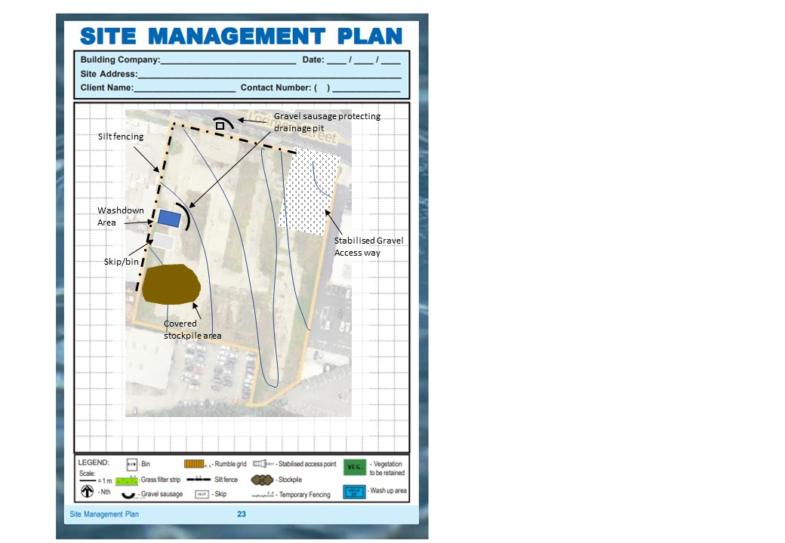

Figure 6: Proposed site management plan

*Note: Where the access way slopes down toward the road, a diversion hump should be installed across the stabilised access to direct stormwater runoff to the side where it can be filtered by the silt fence.*

|  |
| --- |
| E: Site management plan |
| * **E2:** Site management measures shown on a plan. |

|  |
| --- |
| Relevant links For larger scale developments (10 or more dwellings or over 1000m2), consider developing a site management plan that addresses environmental risk, or an Environmental Management Plan (EMP) – guidelines are available at:   * Environmental Management Plan Guidelines (Commonwealth of Australia): <https://www.environment.gov.au/system/files/resources/21b0925f-ea74-4b9e-942e-a097391a77fd/files/environmental-management-plan-guidelines.pdf>   Other useful resources include:   * Site Environmental Management Plan kit (Melbourne Water): <https://www.melbournewater.com.au/planning-and-building/developer-guides-and-resources/standards-and-specifications/develop-site> * Guidance on reducing erosion and sedimentation risk (EPA Victoria): <https://www.epa.vic.gov.au/for-business/find-a-topic/erosion-and-sediment/advice-for-businesses> * Assessing and controlling risk: A guide for business – EPA publication 1695 (EPA Victoria): <https://www.epa.vic.gov.au/about-epa/publications/1695-1> This guide is also available in languages other than English. * Construction techniques for sediment pollution control – EPA publication 275 (EPA Victoria): <https://www.epa.vic.gov.au/about-epa/publications/275> * Construction – Guide to preventing harm to people and the environment – EPA publication 1820 (EPA Victoria):   [https://www.epa.vic.gov.au/about-epa/publications/1820](https://www.epa.vic.gov.au/about-epa/publications/1820%0d)  Outlines how to manage risks in construction, provides an outline of your legal obligations, what actions you can take to comply with the new laws, and contains a list of common hazards and information about how to manage waste. The guide does not tell you about the controls to put in place to suit your circumstances.   * Civil construction, building and demolition guide – EPA publication 1834 (EPA Victoria):   <https://www.epa.vic.gov.au/about-epa/publications/1834>  Supports industry to eliminate or reduce the risk of harm to human health and the environment through good environmental practice. It provides an overview of the duties under the new laws, outlines a risk based approach for assessing and managing risks, and includes information on controls that you can put in place to manage your risks. |
|  |

## F: Asset maintenance program

Note: This section may be required by your council. Check with your council for further advice on what is required. A suggested list is provided in the checklist.

Although an asset maintenance program is not a requirement under this standard, some councils may require maintenance schedule detailing, including inspection of WSUD assets, schedule of maintenance, and responsibilities (i.e. future tenant, owner, body corporate, etc).

In order to protect our waterways and enhance the function, aesthetics and amenity associated with WSUD, it is important that these assets are maintained so they continue to operate as designed.

In this case, in order to maintain the aesthetic and function of the raingarden, the litter will need to be removed at regular intervals (approximately monthly, as required). The management of the raingardens and tanks will be the responsibility of the landowner.

*Note: It is suggested that councils recommend to property owners that they record the location and details of their buried on-site stormwater devices and attach it to property title documents. Councils should also consider recording information about the location of buried stormwater infrastructure on private land where required as part of a planning permit, to support future asset management and/or enforcement.*

|  |
| --- |
| Relevant links  * WSUD Maintenance Guidelines (Melbourne Water): <https://www.melbournewater.com.au/media/636/download> * WSUD Audit Guidelines (Stormwater Victoria): <https://www.musicauditor.com.au/node/36> * WSUD Maintenance Manuals (City of Port Phillip): * Rainwater tanks: <https://manualzz.com/doc/7441220/rainwater-tanks---city-of-port-phillip> * Raingardens: <https://www.portphillip.vic.gov.au/media/dd1n33yv/maintenance_manual_raingarden.pdf> |

delwp.vic.gov.au