|  |
| --- |
| Method for the long-term monitoring of wetlands in Victoria  Technical report |

|  |
| --- |
|  |

|  |
| --- |
| Citation: Department of Environment, Land, Water and Planning (2016). Method for the long-term monitoring of wetlands in Victoria. Department of Environment, Land, Water and Planning, East Melbourne, Victoria.  Logo© The State of Victoria Department of Environment, Land, Water and Planning 2016    This work is licensed under a [Creative Commons Attribution 4.0 International licence](http://creativecommons.org/licenses/by/4.0/). You are free to re-use the work under that licence, on the condition that you credit the State of Victoria as author. The licence does not apply to any images, photographs or branding, including the Victorian Coat of Arms, the Victorian Government logo and the Department of Environment, Land, Water and Planning (DELWP) logo. To view a copy of this licence, visit <http://creativecommons.org/licenses/by/4.0/>  ISBN 978-1-76047-239-9 (pdf/online)  **Disclaimer**  This publication may be of assistance to you but the State of Victoria and its employees do not guarantee that the publication is without flaw of any kind or is wholly appropriate for your particular purposes and therefore disclaims all liability for any error, loss or other consequence which may arise from you relying on any information in this publication.  **Accessibility**  If you would like to receive this publication in an alternative format, please telephone DELWP Customer Service Centre 136 186, email [customer.service@delwp.vic.gov.au](mailto:customer.service@delwp.vic.gov.au), via the National Relay Service on 133 677 [www.relayservice.com.au](http://www.relayservice.com.au). This document is also available on the internet at [www.delwp.vic.gov.au](http://www.delwp.vic.gov.au) |

Contents

Acknowledgements i

Acronyms ii

Executive summary iii

1. Introduction 1

1.1 Context 1

2. Monitoring requirements 4

2.1 Geographic coverage 4

2.2 Temporal assessment 6

2.3 Monitoring indices 6

2.4 Development and implementation cost 8

2.5 Robustness to technological and data supply change 9

3. Wetland extent and water regime monitoring 10

3.1 Indicators 10

3.2 Method 13

3.3 Implementation considerations 23

4. Vegetation monitoring 29

4.1 Indicators 29

4.2 Method 29

4.3 Implementation considerations 32

5. Evaluation and reporting framework 35

5.1 Frequency of evaluation and reporting 35

5.2 Spatial units of evaluation and reporting 36

5.3 Alignment with the Victorian wetland classification framework 37

5. Conclusion 42

6.1 Indicators 42

6.2 Method 42

Appendix 1: Evaluation of the wetland extent and water regime monitoring method 46

Acknowledgements

This report was prepared by Alluvium Consulting Australia in partnership with CSIRO under contract from the Department of Environment, Land, Water and Planning. Doug Frood of Pathways Bushland & Environment provided technical assistance to the project, including the evaluation of wetland extent and water regime monitoring method.

Acronyms

|  |  |
| --- | --- |
| ARG25 | Australian Reflectance Grid |
| BGR | Blue green red |
| CMA | Catchment Management Authority |
| CSIRO | Commonwealth Scientific & Industrial Research Org |
| DELWP | Department of Environment, Land, Water and Planning |
| DEPI | Department of Environment and Primary Industries (precursor to DELWP) |
| DSE | Department of Sustainability and Environment (precursor to DEPI) |
| EVC | Ecological Vegetation Class |
| IEC | Index of Estuary Condition |
| ISC | Index of Stream Condition |
| IWC | Index of Wetland Condition |
| LIDAR | Light Detection and Ranging |
| MODIS | Moderate Resolution Imaging Spectroradiometer |
| NBAR | Nadir ‘Bidirectional Reflectance Distribution Function’ Adjusted Reflectance |
| QA | Quality Assurance |
| SAR | Synthetic Aperture Radar |
| SLC | Scan line corrector |
| TM | (Landsat) Thematic Mapper |
| US | United States (of America) |
| USGS | United States Geological Survey |
| VCMC | Victorian Catchment Management Council |

Executive summary

The Department of Environment, Land, Water and Planning (DELWP) is responsible for policy development with regard to the management of wetlands in Victoria. To fulfil its policy role, DELWP is seeking to better understand the ongoing status of different types of wetlands in Victoria and to identify and investigate threatening processes that are contributing to loss of wetland habitat or changes in wetland type.

To inform this, DELWP commissioned a project by Alluvium Consulting Australia in partnership with CSIRO to develop an efficient and affordable method to monitor changes in the extent and type of wetlands in Victoria. In doing so, this work advances Action 12.13 of the *Victorian Waterway Management Strategy*. The outcomes from the project will be used to improve wetland monitoring in Victoria, assist in updating wetland attributes in the Victorian geospatial wetland inventory and improve the hydrology measures in the Index of Wetland Condition method.

The developed monitoring approach builds upon Victoria’s geospatial wetland inventory, which maps the distribution and extent of approximately 35,500 wetlands in Victoria and identifies that 25,500 of these are naturally occurring wetlands. The scope of the monitoring approach focused on naturally occurring wetlands greater than or equal to 1 ha in size – this represents over 80% of all mapped naturally occurring wetlands across Victoria. Although the focus is on naturally occurring wetlands, the approach provides a method and framework that could well be equally applied to human-made wetlands.

The temporal assessment cycle for the developed monitoring approach is consistent with policy 17.5 of the *Victorian Waterway Management Strategy*, with reporting occurring every eight years (subject to available funding), based upon annual (or more frequent) temporal assessments.

The monitoring approach is based on the following set of indicators, that when considered together, will describe changes in the extent and type of wetlands in Victoria over each eight year reporting cycle:

* **Extent index:**
  + maximum inundation, i.e. maximum inundated area over the assessment period, expressed relative to the historical maximum inundation extent
* **Water regime index:**
  + water regime category/subcategory, which is a function of the frequency of inundation and duration of inundation
  + frequency of inundation i.e. number of years in 10 that a wetland ‘holds water’
  + duration of inundation i.e. number of months that a wetland ‘holds water’ for before drying
  + duration between inundation i.e. number of months between periods when the wetland ‘holds water’ and
* **Vegetation index:**
  + vegetation ‘cover trends’ i.e. assessment of the vegetation cover of wetlands.

The selection of the method for monitoring was informed by a review of the Australian and international literature, the development and evaluation of criteria to assess the suitability of different options for use in Victoria and a trial application of a method across a pilot area in northern Victoria.

Through this process, a remote sensing approach was adopted that utilised optical remote sensing data to classify standing water (which informed the extent index and water regime index) and to assess vegetation cover and character (which informed the vegetation index). In particular, the adopted method draws upon Landsat Thematic Mapper imagery, which has the following key advantages.

* Landsat data is collected regularly, covers all of Victoria, it is archived since 1988 (TM data).
* Landsat data is free and is available in consistently processed form from US and Australian archives.
* Landsat has a forward plan for ongoing acquisition.
* It is proven as the basis for operational vegetation and inundation monitoring systems in Australia.

At its simplest, the monitoring method can be broken-down into a simplified three-step process where:

* satellite remote sensing imagery (in this case Landsat TM) is analysed to delineate the presence of water across the landscape and examine vegetation cover over time
* this data is then used to quantify the temporal and spatial distribution of water in each wetland, and analyse vegetation trends over time and
* this data is then used to analyse the change in the maximum extent of inundation, the change in the frequency and duration of inundation and the change in vegetation cover.

The most notable advantages of the monitoring approach are arguably that it:

* builds upon freely available satellite imagery that is available across all of Victoria
* extends back decades before present and has a forward plan for ongoing acquisition
* is cost effective – implementation is estimated to cost in the order of $230,000 to $400,000 for assessment of all metrics, depending on the intensity of the data collation and classification tasks
* provides consistency in metrics temporally and geographically and
* provides synoptic assessment at state and local scale.

This provides a level of robustness to technological and data supply changes that is unparalleled amongst other optical remote sensing options. However, like all methods there are limitations, most notably:

* vegetation cover over standing water can result in errors of omission, with the extent of inundation particularly difficult to identify beneath dense growths of Cumbungi, Common Reed or Swamp Paperbark and under dense patches of medium-sized graminoids (e.g. Sea Rush)
* it does not distinguish between different vegetation types and has no vertical metric of vegetation structure and
* it highlights change but does not attribute the cause of it.

In light of these advantages and limitations, the adopted method will substantially advance DELWP’s understanding of the ongoing status of different types of wetlands. This will provide major insights into the threatening processes that are contributing to loss of wetland habitat or changes in wetland type, allowing more targeted and effective wetland management programs.

1. Introduction

The Department of Environment, Land, Water and Planning (DELWP) is responsible for policy development with regard to the management of wetlands in Victoria. To fulfil its policy role, DELWP is seeking to better understand the ongoing status of different types of wetlands in Victoria and to identify and investigate threatening processes that are contributing to loss of wetland habitat or changes in wetland type.

This report presents the outcomes from a project (the ‘project’) undertaken to develop an efficient and affordable method to monitor changes in the extent and type of wetlands in Victoria. The outcomes from this project will be used to improve wetland monitoring in Victoria, assist in updating wetland attributes in the Victorian geospatial wetland inventory (the ‘inventory’) and improve the hydrology measures in the Index of Wetland Condition (IWC) method.

This project was undertaken by Alluvium Consulting Australia in partnership with CSIRO under contract from DELWP.

1.1 Context

The Victorian geospatial wetland inventory maps the distribution and extent of approximately 35,500 wetlands in Victoria and identifies that 25,500 of these are naturally occurring wetlands. The remainder are human-made wetlands such as farm dams, reservoirs and stormwater treatment wetlands.

Since European settlement many of these naturally occurring wetlands have been affected by anthropogenic activities that have severely impacted their extent, condition and type. Anthropogenic influences will continue to directly affect wetlands, although arguably at less intensity in future. However, climate change is now considered an additional factor that will further impact on the hydrology and salinity of wetlands and, in coastal areas, may cause changes in wetland extent associated with sea level rise.

Data on long-term changes to wetland extent and type is important to support policy development. To date, the most reliable information on changes to wetland extent and type across Victoria are based on two geospatial datasets which were developed in the period from the late 1970s to 1994. These geospatial datasets, called “Wetland 1994” and “Wetland 1788”, were mapped using manual interpretation of black and white 1:40,000 aerial imagery from April 1968. This was coupled with field survey in the 1970s, and subsequent digitisation at 1:25,000 in 1993 (Corrick and Norman 1976; Ecosystems Management 2006). The ‘current’ (i.e. 1968-1993) extent of each wetland was mapped from this data, as well as the inferred extent ‘pre-European’ settlement (i.e. 1788).

More recently, updates to the inventory have provided new insights into the extent of wetlands across Victoria (Figure 1) and their characteristics. The Victorian wetland classification framework (DELWP, in prep.) has now been applied to all of Victoria’s mapped wetlands, to describe the characteristics of individual wetlands and develop a wetland typology where each wetland is assigned to a wetland ‘type’. Table 1 summarises the attributes used in the Victorian wetland classification framework to derive the wetland types.

This project adopts the definition of wetlands from the Victorian wetland classification framework, where wetlands are defined as surface waters, whether natural, modified or artificial, subject to permanent, periodic or intermittent inundation, which hold static or very slow moving water and support biota adapted to inundation and the aquatic environment (DELWP, 2016).

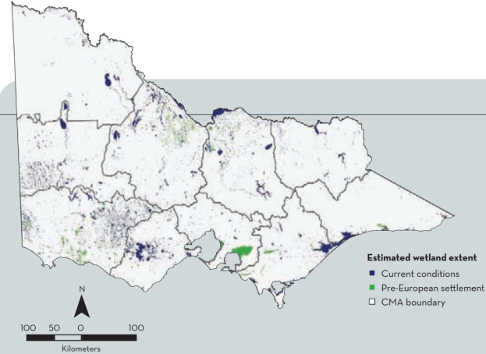

Figure 1. Extent of mapped wetlands across Victoria (VCMC 2012).

The updates to the Victorian wetland inventory were undertaken by CMAs and DELWP over the last 10 years (Alluvium 2011). Due to the progressive and varied nature of these updates, the updated inventory does not provide a reliable indication of how the on-ground extent of wetlands has changed since the original 1968-1993 mapping. For example, changes in mapped wetland extent between the original and updated inventory may be associated with improved detection capability or the inclusion of new wetland types such as alpine bogs, rather that representing actual on-ground changes.

Victoria has a program in place to monitor changes to the condition of individual wetlands using the Index of Wetland Condition (IWC). This s method is however too resource-intensive to apply to all wetlands in Victoria. Information to detect long-term changes to the extent and type of wetlands in Victoria will complement IWC results at individual wetlands and also provide a more generalised overview of changes happening at a landscape, rather than an individual wetland scale.

This objective of this project was to improve the wetland monitoring in Victoria through the development of ’an efficient and affordable method to monitor changes in the extent and type of wetlands in Victoria’ (DEPI 2014).

Table 1. Wetland attributes used to derive wetland types in the Victorian wetland typology (DELWP, 2016).

|  |  |  |  |  |
| --- | --- | --- | --- | --- |
| Wetland system | Salinity regime | Water regime | Dominant vegetation | Wetland type |
| Estuarine | - | - | Not coastal saltmarsh | Estuary |
| Coastal saltmarsh | Coastal saltmarsh |
| Marine | - | - | - | Intertidal flats |
| Lacustrine | Fresh | Permanent | - | Permanent freshwater lakes |
| Periodically Inundated | - | Temporary freshwater lakes |
| Saline | Permanent | - | Permanent saline lakes |
| Periodically Inundated | - | Temporary saline lakes |
| Palustrine | - | - | Moss/heath | High country peatlands |
| Fresh | Permanent | Sedge/grass/forb | Permanent freshwater marshes and meadows |
| Forest/woodland or Shrub | Permanent freshwater swamps |
| No emergent vegetation | Permanent freshwater swamps/marshes/meadows |
| Saline | Permanent | Sedge/grass/forb | Permanent saline marshes and meadows |
| Forest/woodland or Shrub | Permanent saline swamps |
| No emergent vegetation | Permanent saline swamps/marshes/meadows |
| Periodically Inundated | Sedge/grass/forb | Temporary freshwater marshes and meadows |
| Forest/woodland or Shrub | Temporary freshwater swamps |
| No emergent vegetation | Temporary freshwater swamps/marshes/meadows |
| Sedge/grass/forb | Temporary saline marshes and meadows |
| Forest/woodland or Shrub | Temporary saline swamps |
| No emergent vegetation | Temporary saline swamps/marshes/meadows |

2. Monitoring requirements

2.1 Geographic coverage

Monitoring Victoria’s wetlands will require information on long-term changes to the extent and type of wetlands all across Victoria.

Victoria’s geospatial wetland inventory maps the distribution and extent of approximately 35,500 wetlands in Victoria and identifies that 25,500 of these are naturally occurring wetlands. The scope of the project is restricted to naturally occurring wetlands. However, it is worth noting that while the project focused on naturally occurring wetlands, the methods and framework developed could well be equally applied to human-made wetlands.

The monitoring approach is intended to monitor wetlands greater than or equal to 1 ha in size. An analysis of all wetlands in the inventory indicates that there is considerable variation in the size of wetlands, ranging from less than 0.2 ha through to 47,800 ha, with a median size of 2.5 ha (Alluvium 2015a). The 25,500 mapped naturally occurring wetlands tend to be slightly larger than human-made wetlands, with a median size of 3.7 ha. Of these naturally occurring wetlands, approximately 33% are less than 2 ha, 19% are less than 1 ha and 12% are less than 0.5 ha in size (Figure 2). As such, the monitoring is expected to cover at least 81% of all mapped naturally occurring wetlands across Victoria.

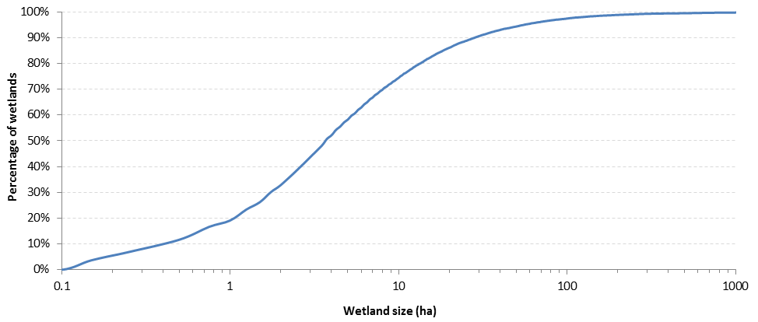

Figure 2. Size distribution of naturally occurring wetlands in the inventory (note logarithmic scale on x axis).

With a focus on naturally occurring wetlands, monitoring would ideally be geared towards the wetland types that are most commonly associated with naturally occurring wetlands. Figure 3 and Figure 4 chart the most common types of naturally occurring wetlands based on the number of wetlands and the total size of wetlands respectively. Together, these charts show that the most common types of naturally occurring wetlands by number and area, are the temporary freshwater marshes and temporary freshwater swamps. These wetlands types account for 69% of all naturally occurring wetlands (of known type) and 38% of the area of naturally occurring wetlands (of known type). Other naturally occurring wetlands wetland types that are particularly numerous or extensive include the high country peatlands, intertidal flats, permanent saline lakes, coastal saltmarshes, temporary freshwater lakes and temporary saline lakes.

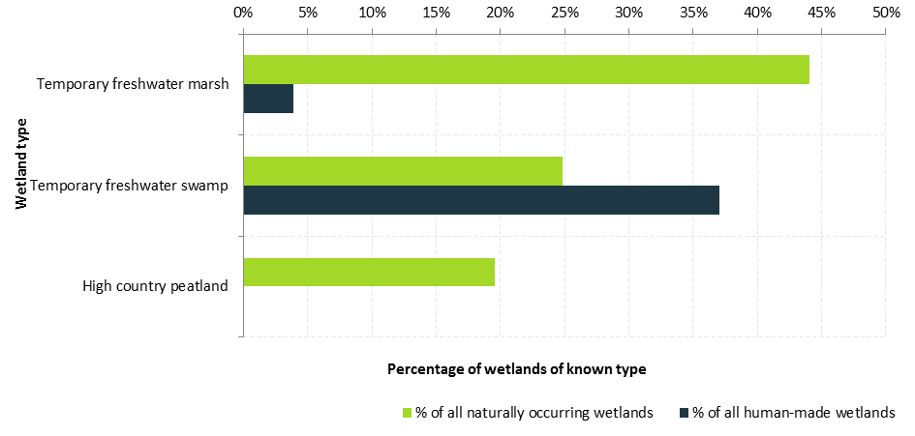

Figure 3. Percentage number of naturally occurring and human-made wetlands of each major wetland type.

Note: The following example shows how to interpret Figure 3: Of the 16,300 naturally occurring wetlands of known type, just fewer than 25% of these (4,000 wetlands) are temporary freshwater swamps).

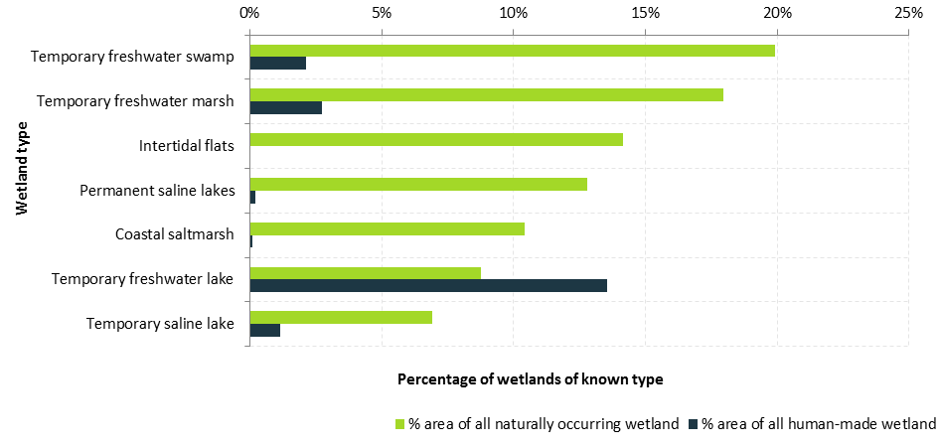

Figure 4. Percentage area of naturally occurring and human-made wetlands of each major wetland type.

Note: The following example shows how to interpret Figure 4: Of the 515,000 ha of naturally occurring wetlands of known type, just few than 20% of the area (2,100 ha) is comprised of temporary freshwater swamps).

The focus on wetlands greater than 1 ha in size tends to influence which wetland types will be monitored. Figure 5 charts the percentage of temporary freshwater marshes and temporary freshwater swamps (the two most common naturally occurring wetland types) that are less than or greater than 1 ha in size. This demonstrates that both these wetland types comprise a relatively large portion of wetlands greater than 1 ha in size. This in turn suggests that monitoring of > 1 ha naturally occurring wetlands is expected to provide a reasonable indicator of the trends across wetlands in these key wetland types.

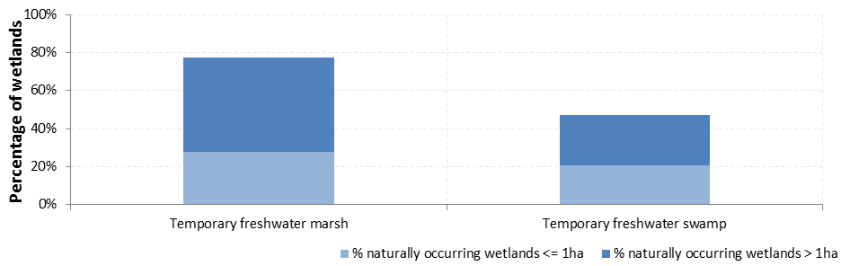

Figure 5. Percentage of naturally occurring wetlands in each wetland type that are greater than or less than 1 ha.

2.2 Temporal assessment

Any monitoring program needs to strike the right balance between undertaking monitoring at a temporal scale sufficient to be able to identify and respond to on-ground change, staying affordable and achievable to implement over time, and adequately considering the natural variability that occurs in aquatic systems.

Policy 17.5 of the *Victorian Waterway Management Strategy* states that state-wide resource condition assessment will occur through the indices of condition programs every eight years (subject to available funding). In addition, Action 12.13 of the Strategy also commits to the development of this monitoring approach to routinely examine changes in wetland extent and changes in wetland water regime.

With this in mind, the temporal assessment scale recommended for this project is annual (or more frequently). The trends in these annual (or more frequent) temporal assessments would then be evaluated and reported every eight years.

2.3 Monitoring indices

Wetlands are complex ecosystems expressing a large variety of characteristics and traits. In an ideal world, monitoring would assess the changes occurring across a large suite of different elements of the ecosystem to provide a comprehensive and complete understanding of change in the ecosystem. However, in reality, limited resources impose constraints that require the scope of monitoring to be restricted to the elements that ecologically meaningful and most informative for management planning.

This project sought to investigate methods for directly assessing temporal changes in three different indices:

* **extent**, i.e. the size and area occupied by wetlands
* **water regime**, i.e. the pattern of inundation and drying in wetlands and
* **vegetation**, i.e. the nature of vegetation occurring within wetlands.

The evaluation and reporting phase of the Victorian Waterway Management Program is currently underpinned by state-wide monitoring of resource condition through three specifically developed indices of condition, the:

* Index of Stream Condition (ISC)
* Index of Wetland Condition (IWC) and
* pilot Index of Estuary Condition (IEC).

These indices of condition integrate data about the key components of rivers, wetlands and estuaries that are important from an ecological perspective. They have been designed to assess environmental condition at individual stream reaches, wetlands and estuaries. Condition data from these indices can be used to infer the level of threat to individual waterways and the effectiveness of management interventions across Victoria.

Of particular relevance to this report is the wetland index, the IWC, which was initially developed in 2005 to assess the condition of naturally-occurring wetlands in Victoria. To do this, the IWC uses six sub-indices that each has one or more measures which examine the condition of ecological components relevant to that sub-index (Table 2). Several of these IWC measures are based on the assessment of threat indicators, rather than on direct measures of the key ecological component (e.g. the measure for water regime). Direct measures developed through this project could provide more reliable indicators of change over time, compared to the indirect threat measures used in the IWC.

Table 2. Sub-indices, components and measures used in the IWC (DEPI 2013a).

|  |  |  |  |
| --- | --- | --- | --- |
| IWC sub-index | Key ecological component | Measure | Measure type |
| Wetland catchment | Wetland catchment | Percentage of land in different land use intensity classes adjacent to the wetland | Threat |
| Wetland buffer | Average width of the buffer | Component |
| Percentage of wetland perimeter with a buffer | Component |
| Physical form | Area of the wetland | Percentage reduction in wetland area | Component |
| Wetland form | Percentage of wetland where activities (excavation and landforming) have resulted in a change in bathymetry | Threat |
| Hydrology | Water regime | Severity of change to the water regime expected from activities identified to alter the water regime | Threat |
| Water properties | Macronutrients (such as nitrogen and phosphorus) | Severity of nutrient enrichment | Threat |
| Electrical conductivity (salinity) | Severity of change in salinity | Threat |
| Soils | Soil physical properties (soil structure, texture, consistency and profile) | Percentage and severity of wetland soil disturbance | Impact |
| Biota | Wetland plants | Wetland vegetation quality assessment based on: • critical lifeforms • presence of weeds • indicators of altered processes • vegetation structure and health | Component Impact Impact Component |

In the period 2009-2011, the IWC was used to benchmark the condition of 587 high value wetlands and 240 additional wetlands selected to represent a range of different wetland types (Papas and Moloney 2012). These assessments confirmed that while the IWC provides condition data for individual wetlands, the resources available for undertaking IWC assessments restrict its use to a small percentage of Victoria’s 25,000 naturally occurring wetlands (e.g. approximately 3% in 2009-11). In addition, as relationships between the factors that influence wetland condition and the measured condition are complex and are not well understood, it is not possible to use IWC results to infer the condition of wetlands that have not been assessed with any degree of confidence (DEPI 2013a). As such, an ability to assess changes in key wetland components across all wetlands is required in order to improve the ability to monitor landscape changes in wetland condition.

In light of the management and policy requirements of the Department, the three monitoring indices were assigned a differing level of priority for the development of monitoring methods.

* **Extent** was considered to be the highest priority index. By monitoring the extent of wetlands over time, DELWP will be able to generate insights on dynamic patterns of wetland extent and address the more fundamental question of ‘are we losing wetlands?’.
* **Water regime** was considered to be the second highest priority index. This reflects the critical role that inundation plays in the ecology of wetland environments.
* **Vegetation** was considered to the third highest priority index. By monitoring the dominant vegetation of wetlands (e.g. density, condition, structure) DELWP will be able to understand if there are broad‑scale changes in the structural composition of vegetation over time.

The project had also initially intended to focus on salinity levels within wetlands. However, a potential salinity index was ruled out early in the project following a review of the literature, which found that salinity monitoring would require in-water monitoring and was not suited to the remote sensing, landscape scale assessments that underpinned this wetland monitoring system.

Loss of wetland extent through human induced disturbance is a major threat to south-east Australian wetlands (Kingsford et al., 2003). As many wetlands show seasonal and other cyclical variations in their inundation extent (Winning, 1997), loss of wetlands through hydrological disturbance (i.e. changes to inundation patterns) can be challenging to quantify. Wetland extent monitoring will need to allow for the high natural variability of wetland environments and therefore focus on identifying changes beyond that expected under ‘natural conditions’ (i.e. that due to human induced disturbance). It is likely that many such changes may be driven by climate change which is predicted to result in more ephemeral wetlands over time across Victoria (DSE 2013).

A common way to compare wetland extent over time has been to assess changes in maximum inundation extent over time (e.g. Johnston and Barson, 1993; Kingsford and Thomas, 2002). The application of such methods has detected losses of up to 59% in the period between 1975-1998 in the Lower Murrumbidgee floodplain in NSW which is consistent with observed declines in wetland biota (Kingsford and Thomas, 2004).

Figure 6. Key points on assessing and monitoring wetland loss.

2.4 Development and implementation cost

A monitoring system is of value only if it continues to operate and inform policy. Cost is an important consideration, as is risk, and these must be weighed against the costs of doing ‘business as usual’ or doing nothing. With this in mind, there are two essential criteria related to practical considerations.

* Currently affordable i.e. data acquisition and processing can be implemented within the budget made available for the current project.
* Cost certainty i.e. confidence that monitoring cost will be stable or decrease over time.

Given the requirement to monitor changes across such a large number of wetlands and such a broad range of wetland types, the wetland monitoring system needs to adopt a remote sensing, landscape scale assessment approach.

This approach contrasts with the Index of Wetland Condition (IWC) program which was designed to assess condition at individual wetlands using on‑ground assessments and would be prohibitively expensive to apply at all wetlands. As discussed above, while IWC assessment results may provide some indication of more widespread changes in wetlands across Victoria, they will be conducted at only a small proportion of wetlands in regular state-wide assessment programs, so a more comprehensive monitoring system is required to detect changes in key wetland attributes at the landscape scale.

Typically, with systems based on remotely-measured data and quantitative methods, the cost of monitoring decreases with time. Initial establishment requires processing of a long historic data sequence and establishment of operational methods and quality assurance (QA) processes. Once established data and processing requirements are reduced and (typically) computation becomes cheaper and more automated.

An example of decreasing cost over time is provided by the Land Monitor vegetation monitoring system (southwest Western Australia), which covers an area similar in size to Victoria. It was set up in the late 1990s when Landsat data were expensive and computational systems were limited. However, Landsat data are now free and processed to a high standard. This combined with established monitoring analysis methods mean the annual update for the entire region now costs only $40,000. Products are distributed to multiple agencies in Western Australia.

2.5 Robustness to technological and data supply change

For monitoring programs, a critical consideration of potential methods and data is the likelihood they will be able to generate consistent metrics or summary information relevant to monitoring wetland extent and inundation regime, or wetland vegetation, and that they can be applied into the future.

To achieve this, the data sources need not be identical, but need to be amenable to methods to produce consistent metrics. Certainty of data supply is critical. If compatible data are not available for a particular method over the period of interest, then the method can be excluded.

Given the eight-year time window for inference of change (refer Section 0), the monitoring approach requires data which will be collected and available for multiples of eight years into the future, and ideally for at least eight years before present to enable evaluation.

Data not only needs to extend across time, but also needs to be available across a spatial extent that covers a large proportion of wetlands and wetland types.

With this in mind, four essential criteria were devised to represent the requirement for a method that is robust to technological and data supply change: These criteria include:

1. certainty of ongoing data supply, i.e. compatible data will be available for the foreseeable future
2. frequency of data collection, i.e. data is collected and available for multiples of eight years into the future
3. ability to monitor a large proportion of wetland types/sizes i.e. appropriate resolution and
4. data available for a large proportion of wetlands i.e. coverage across the State.

3. Wetland extent and water regime monitoring

3.1 Indicators

The monitoring of wetland extent and water regime seeks to understand spatial and temporal patterns in the size and area occupied by wetlands and the inundation and drying cycles of wetlands. The following indicators as used in order to help quantify and describe these patterns:

* **Extent index**:
  + maximum inundation, i.e. maximum inundated area over the assessment period, expressed relative to the historical maximum inundation extent
* **Water regime index**:
  + water regime category/subcategory, which is a function of the frequency of inundation and duration of inundation (refer Table 3)
  + frequency of inundation i.e. number of years in 10 that a wetland ‘holds water’
  + duration of inundation i.e. number of months that a wetland ‘holds water’ for before drying and
  + duration between inundation i.e. number of months between periods when the wetland ‘holds water’.

Each of these indicators can be derived from an assessment of the extent of inundation of each wetland over time, i.e. a ‘time series’ of inundation extent through time.

Figure 7 presents examples of time series inundation plots from four different hypothetical wetlands. Each of the indicators outlined above can be calculated from these data. Time series data such as this represents the core data product, from which the target indicators can be determined.

The maximum inundation indicator for the water regime index would be assessed by comparing the temporal change in the maximum percentage of each wetland that is inundated:

* for each year, for permanent wetlands and
* for each watering event, for periodically inundated wetlands.

The maximum inundation extent in each event/year is represented as red dots in Figure 7. A statistical analysis of the change in the value of these red dots over time allows inferences to be drawn on the change in wetland extent over time.

The four water regime indicators would be assessed by analysis of the time series plots to:

* identify the start date and end date of each time a wetland ‘holds water’ – this period when the wetland ‘holds water’ is called the ‘inundation event’ and
* prepare summary statistics that describe the frequency and duration of those inundation events and the dry periods between them.

In order to identify the start and end date of each inundation event it is necessary to define the following factors.

* **Minimum inundation extent threshold** i.e. the minimum percentage of wetland inundation required to categorise the wetland unit as being ‘inundated’. As an example, this might be at least 5% of wetland area. However, if vegetation is present that prevents water detection, this becomes problematic. A high inundation level in the time series would be required to determine the percentage of obscuring wetland vegetation and the vegetation could cover the wettest part of the wetland. Thus the area obscured by vegetation and 5% of the remaining area may amount to much more than 5% of the wetland.
* **Minimum duration of inundation**. The Victorian wetland classification framework defines the water regime of a wetland on the frequency of inundation events of one month or longer (Table 3). If this logic is applied for the assessment of water regime indicators, a minimum consecutive duration of month would be used to define the number of inundation events that occur.

Table 3. Water regime categories and their definition under the Victorian wetland typology.

|  |  |  |  |  |  |
| --- | --- | --- | --- | --- | --- |
| Wetland system | Water regime category | Category description | Water regime subcategory | Subcategory description | |
| Frequency of inundation | Duration of inundation |
| Lacustrine and palustrine | Permanent | Inundated constantly, rarely drying completely | - | Constant, annual or less frequently but before usually wetland dries. | Never dries or dries rarely (i.e. holds water at least 8 years in every 10), but levels may fluctuate within or between years. |
| Periodically inundated | Inundated annually to infrequently, holding water for at least 1 month to more than 1 year before drying | Seasonal | Annual or near annual inundation (i.e. holds water at least 8 years in every 10) | Holds water 1-8 months, then dries |
| Intermittent | Infrequent – holds water, on average, 3-<8 years in every 10 | Holds water > 1 month to > 1 year, then dries |
| Episodic | Infrequent – holds water, on average, less than 3 years in every 10 | Holds water > 1 month to >1 year, then dries |
| Unknown | Water regime category unable to be determined | | | |
| Marine and estuarine | Intertidal | Inundated twice daily, with inundation lasting hours | - | - | - |
| Supratidal | Inundated several times per year, with inundation lasting hours | - | - | - |
| Unknown | Water regime category unable to be determined | | | |

Having defined the start and end of each inundation event, the four water regime indicators (water regime category/subcategory, frequency of inundation, duration of inundation, duration between inundation) can be calculated. A statistical analysis of the change in each of these indicators over time allows inferences to be drawn on the change in wetland water regime over time.

Victoria’s wetlands express natural variability in the water regime and extent of wetland inundation over quite long timeframes e.g. up to and beyond 50 years for episodic wetlands like Lake Albacutya. The statistical analysis of the indicators for wetland extent and water regime needs to accommodate these long-timeframes as far as possible, such that monitoring results are not unnecessarily ‘skewed’ by temporary fluctuations in climatic/weather conditions.

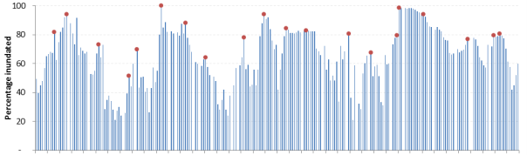

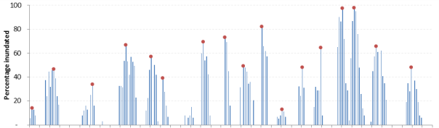

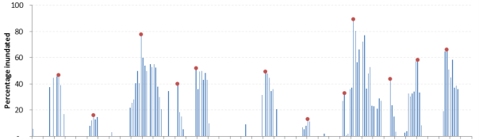

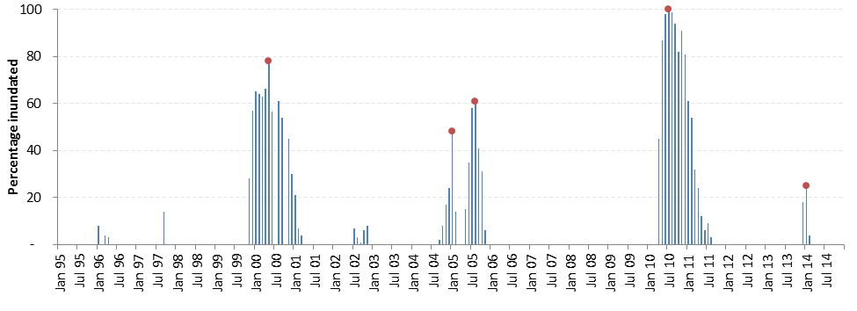

Figure 7. Hypothetical time series plots showing extent of inundation in four different wetlands over 20 years from January 1995 to December 2014. Under the Victorian wetland classification framework these four wetlands would be assigned a water regime of permanent (top), seasonal (second top), intermittent (second bottom) or episodic (bottom). Red dots show the maximum extent of inundation for each event/year.

Ideally the method would build upon an extensive history of inundation, spanning the time period the method (Landsat satellite data) covers. At each eight year assessment interval, the time series could be built up by adding another eight years of inundation data. For example, the

* first assessment may be based on the full record of Landsat data in 2016 e.g. 25 years
* second assessment may be based on the full record of Landsat data in 2024 e.g. 33 years.

3.2 Method

3.2.1 Overview

The selection of a suitable method for monitoring wetland extent and water regime was informed by:

* a literature review (Alluvium 2015a)
* the development of criteria for assessing the suitability of different options for use in Victoria (Alluvium 2015b)
* evaluation of methods against those criteria to confirm feasible options, particularly in light of the available/likely data sources (Alluvium 2015b) and
* ultimately, the trial application of a method across a pilot area in northern Victoria[1] (Alluvium 2015c, 2015e).

Through this process, a remote sensing approach was adopted that utilised optical remote sensing data to classify standing water. This provides monitoring on the inundation and extent of wetlands in two primary ways:

1. changes in the frequency of inundation for the wetland over time, through development of inundation extent maps which may be summarised to show inundation frequency at each pixel location over each analysis period and
2. changes in the maximum extent of the wetland over time, through development of inundation extent maps which may be summarised to show maximum extent of inundation (a surrogate measure for the extent of inundation when ‘full’) over each analysis period.

In particular, the adopted method draws upon Landsat Thematic Mapper (TM) imagery (LS5, LS7, LS8). Landsat imagery has been used for mapping inundation in research and operational applications for many years, across many continents and with varied classification techniques (Alluvium 2015a). The key advantages of Landsat are as follows.

* Landsat data is collected regularly, covers all of Victoria, it is archived since 1988 (TM data).
* Landsat data is free of charge.
* It is available in consistently processed form from US and Australian archives.
* Landsat has a forward plan for ongoing acquisition.
* It is proven as the basis for operational vegetation monitoring systems in Australia.
* Methods for mapping open water extent have been demonstrated and can be applied to long time series.
* It has formed the basis of an existing inundation history dataset/product across Australia developed by Geoscience Australia (Water Observations from Space).

At its simplest, the adopted wetland extent and water regime monitoring method can be broken-down into a simplified three-step process where:

* satellite remote sensing imagery (in this case Landsat TM) is analysed to delineate the presence of water across the landscape over time
* this data is then used to quantify the temporal and spatial distribution of water in each wetland and
* this data is then used to analyse the:
  + change in the maximum extent of inundation and thereby infer changes in wetland extent and
  + change in the frequency and duration of inundation and thereby infer changes in water regime.

The following sections describe each of these three steps in detail, with relevance to how each step was applied during the pilot testing for this project.

3.2.2 Analysis of satellite remote sensing imagery

Data requirements and collation process

For inundation history, it is obviously important to have the highest possible frequency of images over a period. Three primary factors govern the frequency of available satellite imagery.

* **Acquisition cycle**: Landsat systems acquire repeat coverage every 16 days on a regular basis. At present, Landsat 8 and Landsat 7 are operational. Scene edge overlaps mean that more frequent coverage is available for around 25% of area. In addition, for a long period (1999-2012) both Landsat 5 and Landsat 7 were operational on different schedules and more frequent coverage has been archived. However, for most of that period (since May 2003) Landsat 7 suffered from a scan line corrector (SLC) failure, which resulted in areas of missing data in each scene (refer to further discussion below).
* **Cloud**: Cloud cover obscures the land surface in optical imagery. Cloud cover is frequent in Landsat images and very frequent in some areas of Victoria. Further, cloud cover is likely to be associated with wet periods or large rainfall events. The nominal 16 day repeat cycle provides around 23 scenes per year, but for any given area, cloud will affect a significant portion of these.
* **Number of sensors**: Landsat’s TM imagery has been collected by three different sensors over the 2007 to 2014 assessment period. At most times, more than one Landsat TM satellite is acquiring data, each with its own acquisition cycle of 16 days.

Clearly, the frequency of satellite imagery is most important for wetland systems that experience rapid change in inundation. Where imagery is infrequent it is likely that the period of maximum extent may be missed, while short periods of ‘wet’ or ‘dry’ conditions may also be missed. In order to understand the likely influence of the frequency of available data on the adopted methods, an assessment was undertaken of Landsat data availability over the pilot area for the period January 2007 to March 2015. The assessment of data in the pilot area examined the:

* the number of Landsat images available in the primary Landsat data archives
* the number of cloud-free (or largely cloud free) Landsat images over time and
* the number of Landsat images that are affected by the SLC failure.

This assessment of availability in the pilot area provided an insight into the likely availability of Landsat imagery for the eventual state-wide implementation of the method. The results of the assessment are described below.

Landsat data archives

Landsat satellite imagery is available in two primary data archives of relevance to Victoria:

* the United States Geological Survey (USGS) archive, which stores Landsat imagery for the whole world and
* the Australian Reflectance Grid (ARG25) scene archive, which has been created in recent years by Geoscience Australia as input to the Geoscience Australia ‘data cube’ product.

These two archives contain data from the same Landsat satellite sensors, but with different processing streams. The geometric registration is compatible between the two archives, while the ARG25 data has been resampled to a 25m pixel size and calibrated using Geoscience Australia’s ‘NBAR’ calibration procedure[2]. Both archives provide a classification of the degree of cloud cover in each image, albeit with questionable accuracy.

The assessment of the data available in each archive for the pilot area that at the present time made the following findings.

* A number of scenes are available in the USGS archive but are missing from the ARG25 archive. The ARG25 archive typically holds 80% of the number of scenes in the USGS archive (Figure 8). Many of the missing scenes are severely cloud affected, but a number are clear or contain useful cloud-free areas.
* The number of suitable Landsat images is not even between or within years, and varies from 12 images in 2012 through to 22 images in 2007 (based on the scenes in the USGS archive). In general, suitable images appear to be available at least one per month in each calendar year, and more frequently in drier times when there is less cloud cover.
* The discrepancy in number of scenes between the ARG25 and USGS archive can introduce significant differences in the longest duration between Landsat scenes in any given year (Figure 9). For example, in 2010 the number of scenes in ARG25 was less than half that of the USGS archive, which led to a fivefold increase in the longest duration between scenes.

For the purposes of the pilot trial, only images from the ARG25 archive were used to examine wetland extent and water regime, due to the significant additional resources required to download and apply the NBAR-correction to the USGS archive data (in accordance with the processing made to ARG25 imagery).

It is understood that Geoscience Australia are actively investigating the reasons for these missing scenes in the ARG25 archive and it is therefore expected that the ARG25 archive will be more complete in future.

During the state-wide implementation of the method it would be prudent to re-assess the discrepancy between the ARG25 and USGS archive, to determine whether a more resource-intensive approach is needed to incorporate additional scenes from the USGS archive. It is certainly possible to download (free) and process the USGS images if required, but it is significantly more resource intensive than accessing from the ARG25 archive.

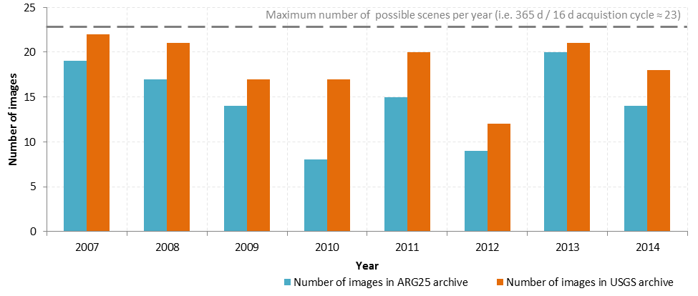

Figure 8. Number of ‘cloud-free’ or ‘largely-cloud-free’ images in the pilot area (row/path 93/85) each year in the ARG25 vs. USGS archives.

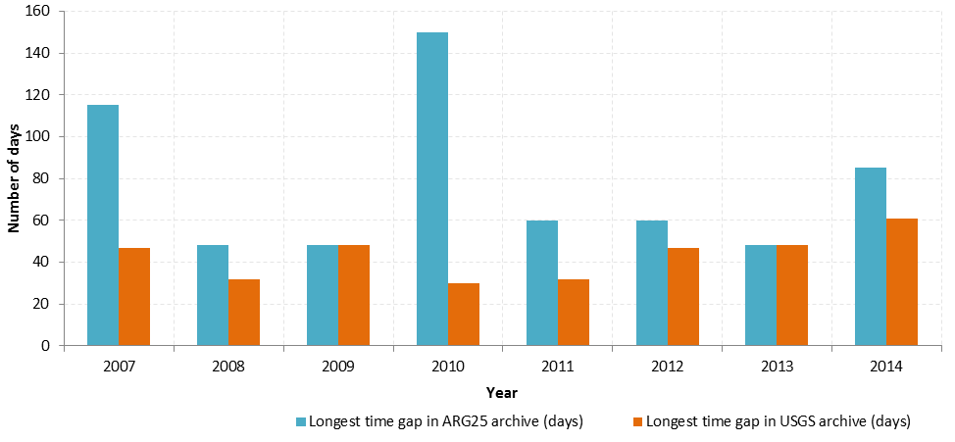

Figure 9. Approximate ‘longest period without observation’ in the pilot area (row/path 93/85) in the ARG25 vs. USGS archives.

Number of cloud-free images

When examining the cloud cover of the Landsat images in both archives, the assessment found that on average, 80% of the ~23 scenes gathered each year in the pilot area were either ‘cloud-free’ or ‘largely-cloud-free’. In 2012, this figure dropped down to ~50% when only 12 scenes from that year were not heavily cloud affected (Figure 10).

Of the 80% of scenes not heavily affected by cloud in the pilot area, approximately 50% were ‘cloud-free’ and the remaining 30% ‘largely-cloud-free’ (Figure 10). These ‘largely-cloud-free’ images required cloud masking prior to satellite imagery analysis, while images heavily affected by cloud were completely removed from the satellite imagery analysis process.

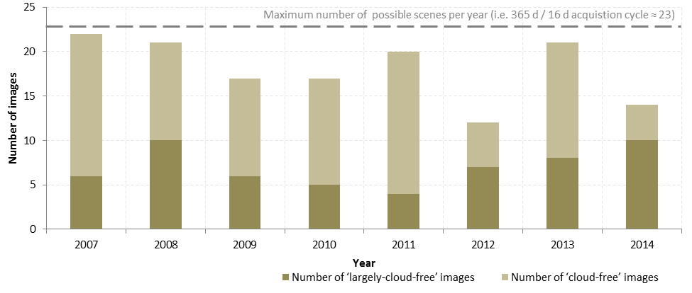

Figure 10. Number of ‘cloud-free’ vs. ‘largely-cloud-free’ images each year in the pilot area (row/path 93/85).

Number of images affected by SLC failure

Landsat’s Thematic Mapper imagery has been collected by three different sensors over the 2007 to 2014 assessment period (Landsat 5, 7 and 8). The locations of images are similar for all sensors.

* Landsat 5 was collected up to November 2011. This had significant gaps in acquisition in winter 2010 and 2011.
* Landsat 7 was collected over the whole period. However all Landsat 7 images from the period suffer from the ‘SLC-off’ problem which results in striping and regular wedges of missing data at the edges of the scenes in particular. At the centre, no data is missing, while at the very edges, around 40% is missing. An example is provided in Figure 11. In such scenes, small water bodies may be missed, while the character of large water bodies needs to be inferred from partial observation.
* Landsat 8 was collected since April 2013.

The number of images available from each sensor in the pilot area is shown in Figure 12, demonstrating that in most years two Landsat sensors have been operating on different satellites with different overpass dates. This increases the chances of cloud-free observations at any given point.

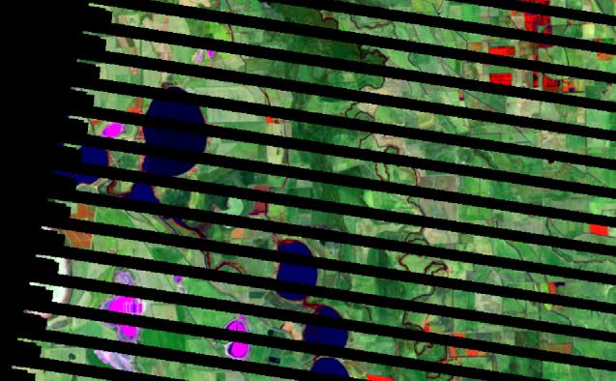

Figure 11. Landsat 7 image from 13/1/2014 illustrating missing data due to ‘SLC-off’ problem. Image is path/row 93/85, with bands 5,4,2 in BGR. Approx. 20km by 13km is shown.

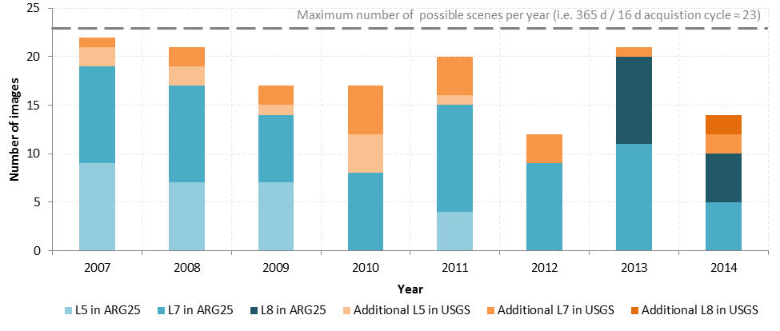

Figure 12. Make-up of the number of ‘cloud-free’ or ‘largely-cloud-free’ images in the pilot area (row/path 93/85) from the Landsat 5 (L5), Landsat 7 (L7) and Landsat 8 (L8) sensors.

Cloud masking

A manual assessment of the location of clouds and shadows is performed and a vector is drawn to define the regions that are affected by cloud and not to be used in the analysis. Figure 13 shows an example of a cloud affected area and the interpreted masking vector. The resultant cloud masked image is shown on the right with the black area representing the masked area.

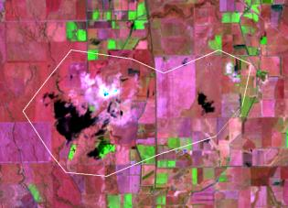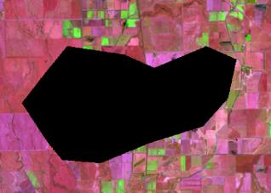

Figure 13. Landsat 8 image data from 18/4/2014 (path/row 94/85) with bands 5,4,2 in RGB (left) with vector in white outline overlaid over cloud affected area, and corresponding resultant cloud masked image (right) where the black area represent the masked out area.

Terrain illumination correction for hilly areas

Terrain illumination correction is applied where there are significant terrain illumination effects, resulting in bright and dark sides of hills and mountains. This is particularly important for time series imagery where terrain effects vary with different dates. In practice it also results in reducing the effort and cost of a monitoring program by reducing the amount of stratification required when performing analysis of the data. A two-step method is preferred, with:

* the first step used to reduce the effects bright and dark side of hills and
* the second step used to identify areas which are truly in shadow i.e. areas where there is no reflected signal from the ground.

The second step is important to identify observation gaps, for example a wetland that may reside in the shadow of a large hill or mountain may not be observed for low sun angle (winter) images. The second step produces a spatial mask of unobserved areas resulting from shadows cast by terrain.

Note, that the terrain illumination correction was not required for the pilot area, due to its relatively low level of relief.

Identification of wet areas

To map the wetlands in the series of Landsat images, an automated thresholding method that applies a set of suitable thresholds to band 5 (i.e. mid – infrared) was used for each Landsat image. First, a base classification at a chosen date was produced using a supervised approach to set the initial threshold values. Then, using in-house CSIRO software, the thresholds for each scene were generated by matching it to the base classification. This automated matching enables an adaptive threshold to be selected for each date to produce a ‘wet/not-wet’ classification for each pixel. This approach produced consistent results, except for the very wet ‘flood’ scene from January 2011 - a supervised threshold was selected for this wet ‘flood’ scene.

Supervised quality assurance (QA) was employed to verify, validate and refine the classification, based on visual interpretation of the Landsat imagery. Following QA, the resulting classification was masked to the mapped extent of each wetland in the inventory so that areas outside the mapped wetland are excluded. Both masked and unmasked versions were kept on file.

In the masked digital files each pixel is classified into one of the following codes:

* 0 = dry
* 1 = wet
* 2 = data that is not within a mapped wetland and
* 255 = null/missing data i.e. areas that have been masked out due to cloud, or were missing in the original Landsat image (often due to the ‘striped’ nature of Landsat 7 images).

Figure 14 shows an example of the classified output from January 2007 across a single Landsat 5 image (note this image is cloud free). The image on the right shows the classification map which has been masked to the wetland boundaries, with wet areas as blue and dry areas as orange. This wet area mapping is consistent with visual interpretation of the Landsat image.

A second example shown in Figure 15 is taken from Landsat 5 in January 2011. This is a special case as there was a flooding event on this date. The image on the left shows the Landsat image while the one on the right shows the corresponding classified image, where the wetland mask has not been applied. This second example demonstrates the extent of the flood has been mapped beyond the mapped wetlands, which is consistent with the Landsat image.

The single band 5 index adopted for this study classifies both standing water and wet soil surface conditions as ‘wet’. This approach was considered to be appropriate for the purposes of this study and avoided the additional complexity of trying to separate or distinguish these classes. The approach is consistent with the work of others such as Van Dongen et al. (2012), who developed inundation maps for wetlands north of Perth using a simple threshold to Landsat band 5 only.

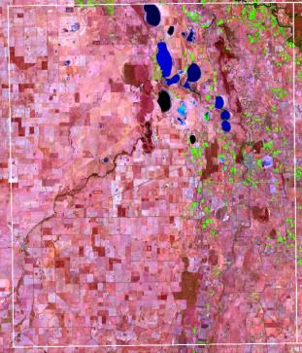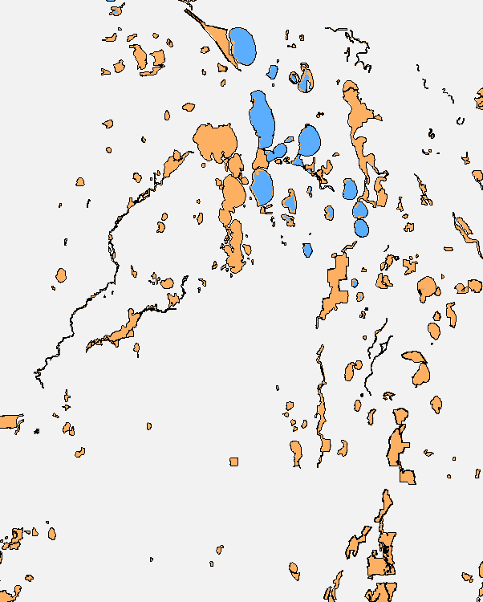

Figure 14. Landsat 5 image data from 9/1/2007 (path/row 94/85) with bands 5,4,2 in RGB (left) and corresponding classified map with wetland boundaries (black lines) overlaid (right). The blue areas represent ‘wet’ and orange areas represent ‘non-wet’. Grey areas are masked as outside mapped wetlands.

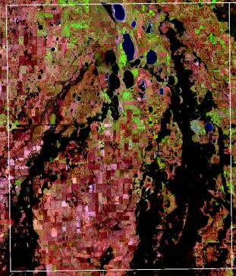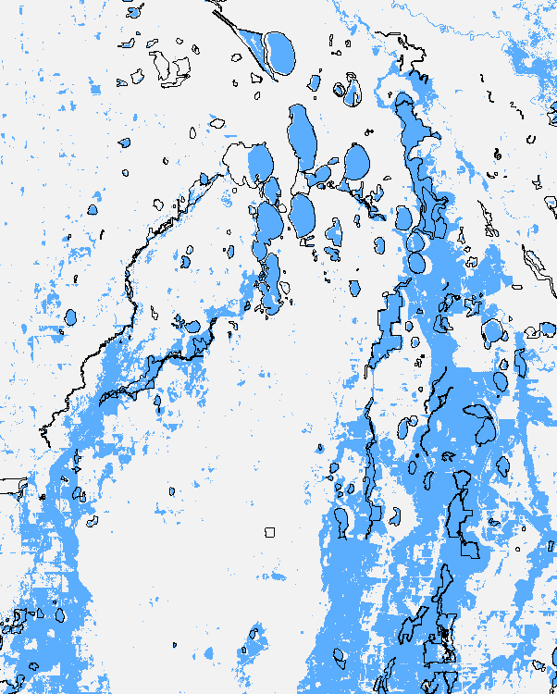

Figure 15. Landsat 5 image data from 20/1/2011 (path/row 94/85) with bands 5,4,2 in RGB (left) and corresponding classified image without masking of wetland boundaries (right). The blue areas represent “wet” areas.

3.2.3 Development of inundation histories for each wetland

The process described above generated one of three classifications (wet, dry, missing data) for every pixel in every Landsat image, which was then masked to the boundaries of wetlands in the inventory. Statistical analysis of these results enabled the development of two key products:

* raster datasets / maps showing the proportion of times that each pixel was subject to inundation and
* statistics for each wetland, describing the proportion of the wetland that was subject to inundation at each point in time (this can in in turn lead to assessment of the water regime category for each wetland).

This information was stored as digital files which record the classification results for each wetland/image and summaries of these. Summaries of area statistics for individual wetlands at each date were also calculated and stored.

Figure 16 provides an example of the raster datasets summarising the frequency of inundation over the eight year period from 1 January 2007 to 31 December 2014 in a sample of the pilot area. This pictorial summary was produced from 8 calendar years, but similar figures can be created from different periods or from aggregates of particular seasons over a number of years. When considering the spatial inundation summary products, it is important to note the following factors.

* Missing values from cloud (masked) and Landsat 7 SLC-off stripes mean the number of observations will vary according to location.
* The value summarised pictorially is the ‘percentage of overpasses where a pixel is classified as wet’ over the period. Missing values have been left out of the calculation so that only the number of observed values is considered at each pixel.
* The ‘striping’ evident in some wet areas in Figure 16 is a result of different numbers of missing values slightly affecting the percentage calculations. The missing strips in Landsat 7 are responsible for this.
* A separate image of number of observations at each pixel can be produce.d
* It is possible to generate similar summaries over different periods or for an aggregate of seasons over the assessment period.

Figure 17 provides several examples of the temporal summary plots available for each wetland. The temporal summary plots shows the percentage of the wetland area which is classified as wet over the period. The lengths of wet and dry periods in different years can be visualised from this temporal plots, as well as the dynamics of inundation. These temporal summary plots are produced for every wetland within the assessment area.

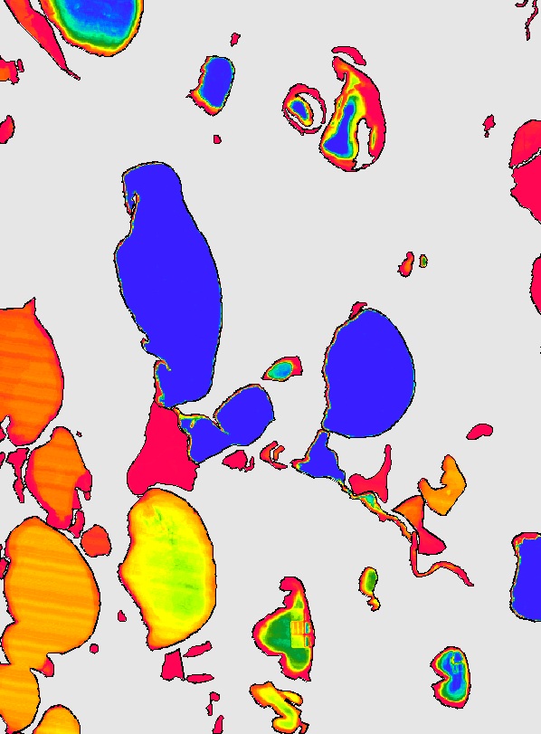

**Kangaroo Lake  
(wetland no. 43164)**

**Third Marsh  
(wetland no. 43143)**

**Lake Tuchewop  
(wetland no. 43158)**

**Red <10%**

**Orange/yellow 25%**

**Light green 50%**

**Dark green 65%**

**Light blue 80%**

**Dark blue >95%**

Figure 16. Percentage of wet observations summarised on a colour scale from red (low) to blue (high) from 2007 to 2014 in the pilot area.

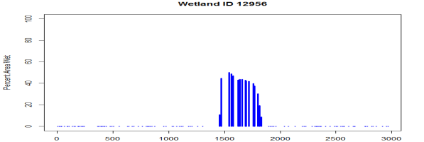

**Third Marsh (wetland no. 43143)**

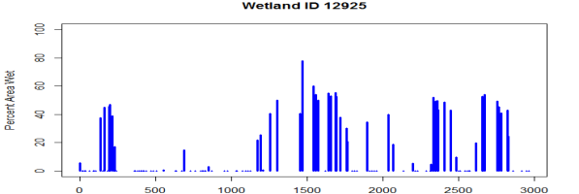

**Unnamed wetland (wetland no. 43112)**

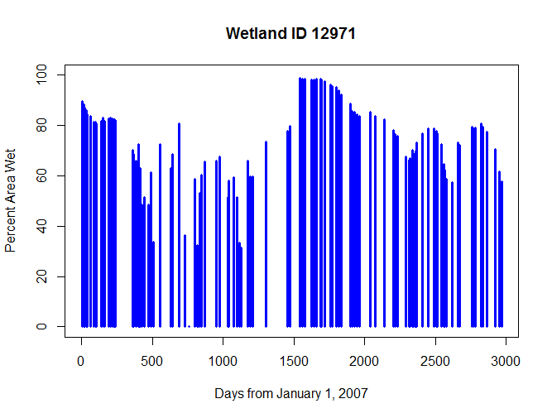

**Lake Tuchewop (wetland no. 43158)**

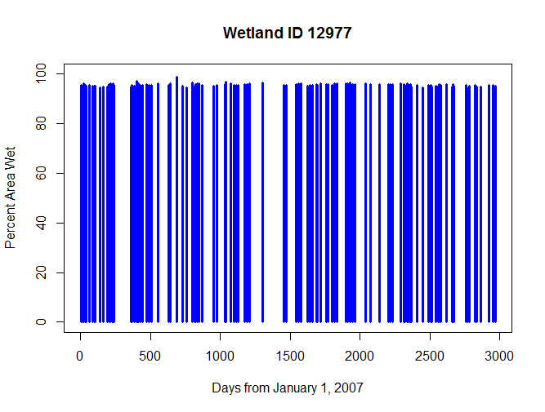

**Kangaroo Lake (wetland no. 43164)**

Figure 17.Examples of history of inundation percentage from January 2007 to March 2015 (116 images). Blue dots on X-axis indicate ‘100% dry’, gaps on the X-axis indicate periods of missing or cloudy imagery.

3.3 Implementation considerations

3.3.1 Advantages and limitations

The most notable advantage of the adopted approach is arguably that is builds upon freely available satellite imagery that is available across all of Victoria, extends back decades before present, and has a forward plan for ongoing acquisition. This provides a level of robustness to technological and data supply changes that is unparalleled amongst other optical remote sensing options.

As with any monitoring approach, the adopted method is subject to a number of important limitations. The key limitations of this method can be grouped into the following themes:

* errors of omission
* errors of commission
* frequency of imagery
* resolution and
* accuracy of wetland boundaries.

Each of these limitations is discussed further below.

Errors of omission

A common source of error in optical imagery analysis of inundation is vegetation cover over standing water, which can result in errors of omission[3]. For example, Wallace and Campbell (1998), in their review of National State of the Environment indicators, note that mapping extent of inundation of inland waters was feasible using Landsat, and for smaller wetlands using aerial photography, as the resolution of these products allows stands of vegetation to be differentiated from standing water. In contrast, the Moderate Resolution Imaging Spectroradiometer (MODIS) imagery was only suitable for very large wetland systems as it did not allow for differentiation of vegetation and standing water.

Following the completion of the pilot, a systematic evaluation was undertaken by the project team to examine the degree of errors of omission in the resulting data products (Alluvium 2015d). This evaluation focused on the influence of emergent vegetation and over-hanging tree canopy cover. In doing so, it focused on a variety of wetlands supporting the following types of plants:

* reeds and rushes
* grasses and herbs
* cane grass
* lignum and
* Swamp Paperbark.

The evaluation provided detailed findings at an individual wetland scale and has been reproduced as Appendix 1 to this report. The evaluation concluded the following about the adopted method.

* It reliably detects inundation in open areas of wetland (either unvegetated or supporting low, open herbaceous vegetation).
* It also appears to reliably detect inundation beneath woodlands (to open forest formations) dominated by River Red-gum and Black Box, and also in shrublands dominated by Tangled Lignum. However further work would be required to detect how it would interpret inundation under larger and denser, or more robust, patches of lignum.
* It does not appear to detect inundation beneath dense growths of Cumbungi, Common Reed or Swamp Paperbark. Presumably this will apply also to other denser scrubs such as those dominated by Scented Paperbark or Woolly Tea-tree.
* There are indications that it does not detect shallow inundation beneath denser patches of medium-sized graminoids (e.g. Sea Rush), however work would be required to determine at what levels of vegetation cover and water depth the method reaches these limitations.
* In general it appears that the method will detect that some water is present in the relevant wetlands, but in these instances the relative extent of inundation may not be reliably determined.

In light of these limitations, the implementation of the method across Victoria needs to take into account that indices might need to be calibrated differently in wetlands with these vegetation types, so that the wetland extent indicator in particular does not skew the results by suggesting the wetland area is reducing greatly, if in fact it is simply that the water isn’t being detected.

Errors of commission

As noted earlier, the adopted method used the single band 5 to identify the presence of inundation. This single band is known to classify both standing water and wet soil surface conditions as ‘wet’, and this was considered appropriate for this application. However, if the monitoring method sought to only identify areas of standing water, then the use of the single band 5 would in effect result in errors of commission as ‘standing water’ would be reported in areas that actually only experience wet soil.

It is noted that alternative approaches to classification could be employed in future using different indices, or multiple indices or decision tree approach using a fixed threshold. Future implementation could also consider alternative indices that incorporated other bands (i.e. not just band 5) if it is considered desirable to separate areas with standing water from those with wet soil surface conditions. This requires wetland experts to identify lakes meeting such scenarios. The identified lakes are then used as statistical training data by the analysis team. This analysis is consistent with the proposed methodology and can be performed within the effort allocated to the project in table 3 below .

Frequency of imagery

As described earlier, the frequency of available Landsat imagery is primarily a factor of its acquisition cycle (approx. 16 days or 23 scenes per year), the influence of cloud during scene acquisition, and the number of Landsat sensors acquiring data at any point in time. Other factors that also influence the frequency of available, albeit to a lesser degree, include the proportion of images stored in the ARG25 archive and the proportion of images affected by the ‘SLC-off’ issue.

The Landsat acquisition cycle, presence of cloud, number of operating sensors and impact of the ‘SLC-off’ issue are clearly well beyond the control of DELWP and its program partners. However, in implementing the adopted method across Victoria, DELWP could potentially influence the frequency of available imagery in the two ways described below.

* DELWP could address the discrepancy between Landsat imagery stored in the ARG25 and USGS archives, by advancing (or funding) work to download and process data from the USGS to ARG25 archive. Even though the pilot analysis was limited to Landsat images available in the ARG25 archive, the results demonstrate that it is still possible to derive a comprehensive temporal understanding of the inundation characteristics of most wetlands (refer Figure 16 for example). The state-wide implementation of the method should consider whether the additional imagery available in the USGS archive warrants the additional effort and resources required to source and process that data stream.
* DELWP could adjust the level of effort invested in cloud masking for different regions, so that regions that are heavily affected by cloud cover have more cloud masking work undertaken, in order to maximise the number of images available for use. The temporal summaries (refer Figure 17 for example) will be improved if the highest possible number of images is used. This will minimise impacts of missing data, and even more importantly, minimise the ‘temporal gaps’ in time series summaries so that wet and dry events can be better quantified.

Resolution

For small and narrow wetlands, the 25m pixel size of Landsat has the potential to affect detection and inundation area estimation. However, this is unlikely to be a major limitation given the focus of this method on wetlands > 1 ha, which equates to an area of > 16 Landsat pixels. Figure 18 illustrates this point, by showing the number of Landsat pixels that are fully contained within the wetland – any therefore not affected by signals from land surrounding the wetland – for 1 ha wetlands of different shapes. It demonstrates that even for the narrowest wetlands, at least four pixels, and generally more, would be expected to be fully contained within the wetland.



Figure 18. Illustration showing the number of 25 x 25 m Landsat pixels fully contained within 1 ha wetlands of different shapes. Dark blue cells represent Landat pixels that are fully contained within the wetland boundary and light blue cells represent Landsat cells that fringe the wetland border.

Accuracy of wetland boundaries

The adopted method has involved masking the wet/dry classification to individual wetlands and statistical analysis to examine the number of wet/dry pixels within each wetland. In doing so, this approach relies upon an accurate delineation of the wetland boundary. This limitation associated with inaccurate boundaries is likely to be most significant in the following circumstances.

* **Mapped wetland extent is smaller than the true on-ground extent**: Assuming a fixed wetland extent boundary, the method would identify inundation up to 100% of the wetland area, but would not identify the extent of inundation beyond the mapped extent. This outcome would be unlikely to significantly influence the water regime index, but would constrain the ability to accurately detect wetlands which increase in extent over time beyond their mapped extent. This scenario can be detected by examining the inundation beyond the mapped boundary using a buffered analysis, and flagging for each wetland when this occurs. Wetlands that raise multiple flags, that is inundation exceeds the boundary “regularly”, may be candidates for boundary redefinition. In addition to the flag, percentage of inundation can be recorded as a continuous variable with possible values exceeding 100%.
* **Mapped wetland is not centred on the true on-ground extent**: In these cases, there will be fewer Landsat pixels within the mapped wetland than if the wetland was correctly positioned, which is particularly the case for long and narrow wetlands (Figure 19). In light of the major updates undertaken on the Victorian geospatial inventory in recent years, this issue is no longer expected to affect many wetlands, so is likely to be a relatively modest limitation for the adopted method.



Figure 19. Derivation of Figure 18, showing the potential impact of a mapped wetland not being centred on the true-ground extent.

3.3.1 Implementation cost, resources and schedule

The state-wide implementation of the wetland extent and water regime monitoring is a substantive exercise, requiring users with proficiencies in the following skillsets:

* photogrammetry
* image processing
* bio-statistics and
* programming e.g. Python.

In addition to these areas of expertise, the method also requires a variety of specialist computer hardware and software, such as:

* ERMapper image processing software
* R statistical software (freely available at https://www.r-project.org)
* assorted CSIRO in-house programs
* high-end computational processors e.g. CSIRO’s cluster computers.

Table 4 presents a preliminary estimate of the personnel resources required for implementation of the method across Victoria over a single eight-year assessment period. This estimate indicates that the implementation cycle is likely to cost in the order of $260,000 to $310,000, depending on the intensity of the data collation and classification tasks.

Based on the preliminary estimates of time required for each task, Table 4 also outlines a proposed implementation schedule for the implementation. Implementation is likely to be best phased over a 24 month period, but could be brought forward if necessary. A longer implementation cycle may have considerable advantages in allowing DELWP to identify and collaborate with program partners, who may be able to build upon the analysis to develop related remote sensing outputs for different environmental indicators.

Table 4. Resources and schedule for state-wide implementation of the wetland extent and water regime monitoring method.

|  |  |  |  |
| --- | --- | --- | --- |
| Task | Person days required | Schedule | Comments |
| Data collation | 5 (or 15 with USGS) | Month 1 | Based on use of the ARG25 archive.  Use of extra images from the USGS archive would require an additional 10 days. |
| Cloud masking | 100 | Months 2 & 3 | Cloud masking only applied to images classes as ‘largely-cloud-free’ in the data archive where cloud is present as a relatively contiguous block. Images with clouds scattered throughout are excluded due to the significant additional time need per image for masking of these images. |
| Terrain illumination correction for hilly areas | 15 | Month 4 | Applies only to images with hills and other significant topography. Applies mainly to the southern part of the state. |
| Identification of wet areas i.e. classification | 60 – 90 | Months 5 - 12 | Apply automated thresholding method for all map sheets to map wetlands. Supervised QA to verify, validate and refine the classification. Following QA, apply wetland mask to map extent of each wetland in the inventory so that areas outside the mapped wetland are excluded. |
| Development of inundation histories for each wetland | 10 | Months 13 - 16 | Extract pixel information from the classified maps. Use R to perform statistical analysis for each wetland and generate the temporal plots. |
| Cluster wetlands into types based on time series responses | 15 | Months 17 - 20 | Format the pixel information from step above to suit the cluster analysis in R. Apply decision tree method to perform cluster analysis. Plot graphs. |
| Reporting | 12 | Months 21 - 24 | Report on all tasks performed in the project to include methodology, data, results achieved and discussion. |
| **Total days** | **217 - 257** |  |  |
| **Total budget** | **$260 -$308k** |  | **Average rate of $1,200/day** |

3.3.2 Potential supplementary approaches and data requirements

This project considered a range of potential methods for the monitoring of wetland extent and water regime, before adopting the method described above. While the adopted method is believed to best achieve the monitoring requirements at this point in time, there may be potential to supplement this method in future with new approaches and data.

**Synthetic Aperture Radar (SAR)** satellite data offer potentially useful capacity in the future. Historically, operational use has been of limited use due to cost of data, difficulties in data access and limited life of the sensors. Current generation high-resolution SAR satellites (e.g. TeraSAR-X, COSMO-Skymed, RADARSAT) can record land-surface observations even in the presence of clouds (this technology “sees-through” clouds), though produce a “noisy” looking image. These satellites may be tactically tasked (turned on) during the course of storms acquiring information on inundations in periods unavailable to optical sensors. However, for all the higher resolution sensors, the lack of long term archive, the need to ‘order in advance’ and the cost of the data are severe shortcomings for uses of this data for routine monitoring.

A promising SAR candidate is the recently-launched Sentinel-1 SAR system which promises a free access data policy and forward continuity. It may provide useful inundation information with which to complement optical data. Sentinel-1 is a ‘C-band’ system with a default mode resolution of 20 m; it is likely to detect water inundation under sparse tree cover, but not under dense vegetation (Zheng-shu Zhou, CSIRO, pers. comm.). Currently, in Australia, data access is limited but routine data acquisition by Geoscience Australia may commence within 2015. This is still under negotiation between Australian government and the European Space Agency. It is anticipated that monthly acquisitions may be available for Australia’s intensive land use zone, with more frequent coverage within the satellites’ capabilities.

4. Vegetation monitoring

4.1 Indicators

As outlined earlier, the monitoring of wetland vegetation sought to examine if there are broad‑scale changes in the structural composition of vegetation over time. Wetland vegetation in Victoria is classified in two ways:

1. Dominant vegetation categories assigned to each wetland under the Victorian wetland classification framework (Table 1)
2. Wetland Ecological Vegetation Classes (EVCs) which are designated on the basis of characteristics of the overall vegetation structure and composition (DSE 2012).

The Landsat-based methods applied for this project provided a means to monitor vegetation cover and/or greenness over long periods using spectral indices, but could not provide structural information on vegetation by itself. With this in mind, a ‘cover trends’ indicator was adopted to describe the spatial and temporal patterns in the vegetation cover of wetlands, but not trends in the structure or type of wetland vegetation.

Table 5. Dominant vegetation categories adopted for the Victorian wetland classification framework. Coastal saltmarsh includes both coastal saltmarsh and estuarine EVCs mapped by Boon et al. (2011).

|  |  |
| --- | --- |
| Dominant vegetation categories | Applicability to wetland system categories |
| Forest/woodland | Applicable for palustrine systems |
| Shrub | Applicable for palustrine systems |
| Sedge/grass/forb | Applicable for palustrine systems |
| Moss/heath | Applicable for palustrine systems |
| Mangrove | Applicable for marine or estuarine systems |
| Coastal saltmarsh | Applicable for palustrine, marine or estuarine systems |
| No emergent vegetation | Applicable for lacustrine, palustrine, marine or estuarine systems |
| Unknown | Applicable to all wetland systems (applied where no dominant vegetation category could be determined) |

4.2 Method

4.2.1 Overview

The selection of a suitable method for monitoring wetland vegetation followed the same process as for the monitoring of wetland extent and water regime i.e. literature review, development of criteria for evaluation, application of those criteria and ultimately trial application across a pilot area in northern Victoria (refer Section 0; Alluvium 2015e).

That work confirmed that in order to provide information relevant to vegetation structure (e.g. height, spatial arrangement and openness of canopy), field visits or very high resolution 3D information is required – with LIDAR and digital air photography being feasible sources to provide such information. However, a review of the Victorian geospatial data holdings confirmed that these data are only available at present over limited areas and limited dates in Victoria, and certainly not as time series of repeatable assessments. This ruled out the use of these data sources for the current method.

In the context of this finding, the adopted vegetation monitoring method utilised the same data source as the monitoring of wetland extent and water regime, namely Landsat TM imagery.

Landsat provides a proven means to monitor vegetation cover or greenness over long periods using spectral indices. However, Landsat cannot provide structural information on vegetation by itself. In extensive perennial vegetation systems, vegetation mapping may be sufficient to enable interpretation of changes from Landsat. As wetland vegetation is typically spatially variable and in small areas, ground visits, and high resolution imagery or 3D derivatives from it, could potentially be used to infer which components of vegetation have changed, with reference to the Landsat analysis.

Landsat may therefore be used as an indicator of change in cover of vegetation (direction and timing) at the sub‑hectare scale, but additional data would be required to infer whether the changes are affecting natural vegetation or particular strata of native vegetation.

The adopted vegetation monitoring method can be broken-down into a simplified three-step process where:

* satellite remote sensing imagery (in this case Landsat TM) is analysed to develop a vegetation cover index across the landscape over time
* the cover index values from each assessment are then analysed to determine their trend in change over time, using mean, linear trend and quadratic curvature equations of best fit and
* these results are aggregated to summarise the direction and timing of the index change across an individual wetland or a group of wetlands.

The following sections describe each of these three steps in detail, with relevance to how each step was applied during the pilot testing for this project.

4.2.2 Analysis of satellite remote sensing imagery

Data requirements, collation process and cloud masking

Given the adopted vegetation monitoring method utilises the same data source as the wetland extent and water regime monitoring, the data requirements, collation process and cloud masking described in Section 0 apply equally to this component of the method.

Identification of vegetation cover index values

In calculating the cover index, it is generally appropriate to adopt a sequence of images from the dry phases, to minimise dynamic short-lived changes from herbaceous components. As a consequence, the number of satellite images analysed will be much less for the vegetation monitoring when compared to the wetland extent and water regime monitoring. The vegetation monitoring will also have longer time periods between each assessment.

For the pilot application, images with summer dates from 2007 – 2015 were used. The flood images from 2011 were omitted as the vegetation signal in many areas is affected by the flooding or by herbaceous growth following the flood. Cloud-free single Landsat 5 and 8 images were chosen for preference, and where Landsat 7 was required in the date window mosaics of more than one date were used – even so, some missing values from Landsat 7 SLC-off image mosaics remain and resulted in some ‘striping effects’ in places.

Following the approach described in Lehmann et al. (2013) for the assessment of forest cover trends across the Australian continent, the cover index is calculated from a linear combination of Landsat bands 3 and 5.

Next, a six-band image consisting of statistical summaries is then calculated for each pixel using established regression techniques. The six statistical summary variables are as follows:

* mean value of index over time
* linear coefficient i.e. the estimated linear rate of change per year
* quadratic coefficient
* standard deviation from mean
* residual mean squared error from fitted linear model and
* residual mean squared error from fitted quadratic model.

Together these six statistical summaries describe the temporal changes and variability for each pixel in the assessment area. For instance, the magnitude of change over the long-term will be summarized by the linear coefficient. Each of these six statistical summaries can also be displayed in a variety of ways to highlight different aspects of the temporal response in vegetation.

It is important to note that vegetation cover changes on heavily modified land cover types may lead to dramatic changes in cover trends where these land covers intersects with wetland environments. In particular, agricultural areas change rapidly and often due to human management. Wetlands subject to agricultural land use are likely to experience major changes in their vegetation cover trends over time – analysis may choose to mask out these results if they unduly influence the regional interpretation of change in vegetation. Similarly, water bodies which dry and fill will also provide a vegetation cover change signal, and could also be masked out using the appropriate high water mask.

4.2.3 Development of vegetation cover trends for each wetland

The process described above generated a cover index value for every pixel in every Landsat image, which was then masked to the boundaries of wetlands in the inventory. Statistical analysis of these results enabled the development of two key products:

* raster datasets / maps indicating the direction and timing of the index change, as described by the six statistical summaries and
* statistics for each wetland, describing the change in cover index across that wetland over time.

The results are best examined through the VegMachine(R) software, which has been developed by CSIRO to graphically present the trends in cover index across time and space. It produces simple graphs and reports that show how ground cover has changed at user-specified locations.

Figure 20 provides an example of the raster datasets summarising the trend in cover index over the eight year period from 1 January 2007 to 31 December 2014 in a sample of the pilot area. It shows the Landsat image on the left with bands 5, 4 and 2 displayed in red, green and blue respectively. The image on the right is the corresponding trend image (2007-2015). In the wetland shown in the figure, the larger area of wetland vegetation shows some change patterns but is essentially stable. The colours in the two wetlands right of centre are from water level changes, while the small ‘red’ wetland above that appears now to be converted to farmland.

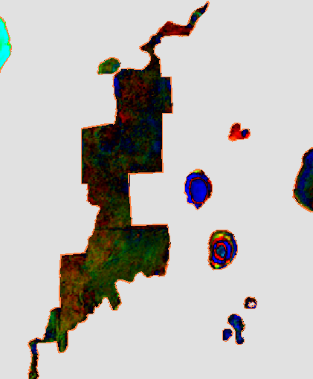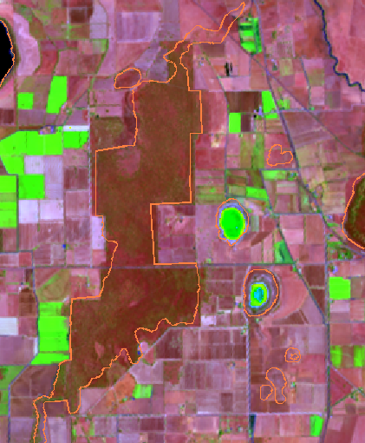

Figure 20. February 2015 image. Right: trend image 2007-2012. The larger area of wetland vegetation shows some change patterns but is essentially stable. The colours in the two wetlands right of centre are from water level changes. The small ‘red’ wetland above appears now to be farmland. Area shown approx. 7km by 8.5km.

4.3 Implementation considerations

4.3.1 Advantages and limitations

Advantages of the method include that it is cost effective, provides consistency in metrics temporally and geographically, and provides synoptic assessment at state and local scale. It is also easy to use for land managers and the use of software like Vegmachine® allows comparative study of control and test sites.

The limitations of the method are that it does not distinguish between different vegetation types, has no vertical metric of structure, and highlights change but does not attribute the cause of it. Ground visits to sites are therefore necessary to establish the causes of change.

4.3.2 Implementation cost, resources and schedule

The trend information is based on a dry season subset of the Landsat time series considered in Section 3. The first three steps of the procedure in section 3 do not need to be reapplied, and appear as greyed inTable 6. Of the remaining steps, step 5 may not need to be applied if the Department is satisfied with the satellite index used in this pilot study, otherwise extra sites may be included to refine the results based on further wetland samples.

We note that the Commonwealth Department of Environment have a similar national program for vegetation trends. The approach demonstrated in this report uses the same methodology. The lowest cost approach for the state would be to build on this information, with the remaining requirement to perform steps 7 and 8 in Table 6: Derivation of monitoring products and Reporting. The advantages of this approach are firstly cost and secondly consistency with the national program. As the national program is aimed at consistent results in woody vegetation at the national scale, the potential drawbacks include: 1) sub-optimality of the analytical method for wetland vegetation in Victoria; and 2) mismatch between reporting periods and timing requirements.

Table 6 presents a preliminary estimate of the personnel resources required for implementation of the method across Victoria over a single eight-year assessment period.

Table 6. Resources and schedule for state-wide implementation of the vegetation monitoring method.

|  |  |  |  |
| --- | --- | --- | --- |
| Task | Person days required | Schedule | Assumptions |
| Data collation | 5 (or 15 with USGS) | Month 1 | Based on use of the ARG25 archive. Use of extra images from the USGS archive would require an additional 10 days |
| Cloud masking | 100 | Months 2 & 3 | Cloud masking only applied to images classes as ‘largely-cloud-free’ in the data archive where cloud is present as a relatively contiguous block. Images with clouds scattered throughout are excluded due to the significant additional time need per image for masking of these images. |
| Terrain illumination correction | 15 | Month 4 | Applies only to images with hills and other significant topography. Applies mainly to the southern part of the state. |
| Compositing of images | 20 | Month 5 | Multiple dry phase images from consecutive months are combined to form one image with minimal cloud. |
| *Analysis of ground and satellite data | 20 | Months 6-9 | Victorian government provides samples of wetlands with default index for possible improvement. |
| Processing of archive | 5 | Months 10 | Dry season images only. |
| Derivation of monitoring products | 20 | Months 11 | Outputs will be in agreed format e.g. BIL, GeoTiff |
| **Reporting | 5-10 | Months 12 | **-** |
| **Total days** | **50-75** |  |  |
| **Total budget** | **$60-90k** |  | **Average rate of $1,200/day** |

*step not required if using existing index. ** only 5 days required (analysis not required)

4.3.3 Potential supplementary approaches and data requirements

This project considered an established and widely applied method for the monitoring of vegetation trend. While the adopted method is believed to best achieve the monitoring requirements at this point in time, there may be potential to supplement this method in future with new approaches and data.

**Synthetic Aperture Radar (SAR)** satellite data offer potentially useful capacity in the future. Historically, operational use has been of limited use due to cost of data, difficulties in data access and limited life of the sensors. Current generation high-resolution SAR satellites (e.g. TeraSAR-X, COSMO-Skymed, RADARSAT) can record land-surface observations even in the presence of clouds (this technology “sees-through” clouds), though produce a “noisy” looking image. For all the higher resolution sensors, the lack of long term archive, the need to ‘order in advance’ and the cost of the data are severe shortcomings for uses of this data for routine monitoring.

A promising SAR candidate is the recently-launched Sentinel-1 SAR system which promises a free access data policy and forward continuity. It may provide useful information which to complement optical data. Sentinel-1 is a ‘C-band’ system with a default mode resolution of 20 m; it can detect grasses and tree canopy and distinguish these from bare ground and water. However, it may have problems distinguishing between vegetation types including the distinction of tree canopy from grasses. Currently, in Australia, data access is limited but routine data acquisition by Geoscience Australia may commence within 2015. This is still under negotiation between Australian government and the European Space Agency. It is anticipated that monthly acquisitions may be available for Australia’s intensive land use zone, with more frequent coverage within the satellites’ capabilities.

Another promising SAR candidate system is PALSAR, which is an L-bands instrument with a better ability to distinguish between wooded and non-wooded vegetation.

**Aerial Photogrammetry** offers land cover extent and height information that may be used to supplement knowledge of the wetland as well as monitoring of spectral and spatial indices. This approach may be cost effective when coordinated with state/regional aerial photography campaigns. Given the latter point, the frequency of acquisition would not be as frequent as satellite observations, but one acquisition in the assessment period may be expected for many parts of the state.

**Aerial LiDAR** offers land cover extent and height information that may be used to supplement knowledge of the wetland as well as monitoring of spectral (typically photography from medium resolution is acquired along with the LiDAR) and spatial indices. This approach may be cost effective when coordinated with state/regional aerial photography campaigns. This form of data is typically less frequently acquired than aerial photography.

5. Evaluation and reporting framework

5.1 Frequency of evaluation and reporting

The *Victorian Waterway Management Strategy* (DEPI 2013b) provides the policy direction for managing Victoria's waterways through the ‘Victorian Waterway Management Program’. The ‘Victorian Waterway Management Program’ adopts an eight-year adaptive management cycle[4] where learning occurs at all stages and is used to update and improve the program in subsequent cycles (Figure 21).

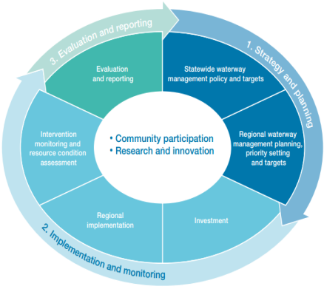

Figure 21. The eight-year adaptive management cycle of the Victorian Waterway Management Program (DEPI 2013b).

Accordingly, it is intended that results from the monitoring methods developed through this project be reported on every eight-years. Note that even though reporting is proposed every eight years, the assessment can also allow reporting on the frequency of inundation over successive ten-year periods up to the maximum number of years of Landsat data collection (i.e. 25 years in 2016).

5.2 Spatial units of evaluation and reporting

Fundamentally, the monitoring seeks to understand whether any particular wetland types are changing their water regime/extent/vegetation, and if so, is this occurring uniformly across the state or is it occurring in particular parts of the state? Spatial units of evaluation and reporting are therefore required to aggregate assessments of the change in extent, water regime and vegetation at individual wetlands to a broader spatial unit – this spatial unit needs to be both ecologically meaningful and relevant to administration of natural resource management in Victoria.

The spatial unit should also present aggregated results in a way that facilitates interpretation of possible causes in any trends detected. Such factors that could drive changes in these trends include:

* climate change i.e. change in rainfall, temperature and sea level
* land use change, especially through impacts on vegetation and topography through agriculture and/or development
* surface water resource use i.e. change in flow regimes and number of farm dams and
* groundwater resource use i.e. change related to lowering or rising water tables.

Wetlands in Victoria can be grouped into clusters of similar ecological function using the:

* wetland type assigned to each wetland in the inventory (refer to Table 1.
* wetland landscape profiles developed for Victoria (Figure 22), which facilitates differentiation between wetlands of the same type based on regional differences in factors such as climate, landform, drainage patterns and topography. In doing so, wetland regionalisation implicitly accounts for many of the factors likely to drive change in trends as listed above.

On the administrative front, wetlands in Victoria are best grouped into clusters of administrative and management arrangements using the jurisdictional boundaries of the catchment management authorities.

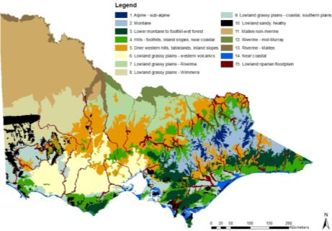

Figure 22. Victorian wetland regionalisation based on wetland landscapes spatial layer (DELWP 2016).

It is therefore proposed that a combination of catchment management authority boundaries, the wetland regionalisation dataset and wetland type classification would provide a good spatial reporting unit to document changes in wetlands in Victoria over time (Figure 23). Reporting would therefore be every eight years and be by wetland type for each wetland landscape (e.g. Montane) for each CMA and for Victoria as a whole. Reporting of changes in individual wetlands would be possible from the method described in this report, but is not intended to be a core component of the reporting framework.

Figure 23. Composition of the spatial reporting units.

5.3 Alignment with the Victorian wetland classification framework

In accordance with the water regime categories shown in Table 3, reporting of wetland change would adopt the previously described spatial units, and be framed around the two primary water regimes:

* permanent wetlands and
* periodically inundated wetlands.

5.3.1 Permanent wetlands

For permanent wetlands, the water regime category/subcategory indicator (refer to Section 0) would be used for reporting on wetland extent and water regime. This indicator would be used to show the change in wetland extent (relative and absolute) of permanent wetlands over the preceding 10 year period for all wetlands within each wetland regionalisation in each CMA – note as each wetland type has a direct relationship to a water regime category it is not necessary to report based on wetland type in this instance. The same changes could be reported in total (i.e. for all wetland regionalisations combined) for each CMA and for the entire state.

Figure 24 provides an example of how this reporting could be presented to show relative and absolute changes in water regime category– this example represents the results for a single wetland region within a single CMA.

For permanent wetlands, the ‘cover trends’ indicator (refer to Section 0) could also be used to report change in vegetation cover within the same regionalisation over the same period, also assessing relative and absolute changes.

5.3.2 Periodically inundated wetlands

For periodically inundated wetlands, all four wetland extent and water regime indicators (refer to Section 0) and the cover trends’ indicator (refer to Section 0) would be used. These indicators include the:

* water regime category/subcategory
* frequency of inundation i.e. number of years in 10 that a wetland ‘holds water’
* duration of inundation i.e. number of months that a wetland ‘holds water’ for before drying
* duration between inundation i.e. number of months between periods when the wetland ‘holds water’ and
* vegetation cover trends’.

Reporting would be of the trend in each of these indicators for all wetlands combined of a single wetland type within each wetland regionalisation in each CMA. These trends could be reported in total (i.e. for all wetland regionalisations combined) for each CMA and for the entire state.

Some examples of how this reporting could be presented for changes in water regime category, frequency of inundation, duration of inundation and extent of inundation are provided in Figure 25, Figure 26, Figure 27 and Figure 28 respectively – these examples represent the results for a single wetland region within a single CMA.

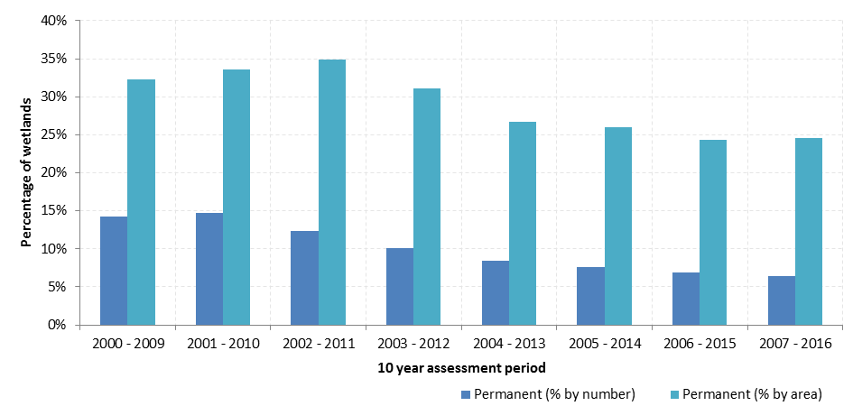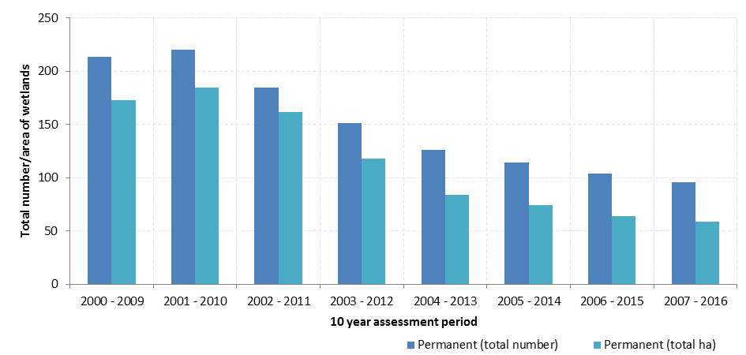

Figure 24. Example of reporting on relative (above) and absolute (below) changes in extent of permanent wetlands.

Note: These figures show the total number and area of permanent wetlands based on an assessment of water regime over each 10 year assessment period. In this example, the number of permanent wetlands decreased from 214 based on analysis of 2000 - 2009, to 96 based on analysis of 2007 - 2016.

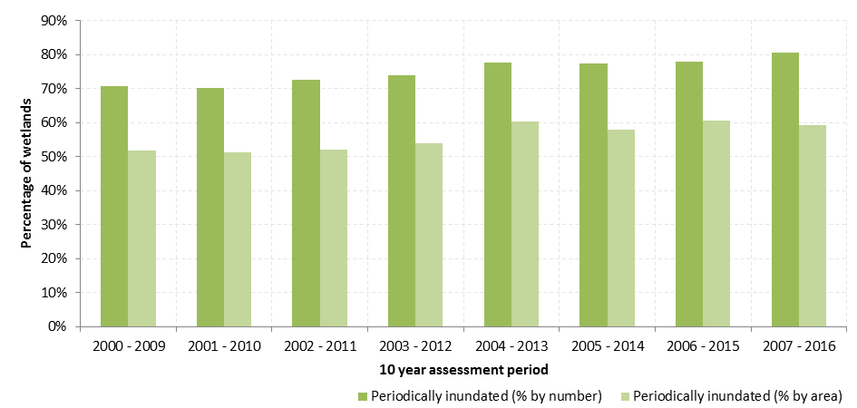

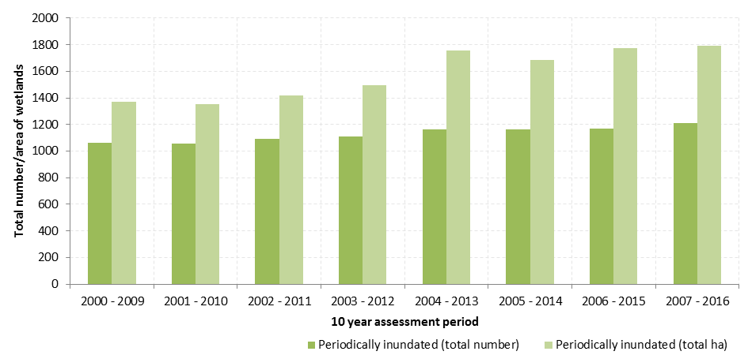

Figure 25. Example of reporting on relative (above) and absolute (below) changes in extent of periodically inundated wetlands.

Note: These figures show the total number and area of periodically inundated wetlands based on an assessment of water regime over each 10 year assessment period. In this example, the number of periodically inundated wetlands increased from 1061 based on analysis of 2000 - 2009, to 1,209 based on analysis of 2007 - 2016.

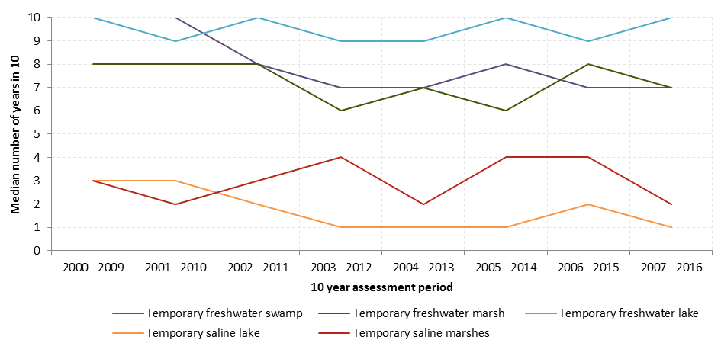

Figure 26. Example of reporting on changes in frequency of inundation of periodically inundated wetlands.

Note: This figure shows the median number of years in 10 that wetlands of each wetland type held water. In this example, the median frequency of inundation of temporary freshwater marshes moved from 8 years over 2000 - 2009 to 6 years over 2003 - 2012.

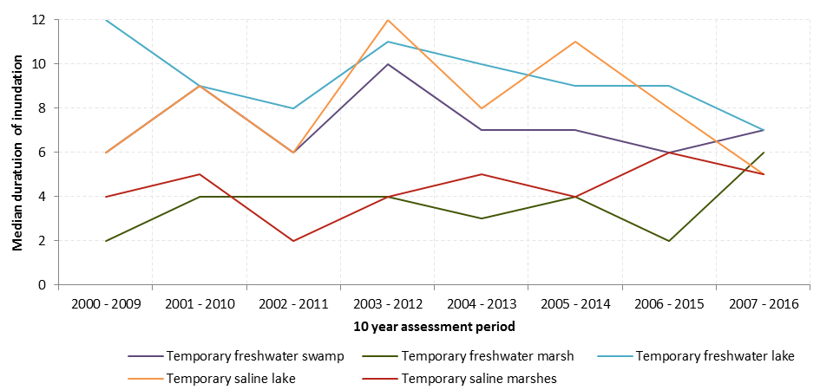

Figure 27. Example of reporting on changes in duration of inundation of periodically inundated wetlands.

Note: This figure shows the median duration (in months) that wetlands of each wetland type held water. In this example, the median duration of inundation of temporary freshwater marshes moved from 2 months over 2000 - 2009 to 4 months over 2003 – 2012.

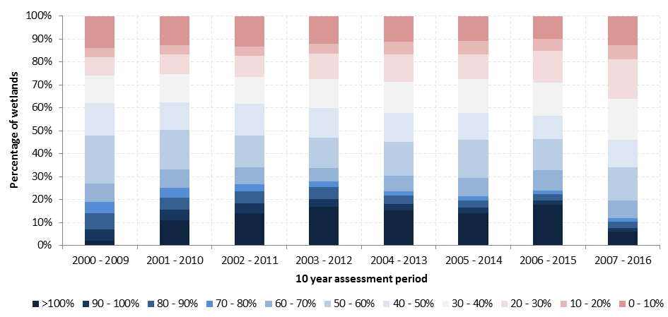

Figure 28. Example of reporting on changes in extent of inundation of periodically inundated wetlands.

Note: This figure shows the percentage number of wetlands where the maximum inundation cover fell into each 10% cover band over the ten year assessment period. In this example, from 2000 - 2009 only 2% of wetlands had a maximum inundation exceeding 100% of their wetland extent (i.e. floodwaters continued beyond the wetland boundary), whereas this increased to 14% over the 2002 - 2011 period.

1. Conclusion

The Department of Environment, Land, Water and Planning (DELWP) is responsible for policy development with regard to the management of wetlands in Victoria. To fulfil its policy role, DELWP is seeking to better understand the ongoing status of different types of wetlands in Victoria and to identify and investigate threatening processes that are contributing to loss of wetland habitat or changes in wetland type.

To inform this, DELWP commissioned a project by Alluvium Consulting Australia in partnership with CSIRO to develop an efficient and affordable method to monitor changes in the extent and type of wetlands in Victoria. In doing so, this work advances Action 12.13 of the *Victorian Waterway Management Strategy*. The outcomes from the project will be used to improve wetland monitoring in Victoria, assist in updating wetland attributes in the Victorian geospatial wetland inventory and improve the hydrology measures in the Index of Wetland Condition method.

The developed monitoring approach builds upon Victoria’s geospatial wetland inventory, which maps the distribution and extent of approximately 35,500 wetlands in Victoria and identifies that 25,500 of these are naturally occurring wetlands. The scope of the monitoring approach focused on naturally occurring wetlands greater than or equal to 1 ha in size – this represents over 80% of all mapped naturally occurring wetlands across Victoria. Although the focus is on naturally occurring wetlands, the approach provides a method and framework that could well be equally applied to human-made wetlands.

The temporal assessment cycle for the developed monitoring approach is consistent with policy 17.5 of the *Victorian Waterway Management Strategy*, with reporting occurring every eight years (subject to available funding), based upon annual (or more frequent) temporal assessments.

6.1 Indicators

The monitoring approach is based on the following set of indicators, that when considered together, will describe changes in the extent and type of wetlands in Victoria over each eight year reporting cycle.

* **Extent index:**
  + maximum inundation, i.e. maximum inundated area over the assessment period, expressed relative to the historical maximum inundation extent.
* **Water regime index:**
  + water regime category/subcategory, which is a function of the frequency of inundation and duration of inundation
  + frequency of inundation i.e. number of years in 10 that a wetland ‘holds water’
  + duration of inundation i.e. number of months that a wetland ‘holds water’ for before drying and
  + duration between inundation i.e. number of months between periods when the wetland ‘holds water’.
* **Vegetation index:**
  + vegetation ‘cover trends’ i.e. assessment of the vegetation cover of wetlands.

6.2 Method

The selection of the method for monitoring was informed by a review of the Australian and international literature, the development and evaluation of criteria to assess the suitability of different options for use in Victoria and a trial application of a method across a pilot area in northern Victoria.

Through this process, a remote sensing approach was adopted that utilised optical remote sensing data to classify standing water (which informed the extent index and water regime index) and to assess vegetation cover and character (which informed the vegetation index). In particular, the adopted method draws upon Landsat Thematic Mapper imagery, which has the following key advantages.

Landsat data is collected regularly, covers all of Victoria, it is archived since 1988 (TM data).

Landsat data is free and is available in consistently processed form from US and Australian archives.

Landsat has a forward plan for ongoing acquisition.

It is proven as the basis for operational vegetation and inundation monitoring systems in Australia.

At its simplest, the monitoring method can be broken-down into a simplified three-step process where:

1. satellite remote sensing imagery (in this case Landsat TM) is analysed to delineate the presence of water across the landscape and examine vegetation cover over time
2. this data is then used to quantify the temporal and spatial distribution of water in each wetland, and analyse vegetation trends over time and
3. this data is then used to analyse the change in the maximum extent of inundation, the change in the frequency and duration of inundation and the change in vegetation cover.

The most notable advantages of the monitoring approach are arguably that it:

* builds upon freely available satellite imagery that is available across all of Victoria
* extends back decades before present and has a forward plan for ongoing acquisition
* is cost effective – implementation is estimated to cost in the order of $230,000 to $400,000 for assessment of all metrics, depending on the intensity of the data collation and classification tasks
* provides consistency in metrics temporally and geographically and
* provides synoptic assessment at state and local scale.

This provides a level of robustness to technological and data supply changes that is unparalleled amongst other optical remote sensing options. However, like all methods there are limitations, most notably:

* vegetation cover over standing water can result in errors of omission, with the extent of inundation particularly difficult to identify beneath dense growths of Cumbungi, Common Reed or Swamp Paperbark and under dense patches of medium-sized graminoids (e.g. Sea Rush)
* it does not distinguish between different vegetation types and has no vertical metric of vegetation structure and
* it highlights change but does not attribute the cause of it.

In light of these advantages and limitations, the adopted method will substantially advance DELWP’s understanding of the ongoing status of different types of wetlands. This will provide major insights into the threatening processes that are contributing to loss of wetland habitat or changes in wetland type, allowing more targeted and effective wetland management programs.

# References

Alluvium 2015a. Literature review to inform methods for the long-term monitoring of wetlands in Victoria. Report P114123R01 by Alluvium Consulting Australia for Department of Environment, Land, Water and Planning, East Melbourne.

Alluvium 2015b. Criteria and recommendation of methods for the long-term monitoring of wetlands in Victoria (draft). Report P114123R02 by Alluvium Consulting Australia for Department of Environment, Land, Water and Planning, East Melbourne.

Alluvium 2015c. Preliminary results of Landsat inundation analysis from the demonstration study for methods for the long-term monitoring of wetlands in Victoria (draft). Report P114123R03 by Alluvium Consulting Australia for Department of Environment, Land, Water and Planning, East Melbourne.

Alluvium 2015d. Further testing of Landsat inundation analysis from the demonstration study for methods for the long term monitoring of wetlands in Victoria (draft). Report P114123R03b by Alluvium Consulting Australia for Department of Environment, Land, Water and Planning, East Melbourne.

Alluvium 2015e. Preliminary results of vegetation analysis from the demonstration study for methods for the long term monitoring of wetlands in Victoria (draft). Report P114123R04 by Alluvium Consulting Australia for Department of Environment, Land, Water and Planning, East Melbourne.

Alluvium 2011. Statewide wetland geospatial inventory update project outcomes. Report P111012R02 by Alluvium for Department of Sustainability and Environment, East Melbourne.

Corrick and Norman 1976. A report on a survey of the coastal wetlands of south-eastern Australia. Fisheries and Wildlife Division, Ministry for Conservation. Unpublished.

DELWP 2016. The Victorian wetland classification framework 2014. Department of Environment, Land, Water and Planning, East Melbourne, Victoria

DEPI 2014. Request for Quotation and Project Specification for the Method for the long-term monitoring of wetlands in Victoria, Department of Environment and Primary Industries, September 2014.

DEPI 2013a. Index of Wetland Condition Assessment Procedure September 2013. Department of Environment and Primary Industries, East Melbourne, Victoria

DEPI 2013b. Victorian Waterway Management Strategy.

DSE 2013. Indicative assessment of climate change vulnerability for wetlands in Victoria. Department of Sustainability and Environment. East Melbourne. <http://www.depi.vic.gov.au/water/rivers-estuaries-and-wetlands/wetlands>.

DSE 2012. Index of Wetland Condition assessment of wetland vegetation update – December 2012. Department of Sustainability and Environment, East Melbourne, Victoria. <http://ics.water.vic.gov.au/ics/files/IWC_Assessment-of-Wetland-Vegetation-Update_December_2012.pdf>

Ecosystems Management 2006. Comparison between 1788, 1994 and 2005 wetland mapping. Report for the West Gippsland Catchment Management Authority, 15 September 2006.

Johnston, R.M. and Barson, M.M. 1993. Remote sensing of Australian wetlands: an evaluation of Landsat TM data for inventory and classification. Aust J Marine and Freshwater Research, 44, 235-52.

Kingsford, R. T. & Thomas, R. F. 2002. Use of satellite image analysis to track wetland loss on the Murrumbidgee River floodplain in arid Australia, 1975-1998. Water Science and Technology 45(11):45-53.

Kingsford, R. T. & Thomas, R. F. 2004. Destruction of wetlands and waterbird populations by dams and irrigation on the Murrumbidgee River in Arid Australia. Environmental Management, 34, 383-396.

Kingsford, R.T., Brandis, K., Thomas, R., Crighton, P. Knowles, E. and Gale, E. 2003. The Distribution of Wetlands in New South Wales.

Lehmann, E., [Wallace](http://www.researchgate.net/researcher/2032898255_Jeremy_F_Wallace), J., [Caccetta](http://www.researchgate.net/researcher/70673015_Peter_A_Caccetta),P., [Furby](http://www.researchgate.net/researcher/2007003595_Suzanne_L_Furby), S., [Zdunic](http://www.researchgate.net/researcher/2032846553_Katherine_Zdunic), K. 2013. [Forest cover trends from time series Landsat data for the Australian continent.](http://www.researchgate.net/publication/257129083_Forest_cover_trends_from_time_series_Landsat_data_for_the_Australian_continent) International Journal of Applied Earth Observation and Geoinformation. Vol. 21, pp 453-462.

Papas, P. and Moloney, P. 2012. Victoria’s wetlands 2009–2011: statewide assessments and condition modelling. Arthur Rylah Institute for Environmental Research Technical Report Series No. 229. Department of Sustainability and Environment, Heidelberg.

Van Dongen, R. J., G. A. Behn, M. Coote, A. Shanahan, and H. Setiawan. 2012. “Hydroperiod classification of cervantes coolimba coastal wetlands using Landsat time series imagery.” ISPRS - International Archives of the Photogrammetry, Remote Sensing and Spatial Information Sciences XXXIX-B8 (July 28, 2012): 199–202.

Wallace, J.F. and Campbell, N.A. 1998. Evaluation of the feasibility of remote sensing for monitoring national State of the Environment Indicators. Australia: State of the Environment Technical Paper Series, Dept of Environment, Canberra.

Winning, G. 1997. The Functions & Width of Wetland Buffers. Hunter Wetlands Research; Technical Memorandum No. 1.

Appendix 1: Evaluation of the wetland extent and water regime monitoring method

Introduction and scope

This appendix reports on the evaluation of the wetland extent and water regime method, with a particular focus on the ability to detect water in wetlands with emergent vegetation and in wetlands with over-hanging tree canopy cover.

The wetlands used for this further testing were identified by DELWP; some of these wetlands were within the previous demonstration area and others outside it (refer map below). This report presents the temporal inundation history plot for each of the selected wetlands in demonstration area; for those wetlands outside the existing demonstration area, multiple dry/wet single-date classifications are provided.

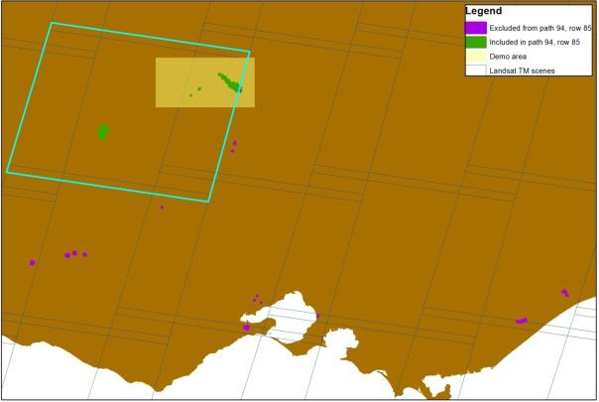

Map showing the wetlands selected by DELWP for further testing (path/row 94/85 highlighted in light blue).

Data sources and method

The selected wetlands span across five different Landsat images (Table A). To test the ability of the inundation analysis method under different environmental conditions, Landsat images for each path/row were acquired for three different dates (Table A) and analysed using the method described in Section 0 of the main report.

Table A. Landsat path/row of selected wetlands.

|  |  |  |  |  |  |
| --- | --- | --- | --- | --- | --- |
| Image path/row | Corresponding wetland IDs | Vegetation type (DELWP) | | Date of images acquisition | |
| 91/86 | 95970 McLeod Morass  90998 Dowd Morass | | Reeds  Various vegetation | | 24/1/2007, 14/7/2007, 4/10/2008 |
| 93/85 | 44745 Tang Tang Swamp  44740 Thunder Swamp | | Grasses and herbs  Grasses and herbs | | 21/1/2008, 29/7/2013, 5/11/2014 |
| 93/86 | 70425 Baths Swamp  70083 Unnamed  70434 Unnamed  54577 Reedy Lake  70988 Seaford Swamp | | Cane grass  Cane grass  Cane grass  Reeds  Various vegetation | | 8/3/2008, 29/7/2013, 2/11/2013 |
| 94/85 | 40516 Lake Buloke | | Cane grass | | 9/1/2007, 20/7/2007, 25/11/2013 |
| 94/86 | 31816 Mount William Swamp  31850 Lake Buninjon  31808 Lake Muirhead  26609 Bryan Swamp  41603 Bradshaw Swamp | | Cane grass  Cane grass  Cane grass  Grasses and herbs  Grasses and herbs | | 25/1/2007, 6/9/2007, 19/10/2011 |
| 94/85 | 45303 Gunbower Island State Forest  43236 Tragowel Swamp  43204 Unnamed | | Various vegetation  Lignum swampy woodland  Lignum swampy woodland | | Many - temporal history plots available |

The vegetation type attributed to the respective wetland by DELWP is also included in Table A. It is important to note that the DELWP vegetation classifications appear to be largely based on modelling or broad-scale mapping exercises, and their reliability/accuracy is far from assured. In addition, the vegetation classification does not provide any information on variation of the vegetation cover within the wetland. In some cases the reviewer had or was able to locate additional information on the vegetation of the respective wetland, whereas in others only Google Earth satellite imagery was used to attempt further clarification of characteristics of the vegetation cover.

Interpretation of three-image classification

95970 McLeod Morass

Denser areas of vegetation within this wetland are believed to be dominated by tall graminoids, in particular Cumbungi, which has invaded Giant Rush stands due to nutrient enrichment and altered hydrology. The method is clearly detecting water if it is present in open or lightly vegetated areas, but is apparently not detecting water beneath the Cumbungi stands.

Date: 14/7/2007 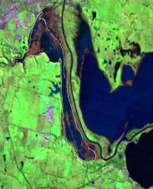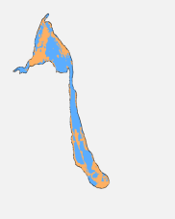  
Date: 4/10/2008 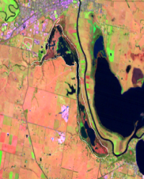 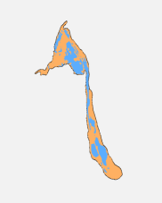  
Date: 24/1/2009 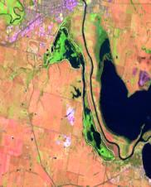 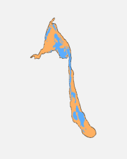

90998 Dowd Morass

The wetland includes extensive areas of largely open water. It also includes extensive areas dominated by Common Reed or Swamp Paperbark, particularly in the eastern portion. A range of more restricted vegetation assemblages are also present, with brackish sedgy-herbaceous vegetation being the most extensive of these. The method appears to be detecting inundation or lack thereof in open areas and low wetland vegetation, but not beneath denser stands of Swamp Paperbark or Common Reed, except perhaps when the latter is more deeply inundated in places where it is more on the edge of its tolerance. Both Dowd Morass and Heart Morass to the immediate north are clearly in deep flood in the 2007 imagery. In this imagery it is clear that inundation is extending across the more marginal brackish wetlands, confirming that the habitat of the reedbeds and paperbark scrubs would be inundated, but the canopy is obscuring the detection of the underlying water.

Date: 14/7/2007 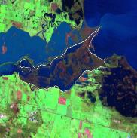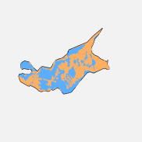  
Date: 4/10/2008 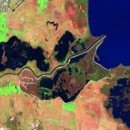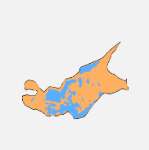  
Date: 24/1/2009 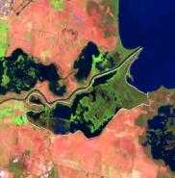 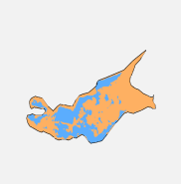

44745 Tang Tang Swamp

Much of the vegetation comprises an open woodland dominated by River Red-gum with a grassy-herbaceous ground-layer. Lower-lying open area are variously dominated by Southern Cane-grass, Common Swamp Wallaby-grass, or small herbs. The method appears to be reliably detecting water or the dry condition within the deeper parts of the wetland. It is presumed that the wetland was only partially full during the wettest conditions recorded in these images, rather than that parts of the open woodland provided any impediment to detecting underlying water.

Date: 21/1/2008 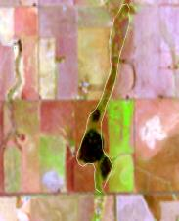 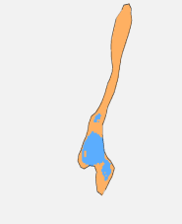  
Date: 29/7/2013 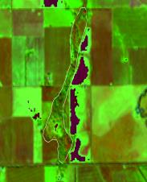 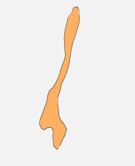  
Date: 5/11/2014 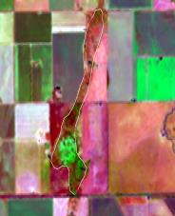 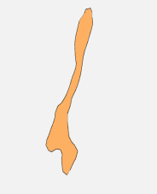

44740 Thunder Swamp

It is noted that the provided outline of the wetland is not consistent with the actual location, being displaced to the south. The wetland appears to be divided along a north-south axis according to management history. A mosaic of clumped vegetation is apparent on the eastern side of the wetland. While this pattern appears suggestive of a shrubland dominated by Tangled Lignum, the actual identity of this plant is not known to the reviewer. It is clear however that this vegetation has not impeded the detection of inundation in the relevant imagery.

Date: 21/1/2008 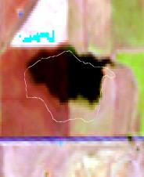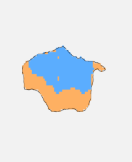  
Date: 29/7/2013 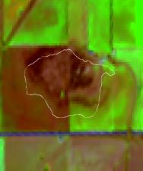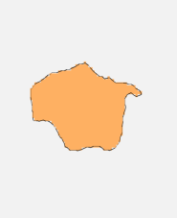  
Date: 5/11/2014 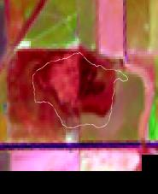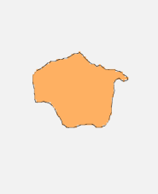

70425 Baths Swamp, 70083 Unnamed and 70434 Unnamed

Wetland 70083 previously supported areas dominated by Southern Cane-grass, variously in association with shrubland dominated by Tangled Lignum. It has been heavily grazed to the point where the diversity and cover of native species has been greatly reduced. Only a small proportion of the wetland is detected as inundated in only one of the images. It is considered probable that this assessment is reliable given the degraded character of the ground-layer. Wetland 70425 appears to support denser growth of lignum, with red gum fringes and patchy open areas in deeper central areas. Inundation was detected over at least a substantial portion of this wetland. Wetland 70434 is presumably dominated/co-dominated by either a range of grasses characteristic of lower rainfall versions of Plains Grassy Wetland, potentially including components of Southern Cane-grass and Tangled Lignum, or possibly Rushes (*Juncus* spp.). Without further information, there appears to be no basis to comment on whether or not the method would detect shallow inundation of the grassy or rushy wetland vegetation at site 70434.

Date: 8/3/2008 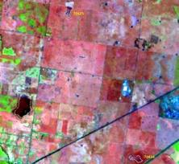 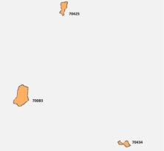  
Date: 29/7/2013 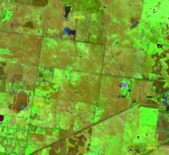 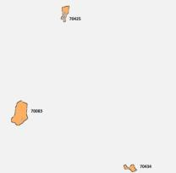  
Date: 2/11/2013 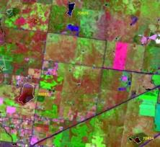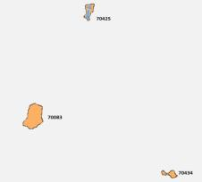

54577 Reedy Lake

This wetland is reported as including areas of open water and reedbed dominated by Common Reed, with the edges including saltmarsh, sedgeland and lignum. While the outer edge of the wetland appears accurately determined, the internal line work within the wetland area does not appear to relate well to on-ground features. The method appears to be determining whether the open areas and low vegetation are inundated or not, but is apparently not detecting water beneath the reeds except perhaps in peripheral areas where they are more deeply inundated and perhaps declining. The extent of detected inundation varies between the different images - this appears in part due to variation in the extent of inundation of more open areas and partly due to changes in the cover of Common Reed between different sampling times.

Date: 8/3/2008 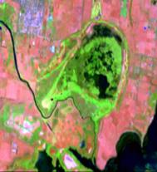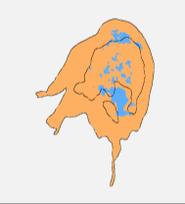  
Date: 29/7/2013 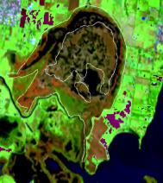 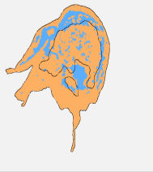  
Date: 2/11/2013 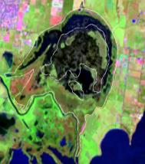 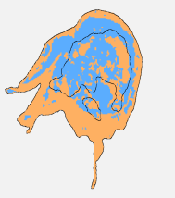

70988 Seaford Swamp

The wetland includes extensive areas of reedbed dominated by Common Reed and open waterbodies. More peripheral parts of the wetland include dense rushland dominated by Sea Rush in the south-eastern corner and a zone of brackish wetland along the eastern side. The mapped outline does not appear to be a good match to the actual wetland extent. The method appears to be successfully detecting when the open areas are inundated, but appears unable to detect water beneath dense reedbeds. It also appears likely that the method is not detecting shallow inundation extending into the rushland.

Date: 8/3/2008 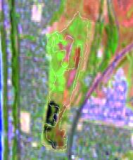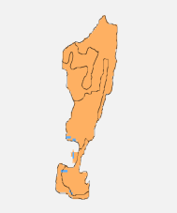  
Date: 29/7/2013 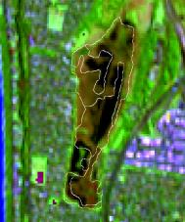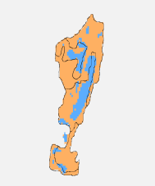  
Date: 2/11/2013 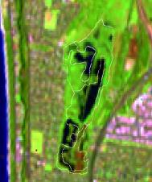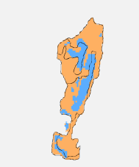

40516 Lake Buloke

Much of the wetland is cropped, but apparently some areas still support Southern Cane-grass. It appears that the wetland was dry at each of the sampling times and it was not possible to determine if the method would detect shallow inundation beneath denser cane grass.

Date: 9/1/2007 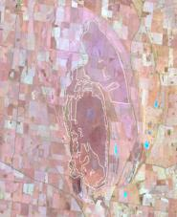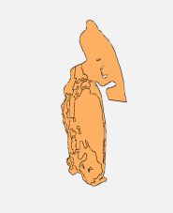  
Date: 20/7/2007 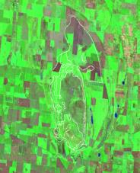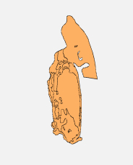  
Date: 25/11/2013 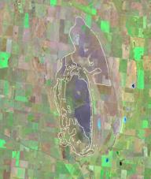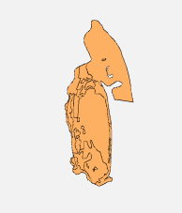

26609 Bryan Swamp, 31808 Lake Muirhead, 31816 Mount William Swamp and 31850 Lake Buninjon

Bryan Swamp apparently primarily supports a grassy-herbaceous aquatic vegetation. It appears to have a patchy cover of an emergent non-woody species, but it is not clear what this is. Lake Muirhead appears to be largely lacking at least more robust wetland species, and appears unvegetated and possibly saline in the Google Earth imagery. Mount William Swamp similarly appears more or less unvegetated. On the basis of the Google Earth imagery, Lake Buninjon supported what appears to be a relatively open largely aquatic herbaceous vegetation. In the January 2007 imagery, the method is not detecting any inundation, In the January 2011 imagery, it is detecting complete inundation in each of these wetlands except for Bryan Swamp, where a few small areas within the wetland are interpreted as not inundated. It appears likely that this is due to lack of detection of water under patches of dense graminoid growth rather than truly dry patches. Otherwise the method appears to be reliably interpreting the inundation status of these wetlands.

Date: 25/1/2007 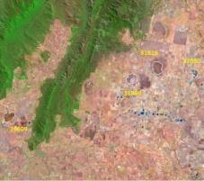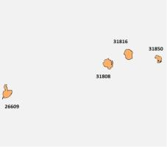  
Date: 6/9/2007 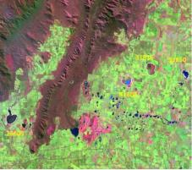 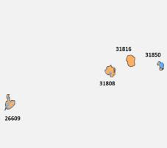  
Date: 4/1/2011 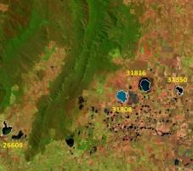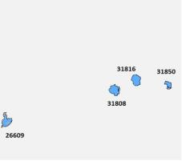

41603 Bradshaw Swamp

Patchy growth of an emergent plant is evident on the Google Earth imagery. This is possibly Southern Cane-grass but accurate information is lacking. The method is clearly detecting inundation or lack thereof in more open parts of the wetland. In the January 2011 imagery, it appears likely that the method is not detecting shallow inundation under denser graminoid growth around the outer zones of the wetland, however the evidence is not conclusive.

Date: 25/1/2007 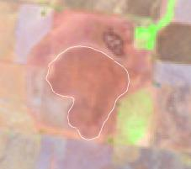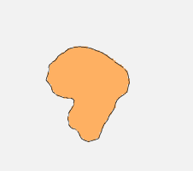  
Date: 6/9/2007 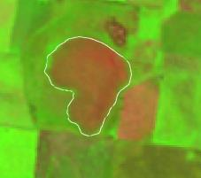 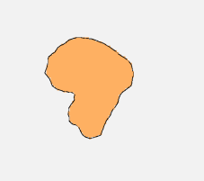  
Date: 4/1/2011 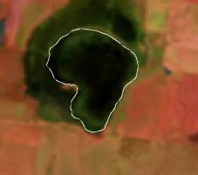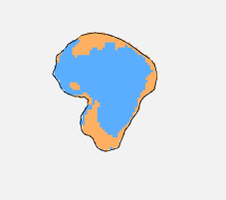

Interpretation of time series classification

45303 Gunbower Island State Forest

Gunbower Forest supports a range of plant communities dominated by River Red-gum, subject to various frequency and depth of inundation relating to their position on the elevation profile, as well as extensive areas dominated by box eucalypts where flooding is highly infrequent if it occurs. Relatively restricted areas of treeless wetlands occur in the most low-lying parts. The plot of extent of inundation at Gunbower suggest that the method is detecting flooding (and lack thereof) within the red gum dominated forest areas quite well (as it shows up to 50-60% inundation of the forest). However the plot does not add any clarification on the capacity of the method to detect water beneath denser growth of the wetland vegetation in more low lying areas, as these are relatively restricted in extent and no indication is provided as to where in the forest the modelling is detecting inundation.

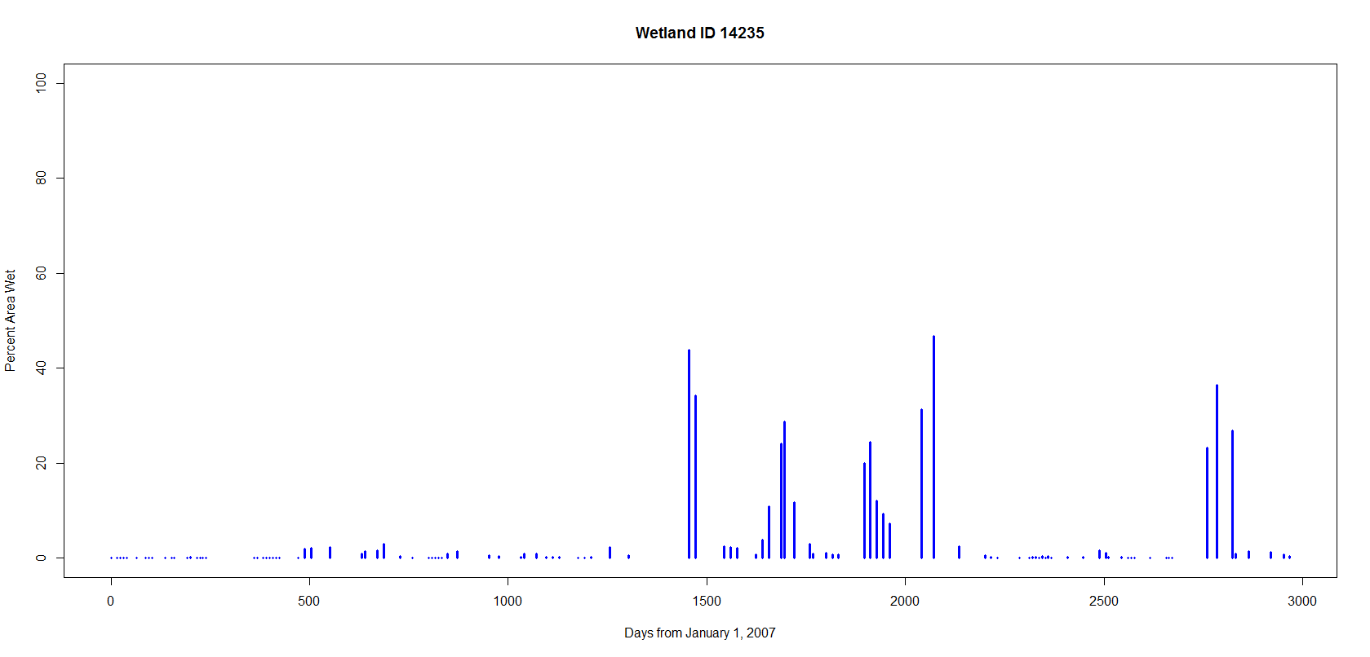

43236 Tragowel Swamp

The larger portion of Tragowel Swamp is occupied by stags of River Red Gum, with Black Box occurring in more elevated areas surrounding the main wetland body. The red gums were drowned due to sustained flooding when the wetland was linked into the irrigation network, and presumably supported vegetation best referred to Intermittent Swampy Woodland prior to its modification to a lake-like condition. Following being allowed to dry out during the 1990s, the wetland was colonised by a dense growth of Tangled Lignum. The interpretation of Lignum Swampy Woodland in the DELWP mapping is here regarded as incorrect, being applied without evaluation of the ecological processes which have accompanied the modification of the site. Given the extent of inundation detected during the last major flooding event (peaking at 100% before a period remaining around the 40-60% range), it appears that the method is detecting inundation beneath both relatively dense growth of lignum and beneath Black Box.

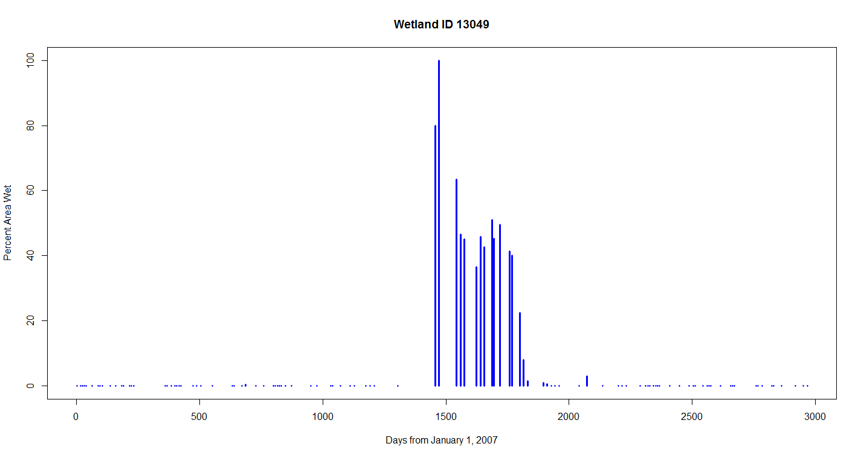

43204 Unnamed wetland

While clarifying information on the unnamed wetland (43204) is lacking, it appears to be highly modified and relatively sparsely vegetated, at least in recent times. Also, it may be artificially drained, as it held water only very briefly during the single wet event. In the absence of further information on this site, the plot does not provide any additional information other than if inundation occurs the method appears capable of detecting it (80% during the flood peak).

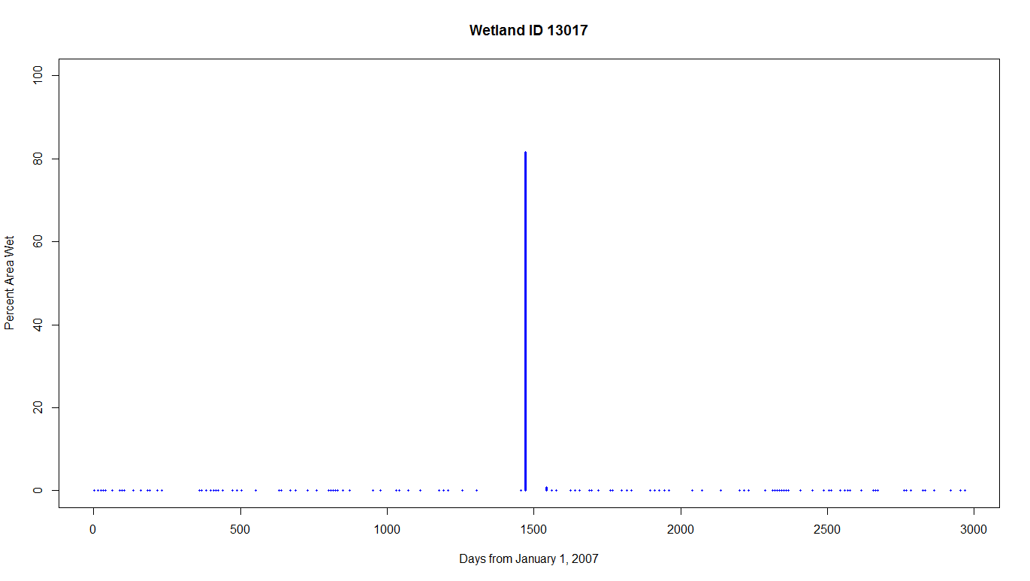

Evaluation summary

The following summary draws upon the interpretation of three-image classification and time series classification discussed above, as well as a series of photos in the pages that follow which show examples of the tested vegetation types. Examination of this imagery suggests that the method reliably detects inundation in open areas of wetland (either unvegetated or supporting low, open herbaceous vegetation).

It also appears to reliably detect inundation beneath woodlands (to open forest formations) dominated by River Red-gum and Black Box, and also apparently in shrublands dominated by Tangled Lignum. However further testing would be required to detect how it will interpret vegetation including larger and denser or more robust patches of lignum.

It does not appear to detect inundation beneath dense growths of Cumbungi, Common Reed or Swamp Paperbark. Presumably this will apply also to other denser scrubs such as those dominated by Scented Paperbark or Woolly Tea-tree.

There are indications that it does not detect shallow inundation beneath denser patches of medium-sized graminoids (e.g. Sea Rush), however further analysis would be required to determine at what levels of cover and depth the method reaches its limitations. In general it appears that the method will detect that some water is present in the relevant wetlands, but in these instances the relative extent of inundation may not be reliably determined.

Vegetation types with good water detection

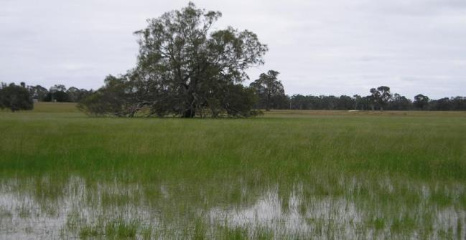

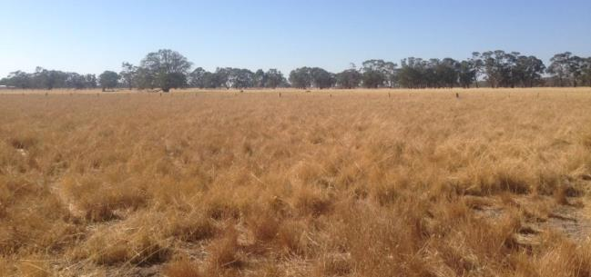

Seasonal Grassy-herbaceous wetland during a wet phase (above) and dry phase (below). The method is apparently able to detect inundation (EVC Plains Grassy Wetland). Photo: DELWP.

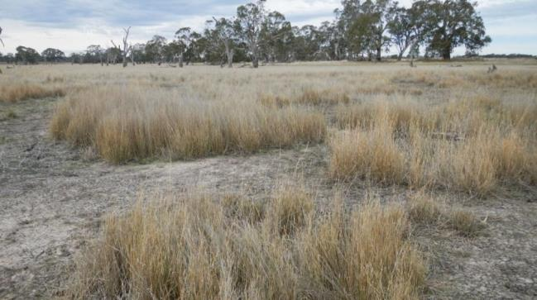

Southern Cane-grass (*Eragrostis infecunda*). The method is presumably able to detect inundation, at least in more open stands (EVC Cane Grass Wetland). Photo: DELWP.

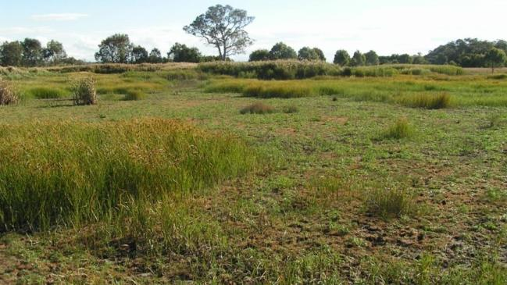

Mosaic of herbland dominated by salt-tolerant species with patches of Salt Club-sedge (*Bolboschoenus caldwellii*). The method is apparently successful in detecting inundation of this vegetation (EVC Brackish Wetland Aggregate). Photo: Doug Frood.

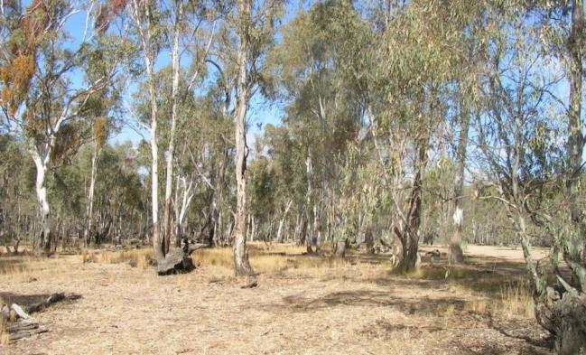

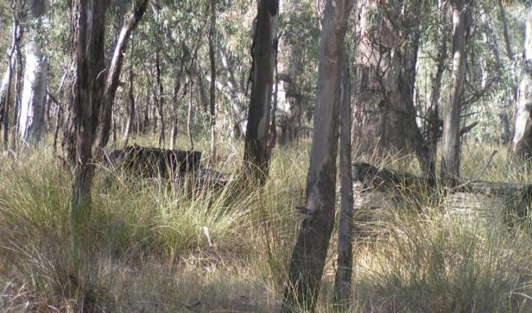

River Red Gum (*Eucalyptus camaldulensis*) with grassy herbaceous ground-layer (above) and with ground-layer dominated by Basket Sedge (*Carex tereticaulis*) (below). The method is presumably effective where the understorey is relatively open (e.g. photo above) but it is unclear whether underlying water would be detected at the density of sedges present in the lower photo. Photo: Doug Frood.

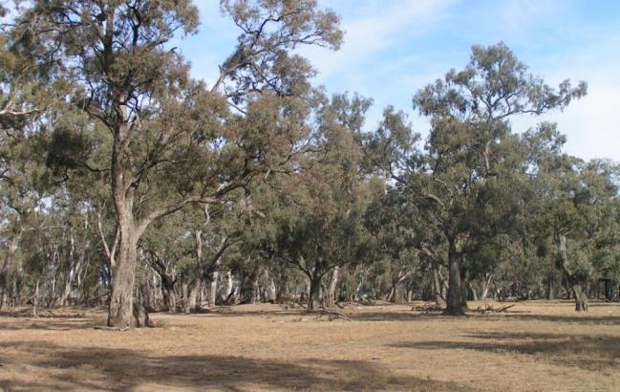

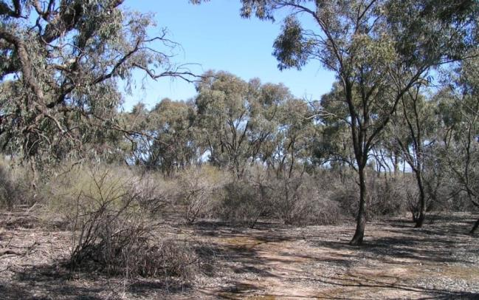

Black Box(*Eucalyptus largiflorens*) on margins of floodplain in EVC Plains Woodland (above) and Black Box with Tangled Lignum (*Duma* florulenta) in EVC Lignum Swampy Woodland (below). The method is presumably effective in detecting inundation in both these vegetation types, at least in relatively open lignum, but possibly not in denser lignum stands..Photo: Doug Frood.

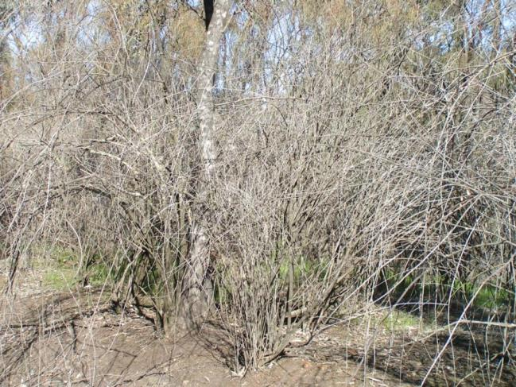

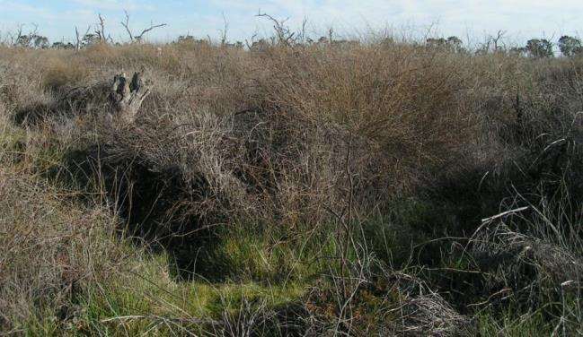

Tangled Lignum with Eumong (*Acacia stenophylla*) (above) and Tangled Lignum variously with dead Black Box (bottom). The method is probably effective at detecting inundation, but not adequately tested in denser stands of lignum (EVCs Lignum Swampy Woodland and Lignum Swamp). Photo: Doug Frood.

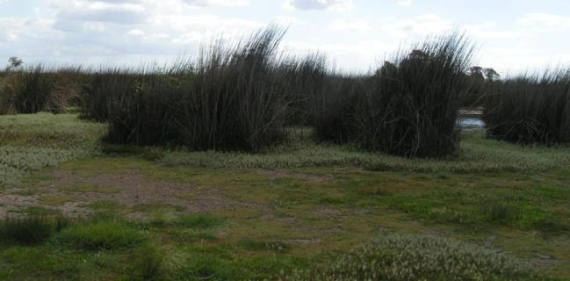

Giant Rush (*Juncus ingens*). Noted as a component of the vegetation at McLeod Morass. The method is apparently able to detect inundation in relatively open stands, but has not been tested for denser stands (EVC Tall Marsh). Photo: Doug Frood.

Vegetation types with poor water detection

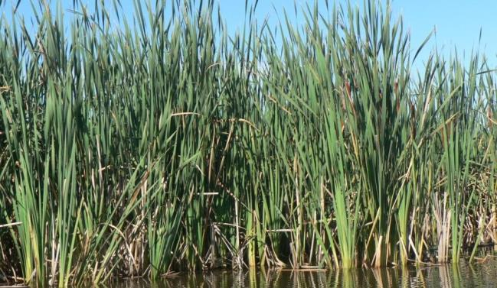

|  |
| --- |
|  |

Cumbungi (*Typha* spp. - in this case *T. domingensis*). The method is apparently unable to detect water underneath dense stands (EVC Tall Marsh). Photo: Alison Oates.

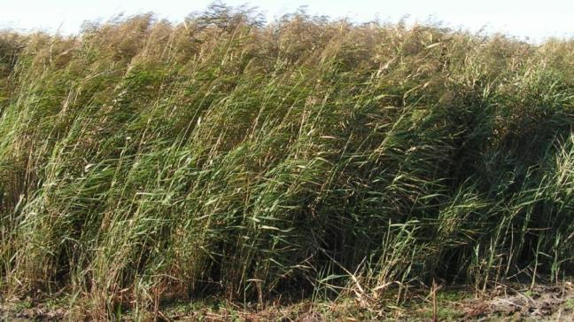

Common Reed *(Phragmites australis*). The method is apparently unable to detect water underneath dense stands (EVC Tall Marsh). Photo: Doug Frood.

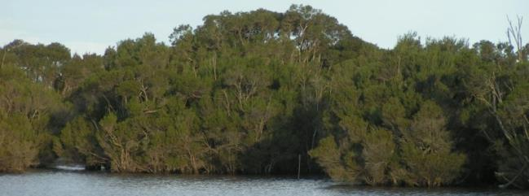

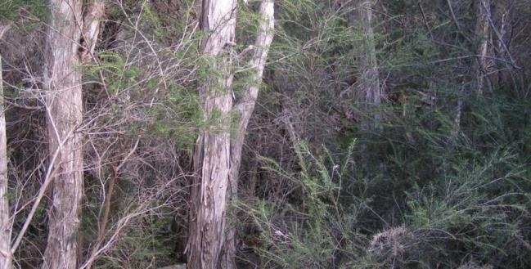

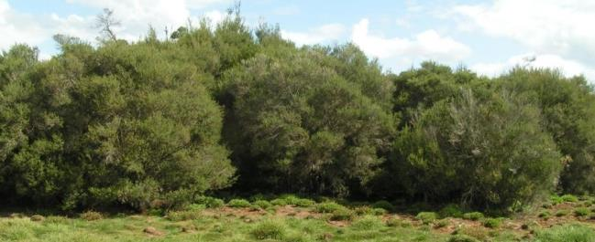

Swamp Paperbark (*Melaleuca ericifolia*) (above), within scrub dominated by Swamp Paperbark (middle) and abutting Wet Sedgy Herbland (below). The method is apparently unable to detect water underneath dense stands (EVC Swamp Scrub; presumably also the case for denser versions of Estuarine Scrub). Photo: Doug Frood.

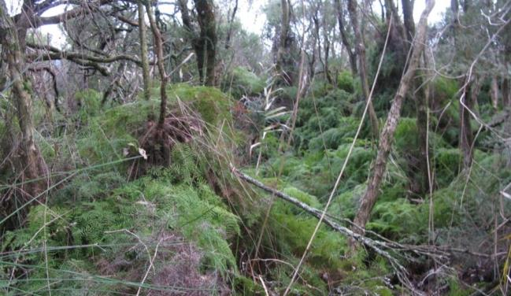

Woolly Tea-tree (*Leptospermum lanigerum*) and Scented Paperbark (*Melaleuca squarrosa*), with Coral Fern (*Gleichenia* spp.): Untested, but on the basis of outcomes of testing of scrubs dominated by Swamp Paperbark, the method appears unlikely to detect underlying water (EVC Riparian Scrub, as part of Swamp Heathland Aggregate). Photo: DELWP.

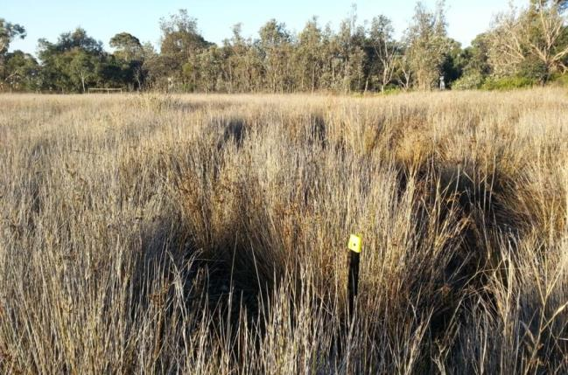

Dense sward of Sea Rush (*Juncus kraussii*). The method appears unable to detect underlying water at this density of the rush (EVC Estuarine Wetland). Photo: DELWP.

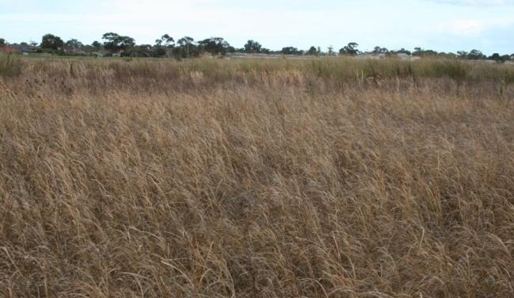

Denser and taller sedgeland dominated by Salt Club-sedge (*Bolboschoenus caldwellii*). The method may be relatively ineffective in detecting shallow inundation in this context, but lacks testing (EVC Brackish Sedgeland, as part of Brackish Wetland Aggregate). Photo: DELWP.

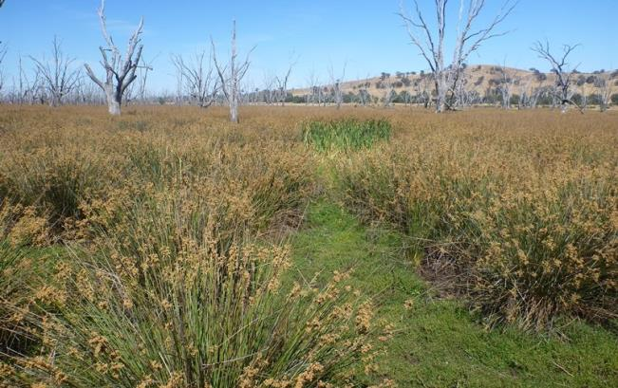

Wetland dominated by Plains Rush (*Juncus semisolidus*). Freshwater wetland dominated by rushes is mentioned in the text. It is unclear whether the method will detect inundation where the rush growth is particularly dense (EVC modified, referred to Red Gum Swamp / Plains Rushy Wetland Complex). Photo: DELWP.

1. The pilot focused primarily on the Kerang 1:100k map sheet in northern Victoria, from Landsat image path/row 93/85. In addition, the method was also piloted on several specific wetlands spread across Victoria to understand the influence of certain types of overhanging vegetation on the detection of water.
2. Nadir ‘Bidirectional Reflectance Distribution Function’ Adjusted Reflectance
3. Errors of commission occur when the analysis reports the presence of a feature (e.g. standing water) that, in reality, is absent (e.g. no standing water is present). Errors of omission occur when the analysis fails to identify the presence of the target feature (e.g. does not identify standing water) that, in reality, is present (e.g. standing water is present).
4. The exception here is Melbourne Water, which operates on the five-year cycle regulated by the Essential Services Commission