Victorian Annual Water Outlook
  - Covering the period December 2023 to November 2024

Acknowledgements
We acknowledge and respect Victorian Traditional Owners as the original custodians of Victoria’s land and waters, their unique ability to care for Country and deep spiritual connection to it. We honour Elders past and present whose knowledge and wisdom has ensured the continuation of culture and traditional practices.
We are committed to genuinely partner, and meaningfully engage, with Victoria’s Traditional Owners and Aboriginal communities to support the protection of Country, the maintenance of spiritual and cultural practices and their broader aspirations in the 21st century and beyond.
DEECA kindly acknowledges the efforts of the urban and rural water corporations of Victoria.
DEECA is grateful for the input of the Victorian Environmental Water Holder and the provision of data by the Australian Bureau of Meteorology.
Cover photograph: Darryl Whitaker
ISSN 2653-7605 - Online (pdf/word)
All images are © State of Victoria, DEECA. Credit: Darryl Whitaker except where noted.
© The State of Victoria Department of Energy, Environment and Climate Action 2023
This work is licensed under a Creative Commons Attribution 4.0 International licence. You are free to re-use the work under that licence, on the condition that you credit the State of Victoria as author. The licence does not apply to any images, photographs or branding, including the Victorian Coat of Arms, the Victorian Government logo and the Department of Energy, Environment and Climate Change (DEECA) logo. To view a copy of this licence, visit http://creativecommons.org/licenses/by/4.0/.
Disclaimer
This publication may be of assistance to you but the State of Victoria and its employees do not guarantee that the publication is without flaw of any kind or is wholly appropriate for your particular purposes and therefore disclaims all liability for any error, loss or other consequence which may arise from you relying on any information in this publication.
Accessibility
If you would like to receive this publication in an alternative format, please telephone the DEECA Customer Service Centre on 136186, email customer.service@delwp.vic.gov.au or via the National Relay Service on 133 677 www.relayservice.com.au. This document is also available on the internet at www.delwp.vic.gov.au.

Ministerial foreword
After three consecutive years of La Niña conditions, which saw above average rainfall and devastating floods across much of the state, the Bureau of Meteorology declared an El Niño event in September 2023. It was a stark reminder of how quickly conditions can change in Victoria and how climate change is intensifying the natural climate variability of our state.
Many communities across Victoria continue to recover from the impacts of floods, and I extend my ongoing thanks to the many people, businesses and organisations who continue to support recovery and rebuilding across these areas.
As we move into summer, Melbourne’s water storages are close to full, and Victoria’s major regional water storages are, on average, just over 93 per cent full. However, with El Niño conditions predicted to continue throughout summer, combined with the effects of a positive Indian Ocean Dipole, these events typically lead to reduced rainfall and higher temperatures.
From December 2023 until November 2024 water restrictions will not be required in Melbourne or in most of Victoria’s regional towns and cities. There is a chance some towns in East Gippsland South Gippsland and Goulburn Valley Water’s supply areas before the end of 2024 if conditions turn unusually dry. These measures will only be taken if necessary to make sure water supplies continue to support the health, wellbeing, and affordability of these communities.
Planning for a strong water future is vital to a healthy and thriving Victoria. Together with the water sector, DEECA continues to work to improve long-term planning for water security, outlined in the Central and Gippsland Region Sustainable Water Strategy (2022).
While storages are in a strong position now, we also know they can drop quickly. Planning now means we can adapt more efficiently, and effectively to challenges like drought, climate variability, a growing population when they arise. It also allows us to make sure we have enough water for our environment, to adequately protect and repair vital river ecosystems.
I want to acknowledge the continuing work underway to help progress our commitment to acknowledging past water injustices in Victoria. Traditional Owners have enduring cultural, spiritual, and economic connections to land, water and resources and the Victorian Government’s roadmap to achieve this: Water is Life – Traditional Owner Access to Water Roadmap (2022) includes a new focus on the role of Traditional Owners in water management. It is testament to the hard work and leadership of First Nations communities and representatives, and we are grateful for their guidance and partnership as we work towards this.
Victoria’s water outlook reminds us of the many complex and competing challenges of water management in our state and the importance of planning. The Annual Water Outlook will assist us to make decisions to support our communities and environment for the next 12 months and beyond. Collaboration between the department, the water sector, Traditional Owners and the community is key, and I am immensely proud of the work to date.
The Hon. Harriet Shing MP
Minister for Water

Contents
1. Introduction 4
2. Snapshot 4
3. Climatic conditions 6
Recent conditions 6
Current state of Victoria’s water storages 7
December to February outlook 7
Victorian climate and streamflow over coming decades and the longer-term future 9
4. Urban water 10
Key messages 10
Urban water supplies, the year ahead 11
Securing our urban water supplies 15
5. Traditional Owners 17
Unallocated water returns in 2023 17
6. Rural water 18
Key messages 18
Rural water supplies, the year ahead 20
Securing our rural water supplies 24
7. Environmental water 25
Key messages 25
Environmental water supplies, the year ahead 28
8. Further information 29
9. Glossary 30

Introduction
The aim of the Victorian Annual Water Outlook (the Outlook) is to keep Victorians informed about the state’s water supplies for the coming year. It also outlines the contingency plans to manage any water shortages that may arise.
Each year, the Outlook synthesises the information provided in the annual water outlooks prepared by Victoria’s 18 urban and rural water corporations for the 12-month period from December through to the following November.
Due to the highly variable nature of Victoria’s climate, ‘average’, ‘dry’ and ‘worst on record’ climate scenario modelling is used to identify potential water security risks and understand the vulnerabilities of each system.
This information can become particularly valuable during ‘dry’ years, such as periods of El Niño climatic conditions, when rainfall is generally lower, and water restrictions are more likely than they are in average conditions.
The individual water corporations’ annual water outlooks present this information and report on the current condition of each water supply system, predict future water availability where possible, and outline strategies to meet customer demand. Each water corporation makes its annual water outlook available on its website.
The Outlook takes this information and provides a state-wide overview of:
- the conditions that can be expected this coming year;
- the seasonal conditions already experienced in 2023 and forecast for the beginning of 2024; and
- environmental water availability across the state.
Note: Data provided within this report was correct as at 1 December 2023 unless otherwise specified.

Snapshot

Overview
- Following three consecutive years of La Niña conditions, in September 2023, the Bureau of Meteorology (BoM) declared an El Niño and positive Indian Ocean Dipole (IOD). The combination of these events typically leads to reduced spring and summer rainfall and above average temperatures.
- Most of Victoria’s major water storages are close to full, with major storages being 93.7% full on average, although this is 3.5% less than this time last year.
- Victoria experienced its warmest and driest September on record, averaged across the state, the mean maximum temperature for September 2023 was 3.77 degrees Celsius above the 1961-1990 average.

Climate outlook
- The BoM’s December to February outlook is for warmer temperatures across all of Victoria, and a moderate chance that rainfall will exceed average for most of the state.
- Large parts of the state are likely to receive average rainfall from December to February, while small areas in the Otways can expect below average rainfall, and maximum temperatures are very likely (greater than 70% chance) to be above median for most of Victoria.

Greater Melbourne
- Water restrictions in Melbourne are not expected this summer and autumn. Melbourne’s water storages are currently at 95.1% capacity, 2.9% lower than this time last year.
- Recent consecutive wet years with above average rainfall have resulted in high storage levels, despite below average rainfall over winter and spring, the traditional ‘storage filling season’.
- Although water supplies are secure in the short-term, supply and demand will continue to be closely managed to ensure effective adaptation to the changing climate and population growth.
- In collaboration with water corporations, DEECA has been working to explore a range of new water source options to boost supplies when needed in the longer term. This includes work to identify preferred supply options for further investigation when required.
- While storages are currently high the across the region, storages can drop rapidly during hot, dry periods. Using water wisely now reduces the chances of needing to implement water restrictions in the future.

Regional urban
- Urban water restrictions are not expected for any regional city or town this summer and autumn, due to strong storage conditions.
- Total storage levels across regional Victoria’s major water storages are 93.5% full, 3.6% less than this time last year.
- Some regional towns could see restrictions in 2024 under ‘dry’ or ‘worst on record’ scenarios. Restrictions are possible, for some towns in East Gippsland, South Gippsland and Goulburn Valley Water’s supply areas before the end of 2024, if conditions turn unusually dry.

Rural
- All northern Victorian regulated systems have received a 100% seasonal determination to high-reliability water shares. Allocations to low-reliability water shares have also been made in all systems.
- Reserves for 2024-25 have been fully established in the Goulburn, Loddon, Campaspe and Murray systems to support opening seasonal allocations to water share holders on 1 July 2024.
- Rural water users in southern Victoria’s regulated systems will have access to 100% of their high-reliability entitlements for the 2023-24 season.
- Historically high volumes of water in storage are supporting allocations to entitlements in the Wimmera-Glenelg system.
- Licence holders in some unregulated systems would be subject to restrictions if dry conditions eventuate this summer and autumn.
- Consecutive wet years have allowed groundwater levels to remain stable or increase. Most groundwater licence holders will not have their take restricted in 2024.
- Following the October 2022 flooding some storages have experienced persistent elevated nutrient levels and turbidity. During 2023-24 there will be an elevated risk of blue green algae and hypoxic blackwater events in many areas.

Traditional Owners
- Traditional Owners have enduring cultural, spiritual, and economic connections to land, water and resources. Building on the release of the Water is Life – Traditional Owner Access to Water Roadmap (2022), the Victorian Government is taking the first steps towards acknowledging past injustices in water management and putting a new focus on increasing the role of Traditional Owners in water management across Victoria.
- Gunaikurnai Land and Waters Aboriginal Corporation (GLaWAC) has been issued with two new licences through unallocated water sources in the past year. GlaWAC received 200 ML at Buchan Munji and intend to hold the water in an aquifer for cultural purposes. In addition, 500 ML of water was returned in the Tambo River for GlaWAC to own and manage.

Environment
- Water the for the environment supports the health of rivers, wetlands and floodplains, with flow-on benefits for the physical and mental wellbeing of Victoria’s communities.
- Catchments in the state’s east, central and northern regions are expected to have high reserves of water for the environment in 2023-24. Environmental water reserves in western Victoria are expected to be moderate.
- High rainfall in early spring 2023 caused mid-level flooding of some floodplains in mid-northern Victoria and high river flows in other parts of the state. These natural events have already met some planned environmental watering actions for 2023-24.
- Extensive flooding in 2022-23 filled many wetlands across Victoria. Going into 2024 some wetlands are expected to receive relatively small top-ups, aimed at maintaining a depth which consolidates environmental gains from last year. This includes providing foraging habitat for juvenile waterbirds that hatched last year and encouraging wetland vegetation to grow and flourish. Other wetlands will be allowed to draw down naturally to enable important receding and dry-phase ecological processes.
- In many river systems, the focus will be on delivering low flows and freshes to support native fish. While the 2022 floods increased available food resources and triggered some successful native fish breeding, in some locations this was partially offset by fish deaths due to low oxygen levels and a large carp-breeding event. Restoring bank vegetation that was damaged during the 2022 floods, maintaining water quality for fish in rivers and encouraging native fish dispersal and migration are our main objectives for 2023-24.

Climatic conditions
Temperature and rainfall influence water use. We use more water in summer when it is hotter and drier (for example for gardens and pools), than in winter when it is wetter and colder. Water corporations are continually monitoring storage conditions. They forecast demand using the BoM’s seasonal climate outlooks, which are updated weekly.

Recent conditions

Autumn 2023
- Autumn rainfall was close to average for the state as a whole, while it was wetter in parts of the Wimmera, South West, Central, North East and Gippsland districts.
- During autumn, mean maximum temperatures were below average in the state’s west and north-east and close to average elsewhere, while mean minimum temperatures were above average across the state’s South West, Central and Gippsland districts.

Winter 2023
- Winter rainfall was below to very much below average across the South West, Central, Gippsland and North East districts. The East Gippsland district observed its lowest winter rainfall on record. Winter rainfall was above average in the Mallee district.
- The Victoria area-average mean maximum temperature was 1.10 °C above the 1961–1990 average for winter, which was the warmest recorded since 2011. Mean maximum temperatures were above to very much above average across the state, with the Central, Gippsland and parts of North East districts having their highest maximum temperature on record.

Spring 2023
- September rainfall totals were very much below average (the lowest 10% since records began) for almost all of the state, and the lowest on record for the South West coast extending into the Central district and parts of the East Gippsland and North East districts.
- The mean maximum temperature for September was 3.77 °C above the 1961–1990 average and it was the warmest on record for September.
- In October a cold front and a low pressure system generated widespread rainfall across Victoria. Many sites in eastern, central and northern Victoria had their highest October daily rainfall on record.

Current state of Victoria’s water storages
Rainfall across Victoria has been above average over the past three years, leading to full storages across almost all of the state.
Figure 1 shows the state of Victorian storages compared to the same time last year.
 | 2023 | 2022 | % change
Victoria’s major storages | 93.7% | 97.2% | -3.5
Melbourne storages | 95.1% | 97.9% | -2.9
Victoria’s regional storages | 93.5% | 97.0% | -3.6
Figure 1: The state of Victorian storages at 30 November 2023 and 2022
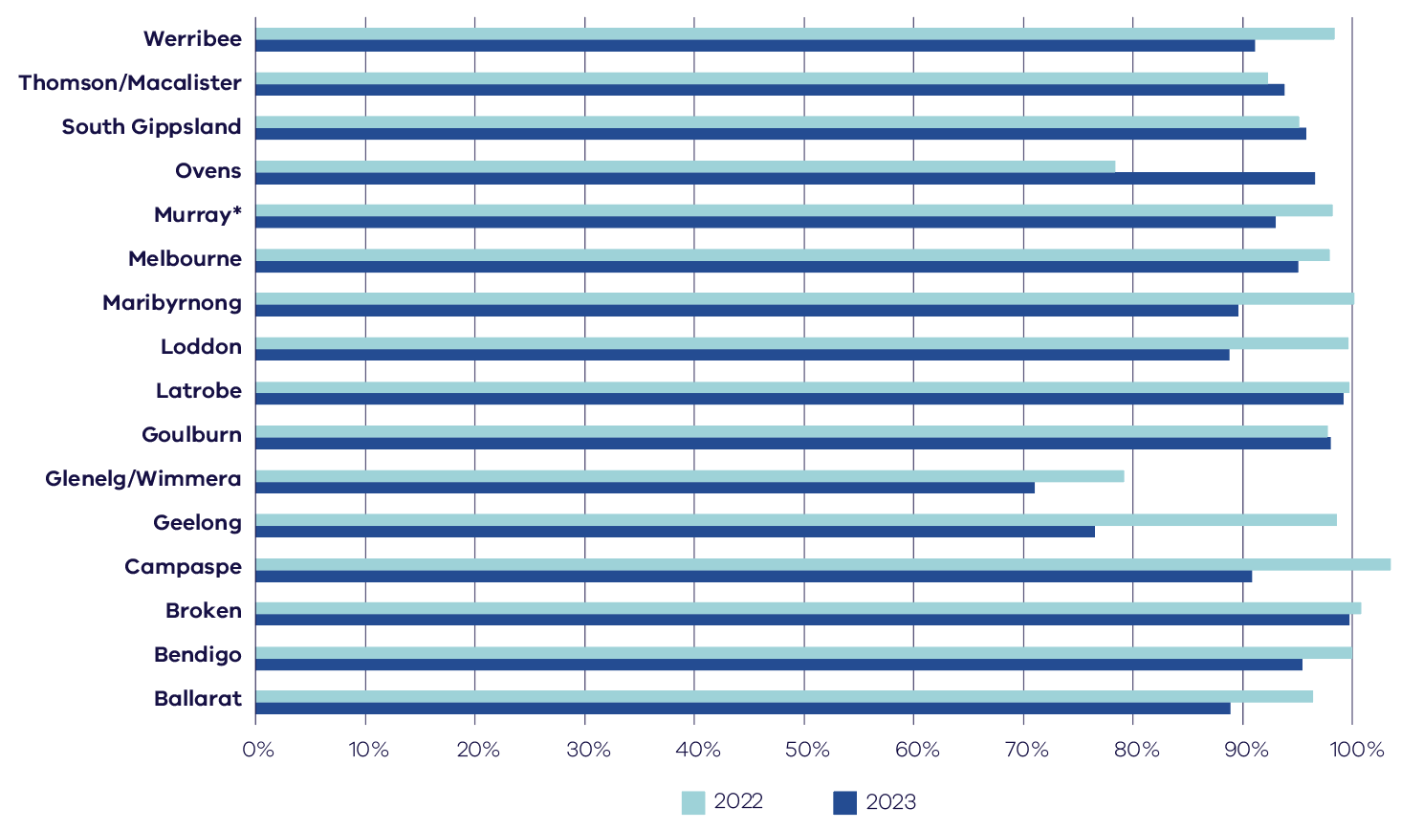
* The Victorian share of the Murray storages are updated monthly. Volumes for Murray storages are from 31 October.

December to February outlook
Figure 2: Chance of exceeding median rainfall for December to February 2024
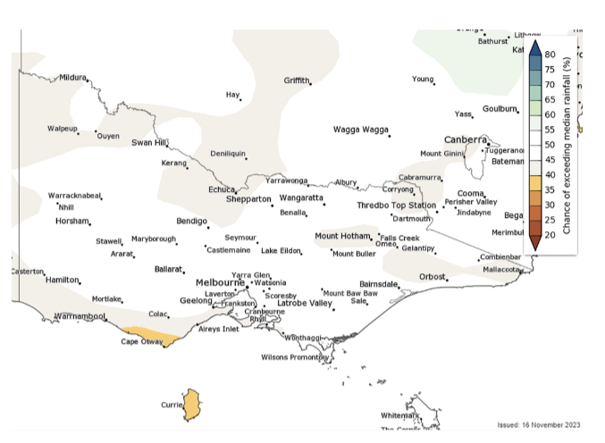
Rainfall is likely to be average for Victoria from December to February 2024
The BoM seasonal outlook indicates that large parts of the state are likely to receive average rainfall from December to February, while small areas in the Otways can expect below average rainfall (Figure 2).
Figure 3: Chance of exceeding median maximum temperature for December to February 2024
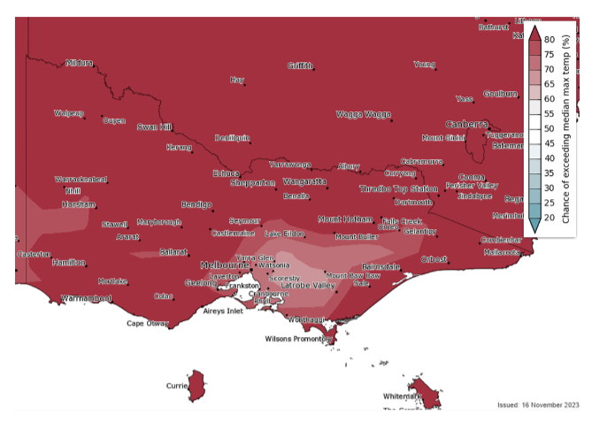
Temperatures will be above average across Victoria between December and February 2024
The BoM seasonal outlook for December to February 2024 indicates that maximum temperatures are very likely (greater than 80% chance) to be above median for most of Victoria (Figure 3).

Victorian climate and streamflow over coming decades and the longer-term future
Victoria’s climate and streamflow is highly variable, but within this variability we have experienced a warming and drying trend over recent decades.
Over recent decades we have experienced trends toward:
- higher temperatures and more hot days;
- reductions in rainfall during the cooler months;
- in some locations, increases in extreme, short-duration rainfall events; and
- in some catchments, particularly in western Victoria, a shift in the streamflow response to rainfall with typically less streamflow generated for a given amount of rain.
Some of the rainfall declines in the cooler months can be attributed to increases in greenhouse gas concentrations in the atmosphere. During the cooler months, we have been getting less rainfall from low-pressure and frontal systems.
Over future decades we can expect:
- the rainfall reductions during the cooler months to persist;
- increases in extreme rainfall events;
- increases in potential evapotranspiration due to higher temperature and lower relative humidity;
- reductions in streamflow because of less rainfall and higher potential evapotranspiration; and
- the streamflow response to rainfall to no longer remain the same, and generally decline.
In September, the Bureau of Meteorology confirmed the occurrence of an El Niño state and positive Indian Ocean Dipole. Climate models indicate this El Niño is likely to persist until at least the end of February. El Niño typically leads to reduced spring and early summer rainfall for eastern Australia, and warmer days for the southern two-thirds of the country. This is expected to have a negative impact on streamflow yield in the warmer months, as catchments are generally drier and any rainfall is more prone to soak into the ground, be used by vegetation or evaporates.
Victoria’s climate will continue to be variable with wet years and dry years, against a background drying trend. With a warmer future and projections of declining water availability, we can expect more frequent and severe droughts in coming decades and increases in extreme rainfall events. The Victorian Government is investing in further research to better understand how Victoria’s climate is changing and the water resource implications, through the Victorian Water and Climate Initiative.

Urban water

Key messages
Despite below average rainfall during winter and spring reducing recent inflow into dams in some areas, three prior consecutive wetter-than-average years due to La Niña events, ongoing water efficiency programs and the added security provided by the desalination plant, means that water restrictions are not expected in any urban city or town for the December 2023 to May 2024 period. However, some regional towns could see restrictions later in 2024 under ‘dry’ or ‘worst on record’ scenarios.
The interactive map on this page illustrates the water restrictions expected across the state under a range of climate scenarios. The restriction projections shown were based on the latest information available from water corporations in November 2023, except where otherwise denoted. These projections are generally for the 12-month period from 1 December 2023 to 30 November 2024, except for some smaller run-of-the river systems.
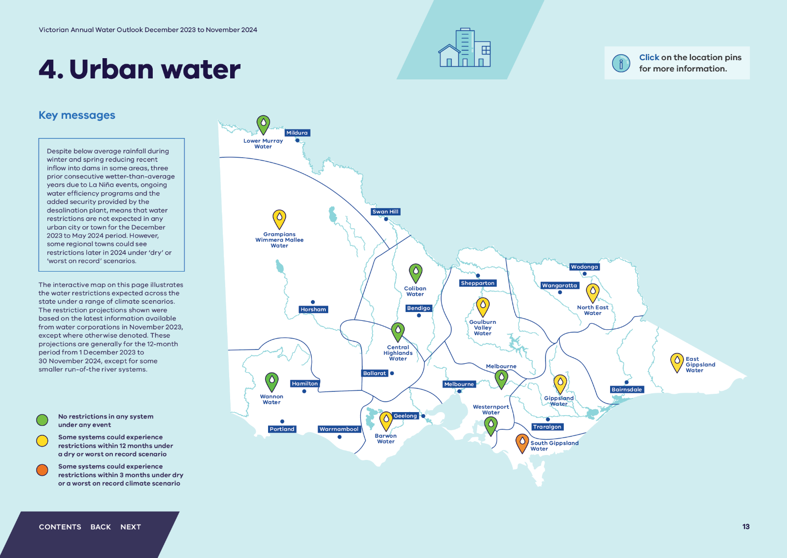

Lower Murray Water
Water restrictions are not expected under any of the modelled climate scenarios.

Grampians Wimmera Mallee Water
Under a worst on record scenario, the Eastern Grampians & Pyrenees supply systems could see restrictions.

Wannon Water
Water restrictions are not expected under any of the modelled climate scenarios.

Coliban Water
Water restrictions are not expected under any of the modelled climate scenarios.

Central Highlands Water
Water restrictions are not expected under any of the modelled climate scenarios.

Barwon Water
Under a worst on record scenario, Lorne and Apollo Bay could each see restrictions.

Goulburn Valley Water
Under a dry climate scenario, the Upper Delatite system could see restrictions.
Under a worst on record scenario, the Seven Creeks (Strathbogie), Upper Delatite and Mollison Creek systems could each see restrictions.

Melbourne
Water restrictions are not expected under any of the modelled climate scenarios.

Westernport Water
Water restrictions are not expected under any of the modelled climate scenarios.

North East Water
Under a worst on record scenario, Beechworth, Benalla, Myrtleford, Corryong and Harrietville systems could each see restrictions.

Gippsland Water
Under a worst on record scenario, Briagolong, Erica, Rawson, Mirboo North and Seaspray systems could each see restrictions.

South Gippsland Water
Under a dry climate scenario, the Fish Creek system could see restrictions.
Under a worst on record scenario, the Ruby Creek system could see restrictions within the outlook period and the Fish Creek and Agnes River systems could each see restrictions within 3 months.

East Gippsland Water
Under a dry climate scenario, the Mitchell River and Buchan systems could each see restrictions.
Under a worst on record scenario, the Mitchell River, Orbost, Omeo, Swifts Creek, Cann River and Buchan systems could each see restrictions.

Urban water supplies, the year ahead
Each urban water corporation assesses water supplies on a system-by-system basis, to determine the best ways to manage supply and demand to ensure secure supply for cities and towns. Implementation of water restrictions is only one of a range of possible responses that water corporations may use to help cope with potential water shortages. Specific to each system, other responses may include behaviour change campaigns, use of standby water sources, water carting and water trading.
For the 12-month outlook period from December 2023 - November 2024:
- Under a wet or average scenario, no water restrictions are expected.
- Under a dry climate scenario, water restrictions could be applied to 17 towns.
- Under a worst on record climate scenario, water restrictions could be applied to 53 towns.
Table 1 contains details for these towns, their outlook for summer and autumn and the short-term measures available to help affected communities and improve supply security.
Water systems across the state are diverse and many factors influence why some are more vulnerable to drought than others. Factors include:
- Climatic conditions
- Physical characteristics of water systems themselves, including reservoir capacity and availability of water for irrigation
- Whether there is a drought reserve
- Flexibility of local demand, including pressure by large industrial or commercial water customers
- Whether there is the option for additional or alternative supplies
Some parts of the state may be reliant on smaller water systems with smaller storages that either have less than 12 months’ supply or a supply direct from a river or stream. These parts of the state are more susceptible to drought and dry conditions.
Climate scenarios explained
The climate scenarios considered for the annual water outlooks are plausible and possible representations of climate conditions over the outlook period.
Average: based on average climate experienced since 1975
Dry: based on the driest tenth percentile (10%) of climate experienced since 1975
Worst: similar to the extremely dry conditions experienced during the peak of the Millennium Drought in 2006-07.
Table 1: Victorian towns that may have water restrictions applied in the outlook period
Water Corporation | System and Towns supplied (if different) | Climate scenarios |  |  | Mitigation actions
 |  | Average | Dry | Worst on record
Barwon Water | Apollo Bay - Skenes Creek, Marengo | No water restrictions | No water restrictions | Water restrictions could be applied | A worst on record scenario could see Stage 2 restrictions applied.  If climate conditions worse than recorded eventuate, other measures could include stage 3 and 4 water restrictions and water carting.
 | Lorne | No water restrictions | No water restrictions | Water restrictions could be applied
East Gippsland Water | Mitchell - Bairnsdale (including Wy Yung and Lucknow), Lindenow, Paynesville, Raymond Island, Metung, Tambo Bluff, Lakes Entrance (including Lake Tyers, Lake Tyers Beach and Kalimna), Nowa Nowa, Nicholson, Johnsonville, Swan Reach, Bruthen and Sarsfield | No water restrictions | Water restrictions could be applied | Water restrictions could be applied | Planning is ongoing for an additional raw water storage at Woodglen. This proposed Woodglen Basin 3 will provide an extra buffer during periods of low flow in the Mitchell system. A new 0.43ML Raw Water Tank was constructed earlier this year to enhance the Buchan water supply system’s resilience during low streamflows or high turbidity periods.  In the unlikely event of an extreme short term water shortage carting is an option for the Omeo, Buchan, Swifts Creek and Cann River systems.
 | Orbost – Marlo, Newmerella | No water restrictions | No water restrictions | Water restrictions could be applied
 | Omeo | No water restrictions | No water restrictions | Water restrictions could be applied
 | Swifts Creek | No water restrictions | No water restrictions | Water restrictions could be applied
 | Buchan | No water restrictions | Water restrictions could be applied | Water restrictions could be applied
 | Cann River | No water restrictions | No water restrictions | Water restrictions could be applied
Gippsland Water | Briagolong | No water restrictions | No water restrictions | Water restrictions could be applied | A deeper groundwater resource is being investigated for Briagolong.  Water can be carted into Seaspray if required.  A worst on record year may result in restrictions but more likely after prolonged dry.
 | Erica Rawson | No water restrictions | No water restrictions | Water restrictions could be applied
 | Mirboo North | No water restrictions | No water restrictions | Water restrictions could be applied
 | Seaspray | No water restrictions | No water restrictions | Water restrictions could be applied
Goulburn Valley Water | Upper Delatite – Sawmill Settlement, Merrijig | No water restrictions | Water restrictions could be applied | Water restrictions could be applied | Anticipated to be for a short period of a month if it occurs. Water carting would be implemented if stream flows decline to where there is insufficient supply.
 | Seven Creeks - Strathbogie | No water restrictions | No water restrictions | Water restrictions could be applied
 | Mollison Creek - Pyalong | No water restrictions | No water restrictions | Water restrictions could be applied
Grampians Wimmera Mallee Water | Eastern Grampians – Lake Bolac, Moyston, Wickliffe, Willaura | No water restrictions | No water restrictions | Water restrictions could be applied | Once completed, the East Grampians Rural Pipeline Project will bolster water security for these towns by providing access to supplementary water from the Grampians reservoir system.
 | Pyrenees – Elmhurst, Buangor | No water restrictions | No water restrictions | Water restrictions could be applied
North East Water | Beechworth | No water restrictions | No water restrictions | Water restrictions could be applied | A worst on record scenario could see Stage 1 restrictions applied.
 | Benalla | No water restrictions | No water restrictions | Water restrictions could be applied
 | Myrtleford | No water restrictions | No water restrictions | Water restrictions could be applied
 | Corryong – Cudgewa | No water restrictions | No water restrictions | Water restrictions could be applied
 | Harrietville | No water restrictions | No water restrictions | Water restrictions could be applied
South Gippsland Water | Ruby Creek – Leongatha, Koonwarra | No water restrictions | No water restrictions | Water restrictions could be applied | South Gippsland Water has a supplementary groundwater supply and is further developing options to enhance water security such as using digital meters to better identify and reduce water losses in the system.
 | Fish Creek | No water restrictions | Water restrictions could be applied | Water restrictions could be applied
 | Agnes River - Toora, Welshpool, Port Welshpool, Port Franklin, Barry Breach | No water restrictions | No water restrictions | Water restrictions could be applied

Securing our urban water supplies

Urban water security planning
Each urban water corporation produces an Urban Water Strategy every five years. These strategies forecast supply and demand for cities and towns, and where a potential future supply risk is identified, they identify the best mix of measures to maintain water security. These strategies include Drought Preparedness Plans that set out how the water corporation will respond to water shortages if they arise.
All urban water corporations released one of these strategies publicly in 2022 (or early 2023). The next updates of urban water strategies are due in 2027.
As part of those strategies, water corporations continue to engage with councils and other public open space managers to identify and assess which important liveability assets might require water to be made available during periods of water shortages (either under a Water Use Plan, exemption or supplied by non-potable water sources, such as recycled water). Examples could include sporting facilities, public gardens, and street trees. Urban water corporations also consult with customers regarding important community assets that might require water to be made available during water shortages.

The Victorian Water Grid
Victoria’s water grid works much like the state’s road network, connecting water sources to urban, rural, environmental, recreational and cultural uses, via infrastructure including pipes and pumps, and natural elements like rivers. The water grid includes the following elements:
- Capture, production and storage infrastructure (including dams, reservoirs, weirs, irrigation districts, groundwater extraction locations and the Victorian Desalination Project)
- Delivery infrastructure (including channels, pipes, pumps and the natural waterways used to deliver water)
- Arrangements by which water can be purchased and sold through the water markets, and allocated through the water entitlement framework.
When each urban water corporation does their Urban Water Strategy, they identify whether additional supply is needed, including whether augmentation to the water grid is required. The Victorian Government supports investment in the water grid to maintain water security for cities and towns.
The Central and Gippsland Region Sustainable Water Strategy (2022) outlines a new proactive readiness approach to water grid augmentation planning, so that new regionally significant supplies are available in time. We need to complete early option assessment and development well in advance of the infrastructure being needed, rather than waiting for a drought or an emergency. A continuous program of planning, readiness and acting before a crisis arises means that future key water supply decisions occur based on the best value options rather than those that can deliver water within the most compressed timeframe. This can help avoid sudden increases in water bills and ensure the community are involved in decisions on supply options.
After three consecutive years of wetter than average conditions across the State, water storage levels are currently high. However storage levels can drop quickly. For example, recent Melbourne Water analysis has found that if a repeat of the Millennium Drought was to occur from the current storage position, even with full use of the existing desalination plant, storages would decline rapidly and could trigger severe water restrictions in less than four years.
This analysis demonstrates the importance of both early readiness work, and continuous monitoring of water security positions, so that proactive steps can be taken before a crisis emerges.
To offset declining inflows into our dams, we will continue to support gains in water efficiency in homes and businesses, and make better use of all water sources. We also need to investigate options to expand our use of seawater desalination – a source of water that does not rely on rainfall.

Victorian Desalination Project
The Victorian Desalination Project is an integral part of our drinking water supplies for Melbourne and surrounding regions. The water grid connects the desalination plant to many regional towns, including Geelong, Sunbury, Melton, Cowes, Wonthaggi, Korumburra, Poowong, Loch and Nyora.
In an average year, demand already outstrips supply from our rainfall-dependent water sources for the Greater Melbourne area. Melburnians currently use at least 50 GL more water per year than what flows into our storages in an average year, and the desalination plant has supplied 455 GL (equivalent of 25.1% of storage capacity) since being turned on in 2016-17. Amid a changing climate which will lead to a future of volatile weather, hotter temperatures and more severe drought, the Government is preparing now so Victoria’s communities, farmers, industry and tourism can have confidence in the state’s future water supply.
On 1 April 2023, the Minister for Water announced that no water delivery was needed from the desalination plant during 2023-24 based on advice provided by Melbourne Water. As at 1 January 2023, Melbourne’s water storages were at their highest, for this time of year, due to higher than average rainfall and inflows into storages during 2020, 2021 and 2022, annual desalinated water orders since 2016 and ongoing water efficiency programs. When a large water order is needed, the desal plant can contribute up to around 33% of Melbourne’s total annual water use. In a severe drought, storage levels can drop by 20% in as little as a year – which is why management of water supply must be responsibly managed to avoid challenging water restrictions like those in place during the Millennium Drought.

How you can help to secure our water supplies

Did you know
Permanent Water Saving Rules are always in place throughout the state to ensure we use water wisely outdoors, even when water restrictions do not apply.
The simple rules cover how and when to use water for lawns, gardens, fountains and hard surfaces such as driveways. For more information visit https://www.water.vic.gov.au/for-households/water-restrictions-and-rules.
The urban water corporations and DEECA are working together to deliver water saving initiatives for residential and non-residential customers, including:
- Target 150 water efficiency program encouraging Melbournians to limit their use to 150 litres of water per person per day or less - https://www.water.vic.gov.au/for-households/target-150-saving-water-in-our-cities
- Target Your Water Use regional water efficiency program focusing on efficient water use for each region - https://www.water.vic.gov.au/for-households/target-your-water-use-in-regional-areas
- Community Rebate and Housing Retrofit programs helping customers in vulnerable and hardship situations and not-for-profit housing organisations save money and water by fixing leaks and replacing and installing more efficient products such as taps, showerheads and toilets - https://www.water.vic.gov.au/our-programs/community-rebate-program
- Schools Water Efficiency Program saving schools water and money by using digital monitoring to track water usage and help identify leaks, faulty appliances and inefficient water use. It also provides water wise education materials for students to use in class and at home - Schools Water Efficiency Program https://www.water.vic.gov.au/our-programs/schools-water-education-program
- WaterSmart providing businesses, councils and other organisations with digital water use monitoring and water efficiency audits to help find leaks, inefficient equipment and opportunities to reduce or substitute potable water use where appropriate - WaterSmart https://www.water.vic.gov.au/for-households/ways-to-save-water/watersmart
- Smart Water Advice delivers practical advice on how to save water at home, in the garden and across different businesses and industries - https://smartwateradvice.org/

Traditional Owners
Traditional Owners have enduring cultural, spiritual, and economic connections to land, water and resources. They have managed land and water sustainably over thousands of generations on Country, and these connections deserve respect and recognition.
The release of Water is Life: Traditional Owner Access to Water Roadmap in September 2022 sets out the opportunities for Traditional Owners to access and manage water for spiritual, cultural, environmental and social economic purposes. It is also a framework to create and maintain a careful and considered balance between the rights and entitlements of everyone involved. The Central and Gippsland Region Sustainable Water Strategy also contributes to the achieving water return outcomes. The Strategy outlines priorities for water savings and investing in more manufactured water supplies to meet our water needs and free up river water to enable the return to the environment and to Traditional Owners in the region. Victoria has so far returned 5.2 GL of water to Traditional Owners across the state - supporting the self-determination of Traditional Owners by providing opportunities to manage water in ways that best meet their needs.

Unallocated water returns in 2023
Gunaikurnai Land and Waters Aboriginal Corporation (GLaWAC) has been issued with two new licences through unallocated water sources. GLaWAC received 200 ML at Buchan Munji and intend to hold the water in an aquifer for cultural purposes. In addition, 500 ML of water was returned in the Tambo River for GLaWAC to own and manage. Daniel Miller, GLaWAC CEO, expressed that “returning water rights to Gunaikurnai Traditional Owners opens a door long closed, restoring the custodial rights to say how, if and when to call on water for Country, and water for mob.”

Rural water

Key messages
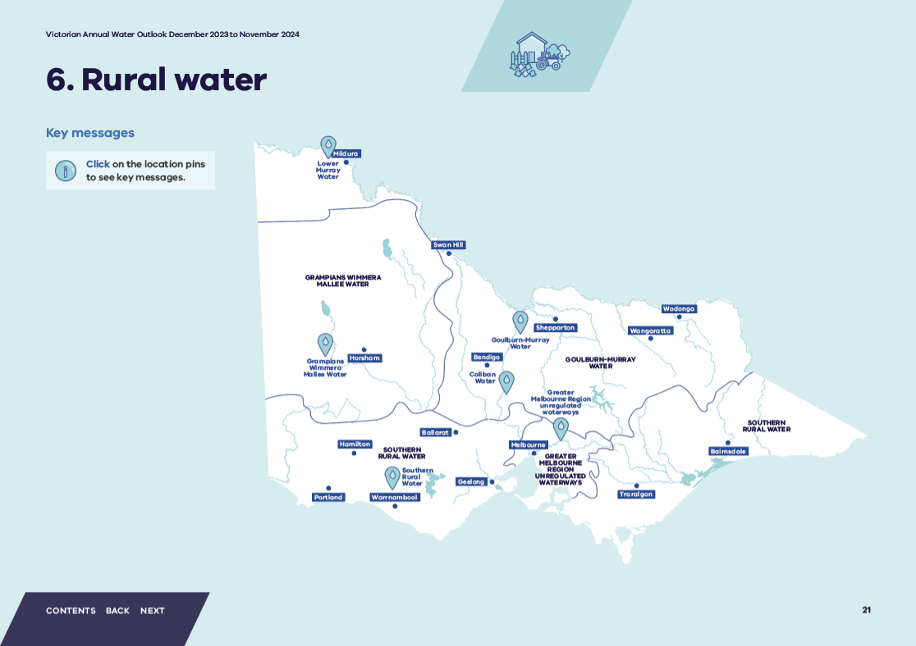

Lower Murray Water
Lower Murray Water rural water users will have access to their full high reliability entitlement volume.

Grampians Wimmera Mallee Water
Grampians Wimmera Mallee Water customers will have access to their full license volume.

Southern Rural Water

Regulated systems
Seasonal determinations as at 1 December 2023
Werribee/Bacchus Marsh system:
- 100% high-reliability water shares
- 60% low-reliability water shares
Customers can plan their irrigation with a high degree of confidence and can carryover water into 2024-25.
Thomson-Macalister system:
- 100% high-reliability water shares
Spill allocation has ceased for the season and allocations to low-reliability water shares will be made from 15 December 2023. Opening allocations for 2024-25 will depend on autumn and winter rainfall.

Unregulated systems
In the south-west, licence holders can expect rosters and restrictions to be in line with those in an average year, with any increase from Stage 1 restrictions to be made just prior to the end of 2023.
In the central region, if dry conditions were to occur we would likely see restrictions imposed in some unregulated waterways, including Monbulk Creek, Turitable Creek, Willimigongon Creek and Lang Lang River.
In Gippsland, high rainfall in October will likely provide mitigation against restrictions to licence holders in unregulated waterways in the upcoming season, however restrictions may apply later in the season if dry conditions eventuate.

Coliban Water
Coliban rural water users will have access to their full licence volume.

Goulburn-Murray Wtaer
Following the October 2022 flooding some storages have experienced persistent elevated nutrient levels and turbidity. During 2023/24 there will be an elevated risk of blue green algae and hypoxic blackwater events.

Regulated systems
All northern Victorian regulated systems have received a 100% seasonal determination to high-reliability water shares. Allocations to low-reliability water shares have also been made in all systems.
Reserves for 2024-25 have been fully established in the Goulburn, Loddon, Campaspe and Murray systems to support opening seasonal allocations to water share holders on 1 July 2024.

Unregulated systems
Licence holders on unregulated waterways should expect some diversion bans or restrictions if dry conditions eventuate. Customers on large streams or rivers are less likely to be restricted than those on the smaller tributary streams.

Groundwater
Groundwater levels are expected to remain stable or decline across northern Victoria, as demand is predicted to increase if drier conditions are experienced.

Greater Melbourne Region Unregulated Waterways
If warmer and drier conditions into summer eventuate, licence holders on unregulated waterways could experience some restrictions. Under average conditions they could see an introduction of restrictions starting in December and likely to extend until at least March 2024.

Water shares explained
A water share is an ongoing entitlement to a share of water available in a water system. The volume of a water share is defined as the maximum amount of allocation that can be made against it each year.
Water shares are classed by their reliability, which is defined by how often full season allocations are expected to be available. In Victoria there are two types, high-reliability water shares (HRWS) and low-reliability water share (LRWS).
Allocations are made to HRWS before LRWS. When HRWS have reached 100 per cent allocation and existing commitments are satisfied, only then will allocation for LRWS be considered.
Figure 4: Seasonal determinations in Victorian declared systems as at 1 December 2023
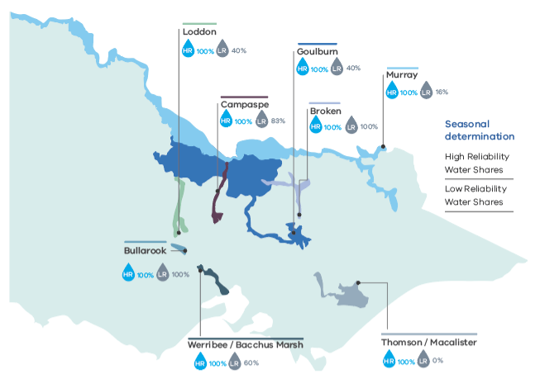
1 Water year – 1 July to 30 June
2 Water shares can be high or low-reliability. Seasonal determinations are made to high-reliability water shares before low-reliability shares.

Accessible version alt text:
 | HRWS | LRWS
Loddon | 100% | 40%
Campaspe | 100% | 83%
Goulburn | 100% | 40%
Murray | 100% | 16%
Broken | 100% | 100%
Bullarook | 100% | 100%
Werribee/Bacchus Marsh | 100% | 60%
Thomson/Macalister | 100% | 0%

Rural water supplies, the year ahead

Northern Victoria

Regulated systems
For 2023-24, all regulated systems have received seasonal determinations of 100% allocation to High-Reliability Water Share (HRWS) as well as some allocations to Low-Reliability Water Share (LRWS).
The reserves established in 2022-23 supported the high level of water availability in northern Victoria early into the 2023-24 season. The strong water resource position from the 2022-23 water year supported seasonal determinations of 100% HRWS in all regulated systems by 15 September 2023.
Although rainfall was below average for July 2023 to September 2023 across the north of the state, June 2023 was very wet and during October 2023 a significant rainfall event caused flooding in the Goulburn, Ovens and upper Murray catchments. This has caused some of the water carried over from the previous season (2022-23) and held in spillable water accounts in the Goulburn, Campaspe and Murray systems to be written off. As at 10 November, 2023, a low risk of spill declaration has not yet been made for any of these systems and so customers will not have access to any water held in spillable water accounts.
There are sufficient reserves for the 2024-25 season to support seasonal determinations of 100% HRWS in the Goulburn systems by April 2025 as long as inflow volumes expected in 99 out of 100 years are received before then. The Murray system is still building these reserves. Campaspe and Loddon systems are also expected to receive 100% HRWS in 2023-24.
The Broken, Bullarook and Ovens are annual systems so water availability in 2024-25 will largely depend on seasonal conditions in winter and spring 2024.

Unregulated rivers, streams and creeks
Licence holders on unregulated waterways only have access to licensed water when streamflows reach the minimum flow requirements specified in management plans. In northern Victoria, these are managed and monitored by GMW.
Following below average rainfall from July 2023 to September 2023 and the Bureau’s current seasonal streamflow forecast – which predicts low stream flows for October 2023 to December 2023 across northern Victoria – restrictions for unregulated waterways are likely in smaller creeks and tributaries to the main rivers. Main rivers in northern Victoria are unlikely to experience restrictions over summer.
The most likely water quality risk to occur this year and next are blue-green algae and hypoxic blackwater as turbidity in storages is elevated from historic levels. While these events are unlikely to impact customer supplies, they would impact aquatic life and recreational uses.

Groundwater
Groundwater recovery and drawdown levels in northern Victoria are dependent on rainfall recharge and groundwater extraction. Groundwater aquifers across northern Victoria showed strong recovery throughout 2022-23 with below average use and above average rainfall. However, with above average groundwater use predicted for 2023-24, it is expected that there will be a reduction in groundwater levels across all aquifers.
Most groundwater licence holders have access to 100% of their entitlement with the exception of customers in the Lower Campaspe Water Supply Protection Area (WSPA) and the Katunga WSPA.

Lower Murray Delivery risks

Lower Murray delivery risks
There is always a possibility that flows in the River Murray System downstream of Barmah are insufficient to meet demands for water entitled to be used where and when it is needed.
This can occur either when the physical channel capacity of the river limits the amount of water that can be delivered (a system shortfall), or when demand spikes and there is not enough time to release more water from dams (a delivery shortfall). The Murray-Darling Basin Authority (MDBA) operates the river on behalf of the River Murray states (Victoria, New South Wales and South Australia) and actively manages the system to avoid shortfalls. However, significant changes over the past 10-20 years in both supply and demand are making it increasingly difficult to avoid shortfalls, and there can always be unforeseen circumstances that may arise. If the MDBA advises that there will be a shortfall in delivering water in the lower Murray, then states will ration demand between water users in the affected reach.
The risk of a delivery shortfall exists every year and is more likely during an extended heatwave. This is because it takes about three weeks for water released from Hume Dam to get to Sunraysia, so releases are made well before a heatwave is forecast or water users decide to increase their take. River operators have a good understanding about typical water use in the Murray, and draw on mid-river storages and weir pools where they can to meet spikes in demand and mitigate delivery shortfalls. When there is spare capacity in Lake Victoria, river operators can also accommodate demand spikes by releasing surplus water from Hume and capturing it in Lake Victoria.
The risk of a Murray shortfall is monitored by the MDBA throughout the year. The MDBA’s River Murray System Annual Operating Outlook for 2023-24 sets out how the system will be operated, including to avoid a shortfall, under a range of different inflow conditions.
The availability of water in Menindee Lakes helps meet demands downstream of Wentworth Weir and reduces the amount of water required to be released from Hume to meet River Murray demands. As advised by the MDBA in the 2023-24 outlook, this means the risk of a system shortfall this year is very low. However, lower releases from Hume reduces the buffer against unanticipated spikes in demand upstream of Wentworth Weir and increases the risk of a delivery shortfall. The MDBA has advised the risk of delivery shortfalls this year is expected to be manageable due to high storage volumes and inter-valley trade availability; however, the risk of delivery shortfall can never be managed to zero.
During summer and autumn, the MDBA report on emerging system and delivery shortfall risk in an updated River Murray System Annual Operating Outlook 2023-24, and in its River Murray Weekly Report.

Wimmera-Mallee

Regulated systems
Inflows to Wimmera-Glenelg System reservoirs for the 2023-24 season so far have been significantly below average. Despite this, the reservoirs hold historically high volumes due to significantly above-average inflows in 2022-23. The total volume in storage is 408,580 ML with all key storages except Rocklands Reservoir (59%) and Lake Toolondo (63%) greater than 90% full (as at 8 November 2023). At the same time last year the total volume in storage was 393,660 ML.
Entitlement holders in the Wimmera-Glenelg system receive allocations in line with the rules in their entitlement. Wimmera-Mallee Pipeline Product entitlement holders have received 81% allocation against their entitlement for the 2023-24 season. All other entitlement holders in the Wimmera-Glenelg system have received 20-25% seasonal allocation except for the Commonwealth Environmental entitlement, which does not receive allocation until the system reserve for the following year has been secured.

Unregulated rivers, streams and creeks
Irrigation diversion triggers have been satisfied for both the Wimmera and Avoca Rivers, so water may be extracted for irrigation and commercial uses subject to licence conditions. Meeting these triggers means that supply is permitted regardless of climatic conditions over the coming months.

Groundwater
There are sufficient volumes of groundwater available to meet demands, except for Neuarpurr Zone 1 which remains on restrictions as part of a long-term management plan.

South-western Victoria

Regulated systems
There are two irrigation districts in south-western Victoria – Werribee and Bacchus Marsh – both of which are supplied from the Werribee and Lerderderg catchments via the Werribee system. At the opening of the irrigation season, Pykes Creek Reservoir was at 96% of capacity and Melton Reservoir was at 77% of capacity. Since then, the catchments have continued to receive good rainfall, resulting in both Reservoirs filling and spilling while seasonal determinations reached 100% HRWS and 60% LRWS on 8 November. Water users carried over 11 GL of allocation equivalent to about 71% of the total entitlement. As water share holders cannot hold more than 100% of their entitlement (including carryover), spills from Melton Reservoir and Pykes Creek Reservoir do not lead to a deduction from carried over allocation.
At the beginning of the irrigation season Rosslynne Reservoir, in the neighbouring Maribyrnong catchment was at 95% capacity, compared to 63% at the same time the year before. This was due to above average rainfall in the previous 12 months and higher inflows from the Maribyrnong catchment. As at 9 November the reservoir is at 91% capacity compared to 100% at the same time last year, when it reached full capacity for the first time in 26 years.

Unregulated rivers, streams and creeks
Rainfall across the region in late winter and spring has been average or below average in Geelong and eastern zones. Late spring rainfall occurred in western Victoria that has prolonged flows in the major streams (Barwon River, Leigh River, Glenelg River, Wannon River, Hopkins River and Mount Emu Creek). There were no peak overbank flows. On farm storages have generally filled, and winter fill licence holders have been able to utilise their full allocations and fill off-stream storages. Rosters and restrictions for diversions from unregulated waterways in all river basin systems are likely to have an average chance of being necessary, with any increase in restrictions likely to be made just prior to the end of 2023.

Groundwater
Groundwater levels in the western areas are generally showing a stable or increasing trend, which reflects the wet conditions from last year. A 100% allocation was announced on 1 July 2023 for the shallow Deutgam aquifer in Werribee South. This is the second consecutive year where the groundwater allocation in Deutgam has been unrestricted. The forecast conditions are unlikely to have an immediate impact on groundwater levels.

Gippsland
Higher rainfall has occurred this year across much of west and south Gippsland. However around central and east Gippsland, lower rainfall during winter and early spring has resulted in an early start to the irrigation season. During October, high rainfall fell across all areas. Due to the strong October rainfall, all onstream and off stream dams are full.
This has allowed high seasonal determinations for water shares and minimal spring diversion rosters or restrictions for unregulated licence holders.

Regulated systems
The Thomson and Macalister irrigation districts are situated in central Gippsland, and their primary source of water is Lake Glenmaggie, supplemented by water held in a ‘drought reserve’ in the Thomson Reservoir which provides additional allocation in years with low rainfall. Good inflows through early winter allowed for an opening seasonal determination of 100% HRWS for Thomson and Macalister water shareholders for the 2023-24 season. Recent high inflows allowed SRW to announce the availability of spill entitlement on 4 October 2023 which continued through to 29 October 2023. This means that water used from the beginning of the irrigation season is classified as spill entitlement and allocation against HRWS are reset to 100%. A seasonal determination for low-reliability entitlements is likely to be made by SRW on 15 December 2023, at the end of the potential spill period.
As at 9 November 2023, Blue Rock Reservoir (in the Latrobe system) is 100% full. If dry conditions occur over the summer months storage levels may decline, however usually they would refill with winter/autumn rains. Blue Rock Reservoir has filled in nine of the last ten years.

Unregulated rivers, streams and creeks
In eastern Gippsland areas for the year to date, licence holders on the Avon River have periodically experienced rosters and licence holders on the Mitchell River have at times been subjected to a winter fill ban. The Mitchell River is the most significant of the systems in the east of the state. The high rainfall in October this year may help to mitigate against restrictions being applied to licences earlier in the season. Restrictions to licence holders on unregulated waterways may be applied mid to late in the season if dry conditions eventuate.

Groundwater
Groundwater systems throughout Gippsland do not have any restrictions on extractions by licence holders and are well placed to meet unrestricted demand.

South-Central Victoria

Unregulated rivers, streams and creeks
The Yarra Valley region experienced a dry start to the year followed by an above average autumn. Winter rainfall was at or below average. Most of the unregulated waterways in the region have remained available during the wet autumn period, with some going on bans during the drier winter and start to spring.
If warmer and drier conditions begin to develop into summer, this could lead to an increase in restrictions or bans to licences on unregulated waterways.
Areas reliant on dams for irrigation water, such as Yarra Glen and Dixons Creek, are in a good position with most off-stream dams full.
Winter and spring rainfall across the Dandenong Creek catchment has been average but streamflow has been more aligned with the wetter conditions observed last year. Stream flows in the Dandenong Creek systems have remained similar to last year. Steady flows have been observed in Mile Creek, Monbulk Creek and Eumemmerring Creek systems. Based upon the current outlook, restrictions may be placed on Monbulk Creek licences this summer with the remaining unregulated waterways in Dandenong Creek unlikely to be subject to licence restrictions.
The Werribee and Maribyrnong catchments continued to have average rainfall throughout 2023. Licence holders along Turitable Creek and Willimigongong Creek are often subject to a total ban or restrictions in the summer months though neither system had bans imposed in the past two years. If dry conditions eventuate, licence holders in these systems may again see bans or restrictions this year.
Rainfall across the Tarago/Bunyip catchment remained average during winter 2023. With the average rainfall forecast expected for this summer and expected increased demand, it is possible that water from Tarago Reservoir will need to be released this summer to meet irrigation demand.

Securing our rural water supplies
Rural water infrastructure is vital to support agriculture and its future growth. Successive governments have invested in modernising irrigation districts with a focus on reducing the amount of water required to operate the irrigation systems and increase the value of agricultural production. Governments have also partnered with communities to build modern stock and domestic supply systems in drier parts of the state that traditionally rely on rainfall or groundwater.
The Victorian Government, the Commonwealth Government, water corporations, Local Government and local communities have invested in a number of important water infrastructure projects that increase water security and improve drought resilience for our regional communities. Between 2020 and 2023, five of these projects have been completed. The most significant of these is the Connections Project, the largest irrigation modernisation project in Australian history, which has now completed works to achieve 433 GL of water savings to be shared between the environment, irrigators, the Melbourne water retailers and Traditional Owners. This world-leading delivery system will support the sustainable future of productive agriculture in the Goulburn-Murray Irrigation District (GMID) for generations to come.
The other four projects which reached practical completion includes the Mitiamo and District Reticulated Water Supply Project, Macalister Irrigation District Phase 1B project, Werribee Irrigation District Modernisation Project (Stages 1-3) and Bacchus Marsh Irrigation District Modernisation Project (Stages 1-4). These projects will improve water security, boost productivity, and provide significant regional community benefit.
Between 2021 and 2023, four feasibility and business case projects were completed, including the Coliban Regional Rural Modernisation Preliminary Business Case, which will now progress to a detailed business case. Victoria has recently secured co-investment from the Australian Government to allow Coliban Water to complete this work, and consider options to modernise the rural water distribution network.
At current, Victoria is overseeing over $750 million of infrastructure projects, which include both capital infrastructure projects, and feasibility and business cases.
There are 18 major water infrastructure projects currently underway. This includes the $177.5 million Goulburn Murray Water (GMW) Water Efficiency Project, which secured Commonwealth funding in March 2021. This project is modernising and rationalising over 250 km of the irrigation supply system in targeted locations across the Goulburn Murray Irrigation District. The project has delivered the first 7GL of audited water savings (out of a total 15.9GL) to the Commonwealth, and is on track to issue the remaining 8.9GL in 2024. The $62.60 million Macalister Irrigation District Phase 2 Project which will further modernise irrigation systems across the District, delivering up to 10.3GL of water savings, increasing system delivery efficiency and agricultural productivity, boosting the regional economy, and improving the health of the Gippsland Lakes by reducing nutrient run-off.
Victoria continues to take advantage of the funding opportunities on offer from the Commonwealth Government. With a range of projects secured under the National Water Grid Fund and the Commonwealth Off-Farm Efficiency Program.
Under the National Water Grid Fund, Victoria currently has 11 water infrastructure projects underway, including the $11 million Recycled Water on the Bellarine Project which will provide high quality, fit-for-purpose recycled water for high value agriculture and horticulture on the Bellarine Peninsula, the $21 million Werribee Irrigation District Modernisation Project (Stages 4 & 5) which will largely complete the replacement of a manual, dilapidated, and inefficient channel-based irrigation network with a modern, automated pipeline across the Werribee Irrigation District. In addition, nine small-scale construction projects across Victoria are being delivered under the Victorian Connections Pathway Package. With these projects expected to collectively deliver up to 100 jobs during construction and secure over 125 ongoing jobs, provide 900 ML in additional water storage capacity, 1700 ML per annum increased water availability and an increase of an estimated 664 hectares of additional irrigable land. An additional six business case projects have been funded across the State.
In 2023-24, Victoria secured additional funding for two projects through the National Water Grid Fund, including the $52.2 million Water Quality for Wannon Project, which will deliver new water treatment infrastructure to improve water quality in Portland, Heywood and Port Fairy. Also, the Coliban Regional Rural Modernisation Detailed Business Case.
Under the Off-Farm Efficiency Program, Victoria is delivering two projects – the GMW Water Efficiency Project, and the $37.9 million Lower Murray Water (LMW) Water Efficiency Project. The project will modernise and upgrade existing irrigation infrastructure and improve metering to provide a more secure and efficient rural water delivery network for the Sunraysia region. The project is expected to recover an estimated 2.5 GL of water from system losses such as leaks and evaporation by upgrading over 27km of irrigation supply channels and replacing or decommissioning around 700 stock, domestic and dethridge meters, providing a more secure water supply to nearly 5,000 irrigators in the LMW irrigation district and supporting an estimated 110 local construction and project delivery jobs.
Victoria continues to progress its Sustainable Diversion Limit Adjustment Mechanism (SDLAM) projects to deliver environmental benefits agreed under the Murray Darling Basin Plan. This includes the $124.99 million Victorian Murray Floodplain Restoration Project and the $10.4 million Victorian Constraints Measures Program (Stage 1A).
Victoria continues to seek investment into projects which deliver broader benefits, not only to the environment, but also Traditional Owners, and to integrated water management including the fit for purpose use of recycled water for mixed uses including irrigation. Current recycled water projects include the $116.3 million Western Irrigation Network, which will provide a climate resilient supply of water for the Parwan-Balliang agricultural district to the west of Melbourne. Also, the $13.9 million Recycled Water on the Bellarine Project and the $9.9 million Horsham Agriculture SmartWater for Grains Project.
The feasibility of developing irrigated agriculture in central Gippsland was explored through a SRW-led Southern Victoria Irrigation Development Feasibility Study which determined prospective locations for development and informed the Central and Gippsland Region Sustainable Water Strategy. Further investigations are now being undertaken separately for the Macalister/Avon and Latrobe Catchments for future irrigation development.

Environmental water

Key messages
Each year the Victorian Environmental Water Holder (VEWH) works closely with nine catchment management authorities and Melbourne Water to develop a seasonal watering plan. Victoria’s environmental watering program adjusts to current climatic conditions and seasonal variability, including our lived experience under accelerating climate change. The VEWH and program partners plan for different climate scenarios, water availability and impacts of system operations, then make decisions as events unfold. Our program continues to work closely with people on the ground to learn how systems operate differently in the cycle of ‘boom and bust’ between record floods and drought, and everything else in between.
Environmental watering in some systems aim to build on positive ecological outcomes achieved in recent years from planned or natural flood/water events.
In other systems environmental water will be used to support recovery from flood impacts like loss of native fish from hypoxic blackwater and loss of plants on the water’s edge of rivers, creeks and wetlands from bank erosion.
Coming out of 2022-23, when much of Victoria experienced extremely wet and flooded conditions, many storage dams were full or near full and many natural wetlands remained inundated in winter/early spring 2023. Northern rivers were still experiencing natural high flows through to early October.
This map does not include all the possible environmental watering that may occur over the outlook period. For more information on other activities across Victoria, please visit www.vewh.vic.gov.au.
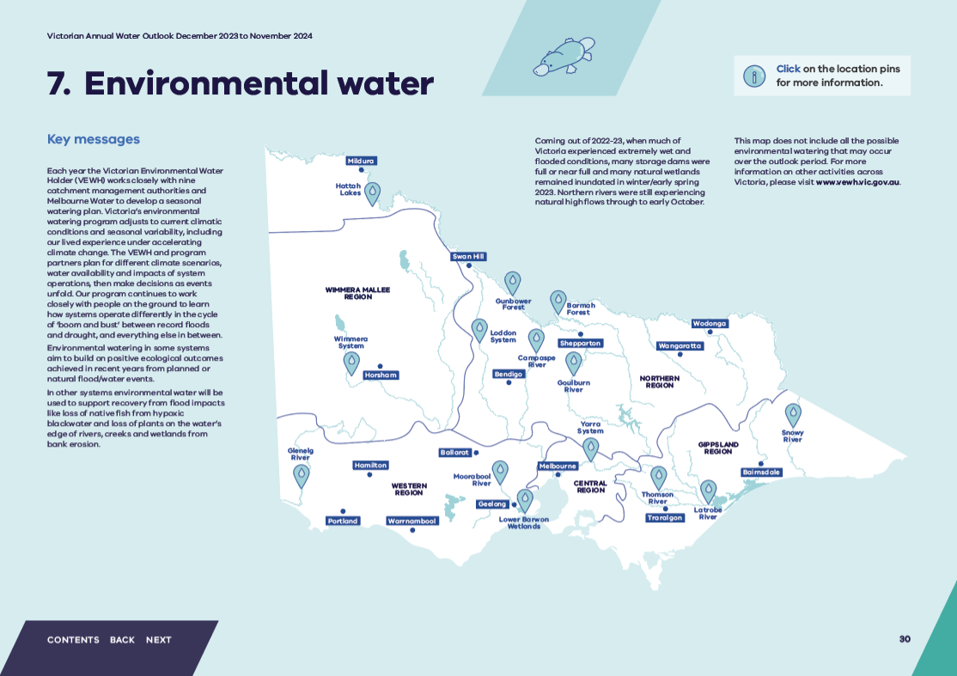

Hattah Lakes
The flood at Hattah Lakes in spring 2022 was the largest since 1956. The system received a natural top up again in August 2023 through natural high flows from the Murray River, which means the active watering planned for autumn 2024 is now unlikely to proceed. The lakes will be allowed to drawdown over coming months to provide foraging habitat for wading waterbirds and opportunities for native plans to grow on exposed lake beds.

Wimmera System
Flooding in the Wimmera River catchment during 2022-23 helped native fish breed and disperse throughout the system. Environmental water planning for 2023-24 aims to combine low flows and freshes recommendations with natural events to maintain flowing habitat for native fish and platypus and capitalise on last year’s positive outcomes.

Loddon System
Water for the environment may be used to provide low flows and freshes in the Loddon River, Pyramid Creek and Serpentine Creek to maintain habitat for native fish, platypus and plants and mitigate poor water quality over summer and autumn.
Most of the Boort wetlands remain inundated after 2022 floods and water levels will be allowed to recede naturally over summer to support ecological processes that rely on varying lake levels. Some top-ups may be delivered to Little Lake Meran and Lake Boort in autumn 2024 to support recently germinated plants and to maintain enough water for nesting waterbirds if there is significant breeding over spring and summer.

Gunbower Forest
Several high flow events in the Murray River between June and October 2023 partially inundated Gunbower Forest. Water for the environment was used between and after these events to maintain water levels in key wetlands and parts of the broader forest floodplain to support native plants and provide food and habitat for waterbirds and frogs. If dry conditions occur throughout summer and autumn, the forest will be allowed to dry out but water is likely to remain in permanent wetlands.

Barmah Forest
Water for the environment is planned to prolong inundation of low-lying wetlands in Barmah Forest through spring 2023 to support native plants and a wide range of animals that depend on water. Water for the environment is likely to be delivered in summer and autumn to help native fish move from the drying floodplain to the Murray and to allow large waterbird colonies to complete their breeding cycle.

Campaspe River
High rainfall early in the water year caused water to spill from Lake Eppalock between mid-July and mid-September. Water for the environment was not needed for low flows in the Campaspe River during the spill but was used to deliver a spring fresh to stimulate native fish and platypus movement and help re-establish plant communities along the banks that were scoured during the 2022 floods.
For the rest of 2023-24, water for the environment aims to deliver baseflows and small-sized freshes to maintain minimum water depths and some flow variability to protect native fish and platypus and support new plant growth.

Glenelg River
High river flows and natural flooding in the Glenelg system provided excellent conditions for native fish, and monitoring in autumn 2023 recorded significant numbers of young-of-year tupong (Pseudaphritis urvillii). Environmental water planning for 2023-24 aims to maintain continuous low flows and freshes to protect and build on the environmental gains of recent years.

Moorabool River
Water for the environment is mainly used in the Moorabool River to maintain critical low flows and occasional freshes during summer and autumn to maintain habitat and food for native fish and platypus. Providing these flows are especially important in dry years when the river is at risk of drying out.

Lower Barwon Wetlands
Wet conditions have prevented the target drawdown at Reedy Lake since 2019-20 and at Hospital Swamps in 2022-23. Partial summer and autumn drawdowns are a priority at both sites in all planning scenarios in 2023-24 to provide foraging habitat for migratory and Australian shorebirds, support a diverse plant community and facilitate nutrient cycling. The timing of the drawdown will be adjusted in response to any natural flooding and to avoid disturbing waterbird breeding.

Yarra System
After wet conditions in 2022-23 filled all the lower Yarra billabongs, Melbourne Water’s landscape assessment has identified watering at Yering Backswamp and Bolin Bolin Billabong as high priorities in 2023-24. Yering Backswamp has a distinct plant community which has adapted to frequent or near-permanent inundation and offers reliable habitat for native frogs and waterbirds. Bolin Bolin Billabong was naturally inundated by high river flows in October 2023, and eel movement back to the main river channel is being monitored to inform future watering.

Goulburn River
A planned spring fresh using water for the environment was delivered in September 2023 and was soon followed by unregulated flows causing moderate flooding in October 2023. These flows are likely to trigger significant native fish breeding and carry seeds, nutrients and sediments that could support new riverbank plant growth. Low flows during summer and autumn will help consolidate that growth and protect banks against future erosion. Some short autumn freshes may be delivered to help the dispersal of juvenile fish. Water for the environment may also be used to help mitigate low dissolved oxygen if summer storms create hypoxic blackwater conditions.

Thomson River
Summer low flows and freshes may be necessary to maintain the environment and water quality for fish and waterbugs and support the growth of fringing plants. Autumn freshes are planned to trigger migration, spawning and recruitment of native fish like Australian grayling that need to move between the river and sea during different stages of their life cycle.

Latrobe River
Freshes may be delivered over summer and autumn to improve water quality, support plant growth in the river channel and sustain aquatic animals. These may be timed to coincide with releases in the Thomson River to flush the lower Latrobe wetlands estuary with fresh water.

Snowy River
Environmental flows in the Snowy River aim to mimic a snowmelt river, with greater flows during winter and spring, then sustain moderate flow rates over summer and autumn.

Environmental water supplies, the year ahead

What is water for the environment?
Water for the environment is water allocated and managed to protect and improve the health of rivers, wetlands, creeks and floodplains and the native plants and animals that depend on them. It aims to build resilience and halt declines in species as the climate changes. Each year environmental watering actions are managed in response to seasonal conditions, including responding to natural events such as the 2022 floods.
Waterway managers plan with Traditional Owners, stakeholders and communities to add to shared benefits when environmental flows are delivered, including for Traditional Owner cultural values, recreation and social values and community wellbeing.
The VEWH holds water entitlements and receives water allocations to use in the environmental watering program for the health of rivers and wetlands and provide outcomes such as:
- cueing fish migration and breeding
- improving water quality
- improving the condition of floodplain trees
- triggering the growth of wetland plants
- providing food and nesting habitats for waterbirds.
The VEWH and partner waterway managers identify and plan watering actions in waterways across Victoria under different climate and water availability scenarios, as published in the Seasonal Watering Plan 2023-24.
In northern Victoria, the VEWH works with the Commonwealth Environmental Water Holder, Murray-Darling Basin Authority and other environmental water holder partners in New South Wales and South Australia so that combined environmental water holdings can deliver the highest priority watering actions in a well-co-ordinated way across the southern-connected Murray-Darling Basin.
Climate conditions across Victoria were variable at the start of 2023-24. Northern Victoria had wet conditions, with the Murray River running high and a positive allocation outlook to supply users, including the environment. Central and most of east Victoria began the water year with full/near-full storages and a high allocation outlook. Western Victoria has had a drier than average start to the year and allocations are expected to be less than 100% during the year. However, large carryover volumes from last year and additional allocations during the year will allow a wide range of environmental watering actions to be delivered in the Wimmera and Glenelg systems during 2023-24.

Environmental watering actions so far in 2023-24
Following the high rainfall and floods across much of Victoria in 2022-23, many areas of Victoria remained wet as the 2023-24 water year began, with some rivers still running, especially the upper and mid-Murray and its tributaries. However, despite full storage dams in most locations, El Niño conditions have been declared and water allocation in the Wimmera-Glenelg system is not forecast to reach 100 per cent. Deliveries of water for the environment so far this year have mainly been used to extend the benefits of natural floods by prolonging flood duration in some systems and provide exit pathways for fish that have entered new systems or recently spawned. For example, while adjoining floodplain wetlands remain full and healthy, an early spring fresh was delivered in the lower Goulburn River to provide connectivity to off channel habitats and increase productivity and soil moisture in the banks for germinating plants. Water for the environment was used in Barmah and Gunbower Forests to extend inundation of low-lying wetlands in early spring when higher unregulated flows receded.
In other locations like the Mallee, water is receding naturally, and some wetlands are entering a drying cycle after extensive flooding.
Any significant rainfall has the potential to cause already full storages to spill and this could cause high flows and floods in some rivers. These natural events support important ecological processes and are critical to the health and persistence of many native plants and animals. Water for the environment may be used to supplement natural high flow events, like extending wetland inundation to help nesting waterbirds successfully raise their chicks or be saved for later use. Unused environmental water can also be carried over to support environmental flows in subsequent years, depending on the entitlement’s conditions. This ability to carry water over between years is critical for sustaining waterway health in drier periods.

Does the VEWH buy or sell water?
The VEWH may consider buying or selling water for the environment where it is important for meeting an environmental objective. The VEWH’s annual Water Allocation Trading Strategy describes the trading activity the VEWH may carry out during 2023-24. Significant commercial trade decisions are announced on our news page and in our annual reports.

Further information
More information about sustainable water management and how we manage in dry conditions can be found at:
- Department of Energy, Environment and Climate Action – www.water.vic.gov.au
More information about your local conditions and how water corporations manage in dry conditions can be found at:
- Barwon Water – www.barwonwater.vic.gov.au
- Central Highlands Water – www.chw.net.au
- Coliban Water – www.coliban.com.au
- East Gippsland Water – www.egwater.vic.gov.au
- Gippsland Water – www.gippswater.com.au
- Goulburn-Murray Water – www.g-mwater.com.au
- Goulburn Valley Water – www.gvwater.vic.gov.au
- Grampian Wimmera Mallee Water – www.gwmwater.org.au
- Greater Western Water – www.gww.com.au
- Lower Murray Water – www.lmw.vic.gov.au
- Melbourne Water – www.melbournewater.com.au
- North East Water – www.newater.com.au
- South East Water – www.southeastwater.com.au
- South Gippsland Water – www.sgwater.com.au
- Southern Rural Water – www.srw.com.au
- Wannon Water – www.wannonwater.com.au
- Westernport Water – www.westernportwater.com.au
- Yarra Valley Water – www.yvw.com.au
More information about environmental water can be found at:
- Victorian Environmental Water Holder – www.vewh.vic.gov.au
More information about forecast rainfall and temperatures can be found at:
- Australian Bureau of Meteorology – www.bom.gov.au/climate/ahead
More information about using water efficiently can be found at:
- Smart Water Advice - https://smartwateradvice.org/
More information on water restrictions can be found at:
- https://www.water.vic.gov.au/for-households/water-restrictions-and-rules

Did you know
Replacing a very inefficient showerhead (1-star or 2-star) with a 4-star showerhead can save a family of four around $315 per year in water bills, plus significant energy savings.

Glossary
Allocation: Allocation (determination): Water that is actually available to use or trade in any given year.
The water that is actually in the dam in any given year is allocated against water shares. The seasonal allocation is the percentage of your water share volume available under current resource conditions, as determined by the resource manager e.g. a 50% allocation to your 100 ML water share gives you 50 ML of water available to use or trade.
In northern Victoria the resource manager uses seasonal determination instead of allocation when allocating water to entitlements.
Average maximum temperatures: The BoM’s median maximum temperature over the selected data period (e.g. February to April) is the midpoint of the ordered maximum temperatures over that data period from 1981-2018.
DEECA: The former Department of Environment, Land, Water and Planning (DELWP) has evolved into the newly-formed Department of Energy, Environment and Climate Action (DEECA).
El Niño: El Niño is a large-scale change in tropical Pacific Ocean temperatures that affects global weather patterns. It’s one phase of a natural cycle called the El Niño -Southern Oscillation. For Victoria, El Niño usually means below-average winter-spring rainfall and warmer temperatures.
Entitlements: A right to take/use/extract/have water delivered that may be limited by conditions. Different entitlements are necessary depending on where and how water is taken, and what it is then used for.
Freshes: Freshes are short-duration flow events that submerge the lower parts of the river channel. They are important for plants that grow low on the banks and provide opportunities for fish and other animals to move more easily along the river.
La Niña: La Niña is a large-scale change in tropical Pacific Ocean temperatures that affects global weather patterns. It’s one phase of a natural cycle called the El Niño -Southern Oscillation. For Victoria, La Niña usually means above-average winter -spring rainfall and cooler temperatures.
Median rainfall: The BoM’s median rainfall over the selected data period (e.g. February to April) is the midpoint of the ordered rainfall totals over that data period from 1981-2018. Due to the high variability of rainfall, the median is usually the preferred measure of `average’ rainfall.
Regulated systems: A water system where the flow of the river is regulated through the operation of major storages or weirs to secure water supplies. For example, in northern Victoria there are seven regulated water systems: the Murray, Ovens, Broken, Goulburn, Campaspe, Loddon and Bullarook.
Reliability: Water shares are classed according to their reliability, which is defined by the frequency with which full seasonal allocations are expected to be available. Most water shares are classified as either high-reliability or low-reliability water shares.
Reserves: Reserves are established to secure the availability of high-reliability entitlements in the following year if conditions turn dry. Each system has different arrangements for establishing reserves.
Run of the river systems: A system with little or no water storage. Forecasts for run of the river systems carry greater uncertainty because the demand on the system makes up a greater proportion of system capacity. Smaller outlook periods (3-6 months) are typically applied to reflect this uncertainty.
Spill: When water is discharged from the storage when there is more water in supply than demand for water. In southern Victoria, spill is extra water that irrigators can receive on top of their normal high-reliability allocation, if their water storage overflows in spring. For example, in the Macalister Irrigation District, any water that spills over the Glenmaggie Weir between 1 July and 15 December becomes spill entitlement.
Stage 1 restrictions: For a summary of key Stage 1 water restrictions head to https://www.water.vic.gov.au/liveable/using-water-wisely/advice-and-rules/stage-1-water-restrictions
Stage 2 restrictions: For a summary of key restrictions head to https://www.water.vic.gov.au/for-households/water-restrictions-and-rules/stage-2-water-restrictions
Unbundling: When the entitlement previously called a water right, or a take and use licence in a declared water system, is converted into three separate entitlements. These are: a water share, a delivery share or extraction share in a works licence, and a water-use licence. This occurred for declared water systems on 1 July 2007 in northern Victoria and 1 July 2008 in southern Victoria.
Unregulated systems: A river system where no major dams or weir structures have been built to regulate the supply, or extraction, of water for consumptive use.
VEWH: The Victorian Environmental Water Holder is an independent statutory body responsible for holding and managing Victoria’s environmental water entitlements.
Victorian Water and Climate Initiative: The Victorian Water and Climate Initiative (VicWaCI) is a partnership between DEECA, the Bureau of Meteorology, and Commonwealth Scientific and Industrial Research Organisation (CSIRO). Through the VicWaCI research our understanding of climate change and its impacts on Victoria’s water resources has grown substantially in recent years. Find out more at https://www.water.vic.gov.au/our-programs/climate-change-and-victorias-water-sector/hydrology-and-climate-science-research/victorian-water-and-climate-initiative
Water is Life: Traditional Owner Access to Water Roadmap (2022): `Water is Life’ sets out the opportunities for Traditional Owners to access and manage water for spiritual, cultural and environmental purposes. Find out more at https://www.water.vic.gov.au/aboriginal-values/the-aboriginal-water-program.

deeca.vic.gov.au

Based on the driest tenth per centile (ten per cent) of climate experienced since 1975.
A worst on record scenario would happen if conditions are similar to the extremely dry conditions that occurred during the peak of the Millennium Drought in 2006-07. This scenario is not expected in the Outlook period of November 2023 to December 2024.

