Green Links Grants Program
  - Application guidelines 2023
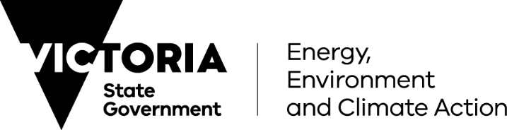
Table of Contents
Protecting our waterways so wildlife can thrive 2
1. What is the Green Links Grants Program? 2
2. How much funding is available? 3
3. Who can apply? 3
4. Who cannot apply? 5
5. What might be funded? 5
6. What will not be funded? 6
7. What are the funding details? 6
8. What are the assessment criteria? 7
9. What supporting documents will need to be provided? 10
10. What are the funding conditions? 10
11. Ongoing evaluation/reporting requirements 12
12. What is the application process? 13
13. Additional information 13
14. What is the notification process? 13
15. Key dates 13
16. Checklist 14
Appendix 1: Green Links Grant program area 15

Protecting our waterways so wildlife can thrive
Victoria’s waterways support biodiversity and are home to more than 1,800 species of native plants and 600 species of native animals. Even in highly modified urban waterways, natural vegetation provides vital habitat corridors for threatened species. Waterways have, and continue to be, sites of significant importance and cultural value to Traditional Owners. Through their association and relationship with Country, Traditional Owners maintain unique cultural and spiritual connections to the waterways and their lands, plants and animals.
Urban waterways and their parkland corridors also play an important role in supporting community wellbeing. Providing safe, natural places for people to spend time and engage with nature. Which has a measurable impact in reducing depression, anxiety and stress in an individual and community. Unfortunately, increasing urban land use, development pressures, and climate change pose an ever-increasing risk to the condition and value of our waterways.
There is a need to act now to avoid an otherwise inevitable decline in waterway health and habitat. With action, many of the catchment’s significant environmental values can be maintained or improved. Supporting the extent and quality of streamside vegetation will improve habitat availability to support bird, frogs, fish and platypus and protect for the catchment’s wetlands and floodplains and in turn increase the availability of places where community can connect with nature in our cities and towns.

1. What is the Green Links Grants Program?
The Green Links grant program will invest $10 million over three years in revegetation and associated on-ground actions that improve habitat, water quality and provide cool green spaces for community.
The Green Links grant program aims to achieve the following outcomes:
- Increase habitat around waterways.
- Improved condition of priority waterways through revegetation and associated activities. (In the first instance waterways within the geographic area of Burndap Birrarung burndap umarkoo, the Yarra Strategic Plan, the Waterways of the West and Rivers of the Barwon (Barre Warre Yulluk) Action Plans and identified for new planning controls.)
- Improve the amenity values of waterways for the community by restoring habitat and improving experiences associated with naturalness, escape, safety and cooling.
- Support the management of waterways and their lands as connected living entities in line with the cultural values of Traditional Owners and community visions.
Green Links aims to revegetate up to 200ha of land, resulting in healthier local communities and environments by enhancing the values derived from waterways and supporting the management of waterways and their lands in line with the cultural values of Traditional Owners and community visions.

Timeframe
This grants program, and funded works, will commence in the 2023-24 financial year and conclude by 30 June 2026. All funded works must be completed by conclusion of the grants program.

2. How much funding is available?
A total of $10 million in grant funding is available. The 2023-24 funding round will allocate up to $6 million. There will be one or more additional funding round prior to the end of the 2025-26 financial year.

3. Who can apply?
Green Links provides funding for revegetation projects along urban waterways. Specifically the following creeks and rivers identified for new planning controls:
- Stony Creek (The Stony Creek that commences is in the St Albans area, flowing through Sunshine, Tottenham, Brooklyn, Footscray West, Yarraville and Spotswood, where It meets the Yarra River.)
- Jacksons Creek
- Kororoit Creek
- Cherry Creek (Located in Western Melbourne and terminating into Port Philip Bay in Altona.)
- Werribee River
- Moonee Ponds Creek
- Maribyrnong River
- Steele Creek
- Darebin Creek
- Merri Creek
- Edgars Creek
- Koonung Creek (Also known as Koonung Koonung Creek)
- Plenty River, and
- Gardiners Creek
And waterways located within the geographic area covered by the:
- Waterways of the West Action Plan Action plan,
- Rivers of the Barwon (Barre Warre Yulluk) Actions Plan,
- Burndap Birrarung burndap umarkoo, the Yarra Strategic Plan (YSP).
These target waterways and areas, referred to as the program area (Appendix 1), face major challenges due to climate change and population growth. Extensive priority setting, collaboration, engagement and partnership work through the YSP and the Action Plans provide a foundation on which Green Links can deliver significant and targeted benefits. The program also strongly complements work to introduce land use planning controls for the urban rivers and creeks listed above, which aims to support creation of wildlife corridors, protection of waterways and restoration of the natural environment.
It recognises the contributions of the Bunurong, Eastern Maar, Wadawurrung and Wurundjeri Woi-wurrung Traditional Owners, along with community in setting directions and priorities in these areas.
The following organisations, located/operating within the program area, can apply for funding:
- land and/or water management authorities
- community or environmental volunteer groups and networks that are not-for-profit and have a focus on on-ground land and natural environment improvement work. This includes Landcare groups and networks, Friends of groups, Riverkeeper/ association groups, Conservation Management Networks and Coastcare groups.
- Registered Aboriginal Parties
- local government authorities

In addition, to be eligible for funding applicants must;
- be an incorporated body, cooperative or association (including business associations);
- be financially solvent; and
- hold insurance sufficient to safeguard volunteers and participants involved in the funded activities, including public liability insurance of at least $10 million and personal accident insurance.
Please contact urban.waterways@deeca.vic.gov.au to check eligibility.

4. Who cannot apply?
The following cannot apply for funding;
- Individuals,
- Private sector business and agencies other than those listed above, and
- Commonwealth Government agencies.

5. What might be funded?
Eligible organisations can apply for funding for projects that are for targeted on-ground works for revegetation and associated works within the program area.
This may include but is not limited to;
- site preparation,
- planting,
- establishment or procurement of seed, seedlings and established plants,
- early maintenance works to support plant establishment (such as, watering and follow-up weed and pest control),
- fencing (e.g. to protect from stock and human trampling, pest grazing), and
- works to improve biodiversity such as habitat restoration, nesting boxes, ground habitat replacement.
Works must be in an area adjacent/around the waterway but must connect to the riparian and/or waterway corridor. Areas that connect waterway habitat to other significant habitat patches are also eligible where habitat value for waterway species can be evidenced.
Works may complement previous or planned works which contribute to revegetation and habitat restoration.
Project management funding may also be available for applicants from community groups and Registered Aboriginal Parties. This cannot exceed 5% of total funding requested.
All activities and final reporting must be completed by 30 June 2026.

Priorities for funding
The following projects will be given priority:
- Projects identified in the Yarra Strategic Plan and/or Barwon or WOW Action Plans themselves, or subsequent work aligning to these Plans.
- Projects that provide significant new areas of habitat.
- Projects that promote the concept of waterways as living and connected systems.

6. What will not be funded?
The program will not fund the following activities:
- The purchase of land.
- Infrastructure works, including major drainage or waterway augmentation.
- The undertaking of routine maintenance activities.
- Non-indigenous vegetation.
- Activities that were already planned and funded, without a net expansion on previous project area.
- Research, feasibility or other studies or business case activities.
- Recurrent operating costs, for example rent and utility costs.
- Activities establishing expectations of ongoing funding.
- Activities located outside the program area.

7. What are the funding details?
The total funding available for this program is $10 million, which will be made available over multiple funding rounds.
Eligible organisations are encouraged to contribute towards the overall cost of the project(s). These contributions can be a combination of in-kind support (time spent planning and delivering the projects) as well as cash contributions (such as planting and maintenance costs).
Funding opportunities are detailed in the following table:
Funding category | Local scale | Large scale
What can be applied for | Projects of targeted  on-ground works for revegetation and associated works within the program area - that are discrete on smaller or singular sites and with local benefits. | Projects of targeted  on-ground works for revegetation and associated works within the program area - that can involve multiple partners, across a region/area and with broad, catchment-scale benefits.
Funding available per grant application | $20,000 - $200,000 | $200,000 - $2 million
Total Funding available in Round 1* | $1 million | $5 million
Timing | Projects to be completed by no later than 30 June 2026
Collaborations and Community involvement | Partnerships with Traditional Owners and/or community groups on applications are highly encouraged.  Community tree planting events and/or other opportunities for involvement for local communities such as Friends groups and schools to participate is encouraged.
* The total funding available for Round 1 is $6 million. In the case where the total funds aren't needed for one of the two categories, they will be reallocated to the other.

8. What are the assessment criteria?
Eligible applications will be assessed using the criteria listed below. Each criterion is given a percentage weighting to indicate its relative importance in the assessment process. Applications should address all relevant criteria, and the level of detail should be commensurate to the scale of the project and funding requested.
Criteria have been developed to ensure that funding meet activity eligibility under Environmental Contribution requirements. (Environmental contributions are funds collected from water supply authorities under the Water Industry Act 1994 (the Act). Under a 2004 amendment to the Act, environmental contributions are collected to fund initiatives that seek to promote the sustainable management of water or address adverse water-related environmental impacts. For more information visit https://www.water.vic.gov.au/planning/environmental-contributions)

Criterion 1: Why is this project required? (25%)
Applications must demonstrate the need for the project, for example, by describing:
How the project can help support:
- riparian habitat,
- urban greening,
- biodiversity improvements,
- urban heat reduction, and/or
- community values.

And for Large scale projects, how the project:
- represents alignment to or directly addresses the Community Vision, actions or objectives of the Yarra Strategic Plan or the Barwon or WOW Actions Plans, and/or
- supports any relevant strategies and place-based landscape plans, e.g. Healthy Waterway Strategy, Regional Catchment/ Waterway Strategies, local masterplans, and/or
- is targeting one or more of the rivers and creeks identified for new planning controls (listed previously).

Criterion 2: What will this project deliver? (40%)
Applications must detail:
- what the funding will be used to deliver (the outputs) and the area covered by the works in hectares,
- the benefits of the project.

For part (a), outputs of the project could include the creation or addition to existing revegetation/ rehabilitation activities, urban greening, or heat reductions, and should be represented quantitatively where possible, for example;
- X hectares of land prepared and revegetated
- X km of fencing to protect revegetation works.
- X hectares of land treated for weeds
- X number of community events or volunteer hours

For part (b), examples of benefits of the project to biodiversity, amenity, and community values/social outcomes may include:
- Improved habitat for threatened species through improved riparian habitat.
- Benefits to local community connection to waterways and, including (where relevant) culturally and linguistically diverse (CALD) communities.
- How the project contributes to waterway amenity in locations of socio-economic vulnerability and high community use or public access, especially by those particularly vulnerable to the effects of urban heat (e.g. young children, older people, people with disabilities).
- How the project will meet the needs of a growing and/or changing population in an urban area.
- How the project will benefit areas of significance for Traditional Owners (as identified by the Traditional Owners).

And for Large scale projects:
- Benefit or connection to significant lengths or areas of waterway habitat, rather than multiple disparate sites.

Criterion 3: How will this project be delivered? (35%)
Applicants must provide/demonstrate:
- A project timeframe that outlines how the project can be completed by no later than 30 June 2026.
- A budget that demonstrates the project is financially viable and represents value for money, outlining any additional proposed funding contributions for the project.
- Their capacity to manage delivery, i.e. previous experience delivering revegetation works, committed volunteer base, relationships with land managers/Local Governments.
- Detail regarding proposed materials and plant types, species and sizes appropriate for the location and future climate conditions.

And Large scale project applications should also demonstrate:
- All relevant planning, approvals and management plans (e.g., cultural heritage) have been obtained, or that relevant approvals have been factored into the project plan and can be delivered within the required timeframes.
- That flooding, fire risk and any other hazards have been considered.
- How any passive watering or integrated water management principles would be utilised as the source for watering.
- That stakeholders have been identified and outline stakeholder management planning.
- Consideration of and addressing any potential impacts on gender equity.
- For projects within the Yarra Strategic Plan area, how the project is consistent with the Yarra Strategic Plan’s decision-making framework (Appendix E of the Plan; Burndap Birrarung burndap umarkoo, the Yarra Strategic Plan - appendix (water.vic.gov.au)).
- How any potential impacts on and benefits for Traditional Owners, their partnership, values and culture have been considered, and how opportunities for self-determined involvement in delivery of the project have been included.

Program-wide considerations
The following program-wide factors will also be considered:
- Equitable distribution - subject to the quality of the submitted applications and supporting documentation in terms of meeting the assessment criteria, the total available program funds will be distributed across eligible organisations as equitably as possible.
- Projects that have delivery partners’ contributions and attract further public, not-for-profit or private sector investment are desirable and strongly encouraged.
- Delivery partners previous performance in delivering DEECA projects.

9. What supporting documents will need to be provided?
Please submit the following documents with your application:
- Project plan, including work schedule and details including vegetation type (i.e. species, canopy types), planting windows, possible events, etc.
- Location with a map, if possible, of target area/site of works.
You may also include:
- Detailed project budget
- Evidence to verify confirmation of other funding sources or in-kind contributions.
- All relevant planning, approvals and management plans (e.g. cultural heritage), or demonstration that those planning considerations can be factored into the projects and still be delivered within the required timeframes.
- Permissions from landowners or land managers to conduct the project on their land e.g. letters of support.
- Any relevant supporting strategies or plans (e.g. Action or Master plans, Urban Forest, Urban Cooling or Vegetation strategies, etc).

10. What are the funding conditions?

Funding agreements
Successful applicants must enter into a funding agreement with Department of Energy, Environment and Climate Action (DEECA).
The Victorian Common Funding Agreement is used for funding agreements with not-for-profit organisations and Local Government Authorities.
The DEECA Transfer Payment Funding Agreement is used for Victorian public entities, as defined under section 5 of the Public Administration Act 2004.
It is recommended that applicants review the terms and conditions before applying. Information about the Victorian Common Funding Agreement is available on https://www.vic.gov.au/victorian-common-funding-agreement
The activity does not include using the Funding for political campaigning or advocacy activities for political parties.

Legislative and regulatory requirements
In delivering the activity grant recipients are required to comply with all relevant Commonwealth and state/territory legislations and regulations, including but not limited to:
- The Privacy Act 1988 (Commonwealth)
- The Freedom of Information Act 1982 (Vic)
- Occupational Health and Safety Act 2004
- Planning and Environment Act 1987
- Heritage Act 2017
- Aboriginal Heritage Act 2006
- Environment Protection Act 2017 (Vic)

Local Jobs First Policy (LJF)
Through its Local Jobs First Policy, the Victorian Government is committed to improving opportunities for local suppliers to create more new jobs and grow the economy.
The LJF applies to all grants awarded under this program valued at over $1 million in regional Victoria, or over $3 million in metropolitan Melbourne and state-wide activities. For further information, go to LJF website (https://localjobsfirst.vic.gov.au/)

Tax implications
Applicants should consult the Australian Taxation Office or seek professional advice on any taxation implications that may arise from this grant funding.
Successful applicants without an ABN will need to provide a completed Australian Taxation Office form ‘Statement by a Supplier” so that no withholding tax is required from the grant payment.

Acknowledging the Victorian Government’s support
Successful applicants are expected to acknowledge the Victorian Government’s support and promotional guidelines (https://www.deeca.vic.gov.au/grants) will form part of the funding agreement. Successful applicants must liaise with the departmental program area to coordinate any public events or announcements related to the project.

Payments
Payments will be made as long as:
- the funding agreement has been signed by both parties,
- grant recipients provide reports as required, or otherwise demonstrate that the activity is progressing as expected, and
- other terms and conditions of funding continue to be met.

11. Ongoing evaluation/reporting requirements
Grant recipients are required to comply with project monitoring and reporting requirements as outlined in the funding agreement. This may include progress reports, site inspections, completion reports and acquittal documentation.
Evaluation is essential to ensure the best use of public monies and for making informed future policy and investment decisions. Grant recipients will be required to submit regular Progress Reports, in line with the deliverable schedule outlined in their funding agreements.
Project evaluation at the end of the project is part of the grant acquittal process. Final reviews at the end of the project seek to answer questions such as:
- Did the project achieve it’s intended result/outcomes?
- What benefit did the project create for the local community?
- How did the project contribute to the Community Vision and/or Traditional Owner self-determined priorities?
- What is the long-term sustainability of the work undertaken?
- Were there unintended outcomes?
Progress and Final Reporting templates will be supplied to grant recipients as part of the execution of the grant agreement.

Privacy
Any personal information about you or a third party in your application will be collected by the department for the purposes of administering your grant application and informing Members of Parliament of successful applications. Personal information may also be disclosed to external experts, such as members of assessment panels, or other Government Departments for assessment, reporting, advice, comment or for discussions regarding alternative or collaborative grant funding opportunities. If you intend to include personal information about third parties in your application, please ensure that they are aware of the contents of this privacy statement.
Any personal information about you or a third party in your correspondence will be collected, held, managed, used, disclosed or transferred in accordance with the provisions of the Privacy and Data Protection Act 2014 and other applicable laws.
DEECA is committed to protecting the privacy of personal information. You can find the DEECA Privacy Policy online at www.deeca.vic.gov.au/privacy.
Requests for access to information about you held by DEECA should be sent to the Manager Privacy, P.O. Box 500 East Melbourne 8002 or contact by emailing Foi.unit@deeca.vic.gov.au

12. What is the application process?
Applications are submitted online using the Grants Online portal.
To apply, go to the grant program web page https://deeca.my.site.com/publicform?id=a0hRF0000000EuD and click on the ‘Start New Application’ button. To return to a saved draft application, https://deeca.my.site.com/ and click on the ‘Access Saved Application’ button.

Attaching required documents
Supporting documents must be in an acceptable file type, such as Word, Excel, PDF, or JPEG. The maximum file size for each file is 10MB.
You will receive an application number when you submit your application online. Please quote this number in all communications with the department relating to your application.
If you have documents to submit that cannot be attached to your online application you can email them to urban.waterways@deeca.vic.gov.au, quoting your application number. Attach all documents to one email, zipping the files if required.
Make sure your application is submitted by 5 pm on Thursday 14 December 2023
Note: No hard-copy applications will be accepted. Late and incomplete applications will not be considered.

13. Additional information
Additional information is available at the program web page www.water.vic.gov.au/grants/green-links-grants
If you require assistance submitting your application online, email grantsinfo@deeca.vic.gov.au.

14. What is the notification process?
Successful and unsuccessful applicants will be notified in writing after the assessment process is completed. All decisions are final and are not subject to further review. Unsuccessful applicants can ask for feedback on their application.

15. Key dates
Applications open: 9 November 2023
Applications close: 14 December 2023
Applicants notified: March 2024
Activities commence by: 30 June 2024
Activities completed and acquittal reports submitted: 30 June 2026

16. Checklist
Read these guidelines and the information about this grants program at www.water.vic.gov.au/grants/green-links-grants before applying and complete the following checklist.
Have you:
- Read these guidelines carefully?
- Checked if you are, or your organisation is, eligible for this grant funding?
- Checked if your activity is eligible for this grant funding?
- Checked that you would be able to comply with all relevant laws and regulations in delivery of your activity?
- Prepared the appropriate supporting documents?

Appendix 1: Green Links Grants Program area
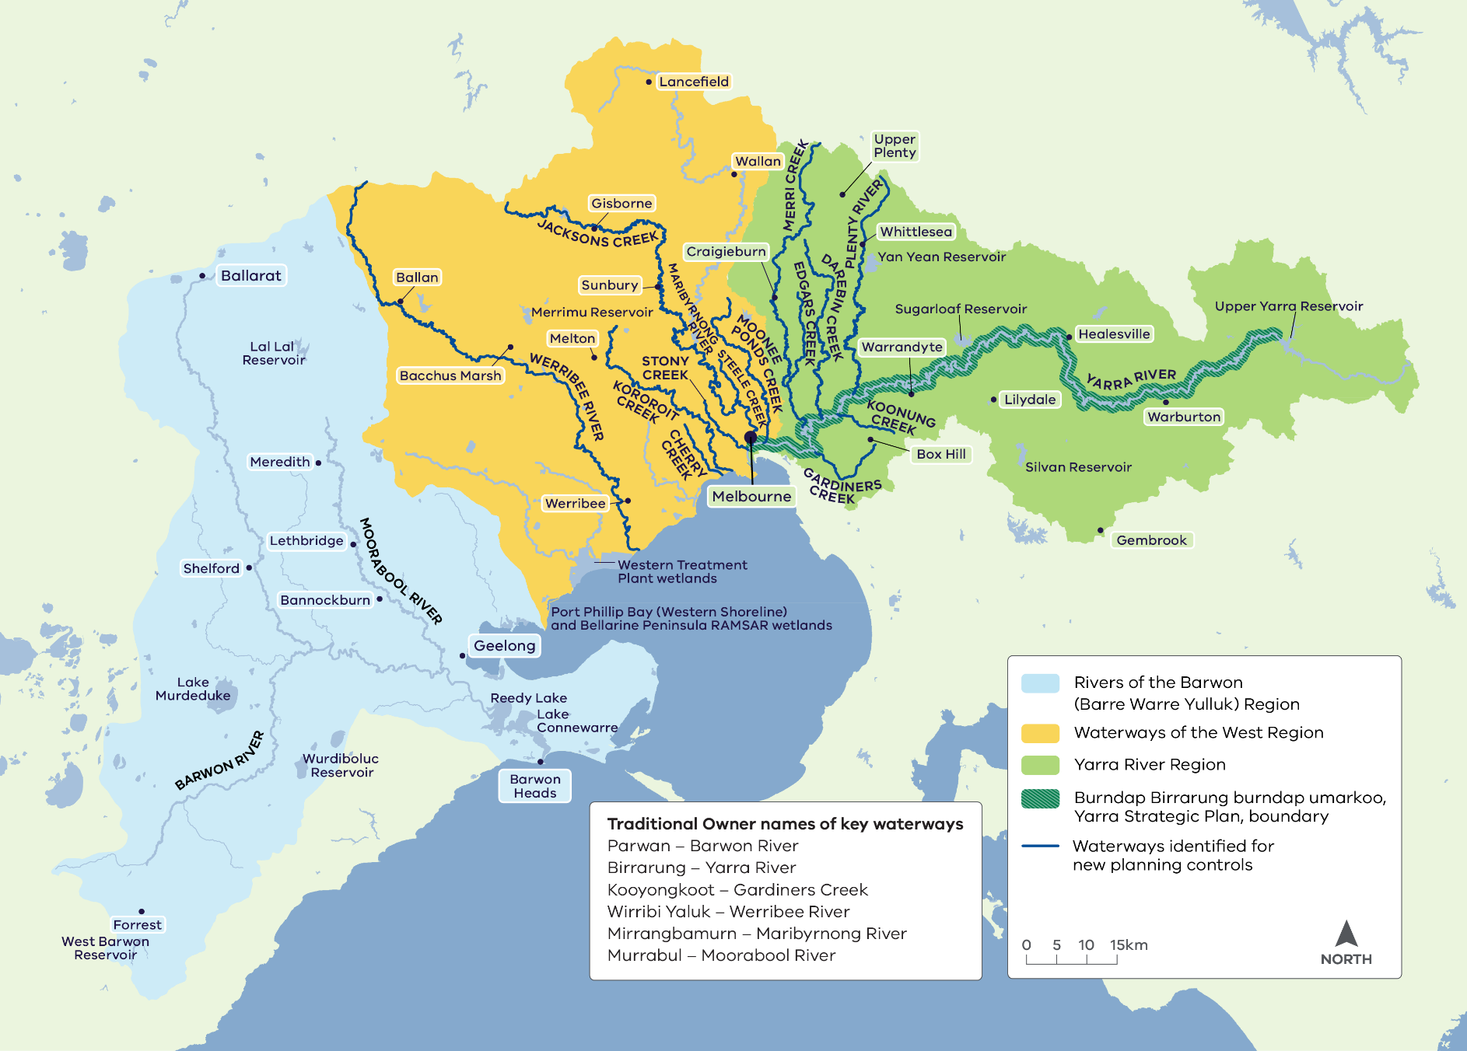

Acknowledgements
The Victorian Government proudly acknowledges the Bunurong, Eastern Maar, Wadawurrung and Wurundjeri Woi wurrung Traditional Owners and pays respect to their Elders past and present. We acknowledge their ongoing connection to land, water and natural and built landscapes, and acknowledge the ongoing contribution this makes to the Birrarung (Yarra River), Rivers of the Barwon (Barre Warre Yulluk) and Waterways of the West regions.
We support the need for genuine and lasting partnerships with Traditional Owners to support self-determination and the protection of Country. The Victorian Government is committed to working towards equity of outcomes and ensuring an equal voice for Traditional Owners
Author
Catchments, Waterways, Cities and Towns Division, Department of Energy, Environment and Climate Action.
Photo credit
Community planting day, Werribee River Association
We acknowledge and respect Victorian Traditional Owners as the original custodians of Victoria’s land and waters, their unique ability to care for Country and deep spiritual connection to it.
We honour Elders past and present whose knowledge and wisdom has ensured the continuation of culture and traditional practices.
DEECA is committed to genuinely partnering with Victorian Traditional Owners and Victoria’s Aboriginal community to progress their aspirations.
© The State of Victoria Department of Energy, Environment and Climate Action October 2023
Creative Commons
This work is licensed under a Creative Commons Attribution 4.0 International licence, visit the Creative Commons website (http://creativecommons.org/licenses/by/4.0/).
You are free to re-use the work under that licence, on the condition that you credit the State of Victoria as author. The licence does not apply to any images, photographs or branding, including the Victorian Coat of Arms, and the Victorian Government and Department logos.

ISBN 978-1-76136-488-4 (pdf/online/MS word)

Disclaimer
This publication may be of assistance to you but the State of Victoria and its employees do not guarantee that the publication is without flaw of any kind or is wholly appropriate for your particular purposes and therefore disclaims all liability for any error, loss or other consequence which may arise from you relying on any information in this publication.
Accessibility
To receive this document in an alternative format, phone the Customer Service Centre on 136 186, email customer.service@deeca.vic.gov.au, or contact National Relay Service on 133 677. Available at DEECA website (www.deeca.vic.gov.au).

