Great South Coast
Strategic directions statement
October 2019

Department of Health
Acknowledgement of Victoria’s Aboriginal communities
The Victorian Government proudly acknowledges Victoria's Aboriginal communities and their rich culture and pays its respects to their Elders past and present. The government also recognises the intrinsic connection of Traditional Owners to Country and acknowledges their contribution to the management of land, water and resources.
We acknowledge Aboriginal people as Australia’s first peoples and as the Traditional Owners and custodians of the land and water on which we rely. We recognise and value the ongoing contribution of Aboriginal people and communities to Victorian life and how this enriches us. We embrace the spirit of reconciliation, working towards the equality of outcomes and ensuring an equal voice.
© The State of Victoria Department of Environment, Land, Water and Planning 2019 This work is licensed under a Creative Commons Attribution 4.0 International licence. You are free to re-use the work under that licence, on the condition that you credit the State of Victoria as author. The licence does not apply to any images, photographs or branding, including the Victorian Coat of Arms, the Victorian Government logo and the Department of Environment, Land, Water and Planning (DELWP) logo. To view a copy of this licence, visit the creative commons site <creativecommons.org/licenses/by/4.0/>
Printed by Finsbury Green, Melbourne
ISBN 978-1-76077-850-7 (print)
ISBN 978-1-76077-851-4 (pdf)
Disclaimer
This publication may be of assistance to you but the State of Victoria and its employees do not guarantee that the publication is without flaw of any kind or is wholly appropriate for your particular purposes and therefore disclaims all liability for any error, loss or other consequence which may arise from you relying on any information in this publication.
Accessibilty
If you would like to receive this publication in an alternative format, please telephone the DELWP Customer Service Centre on 136 186 or email the DELWP Customer Service Centre <customer.service@delwp.vic.gov.au> or via the National Relay Service on 133 677, or at the National Relay Service website <www.relayservice.com.au>.
This document is also available on the internet at the DELWP website <www.delwp.vic.gov.au>
Cover photograph
Traditional Kooyang aquaculture, Budj BimCourtesy: Ben Church, Gunditj Mirring Traditional Owner Aboriginal Corporation

Contents
Foreword 7
Acknowledgements 8
At a glance 9
Our Vision 9
Strategic outcomes: 9
IWM opportunities 10
Regional enablers 10
Town scale 11
Chapter 1 The way forward 12
Introduction 12
Enduring collaboration 13
Chapter 2 IWM in the Region 17
Vision and Outcome Areas for the Great South Coast IWM Forum Region 17
Regional context 20
The case for IWM in the Region 22
Success stories 27
Chapter 3 IWM opportunities 29
State-wide and region specific initiatives 29
IWM opportunities: How were they selected? 30
Impact of IWM opportunities on the Forum’s strategic outcomes 31
IWM project & strategy opportunities – overview 32
Priority Portfolio of IWM projects and strategies 35
References 50

Pareeyt Poondee-teeyt.
Water is Life.
Dhauwurd Wurrung language group
Pa poonteeyt paman paman.
And life is sacred.
Keerray Wurrung language group
Integrated Water Management is a collaborative approach to water planning and management that brings together organisations with an interest in all aspects of the water cycle.
It has the potential to provide greater value to our communities by identifying and leveraging opportunities to optimise outcomes.

Foreword
Water is life – we will work together with our communities to deliver integrated water outcomes contributing to the resilience of our environment, culture and economy. The Great South Coast Integrated Water Management (IWM) Forum is one of 15 IWM Forums established across the state.
The Great South Coast region is a wonderful place to live. Situated in the south-west corner of the state, we are laden with stunning, wild places. The Ramsar listed Glenelg River estuary is at our western boundary, Budj Bim is at the heart of our region, the Grampians are to the north and the Otways to the east, with the Great Ocean Road’s 12 Apostles attracting millions of visitors annually. While our region enjoys abundant water resources, we are serious about grappling with the challenges of climate change. We are invested in securing the future prosperity of our region, building on our nationally significant agriculture, tourism and energy production.
When the Great South Coast Integrated Water Management (IWM) Forum was formed in June 2018, we quickly gained momentum, expanding on the established relationships of the Great South Coast Group, a long-standing alliance of government, industry and community.
This history of collaboration is proving to be invaluable as we work together to set priorities and deliver IWM in our region.
Our forum actively seeks opportunities to inform state policy to better enable IWM and we are motivated by this opportunity to un-lock benefits for our region and beyond.
It has been uplifting to witness a cultural shift in our thinking, conversations and level of engagement about how we approach water management. IWM is now recognised and reflected in many regional and urban strategic plans.
Through the forum and practitioner network process we have greatly benefited from the perspective and insights of our Traditional Owner representatives. World heritage status has just been awarded to Budj Bim. This is a unifying milestone for all members of our forum.
Water quality and quantity at Budj Bim is now of international importance and the benefits of restoring health to this globally significant landscape aligns with many IWM goals and aspirations.
This project will raise the profile of the area’s long and remarkable indigenous water management history. Its tourism potential is untapped. Budj Bim is a vivid example of why we are pursuing integrated water management across our region.
It is my pleasure to present the Strategic Directions Statement of the Great South Coast IWM Forum. It is an excellent example of regional collaboration from a diverse range of organisations. I wish to thank members for their commitment, enthusiasm and shared knowledge, which has opened up many important and innovative opportunities for the life of our region.
Kylie Gaston
Chair of the Great South Coast Region IWM Forum

Acknowledgements
The Great South Coast IWM Forum covers Gunditjmara, Eastern Maar, Djab Wurrung and Wadawurrung country whose ancestors and descendants are the Traditional Owners of this country.
The meetings of the Forum, the practitioner group and individual meetings with project sponsors have developed initiatives from ideas into mature project themes.
Collaboration and cross-pollination have been key outcomes of the Forum, with ideas being shared and improved by input from project partners.
The Great South Coast Strategic Directions Statement has been developed in collaboration with:
- Corangamite Catchment Management Authority
- Corangamite Shire
- Eastern Maar Aboriginal Corporation
- Glenelg Shire Council
- Glenelg Hopkins Catchment Management Authority
- Gunditj Mirring Traditional Owners Aboriginal Corporation
- Moyne Shire Council
- Southern Grampians Shire Council
- Southern Rural Water
- Warrnambool City Council
- Wannon Water

At a glance
The Great South Coast IWM Strategic Directions Statement highlights the key challenges in the region and identifies collaborative IWM opportunities that can improve resilience and liveability in cities and towns in the region.

Our Vision
Water is life – we will work together with our communities to deliver integrated water outcomes contributing to the resilience of our environment, culture and economy.

Strategic outcomes:
- Safe secure and affordable supplies in an uncertain future
- Effective and affordable wastewater systems
- Avoided or minimized existing and future flood risks
- Healthy and valued waterways and marine environments
- Healthy and valued landscapes
- Community values reflected in place-based planning
- Jobs, economic growth and innovation
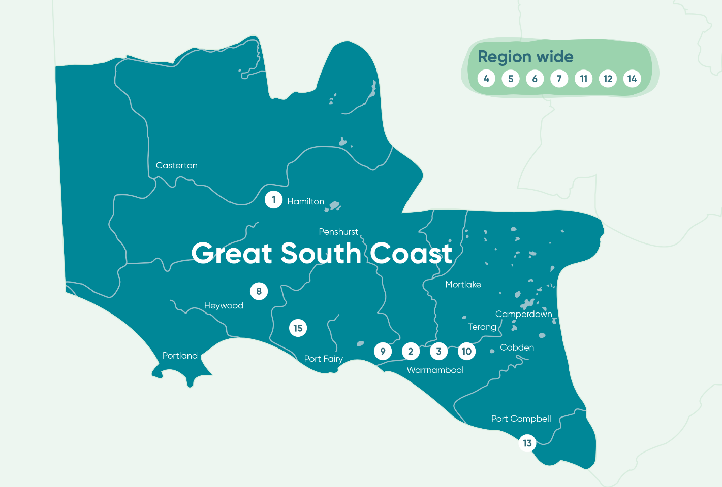

IWM opportunities
Partners of the Forum are committing their best endeavours to ensure priority projects and strategies are progressed in line with the shared vision and strategic outcomes of the Great South Coast IWM Forum.

Regional enablers

4. Great South Coast Urban Water Atlas
Develop an urban water atlas for the region, identifying opportunities for potable supply to be substituted with water from alternative sources, for high priority community assets within our towns that are water-dependent.

5. Adaptive waste water solutions for small towns – Penshurst and Cudgee case studies
The cost of reticulated sewerage is prohibitive in many small towns and private septic systems are often not adequate or able to be effectively managed. This project will build on previous work completed for Branxholme, where a case study was conducted to quantify the benefits of a solution using an innovative, neighbourhood-scale technical solution.

6. Aquifers available for recreation, industry and tourism
This project will promote collaboration between Southern Rural Water and shires to disseminate information about the changes in the regulatory framework for selling and leasing of water licences across the region.

7. Building IWM capacity through an urban drainage community of practice
This project will support the formation and function of a community of practice of drainage infrastructure managers across the Great South Coast region, as a precursor to greater collaboration and integration of more aspects of IWM within and between organisations.

11. Alternative water for major industry
This project will target engagement with major water users to identify alternative water source opportunities.

12. Collaborate on infrastructure capacity
Lack of water infrastructure or limited infrastructure capacity can be a barrier to growth in some areas. A more collaborative and integrated approach to infrastructure planning, in partnership with developers would support growth while making clear investment decisions.

14. Privately owned water supply safety for small towns – a collaborative approach
This project will focus on the potential to support communities to manage private, decentralised water supplies to improve the safety of the water in these supplies.

Town scale

1. IWM Plan for Hamilton
Preparation of an IWM plan for town of Hamilton including a “future road map” to ensure community and environmental water needs are met into the future.

9. IWM Plan for Warrnambool
Whole of town IWM plan to identify opportunities, costs and benefits of interventions across the city.

Site and sub-catchment scale

2. Albert Park IWM Plan
This IWM plan will bring together the various water demands and supply sources at this major sporting precinct in Warrnambool which are currently managed in isolation, to develop a shared vision and a water balance for the site, and develop recommendations for high priority integrated options.

3. Understanding the Merri River
This project proposes the development of an ecological model for the Merri River to inform future interventions. This will enable strategic planning to identify where investment will provide the greatest benefit to enhancing the environmental, cultural and social values of the river.

8. Supporting water management at Budj Bim
This project proposes to facilitate water management in and around Budj Bim that will progress actions to reinstate historic flow paths in the landscape, building on current work being undertaken by the Glenelg Hopkins CMA.

10. IWM in East of Aberline Road Structure Planning
This new 3-4,000 residential development on the north east side of Warrnambool has outstanding potential for IWM to achieve alternative water sources and urban tree canopy. Council and the Victorian Planning Authority will work with other agencies to support these outcomes.

13. Gellibrand Catchment – Targeted interventions for water quality
This project will foster collaboration to improve filtration of runoff throughout the Gellibrand catchment through increased and targeted vegetation establishment and other strategies, which will result in lower treatment costs for potable water supply and environmental benefits.

15. Recycled Water to Orford Power Station
This project will investigate reusing treated wastewater for cooling at the new Orford Power Station, reducing the large amount of potable and groundwater needed.

Chapter 1

The way forward
An unprecedented opportunity to progress water cycle planning and management in Victoria through collaboration.

Introduction
The Integrated Water Management (IWM) Framework for Victoria (September 2017) is designed to help regional stakeholders to work together, ensuring the water cycle contributes to the liveability of towns and cities in Victoria, with communities at the centre of decision making.
The central premise of an IWM approach is the understanding that managing urban liveability and resilience is a shared responsibility, and that water is a key enabler to achieving these shared aims.
To facilitate this, IWM Forums have been established across the state to identify, prioritise and oversee the implementation of critical collaborative opportunities. This Strategic Directions Statement has been produced by the Great South Coast IWM Forum to capture and communicate those opportunities.
IWM seeks to build on existing partnerships and planning processes. In the Great South Coast region, stakeholders such as local government authorities, catchment management authorities and water corporations engage with their communities regularly to improve service delivery and urban planning. Community aspirations are embedded in the strategies and operational plans for organisations throughout the region. These aspirations reflect a desire for liveable and productive places and vibrant communities.
The way in which we plan and use water is fundamental to ensuring these aspirations are realised.
The inherent cultural value of the landscapes in the Great South Coast region is recognised in the Eastern Maar Country Plan ‘Meerreengeeye Ngakeepoorryeeyt’, in the Budj Bim Masterplan 2013 and the Ngootyoong Gunditj Ngootyoong Mara South West Plan developed by the Gunditj Mirring Traditional Owner Aboriginal Corporation.
IWM in the region is also strengthened by the formation of Catchment Partnership Agreements for the Glenelg Hopkins area and Corangamite area under the Government’s Our Catchments, Our Communities Integrated Catchment Management Strategy for Victoria (2016-19).

What is a Strategic Directions Statement?
This Strategic Directions Statement (SDS) articulates the regional context, the shared vision and the strategic water-related outcomes for the Great South Coast IWM Forum region.
It includes a list of IWM opportunities, including projects and strategies, developed in collaboration by the Great South Coast IWM Forum partners.

Integrated Water Management
Integrated Water Management is a collaborative approach to water planning that brings together organisations that influence all aspects of the water cycle. It has the potential to provide greater value to our communities by identifying and leveraging opportunities to optimise the outcomes of water cycle.
Partners of the Forum have committed their organisations to apply their best endeavours to:
- Ensure priority projects and strategies are progressed in line with the shared vision and strategic outcomes of the Great South Coast IWM Forum; and to
- Support DELWP to progress priority strategic enablers for IWM in Victoria.
It is envisaged that the SDS will be a living document which will be updated to reflect the current Great South Coast IWM Forum’s priorities and opportunities.

Enduring collaboration
IWM is an evolving process that seeks to coordinate and balance many views and interests in the water sector around common goals and shared outcomes. IWM Forums collaborate and oversee ongoing IWM planning. The IWM Forum cycle is summarised on the next page.

How we’re working together
The Great South Coast IWM Forum and Strategic Directions Statement builds on existing collaborative networks established to identify issues and set priorities to relating to the environment and regional prosperity including:
- The Great South Coast Group, involving local government and industry and
- The Catchment Partnership Agreements of the Glenelg Hopkins and Corangamite Catchment Management Authorities.
The Great South Coast IWM Forum identifies, coordinates and prioritises areas that would most benefit from collaborative and place-based water management planning and delivery.
To ensure IWM is successful and enduring across the region, the Great South Coast IWM Forum partners have committed to the promotion of a collaborative and shared values culture within their own organisations and beyond through their work with key water cycle delivery partners and local communities.
The Great South Coast IWM Forum is governed by an open and transparent IWM planning process (Figures 1 and 2). This process assumes a holistic, whole-of-cycle approach to determining water cycle solutions, considering regulatory accountabilities and service delivery responsibilities.

Figure 1 IWM Governance Structure
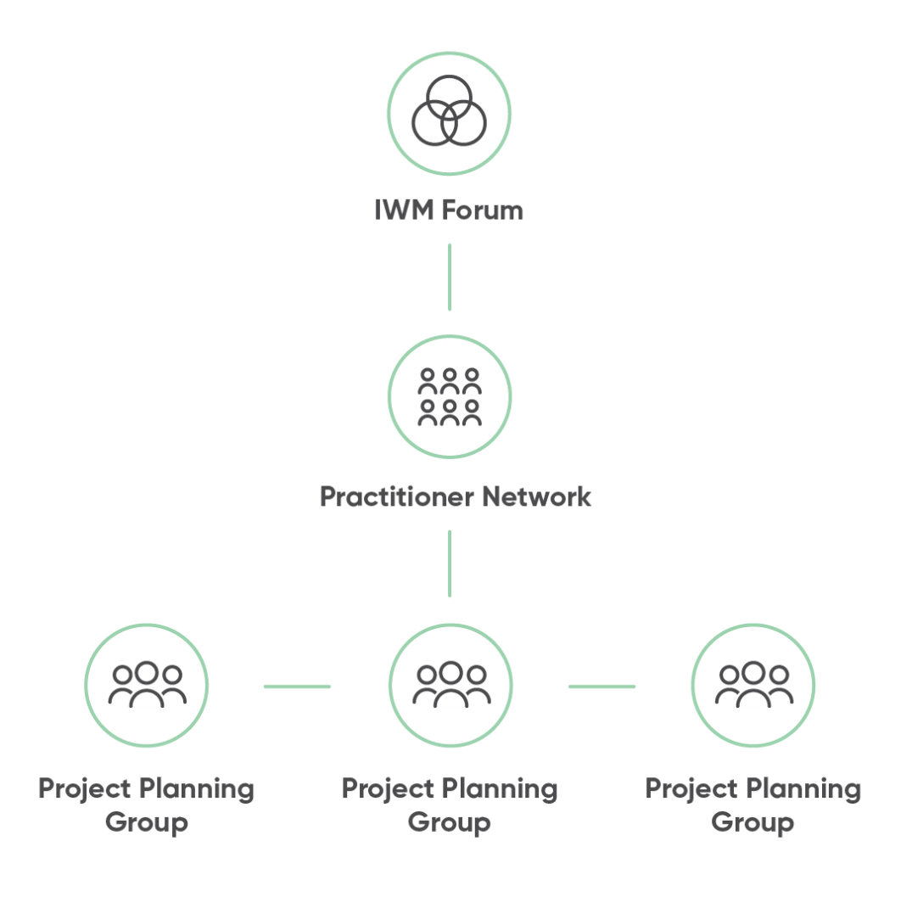
Each organisation plays an important role in the decision-making and management of the water, resources and assets for the entire catchment.
Collaboration across Forum partners ensures balanced consideration of the complex economic, environmental, cultural and community benefits and impacts associated with the range of proposed IWM projects and work programs.
The Great South Coast IWM Forum partners will continue to work together to build inter-organisational trust and develop productive, enduring relationships to realise the shared vision for the region.
Further information on the IWM Forum’s governance and planning framework is outlined in the Integrated Water Management Framework for Victoria, available at https://www.water.vic.gov.au/liveable/resilient-and-liveable-cities-and-towns/iwm-framework

Recognising Aboriginal values in water planning and management
The Great South Coast IWM Forum is committed to working in partnership with Aboriginal Victorians across landscapes, communities and natural resources.
The Forum recognises that Traditional Owners throughout the region are unique to Country and their involvement in IWM planning will be specific to each planning area.
Organisations involved in IWM have obligations to involve Traditional Owners and consider Aboriginal values in their organisational activities. The Forum will continue to work with Traditional Owner groups to determine the appropriate approach and level of involvement in IWM planning processes and projects.

Continued collaboration
Phase One of the IWM Forum process has established an enabling environment for Victoria’s water sector stakeholders to develop shared IWM objectives and overcome sectoral, institutional and geographic boundaries through collaboration. This phase was guided by the experience and knowledge of the Forum members and IWM practitioners, and has resulted in the delivery of this SDS.
Phase Two of the IWM Forum process will assume a more strategic approach to successful IWM implementation and planning for the Forum area. It is anticipated that the IWM Forum collaborative partners will continue to use their best endeavours to advance priority IWM opportunities through regular meetings and future Forums.
Phase Two will create an opportunity to evaluate and share learnings from Phase One. It will also optimise resources and explore the development of innovative tools and approaches that plan for, and respond to, water supply, demand and water-related liveability in the future.
Figure 2 IWM Forum planning and delivery process
Phase I | Outcomes  Phase I | Participants  Phase I
Establish  Organisational leaders come together in collaborative IWM Forums and Working Groups to discuss integrated water management challenges, opportunities  and priorities  for each region | Preliminary work on regional characterisation and collaborative governance  Agree vision, objectives and goals  Agree criteria for selection and prioritisation of IWM opportunities  IWM opportunities identified and prioritised  Collaboratively develop and endorse Strategic Directions Statement for each region | Local governments  Catchment Management Authorities  Water corporations  Traditional Owners  Department of Environment, Land, Water and Planning  Chair  Others as relevant

Phase II | Outcomes  Phase II | Participants  Phase II | Next 12-18 months
Planning  Cultivate a collaborative culture to progress  IWM opportunities | Co-design and agree on Terms of Reference, governance structure, stakeholder engagement and/or community participatory planning guidance for IWM project/strategy | Collaborative partners  Community representatives  Others as relevant | The feasibility of IWM opportunities will be continually reviewed and assessed in Phase II to confirm the need for specific IWM projects/strategies
Progress  Forum Members use best endeavours to progress IWM opportunities to next stage | IWM Project Groups initiate work as per identified project/strategy status, including: feasibility assessment; technical and economic analysis; cost allocation; business case development  Strategic enablers for IWM progressed by DELWP with support from Forum Members  IWM Project Groups report progress to IWM Forums | Collaborative partners  Individual organisations who have committed to a project/strategy  Community representatives  Relevant stakeholders | The feasibility of IWM opportunities will be continually reviewed and assessed in Phase II to confirm the need for specific IWM projects/strategies
Incorporate  Collaborative Partner organisations incorporate relevant elements of IWM in their own plans, guidelines or frameworks | IWM Project Groups to take IWM commitments (projects and strategies) to their Board or Councils for investment endorsement  IWM Project Groups incorporate elements into their own organisational planning systems, e.g. Council and corporate plans, Construction Guidelines, etc.  Report back to IWM Forum | Individual organisations who have committed to deliver a project/strategy | The feasibility of IWM opportunities will be continually reviewed and assessed in Phase II to confirm the need for specific IWM projects/strategies
Realise  IWM benefits are realised following implementation of project/strategy | Application of practical IWM tools and innovative approaches  Additional community value added through participatory planning  Monitoring and evaluation of key measures and outcomes  Economic savings through shared resources, costs, etc.  Improved resilience and liveability of cities and towns | Collaborative partners  Individual organisations who have committed to a project/strategy  Community representatives  Others as relevant | The feasibility of IWM opportunities will be continually reviewed and assessed in Phase II to confirm the need for specific IWM projects/strategies

Phase III | Outcomes  Phase III | Participants  Phase III
Prepare  IWM Forums prepare to refresh the Strategic Directions Statement | Collaborative partners prepare for next round of IWM Forums  IWM Forums collaboratively review key learnings and outcomes from Phase I & II, including catchment-scale IWM Strategy and progress on strategic enablers  Next round of IWM opportunity identification and prioritisation | Collaborative partners

Chapter 2

IWM in the Region
Understanding why an integrated approach to water planning and management is critical for the Great South Coast IWM Region now and for the future.

Vision and Outcome Areas for the Great South Coast IWM Forum Region

Our Vision
Water is life – we will work together with our communities to deliver integrated water outcomes contributing to the resilience of our environment, culture and economy.

IWM Outcome Areas
The region is seeking to achieve seven key outcomes through IWM. Each of these will have a significant role in shaping the liveability, prosperity and resilience of our cities and towns. These outcome areas provide indicators to assess the effectiveness of the various IWM opportunities, recognising that these outcomes are in themselves co-dependent.
Low-emission solutions
IWM opportunities that minimise the release of greenhouse gas (GHGs) emissions will be considered by the Forum as solutions are evaluated for implementation.

 | Outcomes  Safe, secure and affordable supplies in an uncertain future | Outcomes  Effective and affordable wastewater systems | Outcomes  Avoided or minimised existing and future flood risks | Outcomes  Healthy and valued waterways and marine environments | Outcomes  Healthy and valued landscapes | Outcomes  Community values are reflected  in place-based planning | Outcomes  Jobs, economic benefits and innovation
Objectives | Secure water supply for industrial, economic, environmental, cultural and community needs | Meets public health and environmental standards | Communities, properties and infrastructure assets that are resilient to local flood risk | Improved ecological health and biodiversity of our urban waterways, water bodies and beaches | Active and passive recreation supported by sustainable water supply | Diverse urban landscapes that reflect local conditions and community values | Jobs and local economies, including industry, tourism and agriculture, supported by integrated water planning
Objectives | Well-managed water demand and efficient use of water | Effective wastewater systems to meet the needs of economic and population growth |  | The economic value of ecosystem services is understood by our communities and recognised in planning processes | Urban landscapes retain moisture for cooler, greener cities and towns | Water sensitive communities that are empowered and engaged | Strong governance and collaboration models that evolve to deliver innovative solutions
Objectives | A diverse range of water supplies and resources which are fit for purpose | Waste-to-resource opportunities are maximised |  | The whole-of-catchment context (upstream / downstream) is recognised in decision making. | Waterways and coastal environments accessible as valuable open space | Local water related risks and issues understood and managed by the community | Residents and visitors are attracted to our reliably green region and healthy waterways
Objectives | Water quality meets regulatory standards and community expectations | Equitable access to effective wastewater systems |  | Improved connectivity and access for active transport links | Traditional Owner values associated with waterways are protected and enhanced | Traditional Owner values, needs and aspirations associated with water are understood, protected, enhanced and continued
Objectives |  |  |  |  |  | Recognise the competing values that exist for community use of public open space

Regional context
The Great South Coast IWM Forum covers the service area of Wannon Water. The region covers an area of approximately 23,500 square kilometres, extending south from the Great Dividing Range to the coast, and reaching from the South Australian border in the west to the Otway Ranges in the east.
The landscape and climate of the region varies significantly between the forests of the Grampians to the western volcanic plains to the dry hinterland forests and heathlands running along with coastline. Rainfall ranges from 600mm in some northern areas to over 900mm per year west of Heywood.
The region also includes iconic tourism destinations that showcase the natural environment, such as the Great Ocean Road, Port Campbell National Park (featuring the Twelve Apostles and Loch Ard Gorge), the Grampians National Park (Gariwerd), the Kanawinka Geotrail and the recently awarded UNESCO World Heritage Site, Budj Bim.

Population
The region has an estimated population of 120,634, which is forecast to grow to 123,426 by 2031 and become more urbanised. There is growth expected in Warrnambool City with approximately 3,000 new residents expected by 2031. Greenfield developments are both a risk and an opportunity for water management in the region.
The region includes many small-to-medium sized towns, including popular holiday destinations which receive large visitor populations, creating seasonal water management issues. Key centres in the region include Portland, Hamilton, Port Fairy, Port Campbell, Mortlake, Cobden and Casterton.

Climate Change
By 2070, daily temperatures across the region are projected to rise by an average of 1.3°C to 2.4°C (median projection)v. This will be amplified in urban centres due to the prevalence of darker and harder surfaces, leading to environmental and human health impacts. Ensuring the provision of fit for purpose water for the region’s urban greening will be a key priority in enhancing liveability and resilience for the community and environment.
The annual rainfall in the region is predicted to decrease by 6-7% per cent by 2070v – primarily impacting the spring and winter seasons. This is predicted to lead to a reduction in runoff of between 20 and 50% by 2065vi under a medium climate change scenario. This presents a challenge for the region, as there will be an increased demand for urban water resulting from population and economic growth together with a hotter, drier climate.
The Great South Coast region will also be impacted by sea level rise, with levels expected to rise by 0.2 – 0.56m by 2070i , while Victoria’s State Planning Policy Framework calls for 0.8m by 2100 to be planned for. Where areas are at greater risk of sea level rise, some organisations have completed more recent studies that reflect their own circumstances, for example Moyne Shire with 0.8-1.2mii.

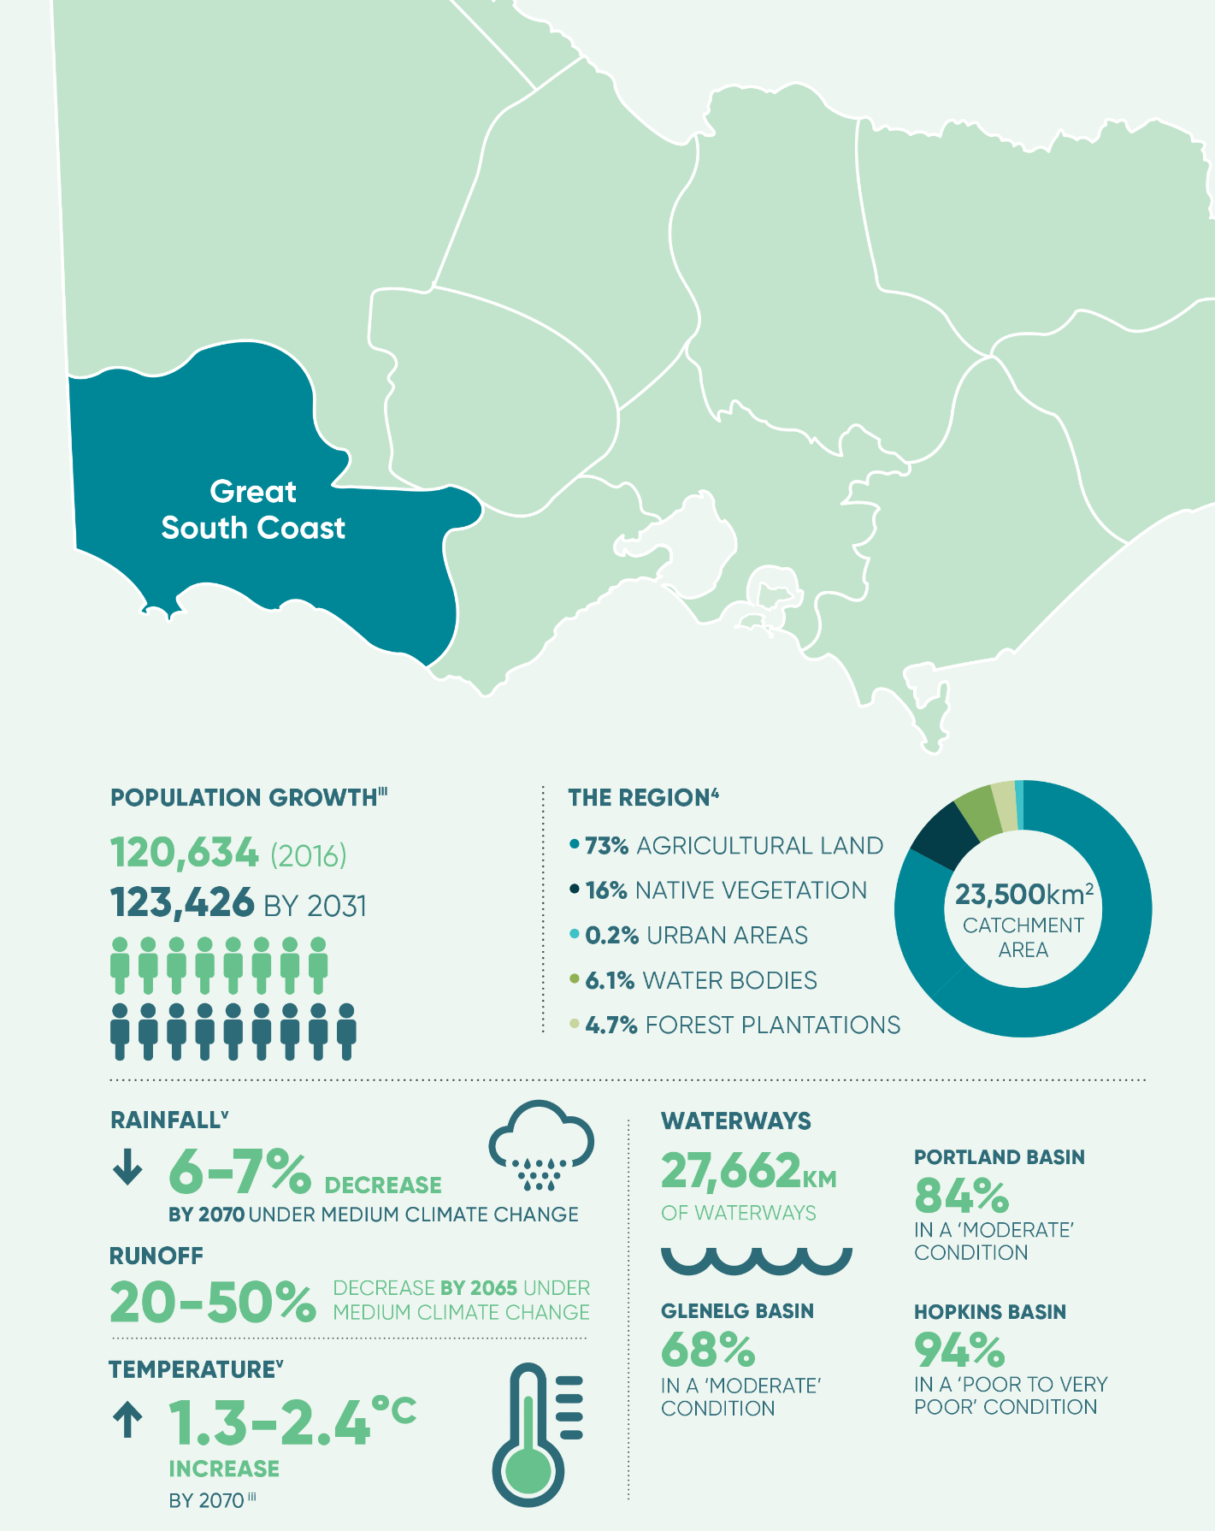

The case for IWM in the Region
Safe, secure and affordable supplies in an uncertain future
Wannon Water provides water supply services to 34 towns across the Forum region. It is anticipated that the overall population served by Wannon Water with residential connections will increase from around 85,000 in 2016 to around 113,000 in 2065. This indicates a rural-urban migration within the region as the overall population is not increasing rapidly. Rapid growth in demand is also expected over the next five years from the 13 major water customers, mainly comprising milk and food processors who account for 25 per cent of the region’s total water consumption. Water allocations and access to water for the agricultural sector is also a key issue for the region which requires integrated management.
Wannon Water supplies water from a diverse range of water sources, including surface water catchments, deep geothermal and shallow groundwater aquifers. The Urban Water Strategy shows that Wannon Water’s groundwater supplied systems will have sufficient supply to meet projected demand for the next 50 years. Of the surface water systems, Glenthompson may require augmentation in the short term but the largest supply system, the Otway system, is unlikely to require augmentation until after 2030.
Raw water and groundwater supply systems have been utilised for fit-for-purpose irrigation of some gardens and sports grounds in Warrnambool and Hamilton. Stormwater is currently not widely harnessed as a fit-for-purpose water supply resource but could become an opportunity.
The Great South Coast Food and Fibre Plan highlights that climate change impacts on agriculture could create significant additional demands for fit-for-purpose water. Consideration of this issue and of alternative water resources in the Forum Area should feed into the Sustainable Water Strategy for the Western region.
The innovative Roof Water Harvesting Project in Warrnambool is already alleviating demand from the Otway system, with 100 per cent of the water for the Russell’s Creek growth corridor provided by the annual volume harvested from residential roofs. The project will continue to expand over the next 30 years.

Effective and affordable wastewater systems
There are reticulated sewerage systems to properties across the region. These systems collect and treat sewage at 13 wastewater management facilities .
In addition to these facilities there are many small towns in the region which typically use onsite septic systems to treat their wastewater. Small town wastewater management is a common issue across the region from an environmental, health, technical, governance and financial perspective. Social disadvantage in many small towns is a constraint to the implementation of cost recovery models for conventional sewering. There are also particular pressures on septic systems from seasonal populations in coastal towns, resulting in impacts on groundwater.
Wannon Water provides recycled water for agricultural, recreational and industrial purposes, including process water supply to the Mortlake Power Station. The majority of the smaller inland wastewater management systems use 100% of the treated wastewater for irrigation of agricultural land or recreational areas. Tertiary treated recycled water is produced in Mortlake for industry customers. The total volume of recycled water reused in 2016-2017 was 1,656 megalitres, representing 14.7 per cent of the overall available supply of treated effluent. The salinity of recycled water in the region remains a challenge which limits its reuse applications. Regulations and standards in relation to the reuse of recycled water also currently limit its use. There is opportunity to investigate higher value uses of recycled water including irrigation of parks and gardens and environmental water for drying lakes.
Wannon Water transports sludge from the Warrnambool and Port Fairy sewage treatment plants to its biosolids treatment facility at Camperdown, and in 2016-2017, reused 100 per cent of available biosolids by applying 3,040 dry tonnes to farm land.

Avoided or minimised existing and future flood risks
Floodplains are a valued part of the ecosystem in the Great South Coast region. The ‘flooding’ process provide essential nutrients to the region’s agricultural land.
In an urban context, flooding is more of a challenge. Many of the urban centres in the region are located on waterways and floodplains, or on coastlines. Coastal areas are particularly vulnerable to the impacts of flooding as well as storm surges. Port Fairy, Portland, some parts of Warrnambool and a number of small, low lying coastal settlements have infrastructure systems already vulnerable to flooding and storm events. Recognising the potential for inundation from sea level rise and storm surges, local authorities have begun planning, for example Moyne Shire Council have developed a Coastal and
Structure Plan for Port Fairy.
Climate change will bring more intense rainfall events and further sea level rise which will create further flooding challenges. It is essential to manage the economic, social, environmental and cultural values from floodplains in a balanced way whilst also having regard for their inherent disadvantages and risks.

Healthy and valued waterways, wetlands and water bodies
The Glenelg Hopkins and Corangamite Catchment Management Authorities have identified a series of priority rivers and environments in the Great South Coast region in their Waterways Strategies.
The Glenelg River is an important asset for the region and the largest river in south-west Victoria. It contains some of the best condition river reaches in the region. The Glenelg basin contains more than 150 threatened to near-threatened species and ecological communities and falls within one of 15 listed ‘biodiversity hotspots’ in Australia, and one of only two in Victoria.
The Hopkins River is another major waterway draining the eastern part of the region and enters the Southern Ocean at Warrnambool. The region also includes a range of shorter waterways which drain the immediate inland areas and flow into the Southern Ocean.
The region’s rivers support a range of social values including fishing, boating, camping, swimming, picnicking and bushwalking. Rivers contribute to the region’s economy and are valued for the supply of water for agriculture, sand mining, drinking water, tourism and fishing.
The region boasts nearly half of the wetlands in Victoria and includes the Ramsar-listed wetlands of the Corangamite Shire along with Glenelg Estuary and Discovery Bay.
Wetlands are integral to healthy ecosystems in the region’s landscape. Wetlands are also of great social and economic value to the region, supporting some of the most significant recreational attractions in the area including boating, fishing, camping, swimming and sightseeing .
The type and extent of threats to the region’s rivers, estuaries and wetlands are often associated with current or historic agricultural land use adjacent to the waterway and in the broader catchment. The proximity of estuaries to coastal settlements exposes them to intense levels of recreation and social use. Predicted population growth in coastal areas will increase development pressure, particularly along waterways.
There is a need to take a whole of catchment approach to waterway health, recognising both the urban and rural impacts on waterways and waterbodies and the varying needs and values connected to waterways. Many of the waterways and wetlands in the area contain a rich and diverse range of important cultural heritage sites and form a culturally important and significant part of country for Traditional Owner groups in the region. Empowering Traditional Owners to restore and enhance waterways and riparian land will support passing on of healthy water to neighbouring groups and the restoration of significant sites.

Healthy and valued landscapes
Healthy landscapes are valued in the Great South Coast region and contribute to the character and attraction of the region. Urban landscapes play a key role in supporting the liveability and resilience of urban areas, and supporting healthy lifestyles, as recognised in the Great South Coast Regional Strategic Plan.
Sporting grounds in both major centres as well as smaller rural towns have a great importance placed on them within communities. Sustainable water resources are needed to support these key landscapes.
Warrnambool City and a number of schools have licences to access the shallow aquifer around Warrnambool. The groundwater resource is used for the greening of a significant portion of the public open space assets of Warrnambool. Southern Grampians Shire uses an historic municipal reservoir for the maintenance of the Hamilton Botanic Gardens and several popular playing fields.
It will be vital for these municipal systems to be managed in a sustainable way because, should these systems fail, there would be a step-increase in the demand on the drinking water supply. Direct use of stormwater as a resource to support local landscapes is relatively undeveloped in the Great South Coast region.
Urban waterways and landscapes are recognised as key landscapes in the built environment by councils in the region. Warrnambool City recognises the potential to revitalise the Merri River to enhance amenity and ecological values, and highlights the need to increase physical activity by providing access to recreational routes and areas in its Healthy City strategy.
There is strong community support for enhancement of urban water assets in Hamilton, including Grange Burn and Lake Hamilton, and the Southern Grampians Shire has developed management plans to enhance these assets. Several of the smaller towns in the region also have Avenues of Honour and green boulevards that are key to their identity and attraction.

Jobs, economic benefits and innovation
The major industries in the region are agriculture, tourism and retail. Agriculture is the region’s economic mainstay, with an estimated 60 per cent of the Great South Coast economy in some way dependent upon food and fibre production.
Retail in the region is strongly fuelled by a buoyant tourism industry. Almost half of all international overnight visits to regional Victoria are in the Great Ocean Road region. With its wealth of natural assets and rich cultural heritage, the Great South Coast is poised to become an important hub for nature-based and adventure-based tourism.
These economies are strongly linked to the health and amenity provided by the region’s coastline and natural assets, for which water management plays a key role in protecting and enhancing their value.
The availability of water and of sewerage services also has an impact on economic growth and development, for example a dairy processor has moved away from Camperdown partly due to the lack of readily available capacity in the wastewater treatment plant.

Community values reflected in place-based planning
The relationship between public health and wellbeing and the environment is becoming increasingly recognised as an area of importance. The creation of greener neighbourhoods and providing residents with access to waterways and green space has the potential to support environmental, social and economic outcomes.
New development and regeneration of existing areas is an opportunity to integrate community values into the evolution of towns and places and deliver integrated water management.
Engagement with Traditional Owners is a key focus for the region. The Great South Coast region covers the traditional lands of the Gunditjmara, Eastern Maar, Djab Wurrung and Wadawurrung people, and the many rivers, landscapes and waterbodies in the area contain a rich and diverse range of important cultural heritage sites. Framlingham and Budj Bim are major Aboriginal cultural sites and are of great importance in the region.

Success stories
There has been a lot of great work over the years by state and local government, regional agencies, communities, planning bodies and boards to identify what we need to do to address the challenges and opportunities in the region. Three recent case studies are outlined below.

Hamilton Regional Livestock Exchange
The Hamilton Regional Livestock Exchange is one of Australia’s busiest saleyards with approximately 1 million sheep and 50,000 cattle sold annually. It is also one of the few livestock exchanges in Victoria still owned and operated by Council. Water plays an important role in the functioning of the Exchange. Access to water is essential for animal welfare, cleaning sheep and cattle yards and washing trucks. Bore water was historically used for yard and truck washing until concerns were raised that the saline water was rusting the trucks.
The exchange had no choice but to switch to town water for truck washing despite the prohibitive cost of $60-$70,000 per year.
In 2012, a Master Plan prepared for the Hamilton Regional Livestock Exchange identified significant opportunities to improve environmental, occupational health and safety, and animal welfare conditions at the exchange and recommended infrastructure upgrades. In June 2015, the exchange commenced a $6.5 million suite of upgrades to take place over three years.
A new roof over the sheep saleyards was installed, driven by the need to improve conditions for workers, visitors and livestock and reduce pressure on the site’s effluent treatment plant,which was at capacity. The opportunity to obtain an alternate water supply for truck washing through roof water harvesting was also considered from the planning stage, and four 230kL raintanks were connected to the roof that now provides the truck washing water, saving $60-70,000 on potable supply per year.

Warrnambool Roof Water Harvesting
The innovative Warrnambool Roof Water Harvesting Project provides a working demonstration of a more sustainable approach to water management.
Demonstration sites were launched in the city’s north-east residential growth corridor in 2011 and the project has been progressively expanded.
The project ‘taps’ a new water catchment by capturing water from rooftops in new residential and industrial subdivisions that would otherwise be lost to run-off. This water is transported through pipes to existing untreated water storage basins where it is it is mixed with other untreated water. The water is then pumped to the Warrnambool Water Treatment Plant where it is treated and becomes part of the drinking water supply.
Funding from Wannon Water, the Australian Government, the Victorian Government and developers allowed the demonstration sites to be established. The regional harvesting principle was also showcased for evaluation by others considering adopting it in other areas of Australia.
Wannon Water has embraced the concept and incorporated it into future water resource planning. Stage one is being enlarged as the residential area grows, and stage two is been implemented in a new industrial area to collect roof water from sheds.
The demonstration sites now harvest water from around 200 homes through a 4.4-kilometre network of pipes, saving 36 million litres of water a year. It has provided the foundation for regional roof water harvesting to expand to encompass over 3000 houses, resulting in an annual yield of more than 420 megalitres. When fully developed, the industrial area is expected to yield an additional 150 megalitres.
The project also involves using innovative approaches to collection pipework design. Allowing the system to work under pressure more than doubles pipe capacities and significantly reduces infrastructure costs.
High rainfall events are buffered using detention tanks, both in the residential subdivisions and on individual lots in the industrial estate. This allows the downstream infrastructure to be substantially downsized while maximising collection volumes.
Wannon Water is very proud of this award-winning project, believed to be the first of its kind in Australia. It is far more cost-effective than individual tanks for on-site use, is a viable alternative to other augmentation options, and it supports more liveable and sustainable cities.

Recycled water use at Mortlake power station
Community engagement in the planning phase of a power station and collaboration between the power company and the water authority lead to a better water outcome in Mortlake.
The Origin gas-fired power station at Mortlake is the largest gas-fired power station in Victoria with a generation capacity of 566 MW. The power station is powered by gas from the Otway Basin and is used to generate power in times of peak demand.
The power station requires an average of 6000 kL of water per year. The bulk of the water is used for cooling of the gas-fired turbines during hot dry days.
One of the community concerns during the planning of the power station was the potential impacts on local water sources. Wannon Water was approached during the planning phase and recycled water was identified as a source that could be diverted from the current lower value use of pasture irrigation. Origin was keen to explore the opportunity to use recycled water rather than local groundwater or potable water supplies as a more sustainable approach to water resource management.
Wannon Water worked with Origin to supply the plant with fit-for-purpose recycled water from the Mortlake sewage treatment plant with groundwater as back-up. The water from the lagoon-based sewage treatment plant is further treated through microfiltration and disinfection at the sewage treatment plant and then piped 15 km to the power station.
Further reverse osmosis treatment is undertaken at the power station to improve a portion of the water to a higher standard, but the bulk of the water is used without further treatment.
The groundwater back-up to the recycled water supply is sourced from a bore that was installed by Wannon Water for this purpose. The water supply agreement requires the recycled water to be used in preference to groundwater.
This will allow the power station to save an average of 6000 kL per year of potable water through alternative sources.

Chapter 3

IWM opportunities
A portfolio of IWM projects and strategies for which IWM collaborative partners have committed themselves to applying their best endeavours to progress.

State-wide and region specific initiatives
This document outlines priority IWM opportunities for the Great South Coast region. These include both strategies that will direct IWM in the region and specific projects that will deliver on-the-ground outcomes. To ensure IWM opportunities are successful and delivered efficiently, work is also being done at a state-wide level.
Across Victoria, IWM Forum members are identifying a range of strategic policy and framework enablers to address barriers to integrated water management and planning and achieve water related benefits in priority areas. A prioritised list of enabling policies and frameworks is being consolidated by DELWP. The Resilient Cities and Towns (RCT) Reference Group was established to support the implementation of integrated water management and planning across the state. The Reference Group provides advice to DELWP on the development and implementation of key initiatives in relation to policy, processes or knowledge gaps.

IWM framework at a State-wide and regional level
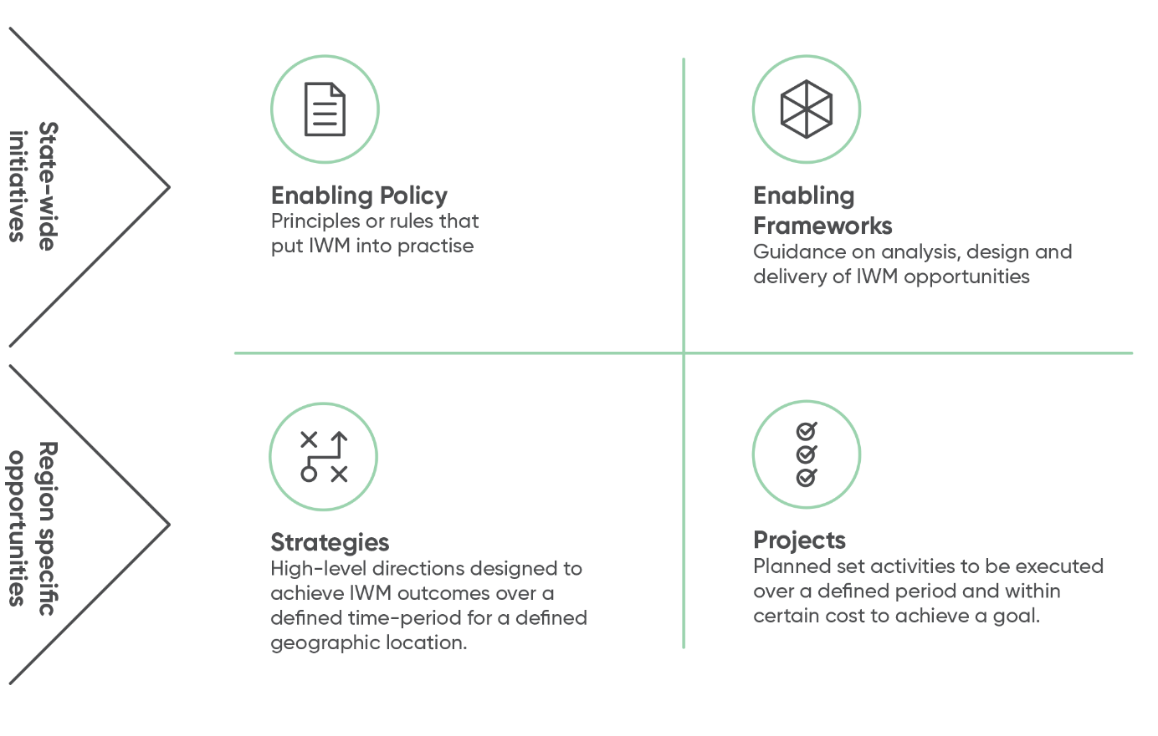

IWM opportunities: How were they selected?
IWM opportunities that link to and address IWM challenges for the region were identified and developed by the nominated practitioners of participating organisations. The process was an iterative, transparent and inclusive approach, as outlined in Figure 3.
This list of opportunities is dynamic and will be reviewed and updated as required to reflect the Forum’s priorities.
Figure 3: The IWM opportunity prioritisation process
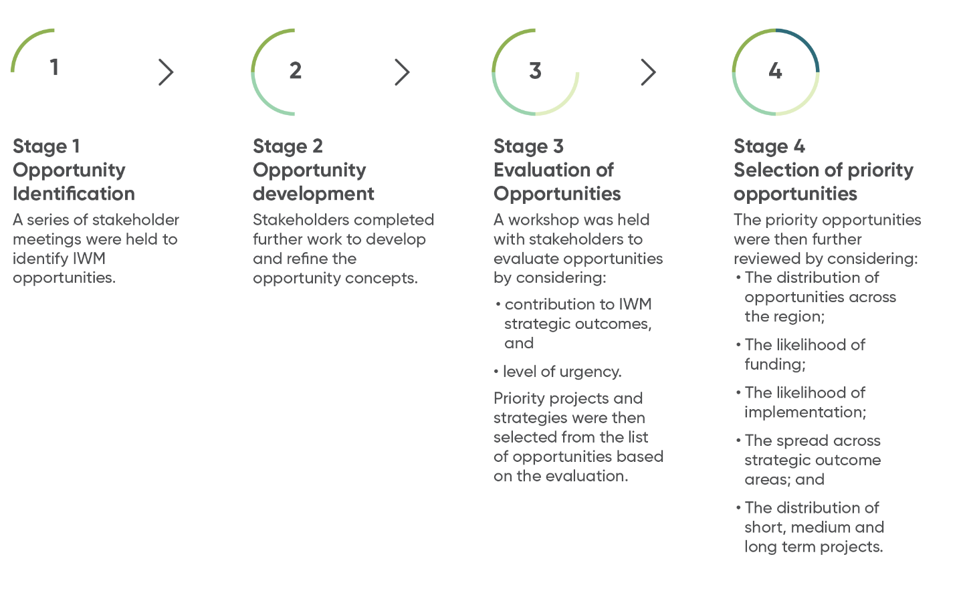

Impact of IWM opportunities on the Forum’s strategic outcomes
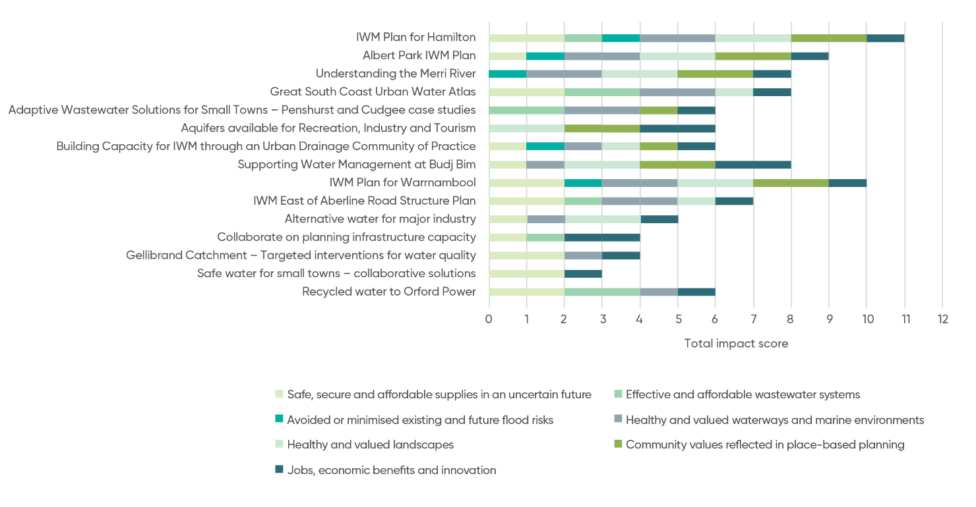

IWM project & strategy opportunities – overview
A summarised list of priority IWM opportunities is shown in the table below, with more detail in the following section. Please note that this list is dynamic and will continue to be updated to reflect the current Great South Coast IWM Forum’s priorities and opportunities.
Partners of the Forum are committing their best endeavours to ensure priority projects and strategies are progressed in line with the shared vision and strategic outcomes of the Great South Coast IWM Forum.
 | Outcomes  Safe, secure and affordable supplies in an uncertain future | Outcomes  Effective and affordable wastewater systems | Outcomes  Avoided or minimised existing and future flood risks | Outcomes  Healthy and valued waterways and marine environments | Outcomes  Healthy and valued landscapes | Outcomes  Community values are reflected  in place-based planning | Outcomes  Jobs, economic benefits and innovation | Location | Scale | Lead agency for collaborative opportunity | Status
- IWM Plan for Hamilton | Impact | Impact | Impact | Impact | Impact | Impact | Impact | Hamilton | Lot scale | Southern Grampians Shire Council | 1,2
- Albert Park IWM Plan | Impact | No impact | Impact | Impact | Impact | Impact | Impact | Warrnambool | Sub-catchment | Warrnambool City Council | 1,2,3,4
- Understanding the Merri River | No impact | No impact | Impact | Impact | Impact | Impact | Impact | Merri River | Sub-catchment | Glenelg Hopkins CMA | 1
- Great South Coast Urban  Water Atlas | Impact | Impact | No impact | Impact | Impact | No impact | Impact | Region-wide | Forum area | Wannon Water | 1,2
- Adaptive Wastewater Solutions for Small Towns – Penshurst and Cudgee case studies | No impact | Impact | No impact | Impact | No impact | Impact | Impact | Small towns in region | Town/City | Wannon Water | 1,2
- Aquifers available for Recreation, Industry and Tourism | Impact | No impact | No impact | No impact | Impact | Impact | Impact | Region-wide | Forum area | Southern Rural Water | 1,2,3
- Building Capacity for IWM through an Urban Drainage Community of Practice | Impact | No impact | Impact | Impact | Impact | Impact | Impact | Region-wide | Town/City | Warrnambool City Council | 1,2
- Supporting Water Management at Budj Bim | Impact | No impact | No impact | Impact | Impact | Impact | Impact | Budj Bim | Sub-catchment | Gunditj Mirring | 1
- IWM Plan for Warrnambool | Impact | No impact | Impact | Impact | Impact | Impact | Impact | Warrnambool | Town/City | Warrnambool City Council | A
- IWM East of Aberline Road Structure Plan | Impact | No impact | Impact | Impact | Impact | No impact | Impact | Warrnambool | Sub-catchment | Warrnambool City Council | 1
- Alternative water for major industry | Impact | No impact | No impact | Impact | Impact | No impact | Impact | Region-wide | Lot scale | Wannon Water | 1
- Collaborate on planning infrastructure capacity | Impact | Impact | No impact | No impact | No impact | No impact | Impact | Region-wide | Lot scale | Wannon Water | 1
- Gellibrand Catchment –  Targeted interventions for water quality | Impact | No impact | No impact | Impact | No impact | No impact | Impact | Gellibrand Catchment | Sub-catchment | Corangamite CMA | 1
- Safe water for small towns  – collaborative solutions | Impact | No impact | No impact | Impact | No impact | No impact | Impact | Small towns in region | Town/City | Wannon Water | 1
- Recycled water to Orford Power | Impact | Impact | No impact | Impact | No impact | No impact | Impact | Orford | Lot scale | Wannon Water | A
The status of each IWM opportunity included in the Priority Portfolio reflects the phase of work to be undertaken in this time period.
Project opportunity status
Concept & feasibility = A, Business case = B, Detailed design + C, Implementation = D, Commission = E, Benefit realisation = F.
Strategy opportunity status
Concept = 1, Commitment = 2, Prepare draft = 3, Consult & finalise = 4, Implement = 5, Evaluate = 6.

Priority Portfolio of IWM projects and strategies

Action GSC1

IWM Plan for Hamilton
Preparation of an IWM plan for the town of Hamilton including:
- Identification of key water related environmental, social and economic values
- Development of a water balance
- Demand forecasting incorporating climate change and;
- Alternative water sources – examining the potential of recycled water, The Old Reservoir and expansion of stormwater collection.
The plan will provide a “future road map” to ensure community and environmental water needs are met into the future, identifying and evaluating specific capital project options.
 | Outcomes  Safe, secure and affordable supplies in an uncertain future | Outcomes  Effective and affordable wastewater systems | Outcomes  Avoided or minimised existing and future flood risks | Outcomes  Healthy and valued waterways and marine environments | Outcomes  Healthy and valued landscapes | Outcomes  Community values are reflected  in place-based planning | Outcomes  Jobs, economic benefits and innovation
Impact status | Impact | Impact | Impact | Impact | Impact | Impact | Impact

Subject | Details
Status | 1,2
Lead  Agency | Southern Grampians Shire Council
Implementation  Partners | Glenelg Hopkins CMA  and Wannon Water.
Location | Hamilton
Timeframe | July 2019 – June 2020
Scale | Town
Project opportunity status
Concept & feasibility = A, Business case = B, Detailed design + C, Implementation = D, Commission = E, Benefit realisation = F.
Strategy opportunity status
Concept = 1, Commitment = 2, Prepare draft = 3, Consult & finalise = 4, Implement = 5, Evaluate = 6.

Action GSC2

Albert Park IWM Plan
Albert Park is a home for four ovals, Warrnambool Bowls Club, Warrnambool College, community gardens, a pony club, and other sport and recreational uses. A new storm water retarding basin has recently been constructed in the racecourse adjacent to the park providing potential for re-use. The development of an IWM plan for the precinct will bring together the various water demands and supply sources which are currently managed in isolation and other stakeholders to develop a shared vision for the site, produce a water balance for the site, and result in an investigation and evaluation of options to improve water management on the site. In addition, the project will raise awareness and provide an education opportunity with the broader community.
 | Outcomes  Safe, secure and affordable supplies in an uncertain future | Outcomes  Effective and affordable wastewater systems | Outcomes  Avoided or minimised existing and future flood risks | Outcomes  Healthy and valued waterways and marine environments | Outcomes  Healthy and valued landscapes | Outcomes  Community values are reflected  in place-based planning | Outcomes  Jobs, economic benefits and innovation
Impact status | Impact | No impact | Impact | Impact | Impact | Impact | Impact

Subject | Details
Status | 1,2,3,4
Lead Agency | Warrnambool City Council
Implementation  Partners | Wannon Water, Warrnambool Community Garden, Warrnambool College, Southern Rural Water and the Glenelg Hopkins CMA,
Location | Albert Park, Warrnambool
Timeframe | 2019
Scale | Site
Project opportunity status
Concept & feasibility = A, Business case = B, Detailed design + C, Implementation = D, Commission = E, Benefit realisation = F.
Strategy opportunity status
Concept = 1, Commitment = 2, Prepare draft = 3, Consult & finalise = 4, Implement = 5, Evaluate = 6.

Action GSC3

Understanding the Merri River
The Merri River is a highly valued waterway that is under ecological stress, with urban reaches within the City of Warrnambool and rural reaches up-stream in the Moyne Shire. This project proposes the development of an ecological model for the Merri River to inform future interventions. There will be significant investment over the coming decades to rehabilitate much of the flood plain of the Merri River. Green-field development on the northern side of the river and will see cleared farming undergoing conversion to public opens space for new residential suburbs. The scope of the ecological model could include:
- Flow and nutrient studies
- Aboriginal cultural values
- Community /recreational values
- Impact of current stormwater discharges
- Impact of barriers to fish passage
This project will enable strategic planning to identify where investment will provide the greatest benefit to enhancing the values of the Merri River.
 | Outcomes  Safe, secure and affordable supplies in an uncertain future | Outcomes  Effective and affordable wastewater systems | Outcomes  Avoided or minimised existing and future flood risks | Outcomes  Healthy and valued waterways and marine environments | Outcomes  Healthy and valued landscapes | Outcomes  Community values are reflected  in place-based planning | Outcomes  Jobs, economic benefits and innovation
Impact status | No impact | No impact | Impact | Impact | Impact | Impact | Impact

Subject | Details
Status | 1
Lead Agency | Glenelg Hopkins CMA
Implementation Partners | Warrnambool City Council, Wannon Water, Moyne Shire Council, Developers, Merri River Alliance
Related strategies | Merri River
Location | Merri River Alliance vison, Green Warrnambool
Timeframe | 2020
Scale | Sub-catchment
Project opportunity status
Concept & feasibility = A, Business case = B, Detailed design + C, Implementation = D, Commission = E, Benefit realisation = F.
Strategy opportunity status
Concept = 1, Commitment = 2, Prepare draft = 3, Consult & finalise = 4, Implement = 5, Evaluate = 6.

Action GSC4

Great South Coast Urban Water Atlas
This project will develop an urban water atlas for the region, identifying opportunities for potable supply to be substituted with water from alternative sources.
The project will:
- Review existing water resource mapping in Wannon Water’s Urban Water Strategy
- Identify priority community assets within our towns that are water-dependant
- Identify and quantify fit for purpose alternative sources, recycled water, stormwater and groundwater through workshops with the councils
- Include a high-level analysis of cost and risks
- Include a case study of opportunities in Camperdown – for the elm avenue of honour and Lake Colongulac, building on previous work assessing the viability of recycled water use, investigating barriers and innovative solutions
- Include the relevant work emerging from more detailed IWM plans underway in the region
- Map the results on GIS platform that can be used by all Councils, CMA’s and Wannon Water and kept up to date.
The project will set the groundwork for future integrated water planning.
 | Outcomes  Safe, secure and affordable supplies in an uncertain future | Outcomes  Effective and affordable wastewater systems | Outcomes  Avoided or minimised existing and future flood risks | Outcomes  Healthy and valued waterways and marine environments | Outcomes  Healthy and valued landscapes | Outcomes  Community values are reflected  in place-based planning | Outcomes  Jobs, economic benefits and innovation
Impact status | Impact | Impact | No impact | Impact | Impact | No impact | Impact

Subject | Details
Status | 1,2
Lead Agency | Wannon Water
Implementation Partners | Warrnambool CC, Corangamite SC, Moyne SC, Glenelg SC and, Southern Rural Water
Location | Region-wide
Timeframe | July 2019 – June 2020
Scale | Forum-wide
Project opportunity status
Concept & feasibility = A, Business case = B, Detailed design + C, Implementation = D, Commission = E, Benefit realisation = F.
Strategy opportunity status
Concept = 1, Commitment = 2, Prepare draft = 3, Consult & finalise = 4, Implement = 5, Evaluate = 6.

Action GSC5

Adaptive Wastewater Solutions for Small Towns – Penshurst and Cudgee Case Studies
This is a regional project with state relevance. All local governments in the Great South Coast forum area have identified managing the impacts associated with small town sewage as a key challenge.
The cost of reticulated sewerage is prohibitive in many small towns and private septic systems are often not adequate or able to be effectively managed. This project will build on previous work completed for Branxholme, where a case study was conducted to quantify the benefits of a solution using an innovative, neighbourhood-scale technical solution.
A similar case-study will be carried out for Penshurst and Cudgee to identify a technical solution for these towns with similar issues, but different geology. Options for governance models will be investigated for each of the towns that will have the potential to be adopted elsewhere across the state.
It is envisaged such a solution will be scalable and deliver a greater equity of service levels for communities. Anticipated benefits will include enabling economic development in smaller towns, prevention of pollution entering receiving environments (waterways and groundwater systems) and provide opportunities for improved community engagement around wastewater management issues.
 | Outcomes  Safe, secure and affordable supplies in an uncertain future | Outcomes  Effective and affordable wastewater systems | Outcomes  Avoided or minimised existing and future flood risks | Outcomes  Healthy and valued waterways and marine environments | Outcomes  Healthy and valued landscapes | Outcomes  Community values are reflected  in place-based planning | Outcomes  Jobs, economic benefits and innovation
Impact status | No impact | Impact | No impact | Impact | No impact | Impact | Impact

Subject | Details
Status | 1,2
Lead Agency | Wannon Water
Implementation Partners | Southern Grampians SC and Moyne SC
Location | Penshurst and Cudgee
Timeframe | Pilot in 2019
Scale | Forum-wide
Project opportunity status
Concept & feasibility = A, Business case = B, Detailed design + C, Implementation = D, Commission = E, Benefit realisation = F.
Strategy opportunity status
Concept = 1, Commitment = 2, Prepare draft = 3, Consult & finalise = 4, Implement = 5, Evaluate = 6.

Action GSC6

Aquifers available for recreation, industry and tourism
This project will promote collaboration between Southern Rural Water and shires to disseminate information about the changes in the regulatory framework for selling and leasing of water licences across the region. This will enable a better understanding of how the management of groundwater works and opportunities to free up water to be used within the sustainable usage framework of the Local Management Plans.
 | Outcomes  Safe, secure and affordable supplies in an uncertain future | Outcomes  Effective and affordable wastewater systems | Outcomes  Avoided or minimised existing and future flood risks | Outcomes  Healthy and valued waterways and marine environments | Outcomes  Healthy and valued landscapes | Outcomes  Community values are reflected  in place-based planning | Outcomes  Jobs, economic benefits and innovation
Impact status | Impact | No impact | No impact | No impact | Impact | Impact | Impact

Subject | Details
Status | 1,2,3
Lead Agency | Southern Rural Water
Implementation Partners | Corangamite SC, Glenelg SC, Moyne SC, Southern Grampians SC and, Warrnambool CC, farmer industry groups and Landcare networks.
Location | Regional
Timeframe | July 2019 to June 2020
Scale | Forum Area
Project opportunity status
Concept & feasibility = A, Business case = B, Detailed design + C, Implementation = D, Commission = E, Benefit realisation = F.
Strategy opportunity status
Concept = 1, Commitment = 2, Prepare draft = 3, Consult & finalise = 4, Implement = 5, Evaluate = 6.

Action GSC7

Building capacity for IWM through an urban drainage
community of practice
This is an IWM capacity building project that will support the formation and function of a community of practice of drainage infrastructure managers across the Great South Coast region. A specialist consultant will be engaged to work with the community of practice to identify challenges, priority issues, opportunities to collaborate and opportunities to adopt a more integrated approach to planning urban drainage.
Pressing issues and opportunities previously identified:
- WSUD planning, operation and maintenance
- WQ testing and targets for stormwater
- Stormwater policy for infill development
- Asset management systems
- Standard designs for WSUD
- Mapping of drainage networks
- Assumptions used for flood modelling
- Planning for impacts of climate change on urban drainage.
A strategy will be put in place for sustaining the benefits of the community of practice beyond the life of the project.
 | Outcomes  Safe, secure and affordable supplies in an uncertain future | Outcomes  Effective and affordable wastewater systems | Outcomes  Avoided or minimised existing and future flood risks | Outcomes  Healthy and valued waterways and marine environments | Outcomes  Healthy and valued landscapes | Outcomes  Community values are reflected  in place-based planning | Outcomes  Jobs, economic benefits and innovation
Impact status | Impact | No impact | Impact | Impact | Impact | Impact | Impact

Subject | Details
Status | 1,2
Lead Agency | Warrnambool City Council
Implementation Partners | Corangamite SC, Glenelg SC, Moyne SC, Southern Grampians SC, Wannon Water,  Glenelg Hopkins CMA and Corangamite CMA.
Location | Regional
Timeframe | June 2019 to June 2020
Scale | Regional
Project opportunity status
Concept & feasibility = A, Business case = B, Detailed design + C, Implementation = D, Commission = E, Benefit realisation = F.
Strategy opportunity status
Concept = 1, Commitment = 2, Prepare draft = 3, Consult & finalise = 4, Implement = 5, Evaluate = 6.

Action GSC8

Supporting water management at Budj Bim
The Budj Bim site has just achieved World Heritage status with evidence of one of the world’s largest and oldest aquaculture systems, dating to about 6600 years ago. Water quality and quantity are an ongoing requirement of World Heritage status.
This project proposes to facilitate water management in and around Budj Bim that will progress actions to reinstating historic flow paths in the landscape, with the aim of looking after Country. This project will build on current work being undertaken by the Glenelg Hopkins CMA relating to hydrological restoration.
Specific investigations include:
- Understanding cultural flows and the related tourism, jobs and growth impacts across the region
- Understanding impacts of rural drainage and groundwater bores
- Analysis of planning, legal frameworks and land ownership
identification of actions leading to better water management.
 | Outcomes  Safe, secure and affordable supplies in an uncertain future | Outcomes  Effective and affordable wastewater systems | Outcomes  Avoided or minimised existing and future flood risks | Outcomes  Healthy and valued waterways and marine environments | Outcomes  Healthy and valued landscapes | Outcomes  Community values are reflected  in place-based planning | Outcomes  Jobs, economic benefits and innovation
Impact status | Impact | No impact | No impact | Impact | Impact | Impact | Impact

Subject | Details
Status | 1
Lead Agency | Gunditj Mirring
Implementation Partners | Southern Rural Water, Glenelg Hopkins CMA, Councils, DELWP, RDV and Great Ocean Road Regional Tourism.
Location | Budj Bim
Timeframe | 2020
Scale | Sub-catchment
Project opportunity status
Concept & feasibility = A, Business case = B, Detailed design + C, Implementation = D, Commission = E, Benefit realisation = F.
Strategy opportunity status
Concept = 1, Commitment = 2, Prepare draft = 3, Consult & finalise = 4, Implement = 5, Evaluate = 6.

Action GSC9

IWM Plan for Warrnambool
An IWM Plan that focusses on Warrnambool, which will:
- Provide strategic direction for future investment in IWM / WSUD
- Quantify a water balance for the city to identify potential sources of alternative water supplies and end-use demands
- Quantify a pollutant balance to enable improved and targeted stormwater quality improvement works to be identified
- Explore strategies to reduce lake dredging costs
- Integrate IWM options with the Lake Pertobe masterplan
Support community needs for amenity and wellbeing.
 | Outcomes  Safe, secure and affordable supplies in an uncertain future | Outcomes  Effective and affordable wastewater systems | Outcomes  Avoided or minimised existing and future flood risks | Outcomes  Healthy and valued waterways and marine environments | Outcomes  Healthy and valued landscapes | Outcomes  Community values are reflected  in place-based planning | Outcomes  Jobs, economic benefits and innovation
Impact status | Impact | No impact | Impact | Impact | Impact | Impact | Impact

Subject | Details
Status | 1
Lead Agency | Warrnambool City Council
Implementation Partners | Wannon Water, Glenelg Hopkins CMA
Location | Warrnambool
Timeframe | 2020
Scale | City
Project opportunity status
Concept & feasibility = A, Business case = B, Detailed design + C, Implementation = D, Commission = E, Benefit realisation = F.
Strategy opportunity status
Concept = 1, Commitment = 2, Prepare draft = 3, Consult & finalise = 4, Implement = 5, Evaluate = 6.

Action GSC10

IWM in East of Aberline Road Structure Planning
There is an opportunity to create a community in North-East Warrnambool that will see residents live their lives embracing all forms of water within the hydrological cycle as a resource.
The new 3-4,000 residential development located east of Aberline Road has the potential to build upon an existing icon of water resourcing in Warrnambool: the Roof Water Harvesting (RWH) system. There are also opportunities to harvest, treat and re-use the remaining stormwater via constructed wetland and/or street-scale water sensitive design. This re-use could provide a source of water for public open space supporting extensive urban tree canopy for the new community. This project links to Warrnambool City Council’s Green Warrnambool Plan that has a target of 30% tree canopy cover in the city.
 | Outcomes  Safe, secure and affordable supplies in an uncertain future | Outcomes  Effective and affordable wastewater systems | Outcomes  Avoided or minimised existing and future flood risks | Outcomes  Healthy and valued waterways and marine environments | Outcomes  Healthy and valued landscapes | Outcomes  Community values are reflected  in place-based planning | Outcomes  Jobs, economic benefits and innovation
Impact status | Impact | No impact | Impact | Impact | Impact | No impact | Impact

Subject | Details
Status | A
Lead Agency | Warrnambool City Council
Implementation Partners | Wannon Water, Glenelg Hopkins CMA
Location | Warrnambool
Timeframe | 2020
Scale | City
Project opportunity status
Concept & feasibility = A, Business case = B, Detailed design + C, Implementation = D, Commission = E, Benefit realisation = F.
Strategy opportunity status
Concept = 1, Commitment = 2, Prepare draft = 3, Consult & finalise = 4, Implement = 5, Evaluate = 6.

Action GSC11

Alternative water for major industry
This project will target engagement with major water users to identify alternative water source opportunities. For example, investigate IWM opportunities such as:
- Roof water harvesting of water for use in the factory
Harvesting of stormwater from the grounds transfer to any nearby green open space.
 | Outcomes  Safe, secure and affordable supplies in an uncertain future | Outcomes  Effective and affordable wastewater systems | Outcomes  Avoided or minimised existing and future flood risks | Outcomes  Healthy and valued waterways and marine environments | Outcomes  Healthy and valued landscapes | Outcomes  Community values are reflected  in place-based planning | Outcomes  Jobs, economic benefits and innovation
Impact status | Impact | No impact | No impact | Impact | Impact | No impact | Impact

Subject | Details
Status | 1
Lead Agency | Wannon Water
Implementation Partners | Major users, private and public
Location | Various across the region
Timeframe | 2020
Scale | Lot-scale
Project opportunity status
Concept & feasibility = A, Business case = B, Detailed design + C, Implementation = D, Commission = E, Benefit realisation = F.
Strategy opportunity status
Concept = 1, Commitment = 2, Prepare draft = 3, Consult & finalise = 4, Implement = 5, Evaluate = 6.

Action GSC12

Collaborate on planning infrastructure capacity
Lack of water infrastructure or limited infrastructure capacity can be a barrier to growth in some areas. A more collaborative and integrated approach to infrastructure planning may be possible and would support growth while making clear investment decisions. There may be opportunities to work with industry and developers to develop decentralised water infrastructure solutions. There is also opportunity to collaborate on water licencing to achieve better outcomes.
 | Outcomes  Safe, secure and affordable supplies in an uncertain future | Outcomes  Effective and affordable wastewater systems | Outcomes  Avoided or minimised existing and future flood risks | Outcomes  Healthy and valued waterways and marine environments | Outcomes  Healthy and valued landscapes | Outcomes  Community values are reflected  in place-based planning | Outcomes  Jobs, economic benefits and innovation
Impact status | Impact | Impact | No impact | No impact | No impact | No impact | Impact

Subject | Details
Status | 1
Lead Agency | Wannon Water
Implementation Partners | Councils, developers
Location | Region-wide
Timeframe | 2020
Scale | Forum-wide
Project opportunity status
Concept & feasibility = A, Business case = B, Detailed design + C, Implementation = D, Commission = E, Benefit realisation = F.
Strategy opportunity status
Concept = 1, Commitment = 2, Prepare draft = 3, Consult & finalise = 4, Implement = 5, Evaluate = 6.

Action GSC13

Gellibrand Catchment – Targeted interventions for water quality
This project will foster collaboration to improve filtration of runoff throughout
the Gellibrand catchment through increased and targeted vegetation establishment and other strategies. The project will collate baseline data which will be used to identify key sites for interventions. Establishment of significant stands of vegetation will enhance biodiversity and ensure water and nutrients are retained in the landscape for improved waterway health and enhanced agricultural productivity. In the long term improved raw water quality for potable supply may reduce treatment requirements and lower the incidence of blue-green algal blooms.
 | Outcomes  Safe, secure and affordable supplies in an uncertain future | Outcomes  Effective and affordable wastewater systems | Outcomes  Avoided or minimised existing and future flood risks | Outcomes  Healthy and valued waterways and marine environments | Outcomes  Healthy and valued landscapes | Outcomes  Community values are reflected  in place-based planning | Outcomes  Jobs, economic benefits and innovation
Impact status | Impact | No impact | No impact | Impact | No impact | No impact | Impact

Subject | Details
Status | 1
Lead Agency | Corangamite CMA
Implementation Partners | Wannon Water, farmer industry groups and Landcare networks.
Location | Gellibrand River
Timeframe | 2020
Scale | Sub-Catchment
Project opportunity status
Concept & feasibility = A, Business case = B, Detailed design + C, Implementation = D, Commission = E, Benefit realisation = F.
Strategy opportunity status
Concept = 1, Commitment = 2, Prepare draft = 3, Consult & finalise = 4, Implement = 5, Evaluate = 6.

Action GSC14

Privately owned water supply safety for small towns
– a collaborative approach
This project will focus on the potential to support communities to manage private, decentralised water supplies to improve the safety of the water in these supplies. For example, Caramut relies on water tanks and raw water from a dam, while Princetown relies on private bores and rainwater tanks. Elevated E. coli levels have been identified in some township rainwater tanks and some schools are privately supplied with water that is not treated.
This project will seek to:
- Identify towns with private water supply
- Risk rate identified towns
Implement solutions for improvement.
 | Outcomes  Safe, secure and affordable supplies in an uncertain future | Outcomes  Effective and affordable wastewater systems | Outcomes  Avoided or minimised existing and future flood risks | Outcomes  Healthy and valued waterways and marine environments | Outcomes  Healthy and valued landscapes | Outcomes  Community values are reflected  in place-based planning | Outcomes  Jobs, economic benefits and innovation
Impact status | Impact | No impact | No impact | Impact | No impact | No impact | Impact

Subject | Details
Status | 1
Lead Agency | Wannon Water during scoping phase
Implementation Partners | Department of Health and Human Services, councils, Southern Rural Water
Location | Great South Coast
Timeframe | 2020
Scale | Town
Project opportunity status
Concept & feasibility = A, Business case = B, Detailed design + C, Implementation = D, Commission = E, Benefit realisation = F.
Strategy opportunity status
Concept = 1, Commitment = 2, Prepare draft = 3, Consult & finalise = 4, Implement = 5, Evaluate = 6.

Action GSC15

Recycled water to Orford Power
The new Orford Power station will require large amounts of water. There is a potential opportunity to treat wastewater from Port Fairy to the required quality to provide recycled water to the power station.
By reusing treated wastewater there would be a beneficial use of water currently discharged to ocean and there would be no additional demand on groundwater and other freshwater resources.
 | Outcomes  Safe, secure and affordable supplies in an uncertain future | Outcomes  Effective and affordable wastewater systems | Outcomes  Avoided or minimised existing and future flood risks | Outcomes  Healthy and valued waterways and marine environments | Outcomes  Healthy and valued landscapes | Outcomes  Community values are reflected  in place-based planning | Outcomes  Jobs, economic benefits and innovation
Impact status | Impact | Impact | No impact | Impact | No impact | No impact | Impact

Subject | Details
Status | A
Lead Agency | Wannon Water
Implementation  Partners | Moyne Shire Council, VicRoads, Cultural Heritage Assessors, Orford Power, Southern Rural Water
Location | Port Fairy
Timeframe | Unknown
Scale | Town
Project opportunity status
Concept & feasibility = A, Business case = B, Detailed design + C, Implementation = D, Commission = E, Benefit realisation = F.
Strategy opportunity status
Concept = 1, Commitment = 2, Prepare draft = 3, Consult & finalise = 4, Implement = 5, Evaluate = 6.

References
i State Government of Victoria (2016) Climate Ready Victoria. Department of Environment, Land, Water and Planning.
Available: https://www.climatechange.vic.gov.au/information-and-resources
ii Moyne Shire Council (2018) Port Fairy Coastal and Structure Plan
iii State Government of Victoria (2016) Victoria in Future. Available: https://www.planning.vic.gov.au/__data/assets/pdf_file/0032/96476/Warrnambool_and_South_West_SA4_VIF_2016_One_Page_Profile_Output.pdf
iv Glenelg Hopkins CMA (2012) Regional Catchment Strategy 2013-2019
v Climate Ready Victoria - Barwon South West climate projections data sheet
vi State Government of Victoria (2016) Water for Victoria
Department of Environment, Land, Water and Planning.
vii State Government of Victoria (2013) Third Index of Stream Condition,
Part 11 Glenelg Hopkins. Department of Environment and Primary Industries.
viii Wannon Water (2017) 2016/2017 Annual Report
ix Wannon Water (2017) Urban Water Strategy
x Wannon Water (2017) Urban Water Strategy
xi South Gippsland Shire Council (2015) Seasonal Population Impacts on Coastal Towns
xii Wannon Water (2017) 2016/2017 Annual Report
xii Wannon Water (2017) 2016/2017 Annual Report
xiv Great South Coast Group (2017) Great South Coast Regional Strategic Plan 2014-2019
xv Glenelg Hopkins Catchment Management Authority (2014) Waterways Strategy
xvi Great South Coast Group (2017) Great South Coast Regional Strategic Plan 2014-2019
xvii Great South Coast Group (2017) Great South Coast Regional Strategic Plan 2014-2019

