|  |
| --- |
| Dam Safety Emergency Plan  Template for local government authorities |

|  |
| --- |
|  |

|  |
| --- |
| © The State of Victoria Department of Environment and Primary Industries Melbourne 2014    This work is licensed under a Creative Commons Attribution 3.0 Australia licence. You are free to re-use the work under that licence, on the condition that you credit the State of Victoria as author. The licence does not apply to any images, photographs or branding, including the Victorian Coat of Arms, the Victorian Government logo and the Department of Environment and Primary Industries logo. To view a copy of this licence, visit <http://creativecommons.org/licenses/by/3.0/au/deed.en>  ISBN VGLS521579  **Accessibility**  If you would like to receive this publication in an alternative format, please telephone DEPI Customer Service Centre136186, email [customer.service@depi.vic.gov.au](mailto:customer.service@depi.vic.gov.au) via the National Relay Service on 133 677 [www.relayservice.com.au](http://www.relayservice.com.au). This document is also available in on the internet at [www.depi.vic.gov.au](http://www.depi.vic.gov.au)  **Disclaimer**  This publication may be of assistance to you but the State of Victoria and its employees do not guarantee that the publication is without flaw of any kind or is wholly appropriate for your particular purposes and therefore disclaims all liability for any error, loss or other consequence which may arise from you relying on any information in this publication. |

Contents

Use of this plan 1

Aim 1

Contents of a Dam Safety Emergency Plan 1

Approval and authorisation 2

Overview of emergency plans 2

Background 2

General structure of emergency plans 2

Existing emergency management plans 2

Limitations 3

Training and review 3

General training 3

Testing the DSEP 4

Review of the DSEP 4

Debriefing after an incident though an After Action Review (AAR) 4

Description of this dam 4

Introduction 4

Site access 4

Summary of previous dam safety issues 4

Roles and responsibilities 5

EMT and IMT context for dam safety emergencies 5

Incident level 6

Regional / State level 6

Local Government 6

Emergency Management Victoria 6

Department of Environment and Primary Industries (DEPI) 7

DEPI strategic control priorities 7

Principles of operation 7

Victoria State Emergency Service 8

Victoria Police 8

CBRN Hazards MFB / Country Fire Authority 8

VicRoads 8

Specialist Dam Engineers / Consultants 8

Incident Management team roles 8

Resources and equipment 9

Water Corporation, Parks Victoria and Dams owned by others 9

Incident Management Teams 9

Communication 10

Communication with Emergency Management Agencies 10

Providing a common operating picture. 10

Warnings and evacuations 11

Flood warnings - Communities immediately downstream of a dam 11

Evacuation types 11

Routine surveillance 12

Routine surveillance of the dam 12

Identification of potential Issues with your dam 13

Dam failure modes and response actions 14

Piping/ Seepage related failures 15

Dam slope failure 17

Floods – overtopping / spillway capacity 18

Dam failure / uncontrolled releases / outlet works failure 19

Earthquake 20

Loss of freeboard or dam cross section due to storm or wave erosion. 22

Spillway channel erosion threatening safety of dam wall 22

Excessive seepage /saturation of the embankment 22

Excessive settlement of the embankment 22

Loss of abutment support or extreme extensive cracking in concrete dams 22

Hazardous substance spill 23

Security threats 23

Initial response options – the first 60 minutes 23

Appendix A – Information on dam 27

Appendix B – Emergency contact list 28

Appendix C – Resource list 29

Appendix D – Example community alert messages 30

Appendix E – Visual inspection report form 31

Appendix F – Incident report form for DEPI 32

Appendix G – Emergency senarios flip charts 33

DAM FAILURE 34

TERRORISM AND SABOTAGE 35

HAZARDOUS SUBSTANCE SPILL 36

OUTLET WORKS FAILURE 37

DAM SLOPE FAILURE 38

PIPING/ SEEPAGE FAILURE 39

FLOOD 40

Appendix I – Glossary of terms 43

Use of this plan

Aim

This Dam Safety Emergency Plan (DSEP) template has been prepared by the Department of Environment and Primary Industries (DEPI) as a guide for Local Government Authorities (LGA) to manage foreseeable dam emergency situations that may occur at dams which it operates. This DSEP template also provides recommendations on actions which could be taken by an LGA in the case of dam emergencies at privately owned farm dams and dams owned by other authorities in their area of operations.

The objective of this document is to prepare LGA staff to respond appropriately and effectively to dam emergency situations that may occur with Local Government owned dams. Local Government is responsible to plan, prepare and respond to a dam safety emergency for a dam owned / operated by them.

This plan aims to achieve its objective by:

* Providing guidance to the development of a Dam Safety Emergency Plan.
* A Dam Safety Emergency Plan Template for consideration and use by LGAs.
* Describing the type of dam safety incidents that may occur;
* Establishing the manner in which dam safety incidents are to be reported;
* Defining the roles and responsibilities of an LGA and other agencies in the reporting process and in responding to dam safety incidents.
* Ensuring that other Agencies are provided with a reliable source of information if they are called upon to address an emergency; and
* Providing a ready reference document that clearly establishes the procedures for dam emergency situations in order to deal with the emergency in a quick, effective and safe manner.

It is the LGA’s obligation to implement this DSEP and ensure all necessary staff are aware of this Plan and content. The responsibility of the personnel assigned to duties as covered in this document will be dependent upon the staff structure of an LGA, any advice from the DEPI and the magnitude of the event.

Any queries on matters not dealt with in this document should first be referred to the DEPI Water and Natural Resources Division and for subsequent revision and issue of this DSEP template.

Contents of a Dam Safety Emergency Plan

This DSEP template comprises:

* A stand alone template that can be adopted by an LGA for individual dams.
* Overview and existing emergency plans.
* Roles and responsibilities.
* Incident procedures.
* Procedures in the event of potential dam safety emergency.
* Procedures in the event of dam safety emergency.
* Recommendations for training and review.

Supporting documentation to this document is located in the Appendices and includes:

* Quick Reference Flip Charts that give the notification procedure for incidents outlined in the Plan.
* Contact List for personnel and authorities in the case of an emergency situation including a list of dam safety consulting engineers.
* Resource List that documents contact numbers for earthmoving contractors and other resources which may be of use in an emergency situation.
* DEPI Incident Report Form to be filled out when inspecting the dam.
* Inundation Map identifying the areas of land that may become inundated in a dam failure scenario.
* Examples of standard SMS Community Alert messages.

Approval and authorisation

This template is a guide to assist LGAs in the preparation of a DSEP. It needs to be completed by the LGA to suit its particular circumstances and endorsed by a suitably qualified engineer.

Overview of emergency plans

Background

For Local Government Owned dams, most dam safety activities fall within the normal day-to-day responsibility of Local Government as part of a routine monitoring and dam surveillance program. Minor defects in appearance by observation can be recorded in a Visual Inspection Report Form.

The consequences of a dam failure could be significant. Therefore, all efforts should be made to prevent minor events developing into catastrophic failure. If there is any doubt as to whether a particular change in appearance or minor defects could become dangerous, it must be acted upon immediately as indicated in this plan.

If in doubt, seek expert dam safety advice. Be aware of the possible serious consequences of a late or non-existent warning. Remember that foresight and discretion dictates that the earliest contact will allow emergency service organisations to move into readiness.

General structure of emergency plans

The structure of emergency management plans for <ENTER LGA’s NAME> is summarised below:

* State Emergency Response Plan (Part 3: Emergency Management Manual Victoria) – This plan provides high level information on the organisational arrangements for managing the response to emergencies within, or with the potential to affect, the state of Victoria. A copy of the plan can be obtained from www.oesc.vic.gov.au.
* The Municipal Emergency Management Plan (MEMP)
* Municipal Emergency Management Sub Plans – This Dam Safety Emergency Plan can be considered by the LGA as a ‘sub-plan’ of the MEMP or as a stand alone Plan within the LGAs specific emergency management plans similar to other emergency plans for LGA owned or operated assets.
* Management of Flooding downstream of Dams – The aim of this document is to provide guidance for the command and control arrangements for a flood response downstream of dams and collaboration between dam operators, Victoria State Emergency Service, Department of Environment Primary Industries and other agencies that have responsibilities in flood management.

Existing emergency management plans

**<ENTER LGA’s NAME>** has a Municipal Emergency Management Plan (MEMP) that provides high level information on roles, responsibilities and plans for prevention of, preparedness for, response to and recovery from emergencies. In drafting this DSEP the Municipal Emergency Management Planning Committee (MEMPC) may wish to propose to Council the DSEP as a sub-plan of **<ENTER LGA’s NAME>** MEMP and that it explicitly deals with dam safety emergencies. The MEMP process and terminology is incorporated in this Dam Safety Emergency Plan Template.

**<ENTER LGA’s NAME>** also has a Flood Emergency Management Sub-Plan. The Flood Emergency Sub-plan should be read in conjunction with the Dam Safety Emergency Plan, since flooding can both be a cause of or a result of Dam Safety Incidents. However, it should be noted that dam safety incidents often occur independently of floods, for example due to structural failures at the dam. For this reason, the Flood Emergency Sub-plan should not be used in isolation to manage emergencies at dams.

Limitations

This DESP gives procedures for the ‘response’ phase of emergency management (Diagram 1), including recommended actions to take during a dam incident. These procedures are ‘guidelines’ that are considered to best fit the likely situations.

The Plan will not necessarily cover every aspect of the dam response in detail. Actions in addition to those listed in this Plan may be required, and in many circumstances, specialist advice may need to be sought. In actual situations it is likely that actions may be based on the limited information available at the time, however sound judgement must be used by all involved.

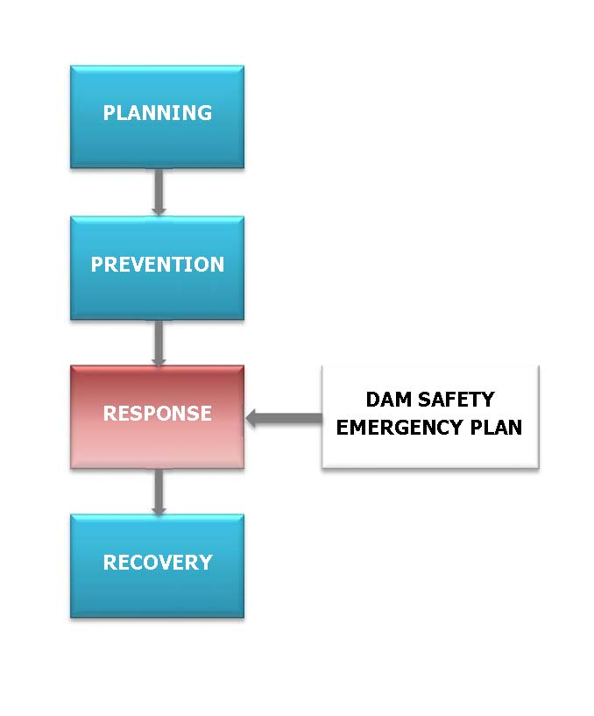

Diagram 1: Emergency Management Phases

This DSEP does not cover the planning, prevention or recovery phases of emergency management as illustrated in Diagram 1, however guidance provided may assist in Planning and Preventative measures.

Training and review

General training

Local Government staff should be made aware of the existence of this DSEP. Local Government Emergency Planning staff should be trained in the contents of the DSEP. Training of personnel involved in the activation of this DSEP should be conducted to ensure that they are thoroughly familiar with all components, their responsibilities, duties and the availability of resources. This training is vital for proper assessment of developing situations at all levels of responsibility. Several staff should be trained to ensure sufficient coverage of the DSEP at any time.

Testing the DSEP

Testing is necessary to identify deficiencies and to ensure all participants are familiar with the prescribed procedures and their roles. An exercise, involving Local Government and staff from appropriate agencies, should be carried out as soon as possible after the personnel have had time to familiarise themselves with their responsibilities and their particular role in the plan. Given ever-changing circumstances, staff movements and the potential to forget the roles and responsibilities, an exercise should be programmed to be undertaken regularly. The added benefit of regular exercises is the identification of necessary revisions to the document.

Review of the DSEP

This DSEP should be reviewed annually to assess its workability and efficiency. The plan is closely aligned with normal work procedures and therefore should be updated when personnel and responsibilities change or when there are changes in response agencies, telephone numbers or communication methods. The loose-leaf format of this plan has been adopted to allow for changes that will occur as the plan is reviewed and updated.

Debriefing after an incident though an After Action Review (AAR)

After every dam safety incident, an AAR should be undertaken to capture opportunities for improvement in the DSEP and to highlight changes which could be made to the Plan to improve its effectiveness. If necessary, changes to the DSEP should be made as soon as possible. Consider the concept of ‘staff rides’ for the responders to share with staff their reflections, learnings and human factors.

Description of this dam

Introduction

In the event of an emergency, information regarding the structure of the dam may be important for use in determining the most appropriate action to take. Details regarding the dam are provided in **Appendix A** *Information on Dam*.

In response to a dam safety event, these details should be provided to the Incident Management Team to confirm planning assumptions and to aid in their initial rapid risk assessment of the situation.

Site access

<ENTER NAME OF DAM> is located <PROVIDE BRIEF DESCRIPTION OF LOCATION> on street directory reference <ENTER MELWAYS/VICROADS REFERENCE>

Normal access to the Dam is from:

<LIST DETAILED DIRECTIONS TO SITE>

<INSERT FIGURE SHOWING ACCESS GATE>

During large floods, it may be difficult for emergency support personnel to access the site or the incident control centre.

During an emergency situation, if there are gates and fences around the dam, access to the dam site beyond the entrance gate should be restricted to essential personnel only. For the safety of the community, Victorian Police should be asked to restrict general public access to the dam embankment.

Summary of previous dam safety issues

<PROVIDE A SUMMRY OF PREVIOUS ISSUES AT THE DAM, SUCH AS FLOOD EVENTS, SEEPAGE ISSUES, SLUMPING OF EMBANKMENT, TREES ON THE EMBANKMENT ETC>

Roles and responsibilities

EMT and IMT context for dam safety emergencies

The State Emergency Response Plan (SERP) explains that the three key management tasks of command, control and coordination form the basis of Victorian emergency management arrangements. This structure will be used in response to dam safety emergencies in Victoria.

Victoria uses a three-tiered approach to dam safety emergency management - with incident, regional (and/or area-of-operation) and state tiers operating as required.

DEPI as the control agency appoints controllers to have overall responsibility for response activities at each tier. Where required, an Incident Management Team (IMT) directly assists the Incident Controller to meet their control responsibilities.

Where support agencies are involved, the controller at each tier is responsible for forming an EMT. Once formed, an EMT operates through all phases of the dam safety emergency, including the readiness, response and recovery phases. The controller does not command the agencies through the EMT, but works through each DEPI agency commander to achieve a specified outcome.

The following diagram shows the context of coordination, control, support agency command and the EMT at each tier of a dam safety emergency. Not all agencies will have representatives at each tier. For example, where potential for significant consequences or capacity issues exist, an agency may escalate management of their responsibilities directly to the state tier.

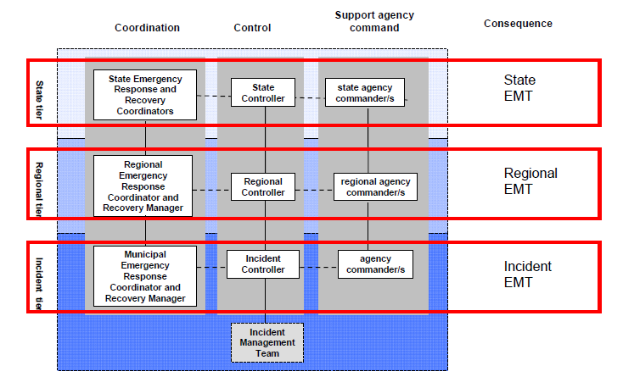

The severity of the dam safety incident will influence the extent of inter-agencies participation.

As the magnitude of the emergency increases, Municipal, Regional and State emergency response arrangements would be utilised as appropriate to the given emergency situation. It is acknowledged that in most cases, the Municipality will be one of the first agencies to become aware of the incident and as the owner / operator of the dam will most likely initially be the best placed agency to determine the level of response required.

Incident level

In the event of a minor incident, such as a low magnitude earthquake or flood where the community is not at risk, it is appropriate that the dam safety event would be managed within the municipality at a local incident level.

Regional / State level

In the event of an actual or a potential dam failure, it is envisaged that the emergency would be controlled at the Regional Incident Control Centre or State Control Centre, depending on the extent of the incident. Local resources would work within the overall regional or state incident control structure to complement the emergency response, particularly in terms of providing information to the Incident Controller at the Incident Control Centre on the performance of the dam.

Local Government

As a dam operator, <ENTER LGA NAME> has responsibility for managing the dam’s safety, and in particular has responsibility for:

* Regular monitoring and visual inspection of the condition of their dams.
* Reporting incidents and/or potential emergency situations. In the first instance, local government is to assess the situation and contact DEPI State Agency Commander (Ph: 1300 13 4444), for incidents with potential for escalation of consequences.
* Resolving emergency situations, as far as practicable, may involve engaging specialist dam safety engineers for advice.
* Implementing initial stages of emergency procedures until, where relevant, other agencies (DEPI, Victorian Police or VicSES) provide an “All Agencies” response capability.
* Providing the initial timely and accurate notifications to the VicSES (Ph: 132500) and the Victorian Police (Ph: 000) to assist them in making timely and accurate decisions regarding their warning and evacuation responsibilities.
* Management of municipal resources to make the dam safe and minimise any impacts to the community.

For Local Government owned dams they should have in place procedures to mobilise resources and contact appropriate agencies for an imminent dam failure scenario.

Emergency Management Victoria

The *Emergency Management Act* 2013 contains specific arrangements for the management of major emergencies that potentially include dam safety emergencies. The criteria for a major emergency are;

* has the potential to cause, or is causing, loss of life and extensive damage to property, infrastructure or the environment; or
* has the potential to have, or is having, significant adverse consequences for the Victorian community or a part of the Victorian community, or
* requires the involvement of two or more agencies to respond to the emergency

Dam safety events will need to be assessed to determine if a major emergency. In the past most dam safety events in Victoria would not be considered a major emergency in the first instance.

*The Emergency Management Act* 2013 also outlines two categories of major emergencies, with prescribed specific arrangements for each. There are Major emergencies Class 1 and Class 2. A dam safety event assessed as Major, would be a Class 2 emergency.

For a Major, Class 2 Emergency the Emergency Management Commissioner will lead the response, ensuring that the control, command, coordination, consequence management, communication and recovery functions are integrated and effective.

The DEPI will continue to maintain its control agency function with the emergency management of a dam safety event.

Department of Environment and Primary Industries (DEPI)

DEPI has a regulatory role for dam safety in Victoria and is the control agency for dam safety, as defined in the *Emergency Management Manual Victoria*. The control agency role involves the management of the response activities in order to minimise the impact on community and environment.

The primary responsibilities of the DEPI are:

* Prevention - provide State government policy and regulation and administration of dam safety provisions in the Water Act 1989.
* Response - control agency activities in order to minimise the impact to the community from a dam safety incidents.

The DEPI must be contacted through the State Control Centre (Ph: 1300 13 4444) for incidents with potential for escalation of consequences and be informed of the type and magnitude of the situation.

DEPI as the control agency for dam safety determines the strategic control priority in response to a dam safety event.

DEPI strategic control priorities

The DEPI strategic control priorities, also known as the State Controllers intent, were developed to articulate and formalise the focus on primacy of life and issuing community information and community warnings to assist people to make informed decisions about their risks in a dam safety emergency.

These DEPI strategic control priorities provide direction and guidance to the Incident Controller and IMT that will inform their approach and the development of incident response strategies and Incident Action Plan.

1. Protection and preservation of life is paramount - this includes;

* Safety of emergency services personnel, and
* Safety of community members including vulnerable community members and visitors/tourist located within the emergency area.

2. Issuing of community information and warnings.

3. Protection of critical infrastructure and essential services that support community resilience.

4. Protection of residential property as a place of primary residence.

5. Protection of assets supporting economic production and individual livelihoods.

6. Protection of environmental and conservation values.

7. Safety and welfare of displaced community members.

8. Effective transition to recovery.

The incident controller may need to vary the strategic control priorities in some circumstance. This shall be done in consultation with the DEPI Regional Controller or State Controller based on sound incident predictions and risk assessments.

Principles of operation

The approach to the management of a dam safety emergency needs to be consistent with the philosophy adopted Australia-wide, in that:

* the protection of life is the priority
* timely, tailored and relevant warnings and information are communicated to the community
* agencies, which have personnel trained and equipped to provide a particular emergency response service, respond to the emergency
* responding agencies are coordinated in their activities
* the provision of relief and recovery is integrated with response management at an early stage in the emergency
* there is ongoing assessment and management of the impact and consequences of the emergency
* the immediate needs of affected people and the impacts upon the community as a whole are managed.

These principles apply to the response to any dam safety emergency, regardless of the size of

the emergency, and regardless of how many agencies are involved in the

response.

Victoria State Emergency Service

The Victoria State Emergency Service (VicSES) is the control agency for flood, earthquake and storm damage and accredited provider of road accident and industrial accident rescue. In the majority of Flood emergency situations arising from a dam safety event the VicSES would be contacted.

Victoria Police

Under the Emergency Management Manual Victoria, the Victoria Police are responsible for the effective coordination of resources or services in response to emergencies. They are also the primary agency for communications, evacuation, and public warnings.

CBRN Hazards MFB / Country Fire Authority

The MFB / Country Fire Authority (CFA) is the control agency for all fires and actual hazardous CBR material spills that may occur in or around a dam. For chemical / biological contamination events involving a dam, contact the CFA by calling 000 and asking for “Fire”.

VicRoads

Under the State Emergency Response Planning Committee VicRoads is the co-ordinating agency for the functional subcommittee entitled Transport, Engineering and Services Support. The subcommittee can provide advice on relevant matters during emergency response. Advice is sourced through the, Municipal or Regional Emergency Response Coordinator.

Specialist Dam Engineers / Consultants

Dam safety incidents may require the expert advice of an engineer specialising in dams. The dam specialist would be engaged by the LGA to provide recommendations on the severity of the incident and possible courses of action. The dam specialist may need to visit the site. A list of dam consultants is at **Appendix B** or available from the Water and Natural Resources Division of DEPI.

Incident Management team roles

The responsibilities of key personnel during the dam safety incident are described in the following table. It is noted that there may be many additional resources assisting with the emergency response.

| Key Personnel | Responsibility |
| --- | --- |
| MERO (Municipal Emergency Resource Officer) | Co-ordination of municipal resources used in responding to emergencies in which the LGA are involved. Responsible for emergency coordination, maintenance and review of emergency plans. |
| MERC (Municipal Emergency Response Coordinator) | A Member of VicPol that provides Co-ordination of personnel and resources who are responding to the emergency. |
| Site Officer (Municipal Asset Manager or similar role) | It is generally recommended to locate a person at site to observe the performance of the dam during the incident. This LGA representative will be responsible for the on-going observation of the dam safety incident during the emergency and provide information to the ICC and council officers. |
| DEPI State Agency Commander | Person responsible for providing strategic advice for the management of the emergency response. For a perceived or imminent significant dams safety event this person should be contacted by Local Government.  **DEPI SCC 1300 13 4444**  [**sccvic.sdo.depi@scc.vic.gov.au**](mailto:sccvic.sdo.depi@scc.vic.gov.au) |

Resources and equipment

A list of other resources and local contractors available for carrying out emergency works during a dam safety emergency is attached in **Appendix C**. These resources include:

* Construction equipment (excavators, loaders, tippers);
* Material suppliers (rock beaching, gravel, sand, earth fill and concrete);
* Equipment Hire (Pumps, Generators, Sand bags);
* Labour force.

Resources may not be available depending upon the nature or extent of the emergency and therefore may need to be drawn from other authorities.

Water Corporation, Parks Victoria and Dams owned by others

If the Local Government becomes aware of a potential dam safety incident at a privately owned dam or any other dam they do not own or operate, they should contact both the licensing authority and DEPI. There are five licensing authorities in Victoria. They are listed in the Contact List at **Appendix B**.

For a privately owned dam emergency, DEPI will maintain the control agency function and the Local Governments will act as a support agency.

Incident Management Teams

The type of the dam safety incident and subsequent location of staff will influence the AIIMS-ICS structure required to be established between agencies. The location of staff involved in the response may include:

* The dam site – In most dam safety incidents, it is recommended that the Site Officer is located at the dam site, if safe to do so, for the duration of the incident to provide current information to the Incident Controller on the condition of the dam. The Site Officer will need phone communication to the Incident Control Centre. If no telephone or radio contact is available at the site, then Site Officer is to proceed to the closest place with communication facilities or, if necessary, directly to the nearest Police Station which is <ENTER NAME AND LOCATION OF NEAREST POLICE STATION TO DAM>
* The Incident Control Centre (ICC) – The ICC will require communication with various authorities and personnel under the direction of Incident Controller and the Emergency Response Coordinator. The proposed location of the incident control centre would be:
* Primary location: <ENTER NAME AND LOCATION- PRIMARY LOCATION>
* Secondary location: <ENTER NAME AND LOCATION- SECONDARY LOCATION>
* State Control Centre (SCC) – The SCC is located in the DEPI building in Melbourne and is the Incident Control Centre for any large scale state emergency.
* DEPI dam safety staff are located in Melbourne and emergency management staff are also located in the regions. Communication with DEPI would occur through the SCC.
* Specialist dam engineers – Depending on the severity of the dam safety incident, a specialist dam engineers may be required. The engineer may need to inspect the site, however information can be collected by the Site Officer to assist the specialist engineer in remotely assessing the situation. Ideally, the specialist dam engineer will have phone communication with the Site Officer and the ICC.
* Support Agencies – Communication with support agencies may be required during a dam incident to initiate road blocks, effect evacuations and provide support equipment. <ENTER LGA NAME> should contact support agencies to setup lines of communication, in preparation for future dam emergencies.

Communication

Communication with Emergency Management Agencies

In a dam safety emergency it is important that all communication is clear and concise.

If the Incident Control Centre has become operational, the Incident Controller should be well briefed on the dam safety emergency and all response actions should be through the Incident Control Centre. This is to provide a common operating picture to all responding agencies.

Specialist dam engineers and other agencies may benefit from seeing photos of the site prior to inspecting the dam.

Records should be kept of actions taken and communications made between local government responders and other agencies.

Providing a common operating picture.

Surveillance and initial assessment of a potential dam safety incident at an LGA owned dam is the responsibility of the Local Government owner. Immediate reporting of any unusual observations is the front line of defence in ensuring continuing safety of the dam.

In an emergency situation, the most useful information to be communicated to Specialist Dam Engineers will be:

* Reservoir level, and any known flood inflows likely to occur.
* Type of dam, dimensions of dam and spillway, drawings of dam and spillway (this information should be collated in non-emergency times and kept with this DSEP so that it can be accessed if an emergency situation arises).
* Type of defect (ie. cracking, seepage, erosion).
* Location of Defect (orientation with respect to the crest and abutments of the dam).
* Extent of Defect (ie. length and depth of cracks, quantity of seepage and whether the seepage is ‘cloudy’),   
  a photographic record should be taken where possible.
* Spillway operation - whether there is flow in the spillway and whether there are any obstructions to the   
  flow (the spillway is the channel for carrying flood flows downstream of the dam embankment, to prevent overtopping).

Where visual inspection reveals a change or fault that threatens the safety of the dam this is to be reported immediately to the LGA Asset Manager. If the change is not considered to be immediately threatening to the safety of the dam, the Asset Manager will carry out a special inspection as soon as practicable to assess the situation.

In general, all matters are to be referred to the Asset Manager via telephone/radio. If there is no response within 5-10 minutes, contact another member on the Emergency Contact List proceeding down the list. In such events, the Officers and Engineers carrying out the duties detailed in this plan or thought necessary under particular circumstances have all the necessary authority to use whatever resources are considered necessary, based on the known facts given the “time to assess” limitations. Additionally, they may co-opt any relevant assistance from any service within local government as dictated by circumstances.

Warnings and evacuations

Whilst a decision to evacuate people who are at immediate risk may seem straightforward, a decision to evacuate people based on incomplete or unverified information in a developing situation and / or from a possible safe location requires significant consideration and planning.

The necessity for, and extent of, any evacuation will vary according to the area of inundation. A need to evacuate the population at risk in the inundation area may apply to individuals, a house, a street, a large institutions or a vulnerable communities.

The Incident Controller, in consultation with Victoria Police and support agencies, must consider and if necessary recommend evacuation of people form potential dangerous areas as a consequence of a dam safety emergency. The State Emergency Response Plan notes, “In making this decision, the Incident Controller should, if time permits, consult with police and seek other expert advice”.

Examples of community alert messages which could be used to warn the population at risk are provided at **Appendix D**.

For the case of a dam safety emergency the VicSES in consultation with DEPI and specialist dam engineers, is to provide an informed decision on evacuation to the Vicpol Evacuation Manager.

Flood warnings - Communities immediately downstream of a dam

There are instances where houses are located immediately below a LGA owned dam. Warning time and flood travel time to these households can be short. In such situations, communication with these residents may be better managed by the dam operator given the short timeframe available. This should only be done where there is written agreement between VICSES and the LGA dam owner. In the absence of any locally agreed arrangements, VICSES will remain responsible for flood warning and informing downstream communities.

DEPI and the LGA dam operator will continue to provide technical expertise and advice to VICSES in order to prepare updates, information and warnings to the downstream communities. Further details are contained in the Management of Flooding Downstream of Dams published by VicSES.

**It is important to note that the context at each dam site will vary and the notification arrangements to downstream communities will need to be developed by agreement with relevant stakeholders on a case by case basis.**

Evacuation types

All Evacuations can be considered under two generic categories;

**Immediate Evacuation : Where people maybe at immediate risk from a dam safety incident and it will be recommended they evacuate immediately. The nature of the dam safety emergency may provide limited or no opportunity for warnings or preparation time.**

**Pre-warned Evacuation:** An evacuation resulting from an event that provides adequate warning and does not unduly limit preparation time.

Evacuation planning should take into consideration the Victoria Police 5 Step Model

* Decision to recommend evacuation
* Warning to evacuate
* Withdrawal
* Shelter
* Return

Routine surveillance

Routine surveillance of the dam

Regular surveillance and monitoring should be undertaken on <ENTER NAME OF DAM>. The frequency of routine surveillance should be in accordance with the hazard category of the dam.

A copy of a Visual Inspection Report form which may be used for regular inspections of the dam is provided in **Appendix E.**

There some preconditions at a dam site that can increased the risk of a dam safety event occurring. These are vegitation on an earhern embankment **Diagram 2** , settlement on the crest of a dam wall **Diagram 3** and areas of missing rip rap on the upstream face of a dam wall **Diagram 4**.

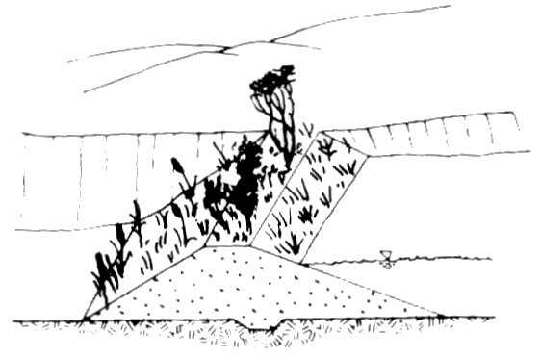

Diagram 2 Vegetation on Embankment that may lead to piping failure

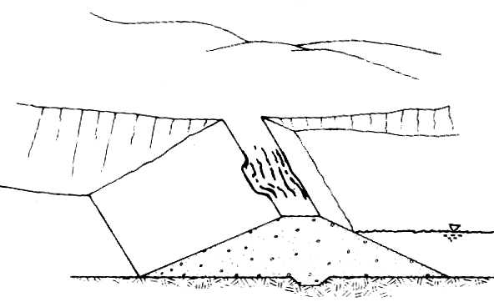

Diagram 3 Settlement of embankment that reduces flood protection of embankment.

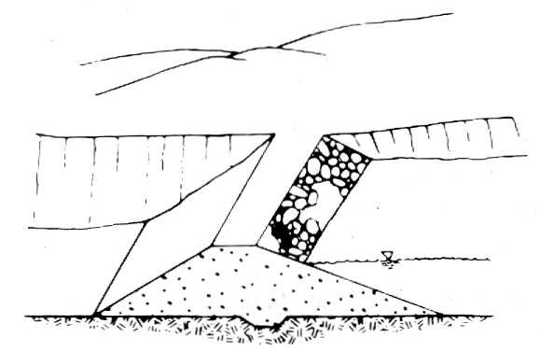

Diagram 4 Areas of missing rip rap that means lack of erosion protection.

Where routine visual inspection reveals a change or fault that threatens the safety of the structure, the observer is to report the change to the LGA and complete an Incident Report form which is included in **Appendix F.**

Identification of potential Issues with your dam

Early identification of a dam safety issue will have a significant influence on avoiding a potential dam failure by allowing remedial works to be undertaken in a timely manner. Signs that indicate potential dam safety issues are listed in the Table A below.

| **Issue** | **Observation** | **Potential Issue** |
| --- | --- | --- |
| Seepage/ Leakage | * An unusual increase in monitored seepage. | Erosion through the dam embankment leading to dam breach/ failure. |
| * New seepage, indicated by wet patches on the downstream slope of the embankment. Noticeable patches of fresh growth grass or patches that have died can indicate potential wet patches/seepage. |
| * Evidence of seepage through the abutments or foundation of the dam, indicating seepage through potential granular layers in the foundation. |
| * Variation in colour/clarity in any seepage water due to soil particles (evidence of internal erosion/ piping). |
| * Whirlpool (vortices) in reservoir (would be associated with significant downstream leakage). |
| Movement/ Cracking | Embankment slides or slumps or evidence of slides occurring (longitudinal cracking). | Structural/slope instability of the embankment or seepage path through embankment, which may lead to dam breach or failure. |
| Excessive and/or differential settlements in the embankment. |
| Severe cracking with or without leakage. |
| Erosion | * Evidence of erosion in the abutments of the dam. | Degradation of embankment, & sometimes reduction in crest levels, which will reduce factor of safety of embankment and may lead to failure. |
| * Erosion gullies develop on the surface of the dam. |
| * Sinkholes, soft spots and boggy areas. | Erosion through embankment (including along tree roots) which could lead to uncontrolled seepage through the dam. |
| * Trees/shrubs growing on the embankment (which could lead to flow path through the embankment along the tree roots). |
| Structural Defects in Outlet Works or Spillway | A break in the outlet pipe resulting in the release of water at and around the outlet pipe. | Uncontrolled seepage along the outlet pipe, leading to progressive breach of the dam. |
| A flow path developing along the outside of the outlet pipe. |
| Inoperable valve. | Causes difficulty in lowering the reservoir level. |
| Vegetation growing, or other blockage in spillway channel or outlet pipe. | Reduces the capacity of the spillway. Could lead to dam overtopping. |
| Other | * An earth tremor which is generally felt outdoors and by almost everyone indoors, where the direction of motion can be estimated and small unstable objects are displaced or upset. This is generally in the order of MM4 or 5 on the modified Mercalli scale. | Instability of the dam, leading to slumping, slope failure and potential dam failure. |
| * Stock damage/pest damage due to rabbit, yabby, wombat or fox holes and stock tracks. | May cause seepage holes, concentrate rainfall into holes, general erosion, potential seepage failures. |

Table A – Observation Table

Dam failure modes and response actions

Although dam failure maybe relatively rare, preparation for their occurrence is appropriate. Two common scenarios failure modes are:

* flood overtopping, and
* “sunny day” (non-flood) event.

An overtopping failure may occur if a flood overtops the dam embankment because the spillway cannot pass the flood flow. Before this form of failure occurs, it is likely that considerable areas of the downstream of the dam will already be inundated by river flood flow and emergency response organisations would be in readiness or in response due to flood warning systems.

A non-flood failure may occur due to an incident when the reservoir is at normal operating level. Downstream inundation will be solely due to failure of the dam. “Piping” erosion through the embankment or its foundations, fracturing of the dam’s clay core, an earthquake, slide, or settlement, are possible causes of a non-flood failure.

The DEPI public document entitled “*Your Dam Your Responsibility - A Guide to Managing the Safety of Farm Dams”* gives clear failure scenarios that can be used as guidance when assessing a situation at a small dam. A copy of this publication can be found at the following website: <http://www.water.vic.gov.au/saving/farms/dams>.

This section deals with an incident that may lead to a potential dam failure. The potential failure situation is an emergency situation where there are serious signs of the dam or its foundations being breached or eroded.

These situations include:

* Piping / Seepage related failures
* Dam Slope Failure
* Earthquake
* Floods (including Dam Overtopping)
* Outlet work failure
* Hazardous substance spill
* Threats from terrorism and sabotage

Piping/ Seepage related failures

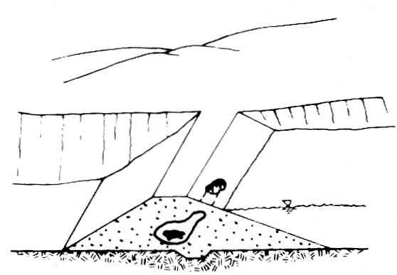

Diagram 5 Piping failure

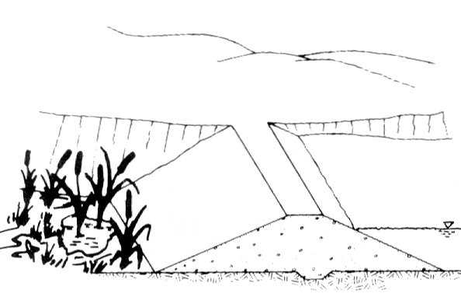

Diagram 6 Seepage at the Toe

|  |  |
| --- | --- |
| **RESPONSE TO PIPING THROUGH THE EMBANKMENT, FOUNDATION OR**  **ABUTMENTS** |  |
| Plug the flow with whatever material is available (hay bales, bentonite or plastic sheeting if the entrance to the leak is in the reservoir basin). |  |
| Lower the water level until the flow decreases to a non-erosive velocity or until it stops. |  |
| Place protective sand and gravel filter over the exit area to hold materials in place. |  |
| Continue lowering the water level until a safe elevation is reached. |  |
| Continue operating at a reduced level until repairs can be made. |  |
| Note: this flow may originate alongside an outlet of spillway structure |  |

Most dams show some signs of seepage, however seepage may indicate the progression of an ‘erosion hole’ developing through the embankment, or the potential for a slope failure to occur. Piping or seepage related failures may be caused by:

* Vermin / animal damage in the embankment, leading to the initiation of an erosion hole
* Defects in the erosion protection leading to localised erosion / erosion holes developing due to wave action,
* Cracks in the embankment (long-term ‘drying out’ of the embankment/ settlement causing cracks/ earthquake cracking)
* Poor construction techniques (ie. one area of the embankment being under-compacted, creating a defect through the embankment)
* Trees on the embankment (tree roots may cause a water-path).

It is critical that seepage is monitored to develop an understanding of the significance of the issue. Monitoring of changes in the amount of flow, as well as whether the water is clear or dirty, it important in assessing the severity of the issue. If the amount of flow from a seepage point has rapidly increased, or if the seepage water is dirty (indicating that material is being eroded), the following actions should be taken.

**Management actions**:

* Observer alerts the LGA Service Centre or Asset Manager of the developing seepage issue
* Asset Manager makes a preliminary assessment based on available information and initiates response. If called upon to have information and plans for addressing the safety of the residents and businesses downstream of the dam and to assist the VicSES and Police by providing this information.
* Asset Manager organises the Site Officer to attend and inspect the dam site. The Site Officer will commence taking fifteen minute interval records of the seepage using form Visual Inspection Format **Appendix E**.
* If the seepage issue is getting rapidly worse, the LGA is to escalate and an Incident Control Centre established, unless it is deemed that there is no population, business or environment at risk if the dam fails.
* Asset Manager contacts DEPI and most likely a dam safety consultant, possibly resulting in mobilising an Assessment Team to visit the site. LGA to send DEPI Incident Report Format **Appendix F** .
* LGA ensures site status is monitored and general access to the area is controlled.
* If required establish an Incident Control Centre and appoint an Incident Controller. The Site Officer monitors information from the site and is authorised to advise Local Government and the Incident Controller if the situation warrants evacuation action.
* Assessment team moves to site, assesses situation and initiates appropriate course of action. Action may include releasing water from the dam in a controlled manner, further inspection of the seepage, or emergency earthworks.

Dam slope failure

Slope instability of embankment dams can be caused through a range of issues, including earthquakes, rapid filling or drawdown, or excessive ground water pressures developing within the embankment.

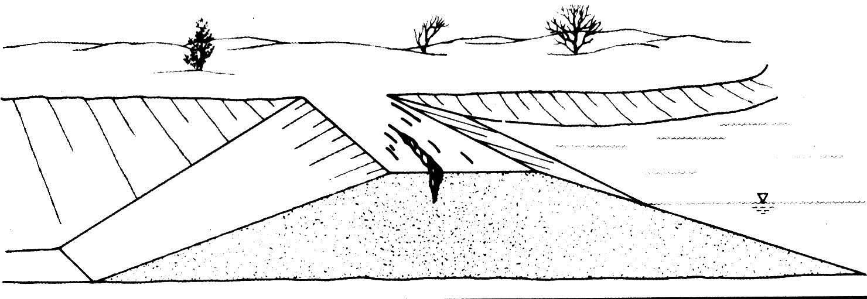

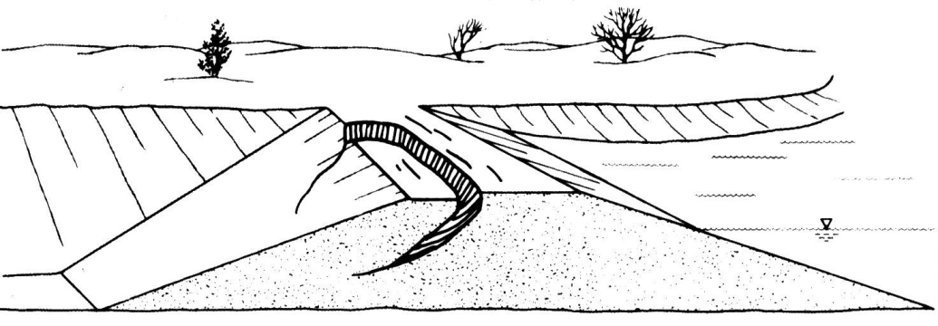

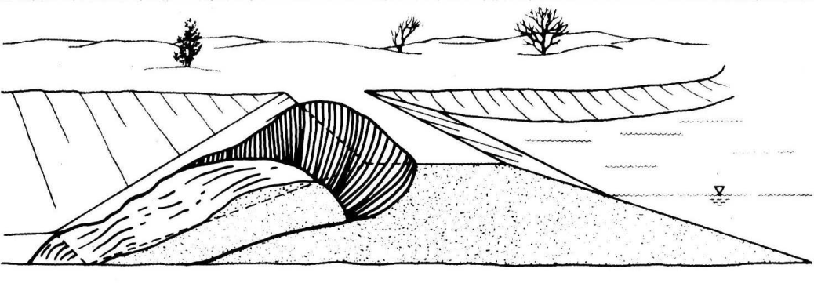

Diagram 7 Dam Slope Failure

|  |  |
| --- | --- |
| **RESPONSE TO SLIDES ON THE UPSTREAM OR DOWNSTREAM SLOPE OF THE EMBANKMENT** |  |
| Lower the water level at a rate and to an elevation considered safe given the slide condition. If the outlet is damaged or blocked, pumping, siphoning or a controlled breach may be required. |  |
| Restore lost freeboard if required by placing sandbags or filling in the top of the slide. |  |
| Stabilize slides on the downstream slope by weighting the toe area with additional soil, rock or gravel |  |

**Management actions**

* Observer alerts the Service Centre or Asset Manager of the slope failure.
* Asset Manager makes a preliminary assessment based on available information and initiates response. If called upon to have information and plans for addressing the safety of the residents and businesses downstream of the dam and to assist the VicSES and Police by providing this information.
* Asset Manager organises a Site Officer to attend and inspect the dam site.
* Site Officer will make an assessment and record the dimensions and location of the slope failure, making sure their own safety is addressed. The Site Office will also record the water level within the reservoir and proceed to make on-going assessments of the changes in the slope failure, such as seepage through the failed area of the bank, the progression of cracking along the top of the slope failure, and the amount of rainfall at the time (if any).
* Asset Manager contacts DEPI, and most likely a dam safety consultant, possibly resulting in mobilising an Assessment Team to visit the site. LGA to provide DEPI regular updates from the Site Officer.
* The Site Officer will commence taking fifteen minute interval records of the seepage using form Incident Inspection Form at **Appendix E**.
* If the slope failure is judged to have the potential for cause failure of the dam, the Asset Manager should escalate, unless it is deemed that there is no population, business or environment at risk if the dam fails.
* LGA ensures site status is monitored and general access to the area is controlled.
* If required DEPI establishes an Incident Control Centre and appoint Incident Controller. The Site Officer monitors information from the site and is authorised to advise the Incident Controller if the situation warrants evacuation action.
* Assessment team moves to site, assesses situation and initiates appropriate course of action. Action may include the controlled release of water from the dam and temporary ‘buttressing’ of the area with free-draining gravels and rockfill

Floods – overtopping / spillway capacity

Normal spillway flows will not require any emergency action by Local Government, unless a defect in the dam embankment is observed to have developed during the event.

Floods, for the purpose of a specific Dam Safety Emergency Plan, are defined as flows which are likely to cause the downstream river to rise above the normal riverbank level, or cause a rapid rise in reservoir level.

In an extreme scenario, the spillway may not be capable of passing the flood event and water may overtop the embankment leading to potential failure of the embankment.

Subsequent to long periods of low storage level, the condition of the embankment can be assumed to be in a similar condition to that experienced during initial filling of the dam. On initial filling the pore pressure in the embankment material has not been exposed to soil saturation. This condition poses a risk of embankment failure and therefore must be treated as an extreme condition that requires monitoring. Particular care must be taken if the reservoir level rises quickly following a long period of low storage level.

Generally if the storage level rise over a period of 30 days exceeds an average of 2m/week, or if the short term rise in level exceeds 4m in any 7 day period, then arrangements should be made to release water from the reservoir with direction from the Municipal engineering division or specialist consultant.

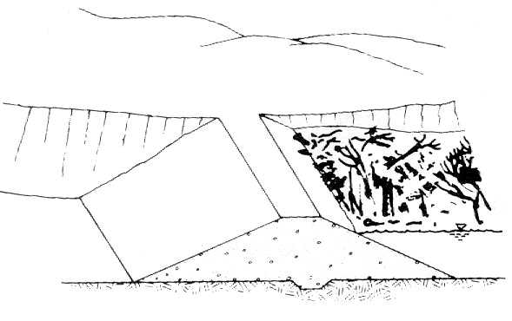

Diagram 8 Debris build up that may lead to overtopping

|  |  |
| --- | --- |
| **RESPONSE TO OVERTOPPING BY FLOODWATER** |  |
| Open outlet to its maximum safe capacity. |  |
| Place sandbags along the crest to increase freeboard and force more water through the spillway and outlet. |  |
| Provide erosion-resistant protection to the downstream slope by placing plastic sheets or other materials over eroding areas. |  |
| Divert floodwater around the reservoir basin if possible. |  |
| Create additional spillway capacity by making a controlled breach in a low embankment or dyke section where the foundation materials are erosion resistant. |  |

|  |  |
| --- | --- |
| **RESPONSE TO OVERTOPPING DUE TO BLOCKED SPILLWAY CHANNEL** |  |
| Open outlet to its maximum safe capacity. |  |
| If the reservoir does not drop with outlet open then slowly remove debris blocking the spillway channel to allow more water through the spillway. (Note, rapid removal of the spillway blockage may result in extensive flooding downstream. Only if there is an immediate threat to the integrity of the dam should the blockage be removed rapidly.) |  |
| If debris cannot be removed then follow the response action noted above under ‘Overtopping by Floodwater’. (Note: During times of large storm events, high inflow and high reservoir levels, debris resting along the reservoir shoreline can be washed into the reservoir and drawn up to the spillway entrance. This debris should be monitored and removed if it threatens to block the spillway or break the log boom or fish trap.) |  |

When it is predicted by the Bureau of Meteorology or local intelligence that a flood is likely, the following actions are to be undertaken:

**Management Actions:**

* arranges for a Site Officer to undertake surveillance at the dam during the course of the flood, including regular monitoring of reservoir water level and depth of water over spillway. The spillway should be checked for obstructions, and cleared if necessary and appropriate.
* should ensure that inundation maps are available to relevant authorities, and should also familiarise them with the capacity of the spillway, should this information be available.
* If there is potential for dam failure, then revert to the Dam Breach / Dam Failure procedures in the quick reference flip chart in **Appendix G.**

Dam failure / uncontrolled releases / outlet works failure

Dam failure involves the breaching of the dam and an uncontrolled outflow of water with possible loss of life and damage to property. This situation requires immediate evacuation of any population at risk downstream of the dam in the inundation area.

Uncontrolled releases may occur when there is a failure of outlet works. Outlet works are pipes and associated valves that release flows in a controlled manner downstream of the dam for environmental flows or draining of the reservoir. Uncontrolled flows for dam outlet works are deemed to be releases above the maximum outflow possible under normal circumstances, or the inability to stop flows from an outlet pipe due to valve failure, damaged pipework, or a similar scenario.

|  |  |
| --- | --- |
| **RESPONSE ACTIONS TO FAILURE OF APPURTENANT STRUCTURES SUCH AS OUTLETS OR SPILLWAYS** |  |
| Implement temporary measures to protect the damaged structure, such as closing an outlet or providing temporary protection for a damaged spillway. |  |
| Lower the water level to a safe elevation. If the outlet is inoperable, pumping, siphoning or a controlled breach may be required. |  |
| Uncontrolled seepage alongside the structure may cause damage or failure. |  |

**Management actions**

* The Observer notifies the LGA of a potential incident.
* LGA immediately informs the Victoria Police VicSES and DEPI.
* The Asset Manager organises a Site Officer to inspect the dam site.
* Site Officer shall ensure their own safety and the safety of others at all times.
* Site Officer notifies the Asset Manager of the site conditions as soon as possible, in particular the risk of inundation of the downstream community and the consequences of draining the reservoir.
* The LGA shall source expert advice on the ways in which to stem or cease the flow. This work may involve the design and installation of a temporary structure (bulkhead/stop logs/ earthen structure/ balloon-type plug) at the upstream or downstream end of the pipe, until a permanent solution is designed. It may be necessary to have a temporary means for lowering the reservoir water during this phase, such as pumps set up on the crest of the embankment to drawdown reservoir water.
* LGA assures the accuracy of the reported situation by appropriate questioning of the Site Officer.
* Establish Incident Control Centre. It is noted that this step may occur prior to the Site Officer reaching the site if other Emergency Services are providing information back to the Asset Manager.
* Asset Manager contacts and discusses the situation with the Incident Controller, the DEPI and consults further with the Police and other support agencies with an aim of providing a common operating picture.
* The VicSES are the control agency for flood events and responsible for notifying communities at risk from flood waters, including floods resulting from a dam safety emergency. The Incident Controller for the downstream Flood event from the dam may recommend to the Vicpol Evacuation Manager the need for evacuation.
* The Asset Manager ensures that the ICC has current information regarding inundation zones and that VicSES is notified if there is a population at risk downstream of the dam.
* VicSES will liaise with the Vicpol Evacuation Manager regarding evacuations and notifications. It would be appropriate to have agreed arrangements in place formed during the emergency management planning phase between VicSES and the LGA.

Inundation maps are important in identifying the residents and businesses downstream of the dam to be evacuated in the event of a potential dam failure.

Earthquake

An earthquake event may be registered in any of the following ways:

* felt by staff;
* notified by a person as having been felt in the vicinity of the dam;
* advice from an external Authority that an earthquake has been recorded in the area.

The Seismicity Research Centre (SRC) operates a network of approximately 100 seismographs and accelerographs in Victoria, New South Wales, Queensland and Tasmania. It locates about 300 earthquakes within this network each year. The earthquakes are recorded and the data provided in an online information service provided by the SRC, the web site is a handy tool to monitor earthquakes and provides the opportunity to report earthquakes felt in the area. There are also contact numbers for any information that may be required.

The site can be accessed by the following address: http://www.seis.com.au.

In the event of an earthquake, the actions listed in the following sections should be undertaken.

Refer to the flip chart “Earthquake” in **Appendix G** for a summary of recommended actions.

Initial inspection

In the event of an earthquake the Site Officer is to:

|  |
| --- |
| Ensure their own safety and the safety of others at all times, being mindful of the potential for aftershocks. |
| Conduct an assessment of the earthquake based on the approximate magnitude based on initial observations (refer to Modified Mercalli Scale in Appendix G). This information should be provided to the Specialist Consultants. |
| immediately conduct a general overall visual examination of the dam regardless of the time of day. If safe to do so, obtain storage water level, discharge rate, evidence of cracking and / or leakage and any other relevant data. |

If no damage is observed:

|  |
| --- |
| Proceed with a detailed Inspection or if at night, carry out a detailed Inspection at first light; and |
| Notify the Asset Manager of the observations and actions taken. Complete visual inspection form at **Appendix E** |

If any damage is observed (leakage, etc) as a result of the earthquake, no matter how minor:

|  |
| --- |
| immediately notify Asset Manager |
| If safe to do so, obtain storage water level, inflow rate, discharge rate, seepage rates and colour of seepage and any other relevant data for reporting to the dam safety engineers or specialist dam Consultants. |
| Depending on the extent of the damage (event greater than MM3 or MM4, refer Modified Mercalli Scale Appendix G a decision must be made whether to proceed with a Detailed Inspection or to initiate emergency action. It is suggested that the following emergency action might be taken. |
| Ensure that a Site Officer is stationed at the dam to undertake a detailed assessment of the damaged area/s. |
| Arrange site resources. |
| Contact dam safety engineers and DEPI if assessed necessary. |
| Initiate appropriate action based on dam safety engineers specialist’ advice. |
| Notify the Seismology Research Centre by visiting their website and filling in the Earthquake Intensity Report of the earthquake event. |

Detailed Inspection

A detailed inspection of the dam should be made as soon as possible after any earthquake.

**Note: Care should be taken when carrying out on site inspections following earthquake events with respect to potential aftershocks and the risk to life and safety of first responders**

Special attention should be paid to the following areas:

* Abutments (sides of the dam) for displacements, slips, cracks and seepage.
* Dam for cracking, evidence of slope failure and leakage.
* Flow from outlet pipe.

If the structure is damaged to a point of impending failure, immediately notify the VicSES who in consultation with DEPI, specialist dam engineers and support agencies is to provide an informed decision on evacuation to the Vicpol Evacuation Manager.

Some damage to the structures may not be readily apparent during an inspection immediately following an earthquake. It is possible that settlement, reactivation of old slides or development of new slides or springs may not occur with ground shaking, but may appear some days after the initial inspection. Failure may occur at any time in the first 48 hours after the main earthquake event. Therefore continuous surveillance over the 48 hour period following and earthquake is required.

Loss of freeboard or dam cross section due to storm or wave erosion.

|  |  |
| --- | --- |
| Place additional riprap or sandbags in damaged areas to prevent further embankment erosion. |  |
| Lower the water level to an elevation below the damaged area. |  |
| Restore freeboard with sandbags or earth and rock fill. |  |
| Continue close inspection of the damaged area until the storm is over. |  |

Spillway channel erosion threatening safety of dam wall

|  |  |
| --- | --- |
| Reduce the flow over the spillway by fully opening the main outlet. |  |
| Provide temporary protection at the point of erosion by placing sandbags, riprap materials or plastic sheets weighted with sandbags. |  |
| When inflow subsides, lower the water to a safe level. |  |
| Continue operating at a low water level in order to minimize spillway flow. |  |

Excessive seepage /saturation of the embankment

|  |  |
| --- | --- |
| Lower the water to a safe level. |  |
| Continue frequent monitoring for signs of slides, cracking or concentrated seepage. |  |
| Continue operation at a reduced level until repairs can be made. |  |

Excessive settlement of the embankment

|  |  |
| --- | --- |
| Lower the water level by releasing it through the outlet or by pumping, siphoning or a controlled breach. |  |
| If necessary, restore freeboard, preferably by placing sandbags. |  |
| Lower water to a safe level. |  |
| Continue operating at a reduced level until repairs can be made. |  |

Loss of abutment support or extreme extensive cracking in concrete dams

|  |  |
| --- | --- |
| Lower the water to a safe level by releasing it through the outlet. |  |
| Implement notification procedures. |  |
| Attempt to block water movement through the dam by placing plastic sheets on the upstream face. |  |

Hazardous substance spill

The control agency for a hazardous substance spill/ pollution within inland waterways is the Country Fire Authority or the Melbourne Fire and Emergency Services Board, with support agencies being the Environmental Protection Agency (EPA) and Victoria Police. If there is a problem with pollution continually entering inland water ways then the control agency will be the EPA and Melbourne Water with the support agency being the Victoria Police.

For the safety of the community, steps should be taken to isolate the dam, shutoff downstream flows from the reservoir and arrange for water quality sampling.

Refer to the flip chart “Hazardous Substance Spill” in **Appendix G** for further actions.

Security threats

A dam safety security threat is a situation which could result in damage, failure or contamination of the reservoir. Safety threats include terrorism, sabotage and deliberate toxic spills. For all cases the Victoria Police should be immediately contacted. As a matter of priority ensure your own and other people’s personal safety.

Refer to the flip chart “Terrorism and Sabotage” in **Appendix G** for further actions.

Initial response options – the first 60 minutes

To help guide the initial actions in the first 60 minutes of a dam safety incident a generic list of actions for consideration by emergency response agencies is shown below.

An Emergency Response Quick Reference Flip Chart is included in **Appendix G**. A copy of this “Flip Chart” should be printed and kept with members of the Municipal Emergency Planning Committee or Asset Manager , with maintenance personnel responsible for the dam and if possible at the dam.

This chart is an easy to read document that can be used by staff to quickly access contact personnel and telephone numbers suited to the particular incident.

1. Has the dam failed or is there potential for imminent failure?
2. If initial notification / field observations / report suggest imminent dam failure;

* contact SES to arrange for necessary warning notifications to people downstream;
* VicPol for appointment of Evacuation Manager and for any potential evacuations required and;
* If limited time consider other options with the local resources currently available – door knock, phone tree, emergency alert.
* DEPI to Notify Emergency Management Victoria as a potential Major Class 2 dam safety emergency.

1. Description of incident and damage to dam.

* Are outflows increasing?
* What is happening at the dam (e.g. overtopping, seeping?)
  + Weather forecast (i.e. is more rain forecast?)
  + Are the upstream flows increasing or decreasing?
  + Upstream events?
  + Are flows being measured?
* Is the water cloudy or muddy?
  + 1. Take a sample of the outflow water now and every 15min and store in clear container.
  + If the outflow contains sediment, this may indicate the dam wall is eroding.
  + Sediment may need to be measured.
  + IC to consider taking a sample of the outflow water now and every 15min and store in clear container. Over a period a time do a comparative analysis and assess the trend in water colour. Is the water becoming more cloudy or less cloudy?
    1. If the water is becoming more cloudy escalate response.
    2. Same colour, maintain level of response.
    3. Colour of water is clearing, monitor and review.
* Has the dam been regularly inspected and maintained? (If not, there is a greater risk of undetected faults leading to imminent failure).
* Is the damage in the dam wall expanding and water outflow increasing?
* What is the current water level? Is there a history of problems when the dam exceeds the normal level?

1. Location of dam? Street address / township and owner.
2. Has the owner / operator been identified?
3. Has the owner / operator been contacted?
4. Has the owner / operator’s Dam Safety Emergency Plan been activated?
5. Consider implementing actions in the *Management of Flooding downstream of Dams* in conjunction with VicSES and VICPOL if population at risk.
6. Is there population at risk downstream?

* Numbers and location?
* Have the Victoria Police Evacuation Manager and Control Agency been advised of the need for warnings or evacuation?
* Evacuate people at risk until a dam expert confirms there is no dam safety incident.

1. Assess what else is at risk downstream.

* Another dam that could fail if on stream?
* Receiving waters of another lake or water body that could fail?
* Events (e.g. regatta on a lake)?
* River diverters? (notify)
* Horticulturalists? (notify)
* Public / private asset? (notify)
* Roads closures needed?

1. Size of dam wall and capacity – wall height and water level will influence impact.

* Date of dam construction.
* Construction type, eg. earthfill, rockfill, concrete.
* Capacity of dam.
* Current water levels.
* Gate or fixed crest.
* Are all operational structures on the dam operating properly (will influence selection of mitigation strategies)

1. Is a dam safety expert needed? (refer **Appendix B** for a list of dam safety consultant experts)
2. Ensure that they are monitored/supervised and fit into IMT arrangements

***The following are precautionary planning options, intended to provide some level of guidance to the IC at the ‘incident-level’ within the first hour.***

***It is important to note these items require expert technical and engineering knowledge before implementing and it is important that specialist dam safety advice is sought. These items can be considered while the Dam safety engineers are moving to the dam site. Following Dam safety engineers assessment, their expert advice will guide the actions to be implemented.***

***Information / actions onsite must be shared with the Incident Controller, so that it can be shared with the IMT and EMT. Note that OH&S provisions apply and actions should only be undertaken if it is safe to do so.***

1. IC to consider siphon options to lower level in the dam. Arrange on site for lengths of flexible poly pipe for siphon if required.
2. IC to consider organising portable pumps and generators if required
3. IC to consider organising lighting and generator for site if required
4. IC to consider organising excavator / backhoes for spillway earthworks if required
5. IC to consider organising hay bails to plug the upstream inlet and downstream inlet of any piping failure in an earthen dam.
6. IC to consider signage and community warnings at the dam due to site convergence.
7. IC to consider requesting dam operator if the outlet value can be operated / opened
8. IC to consider requesting any telemetry for the dam for the history of inflows and outflows and timings and volumes.
9. IC to consider pegging width of overtopping and take photos every 15 min
10. IC to consider pegging piping failure and take photos every 15 min
11. IC to consider pegging extend of flooding downstream every 15 min and take photos.
12. IC to consider the need for evacuation and timings required to notify the Victoria Police Evacuation Manager for this incident who would be located in the IMT.
13. IC to consider contact with DEPI Comms regarding development evacuation messages / holding statements / information to community via MJPIC and VicSES.
14. IC to consider organising sandbags to
    1. Increase the crest height
    2. Increase the spillway capacity
    3. possible works on a secondary spillway
15. IC to consider ordering materials required on site for temporary rd construction
    1. Crushed rock
    2. Class C gravel
    3. Sand
16. IC to consider onsite spokesperson and key holding messages.
17. If inflows are increasing and if safe to do so, possible mitigation strategies to decease inflows are to:
    * + Stop or reduce flows coming from dams upstream.
      + Construct bypass around dam.
      + Construct cut off drains to decrease flows into dam.
18. Strategies to consider to increase the outflows (only if safe to do so) are:

* Sandbag dam wall to increase capacity of discharge from dam.
* Sandbag crest to increase volume of dam and stop overtopping.
* Open scour to increase outflow from dam.
* Open gates.
* Lower spillway level.
* Lower secondary spillway or create a secondary spillway.
* Clear spillway of debris.
* Pump or siphon water from dam.
* Increase outflows from downstream dams where possible.

1. Determine final receiving waters and the final water body where the water will impact.

Appendix A – Information on dam

| **Item** | | **Description** |
| --- | --- | --- |
| **General Information** | Name of Dam | ####### |
| Location (include road name) | ##km North of #####, Victoria |
| Map Reference | VicRoads Ref 56, A4 |
| Period of Original Construction | 19## |
| Water course | #### River |
| Hazard Category (ANCOLD) | ##### |
| Population at Risk | ### people |
| **Reservoir** | Storage Capacity at FSL | ##### ML |
| Catchment Area | #### km² |
| Full Supply Level (Spillway Crest Level) | #### mAHD |
| **Dam/ Embankment** | Type of Dam (material) | For example, earthfill with clay core |
| Embankment Height (max) | ## m |
| Embankment Length | ### m |
| Embankment Crest Elevation | ### mAHD |
| Upstream Slope of Embankment | ## Horizontal: 1 Vertical |
| Downstream Slope of Embankment | ## Horizontal: 1 Vertical |
| Embankment Crest Width | ##m |
| Spillway | Description of Spillway (material etc) | For example, Unlined spillway channel with concrete control structure |
| Location of Spillway | For example, Left side of embankment (looking downstream) |
| Full Supply Level (Spillway Crest Level) | #### mAHD |
| Width of Spillway Crest | ### m |
| Existing Spillway Capacity | ### m³/s |
| Dam Crest Flood | 1 in #### AEP |
| Outlet Works | Description of Outlet Works | For example, ## diam. Cast iron pipe |
| Location | ##m from left abutment (looking downstream) |
| Capacity | ## m3/s |
| Details of Operation | For example, operated by valve at downstream end |

<INCLUDE INFORMATION SUCH AS:>

* GENERAL ARRANGEMENT DRAWINGS OF THE DAM
* PHOTGRAPHIC RECORD OF THE DAM
* INUNDATION MAP

Appendix B – Emergency contact list

|  |  |  |  |
| --- | --- | --- | --- |
| Emergency Contact | Telephone numbers | | |
| Business | After hours | Mobile |
| Municipal Emergency Resource Officer (MERO):  **First Name Last Name** |  |  |  |
| Municipal Asset Manager and Risk Manager  **First Name Last Name** |  |  |  |
| Emergency Response Coordinator  **First Name Last Name** |  |  |  |
| Regional Emergency Response Coordinator  **First Name Last Name** |  |  |  |
| VicSES |  | 132 500 |  |
| DEPI State Control Centre, 24hr Contact | 1300 13 4444 | 1300 13 4444 |  |
| DEPI Water Division (Dam Emergency)  **Siraj Perera** | 03 9637 9125 | 1300 13 4444 | 0408 110 939 |
| DEPI Water Division (Dam Emergency)  **Konrad Gill** | 03 9637 8775 | 1300 13 4444 | 0431 500 111 |
| DEPI Water Division (Dam Emergency) **Pradeepa Adihetty** | 03 9637 9526 | 1300 13 4444 | 0438 571 614 |
| **Licensing Authorities for Private Dams** | | | |
| Goulburn –Murray Water  (Water Authority, private dam licensing) | 1800 064 184 | 1800 064 184 |  |
| Southern Rural Water  (Water Authority, private dam licensing) | (03) 5139 3113 | 1300 139 510 |  |
| Lower Murray Urban and Rural Water  (Water Authority, private dam licensing) | (03) 5051 3400 | 1800 808 830 |  |
| Grampians Wimmera Mallee Water  (Water Authority, private dam licensing) | 1300 659 961 | 1800 188 586 |  |
| Melbourne Water  (Water Authority, private dam licensing) | 131 722 | 132 446 |  |

|  |  |  |
| --- | --- | --- |
| List of Dams Consultants | | |
| GHD | 8687 8000; 0403 188 140 |  |
| SMEC | 9573 8135; 0429 988 900 |  |
| SKM | 9248 3307; 0438 110 618 |  |
| URS | 8699 7672; 0419 340 148 |  |
| Fisher Stewart | 8717 9272; 0407 382 885 |  |
| **Better suited for smaller dams (eg. farm dams)** | | |
| Doug Goad | 8862 3500; 0414 255 105 | Hawthorn |
| Bob Keleher | 5441 5422; 0412 459 122 | Bendigo |
| Trevor Clark | 5442 9874; 0418 540 874 | Bendigo |
| Neil Kirby | 9874 2663; 0418 869 812 | Mitcham |
| Don Rickerby Consulting | 5367 6363 or 0459676363 |  |
| Ron Archibald | 9707 0039; 0418 145 431 | Berwick |

Appendix C – Resource list

|  |  |  |  |
| --- | --- | --- | --- |
|  | Business | After Hours | Mobile |
| Support Agencies |  |  |  |
| Emergency Services (Police, Fire, Ambulance) | 000 | 000 |  |
| Local Police Station: Name  Station: Name |  |  |  |
| State Emergency Office: Name  Services Office: Name |  |  |  |
| Local Fire Station: Name  Authority Station: Name |  |  |  |
| Local Electrical Distributo Name |  |  |  |
| Dial before you dig |  |  |  |
| EPA (Environmental Protection Authority) |  |  |  |
| Water Corporation |  |  |  |
| Vic Roads |  |  |  |
| Earth Moving Equipment and Labour |  |  |  |
| Shire council: Location |  |  |  |
| Company (Excavator, loader, generator) |  |  |  |
| Company (Excavator, loader, generator) |  |  |  |
| Rock Beaching, crushed rock & sand |  |  |  |
| Company: Name |  |  |  |
| Sand Bags |  |  |  |
| Shire council: Location |  |  |  |
| Company: Name |  |  |  |
| Ready Mix Concrete |  |  |  |
| Company: Name |  |  |  |
| Company: Name |  |  |  |
| Electrical |  |  |  |
| Electricians Company: Name |  |  |  |
| Electricians Company: Name |  |  |  |
| Pump Hire |  |  |  |
| Shire council: Location |  |  |  |
| Company: Name |  |  |  |
| Generator Hire |  |  |  |
| Shire council: Location |  |  |  |
| Company: Name |  |  |  |
| Portable Lights Hire |  |  |  |
| Shire council: Location |  |  |  |
| Company: Name |  |  |  |

Appendix D – Example community alert messages

**Immediate evacuation messaging**

For immediate, time critical warning advice, these messages may be used by the LGA for the population at risk.

The following are example SMS mobile phone messages for alerting the community at risk in the dam breach area.

|  |
| --- |
| **Flood Alert SMS Message Example:**  <ENTER AUTHORITY> issuing a <MAJOR/MODERATE/MINOR> flood warning for the <ENTER RIVER NAME> downstream of <ENTER NAME OF DAM>. River levels expected to peak at <ENTER TIME>. Further information, <ENTER PHONE NUMBER OR WEBSITE> |
| **Immediate Evacuation Alert Example:**  <ENTER AUTHORITY> advises that residents downstream of <ENTER NAME OF DAM> should evacuate immediately to <ENTER EVACUATION LOCATION> due to potential dam failure. Further information, <ENTER PHONE NUMBER OR WEBSITE> |

**Pre – Warned evacuation messaging**

If there is no imminent threat, warning to evacuate will be arranged by the Vipol Evacuation Manager.

Appendix E – Visual inspection report form

|  |  |  |  |  |  |  |  |  |  |
| --- | --- | --- | --- | --- | --- | --- | --- | --- | --- |
| Structure | | | | | |  | | | |
| Date and Time of Inspection | | | | | |  | | | |
| Reservoir Level | | | | | |  |  |  |  |
| Full Supply Level | | | | | |  |  |  | Recent Rainfall |
| Tailwater Level | | | | | |  |  |  | Inspecting Officer |
|  |  | Condition of Structure  or  | | | | | | | |
|  |  | Seepage | Cracking | Slip | Settlement | Erosion | General Damage | Vegetation or Debris | Description of Defect and Location |
|  |  |
| EMBANKMENT | Upstream Face |  |  |  |  |  |  |  |  |
| Crest |  |  |  |  |  |  |  |  |
| Downstream Face |  |  |  |  |  |  |  |  |
| Natural Surface (Toe Area) |  |  |  |  |  |  |  |  |
| Reservoir Perimeter |  |  |  |  |  |  |  |  |
|  |  |  |  |  |  |  |  |  |  |
|  |  | Cracking | Movement | Deterioration | Leakages | Vegetation/ Debris | General Damage |  | Description of Defect and Location |
|  |  |
| SPILLWAY | Approach area |  |  |  |  |  |  |  |  |
| Control Weir |  |  |  |  |  |  |  |  |
| Retaining Wall |  |  |  |  |  |  |  |  |
| Discharge Channel |  |  |  |  |  |  |  |  |
|  |  |  |  |  |  |  |  |  |  |
|  |  | Cracking | Movement | Deterioration | Leakages | Vegetation/ Debris | General Damage |  | Description of Defect and Location |
|  |  |
| OUTLET WORKS | Upstream Area (if visible) |  |  |  |  |  |  |  |  |
| Downstream Outlet Area |  |  |  |  |  |  |  |  |
| Discharge Channel |  |  |  |  |  |  |  |  |

Appendix F – Incident report form for DEPI

**Incident Report Form for <ENTER NAME OF DAM>**

**Date / time of report:** Date _ _ / _ _ / _ _ _ _ Time _ _ : _ _ hours

**Incident name:** _ _ _ _ _ _ _ _ _ _ _ _ _ _ _ _ _ _ _ _ _ _ _ _ _ _ _ _ _ _ _

**Is the dam about to fail?**   **Yes / No**

If Yes, have the police been notified? Yes / No

**Is there a population at risk or potential loss of life ? Yes / No**

If Yes, have the police been notified? Yes / No

Have the SES been notified Yes No

Have any warnings been issued /evacuations occurred? Yes No

Numbers of Population at risk ………………..........................

Potential loss of life numbers ………………………………….

**Details of the person sending the report:**

Name _ _ _ _ _ _ _ _ _ _ _ _ _ _ _ _ _ _ _ _ _ _ _ _ _ _ _ _ _ _ _ _ _ _

Contact number _ _ _ _ _ _ _ _ _ _ _ _ _ _ _ _ _ _ _ _ _ _ _ _ _ _ _ _ _

Organisation _ _ _ _ _ _ _ _ _ _ _ _ _ _ _ _ _ _ _ _ _ _ _ _ _ _ _ _ _ _ _

**Incident details:**

Date of incident _ _ _ _ _ _ _ _ _ _ _ _ _ _Time _ _ _ _ _ _ _ _ _ _ _ _ _

Type of incident / description _ _ _ _ _ _ _ _ _ _ _ _ _ _ _ _ _ _ _ _ _ _ _

_ _ _ _ _ _ _ _ _ _ _ _ _ _ _ _ _ _ _ _ _ _ __ _ _ _ _ _ _ _ _ __ _ _ _ _ _

Address of incident _ _ _ _ _ _ _ _ _ _ _ _ _ _ _ _ _ _ _ _ _ _ _ _ _ _ _ _

Is it a part of a larger incident (e.g. flood or fire)? Yes / No

**Incident management details (if known):**

Control agency _ _ _ _ _ _ _ _ _ _ _ _ _ _ _ _ _ _ _ _ __ _ _ _ _ _ _ _ _

Incident Controller name _ _ _ _ _ _ _ _ _ _ _ _ _ _ _ _ _ _ _ _ _ _ _ _ _

Contact number _ _ _ _ _ _ _ _ _ _ _ _ _ _ _ _ _ _ _ _ _ _ _ _ _ _ _ _ _ _

**Has there been failure of critical infrastructure? Yes / No**

If Yes, describe: _ _ _ _ _ ___ _ _ _ __ _ _ _ _ _ _ _ _ _ _ _ _ _ _ _ _ _ _

_ _ _ _ _ _ _ _ _ _ _ _ _ _ _ _ _ _ _ _ _ _ _ _ _ _ _ _ _ _ _ _ _ _ _ _ _ _ _

**Expected resolution?** Date _ _ / _ _ / _ _ _ _ Time _ _ : _ _ hours

**Time of next report:** Date _ _ / _ _ / _ _ _ _ Time _ _ : _ _ hours

|  |  |
| --- | --- |
| **DEPI 24hr Emergency Contact**  **Email** | **1300 13 4444 AH (State Agency Commander)**  [**sccvic.sdo.depi@scc.vic.gov.au**](mailto:sccvic.sdo.depi@scc.vic.gov.au) |

Appendix G – Emergency scenarios flip charts

*- Piping/ Seepage Failures*

*- Dam Slope Failure*

*- Earthquake*

*- Flood*

*- Outlet Works Failure*

*- Hazardous Substance Spill*

*- Terrorism & Sabotage*

*- Dam Failure*

Report unusual observations or changes in dam structures to the Service Centre or Asset Manager who will determine whether to contact Specialist Dam Consultants DEPI and SES.

Report unusual or suspicious human behaviour to local police, Service Centre or Asset Manager.

Take action as indicated in this flip chart or in Dam Safety Emergency Plan.

**Yes**

**No**

Refer to appropriate flip chart procedure.

Has the Dam failed?

LGA to notify VicSES , DEPI and Vicpol

Record event (eg. Times, photographs, notes, videos, communications log etc) and maintain communications

LGA to send Site Emergency Office to Dam if safe.

LGA establishes Incident Control Centre

LGA to confirm or cancel the situation with Incident Controller, DEPI and consults with Police

Evacuation, if necessary. LGA to provide current information on inundation area.

DAM FAILURE

TERRORISM AND SABOTAGE

**CONTAMINATION THREAT**

**BOMB THREAT**

Isolate reservoir. Shutoff downstream flows coming from the reservoir

Check for danger – to self or others

Contact Emergency Services – Dial 000

Contact Emergency Services – Dial 000

**Ensure your own and other people's personal safety as a matter of priority**

Contact Asset Manager

Organise dam inspection and arrange for sampling of water quality

LGA notified of hazardous substance spill.

HAZARDOUS SUBSTANCE SPILL

Asset Manager to send Site Emergency Office to the dam

Asset Manager to organize additional resources which may be required to isolate reservoir (sandbags etc), and assist CFA/MFB with cleanup operations (ie. backhoe to remove contaminated soil)

Seek advice and equipment to contain the spill

Contact: Fire Authority, Environmental Protection Agency, and Local Water Authority.

Arrange for water quality sampling

Asset Manager to Contact CFA – Dial 000

Site Emergency Office to identify substance (refer to HAZCHEM Chart) if possible, and report back to Asset Manager

Site Emergency Officer to isolate reservoir (prevent inflows and outflow from the reservoir).

**Yes**

**No**

Is downstream flooding likely?

Asset Manager to source resources necessary to stop/reduce flows, and organize alternative means for releasing water if necessary

Refer to “Flooding” flip chart

Asset Manager to activate ICC and contact SES

Asset Manager to send Site Emergency Office to dam to inspect

Asset Manager to source advice regarding temporary repair methods

Site Emergency Office to assess the potential for downstream flooding

OUTLET WORKS FAILURE

LGA notified of uncontrolled releases from outlet works.

DAM SLOPE FAILURE

Observer

Reports event to LGA

Asset Manager is notified and sends Site Emergency Officer to Dam

Site Emergency Officer undertakes site inspection, and every 15 minutes records:

* Dimensions/location slope failure
* Cracking at top of failure
* Presence of seepage
* reservoir water level,
* takes photos

Asset Manager to contact Specialist Dam Consultants, DEPI and SES

Is dam failure imminent?

**Yes**

**No**

LGA activate its ICC

Limit access to area

Asset Manager mobilises the Assessment Team – may include Specialist Consultants, DEPI and LGA staff

Asset Manager initiates actions arising advice from Assessment Team and arranges sites resources to assist with temporary rectification/protection works. Work may involve

* lowering water in reservoir.
* Placing filter/rockfill against slope

Mobilise Local Government Emergency Response Committee to assist VicSES.

Decision to be made on need to evacuate and Advice to Vicpol Evacuation Manager

Observer

Reports event to LGA

PIPING/ SEEPAGE FAILURE

Site Emergency Officer undertakes site inspection, and every 15 minutes records:

* quantity and color of seepage flow
* records reservoir water level,
* takes photos)

Asset Manager is notified and sends Site Emergency Officer to Dam

Asset Manager to contact Specialist Dam Consultants, DEPI and SES

Is dam failure imminent?

**Yes**

LGA to activate its ICC

**No**

Limit access to area

Mobilise Local Government Emergency Response Committee to assist Police and VicSES.

Decision to be made on need to evacuate

Asset Manager mobilises the Assessment Team – may include Specialist Consultants, DEPI and LGA staff

Asset Manager initiates actions arising from initial advice from Assessment Team and arranges sites resources to assist with temporary rectification/protection works Work may involve:

* Lowering water in reservoir.
* Placing filter/rockfill over seepage area

LGA is notified of significant flood event/ reservoir level rapidly rising

FLOOD

Clear debris from spillway if time permits

Is spillway clear?

**No**

Asset Manager to send Site Emergency Office to site to inspect dam, condition of spillway (check for debris etc), and to monitor water levels

**Yes**

Is spillway operating and reservoir still rising?

**No**

Continue to undertake frequent inspections of dam due to rapid rise loading on embankment

**Yes**

VicSES to determine if flood warnings required to downstream population, activate ICC if necessary, and notify DEPI

Is dam overtopping likely?

Continue to undertake frequent inspections of dam

**No**

**Yes**

Asset Manager to seek specialist advice regarding possible actions (ie. Cutting another spillway/ sandbagging crest etc)

Asset Manager to organize emergency resources (ie. Sandbags, backhoe etc)

Refer to “Potential Dam Failure” flip chart

|  |  |  |
| --- | --- | --- |
| **MODIFIED MERCALLI SCALE**  **Zone** | **Typical Effects Observed** | |
| 1 | Not felt, except under especially favourable circumstances. | |
| 2 | Felt by persons a rest, on upper floors or favorable places. | |
| 3 | Felt indoors. Hanging objects swing. Vibrations like a passing light truck. Duration estimated. May not be recognised as an earthquake. | |
| 4 | Vibration like a passing heavy truck. Sensation like an object striking walls. Windows, dishes and doors rattle crockery clashes. Standing cars rock. In upper ranges, wood walls and frames creak. | |
| 5 | Felt outdoors, direction estimated. Sleepers wakened. Small unstable objects displaced or upset. Doors swing closed or open. Pictures move. Liquids disturbed, some spilled. Some cracked plaster. | |
| 6 | Felt by all. Many frightened and run outdoors. People walk unsteadily. Windows, dishes, glassware broken. Small items fall from shelves. Pictures off walls, furniture moved or overturned. Weak plaster and masonry D cracked. Trees shaken visibly. | |
| 7 | Difficult to stand. Noticed by car drivers. Furniture broken. Damage to masonry D, some cracks in masonry C. Waves on water. Small slides and caving in along sand and gravel banks. | |
| 8 | Partial collapse of masonry C, damage to masonry B, none to masonry A. Car steering affected. Twisting or fall of chimneys, monuments, towers and tanks. Frame houses moved if not bolted down. Tree branches broken. Cracks in wet ground and on slopes. | |
| 9 | General panic. Masonry D destroyed masonry C heavily damaged masonry B seriously damaged. General damage to foundations. Frames cracked. Underground pipes broken. | |
| 10 | Most masonry and frame structures destroyed with their foundations. Serious damage to dams. Large landslides. Rails bent slightly. | |
| 11 | Rails bent greatly. All underground pipes destroyed. | |
| 12 | Near total damage. Objects thrown into the air. | |
| Masonry A | | Good workmanship, mortar and design; reinforced or bound; Designed to resist lateral forces. |
| Masonry B | | Good workmanship and mortar; reinforced, but not designed in detail to resist lateral forces. |
| Masonry C | | Ordinary workmanship and mortar; no extreme weaknesses, but neither reinforcement nor design against lateral force. |
| Masonry D | | Weak materials such as adobe; poor mortar; low standards of workmanship; weak horizontally. |

The effects are those of large earthquakes. The higher frequencies of seismic waves from smaller nearby events yield different effects, and in particular are more likely to be heard rather than felt at low intensity.

**Yes**

Record the Magnitude of the seismic event according to the Modified Mercalli Scale (MM Scale)

**No**

Is dam failure imminent?

Damage observed

(Likely for >MM5)

No damaged observed

(Unlike for <MM5)

Evacuate to safe area

Conduct detailed inspection

**EARTHQUAKE**

Initiate appropriate action based on Specialist Dam Consultant advice. This may include lowering the reservoir level to at least 10% below FSL and diverting all inflow, if possible

Pass the Incident Report Form to Asset Manager

Local Government to undertake an inspection after the earthquake, when safe to do so

Observer notifies LGA that Earthquake has occurred and LGA contacts VicSES as control agency for earthquake

VicSES

Asset Manager to contact Dam Safety Consultants and DEPI

Inform the Asset Manager of observations and record observations in an Incident Report Form

If safe, obtain relevant data (reservoir levels, type and location of damage)

Immediately notify Asset Manager

Site Emergency Officer to conduct a detailed inspection of the dam

Appendix I – Glossary of terms

|  |  |
| --- | --- |
| Abutment | The natural ground below the excavated surface, against which the left and right sides of the dam are placed. Left and right dam abutments refer to a view looking downstream. |
| Annual Exceedance Probability (AEP) | The likelihood of occurrence of an event of given size or larger occurring in any one year. For example, if a peak flood discharge of 500 m3/s has an AEP of 1 in 20, it means that there is a 1 in 20 (5%) risk of a peak flood discharge of 500 m3/s or larger occurring in any one year. |
| Australian National Committee on Large Dams (ANCOLD) | ANCOLD is a non-governmental association of organisations and individual professionals with an interest in dams in Australia. It provides guidelines on the design, construction and management of dams in Australia. |
| Assessment Team | Team of experts including Specialist Consultants assembled to assess the situation and advise appropriate action. |
| Asset Manager | Local government representative responsible for assessing hazards, monitoring and maintaining local council assets. |
| Breach | Refers to the opening in a dam resulting from partial or total physical failure of the dam. The breach process is modelled by postulating certain breach shapes and rates of breach development. |
| Catchment | The area of land drained by the landform, streams or waterways down to the point at which the dam is located. |
| “Sunny day” Failure | Failure of a dam that occurs due to causes other than a flood event (ie. occurs when there is a ‘sunny day”). |
| Control Agency | Once an emergency response has been initiated, the Control Agency is nominated to control the response activities. The nominated Control Agency is dependent upon the type of emergency. The Control Agency for a Dam safety Emergency is the DEPI. The Control Agency for a Flooding Incident, is the Victorian State Emergency Service (SES). |
| Cracking | Opening of the earthen material on the surface of a dam. Longitudinal cracks are those which run along the length of the dam embankment. Transverse cracks run in an upstream-downstream direction. |
| Crest of Dam | Also called the embankment crest. Used to denote the top level of the dam wall or embankment (not the spillway). The uppermost surface of the dam proper, excluding parapets, handrails -etc. |
| Dam | In general, an artificial barrier constructed for storage, control or diversion of water or other liquids. |
| Dam Safety Emergency Plan (DSEP) | A continually updated set of instructions and maps that deal with possible emergency situations or unusual occurrences at a dam. |
| Design Flood | The maximum flood for which the dam is designed to withstand taking into account the consequences of failure and likely rainfall. |
| DEPI | Department of Environment and Primary Industries. |
| DEPI Water Division (Risk and Resilience Team) | The division of DEPI which deals with Dam Safety Emergency management arrangements. |
| Earthquake | A sudden movement of the earth's crust caused by the release of stress accumulated along geologic faults or by volcanic activity. Earthquake magnitude is normally reported by seismologists in terms of the Richter scale. For the purposes of the Dam Safety Emergency Plan, the Modified Mercalli Scale is used to ascertain intensity based on observed effects. |
| Embankment | An earth structure which is built across a waterway to either protect adjacent land from inundation by flooding or to store water. The term also applies to earthen structures which are built to contain water off a waterway. |
| Emergency Response Coordinator | Member of the Victorian Police appointed as State, Regional, Municipal or Field Emergency Response co-ordinator, whose role it is to co-ordinate the response to an emergency. |
| Flood | Generally considered to be an event which causes water downstream of the dam to rise above the normal riverbank level, or an unusually rapid rise in water level within the reservoir. |
| Freeboard | The vertical distance between the spillway crest and the crest of the dam. |
| Full Supply Level (FSL) | The maximum reservoir level during normal operation, as distinct from flood surcharge. This is usually the level of the spillway crest. |
| Incident Controller (IC) | The role of the Incident Controller is to provide leadership and management to resolve the emergency at the incident site. This is the agency forward controller and operates in close proximity to the incident. (EMMV 3-12) |
| Incident Control Centre (ICC) | Incident level, local centre where agencies meet to respond and actions taken for dam safety emergencies. |
| Hazard Category | The hazard category of a dam is determined using a risk rating system which is based on the consequences of dam failure, in accordance with ANCOLD guidelines. The purpose of assigning a hazard category to a dam is to provide an indication of the level of protection against failure that is required for the dam; for example, ANCOLD sets out guidelines for inspection, monitoring and flood protection (spillway sizing) for a dam given its hazard category. |
| Headwater Level | The level of water within the reservoir. |
| Site Assessment Team | The team given the responsibility to assess the adequacy of the dam during an emergency. May include Specialist Consultants and representatives from DEPI. |
| LGA | Local Government Authority |
| Modified Mercalli Scale | A scale for measuring the intensity of earthquakes. It does not have a mathematical basis; instead it is an arbitrary ranking based on observed effects. |
| Municipal Emergency Resource Officer | The person responsible for the co-ordination of municipal resources in responding to emergencies. Responsible for emergency coordination, maintenance and review of emergency plans. |
| Observer | The person who observes the incident and notifies Authorities. |
| Outlet Works | The pipe, valves and structure that permit controlled release of water from the dam. |
| Piping | Establishment of a seepage path through an earthen embankment, leading to significant erosion of the embankment due to the flow of water along the seepage path. |
| Population At Risk (PAR) | All those persons who would be directly exposed to floodwaters in the event of a dam failure if they took no action to evacuate. That is all persons situated within the dambreak affected zone. |
| Potential Loss of Life | All those persons who in the event of a dam failure would potentially lose their life from being directly exposed to floodwaters if they took no action to evacuate. That is, a proportion of the persons situated within the dambreak affected zone. |
| Reservoir | In general, the body of water or other liquids constructed for storage, control or diversion of water or other liquids. |
| Seepage | Reservoir water that has seeps through or under the dam embankment. |
| VicSES | State Emergency Service in Victoria. |
| Sink hole | Holes or depressions at either the surface of an embankment dam or downstream of the embankment toe which may indicate underground cavities. |
| Site Emergency Officer | <ENTER LGA’s NAME> officer who is located at the dam site during the emergency to gather and provide information to the Incident Control Centre regarding the developments at site. |
| Specialist Consultants | Person or persons who specialise in particular areas of engineering relating to dam safety and associated issues (including earthquakes). |
| Spillway | An open channel, weir, conduit, tunnel or other structure to allow discharges from the dam when water level in the reservoir rises above the full supply level. The purpose of the spillway is principally to discharge flood flows safely past a dam without overtopping the embankment. |
| Spillway Chute | An inclined open channel through which water is directed from the spillway crest to beyond the toe of the dam. Surface may be grass, concrete or beached. |
| Spillway Crest | Usually the highest section of floor in the spillway cut, which sets the full supply level of the storage. |
| State Control Centre (SCC) | The location where agencies meet to respond at state level to dam safety emergencies. The State Control Centre is located at the DEPI offices in Melbourne. |
| State Emergency Response Plan | A plan that provides high level guidance on the response to emergencies in the state of Victoria. Referred to in the Emergency Management Act 1986 (Vic). Previously known as DISPLAN. |
| Tailwater level | The level of water in the river at the downstream toe of the dam. |
| Toe of dam | The location where the embankment intersects the natural surface/foundation at the downstream base of the dam. |

