|  |
| --- |
| Social and economic impacts of the Basin Plan in Victoria |
| March 2017 |

The Victorian Government is committed to achieving balanced outcomes from implementing the Murray-Darling Basin Plan.

## What is the study?

*Social and economic impacts of the Basin Plan in Victoria* is an independent study commissioned by the Victorian Government.

The findings of this study will help ensure that all future water recovery is based on robust evidence and can be done with neutral or positive social and economic impacts to irrigation communities.

The study looks at how communities and irrigators have been impacted and potential futher impacts from the implementation of the Basin Plan.

## What did the study show?

The study shows that the social economic impacts are real and are being felt across the southern connected basin.

* Less water is now available due to climate change and the increased demand associated with horticulture expansion across the Basin.

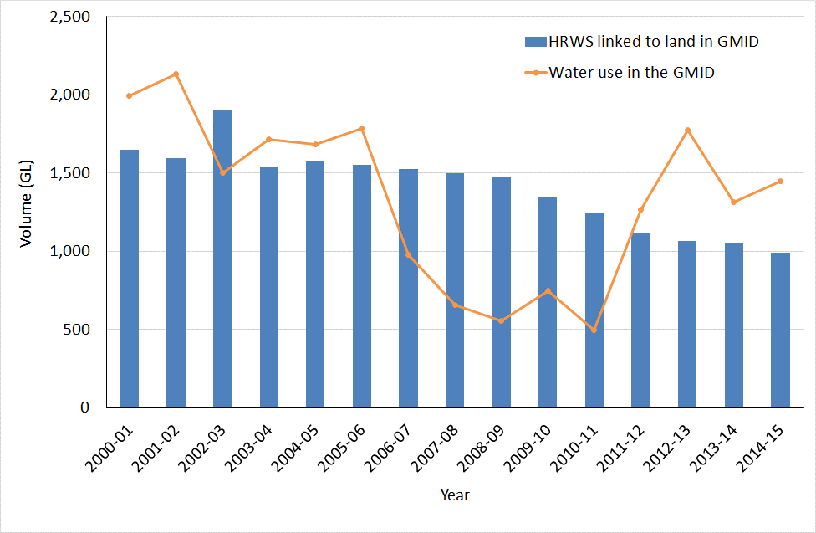**Figure1: High Reliability Water Shares linked to land and water use in the GMID**

* This impact has been exacerbated by Commonwealth buybacks during the period of 2007/08 to 2011/12.
* There is decreasing water available which puts pressure on allocation prices particularly in dry years.
* Participants in buybacks increased their reliance on purchasing on the allocation market from 0-12% (2007/08) up to 52% (2015/16).
* Basin irrigators are exposed to more risk and are likely to be less resilient during dry spells because of their increased reliance on purchasing allocation.
* The high level of Victorian High Reliability Water held by the Commonwealth is having a disproportionate impact on irrigators in dry years.



Figure 2: Transfer of ownership of high and low reliability Victorian water shares to the Commonwealth, by grouped delivery system

* There has been a 41% reduction in long term average deliveries in the Goulburn Murray Irrigation District (GMID) (from 2000 GL in 2009 to average of 1200 GL in 2016).
* The GMID is more impacted than other districts in Victoria due to the high number of dairy properties and will need to continue to find ways to reduce its asset base and cost to customers.
* In extreme drought, horticulture across Victoria, NSW and SA are now more exposed with demand likely to outstrip supply if water availability drops below 40% of entitlement.

Table 1: Potential impact on Victorian horticultural investment

|  |  |  |
| --- | --- | --- |
| Recovery scenario | Plantings at risk a | Value |
| 2,100 GL | 8,850 ha | $162m |
| 2,750 GL | 16,000 ha | $306m |
| 3,200 GL | 20,000 ha | $381m |

1. Based on shortfall of allocation required for existing mature plantings due to water recovery in a repeat of 2008‑09 allocation levels

## How will the government respond?

The study supports Victoria’s approach to invest in water efficient infrastructure, works and measures that achieve environmental outcomes that balance the needs of local communities, agriculture and the environment.

The government is helping GMID farmers adapt to reduced water availability through projects like the $2 billion Connections Project, on-farm modernisation, Plan2Farm project and programs to upskill farmers.

The Victorian Government has already make significant investment in the environmental health of the Murray Darling River, including the successful reset of the Connections Project and $222 million to protect Victoria’s rivers and waterways as part of *Water for Victoria*.

|  |
| --- |
| **The study supports Victoria’s approach to invest in water efficient infrastructure, works and measures that achieve environmental outcomes that balance the competing needs of local communities, agriculture and the environment.** |

|  |  |
| --- | --- |
| © The State of Victoria Department of Environment, Land, Water and Planning 2023  LogoThis work is licensed under a Creative Commons Attribution 4.0 International licence. You are free to re-use the work under that licence, on the condition that you credit the State of Victoria as author. The licence does not apply to any images, photographs or branding, including the Victorian Coat of Arms, the Victorian Government logo and the Department of Environment, Land, Water and Planning (DELWP) logo. To view a copy of this licence, visit http://creativecommons.org/licenses/by/4.0/  ISBN 978-1-76047-517-8  Disclaimer  This publication may be of assistance to you but the State of Victoria and its employees do not guarantee that the publication is without flaw of any kind or is wholly appropriate for your particular purposes and therefore disclaims all liability for any error, loss or other consequence which may arise from you relying on any information in this publication. | Accessibility  If you would like to receive this publication in an alternative format, please telephone the DELWP Customer Service Centre on 136186, email [customer.service@delwp.vic.gov.au](mailto:customer.service@delwp.vic.gov.au), or via the National Relay Service on 133 677 [www.relayservice.com.au](http://www.relayservice.com.au). This document is also available on the internet at [www.delwp.vic.gov.au](http://www.delwp.vic.gov.au). |