# **Gippsland Region Sustainable Water Strategy**

Information sheet for stakeholders on the Five-Yearly Assessment

The picture shows the Mitchell River, Bairnsdale near Mitchell Port road.

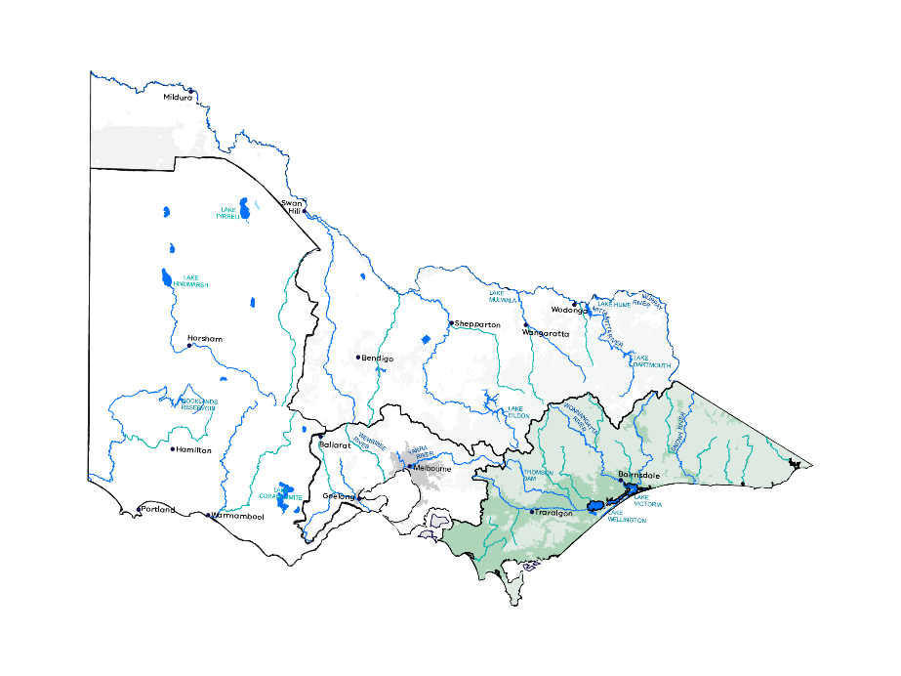

## **Reviewing Victoria’s sustainable water strategies**

Sustainable Water Strategies are long term plans for Victoria’s water resources so there are secure supplies for cities and towns, industry and the environment well into the future.

This information sheet provides background for the Five-Yearly Assessment of the Gippsland Region Sustainable Water Strategy. Outcomes of the assessment will inform any future development of a new sustainable water strategy.

## **Sustainable Water Strategies**

Sustainable water strategies are long term plans for water resources within Victoria. Sustainable water strategies were completed for the Central, Northern, Western and Gippsland regions between 2006 and 2011.

These landmark strategies identified risks to water supply and quality. They included actions to help water users, water corporations and catchment management authorities manage and respond to risks over the next 50 years.

The Water Act 1989 requires each Sustainable Water Strategy to be reviewed at least every 10 years.

The Victorian Government’s Water for Victoria plan (2016) introduced five-yearly assessments of sustainable water strategies to help deal with climate change, drought and population growth and consider changes in land use.

The government started the review of the Central Region Sustainable Water Strategy in 2016 and five-yearly assessments of the Gippsland Region and Western Region Sustainable Water Strategies in 2017.

## **Snapshot of the region**

The Gippsland region covers the area south of the Great Dividing Range in Victoria from the Latrobe River catchment and Strzelecki Ranges to the New South Wales border in the east. It has some of Victoria’s best preserved natural environments, with national parks, state forests, heritage-listed rivers and internationally recognised wetlands. Local Aboriginal communities retain a strong connection to land and water as important sources of food and medicine and places for cultural practices and values.

The larger urban centres include Warragul, Traralgon, Wonthaggi, Sale and Bairnsdale.

Average annual rainfall across Gippsland varies widely from less than 700 mm to more than 1,100 mm. Dry ‘rainshadow’ valleys contrast with wet forested mountains and alpine areas.

Water to support the region’s communities, agriculture, forestry, fisheries, energy, mining and tourism industries comes from waterways and groundwater. Agribusiness and industry are the largest users of groundwater where there is low salinity and high yield.

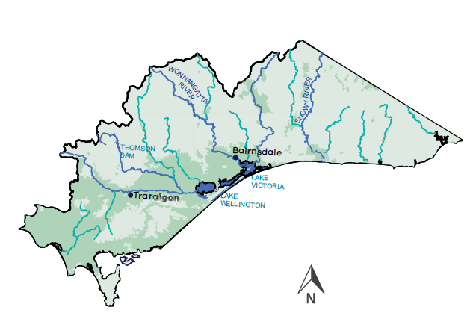

## **Five-yearly assessment Gippsland Region Sustainable Water Strategy**

The Five-Yearly Assessment of the Gippsland Region Sustainable Water Strategy started in 2017.

This assessment will

• report on the timing of the strategy’s actions

• check how well the aims and targets have been met

• outline how water management has changed since the strategy’s release

• identify lessons learned to inform a new sustainable water strategy.

It will combine information from the original strategy, Water for Victoria and targeted consultation.

The Department of Environment, Land, Water and Planning (DELWP) assessment will consider the shared benefits since the Gippsland Region Sustainable Water Strategy was released, including recreational and Aboriginal values.

The picture shows a pelican (Pelecanus onocrotalus) at the Mitchell River silt jetties, Gippsland.
Image: Copyrights State of Victoria, DELPW. Credit Yvette Baker.

The timeline shows:
Between 2004 and 2009
• Picture showing a lake in a drought event (Image: Credit Alison Pouliot) - Prolonged drought (1997 to 2009) flows up to 90% lower than long-term average
• Our Water Our Future launched
• Water Act 1989 Amendments
• Our Water Our Future: The next stage of the Government’s Water Plan
• Discussion paper
Between 2010 and 2011
• Picture showing a flood event (Image: Credit Jon Garner) - Severe flooding (2010 to 2011)
• Draft Gippsland Region Sustainable Water Strategy
• Public Consultation
• Targeted engagement with Traditional Owners
• Final Gippsland Region Sustainable Water Strategy
Between 2012 and 2016
• Victorian Waterway Management Strategy
• Water for Victoria launched
• Stocktake of Sustainable Water Strategies actions
Between 2017 and 2019
• Progress update of actions for Gippsland Region Sustainable Water Strategy
• Five-Yearly Assessment of the Gippsland Region Sustainable Water Strategy
Footnotes
Regional stakeholders provided guidance, advice and oversight of the strategy’s development, meeting 24 times between March 2009 and September 2011
1. Indicative dates.
2. The review of the Central Region Sustainable Water Strategy commenced in 2016 and a draft report will be released for public consultation in 2018.
3. Five-yearly assessments of the Western Region Sustainable Water Strategy started in 2017.
4. The review of the Northern Region Sustainable Water Strategy is due to start in 2019.

## **Highlights of the Gippsland Region Sustainable Water Strategy**

The original strategy aimed to secure supply for water users and the environment, promote sustainable water use and protect and improve the health of waterways, aquifers, wetlands and estuaries. That included:

• Establishing a drought reserve in Blue Rock Reservoir in the Latrobe system and improving recreational opportunities on Lake Narracan.

• Better environmental flows for the Thomson, Latrobe and Snowy Rivers and more flexible environmental releases.

• Protecting pristine environments through local management plans for the main river systems.

• Modernising irrigation systems for efficiency, water savings and more productive farming.

• Developing groundwater dependent ecosystem. Ministerial guidelines to help authorities consider the risk to ecosystems that rely totally or in part on groundwater

## **Working together**

The sustainable water strategy assessments will involve people from across state and local government, the water sector and communities.

The Victorian Government, through the Aboriginal Water Program, is including Traditional Owners and Aboriginal people in water management. DELWP’s Aboriginal Water Unit is working with communities on ways to share the benefits of Victoria’s water with Traditional Owners and their communities.

The assessments currently underway will explore links with key DELWP projects such as the long-term water resource assessment, water grid and markets, and integrated water management forums.

## **Stocktake of actions**

The original Gippsland Region Sustainable Water Strategy included 68 actions, 47 of which have been completed. Of the remaining actions, 11 are ongoing and 10 form part of Water for Victoria. Update on the status of all actions will be incorporated in the assessment.

### Want to know more?

[Click here for the Stocktake of the Gippsland Region Sustainable Water Strategy](https://www.water.vic.gov.au/planning-and-entitlements/water-resource-planning/sustainable-water-strategies/western-and-gippsland-region-sustainable-water-strategies)

[Click here for the Victorian Waterway Management Strategy](https://www.water.vic.gov.au/waterways-and-catchments/rivers-estuaries-and-waterways/strategies-and-planning)

[Click here for the Western Region Sustainable Water Strategy](https://www.water.vic.gov.au/__data/assets/pdf_file/0025/52882/WRSWS_accessible_linked_final.pdf)

[Click here for the Gippsland Region Sustainable Water Strategy](https://www.water.vic.gov.au/__data/assets/pdf_file/0026/52883/DSE_GRWS_accessible_linked.pdf)

[Click here for the Central Region Sustainable Water Strategy](https://www.water.vic.gov.au/planning-and-entitlements/sustainable-water-strategies)

[Click here for the Northern Region Sustainable Water Strategy](https://www.water.vic.gov.au/__data/assets/pdf_file/0018/63270/NRSWS-Full-Document.pdf)

[Click here for Water for Victoria, Chapters 6 to 9](https://www.water.vic.gov.au/water-for-victoria)

### For more information

Email [SWS.Team@delwp](mailto:SWS.Team@delwp). vic.gov.au or contact the DELWP Customer Service on 136 186

[Click here for information on the long-term water resources assessment](https://www.water.vic.gov.au/planning-and-entitlements/long-term-water-resource-assessment)

[Click her for information on realising the potential of the grid and markets](https://www.water.vic.gov.au/water-grid-and-markets/water-grid-and-markets)

[Click here for information on Integrated Water Management Forums](https://www.water.vic.gov.au/liveable-cities-and-towns/resilient-and-liveable-cities-and-towns/iwm-framework)

Front cover image: Copyright Victoria, DELWP. Credit Yvette Baker.

## **Footer**

Copyright The State of Victoria Department of Environment, Land, Water and Planning 2018

This work is licensed under a Creative Commons Attribution 4.0 International licence. You are free to re-use the work under that licence, on the condition that you credit the State of Victoria as author.

The licence does not apply to any images, photographs or branding, including the Victorian Coat of Arms, the Victorian Government logo and the Department of Environment, Land, Water and Planning (DELWP) logo.

To view a copy of this licence, [click here](https://creativecommons.org/licenses/by/4.0/).

ISBN 978-1-76047-960-2 (print)

ISBN 978-1-76047-961-9 (pdf/online)

### Disclaimer

This publication may be of assistance to you but the State of Victoria and its employees do not guarantee that the publication is without flaw of any kind or is wholly appropriate for your particular purposes and therefore disclaims all liability for any error, loss or other consequence which may arise from you relying on any information in this publication.

[Click here to the DELWP website](http://www.delwp.vic.gov.au)