**This summary documents the key findings and recommendations of the independent review of the 2013 Victorian Waterway Management Strategy. This review was a requirement of the current strategy under Action 17.11.**

# BACKGROUND

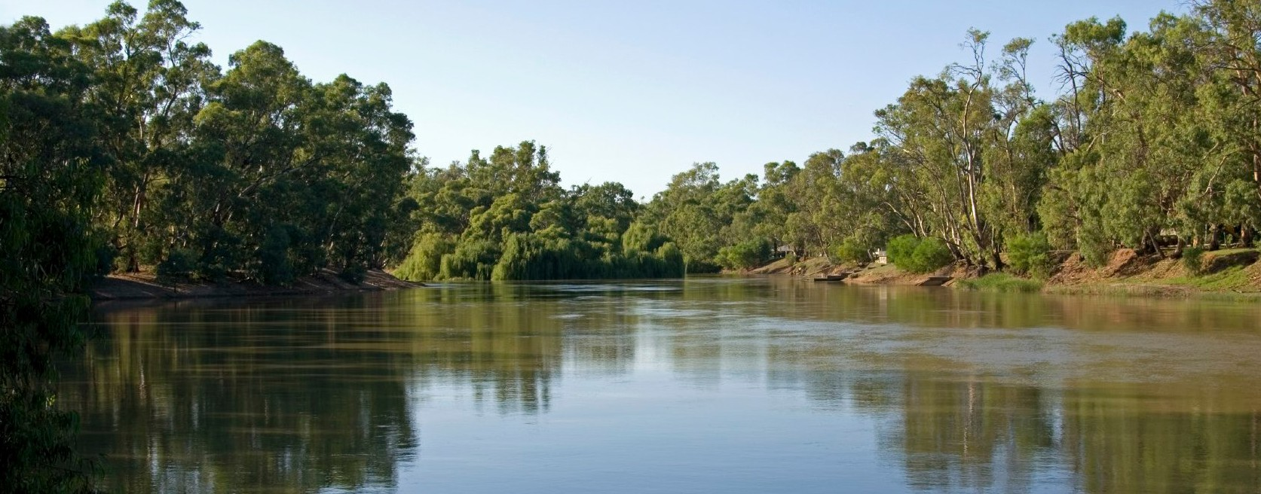

**Independent Review of the Victorian Waterway Management Strategy**

Summary

The Victorian Waterway Management Strategy (the Strategy), released in 2013, provided a detailed statewide policy framework for managing Victoria’s waterways over an eight-year period.

The Strategy aimed to maintain or improve the condition of Victoria’s waterways so they can support environmental, social, cultural and economic values that are important to communities.

The Strategy was designed to address community expectations and obligations for waterway management expressed in the Victorian *Water Act 1989* and in other relevant legislation, policies and international agreements. It provided direction

for regional decision-making, investment and management of waterways, detailed policies for a range of waterway issues, and defined the roles and responsibilities of management agencies.

The Department of Environment, Land, Water and Planning (DELWP), as the lead agency for state water policy and programs in Victoria, led the implementation of the Strategy.

Regional implementation was led by waterway managers from the nine Catchment Management Authorities (CMAs) in regional Victoria and Melbourne Water in the Port Phillip and Westernport region. Under the *Water Act 1989*, waterway managers have lead responsibility for developing and delivering regional programs for waterway management through their Regional Waterway Strategies (RWSs) in partnership with Traditional Owners, water corporations, local government, local communities and other key stakeholders.

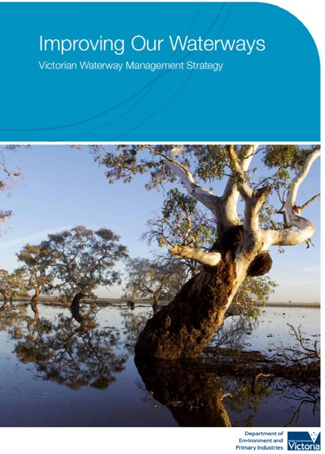

# PURPOSE OF THE REVIEW

DELWP commissioned RMCG to undertake an independent review of the Victorian Waterway Management Strategy.

The purpose of the review was to:

* provide a high-level evaluation of the Strategy, including what went well, the appropriateness of the Strategy, and any challenges with implementation;
* appraise the success, strengths and weaknesses of the Strategy as a policy framework for the management of waterways; and
* 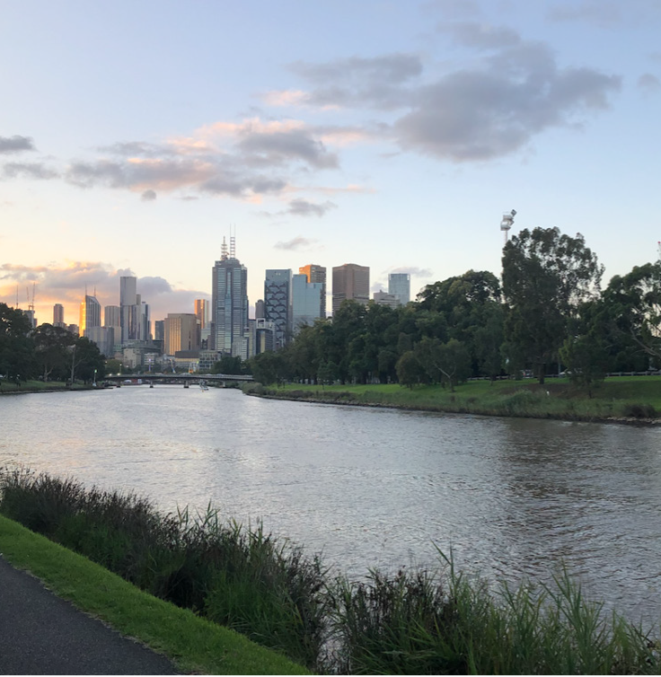identify key areas for improvement for the next strategy based on the learnings from the current Strategy.

Yarra River, Melbourne. Photographer: Trent Wallis

The independent review is a key activity in the evaluation and reporting stage of the Strategy’s eight-year adaptive management approach.

It provides an opportunity to review the implementation of policy directions and actions, reflect on key learnings, and consider advances in policy, legislation and knowledge since the

current Strategy commenced. The review is also a requirement of the Strategy (Action 17.11).

With the life of the Strategy coming to an end, this review is a foundational piece of work for the development of the next strategy. Identifying and understanding the key strengths, limitations and lessons from the current Strategy will be instrumental to improving the next strategy.

# HOW THE REVIEW WAS UNDERTAKEN

RMCG developed a framework and a set of review questions focussed on three key components of the Strategy:

* **Design** (development)
* **Delivery** (implementation)
* **Impact** (success and lessons), including progress towards the Strategy’s vision and objectives.

The framework also outlined the data collection methods used (for example - interviews, surveys or desktop review), along with the success criteria or indicators that were used to address each question.

DELWP established an expert panel to work alongside RMCG in providing independent advice and expertise to the review of the Strategy.

The panel comprised of four industry experts with significant scientific and policy expertise in waterway management: Dr Tamara Boyd, Dr

Sandra Brizga, Professor Barry Hart and Professor Ian Rutherfurd. The panellists participated in

two workshop sessions and provided comments on the first draft of the review report and its recommendations.

Across the whole data collection process, a total of 58 stakeholders were interviewed, 47 participants completed the on-line survey, there were two workshops with DELWP policy and program leads, and one workshop with waterway managers.

Stakeholders invited to participate in the interviews and/or survey were mainly those who had been involved in the development or implementation of the Strategy – either directly themselves or their organisation. Organisations included DELWP, other state government agencies, waterway managers, peak bodies, advocacy groups and other waterway and catchments industry experts.

The review was undertaken between November 2020 and May 2021, towards the end of the eight- year cycle of the Strategy. The review was undertaken slightly prior to the end of the delivery period on 30 June 2021, to provide findings before the commencement of the Strategy renewal project. DELWP will release a separate final

report in 2021−22 to provide an acquittal against the Strategy’s committed statewide targets and actions.

# KEY FINDINGS OF THE REVIEW

The Victorian Waterway Management Strategy has been a successful vehicle for advancing the management of Victoria’s rivers, wetlands and estuaries. The Strategy has provided a highly comprehensive and integrated policy framework for managing the health of Victoria’s waterways, with strong buy-in from the state’s lead delivery partners for the Strategy – the nine regional CMAs and Melbourne Water.

This review found that the Strategy has built upon the strong foundations of the 2002 Victorian River Health Strategy and has been instrumental in maintaining momentum in improving the health of Victoria’s waterways. The Strategy has also led to significant policy advancements in a number of areas and provided a solid platform for regional planning, investment and on-ground management over the last eight years.

Overall, the review has been overwhelmingly positive, with an emphasis on minor Strategy improvements rather than wholesale change. The Strategy remains the only statewide waterway strategy of its type in Australia.

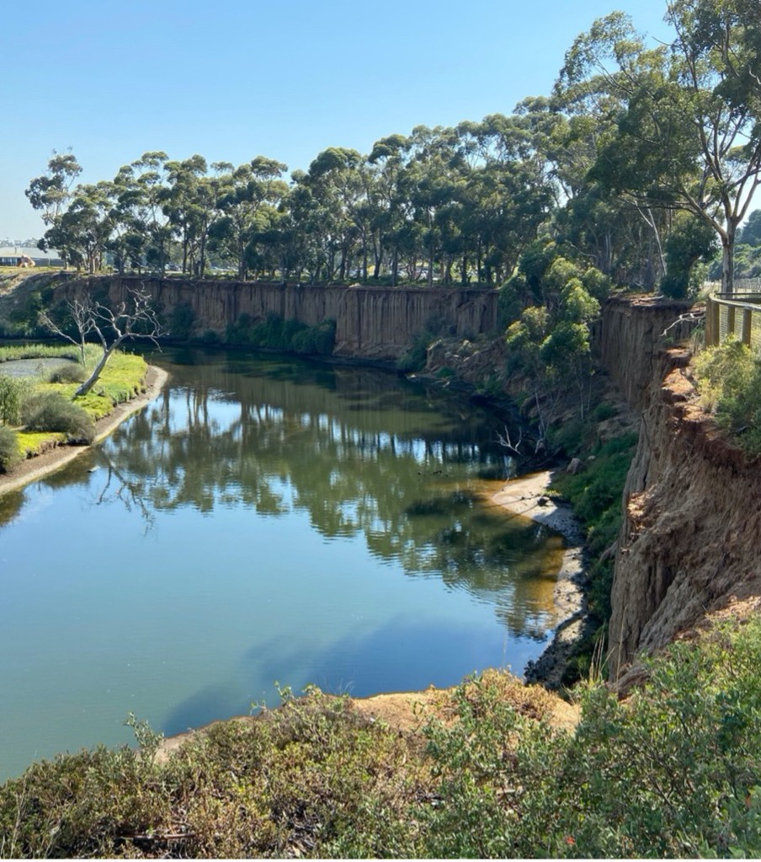

Lower Werribee River. Photographer: Trent Wallis

# Strategy Design

The Strategy’s vision for the management of Victoria’s waterways was assessed as clear and well-defined, with the suite of policy themes

in the Strategy appropriate at the time of its development in 2013.

The enduring partnership approach between DELWP, the CMAs and Melbourne Water was evident throughout all areas of the Strategy, from its development to implementation. There was clear evidence that the policy guidance

of the Strategy was effective in informing the development of the RWSs. Stakeholders also found the Strategy framework had assisted in their role over the last eight years.

The increased scope of the Strategy to include wetlands and estuaries was seen by all stakeholders involved in the review as a key success.

# Strategy Delivery

Over the last eight years, the Strategy has provided a strong foundation for regional planning, investment and on-ground management of waterways that incorporates lessons learned from the preceding decade. This has largely been due

to clearly defined roles and responsibilities for implementation, and the suite of guiding policies for delivering waterway management outcomes in Victoria.

The following elements of the Strategy were particularly well delivered across each region of Victoria: community engagement, regional priority and target setting, and management action planning. However, adaptive management could have been improved at state and regional levels to allow for new information, new policy directions and unanticipated issues to be better managed over the course of the eight years.

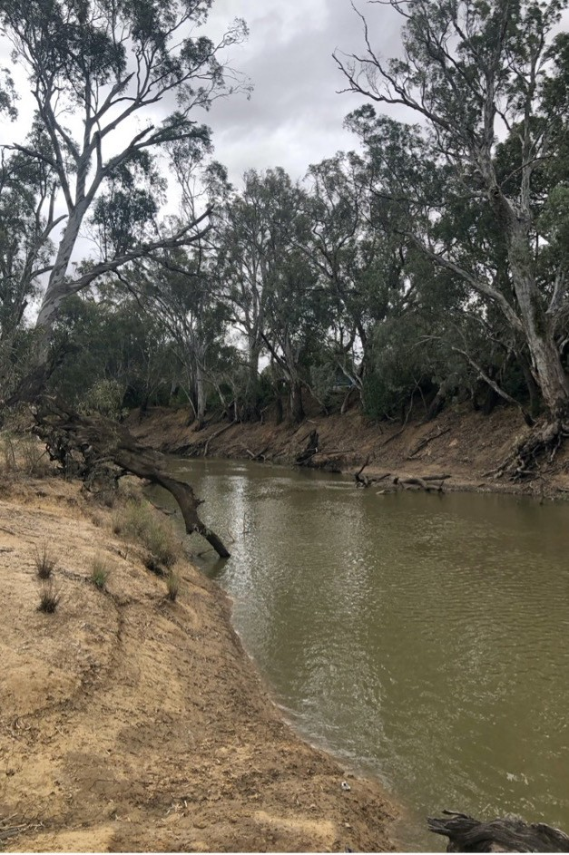

Campaspe River at Echuca. Photographer: Trent Wallis

# Strategy Impact

Over 81% of the Strategy’s 96 actions were completed at the time of the review or are ongoing actions, with another 16% in progress and on track for completion by the end of 2022. Four actions were deemed by DELWP to be no longer required as these actions will be progressed through other work within the Department.

The majority of the management outcome targets had also been exceeded at the time of the review.

The Strategy has led to significant policy advances in all management themes with some significant policy gains evident, including estuary management, environmental watering, and wetland management, as well as improvements to community participation and engagement with Traditional Owners and Aboriginal Victorians.

The Strategy also implemented several key improvements to Victoria’s waterway policy framework that were identified in the review of the former Victorian River Health Strategy. Most progress was made in strengthening community partnerships in waterway management, directing investment to regional priorities, managing

all waterways within a single framework, and recognising that working waterways need ongoing management.

Stakeholders summarised the most important enduring legacies of the Strategy as:

* Significant improvements in the management of water for the environment
* Greater policy clarity in areas like estuary and wetland management
* The integration of estuaries and wetlands into the waterway management framework
* Greater involvement of Traditional Owners in waterway management programs
* The continued commitment to engage partners and stakeholders across the state in strategic planning for management of Victoria’s waterways.

# Looking Forward

Despite the success of the Strategy in delivering a range of policy and on-ground management outcomes for waterway health, there are many areas where the Strategy could be strengthened. This includes addressing the legacy of past impacts to Victoria’s waterways, which should remain an ongoing focus for the years to come, as well as tackling new pressures, particularly from those associated with climate change and population growth.

There are number of updates required to bring the Strategy into line with recent legislative and policy advances through Water for Victoria and the amendments to the *Water Act* made through the *Water and Catchment Legislation Amendment Act*

*2019*. These have implications relating to recreation and Aboriginal water values, urban waterways and integrated water management.

The review highlighted the importance of transitioning from a model of engagement and involvement of Traditional Owners to one of First Nations leadership and partnership in waterway management. The approach for the development of the next Strategy should reflect the Victorian Government’s legislative and policy commitments to supporting the aspirations and rights of Traditional Owners and self-determination principles. The next Strategy is an opportunity

to deepen the recognition of cultural values and Traditional Owner knowledge of managing Country.

Other new legislation and policy to reflect in the next Strategy include the *Environment Protection Act 2017*, the *Marine and Coastal Act 2018* and the government’s response to the Victorian Auditor-

General Office’s audit into management of Ramsar wetlands.

Other policy areas that will require a renewed focus under a new Strategy include climate change and climate adaptation (particularly under a drying climate and sea level rise) and reference to the new *Climate Change Act 2017*, floodplain ecology

and waterway connectivity between wetlands and floodplains, management of wetlands on private land and a more effective long-term approach for managing estuary mouth openings and protecting estuarine health.

A tree over a riverbank


Barwon River, Geelong. Photographer: Trent Wallis

In relation to the waterway management framework, there should be a greater focus on integrated catchment management outcomes and better linkages between management and policy themes at both a state and regional level.

The review identified a number of key areas for greater breadth and depth in stakeholder commitment to strategy development and implementation, particularly for individual management themes, such as with local

government or other DELWP programs (such as marine and coastal, biodiversity and planning).

Existing waterway management approaches and their effectiveness in delivering long term waterway management outcomes were also explored. The review noted the need for

strengthened policies in the Strategy and other state policies (such as the Victorian Planning Provisions under the *Planning and Environment Act 1987*) aimed at protecting waterway health,

particularly for waterways experiencing population growth and urban development pressures.

The momentum built through the significant work undertaken by DELWP and waterway managers

in recent years in the development of more robust target setting and intervention monitoring

programs at a series of ‘flagship’ waterways should be continued. This should be supported through

a renewed focus on appropriate capacity building and knowledge exchange opportunities aimed

A river with a hill in the background
at the current and next generation of water and catchment management professionals.

Lower Glenelg River. Photographer: Trent Wallis

# RECOMMENDATIONS

In light of the findings of this review and the input from the expert panel, RMCG proposed the following recommendations for improving statewide waterway management and for consideration in the development of the next Victorian Waterway Management Strategy:

1. Maintain the key design elements of the existing Strategy
2. Improve the structure of the Strategy and clarity of its purpose
3. Update the Strategy to reflect new and emerging government waterway policy, including strengthening the focus on climate change and adaptation
4. Modernise engagement processes to improve the breadth and depth of stakeholder commitment to implementation, and to ensure the level of involvement of Traditional Owners and Aboriginal Victorians in waterway management is based on a model of partnership and self-determination
5. Develop greater integration to deliver catchment and waterway outcomes
6. Consolidate processes to demonstrate and communicate outcomes, and measures of success
7. Extend the adaptive management framework to respond to a broader range of waterway management drivers and management scales
8. Explore fit-for-purpose management tools to deliver more effective waterway outcomes
9. Build capacity for the current and next generation of waterway and catchment management professionals.

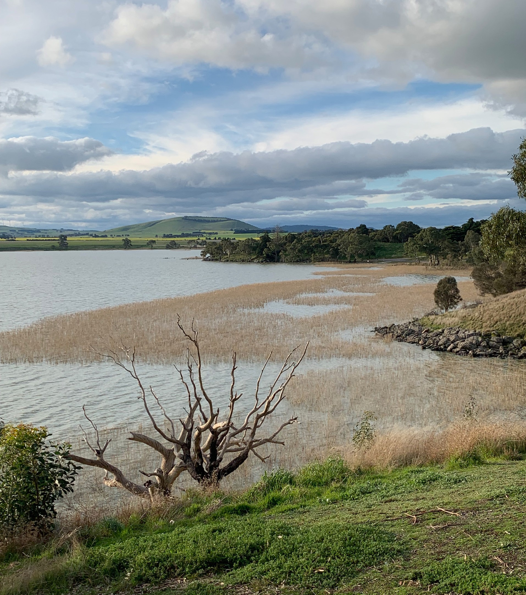

Lake Burrumbeet. Photographer: Trent Wallis

**RMCG thanks all those who contributed to the Victorian Waterway Management Strategy Independent Review via participation in workshops, interviews and/or the online survey. This includes many staff from across DELWP, CMAs, Melbourne Water, other Victorian government agencies, peak bodies and other organisations involved in the design or delivery of the Strategy.**

**In particular, RMCG would like to acknowledge the valuable and signification contributions of the expert panel for the independent review − Dr Tamara Boyd, Dr Sandra Brizga, Professor Barry Hart and Professor Ian Rutherfurd.**