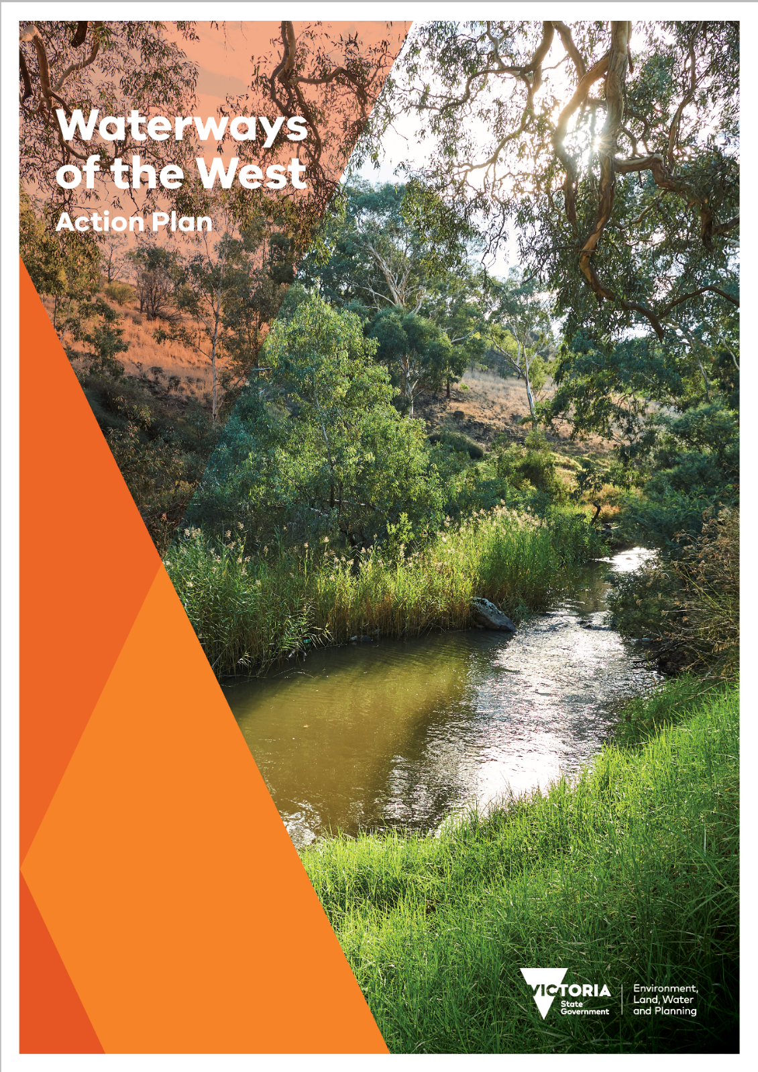

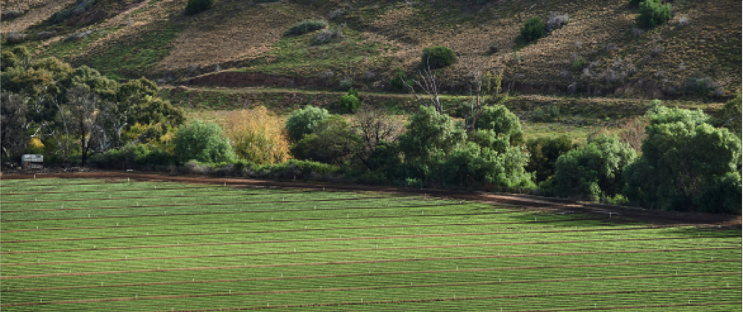

Acknowledgement of Country
The Victorian Government proudly acknowledges the Bunurong, Wadawurrung and Wurundjeri Woi wurrung Traditional Owners and pays respect to their Elders past and present and emerging. We acknowledge their ongoing connection to land, water and natural and built landscapes, and acknowledge the ongoing contribution this makes to the Waterways of the West region.
We support the need for genuine and lasting partnerships with Traditional Owners to support self-determination and the protection of Country. The Victorian Government is committed to working towards equity of outcomes and ensuring an equal voice for Traditional Owners.
We recognise the Waterways of the West as living and integrated natural entities: the rivers, creeks and wetlands and the landscapes through which they flow that form the Maribyrnong (Mirrangbamurn) River, Werribee River (Wirribi Yaluk) and Moonee Ponds (Moonee Moonee) Creek catchments. Their waters flow together from the uplands to the sea, supporting and bringing life to the region.
© The State of Victoria Department of Environment, Land, Water and Planning 2021
This work is licensed under a Creative Commons Attribution 4.0 International licence. You are free to re-use the work under that licence, on the condition that you credit the State of Victoria as author. The licence does not apply to any images, photographs or branding, including the Victorian Coat of Arms, the Victorian Government logo and the Department of Environment, Land, Water and Planning (DELWP) logo. To view a copy of this licence, visit http://creativecommons.org/licenses/by/4.0/
ISBN 978-1-76105-483-9
Disclaimer
This publication may be of assistance to you but the State of Victoria and its employees do not guarantee that the publication is without flaw of any kind or is wholly appropriate for your particular purposes and therefore disclaims all liability for any error, loss or other consequence which may arise from you relying on any information in this publication.
Accessibility
If you would like to receive this publication in an alternative format, please telephone the DELWP Customer Service Centre on 136 186, email customer.service@delwp.vic.gov.au, or via the National Relay Service on 133 677 www.relayservice.com.au. This document is also available on the internet at www.delwp.vic.gov.au
Author: Catchments, Waterways, Cities and Towns Division, Department of Environment, Land, Water and Planning

MINISTERS’ FOREWORD
The rivers and creeks of Melbourne’s west are distinct. Waterways like the Werribee River (Wirribi Yaluk) and Kororoit Creek meander through rocky volcanic plains that are unique to landscapes west of Melbourne.
As a result, they naturally flow clear and relatively free of sediment. And due to a rain shadow created by the Otway Ranges, they also flow through lands that are much drier than areas found anywhere else in Melbourne.
This has been known by thousands of generations of Bunurong, Wadawurrung and Wurundjeri Woi wurrung peoples – the custodians of the Waterways of the West. The ancient waterways that shaped the landscape, carving deep gorges and nourishing broad floodplains, feature in their oral history as living entities.
It is now time to restore the status of the region’s waterways as living and integrated natural entities – the rivers, creeks and wetlands and the landscapes through which they flow – and the Bunurong, Wadawurrung and Wurundjeri Woi wurrung peoples as the Voice of these living entities.
Colonisation has had an ongoing and significant impact on the health of the region’s waterways and their Traditional Custodians. Despite this, the Bunurong, Wadawurrung and Wurundjeri Woi wurrung Traditional Owners’ association and relationship with this Country remains strong through unique tangible and intangible connections that are cultural, spiritual and economic.
The diverse community of the west has also come together to advocate for their local creeks, wetlands and parks. Community champions have long shown they want to see their waterways healthier, maintaining a range of social and cultural values, and supporting a sustainable economy.
If we are to achieve the community’s vision for the Waterways of the West, now is the time to act. The population in the region is growing at a rate higher than any other part of Melbourne. The west will become home to a million more people over the next 30 years. Alongside a changing climate, the pressures of urban development create a compelling need for action.
And that is why we have released a new plan for the waterways of Melbourne’s west.
The Waterways of the West Action Plan builds on our strong policy base for protecting waterways in Victoria and will be reinforced by water resource management directions of the Central and Gippsland Region Sustainable Water Strategy. This Action Plan includes nine directions supported by 20 shorter-term actions which will be implemented in the next year, and a further 20 actions that will be delivered within five years.
This Action Plan was developed via extensive consultation with Traditional Owners, community and government agencies and takes steps to protect these waterways and improve the liveability of the region. Embedding Traditional Owners’ values and knowledge in the management of waterways on Country will be at the forefront of this Plan. With our partners in the region, it will help deliver greener, healthier towns and cities.
With this Plan, we emphasise the vital role waterways play in supporting the wellbeing of Melbourne’s west, and we take steps to protect our vital waterways for future generations.
The Hon Lisa Neville MP  Minister for Water | The Hon Richard Wynne MP  Minister for Planning

CONTENTS
MINISTERS’ FOREWORD 3
AN ACTION PLAN FOR THE WATERWAYS OF THE WEST 6
Directions and actions 7
WATERWAYS OF THE WEST COMMUNITY VISION 11
CONTEXT AND IMPLEMENTATION 13
The directions explained 15
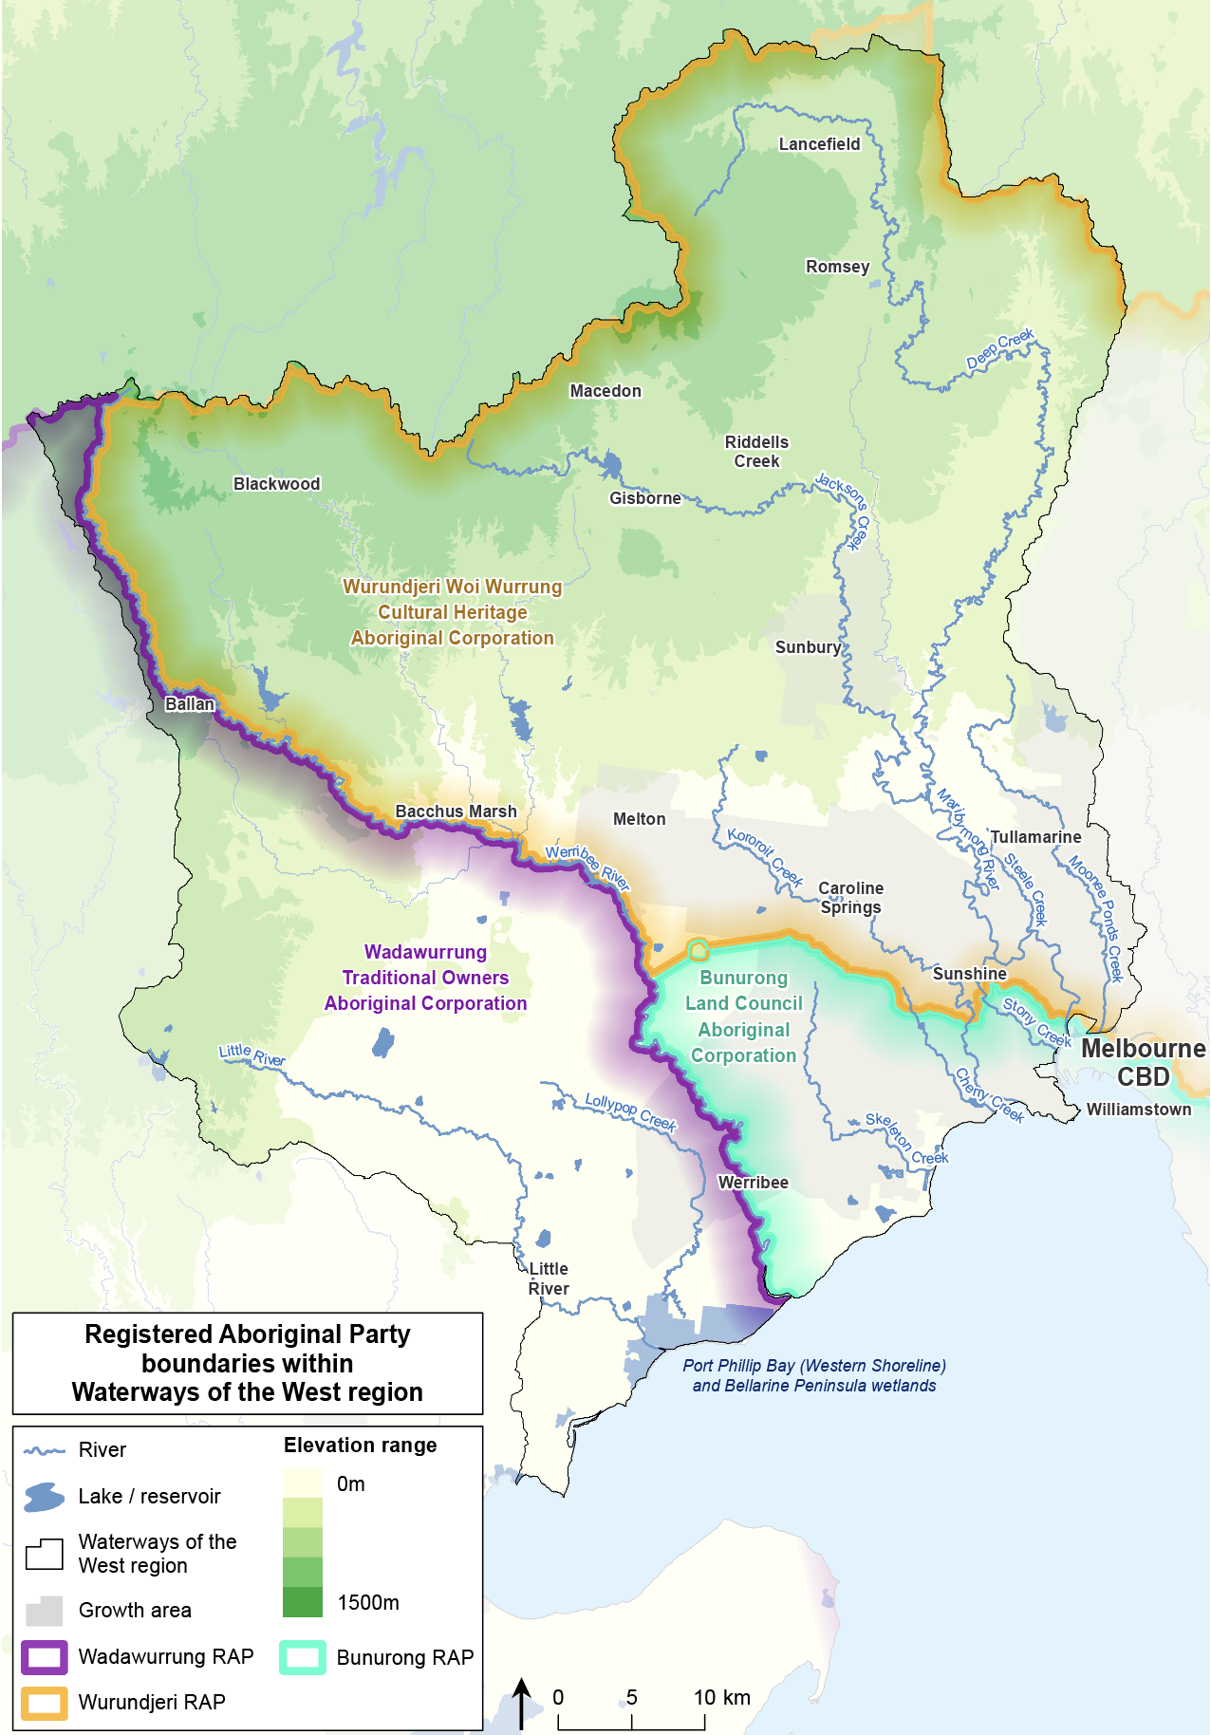
Registered Aboriginal Party boundaries within Waterways of the West region map

AN ACTION PLAN FOR THE WATERWAYS OF THE WEST
The Waterways of the West Action Plan is a transformational, five-year plan that will bring to life the 50-year vision developed by the community, with guidance from the Bunurong, Wadawurrung and Wurundjeri Woi wurrung Traditional Owners. It includes immediate actions to improve the health, amenity and sustainability of the waterways of Melbourne’s west.
The Waterways of the West region extends from Ballan – north-west of Melbourne – to Lancefield in the north, to Footscray in inner Melbourne, and to Little River settlement to the west. The main waterways are the Maribyrnong (Mirrangbamurn) River and the Werribee River (Wirribi Yaluk). Other rivers and creeks in the region include Moonee Ponds (Moonee Moonee) Creek, the Little River (Worrin-yaloke) and Laverton, Skeleton and Kororoit creeks. The region’s waterways also include internationally significant coastal wetlands and estuaries.
The waterways’ lands are as diverse as the region’s vibrant communities: the waterways flow through foothill forests, spectacular rocky gorges, open volcanic plains grasslands and woodlands, and saltmarsh. The landscape is also dotted with thousands of intermittent wetlands.
The waterways are highly valued by the community, and they support the region’s economy with water for irrigation, urban uses and tourism. With endless opportunities to picnic, hike, walk and cycle along the many connected waterway corridors, people can restore their spirits, explore nature, escape the city and connect with family and friends.
This Action Plan will build on the community’s connections to their waterways, establish the institutional arrangements needed to ensure an enduring legacy of waterway protection, and instil a new way of working with Traditional Owners and the community to walk together to heal Waterways of the West Country.
The Action Plan has three parts:
- nine directions and 40 actions that guide the Victorian Government’s commitment to implementation over the next five years
- the 50-year Waterways of the West Community Vision
- the background for the actions, setting out the key issues for the waterways and the implementation context for the Action Plan.
The Action Plan includes shorter-term actions to deliver results within the first year of implementation and longer-term actions to deliver within five years. Longer-term actions are to consider necessary changes to institutional arrangements, strengthen planning provisions for waterways and strengthen the role of Traditional Owners in planning and management. Completion of longer-term actions will be dependent on the availability of funding. Decisions about the implementation and timing of these actions will be made in line with government policy and budget processes.

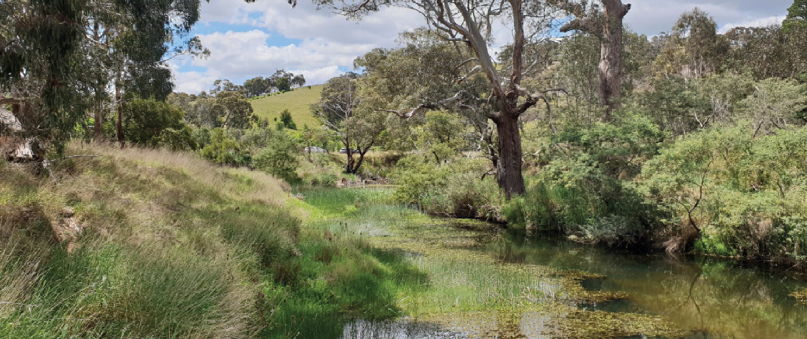

Directions and actions

Direction 1:
Recognise the Waterways of the West as living and integrated natural entities and the Traditional Owners as the ‘voice of these living entities’

Shorter-term actions
1.1 The Port Phillip and Western Port Regional Catchment Strategy (RCS) will recognise the Waterways of the West and their lands as living and integrated natural entities and the Traditional Owners as the ‘voice of these living entities’.
1.2 Bunurong, Wadawurrung and Wurundjeri Woi wurrung Traditional Owners to be funded to meaningfully participate in the planning and implementation of the RCS, to enable their reinstated role as a unique voice for the waterways.
1.3 Bunurong, Wadawurrung and Wurundjeri Woi wurrung Traditional Owners will be supported by the government to express what ‘the voice of the living entities’ is to them.

Longer-term actions
1.4 Engage with Traditional Owners across Victoria on possible legislation to enable all waterways and the landscapes through which they flow to be recognised as living and integrated natural entities and the Traditional Owners to self- determine the application of these concepts on Country.
1.5 Investigate legislation to embed the recognition of the waterways and their lands as living and integrated natural entities and the Traditional Owners as the ‘voice of these living entities’ on Country.
1.6 If legislation is introduced, it will contain a preamble that celebrates and supports the Country and the preservation and promotion of Aboriginal cultures and languages and recognises past and ongoing Bunurong, Wadawurrung and Wurundjeri Woi wurrung Traditional Owners’ stewardship of and connection to Country.

Direction 2:
Embed Traditional Owners’ values in planning and decision-making for waterways

Shorter-term actions
2.1 The Port Phillip and Westernport Catchment Management Authority (CMA) will invite the Bunurong, Wadawurrung and Wurundjeri Woi wurrung Traditional Owners to partner in the planning and implementation of the next RCS (due in 2021) to:
- recognise Traditional Owners’ right to self-determination
- embed in the RCS the cultural connections of Traditional Owners to Country, as outlined in Country plans or through other means
2.2 Melbourne Water and the Port Phillip and Westernport CMA will partner directly with the Traditional Owners to implement ‘the voice of the living entities’ on Country.
2.3 The Wurundjeri Woi wurrung will undertake the Jacksons Creek Regional Parklands cultural values study and will be supported in achieving aspirations identified by the study.

Longer-term actions
2.4 Partner with the Wurundjeri Woi wurrung to deliver a planning pilot project — the Jacksons Creek Planning Partnership — to embed cultural mapping values that inform future protections and form part of the broader Jacksons Creek Regional Parklands Master Plan.
2.5 Investigate potential amendments to the Planning and Environment Act 1987 and the planning policy framework to embed Traditional Owners and their values. Develop tools to support agencies, Traditional Owner groups and planning practitioners to implement any amendments to the Act and the planning policy framework.
2.6 Melbourne Water will include in its RCS reporting an assessment by the Traditional Owners of RCS activities that give effect to Traditional Owners’ aspirations and Country plans.
2.7 Melbourne Water will invite the Bunurong, Wadawurrung and Wurundjeri Woi wurrung Traditional Owners to partner in the planning and the implementation of the next Healthy Waterways Strategy (due in 2028), with a focus on their reinstated role as the ‘voice of the living entities’.

Direction 3:
Strengthen planning policy and controls for waterways

Shorter-term actions
3.1 Protect waterways statewide through a strengthened planning policy framework, processes and supporting guidance
3.2 Protect and elevate the significance of the Maribyrnong (Mirrangbamurn) River, Moonee Ponds (Moonee Moonee) Creek and the Werribee River (Wirribi Yaluk) urban corridors through stronger landscape and environment planning controls and new regional policies.

Longer-term action
3.3 Protect the Maribyrnong (Mirrangbamurn) River, Moonee Ponds (Moonee Moonee) Creek and the Werribee River (Wirribi Yaluk) from inappropriate development with stronger built-form planning controls.
3.4 Review planning controls for the regional reaches of the Waterways of the West and prepare stronger planning controls for other significant waterways including Skeleton Creek, Stony Creek and Jacksons Creek.
3.5 Review interim planning controls to ensure the ongoing protection of waterways.

Direction 4:
Improve waterway amenity to meet community expectations

Shorter-term actions
4.1 The Port Phillip and Western Port RCS will include the amenity values of the waterways and their lands across the region.
4.2 Support Melbourne Water and other public land managers to deliver the Lower Werribee Waterway Amenity Action Plan.
4.3 Melbourne Water will advocate for amenity outcomes along waterways and their lands through:
- implementing the Healthy Waterways Strategy 2018 and expert advice
- renewing Waterway Corridors: Guidelines for areas within the Port Phillip and Westernport Region
- conducting education and participation programs
- undertaking waterway amenity value mapping for the RCS.

Longer-term actions
4.4 Update the Melbourne Water Statement of Obligations to incorporate a clear role to plan for the amenity of waterways and their lands that will include:
- advocating for amenity outcomes through planning processes
- testing customers’ willingness to pay for higher amenity in priority areas, to inform future pricing and investment
- better incorporating amenity values in the renewed Healthy Waterways Strategy.
4.5 The Victorian Management Strategy will provide stronger guidance about planning for urban waterway values and threats including waterway amenity: naturalness, escape and safety.

Direction 5:
Better protection of the region’s wetland values

Shorter-term actions
5.1 Update public wetland information to enable wider access to more accurate and comprehensive wetland mapping for the Port Phillip and Western Port region.
5.2 The Port Phillip and Western Port RCS will include mapping of the region’s wetlands.

Longer-term actions
5.3 Deliver a ‘pathways to resilience’ plan through a Regional and Strategic Partnership (as the Marine and Coastal Act 2018 enables) for the western shoreline of Port Phillip Bay. This project will identify effective adaptation strategies and actions to mitigate the impacts of climate change and rising sea levels on the natural systems of the north-western coast and estuaries.
5.4 Develop a master plan that prioritises activities to protect the coastal wetlands and enable their management as a living and integrated natural entity and consider how best to protect them in a formalised park system.

Direction 6:
Identify opportunities to meet environmental and cultural water needs

Shorter-term action
6.1 Provide funding to support Traditional Owners’ cultural water assessments in accordance with Traditional Owners’ priorities.

Longer-term action
6.2 In the Central and Gippsland Region Sustainable Water Strategy, address environmental water deficits and water for culture by investigating:
- options to meet flow- related objectives through investment in all sources of water including recycled water and stormwater and irrigation efficiency and modernisation, to reduce extraction from waterways
- complementary works to improve waterway health.

Direction 7:
Protect the Waterways of the West from pollution

Shorter-term actions
7.1 A collaborative Pollution Prevention Taskforce led by an independent chairperson will be established to:
- identify and understand pollution hotspots and priority industries
- develop a cross-agency program of works to target these hotspots and industries
- investigate funding and resourcing requirements to address waterway pollution.

Longer-term actions
7.2 Undertake actions developed by the Pollution Prevention Taskforce to reduce pollution and change business practices to improve water quality across the Waterways of the West.
7.3 Melbourne Water will lead the implementation of the place-based stormwater performance objectives identified in the Healthy Waterways Strategy 2018 to protect the ecological health of sensitive, downstream waterways and bays, enhance amenity and recreational values and reduce flooding.

Direction 8:
Increase community connection, education and participation

Shorter-term actions
8.1 Port Phillip and Westernport CMA/Melbourne Water will develop a community engagement program in partnership with the Bunurong, Wadawurrung and Wurundjeri Woi wurrung Traditional Owners to foster connection with and cultural awareness and understanding of Traditional Owners, their culture and values, and they will fund cultural services and community engagement activities on Country.
8.2 Melbourne Water will develop a community participation and volunteer strategy to boost community involvement in waterway planning and management, that includes a program specifically for the Waterways of the West's culturally and linguistically diverse (CALD) communities.
8.3 Deliver a Waterways of the West CALD engagement toolkit to assist planning to increase the connection of the region’s CALD communities with the Waterways of the West.
8.4 The RCS will acknowledge the 50-year Waterways of the West Community Vision.

Longer-term action
8.5 Melbourne Water will include the Waterways of the West Community Vision in its co-designed catchment programs for the Werribee (Wirribi Yaluk) and the Maribyrnong (Mirrangbamurn) River catchments at the mid- term review of the Healthy Waterways Strategy.

Direction 9:
Ensure accountability and transparency for Action Plan delivery

Shorter-term action
9.1 Publish an annual implementation report for the Action Plan on the Plan’s website.

Longer-term actions
9.2 Publish a final review of the implementation of the Action Plan.
9.3 Melbourne Water will continue to report on the waterway values and conditions andon the delivery of this Plan’s actions within its responsibility, including implementation of the ‘voice of the living entities’ concept, advocacy for amenity outcomes along waterways, and community engagement and participation programs, in the Healthy Strategy 2018 performance objectives.
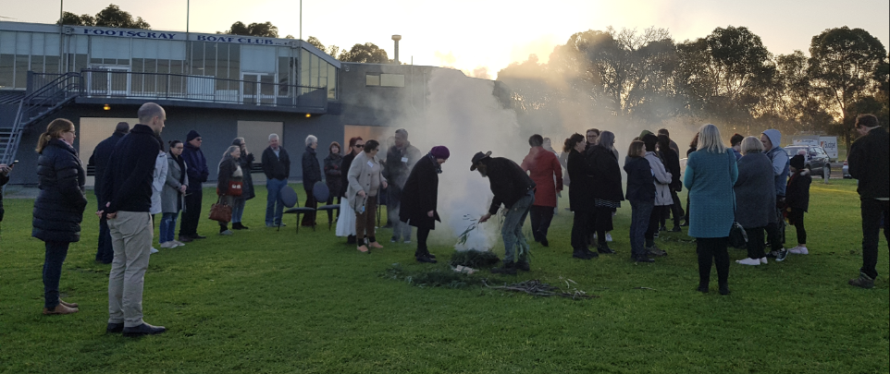

WATERWAYS OF THE WEST COMMUNITY VISION
The Waterways of the West Community Vision is the first, overarching, long-term vision for this complex, connected, living system of waterways and parklands. This vision will guide policymakers, waterway and land managers and the community as we walk together with the Traditional Owners of the Waterways of the West and their lands over the next 50 years.
Our vision is for healthy, diverse and sustainable waterways throughout our west. As a diverse community, we care for its interconnected rivers, creeks and landscapes.
Respectfully acknowledging and embracing the cultural values of the Bunurong, Wadawurrung and Wurundjeri Woi wurrung peoples, we walk together to care for Country. The Bunurong, Wadawurrung and Wurundjeri Woi wurrung people cared for Country in many different ways and for all living things. Working collaboratively, the people of the west protect and celebrate these unique and interconnected waterways.
The Maribyrnong (Mirrangbamurn) and Werribee (Wirribi) rivers and their surrounding creeks and tributaries run cleanly. They’re filled with abundant life. Their banks teem with native plants and animals.
Crystal-clear in the forested hills, the water flows through volcanic, grassy plains under big skies. It seeps into and sustains wetlands, travels down through farms, between homes and into internationally recognised salt marshes, ending its journey in Port Phillip Bay.
Along these waters, we see birds – like Reed warblers and Rainbow bee-eaters – nesting along the creek banks, and migratory birds from as far away as Alaska and Siberia stop and rest in the salt marshes. Tawny frogmouth chicks are spotted by passers- by, and the air is filled with the chorus of Growling grass frogs and Pobblebonks.
We respect and value what the waters provide us: the food they help us grow and the places that nurture our wellbeing, whose beauty we enjoy. It’s where we meet and gather, reflect, run, walk and play. WoW – it’s the emotion evoked by the Waterways of the West.
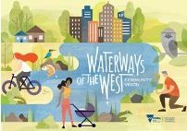

The vision for cities, towns and suburbs
From Sunshine to Spotswood, Melton to Werribee South, Macedon to Footscray: communities connect and flow through our water corridors. In Footscray Park, Point Cook Coastal Park, Birmingham Reserve and the many other parks along our waterways, we see families from different cultures gathering and celebrating. We see communities interacting in harmony with the natural environment, joggers, cyclists commuting to and from work. We hear people laughing together with the sounds of children splashing in the water, frogs croaking, birds singing and the hum of urban life. Along waterways in our cities and towns, like Moonee Ponds (Moonee Moonee) Creek, cyclists pass protected natural areas with native vegetation and wildlife. Urban development is designed to protect and improve the health of the creek. Communities are proud of their contribution to restoring and growing landscapes that enhance the wellbeing of people and the environment.
We wander through hidden natural refuges, pockets of greenery, places to escape from the city; and along the way, we are reminded of the layers of history and different lessons of the waterways.

The vision for rural and agricultural lands
In the agricultural areas, sustainable farming is part of a thriving ecosystem of healthy waterways. Where Bunurong, Wadawurrung and Wurundjeri Woi wurrung peoples’ knowledge and cultural practices have become a part of everyday sustainable farming. Where water is carefully managed, used and re-used rather than being taken out of the rivers and waterways.
The waterways in these rural areas are full and flowing, feeding the vital connections between the urban ecosystems and natural and forested environments. Flourishing green corridors co-exist and connect communities with the neighbouring prosperous and sustainable agricultural land.
It’s an immense region outside of the urban growth boundary: from Macedon to Ballan, all the way to the Werribee River (Wirribi Yaluk) as it flows through the Bacchus Marsh and Werribee irrigation districts, and Deep Creek in the upper Maribyrnong (Mirrangbamurn) River catchment. Its waterways continue to vary widely in colour and shape, flowing through grasslands and set against the rugged beauty of places like Werribee Gorge.
Collaboration is central to how we get things done. With the Traditional Owners – the Bunurong, Wadawurrung and Wurundjeri Woi wurrung – farmers, communities and all levels of government come together to protect and enhance our essential food bowl, so we all benefit from healthy, high-quality food. It’s an area that is both economically and ecologically sustainable.

The vision for natural places and forested areas
From the wetlands to Macedon Ranges, the protected Waterways of the West have natural headwaters and are pristine and healthy, supporting abundant, unique flora and fauna from source to sea.
In the vast expanses of the Victorian Volcanic Plains grassland, people appreciate the wide horizons and gently undulating vistas. This environmentally significant landscape supports a wide variety of bird and insect life, that is essential to maintaining a healthy ecology.
Cheetham Wetlands, other coastal wetlands and the thousands of inland wetlands are home to many indigenous and migratory birds — feeding and breeding — as well as being spaces for people to walk and commune with nature.
In the forested areas (such as Wombat Forest and the Macedon Ranges), visitors gather to enjoy the varied experiences offered by accessible natural areas with maintained facilities. They feel connected to nature through immersion in the smells, sights and sounds of rejuvenated bushland: a chorus of birdsong and buzzing insects, native wildlife foraging in eucalyptus forests and healthy rivers sustaining life. It signals ecosystems in balance, engendered through respect for Mother Earth.
Our communities respect the areas reserved as protected environments to preserve clean water catchments and native habitats for our wildlife. We have learnt from the experiences, cultural practices and the understanding of cultural values of the Traditional Owners of our land: the Bunurong, Wadawurrung and Wurundjeri Woi wurrung peoples.
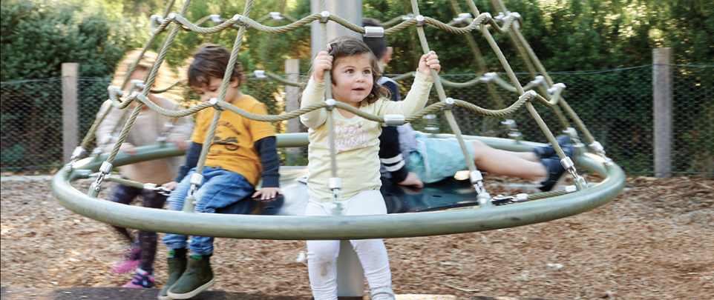

CONTEXT AND IMPLEMENTATION

Why an Action Plan for the Waterways of the West?
The Waterways of the West region is rapidly transforming. We must act now to protect the enduring and unique beauty, character and history of the waterways if we are to move towards the long-term aspirations in the Waterways of the West Community Vision.
The Bunurong, Wadawurrung and Wurundjeri Woi wurrung Traditional Owners have cared for this Country for thousands of generations, and the communities of the region have shown that they are passionate about their waterways. The open space and amenity of the waterways, their lands and the coastal area underpin the region’s vibrancy and the liveability of local neighbourhoods. Now, more than ever, we need to meet the changing and growing needs of the people of the Waterways of the West region by protecting natural spaces for their environmental, health and wellbeing values and by planning for new social, recreational and amenity opportunities.
The warming and drying climate is already affecting the Waterways of the West, putting greater pressure on ecosystems and reducing water for irrigated agriculture and towns while increasing demand for water to keep parks and gardens green.
By 2040, the region’s population is forecast to double, to over 1.9 million people. This means there will be more stormwater, litter and pollution as well as other pressures on waterways if we don’t make changes now. Pollution from past and current industrial activity remains a threat to water quality. The Waterways of the West are facing further decline, and now is the time for action.
Victoria already has comprehensive policies to protect and manage waterways, but step-change improvements are needed to meet the challenges the Waterways of the West face, embed Traditional Owner’s voices – that in the past have not been heard – and support the liveability and amenity needs of our communities.
Through their associations and relationship with Country, the Traditional Owners continue to maintain unique tangible and intangible connections – cultural, spiritual and economic – to the Waterways of the West and their lands.
Waterways of the West Ministerial Advisory Committee Recommendations Report (2021), p 17

How was the Action Plan developed?
The Waterways of the West Action Plan resulted from strong community advocacy following a similar initiative for the Yarra (Birrarung) River. Plan (2017) and the Yarra River A Plan (2017) recognised the need to reconsider the planning and policy context for other urban waterways including the Werribee (Wirribi Yaluk) and Maribyrnong (Mirrangbamurn) rivers. The government has sought to understand what matters most to the community of Melbourne’s west and to focus on actions that will bring to life the Waterways of the West Community Vision.
In August 2018, the government established the Waterways of the West Ministerial Advisory Committee (MAC) to make recommendations about how best to protect the health and amenity of these waterways and their parklands and to promote their cultural significance, values and recreational benefits. This included advice about policy and planning mechanisms and a review of institutional, legislative and regulatory arrangements to enhance the waterways and bring to life a community vision.
The members of the MAC were: Chris Chesterfield (Chair); Wurundjeri Traditional Owners Doreen Garvey Wandin (until April 2019), Uncle Dave Wandin (after April 2019), Aunty Diane Kerr, and Aunty Alice Kolasa; Wadawurrung Traditional Owner Melinda Kennedy; Shelley Penn; and Lydia Wilson.
The MAC conducted an extensive consultative process with Traditional Owners, community champions, primary and secondary schools in the west, and government agencies, and the process included two periods of public consultation. The MAC oversaw the development of the Waterways of the West Community Vision by an assembly of 45 people, and it presented its final report to the government in March 2020.
The Action Plan builds on previous public consultations and collaborative efforts by government agencies, particularly Melbourne Water’s Waterways Strategy 2018 and its 2018 Co-Designed Catchment Program for the Werribee Catchment Region and Co-Designed Catchment Program for the Maribyrnong Catchment Region (including Moonee Ponds Creek).
The Action Plan is part of the government’s Iconic Urban Waterways initiative, which has also developed the Rivers of the Barwon (Barre Warre Yalluk) Action Plan in parallel to this plan.
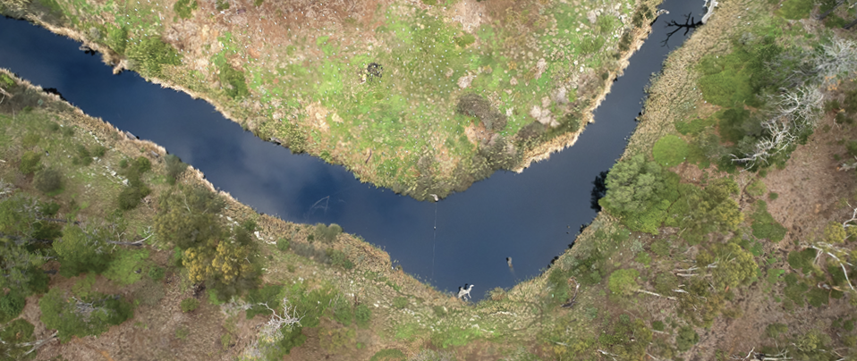

The directions explained
The Action Plan’s nine directions commit to achieving broad reforms to secure the future of the Waterways of the West. The critical drivers for the directions and integrated actions are explained below.

Direction 1:
Recognise the Waterways of the West as living and integrated natural entities and the Traditional Owners as the ‘voice of these living entities’
The Action Plan recognises the Waterways of the West as ‘living and integrated natural entities’ and the Traditional Owners as the ‘voice of these living entities’.
We have a collective and individual responsibility to keep these waterways alive. The Bunurong, Wadawurrung and Wurundjeri Woi wurrung Traditional Owners have shared their knowledge of the living, interconnected essence of these natural places in the development of this plan, and they are uniquely placed to speak for the waterways and their lands as connected, living entities. The Waterways of the West Community Vision embraces this interconnectedness and puts it at the centre of community aspirations for the management of the waterways. It will take time, however, for the Traditional Owners to give these concepts practical meaning through their self-determined involvement. It will also take time to grow a shared, new understanding based on synthesising contemporary scientific and traditional ecological knowledge. Our framework to plan for and manage these waterways must adapt to this new understanding.
The new RCS being prepared by the Port Phillip and Westernport CMA and the merging of the CMA and Melbourne Water on 1 January 2022 are shorter-term opportunities to start redefining ways of working that give life to the ‘living and integrated natural entities’ and ‘voice of the living entities’ concepts and putting Traditional Owners’ cultural stories at the centre of planning for waterways. The government intends to continue to partner with the Traditional Owners of this region and Victoria to understand how the management of waterways and their lands as living and integrated natural entities can be more broadly applied across land and water management portfolios and agencies.
In the longer-term, options will be explored to recognise the unique aspects of the Traditional Owners’ Country and culture in strengthening their roles as the ‘voice of the living entities’ in legislation. Approaches to legislative change would look to embed the legacy of the Waterways of the West collaboration, including incorporating Bunurong, Wadawurrung and Wurundjeri Woi wurrung language in the title and preamble of any legislation introduced in response to this Action Plan.
Our message is that Wurundjeri Woi wurrung people have a deep understanding and knowledge of Country as well as rights to Country, and that this should be valued and respected. There is a deep cultural obligation and birthright to look after Country and keep it healthy.
Waterways of the West Ministerial Advisory Committee Recommendations Report (2021), p 22

We are still here, and we continue to maintain our cultural obligations to care for the people, the flora and fauna, the lands and the waters within the Bunurong cultural landscape, which is alive with our stories.
Bunurong Land Council Aboriginal Corporation Statement of Significance for the Yarra Strategic Plan

Direction 2:
Embed Traditional Owners’ values in planning and decision-making for waterways
The Bunurong, Wadawurrung and Wurundjeri Woi wurrung Traditional Owners have managed the Waterways of the West and the landscapes through which they flow for over a thousand generations; and through their association and relationship with Country, they continue to maintain unique cultural and spiritual connections to the waterways and their lands. The government respectfully acknowledges the Bunurong, Wadawurrung and Wurundjeri Woi wurrung Traditional Owners, who have Registered Aboriginal Party status in the region.
Country plans assert the inherent rights of Traditional Owners for Country. They communicate Traditional Owners’ vision and aspirations for Country, culture and people, educating and guiding all those who make decisions about Country. Country plans are living documents.
The government acknowledges the aspirations for Country identified in the Paleert Tjaara Dja – make Country good together 2020 – 2030 – Wadawurrung Plan, and that work is underway to renew the Narrap Plan (Wurundjeri Country Plan) and to develop a Bunurong Country plan. References to a Country plan are not substitutes for Traditional Owners having a seat and voice at the table for waterway and land planning and management.
Treaty negotiations are underway in Victoria, which may affect how the Action Plan is implemented. Until a treaty is achieved, the government is committed to enabling self-determination, creating partnerships and engaging with Traditional Owners in line with the Victorian Affairs Framework 2018–2023 and with DELWP's Marmarnepu ‘Owning Our Aboriginal Reform Strategy 2020-2025. Self- determination means Traditional Owners have the right to freely determine their political status and to pursue their economic, social and cultural development, based on their values and way of life.³
The Action Plan supports the Bunurong, Wadawurrung and Wurundjeri Woi wurrung Traditional Owners to self- determine their involvement in planning and decision-making for waterways, so their aspirations for Country and culture are realised. The government is committed to building trusting relationships with these Traditional Owners over time. These relationships should not be overburdened with administration, and they should allow time for strategic, longer-term goal setting and for governance responsibilities to adapt to the growing capabilities of the Traditional Owners.
We are connected to our land, our skies, our waterways, and our coastal areas, keeping them healthy keeps our People and Culture healthy.
Paleert Tjaara Dja – Let’s make Country good together 2020 – 2030 – Wadawurrung Country Plan (2020), p. 4

Direction 3:
Stronger planning policy and controls for waterways
The waterways and parkland corridors of Melbourne’s West are some of its most defining features, providing cool, green places where people connect with nature and one another. The waterways and their corridors also sustain abundant, biologically diverse plant and animal life, which is under increasing pressure from urban development and climate change impacts.
The government will strengthen state and regional planning policy to protect Victoria's precious waterways including by immediately releasing a new regional policy for the urban reaches of the Maribyrnong (Mirrangbamurn) River, Moonee Ponds (Moonee Moonee) Creek and the Werribee River (Wirribi Yaluk). The stronger planning policies will be supported by new, built-form and environmental planning controls – overlays in planning schemes – that will be applied in stages across local government boundaries.
These actions will ensure that decision-making affecting the health and vitality of the Waterways of the West by agencies is consistent across local government boundaries.
To support the implementation of stronger planning controls, the government will prepare new guidance and tools for planners and decision-makers to drive a consistent approach to waterway protection.

Direction 4:
Improve waterway amenity to meet community expectations
‘Waterway amenity’ is people’s experience of the naturalness, escape from the busyness of urban life and perception of personal safety along waterways. It includes the character of the landscape and the vistas and views from and to the waterway, as well as the many benefits that public open space near waterways provides. Public open space includes public areas that provide for outdoor recreation, leisure, environmental and cultural benefits, visual appeal and off-road active transport. The cultural values of waterways and their recreational uses and facilities also contribute to amenity, as does the ability to access and safely enjoy spaces along the waterways.
In 2020, people came to better appreciate their local waterways, parks and playgrounds, and how they offer a place to connect with nature and each other. The enjoyment and experience of waterway amenity arise from the combined experiences of a sense of naturalness, escape and safety. The government is helping build stronger connections between communities, local neighbourhoods and the environment with initiatives such as the Moonee Ponds Creek improvement project, the Maribyrnong River Pontoon, the 500,000 new trees for the West, and the creation of parks with links to waterways including the proposed Werribee River Regional Park, Werribee Township Regional Park, Toolern Park, Kororoit Creek Regional Park and Jacksons Creek Regional Parklands.
Over the next five years, Melbourne Water will be spending about $40 million to revegetate over 1,000 hectares of waterway lands and maintain over 2,600 hectares of riparian vegetation in the Waterways of the West.
There are still opportunities to improve waterway amenity planning and management in the Waterways of the West.
The Action Plan includes shorter- term actions to better recognise waterway amenity, complementing existing waterway health actions. Melbourne Water will take on a coordinating role for planning and protecting waterway amenity in the Waterways of the West region, with the arrangements and scope of the role to be staged over the Action Plan implementation period. This will build on 2019 amendments to the Water Act 1989, which require waterway managers to consider their social and recreational uses and values.
Waterway amenity mapping and other government initiatives such as Open Space for Everyone (2021) will support the planning of an interconnected network of blue- green (waterway-land) corridors.

Direction 5:
Better protection of the region’s wetland values
Wetlands are valued elements of Victoria’s landscapes. They provide habitat for fauna and flora, act as sediment traps, filter nutrients from run-off and provide recreational opportunities for people. The Healthy Waterways Strategy 2018 aims to stop the current declining trajectory of the region’s wetlands, a consequence of urban development and climate change. Improving the community’s understanding of the location and nature of the Waterways of the West’s wetlands will help make decision-making about land use and development more transparent. The Action Plan includes actions to update and improve access to more accurate and comprehensive wetland mapping for state and local government agencies, Traditional Owners, the community, other land managers and land developers.
The Action Plan also has new, strategic planning initiatives for specific areas. Port Phillip Bay’s north-western shoreline contains wetlands that are internationally recognised as migratory bird habitats. Coastal resilience planning will be undertaken at a whole-of-system scale, by considering the coastal wetlands as a single ‘living and integrated natural entity’ when planning to address land-based threats (such as advancing urbanisation and rising sea levels caused by climate change).
The existing coastal reserves between Altona and Point Wilson are important assets, but not all are accessible or connected for public use and habitat connectivity. In the longer term, establishing the reserves as a continuous park could recognise and celebrate their importance and encourage more consistent, regional-scale, strategic planning.
A shoreline park of this scale, close to Melbourne, would enhance Melbourne’s identity and reputation, provide major environmental and amenity benefits, improve the balancing of conservation and access and provide a natural tourism asset. The Action Plan has an action to develop with Traditional Owners – as the ‘voice of this living entity’ and to acknowledge their continuous connection to the wetlands and sea Country – a coastal wetlands master plan.

Direction 6:
Identify opportunities to meet environmental and cultural water needs
Water from the Werribee River (Wirribi Yaluk) supports the thriving horticulture industries of the Bacchus Marsh and Werribee irrigation districts. The Werribee River (Wirribi Yaluk) and Maribyrnong (Mirrangbamurn) River have historically supplied water for local settlements in the region. Secure water supplies for the region’s increasing population have been maintained by connections to Melbourne’s supply system. The availability of secure water supplies from Melbourne’s supply system, along with future opportunities to use all sources of water for urban and agricultural uses, provides a strong basis for considering how water from the Werribee River (Wirribi Yaluk) and the Maribyrnong (Mirrangbamurn) River may be better shared between the environment, Traditional Owners and existing water users.
The 2020 Long-Term Resource Assessment determined that there has been a substantial decline in surface water availability in the Werribee (Wirribi) and Maribyrnong (Mirrangbamurn) catchments. There has also been a disproportionate impact on the environment as water availability has reduced over the last 15 years.
Cultural water is a water entitlement that is owned and managed by Traditional Owners in accordance with their own laws and cultural practices. Each Traditional Owner group will determine how to use its own water entitlements, including caring for Country and cultural heritage, providing for healthy people and wellbeing, and fostering economic benefits and sustainable development.
The government will provide funding to support Traditional Owners’ cultural water assessments, or other preferred methods, in accordance with Traditional Owners’ priorities.
Public and stakeholder consultation on the discussion draft Central and Gippsland Region Sustainable Water Strategy is occurring in 2021, and it proposes actions to respond to environmental water deficits and the need to make water available for Traditional Owners' purposes.
On the natural rises along the waterways our people camped and caught eels, other fish and waterbirds to eat. Important decisions were made on the banks of these waterways by our Ancestors. They were important living and meeting places. Just as they are today.
Paleert Tjaara Dja – Let’s make Country good together 2020 – 2030 – Wadawurrung Country Plan (2020), p. 34

Direction 7:
Protect the Waterways of the West from pollution
Many of the Waterways of the West have a legacy of pollution from early industry that continues to detract from water quality and waterway values in the region. Pollution from commercial and industrial properties also continues to affect the Waterways of the West and the community.
Amendments to the Environment Protection Act 2017 effective from 1 July 2021 introduce new environmental management obligations, which will help avoid waterway pollution at its source including through more effective, proactive compliance and enforcement. A Pollution Prevention Taskforce led by an independent chairperson will be set up to focus on the implementation of the new arrangements in Melbourne’s inner west. The Taskforce will work to identify how programs, industries, waterway hotspots and funding can be best targeted to protect the Waterways of the West.
With the Pollution Prevention Taskforce, Melbourne Water, the EPA, local governments and other stakeholders will collaborate over the next 12 months to develop a program of measures to support industry to meet these new obligations and to improve their pollution management practices over time.
Urban stormwater run-off also threatens the health of waterways and marine environments. If inadequately managed, run-off from heavy rainfall can carry pollution and litter into waterways. The government has introduced initiatives since 2018 to improve the management of stormwater run-off at its source. Changes to the Victoria Planning Provisions have strengthened stormwater management standards for a range of development types, and the Healthy Waterways 2018 included initiatives to address stormwater pollution in priority areas and raise industry’s capacity for water-sensitive stormwater management. In 2021, the EPA published Urban stormwater management guidance for reducing stormwater flows and pollution from new developments.
As well, waterway managers continue to address the large volumes of excess stormwater running off existing urban areas. The Healthy Waterways 2018 includes ambitious targets for stormwater harvesting and infiltration volumes for Melbourne that will require the investigation of new large-scale options. There will also be further consideration of projects to harvest and reuse urban stormwater in the Central and Gippsland Region Sustainable Water Strategy.

Direction 8:
Increase community connection, education and participation
Community advocates and Traditional Owners have long championed the protection of and investment in the Waterways of the West, for current and future generations to enjoy. The Waterways of the West Community Vision explains the community’s aspirations and expectations for the protection of their much-loved waterways. Importantly, the community has clearly said they want to walk with the Bunurong, Wadawurrung and Wurundjeri Woi wurrung Traditional Owners to manage the waterways and their lands. The government acknowledges the continuing importance of the work of community groups in bringing to life the 50-year Waterways of the West Community Vision.
The Waterways of the West region has a rich, diverse, multicultural heritage. The Action Plan includes actions to better connect the region’s culturally and linguistically diverse community with their local waterways and involve them more in planning and management. This will strengthen the broader community’s connection to and celebration of the cultural, amenity, wellbeing and environmental values of these unique, beautiful natural assets. This is needed now more than ever, as communities expand and diversify.
Melbourne Water and Port Phillip and Westernport CMA have strong connections with communities and programs to work with them to maintain and enhance the Waterways of the West. After the merging of the CMA and Melbourne Water on 1 January 2022, Melbourne Water will continue to support existing and new community groups to deliver projects that increase awareness of, education about and connection to the Waterways of the West and contribute to the realisation of the community vision.

Direction 9:
Ensure accountability and transparency for Action Plan delivery
This Action Plan aims to leave a legacy of enduring protection for the Waterways of the West and their lands. To do this, the Victorian Government will use an adaptive approach to deliver each direction and its actions. While the government is committed to delivery of the directions, the actions may be adapted to deliver on the intent of the direction as Traditional Owners identify their priorities and new information and opportunities emerge. DELWP will publish an annual report card about the delivery of this Action Plan on its website.
Melbourne Water will report on the actions under its responsibility emerging from this Action Plan through the Healthy Strategy Reporting and Framework. This reporting will include progress towards partnerships with Traditional Owners to implement ‘the voice of the living entities’ on Country and in developing community engagement programs for cultural awareness, implementation of amenity outcomes such as mapping of amenity values, and the development of a range of community participation and volunteer initiatives.
The Action Plan will be evaluated in 2026 to review and evaluate progress and to recommend further work or new approaches.
The table on the following page summarises the implementation plan for all 40 actions.
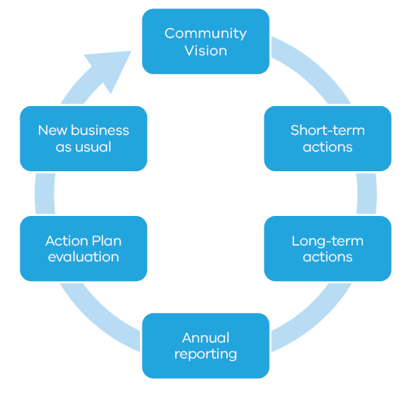

Implementation
Action | Lead | Timing
1.1 ‘Living entity’ and ‘voice’ for Regional Catchment Strategy (RCS) | PPWCMA | Short term
1.2 Bunurong, Wadawurrung and Wurundjeri aspirations in RCS planning | PPWCMA | Short term
1.3 Support for Bunurong, Wadawurrung and Wurundjeri to  express ‘voice of living entities’ | DELWP | Short term
1.4 Wider engagement with Traditional Owners about ‘living  entity’ and ‘voice’ | DELWP | Longer term
1.5 Investigate legislation for ‘living entity’ and ‘voice’ concepts | DELWP | Longer term
1.6 Traditional Owner preamble for possible legislation | DELWP | Longer term
2.1 Embed connections to Country in RCS | PPWCMA | Short term
2.2 Partnerships to implement ‘voice’ on Country | PPWCMA/  Melbourne Water | Short term
2.3 Support for Jacksons Creek Regional Parklands cultural  values study | DELWP | Short term
2.4 Jacksons Creek Planning Partnership | DELWP | Longer term
2.5 Traditional Owner values and knowledge in land use planning | DELWP | Longer term
2.6 RCS reporting Traditional Owner aspirations | Melbourne Water | Longer term
2.7 Bunurong, Wadawurrung and Wurundjeri Healthy Waterway Strategy partnership | Melbourne Water | Longer term
3.1 Stronger planning policy and guidance | DELWP | Short term
3.2 Interim landscape and environmental controls for key waterways | DELWP | Short term
3.3 Interim built-form controls for key waterways | DELWP | Longer term
3.4 Planning controls for additional waterways | DELWP | Longer term
3.5 Review of interim planning controls | DELWP | Longer term
4.1 Waterway amenity values in RCS | PPWCMA | Short term
4.2 Develop a Lower Werribee Waterway Amenity Action Plan | Melbourne Water | Short term
4.3 Waterway amenity advocacy | Melbourne Water | Short term
4.4 Melbourne Water statement of obligations to reflect amenity role | DELWP | Longer term
4.5 Victorian Waterway Management Strategy – urban waterway values | DELWP | Longer term
5.1 Wetland mapping data update | DELWP | Short term
5.2 RCS wetland mapping | PPWCMA | Short term
5.3 Adaptation strategies for western shoreline wetlands of Port Phillip Bay | DELWP | Longer term
5.4 Western shoreline wetlands master plan | DELWP | Longer term
6.1 Funding for Traditional Owner cultural water assessment priorities | DELWP | Short term
6.2 Central and Gippsland Region Sustainable Water Strategy water options for environment and culture | DELWP | Longer term
7.1 Pollution prevention taskforce | DELWP/EPA | Short term
7.2 Priority pollution prevention projects | DELWP/EPA | Longer term
7.3 Implementation of place-based stormwater objectives | Melbourne Water | Longer term
8.1 Community engagement about Traditional Owner culture and values | PPWCMA/  Melbourne Water | Short term
8.2 Community engagement strategy, including CALD | Melbourne Water | Short term
8.3 CALD engagement toolkit | Melbourne Water | Short term
8.4 Community Vision inclusion in RCS | PPWCMA | Short term
8.5 Community Vision inclusion in Healthy Waterway Strategy programs | Melbourne Water | Longer term
9.1 Annual implementation report | DELWP | Short term
9.2 Final review of implementation | DELWP | Longer term
9.3 Waterway condition reporting through Healthy Waterways Strategy | Melbourne Water | Longer term

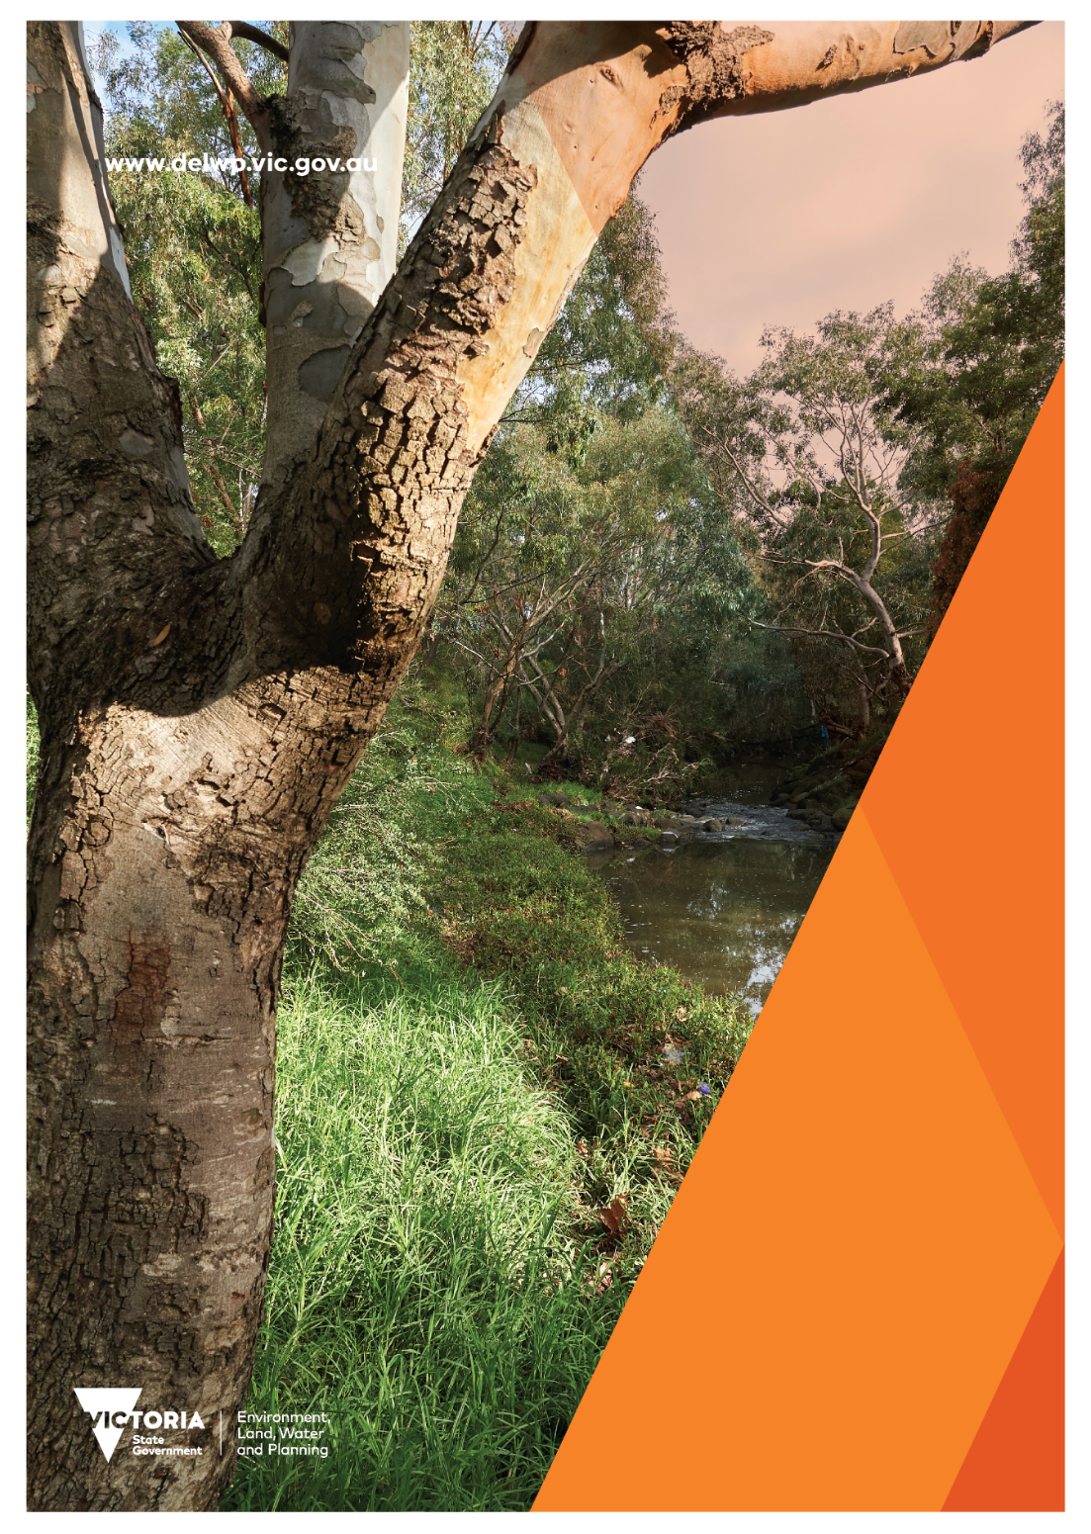

The Port Phillip and Westernport CMA will be integrated into Melbourne Water on 1 January 2022. This will bring catchment management and waterway management functions in the Port Phillip and Western Port region into one organisation. In this Action Plan, any reference to the Port Phillip and Westernport CMA should be taken to mean Melbourne Water once the merger is complete.
Yarra River Action Plan Action 27 is “Use the landscape assessment methods applied along the Yarra to establish stronger planning controls to protect the Maribyrnong River and its environs”. Action 28 is “Review the reforms to protect the Yarra River and consider protection of other major Melbourne rivers and their open spaces (such as the Maribyrnong and Werribee rivers)”.

