Victorian Waterway Management Strategy: third edition
  - Sustaining Living Waterways

Table of Contents
Acknowledgements 4
Publication information 6
Part 1. Strategy framework and context 7
What we mean 7
Chapter 1. The Strategy framework 10
Chapter 2. The importance of Victorian waterways 26
Chapter 3. Waterway management challenges 36
Part 2. The management approach 48
Chapter 4. Waterway management levers 48
Chapter 5. Planning for our waterways even as our climate changes 66
Part 3. Traditional Owners’ cultural rights and responsibilities in waterway management 85
Chapter 6. Understanding and progressing Traditional Owners’ cultural rights and responsibilities in waterway management 85
Part 4. Waterway management themes 107
Chapter 7. Water for the environment 107
Chapter 8. Wetlands 145
Chapter 9. Riparian 161
Chapter 10. River channels 176
Chapter 11. Water quality 185
Chapter 12. Estuaries 199
Chapter 13. Invasive species 209
Part 5. Urban waterways 219
Chapter 14. Managing for urban waterway values and protecting waterways from the impacts of excess urban stormwater 219
Part 6. Communities value and enjoy waterways 235
Chapter 15. Community wellbeing and contributions 235
Chapter 16. Recreational use of waterways 245
Part 7. Delivering the Strategy 257
Chapter 17. Implementation 257
Chapter 18. Knowledge and adaptive management 272
Appendices 278
Appendix 1. Victoria’s catchment management framework 279
Appendix 2. Relevant legislation and policies relating to the Strategy 282
Appendix 3. Values, pressures and challenges for waterways in Victoria 287
Appendix 4. Planning system tools for waterway protection 289
Appendix 5. Roles and responsibilities in waterway management 291
Appendix 6. Expectations for partnership with Traditional Owners 299
Appendix 7. Mechanisms to preserve the environmental water reserve and make best use of entitlements 301
Appendix 8. Volumes of water held for the environment across river basins in Victoria 303
Appendix 9. Victoria’s environmental water management framework and alignment with the Australian Government framework 307
Appendix 10. Victoria’s water quality management framework 310
Appendix 11. National biosecurity system and overview of other relevant strategies and legislation relating to Victoria 312
Appendix 12. Links between waterway conditions and social values 315
Endnotes 322

Acknowledgements
Cover image: Sale Wetlands near the entrance to the Gippsland Lakes / Gunaikurnai Country / DEECA
We acknowledge and respect Victorian Traditional Owners as the original custodians of Victoria’s land and waters, their unique ability to care for Country and deep spiritual connection to it.
We honour Elders past and present whose knowledge and wisdom has ensured the continuation of culture and traditional practices.
DEECA is committed to genuinely partnering with Victorian Traditional Owners and Victoria’s Aboriginal community to progress their aspirations.
DEECA thanks the Traditional Owner groups who contributed to the development of the Victorian Waterway Management Strategy. Their time, expertise, cultural knowledge and lived experience have helped shape the Strategy and strengthen its approach to caring for waterways, cultural governance, partnership and self-determination. The Department acknowledges the generosity with which Traditional Owners shared their knowledge and perspectives throughout the development of this Strategy.
Advice during the preparation of the Victorian Waterway Management Strategy has been provided by the following Traditional Owner groups:
- Bangerang Aboriginal Corporation
- Barapa Ltd
- Barengi Gadjin Land Council Aboriginal Corporation RNTBC
- Bidwell-Maap Aboriginal Corporation
- Bunurong Land Council Aboriginal Corporation
- Dhudhuroa Waywurru Nations Aboriginal Corporation
- Dja Dja Wurrung Clans Aboriginal Corporation
- Duduroa Dhargal Aboriginal Corporation
- Eastern Maar Aboriginal Corporation
- First People of the Millewa-Mallee Aboriginal Corporation
- Gunaikurnai Land and Waters Aboriginal Corporation
- Gunditj Mirring Traditional Owners Aboriginal Corporation
- Jaithmathang Traditional Ancestral Bloodline Original Owners First Nations Aboriginal Corporation
- Konermar Buller Jaithmatang
- Latji Latji Land and Water Aboriginal Corporation
- Ngurai Illum Wurrung Traditional Owners
- Nindi-Ngujarn Ngarigo Monero Aboriginal Corporation
- Tati Tati Kaiejin
- Taungurung Land and Waters Council
- Wadawurrung Traditional Owners Aboriginal Corporation
- Wadi Wadi Land and Water Indigenous Corporation
- Wadi Wadi Traditional Owners
- Wamba Wemba Aboriginal Corporation
- Weki Weki Traditional Owners
- Wiran Aboriginal Corporation
- Wurundjeri Woi Wurrung Cultural Heritage Aboriginal Corporation
- Yorta Yorta Nation Aboriginal Corporation.

Publication information

Copyright
© The State of Victoria Department of Energy, Environment and Climate Action 2026.

Creative Commons
This work is licensed under a Creative Commons Attribution 4.0 International licence, visit the Creative Commons website.
You are free to re-use the work under that licence, on the condition that you credit the State of Victoria as author. The licence does not apply to any images, photographs or branding, including the Victorian Coat of Arms, and the Victorian Government and Department logos.
ISBN 978-1-76176-971-9 (print)
ISBN 978-1-76176-972-6 (pdf)

Disclaimer
This publication may be of assistance to you but the State of Victoria and its employees do not guarantee that the publication is without flaw of any kind or is wholly appropriate for your particular purposes and therefore disclaims all liability for any error, loss or other consequence which may arise from you relying on any information in this publication.

Accessibility
To receive this document in an alternative format, phone the Customer Service Centre on 136 186, email customer.service@deeca.vic.gov.au, or contact National Relay Service on 133 677 or visit the National Relay Service website. This document is available on the DEECA website.

Part 1. Strategy framework and context

What we mean
Waterway is the term used in the Strategy to collectively refer to rivers, their associated estuaries and floodplains (including floodplain wetlands) and non-riverine wetlands. It does not replace other definitions of the term (for example, the definition in the Water Act 1989).
Waterway land refers to land that is important to waterways from an ecological, landscape or cultural perspective.
Waterway manager is a statutory role under the Water Act 1989 given to catchment management authorities (and Melbourne Water) to manage designated waterways and lands.
River refers to rivers, creeks and streams. It also includes their beds, banks and adjoining riparian land.
Wetland is any area of land that is inundated with water – standing or running, fresh or saline – with enough frequency and/or duration for the water to influence the plant and animal communities and ecological processes that occur there.
The Strategy’s focus for wetlands is largely on natural wetlands (including lakes), however some policies will refer to artificial wetlands such as reservoirs, stormwater wetlands and sewerage treatment ponds.
The Strategy does not include shallow marine waters, except for those listed as internationally or nationally important wetlands.
Estuary is the section of some coastal rivers and creeks where freshwater from the river meets the tidal inflow from the marine environment, where the freshwater and saltwater interact.
Floodplain is the area of land that is inundated with water when a waterway flows over its banks under wet conditions. Flows are distributed over a broad, relatively flat area of land, often including wetlands and smaller tributaries of the larger river channel. This definition includes estuarine floodplains, which depend on both the hydrological exchange with the marine environment and freshwater inflows from rivers. In the Strategy, floodplains are included primarily where the management focus is on significant environmental or cultural values.
Riparian land is the area of land that occurs along the edges of rivers, wetlands and estuaries.
Catchment is the region from which all rainfall flows (unless removed by evaporation) into specific waterways and then to the sea or terminal lake.
Active waterway management is the ongoing, deliberate intervention and hands-on activities undertaken to improve the condition of waterways, such as fencing, pest management, and watering. A waterway includes rivers, their associated estuaries and floodplains (including floodplain wetlands) and non-riverine wetlands.
Image 1: The catchment system, showing how waterway types connect from the mountains to the sea – reservoirs, waterway land, wetlands, rivers, floodplains, riparian land and estuaries.
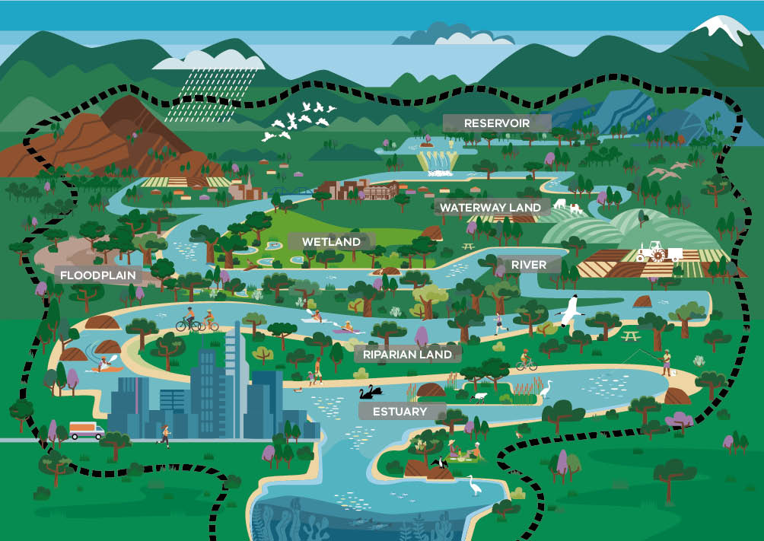

Chapter 1. The Strategy framework

About this Strategy
Waterways are diverse systems across Victoria, including rivers, creeks, streams, estuaries, floodplains, and wetlands. The Victorian Waterway Management Strategy 3rd edition (the Strategy) provides the framework for government, in partnership with waterway managers, Traditional Owners and regional communities, to sustain Victorian waterways and balance the values and uses they support.
The Strategy outlines how Victoria will meet its obligations for waterway management in relevant state, national and international legislation, policy and agreements (See Appendix 1. Victoria’s catchment management framework). In Victoria, regional planning, priority-setting and delivery is essential to successfully manage waterways and catchments. This Strategy provides the framework for this to continue, while also addressing emerging challenges and aligning to policy changes since the second strategy was released in 2013.
The Strategy has a 10-year lifespan and replaces the 2013 Victorian Waterway Management Strategy. It is primarily implemented through the Victorian Waterway Management Program, with funding from the Environmental Contribution (EC).
Over the last decade, several key improvements to the state policy framework – along with active management – have contributed to maintaining or improving environmental conditions at targeted waterway areas. However, there’s still much to be done to care for Victorian waterways and make sure that they continue to provide a balance of environmental, social, cultural and economic benefits for all – even as our climate changes.

The Strategy framework
The Strategy framework includes a 50-year aspirational vision, cultural outcomes and long-term (20-year) outcomes to guide policies and actions (See Figure 1).
The vision for Victoria’s waterways is:
Victorian waterways are valued as living and life-giving systems. They sustain diverse ecosystems and enrich the lives of current and future generations, even as our climate changes.
Traditional Owners’ cultural obligations to care for Country are valued and enabled through joint waterway management.
Victorians are active stewards of waterways, caring for and shaping their future for environmental, social, cultural and economic benefit.
They bring together the obligations for waterway management outlined in relevant state, national and international legislation, policy and agreements – and guide how to address these too (See Appendix 2. Relevant legislation and policies relating to the Strategy).
The framework in Figure 1 translates the vision into four quantifiable outcomes:
- Traditional Owner cultural rights and responsibilities for waterways
- Living and connected waterway ecosystems and habitats
- Victorians value, care for, use and enjoy waterways
Efficient and effective waterway planning and management.
These outcomes cut across all the themes in the Strategy, informing the policies in each chapter. These 20-year outcomes for Victoria's waterways set the long-term ambition, while 10-year outcomes to be delivered through the policies and actions are identified in each chapter. The actions will be implemented within the life of the strategy, and in some cases, the identified actions will be ongoing, or the action is the first step in an ongoing process. Collectively, the policies, actions and outcomes provide a pathway towards achieving the vision.
The Victorian Government has also committed to waterway outcomes and targets in related policies, such as:
- Protecting Victoria's Environment - Biodiversity 2037 (2017)
- Water is Life: Traditional Owner Access to Water Roadmap (2022)
- Marine and Coastal Policy (2020) and Marine and Coastal Strategy (2022)
- National agreements such as the Murray–Darling Basin Agreement
International agreements such as the Ramsar Convention.
These outcomes, targets and obligations guide our approach to waterway management and contribute to our vision. The Strategy will be implemented in accordance with the State’s legal obligations under Statewide Treaty Act 2025 including to engage in good faith with the First Peoples Assembly of Gellung Warl as the democratically elected representative body for First Peoples in Victoria and give effect to Gellung Warl’s legislated powers and functions, including its role to inform, advise and make decisions on matters affecting First Peoples.
Figure 1: Outcomes framework for the Victorian Waterway Management Strategy
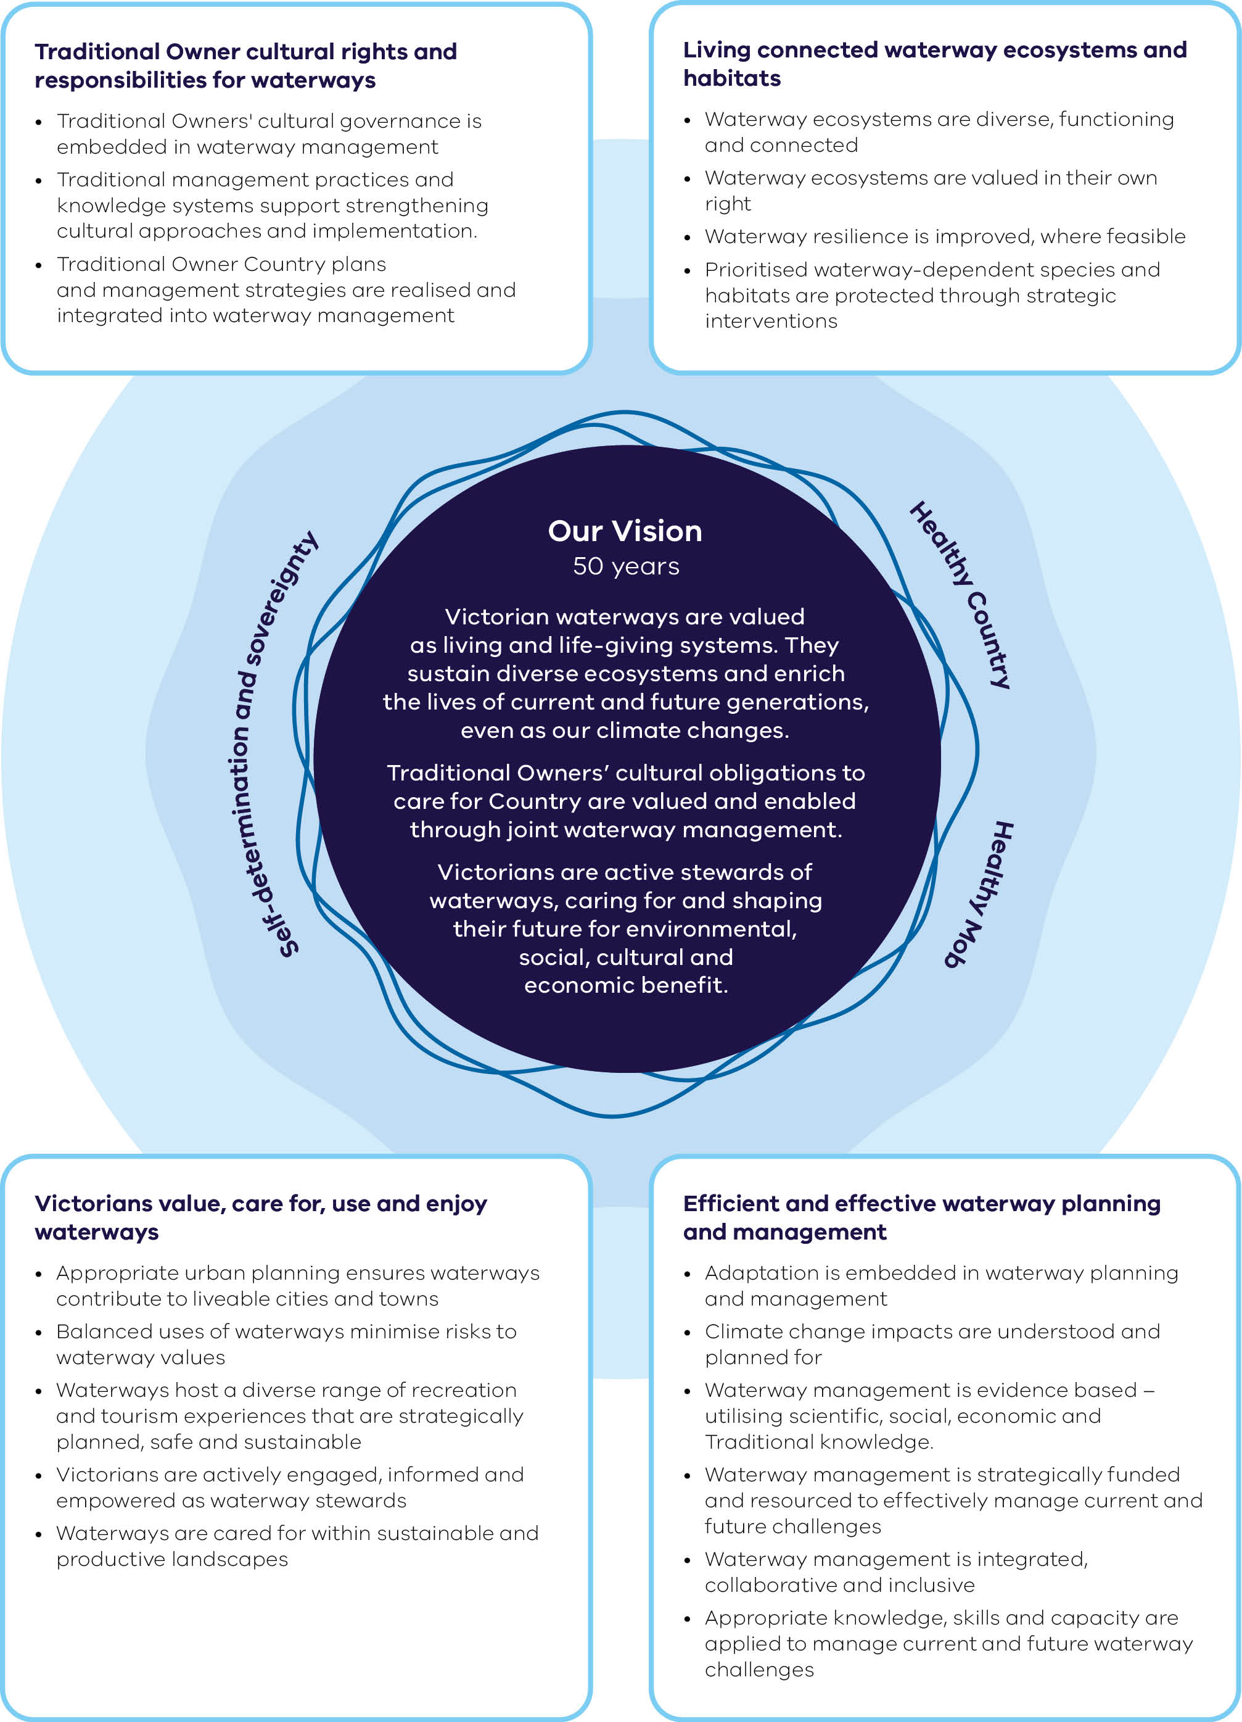
Figure 1 outlines the outcomes framework for the Victorian Waterway Management Strategy. The framework includes:

Our Vision for the next 50 years
- Healthy Country
- Healthy Mob
Self-determination and sovereignty
Victorian waterways are valued as living and life-giving systems. They sustain diverse ecosystems and enrich the lives of current and future generations, even as our climate changes.
Traditional Owners’ cultural obligations to care for Country are valued and enabled through joint waterway management.
Victorians are active stewards of waterways, caring for and shaping their future for environmental, social, cultural and economic benefit.

Traditional Owner cultural rights and responsibilities for waterways
- Traditional Owners' cultural governance is embedded in waterway management
- Traditional management practices and knowledge systems support strengthening cultural approaches and implementation.
Traditional Owner Country plans and management strategies are realised and integrated into waterway management

Victorians value, care for, use and enjoy waterways
- Appropriate urban planning ensures waterways contribute to liveable cities and towns
- Balanced uses of waterways minimise risks to waterway values
- Waterways host a diverse range of recreation and tourism experiences that are strategically planned, safe and sustainable
- Victorians are actively engaged, informed and empowered as waterway stewards
Waterways are cared for within sustainable and productive landscapes

Living connected waterway ecosystems and habitats
- Waterway ecosystems are diverse, functioning and connected
- Waterway ecosystems are valued in their own right
- Waterway resilience is improved, where feasible
Prioritised waterway-dependent species and habitats are protected through strategic interventions

Efficient and effective waterway planning and management
- Adaptation is embedded in waterway planning and management
- Climate change impacts are understood and planned for
- Waterway management is evidence based – utilising scientific, social, economic and Traditional knowledge.
- Waterway management is strategically funded and resourced to effectively manage current and future challenges
- Waterway management is integrated, collaborative and inclusive
Appropriate knowledge, skills and capacity are applied to manage current and future waterway challenges

Strategy outline
The Strategy is divided into 7 parts:
- Part 1 – Strategy framework and context – provides a vision, guiding principles and statewide outcomes. It outlines the challenges of waterway management and the importance of investing long-term in environmental condition, to provide for a balance of uses and values of waterways.
- Part 2 – The management approach – outlines the five-part management approach and how regional waterway strategies will be used for setting waterway outcomes with communities, as we plan adaptation pathways to respond to climate change and other pressures.
- Part 3 – Traditional Owners’ cultural rights in waterway management – acknowledges the significant dispossession of Victorian Traditional Owners from their cultural rights to care for waterways as part of Country. The Victorian Government is committed to enabling and supporting Traditional Owners' self-determination by embedding cultural governance in waterway management.
- Part 4 – Waterway management themes – outlines existing approaches, frameworks and commitments to address waterway issues and opportunities (such as riparian management and management of water for the environment).
- Part 5 – Urban waterways – improves how urban waterways integrate into the Strategy framework, including how integrated water management is applied to address waterway impacts in our cities and towns.
- Part 6 – Communities value and enjoy waterways – outlines the importance of communities in decision-making for waterways. It provides commitments to citizen science and waterway stewardship, plus policy directions for the recreational use of waterways.
- Part 7 – Delivering the Strategy – outlines institutional funding and cost-sharing arrangements, along with commitments to monitoring, evaluation and reporting.

Policies and actions
To achieve the Strategy vision and outcomes (See Figure 1) there are:
- 68 policies
44 actions.
Underpinned by partner, stakeholder and community feedback, the Strategy:
- builds on the approach and lessons from the delivery of the first two strategies
reflects or applies existing Victorian Government policy to the waterway management context (for example, the Water is Life: Traditional Owner Access to Water Roadmap).
To easily identify changes made since the 2013 Victorian Waterway Management Strategy, the policies have been labelled as:
- Existing policy incorporated into the Victorian Waterway Management Strategy, to reflect or apply existing Victorian Government policy that did not appear in the previous waterway management strategies because it has more recently become government policy
- Updated policy from the previous Victorian Waterway Management Strategy, to provide necessary updates to policies that have evolved or need clarification since the previous waterway management strategies
New policy, that has been developed during the preparation of this Victorian Waterway Management Strategy 3rd edition.
Actions have been identified for some policies to be implemented on or before the date nominated. Some actions will also be ongoing or will lead to future actions.

Policies and actions overview

Part 2: The management approach
Summary of the policies and actions in Part 2
Policy/Action | Page
Chapter 4. Waterway management levers | 48
Policy 1 – Waterways as living and connected entities | 50
Action 1 | 52
Policy 2 – Land use planning system for waterway outcomes | 62
Action 2 | 62
Action 3 | 62
Policy 3 – Collaborating among regional waterway managers and partners | 64
Chapter 5. Planning for our waterways even as our climate changes | 66
Policy 4 – Planning for resilience, transition and transformation | 68
Policy 5 – Principles for regional waterway strategies | 74
Policy 6 – Improving preparedness and response planning for waterways | 83
Action 4 | 83

Part 3: Traditional Owners' cultural rights and responsibilities in waterway
Summary of the policies and actions in Part 3
Policy/Action | Page
Chapter 6. Understanding and progressing Traditional Owners’ cultural rights and responsibilities in waterway management | 85
Policy 7 – Embedding Traditional Owners' cultural rights, responsibilities and roles in waterway management | 98
Policy 8 – Embedding cultural governance and self-determination through partnerships in regional waterway management (Water is Life Outcomes 2 & 5) | 99
Policy 9 – Embedding cultural governance and self-determination through partnership with DEECA (Water is Life Outcomes 2 & 5) | 100
Action 5 | 102
Policy 10 – Water sector agencies supporting Traditional Owner-led initiatives in waterway stewardship (Water is Life Outcome 2) | 103
Policy 11 – Increasing the role of Traditional Owners in managing water for the environment (Water is Life Outcome 3 & 6) | 104
Action 6 | 105
Action 7 | 105

Part 4: Waterway management themes
Summary of the policies and actions in Part 4
Policy/Action | Page
Chapter 7. Water for the environment | 107
Policy 12 – Integrating environmental water to achieve waterway outcomes | 118
Policy 13 – Developing and adapting environmental water management plans to achieve regional outcomes | 119
Policy 14 – Making informed decisions on Victorian watering priorities | 120
Policy 15 – VEWH working with other environmental water holders | 122
Action 8 | 123
Policy 16 – Principles for considering complementary benefits in environmental water planning | 126
Policy 17 – Using all mechanisms to secure outcomes from environmental water use | 129
Policy 18 – Agreeing on asset management arrangements for environmental watering infrastructure | 129
Policy 19 – Managing river operations for more sustainable waterways | 130
Action 9 | 130
Action 10 | 131
Policy 20 – Principles for charging for environmental water holdings | 132
Policy 21 – Protecting the environmental water reserve in unregulated waterways | 136
Policy 22 – Protecting groundwater-dependent ecosystems | 137
Policy 23 – Improving floodplain flow and connectivity on public land | 138
Policy 24 – Using recycled water for the environment | 139
Action 11 | 143
Action 12 | 143
Action 13 | 144
Action 14 | 144
Chapter 8. Wetlands | 145
Policy 25 – Governance, management planning and monitoring, evaluating and reporting of Ramsar sites | 148
Policy 26 – Responding to potential changes in ecological character of Ramsar sites | 150
Policy 27 – Principles for listing a new Ramsar site and extending the boundaries of an existing Ramsar site | 150
Policy 28 – Managing wetlands on public land to achieve regional outcomes | 152
Policy 29 – Managing wetlands on private land to improve protection | 154
Action 15 | 155
Action 16 | 155
Policy 30 – Managing water regimes of wetlands to maintain or enhance values | 158
Policy 31 – Managing rural drainage to minimise impacts on wetlands | 159
Action 17 | 159
Policy 32 – Managing irrigation drainage to minimise impacts on wetlands and other waterways | 160
Chapter 9. Riparian | 161
Policy 33 – Managing riparian land | 167
Policy 34 – Administering and managing Crown frontage | 168
Action 18 | 170
Action 19 | 170
Policy 35 – Fencing and managing fenced riparian land to minimise grazing impacts | 171
Action 20 | 172
Policy 36 – Providing livestock access to water along fenced Crown frontages | 173
Policy 37 – Minimising the planting of non-native species on riparian land | 174
Policy 38 – Improving climate resilience of riparian land | 174
Chapter 10. River channels | 176
Policy 39 – Managing river channels | 179
Policy 40 – On-ground management of river channels | 181
Action 21 | 182
Policy 41 – Management of instream wood | 182
Policy 42 – Managing sand and gravel extraction | 183
Action 22 | 184
Chapter 11. Water quality | 185
Policy 43 – Managing a risk-based approach to regulated releases from water storages | 193
Policy 44 – Releasing water from storages to mitigate water quality events | 194
Action 23 | 194
Policy 45 – Development of toxicant default guidelines | 196
Policy 46 – Principles for targeted and coordinated investment in long-term water quality data collection | 197
Action 24 | 198
Action 25 | 198
Action 26 | 198
Chapter 12. Estuaries | 199
Policy 47 – Framework for managing estuaries | 201
Policy 48 – Managing estuary entrances | 203
Action 27 | 204
Policy 49 – Maintaining, improving and adapting the environmental condition of estuaries | 206
Policy 50 – Adaptation planning for estuary entrance management | 208
Chapter 13. Invasive species | 209
Policy 51 – Managing weeds, pests and diseases that threaten waterways within Victoria’s biosecurity system | 215
Policy 52 – Addressing weeds, pests and diseases that threaten waterways | 218
Action 28 | 218

Part 5: Urban waterways
Summary of the policies and actions in Part 5
Policy/Action | Page
Chapter 14. Managing for urban waterway values and protecting waterways from the impacts of excess urban stormwater | 219
Policy 53 – Protecting and enhancing urban waterway values and resilience | 225
Action 29 | 226
Action 30 | 226
Policy 54 – Planning for waterway outcomes in sustainable urban development | 227
Action 31 | 228
Policy 55 – Integrating urban waterway management with regional waterway planning | 228
Action 32 | 229
Action 33 | 229
Policy 56 – Protecting waterways from excess urban stormwater | 232
Action 34 | 233
Action 35 | 233
Action 36 | 234
Action 37 | 234

Part 6: Communities value and enjoy waterways
Summary of the policies and actions in Part 6
Policy/Action | Page
Chapter 15. Community wellbeing and contributions | 235
Policy 57 – Supporting stewardship of waterways | 239
Action 38 | 239
Action 39 | 240
Policy 58 – Supporting citizen science | 241
Policy 59 – Supporting community participation in waterway management planning | 242
Action 40 | 243
Chapter 16. Recreational use of waterways | 245
Policy 60 – Planning for waterway sites of significant value | 249
Policy 61 – Planning for recreational values of waterways at sites with significant recreational value aligned to regional outcomes | 251
Policy 62 – Providing information about opportunities to access waterways for recreation | 254
Action 41 | 255
Policy 63 – Investment in waterway-based recreation planning and infrastructure | 256

Part 7: Delivering the strategy
Summary of the policies and actions in Part 7
Policy/Action | Page
Chapter 17. Implementation | 257
Policy 64 – Considering the cumulative impacts of works on waterways | 260
Policy 65 – Cost-sharing principles for waterway management | 265
Policy 66 – Implementing seasonally-adaptive approaches to waterway management | 267
Action 42 | 269
Action 43 | 269
Action 44 | 271
Chapter 18. Knowledge and adaptive management | 272
Policy 67 – Undertaking statewide waterway condition assessments | 273
Policy 68 – Development of a reporting framework for environmental water | 275

Chapter 2. The importance of Victorian waterways
Waterways underpin Victoria’s productivity, liveability and human health, all of which are supported and influenced by waterway condition.

Environmental value
From the highest alpine ranges to the Southern Ocean. Through river red gum forests in the north and rainforests in the south. Across Mallee country, woodlands and grasslands, to saltmarshes and coastal scrub. Victoria’s waterways are the veins that connect land and water and are the lifeblood for plants and animals.
The vegetation that occurs along waterways (riparian vegetation) and on their floodplains provides habitat for many terrestrial animal species. It’s also a source of energy (through leaves and organic matter) for aquatic species, such as the iconic platypus. Waterways and floodplains are vital for the movement and cycling of sediments and nutrients and these living processes underpin rich agricultural soils in many areas of the state. The flow of water moves food sources through the system and can trigger breeding and migrations – critical factors in the survival of many native species.
Vegetation along riverbanks and floodplains is increasingly valued for its role in carbon storage, filtering nutrients and pollutants and as habitat corridors in fragmented landscapes. Riparian vegetation can sequester approximately 2.7–4.5 tonnes of CO₂-e per hectare each year while storing substantial carbon stocks. Instream vegetation also provides important habitat and food sources in all types of waterways.
Despite past and current uses, waterways continue to sustain a diversity of habitats and support unique plant and animal populations. This includes brolgas that were once spread across much of Victoria, as well as threatened species such as Macquarie perch, catfish and Murray cod.

Economic value
Our communities depend on waterways to provide safe drinking water for over 5 million people. Waterways support over $5 billion of irrigated agricultural production annually, along with significant manufacturing output. The combined annual value of Victoria's rivers has been previously estimated at around $1.56 billion per year. Sectors such as agriculture and fisheries directly rely on this natural capital. Waterway restoration can help realise these broader economic benefits and deliver strong returns through increased adjacent land values and avoided downstream costs following rehabilitation.

Recreational value
Waterways provide opportunities for activities such as walking, picnicking, swimming, fishing and boating. Victoria’s parks and protected areas, which include many of the state's waterways, are estimated to support $1.4 billion in annual tourism expenditure, generate $1 billion in gross value added, and sustain around 14,000 jobs through the parks and nature-based tourism economy. Victoria's waterways also support recreational fishing by more than one million people, contributing at least $2.27 billion per annum and 19,737 full-time equivalent jobs to the economy. Waterways are often the ‘hero’ of tourism destinations and nature-based recreation, with waterways such as the Great Ocean Road estuaries, Gippsland Lakes, Goulburn River and Ovens River contributing greatly to regional economies and employment.

Liveability
With appropriate planning, waterways enhance liveability in our cities and towns. Access to waterways close to where people live is an important contributor to liveability, providing blue spaces for recreation, relaxation and a relationship with nature. They also cool urban environments. Waterways support physical and mental wellbeing, strengthen social connections, and provide valued places where people can gather, learn, and connect with their communities. The My Victorian Waterway Survey (2022) found that 94% of respondents agreed waterways nurture their health and wellbeing, while 71% agreed that feeling connected to nature and waterways helps them deal with everyday stress. The value of these benefits is reflected in many ways, including property markets. Properties located within 200 metres of activated living streams have been associated with a 1.1% uplift in house prices and a 1.5% uplift in lot prices. More broadly, improved green and blue infrastructure can increase property values by $32,000 to $58,000 per dwelling across Australian capital cities.

Traditional Owner values
Traditional Owners have cared for Country and waterways for countless generations – maintaining the health and flow of water, while sustaining connections to place, each other, animals, culture and Country.
Water has been provided and maintained by the ancestors. Today, Victorian Traditional Owners continue to have rights and cultural obligations to care for water on Country.
Traditional Owner-led management processes can restore the conditions of Country and deliver water justice for Traditional Owner groups who have been deprived of water rights and access. Sustainable water strategies and Water is Life: Traditional Owner Access to Water Roadmap provide the policy frameworks for the return of water to Traditional Owner groups.
Values provided by waterways are reliant on their environmental condition
Waterway management is the balancing of values and uses of waterways while recognising that environmental condition is fundamental to sustaining cultural, social and economic benefits.
Managing waterways is a complex task. This is largely due to the interdependencies between waterway conditions, values and their uses such as water supply and recreation. Most values provided by waterways rely, to some extent, on their environmental condition (See Figure 2). For example, waterway condition influences drinking water safety and safety of recreational uses of waterways.
Deteriorating conditions of waterways can lead to:
- increased costs for water treatment
- loss of habitat and the resulting loss of fisheries, waterbirds and other wildlife
loss of recreational and tourism opportunities
Decisions about the future of Victorian waterways must balance environmental, social, cultural and economic needs transparently and responsibly – while also retaining options for future adaptations whenever possible (See section on setting priorities in regional waterway strategies and Box 3 for information on regional processes for balancing values).
Figure 2: Relationship between waterway values and conditions
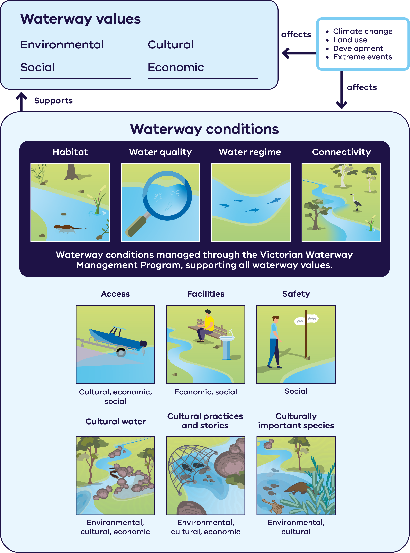
The values, pressures and opportunities facing waterways across the Victorian landscape are shown in Appendix 3.
Figure 2 summarises the relationship between waterway values and conditions:
Waterway values are grouped into four types: environmental, cultural, social and economic. Waterway conditions sit beneath these values and support them, so the values a waterway provides depend on the condition it is in.
Four waterway conditions are managed through the Victorian Waterway Management Program, and these support all waterway values:
- habitat
- water quality
- water regime
connectivity.
A further six conditions each support a particular combination of waterway values:
- access – cultural, economic and social values
- facilities – economic and social values
- safety – social values
- cultural water – environmental, cultural and economic values
- cultural practices and stories – environmental, cultural and economic values
culturally important species – environmental and cultural values.
Climate change, land use, development and extreme events act as external pressures on the system. They affect waterway values directly and also affect waterway conditions, which in turn changes the values those waterways can support.

Victoria’s catchment management framework and achievements since the last Strategy
Victoria’s catchment management framework (Appendix 1) has been in place for nearly 30 years now. It helps us manage our waterways and catchment landscapes despite the modifications we have made and our ongoing use. This has sustained and restored some waterways that had been degraded and neglected since colonisation. Waterways are now more valued and visited by a growing population.
The environmental condition of some Victorian waterways is still declining, with some locations still adapting to both changes and management practices from years ago. Guided by the first and second Victorian waterway management strategies, waterway managers have partnered with communities to actively manage the condition of waterways identified as priorities through regional waterway strategies since 1999.
Farmers and other landholders play a vital role. They provide access to land (particularly when there is no crown frontage), control pest plant and animals, and partner with waterway managers on the management of waterways and long-term stewardship of catchments.
Victoria has an enduring framework and strong foundation for waterway management.
Evaluating these activities has shown that active management improves the condition of waterways, with environmental and other values being maintained or improved in targeted areas. We target change from the scale of individual river reaches and wetlands to entire river basins, focusing on key indicators of waterway health. We have learnt to regulate new developments to minimise future impacts. It’s also become clearer over time that success is achieved by localised, consistent effort over long periods of time across physical landscapes and social landscapes, public and private land.
Since 2004, over $1 billion has been invested to improve waterway and catchment conditions in regional areas. This is largely through the activities of catchment management authorities, including:
- 89,892 ha of local riparian vegetation improvements (from 2013/14 to 2023/24). For example, see Figure 5: The Genoa River Restoration Project, East Gippsland region.
- 1,950 km of waterways being fenced to prevent access by stock (from 2014/15 to 2022/23). For example, see Figure 5: Hughes Creek, Goulburn Broken region.
- 667 GL per year of water for the environment being secured to improve waterway outcomes across Victoria. This is an additional 640 GL per year since the 2013 Strategy. (Note: CEWH also holds approximately 753 GL in Northern Victoria.) For example, see Figure 5: Annulus Billabong Project, Port Phillip and Western Port region.
800 km of waterway opening up to native fish migration. For example, see Figure 5: The Tea Garden Weir fishway structure, North East region.
Image 2: Before (2016) and after (2026): Stoney Creek following livestock exclusion and revegetation through the Riparian Intervention Monitoring Program / Gunditj Mirring Country / Arthur Rylah Institute, Bryan Mole.
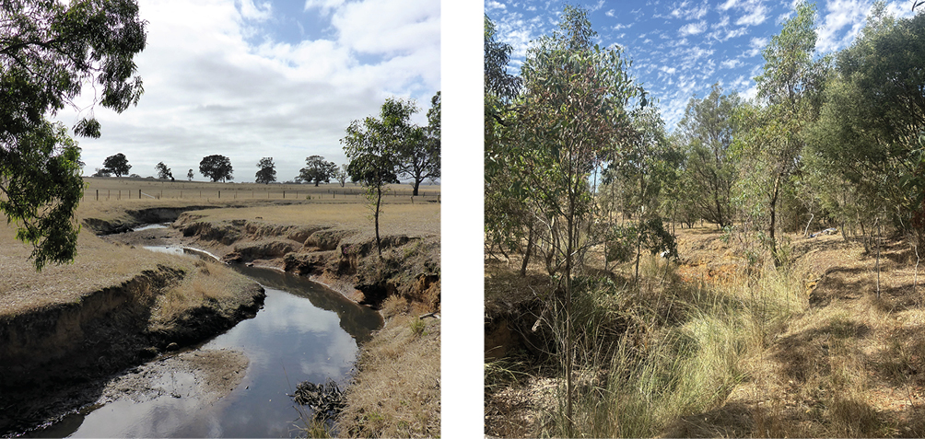

Waterway management is a long-term commitment
Just as we need healthcare for our bodies, or a maintenance plan for our public assets, waterways require ongoing care and investment so that they’re sustained and they continue to meet the needs of the community.
The Strategy acknowledges that the critical use of many of our waterways means they will never be pristine. However, they are living and life-giving systems. We must continue to invest in the condition of these waterways, and they will continue to support community values.
Climate change and population change are significant challenges for waterway management. Both are already having significant effects on waterway values, including more frequent extreme events and habitat loss.
The Strategy recognises that preservation or conservation of all current waterway values may no longer be achievable and that we may need to adjust and support our waterways to adapt to changing conditions.
This includes a renewed approach to identifying regionally important outcomes and sustained support for ongoing active management through investment, including in the Victorian Waterway Management Program.
Some waterways will no longer be able to sustain the types of plants and animals that have been there for thousands of years, or even those that are there now. Large-scale and long-term investments will enable other areas to continue to support existing native species and values. There will be conversations that need to take place with communities to weigh up options and set realistic outcomes within the current water entitlement framework, so that the type and rate of change is achievable and can provide for as many values as possible for future generations.
This Strategy provides the framework for this conversation and ongoing investment.
Image 3: Before (1998) and after (2021) riparian and waterway health works at Tambo River. The success of the long-term rehabilitation of the river has been built on partnerships with farmers, community groups and the broader community / Gunaikurnai Country / Bruthen, East Gippsland / East Gippsland CMA.
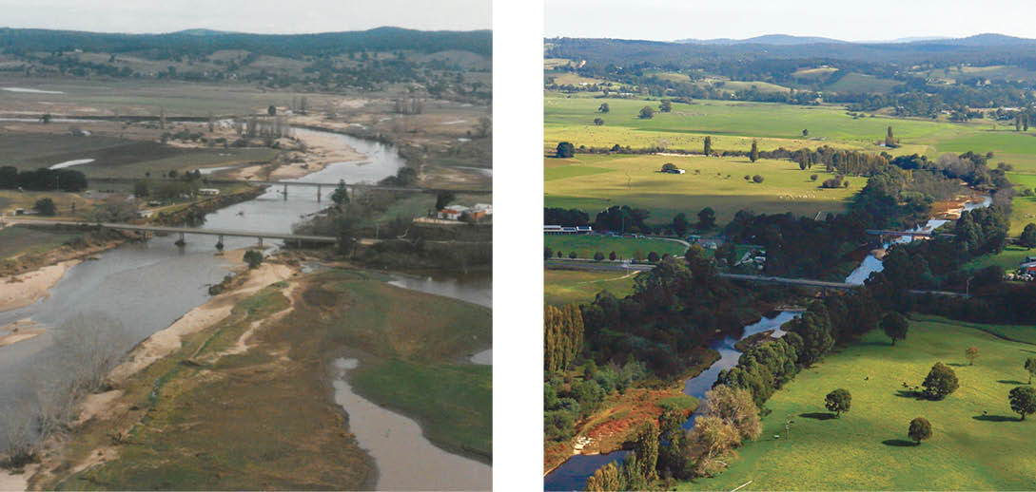

Chapter 3. Waterway management challenges

History of Victorian Waterway Management
The current environmental condition of Victorian waterways reflects the cumulative impact of historic and enduring land and waterway management practices. These include land clearing, urban and industrial development, mining, agriculture on floodplains and regulated water regimes for water supply. Victoria’s approach to managing waterways has evolved over time (as shown in Figure 3) to respond to these practices.
Figure 3: The evolution of Victorian waterway management
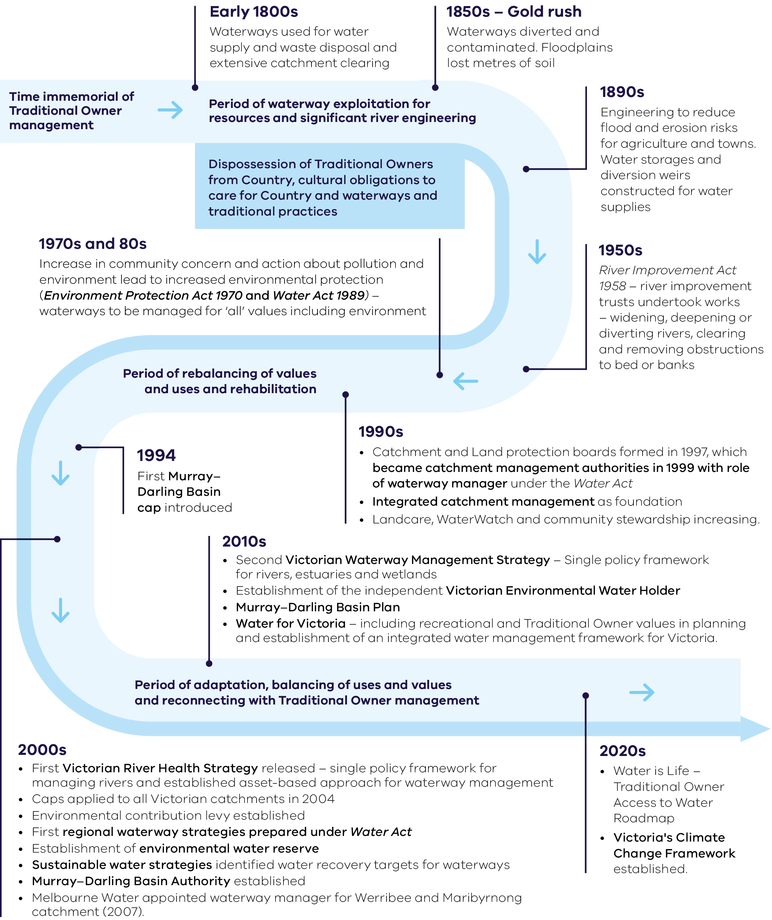
Figure 3 shows the evolution of Victorian waterway management as a timeline. It begins with time immemorial of Traditional Owner management, then flows through three periods: a period of waterway exploitation for resources and significant river engineering; a period of rebalancing of values and uses and rehabilitation; and a period of adaptation, balancing of uses and values and reconnecting with Traditional Owner management. Spanning the first period is the dispossession of Traditional Owners from Country, from cultural obligations to care for Country and waterways, and from traditional practices.
Period of waterway exploitation for resources and significant river engineering:
- Early 1800s – waterways used for water supply and waste disposal, and extensive catchment clearing
- 1850s, gold rush – waterways diverted and contaminated, and floodplains lost metres of soil
- 1890s – engineering to reduce flood and erosion risks for agriculture and towns, with water storages and diversion weirs constructed for water supplies
1950s – under the River Improvement Act 1958, river improvement trusts undertook works including widening, deepening or diverting rivers, and clearing and removing obstructions to the bed or banks.
Period of rebalancing of values and uses and rehabilitation:
- 1970s and 80s – an increase in community concern and action about pollution and the environment led to increased environmental protection through the Environment Protection Act 1970 and the Water Act 1989, with waterways to be managed for ‘all’ values, including the environment
- 1994 – the first Murray–Darling Basin cap was introduced
1990s – Catchment and Land Protection boards were formed in 1997 and became catchment management authorities in 1999 with the role of waterway manager under the Water Act; integrated catchment management was adopted as the foundation; and Landcare, WaterWatch and community stewardship increased.
Period of adaptation, balancing of uses and values and reconnecting with Traditional Owner management:
- 2000s – the first Victorian River Health Strategy was released as a single policy framework for managing rivers and established an asset-based approach to waterway management; caps were applied to all Victorian catchments in 2004; the environmental contribution levy was established; the first regional waterway strategies were prepared under the Water Act; the environmental water reserve was established; sustainable water strategies identified water recovery targets for waterways; the Murray–Darling Basin Authority was established; and Melbourne Water was appointed waterway manager for the Werribee and Maribyrnong catchments in 2007
- 2010s – the second Victorian Waterway Management Strategy provided a single policy framework for rivers, estuaries and wetlands; the independent Victorian Environmental Water Holder was established; the Murray–Darling Basin Plan was introduced; and Water for Victoria included recreational and Traditional Owner values in planning and established an integrated water management framework for Victoria
2020s – Water is Life: Traditional Owner Access to Water Roadmap was released and Victoria’s Climate Change Framework was established.

The current waterway condition
State-wide environmental condition data shows that waterways are under continued pressure. This highlights the need for active long-term management to restore environmental conditions and address climate change impacts and other challenges. Not all waterway values and uses are complementary or protect the environmental conditions that underpin a broad range of values. The long-term condition data demonstrate this at a broad scale. Waterway managers use this and other more current datasets and tools (See Box 3) to have a better understanding of suitable habitats at a regional scale. They can identify the most vulnerable environmental values and use this knowledge to inform management priorities.
This Strategy also recognises that cultural and social waterway conditions also underpin waterway values (See Figure 2). While there is no statewide long-term dataset to assess these conditions, their inclusion is important. This is because activities that address cultural and social waterway conditions can also support environmental conditions – or can be used as trade-offs with these. Regional collaboration between waterway managers and other partners is important to reduce duplicated effort or competition between values (See Chapter 4 and Chapter 5).
Note: The information presented in Figure 4 is based on available statewide monitoring and/or remotely sensed data and should be interpreted alongside local ecological knowledge and other sources of information. Areas mapped as having moderate or higher condition may still include waterways that are degraded and are the focus of ongoing restoration efforts.
Figure 4: Waterway condition as identified through Victoria’s condition assessment programs.
Sub-figure 4.1: Rivers and streams
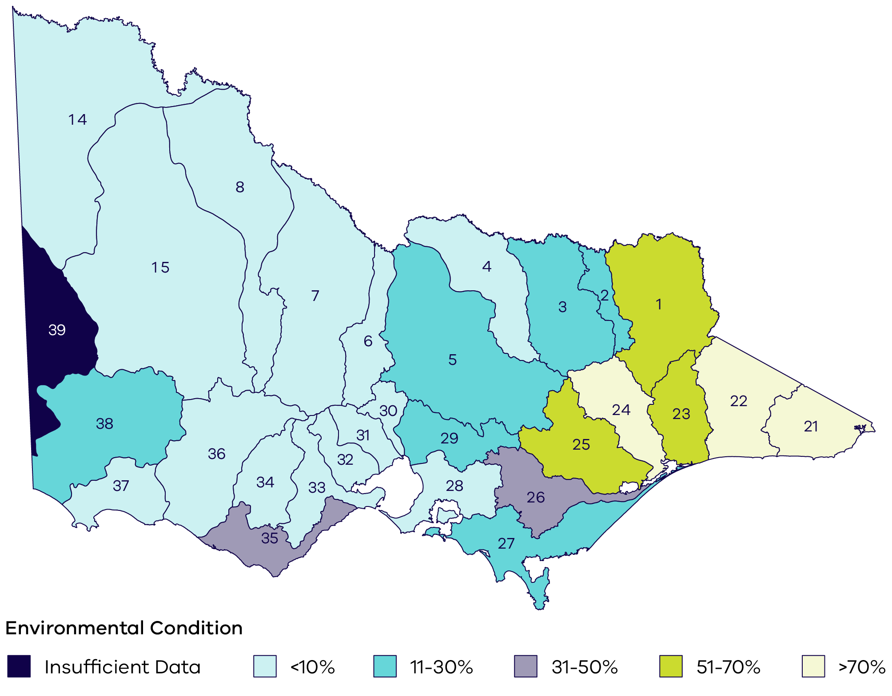

Rivers and streams
The 2010 Index of Stream Condition report found nearly 70% of riparian land was in poor to moderate condition. The map shows the percentage of river length in good to excellent condition in each river basin (numbers identify the respective river basin).
The 2022 Stream Change Assessment project assessed changes in woody riparian vegetation along several targeted streams in Victoria.
The project found that various indicators of riparian condition have shown minimal improvement since 2010 at the regional scale. Significant change occurred almost exclusively at sites where active management occurred in the 2010s.
Sub-figure 4.2: Wetlands
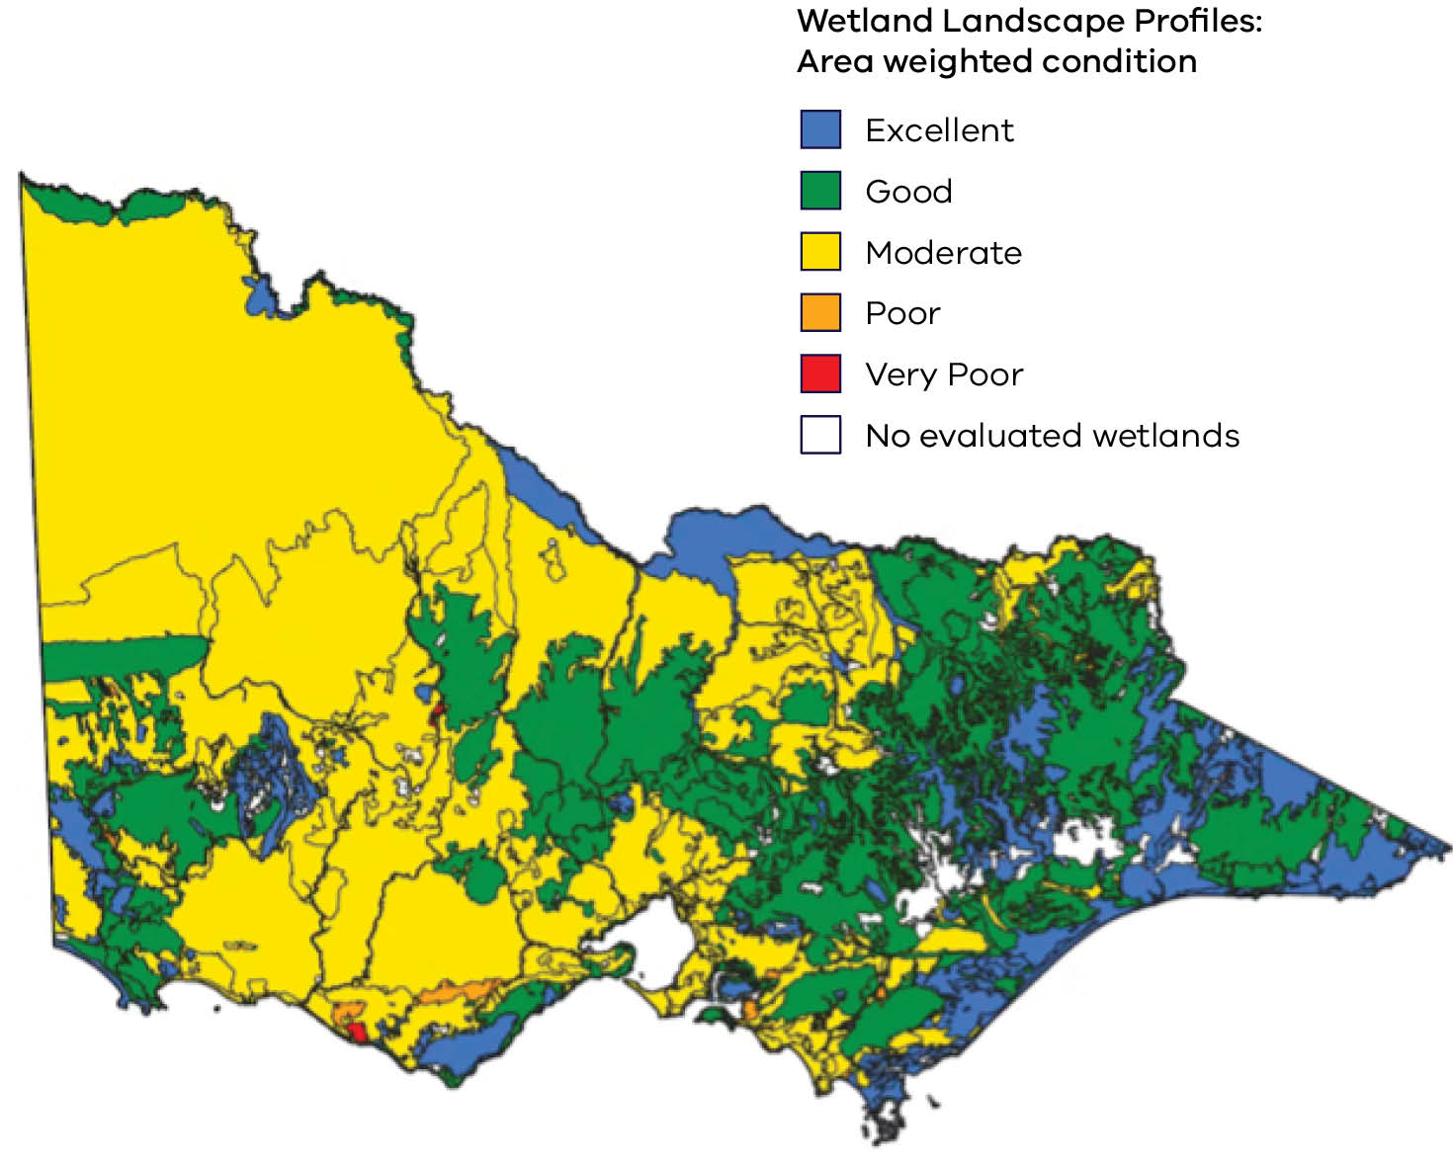

Wetlands
The new Victorian Wetland Condition Assessment used remote sensing approaches to calculate area-weighted average wetland condition. The map shows results from the first assessment of the environmental condition of Victoria's inland natural wetlands.
Statewide, 13% of wetland area was assessed as being in excellent condition, 11% in good condition, 30% in moderate condition, 26% in poor condition and 6% in very poor condition. On average, wetlands on public land are in better condition, with one third of wetland area rated as excellent condition, compared to just 2% on private land.
Sub-figure 4.3: Estuaries
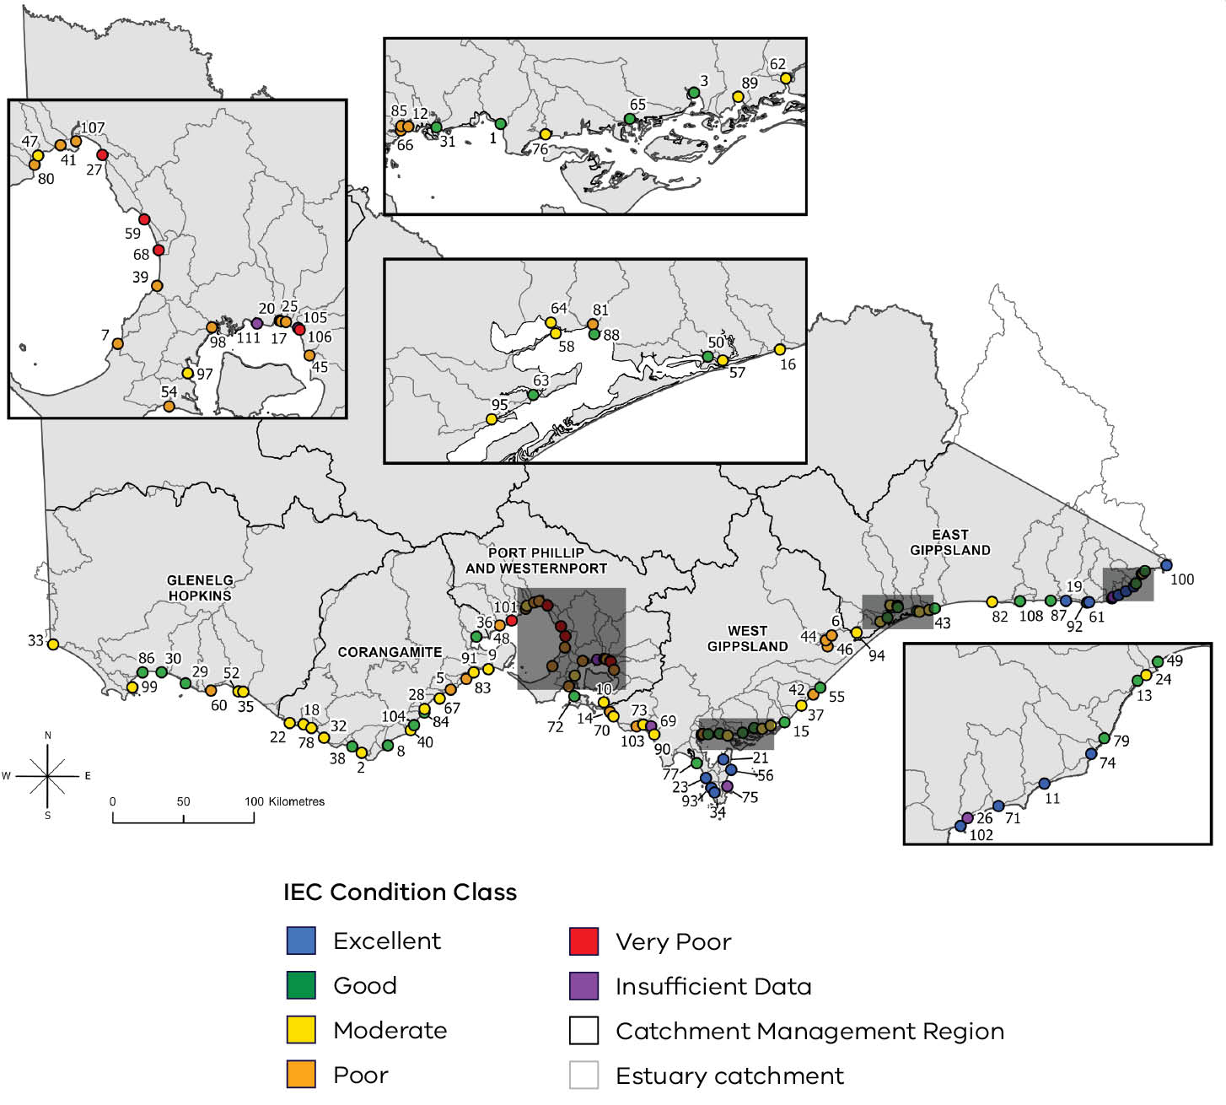

Estuaries
In 2021 the Index of Estuary Condition (IEC) provided the first statewide benchmark condition assessment for 101 estuaries. It found that 13% were in excellent condition, 25% in good condition, 32% in moderate condition, 25% in poor condition and 5% in very poor condition.
The estuaries in excellent condition were generally located along the Gippsland coastline, downstream of forested landscapes, while those in poor condition were generally in catchments with either intensive agriculture or urbanisation.

Climate change
Climate change presents a critical challenge to the management of Victorian waterways. It’s impacting their health, biodiversity and the communities that rely on them. Victoria is already experiencing a range of documented changes in climate, which are relevant to how we approach waterway management. These include:
- an increase in average temperature by 1.2°C since official records began in 1910 and by around 1.4°C since the pre-industrial era, with hot days and heatwaves becoming hotter and more frequent
- a decrease in average rainfall in all seasons except summer, with a more than 10% decline in cool season rainfall over the past 30 years, plus a corresponding step-change reduction in stream flows
- a decrease in average annual rainfall, with extreme rainfall events generally becoming more intense
- more intense, frequent and longer heatwaves since the 1950s, with the heatwave season starting earlier
- an increase in bushfire frequency, area burned and severity
- a decrease in snow depth cover in alpine regions since the late 1950s
- more extended dry periods and changing flood patterns
rising sea levels, increasing the frequency of coastal inundation and affecting estuaries, wetlands and other low-lying coastal waterways.
These changes present significant challenges to Victorian waterways – affecting their flow regimes, water quality and overall ecosystem health. Wetlands, for instance, are particularly vulnerable to drying, with implications for waterbird breeding and biodiversity.
Other climate change impacts that have been observed in Victorian waterways include:
- more algal blooms and fish deaths
- conditions favouring invasive species
- increased storm surges
- more periods of estuary mouth closures
larger floods.
These impacts are expected to continue and increase in severity, with higher temperatures, increased heatwaves and intense rainfall events and sea level rise.¹⁵ While the natural environment can adapt to climate change in some ways, this varies across ecosystems and species. Waterways that are already degraded and/or subject to significant ongoing threats are likely to be less resilient and more vulnerable to the impacts of climate change.
Given these long-term trends, waterway management needs to continue being innovative, adaptable and specific to regional needs.
Waterway managers will work with partners to respond to opportunities and risks so that Victorian waterways sustain their biodiversity, ecological function and communities, while continuing to provide for a range of other values and uses.
Opportunities to respond to climate change are outlined in Chapter 5. This includes the regional waterway strategy development process to consider risk management and systematic adaptation. Opportunities to leverage regional partnerships and public-private models to deliver regional outcomes are outlined in Chapter 15.

Population change

Population growth
Victoria is one of Australia’s fastest growing states, with the population expected to grow from 6.8 million in 2023 to 10.3 million in 2051. Melbourne’s population is expected to grow from 5.1 million in 2023 to 8 million in 2051 – and Victoria’s regional population from 1.7 million to 2.3 million over this same period. Population growth, combined with hotter and drier conditions, will significantly increase demand for water and intensify competition to support a range of values. The Water Cycle Climate Change Adaptation Action Plan outlines key risks and opportunities for Victoria’s water cycle in response to these pressures.
Opportunities to diversify water supplies and reduce pressure on surface flows to meet growing demands are outlined in Chapters 7 and 14.

Urban development
By 2036, the 3 largest local government areas (Greater Geelong, Greater Bendigo and Ballarat) are projected to continue to account for about one third of Victoria’s regional population, having underpinned around half of its growth since 2021. It’s expected that one in five regional Victorians will live in Greater Geelong by 2036.
Increasing population in both metropolitan and regional Victoria will see urban development contribute to significant changes to water flows. Stormwater management has become a critical issue, affecting both urban centres and regional areas. Its effective management is vital for protecting the health of waterways from pollution and degradation. Increased urbanisation leads to more impervious surfaces such as roads, rooftops and paving, which contribute to higher volumes of stormwater runoff. This runoff carries pollutants into waterways and threatens aquatic life and water quality. The percentage of impervious surfaces has already caused irreversible impacts on estuarine ecological function and physical form across many Victorian estuaries.
Opportunities to influence urban planning are outlined in Chapter 14.

Changing rural and regional areas
In rural Victoria, population growth is accompanied by the changing nature of farming – which is:
- becoming more diverse in response to consumption patterns
- becoming more industrialised – involving heavy machinery and large-scale irrigation and equipment
- intensifying – with more horticulture, supplementary feeding livestock, aquaculture and poultry farming
- aggregating – with farms becoming larger to achieve economies of scale and productivity
- experiencing social change – with part-time farming and an increase in off-farm income
increasingly guided by the use of technology.
While all of these changes can increase threats to waterway habitats, emerging technologies also offer opportunities to benefit waterways by more precisely applying fertiliser and water.
A key challenge is supporting social capacity for waterway stewardship, especially when working with farmers and other private landholders who have diverse perspectives, land management practices and aspirations.
In addition, more people are moving to rural and regional areas. Much of this growth is expected close to or in regional cities and towns, bringing both new pressures and new opportunities for the planning and management of waterways and land use.
Opportunities to undertake active management in partnership with farmers and other landholders, Traditional Owners, and communities, are outlined throughout this Strategy, and in particular in Chapter 15.

Part 2. The management approach

Chapter 4. Waterway management levers
Victoria’s waterway management approach requires the full range of management levers and activities to be applied at appropriate scales, including:
- recognising waterways as living and connected entities
- on-ground waterway management, informed by regional waterway strategies
- protecting waterways within parks and reserves
- applying appropriate regulation to protect waterways
- integrating land use and waterway management
working together in waterway management.
This approach will help address waterway conditions that balance and support the values and uses of waterways. It will apply a climate-change lens to planning, prioritisation and on-ground delivery, in line with Victoria’s climate change policy framework as per the Climate Action Act 2017. More information on Victoria’s climate change framework can be found at climatechange.vic.gov.au.

Recognising waterways as living and connected entities
First Nations people and community groups around the world are leading the push to recognise waterways and other important cultural landscapes as living entities with an independent right to flourish. This was also evident in most Nation Statements provided by Victorian Traditional Owners for the Water is Life: Traditional Owner Access to Water Roadmap.

Box 1 – Caring for Birrarung as a living entity
Burndap Birrarung burndap umarkoo has created a new way of working for the agencies, councils, Traditional Owners and community organisations responsible for Birrarung and its lands. The recognition of the river and its surrounding public land as one living and integrated natural entity connected from source to sea has created space for conversations and decisions that cross boundaries and generations.
One example of how this works in practice is the implementation of Greening the Birrarung. Councils and agencies are working together to align planting, habitat protection, canopy mapping and biodiversity investment along the length of Birrarung, strengthening relationships and supporting a more connected approach to caring for the river. This work has been enriched by Traditional Owner guidance, including knowledge that understands the river as a living entity and grounds restoration in responsibility, connection and care for Country.
The experience of Burndap Birrarung burndap umarkoo shows that recognising a waterway as a living entity can change how institutions work together. It provides a shared language and purpose for agencies that might otherwise operate within separate mandates, boundaries and planning cycles. Most importantly, it places the wellbeing of Birrarung at the centre of decision-making, reflecting the principle expressed in the plan’s Woi-wurrung title: what is good for the river is good for all.

Policy 1 – Waterways as living and connected entities
Existing policy incorporated into the Victorian Waterway Management Strategy
Victorian waterways are to be recognised as living and connected entities.
Management approaches must continue to consider:
- Lateral and longitudinal connectivity, regardless of institutional boundaries and land tenure
- groundwater/surface water connectivity
- active management at meaningful scales
- spiritual connections and cultural rights of Traditional Owners
- community wellbeing.
Recent evidence suggests that the most successful aspect of recognising waterways as living entities has been changing how the community and natural resource managers interact with the environment. Previous Victorian waterway strategies embedded an integrated catchment management approach, which has supported management of waterways at meaningful scales for many years. For the first time, the Strategy specifically recognises waterways as living and connected entities, to build upon this ‘systems approach’ and reflect the cultural knowledge that Traditional Owners have shared.
The shift places First Nations people, their world views and their traditional environmental care practices at the centre of waterway management. It acknowledges the tension between the practices of waterway managers, other agencies and an evolving community mindset that values recreation. This mindset also understands many rivers as working rivers, while also recognising their cultural and intrinsic value. This informs Policy 4, which recognises that waterways continue to have values even when conditions are under pressure, or change.
This policy is not a reform program. It’s an acknowledgment of a truth. This policy allows Traditional Owners to meet their cultural responsibilities and offers a clear way for all Victorians to develop a deeper and more respectful relationship with our waterways. Our mindset changes from ‘we own the river’ to ‘we are the river’.
For waterway management agencies and their partners, it means:
- planning for waterways and their lands as interconnected systems that are intrinsically linked to their communities’ wellbeing and provide for a balance of values and uses. This approach aligns with integrated catchment management and systems thinking, which are well-known practices in Victoria.
- collaborative leadership, using existing partnership forums to advocate for exploring options that transcend institutional boundaries and plans at meaningful time-and-place scales. This will help identify opportunities to achieve multiple benefits through collaborative investment.
- engaging with Traditional Owners with this policy as the starting point, to support cultural safety and mutual respect as the basis for partnership.
encouraging conversations about community relationships with waterways and how we continue to support waterways through change.
Recognising waterways as living and connected entities in the Strategy will be the first step for informing future regional waterway strategies and regional catchment strategies. Future opportunities to build it into other water management frameworks will be investigated. It doesn’t change the functions of any authority, or the rights of Traditional Owners. The legislative framework or obligations that must be considered as part of water management, storage management or river operations won’t change either. It also doesn’t recognise legal personhood or require new governance structures for waterways.
Instead, the Strategy guides how waterway managers and partners should perform their functions.
This policy supports the Victorian Government’s work on commitments to investigate legislation around waterways as living entities (as outlined in Water is Life and the Rivers of the Barwon and Waterways of the West action plans).

Action 1
Action | Who | When
A. 1–Develop case studies with partners that demonstrate how a living and connected entity approach is being applied. These will be shared through regional waterway strategy mid-term and final evaluation. | Lead: Waterway managers  Collaborate: Traditional Owners, farmers and other landholders, agencies and community | by 2035

On-ground waterway management informed by regional waterway strategies
Waterway managers and partners will continue to deliver on-ground waterway activities in the priority areas identified in regional waterway strategies – on both public and private land. These activities are delivered with landholders and other land managers and apply the cost-sharing principles outlined in Chapter 17. On-ground works programs include activities like those shown in Figure 5, with implementation informed by policies within this Strategy.

Victorian Waterway Management Program
The Department of Energy, Environment and Climate Action (DEECA) is primarily responsible for overseeing the Victorian Waterway Management Program and establishing Victoria’s policy framework for waterway management.
The Program works alongside other programs and activities that contribute to outcomes for waterway values. It has contributed to:
- improving critical waterway habitats and managing water for native plants and animals, threatened species, iconic fish and waterbirds
- maintaining high-quality water which benefits everyone
- removing weeds and reducing threats from invasive animals
- protecting waterways from inappropriate works and activities and guiding developments to reduce the risk of harm
- research that targets critical short-term and strategic long-term knowledge gaps to inform and improve waterway management activities and policy.
Figure 5: Regions of Victoria with examples of on-ground waterway management projects
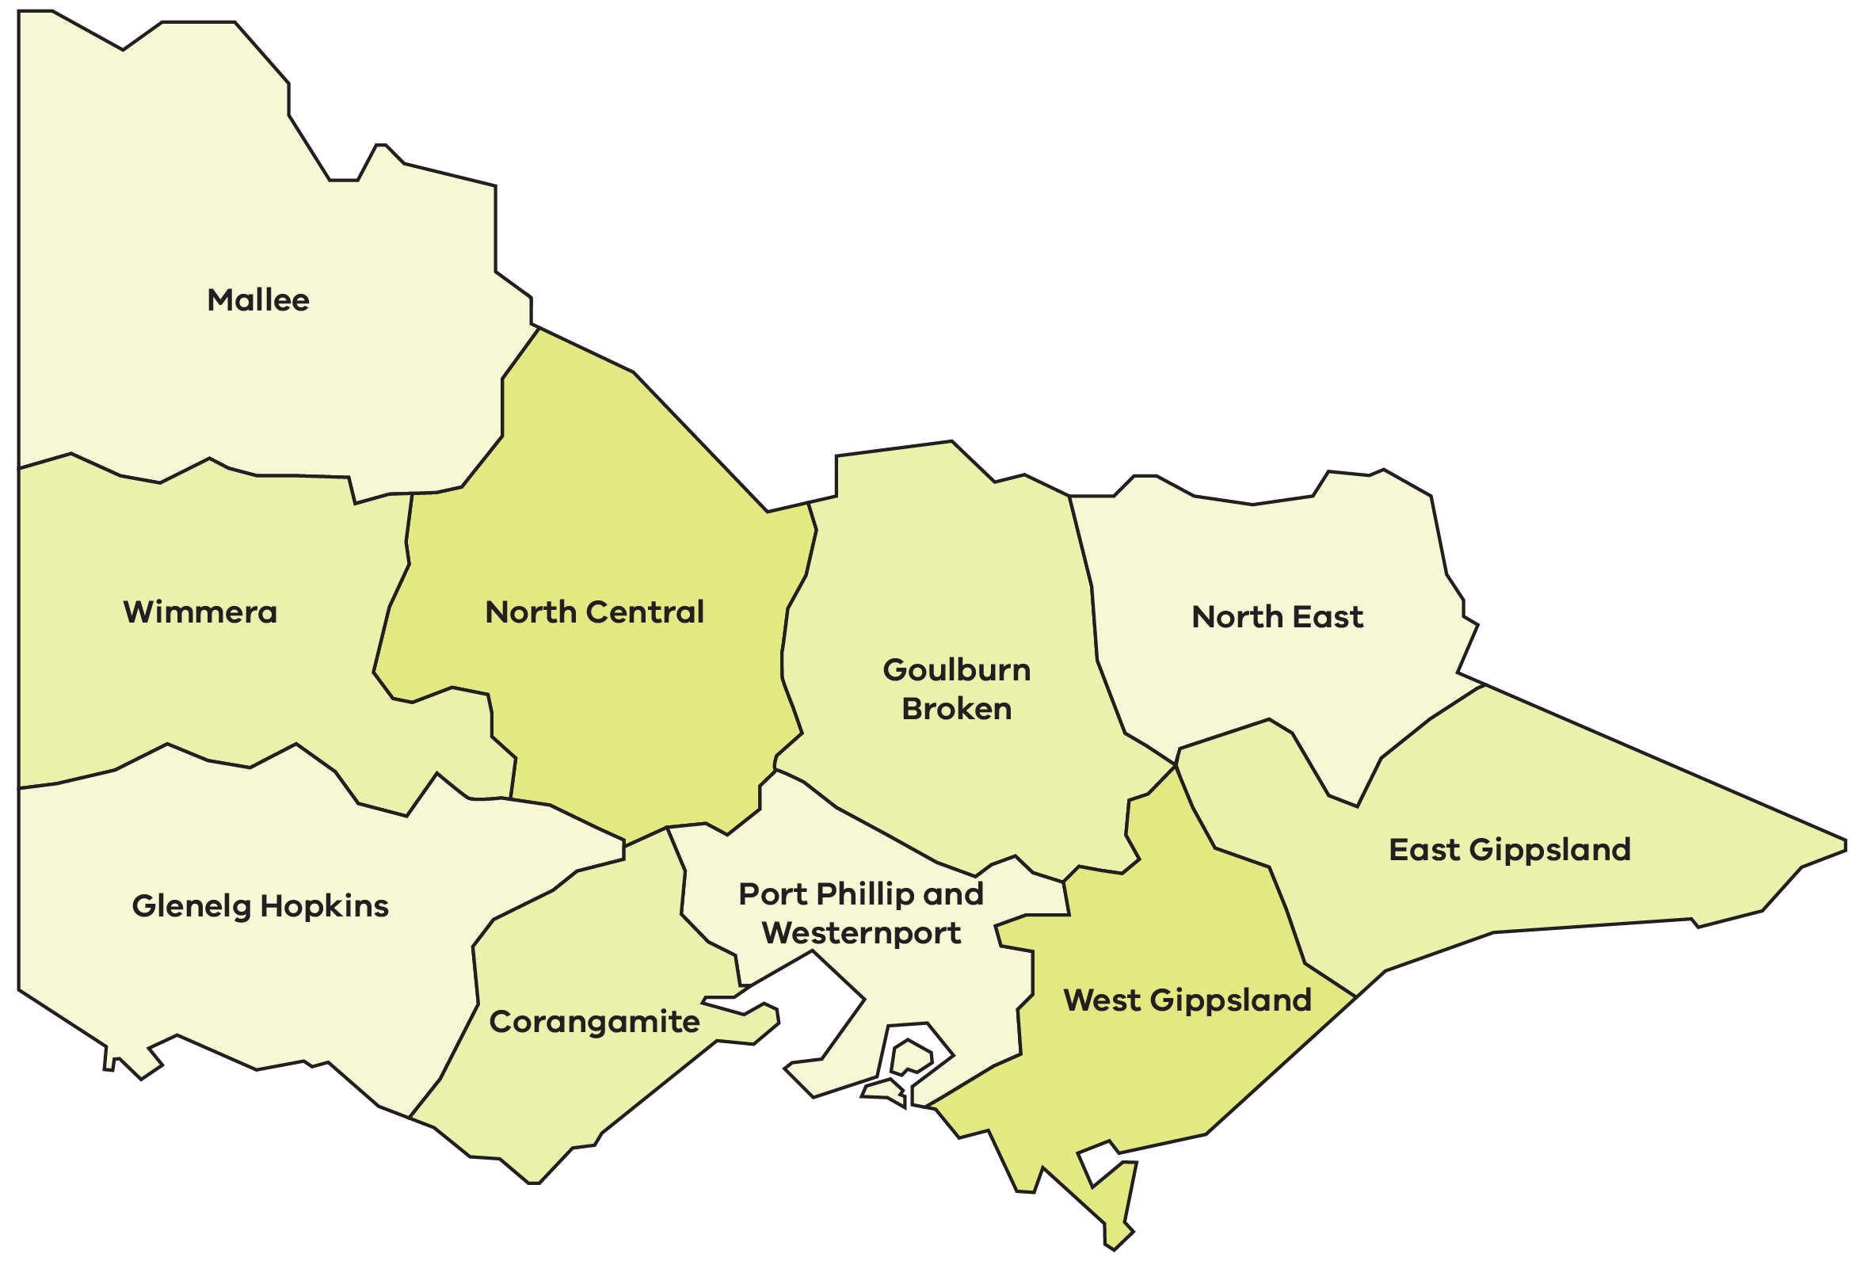
The regions of Victoria with examples of on-ground waterway management projects are:
- Mallee
- Wimmera
- North Central
- Goulburn Broken
- North East
- Glenelg Hopkins
- Corangamite
- Port Phillip and Westernport
- West Gippsland
East Gippsland.

Mallee
Floodplain infrastructure for environmental water management was installed, as part of the Catfish Billabong Project, to return more natural wetting and drying cycles to the wetland, benefitting the billabong and native species.
Figure 5.1: Catfish Billabong Project, Mallee region
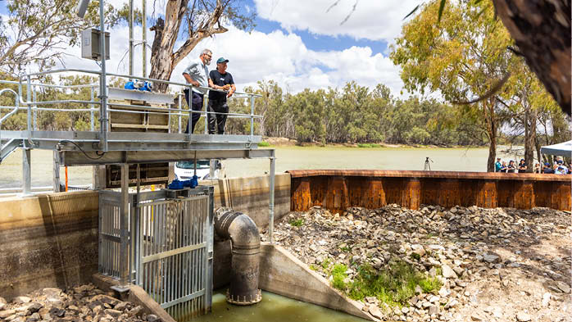

North Central
The Tullaroop Catchment Restoration Project partnered with farmers, other landholders and Traditional Owners to create a healthy, continuous riparian corridor to improve river blackfish and platypus populations and improve water quality.
Figure 5.2: The Tullaroop Catchment Restoration Project, North Central region
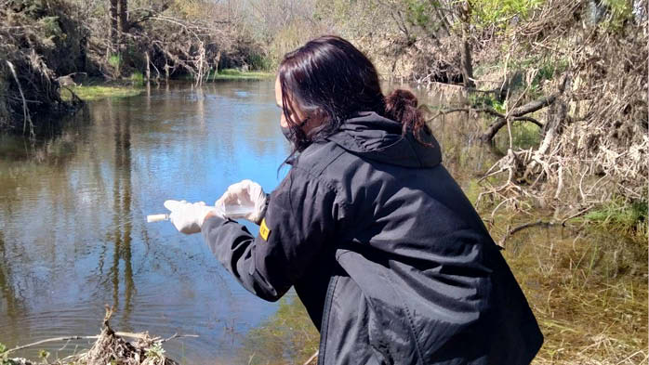

Wimmera
The Wimmera Clearwater Revival Project works with the community to enhance the waterway values of the Upper Wimmera Catchment. Rock chutes have been constructed to control active erosion and sedimentation movement in creeks and gullies.
Figure 5.3: The Wimmera Clearwater Revival Project, Wimmera region
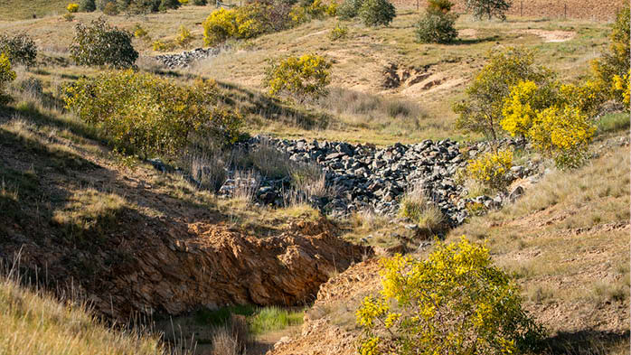

Glenelg Hopkins
The Grange Burn Restoration Project protects platypus, rakali, and threatened native fish by removing invasive weeds and planting native vegetation. The project also launched an exciting livestream feature, ‘Platycam’.
Figure 5.4: The Grange Burn Restoration Project launched livestream feature, ‘Platycam’
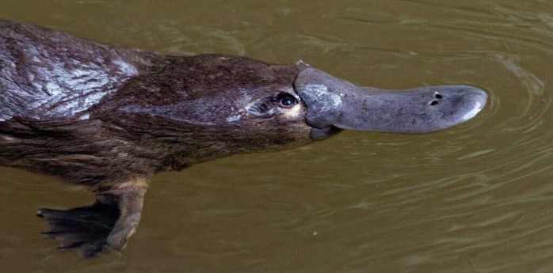

Goulburn Broken
Hughes Creek has seen targeted investment in fencing, revegetation, weed control and instream structures, improving habitat and connectivity for a genetically important local population of endangered Macquarie Perch. Works are complemented by monitoring, translocations and re-stocking to sustain this population and contribute to wider recovery efforts.
Figure 5.5: Hughes Creek, Goulburn Broken region
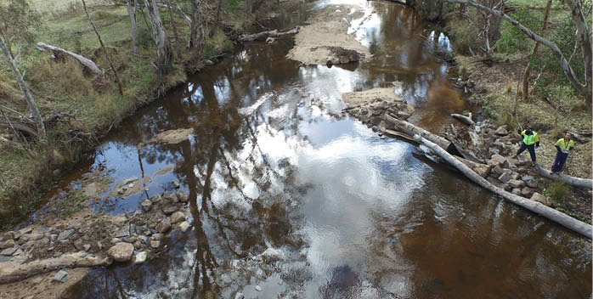

North East
The Tea Garden Weir fishway structure helps endangered fish species, such as Murray Cod and Trout Cod, move freely and connect with habitats and refuge.
Figure 5.6: The Tea Garden Weir fishway structure, North East
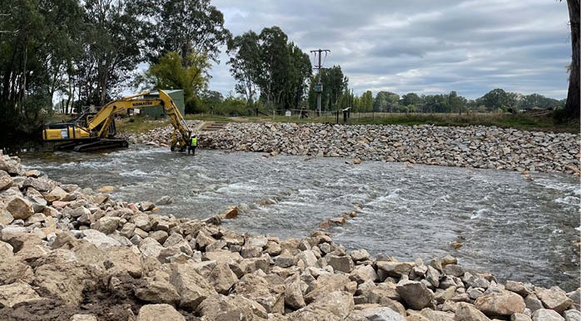

Port Phillip and Westernport
The Annulus Billabong project is a partnership between Melbourne Water and Wurundjeri Woi-wurrung Cultural Heritage Aboriginal Corporation reconnecting the billabong to the Birrarung (Yarra) to restore native plants and wildlife.
Figure 5.7: The Annulus Billabong project, Port Phillip and Westernport region
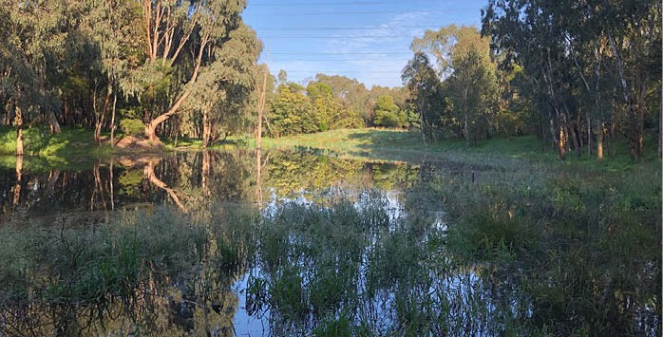

East Gippsland
The Genoa River Restoration project has enhanced the resilience of the river channel. Working with landholders on innovative techniques, including replacing timber and vegetation, has restored fish passage and stabilised this important sand bed stream.
Figure 5.8: The Genoa River Restoration project, East Gippsland
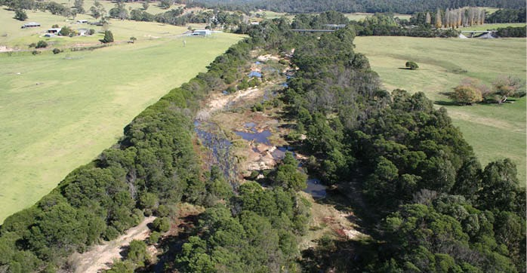

Corangamite
The Barwon Flagship Waterway Project is a large scale, long-term project to improve the health, connectivity and biodiversity of the Barwon River by reducing the impacts of willows and Reed Sweet Grass, removing stock from the river system and revegetating with indigenous plant species.
Figure 5.9: The Barwon Flagship Waterway Project, Corangamite region
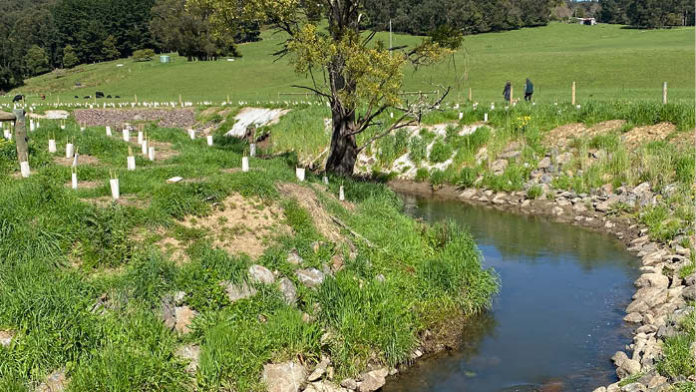

West Gippsland
The Agnes River project sees Landcare groups, landholders, West Gippsland CMA and others working together to rehabilitate the entire length of the Agnes River. Enthusiastic, long term community support and partnerships are improving catchment health and protecting the downstream, Corner Inlet Ramsar site.
Figure 5.10: The Agnes River project, West Gippsland region
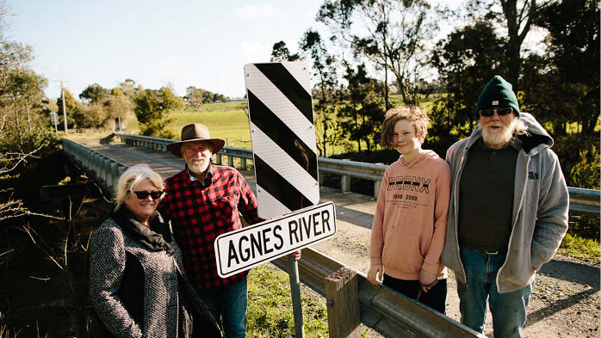

Protection of waterways within parks and reserves
Some Victorian waterways are located either partly or entirely within public land in parks and reserves. In some cases, the primary function of the public reserve is to protect waterway values. Public land in Victoria covers approximately 8 million ha – about one third of the state. It’s made up of over 110,000 parcels which form parks, reserves and areas of state forest. Public land is managed for a range of uses including recreational, cultural, forestry, conservation and government services. Victoria also has an extensive area of land set aside in protected water supply catchments, which are managed for the protection of potable water supply in accordance with the Safe Drinking Water Act 2003.
Public land managers are important partners in waterway management and for implementing this Strategy and regional waterway strategies. Managers of public land reserves include DEECA, other state government departments, statutory agencies such as Parks Victoria, local councils and voluntary committees of management.
Increasing permanent protection of significant environmental values in protected areas is part of the Australian and Victorian governments’ ‘30 by 30’ target. This is an ongoing commitment to protect and conserve 30% of Australia’s landmass and 30% of Australia’s marine areas by 2030. Waterway lands are a small proportion of the landmass but represent high biodiversity value (See Box 15 – Nature Repair Act 2023 for further information).

Applying appropriate regulation to protect waterways
Regulation is a key tool for protecting waterway values. A range of regulatory requirements are already in place, including:
- Victoria’s Environmental Protection Framework (See Chapter 11)
- requirements for licensing of works on waterways (refer to Chapter 17)
- licensing of the take and use of water (refer to Chapter 7)
- protections under the Aboriginal Heritage Act 2006 and Traditional Owner Settlement Act 2011
aspects of land use planning.

Integrating land use and waterway management
The land use planning system is important for influencing waterway outcomes. While it includes policies and controls to manage the potentially adverse impacts of development on waterway values, land use change and development still represents a key threat to waterways. The land use planning system can’t address legacy impacts from colonisation or existing land use. However, it can help to minimise future threats to waterway values and outcomes, optimise the benefits of waterways for future communities and ensure development planning reasonably prepares for climate change impacts.
The planning system sits under the Planning and Environment Act 1987. It has the potential to manage the siting, form and design of development which may affect a waterway, such as its amenity or the quality of stormwater runoff.
The land use planning system is made up of the components shown in Appendix 4. The key components of the Victoria Planning Provisions (VPPs) and planning schemes are state and local provisions, zones and overlays, as well as particular provisions for specific development types – which all influence waterway protection and management. Clause 12.03-1S of the Victoria Planning Provisions sets out the state planning policy on river and riparian corridors, waterways, lakes, wetlands and billabongs.
Some tools, like guidelines, practice notes and background documents, exist outside the VPPs and planning schemes – but support decisions by developers and local councils.

Policy 2 – Land use planning system for waterway outcomes
Existing policy incorporated into the Victorian Waterway Management Strategy
The Victorian Government will embed waterway values in land use planning processes to support delivery of the Victorian Waterway Management Strategy.

Action 2
Action | Who | When
A.2–Work with the Department of Transport and Planning (DTP) and local government to ensure consistency in how the Victorian Waterway Management Strategy and the regional waterway strategies are referenced in the VPP and planning schemes. | Lead: DEECA  Collaborate: DTP, Municipal Association (MAV), waterway managers | by 2030

Action 3
Action | Who | When
A.3–Work in partnership to investigate opportunities to strengthen the planning schemes’ protection of waterways and support the role of waterway managers and planning authorities to:  - use existing mechanisms within the land use planning system more effectively  - clarify roles and responsibilities, particularly for waterway managers and ensure that existing functions are used as efficiently as possible  - address key gaps in waterway protection through applying specific planning tools  - recognise Traditional Owners’ cultural rights and responsibilities for waterways in planning tools and guidance  - improve guidance and tools for practitioners. | Lead: DEECA  Collaborate: DTP, Traditional Owners, MAV, Local government, waterway managers, water corporations | by 2030

Working together in waterway management
Effective planning and management for waterways requires strong collaboration, for addressing the scale and complexity of issues and balancing the various uses and values of waterways. With around 62% of land in Victoria privately owned and managed, many waterway outcomes depend on strong, enduring partnerships with farmers and other landholders. It’s a joint effort that respects the functions of government agencies, the knowledge and cultural obligations of Traditional Owners, and the stewardship of farmers and other landholders, communities and advocates (See also Chapter 17 and Appendix 6).
Along with formal institutional arrangements, effective waterway management takes the ongoing commitment and input of the community, non-government organisations, industry and research institutions. This helps to leverage the approximately $1.56 billion worth of services and benefits that Victorian waterways provide to the community each year.⁵ When the environmental conditions of waterways decline, so too do the public and private benefits they deliver.
Existing collaborative approaches, like the Regional Partnership Groups and Integrated Water Management Forums, will be led regionally – with support from DEECA where required.
Consultation, collaboration and partnership describe different ways of working together and may overlap in practice (for example, collaborative partnerships) or vary in scope and form. Consultation involves seeking and considering knowledge, perspectives and feedback to inform decisions. Collaboration involves working together to achieve shared objectives and may include shared influence over decisions and outcomes. Partnerships go further, involving agreed roles, responsibilities and governance arrangements, with greater shared decision-making, mutual accountability and collective responsibility for achieving outcomes.

Policy 3 – Collaborating among regional waterway managers and partners
Updated policy from the previous Victorian Waterway Management Strategy
Waterway managers will continue to lead collaboration to work towards regional outcomes. Partnerships will also continue to be central to the approach. Waterway managers will work with Traditional Owners, local government and public agencies, as well as communities including landholders, recreational users and other community groups.
Waterway management partners will be supported to collaborate through capacity building and guidance.

Box 2 – Partnerships with landholders
Stewardship programs help waterway managers work alongside farmers and other landholders to protect and restore waterways on private land. Supported by Victorian Government investment, these partnerships deliver practical actions such as fencing, revegetation and pest management, improving waterway health while supporting productive and sustainable agricultural landscapes.
By combining local knowledge with practical support and funding, stewardship programs enable landholders to make lasting improvements that benefit waterways, native vegetation, wildlife and future generations. As one third-generation farmer participating in the Mallee CMA stewardship program said, "It’s really rewarding to see those little trees growing – it brings in native wildlife, changes the landscape and makes you feel good about doing something for the future and sustainability of your land."

Chapter 5. Planning for our waterways even as our climate changes

What we mean
Regions are the 10 catchment management regions in Victoria.
Regional waterway strategies integrate the management levers and activities (See Chapter 4) to balance the values and uses of waterways and achieve regionally set outcomes consistent with statewide policy. A regional waterway strategy is developed by the waterway manager in collaboration with Traditional Owners, local communities and other regional and state agencies, as required under Section 190 of the Water Act 1989.
Regional outcomes are objectives for the region’s waterways set collaboratively with waterway managers, Traditional Owners, community and agencies. They direct the priorities of the regional waterway strategies.
Adaptation approaches refer to the methods and approaches used to adjust to the impacts of climate change and other challenges, enhancing resilience and reducing vulnerability.
Adaptation pathways are broadly understood as sequences of actions that can be implemented progressively, depending on future dynamics.

What we're already doing
Waterway managers have effectively collaborated with local communities and agencies to create and implement regional waterway strategies for over 20 years now. These efforts have led to targeted improvements in waterways throughout Victoria, where active management is undertaken by waterway managers, Traditional Owners, agencies and communities.
Regional waterway strategies are sub-plans to regional catchment strategies (RCS) as shown in Appendix 1 and drive the achievement of long-term outcomes in the RCS. Regional waterway strategies will continue to align with other key regional and statewide plans – such as Country plans, Water is Life and sustainable water strategies.
Regional waterway planning has been crucial for identifying local threats to waterways and working with landowners and managers to address these issues.
New regional waterway strategies are under development in accordance with Ministerial Guidelines (2024). The updated strategies will focus on planning for the broad range of uses and values of waterways, recognising the central role of environmental conditions and functioning ecosystems in supporting all waterway values.

Adaptation approaches in waterway planning
The natural environment can adapt to climate change and other impacts to some degree, but this ability varies across ecosystems and species. Waterways that are already degraded and subject to significant ongoing threats are likely to be less resilient to future impacts. Some ecosystems will be able to withstand climate-related impacts and remain unchanged, or can recover components of their natural processes and functions. Others will not.
The social, economic and cultural values of waterways will also be impacted by climate change and other impacts, with these values having varying levels of resilience. For example, extreme events may repeatedly impact particular cultural sites or infrastructure through flooding. In other cases, highly-valued places used for recreation may no longer be able to be enjoyed due to lack of water or water quality issues.
Adaptation approaches are essential for setting regional outcomes, as they consider all the factors affecting waterway values, conditions, and the communities that rely on them. There are 3 adaptation approaches that can be used to help inform the planning and management of waterway values (See Figure 6). They can be applied at different scales or to different values, and in some waterways multiple approaches may be applied at the same time.
- Resilience – the value/values will be impacted but has the capacity to recover to its previous state. Management involves minimising the impacts of threats and supporting existing waterway values so that they can persist or be restored in their current locations.
- Transition – the value/values will be impacted and won’t recover to its previous state. Waterway values can change in structure or composition. Management involves supporting existing waterway values/systems to gradually move to a new state, by maintaining the integrity of ecosystems and processes.
- Transformation - the value/values will be impacted when a step change or tipping point is reached and won’t recover to its previous state. This could lead to new waterway values and new management outcomes. Waterway values and systems may need to be managed in new ways. This is especially important for those waterways undergoing rapid and significant transformation, or those that have already reached a tipping point and have changed irrevocably.

Policy 4 – Planning for resilience, transition and transformation
Existing policy incorporated into the Victorian Waterway Management Strategy
Waterway ecosystems, biodiversity and other values will be managed to build resilience.
Where appropriate, regional outcomes and management approaches will be adapted to support transition and transformation that balances the values and uses of waterways.
Figure 6: Climate change adaptation approaches and examples for regional waterway planning
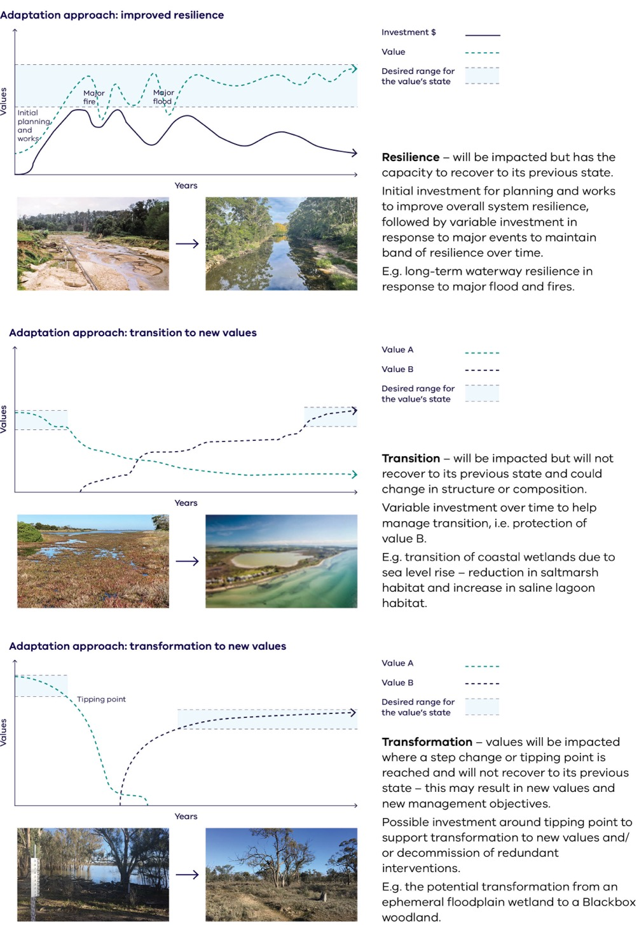

Text description of Figure 6
Figure 6 sets out three approaches to climate change adaptation for regional waterway planning. Each approach is illustrated by a graph showing how values change over time relative to the desired range for the value's state, a pair of before-and-after photographs, and a short explanation.

Adaptation approach: improved resilience
- Resilience – the value will be impacted but has the capacity to recover to its previous state.
- The graph plots investment and value over years. An initial investment in planning and works lifts the value into the desired range; the value then dips and recovers after a major fire and a major flood, while investment varies in response to each event.
- Initial investment for planning and works to improve overall system resilience, followed by variable investment in response to major events to maintain a band of resilience over time.
- Example: long-term waterway resilience in response to major flood and fires.

Adaptation approach: transition to new values
- Transition – the value will be impacted but will not recover to its previous state and could change in structure or composition.
- The graph plots two values over years. Value A declines out of its desired range, while Value B rises into a new desired range.
- Variable investment over time to help manage the transition, that is, protection of Value B.
- Example: transition of coastal wetlands due to sea level rise – a reduction in saltmarsh habitat and an increase in saline lagoon habitat.

Adaptation approach: transformation to new values
- Transformation – values will be impacted where a step change or tipping point is reached and will not recover to their previous state. This may result in new values and new management objectives.
- The graph plots two values over years. Value A falls sharply past a tipping point and remains low, while Value B rises from that point into a new desired range.
- Possible investment around the tipping point to support transformation to new values and/or decommission of redundant interventions.
- Example: the potential transformation from an ephemeral floodplain wetland to a Blackbox woodland.

Management principles
The following principles will guide our approach to state and regional decision-making for the management of waterways:
- Traditional Owner self-determination
The government and water sector agencies will partner with Traditional Owners to manage waterways guided by the principles of self-determination, free, prior and informed consent, protection of Indigenous data sovereignty, and the following:
- recognise that equitable outcomes may not always be achieved through equal pathways, and different approaches may be required for each Traditional Owner Group. Engagement, collaboration and partnership arrangements will be adaptive and responsive to each group’s self-determined governance structures, priorities, capacities and resourcing contexts.
- work in partnership with Traditional Owner groups with and without formal recognition in the implementation of the Strategy, recognising their cultural authority, rights and enduring connection to Country.
- engage with Traditional Owners in the planning, implementation and evaluation of actions that have potential to create opportunities or impacts for Country, cultural rights, interests, or aspirations, recognising the right of Traditional Owners to self-determine whether and how they collaborate or partner.
- A climate-change lens to waterway planning
Waterway management will apply a lens of climate change adaptation, which will require managers to:
- consider climate change issues within context – of other pressures on the environment and other socio-economic drivers
- account for the lifetime of the decision – if a decision has long-term consequences, consider climate change projections over this time and whether transformative change may be necessary
- acknowledge uncertainty in future projections – and be transparent about assumptions
- take a futures approach – explore multiple futures and identify tipping points where possible, as well as potential maladaptive actions
- anticipate transformational change early – continually monitor and assess whether resilience or transitional adaptation is sufficient, or whether a new management approach that supports transformational adaptation is required
- Be transparent about trade-offs – consider the potential negative consequences of an action in decision-making and clearly document trade-offs
- Being prepared without acting prematurely Waterway management will be informed by the best available knowledge, and proportionate, risk-based action will be facilitated through ongoing monitoring and evaluation.
- Incorporate Victorian and national legislation, policy and international agreements and obligations for waterway management into decisions (See Chapter 17).

New directions for regional waterway strategies
Regional waterway strategies will recognise that the preservation or conservation of all waterway values could no longer be feasible. We will need to adjust and support our living waterways to adapt to the challenges they face. Waterways will still underpin a balance of values and uses. This requires a renewed approach to identify regionally-important outcomes that still recognise the importance of environmental conditions and functioning ecosystems in supporting waterway values.
New regional waterway strategies will incorporate lessons learned from reviews of previous strategies undertaken by waterway managers. They will also include new information that has emerged since 2014, including policy directions from this Strategy – so that regions are well-placed to meet the challenges facing waterways over the next 10 years and beyond.
Traditional Owners have the right to partner with waterway managers to develop and implement regional waterway strategies with community, regional and statewide agencies, and other stakeholders. Traditional Owners will self-determine their level of engagement and cultural knowledge-sharing for waterway management.
The strategies should be used to guide investment into work programs which deliver regional waterway outcomes.

Policy 5 – Principles for regional waterway strategies
Updated policy from the previous Victorian Waterway Management Strategy
New regional waterway strategies will:
- be guided by a long-term vision which considers the overall vision of the Strategy, relevant regional catchment strategies and waterway values and condition
- include a set of regional outcomes that sit under the regional vision
- embed adaptation approaches and pathways to address challenges including climate change and other regional specific issues
- work with community and partners to set regional outcomes and priorities for management actions using the best available tools and information
- be adaptive to changing strategic priorities – delivered through flexible implementation plans, work programs and other regional plans. These will need to adapt to extreme events, available budgets and other pressures, incorporate new knowledge and information as it emerges, and apply the most suitable approaches and management levers while working towards achieving regional outcomes
- embed Traditional Owners' cultural rights (See Part 3).

Setting outcomes in regional waterway strategies
Regional outcomes sit under the vision. They will be set by considering future scenarios around values, threats, risks to waterway values and the feasibility of addressing these issues. Climate change, population change, other emerging issues and existing conditions should all be considered in identifying and refining regional outcomes. Regional outcomes in regional waterway strategies should be informed by the 3 adaptation approaches outlined in Figure 6. Robust and flexible approaches to achieving regional outcomes will be identified using the best available information.
Regional planning around appropriate scales for outcomes, who should be involved and how we can meaningfully apply Traditional Owner and community knowledge and aspirations will be informed by Policy 1 (Waterways as living and connected entities) and Policy 3 (Regional Collaboration).
Outcomes may refer to:
- the whole of the region
- a particular landscape within or across regions (for example the Victorian Volcanic Plain, Gippsland Lakes or the Victorian Murray Floodplain)
- the Country of a particular Traditional Owner Nation
- specific species or communities
particular recreational, social or cultural values or places.
The outcome setting process must also have regard to the Victorian and national legislation, policy and international agreements obligations for waterway management.

Setting priorities in regional waterway strategies
Waterway management challenges are complex and significant in scale. This makes setting priorities essential. It is important to focus efforts and resources on the most critical issues and cost-effective actions.
Previous approaches have identified high-value waterways and prioritised individual sites, such as a river reach or wetland, based on the level of risk from various threats. While this helped waterway managers identify valuable areas at risk, it was limited in its comparison of the relative value, risk, feasibility and cost of addressing risks of different locations. This made it difficult to prioritise sites for management that would provide the greatest benefits towards achieving outcomes. It was also limited in considering landscape-scale threats and future scenarios, such as climate change.
Waterway managers and partners will set priorities for new regional waterway strategies using a regional priority-setting process summarised in Figure 7. This process aims to identify the most effective and efficient management actions to work towards desired regional outcomes, by using new and improved tools and information. It will involve identifying priority management areas to apply feasible actions that will most likely address threats and improve specific values. The process must consider a range of information, including biodiversity decision support tools (Box 3), traditional ecological knowledge and local community knowledge.
Where there are conflicts between different values, competing views or potential management approaches, decision-making will be guided by the principles and policies of this Strategy. Formal tools such as multi-criteria analysis might also be used to prioritise actions that will deliver balanced and integrated outcomes.
Figure 7: Regional priority-setting process
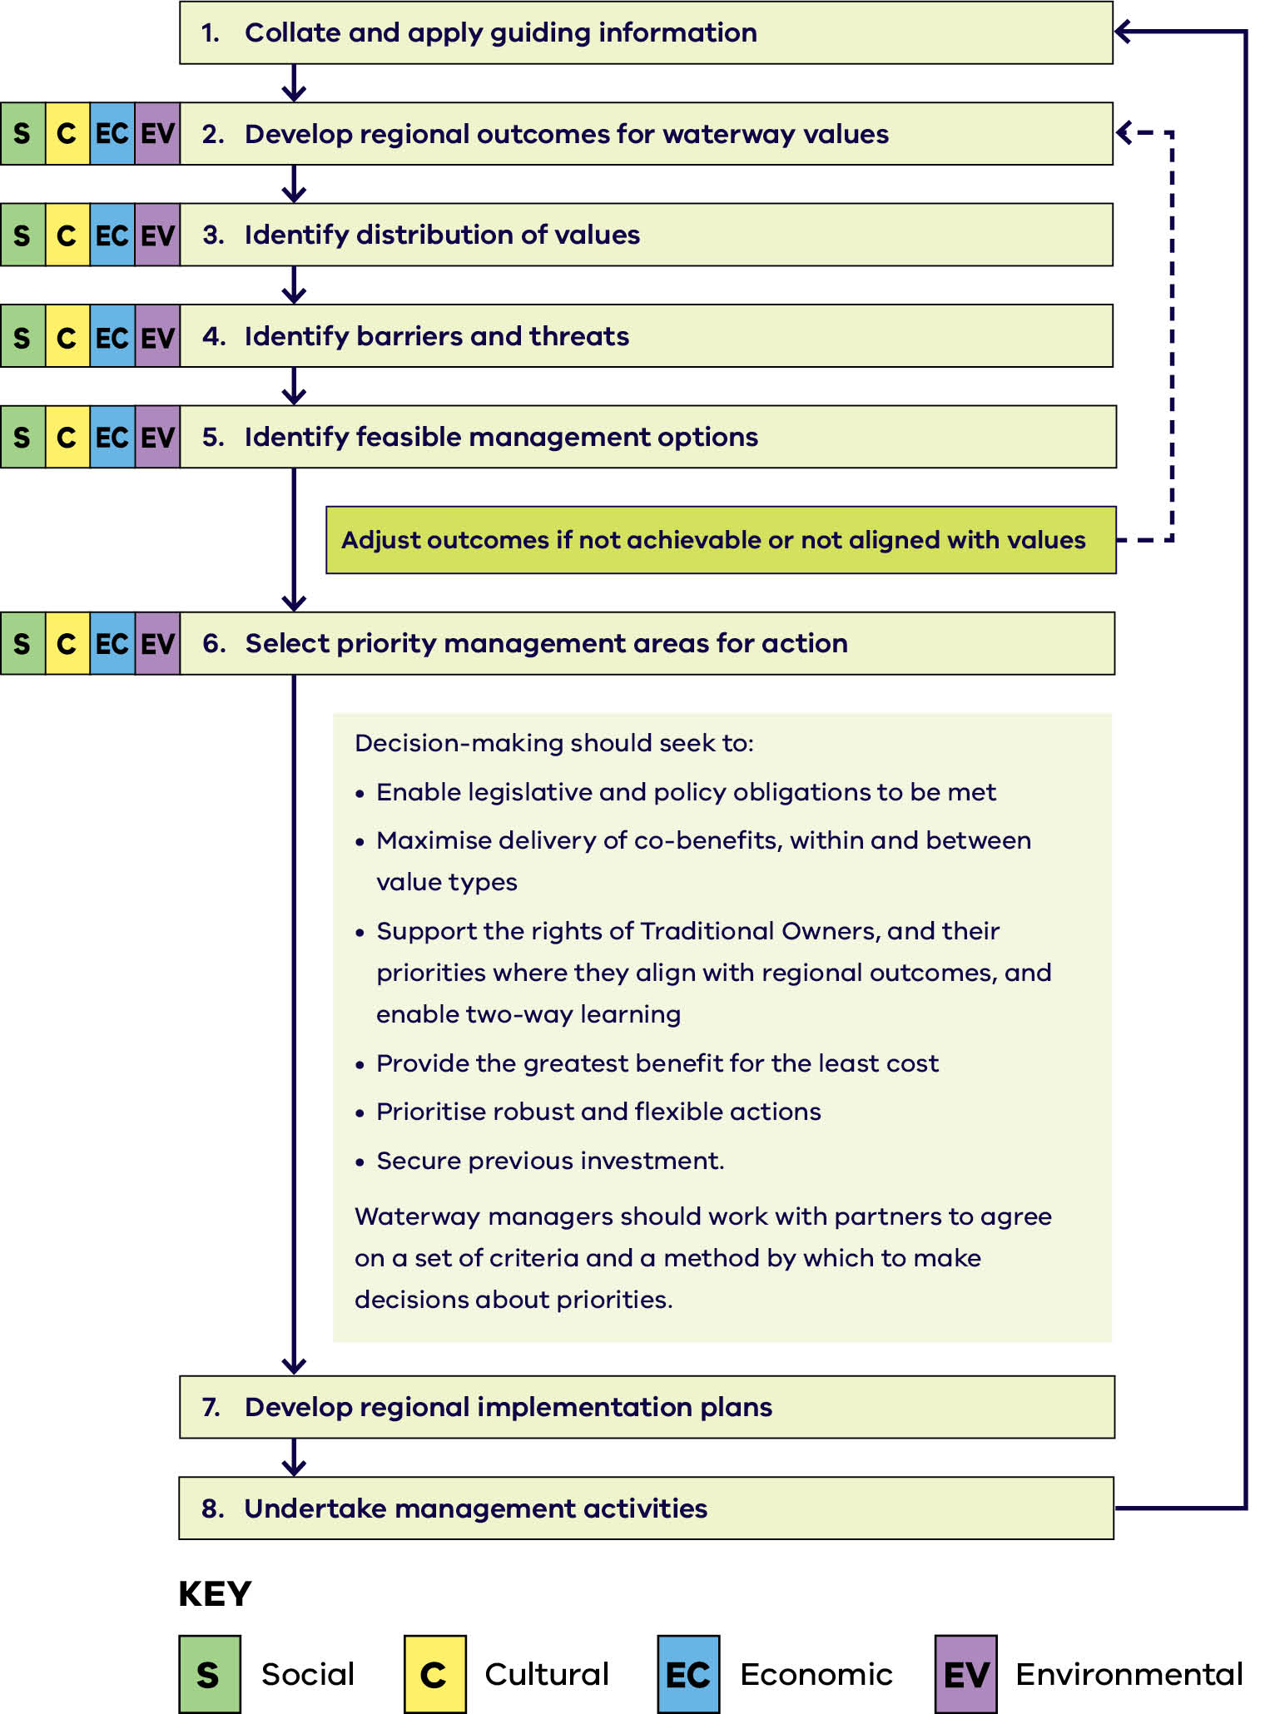
Figure 7 summarises the regional priority-setting process as a flow chart of eight steps, read from top to bottom. Steps 2 to 6 each apply to all four waterway value types, shown in the key as S for social, C for cultural, EC for economic and EV for environmental.
The eight steps are:
- Step 1 – collate and apply guiding information
- Step 2 – develop regional outcomes for waterway values
- Step 3 – identify distribution of values
- Step 4 – identify barriers and threats
- Step 5 – identify feasible management options
- Step 6 – select priority management areas for action
- Step 7 – develop regional implementation plans
Step 8 – undertake management activities.
Two feedback loops connect the steps. After step 5, outcomes are adjusted if they are not achievable or not aligned with values, and the process returns to step 2. After step 8, the process returns to step 1, so guiding information is collated and applied again.
At step 6, decision-making should seek to:
- enable legislative and policy obligations to be met
- maximise delivery of co-benefits, within and between value types
- support the rights of Traditional Owners, and their priorities where they align with regional outcomes, and enable two-way learning
- provide the greatest benefit for the least cost
- prioritise robust and flexible actions
- secure previous investment.
Waterway managers should work with partners to agree on a set of criteria and a method by which to make decisions about priorities.

Box 3 – Waterway management decision tools
DEECA has developed a set of waterway management decision support tools to support priority-setting for the environmental values of waterways. These tools help waterway managers prioritise areas for management, by combining spatial data on waterway biodiversity values with threats to those values, to create a spatially-explicit risk assessment.
The tools assess biodiversity value by combining habitat suitability models for waterway-dependent species to create a biodiversity index, which can be compared between different locations. Decision support tools also map key threats to biodiversity values, so that waterway managers can understand how the intensity of threats is distributed.
Biodiversity value and threat intensity are combined to produce risk to waterway biodiversity maps. This allows the relative impact of a threat on biodiversity to be compared between locations.
Decision support tools are designed to complement existing statewide and regional datasets, along with local and Traditional Owner knowledge. Waterway managers will collaborate with community and partners to balance the environmental priorities identified using these tools with the priorities for cultural, social and economic values of waterways.

Flagship waterways
The benefits of strategic long-term investments in waterway health may not be seen for more than 30 years. Approaches will need to continue adapting over time.
Specific waterways in each region have been identified as a strategic focus for long-term investment in integrated and active management. These flagship waterways can provide an opportunity to track and evaluate progress towards regional waterway outcomes and report the results back to communities.
The Victorian Waterway Management Program will maintain an ongoing commitment to large-scale, long-term investment in managing flagship waterways. The development of regional waterway strategies provides an opportunity to assess whether existing flagship waterway projects remain regional priorities, or if they should be revised accordingly.

Traditional Owner partnership in regional waterway planning
Regional waterway strategies are intended to play a significant role in recognising and embedding Traditional Owners’ cultural obligations and rights to care for water and Country – and in progressing the outcomes in Water is Life. To realise this objective, the Victorian Government requires waterway managers to:
- seek to collaborate and partner with Traditional Owners to develop regional waterway strategies, providing opportunities for increased resourcing and roles for Traditional Owners
- invite Traditional Owners to provide advice and increase the role of traditional ecological knowledge, where Traditional Owners’ free, prior and informed consent is provided to inform waterway planning
- incorporate advice from Traditional Owners into regional waterway strategies
- recognise and respect that Traditional Owner groups will always maintain sovereignty over their cultural data and information – and may prepare a separate document to sit alongside a regional waterway strategy
- embed formal partnership arrangements for waterway management in regional waterway strategies or pave the way for these arrangements through ‘learning by doing’ (refer to Policy 8, Chapter 6).

Preparing for extreme events
Extreme events are intense weather phenomena that have historically occurred infrequently. Climate change is increasing the magnitude and frequency of these major weather events across Victoria, resulting in significant impacts on waterways and communities. Flooding remains one of Australia's most costly natural disasters.
More intense rainfall leads to more frequent and severe flooding, which can accelerate or trigger changes to downstream waterways, including flow paths. Longer and more severe droughts place pressure on natural flow regimes and water resource allocation, which affects aquatic ecosystems and other waterway values in regulated and unregulated waterways. More intense/frequent bushfires result in increased sediment/debris flows, impacting waterway values as well as public and private land.
As these major events occur more frequently, so too does the likelihood of multiple events coinciding and compounding impacts. When consecutive or concurrent events occur, significant impacts are amplified even further. It becomes increasingly difficult to respond to and recover from a new event, while still dealing with the effects of the previous one.
Waterway managers increasingly need to balance their capability requirements, so that they can prepare for and manage major events effectively. This includes the capability to take steps to avoid or mitigate the cost or impact of an event if possible, effectively respond when required, as well as the capacity to sustain the response over time.
The impacts that major events have on affected communities can be profound, long-lasting and life-changing. Waterway managers work with individuals and communities to assess the impacts an event has on the trajectory of the waterway where public assets and waterway values are affected. Recovery activities can support the community and build trust.
It has become clear that a different approach is needed to manage the compounding risks of major events across communities, waterway management services and infrastructure.
The Australian Government’s Emergency Preparedness and Response Plan for Biodiversity and Agricultural Natural Capital Assets provides a useful model to improve preparedness, response and recovery around extreme events impacting waterways in Victoria. This approach emphasises finer-scale planning to protect waterway health and public assets in waterways with a history of concurrent events or at-risk systems – which can be identified through the regional waterway strategy development process.
Planning helps to recognise risks and threats posed by extreme events. This includes planning for all waterway values, including cultural heritage values and public assets. It will aim to improve outcomes through actions and management before, during (to the extent possible) and post-event to support recovery. This approach helps identify the overall management outcomes of waterways, including their resilience to change and their ability to transition or transform to new states (since an impacted system may never recover to its previous state).
As a result, waterway managers, Traditional Owners and communities can prepare for major events and coordinate more effectively across agencies to recover from all hazards. Ensuring that communities are engaged in finding ways to manage risks to waterways arising from major events helps them to navigate trade-offs – and, in the case of flooding impacts, making informed decisions about assets on floodplains.

Policy 6 – Improving preparedness and response planning for waterways
New policy
Waterway preparedness and response planning will be developed for waterways with a history of concurrent events or at-risk systems, to protect waterway values and public assets.

Action 4
Action | Who | When
A.4–In a waterway with a history of concurrent events or at-risk systems, pilot a preparedness and response-planning approach for waterways to protect waterway values and public assets. | Lead: Waterway managers  Collaborators: DEECA, public land and asset managers | by 2030

Implementation planning, monitoring and review of regional waterway strategies
Regional waterway strategies will be delivered through flexible implementation plans, alongside other nested regional and place-based management plans – which provide more detail on management outcomes, actions and targets. This will support improved adaptive management of activities delivered through regional waterway strategies in response to seasonal conditions, new information or changed circumstances (See Policy 66 – Seasonally-adaptive approach).

Monitoring and review
Waterway managers will develop monitoring, evaluation, reporting and improvement (MERI) plans for their regional waterway strategy, with guidance provided by DEECA. Flagship waterways and areas with formal obligations, such as Ramsar sites, will be a core component of monitoring and evaluating regional waterway strategy outcomes. How the implementation of regional waterway strategies has helped progress Water is Life outcomes will also be a focus. Monitoring and review will require collaboration, consistent with Policy 3.

Part 3. Traditional Owners’ cultural rights and responsibilities in waterway management

Chapter 6. Understanding and progressing Traditional Owners’ cultural rights and responsibilities in waterway management

What we mean
Cultural awareness is about respect. It is awareness about how cultural experiences (values, knowledge, skills and attitudes) are formed and affect others.
Cultural capability refers to the skills, knowledge and behaviours that are required to plan, support, improve and deliver services in a culturally-respectful and appropriate manner. It’s also how we support, value and embrace Traditional Owners' decision-making to embed self-determination.
Cultural governance refers to the evolving processes, relationships, institutions, practices and arrangements through which Traditional Owners embed self-determination and culturally-based guiding principles into waterway management – to make sure knowledge, management and cultural practices can be implemented.
First Nations or First Nations people refers to peoples or nations of people connected to an area before colonisation. These terms have some general acceptance but may not be the term preferred by individuals or specific groups of Aboriginal and/or Torres Strait Islander peoples.
Traditional ecological knowledge is accumulated knowledge that encompasses science, spiritual relationships, relationships with the natural environment, the sustainable use of natural resources and relationships between First People.
Traditional Owner is an Aboriginal and/or Torres Strait Islander person or group who has traditional connections to an identified geographical area of Country. Unless explicitly stated otherwise, First Nations people and Traditional Owners are used (together and separately) throughout the Strategy to include Traditional Owner groups with and without formal recognition (See Appendix 5).
The Strategy recognises that Traditional Owner groups have different governance arrangements across Victoria. Engagement, planning and implementation will seek to support the inclusion of both formally recognised (formally recognised under the Aboriginal Heritage Act 2006 (Vic), Native Title Act 1993 (Cth) and/or Traditional Owner Settlement Act 2010 (Vic)) and non-formally recognised Traditional Owner groups, recognising their cultural authority and connection to Country.
Two-way learning refers to exchanging traditional ecological knowledge and management practices with western science and management practices. This exchange is not necessarily assumed to be equal; traditional ecological knowledge, cultural practices and insights are shared only where Traditional Owners and knowledge holders determine it is culturally safe to do so and provide their free, prior and informed consent. In practice, this may include instances where water sector agencies provide information unilaterally, recognising that reciprocity does not require equivalent disclosure.

Why is this important?
First Nations people managed the landscapes in Victoria for thousands of years before colonisation. Traditional Owners have and continue to actively shape the landscape through traditional management practices and thousands of years of accrued knowledge. Colonisation has intentionally capitalised on what was a deliberately-curated and managed landscape, while giving no acknowledgement or recognition to the people who created it. To this day, systemic barriers continue to exist, including capacity constraints, short or inflexible timeframes, legislative limitations, and ongoing resourcing gaps. These barriers have a significant impact on Traditional Owner self-determination in waterway management.
Today, Traditional Owners still have cultural rights and obligations to care for water and Country. However, they have been treated as bystanders in the management of waterways until recently. They have witnessed the destruction of food and water sources and sites of cultural significance. Dispossession, environmental degradation and the effects of a violent colonial history have curtailed Traditional Owners’ ability to use traditional ecological knowledge and management practices to support healthy Country and thriving cultural economies. The Yoorrook Truth Be Told report provides a detailed account of colonisation - finding that the taking of Country and resources was violent, and that the sovereignty of First Peoples in Victoria has never been ceded and continues to exist.
The economic, environmental, cultural, physical, mental and spiritual loss for Traditional Owners has been enormous. In addition, Victoria’s waterway management and planning have not benefited from traditional ecological knowledge.
Traditional ecological knowledge is a profound understanding of the connections between Country, people, cultural practices and social relationships. Traditional ecological knowledge and caring for Country approaches should be recognised and respected as a valuable knowledge system that is consistently considered and ingrained in waterway management decision-making. Integrating traditional and contemporary cultural waterway management practices will help us care for waterways – and the social, economic, cultural and environmental values they support.
The Cultural Benefits Framework was developed by the Traditional Owner Partnership Group formed for the development of the Central and Gippsland Region Sustainable Water Strategy. The framework is also informative in a waterway management setting. There are 3 dimensions of Traditional Owners' values underlying the Cultural Benefits Framework (See Box 4) and they align with the Strategy’s outcomes framework (See Figure 1).

Box 4 – Three dimensions of the Cultural Benefits Framework
Healthy Country – Country is the lifeline that sustains Traditional Owners. It is the source of life and provides the essential resources for survival. Everything on Country is connected. There is no separation between landscapes, waterways, natural and cultural resources and people. For Country to keep providing the resources and sustain life as it has always done, Country needs to be healthy. Traditional Owners have cultural and moral obligations to care for Country. Country is the connection to the past, to ancestors, to history and to the future. This connection is ongoing and has never been broken.
Healthy Mob – The wellbeing of Traditional Owners is about more than just physical health and security. A key pillar of wellbeing is maintaining strong spiritual and cultural connections to Country. This can only be done through the ongoing practice of culture which is dependent on Healthy Country. Caring for Country can provide opportunities to secure the future economically and contribute to wellbeing.
Self-determination and sovereignty – Traditional Owners in Victoria maintain that their sovereignty has never been ceded. Traditional Owners have a cultural obligation to care for Country and invaluable knowledge of Country through sustained traditional practices and management approaches. Country that is managed in harmony with traditional practices is healthy, having sustained people for thousands of years. This long-standing knowledge of and occupation of Country provides the basis for Traditional Owner rights to use, manage and control Country. Traditional Owners will set their own priorities through self-determination.

What we're already doing
The Victorian Government and Traditional Owners are embarking on bringing two knowledge systems together to heal waterways. This includes embedding Traditional Owners’ cultural governance and managing Country together, applying both knowledge systems and practices to sustainably manage our waterways and putting the health of the Country and people at the centre of our policies and practices.
Our waterways are not separate from our communities. Integrating traditional ecological knowledge has the potential to improve decision-making and governance in waterway management – balancing the values of waterways, harmonising social relationships and ensuring more effective stewardship of our waterways.
The Victorian Government has acknowledged the history of dispossession and committed – on behalf of the people of Victoria – to work in partnership with Traditional Owners to support their right to self-determination. Key Victorian Government policies and processes to realise self-determination goals include the:
- Treaty for Victoria
- Yoorrook Justice Commission
- Victorian Aboriginal Affairs Framework (VAAF)
- Self-Determination Reform Framework
- Pupangarli Marnmarnepu ‘Owning Our Future’ Aboriginal Self-Determination Reform Strategy 2020-2025
- Water is Life: Traditional Owner Access to Water Roadmap
- DEECA’s Traditional Owner and Aboriginal Community Engagement Framework.
In Victoria, formal recognition of Traditional Owners can occur through the Native Title Act 1993, the Traditional Owner Settlement Act 2010, or the Aboriginal Heritage Act 2006. These processes can lead to agreements that formalise the relationship between Traditional Owners and the land, and rights to manage the land.
The Victorian Government has recently developed and implemented a range of programs and projects to incorporate Traditional Owners’ perspectives, participation and leadership into Victorian waterway management (including environmental watering). However, the existing legislative framework, current policies and funding mechanisms continue to perpetuate barriers for Traditional Owners’ decision-making, knowledge and management practices – and ultimately their ability to enact cultural governance. The implementation of Water is Life and the Victorian Waterway Management Strategy has the potential to overcome some of these barriers.

Intended outcomes
The Strategy will contribute to the following outcomes over the next 10 years:
- Cultural governance is valued and ingrained into waterway management to embed and support Traditional Owners’ self-determination over land and water management
- Traditional Owners’ contemporary and traditional management practices, lore and knowledge systems are recognised, protected, supported and integrated into waterway management, to guide and direct healing and caring for Country activities
- Culturally-informed programs and projects are developed, resourced and implemented through partnerships with waterway managers for healing waterways, enabling intergenerational knowledge transfer and fulfilling cultural responsibilities to care for Country (See Appendix 6).

The pathway to a Traditional Owner-centred approach in waterway management
The Victorian Waterway Management Strategy is one step forward on the pathway to the Traditional Owner-centred approach to caring for Country and waters. This caring is a cultural obligation for Traditional Owners across Victoria.
The focus to date has been on the joint effort of the Victorian Government, waterway managers, land managers and Traditional Owners to identify and protect the cultural values of waterways. This collaborative management approach is underpinned by policy in Water for Victoria and amendments to the Water Act in 2019. It has focused on partnering with Traditional Owners to develop culturally-informed management plans and actions, supporting Traditional Owners to participate in managing waterways within their Country. This has led to increased participation and expertise of Traditional Owners in western management practices, supporting waterway managers and agencies in delivering core functions.
The Victorian Government acknowledges that Traditional Owners’ objectives are broader than participating in a collaborative management model, though. Traditional Owners' long-term objectives are clearly described in Water is Life Nation Statements and are reflected in recommendations of the Yoorrook Justice Commission. There is a call for the formal recognition of Traditional Owners as holders of contemporary rights for managing waterways and as knowledge holders, decision-makers and cultural authorities over the management of Country. Nation Statements and the Yoorrook recommendations are informed by the reciprocal, caring relationship of Traditional Owners with their Country – understood as a cultural landscape where waterways are ancestral and living beings.
There are many other ways that Traditional Owners may convey their priorities for waterway management on their Country. Some current pathways include:
- DEECA and Traditional Owners partnerships
- CMA and Traditional Owners partnerships
- Traditional Owner-led seasonal watering proposals and environmental water deliveries
- Partnering or collaborating in the development of sustainable water strategies, regional waterway strategies and environmental water management plans
Partnering or collaboration in Arthur Rylah Institute and CMA monitoring actions
The pathways outlined in Figure 8 can provide guidance for Traditional Owners and agencies about opportunities to collaborate and partner in the first instance, as well as the types of projects, programs and activities that have been supported by the learning-by-doing approach so far. Some of these activities have been demonstrated at various locations, while others have yet to be realised. The Victorian Government acknowledges that there is no single pathway towards Traditional Owner-centred waterway management. Each group will identify its own pathway, in its regional context with the agencies and communities on its Country.
Developing collaborative management arrangements and embedding cultural governance are evolving processes. Traditional Owners’ ability to participate and take leadership roles might change over time, which could increase or expand their waterway management objectives. This means Traditional Owners might plan and deliver some routine activities if established by the collaborative arrangements. Some culturally-informed local projects might grow in scale and evolve. Transformative projects led by Traditional Owners will emerge as the role of Traditional Owners is reinstated.

Embedding cultural governance into waterway management for healing and caring for Country
Embedding cultural governance involves co-designing the institutional arrangements, increasing government cultural capability and securing adequate resources to enable Traditional Owners' self-determination in waterway management. It’s a process expressed through culturally-guided partnerships, culturally-informed decision making, government accountability and collaborative waterway management. This will pave the way for transitioning to a Traditional Owner-centred approach and leading the management of waterways in the future (subject to the government’s direction).
Reintroducing cultural governance has the potential to activate rights and the principles of self-determination, supporting cultural obligations to care for Country and finding practical solutions to achieve transformative and collaborative waterway management. The Victorian Government is committed to collaborating and engaging with all Traditional Owner groups (where a group chooses to be involved) to propose legislative reforms that support their transition in leading the management of waterways at specific sites. This can inform further negotiations on the scope and extent of Traditional Owners' decision-making power and waterway management roles. This may be explored through Statewide Treaty and Gellung Warl’s legislated functions, as well as future Traditional Owner treaties and future chapters of Statewide Treaty.

Box 5 – Key concepts for embedding cultural governance for Traditional Owners in waterway management
Cultural rights refer to the inherent entitlements of Traditional Owners, grounded in their kinship ties and spiritual connections to place and all elements of Country. They empower collectives or individuals to actively engage in the stewardship and caring of their ancestral lands or Country.
Contemporary refers to the present-day expression, practice or recognition of a right, role, interest or practice within current social, cultural, legal and governance contexts.
Free, prior and informed consent is a specific right of Indigenous Peoples, which aligns with their universal right to self-determination. The United Nations Declaration on the Rights of Indigenous Peoples (UNDRIP) describes free, prior and informed consent. Indigenous Peoples may provide, withhold or withdraw consent regarding projects impacting their land at any point.
Indigenous data sovereignty is the inherent right of Traditional Owners to govern the collection, access, ownership, control and use of data relating to their peoples, communities, Country, cultures, knowledges and resources. It recognises that Indigenous data should be managed in accordance with Traditional Owner values, protocols and governance arrangements, supporting self-determination in decision-making. In practice, this means Traditional Owners determine how data is collected, stored, shared and used and the benefits it delivers to their communities and Country.
Indigenous Data is any information from, or about, First Nations people both individually and collectively, their culture and their Country.
Self-determination is all about choice. The UNDRIP describes self-determination as the ability for Indigenous Peoples to freely determine their political status and pursue their economic, social and cultural equity, based on their own values and way of life. The UNDRIP also affirms the right of Indigenous Peoples to the conservation and protection of the environment and the productive capacity of their lands, territories and resources. This means supporting Traditional Owners to protect and care for waterways and play a central role in decisions that affect Country. This right is fundamental to self-determination and to achieving Healthy Country, Healthy Mob and enduring benefits for future generations. The right to self-determination is supported through Victorian legislation, including under section 19 of the Charter of Human Rights and Responsibilities Act 2006 (Vic).

Figure 8: Pathways for Traditional Owner-centred outcomes in waterway management
Strategic theme | Routine activities (government-centred) | Culturally-informed local projects  (government-centred) | Transformative projects (Traditional Owner-centred) | Outcome  (Traditional Owner-centred)
Reading Country and Healing Country activities | - CMA and Traditional Owner environmental water deliveries  - Revegetation projects  - Invasive species control activities  - Traditional Owners natural resource management works  - Arthur Rylah Institute and CMA monitoring actions | - Traditional Owner-led environmental water deliveries  - Aboriginal Waterway Assessments  - CMA and Traditional Owners joint Country assessments | - Traditional Owners ranger programs  - Aboriginal Water officers and managers  - Aboriginal Waterway Assessments  - Reading and Healing Country programs | - Traditional management practices and knowledge systems are in place and implemented
Policy development and plans | - CMA and Traditional Owner seasonal watering proposals  - Traditional Owner-led seasonal watering proposals  - Water resource plans  - Environmental Water Management Plans  - Victorian Environmental Water Holder seasonal watering plans | - Sustainable water strategies  - Victorian Waterway Management Strategy  - Regional waterway strategies  - Water is Life, Part 1 | - Traditional Owners Country Plans  - Traditional Owners cultural landscapes strategies  - Traditional Owners' waterway strategies  - Traditional Owners cultural management plans  - Water is Life Nation Statements | - Traditional Owners Country Plans and management strategies are realised and integrated into waterway management
Managing Country (governance) | - Waterway statutory functions  - Community consultation  - CMA advisory groups  - CMA steering committees (environmental water) | - Victorian Environmental Water Holder and Traditional Owners partnerships  - Traditional Owners governance arrangements  - CMA and Traditional Owners partnerships | - Traditional Owners water knowledge groups  - Traditional Owners Water Authorities  - Traditional Owners Waterway Council  - Traditional Owners cultural management plans  - Statewide Treaty  - Gellung Warl | - Traditional Owners' cultural governance is embedded in waterway management

Policy 7 – Embedding Traditional Owners’ cultural rights, responsibilities and roles in waterway management
Existing policy incorporated into the Victorian Waterway Management Strategy
In addition to formal roles under legislation, Victorian Traditional Owners are:
- cultural rights holders, with customary obligations to care for Country
- holders of traditional ecological knowledge
- sole experts (unique holders of knowledge) on Aboriginal cultural values and lore
- holders of a spiritual connection to waterways on Country
- partners in waterway management.
The Victorian Government will support Traditional Owners' self-determination to exercise these rights and to embed cultural governance into waterway management within their Country.

Embedding cultural governance into regional waterway management for healing and caring for Country
Formal partnership arrangements are a way of ‘locking in’ specific agreements between waterway managers, DEECA, other agencies and Traditional Owners. They allow for further levels of detail in partnership expectations with a particular Nation. The Victorian Government has committed to supporting formal partnerships with Traditional Owners.
Victoria’s experience in enabling community leadership in catchment management shows the benefits of slowing down decisions – so that people feel empowered to contribute to the decisions that affect them. This knowledge needs to be applied so that cultural governance can have a role in regional waterway management.
Traditional Owners’ Nation Statements in Water is Life outline the broader objectives of each Nation, and many Traditional Owners have shared their aspirations and interest in waterway management. They should be supported in these aspirations by being given a greater understanding of the statutory functions and responsibilities of waterway managers. This will enable further planning and consideration by Traditional Owners of the outcomes their Nation is seeking.

Policy 8 – Embedding cultural governance and self-determination through partnerships in regional waterway management (Water is Life Outcomes 2 & 5)
Existing policy incorporated into the Victorian Waterway Management Strategy
Traditional Owners have the right to enter formal partnerships with waterway managers and other agencies that recognise and support Traditional Owners’ rights to leadership, cultural governance, and self-determination in waterway management, recognising that partnership models may differ across Country. These partnerships should consider the following:
- recognising, enabling and building on Traditional Owner leadership in the governance, planning and management of waterways, including where Traditional Owners are already leading or co-leading waterway management and caring for Country
- identifying site/s for Traditional Owners to undertake a subset of management roles
- incorporation of cultural governance, Traditional Owners' authority to speak for Country, priorities and outcomes into agency decision-making – plus culturally appropriate and agreed protocols to seek free, prior and informed consent
- maintenance of Indigenous data sovereignty
- waterway manager transparency to Traditional Owners on decisions made around healing and caring for Country activities
- two-way learning and capacity and capability building, to increase government and waterway manager's cultural capability and competency, community cultural awareness – and Traditional Owners’ understanding of the contemporary roles and statutory functions of waterway managers and other agencies in waterway management
- formal partnership agreements, that can be amended over time to reflect changes in Traditional Owners' priorities and capacity to take on additional responsibilities
- shared regional decision-making arrangements that support Traditional Owners as equal partners in waterway governance, planning and management.

Policy 9 – Embedding cultural governance and self-determination through partnership with DEECA (Water is Life Outcomes 2 & 5)
Existing policy incorporated into the Victorian Waterway Management Strategy
Traditional Owners have the right to partner with DEECA to enable the design, delivery and evaluation of transformative programs, which achieve the following:
- increased decision-making in waterway management from Traditional Owners and increased transparency from DEECA, including establishing internal governance arrangements like knowledge holder groups or advisory groups
- supporting Traditional Owner groups to fund programs that increase their waterway management capacity and progress their self-determined waterway outcomes
- support cultural governance and enable Traditional Owners to participate in or lead catchment stewardship initiatives, integrated water management forums, or other government programs that aim to heal waterways on Country, expand their own documented cultural knowledge and undertake monitoring activities for waterways on their Country
- programs to deliver other self-determined initiatives to achieve cultural outcomes in waterway management
- increased recognition of, respect for and inclusion of traditional ecological knowledge by DEECA
- increased Traditional Owner leadership in identifying and working to remove barriers towards leading or joint management of waterways
- increased cultural capability and competency by DEECA.
The Victorian Government recognises that partnerships should be built on trusted long-term relationships. These are achieved by actively supporting and being respectful of Traditional Owners’ self-determination, internal decision-making processes and capacity.

Action 5
Action | Who | When
A.5–Traditional Owners as waterway managers for specific locations:  - Identify and address barriers to Traditional Owners leading or jointly managing waterways  - Identify and develop new legislative proposals through engagement with Traditional Owners and wider stakeholders for government consideration  - Develop and share case studies of Traditional Owner governance, partnership arrangements and traditional ecological knowledge in waterway management, including key lessons, outcomes and enabling factors (while respecting Indigenous data sovereignty and free, prior and informed consent). | Lead: DEECA  Collaborate: waterway managers, Traditional Owners, partner agencies | by 2030
Often waterways of cultural significance pass through a landscape with multiple land tenure arrangements, with multiple government agencies, groups and individuals having roles and responsibilities relating to the waterway. This can present a barrier for Traditional Owners to exercise their cultural rights and responsibilities to care for these waterways.
In these situations, Traditional Owners may be seeking to connect with government agencies, land managers and private landholders to initiate and lead place-based initiatives, which could benefit both the waterway and the broader catchment. Traditional Owners might also be seeking Ongoing Protection Declarations over culturally significant waterways under the Aboriginal Heritage Act 2006.

Policy 10 – Water sector agencies supporting Traditional Owner-led initiatives in waterway stewardship (Water is Life Outcome 2)
Existing policy incorporated into the Victorian Waterway Management Strategy
For Traditional Owner-led initiatives in waterway stewardship, water sector agencies will:
- contribute to planning for Traditional Owner-led programs
- actively support and participate in Traditional Owner-led initiatives for water landscape stewardship. Where needed, waterway managers will seek to connect Traditional Owners with relevant government agencies, land managers and private landholders
- share appropriate data to support Traditional Owner-led initiatives.

Embedding cultural governance, values and objectives into environmental water management

Increasing the role of Traditional Owners in environmental water planning
For Traditional Owners, water on Country is integral to life itself and interconnected with the broader cultural landscape. Keeping as much water as possible flowing naturally through waterways is vital in achieving Healthy Country, Healthy Mob and for self-determination.
Enabling Traditional Owners to make decisions about the use of water for the environment can also contribute to outcomes for Healthy Country and Healthy Mob, but it won’t meet all outcomes asserted through self-determination and sovereignty. Traditional Owners are using water returned to them for cultural objectives and their self-determined outcomes – which may align with, or contribute towards, environmental outcomes for waterways.
Environmental watering will remain a collaborative process, led by Traditional Owners in partnership with waterway managers, water corporations, local communities and public land managers.

Policy 11 – Increasing the role of Traditional Owners in managing water for the environment (Water is Life Outcomes 3 & 6)
Existing policy incorporated into the Victorian Waterway Management Strategy
Traditional Owners will have the right, and will be actively supported, to increase their role in determining how held environmental water is used for healing and caring for Country. The following mechanisms may be included:
- Partnering with waterway managers to develop seasonal watering proposals and environmental water management plans
- Developing their own seasonal watering proposals and submitting these directly to the Victorian Environmental Water Holder (VEWH) for consideration
- Developing and entering into agreements with the VEWH to manage an agreed volume of environmental water allocation for dual environmental and cultural benefit.
Traditional Owners will have the right to plan for environmental water deliveries that also achieve their self-determined cultural objectives. Any water for the environment that is managed by Traditional Owners must still meet the environmental water reserve objective specified in the Water Act 1989 and other relevant legal instruments, such as the Murray-Darling Basin Plan, along with relevant policies in the Strategy like applicable environmental fees and charges.

Action 6
Action | Who | When
A.6–Transfer of environmental water allocations to Traditional Owners for dual environmental and cultural benefit for an agreed period, in accordance with currently legislated objectives for environmental water:  - Use a case study or experimental approach to explore options for multi-year agreements between VEWH and Traditional Owner groups  - Develop a framework for multi-year agreements between VEWH and Traditional Owner groups. | Lead: DEECA  Collaborate: Traditional Owners, VEWH | by 2030

Action 7
Action | Who | When
A.7–Traditional Owners' as environmental water holders:  - Identify barriers to Traditional Owners management of water for the environment  - Consider any potential new legislative proposals through engagement with Traditional Owners and wider stakeholders for government consideration. | Lead: DEECA  Collaborate: Traditional Owners, VEWH | by 2030

Waterway contributions to cultural economies
The importance of Traditional Owners' access to water to support cultural economies has been highlighted through reports such as Cultural Water for Cultural Economies and supported through Water Is Life.
The Strategy recognises that there are five potential broad opportunities for Traditional Owners' economic development that can be supported in waterway management:
- Leverage natural resources and traditional practices for economic benefit (including adopting traditional hunting and agricultural techniques)
- Pursue greater First Nations’ ownership of land and water to sustainably manage resources, with caring for the land having many cultural, environmental and economic benefits
- Promote recognition of the land, its waters and its cultural significance, so that economic activities (like nature-based or cultural tourism) generate benefits in circumstances where degradation or destruction can be avoided and existing damage is healed
- Encourage the use of cultural places and practices as a mechanism for telling stories, maintaining traditions and creating economic opportunities
- Enhance First Nations participation across waterway management as a way to strengthen cultural and community connections.

Part 4. Waterway management themes

Chapter 7. Water for the environment

What we mean
Regulated waterways: have flows that are regulated by large dams or weirs.
Unregulated waterways: do not have large dams or weirs that regulate flows. Flows are largely driven by rainfall and runoff in the surrounding catchment.
Environmental water reserve (EWR): is water legally set aside to preserve the environmental values and health of water ecosystems, consisting of environmental entitlements, passing flows and above cap water. The types of water set aside for the environment are described at Where we get water for the environment web page
Groundwater-dependent ecosystems: rely on groundwater for all or part of their water needs, including rivers, estuaries, wetlands and terrestrial vegetation.
Drought refuge: physical places in waterways (for example deep pools) where plants and animals can persist during droughts and then contribute to post-drought recovery and recolonisation.

Why is this important?
Victorian waterways have natural flow patterns that change throughout the year, with more water in winter and spring due to rain, and less in summer when it’s dry. They’re vital to supporting a waterway’s ecological processes and providing social and economic benefits (See Figure 9).
Water for the environment cannot restore health to our highly-modified waterways. However, it is still critical to restore some components of the natural flow regime and support critical ecological processes (See Figure 10).
Native animals and plants that live in and around waterways rely on wet and dry phases to sustain habitat, support their lifecycles and promote nutrient cycling. In drier times, refuges are critical for plants and animals to avoid catastrophic loss and then recover during wetter conditions.
A recent study showed that declining flows in the Barwon and Moorabool rivers are leading to reduced water quality in the lower Barwon through Geelong, reducing its recreational use and economic value by $4.8 million per year.
Flows that connect a floodplain to its river also provide substantial benefits to segments of the agricultural sector. For example, environmental watering that contributes to healthy river red gum forests is important for the commercial pollination services that supports almond production in the Mallee region. These benefits are estimated to be in the range of $13 million to $38 million per year. Environmental watering also generates broader ecosystem service benefits, including improvements to water quality, biodiversity, recreation and community wellbeing. Environmental watering delivers recreation benefits ranging from hundreds of thousands to tens of millions of dollars annually per river basin, depending on user population and site visitation. It can also reduce costs associated with blackwater events, algal blooms and salinity management.²⁷
The natural flow patterns (or regimes) of many waterways have been changed by the construction of dams and weirs, which store and extract water for consumptive uses to support people, agriculture and industry. This, together with changing land uses and increasing peri-urban development within catchments, has drastically reduced the amount of water in many waterways – despite limits on new extraction licences. It has changed the timing or seasonality of flows and reduced the size, frequency and duration of high flows in winter and spring, while increasing summer flows to supply water for irrigation and towns during the drier season. Other waterways have increased periods of low or no flows, or are dry for longer than would have occurred before colonisation.
Drainage channels and levees have been built to increase the areas available for development and reduce the impact of floods. This has changed the way water moves through the landscape and has isolated large parts of floodplains from their river. Disrupted connectivity reduces plant and wildlife communities’ resilience to changing conditions (e.g. climate change).
Figure 9: Water for the environment provides social, economic and cultural benefits to our communities
Wellbeing of Traditional Owners and communities | Supporting  economy | Resilience to  climate change
- Supports and keeps alive valuable places for communities.  - Provides lifeblood to Country for which Traditional Owners have cared for countless generations.  - Contributes to a range of active and passive nature-based recreation activities like fishing, swimming, camping, bushwalking, boating and kayaking.  - Generates important health, enjoyment and recuperation benefits for local communities. | - Provides substantial benefits to the agriculture sector by helping increase the output of many crops and improving water quality in waterways.  - Boosts Victoria's income from recreation by millions of dollars each year, and this is expected to continue to increase over the next decade.  - Underpins the hundreds of small businesses that rely on recreation and tourism for their income. | - Supports recovery of floodplains and wetlands in between drought, heatwaves and floods, which are increasing in frequency and intensity.  - Helps local communities cope with climate change.  - Maintains drought refuges that are critical during dry periods to avoid irreversible decline.
Image 4: Vegetation recruitment before environmental watering (left) and after (right) / North Central CMA
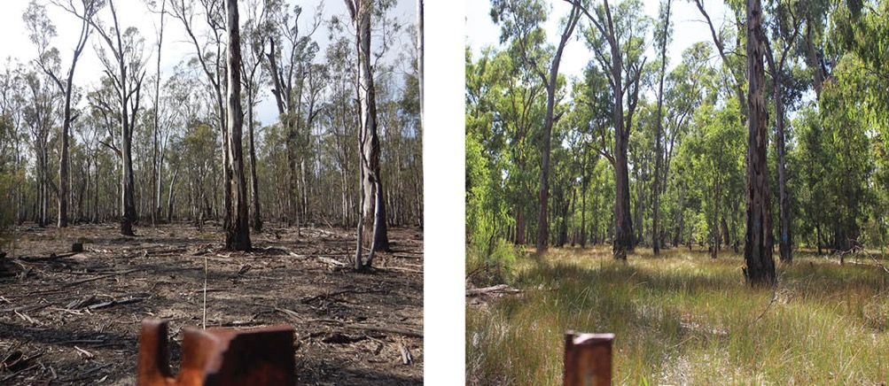
Figure 10: Western science-based understanding of the components of the flow regime in rivers. This representation may differ from Traditional Owner concepts, e.g. Dhelkunyangu Gatjin. Djaara Gatjin Strategy, which refers to ‘Right water, right place, right time’
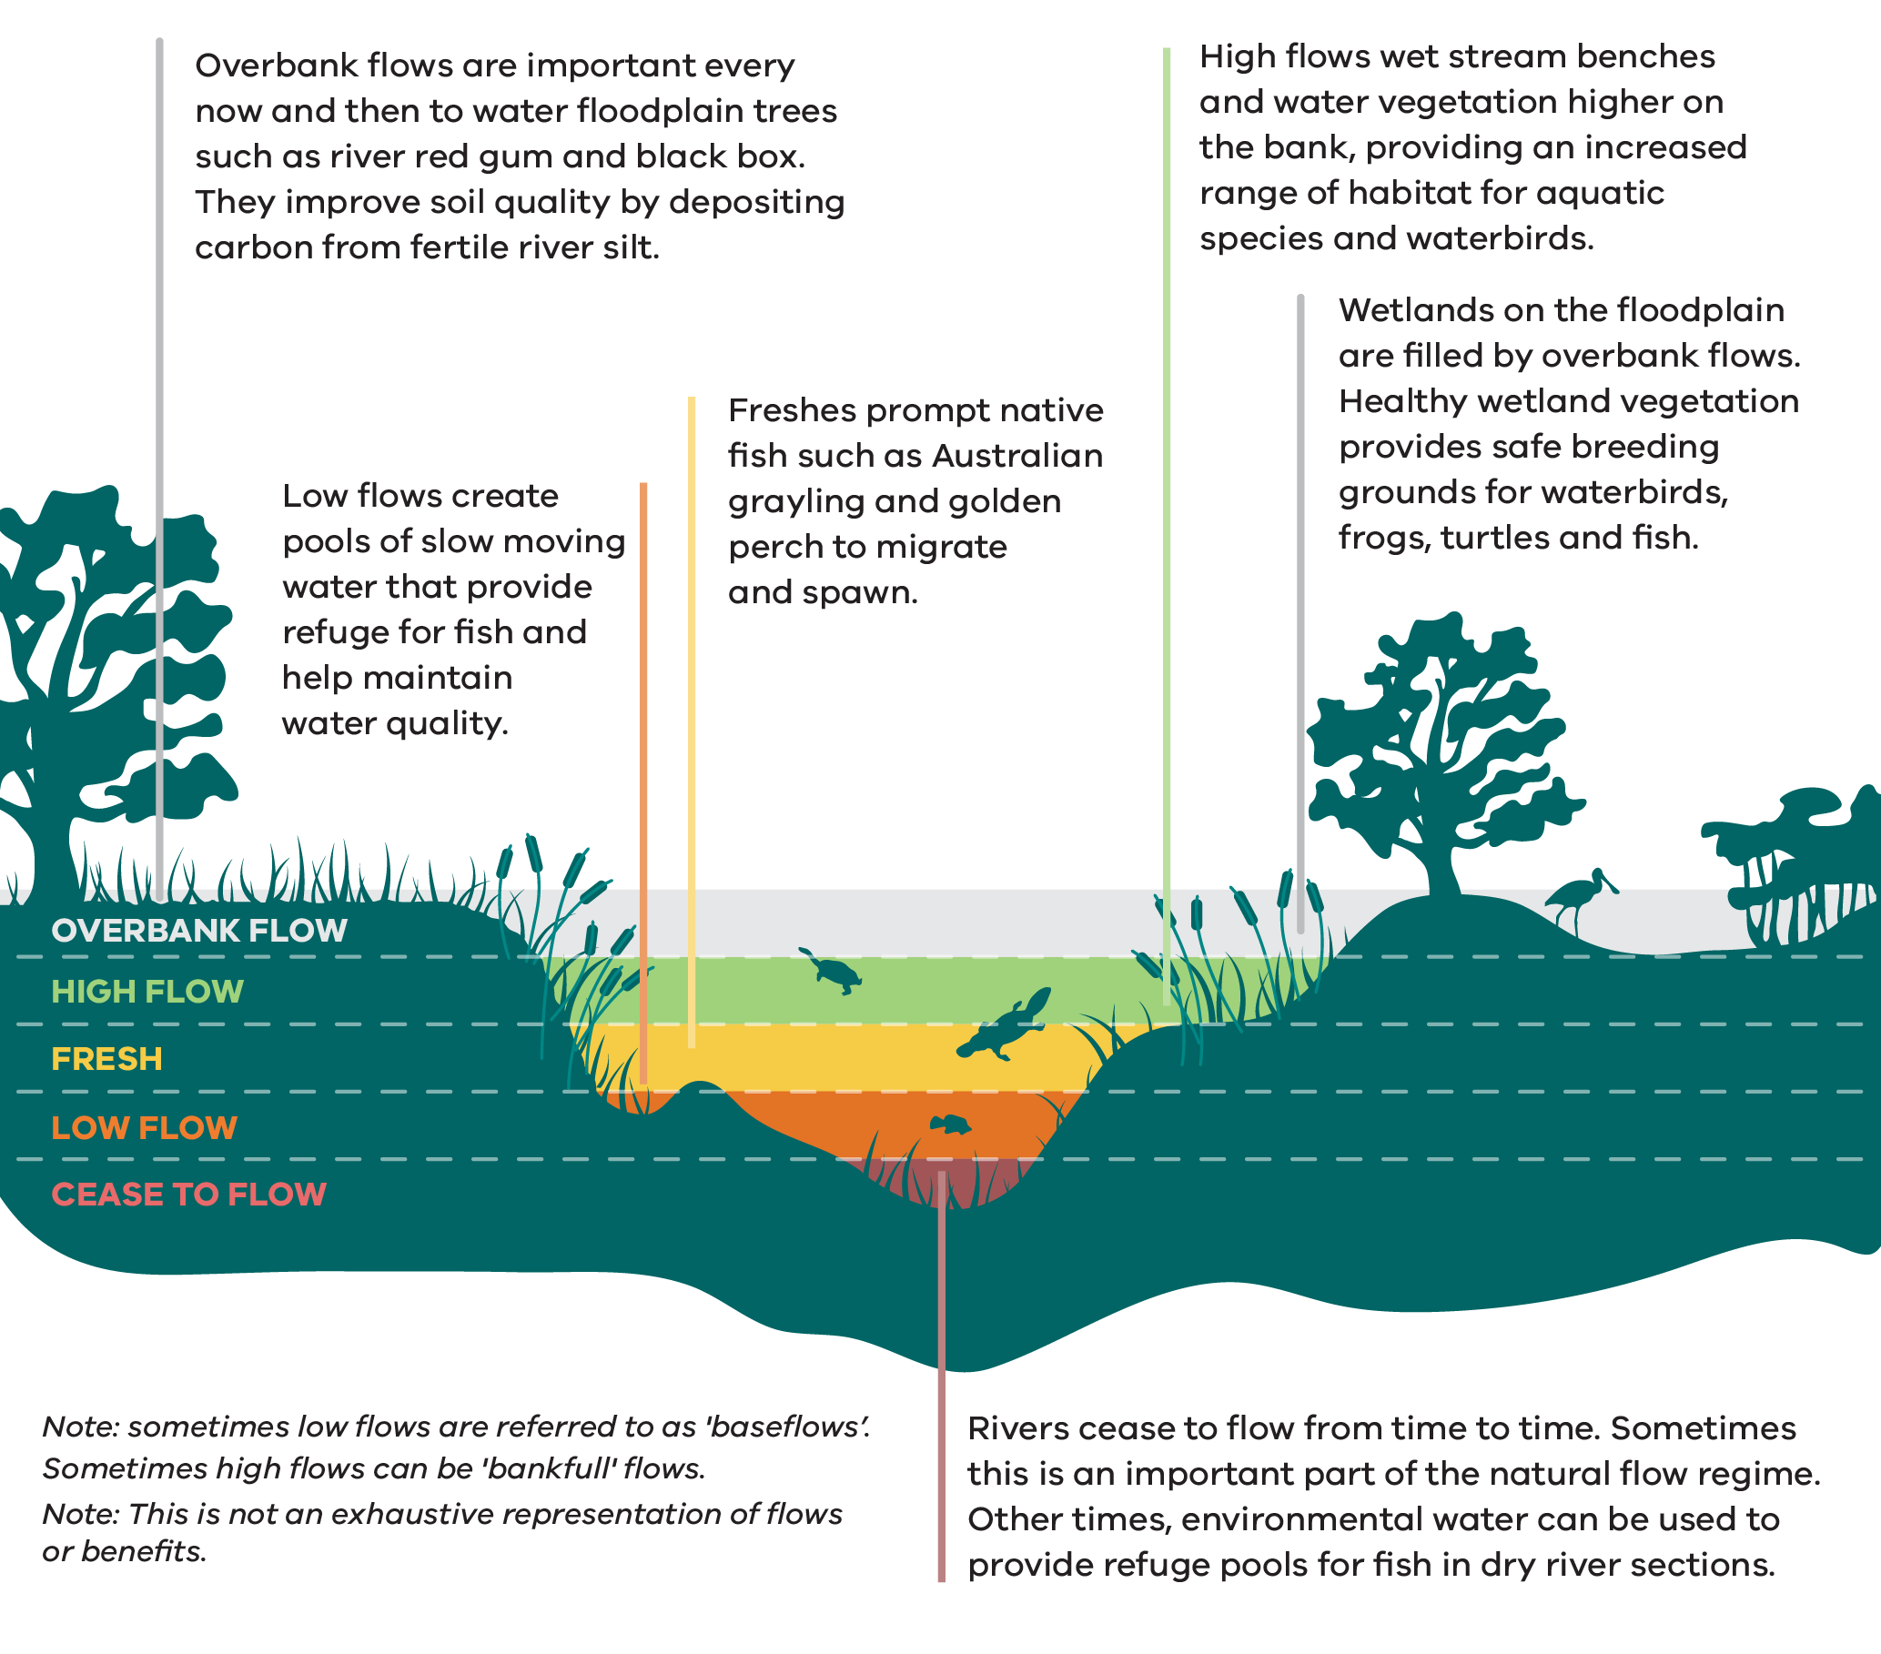
Figure 10 illustrates a river cross-section showing five flow levels, from lowest to highest, and the ecological benefits each provides. Two notes accompany the figure: low flows are sometimes referred to as 'baseflows'; high flows can sometimes be 'bankfull' flows. This is not an exhaustive representation of flows or benefits.
- Cease to flow Rivers cease to flow from time to time. Sometimes this is an important part of the natural flow regime. At other times, environmental water can be used to provide refuge pools for fish in dry river sections.
- Low flow Low flows create pools of slow-moving water that provide refuge for fish and help maintain water quality.
- Fresh Freshes prompt native fish such as Australian grayling and golden perch to migrate and spawn.
- High flow High flows wet stream benches and water vegetation higher on the bank, providing an increased range of habitat for aquatic species and waterbirds.
Overbank flow Overbank flows are important every now and then to water floodplain trees such as river red gum and black box. They improve soil quality by depositing carbon from fertile river silt. Wetlands on the floodplain are filled by overbank flows. Healthy wetland vegetation provides safe breeding grounds for waterbirds, frogs, turtles and fish.

What we're already doing
Victoria’s water entitlement framework defines how we share, hold, use and trade water to support agricultural, urban and environmental water needs. Water for the environment has been an important part of this framework since 2005, when the Victorian Government established the EWR under the Water Act 1989 ‘to preserve the environmental values and health of water ecosystems, including their biodiversity, ecological functioning and quality of water and the other uses that depend on environmental condition’.
The Victorian water entitlement framework provides a range of mechanisms for sustainable water use in both regulated and unregulated systems, including preventing unacceptable impacts on the availability of water for the environment that could result from water extraction and river regulation. These mechanisms are set out in Appendix 7.
In Victoria, decisions to recover additional water for the environment are made through regional sustainable water strategies – which undergo a comprehensive consultation process with regional communities, water users, Traditional Owners and waterway managers. Research indicates that Melbourne Water customers are willing to pay more on their water bills to support additional water being returned to the environment in their region, showing that households place value on healthy waterways. Significant volumes of water have been recovered over the last 2 decades. Almost all regulated waterways across Victoria now have environmental entitlements in place. These are managed by the VEWH, which was established by the Victorian Government in 2011. Victoria also works with other agencies across the Murray-Darling Basin to achieve environmental outcomes with water available under the joint Living Murray Initiative and water held by the Commonwealth Environmental Water Holder (CEWH). The VEWH holds approximately 731 GL per year across Victoria and the CEWH holds approximately 874 GL per year in northern Victoria (See Appendix 8).
Fit-for-purpose monitoring and evaluation facilitate adaptive management by integrating learnings and management improvements into regional waterway strategies, environmental water management plans and annual seasonal watering proposals.
Infrastructure (or environmental works) such as pipes, pumps, channels, flow regulators and earthen banks are used to manage water for the environment as efficiently as possible (See Figure 11). Several other innovative tools developed during the Millennium Drought, including carryover, trade, reuse of return flows and the utilisation of consumptive water en route, are also used.
In many cases, environmental works are the only way to water wetlands and floodplains that have become disconnected from the main river channel due to changes in the landscape after colonisation. These restore some key ecological functions, but don’t reconnect rivers to their entire floodplains or enable the large-scale exchange of nutrients between habitats (See Box 6).
Only 10% of total stream length across Victoria is made up of regulated waterways. In unregulated waterways, where there are no environmental entitlements, the EWR is protected by:
- managing existing diversions via licence conditions
- rules for rostering and restrictions on when water can be taken
- maintaining groundwater baseflow contributions to waterways, through conditions on groundwater licences.
Other waterway management actions are also important in these systems to improve their condition and support waterway values.
The Central and Gippsland Region Sustainable Water Strategy outlines the increased use of desalinated and recycled water where it is fit-for-purpose to meet the increasing demand for consumptive water use. This in turn could free up river water for improved environmental outcomes and to return water entitlements to Traditional Owners. The Sustainable Water Strategy also commits to reviewing options to address the increasing effects of small catchment dams and could support recommendations relevant to other hotspots across Victoria.
The Victorian Floodplain Management Strategy (VFMS) sets out the roles and responsibilities of government agencies and authorities in relation to floodplain management. The key elements in the VFMS that align with this Strategy include governance arrangements for sustainably managing existing and new levees, adapting to climate change to manage flood risk and considering the environmental benefits of flooding.
This Strategy adopts the VFMS principle that wherever possible, waterways should be allowed to flood naturally, maintaining connectivity to floodplains and their associated wetlands. In addition, regional floodplain management strategies must integrate the management of flood risks with waterway priorities identified in regional waterway strategies.
Most water for the environment is delivered within the river channel, below levels that pose a risk to private land or infrastructure. However, in some instances, it is possible to deliver water for the environment to the floodplain. This occurs mainly on public land, such as national parks and state forests, and where the landholder has given consent.
Environmental water holders work with other environmental watering program partners, such as waterway managers and storage managers, to appropriately manage risks to third parties in the delivery of water for the environment.
Management of water for the environment in northern Victoria also complies with the Murray-Darling Basin Plan. Victoria’s environmental water management framework, together with the Australian Government’s framework for the Murray-Darling Basin Plan and associated instruments are outlined in Appendix 9.
Figure 11: Infrastructure for use of environmental water
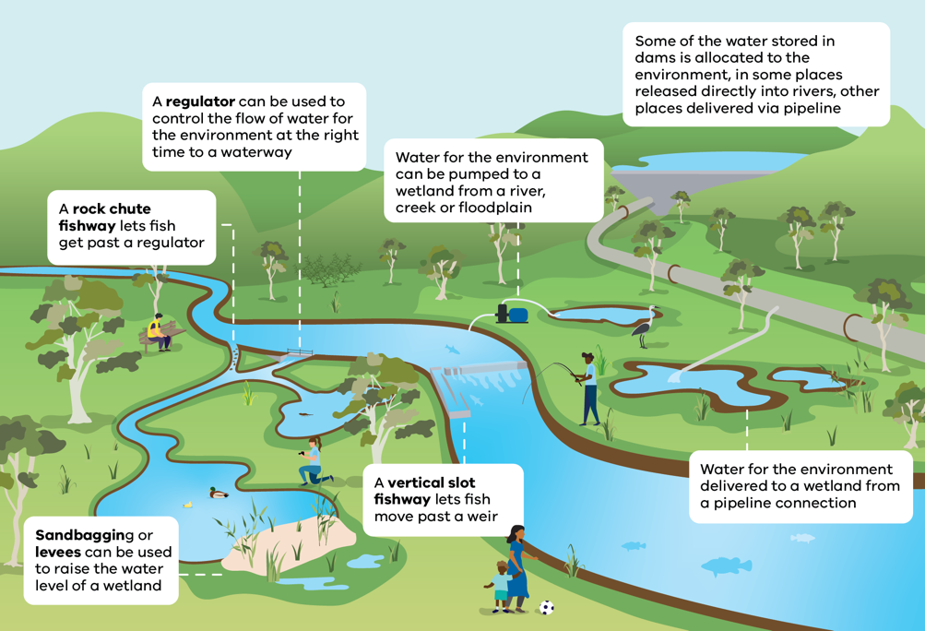
Figure 11 shows the types of Infrastructure that can make use of environmental water. These include:
- A regulator can be used to control the flow of water for the environment at the right time to a waterway
- A rock chute fishway lets fish get past a regulator
- Sandbagging or levees can be used to raise the water level of a wetland
A vertical slot fishway lets fish move past a weir
Water for the environment can be pumped to a wetland from a river, creek or floodplain
Some of the water stored in dams is allocated to the environment, in some places released directly into rivers, other places delivered via a pipeline connection

Intended outcomes
The Strategy will contribute to the following outcomes over the next 10 years:
- Management of water for the environment is optimised and prioritised to contribute towards state and regional goals
- Management of water for the environment continues to be integrated with other management actions to achieve state and regional goals
- Ecological objectives and management regimes are informed by a changing climate
Traditional Owners are enabled to take a lead role in determining how water for the environment is used for the purpose of healing and caring for Country.

Management challenges and opportunities

Regulated systems
In regulated waterways where flows are impacted by infrastructure, like large dams and weirs, waterway managers deliver environmental entitlements to restore some components of the natural flow regime. In most systems, environmental entitlements still represent a relatively small proportion of the total entitlement volume. Sometimes the environmental entitlement does not provide enough water in regulated waterways to meet critical low flow needs over the drier summer and autumn months. These low flows are required to avoid cease-to-flow events that can result in the death of fish and other aquatic species.
Environmental entitlements are managed efficiently and effectively to achieve the best environmental outcomes with the available environmental water. Waterway managers identify the flow regime required to support environmental values. They work with partners and local communities to set realistic management objectives, considering the gaps between current and ‘ideal’ watering regimes and what is possible in highly-modified systems (See Appendix 9). Regional waterway strategies integrate environmental watering with other targeted management actions (See Part 2), like removing barriers and building fishways that allow fish to move past dams and weirs, fencing to control stock access, controlling pest plants and animals, and reinstating native riparian vegetation and in-stream habitat. This approach effectively manages priority threats to improve the benefits of environmental watering.

Policy 12 – Integrating environmental water to achieve waterway outcomes
Updated policy from the previous Victorian Waterway Management Strategy
Waterway managers will continue to comprehensively integrate environmental water with other waterway management activities to contribute to regional, state and interjurisdictional waterway outcomes, with consideration of different climate scenarios and adaptation pathways. This includes considering where watering infrastructure is needed to deliver water for the environment and working with river operators to consider how current system operating rules in the water resource framework could be altered to match future user demand and provide long-term environmental benefits.
The Murray-Darling Basin Authority’s Basin-wide Environmental Watering Strategy sets expected outcomes to meet the Basin Plan ecological objectives and describes how Victorian sites contribute to them. The next iteration of Victoria’s regional waterway strategies will describe how regional outcomes contribute to the expected environmental outcomes in the Basin-wide Environmental Watering Strategy.

Policy 13 – Developing and adapting environmental water management to achieve regional outcomes
Updated policy from the previous Victorian Waterway Management Strategy
Waterway managers will continue to prepare or update environmental water management plans at relevant scales for waterways where management of water for the environment is needed to achieve regional outcomes. These are identified in regional waterway strategies and in consultation with partners.
Waterway managers prepare seasonal watering proposals to identify annual priorities for the use of environmental entitlements in their region and specify potential environmental watering objectives for a range of climate scenarios (See Policy 14 and Figure 12). These proposals must be consistent with regional waterway strategies and aligned with any relevant environmental water management plan. They should consider new information from recent monitoring and research, plus any ecological knowledge contributed by the relevant Traditional Owners.
Traditional Owner groups can also develop their own seasonal watering proposals which align with their aspirations and environmental objectives (refer to Policy 11).
The VEWH must collaborate with partners and stakeholders when developing the annual seasonal watering plan. This plan sets out priority watering actions under different seasonal conditions and can be found at the Victorian Environmental Water Holder (VEWH) website.
Program partners work together and apply the Victorian Environmental Watering Program Risk Management Framework for due diligence and the use of best available information to manage risks throughout the year. The VEWH is responsible for ensuring this risk management framework is current.

Policy 14 – Making informed decisions on Victorian watering priorities
Updated policy from the previous Victorian Waterway Management Strategy
The VEWH will continue to plan annually for the use of environmental water entitlements, though the form and timing of this plan may vary to improve efficiency and effectiveness. The plan will align with regionally-led seasonal watering proposals and a balanced, evidence-based consideration of the criteria set out in the Ministerial Rules relating to the VEWH and Victorian water policy.
Not all seasonal watering proposals will always be met.
The VEWH will continue to make decisions on watering throughout the year that are consistent with this plan. It will use the water holdings to first prioritise management objectives under drought and dry scenarios in all Victorian connected systems – to maintain basic functioning and prevent irreversible degradation in line with the seasonally-adaptive approach (See Policy 66 and Figure 12).
Figure 12: Seasonally-adaptive approach: potential environmental watering objectives under different climate scenarios (adapted from Seasonal Watering Plan 2024-25)
Planning scenario | Drought | Dry | Average | Wet
Expected  conditions | No or negligible contributions from unregulated flows; waterways may stop flowing at times; more likely in summer and autumn | Minor contributions from unregulated reaches and tributaries; more likely in winter and spring | Unregulated flows provide extended low flows and multiple freshes; more likely in winter and spring; minor storage spills may occur | Extended unregulated high flows, multiple large storage spills and overbank flooding; more likely in winter and spring but possible at any time of the year
Management  objectives | Protect  - Avoid critical loss  - Maintain refuges  - Avoid catastrophic events | Maintain  - Maintain river functioning with reduced recruitment opportunities  - Maintain key functions of high-priority wetlands  - Manage within dry-spell tolerances | Recover  - Improve ecological health and resilience  - Improve recruitment opportunities for key plant and animal species | Enhance  - Restore key floodplain wetland linkages  - Maximise recruitment opportunities for key animal and plant species

Policy 15 – VEWH working with other environmental water holders
Updated policy from the previous Victorian Waterway Management Strategy
The VEWH will continue to work collaboratively and constructively with other environmental water holders. While other environmental water holders decide their priorities for their water, all environmental watering within Victoria will be aligned with regionally-set watering objectives.
Delivery of all environmental water entitlements to meet outcomes in Victorian waterways will continue to be coordinated through the VEWH’s processes under Victoria’s water entitlement framework, unless water holders transfer water to authorised private landholders to water a wetland on their land. The coordination of Victorian, The Living Murray and Commonwealth environmental water entitlements reduces administrative burden, improves environmental outcomes based on regionally-set environmental watering objectives, and enables water to be accounted for and used again for downstream environmental outcomes (return flows).
Other environmental water holders will fund (through appropriate mechanisms) the delivery, monitoring and management of their own environmental water, consistent with the fees and charges set by the Victorian Government.
The VEWH’s annual reports on environmental watering use and outcomes in Victoria can be found at the Victorian Environmental Water Holder (VEWH) website.

Capacity challenges for delivering water in northern Victoria and the River Murray System
There are instances where different water users would like water delivered down rivers or through channels at the same time, resulting in the need to share the available capacity.
Storage managers, river operators and environmental water holders work collaboratively to meet demands across the system, by adjusting the timing and scale of different deliveries.
In the River Murray System, it is becoming increasingly challenging to deliver water to meet downstream uses. This is increasing the risk of water needs not being delivered where it is needed, creating a ‘shortfall’ event. The arrangements for how water for the environment is treated in these circumstances is not consistent and can be affected by both Victorian and interstate management frameworks.
Victoria has previously managed these shortfall risks through interim arrangements. Environmental water holders identify watering events that cannot be interrupted without causing significant environmental damage or impacts and delay other watering in preference to the needs of irrigation customers. Delivery rights for environmental water holders need to be clearly defined to provide certainty for environmental water holders, river operators and the community.

Action 8
Action | Who | When
A.8–Work with the Murray-Darling Basin Authority, New South Wales and South Australia to more clearly define how environmental water deliveries in the River Murray System will be managed in the event of a shortfall. Victoria will also define delivery rights in Victorian tributaries where required. | Lead: DEECA  Collaborate:  Murray–Darling Basin Authority and other Southern Basin agencies, where relevant | by 2030

Box 6 – The Murray–Darling Basin Plan
The Murray-Darling Basin has over 77,000 km of rivers. In Victoria, the Kiewa, Ovens, Broken, Goulburn, Campaspe and Loddon systems all flow into the Murray River, while the Wimmera River system and a number of Ramsar sites contribute to the overall basin.
The Murray-Darling Basin Plan supports the integrated management of water resources across the basin, forming a significant part of waterway management in northern Victoria. Victoria is committed to the objectives of the Murray-Darling Basin Plan – and Victorian agencies are working closely with the Murray-Darling Basin Authority, other jurisdictions and the CEWH to implement the Plan.
Victoria’s approach is to recover water where it can have the most benefit and invest in projects that can improve the effectiveness of delivering held environmental water, including that recovered under the Basin Plan. The Victorian Government has worked with communities to recover 826.5 GL for the environment, meeting 77% of Victoria’s target to date. The Living Murray Initiative and Victoria’s sustainable diversion limit adjustment mechanism (SDLAM) projects are examples of this approach, with new projects in planning to contribute to implementation of the Australian Government’s Restoring Our Rivers program. These new projects cover different functions that are consistent with Victoria’s approach for all waterways, and include:
- Restoring floodplains – the Victorian Murray Floodplain Restoration Project and Restoring Mallee Floodplains Project have identified key landscapes where filling of environmentally and culturally-significant wetlands could occur. Watering these landscapes currently requires annual earthworks and movable diesel pumps within the public land estate.
- Tackling barriers to flow – the Victorian Constraints Measures Project has identified current river operation rules and existing physical barriers that could be removed or shifted to enable a better environmental outcome if risks can be managed. The Murray-Darling Basin Authority has released its Constraints Relaxation Implementation Roadmap to define an appropriate way forward for considering constraints measures across all basin states. For more information on the 3 Victorian constraints projects see Victorian Constraints Measures Program.
- Improving flow patterns – projects that progress operating rule changes, along with improvements to modelling tools that improve the way we operate the river to benefit the environment. This includes guiding coordinated releases from storages on the Murray and its key tributaries to maximise the outcomes achievable from the existing volume of environmental water.

Complementary benefits from environmental water
The VEWH is required by the Water Act 1989 to consider opportunities for Aboriginal cultural values and uses of waterways, as well as the shared social and recreational values and uses of waterways, consistent with its objectives. Waterway managers and Traditional Owners identify these complementary cultural, social and recreational benefits associated with proposed watering actions in seasonal watering proposals by consulting with their partners and the community. The VEWH describes where and how priority environmental watering actions incorporate social and cultural values as part of its annual planning process and when reporting on outcomes from the use of environmental entitlements.

Policy 16 – Principles for considering complementary benefits in environmental water planning
Updated policy from the previous Victorian Waterway Management Strategy
The primary purpose of environmental watering continues to be maximising environmental benefit. Where consistent with this objective, waterway managers must also consider whether social and cultural complementary benefits can be achieved by applying the following guiding principles:
- The primary purpose of using water holdings is to support environmental values and improve the health of water ecosystems
- Acknowledging that a range of complementary social, recreational and cultural benefits stem from improving the health of water ecosystems
- Participation of Traditional Owners, partners, stakeholders and the community during the development of seasonal watering proposals is critical to identifying opportunities for complementary benefits, which may vary between and during watering events
- Environmental watering actions may be modified to provide complementary benefits or avoid material impacts to waterway values on other users, where this doesn’t materially compromise immediate or longer-term environmental outcomes (at either local or landscape scales, based on scientific understanding or advice).

Watering infrastructure
Environmental works are critical to maximise the benefits of water for the environment and will become increasingly important under climate change (Figure 11). In line with the seasonally-adaptive approach, environmental works are used differently in wet and dry years. In dry years, environmental works are used to support critical values and processes in high value wetlands and floodplains, maintaining critical habitats and drought refuges, while avoiding catastrophic losses.
In wetter years, environmental works are used to increase the area and duration of natural high flows, improve condition, build resilience and increase connectivity of habitats between the river and its floodplain.
Environmental works don’t prevent natural floods occurring, but they are an efficient and effective way of delivering environmental water to targeted ecosystems on the floodplain without causing widespread impacts to the community (See Box 7).

Box 7 – The Living Murray – benefits of environmental works
The Living Murray Initiative maintains the health of 6 iconic sites along the river through NSW, Victoria and South Australia. Environmental watering infrastructure built at the Hattah Lakes Icon Site has made it possible to water an ecologically-significant floodplain holding iconic Australian species such as river red gum and black box woodlands. The freshwater lakes are listed as an internationally important Ramsar wetland. They are valuable as drought refuges and breeding places for the nationally-listed regent parrot, as well as waterbirds, frogs, turtles and native fish.
Hattah Lakes support significant Aboriginal cultural values and lie on the border of 2 language groups – the Latji Latji and the Jari Jari.
Groups with an interest in Hattah Lakes include: Culpra Milli Aboriginal Corporation, Dadi Dadi Weki Weki Aboriginal Corporation, Gilbie Aboriginal Corporation, Latji Latji Traditional Owners, Latji Latji Mumthelang Aboriginal Corporation, Nyeri Nyeri Traditional Owners and Munatunga Elders Aboriginal Corporation, Tati Tati Kaiejin, Tati Tati Land and Water Indigenous Corporation, Waddi Waddi Traditional Owners, Wadi Wadi Land and Water Indigenous Corporation and Wadi Wadi Traditional Owners.
Infrastructure has helped return water to more than 6,000 ha of high-value floodplain within the Hattah-Kulkyne National Park, including 1,255 ha of black box trees higher up on the floodplain – all without impacting other river users.
Since first using these works for watering in 2014, watered trees and lignum (an important floodplain shrub) are in better condition and produce more seedlings than unwatered trees. Flooding has prompted the trees to produce more flowers, which are a source of nectar for birds and insects. The total number of bush birds was 60% higher up to 3 years after watering. They then become food sources for other animals, keeping the food web alive.
Image 5: Lake Brokie, Hattah Lakes before environmental watering in 2021 (left) and after in 2023 (right) / Mallee CMA
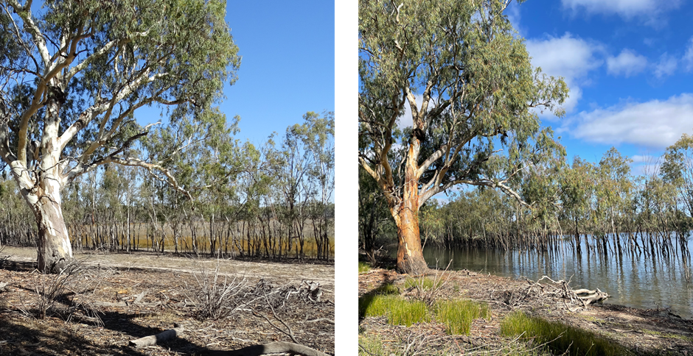

Policy 17 – Using all mechanisms to secure outcomes from environmental water use
Updated policy from the previous Victorian Waterway Management Strategy
To ensure the effective and efficient use of water for the environment, the Victorian Government will continue to explore environmental works and enable the use of tools such as carryover, trade, use of consumptive flows en route and reuse of return flows, improved forecasting and coordinated water planning tools. Options will be assessed on a case-by-case basis, considering potential benefits, risks, feasibility and cost-effectiveness. We will work collaboratively with other jurisdictions as needed for catchments in the Murray-Darling Basin.
In the forecast drier and more variable future, infrastructure will be increasingly important for the targeted use of held environmental water at high-value sites. Environmental infrastructure built for this purpose must have clear rationale, ownership and funding arrangements for effective outcomes, as well as safe operation and ongoing maintenance.

Policy 18 – Agreeing on asset management arrangements for environmental watering infrastructure
Existing policy incorporated into the Victorian Waterway Management Strategy
Asset ownership arrangements will be known and agreed upon before proposals for the funding of construction of new environmental watering infrastructure are submitted to DEECA. DEECA must be satisfied that appropriate management arrangements are in place before investing in the construction of such assets. This includes a clear asset owner and source of funding for ongoing costs, consistent with the DEECA Asset Ownership Framework.
Water corporations need to manage water resources in a sustainable manner that enhances environmental outcomes. While good practices are already occurring in some instances, proactive and targeted collaboration with waterway managers can identify seasonal opportunities to provide even more environmental benefits.

Policy 19 – Managing river operations for more sustainable waterways
Updated policy from the previous Victorian Waterway Management Strategy
River operators in regulated waterways will continue to work with waterway managers to identify seasonal opportunities to optimise flow regimes which better align with environmental objectives, provided this doesn’t compromise statutory obligations. Priorities for changing river operations to improve the water regime in regulated rivers will be guided by waterway outcomes, as identified by waterway managers in regional waterway strategies and other relevant documents.
Modifying dams and weirs to provide for fish passage helps native fish to move and supports native fish lifecycle stages and their resilience during extreme events. Water corporations are obliged to provide fish passage when building new structures on waterways or doing major refurbishments of existing dams and weirs. Monitoring across Victoria has demonstrated the success of fishways in supporting fish movement, however the maintenance needs of fishways are generally not well-understood or funded by the asset owner.

Action 9
Action | Who | When
A.9–Refresh existing guidance to assist water corporations and storage managers, so that they can deliver on their obligations to maintain the objectives of the environmental water reserve and provide fish passage. | Lead: DEECA  Collaborate: water corporations | by 2030

Action 10
Action | Who | When
A.10–Undertake a statewide assessment of the condition and effectiveness of existing priority fishways and identify fish passage knowledge gaps. | Lead: DEECA  Collaborate: waterway managers, water corporations | by 2035

Costs of managing environmental entitlements
The Victorian Government requires environmental water holders to pay for the costs of storing and delivering water for the environment, consistent with other water users (See Box 8). As the volume of environmental water entitlements has increased, operating and maintaining the infrastructure and services to store and deliver water has become a significant part of some water corporations’ operations and revenue. These corporations have been using various approaches to calculate applicable charges.
The Victorian Government has reviewed environmental water charges in Victoria to make sure they’re clear and fair and provide certainty for all water users. A policy has been developed in consultation with the relevant water corporations and environmental water holders to guide fees and charges for environmental water.
The policies minimise price impacts on other water users and provide transparency, by requiring all environmental water storage and delivery charges to be published and regulated independently through the Essential Services Commission as part of water corporation pricing submissions.

Box 8 – Costs of managing environmental water entitlements in Victoria paid to water corporations
Over the past 3 years, environmental water holders have paid the following for the storage and delivery of environmental entitlements in Victoria:
2021-22: $15.2 million ($4.1M paid by the VEWH, $2.6M by TLM, $8.4M by CEWH)
2022-23: $14.6 million ($3.9M paid by the VEWH, $2.1M by TLM, $8.5M by CEWH)
2023-24: $15.5 million ($4.2M paid by the VEWH, $2.3M by TLM, $8.9M by CEWH).
Note: costs exclude carryover fees. The Victorian Government has paid these fees and charges for environmental water entitlements held by the VEWH.

Policy 20 – Principles for charging for environmental water holdings
New policy
Environmental water holders will pay for the storage and delivery of held environmental water consistent with the following:

Storage charges
- Where an environmental entitlement has been purchased from a consumptive user, standard headworks charges will apply.
- Where an environmental entitlement is provided through a bulk entitlement conversion process, no headworks charges will apply.
- Where water is set aside for the environment as part of an obligation associated with a consumptive bulk entitlement (i.e. passing flows), no headworks charges will apply. This includes the flexible use of passing flows.
- Where an environmental entitlement is provided to mitigate or offset modernisation impacts on waterways, including wetlands, no headworks charges will apply.
- Where an environmental entitlement is provided through the assignment of unallocated or unregulated water, no headworks charges will apply unless charges were previously applied (e.g. Blue Rock Environmental Entitlement).
- Where an environmental entitlement is provided through a water savings project or system augmentation, headworks charges will be determined as part of negotiating the project funding agreements. Existing negotiated charges will remain as outlined in original project funding agreements, or as amended by changes in 2014 – except where clear inconsistencies with other rules exist.
- When water is recovered and returned as water shares to the proponent, full charges are applied as they would be for any other water share product.
Where headworks charges should be determined through a negotiation process, the following matters should be considered:
- the reliability of the entitlement
- the deliverability of the entitlement
- the level of benefits provided to the water corporation and their customers by the project
- the level of funding provided by government, the water corporation and their customers.

Delivery charges
Charges for delivering environmental water will be determined by water corporations as part of the ESC process and in accordance with any relevant Guidelines. Charges need to be transparent, easily understood and published in an accessible manner. Delivery charges provide signals for the efficient and sustainable use of water infrastructure. If investment in infrastructure is required, charges should aim to reflect the long run incremental costs of the assets required to deliver water.
Environmental water holders will pay delivery charges specified as part of the ESC process that will include:
- all costs associated with the future operating and maintenance of infrastructure assets that only provide services to the environment
- a percentage/proportional cost of the future operating, maintenance and refurbishment costs of infrastructure assets that are shared with consumptive users and are directly required to deliver the environmental watering service
- the incremental costs associated with the planning, management and delivery of environmental water (excluding business-as-usual costs for meeting environmental obligations)
- no costs associated with delivery through natural waterways (to recognise that the environment received water from the natural waterways before being incorporated into the irrigation distribution network)
- no costs associated with delivery of an environmental entitlement that is provided to mitigate or offset modernisation impacts on waterways including wetlands.
Charges will reflect the level of services received. The rules for defining a separate environmental watering service level are:
- where environmental water deliveries are afforded a lower priority than consumptive water (i.e. in an irrigation distribution network), the lower level of service will be reflected in the charges
- cross-subsidies from water users to the environment, or the environment to water users, will be avoided.

Unregulated systems
DEECA has developed new hydrological information to guide future management decisions and investments in unregulated rivers. This information identifies areas likely to face significant threats due to changes in natural flow variability caused by climate change, extraction and/or interception. These areas can be considered in regional planning processes – with waterway managers, in collaboration with their partners and stakeholders, identifying achievable climate adaptation approaches over time.
DEECA is reviewing groundwater licensing guidelines and regulation to protect the EWR in unregulated waterways. The Central and Gippsland Region Sustainable Water Strategy also has actions aimed at further assessing the impacts of interception activities on our waterways, with hot spot investigations completed in the Maribyrnong and Moorabool catchments (See Central Gippsland Region Sustainable Water Strategy Action 4.13).
Statutory management plans implement formal arrangements to address flow stress in unregulated waterways and declines in groundwater systems caused by consumptive use or where there is demand for further development. These plans aim to sustainably manage available water resources and balance the needs of all users, including the environment. Local management plans are non-statutory and are used as a planning tool which communicates how unregulated waterway or groundwater systems are managed, including when rosters and restrictions will be applied to a waterway. The process for development and review of statutory management plans is cumbersome and resource and time-intensive. There may be opportunities to streamline the development and review of statutory management plans so that they can be efficiently used to ensure robust management of unregulated rivers and groundwater systems to protect environmental values, as well as reliability of supply for users.

Policy 21 – Protecting the environmental water reserve in unregulated waterways
Updated policy from the previous Victorian Waterway Management Strategy
Statutory management plans will be developed and renewed where appropriate and where regional outcomes are threatened by flow stress in unregulated waterways.

Groundwater-dependent ecosystems
Historical management of groundwater has focused on the sustainability of the water resource (in terms of managing the volume for users). However, more emphasis has recently been placed on managing risks to ecosystems reliant on groundwater.
DEECA is working with waterway managers and water corporations to maintain and manage the EWR through the implementation of Groundwater Management 2030 and its commitment to evidence based management and sustainable groundwater use. This includes a review and update to the Ministerial Guidelines for Groundwater Licensing and Protection of High‑Value Groundwater Dependent Ecosystems (See Action 12). Waterway managers and water corporations use a wide range of information sources to identify high value groundwater dependent ecosystems. Information at state and regional levels is used by waterway managers and water corporations in risk assessment and referral processes.

Policy 22 – Protecting groundwater-dependent ecosystems
Existing policy incorporated into the Victorian Waterway Management Strategy
The groundwater management and allocation framework will continue to adopt a
risk-based approach to considering groundwater-dependent ecosystems. This approach will reflect the level of groundwater interaction and the level of risk posed by water use.
Systems with high groundwater and surface water interaction will be:
- managed recognising the interaction of the resource
- considered as part of ongoing strategic groundwater resource assessments and local management plans, or statutory management plans
- monitored to inform understanding of the condition of and impacts to high-value and high-risk groundwater-dependent ecosystems.

Floodplain connectivity
Landscape connectivity and water quality have a significant influence on waterway health outcomes and are closely linked to flows.
Earthworks can fill or block natural flow paths and impact the connection between rivers and key floodplain habitats. Removing blockages that don’t threaten private land assets could increase the area of floodplain wetlands. This, in turn, could reduce the need for environmental watering via pumps and regulators in some areas.
Infrastructure like dams and levees are used to restrict floodplain inundation and protect infrastructure, roads, buildings and farmland. While this infrastructure remains very important for protecting communities from the impacts of flooding, improved modelling of floods and the knowledge of Traditional Owners and communities may identify areas where it isn’t necessary (See Box 6). Waterway managers may need targeted education and awareness programs to increase understanding of the benefits of floodplain connectivity.

Policy 23 – Improving floodplain flow and connectivity on public land
Updated policy from the previous Victorian Waterway Management Strategy
Waterway managers will consider removing physical and operational barriers to inundation of floodplains to meet regional outcomes, where feasible and risks can be effectively managed.
Redundant flood mitigation infrastructure on public land will be considered for decommissioning, so long as it aligns with the principles of the Victorian Floodplain Management Strategy and regional waterway strategy outcomes.
New flood mitigation infrastructure will be designed to consider floodplain flow and connectivity outcomes.

Use of alternative sources of water for the environment
The Central and Gippsland Region Sustainable Water Strategy identifies that alternative water sources can be substituted for fit-for-purpose uses, to free up river water to be returned to Traditional Owners and for environmental outcomes. This is not always possible and in limited circumstances, alternative water sources can directly provide environmental outcomes. Treated wastewater is sometimes released into waterways under EPA Victoria discharge licences and may already support some waterway values. In some situations, adjusting the timing, frequency, duration, quantity and/or quality of these discharges may provide environmental benefits for the waterway. Additional treatment and investment in storage infrastructure will likely be needed to ensure water is released appropriately to achieve these benefits. Recycled water for the environment (RWE) is the beneficial re-use of treated wastewater discharge that can be stored and released with appropriate timing, volume, variability and quality to support environmental flow regimes and achieve ecological benefit in flow stressed systems.

Policy 24 – Using recycled water for the environment
Updated policy from the previous Victorian Waterway Management Strategy
Recycled water for the environment will be considered for waterways on a case-by-case basis and should:
- protect human and animal health and waterway values (environmental, social, recreational, cultural, including Traditional Owners and economic) in accordance with the Safe Drinking Water Act 2003, Livestock Disease Control Act 1994 and Environment Protection Act 2017
- be consistent with Recycled water use in surface waters guideline (EPA Victoria publication 3005) and other existing government legislative and policy frameworks that may be relevant
- improve flow in flow-stressed waterways and maintain or improve ecological outcomes
- be of an appropriate quality that does not pose an unacceptable risk to environmental values and considers quantity, quality, timing, duration and frequency of flows and has regard to the Sustainable Management Principles of the Water Act 1989 (s93) and Public Health and Wellbeing Act 2008 (Part 2)
- not be used for the purpose of increasing the reliability of supply for downstream consumptive water users or existing entitlement holders. Rather it should be managed in accordance with current practices for environmental entitlement releases
- balance treatment costs and environmental outcomes in accordance with the waste hierarchy and other components in Part 2.3 – Principles of environment protection of the Environment Protection Act 2017.
Recycled water for the environment (RWE) is not:
- supported for systems that aren’t flow-stressed. DEECA, Traditional Owners and the relevant waterway manager are to be consulted to determine if a system is flow-stressed and suitable for RWE.
- a typical treated wastewater-licensed discharge (which is not considered a beneficial reuse). RWE involves meeting the environmental needs of a waterway – typically by modifying and optimising the existing discharge – so that recycled water is released at the right time, quality, volume, frequency and duration.
supported in declared special water supply catchment areas, if an RWE scheme involves a new release (as opposed to optimising an existing release).
Where the use of recycled water for the environment is considered appropriate, a licence must be obtained from EPA Victoria and the supply of water for the environment must be formalised through a Supply by Agreement. Figure 13 illustrates the RWE approval process, with key stakeholders engaged as part of this process or the relevant FLOWS study. Lessons will be learnt from emerging RWE cases that may prompt an update to this process through DEECA guidance, so as to remain consistent with the intent of Policy 24.
Figure 13: Recycled water for the environment application process
Step | Agency roles per process step
- Is the system flow stressed  (environmental water recovery targets)? | Waterway manager, DEECA, Traditional Owners  - Based on FLOWS studies, SWS, RWS  - In principle support from DEECA
- Is recycled water available in the system? | Water corporation, waterway manager, DEECA, Traditional Owners  - Adequate volume and quality  - Right location  - Substitution possible  - Determine storage requirements, if any
- Can ecological benefit be demonstrated? | Water corporation¹, waterway manager, DEECA, Traditional Owners  - Technical work to determine if releasing RWE will provide ecological benefit  - Cost benefit analysis
- Are there any unacceptable risks to human health and environment? | Water corporation¹, EPA  - Preliminary engagement with EPA to support the proponent’s technical work regarding risk to human health and the environment that will form the basis of their application  - Align with EPA’s risk-based statutory decision-making framework and EPA publication 3005 and 1287, where appropriate
- Monitoring arrangements | Water corporation¹, waterway manager, DEECA, Traditional Owners  - Draft Supply by Agreement  - Draft monitoring program required to demonstrate ecological benefit
Formal letter of support from DEECA
- Apply for relevant EPA permission | Water corporation¹, EPA  - Recycled water use in Surface Water Guideline (publication 3005)
- Monitoring and evaluation | Water corporation¹, waterway manager, DEECA, Traditional Owners, EPA  - Execute monitoring program agreed to in Step 5  - Evaluate if recycled water is providing ecological benefit

In some circumstances, depending on the quality, quantity and timing of release, treated stormwater can provide benefits to the environment. These opportunities will be worked through on a case-by-case basis. Due to the need for large storages which require suitable land and significant infrastructure investment, these opportunities may be limited. (See Part 5 for further detail on the impacts of unmanaged excess stormwater on waterways).

Improved tools and guidance to manage the EWR
Existing tools and guidance for the management of the EWR will need to be updated to continue achieving environmental outcomes and adapt to changing conditions and new knowledge.

Action 11
Action | Who | When
A.11–Review and apply lessons learned from regional and statewide drought refuge projects, including dry inflow contingency plans, to guide proactive management decisions across a broader regional context. | Lead: DEECA  Collaborate: waterway managers, water corporations, VEWH | by 2030

Action 12
Action | Who | When
A.12–Update the Ministerial Guidelines for Groundwater Licensing and the Protection of High Value Groundwater Dependent Ecosystems, based on the outcomes of the recent review. | Lead: DEECA  Collaborate: waterway managers, water corporations | by 2030

Action 13
Action | Who | When
A.13–Investigate opportunities to streamline the development and review of Statutory Management Plans (including streamflow management plans). | Lead: DEECA  Collaborate: water corporations, waterway managers | by 2035

Action 14
Action | Who | When
A.14–Review of the Ministerial Rules Relating to the VEWH, including how the VEWH will consider environmental watering proposals from Traditional Owners. | Lead: DEECA  Collaborate: VEWH, waterway managers, Traditional Owners | by 2030

Chapter 8. Wetlands

What we mean
Ramsar sites are wetlands of international importance. Australia has an obligation to manage these wetlands to maintain or improve their ecological character.
Wetlands in fragmented landscapes are surrounded by land that has been altered for agriculture or urban development. These land uses can negatively affect wetland water regimes, habitat and water quality.
Drainage is works relating to the removal of water to support agricultural production or urban development. Changes to the water regime of wetlands present a key threat to wetland environmental values.

Why is this important?
Wetlands are diverse habitats that include billabongs, marshes, lakes, swamps, alpine peatlands, intertidal saltmarshes, mangroves, mudflats and seagrass areas. They’re home to many unique plants, as well as fish, invertebrates, birds, amphibians, bats, and reptiles. Wetlands are crucial for biodiversity, water purification and flood control. During droughts, wetlands that still have water become essential refuges for wildlife – including threatened species. They also offer significant benefits to the surrounding systems, such as reducing flooding, filtering nutrients and trapping sediment.
Australia is a signatory to the Ramsar Convention. Our commitment under the convention is to halt the loss of wetlands, conserve them through wise and sustainable use and maintain Ramsar-listed sites.
The Victorian Government acknowledges the extensive and continuing loss of wetland habitat across Victoria. It recognises that protecting existing, and restoration of degraded wetlands is critical to support the persistence of wetland-dependent species and communities. In 1994, it was estimated that 26% of wetland habitat area in Victoria had been lost since colonisation, primarily due to drainage. More recently, a study found a 15% reduction in wetland habitat area between 1988 and 2023.
Most wetland habitat loss has occurred on private land and is primarily due to modifications from land use change (such as cropping and urban development) and more recently the drying trend from climate change. This can affect wetland types differently based on their vulnerability.

What we're already doing
Australia has 67 Ramsar wetlands, 12 of which are in Victoria. We are meeting our obligations to maintain or improve ecological character at these sites.
The Victorian Government invests in collaborations between waterway managers, Traditional Owners, farmers, other landholders and partners to undertake on-ground management activities and encourage good wetland management practices in priority areas (as identified by regional waterway strategies). This work is undertaken through voluntary agreements and cooperative partnerships.
A quarter of Victorian wetlands are on public land and represent about 65% of the wetland area. Public land managers and waterway managers, including Parks Victoria, CMAs, water corporations, local government, Traditional Owners and DEECA, are responsible for the management and protection of these wetlands.

Intended outcomes
The Strategy will contribute to the following outcomes over the next 10 years:
- The ecological character of Victorian Ramsar sites is maintained or improved
- Wetlands are managed to maintain or increase their condition and extent of habitat, further supporting wetland-dependent values like flora and fauna
The loss and degradation of wetlands on private land is limited.

Management challenges and opportunities

Managing Ramsar wetlands
The implementation of the Ramsar Convention is supported by the Environment Protection and Biodiversity Conservation Act 1999 (EPBC Act) and the Victorian Environmental Effects Act 1978, which include requirements to assess and approve actions which could cause significant impact on the ecological character of a Ramsar site.
The Victorian Government has developed and will continue to implement a robust governance framework in response to the Victorian Auditor General’s Office report Meeting obligations to protect Ramsar wetlands (2016). The framework includes clear roles and responsibilities for Ramsar site management, monitoring and coordination, and funding for these activities. This includes ongoing work with Traditional Owners across Victoria to embed meaningful engagement and input across all Victorian Ramsar sites (refer to Chapter 6). Ramsar site monitoring in Victoria is risk-based – it considers the threats to ecological character at each site (as set out in the site management plan) and indicators of site condition to prioritise monitoring activities. Figure 14 outlines Ramsar monitoring, reporting and planning requirements. All management plans meet the Australian Ramsar Management Principles (EPBC Regulations 2000).

Policy 25 – Governance, management planning and monitoring, evaluating and reporting of Ramsar sites
Updated policy from the previous Victorian Waterway Management Strategy
DEECA will continue to work in partnership with key agencies, Traditional Owner groups and the Australian Government to ensure that:
- governance arrangements for Ramsar management in Victoria continue to be implemented
- all necessary approvals are undertaken for actions which could cause long-term change to the ecological character of Ramsar sites
- Ramsar site management plans set out the range of activities required to maintain or improve the ecological character of sites
- Ramsar sites’ ecological character is monitored and reporting requirements are met
- effectiveness of management interventions is monitored so that actions achieve the outcomes in Ramsar site management plans.
Figure 14: Ramsar reporting and planning requirements
Requirement | Details
Ramsar  Information  Sheets | Review and publish updated Ramsar Information Sheets every 6 years and report on the status of Ramsar site documentation through triennial national reports to the Ramsar Convention.
Monitor and report on ecological character | Monitor the ecological character of Ramsar sites and provide information on the status of ecological character through three-yearly national reports to the Ramsar Convention. Regularly report to the community on the ecological character of Ramsar sites.
Ramsar site management plans | Review and publish updated Ramsar site management plans every 7 years that meet the Australian Ramsar Management Principles. Identify priority threats to ecological character to ensure highest level threats to ecological character are targeted.
Annual action plans for Ramsar sites | Develop annual action plans that set out actions required to implement strategies in Ramsar site management plans over a 12-month period. Review monitoring data to understand the status of ecological character and effectiveness of management.
A change to the ecological character of a Ramsar site might still occur despite the best-possible management efforts. Threatening processes such as sea level rise and the increasing frequency and severity of droughts, floods and bushfires from climate change are sometimes so severe that they limit the ability of managers to respond effectively.
Victorian Government agencies, the community, organisations or individuals can propose a wetland in Victoria for listing as a Ramsar site. Proposals may also be made to extend the boundaries of an existing Ramsar site to incorporate additional wetland areas. DEECA is responsible for assessing the evidence for any proposal to list a new Ramsar site, or extend the boundaries of an existing site.

Policy 26 – Responding to potential changes in ecological character of Ramsar sites
Updated policy from the previous Victorian Waterway Management Strategy
If monitoring indicates the ecological character of a Ramsar site is likely to change or has changed, the Victorian Government will notify the Australian Government and develop a response plan.
If there are no feasible management response options to maintain the site’s ecological character, DEECA will engage the Australian Government to review management objectives for the site. This will be done in consultation with the community, with the aim of adapting to a new ecological regime that maximises existing and likely future values.

Policy 27 – Principles for listing a new Ramsar site and extending the boundaries of an existing Ramsar site
Updated policy from the previous Victorian Waterway Management Strategy
The Victorian Government will consider proposals from the community and other parties to list a new Ramsar site, or add to an existing site where the proponent has provided an investigation that considers the following factors:
- if the wetland meets Ramsar Convention criteria
- the Ramsar Convention Strategic Framework and guidelines for the future development of the List of Wetlands of International Importance of the Convention on Wetlands, plus any national strategic direction on priorities for Ramsar site listing
- the level of support for listing or extending the boundary from relevant Traditional Owner groups
- agreement by the land manager and key stakeholders involved in managing the wetland and proposed actions to meet relevant Ramsar obligations
- the current degree of protection of the wetland and opportunities for increasing the level of protection
- alternative legislative and management frameworks
- the level of threat to the wetland and how listing would help manage these threats
- the feasibility and cost-effectiveness of maintaining the ecological character of the wetland in the long-term
- the contribution that listing would make to awareness-raising and community education
- the level of community support for listing
- national and international documentation and administrative requirements.
The Victorian Government will recommend proposals to the Australian Government for its decision.

Managing wetlands on public land
Wetlands on public land are subject to threats, including impacts from surrounding land use and loss of connectivity, climate change and invasive species.

Policy 28 – Managing wetlands on public land to achieve regional outcomes
Updated policy from the previous Victorian Waterway Management Strategy
The Victorian Government will ensure that threats to wetlands in natural areas (like national parks) on public land are addressed through legislative controls, park and forest management planning and implementation. Public land and waterway managers will align their individual strategic planning processes to address catchment-based threats to wetlands on public land in fragmented landscapes (like lake reserves) to achieve regional outcomes set through regional waterway strategies.

Managing wetlands on private land
Most wetland loss and degradation since colonisation in Victoria has occurred on private land. The main cause has been drainage to facilitate agricultural use, especially where shallow marshes and freshwater meadows occur. The ongoing loss of wetlands on private land is largely due to land use changes like cropping and urban development.
Parts of the Corangamite, Glenelg Hopkins and Wimmera regions have seen a shift from grazing to cropping. Aerial imagery indicates that for a cluster of over 2,200 wetlands southeast of the Grampians, cropping has increased from 2% of wetlands in 2010 to 45% in 2016 and 55% in 2020. Cropping is more destructive to wetlands than grazing as it involves vegetation removal, mechanical disturbance, use of biocides and increased drainage.
In the Port Phillip Bay and Westernport region, urban development is a key driver of wetland degradation and loss. Melbourne Water reported that several wetlands of significance had been lost over the first few years of the Healthy Waterways Strategy.

Legislative protection
Evidence suggests that the current legislative and regulatory framework – and its application – provides a low level of protection for wetlands on private land.
Unlike other waterways, wetlands on private land are generally not defined as a waterway under the Water Act 1989. This means waterway managers have very limited ability to manage or regulate activities impacting these wetlands (except when a wetland is connected to a waterway defined under the Act). Strengthening Victoria’s legislation so that wetlands on private land are captured in the waterway management framework in the Water Act 1989 would improve the ability to manage and protect wetlands, while still enabling private landowners to manage their land.
The ability to influence land use and development affecting wetlands is largely enabled through Victoria’s Planning Provisions. Wetlands on private land can be considered in land use planning processes through schedules to flood overlays, environmental significance overlays and native vegetation regulations. The planning system’s rural suite of zones can also through localised schedules require a permit for earthworks that change the rate of flow or discharge point of water across a property boundary, which will often occur when a wetland is drained or filled. These planning provisions are largely administered by local government.
Aboriginal cultural heritage on private land – including heritage associated with waterways and culturally significant waterways themselves – is protected under the Aboriginal Heritage Act 2006. This Act also applies permit processes for activities on private land likely to cause harm, as well as Cultural Heritage Management Plan requirements for landowners before installing certain utilities and dam development. The Aboriginal Heritage Act 2006 also applies areas of Aboriginal cultural heritage sensitivity over areas of land in Victoria regardless of land tenure, which must be considered whenever a land use activity or change is proposed.
The Australian Environment Protection and Biodiversity Conservation Act 1999 (EPBC Act) includes provisions to protect matters of national environmental significance (MNES) including Ramsar sites, listed threatened species and communities, and listed migratory species – a significant number of which are wetland-dependent and on private land. The EPBC Act referral process begins with self-assessment and penalties exist for failing to refer activities that may impact MNES. It is hard to gauge the rate of non-compliance, though.

Policy 29 – Managing wetlands on private land to improve protection
New policy
Wetlands on private land will be incorporated into the waterway management framework.
The use of all existing legislative and regulatory mechanisms for protecting wetlands on private land will also be optimised.
The Victorian Government recognises and supports the role of private landholders in wetland protection through stewardship activities. Urban planning processes will engage waterway managers early to understand and support wetland values.

Action 15
Action | Who | When
A.15–Undertake further analysis to identify feasible options to improve the protection of wetlands. | Lead: DEECA  Collaborate: DTP, agricultural sector, waterway managers and Traditional Owners | by 2030

Action 16
Action | Who | When
A.16–To assist with the management of wetlands on private land:  - Undertake investigations to improve the understanding of the motivations, attitudes and barriers to participation of landowners to undertake wetland and riparian management and protection  - Develop targeted education and awareness programs to increase understanding of wetland protection on private land  - Improve fit-for-purpose wetland information to assist agencies and community with applying regulatory and legislative protective mechanisms, including maintaining the Victoria Wetland Inventory  - Review and explore changes to an incentive program that helps landowners improve the condition and protection of wetlands on their land (subject to future Budget processes). | Lead: DEECA  Collaborate: waterway managers, Traditional Owners | by 2030
Evidence from case studies and landowner surveys highlights the challenge in recognising wetlands and wetland values on private land, as well as landholder obligations to protect them. This contributes to wetland degradation and loss. Capacity-building activities aim to strengthen links between landowners, agencies, Traditional Owners and community stakeholder groups (such as Landcare, Trust for Nature and agronomists) that have a shared interest in improved wetland management and protection.

Box 9 – Case study: Managing wetlands on private land
Dale Trevorrow runs a mixed farming enterprise in north central Victoria, located just south of Kerang. Since purchasing the first 600-acre block back in 1996, the property has grown over the years to more than 3500 acres. Bordered to the east by the Loddon River, flood runners intersect the property and fill in wet times. It was when Dale saw this happening that he realised the potential of the property to support a thriving wetland.
In the early days his focus was on protecting the river itself and in partnership with North Central CMA’s Loddon Stressed River project, funded by the Victorian Government, was able to fence around 11km of river frontage.
Visiting Agriculture Victoria staff suggested that there may be a way to secure environmental water, which led to Dale’s partnership with the Murray Darling Wetlands Working Group to restore flows to the wetland. Dale said that the change to the property was almost immediate after the first water delivery – with a big increase in waterbirds at the site within weeks.
Since then, Dale has continued to work with North Central CMA to release three species of small-bodied threatened fish including olive perchlet, southern purple-spotted gudgeon and flat-headed galaxias.
Dale and the North Central CMA team are now setting their sights on slightly larger species and looking at opportunities to bring freshwater catfish to the site. “It’s not just about getting whatever you can from the land. A neighbour once told me that he just wanted to leave his place better than he found it – and that really stuck.”
It’s not just the environment reaping the benefits of his work either, “I do enjoy just going down there in summer. I park on the eastern side and watch the sun set and listen to the frogs. It’s very relaxing.”

Managing water regimes of wetlands
The natural wetting and drying regimes of wetlands are critical for good wetland condition and to support wetland values. Altered water regimes can result from a range of factors – including levees and other floodplain barriers, stormwater input, extraction of water for consumptive purposes, drainage, surrounding land management, climate change and dams constructed within the bed of a wetland.
Managing risks to the water regime of wetlands needs to be considered across many management areas, including in the urban context (See Part 5) and when managing water for the environment (See Chapter 7).

Policy 30 – Managing water regimes of wetlands to maintain or enhance values
Updated policy from the previous Victorian Waterway Management Strategy
Management will consider appropriate wetting and drying regimes of receiving wetlands, to maintain or enhance their ecological and cultural values.

Dryland rural drainage
The Victorian Rural Drainage Strategy (2018) and Dryland Rural Drainage Resource Kit (2024) provide some advice for protecting wetlands and wetland values from the impacts of rural drainage, in areas of dryland agricultural production.
Wetland vegetation is managed under Clause 52.17 of the Victoria Planning Provisions and planning schemes. Mapped wetlands, as identified in the Guidelines for the removal, destruction or lopping of native vegetation (Guidelines), are considered a patch of native vegetation. Proposed impacts to mapped wetlands, or indirect impacts through hydrological changes, are considered native vegetation loss and must be approved. The avoid, minimise and offset hierarchy of the Guidelines must be addressed when seeking a permit to impact native vegetation. Regional waterway strategies might identify where dryland rural drainage is a risk to regional outcomes and outline where protection is a priority in previously modified wetland drainage areas.

Policy 31 – Managing rural drainage to minimise impacts on wetlands
Updated policy from the previous Victorian Waterway Management Strategy
The Victorian Government will continue to require Water Act 1989 and planning permit approvals for actions to manage drainage works with the potential to impact the water regime of wetlands. The draining of natural wetlands to establish new drainage areas is generally not supported.

Action 17
Action | Who | When
A.17–Develop information for landholders and guidance to assist government agencies in applying legislation to protect wetlands from the impacts of rural drainage. | Lead: DEECA  Collaborate:  waterway managers | by 2030

Irrigation drainage
Irrigation drainage management has evolved from the construction of drains to a focus on reinstating natural flow paths to improve the management of irrigation drainage and environmental conditions. This change further protects environmental sites including wetlands at risk from irrigation-induced shallow water tables, loss of drainage flows or residual drainage flows.
Strong community support in the Goulburn Broken region has helped drive efforts to restore natural drainage lines, recognising the importance of rectifying landscape fragmentation that stems from previous irrigation development decisions.
New irrigation developments outside established irrigation areas are required to minimise the environmental impacts of irrigation drainage.
Regional waterway strategies may identify areas where existing irrigation drainage is a threat to wetland values and consider approaches to improve wetland condition and environmental outcomes.

Policy 32 – Managing irrigation drainage to minimise impacts on wetlands and other waterways
Updated policy from the previous Victorian Waterway Management Strategy
The impacts of irrigation drainage on wetlands will be minimised by incorporating environmental risk assessment and mitigation in irrigation drainage management programs and irrigation development guidelines. Reinstating natural drainage lines within irrigated landscapes can help to achieve both improved irrigation drainage and waterway outcomes. Catchment management authorities, working with rural water corporations, will identify priority areas to reinstate natural drainage lines within their regional waterway strategies, where relevant.

Improved wetland data and knowledge
Since 2020, there has been significant investment by DEECA to improve knowledge and understanding of Victorian wetlands. This includes developing climate change projections for water regimes and wetland extent, to identify wetland metrics or wetland types with the highest vulnerability.
Information on wetland condition, extent, threats and values will continue to guide strategic planning and adaptive management approaches (refer Chapter 18).

Chapter 9. Riparian

What we mean
Riparian land is the land adjacent to a waterway, often called ‘frontage’ or ‘streamside land.’ It can vary from a narrow strip at the top of a riverbank to a wide floodplain corridor and is often the only remaining area of remnant vegetation in the landscape.
The condition of riparian land is largely determined by the extent and health of its vegetation with sufficient width, resilience, connectivity, quality and structure to support its waterway values.
Public riparian land is known as Crown frontage. Crown frontages occur mostly on larger waterways. On smaller waterways in agricultural landscapes, riparian land is usually privately owned.
Agricultural licences are provided to private landholders adjoining Crown frontages by the public land manager, typically DEECA, to permit grazing on the frontage.
Riparian management licences are licences that recognise that all or part of the Crown frontage is being managed to protect and improve the riparian environment.
On-ground riparian management activities typically include fencing to manage stock access, revegetation, weed management and the provision of off-stream watering infrastructure for stock.

Why is this important?
Riparian land plays a unique role in the water landscape. When it’s in good condition, it provides a range of important values and functions like:
- cultural values, especially sites, habitat and species of cultural significance for Traditional Owners
- critical habitat for native plants and animals, including rare and threatened species
- improving water quality, especially upstream of drinking water supplies, by filtering nutrients and sediment
- reducing soil erosion (by up to 80% to 90%)²⁷ and reducing flood damage by stabilising the riverbed and banks
- supplying organic matter as a food source and instream habitat for many native fish and invertebrates
providing recreational opportunities, such as walking, picnicking, swimming and fishing.
Much of the riparian land in Victoria’s cleared catchments continues to be used for agriculture, particularly grazing. This makes stock access the main threat to riparian land across Victoria. Stock (especially juvenile stock) having access to waterways upstream of drinking water offtakes and storages is also a health risk to drinking water supplies.
Other significant threats to riparian land include weeds and pest animals, erosion, lack of or degraded riparian vegetation due to past land clearing, recreational pressure, urbanisation and land use change.
Climate change is also compounding these threats and their impact on riparian management interventions. Consequences for revegetation including limitations on species selection and seed supply and survival of seedlings.
Riparian land also provides opportunities to sequester carbon, shelter for stock and contributes to regional economies through tourism. A 2008 study on the economic value associated with waterway management found that around $960,000 invested in 30km of riparian vegetation along the Goulburn River would generate around $12.5 million in benefits from improved environmental condition.⁵
Agricultural productivity benefits also flow from improved water quality, improved stock control and provision of shelter when riparian areas are fenced. Fencing and revegetating riparian land delivers farm productivity benefits of approximately $103-327 per hectare of riparian land, depending on the region.
Large-scale riparian protection and revegetation still remains one of the most cost-effective methods of protecting riverbanks against the erosive force of flood waters (See Chapter 10).

What we're already doing
The Victorian Government invests in collaborations between waterway managers, landholders and other partners to undertake on-ground management activities and encourage good riparian management practices in priority areas (as identified by regional waterway strategies) (See Figure 15). This work is undertaken through voluntary agreements and cooperative partnerships involving:
waterway managers entering into riparian management agreements with farmers and other landholders (for Crown and private land), along with DEECA establishing riparian management licences with adjoining landholders (for Crown frontages)
DEECA, as the primary land manager for Crown frontages, collaborating with other land managers (for example, Parks Victoria, Traditional Owners, committees of management and local government).
Since the 2013 Strategy, this has included over: 2,000 km of waterways fenced to manage stock access; 7,800 ha of riparian revegetation and 510,000 ha of weed management in riparian areas. (See Figure 16).
Under the previous Strategy and Regional Riparian Action Plan, the Victorian Government and waterway managers have developed guidance and implemented a range of directions for riparian management issues, including the management of fences and fenced riparian land.
Figure 15: Good riparian management practice compared to poor practice
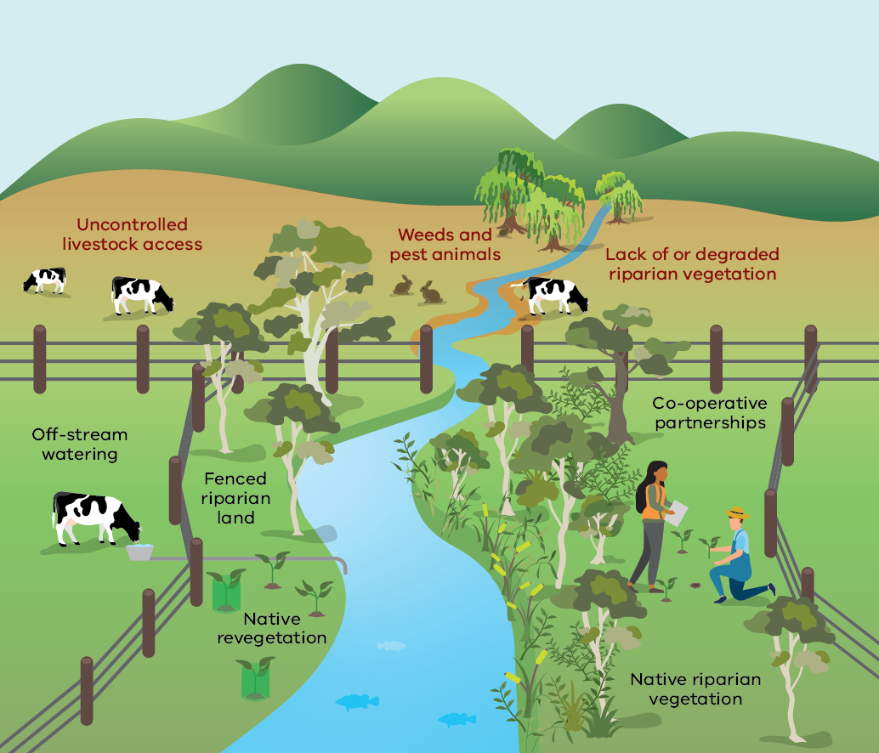
Summary of good and poor riparian management practices – illustrated in Figure 15 – of the Third Victorian Waterway Management Strategy.
Practice Area | Poor Practice | Good Practice
Livestock management | Uncontrolled livestock accessing the waterway directly | Fenced riparian land preventing livestock access; off-stream watering provided away from the waterway
Vegetation | Lack of, or degraded, riparian vegetation along waterway banks | Native revegetation plantings and established native riparian vegetation
Pest management | Weeds and pest animals present and unmanaged along the waterway | Active management and control of weeds and pest animals
Partnerships | No collaborative management arrangements in place | Co-operative partnerships between landholders, waterway managers and communities
Figure 16: Length of fencing undertaken along waterways in partnership with CMAs across Victoria (excluding Port Phillip and Westernport region) from 2013/14 to 2022/23. Note this only includes projects funded by the State Government.
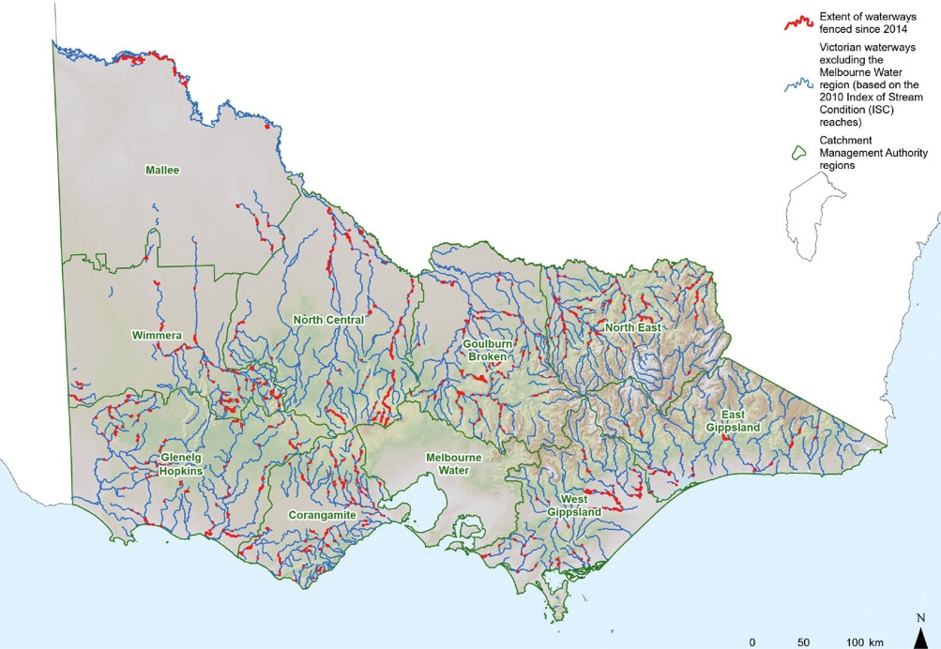

Intended outcomes
The Strategy will contribute to the following outcomes over the next 10 years:
- Riparian land is managed to maintain or increase vegetation condition
- Approaches are in place to support greater landholder uptake of riparian management, informed by an improved understanding of landholder motivations and attitudes
- Regulatory and policy settings are in place to support waterway managers, partners, farmers and other landholders to undertake improved riparian management (focusing on Crown water frontages).
Image 6: Revegetation works on the Barwon River as part of the Barwon Flagship Waterways project, working alongside the farmer to remove weeds and revegetate. Before (2019) and after (2022) / Gulidjan Country - Eastern Maar / Birregurra / Corangamite CMA
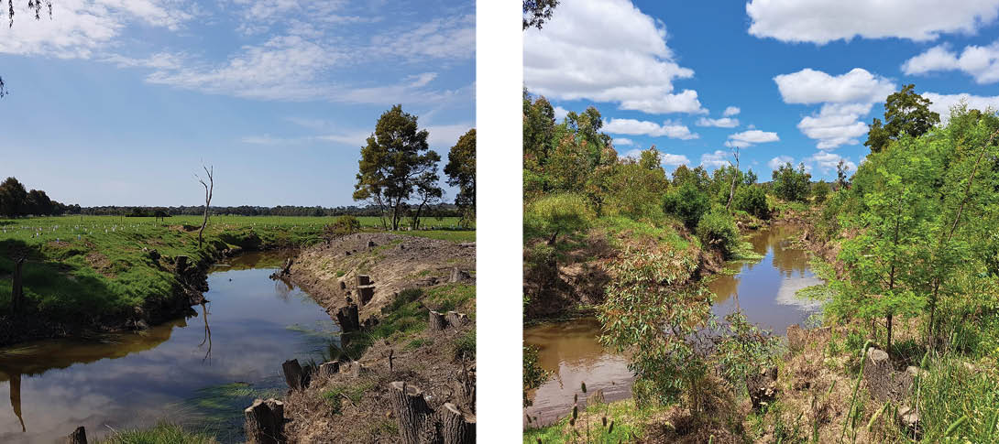

Management challenges and opportunities

Working together to manage riparian land
The most effective long-term approach to achieving riparian management outcomes is working with farmers, landholders, Traditional Owners, and community volunteers to foster their ongoing commitment to stewardship of riparian areas. However, some landholders are still reluctant to participate in riparian management programs and more can be done to understand their barriers and motivations in this area.

Policy 33 – Managing riparian land
Updated policy from the previous Victorian Waterway Management Strategy
The Victorian Government will continue working to maintain and improve the condition and resilience of riparian land, particularly through the reduction of stock access to waterways on both public and private land. It will do this by:
- encouraging voluntary and cooperative partnerships between landholders, other partners and the government, typically through waterway managers
- providing funding for programs to undertake riparian management activities, including fencing to reduce stock access to waterways, revegetation, weed management and installation of stock watering infrastructure
- assisting with the conversion of traditional agricultural licences to riparian management licences for Crown frontages
- strengthening links with relevant industries, local government, and community and stakeholder groups (such as angling, Landcare and other conservation and recreational groups) that have a shared interest in improved riparian management
- supporting waterway managers to work with water corporations, landholders, and various companies, agencies and not-for-profit organisations in biodiversity and carbon offset programs (including nature positive programs)
- supporting waterway managers to work through, or with, other programs that have a shared interest in improved riparian management (e.g. whole farm planning, land use planning, and water quality protection).
Water corporations, in cooperation with waterway managers, other agencies and private landholders, will continue to undertake risk management programs to reduce stock access for waterways upstream of drinking water offtakes and storages.

Management of Crown frontages to support community values
Around 17,000 km of the 22,000 km of Crown frontages within cleared catchments are currently managed by the adjacent landholder, under approximately 9,000 agricultural licences. Most of these licences are for grazing purposes. Crown frontage licences are typically issued by DEECA as the primary land manager for Crown frontages and other land managers where appropriate (for example, Parks Victoria, committees of management and local government).
Given the extent of Crown frontages and the important role they can play in protecting riparian values, there is a renewed emphasis on their maintenance and improvement to support broader community values.

Policy 34 – Administering and managing Crown frontage
Refinement of existing policy within the Victorian Waterway Management Strategy
DEECA will continue to support and implement improved compliance approaches for Crown frontages. Landholders managing licensed Crown frontages will need to meet minimum management standards.
Existing grazing licences on Crown frontage identified to be high value and within priority riparian management works areas must be surrendered or converted to riparian management licences when the abutting private land is transferred or sold.
DEECA will promote Crown frontages with existing riparian works, but not riparian management licences, to have their licence converted to a riparian management licence upon sale or transfer of the abutting private land.
Where Crown frontages are in unauthorised occupation with environmental, cultural, social and economic values threatened by grazing or other licensed agricultural activities, and it’s deemed appropriate to issue a licence by the public land manager, they will give the landholder the choice of:
- taking up a riparian management licence (which provides for the issue of a licence to take and use water for stock) and potentially being eligible for fencing and off-stream stock watering incentives, or
- not taking up a licence which will require fencing the frontage off at the landholder’s cost.
- Where Crown frontages are in unauthorised occupation of a waterway reach where there are no (or minimal) values threatened by the licensed agricultural activity, the public land manager may offer the landholder a standard agricultural licence.
- When riparian management works are being undertaken on Crown frontages, waterway managers will engage with licensees to ensure:
- public and Traditional Owner access to Crown frontages is enabled, including providing access (such as gates and stiles) and appropriate signage, especially in areas of known high public use
- special conditions from Crown frontage licences regarding public access are included in riparian management agreements where applicable
- when entering riparian management agreements for licensed or unlicensed Crown frontages, landholders are required to convert their existing licences into riparian management licences or take out a riparian management licence (in the case of a previously unlicensed frontage).
The Victorian Government recognises the significant cultural, environmental and social values of Crown frontages and will support their administration and management to protect these values. It also supports Traditional Owner self-determination for the management of Crown frontages.

Action 18
Action | Who | When
A.18–Evaluate the use of riparian management licences to determine:  - whether they can be improved to achieve the longer-term protection and environmental outcomes they are intended to achieve  - whether other mechanisms can also be used to achieve the desired aims. | Lead: DEECA  Collaborate:  waterway managers | by 2030

Action 19
Action | Who | When
A.19–Examine options for improving landholder compliance with the statutory requirements and licence conditions of Crown water frontages. | Lead: DEECA  Collaborate:  waterway managers | by 2035

Fencing and management of fenced riparian land
The Victorian Government and waterway managers have developed and implemented a range of guidelines and supporting information for fencing and managing riparian land, including:
- Livestock management on riparian land
- Management of floods and fire on riparian land
- Benefits of riparian land to landholders
Controlled grazing on riparian land
There is considerable evidence that ongoing weed management by farmers and other landholders with fenced riparian land can be challenging. New ways of encouraging this ongoing management need to be explored.

Policy 35 – Fencing and managing fenced riparian land to minimise grazing impacts
Updated policy from the previous Victorian Waterway Management Strategy
The following policies apply when the Victorian Government contributes to the costs of management activities on riparian land:
- Works on Crown frontages and private riparian land will be documented in clear and binding riparian management agreements between waterway managers and landholders.
- Controlled grazing will be allowed on riparian land subject to riparian management agreements where it:
- is consistent with the General Environmental Duty under the Environment Protection Act 2017 to reduce risks of harm to the environment
- is environmentally beneficial
- is acceptable as a management tool and/or
- doesn’t compromise the environmental, cultural, social and economic values of the riparian land and downstream values
Landholders, including licensees on Crown frontages, are responsible for the long-term management of the riparian fence and fenced riparian land that are the subject of riparian management agreements and/or licences.
Fencing for the purposes of riparian land management will:
- aim to be at least 20 metres wide on average from the top of the bank, and not narrower than 10 metres in any one place, or
- in the case of properties used for dairy, while aiming for at least 20 metres wide, will not be less than 10 metres wide on average from the top of the bank.

Action 20
Action | Who | When
A. 20–Continue to improve the management of fenced riparian land by:  - Investigating new approaches to achieve long-term management of fenced riparian land by landholders, such as:  - small stewardship payments with waterway manager riparian management agreements, to encourage ongoing maintenance  - involvement of Traditional Owner works crews  - involvement of community groups like Landcare or angling clubs.  - Enabling new and emerging technologies for the management of fences and fenced riparian land, including updating and developing relevant guidelines and standards  - Continuing to review on ground riparian management works to ensure they are undertaken to standard and to ensure landholders are meeting their obligations in riparian management agreements. | Lead: DEECA  Collaborate: waterway managers, Traditional Owners, community | by 2035

Off-stream stock watering on Crown frontages
Accessing water for stock is a critical issue for landholders participating in riparian management programs. It’s just as important to try and reduce the costs and administrative burden associated with obtaining a take-and-use licence for water when farmers and other landholders take out a riparian management licence and fence Crown frontages. For further information see take-and-use licences for off-stream stock watering.

Policy 36 – Providing livestock access to water along fenced Crown frontages
Updated policy from the previous Victorian Waterway Management Strategy
Access to water for stock will continue to be available for landholders with riparian management licences for their adjoining Crown frontage, through take-and-use licences where riparian fencing excludes stock from direct access to a waterway.
For landholders participating in riparian management programs and taking out a riparian management licence:
- the waterway manager will pay for the take-and-use licence application fee as part of the cost of a riparian management project
- rural water corporations will waive the annual fee for the first 3 years
- rural water corporations will issue take-and-use licences for up to 15 years (the current legislative maximum).

Planting of non-indigenous species on riparian land
Revegetation with indigenous native plant species is one of the most important riparian management activities supported by the Victorian Government and waterway managers. Planting non-native plant species on riparian land has been actively discouraged for more than 20 years due to the degradation it can cause to environmental and other riparian values. Willows in particular continue to cause significant impacts on waterway health.

Policy 37 – Minimising the planting of non-native species on riparian land
Updated policy from the previous Victorian Waterway Management Strategy
The Victorian Government and waterway managers will continue to discourage the planting of non-native species on riparian land under private ownership.
Victorian Government funding is not available for the planting of any non-native species on riparian land.
(Note: the use of sterile non-native grasses may be required as a rehabilitation tool in some circumstances on riparian land. Further policy around planting climate-suitable non-indigenous natives to transition to an altered state due to climate change is still to be developed).

Mitigating the impacts of climate change
Maintaining or improving the condition of riparian land, including by revegetation, will help mitigate some of the impacts of climate change by:
- shading waterways to regulate stream temperature increases
- helping reduce accelerated erosion of stream banks from increased flooding and runoff
- providing habitat and enhanced connectivity for plants and animals seeking more suitable environments due to climate change impacts.
Revegetation of riparian land also supports climate change mitigation, since riparian land is typically capable of sequestering higher levels of carbon than equivalent areas of terrestrial sites. Wetlands, estuaries and floodplains can also be used as sites for carbon sequestration.

Policy 38 – Improving climate resilience of riparian land
Updated policy from the previous Victorian Waterway Management Strategy
The Victorian Government will continue to support:
- riparian vegetation improvement programs as a cost-effective way to improve the resilience and resistance of riverbanks against erosive flood waters
- riparian land management programs that enhance the resilience of riparian land and/or waterways to climate change.
The Victorian Government and waterway managers will:
- ensure the approach to revegetating riparian land adapts to climate change impacts through species selection, seed and seedling provenance, and Ecological Vegetation Class (EVC) selection
- continue to explore the use of riparian land as sites of carbon storage to mitigate the impacts of climate change.

Chapter 10. River channels

What we mean
River channels cover the physical form (including beds, banks and instream habitat), functions and processes of rivers, streams and creeks. They include the presence or absence of features such as pools, riverbanks, large woody habitat and sediments. Functions and processes include the way in which flow, sediment and vegetation change, interact, threaten and benefit the fluvial system.
The fluvial corridor is a zone based on the likely trajectory of river movement without intervention.
Instream woody habitat, commonly referred to as ‘snags’, consists of trees, branches and logs that fall or are washed into rivers and streams. Snags have a range of functions essential for maintaining the ecological health and physical form of a waterway.
An avulsion is the rapid abandonment of a river channel and the formation of a new river channel.

Why is this important?
The physical condition of the beds and banks of rivers, creeks and streams supports a range of regional objectives for protecting environmental, cultural, social and economic values. It’s fundamental to the environmental functioning of waterways.
Of all the legacy impacts on waterways (such as water quality decline, flow regulation and vegetation removal), modification of the physical form of a river channel is among the most difficult to restore.
The condition of Victorian river channels has previously been impacted through land clearing, mining (including massive and ongoing sediment problems, e.g. ‘sand slugs’), considerable ‘hard engineering’ of rivers (e.g. weirs and dams, artificial straightening, concrete lining and the building of levee banks). Stock access can also cause damage to the stability of the bed and banks.

What we are already doing
River channels are managed by a range of stakeholders including various government and statutory agencies. Waterway managers, working in cooperation with adjoining landholders, Traditional Owners, the broader community and other partners, undertake and regulate works and activities on waterways.
Many other agencies also undertake or regulate works and activities that impact and manage river channels. These include water corporations that manage dams and weirs and some waterways as delivery channels, and local governments that manage and mitigate flood risk through levees. Often landholders also undertake works that can impact the condition of river channels.
Since the 2013 Strategy, DEECA and waterway managers have developed guidance e.g. 2024 Technical Guidelines for Waterway Management and implemented a range of policies and actions for river channel management. They are also continuing to develop and refine on-ground approaches to channel management as new knowledge emerges, especially considering the impacts of climate change.

Intended outcomes
The Strategy will contribute to the following outcomes over the next 10 years:
- Natural geomorphic functions and river processes that underpin functioning and diverse ecosystems are supported
- River channel planning and management approaches that allow the river to move within a fluvial corridor are incorporated where appropriate
- Community understanding of river behaviour and the environmental impacts of the traditional ‘hard engineering’ approaches to waterway management, such as rock beaching, is improved
Planning and organisational approaches are in place to ensure works and activities on waterways are undertaken to appropriate standards and comply with all required obligations.

Management challenges and opportunities
The approach to the management of river channels was historically to ‘hold rivers in place’ and protect infrastructure, deliver regulated flows or faster movement of floodwater. There was less recognition of the dynamic nature of rivers. The management of river channels is changing as we come to understand more about the environmental impacts of historical ‘hard engineering’ approaches to waterway management for broader environmental, social and cultural values.
Many physical interventions that attempt to stabilise all or most movement of the channel lead to waterways with lower environmental diversity and a reduced ability to support instream values like fish and aquatic mammals. It is now understood that active erosion, migration and sediment deposition can be positive attributes of a healthy waterway.
Many physical interventions designed to ‘stabilise’ a river can be costly to undertake and maintain. They often ultimately fail over time due to lack of maintenance, or because the interventions are extensively damaged – particularly due to large floods, where they were not designed for such extreme events.

The focus for management of river channels
Clearer guidance and direction is required from the Victorian Government about how to manage river channels in practice.
Where appropriate, defining a fluvial corridor for a river (a zone based on the likely trajectory of river movement without intervention) will assist with planning for and managing the river, including any potential river channel and riparian management works. This will lead to river systems with more natural ecological function, diverse river channel morphology and increased resilience, meaning less management intervention. Considering the fluvial corridor in managing waterways could help reduce intervention costs and lead to improved waterway condition. Defining a fluvial corridor would also incorporate Traditional Owners' identification of culturally sensitive areas, values and obligations to inform acceptable channel movement.

Policy 39 – Managing river channels
Updated policy from the previous Victorian Waterway Management Strategy
Management of river channels will focus on supporting the natural geomorphic functions and processes of river systems, leading to less intervention needed. The management of river channels will accept and support natural rates of erosion and deposition and support interventions only when significant waterway values and public assets are threatened and no acceptable alternative (e.g. relocation of the asset) can be identified. A proportionate and risk-based approach will be applied.
Sufficient space will be provided for river channels to move within their fluvial corridor where practicable. This can be achieved by:
- formally defining and mapping the fluvial corridor (where required)
- establishing sufficient riparian setbacks
- avoiding hard engineering works that hold the river in place
- establishing agreements or covenants with landholders to enable channel movement.

On-ground intervention and investment in the management of river channels
It’s important to clarify when and by whom intervention in river channel management should occur especially when private and public assets are at risk or impacted by river channel processes, like erosion after a flood. The community often expects intervention, even where there may be little broader public or environmental benefit, or when the intervention could cause broader environmental, cultural or social impacts. Some rivers are particularly high energy and require space to move, even with established riparian vegetation and in-stream wood.
Avulsion is a natural river process which can lead to significant disruption and cost. In some cases, it can impact private land and assets such as paddocks, pump sheds and fences. Many avulsions, especially larger ones, will have impacts on the community from road networks (and access) to urban environments and homes.
Any on-ground intervention to manage the physical form of rivers or inhibit avulsions should only be considered in limited circumstances. It’s often inevitable that the river will break through at some stage, at which time the impacts can become worse.
In many cases a major risk from avulsions will be to public and private infrastructure, which falls outside the remit of waterway managers. The involvement of other stakeholders (such as public authorities and local government) is required to manage the risk.

Policy 40 – On-ground management of river channels
Updated policy from the previous Victorian Waterway Management Strategy
Intervention by waterway managers may be required in the management of river channels when channel change is accelerated and threatens priority cultural, environmental and social waterway values and public waterway management assets. In these cases, intervention will:
- be consistent with cost-sharing principles
- be considered in the context of overall management outcomes for the waterway (and floodplain), including the trajectory of the waterway without intervention
- work with geomorphic processes where possible to promote long-term waterway resilience
- be considered an option when no alternative management approach (such as relocating assets) is feasible.
Managing risks from waterway processes to public and private infrastructure is primarily the responsibility of the infrastructure owner.
Waterway managers will only contribute funds to risk reduction if priority cultural, environmental and social values are threatened. This may include previous waterway management works that had an objective to protect environmental and cultural values.
Waterway managers aren’t obliged to assess or remediate impacts of waterway processes on private land or private assets.

Action 21
Action | Who | When
A.21–Develop an approach for defining a ‘fluvial corridor’ in which a river is likely to move and shape the landscape. Use the outputs from this approach to improve community knowledge of river behaviour and when government and waterway managers may intervene in managing the river channel. | Lead: DEECA  Collaborate:  waterway managers | by 2035

Instream wood management
Instream wood provides important fish habitat and can contribute to riverbank stability and other waterway processes. Guidance has been developed for managing and reinstalling instream wood. (Large wood snags and flooding).

Policy 41 – Management of instream wood
Updated policy from the previous Victorian Waterway Management Strategy
Removal of large woody habitat or native instream vegetation will not be authorised by waterway managers unless:
- it poses a serious and demonstrable risk to public safety or public infrastructure, or
- its removal provides an overall improvement to the river and ecosystem function.
- If authorised, realignment or anchoring of large, woody habitat will be undertaken where feasible, rather than removal.

Management of sand and gravel extraction
Sand and gravel extraction from river channels can accelerate erosion and sedimentation, alter flow regimes during and after the extraction works, cause loss of habitat and breeding areas for in-stream species, loss of vegetation on stream banks and loss of instream wood. Sand and gravel extraction on floodplains can accelerate the likelihood of avulsions and also damage high value environmental and cultural values, for example by damaging floodplain wetlands.
Excess sand and gravel are a feature of many Victorian waterways due to legacy issues from gold mining and land clearing. In cases where excess sand and gravel threaten high environmental, cultural and social values, waterway managers can use sand and gravel extraction in river channels.

Policy 42 – Managing sand and gravel extraction
Updated policy from the previous Victorian Waterway Management Strategy
Sand and gravel extraction in river channels may be undertaken (or authorised) by waterway managers as a management tool where excess sand and gravel threaten high environmental, cultural and social values. Sand and gravel extraction may also be authorised by waterway managers where it will not significantly harm environmental, cultural or social values.

Improved waterway compliance
A range of agencies are involved in managing waterways and waterway structures. This includes the important statutory role of waterway managers to authorise works and activities on waterways and undertake compliance and enforcement for unauthorised works and activities, as outlined in the water and catchments regulatory framework. Preventing inappropriate works and activities on waterways reduces environmental harm to the physical form and associated values of waterways. This is why clarity of roles and responsibilities for undertaking compliance activities on waterways is essential, including inter-agency cooperation and coordination.

Action 22
Action | Who | When
A. 22–Investigate and implement approaches to strengthen waterway manager statutory, compliance and enforcement capabilities regarding works and activities on waterways. This includes developing new guidelines and information material as required and improving  inter-agency cooperation and coordination. | Lead: DEECA  Collaborate: waterway managers | by 2030

Chapter 11. Water quality

What we mean
Water quality is the physical, chemical and biological attributes of water and is a key measure of waterway condition.
Pathogen is a disease-causing organism. Microbial indicators are microorganisms such as bacteria and viruses, which are used as a surrogate of pathogen behaviour in a waterway.
Point source pollutants are direct inputs of pollutants into waterways, such as fire runoff spills and releases from wastewater treatment plants, which are typically regulated by EPA Victoria.
Non-point sources (or diffuse sources) are indirect inputs of pollutants from surface runoff when it rains, which enter waterways through stormwater or overland flow, or as a result of groundwater discharge to waterways.
Point and diffuse sources of pollution each require different management approaches.
Toxicants is a term used for chemical contaminants that have the potential to exert toxic effects at concentrations that might be encountered in the environment.
In Victoria, the General Environmental Duty (GED) is a legal obligation for everyone to minimise harm to human health and the environment from pollution and waste. This means taking all reasonably practicable measures to prevent or minimise harm before it occurs.
The 2021 Victorian Environment Reference Standard includes water quality indicators and objectives for a range of values (including Aboriginal cultural values and values related to human health) for both surface and groundwater.

Why is this important?
Water quality determines the suitability of water for a particular use or purpose, with better quality water sources able to support living systems and a wider range of uses.
Changes to water quality that affect waterway condition include (See Figure 17):
- increased nutrients, e.g. phosphorus and nitrogen
- increased sediment and turbidity
- increased salinity in freshwater
- decreased salinity in saline waters
- presence of toxicants, e.g. heavy metals, pesticides, organic pollutants, algal toxins, pharmaceuticals from wastewater discharges, veterinary products used in agriculture, endocrine disruption and per- and polyfluoroalkyl substances (PFASs) used in many industrial, household and fire-fighting activities
- pathogen and microbial contamination
- reduced dissolved oxygen levels
- altered acidity (pH)
- altered water temperatures or water regimes
litter and other foreign materials.
Culturally-important plants, animals and other values of Traditional Owners for waterways can be adversely affected by poor water quality.
Poor water quality that impacts drinking water supply sources can require water corporations to provide additional costly treatments to meet obligations under the Safe Drinking Water Act 2003 framework. It can also impact recreational activities and agricultural uses.
Water quality in waterways also affects connected groundwater systems and coastal and marine environments. Many key marine species (such as seagrass) can be adversely affected by changes in nutrient and sediment loads and pollutants flowing from upstream catchments.
The Victorian State of the Environment Report 2023, State of the Birrarung (Yarra) and its Parklands 2023 Report, EPA Victoria Beach Report, YarraWatch season summaries, and DEECA’s Water Quality Trends Report all show the pressures water quality continues to face across Victoria.
DEECA’s Water Quality Trends Report assessed long-term underlying trends in surface water quality over 27 years and showed an increase in turbidity at 80% of regional sites analysed and an increase in total phosphorus at 40% of sites. The analysis was designed to assess long-term underlying trends and remove water quality fluctuations caused by streamflow and seasonality.
The report also showed different long-term trends for salinity. Over the last 27 years, salinity levels have improved (i.e. decreased) at 46% of regional sites, where significant investment has been made in improving irrigation practices. Salinity levels across Victoria increased markedly during the extremely dry period of the Millennium Drought from 2001-2009, but continues to be managed within acceptable limits.
The cost of managing poor water quality including events such as blue-green algal blooms and blackwater can be significant. It can impact the way people value waterways, and lead to economic losses from increased water treatment costs, and the loss of recreation and tourism opportunities. It can also impact both commercial and recreational fishing industries. Preventing pollutants from entering waterways can avoid substantial treatment costs.
Figure 17: Activities affecting water quality and waterway values affected by water quality
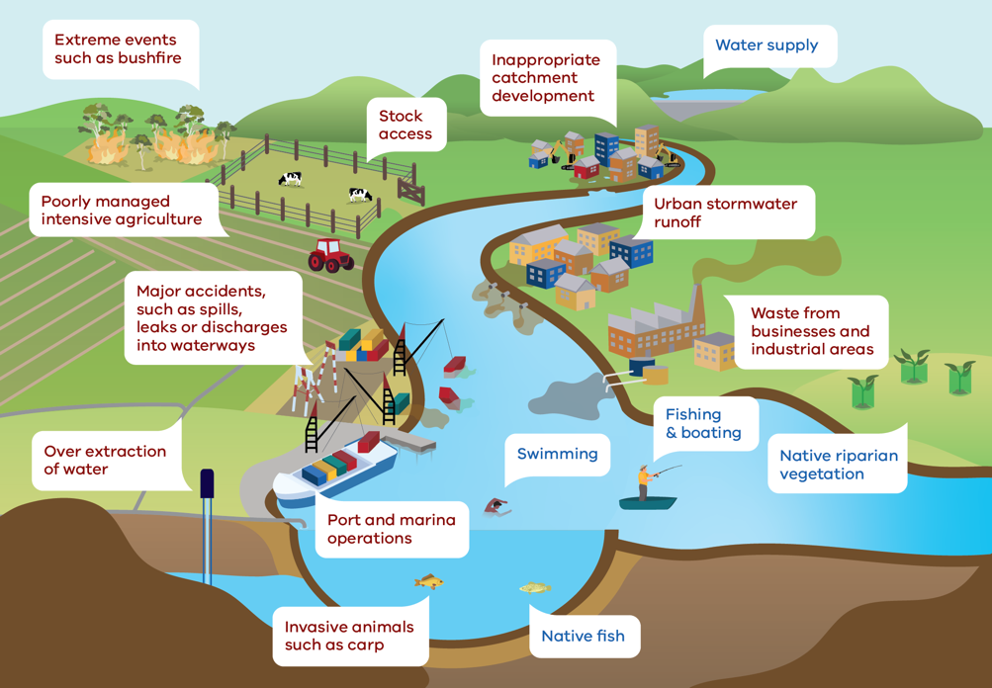
Summary of activities and waterway values illustrated in Figure 17 of the Third Victorian Waterway Management Strategy.
Activities Affecting Water Quality | Waterway Values Affected by Poor Water Quality
- Extreme events such as bushfire  - Poorly managed intensive agriculture  - Stock access  - Inappropriate catchment development  - Major accidents, such as spills, leaks or discharges into waterways  - Over extraction of water  - Port and marina operations  - Urban stormwater runoff  - Waste from businesses and industrial areas  - Invasive animals such as carp | - Water supply  - Swimming  - Fishing and boating  - Native riparian vegetation  - Native fish

What we are already doing
Victoria’s management approach to prevent environmental harm to waterways from poor water quality includes:
- preventing environmental harm to the water cycle
- addressing both point and diffuse sources of pollution to waterways
- addressing the cause of pollution to waterways
protecting areas where environmental objectives are already met.
The best way to protect water quality is to reduce the risks of pollution and waste entering our waterways, groundwater, marine and coastal environments.
The management framework for water quality in Victoria includes national, state and regional arrangements. The key aspects of the framework are outlined in Appendix 10.
In 2021, the Environment Protection Act 2017 reforms led to significant changes to Victoria’s environment protection framework, with improved tools and sanctions now available. The framework is underpinned by the general environmental duty (GED) and new duties for waste, contaminated land and incident notification and management. The GED is a key mechanism to reduce the risk of environmental harm to waterway environments from pollution and waste, by making it clear that:
- Victorians have a responsibility to manage their activities to reduce risk to human health and the environment from pollution and waste
- entities are responsible for understanding and assessing their risks (whether point or diffuse) to the environment and human health – and eliminating or reducing risks as far as reasonably practicable.
EPA Victoria is encouraging water corporations to determine their baseline emerging contaminants in any effluents discharged to waterways.
EPA Victoria and DEECA continue to guide and encourage appropriate management practices to reduce both point and diffuse source pollution to receiving waters, including marine environments and groundwater.
Recent examples of EPA Victoria using its powers include a campaign to prevent stormwater pollution from construction sites in regional areas including Castlemaine, Gisborne, Mildura, Bass Coast, Shepparton, Bairnsdale, Ballarat, Wodonga, Geelong and Bendigo.
The Victorian Government is also taking steps to help stop litter at its source. In recent years, new regulations have been introduced to ban the use and supply of lightweight, plastic shopping bags and certain single-use plastics. A container deposit scheme has also been introduced. Many local authorities, non-government organisations and volunteer groups are tackling the ongoing flow of litter and plastic pollution into our waterways within their local communities.
Victoria is collaborating with the Australian Government and the other state and territory governments to strengthen the Industrial Chemicals Environmental Management Standard (IChEMS) framework and is committed to its implementation (refer to Australia’s industrial chemicals roadmap). Its objective is to prevent chemicals being released and reduce human exposure to chemicals through the environment.
The Victorian Government and its partners continue to invest in a range of water quality research and modelling projects, report card initiatives and citizen science programs.
For example:
- DEECA and its partners invest in monitoring waterways and other water bodies to determine overall water resource condition, through the Regional Water Monitoring Partnership (RWMP)
- DEECA and its partners have invested also in monitoring the water quality impacts of the 2019-2020 bushfires to understand water quality impacts and how these might be managed in the future
EPA Victoria has commenced a new pilot project, with water sensors deployed in metropolitan catchments to target hot spot pollution.
Under the Murray-Darling Basin Agreement, Victoria is also required to carry out salinity monitoring and maintain an accurate record of sites which are part of the Basin-wide Core Salinity Monitoring Network. This includes the monitoring of end-of-valley target sites, accountable actions and delayed salinity impacts. Monitoring supports the tools used in evaluating the success of Victoria’s implementation of the Basin Salinity Management 2030 Strategy. The Murray-Darling Basin Authority and basin governments across Australia are actively working together to manage salinity risks to the environment, economy and communities in the Murray-Darling Basin.

Intended outcomes
The Strategy will contribute to the following outcomes over the next 10 years:
- Preventing or diminishing harm to waterway values from degraded water quality where practicable
Identifying and managing waterway values at risk from both point and diffuse water quality issues, in line with regional outcomes.

Management challenges and opportunities
Urban development and population growth, rural land management and climate change are all impacting water quality in Victorian waterways. Further changes like increased algal blooms, reduced dissolved oxygen and increased salinity are likely.

Roles and responsibilities in water quality management
Regional management arrangements (See Chapter 5) will remain the main approach for managing water quality where diffuse sources pose a threat to waterway outcomes, which are identified in regional catchment strategies and regional waterway strategies.
While regional waterway management arrangements work well and remain valid, relying on them alone won’t result in significant improvements to water quality across Victoria.
There are areas in Victoria where water quality has been significantly impacted by point and diffuse source pollutants from past and ongoing land use management practices. Legacy pollutants such as mercury, polychlorinated biphenyls, dioxins and other chemicals persist in the environment and can have health and environmental effects.
Management of water quality can only be successfully undertaken within a framework of integrated catchment and water cycle management that involves all agencies, landowners and land managers. This means broad collective effort will also be needed to address the legacy water quality issues affecting waterway values.
The Victorian Government will continue to apply the GED and use a range of legislative instruments, policy and guidance to either directly or indirectly protect and manage water quality. Entities with a role in protecting water quality are outlined in Appendix 5.
Local agencies and stakeholders are encouraged to work with regional EPA and the Department of Health (DoH), to focus regulatory support on priority areas identified in each regional waterway strategy.
The success of water quality management will continue to be affected by a range of factors such as:
- time lags between management activities being implemented and the response
- the amount of water in waterways (as droughts or floods can affect water quality)
- the level of impact from other management activities
- the persistence of materials in the environment that were created through past activities.

Water storage releases
The storage of water in large dams can affect water quality both within the storage and downstream when it is released. For example, holding water in storages can change the temperature, natural levels of sediment, metals, dissolved oxygen and growth rates of algae. While the impacts of river regulation cannot be avoided altogether, storage managers and river operators need to manage water releases for water users in a way that reduces some water quality risks where possible.

Policy 43 – Managing a risk-based approach to regulated releases from water storages
Updated policy from the previous Victorian Waterway Management Strategy
Storage managers and operators will continue to consider risks from planned storage releases and apply risk mitigation measures where reasonably practicable, to protect water quality and downstream values, in consultation with affected stakeholders.
Poor water quality events downstream of a water storage can lead to community pressure for storage releases to reduce some of the impacts.

Policy 44 – Releasing water from storages to mitigate water quality events
New policy
Storage managers will consider flexible river operations along with other risk strategies to help manage downstream water quality risks, where this doesn’t compromise water user needs (including environmental water holders).

Action 23
Action | Who | When
A.23–Work with water corporations and other relevant partners to clarify the considerations in using storage releases to manage poor water quality downstream. | Lead: DEECA  Collaborate: water corporations, waterway managers | by 2030

Impacts from disturbance of acid sulfate soils
Acid sulfate soils are soils or sediments that contain (or once contained) high levels of reduced inorganic sulfur. When exposed to oxygen, the soils or sediments undergo oxidation and produce acid. Disturbance of acid sulfate soils can occur as a result of:
- drainage
- dredging
- drilling for bores
- drought that induces drying of soil profiles
- extractive industries
- infrastructure works
- land uses practices and changes that alter water tables
- urban and tourism development
water extraction.
Coastal land in Victoria with the potential to contain acid sulfate soils has been mapped since 2013. Inland waterways in Victoria can also undergo acidification events when acid sulfate soils are exposed (such as during droughts). Improved mapping of potential hotspots is required.
Impacts to the environment and humans from the disturbance of acid sulfate soils should be avoided in accordance with the Victorian Acid Sulfate Soils Strategy 2009 (and any future iterations).

Informing water quality standards
The Environment Reference Standard 2021 identifies the environmental values, indicators and objectives that apply to different areas of Victoria. For example, marine pollutant load objectives are specified for Port Phillip Bay, Western Port, Lake Wellington and Corner Inlet and Nooramunga. The Central and Gippsland Region Sustainable Water Strategy aims to protect water quality in these areas through Actions 8.24-8.26. For the Lake Wellington pollutant load objective to be achieved, the revoked State Environment Protection Policy (Waters) 2018 outlines that annual load reductions are to be equally split between catchment and irrigation sources. The pollutant load split may need to be updated over time.
Where sufficient monitoring data is available, the Environment Reference Standard 2021 will be used by waterway managers to identify areas where water quality targets are applicable for Victorian waterways. These areas will be identified in regional waterway strategies.
The Environment Reference Standard 2021 includes Traditional Owner cultural values and requires that indicators and objectives be developed in consultation with Traditional Owners. This may be informed by the process identified in Indigenous cultural & spiritual values in water quality planning (2012).
Standards do not exist for many toxicants yet. Increasing the number of toxicant indicators and objectives will help to measure, determine or assess whether waterway values are being protected. These standards will continue to be published on the Australian Government water quality website, Default guideline values.
There is an opportunity to learn from and build on the work Melbourne Water is undertaking to understand chemicals of emerging concern, including research and surveillance monitoring to flag new chemicals appearing in waterways.
While Victoria’s relevant regulatory frameworks are fundamentally preventative and reflect the objective of the Industrial Chemicals Environmental Management Standard framework, it is important to continually assess scheduled chemicals and determine whether additional controls are needed.
The PFAS National Environmental Management Plan (PFAS NEMP) is Australia’s national guide for managing Per- and poly-Fluoroalkyl substances (PFAS) contamination in the environment.

Policy 45 – Development of toxicant default guidelines
Existing policy incorporated into the Victorian Waterway Management Strategy
DEECA and EPA Victoria will continue to work with the Australian Government to develop default guideline values for priority toxicants. These will be used to allow for greater measurement, determination or assessment of whether values in waterways are being protected in Victoria.

Investing in long-term water quality data collection
Intervention monitoring that is conducted outside of the Regional Water Monitoring Partnership is held by the individual organisations who collected it and may not be publicly available.
Increasing the accessibility of publicly-funded water quality data in Victoria can help to build a more complete picture of water quality across the state.

Policy 46 – Principles for targeted and coordinated investment in long-term water quality data collection
Updated policy from the previous Victorian Waterway Management Strategy
The Regional Water Monitoring Partnership will keep collecting statewide long-term water quality data to inform water management decisions. Data will be publicly accessible and published online.
Water quality monitoring programs receiving Victorian Government investment should:
- be fit-for-purpose
- maintain high data quality and quality assurance standards
- provide a publicly accessible and centralised water information management source.
- Any process to collect and assess water quality data against cultural value indicators and objectives will be self-determined and led by Traditional Owners, respecting their cultural rights and Indigenous data sovereignty.

Action 24
Action | Who | When
A. 24–Investigate the types of land use that pose a high risk to aquatic ecosystems via chemical use pathways. | Lead: DEECA  Collaborate: waterway managers | by 2030

Action 25
Action | Who | When
A. 25–Investigate opportunities to increase the accessibility of publicly funded water quality data, such as a central digital entry point to locate relevant water quality datasets. | Lead: DEECA  Collaborate: waterway managers, EPA, DoH, water corporations | by 2030

Action 26
Action | Who | When
A. 26–Assess the extent to which current water quality monitoring meets the data requirements identified for indicators and outcomes of the Victorian Waterway Management Strategy and regional waterway strategies. | Lead: DEECA  Collaborate: waterway managers, water corporations | by 2030

Chapter 12. Estuaries

What we mean
Intermittently open and closed estuaries may be periodically open to the ocean and have salinities that vary from almost fresh to very salty. Under conditions associated with low stream flows and high wave and tide activity, a sand berm can form near the estuary mouth, periodically ‘closing’ the estuary to the sea.
Artificial estuary entrance opening is the removal of the sand berm (usually by mechanical means) to reinstate the exchange of water between the estuary and the sea.
Lateral connectivity is the connection of habitat or water between the estuary channel and the surrounding estuarine floodplain and wetlands.

Why is this important?
Estuaries connect rivers to the sea, and their ecosystems are highly complex and dynamic. The condition of an estuary directly affects nearby marine and coastal areas. This entire system – including the catchment, river, estuary, coast and marine areas – works together as a connected, living environment. They’re crucial breeding and feeding grounds for birds, as well as spawning and nursery sites for fish. The vegetation and salt marshes near estuaries help maintain water quality, support nutrient cycling, and protect against sediments and pollutants entering the marine environment.
Estuaries have great importance for Victorian Traditional Owners, with many being sites of cultural significance. They play a key role in local and regional economies through tourism, recreation and increased land values. For example, expanding seagrass in Port Phillip Bay and Western Port could deliver up to about $22 million a year in recreational-fishing benefits, equivalent to as much as $85 per fishing trip in the most productive areas. People love to visit Victorian estuaries for camping, swimming, boating, sightseeing, and connecting with each other and nature.
In Victoria, growing population, urbanisation and development pose significant threats to many estuaries. Estuaries within highly-urbanised areas are generally in poorer condition. This decline can be caused by increased stormwater runoff, pollution, physical barriers that disrupt natural flows and development that limits lateral connectivity.
Other significant threats to the environmental condition of estuaries include sea level rise due to climate change and pressure for artificial estuary openings to protect development on estuarine floodplains.

What we are already doing
Victoria’s Marine and Coastal Act 2018 sets objectives and guiding principles for the planning and management of the state’s marine and coastal environment. The Marine and Coastal Policy 2020 and Marine and Coastal Strategy 2022 outline policies and priority actions to achieve the legislation’s objectives. The Victorian Waterway Management Strategy and its arrangements for regional waterway strategies sit alongside the renewed Marine and Coastal Policy framework – guiding waterway managers and other stakeholders on estuary management, including the management of estuarine floodplains.

Intended outcomes
The Strategy will contribute to the following outcomes over the next 10 years:
- Artificial estuary management openings undertaken for private and public assets are avoided, unless there are significant risks to public and private values and environmental impacts are minimised
- Appropriate planning controls and management arrangements protect critical habitat surrounding estuaries.

Management challenges and opportunities
A strong framework for estuary management is essential to balance the values and uses of estuaries which can be in conflict, particularly in areas with high development or tourism, and cultural and/or environmental value.
Estuary management activities will incorporate bio-cultural management, planning and policies and support Traditional Owners objectives for Country.

Policy 47 – Framework for managing estuaries
Existing policy incorporated into the Victorian Waterway Management Strategy
Waterway managers will coordinate a regional approach to managing the environmental condition of estuaries, in accordance with the following:
- The Victorian Waterway Management Strategy will provide the leading statewide strategic direction on managing the environmental condition of estuaries
- The Marine and Coastal Policy 2020 and Marine and Coastal Strategy 2022 will provide strategic direction for coastal land use planning, sustainable development issues and managing coastal (and estuary) hazard risk
- Regional waterway strategies will identify strategic outcomes and management approaches for managing estuary condition
- Sub-strategies or plans identified in regional waterway strategies will outline management activities required to maintain, improve or adapt the condition of a specific estuary.

Managing estuary entrances
Inundation of estuarine floodplains is a natural process and plays an important role in the lifecycle of many species and for the cycling of nutrients. Periodic inundation of adjacent wetlands and fringing vegetation is also necessary for their ongoing health. The closure of an estuary entrance can lead to an increase in water level and can negatively impact nearby agricultural and residential land, as well as infrastructure such as roads, bridges and boat ramps.
Over the past decade, significant improvements have been made in managing artificial estuary entrance openings, due to clear principles, policy and actions in the second Victorian Waterway Management Strategy. There is still work to do to improve how Aboriginal cultural values and the impacts of climate change are considered.
When deciding whether to open an estuary, it is necessary to conduct a risk assessment that considers the values of the area. This assessment helps to identify the potential impacts and risks associated with both opening and not opening the estuary at different water levels.
Image 7: Natural flooding across the Gellibrand Estuary floodplains at Princetown and the process of artificial estuary opening/ Kirrae Whurrong Country – Eastern Maar / Corangamite CMA 2024
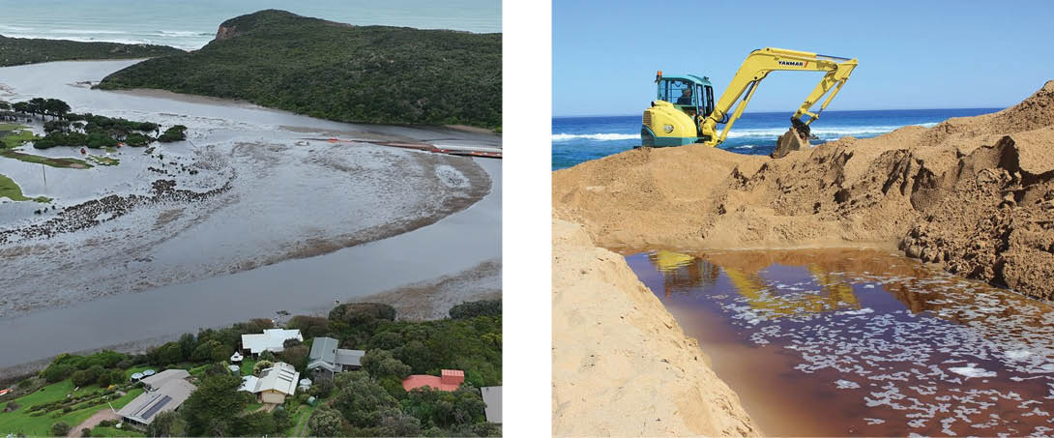

Policy 48 – Managing estuary entrances
Updated policy from the previous Victorian Waterway Management Strategy
An artificial estuary entrance opening should be avoided, except in cases where:
- it’s determined to be appropriate after a risk-based assessment that considers impacts (direct and cumulative) on the specific estuary values; and
weather and physical conditions allow for a safe and effective opening as outlined in the approval condition.
The costs of artificially opening estuaries should be funded by beneficiaries as outlined in cost-sharing principles.
Waterway managers will take the lead role in regulating estuary entrance opening using the process outlined below:
- Approval under the Water Act 1989 issued by the waterway manager will outline the conditions of ‘permitted’ estuary openings
- A risk-based assessment will be used by waterway managers when considering the waterway values of, and risks to, an estuary.
- Where required, waterway managers, Traditional Owners, relevant agencies, land managers and landholders will enter into a memorandum of understanding (MOU) or similar for estuary openings which will include:
- roles and responsibilities
- water quality monitoring requirements
- the process and the beneficiaries of artificial openings
- funding arrangements.
- The land manager or delegated responsible entity will be responsible for:
- carrying out the works component of all artificial estuary entrance openings
- obtaining all relevant approvals, including compliance with any land use activity agreement under the Traditional Owner Settlement Act 2010 and any approvals required under the Aboriginal Heritage Act 2006
- notifying the waterway manager, relevant land managers and Traditional Owner group before works begin.
- In some cases, artificial estuary entrance openings are undertaken as part of Victoria’s emergency management arrangements. In these cases, the waterway manager will provide advice on environmental risks, conditions and opening triggers – and work collaboratively with responsible agencies.

Action 27
Action | Who | When
A.27–Identify land or built assets that are regularly the subject of requests for estuary openings and work with asset owners to assess alternative actions, where appropriate, that could minimise the long-term threat of inundation. | Lead: waterway managers  Collaborate: Parks Victoria, local government, Great Ocean Road Coast and Parks Authority, VicRoads | by 2035

Maintaining and improving the environmental condition of estuaries
Estuaries are located at the end of the catchment, so their environmental condition and flow regime are significantly influenced by upstream activities. This includes the accumulation of nutrients, sediments, pollutants and pathogens from agriculture and urban land use, freshwater extraction and physical instream barriers.
Interventions to reduce natural flooding from the closure of estuary entrances and the loss of surrounding native vegetation further contribute to the degradation of these ecosystems.
Waterway managers, Traditional Owners, relevant agencies and land managers will work together to maintain, improve or adapt the environmental condition of estuaries. This may include:
- identifying management arrangements and priority areas to reduce stormwater input into estuaries
- maintaining ecological corridors and promoting linkages (such as migration pathways) and habitat adaptation to climate change (e.g. through landward movement of habitats in response to sea level rise) across public and private land
- identifying opportunities to mitigate impacts on estuarine condition, including those caused by surrounding land uses, and more frequent estuary closures expected from reduced flows in dry periods
identifying critical areas of habitat to protect through available planning mechanisms.

Policy 49 – Maintaining, improving and adapting the environmental condition of estuaries
Updated policy from the previous Victorian Waterway Management Strategy
The Victorian Government will continue to use statutory processes, works on waterways approvals and planning controls to protect the environmental condition of Victoria’s estuaries.
Where private land interfaces with high-value estuaries, waterway managers will seek land stewardship arrangements, such as agreements or covenants, that support the condition and resilience of these estuaries, even as the climate changes.
In limited circumstances where land is offered for sale, the government may choose to support the purchase of the land.
Image 8: Works completed to improve Beach Road following inundation / Gunditjmara Country / Nelson / Glenelg Hopkins CMA 2018
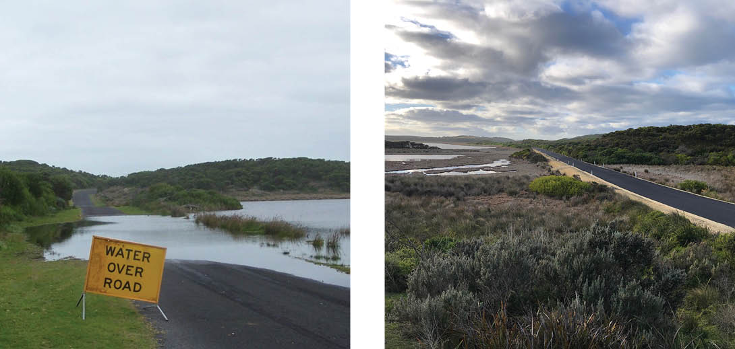

Estuaries and climate change
Victorian estuaries are likely to become increasingly vulnerable to climate change. Rising sea levels will increase the frequency of inundation in low-lying land adjacent to estuaries. Reductions in freshwater flow will allow marine waters to move further upstream in some systems. The combination of these factors will have serious implications on how and where critical habitats such as saltmarsh, mangroves and seagrass will persist. The altered estuarine hydrology may also result in more frequent and longer periods of mouth closures for some estuaries.
Flood provisions in planning schemes for estuarine areas will be reviewed by waterway or floodplain managers and local government, as we learn more about the vulnerability of estuaries and other coastal assets to sea level rise and potential climate change impacts.
Under the Marine and Coastal Policy 2020, coastal processes – including natural inundation and those increasingly induced by climate change and catchment changes (such as estuary entrance closures) – are referred to as coastal hazards.
Coastal hazard exposure occurs periodically across the coast and is projected to increase with changes in wave action, storm activity and sea level rise associated with climate change.
Building on the directions in the Marine and Coastal Policy 2020, Victoria’s Resilient Coast – Adapting for 2100+ provides a framework, guidelines and support for waterway managers, local government, land managers and their communities. This will help to enable place-based, best practice and long-term coastal hazard risk management and adaptation.

Policy 50 – Adaptation planning for estuary entrance management
Existing policy incorporated into the Victorian Waterway Management Strategy
Strategic waterway and coastal planning will apply an adaptation approach which considers the existing and potential future impacts of climate change on coastlines, estuary structures (built), estuarine extent, sea level changes and other relevant factors, to prepare for changes in the extent of estuary areas and their associated plants and animals.
With some estuarine systems expected to experience a reduction in the number of natural openings because of climate change, artificial openings may be considered as part of transition planning where a risk assessment identifies opening will protect critical environmental values.
To remove or reduce the need to artificially open estuary entrances for private and public assets, waterway managers – in conjunction with relevant agencies, land managers and landholders – will investigate adaptation pathways. These include options for agricultural or residential land and infrastructure (built) assets that are regularly threatened by inundation due to estuary closures.

Chapter 13. Invasive species

What we mean
An invasive species is a species that occurs beyond its accepted normal distribution and threatens environmental, agricultural or other social values, as a result of human activity. These species can be native Australian or introduced plants (weeds), animals (pests) or diseases from another country.
Biosecurity is the collective effort to prevent and manage the harms caused by weeds, pests and diseases and the impact they have on what we value most.

Why is this important?
Invasive species may occur in freshwater, brackish or saline environments (such as rivers, wetlands and estuaries), human-made environments (such as channels or reservoirs) or along riparian land. These species may be difficult to detect in waterways. Invasive species can reproduce rapidly and quickly become dominant over native species – spreading via natural dispersal, assisted by wind, carried on animals or in water flowing downstream or onto floodplains and wetlands (See Figure 18). People can spread invasive species either deliberately or accidentally.
Invasive species can be difficult and expensive to eradicate or control and can undermine previous waterway management works like riparian revegetation. Their spread can have devastating consequences, and it’s often more effective to prevent their introduction altogether, or to detect an incursion as early as possible. The impacts extend beyond waterways, with invasive weeds accounting for an estimated 81% of the costs associated with recovering Australia's threatened species.
Figure 18: Methods of weed and pest incursions and spread
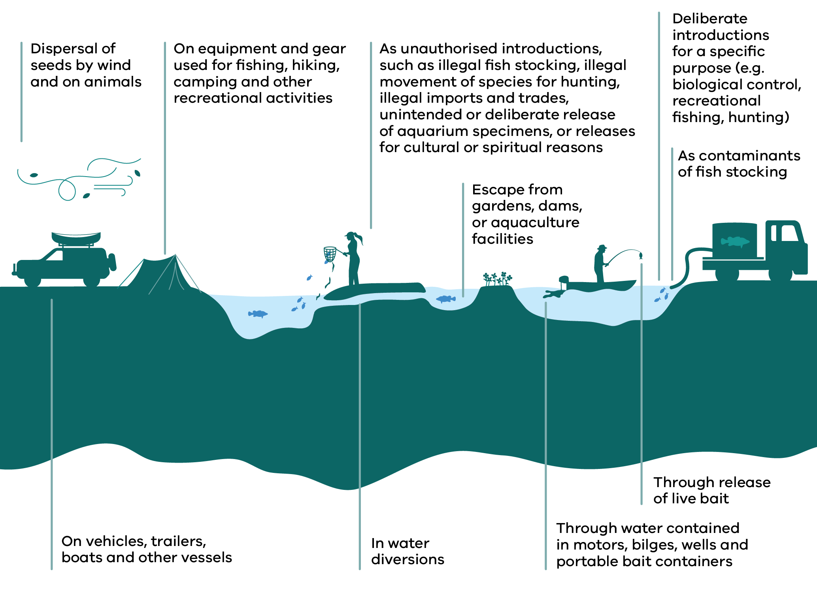
Methods of weed and pest incursions and spread shown in Figure 18
Method of introduction or spread
Dispersal of seeds by wind and on animals
On vehicles, trailers, boats and other vessels
On equipment and gear used for fishing, hiking, camping and other recreational activities
In water diversions
As unauthorised introductions – including illegal fish stocking, illegal movement of species for hunting, illegal imports and trades, unintended or deliberate release of aquarium specimens, or releases for cultural or spiritual reasons
Escape from gardens, dams, or aquaculture facilities
Through water contained in motors, bilges, wells and portable bait containers
Through release of live bait
As contaminants of fish stocking
Deliberate introductions for a specific purpose (e.g. biological control, recreational fishing, hunting)
Weeds, pests and diseases are an increasing threat to the health of Victorian waterways and riparian land. They disrupt ecosystem processes, harm our environments and threaten native biodiversity. They can also pose a significant economic impact and affect people’s lives, culture and livelihoods. This includes blocking water flow, changing water quality, impacting access and use of waterways, damaging Aboriginal heritage, and damaging infrastructure. For example, direct impacts of carp are estimated to cost the Australian economy between $11.8 million and $500 million per year.
While many invasive species were deliberately introduced in the past, the threat of new incursions and spread of established species into new areas remains. A range of emerging global challenges are exacerbating these threats, particularly:
- climate change – which changes the geographic range and impact of weeds, pests and diseases, increases the risk of new incursions and raises the susceptibility of waterways to impacts
greater overseas travel and trade, changing consumer preferences for pets, garden and recreational fishing species, and changes in demand, use and visitation patterns to waterways – which all increase the likelihood of illegal trade and deliberate or accidental introduction of invasive species.

What we are already doing
The Victorian Government has developed the Biosecurity Strategy (2023) to protect our economy, natural environment, human health and cultural heritage from the impacts of plant and animal pests and diseases. The strategy outlines 5 overarching goals, which aim to build effective partnerships with key stakeholders, strengthen the state’s capacity to prepare and respond to emergencies, and identify more ways the government can support Victoria’s biosecurity system (See Appendix 11). Victoria’s biosecurity system is based on 3 key areas:
- prevention and mitigation
- preparedness and response
management and control.
This approach aligns with the Invasive Plants and Animals Policy Framework.
While some introduced species such as trout and deer pose a significant risk to environmental values, they also support social and economic values like recreational fishing and hunting. A balanced management approach informed by regional outcomes is necessary for effectively managing invasive species. This approach should aim to reduce the impacts of introduced species, while recognising that some of these species are valued by the community – and are either protected by legislation or have specific management arrangements.
For example, fish stocking occurs in Victoria to improve recreational fishing opportunities and recover threatened fish species populations. Up to 11.5 million fish are stocked annually into over 220 waterways, which includes introduced species and native species outside their natural range. The management and impact of stocking introduced fish species in Victorian waterways is covered in Chapter 16 of this Strategy.
Some varieties of deer are protected as wildlife or game species by the Wildlife Act 1975. Deer control or other measures to manage their impacts are guided by the Victorian Deer Control Strategy (2021) and regional deer control plans. Priority areas for deer management often include waterways (such as Ramsar sites and wetlands) and Heritage Rivers. More effective integration between deer control programs and waterway management programs is required.

Box 10 – Case study – Local carp management for regional waterway outcomes
Carp are a major pest fish in Australia and harm water quality, habitats, native fish, fishing, irrigation and other values. Carp have broad environmental tolerances, are fast growing and are prolific breeders. Populations spread easily and increase quickly in favourable conditions. Carp often dominate fish communities in many catchments.
However, there are currently no effective broadscale control options for carp and no coordinated or integrated approach to carp management within Victoria or across Australia. Victoria’s catchment management authorities apply an integrated approach to reducing carp numbers at priority sites where they pose a key threat to regional waterway outcomes, including targeted removal, drying out wetlands that contain large numbers of carp, and using screens to prevent carp moving into wetlands.
This complements other management actions to improve waterway condition and promote native fish populations, such as habitat protection and rehabilitation, construction of fishways, environmental water delivery and threatened species conservation.
Victoria is actively participating in the Commonwealth Government’s Carp Biological Control Program, which is investigating the potential use of Cyprinid herpesvirus 3 (carp herpes virus) to manage carp. Victoria will continue to collaborate and invest in a range of activities to manage carp and promote native fish recovery while these investigations continue, ensuring our native species have a chance to outcompete this introduced pest.

Intended outcomes
The Strategy will contribute to the following outcomes over the next 10 years:
- Victorians understand and act to reduce the threats posed by weeds, pests and diseases to waterways
- Planning and organisational approaches are in place that promote Government, Traditional Owners, industry, and community working together within Victoria’s biosecurity system, to protect waterway values and assets from the impact of weeds, pests and diseases.

Management challenges and opportunities

Management of weeds, pests and diseases that impact waterways
The management of weeds, pests and diseases that threaten waterways is complex. It requires an integrated approach and shared responsibility, regardless of institutional boundaries and tenure, because:
- management involves various institutional arrangements made through legislation, regulation and strategies (See Appendix 2)
- management varies depending on legal classification and risk, with ongoing gaps for species that aren’t legally declared or covered by invasive species or biosecurity legislation
- invasive species may move between freshwater and marine environments, or between land and aquatic environments, depending on their ecological characteristics and tolerances
- there continues to be key knowledge gaps in our understanding of the extent and impact of many aquatic invasive species in Victoria.

Policy 51 – Managing weeds, pests and diseases that threaten waterways within Victoria’s biosecurity system
Existing policy incorporated into the Victorian Waterway Management Strategy
Regional waterway strategies will direct management priorities for weeds, pests and diseases, where invasive species are identified as a key threat to regional outcomes. The approach to managing of weeds and pests that impact waterways will align with Victoria’s Biosecurity Strategy and the Invasive Plants and Animals Policy Framework.
Past biosecurity efforts in Victoria have primarily targeted weeds, pests and diseases affecting terrestrial and marine environments and the agriculture sector. The current management of weeds and pests in waterways is mainly focused on site-based protection. Social research suggests that community awareness and understanding of biosecurity risks to waterways is limited.
This presents a significant opportunity to improve and integrate the management of weeds, pests and diseases in waterways within the broader biosecurity framework. Improving stakeholder and community engagement is also crucial to prevent incursions and the spread of these threats.
Effective management requires a comprehensive, system-wide approach to aquatic biosecurity (See Table 1). Resources and investment should be directed towards strengthening this biosecurity focus, for more effective management of weeds, pests and diseases that threaten waterways. While the Victorian Government plays a key role, it isn’t the sole manager of invasive species. Collaborating with various partners and stakeholders – including Traditional Owners, land managers, industry, and the community – is essential for success.
Image 9: (from Left to Right): Gellibrand River before the removal of willows (2002), during works, and after native revegetation (2010) / Kirrae Whurrong / Gulidjan Country – Eastern Maar / Corangamite CMA
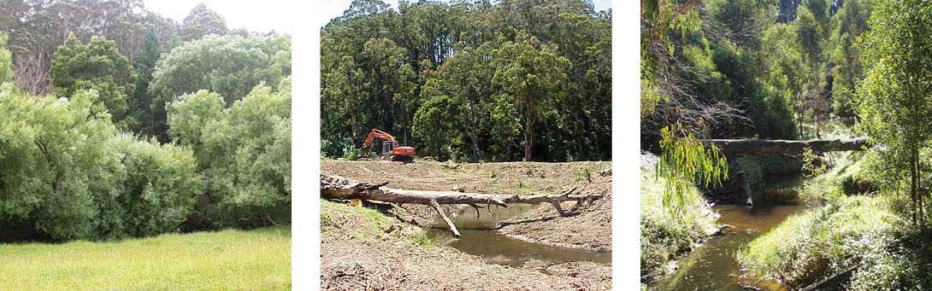
Table 1: Purpose and examples of prevention and mitigation, preparedness and response, management and control and enabling activities relating to invasive species (adapted from Victoria’s Biosecurity Strategy)
Purpose | Description | Activities (example)
Prevention and mitigation | Reduce the risks of new threats. | Improve community and stakeholder understanding and awareness of biosecurity risks to waterways.
Preparedness and response | Quickly detect and control a new incursion/outbreak. | Strengthen arrangements and partnerships across government, Traditional Owners, industry and community.  Embed biosecurity risk management planning, including in regional waterway management.
Management and control | Reduce the impacts of established weeds and pests. | Undertake ongoing management of established invasive species impacting waterways by waterway managers and public land managers at priority sites and in partnership with Traditional Owners and the community.
Enablers | Enable system-wide capacity and capability for collective action, effective decision-making and adaptive management. | Invest in and implement system-wide science, knowledge and tools, including monitoring and reporting with a shared set of performance measures.

Policy 52 – Addressing weeds, pests and diseases that threaten waterways
Existing policy incorporated into the Victorian Waterway Management Strategy
The Victorian Government will address invasive species threatening waterways by:
- strengthening and coordinating governance arrangements
- undertaking prevention and mitigation activities to decrease the likelihood and potential consequences of new species, or new incursions of established species
- undertaking preparedness and response activities to respond to new incursions of weeds, pests and diseases that impact waterways
- supporting waterway managers, public land managers and Traditional Owners to control established weeds and pests at priority management sites that support regional outcomes
- supporting landholder stewardship of waterways and increasing knowledge and capacity to address priority weeds and pests.

Action 28
Action | Who | When
A. 28–Integrate management of invasive species that impact waterways into the broader Victorian Biosecurity Strategy implementation processes. | Lead: DEECA, Fishing, Hunting and Outdoor Victoria  Collaborate: waterway managers | by 2030

Part 5. Urban waterways

Chapter 14. Managing for urban waterway values and protecting waterways from the impacts of excess urban stormwater

What we mean
Excess urban stormwater is the additional runoff created by urbanised environments, especially due to impervious surfaces, compared to non-urbanised areas. Uncontrolled stormwater runoff is the most significant threat to the condition of urban waterways and the diverse values they support. Urban runoff also has the potential to impact the condition of any waterway downstream of an urban waterway. Figure 19 illustrates how urbanisation poses threats to both local and connected waterways.
Urban waterways are waterways and their corridors that are within, flow through or are influenced by existing and planned urban areas, including cities, towns, small settlements, rural living areas and growth areas. They include waterways that are highly modified by urbanisation, as well as waterways that may be affected by current or future urban development.
Green infrastructure is a strategically-planned network of natural and semi-natural areas, including waterways with other environmental features. It’s designed and managed to deliver a wide range of ecosystem services, such as water filtering and urban cooling while enhancing biodiversity.
Integrated water management is a holistic and collaborative approach to the way we plan for and manage all elements of the urban water cycle. It recognises that water management is a shared responsibility and that Traditional Owners, waterway managers, water corporations, local government, planning authorities and other relevant agencies working together is essential to achieving better environmental, social, cultural and economic outcomes.
The urban heat island effect is when urban areas are hotter than the surrounding rural areas due to factors that include hard, dark surfaces and a lack of vegetation.
Waterway amenity refers to the qualities of a waterway and its corridor that support wellbeing and a relationship with nature, including naturalness, visual appeal, opportunities for recreation and safe access where appropriate.
Note - While waterway amenity is defined in this chapter in the context of urban waterways, it is recognised that waterway amenity values are present in both urban and non-urban settings.

Why is this important?
Urban waterways are living and connected entities that continue to hold environmental, cultural, social and economic values, even where they have been heavily modified by urbanisation. Urban waterways play a crucial role in Victoria’s environmental sustainability, community wellbeing and economic prosperity. They are highly-valued community places, offering recreational spaces, enhancing public health, supporting biodiversity, and contributing to the aesthetic appeal of urban areas. They are part of Country and remain places of cultural significance, responsibility and connection for Traditional Owners.
Melbourne households are willing to pay approximately $297 per year to improve urban stream health, reflecting the high value the community places on healthy urban waterways.²⁸ Factors contributing to waterway amenity are shown in Appendix 12. These waterways contribute to urban cooling, natural flood control and delivering a range of other essential ecosystem services that support healthy and liveable urban environments. They boost property values, attract tourism and support local businesses. Urban waterways also create opportunities for community engagement and education, and promoting environmental stewardship.
However, they face unique challenges due to the combined pressures of urban development, climate change and pollution. As urban areas expand, the increase in impervious surfaces – such as roads and buildings – directly connects more of the landscape to our waterways. Research indicates that an increase of just 2% in connected impervious areas within a catchment can severely degrade waterway health, through the effects of excess stormwater.
The consequences include erosion, heightened pollutant loads and disrupted flow patterns, which can have extensive ecological impacts downstream. These impacts can also affect cultural values and Traditional Owners’ ability to care for Country.
Given the rapid pace of urban development, it is critical to enhance stormwater management. Doing so will protect waterway health, support biodiversity and enhance urban liveability. The cost of addressing the impacts of inadequate stormwater infrastructure is often many times higher than implementing effective solutions at the time of construction – and in many cases the ecological damage can never be fully repaired.

What we are already doing
The Integrated Water Management Framework for Victoria was released in 2017 and the Integrated Water Management Planning Guidelines provide additional practitioner guidance on integrating water and land use planning.
Integrated Water Management forums across Victoria bring together all water cycle managers (waterway managers, Traditional Owners, water corporations and local government) to address water management challenges. Strategic Directions Statements and Catchment-Scale IWM plans developed by these forums provide guidance and priorities for improved water management outcomes including waterway health. They complement regional waterway and catchment strategies by connecting urban water management with broader catchment objectives.
This has led to significant collaborative investment in projects that improve environmental condition such as the Wanyarram Dhelk–Bendigo Creek Restoration Works and the Moonee Ponds Creek Ecological Restoration and Stormwater Harvesting project.
The Planning Policy Framework includes an integrated water management policy, Clause 19.03-3S – to embed integrated water management objectives and strategies in urban land use planning and Clause 12.03-1S – River and riparian corridors, waterways, lakes, wetlands and billabongs to protect and enhance waterway systems. Clause 53.18 – Stormwater management in urban development applies to largely non-residential applications, under the provision of a planning scheme zone to subdivide land, construct a building, or construct or carry out works.
The landmark Yarra River Protection (Wilip-gin Birrarung murron) Act 2017 and Burndap Birrarung burndap umarkoo–Yarra Strategic Plan demonstrate the importance of protecting iconic urban waterways such as the Birrarung. Their implementation has sharpened the focus on aligning waterway management, land use planning and Traditional Owner partnerships to protect waterway values across urban landscapes. This integrated approach informed the Waterways of the West Action Plan and the Rivers of the Barwon / Barre Warre Yulluk Action Plan in 2021. Together, these action plans extend the ambition of integrated, place-based waterway protection to other major urbanising river systems.
In December 2025, Amendment VC278 applied Significant Landscape Overlays (SLOs) to 17 waterways within the Yarra (Birrarung) and Waterways of the West catchments. The controls preserve the unique landscape character, cultural values, amenity and ecological health of each waterway. In January 2026 Amendment VC278 also updated Clause 12.03-1S – River and riparian corridors, waterways, lakes, wetlands and billabongs, with the Policy guideline for locating development a minimum of 50 metres from the banks of waterways.
The Central and Gippsland Region Sustainable Water Strategy identified the need to transition away from relying on river water to meet urban water needs in southern Victoria. It also proposed a greater reliance on manufactured water sources, such as fit-for-purpose recycled water and treated stormwater.
EPA Victoria has published Urban stormwater management guidance that highlighted the importance of reducing the volume of urban runoff and setting targets for reducing stormwater flows.
The policies and actions within this chapter, whilst new in the Strategy, build on policy directions established through the above plans and frameworks. They’re tailored to focus on waterway outcomes – while recognising the strong links to other critical outcomes such as water security, which are the focus of other plans.

Intended outcomes
The Strategy will contribute to the following outcomes over the next 10 years:
- Urban waterway corridors provide opportunities for amenity, urban cooling and connection to Country
- Stormwater impacts from new developments on the condition and ecological functioning of waterways is minimised
- The ecological and physical processes and functioning of urban waterway ecosystems are maintained.

Management challenges and opportunities

Recognising that urban waterways are highly valued
Despite their value, most urban waterways are in highly modified condition. This is largely due to historical management practices that prioritised flood control and urban expansion over ecological health. Until the 1970s, urban waterways were primarily viewed from an engineering perspective – focused on storing and transporting water to protect private and public infrastructure. This legacy also obscured the continuing cultural significance of urban waterways and their role as living parts of Country. Even where waterways have been channelised, piped, straightened or constrained by urban development, they can retain cultural values and remain important to Traditional Owners and communities.
These practices led to significant habitat loss, pollution and altered flow regimes, creating a legacy of degradation, including in downstream waterways.
Repairing the damage is costly, complex – and in some cases, unachievable. It’s critical to improve the resilience of urban waterways at priority sites though, for both the environment and the communities they sustain. Despite their modified state, communities highly value their waterways. Investments in targeted repair projects, green infrastructure and integrated water management practices can enhance amenity, improve environmental condition, reduce pollution and improve resilience to climate change.

Planning for waterway outcomes in sustainable urban development
There are many successful examples of urban waterway restoration and pollution control, and improvements to planning controls. However, the overall health and resilience of Victorian urban waterways is still in decline. Urban expansion, changes in housing preferences and increased densification are expanding the number of impacted waterways. Sustainable development practices can protect waterway corridors as set out in Plan for Victoria. Victoria’s commitment to integrated water management practice provides an established, collaborative approach to tackle these issues.
Integrating urban waterway management with regional waterway and catchment-scale planning can guide urban initiatives to align with broader catchment goals and encourage improved land management practices upstream of cities and towns. Early engagement by waterway managers in land use and urban water planning processes is important to identify risks and opportunities before development decisions are made, supporting more proactive and cost-effective waterway outcomes. This integrated approach enhances ecological health, water quality and resilience to climate change. It also fosters collaboration between urban and regional stakeholders, leveraging resources and expertise to achieve waterway outcomes.

Policy 53 – Protecting and enhancing urban waterway values and resilience
Existing policy incorporated into the Victorian Waterway Management Strategy
Waterway managers will work with public land managers, Traditional Owners and local government to:
- enhance the amenity, recreational and cultural values of urban waterways where appropriate, contributing to liveability and wellbeing
- recognise urban waterways as living and connected entities that continue to hold cultural, environmental, social and economic values, including in highly modified landscapes
- advocate for equitable and inclusive access to urban waterways and corridors, in ways that minimise risk to public safety and protect values
- address catchment activities that impact on urban waterway outcomes identified in regional waterway strategies.

DEECA will:
- promote accelerated implementation of green infrastructure and water-sensitive urban design across all urban planning and development activities, with a focus on waterway outcomes
- support targeted urban waterway repair projects that deliver regional outcomes, focusing on restoring ecosystem function, cultural values, connectivity and the integrity of waterway corridors – as well as enhancing natural aesthetics and amenity and community relationship to waterways
- recognise and enhance the role of urban waterway corridors in climate change mitigation and adaptation, particularly in managing urban heat island effects and increased rainfall intensity.

Action 29
Action | Who | When
A.29–Deliver capacity-building opportunities, tools and resources to identify and support priorities for targeted urban waterway repair projects in metropolitan Melbourne and regional areas. | Lead: DEECA  Collaborate: waterway managers, Traditional Owners, Parks Victoria (where appropriate), local government | by 2030

Action 30
Action | Who | When
A.30–Develop options for updating planning schemes to include specific policies or decision guidelines for enhancing climate mitigation and adaptation benefits from urban waterway corridors and share case studies. | Lead: DEECA  Collaborate: waterway managers, Traditional Owners, water corporations, local government, Parks Victoria, DTP | by 2030

Policy 54 – Planning for waterway outcomes in sustainable urban development
Existing policy incorporated into the Victorian Waterway Management Strategy
Waterway managers will work with public land managers and local government to:
- advocate for waterway health, cultural values and amenity to be considered early in land use planning and development processes, including the protection of urban waterway corridors and adjacent parklands to safeguard ecological function, support Traditional Owner priorities and enhance values
- promote urban planning practices that achieve multiple benefits by enhancing the integration and connectivity of urban waterway corridors with the broader built and natural landscape.
Waterway managers will encourage local plans for urban waterway land to align with broader goals in regional waterway and regional catchment strategies. This will help local initiatives contribute to the overall health and resilience of waterways.

Action 31
Action | Who | When
A.31–Strengthen the protection of urban waterway corridors, by developing or updating statewide urban waterway corridor planning guidance and tools that includes the following:  - a process for determining appropriate corridor width, buffer zones and other protective measures for specific waterways  - clarifies the roles of waterway managers, planning authorities and other relevant agencies  - guidance and tools for protecting the natural processes and functions of specific waterway features, such as headwaters  - information to support improved, consistent and effective application of urban waterway corridor planning controls across Victoria. | Lead: DEECA  Collaborate: DTP, waterway managers, Traditional Owners, local government, Parks Victoria where appropriate | by 2030

Policy 55 – Integrating urban waterway management with regional waterway planning
Existing policy incorporated into the Victorian Waterway Management Strategy
The Victorian Government will continue to embed integrated water management into business-as-usual practice for the water sector, local government and development industry, to support improved outcomes for waterways and their communities and Traditional Owners.

Action 32
Action | Who | When
A.32–Investigate improvements to water management governance that strengthens cross-portfolio collaboration for improved community, Traditional Owners and waterway outcomes. | Lead: DEECA  Collaborate: waterway managers, Traditional Owners, water corporations, local government, Parks Victoria | by 2035

Action 33
Action | Who | When
A.33–Continue to develop tools and guidance for waterway managers to advocate for waterway outcomes in water and land use planning.  Provide funding for catchment management authorities to increase their participation in integrated water management where it supports waterway outcomes. | Lead: DEECA  Collaborate: waterway managers, DTP, public land managers | by 2030

Protecting waterways from excess urban stormwater
Uncontrolled stormwater runoff is the most significant threat to the condition of urban waterways and the diverse values they support. Figure 19 illustrates how urbanisation poses threats to both local and connected waterways.
Figure 19: Impacts of urbanisation on waterways
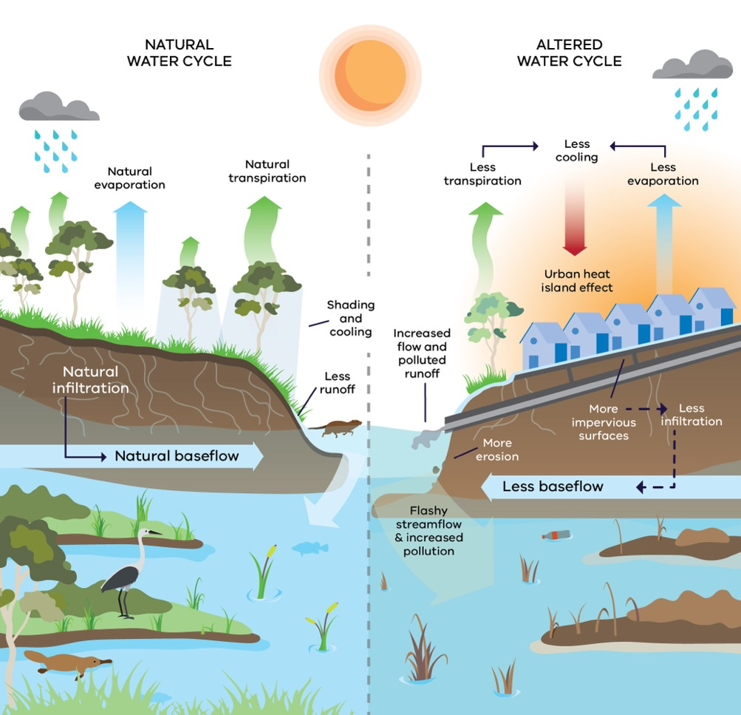
Figure 19 contrasts a natural water cycle with an altered urban water cycle. In natural conditions, water infiltrates into soil, maintains natural baseflow, and produces less runoff. Evaporation and transpiration provide cooling and shading. In the altered urban cycle, impervious surfaces reduce infiltration and baseflow, while increasing runoff, erosion, and pollution. Evaporation and transpiration are reduced, contributing to the urban heat island effect. Streamflow becomes flashier, and polluted runoff increases.
Comparison of Natural and Altered Urban Water Cycles (Figure 19)
Natural Water Cycle | Altered Urban Water Cycle
Natural evaporation | Less evaporation – less cooling
Natural transpiration | Less transpiration – less cooling
Natural infiltration | Less infiltration
Natural baseflow | Less baseflow
Less runoff | Increased flow and polluted runoff
Shading and cooling | Urban heat island effect
Stable streamflow | Flashy streamflow and increased pollution
Minimal erosion | More erosion
Permeable surfaces | More impervious surfaces
With the ongoing threat of climate change, these impacts are expected to get worse – with increased pollutant concentrations and more frequent and intense runoff events.
Proactive and effective stormwater management doesn’t just reduce these risks – it also offers significant environmental, social and economic benefits. By integrating green infrastructure into urban areas, we can enhance urban cooling and amenity, contributing to both climate change mitigation and adaptation. Effective stormwater use can reduce the demand on our scarce drinking water supplies, so more water remains in natural ecosystems and can be sustainably used for irrigation and other urban needs.

Policy 56 – Protecting waterways from excess urban stormwater
Existing policy incorporated into the Victorian Waterway Management Strategy
The Victorian Government will continue to strengthen stormwater management policies and practices to protect waterways, focusing on integrated approaches that minimise runoff and pollution while maximising infiltration and reuse. It will progress mechanisms to:
- reduce stormwater flows and stormwater quality impacts for new developments
- implement IWM planning in greenfield and redevelopment precincts and introduce targets at a precinct scale
- continue to support drainage managers, including catchment management authorities and local government and promote solutions that prioritise waterway health
- address gaps in institutional arrangements for stormwater management in regional Victoria and metropolitan Melbourne, in order to more effectively manage stormwater from urban developments and enable more stormwater to be harvested
- consider contributing funds to stormwater projects where public benefits outweigh the costs – and all duty-of-care and beneficiary pays avenues have been exhausted.

Action 34
Action | Who | When
A.34–Work with the water, planning, development and construction sectors to guide the implementation of stormwater management measures. Identify and address key industry needs in protecting, maintaining or improving waterway health in response to urban development. | Lead: DEECA  Collaborate: DTP, waterway managers | by 2030

Action 35
Action | Who | When
A.35–Strengthen policies and practices for sustainable stormwater management in regional Victoria with consideration of opportunities to improve role clarity and coordination across organisations by:  - reviewing the suitability of funding arrangements and cost-sharing of stormwater volume management by 2030  - developing a process to identify priority areas for enhanced stormwater management outside the Greater Melbourne area to inform implementation of regional waterway and catchment strategies by 2027. | Lead: DEECA  Collaborate: DTP, water corporations, waterway managers, MAV, local government | by 2030

Action 36
Action | Who | When
A.36–Investigate opportunities to capture sediment and erosion risk and mitigation requirements early in the planning process (e.g. through precinct structure planning, planning scheme amendments) to regulate best practice outcomes. | Lead: DEECA  Collaborate: DTP, waterway managers, MAV, local government | by 2030

Action 37
Action | Who | When
A.37–Regulate stormwater flow targets for urban developments, where investigations have shown they are reasonably practicable, having regard to environmental, social, cultural and economic outcomes, including opportunities for multi-benefit and shared-investment approaches that protect waterways as living and connected entities. | Lead: DEECA  Collaborate: DTP, water corporations, waterway managers, MAV, local government | by 2035

Part 6. Communities value and enjoy waterways

Chapter 15. Community wellbeing and contributions

What we mean
Citizen science is the collection and analysis of scientific data relating to the natural world that is mostly performed by citizens, usually in collaboration with scientists and field experts.
Waterway stewardship refers to managing waterways in a way that is socially equitable, environmentally sustainable and economically beneficial. We all have a responsibility to be waterway stewards.
CALD communities refers to culturally and linguistically diverse members of our community.

Why is this important?
Waterways are important for everyone. They support our physical, mental, emotional, cultural and spiritual wellbeing. They provide cool, green places to connect with each other and with nature. They’re places to exercise and rejuvenate, spaces for family and social connection. Appendix 12 highlights the waterway conditions that support people’s relationship with waterways.
The My Victorian Waterway Survey (2022) found that 82% of respondents personally care about waterway health and 74% feel a personal responsibility to do the right thing for waterways. As our population grows and changes, these spaces will become even more valuable for community wellbeing.
The economic value of landholder and community efforts to care for waterways is also significant. In the 2022–23 financial year, citizen science programs were estimated to contribute a total of 92,030 hours to the care of our waterways – or the equivalent to 12,720 volunteer days, worth nearly $4 million.

Box 11 – Community action for waterway health
The Werribee River Association was established in 1981 and has since played a vital role in supporting, educating, and engaging local communities in the care of their waterways.
Over multiple decades, the Association has worked in partnership with community organisations, local government, and waterway managers to improve the health of the Werribee River and its broader catchment. In 1997, it became one of the first community groups in Victoria to arrange platypus surveys, in partnership with the Australian Platypus Conservancy. This revealed a decline in platypus numbers and provided important evidence to strengthen action on litter, habitat restoration, and water quality improvement.
The Association's on-ground greening efforts expanded significantly through the River Recovery Project, led by Wyndham City, which delivered more than $2 million in blue-green infrastructure works, planting, and weed removal between 1998 and 2003.
A 2021 business analysis valued the Association's contribution to waterway health and community outcomes at more than $1 million per year. Since then, the organisation has continued to strengthen community engagement and deliver positive environmental outcomes for the river. It now operates with a team of part-time staff working alongside community volunteers across multiple programs and in partnership with a wide range of stakeholders.

What we are already doing
Victoria has been at the forefront of community-driven environmental stewardship for over 40 years now, exemplified by programs such as Landcare, WaterWatch and EstuaryWatch. The Victorian Government continues to support these programs and the pivotal role they play in nurturing relationships between communities and waterways.
The state’s integrated catchment management program, Our Catchments Our Communities, is also strongly grounded at the local scale. It recognises the community as a genuine partner in setting strategic directions and in the planning and delivery of place-based projects to improve catchment condition and resilience. A long-term outcome of the program is to build community members’ capacity to act as catchment stewards, managing catchments to generate intergenerational benefits for the environment, people and place.
In recent years, the Victorian Government has recognised the strong relationship urban communities have with their waterways. Green Links is a $10 million Victorian Government investment to improve habitat and water quality and provide cool, green spaces for communities around our urban creeks, rivers and waterways. The program aims to fund up to 200 ha of revegetation projects over 3 years, delivered in partnership with Traditional Owners and local communities.

Intended outcomes
The Strategy will contribute to the following outcomes over the next 10 years:
- Active community stewardship and citizen science are contributing to improved place-based waterway health and resilience
- More Victorians from diverse backgrounds are participating in waterway management programs for social connection and improved wellbeing.

Management challenges and opportunities

Waterway stewardship
The Victorian Government recognises that community stewardship is a cornerstone of waterway management, and that community partnerships and positive relationships with nature should be fostered.
This often starts out early in life, with many schools being involved in waterway citizen science and habitat improvement activities which support educational outcomes and bring students to their local waterways.
The environmental volunteer base in Victoria is growing – with an increase in volunteer numbers and hours since 2021, despite other forms of volunteering decreasing. The My Victorian Waterway Survey (2022) found that more than half of respondents were interested in volunteering to support the rehabilitation and maintenance of waterways and their habitats. It also found that 75% of Victorians from culturally diverse backgrounds who were surveyed would like to get involved in environmental volunteering if the opportunity arose.
Waterway stewardship takes many forms, from volunteering to support citizen science through to farmers fencing off waterways to limit livestock access. As waterways are located on both public and private land, improving and maintaining waterways relies on strong partnerships between Traditional Owners, landholders, farmers, community groups, waterway managers and other government agencies.
Many farmers and other landholders across Victoria manage their land in a way that protects and improves the condition of waterways and riparian land. While waterway managers support some works, many farmers and landholders undertake good land management practices at their own cost and initiative, contributing to waterway and broader catchment stewardship outcomes. Landholders and rural communities were at the forefront of reforms in Victoria in the 1990s to establish catchment management authorities and drive locally led action with their knowledge and advocacy. This community buy-in, supported through continued education and awareness, remains critical to addressing waterway challenges in the face of changing land use and climate change.

Policy 57 – Supporting stewardship of waterways
Updated policy from the previous Victorian Waterway Management Strategy
Catchment and waterway managers will continue to support active community stewardship to:
- maintain, improve or adapt waterway conditions
- improve partnerships, collaborative governance and shared leadership with Traditional Owners and local and regional community networks.

Action 38
Action | Who | When
A.38–Work through the Victorian Government’s integrated catchment management program with catchment and waterway managers, Traditional Owners and communities, to develop and deliver place-based stewardship projects. This will help to build better partnerships, shared leadership and capacity to be active catchment and waterway stewards. | Lead: DEECA  Collaborate: waterway managers, Parks Victoria | by 2030

Action 39
Action | Who | When
A. 39–Continue to undertake the My Victorian Waterway Survey to inform regional waterway management programs and tailor community education and engagement. This data will also inform an understanding of the recreational values of waterways. | Lead: DEECA | by 2035

Box 12 – Volunteering is good for us and waterways
Volunteering in green spaces provides opportunities for social connection while being physically active.
A 2021 study conducted by KPMG estimated that the Landcare movement saved the Australian public $57 million in avoided healthcare costs nationally. A similar study from New South Wales found environmental volunteering offers a range of benefits for individuals, including enhanced mental and social health – and was an untapped resource for promoting community-based health and for achieving environmental outcomes.⁶⁴
Community- based programs such as Landcare, WaterWatch and EstuaryWatch also offer volunteers opportunities to deepen their understanding of environmental issues, learn new skills and foster a sense of environmental stewardship. This in turn can lead to greater community advocacy and action to protect and restore the environment.

Citizen science
The Victorian Government recognises the community’s contribution to scientific research and monitoring through programs such as WaterWatch, EstuaryWatch and other citizen science initiatives. These programs play a significant role in connecting local citizens to waterways, supporting environmental education and building community awareness and stewardship of waterway health, as well as providing data that can help inform waterway management decisions.
There is an opportunity for citizen science groups to diversify their scope and build community awareness of, and action on, significant place-based waterway issues, such as monitoring the impacts of climate change.
It is important that data collected by citizen scientists aligns with waterway programs so it can be used to inform management and decision-making. Groups will be supported to do this, as well as ensuring community-collected monitoring data can be easily accessed and interpreted by the public and waterway managers.
There is also an opportunity to broaden the reach of citizen science programs to attract a more diverse cross section of the community and support groups to trial more diverse and inclusive approaches to participation.

Policy 58 – Supporting citizen science
Updated policy from the previous Victorian Waterway Management Strategy
Citizen science, including WaterWatch and EstuaryWatch, is recognised as a valued source of knowledge and opportunity to promote environmental education. Waterway managers will keep supporting citizen science programs, providing diverse and collaborative opportunities for community members to contribute to waterway stewardship.

Supporting everyone to participate in waterway management
Victoria has a long-standing history of community driving or contributing to waterway management. However, there are sectors of our community that are under-represented in environmental volunteering and waterway management programs. Victorian First Nations people, young people, people with disability, and people from culturally and linguistically diverse (CALD) communities are among them. Barriers to participation can include language and communication, low levels of trust in (or understanding of) institutions and processes in Victoria, and limited time and resources to invest outside of work and family. Participation is also constrained by limited knowledge of local waterways, engagement processes and Traditional Owner connections to land and water.
It's important that people of all ages, abilities and cultural backgrounds can relate to waterways sustainably – and participate meaningfully in waterway management programs and activities like planning, implementation and monitoring. We need to diversify the way community engagement is delivered and trial approaches that promote greater inclusion. This involves deepening our knowledge of how diverse groups use waterways, understanding the barriers to participation and working together to identify the most appropriate ways to engage. A business-as-usual approach to engaging the community will not suffice in many cases, particularly as our population grows and diversifies.

Policy 59 – Supporting community participation in waterway management planning
Updated policy from the previous Victorian Waterway Management Strategy
The Victorian Government will listen to the community and make sure everyone has a genuine opportunity to contribute to waterway management planning. This includes actively supporting diverse and inclusive participation in waterway management programs.

Action 40
Action | Who | When
A.40–Increase the capacity of waterway managers to engage CALD communities, Traditional Owners, people living with a disability and young people through appropriate tools and guidance – including developing new and diverse approaches to support inclusive, culturally appropriate and accessible participation for all communities. | Lead: DEECA  Collaborate: Traditional Owners, waterway managers, Parks Victoria | by 2035

Box 13 – Diverse communities shape the future of Waterways of the West
The Waterways of the West include the whole network of creeks and rivers from Moonee Ponds Creek (Moonee Moonee) to Little River (Worrin-yaloke) to the west of Melbourne. The region faces multiple challenges resulting from historic land and waterway use, climate change and population growth.,
Over 18 months, a ministerial advisory committee worked with the community, Traditional Owners and industry to present 14 recommendations to the Victorian Government. The Victorian Government responded to these recommendations by developing an action plan for the Waterways of the West.
Engaging with the region’s CALD communities continues to be an important part of the initiative. There have also been challenges with engaging CALD communities in the west on issues relating to waterways and the environment.⁶⁵
The Waterways of the West initiative invited Vietnamese and emerging migrant communities to participate in focus groups, to share how and why they interact with these waterways and their adjoining lands. They also provided insights on how agencies can continue to involve CALD communities in the future planning and management of these places. CALD communities were central in developing the 50-year Community Vision for the Waterways of the West.
A tool kit has since been prepared to provide guidance and resources for organisations to effectively engage and educate CALD communities about these waterways. This will help strengthen CALD communities’ capacity to shape the future of the Waterways of the West, enjoy their abundant benefits, and contribute to their care and protection. ⁶⁵

Chapter 16. Recreational use of waterways

What we mean
Water-based recreational activities include fishing, water skiing, swimming, rowing, camping, walking, birdwatching, hunting, outdoor sporting events, photography and social gatherings.
Recreational values refer to the total value associated with recreation activities on, or at, waterways. Recreation at waterways can provide many benefits including improved health and wellbeing, increased social cohesion, more tourism and greater environmental stewardship of waterways.
Water storages are reservoirs or dams used to supply water for irrigation or potable uses managed by water corporations.

Why is this important?
Victorian waterways and water storages provide the community with a range of recreational opportunities and benefits (See Appendix 12). They are highly valued by the community, with 69% of Victorians visiting waterways at least monthly and 82% reporting that they care about waterway health.⁹ Nature-based outdoor recreational activities support wellbeing in all kinds of ways.⁸ They also promote a relationship with nature, serving as the catalyst for people to learn more about the natural environment and take action to protect it (See Policy 57 – Supporting waterway stewardship). It is important to promote safe and enjoyable recreation for the community, whilst protecting the multiple values of our waterways.
Waterway-based recreation is a favourite activity for many Victorians. In fact, more than one million Victorians participate in recreational fishing every year. ⁸ More than one in 10 Victorians regularly participates in recreational boating and nearly 10,000 new recreational vessel licences are issued every year.
The contribution of recreation on and around waterways to local economies is significant, particularly in regional, rural and coastal towns. A study by Street Ryan estimated that Rocklands Reservoir, a recreational fishery stocked with Murray cod and golden perch near Balmoral, attracted 32,109 overnight visitors and 9,412 active day visitors and generated $5.5 million for the regional economy in 2023-2024.
The scenic and amenity value of waterways is also a critical underpinning of the recreational values they support. The importance of protecting the amenity value of waterways is addressed in the Urban Waterways Chapter 14.

What we are already doing
The Victorian Government developed the Recreational Values Program in 2016 to enhance the recreational values of water. It outlines 3 actions to help the Victorian community achieve tangible recreational benefits:
- include recreational values in water and waterway planning
- help communities understand how to achieve their recreational objectives
- support recreation at water storages, where feasible, through infrastructure and information.
In 2019, the Water Act 1989 was amended to recognise the social and recreational values of water. This amendment requires water corporations, waterway managers, Melbourne Water and the VEWH to consider the social and recreational uses and values of waterways in their water and waterway planning processes.
This change has led to an increased consideration of recreational values in waterway planning processes. For example, Wannon Water has developed a recreational opportunities strategy – to guide how existing water assets and infrastructure can be used or accessed by the community to support positive health and wellbeing outcomes.
The Victorian Government has developed new Water (Recreational Area) Regulations to support the control, management and use of determined recreational areas under the Water Act 1989 (many of which are water storages). The regulations help protect water quality, recreational area facilities, Aboriginal cultural heritage and environmental values, while still promoting the safe recreational enjoyment of these places.

Box 14 – Increasing opportunities for recreation on the Wimmera River
The Wimmera CMA, in partnership with local councils and community groups, has installed multiple recreation facilities along the Wimmera River to help the local community to enjoy the waterway.
The project saw the construction of 2 new shelters, canoe launching facilities, walking tracks and seating at multiple locations along the Horsham weir pool. The new infrastructure is accessible for all abilities and has significantly improved visitor experience along the river, while enhancing opportunities to spend time in nature.
An analysis showed that in 2016-2017, the Horsham and Dimboola weir pools contributed over $1.26 million to the economy with over 119,000 visitors. The works complement other projects along the river which promote recreational values, while protecting important cultural and environmental values.

Intended outcomes
The Strategy will contribute to the following outcome over the next 10 years:
- Waterways provide opportunities for a diverse range of recreational and tourism experiences that are strategically planned, safe and sustainable in a changing climate.

Management challenges and opportunities

Regional planning
Many organisations are formally or informally involved in managing areas where recreation is valued on or near waterways. This can often lead to confusion. Developing a regional waterway strategy offers an opportunity to clarify roles, responsibilities and priorities for managing recreational values. This includes the delivery, management and maintenance of land, assets and activities on and around waterways and the protection of water quality.
The regional waterway strategy development process enables communities to discuss how to achieve shared benefits for recreational users alongside other objectives. It aims to align priorities, recognise work that’s already been done and guide land and water managers in developing and implementing outcomes.
Applying a consistent approach to identifying areas of recreational value and the conditions that support them is important for considering community aspirations. This approach helps balance the long-term protection or maintenance of other waterway values (including drinking water supply considerations) as the climate changes.

Policy 60 – Planning for waterway sites of significant value
Updated policy from the previous Victorian Waterway Management Strategy
Regional waterway strategies will identify regional outcomes, which could include opportunities for recreation. They will prioritise areas for further planning and investment to support recreational activities, with a focus on improved access, safety and facilities. Recreational users will be actively encouraged to take part in this process.
Waterway managers, in partnership with Traditional Owners, water corporations and public land managers, will consider opportunities for appropriate recreational uses and values of waterways within the context of environmental conditions, surrounding landscape and the region.

Planning for waterways with significant recreational values
Where regional waterway strategies identify waterways with significant recreational values connected to regional outcomes, more detailed planning may be recommended – like the development of a management plan or similar.
Community expectations and demands for access and quality of experience have increased. This includes the need for all-ability access, safe and fit-for-purpose infrastructure, as well as cultural heritage experiences and education. Planning for access, facilities and safety will optimise recreational values at suitable sites.
Management plans for priority areas will draw on the expertise of waterway managers, Traditional Owners, public land managers (local government, water corporations and Parks Victoria), Fishing, Hunting and Outdoor Victoria (including Better Boating Victoria) or peak bodies such as VRFish or Field and Game Australia. Collaboration is essential to bring together expertise and agree on various responsibilities. Some water corporations already incorporate this approach in their management planning for land and recreation at priority water storages.
The development of a management plan may be Traditional Owner-led, particularly if it aligns to self-determined priorities.
In some areas, management planning will be led by public land managers like Parks Victoria, local government or a water corporation. In instances where there are multiple land managers, the agency or group best-placed to lead collaborative planning will need to be determined based on the local context, and may include tourism or regional development agencies. This collaboration can also reveal opportunities for co-investment or to deliver stronger outcomes for communities.
The Water (Recreational Area) Regulations will apply to determined recreational areas under the Water Act 1989, many of which are water storages. The regulations set out requirements for developing management plans, including the need to engage with relevant Traditional Owners and communities who have an interest in the area.

Providing information about waterway-based recreational opportunities
There are many opportunities for people to enjoy recreational activities at Victorian waterways. Microbial and chemical water quality can place restrictions on the suitability of water for recreational use to support safe recreation, as can other risk factors. To help recreational users plan their activities, they should have access to accurate and up-to-date information that is easy to find and understand. Government departments and agencies will collaborate and support new ways of presenting this information.

Policy 61 – Planning for recreational values of waterways at sites with significant recreational value aligned to regional outcomes
Updated policy from the previous Victorian Waterway Management Strategy
Regional waterway strategies will identify sites of significant recreational value and recommend the development of a specific place-based plan to guide their management. The regional context will inform the most appropriate lead for this plan, such as the land manager, Traditional Owner, community interest group, or other agency or group. Collaboration with all interested parties will be essential. The plan should ensure that the area is managed and used in a way that respects and upholds the rights of Traditional Owner groups who have a connection to the area.
The place-based plan should promote suitable activities for visitors to enjoy the area and establish and maintain an agreed level of visitor experience for activities. It should consider:
- the health and safety of visitors
- the land, services and facilities
- maintaining water quality in waterways
- protection of fauna and habitat
- protection and promotion (subject to Traditional Owner consent) of Aboriginal cultural heritage and intangible Aboriginal heritage
- emergency preparation and response which may impact any of these considerations.

Accessing water storages for recreation
Water corporations manage water storages to supply water for irrigation, urban and rural use, and environmental use (in partnership with CMAs and the VEWH). Many of these storages also provide opportunities for water-based recreation and tourism. Some are high-visitation sites with significant infrastructure, providing for activities like camping, boating, fishing, swimming, hunting, picnics and barbeques.
The list of recreational areas covered under the new Water (Recreational Area) Regulations, many of which are water storages, can be found in the Recreational Areas list.

Recreational fishing and fish stocking
Victoria sustains a range of recreational fisheries in rivers, lakes and estuaries. The most popular are introduced trout and redfin species, and native species such as golden perch, Murray cod and Australian bass. According to the 2024 VRFish Survey of Advocacy and Fisher Priorities, trout (brown and rainbow) and Murray cod were the most targeted inland species. In 2023-24, the Victorian Fisheries Authority (VFA) stocked a record 11.5 million fish into Victorian lakes and rivers for recreational fishing purposes.
Fish stocking provides environmental, social and economic benefits to Victoria by creating, maintaining and enhancing fish populations. Fish species stocked by VFA in Victoria include threatened or endangered native species such as Murray cod, trout cod, Macquarie perch, golden perch and silver perch, and recreational fish species such as brown trout. The VFA in partnership with State and Commonwealth Governments established the Conservation Hatchery at Snobs Creek as a purpose-built facility to breed, restock and recover threatened freshwater species in south-eastern Australia. This and the expanded Arcadia hatchery are supporting native fish recovery programs including the 10inTen program, which aims to secure new populations of 10 threatened native fish species within 10 years.
The stocking of fish is managed in accordance with the Fisheries Act 1995, translocation protocols and assessment guidelines, stocking strategies and annual stocking plans in consultation with stakeholders. Waterway managers and partners contribute to fish stocking plans by communicating where waterway outcomes can be improved with the stocking of key species (such as threatened native fish) and where specific stocked species could pose a significant threat to waterway values. This supports responsible stocking.
Recreational fishing is highly dependent on the environmental condition of waterways. Recreational fishers spend considerable time on Victorian waterways and their advocacy for river restoration continues to grow. The Angler Riparian Partnerships Program worked together to improve riparian land along waterways important to them from 2016-17 to 2019-20. Recreational fishers also contribute through the Recreational Fishing Grants Program. Since 2000, this program has reinvested fishing licence fees into projects to improve waterway habitat, undertake research and provide access and facilities.
The Victorian Government recognises Traditional Owners’ cultural and customary fishing as unique and separate from recreational fishing. It is working with Traditional Owners to manage fish resources in freshwater and saltwater Country sustainably. The Victorian Aboriginal Fishing Strategy (2012), which is currently being updated, focuses on recognising customary fishing rights for Traditional Owners, increased economic opportunities for Traditional Owners in fishing and related industries, and sustainable fisheries management in collaboration with Traditional Owners.

Crown frontages
Crown frontages were set aside for public use in the late 1880s and are usually a strip of riparian Crown land between 20 and 100 metres wide alongside a waterway (refer to Chapter 9). They are typically located between the waterway and a private land boundary.
Crown frontages are subject to licences issued by DEECA or Parks Victoria to the adjoining landowner/occupier, under the Land Act 1958, for livestock grazing or ‘riparian management.’ Crown frontage licences do not provide an exclusive right or use by the licensee, and in most cases recreational use by the public is permitted with a range of conditions. Ongoing effort is required to foster improved public access to Crown frontages and ensure that both licensees and recreational users understand their rights and responsibilities.
The Regulated Watercourse Land Regulations 2021 provides a clear set of rules and behaviours for the recreational use of Crown frontages. Further information about camping and access to Crown frontages can be found at the Victorian government forest and reserves website.

Information to support achieving recreational objectives
Sharing knowledge, user-friendly information and the expertise of community members, land managers and potential investors will help maximise recreational outcomes. This can involve connecting recreational users with local government, tourism boards and potential investors to improve visitor experiences at valued waterways.

Policy 62 – Providing information about opportunities to access waterways for recreation
Existing policy incorporated into the Victorian Waterway Management Strategy
The Victorian Government, waterway managers and public land managers will provide easily accessible and user-friendly information to recreational users on existing opportunities and areas for waterway-based recreation to help them plan activities and to promote their safe use.
Up-to-date information on access and use of Crown frontages will be made publicly available to support community access to Crown frontages.

Action 41
Action | Who | When
A. 41–Investigate the inclusion of waterway-based recreation in existing tools and smart phone apps such as the More to Explore app. | Lead: DEECA  Collaborate: Outdoor Recreation Victoria | by 2030

Managing for waterway safety
The Victorian Government encourages safe and inclusive participation in water-based recreation. The Victorian Water Safety Strategy (2021-2025) and the Australian Water Safety Strategy 2030 provide frameworks for inland waterway recreation and safety, including localised water safety plans, site-specific risk assessments, inland waterway safety guidelines, signage, public rescue equipment and community awareness measures.
For many waterways that are popular for recreation, a ‘waterway manager’ is in place, who is appointed under the Marine Safety Act 2010. This is distinct from the waterway managers defined under the Water Act 1989 and applied in this Strategy. There are certain statutory requirements that these managers must comply with when planning for and managing recreational activities on waterways to keep the public safe.
The Guide to vessel operation and zoning rules for Victorian waters apply for boating on all waters in Victoria. These rules are designed to provide a safe operating environment, cater for a wide range of boating and water activities, separate different activities (where needed) for safety and reflect local conditions. Many Victorian waterways also have local scheduled operating and zoning rules, which highlight the important role waterways play in boating, fishing and other associated recreational activities.

Resourcing to support waterway-based recreation
Many organisations contribute to providing infrastructure such as boat ramps, jetties, fishing platforms and amenities to support waterway-based recreation. Water corporations contribute to the ongoing cost and management of infrastructure for water storages and land that they manage. Additional funding is available from sources like the Better Boating Fund, Recreational Fishing Licence Trust and regional development funds. In some cases, investment priorities are guided by state-wide strategies, such as the Victorian Government’s Recreational Boating Strategy 2021-2030. Parks Victoria and local government support access, facilities and safety on the land they manage through strategic investment via place-based open space and site management plans. DEECA also directly invests in supporting waterway-based recreation through the Recreational Values Program and public land programs.
Collaboration across government agencies is essential to provide access to investment opportunities and increase the likelihood of achieving recreational objectives. Collaborative planning at an appropriate scale and across jurisdictions is key to Victoria’s waterway management approach. It leads to efficiencies in effort, investment and ultimately outcomes for our waterways and community. Aligning waterway-based recreation priorities with broader regional goals can attract investment in sites that offer many benefits to the economy, community and environment.

Policy 63 – Investment in waterway-based recreation planning and infrastructure
Updated policy from the previous Victorian Waterway Management Strategy
Investment priorities for recreation planning and infrastructure that supports water-based recreation will be informed by state and regional planning processes and place-based plans (where applicable).
The level of public funding will reflect the public benefits.
A clear asset owner and source of funding for ongoing costs needs to be agreed upon before any investment commitment.

Part 7. Delivering the Strategy

Chapter 17. Implementation

What we mean
Statement of Obligations is a document prepared by the relevant minister, that relates to the functions and powers of catchment management authorities and water corporations under the Water Act 1989, along with associated government policy conferred by the Minister for Water pursuant to the Act.
Beneficiary pays or user pays is a pricing approach based on the idea that the most efficient allocation (and consumption) of resources occurs when the beneficiary contributes to the part or full cost of the benefit it receives.
Nature positive is where sustained degradation has been halted, and instead, nature is being repaired and regenerating. A worldwide movement supports becoming nature positive by 2030.
Transformational adaptation addresses the root cause of vulnerability and risk from climate change impacts, noting that conventional or ‘business as usual’ coping strategies may not always support ecosystems to reduce their vulnerabilities.

Why is this important?
The Victorian Government and its partners will employ all available delivery mechanisms to achieve the Strategy’s outcomes. Implementing the policies and actions in the Strategy is subject to rigorous government business case processes. As funding becomes available, the timing of the delivery of actions may be altered. Water corporations’ ability to contribute is regulated by the Essential Services Commission, based on statutory obligations and customer willingness to pay.
The waterway management roles and responsibilities are outlined in Appendix 5. Achieving the Strategy’s outcomes requires a focus on active management in modified landscapes – and regulation of new developments to minimise further impacts.
These include:
- duty of care
- compliance and enforcement with statutory regulations and obligations (See below)
- directly funding on-ground works and activities
- market mechanisms and incentives
- environmental education and awareness
- new or updated legislative or regulatory mechanisms
knowledge and adaptive management.

Legislative and policy obligations and regulation

International and national obligations to protect formally-recognised waterways, species and communities
Many Victorian waterways have been formally recognised or listed as significant for their high conservation, recreation or cultural value. These include Ramsar wetlands, Heritage Rivers and waterways in national parks and other conservation areas. Formal recognition can occur at international, national and state levels through legislation, international agreements/ conventions or state policy decisions. Many Victorian waterways also support species or ecological communities that are protected under state and federal biodiversity conservation legislation.
All named Victorian waterways and Ramsar wetlands are ‘areas of cultural heritage sensitivity’ under the Aboriginal Heritage Regulations 2018, unless significantly disturbed. This means Aboriginal cultural heritage needs to be assessed and proactively managed if high-impact land use is proposed close to waterways and wetlands.
Significant and formally-recognised waterways and waterway-dependent species or communities will continue to be protected in line with legal obligations and the implementation of approved management recommendations. The policy framework in this Strategy incorporates obligations for waterway management outlined in relevant Victorian, national and international legislation, policy and agreements. These are detailed in Appendix 2.

Regulations
Key regulatory instruments aimed at specifically protecting Victorian waterways include:
- the Victoria Planning Provisions
- planning schemes established under the Planning and Environment Act 1987
licences and permits for works and activities on waterways under the Water Act 1989.
The Catchment and Land Protection Act 1994 includes functions that align with waterway management responsibilities (See Appendix 1).
The Environment Protection Act 2017 applies the GED to all Victorians and all businesses located in Victoria, as outlined in Chapter 11.
Statements of obligations are used to provide clarity for existing functions of authorities under the Water Act 1989 from the responsible minister.

Works on Waterways
Waterway managers and water corporations have functions under the Water Act 1989 to regulate activities that impact waterways. This includes waterway managers having a regulatory role in authorising individuals and organisations to carry out works and activities on waterways (Authorising works and activities on waterways) and water corporations assessing works licences related to the take of water, including new private dams (Policies for Managing Works Licences).
Possible impacts of proposed works include impacting the physical form of a river channel, restricting or preventing the natural migration of fish and other aquatic animals, loss of habitat for aquatic life, and changing natural flow and temperature regimes.
Many of these changes within the waterway may be reasonably small, however, the cumulative impacts of the works may be significant. Therefore, it is important for waterway managers and water corporations to consider cumulative impacts on the waterway when assessing authorisations for all works on waterways.

Policy 64 – Considering the cumulative impacts of works on waterways
Existing policy incorporated into the Victorian Waterway Management Strategy
When assessing works on waterways and works licence applications, catchment management authorities and water corporations should consider the cumulative impacts on flow regimes, temperature regimes, the physical form of the river channel, and the quality and extent of habitat for fish and other aquatic animals.
Cultural Heritage permits and Cultural Heritage Management Plans may be required as part of the Aboriginal Heritage Regulations 2018. There are also cooperative voluntary measures, such as Cultural Heritage agreements, which can be explored to manage Aboriginal cultural heritage values related to waterways.

On-ground works and other waterway management activities
Waterway managers, partner agencies, landholders and the community (including Landcare and other community volunteer groups) play a major role in the planning and delivery of on-ground works and activities to deliver on the Strategy’s outcomes. Many of these on-ground works and activities are detailed in Parts 4 and 5 of the Strategy and include:
- direct waterway works by waterway managers and partner agencies (willow removal, erosion control, removal of fish barriers and construction of structures to regulate water for the environment and environmental watering)
- public land management by Parks Victoria, DEECA, local government and committees of management for many of the state’s high-value waterways, including:
- National, state and regional parks, marine parks, numerous natural features and conservation reserves and metropolitan parks managed by Parks Victoria (4.1 million ha)
- State forests, managed by DEECA (3.2 million ha)
- Over 1,200 public land reserves with a broad range of purposes (550,000 ha), including Crown frontages
- Crown frontage management (refer to Chapter 9 and Chapter 16)
- incentive programs through devolved grants (for example, incentives for fencing, revegetation, weed control and off-stream watering)
- other market mechanisms such as land stewardship payments or tenders based on public/ private benefit
- offset markets (carbon, biodiversity) through private investment
- Covenant agreements.

Box 15 – Nature Repair Act 2023 – biodiversity market
An example of a biodiversity market is the Australian Government’s Nature Repair Act 2023, which establishes a framework for a world-first legislated, national, voluntary biodiversity market. The Act provides legislated rules to support transparency and integrity – and to foster collaborative efforts to address environmental decline.
The Nature Repair Market scheme is an Australian Government initiative that seeks to incentivise actions to restore and protect the environment. The scheme establishes a marketplace where individuals and organisations can undertake nature repair projects to generate a tradable certificate.
Victoria’s aquatic ecosystems often provide high biodiversity values and our mature waterway management frameworks offer proven delivery approaches for future nature repair investment.

Funding arrangements for waterway management

Victorian Government funding
The Victorian Government provides funding for waterway management from the environmental contribution (EC). This is a legally-obligated contribution from water corporations to fund initiatives that promote the sustainable management of water – or address the adverse environmental impacts of water consumption and extraction.
Environmental Contribution funding is provided to DEECA, CMAs and Traditional Owners for waterway management activities. It’s also provided to VEWH to help undertake its required functions for managing water for the environment. CMAs and DEECA also run devolved grant programs using EC funds to contribute to priority projects, with cost-sharing by community groups and individuals.
Investment in maintaining the health of Victorian waterways through the EC supports an estimated 378 jobs a year. This includes flow on roles such as contractors for delivering waterway services (e.g. fencing for revegetation, and pest plant and animal control). Over the four years of EC Tranche 5, this investment is estimated to have generated around $169 million in wages, profits and taxes across Victoria.
In addition to state funds provided directly for waterway management, the Victorian Government provides funds:
- to public land managers (including Parks Victoria, Great Ocean Road Coast and Parks Authority and DEECA) to manage the land assigned to them in accordance with statutory requirements, which may include waterway management activities
- to regional organisations like rural water corporations, to undertake activities that are in addition to their statutory functions (and therefore not covered by customers)
- through the Our Catchments Our Communities program for catchment management and stewardship programs to groups such as Landcare
- for natural disaster relief funding assistance.

Waterways and drainage charge in the Port Phillip and Westernport region
The waterways and drainage charge collected by metropolitan retail water corporations on behalf of Melbourne Water is used in the Port Phillip and Westernport region to:
- manage waterways towards regional outcomes
- manage urban development planning and approvals
- provide grants to landholders and community groups to improve waterway condition
- deliver drainage maintenance and improvements
provide appropriate flood levels of protection.
The Essential Services Commission (ESC) reviews this charge every 5 years through the Waterways and Drainage Investment Planning process, to make sure the program is efficient and meets community expectations.

Australian Government funding
The Australian Government provides funds for waterway management through several national programs – such as the Natural Heritage Trust Program, which includes the Urban Rivers and Catchments Program and the Restoring our Rivers Program in the Murray-Darling Basin.

Murray-Darling Basin funding
The Murray-Darling Basin Authority oversees joint funds for a range of programs in the Murray-Darling Basin that cover monitoring, research and implementation, e.g. The Living Murray.

Regional funding
There are also some significant regional contributions for implementing activities that contribute to waterway outcomes. They include:
- funding and in-kind contributions from landholders, community groups and individuals to undertake waterway management activities
- local government funding to manage the land assigned to it (particularly in urban areas) in line with statutory requirements, which may include waterway management activities
- funding from beneficiaries towards agreed plans, like maintaining community drainage systems.

Cost-sharing principles
Victoria’s waterway management approach continues to direct resources to the highest-priority management activities. Investment priorities will be informed by state priorities, regional planning processes and place-based plans, where applicable. Progressing strategic outcomes is a significant task that requires considerable resources and sustained long-term commitment. Cost-sharing with beneficiaries (those who benefit from a management activity) is an effective way to advance state and regional priorities within the limits of available government resources.

Policy 65 – Cost-sharing principles for waterway management
Updated policy from the previous Victorian Waterway Management Strategy
The Victorian Government expects the following cost-sharing principles to be applied to waterway management projects:
- Duty of care – All natural resource users and managers have a duty of care to not damage the natural resource base, as outlined in the Catchment and Land Protection Act 1994 and Environment Protection Framework. They are responsible for making good any damage incurred as a result of their actions.
- Beneficiary pays – When it is not possible to attribute damage, then direct beneficiaries should pay. Users, both existing and future, are expected to pay for activities that provide private benefits. Contributions from indirect beneficiaries will, where appropriate, be negotiated with the primary beneficiaries. Managing risks from waterway processes to public and private infrastructure is primarily the responsibility of the infrastructure owner.
- Government contributions to private beneficiaries – The government contributes primarily to activities that produce public benefits. The government may agree to contribute to land and water management activities that provide significant public benefit and where government support is required to facilitate this uptake.
- Net public benefit – Net public benefits to the Victorian environment, economy and community values must be demonstrated.
- Private cost-share contributions – Management activities will be prioritised based on the greatest public benefit for the least public cost. Financial or in-kind contributions by private or corporate stakeholders will influence the support for a management activity
- Upfront and maintenance costs – Waterway managers may collaborate with private landholders and other government agencies to upgrade a built asset to a declared standard. After that, the beneficiary will generally be responsible for its maintenance. Government or waterway managers may also collaborate with private landholders and with other government agencies to build new assets, so long as the beneficiary agrees to be responsible for the maintenance of the built asset.
- Extreme events – Funding for the repair and recovery of essential public assets following natural disasters will be guided by State and national disaster recovery funding arrangements.
- Statewide policy and monitoring – The government will contribute to the cost of statewide planning, resource monitoring and assessment, research and investigations, where they’re crucial to evaluating the success of statewide and regional waterway management approaches.
Government may invest where the public benefits outweigh costs and all duty of care and beneficiary pays avenues have been exhausted.

Applying the seasonally-adaptive approach
The seasonally-adaptive approach to waterway management has been applied in Victoria since 2013. This increasingly important approach allows for the annual implementation of management activities to achieve environmental outcomes, adjusted to reflect the prevailing climatic conditions, such as drought or periods of high rainfall and flood.
The approach could involve undertaking specific activities, such as weed control, in some years but not others – or using different approaches to achieve the same goal. It also includes continuing to manage environmental water in a way that addresses seasonal objectives (refer to Figure 12, Chapter 7).

Policy 66 – Implementing seasonally-adaptive approaches to waterway management
Updated policy from the previous Victorian Waterway Management Strategy
Waterway managers, environmental water holders and other land managers will continue to implement the seasonally-adaptive approach through annual works programs, annual environmental watering plans or other regional implementation plans.
This approach will involve:
- setting short-term management outcomes through annual planning processes that reflect the current seasonal conditions – drought, dry, average or wet
- adapting management activities to prevailing conditions
- engaging with communities on the approach depending on climatic conditions
- a strategic approach to monitoring the efficiency and effectiveness of these activities given the seasonal conditions.

Emergency management arrangements
Emergencies can impact waterways and communities with wide-ranging consequences to values. Floods, bushfires, blue-green algal blooms, fish deaths and biosecurity outbreaks are all managed under the State Emergency Management Plan (SEMP). The SEMP contains provisions to mitigate, respond to and recover from emergencies, while specifying the roles and responsibilities of agencies relating to emergency management. Under the SEMP, DEECA is the control agency for a range of water-related emergencies, including blue-green algae incidents, the safety of dams in Victoria, disruption to water and wastewater services, non-hazardous pollution of inland waters and biosecurity. DEECA and waterway managers are guided by the SEMP, sub-plans for specific emergencies, state guidelines and other topic-specific plans when responding to emergencies. Victoria has an established blue-green algae coordination arrangement involving health and DEECA (See Blue-Green Algae Emergency Response Plan).
The Victorian Government will continue to minimise impacts on waterway condition by responding to and recovering from emergencies in the following ways:

Funding waterway manager statutory obligations
Waterway managers will be supported to deliver their emergency-related responsibilities under the Water Act 1989 and associated Statement of Obligations.
Planning for flooding will continue to be guided by the Victorian Floodplain Management Strategy and related regional floodplain management strategies.

Encouraging adaptive decision-making
Large floods, bushfires and other emergencies will occur in the future. The government will respond to these and achieve the best outcomes for waterways through an adaptive, evidence-based management approach, which includes:
- investigating how to effectively use data and inputs from past events to improve responses (e.g. use of fish death event data to inform preparedness and resource allocation)
- investigating new ways to adapt and respond to emergencies
- providing technical advice such as the 2024 Technical Guidelines for Waterway Management.

Action 42
Action | Who | When
A.42–Investigate the use of reporting systems for fish death events to inform preparedness and resource allocation. | Lead: DEECA  Collaborate: waterway managers, water corporations | by 2030

Preparing for response to extreme events
Waterway managers will continue to work with DEECA, other fire management agencies and local government to minimise the impacts of bushfires and bushfire management activities on waterway condition, taking account of the priority to protect human life. Waterway managers are already working with fire management agencies to build waterway value protections into preparedness planning and burning programs.
Clear communication of potential impacts to waterway values from emergencies is needed to prepare for response. DEECA will prepare data on waterway values and potential risks from emergencies and make it available to control agencies to inform emergency response.

Action 43
Action | Who | When
A.43–Describe potential risks to waterway values from emergencies. | Lead: DEECA  Collaborate: waterway managers, land managers, VEWH, and Traditional Owners | by 2030
The Victorian Government will keep using rapid risk assessment tools to identify, assess, prioritise and evaluate risks on public land to inform bushfire emergency recovery planning.
Waterway managers are responsible for quantifying regional funding needs and administering funding allocated for waterway recovery (following bushfires/flood and other emergencies). Traditional Owners may self-determine their recovery needs and seek government funding.

Supporting community resilience and recovery
The Victorian Government will continue to support large-scale riparian management programs and structural works for riverbed and bank stabilisation to improve climate resilience, consistent with Policies 39-41.

Providing further clarity about roles and responsibilities for water quality incidents
The Victorian Government will continue to support regional arrangements for managing water quality events and incidents. The regional catchment partnership agreements that are in place in some parts of Victoria will keep informing local business-as-usual approaches to managing water quality incidents.
Not all water quality incidents are considered ‘emergencies’ in the SEMP, with some local responses currently handled by the business-as-usual arrangements of various agencies. Despite blackwater being adequately managed during the recent flood of 2022/23, stakeholders highlighted how efficiency could be improved by further clarifying agency roles and responsibilities, particularly when blackwater arises as a consequence of another emergency.

Action 44
Action | Who | When
A.44–Document roles and responsibilities for blackwater incidents. | Lead: DEECA  Collaborate: waterway managers, land managers, VEWH, EPA, Traditional Owners and water corporations | by 2030

Reducing pollution incidents
Pollution incidents can include industrial spills, oil spills, uncontrolled discharges from industry and poor land or waste management practices. Melbourne Water is a support agency in the SEMP for managing pollution events in waterways in its region. In 2024, Melbourne Water responded to 106 externally-caused pollution incidents costing in excess of $2.5 million to clean up. Reducing these incidents and allocating sufficient funds for cleanup and rehabilitation is critical to protecting waterway health.
EPA Victoria will continue to pursue its provisions under the Environment Protection Act 2017 and apply its Compliance and Enforcement Policy to prevent pollution of waterways from waste.

Incorporating Traditional Owners, their knowledge and values
Emergencies and extreme events can impact Traditional Owner values, including cultural heritage places. The government will continue to improve engagement and involvement of Traditional Owners in all aspects of waterway emergencies – including preparation, response and recovery – so that processes are in place to manage heritage sites. An example of this is the Strategy for Aboriginal Community-led Recovery.

Chapter 18. Knowledge and adaptive management
Appropriate knowledge and adaptive management approaches need to inform the implementation of the Strategy, the regional waterway strategies and the approach to waterway management across Victoria. Monitoring and research can help improve the way waterways are managed, evaluate management approaches and fill critical knowledge gaps. Victoria’s approach to monitoring is three-fold:
- Surveillance monitoring
- Management intervention monitoring
- Strategic research.

Surveillance monitoring
Periodic statewide condition assessments provide a spatial snapshot of waterway condition to inform planning, management and reporting. Victoria is a pioneer in using broad-scale environmental condition monitoring of waterways with the Index of Stream Condition (ISC). Three ISC assessments that have been conducted providing valuable insights into the environmental condition of rivers and streams. This approach has also been expanded to include reporting on wetlands and estuaries (refer to Chapter 3). To implement waterway condition assessments at a statewide scale it is necessary to use relatively coarse indicators and standardised assessment approaches. These indicators and approaches are suitable for identifying large differences in condition over broad spatial areas. Previous assessments showed that such changes are unlikely to occur over the 4-yearly or 8-yearly frequency used between assessments.
In addition to periodic statewide waterway condition assessments, more frequent surveillance monitoring of key environmental values and threats will be undertaken at priority management locations. This will help guide decision-making and support evaluation of The Victorian Waterway Management Program.
Evidence from surveillance monitoring programs is also used to fulfil Victoria’s reporting obligations. These include reporting on environmental condition by the Commissioner for Environmental Sustainability.

Policy 67 – Undertaking statewide waterway condition assessments
Updated policy from the previous Victorian Waterway Management Strategy
Statewide waterway condition assessments are conducted on a four-year cycle, with rivers, estuaries and wetlands each assessed approximately every 12 years.
Statewide waterway condition assessments will be used to:
- provide statewide information on the condition of Victorian rivers, estuaries and wetlands to inform the Victorian Waterway Management Program
- provide high-quality baseline information on environmental values and threats to values to inform regional planning and priority-setting.
The scope and scheduling of these statewide waterway condition assessments will be subject to periodic review to ensure they are meeting state and regional strategic needs.

Management intervention monitoring
Management intervention monitoring allows us to answer the following questions:
- Did our management actions achieve the desired change in the environment?
Did we apply the appropriate amount or type of management effort to achieve the desired environmental change?
For example, the Riparian Intervention Monitoring Program was established to assess the impact and effectiveness of riparian management. It has demonstrated that riparian management interventions (such as fencing to exclude grazing by stock, willow and weed management, and revegetation) have had positive impacts on a range of riparian vegetation parameters – including increased leaf litter, native vegetation cover and native seedling survival.
DEECA also currently undertakes strategic and systematic monitoring and assessment of environmental water delivered to Victorian rivers and wetlands. This includes a combination of monitoring to evaluate environmental water responses and management outcomes, together with targeted surveillance monitoring of environmental values and hydrological context needed to meaningfully interpret those responses.
Evidence from management intervention and surveillance monitoring is used to fulfil DEECA's range of environmental watering related assessment and reporting obligations. They include requirements to report on environmental outcomes of the Murray–Darling Basin Plan. The VEWH also has obligations to report annually on the outcomes of watering actions. It’s important to consolidate and streamline the current approach to reporting, to reduce duplication and assess outcomes to inform future decisions.

Policy 68 – Development of a reporting framework for environmental water
Existing policy incorporated into the Victorian Waterway Management Strategy
DEECA, in collaboration with the VEWH and program partners, will develop a framework for reporting on the outcomes of watering actions that’s consistent with and aligned to existing state and VEWH obligations. This framework will be developed in consultation with the Commissioner for Environmental Sustainability and will replace the Commissioner’s requirements under Action 3.6 in Water for Victoria.

Strategic research
Strategic research investigates the relationships between waterway management and outcomes. It can also identify emerging threats to waterways. Regular review and evaluation of the knowledge base will help us direct our efforts towards areas of higher uncertainty. Targeted research helps to fill gaps in our knowledge and data and inform the development of decision-support tools, like modelling to assist the priority-setting process in regional waterway strategies. Strategic research can also test key assumptions, for example, to better inform and evaluate environmental water management.

Sector capability
Waterway management is complex, which is why investing in the capability of the key delivery organisations and their partners is so important. The Victorian Government will continue to support opportunities for learning from each other and building on existing knowledge. This could be through partnership forums, professional development and conferences, the water sector staff exchange program and staff exchanges with Traditional Owner Corporations.

Evaluating this Strategy
The outcomes framework for the Strategy is presented in Chapter 1 and has been developed in line with Victoria’s Outcomes Architecture Outcomes Reform. This architecture has also been used to develop the strategy’s monitoring, evaluation and reporting approach.
Planning for monitoring, evaluation and reporting commenced during the strategy development process. The focus of the process was to use the 50-year vision and the 20-year domain statements to describe what successful strategy implementation looks like and select a range of chapter outcomes where indicators and measures could be identified and measured to evaluate success over the 10-year implementation period.
Chapter outcomes articulate the ambition for waterway management outcomes under each theme. The outcome indicators will specify what needs to change to achieve a chapter outcome. They will reflect the key drivers and influences on progress towards an outcome, and the outcome measures will provide the more granular, specific detail about what will change and how we will know if we are making progress.
DEECA will develop and publish an evaluation plan that will aim to evaluate against these outcome measures for the strategy.
CMAs are updating their regional waterway strategies. They will also develop evaluation plans to document how implementation of each strategy will lead to the change required to deliver the stated regional outcomes. The regional outcome indicators and measures will not only be used by CMAs to track progress towards achieving regional outcomes but collated and used by DEECA to demonstrate how they collectively contribute to the Strategy outcomes.
The CMA regional outcome indicators will specify what needs to change to reach the desired outcome, such as improving an aspect of waterway condition (for example enhancing riparian habitat). The outcome measures will provide more specific detail around what will change in order to know if progress is being made (for example, monitoring condition of River Red Gums).
A high-level mid-term review (5 years) will be undertaken to check in on progress towards the Strategy’s outcomes. This will assess whether it continues to reflect the priorities of the Victorian Government, the Victorian Waterway Management Program, communities and Traditional Owners. It will also be adaptive, considering new insights from research and feedback from waterway managers, Traditional Owners, and the community.
A full evaluation will be undertaken after 8 years to inform the next strategy’s development.
Image 10: Before and after of willow removal works at Campaspe River, Kyneton / Boundary between Djaara and Taungurung Country / North Central CMA 2016
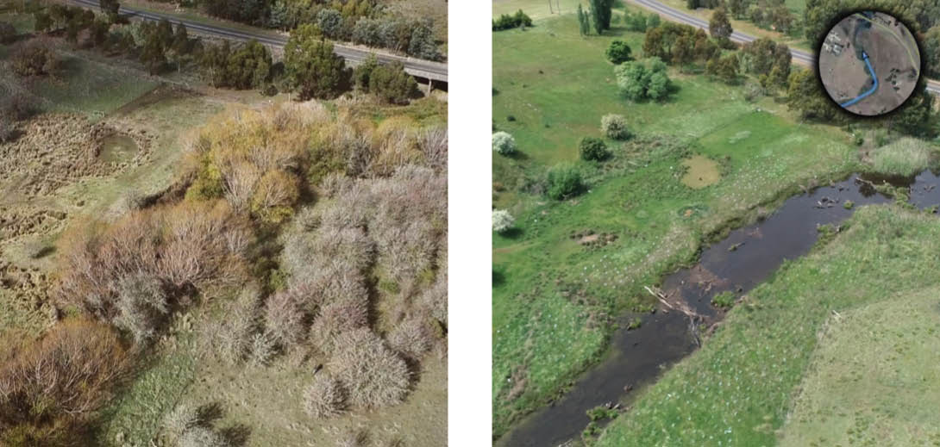

Appendices
Appendix 1. Victoria’s catchment management framework 279
Appendix 2. Relevant legislation and policies relating to the Strategy 282
Appendix 3. Values, pressures and challenges for waterways in Victoria 287
Appendix 4. Planning system tools for waterway protection 289
Appendix 5. Roles and responsibilities in waterway management 291
Appendix 6. Expectations for partnership with Traditional Owners 299
Appendix 7. Mechanisms to preserve the environmental water reserve and make best use of entitlements 301
Appendix 8. Volumes of water held for the environment across river basins in Victoria 303
Appendix 9. Victoria’s environmental water management framework and alignment with the Australian Government framework 307
Appendix 10. Victoria’s water quality management framework 310
Appendix 11. National biosecurity system and overview of other relevant strategies and legislation relating to Victoria 312
Appendix 12. Links between waterway conditions and social values 315

Appendix 1. Victoria’s catchment management framework
Other key legislation and policies can be found in Appendix 2. Relevant legislation and policies relating to the Strategy
Figure 20: Victoria’s catchment management framework
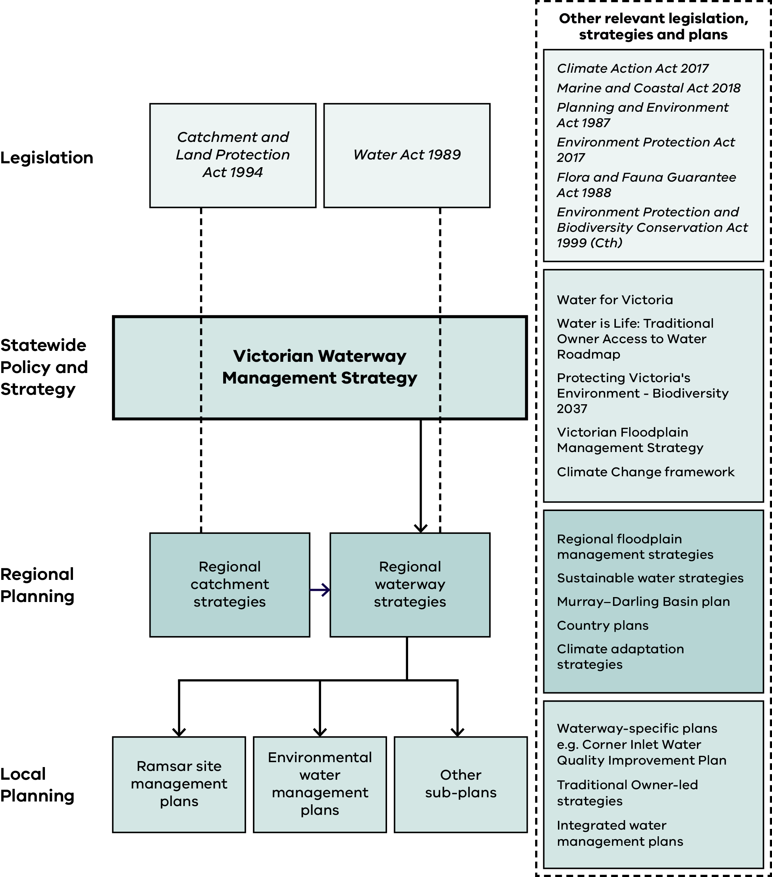
Note: Table 2 presents the information in this diagram in an alternative format.
Table 2: Victoria's catchment management framework – the four hierarchical levels of the framework, the primary documents and tools at each level, and other relevant legislation, strategies and plans
Level | Primary documents / tools | Other relevant legislation, strategies and plans
Legislation | - Catchment and Land Protection Act 1994  - Water Act 1989 | - Climate Action Act 2017  - Marine and Coastal Act 2018  - Planning and Environment Act 1987  - Environment Protection Act 2017  - Flora and Fauna Guarantee Act 1988  - Environment Protection and Biodiversity Conservation Act 1999 (Cth)
Statewide Policy and Strategy | - Victorian Waterway Management Strategy (central coordinating document) | - Water for Victoria  - Water is Life: Traditional Owner Access to Water Roadmap  - Protecting Victoria's Environment - Biodiversity 2037  - Victorian Floodplain Management Strategy  - Climate Change framework
Regional Planning | - Regional catchment strategies (which inform)  - Regional waterway strategies | - Regional floodplain management strategies  - Sustainable water strategies  - Murray-Darling Basin plan  - Country plans  - Climate adaptation strategies
Local Planning | - Ramsar site management plans  - Environmental water management plans  - Other sub-plans | - Waterway-specific plans (e.g. Corner Inlet Water Quality Improvement Plan)  - Traditional Owner-led strategies  - Integrated water management plans
Note: In the Regional Planning row, regional catchment strategies inform regional waterway strategies. The Victorian Waterway Management Strategy is the central coordinating document of the framework, sitting between legislation above and regional and local planning below.

Appendix 2. Relevant legislation and policies relating to the Strategy

Legislation

National (Commonwealth)
Biosecurity Act 2015
Climate Action Act 2022
Environment Protection and Biodiversity Conservation Act 1999
National Emergency Declaration Act 2020
Native Title Act 1993
Water Act 2007
Water Amendment Act 2008

State (Victorian)
Aboriginal Heritage Act 2006 and Aboriginal Heritage Regulations 2018
Catchment and Land Protection Act 1994
Charter of Human Rights and Responsibilities Act 2006
Climate Action Act 2017
Conservation, Forests and Lands Act 1987
Crown Land (Reserves) Act 1978
Emergency Management Act 2013
Environment Effects Act 1978
Environment Protection Act 2017 and Environment Protection Regulations 2021
Fisheries Act 1995
Fishing, Hunting and Outdoor Victoria Act 2026
Flora and Fauna Guarantee Act 1988
Great Ocean Road and Environs Protection Act 2020
Heritage Rivers Act 1992
Land Act 1958
Marine and Coastal Act 2018
Marine Safety Act 2010
National Parks Act 1975
Safe Drinking Water Act 2003 and Safe Drinking Water Regulations 2025
Parks Victoria Act 2018
Planning and Environment Act 1987, including the Victoria Planning Provisions (VPPs)
Traditional Owner Settlement Act 2010
Statewide Treaty Act 2025
Water Act 1989
Wildlife Act 1975
Yarra River Protection (Wilip-gin Birrarung murron) Act 2017

Policies, strategies and agreements

International
Convention on Biological Diversity
Kunming-Montreal Global Biodiversity Framework
The Convention on Wetlands of International Importance, 1971 (the Ramsar Convention)
The Paris Agreement
United Nations Declaration on the Rights of Indigenous Peoples

National (Commonwealth)
Australian Government Biosecurity and Agricultural Response Plan (AUSBIOAGPLAN) (2022)
Australian Pest Animal Strategy 2017-2027
Australian Weeds Strategy 2017-2027
Australia’s Strategy for Nature 2024-2030
Basin Plan (2012)
DAFF Biosecurity 2030 Roadmap (2024)
Intergovernmental Agreement on Biosecurity (IGAB) (2012)
Marine Pest Plan 2018-2023
National Biosecurity Strategy 2022-2032
National Carp Control Plan (2022)
National Climate Resilience and Adaptation Strategy 2021-2025
National Environmental Biosecurity Response Agreement (NEBRA) (2022)
National Water Initiative (2004)
Native Fish Recovery Strategy (2020)
Net Zero Plan 2050
The National Priority List of Exotic Environmental Pests, Weeds and Diseases (2020)
The Threatened Species Action Plan 2022-2032

State (Victorian)
Freshwater Fisheries Management Plan (2018)
Guidelines for assessing translocations of live aquatic organisms in Victoria (2014)
Invasive Plants and Animals Policy Framework (2010)
Marine and Coastal Policy (2020)
Marine and Coastal Strategy (2022)
Mining legislation and policy
Nature Conservation Strategy for parks and reserves managed by Parks Victoria 2021-2031
Plan for Victoria (2025)
Protecting Victoria’s Environment - Biodiversity 2037
Protocols for the translocation of fish in Victorian inland public waters (2005)
Pupangarli Marnmarnepu ‘Owning Our Future’ Aboriginal Self-Determination Reform Strategy 2020-2025
Self-Determination Reform Framework (2019)
State Emergency Management Plan Animal, Plant, Marine and Environmental Biosecurity Sub-Plan (2024)
Traditional Owner and Aboriginal Community Engagement Framework (Edition 2)
Victorian Deer Control Strategy (2020)
Victorian Floodplain Management Strategy (2016)
Victorian Rural Drainage Strategy (2018)
Victorian Waterway Management Strategy (2013)
Victoria's Climate Change Strategy (2026)
Victoria’s Biosecurity Strategy (2023)
Water Cycle and Natural Environment Adaptation Action Plans (AAPs)
Water for Victoria (2016)
Water is Life: Traditional Owner Access to Water Roadmap (2022)

Regional
Burndap Birrarung burndap umarkoo, Yarra Strategic Plan 2022-2032
Integrated water management (IWM) forum strategic directions statements
Catchment integrated water management plans
Distinctive Areas and Landscapes – Statement of Planning policies
Land and Water management plans
Ramsar site information sheets, ecological character descriptions and management plans
Regional biosecurity, invasive plants and animal strategies
Regional catchment strategies
Regional climate change adaptation strategies
Regional deer control plans
Regional floodplain management strategies
Regional waterway strategies
Rivers of the Barwon (Barre Warre Yulluk) Action Plan (2021)
Sustainable waterway strategies
Traditional Owner Whole-of-Country Plans, Country Plans, Aboriginal Cultural Heritage Land Management Agreements, Cultural Land Management Strategies, Strategic Plans
Urban water strategies
Waterways of the West Action Plan (2021)

Appendix 3. Values, pressures and challenges for waterways in Victoria
Table 3: Table showing values, pressures and challenges for waterways in Victoria
Type | Values and uses | Pressures and opportunities
Waterways in parks and reserves | - Often valued for nature-based activities and environmental condition  - Strong Traditional Owner connection  - Aboriginal cultural heritage values  - Closed water supply catchments for potable supply  - Managed for biodiversity conservation | - Increasing aspirations for activities, facilities and use from communities  - Increased aspirations for environmental values  - Increasing risks of bushfire and invasive species
Rural and regional working waterways | - May reflect diverse communities of flora and fauna  - May have public health and economic benefits, such as declared special water supply catchment areas  - Aboriginal cultural heritage values  - Strong Traditional Owner connection but limited access  - Riparian and floodplain areas valued for cropping and grazing  - May have high values for recreation such as fishing and boating | - Water quality affected by pollution including legacy pollution from past practices  - Can be affected by both local impacts and upstream catchment impacts  - Significant areas of privately-owned waterways and land  - Active management in places to improve riparian condition  - May be subject to livestock access or impacts of adjacent land use  - Increasing aspirations and use from communities  - Invasive species (pests)
Urban waterways | - Waterway corridors may provide significant amenity and recreational values and infrastructure  - May provide critical habitat for a range of species (but can be isolated)  - May provide habitat corridors in an urban landscape  - Strong Traditional Owner connection  - Aboriginal cultural heritage values | - Water quality affected by pollution including legacy pollution from past practices  - Can be affected by both local and upstream catchment impacts  - Increasing aspirations and use from communities  - Competing uses for waterway corridor land for infrastructure and services, i.e. corridor width  - Excess stormwater  - Invasive species (pests)

Appendix 4. Planning system tools for waterway protection
Figure 21: Planning system tools for waterway protection
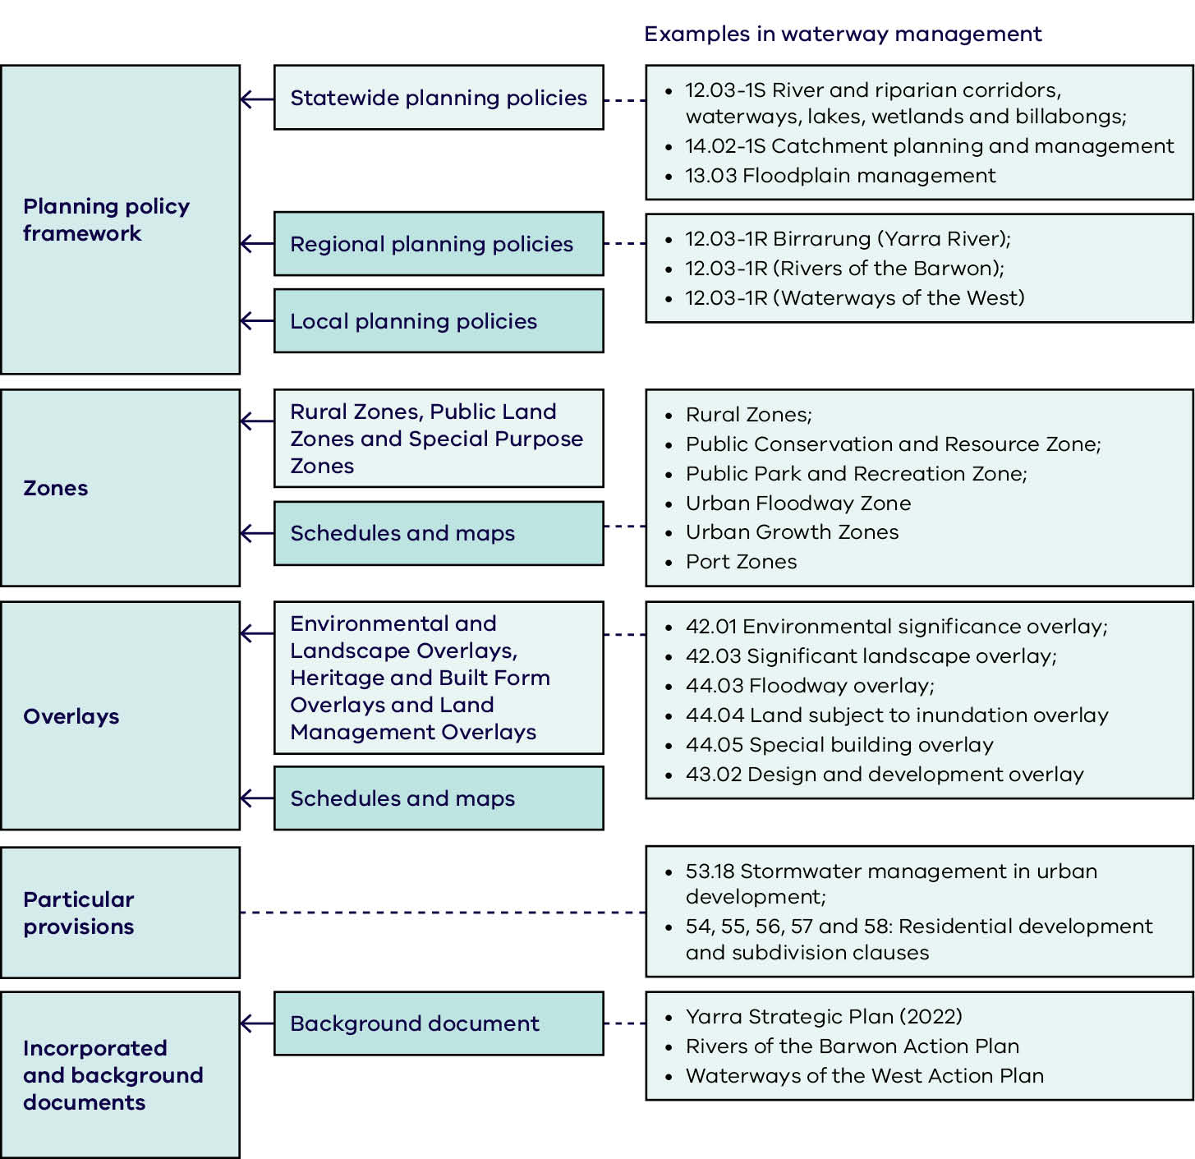
Note: Table 4 presents the information in this diagram in an alternative format.
Table 4: Planning system tools for waterway protection – planning system tool category, its relevant sub-types, and examples in waterway management
Planning system tool | Sub-type | Examples in waterway management
Planning policy framework | Statewide planning policies | - 12.03-1S River and riparian corridors, waterways, lakes, wetlands and billabongs;  - 14.02-1S Catchment planning and management
Planning policy framework | Regional planning policies | - Burndap Birrarung burndap umarkoo / Yarra Strategic Plan;  - Barre Warre Yulluk Action Plan / Rivers of the Barwon;  - Waterways of the West Action Plan
Planning policy framework | Local planning policies | - Burndap Birrarung burndap umarkoo / Yarra Strategic Plan;  - Barre Warre Yulluk Action Plan / Rivers of the Barwon;  - Waterways of the West Action Plan
Zones | PCRZ, PPRZ, FZ and Schedules and maps | - Farming Zone;  - Public Conservation and Resource Zone;  - Public Park and Recreation Zone; Urban  - Floodway Zone
Overlays | ESO, SLO, LSIO and Schedules and maps | - 42.01 Environmental significance overlay;  - 42.03 Significant landscape overlay;  - 44.03 Floodway overlay;  - 44.04 Land subject to inundation overlay
Particular  provisions | (none) | - 54.18 Stormwater management in urban development;  - 55, 56 and 58: Residential development and subdivision clauses
Incorporated and background documents | Background document | - (no specific examples listed in figure)
Note: PCRZ = Public Conservation and Resource Zone; PPRZ = Public Park and Recreation Zone; FZ = Farming Zone; ESO = Environmental Significance Overlay;
SLO = Significant Landscape Overlay; LSIO = Land Subject to Inundation Overlay.

Appendix 5. Roles and responsibilities in waterway management
The section below outlines the roles and responsibilities for waterway planning and management in Victoria. It includes institutional arrangements made through legislation, along with the informal but essential roles undertaken by community and groups like research institutions.
Table 5: Waterway policy
Institution | Role and responsibility
Department of Energy, Environment and Climate Action (DEECA) | DEECA is a Victorian Government department that develops and implements statewide policy for waterway management, including environmental water and water resource allocation. It oversees Victoria’s compliance with international and national water obligations and intergovernmental agreements – including the Murray-Darling Basin Plan, Living Murray and Ramsar Convention for wetlands. The department also develops and implements related policy and programs for Crown frontage management, biodiversity, biosecurity, climate action and emergency management.
Australian Government | Manages the national legislative frameworks for matters of national environmental significance, such as Ramsar wetlands and water sharing, salinity and water quality in the Murray-Darling Basin.  The Australian Government also funds significant initiatives to protect waterways, including the Federal Urban Rivers Fund – and regulation to reduce the potential of entry of invasive species into Australia.
Table 6: Water sector
Institution | Role and responsibility
Catchment management authorities | CMAs are independent statutory authorities that develop and coordinate the implementation of regional catchment strategies, regional waterway strategies and regional floodplain management strategies. They’re the waterway manager appointed under Part 10 of the Water Act 1989 and the regional floodplain manager. CMAs are required to submit seasonal watering proposals to the VEWH each year and deliver approved watering plans. They also provide critical input to managing other types of environmental water.
Water corporations | Some water corporations provide drinking water, sewerage, trade waste and recycled water services. Some also manage land, including riparian land in water supply catchments.
Melbourne Water | Melbourne Water is the catchment management authority for the Port Phillip and Westernport region. Melbourne Water is a wholesale water company that provides bulk water and sewerage services to water corporations in the metropolitan area, provides stormwater drainage services and manages surface water diversion licences in parts of its region. It is the waterway manager appointed under Section 10 of the Water Act 1989 and the regional floodplain manager and has other catchment management functions in its region. It is required to submit seasonal watering proposals to the VEWH each year and deliver approved watering plans. It also provides critical input to managing other types of environmental water. Melbourne Water is the lead agency under the Yarra River Protection (Wilip-gin Birrarung murron) Act 2017.
Rural water corporations | Manage irrigation districts, some reservoirs and water diversion licences (surface water and groundwater). Some water corporations manage land, including determined recreational areas (Water Act 1989) and riparian land in water supply catchments. Some provide untreated water to rural customers for domestic and stock use (e.g. via pipelines and channels) and deliver environmental water. They work with the VEWH, waterway managers and Traditional Owners in planning for the delivery of environmental water – and ensure the provision of passing flows and compliance with the management of diversion limits in unregulated and groundwater systems.
Victorian Environmental Water Holder (VEWH) | The VEWH is an independent statutory authority under the Water Act 1989 that manages Victoria’s environmental water entitlements. It liaises with other water holders to coordinate the use of all environmental water entitlements at Victorian sites.
Murray-Darling Basin Authority | Coordinates planning and management for the equitable, efficient and sustainable use of the water and other natural resources of the Murray-Darling Basin. This includes coordination of The Living Murray Program and management of its joint water portfolio.
Commonwealth Environmental Water Holder | Makes decisions about the use of Australian environmental water holdings to protect or restore the environmental assets of the Murray-Darling Basin and reports on use of this water. Liaises with the VEWH to coordinate the use of environmental water entitlements at Victorian sites.
Table 7: Environment
Institution | Role and responsibility
Environment Protection Authority Victoria (EPA Victoria) | EPA is Victoria’s environmental regulator. As an independent statutory authority under the Environment Protection Act 2017, EPA’s regulatory role is to prevent and reduce harm to human health and the environment from pollution and waste. EPA Victoria uses a range of tools available under the Act to deliver improved outcomes for Victorian communities and the environment. This includes providing guidance on how to minimise harm to waterways from pollution and waste.
Parks Victoria | Parks Victoria is a statutory authority under the Parks Victoria Act 2018. It manages public land – including some waterway lands – for conservation, recreation, leisure, tourism and water transport. It works with waterway managers, Traditional Owners, water corporations and the VEWH to plan and deliver environmental water entitlements, including endorsing relevant seasonal watering proposals that affect public land.
Committees of management | Manage Crown Land reserves, including some waterway lands, for the benefit of the Victorian community.
Fishing, Hunting and Outdoor Victoria (FHOV) | FHOV administers the Fisheries Act 1995. It is an independent statutory authority established to effectively manage Victoria’s fisheries resources – including licensing for fishing, assessing fish stocks, and stocking fish for conservation and recreational fishing.  The Fishing, Hunting and Outdoor Victoria Act 2026 objective is to promote outdoor recreation (including fishing, and to work with land, water, waterway and coastal managers to improve access to public land for outdoor recreation, and fisheries and recreational boating activities).
Conservation Regulator | The Conservation Regulator oversees the regulation of wildlife, biodiversity and the use of public land in Victoria, including responsibilities for fire prevention. Its role includes monitoring compliance with legislation, investigating suspected breaches and taking enforcement action where necessary, as well as issuing licences, permits and other authorisations to protect forests and wildlife. The regulator also promotes voluntary compliance by educating the community about the laws that apply to biodiversity, public land and wildlife across the state.
Table 8: Cultural
Institution | Role and responsibility
Traditional Owner groups with formal recognition | Traditional Owner groups with formal recognition hold enduring cultural authority and responsibilities for Caring for Country. Formal recognition provides a legislative framework that acknowledges and supports the exercise of cultural rights, interests and governance responsibilities in relation to Country. For example, some groups have Recognition and Settlement Agreements under the Traditional Owner Settlement Act 2010 (Vic), Native Title rights and interests recognised under the Native Title Act 1993 (Cth), or responsibilities as Registered Aboriginal Parties under the Aboriginal Heritage Act 2006 (Vic). Traditional Owner groups with formal recognition are also recognised as:  - cultural rights holders  - having customary obligations to care for Country  - holders of traditional ecological knowledge  - holders of knowledge about Aboriginal cultural values  - partners in waterway management  holders of contemporary rights to participate or lead and develop enduring cultural governance arrangements for managing Country  They have state recognition of ‘right people for right Country’.
Traditional Owner groups without formal recognition | Traditional Owner groups without formal recognition also hold enduring cultural authority and responsibilities for Caring for Country. Cultural authority, rights, interests and responsibilities do not depend on formal recognition and endure regardless of whether a group is recognised under a legislative framework. Traditional Owner groups without formal recognition are also recognised as:  - cultural rights holders  - having customary obligations to care for Country  - holders of Traditional ecological knowledge  - holders of knowledge on Aboriginal cultural values  - partners in waterway management.
Victorian Aboriginal Heritage Council | A Council of Traditional Owners created in May 2007 as part of the Aboriginal Heritage Act 2006. Council appoints Registered Aboriginal Parties to manage and protect Cultural Heritage on their Country.
Heritage Services in the Department of Premier and Cabinet | - regulator of the Aboriginal Heritage Act 2006  - maintain the Victorian Aboriginal Heritage Register.
Table 9: Land use planning
Institution | Role and responsibility
Department of Transport and Planning (DTP) | DTP brings together key transport, planning, land, precinct and policy functions within a single department, to create thriving places and connected communities. They’re responsible for planning, building, operating and maintaining Victoria’s transport, planning and land services for use by all.
Victorian Planning Authority (VPA) | A statutory authority within DTP, VPA undertakes strategic planning and coordinates infrastructure for strategically-important precincts, so Victorians have equitable access to employment, public transport, public open space and affordable housing.
Local government | Councils are established by the Local Government Act 1989 and have responsibilities for land-use planning and management, including open space, under the Planning and Environment Act 1987. They develop local planning frameworks, govern planning approvals for the use or development of private land, and issue and enforce planning permits. Local government contributes to waterway management by regulating land use and development through municipal planning schemes, and developing and implementing urban stormwater plans. Local government also have public health and emergency management roles.
Table 10: Economic regulation
Institution | Role and responsibility
Essential Services Commission (ESC) | The ESC assesses and approves water prices, specifies service standards and reports on the performance of water corporations and local governments. It assesses Melbourne Water’s Waterways and Drainage Plan which guides its investment in these areas.
Table 11: Community
Institution | Role and responsibility
Community groups, volunteers and individuals | Undertake voluntary advocacy and on-ground management activities. They provide essential local insights and knowledge to inform waterway management priorities and actions. Volunteers also contribute through citizen science programs.
Private landholders, including farmers, with waterway lands | Have obligations to prevent harm to the waterway environment under the Environment Protection Act 2017 (in accordance with the General Environmental Duty) and to manage established invasive species under the Catchment and Land Protection Act 1994 and noxious aquatic species under the Fisheries Act 1995. Landholders also undertake on-ground management activities, including riparian and wetland fencing, revegetation and invasive species management. Many landholders also abut public land along waterways which they licence, often for grazing. The licence conditions also place various obligations on the landholder.
Recreational users and groups | Play a key role in education and information sharing to support good practice. Participate in waterway management activities and information sharing to inform priorities and actions.
Table 12: Industry
Institution | Role and responsibility
Industry | Has obligations to prevent harm to the waterway environment under the Environment Protection Act 2017. Industry can assist in maintaining and improving waterway condition, by managing its activities to prevent harm to the environment in accordance with the General Environmental Duty – and by staying informed of best practices and guidance to minimise harm.
Table 13: Research organisations
Institution | Role and responsibility
Research organisations | Continue to improve the state of knowledge for waterway management and provide advice to inform adaptive management, particularly in light of climate change and two-way learning with Traditional Owners.
Table 14: Health
Institution | Role and responsibility
Department of Health and Chief Health Officer (CHO) | The Department of Health and CHO interfaces with agencies responsible for drinking water source protection, recreational water quality, harmful algal blooms and waterway related emergency events to provide or support data and risk communication in relation to impacts on public health.

Appendix 6. Expectations for partnership with Traditional Owners
Expectations for waterway managers need to be clear at levels relating to the complexity and scale of the project. Each type of activity describes the rights of and present means to Traditional Owner participation or leadership roles. Some of these activities have been demonstrated at various locations or in collaboration with various agencies – while some have yet to be realised.
Routine business activities are the delivery of agencies’ core functions. They occur regularly and are guided by existing policies and procedures (e.g. invasive species management, track maintenance, revegetation and fencing of local sites). The development of policies and procedures for these activities should be guided by the Strategy’s principles, outcomes and approach. Traditional Owners have the right to participate in the planning and review of routine activities, which will be mostly developed and implemented through partnership arrangements.
Culturally-informed local projects are projects identified in the strategies or plans that contribute to waterway management and planning. They have clearly-articulated goals and may involve a small number of management levers that contribute to waterway outcomes at a local scale – covering single waterway reaches, wetlands or land tenures. These projects can achieve incremental improvements in waterway conditions and cultural outcomes. Agencies should look for opportunities to collaborate and link these projects with others, and leverage funding and resources for efficiency. Projects should be guided by the Strategy’s principles, outcomes and approach.
Traditional Owners have the right to participate or take a leadership role in the project inception, planning, delivery and review of culturally-informed local projects. They also have the right to be supported to deliver projects and works for waterways on Country. Collaborative arrangements and partnerships with Traditional Owners will aim to embed cultural governance.
Transformative/landscape-scale projects are integrated projects with broader aspirations for change. These projects require higher levels of collaboration and resourcing to achieve their desired outcomes. They involve multiple partners, use numerous management levers and will work across land tenures, to provide opportunities for working together to identify outcomes.
Traditional Owners have the right to participate or take a leadership role in project inception, planning, delivery and review with support from agencies and DEECA. Most of the projects will continue having government-centred outcomes. However, they must seek to identify and remove barriers for Traditional Owners’ objectives to be achieved, by increasing capacity and ability to provide cultural care for Country and applying both knowledge systems and contemporary and traditional management practices. DEECA and water agencies must support opportunities for piloting Traditional Owner-centred approaches and projects.

Appendix 7. Mechanisms to preserve the environmental water reserve and make best use of entitlements
Table 15: The mechanisms to preserve the environmental water reserve
Mechanism | Description | Types of systems
Sustainable diversion limits (SDLs) in the Basin Plan | In northern Victoria, the Murray-Darling Basin Plan places limits on the taking of surface water and groundwater for consumptive use.  Management of environmental water in northern Victoria also complies with the Murray-Darling Basin Plan (refer to Box 6). | Regulated  Unregulated  Groundwater
Environmental entitlements | Provide for a share of the available water – a legal right to take and use water granted under the Water Act 1989 to maintain or improve environmental values. | Regulated
Permissible consumptive volumes | Set the maximum volume of water that may be taken for consumptive use in a system. | Regulated  Unregulated  Groundwater
Requirements/rules in statutory management plans and entitlements setting aside minimum or passing flows | Flows that must be allowed to pass a dam, weir or gauge before water can be harvested. | Regulated  Unregulated
Section 40 of the  Water Act 1989 | Legislative requirements for consideration of impacts to the EWR as part of the allocation, amendment or transfer of entitlements. | Regulated  Unregulated
Statutory management plans | Prepared under the Water Act 1989 to manage water resources of the area. | Unregulated  Groundwater
SDLs in Victoria  (Victorian policy-based diversion limits on consumptive use of water) | Prevent the issuing of summer licences and determine the upper limit on winter-fill diversions, beyond which there is an unacceptable risk to the environment. | Unregulated
Policies for managing take-and-use licences  Rules on licences | Prohibit summer diversions, restrict upstream trade and unregulated-to-regulated system trade, setting rosters and restrictions to share summer low flows. | Unregulated
Carryover | Allows environmental (and other) entitlement holders to hold unused water allocations for use in subsequent seasons. This provides greater flexibility to achieve environmental outcomes. | Regulated
Trade | Environmental water entitlements and allocations can be bought and sold by the VEWH where consistent with the objectives of the Water Act 1989. | Regulated
Reuse of return flows | Return flows are the portion of water that ‘returns’ to the river (or water supply) system after a watering event. This water can be reused for other environmental watering downstream. | Regulated
Using consumptive water en route | Use of consumptive water or ‘piggyback’ environmental water on its way to being delivered to water users via rivers, creeks or wetlands. | Regulated

Appendix 8. Volumes of water held for the environment across river basins in Victoria
Water is held as environmental entitlements or water shares by either the VEWH or CEWH and includes a mix of reliabilities (or securities of supply). The actual amount available in a particular year will differ across entitlements, due to the rules of each entitlement and the seasonal conditions in that year. Some entitlements do not have a specified annual volume. Further information about these environmental entitlements and water shares can be found at Victorian Water Register website and VEWH and CEWH water holdings, current as of 30 June 2026.
Figure 22: Map showing the volumes of water held for the environment across river basins in Victoria
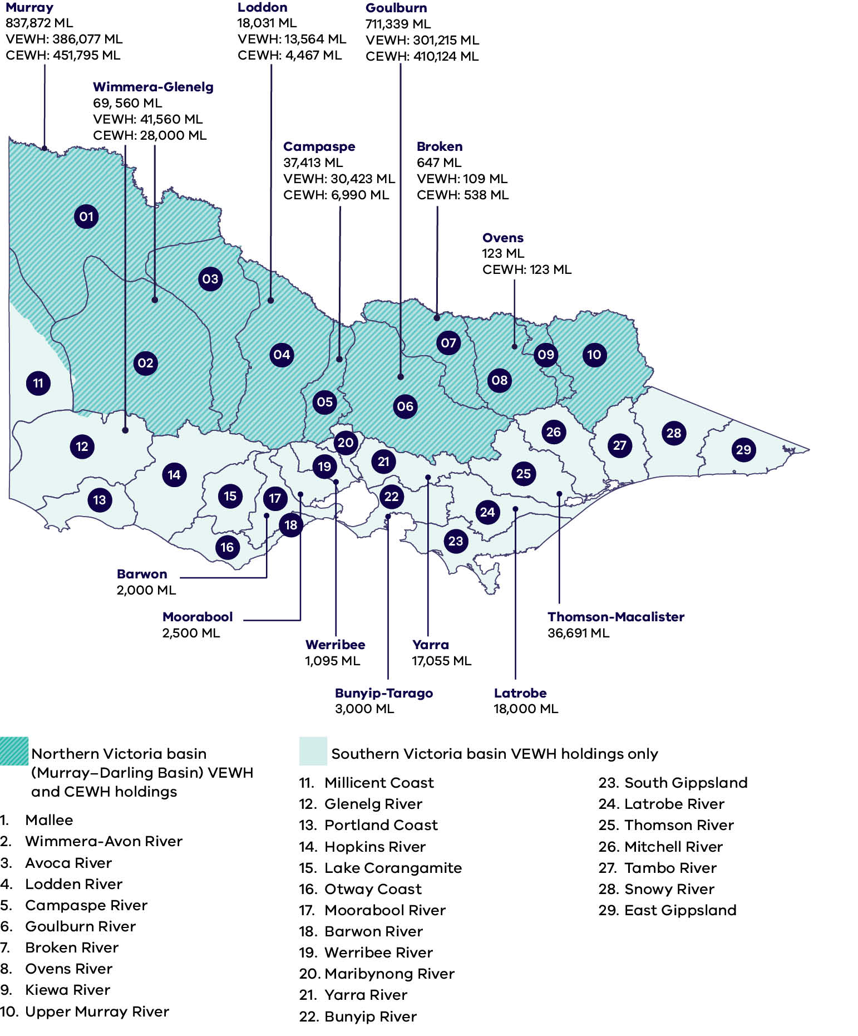

Text description of Figure 22
Figure 22 is a map of Victoria divided into 29 numbered river basins. Shading distinguishes northern Victoria basins, which are part of the Murray–Darling Basin and hold entitlements of both the Victorian Environmental Water Holder (VEWH) and the Commonwealth Environmental Water Holder (CEWH), from southern Victoria basins, which hold VEWH entitlements only. Labelled volumes show the total water held for the environment in each named basin in megalitres (ML), current as of 30 June 2026. Volumes are reported for the water systems named below; basins without a labelled volume have no separately reported holding in the figure.

Northern Victoria basins (Murray–Darling Basin) – VEWH and CEWH holdings:
- Murray – 837,872 ML total (VEWH 386,077 ML; CEWH 451,795 ML).
- Goulburn – 711,339 ML total (VEWH 301,215 ML; CEWH 410,124 ML).
- Wimmera–Glenelg – 69,560 ML total (VEWH 41,560 ML; CEWH 28,000 ML).
- Campaspe – 37,413 ML total (VEWH 30,423 ML; CEWH 6,990 ML).
- Loddon – 18,031 ML total (VEWH 13,564 ML; CEWH 4,467 ML).
- Broken – 647 ML total (VEWH 109 ML; CEWH 538 ML).
- Ovens – 123 ML total (CEWH 123 ML; no VEWH holding shown).

Southern Victoria basins – VEWH holdings only:
- Thomson–Macalister – 36,691 ML.
- Latrobe – 18,000 ML.
- Yarra – 17,055 ML.
- Bunyip–Tarago – 3,000 ML.
- Moorabool – 2,500 ML.
- Barwon – 2,000 ML.
- Werribee – 1,095 ML.

Numbered basins shown on the map, 1 to 10 (northern Victoria, Murray–Darling Basin):
- 1. Mallee. 2. Wimmera-Avon River. 3. Avoca River. 4. Loddon River. 5. Campaspe River.
- 6. Goulburn River. 7. Broken River. 8. Ovens River. 9. Kiewa River. 10. Upper Murray River.

Numbered basins shown on the map, 11 to 29 (southern Victoria):
- 11. Millicent Coast. 12. Glenelg River. 13. Portland Coast. 14. Hopkins River. 15. Lake Corangamite.
- 16. Otway Coast. 17. Moorabool River. 18. Barwon River. 19. Werribee River. 20. Maribyrnong River.
- 21. Yarra River. 22. Bunyip River. 23. South Gippsland. 24. Latrobe River. 25. Thomson River.
- 26. Mitchell River. 27. Tambo River. 28. Snowy River. 29. East Gippsland.

Appendix 9. Victoria’s environmental water management framework and alignment with the Australian Government framework
Figure 23: Diagram showing Victoria’s environmental water management framework
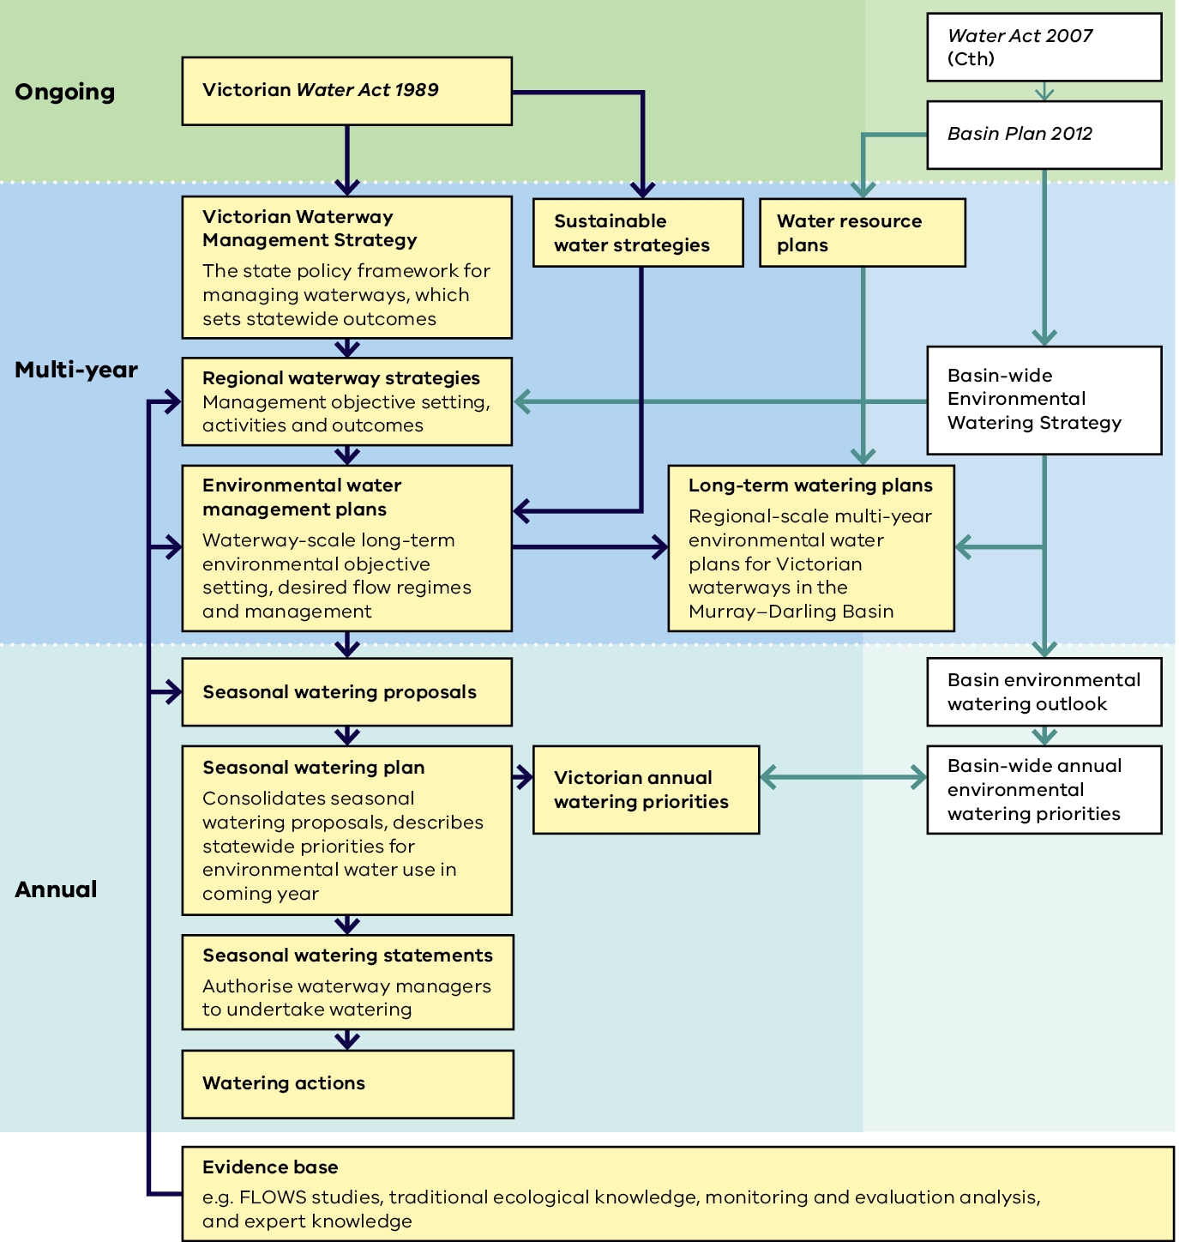

Text description of Figure 23
Figure 23 is a flow diagram showing Victoria's environmental water management framework and how it aligns with the Australian Government framework for the Murray-Darling Basin. The diagram is arranged in three horizontal time bands - ongoing, multi-year and annual - with Victorian instruments on the left and Australian Government (Murray-Darling Basin) instruments on the right. Arrows show how each instrument informs the next.

Ongoing
- The Victorian Water Act 1989 informs the Victorian Waterway Management Strategy and the sustainable water strategies.
- The Commonwealth Water Act 2007 informs the Basin Plan 2012.

Multi-year: Victorian instruments
- Victorian Waterway Management Strategy - the state policy framework for managing waterways, which sets statewide outcomes. It informs the regional waterway strategies.
- Regional waterway strategies - management objective setting, activities and outcomes. They inform the environmental water management plans.
- Environmental water management plans - waterway-scale long-term environmental objective setting, desired flow regimes and management. They are also informed by the sustainable water strategies, and they inform the long-term watering plans.
- Long-term watering plans - regional-scale multi-year environmental water plans for Victorian waterways in the Murray-Darling Basin.

Multi-year: Australian Government instruments
- Basin Plan 2012 informs the water resource plans and the Basin-wide Environmental Watering Strategy.
- Water resource plans inform the long-term watering plans.
- Basin-wide Environmental Watering Strategy informs the regional waterway strategies and the long-term watering plans.

Annual: Victorian instruments
- Seasonal watering proposals, informed by the environmental water management plans.
- Seasonal watering plan - consolidates the seasonal watering proposals and describes statewide priorities for environmental water use in the coming year. It informs the Victorian annual watering priorities.
- Seasonal watering statements - authorise waterway managers to undertake watering.
- Watering actions - the on-ground delivery of environmental water.

Annual: Australian Government instruments
- Basin environmental watering outlook, informed by the Basin-wide Environmental Watering Strategy.
- Basin-wide annual environmental watering priorities, informed by the Basin environmental watering outlook. These priorities and the Victorian annual watering priorities inform each other.

Evidence base
- An evidence base spans the bottom of the diagram - for example FLOWS studies, traditional ecological knowledge, monitoring and evaluation analysis, and expert knowledge. It feeds back into the regional waterway strategies, the environmental water management plans and the seasonal watering proposals.

Appendix 10. Victoria’s water quality management framework
Table 16: Victoria’s water quality management framework
Level | Details
National | Water Act 2007  - Murray–Darling Basin Agreement Basin Plan  - Water trading rules  - National Water Quality Management Strategy  - Murray–Darling Basin Agreement schedule B salinity management  Basin Plan 2012  - Water quality objectives and targets for water resource plans  - Salinity targets  - Long term watering plans
State | Water Act 1989  - Waterway management  - Floodplain and drainage management  - Water use licences  - Water trading regulation  - Sustainable water strategies  Safe Drinking Water Act 2003  - Safe Drinking Water Regulations 2025  Catchment and Land Protection Act 1994  - Integrated management and protection of catchments  - Maintaining and enhancing the quality of the state's land and water resources and associated plant and animal life  - Regional catchment strategy development  Planning and Environment Act 1987  - Victoria Planning provisions – land use planning  Environment Protection Act 2017  - Environment Protection Regulations 2021  - Environment Reference Standard 2021  - Guidance
Regional | - Regional catchment strategies  - Regional waterway strategies  - Environmental watering plans  - Land and water management plans  - Water quality plans  - Works on waterways  - Waterways of the West Action Plan 2021  - Yarra Strategic Plan Yarra River Action Plan 2021  - Rivers of the Barwon/Barre Warre Yulluk Action Plan 2021  - Local Government – Integrated Water Management Plans and other council policies and strategies  - Water Corporations – safe drinking water, management of licensed discharges, general environmental duty, water quality monitoring

Appendix 11. National biosecurity system and overview of other relevant strategies and legislation relating to Victoria
Table 17: National biosecurity system and overview of other relevant strategies and legislation relating to Victoria
Level | Biosecurity system:  Strategies, policies and legislation | Biosecurity system:  Institutions | Other strategies, plans and legislation relevant to the management of invasive species in waterways
National | - Intergovernmental Agreement on Biosecurity (IGAB)  - National Environmental Biosecurity Response Agreement (NEBRA)  - National Biosecurity Strategy (2022)  - Australian Pest Animal Strategy 2017–2027  - Australian Weeds Strategy  2017–2027  - Biosecurity Act 2015  - Australian Government Biosecurity and Agricultural Response Plan (2022)  (Statutory responsibility: Emergency)  - National Emergency Declaration Act 2020  (Statutory responsibility: Emergency) | - Australian Government  - National Biosecurity Committee  - Environment and Invasives Committee  - Australian Pesticides and Veterinary Medicines Authority | - National policy guidelines for the translocation of live aquatic animals  (Statutory responsibility: Fisheries)  - Australia's Strategy for Nature  2024–2030  (Statutory responsibility: Biodiversity)  - Australia's Threatened Species Action Plan 2022-2032  (Statutory responsibility: Biodiversity)  - Environment Protection and Biodiversity Conservation Act 1999  (Statutory responsibility: Biodiversity)
State  (Victoria) | - Victoria's Biosecurity Strategy (2023)  - Invasive Plants and Animals Policy Framework (2010) and Modules  - Catchment and Land Protection Act 1994  - State Emergency Management Plan; Animal, Plant, Marine and Environmental Biosecurity  Sub-Plan (2021)  (Statutory responsibility: Emergency)  - Emergency Management Act 2013  (Statutory responsibility: Emergency) | - DEECA  (Statutory responsibilities: Water and Biodiversity)  - Fishing, Hunting and Outdoor Victoria  (Statutory responsibility: Fisheries)  - Emergency Management Victoria  (Statutory responsibility: Emergency)  - Parks Victoria | - Water Act 1989  (Statutory responsibility: Water)  - Freshwater Fisheries Management Plan (2018)  (Statutory responsibility: Fisheries)  - Protocols for the translocation of fish in Victorian inland public waters  (Statutory responsibility: Fisheries)  - Fisheries Act 1995  (Statutory responsibility: Fisheries)  - Protecting Victoria's Environment – Biodiversity 2037  (Statutory responsibility: Biodiversity)  - Flora and Fauna Guarantee Act 1988  (Statutory responsibility: Biodiversity)  - Nature Conservation Strategy (2021)  - Victorian Deer Control Strategy (2021)  - National Parks Act 1975  - Wildlife Act 1975  - Outbreak! Investigation guidelines for aquatic animal disease events (2023)  - Victorian Waterway Management Strategy  (Statutory responsibility: Water)
Regional/  local | - Regional biosecurity, invasive plant and animal strategies | - Traditional Owner groups  - Waterway managers  (Statutory responsibility: Water)  - Water corporations  (Statutory responsibility: Water)  - Local government  - Private landowner/ land manager  - Waterway and recreational users  - Community | - Regional deer control plans  - Regional waterway strategies  (Statutory responsibility: Water)  - Regional catchment strategies  (Statutory responsibility: Water)

Appendix 12. Links between waterway conditions and social values
Figure 24: Links between waterway conditions and social values – Community wellbeing
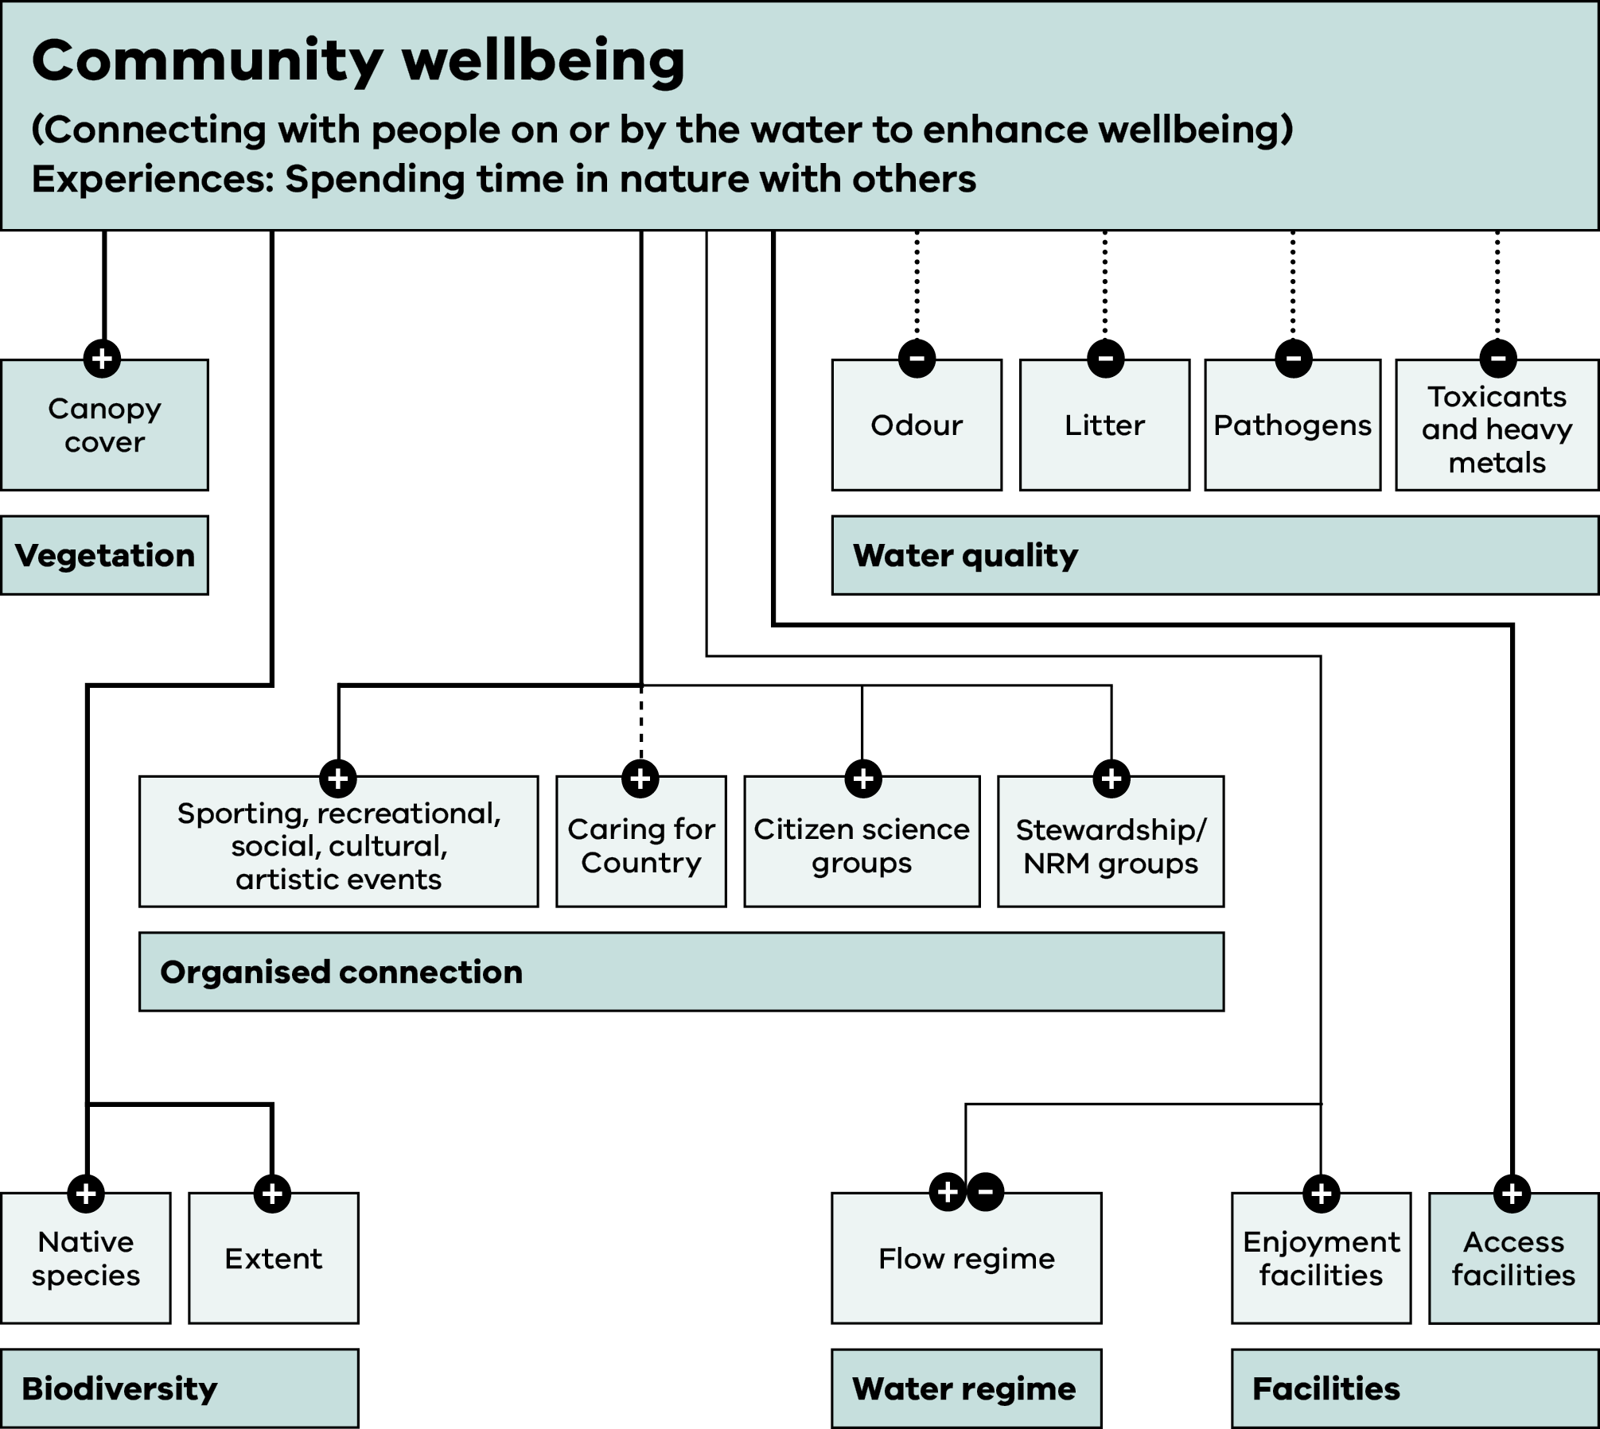
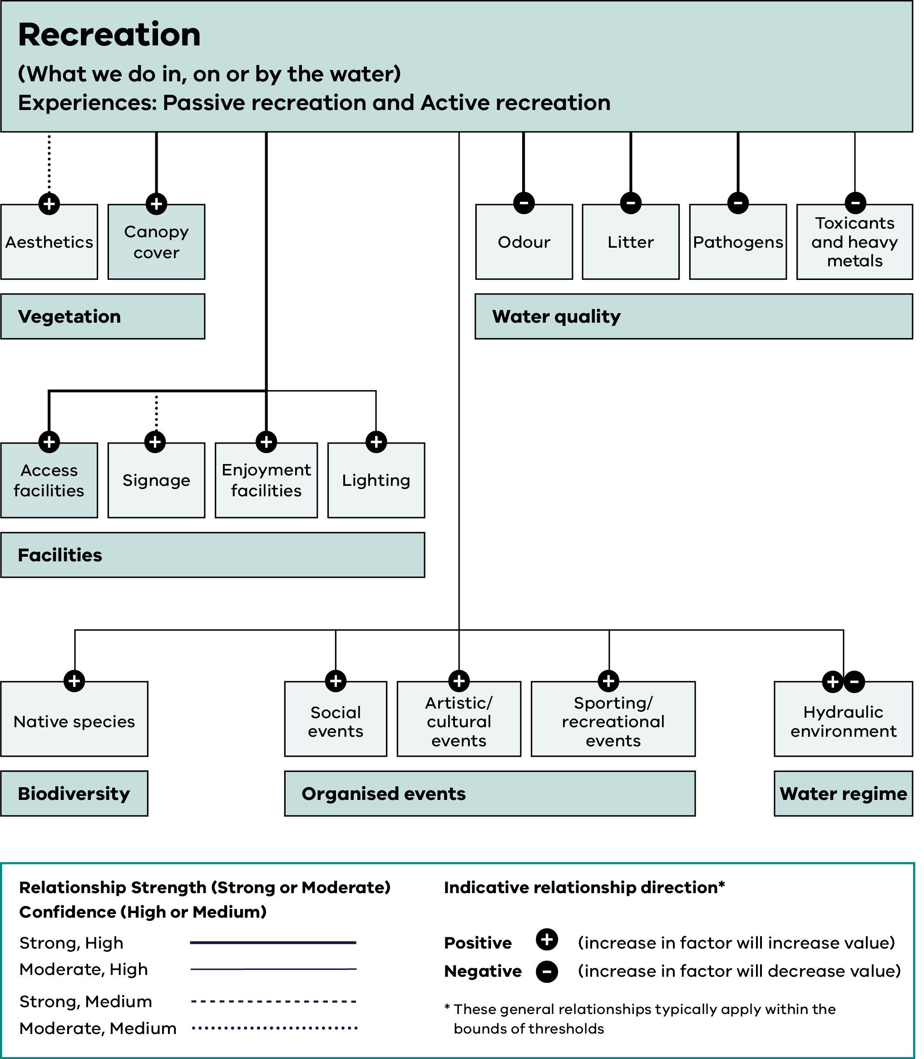

Text description of Figure 24
Figure 24 shows the links between waterway conditions and the social value of Community wellbeing, defined as connecting with people on or by the water to enhance wellbeing. The experience supported is spending time in nature with others. Community wellbeing is linked to six driver groups: Vegetation, Water quality, Organised connection, Biodiversity, Water regime, and Facilities. Each driver has an indicative direction – positive, negative, or both.

Vegetation drivers:
- Canopy cover – positive.

Water quality drivers:
- Odour – negative.
- Litter – negative.
- Pathogens – negative.
- Toxicants and heavy metals – negative.

Organised connection drivers:
- Sporting, recreational, social, cultural and artistic events – positive.
- Caring for Country – positive.
- Citizen science groups – positive.
- Stewardship / NRM groups – positive.

Biodiversity drivers:
- Native species – positive.
- Extent – positive.

Water regime drivers:
- Flow regime – both positive and negative depending on context.

Facilities drivers:
- Enjoyment facilities – positive.
- Access facilities – positive.
Figure 25: Links between waterway conditions and social values – Recreation

Text description of Figure 25
Figure 25 shows the links between waterway conditions and the social value of Recreation, defined as what we do in, on or by the water. The experiences supported are Passive recreation and Active recreation. Recreation is linked to six driver groups: Vegetation, Water quality, Facilities, Biodiversity, Organised events, and Water regime. Each driver has an indicative direction – positive, negative, or both – and the source diagram also indicates relationship strength and confidence by line style.

Vegetation drivers:
- Aesthetics – positive.
- Canopy cover – positive.

Water quality drivers:
- Odour – negative.
- Litter – negative.
- Pathogens – negative.
- Toxicants and heavy metals – negative.

Facilities drivers:
- Access facilities – positive.
- Signage – positive.
- Enjoyment facilities – positive.
- Lighting – positive.

Biodiversity drivers:
- Native species – positive.

Organised events drivers:
- Social events – positive.
- Artistic / cultural events – positive.
- Sporting / recreational events – positive.

Water regime drivers:
- Hydraulic environment – both positive and negative depending on context.
Figure 26: Links between waterway conditions and social values – Amenity
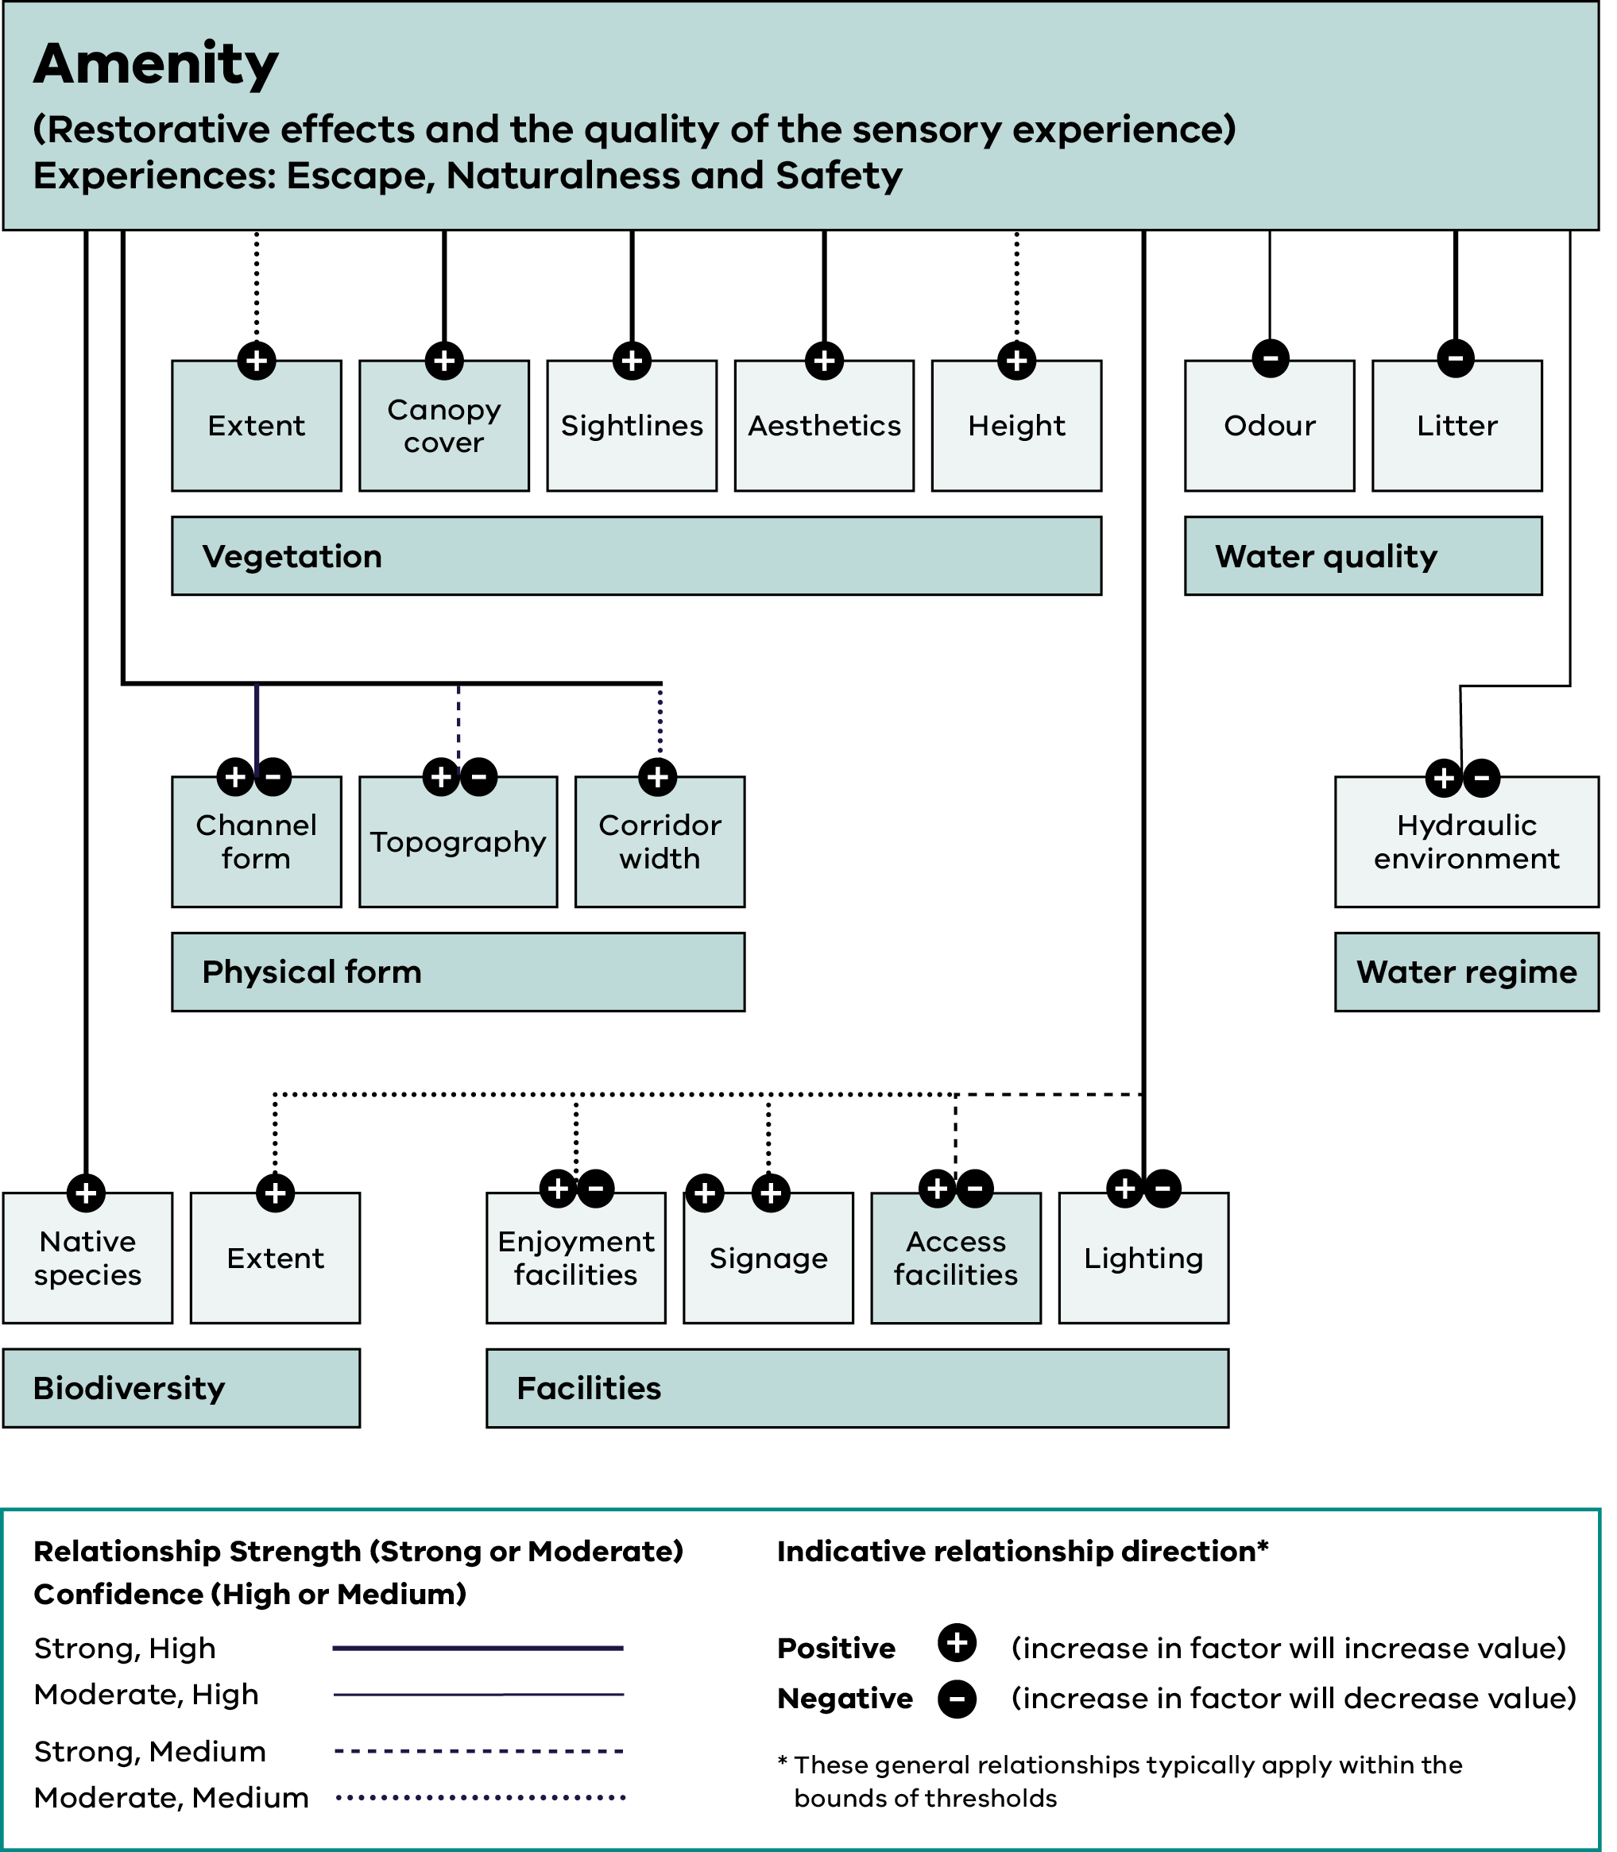

Text description of Figure 26
Figure 26 shows the links between waterway conditions and the social value of Amenity, defined as restorative effects and the quality of the sensory experience. The experiences supported are Escape, Naturalness and Safety. Amenity is linked to seven driver groups: Vegetation, Water quality, Biodiversity, Water regime, Facilities, Physical form, and Lighting. Each driver has an indicative direction – positive (an increase in the driver increases the value), negative (an increase in the driver decreases the value), or both, depending on context. Relationship strength and confidence are also indicated in the source diagram by line style.

Vegetation drivers:
- Extent – positive.
- Canopy cover – positive.
- Sightlines – positive.
- Aesthetics – positive.
- Height – positive.

Water quality drivers:
- Odour – negative.
- Litter – negative.

Physical form drivers:
- Channel form – both positive and negative depending on context.
- Topography – both positive and negative depending on context.
- Corridor width – positive.

Water regime drivers:
- Hydraulic environment – both positive and negative depending on context.

Biodiversity drivers:
- Native species – positive.
- Extent – positive.

Facilities drivers:
- Enjoyment facilities – both positive and negative depending on context.
- Signage – positive.
- Access facilities – both positive and negative depending on context.
- Lighting – both positive and negative depending on context.

Endnotes

The water corporation that holds/will hold the EPA permission to discharge treated wastewater.
Beneficiaries that may need to be considered in waterway management activities include direct beneficiaries such as recreation groups or private landholders, water corporations, local government representing regional benefits (e.g. increased tourism, increased liveability, avoided costs), the broader Victorian community and owners and managers of public infrastructure.
Place names used throughout this Strategy often reflect those formally in use at the time of publication. As Treaty processes progress in Victoria, the names of geographical features, including waterways, may change to recognise and reflect Traditional Owner language for Country.
DEECA (Department of Energy, Environment and Climate Action), Environmental Contribution, accessed 11 August 2026. https://www.water.vic.gov.au/about-us/environmental-contributions
NSW Department of Planning and Environment (2023) Framework for Valuing Green Infrastructure and Public Spaces
DEECA (Department of Energy, Environment and Climate Action), Agriculture and industry, Irrigation, accessed 11 August 2026. https://www.water.vic.gov.au/for-agriculture-and-industry/irrigation
URS (2008) Valuing the Benefits of Victorian Rivers. Report prepared for the Department of Sustainability and Environment.
Gunawardena A., Iftekhar S. & Fogarty J. (2017) Review of non-market values of water sensitive systems and practices: An update. Cooperative Research Centre for Water Sensitive Cities.
DEECA (Department of Energy, Environment and Climate Action), Protecting Victoria's Environment - Biodiversity 2037 (2017), accessed 11 August 2026. https://www.environment.vic.gov.au/biodiversity/biodiversity-plan
Moore, A., Schirmer, J., Magnusson, A., Keller, K., Hinten, G., Galeano, D., Woodhams, J., Wright, D., Maloney, L. and Dix, A. (2023) National Social and Economic Survey of Recreational Fishers 2018-2021, Fisheries Research and Development Corporation, accessed 21 February 2025. https://www.frdc.com.au/sites/default/files/products/2018-161-NRFS_main%20report_FINAL_19Feb2023.pdf
DELWP (Department of Environment, Land, Water and Planning) My Victorian Waterway Survey. Social research to understand the community's connection to Victorian waterways (2022). Report prepared by Quantum Market Research, accessed 11 August 2026. https://www.water.vic.gov.au/waterways/my-victorian-waterway-survey
Akbari S., Polyakov M., Iftekhar M.S., (2023) Capitalised nonmarket benefits of multifunctional water-sensitive urban infrastructure
Rossetti, J.O.E (2013) Valuation of Australia’s green infrastructure: Hedonic pricing model using the enhanced vegetation index as cited in Gunawardena, A. et al. (2017) Review of non-market values of water sensitive systems and practices: An update. Cooperative Research Centre for Water Sensitive Cities.
DEPI (Department of Environment and Primary Industries), Index of Stream Condition: The Third Benchmark of Victorian River Condition, accessed 11 August 2026. https://www.water.vic.gov.au/our-programs/water-monitoring-and-reporting/third-index-of-stream-condition-report
DEECA (Department of Energy Environment and Climate Action), Victorian Wetland Condition Assessment, accessed 11 August 2026. https://www.water.vic.gov.au/waterways/wetlands
DELWP (Department of Environment, Land, Water and Planning), Assessment of Victoria’s estuaries using the Index of Estuary Condition: Results 2021, accessed 11 August 2026. https://www.water.vic.gov.au/__data/assets/pdf_file/0033/664773/assessment-of-victorias-estuaries-index-estuary-condition-results-2021.pdf
DEECA (Department of Energy, Environment and Climate Action), Victoria's Climate Science Report (2024), accessed 11 August 2026. https://www.climatechange.vic.gov.au/victorias-changing-climate
DTP (Department of Transport and Planning), Victoria in Future: Population and household projections to 2051 (2023), accessed 11 August 2026. https://www.planning.vic.gov.au/guides-and-resources/Data-spatial-and-insights/discover-and-access-planning-open-data/victoria-in-future
Takacs, D. (2021) We Are the River, University of Illinois Law Review, Hastings Research Paper Forthcoming, Rev. 545, accessed 11 August 2026. https://papers.ssrn.com/sol3/papers.cfm?abstract_id=3818820
DEECA (Department of Energy, Environment and Climate Action) Forests and Reserves, Crown Land Water Frontages, accessed 11 August 2026. https://www.forestsandreserves.vic.gov.au/land-management/managing-crown-land
Protected areas must have a primary management objective to conserve biodiversity.
DEECA (Department of Energy, Environment and Climate Action), Permanent protection. Securing Victorian nature for future generations, accessed 11 August 2026. https://www.environment.vic.gov.au/biodiversity/biodiversity-progress-report/permanent-protection
Middelmann-Fernandes (2010) Flood damage estimation beyond stage–damage functions: an Australian example. Journal of Flood Risk Management, 3, 88-96, as cited in Gunawardena, A. et al. (2017) Review of non-market values of water sensitive systems and practices: An update. Cooperative Research Centre for Water Sensitive Cities.
Adapted from governance concept and principles in Smith, D. (2005) Researching Australian Indigenous Governance: A Methodological and Conceptual Framework. Working paper No 29. The Australian National University Centre for Aboriginal Economic Policy Research.
Andrews, T., & Buggey, S. (2008) in F. Cahir, I. Clark, & P. Clarke (Eds.) (2018) Aboriginal Biocultural Knowledge in South-eastern Australia: Perspectives of Early Colonists (p. xviii). CSIRO Publishing
Cumpston, Z. et al. (2022) First Knowledges Plants: Past, present and future. Port Melbourne, Victoria: Thames & Hudson Australia.
Kukutai, T. and Taylor, J. (2016) Indigenous data sovereignty: Toward an agenda. Australian National University Press.
RMCG (2021) Analysis of the social and economic values dependent on a flowing Barwon River (through Geelong) and lower Moorabool River. Final Report to the Corangamite Catchment Management Authority, accessed 11 August 2026. https://www.ccmaknowledgebase.vic.gov.au/kb_resource_details.php?resource_id=4897
Natural Capital Economics (2020) Socio-economic outcomes of environmental watering in northern Victoria. Final Report.
Cooper, B., Crase, L. & Burton, M. (2023) Households’ willingness to pay for water for the environment in an urban setting. Journal of Environmental Management
Victorian Environmental Water Holder (2025), Annual Report 2024-25, accessed 11 August 2026. https://www.vewh.vic.gov.au/planning-and-reporting/annual-report
Commonwealth Environmental Water Holder, Water holdings, Australian Government, accessed 11 August 2026. https://www.dcceew.gov.au/cewh/manage-water/basin/water-holdings
Murray-Darling Basin Authority (revised 2020) The Basin-wide environmental watering strategy, 2nd Edition, Australian Government, accessed 11 August 2026. https://www.mdba.gov.au/publications-and-data/publications/basin-wide-environmental-watering-strategy-publications
DEPI (Department of Environment and Primary Industries) (2013) Improving our Waterways: Victorian Waterway Management Strategy
John, A et al. (2024) Developing hydrologic stress metrics for Victoria’s wetlands; revised wetland inventory. University of Melbourne, Melbourne, Victoria
Applied Aquatic Ecology Hub (2024) Wetlands and Floodplains, accessed on 11 August 2026. https://www.aquaticecohub.com.au/
NRE (Department of Natural Resources and Environment), Victoria's Biodiversity: Directions in Management (1997) East Melbourne, accessed 11 August 2026. https://catalogue.nla.gov.au/catalog/183339
Victorian Catchment Management Council (2007) Catchment Condition Report 2007, accessed 24 February 2025. https://indicators.ucdavis.edu/framework-assessment/catchment-condition-report-2007
Casanova, M.T. and A.J. Casanova (2016) Current and future risks of cropping wetlands in Victoria, Report for DELWP Wetland Program; and Farrington, L., R. Cranswick, Z. Elotrovic and G. Kerr (2020). Wetland Spatial Analysis: Southeast Grampians Cluster, Nature Glenelg Trust & CDM Smith, Final Report to the Glenelg Hopkins Catchment Management Authority
Melbourne Water, Healthy Waterways Strategy Mid-term Review: Summary (2024), accessed 11 August 2026. https://mwhwsstorage.blob.core.windows.net/files/2024-06/Healthy%20Waterway%20Strategy-Mid-term%20Review-Summary.pdf
DEECA (Department of Energy, Environment and Climate Action) (2021) Forests, Reserves, Riparian management licences, accessed 11 August 2026. https://www.forestsandreserves.vic.gov.au/
DELWP (Department of Environment, Land, Water and Planning) Managing riparian land: an overview of benefits to landholders (2019), accessed 11 August 2026. https://www.water.vic.gov.au/__data/assets/pdf_file/0031/729742/Benefits-to-landholders-of-riparian-works-summary.pdf
BDA Group, Valuing the benefits of Victorian waterway management. Final report (2015) prepared for the Glenelg Hopkins Catchment Management Authority.
Alluvium Consulting Australia, An assessment of the impact of riparian revegetation on stream erosion during floods. Final Report to the Department of Energy, Environment and Climate Action (2021), accessed 11 August 2026. https://www.water.vic.gov.au/waterways/riparian-land/floods-and-fires-on-riparian-land
The condition of riparian land is largely determined by the extent and health of its vegetation with sufficient width, resilience, connectivity, quality and structure to support its waterway values.
DEECA (Department of Energy, Environment and Climate Action) Instream Woody Habitat, Arthur Rylah Institute, accessed 11 August 2026. https://www.ari.vic.gov.au/research/rivers-and-estuaries/instream-woody-habitat
DELWP (Department of Environment, Land, Water and Planning) (2019) Managing vegetation and large wood in and around waterways, accessed 11 August 2026. https://www.water.vic.gov.au/__data/assets/pdf_file/0033/665907/large-wood-snags-and-flooding.pdf
DEECA (Department of Energy, Environment and Climate Action) (2023) Victorian Water Quality Analysis 2022. Summary Report, accessed 11 August 2026. https://www.water.vic.gov.au/__data/assets/pdf_file/0036/685890/Victorian-water-quality-analysis-2022-summary-report.pdf
EPA (Environment Protection Authority), Publication 5005: Guidance for emerging contaminants in recycled water, accessed 11 August 2026. https://www.epa.vic.gov.au/technical-guideline-emerging-contaminants-recycled-water
DCCEEW (Department of Climate Change, Energy, the Environment and Water) Industrial Chemicals Environmental Management Standard (IChEMS) (2022), accessed 11 August 2026. https://www.dcceew.gov.au/environment/protection/chemicals-management/national-standard
Commissioner for Environmental Sustainability (2023) Victorian State of the Environment 2023 Report, accessed 11 August 2026. https://www.ces.vic.gov.au/soe2023
DSE (Department of Sustainability and Environment) Victorian Coastal Acid Sulfate Soils Strategy (2009) The State of Victoria
Environment Reference Standard (ERS) (2021). Section 93 of the Environment Protection Act 2017. Victoria Government Gazette, accessed 11 August 2026. https://www.epa.vic.gov.au/environment-reference-standard
Collings, N. (2012) Indigenous cultural and spiritual values in water quality planning. Report prepared for the Department of Sustainability, Environment, Water, Population and Communities, Australian Department of Agriculture and Water Resources, accessed 11 August 2026. https://www.waterquality.gov.au/your-planning/indigenous-cultural-spiritual-values
ANZG 2018. Australian and New Zealand Guidelines for Fresh and Marine Water Quality. Australian and New Zealand Governments and Australian state and territory governments, Canberra ACT, Australia.
DCCEEW (Department of Climate Change, Energy, the Environment and Water), PFAS National Environmental Management Plan 3.1, accessed 11 August 2026. https://www.dcceew.gov.au/environment/protection/publications/pfas-nemp-3
Huang, B. et al. (2020) Quantifying welfare gains of coastal and estuarine ecosystem rehabilitation for recreational fisheries. Science of the Total Environment.
Reside, A.E. et al. (2024) The cost of recovering Australia’s threatened species. Nature Ecology & Evolution. https://doi.org/10.1038/s41559-024-02617-z
FRDC (Fisheries Research and Development Corporation) (2022) The National Carp Control Plan, accessed 18 August 2026. https://www.agriculture.gov.au/sites/default/files/documents/national-carp-control-plan.pdf
Agriculture Victoria and DEECA (Department of Energy, Environment and Climate Action) (2023) Victoria’s Biosecurity Strategy, accessed 11 August 2026. https://agriculture.vic.gov.au/biosecurity/protecting-victoria/strengthening-victorias-biosecurity-system/biosecurity-strategy-for-victoria
Agriculture Victoria, DPI (Department of Primary Industries) (2010) Invasive Plants and Animals Policy Framework, accessed 11 August 2026. https://agriculture.vic.gov.au/biosecurity/protecting-victoria/legislation-policy-and-permits/invasive-plants-and-animals-policy-framework
DELWP (Department of Environment, Land, Water and Planning) (2020) Victorian Deer Control Strategy, accessed 10 August 2026. https://www.environment.vic.gov.au/invasive-plants-and-animals/deer-control-program/deer-control-strategy
EPA Victoria (October 2020) 1919: Review of stormwater science, accessed 11 August 2026. https://www.epa.vic.gov.au/about-epa/publications/1919
Melbourne Water Corporation (2022) Burndap Birrarung burndap umarkoo, Yarra Strategic Plan 2022-2032, accessed 11 August 2026. https://www.water.vic.gov.au/waterways/protecting-the-yarra-birrarung/burndap-birrarung-burndap-umarkoo-yarra-strategic-plan
Adapted from Melbourne Water (2013) Stormwater Strategy: A Melbourne Water strategy for managing rural and urban runoff and Walsh, C.J et al. (2004) Urban stormwater and the ecology of streams. Technical Report for the Cooperative Research Centre for Freshwater Ecology and the Cooperative Research Centre for Catchment Hydrology.
DEECA (Department of Energy, Environment and Climate Action), Volunteering Naturally: Understanding Victoria's Environmental Volunteers 2023, accessed 11 August 2026. https://www.environment.vic.gov.au/__data/assets/pdf_file/0020/691004/Volunteering-Naturally-2023-Report-FINAL.pdf
DEECA (Department of Energy, Environment and Climate Action) Waterways of the West: Toolkit for Practitioners, Engaging culturally and linguistically diverse communities on the Waterways of the West (2023), accessed 11 August 2026. https://www.water.vic.gov.au/waterways/waterways-of-the-west-action-plan/waterways-of-the-west-cald-toolkit-for-practitioners
DTP (Department of Transport and Planning), accessed 11 August 2026. https://www.planning.vic.gov.au/guides-and-resources/strategies-and-initiatives/waterways-planning/waterways-of-the-west
DELWP (Department of Environment, Land, Water and Planning) (2020). Protecting the Waterways of the West - Ministerial Advisory Committee Final Report. The State of Victoria, accessed 11 August 2026. https://www.water.vic.gov.au/__data/assets/pdf_file/0033/661929/protecting-the-waterways-of-the-west-ministerial-advisory-committee-final-report.pdf
Better Boating Victoria, Charting the Course: Victorian recreational boating strategy 2021-2030 (2021). Victorian Fisheries Authority, accessed 11 August 2026. https://betterboating.vic.gov.au/boatingstrategy/
Street Ryan (2024) Value of Recreational Water: Rocklands Reservoir 2023/24. Wimmera Southern Mallee Development, accessed 11 August 2026. https://www.gwmwater.org.au/water-and-sewerage/managing-our-water-supply/wimmera-southern-mallee-development-value-of-recreational-water-rocklands-reservoir-202324/
VRFish (2024), Summary of results - VRFish Advocacy and Fisher Priorities, accessed 11 August 2026. https://vrfish.com.au/vrfish_publication/vrfish-survey-advocacy-and-fisher-priorities-2024/
Victorian Fisheries Authority (2024) Record 11.5 million fish stocked, accessed 11 August 2026. https://vfa.vic.gov.au/recreational-fishing/featured/old/record-stocking
These figures are based on EC5 evaluation on the actual investment in the catchment and waterway programs (Waterway Health, Environmental Water and Our Catchments Our Communities). The figures of wages, profits and taxes includes the programs themselves and the businesses supplying goods and services to them. These are gross estimates and do not deduct employment or activity that may have occurred elsewhere in the economy without EC5.
Emergency Recovery Victoria, Strategy for Aboriginal Community-led Recovery (2023), accessed 11 August 2026. https://www.emv.vic.gov.au/strategy-for-aboriginal-community-led-recovery
Adapted from Melbourne Water (2018) Healthy Waterways Strategy Resource Document. Supporting the development of the Strategy, accessed 24 February 2025. https://healthywaterways.com.au/ End of document.

