

What We Heard Report: Traditional Owner Oversight Forum 2025
  - Water is Life: Traditional Owner Access to Water Roadmap
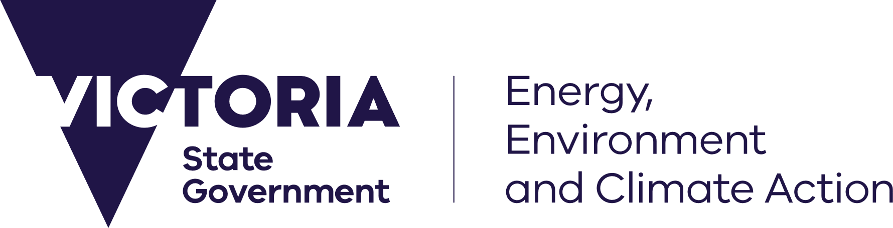




deeca.vic.gov.au

We acknowledge and respect Victorian Traditional Owners as the original custodians of Victoria’s land and waters, their unique ability to care for Country and deep spiritual connection to it.
We honour Elders past and present whose knowledge and wisdom
has ensured the continuation of culture and traditional practices.
DEECA is committed to genuinely partnering with Victorian Traditional Owners and Victoria’s Aboriginal community to progress their aspirations.
© The State of Victoria Department of Energy, Environment and Climate Action September 2024.
WARNING: Aboriginal and Torres Strait Islander readers are warned that the following document may contain images, quotes or views of deceased persons.

Design credit
Front page graphic design by Mazart Communications. Supply Nation and Kinaway certified

Table of Contents
DEECA Foreword 4
Traditional Owner Oversight Forum 2025 5
Attendees 6
Summary of discussion and key themes 8
Actions 11
Oversight in Action 15
Appendix A – Response to Action 1 17

DEECA Foreword

Deb Brown, Executive Director Water Sector Strategy and Partnerships

I acknowledge all First Nations and Traditional Owners of Victoria and pay respect to their Elders past and present. I acknowledge the Wurundjeri people as the Traditional Owners of the land on which I work, live, raise my children and from where I write this report. I also acknowledge and thank the Taungurung people for welcoming us onto their Country for the Water is Life Traditional Owner Oversight Forum, March 2025.
Thank you to all attendees at the Water is Life Oversight Forum, March 2025. The smoking ceremony and Welcome to Country from Taungurung and the cultural protocols I witnessed was a great privilege and pleasure.
First Nations peoples and Traditional Owners hold the cultural expertise that has always ensured the health of waterways and river Country. Thank you to those who shared their work, learnings and challenges at the Forum. I am committed to learning from you and providing support so that you can continue to care for and heal Country.
Water is Life: Traditional Owner Access to Water Roadmap is the Victorian Government commitment to working with Traditional Owners to:
- increase Traditional Owners’ decision making in caring for water landscapes,
- returning water for healthy Country, healthy mob and cultural economies; and
- ensure accountability for progress and implementation.
The Oversight Forum and this What we Heard Report is one part of that accountability and progress – it’s a documentation of the key themes and actions from the forum, we are sharing it publicly and with attendees.
The report will also be used and shared across DEECA, to ensure that all staff involved in Water is Life have read, listened and considered what attendees said, as work to progress Water is Life outcomes and actions continue.
I personally will share with the executives across DEECA’s Water and Catchments Group and ensure they read and pass the learnings onto their staff.
Thank you to all First Nations peoples and Traditional Owners who attended the Forum and continue to partner with the Aboriginal Water Program and DEECA for your commitment, time and generosity.



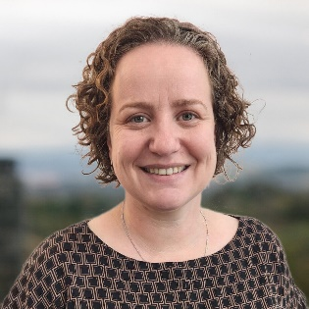
Deb Brown, Executive Director, WSSP

Traditional Owner Oversight Forum 2025
The Oversight Forum was an opportunity for Traditional Owners to have oversight of the implementation of Water is Life: Traditional Owner Access to Water Roadmap (Water is Life). 57 Traditional Owner organisation representatives met with First Nation Water Branch (FNWB) staff and DEECA decision makers across two days on Taungurung Country in central Victoria.
The Forum provided Traditional Owners with a line of sight on the progress being made, and was an opportunity to pose questions and seek clarity on delays in delivery and make recommendations on improvements and identify opportunities for further collaboration.
The Forum balanced a full agenda with opportunities to yarn outside on Country. During the formal sessions, DEECA Directors responsible for delivery of Water is Life actions shared implementation progress and outlined plans for the year ahead. Traditional Owners were, and continue to be, generous in sharing the successes and challenges they have experienced so far through implementation and progression of Water is Life.
Whilst the Forum was not a decision-making environment, DEECA has taken on 10 actions as requested by attendees. These actions will guide future implementation of Water is Life and form part of the iterative process of this policy. The actions, alongside the Forum and this What We Heard Report, mark an important point in the collaborative implementation of Water is Life. Throughout the Forum, Traditional Owners expressed eagerness to continue this approach and re-iterated the need for an oversight committee.
Embracing the Water is Life principle of ‘no one left behind, no one held back’, some Traditional Owner organisations shared projects underway on their Country. By demonstrating this principle in action, those who spoke gave attendees an opportunity to gain understanding of self-determined projects and different ways they could participate further in the water sector. Opportunities for resource sharing, peer-to-peer mentoring and collaborative benefit realisation were identified. This peer-to-peer knowledge sharing was greatly appreciated by all and the spirit of reciprocity and partnership carried throughout the Forum. Attendees identified collaboration as integral for Water is Life implementation.
This What We Heard Report will be used by staff responsible for Water is Life implementation to inform learnings and progression on medium- and long-term outcomes. The actions demonstrate Traditional Owners’ interests and expectations of Government and act as a pathway to further partnership and better results for Country, Traditional Owners and water management.
Water is Life’s commitment to restorative water justice will lead to wide ranging system reform within the water sector. This commitment will take time, grunt and resourcing. It’s a journey that Traditional Owners, DEECA and the water sector must walk together. Everyone who attended the Forum is committed to the challenge.

Attendees
DEECA expresses deep appreciation to representatives from the following Traditional Owner organisations for attending the Oversight Forum. Thank you for sharing your valuable knowledge and insights, for passing on deep wisdom, and for participating in the two-day forum. For many, attending the Forum involved time spent off Country and away from family, community and commitments. DEECA acknowledges your commitment to working in partnership and recognises that conversations about Country and self-determination carry deep meaning and weight. As Water is Life is implemented, we will continue to collaborate and learn from each other.

Bangerang Aboriginal Corporation | North Central Catchment Management Authority – Aboriginal Water Officer
Bidwell-Maap Aboriginal Corporation | Tati Tati Kaiejin
Bunurong Land Council | Tati Tati Land and Water Indigenous Corporation
Dja Dja Wurrung Clans Aboriginal Corporation | Taungurung Land and Waters Council
Duduroa Dhargal Aboriginal Corporation | Wadawurrung Traditional Owners Aboriginal Corporation
Eastern Maar Aboriginal Corporation | Waddi Waddi
First People of the Millewa-Mallee Aboriginal Corporation | Wadi Wadi
Gunditj Mirring Traditional Owners Aboriginal Corporation | Weki Weki
Jaithmathang TABOO | Werai Land and Water Aboriginal Corporation
Konermar Buller Jaithmatang Pty Ltd | Wiran Corporation
Latji Latji Mumthelang | Wurundjeri Woi-wurrung Cultural Heritage Aboriginal Corporation
Murray Lower Darling Rivers Indigenous Nations | Yorta Yorta Nation Aboriginal Corporation
Nindi-Ngujarn Ngarigo Monero Aboriginal Corporation

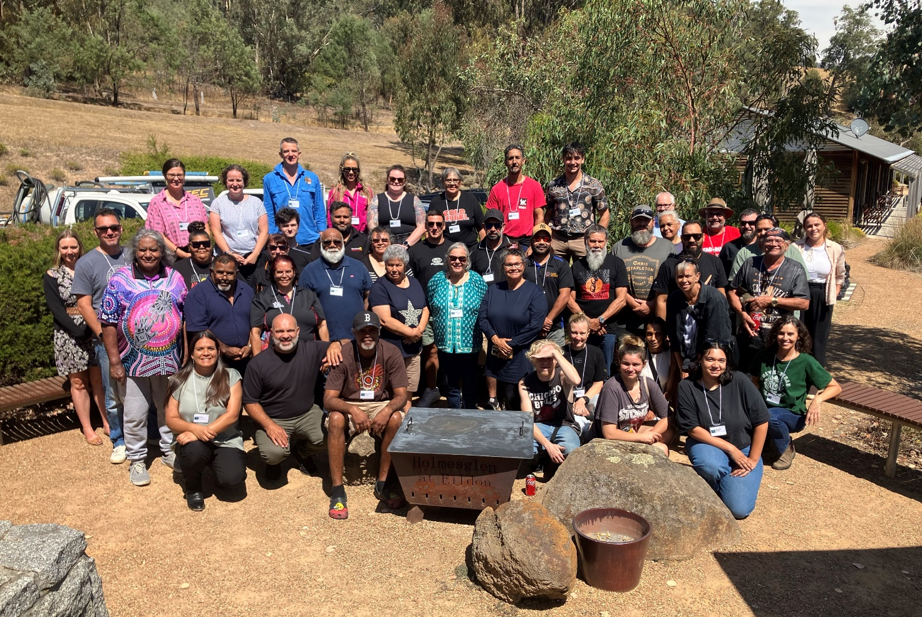
Image 1: Forum attendees, Day Two
NOTE: This photo is not to be replicated or used in any other publication. Participants agree to the use of this photo in this publication only. No further use permitted.

Summary of discussion and key themes
There was power in the collective voice that emerged throughout the Forum. Whilst implementation of Water is Life is Country-specific and will occur with respect to individual Nation’s self-determined priorities, there were commonalities and key principle-based themes that emerged and were largely agreed to by all attendees. The discussions during the Forum have been summarised into 6 key themes. They reflect common sentiment and reoccurring feedback provided. The following summary of oversight shared will be used to inform the iterative ‘learning by doing’ components of Water is Life. DEECA staff will use this to inform future implementation activities.

Theme | Summary
Country-centred work | - Country needs to be at the centre of all work.  - Traditional Owners should be involved in all decisions made about their Country.  - The importance of meeting on Country cannot be overstated.  - DEECA staff need to spend more time on Country, a short meeting isn’t enough time to understand Country. Traditional Owners don’t want FIFO (fly-in, fly-out) relationships.  - Traditional Owners care for Country as a whole, government stakeholders need to come together and meet collaboratively, rather than managing Country in silos.
Partnerships | Between Traditional Owner organisations:  - Water is a songline that connects Nations.  - Traditional Owners want to work together and be engaged with as a collective, as they determine.  - There is a desire for greater opportunities for peer-to-peer learning, pooling of resources and collective knowledge building.  - A “rangers without borders” approach was an option discussed.
Partnerships | Between DEECA and Traditional Owners:  - Partnerships need to be at the organisational level, not just between individuals.  - DEECA needs to assume all Traditional Owners want to be involved in projects, Traditional Owners shouldn’t need to come to DEECA and ask to be involved.  - State-wide engagement needs to be through multiple forums to ensure all Traditional Owner groups are represented, including those without formal RAP status.  - A successful relationship is built on:  - Respect for mob, Elders and community,  - Respecting cultural knowledge,  - Meeting on Country, and,  - Collaboration.  - Government needs to be comfortable meeting in Traditional Owners’ spaces and spending time on Country.  - The Aboriginal Water Program is a good starting place for building networks and partnerships with the water sector.  - ‘Learning by doing’ should include two-way learning.
Partnerships | Between the water sector and Traditional Owners:  - Relationships need to move beyond what is required by legislation to include all Traditional Owners (RAPs and non-RAPs) and take a collaborative partnership approach.  - Rivers need to be managed as one holistic system through a combination of cultural and western knowledge.  - Partnerships can make great progress when each party is willing to take on some risk. Obligations for partnerships need to be formalised so there is less reliance on individual people.  - Traditional Owners need to work with many different agencies as government agency boundaries don’t neatly align with Country. There has been success in establishing whole-of-government working groups that are led by Traditional Owner organisations.  - Any obligations or policy on partnerships (such as the Statement of Obligations and Letter of Expectations) must be clear on minimum expectations for engagement and include accountability mechanisms.
Continued Oversight | - Attendees want continued oversight of Water is Life implementation and called for an oversight committee.  - Having an oversight committee or some form of Indigenous water council would better support self-determination than current oversight models.  - Many Traditional Owners want to progress beyond what is written in Water is Life policy. An oversight committee would support new policy developments, further progressed aspirations, and progress towards true system reform.
Engagement with decision makers | - Engaging with senior government executives and the Minister for Water is crucial.  - Traditional Owners need to speak directly to decision makers - this is crucial for successful partnerships and Water is Life implementation.  - DEECA should develop a process that facilitates Traditional Owners engaging directly with decision makers regularly.
Enabling environments | - Current work is progressing at the speed of good relationships, enabling legislation is required to spur on further progress.  - Water is Life should focus on reform, the current water framework excludes Traditional Owners, so a new framework should be created rather than trying to work within existing limitations.  - Trying new ways of working involves everyone taking on and managing some level of risk.  - Secure, ongoing resourcing is needed to build and maintain enabling environments.  - Success stories and learnings need to be shared to build awareness of what is possible within current legislative environments.  - Water is Life implementation requires supportive professional environments and a willingness to evolve current processes.
Capacity building | - Traditional Owners have always managed water and have always had the capacity to manage water. It is more resources and knowledge of western water management systems that Traditional Owners need.  - Implementing Water is Life should include bottom-up skills development opportunities or career pathways for mob.  - The western water sector needs to build their capacity in understanding Country and cultural water priorities.  - Aboriginal Water Officers and the Aboriginal Water Officer Network (AWON) are a great resource for building relationships and knowledge of the water sector. The program should grow and continue to support capacity building moving forward.

Actions
During the Oversight Forum DEECA committed to taking 10 actions on notice, of which four have already been actioned and communicated to attendees. These actions are wide-reaching and reflect the scope of discussions at the Forum.
For consistency, the action status provided reflects language used in the Water is Life September 2024 Progress Report. An explanation of status terms is included below.
- Not yet started: This action is due to be delivered in future years
- Behind schedule (action needed): This action requires attention, unlikely to be fulfilled within committed timeframes
- Behind schedule (progressing): This action may not be fulfilled within committed timeframes, but action is being taken to either get this action back on track or modify the timeframe
- Started: Collaboration or a scope of work has commenced
- Progressing: The action has been partially achieved and still has remaining tasks to complete
- Achieved and completed: The action has been completed in full
- Achieved and ongoing: The action has been achieved and the strategy’s requirements have been met, but ongoing effort is needed to ensure the intended outcome of the action continues to be maintained.
 | Action | Status | Response
1. | DEECA to report back on if 1.36GL from the Connections Project will be carried over and accumulated from when the water was first committed to in 2022. | Achieved and completed | This water allocation cannot be used or carried over until the water shares are issued. Please see Appendix A for the full response which was emailed to attendees on 8 April 2025.
2. | First Nations Water Branch (FNWB) to provide feedback to DEECA’s land management team leading Water is Life Outcome 4 (review of public land legislation) that engagement should not be limited to the Traditional Owner Corporation Caucus and First Peoples’ Assembly. Engagement should include all Traditional Owners. | Achieved and ongoing | The FNWB provided this feedback to the project team.  In response, the team leading Outcome 4 will work with DEECA’s Regional teams to ensure that, wherever possible, all Traditional Owner groups are aware of the reforms and extend an invitation to meet if they would like further information.
3. | DEECA to investigate how we can acknowledge those who have contributed to Water is Life Nation Statements and/or are included within the policy document and who have since passed away. | Achieved and completed | The FNWB proposes that future Water is Life Oversight Forums will commence with a minute silence in memory of those who have passed away.  An acknowledgement that Water is Life may contain images, quotes or views of those who have passed away has been added in front of the online link to the policy document on the DEECA website. All subsequent print re-runs of Water is Life will include this acknowledgement at the start of the document.
4. | DEECA to follow up on the Water is Life September 2024 Progress Report and consider that the summary provided (on page 15) does not reflect Minister Shing’s statements made during Yoorrook Justice Commission hearings. | Achieved and ongoing | DEECA acknowledges that the Water is Life September 2024 Progress Report (page 15) is a summary and does not reflect Minister Shing’s evidence in completeness provided at the Yoorrook Justice Commission Land, Sky and Waters Hearings on 24 April 2024.  Minister Shing’s full statement of evidence at the Yoorrook Justice Commission Land, Sky and Waters Hearings on Wednesday 24 April 2024 is available on the Yoorrook Justice Commission website: Public Hearings: 22 April – 26 April 2024 | Yoorrook Justice Commission.
5. | DEECA to request the Minister for Water attend future Water is Life Oversight Forums and meet with Traditional Owners to hear more about cultural values and Aboriginal water. | Started | The FNWB will invite the Minister for Water to attend future Oversight Forums. In the meantime, other opportunities for the Minister to meet with Traditional Owners have and will be explored.
6. | DEECA to investigate setting up a Water is Life oversight committee (as written in Outcome 12 of Water is Life). | Started | Initial steps were taken to establish an oversight committee in 2022, including a call for nominations (via letters sent by previous Water and Catchments Group Deputy Secretary Helen Vaughan in October 2022), individual meetings between Traditional Owner organisations and previous Water and Catchments Group Executive Director Karen Lau and meetings between Traditional Owner organisations and the AWU. The call for nominations received a very limited number of responses and the AWU has heard varied perspectives from Traditional Owners on the proposal. Subsequently, establishment of the oversight committee was put on hold. Given the renewed calls for a committee heard at the Oversight Forum in 2025, the FNWB will further investigate the establishment of an oversight committee in the 2025-2026 financial year.
7. | DEECA to investigate how fees and charges are managed under the Australian Government’s Aboriginal Water Entitlement Program (AWEP) and report back. | Achieved and ongoing | DEECA contacted the Department of Climate Change, Energy, the Environment and Water (DCCEEW) in April 2025.  In response, DCCEEW advised it has allocated $10.1 million to cover transaction costs associated with the purchase of water entitlements under the Australian Government’s AWEP. This includes costs such as conveyancing, commercial advice, independent valuations, legal advice, and ongoing expenses related to holding water entitlements, including fees and charges.  Under interim governance arrangements, DCCEEW is currently managing this funding. Once a First Nations enduring water holding mechanism is established, any remaining funds and the water entitlements will be transferred to that entity. DCCEEW intends for this governance body to be durable, transparent, and culturally appropriate, ensuring it aligns with the values and aspirations of First Nations communities.  DEECA will continue to raise the importance of fees and charges not being passed onto Traditional Owner organisations with DCCEEW.  Recommendations to DCCEEW will be in line with Water is Life policy, which includes provisions for Traditional Owners to eventually become responsible for an increasing portion of fees and charges over time to full cost recovery where the use of water is purely commercial.
8. | DEECA (Living Entities and Voice team) will explore how to fund groups to come together to discuss Outcome 1, including options for Nations to work collaboratively to care for the same river (upstream and downstream neighbours). | Started | Funding for engagement and participation in development of Outcome 1 law proposal  Participation and engagement in development of the law proposal is currently funded via a similar mechanism to participation in the Oversight forum. Sitting fees are available to support participation in workshops, which may include collaborative sessions with multiple Nations. Other participation events may include online community workshops, presentations and member engagement activities, with specific details to be agreed upon with individual Traditional Owner organisations.  Learning by doing grants  The upcoming ‘learning by doing’ grant round will be open to Traditional Owner groups to progress Outcome 1. This could include project proposals that enable Nations to work collaboratively to express what understanding a waterway as a living entity means for them and enhance their ability to speak for a waterway.
9. | DEECA to continue preparation of Partnership Guidelines with Traditional Owners and the water sector to ensure they are fit for purpose and support Traditional Owners to establish and build relationships with the water sector. | Progressing | The FNWB is planning for engagement with Traditional Owners in the second half of 2025 on partnership guidelines to support the new Statements of Obligations for water corporations and catchment management authorities. The new Statements of Obligations are anticipated to be gazetted and in effect by end of this year, pending approval from the Minister for Water. Attendees at the Forum had the opportunity to register their interest in being part of dedicated engagement on developing these guidelines. The FNWB will be in contact with those individuals and request further participants when the engagement process commences.
10. | DEECA to provide ways for two-way learning to occur between Nations, especially those that have greater resources with those who are starting their journey with the Aboriginal Water Program. | Started | DEECA remains committed to enabling two-way learning between Nations through existing forums such as the Aboriginal Water Officer Network and Water is Life Oversight Forums.  Additional opportunities will also be considered as the FNWB investigates the establishment of an Oversight Committee (see action 6 above). Through the upcoming Water is Life 'Learning by Doing' grant round, Traditional Owner organisations may also identify other Nations they wish to work with in their expression of interest for learning by doing pilot projects.

Oversight in Action
The 2025 Oversight Forum is one way in which Traditional Owners are having oversight of Water is Life. The below graphic demonstrates and recognises that much work has taken place prior to the Forum, and that the work will continue beyond the Forum.
Figure 1: Oversight in Action, within the Forum and beyond.
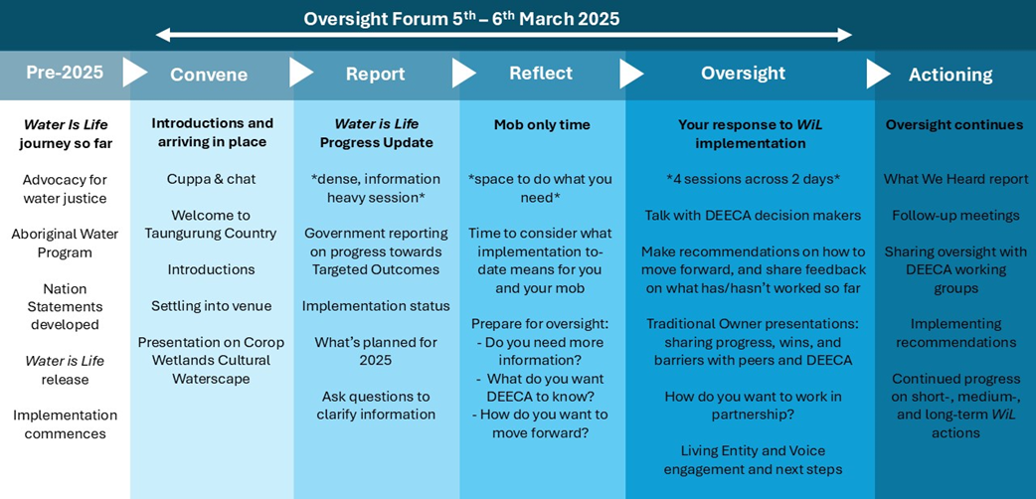
The FNWB is continuing to work with all Traditional Owners across Victoria to ensure oversight of Water is Life is fair and available to everyone. The knowledge shared during the Oversight Forum was invaluable and was a great platform to kick-start another year of Water is Life implementation.
Beyond the Forum, oversight will continue via existing forums. As outlined in Figure 2, DEECA committed to a number of actions post-Forum to ensure Traditional Owner oversight continues.

Actioning Oversight
- What We Heard Report
This report ensures the two-way dialogue between Traditional Owners and the FNWB continues beyond the Forum. Reporting back on what we heard and how we are actioning outcomes of the Forum is essential. This report also adds to the public record of partnership and oversight that Traditional Owners have provided for Water is Life.
- Follow-up meetings
For those Nations who were unable to attend the forum in person, DEECA has offered the opportunity to provide individual implementation updates as requested. This offer is open to all Traditional Owners across Victoria.
- Sharing oversight with DEECA internal working groups
DEECA has three internal working groups that focus on Water is Life implementation. These working groups include staff from Policy Officer to Director level and play a role in ensuring implementation occurs in a co-ordinated manner and within committed timeframes.
The Director-level working group provides strategic direction and high-level internal coordination. The two Policy Officer/Senior Manager-level working groups ensure ‘learning by doing’ occurs, providing a forum for teams delivering short- and medium-term outcomes to collaborate and share learnings with teams delivering long-term outcomes.
This report will be tabled and discussed at the meetings immediately following its release, ensuring all teams delivering Water is Life outcomes can learn from insights shared at the Oversight Forum.
The FNWB also held debriefs with DEECA attendees where we shared our lessons learnt, takeaways and any implications for our work programs that arose at the Forum. Everyone who attended commented on the power of the collective voice and the profound impact that attending the Forum had on their understanding of implementing Water is Life.
- Implementing actions
As outlined on pages 7-10 of this report, DEECA committed to 10 actions that were requested during the Oversight Forum. Work is progressing on implementing these actions, with five achieved and four started or progressing. The remaining action is planned for future delivery.
Beyond the actions, DEECA is committed to ensuring the lessons learnt and information shared during the Forum are shared with all staff working on Water is Life. Discussing this report, specifically the feedback summary and actions, at internal working groups ensures that the action and commitment that was called for by Traditional Owners is heard across DEECA. Collective action on Water is Life delivery and shared learnings were central to the Forum and will remain central post-Forum.
- Continued implementation of Water is Life
Work continues to deliver all Water is Life outcomes. Regular updates are given at the Aboriginal Water Officer Network (AWON), to the Statewide Caring for Country Partnership Forum, the Traditional Owner Corporation Caucus (TOCC) and in the annual Progress Reports (released around September each year). DEECA remains committed to ensuring Water is Life is delivered, water is returned to Traditional Owners and that Traditional Owners have increased roles in water management.

Appendix A – Response to Action 1
How has the Connections water been set aside for Traditional Owners?
Following the Minister for Water’s announcement in February 2022, the Connections 1.36 GL (1,364.4 ML) entitlement was set aside for Traditional Owners under Goulburn-Murray Water’s bulk entitlements in the Murray, Goulburn, Campaspe and Loddon systems.
At that time, arrangements had not been made for how the entitlement would be distributed. Setting it aside in the relevant bulk entitlements provided an interim holding mechanism until arrangements could be made for how to distribute the water to Traditional Owners.
It also enabled provisions to be included in schedules attached to the bulk entitlements to:
- secure the entitlement by formally setting it aside for Traditional Owners.
- establish rules to set water aside in an ‘additional water recovery account’ as part of the seasonal determination process, so that when the water shares are issued, they can include allocation available for the water year to date. Any water remaining in this account at the end of the water year does not carry over to the next water year.
- ensure fees and charges would not be incurred until the entitlement is issued as water shares.
Has the 1.36 GL been carried over from when the water return was first announced in 2022? Does it accumulate from year to year?
As outlined above, every year allocation is set aside against the Connections water held in bulk entitlements, but the allocation does not accumulate from year to year. The allocation will only be available to use once the entitlement is issued as water shares.
Once issued as water shares, allocations will be made against the water shares each year through the seasonal determination process. The volume of water available to use or trade each year (allocation) varies depending on seasonal conditions such as the amount of rainfall and volume of water held in storages, and the reliability of the water shares. Allocations against the water shares can be carried over from one year to the next, subject to carryover rules in place for each water system.
What are water shares, allocations and bulk entitlements?
Water shares are legally recognised, ongoing entitlements that give the holder a right to a share of available water in that system. Features of a water share include:
- its water system, e.g. Goulburn, Murray;
- its reliability, which can be high or low (the reliability of a water share gives an indication of the relative likelihood of the water share volume being fully available each year);
- its volume, e.g. 100 megalitres (ML).
An allocation is the percentage of water share volume available each year depending on seasonal conditions and is announced through seasonal determinations made by Goulburn-Murray Water (see https://nvrm.net.au/seasonal-determinations/current). For example, a 50% allocation against a 100 ML water share provides 50 ML of water available to use or trade in that year. A 100% allocation means there is a full water share volume available. In declared water systems such as the Murray, Goulburn, Campaspe and Loddon systems, Goulburn-Murray Water’s bulk entitlements provide the right to take, store and use water subject to conditions. Bulk entitlements are used to supply water to water share holders and other ‘customers’.

