Water for Victoria
CLOSING THE LOOP
FEEDBACK REPORT

Water for Victoria is Victoria’s plan to adapt to the impact of population growth and climate change on our water resources and a future with less water as the state becomes warmer and drier. This plan is the result of an 18‑month‑long broad and deep engagement with individuals, communities and stakeholder groups reflecting a wide variety of interests about water and how we should use water in the future.

Aboriginal acknowledgement
The Victorian Government proudly acknowledges Victoria’s Aboriginal community and their rich culture and pays respect to their Elders past and present.
We acknowledge Aboriginal people as Australia’s first peoples and as the Traditional Owners and custodians of the land and water on which we rely. We recognise and value the ongoing contribution of Aboriginal people and communities to Victorian life and how this enriches us. We embrace the spirit of reconciliation, working towards the equality of outcomes and ensuring an equal voice.

One thing is clear – Water for Victoria comes at the right time for Victoria to deal with the challenges of climate change and a growing population. Community expectations have changed too, which is why Water for Victoria considers all values of water.
Our communities expect healthy rivers, lakes and bays for recreation. The viability of industries, including agriculture, energy, mining and manufacturing, depends on water. Victorians put a high premium on cities and towns with trees and green spaces and usable sports grounds, especially after the Millennium Drought. Traditional Owners and Aboriginal Victorians want their values of water to be finally recognised.
Working together to put Water for Victoria into practice, we will make our water system and services modern and efficient, innovative, future-focused and importantly, affordable. Victorians, wherever they live, can thrive and prosper.
Water for Victoria includes actions for government and actions for urban and rural water corporations, catchment management authorities, and the Victorian Environmental Water Holder.
The input of stakeholders, community and Traditional Owners – all with a wide range of views – has been fundamental in shaping Water for Victoria. This report, Closing the Loop, provides a snapshot of what you told us and how we responded to your feedback.
The Victorian Government would like to thank the Water Plan Reference Group, Stakeholder Group and everyone who attended meetings, workshops or who commented on the discussion paper for your thoughtful contributions. The final plan, Water for Victoria, and the Victorian community as a whole, have benefited.
- 27 workshops
- 712 participants
- 272 submissions
- 67 comments from the online ideas tool
- 2140 comments from feedback forms at stakeholder and community workshops

Developing the plan
In April 2015, the Victorian Government announced that the Victorian community and key stakeholders would be involved in developing a new water plan for Victoria. The Department of Environment, Land, Water and Planning led four phases of engagement about the water plan:

Phase 1

Developing the discussion paper
June 2015–Feb 2016
To scope the plan and develop a discussion paper, we began conversations with key stakeholders – people and organisations actively involved in water or representing major interests.
Workshops and meetings were held around the state with stakeholders, including:
- water corporations
- catchment management authorities
- the Victorian Environmental Water Holder
- water user peak bodies including the Victorian Farmers’ Federation, Dairy Australia and Devondale Murray Goulburn
- environmental interest groups, such as Environment Victoria, Environment Farmers Network, and Yarra Riverkeeper Association
- other government departments and agencies involved in related policy, such as Department of Health and Human Services; Department of Economic Development, Jobs, Transport and Resources; the Environment Protection Authority; Sustainability Victoria; and Parks Victoria
- local government, represented by the Municipal Association of Victoria.

Phase 2

Broadening the conversation
March–May 2016
In March 2016, the government invited the community and stakeholders to comment on the Water for Victoria – Discussion Paper.
We encouraged a wide range of people and organisations to provide feedback about the plan through the department’s Have Your Say website, state-wide community and stakeholder workshops, and by writing submissions.
This broader conversation included:
- general water users from urban, regional and rural communities
- farmers from both dryland and irrigated areas
- businesses, industry and agricultural groups
- Aboriginal Victorians and Traditional Owners
- Landcare and environmental groups
- consumer and advocacy groups
- recreational water users
- local councils
- research organisations and universities
- elected officials
- other government departments and agencies.

Phase 3

Refining the plan
May–June 2016
The department continued to work with key stakeholders to test our response to the feedback, and to refine and finalise the water plan.

Phase 4

Implementation
October 2016–ongoing
We will continue to work with key stakeholders and the community to put this plan into practice.
Figure 1 – DELWP Community charter
What you can expect of us. In all aspects of our work and interaction with the public, we will

Be available
- Place‑based community focus – Talk to you where you live, work and play and be visible in local communities
- Accessibility – Make sure we are easy to contact and our information is straightforward and available in a variety of ways
- Flexibility – Respect the way you want to work with us, and adapt our approach according to local needs

Speak and listen
- Active listening and understanding – Listen to and understand your views and needs and respect different opinions
- Honesty and transparency – Be honest about what’s driving our priorities, what we can and can’t promise to do, our timelines and why decisions have been made
- Clarity and purposefulness – Be clear why and how we are engaging, making sure we give you real opportunities to influence and make a difference

Take action
- Timely and proactive – Talk to the community as early as we can, responding quickly to issues and feedback
- Consistency – Ensure we are consistent in the way we approach decisions
- Closing the loop – Inform communities about the outcomes of projects and if our plans change we will let you know when this happens and why

1. Having your say
There were 27 community and stakeholder workshops in 17 locations across the state. The location and key themes of the workshops are shown in Figure 3.
We received 272 written submissions.
Comments were made on all aspects of the Discussion Paper. Individuals and community groups, such as local Landcare groups were the majority of submitters (132 in total). We received 37 local government submissions from across Victoria. The water corporations, catchment management authorities and the Victorian Environmental Water Holder all provided submissions. Peak bodies, such as the Victorian Farmers Federation, Environment Victoria, and the Municipal Association of Victoria provided comprehensive submissions. We received submissions from universities and research entities, and from Aboriginal groups and others with an interest in Aboriginal values.
Figure 2 – Breakdown of submitters
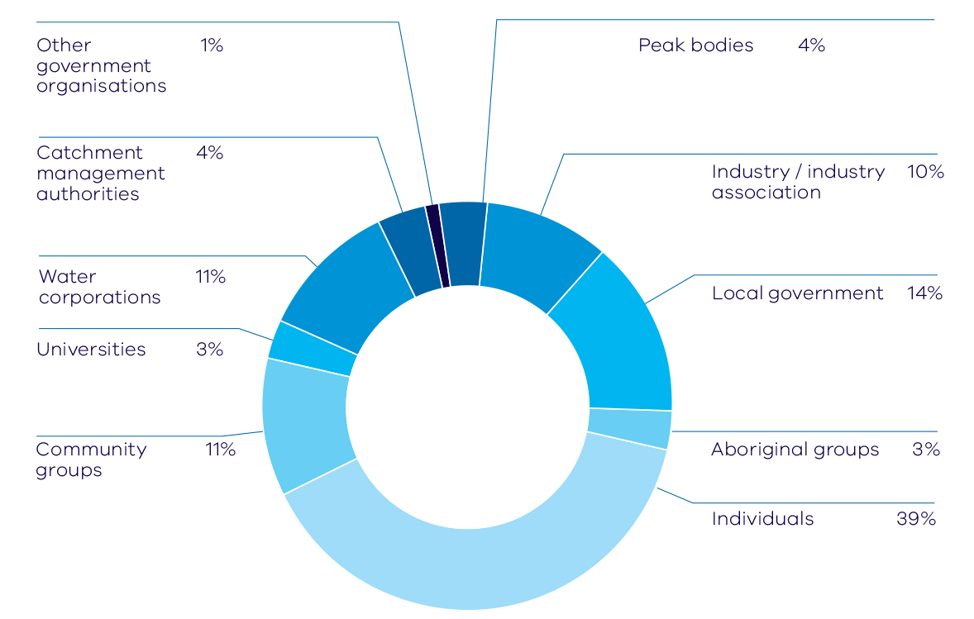
Other government organisations 1%
Catchment management authorities 4%
Water corporations 11%
Universities 3%
Community groups 11%
Peak bodies 4%
Industry/industry association 10%
Local government 14%
Aboriginal groups 3%
Individuals 39%
Figure 3 – Relevance of chapter by region – nominated during workshops
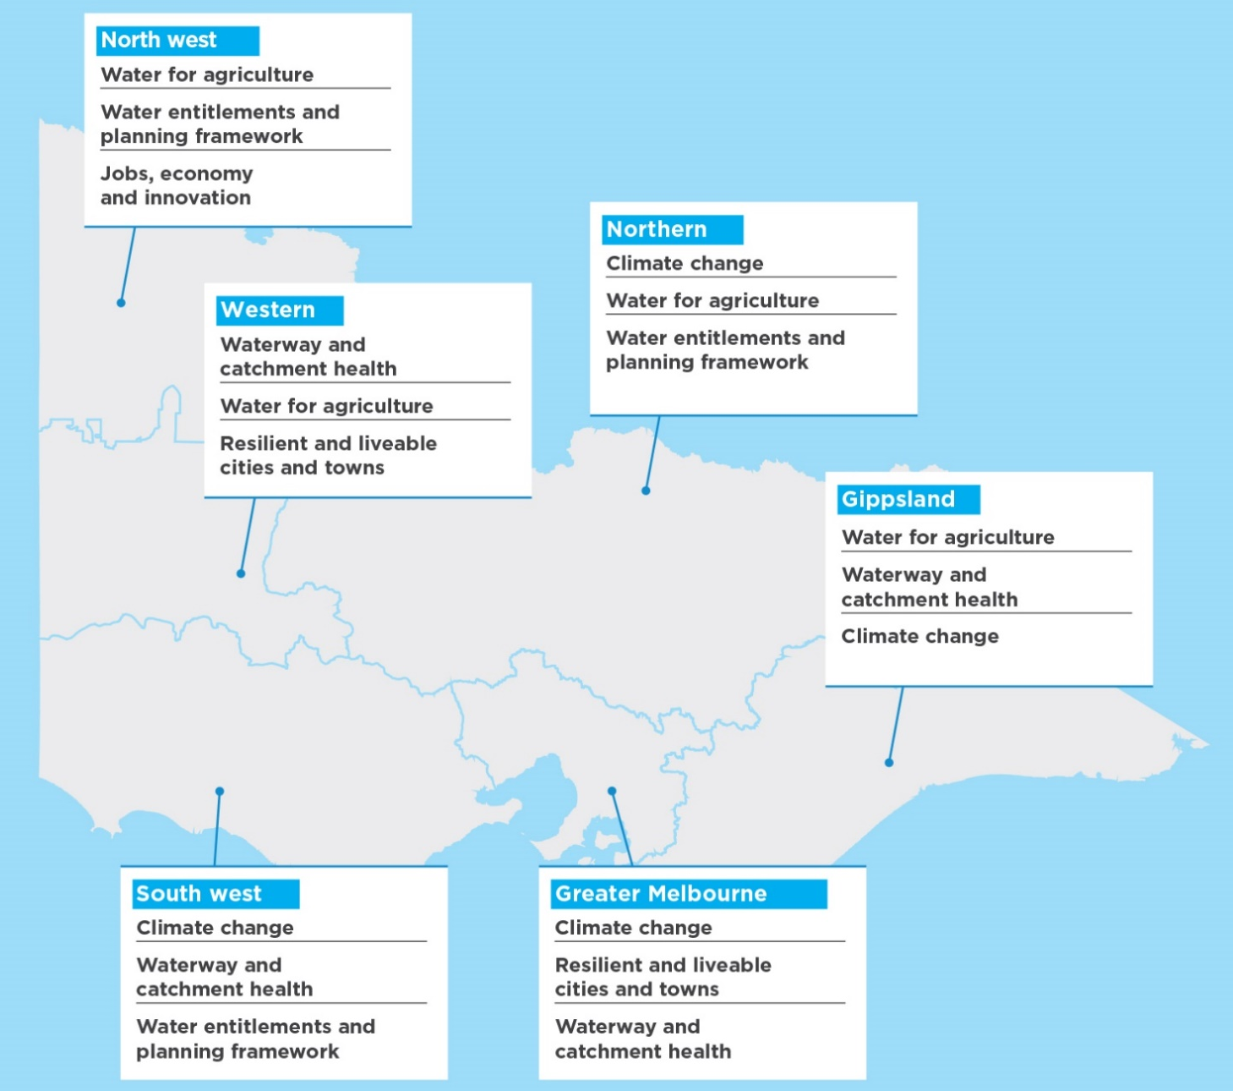

North west
- Water for agriculture
- Water entitlements and planning framework
- Jobs, economy and innovation

Northern
- Climate change
- Water for agriculture
- Water entitlements and planning framework

Western
- Waterway and catchment health
- Water for agriculture
- Resilient and liveable cities and towns

South West
- Climate change
- Waterway and catchment health
- Water entitlements and planning framework

Greater Melbourne
- Climate change
- Resilient and liveable cities and towns
- Waterway and catchment health

Gippsland
- Water for agriculture
- Waterway and catchment health
- Climate change
Figure 4 – Chapter relevance to workshop participants
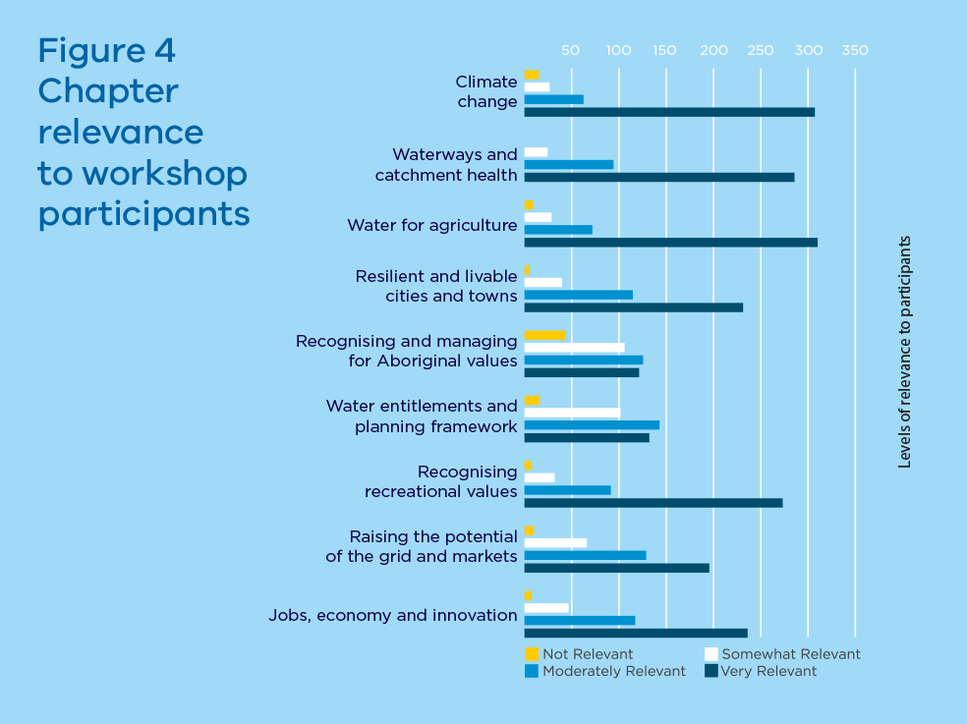
Figure 5 – Proportion of participant comments by chapter
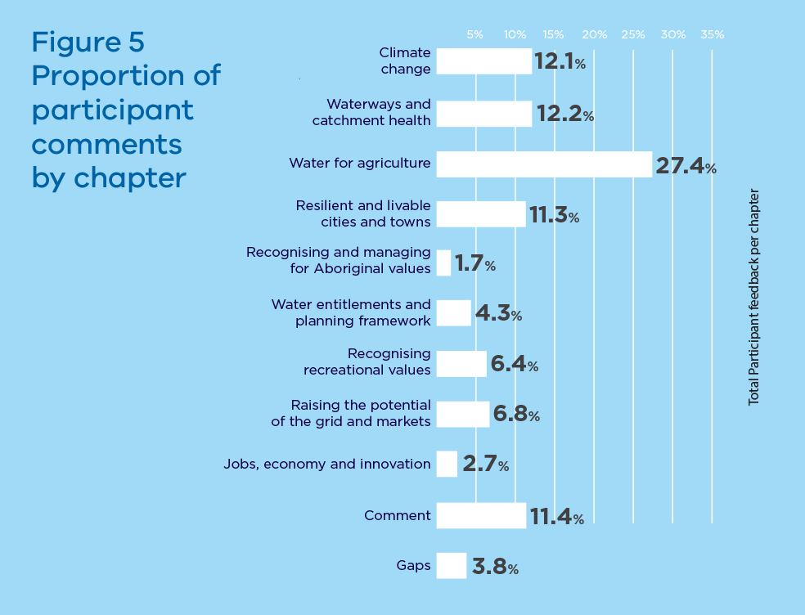

Total Participant Feedback per Chapter
Climate change 12.1%
Waterways and catchment health 12.2%
Water for agriculture 27.4%
Resilient and livable cities and towns 11.3%
Recognising and managing for Aboriginal values 1.7%
Water entitlements and planning framework 4.3%
Recognising recreational values 6.4%
Raising the potential of the grid and markets 6.8%
Jobs, economy and innovation 2.7%
Comments 11.4%
Gaps 3.8%
Figure 6 – Who we engaged
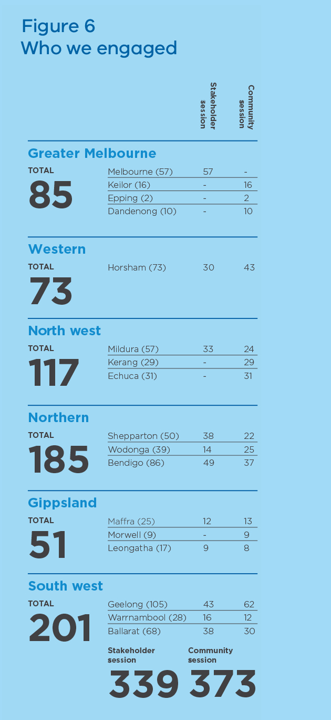

Greater Melbourne – Total 85
 | Stakeholder Session | Community Session | Total
Melbourne | 57 |  | 57
Keilor |  | 16 | 16
Epping |  | 2 | 2
Dandenong |  | 10 | 10

Western – Total 73
 | Stakeholder Session | Community Session | Total
Horsham | 30 | 41 | 73

North west – Total 117
 | Stakeholder Session | Community Session | Total
Mildura | 33 | 24 | 57
Kerang | – | 29 | 29
Echuca | – | 31 | 31

Northern – Total 185
 | Stakeholder Session | Community Session | Total
Shepparton | 38 | 22 | 50
Woodonga | 14 | 25 | 39
Bendigo | 49 | 37 | 86

Gippsland – Total 51
 | Stakeholder Session | Community Session | Total
Maffra | 12 | 13 | 25
Morwell | – | 9 | 9
Leongatha | 9 | 8 | 17

South west – Total 201
 | Stakeholder Session | Community Session | Total
Geelong | 43 | 62 | 105
Warrnambool | 16 | 12 | 28
Ballarat | 38 | 30 | 68
Shareholder session 339
Community sessions 373
Figure 7 – Workshop attendance by stakeholder type
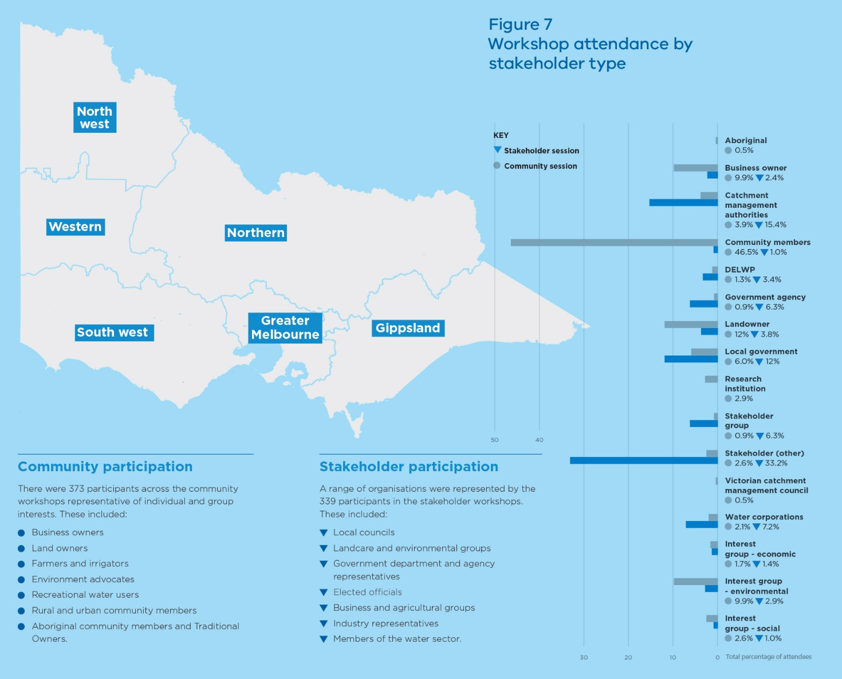

Community participation
There were 373 participants across the community workshops representative of individual and group interests. These included:
- Business owners
- Land owners
- Farmers and irrigators
- Environment advocates
- Recreational water users
- Rural and urban community members
- Aboriginal community members and Traditional Owners.

Stakeholder participation
A range of organisations were represented by the 339 participants in the stakeholder workshops. These included:
- Local councils
- Landcare and environmental groups
- Government department and agency representatives
- Elected officials
- Business and agricultural groups
- Industry representatives
- Members of the water sector.

Percentage of attendees
 | Community Sessions | Stakeholder Session
Aboriginal | 0.5%
Business owner | 9.9% | 2.4%
Catchment management authorities | 3.9% | 15.4%
Community members | 46.5% | 1.0%
DELWP | 1.3% | 3.4%
Government agency | 0.9% | 6.3%
Landowner | 12% | 3.8%
Local government | 6.0% | 12%
Research institution | 2.9%
Stakeholder group | 0.9% | 6.3%
Stakeholder (other) | 2.6% | 33.2%
Victorian catchment management council | 0.5%
Water corporations | 2.1% | 7.2%
Interest group - economic | 1.7% | 1.4%
Interest group - environmental | 9.9% | 2.9%
Interest group - social | 2.6% | 1.0%

What we did with the feedback
Public submissions were uploaded on the departmental website haveyoursay.delwp.vic.gov.au shortly after submissions closed. To keep stakeholders in the loop, we placed a summary of the stakeholder engagement – Water for Victoria, Engagement Summary Report – on our Have Your Say website.
A summary of the submissions was prepared for formal consideration by both the Reference Group and Stakeholder Group. Each submission was analysed and attached to codes based on the themes raised in the individual submission. This process provided a summary of the key themes raised that allowed detailed consideration about how to address the matters raised in the submission process.
Detailed analysis identified the level of support for the proposals in the Discussion Paper and any gaps. Responses to feedback were proposed and continually tested with key stakeholders as an integral part of the development of the final plan.
Closing the Loop shows how Water for Victoria reflects the feedback.

Reactions to the scope of the discussion paper
Participants at the 27 community and stakeholder workshops around the state were asked for their initial reactions to the discussion paper. In summary, they said:
- Overall, the plan covers a good breadth of high level issues.
- The plan needs a story pulling it together.
- The plan needs to take an integrated, whole-of- system approach.
- There are some gaps, and the plan doesn’t always provide enough detail.
People providing written submissions were invited to comment on all or some aspects of the discussion paper. Many submitters had quite specific interests and only commented on those interests. Some submitters made general observations about the paper.

What we heard
Workshop participants and many written submissions supported including climate change, Aboriginal values, recreational values, and water for agriculture as distinct chapters.
“I like that this document is not a blame game. It has a positive outlook.”
Geelong stakeholder workshop, 18 April 2016
“Good to see science and thought behind the directions.”
Wodonga stakeholder workshop, 20 April 2016
“With the growing population that our state is experiencing, along with challenging climatic conditions, such a plan is integral to ensuring Victorians can access water in ways that maximises their economic and overall wellbeing.”
Australian Football League Victoria, submission
“It’s really good to see climate change up‑front.”
Mildura community workshop, 21 April 2016
“Give Traditional Owners the ability and tools to make decisions about water.”
Horsham stakeholder workshop, 19 April 2016
“It’s great to see Water for Agriculture in the spotlight, rather than just included within the Economy chapter.”
Melbourne stakeholder workshop, 11 April 2016
“Recreational water and liveability haven’t been properly addressed in the past.”
Kerang community workshop, 26 April 2016

Our response
Water for Victoria gives prominence to some issues that have not been considered adequately in the past, for example, the Aboriginal values of water, and recreational values of water.
The plan addresses Aboriginal values as a matter of justice, and recognises that contemporary Aboriginal water objectives include economic development. The Millennium Drought brought home to us that Victorian communities put a high premium on water to provide cooler and greener urban landscapes. And we recognise that agriculture, which depends on access to water, makes a significant contribution to the Victorian and national economies.

Working across government
Participants in the workshops recommended that the final plan explicitly acknowledge interconnections across policies, jurisdictions, departments and states.
“We need to see more about how this plan will work with other policies, departments, states we don’t want NSW piggybacking off our elegant water system.”
Mildura stakeholder workshop, 21 April 2016

Our response
Water for Victoria explains how we will work across government, including stronger connections between land use planning and water management, and how we will strengthen connections between climate change, water and biodiversity policies and strategies.

Water education
Many submitters and workshop participants advocated ongoing support for raising awareness about the water cycle, behavioural change, and education and engagement around decision-making.
Almost 20 per cent of written submissions pointed to the need for education about water.
“Incentivise behavioural change to influence water efficiency.”
Warrnambool stakeholder workshop, 14 April 2016
“The community needs to be better educated to understand dry times and appropriate use of water.”
Leongatha community workshop, 20 April 2016
“Better understanding is needed by all users.”
Kerang community workshop, 26 April 2016
“Access to information is an essential pre‑requisite for community input into decision making.”
Individual, submission
“Education in regards to water is vital.”
Individual, submission
“Get schools actively involved in catchment and waterways maintenance.”
Comment on haveyoursay website

Our response
Water for Victoria includes community education and citizen science programs, and a commitment to better monitoring and information about water for many different users, such as recreational users, Traditional Owners and Aboriginal Victorians, farmers, and businesses seeking new developments.

Regional impacts
Local or regional characteristics were a gap identified in the discussion paper.
Many passionate individuals and community groups promoted issues that matter to their communities, such as the health of particular rivers and lakes.
“Irrigated agriculture is a focus, tending to ignore dryland farming, and not recognising the importance of secure stock supplies, particularly in the south west.”
Warrnambool stakeholder workshop, 14 April 2016
“The Water Plan needs to incorporate place‑based and regional responses.”
Morwell community workshop, 19 April 2016
“Wetlands (in the Wimmera region) are more productive than rivers and streams, yet they get all the attention.”
Horsham community workshop, 19 April 2016
“The delivery of environmental flows should include a focus on the Moorabool River, recognised in the last drought as being one of the most stressed river in Victoria.”
City of Greater Geelong, submission

Our response
Water for Victoria now shows what will occur in each region of Victoria. The plan also includes more information about how we will deliver responsive, place-based decision-making from stronger community engagement in planning processes, and how we will give communities better and more timely information about decisions that affect them.

Implementation and funding details
Provide more detail about the actions, implementation and funding.
“It needs more concrete proposals for implementation such as funding and timelines.”
Shepparton stakeholder workshop, 19 April 2016

Our response
Water for Victoria now includes an implementation plan with funding. In total, the government is making a substantial investment – $537 million over four years – in the sustainable management of water, including initiatives to improve the health of waterways and their catchments, to modernise irrigation, to upgrade rural water systems and to prepare Victorians for floods and emergencies.

Groundwater
There should be more information about groundwater.
“Groundwater could do with more focus.”
Maffra stakeholder workshop, 18 April 2016

Our response
The government will continue to invest in understanding where groundwater and surface water interactions have a significant impact to inform future combined management plans. We will also develop policy to facilitate trade in groundwater systems and investigate the potential for trade where groundwater and surface water is connected.

Shared benefits
In written submissions and in the workshops, there was broad support for the relatively new concept, shared benefits, provided that these benefits could be achieved without affecting existing entitlement holders.
“The VFF supports consideration of cultural and recreational values and benefits in water resource management as long as there are no third party impacts on existing entitlement holders.”
Victorian Farmers Federation, submission

Our response
Some shared benefits are already achieved in the way we manage water. Water for Victoria explains that there are likely to be other opportunities. These will come to light as we improve our understanding of the Aboriginal values and objectives for water and recreational values and objectives. We will do what we can to achieve shared benefits, while protecting the rights of existing entitlement holders.

2. Climate change
“It’s good to see state‑level support for managing climate change. We need to adapt to the availability of water. It’s good to see drought preparedness.”
Geelong stakeholder workshop, 18 April 2016
“We are very aware of reducing water availability whether it be through decreased annual rainfall, which means less surface runoff, or depleting underground aquifers.”
Individual submission

Water for Victoria is Victoria's climate change adaptation response for water

What we heard
In the workshop discussions, written submissions and online comments about climate change, we heard:
- strong support for increased research and investment in climate change science
- strong support for reducing emissions from the water sector although some concern about potential cost impacts
- questions about the water sector’s role in climate change adaptation planning and action, with support for evidence-based decision-making and adaptive management.

Research and investment
“We support continued investment in science and making information available.”
Geelong community workshop, 18 April 2016

Our response
The Victorian Government will now invest $1.6 million in research on climate change in 2016-17, and then identify future research needs. Our proposed action has been expanded to include sharing of knowledge and applying knowledge to policy, planning and practice.

Cutting emissions in the water sector
“Climate change mitigation will need to focus on using technology to gain more water and use less.”
Geelong stakeholder workshop 18 April 2016,
“It is recognised there is a tension between carbon neutrality and affordability, however our past experience … shows our ability to reduce carbon emissions and reduce prices concurrently.”
Wannon Water written submission
“Climate mitigation and carbon neutrality is a noble cause but who will pay for it?”
Wodonga stakeholder, 20 April 2016

Our response
Water for Victoria now reflects the government’s commitment to achieve net-zero emissions by 2050. The plan explains how the water sector will maximise its contribution to climate change mitigation by reaching net-zero emissions, and sets out a process for government to work with the sector to determine appropriate timelines for this to occur.
By July 2017, water corporations and catchment management authorities will pledge a pathway to net-zero emissions. The four metropolitan water corporations will examine an early path to achieve net-zero emissions by 2030. The water sector will adopt renewable energy use targets of at least 25 per cent by 2020 and 40 per cent by 2025.
The Department of Environment, Land, Water and Planning will work with water corporations, catchment management authorities and regulatory bodies to develop principles to guide the mitigation effort, and evaluate the costs and benefits of emissions reduction activities.
The water sector can reduce emissions through a variety of options, including developing more energy efficient equipment, capturing biogas for energy generation, investing in renewable energy generation, and purchasing renewable energy and carbon offsets. Water corporations can borrow money from green bond investors through Treasury Corporation Victoria to fund initiatives that reduce emissions.
Government will continue to explore opportunities for catchment management authorities to provide carbon offsets. Catchment management authorities will consider partnerships with Traditional Owners for carbon sequestration.

Climate change adaptation in the water sector
“We need to project into the future about the effects of climate change and plan accordingly.”
Morwell community member, 19 April 2016
“Climate change exists. We need more detail on how we will manage during drier times.”
Mildura stakeholder workshop, 21 April 2016

Our response
Water for Victoria is Victoria’s climate change adaptation response for water. The water sector will lead climate adaptation for the state. The water sector will consider climate change adaptation issues across all operations, including resource, asset and risk management. Evidence-based decision-making and ongoing monitoring of results will be important elements of leadership in adaptation.

3. Waterway and catchment health
“Walk the talk. Low level water restrictions should be imposed early to save the decline of waterway health.”
Ballarat community workshop, 13 April 2016
“Given the reliance of waterways to supply our water, their future health is a critical and non‑negotiable if water quality is to be protected more investment is needed.”
Individual, submission
“People just do not understand what an environmental flow is.”
Epping community workshop, 13 April 2016
Over the next four years, the government will invest $222 million to improve waterway health and strengthen integrated catchment management

What we heard
In the workshop discussions, written submissions and online comments about waterway and catchment health, we heard:
- strong support for increased effort and investment in waterway and catchment health, including for 36 large-scale waterway projects, but please don’t forget locally important waterways
- support for environmental water management, with clearer reporting of results and benefits
- support for improving waterway health knowledge and monitoring, with communities seeing a role for themselves in monitoring and onground work activities.

Investment in waterway and catchment health
“The proposed Yarra River Protection Act that enjoys significant support from Victorians can produce principles that assist in the management of other urban waterways.”
Yarra Riverkeeper Association, submission
“Protecting priority waterways must include the wider catchment, not just the immediate waterway.”
Warrnambool community workshop, 14 April 2016
“We need to build the resilience of our river systems in light of climate change.”
Ballarat stakeholder workshop, 13 April 2016

Our response
Over the next four years, the Victorian Government will invest $200 million to improve waterway health, and $22 million to strengthen integrated catchment management. This is the largest state investment in waterway health and will be complemented with a renewed focus on managing catchments from the top to the bottom.
Water for Victoria retains the commitment to invest in 36 large-scale waterway projects, and explains that the government will also invest in other priority waterways identified through regional waterway strategies. We are trialling 10 of the 36 projects to track progress and report back to communities.
The government is investing an additional $30 million over four years to implement the Regional Riparian Action Plan and accelerate riparian works across regional Victoria. The government is also investing an additional $10 million over four years to support the Gippsland Lakes Coordinating Committee, and the delivery of on-ground environmental works and community engagement.
In response to concerns about the Yarra River, the government will respond to the recommendations of Yarra River Protection Ministerial Advisory Committee. The government will also consider applying the agreed recommendations to other major urban waterways.

Efficient and effective use of environmental water
“We need to look at the minimum environmental flows for our rivers.”
Geelong community workshop, 18 April 2016
“We would like more consultation around the allocation of the flows.”
Horsham community workshop, 19 April 2016
“Who pays needs to be spelt out.”
Bendigo community workshop, 14 April 2016
“There needs to be more research and infrastructure to improve efficiency when delivering environmental outcomes.”
Shepparton community workshop, 18 April 2016

Our response
Water for Victoria explains that the government will continue to invest in environmental works and measures for priority environmental watering sites to achieve more efficient and effective use of existing environmental water.
We will share the results of environmental watering to demonstrate impact. We will increase monitoring and reporting back to communities on progress. The Victorian Environmental Water Holder will report annually about where environmental watering has achieved shared benefits.
The government will explore the need for future environmental water recovery in the sustainable water strategies, taking into account the findings of long-term water resource assessments.
Options for meeting the 2015 environmental water recovery targets for the Moorabool, Werribee and Maribyrnong Rivers will be discussed with local communities and stakeholders as part of the review of the Central Region Sustainable Water Strategy in 2017.
Water corporations will work with the Department of Environment, Land, Water and Planning and the environmental water holders to ensure clear, transparent and equitable charging arrangements for environmental water.

Monitoring, reporting and engagement
“Connecting Country advocates for the value of involving and engaging community groups in waterway enhancement. Community groups can provide cost effective restoration, establish effective relationships with local landholders, and are involved in on‑going maintenance and monitoring.”
Connecting Country, submission
“Community programs are important to build community capacity the community needs to be much more involved in natural resource management.”
Geelong community workshop, 18 April 2016

Our response
Water for Victoria demonstrates the strength of the government’s commitment to community engagement, and improved monitoring and reporting.
We value community partnerships and will continue to support groups such as Landcare, Waterwatch and EstuaryWatch who do great work in local waterways and catchments. We will invest some $1 million in partnerships between catchment management authorities and recreational anglers to deliver riparian improvement works in local priority areas.
The government is investing $20 million over the next four years in monitoring, evaluation and reporting for waterways. This will improve information and knowledge about waterways and their catchments through more coordinated, strategic research, and monitoring that informs adaptive management, continuous improvement and better reporting back to communities.
We are setting up a waterway research hub to coordinate research, improving Victoria’s waterway health monitoring programs, and investigating new ways of accounting for multiple benefits (water, carbon and biodiversity).

4. Water for agriculture
“We should be linking land use to water availability to minimise cost and maximise productivity.”
Geelong stakeholder workshop, 18 April 2016
“We agree that there needs to be support for farmers to access information and training for improving water use efficiency however the government should investigate opportunities to assist agribusiness with implementing improved water use methods/ practices and efficiencies.”
Cultivate Agribusiness Central Highlands, submission
“We need some guidance on investment decisions. We will end up with infrastructure that is abandoned because the water market shifts to another area.”
Shepparton stakeholder workshop, 19 April 2016

The government supports growth in agriculture and will help communities adapt to change

What we heard
In the workshop discussions, written submissions and online comments about water for agriculture, we heard:
- mixed responses about whether the water market enables adjustment – some said the market allows farmers to manage their risk, others point to the fact water is leaving districts
- questions about affordability and viability of irrigation
- support for managing impacts of irrigation, including salinity and water quality
- concern about the Murray-Darling Basin Plan, the benefits of environmental water recovery and potential socio-economic impacts on irrigation communities
- support for improving water security for dryland farmers.

Change in the agricultural sector
“It should not be assumed that areas that traditionally have been appropriate for certain crops and farming practice will continue to be productive spaces for these into a climate constrained future. This should inform the direction of investment into infrastructure to where it will have most benefit now and into the future.”
City of Whittlesea, submission
“The high cost of water is pushing growers off the farm; the Werribee food bowl will be lost.”
Keilor community workshop, 12 April 2016
“Gippsland’s relatively reliable rainfall will make this area more important for food production in the future.”
Individual, submission

Our response
Water for Victoria is a clear statement about the government’s commitment to agriculture and the government’s role in future regional development and investment. The plan focuses on enabling agricultural development, and supporting farmers and communities to adapt to change.
The government will consider business cases for future investment in rural water infrastructure based on viability, public benefit and value for money, recognising climate change, regional plans and the health of the environment. Water corporations will inform regional development processes about water resource opportunities and constraints including infrastructure projects for agriculture.
The government will remove barriers to development, for example, making it easier to consolidate properties in irrigation districts so that farmers can achieve economies of scale that enable them to be competitive and resilient.
A new approach to facilitating agribusiness developments is being trialled. This service is led by Regional Development Victoria and draws on expertise across government, including Agriculture Victoria Invest Assist and the water sector. The service will facilitate discussion with the right agencies so that developers get timely information about water supply options and regulations before proceeding.

Irrigation – impacts and development
“Planning for good irrigation practices is vital to our success in using water wisely and having sufficient for all uses including the environment. The data for climate and predictions will be a valuable tool here. But communities must own the strategies and actions or it will not work.”
Individual, submission

Our response
Water for Victoria recognises that change in agriculture is constant with changing farming trends and ongoing adjustment pressures.
In northern Victoria, competition for water has increased. The government believes that intervention to delay change will only increase the social and economic costs. The government will assist as farmers and local communities adapt.
Rural water corporations will plan for, and actively respond to, the changing needs of their customers. In irrigation districts, this includes providing levels of service that support modern practices. Rural water corporations will report on delivery system efficiency. The government will improve monitoring and reporting of farm water use efficiency in irrigation districts to drive future on-farm improvements.
The government is investing $59 million over four years in the sustainable irrigation program which includes grants for decision support and farm planning. The government will work with water corporations and catchment management authorities to ensure that regional irrigation development guidelines are up to date, and are applied to new developments and significant redevelopments. We will also modernise licence conditions to ensure that water-use licence conditions are relevant to current and future risks, and are enforced.

Balancing environmental water recovery
“What will be the economic impact if Victoria meets its Murray‑Darling Basin obligations and other states do not?”
Shepparton community workshop, 19 April 2016
“The Goulburn Broken CMA would like to see that environmental offset projects are adopted to address any shortfalls in meeting basin plan targets and indeed the 650 GL target. The potential for any further buy backs must be averted.”
Goulburn Broken Catchment Management Authority, submission

Our response
The government will balance water recovery for the Murray-Darling Basin Plan by continuing to prioritise projects with water savings and environmental offsets rather than further reducing the consumptive pool.
We will publish a yearly update on Victoria’s progress in meeting the targets.
Victoria will conduct its own socio-economic analysis of the impact of water recovery to inform discussions with the Federal Government. Any further water recovery (above 2750 gigalitres) must be based upon robust evidence that it can be done with neutral or positive social and economic impacts.

Water security for dryland farming
“Stock and domestic water supplies not only underpin Victoria’s meat and wool industries but also support the health and liveability of rural Victoria. The fact is today that many Victorian farming families do not have a secure good quality domestic water supply.”
Victorian Farmers Federation, submission

Our response
Dryland farmers have the right to access water that falls on their land, or they can access supply through agreement with water corporations. The government will work in partnership with communities to inform water supply decisions and will continue to work with industry to help farmers adapt and mitigate the risks of reduced water availability.
Local government and water corporations own and manage water supply points to provide water supplies for water carting during drought. The government, in partnership with local government and water corporations, will improve information about the constraints and availability of emergency water supply points. Further action is required in implementing the water plan to define roles and responsibilities in the management and communication of emergency water supply points, and the pricing principles for emergency water supplies.

5. Resilient and liveable cities and towns
“Green spaces and waterways are very important for regional communities.”
Maffra stakeholder workshop, 18 April 2016
“In our view, in times of drought, the local community football club becomes even more important to maintain given the benefits it provides to those community members most affected … we believe we could assist greatly in any decisions, along with local Councils, to determine which grounds should be maintained in the toughest period of water shortages.”
Australian Football League Victoria, submission
“Stormwater remains both a problem and opportunity.”
Geelong stakeholder workshop, 18 April 2016

Local issues and priorities will inform our decisions about water

What we heard
In the workshop discussions, written submissions and online comments about resilient and liveable cities and towns, we heard:
- strong support for safe, secure, affordable supplies; effective and affordable wastewater systems; effective stormwater management; healthy urban landscapes; and community values in local planning
- strong support for using diverse water sources and better stormwater management, with questions about how we intend to improve stormwater management
- strong support for efficiency programs and education about the broader water cycle
- support for integrated water management and aligning water and urban planning, with requests for details about how integrated water management planning will work.

Using diverse sources of water and managing stormwater
“Diversity of supply will assist with security.”
Leongatha community workshop, 20 April 2016
“Council has invested in stormwater harvesting systems that ensure playing fields remain playable throughout the year. These measures provide resilience to these assets against future shocks such as severe drought conditions and water restrictions.”
Brimbank City Council, submission
“A centralised supply system relying on existing catchments in the Yarra Ranges is susceptible to climate change (reduced runoff, increased bushfire risk). This means taking full advantage of stormwater.”
Individual, submission

Our response
The government supports the use of diverse water sources that are safe and suitable to improve water security and the resilience and liveability of our cities and towns. We will support the use of stormwater and recycled water for urban greening and to improve water security, and improve community and environmental outcomes. This action will reduce pressure on our precious drinking water supplies.
Water corporations, local government, catchment management authorities and community leaders will work together to protect our public spaces by identifying parks, gardens and open spaces that must be preserved during drought.
To improve stormwater management, we will review the Victoria Planning Provisions (including Clause 56) and related building regulations, lead the development of place-based stormwater management targets, and look at the best mix of tools to support decision making.
Water for Victoria promotes the use of innovative solutions to improve management of on-site domestic wastewater and sewerage infrastructure. The government will work with local government to prioritise actions to improve on-site domestic wastewater management. Water corporations will consider treated wastewater’s role in the urban water cycle and will produce long-term bulk sewerage strategies as part of their effort to better manage our wastewater.
The Department of Environment, Land, Water and Planning will work with the Environment Protection Authority and the Department of Health and Human Services to strengthen the regulatory arrangements for recycled water and stormwater.

Education and efficiency
“We need to promote the spend on water saving measures as money spent on improving lifestyle and community benefit.”
Ballarat stakeholder workshop, 13 April 2016
“Education is vital to teach urban dwellers about the connectivity of the system and the finite value of water.”
Warrnambool community workshop, 14 April 2016
“The T155 initiative should be across the entire state, not just Melbourne.”
Geelong community workshop, 18 April 2016

Our response
The next generation Target 155 program will be rolled out for Melbourne, and a Target Your Water Use program will be developed for regional Victoria. More schools will be involved in the Schools Water Efficiency Program, and the program will be extended to cover other sectors, such as government buildings. The government will also promote the efficient use of water by high water use industries.

Integrated water management and aligning water and urban planning
“Water retailers and councils (tend) to concentrate on water aspects where they have familiarity and remit (water retailers with potable water, recycled water and sewerage, and councils with stormwater, waterways and green assets). A true integrated water management plan needs consideration of all of these aspects through a collaborative approach.”
E2 Design Lab, submission
“There needs to be greater legislative teeth for councils to help manage development pressures.”
Ballarat community workshop, 13 April 2016
“A significant issue facing the roll out of integrated water cycle management is determining who the beneficiaries of particular projects are and accordingly which parties should fund them. City West Water welcomes the development of economic evaluation and cost allocation guidelines to support … investment decisions.”
City West Water, submission

Our response
The government is implementing a new integrated water management framework across metropolitan Melbourne and regional Victoria. This framework will clarify the role of key stakeholders and identify place-based priorities across the state. The Department of Environment, Land, Water and Planning will provide planning tools and guidelines to support community involvement in integrated water management.
Water for Victoria provides more detail about capacity building, including the development of common economic evaluation frameworks, promotion of exemplar projects, targeted training and development programs, and capability funding for local government. The government will invest $8.8 million to strengthen urban water policy and deliver integrated water management.
Water for Victoria includes new actions to align urban water management and land use planning. The government will review the relevant Victoria Planning Provisions and related building regulations. Local place-based targets for stormwater management will be developed.
A Joint Ministerial Statement on Liveability will help to embed the partnership arrangement between government, water corporations and local government.

6. Recognising and managing for Aboriginal values
“As Traditional Owners, our community expectations are to use, develop and control water resources on and under our Country for economic purposes: to support and generate Aboriginal businesses that depend on water allocations; and to generate economic development opportunities through the trading of water resources on the market.”
Federation of Victorian Traditional Owner Corporations, submission
“We need to work UNDER the traditional owner guidance using their knowledge and skill as leaders in this field. They understand this country so much better than us. We have the ability to do the measuring, they have the ability to do the management. Let them, and abide by their knowledge to better manage the systems.”
Individual, submission
“Aboriginal groups should have their own plans for water, and there needs to be preparedness on both sides to work together.”
Bendigo stakeholder workshop, 14 April 2016

Water for Victoria leads the way in improving Aboriginal access to water

What we heard
In the workshop discussions, written submissions, online comments and in further work with Traditional Owners and Aboriginal Victorians about recognising and managing for the Aboriginal values of water, we heard:
- strong support for recognising and managing for the Aboriginal values of water
- increasing recognition that water is a fundamental part of the living culture of Traditional Owners, and is important for economic development and self-determination
- Aboriginal Victorians want to understand the pathway to get access to water for economic development and want to know what water resources are available
- support for involvement by Traditional Owners in water planning, partnerships, employment and service provision.

Recognising Aboriginal values of water
“Our platforms of action in relation to our cultural water obligations include creating economic independence, improve water quality, water flows and wetland restoration.”
Yorta Yorta Nation Aboriginal Corporation, submission
“There is significant value in recognising and consulting with Aboriginal communities to understand their values and needs as waterway and waterbody custodians.”
Individual submission
“Engagement with Aboriginal communities needs to be a two‑way street – give Traditional Owners the ability and tools to make decisions about water.”
Horsham stakeholder workshop 19 April 2016

Our response
Water for Victoria now considers Aboriginal values in all aspects of water and in every section of the final plan. Addressing Aboriginal values is a matter of justice. Traditional Owners want to be alerted to opportunities to engage in water planning and management.
The government will invest $4.7 million over four years in the Aboriginal Water Program to incorporate Aboriginal values and expertise into water management. This includes investment in local projects across the state. The Aboriginal Water Reference Group will co-design the program with the Department of Environment, Land, Water and Planning.
The water sector will partner with Traditional Owners to include Aboriginal values and knowledge in water resource planning using tools developed by Traditional Owners and Aboriginal Waterway Assessments. Aboriginal water officers will be established in regional Victoria.

The pathway to water for economic development
“The Discussion Paper underestimates the need for a significant effort in capacity building … research, reform of the entitlement system, and funding for measures to bring Aboriginal people into the water market; also the effort in generating public support for reallocation to Aboriginal water uses/users.”
Dja Dja Wurrung, submission
“(The lack of) resourcing of Traditional Owners is a barrier to effective engagement in current arrangements, for example, heritage planning, let alone increased participation. What does market participation look like?”
Wodonga stakeholder workshop, 20 April 2016

Our response
The plan now includes explicit consideration of the relationship between water and economic development, and Aboriginal self-determination. Water for Victoria recognises that access to water has the potential to create new economic opportunities for Traditional Owners and Aboriginal Victorians.
The government will invest $5 million and work in partnership with Traditional Owners and Aboriginal Victorians to develop a roadmap for access to water for economic development. This will include support for Traditional Owners to develop business cases to access water.

Supporting partnerships with Traditional Owners
“Barwon Water plans to further understand Aboriginal values in water resource management, and deliver shared benefits where possible, by building true partnerships with local Aboriginal organisations.”
Barwon Water, submission
“The building of capacity within the water management sector to engage with Traditional Owners is important, as is the building of confidence and expertise within our Aboriginal communities if we are to see genuine participation in water management.”
Victorian Farmers Federation, submission

Our response
Water for Victoria acknowledges that resourcing Traditional Owners will be important to achieve increased participation of Aboriginal Victorians in water management and planning and for access to water.
The Aboriginal Water Reference Group and the Department of Environment, Land, Water and Planning will co-design a capacity development program to increase Aboriginal participation in water management. The water sector and Traditional Owners have much to learn from each other.
The government recognises the need to pilot different approaches to address Aboriginal values and uses of water. The water sector and Traditional Owners will look for opportunities to trial different ways of providing access to water and achieving shared benefits.
Chapter 10 of Water for Victoria, which has a focus on water sector diversity and inclusion, describes actions about Aboriginal appointments, scholarships and training. It also includes a new action to explore business arrangements between the water sector and Aboriginal enterprise to enable economic self-determination.

7. Recreational values of water
“Towns that play together, stay together.”
Horsham community workshop, 19 April 2016
“The economic benefits of recreation are significant. Recognition is an opportunity for a stronger focus and better management.”
Bendigo community workshop, 14 April 2016
“The Environmental Farmers Network supports water and waterway planning that considers opportunities for shared benefits for recreational water users whilst not impacting on existing users or the environment.”
Environmental Farmers Network, submission

Connection to nature contributes to the social fabric of Victorian communities

What we heard
In the workshop discussions, written submissions and online comments about recreational values of water, we heard:
- strong support for systematic consideration of recreational values by waterway managers, and request for a stronger link between recreational opportunities, liveability, economic growth and jobs in regional areas
- concern about how relevant agencies, including land managers and waterway managers, can meet increased costs and responsibilities associated with recreational objectives
- request for better support for recreational users to pursue their objectives at waterways
- lack of data on the social and economic benefits of recreation to inform decision-making, and the need for better information for recreational users about how decisions are made.

Including recreational values of water in planning
“Parks Victoria supports the primary purpose of environmental watering being to maximise environmental benefit, with shared benefits, such as Aboriginal values and recreational values, being maximised when possible, when this can be done without compromising environmental outcomes.”
Parks Victoria, submission
“… while recognising these values and encouraging a shared benefits approach, priorities must still be made clear to enable communities to plan for the future and make best use of an increasingly limited resource. Shared benefits do not mean equal benefits.”
Victorian Catchment Management Council, submission

Our response
While recreational water users currently benefit from water management in many parts of Victoria, there will be less water available for everyone in the future; recreational opportunities at waterways and water storages cannot be guaranteed. By improving the way we consider recreational values, we can increase the likelihood of achieving shared benefits of water for recreational users.
Water for Victoria recognises that we need to better understand how communities want to use water, and explicitly consider the recreational values of water in state-wide and regional planning.
We will improve our understanding by including communities in conversations about water and waterway planning. We will collaborate with recreational users and consider their objectives where this can be done without impacting on entitlement holders, and while still meeting environmental water and waterway health goals.

Costs and responsibilities
“Grampians Wimmera Mallee Water has established a recreation contribution charge to support a subsidised pricing model for delivery network supplied recreation lakes. A policy framework for cost recovery would assist water business involved in these activities where access to water storages are granted that are part of the headworks system or river systems that receive the benefit of recreation from water releases.”
Grampians Wimmera Mallee Water, submission

Our response
Where water corporations provide recreational infrastructure and facilities, the costs should be allocated on a user-pays basis. These costs can be recovered in different ways. Some water corporations recover costs of land and recreation management functions relating to water storages via fees paid by urban water customers. There may be opportunities for additional funding through fees recovered from recreational users or specific government funding for recreation, tourism and regional development.
Water corporations will maintain infrastructure and facilities to support recreational activities at their water storages under existing arrangements. Costs that water corporations recover from individual or urban water corporation customers should be based on what is needed for ongoing management and capital works. These costs should be identified by collaborating with all relevant agencies, community members, and recreational users.

Helping communities achieve their objectives
“Good to see emphasis on the community getting involved in water management, but how do we help community understand complex issues?”
Bendigo stakeholder workshop, 14 April 2016
“There should be reference and policy support for recreational infrastructure enhancement/improvement for resilient areas likely to continue to support on‑water and beside water recreation in the face of a drying climate or drought.”
Corangamite City Council, submission

Our response
Sometimes communities need additional funds to support recreational activities, for example, to build boat ramps and other facilities. Collaborating across the relevant agencies will help identify investment opportunities to support recreational goals.
The water sector will share its knowledge and expertise to help communities plan activities and find ways to meet their goals. Water corporations and land managers will help communities connect with the right agencies, such as local government and tourism boards, for assistance and advice.
The water sector will also share information about community recreational objectives with regional development, community and health-related organisations to prioritise possible investment in activities.

Better information for recreational users and decision-makers
“The benefits of recreational water seem anecdotal. Support further targeted research, and articulate if and how this is different to cultural water.”
Horsham stakeholder workshop, 19 April 2016
“We are missing a real understanding of what are the recreational values of water, how communities use it and rely upon it.”
Melbourne CBD stakeholder workshop, 11 April 2016

Our response
Water for Victoria recognises that the water sector needs to better understand the broader social and economic benefits of recreational opportunities at waterways. We will gather evidence to understand these benefits to assist decision-making.
The water sector will provide user-friendly, relevant information about water storage levels and lake conditions to help recreational users plan their activities. The water sector will explain why it makes certain decisions and what it can and cannot do.

8. Water entitlements and planning
“We need water security to support farming in the long term.”
Keilor community workshop, 12 April 2016
“Climate conditions have changed over the past two decades and last year’s growing season rainfall was one of the lowest we have had for some time. Access to water for stock and domestic use is integral to support our agricultural sector through these tough periods.”
Cultivate Agribusiness Central Highlands, submission
“Victoria’s entitlement framework must continue to be adaptable to change. Once information is available from research and assessment projects, a discussion regarding entitlements to meet Traditional Owners’ objectives will be required.”
Murray Lower Darling Rivers Indigenous Nations, submission

Water for Victoria promotes greater flexibility and choice for licence-holders

What we heard
In the workshop discussions, written submissions and online comments about water entitlements and planning, we heard:
- support for actions to strengthen the entitlement framework and for retaining the integrity of existing planning arrangements
- support for better accounting for activities that intercept water, such as farm dams
- support for the investigation of a reasonable use limit for stock and domestic rights, but some concerns about a pilot to investigate converting section 51 licences to water shares
- desire to understand the timing and alignment of plans and strategies noting that the system is complex.

Better accounting for activities that intercept water
“The extraction and building of small dams across the landscape results in a loss of environmental benefit.”
Wodonga community workshop, 20 April 2016

Our response
Water for Victoria recognises the importance of accounting for the emerging significant uses of water. The Department of Environment, Land, Water and Planning will monitor and report on the significant uses of water, and information will be included in the annual Victorian Water Accounts.
Long-term risks to Victoria’s water resources will be reviewed through mechanisms such as the long-term water resource assessment and sustainable water strategies.

Domestic and stock rights
“Farmers want a common sense approach to stock and domestic water use.”
Victorian Farmers Federation, submission
“Compensation flow for Glenelg River has been severely cut in recent allocation years resulting in the river at Casterton ceasing to flow for several months at a time causing stress and water shortage problems for many farmers who traditionally rely on the river for Stock and Domestic supplies.”
Individual, submission

Our response
The Department of Environment, Land, Water and Planning will investigate the introduction of a reasonable use limit for domestic and stock rights (section 8 of the Water Act 1989) to ensure consistency and fairness in access to water resources. Water for Victoria commits to involving the community and relevant stakeholders in completing this work.

Section 51 licences
“Need to review the language around section 51 licences it’s about conversion.”
Echuca community workshop, 27 April 2016

Our response
Water for Victoria promotes greater flexibility and choice for licence-holders. In recent years there has been significant reform of water entitlements in most regulated water systems; water rights have been converted into water shares, delivery shares and water-use licences and registrations.
Take and use licences (section 51 licences under the Water Act) in unregulated surface water systems or groundwater systems have not been converted into water shares. While we heard some concerns about conversion, this could provide flexibility and trade opportunities. The Department of Environment, Land, Water and Planning will work with stakeholders to investigate the merits of converting these rights, and any further work will depend on the outcome of this work.

Water resource planning cycles
“Planning processes can be bamboozling! It should be holistic and incorporate a wide range of activities.”
Leongatha community workshop, 20 April 2016

Our response
Water for Victoria demonstrates how rural water planning, urban water planning and environmental water planning interact with state-wide water resource planning, such as the sustainable water strategies and long-term water resource assessments. The government is keen to support processes that complement each other, and avoid duplication and consultation fatigue.
In response to stakeholders, the government will align the sustainable water strategy and long-term water resource assessment processes with other planning processes.
The government will seek to amend legislation to align the long-term water resource assessment for northern Victoria with the Murray-Darling Basin Plan review, which is scheduled to take place in 2026. This is intended to support northern Victorian communities adapting to structural change, and also provides an opportunity to demonstrate the benefits of significant environmental water recovery through the Murray-Darling Basin Plan.
Outside of the Murray-Darling Basin Plan, a long-term water resource assessment for southern Victoria will begin in 2018. New five year assessments of sustainable water strategies will occur so that we can better track progress on the implementation of the water strategy actions and provide information to better coordinate across different elements of planning.

Improving communication and the quality of information and data
“We need greater transparency; there’s scepticism as to why it is allocated to different places. Decision‑making processes need to be communicated.”
Mildura stakeholder workshop, 21 April 2016

Our response
The Department of Environment, Land, Water and Planning will work across government to improve and coordinate public reporting on the condition and use of Victoria’s water resources. The department will use new technologies and smart ways to provide timely, targeted and relevant information for different audiences. This will include accessible weekly and monthly updates.
Accurate and high quality information is important for decision-makers in water corporations, catchment management authorities and the Victorian Environmental Water Holder. The government will continue to invest in state-wide surface and groundwater monitoring networks, and improve the quality and accuracy of data by upgrading infrastructure and using new technologies. In particular, there will be a greater focus on providing user-friendly and accessible information.

9. Realising the potential of the grid and markets
“It would be great to see a long‑term vision of the grid.”
Horsham stakeholder workshop, 19 April 2016
“We support more open markets, but government needs to be managing investment and development.”
Mildura community workshop, 21 April 2016
“I hope we can have a frank and fearless conversation about who pays, what water is available (e.g. recycled water) and what people are willing to pay for.”
Geelong stakeholder workshop, 18 April 2016

Victoria's water grid and markets will help us realise the greatest benefit from our valuable water resources

What we heard
In the workshop discussions, written submissions and online comments about realising the potential of the water grid and markets, we heard:
- positive feedback with request for more detail
- questions about the new water grid oversight function
- interest in new additions to the grid, access to the grid and better information
- concern about the affordability of water on the market and rate of structural adjustment.

Water grid oversight
“This new centralised role could be beneficial in identifying grid augmentations that might not otherwise be identified by individual water supply system managers. Recognition of operating and statutory roles and responsibilities of this proposed centralised function would need to be clearly defined to avoid duplication with individual water businesses.”
“The Millennium Drought experience demonstrated that the need for a major augmentation can arise relatively quickly. In this situation, it is critical that any additional level of oversight be agile and facilitate, rather than delay, an appropriate response.”
Melbourne Water, submission

Our response
Water for Victoria explains the importance of an oversight function to inform future state-wide water resource planning and investment decisions.
It makes sense to look at the grid regionally and as a whole, and take a long-term view. This new strategic function will provide information that supports water corporations, private sector and broader government decisions about where the greatest return can be delivered on investment in additions to the grid. It will not diminish or duplicate the planning and investment undertaken by the water corporations.

Adding to the water grid, access and better information
“Council believes consideration now needs to be given to a water grid such as the Wimmera Mallee Pipeline across south west Victoria to support agriculture, rural towns and tourism. There is a very large gap in infrastructure if you view the current grid.”
Southern Grampians Shire Council, submission
“The opportunity to transfer water between regions requires further investigation for locations throughout the Pyrenees Shire and south west Victoria for the benefit of industry and communities.”
Pyrenees Shire Council, submission
“The water register is great, but more information in the register will be excellent.”
Mildura stakeholder workshop, 21 April 2016

Our response
The Department of Environment, Land, Water and Planning will explore options for additional connections to better use the state water grid to share water security benefits of the grid and the desalination plant more broadly.
Providing better information and improving transparency is a theme throughout Water for Victoria. This includes providing information that supports decision-making by water entitlement holders, water corporations and the Victorian Environmental Water Holder.
The grid oversight function and transparent and effective markets will support information provision and effective decision-making.

Water markets
“The markets need to make sure that water remains affordable so farmers can invest without going into debt.”
Horsham stakeholder workshop, 19 April 2016
“Farmers want transparent open markets that allow them to plan the best use of their water resources and capital.”
Victorian Farmers Federation, submission

Our response
Water for Victoria explains the importance and benefits of water markets. Through water markets Victoria can share water security benefits in ways that are equitable, responsive and transparent.
The plan clearly articulates the elements of an effective market and the different roles and responsibilities of players in markets. The government’s role is to have the right kind of regulations and rules governing the design and operation of water markets so that they function effectively, and all participants and the broader community have confidence in them.
The Department of Environment, Land, Water and Planning will monitor and review the markets to ensure effective operation, as well as improving market transparency and information to support investment and inform decisions. Clear and accessible information is critical to the efficient operation of water markets and to efficient investment in the infrastructure of the water grid.
The government will trial a water market in south central Victoria, working with key stakeholders to test arrangements.
The grid oversight function will also contribute to maintaining the affordability of water across Victoria.

10. Jobs, economy and innovation
“How do you proliferate and share the benefits of innovations in water efficiency so the whole state benefits?”
Bendigo stakeholder workshop, 14 April 2016
“… ensure that water pricing reflects demand, source and quality and not be pre‑determined based on industry or end use; and be flexible and apply equitably to all water uses.”
Minerals Council of Australia, submission
“Westernport Water would welcome a co‑ordinated approach to skill development in the water sector and a particular focus on building diversity within the sector.”
Westernport Water, submission

The water sector will ensure that services remain affordable for all customers

What we heard
In the workshop discussions, written submissions and online comments about jobs, economy and innovation, we heard:
- feedback that this section of the discussion paper should place more emphasis on the importance of water for the economy and jobs
- support for improving performance and innovation in the water to keep downward pressure on cost
- support for greater community involvement in decision-making, connecting with communities and business customers to better understand their needs
- support for diversity in the water sector to reflect the community it serves
- concern about the regulatory burden and the need to reduce red tape.

Affordability
“Lower Murray Water is keen to work with Essential Services Commission to develop clear, fit‑for‑purpose indicators that measure performance in terms of service delivery and value for customers and the community.”
Lower Murray Water, submission
“Reducing the regulatory burden and the active avoidance of any additional unnecessary burden so we can keep costs low for customers and focus our energy on providing value for them and ensuring our water systems are sustainable.”
Southern Rural Water, submission

Our response
Affordability is a theme throughout Water for Victoria.
The water sector will ensure that services remain affordable for all customers. The government expects bills to remain stable in the coming years, and will retain downward pressure on bills through efficiency, innovation, performance improvement and red tape reduction across the sector.
Water for Victoria actions align with the Victorian Government commitment to reduce the overall burden of regulation by 25 per cent. The Department of Environment, Land, Water and Planning and the water sector will identify ways to reduce red tape.

Performance and innovation
“…we also agree with the need to review customer service and performance indicators that reflect customer value.”
Water Services Association of Australia, submission
“Lower Murray Water has recently participated in a benchmarking study relating to service and pricing and would endorse further studies be carried out to ensure continued improvement and innovation within the industry.”
Lower Murray Water, submission
“Western Water would support research and development to advance the adoption of new technologies to create intelligent and efficient water services, water supply, sewage, drainage and waterways etc.”
Western Water, submission

Our response
The government will encourage innovation in the water sector by building on existing programs, including the Intelligent Water Networks in which all urban water corporations will participate. The government also will continue to promote the export of Victorian knowledge and expertise nationally and internationally through Liveability Victoria International.

Diversity and inclusion
“Diversity is the strength of any organisation. We all have different skills, training and views. The mix is what will ensure success.”
Individual, submission
“It is great the government is looking at creating employment, business opportunities and trade as an outcome under the Aboriginal Water Program but it’s the steps that it takes to get there.”
Yorta Yorta Nation Aboriginal Corporation, submission
“Melbourne Water recognises the value of a diverse workforce and supports initiatives to encourage indigenous (and other) employment in the water sector, including working at Melbourne Water. Melbourne Water also supports initiatives to increase the diversity of its workforce, including through scholarships, cadetships, internship programs and appointments to key positions.”
Melbourne Water, submission
“While the organisation currently has a significant number of women in executive leadership positions, the focus on diversity at this level is welcomed … We also see many opportunities for increasing the capacity of Aboriginal people to be involved in the sector, with the Authority currently offering a traineeship program to Indigenous people keen to work in natural resource management …”
Mallee Catchment Management Authority, submission

Our response
Water for Victoria recognises the benefits of gender equity and cultural diversity, and includes actions to ensure that water sector organisations reflect the communities they serve. The water sector will achieve greater diversity on boards, in management (including women in leadership) and in employment generally.
Across the water sector, there are opportunities to partner with Aboriginal Victorians in water planning and policy development, in service delivery, governance and representation on boards and committees. The government will appoint an Aboriginal Victorian as a fourth commissioner of the Victorian Environmental Water Holder.
Actions around Aboriginal appointments, scholarships and training were moved to this chapter because of the link with water sector diversity and inclusion. A new action was added about exploring business arrangements between water sector and Aboriginal enterprise to support economic development.

Community engagement
“Melbourne Water’s 2016 Price Review utilised best practice community engagement where a large range of community were offered the opportunity to provide feedback on prices in various forms and at various levels. This engagement ranged from online polls to participations comprehensive deliberative forums.”
Melbourne Water, submission

Our response
The importance of meaningful community engagement is a theme throughout Water for Victoria. The water sector will deliver better outcomes through better engagement with customers and the broader community including households, farmers, Traditional Owners, and business and industry to better understand their water needs.
The water sector will also participate in regionally-based forums in partnership with other government agencies, local government, and industries and communities to inform the Regional Partnerships on strategic water-related economic opportunities.

© The State of Victoria Department of Environment, Land, Water and Planning 2016
This work is licensed under a Creative Commons Attribution 4.0 International licence. You are free to re‑use the work under that licence, on the condition that you credit the State of Victoria as author. The licence does not apply to any images, photographs or branding, including the Victorian Coat of Arms, the Victorian Government logo and the Department of Environment, Land, Water and Planning (DELWP) logo. To view a copy of this licence, visit http://creativecommons.org/licenses/by/4.0/
Printed by Impact Digital, Brunswick ISBN 978‑1‑76047‑351‑8 (Print)
ISBN 978‑1‑76047‑352‑5 (pdf/online)

Disclaimer
This publication may be of assistance to you but the State of Victoria and its employees do not guarantee that the publication is without flaw of any kind or is wholly appropriate for your particular purposes and therefore disclaims all liability for any error, loss or other consequence which may arise from you relying on any information in this publication.

Accessibility
If you would like to receive this publication in an alternative format, please telephone the DELWP Customer Service Centre on 136186, email customer.service@delwp.vic. gov.au, or via the National Relay Service on 133 677
www.relayservice.com.au. This document is also available on the internet at www.delwp.vic.gov.au.

