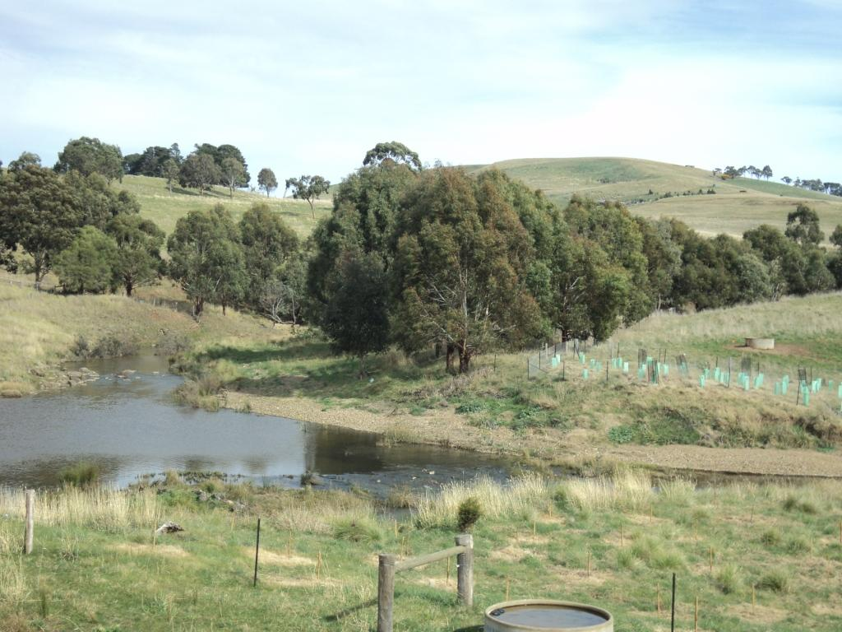
Riparian Works Evaluation Project: Final Report
Riparian Works Evaluation Project: Final Report

Prepared by: Fiona Ede

Published by: Department of Primary Industries
Weed Sciences
PO Box 48
Frankston
Victoria 3199
Australia

© The State of Victoria 2011

This publication is copyright. No part may be reproduced by any process except in accordance with the provisions of the Copyright Act 1968.

Authorised by the Department of Primary Industries, 1 Spring Street, Melbourne 3000

Published November 2011

Acknowledgements:
This project would not have been possible without the involvement of two key people. Rebecca Grant played a major role in collating and processing the Social Survey responses as they were received from landholders. In addition, she ably assisted in field assessments at the majority of field sites and her enthusiasm and expertise were greatly appreciated. Masha Fridman undertook the extensive statistical analyses contained within this report, including interpretation of the outcomes of these tests, and her contribution is gratefully acknowledged.

The assistance provided with field assessments by Trevor Hunt, Daniel Clements and Valerie Caron is also much appreciated.

Other contributions to various aspects of the project were made by staff from DSE and the various CMAs involved in the project.

Front Cover Photo:
Field site on Deep Creek at Monegeetta, near Gisborne, showing older established trees, recent replanting, riparian fencing and off-stream watering infrastructure.

Project Funding
This project was fully funded by the Department of Sustainability and Environment.

If you would like to receive this information/publication in an accessible format (such as large print or audio) please call the Customer Service Centre on 136 186, TTY 1800 122 969, or email customer.service@dpi.vic.gov.au.

Disclaimer
This publication may be of assistance to you but the State of Victoria and its employees do not guarantee that the publication is without flaw of any kind or is wholly appropriate for your particular purposes and therefore disclaims all liability for any error, loss or other consequence which may arise from you relying on any information in this publication.

For more information about DPI go to www.dpi.vic.gov.au or phone the Customer Service Centre on 136 186.
Executive Summary
Project Outline
A project was developed to evaluate riparian works undertaken at sites across Victoria by Catchment Management Authorities (CMAs) and Melbourne Water. The project focussed on work sites where the riparian zone has been fenced to manage stock access to waterways.

The aims of the project were to assess the impact of investment in riparian works on landholder attitudes to riparian management, using a Social Survey, and to assess the current condition of the works during an on-site field inspection.

The project was undertaken in all CMAs across the state (including Melbourne Water) except the Mallee CMA and North East CMA.

Social Survey responses were received from 218 landholders and 129 field sites were assessed.

Project Findings
Land Tenure
- Survey respondents indicated that 76% of riparian works sites were on private land;
- Land tenure was not found to have any association with other variables assessed as part of the Social Survey, indicating it did not influence the outcomes of these variables.

Fencing and Stock Access
- Prior to works, survey respondents reported that stock had access to 86% of works sites;
- After works, stock had access to 15% of sites;
- There were differences between the CMAs in this measure with at least 95% of sites in CCMA, EGCMA and MW having no stock access after works, while less than 70% of sites in GBCMA and WCMA had no stock access;
- Of the field sites assessed, the fence condition and design was such that at 86% of sites, the fences prevented stock accessing the riparian area and the waterway;
- All sites in GHCMA and MW were fenced to exclude stock from the riparian area and waterway;
- At 6% of field sites, stock could access the waterway either via controlled stock crossings, or through areas left unfenced to provide access for stock watering;
- At these sites, the riparian fencing protected the biodiversity values of the riparian area but did not protect aquatic biodiversity or prevent stock impacting on water quality, erosional processes and bank stability;
- At 19% of field sites, stock were able to access the waterway, and potentially the fenced riparian area, from the opposite bank;
- The average fence length was 930 m, but ranged from 95 – 3050 m;
- The average fence width was 27 m, but ranged from 3 – 150 m;
- Fences were between 10 – 20 m at 48% of field sites;
- Fences were more than 40 m wide at 15% of field sites;
- 76% of respondents indicated that there had been no loss of productivity across the property as a result of the riparian works.

Native Vegetation and Landscape Context
- Prior to works, respondents reported that 33% of sites did not have any native tree or shrub cover;
- Revegetation formed part of the riparian works undertaken at 85% of sites;
- During the field assessments, all sites were found to have some cover of native trees and/or shrubs;
- Most sites had sufficient tree and shrub cover to allow for the development of a healthy, self-sustaining riparian vegetation community over time;
- Prior to works, respondents reported that 50% of sites did not have any natural regeneration of native species;
- During field assessments, natural regeneration of native species was observed at 67% of sites;
- Despite good establishment of native trees and shrubs at most sites, there were fewer sites where native ground cover species were well established;
- 42% of sites had <1% cover of native ground cover species;
- The extent of weed cover at sites was found to affect the extent of cover of native ground cover species;
- The landscape context of the field sites was such that 86% of sites were embedded in predominantly agricultural landscape;
- The revegetation undertaken through the riparian works program has the potential to significantly enhance the extent of native vegetation and provide corridors in these landscapes.

Weeds and Pest Animals
- Every field site contained at least one weed species;
- 71% of field sites had >25% weed cover;
- Common weeds were pasture grass species and other herbaceous agricultural weeds;
- Survey respondents reported that prior to works, 66% of sites had some woody weeds;
- Common species of woody weeds included blackberry, gorse, sweet briar and willows;
- Weed management formed part of the riparian works activities at 54% of sites as well as being undertaken at sites both prior to and after works;
- Weed management after works was the most frequently mentioned issue for survey respondents;
- A number of respondents were concerned about the extent of resources required to manage weeds after works;
- Some improvements in willow management are required, including ensuring that there are adequate follow-up inspections to control any willow regrowth and that willow debris piles are located off the floodplain;
- Respondents managed pest animals including foxes, feral cats, rabbits, hares and deer;
- Native species such as wallabies, kangaroos and wombats also caused problems at some sites, particularly for newly planted seedlings.

Neighbouring Stock
- Some respondents expressed concern about stock from neighbouring properties accessing the fenced riparian area and the waterway;
- At all sites where it is possible, it is preferable to fence both sides of the waterway.

Riparian Works Process and Interaction with CMAs
- In addition to fencing, riparian works commonly undertaken on sites included revegetation, weed management including willow control, provision of off-stream watering, erosion control, recontouring and provision of stock crossings;
- Landholders were involved in the on-ground works at 78% of sites;
- Landholders have been involved in site maintenance at 93% of sites;
- The median score for the effectiveness of the collaboration with the CMA during the works process was 8 out of 10;
- There was no difference between CMAs in this score;
- The median score for the effectiveness of the interaction with the CMA after the works process was 7 out of 10;
- Landholders in MW and NCCMA scored their CMAs more highly on this measure;
- Landholders in GBCMA gave the lowest median score for this measure;
- Some survey respondents expressed frustration at the unwillingness of CMA staff to take into account local knowledge about the sites in works planning or to allow any flexibility in the works process;
- Greater clarity is required in some CMAs about the roles and responsibilities of all parties under a range of scenarios, including after floods and fires.

Off-Stream Watering
- Some respondents expressed frustration about the unreliability or inadequacy of off-stream watering systems that had been installed as part of riparian works;
- However, landholders were happy when systems worked effectively;
- There appeared to be some differences between the CMAs as to the resourcing of off-stream watering systems.

Motivation to Undertake Riparian Works
- The reasons most frequently cited by survey respondents as to why they did the riparian works were:
  - to improve the health of the waterway;
  - to improve overall environmental outcomes across the property;
  - to improve the aesthetic value of the riparian zone;
- 74% of respondents indicated that they considered that the health of the waterway had improved as a result of riparian works;
- A number of respondents indicated that they were already doing riparian works or other revegetation across their property, independently of the CMA works program;
- The resources that the CMAs have provided to riparian works have enabled some respondents to either increase the extent or the rate at which they undertake riparian works.

Landholder Expectations and Willingness to Recommend Works
- The median score of 8 of 10 for the measure of “expectations met’ indicated that in general, the riparian works had met landholder expectations;
- There were no differences in the score for this measure between the CMAs;
- The score for “expectations met” increased as the extent to which landholders felt that their interaction with the CMA increased both during and after works;
- Most respondents indicated they would consider future works on their property;
- Factors that would discourage future works related to costs – both direct and indirect;
- Respondents were willing to recommend riparian works to other landholders, giving this measure a median score of 9 out of 10;
- A number of respondents had already recommended works to other landholders;
- Some respondents suggested that the CMAs could improve landholder engagement processes by holding workshops or similar forums to both motivate uncommitted landholders and to provide feedback to committed landholders.

Landholder Age and Capacity
- The demographic trend of an increasingly aging population in the agricultural sector is reflected in this study, where landholders were predominantly aged between about 55 and 65 years;
- A number of respondents indicated that their capacity to undertake both on-ground works and site maintenance was compromised by advancing age;
- Additional resourcing for some of the physical aspects of the works would alleviate this problem to some extent;
- It is also important that CMAs recognise the predominant age structure of their landholder population in order to develop appropriate engagement strategies.

Differences Between CMAs
- Some of the differences between CMAs found in this study related to the differences in vegetation on sites prior to works and after works, including the extent to which willow management formed a part of riparian works;
- Revegetation was more commonly undertaken in CCMA and GBCMA than in WCMA;
- Weed control after works was more of an issue for respondents in WGCMA and CCMA, but less of problem for those in GHCMA;
- Pest animal management was more of an issue for respondents in GHCMA;
- Fewer sites in EGCMA, NCCMA and WGCMA had fences that prevented stock accessing both the riparian area and the waterway than sites in other CMAs.

Resources
- Direct and indirect costs were found to be the major barriers to landholders undertaking riparian works;
- A number of respondents indicated that the costs associated with site maintenance were significant and potentially a disincentive to undertake works;
- Some assistance with meeting these costs would be appreciated by many landholders and would acknowledge the importance of ongoing site maintenance in the overall riparian works process.

Evaluating Investment
- This project has shown that at most sites assessed, riparian fencing is effective at preventing stock access to both the riparian site and the waterway, and that native vegetation communities are being established;
- Overall, landholders are happy with the riparian works processes and outcomes;
- However, a long term monitoring program is required to provide information on the impact of riparian works on biodiversity outcomes, water quality measures, rates of sedimentation and erosion, and changes in landholder attitudes to riparian management;
- Such a program would provide the opportunity to evaluate the effectiveness of investment in riparian works and allow for the refinement of the works program.

Table of Contents

1. Introduction 1
2. Project Findings 3
2.1 Outcomes 3
2.2 Issues Raised and Recommendations 9
3. Results: Social Survey 15
3.1 Number of Responses 15
3.2 Land Tenure 16
3.3 Site Condition Before Works: Native Vegetation 18
3.4 Site Condition Before Works: Weeds and Weed Management 20
3.5 Riparian Works Carried Out 23
3.6 Riparian Works Maintenance 26
3.7 Consequences of Riparian Works 29
3.8 Motivation to Undertake Riparian Works 34
3.9 Managing Stock Access to Riparian Zones 37
3.10 Meeting Landholder Expectations 42
3.11 Effectiveness of Collaboration with CMAs During Works 45
3.12 Effectiveness of Interaction with CMAs After Works 48
3.13 Improved Waterway Health 51
3.14 Future Riparian Works 54
3.15 Likelihood to Recommend Riparian Works 58
4. Results: Field Assessments 61
4.1 Landscape Context of Sites 61
4.2 Fencing and Stock Access 63
4.3 Native Riparian Vegetation 68
4.4 Weeds 78
4.5 Natural Recruitment of Native Trees and Shrubs 85
Appendix 1: Project Methods 87
Data Collection 87
Social Survey 87
Assessment of Field Sites 88
CMA Data 89
Project Limitations 89
Data Analysis 92
Appendix 2: Social Survey 96
Appendix 3: Field Site Assessment Sheet 109
Appendix 4: Location of Field Sites Assessed in the Project 110
Appendix 5: Overall Landholder Comments 115

List of Figures

Figure 1: Percentage of works sites on private land or on licensed Crown Frontage across the state and in each CMA 16
Figure 2: Extent of native trees and shrubs on work sites, prior to riparian works, across the state and in each CMA 18
Figure 3: Extent of native tree and shrub regeneration on work sites, prior to riparian works, across the state and in each CMA 19
Figure 4: Extent of tree and shrub weeds on work sites, prior to riparian works, across the state and in each CMA 20
Figure 5: Sites with willows, blackberries or other tree and shrub weeds present prior to works 21
Figure 6: Agencies undertaking riparian works 24
Figure 7: Agency undertaking site maintenance 28
Figure 8: Percentage of survey respondents reporting issues arising from riparian works 29
Figure 9: Percentage of respondents reporting issues with weed control, extent of effort required to maintain riparian site, drought impacts on vegetation and pest animal control 30
Figure 10: Percentage of respondents who had either experienced some loss of productivity or no loss of productivity across their property as a result of riparian works 33
Figure 11: Motivation to undertake riparian works – environmental outcomes 35
Figure 12: Motivation to undertake riparian works – property management outcomes 35
Figure 13: CMA motivation to undertake riparian works as perceived by landholders 36
Figure 14: Stock access to riparian sites prior to riparian works 37
Figure 15: Stock access to riparian sites after riparian works 37
Figure 16: Sites with no stock access before riparian works and after riparian works 38
Figure 17: Number of respondents willing to undertake future riparian works 54
Figure 18: The percentage of field sites that were surrounded by either agricultural land only or by land dominated by native vegetation or urban areas. 62
Figure 19: Fence condition scores 64
Figure 20: Width of fenced sites classified into categories 66
Figure 21: Cover provided by adult trees at field sites, by cover class 69
Figure 22: Cover provided by juvenile trees at field sites, by cover class 69
Figure 23: Cover provided by shrubs at field sites, by cover class 71
Figure 24: Cover provided by native ground cover species at field sites, by cover class 71
Figure 25: Cover provided by litter at field sites, by cover class 73
Figure 26: Cover provided by bare ground at field sites, by cover class 73
Figure 27: Cover provided by all weed species combined at field sites, by cover class 80
Figure 28: Percentage of field sites across the state with cover provided by grass weeds, by cover class 80
Figure 29: Percentage of field sites across the state with cover provided by selected woody and herbaceous weeds, by cover class 81
Figure 30: Percentage of field sites across the state with cover provided by selected herbaceous weeds, by cover class 81
Figure 31: Number of naturally occurring recruits of Acacia spp. and Eucalyptus spp. 85
Figure 32: Location of all field sites assessed across state 110
Figure 33: Location of field sites assessed in Glenelg Hopkins CMA 111
Figure 34: Location of field sites assessed in Corangamite CMA 111
Figure 35: Location of field sites assessed in Wimmera CMA 112
Figure 36: Location of field sites assessed in North Central CMA 112
Figure 37: Location of field sites assessed in Goulburn Broken CMA 113
Figure 38: Location of field sites assessed in Melbourne Water 113
Figure 39: Location of field sites assessed in West Gippsland CMA 114
Figure 40: Location of field sites assessed in East Gippsland CMA 114

List of Tables

Table 1: Number of Surveys Returned and Field Visits Completed 15
Table 2: Land Tenure of Works Sites (Statewide data) 16
Table 3: Additional Woody Weed Species Reported by Survey Respondents 21
Table 4: Management Activities Undertaken at Riparian Work Sites (% of Sites) 23
Table 5: Riparian Works Maintenance Activities 26
Table 6: Reasons Why Maintenance was Undertaken on Riparian Sites 26
Table 7: Issues Arising from Riparian Works (% of Respondents who Reported Issues) and CMAs with Greatest and Least Number of Respondents Reporting Issues 30
Table 8: Variables Associated with Change in Site Status from Stock Access Before Works to No Stock Access After Works 39
Table 9: Association between Change in Site Status and Variables Ranking Landholder Satisfaction with Works Process and Outcomes 41
Table 10: Variables Affecting the Extent to which Landholders Felt the Riparian Works had Met Their Expectations 43
Table 11: Association between “Expectations Met” Score and Variables Ranking Landholder Satisfaction with CMA Interactions 44
Table 12: Variables Affecting the Extent to which Landholders Considered the Collaboration with the CMA Effective During the Works Process 46
Table 13: Variables Affecting the Extent to which Landholders Considered the Interaction with the CMA Effective After the Works Process 49
Table 14: Variables Associated with the Number of Respondents Who Considered that the Riparian Works had Improved Waterway Health 52
Table 15: Association between Reponses Relating to Improvement in Waterway Health and Variables Ranking Landholder Satisfaction with Works Process and Outcomes 53
Table 16: Variables Affecting the Likelihood that Landholders Recommend Riparian Works to Other Landholders 59
Table 17: Association between “Likelihood to Recommend” Score and Variables Ranking Landholder Satisfaction with Works Processes and Outcomes 60
Table 18: Fence Condition Scores 63
Table 19: Association between Fence Condition Scores and Variables Ranking Landholder Satisfaction with Works Process and Outcomes 65
Table 20: Dimensions of Riparian Fences at Assessed Sites 66
Table 21: Average Cover Provided by Adult and Juvenile Trees at Sites in Each CMA 70
Table 22: Average Cover Provided by Shrubs and Native Ground Cover Species at Sites in Each CMA 72
Table 23: Average Cover Provided by Litter and Bare Ground at Sites in Each CMA 74
Table 24: Correlation Matrix for Cover Provided by Native Vegetation Life Forms 75
Table 25: Correlation Between Cover Provided by Native Vegetation Life Forms and Cover Provided by Selected Weed Species 75
Table 26: Association Between Cover Provided by Native Vegetation Life Forms and Stock Access to Riparian Sites 76
Table 27: Weed Species Commonly Found in Riparian Works Sites - Statewide Data 78
Table 28: Weed Species Commonly Found in Riparian Works Sites – CMA Data 79
Table 29: Relationship Between the Cover of Widespread Weed Species and Total Weed Cover at Sites 82
Table 30: Variables Affecting Total Weed Cover at Sites 83
Table 31: Number of Field Sites with Shrub Seedlings 86
Table 32: Extent of Recruitment of Native Trees and Shrubs Before and After Riparian Works 86

List of Abbreviations

CCMA……………....... Corangamite Catchment Management Authority
CMA…………………..Catchment Management Authority
DPI…………………… Department of Primary Industries
DSE…………………... Department of Sustainability and Environment
EGCMA……………… East Gippsland Catchment Management Authority
GBCMA……………… Goulburn Broken Catchment Management Authority
GHCMA……………… Glenelg Hopkins Catchment Management Authority
IQR…………………… Inter Quartile Range
MW……………………Melbourne Water
NCCMA…………........ North Central Catchment Management Authority
WCMA……………….. Wimmera Catchment Management Authority
WGCMA……………... West Gippsland Catchment Management Authority

Riparian Works Evaluation Project

1. Introduction
Project Description
Considerable resources are invested annually by the state government in river health activities, including rock works, re-introduction of snags, installation of fish ladders, willow removal, other weed control, fencing off to limit stock access to waterways and revegetation of the riparian zone with native species. Funding for these works, undertaken by the Catchment Management Authorities (CMAs) and Melbourne Water, is managed by the Department of Sustainability and Environment (DSE).

Since the introduction of the current Regional River Health Strategies in 2002, more than 7,000 kilometres of stream frontage have been fenced off by CMAs in conjunction with landholders, to limit stock access to waterways. At many of these sites, revegetation activities to establish native riparian species have also occurred.

Auditing of this investment in river health activities is critical to providing evidence that the investment has been strategic, cost-effective and to standard. As part of the auditing process, a project was developed to assess the outcomes of investment in riparian fencing and revegetation. This project was undertaken by DPI staff, in conjunction with DSE and CMA staff.

The aims of the project were to:

Evaluate a sample of riparian sites where on-ground works have been completed since the start of Victorian River Health Strategy (2002), in order to:
    - assess the impact of investment in riparian on-ground works on landholder attitudes to riparian management; and
    - determine the condition of riparian works carried out by government, in collaboration with landholders, across Victoria.

Data Collection and Analysis
In order to achieve these aims, a Social Survey was distributed to several hundred landholders on whose property riparian fencing has been installed. This survey asked respondents to describe the site management undertaken and vegetation present on site before works, and the works that were undertaken and their management after works. The survey asked landholders to evaluate their interactions with the CMA during and after works, the outcomes of the works and their willingness to undertake future works or to recommend works to other landholders. Questions about the motivation to undertake the works and any issues arising from the works were also included.

Field assessments were then conducted at sites selected from a subset of survey respondents. These included assessments of the riparian fencing and stock access, the current vegetation community (both native and exotic species), and various site factors such as the landscape context of the site.

The project was conducted in all CMAs across the state except for Mallee CMA and North East CMA. Responses to the Social Survey were received from 218 landholders and field assessments were undertaken on 129 properties.

For a number of variables from both the Social Survey and the field assessments, analyses were restricted to simple calculations of the percentage of work sites or respondents in each category. In this report, these data have either been tabulated or presented in bar charts, with the full data set and the data for each CMA presented. Landholder comments or other relevant data have been included in the section pertaining to each variable where appropriate.

In addition, some data were subjected to statistical analyses to determine if there were any significant associations between variables. The variables analysed included those relating to the effectiveness of the interaction with the CMAs; whether the works had met landholder expectations and improved river health; the likelihood of landholders to recommend works to others; fence condition and stock access after works; and vegetation cover.

Full descriptions of the data collection and analysis methods are provided in Appendix 1.

Project Limitations
Although the full dataset from the Social Survey contained 218 responses, the number of responses for each CMA ranged from 14 to 52. Likewise, the number of field sites assessed in each CMA ranged from 11 to 21. Therefore, interpretation of the statistical analyses using data broken down by CMA needs to be undertaken with caution, as the low numbers of respondents or field sites in some CMAs means that the results may not be representative of the overall situation for those CMAs.

In addition to the low number of survey responses and field sites in some CMAs, it is also important to note that respondents to the Social Survey were self-selecting from all the landholders who received the survey. As such, they may not form a representative cross-section of the overall landholder community who have undertaken riparian works within each CMA.

There was also a degree of subjective judgement required in answering the questions on the Social Survey and it is likely that landholders interpreted questions differently to one another. This factor potentially introduces a high level of variability into the answers, which needs to be acknowledged in the analysis of responses.

A further limitation relates to the impacts of the floods in spring 2010 and summer 2011 which affected many landholders across the state. Landholder attitudes towards the CMA may have been influenced by the CMA response to the floods, as well as by the interactions that occurred as part of the riparian works process.

Project Report
This report presents a synthesis of the findings of the project, describing the outcomes of the riparian works and issues with the riparian works process. Results for both the statewide datasets and for each CMA are then presented, with the key points highlighted at the end of each section. These key points, in conjunction with landholder comments, have been used to synthesise the project findings.

Detailed information about the methods used to collect and analyse the data; the Social Survey and field assessment sheet; and maps of field site locations are contained in appendices at the conclusion of the report.

2. Project Findings

2.1 Outcomes
Fencing and Stock Access
The data from the Social Survey indicated that prior to riparian works, stock had access to 86% of sites. After works, stock continued to have access at 15% of sites. Assessments of field sites found that fences at 92% of sites prevented stock accessing the riparian area. This outcome indicates that at almost all sites where fencing has been installed as part of a riparian works program, this fencing has been effective at preventing stock from accessing the riparian area.

At those sites where stock were still able to access the riparian area, either through deliberate grazing or through inadvertent breaches of the fence, it appeared that access was likely to occur very infrequently. Although agreements with landholders in some CMAs allow for the return of stock to the riparian area at some period of time after works completion, very few sites had any evidence of extensive or sustained grazing.

However, there were a small number of sites where the design of the fence was such that stock still had unimpeded access to the waterway to access drinking water. At these sites, the riparian fences were effective at protecting the biodiversity values embedded in the riparian zone, but were not effective at protecting aquatic biodiversity or at preventing stock impacting on water quality, erosion and bank stability.

Stock were also able to access the waterway from the opposite bank at 19% of the field sites. At these sites, once in the waterway stock could also potentially access the fenced riparian area. This situation was raised as a concern by a number of landholders.

The dimensions of the riparian fences were highly variable between sites. Fence lengths ranged from 95 m to 3050 m, but averaged 930 m, while widths ranged from 3 m to 150 m and averaged 27 m across all sites. Fences were between 10 m and 20 m wide at 48% of sites, and were greater than 40 m wide at 15% of sites.

Although on average the area enclosed by the riparian fence was about 2.3 ha, 76% of survey respondents indicated that there had been no loss in productivity or yield across the property as a result of undertaking the riparian works. For a number of landholders who reported some loss in productivity, the overall gains were considered to be of greater benefit in comparison with the relatively minor productivity loss.

Native Vegetation, Landscape Context and Land Tenure
Prior to works, 33% of sites did not have any cover of native trees or shrubs. Revegetation activities to establish native tree and shrub species formed a key component of riparian works at 85% of sites across the state, through either planting or direct seeding.

As a result of these revegetation activities, 100% of field sites assessed had some cover of native trees and/or shrubs. The extent of cover varied between sites depending on the density of replanting, the extent of natural regeneration and the age of the site, but in most sites there were sufficient numbers of trees and shrubs to indicate that over time, a healthy, self-sustaining riparian community is likely to develop. At some sites, this had already occurred with the development of highly diverse and complex communities with high levels of natural recruitment occurring.

There were a very small number of field sites where the extent of plant establishment observed at the time of the site assessment indicated that a robust riparian community is unlikely to develop over time without further intervention. Plant establishment was poor due to factors such as the drought, flooding or damage by animals, or the plantings were extremely sparse. At these sites, it is unlikely that the trajectory of vegetation development would result in a self-sustaining native riparian community.

In comparison with the situation prior to works, where there was no natural regeneration of native trees or shrubs at 50% of sites, seedlings of native trees and/or shrubs was observed at 67% of the field sites. Seedlings of Acacia spp. and Eucalyptus spp. were most frequently observed, with numbers in excess of 400 seedlings per hectare at several sites.

Given the landscape context of the sites assessed in this project, where 86% of sites were embedded in a predominantly agricultural landscape and where 76% of sites were on private land, development of healthy native-dominated riparian vegetation communities in these areas has the potential to significantly enhance the extent of native vegetation throughout the agricultural landscape and to provide corridors through this landscape.

Although most field sites had moderate to high levels of cover of native trees and/or shrubs, there were fewer sites that had moderate to high levels of cover of native ground cover species. At 42% of all field sites, the cover of native ground cover species was <1% and in WGCMA, 92% of sites had <1% cover of native ground cover species.

These results indicate that although the revegetation activities undertaken in riparian areas have been relatively successful in establishing woody perennial species, there has been less success in establishing native ground cover species, especially native grasses. Where they did occur, native grasses often provided extensive cover, but they were absent from many sites.

One of the key factors limiting the establishment of native ground cover species is weed competition, as many of the commonly occurring weeds in these riparian sites are grasses and herbaceous species that compete for similar niches as the native ground cover species. A strong negative correlation was found between the cover of native ground cover species at sites and the cover of both canary grass and cocksfoot, indicating that these two exotic species were limiting the development of native ground cover species. There was also a strong negative association between total weed cover and the cover of native ground cover species.

Weeds and Pest Animals
At least one weed species was found at every field site, with pasture grasses and typical herbaceous agricultural weeds commonly present. Canary grass and cocksfoot were the most frequently found weed species, occurring at 46% and 36% of sites respectively. Grasses were not only common, but also provided high levels of cover at sites – at 37% of sites, at least one grass species provided more than 25% cover. Overall, 71% of sites had a total weed cover of >25%.

Survey respondents indicated that woody weeds were present at some level at 56% of sites prior to works, with the species reported including blackberry, gorse, sweet briar and willows.

Weed management formed part of the riparian works activities at 54% of sites, with willow management a key component of these works at many sites. Prior to works willows were present at 37% of sites, but they were only found at 9% of field sites and at these sites, most were young plants that had regrown since works were completed.

Most landholders also undertook weed management as part of the overall riparian zone management, both prior to works and after works, and many noted that it was an ongoing commitment for them within the riparian sites.

Management of pest animals was also undertaken by landholders at many sites, particularly rabbit control. A range of animal species were noted as problematic to the establishment of new plantings, including feral species such as rabbits, hares and deer, and native species including kangaroos, wallabies and wombats. Foxes and feral cats were also a concern for some landholders, some of whom observed that well vegetated riparian areas provided increased harbour for these species.

Riparian Works Processes and Collaboration Effectiveness
In addition to riparian fencing, a number of other riparian works activities have been carried out at sites including revegetation, weed management, provision of off-stream watering, erosion control, recontouring and provision of stock crossings. After works, site maintenance activities have included weed and pest animal management, maintenance of fences and replanting.

Landholders were involved in the on-ground works in some capacity at 78% of sites, and 93% of survey respondents indicated that they undertook site maintenance.

Overall landholders felt that the collaboration with the CMA during the works process was effective, with the median score for this measure being 8 out of 10. There was no difference in the scores between CMAs, indicating that the collaboration during the works process was equally effective across all CMAs.

In contrast, the median score for the effectiveness of the interaction with the CMA after works was 7 out of 10 and there were differences in the scores between the CMAs. Landholders in MW and NCCMA scored their CMAs more highly on this measure, while scores were lowest for landholders in GBCMA.

Several survey respondents commented on the lack of ongoing interaction with the CMA post-works and their disappointment with this lack of follow-up. There was a very weak association between the score for effectiveness of ongoing interaction and the extent to which the CMA was involved in site maintenance. Comments from survey respondents indicated that the effectiveness of the ongoing interaction was linked with the relationship that developed with individual project officers, with some project officers being mentioned by multiple land holders as being highly effective.

Motivation to Undertake Riparian Works
The reasons most frequently cited by landholders as to why they undertook riparian works were:
- to improve the health of the waterway;
- to improve overall environmental outcomes across the property;
- to improve the aesthetic value of the riparian zone.

These results, and comments from survey respondents, indicate that landholders who engage in the riparian works process are committed to undertaking activities that can enhance environmental outcomes, both in terms of waterway health and biodiversity outcomes.

Given that improving waterway health was an important motivating factor, it is interesting to note that 74% of survey respondents considered that waterway health had improved as a result of riparian works. There was a strong association between the score for “expectations met” and improvement in waterway health, indicating that those respondents who considered that waterway health had improved were more likely to have had their expectations of the riparian works met. As well, those respondents who had not experienced any issues arising from the riparian works were more likely to consider that waterway health had improved than those who had experienced issues.

A number of respondents indicated that they were already doing riparian revegetation or other revegetation activities across their property such as direct seeding fence lines with native species. For 37% of survey respondents, the financial contribution of the CMA was a motivating factor to undertake riparian works, with some commenting that the CMA resources increased either the extent of works undertaken or the rate at which works could be undertaken.

Meeting Expectations and Likelihood to Do Future Works or to Recommend Works
In general, landholders indicated that the riparian works had met their expectations to a high degree as the median score for this measure was 8 out of 10. There were no differences in the scores between the CMAs.

There was a strong association between the score for “expectations met” and both the effectiveness of the collaboration with the CMA during works and the interaction with the CMA after works, indicating that as effectiveness of these interactions with the CMA increased, so to did the extent to which landholders felt their expectations had been met.

Associations were also found between some of the field assessment variables and “expectations met” scores. Scores were higher for sites where fence condition and design prevented stock access to the riparian area and waterway (a fence condition score of “1”) than at sites with other fence condition scores. As well, the extent of total weed cover influenced the “expectations met” scores, with a trend of declining scores as total weed cover increased.

The majority of landholders indicated they would be likely to undertake future works on their properties. The main factor that would discourage future works related to costs, both direct costs and indirect and ongoing costs, including the resources required to undertake site maintenance.

Landholders were also willing to recommend works to other landholders, with the median score for this measure being 9 out of 10. Indeed, some landholders had already been proactive in recommending works to neighbours and others, either through formal channels such as Landcare groups, or less formal avenues. Landholders were more likely to recommend riparian works to other if they felt that their expectations about the works had been met and the interactions with the CMA during and after works had been effective.

Differences Between CMAs
There were differences in between the CMAs for many of the variables assessed in this study. Some differences were the result of the location of the CMAs, their topography and vegetation types, while others related to the way that the CMAs undertake riparian works.
Examples of those differences that resulted from the physical nature of the CMAs included the vegetation present at sites prior to works and the native vegetation cover found at field sites. Prior to works, the majority of sites in CCMA and GHCMA had no existing native trees or shrubs whereas landholders reported that at 25% or more of sites in GBCMA, NCCMA and WGCMA, there was extensive cover of native trees or shrubs. There were also large differences found in the cover of native ground cover species during the field assessments, with this life form providing more than >25% of cover in 28% of sites in GHCMA and in 17% of sites in WCMA. In contrast, there were no sites in WGCMA that had more than 5% cover of native ground cover species.

One of the most significant differences in site vegetation that influenced the riparian works undertaken and site maintenance was whether or not willow management was required at sites. Willow control forms an important component of riparian works in parts of CCMA, EGCMA, GBCMA, MW, NCCMA and WGCMA. In this study, landholders reported willows prior to works at more than 70% of sites in EGCMA and WGCMA. Because the control of willows often occurs at a large scale and involves the use of heavy machinery and skilled labour, CMAs generally undertake these operations themselves or use contractors, rather than allowing landholders to undertake willow control. There is also a need to undertake ongoing maintenance of willow management sites after the initial control operations, which is reflected in the high levels of CMA involvement in post-works maintenance that were reported by landholders in both EGCMA and WGCMA.

The operational differences between the CMAs can be illustrated by the difference types of work activities undertaken. For example, revegetation was a key component of riparian works at all sites in CCMA and GBCMA, but undertaken at only 55% of sites in WCMA. It is interesting to note that in WCMA, “other” riparian work activities were only reported by 6% of respondents. However, during the field site assessment process, evidence of “other” activities, particularly around erosion control and rock works was observed at 39% of the sites. This indicates that potentially there was an under-reporting of riparian works activities by survey respondents, possibly because they did not remember all the details of the works carried out or were unsure about the sort of works that should be included in the answer to the survey question.

There were also differences between the CMAs in the issues that had arisen as a result of riparian works between the CMAs. The requirement for weed control after works was an issue for 80% of WGCMA respondents and 77% of CCMA respondents, but for only 26% of respondents in GHCMA, where pest animal control was an issue for more landholders. In contrast, the extent of effort required to maintain the riparian area concerned 61% of MW respondents but only 9% of respondents in WCMA, while the cost of maintaining the site was an issue for 50% of WGCMA respondents, but of not of concern to any landholders in GHCMA.

There were some variations in the motivations for undertaking works between respondents across the CMAs that were most apparent around improving the aesthetic value of the riparian area and enhancing enjoyment of the riparian area and waterway.

There was a strong association found between CMA and the likelihood of sites to change status from being grazed prior to works to not being grazed after works. In CCMA, EGCMA and MW, survey respondents indicated that at least 95% of sites did not have stock access after works. In contrast, stock still had potential access to 37% of sites in WCMA and 31% of sites in GBCMA after works. However this result needs to be seen in the light of the results from the field assessments, where the fence condition or design was such that inadvertent stock access was possible at only 10% of sites in GBCMA and WCMA.

Fence condition scores differed between the CMAs, with fewer sites in EGCMA, NCCMA and WGCMA achieving a score of “1” (fence condition and design prevented stock access to the riparian area and waterway) than in other CMAs. In these three CMAs, fences in at least 25% of field sites were either in poor condition or had been designed to deliberately allow stock to access the waterway for drinking purposes.

2.2 Issues Raised and Recommendations
A number of issues were highlighted by the project, through both the Social Survey process and the field assessment process. Comments and concerns voiced by landholders during discussions on site are included in this analysis. Recommendations to address these issues are provided at the end of each subsection.

Weed Management
Ongoing weed management was the most frequently mentioned issue for landholders. Many survey respondents noted that weed management requirements had increased at sites from which grazing had been removed and that the increased density of riparian vegetation that resulted from revegetation activities made weed management more difficult.

Access to fenced riparian areas appeared to be an issue at a number of sites, which hampered weed control. Installation of gates and/or other means of access at appropriate locations in fences would readily solve access issues at many sites. Although accessibility within sites tended to decline as native riparian vegetation grew more densely, weed loads also declined with increasing density of native trees and shrubs.

Landholders were concerned both about existing weed species and new weed species colonising their riparian sites, particularly when these weeds were a result of poor weed management on neighbouring properties. In general, most landholders were committed to maintaining their riparian sites, and the remainder of their properties, as free of weeds as possible and most were proactive in undertaking weed management.

Some respondents were disappointed by the lack of follow-up weed control undertaken by the CMA, particularly at sites where they had been led to believe this would occur. A number of landholders indicated that assistance to aid in their ongoing weed management in the riparian sites would be welcomed and that there needs to be recognition of the resources required to maintain weed levels at acceptable levels in riparian works sites.

Recommendations:
- install gates or other means of access at appropriate locations within riparian fences to aid access for ongoing weed management;
- provide direct or indirect support and/or resources to landholders to effectively manage weeds in riparian works sites.

Willow Management
As a subset of weed management activities, willow management is a highly specialised and technical process. Best practice management guidelines have been widely available for a number of years and CMAs are generally following those guidelines appropriately.

However, it must be noted that ongoing follow-up of willow sites is critical as many willow species can resprout from stem fragments or from inadequately treated stumps, while other species spread by seed. At a number of sites, follow-up of willow management has been inadequate to date and unless this is rectified, the rapid growth rate of new willow plants will negate much of the investment made in the initial willow control.

At some sites there were also issues with the inappropriate location of willow debris piles. Ideally willow debris should be removed off-site if possible, and if this is not possible, then all debris must be located beyond the floodplain. At one site in GBCMA this did not occur and during the summer floods, willow debris were caught up in the flood waters and destroyed a farm bridge, causing considerable expense and inconvenience to the landholder.

Some landholders also expressed concern about the exacerbation of erosion problems at sites from which willows had been removed. In many sites, this is an unavoidable consequence of willow management but with careful management, including replanting with appropriate native species, any increase in the extent or rate of erosion should be relatively short-lived. Other consequences of the removal of willows, such as loss of shade and shelter for stock, can also be rectified by appropriate revegetation.

Recommendations:
- undertake adequate control of willow regrowth at all willow management sites for an appropriate period of time after control works are completed;
- ensure all willow debris piles are located out of the floodplain area;
- undertake adequate revegetation with appropriate species at sites where willow removal has the potential to exacerbate erosion problems.

Pest Animal Management
Many landholders commented on issues relating to the management of pest animals. These included predators such as foxes and feral cats that prey on native species, and concerns were expressed about the increased harbour provided for these animals in revegetated riparian areas.

The other group of pest animals that affected riparian sites were those that browse or graze on native plantings, including exotic species such as rabbits, hares and deer, and native species including wallabies and kangaroos. Significant damage to plantings had been caused at some sites by these animals, with native species particularly destructive to young seedlings. The effectiveness of tree guards at protecting seedlings varied between sites – in some cases they were highly effective and in other cases, the tree guards acted as beacons to indicate the location of plants to be browsed. Exclosure fences to keep out native herbivores had been used to good effect at some sites.

The burrowing activities of wombats were also a concern for landholders in some CMAs, with high populations occurring in riparian areas. Wombat diggings have the potential to undermine banks and exacerbate erosion problems, as well as limiting the successful establishment of plantings when population densities are high.

Recommendations:
- assess the likely herbivore pressure on revegetation at each site and determine the most effective means of limiting damage, including the use of tree guards or exclosure fences where appropriate.

Neighbouring Stock
There was considerable concern expressed about neighbouring stock accessing riparian sites by those landholders whose riparian sites have been adequately protected from stock on their side of the fence. In some cases, it appeared that the neighbour’s stock were regularly accessing “free” grazing in the riparian area, as well as damaging sites and polluting the waterway. This caused deep frustration with affected landholders.

Fencing both sides of the waterway would be the most effective way to deal with this concern. Fencing extensive areas along waterways would also prevent stock accessing sites from adjoining properties on the same side of the waterway.
Recommendations:
- wherever possible, fence both sides of the waterway to prevent stock accessing riparian sites.

Provision of Off-Stream Watering
Installation of off-stream watering systems was undertaken as part of riparian works at 37% of sites, across all CMAs. However, there appeared to be some variation in the extent to which CMAs funded the cost of such systems, both in terms of the required infrastructure and its installation.

Some landholders had experienced considerable frustration with their systems, including problems with inadequate equipment and issues with unreliable water supply. Other landholders were not prepared to consider the installation of off-stream watering and instead maintained stock access to the waterway for drinking purposes.

When the systems worked effectively, landholders were generally very happy with the outcomes, but the lack of reliability was a barrier for some landholders.

Recommendations:
- develop a funding mechanism to ensure that reliable, adequate off-stream watering systems are available to all landholders in a way that optimises their installation at riparian works sites.

Riparian Vegetation Communities
One of the key aims of many riparian works projects is to increase the amount of native vegetation in riparian areas. Through replanting and direct seeding, most sites have the potential to develop a healthy, native-dominated riparian vegetation community that over time becomes self-sustaining, through the processes of natural regeneration.

However, although there has been considerable success in re-establishing native tree and shrub species at many sites, the re-establishment of native ground cover species has been less successful. To restore a fully functioning riparian vegetation community, all life forms should be represented. Native ground cover species include native grasses, sedges, rushes, ferns and other groups, and play an important role in the functioning of healthy riparian communities.

It is unclear why native ground cover species were incorporated into the planting mixtures at so few sites and what barriers are preventing their inclusion in planting schemes. Where they had been planted, these species appeared to be flourishing, so it is unlikely that poor rates of establishment are a limiting factor.

Recommendations:
- at sites where the desired outcomes is the restoration of a fully functioning riparian vegetation community, ensure all life forms, including native ground cover species, are incorporated into the planting scheme.

The Works Process
In general, landholders were happy with the riparian works process, with improvements to the planning stage of the process the most frequently mentioned concern. In some instances there appeared to have been very little consultation with the landholder about the riparian works prior to commencement. This created friction between the landholders and CMA staff.
The unwillingness of CMA to incorporate local landholder knowledge about the waterway and surrounding land, particularly local experience with different water flow scenarios and erosion issues, was a concern to some landholders, particularly in WCMA. Landholders were frustrated by inflexible approaches to the riparian work activities and their inability to influence the way these activities were carried out. In some instances, their knowledge of their riparian systems predicted poor outcomes that did come to pass as a result of the riparian works.

Inflexibility around fence locations and planting mixtures was another source of frustration for landholders.

There was also some confusion about the roles and responsibilities of the CMA and of landholders, with some landholders who expected the CMA to undertake activities such as site maintenance or fence repair after flooding being disappointed when this was not forthcoming. Clarity about the roles and responsibilities is required, and these issues should be addressed as early in the planning phase as possible.

Recommendations:
- ensure that for each works site, appropriate and timely consultation about the riparian works processes and activities are discussed and agreed with the landholder, taking into account landholder expertise and concerns;
- ensure landholder agreements clearly state the roles and responsibilities of all parties, under a range of scenarios including flood events and fires.

Engaging with Landholders
Landholders are critical to the successful implementation of riparian works and developing a good working relationship with them enhances the likelihood of successful outcomes. In most cases, landholders were happy with the way that CMA staff had interacted with them. In some instances, survey respondents were effusive in their praise for CMA staff and the job that they were doing in the riparian works process.

One area of concern around landholder engagement relates to sites where willow management is a component of the riparian works. Although willow removal is a relatively rapid operation, these sites require the investment of resources over a sustained period of time to convert them from a willow-dominated community to a native-dominated community. This process may incorporate a period of time when the waterway is more vulnerable to erosion and water quality often declines in the short term as a consequence of willow removal. Landholders need to be made aware of this and to understand that these detrimental impacts will be relatively short term in nature. Most landholders are willing to invest in such activities if they are sure that the medium to long term benefits are worthwhile, and it is important that CMA staff ensure that landholders have confidence in the process over the lifetime of the project.

A number of landholders suggested that the effectiveness of riparian works would be enhanced if all neighbouring properties on a waterway reach were included in a strategic program of works. They felt that the CMA should be engaging with all neighbours to get landholders involved in programs. In some areas, Landcare and similar groups were a vehicle for landholder engagement, but often these groups were “preaching to the converted”, with uncommitted landholders not engaging in dialogue with these groups.

It was suggested that the CMAs could bolster landholder engagement by running workshops or forums whereby both committed and uncommitted landholders could met to discuss riparian projects, and other related topics. Such forums would have the potential to not only motivate uncommitted landholders, but to also provide feedback and encouragement to landholders already undertaking riparian works. Additional information at such forums relating to weed and plant identification, or weed management techniques were also mentioned as ways to enhance landholder engagement and to increase landholder expertise.

One landholder commented that he had resisted all attempts to undertake riparian works for about seven years for various reasons, and when he did eventually get around to implementing works, he was so impressed with the outcomes that he wished he had done them earlier. Harnessing this power of landholder experience to encourage other landholders to undertake riparian works can be very effective.

Recommendations:
- ensure engagement with landholders is effective and landholders are provided with sufficient information to understand the short term and long term outcomes of riparian works;
- facilitate dialogue between landholders along a waterway reach through appropriate forums, to encourage landholders to undertake riparian works;
- use landholder experience to encourage other landholders to undertake works.

Landholder Age and Capacity
One of the very interesting observations made during the field site assessment process related to the demographics of the landholder community. Amongst those whose properties were visited, there were more landholders who were over 80 years in age than landholders under 40 years in age. The dominant age range of landholders was between approximately 55 and 65 years of age. This trend of an aging workforce in the agricultural sector has been observed for some years now and has implications for the riparian works process.

Several respondents noted on their survey that their age and associated capacity limited their ability to undertake riparian works activities such as planting, weed management and site maintenance. A quote from one MW landholder expresses this sentiment “As my wife and I are both turning 80 this year and on fixed incomes, we find the cost daunting and the labour beyond us”.

For many landholders, provision of additional support for the physical aspects of riparian works, whether through payment for the cost of contracted labour or the use of volunteers to assist with tasks such as planting, would make a difference in their willingness to undertake riparian works.

It was also interesting to note that only 5% of survey respondents provided their responses via the on-line survey tool, with 95% of responses being hand written and sent by post. This result probably also reflects the age demographic of landholders. Most use computer technology routinely in their daily activities, but are probably more comfortable with written communication tools. It is important that any landholder engagement strategies employed by CMAs recognise and respect this approach, particularly when CMA staff are considerably younger than the landholders with whom they are interacting.

Recommendations:
- investigate resourcing options to assist those landholders who have limited physical capacity to carry out riparian works activities, due to age or health;
- ensure communication tools used to engage with landholders are appropriate for the level of technology uptake by the target audience.
Resources
The major barrier to landholders implementing riparian works was cost. Landholders face costs both during the works process and afterwards, in undertaking site maintenance. These costs include direct costs for materials, as part of the CMA cost-sharing models, and indirect costs such as time.

It was noted that CMA cost structures for projects had not kept pace with recent steep rises in the cost of fencing materials, meaning that less fencing can be installed if project budgets remain unchanged.

A number of landholders commented that the ongoing site maintenance costs were significant and potentially a disincentive to undertake works. These costs included direct costs incurred through activities such as replanting or fence repairs, and indirect costs, particularly the time required to do maintenance, such as weed management. It was suggested that there needed to be a more formal recognition of these site maintenance costs, which may include reimbursement of some costs over time. It was felt by some respondents that site maintenance costs should be built into the overall project budget to recognise that unless appropriate and timely maintenance occurs, much of the initial investment in riparian works is pointless.

Recommendations:
- ensure cost-sharing arrangements between CMAs and landholders reflect the appropriate allocation of costs to each party;
- build site maintenance costs into overall project budgets to ensure appropriate maintenance occurs.

Evaluating Investment
This project has been able to provide a snapshot of some outcomes of the riparian works program across the state. Findings indicate that in most sites, riparian fences are effective at preventing stock from accessing riparian areas, and that riparian works sites are generally now effectively vegetated with native trees and shrubs. On the whole, landholders are happy with the riparian works process and outcomes.

However, this project has not been able to provide data on a number of other outcomes. Ongoing monitoring is required to collect these data, rather than a once-only assessment of field sites and landholder perspectives. Outcomes requiring ongoing monitoring include those relating to changes in both terrestrial and aquatic biodiversity, water quality measures, rates of sedimentation and erosion, and long term changes in landholder attitudes to riparian management.

Instituting a robust and broad-ranging monitoring program to address these outcomes would provide a tool to evaluate the effectiveness of the overall investment in riparian works across the state. This monitoring program could incorporate different levels of assessment, ranging from detailed scientific analysis of specific parameters at key sites to less formalised reporting by landholders on a range of variables. Collecting these data over time would allow for both the evaluation of the investment in riparian works and for the refinement of works programs to improve their effectiveness.

Recommendations:
- a long term monitoring program be instituted to assess changes in biodiversity, water quality, erosion and sedimentation rates and landholder attitudes to evaluate the effectiveness of the investment in riparian works across the state.

3. Results: Social Survey

3.1 Number of Responses
Throughout the project, 218 responses to the Social Survey were received (Table 1). About 5% of respondents used the online form on Survey Monkey, with 95% of respondents returning the hard copy.

Table 1: Number of Surveys Returned and Field Visits Completed

CMA | Number of Social Survey Responses | Number of Sites Visited
Corangamite | 23 | 13
East Gippsland | 14 | 11
Goulburn-Broken | 30 | 21
Glenelg-Hopkins | 29 | 18
Melbourne Water | 52 | 20
North Central | 25 | 15
Wimmera | 31 | 18
West Gippsland | 14 | 13
Totals | 218 | 129

Maps of the location of the field sites visited are given in Appendix 4.

3.2 Land Tenure
Statewide Data
Survey respondents were asked to indicate the land tenure of the riparian works site and were able to provide multiple responses. Of the responses received, 15% indicated multiple land tenures, which probably indicates that across the property there are riparian areas to which different tenures apply and that works have been done on multiple sites on the property. It is also possible that landholders were unsure about which tenure category applied to the site on which works were done and gave the most likely options.

Of the 184 responses where only one land tenure was identified, the majority of riparian works sites were on private land (76%), with only 18% of sites being on licensed Crown Frontage (Table 2, Fig. 1). Very few works sites were on unlicensed Crown Frontage.

Table 2: Land Tenure of Works Sites (Statewide data)

Land Tenure | % Respondents
Private land | 76%
Licensed Crown Frontage | 18%
Occupied unlicensed Crown Frontage | 1%
Unoccupied unlicensed Crown Frontage | 1%
Unsure | 4%

CMA Data
There were considerable differences between the CMAs in the proportion of works sites that were on private land and those that were on crown land. In EGCMA, only 10% of the works sites were on private land, while in GBCMA, GHCMA, MW and WCMA, more than 80% of works sites were on private land (Fig. 1).

Figure 1: Percentage of works sites on private land or on licensed Crown Frontage across the state and in each CMA
Verifying Land Tenure Data
Four CMAs (CCMA, NCCMA, WCMA and WGCMA) provided data on land tenure for the sites visited during the field assessments. There was agreement between the CMA and landholder on land tenure for 53 sites of 58 sites. Of the remaining sites, two were identified as private land by the landholders but as licensed Crown Frontage by the CMA, while three sites were described as licensed Crown Frontage by the landholders but as private land by the CMA.

These discrepancies between landholder perceptions and CMA perceptions of land tenure may have arisen either because each party is referring to a different site or because the land tenure of the works site is unclear to one or both of the parties.

Relationship Between Land Tenure and Other Variables
In the statistical analyses undertaken to determine the strength of the associations between variables, land tenure was included as an independent variable and tested against the following dependent variables:
- stock access after works;
- the extent to which works have met landholder expectations;
- the effectiveness of the collaboration with the CMA during works;
- the effectiveness of the interaction with the CMA after works;
- whether the landholder considered that the riparian works had improved waterway health;
- the likelihood that the landholder would recommend riparian works to other landholders.

There were no significant associations found between land tenure and any of these variables, indicating that land tenure was not a driver for these variables.

Key Points – Land Tenure:
- Most riparian works sites (76%) were on private land;
- More than 80% of works sites were on private land in GBCMA, GHCMA, MW and WCMA;
- Only 10% of works sites were on private land in EGCMA;
- Land tenure was not found to be associated with the outcomes of any of the variables tested.

3.3 Site Condition Before Works: Native Vegetation
Extent of Native Trees and Shrubs
Prior to riparian works, 33% of sites had no native trees or shrubs, 51% of sites had moderate levels and 16% of sites had extensive levels of native trees or shrubs (All data, Fig. 2).

There was some variation across the state. For example in CCMA and GHCMA, more than 50% of sites had no existing trees and shrubs, while in EGCMA and WGCMA more than 70% of sites had moderate tree and shrub levels. The number of sites described as having extensive native tree and shrub levels varied from 25% or more in GBCMA, NCCMA and WCMA to 0% in WGCMA (Fig. 2).

Figure 2: Extent of native trees and shrubs on work sites, prior to riparian works, across the state and in each CMA

Extent of Native Tree and Shrub Regeneration
Landholders at 50% of sites reported no regeneration of native trees and shrubs prior to works, with moderate levels of regeneration observed at 42% of sites and extensive regeneration occurring at 8% of sites (All data, Fig. 3). Sites with extensive regeneration only occurred in GBCMA, MW, NCCMA and WCMA (Fig. 3).

As would be expected from the results relating to the extent of native trees and shrubs, most sites in CCMA and GHCMA did not have any tree and shrub regeneration (Fig. 3).

Figure 3: Extent of native tree and shrub regeneration on work sites, prior to riparian works, across the state and in each CMA

Landholder Comments
The native tree and shrub species most commonly mentioned in the surveys were river red gums, various acacia species including blackwoods, and teatree species.

In relation to the natural regeneration of native trees and shrubs, several landholders indicated that regeneration had been promoted by the recent floods and, at some sites, by fire. Factors that were observed to limit the extent of regeneration included drought, competition from weeds and grazing by both domestic stock and wild animals.

Key Points – Extent of Native Vegetation Before Works:
- Prior to works:
  - 33% of sites had no existing native trees or shrubs;
  - 51% of sites had moderate levels of native trees or shrubs;
  - 16% of sites had extensive levels native trees or shrubs;
  - 50% of sites had no regeneration of native trees or shrubs;
  - 42% of sites had moderate rates of regeneration of native trees or shrubs;
  - 8% of sites had extensive rates of regeneration of native trees or shrubs.

3.4 Site Condition Before Works: Weeds and Weed Management
Tree and Shrub Weeds
Landholders were asked about the extent of tree and shrub weeds present in the site prior to works and whether willows, blackberry or other species were common. Sites tended to either have no tree and shrub weeds prior to works (44% of respondents) or moderate levels (41% of respondents), with only 15% of respondents reporting extensive weed levels (All data, Fig. 4).

In GHCMA and WCMA, more than 60% of sites had no weeds prior to works, compared with only 20% of sites in EGCMA and MW (Fig. 4). However, 31% of sites in MW had extensive weeds prior to works while no sites in WCMA had extensive weed cover prior to works (Fig. 4).

Figure 4: Extent of tree and shrub weeds on work sites, prior to riparian works, across the state and in each CMA

Willows were present at 37% of sites prior to works (All data, Fig. 5), but their prevalence varied widely. In EGCMA and WGCMA, more than 70% of sites had willows, while in GHCMA and WCMA less than 10% of sites had willows (Fig. 5).

Willows were found at 9% of sites during field visits and most of these sites the only willows on site were young plants that had regrown since willow removal had occurred. Very few mature willow trees were found at sites.

The prevalence of blackberry was also variable across the state, with fewer than 10% of sites in GHCMA, NCCMA and WCMA having blackberry prior to works, while it was present at more than 60% of sites in CCMA, EGCMA, MW and WGCMA (Fig. 5).

Prior to works, blackberry was reported at 42% statewide (Fig. 5) and during the field visits, it was found at 19% of sites. However in CCMA, blackberry was present at 62% of field sites visited (see Table 28).

Figure 5: Sites with willows, blackberries or other tree and shrub weeds present prior to works

Other Species Reported by Landholders
A range of other woody weed species were mentioned by survey respondents, with those present at multiple sites outlined in Table 3. Gorse was the most commonly reported species, which was present at 18 sites (8% of all sites), including six sites in NCCMA and seven sites in MW. Sweet briar (also known as briar rose) was noted at 10 sites (Table 3).

Some landholders also reported non-woody weed species, with the most common of these being ragwort and thistles. Bathurst burr, hemlock, horehound, Patterson’s curse and grasses such as phalaris, serrated tussock and Chilean needle grass were also reported by a number of respondents.

Table 3: Additional Woody Weed Species Reported by Survey Respondents

Species | Number of Sites | Location of Sites by CMA
Boxthorn | 6 | GH, MW, NC, WG
Broom | 5 | GB, MW, NC
Desert ash | 2 | EG, GB
Gorse | 18 | C, GB, GH, MW, NC, W
Hawthorn | 6 | GH, MW, NC
Holly | 2 | MW
Prunus | 2 | MW
Sweet briar | 10 | C, GB, GH, MW, NC
Sweet pittosporum | 3 | GH, MW
Sycamore | 2 | MW

Weed and Pest Animal Management
Prior to works, 77% of respondents had undertaken some weed or pest animal management in the riparian zones. Only 51-55% of respondents in GHCMA and WCMA had undertaken weed or pest animal management prior to works, which probably reflects the lower levels of tree and shrub weeds in these CMAs, in comparison with more than 90% of respondents in EGCMA and WGCMA who had undertaken weed or pest animal management.

The majority of landholders who provided information about their weed and pest management activities had undertaken weed management. These activities ranged from hand weeding and judicious stock management to the use of chemical and mechanical means to control weeds. Aerial spraying was used on some properties to control weeds on steep terrain.

Pest animal management predominantly involved controlling rabbits, with 14% of respondents reporting some level of rabbit management. However in WCMA, 45% of respondents undertook rabbit management.

Only 6% of respondents reported undertaking fox control, while one respondent reported controlling feral cats and another had a permit to undertake kangaroo culling.

Key Points – Extent of Weeds and Weed Management Before Works:
- Prior to works:
  - 44% of sites had no tree and shrub weeds;
  - 41% of sites had moderate levels of tree and shrub weeds;
  - 15% of sites had extensive levels of tree and shrub weeds;
  - 37% of sites had willows present;
  - 42% of sites had blackberry present;
- Other tree and shrub weeds species reported from sites included boxthorn, broom, gorse, hawthorn and sweet briar;
- 77% of respondents had undertaken some weed and/or pest animal management in riparian sites prior to works;
- Rabbit control was the most frequently mentioned pest animal management, with 45% of respondents in WCMA undertaking rabbit management.

3.5 Riparian Works Carried Out
Site Works Undertaken
In addition to riparian fencing, landholders reported that a number of other management activities were carried out at sites. Revegetation, including planting of tube stock and direct seeding, was undertaken at most sites across the state (85%) and in all sites in CCMA and GBCMA (Table 4). Fewer sites were revegetated in NCCMA and WCMA.

The proportion of sites where weed management (including willow management) was undertaken as part of the riparian works was 54% across the state but varied widely between CMAs (Table 4). Installation of off-stream watering occurred at 37% of sites, and other management activities (such as stock crossings, erosion control and recontouring) occurred at 7% of sites (Table 4).

Table 4: Management Activities Undertaken at Riparian Work Sites (% of Sites)

 | Number of Sites | Revegetation | Weed Management | Off-stream Watering | Other
All data | 218 | 85% | 54% | 37% | 7%
CCMA | 23 | 100% | 78% | 43% | 9%
EGCMA | 14 | 86% | 86% | 43% | 14%
GBCMA | 30 | 100% | 53% | 50% | 13%
GHCMA | 29 | 93% | 38% | 38% | 7%
MW | 52 | 92% | 69% | 29% | 4%
NCCMA | 25 | 64% | 36% | 40% | 4%
WCMA | 31 | 55% | 13% | 26% | 6%
WGCMA | 14 | 93% | 86% | 36% | 0%

Agency Undertaking Works and Works Funding
Landholders were asked who did the riparian works and were able to give multiple answers. The options included the CMA and/or its contractors; the landholder themselves; community groups such as Landcare or school groups; or ‘other’ that could include contractors engaged by the landholder, neighbours or friends, for example. Landholders were also asked how the works were funded.

Across the state, the CMAs did the on-ground work at 51% of sites (All data, Fig. 6) but there was wide variability between CMAs. WGCMA undertook the on-ground activities at all sites, whereas GHCMA only did the works at 10% of sites (Fig. 6). Landholders themselves were involved in works at 78% of sites except in EGCMA (Fig. 6), and in many cases it appears that the CMA and landholders were jointly involved in undertaking the on-ground activities.

Community groups contributed to the on-ground works at a 14% of sites (All data, Fig. 6). Some landholders commented on the involvement of school or TAFE students in replanting activities while others had had contributions from groups from nearby prisons. On other properties, Rotary or Scout groups were involved, and at some sites community-based work schemes provided labour. Community groups contributed most frequently in CCMA (30% of sites, Fig. 6), which may reflect the network of strong Landcare groups within this CMA.

Figure 6: Agencies undertaking riparian works

Other agencies were involved in the on-ground works most frequently in MW whereas MW itself had a relatively low involvement (Fig. 6). This may reflect the widespread use of contractors by MW to undertake on-ground activities, if respondents considered MW contractors as “other” rather than as “MW”.

In almost all cases, government funding for the riparian works was channelled through the CMAs, but for 3% of sites the funding was provided through community groups such as Landcare. Some respondents also received funding from local councils.

Landholders indicated that they contributed in some way to the funding of the works in 62% of cases. However, this is likely to be an under-reporting of the real extent of landholder contributions, as a number of landholders indicated that they undertook the actual on-ground works but did not indicate that they contributed to the funding of those works. In answering these questions in this manner, these landholders were not including the cost of their labour in overall project costs. For this reason, it is highly likely that in most cases, landholders did in fact contribute to the actual costs of the riparian works, whether directly through payment for materials or indirectly through the investment of their labour.

Relationships between Riparian Works Activities
It is likely that the extent to which each CMA was involved directly in on-ground activities is a result of several interacting variables. For four CMAs (CCMA, EGCMA, GBCMA and WGCMA) that were involved in on-ground activities at more than 60% of sites (Fig. 6), the majority of sites also had willows (Fig. 5) with weed management occurring at a high number of sites in CCMA, EGCMA and WGCMA (Table 4). Most willow management is undertaken directly by CMAs as it requires large machinery with skilled labour, and is often a large-scale operation. So if willow management is a component of the on-ground activities at a high number of works sites, then it follows that a large proportion of sites will have direct CMA involvement in on-ground works.

Although weed management activities were not undertaken in GBCMA in a high number of sites, off-stream watering systems were installed more frequently in GBCMA than in other CMAs (Table 4) which may help explain the high level of CMA involvement in on-ground works.

The high proportion of NCCMA sites with a direct CMA involvement in the riparian works is not explained either by willow presence or the type of management activities undertaken. However, more sites in this CMA were on licensed Crown Frontage (Fig. 1) which may explain the direct involvement of NCCMA in on-ground works. This variable may also be contributing to the CMA involvement in EGCMA and WGCMA (Fig. 1).

Key Points – Riparian Works Undertaken:
- In addition to riparian fencing, other riparian works were undertaken at many sites;
- Replanting occurred at 85% of sites, including all sites in CCMA and GBCMA;
- Weed management occurred at 54% of sites;
- Provision of off-stream watering occurred at 37% of sites;
- Other activities such as installation of stock crossings, erosion control and recontouring occurred at 7% of sites;
- CMAs did the on-ground work at 51% of sites;
- In CMAs where willow management formed a component of works at many sites, there was a higher involvement of the CMA in on-ground works;
- Landholders were involved in works to some extent at 78% of sites;
- Landholders contributed to works funding in at least 62% of sites.

3.6 Riparian Works Maintenance
Some level of site maintenance has been carried out at 95% of sites since the initial works were completed. The most common maintenance activities related to weed management and fence maintenance (69% of sites across the state), with replanting also undertaken at 53% of all sites (Table 5).

In WCMA, pest management was undertaken at more than half the sites, probably reflecting the ongoing control of rabbits as discussed above (Section 3.4). However in this CMA, weed management only occurred at 32% of sites and replanting at 29% of sites (Table 5), with this latter figure reflecting the low rates of initial revegetation (Table 4).

Table 5: Riparian Works Maintenance Activities

 | Weed Management | Pest Management | Fence Maintenance | Replanting | Other
All data | 69% | 32% | 69% | 53% | 4%
CCMA | 83% | 30% | 65% | 48% | 4%
EGCMA | 78% | 21% | 43% | 50% | 0%
GBCMA | 77% | 43% | 87% | 50% | 3%
GHCMA | 41% | 24% | 79% | 66% | 7%
MW | 88% | 21% | 60% | 73% | 6%
NCCMA | 80% | 20% | 76% | 40% | 0%
WCMA | 32% | 55% | 71% | 29% | 3%
WGCMA | 71% | 36% | 64% | 43% | 7%

Table 6: Reasons Why Maintenance was Undertaken on Riparian Sites

 | Fire | Flood | Damage by Animals | General | Other
All data | 5% | 52% | 22% | 51% | 25%
CCMA | 0% | 55% | 5% | 45% | 36%
EGCMA | 0% | 40% | 10% | 30% | 50%
GBCMA | 7% | 48% | 22% | 81% | 15%
GHCMA | 0% | 46% | 21% | 68% | 18%
MW | 14% | 47% | 43% | 37% | 33%
NCCMA | 0% | 74% | 9% | 30% | 13%
WCMA | 0% | 52% | 10% | 45% | 21%
WGCMA | 8% | 50% | 17% | 50% | 8%

Maintenance in riparian work sites was carried out in response to flood damage in about half the sites across the state, although a higher proportion of sites in NCCMA required maintenance as a result of floods (Table 6). This maintenance ranged from removing floods debris from fences and minor repairs to fences and gates, through to re-erecting flattened fences and replacing extensive lengths of fencing.

Across the state very few sites had been affected by fire, with the exception of MW where 14% of sites had been fire-affected.
There was wide variation in the proportion of sites needing maintenance as a consequence of animal activity, with this problem occurring most frequently in MW (43% of sites) and least frequently in CCMA (5% of sites, Table 6).

The animal species incurring the damage ranged from exotic animals including deer, rabbits, hares and foxes to native species such as wombats, kangaroos and wallabies. In MW, 19% of respondents noted that maintenance was required as a result of damage by kangaroos and wallabies. However, one of these respondents also commented that part of the motivation for undertaking the riparian works in the first place was to “enhance local biodiversity values”.

Carp were mentioned by a few landholders as contributing to river bank erosion, and as they were extremely common at some field sites it is likely that their activities are having an adverse impact on a number of ecosystem processes within the riverine environments.

Replanting was required at some sites where dry conditions had resulted in poor plant establishment. Some landholders undertook to water plants during the establishment phase, where this was feasible. A number of respondents mentioned that initial attempts at direct seeding had not been successful and so either additional direct seeding or planting was required. Salinity was another factor that influenced the outcome of planting activities, making it very difficult to establish new plants in some riparian areas.

General wear and tear resulted in maintenance at about half the sites across the state, but at a higher proportion of sites in GBCMA and GHCMA (Table 6). Ongoing weed control was mentioned by a number of respondents as a significant maintenance activity to both control new weeds and manage weed regrowth (including willow regrowth). Other reasons to undertake site maintenance included tree limbs falling on fences and the requirement to stake trees and remove tree guards as trees grew.

In 93% of sites, maintenance was carried out by the landholders (Fig. 7). However in EGCMA the CMA undertook maintenance at 92% of sites and in WGCMA the CMA undertook maintenance at 67% of sites (Fig. 7). In NCCMA, labour to clean and repair fences after flooding in summer was provided by TAFE students and volunteers organised by the CMA.

Figure 7: Agency undertaking site maintenance

Key Points – Riparian Works Maintenance:
- Site maintenance has been undertaken at 95% of sites since works completion;
- Weed management has been undertaken at 69% of sites;
- Pest management has been undertaken at 32% of sites;
- Fence maintenance has been undertaken at 69% of sites;
- Replanting has been undertaken at 53% of sites, particularly where dry conditions had limited plant establishment;
- Other maintenance activities have been undertaken at 4% of sites;
- Maintenance was carried out in response to flood events at 52% of sites across the state, but at 74% of sites in NCCMA;
- Other maintenance was required as a result of the activities of animals such as deer, rabbits, hares, foxes and native species;
- Landholders were involved in site maintenance at 93% of sites, and in EGCMA and WGCMA, the CMA was also involved in maintenance at most sites.

3.7 Consequences of Riparian Works
Issues Arising from Riparian Works
Landholders were asked if any issues had arisen as a consequence of the riparian works. Overall 70% of respondents had had some issues arising as a result of the works (All data, Fig. 8). Response rates were similar across the CMAs, although more respondents (80%) reported issues in MW while fewer respondents (54%) reported issues in GHCMA (Fig. 8).

Figure 8: Percentage of survey respondents reporting issues arising from riparian works

For those respondents who did report issues arising from the works, the most common issues related to weed and pest animal control; the landholder effort required to maintain the riparian zone; and drought affecting vegetation (Table 7). Data for these four responses for each CMA are presented in Figure 9.

There was variation between the CMAs in the frequency of reporting of issues. The requirement for weed control was the most commonly reported issue for respondents in CCMA, EGCMA, WCMA and WGCMA, although in WCMA access to water and changes in fire fuel loads were reported as issues at a similar frequency as weed control. The requirement for pest control was the most commonly reported issue in GHCMA. The impact of drought on vegetation was the most frequently reported issue in GBCMA and NCCMA, whereas in MW the issue reported most frequently related to the effort required by the landholder to maintain the riparian site.

Landholder Comments
Landholders made a wide range of comments in this section of the survey. Some comments were very site specific and related only to particular projects, while others were repeated by several landholders.

Site specific comments included poor weed control that resulted in increased weed problems later in the process. Other landholders were unhappy with aspects of the revegetation process, such as the mix of plants provided or plant health. For one land
Table 7: Issues Arising from Riparian Works (% of Respondents who Reported Issues) and CMAs with Greatest and Least Number of Respondents Reporting Issues

Issue | % Respondents Across all CMAs | CMA with Greatest Concerns  (% respondents) | CMA with Least Concerns  (% respondents)
Requirement for weed control | 50% | WG (80%) | GH (26%)
Effort required to maintain site | 35% | MW (61%) | W (9%)
Drought affecting vegetation | 33% | GB (52%) | C (8%)
Requirement for pest animal control | 30% | GH (47%) | GB (14%)
Access to water for stock and other purposes | 25% | EG (50%) | C (8%)
Changes in fire fuels loads | 25% | GB (43%) | WG (0%)
Cost of maintaining riparian site | 23% | WG (50%) | GH (0%)
Changes in river dynamics | 20% | GB (38%) | MW (10%)
Administration related to project | 9% | WG (20%) | EG, GB, GH (0%)
Other | 6% | W (14%) | C, EG, NC, WG  (0%)

Figure 9: Percentage of survey respondents reporting issues with weed control, extent of effort required to maintain riparian site, drought impacts on vegetation and pest animal control
holder, the timing of delivery meant that plants were not planted at the optimum time resulting in a very poor rate of establishment.

Another respondent suggested that landholders be paid to undertake weed management instead of spray contractors to improve the quality of the work and to compensate farmers realistically for their labour and costs. Other respondents stressed the need to acknowledge the real costs of site maintenance and invest appropriately, in order to get the maximum return on the initial investment.

Comments about feral animals were frequent, including the observation that the increase in ground cover as a result of the cessation of grazing provides more cover for pest animals, particularly foxes. Both foxes and feral cats were mentioned as taking a toll on native wildlife.

Damage to plantings by herbivorous animals such as rabbits, deer, wallabies and kangaroos was frequently mentioned. One landholder noted that wallabies seemed to preferentially eat planted tube stock but not self-seeded plants. Some respondents noted the success of wallaby and/or kangaroo exclosure fencing to protect plantings. Damage to vegetation and river bank stability caused by wombats were also significant issues for landholders in some CMAs.

There were also several comments expressing frustration about stock from neighbouring properties accessing fenced off sites in terms of both the damage they caused to the site and the perception that they were accessing “free” grazing. Many landholders felt that it was important that both sides of the waterway be fenced to prevent this occurring.

The increase in ground cover biomass as a result of reduced grazing caused concern for some landholders in relation to the increase in fire fuels loads and the hazards therein, as well increasing the amount of flood debris. The damage caused by branches (and whole trees) falling on fences was also mentioned by several landholders.

Fence design and materials were mentioned by some landholders as problematic with some suggesting improvements for future fencing activities. There were some comments about fence placement, with some landholders concerned fences were too close to the waterway (particularly given the recent flooding) while others were concerned about the requirement to fence so far back from the waterway.

Issues with access to water for stock and other purposes were noted by some landholders. These ranged from frustration at being charged for water that was no longer accessible to problems with the infrastructure for alternative watering points and its maintenance. However, when the infrastructure did operate reliably, most landholders were very happy with it. There also appeared to be some variation amongst CMAs as to their willingness to fund off-stream watering.

Many respondents made comment about the ongoing weed control required, particularly at sites that are no longer grazed. In some instances these comments related to the regrowth of weeds, such as willows and blackberry, and in other cases there were concerns about new weeds that had arisen in the sites. The replacement of managed species by new species was a concern for some landholders, particularly where infestations were arising as a result of poor weed management on neighbouring properties.

Access to the sites for weed control was mentioned by a number of respondents, and it appears that some sites have been fenced without incorporating gates or other access points. At sites that have been revegetated, both chemical and physical means of weed management require more care and are more time-consuming than prior to fencing and replanting. Weeds can also establish and flourish more easily in sites that are less frequently accessed and where there is an increasing cover and diversity of species.

Some respondents were very concerned about the impacts of willow management, particularly the increase in erosion in the short term after willow removal and the disposal of willow debris. In one serious case, a concrete bridge had been destroyed by willow debris coming downstream in the January floods. Correct storage and disposal of willow debris would prevent these issues arising. The loss of shade and stock shelter was also mentioned as a negative consequence of willow removal, although if replanting is successful, it is anticipated that this is a relatively short term impact, as are increased rates of erosion.

The impacts of the floods in spring 2010 and summer 2011 were still being felt by many landholders at the time of the survey. In some instances, landholders were very happy with the level of response they had received from the CMA in dealing with the impacts (such as the need for fence repairs or replacement, erosion control, debris removal and replanting). However, a number of landholders expressed frustration at the lack of adequate response by the CMA. These indicated a level of expectation that the CMA would fix many of the problems resulting from the floods, which had not been met. In many instances, landholders commented that they have incurred increased costs in works site management as a result of the flooding and many are unhappy about bearing those costs.

A number of MW landholders commented on the increased in weeds and pest animals since the 2009 fires.

Loss of Productivity
Landholders were also asked if the riparian works had resulted in any loss of yield or productivity across their property. Overall, 76% responded that there had been no loss, while 23% had experienced some loss of productivity and 1% were unsure (All data, Fig. 10). There was some variation between the CMAs, with more than 80% of respondents in GBCMA, GHCMA and NCCMA experiencing no loss of productivity, whereas more than 40% of EGCMA respondents had experienced some loss of productivity (Fig. 10).

Landholders who provided comments for this question generally mentioned the loss of grazing land, but many were unconcerned about that loss as it was relatively minor across the property as a whole and the overall gains more than offset the costs. Some commented that they expect productivity gains to accrue from the increase in shelter for both stock and pasture, whereas other landholders were concerned about the loss of shade and shelter for stock (particularly if willow removal was part of the riparian works).

Other landholders noted the loss of access to water and the requirement to maintain alternative watering points, as well as the investment (including labour and materials) required to undertake other maintenance such as stock crossings.

One respondent noted the improved stock management after works, including mustering and safety of stock. Others also commented that improved stock management was a motivating factor for undertaking the works in the first place, and keeping stock out the waterway reduced stock injury and death.

Figure 10: Percentage of respondents who had either experienced some loss of productivity (Yes) or no (No) loss of productivity across their property as a result of riparian works

Key Points – Consequences of Riparian Works:
- 70% of landholders reported some issues arising from the riparian works;
- The need to control weeds in the riparian zone was the most frequent issue (50% of respondents);
- Weed control was an issue for >75% of respondents in CCMA and WGCMA;
- Several respondents commented that the cessation of grazing and decreased site access had increased weed loads and the requirement to manage weeds;
- The effort to maintain the riparian zone, drought affecting revegetation and pest animal management were issues for more than 30% of respondents;
- Several landholders commented that increased riparian vegetation provided increased harbour for feral animals such as foxes and for native animals;
- Stock accessing the sites from neighbouring properties was a concern for some respondents;
- Other concerns included increased fire fuel loads, access to water for stock, poor fence design and location, aspects of willow management, and CMA responses to the recent flood events;
- 76% of respondents had not experienced any loss in productivity as a result of riparian works.

3.8 Motivation to Undertake Riparian Works
Respondents were asked to nominate the key reasons why they undertook the riparian works on their property, as well as the reasons that the CMA undertook the works.

Landholder Motivation
Three reasons were nominated by more than half the respondents, these being to improve the health of the waterway; to improve environmental outcomes across the overall property; and improve the aesthetic value of the riparian zone (All data, Fig. 11). Differences between CMAs in these responses were greatest for motivation around improving the aesthetic value, ranging from 21% of respondents in GHCMA to 64% of respondents from CCMA (Fig. 11).

There was also wide disparity between the number of respondents choosing the factor relating to enhancing the enjoyment of riparian zone, with only 7% of WCMA respondents choosing this option, compared with 27% overall and 50% of respondents from CCMA (Fig. 11).

Improving the value of the property, stock management and shelter for stock were nominated by 19% - 29% of respondents while 37% indicated that having the CMA pay for the work provided motivation to undertake the works (All data, Fig. 12). This factor was important for more landholders in EGCMA (62% of respondents) than in GBCMA (20% of respondents) and GHCMA (17% of respondents) (Fig. 12).

Landholder Comments
A number of respondents included comments around their desire to improve habitat, indigenous flora and fauna, and overall biodiversity outcomes on their property and in the wider landscape by providing vegetated corridors. Some mentioned the responsibility of landholders to manage the land in a sustainable way and to leave a sustainable legacy to future generations. A number also commented that they would be doing the works regardless of CMA involvement, but having the CMA investment increased the rate at which progress could be made.

In other cases, works were done to repair or prevent damage from erosion or to lessen the impacts of high flow events on both the waterway and the adjoining property. On some properties, the recent run of dry seasons meant that waterways were lower than usual and stock were able to wander more freely across waterways, which prompted the decision to install riparian fencing.

For a small number of respondents, either their motivation or that of the CMA was tied to their involvement in other environmental programs such as Biolinks.

Figure 11: Motivation to undertake riparian works – environmental outcomes

Figure 12: Motivation to undertake riparian works – property management outcomes

CMA Motivation
In general, 86% of landholders responded that the reason the CMA undertook the riparian works was to improve river health outcomes (All data, Fig. 13). In CCMA, EGCMA and WGCMA integrated weed management was seen as a driver of works by more than 40% of respondents (Fig. 13). These results reflect the data on riparian works described in Section 3.5, where weed management was undertaken as part of the riparian works at 78% or more of sites within these three CMAs (Table 4).
Figure 13: CMA motivation to undertake riparian works as perceived by landholders

Key Points – Motivation to Undertake Riparian Works:
- The most frequently cited reasons to undertake riparian works were:
  - to improve waterway health (79% respondents);
  - to improve environmental outcomes across the property (69% respondents);
  - to improve the aesthetic value of the riparian zone (51% respondents);
- Having the CMA pay for the work contributed to the motivation for 37% of respondents overall, and 62% of respondents in EGCMA;
- A number of respondents commented that they would undertake the works anyway, but CMA involvement increased the extent and/or rate at which works were done;
- Most landholders (86%) believed that the CMA was motivated to undertake works to improve waterway health;
- More than 40% of respondents in CCMA, EGCMA and WGCMA also believed that integrated weed management was a driving factor for the CMA to undertake works.

3.9 Managing Stock Access to Riparian Zones
Stock access, either through continual or rotational grazing, occurred at 86% of sites prior to works (All data, Fig. 14). In GHCMA, 88% of sites were continually grazed while in WGCMA, only 14% of sites were continually grazed and 29% of sites had no stock access prior to works (Fig. 14).

Before works, 14% of sites did not have stock access (All data, Fig. 14) while after works, this had risen to 85% of sites (All data, Fig. 15). This change is illustrated most clearly in Figure 16 and is obvious across all the CMAs.

Figure 14: Stock access to riparian sites prior to riparian works

Figure 15: Stock access to riparian sites after riparian works
Figure 16: Sites with no stock access before riparian works and after riparian works

Landholder Comments
Only one landholder (in GHCMA) reported continual grazing in the riparian zone after works, as a result of inadequate fencing. This landholder intends to replace the current fence with stock-proof fencing to prevent stock access in the future.

Some landholders who indicated that they rotationally graze the riparian zone after works commented that stock access tends to consist of infrequent crash grazing to control herbaceous weed growth, as a weed management tool and to decrease the fire hazard.

A number of respondents indicated that stock from neighbouring properties can and do access the riparian zone, while some mentioned that fencing has not restricted the access of native or feral animals such as kangaroos, wallabies, wombats or deer. Other respondents indicated that occasional breaches of fences have occurred, particularly with younger (smaller) stock such as calves.

Damage to fences from recent flooding meant that on some properties, stock had gained temporary access to riparian areas, but it was expected in all cases that when fences repairs were completed, that stock would no longer have access.

It was mentioned by some landholders that the agreement between the landholder and CMA allowed for grazing of the riparian area at some point after initial works were completed. In some CMAs this period is three years after works completion and in other CMAs it is five years. It is unclear what level of grazing is permissible under these agreements - whether they allow periodic crash grazing or whether more permanent grazing is allowed.

Drivers of Change in Site Status
Statistical analyses of the data relating to the change in site status from stock access (either continually or in rotation) before works to no stock access after works have been undertaken.
Only those sites where stock had access before works were included in the analyses (a total of 171 sites). The percentages given in Table 8 relate to sites that had been grazed prior to works and were no longer grazed after works.

Table 8: Variables Associated with Change in Site Status from Stock Access Before Works to No Stock Access After Works

Variable | Category | Number of Sites | Previously Grazed Sites with No Stock Access After Works | p-value¹
CMA | CCMA | 20 | 96% | 0.003²
CMA | EGCMA | 11 | 100%
CMA | GBCMA | 26 | 73%
CMA | GHCMA | 23 | 83%
CMA | MW | 35 | 97%
CMA | NCCMA | 19 | 78%
CMA | WCMA | 27 | 67%
CMA | WGCMA | 10 | 86%
Extent of weeds before works | None | 76 | 70% | 0.002
Extent of weeds before works | Some | 68 | 91%
Extent of weeds before works | Extensive | 23 | 91%
Identity of weeds before works | Willows | 61 | 90% | 0.040³
Identity of weeds before works | Blackberry | 67 | 88% | 0.106
Identity of weeds before works | Other | 62 | 84% | 0.683
Works done | Revegetation | 149 | 84% | 0.084
Works done | Weed management | 94 | 94% | <0.001
Works done | Off stream watering | 72 | 79% | 0.547
Works done | Other | 12 | 67% | 0.234
Site maintenance | CMA involved | 40 | 100% | <0.001
Site maintenance | CMA not involved | 131 | 76%
CMA motivation | River health | 145 | 83% | 0.580
CMA motivation | Weed management | 43 | 91% | 0.109
Loss of productivity | Yes | 124 | 78% | 0.035
Loss of productivity | No | 36 | 94%
Loss of productivity | Unsure | 3 | 67%
Likely to do future works on property | Yes | 113 | 81% | 0.008
Likely to do future works on property | No | 24 | 100%
Likely to do future works on property | Unsure | 22 | 68%
¹ Calculated using Fisher’s exact test (p-values ≤0.05 are highlighted in bold);
² Where there is only one possible answer per question, only one p-value is calculated;
³ Where multiple answers are possible, each category is tested against all other categories combined, hence multiple p-values are calculated.

CMA was strongly associated with the change in site status, with riparian works at more than 95% of sites in CCMA, EGCMA and MW resulting in no stock access while less than 75% of sites in GBCMA and WCMA changed to no stock access after works (Table 8, see also Fig. 16).

Sites that had some or extensive cover of woody weeds prior to riparian works were more likely to change status to no stock access after works than sites with no woody weeds, and sites with willows were more likely to change status than sites with blackberry and/or other weeds (Table 8). These findings also align with the strong association found between riparian works that incorporated weed management and the change in site status, as well as weed management being the key motivation of the CMA to do works, although this latter relationship is much weaker (Table 8). CMA involvement in site maintenance post-works was also strongly associated with a change in site status.

Taken together, these results indicate that sites with high levels of woody weeds, particularly willows, where weed management is a strong driver of riparian works, are more likely to change status from stock access prior to works to no stock access after works, than other sites. These sites are also more likely to require CMA maintenance after the initial works, particularly to manage willow regrowth.

Sites where landholders reported no loss in productivity as a result of riparian works were more likely to change status than sites where there had been a loss in productivity (Table 8). This result indicates that on properties where there has been a loss of productivity, stock are more likely to continue to access riparian areas, perhaps to counter the productivity losses, than on those properties where losses had not occurred.

Surprisingly, landholders who were unlikely to undertake future riparian works on their properties were more likely to have sites that had changed status after works than those who would be prepared to undertake future works (Table 8). However, this result incorporates both landholders who were unwilling to undertake future works due to problems with the existing process and those who had no further areas in which works could be undertaken.

Analyses of the questions asking respondents to rank their experiences with the works process and outcomes found no evidence of an association between the extent to which works had met landholder expectations and the change in site status (Table 9).

However for the remaining variables, landholders whose sites had changed status from stock access to no stock access tended to have higher scores (Table 9). This association was particularly strong for the variable relating to the effectiveness of the ongoing interaction with the CMA since works completion. Those landholders whose sites had changed status had a median score of 8 for this variable, but those whose sites had not changed status had a median score of 5 (Table 9). It is likely that this result reflects the level of involvement of CMAs in site maintenance post-works, which is a strong driver for status change (Table 8).

These results indicate that sites are more likely to change in status from stock access before works to no stock access after works if the landholders are more satisfied with the effectiveness of the collaboration with the CMA before and after works, and if the landholders are more likely to recommend works to other landholders.

Table 9: Association between Change in Site Status and Variables Ranking Landholder Satisfaction with Works Process and Outcomes

Variable | Median Score (IQR)¹ of Sites with Access After Works (n=31) | Median Score (IQR) of Sites with No Access After Works (n=140) | p-value²
Extent to which works have met expectations | 8 (6-9) | 8 (7-9) | 0.639
Effectiveness of CMA collaboration during works | 8 (6-9) | 8 (8-10) | 0.036
Effectiveness of CMA interaction since works | 5 (4-7) | 8 (6-9) | 0.0006
Likelihood of recommending works to other landholders | 8 (7-9.5) | 9 (8-10) | 0.037
¹ Inter-quartile rank (range within which the middle 50% of scores fall);
² Calculated using Kruskal-Wallis rank test (p-values ≤0.05 are highlighted in bold).

Key Points – Stock Access to Riparian Sites:
- Prior to works, 86% of sites were accessed by stock;
- After works, only 15% of sites were accessed by stock;
- Only 1 landholder reported continual grazing after works and expressed the intention to replace the fence to prevent stock access to the site;
- Most landholders who reported rotational grazing after works indicated that it consisted of infrequent crash grazing to control weeds and fire fuel loads;
- Variables which were associated with the change in site status from stock access prior to works to no stock access after works were:
  - CMA (change greatest in CCMA, EGCMA and MW; least in WCMA);
  - the extent of tree and shrub weeds prior to works;
  - the presence of willows prior to works;
  - weed management being a component of riparian works;
  - CMA involvement in site maintenance;
  - the impact of works on loss of productivity;
  - the likelihood of landholder to undertake future works;
  - the effectiveness of collaboration with the CMA during works;
  - the effectiveness of the interaction with the CMA since works;
  - the likelihood of the landholder to recommend works to others.

3.10 Meeting Landholder Expectations
Respondents were asked to rank the extent to which the riparian works had met their expectations on a scale of 1 to 10.

In general, landholders indicated that the works had met their expectations to a high degree as the median score across all respondents was 8. Of the respondents, 21% scored this variable between 1 and 6 on the scale, 46% scored it as 7 or 8, and 33% scored it as 9 or 10.

There was no difference between CMAs as the median score for each CMA was also 8 and the range of scores was very similar between CMAs.

Landholder Comments
Comments from landholders included very positive feedback such as these examples: “far and above our expectations” (CCMA);
“one of the most positive/effective improvements of the Buchan River” (EGCMA);
“regeneration of the waterway and surrounds is beyond expectation” (GHCMA).

Others were disappointed by lack of follow-up weed control by CMAs, including willow regrowth, which had been promised in some instances. A number of respondents were disappointed by poor plant establishment, citing drought, floods and animal activity as contributing factors.

Variables Affecting “Expectations Met” Score
Analyses of the association between variables and responses to the question about the extent to which riparian works had met landholder expectations indicated that a small number of variables were strongly associated with this outcome, as outlined in Table 10.

The first of these variables was the extent of woody weed cover at sites prior to works. Those landholders whose sites had some cover of woody weeds prior to works had the lowest median scores (as indicated by the lowest inter-quartile range in Table 10). In comparison, landholders whose sites had extensive woody weeds had higher scores, which may reflect a change at these sites from them being dominated by woody weeds to being dominated by native tree and shrub species after works.

There was a weak association between the “expectations met” score and the agency undertaking works. Those sites where “Other” (such as contractors) undertook the works had lower scores than sites where the CMA and/or landholders did the works. Similarly, sites where “Other” undertook site maintenance had lower scores (Table 10) than other sites. Further analysis of this variable indicated that “expectations met” scores were higher when landholders were involved in site maintenance.

Landholders who felt that the riparian works had improved the health of the waterway were more likely to have higher “expectations met” scores than those who did not think waterway health had improved (Table 10). As well, landholders who would consider doing future riparian works scored the extent to which their expectations had been met more highly than landholders who would not do future works or who were unsure (Table 10).

In contrast, landholders who experienced issues arising as a result of the riparian works scored the extent to which the works had met their expectations less highly than those who had not experienced issues (Table 10).

Table 10: Variables Affecting the Extent to which Landholders Felt the Riparian Works had Met Their Expectations

Variable | Category | Number of Sites | Median Score (IQR)¹ | p-value²
Extent of weeds before works | None | 89 | 8 (7-9) | 0.008
Extent of weeds before works | Some | 84 | 8 (6-8)
Extent of weeds before works | Extensive | 31 | 8 (7-10)
Agency undertaking works | CMA | 38 | 8 (7-9) | 0.076
Agency undertaking works | CMA + landholder | 70 | 8 (7-9)
Agency undertaking works | Landholder | 95 | 8 (6-9)
Agency undertaking works | Other | 7 | 6 (5-8)
Agency doing site maintenance | CMA | 9 | 8 (6-9) | 0.050
Agency doing site maintenance | CMA + landholder | 37 | 8 (7-9)
Agency doing site maintenance | Landholder | 151 | 8 (7-9)
Agency doing site maintenance | Other | 13 | 7 (5-8)
Improved river health | Yes | 143 | 8 (8-9) | 0.0001
Improved river health | No | 12 | 5 (2-8)
Improved river health | Unsure | 38 | 7 (5-8)
Issues arising from works | Yes | 148 | 8 (7-9) | 0.002
Issues arising from works | No | 62 | 8 (8-9)
Likely to agree to future works | Yes | 132 | 8 (7-9) | 0.001
Likely to agree to future works | No | 30 | 8 (5-8)
Likely to agree to future works | Unsure | 33 | 7 (5-8)
¹ Inter-quartile rank (range within which the middle 50% of scores fall);
² Calculated using Kruskal-Wallis rank test (p-values ≤0.05 are highlighted in bold).

A second set of analyses between the scores for “expectations met” and for responses to the questions about collaboration with the CMA during and after works indicated highly significant relationships between these variables (Table 11).

There was a 14% increase in “expectations met” scores for each increase of 1 unit in the score for the effectiveness of the collaboration with the CMA during works (Rate ratio of 1.14, Table 11). In regards to the effectiveness of the ongoing interaction with the CMA, there was a 9% increase in “expectations met” scores for each 1 unit increase (Rate ratio of 1.09, Table 11).

Thus as scores around the effectiveness of interaction with the CMA both during and after works increased, so scores for the extent to which riparian works met landholder expectations increased.

Table 11: Association between “Expectations Met” Score and Variables Ranking Landholder Satisfaction with CMA Interactions

Variable | Median Score (IQR)¹ | Rate Ratio² | p-value³
Effectiveness of CMA collaboration during works | 8 (7-10) | 1.14 | <0.001
Effectiveness of CMA interaction since works | 7 (5-9) | 1.09 | <0.001
¹ Inter-quartile rank (range within which the middle 50% of scores fall);
² Rate Ratio is the change in the value of the outcome given a 1 unit change in the variable;
³ Calculated using a bivariate Poisson model (p-values ≤0.05 are highlighted in bold).

Key Points – Meeting Landholder Expectations:
- The median score for the extent to which the riparian works had met landholder expectations was 8 out of 10;
- There was no difference found in the median scores between CMAs;
- Variables which were associated with score for “expectations met” were:
  - the extent of tree and shrub weeds prior to works;
  - the agency which undertook site maintenance;
  - landholder perception of improvement of waterway health;
  - whether or not issues had arisen as a result of works;
  - the likelihood of landholder to undertake future works;
  - the effectiveness of collaboration with the CMA during works;
  - the effectiveness of the interaction with the CMA since works.

3.11 Effectiveness of Collaboration with CMAs During Works
Respondents were asked to rank their evaluation of the effectiveness of the collaboration with the CMA during the works process on a scale of 1 to 10.

The median score of 8 across all respondents indicated that generally landholders found the collaboration effective. Only 16% of scores were between 1 and 6, while 40% of respondents scored this variable at 7 and 8, and 44% scored it as 9 or 10.

There was no difference in scores between the CMAs, indicating that collaboration during the works process was equally effective in all CMAs.

Landholder Comments
Feed back from respondents ranged from very positive comments to highly critical responses, with a single landholder in both CCMA and EGCMA outlining problems that had arisen. One MW landholder, although generally happy, noted problems with slow and ineffective communication.

Some respondents were impressed with the work of CMA staff to the extent of naming those CMA officers who had done a great job for them, while a number commented on the helpful and professional support and advice provided.

Conversations with landholders during site visits provided the opportunity to further explore the relationships with CMAs and in some instances landholders expressed frustrations that were not included in the written surveys. This was particularly noticeable in the WCMA where at least three landholders articulated concerns about CMA staff or the CMA overall, including the unwillingness of the CMA to heed advice on how to undertake works based on the local knowledge and experience of the landholder and the poor outcomes that resulted from these works, including the exacerbation of erosion problems. It also appeared from conversations that WCMA had only recently agreed to invest in off-stream watering systems, and prior to this landholders had to bear the full cost of these works, which was an issue for some landholders.

On occasions across all CMAs, landholders expressed concern about the inflexible nature of the works process relating to all works activities. These concerns included the range of species provided for revegetation, the location of the fence-line, fence design and materials, the nature and location of erosion works, and difficulties with providing stock access to water, either in-stream or off-stream. Landholders who articulated these concerns felt that a rigid, “one size fits all” approach was not appropriate for their riparian site and that each site should have a tailored works program that was appropriate for the site.

A small number of landholders also expressed unhappiness at the poor consultation process before works, with some not being aware that works were to be undertaken on their property until the works program had been planned and was ready to commence. In these situations, the landholders would have preferred to have had an input into the planning process at an earlier stage.

Variables Affecting “Collaboration Effectiveness” Score
The results of analyses indicate that landholders rated their collaboration with the CMAs as more effective if they felt that the works had improved the health of the waterway and if there were no issues arising from the works (Table 12).

There were some more complex associations contained within the data around weeds and weed management (Table 12). Scores for “collaboration effectiveness” were higher if weed management was motivating the CMA to do works and where weed management was part of the works undertaken compared with sites where weed management was not part of the works. Scores were also higher at sites where blackberry or other weeds were present prior to works, but there was no difference at a statistical level between sites where willows were present and all other sites.

There was an association between “collaboration effectiveness” scores and sites where revegetation occurred, with scores tending to be lower on these sites compared with sites where revegetation was not undertaken (Table 12).

Table 12: Variables Affecting the Extent to which Landholders Considered the Collaboration with the CMA Effective During the Works Process

Variable | Category | Number of Sites | Median Score (IQR)¹ | p-value²
Identity of weeds before works | Willows | 74 | 8 (8-9) | 0.815
Identity of weeds before works | Blackberry | 88 | 9 (8-10) | 0.028
Identity of weeds before works | Other | 80 | 9 (8-10) | 0.023
Works done | Revegetation | 178 | 8 (7-10) | 0.028
Works done | Weed management | 113 | 8 (8-10) | 0.009
Works done | Off stream watering | 77 | 9 (8-9) | 0.285
Works done | Other | 15 | 8 (7-9) | 0.975
CMA motivation | River health | 180 | 8 (7-10) | 0.102
CMA motivation | Weed management | 53 | 8 (8-10) | 0.038
Improved river health | Yes | 142 | 8 (8-10) | 0.022
Improved river health | No | 10 | 6 (3-10)
Improved river health | Unsure | 37 | 8 (7-9)
Issues arising from works | Yes | 145 | 8 (7-9) | 0.036
Issues arising from works | No | 61 | 9 (8-10)
¹ Inter-quartile rank (range within which the middle 50% of scores fall);
² Calculated using Kruskal-Wallis rank test (p-values ≤0.05 are highlighted in bold).

There was also a significant association between the effectiveness of collaboration with the CMA during works and the interaction with the CMA after works, such that for every 1 unit increase in effectiveness of the interaction after works, there was a 14% increase in the “collaboration effectiveness” score (Rate ratio 1.14, p<0.0001).

Key Points - Effectiveness of Collaboration with CMAs During Works:
- The median score for the effectiveness of the collaboration with the CMA during the works process was 8 out of 10;
- There was no difference found in the median scores between CMAs;
- Some landholder feedback was very positive, particularly around the provision of professional support and advice;
- Other landholders raised concerns about the unwillingness of the CMA to incorporate local knowledge and experience into the works, and inflexibility about the works process;
- Poor consultation prior and during works was also a concern for some respondents;
- Variables which were associated with the score of effective collaboration during works were:
  - the identity of tree and shrub weeds prior to works;
  - whether revegetation was a component of the riparian works;
  - whether weed management was a component of the riparian works;
  - whether weed management was a motivating factor for the CMA to undertake works;
  - landholder perception of improvement of waterway health;
  - whether or not issues had arisen as a result of works;
  - the effectiveness of the interaction with the CMA since works.

3.12 Effectiveness of Interaction with CMAs After Works
Respondents were asked to score how effective their ongoing interaction with the CMA has been since the riparian works were completed, on a scale of 1 to 10.

The median score of 7 (IQR of 5-9) indicated that the ongoing interaction with CMAs was moderately effective. Of the respondents, 40% scored this variable between 1 and 6 on the scale, 32% scored it as 7 or 8, and 28% scored it as 9 or 10.

Where there had been no interaction since works, respondents either did not answer the question, or scored at the very low end of the scale.

Landholder Comments
A number of respondents commented on the lack of ongoing interaction with CMAs, which was particularly disappointing for those who had been led to believe that ongoing weed management or site maintenance would be undertaken by the CMA. The lack of follow-up to evaluate the outcome of works was noted by one landholder, while another indicated that attempts to contact the CMA had met with no response. There were also isolated examples of landholders trying to get the CMA to address issues on their property, particularly around erosion, without much success.

A small number of respondents indicated that there was an ongoing relationship with the CMA and that good follow-up had occurred. Some were aware that funding cuts had limited the extent to which CMAs could follow up projects.

The floods of 2010/11 across many CMAs obviously put enormous pressure on the work loads of CMAs and led to a change in works priorities. Some landholders were happy about the extent to which the CMA had provided support to repair and reinstate riparian works on their property after the floods, while others were not happy. There was a range of expectations amongst landholders about the extent to which the CMAs should contribute to flood repair works, with some expecting that the CMA should either undertake or reimburse the full costs of fence and other repairs, while other landholders were prepared to invest at least some of their own resources into the required flood repair works.

Variables Affecting “Effectiveness of Ongoing Interaction” Score
There was an association between CMAs and scores relating to the effectiveness of the ongoing interaction after works (Table 13). MW and NCCMA had the highest median scores for this factor, while GBCMA had the lowest median score. It is possible that these results reflect the age of sites to some extent, at least in the case of MW. It was found during the field visits that many sites in MW are relatively new and work is either still ongoing at the initial works site or at other sites on the property, which indicates that there is an ongoing relationship with MW.

The extent of native species on site prior to works was also associated with the “effectiveness of ongoing interaction” score (Table 13). Those sites covered with mostly native vegetation had a lower score than sites with some or no native vegetation.

There was also a weak association with the extent of woody weeds on site prior to works, with a stronger trend evident as the extent of weeds increased from “none” to “some” to “mostly” (p=0.021). Sites that had “other” weeds present had higher scores than other sites, while those with willows tended to score less highly but this association was weak (Table 13). There was a stronger association between those sites that had had weed management undertaken as part of the riparian works and the “effectiveness of ongoing interaction” score, while weed management as a motivating factor for the CMAs also increased the score (Table 13). It is possible that the weak association with CMA in site maintenance (p=0.051) was also associated with weed management activities and their follow-up. It is also likely that having a level of CMA involvement in site maintenance increased the score as it increased the likelihood of an ongoing relationship for at least some period after the completion of works.

There was a strong tendency for those landholders who felt that the health of the waterway had improved after works to score the “effectiveness of ongoing interaction” more highly (median score of 8), with those who did not consider that waterway health had improved giving this factor a very low score (median score of 3, Table 13).

Table 13: Variables Affecting the Extent to which Landholders Considered the Interaction with the CMA Effective After the Works Process

Variable | Category | Number of Sites | Median Score (IQR)¹ | p-value²
CMA | CCMA | 18 | 7 (3-9) | 0.034
CMA | EGCMA | 12 | 8 (3-9)
CMA | GBCMA | 24 | 6 (5-8)
CMA | GHCMA | 25 | 7 (5-8)
CMA | MW | 46 | 8 (7-9)
CMA | NCCMA | 23 | 8 (6-9)
CMA | WCMA | 25 | 7 (4-8)
CMA | WGCMA | 13 | 8 (5-9)
Extent of native species before works | None | 60 | 8 (5-9) | 0.031
Extent of native species before works | Some | 92 | 8 (5-9)
Extent of native species before works | Extensive | 31 | 6 (3-8)
Extent of weeds before works | None | 77 | 6 (4-8) | 0.052
Extent of weeds before works | Some | 76 | 8 (5-9)
Extent of weeds before works | Extensive | 28 | 8 (7-9)
Identity of weeds before works | Willows | 68 | 7 (4-9) | 0.057
Identity of weeds before works | Blackberry | 79 | 8 (5-9) | 0.385
Identity of weeds before works | Other | 80 | 8 (6-9) | 0.032
Works done | Revegetation | 159 | 8 (5-9) | 0.093
Works done | Weed management | 104 | 8 (6-9) | 0.002
Works done | Off stream watering | 71 | 7 (5-9) | 0.760
Works done | Other | 12 | 8 (2-9) | 0.660
Site maintenance | CMA involved | 43 | 8 (6-9) | 0.051
Site maintenance | CMA not involved | 143 | 7 (4-9)
CMA motivation | River health | 160 | 8 (4-8) | 0.388
CMA motivation | Weed management | 50 | 8 (6-9) | 0.048
Improved river health | Yes | 128 | 8 (5-9) | 0.003
Improved river health | No | 11 | 3 (3-5)
Improved river health | Unsure | 33 | 6 (3-8)
¹ Inter-quartile rank (range within which the middle 50% of scores fall);
² Calculated using Kruskal-Wallis rank test (p-values ≤0.05 are highlighted in bold).
There was a significant association between the effectiveness of collaboration during works and the interaction after works (p<0.001), with a 1 unit increase in collaboration during works resulting in a 17% increase in the “effectiveness of ongoing interaction” score (Rate ratio of 1.17).

Key Points - Effectiveness of Interaction with CMAs After Works:
- The median score for the effectiveness of the interaction with the CMA since works was 7 out of 10;
- There was a difference in the median scores between CMAs, with MW and NCCMA having the highest median scores and GBCMA the lowest;
- Some landholder feedback was very positive;
- However a number of landholders expressed disappointment at the lack of ongoing interaction with the CMA;
- Variables which were associated with the score of effective interaction since works were:
  - the extent of native vegetation present prior to works;
  - the extent and identity of tree and shrub weeds prior to works;
  - whether weed management was a component of the riparian works;
  - whether weed management was a motivating factor for the CMA to undertake works;
  - CMA involvement in site maintenance;
  - landholder perception of improvement of waterway health;
  - the effectiveness of collaboration with the CMA during works.

3.13 Improved Waterway Health
Respondents were asked whether or not they thought that the riparian works had improved the health of the waterway. The statistical analyses presented below compared the rates of respondents who thought the works had improved waterway health against those who did not think works had improved waterway health combined with those who were unsure.

Overall, 74% of respondents considered that waterway health had improved as a consequence of the riparian works, and there was no difference between the CMAs for this factor.

Landholder Comments
A number of landholders commented on the improved environmental outcomes such as decreased erosion and sedimentation, improved waterway health, water quality and water flow, and increases in biodiversity including native fish species, birdlife, bats, small mammals, frogs, lizards, insects and platypus. Natural regeneration of riparian vegetation was also noted by some respondents and one mentioned an increase in native aquatic plants.

One respondent commented that good rains have helped the waterway but that in dry years, no works can improve waterway health.

In other cases, the works have not resulted in improved health, with one EGCMA landholder noting that increasing salt levels and carp populations have resulted in a decline in river health. One landholder in GHCMA commented that water quality has continued to decline due to contamination with effluent and fertilisers. There was also a comment from a respondent in WGCMA, that significant erosion and flood damage occurred initially after willow removal, but that further works reduced the speed of water flow.

Variables Affecting Reponses Relating to Improvement in Waterway Health
The proportion of respondents who considered that waterway health had improved was associated with the extent of native species present on the site prior to riparian works (Table 14). There was also a significant trend (p=0.015) of increasing perception of improvement as the extent of native species decreased. This is a possibility a reflection of the difference in the starting point of sites – those waterways with sites that already have high levels of native vegetation are probably in better health than those with moderate levels of native vegetation or no native vegetation, and so improvements in waterway health are less noticeable.

The three most common reasons for agreeing to undertake the riparian works, to improve waterway health, environmental outcomes and aesthetic value, were all positively associated with the responses relating to improved waterway health (Table 14). This indicates that for many of those people motivated by these factors, that they had achieved their goals, at least to some extent. Although other motivating factors also had higher positive response rates than the average of 74%, the smaller sample sizes meant that these outcomes were not statistically significant (Table 14).

Those respondents who reported issues arising after the riparian works tended to consider that the riparian works had improved waterway health less often than those who did not report any issues (Table 14).

There was a strong association between the likelihood to do future works and the responses relating to improved waterway health, with those likely to do future works considering the works had improved waterway health more frequently than those not considering do future works or those who were unsure (Table 14).

Table 14: Variables Associated with the Number of Respondents Who Considered that the Riparian Works had Improved Waterway Health

Variable | Category | Number of Sites | % Respondents | p-value¹
Extent of native species before works | None | 64 | 83% | 0.050
Extent of native species before works | Some | 95 | 74%
Extent of native species before works | Extensive | 35 | 60%
Reasons for agreeing to do works | Waterway health | 155 | 80% | 0.001
Reasons for agreeing to do works | Environment | 138 | 79% | 0.021
Reasons for agreeing to do works | Property value | 40 | 83% | 0.226
Reasons for agreeing to do works | Stock management | 58 | 69% | 0.290
Reasons for agreeing to do works | Stock shelter | 38 | 84% | 0.149
Reasons for agreeing to do works | Aesthetic value | 99 | 81% | 0.035
Reasons for agreeing to do works | Enjoyment | 57 | 74% | 1.000
Reasons for agreeing to do works | CMA paid for work | 70 | 71% | 0.611
Reasons for agreeing to do works | Other | 14 | 54% | 0.103
Issues arising from works | Yes | 137 | 68% | 0.002
Issues arising from works | No | 60 | 88%
Likely to do future works on property | Yes | 129 | 87% | <0.001
Likely to do future works on property | No | 31 | 55%
Likely to do future works on property | Unsure | 33 | 46%
¹ Calculated using Fisher’s exact test (p-values ≤0.05 are highlighted in bold).

The association between the responses relating to the improvement in waterway health and the four variables relating to works processes and outcomes (all of which were scored on a scale of 1 – 10) was strongly significant in all cases (Table 15). Thus respondents who considered that waterway health had improved tended to have higher scores in relation to whether their expectations had been met; the effectiveness of the collaboration with the CMA during works; the effectiveness of the interaction with the CMA since works; and their likelihood to recommend works to other landholders.

Table 15: Association between Reponses Relating to Improvement in Waterway Health and Variables Ranking Landholder Satisfaction with Works Process and Outcomes

Variable | Median Score (IQR)¹ for Sites Where Response was “Health has Improved” (n=146) | Median Score (IQR) for Sites Where Response was not “Health has Improved” (n=51) | p-value²
Extent to which works have met expectations | 8 (8-9) | 8 (5-8) | 0.0001
Effectiveness of CMA collaboration during works | 8 (8-10) | 8 (6-9) | 0.0066
Effectiveness of CMA interaction since works | 8 (5-9) | 5 (3-8) | 0.0032
Likelihood of recommending works to other landholders | 10 (8-10) | 7 (5-8) | 0.0001
¹ Inter-quartile rank (range within which the middle 50% of scores fall);
² Calculated using Kruskal-Wallis rank test (p-values ≤0.05 are highlighted in bold).

Key Points – Improved Waterway Health:
- 74% of respondents considered that waterway health had improved as a result of the riparian works;
- No difference in the scores between CMAs was found;
- Variables which were associated with the perception of improved waterway health were:
  - the extent of native vegetation present prior to works;
  - the motivation of landholders to undertake works;
  - whether or not issues had arisen as a result of works;
  - the likelihood of landholder to undertake future works;
  - the extent to which the works had met landholder expectations;
  - the effectiveness of collaboration with the CMA during works;
  - the effectiveness of the interaction with the CMA since works;
  - the likelihood of the landholder to recommend works to others.

3.14 Future Riparian Works
A series of questions were posed about the likelihood of respondents to undertake future riparian works on their properties and any changes they would implement in the process.

Likelihood to Undertake Future Works
Asked as to whether they would be likely to implement other riparian works, 68% of all respondents indicated that they would consider future works. However a number of those respondents who indicated that they would not undertake further works, or were unsure, commented that the reason for their response was not that they were unhappy with the works, but that there were no other areas on their property that required works. Thus it is likely that the proportion of landholders with areas requiring future riparian works who would agree to implement them is greater than 68%.

There was some variation in responses between CMAs, with 80% or more of landholders in GHCMA and NCCMA prepared to undertake future works, but only 46% of landholders in EGCMA (Fig. 17). There were insufficient responses to this question from WGCMA to include in the analysis.

Figure 17: Number of respondents willing to undertake future riparian works

Discouraging Factors
There were a range of responses to the question asking about the factors that would discourage respondents from undertaking future works, in addition to the situation where no further works were required on the property.

The most commonly mentioned factor discouraging future works was cost – both direct costs and indirect costs such as time. Comments around this issue mentioned the costs of labour (including accessing competent labour) and material costs of activities such as planting and replanting, and installing reliable alternative stock watering points.

The costs associated with ongoing site maintenance were also mentioned by several respondents, while others were discouraged by the lack of follow-up and site maintenance by the CMA or their contractors. An increased level of support and assistance from the CMA was noted as being required by one landholder in order to undertake future works.

In addition to the direct costs of undertaking future works, some landholders mentioned the loss of productive land, the loss of stock access to water or across the waterway, and the loss of shade and shelter for stock as disincentives to undertake further works.

Issues with erosion were a concern for some respondents who felt that the CMA should be addressing these problems. Until these concerns were addressed, it was unlikely that these landholders would undertake further works. Also mentioned was the impact of works (such as planting trees low on the river bank) on flood flows and river dynamics, and general concerns around the impacts of floods, particularly on fences. Drought impacts and fire risk were also mentioned by a few respondents as discouraging factors.

Some landholders were discouraged by the difficulty in undertaking weed control in fenced and replanted sites, and by the increase in weed levels and in the requirement for weed management and the associated costs. Others were discouraged by the activity of native and pest animals, including wallabies and wombats, and the damage they caused to the riparian area and to new plantings. The requirement to repair fences, particularly when trees or limbs fall on them, was an issue for a small number of landholders.

For other respondents, their own capacity to undertake and maintain future works, including watering new plantings, was a limiting factor. Some mentioned the limitations of their own energy levels or time constraints. One of these respondents (from GHCMA) posed the question “Is it worth it if other environment problems are not being addressed?” In MW particularly, a number of respondents (15%) indicated that their age was a limiting factor in undertaking and maintaining current and future riparian works. One wheelchair-bound landholder indicated that the requirement to pay all labour costs was a disincentive as he was unable to undertake any of the works himself.

Some respondents indicated that there needed to be procedural or contractual changes in the process of dealing with the CMA in order for them to re-engage in the works process in the future, with one indicating that the time taken to get the grant money to start works was a problem. A very small number of landholders expressed considerable frustration with the CMA and with government agencies in general, and it is likely that these frustrations covered a range of land management issues, not just riparian management. One respondent mentioned the loss of control of riparian zone management as an issue, while others were not prepared to undertake future works unless both sides of the waterway were included.

The lack of flexibility by the CMA in the planning process was mentioned as another disincentive by a few respondents, as well as the lack of discussion with the landholders about the works to be done, including how the works were to be done.

One respondent was concerned that plantings use more water out of the waterway, while another was discouraged by poor advice from the CMA regarding appropriate species to plant.

Changes to Future Works
Respondents suggested a range of changes that they believed would improve the delivery and outcome of future riparian works.

Some changes suggested related to specific logistical issues such as fence placement and fence materials; the installation of gates; site preparation; the species and type of planting stock; the health and delivery processes of planting stock; improvements in contractor work standards; improvements in follow-up including replanting and weed control; improvements in stock water access and provision of off-stream watering; the use of tree guards; and the management of feral animals.

Comments about the width of the fenced area tended to suggest that areas be made wider, particularly on floodplains, although this may mean that sites are grazed occasionally. However, one landholder recommended that the fences be placed closer to the waterway.

Changes to the sequence of project activities were also suggested, such as undertaking effective weed control or erosion management as the first stage of the process, before other activities commence. Other respondents recommended that plantings of appropriate native trees to provide shelter and prevent erosion occur well before the removal of weedy species.

One landholder noted the need to ensure that fences were stock-proof before planting occurred, while another recommended the destruction of rabbit burrows as a part of the works activities. One suggested that the waterway itself should be given more attention with activities to repair banks, improve flow and river health, and improve aquatic flora and fauna. Others mentioned that it was important to address the issue of lack of fencing on the opposite bank to prevent neighbouring stock accessing the waterway and works sites.

Other changes related to the CMA processes such as increasing funding for all or part of the works projects; improving communication and consultation, including outlining responsibilities for site maintenance activities such as ongoing weed control and replanting; improving contracts with CMAs, including drawing up more detailed plans; and simplifying the application process.

There were a small number of comments relating to improvements required in the manner in which CMAs deal with landholders and that more consideration be given to landholder experience and expertise. A number of landholders in WCMA raised concerns about the lack of consultation prior to works, with one landholder unaware of the proposed works until planning was well underway. In addition to these recommendations for improved dialogue and inclusion, one landholder noted the need for more flexibility as the guidelines were too rigid.

Other suggestions related to promoting riparian works efforts within the local community and maintaining a register of improvements, for example through aerial mapping.

Some respondents commented that they would tackle smaller projects in the future, for example only revegetating key areas affected by erosion or allowing natural regeneration to occur rather than planting. One landholder suggested using direct seeding rather than planting tube stock as a more effective means of revegetation, whereas this was not successful on other properties.

A number of landholders commented on the need to increase the use of additional labour (both paid and volunteer) to undertake activities such as planting, with some indicating that these additional costs should be met by the CMA.

One respondent commented that there should be compensation for loss of production, for example by leasing the land back to the CMA, while another suggested reimbursing landholders at the same rate as contractors for work undertaken on their property as that would increase the likelihood of the job being done to a high standard.

Aspects of Works Process to Remain Unchanged
There were fewer comments from respondents about the parts of the riparian works process that should remain unchanged.

Some respondents commented that the process as a whole was effective and did not require any changes. Others commented on aspects of the process that had worked well for their projects, mentioning specific logistical aspects and the interaction with the CMA, including communication, planning and site visits. A number expressed high levels of satisfaction with the CMA staff involved in their project, particularly when these staff had high levels of local knowledge and experience, and where they had provided good advice and support to the landholder.

Some respondents were keen to ensure that projects continue to use locally indigenous plants and that as much of the riparian area is fenced off as is possible. Others emphasised the need to continue funding riparian works.

Key Points – Future Riparian Works:
- 68% of respondents would consider doing more riparian works in the future;
- The reason that some respondents would not consider future works is the lack of additional sites on their property needing riparian works;
- Factors which would discourage landholders from doing future works:
  - cost – both direct and indirect costs, including time;
  - cost and difficulties associated with site maintenance, including weed control;
  - personal capacity, particularly around age constraints;
  - loss of productive land, stock access to water, shade and stock shelter;
  - poor CMA processes;
- Changes suggested to improve future works included:
  - logistical considerations around fence design, installation of gates, site preparation, replanting, off-stream watering, feral animal management;
  - the sequence and timing of project activities;
  - ensuring that both sides of the waterway are fenced;
  - changes to CMA funding and processes.

3.15 Likelihood to Recommend Riparian Works
Respondents were asked to score how likely they were to recommend riparian works to another landholder, on a scale of 1 to 10.

The median score of 9 (IQR of 7-10) indicated that overall, landholders would strongly recommend riparian works to other landholders. Of the respondents, 17% scored this variable between 1 and 6 on the scale, 30% scored it as 7 or 8, and 53% scored it as 9 or 10. In fact, 42% of respondents gave this variable a score of 10.

Landholder Comments
Landholder comments ranged from the effusive (“I would rate it 100 if an option!”) through to the more cautious, with the strength of their recommendation tempered by comments that it depends on the site and that each site is different and some may not need works. Respondents noted that the individual circumstances of other landholders also affect their capacity to undertake riparian works.

Some respondents indicated that they have already recommended works to other local landholders and, on occasions, have assisted these landholders with riparian works. One landholder felt that the CMA should be targeting neighbours to extend the reach of the works in a local catchment.

One respondent commented that landholders need to go into the process with their eyes open and to have realistic expectations, while another cautions that the amount of red tape involved in the process needs to be tolerated.

Some respondents provided final comments more generally about the riparian works at the end of the survey. A selection of these comments is provided in Appendix 5.

Variables Affecting “Likelihood to Recommend” Score
These was a very weak association (p=0.070, Table 16) between the “likelihood to recommend” score and CMA, with respondents in CCMA and MW more likely to recommend riparian works to other landholders than respondents in WGCMA and EGCMA.

Landholders with sites where there was extensive native vegetation prior to works were less likely to recommend works than other landholders (Table 16). In contrast, landholders where sites had extensive native regeneration prior to works were more likely to recommend works than other landholders (Table 16).

There was also an association between the extent of weeds prior to works and the “likelihood to recommend” score, with landholders whose sites were extensively covered in woody weeds prior to works more likely to recommend works than other landholders (Table 16).

Those landholders who undertook the riparian works to improve waterway health and environmental outcomes on their property tended to have higher “likelihood to recommend” scores, and there was also a weak association between this score and the desire to improve the aesthetic value of the riparian zone (Table 16).

Those landholders who felt that the riparian works had improved river health had much higher “likelihood to recommend” scores (median score of 10) than those who did not consider there had been an improvement in river health (median score of 3, Table 16). Similarly, those landholders who had not experienced any issues as a result of the works were more likely to recommend them to others than those who had experienced issues and, perhaps unsurprisingly, those landholders who were prepared to consider future riparian works on their own property were more willing to recommend works to others (Table 16).

Table 16: Variables Affecting the Likelihood that Landholders Recommend Riparian Works to Other Landholders

Variable | Category | Number of Sites | Median Score (IQR)¹ | p-value²
CMA | CCMA | 21 | 10 (8-10) | 0.070
CMA | EGCMA | 10 | 8 (5-10)
CMA | GBCMA | 30 | 8 (7-10)
CMA | GHCMA | 27 | 9 (8-10)
CMA | MW | 49 | 10 (8-10)
CMA | NCCMA | 25 | 8 (8-10)
CMA | WCMA | 29 | 8 (8-10)
CMA | WGCMA | 14 | 8 (5-8)
Extent of native species before works | None | 66 | 9 (8-10) | 0.015
Extent of native species before works | Some | 102 | 9 (7-10)
Extent of native species before works | Extensive | 33 | 8 (6-10)
Regeneration of native trees prior to works | None | 99 | 9 (8-10) | 0.023
Regeneration of native trees prior to works | Some | 86 | 8 (7-10)
Regeneration of native trees prior to works | Extensive | 15 | 10 (8-10)
Extent of weeds before works | None | 87 | 9 (7-10) | 0.031
Extent of weeds before works | Some | 82 | 8 (7-10)
Extent of weeds before works | Extensive | 31 | 10 (8-10)
Reasons for agreeing to do works | Waterway health | 161 | 9 (8-10) | 0.013
Reasons for agreeing to do works | Environment | 141 | 8 (8-10) | 0.017
Reasons for agreeing to do works | Property value | 43 | 9 (7-10) | 0.745
Reasons for agreeing to do works | Stock management | 63 | 8 (7-10) | 0.346
Reasons for agreeing to do works | Stock shelter | 38 | 9 (7-10) | 0.889
Reasons for agreeing to do works | Aesthetic value | 105 | 9 (8-10) | 0.070
Reasons for agreeing to do works | Enjoyment | 53 | 10 (8-10) | 0.113
Reasons for agreeing to do works | CMA paid for work | 73 | 8 (7-10) | 0.108
Reasons for agreeing to do works | Other | 17 | 8 (5-10) | 0.122
Improved river health | Yes | 141 | 10 (8-10) | 0.0001
Improved river health | No | 9 | 3 (2-7)
Improved river health | Unsure | 37 | 7 (6-8)
Issues arising from works | Yes | 140 | 8 (7-10) | 0.010
Issues arising from works | No | 63 | 10 (8-10)
Likely to do future works on property | Yes | 131 | 9 (8-10) | 0.0001
Likely to do future works on property | No | 29 | 8 (5-10)
Likely to do future works on property | Unsure | 30 | 7 (5-8)
¹ Inter-quartile rank (range within which the middle 50% of scores fall);
² Calculated using Kruskal-Wallis rank test (p-values ≤0.05 are highlighted in bold).
There were strong associations between the likelihood of landholders to recommend riparian works to other landholders and the variables relating to works processes and outcomes (Table 17). For every unit change in the extent to which expectations had been met, there was an increase of 19% in the “likelihood to recommend” score (Rate ratio 1.19, Table 17). Similarly, every unit change in the effectiveness of the collaboration with the CMA during works and in the interaction with the CMA after works increased the “likelihood to recommend” score by 12% and 8% respectively (Rate ratios of 1.12 and 1.08, Table 17).

These results indicate that landholders are more likely to recommend riparian works to other landholders if they feel that their own expectations about the works have been met and that the interaction with the CMA during and after works has been effective.

Table 17: Association between “Likelihood to Recommend” Score and Variables Ranking Landholder Satisfaction with Works Processes and Outcomes

Variable | Median Score (IQR)¹ | Rate Ratio² | p-value³
Extent to which works have met expectations | 8 (7-9) | 1.19 | <0.001
Effectiveness of CMA collaboration during works | 8 (7-10) | 1.12 | <0.001
Effectiveness of CMA interaction since works | 8 (5-9) | 1.08 | <0.001
¹ Inter-quartile rank (range within which the middle 50% of scores fall);
² Rate Ratio is the change in the value of the outcome given a 1 unit change in the variable;
³ Calculated using a bivariate Poisson model (p-values ≤0.05 are highlighted in bold).

Key Points – Likelihood to Recommend Riparian Works:
- The median score relating to the likelihood of landholders recommending works to others was 9 out of 10;
- Some landholders had already been active in promoting riparian works to others;
- Variables which were associated with the likely to recommend scores were:
  - the extent of native riparian vegetation prior to works;
  - the regeneration of native species prior to works;
  - the extent of tree and shrub weeds prior to works;
  - the motivation of landholders to undertake works;
  - landholder perception of improvement of waterway health;
  - whether or not issues had arisen as a result of works;
  - the likelihood of landholders to undertake future works;
  - the extent to which works had met landholder expectations;
  - the effectiveness of collaboration with the CMA during works;
  - the effectiveness of interaction with the CMA since works.

4. Results: Field Assessments

4.1 Landscape Context of Sites
For each of the field sites, assessments were made of the land use of the area adjacent to the site, on the opposite bank, and in the context of the wider landscape.

Land Use Adjacent to the Waterway
In all cases except one in WGCMA, the area immediately adjacent to the fence was used for some form of agriculture. The one exception had extensive native bush adjacent to the fence, but this area was periodically grazed by cattle that necessitated the installation of the fence. Most paddocks adjacent to the fence were being used as pasture for cattle or sheep, although on some properties the land was used for cropping or horticultural activities.

At a small number of sites, some remnant native vegetation was present on the same side of the waterway as the field site, at either the upstream or downstream end of the site.

Land on the bank opposite the assessment sites was also used for agricultural activities in 92% of cases. For the remaining sites, land on the opposite bank included parks and reserves, and urban or peri-urban areas.

Landscape Context
In general, the field sites were embedded in an agricultural landscape, with most of the surrounding land being used for some form of agricultural activity. These sites accounted for 86% of all sites (All data, Fig. 18). For the remaining sites, there were either extensive areas of native vegetation in the surrounding landscape (10% of sites) or sites were adjacent to urban or peri-urban areas (4% of sites).

These results indicate that the development of native vegetation communities along riparian corridors through the implementation of the riparian works programs has the potential to play an important role in increasing the extent of native vegetation in agricultural landscapes and in providing corridors through the landscape.

There were some differences relating to landscape context between the CMAs. Agriculture was the dominant land use for all sites in GBCMA and NCCMA, while in CCMA, EGCMA and MW more than 20% of sites were embedded in a landscape that was not dominated by agriculture (Fig. 18).

Figure 18: The percentage of field sites that were surrounded by either agricultural land only (Ag Only) or by land dominated by native vegetation or urban areas (Other).

Key Points – Landscape Context of Sites:
- At all field sites assessed, the land immediately adjacent to the riparian fence was either grazed or used for cropping or horticultural activities;
- Land on the opposite bank of the waterway was used for agricultural purposes at 92% of assessed sites;
- 86% of all sites were embedded in a predominantly agricultural landscape;
- Thus the development of native riparian vegetation communities has the potential to play an important role in increasing the extent of native vegetation in agricultural landscapes and in providing corridors through the landscape.

4.2 Fencing and Stock Access
Fence Condition
The condition of fences at each site was scored according to the descriptions in Table 18. The design and condition of those fences scoring a “1” prevented stock accessing either the riparian zone or the waterway. A score of “2” indicated that either the fence was in such a condition that stock, particularly smaller animals such as calves or sheep, could access the riparian area and waterway, or that the design was such that access was possible. Designs that allowed access included those fences where the uneven topography of the land meant there were areas of fence where the lowest strand was not sufficiently low to keep out stock, or where the fence was deliberately incomplete such that stock could enter the waterway and from there, could enter the fenced-off riparian area.

Scores of either “3” or “4” were assigned to intact fences, where either there were controlled stock crossings (“3”) where stock could access a small portion of the waterway during the crossing process, or where the fences were incomplete and watering points providing access to the waterway were left deliberately unfenced (“4”). In both these situations, the riparian areas were protected from stock.

Table 18: Fence Condition Scores

Fence Score | Description
1 | Fence intact, prevents stock accessing either the riparian area or the waterway
2 | Fence condition and/or design is such that stock can access either the riparian area and/or the waterway
3 | Fence intact, but stock can cross the waterway via controlled (fenced) crossings
4 | Fence intact, but incomplete such that watering points exist to allow stock to access the waterway

As noted in the Methods (Appendix 1) recent floods had damaged fences on a number of the properties visited and repairs had yet to be completed at the time of the site visit. As far as was possible, the impact of the floods did not influence the score assigned to the fence, with the assessment was made as to the likely condition of the fence prior to flooding.

Fences at 86% of sites were given a condition score of “1” (All data, Fig. 19), indicating that they were effectively excluding stock from the riparian area and the waterway. At further 6% of sites, fences were scored either “3” or “4”. At the remaining 8% of sites, the fences were scored as “2” indicating that stock could potentially access both the riparian area and the waterway. However, in a number of cases where fences scored a “2”, stock either did not access the land adjacent to the fenced area as it was cropped, or else access was very infrequent and so it is likely that stock access to the riparian area and waterway occurred only very occasionally.

In GHCMA and MW all fences were given a condition score of “1” (Fig. 19), in comparison with EGCMA where 3 of the 11 sites had been deliberately fenced to allow stock to access the waterway for watering (score of “4”, Fig. 19). These differences in fence condition scores between CMAs were statistically significant, with fewer fences scoring a condition score of “1” in EGCMA, NCCMA and WGCMA in comparison with the remaining CMAs.

Figure 19: Fence condition scores (see Table 18 for descriptions of each condition category)

Relationships Between Fence Condition Scores and Social Survey Variables
Analysis was undertaken of the relationships between fence condition scores and Social Survey variables relating to the extent to which works met landholder expectations, the collaboration with CMAs during and post works, and the likelihood to recommend works. These analyses compared sites where fences scored a “1” against all other sites (i.e. scores of “2”, “3” or “4”).

The scores relating to the extent to which landholders expectations had been met by the riparian works were higher at those sites where the fences scored a “1” than at sites where conditions cores were not “1” (Table 19). There was also a statistically significant increase in the “likelihood to recommend” scores at sites with fences conditions scores of “1” compared with remaining sites. The relationship between fences conditions scores and effectiveness of the collaboration with CMAs during and post works was less strong, and was not statistically significant (Table 19).

These results indicate that landholders at sites where the fences are designed and installed in such a way as to fully exclude stock from the riparian area and from the waterway are more likely to have had their expectations about the riparian works met, and more likely to recommend riparian works to other landholders.
Table 19: Association between Fence Condition Scores and Variables Ranking Landholder Satisfaction with Works Process and Outcomes

Variable | Median Score (IQR)¹ for Sites Where Fence Score is “1” (n=110) | Median Score (IQR) for Sites Where Fence Score is not “1” (n=18) | p-value²
Extent to which works have met expectations | 8 (7-9) | 7 (4-8) | 0.017
Effectiveness of CMA collaboration during works | 8 (7-10) | 8 (5-9) | 0.088
Effectiveness of CMA interaction since works | 8 (5-9) | 7 (3-8) | 0.060
Likelihood of recommending works to other landholders | 8.5 (7-10) | 6 (4-8) | 0.004
¹ Inter-quartile rank (range within which the middle 50% of scores fall);
² Calculated using Kruskal-Wallis rank test (p-values ≤0.05 are highlighted in bold).

Fence Dimensions
For each site, the length and width of the riparian fencing was assessed as accurately as possible. Wherever possible, fence length was measured directly but for a number of sites, length was estimated from satellite imagery, backed up with CMA data and landholder information.

Fences ranged in length from 95 m to 3050 m, and averaged 930 m across all sites. Average fence length was greatest in CCMA and least in GBCMA and MW (Table 20).

The width of the fenced area averaged 27 m across all sites, but ranged from 3 m at one site in EGCMA to 150 m at a site in CCMA (Table 20). Average widths were greater in CCMA and GBCMA than in EGCMA and WGCMA (Table 20). However, as the ranges indicate, there was wide variation in the widths of fenced areas within CMAs.

Analysis of the number of sites where fence width was classed within one of four categories (<10 m wide, 10 – 20 m wide, 21 – 40 m wide, 40+ m wide) shows that almost half of all sites were between 10 and 20 m wide (All data, Fig. 20). There were differences between the CMAs, for example in WGCMA 31% of sites were <10 m wide, whereas in CCMA and GBCMA more than 20% of sites were 40+ m wide (Fig. 20).

The width of the fenced area within a site was often variable, depending on the nature of the site. In some cases the width varied by only a small amount, while at other sites the variation in width was in the order of several metres. Variation in width tended to be less when the fences closely followed contours of the waterway, whereas when fences were placed in more direct lines between each end of the site, variation in width due to waterway sinuosity were greater. An estimate of the average width of the fenced area was made for each site.

It should also be noted that some sites were assessed while high flow events were still in progress, which meant that higher than usual water levels decreased the estimate of the fenced area. This situation was most extreme at one site in GHCMA where water was still flowing on the paddock side of the fence, some weeks after the peak of the high flow event had passed, thereby potentially resulting in a negative measure for fence width. At this site, the landholder provided an estimated of average width for normal flow conditions.

Table 20: Dimensions of Riparian Fences at Assessed Sites

 | Length (m) |  | Width (m) |  | Area (ha)
 | Average | Range | Average | Range | Average | Range
All data | 930 | 95 – 3050 | 27 | 3 – 150 | 2.30 | 0.10 – 11.28
CCMA | 1505 | 230 – 3000 | 34 | 8 – 150 | 3.30 | 0.83 – 6.50
EGCMA | 1122 | 300 – 3050 | 18 | 7 – 35 | 1.80 | 0.38 – 4.52
GBCMA | 677 | 100 – 2070 | 37 | 10 – 120 | 2.53 | 0.22 – 8.28
GHCMA | 1094 | 100 – 2300 | 23 | 6 – 94 | 2.45 | 0.10 – 11.28
MW | 533 | 115 – 1400 | 23 | 6 – 60 | 1.21 | 0.12 – 4.25
NCCMA | 943 | 120 – 2400 | 28 | 5 – 80 | 2.68 | 0.15 – 9.60
WCMA | 881 | 130 – 2080 | 30 | 9 – 130 | 2.61 | 0.20 – 10.40
WGCMA | 1026 | 95 – 2270 | 21 | 3 – 120 | 1.76 | 0.14 – 9.31

Figure 20: Width of fenced sites classified into categories (<10 m wide, 10 – 20 m wide, 21 – 40 m wide, 40+ m wide)

Due to the constraints of estimating average fence width and indirectly measuring fence length, the estimates of fenced area provided here are indicative only and cannot be used to accurately extrapolate the areal extent of fenced riparian land at a wider scale. On average, 2.3 ha of land was enclosed by riparian fencing, with the smallest sites in each CMA being less than 0.9 ha in size and the largest sites ranging up to 11.3 ha (Table 20). On average, CCMA sites (3.3 ha) were more than twice as large as those in MW (1.2 ha) (Table 20).
Stock Access
The potential for stock access was assessed at each site. For the bank being assessed (the nearside riparian bank), stock access was directly related to fence condition score, so stock access to the riparian area and waterway was not possible at any site with a fence condition score of “1” and for those sites with a score of “3” only very limited access to the waterway via controlled crossings was possible.

For sites where the fence scored a “2” stock could potentially access both the riparian area and waterway, although this was likely to happen only infrequently at most sites, as noted above. For the sites where the fence design included watering points (a condition score of “4”), stock could access the waterway but not the riparian area.

Overall at 92% of sites, fencing prevented stock accessing the riparian area on the nearside bank.

The potential for stock to access the riparian area on the opposite bank and therefore potentially to access the waterway and nearside bank, was dependent on whether the opposite bank was adequately fenced and the associated land use on that bank. It was assumed that if stock could access the opposite bank, then in times of low flow they could potentially access the nearside bank, even on moderately large waterways.

Across all CMAs, fencing and/or land use on the opposite bank prevented stock access to the riparian areas and waterway in 81% of sites. In CCMA the opposite bank was protected from stock at 100% of sites, while in EGCMA, stock access on the opposite bank was only prevented at 55% of sites.

Key Points – Fencing and Stock Access:
- At 86% of sites, riparian fences prevented stock accessing the riparian area and the waterway, including all sites in GHCMA and MW;
- At 6% of sites stock could access the waterway either at controlled crossings or at unfenced waterway access points;
- At 8% of sites, fence design or condition potentially allowed stock access to the both the riparian and the waterway;
- At the majority of these latter sites, stock access is likely to be very infrequent as the adjacent land is rarely grazed or the fence prevents access to all but small stock;
- Landholders at sites where the fences prevented stock access were more likely to have higher scores for “expectations met” and more likely to recommend works to others than landholders at sites where fences did not prevent stock access;
- The average fence length was 930 m, and fences ranged from 95 m to 3050 m long;
- The average fence length in CCMA was 1505 m compared with 533 m in MW;
- The average width of the fenced area was 27 m, and widths ranged from 3 – 150 m;
- The average width of fenced area was 37 m in GBCMA and 18 m in EGCMA;
- 48% of all fenced areas were between 10 m and 20 m wide;
- The average fenced area was 2.30 ha, and ranged from 0.10 – 11.28 ha;
- At 92% of sites, riparian fencing prevented stock accessing the nearside bank;
- At 81% sites, fencing or land use prevented stock accessing the opposite bank.

4.3 Native Riparian Vegetation
Planting and Sowing Native Species
Of the field sites visited, 83% had undertaken replanting or direct seeding as part of the riparian works activities. The mixtures of species incorporated into these plantings were appropriate for each site within the various CMAs, and analysis of the data by species is not appropriate for this report. At some sites, the number of species planted or sown was very limited, while other sites included a much greater diversity of species.

At most sites replanting was limited to tree and shrub species, but understorey and herbaceous species were included in the planting mixture at a few sites. Of the 107 sites that had been replanted or sown, 93% included at least one species of Acacia and 94% included at least one Eucalyptus species. Shrubs were planted at 87% of sites.

It was not possible to determine the establishment rate of planted stock at most sites as the number of trees and shrubs initially planted was unknown. Discussions with landholders indicated that at some sites, establishment was mostly successful with high survival rates, while at other sites establishment rates were poor. Often this poor establishment was a consequence of ongoing drought conditions, but floods and damage by native and feral animals also lead to plant losses. Replanting to boost plant numbers had been undertaken at a number of sites.

There were also mixed reports about the success of direct seeding activities, with some sites having been successfully sown while at others, two or three attempts at sowing had not resulted in good establishment. At some of these latter sites, landholders had subsequently planted tube-stock in order to establish some native species.

Cover of Adult and Juvenile Trees
Adult trees provided between 1 – 5% of cover at 40% of sites and 6 – 25% of cover at 36% of sites (All data, Fig. 21). In EGCMA adult trees provided >25% of cover at 36% of sites, whereas in CCMA, GBCMA, NCCMA and WCMA there were no sites with this high level of adult tree cover (Fig. 21).

There was a significant association between the cover provided by adult trees and CMA (p=0.0064, Table 21), with EGCMA having the highest average cover score for adult trees and CCMA the lowest.

Most sites had juvenile (non-reproductive) tree cover levels of 1 – 5% cover (52% of sites) or 6 – 25% cover (40% of sites) (All data, Fig. 22). Only GBCMA, GHCMA and WGCMA had sites that had juvenile tree cover of >25%. In these CMAs, high numbers of survey respondents indicated that revegetation was a part of the riparian works activities undertaken (Table 4).

As was found for the cover provided by adult trees, there was a significant association between the cover provided by juvenile trees and CMA (p=0.0142, Table 21). GBCMA had the highest average cover score for juvenile trees while NCCMA and WCMA had the lowest. Again this reflects the revegetation activities in these CMAs, with revegetation undertaken at 100% of sites in GBCMA, but only at 64% of NCCMA sites and 55% of WCMA sites (Table 4).

Figure 21: Cover provided by adult trees at field sites, by cover class

Figure 22: Cover provided by juvenile trees at field sites, by cover class

Table 21: Average Cover Provided by Adult and Juvenile Trees at Sites within Each CMA

CMA | Number of Sites | Adult Tree Cover  (mean ± sd)¹ | Juvenile Tree Cover  (mean ± sd)
CCMA | 13 | 2.5 ± 1.1 | 3.6 ± 0.5
EGCMA | 11 | 4.0 ± 1.0 | 3.5 ± 0.5
GBCMA | 21 | 2.9 ± 0.8 | 3.7 ± 0.6
GHCMA | 18 | 3.7 ± 0.7 | 3.2 ± 0.8
MW | 20 | 3.0 ± 1.3 | 3.5 ± 0.5
NCCMA | 15 | 3.1 ± 1.3 | 3.1 ± 0.3
WCMA | 18 | 3.3 ± 0.6 | 3.1 ± 0.6
WGCMA | 13 | 3.4 ± 1.1 | 3.5 ± 0.9
p-value² |  | 0.0064 | 0.0142

¹ These data represent the mean score (± the standard deviation) of the cover category for each weed species, where a cover category of 1 = 0% cover; 2 = <1% cover; 3 = 1-5% cover; 4 = 6-25% cover; and 5 = >25% cover;
² Calculated using Kruskal-Wallis rank test (p-values ≤0.05 are highlighted in bold).

Cover of Shrubs and Native Ground Cover Species
Shrubs provided 1 – 5% cover at 52% of sites, with a further 25% of sites having a shrub cover of 6 – 25% (All data, Fig. 23). As was the case for adult trees, a higher proportion of sites in EGCMA had a shrub cover of >25% than in other CMAs. In contrast, no sites in NCCMA had a cover of more than 5% (Fig. 23).

There was a significant association between the cover provided by shrubs and CMA (p=0.0001, Table 22), with EGCMA having the highest average cover score for shrubs and NCCMA the lowest.

Native ground cover species were predominantly grasses and sedges but some herbaceous species were found at some sites. These species provided <1% cover in 42% of sites and 1 – 5% cover in 32% of sites (All data, Fig. 24). There was wide variability between CMAs with 28% of sites in GHCMA having >25% cover of ground cover species, while in 92% of WGCMA sites, ground cover species provided <1% cover and no sites had more than 5% cover (Fig. 24).

The association between the cover provided by native ground cover species and CMA was significant (p=0.0004, Table 22). Sites in WCMA had the highest average cover score and sites in WGCMA had the lowest.
Figure 23: Cover provided by shrubs at field sites, by cover class

Figure 24: Cover provided by native ground cover species at field sites, by cover class

Table 22: Average Cover Provided by Shrubs and Native Ground Cover Species at Sites within Each CMA

CMA | Number of Sites | Shrub Cover  (mean ± sd)¹ | Native Ground Cover  (mean ± sd)
CCMA | 13 | 3.3 ± 0.6 | 2.8 ± 0.8
EGCMA | 11 | 3.8 ± 0.9 | 3.0 ± 0.9
GBCMA | 21 | 3.1 ± 0.4 | 2.6 ± 0.9
GHCMA | 18 | 2.9 ± 1.0 | 3.2 ± 1.4
MW | 20 | 3.6 ± 0.7 | 3.1 ± 0.9
NCCMA | 15 | 2.5 ± 0.6 | 3.2 ± 0.7
WCMA | 18 | 2.6 ± 1.1 | 3.3 ± 1.1
WGCMA | 13 | 3.3 ± 0.5 | 1.7 ± 0.6
p-value² |  | 0.0001 | 0.0004

¹ These data represent the mean score (± the standard deviation) of the cover category for each weed species, where a cover category of 1 = 0% cover; 2 = <1% cover; 3 = 1-5% cover; 4 = 6-25% cover; and 5 = >25% cover;
² Calculated using Kruskal-Wallis rank test (p-values ≤0.05 are highlighted in bold).

Cover of Litter and Bare Ground
In the context of this study, the category of cover provided by litter also included the cover provided by logs, rocks and bryophytes (mosses and lichens). This category defined those areas of the site that were not covered by higher vegetation but which had a cover of either biotic or abiotic material that was less likely to provide a recruitment site for new plants. In comparison, the area defined as bare ground at each site was the area of bare mineral soil where potential recruitment of new plants was more likely to occur.

Most sites (63%) had litter cover levels of 1 – 5% cover while no sites had litter cover levels of >25% (All data, Fig. 25). In GBCMA, 48% of sites had litter cover levels of
6 – 25%, while no sites in MW or WGCMA had more than 5% litter cover (Fig. 25).

There was a significant association between the cover provided by litter and CMA (p=0.0004, Table 23), with GBCMA having the highest average cover score for litter and WGCMA the lowest.

Levels of bare ground were <1% in 60% of sites, with 36% of sites having 1 – 5% cover of bare ground (All data, Fig. 26). NCCMA and WCMA were the only CMAs were some sites had bare ground levels greater than 5% (Fig. 26).

The association between the cover provided by bare ground and CMA was significant (p=0.0001, Table 23). Sites in WCMA had the highest average bare ground cover score and sites in MW had the lowest.
Figure 25: Cover provided by litter at field sites, by cover class

Figure 26: Cover provided by bare ground at field sites, by cover class

Table 23: Average Cover Provided by Litter and Bare Ground at Sites within Each CMA

CMA | Number of Sites | Litter Cover  (mean ± sd)¹ | Bare Ground Cover  (mean ± sd)
CCMA | 13 | 3.0 ± 0.7 | 2.2 ± 0.4
EGCMA | 11 | 3.0 ± 0.4 | 2.5 ± 0.5
GBCMA | 21 | 3.4 ± 0.6 | 2.4 ± 0.6
GHCMA | 18 | 3.2 ± 0.6 | 2.4 ± 0.5
MW | 20 | 2.8 ± 0.4 | 2.1 ± 0.3
NCCMA | 15 | 2.9 ± 0.5 | 2.5 ± 0.6
WCMA | 18 | 2.9 ± 0.5 | 3.0 ± 0.6
WGCMA | 13 | 2.5 ± 0.5 | 2.2 ± 0.6
p-value² |  | 0.0004 | 0.0001

¹ These data represent the mean score (± the standard deviation) of the cover category for each weed species, where a cover category of 1 = 0% cover; 2 = <1% cover; 3 = 1-5% cover; 4 = 6-25% cover; and 5 = >25% cover;
² Calculated using Kruskal-Wallis rank test (p-values ≤0.05 are highlighted in bold).

Correlations Between Native Vegetation Cover Variables
A series of correlations were undertaken to determine the extent to which the cover provided by one native vegetation life form was correlated with the cover provided by another life form. These analyses were undertaken using the statewide dataset.

A maximum correlation score of 1.00 indicates that the two variables are fully correlated with one another, while a minimum score of 0.00 indicates that there is no correlation between the two variables. The direction of the correlation may be either positive or negative, and if negative it means that the value of one variable decreases as the value of the other variable increases.

The results presented in Table 24 indicate that as the cover of adult trees increased at sites, there tended to be an increase in the cover provided by shrubs, litter and bare ground.

Shrub cover also increased as the cover provided by juvenile trees increased. This may reflect the tendency to plant to a variety of tree and shrub species during revegetation activities, so that at sites at which juvenile trees had been planted, shrubs had also been planted.

There was also a correlation between the cover provided by litter and the cover provided by bare ground (Table 24). However, there were no significant correlations between the cover of native ground cover species and any of the other life forms.

Table 24: Correlation Matrix for Cover Provided by Native Vegetation Life Forms

Correlation  (p-value)¹ | Adult Trees | Juvenile Trees | Shrubs | Ground Cover | Litter | Bare Ground
Adult Trees | 1.00
Juvenile Trees | -0.08  (0.346) | 1.00
Shrubs | 0.24  (0.007) | 0.31  (0.003) | 1.00
Ground Cover | -0.09  (0.287) | -0.17  (0.061) | -0.10  (0.242) | 1.00
Litter | 0.23  (0.008) | 0.07  (0.443) | 0.09  (0.291) | -0.13  (0.156) | 1.00
Bare Ground | 0.21  (0.015) | -0.13  (0.146) | -0.08  (0.392) | -0.05  (0.594) | 0.25  (0.005) | 1.00

¹ p-values ≤0.05 are highlighted in bold.

Correlations Between Native Vegetation Cover and Cover of Individual Weed Species
To investigate the relationship between the cover provided by native life forms and by four commonly occurring weed species, a second series of correlations were undertaken. (Analysis of the relationship between total weed cover and native life forms is provided in Section 4.4 below.)

There were no significant correlations between the cover of adult or juvenile trees and the cover of the four weed species (Table 25), indicating that these weed species were not impacting on tree cover at sites.

Table 25: Correlation Between Cover Provided by Native Vegetation Life Forms and Cover Provided by Selected Weed Species

Correlation  (p-value)¹ | Canary Grass | Cocksfoot | Fog Grass | Blackberry
Adult Trees | -0.16  (0.064) | 0.02  (0.810) | 0.00  (0.966) | -0.02  (0.853)
Juvenile Trees | -0.02  (0.815) | 0.10  (0.273) | 0.12  (0.163) | 0.13  (0.152)
Shrubs | -0.19  (0.030) | 0.22  (0.014) | 0.16  (0.062) | 0.09  (0.290)
Ground Cover | -0.27  (0.002) | -0.30  (0.002) | 0.17  (0.056) | -0.02  (0.849)
Litter | 0.21  (0.019) | -0.25  (0.004) | -0.11  (0.213) | -0.11  (0.195)
Bare Ground | 0.05  (0.563) | -0.10  (0.263) | -0.30  (0.001) | 0.01  (0.281)

¹ p-values ≤0.05 are highlighted in bold.
However, there was a negative correlation between the cover of native shrubs and the cover of canary grass (Table 25). There was a positive correlation between shrub cover and the cover of cocksfoot, and although these data do not permit exploration of the reasons behind this result, it is possible that sites that had high levels of cocksfoot had lower levels of canary grass or sites that had been planted with shrub species to a greater extent were more likely to be invaded by cocksfoot that those sites with lower levels of shrubs.

The cover of native ground cover species decreased as the cover of both canary grass and cocksfoot increased (Table 25), which indicates that competition for similar niches was probably occurring at sites. There was a very weak, positive correlation between fog grass cover and native ground cover species cover (p=0.056, Table 25), which indicates that fog grass levels do not prevent the establishment of native ground cover species and/or that those sites with high fog grass cover have other features that encourage the development of native ground cover species.

The cover of litter at sites increased as the cover of canary grass increased, but decreased as the cover of cocksfoot increased, while the cover of bare ground at sites decreased as the cover of fog grass increased (Table 25). Without further investigation, it is not possible to determine the drivers behind these correlations.

It is interesting to note that the cover of blackberry was not correlated with the cover of any of the native life forms (Table 25), indicating that blackberry was not impacting on native species at the field sites assessed in this project.

Variables Affecting Vegetation Cover
Analyses of a number of additional variables were undertaken to investigate the relationships between these variables and the cover of native life forms. The variables tested were the score for “expectations met” from the Social Survey; fence width; fence length; fence condition; and stock access.

No statistically significant associations were found between the cover of any of the native life forms and the score for “expectations met”, or fence width, length or condition.

However, statistically significant associations were found between the cover of shrubs and stock access, and the cover of juvenile trees and stock access (Table 26). At sites where

Table 26: Association Between Cover Provided by Native Vegetation Life Forms and Stock Access to Riparian Sites

 | No Stock Access  (mean ± sd)¹ | Stock Access  (mean ± sd)¹ | p-value¹
Adult Trees | 3.2 ± 1.1 | 3.2 ± 1.0 | 0.911
Juvenile Trees | 3.4 ± 0.6 | 3.1 ± 0.8 | 0.041
Shrubs | 3.2 ± 0.8 | 2.5 ± 0.8 | 0.002
Ground Cover | 2.9 ± 1.0 | 2.8 ± 1.1 | 0.737
Litter | 3.0 ± 0.6 | 3.0 ± 0.7 | 0.853
Bare Ground | 2.4 ± 0.6 | 2.5 ± 0.7 | 0.530

¹ These data represent the mean score (± the standard deviation) of the cover category for each weed species, where a cover category of 1 = 0% cover; 2 = <1% cover; 3 = 1-5% cover; 4 = 6-25% cover; and 5 = >25% cover;
² Calculated using Kruskal-Wallis rank test (p-values ≤0.05 are highlighted in bold).
stock continued to have access to the riparian areas, the cover of both shrubs and juvenile trees was lower than at sites where stock no longer had access.

Key Points – Native Riparian Vegetation:
- Revegetation had been undertaken at 83% of field sites assessed;
- Acacia spp. and Eucalyptus spp. were included in the revegetation at more than 90% of sites, while shrubs were included at 87% of sites;
- The cover provided by adult trees, juvenile trees and shrubs was most commonly between 1 – 5%;
- In comparison, the cover of native ground species was lower with 42% of sites having <1% cover;
- Most sites had between 1 – 5% cover of litter, but <1% cover of bare ground;
- There were significant differences between CMAs in the cover provided by all life forms;
- As the cover of adult trees increased at sites, there tended to be an increase in the cover provided by shrubs, litter and bare ground;
- Shrub cover also increased as the cover provided by juvenile trees increased;
- The cover of litter and bare ground were found to be correlated;
- The cover of shrubs decreased as the cover of canary grass increased, but increased as the cover of cocksfoot increased;
- The cover of native ground cover species decreased as the cover of both canary grass and cocksfoot increased;
- The cover of litter at sites increased as the cover of canary grass increased, but decreased as the cover of cocksfoot increased;
- The cover of bare ground at sites decreased as the cover of fog grass increased;
- The cover of blackberry was not correlated with the cover of any native life forms;
- No statistically significant associations were found between the cover of any of the native life forms and:
- the score for “expectations met”;
- fence width;
- fence length;
- fence condition;
- However, at sites with continued stock access, the cover of both shrubs and juvenile trees was lower than at sites where stock no longer had access.

4.4 Weeds
Diversity of Weed Species
Weeds were present at all sites, with six or more weed species observed at a quarter of all of sites. Rigorous identification of weeds to species level was not undertaken at sites as part of this assessment process, partly because site visits were conducted over the course of 10 months which made identification difficult for some species, particularly grasses. It should also be noted that only the six most abundant weed species were recorded at any site. These factors mean it is likely that there is a greater diversity of weed species in riparian works sites than has been captured by this assessment process.

Across all sites, more than 65 weed species were found, with 17 of these present in at least 5% of sites (Table 27). As most works sites are on private land adjacent to agricultural areas, it is not unexpected that pasture grasses, particularly canary grass (Phalaris spp.), cocksfoot (Dactylis glomerata) and fog grass (Holcus lanatus) were found in many sites (Table 27).

Other typical agricultural weeds were also common including various species of dock, flatweeds and thistles (Table 27). Blackberry and willows were the most frequently found woody species, with regrowth of willows occurring at some sites where willow management has been undertaken as part of the works process.

Table 27: Weed Species Commonly Found in Riparian Works Sites - Statewide Data

Common Name | Scientific Name | % Sites Where Weed Found | % Sites Where Weed Cover >5%
Grass Species
Brome | Bromus spp. | 19% | 6%
Canary grass | Phalaris spp. | 46% | 26%
Cocksfoot | Dactylis glomerata | 36% | 24%
Fog grass | Holcus lanatus | 27% | 12%
Kikuyu | Pennisetum clandestinum | 9% | 9%
Paspalum | Paspalum spp. | 11% | 1%
Other Species
Blackberry | Rubus fruticosus agg. | 19% | 6%
Buttercup | Ranunculus repens | 6% | 3%
Clover | Trifolium spp. | 8% | 1%
Dock | Rumex spp. | 21% | 1%
Flatweeds | Various species | 22% | 1%
Hemlock | Conium maculatum | 8% | 0%
Plantain | Plantago lanceolata | 11% | 0%
Sorrel | Acetosella vulgaris | 8% | 1%
Soursob | Oxalis spp. | 9% | 3%
Thistles | Various species | 28% | 2%
Willow | Salix spp. | 9% | 1%

Table 28: Weed Species Commonly Found in Riparian Works Sites – CMA Data

Weed Species | % of Sites Containing Frequently Found Weed Species¹
Weed Species | C  CMA | EG  CMA | GB  CMA | GH  CMA | MW | NC  CMA | W  CMA | WG  CMA
Grass Species
Brome | 0% | 36% | 24% | 0% | 30% | 27% | 0% | 46%
Canary grass | 46% | 9% | 62% | 50% | 35% | 40% | 56% | 54%
Cocksfoot | 23% | 36% | 19% | 28% | 65% | 20% | 17% | 92%
Fog grass | 38% | 0% | 19% | 39% | 55% | 20% | 17% | 15%
Kikuyu | 0% | 81% | 0% | 0% | 0% | 0% | 0% | 15%
Paspalum | 0% | 9% | 52% | 6% | 0% | 0% | 0% | 8%
Other Species
Blackberry | 62% | 45% | 5% | 0% | 10% | 13% | 6% | 46%
Buttercup | 23% | 0% | 0% | 0% | 25% | 0% | 0% | 0%
Clover | 15% | 0% | 5% | 17% | 10% | 0% | 11% | 0%
Dock | 31% | 9% | 10% | 22% | 35% | 33% | 11% | 15%
Flatweeds | 15% | 9% | 33% | 33% | 10% | 13% | 39% | 8%
Hemlock | 0% | 9% | 0% | 17% | 10% | 0% | 0% | 31%
Plantain | 8% | 9% | 5% | 11% | 30% | 13% | 6% | 0%
Sorrel | 0% | 0% | 14% | 6% | 0% | 13% | 22% | 0%
Soursob | 0% | 0% | 0% | 0% | 5% | 40% | 22% | 0%
Thistles | 23% | 36% | 38% | 39% | 25% | 27% | 17% | 15%
Willow | 15% | 36% | 14% | 0% | 0% | 13% | 0% | 23%
¹ Frequently found weed species are defined as those species found in at least 5% of sites across the state

Some species, such as canary grass, cocksfoot, dock, flatweeds and thistles, were found at sites in every CMA while fog grass, blackberry and plantain occurred at sites in seven of the CMAs (Table 28). In contrast, kikuyu was present only at sites in EGCMA and WGCMA, but was extremely common in EGCMA (Table 28).

Cover of Weeds
Most sites (71%) had a weed cover of >25%, including all sites in EGCMA and WGCMA (Fig. 27). Weed cover at all sites in CCMA, MW and NCCMA was at least 6% (Fig. 27). Sites in WCMA tended to have lower weed cover than sites in other CMAs (see also Table 30).

Grass species provided the greatest cover with 37% of all sites having at least one grass species with a cover of >25% (Fig. 28). At the sites where present, kikuyu, and to a lesser extent canary grass, had high levels of cover. This is in comparison with paspalum, which generally formed low levels of cover (Fig. 28).

Of the non-grass weed species, blackberry, soursob and thistles each provided >25% cover at one site (Figs. 29 and 30). In contrast, dock and flatweeds were present at approximately 20% of sites (Table 27), but these species generally provided only very low cover (Fig. 29).
Figure 27: Cover provided by all weed species combined at field sites, by cover class

Figure 28: Percentage of field sites across the state with cover provided by grass weeds, by cover class

Figure 29: Percentage of field sites across the state with cover provided by selected woody and herbaceous weeds, by cover class

Figure 30: Percentage of field sites across the state with cover provided by selected herbaceous weeds, by cover class

Analysis of cover data for the seven most widespread weeds indicated that there was a significant association (p<0.05) between the total weed cover and the cover of cocksfoot and of blackberry but not for the remaining five species (Table 29). This indicates that at sites where cocksfoot and blackberry occur, the overall weed cover is strongly driven by the extent of cover of these two species. For sites that do not contain these species, the extent of weed cover is not tied to any particular species but reflects the number of weed species and their abundance at that site.

Table 29: Relationship Between the Cover of Widespread Weed Species and Total Weed Cover at Sites

 | Total Weed Cover
Weed Species | 1 - 5% (n=6) | 6 - 25% (n=31) | >25% (n=92) | p-value¹
Canary grass | 1.7 ± 1.0 | 2.0 ± 1.2 | 2.5 ± 1.7 | 0.080
Cocksfoot | 1.2 ± 0.4 | 1.2 ± 0.7 | 2.4 ± 1.5 | <0.001
Fog grass | 1.7 ± 1.0 | 1.5 ± 1.0 | 1.8 ± 1.3 | 0.587
Blackberry | 1.0 ± 0.0 | 1.1 ± 0.5 | 1.6 ± 1.1 | 0.011
Dock | 1.3 ± 0.8 | 1.2 ± 0.5 | 1.5 ± 0.9 | 0.111
Flatweeds | 1.3 ± 0.8 | 1.7 ± 1.0 | 1.3 ± 0.7 | 0.143
Thistles | 1.3 ± 0.8 | 1.5 ± 0.9 | 1.6 ± 1.0 | 0419

¹ Calculated using the Cuzick test for trend (p-values ≤0.05 are highlighted in bold);
² These data represent the mean score (± the standard deviation) of the cover category for each weed species, where a cover category of 1 = 0% cover; 2 = <1% cover; 3 = 1-5% cover; 4 = 6-25% cover; and 5 = >25% cover.

Variables Affecting Total Weed Cover
A small number of variables were found to be associated (p<0.05) with total weed cover (Table 30). The first of these variables was CMA. More sites in EGCMA and WGCMA had a total weed cover of >25% than sites in WCMA, where sites predominantly had a cover of 6 – 25%. GHCMA had the highest number of sites with low weed cover (1 – 5% cover), whereas there were no sites in CCMA, EGCMA, MW, NCCMA or WGCMA that had low cover (Table 30).

There was a strong association found between the extent of native ground cover and total weed cover, and between the extent of bare ground and total weed cover (Table 30). The extent of both native ground and bare ground declined as weed cover increased. As the dominant weed species at sites were ground cover species, this decline in both native ground cover and bare ground with increasing weed cover is expected.

It was not possible to determine from these once-only assessments whether there is any “cause and effect” relationship between native ground cover species and weed species, whereby sites with high levels of native species are less likely to be invaded by weed species, or conversely whether weed species prevent or inhibit the colonisation of sites by native species.

No associations were found between total weed cover and the cover provided by adult trees, juvenile trees, shrubs or litter (Table 30), indicating that weed species were not having a noticeable impact on the woody vegetation at sites.

Although there was no association found between total weed cover and fence condition, fence width or fence length (Table 30), there was a significant association (p=0.046) in the trend with fence width. This is best illustrated using the median data for fence width. For sites with either 1 – 5% or 6 – 25% weed cover, the median fence width was 30 m. In comparison, the median fence width for sites with >25% cover was 19 m. Thus sites with high weed cover tended to be less wide.

Similarly there was no association found between total weed cover and the scores that social survey participants gave in response to the extent to which they felt that the riparian works had met their expectation (p = 0.115, Table 30) but a trend was evident. The median “expectations met” score declined as total weed cover increased (p=0.040).

It was also found that stock access to sites was associated with weed cover (p=0.004). Sites that did not have stock access had an overall average weed cover score of 4.7 (± 0.5) compared with sites where stock did have access, which had an overall average weed cover score of 4.4 (± 0.6).

Table 30: Variables Affecting Total Weed Cover at Sites

 |  | Total Weed Cover
Variable | Category | 1 - 5% (n=6) | 6 - 25% (n=31) | >25% (n=92) | p-value
CMA¹ | CCMA | 0% | 15% | 85% | <0.001²
 | EGCMA | 0% | 0% | 100%
 | GBCMA | 5% | 43% | 52%
 | GHCMA | 17% | 22% | 61%
 | MW | 0% | 20% | 80%
 | NCCMA | 0% | 7% | 93%
 | WCMA | 11% | 61% | 28%
 | WGCMA | 0% | 0% | 100%
Fence | Score = “1” | 5% | 26% | 69% | 0.388²
Condition¹ | Score ≠ “1” | 6% | 11% | 83%
Fence Width (m) |  | 27.9 ± 9.9 | 32.8 ± 29.8 | 25.3 ± 23.7 | 0.135³
Fence Length (m) |  | 1142 ± 740 | 808 ± 706 | 954 ± 709 | 0.388³
Cover⁴ | Adult Trees | 3.0 ± 1.1 | 3.1 ± 0.9 | 3.3 ± 1.1 | 0.648³
 | Juvenile Trees | 3.2 ± 0.4 | 3.3 ± 0.8 | 3.4 ± 0.6 | 0.165²
 | Shrubs | 2.7 ± 0.5 | 3.1 ± 0.9 | 3.2 ± 0.8 | 0.252³
 | Ground Cover | 3.8 ± 1.5 | 3.4 ± 1.1 | 2.7 ± 0.9 | 0.003³
 | Litter | 3.2 ± 1.0 | 3.0 ± 0.6 | 3.0 ± 0.6 | 0.123²
 | Bare Ground | 2.7 ± 1.0 | 2.6 ± 0.7 | 2.3 ± 0.5 | <0.001²
Expectations Met |  | 8.5 (8-10) | 8 (8-9) | 8 (7-9) | 0.115³

¹ Percentage of sites in each category;
² Calculated using the Fisher exact test (p-values ≤0.05 are highlighted in bold);
³ Calculated using Kruskal-Wallis rank test;
⁴ These data represent the mean score (± the standard deviation) of the cover category for each life form, where a cover category of 1 = 0% cover; 2 = <1% cover; 3 = 1-5% cover; 4 = 6-25% cover; and 5 = >25% cover.

Key Points – Weeds:
- More than 65 weed species were found during the field assessments;
- All sites contained at least one weed species;
- 25% of sites had at least 6 weed species;
- Pasture grasses and herbaceous agricultural weeds were commonly found at sites;
- 71% of sites had a weed cover of >25%, including all sites in EGCMA and WGCMA;
- 37% of sites had a weed cover of >25% as a result of the presence of at least one grass species;
- There was an association between the extent of total weed cover at a site and the cover provided by cocksfoot and by blackberry, indicating that these species contributed strongly to overall weed cover at sites where present;
- There was an association between total weed cover and extent of native ground cover, which declined as weed cover increased;
- There was an association between total weed cover and cover of bare ground, which declined as weed cover increased;
- There was also an association of increasing weed cover with declining fence width, but no relationship found between fence length or fence condition and total weed cover;
- A trend of declining score for “expectations met” and total weed cover was found;
- Sites which had no stock access were found to have higher overall weed cover than sites with stock access.

4.5 Natural Recruitment of Native Trees and Shrubs
At sites where it was possible to distinguish trees and shrubs that had arisen from natural recruitment processes from those that had been deliberately planted, estimates of the numbers of natural recruits were made.

Tree Recruitment
In general, tree species were recruiting more frequently and in greater numbers than shrub species. Seedlings of several species of both Acacia and Eucalyptus were observed, with Acacia seedlings found at 41% of sites and Eucalyptus seedlings at 38% of sites. The numbers of new seedlings ranged from only one or two per hectare to more than 400 seedlings per hectare (Fig. 31). In particular, high numbers of river red gum (E. camaldulensis) seedlings were found at sites in GBCMA, GHCMA and WCMA as a consequence of recent floods.

At some sites where there was good cover of native overstorey within the vicinity of the site, landholders had chosen to not replant with tube stock or to direct sow, but to allow the development of the riparian vegetation community to occur solely through natural recruitment processes.

Figure 31: Number of naturally occurring recruits of Acacia spp. and Eucalyptus spp.

Shrub Recruitment
Shrub seedlings occurred at far fewer sites than tree seedlings with seedlings of kangaroo apple (Solanum aviculare), various tea tree species (Leptospermum spp.) and tree violet (Melicytus dentatus) most frequently found (Table 31).

As was the case for the tree species, the numbers of shrub seedlings varied from one or two seedlings at some sites to large numbers at other sites. Two sites had >400 seedlings of kangaroo apple per hectare, while similarly high numbers of lilly pilly (Acmena smithii), prickly currant bush (Coprosma quadrifida), paperbark (Melaleuca spp.) and tea tree were each found at one site.

Table 31: Number of Field Sites with Shrub Seedlings

Number of Sites | Species
1 | Acmena, Casuarina, Kunzea, Prostanthera, Rapanea
2 | Gynatrix, Olearia
3 | Cassinia, Coprosma
4 | Bursaria, Melaleuca
5 | Solanum
6 | Leptospermum, Melicytus

Comparison of Recruitment Before and After Works
Survey participants were asked to assess the extent of tree and shrub recruitment before works in their riparian sites, using a scale of “None”, “Moderate” and “Extensive”. It is possible to convert the field data to the same categories, with “Moderate” equating to
1 – 400 seedlings per hectare and “Extensive” equating to >400 seedlings per hectare.

Using this system, it can be seen that recruitment occurred at more sites after works than before, with this increase particularly evident in sites classified as having “Extensive” recruitment (Table 32).
In comparison with the data from “Before Works” (Section 3.3) when there was no “Extensive” regeneration in sites in CCMA, EGCMA, GHCMA and WGCMA, after works there was at least one site in each of these CMAs with “Extensive” seedling recruitment. However in GHCMA, recruitment was not evident in 78% of sites post works and only one site had “Extensive” recruitment.

Table 32: Extent of Recruitment of Native Trees and Shrubs Before and After Riparian Works

Extent of Recruitment | Before Works (% survey respondents) | After Works (% of field sites visited)
None | 50% | 33%
Moderate | 42% | 40%
Extensive | 8% | 27%

Key Points – Natural Recruitment of Native Trees and Shrubs:
- Seedlings of Acacia species were found at 41% of sites;
- Seedlings of Eucalyptus species were found at 38% of sites;
- Extensive numbers of river red gum seedlings were apparent at a number of sites as a consequence of recent flooding;
- Natural recruitment of other shrub species was observed at fewer sites;
- In comparison with the situation at sites prior to works, tree and shrub recruitment was occurring at more sites after works.
Appendix 1: Project Methods

Data Collection
Project data were collected from three sources – landholders perspectives via a survey; field assessments made during a site visit; and site details from CMA records.

The first surveys were sent out in October 2010 (to WGCMA landholders), while the final surveys were distributed in June 2011 (to MW landholders). Site visits were undertaken over the period from November 2010 to August 2011.

The project encompassed eight CMAs across Victoria, with Melbourne Water considered as a CMA in the context of this project. During the project planning phase, it was decided to not include the Mallee CMA because limited riparian fencing had been undertaken in this CMA and it was unlikely that sufficient sites could be sourced to develop a large enough dataset for the CMA.

Initially the North East CMA was included in the project. However flooding of properties in late 2010 and again in 2011 limited the number of potential sites that could be included in the project and so it was decided to not to proceed with assessments in this CMA.

Social Survey
A Social Survey was developed in association with staff from DSE and CMAs who have experience in social survey techniques. The survey was designed to assess landholder attitudes to riparian management, with particular emphasis on the collaboration process with their local CMA during and after the works process on their property. This was done to determine if the experience of collaborating with government on riparian works has meant that landholders are supportive of riparian works.

The survey questions covered the following topic areas:
- the site condition before works (weeds, native vegetation, management);
- the nature of works, including funding sources and who carried them out;
- subsequent site maintenance;
- stock access to the site before and after works;
- why works were done (landholder and CMA motivation);
- the effectiveness of the collaboration with the CMA during and after works;
- their perceived effectiveness of works in improving waterway health;
- issues that have arisen as a result of works, including loss of productivity;
- their willingness to undertake future works and suggestions for potential improvements
- their willingness to recommend works to other landholders.

A full copy of the survey is provided in Appendix 2.

The survey was distributed to approximately 40 to 80 landholders per CMA who had had fencing works done on their properties in the past 6 - 8 years. Respondents were given the opportunity to respond either by hard copy or electronically through the internet-based Survey Monkey program.

Assessment of Field Sites
In order to determine the condition of sites where riparian works have been undertaken, field assessments were carried out at a subset of the sites from which survey responses were received.

Data collected in the field and from CMAs included information on:
  - site location, size and landscape context including adjacent land use;
  - type/s of works undertaken and time since works;
  - length and condition of fence, and width of fenced area;
  - accessibility of either bank to stock;
  - estimated cover of native vegetation life forms including adult and juvenile trees, shrubs, and ground cover species as well as litter and bare ground;
  - estimated density of planted and/or naturally regenerating native trees and shrubs;
  - estimated cover of weeds in total and of key individual weed species;
  - general site condition, including evidence of pest animals, erosion or other disturbance factors; condition of the waterway; and information on the wider landscape, such as nearby remnant vegetation and other works undertaken on property.

A copy of the datasheet used in the field is provided in Appendix 3 and locations of the field sites provided in Appendix 4.

Cover Assessments
The vegetation assessments were undertaken within a plot area of 1,000 m² that was judged to be representative of the site. Within this plot, an estimate by eye was made of the cover provided by the various vegetation types, and by litter and bare ground. The same observer made these assessments for all life forms at all sites. The estimates classed cover into five categories:
- 0% cover;
- < 1% cover;
- 1 – 5 % cover;
- 6 – 25% cover;
- >25% cover.

A cover class of <1% indicated that there was only one or a very small number of small plants present in this life form.

A cover class of 1 – 5% indicated that a small area of the plot was covered by this life form. In the case of adult trees, one tree would be sufficient to provide a cover assessment in this category, but for ground cover species, several plants were required to meet the criteria for this cover class.

A moderate number of plants of any life form were required to meet the criteria of the cover class of 6 – 25%. It is expected that the cover provided by shrubs and trees in healthy riparian vegetation communities, particularly open riparian woodland communities, would fall within this cover class.

A cover class of >25% of the plot indicated that there were considerable numbers of plants of the life form present, either in patches or spread across the plot. In healthy riparian communities, it would be expected native ground cover species and potentially also shrubs and trees would fall within this cover class.

In the context of this study, litter was defined as both coarse and fine particulate matter that was not covered by live vegetation. Logs, bryophytes (such as mosses and lichens) and rocks were also included in this classification.

Bare ground was defined as bare mineral soil that was not covered by litter or live vegetation.

Plant Recruitment
At each site, an estimate was made of the number of trees and shrubs that had recruited naturally. Differentiating between planted and naturally occurring plants was relatively straightforward at some sites, particularly younger sites, but at other sites it was not possible.

Estimates of the numbers of recruits were classed into four categories:
- 1 – 100 plants per hectare;
- 101 – 200 plants per hectare;
- 201 – 400 plants per hectare;
- > 400 plants per hectare.

Plant Identification and Definition
Wherever possible, plants were identified to species level. However, full species identifications were not undertaken for either the weed species or native species at sites, due to both time constraints and the difficulty in identifying species at different times of the year. As the field visits were undertaken from late spring until mid-winter, many visits occurred when conditions were less than ideal for plant identification – particularly for grasses that are best identified when flowering.

For the purposes of this project, a weed has been defined as a plant that is not indigenous to the local area. Thus exotic pasture grasses that are beneficial in a productive system, such as ryegrass and canary grass (Phalaris spp.), are considered weeds. As well, species that are native to other parts of Australia are also considered weeds when found on sites outside their range. An example of this is sweet pittosporum which is indigenous to sites in the two Gippsland CMAs, but is a weed in sites further west in Victoria.

CMA Data
Further site information was sourced from CMA records for each site. The extent of this information varied between CMAs, but generally included data on the age of the sites, the nature of the works undertaken and whether multiple projects had been done on a property. Some CMAs also provided data on the land tenure of sites.

Project Limitations
Sample Selection from Whole Population
For this project, the potential population that could be sampled was all landholders with sites where riparian fencing had been undertaken in the past eight years. However, a subset of these was selected for inclusion in the project. The first filter that was applied to potential sites within each CMA was location, with sites that were geographically co-located selected to decrease potential travelling time during the field assessments.
Once this process had been completed, social surveys were mailed to the selected landholders, about 40 - 80 landholders per CMA. In some instances, there were some incentives and/or follow-up of landholders to encourage them to respond to the survey. The landholders included in the mail-out were selected by CMA staff, rather than by the project team, as privacy considerations prevented landholder details being passed on to a third party without consent.

Those landholders who did respond represent a self-selecting sample and may not be fully representative of all landholders with sites that had been fenced. The responses and comments of respondents may not necessarily reflect those of the broader group of landholders. It is likely that responses were received from those who were either relatively happy with the works process and also willing to host a site visit; or from those who were unhappy with all or part of the works process and who wanted to take the opportunity to express their concerns. Landholders who were ambivalent about the works process or its outcomes may have been less likely to respond. It is also likely that those landholders who were extremely busy at the time that the survey arrived were also less likely to respond.

Thus the findings of the Social Survey relate to the sample of landholders who responded to the survey and it is not known how generally these findings apply to the overall population of landholders who have had riparian works undertaken on their properties.

Site visits were only made to properties where landholders had responded to the social survey, rather than a truly representative sample of sites, and so it is possible that the results from the field assessments do not fully reflect the condition of riparian sites across the state.

Interpretation of Survey Questions
The Social Survey asked landholders to evaluate aspects of the riparian works process, from their perspective. In doing so, a number of subjective judgements were required, which potentially introduces a high level of variability into the answers. For example, respondents were asked to ascertain whether the extent of cover of native trees and shrubs on the site prior to works was None, Moderate or Extensive. Without training in determining vegetation cover, it is possible that different observers will score the same site differently, depending on their own perspective and interpretation of this variable.

This variability in potential responses to the same question is even more pronounced where attitudes are being assessed, particularly where it is possible to interpret questions differently, and needs to be acknowledged in the analysis of responses.

Although a degree of subjective analysis was applied to the field assessment process, with vegetation cover scored by eye, the same operator undertook all the field assessments, decreasing the possibility of any potential assessment bias.

Floods
Many areas of the state were significantly affected by floods between spring 2010 and autumn 2011, with some areas flooded multiple times. It is likely that holder responses to questions about the riparian works were influenced by the impacts of flooding in some cases, and that responses to the questions about the CMA were affected by the CMA response to the floods, to some degree.

It is also likely that landholder willingness to engage in the project was affected by the additional work that arose as a result of flooding.
The condition of riparian fencing was assessed during the field visits, as part of the assessment process. At sites where fences had been damaged by flooding and had not been repaired at the time of the site visit, an assessment was made as to the likely condition of the fence prior to flooding. In all cases, the condition score of the fencing was not affected by any damage sustained as a result of flooding.

Flood damage to fences also meant that on some properties, stock had access to the riparian zone. In most cases this was a temporary situation that would be resolved once fence repairs were completed.

Weed Species
As noted above, full species identifications were not undertaken in this project. In some cases, species were grouped by genus –for example clover (Trifolium spp.). Others were grouped by plant type – e.g. thistles or flatweeds, and these groupings included a number of species and genera.

Amongst the grass species, some were readily identifiable and as such were treated as individual species (e.g. cocksfoot, fog grass and kikuyu). Others were identified to genus, such as the bromes (Bromus spp.). However, a number of grass species could not be readily identified and so were grouped as “Other grasses”. At some sites, this grouping included only one species, while at other sites several species were grouped into this classification.

As well, provision for recording the cover of individual weed species was limited to six species (or groups) and so only the six most abundant species were noted. At some sites, identifying the six most abundant weed species adequately described much of the weed flora at the site, but at other sites with high weed diversity, many more species were present than recorded.

For these reasons, it is not possible to undertake a full analysis of the weed species abundance and diversity present at sites, and only general conclusions can be drawn from the data collected.

Multiple Projects
At the outset of the project, it was anticipated that the Social Survey would be only sent to landholders who had had one riparian works project carried out on their property. This would ensure that the information on the survey related to one project and was not a synthesis of several projects, and that the survey data directly related to the site visited during the field assessment process.

This did not eventuate as it was too difficult to separate out landholders with a single project and those with multiple projects on their property. Thus much of the data collected in the Social Survey process relate to more than one riparian works project and it is not possible to assign responses to individual projects. During the field assessments, only one site was assessed on each property and for those properties with multiple riparian works projects, the choice of site was governed primarily by the age of the sites, with the oldest site generally assessed.

Data Analysis
Non-statistical Analyses
For a number of variables from both the Social Survey and the field assessments, analyses were restricted to simple calculations of the percentage of work sites or respondents in each category. These data have either been tabulated or presented in bar charts, with the full data set and the data for each CMA presented. Landholder comments or other relevant data have been included in the section pertaining to each variable where appropriate.

Social Survey Variables and Datasets
Statistical analyses have been applied to the data collected for key variables. Within the Social Survey, the variables tested were:
- stock access after works;
- the extent to which works have met landholder expectations;
- the effectiveness of the collaboration with the CMA during works;
- the effectiveness of the interaction with the CMA after works;
- whether the landholder considered that the riparian works had improved waterway health;
- the likelihood that the landholder would recommend riparian works to other landholders.

The stock access dataset used in the statistical analyses was composed only of those sites that had had stock access prior to works, and tested which variables were associated with the change in site status from stock access before works to no stock access after works.

The dataset relating to waterway health which was analysed contrasted those sites where the landholder considered that the riparian works had improved waterway health against those sites where the landholder either did not consider the health to have improved or was unsure.

Field Assessment Variables and Datasets
A subset of the field assessment variables have been subjected to statistical analysis. The variables tested were:
- fence condition scores;
- cover of adult trees;
- cover of juvenile trees;
- cover of shrubs;
- cover of native ground cover species;
- cover of litter;
- cover of bare ground;
- cover of total weed species;
- cover of individual weed species (selected species only).

A binary dataset was used to analyse the fence condition scores. The first category used was those sites where the fences prevented stock access to the riparian area and waterway (a score of “1” in Table 18). All other sites, where the fence scored “2”, “3”, or “4” (indicating the potential to access to either the riparian area and/or the waterway, as per Table 18) were classed together in the second category.

Statistical Techniques Used to Analyse the Social Survey Data
Logistic regression techniques were used to analyse the stock access and waterway health data, testing the relationship between these variables and all other variables in the Social Survey that were expressed as percentage of sites or of respondents. The probability value (p-values) associated with these relationships were calculated using the Fisher exact test.

For those survey questions where only one answer was possible, only 1 p-value was calculated. However, for questions where respondents could provide multiple answers, the number of respondents choosing each option was compared against the number of respondents not choosing that option, i.e. the remaining respondents. A p-value was then calculated for each option.

For the variables where respondents scored their response on a scale of 1-10, analysis of the relationship with the stock access and waterway health variables employed a non-parametric test (the Kruskal-Wallis equality of population rank test with ties). For the stock access dataset, this analysis enabled the comparison of the scores given by respondents whose sites had not changed status with the scores of those respondents whose sites had changed status. Similarly for the waterway health dataset, the Kruskal-Wallis test compared the scores of landholders who considered there had been an improvement in waterway health with those of landholders who did not.

For these analyses, the descriptive statistics that best represent the data are the median (the middle score when all scores are ranked from lowest to highest) and the inter-quartile range (IQR), which is the range within which the middle 50% of scores lie. It is possible that the medians of two variables are the same (particularly where the possible range of scores is only from 1 to 10), but that the frequency distributions of each variable are quite different and hence the IQR is likely to be different. It is the frequency distribution of the datasets that are compared in the Kruskal-Wallis test.

Analyses of the associations between the four variables scored on the 1-10 scale (expectations met; effectiveness of CMA collaboration during works; effectiveness of CMA interaction after works; and likelihood to recommend) and the remaining variables in the Social Survey also employed the Kruskal-Wallis test.

Analysis of the relationships between these four variables involved bivariate Poisson models and calculated the Rate Ratio for each variable. This ratio is a measure of the amount of change in the dependent variable given a 1 unit change in the independent variable.

Statistical Techniques Used To Analyse the Field Assessment Data
Logistic regression techniques were used to analyse the fence condition data, testing the relationship between these scores and selected variables from both the field assessments and the Social Survey.

Analysis of the relationships between the cover of native life forms and stock access and fence condition also used logistical regression techniques, as did the analysis of the data relating to total weed cover. Total weed cover was tested against a range of variables from the field survey and the “expectations met” score from the Social Survey.

The datasets relating to the cover of the various native life forms were further analysed using correlation techniques, to assess the strength of the relationships between variables.

The calculation of p-values for these various relationships used the same tests as described above, depending on the nature of the variables under test. In addition, the Cuzick test for trend was used with some data to analyse the change in one variable as the other variable increased in value.
Interpretation of the Statistical Analyses
The tables reporting the results of these analyses presented in this report only include those associations that are considered to be statistically significant, i.e. have a p-value of 0.05 or lower. Thus the variables that are absent from the tables are not considered to be strongly associated with the variable under test. However in some instances, associations that have contextual significance, and where 0.05<p<0.1, are also presented.

The numerical value of the p-value describes the strength of the relationship between two variables, and decreases as the strength of the relationship increases. For example, a p-value of 0.001 indicates that there is strong relationship between two variables, whereas a p-value of 0.04 is indicative of a much weaker relationship between variables.

The associations that are reported in the tables are statistically significant, even when sample sizes are relatively small. In some instances, differences between values of variables are obvious from the raw data presented in the tables but in other cases differences are less obvious. This is particularly relevant where the data are expressed as medians. As the statistical techniques used to analyse these data test the frequency distribution of scores, it is possible for two groups of data to have the same median score and similar inter-quartile ranges, but for the data to be distributed differently within those ranges and hence be different from one another.

It is important to note, however, that the absence of evidence for an association does not equate to evidence of absence, and that it is possible that associations between variables do exist but have not been detected in these analyses, due to a range of reasons. One of the main reasons why associations would not be detected relates to sample size, which is obvious in some of the analyses undertaken. In some instances, the values of variables with small sample sizes appear to be different from the values of other variables, but these apparent differences are not reflected in the p-values as there were too few responses to reliably detect differences.

Conversely, it must also be recognised that a p-value of 0.05 or less does not necessarily mean that the relationship between two variables is significant in either the ecological or social context of this study, as the statistical tests applied only relate to the numerical values of the data. Thus a relationship may be statistically significant but of low significance or even meaningless within the context of this study.

It is also not possible to assign “cause and effect” to two variables when there is a statistically significant association between them, without further analysis and potentially additional data collection. It is possible that two variables are collinear, with changes in the predictor (independent) variable correlated with changes in the dependent variable of interest. This may occur because the two variables are not strictly independent or because they are both responding in a very similar way to additional drivers or variables. An example of this from the field data is the correlation between the cover of juvenile trees and cover of shrubs at sites. As the cover of one increases, so the cover of the other increases, not because one is causing the other, but because both juvenile tree and shrubs tended to be planted at sites at which revegetation has been undertaken.

Key Points – Project Methods:
- A Social Survey was distributed to landholders to collect data about riparian works sites, the riparian works undertaken, and their perceptions of the works process and outcomes;
- The survey was sent to several hundred landholders in all CMAs across the state except Mallee CMA and North East CMA;
- It is not possible to determine how representative of the overall population the sample of landholders who responded to the Social Survey is likely to be as respondents were self-selecting;
- Field visits were made to a subset of riparian works sites to assess fence condition and dimensions, riparian vegetation and other variables;
- Additional data about sites were obtained from the CMAs;
- Statistical analyses were undertaken on the data in both the Social Survey dataset and the field assessment dataset to determine whether there were associations between key variables.

Appendix 2: Social Survey

Victorian Riparian Works Evaluation 2010/11

Dear Landholder November 2010

This letter is to provide information about the annual Victorian Waterway Health Program Evaluation Project.

This evaluation is a collaboration between the bodies who are responsible for the health of Victoria’s waterways; Department of Sustainability and Environment (DSE), Department of Primary Industries (DPI), Catchment Management Authorities (CMAs) and Melbourne Water (MW). DPI is conducting the evaluation on behalf of these agencies.

Your property is in a locality that has been selected from areas where the West Gippsland CMA has been carrying out riparian works over the last ten years. Enclosed with this letter is a survey to collect information on your opinions and understanding of these works. Throughout the survey, we use the term ‘riparian’ to refer to land next to any river, stream, creek, estuary, gully, drain or channel on your property on which the CMA have completed riparian restoration works.

We expect that this survey will take about fifteen minutes to complete. If you are unable to answer any of the questions, please leave them blank. By completing the survey you will be contributing critical information to the evaluation process of the Victorian Waterway Management Program. We would appreciate it if you can return the survey by 30th Nov.

Your information will remain confidential to the project team and will be treated in accordance with the privacy principles of the Information Privacy Act 2000. Neither you nor your property will be identified in any report produced by this project.

In conjunction with this survey, DPI will be conducting a field inspection of the riparian works undertaken on your property to understand the effectiveness of the works. Both your survey results and the field riparian works inspection will be used to:
- improve communication with landholders with whom we are working;
- help government agencies understand your views and take them into account when seeking to improve the health of Victoria’s waterways;
- improve the service delivery of government riparian restoration work; and
- update our understanding of how riparian zones respond to restoration efforts.

Staff from the project team will be in contact with you soon to arrange a suitable time to complete the field inspection. These inspections are relatively rapid and should only take around half an hour. To facilitate process of arranging a schedule of field inspections, this survey also asks for your preferred time and method of contact (phone or email).

If you have any concerns about the questions asked in this survey or would like more information please don’t hesitate to contact the DPI project manager, Fiona Ede, or the West Gippsland CMA contact, Michelle Dickson on the numbers provided below.

Thank you for taking the time to read this letter and respond to the survey. For more information on the Victorian government’s Waterway Health Program please visit: www.ourwater.vic.gov.au/environment/rivers

Yours sincerely
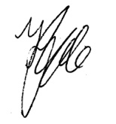
Fiona Ede, Project Manager, Department of Primary Industries (0427 527-782)
Riparian Works Evaluation Survey

INTRODUCTION
The survey seeks information about aspects of the works undertaken in the riparian zone (i.e. on the bank/s of the waterway) on your property:
- Condition of the site before works
- Activities undertaken during works
- Site management after works
- Evaluation of the riparian works

Landholder Information
- Please provide your name and contact details:

Name:

Physical Address:

Post Code:

Email address:

Landline Number:

Mobile Number:

Waterway name:

- Please nominate your preferred method and time for project team members to contact you to arrange a suitable time to conduct a field inspection:

Contact method | Morning | Middle of day | Afternoon | Evening | Anytime

Landline

Mobile phone

Email

- Is the riparian work site (tick more than one box if required):

□ Private land?
□ Licensed Crown Frontage?
□ Occupied unlicensed Crown Frontage?
□ Unoccupied unlicensed Crown Frontage?
□ Don’t know?
SITE CONDITION BEFORE RIPARIAN WORKS

- Do you have photographs of the site before or after the works were completed?

□ No
□ Yes (if so, are copies available?).

The following questions relate to the type of vegetation present on the bank/s of the waterway before works were undertaken.

- What was the extent of native trees and shrubs within the riparian zone?

□ None (vegetation was predominately pasture grasses)
□ Some native trees and / or shrubs
□ Mostly native trees and / or shrubs

Comments:

- What was the extent of weed (exotic) trees and shrubs within the riparian zone?

□ None or very limited
□ Moderate numbers
□ Extensive

- What species of weed trees or shrubs were more common? (tick more than one box if required)

□ Willows
□ Blackberries
□ Other _______________________

Comments:

- Were young native trees and shrubs regenerating in the riparian zone?

□ No
□ To some extent
□ Yes, extensive regeneration

Comments:

The following questions relate to management done in the riparian zone before works were undertaken:

- How frequently did livestock access the riparian zone?

□ Continually (unlimited access)
□ In rotation (planned and/or restricted grazing)
□ No stock access (exclusion)

Comments:

- Did you undertake any weed or pest animal management in the riparian zone?

□ No
□ Yes

If ‘Yes” please provide some details:
RIPARIAN WORKS UNDERTAKEN ON SITE

- What riparian works were completed on your property? (tick more than one box if required)

□ Fencing the riparian zone
□ Revegetation (replanting or direct seeding)
□ Weed management (including willow management)
□ Off-stream watering point installed (such as a trough)
□ Other: ______________________________

Comments:

- Who did the works? (tick more than one box if required)

□ Government organisation (e.g. CMA, MW, DPI or their contractors)
□ Landcare or community group
□ Self
□ Other: ______________________________

Comments:

- How were the works funded? (tick more than one box if required)

□ Government grant (including CMA funding)
□ Landcare or community group
□ Self-funded
□ Other: ______________________________

Comments:
AFTER RIPARIAN WORKS – MAINTENANCE AND MANAGEMENT

- What maintenance has been done since the works were completed? (tick more than one box if required)

□ Weed management
□ Pest management
□ Fence maintenance
□ Follow-up replanting
□ Other: ______________________________

Comments:

- Who carried out the maintenance? (tick more than one box if required)

□ Self
□ Catchment Management Authority / Melbourne Water
□ Other: ______________________________

Comments:

- Why was maintenance undertaken? (tick more than one box if required)

□ Fire damage
□ Flood damage
□ Damage caused by feral animals
□ General wear and tear
□ Other: ______________________________

Comments:

- How frequently have livestock had access to the riparian zone since the works have been completed?

□ Continually (unlimited access)
□ In rotation (planned and/or restricted grazing)
□ No stock access (exclusion)

Comments:

EVALUATION OF THE RIPARIAN WORKS

- Why did you agree to have this work done on your property? (select up to 3 reasons)

□ To improve the health of the waterway
□ As part of overall improved environmental outcomes for my property (e.g. Whole Farm Planning)
□ To improve the value of my property
□ To improve stock management
□ To provide shelter for stock
□ To improve the aesthetic value of the riparian zone
□ To enhance enjoyment of the riparian zone and river
□ Catchment Management Authority / Melbourne Water paid for the work
□ Other: _____________________

Comments:

- Why did the Catchment Management Authority / Melbourne Water support the works?

□ To improve the health of the overall waterway
□ As part of integrated weed management (particularly willow management)
□ Other: _____________________
□ Unsure

Comments:

For the following questions, please circle the number that best represents your perspective, with ‘1’ being the lowest on the scale and ‘10’ the highest.

- To what extent have the works met your expectations?

1 2 3 4 5 6 7 8 9 10

Comments:

- How effective was the collaboration with the Catchment Management Authority / Melbourne Water during the works process?

1 2 3 4 5 6 7 8 9 10

Comments:

- How effective has your ongoing interaction with Catchment Management Authority / Melbourne Water been since the completion of works?

1 2 3 4 5 6 7 8 9 10

Comments:

- Do you think that the works have improved the health of the waterway?

□ Yes
  - No
  - Unsure

Comments:
- Have any issues arisen as a result of the works? (tick more than one box if required)

□ No
□ Yes:
□ The extent of your effort in maintaining the riparian zone
□ The cost of maintaining the riparian zone
□ Drought affecting the vegetation
□ Access to water for stock and other uses
□ Requirement for weed control
□ Requirement for pest animal control
  - Changes in river dynamics
  - Changes in fire fuel loads
□ Administration related to implementing and maintaining the riparian work
□ Other: _____________________

Please comment about why these issues have occurred:

Please provide further information about required weed or pest control:

- Have the riparian works resulted in any loss of yield or productivity across your property?

□ No
□ Yes

If ‘Yes’ please provide further information:
- Given your experiences with the riparian works program, would you be likely to implement other riparian works on your property?

□ Yes
  - No
  - Unsure

Comments:

- What factors would discourage you from undertaking similar riparian works elsewhere on your property?

- If you were to complete riparian works on your property again, what changes in the process would you implement?

- If you were to complete riparian works on your property again, which parts of the process would you recommend stay unchanged?

- How likely is it that you would recommend undertaking riparian works to another landholder (1: I would not recommend it – 10: I would strongly recommend it)

1 2 3 4 5 6 7 8 9 10

Comment:

- Please provide any final comments:

Thank you very much for taking the time to fill in this survey.

Appendix 3: Field Site Assessment Sheet

Site Information
Site name: |  |  |  |  |  |  |  |  |  |  |  |  |  |  |  |  |  |  |  | Date:
Plot dimensions: |  |  |  |  | L x W: |  |  |  |  |  |  |  |  |  |  |  |  |  |  | Assessor:
Location (GPS): |  |  |  |  | Easting: |  |  |  |  |  |  |  |  |  |  |  |  |  |  | Northing:
Wider landscape context: |  |  |  |  |  |  |  |  |  |  |  |  |  |  |  |  |  |  |  | Bank (L/R):
Land use adjacent to site: |  |  |  |  |  |  |  |  |  |  |  |  | Stock access this bank (Y/N):
Land use on opposite bank: |  |  |  |  |  |  |  |  |  |  |  |  | Stock access opp. bank (Y/N):
Fence condition: |  |  |  |  |  |  | L x W: |  |  |  |  |  |  |  |  |  | Fence opp. bank (Y/N):
Riparian Vegetation
Cover of Life Forms |  |  |  |  |  |  | 0% |  |  |  |  | <1% |  |  |  |  |  | 1-5% |  |  |  | 6-25% |  |  |  | 25%+
Native tree layer (adult)
Native tree layer (juvenile)
Native shrub layer
Native ground layer
Litter/logs/bryophytes/rocks
Bare ground (mineral soil)
Weeds - all species
Weed Sp 1:
Sp 2:
Sp 3:
Sp 4:
Sp 5:
Sp 6:
Recruitment of trees and shrubs
Numbers as a result of natural regeneration or planting |  |  |  |  |  |  |  |  |  |  |  |  |  |  |  |  |  |  |  | # Natural Regen |  |  |  |  |  | # Planted
Sp 7:
Sp 8:
Sp 9:
Sp 10:
Sp 11:
Sp 12:
% Establishment from revegetation activities:

Appendix 4: Location of Field Sites Assessed in the Project

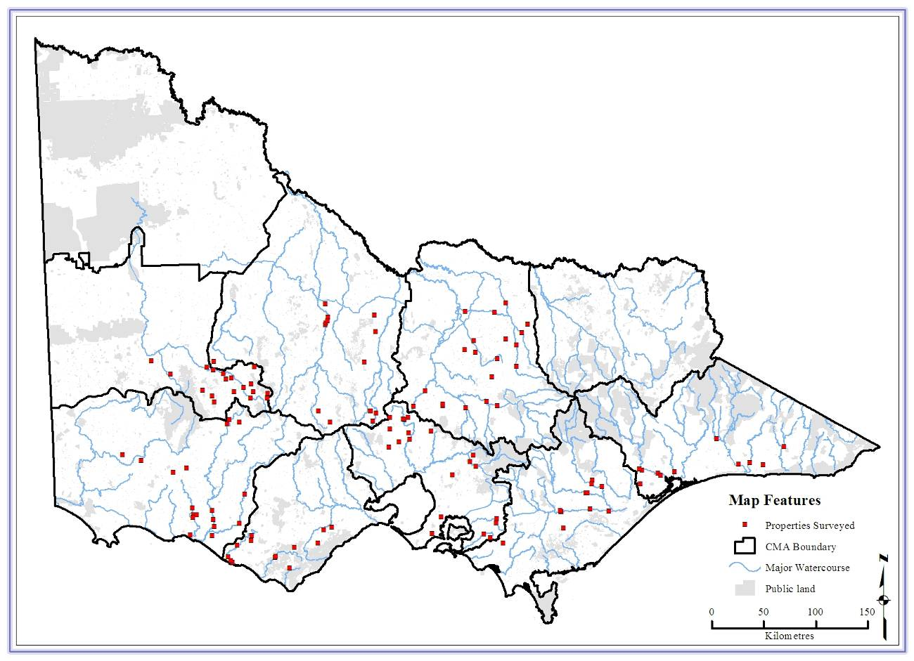

Figure 32: Location of all field sites assessed across state

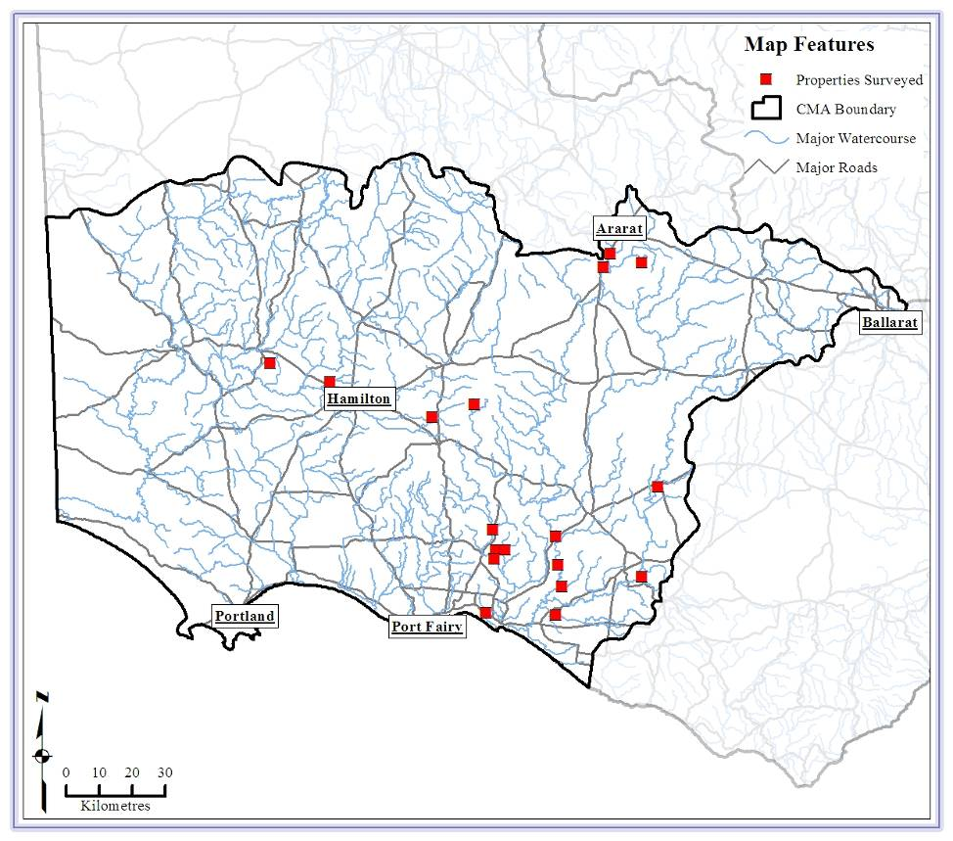

Figure 33: Location of field sites assessed in Glenelg Hopkins CMA

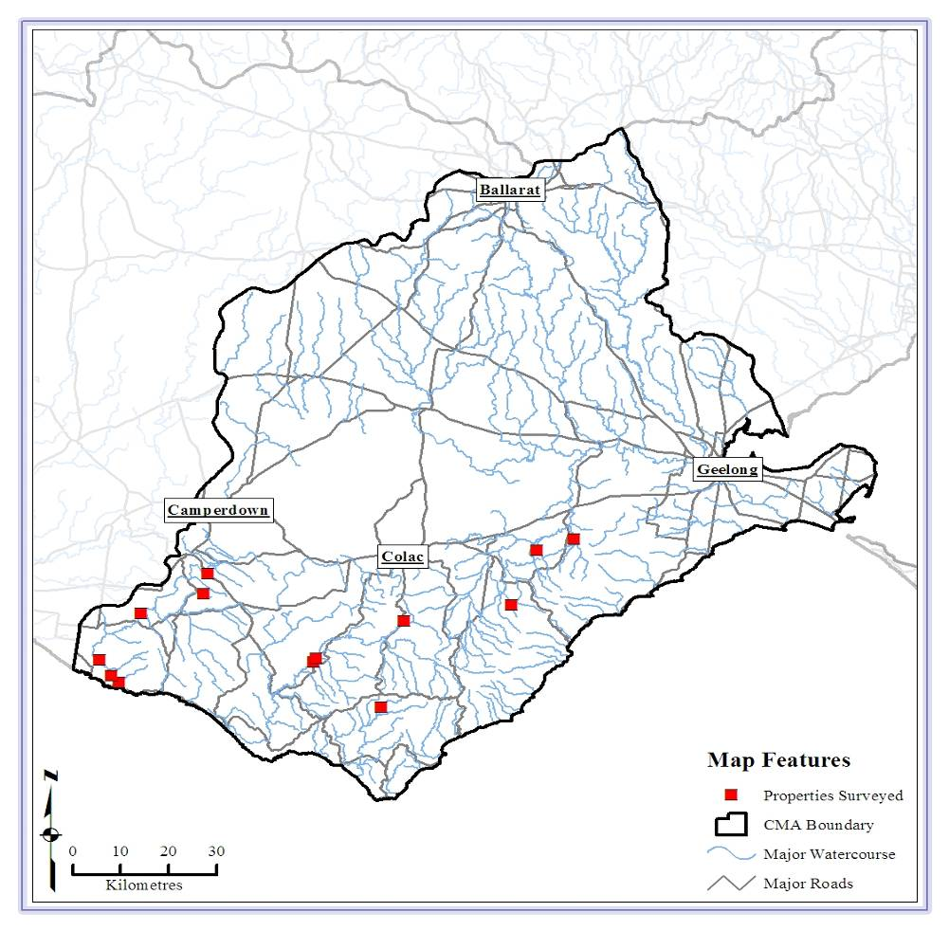

Figure 34: Location of field sites assessed in Corangamite CMA
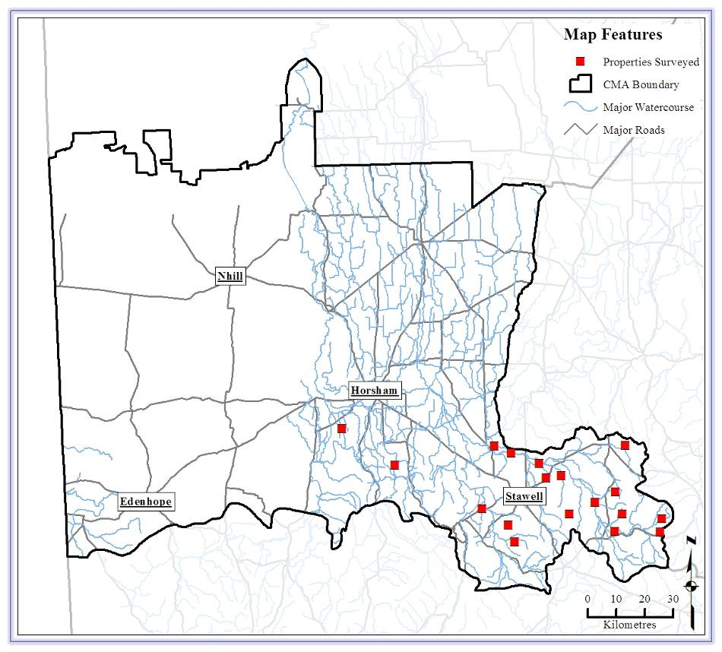

Figure 35: Location of field sites assessed in Wimmera CMA

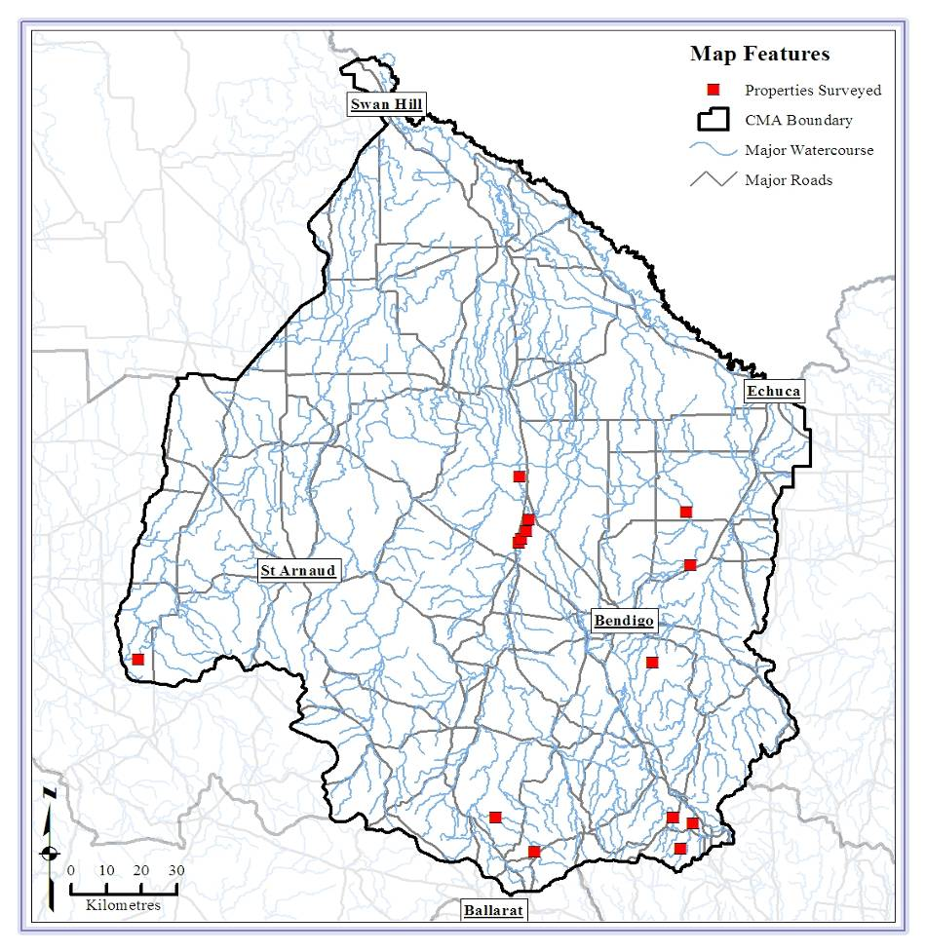

Figure 36: Location of field sites assessed in North Central CMA
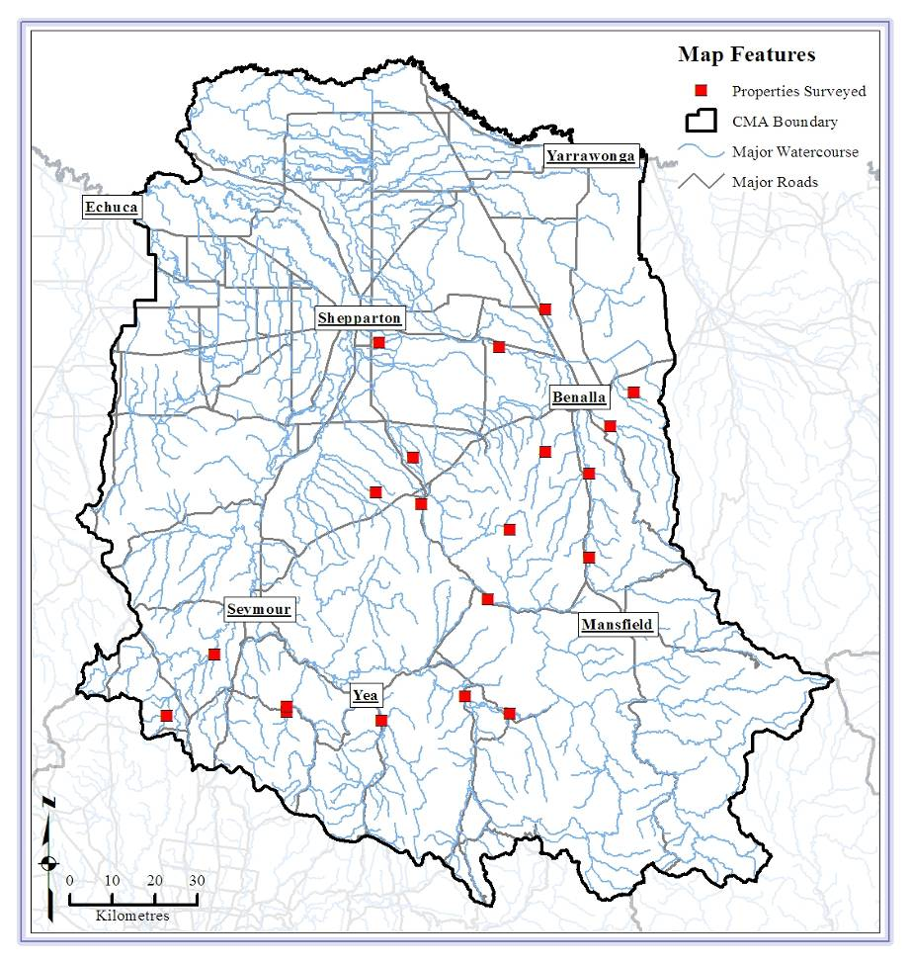

Figure 37: Location of field sites assessed in Goulburn Broken CMA

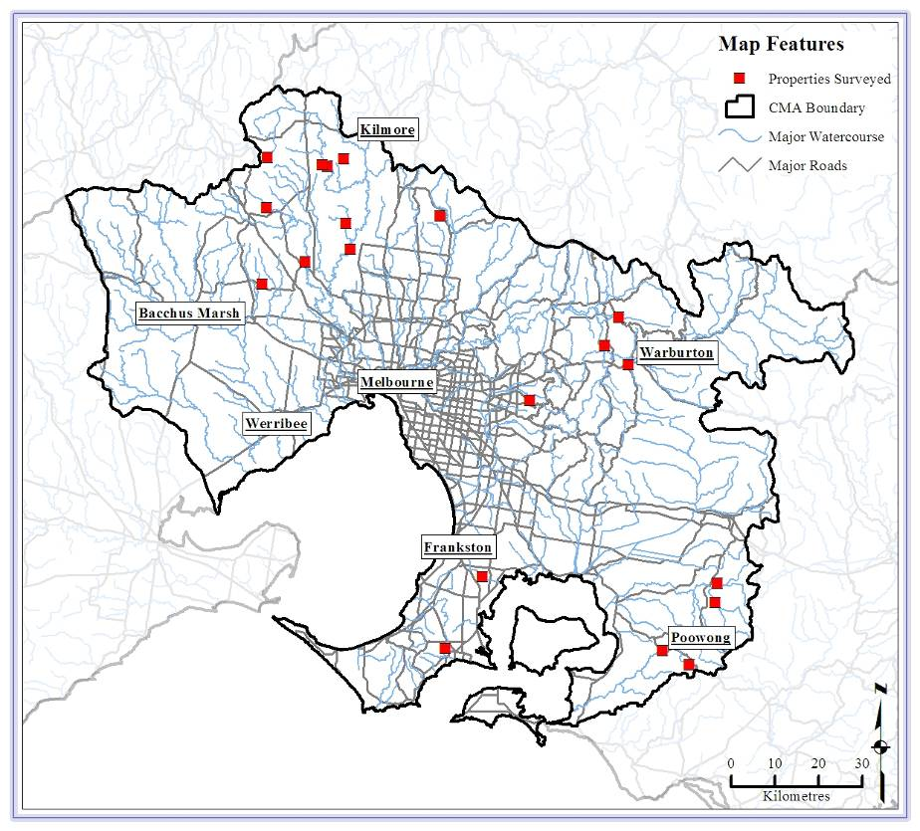

Figure 38: Location of field sites assessed in Melbourne Water
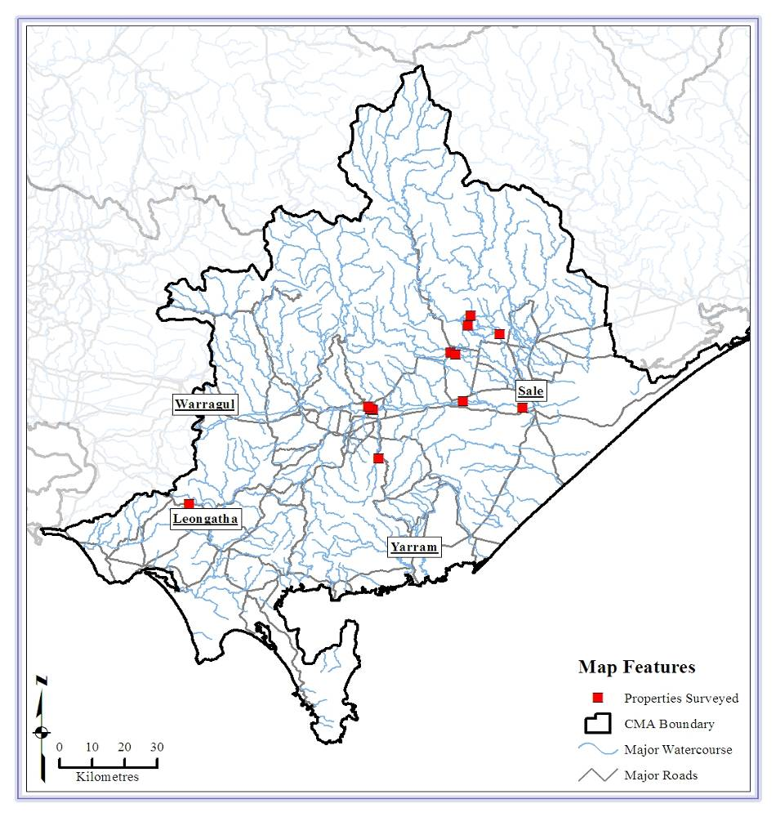

Figure 39: Location of field sites assessed in West Gippsland CMA

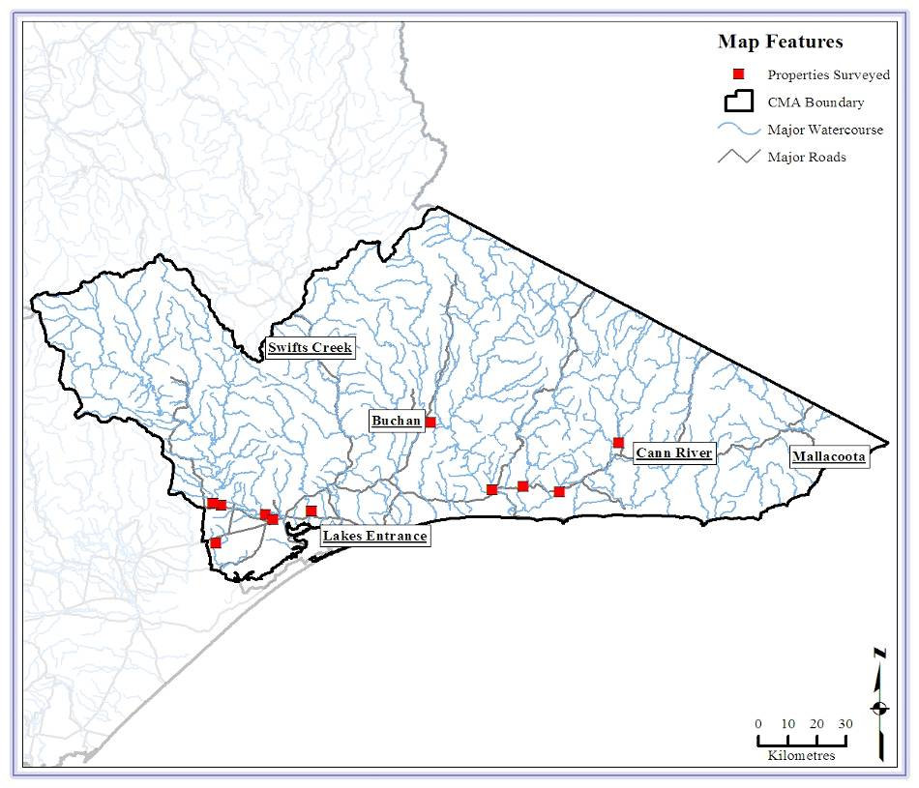

Figure 40: Location of field sites assessed in East Gippsland CMA

Appendix 5: Overall Landholder Comments
Some respondents provided final comments about the riparian works at the end of the social survey. A selection of these comments is reproduced here where they provide additional insight into landholder perceptions. In some instances, comments have been edited for brevity. The comments are grouped by CMA.

CCMA
Overall the riparian works have been a great success. We have enjoyed watching the trees grow and the river improve.
Looking at the results 4 years down the track and seeing the growth of the trees is very satisfying.
A good scheme. The platypus are doing well.
Unhappy about willow management – only had a few trees and lost our only shade in some areas. Weed control needs to be undertaken by the neighbours and on roadsides, we have major concerns about weed issues.
Can’t understand why more farmers don’t do it. In the past we would lose 1-2 animals in the stream each year, but we haven’t lost any for years. Property looks better with healthier streams and surrounds, and has increased in value.
End result is good, with a wind break that protects stock. Works prevent erosion, and have increased bird life. Negatives are increased pests and weeds, and possibly extra water use by trees.
Totally happy with results of trees as they are growing nicely.
It is a worthwhile exercise to revegetate creek frontages to reduce erosion. We have also planted/seeded lots elsewhere.
Huge improvement! Have also planted saline discharge areas – overall planted 35-40,000 trees in last 22 years.
River suffered badly as a result of works (willow removal), extra long time will be required to repair the damage. Lots of native trees fell into river after willow removal and excessive trash from willow removal in river.

EGCMA
I have an issue with off-stream watering. All equipment was funded by the CMA, but the pump was inadequate and failed. I do not have the money to install an adequate pump and the CMA has not responded to the issue.
Black wattle has taken over and will become an issue – eliminating other species and impacting on high water flows.
The end result was willow removal, fencing and replanting. The outcome for the river was less erosion and willow blockages. The CMA handled the owners with courtesy – this was appreciated.
Concerned at vegetation removal on other side of river, leaving it bare. A big flood will open the gulch and pour sand onto nearby properties, so this needs attention.
The project was worthwhile and as long as it is maintained into the future, it will have been successful.
Site is working well, but can see weeds (especially blackberry) being a problem in the future. One section of the river bank is a problem, especially in floods.
It is a mutually beneficial program. CMA staff and contractors deserve credit for their very professional and courteous approach.
Public land management is not a short term commitment, it needs ongoing maintenance. The owner cannot be expected to maintain land he can’t use, e.g. undertake weed and rabbit control.

GBCMA
Wanted to do works, but cost had been a barrier. During drought wandering stock were an issue. Now works have been done, I am very grateful for them as the creeks are healthier and I now have a permanent water supply.
I am grateful for CMA support, advice and back-up supplies for repair and replanting.
I appreciated the proactive contact by the CMA after the bushfires and the follow-up to complete the works.
The works cost the landholder in cash, but in capital terms there is an increase in property value and it has made stock management easier.
Win/win situation, with increase in birds, especially waterbirds. Added a wetland into system, and also increased fauna. Whole experience has been exciting and satisfying.
Removing willows was a mistake as there is a hell of a mess. Happy with the work but disappointed that the erosion issue has not been addressed as the creeks are a real mess and there is a threat to the property through flooding.
Remove willows from flood plain area – willow debris destroyed farm bridge in floods.
Direct seeding in 02/03 not very successful, have also done replanting.
Believe reducing stock access to river banks is beneficial, would encourage others to do it.
Financing needs to be initially provided by the CMA as ongoing costs of fence maintenance and weed and pest management is significant for the farmer. Site needs a track for weed and fire maintenance. Fenced off larger areas so can use it as temporary stock shelter, once the trees have grown.
The water is clean, the banks aren’t eroding, the tree are park-like, and they provide shelter from the wind for stock.
Successful program.
All works were done professionally. Site was ripped prior to planting and trees are thriving.

GHCMA
Please let us know when you have funding for trees, watering points and fences. We still have many km of creek left to do.
Property is in the Moyne Shire and this shire is very hard to deal with.
Creek can now be shown off and I appreciate the huge improvement. It is not as beautiful as it could be but more so than it was. It looks “wealthy’ with lots of frogs and vegetation.
When enquired about funding next phase, told no funding available.
Planning is the key and I try and do a project a year as time and funds allow. Seeing each planting progress has its own rewards.
Concern about council wanting to further sub-divide on and near the river – flood and river health issues.
The money available as a grant has been eroded by dramatic increases in cost of fencing materials – this will impact on extent of works.
Continue the Landcare subsidy – it makes it possible to complete works when farm incomes are low.
Recent flood damage has caused huge fencing loss (estimated at $150,000 across all property) – need help to reinstate previous works. Need investment in maintenance, not just new works, otherwise initial work can be wasted.
Always ongoing maintenance required, especially after high flows.
Outcome would have been much better if all landholders along the waterway had been encouraged to participate – i.e. if there had been an overall works plan. One neighbour has pigs in the waterway while another has plantations but no riparian plantings.
Riparian works are a slow, rewarding process and you need to be patient.

MW
Excellent program, with minimal administration. Time with MW officer is always useful – they are accommodating of required changes. This is "grant making and support for landholders" at it's best.
The riparian area is used by nearly all fauna and a great deal of flora as well. It is paramount to help keep waterway clear of silting and over-supply of nutrients from agriculture, although much needs to be done away from the riparian area to achieve this. However, we support MW stream frontage program and appreciate the one on one support and reduced paperwork, which will encourage others to come on board.
Appreciate financial support - thank you. Have been doing works for 4 years only and can’t believe growth rates. Despite floods and droughts, have had good success. Fencing off also benefitted cattle through extra troughs.
More active effort to encourage other owners on-board, perhaps with physical assistance and guidance as an incentive to start. Physical help should be funded, if required.
Support initiatives to establish clean, clear waterways and improve native vegetation in Dandenongs. Wallabies a delight but problem too. Lots of weeds, rabbits and foxes. MW v helpful.
Encouraging neighbouring properties to join in combined effort to improve stretch of waterway may be more effective
Planting 350 tube-stock by self is too arduous. Drought and kangaroos have limited success, but the fence is still there and natural regeneration is occurring. Growth has been marked since the drought has broken.
Much healthier creek area, providing better habitat for frogs etc.
MW has been encouraged to act by work already done by Western Water. WW appreciates ongoing support under this program, as demonstrated by 4 stream frontage agreements for 4 separate properties. Ongoing funding more successful than one-off grants.
As my wife and I are both turning 80 this year and on fixed income, we find the cost daunting and labour beyond us.
Keeping animals off makes the biggest improvement; slowing water allowing sediment to fall out which reverses erosion process
It is a pleasure to have been involved. But it is a lot of work – 5-6000 trees over 10 years.
We appreciate all the support given to us.
We are very pleased to keep cattle out through fencing and off-stream watering. We had hoped to control erosion with revegetation but the death and damage of many seedlings has been disappointing.
Farmer efforts far more important than those of city dwellers' efforts, so we need to pay farmers to do environmental good.
It was good to have an officer come every year to check on project and discuss what is possible. Same person came for a few years and he could see the changes.
Benefit to owners and riparian area - win/win!
Good program but needs changes for me to participate again - MW should pay supplier of materials and plants directly, so they can be replaced if damaged. Need contractors to help with some of the work.
Unlikely anyone going to rip off system in these projects, so make it easier to participate and apply. There is a multiplier effect of Landcare and planting which gets farmers enthused to do other environment stuff, and also means more neighbours get involved.
Is it possible to have program through Landcare or the grants program to educate farmers about plants - native and desirable species?
Process requires good relations between owner and MW officers. This occurred in this case. MW also needs a good audit process.
It has been a long term project, started with direct seeding, and more recently planting. But site needs kangaroo exclosures to increase success rate.
First stage has gone well, but rabbits are an issue - not sure how to control. Although bracken is native, it creates a monoculture, harbours rabbits and is toxic to stock. Overall, project has been very positive - thanks.
Enjoyed the time spent improving riparian area. Slow progress better than trying to change it in one action - stage the work so can maintain and establish growth in one area before moving to next.
Farms upstream and downstream do nothing. Need more local awareness programs.
Overall a very pleasing result. Staff from different departments friendly, polite and informative - very satisfactory outcome.
Overall it's been a great experience and we have no regrets at all, has been great for the property. We hope to see benefits in the creek soon.
Stream Frontage management is a great program thanks to excellent design and great assessors who really are very interested in the property, happy to provide excellent advice and are very encouraging. Pre payment for works to be undertaken is especially attractive to landholders - indicates a definite commitment from MW, and the continuing or ongoing involvement of assessors is also a very strong point. One key improvement: As an active Landcare person trying to persuade others, perhaps less keen on reveg work than me, I would suggest payment to landholders for planting, site prep, and maintenance should be provided at the same rate as if undertaken by contractors. This has been introduced for fencing as I understand it. Landholders, especially farmers, do get a bit racked off when they do good work without recompense, while neighbours who use only very expensive, but not always very effective contractors, get the job done and paid for, for no effort!

NCCMA
Love the stretch of river and am happy to maintain it. Floods removed some planting, will replant higher up and let native grasses multiply.
Grateful for work done, funding made it happen now - otherwise it would be a low priority.
Unreliable off-stream water supply; concern about spread of wattle on property.
Happy to develop corridor.
Big floods a problem - fence design can help.
Happy with CMA staff. Debris from willow removal caused problems in recent floods.
Some of the fence-line locations are impractical to avoid damage from major floods. Major flood scouring likely to impact on the health and longevity of mature river red gum in riparian zones. Use of mostly shrub species rather than large, faster growing eucalypts may have been detrimental to success of revegetation.
After fencing completed, noticed significant increase in native grass and trees, erosion not evident. Floods destroyed fences and dumped lots debris. Washout on banks needs to be monitored.
NCCMA is encouraging fencing and replanting. As Sec/Pres of the local Landcare, I have been encouraging others and farmers continuing to join project.
Further understorey planting desirable, due to losses from birds, animals and floods which will require weed management.
Willow removal and replanting is already having a big effect, it will provide cover for fauna. Ongoing issues - need to prevent willow regrowth and control gorse.
Flood management is very important so don’t plant in waterways but de-snag in certain areas. More stringent controls of levee banks on floodplains are required.

WCMA
Want CMA to visit and make comparison between then (continual grazing, no fencing, gully scouring) and now (no grazing, trees, native grasses, slow water flow).
Fenced other native vegetation patches on property. Property sold to new owner.
Except for issue of the water supply for stock and loss of some acacias, projects are very pleasing. Would do further replanting.
Several projects undertaken over 18 yrs. High success rate with tube-stock and direct seeding. Whole farm plan recommended as way to start the process. Thanks for funds, it would not be possible without them. Overall, projects have resulted in increased value and production.
Riparian improvements rely on continual management, de-snagging, control of bridal creeper etc. Overall very happy with outcome. Deep groyne work facilitated flows.
It’s a great program. We are (or should be!) appreciative of the assistance provided for this type of program.
Accessing and requirements of funding were clearly defined. Project manager available during project for clarification.
A variety of works have been undertaken in creek and tributaries over time, some have been successful, some failed. Older successful works seem to be disregarded by current CMA staff.
Been working on projects for 25 years. They have given me great pleasure and the improvements have enhanced our property. Enjoyed by all family and now my son is continuing works.
Glenpatrick Ck as a whole is a disgrace. Landholders up and downstream do nothing and yet nothing is done. Lack of maintenance of erosion works by the CMA is an issue. However, CMA did pay for flood repairs.
Creek erosion worse than before - works not well done or effective. Lost access to paddock across river by fence, lost water to that paddock. No consultation on how work was going to be done nor any inspection in the 5 years since done.
Tender application to undertake revegetation, weed management etc not successful - disappointed. Program should be more accommodating of vegetation that is already on site and build on it. CMA staff need to get out and encourage landholders.
Poor success at planting, various reasons. Tough site. Owner keen to do right thing, fenced off large areas, but grazing area and overall no new plants established. Can CMA/DPI/other run weed and grass identification courses for land owners? Provide lists of low/no cost local helpers for fencing/planting?
Neighbours cattle are eating out the frontage. Very disappointed, CMA and DSE don’t seem to have power to stop this even though neighbour does not lease frontage.
Need 2 adjoining owners to fence their riparian area – it would provide a huge benefit. Progressive landholders will take advantage of restricted pool of funding and give a sense of progress (may be illusory?).
Unhappy with CMA – frustrated by changes of rules. Disappointed at the lack of consultation, e.g. placement of fence, and lack of flexibility, poor understanding of local river dynamics.
A great project to reinstate vegetation and protect waterways. Long term benefits will be appreciated by next generation, who will see major benefits. Let’s do it again!

WGCMA
Happy with fencing and stock exclusion. But main aim is to protect waterways and am disappointed with follow-up work, trees etc as when I make a deal I expect both parties to keep it.
Landholder didn't want project done - neighbours wanted it. Was happy with the way it was, so wouldn’t do it again. Seems a lot of money to invest with no advantage to erecting the fence and plantings as stock couldn't access the river anyway. As well, the willows have grown back.
Very worthwhile – unsure at first but now see the natural beauty. Wombats will ruin a lot of good work carried out - floods fill their holes and erode banks, taking out plants.
Consider actions in 10 years time to evaluate outcomes.
River access a liability - flooding, and an asset - water supply. Stewardship of floodplain needs to be taken into account. Works benefitting public good should be paid for by public. Decrease in CMA funds limits personal contact with staff and landowners, while better contact increases participation and cooperation.
Project had potential to become bureaucratic nightmare, unless locals have input. Could have caused irreparable damage to environment - already extensive damage to fauna populations - may be permanent.
Happy with the way we were approached about works being carried out.
Happy with cheerful, efficient and professional manner of work. Delighted with results which are now very visible with plant growth. Thanks.
Thanks to CMA for a job well done.

