Central and Gippsland Region Sustainable Water Strategy Final Strategy

Acknowledgment
We acknowledge and respect Victorian Traditional Owners as the original custodians of Victoria’s land and waters, their unique ability to care for Country and deep spiritual connection to it. We honour Elders past and present, whose knowledge and wisdom have ensured the continuation of culture and traditional practices.
We are committed to genuinely partner, and meaningfully engage, with Victoria’s Traditional Owners and Aboriginal communities to support the protection of Country, the maintenance of spiritual and cultural practices and their broader aspirations in the 21st century and beyond.
© The State of Victoria Department of Environment, Land, Water and Planning 2022
This work is licensed under a Creative Commons Attribution 4.0 International licence. You are free to re-use the work under that licence, on the condition that you credit the State of Victoria as author. The licence does not apply to any images, photographs or branding, including the Victorian Coat of Arms, the Victorian Government logo and the Department of Environment, Land, Water and Planning (DELWP) logo. To view a copy of this licence, visit http://creativecommons.org/licenses/by/4.0/
ISBN 978-1-76105-979-7 (pdf/online/MS word)

Disclaimer
This publication may be of assistance to you but the State of Victoria and its employees do not guarantee that the publication is without flaw of any kind or is wholly appropriate for your particular purposes and therefore disclaim all liability for any error, loss or other consequence which may arise from you relying on any information in this publication.

Accessibility
If you would like to receive this publication in an alternative format, please telephone the DELWP Customer Service Centre on 136186, email customer.service@delwp.vic.gov.au, or via the National Relay Service on 133 677 www.relayservice.com.au. This document is also available on the internet at www.delwp.vic.gov.au

Minister’s foreword
Water is essential to life. We all rely on safe, reliable and affordable water for drinking and everyday use, to grow our food and to keep our open spaces green and cool. Water is vital to protecting jobs and to supporting our businesses, our farms and our industries. Rivers need water to keep flowing and to support healthy and thriving communities. Traditional Owner access to water is vital for culture and Country.
While rainfall will vary from year to year, climate change means we can expect extended dry periods and less reliable rainfall. River water is already declining, and, in the future, there will be less water in our rivers, dams and aquifers. At the same time our population is growing and so is the demand for water. We need to act now to start transitioning to a more sustainable water future to secure our water supply, as well as our jobs, rivers, communities and industries for the decades to come.
Victorians know how to use water wisely and feedback from the community tells us there is support for us to go further. In response we are encouraging households to take the next step by changing Melbourne’s maximum water-use target from 155 litres per person per day to 150 litres per person per day. Simple changes at home can add up to significant water savings overall.
Water efficiency alone won’t meet future demand and so we are taking a proactive and incremental approach to growing our water supplies. Planning will start early on new climate-resilient water supplies so that a range of options are ready when we need them at the lowest possible cost. This will help to keep water bills affordable and prices as stable as possible to ease cost of living pressures. Water corporations will continue to provide financial relief and assistance to households who are vulnerable or experiencing hardship.
We will use desalinated water to supplement our drinking water supplies and increase our use of recycled water and stormwater for non-drinking uses like irrigating parks and ovals. Opportunities to return water to Traditional Owners and the environment will be identified early when planning for new water supplies.
This Strategy will support farmers to continue to adapt to drier conditions and expand their businesses within existing system caps. Farmers will also benefit from greater access to recycled water supplies and continued support for sustainable irrigation practices.
For the first time we have partnered with Traditional Owners to develop this Strategy. A key focus is to increase Traditional Owner access to water entitlements across the region.
Growing water demand will be met without issuing additional entitlements where the rivers or groundwater resources are already stressed. We have set an ambitious target of almost 100 gigalitres of water to be returned to major rivers in the region over the next 10 years to meet environmental outcomes. Access to healthy waterways supports mental health, recreation, tourism and the liveability of our communities. Investments in preserving and boosting our water supplies will mean no water is taken from farmers or other existing entitlement holders to meet these commitments. A significant package of works, including a fishway at Maffra Weir and an upgrade to the Werribee Diversion Weir, will also help to boost the health of the region’s rivers, creeks lakes and wetlands so they can continue to be enjoyed by future generations.
This Strategy sets a clear way forward for collectively addressing the significant long-term water challenges we face and articulating a clear orderly transition for our water supplies. I want to thank everyone who contributed to the development of the Strategy. Working together we will ensure a sustainable water future for our region and our waterways and the communities, businesses and industries that rely on them.
The Hon. Harriet Shing MP
Minister for Water

Chair’s foreword
Water supplies in the Central and Gippsland region will need to double over the next 50 years to meet the needs of a growing population under a drying climate. We need to improve how we share our water resources and find new, climate resilient water supplies to meet our future needs.
The Victorian Government, Victorian water industry and representatives from Traditional Owner groups have been working together on a strategy to meet the region’s future water challenges by developing the Central and Gippsland Region Sustainable Water Strategy.
The community was asked to provide feedback on this strategy. Those who we heard from showed strong support for reducing demand for water, increasing water efficiencies and for new manufactured sources of water which include expanding desalination capacity, increasing stormwater harvesting and the use of recycled water. Overwhelmingly, the responses we received supported returning river water to the environment to preserve our natural waterways.
The completed Strategy shows how we can all use water more efficiently which is an important first step. But the real strength of this Strategy is a universal Victorian water industry commitment to transition to manufactured water supplies to reduce pressure on river water and groundwater. Over time, manufacturing more of our water will provide climate resilient water sources for our cities and towns. Farmers and industries will also benefit from greater access to more reliable supplies such as recycled water. A transition to manufactured water will also mean that water remains in rivers to support our native wildlife including platypus, fish and frogs, as well as recreation, and will be used to restore water rights to Traditional Owners who have a deep and ongoing connection to water and Country.
Traditional Owners have been excluded from water ownership and management in the past. This is the first Sustainable Water Strategy that has been developed in partnership with Traditional Owners, and they have played an instrumental role in its development. As a result, this Strategy takes an important step towards restoring water justice for Traditional Owners in this region.
We must continue to work together.
The Strategy outlines a strong, shared vision and an industry wide commitment to the steps we all need to take to achieve a sustainable water future for the region. The implementation plan shows how we will take action on each of those steps to make change while providing us with the tools to plan for and adapt to an uncertain future.
I want to thank everyone who was involved in the consultation on this Strategy. Members of community, stakeholders and peak bodies had their say by attending online community information sessions, webinars and peak body forums and by completing online surveys and making submissions. This feedback was essential to understanding the challenges and priorities facing the region’s water future and informed the development of the final Strategy.
The Strategy provides clear direction about what we need to do to ensure a sustainable water future for our region; where cities and towns have safe and reliable water supplies, agriculture can prosper, waterways are healthy and justice for Traditional Owners is achieved. Many of the actions in the strategy point to further work, such as developing business cases to inform major infrastructure investments that will be essential to successful implementation of this Strategy. I am confident that the ongoing commitment to collaboration and innovation from all of the key agencies with responsibility for delivering this strategy (my fellow consultative committee members) will enable us to meet our water needs over the next decade and beyond and to improve water outcomes for Traditional Owners, community and the rivers that support us all.
Christine Forster AM
Chair, Central and Gippsland Region Sustainable Water Strategy Consultative Committee

The Central and Gippsland Region Sustainable Water Strategy water sector statement of commitment to Traditional Owners
This statement reflects our collective commitment to a restorative justice approach for the Country – water and lands of the Traditional Owners in this region. We offer it to reinforce the journey we have made together with Bunurong Land Council Aboriginal Corporation, Gunaikurnai Land and Waters Aboriginal Corporation, Wadawurrung Traditional Owners Aboriginal Corporation and Wurundjeri Woi-wurrung Cultural Heritage Aboriginal Corporation in the formation of the Central and Gippsland Region Sustainable Water Strategy. It has been an extraordinary process and this statement seeks to reinforce the shared commitment of the water industry organisations represented on the Consultative Committee and commit to a future where water justice is delivered for Traditional Owners. While the Consultative Committee’s terms of reference do not extend past the development of this Strategy, the water industry member organisations will individually play a vital role in partnering with Traditional Owners in the implementation and delivery of this Strategy.

Commitment
We pledge to follow the principles of the Central and Gippsland Region Sustainable Water Strategy (see Chapter 6, Section 6.5), and together continue to build opportunities to ecognize the social, economic, cultural and Country objectives of Traditional Owners in this region.
We will:
- through our strategic planning and preparation to meet water demands with water availability for our customers, ensure opportunities to return water to Traditional Owners is a measurable output in decision-making
- waive relevant fees where Traditional Owners hold water entitlements that do not add to the costs of water management in a system while policies regarding fees are being developed through Water is Life: Traditional Owner Access to Water Roadmap
- work together with Traditional Owners to expand opportunities to realise Traditional Owner cultural objectives for values and uses of water, including for water for the environment, and water for resource management
- in partnership, increase the involvement of Traditional Owners in the management of environmental water, and water for consumption
- empower Traditional Owners’ voice in all aspects of water management through the implementation of this Strategy.

Acknowledging the legacy of past decisions
We ecognize that laws, policies and practices of successive governments and government agencies, including the water sector, have inflicted profound grief, suffering and loss on Traditional Owners. These systems and policies acted to exclude Traditional Owners from many aspects of land and water management. We must also ecognize where the legacy of past decisions continues to influence current practice. We as water sector members are committed to transforming current systems and building a new future, based on restorative justice and Traditional Owner self-determination.

Respect
We commit to respecting and promoting the customs and traditions of the Traditional Owners within the Central and Gippsland region.

Recognition
We value Traditional Owner societies and culture as an important part of Victorian society and recognize the custodial obligations that Traditional Owners have to care for Country – lands and waters.

Rights
We support the rights of all Aboriginal peoples, as outlined in the United Nations Declaration on the Rights of Indigenous Peoples as ratified by the Commonwealth of Australia.

Participation
We support the rights of Traditional Owners, to make decisions on and for their Country. Self-determination is all about choice. It must be defined by Traditional Owners and not government or agencies. Traditional Owners have the right to make choices that best reflect them on their journey to self-determination and self-governance – and that right must be enabled and respected.

Reconciliation
We commit to encourage the Central and Gippsland community to achieve just and respectful relations between Traditional Owners, their communities and non-Aboriginal Victorians in the spirit of reconciliation.
We understand that reconciliation begins with self-determination – working in partnership with Traditional Owners as they take control of their own destiny.

Fairness, inclusion and access
We commit to fairness and inclusion, and in so doing, providing access to water services provided by Barwon Water, Wannon Water, Central Highlands Water, South Gippsland Water, Gippsland Water, Yarra Valley Water, Greater Western Water, East Gippsland Water, Melbourne Water, South East Water, Westernport Water, Southern Rural Water, Corangamite Catchment Management Authority, East Gippsland Catchment Management Authority, West Gippsland Catchment Management Authority, Victorian Environmental Water Holder for Traditional Owners of the Central and Gippsland region.

Advocacy
We will advocate, in partnership with Traditional Owners and others, to address the gap in social, economic and health inequalities experienced by many Aboriginal Victorians, through returning water and decision-making to them.

Water industry organisations in the Central and Gippsland Region
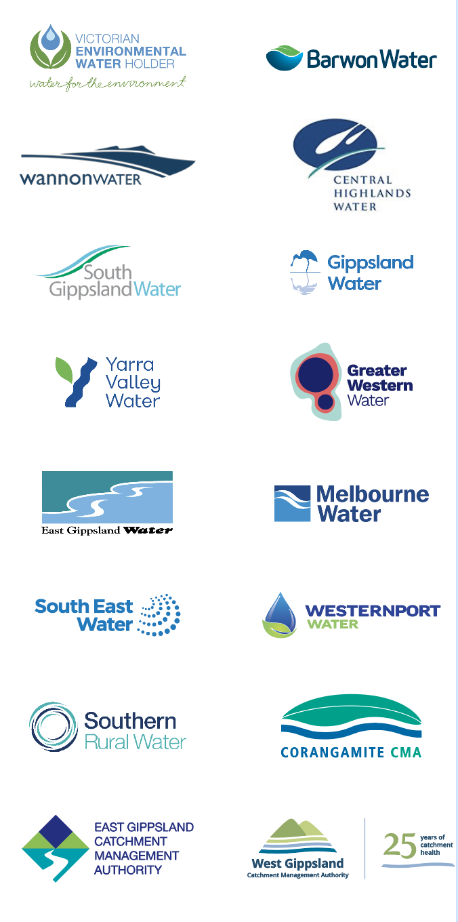

Executive summary

The role of the Central and Gippsland Region Sustainable Water Strategy
The role of the Central and Gippsland Region Sustainable Water Strategy (the Strategy) is to set policy directions and outline actions for securing the region’s long-term water supplies to protect the jobs, farms, ecosystems, communities and Traditional Owners that rely on them.
The Strategy meets the current and emerging water challenges over the next 50 years, during which time the region’s population is expected to grow to over 10 million and there will be a further decrease in water availability due to climate change. This is already having a significant impact on many of our rivers across the region. To ensure we are prepared for any eventuality, the Strategy uses the latest projections for our future climate under a range of scenarios.
The Strategy provides the framework under which individual decisions that contribute to meeting our water challenges are made, some of which can be acted on now, others will be acted on over time. It ensures that the water sector, working in partnership with Traditional Owners, is managing our water supplies sustainably.
The Strategy was developed by the Victorian Government (Department of Environment, Land, Water and Planning) in partnership with Traditional Owner groups and the water sector. It incorporates changes made based on feedback received from stakeholders and the community during public consultation on the Central and Gippsland Region Sustainable Water Strategy Discussion Draft.

The Central and Gippsland Region
The Central and Gippsland Region (region) is essential to the state’s liveability, sustainability and prosperity and more than six million Victorians currently depend on its rivers, aquifers, wetlands and lakes to live, work and play. This region covers the waterways and catchments south of the Great Dividing Range all the way to the coast and across from the Otway Ranges in the west to Mallacoota in the east. As well as providing drinking water to 90 per cent of Victorians, water in this region is a vital input to agriculture, businesses and industry. The formally recognised Traditional Owners of the region’s land and waters are the Bunurong, Eastern Maar, Gunaikurnai, Wadawurrung and Wurundjeri Woi-wurrung peoples.

What does this Strategy propose?
The Strategy supports ongoing investment in water efficiency for homes, businesses and farms and proposes the pathway to doubling the region’s water supplies over the next 50 years. Key to this pathway is the orderly transition away from a reliance on river water for meeting our water needs, to a greater reliance on manufactured water. This transition to manufactured water could see 80 per cent of Greater Melbourne’s water supply coming from manufactured water sources such as recycled water and desalination by 2070 as compared to 35 per cent now.
In addition, as the use of manufactured water increases, some river water will be freed up for other uses such as returning water to Traditional Owners and the environment, without taking water off farmers or other water users.
The reasons for the transition to manufactured water are outlined in more detail below:
- the region is expected to experience a water supply shortfall, with demands further outstripping supply within the decade
- while the focus on water efficiency and demand management will continue, this alone cannot meet the ever-growing shortfall
- this shortfall will worsen with time as population grows and the climate dries and combined this means instead of requiring a once in a generation water supply augmentation, we will need to add more supply options, more often
- additional extraction from our rivers is no longer an option to meet this shortfall – due to climate change impacting on water availability and reliability, and the environmental damage existing extraction is already causing opportunities to return water to our rivers for the environment and Traditional Owners are critical.
Severe water restrictions to address acute water shortages have significant economic implications. It was estimated that the impact of severe water restrictions cost Melbourne between $420 million to $1,500 million over a 10 year period during the Millennium Drought in the mid-1990s and early 2000s.
For this Strategy to be successful we need to decouple key water management decisions from crisis management. A continuous program of planning, readiness and acting before a short-term crisis arises (e.g. bushfire or extreme drought years) or long-term need emerges (where demand is higher than supply) means that future key water supply decisions occur on the basis of the best value options rather than those that can deliver water within the most compressed timeframe. This can help avoid sudden increases in water bills and ensure the community are involved in decisions on supply options.
Figure ES-1 outlines how the Strategy development and implementation will support a strategic approach to meet the water challenges for the region. Water security, the availability of an acceptable quantity and quality of water, is a complex and dynamic concept - it requires continuous planning, monitoring and action to achieve results.
Why the change in approach?
Ensuring water security for the region is not a new concept, it is an ongoing responsibility of the water sector. However how the water sector addressed this challenge in the past is not the way we need to address it in the future. Environmentally, the region is at its limits and we need to think, plan and respond differently.
Interventions that have previously generated large water savings, such as behaviour change (for example, it is estimated that Melburnians have reduced their demand since 2001 by approximately 150 gigalitres per year (245 L/day to 159 L/day)) no longer yield the same outcomes.
Our large water storages are also less reliable with the region’s current streamflow (water that flows into rivers and refills water storages) has already decreased by up to 21 per cent since 1975.
We have established and modernised irrigation districts that are highly efficient and are incredibly important for the State’s economy.
We have also built a Water Grid that allows us to move water around to where it is needed most. For example, the addition of the Victorian Desalination Project not only provided greater water security for Greater Melbourne, but also to connected cities and towns including Geelong and in areas of Gippsland.
Community expectations are changing and we need to return water to our rivers and address historical water injustices for Traditional Owners.
Finally, we know that water management has implications beyond the water sector and that there are significant opportunity costs from inaction. The World Economic Forum’s Global Risks Report 2020 (World Economic Forum 2020), identifies water crises as one of its top five global risks in terms of severity of impact over the next ten years. In the Australian context, in 2020, Moody’s Investor Service used water security to assist to determine state credit ratings with one state losing their AAA rating as a result.
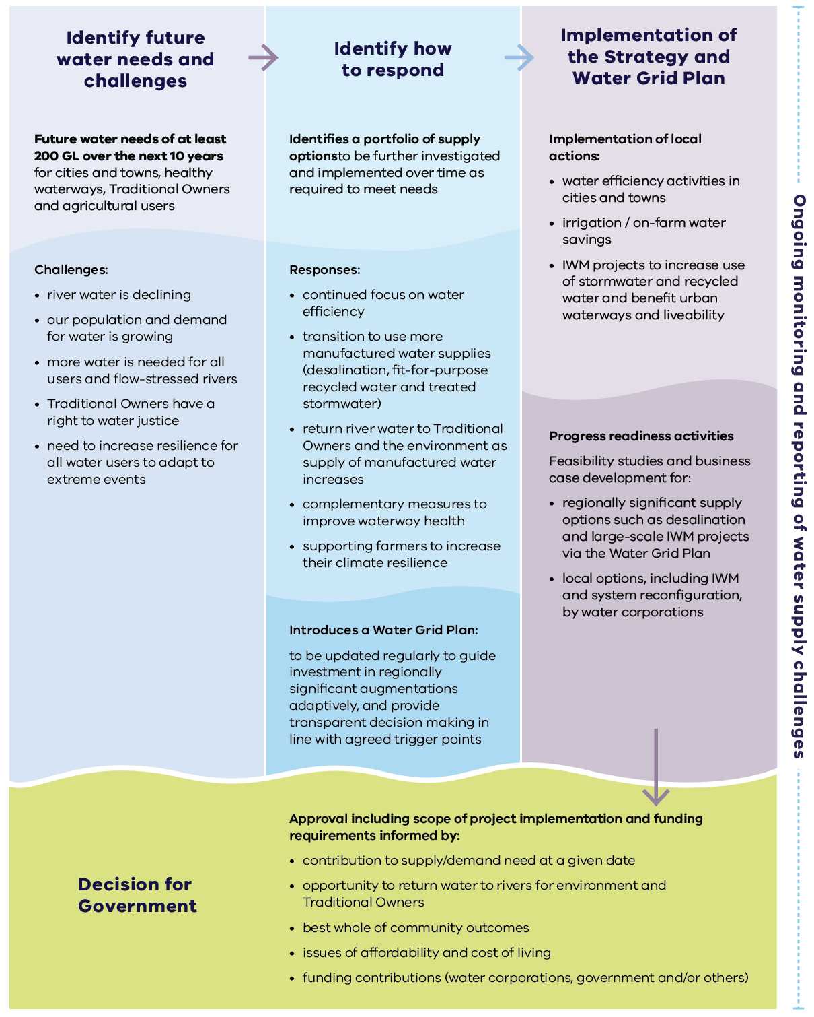
Figure ES.1: Summary of the Strategy’s process and implementation

Our water supply challenges
Water is an essential service and access to clean, fit-for-purpose water is a human right. Its availability underpins human health, confidence in present and future economic activity and the viability of our communities, environmental health and biodiversity. For Traditional Owners, water is a sacred, living entity.
Victoria is becoming warmer and drier, with less water flowing into our rivers and water storages (or dams) across the region. While climate conditions fluctuate from year to year, the region’s streamflow (water that flows into rivers and refills water storages) has already decreased by up to 21 per cent since 1975 and this decline is expected to continue (DELWP 2020a, Potter et al. 2016). At the same time, population growth is increasing the demand for water, especially within the Central and Gippsland region and we are experiencing more frequent and intense weather events such as storms, droughts, floods and bushfires that we expect to continue in future.
The wetter-than-average conditions in 2020 and 2021, and annual desalinated water orders, have meant that our cities and towns are not facing an immediate water supply deficit. But warmer and drier conditions are predicted to continue, and we need to plan for potential water shortfalls later this decade.
Currently Melburnians use 50 to 70 gigalitres more water per year on average than flows into our storages, depending on rainfall, with desalinated water orders currently meeting this gap.
While demand for urban water is growing, the availability of water in our rivers is declining. Additional water for the environment is essential to prevent further decline in the health of many waterways and water quality must be protected to support a wide range of uses. Importantly, we must remedy historic water injustices for Traditional Owners who have long been excluded from water management decisions and water ownership in Victoria. We also need to find ways to strengthen the agricultural industry’s resilience to an increasingly dry and more variable climate in the future.
Even with the current high storage levels, modelling shows that communities and waterways across the region could need at least 200 gigalitres of additional water over the next 10 years under a worst-case scenario (high climate change and high demand scenario).
This volume includes:
- up to 85 gigalitres to meet the needs of our cities and towns (Greater Western Water et al. 2022)
- up to almost 100 gigalitres to improve waterway health by meeting priority environmental water recovery targets (see Chapter 8 and Appendix D)
- water to meet additional irrigation demand (see Chapter 7)
- commitments to return water to Traditional Owners (see Chapter 6).
These water needs do not consider potential water sources for mine rehabilitation in the Latrobe Valley because that is part of the Latrobe Valley Regional Rehabilitation Strategy (DJPR and DELWP 2020) – a regional-scale blueprint guiding the transformation of the Latrobe Valley coal mines and adjacent lands to safe, stable and sustainable landforms.
Over the long-term, modelling across different population growth and climate change scenarios shows that we need to be prepared for a wide range of volumes that may be required in the future. For example, Melbourne, Geelong and towns connected to the Melbourne supply system may need between zero and 85 gigalitres per year of additional water over the next 10 years and an extra 140 to 600 gigalitres per year in 50 years to meet urban demands depending on how climate and population demands eventuate (Greater Western Water et al. 2022). There is considerable uncertainty in the shortfall projections and therefore, we consider a range of scenarios to ensure our planning is as robust and adaptable as possible.

Responding to the region’s water challenges
In responding to the water challenges described above, the Strategy outlines a range of management actions. These include:
- people and businesses using water more efficiently (see Chapter 2)
- modernisation of our irrigation districts and on-farm water savings (see Chapter 7)
- transfer of underutilised entitlements held by public agencies (see Chapter 4)
- use of unallocated water (see Chapter 4).
- investment in manufactured water supplies (see Chapter 3)
  - via integrated water management (IWM) to increase fit-for-purpose recycled water and treated stormwater use; and
  - via desalination.
- use of the Water Grid to move water to where it is most needed to address localised water security challenges (see Chapter 4).
These water management actions make the most of our existing water supplies, identify new supply options and are supported by a range of complementary measures and actions that will maximise the outcomes of any water returns and addition of new water sources. This includes for the environment, Traditional Owners, for irrigators and for the liveability of our cities and towns.
While water efficiency measures and other local water management actions help to reduce the demand on our existing water supplies, this alone will not meet all our future water needs. Adding new water sources, via manufactured water, needs to be investigated now so they can be ready to meet the projected supply shortfalls this decade (Figure ES-2).
A combination of local and regional-scale new water supply sources are critical to providing certainty (volume and reliability) for the growing needs of our cities and towns. Collectively – water efficiency measures, local water management actions and new water sources – provide a portfolio of management actions to address this emerging challenge. When large-scale options that add to the Water Grid are considered for meeting the needs of our cities and towns, opportunities to concurrently reduce our reliance on river water for cities and towns will also be explored. This approach provides an avenue for meeting priority environmental water outcomes and returning water to Traditional Owners, via substitution with river water.
Some of the proposed portfolio of management actions can and will be implemented now to meet the water challenges of this region. Others will have longer lead times and need considerable planning with progressive decision points, such as large-scale manufactured water sources.
We have identified the need for the Water Grid Plan (see Chapter 9) to document and track progress for these regionally significant augmentations and have clear triggers for when to move through the range of progressive decision points required for these large-scale projects. The Water Grid Plan, when released in 2023, will demonstrate how the overall water resource demand and supply conditions are tracking within the region. These conditions together with an understanding of lead times will be the context that triggers progress through decision points.
Investing in early planning will smooth out cost impacts, bring future flexibility by having multiple options to choose from - or progress concurrently - and support augmentations occurring in a way that better aligns with the changes in demand caused by population growth and in supply caused by climate change.
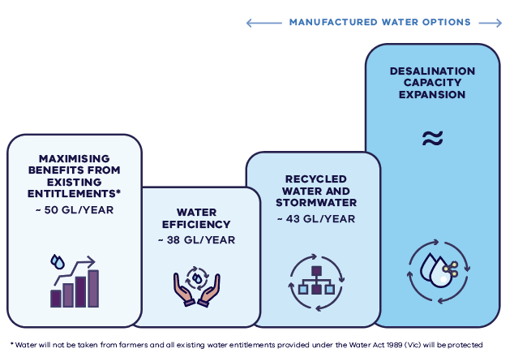
Figure ES.2: Options identified in the Strategy for additional water to be progressed
Keeping a broad and varied portfolio of new water sources is ideal, to allow response to a range of possible future conditions. However, not all options align with current government policy, and these options, while not modelled or assessed in detail, were considered in the initial analysis of opportunities, and were deemed not to be viable (see Chapter 1).
The Strategy also includes a range of actions to improve water quality and waterway health across the region. It focusses on water recovery in the major regulated rivers where there are large environmental deficits and on complementary measures, such as fishways and regulators, that can increase the effectiveness of environmental water delivery. It also outlines a range of actions to support farmers, businesses and industry across the region to increase their water efficiency and resilience.

Implementing the Strategy – ongoing planning, tracking and action
A secure water future for the region relies on action in houses, on farms, at water storages, at the desalination plant and right across the Water Grid. Oversight, planning and implementation of the water management actions is split into two scales – the region, led by the Department of Environment, Land, Water and Planning, and the local level, led by water corporations.
The Strategy considers the broad range of water supply and demands across the region. Meeting the significant needs of our cities and towns is undertaken by urban water corporations and documented in their urban water strategies. Across the region, there are eight urban water strategies, with a single water strategy completed for Melbourne by Greater Western Water, Melbourne Water, South East Water and Yarra Valley Water.
Each urban water strategy is implemented, at local scale within the water corporation’s boundary, consistent with the directions outlined in this Strategy. Each urban water corporation across the region will investigate options for reducing their reliance on river water and greater use of manufactured water. This will enable the Victorian Government to understand how commitments around returning water to the environment and Traditional Owners can best be met, subject to required investment.
This two-scale approach ensures that decisions that can be implemented locally are, however those situations which are better resolved at a regional scale can be facilitated across water corporation boundaries by the Department of Environment, Land, Water and Planning. Figure ES-3 shows the role of both sustainable water strategies and urban water strategies.
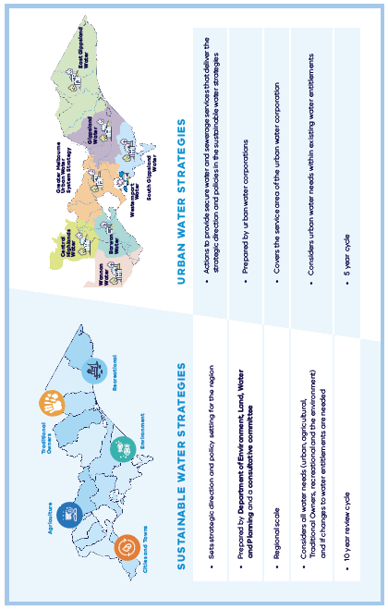
Figure ES.3: Role of the sustainable water strategies versus urban water strategies in the Central and Gippsland Region.
The Department of Environment, Land, Water and Planning will lead the Strategy’s implementation in partnership with the water sector, Traditional Owners and the community. This process includes overseeing the delivery of water management actions, providing updates in annual reports, and developing a five year mid-point assessment. A major review of the Strategy will be completed after 10 years. The Strategy identifies 41 policies and 96 actions to be delivered over the next 10 years.
We must plan for uncertainty and a range of plausible future water scenarios. Early investment in readiness activities, such as feasibility studies and business cases, is prudent investment for any large scale infrastructure projects and helps reduce lead times to have new water supplies constructed and water flowing.
To manage this uncertainty, implementation of Strategy actions will be assessed at the five year mid-point and be complemented by the role of the Water Grid Plan to adaptively progress new water sources as the situation changes.
Local options will be considered alongside regionally significant options identified in the Water Grid Plan using a preliminary quadruple-bottom-line assessment by the Department of Environment, Land, Water and Planning. The best value package of projects across the region that will meet the needs of cities and towns while enabling some water to be returned to rivers will be progressed – some implemented by one water corporation, others implemented across water corporation boundaries.
This two-scale approach – the Strategy together with the eight complementary urban water strategies – will ensure that decisions on planning and investment in new major infrastructure and supplies are made at the right time, so that we have the best options ready when we need them, supporting a secure water future for all users across the Central and Gippsland Region.

Funding implementation
The majority of actions in the Strategy are anticipated to be funded by a combination of government funded programs and water corporation contributions via their pricing determinations. While many actions are consistent with current levels of investment, additional government funding and/or increases in water bills will be required in future to ensure full delivery of water needs identified in the Strategy over the next decade. The cost of inaction if we don’t start transitioning to more manufactured water supplies is too great and could result in major cities and towns across the region running out of water.
The 2022-23 Victorian Budget invested $56.6 million to deliver the first phase of this Strategy. This funding included investment for waterway and catchment health projects, water efficiency measures and more recycled and stormwater projects (including the large-scale Dingley Recycled Water Scheme), building resilience of the water sector to the impacts of climate change and preparatory work required for larger scale augmentation decisions.
Smaller, local water supply projects will be progressed by water corporations and regionally significant water supply options will be progressed through the Water Grid Plan. Victorian Government co-investment in local and regionally significant water supply benefits will be considered on a case-by-case basis where there are important public benefits, such as the return of water to rivers and Traditional Owners, and where funding is available in the state budget.
The clear policy directions and outcomes outlined in this Strategy, including principles for public co-investment, will improve coordination and consistency around future planning and decisions. The approach to continuous planning will also ensure the impact on water bills is managed. Water corporations will continue to support customers who are experiencing hardship.

The Strategy – at a glance

Chapter 1: Our reality
Chapter 1 describes the role of the Strategy, its vision and objectives, provides an overview of the water sources, uses and values in the region, it includes our water challenges and describes the process used to develop the Strategy and the way it will be implemented.

Chapters 2: Using water efficiency
The Strategy identifies water efficiency measures that could save up to an additional 38 gigalitres per year– this will include water efficiency campaigns, regulations, and incentives that will help people, businesses and industry all save water. It also includes changing Melbourne’s daily water use target to 150 litres per person per day (down from 155 litres).

Chapter 3: Transitioning to manufactured water
The Strategy articulates the range of options for new manufactured water supplies that need to be investigated to ensure we have enough options ready if and when they are needed. Options that will be progressed, and bought online when appropriate include:
- use of integrated water management to increase reuse of recycled water and stormwater and improve liveability, including:
  - large-scale recycled water supply networks in Greater Melbourne and Geelong
  - smaller recycled water and stormwater reuse projects across the region
- expansion of desalination capacity.

Chapter 4: Sharing water for multiple benefits
The Strategy identifies options to improve how we use and share our existing water sources and make the most of all water sources. This includes optimising the water grid so we can meet some of the immediate urban water needs of our cities and towns and progressing opportunities to return water to Traditional Owners and the environment. Work that will be progressed include:
Securing Geelong’s water supply by upgrading the capacity and reach of the Melbourne storages – increasing the Geelong pipeline from 16 to 22 gigalitres per year by 2025.
- Securing Warragul and Drouin’s urban water supply by increasing Gippsland Water’s access to water from Tarago Reservoir by 3.33 gigalitres per year by 2023.
- Opportunities to reallocate water held by the Victorian Government that is no longer needed, including approximately 16 gigalitres from the Latrobe 3 – 4 Bench entitlement that was originally intended to support the expansion of coal-fired electricity generation and a 1.4 gigalitre water licence to the Birrarung (Yarra River) formally used by the Amcor Paper Mills.
- Developing a business case to transform how water is used and shared in the Werribee system including greater use of recycled water and stormwater for non-drinking purposes such as irrigating crops and parks.
- Review how water is used and monitored in small, dry peri-urban catchments.

Chapters 5 and 6: Water for Traditional Owners
The Victorian Government is committed to addressing the historical and ongoing exclusion of Traditional Owners from holding and managing water through a restorative justice approach.
The Strategy has been developed in partnership with the formally recognised Traditional Owner groups, Gunaikurnai, Bunurong, Wadawurrung and Wurundjeri Woi-wurrung in the region (the Partnership). Eastern Maar was also invited to participate but self-determined to engage through a parallel process. We will also continue to engage and provide support to enable Traditional Owners in the Far East Gippsland region to access the water management and ownership opportunities in the Strategy, in a self-determined way. This is the first sustainable water strategy that has been developed in partnership with Traditional Owners.
The Traditional Owner Partnership have been involved in all aspects of the development of the Strategy and have written their own stand-alone chapter, Healthy Country, Healthy Mob (see Chapter 5). The Strategy responds to this chapter by taking significant steps towards restoring water justice for Traditional Owners in this region through opportunities to return water to Traditional Owners and by removing barriers to water ownership and access (see Chapter 6).
Commitments that will be progressed include:
- Working with Traditional Owners to continue to identify and pursue opportunities to return water as it becomes available, without taking water away from farmers or other entitlement holders.
- Strengthening the role of Traditional Owners in water resource planning and management.
- The Strategy will support the delivery of the Victorian Government’s roadmap for increasing Traditional Owner access and ownership of water, Water for Life, which is expected to be released in late 2022.

Chapter 7: Water for agriculture
The Strategy will support farmers to adapt and grow their businesses in an increasingly dry climate. Food and fibre production is an important economic driver in the region and directly employs around 36,000 people in agriculture, forestry and fishing. In Gippsland around 10 per cent of all jobs are in the agricultural sector. Commitments that will be progressed include:
- water efficiency advice, incentives and investments through the Sustainable Irrigation Program
- investigating opportunities to expand irrigation through new recycled water and stormwater supplies, including in the Werribee system
- investigating the feasibility of new irrigation areas in the lower Latrobe region and in the Macalister and Avon systems
- improvements to water trading.

Chapter 8: Healthy waterways for all
The Strategy commits to returning water to the environment in major rivers across the region over the next 10 years. This will achieve the most critical environmental outcomes such as the survival of native fish and platypus and help sustain river flows during summer. A suite of complementary investments in remediation works or infrastructure, such as fishways, will help to boost waterway health. Commitments that will be progressed include:
- an ambitious target of returning almost 100 gigalitres of water to major rivers across the region by 2032, including the Barwon River, Moorabool Yulluk (Moorabool River), Werribee River (Wirribi Yaluk), Mirrangbamurn (Maribyrnong River), Birrarung (Yarra River), Bunyip River, Durt-Yowan (Latrobe River), Carran Carran (Thomson River) and Wirn Wirndook Yeerung (Macalister River).
- water returns will be commented by a range of complementary works ensuring maximum environmental outcomes can be achieved
- undertaking detailed designs for a fishway at the lower Werribee Diversion Weir
- improving the health of the Kooyongkoot (Gardiners Creek)
- building the Maffra Weir fishway
- upgrading watering infrastructure at the lower Latrobe wetlands to deliver freshwater flows into the wetlands more efficiently
- protecting water quality in our waterways and bays by managing nutrient loads that run into Victoria’s largest marine bays
- protecting drinking water quality will remain a priority and Victoria’s regulatory framework for recycled water use, including water quality standards to protect public health, will continue to be developed and updated.

Chapter 9: A new approach to planning and building water supplies
The Strategy outlines a new approach to delivering water supplies in the future and strengthening the community’s role in future decisions. It also commits to investigating reforms to bulk entitlements held by urban water corporations as the region transitions to using more manufactured water. Commitments that will be progressed include:
- publishing and regularly updating a Water Grid Plan to identify, track and progress urban water supply options that are regionally significant to the inter-connected south-central water grid
- creating a south-central pooled resource and associated reforms
- building community knowledge and involvement in urban water management including through a review of public information sources about water and community engagement programs
- applying principles for public investment in water supply infrastructure.

Chapter 10: Delivering the Strategy
Chapter 10 outlines how the actions in the Strategy will be implemented and how its delivery will be monitored and evaluated.

Key actions in each sub-region
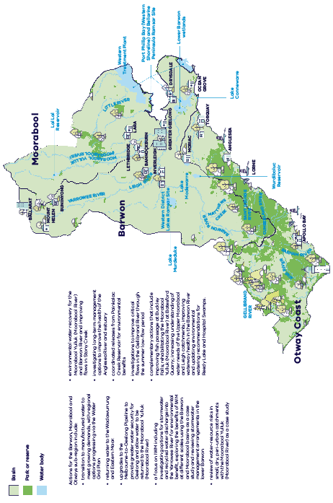
Figure ES.4: Barwon, Moorabool and Otways sub-region
Actions for the Barwon, Moorabool and Otways sub-region include:
- transition to manufactured water to meet growing demands, with regional options progressing via the Water Grid Plan
- returning water to the Wadawurrung and Eastern Maar.
- upgrades to the Melbourne-to-Geelong Pipeline to provide greater water security for Geelong and allow water to be returned to the Moorabool Yulluk (Moorabool River)
- a focus on IWM including investigating options for stormwater and recycled water discharge into the Yarrowee River for environmental benefit, exploring the benefits of IWM at different scales using the Barwon and Moorabool basins as a case study and reviewing stormwater management arrangements in the lower Barwon
- review of water-resource risks in small, dry, peri-urban catchments with the Moorabool Yulluk (Moorabool River) as a case study
- environmental water recovery for the Moorabool Yulluk (Moorabool River) and Barwon River and improving flows in Stony Creek
- investigating long-term management options to improve the health of the Anglesea River and estuary
- coordinated releases from Painkalac Creek Reservoir for environmental benefits
- investigations to improve critical flows in the Gellibrand River through the summer low-flow period
- complementary actions that include improving fish passage at Buckley Falls; rehabilitating the Moorabool Yulluk (Moorabool River) at Batesford Quarry; increasing understanding of water needs of the Upper Moorabool and Leigh catchments; improving waterway health in the Barwon River and updating environmental watering recommendations for Reedy Lake and Hospital Swamps.
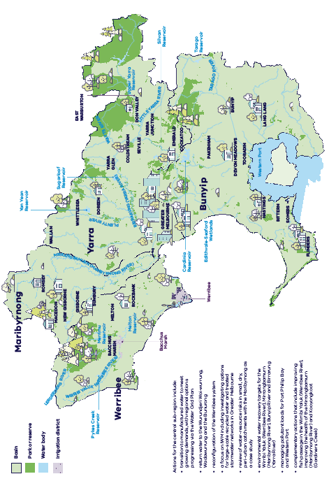
Figure ES.5: Central sub-region
Actions for the central sub-region include:
- transition to manufactured water to meet growing demands, with regional options progressing via the Water Grid Plan
- return water to the Wurundjeri Woi-wurrung, Wadawurrung and the Bunurong
- reconfiguration of the Werribee system • a focus on IWM including investigating options for large-scale recycled water and treated stormwater networks in Greater Melbourne
- review of water-resource risks in small, dry, peri-urban catchments with the Maribyrnong as a case study
- environmental water recovery targets for the Wirribi Yaluk (Werribee River), Mirrangbamurn (Maribyrnong River), Bunyip River and Birrarung (Yarra River)
- managing pollutant loads for Port Phillip Bay and Western Port
- complementary actions that include improving fish passage in the Wirribi Yaluk (Werribee River), improving the health of the Mirrangbamurn (Maribyrnong River) and Kooyongkoot (Gardiners Creek)
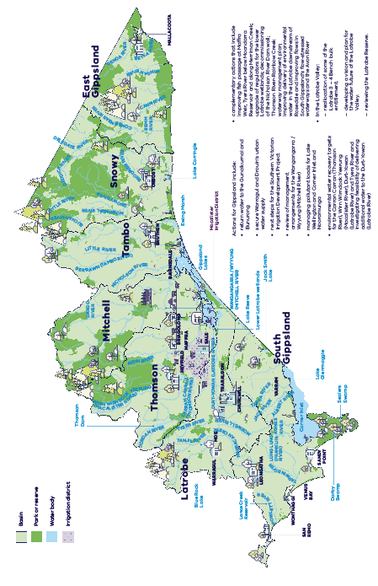
Figure ES.6: Gippsland sub-region
Actions for Gippsland include:
- return water to the Gunaikurnai and Bunurong
- secure Warragul and Drouin’s urban water supply
- next steps for the Southern Victorian Irrigation Development Project
- review of management arrangements for the Wangangarra / Wyyung (Mitchell River)
- managing pollutant loads for Lake Wellington and Corner Inlet and Nooramunga
- environmental water recovery targets for the Carran Carran (Thomson River), Wirn Wirndook Yeerung (Macalister River), Durt-Yowan (Latrobe River) and Tyers River and investigating feasibility of delivering additional water to the Durt-Yowan (Latrobe River)
- complementary actions that include improving fish passage at Maffra Weir, Tyers River below Moondarra Reservoir and along Merriman Creek; upgrade of regulators for the lower Latrobe wetlands; decommissioning of the Nicholson River Dam wall; Thomson River-Rainbow Creek waterway management plan; improving delivery of environmental water in the Latrobe downstream of Rosedale and improving flows in South Gippsland’s flow-stressed waterways and the Avon River
- In the Latrobe Valley:
  - reallocation of some of the Latrobe 3 – 4 Bench bulk entitlement.
  - developing a vision and plan for the water future of the Latrobe Valley.
  - reviewing the Latrobe Reserve.

Chapter 1 Our reality
Sustainable water strategies set directions and outline actions to meet current and emerging water challenges for all users in Victoria’s regions. They take a long-term view – the next 50 years – to describe the water challenges and set out actions to meet these challenges for communities, healthy rivers and wetlands, Traditional Owners, farmers, industries and tourism.

About the Strategy
The Central and Gippsland Region Sustainable Water Strategy (the Strategy) sets the direction and outlines actions for securing the region’s long-term water supplies to protect the jobs, farms, ecosystems, communities and Traditional Owners that rely on them..
Vision
The region will work together to ensure our waterways and aquifers can support a healthy environment and regional prosperity for current and future generations, the water needs of our cities, towns and regional communities are met and drinking water quality and public health are protected— even as the climate becomes drier and more variable — where agricultural, industrial and recreational activities can thrive and where Traditional Owners ongoing connection to water is recognised, respected and reinstated
The Strategy’s objectives are to:
- Secure the region’s urban water future and safe drinking water supplies by using water more wisely and efficiently and increasing the use of manufactured water sources
- Return water to Traditional Owners across the region and strengthen Traditional Owners’ role in water resource planning and management
- Maintain and improve waterway health for environmental and healthy Country outcomes
- Build the resilience of agriculture to a drying and variable climate
- Provide for social and recreational uses and values of waterways
The Strategy also embeds public health outcomes by providing for secure drinking water supplies and improved water quality.

The Central and Gippsland Region
The Central and Gippsland Region covers the waterways and catchments relied on by Victorians south of the Great Dividing Range, right down to the coast, and from the Otway Ranges in the west to Mallacoota in the east. This region is essential to the state’s liveability, sustainability and prosperity, as more than 6 million Victorians currently depend on its rivers, wetlands and lakes to live, work and play. As well as providing habitat for native wildlife, the region accounts for almost a third of Victoria’s agricultural production including approximately 33 per cent of Victoria’s milk products, 70 percent of Victoria’s eggs and poultry, and 70 per cent of the state’s vegetables. The Registered Aboriginal Parties (RAPs) and original custodians of the land and waters across this region are the Bunurong, Eastern Maar, Gunaikurnai, Wadawurrung and Wurundjeri Woi-wurrung peoples (Figure 1.1).
This Strategy replaces the former Central Region Sustainable Water Strategy (DSE 2006) and Gippsland Region Sustainable Water Strategy (DSE 2011a). A decision was made to combine the strategies to reflect the growing connections between the Melbourne supply system and cities and towns across the region including Geelong, Korumburra, Cowes and Wonthaggi.
The other two sustainable water strategies are the Northern Region Sustainable Water Strategy which was published in 2009 (DSE 2009) and the Western Region Sustainable Water Strategy (DSE 2011b) which was published in 2011.
Revocation of the Central Region Sustainable Water Strategy and the Gippsland Region Sustainable Water Strategy
The Minister for Water gives notice that under section 22G(3) of the Water Act 1989 she has revoked the Central Region Sustainable Water Strategy (DSE 2006) and the Gippsland Region Sustainable Water Strategy (DSE 2011a).
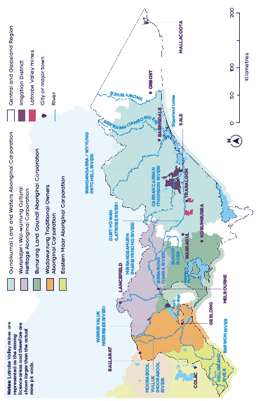
Figure 1.1. The Central and Gippsland Region and major waterways covered by this Strategy and the RAPs in the region. The RAP boundaries are current at June 2022

Water in the region
Water is essential for life and prosperity in the Central and Gippsland Region. We all rely on safe and affordable water for drinking and everyday use, to grow our food and power our industries and to keep our waterways healthy. The importance of water and sanitation for protecting human health has been highlighted during the COVID-19 pandemic. Water has a cultural and spiritual importance to Traditional Owners and supports community wellbeing by providing places for recreation and by keeping our suburbs and parks green and cool.
Figure 1.2 describes how the region uses a mix of water sources to meet different needs and demands.

Sources of water
River water is the main source of water for people in urban areas, industry and farms in the region, providing around 84 per cent of our water needs. River water is also essential for the environment to Traditional Owners and to support recreation and tourism. Appendix A shows the volumes of river water available across the region and its use.
Groundwater is used mostly for irrigating crops and dairy farms and for town water supplies where river water is unavailable or unreliable.
Victorian Desalination Project can supply up to 150 billion litres of water per year to Greater Melbourne and connected towns, which is about one-third of Melbourne’s annual water use.
Recycled water is used for agriculture, industry and other non-drinking purposes including watering sporting fields, trees and parks, and for residential or commercial uses (via purple pipe schemes).
Treated stormwater is used for a range of non-drinking uses including watering parks and gardens.
Rainwater tanks and small catchment dams are the main source of water for people in rural areas and the primary source of water for dryland agriculture. In urban areas, rainwater captured in tanks is used in homes and businesses to supplement or reduce the use of mains water. In peri-urban and rural areas, small catchment dams intercept water that is used to meet domestic and stock needs or, when licenced, used for irrigation and other commercial purposes.
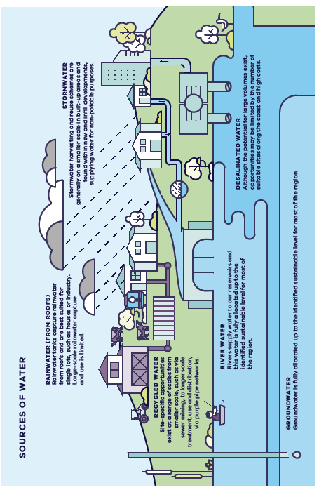
Figure 1.2. Sources of water for different needs, and opportunities for meeting demand

Water uses and values

Water for cities and towns
Cities and towns are the biggest water users, accounting for about half of the region’s water entitlements (707 gigalitres per year or 47 per cent). Residential water use accounts for the majority of the water used in cities and towns. Other water uses include non-residential customer use (such as for commercial, industrial or public open spaces) and system losses, mostly leakage (see Figure 1.3 and Figure 1.4). While only a small percentage of residential water use is for drinking and cooking, delivery of high-quality water is essential for the protection of public health.
Water is supplied to cities and towns through the Victorian water grid (see Figure 1.5). Much like our road network, dams and reservoirs (which collect and store river water), irrigation districts and the Victorian Desalination Project are connected via infrastructure including pipes, pumps and natural systems such as rivers. The growing demand for urban water is explained further in Section 1.3.

Water for agriculture
Agricultural production accounts for 39 per cent of river water and groundwater entitlements in the region (or 576 gigalitres per year). Water used for agriculture is concentrated in the Macalister, Werribee and Bacchus Marsh irrigation districts. Irrigators in the Werribee Irrigation District also use recycled water to supplement their river water entitlements. Outside major irrigation districts, farmers rely on water provided by natural rainfall on their land in combination with water diverted from waterways or groundwater aquifers to use or store in private licensed dams. See Chapter 7 for further details.

Water for Traditional Owners
Traditional Owners have never ceded rights to water. Traditional Owners in the Central and Gippsland Region own 2 gigalitres. Traditional Owners have cultural, spiritual and economic connections to water, but have been largely excluded from water planning, management and ownership since colonisation. See Chapter 6 for further details.

Water for the environment
Water for the environment is essential for healthy and resilient waterways and for the survival of native fish, platypus populations and other species. Healthy flowing waterways support recreation, tourism, Traditional Owner culture and the liveability of communities, as well as supporting the delivery of consumptive water. Currently, environmental entitlements are about 5 per cent of all water entitlements in the region (or an average of 70 gigalitres per year).
The environment also benefits from ‘above-cap’ water, which is water that is left over after limits (or caps) on diversions have been reached, and includes water that spills from storages after high rainfall and inflows. Across the Central and Gippsland Region, the estimated volume of above-cap water is 5,528 gigalitres. The valuable instream benefits this water provides include environment, recreation, domestic and stock use, and improved water quality for all river users. See Chapter 8 for further details.

Power generation and mines
Large volumes of high-reliability water are required for coal-fired electricity generation in the Latrobe Valley. While water will continue to be needed for electricity generation for some time yet, the transition away from coal-fired electricity generation offers the Latrobe Valley the potential for a water transition too. The Latrobe Valley mine operators are considering water-based options to rehabilitate the coal mines into safe, stable and sustainable landforms. The Victorian Government is guiding the rehabilitation of the mines via the Latrobe Valley Regional Rehabilitation Strategy.

Domestic and stock use
People can take water from a range of sources for their essential household and stock watering needs. This includes extracting water from a waterway that runs alongside or in their property, by capturing water in a small catchment dam or pumping groundwater. Where water is used for commercial purpose, a licence is required.

Social and recreational uses and values
Waterways and water bodies in the region are highly valued by Victorians for the wide range of recreational activities they offer and their contribution to the health, wellbeing and social fabric of communities. They support tourism and provide important economic benefits to regional Victoria.
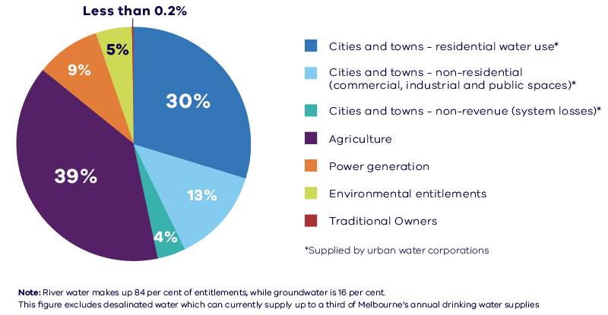
Figure 1.3. Approximate distribution of river water (or surface water) and groundwater entitlements across different uses in the Central and Gippsland Region
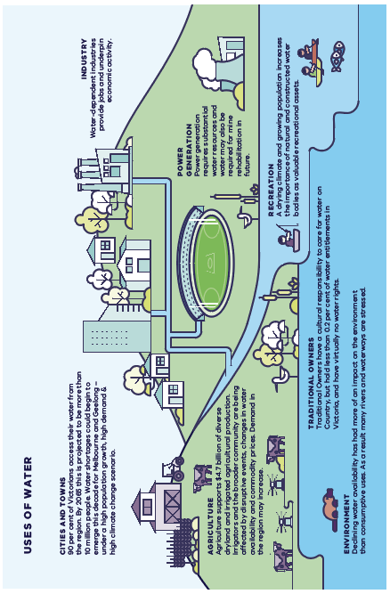
Figure 1.4. Various uses and values of water across the Central and Gippsland Region
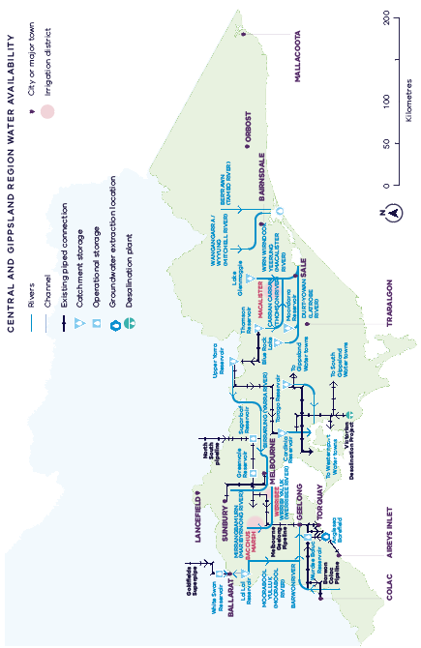
Figure 1.5. Victoria’s connected water grid in the Central and Gippsland Region

Our water challenges
The region’s key water challenges:
- Victoria is becoming warmer and drier with less water flowing into our water storages over the longer-term, and more frequent and extreme weather events.
- River water has already declined by as much as 21 per cent and is projected to decline by a further 8 to 22 per cent by 2065 under a medium climate change scenario.
- The demand for water is increasing as the region’s population is expected to grow from 6.2 million to over 10 million people by 2056.
- Agriculture and industry are under increasing pressure due to declining water supplies and population growth.
- Rivers need more water to prevent further declines in waterway health, to keep native species alive and to continue to support water uses and values across the region.
- Traditional Owners have a right to water justice.
Even with the current high storage levels, communities and waterways in region could need up to an extra 300 gigalitres of water over the next 10 years. This volume includes up to 85 gigalitres to meet urban water demand, up to 100 gigalitres to improve waterway health by meeting priority environmental water recovery targets, plus additional water for irrigation and a commitment to return water to Traditional Owners as new water supplies are progressed.

Climate change
The wetter-than-average conditions in 2021, annual desalination orders, and ongoing water efficiency measures, have meant that water supplies are secure in the short-term. No water restrictions are expected in any Victorian city or town in 2022 (DELWP 2021g).
While we will continue to experience some years of higher rainfall, climate change will mean that Victoria experiences higher temperatures, more frequent droughts and lower rainfall on average, which will result in less water being available for all uses. The Long-term water resource assessment for southern Victoria showed that streamflow across the region has already declined by up to 21 per cent (since 1975) (DELWP 2020a). Current long-term estimates of water availability are lower than estimates for previous sustainable water strategies. Greater declines have been observed in recent decades (since 1997), but it is uncertain if this reflects a long-term change.
In comparison to historical conditions, Victoria is already experiencing trends towards:
- higher temperatures and more hot days
- reductions in rainfall in late autumn and winter
- increases in rainfall during the warmer months and more frequent extreme rainfall events in some locations
- reductions in runoff and streamflow (DELWP 2021g).
Over the long-term, we can expect:
- persistent reductions in winter rainfall
- possible increases in summer rainfall
- increases in the intensity of short-duration rainfall events
- reductions in streamflow to continue.
Streamflows throughout the region are projected to decline by an additional 8 to 22 per cent under a medium climate change scenario by 2065 (relative to the period since 1975). Declines in streamflow of up to 40 per cent are predicted under a high climate change scenario in some catchments by 2065 (Potter et al. 2016). It is also possible that rather than undergoing a gradual drying trend, our streamflows have already undergone a step change, in which the drier conditions we have experienced since 1997 are here to stay. We need to prepare now for a range of future climate conditions.
How are we planning to manage more extreme events due to climate change?
While an overall trend of warmer and drier conditions is expected, the Victorian water sector has developed a plan for climate resilience to address more frequent and extreme weather events, including droughts, storms, floods and bushfires.
Water sector planning for climate change and resilience
The Climate Change Water Cycle Adaptation Action Plan 2022 – 2026 (DELWP 2022d) is helping the water sector to build resilience to our changing climate in the delivery of water, wastewater, drainage and flooding services.
Guidelines for the development of urban water strategies (DELWP 2021d) highlight uncertainties that water corporations must consider in their long-term water planning. These include climate change and variability as well as the effects of extreme events such as bushfires, major asset failure and poor water quality events. In accordance with these guidelines, urban water corporations must develop an urban water strategy for its supply area every five years.
Bushfires
The 2019-20 Black Summer bushfires were unprecedented in scale and intensity. These fires burnt more than 1.5 million hectares across Victoria and caused significant damage. They caused some water storages to be taken temporarily offline due to contamination from ash and debris, disrupting water supply and treatment for thousands of Victorians. Bushfires in water supply catchments can also cause longer-term impacts to the quality and quantity of water.
The Victorian Government’s bushfire recovery program is supporting the long-term recovery of East Gippsland’s waterways and catchments. The program is also helping to strengthen resilience in critical water infrastructure, for example by repairing riparian fencing and off-stream watering systems, replacing and improving water monitoring stations, repairing and upgrading water treatment plants, and installing backup solar power.
Extreme rainfall events, storms and flooding
More intense rainfall and storms will increase flooding, power outages and damage to water infrastructure. This was seen in June 2021, when Gippsland experienced a severe weather event with strong winds, heavy rains and flooding. The Victorian Government is supporting the recovery of Gippsland’s waterways and water infrastructure to prevent long-term compound impacts of the event and support communities and waterways to be more resilient in the face of future extreme weather events.
The Victorian Floodplain Management Strategy was developed by the Victorian Government to help communities better prepare for future floods (DELWP 2016a). This includes adapting to climate change to manage flood risk.
Excess stormwater runoff following severe weather events also carries pollution into waterways, disrupts natural flows and causes erosion, while warmer temperatures along with declining water flows could cause more frequent and widespread blue-green algae outbreaks. These outbreaks are a risk to human health and animals and can stop the recreational use of waterways.

Our growing population and increasing demands
Although it makes up just 25 per cent of Victoria’s land area, the Central and Gippsland Region supplies water to more than 90 per cent of the state’s population (over 6 million Victorians). The cities and towns south of the Great Dividing Range, from Warrnambool in the west to Mallacoota in the east, rely on water from this region. In 2020–21, more than 440 gigalitres of water were supplied to businesses, industries and urban residential customers (DELWP 2022c). The region’s population is expected to grow to over 10 million people by 2061 (Figure 1.6), which will significantly increase water demand.
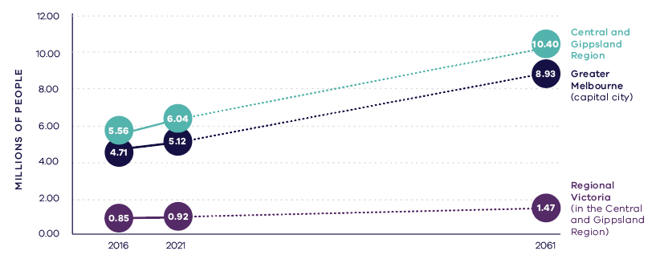
Figure 1.6. Past and projected populations of major Victorian regions 2016 to 2061 (Unpublished Victorian Government projections 2021)
Currently Melburnians use 50 to 70 gigalitres more water per year on average than flows into our storages, depending on rainfall, with desalinated water orders currently meeting this gap. Modelling shows that even with the Victorian Desalination Project operating at full capacity, the supply shortfall for Greater Melbourne and the connected systems could increase to 85 gigalitres per year by 2030 in a worst-case scenario (high climate change and high demand scenario) (Figure 1.7). Parts of Gippsland, such as the growing towns of Warragul and Drouin, are already experiencing supply shortfalls and rely on interim arrangements to supplement local supply.
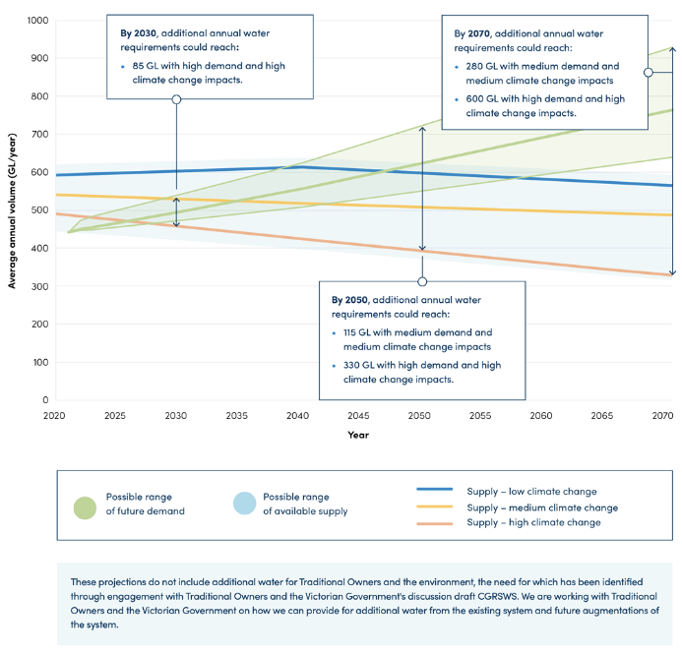
Figure 1.7. Projected future supply and demand under various climate change scenarios shows an increasing risk of water shortages over the next decade for Greater Melbourne and connected systems (Greater Western Water et al. 2022)
Over the long-term, modelling using different population growth and climate change scenarios shows the range of volumes that may be required. For example, Melbourne, Geelong and towns connected to the Melbourne supply system could need an additional 140 to 600 gigalitres per year over the next 50 years.
As well as water for cities and towns, farmers need new, climate-resilient water supplies to produce food including vegetables, milk, eggs and poultry close to urban centres. Years of drought and bushfires combined with drying conditions mean that farmers are seeking additional, and more reliable, water supplies for both irrigated and dryland enterprises.
Population growth and rapid urbanisation are also increasing stormwater runoff, which adversely affects our waterways unless it is treated and used.

Rivers need more water
Availability of river water in southern Victoria has declined by up to 21 per cent over the past 15 years, and this trend is likely to continue. All water users have been affected and in most rivers the environment now has a smaller share of available water.
Our reliance on rivers and dams to provide most of our water supplies, along with a drying climate, has come at a cost to the environment and Country. This dependence has also affected the recreational use of waterways. There is less water in our rivers and this is adversely impacting the environment, native fish, platypus populations and riparian vegetation. We need to act now to avoid an irreversible decline in river health and ecosystems and to ensure the survival of native species.
An estimated 380 gigalitres of water per year (on average) would be needed to meet the full environmental water requirements for major rivers in the Central and Gippsland Region over the long-term – a volume greater than Melbourne’s total annual residential water usage. To achieve the most critical environmental outcomes, such as the survival of native fish and platypus populations and help sustain river flows during summer, almost 100 gigalitres of water is needed over the next decade. To achieve this, we need to start reducing our reliance on rivers for urban water supply. We must also improve the delivery of existing environmental water and invest in complementary measures to maximise the benefits of the available environmental water.
Declining water availability also diminishes the recreational use and enjoyment of the region’s rivers, creeks and lakes. Low water flows during dry summers and droughts, and algal blooms, can lead to the closure of waterways for public use or fishing and the cancellation of major water sport events. While the Strategy focuses on how to increase environmental water entitlements in major rivers across the region, the adaptative management of our rivers is considered through the development of regional waterway strategies, taking into consideration community expectations and future environmental conditions.

Traditional Owners have a right to water justice
Traditional Owners have never ceded rights to water across Victoria. Aboriginal people hold less than 0.2 per cent of water rights in this state. This exclusion denies Traditional Owners the right to care for Country – the essence of Aboriginal social, spiritual, economic and physical wellbeing, and the basis of cultural lore. How water is shared and managed in the future needs to redress these historical injustices.

Meeting future water needs
This Strategy sets-out a range of management actions to ensure we have enough water to fully meet future needs for all users over the next 10 years. Some of the proposed actions can and will be implemented now to meet the water challenges of this region. Others will have longer lead-in times and need considerable additional planning and investigation with progressive decision points, such as large-scale manufactured water sources.
While water efficiency measures and other local water management actions help to reduce the demand on our existing water supplies, this alone will not meet all our future water needs. New water supplies will largely come from manufactured water resources – desalinated water, recycled water and treated stormwater – as there are no new largescale opportunities to take water sustainably from rivers or groundwater in the region. By 2050, manufactured water sources could supply up to 65 per cent of Melbourne’s water needs, up from 35 per cent in 2020. This could increase to 80 per cent by 2070 (See Figure 1.8).
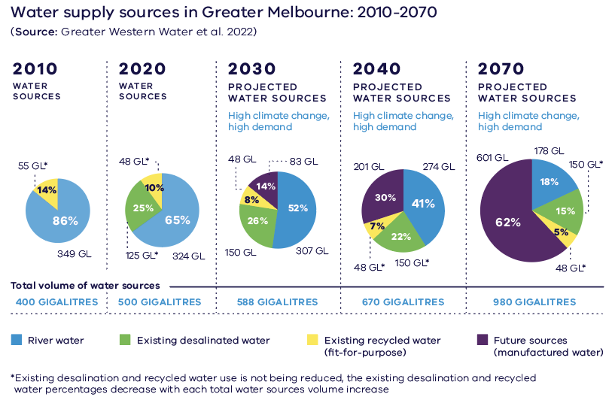
Figure 1.8. Greater Melbourne’s expected transition to using more manufactured water between 2010 and 2070
As the use of manufactured water increases, some river water will be freed up for other uses, such as returning water to Traditional Owners and to the environment, without taking water away from farmers or other water users. Farmers will be supported to adapt and expand their businesses in an increasingly dry climate with advice, incentives and investment in water efficiency. They will also have greater access to water supplies that don’t rely on rainfall, including recycled water and treated stormwater. We will monitor areas of significant water use, for example small catchment dams and plantations, to identify potential risks to the sustainable management of water resources.
Keeping a broad and varied portfolio of new water sources is ideal, so we can respond to range of possible future conditions. However, not all options align with current government policy, and these options, while not modelled or assessed in detail, were considered in the initial analysis of opportunities and deemed to be unviable. The range of options considered to increase water supplies across the region is shown in Figure 1.9 and Table 1.1.
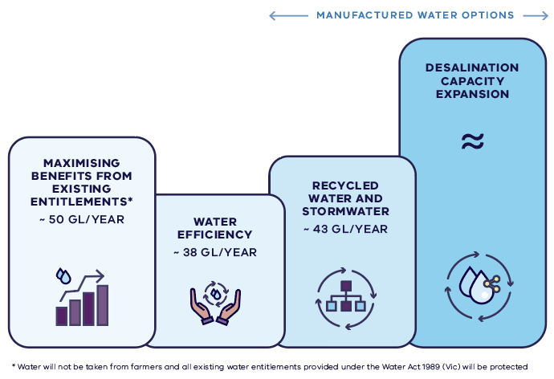
Figure 1.9. Options identified in the Strategy for additional water to be progressed
Table 1-1. Options to increase water supply
Possible Option | Viability | Description | Reference
Water efficiency - cities and towns | Viable (but limited) | The Strategy proposes to yield up to 38 gigalitres of water savings. | Chapter 2
Water recovery – irrigation modernisation | Viable (but limited) | Water is being recovered through modernisation works. | Section 7.3
Underutilised entitlements held by public agencies | Viable (but limited) | Opportunities identified were the Latrobe 3 – 4 Bench bulk entitlement and water entitlements in the Birrarung (Yarra River) previously held by Amcor. | Section 4.3
Non-potable use of recycled water, treated stormwater and rainwater | Viable | The Strategy proposes to use IWM to drive investment and collaboration, which could deliver up to 43 gigalitres per year. | Section 3.3 to 3.5
Desalination capacity expansion | Viable | Seawater is a highly abundant resource and possible additional desalination capacity could deliver incremental increases in water supplies as demand for water grows. | Section 3.2
Increased use of river water in unregulated catchments | Limited viability | There is only a small volume of water under local caps which remain available for allocation in unregulated catchments in Gippsland and the Otways. | Section 4.3
Increased use of groundwater | Limited viability | There is only a small volume of water under local caps which remain available for allocation. | Section 4.3
Water savings – on farm savings | Limited viability | Irrigators are responsible for investments that provide private benefits. | Section 7.2
Build more dams | Unviable | No additional potential sites that could provide regionally significant improvements in urban water security, without significant negative consequences for people and the environment.
Greater use of the north-south pipeline | Unviable | Creates water shortfalls in northern Victoria.  Provides a valuable emergency water supply but is not considered an augmentation option that increases supply
Potable use of recycled water | Unviable | Recycled water is currently not a permitted source of drinking water.  Does not have social licence, partly due to concerns about emerging contaminants
Purchasing or taking back water from farming or placing limits on domestic and stock water rights | Unviable | The Victorian Government does not support purchasing or taking back water from farming due to the socio-economic impacts.
Water entitlements currently used for power generation | Unviable | May be needed as part of the transition of power generation in the Latrobe valley.
Restrict supply (severe restrictions / potential shortfall) | Unviable | Water is a human right and shortfalls are not socially/economically acceptable.

Water efficiency
Water efficiency will continue to be a focus with campaigns, regulations, and incentives to help people and businesses to use water efficiently and save up to 38 gigalitres per year across the Central and Gippsland Region. A new target 150 campaign will encourage Melburnians to reduce their water use to 150 litres per person per day, and similar campaigns will be developed by water corporations for regional areas. While water efficiency measures will help to reduce the demand on our drinking water supplies, this alone will not meet all our future water needs.

Transitioning to manufactured water
To manage the challenges of population growth and climate change, the region will need to reduce its reliance on river water and transition to using more manufactured water. In the near term, manufactured water sources will largely come from additional desalination supplies because, unlike recycled water, desalinated water can be supplied directly into the drinking water system. Desalination has the added advantage of being completely rainfall independent and can operate at its full design capacity immediately after construction. In the medium to longer-term, the region will need to dramatically increase the use of recycled water and treated stormwater for non-drinking purposes to complement desalinated water supplies. Large volumes of recycled water and treated stormwater could be used for agriculture and industry if available at the right place, quality and time. Smaller, local recycled water and stormwater systems could be used for non-drinking purposes such as irrigating ovals, parks and gardens, helping to support greener, cooler and more liveable communities.
Options identified in this Strategy for new manufactured water supplies (Figure 1.9) include:
- using IWM to drive greater use of recycled water and stormwater and improve liveability. This includes investigating large-scale recycled water supply networks in Greater Melbourne and Geelong and smaller recycled water and stormwater reuse projects across the region. This could deliver 43 gigalitres per year in the next decade and 200 gigalitres per year by 2070.
- potential 50 gigalitre expansion of the Victorian Desalination Project at Wonthaggi
- expansion of desalination capacity.
- The transition to manufactured water will help meet the strategy’s commitment to return water to rivers for priority environmental outcomes plus a commitment to return water entitlements to Traditional Owners. In most major rivers, this will occur as new sources of manufactured water are brought online to supply water to the cities and towns in the region. The scale and timing of the investment in additional manufactured water supplies will determine how quickly we can reduce our reliance on rivers, and by how much.

Maximising benefits from existing entitlements
As well as using water more efficiently, and growing the region’s water supplies, the Strategy commits to improving how we use and share water to deliver multiple benefits.
Water will be moved around Victoria’s water grid to meet the immediate priorities of some of the region’s fastest growing areas such as Geelong, Warragul and Drouin and flow-stressed rivers.
Decisions on how we share and use unallocated water will ensure opportunities to return water to Traditional Owners are progressed and other water uses and values are considered. There is approximately 10 gigalitres of unallocated river water and 9 gigalitres of unallocated groundwater in the region, generally in areas where demand has been low historically.
We will progress opportunities to reallocate water held by public agencies that is no longer needed for its intended purpose, including approximately 16 gigalitres from the Latrobe 3 – 4 Bench entitlement that was originally intended to support the expansion of coal-fired electricity generation and a 1.4 gigalitre water licence to the Birrarung (Yarra River) formally used by the Amcor Paper Mills.

Enabling the water sector
A secure water future for the region relies on action in houses, on farms, at water storages, at the desalination plant and right across the Water Grid. Oversight, planning and implementation of the water management actions is split into two scales – the region, led by the Department of Environment, Land, Water and Planning, and the local level, led by water corporations.
The Strategy considers the broad range of water supply and demands across the region. Meeting the significant needs of our cities and towns is undertaken by urban water corporations and documented in their urban water strategies. Across the region, there are eight urban water strategies, with a single one completed for Melbourne by Greater Western Water, Melbourne Water, South East Water and Yarra Valley Water.
Each urban water strategy is implemented, at the local scale within the water corporation’s boundary, consistent with the directions outlined in this Strategy. Each urban water corporation across the region will investigate options for reducing their reliance on river water and greater use of manufactured water. This will enable the Victorian Government to understand how commitments around returning water to the environment and Traditional Owners can best be met, subject to required investment.
This two-scale approach ensures that decisions that can be implemented locally are, but those situations which are better resolved at a regional scale can be facilitated across water corporations’ boundaries by the Department of Environment, Land, Water and Planning. Figure 1.10 shows the role of both sustainable water strategies and urban water strategies.

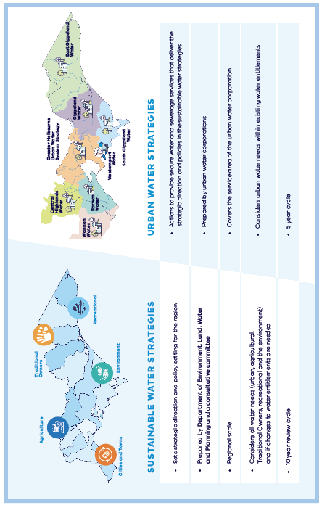
Figure 1.10. Role of the sustainable water strategies versus urban water strategies in the Central and Gippsland Region
Local options will be considered alongside regionally significant options identified in the Water Grid Plan using a preliminary quadruple-bottom-line assessment by the Department of Environment, Land, Water and Planning. The best value package of projects across the region that will meet the needs of cities and towns while enabling some water to be returned to rivers will be progressed – some implemented by one water corporation, others implemented across water corporation boundaries.
This two-scale approach – the Strategy together with the eight complementary urban water strategies – will ensure that decisions on planning and investment in new major infrastructure and supplies are made at the right time, so that we have the best options ready when we need them, supporting a secure water future for all users across the Central and Gippsland Region.

How we developed the Strategy
The Strategy was developed by the Victorian Government (Department of Environment, Land, Water and Planning) in partnership with Traditional Owner groups, water corporations, catchment management authorities, and the Victorian Environmental Water Holder. Representatives from these groups and authorities formed a ministerially appointed consultative committee that guided the Strategy’s development. An independent panel oversaw the Strategy’s development with a particular focus on community engagement (see Appendix B).
This is the first Strategy of its kind to be developed in partnership with Traditional Owners from the region. Representatives from four RAPs formed a Traditional Owner Partnership that collaborated in the decision-making with government and with the water industry and guided the development of the Strategy. Read more about the Traditional Owner Partnership and its role in Chapter 6.
Sustainable water strategies are legislated through the Water Act. The Water Act sets out what must be included the Strategy, how a consultative committee and panel should be appointed and their responsibilities and the requirements for public consultation. A summary of what must be included in the Strategy is provided in Appendix B.

Technical data and modelling
The Strategy reflects best available data and evidence that was prepared and collated by policy working groups set-up to support the development of the Strategy. For example, the environmental working group with representatives of waterway managers across the region developed the environmental water recovery targets for major rivers in the region using the latest environment flow studies and modelling.
The Strategy draws on data from several technical reports and water sector strategies, including modelling on the long-term availability of surface water (river water) was taken from the 2020 Long-term water resource assessment for Southern Victoria (DELWP 2020a) while latest data on urban water supply and demand projections was sourced from urban water strategies such as the Greater Melbourne Urban Water and System Strategy (GMUWSS) (Greater Western Water et al. 2022). The links between this Strategy and urban water strategies are described in Figure 1.10.

Greater Melbourne Urban Water and System Strategy
The Strategy was developed in parallel with the GMUWSS allowing policy alignment and sharing of best available modelling and data. The GMUWSS was developed by Greater Western Water, Melbourne Water, South East Water and Yarra Valley Water and includes updated urban water supply and demand projections, climate change and population scenario modelling over the next 50 years as well as a range of new water supply options and plans to respond to drought and extreme events across Greater Melbourne and the connected system. The policy directions in this Strategy have informed the development of the GMUWSS and the technical and modelling data from the GMUWSS have been key inputs to this Strategy.

Engagement
The Strategy has been informed by stakeholders and the community based on two stages of engagement. Preliminary engagement helped shape the discussion draft of the Strategy (DELWP 2021b). The goal was to understand the community’s and key stakeholders’ challenges and considerations to inform the Strategy’s discussion draft (Figure 1.11).
The discussion draft was released for community consultation from October to December 2021. In line with COVIDSafe settings in Victoria, all engagement was via online forums, including a virtual consultation room, interactive community information sessions, webinars, and stakeholder forums (see Figure 1.11). Feedback was provided via 225 survey responses, 22 comments on proposed directions or chapters and 58 submissions.
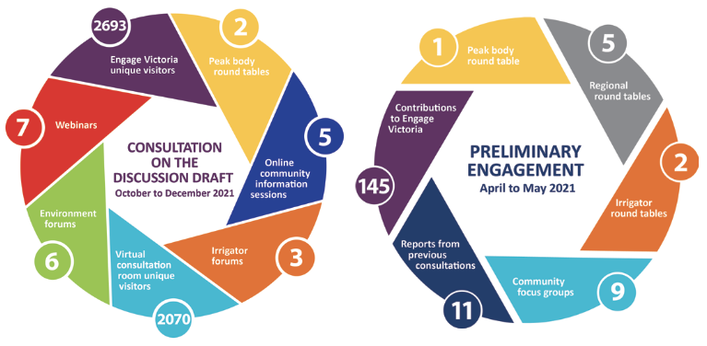
Figure 1.11. Summary of the Strategy engagement
The results should be viewed considering the sample of people who responded. Of the respondents, 65 per cent represented community or environmental groups and 61 per cent were from the central sub-region, which covers Melbourne.
All community engagement feedback was considered and informed the Strategy’s development. High-level themes that emerged from the consultation are listed in the box below
High-level themes emerging from consultation
Theme: Concern for the environment and health of waterways
Our response: A dedicated chapter on healthy waterways explains how we will achieve environmental outcomes by returning water to the environment, investing in complementary works and infrastructure upgrades, and other actions to improve how we use and share water to benefit the environment (see Chapter 8).
Theme: Support for new sources of water
Our response: A revised chapter on manufactured water explains how we will increase the use of recycled water and stormwater while protecting human health and the environment (see Chapter 3), as well as role of desalination.
Theme: The discussion draft lacks detail
Our response: Chapter 3 provides greater detail on how we will expand manufactured water supplies in the future and Chapter 9 provides more information on the associated roles and responsibilities. Chapter 8 of the Strategy provides more detail on how we will achieve environmental outcomes, which includes returning water to the environment. The implementation plan (Appendix E) sets out who is responsible for each action, indicative timeframes, and actions that require targeted community and stakeholder engagement. The Water Grid Plan will provide more detail on regionally significant options for increasing our water supplies as readiness work progresses.
Further details on the consultation and feedback are provided in the What we heard report (DELWP 2022a).

Actions at a glance
THE STRATEGY IDENTIFIES 41 POLICIES AND 96 ACTIONS TO DELIVER WITHIN THE NEXT 5 YEARS, 10 YEARS AND BEYOND, WHICH WILL:
- Support people, businesses and schools to continue to use water efficiently (Chapter 2 - Using water efficiently)
- Plan for how we could double our water supplies over the next 50 years by using more manufactured water – desalination water, recycled water and treated stormwater – for a range of uses (Chapter 3 - Transitioning to manufactured water)
- Improve how we share the benefits of our limited water resources, without compromising existing water entitlements (Chapter 4 - Sharing water for multiple benefits)
- Restore water justice to Traditional Owners, including by returning water to Traditional Owners (Chapter 6 - Water justice for Traditional Owners)
- Support farmers adapt and expand in a drying climate by using water more efficiently and through greater use of recycled water and treated stormwater (Chapter 7 - Water for agriculture)
- Return water to the environment in major rivers in the region in the next 10 years and deliver environmental works and complementary measures (Chapter 8 – Healthy waterways For all)
- Commence planning for preferred future urban water supply options so new water supplies are ready when they are needed (Chapter 9 - A new approach to planning and delivering water)

Chapter 2: Using water efficiently
The region’s population is expected to grow from 6.2 million people to more than 10 million people by 2056, increasing the demand for drinking water and water for household use (DELWP 2019b). The wetter-than-average conditions in 2021, annual desalination orders, and ongoing water efficiency measures have meant that water supplies are secure in the short-term however climate conditions can change quickly, and we need to prepare for a future with longer, drier periods and less reliable rainfall. Small water savings can accumulate to make a big impact on the region’s long-term water supplies.

By saving a little, we can all save a lot
Victorians have a strong track record of saving water, achieving large reductions in water use during the Millennium Drought and maintaining those savings in recent years. During periods of drought, Victorians have embraced voluntary campaigns such as Melbourne’s Target 155 campaign and the regional campaign Target Your Water Use (see Figure 2.1). Since 2001, residential water use in Melbourne has dropped by a third (Melbourne Water et al. 2020) and Geelong uses less water today than in the early 1980s, despite doubling its population.
Using less water has many benefits in both wet and dry years. In the short-term, water efficiency initiatives can help to defer and reduce the number of future water supply infrastructure investments required, by easing the demand on drinking water supplies, largely from river water. For households and businesses, reducing water use helps to lower water and energy bills (from hot water use). By using water more efficiently, we can also reduce the amount of wastewater we need to treat and leave more water in storages, rivers and aquifers to support other water uses and values. Water efficiency on farms and in irrigation districts is discussed in Chapter 7.
Efficient water use is the most cost-effective way to manage growing water demands, but the water-saving behaviours and gains already in place mean that the potential for further savings is diminishing. Water efficiency measures will continue to help reduce demand and can help us to meet our future water needs in combination with new water supply options. To meet our future water needs, the region must increase its use of manufactured water (desalinated water, fit-for-purpose recycled water and treated stormwater). This will also help us to manage the impacts of drought, bushfires and more variable weather conditions (see Chapter 3).
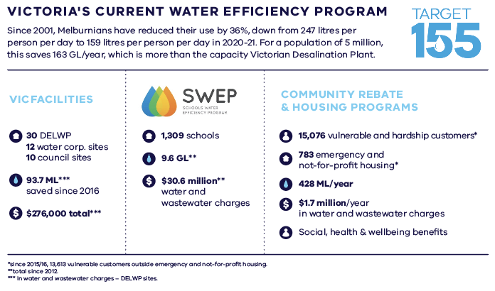
Figure 2.1. Key components of the Victorian Government’s current Water Efficiency Program
Policy 2-1: Promotion and investment in water efficiency
Promotion and investment in water efficiency across all users are foundational elements of water management to enable all users to contribute to securing the region’s water supplies.

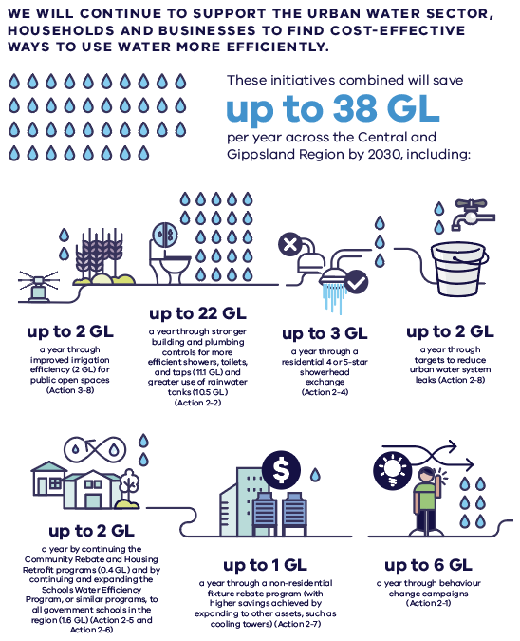
Figure 2.2. Supporting the urban water sector, households and businesses to find cost effective ways to use water more efficiently

Water efficiency at home
Our plan:
- increase community awareness of water supply demands and challenges and promote simple ways to reduce water use at home

Changing behaviours at home
Households are responsible for about two-thirds of the water used in cities and towns in the region. As our population grows, and climate change makes rainfall less reliable, we all need to continue to find ways to save water at home. More than half of Melbourne’s water customers preferred to make changes at home rather than pay higher water bills, when surveyed in 2017 Melbourne Urban Water Strategy consultation.
Following the Millennium Drought, residential drinking water use in Melbourne decreased from 247 litres per person per day in 2000–01 to 159 litres per person per day in 2008–09. However, as the Millennium Drought recedes from memory, community awareness of the need for water efficiency is declining. For example, residential water use in Melbourne has plateaued, with an average of 159 litres per person per day in 2020-21 and sales of relatively inefficient 3-star washing machines have increased (Institute for Sustainable Futures 2018). There are many ways that we can reduce our water use without reducing our quality of life, such as using more efficient fixtures and appliances, watering our gardens more efficiently or installing rainwater tanks for garden irrigation.
In 2019–20, the Make Every Drop Count campaign encouraged people to limit their water use to 155 litres per person per day (Target 155). Equipped with better data, we now have an opportunity to refine behaviour-change programs to focus on those water uses that will bring the greatest savings. We will work with urban water corporations to develop new campaigns that help people continue to reduce their water usage at home. This includes using smart technology, such as digital water meters, to track water use and make simple and cost-effective changes at home.

New daily water use targets
While average residential water use in Melbourne was 159 litres per person per day in 2020–21, many residents are using less. In a recent survey, 54 per cent of sampled households in Melbourne were using less than 150 litres per person per day (Figure 2.3). In light of this, we are changing Melbourne’s average per capita water use target from 155 to 150 litres per person per day. Similarly, water corporations will explore per person water use targets for regional areas that allow for geographical differences through their urban water strategies. Performance against all targets will be published in water corporation annual reports.
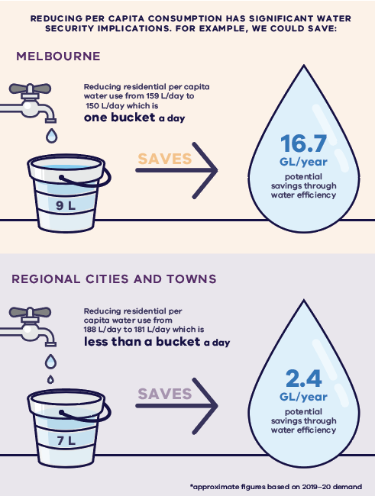
Figure 2.3. The significant water security implications from reducing per capita consumption

Action 2-1: Changing behaviours at home
Urban water corporations, in partnership with the Victorian Government, will help people change water behaviours at home by:  - setting a new aspirational average water use target for Melbourne of 150 litres per person per day, with regional water corporations setting equivalent per capita targets reflective of local conditions  - developing and investing in water efficiency behaviour-change campaigns targeting residential users likely to generate the greatest water savings  - using new technologies, such as apps and digital water meters that provide daily usage data, to encourage behaviour change. | By 2024

Water-efficient buildings and rainwater tanks
In urban areas, rainwater captured in rainwater tanks can be used in homes and businesses for a range of uses such as flushing toilets, watering gardens and washing clothes, helping to save valuable drinking water supplies. The availability of rainwater depends on the amount of rain, tank size, number of connections (such as toilets) and area of roof harvested, as well as the number of tanks installed and operating effectively at any given time.
In 2018, an estimated 6.5 gigalitres of rainwater was captured in Greater Melbourne by residential buildings (5.3 gigalitres), and commercial and industrial premises (1.2 gigalitres). Rainwater use is generally higher in recently built homes that have tanks connected for both internal and external use and in properties without potable water access in peri-urban areas. Even with less rainfall, there is an opportunity to increase the overall volume of rainwater we use through greater uptake of properly installed and maintained rainwater tanks. Increasing the use of rainwater tanks also reduces harmful urban stormwater impacts, by reducing the amount of stormwater that flows into waterways and bays from the urban drainage system. Other actions to reduce the impact of stormwater are discussed in Chapter 3.
Fixtures that use water such as showerheads, toilets and taps have become much more water efficient, without detrimental impacts on useability. While more efficient fixtures are sometimes more expensive, they save a lot of water (and for taps and showers they save energy too from reduced hot water use) which means there is a relatively rapid return on this investment. For example, the additional cost of purchasing a 4 or 5-star showerhead (instead of a 3-star showerhead) will be paid back within two years.

Building and plumbing controls
Although individuals in established homes may install a rainwater tank as a personal choice, a Victorian variation to the 2019 National Construction Code (NCC) for efficiency requires all new freestanding homes and townhouses to install either a rainwater tank or a solar hot water system. Of these properties, approximately one-third of new homes currently choose to install tanks.
This variation will likely cease due to proposed national updates to energy efficiency standards that will supersede the energy component of this variation. In its place, we will implement new Victorian variations for water efficiency in the 2022 version of the NCC. These variations, for both rainwater tanks and water-efficient fixtures, will ensure that Victorian water efficiency requirements remain visible to practitioners through the NCC.
In addition, we will investigate the cost and benefits of new Victorian regulations to:
- improve and extend current rainwater tank requirements
- introduce higher water efficient fixture standards for all buildings.
A regulatory impact statement will be prepared to test and consult on these potential changes to state regulations, which would complement the NCC variations.
Regular maintenance is needed for tanks to function correctly, so ways to improve the maintenance and functionality of tanks will also be assessed to help increase water efficiency and support implementation of any future tank requirements.
Action 2-2: Water-efficient buildings
The Victorian Government proposes to implement new variations to the National Construction Code, and stronger state building and plumbing regulations for water efficiency, to improve the water efficiency of all buildings, subject to a regulatory impact statement and stakeholder and community consultation. | By 2024

Better information and standards for appliances
Water efficiency labels and ratings for appliances are set nationally, through the Water Efficiency Labelling and Standards (WELS) scheme, and help consumers make informed choices about the water-using products they are buying. While most appliances and fixtures display water efficiency rating labels, or provide this information online, currently only washing machines and toilets have minimum water efficiency standards that must be met at the point of sale. However, minimum WELS standards for showers, taps, dishwashers (all 3-star) and urinals (2-star) are being considered, including changing the minimum standard for toilets from 1-star to 3-star, to align with NCC water efficiency requirements.
Applying minimum standards to a wider range of products would prevent the sale of inefficient products. It would also ensure the sale of more water efficient products and the replacement of old appliances with more efficient models. In the longer-term, this would encourage innovation and reduce the cost of the more efficient products (by increasing their sales and range), while phasing out inefficient products.
Action 2-3: Better information and standards for appliances
The Victorian Government will advocate for stronger minimum Water Efficiency Labelling and Standards (WELS) scheme ratings for appliances and fixtures, and will collaborate with water corporations to increase awareness of WELS ratings and minimum standards in Victoria. | Ongoing

Showerhead replacement
About 40 per cent of all water used in the home is used in the bathroom. Replacing an inefficient showerhead is a cost-effective and simple way to reduce water and energy use and save money on household bills. Replacing a very inefficient showerhead (1-star or 2-star) with a 4-star showerhead can save a family of four around $315 per year in water bills, plus significant energy savings.
Discounts on low flow (6.0-7.5 L/min) water-efficient showerheads are already offered through the Victorian Energy Upgrades program. Between September 2006 and May 2010, 390,000 showerheads were exchanged under the Melbourne Showerhead exchange program, and savings were estimated to be in the order of 12.7 gigalitres per year. To encourage even more people to replace their ineffective showerheads, we will investigate options to extend this program, such as offering free installation.
Action 2-4: Showerhead replacement
The Victorian Government will develop a business case to expand statewide incentives for water-efficient showerheads and implement initiatives. This could include incentives for even more efficient showerheads or offering free installation. | By 2025

Assistance for customers who are vulnerable or experiencing hardship
Victorian urban water corporations offer rebates for customers who are vulnerable or experiencing hardship to upgrade and fix water-using fixtures and appliances, and fix leaks, to increase water efficiency. The Community Rebate Program targets low-income and vulnerable water customers by improving the water efficiency of their homes, leading to lower water bills and increased wellbeing. The Community Housing Retrofit Program assists not-for-profit organisations providing housing for individuals or families in a vulnerable or hardship situation.
Since July 2015, the Community Rebate and Community Retrofit programs have assisted 15,859 water customers, saving more than 428 megalitres of water a year. This equates to total annual bill savings of $1.7 million or approximately $90 per customer, or $435 per social housing property.
Action 2-5: Community rebates and community housing retrofits
Urban water corporations will continue to support customers who are vulnerable or experiencing hardship to become more water efficient and reduce their water bills through the Community Rebate and Community Housing Retrofit programs. | Ongoing

Water efficiency in schools, businesses and industry
Our plan:
- help schools, businesses and industry to monitor and reduce their water usage through targets and incentives

Waterwise schools
The Schools Water Efficiency Program helps students to learn about water efficiency and track the school’s water use online, including by detecting leaks. An ongoing review of the program (at the end of each school term) shows that about 28 per cent of water used by schools is due to leaks and unnecessary usage. Since 2012, more than 1,309 Victorian schools (more than 50 per cent of all Victorian schools) have signed up to the program, saving a total of 9.6 gigalitres that would have cost more than $30.6 million in water and wastewater charges up to December 2021.
To encourage more schools to be waterwise, the Schools Water Efficiency Program, or other similar digital metering and education programs, will be expanded to all government schools in the Central and Gippsland Region by 2030. Non-government schools will also be strongly encouraged to participate.
Action 2-6: Waterwise schools
The Victorian Government, in collaboration with water corporations, will ensure that all government schools in the Central and Gippsland Region become waterwise, by participating in the Schools Water Efficiency Program (including use of school curriculum material) or other similar digital metering and education programs, by 2030, with a mid-term target of capturing 80 per cent of government schools by the end of 2026. | By 2030  (with a mid-term target of 80% by end 2026)
Maximising water efficiency in business and industry
Non-residential customers – including businesses, industry and institutions – account for 28 per cent of water used in cities and towns across the Central and Gippsland Region, and are becoming increasingly water efficient. In Melbourne during the Millennium Drought, non-residential water customers collectively reduced their water consumption by almost 20 per cent, making a significant impact on the state of the region’s water storages (DELWP 2020b).
New programs will be developed to target the non-residential water users most likely to generate the greatest water savings, to encourage them to continue using water more efficiently and to actively involve them in achieving long-term water security for the region. These programs could use digital meters and water usage benchmarking to help these customers better understand and lower their water use.
Action 2-7: Maximising water efficiency in business and industry
Urban water corporations, in partnership with the Victorian Government, will implement a targeted non-residential water efficiency program, including investigating the merits of:  - benchmarking water usage across business and industry  - re-introducing Water Management Action Plans (a tool used successfully during the Millennium Drought)  - rebates for digital water meters (for large water users not captured by other programs) or other water efficiency upgrades. | By 2025

Targets for reducing urban water system leaks
Australia has among the lowest levels of water system leakage in the world, but 10 per cent of Australia’s drinking water is lost to leaks every day (WSAA 2019). In the Central and Gippsland Region, system losses account for approximately 8 per cent. Over the past 10 years, there have been significant advancements in leak identification methods, often involving the use of electronic monitoring, including digital metering. Reducing leaks across the urban water network can save large quantities of water and money. For example, Central Highlands Water reduced system losses (mainly through leakage reduction) from as much as 20 per cent in the early 2000s to just 10–11 per cent in 2017, saving 1.3 to 1.5 gigalitres per year.
To encourage further water savings, urban water corporations will set individual targets for leakage reduction (where possible), that look beyond the costs and benefits to their businesses and consider broader social and environmental costs and benefits. Targets will vary, because the costs and benefits of reducing leaks across different water supply systems are dependent on local conditions and system characteristics, such as the age of supply system infrastructure.
Action 2-8: Targets for reducing urban water system leaks
Urban water corporations will  - set targets (where possible) for managing distribution system leaks and losses, which consider the broader social and environmental costs and benefits  - work with the Essential Services Commission, Bureau of Meteorology and Water Services Association of Australia to review annual leakage reporting and increase transparency and benchmarking of leakage performance. | By 2025

Transitioning to manufactured water
As our population grows and river water becomes scarcer, the Central and Gippsland Region will need to reduce its reliance on river water. While water efficiency measures and better use of existing supplies are important, these alone will not meet future demand. Instead, a transition to using more manufactured water (desalinated water, fit-for-purpose recycled water and treated stormwater) will be required to supply our cities and towns.

Transitioning to manufactured water

Manufactured water sources include desalinated water, recycled water and treated stormwater.
Water efficiency measures and better use of existing supplies continue to be a focus, but these alone will not meet the widening gap between water supply and demand. Greater Melbourne has a current shortfall of 50 to 70 gigalitres per year, depending on rainfall, and this could increase by an additional 85 gigalitres by 2030 in a worst-case scenario (high climate change and high demand scenario).
Modelling shows that the Central and Gippsland Region is likely to need additional water supplies within the next 10 years. Water supplies may also need to double over the next 50 years to meet demand. We must start planning now for a range of near-term water supply options so that new urban water supplies are ready for delivery when they are needed.
There are no new large-scale opportunities to extract water sustainably from rivers or groundwater supplies in the region. New water supplies will largely come from manufactured water resources such as desalinated water, recycled water and treated stormwater. Building new dams is not an option because suitable dam sites have been exhausted. In the future there will also be less rainfall on average to refill dams. Dams do not create water, so any new dams would source water from elsewhere, either from the environment or other supplies. Groundwater also relies on recharge from rainfall and is not a climate-independent water source.
For Melbourne, Geelong and cities and towns connected to the Melbourne Supply System, manufactured water sources will need to meet 65 per cent of water needs by 2050, up from 35 per cent in 2020. This could increase to 80 per cent by 2070 (see Figure 1.8). In the near term, manufactured water sources will largely come from additional desalination supplies. There is also potential for other water sources – recycled water, treated stormwater and rainwater via household tanks – to supply up to 20 per cent (or 200 gigalitres per year) of non-drinking water needs by 2070 across Greater Melbourne.
New water supplies will be matched to fit-for-purpose uses and adhere to state and national water quality guidelines, to protect public health and the environment. The water supply cost, quantity and quality will also influence how water can be used.
Desalination provides us with safe, affordable and reliable water direct to our drinking supplies, which we need in the near term. Desalination has the added advantage of being completely rainfall independent. It can operate at its full design capacity immediately after construction, so that we can be confident in the volume of water it will deliver.
There are still aspects about other manufactured water sources that we need to better understand, but they remain integral to securing our water supplies. Through smart investment now, and as technology evolves and our understanding of how to capitalise on manufactured water grows, we can unlock the potential of all manufactured water sources. This will ensure we have a diverse and adaptable portfolio of water supply options in the future.
Investments in new water supplies will balance the region’s growing water demands with the need to keep water bills affordable. As the use of manufactured water increases, some river water will be freed up for other uses, such as returning water to Traditional Owners and to the environment, without taking water away from farmers or other water users (see Chapter 9).
The role of recycled water and stormwater usage for agriculture is discussed in Chapter 7.
Links to the Water Grid Plan
Options for future, regionally significant urban water supplies will be progressed via the Water Grid Plan, a new infrastructure plan that will be released in 2023.
The Water Grid Plan will include a portfolio of projects to help meet short to medium-term urban water supply needs and will include options to increase manufactured water supplies. It will align with options included in this Strategy.
Smaller, but important local projects to increase use of manufactured water, will be progressed by water corporations or through IWM forums.

Increasing desalination supplies
Our plan:
- investigate options to expand the region’s desalination supplies to meet future needs
- progress regionally significant urban water projects through the Water Grid Plan

The role of desalinated water
Regular desalinated water orders from the Victorian Desalination Project are an integral part of the region’s drinking water supplies, due to the current water supply deficit in storages of 50 to 70 gigalitres annually. Storage levels would be 24 per cent lower today without the ongoing contribution of desalinated water.
Desalinated water is ordered annually based on advice from metropolitan water corporations (Figure 3.1). Placing annual orders allows the flexibility to adapt to changes in weather patterns while maintaining water storage levels so that the region is prepared for the next drought. For example, 15 gigalitres of desalinated water was ordered for 2022–23 due to the 2021–22 wet summer and La Niña weather pattern.
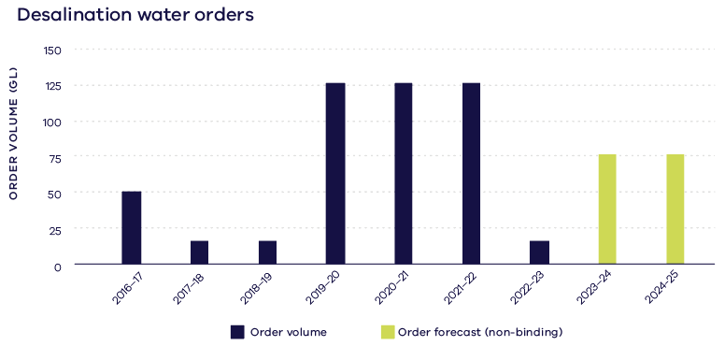
Figure 3.1. Water orders for the Victorian Desalination Project, 2016–23
Wonthaggi desalination
Water security benefits
The Victorian Desalination Project is a rainfall-independent source of water. It has the capacity to supply up to 150 billion litres of water a year or about one-third of Melbourne’s annual water use. Since 2016–17, desalinated water orders have contributed to 24 per cent of Greater Melbourne’s water storages. Importantly, the plant is not only operational when our water supply reaches critical levels. Instead, its purpose is to help ensure that our water supply does not drop to those levels. While there is a cost to run the desalination plant and secure our water supplies, the economic costs of severe water restrictions or water shortages are far worse. Even with annual orders of desalinated water, Melbourne’s water bills are among the lowest of any capital city in Australia.
Protecting the Wonthaggi marine and coastal environment
Ongoing environmental management is a key focus of the desalination plant. The plant connects to Bass Strait at Wonthaggi via long intake and outlet tunnels. These tunnels not only draw in seawater but also protect the coast and marine environment by exiting outside this sensitive marine and coastal park. The intake has been specifically located and designed to minimise adverse effects on marine life. Water is drawn from the ocean at a low velocity so that marine life can freely swim in and around the pipe without being drawn into the plant. The inlets are located approximately 800 metres from the shore, a distance that further reduces impacts on marine flora and fauna. A monitoring and reporting program has found that the impact on marine life from the project is negligible.
There are strict guidelines and requirements for any discharges to waterways or the ocean. The plant’s discharge licence, issued by the Environmental Protection Authority (EPA), specifies the quality of the water permitted to be discharged to the ocean. The EPA monitors the operator’s compliance with the discharge licence as part of its annual reporting regime – See the Victorian Desalination Project Environmental Management Plan (AquaSure 2019).
Powering the desalination plant with renewable energy
In recognition that the desalination process is energy intensive, we have committed to offsetting 100 per cent of the energy used with renewable energy. This commitment is in place regardless of the size of the water order. AquaSure, which owns and operates the plant, offsets all power used to operate the plant and transfer pipeline by buying Renewable Energy Certificates through AGL. This provides incentives for AGL to produce energy through renewable sources from its portfolio, including windfarms and solar.
The renewable energy requirements for the Victorian Desalination Project have set the highest benchmarks and have directly stimulated new renewable energy projects. Victoria is transitioning to a clean and modern energy future that will create jobs and build skills and capabilities across the sector.
The impact on bird and bat populations from wind farms, which are one source of renewable energy, is minimal, with independent monitoring programs finding negligible effect on the populations of threatened species. Further details about these programs, including the exact numbers of bird deaths, can be found online at: www.agl.com.au/about-agl/how-we-source-energy.

Investigating options to expand desalination capacity
Modelling shows that, even with the Victorian Desalination Plant operating at full capacity, Melbourne, Geelong and other cities and towns which depend on the Melbourne Supply System could experience water shortages this decade if we experience a severe drought. For example, Melbourne’s storages dropped quickly in 2006, when they fell by around 20 per cent in a single year. It is important that we have additional water supply options ready to deliver for this reason, to avoid delays and minimise costs for any infrastructure required.
Moving to climate-independent water sources over time – including desalinated water – is critical to meeting the region’s future water needs and avoiding severe water restrictions. Desalinated water is a viable near-term option because, unlike recycled water and treated stormwater, large volumes can be supplied directly into the drinking water system. Increasing the use of desalinated water can also free-up river water for other uses and values. This includes returning water to the environment and to Traditional Owners (see Chapter 4).
Victoria’s existing desalination plant at Wonthaggi was designed to allow a 50-gigalitre expansion, to deliver 200 gigalitres per year to the Melbourne supply system. Further work is required to identify and assess the viability of options for additional desalination capacity and significant community engagement and input will inform any future decisions.
Future regionally significant urban water projects, which include expanding the region’s desalination supplies, will be identified and progressed through the Water Grid Plan (see Chapter 9).
Any increase to supplies from desalination requires significant lead and implementation time, that’s why we need to progress planning activities for desalination options now so we can meet critical urban supply issues when needed and avoid rushed execution during a crisis.
The regionally significant supply options will be complemented by smaller but important local projects that will be progressed by water corporations or through Victoria’s IWM program.
In line with our commitment to net zero greenhouse gas emissions by 2050, any new water supplies will need to use renewable energy, or offset the energy used.
Action 3-1: Investigating options to expand the region’s desalination capacity
The Victorian Government and water corporations will undertake planning and readiness work on several near-term desalination options to ensure that the region’s desalination capacity can meet system shocks and future needs. Options will be progressed through the Water Grid Plan. | Ongoing
Significant community engagement and input will inform any future decisions about potential sites to expand desalination capacity. As potential sites are identified we will apply planning controls to maintain their viability in the long term. The potential expansion of desalination capacity in the region will inform strategic land-use plans in the region, including via the review of Plan Melbourne (DELWP 2017a) and future regional growth plans (DELWP 2014).
Action 3-2: Incorporating consideration of water security into Plan Melbourne
The Victorian Government will consider water security needs and the likely future expansion of desalination capacity in the review of Plan Melbourne. | By 2024

Increasing the use of recycled water and stormwater
Our plan:
- use IWM to drive investment and collaboration
- investigate options for large-scale supply networks and smaller, local recycled water and stormwater projects
- offer grants for using recycled water and stormwater to irrigate open spaces

Recycled water
Less than 20 per cent of the region’s recycled water is used each year, making it an underutilised resource in a drying climate. For decades, wastewater has been treated and used safely as recycled water for a range of non-drinking uses, including for:
- agriculture for irrigating crops and for stock drinking water (see Chapter 7)
- irrigating sporting fields, trees, private open spaces such as private golf courses and public open spaces and parks
- residential and commercial purposes (via purple pipe schemes) or industrial processes
- supporting biodiversity, for example, the Ramsar wetlands at the Western Treatment Plant
- wastewater treatment processes.
Overcoming barriers to using recycled water is critical. One of the main barriers is the high costs associated with treating, storing and delivering recycled water to where and when it is needed (DELWP 2021e). A recent performance audit by the Victorian Auditor-General’s Office on the supply and use of recycled water outlines other key barriers to using more recycled water and how they are being addressed by responsible agencies (VAGO 2021).
This Strategy commits to actions that address these barriers, including matching suitable supplies with demand and improving user confidence. Making better use of recycled water, for non-drinking purposes, can delay the need for major augmentations to our drinking water supplies and help return water to our rivers and to Traditional Owners.
Fit-for-purpose recycled water
To protect public health and the environment, recycled water is deemed fit for purpose based on the microbial qualities of the water, and is classified into three classes (A, B and C) that represent the minimum standards of treatment for categories of use. The level of treatment increases with the potential for higher levels of human exposure to the water, reflecting the potential risks associated with uses.
Fit-for-purpose use is also influenced by how much salt is in the recycled water. Salt levels in recycled water are managed by the supplier through trade waste agreements, influent monitoring, or in the west of Melbourne, via a recycled water desalination plant. They can also be managed by the user on application, for example by shandying with less salty water appropriate for a specific crop.
Class A is water designated for high exposure uses, so it is the highest-quality recycled water. It is suitable for use in residential developments (for purposes such as washing clothes, flushing toilets and watering gardens), irrigation of open spaces with unrestricted public access and irrigation of edible crops intended for raw or unprocessed consumption.
Class B recycled water is used mostly on dairy cattle grazing land. It can also be used for industrial use, subject to restrictions on human contact.
Class C may be used in urban areas that have controlled public access (for non-potable purposes only), and in agriculture – for example, on human food crops that will be cooked or processed, grazing or fodder for livestock – and in industrial systems with no potential worker exposure.
Recycled water is not currently a permitted source of drinking water. We will continue to consult the community on future water sources, how to best use stormwater and recycled water, and advance our understanding of the technology, regulation and community acceptance of using recycled water for this purpose.

Stormwater
As our cities and towns grow, stormwater created from rain on impervious surfaces such as roofs, roads and footpaths will increase, and so will the damage it causes to urban waterways. While retarding basins, wetlands and litter traps help to slow and clean stormwater, this alone is not enough to manage the volumes of stormwater that are generated by urbanisation. For example, in Wyndham, one of Australia’s fastest-growing municipalities, annual stormwater production is expected to grow from 19 gigalitres in 2018 to 35 gigalitres in 2050 (Werribee catchment scale integrated water management plan (DELWP 2021i)). Growing regional towns will also experience similar changes. For example, Bannockburn’s annual stormwater production is expected to increase to 2.6 gigalitres by 2050, almost doubling current stormwater production in the township (Bannockburn water and pollutant balance summary (DELWP 2021a)).
From 2020 to 2021, 5 gigalitres of stormwater was used in Greater Melbourne, out of approximately 400 gigalitres of stormwater generated. If we can find cost-effective ways to store, treat and distribute stormwater to where it is needed, we can save precious drinking water, contribute to local greening, amenity and recreational opportunities as well as improve the health of urban waterways. The contribution that rainwater tanks make towards reducing stormwater runoff and saving drinking water is discussed in Chapter 2.
Why is stormwater a problem?
Stormwater that is not captured can harm our waterways and is a major threat to the environmental health of waterways in urban areas.
The effects of stormwater include:
- erosion – fast-moving urban water flows can erode waterway corridors and damage aquatic habitats
- loss of baseflow – lack of infiltration caused by impermeable surfaces reduces baseflows in waterways
- nutrients – stormwater runoff collects pollutants, including nutrients from fertilisers and pet droppings, leading to algal blooms
- other pollutants – chemicals such as pesticides and petrol can be washed into urban waterways and cause significant damage
- sediment – can block sunlight from reaching important aquatic ecosystems
- changes to natural flow patterns – rapid stormwater runoff changes the flow regime in waterways, which affects aquatic species that rely on natural flow and temperature cues as part of their lifecycle
- flooding – fast-moving stormwater can cause flooding in urban and suburban areas
This is particularly evident in the highly urbanised local waterways such as the Kooyongkoot (Gardiners Creek), Merri Creek, Lollypop Creek, and Steele Creek in Greater Melbourne, the Yarrowee River in Ballarat and Armstrong Creek in Greater Geelong.
Stormwater pollutants also have an adverse impact on the marine environment, either when stormwater drains directly or via waterways.
Read more about the effects of stormwater on waterway health across Melbourne, in Melbourne Water’s Healthy waterways strategy (Melbourne Water 2018): healthywaterways.com.au.

Increasing the use of recycled water, stormwater and rainwater through IWM
In the past, our management of stormwater and wastewater has focused on protecting the environment. This has meant moving it away as quickly as possible and treating the wastewater to an agreed environmental standard, so that it can be safely discharged into waterways and bays or applied to land. We have not always considered changes to the flow regimes of receiving rivers, or Traditional Owners’ responses to seeing their waterways used as a drainage system. But this philosophy is changing to a more holistic one, encompassing the numerous social, cultural, environmental and economic benefits of using stormwater, rainwater and recycled water.
IWM captures this holistic philosophy. It is a collaborative approach to the planning and management of all elements of the water cycle that fundamentally shifts the way water, land-use planning, and urban development opportunities are understood and undertaken in Victoria.
Realising opportunities to use recycled water, stormwater and rainwater through an IWM approach is central to this Strategy and how we plan to secure our water needs. Continued incremental investment is required in infrastructure to treat, store and deliver these new water supplies to users where net public benefits can be achieved, and it is important that the costs and benefits are fairly spread over time.
IWM forums
The Victorian Government supported the establishment of 18 IWM forums across the state to enable partnerships with Traditional Owners, water corporations, local government and catchment management authorities. The IWM forums in the Central and Gippsland Region are Barwon, Central Highlands, Werribee, Maribyrnong, Yarra, Dandenong, Western Port, Gippsland and East Gippsland. Each IWM forum has a shared vision and identifies local opportunities to increase the use of recycled water, treated stormwater and rainwater to match suitable water supply with the water needs in the forum area. As a result of the IWM forums, more than $17 million was invested over the last four years (2017 and 2021) to support 50 IWM projects in the Central and Gippsland Region. These projects will ultimately supply around 1,700 megalitres per year of recycled water and more than 100 megalitres per year of stormwater to a range of end users. For more information on these IWM projects, a progress report is available at www.water.vic.gov.au.
Further investment in 2022–23 is highlighted in Figure 3.2.
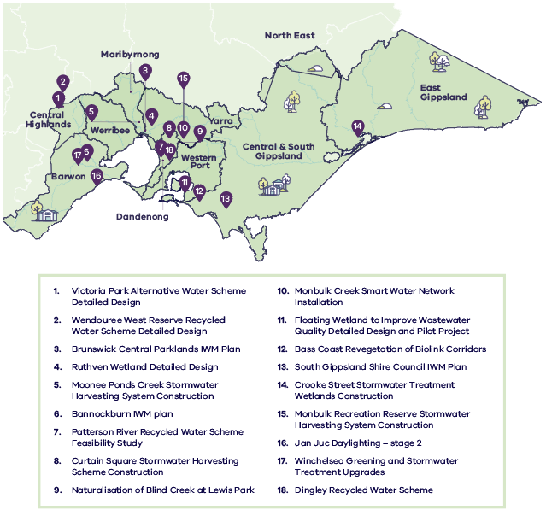
Figure 3.2. New IWM projects of 2021-22 within IWM forum boundaries in the Central and Gippsland Region

Policy 3-1: Continue to progress IWM projects identified through IWM forums
The Victorian Government will continue to support IWM forums to collaboratively plan and deliver an optimal mix of recycled water, stormwater and rainwater that contributes to long-term water security, and improved liveability and economic prosperity in the Gippsland and Central Region.

Action 3-3: Maturing the IWM investment framework
The Victorian Government, in collaboration with IWM forum partners, will improve how investments in IWM projects are made to best realise the multiple community and environmental benefits that are difficult to quantify when using all sources of water. | By 2025

Policy 3-2: Clarifying roles and responsibilities for delivering IWM outcomes
The Victorian Government will clarify existing roles and responsibilities to ensure the water, land-use planning and urban development sectors can deliver on IWM outcomes

Investigating options for large-scale supply networks
To help meet the expected demand for water in the Central and Gippsland Region, we will need to dramatically increase the volumes of recycled water and treated stormwater we use to complement desalination in the longer-term. This will require substantial investment in large-scale water supply infrastructure to connect end users with fit-for-purpose water supplies. Large volumes of recycled water and treated stormwater could be used for agriculture and industry if available at the right place, quality and time. Where large-scale urban redevelopment occurs within the same sub-catchment, this new water could also supply non-drinking uses in homes, public open spaces and workplaces. It could help meet future demands and free up water in rivers, storages and aquifers for other uses and values.
Preliminary investigations show that large-scale recycled water networks are not cost effective across the whole of Greater Melbourne. However, networks to service Greater Melbourne areas that can connect to agricultural users in the peri-urban landscape or to high urban growth areas are worth further consideration (see Chapter 7).
These large-scale networks in Greater Melbourne have the potential to:
- save up to 126 gigalitres of drinking water a year by 2070, across urban growth and redevelopment and existing areas
- supply up to 196 gigalitres of recycled water to agribusinesses by 2070, freeing up around 28 gigalitres for other uses and values.
Future investigations will consider a broader range of water sources, including treated stormwater and internally plumbed rainwater tanks.
Large-scale recycled water and treated stormwater networks are likely to become increasingly important for meeting non-drinking water needs in regional areas, with potential to promote the growth, sustainability and resilience of the regional economy and provide water for environmental and Traditional Owner cultural values. For example, in the Barwon region a large-scale network connecting schemes in the Moorabool Valley, Surf Coast Hinterland, South Balliang and on the Bellarine Peninsula could potentially:
- save up to an additional 4 gigalitres of drinking water demand a year by 2070 across urban growth and existing areas
- supply up to 40 gigalitres of alternative water to agribusinesses by 2070
- assist in managing the impact of urban stormwater on sensitive environments.
Large-scale recycled water and treated stormwater networks could be built alongside other major infrastructure projects to streamline costs and planning and provide an additional boost to Victoria’s economic recovery. Further investigations will clarify the costs and benefits to the community, to guide future decisions on staged implementation of network infrastructure, building on local networks over time.
Action 3-4: Investigating options for large-scale recycled water and treated stormwater networks in Greater Melbourne
The Victorian Government in collaboration with Greater Metropolitan Melbourne IWM forum partners will:  - Further investigate the feasibility of large-scale recycled water and treated stormwater networks to meet a range of uses and values in Greater Melbourne, focusing on five regions:  - west and north-west (Werribee and Maribyrnong catchments)  - north (Northern Growth Area and surrounding agricultural areas)  - east (high-density redevelopments in the eastern and south-eastern suburbs and agricultural areas in Yarra Valley)  - south-east (South East Growth Area and agricultural areas in Pakenham and neighbouring regions)  - Mornington Peninsula.  - Commence development of business cases for the feasible, large-scale networks. | By 2025

Action 3-5: Investigating options for a large-scale recycled water and treated stormwater network in the Barwon Region
The Victorian Government will support Barwon Water to investigate, in collaboration with the Barwon IWM forum partners, the feasibility of large-scale recycled water and treated stormwater schemes in the Barwon Region, including the Moorabool Valley, Surf Coast Hinterland, South Balliang and the Bellarine Peninsula. In the long term, opportunities to connect these schemes to create a network will also be considered. | By 2025

Barwon’s large-scale recycled water and stormwater network
Barwon Water has an ambitious goal to convert 100 per cent of recycled water to beneficial use. By 2070 the volume of recycled water available for beneficial use in the Barwon region could increase to 40 gigalitres per year. While this is a significant challenge, it also presents a huge opportunity to achieve positive outcomes for the regional economy and to provide for the region’s environmental and cultural needs. A staged transition away from conventional water, sewerage and stormwater systems that discharge to waterways or the ocean, to a connected network that matches recycled water and stormwater to suitable uses, would enhance the region’s resilience and prosperity in the face of a changing climate.
The network would link to and improve several local IWM initiatives currently in progress in the region, including the Northern and Western Geelong Growth Area IWM Plan.
Subject to further assessment, the potential benefits in the long term include:
- boosting agriculture and primary industries, for example in the Moorabool Valley, Surf Coast Hinterland and the Bellarine Peninsula
- reduced environmental impact from urban stormwater, for example in the Karaaf wetland near Torquay
- increased resilience to climate change for existing river water irrigators
- potential for returned water to rivers
- efficient sewage management from key future growth areas, which includes avoiding expensive sewerage upgrades through congested built-up areas of Geelong.

Investigating recycled water, treated stormwater and rainwater for local use
The IWM program is driving investment in local recycled water, treated stormwater and rainwater projects that can save regionally significant volumes of water and support greener and cooler communities. Local opportunities, including the role of catchment-scale IWM plans, are described below and examples of recently funded projects are illustrated in Figure 3.2.

Greater Melbourne
Developed through the five IWM forums in Greater Melbourne, catchment-scale IWM plans are bridging the gap between regional Water Grid Planning and local plans for climate change adaptation, stormwater management and open space provision. The plans seek to inform future water, land-use and infrastructure decisions, including opportunities to enhance our waterways and natural environments. Performance targets drive action across seven strategic outcomes for IWM (see Figure 3.3). Targets that support resilient water supplies for the region include:
- gigalitres per year of recycled water, stormwater and rainwater for non-drinking uses, to substitute potable water supplies and help meet Greater Melbourne’s future water needs
- gigalitres per year of recycled water and stormwater for agricultural production to support existing and new production
- gigalitres per year of recycled water delivered to customers working to achieve ambitious aspirations for a circular economy.
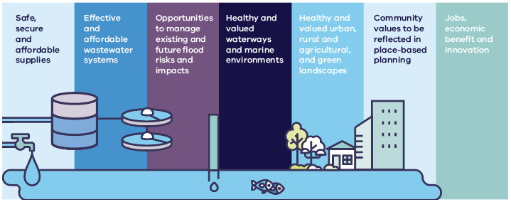
Figure 3.3. The seven strategic outcomes for IWM in Victoria
To continue to drive progress, action plans will be developed to help each IWM forum work towards its performance targets. These will clarify how and when each action will be delivered, by whom, and to where in the catchment.
Policy 3-3: Contribute to achieving the targets in the catchment-scale IWM plans
Melbourne Water and metropolitan water corporations will work with IWM forum partners to contribute to achieving the relevant targets in the catchment-scale IWM plans, to increase the use of fit-for-purpose recycled water, treated stormwater and rainwater for the five metropolitan Melbourne catchments.

Action 3-6: Developing catchment-scale IWM action plans for Greater Melbourne
The Victorian Government, through the Greater Metropolitan Melbourne IWM forums, will develop action plans in the Werribee, Maribyrnong, Yarra, Dandenong and Western Port catchments to strategically drive delivery of their catchment-scale IWM plans. | By 2023

Integrated opportunities in Sunbury
The population of Sunbury is forecast to more than double over the next 20 years. With serious water shortfalls expected in the local area’s supplies, this is predicted to lead to an increased reliance on the Melbourne Supply System to supply Sunbury customers. Under current stormwater management arrangements, this will diminish waterway values. Sunbury’s Jacksons and Emu creeks will see a decline in populations of platypus, frogs, macroinvertebrates and vegetation, and a weakening of community connection.
Greater Western Water, Melbourne Water, Hume City Council and the Department of Environment, Land, Water and Planning are working with the community to find IWM opportunities to meet these challenges. Opportunities being progressed include a regional-scale stormwater harvesting scheme that could supply up to 3.8 gigalitres of water per year. The project could help to ease growing pressure on drinking water supplies, support a cooler and greener community, and reduce excess stormwater runoff from damaging local waterways.
To find out more, visit: YourSay
https://yoursay.melbournewater.com.au/Sunburys-Water-Future

Case Study: Dingley Recycled Water Scheme for South-East Green Wedge
The Dingley Recycled Water Scheme will deliver reliable, high quality (Class A) recycled water, through 42 km of pipes and a pump station, to large water users in the Dingley Green Wedge zone and Sandringham Sandbelt region (see Figure 3.4). The Victorian Government is providing $24.8 million towards the $72 million capital project, with South East Water funding the remainder.
The scheme will supply 1,800 million litres annually from the Eastern Treatment Plant to public and private sites, including local parks, golf courses, education and sporting facilities, commercial nurseries and market gardens.
The scheme has the capacity to supply potential future demand from the Suburban Rail Loop precincts, as well as the National Employment and Innovation Clusters in Monash and Dandenong. The use of recycled water for agriculture and liveability outcomes is strongly supported by the local community.
The project provides a unique opportunity to increase the sustainability of local economies and communities, provide economic stimulus to help grow Victoria, respond to the impacts of climate change and supporting Victorians with high quality public open space. It is an excellent example of IWM approach to water services.
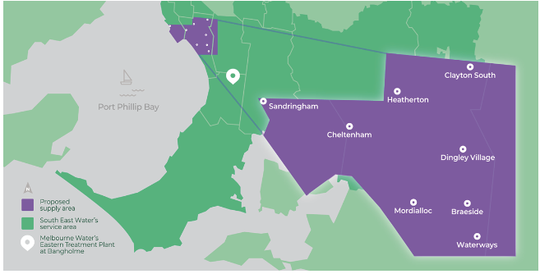
Figure 3.4. Dingley Recycled Water Scheme supply area

Regional areas
There are opportunities to use IWM to increase manufactured water use in regional areas, particularly in the west and north of Geelong, Ballarat and Bairnsdale. For example, the City of Ballarat’s IWM plan identifies several small, medium and large-scale opportunities to better use stormwater, groundwater and recycled water for a variety of uses and values (Central Highlands Water et al. 2018).
To date, IWM planning in regional Victoria has occurred at the town or precinct scale, and this has identified many opportunities to provide new water supplies for valued local community assets such as sports ovals (see Figure 3.2). To understand the best opportunities and priorities for using manufactured water in a regional setting, we need to examine the relationship between the water cycles of regional towns within the broader catchment-scale water cycle. We will work with stakeholders to undertake a case study in the Barwon and Moorabool basins, to examine this relationship. The case study will identify manufactured water use opportunities and inform future water management planning decisions and policy reform to suit the regional context.
Action 3-7: IWM planning for regional Victoria
The Victorian Government will explore the benefits of IWM planning at different scales using the Barwon and Moorabool basins as a case study. | By 2024

Case Study: IWM for Geelong’s northern and western growth areas
New growth areas in the north and west of Geelong, which will become home to more than 110,000 new residents and a variety of new businesses and industries over the next 50 years, will be planned and built applying IWM. More than one-third of the total expected population growth in Barwon Water’s service area will occur here. Clever and creative urban design for these areas will generate a green, liveable city and build water resilience in the area. This aims to avoid any long-term net increase in imported potable water to these growth areas and allows for any new water sources identified to support environmental and Traditional Owner values (see Section 4.1 and Policy 4-2). The North and West Geelong IWM plan has been co-funded by the Department of Environment, Land, Water and Planning, Barwon Water and the City of Greater Geelong, its key features include the following:
- Class A recycled water will be delivered via a purple pipe network to homes, industry and open spaces to reduce the future demand for potable water supplies by 3.4 gigalitres per year. Pending further investigation of water quality and seasonal availability of the new water, this could also enable the supply of recycled water for environmental flows in the Moorabool Yulluk (Moorabool River) as pumped groundwater contributions from the Batesford Quarry decline. Alternatively, this initiative could support irrigated agriculture, horticulture and viticulture in the Moorabool Valley.
- Passively irrigated street trees, swales and enhanced-infiltration billabongs will retain 4.4 gigalitres of water per year in the landscape. These will support a greater tree canopy, covering an additional 85 hectares, for a cooler, greener community.
- Local waterways will be naturalised and rehabilitated and revegetation works will be completed along the Barwon River, Moorabool Yulluk (Moorabool River) and Cowies Creek. This will create high-value green corridors and increase biodiversity.
- In the long term, the capture and transfer of treated stormwater from wetlands in the development could supply more than 5 gigalitres to the region over the next 30 to 50 years (subject to investigations confirming the viability of this proposal).
Actions to improve waterway health in the Barwon River are described in Chapter 8.

Case Study: Western Park stormwater harvesting project
Through a partnership between Baw Baw Council, Gippsland Water and the Victorian Government, facilitated through the Gippsland IWM forum, an existing wetland near the Western Park ovals in Warragul has been modified for stormwater harvesting and treatment to irrigate nearby sports fields. A new storage tank will supply 20 megalitres per year of treated stormwater to irrigate the sporting grounds, helping to reduce potable water use, and stormwater discharges to the Hazel Creek. The project is expected to be completed by the end of 2022.

Using recycled water and stormwater to create greener, open spaces
With increased urbanisation, demand for open space in urban areas is growing. On very hot days, irrigated green spaces provide significant cooling benefits to those visiting or living nearby – supplying water to these spaces is essential to maintaining their amenity. However, not all communities in the region have close access to irrigated green open spaces and the impact of this imbalance is expected to amplify, as we experience more frequent and intense hot, dry periods in the future.
Studies show that the amount of water required to irrigate Melbourne’s open spaces could more than double by 2050, increasing by an additional 16 gigalitres per year (Melbourne Water 2021). However, Melbourne Water predicts that at least 40 per cent of this demand could be met by stormwater and recycled water.
In locations where it is not practical to irrigate green open spaces with stormwater or recycled water, smarter irrigation practices are paramount. Smarter irrigation enables us to get greater value from the water that we use, by saving water during cooler periods, as well as hot periods, using sufficient water to provide cooling benefits for the local community.
However, water corporations have limited authority to deliver these projects that provide liveability, amenity or health and wellbeing benefits for the community. To deliver these opportunities, water corporations often partner with other organisations, including local councils, who may have clearer accountability to deliver projects with these outcomes in mind.
Action 3-8: Use of recycled water and stormwater for greener, open spaces
The Victorian Government will provide:  - grants to co-invest with water corporations and councils in infrastructure to use stormwater and recycled water to irrigate open spaces, facilitated through the IWM program  - one-off grants to managers of open space, to complete water use and efficiency audits for sporting grounds which identify and map opportunities to reduce, or substitute, demands on the potable water system. | By 2026

Better planning and regulation
Our plan:
- embed IWM in land use planning decisions and urban design
- improve guidelines for using recycled water and stormwater
- work with the water sector to identify and manage emerging contaminants

Embedding IWM in land-use planning
Urban planning in Victoria is guided by many land-use policies, controls and regulations. Urban planning is closely linked to water management, as it determines the use of land on which water can be collected, stored and distributed to communities, as well as how much water can be used in urban and peri-urban areas.
To deliver effective and affordable water services, IWM needs to be embedded at the start of land-use planning decisions and urban design. This allows a greater range of options to be identified and evaluated early and at a lower cost. Now, more than ever, we need to consider how our water systems can be designed to provide broader benefits to the community, such as improved urban amenity, reduced flooding and greener, cooler landscapes. Like Victoria’s land-use planning system, different scales of IWM planning are necessary to guide decision-makers at different stages of water infrastructure development or renewal (see Figure 3.5).
In new developments, for example, houses can be designed to help households reduce their water and energy usage, leading to lower household utility bills. Residential streets can be designed to use gravity to direct stormwater runoff (passive irrigation) to irrigate street trees and create fuller canopies. Retrofitting passive irrigation systems can cost up to 13 times more per tree, on average, than installing them at the start.
IWM not only supports water sector objectives but can also boost land and property sales and contribute to high-quality and environmentally sensitive ‘big builds’. For example, ways to use recycled water, instead of drinking water, for dust suppression during the construction of a third runway at Melbourne Airport are being explored. This could save over 1 gigalitre of drinking water over two years.
Policy 3-4: Embed IWM in land-use and infrastructure planning
Land-use planning decisions and major infrastructure projects should consider IWM early in the design process and throughout the different stages of urban development or renewal, to ensure that all sources of water, including stormwater and recycled water, are used in the landscape.

Action 3-9: Strengthen IWM in land-use and infrastructure planning
The Victorian Government will explore ways to clarify IWM objectives and strengthen IWM criteria in planning guidance material and policies, and will explore a potential requirement for the development and use of IWM plans at different geographic scales to guide land-use decisions related to future urban developments. | By 2025

Value of IWM Planning and Delivery for:
The water sector:
- Contribution to water security: Reduces demands on potable supplies by maximising use of all sources.
- Waterway protection: Reduces stormwater entering urban waterways and protects lands adjacent to waterways.
- Lowering infrastructure costs: Can reduce the size, and delay the timing, of centralised augmentations by using more local water supplies.
- Meeting wastewater obligations: Identifying opportunities for the re-use of wastewater for productive use/protection of public assets – within development or adjacent to development (i.e. productive use of peri-urban agriculture).
- Meeting customer expectations: Delivering on sustainability credentials – maximising use of all water sources.
Councils, developers and communities:
- Improved liveability and desirability of suburb: Building climate-resilient developments through retaining water in the landscape – managing the heat island effect and improving urban greening.
- Branding/marketing: Opportunity to brand and sell sustainability credentials of the development (point of difference from other developments).
- Providing and protecting community assets: Water-based amenity assets (lakes, wetlands) and drought-proofing of public assets (sporting grounds and gardens) through provision of stormwater and recycled water.
- Meeting planning requirements: Supporting developers to meet obligations (such as stormwater management or waterway protection) required under Victoria Planning Provisions.
- Property uplift/development opportunity: Increased property value due to ‘water-based development’ providing greater returns on investment. Opportunity for higher-quality development due to high-quality drainage management.

Improving the recycled water regulatory framework and guidance
Clear and simple regulations help to build confidence around the many benefits of using fit-for-purpose recycled water. As the first phase of a review of recycled water guidance, a new Victorian guideline for large-scale recycled water schemes was released in 2021 (EPA 2021b). The guideline focused on simplifying and streamlining scheme approvals and reporting processes, using a best-practice, risk-based approach. To help recycled water scheme proponents adjust to the new guideline, the Environment Protection Authority (EPA) is developing templates and examples for key approval and reporting processes.
The next phase of the review of recycled water guidelines focuses on several scientific aspects of recently updated guidance. Key projects include:
- updated guidelines for the use of recycled water for irrigation (EPA 1991). This will help irrigators and proponents of recycled water irrigation schemes to use recycled water appropriately and ensure management controls are in place to protect the environment, the crops being irrigated and human and animal health
- developing guidelines for the use of recycled water for the environment, for example, to improve environmental flows and overall river health where it is safe and suitable (see Section 8.7).
Action 3-10: Develop template guidance for recycled water use to streamline approvals
The Victorian Government, EPA and the water industry will develop templates to help industry apply and adjust to the new Victorian recycled water guidelines by streamlining documentation for approvals. | By 2023

Managing emerging contaminants in recycled water
As previously discussed, using fit-for-purpose recycled water and treated stormwater is integral to building secure and climate-resilient cities and towns. Community feedback tells us there is concern about the potential risks of emerging contaminants in recycled water and in the broader environment. For this reason, we must continue the important work underway to assess and manage risks to the environment and human health from emerging contaminants (see Figure 3.6). We must also improve communication about this work as we seek to increase the use of recycled water for non-drinking purposes.
Emerging contaminants include pharmaceutical, persistent and bio-accumulative organic pollutants, endocrine-disrupting chemicals, personal care products and industrial or agricultural compounds that can potentially cause harm to the environment or public health. They are not yet well understood and are therefore largely unregulated. These contaminants can be present in the environment due to previous land uses or activities. They frequently occur in many manufactured products which we rely on, such as common household products including non-stick cookware, cleaning products and food packaging.
Emerging contaminants can enter our environment (water, sediment, soil, air, dust, biota and plants) via runoff into water catchments and drinking water storages, direct use on land and disposal via our waste systems, and through garbage, sinks, showers, toilets and trade waste. This makes them difficult to track and regulate across sources and uses. However, technological advances mean we can detect more chemicals in the environment today than we could five years ago.
Water corporations proactively manage new risks to water supplies including: emerging contaminants that might be present in sewage, water storages used to supply drinking water, water treatment plant discharges and recycled water. We will continue to work collaboratively with EPA and the water sector to develop our knowledge of the potential risks from emerging contaminants, as well as refining risk management frameworks and implementing proportional and reasonably practical actions. These actions will ensure risks from the use of recovered resources, such as recycled water, are minimised to prevent harm to the environment or public health. We will also continue to contribute to national research and standards that will inform our state’s management approach on emerging contaminants in recycled water.
Policy 3-5: Invest in research to improve our understanding of emerging contaminants
The Victorian Government will continue to support investment in research that improves our understanding of emerging contaminants, their potential risks, and reasonably practical actions to ensure safe uses of recycled water.

Policy 3-6: Contribute to national regulatory processes and water quality guidelines
The Victorian Government will continue to participate and contribute to national processes, including input into water quality policy and regulatory processes, actions to reduce contaminants at the source and the development of water quality guidelines and standards, to inform safe uses of all water sources.

Action 3-11: Identify priority projects to contribute to state of knowledge of emerging contaminants
The Victorian Government will work with the water sector to identify priority projects to enhance our knowledge of emerging contaminants. | By 2023

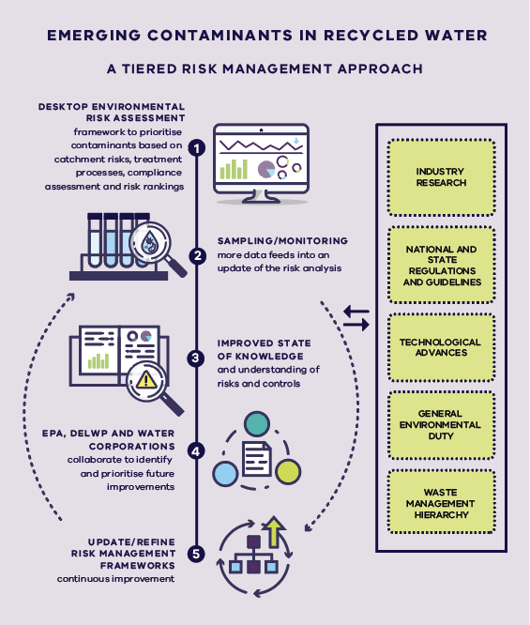
Figure 3.6. Victoria’s approach to managing emerging contaminants

Improving stormwater regulations and guidance

Reviewing stormwater licensing arrangements
Stormwater has historically been treated as a waste product and removed via drains to local waterways as quickly as possible. Regulations focus largely on reducing the risk of flooding and who is responsible for managing drainage. If we are to recognise the benefits stormwater can provide as a resource, the current licensing arrangements require updating to enable greater capture and use of stormwater. For example, the Water Act does not define or refer to stormwater, so interpreting how stormwater fits into the water entitlements framework can be difficult. The water entitlements framework covers water flowing or held in Melbourne Water’s infrastructure, but does not include stormwater in local council infrastructure. Up to 3.7 gigalitres of stormwater is licensed, to be harvested from Melbourne Water’s works, but harvesting from council assets is not licensed which means that it is not accounted for, and the lack of a clear authority for councils to sell the water to potential users is a barrier to increased uptake.
Action 3-12: Improving stormwater regulations to support increased capture and use
The Victorian Government will work with water corporations and councils to review statewide stormwater licensing and supply arrangements and determine preferred statutory and non-statutory implementation options. | By 2023

Clarifying stormwater roles and responsibilities
To gain better oversight of stormwater as a water resource and to enable more stormwater to be harvested we will also work with water corporations and councils to clarify roles and responsibilities for harvesting stormwater in Greater Melbourne and regional areas. Implementing the preferred option from the Melbourne Urban Stormwater Institutional Arrangements (MUSIA) Review and clarifying roles and responsibilities in high-growth regional areas, such as the Lower Barwon, will help to address the future increase in stormwater from new urban developments. It will also better manage any adverse effects and opportunities to maximise the use of this water resource to meet future urban needs, which may also lead to improved waterway health outcomes. IWM forums will continue to encourage greater harvesting and use of treated stormwater by identifying place-based opportunities across the Gippsland and Central regions, consistent with these clarified roles.
Action 3-13: Implement Melbourne Urban Stormwater Institutional Arrangements (MUSIA)
The Victorian Government will:  - support Melbourne Water and the Municipal Association of Victoria (on behalf of local government) to implement the preferred option from the MUSIA review: the improved 60-hectare option embed the confirmed approach into policy or legislation. | By 2028

Review of the Melbourne Urban Stormwater Institutional Arrangements (MUSIA)
The MUSIA Review is a collaboration between the Department of Environment, Land, Water and Planning, Melbourne Water and the Municipal Association of Victoria (MAV) on behalf of the 38 councils in the Port Phillip and Westernport Region. MUSIA aims to better delineate roles and responsibilities for public urban stormwater assets and services. The project partners have agreed in principle on a recommended option to delineate urban stormwater responsibility: delineation by catchment size (improved 60-hectare option).
The agreed option will include an exception to the 60-hectare rule for complex IWM projects involving multi-purpose assets designed to function as a single interlinked network, despite being spread across multiple sub-catchments. For these types of projects, there is benefit in the whole network of treatment assets being managed by one organisation, rather than being divided between councils and Melbourne Water according to a strict 60-hectare rule.
Melbourne Water and the MAV will lead the implementation of the preferred MUSIA options, with the Department of Environment, Land, Water and Planning supporting on an as-needed basis.

Action 3-14: Review stormwater management arrangements in the Lower Barwon
The Victorian Government will work with local government, Barwon water and Corangamite CMA to review arrangements for managing stormwater as a resource for Geelong and the Bellarine. | By 2023

Develop stormwater offsets framework
Many new developments are required to meet stormwater management best-practice standards, by constructing treatment assets on site that remove sediment and nutrients from stormwater. In some cases, it is not practical or cost effective for developers to treat the stormwater on site, and there may be better options for communities if council can build a larger treatment asset within the same precinct or catchment.
Stormwater offsets schemes provide an opportunity for urban developments to meet the required stormwater standards by contributing money towards an offsite asset, rather than constructing an onsite asset.
Action 3-15: Develop a stormwater offsets framework
The Victorian Government will develop a stormwater offsets framework to enable robust and consistent application of offsets for developers and local governments to meet stormwater requirements in the Victoria Planning Provisions. | By 2024

Embedding stormwater flow requirements
Current best-practice standards for stormwater management require new developments to reduce pollutants in stormwater: suspended solids (sediment), phosphorus, nitrogen and litter. However, these pollutants are not the only harmful part of stormwater. The increased volume of stormwater running off new hard surfaces can also damage urban waterways.
The EPA published urban stormwater management guidance to help improve the management of urban stormwater in Victoria (EPA 2021a). The guidance reflects current science and addresses the risk of harm from urban stormwater flows, including setting stormwater flow reduction targets for Greater Melbourne. It also contributes to Victoria’s state of knowledge and helps organisations minimise the risk of harm to the environment and human health so far as reasonably practicable. To complement the guidance and strengthen compliance with the targets, we will investigate options to include them in the Victoria Planning Provisions or other regulations.
Action 3-16: Embedding stormwater flow requirements
The Victorian Government will assess and explore the feasibility of options that include stormwater flow reduction targets into the Victoria Planning Provisions or other regulations. | By 2024

Building community confidence
There are significant opportunities to improve the use of fit-for-purpose recycled water and treated stormwater to provide water security and other broader community benefits if we can build community confidence in the use of recycled water and stormwater as a resource. This will require demonstrating best-practice science, enforcing strong regulation, and engaging with the community about their concerns (largely on water quality) and the potential benefits. See the section on emerging contaminants above.
Action 3-17: Building community confidence in recycled water and stormwater
The Victorian Government will work with the water sector and EPA to develop and implement engagement and education programs that improve understanding of the benefits and risks of using recycled water and stormwater. | By 2026

Better accounting and reporting
Tracking progress of recycled water and stormwater use is important for increasing the use of stormwater and recycled water in some localities, because it demonstrates the benefits that can be important for a region’s prosperity, liveability and productivity. Importantly, using these new decentralised sources can free up drinking water and reduce extraction from already stressed rivers, helping to preserve these supplies for future generations and creating opportunities to return river water to Traditional Owners.
Action 3-18: Clearer guidance on recycled water accounting and reporting
The Victorian Government will assess the need for clearer guidance on recycled water accounting and reporting, to increase the consistency and accuracy of recycled water data for a better understanding of its use and availability. | By 2023
For more information about the use of stormwater and recycled water to improve environmental flows, see Section 8.7.

A circular economy
Our plan:
- support transition to a circular economy by using recycled water for renewable hydrogen production
A circular economy separates economic activity from the use of finite resources and environmental degradation. It moves away from a linear consumption model where we take, make, use and dispose, towards a system where waste is instead seen as a valuable resource or input, which can be repurposed for another unconnected process (see Figure 3.7).
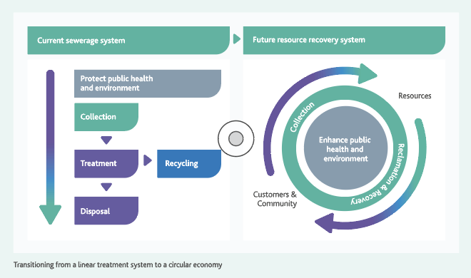
Figure 3.7. Transitioning from a linear treatment system to a circular-economy system (Melbourne Water 2017)
Victoria’s water sector can play a central role in embedding circular economy approaches, not just across the water cycle but also in the energy, agriculture, waste and construction sectors. It can:
- provide benefits such as recovering valuable resources from food waste
- boost clean, secure and reliable green energy supplies close to end-users
- generate by-products that improve soil condition and agricultural productivity
- reduce waste and harmful contaminants released to the natural environment.
These opportunities convert wastewater, and the organic waste it contains, into valued commodities. Products such as recycled water and biosolids are valued resources in a circular economy, to grow our food, light our homes and manufacture products. This model can convert wastewater treatment from a cost liability and business risk to a potential revenue source, which can offset other pressures on customer prices.
The Victorian Government is working with water corporations, catchment management authorities and industry peak bodies to collectively drive circular economy opportunities. We are using the power of collaboration to champion positive change, prioritise our focus areas and build confidence in projects that accelerate our transition to a circular economy. Flagship research and pilot projects will find new ways to reduce waste in water processes, identify markets for by-products and help regenerate natural systems.

Renewable hydrogen production
Renewable hydrogen could play an important role in the decarbonisation of Victoria. Potential uses include blending with or replacing natural gas in our pipelines, long-term energy storage, direct use in industrial applications or powering zero-emissions vehicles, including trains, buses and cars.
Although the water requirements for renewable hydrogen production are relatively small, the use of climate resilient water, such as recycled water, is an important step towards a circular economy, and would avoid the need for the industry to compete for river water. A further incentive for the co-location of hydrogen production facilities and wastewater treatment plants is high-purity oxygen, a by product of renewable hydrogen production via electrolysis. Low-cost and sustainable, pure oxygen is a useful input to wastewater treatment plants and has the potential to significantly reduce the carbon emissions of Victorian water corporations.
The Victorian Government and the water industry are working together to identify pilot projects such as the Hydrogen Park Murray Valley gas blending project at Wodonga, the Bacchus Marsh Recycled Water Plant and the Aurora wastewater treatment plant in Wollert, north of Melbourne. These projects will showcase the fundamental role recycled water can play in providing sustainable water supplies to Victoria’s emerging renewable hydrogen industry. In future, stormwater could also play a role in renewable hydrogen production.
Policy 3-7: Support transition to a circular economy by using recycled water or stormwater for renewable hydrogen production
The Victorian Government will continue to work together with the water sector to identify where recycled water or stormwater can supply renewable hydrogen production to support transition to a circular economy.

Sharing water for multiple benefits
We will improve how we share the benefits of our limited water resources, without compromising the needs of our cities and towns, farmers, Traditional Owners, the environment or other water users. By changing how we source, share, store and deliver water, we can meet some of the immediate urban water needs of our cities and towns and return water to Traditional Owners and the environment. Over the longer-term, as we transition to using more manufactured to secure urban water needs, there will be further opportunities to improve water sharing for all uses and values.

Reducing our reliance on rivers to meet the needs of our cities and towns
Our plan:
- meet growing water demands without issuing additional entitlements from rivers or groundwater resources that are already stressed
- prioritise water savings and manufacture more of our water supplies to meet demand and help free up river water to return to the environment and to Traditional Owners

Caps on extractions from rivers and groundwater
Our drying climate means that less water is flowing into our rivers and so less water can be captured in our water storages. Over time, we need to reduce our dependence on river water to:
- strengthen the resilience of our water supplies in the face of climate change
- sustain river water and support the health of waterways
- maintain waterway recreational activities
- recover water to be returned to Traditional Owners.
This Strategy outlines our commitment to prioritising water savings, through water efficiency measures and investment in manufacturing more of our water supplies – for example, increased use of desalinated and recycled water where it is fit-for-purpose, as well as better capture and use of rainfall in our cities and towns. Over time, these measures will help free up some river water for improved environmental outcomes and for the return of water entitlements to Traditional Owners.
Caps limit the amount of water that can be extracted from each river basin and aquifer for consumptive purposes. These caps are put in place to limit negative outcomes from over-allocation of water resources (such as impacts on other users or the environment). Where water corporations require additional access to river water or groundwater, they need to access existing entitlements through trade, reallocation of entitlements that are no longer required or apply for specific volumes of unallocated water where it exists.
Where water is recovered for rivers to meet identified environmental targets, this will reduce the volume of consumptive entitlements from a given river system and the relevant cap on consumptive take. It can also increase the volume of environmental entitlements.
Policy 4-1: Maintaining strong caps on extraction of river water and groundwater
Where additional river water or groundwater is needed to meet growing demands, this will be met by accessing existing entitlements through trade, reallocation of entitlements that are no longer required or applications for unallocated water where it exists.

Returning water to rivers and Traditional Owners through water efficiency measures, IWM and substituting river water with manufactured water
We will continue to invest in water efficiency measures and IWM to reduce the demand for drinking water and will add more manufactured water to secure our urban water supplies (see Chapter 2 and Chapter 3). This will bring opportunities to return some river water entitlements (held by water corporations) to the environment and to Traditional Owners.
River water can be substituted with other water sources that are fit-for-purpose (see Figure 4.1). Substitution doesn’t reduce the amount of water required, it just changes where the water comes from. For example, additional desalinated water supplies could be used to supply drinking water instead of water diverted from rivers. This would free up some of the existing river water that was previously used for drinking to be used for another purpose. Substitution arrangements, by agreement, are possible across most of the region because of the connections through Victoria’s water grid (see Figure 1.5). Data on our projected urban water needs and consultation with existing entitlement holders and potential future water users will be required to determine if substitution is feasible, on a case-by-case basis.
Substitution means swapping one source of water for another that is fit-for-purpose. For example, using water from a rainwater tank instead of the tap to water the garden. This helps save drinking water for other purposes.
Public co-investment with the water sector may be considered if a project provides wider benefit to the public and funding is available. For example, a water efficiency project where the savings enable the recovery of water entitlements that can be used to achieve improved environmental or cultural outcomes. Another example is where a shift to a manufactured water supply option, that frees up some river water for other uses, incurs more costs because the initial and ongoing costs of manufactured water are relatively high compared to existing river water or groundwater sources. This is the same approach that has been applied to rural water infrastructure modernisation, where public co-investment has allowed a portion of the water saved to be recovered for environmental entitlements. Principles for public co-investment in water infrastructure are set out in Action 9-6. The scale and timing of investment in these projects will determine how quickly we can reduce our reliance on river water.

Decisions will need thorough consultation with water corporations, their customers and the community. Traditional Owners, waterway managers and the Victorian Environmental Water Holder will provide advice on options for returning water to Traditional Owners and the environment.
Policy 4-2: Water efficiency measures and IWM projects will contribute to water recovery for the environment and Traditional Owners
The Victorian Government will consider future investment in water efficiency measures and IWM projects where water can be recovered for the environment and Traditional Owners and provide a net public benefit, aligned with principles for government investment (see Action 9-6).

Policy 4-3: Substituting river water with manufactured water in the longer-term
The Victorian Government and water corporations will invest in manufactured water, including desalinated water, recycled water and treated stormwater, to meet growing urban water needs. This will free up some river water for other uses and values in the longer-term.
There will be opportunities to return some water to rivers and Traditional Owners (from river water entitlements held by water corporations) as we bring on regionally significant manufactured water sources to meet the needs of the cities and towns that are connected to the south-central system (Figure 4.2). This will be possible when a project can deliver above what is needed to meet the needs of our cities and towns at a given time. Early planning will start on near-term options to ensure that new water supplies are ready for construction and delivery when they are needed and to further progress opportunities for substitution (see Section 9.1).
Action 4-1: Investigate options to return water to the environment and Traditional Owners as regional-scale manufactured water sources are planned for Greater Melbourne and Geelong
The Victorian Government, in partnership with the water industry, will investigate options to return water to the Birrarung (Yarra River), Carran Carran (Thomson River), Mirrangbamurn (Maribyrnong River), Wirribi Yaluk (Werribee River), Moorabool Yulluk (Moorabool River) and Barwon River and Traditional Owners, whose Country these rivers are part of, when new regional-scale manufactured sources of water are brought online for Greater Melbourne and Geelong. Projects will be progressed via the Water Grid Plan (see Action 9-2), and costs and water sharing arrangements will be considered on a case-by-case basis through the development of a business case using a quadruple-bottom-line assessment. | Ongoing

Smaller but important local projects will be progressed by urban water corporations through urban water strategies or through the IWM forums. These local projects will also provide opportunities to return some river water (from water corporation entitlements) to Traditional Owners and the environment.
Action 4-2: Commitment to consider how river entitlements can be reduced via water efficiency, IWM and substitution with manufactured water sources
Urban water corporations will consider how to reduce their reliance on river water for urban water security to enable river water to be returned to the environment and Traditional Owners across the region as they invest in water efficiency measures, IWM and reconfiguration of existing supply infrastructure, and as manufactured supplies come online.  Each urban water corporation across the region will investigate options for reducing reliance on river water, and will work with the Department of Environment, Land, Water and Planning to, by the end of 2023, identify a volume of water that could be returned by 2032. The local options and volumes proposed will be considered alongside regional options identified in the Water Grid Plan, using a preliminary quadruple-bottom-line assessment by the Department of Environment, Land, Water and Planning to inform planning under Policy 9-1. The most cost-effective package of incentives across the region that will meet urban water security, Traditional Owner and environmental water needs will progress with appropriate funding sources to enable implementation from 2024–25 onwards (in line with Action 9-6). Related targets for each urban water corporation will be developed, in line with funding and financing arrangements, and embedded in the Statement of Obligations. | Ongoing, proposals due by 2023

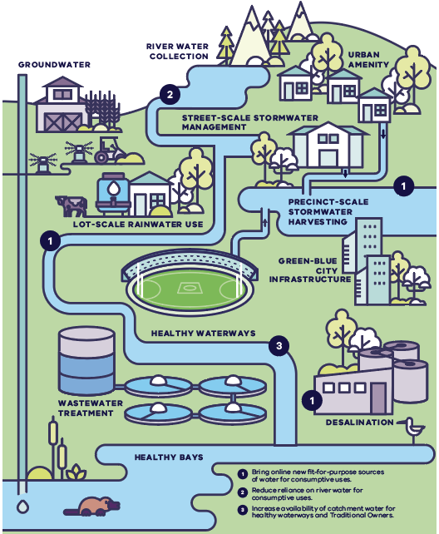
Figure 4.1. Example of substitution where one user’s needs are met by other uses and values accessing new water sources
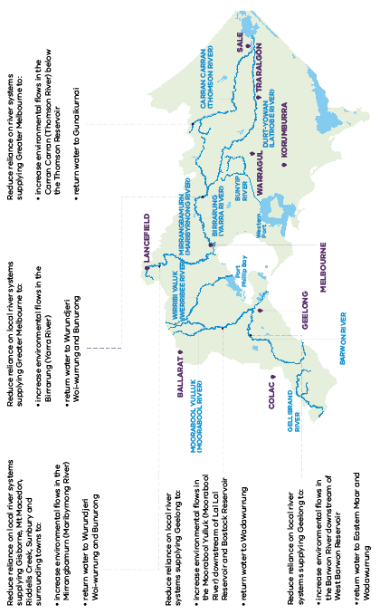
Figure 4.2. Potential opportunities to return water to Traditional Owners and the environment with the next major augmentation of the south-central system

Allowing water to move around the Victorian water grid
Our plan:
- move water around the Victorian water grid over the next five years to meet the immediate priorities of some of the region’s fastest-growing areas, including Geelong, Warragul and Drouin, and flow-stressed rivers such as the Moorabool Yulluk (Moorabool River)
- improve how water is shared between urban water corporations connected to the south-central system so that more people benefit from the Victorian Desalination Project

Upgrades to the Melbourne-to-Geelong pipeline
The Moorabool Yulluk (Moorabool River) is a source of drinking water for Geelong and Ballarat and provides a small amount of water for local agriculture. The river also provides a natural habitat for native species including endangered plants, platypus, fish and bird populations. It is one of the most flow-stressed rivers in the state, due to its relatively small size, diversions from the river and a drying climate. It is therefore very dependent on seasonal rainfall and its limited entitlement for water for the environment. Chapter 8 sets out targets for returning critical volumes of environmental water to the Moorabool Yulluk (Moorabool River).
Recently Barwon Water identified that the best option for securing supply to meet its urban water demands over the next decade is to access a share of the next major augmentation of the south-central system. Barwon Water has also identified an opportunity to return a portion of its Moorabool water entitlements in advance of receiving additional supply. This can be achieved by increasing its use of existing water entitlements and using trade in the south-central system.
Over the next five years, proposed upgrades to the Melbourne-to-Geelong pipeline would provide an increase in water security for Geelong that would help return water from the Moorabool Yulluk (Moorabool River) to the environment and to the Wadawurrung for their self-determined use. In the longer-term this action will rely on Barwon Water increasing its supply of manufactured water from the south-central system to maintain Geelong’s urban water security. These future demands are incorporated into the demand projections for the Greater Melbourne supply system and will be considered in the planning and decision-making for the next major augmentation of the south-central supply system via the Water Grid Plan (Chapter 9).
Action 4-3: Securing additional water for Geelong and the Moorabool Yulluk (Moorabool River)
The Victorian Government and Barwon Water will co-invest in works to enable the return of 3.7 gigalitres per year of long-term average equivalent Moorabool water entitlement to be shared between the environment, the Wadawurrung for their self-determined use and to increase urban water security for Geelong over the long-term to:  - upgrade pumps and extend the reach of the Melbourne-to-Geelong pipeline to increase capacity of the pipeline from 16 gigalitres to 22 gigalitres per year by 2025  - transfer a long-term average equivalent of 3 gigalitres per year of Barwon Water’s Lal Lal bulk entitlement and 0.7 gigalitres per year of Barwon Water’s Upper East Moorabool bulk entitlement in the Bostock Reservoir to the Wadawurrung and to the Victorian Environmental Water Holder by 2025  - prioritise the creation of a south-central pooled resource and associated reforms (Action 9-3), while ensuring a short-term agreement between Barwon Water and the metropolitan water corporations is in place by 2025. This is dependent on if Action 9-3 is still in progress, which will specify water sharing such that Barwon Water can operate the augmented Melbourne-to-Geelong pipeline at up to 22 gigalitres per year if needed once Barwon Water’s existing carryover in the Melbourne system has been used  - factor Barwon Water’s required water entitlement volume into the planning and decision-making for the south-central system’s next major augmentation, to increase Geelong’s urban water security. | By 2025

Action 4-4: Determine how water returned to the Moorabool Yulluk (Moorabool River) will be shared between Wadawurrung and the environment
The Victorian Government, in partnership with the Wadawurrung Traditional Owners Aboriginal Corporation, Victorian Environmental Water Holder and Corangamite CMA, will determine the respective share of water that will be issued to Wadawurrung and the Victorian Environmental Water Holder under Action 4-3, and remove barriers to Wadawurrung Traditional Owners Aboriginal Corporation accessing water (see actions in Section 6.5 and Section 6.6). | By 2025

Securing Warragul and Drouin’s urban water supply
High levels of sustained population growth in Warragul and Drouin are increasing the demand for urban water. These townships already rely on temporary access to water in neighbouring supply systems. To better address current demand and to meet future growth requirements, Warragul and Drouin will receive an additional 3.33 gigalitres per year of water entitlement from the Tarago Reservoir. This will provide a cost-effective boost to water security for Gippsland Water customers from a neighbouring storage via trade of existing entitlements. The additional water entitlements will be sourced without the need for new infrastructure and without any adverse material impacts to other water users or the environment because, through this arrangement, there will be no net increase in urban entitlement volume. This measure is required urgently to secure urban supplies ahead of meeting environmental water recovery targets, and avoids relying on more costly options which may have more adverse effects.
Action 4-5: Securing Warragul and Drouin’s urban water supply
The Victorian Government will secure Warragul and Drouin’s urban water supply by increasing Gippsland Water’s access to water from Tarago Reservoir by transferring 3.33 gigalitres of entitlement in the Yarra–Thomson system to Gippsland Water. | By 2023

Temporary trade
When urban water corporations have surplus water, for example due to wet weather conditions, temporary trade can be used to boost water for the environment in a river system or to provide Traditional Owners with water. Temporary trade is already available across the Central and Gippsland Region when conditions and connections allow and where there are parties willing to trade. However, establishing the process and any agreements required before suitable conditions arise will help to streamline the temporary trade process and make it easier to maximise opportunities as they surface. In some circumstances where a trade from a bulk entitlement is more likely than trade in an irrigation district, agreements will be required between parties to facilitate delivery. This strategy also includes actions to help farmers capitalise on water markets (see Chapter 7).
Temporary trades have already helped to realise environmental and cultural benefits: In 2018–19, 500 megalitres of additional water was delivered to the Moorabool Yulluk (Moorabool River) through a substitution arrangement between Central Highlands Water, the Victorian Environmental Water Holder in partnership with Wadawurrung Traditional Owners Aboriginal Corporation and Corangamite Catchment Management Authority (CMA). The flow filled refuge pools and linked habitats for native fish survival, while also preserving locations on the river that are culturally significant for meeting, ceremonies and trade. This was supplemented by Barwon Water, which timed a drinking water release to increase the amount of flow in the river.
Central Highlands Water is working with Corangamite CMA, the Victorian Environmental Water Holder and the Wadawurrung Traditional Owners Aboriginal Corporation to develop agreements to deliver temporary water transfers to the Moorabool system at Lal Lal Reservoir, when conditions allow. Temporary water transfer can improve river flow, build waterway resilience and support Traditional Owner cultural values. This process will incorporate lessons learnt from the previous agreement with the Victorian Environmental Water Holder and consider how water can be made available to the Wadawurrung Traditional Owners Aboriginal Corporation.
Overall, this process can be used as a case study to help encourage more urban water corporations across the region to temporarily trade water to Traditional Owners and the environment where the opportunity arises. It will facilitate a learning-by-doing approach in preparation for more permanent returns of water entitlement to Traditional Owners.
Action 4-6: Streamlining temporary water trades
Central Highlands Water, the Wadawurrung Traditional Owners Aboriginal Corporation, the Victorian Environmental Water Holder and the Corangamite CMA will work together to develop agreements to support temporary water trade in the Moorabool system, when conditions allow, from Central Highlands Water to the Wadawurrung and environment, at Lal Lal Reservoir. This will include consideration of how water can be made available to the Wadawurrung Traditional Owners Aboriginal Corporation.  Lessons from this case study can be used across the region to make it easier for similar trades to occur for other rivers. | By 2027

Unallocated water and entitlements available for reallocation
Our plan:
- explicitly consider water for Traditional Owners and water to meet critical human needs when making decisions about using unallocated water
- progress opportunities to reallocate water held by public agencies that is no longer needed for its intended purpose
Unallocated water is water that can still be issued for use without exceeding the limits, or caps, on how much water can be extracted from a waterway or groundwater system. This differs from ‘unused water’, which is water that has already been allocated, but is not being used because it is no longer needed for its intended purpose.

Sharing the benefits of unallocated water
There is a limit or cap on how much water can be extracted from waterways and groundwater systems. These caps do not account for water that is left in a waterway or in groundwater (without entitlement) for environmental purposes. Most of the region’s river water and accessible groundwater supplies are already allocated to users for consumptive purposes or to support waterway health. There are some small volumes of water under local caps which remain available for allocation. This is called unallocated water (Figure 4.3 and Figure 4.4).
In the past, some of this water has been sold to users through market processes – usually going to parties who are best resourced to pay for it. However, unallocated water is generally in areas where there is low commercial demand for water, and capacity to pay does not always reflect the greatest need or benefit.
We are committed to returning water to Traditional Owners. Access to unallocated water, where it exists, is one pathway to achieving this. We will work with Traditional Owners proactively to ensure that they have the information and support they need to apply for unallocated water across the region and to resolve issues that are limiting the ability of Traditional Owners to hold and use water (see Section 6.5). There are recent examples where this has already taken place and water entitlements have been issued from unallocated water in the Wangangarra / WyYung (Mitchell River) and the Fitzroy River.
Figure 4.5 has been developed to guide water corporation decision-making. Over the next 12 months, further guidance will be developed to improve how applications for unallocated water are assessed so that all potential uses are considered.
In the meantime, subject to applications, unallocated water can be applied for and issued now. The guidance will build on existing processes that ensure unallocated water is only made available where there are no unacceptable impacts on the environment and existing entitlement holders. When an application for unallocated water is assessed, all potential water uses including commercial use (such as for irrigation) will be considered, with explicit consideration given to meeting critical human needs during periods of low water availability, and access to water for Traditional Owners.
Decisions about using unallocated water will be transparent and clear about how competing interests are managed. After any water is allocated, public information on water availability will be updated. Depending on local conditions, this may identify volumes of water to be set aside for future applications or made available for release on the market.
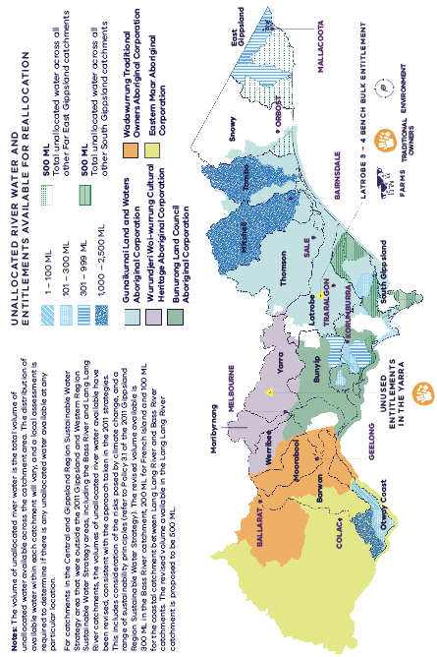
Figure 4.3. Unallocated river water in each river basin across the Central and Gippsland Region and the location of water entitlements (held by public agencies) that are no longer needed for their current purposes
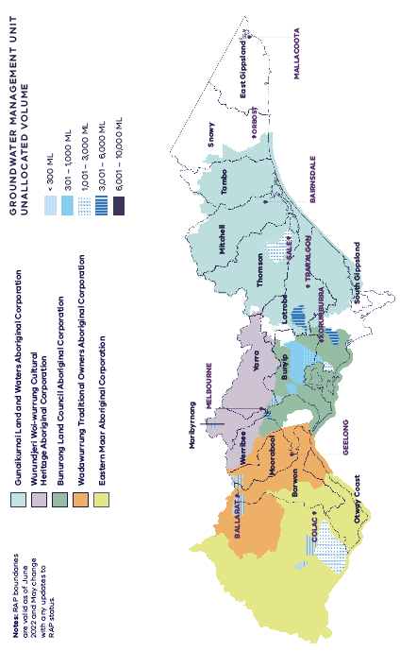
Figure 4.4. Unallocated groundwater across the Central and Gippsland Region
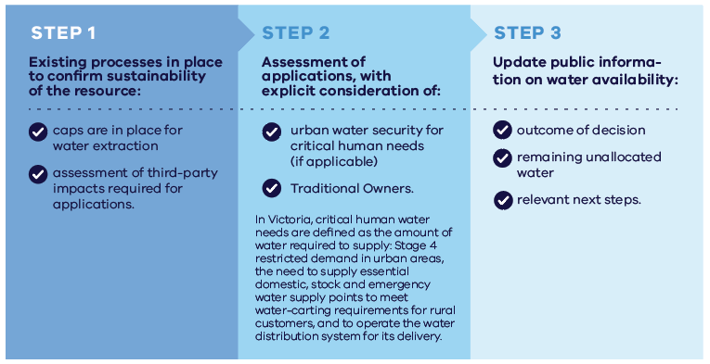
Figure 4.5. Decision-making steps for unallocated water

Action 4-7: Guidance for decisions about unallocated water
The Victorian Government will publish guidance for licensing authorities’ decisions about unallocated water, to provide clarity and transparency on how all uses of water will be considered, including access to water for Traditional Owners. | By 2023

Water entitlements available for reallocation
In some specific areas, some water held by public agencies is no longer required for the original intended purposes and could be made available to meet environmental water recovery targets, return water to Traditional Owners or meet other demands in the future. Over the next five years, we will progress investigations and community consultation about how to maximise the use of these water resources in the future for greatest community benefit.

Latrobe 3 — 4 Bench bulk entitlement
The Victorian Government holds a water entitlement of up to 25 gigalitres per year in the Latrobe system, commonly referred to as the Latrobe 3 – 4 Bench bulk entitlement. The entitlement is currently unused and was originally intended to support the expansion of coal-fired electricity generation. As Victoria transitions to new, less water-intensive and renewable forms of energy generation, there is an opportunity to re-allocate some water from the Latrobe 3 – 4 Bench bulk entitlement.
By 2024, around two-thirds (or about 16 gigalitres) of this bulk entitlement will be permanently reallocated to deliver three key outcomes:
providing priority environmental flows to support native fish species, macroinvertebrates and platypus, as well as contributing to the many values and uses of the connected Gippsland Lakes system and Ramsar-listed wetlands, such as nature-based tourism which contributes to the visitor economy;
- returning water to Gunaikurnai Land and Waters Aboriginal Corporation to support cultural values and self-determined outcomes for Gunaikurnai Traditional Owners; and
- underpinning the climate resilience of irrigated agriculture and supporting farmers to grow their businesses.
The State will work with stakeholders to consider how to allocate the approximately 16 gigalitres of water from this entitlement to optimise these three outcomes for the Latrobe Valley community, the health of the Durt-Yowan (Latrobe River) and Gippsland Lakes system, and for the Gunaikurnai Traditional Owners.
Water made available to support irrigated agriculture will be in addition to the 1 per cent inflow and storage share of Blue Rock Reservoir ring-fenced for irrigators in the Gippsland Region Sustainable Water Strategy (DSE 2011).
Maintaining flexibility is also important during the significant transition underway in the Latrobe Valley to help the region to progressively respond to emerging water needs and climate change. For this reason, some water from the Latrobe 3 – 4 Bench bulk entitlement will not be permanently reallocated to a specific purpose in the short-term, but could be made available on a temporary basis.
Action 4-8: Reallocation of the Latrobe 3 – 4 Bench bulk entitlement
The Victorian Government proposes that water from the 25 gigalitre Latrobe 3 – 4 Bench bulk entitlement will be made available to support the region’s socio-economic transition and build its resilience to climate change. Three key outcomes will be achieved using two-thirds (around 16 gigalitres) of the entitlement to:  - provide priority environmental flows to support native fish species, macroinvertebrates, and platypus as well as supporting the many values and uses of the connected Gippsland Lakes system and Ramsar-listed wetlands  - support cultural values and self-determined outcomes for Gunaikurnai Traditional Owners  - underpin the continued resilience and future growth of irrigated agriculture.  A consultative process with key stakeholders, will establish how the benefits could best be shared to maximise the outcomes of this critical resource for the community.  The remaining one-third of the entitlement (or up to 9 gigalitres) will be retained by government to provide continued flexibility to respond to emerging needs, including Victoria’s future energy needs. | By 2024

Returning water to Wurundjeri Woi-wurrung Cultural Heritage Aboriginal Corporation
The Victorian Government supports the return of water entitlements for the Birrarung (Yarra River) to the Wurundjeri Woi-wurrung Cultural Heritage Aboriginal Corporation, in recognition of the deep connection between Traditional Owners and waterways.
Action 4-9: Returning water to the Wurundjeri Woi-wurrung Cultural Heritage Aboriginal Corporation
The Victorian Government supports an application to return water to the Wurundjeri Woi-wurrung Cultural Heritage Aboriginal Corporation through the transfer of a 1.4 gigalitre water licence in the Birrarung (Yarra River), formerly used by the Amcor Paper Mills and now held by the Victorian Government. | By 2022

Optimising river system management for multiple benefits
Our plan
- develop a business case to transform how water is used and shared in the Werribee system
- review and improve management arrangements in the Wangangarra / WyYung (Mitchell River)
- review how water is used and monitored in small, dry, peri-urban catchments
- support the Latrobe Valley transition through a new vision and plan for the future of the Latrobe water-supply system and a review of the Latrobe Reserve.

Reconfiguring the Werribee system
Planning will start on options to transform how we use and share water sources in the Werribee system to meet the unique challenges of this growing area. The Werribee Catchment is the driest in southern Victoria. Long-term water availability has declined by about 18 gigalitres per year. At the same time, the catchment is experiencing some of the fastest population growth in Australia while also supporting high-value irrigation districts that are vital to Victoria’s food security. By 2050 the catchment will need an additional 25 gigalitres of drinking water per year and generate an extra 25 gigalitres of wastewater and 40 gigalitres of stormwater per year from increased population growth and urban development.
Rethinking how we manage the Werribee catchment by using IWM will help to better plan for, store and deliver water (river water, recycled water and stormwater) to meet growing demands (irrigation, environment, Traditional Owner and urban). This will involve reconfiguring how and where water is supplied and delivered in the Werribee catchment, with potential for river water to be substituted for manufactured water for some uses by agreement.
Options to reconfigure the Werribee system will prioritise:
- affordable and cost-effective water supplies for urban use (drinking and non-drinking uses)
- a secure future for agriculture through more reliable water supplies and improved water quality (including managing salinity levels)
- healthier waterways by returning more water to the environment and capturing and re-using more stormwater (which can damage receiving waterways)
- water justice for Traditional Owners through returned river water entitlements
- greater use of recycled water and reducing the amount of treated wastewater discharged into the bay.
Action 4-10: Reconfiguring the Werribee system
The Victorian Government will confirm feasibility and the preferred infrastructure plan by mid-2023. A business case will be developed to reconfigure the Werribee system to provide more climate-resilient water sources for non-drinking purposes and make better use of all sources of water and reservoirs in the local system.  The project will consider the best combination of water supply options to meet the region’s multiple demands and values, including:  - providing fit-for-purpose recycled water (including appropriate salinity levels) for the Werribee and Bacchus Marsh irrigation districts, including the opportunity for irrigation expansion  - harvesting stormwater from the Melton growth area for re-use, which will also protect local waterways  - supplying recycled water from the Western Irrigation Network’s Sunbury-to-Melton pipeline to irrigate open space and schools in the Melton growth area  - using returned river entitlements to provide for environmental water recovery; water justice for the Bunurong, Wadawurrung and Wurundjeri Woi-wurrung Traditional Owners; and urban supply  - improving waterway health through complementary works at Werribee weir  (see Action 8-10). | By 2024

Optimisation of passing flow arrangements
A passing flow is the minimum volume of river water that must be released from a reservoir or allowed to pass a diversion weir before water can be extracted for other uses. Passing flows have multiple purposes including meeting stock and domestic needs, supporting ecological values and healthy rivers for tourism and recreation and supporting delivery of consumptive water downstream. They may also support Traditional Owner cultural values, such as aquatic species of cultural value.
Sustained provision of winter/spring baseflow in the Watts River in the Yarra catchment is important to provide good foraging conditions when female platypus are gaining weight in preparation for breeding.
There may be opportunities to achieve better environmental outcomes from passing flows in the Watts River below Maroondah Reservoir without negative impacts on the reliability of existing entitlements by modifying the timing and volume of releases for passing flows throughout the season. This could improve conditions for platypus breeding by increasing passing flow releases in early winter to provide more sustained good foraging conditions and a more natural flow regime below the reservoir.
Any proposed change to passing flow arrangements will require in-depth consultation with relevant entitlement holders, Traditional Owners, waterway managers and local stakeholders before finalisation.
Action 4-11: Investigating optimisation of Yarra system passing flow arrangements
The Victorian Government will investigate optimisation of passing flow arrangements for the Yarra system at Watts River below Maroondah Reservoir to identify opportunities to increase the benefits of passing flows for all users without reducing the reliability of existing entitlements. | By 2024

Reviewing water management in the Wangangarra / WyYung (Mitchell River)
The Wangangarra / WyYung (Mitchell River) is an unregulated system, with large flow volumes during winter and lower flows during the summer period. A small proportion of annual flow (less than 3 per cent) is allocated for consumptive use, comprising irrigated agriculture and supply to towns (including Bairnsdale, Paynesville and Lakes Entrance).
Current water management arrangements in the Mitchell system go some way to protecting low flows over summer through the use of passing flows and irrigation rosters and restrictions. However, summer flow stress is an issue and the impacts of climate change on water availability over summer, especially during droughts, mean that current arrangements may not adequately protect low flows over summer now and into the future. Arrangements also require updating to become consistent with other unregulated systems across the state. We will work with Southern Rural Water, local entitlement holders and key stakeholders to review how the current arrangements are working.
Any proposed changes in the Mitchell system, following the review, will ensure that management arrangements are fit-for-purpose – providing clarity and consistency to entitlement holders and addressing the protection of environmental and cultural values.
There is some unallocated water currently available in the Wangangarra / WyYung (Mitchell River) as winterfill licences. Further work will be undertaken to determine whether any additional entitlements could be allocated for future consumptive use without impacting on environmental and cultural values. In addition, opportunities to address low flows during summer will be considered.
Action 4-12: Reviewing management arrangements for the Wangangarra / WyYung (Mitchell River) for all water users
The Victorian Government will review the current management arrangements for the Wangangarra / WyYung (Mitchell River) to ensure that arrangements are fit-for-purpose and consistent with other systems across the state. Investigations will be made into whether additional entitlements could be made available to support additional consumptive use without compromising environmental and cultural values and where possible improve low flows during summer. | By 2024

Reviewing how water is used and monitored in small, dry, peri-urban catchments
Peri-urban catchments with small-scale agricultural enterprises and changing land use with increasing urban development are facing unique challenges to water resource availability and climate change adaptation. The upper Maribyrnong and upper Moorabool catchments are identified hotspots where land uses are changing between agriculture and urbanisation. Streamflows have reduced, partly due to the effects of climate change, many small-volume river water licences and a high number of small catchment dams and groundwater bores.
Water corporations are responsible for monitoring changing resource risks and taking action where it is needed, such as increased communication and education on rules. There is a need to create a transparent approach to understanding and managing the cumulative effect of small catchment dams on water supplies in these identified hotspots. This is in the context of all other water use, including groundwater.
Action 4-13: Review of water resource risks in small, dry, peri-urban catchments
Southern Rural Water will lead a project over two years to review resource risk and share evidence and reporting to build a shared understanding with communities on the risks, consequences and mitigation options we can use to address the increasing effects of small catchment dams.  This project will focus on the upper Maribyrnong and upper Moorabool catchments (including tributaries) as identified hotspots, but recommendations from this review may be relevant to other catchments. | By 2024

Reviewing the Latrobe Reserve
The Latrobe system provides a reliable supply of water to the coal-fired power generators which are the largest consumptive users of water in the Latrobe Valley. The Latrobe Reserve (held under a bulk entitlement by Southern Rural Water) sets aside water for periods of water shortages and drought to underpin the reliability of water supply in the Latrobe system. This is essential to protect Victoria’s energy security, because coal-fired electricity generation requires a water supply of the highest possible reliability. The reserve also supports water-based recreation in Lake Narracan (mainly for waterskiing) by offsetting any water losses for power generators arising from operating rules to support waterskiing events on Lake Narracan.
For as long as coal-fired electricity generation continues in the Latrobe Valley, the Latrobe Reserve will remain an important safeguard to protect electricity generation and industry. At the same time, as the region transitions away from coal-fired electricity, there is an opportunity to consider how this reserve could be used in the future to support the region’s socio-economic transition, deliver outcomes that contribute to the environmental and cultural values of the Durt-Yowan (Latrobe River) and Gippsland Lakes system, and build its resilience to climate change.
Action 4-14: Reviewing the Latrobe Reserve
The Victorian Government will review the future need for the Latrobe Reserve as the Latrobe Valley transitions away from coal-fired electricity generation. The timing of the review aligns with the expected closure of the Yallourn Power Station in 2028. The review will consider how to adapt to changes in water use in the Latrobe system, including the consequences of the closure of power stations, and to water availability due to a drying climate. The review will make recommendations for any entitlement rule changes. | By 2028
The Victorian Government recommits to the Latrobe Reserve arrangements continuing to support recreational uses of Lake Narracan for waterskiing. These arrangements will be considered as part of the review of the Latrobe Reserve by 2028.

A staged, broad-scale redesign of the Latrobe water supply system
The Latrobe Valley’s water supply system has been designed to provide large volumes of high-reliability water for coal-fired electricity generation, as well as other industrial needs and drinking water for around 60,000 people. The transition away from coal-fired electricity generation presents a unique opportunity for a staged, broad-scale redesign of the Latrobe system to support the region’s changing needs and values over coming decades.
Together with the Latrobe Valley community, the West Gippsland water sector stakeholders – West Gippsland Catchment Management Authority, Gippsland Water and Southern Rural Water, and the Gunaikurnai Land and Waters Corporation – will develop a vision and plan for the water future of the Latrobe Valley that will deliver positive and enduring outcomes. The vision will guide investment and action to protect and improve the region’s waterways and support jobs, the environment, Traditional Owners, farmers and tourism. While this action is focused on the Latrobe Valley’s water future, the vision will inform broader policy development, such as the 2023 review of the Latrobe Valley Regional Rehabilitation Strategy.
A strong understanding of emerging water demands is critical to inform redesign of the Latrobe water supply system. Much work has already been done to understand the future water needs of the Latrobe Valley community, including:
- setting of environmental water recovery targets (see Section 8.5 and Appendix D)
- exploring future irrigation needs (for example, the Southern Victorian Irrigation Development Project)
- forecasting future urban and industrial demands (for example, Gippsland Water’s Urban Water Strategy)
- understanding Gunaikurnai objectives
- understanding potential water needs for future power generation and coal mine rehabilitation.
To ensure the best value outcomes from this unique opportunity, it is crucial that future infrastructure planning takes a whole-of-system approach to both water resources and the known and emerging future demands.
Underpinning the vision will be a quadruple-bottom-line assessment of how the water supply system could be redesigned to best meet future water needs. This will identify beneficiaries and funding arrangements for any infrastructure to be built. The assessment will consider:
- The options that together will optimise the water supply system, for example:
  - a pipeline between Blue Rock Reservoir and the Latrobe Valley
  - increased outlet capacity at Blue Rock and Moondarra reservoirs
  - the future of infrastructure designed specifically to meet the needs of coal-fired power generation
  - opportunities for new irrigation development along the lower Latrobe (see Section 7.4).
- Critical works to build the ecological resilience of the overall system, such as:
  - upgrading watering infrastructure at the lower Latrobe wetlands to improve inflows and help protect this vital gateway to the Gippsland Lakes (see Action 8-17)
  - improving the delivery of environmental water in the Durt-Yowan (Latrobe River) downstream of Rosedale (see Action 8-16)
  - improving fish passage in the Tyers River below Moondarra Reservoir (see Action 8-18)
  - riparian, floodplain and river channel protection, enhancement and rehabilitation works (for example, West Gippsland Waterway Strategy).
Action 4-15: Developing a vision and plan for the water future of the Latrobe Valley
The West Gippsland water sector and Gunaikurnai Land and Waters Aboriginal Corporation will work with the Victorian Government and the Latrobe Valley community and stakeholders to develop and implement a collaborative vision and works plan for the water future of the Latrobe Valley and its waterways. The plan will determine the optimal water infrastructure arrangements to meet emerging environmental, cultural, economic and social water demands. | Vision and plan for short-term actions: by 2023  Plan for medium to long-term actions: by 2025  Implementation: ongoing

Hazelwood environment effects statement
In February 2022, the Minister for Planning determined that an environment effects statement (EES) is required for the Hazelwood Mine Rehabilitation Project. The project requires an EES to be undertaken due to the potential for significant impacts on environmental values, including effects on river and groundwater resources, land-use and landscape values, the Gippsland Lakes Ramsar site, native vegetation and listed ecological communities, and Aboriginal and non-Aboriginal heritage values. The project also has potential for cumulative adverse effects on the environment.
The Hazelwood Rehabilitation Project is proposing to fill the mine void with water to create a full waterbody. To achieve this scenario, a number of sources of water would be required, which may include groundwater and river water. The project would also consider the re-establishment of the original course of the Morwell River through the site once the full waterbody is assured.
ENGIE Hazelwood is responsible for preparing the EES and undertaking the necessary technical studies, assessments and investigations. The proponent is also responsible for consulting with stakeholders and the community.
The EES process will provide an integrated and transparent assessment of the project’s potential environmental impacts and how they can best be managed. In turn, this will inform decision-making for required approvals.

Mine rehabilitation in the Latrobe Valley
The Victorian Government’s Latrobe Valley Regional Rehabilitation Strategy is a regional-scale blueprint to guide the Latrobe Valley electricity generators/mine licensees, government and the community in transforming the Latrobe Valley coal mines and adjacent lands to safe, stable and sustainable landforms.
The Victorian Government, in collaboration with the Latrobe Valley electricity generators/mine licensees, is continuing to investigate regional-scale rehabilitation options, including water-based options. Because rehabilitation will be undertaken as each mine closes, the volume of any water required will vary over time and for each location. If water is to be used, rehabilitation could take many decades and may require a range of water sources – including river water, groundwater and manufactured water sources.
Electricity generators and mine licensees have been clear that – from their perspective – water is the only practicable option for mine rehabilitation (DJPR and DELWP 2020). The Latrobe Valley Regional Rehabilitation Strategy outlines principles and outcomes to guide mine rehabilitation. These principles include that decisions about using water for mine rehabilitation will need to take into account the availability of different water sources and a drying climate, and should not negatively impact on Traditional Owners’ values, environmental values of the Latrobe system and the rights of other existing water users (Figure 4.6). Measures to protect other uses and values of water in the Latrobe system are being investigated, including limiting the volumes available for mine rehabilitation, and restricting the taking of water to wet periods only, when competition for water is low and the river is least flow-stressed.
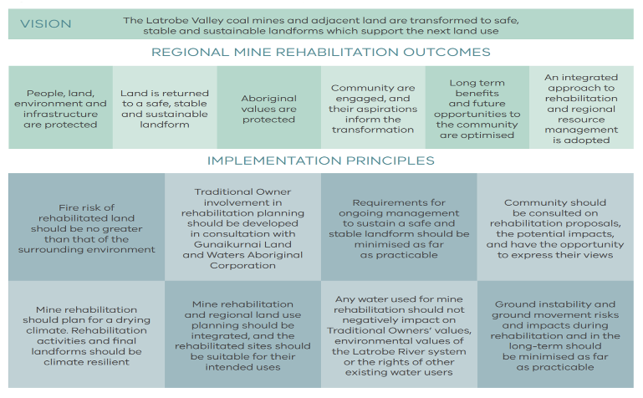
Figure 4.6. Vision, outcomes and principles of the Latrobe Valley Regional Rehabilitation Strategy (DJPR and DELWP 2020)
Options for mine rehabilitation that do not rely on water from the Latrobe system are also being considered. For example, the Victorian Government is exploring the feasibility of using manufactured water, such as recycled water, as well as non-water-based options.
The first review of the Latrobe Valley Regional Rehabilitation Strategy is to be completed in June 2023. It will take into account new knowledge gained through implementation of the first Strategy, together with any preliminary findings from the Hazelwood EES that are relevant to regional rehabilitation.
This increased knowledge base is being complemented with enhancements to the regulatory framework to ensure that mine licensees’ responsibilities for rehabilitation are clear and enforceable, regardless of any corporate changes. These enhancements include:
This includes amendments to Victoria’s Mineral Resources (Sustainable Development) Act 1990 to ensure rehabilitation liabilities remain the responsibility of the coal mining industry. This trailing liability regime will allow the State’s mining monitors to issue remedial directions to former title holders for any required future remediation works.

Providing shared benefits and flexible water sharing arrangements
Our plan:
- provide shared benefits through flexible water sharing arrangements and temporary trades
- apply new principles guiding the use of water storages for recreation
Water managers can be innovative in the way they meet the needs of all users, including Traditional Owners, and in some cases can provide social and environmental benefits without requiring additional water.
Policy 4-4: Managing water resources for shared benefits
Water supply systems and waterways will be managed to deliver shared benefits to all water users and values where possible.

Multiple benefits of water storage at Woodglen on the Wangangarra / WyYung (Mitchell River)
East Gippsland Water, in partnership with the Gunaikurnai Land and Waters Aboriginal Corporation, is investigating an option to create a Wangangarra / WyYung (Mitchell River) off-stream multiple-benefit water storage at Woodglen. Integral to the project are identifying and embedding ways to provide cultural, environmental and social benefits, with providing maximum flexibility to Gunaikurnai Land and Waters Aboriginal Corporation’s Wangangarra / WyYung (Mitchell River) water a key objective, in conjunction with urban water security.
Project opportunity for Traditional Owners
In late 2020, 2 gigalitres of water in the Wangangarra / WyYung (Mitchell River) was granted to Gunaikurnai Land and Waters Aboriginal Corporation. This was the first time under the Water Act that water has been issued to Traditional Owners. The Woodglen project would give the Gunaikurnai Land and Waters Aboriginal Corporation the ability to access and store cultural water in the new water storage for self-determined use.
The business case
East Gippsland Water and the Gunaikurnai Land and Waters Aboriginal Corporation are working together to further develop this project. This includes producing a simple prospectus, creating a project partnership plan and designing a business case. Operational logistics will be determined by the business case and will be guided by the Traditional Owner Cultural Water Benefits Framework, to achieve the best outcomes for water security, Gunaikurnai, and the environment.

Improving water management to deliver shared benefits
The Victorian Environmental Water Holder already works with waterway managers and Traditional Owners to maximise the shared benefits of environmental water releases, and this work will continue. While Traditional Owner values have started to be considered through environmental water management, there is still much work required. More can also be done to provide multiple benefits when we store and deliver water for consumptive use.
Action 4-16: Improving water management to deliver shared benefits
The Victorian Government will work with Traditional Owners, water corporations, waterway managers and the Victorian Environmental Water Holder to deliver improvements to water management in rivers, to benefit the environment and to support Traditional Owner cultural values and other shared benefits.  This could be achieved through a combination of more flexible and efficient operations: the flexible use of passing flows (where appropriate), using consumptive water en route, temporary trades (see Action 4-6) and building greater flexibility into environmental entitlements (where there are no adverse impacts on other existing entitlement holders). | Ongoing

Principles guiding the use of water storages for recreation
Waterways and water storages in the region are highly valued by Victorians for the wide range of recreational activities they offer and their contribution to the health, wellbeing and social fabric of communities, which support tourism and provide important economic benefits.
Water storages provide recreational facilities for community use. For example, near Ballarat, visitors can enjoy picnic areas, walking tracks, bike trails and barbecues at Kirks, Gong Gong and Moorabool reservoirs, while further east, water storages such as Lake Glenmaggie, Lake Narracan and Blue Rock Lake are popular for power-boating, fishing and swimming.
Some community groups want greater access, including on-water access, to reservoirs in the region. Recreational activities increase the risk to drinking water supplies by introducing contaminants and increasing the potential for outbreaks of waterborne diseases.
Water storages used for the purposes of drinking water supply are critical assets. Water corporations take a risk-based approach, using multiple barriers to protect against potential contaminants, including source water protection. However, even with robust water treatment processes in place, some risks to the drinking water supply remain. Augmenting water treatment systems to reduce contamination risk may increase water supply costs for customers.
We will provide greater clarity to the community about the risks of recreational access to drinking water storages, and measures that must be in place to reduce those risks. We will be transparent about the increased risks, the reliability of measures to reduce that risk and the associated ongoing costs to consumers.
New principles have been developed to guide decision-making about opening drinking water storages for water-based recreation. The principles set out how we aim to support the health, social and economic benefits of water-based recreation while continuing to reduce the risks to drinking water supply, and protect Aboriginal cultural heritage and environmental values.
Policy 4-5: Principles for deciding whether to permit water-based recreation at drinking water storages
The Victorian Government will apply the following principles when deciding whether to permit water-based recreation at drinking water storages. Permitting access to drinking water storages for water-based recreation will consider where the recreational benefits are the greatest and outweigh the risks and the costs, including to consumers of drinking water. Where the risks and benefits are not clear, the precautionary principle will be applied to decision-making: tipping the balance in favour of protecting our drinking water quality in the absence of certainty.
New recreational access proposals must articulate:
- which water bodies in the region are currently accessible for recreation, and whether alternative water storages not used for drinking water supply have been exhausted
- the facilities, infrastructure and surveillance programs required to support recreational access in a way that is safe for the public and maximises community benefits
- how risks to drinking water quality and human health have been assessed by water agencies, including against legislative responsibilities and the Australian Drinking Water Guidelines;
- the measures necessary to reduce risks to as low as reasonably practicable, including the robustness and reliability of these measures
- the extent of Traditional Owner support, and any considerations for the protection of cultural values
- the extent of the support of those consumers whose drinking water is supplied by these water storages
- any measures necessary to protect environmental values.
Proposals need to demonstrate how the community will benefit and how consumers of drinking water may be affected, through a robust cost–benefit analysis from the perspective of those using storages for recreation and those of supply customers
Proposals need to verify that consumers of the drinking water supply have been directly consulted about the risk and ongoing costs to the community.
Proposals must be assessed against obligations under the general environmental duty provisions of the Environment Protection Act 2017, obligations under the Safe Drinking Water Act 2003 for the provision of safe drinking water supply, and any other legislation relating to the protection and security of critical assets and maintaining water quality, and the reliability and quality of water supply.
Investment decisions will ultimately be made on the basis of the above information, where the benefits outweigh the costs and risks to water quality. Cost-sharing arrangements will be agreed as part of the investment decision and will take into account the relative beneficiaries of the project
Water corporations will report annually on work programs to manage the recreational value of water storages.

Tracking and understanding interception activities
Our plan:
- continue to track interception activities such as small catchment dams and plantations
- assess the impact of interception activities on water resources, while recognising the broader benefits of these activities
A study commissioned for the Strategy found that the proportion of runoff intercepted by catchment dams in a tributary of the Moorabool catchment could increase from 17 to 32 per cent in a dry year (based on a scenario of moderate growth and climate change).
Monitoring the range of different water uses helps to improve our understanding of the potential challenges for water resource management. This includes major water uses that do not currently require a licence, such as small catchment dams, plantations and other large-scale tree plantings (for instance, for carbon or biodiversity benefits). These activities can affect water availability by intercepting water that would otherwise reach waterways and aquifers. However, some tree-planting activities can have benefits for waterways, including reducing erosion and improving water quality.
Better information and data on these interception activities will help to identify emerging risks to water resources, and any controls that may be required. Small catchment dams and plantations have a range of social and economic benefits for regional communities and economies, which must form part of any future decision-making. By building our understanding of the impacts of interception activities and recognising the broader benefits of plantations and small catchment dams for the community, we will be prepared should future issues arise.
Action 4-17: Tracking and improving our understanding of interception activities, including small catchment dams and plantations
The Victorian Government will track and improve the understanding of unlicensed water uses in the region, including small catchment dams and plantations, by:  - continuing to monitor and report on the total volume of, and estimated take from, small catchment dams, including identification of emerging risks to water resources  - monitoring plantation and other large-scale tree-planting activities and assessing impacts on water resources. | Ongoing

Timber harvesting in water supply catchments
A key part of the Government’s Victorian Forestry Plan is the phasing out of timber harvesting in native forests by the year 2030. Currently, timber harvesting is allowed in Melbourne’s water catchments in limited areas under strict environmental guidelines. A study funded by the Department of Environment, Land, Water and Planning in 2020 supported earlier findings that, in the near term, little additional water would be gained if timber harvesting in Melbourne’s catchments ceased (Jordan et al. 2020). The earlier findings also demonstrated that climate change and bushfires posed greater risks to water yields than timber harvesting in water supply catchments.

Sustainable use of groundwater
Our plan:
- Taking a statewide approach, the Department of Environment, Land, Water and Planning and rural water corporations will partner with Victoria’s Traditional Owners and key stakeholders to improve groundwater management and licensing through to 2030. Groundwater Management 2030 will outline priority areas and be published in the second half of 2022. The initial focus will be on building a stronger common understanding of groundwater systems and management and working together with Traditional Owners and key stakeholders to further shape and address key outcomes and priority areas.

Enhancing groundwater management and licencing
Groundwater is vital to maintaining healthy environments and is a recognised and valued part of Country for Traditional Owners. It is a significant natural resource that must be well managed now and for the future for all Victorians. Groundwater already supplies about 15 per cent of Victoria’s consumptive water needs, including to cities and towns and farms.
The Victorian Government is committed to the equitable participation of Victoria’s Traditional Owners in the management of the state’s water resources through Water for Victoria (DELWP 2016b), this strategy, and draft Water is Life (DELWP 2022e). Traditional Owners will be actively invited to partner in shaping and addressing priority areas and determining how this will be achieved. Working with water users, key stakeholders and the community will also be critical.
The Department of Environment, Land, Water and Planning and rural water corporations are committed to the sustainable use of groundwater that supports existing and new uses, protects ecosystems and supports living cultural landscapes. To deliver this, priorities will be delivered linked to the following three outcomes by 2030:
- Having the best available information and science
Having good-quality, timely groundwater information is essential for the management and licensing frameworks to work effectively. Better information and the inclusion of Traditional Owner cultural knowledge and understanding will help us understand groundwater systems, how groundwater is used and how it supports cultural and environmental values. This will lead to improved management and licensing controls. This will ensure it is protected now and into the future in the face of declining river water availability and a changing climate.
- Having the right management tools in our framework
The foundations of groundwater management were developed to be enabling for consumptive use, aiming for flexibility and to respond to new information about the state of the resource. While we continue to take a precautionary approach when managing groundwater, our work will ensure that we have the tools to support sustainable groundwater management and licensing decisions into the future.
- Improving licensing
Victoria’s groundwater management approach, including the licensing framework, has not fundamentally changed since the introduction of the Water Act, more than 30 years ago. Our work will ensure that we can capitalise on, and respond to, the latest cultural knowledge, monitoring information and science to improve sustainable groundwater management.
Action 4-18: Updating groundwater management arrangements and implementing priorities for reform
The Department of Environment, Land, Water and Planning and rural water corporations will lead a staged approach to improve statewide groundwater management and licensing for the future.  Priority areas of reform will be addressed with the active participation of Traditional Owners and key stakeholders including existing entitlement holders and the community. | Ongoing

Continuing our focus on information, monitoring and compliance
Our plan:
- continue the zero-tolerance approach to the unauthorised extraction of water
- improve access to information about water licence rules, rosters, restrictions and bans so everyone can understand the rules that are in place to govern water use.
Effective and strong compliance around the take and use of water helps maintain fair access to our limited water resources. It supports community confidence in the water entitlement framework and water trading and deters people from taking and using water illegally. Water theft is a crime that undermines the health of our environment and impacts other water uses and values. While most instances of unauthorised take are small, the collective amount of water taken without authorisation can add up.
Victoria is committed to a strong compliance record to protect water entitlements the environment. The Water and Catchment Legislation Amendment Act 2019 strengthened penalties and enforcement measures, making it easier to prosecute offences. Proactive monitoring by water corporations is also critical to an effective and strong compliance regime. Ongoing improvements to access to information about water licence rules, rosters, restrictions and bans are helping water users to manage their own risks and improve compliance.
Policy 4-6: Continuing to improve information about water management rules and compliance
The Victorian Government will work with Melbourne Water and Southern Rural Water to ensure that licence holders and the community have access to consistent and accessible information about water management rules, including licensing and compliance arrangements, so that the framework for managing water resources in specific systems is clear.

Healthy Country, Healthy Mob
This chapter was originally prepared by the Central and Gippsland Region Sustainable Water Strategy Traditional Owner Partnership for the release of the discussion draft for public comment.
The Partnership members represent the following Registered Aboriginal Party groups:
- Bunurong Land Council Aboriginal Corporation
- Gunaikurnai Land and Waters Aboriginal Corporation
- Wadawurrung Traditional Owners Aboriginal Corporation
- Wurundjeri Woi-wurrung Cultural Heritage Aboriginal Corporation
The chapter progresses from the discussion draft, and reflects the insights, main messages and recommendations developed by the Central and Gippsland Region Sustainable Water Strategy Traditional Owner Partnership. We gratefully acknowledge the time, energy and expertise of partnership members: Dr Rohan Henry, Uncle Lloyd Hood, Tim Paton, Lisa Hocking, Michael Cook, Jordan Smith, Karmen Jobling, Sean Sexton, Greg Robinson, Matthew Chatterton, David Tutchener and their organisations. It includes a statement from the Traditional Owner Partnership in response to the Government’s Chapter 6 Water Justice for Traditional Owners. This statement is presented at the forefront.

Statement from Traditional Owner Partnership in response to the Government’s Chapter 6 - Water Justice for Traditional Owner
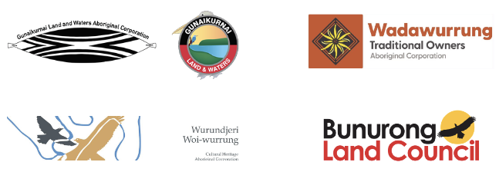
Statement prepared on behalf of the Bunurong Land Council Aboriginal Corporation, Gunaikurnai Land and Waters Aboriginal Corporation, Wadawurrung Traditional Owners Aboriginal Corporation, and Wurundjeri Woi-wurrung Cultural Heritage Aboriginal Corporation: the central and Gippsland region sustainable water strategy Traditional Owner Partnership.
We thank the Victorian Government for the opportunity to co-design how we participated in the Central and Gippsland Region Sustainable Water Strategy. The Central and Gippsland Region Sustainable Water Strategy Traditional Owner Partnership was formed mid 2019 by four of the five Traditional Owner corporations on whose Country – land and waters - the Central and Gippsland Region Sustainable Water Strategy is based. We determined from the outset the governance structure we required to help ensure our participation at this granular level was most collaborative with Government on several layers, but with empowerment at its core.
Through being embedded, we sought to realise our respective Traditional Owner corporation objectives, and to amplify the First Nations People’s voice in policy development from its commencement, through to sign off by the Minister.
While we were a Partnership, each Traditional Owner Corporation represented had its own priorities on behalf of its members – these needed to be protected so outcomes weren’t homogenised at the expense of Nation building.
However, there were strong commonalities, and water ownership was one. Of each Traditional Owner corporation represented on the Partnership, from the outset we communicated the objective to have water returned in regulated, semi-regulated, unregulated systems:
Sovereignty and self-determination in water is foundational to enabling Traditional Owners to care for Country and cultural heritage (tangible and intangible). Through sovereignty and self-determination, Traditional Owners can choose how to exercise their own water rights, guided by their own laws and cultural protocols. This is best achieved by Traditional Owners owning water and can be progressed by empowering Traditional Owners through changes to instruments and tools and having a seat at the table when decisions are being discussed and made by Government and its agencies. – Central and Gippsland Region Sustainable Water Strategy Traditional Owner Partnership presentation to the Consultative Committee, Meeting four (30th April 2021)
We applaud the Victorian Government for committing in this policy document to return water to Traditional Owners through Chapter 6. Water justice for Traditional Owners in the Strategy.
We anticipate all waterways with unallocated water will have water returned, as Traditional Owner Corporations apply for it, as a matter of urgency. We refer to the table we included in the Traditional Owner Partnership Chapter 4. Healthy Country, Healthy Mob in the Central and Gippsland Region Sustainable Water Strategy discussion draft, (released 7th October 2021 by the Victorian Government). We would like to reiterate the Traditional Owner corporations we represent seek water return of groundwater as well as surface water.

Table 5-1. Volumes of unallocated water available on Country
Water system | Name | Volume of unallocated water (ML)
Rivers and creeks | Aire River | 300
Rivers and creeks | Albert River | 300
Rivers and creeks | Bass River* | 300
Rivers and creeks | Cann River | 500
Rivers and creeks | Dividing Creek | 300
Rivers and creeks | Lung Lung (Franklin River) | 300
Rivers and creeks | French Island* | 200
Rivers and creeks | Johanna River, Milanesia Creek and Brown Creek | 300
Rivers and creeks | Parker River to Skenes Creek | 300
Rivers and creeks | Powlett River | 500
Rivers and creeks | Shady Creek & Nine Mile Creek | 300
Rivers and creeks | Ber’rawn (Tambo River) | 1,500
Rivers and creeks | Ten Mile Creek | 300
Rivers and creeks | Wangangarra / WyYung (Mitchell River) | 2,000
Rivers and creeks | Otways other | 90
Rivers and creeks | Genoa River | 500
Rivers and creeks | Gellibrand River | 1,000
Rivers and creeks | Lang Lang River* | 500
Rivers and creeks | South Gippsland Coastal* | 100
Rivers and creeks | South Gippsland other | 500
Rivers and creeks | Far East Gippsland other | 500
Groundwater Management Unit | Leongatha | 4,687
Groundwater Management Unit | Frankston | 994
Groundwater Management Unit | Boneo** | 800
Groundwater Management Unit | Werribee (Cut Paw Paw) | 3127
Groundwater Management Unit | Werribee (Merrimu) | 441

* For catchments in the Central and Gippsland Region Sustainable Water Strategy area that were outside of the 2011 Gippsland and Western Region Sustainable Water Strategy areas, including the Bass River and Lang Lang River catchments, the volumes of unallocated surface water available have been revised consistent with the approach taken in the 2011 strategies. This includes consideration of the risks posed by climate change, and a range of sustainability principles (refer to Policy 3.1 of the 2011 Gippsland Region Sustainable Water Strategy). The revised volume available is 300 ML in the Bass River catchment, 200 ML for French Island and 100ML for the coastal catchment between Lang Lang River and Bass River catchments. The revised volume available in the Lang Lang River catchment is proposed to be 500 ML
**Subject to Minister declaration of Boneo permissible consumptive volume
We would like to confirm that in addition to the waterways mentioned in Chapter 6, there is immediate interest in the Bass River, groundwater in Boneo, Leongatha and Frankston from the Bunurong, and interest in the Franklin River from the Gunaikurnai Land and Waters Aboriginal.
We look forward to unallocated water being returned unencumbered, upon application by Traditional Owner corporations and Section 40 requirements being assessed by the water corporations without delay. We welcome the water sharing principles outlined in Policy 6-1, and confirm they align with the Central and Gippsland Region Sustainable Water Strategy Traditional Owner Partnership principles.
The Government’s commitment to ensure fees and charges are not a barrier to Traditional Owners holding water (Section 6.5) is an important policy commitment which will better enable Traditional Owners to self-determine how they wish to use cultural water where it is not used for commercial purposes.
The Central and Gippsland Region Sustainable Water Strategy Traditional Owner Partnership worked closely with Government to have a quadruple-bottom-line assessment incorporated into the Strategy. This is a significant step to cement the rights of Traditional Owners through fulsome consideration of cultural values in decision making, including water augmentation decisions. We have through the ‘Framework: Multiple benefits of ownership and management of water by Traditional Owners’, attached to the Strategy (the framework) sought a strong evidence base of the benefits of restorative water justice for Traditional Owners, and an accompanying methodology to be tested. We are pleased to see this well represented in the Central and Gippsland Region Sustainable Water Strategy.
The framework identifies the multiple, intergenerational benefits from Traditional Owner management and ownership of water in a way that can inform government decision making, through measurement that meets the three dimensions of Healthy Country, Healthy Mob, Sovereignty and Self-determination.
Sovereignty and self-determination in water is foundational to enabling Traditional Owners to care for Country and cultural heritage (tangible and intangible). Through sovereignty and self-determination, Traditional Owners can choose how to exercise their own water rights, guided by their own laws and cultural protocols. This is best achieved by Traditional Owners owning water and being empowered to manage water, and is progressed through changes to instruments and tools, and giving Traditional Owners a seat at the table when decisions are being discussed and made by Government and its agencies.
We see the Strategy as a very important step toward reform – but it is still a step. For lasting reform, the change needs to be institutionalised. We have built some strong relationships through the Central and Gippsland Region Sustainable Water Strategy Consultative Committee, but water justice must not be dependent on relationships and goodwill. Cultural water must be granted, managed, and held and accessed without compromise through an entitlement and management framework that rejects the concept that water is a commodity. Water is not a commodity, water is life. No-one knows this more than the Traditional Owners who have managed water on Country for tens of thousands of years.
As Gunaikurnai, we see our land (Wurruk), waters (Yarnda), air (Watpootjan) and every living thing as one. All things come from Wurruk, Yarnda and Watpootjan and they are the spiritual life-giving resources, providing us with resources and forming the basis of our cultural practices. We have a cultural responsibility to ensure that all of it is looked after.
Bunurong people belong to Country, as a part of Country water is integral to this belonging. Bunurong people belong to the water of a place.
Bunjil’s brother, Palliyang, the Bat, created Bagarook, women, from the water. Since our beginning it has been known that we have an obligation to keep the Birrarung alive and healthy—for all generations to come
– Wurundjeri Woi Wurrung
Caring for our Country, land, sky, and waters, and continual cultural practices are core to our identity as the Traditional Owners of Wadawurrung Country.
We have asked the Healthy Country, Healthy Mob chapter be re-presented in the final.

Water rights for Traditional Owners

Water is life
The land, water, and waterways of the Bunurong, Gunaikurnai, Wadawurrung and Wurundjeri Woi-wurrung are living entities. They should be recognised as such, and treated accordingly under Victorian law, associated guidance material, letters of obligation and policy.
Traditional Owners know that water is essential to life, and to Creation. The Sustainable Water Strategy Traditional Owner Partners, and the communities they represent, have Dreaming stories and/or Ancestral beings associated with water. The cultural, spiritual, physical, and economic health of the Bunurong, Gunaikurnai, Wadawurrung and Wurundjeri Woi-wurrung peoples cannot be separated from the health of their respective Countries, including their water and waterways. Any benefits realised by the Traditional Owner Partnership to improve the health of their Countries will benefit all communities residing within their borders. Healthy water, waterways and Country are good for all.
In order to improve the health of the Traditional Owner communities and Countries represented by the partnership, the legal entitlements to the ownership of water, which have since (un)Settlement almost entirely been denied, must be reinstated, unencumbered by fees. Water entitlements transferred to member organisations of the Traditional Owner Partnership must be sufficient to achieve substantial and measurable outcomes as determined by the communities represented by the partnership.
Concurrent with the transfer of legal titles to water, Bunurong, Gunaikurnai, Wadawurrung and Wurundjeri Woi-wurrung peoples must be resourced to undertake critical foundational work to develop strategies and implementation plans to achieve their respective objectives.
Water is life. No-one knows this more profoundly than the Traditional Owners. In the Central and Gippsland Region, Traditional Owners have managed water on Country for more than 50,000 years, making sure there was enough water to go around for healthy Country, and healthy mob.
Nowadays, government — through its water corporations and catchment management authorities, and its regulators responsible for water quality and pricing — decide how and where water goes, how much, when, and for how long, and Traditional Owners until very recently have been completely denied the right to have a say about water on their Country.
This chapter acknowledges the Victorian Government policy of returning water entitlements to Traditional Owners and has been developed to guide the reinstatement of such rights and decision-making for Traditional Owners represented by Bunurong Land Council Aboriginal Corporation, Gunaikurnai Land and Waters Aboriginal Corporation, Wadawurrung Traditional Owners Aboriginal Corporation and Wurundjeri Woi-wurrung Cultural Heritage Aboriginal Corporation. It presents Six Principles and other actions to progress Traditional Owner access to water through both entitlement and authority, and to embed on-Country monitoring, evaluation and research designed and undertaken by Traditional Owners in a manner that meets Traditional Owner objectives and, in turn, cultural obligations. It also highlights the need for the water sector to have an obligation to report back to Traditional Owners on how they are meeting those objectives.
Bunurong people belong to Country, as a part of Country water is integral to this belonging. Bunurong people belong to the water of a place.
Caring for Country also has a flow-on effect for Bunurong people. By keeping Country healthy and in balance, Country would then also care for the people. As Country is not passive it is able to provide everything required to survive and thrive. However, if Country is not cared for it can also cause harm to the spiritual and cultural health and mental wellbeing of Bunurong people. — Bunurong Land Council Aboriginal Corporation
Water is very important — I suppose it’s important to everyone now today, but it’s always been the very core of our existence.
— Uncle Lloyd Hood, Gunaikurnai Land and Waters Aboriginal Corporation
We hold moral obligations to the health of Country, it’s what we’re taught from a young age. — Michael Cook, Wadawurrung
For me walking in these sands is recreating and walking in the footsteps of my ancestors in the past. It’s about connecting, reconnecting, and their spirits guide you and take you to these places that they’ve accessed and used for over forty thousand years. — Robert Ogden, Bunurong
Balliyang, barnumbinyu Bundjilal, banyu bagurrk munggany. Ngarn gunganyinu nhanbu nyilam biik, nyilam kuliny — balit biik, balit kuliny: balitmanhanganyin manyi biik ba Birrarung. Balitmanhanganyin durrungu ba murrupu, ba nhanbu murrondjak! (Bunjil’s brother, Palliyang, the Bat, created Bagarook, women, from the water. Since our beginning it has been known that we have an obligation to keep the Birrarung alive and healthy — for all generations to come).
— Wurundjeri Woi-wurrung Cultural Heritage Aboriginal Corporation

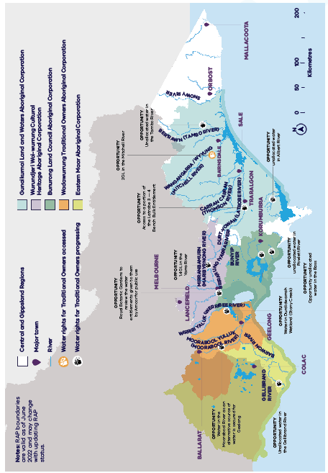
Figure 5.1. The Registered Aboriginal Parties (RAPs) of the Central and Gippsland Region Sustainable Wa-ter Strategy. The RAP boundaries are current at June 2022

The Traditional Owner Partnership
The Central and Gippsland Region Sustainable Water Strategy is the first Sustainable Water Strategy to formally include Traditional Owners as members of the consultative committee, alongside other representatives from the water sector, the Victorian Environmental Water Holder and the Department of Environment, Land, Water and Planning. This chapter has been written by the Traditional Owner Partnership, formed by Bunurong Land Council Aboriginal Corporation, Gunaikurnai Land and Waters Aboriginal Corporation, Wadawurrung Traditional Owners Aboriginal Corporation and Wurundjeri Woi-wurrung Cultural Heritage Aboriginal Corporation.
Through the Strategy, the Victorian Government and the Traditional Owners of the region have worked together to ensure that the water needs of the Traditional Owner corporations represented are considered alongside those of other water users in the discussion about water availability and sharing. In its role in the Strategy, the partnership has endeavoured to:
- amplify Traditional Owner voices and perspectives in the Sustainable Water Strategy
- identify and express barriers to Traditional Owners holding water in Victoria’s consumptive-based water-entitlement framework
- work with government to determine what changes to instruments and tools are required for water to be held and used flexibly by Traditional Owners
- identify what needs to occur to protect any ensuing Traditional Owner water entitlements from competing pressures
- help government articulate how ‘Health Country, Healthy Mob’ and self-determination will be realised in government legislation, agreement-making, policy, and Strategy implementation.
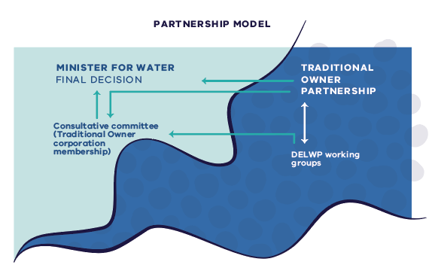
Figure 5.2. Traditional Owner groups are embedded in all levels of the Central and Gippsland Region Sustainable Water Strategy governance structure
The Traditional Owner Partnership identified the main aims to include in the Strategy in line with each Traditional Owner Corporation’s water objectives and to progress the Victorian Government Aboriginal Water Policy. No policy in the Strategy should dictate a path for individual Traditional Owner groups. Instead, the Strategy should enable each Traditional Owner group to realise its priorities for water in a way and within a timeframe that best suit the priorities and objectives of that group, and the Traditional Owner community it represents.
Each Traditional Owner group has and will continue to work directly and independently with the government regarding place-based discussions about their Country.

Redressing an unjust history
The Bunurong, Gunaikurnai, Wadawurrung and Wurundjeri Woi-wurrung peoples have never ceded rights to land and waters. Cultural responsibilities to care for Country have been denied by the historical segregation of Traditional Owners from water policy, management and planning in Victoria. This has had severe and compounding ramifications for healthy Country and for the health and wellbeing, including the economic wellbeing, of all Traditional Owners, and has contributed to unsustainable water management practices — which affect everyone.
Across Australia, Aboriginal peoples have had rights to water taken away. In Victoria it is estimated that Aboriginal people own less than 0.2 per cent of all water rights. Without water rights, including water entitlements, Traditional Owners are unable to exercise self-determination. Without water entitlements, Traditional Owners cannot mandate where or how water can be used to support cultural, spiritual, environmental, or economic outcomes. This exclusion denies Traditional Owners the right to care for Country, which is the essence of Aboriginal social, spiritual, economic, and physical wellbeing, and the basis of cultural lore.
Traditional Owners are not the first in line with the bucket. We’re way down behind everyone else. So, we’re not even considered most of the time. All the time. And we need to change that. We want to be first in line.
— Uncle Lloyd Hood, Gunaikurnai Land and Waters Aboriginal Corporation
Victoria has begun the process of handing water entitlements back to Traditional Owners (Figure 1.3). The Sustainable Water Strategies are an important tool to enable the Victorian Government to work in genuine partnership with Traditional Owners, to understand and decide upon actions to achieve tangible benefits for Traditional Owners, including restoration of water rights. The Central and Gippsland Region Sustainable Water Strategy will reflect the value of water to the health, wellbeing, and economic outcomes of Traditional Owners, by enabling self-determination in water management.
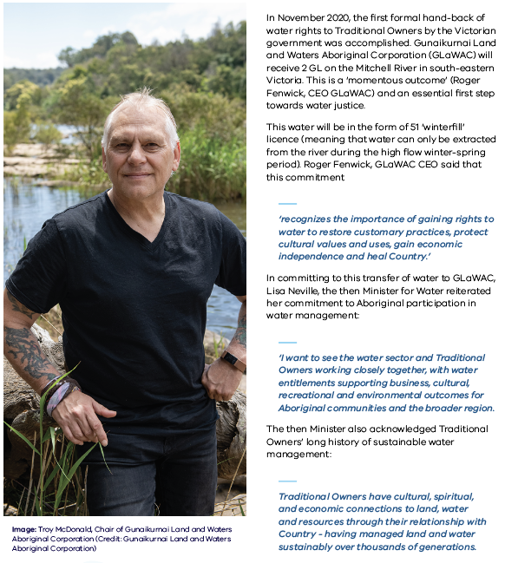
Figure 5.3. Water handback to Gunaikurnai on the Wangangarra / WyYung (Mitchell River)

Sovereignty and self-determination
Traditional Owner sovereignty and self-determination in water are a foundation for water management in Victoria. Each Traditional Owner expresses this relationship with water slightly differently. Some examples from each of the partnership organisations are set out below.

Bunurong
As Traditional Owners, we never considered our right to water until that right was taken away. Australia has one of the biggest water markets in the world, worth billions, yet for a long time it seemed Aboriginal water entitlements continued to shrink. While we make up around 3% of the population, we retain rights to a much smaller percentage of available water. If we want to live on our own Country, we must buy land back from those who benefited from its theft. If we want water, we must pay companies that have impacted our land and cultural sites by piping water here and there, for the convenience of their customers.
The Government’s overall management of that water has led to diminished volumes, higher prices, lower quality of life for people in many areas and a biodiversity imbalance. Aboriginal people deserve to also be able to enjoy the benefits of water rights as not only a basic human right, but as part of their obligation as Traditional Owners, or custodians of Country. Our custodianship is a human right, but it’s also an inherited obligation we have as Aboriginal people. For us to have water rights within Bunurong Country, means that once again we can continue to care for Country in ways we were not able to before; bringing cultural flows back to dry creeks and tributaries and assisting with the biodiversity issues caused by bad planning and decision making in the past. It also allows us to take part in the broader water economy, which is long overdue. We can’t live without water and Country cannot function without water. For Bunurong people to have water rights, is a turning point; a marker in time that shows us that our role on Country is respected, and important, and as one part of the oldest continued culture on this planet.
— Bunurong Land Council Aboriginal Corporation
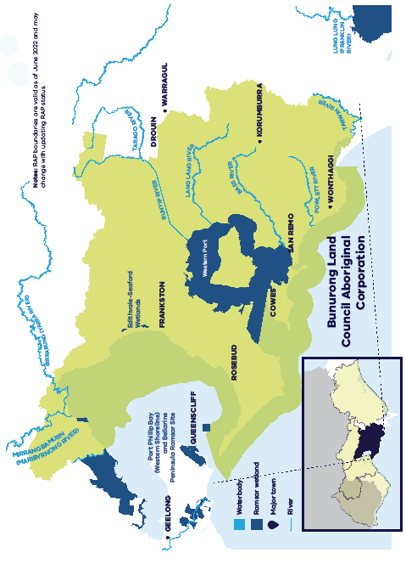
Figure 5.4. The Registered Aboriginal Party (RAP) area of Bunurong Land Council Aboriginal Corporation. The RAP boundary is current at June 2022

Gunaikurnai
As Gunaikurnai, we see our land (Wurruk), waters (Yarnda), air (Watpootjan) and every living thing as one. All things come from Wurruk, Yarnda and Watpootjan and they are the spiritual life-giving resources, providing us with resources and forming the basis of our cultural practices. We have a cultural responsibility to ensure that all of it is looked after.
— Gunaikurnai Whole of Country Plan, 2015
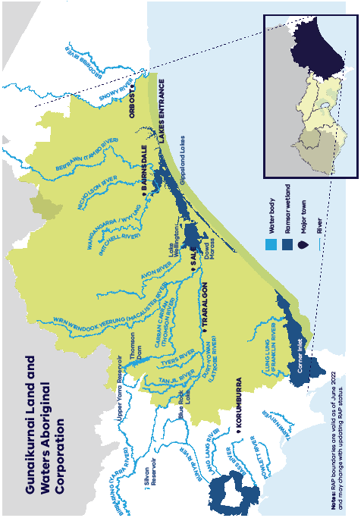
Figure 5.5. The Registered Aboriginal Party (RAP) area of Gunaikurnai Land and Waters Aboriginal Corpo-ration. The RAP boundary is current at June 2022

Wadawurrung
Our main river systems are the Barwon/Moorabool, Yarrowee and Leigh rivers or Barre Warre Yulluk. Yulluk (great river) that runs from the Barre (mountains) to the Warre (ocean), and our stories tell of these connections. The name Barwon is derived from Parwan meaning ‘magpie’ or ‘great wide.’
The chain of ponds from the Barre Warre Yulluk (Barwon River) to Reedy Lake, Hospital Lake, Lake Connewarre and Estuary Bay is connected through water and our Connewarre (Black Swan) Dreaming. The Connewarre Wetland Complex is internationally significant for wader and shoreline birds and forms part of the Port Phillip Bay (Western Shoreline) and Bellarine Peninsula Ramsar Site.
Our waterways were like our highways, they were how Wadawurrung people moved around Country.
Our people used canoes or in calmer waters, Murriyans bark floats, or punts pushed by long poles to gather the abundance of food. On the natural rises along the waterways our people camped and caught eels, other fish and waterbirds to eat. Important decisions were made on the banks of these waterways by our Ancestors. They were important living and meeting places. Just as they are today.
— Paleert Tjaara Dja, Let’s make Country good together 2020–2030 (Wadawurrung Country Plan)
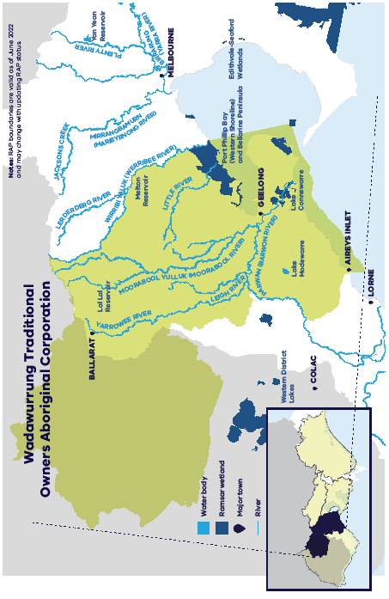
Figure 5.6. The Registered Aboriginal Party (RAP) area of Wadawurrung Traditional Owners Aboriginal Corporation. The RAP boundary is current at June 2022

Wurundjeri Woi-wurrung
Woiwurrungbaluk ba Birrarung wanganyinu biikpil. Yarrayarrapil, manyi biik ba Birrarung, ganbu marram-nganyinu. Manyi Birrarung murrondjak, durrung ba murrup warrongguny, ngargunin twarnpil. Birrarungwa nhanbu wilamnganyinu. (We, the Woi-wurrung, the First People, and the Birrarung, belong to this Country. This Country, and the Birrarung are part of us. The Birrarung is alive, has a heart, a spirit and is part of our Dreaming. We have lived with and known the Birrarung since the beginning).
— Yarra River Protection (Wilip-gin Birrarung murron) Act 2017, preamble from Wurundjeri Woi-wurrung Cultural Heritage Aboriginal Corporation
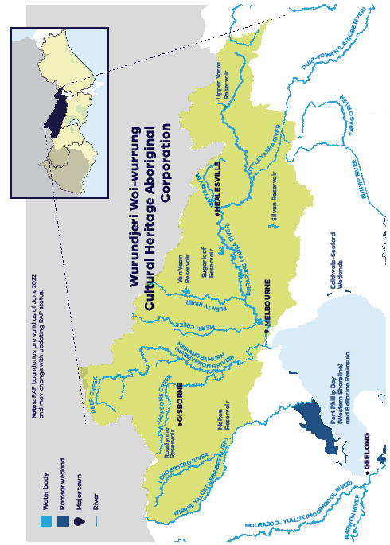
Figure 5.7. The Registered Aboriginal Party (RAP) area of Wurundjeri Woi-wurrung Cultural Heritage Abo-riginal Corporation. The RAP boundary is current at June 2022

The quadruple-bottom-line
Managing water holistically to care for Country and people brings great benefits to everyone living in the region: healthy rivers, happy and healthy people, and thriving towns and regions. The Traditional Owner Partnership is developing a framework to express the wide range of benefits that flow from increasing Traditional Owner ownership and management of water in the Central and Gippsland Region.
The quadruple-bottom-line approach takes into account not only economic or financial results or benefits, but also social, environmental, and cultural factors and outcomes. Consideration of all four elements should bring community wellbeing, prosperity, and jobs (Figure 5.8).
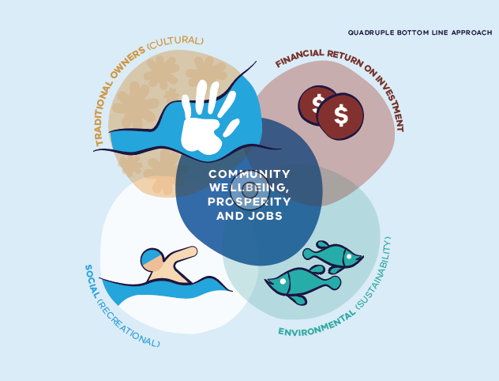
Figure 5.8. The elements of the quadruple-bottom-line approach
Caring for Country, including its waterways and water bodies, is the custodial obligation of Traditional Owners, handed down over countless generations. Managing the health of Countries (and governing communities) has been a foundational responsibility of Traditional Owners. However, these rights have been largely denied in the Central and Gippsland Region since European (un)Settlement.
All Victorians and water users must work together to secure water for the 50-year planning period of the Strategy, and beyond. Long-term planning is required. No-one knows this better than Traditional Owners, who managed Country sustainably for tens of thousands of years.
Caring for Country, which includes caring for water and waterways, benefits all Victorians. Traditional Owners have successfully cared for Country for many thousands of years. When Country is cared for, it is healthy, its resources are shared equitably, it supports healthy people and economies, and it provides an environment that can be enjoyed by everyone.
It’s part of us, we’re taught not to take more than we need.
— Tim Paton, Gunaikurnai Land and Waters Aboriginal Corporation
That’s part of our Aboriginal upbringing. Don’t take too much of the fish stocks, don’t take too much because there’s always other people that would come behind. We travelled a lot, there was always another clan group coming behind us, so it was important that there was something left. And they would then do the same for others.
— Uncle Lloyd Hood, Gunaikurnai Land and Waters Aboriginal Corporation
The Strategy will play a significant role in returning water entitlements to Traditional Owners, as well as strengthening and developing agreement-making between Traditional Owners, water authorities and other government agencies. To do so, the proposed Strategy actions will:
- increase Traditional Owner access to water entitlements
- remove barriers to Traditional Owners’ use of water
- support partnerships between Traditional Owners and water managers
- establish longer-term goals for place-based, integrated land and water management.

Six Principles to guide allocation of water to Traditional Owners
As water becomes available, the Strategy should guide the return of water to Traditional Owners. The following Six Principles have been developed by the Traditional Owner Partnership, and endorsed by the Strategy’s consultative committee as actions for the Strategy:
Water sharing principles:
- Each Traditional Owner will receive entitlements to water in rivers and aquifers on their Country for their self-determined use.
- Where a water source is shared between more than one Traditional Owner group, water rights from that water source (a river, or aquifer) will be similarly shared.
- Where more than one party claims an interest in new water entitlements for a river or aquifer (via water substitution, unallocated water and formerly allocated water), Traditional Owners will receive a negotiated and equitable share of the available water.
- The share of unallocated water going to Traditional Owners should be allocated as a priority (without waiting for remaining shares to be allocated via auction processes or similar) (see Action 4-7, Action 4-8 and Action 4-9).
Water substitution arrangements that free up water in rivers for Traditional Owners should be pursued in water systems on the Country of each Traditional Owner group.
As new water supplies are built (such as recycled water systems and desalination plants), the Victorian Government will seek to provide Traditional Owners with access to a share of these new supplies, directly or via substitution for river water. The share will be determined on a case-by-case basis based on a business case developed in partnership with Traditional Owners, and other relevant parties, and using the Cultural Benefits Framework to quantify Traditional Owner benefits (see Figure 6.3 and Action 9-1 and Action 9-6).

Introducing the Cultural Benefits Framework
The Traditional Owner Partnership, with support from DELWP, embarked on a project to identify and communicate the multiple benefits that can be achieved from enabling Traditional Owner management and ownership of water. The purpose of the project was primarily to inform government and its delivery partners’ decision making, providing a framework to demonstrate how changes in ownership and management can result in benefits across multiple scales, and to introduce a methodology to both identify and estimate the expected benefits.
Understanding the benefits and having a process for assessment elevates the quadruple-bottom-line assessment. While commodity-based claimants to water resources (e.g. irrigated agriculture, mining, urban users) have relatively well-accepted ways of measuring the benefits that come from water access, a means for assessing the benefits for water ownership and control for Traditional Owners has not been undertaken in Australia. It is particularly important to both not monetarise the assessment, nor subject water restorative justice for Traditional Owners to a populace approach. The cultural benefits framework shows that while Traditional Owners have not been afforded access to water – which of course leads to a lack of any evidence base in measuring the benefits of reversing this historic injustice – that benefits from rights restoration has been demonstrated in Australian and international literature, and that these benefits are likely to result in spill over benefits for the wider community.
Bringing this evidence together into a framework demonstrates how changes in ownership and management can result in benefits at the scale of individuals, at a Traditional Owner Nation level, and also creates a ripple effect that extends to the wider community and, in some cases, the whole of Victoria and Australia.

Identifying the multiple benefits
The framework identifies and communicates the multiple benefits from Traditional Owner management and ownership of water in a way that can inform government decision making whilst ensuring these benefits are expressed and measured in ways that are meaningful for Traditional Owners, through the three dimensions of Healthy Country, Healthy Mob, Sovereignty and Self-determination. It is intended that this framework (Cultural Benefits Framework, Traditional Owner Partnership and Alluvium, 2022) be used by government departments (including the Department of Treasury and Finance and the Department of Environment, Land, Water and Planning), other public sector bodies (such as water authorities and catchment management authorities), and delivery partners to guide decisions that would have impact on Traditional Owner access to water, including restoration of water rights, and management of water, including through the Central and Gippsland Region Sustainable Water Strategy.
The objectives of the framework when applied is to demonstrate:
- The health, wellbeing and economic benefits for Traditional Owners associated with the ownership and management of water.
- Benefits (including water security) to other water users (e.g., the environment, recreational users, irrigators and others) as a result of Traditional Owner ownership and management.
- The flow-on implications for quadruple-bottom-line (see Section 9.1) outcomes for the Central and Gippsland Region.
- Contributions to mobs as well as meeting Government priorities and obligations such as the Treaty process, Closing the Gap, the Victorian Self-Determination Reform Agenda and legal obligations.
Figure 5.9: Values adopted by the Traditional Owner Partnership
Value | Description
AFFECTIVE VALUES | Qualities of the resource that sustain important affective qualities, such as aesthetic appreciation, ambience, inspiration, sensory responses, ecological appreciation, spiritual realisation and emotional well-being,
CUSTODIAL VALUES | Moral or cultural obligations for the care of the landscape for present and future generations. Custodial values include values associated with bequest, future options and the transmission of knowledge and learning.
FUTURE USE VALUES | Includes commercial or enterprise development aspirations.
IDENTITY VALUES | Sites or features of the resource that contributes to self or group identification.
PLACE-BASED VALUES* | Places that are dependent upon the resource that are significant or valuable for their existence.
PRACTICE BASED VALUES | Qualities of the resource or location that is necessary to support personally, socially or culturally important practices, such as recreational use, resource harvest or spiritual and ceremonial practice.
RELATIONAL VALUES | Contributions of a site or feature of the resource that sustains, represents or embodies a relationship to historical or spiritual connections with the landscape, identity, genealogy, law and custom as a whole.
SOCIAL COHESION | Sites or qualities of the resource that contribute to community connectedness, social interaction, trust, inclusion, sense of belonging and the reduction of conflict within a community.
WELL-BEING VALUES | The qualities of the resource or location that contribute to physical and mental health, therapeutic activity and quality of life.
The values in Figure 5.9 can be grouped into three key themes: Healthy Country, Healthy Mob and self-determination and sovereignty. Some values occur in more than one category. These three themes are also adopted in the Cultural Water for Cultural Economies report (O’Donnell et al 2021).

Healthy Country
Country is the lifeline that sustains Mob. It is the source of all life and provides all the essential resources for survival. Everything on Country is connected. There is no separation between landscapes, waterways, natural and cultural resources and people. In order for Country to keep providing the resources and sustaining life as it has always done, Country needs to be healthy. The health of individual species is important but because everything is connected, Healthy Country is critical. Having Healthy Country means individual species and resources of value will be looked after. Traditional Owners have cultural and moral obligations to care for Country. To protect and heal the damage of the past and to protect Country for future generations. Obligations to care for Country connect people across communities and language groups and extend across the landscape (MLDRIN et al. 2017)
Country is the connection to the past, to ancestors, to history and to the future. This connection is ongoing and has never been broken. Features on the landscape provide a direct connection to ancestors and the past. Maintaining values and sites on Country are important to maintain this connection to the past. Culture is embedded in Country and is foundational to identity. Continuing cultural practices link people to ancestors through shared customs. To continue these cultural practices, it is essential that Country is healthy. Many resources used in cultural practices rely on healthy Country and the protection of important places to make them available for use.

Healthy Mob
The wellbeing of Mob is about more than just physical health and security. There are many elements to wellbeing. A key pillar of wellbeing is maintaining strong spiritual and cultural connections to Country. This can only be done through the ongoing practice of culture which is dependent on a Healthy Country. The wellbeing of Mob is also dependent on having stable and secure employment and housing. Caring for Country can provide opportunities to secure the future economically and contribute to wellbeing.
Self-determination and sovereignty
Victorian Traditional Owners maintain that their sovereignty has never been ceded (Advancing the Treaty Process with Aboriginal Victorians Act 2018). Traditional Owners have a cultural obligation to care for Country and invaluable knowledge of Country through sustained traditional practices and management approaches. Country that is managed in harmony with traditional practices is healthy, having sustained people for thousands of years. This long-standing knowledge of and occupation of Country provides the basis for Aboriginal rights to use, manage and control Country. Through these rights, work can be progressed to heal and protect Country, to improve the wellbeing of Mob, to maintain and pass down cultural practices and traditions. The right of Aboriginal groups to use, manage and control Country ensures that Country can be managed utilising traditional knowledge which inherently results in sustainable use. Self determination is a key component of the United Nations Declaration on the Rights of Indigenous Peoples.
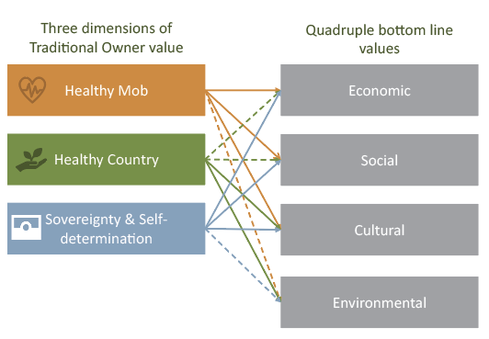
Figure 5.10. Alignment with the Quadruple-Bottom-Line Approach

Water rights
Access to water for Wadawurrung Traditional Owners is a major aspiration for us. It enables economic development for the Wadawurrung but it also meets obligations around the overall health of the Country. This also contributes to self-determination.
— Michael Cook, Wadawurrung
Cultural flows are water entitlements that are owned or managed by Traditional Owners in accordance with their own laws and cultural protocols. Each Traditional Owner group will determine how to use its own water entitlements, including caring for Country and cultural heritage, providing for healthy people and wellbeing, and delivering economic benefits and sustainable development.
Groundwater, like all water sources, is very important to Traditional Owners. However, to date, discussions with government on cultural values and uses of water have focused on surface water, not groundwater. This does not reflect the cultural value of groundwater. The Strategy gives the opportunity to acknowledge the cultural importance of protection of groundwater to Traditional Owners and bring this important natural resource into the discussion. It is proposed that Traditional Owners must be included in the assessment of any future applications for groundwater extraction and transfer (both within and between Traditional Owner Countries).
Water rights and entitlements in Victoria
Water rights are defined and allocated under Victoria’s Water Act 1989:
- section 8 rights — the right to take water from a waterway, groundwater bore, spring, soak or dam on or adjacent to the landholder’s property, for domestic and stock purposes (no fees and charges).
- section 8A rights — the right of Traditional Owners to take water from a waterway, groundwater bore, spring, soak or dam on or adjacent to land that is the subject of a Traditional Owner Settlement Agreement, for purposes related to the cultural values and uses specified in the agreement (no fees and charges). These rights are expressed in Traditional Owner Settlement Agreements. Currently none of the Traditional Owner Partnership corporations is able to access section 8A rights, as the process requires both having a Recognition and Settlement Agreement and having section 8A rights written into that agreement.
- section 51 licence — the right to take water from a waterway, dam or groundwater bore under the conditions specified on the licence (including a specific location for use). This licence can be transferred to another user (traded) and includes fees and charges for water use.
- water share — the right to receive water allocations in a declared water system (such as the Thomson-Macalister system). Water share owners do not need to own land, water shares can be transferred (traded), and there will be annual fees for water share ownership.
- water allocation — the physical water available under a water share, allocated by a water corporation in a declared system. Water allocation owners do not need to own land (unless they wish to use the water on land), water allocation can be transferred (traded), and there will be annual fees for water use.
Other rights may also be necessary (such as a water-use registration, which enables water to be used on land; a works licence, which enables infrastructure such as a water pump or a groundwater bore to be constructed; or a delivery share, to receive water through a water corporation’s infrastructure).

Traditional Owner share of water

Unallocated water
Across Victoria, most surface and groundwater systems are fully allocated, which means that no new water rights can be issued without:
- compromising the future sustainability of the water resource
- freeing up surface water and groundwater through substitution
- reallocating water that was allocated for a purpose that no longer exists.
Unallocated surface water volumes are illustrated in Figure 5.11. Unallocated groundwater volumes are illustrated in Figure 5.12.
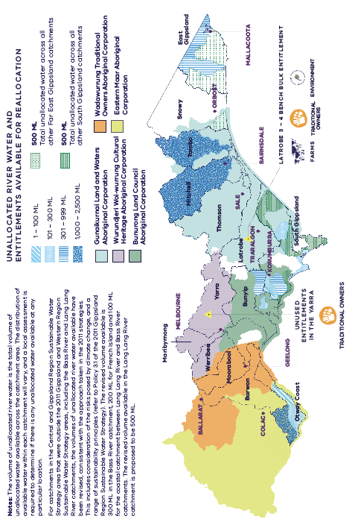
Figure 5.11. Unallocated river water in each river basin across the Central and Gippsland Region and the location of water entitlements (held by public agencies) that are no longer needed for their current purposes
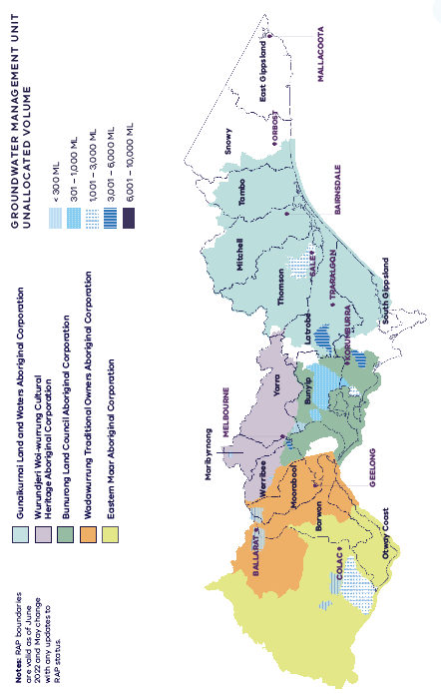
Figure 5.12. Unallocated groundwater volumes across the Central and Gippsland Region

Proposal 5-1:
It is proposed that the Strategy determine the share of the unallocated water in each of these locations that will be allocated to Traditional Owners, in accordance with the Six Principles.
Unallocated water exists at many locations across the Central and Gippsland Region. Chapter 6 outlines proposed principles to guide the allocation of water to Traditional Owners as water becomes available across the Central and Gippsland Region.
After the share of the volume for Traditional Owners has been determined, this is to be allocated to the relevant Traditional Owners as a matter of urgency — if necessary, in advance of other water allocation processes. This water will be allocated to Traditional Owners as the most appropriate form of water entitlement, most likely under a section 51 licence, as cultural water (unless otherwise specified by the relevant Traditional Owners).
In addition, future studies may identify further volumes of water that can be allocated. To remedy the historical exclusion of Traditional Owners from water rights, after the share of the volume available to Traditional Owners has been determined, the relevant water corporation will complete the process by allocating this water to the relevant Traditional Owners under the appropriate licensing system.

Water handback opportunity: the Birrarung
The Birrarung has always been central to our identity. In addition to supporting Wurundjeri Woi-wurrung people’s social, spiritual, and cultural wellbeing prior to European contact, the river provided a basis for our trade and economic prosperity. Moving forward we will be seeking support from the State Government … for a dedicated water allocation. Once attained, this water will be used to support Wurundjeri Woi-wurrung people’s cultural and economic health into the future.
— Wurundjeri Woi-wurrung Cultural Heritage Aboriginal Corporation, 2017
Water entitlements can be returned to Traditional Owners by ‘gifting’ water rights currently held by other parties or individuals. In 2012, after the Amcor facility (paper mills) on the banks of the Birrarung (Yarra River) in the Melbourne suburb of Fairfield was decommissioned, the company sought opportunities to gift its water licence of 2.2 gigalitres. In 2015, 0.1 gigalitres of this was transferred to the Royal Botanic Gardens and, in 2017, 0.7 gigalitres was transferred to the City of Melbourne. Rights to the remaining 1.4 gigalitres are currently held by the Department of Environment, Land, Water and Planning.
Wurundjeri Woi-wurrung have formally expressed their interest to the Department of Environment, Land, Water and Planning and Melbourne Water in the remaining 1.4 gigalitres. They have also requested a review of the decisions to allocate water to the Royal Botanic Gardens and the City of Melbourne, on the grounds that they have never ceded their rights to water, and at least one of these allocation decisions (City of Melbourne) occurred after Water for Victoria required water corporations to notify Traditional Owners when opportunities to obtain water entitlements arise. Wurundjeri Woi-wurrung are consequently requesting that the full 2.2 gigalitres be allocated to the Wurundjeri Woi-wurrung Cultural Heritage Aboriginal Corporation.

Proposal 5-2:
It is proposed that entitlement to 1.4 gigalitres of water in the Birrarung be returned to Wurundjeri Woi-wurrung Cultural Heritage Aboriginal Corporation, and that the Victorian Government complete a formal review of the allocation decision for the remaining 0.7 gigalitres.

Water substitution
Water substitution arrangements enable water from new sources (recycled water, treated stormwater and future desalinated water) to be used instead of river water. Section 4.1 of the Strategy identifies an adaptive approach for water substitution arrangements as part of water supply augmentations to meet emerging and future supply and demand requirements.
There is a strong case for increasing Victoria’s reliance on new, climate-independent water sources. As noted by the Victorian Government’s long term water resource assessment, water security across the Central and Gippsland Region is already declining significantly. In a future where water resources are becoming more and more scarce, climate-independent water sources will be increasingly valuable.
New climate-independent sources of water (recycled water and desalination) are being prioritised for industry, irrigation and urban use, to reduce reliance on river flows. To avoid repeating the mistakes of the past, through which Traditional Owners were excluded from water ownership, it is necessary to ensure that Traditional Owners also have access to climate-independent sources of water should they wish, to support self-determination and economic development in the future.
For these reasons, it is proposed that Traditional Owners be considered as recipients of a portion of these new, highly reliable water sources as they become available, if Traditional Owner groups are interested. This share would not necessarily be an equal share as outlined in the Six Principles but would be determined on a case-by-case basis, taking into consideration the restorative justice approach of the Strategy and the size and purpose of the augmentation.

Proposal 5-3:
It is proposed that all future business cases for investment in new sources of water include a commitment to hand back a proportion of water to Traditional Owners on the completion of these substitution projects. The timeline for the completion of these projects will be included in the Sustainable Water Strategy implementation plan.

Proposal 5-4:
It is proposed that water returned to rivers and creeks as a result of substitution by alternative water sources will be shared equally between the environment (the Victorian Environmental Water Holder) and Traditional Owners.
What this means: Where new, climate-independent water sources are created to serve towns, irrigation and industry, this water will not only be used to meet future water needs but will also be used to reduce the volumes of water extracted from creeks and rivers.

Water substitution on the Werribee and Lerderderg rivers
One of the proposals in this draft Strategy includes using treated, fit-for-purpose recycled water to substitute for irrigation in the Werribee Irrigation District and the Bacchus Marsh Irrigation District (see Chapter 4). The water that was once used for irrigation would become available for urban, environment and Traditional Owner uses (Wadawurrung and Wurundjeri Woi-wurrung). Traditional Owner entitlements should be realised through this process, and a quadruple-bottom-line assessment could bring about a fair and equitable entitlement split of any water made available. The benefits to Traditional Owners, as well as to the wider community, from increasing Traditional Owner water ownership and management will be expressed as part of the new framework being developed by the Traditional Owner Partnership.

Proposal 5-5:
It is proposed that the business case for the recycled water substitution project in the Werribee and Bacchus Marsh irrigation districts include the benefits to Traditional Owners of receiving an equitable proportion of water saved as a result of water substitution.

Removing barriers to water rights
The range of water rights that Traditional Owners may hold in Victoria under the Entitlement Framework (see Section 5.6) come with constraints over how the water can be held and used by Traditional Owners.
We have to navigate this system that’s been established by a society that has impacted our Country. And at the end of the day, that Country used to belong to us, and now we have to jump through these hoops to secure water, and it’s not fair.
— Michael Cook, Wadawurrung
Even when water entitlements are held by Traditional Owners, current Victorian law places significant barriers in the way of Traditional Owners using that water.
Most fundamentally, Victorian water law treats water as a commodity. This disconnects water from Country and from its Traditional Owners and is a profound problem for Traditional Owners’ management of water.
In the Central and Gippsland Region, the section 51 licence water right requires reform, in order to remove significant impediments for Traditional Owners, such as:
- short-term ownership — Traditional Owners require water rights in perpetuity
- fees and charges — fees and charges are set according to economic return. Traditional Owners’ use of water may not produce either a direct or commensurate financial return, which makes it impossible to pay these fees
- land access — section 51 licences must be associated with land, and a single point of take. Not all Traditional Owners have land rights, and even where Native Title or a Traditional Owner Settlement Agreement does exist, these arrangements must be more flexible, rather than fixed to one take-and-use point, in order to bring cultural benefits.
Our greater understanding of the barriers that prevent Traditional Owners from holding water under a section 51 licence has come largely from the handback of water to the Gunaikurnai. For the Strategy to remove barriers in ways other than through a section 51, the Traditional Owner Partnership will work with the water sector to develop actions as part of the Strategy.

Proposal 5-6:
It is proposed that the Traditional Owner Partnership work with the water sector to recommend ways to remove barriers to water rights, including section 51 licences.

Fees and charges
Water licences and water shares require the payment of annual fees. Traditional Owners use water in numerous ways, many of which do not generate a direct financial return. This makes it very difficult for Traditional Owners to pay fees and charges associated with water use. In other states of Australia, this has led to a decline in an already low level of water entitlements held by Traditional Owners, who have had to sell their water to cover these fees. Where water is used for cultural purposes, which are defined as being not purely commercial uses (such as irrigation as part of an established, for-profit enterprise, or the temporary trade of water), Traditional Owners should not be charged water-use fees. This is currently the agreed position of Southern Rural Water through a board decision made in 2020 before the handback of 2 gigalitres of water to the Gunaikurnai on the Wangangarra / WyYung (Mitchell River). This waiving of fees is an essential step towards water justice and self-determination for Traditional Owners in the Central and Gippsland Region.

Proposal 5-7:
It is proposed that, where Traditional Owners in the Central and Gippsland Region hold section 51 licences expressed as ‘cultural water’, there will be no annual fees or water usage charges.

Access to land
Applications for section 51 licences require the applicant to specify the land on which the water will be used. However, not all Traditional Owners have rights to land, which can be Native Title, freehold land or Traditional Owner Settlement Agreement.
There needs to be an urgent review of section 51 licence regulations to create more flexibility for Traditional Owners to nominate the land with which the licence would be associated. In the short term, Traditional Owners should also be able to establish an access agreement with a landholder (such as Parks Victoria, the Department of Environment, Land, Water and Planning, local government, a water corporation, or a private landholder) for the purposes of allocating water to Traditional Owners under a section 51 licence.

Proposal 5-8:
It is proposed that, where Traditional Owners do not hold rights to land (via Native Title, Traditional Owner Settlement Agreement or freehold), they may nominate land for the purposes of the section 51 licence to which they have an access agreement with the landholder (such as Parks Victoria, the Department of Environment, Land, Water and Planning, local government, water authorities or private landholders).

Proposal 5-9:
It is proposed that, where Traditional Owners do not have existing access agreements, this process be expedited as part of the SWS.

Enduring partnership agreements with Traditional Owners
Through the SWS process I think we can achieve these goals together. At the moment, we rely on partnerships and support, but at the end of the process we kind of hope that we won’t need any more support to secure water for us and our family.
— Michael Cook, Wadawurrung
Our aspiration is to be structurally involved in each level of government regarding the decision making and management of our lands and waterways. We want this to be standard practice, not the exception.
— Aunty Margaret Gardiner, Wurundjeri Woi-wurrung Elder
Water for Country is about much more than the ownership of water by Traditional Owners. The Traditional Owner Partnership has developed a wide range of objectives for sustainable, long-term water management across the Central and Gippsland Region. The heart of this transformative approach is the creation of true partnerships between water authorities and Traditional Owners. This is the only way to ensure that Traditional Owners are genuinely understood to be, and treated as, rights holders — not stakeholders — and to comply with the Department of Environment, Land, Water and Planning’s policies on Aboriginal self-determination and the Treaty process. Traditional Owners have managed water sustainably in Victoria for tens of thousands of years, and we want to bring our knowledge and skills to participate fully, as partners, in water resource management.
The way water is managed and used will not return to the ways of pre-colonial days. The Traditional Owners represented by the partnership recognise this but seek an equal say in how water is managed on Country. This includes an equal say at legislative, policy, planning, implementation, and practice levels. To participate at each of these levels requires acknowledgment of, and management towards, the recognition, preservation, and promotion of culturally significant values.
Having an equal say on how water is managed on Country also requires adequate and continuing resourcing, so that Traditional Owner groups can work alongside legislators, policy makers and land managers to embed culturally appropriate objectives and outcomes in the management of Victoria’s water.
We have a different view on our waterways through the management of water, based on the plants and animals that need it to survive, based around our heritage, that’s part of our responsibility for caring for Country.
— Tim Paton, Gunaikurnai

Proposal 5-10:
It is proposed that new funding be allocated to employ Traditional Owner cultural water rangers, to care for Country on Native Title, Traditional Owner Settlement Agreement and Registered Aboriginal Party land.
The Strategy will also include an implementation plan that sets out priority water-related actions for the next 10 years. This program of work provides an opportunity to not only establish long-term, meaningful partnerships between water authorities and Traditional Owners, but also to adequately resource Traditional Owners to undertake the necessary work of implementing the Strategy.
The Strategy should establish clear expectations that all water corporations and government agencies involved in managing water resources or monitoring the health of Country will enter partnership agreements with each Traditional Owner group on whose Country the agencies are working. These partnership agreements should include formal resourcing arrangements so that Traditional Owners can plan and manage the work in a sustainable and continuing way.

Proposal 5-11:
It is proposed that there will be further reform to the Water Act 1989 to require the establishment and resourcing of Traditional Owner Partnership agreements between water corporations, catchment management authorities, and other government agencies involved in managing Country and Traditional Owners.
There should be a clear expectation that government and its delivery partners agree upon arrangements with the Traditional Owners on whose lands they operate.

Proposal 5-12:
It is proposed that water corporations, waterway managers, government agencies and public land managers enter into specific partnership agreements with the Traditional Owners of the Country on which they operate. These partnerships will be developed and resourced in a holistic way with each Traditional Owner group, with new funding for implementation of Strategy actions on Country.
What this means: As more government agencies begin working with Traditional Owners, the responsibilities of and expectations on Traditional Owners have increased. Formalising these arrangements through partnership agreements with each Traditional Owner group ensures that Traditional Owners can adequately plan and resource the necessary work.
The current statements of obligations under the Water Industry Act 1994 require water corporations and catchment management authorities only to report on their involvement with Traditional Owners.

Proposal 5-13:
It is proposed that the Department of Environment, Land, Water and Planning, together with the appropriate Traditional Owner groups, review all water corporation statements of obligation (under the Water Industry Regulatory Order) to ensure that they explicitly include requirements to resource Traditional Owner participation in water planning, management, and monitoring work.
What this means: Water authorities are currently required to seek approval from the Essential Services Commission for their pricing proposals, which are tied to their formal obligations. Ensuring that these obligations include the necessary resourcing of Traditional Owners will enable both water authorities and Traditional Owners to carry out this work in a sustainable way in the long term. However, in order to understand the resourcing needs of Traditional Owners, there must be an initial investment in each Traditional Owner community to map out objectives and associated costs. It is not possible, or appropriate, for water corporations to undertake this work. Traditional Owners must be empowered to undertake this work.

Water justice in the long term
The rivers that flow on Gunaikurnai Country, we believe belong to Gunaikurnai People, and we should then have a huge say in who gets what and how. We should be the first people invited to the table … We think that we can look after the rivers better. When you have a look at some of the rivers that have irrigation, it’s all mud. It’s full of carp. That’s not what we’re about. We used to be able to drink out of that, our people. We may never go back to that, but we just want a larger say in how things work on our Country. I don’t know if we’re taken seriously by governments, and we should be.
— Uncle Lloyd Hood, Gunaikurnai Land and Waters Aboriginal Corporation
We hope that the SWS can support a just reform agenda.
— Water Unit, Wurundjeri Woi-wurrung Cultural Heritage Aboriginal Corporation

All Country is connected
The Central and Gippsland Region Sustainable Water Strategy is a tremendous opportunity to transform the foundations of water resource management in a way that recognises Traditional Owner rights and interests in water. The combination of increasing Traditional Owner water rights and entitlements and meaningful and well-resourced partnership agreements between Traditional Owners and government agencies involved in water management and monitoring the health of Country will be a significant step towards self-determination and restorative justice.
However, the Strategy is also a forward-looking document, with a plan for the next 10 years of water management and a broader vision for the future. The Traditional Owner Partnership has developed a wide range of objectives to bring water justice in the long term, and to enable Traditional Owner decision-making and management of water on Country in the Central and Gippsland Region.
The Strategy includes a cultural landscape approach to water decisions and measurement, including better integration between land and water policy and competing land uses. Management systems based on Western science typically deal with land and water in a fragmented way: separate efforts to preserve threatened or endangered species, and segmented management of land, water, and competing land uses. Traditional Owners consider that all Country is connected, and that water cannot be considered in isolation of the land around it — for example, an upper reach is connected to the lower wetlands and beyond.

Proposal 5-14:
It is proposed that waterways named in the Strategy will include Traditional Owner names (as directed by each Traditional Owner group on a case-by-case basis).

Place-based connected land and water management
Our involvement with the Wilip-gin Birrarung murron Act has raised expectations amongst our community about what is possible if we work together in partnership.
— Aunty Margaret Gardiner, Wurundjeri Woi-wurrung Elder
Victoria has two pieces of place-based legislation that specify Traditional Owners as rights holders (including preambles in many languages): the Yarra River Protection (Wilip-gin Birrarung murron) Act 2017 and the Great Ocean Road and Environs Protection Act 2020. Both statutes establish the foundations for partnership arrangements with Traditional Owners in a modern collaborative governance model that is framed around the protection and management of revered, iconic landscapes, in a way that integrates the management of land and water.
The Traditional Owner Partnership considers that place-based legislation reflects the connection to Country of Traditional Owners, and the laws and cultural protocols of Traditional Owners, which have been developed over millennia of caring for Country. The partnership is not advocating for the exact replication of the two existing statutes, as each has strengths and weaknesses, but rather is emphasising that this model of legislating for connected land and water governance should be widely adopted within the Sustainable Water Strategy region and developed in partnership with each Traditional Owner on Country.
Proposal 5-15:
It is proposed that each Traditional Owner group be resourced to participate in the development of placed-based legislation, named in relevant place-based legislation, and resourced to undertake prescribed responsibilities.

Water justice for Traditional Owners
Together we have made significant steps toward strengthening the role of Traditional Owners in caring for Country but there is still much more to be done to enable self-determination for Traditional Owners and Aboriginal Victorians. Traditional Owners have cultural, spiritual, and economic connections to water, but have been largely excluded from water planning, management, and ownership since colonisation. This Strategy recognises these challenges and takes the next step by committing to return water entitlements to Traditional Owners without disrupting the rights of existing water entitlement holders.
Traditional Owners have never ceded rights to land and waters and should have the opportunity to determine where, when, and how they use water on Country. Consistent with commitments in Pupangarli Marnmarnepu (DELWP 2019a), the Department of Environment, Land, Water and Planning also recognises that Traditional Owners, including those not formally recognised under the Aboriginal Heritage Act 2006, Traditional Owner Settlement Act 2010 or Native Title Act 1993 (Cth), will set their own priorities, and the Department of Environment, Land, Water and Planning will respect their decision-making processes – this is often referred to as self-determination. Decisions on water management and planning relating to Traditional Owners should be based on their free, prior, and informed consent. Traditional Owners should be joint decision-makers in water planning and management; they are not stakeholders. It is important to recognise that, as with land, a system of entitlements and rights has been applied to water without respect for Traditional Owners’ ancestral rights and obligations to water.

Treaty in Victoria
The Victorian Government is committed to acknowledging the truth of Victoria’s history and laying the foundations for new, positive relationships between the State, Aboriginal Victorians, and non-Aboriginal Victorians.
The State of Victoria will work with Traditional Owners and Aboriginal Victorians as equal partners on this journey. It is important for government not to pre-empt what may be in a treaty – instead, it must listen to the aspirations of Traditional Owners and Aboriginal Victorians expressed through the treaty process, and work together to deliver a treaty or treaties that will benefit all Victorians. Policies and actions in this Strategy will be regularly reviewed and updated in line with outcomes from the treaty process.
Treaty is an opportunity to recognise and celebrate the unique status, rights, cultures and histories of Traditional Owners and Aboriginal Victorians.

Closing the Gap
The National Agreement on Closing the Gap commits Parties to negotiate a new Inland Waters target. The Inland Waters target is expected to be agreed by Joint Council on Closing the Gap in July 2022. At the time of writing, the target was still being negotiated between the Commonwealth, states and territories and the Coalition of Peaks. The Strategy will play a key role in guiding local action to ensure Victoria achieves this target.

Our commitment to water justice
For countless generations, Traditional Owners have cared for Country and waterways, maintaining the health and flow of water, and sustaining connections to place, each other, animals, culture and Country. However, since the colonisation of land and waters, Traditional Owners have largely been excluded from the management, allocation, and ownership of water and water landscapes. Traditional Owners have never ceded rights to water, yet Traditional Owners in the Central and Gippsland Region own less than 0.2 per cent of water rights. As a result, Traditional Owner water values and uses have gone unrealised. This means that Victoria’s water management and planning have been denied the benefits of traditional ecological knowledge in their use and application (see Figure 6.1).
The Victorian Government is committed to addressing this historical and ongoing exclusion through a restorative justice approach. We will do this by working with the water sector to strengthen the role of Traditional Owners in water planning and management and by returning water entitlements to Traditional Owners, from the limited available sources. This will be prioritised now and as water becomes available in future. Returning water and decision-making to Traditional Owners on their Country can help to revive culture and contribute to an improved sense of identity. This has wide-ranging benefits that extend to the community and State (see Section 6.2 below).
Returning water entitlements to Aboriginal ownership is part of addressing the historical and ongoing legacy of colonisation and Aboriginal exclusion from land and water ownership and management. This is called a restorative justice approach.
We will continue to work with Traditional Owners, and in the process consult with stakeholders, to determine ways to meet Traditional Owner objectives for water with a clear and immediate opportunity for where unallocated water is identified. This will also identify where infrastructure projects free up additional water through measures such as reduction in losses due to evaporation and seepage and, ultimately, where larger scale augmentation is brought online.
In our commitment to water justice, we will:
- prioritise opportunities to return water entitlements to Traditional Owners in the region, as water becomes available, without compromising the needs of other water users, including farmers
- confirm with water corporations to waive relevant fees where Traditional Owners hold water entitlements that do not add to the costs of water management in a system
- pay the associated fees and charges where Traditional Owners hold water entitlements that have inherent water management costs and water is not used for commercial purposes (see Section 6.5)
- explore opportunities to express cultural values through returning water to the environment and involving Traditional Owners in the management of environmental water (see Chapter 8)
- empower Traditional Owners’ voice in all aspects of water management through the implementation of this Strategy
- consider how to reduce reliance on river water for urban supply to enable river water to be returned to the environment and Traditional Owners across the region as water corporations invest in water efficiency measures, IWM projects and as manufactured supplies come online (see Action 4-2).

What is cultural water?
Cultural water
Cultural water is water controlled or held by Traditional Owner groups to benefit a range of outcomes, as determined by each Traditional Owner group. A cultural water paradigm involves a holistic approach to managing and thinking about water, based on the rich, long-lasting history and knowledge of Australia’s First Peoples. Cultural water management processes offer the potential to restore the condition of Country and deliver water justice to Traditional Owner groups who have been deprived of water rights and access.
A common misconception is that environmental water is interchangeable with cultural water and that simply transferring environmental water allocations to Traditional Owners is either adequate or appropriate in attempting to fulfil cultural obligations. This is incorrect. Outcomes for Country and culture are in addition to the positive effects of environmental watering. The cultural flows methodology is developed by and for Traditional Owners. It aims to help to embed Traditional Owners’ water allocations in Australia’s water management framework (O’Bryan, K. 2018). The methodology provides a powerful platform for Traditional Owner groups to assert their inherent rights to care for and make decisions about water.
Just as environmental flows are needed to sustain the ecological values of rivers, cultural flows are needed to support the cultural traditions and community development needs of Traditional Owners.
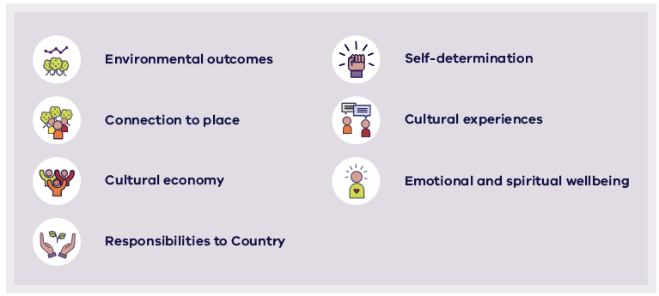
Figure 6.1. Possible benefits from cultural water
Legal obligations
The Aboriginal Heritage Act seeks to protect Aboriginal cultural heritage, including waterways and bodies of water as areas of cultural significance to Aboriginal people.
Aboriginal cultural heritage is vital to Aboriginal people and an important and irreplaceable asset for all Victorians. It carries the stories of generations long ago as well as those of people living here and now. Aboriginal cultural heritage values in our landscape are part of our identity and our legacy for future generations.
In partnership with Traditional Owners and other Aboriginal Victorians, the Victorian Government will continue to protect and manage Aboriginal cultural heritage through comprehensive planning, collaboration, and consistency in our actions. This partnership is based on mutual respect for Aboriginal cultural heritage and the cultural responsibilities of Traditional Owners.
We acknowledge that protecting Aboriginal cultural heritage goes hand in hand with land management and protecting Victoria’s environment and diverse landscapes. This protection spans our waterways, coasts and alpine regions, our tall forests and heathlands, and all the biodiversity within.
RAPs are responsible for managing Aboriginal cultural heritage within their appointed areas. RAPs are appointed by the Victorian Aboriginal Heritage Council, a statutory body made up of Victorian Traditional Owners, established under the Aboriginal Heritage Act. RAP responsibilities apply to all land and waters in a RAP’s appointed area.

The role of Traditional Owners in developing the Strategy
This Strategy is the first of its kind to be developed through a genuine partnership with Traditional Owners. Representatives from RAPs within the region formed a Traditional Owner Partnership that sat alongside decision-makers from government and the water industry and guided the development of the Strategy.

The RAP groups within the region include (Figure 6.2):
- Bunurong Land Council Aboriginal Corporation
- Gunaikurnai Land and Waters Aboriginal Corporation
- Wadawurrung Traditional Owners Aboriginal Corporation
- Wurundjeri Woi-wurrung Cultural Heritage Aboriginal Corporation
- Eastern Maar Aboriginal Corporation.
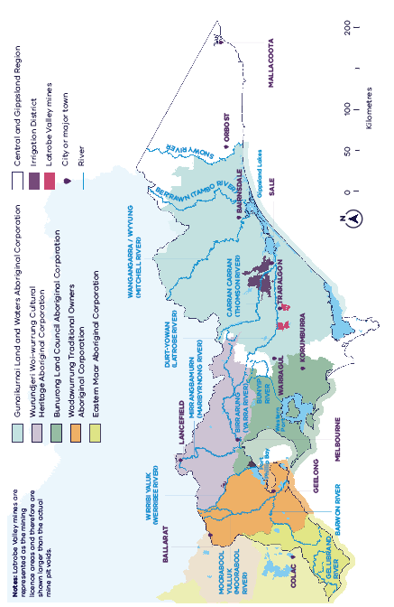
Figure 6.2. The RAPs of the Central and Gippsland Region

Reinstating Traditional Owners’ meaningful voice
The Traditional Owner Partnership had a formal voice in the development of this Strategy, including representation on the Consultative Committee, policy working groups and a single nominated representative on the Independent Panel. Most significantly, the Traditional Owner Partnership wrote a chapter of this Strategy (an update of the Traditional Owner Partnership’s chapter from the discussion draft of the Strategy) that sets out the expectations of Traditional Owners across the region (see Chapter 5).
The Traditional Owner Partnership identified the following key outcomes for this Strategy:
- ‘water justice’ is achieved in fully allocated systems
- Traditional Owner water entitlements created and protected
- Traditional Owners manage Traditional Owner water entitlements
- caring for Country is resourced in the water space
- water rules are changed, including removing barriers and increasing opportunities for Traditional Owners to own water
- future water policy and management practices incorporate input from Traditional Owners
- deliver shared benefits at a cultural landscape level
- cultural responsibility for caring for Country on waterways.
Action 6-1: The Victorian Government will ensure that Traditional Owners are resourced in order to partner in the implementation of the Strategy’s actions and policies in a self-determined way
Funding will be provided for Traditional Owners to partner and participate in a self-determined way in the implementation of this Strategy’s actions and policies as they relate to Mob, Country and self-determination. | Ongoing

Benefits of Traditional Owner water management and ownership

Cultural values of water
Traditional Owners have a deep cultural connection with water under traditional laws and customs to care for Country under state legislation and policy. In 2008, the Australian Human Rights Commission noted that access to cultural water was vital for the wellbeing of Aboriginal people, and their ability to care for Country (Australian Human Rights Commission 2008).
In Chapter 5, the Traditional Owner Partnership articulates the cultural values of water in the Central and Gippsland Region (see Figure 5.9). These cultural values include tangible natural resources and places, and intangible values such as obligations to care for Country, and the role of water in supporting physical and mental wellbeing. The values can be grouped into three themes – Healthy Country, Healthy Mob; and self-determination and sovereignty – and are the basis for the Cultural Benefits Framework described below.
Cultural Benefits Framework
A Cultural Benefits Framework (Figure 6.3) has been developed by the Traditional Owner Partnership for this Strategy, to highlight the wide-ranging benefits of Traditional Owners managing and owning water. It will be applied when water agencies across the region develop business cases for future water supply projects as part of the Water Grid Plan.
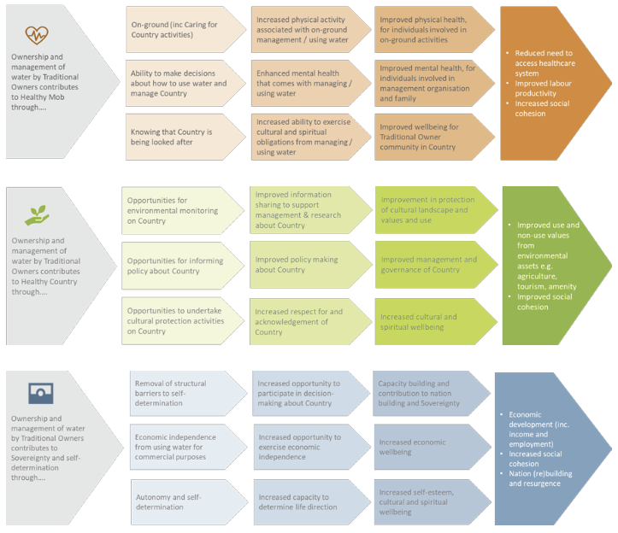
Figure 6.3. Cultural Benefits Framework (Traditional Owner Partnership and Alluvium 2022)

Action 6-2: The Victorian Government will work with water corporations to amend their Statements of Obligations (General) to include the cultural benefits framework in water planning and management
The Water Industry Act 1994 Statements of Obligations (General) will be reviewed, together with the appropriate Traditional Owner group(s), to develop amendments to resource Traditional Owner participation and inclusion of the cultural benefits framework in all water planning, management and monitoring work, for consideration by the Minister. | By 2025

As we continue to transition to manufactured water, water corporations consider how to reduce their reliance on river water for urban supply (see Action 4-2). This will enable river water to be returned to the environment and Traditional Owners across the region as they invest in water efficiency measures, IWM projects and as manufactured supplies come online.

Returning water to Traditional Owners and removing barriers to water access
Our plan
- work with Traditional Owners to continue to identify and pursue opportunities to return water to Traditional Owners as it becomes available, without taking water off other water users, unless by agreement.
- proactively progress opportunities for Traditional Owners to access unallocated water in the region
- act to remove any barriers to enable cultural water to be held by Traditional Owners, including through short-term arrangements and longer-term proposals for legislative amendments or other changes to instruments and tools as required.
- continue to engage and provide support to enable Traditional Owners in the Far East Gippsland region to access the water management and ownership opportunities in the Strategy, in a self-determined way.

Principles guiding the return of water to Traditional Owners
Traditional Owners will access water under the existing entitlement framework. They will self-determine how this water is used, including for cultural water and caring for Country, providing for healthy people and wellbeing, and using water for economic benefits. To give greater certainty to the water sector and all water users, water entitlements for Traditional Owners will be allocated according to principles outlined below.
Policy 6-1: The Victorian Government, in partnership with Traditional Owners in the region, will apply these water sharing principles when allocating water to Traditional Owners, as water becomes available
Water sharing principles:  - Each Traditional Owner group will receive entitlements to water in rivers and aquifers on their Country for their self-determined use.  - Where a water source is shared between more than one Traditional Owner group, water rights from that water source (a river or aquifer) will be similarly shared.  - Where more than one party claims an interest in new water entitlements for a river or aquifer (via water substitution, unallocated water, or formerly allocated water), Traditional Owners will receive a negotiated and equitable share of the available water.  - The share of unallocated water going to Traditional Owners should be allocated as a priority (without waiting for remaining shares to be allocated via auction processes or similar) (see Action 4-7, Action 4-8 and Action 4-9).  - Water substitution arrangements that free up water in rivers for Traditional Owners should be pursued in water systems on the Country of each Traditional Owner group.  - As new water supplies are built (such as recycled water systems and desalination plants), the Victorian Government will seek to provide Traditional Owners with access to a share of these new supplies, directly or via substitution for river water. The share will be determined on a case-by-case basis based on a business case developed in partnership with Traditional Owners, and other relevant parties, and using the Cultural Benefits Framework to quantify Traditional Owner benefits (see Figure 6.3, Action 4-1, Action 4-2 and Action 9-6). | Ongoing

Action 6-3: Implement a Traditional Owner led principle review process
The Victorian Government, in partnership with Traditional Owners, will ensure the Traditional Owner water sharing principles (see Policy 6-1) are being applied as intended and allow for an effective mechanism to review and update the principles as required | By 2025

Removing barriers to water access
There are many ways to access water in Victoria, but Traditional Owners tell us there are constraints and barriers to Traditional Owners using and holding water. For example, Traditional Owners want water rights in perpetuity to reflect their ongoing relationship to Country. However, water held under a section 51 licence, the most likely entitlement product available for Traditional Owners in this region, has a maximum 15 year term. Section 51 licences were not originally designed with the Traditional Owners’ water rights in mind. We will continue to work with Traditional Owners to overcome these barriers and improve Traditional Owners’ access to water.
Issues to be considered include:
- how to best meet the principles of self-determination
- potential uses of the water and how existing arrangements can support them.
- the physical and governance characteristics of the system
- types of entitlements already available to meet Traditional Owner needs
- removal of time limits on duration of ownership or management arrangements
- how water can be used on land where Traditional Owners do not have freehold title, Native Title, or other land use agreement
- streamline application process for river water or groundwater, to remove initial requirement for access to land
- whether the current legislation can support Traditional Owner needs
- the roles and responsibilities of each organisation involved in facilitating and delivering water justice.
Policy 6-2: The Victorian Government will resolve issues that are limiting the ability of Traditional Owners to hold and use water
The Victorian Government will work through and resolve issues that are limiting the ability of Traditional Owners to hold and use water under their own legal entitlements. | Ongoing

Fees and charges
Melbourne Water and Southern Rural Water have committed to waiving relevant entitlement fees for Traditional Owners where their take and use of water does not add to the costs of water management in a system. Where Traditional Owners hold water entitlements that have inherent water management costs, the Victorian Government will pay the associated fees and charges to ensure that costs for other water users do not increase as a result of water entitlements being issued to Traditional Owners.
When Traditional Owners hold water entitlements and intend to use the water for purely commercial purposes that are not aligned to cultural values, the Traditional Owners will be responsible for payment of the fees and charges. This payment will take place after an agreed transitional period, during which time the Victorian Government will pay a portion of the fees and charges.

Unallocated water
We are committed to returning water to Traditional Owners. Access to unallocated water, where it exists (Figure 6.4 and Figure 6.5), is one pathway to achieve this. We will work proactively with Traditional Owners to ensure they have the information and support they need to apply for unallocated water across the region (for example, identifying appropriate land parcels to be nominated in the application (see Action 6-4). There are recent examples where this has already taken place and water entitlements have been issued to Traditional Owners in the Wangangarra / WyYung (Mitchell River) and the Fitzroy River.
Additional guidance for decisions about unallocated water will be published to provide clarity and transparency on how all uses of water will be considered, including access to water for Traditional Owners (see Action 4-7). While this guidance is being developed, we will continue to facilitate applications for unallocated water by Traditional Owners. Figure 6.6 has been developed to guide decision-making in the interim, which includes explicit consideration of Traditional Owners when applications for unallocated water are assessed.
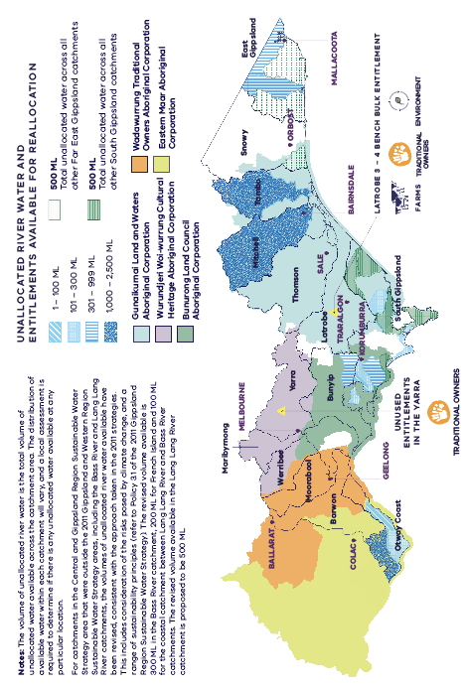
Figure 6.4. Unallocated river water in each river basin across the Central and Gippsland Region and the location of water entitlements (held by public agencies) that are no longer needed for their current purposes. The RAP boundary is current at June 2022 and may

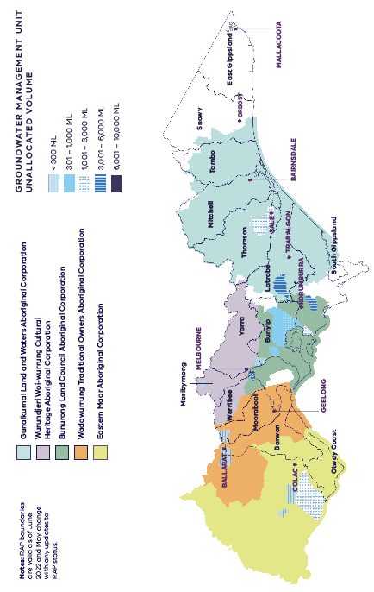
Figure 6.5. Unallocated groundwater across the Central and Gippsland Region
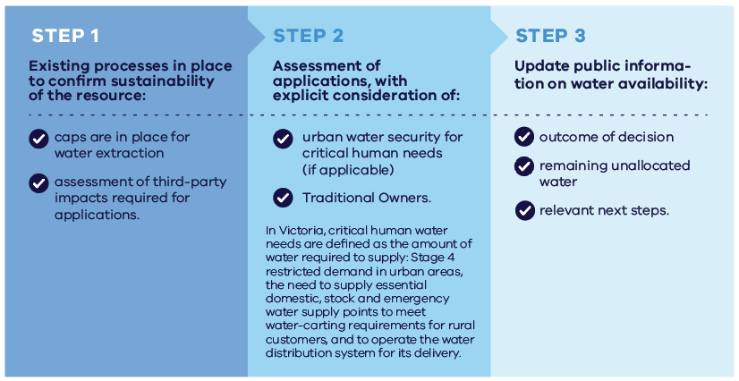
Figure 6.6. Proposed decision-making process for unallocated water
The structure of section 51 licences - which bundle the take and use of water to land - require the nomination of specific land parcels to support the assessment and decision-making for licence applications. To address this issue for Traditional Owners seeking entitlements for cultural in-stream use or in-aquifer use of groundwater, a review of current arrangements is required.
We will continue to work with Traditional Owners to overcome these barriers and improve Traditional Owners’ access to water. This includes finding options in the short term for the assessment of any applications by Traditional Owners for take and use licences in undeclared and groundwater systems.
Action 6-4: The Victorian Government will work to ensure that ownership of land is not a barrier to Traditional Owners applying for, or holding, water entitlements
The Victorian Government will provide more appropriate mechanisms within the entitlement framework to support access to water for Traditional Owners for cultural use purposes. | By 2025
In the interim, the Victorian Government will work with Traditional Owners and public land managers to support identification of appropriate land parcels that can be nominated for assessment and decision-making on applications for section 51 licences. This may include:  - providing Traditional Owners with information on public land that can be nominated to enable the application and issuing of licences for cultural use and streamlining permissions with public land managers  - working with Southern Rural Water and Melbourne Water to streamline the existing approval requirements to reduce red tape for Traditional Owners wanting to apply for a section 51 licence. | By 2022

Returning water to Traditional Owners

Returning water to Gunaikurnai Land and Waters Aboriginal Corporation
Policy 6-3: The Victorian Government will return water to Gunaikurnai Land and Waters Aboriginal Corporation
The Victorian Government will enable the Gunaikurnai Land and Waters Aboriginal Corporation to access water entitlements from rivers and groundwater within their RAP boundary. | Ongoing
Over the next one to five years, the Victorian Government will:
Action 6-5: Support Gunaikurnai Land and Waters Aboriginal Corporation applications for unallocated water, including in the Ber’rawn (Tambo River) and South Gippsland basin (including the Lung Lung (Franklin River) and Albert River)
Ensure Gunaikurnai Land and Waters Aboriginal Corporation can apply for unallocated surface and groundwater on and under Country.  This will support the government’s commitment to providing access to water for Traditional Owners. | By 2022

Supporting actions
- Reallocating a share of the Latrobe 3 — 4 Bench bulk entitlement to the Gunaikurnai Land and Waters Aboriginal Corporation (see Action 4-8). The Gunaikurnai Land and Waters Aboriginal Corporation is seeking an equitable proportion of any water that becomes available.
- Develop a collaborative vision and works plan for the water future of the Latrobe Valley and its waterways for the optimal water infrastructure arrangements to meet emerging environmental, cultural, economic and social water demands (see Action 4-15).
- Improve the delivery of environmental water in the Durt-Yowan (Latrobe River) downstream of Rosedale (see Action 8-16).

Over the next 10 years, the Victorian Government will:
Action 6-6: The Victorian Government will seek to return water in the Carran Carran (Thomson River) and Durt-Yowan (Latrobe River) to the Gunaikurnai Land and Waters Aboriginal Corporation
Seek opportunities to provide access to water in the Carran Carran (Thomson River) if new manufactured sources are brought online for the south-central system, to be used for self-determined purposes.  Pursue opportunities for entitlements in the Durt-Yowan (Latrobe River) as the Latrobe Valley transitions away from coal-fired power generation. | Long-term

Returning water to Bunurong Land Council Aboriginal Corporation
Policy 6-4: The Victorian Government will return water to Bunurong Land Council Aboriginal Corporation
The Victorian Government will return water to Bunurong Land Council Aboriginal Corporation and support access to water entitlements from various water sources within their RAP area. | Ongoing
Over the next one to five years the Victorian Government will:
Action 6-7: Evaluate opportunities to return water to Bunurong Land Council Aboriginal Corporation currently used by the Royal Botanic Gardens
Evaluate opportunities and ways to give water to Bunurong Land Council Aboriginal Corporation, including working with the City of Melbourne and the Royal Botanic Gardens, to review the water entitlements given to them by Amcor for public use. | By 2023

Action 6-8: Support applications for unallocated water, including in the Powlett and Bass Rivers
Ensure Bunurong can apply for unallocated water in South Gippsland catchments that include the culturally significant Powlett and Bass Rivers, and investigate other opportunities for access to surface water and groundwater in the region as they present themselves. | By 2022

Supporting actions
- The Department of Environment, Land, Water and Planning will support the further investigation of the development of water opportunities across the Bunurong Land Council Aboriginal Corporation RAP area.
- Pursue opportunities to provide access to water in the Werribee Catchment as part of the Business Case for reconfiguring the Werribee system (see Action 4-10) and by substituting river water with manufactured water in the longer-term (see Policy 4-3).
Over the next 10 years the Victorian Government will:
Action 6-9: The Victorian Government will seek to return water to the Bunurong Land Council Aboriginal Corporation on Bunurong Country
Seek opportunities to provide access to water if new manufactured sources are brought online for urban water security for the south-central system, to be used for self-determined purposes. | Long-term

Returning water to Wurundjeri Woi-wurrung Cultural Heritage Aboriginal Corporation

Policy 6-5: The Victorian Government will return water to Wurundjeri Woi-wurrung Cultural Heritage Aboriginal Corporation
The Victorian Government will enable the Wurundjeri Woi-wurrung Cultural Heritage Aboriginal Corporation to access water entitlements from rivers and groundwater within its RAP boundary. | Ongoing

Over the next one to five years, the Victorian Government will:
Action 6-10: Evaluate opportunities to return water to Wurundjeri Woi-wurrung Cultural Heritage Aboriginal Corporation currently used by the Royal Botanic Gardens
Evaluate opportunities and ways to give water to Wurundjeri Woi-wurrung Cultural Heritage Aboriginal Corporation, including working with the City of Melbourne and the Royal Botanic Gardens to review the water entitlements given to them by Amcor for public use. | By 2023

Supporting actions
- the Victorian Government supports an application to return water to the Wurundjeri Woi-wurrung Cultural Heritage Aboriginal Corporation through the transfer of a 1.4 gigalitre water licence in the Birrarung (Yarra River), formerly used by the Amcor Paper Mills and now held by the Victorian Government (see Action 4-9)
- pursue opportunities to provide access to water in the Werribee catchment as part of the business case for reconfiguring the Werribee system (see Action 4-10) and by substituting river water with manufactured water in the longer-term (see Policy 4-3).
Over the next 10-plus years, the Victorian Government will:
Action 6-11: The Victorian Government will seek to return water in the Birrarung (Yarra River) to the Wurundjeri Woi-wurrung Cultural Heritage Aboriginal Corporation.
Seek opportunities to provide access to water on the Birrarung (Yarra River) if new manufactured sources are brought online for urban water security in the south-central system, to be used for self-determined purposes. | Long-term

Action 6-12: The Victorian Government will seek to return water to Wurundjeri
Woi-wurrung Cultural Heritage Aboriginal Corporation in the Mirrangbamurn (Maribyrnong River).
Seek opportunities to provide access to water in the Mirrangbamurn (Maribyrnong River) if new manufactured sources are brought online for urban water security in the south-central system, to be used for self-determined purposes. | Long-term

Returning water to Wadawurrung Traditional Owners Aboriginal Corporation

Policy 6-6: The Victorian Government will return water to the Wadawurrung Traditional Owners Aboriginal Corporation
The Victorian Government will enable the Wadawurrung Traditional Owners Aboriginal Corporation to access water entitlements from rivers and groundwater within its RAP boundary. | Ongoing
Over the next one to five years the Victorian Government will:
Action 6-13: Explore opportunities to return water to the Wadawurrung in Durdidwarrah Wetland
Wadawurrung and Barwon Water will work together to explore opportunities to return a volume of water to the Wadawurrung in Durdidwarrah Wetland. | By 2025

Supporting actions
- Provide the Wadawurrung with a share of the 3.7 gigalitres of water to be recovered in the Moorabool Yulluk (Moorabool River) by upgrading infrastructure to reduce reliance on the Moorabool Yulluk (Moorabool River) for water for Geelong (see Action 4-3). Water sharing arrangements between the Wadawurrung and the Victorian Environmental Water Holder will be determined in partnership with the Wadawurrung Traditional Owners Aboriginal Corporation, the Victorian Environmental Water Holder, the Corangamite CMA and the Victorian Government (See Action 4-4). Water returned to the Wadawurrung will be for their self-determined use.
- Seek opportunities to deliver temporary water trades to support the Moorabool River and Traditional Owner values (see Action 4-6).
- Improve flows in Stony Creek through operational changes (see Action 8-3).
- Increase understanding of environmental water needs and Traditional Owner values of the Upper Moorabool and Leigh catchments (see Action 8-2).
- Rehabilitate the Moorabool Yulluk (Moorabool River) at Batesford Quarry (see Action 8-1).
- Pursue opportunities to provide access to water in the Werribee Catchment as part of the Business Case for reconfiguring the Werribee system (see Action 4-10) and by substituting river water with manufactured water in the longer-term (see Policy 4-3).
Over the next 10-plus years, the Victorian Government will:
Action 6-14: The Victorian Government will seek to return water to the Wadawurrung in the Moorabool Yulluk (Moorabool River) and Parwan (Barwon River).
Seek opportunities to provide access to water in the Moorabool Yulluk (Moorabool River) and/or Parwan (Barwon River) when alternative sources are found for urban customers supplied by Barwon Water and Central Highlands Water, to be used for self-determined purposes. | Long-term

Returning water to Eastern Maar Aboriginal Corporation
Policy 6-7: The Victorian Government will return water to the Eastern Maar Aboriginal Corporation
The Victorian Government will enable the Eastern Maar Aboriginal Corporation to access water entitlements from rivers and groundwater within its RAP boundary. | Ongoing
Over the next one to five years the Victorian Government will:
Action 6-15: Support applications for unallocated water in the Otway Basin, including in the Gellibrand River
Ensure the Eastern Maar Aboriginal Corporation can apply for unallocated surface water and groundwater on and under their Country. This will support the Victorian Government’s commitment to providing access to water for Traditional Owners. | By 2022

Supporting action
- Improving summer flows in the Gellibrand River (see Action 8-9).
Over the next 10-plus years, the Victorian Government will:
Action 6-16: The Victorian Government will seek to return water to the Eastern Maar in the Barwon River.
Seek opportunities to provide access to water in the Barwon River when alternative sources are found for urban customers supplied by Barwon Water and Wannon Water, to be used for self-determined purposes. | Long-term

Other opportunities to return water
In the longer-term, investments in new manufactured water supplies could create more opportunities to return river water and groundwater entitlements (held by water corporations) to Traditional Owners and the environment. Decisions by the Water Grid Plan around future augmentations will consider cultural values and benefits for Traditional Owners through applying the quadruple-bottom-line assessment process, which will incorporate the Cultural Benefits Framework (see Figure 6.3). This is explained further in Chapter 9.
Having a longer-term approach – while simultaneously seeking to return some water now – is necessary to ensure intergenerational equity and to ensure we do not continue the inequities of the past.

Shared benefits for Traditional Owners from water for the environment
Chapter 8 sets out plans for returning water to the environment in every major river in the region to support healthy living waterways and native species. Healthy waterways are also essential for Traditional Owner cultural values. For Traditional Owners, all water on Country is integral to life itself, and interconnected with the broader cultural landscape. Protecting waterway ecosystems, and involving Traditional Owners in the management of waterways, is vital to achieve Healthy Country, Healthy Mob, and for self-determination.
Case Study: Traditional Owner involvement in the management of the lower Latrobe wetlands
The West Gippsland Catchment Management Authority and Victorian Environmental Water Holder are investigating a partnership arrangement with the Gunaikurnai Land and Waters Aboriginal Corporation to jointly manage water in the lower Latrobe wetlands. This would give the Gunaikurnai Land and Waters Aboriginal Corporation an official voice in the development of annual watering plans and longer-term environmental water management plans (see Action 8-16 and Action 8-17).

Recognising cultural values in the Environment Reference Standard
The Environment Reference Standard is a new tool made under the Environment Protection Act. In Victoria, from 1 July 2021, the Environment Reference Standard sets out the environmental values to be achieved or maintained in Victoria (including for water). The Environment Reference Standard recognises Traditional Owner cultural values as important, but does not yet state specific indicators or objectives for these values.
Policy 6-8: Recognising cultural values in the Environment Reference Standard
Traditional Owners will determine their own priorities for developing indicators and objectives to protect Traditional Owner cultural values recognised in the Environment Reference Standard. | Ongoing

Response to the Traditional Owner Partnership’s key outcomes
Table 6-1. Government response to Traditional Owner proposal
Proposals from the Healthy Country, Healthy Mob chapter of the discussion draft (DELWP 2021b) | Action the Strategy will take  (see implementation plan (Appendix E) for detail)
5.1: It is proposed that the Strategy determines the share of unallocated water in each of these locations that will be allocated to Traditional Owners, in accordance with the Six Principles. | See Section 4.3 and Action 4-7  The Victorian Government will publish guidance for licensing authorities’ decisions about unallocated water, to provide clarity and transparency on how all uses of water will be considered, including access to water for Traditional Owners.
5.2: It is proposed that entitlement to 1.4 gigalitres of water in the Birrarung be returned to Wurundjeri Woi-wurrung Cultural Heritage Aboriginal Corporation, and that the Victorian Government complete a formal review of the allocation decision for the remaining 0.7 gigalitres. | See Policy 6-5, Action 6-10 and Action 4-9  Return water to Wurundjeri Woi-wurrung Cultural Heritage Aboriginal Corporation.
5.3: It is proposed that all future business cases for investment in new sources of water include a commitment to hand back a proportion of water to Traditional Owners on the completion of these projects (either directly or via substitution for river water). The timeline and status for these projects will be included in the Water Grid Plan. | See Action 4-1, Action 4-2 and Action 9-6  The Victorian Government will work with water corporations, catchment management authorities and Traditional Owners to identify preferred future urban water supply options based on a quadruple-bottom-line assessment. The Cultural Benefits Framework will be used to measure cultural values of water and incorporated into the quadruple-bottom-line assessment. The options will be set out in a Water Grid Plan that is updated regularly.
5.4: It is proposed that water returned to rivers and creeks as a result of substitution by alternative water sources will be shared equally between the environment (the Victorian Environmental Water Holder) and Traditional Owners. | See Policy 4-3  Returning water to the environment and Traditional Owners as manufactured water sources are added for Greater Melbourne and Geelong.
5.5: It is proposed that the business case for the recycled water substitution project in the Werribee and Bacchus Marsh irrigation districts include the benefits to Traditional Owners of receiving an equitable proportion of water saved as a result of water substitution. | See Section Action 4-10  Reconfiguring the Werribee system.
5.6: The Traditional Owner Partnership will work with the water sector to recommend ways to remove barriers to water rights, including section 51 licences. | See Section 6.5 and Policy 6-2  The Victorian Government will work through and resolve issues that are limiting the ability of Traditional Owners to hold and use water under their own legal entitlements.
5.7: Where Traditional Owners in the Central and Gippsland Region hold section 51 licences expressed as ‘cultural water’, there will be no annual fees or water usage charges. | See Section 6.7  When Traditional Owners hold water entitlements that do not add to the costs of water management in a system, relevant fees will be waived by water corporations. Where Traditional Owners hold water entitlements that have inherent water management costs, the Victorian Government will pay the associated fees and charges. When Traditional Owners hold water entitlements where water is used for purely commercial purposes, the Traditional Owners will be responsible for payment of the fees and charges after an agreed transitional period.
5.8: Where Traditional Owners do not hold rights to land (via Native Title, Traditional Owner Settlement Agreement or freehold), they may nominate land for the purposes of the section 51 licence to which they have an access agreement with the landholder (such as Parks Vic, DELWP, local government, water authorities or private landholders).  and  5.9: Where Traditional Owners do not have existing access agreements, this process be expedited as part of the Strategy. | The Victorian Government will work to ensure that ownership of land is not a barrier to Traditional Owners applying for or holding water entitlements (see Action 6-4).  The Victorian Government will provide more appropriate mechanisms within the entitlement framework to support access to water for Traditional Owners for cultural use purposes.  In the interim, the Department of Environment, Land, Water and Planning will work with Traditional Owners and public land managers to support identification of appropriate land parcels that can be nominated for assessment and decision-making on applications for section 51 licences.
5.13: DELWP, together with the appropriate Traditional Owner groups, will review all water corporation statements of obligation (under the Water Industry Regulatory Order) to ensure that they explicitly include requirements to resource Traditional Owner participation in water planning, management and monitoring work. | See Action 6-2  All water corporation statements of obligation will be reviewed, together with the appropriate Traditional Owner group, to develop amendments to resource Traditional Owner participation and inclusion of the Cultural Benefits Framework in all water planning, management and monitoring work for consideration by the Minister.
5.14: Waterways named in the final Strategy will include Traditional Owner names (as directed by each Traditional Owner group on a case-by-case basis). | Where possible, this Strategy uses the traditional names of waterways.
5.15 Each Traditional Owner group will be resourced to participate in the development of placed-based legislation, named in relevant place-based legislation, and resourced to undertake prescribed responsibilities. | Aspiration is out of scope of this Strategy. It will be addressed as part of other statewide processes.

Strengthening the role of Traditional Owners in water resource planning and management
Through this Strategy, together with Traditional Owners and the water sector we have made significant steps toward strengthening the role of Traditional Owners in water resource planning and management. The policies and actions set out in this Strategy are the next step for water justice for Traditional Owner groups in the Central and Gippsland regions. Each step we take to strengthen the role of Traditional Owners informs the next step, and the progress made in this Strategy will feed into new projects and initiatives.

Progress to date
In 2019, the Victorian Government passed new legislation that amended the Water Act to include consideration of Aboriginal cultural values and uses of waterways in the way that Victoria’s water resources are managed. The new legislation also increased the requirement to consult and engage with Aboriginal people in water and waterway management. The purpose of the Water Act now includes considering Aboriginal cultural values and uses of waterways, along with the social and recreational uses and values of waterways.
Further amendments now specify the need for sustainable water strategies to consider opportunities that provide for Aboriginal cultural values and waterway uses in each sustainable water strategy region. They include at least one Aboriginal person as a member on the consultative committee tasked with advising the Minister on the preparation of the sustainable water strategy. Similarly, the committees advising on management plans for water supply protection areas must also include at least one Aboriginal representative from the area under consideration (where possible). We are committed to continue building on the progress we have made to date.
Since the release of Water for Victoria in 2016, there have been significant steps toward strengthening the role of Traditional Owners in caring for Country, but there is still much more to be done to enable self-determination for Traditional Owners and Aboriginal Victorians.
To date we have:
    - recognised the role of Traditional Owners in water resource management in legislation and planning frameworks through the Victorian Government’s water plan, Water for Victoria (DELWP 2016b) (and subsequent Water and Catchment Legislation Amendment Act)
    - employed more than 17 full-time Aboriginal water officers and allocated $4.6 million for projects that bring Traditional Owners together to spend time engaging on Country to improve understanding of cultural values and uses, and share their expertise through the Aboriginal Water Program (launched in 2016)
    - committed to metrics and targets to guide progress on Aboriginal affairs in Victoria, including water-related initiatives, through the Victorian Aboriginal Affairs Framework 2018–2023 (DPC 2018)
    - increased the number of Aboriginal Victorians on water sector boards over the past seven years, from zero pre-2015 to 13 in 2021
    - recognised the Birrarung (Yarra River) and its parklands as one living and integrated entity, and supported Wurundjeri Woi-wurrung and Bunurong Traditional Owners to partner in all aspects of caring for the river through Burndap Birrarung burndap umarkoo, the first Yarra Strategic Plan (launched in 2022) (Melbourne Water 2022)
    - committed to recognising waterways in Melbourne’s west and the Barwon Region as living natural entities and reinstating Traditional Owners’ voice, by committing to Traditional Owner priority projects through the Waterways of the West and Rivers of the Barwon (Barre Warre Yulluk) action plans (released in 2021) (DELWP 2021h and 2021f). See https://www.water.vic.gov.au/waterways-and-catchments/wow and https://www.water.vic.gov.au/waterways-and-catchments/barwon.

Other projects and initiatives
Our new projects and initiatives will:
- provide opportunities for Traditional Owners and First Peoples to manage and hold water for spiritual, cultural, environmental, social and economic purposes, through Water is Life (due to be released in 2022)
- support the transfer of power and resources to Traditional Owners in the management of waterways in Victoria through the delivery of Water is Life, the revised Victorian Waterway Management Strategy and by respecting and responding to Victoria’s treaty process and treaties negotiated
- continue to support discussions with the Commonwealth and other states and territories around national baselines for water access entitlements for Traditional Owners as part of the Closing the Gap initiative
- continue to build relationships and partnerships between the water industry and Traditional Owners to achieve multiple benefits.

Water for agriculture
Water is critical to agricultural production in the Central and Gippsland Region for irrigating crops and pastures and providing domestic and stock water to dryland farms. With river water declining in most areas, and even less water expected to be available in the future, we are working with farmers to improve water efficiency on and off farms and increase the use of fit-for-purpose recycled water and stormwater. This will improve the reliability and security of water supplies and help to protect the environment.

Agriculture in the Central and Gippsland Region
The Victorian Government will continue to look for ways to improve water-use efficiency and increase water supplies for all users, including cities and towns, farmers, Traditional Owners and the environment. Importantly, the Victorian Government will not look to increase other users’ supplies by taking water away from farmers, and will protect all existing water entitlements provided under the Water Act.

The value of agriculture in the Central and Gippsland Region
The Central and Gippsland Region of Victoria supports $4.7 billion of diverse dryland and irrigated agricultural production, and accounts for around 30 per cent of Victoria’s agricultural production. This includes approximately 33 per cent of Victoria’s milk products, 70 per cent of Victoria’s eggs and poultry and 70 per cent of the state’s vegetables (RMCG and Tim Cummins & Associates 2021) (see Figure 7.1). Other major enterprises include orchards, nurseries, cropping and viticulture.

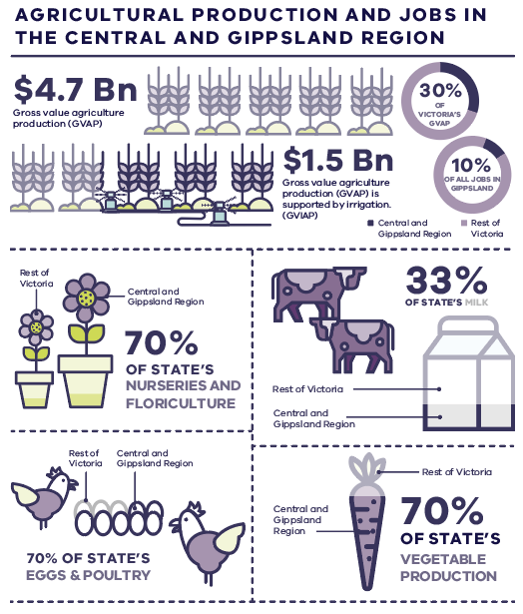
Figure 7.1. Agricultural production and jobs in the Central and Gippsland Region (RMCG and Tim Cummins & Associates 2021)
Agricultural production is an important economic driver in the Central and Gippsland Region, particularly in regional areas, and supports major food-processing enterprises in the Greater Melbourne area. Around 36,000 people in the region are directly employed in agriculture, forestry and fishing. In Gippsland around 10 per cent of all jobs are in this sector. In other parts of the region, such as Melbourne, agriculture accounts for a small part of the total economic activity but provides critical food production close to urban centres. Some of Victoria’s highest-value crops are produced close to Melbourne.

Agricultural water use in the Central and Gippsland Region
Agricultural production accounts for 39 per cent of water entitlements in the region. Water is used for agriculture right across the region, but is concentrated in the Macalister, Werribee and Bacchus Marsh irrigation districts, managed by Southern Rural Water. In 2019–20, irrigators in the Macalister Irrigation District (MID) used 160 gigalitres of water from the Wirn Wirndook Yeerung (Macalister River) and Carran Carran (Thomson River), while those in the Bacchus Marsh and Werribee irrigation districts used 12 gigalitres of river water, predominantly supplied from the Wirribi Yaluk (Werribee River).
Irrigators in the Werribee Irrigation District use recycled water from the Western Treatment Plant in Werribee to supplement their river water entitlements – in 2019–20 they used 14 gigalitres of recycled water (DELWP 2020b). In 2020–21, approximately 7.5 gigalitres of recycled water was used for agriculture to the south-east of Melbourne, supplied from the Eastern Treatment Plant and smaller local treatment plants. Agricultural use in this part of the region includes the Eastern Irrigation Scheme.
Outside major irrigation districts, farmers divert water directly from waterways or groundwater aquifers, which they can use immediately, or store in private dams for future use. Both the diversion of water and storage in a dam require a licence. Groundwater used for agriculture across the region was 59 gigalitres in 2019–20, with most use in the Central Gippsland groundwater catchment. The volumes of water used from waterways or private commercial and irrigation dams across the region in 2019–20 were 34 gigalitres and 37 gigalitres respectively (DELWP 2020b).
Relatively reliable rainfall and proximity to markets and food processors mean the region is well placed to expand and diversify its agricultural production. However, climate change, years of drought, and bushfires are already putting pressure on farm water supplies (DJPR 2022).

Improving water efficiency on farms
Our plan:
- work with farmers to encourage more efficient use of water and best-practice irrigation through advice and incentives via the Sustainable Irrigation Program (SIP)
- help farmers to reduce the effects of irrigation on the environment, including salinity, nutrient runoff and waterlogging, to support a sustainable and productive industry

Supporting sustainable irrigation
The SIP is a partnership between the Department of Environment, Land, Water and Planning, Agriculture Victoria, waterway managers, water corporations and communities. For more information about the Sustainable Irrigation Program visit the website: https://www.water.vic.gov.au/water-for-agriculture/sustainable-irrigation-program.
The SIP provides advice and incentives to support irrigators adapt to a drying climate and get the most out of their water, particularly where there is a wider public benefit. In the MID between 2000 and 2021 the program completed 564 irrigation farm plans, covering 43,160 hectares or 81 per cent of the MID’s total surface area. These professionally designed plans provide irrigators with the blueprint they need to achieve best practice on their farm (see case study below).
The program has also completed more than 500 on-farm irrigation infrastructure projects, including the installation of re-use systems to prevent nutrient runoff from farms and the installation of best-practice surface irrigation infrastructure. The collective on-farm works improved water use efficiency and increased production while reducing high nutrient runoff back into streams. The program complements other rural water efficiency initiatives led by waterway managers in partnership with water corporations, for example the Newry Farm Planning Project (see Newry Farm Planning Project case study on next page).
We will continue to seek opportunities to integrate the Sustainable Irrigation Program with major changes to infrastructure networks to maximise the public benefits of investment.
Case Study: Investing in using water wisely in the Gippsland sub-region
The 2018–19 season was challenging for irrigators in the MID. The district, fed by the Wirn Wirndook Yeerung (Macalister River) and Carran Carran (Thomson River), was in its third consecutive year of drought. Historically such conditions would result in many farms running out of water, with flow-on effects for pasture growth, milk production and economic and social impacts in the community.
With the support of the SIP and the MID2030 modernisation project, irrigators have invested heavily in planning and infrastructure improvements. This means that every drop of water can be used wisely and the impact of dry conditions on regional communities can be minimised.
The benefits of efficiency improvements go beyond production. In the 2018–19 season these efficiencies led to record low levels of irrigation runoff and nutrients leaving farms and flowing into waterways and the Gippsland Lakes. In turn, this reduced the risk of algal blooms, and improved water quality for all waterways users, from recreational users and nature-based tourism to the wildlife that depend on clean, healthy rivers. Further efficiency gains will only increase resilience to drought and climate change and improve water quality across our region’s waterways.

Case Study: Newry Farm Planning Project
Newry farmers are being offered irrigation farm plans as part of delivering Phase 2 of the MID2030 modernisation project. Led by the West Gippsland Catchment Management Authority and Southern Rural Water, the Newry Farm Planning Project helps farmers to get the most out of being upgraded from the existing channel system, shown in red (Figure 7.2), to a piped water supply system (shown in blue) and to save time, money and water through changes to their irrigation systems. The project aims to help 27 irrigation businesses, covering 2,600 hectares, to implement best-practice irrigation at a landscape scale and maximise the benefits to their business of off-farm improvements.
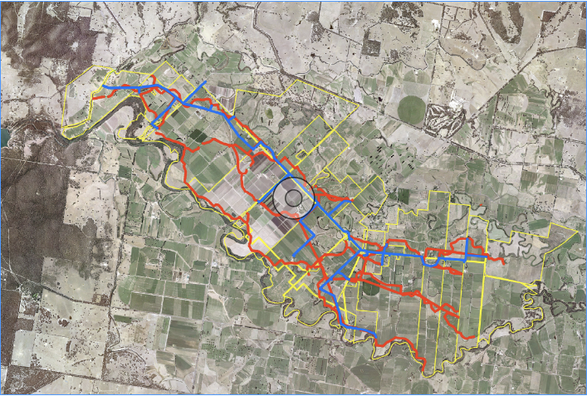
Figure 7.2. Map of the Newry Farm Planning Project (West Gippsland CMA 2021, p. 11)

Irrigated land-use and water-use mapping
As water availability changes across the region, local water demands and production systems for agriculture are also changing. People want to maximise the production of high-value crops in those areas that enjoy reliable access to water. Through the SIP a coordinated program of land- and water-use mapping is being developed to improve our understanding of how agriculture in Victoria is changing and identify emerging trends in water use.
As shown Figure 7.3, we are seeing a diversification of land use across the MID, as horticultural expansion and new crop types experience significant growth in the region. This spatial data allows us to understand what is happening, and to respond appropriately to emerging trends, ensuring that extension services and activities delivered by the program remain fit-for-purpose.
This information will inform updates to Irrigation Development Guidelines to ensure that any new, changed, or redeveloped irrigation farms install efficient and effective systems that maximise water-use efficiency and minimise harm to the environment.
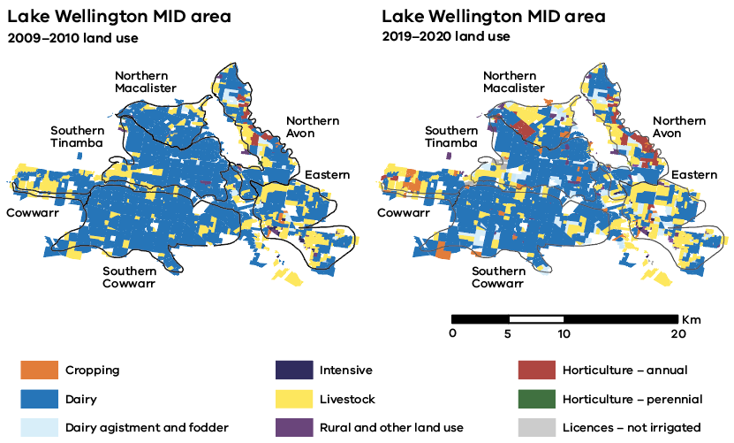
Figure 7.3. Land-use change in the Lake Wellington MID area 2009–10 and 2019–20 (Agriculture Victoria Research 2020)

Reducing impacts of irrigation on land
Long-term public and private investment in reducing the impacts of irrigation on land have been critical to maintaining a sustainable irrigation sector that supports healthy landscapes and waterways. A particular focus in the Central and Gippsland Region is minimising potential harm to Lake Wellington from the intensive irrigation in the MID and surrounds (see the adjacent case study). Lake Wellington is the largest lake in the Gippsland Lakes system and forms part of a Ramsar-listed wetland of international conservation significance.
Within Melbourne, Melbourne Water’s Rural Land Program offers incentives to property owners to reduce nutrient and sediment runoff into waterways in the Yarra catchment and waterways connected to Port Phillip and Westernport bays. Further measures to protect water quality in waterways are outlined in Chapter 8.
Case Study: Lake Wellington land and water management
The Lake Wellington Land and Water Management Plan (2018) outlines a vision for how irrigators, industry and government will work together to achieve a highly productive and sustainable irrigation community that values and protects its natural and cultural assets. The plan guides investment through the SIP and sets out actions to:
- support irrigators to be more productive, sustainable and efficient
- protect rivers, wetlands and the Gippsland Lakes from excess nutrients and sediment and reduce the risk of algal blooms
- help manage impacts of salinity and high water tables
- protect natural, cultural and social assets of the irrigation regions for future generations.

Supporting rural landowners to improve waterway health in the Central sub-region
Melbourne Water’s Rural Land Program advocates for best management practices that reduce the amount of nutrient and sediment runoff from rural properties entering waterways that flow into Port Phillip and Westernport bays. Activities funded under the incentives program include farm planning and design, gully exclusion and revegetation, track and drainage improvements, stormwater harvesting and re-use, erosion control and sediment ponds, pasture improvement, effluent management, soil analysis and nutrient budgeting, off-stream/dam stock watering and dam decommissioning.
In the Yarra catchment, Melbourne Water’s rural land officers engage landholders and assist with the development of irrigation and drainage plans to improve runoff quality and meet targets under Melbourne Water’s Healthy Waterways Strategy performance objectives.
For further information see:
www.melbournewater.com.au/liveable-communities-liveable-waterways.
Policy 7-1: Maximising water efficiency in agriculture
The Victorian Government will continue to invest in improvements to agricultural water-use efficiency and best-practice land and water management. This will be achieved by helping irrigators continue to use water wisely, with targeted extension and support for on-farm changes and more information on making the most of their water. | Ongoing

Modernising irrigation districts
Our plan:
- upgrade ageing and inefficient water supply infrastructure in major irrigation districts to improve water-use efficiency and service standards for irrigators
- use water recovered through modernisation works to boost agricultural production and deliver wider benefits to the environment, Traditional Owners and regional communities

Modernising irrigation districts
Across the region’s major irrigation districts, we are partnering with Southern Rural Water, agricultural businesses and the Australian Government to upgrade ageing and inefficient water supply infrastructure. These multi-million-dollar projects are modernising the delivery of water to irrigators to drive economic development and meet the challenges of drought and climate change. Significant water recovery from the projects has been provided to both irrigators and the environment. Future projects will also consider opportunities to improve Traditional Owner outcomes.
Principles guiding public investments in rural water infrastructure are set out in Water for Victoria and discussed further in Chapter 9. New guidelines for water corporations will provide greater guidance for public co-investment in infrastructure projects that can deliver wider public benefits. For example, upgrades to rural water infrastructure that will recover water and improve environmental, Traditional Owner and social outcomes.
Action 7-1: Planning for future investment in rural water infrastructure
The Victorian Government will work with water corporations to provide updated guidance for the development and delivery of rural water infrastructure projects in the region, in ways that consider the benefits to irrigators, the environment, Traditional Owners and regional communities. | By 2023

Key projects

$159.7 million MID2030
The MID, the largest irrigation area in southern Victoria, supports a strong dairy and livestock sector and developing vegetable and cropping industries that generate approximately $500 million in economic activity annually. The MID2030 modernisation project is reducing system leaks and improving water efficiency in the district, from less than 60 per cent in 2004, to up to 90 per cent on completion in 2024. Funded by Southern Rural Water and the Victorian and Australian governments, the project involves replacing ageing water supply infrastructure and introducing channel automation.
Southern Rural Water has completed works under phases 1A and 1B of the project. Works are continuing under Phase 2. Under contractual arrangements agreed at the time of co-investment, approximately 30 gigalitres of the water recovered by the MID2030 program will be made available to irrigators to support increased agricultural production across the region. This will help to boost productivity, underpin water security for irrigators and support the investigation of agricultural expansion opportunities. In addition, the works will improve environmental outcomes through reduction of runoff into the Gippsland Lakes and recovery of a proportion of Phase 2 water savings to support environmental values within the Wirn Wirndook Yeerung (Macalister River).

$46 million Werribee Irrigation District Modernisation Project
The Werribee Irrigation District covers more than 3,000 hectares of intensive, high-value horticulture, including green leafy vegetables, and generates more than $187 million per year in farm gate value. The Werribee Irrigation District Modernisation Project is upgrading ageing and inefficient water supply pipelines and outlets to generate a long-term average of approximately 5 gigalitres of water recovery. Half of the water recovered will be made available to the district’s irrigators to increase water security and agriculture production. The balance of the savings will be returned to the Wirribi Yaluk (Werribee River) to support river health, tourism and recreational use of the river. Funded by Southern Rural Water and the Victorian and Australian governments, the project is being delivered over five stages, with final stages four and five to be completed in late 2023.

$9.9 million Bacchus Marsh Irrigation District Modernisation Project
Bacchus Marsh Irrigation District covers around 900 hectares and generates more than $50 million in farm gate value. The Bacchus Marsh Irrigation District Modernisation Project has generated an estimated 1 gigalitre of water recovery (long-term average) to be shared equally between district irrigators and the environment, which will support Wirribi Yaluk (Werribee River) flows. The reconfiguration works and replacement of poorly performing open channels with a pipeline improved service levels for irrigators and allowed new customers to connect to the improved system. The project was completed in 2020 and funded by Southern Rural Water customers together with the Victorian and Australian governments.

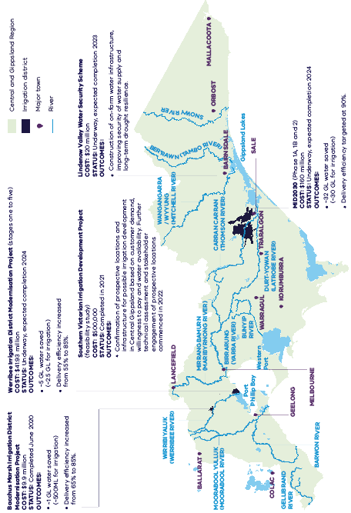
Figure 7.4. Recent investment in major irrigation projects in the Central and Gippsland Region

Opportunities to expand irrigation
Our plan:
- connect farmers to new, fit-for-purpose, recycled water supplies to build their resilience to climate change and climate variability and support industry growth
- investigate opportunities to sustainably develop new irrigation areas in the lower Latrobe region and in the Avon and Macalister systems
- consider proposals to expand irrigation where water is recovered through irrigation district modernisation, repurposed from other consumptive uses or made available through recycled water or stormwater schemes

Supplying recycled water to irrigators
Recycled water has been used for irrigation across Central and Gippsland Region for more than 15 years, particularly where properties or irrigation districts are close to major water treatment infrastructure. Recycled water can provide farmers with a secure, climate-resilient and consistent supply of affordable water and ease pressure on river water and groundwater supplies. Increased interest in recycled water uptake is seen where production systems can support its use, water quality is appropriate and it is economically viable to do so. Section 7.1 of this chapter explains the volume of recycled water used by irrigators.
Opportunities for using recycled water for agriculture can be site-specific, local or decentralised. However, recycled water may not be the most cost-effective product for farmers. The shift to further uptake of recycled water in agriculture is dependent on several factors, including water quality meeting the stringent requirements that food producers must adhere to, water supply security and the cost to treat and deliver water to farms. Decisions to open new areas of irrigation, or supplement existing water sources with recycled water, need to be considered with these factors in mind.
Concerns about the quality of recycled water for agricultural use, such as applying saline water on land, also remain a barrier that will need to be considered. Work is underway to better understand and manage the potential risks from emerging contaminants in recycled water, including protection of public health and any potential implications for irrigated agriculture (see Chapter 3). More information about how recycled water quality concerns are managed through this Strategy and other controls is outlined in Chapter 8.
As climate-dependent water sources decrease and technological advances help reduce the cost of treating recycled water, there is a growing opportunity to use more of this water for fit-for-purpose agricultural production. Improved security of supply helps to justify the capital investment and additional operating costs required to implement a scheme.
To encourage further uptake, we are working with water corporations and industry to secure Australian Government funding for recycled water projects that can bring many benefits, such as supplying recycled water for agriculture and reducing treated wastewater discharges (see Section 9.4). Information about the agricultural requirements of recycled water schemes and guidance on investment, including pricing, supply and use arrangements, and service standards, will help deliver a consistent approach to increasing uptake.
State guidelines for large-scale recycled water schemes, released in 2021, are helping to build confidence around the many benefits of using fit-for-purpose recycled water (See Section 3.4).

Key projects

Western Irrigation Network
The Western Irrigation Network is a major new recycled water irrigation scheme that will connect dryland farmers in the Parwan–Balliang Agricultural District, to the west of Melbourne, to a guaranteed supply of Class C recycled water by 2022. Funded by Greater Western Water, the Australia Government, and agribusinesses, the scheme will initially supply 1.7 gigalitres per year, increasing as irrigators expand and adapt. By 2050 the scheme could supply up to 19 gigalitres each year and irrigate up to 4,500 hectares of high-quality land.
The network will consist of more than 50 kilometres of pipelines, connecting the irrigation district to Greater Western Water’s recycled water plants at Sunbury, Melton and Bacchus Marsh. Fit-for-purpose recycled water will be supplied to farmers to grow crops such as wheat and barley, and support increased production, generating jobs and economic growth. The project will help to manage the increasing volumes of wastewater in the region, particularly in the Melton, Sunbury and Bacchus Marsh areas, and reduce discharges into local rivers and creeks to improve waterway health.

Recycled water along the Bellarine Peninsula
Works are underway to expand the supply of recycled water from the Portarlington Water Reclamation Plant to more agricultural customers on the Bellarine Peninsula, offering growers a guaranteed water source at an affordable price. Further expansion of the scheme by early 2024 will involve construction of a reverse osmosis treatment plant to improve the quality of the recycled water, enabling it to serve high-value agriculture and tourism on the Bellarine. The $11 million project is jointly funded by the Australian Government, Victorian Government and Barwon Water. An additional stage to double the available volume of fit-for-purpose recycled water to approximately 1 gigalitre per year is being considered.

Other opportunities
Across the region, investigations are underway into potential opportunities to extend the supply of recycled water and stormwater to support agricultural production and ease pressure on river water and groundwater supplies.
Opportunities under consideration include:
- supplying high-quality, fit-for-purpose recycled water to irrigators in the Werribee and Bacchus Marsh irrigation districts, with options for farmers to improve water supply security by entering into entitlement substitution arrangements – see Action 4-10, Chapter 4 (business case to be developed)
- expanding the Western Irrigation Network to use more recycled water from other Greater Western Water wastewater recycling plants, which would otherwise be discharged to waterways (business case funded)
- establishing irrigation networks similar to the Western Irrigation Network, in the northern Maribyrnong catchment or adjacent catchment areas
- supplying recycled water to agriculture and open space in the Sunbury–Bulla–Keilor areas, including the Keilor Irrigation District (business case funded)
- using recycled water for irrigated agriculture in the Tyabb–Somerville area, and further expanding the agricultural use of recycled water from the Eastern Treatment Plant (business case funded)
- supplying recycled water to the Kingston green wedge and beyond will expand the use of recycled water from the Eastern Treatment Plant for purposes including tourism, agriculture, industry, sports fields, passive open space and major activity hubs
- using recycled water from the Pakenham Water Recycling Plant for agriculture in the Pakenham–Cora Lynn area and further expanding the use of recycled water from the Pakenham Plant network for agriculture to the south and east beyond Pakenham–Cora Lynn (business case funded)
- attracting urban agricultural enterprises through the supply of recycled water from a new wastewater treatment and recycled water plant in the Moorabool Valley, as proposed in the IWM Plan for the northern and western Geelong growth areas
- using stormwater captured from the Sunbury and Melton growth corridors for agriculture in the region.

Making the most of all sources of water
Aligning water resource planning and land-use policy recognises that access to water plays a critical role in protecting agricultural land, particularly in Melbourne’s green wedges and peri-urban areas, which are at risk of loss and fragmentation due to urban growth and competing land-use interests.
By strategically considering how agriculture can make the most of all sources of water, we can support the long-term resilience of Melbourne’s green wedges and the expansion of peri-urban agriculture for greater food security and economic productivity. Long-term strategic planning in these areas should consider how access to all water sources can help safeguard agricultural land into the future. This includes strategic consideration of future urban developments, the location of wastewater treatment infrastructure, and agricultural demands for recycled water.
Opportunities to safeguard agricultural land for agricultural purposes through access to recycled water and stormwater are being considered through Victorian Government projects, including:
- Agriculture Victoria’s Strategic agriculture land and development (SALAD) project (Agriculture Victoria 2022) (complete)
- Department of Environment, Land, Water and Planning, Planning for Melbourne’s green wedges and agricultural land project (DELWP 2022b) (in progress)
- Metropolitan IWM forum/Western Growth Area IWM planning (in progress)
- Department of Environment, Land, Water and Planning and IWM forum partners investigating opportunities for large-scale recycled water and treated stormwater networks (see Action 3-4 and Action 3-5)
Policy 7-2: Strategically considering opportunities for agriculture to make the most of all sources of water
The Victorian Government and water sector will support the long-term resilience of agricultural land use in Melbourne’s green wedges and the Central and Gippsland Region by strategically considering opportunities for agriculture to make the most of all sources of water where demands are identified.

Developing new irrigation districts
We are working with Southern Rural Water and other stakeholders to investigate opportunities for irrigation development in Central Gippsland. The Southern Victorian Irrigation Development project has identified where agricultural production could be sustainably developed in the region with available water, now and in the future, supporting regional economic growth.
With competing demands for water across users, understanding opportunities for agriculture and how these fit into decisions on water sharing is critical. A report by Southern Rural Water in 2021 identified two focus areas in the Macalister/Avon and Latrobe River regions (RMCG 2021b). Investigations included consultation with current landholders and industry stakeholders to assess water demands and willingness to invest in agricultural irrigation development in these regions.
Latrobe River focus area – up to 30,000 hectares along the lower Durt-Yowan (Latrobe River) from Yallourn to Longford could be suitable for irrigation if water was available. This development could boost economic activity and employment in the region through the dairy, beef and fodder industries. Work to date suggests that there is demand for water for agriculture, and that private industry is willing to pay and invest if water can be made available. Decisions regarding industry transition in the Latrobe region in coming years will affect how water is shared in the Latrobe system, making this proposal a long-term prospect. In the near term, decisions about the future use of the Latrobe 3 — 4 Bench bulk entitlement will consider sharing between agriculture and other uses (see Action 4-8). Investigations will consider third-party effects as well as the environmental impacts or benefits of altered flows along the Durt-Yowan (Latrobe River).
Macalister/Avon River focus area – around 6,000 hectares in the Avon River region to the east of the MID could be viable for high-value vegetable and dairy production, helping to drive broad economic benefits in the region. Water from the Macalister system could be reliably supplied to new areas, where industries are ready to invest through the extension of MID infrastructure, helping to improve service levels in the district. Further investigations, led by Southern Rural Water, will consider current and future use of land, water and infrastructure within the MID, and opportunities to improve environmental flows in the Avon River. There is potential to use some of the savings from the MID2030 modernisation program to support this proposal.
Action 7-2: Investigating opportunities for new irrigation development
The Victorian Government will continue to work with Southern Rural Water to assess the feasibility of agricultural development and infrastructure in the focus areas identified through the Southern Victoria Irrigation Development project. | By 2024

More effective water markets
Our plan:
- help farmers to make the most out of water markets by providing clear and simple information about water trading and water availability in one place, and trialling an online water market exchange for southern Victoria
- investigate options to make it easier to buy and sell water, through more flexible water-trading rules without impacting other water users or the environment
Victoria’s water markets allow farmers, environmental water holders, water corporations and other users to buy and sell water entitlements, allocations and licences, so that they can manage their risks according to their willingness to pay. This allows people to share the benefits of water in ways that are fair, responsive and transparent. In the Central and Gippsland Region, water-trading zones have been established in the Werribee, Thomson and Macalister systems.
Water trade is more difficult in smaller and developing markets, like those in the Central and Gippsland Region, because buyers and sellers struggle to find each other and determine a fair price in a market where there are very few transactions. This means that people can hold water that they do not eventually use for production, while others dry off parts of productive land as they are unable to access the additional water they need for irrigation.
While the water markets in southern Victoria are unlikely to reach the level of development seen in the north – where connected and regulated systems support high levels of trade – there are opportunities to help more farmers to benefit from water markets and maximise their outputs while protecting the environment. This includes providing clear information about water availability and water-trading rules in one place, trialling an online water market exchange to help buyers and sellers to find each other, and allowing more flexible trading rules. We will work closely with environmental water managers, Traditional Owners and other water users as we investigate reforms to water markets and trade.
We’ve heard concerns from the community about how increasing trade flexibility might impact water availability for waterways. All water entitlement holders in Victoria have the right to access the water they hold. As reforms to improve water markets and trade are investigated, the effect on other users and the environment must be taken into account.
The previous Central Region Sustainable Water Strategy (DSE 2006) recommended purchasing water entitlements from farmers through voluntary buy-back. This Strategy does not support the purchase of water entitlements from farmers to meet water recovery targets identified for the environment, or any other user groups, including Traditional Owners.
Action 7-3: Improving trade and transparency in Central and Gippsland water markets
The Victorian Government will improve transparency and trade in water markets in the Central and Gippsland Region by:  - improving the accessibility of information about water management and trade rules across southern Victoria, all in one place | By 2024
- trialling an online water market exchange that helps buyers and sellers find each other and trade in a fair and efficient way | By 2023
- investigating local opportunities to make water trade rules more flexible without impacting other water users or the environment. | By 2024

The Victorian Government is working with Southern Rural Water to deliver a trial water-trading exchange in the MID. The project will:
    - work with irrigators to understand the information they need to participate in water markets, address any gaps, and improve communication to make it easier to access information
    - document the current barriers to trade and assess the barriers that would be addressed by the introduction of a water-trading exchange
    - launch a pilot water-trading exchange in the MID
    - assess the effectiveness of interventions and identify suitability for scaling or continuing the pilot in the following season, or expanding to other areas.

Domestic and stock water
People can take water from a range of sources for domestic and stock purposes, including extracting water from a waterway that runs alongside or in their property, capturing water in a small catchment dam, or pumping groundwater. More than 5,000 farm businesses are involved in dryland agriculture in the Central and Gippsland Region and rely on water provided by natural rainfall and via domestic and stock rights.
In the past, domestic and stock water supplies in the Central and Gippsland Region have been supported by reliable rainfall. But long periods of below-average rainfall – particularly the most recent drought in Gippsland – have put domestic and stock water supplies under pressure, highlighting the need to plan for access to water during future dry conditions and extreme events.
Development of large-scale domestic and stock water supply systems are currently not feasible in Gippsland due to distance, landscapes and the high costs of construction and operations. This emphasises the importance of maintaining reliable access to domestic and stock water supplies through emergency water supply points.
As we prepare for water availability and climate conditions to change, decisions about public investment in domestic and stock water supply projects will be guided by Victoria’s principles for public investment in rural water infrastructure (see Chapter 9).
Maintaining access to domestic and stock water supplies through emergency water supply points
Opportunities for investment in large-scale domestic and stock water supply systems are often limited by geographic constraints. Domestic and stock water supplies can also be affected by bushfires and other extreme events. Emergency water supply points (EWSPs) are distributed through the region to supplement existing domestic and stock water supply during dry conditions and extreme events such as bushfires and floods. In the Central and Gippsland Region, responsibilities for the construction, operation, use and maintenance of EWSPs are shared between the Victorian Government, local government, Agriculture Victoria and Southern Rural Water. The Victorian Government has recently invested in the construction of additional EWSPs in strategic locations identified by Southern Rural Water.
We will continue to work with local councils, water corporations and the community to regularly review the EWSP network, undertaking maintenance and augmentation as required. We will make sure that before we invest in the refurbishment of existing EWSPs, or construction of new ones, there is an agreement in place for a responsible agency to maintain, operate and provide access to EWSPs.

Healthy waterways for all
Healthy waterways are vital for the region’s health, economy and liveability – supporting agriculture, industry and jobs and ensuring we have water for communities, Traditional Owners and the environment. Yet almost every waterway in the region is under stress due to water extraction, land-use changes, population growth and climate change. This Strategy will return additional water to rivers (environmental water) to achieve environmental outcomes and invest in complementary actions to improve waterway health. The Victorian Environmental Water Holder and waterway managers will continue to ensure the most efficient and effective use of existing environmental water to achieve environmental outcomes.

Returning water to our rivers

We all rely on healthy rivers, yet river water is declining
Everyone in the Central and Gippsland Region relies on healthy rivers. However decades of extracting water, changes to land use, and a warmer and drier climate have resulted in less water in rivers and significant disruptions to natural flows. In 2020, the long term water resource assessment found that river water in Southern Victoria has declined by up to 21 per cent since the last sustainable water strategy, and that this trend is likely to continue – see Figure 8.1 (DELWP 2020a). All water users have been affected. However, in most rivers the decline has not been shared equally with users who extract water from rivers, and the environment now has a smaller share of available water. We need to act now to achieve critical environmental outcomes without compromising the needs of other water users, including farmers.
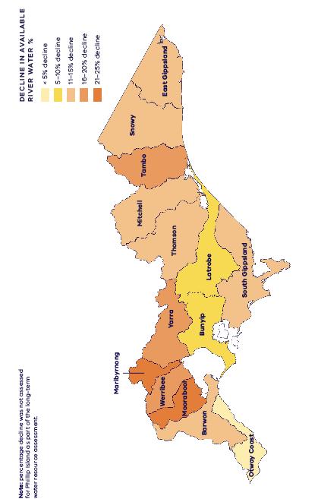
Figure 8.1. Percentage decline in river water availability in each river basin across the Central and Gipps-land Region for 1975–2020, relative to the long-term record

We cannot recover all the water our rivers need
There are regulated and unregulated river systems across the Central and Gippsland Region. Unregulated rivers are important natural assets and the Victorian Government has committed to not building any new dams on these rivers. Environmental water recovery, required to improve and maintain environmental values in the nine major regulated rivers in the region, has been informed by FLOWS studies. An estimated 380 gigalitres of water per year (on average) would be needed to meet the full environmental water requirements for major rivers in the Central and Gippsland Region – a volume greater than Melbourne’s total annual residential water usage., This environmental water deficit cannot be met with a growing population and drying climate without taking water away from households, industry, businesses and farms – it is simply too large.
While recognising we cannot recover all the water our rivers need immediately, environmental water recovery targets have been developed that strive to meet critical environmental outcomes over the next decade without taking water away from other uses. We expect that environmental water recovery will continue to be an ongoing challenge across the region for the decades to come.

Returning critical volumes of environmental water
Environmental water recovery targets have been developed that reflect a balance between meeting critical environmental outcomes and affordable water bills without taking water away from other users. Over the next 10 years, a total of up to 99.5 gigalitres of water will be returned to the environment in major rivers in the Central and Gippsland Region. Water will be recovered for the environment through infrastructure upgrades, local opportunities to use recycled water and stormwater, instead of river water, for non-drinking uses (See Chapter 3), and by moving water more effectively around Victoria’s water grid. Water will not be taken away from farmers, and all existing water entitlements provided under the Water Act will be protected.
In the longer-term (the next 10 years and beyond) we will look for opportunities to return larger volumes of river water (currently held by urban water corporations) to Traditional Owners and the environment as we add more manufactured water to the region’s supplies. For example, additional desalinated water supplies could free up a portion of existing river water used for drinking via substitution – when, by agreement, the right to draw on one water source is replaced by the right to draw on another (see Chapter 4). While these projects are being developed, we will deliver a package of investments to improve waterway health, including building fishways, upgrading water infrastructure and addressing constraints to improve the effectiveness of environmental watering.
Appendix C explains how the actions set out in this chapter to meet the environmental water recovery targets also respond to the findings of the long-term water resource assessment.

Adaptive targets and objectives
We recognise that rivers still need more water to improve waterway health and resilience in the long-term (as shown by the environmental water deficits), and that water recovery targets will need to be adapted over time. Irreversible changes in climate and land use also mean that in the future not all values in every system can be maintained. An evidence-based approach is used for reviewing and changing management objectives for waterways, and this occurs in consultation with communities every eight years through regional waterway strategies and Melbourne Water’s Healthy Waterways Strategy (Melbourne Water 2018) (Figure 8.2). The 10 year review and renewal process for this Strategy allows us to further adapt water recovery targets based on the agreed management objectives in regional waterway strategies.
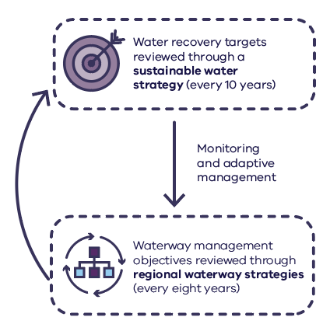
Figure 8.2. Adaptive management cycle of water recovery targets and waterway management objectives (Melbourne Water reviews its healthy waterway strategy every 10 years)

How much water do our rivers need?

Setting water recovery targets
Waterway managers have developed water recovery targets for major rivers in the region over the next 10 years. The targets are unique to each river and focus on achieving the most critical environmental outcomes in the short and medium term, for example flushing refuge pools or aiding native fish breeding and migration. Detailed examples of the environmental outcomes for each of the environmental water recovery targets are in Appendix D. Comprehensive FLOWS studies are used to identify the recommended environmental flows and allow the environmental water deficits to be calculated for each system (see Figure 8.3).
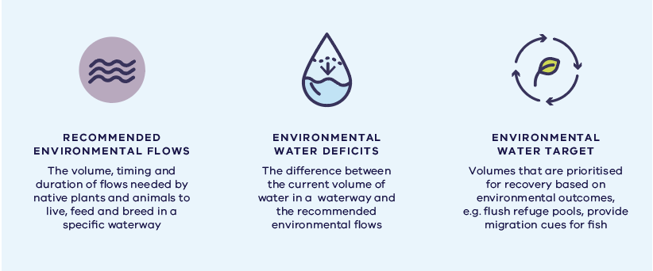
Figure 8.3. How environmental flow recommendations, environmental water deficits and environmental water targets fit together
While it is not possible to meet the full environmental water deficits for all rivers in the region, it is important to highlight these deficits as aspirational figures that would be required to meet existing environmental objectives in the long term. In the short to medium term, prioritised environmental water recovery targets provide a specific commitment to returning water to the environment, and use the term ‘up to’, as further investigations and analysis are required to determine the exact volumes available from each of the water recovery actions listed for each target.

Optimising use of environmental water
Water that is held for the environment, for example in dams and storages, is released into rivers and wetlands as environmental flows to achieve specific environmental outcomes. This means releasing the right volume of water at the right time and for the right duration. For example, at certain times of the year, higher flows are needed to allow fish migration and breeding. At other times, lower flows are needed to maintain pools and slow-water habitats that provide shelter and refuge. In addition to releases of held environmental water, passing flows provide a range of benefits for all water uses in many systems, including the environment.
Releases of held environmental water are planned by the Victorian Environmental Water Holder – an independent statutory body – in partnership with water corporations and CMAs. The Victorian Environmental Water Holder works with water corporations and CMAs/Melbourne Water to deliver environmental water as efficiently and effectively as possible. For example, environmental water may be released from storage at the same time as water for downstream consumptive use, allowing a larger flow to move down the river and provide more environmental benefits.
Environmental monitoring assesses how environmental water is working, whether environmental objectives are being met and how environmental water delivery and outcomes can be improved.
We use FLOWS studies to tell us the volume, timing and duration of flows needed to support environmental values, and monitoring programs (statewide and regional) to tell us how the environmental flows are working. The Victorian Environmental Flows Monitoring and Assessment Program helps us better understand how our waterway ecosystems respond to the release of environmental water, focusing on fish and vegetation, so that we can manage environmental water more effectively.
Thomson River environmental flows
Base flows and freshes in the Thomson River are supporting native fish breeding and migration by helping juvenile fish enter the river in spring or early summer and by supporting large numbers of adult fish to migrate downstream to spawn in autumn. Monitoring shows that juvenile tupong are migrating to the mid-reaches of the Thomson River within around two months of entering the estuary, and reaching the upper reaches by the next sampling event, a year later.

Improving waterway health for rivers in the west
Our plan:
- return additional water to the environment in major rivers in the west to achieve environmental outcomes, without compromising the needs of other water users
- deliver a suite of complementary investments to improve the health and resilience of waterways

Moorabool Yulluk (Moorabool River)
The Moorabool Yulluk (Moorabool River) is one of the state’s most flow-stressed rivers. The river’s current environmental entitlement – 2.5 gigalitres per year – only delivers 25 per cent of the annual minimum recommended flows. During most summers, disconnected pools develop in the lower reach of the river and, if flows are not provided, the pools can dry out completely within a week, resulting in fish deaths.
Comprehensive studies have found the Moorabool Yulluk (Moorabool River) has an environmental water deficit of 17 gigalitres per year and additional water is urgently needed to improve summer flows and support the survival of native fish species (including tupong, galaxiids and Australian grayling) and platypus. Based on these studies, the waterway manager has identified water recovery targets to be met in the next 10 years that will aim to achieve the most critical environmental outcomes (see Appendix D). Water recovery will also maintain, and help to improve, the environmental and cultural values of the river and broader economic and social values.
Chapter 4 sets out plans to improve water management in the Moorabool Yulluk (Moorabool River) to benefit the environment, Traditional Owner cultural values and other shared benefits.
To achieve the greatest possible environmental outcomes in the Moorabool Yulluk (Moorabool River) from any water recovery or improvements in flow regimes, complementary works or measures will be required. This may include works to restore and rehabilitate the river at Batesford and prevent flow losses. Restoration and rehabilitation will need to consider maintenance of flows in the Moorabool River at Batesford following the Batesford Quarry decommissioning expected later this decade, when the contribution of groundwater pumped from the quarry and transferred to the Moorabool Yulluk (Moorabool River) downstream as an environmental flow will cease. Resource risks in the upper Moorabool catchment will also be reviewed to identify potential impacts from small catchment dams (See Action 4-13).
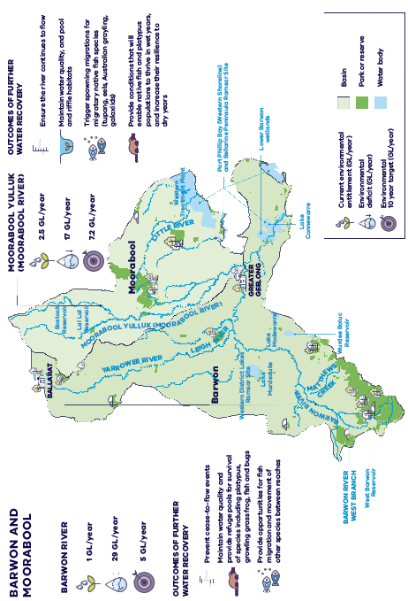
Figure 8.4. Environmental outcomes for rivers in the west – see Appendix D for further detail

Policy 8-1: Return water to the Moorabool Yulluk (Moorabool River) west branch
The Victorian Government will return up to 6.5 gigalitres to the Moorabool Yulluk (Moorabool River) west branch to improve waterway health by maintaining water quality and preventing fish deaths. By 2032

Policy 8-2: Return water to the Moorabool River east branch
The Victorian Government will return up to 700 megalitres to the Moorabool Yulluk (Moorabool River) east branch to improve waterway health and support thriving native fish and platypus populations. By 2032
These outcomes will be achieved through a combination of:
- transferring a long-term average of up to 3 gigalitres per year from Barwon Water’s bulk entitlement in Lal Lal Reservoir to be shared between the environment and Wadawurrung Traditional Owners by 2025 (see Action 4-3 and Action 4-4)
- transferring a long-term average of up to
700 ML/year from Barwon Water’s bulk entitlement in Bostock Reservoir to be shared between the environment and Wadawurrung Traditional Owners by 2025 (see Action 4-3 and Action 4-4)
- increasing use of stormwater, recycled water or efficiency measures to reduce water extraction from rivers for cities and towns (see Policy 4-2) as well as increase their use as sources for environmental flows if appropriate (see Policy 8-16, Action 8-22 and Action 8-23)
- substituting river water with manufactured water in the longer-term (see Policy 4-3).

Complementary actions
Action 8-1: Rehabilitate the Moorabool Yulluk (Moorabool River) at Batesford Quarry
The Victorian Government will investigate impacts to the Moorabool Yulluk (Moorabool River) from the closure of Batesford Quarry and fund preliminary investigations to determine the best methods of restoring and rehabilitating the river and preventing flow losses. These investigations consider environmental and Wadawurrung Traditional Owner cultural values. In addition this will contribute to the resilience and liveability of the North and Western Geelong Growth Area neighbourhoods through integration of this work with the IWM Plan. By 2026

Action 8-2: Increase understanding of water needs of the Upper Moorabool and Leigh catchments
The Victorian Government, Corangamite CMA and Wadawurrung Traditional Owners Aboriginal Corporation will investigate flows required to protect environmental and Traditional Owner values for the upper Moorabool and Leigh catchments. This will also consider the relative importance of water recovery in these areas against existing water recovery targets for the Barwon catchment that include both the Moorabool Yulluk (Moorabool River) and Leigh River. By 2027

Stony Creek and Little River
Stony Creek is a major headwater tributary of Little River that is popular for recreation, including fishing and picnicking. Barwon Water operates the Upper Stony Creek Reservoir as part of Geelong’s water supply system. The now decommissioned Lower Stony Creek Reservoir – Geelong’s first dam – is among the earliest water supply systems constructed in Victoria. The Little River catchment contains places of cultural significance to Traditional Owners.
Investigations will determine whether upgrades to the Lower Stony Creek Reservoir could improve flows in Stony Creek and Little River by allowing a more natural flow regime to be released from the reservoir. Any works will consider the heritage and cultural values of the area.
Action 8-3: Improve flows in Stony Creek
The Victorian Government will work with Melbourne Water, Barwon Water, Parks Victoria and the Wadawurrung Traditional Owners Aboriginal Corporation to explore options for improving flows in Stony Creek and Little River through operational changes. This will include assessing the feasibility of providing more transparent passing of natural flows from Lower Stony Creek Reservoir into Stony Creek. By 2027

Barwon River
The Barwon River is one of Geelong’s most loved natural assets – supporting recreation, tourism, and Traditional Owner values – however, the river is under significant stress due to low flows and poor water quality. Low flows in the lower reaches through Geelong, particularly in summer and autumn when the river is most used by the community, have led to more frequent outbreaks of blue-green algae and poor water quality.
The existing upper Barwon River environmental entitlement of 1 gigalitre per year delivers only a small portion of the recommended summer flows for the upper Barwon’s east and west branches, with diminishing returns as it moves downstream in most years.
Comprehensive studies have found that the Barwon River has an environmental water deficit of 29 gigalitres per year, and additional water is urgently needed to prevent cease-to-flow events and support more continuous flows. Based on these studies, the waterway manager has identified water recovery targets to be met in the next 10 years that will aim to achieve the most critical environmental outcomes (see Appendix D). Water recovery will also help maintain water quality and provide enough water over summer for spotted galaxias, Australian grayling and other native fish species to survive.
Policy 8-3: Return water to the Barwon River
The Victorian Government will return up to 5 gigalitres of water for the environment in the Barwon River to improve waterway health by preventing cease-to-flow events, maintaining water quality, and providing water for native fish species to survive. By 2032
These outcomes will be achieved through a combination of:
- substituting river water with manufactured water in the longer-term (see Policy 4-3, Chapter 4)
- increasing use of stormwater, recycled water or efficiency measures to reduce water extraction from rivers for cities and towns (see Policy 4-2, Chapter 4) and as sources for environmental flows if appropriate (see Policy 8-16, Action 8-22 and Action 8-23 in this chapter).
Social and economic benefits of the Barwon and Moorabool rivers
In 2021, Corangamite CMA undertook a study to examine the social and economic benefits that the Barwon and Moorabool rivers provide to the community of Geelong, and the importance of river flows for supporting and protecting these values (RMCG 2021a).
The lower Barwon and Moorabool rivers and their surrounding parklands support a wide range of recreational activities which are valued by Geelong locals and visitors. These include walking, cycling, fishing, rowing, paddle sports and game hunting, or simply taking the time to enjoy nature.
Declining flows in the Barwon and Moorabool rivers are leading to reduced water quality in the lower Barwon through Geelong, particularly in summer and autumn when the river is most widely used and valued by the local community. This decline has also led to the increased frequency and severity of blue-green algal outbreaks, which impact the surrounding environment and threaten safe boating and recreational water sports over the long term.
The study estimated that the rivers currently provide an annual value of about $24.7 million to the Geelong community, assuming no impact by low water levels or algal events, which reduce this value by $4.8 million per year. Improving flows in the Barwon and Moorabool rivers can increase the average annual value of the river by $3.8 million per year, or a benefit over a 40 year period of $95 million.

Complementary actions
Action 8-4: Improve waterway health in the Barwon River
The Victorian Government will improve waterway health in the Barwon River, increase the effectiveness of environmental water releases and address constraints to their delivery by:
- investigating options to improve native fish migration at Buckley Falls
- restoring channel form and removing willows and reed sweet-grass from the upper Barwon River
- investigating risks of releasing higher volumes of water and prioritising works to mitigate them.
By 2027

Action 8-5: Update watering recommendations for Reedy Lake and Hospital Swamp
The Corangamite CMA will update the watering recommendations for the Ramsar-listed Reedy Lake and Hospital Swamps, including the development of a water-salt balance model to support effective water management for the Ramsar-listed Reedy Lake and Hospital Swamp and to protect and improve these wetlands for all uses. By 2025

Meeting management objectives for our Ramsar listed wetlands
Reedy Lake and Hospital Swamp are the two main floodplain wetlands on the lower Barwon River. They are recognised as internationally significant under the Ramsar Convention on Wetlands, forming part of the Port Phillip Bay (Western Shoreline) and Bellarine Peninsula Ramsar Site. The Ramsar Convention provides the framework for international cooperation on wetland conservation; contracting countries to the convention are obliged to manage all wetlands through wise and sustainable use​. It initially focused on protecting migratory waterbirds, but now considers all biodiversity​.
The lower Barwon wetlands consist of a diverse range of aquatic vegetation communities that provide important feeding and breeding habitat for native fish and wetland-dependent bird species. The wetlands are home to several species of rare and endangered flora and fauna, including the Australasian bittern and the orange-bellied parrot.
The primary objective of the Port Phillip Bay (Western Shoreline) and Bellarine Peninsula Ramsar site management plan (DELWP 2018) is to:
maintain, and where necessary improve, the ecological character of the ecological character of the Port Phillip Bay (Western Shoreline) and Bellarine Peninsula Ramsar Site and support wise and sustainable use.
The plan also includes a specific management strategy for these important wetlands:
Management strategy 3.4 – Continue to develop and implement environmental water management at Reedy Lake and Hospital Swamp.
The Barwon River Environmental Entitlement 2011 allows water to be diverted from the Barwon River, to manage water levels in Reedy Lake and Hospital Swamps. The overarching objective of the environmental watering is to maintain the ecological character of the wetlands – that is, the combination of ecosystem components, processes, benefits and services that characterised the wetlands when Ramsar listed. Action 8-5 will allow us to improve our knowledge to further inform the most effective watering regime for these Ramsar-listed wetlands, to protect and improve these wetlands for all uses. This will also help us to achieve Management Strategy 3.4 from the Ramsar site management plan.

Leigh and Yarrowee rivers
The Leigh and Yarrowee rivers are part of the Barwon River system and are also important contributors to flows into the internationally significant wetlands at Lake Connewarre, Reedy Lake and the lower Barwon further downstream. Key threats to the health of the Leigh and Yarrowee rivers include poor water quality, and erosion from increased urbanisation and stormwater runoff.
The Ballarat South Treatment Plant discharges about 20 megalitres of treated wastewater each day into the Yarrowee River under an EPA licence (or 7.43 gigalitres in 2019–20). For the Leigh and Yarrowee rivers, the environmental FLOWS study highlights the value of the treated water from the plant in providing flows (Alluvium 2021a), as does the Central Region Sustainable Water Strategy (DSE 2006), which committed to discharging 2 gigalitres of recycled water into the Yarrowee River each year. The study also found that changes to the timing of discharges and better water quality management could improve the long-term supply of environmental water to the Barwon River system. See Section 8.7 for more on recycled water and stormwater for the environment.
Action 8-6: Investigate the use of recycled water and stormwater for environmental flows in the Yarrowee and Leigh rivers
The Victorian Government, Central Highlands Water, Corangamite CMA and Wadawurrung Traditional Owners Aboriginal Corporation will investigate options for using stormwater and recycled water from the South Ballarat Treatment Plant to improve flows and waterway health for the Yarrowee River, Leigh River and Moorabool Yulluk (Moorabool River). By 2027

Anglesea River
Historically, the Anglesea River has frequently experienced periods of acidic or low-pH water quality, predominantly due to natural sources of acid in the catchment, including coal seams, acid sulphate soils and tea tree marshes. Research suggests that these events are the result of heavy rainfall following a dry period and have been exacerbated by lower rainfall and higher temperatures resulting from climate change impacts.
Between 1963 and 2015, Alcoa operated the Anglesea Power Station, during which time groundwater was extracted for use in power generation, and subsequently released into the Anglesea River. Alcoa’s discharge was generally the only flow-source into the river during the summer–autumn period and is likely to have also played a role in buffering acidic events.
Alcoa is responsible for preparing a plan for the rehabilitation of the former Anglesea coal mine, to achieve a safe, stable and sustainable landform. Rehabilitation may involve filling the mine void, which could hold around 16 gigalitres of water. Alcoa is investigating the feasibility of using local groundwater for this. Fit-for-purpose recycled water is also an option, but this would need investment in infrastructure, including a pipeline to Anglesea from the Black Rock Water Reclamation Plant.
In response to the power station closure and releases of water ceasing, a technical investigation determined the main impact would be a reduction in Anglesea River’s water levels by approximately one metre in summer. This could expose mudflats and parts of the channel in the lower estuary and Coogoorah Park. This in turn increases the risk of additional acid events in the river by exposing coastal acid sulphate soils in Coogoorah Park. These impacts are likely to be exacerbated by reduced rainfall due to climate change.
Since 2016, water has been extracted from the Anglesea River during winter and spring. The water is stored in a pond on the former Alcoa mine site and released back into the estuary over the drier summer months. This additional flow helped supplement natural inflows, maintaining water levels in the estuary over summer to provide social, economic and environmental benefits for the local community.
Managing the Anglesea River remains a challenge due to the range of natural and anthropogenic effects on the river and its catchment over many decades. We are continuing to work with stakeholders and the community to identify longer-term management interventions to improve the health of the river.
Action 8-7: Complete a feasibility study of the long-term management options to mitigate waterway health issues of the Anglesea River and estuary
The Victorian Government, in partnership with the local community, will continue to investigate feasible long-term management options to improve the health of the Anglesea River and estuary. By 2023

Painkalac Creek
Painkalac Creek flows from the Otway Ranges through Aireys Inlet, ending in a coastal lagoon system, which attracts both the spotted green frog and the eastern banjo frog (pobblebonk). Flows in the Painkalac Creek and estuary are modified by the Painkalac Reservoir, which supplied potable water to the towns of Aireys Inlet and Fairhaven until 2016.
When Painkalac Creek Reservoir ceased supplying potable water in 2016, the reservoir became a popular recreation site, and allowed the Corangamite CMA and Barwon Water to work together to coordinate releases from the reservoir for environmental benefits in the creek and estuary.
These releases occur throughout the year to mimic natural flows as much as possible, to prevent downstream reaches of the creek from drying out, help maintain water quality and habitat for fish, frogs and birds, and provide water for recreation.
Painkalac Creek is a great example of agencies working together effectively to provide shared benefits for all users and maximise use of the resource.
Action 8-8: Improve the health of Painkalac Creek
The Corangamite CMA and Barwon Water will continue to work together to achieve environmental benefits in Painkalac Creek through coordinated releases from Painkalac Creek Reservoir.
Ongoing

Gellibrand River
The Gellibrand River is an unregulated river that supplies water to the towns of Warrnambool, Camperdown, Lismore, Cobden and Colac, and ends in a coastal estuary that is part of the Great Otway National Park. The river and estuary are popular places for recreation and tourism and an important cultural area for the Eastern Maar. Summer flows are important for maintaining habitat and water quality for macroinvertebrates and native fish such as Australian grayling and river blackfish and for reducing the risk of fish kills in the estuary after artificial openings. Wannon Water is investigating options to improve summer flows by reducing water extraction and increasing the use of other water resources.
Action 8-9: Improve summer flows in the Gellibrand River
The Victorian Government, Wannon Water, Eastern Maar Aboriginal Corporation and Corangamite CMA will continue to work together to investigate a preferred water supply augmentation option to improve critical water flows in the Gellibrand River through the summer low flow period.
This will be achieved through a combination of:
- assessing the expected environmental outcomes for each option to reduce water extraction from the Gellibrand River (independent expert report)
- completing a quadruple-bottom-line assessment of the preferred options, to identify the best way to improve flows in the Gellibrand River.
Ongoing

Improving waterway health for rivers in Greater Melbourne
Our plan:
- return additional water to the environment in major rivers in Greater Melbourne to achieve environmental outcomes, without compromising the needs of other water users
- deliver a suite of complementary investments to improve the health and resilience of waterways

Wirribi Yaluk (Werribee River)
The Werribee catchment is the driest in southern Victoria, with comprehensive studies finding that the river has an environmental water deficit of 12 gigalitres per year. Additional water is urgently needed for the environment to prevent further decline and improve water quality, support native fish populations, including galaxiids, and provide habitat for a regionally significant platypus population. Based on these studies, the waterway manager has identified water recovery targets to be met in the next 10 years that will aim to achieve the most critical environmental outcomes (see Appendix D). Water recovery will also help to reduce algal blooms which can affect the use of the river for recreation and events, including canoeing, fishing and kayaking.
Policy 8-4: Return water to the Wirribi Yaluk (Werribee River) in the short term
The Victorian Government will return approximately 2 gigalitres of water for the environment in the Wirribi Yaluk (Werribee River) to improve waterway health by maintaining water quality and providing refuges for fish. By 2024

Action 8-10: Improve fish passage in the Wirribi Yaluk (Werribee River)
The Victorian Government and Melbourne Water will work together to address barriers to native fish migration by undertaking detailed designs for a fishway at the lower Werribee Diversion Weir, and potential upgrades to the weir to improve the delivery of environmental water. By 2027
These outcomes will be achieved through:
- completion of the irrigation modernisation projects in Werribee and Bacchus Marsh (see Section 7.3).
Policy 8-5: Return water to the Wirribi Yaluk (Werribee River)
The Victorian Government will return up to an additional 10 gigalitres of water to the environment in the Wirribi Yaluk (Werribee River) to improve waterway health by maintaining water quality and providing refuges for fish. By 2032
These outcomes will be achieved through a combination of:
- reconfiguring the Werribee system (see Action 4-10)
- increasing use of stormwater, recycled water or efficiency measures to reduce water extraction from rivers for cities and towns (see Policy 4-2 and as sources for environmental flows if appropriate (see Policy 8-16, Action 8-22 and Action 8-23)
- substituting river water with manufactured water in the longer-term (see Policy 4-3).
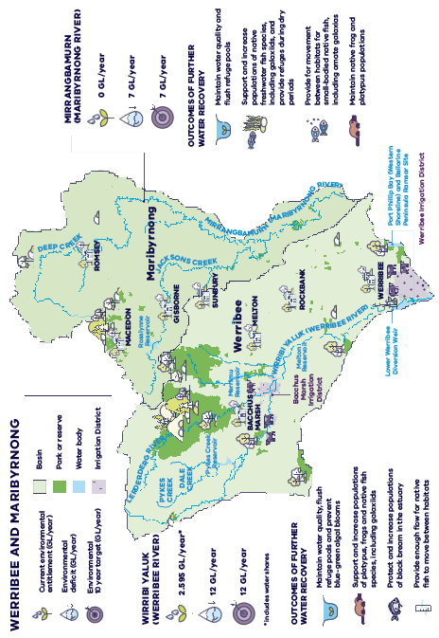
Figure 8.5. Environmental outcomes for the Wirribi Yaluk (Werribee River) and the Mirrangbamurn (Ma-ribyrnong River) – see Appendix D for further detail

Mirrangbamurn (Maribyrnong River)
The Maribyrnong basin has experienced one of the largest percentage declines in inflows across southern Victoria (17 per cent or about 17 gigalitres per year). Like most rivers in the region, there is now less water for the environment, and the river has extended periods of low flows which can affect the river’s many values.
Comprehensive studies have found that the Mirrangbamurn (Maribyrnong River) has an environmental water deficit of 7 gigalitres per year. Additional water is urgently needed to flush pools to maintain water quality, allow native fish species, including galaxiids, to breed and move between habitats, and to provide habitat for platypus populations and waterbugs. Based on these studies, the waterway manager has identified water recovery targets to be met in the next 10 years that will aim to achieve the most critical environmental outcomes (see Appendix D).
Resource risks in the upper Maribyrnong catchment will be reviewed to identify potential impacts caused by small catchment dams (see Action 4-13).
Policy 8-6: Return water to the Mirrangbamurn (Maribyrnong River)
The Victorian Government will return up to 7 gigalitres of water to the Mirrangbamurn (Maribyrnong River) to improve waterway health by maintaining water quality and supporting native species to survive.
By 2032
These outcomes will be achieved through a combination of:
- substituting river water with manufactured water in the longer-term (see Policy 4-3)
- increasing use of stormwater, recycled water or efficiency measures to reduce water extraction from rivers for cities and towns (see Policy 4-2) and as sources for environmental flows if appropriate (see Policy 8-16, Action 8-22 and Action 8-23).

Complementary actions
Action 8-11: Improve the health of the Mirrangbamurn (Maribyrnong River)
The Victorian Government will improve the health of the Mirrangbamurn (Maribyrnong River), increase the effectiveness of environmental water releases and address constraints to their delivery by exploring options to:
- upgrade Rosslynne Reservoir outlet to allow larger releases of environmental water
- remove willows and other weeds and establish vegetation buffers in the upper catchment
- address barriers to fish movement in the upper Mirrangbamurn (Maribyrnong River).
By 2032

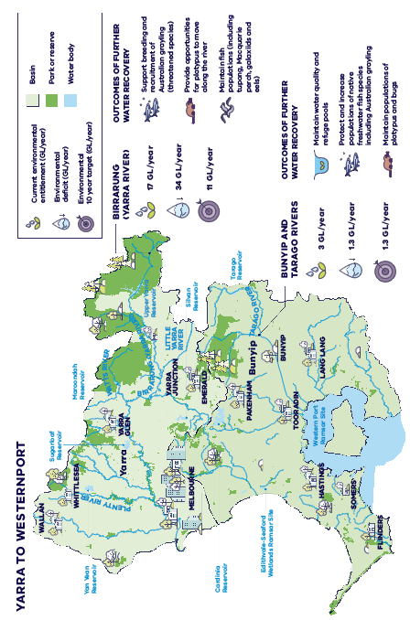
Figure 8.6. Environmental outcomes for the Birrarung (Yarra River) and the Bunyip and Tarago rivers – see Appendix D for further detail

Birrarung (Yarra River)
The Birrarung (Yarra River) is one of the state’s most iconic waterways, with significant economic, social and cultural values for locals and visitors to Melbourne. The river provides 70 per cent of Melbourne’s drinking water and includes 2,450 hectares of urban parklands and green open spaces. The river supports farming, tourism and recreation and includes numerous places of high cultural significance for the Wurundjeri people, such as the Mount Lofty and the Brushy Creek confluence. The major biodiversity corridor, created by the river and its connected parklands, supports populations of platypus, native fish and koalas, along with more than 150 bird species.
Despite continued investment and collaboration, the health of the Birrarung (Yarra River) is under threat from climate change, urbanisation and population growth. Like most rivers in the region, water availability is declining and there is less water available for the environment.
Comprehensive studies have found that the Birrarung (Yarra River) has an environmental water deficit of 34 gigalitres per year. Based on these studies, the waterway manager has identified water recovery targets to be met in the next 10 years that will aim to achieve the most critical environmental outcomes (see Appendix D). This additional water is urgently needed to prevent the loss of Australian graylings, to allow platypus populations to move along the river and to support native fish.
Policy 8-7: Return water to the Birrarung (Yarra River)
The Victorian Government will return up to 11 gigalitres to the environment in the Birrarung (Yarra River) to improve waterway health, support native species and improve riparian vegetation and billabong habitat. By 2032

These outcomes will be achieved through a combination of:
- investigating optimisation of Birrarung (Yarra River) system passing flow arrangements (see Action 4-11)
- increasing use of stormwater, recycled water or efficiency measures to reduce water extraction from rivers for cities and towns (see Policy 4-2) and as sources for environmental flows if appropriate (see Policy 8-16, Action 8-22 and Action 8-23)
- substituting river water with manufactured water in the longer-term (see Policy 4-3).
Recovering water in the Birrarung (Yarra River) supports the implementation of the Victorian Government’s Burndap Birrarung burndap umarkoo (Yarra Strategic Plan), which is an Australian first and manages the Birrarung (Yarra River) and its parklands as one integrated living entity (Melbourne Water 2022).
Action 8-12: Improve the health of the Kooyongkoot (Gardiners Creek)
The Victorian Government will support a co-ordinating committee to oversee improvements to the health and amenity of Kooyongkoot (Gardiners Creek) in the Yarra catchment, in partnership with Wurundjeri Woi-wurrung Cultural Heritage Aboriginal Corporation. By 2023

Bunyip and Tarago rivers
The Bunyip and Tarago rivers support several significant and threatened native plant and animal species, including the Australian grayling. The upper catchment supports platypus populations and native fish such as river blackfish and mountain galaxias. The lower catchment has been highly modified, but still contains patches of remnant vegetation and healthy populations of Australian grayling and platypus. Water for the environment is declining, with the greatest impact to flows in the reaches downstream of Tarago Reservoir, where mean annual flows have declined by up to 20 per cent.
Comprehensive studies have found the Bunyip and Tarago rivers have an environmental water deficit of 1.3 gigalitres per year and additional water is urgently needed to maintain water quality and support native species. Based on these studies, the waterway manager has identified water recovery targets to be met in the next 10 years that will aim to achieve these critical environmental outcomes (see Appendix D).
Policy 8-8: Return water to the Bunyip and Tarago rivers
The Victorian Government will return up to 1.3 gigalitres for the environment in the Bunyip and Tarago rivers to protect populations of platypus and native fish and maintain water quality. By 2032
These outcomes will be achieved through a combination of:
- increasing use of stormwater, recycled water or efficiency measures to reduce take from rivers for cities and towns (see Policy 4-2) and as sources for environmental flows if appropriate (see Policy 8-16, Action 8-22 and Action 8-23)
- substituting river water with manufactured water in the longer-term (see Policy 4-3).

Improve waterway health for rivers in Gippsland
Our plan:
- return additional water to the environment in major rivers in Gippsland to achieve environmental outcomes, without compromising the needs of other water users
- deliver a suite of complementary investments to improve the health and resilience of waterways
The major rivers in the Gippsland Region are much larger than those to the west of Melbourne. For example, the long-term water availability in the Thomson–Macalister and Latrobe rivers (750 and 830 gigalitres per year respectively) are around 10 times the size of the Maribyrnong, Werribee and Moorabool rivers (85, 78 and 85 gigalitres per year respectively) and more than three times the size of the Barwon River (233 gigalitres per year). This means they need more water to achieve the same flow objectives than the smaller rivers to the west of Melbourne, such as minimum flows in summer and winter and fresh flows. These large Gippsland rivers therefore have larger deficits and water recovery targets.

Carran Carran (Thomson River)
The Carran Carran (Thomson River) is part of a network of coastal rivers across Gippsland and south-eastern Australia that support populations of nationally significant migratory fish species, including the Australian grayling, tupong and short- and long-finned eel. The reach from the Aberfeldy River confluence to Cowwarr Weir has heritage river status, with largely intact native riparian vegetation communities and fish populations.
Comprehensive studies have found the Carran Carran (Thomson River) has an environmental water deficit of 80 gigalitres per year. Based on these studies, the waterway manager has identified water recovery targets to be met in the next 10 years that will aim to achieve the most critical environmental outcomes (see Appendix D). The additional water is urgently needed to prevent the loss of native aquatic species and support regular breeding of Australian grayling and other native fish.
Policy 8-9: Return water to the Carran Carran (Thomson River)
The Victorian Government will return up to 15 gigalitres of water for the environment in the Carran Carran (Thomson River) to improve waterway health by supporting migratory native fish populations, including the Australian grayling, and providing habitat for platypus. By 2032
These outcomes will be achieved through a combination of:
- substituting river water with manufactured water in the longer-term (see Policy 4-3)
- increasing use of stormwater, recycled water or efficiency measures to reduce water extraction from rivers for cities and towns (see Policy 4-2) and as sources for environmental flows if appropriate (see Policy 8-16, Action 8-22 and Action 8-23).

Action 8-13: Thomson River–Rainbow Creek waterway management plan
The Victorian Government has funded a number of high-priority actions under the Thomson River–Rainbow Creek waterway management plan 2020 and will seek to secure funding for the implementation of the remaining actions to address the risk of waterway avulsion to urban and rural water supplies and waterway health.
Ongoing

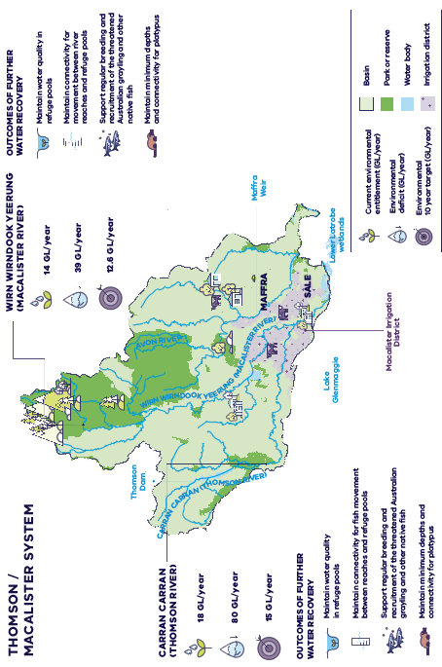
Figure 8.7. Environmental outcomes for the Carran Carran (Thomson River) and the Wirn Wirndook Yeerung (Macalister River) – see Appendix D for further detail

Action 8-14: Improve flows in the Avon River
West Gippsland CMA and Gunaikurnai Land and Waters Aboriginal Corporation will review and update the environmental water needs of the Avon River to protect environmental and Traditional Owner values and will work with relevant authorities to investigate options to improve critical flows. By 2032
West Gippsland CMA, Gunaikurnai Land and Waters Aboriginal Corporation and Southern Rural Water will continue to work together to improve knowledge and management of flows in the Avon River and connected groundwater for all uses. Ongoing
Opportunities to improve environmental flows in the Avon River will be explored during investigations to consider current and future use of land, water, and infrastructure within the MID (see Action 7-2).

Wirn Wirndook Yeerung (Macalister River)
The Wirn Wirndook Yeerung (Macalister River) is home to several migratory native fish species, including the threatened Australian grayling, short-finned eel, long-finned eel and tupong. Platypus and rakali (Australian water rats) are widely distributed through the river and its tributaries.
Comprehensive studies have found the river has an environmental water deficit of 39 gigalitres per year and additional water is urgently needed to prevent the loss of critical species and support regular breeding of the Australian grayling and other native fish. Based on these studies, the waterway manager has identified water recovery targets to be met in the next 10 years that will aim to achieve the most critical environmental outcomes (see Appendix D). Improving fish passage at the Maffra Weir – one of the most significant fish barriers in coastal Victoria – is also critical to native fish breeding and migration.
Policy 8-10: Return water to the Wirn Wirndook Yeerung (Macalister River) in the short term
The Victorian Government will return 1.7 gigalitres of water for the environment in the Wirn Wirndook Yeerung (Macalister River) to improve waterway health maintaining water quality in refuge pools and connectivity for aquatic species. By 2026

These outcomes will be achieved through:
- completion of Phase 2 of MID2030 (see Section 7.3).

Policy 8-11: Return water to the Wirn Wirndook Yeerung (Macalister River)
The Victorian Government will return up to an additional 10.9 gigalitres of water for the environment in the Wirn Wirndook Yeerung (Macalister River) to improve waterway health by supporting breeding and recruitment of the threatened Australian grayling and other native fish, and providing habitat for platypus. By 2032

These outcomes may be achieved through a combination of:
- substituting river water with manufactured water in the longer-term (see Policy 4-3)
- potential further irrigation modernisation (see Chapter 7).

Complementary actions
Action 8-15: Build the Maffra Weir fishway (Wirn Wirndook Yeerung (Macalister River))
The Victorian Government will work with Southern Rural Water and West Gippsland CMA to:
- complete the detailed design of the proposed Maffra Weir fishway By 2024
- construct a fishway at Maffra Weir. This will improve native fish migration, breeding and diversity in the Wirn Wirndook Yeerung (Macalister River) and the broader Gippsland catchments and significantly improve the effectiveness of the environmental water releases, current and future. By 2027
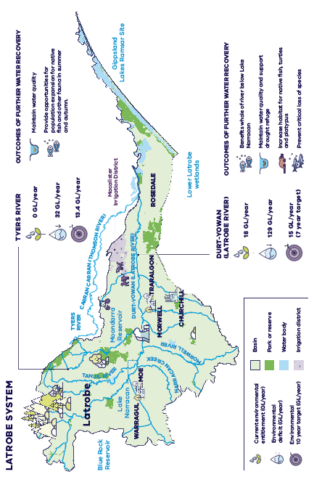
Figure 8.8. Environmental outcomes for the Latrobe system – see Appendix D for further detail

Durt-Yowan (Latrobe River)
The Durt-Yowan (Latrobe River) supports Australian bass, Australian grayling and short- and long-finned eel as well as platypus, rakali (water rats) and freshwater turtles. The Durt-Yowan (Latrobe River) and its tributaries provide an essential source of freshwater to the Gippsland Lakes system, of which the Ramsar-listed lower Latrobe wetlands are an important component.
Comprehensive studies have found the Durt-Yowan (Latrobe River) and estuary have an environmental water deficit of 129 gigalitres per year and additional water is urgently needed to maintain water quality and habitat, and support drought refuges. Based on these studies, the waterway manager has identified water recovery targets to be met in the next 7–10 years that will aim to achieve the most critical environmental outcomes (see Appendix D). Water recovery will also support regular breeding of Australian grayling and other native fish species. Improvements to watering infrastructure at the lower Latrobe wetlands is also needed to improve delivery of freshwater flows to the wetlands.
West Gippsland CMA have developed principles and long-term goals for management of the Durt-Yowan (Latrobe River) system which form the vision for the long-term health of the system, including the river and its floodplains, wetlands and estuary.
Policy 8-12: Return water to the Durt-Yowan (Latrobe River) in the short term
The Victorian Government will return up to 7.3 gigalitres of water for the environment in the Durt-Yowan (Latrobe River) to improve waterway health by maintaining water quality in pools and increasing habitat for native fish, turtles and platypus populations in currently deliverable reaches. By 2027
This outcome will be achieved through:
- reallocating a share of water from the Latrobe 3 — 4 Bench bulk entitlement to contribute towards meeting environmental water recovery targets (see Action 4-8).
Policy 8-13: Return water to the Durt-Yowan (Latrobe River)
The Victorian Government will return up to an additional 7.7 gigalitres of water for the environment in the Durt-Yowan (Latrobe River) to improve waterway health in the whole river. This will maintain water quality in refuge pools and increase habitat for native fish, turtles and platypus, pending the outcomes of the Latrobe constraints investigation. By 2029
These outcomes will be achieved through a combination of:
- reallocating a share of water from the Latrobe 3 — 4 Bench bulk entitlement to contribute towards meeting environmental water recovery targets (see Action 4-8)
- increasing use of stormwater, recycled water or efficiency measures to reduce water extraction from rivers for cities and towns (see Policy 4-2) and as sources for environmental flows if appropriate (see Policy 8-16, Action 8-22 and Action 8-23)
- opportunities through the development of a vision and plan for the water future of the Latrobe Valley (see Action 4-15).
Policy 8-14: Investigate feasibility of delivering additional water to the Durt-Yowan (Latrobe River)
The Victorian Government will undertake a review within five years to assess the feasibility of delivering up to an additional 58 gigalitres of water for the environment in the Durt-Yowan (Latrobe River), given completion of the Latrobe constraints investigation and lower Latrobe wetlands infrastructure upgrades (see Action 4-14, Action 4-15, Action 8-17 and Action 8-18). This additional water would support breeding and recruitment of Australian grayling and other native fish species, and provide fresh water to the Latrobe estuary and lower Latrobe wetlands. By 2027

Environmental water recovery targets for the Latrobe River are higher than the targets published in the discussion draft of this Strategy. The discussion draft targets were interim, while further work was undertaken by the West Gippsland CMA and an expert independent panel, and did not include the volumes required for the whole Latrobe system, including the Latrobe estuary or lower Latrobe Ramsar-listed wetlands. The revised targets consider environmental outcomes that can be achieved at a whole-of-river scale if constraints to delivery of environmental water can be addressed.

Complementary actions
Action 8-16: Improve the delivery of environmental water to the Durt-Yowan (Latrobe River) downstream of Rosedale
The Victorian Government, West Gippsland CMA and Gunaikurnai Land and Waters Aboriginal Corporation will investigate options to remove constraints to the delivery of water for the environment in the Durt-Yowan (Latrobe River) downstream of Rosedale and, pending the outcomes of this investigation, prioritise options for implementation. This will significantly improve the effectiveness of environmental releases into the Durt-Yowan (Latrobe River). By 2027

Action 8-17: Improve flows to the lower Latrobe wetlands
The Victorian Government will work with the West Gippsland CMA to upgrade watering infrastructure at the lower Latrobe wetlands to deliver freshwater flows into the wetlands more efficiently. This will improve the health of the wetlands in the medium-term, and allow time to plan for the long-term, in accordance with Australia’s international obligations under the Ramsar Convention. The wetlands are a priority site for Gunaikurnai Traditional Owners and the local community. By 2027

Improving flows to the lower Latrobe wetlands
The lower Latrobe wetlands (Dowd Morass, Heart Morass and Sale Common) are part of the Gippsland Lakes Ramsar site and provide important habitat for a variety of waterbirds of state, national and international conservation significance. The wetlands are also a traditional meeting place for the Gunaikurnai Traditional Owners and support a range of recreational values. Regulation and water extraction from Latrobe, Thomson and Macalister rivers, combined with changes to the surrounding catchment (such as levees, drains and filling natural depressions) have affected how water flows into and through the wetlands.
Rising salinisation levels in the lower Latrobe River and the limited capacity of existing watering infrastructure (flow regulators) also means that it is increasingly difficult to deliver fresh water to the wetlands. Upgrading the existing regulators and constructing three new regulators (see Figure 8.9) will enable flows to be delivered effectively and efficiently, meeting environmental water requirements and significantly reducing the annual environmental water deficit for the wetlands by up to 6,000 megalitres per year.
In addition to significantly reducing the water requirements of the wetlands, the works will greatly improve the ability to protect and improve the freshwater-dependent values of the wetlands and allow time to plan for the longer-term, in accordance with Australia’s obligations under the Ramsar Convention, by:
- reducing salinity levels in Dowd Morass and Heart Morass by improving freshwater inflows and saltwater outflows.
- providing a more regular water supply to Sale Common– protecting freshwater-dependent flora and fauna to maintain and improve species diversity and refuge value.
- allowing better management of wetting and drying regimes between flood years, improving conditions for wetland vegetation and providing food and habitat for wetland-dependent fauna.
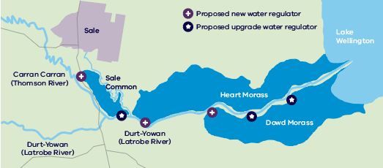
Figure 8.9. Proposed new and upgraded water regulating structures in the lower Latrobe wetlands

Tyers River
The upper reaches of the Tyers River flow through native forest and are relatively intact and ecologically healthy. They support native animals including barred galaxias and river blackfish. Below Moondarra Reservoir, the river is regulated but maintains good quality riverine habitat. Several native migratory fish species are found in the Tyers River including southern shortfin and longfin eel, shorthead lamprey, Australian grayling and tupong.
Comprehensive studies have found the Tyers River has an environmental water deficit of 32,000 megalitres per year and additional water is urgently needed to maintain water quality and prevent the critical loss of species. Based on these studies, the waterway manager has identified water recovery targets to be met in the next 10 years that will aim to achieve the most critical environmental outcomes (see Appendix D). Water recovery will also provide pool habitat to support migratory and resident freshwater fish, macroinvertebrates, aquatic mammals, turtles, and submerged vegetation.
Policy 8-15: Return water to the Tyers River
The Victorian Government will return up to 13 gigalitres of water for the environment in the Tyers River to improve waterway health by preventing the loss of native fish species, macroinvertebrates, and platypus, and providing expansion opportunities for these species in summer and autumn. By 2032

These outcomes may be achieved through a combination of:
- developing a vision for the reconfiguration of the Latrobe Valley water supply system which could reduce reliance on Moondarra Reservoir for urban and industrial supply (see Action 4-15).
- increasing use of stormwater, recycled water or efficiency measures to reduce water extraction from rivers for cities and towns (see Policy 4-2) and as sources for environmental flows if appropriate (see Policy 8-16, Action 8-22 and Action 8-23).
Environmental water recovery targets for the Tyers River are lower than the targets published in the discussion draft of this Strategy. This change reflects the findings of a review by the West Gippsland CMA and an expert independent panel that the geomorphic outcomes are a lower priority than the other outcomes in the short-medium term.

Complementary actions
Action 8-18: Improve fish passage in Tyers River
The Victorian Government will investigate options to provide fish passage in the Tyers River below Moondarra Reservoir (existing fish barriers between Moondarra and Latrobe confluence) to improve native fish migration and breeding and improve effectiveness of future environmental entitlements. By 2027

South Gippsland waterways
Action 8 -19: Improve flows in South Gippsland’s flow-stressed waterways
West Gippsland CMA, Gunaikurnai Land and Waters Aboriginal Corporation and Bunurong Land Council Aboriginal Corporation will investigate flows required to protect environmental and Traditional Owner values of flow stressed waterways in priority South Gippsland waterways and will work with relevant authorities to investigate options to improve critical flows in these waterways. Waterways for consideration include Merriman Creek and the Tarra, Agnes, Tarwin and Powlett rivers. By 2032

Merriman Creek
Action 8-20: Improve fish passage along Merriman Creek
The Victorian Government will investigate options to address constraints to fish passage in Merriman Creek to improve native fish migration and breeding. By 2027

Nicholson River
The Nicholson River Dam sits on the Nicholson River in East Gippsland. The dam is the only major physical structure interrupting the otherwise unregulated river, preventing native fish from reaching 80 per cent of the upper reaches of the river. The dam is no longer used, and opportunities are being explored for it to be decommissioned.
Decommissioning the dam would improve the health of the river and native fish populations and reduce costs associated with the dam’s maintenance and surveillance. Removing most of the dam wall, including its central section down to bedrock level, would immediately improve connectivity and fish passage for native migratory fish including the vulnerable Australian grayling. Improving flows in the Nicholson River, and into the connected Gippsland Lakes, would also support tourism and recreation including fishing and kayaking.
Action 8-21: Decommission the Nicholson River Dam
The Victorian Government, with East Gippsland Water, the East Gippsland CMA and Gunaikurnai Land and Waters Aboriginal Corporation will decommission the Nicholson River Dam to improve waterway health and flows into the Gippsland Lakes. By 2030

Snowy Mountains Hydro Scheme
The Snowy Mountains Hydro Scheme (Snowy Scheme) is an integrated water and hydro-electric power utility that can store up to 5,300 gigalitres of water originating from the headwaters of the Snowy, Murrumbidgee and Murray river catchments. Management of water in the Snowy Scheme is important to Victoria, as water stored and released from the Scheme provides environmental flows to the Snowy and Murray rivers and underpins the reliability of Victorian Murray water entitlements.
The Victorian Government was instrumental in securing intergovernmental agreement to increase flows in the Snowy River in response to the impacts the Snowy Scheme was having on the iconic river’s health and the important values it supports. The Victorian Government contributed $150 million towards meeting the recovery targets established under the Snowy Water Inquiry Outcomes Implementation Deed (SWIOID) to return 21 per cent of mean annual natural flows to the Snowy River. Water recovery volumes to support delivery of 21 per cent mean annual natural flows (equal to a long-term average of 212 gigalitres per year) as committed under the SWIOID were met in July 2012.
Each year, the Snowy Advisory Committee provides advice on the timing and pattern of releases to support environmental outcomes. The advisory committee comprises Victorian and New South Wales community representatives, an aquatic ecologist, and natural resource managers from the Victorian and New South Wales governments. It is enabled under New South Wales legislation.
The Victorian Government maintains its commitment to the objectives of the SWIOID to improve the health of the Snowy River and is supporting New South Wales to implement actions arising from the Ten-year review of the Snowy water licence (NSW Department of Industry 2018) to ensure that the intent of the objectives set out in the SWIOID will be met.

Improve water management to benefit the environment
While we need to recover more water for the environment, we also need to maximise the use of water in a system to achieve benefits for all uses, including the environment. This includes:
- temporary trade of water between agencies (see Action 4-6)
- more flexibility in the use of passing flows (see Action 4-11)
- operating the system as efficiently as possible to enable opportunities for environmental releases to ‘piggyback’ on consumptive releases to achieve larger flows (see Section 4.5).

Recycled water and stormwater for the environment
Our plan:
- increase the use of recycled water and stormwater for a range of non-drinking uses, to reduce the pressure on river water supplies and return more water to the environment
- where re-use isn’t possible, investigate opportunities to use recycled water and stormwater to improve environmental flows and overall waterway health

The role of recycled water and stormwater
Waterways in the Central and Gippsland Region need significant volumes of additional water to prevent further decline and support healthier and more resilient waterways. To return more water to rivers, the region will transition to using more manufactured water for fit-for-purpose uses (see Chapter 3 and Chapter 4). Where substitution is not possible, improvements to the water quality, timing and volumes of urban stormwater flows or releases from wastewater treatment plants could maintain or improve the health of waterways. This will also help to address climate change impacts.

Recycled water for the environment
Recycled water (treated wastewater) can already be discharged into rivers, under certain circumstances, if strict EPA requirements are met. These discharge conditions are effective at mitigating risks but are not targeted to providing ecological benefits.
Recycled water that is released into rivers at the right time, and at the right quality, can help to keep rivers flowing and improve river health, particularly in flow-stressed rivers and during drier periods. For example, the Ballarat South Treatment Plant discharges around 20 megalitres of treated wastewater into the Yarrowee and Leigh rivers each day. This provides important base flow for the rivers, but the water may require further treatment to truly meet the needs of the waterway. We will investigate ways to maximise the environmental benefits of using recycled water in waterways, for example by timing releases to match the recommended environmental flows of the river system.
Action 8-22: Develop guidelines for using recycled water for the environment
The Victorian Government will work with EPA to develop EPA guidelines for using recycled water for the environment, with the aim of improving the overall health of waterways while protecting human health. By 2023

Stormwater for the environment
In highly urbanised catchments, stormwater drainage systems are generally designed to move large volumes of stormwater as quickly as possible into creeks and rivers and away from the source to reduce the risk of flooding. Uncontrolled and untreated stormwater flows harm waterway health by carrying pollutants into waterways and disrupting natural flow patterns. However, if stormwater is harvested, treated to an appropriate standard and released when needed, it not only prevents harm but also provides benefits to the environment, such as maintaining flows in flow-stressed waterways.
The opportunities to use stormwater for the environment may be limited, due to the need for large storages, which will require suitable land and significant infrastructure investment. IWM plans for the Sunbury and Melton growth areas identified stormwater for the environment as potential options. We will use these case studies to better understand the benefits and identify the tools required to enable the use of stormwater for the environment, and also explore options in the Yarrowee and Leigh rivers (see Action 8-6). Where IWM plans in other areas identify opportunities to use stormwater for the environment, we will work with the relevant project partners on a case-by-case basis, applying the learnings from Sunbury and Melton.
Policy 8-16: Stormwater for the environment
The Victorian Government supports the controlled release of stormwater by an authority, where the authority can demonstrate that it:
- is safe and suitable
- improves waterway health (including flows)
- aligns with advice provided by the waterway manager for timing and volume
- has been identified as a viable option in a catchment-scale or region-specific IWM plan.

Policy 8-16: Stormwater for the environment
The Victorian Government will work with Melbourne Water and other project partners to investigate harvesting and using stormwater for the environment, to improve waterway health and provide flows in stressed rivers. We will use the Sunbury and Melton growth areas to explore the possible benefits and enabling policy requirements. By 2025

Managing nutrient and sediment loads in waterways and bays
Our plan:
- protect water quality in our waterways and bays by managing nutrient loads and sediments in Victoria’s largest marine bays: Port Phillip Bay, Western Port, Lake Wellington and Corner Inlet and Nooramunga
Runoff from urban, agricultural and industrial land carries sediment, nutrients and contaminants that can damage the health of our waterways and bays. High levels of sediment and nutrients can cause algal blooms and fish deaths, and prevent the safe use and enjoyment of waterways and bays, as well as increase the burden of treatment for drinking water. While regulation and ongoing investment by government, industry and the community has helped to manage nutrient loads and protect the health of our waterways and bays, we cannot take this health for granted.
The role of Traditional Owners in self-determining objectives and indicators to protect the Traditional Owner cultural values of waterways and bays is discussed in Chapter 6.

Managing nutrient loads in Port Phillip Bay and Western Port
Managing nutrient loads in Port Phillip Bay and Western Port remains a high priority to protect these precious natural assets and their immense social, economic, environmental and cultural value to Victoria. Nutrients are considered a key threat because they are one of the main causes of algal blooms, which pose a risk to marine life and human health. Marine pollutant load objectives for Port Phillip Bay, Western Port and the Western Treatment Plant in Werribee will continue to guide action and investment to ensure the protection of water quality and beneficial uses (see Table 8.1). The Port Phillip Bay Environmental Management Plan 2017–2027 (DELWP 2017b) represents the Victorian Government’s ongoing commitment to ensuring that Port Phillip Bay remains healthy and resilient over the coming decade.
To continue to protect the water quality of receiving waters (downstream of major storages), in response to population growth and land-use change, we need to ensure that:
- seasonal levels of nitrogen remain low, to reduce the risk of algae blooms
- nitrogen loads from sewage treatment plants that discharge into Port Phillip Bay (directly or indirectly via waterways) do not increase
- pollution loads (nitrogen and suspended solids) from the Yarra and Maribyrnong rivers do not exceed 70 per cent of total annual average loads from all waterways discharging into Port Phillip Bay.
Action 8-24: Marine pollution load objectives for Port Phillip Bay and Western Port
The Victorian Government will implement plans and undertake management actions to help reach the marine pollutant load objectives specified in the Environment Reference Standard (Victoria Government Gazette No. S245, 2021) for Port Phillip Bay and for Western Port. Ongoing

Table 8-1. Marine pollutant load objectives for Port Phillip Bay and Western Port.
Geographic area | Indicator | Objective (annual average)
Port Phillip Bay | Total nitrogen from surrounding waterways | 1,500 to 2,200 tonnes
 | Nitrogen from the Western Treatment Plant | 3,100 tonnes (based on a rolling three year average)
 | Total nitrogen from the Yarra and Maribyrnong rivers | Contribution of total nitrogen load not to exceed 70% of total annual average load from all surrounding waterways
 | TSS* from surrounding waterways | 60,000 to 70,000 tonnes
 | TSS from the Yarra and Maribyrnong rivers | Contribution of TSS load not to exceed 70% of annual average load from all surrounding waterways
Western Port | TSS | 28,000 tonnes
*TSS – total suspended solids (measure of turbidity)

Managing nutrient loads in the Gippsland Lakes, and Corner Inlet and Nooramunga
Protecting water quality in the Gippsland Lakes, and Corner Inlet and Nooramunga is vital to supporting regional tourism and jobs and the social, recreational and cultural uses of these natural assets. Elevated levels of nutrients in the Gippsland Lakes lead to regular algae blooms that can threaten the use of the lakes for fishing, boating and water sports. Algae blooms are monitored regularly in the lakes – and every week in summer – to inform government and agency action to reduce the risk to human health and the environment.
Intensive agriculture contributes to nutrient loads and sediment runoff into Lake Wellington – the largest lake in the Gippsland Lakes system. The Sustainable Irrigation Program provides information and incentives to irrigators in the nearby MID, and surrounds, to reduce the offsite effects of irrigation and support best practice through land and water management planning and implementation (see Chapter 7). The implementation of the Gippsland Lakes Ramsar Site Management Plan is also helping to reduce nutrient loads from dryland and waterway sources entering Lake Wellington.
Marine pollutant load objectives for Lake Wellington, Corner Inlet and Nooramunga require annual loads of pollution to be progressively reduced (see Table 8.2).
Action 8-25: Marine pollution load objectives for Lake Wellington
The Victorian Government will develop and implement plans to help reach the marine pollutant load objectives outlined in the Environment reference standard (Victoria Government Gazette No. S245, 2021) for Lake Wellington, including through the Lake Wellington land and water management plan (West Gippsland CMA 2018) and the Gippsland Lakes Ramsar site management plan (East Gippsland CMA 2015). Ongoing

Action 8-26: Marine pollution load objectives for Corner Inlet and Nooramunga
The Victorian Government will develop and implement plans to help reach the marine pollutant load objectives outlined in the Environment reference standard (Victoria Government Gazette No. S245, 2021) for Corner Inlet and Nooramunga, including through the Corner Inlet water quality improvement plan (West Gippsland CMA 2013) Ongoing

Table 8-2. Marine pollutant load objectives for Lake Wellington, Corner Inlet and Nooramunga.
Geographic area | Indicator | Objective (annual average)
Lake Wellington | Total phosphorus | 100 tonnes
Corner Inlet (excluding Nooramunga Marine and Coastal Park) | Total nitrogen | 90 tonnes
Corner Inlet (excluding Nooramunga Marine and Coastal Park) | Total phosphorus | 16 tonnes
Corner Inlet (excluding Nooramunga Marine and Coastal Park) | TSS | 1,800 tonnes
Nooramunga Marine and Coastal Park | Total nitrogen | 68 tonnes
 | Total phosphorus | 6 tonnes
 | TSS | 1,730 tonnes

Protecting water quality in waterways and bays
In Victoria, water quality in our waterways and bays is managed by councils, waterway managers and water corporations and regulated by the EPA. The Department of Health regulates agencies in the provision of safe drinking water, from catchment to tap, to protect water quality. Many environmental and community groups also help to improve water quality through monitoring, weed control, revegetation and litter collection.
Protecting water quality helps to improve waterway health (reducing pollution and managing discharges into waterways) and minimising the impacts of recycled water on land and waterways (see Figure 8.10).
This Strategy contributes to protecting water quality by:
- recognising that safe and affordable drinking water is essential to the health and wellbeing of all Victorians. It acknowledges that climate change causes more frequent bushfires, floods, power outages and algal blooms, which can impact the quality and supply of our drinking water. Therefore, appropriate actions need to be taken to protect drinking water quality, from catchment to tap, and to protect public health
- committing to greater use of desalinated water, recycled water and stormwater to enable more water to be retained in rivers. This will reduce the amount and improve the quality of recycled water and stormwater discharges into waterways and supply fit-for-purpose water to ensure the available supply of potable water for drinking purposes (see Policy 4-3)
- returning a total of up to 99.5 gigalitres of water to the environment in major rivers in the region over the next 10 years, which will maintain flows under a drying climate (see Section 8.1, Section 8.3, Section 8.4 and Section 8.5)
- continuing to develop and update Victoria’s regulatory framework for recycled water use, including standards for water quality (see Section 3.4)
- continuing to invest in improvements to agricultural water-use efficiency and best-practice land and water management to reduce off-site effects of irrigation (see Chapter 7)
We will continue to work with agencies, the water sector and the community to build on the existing statutory frameworks, guidelines and legislation that aim to protect and improve water quality by:
- working with the EPA to develop guidelines for using recycled water for the environment, with the aim of improving the overall health of waterways (see Action 8-22)
- being guided by the Department of Health and the Safe Drinking Water Act and Safe Drinking Water Regulations 2015 and supporting water agencies to meet their obligations around safe drinking water and safe and appropriate uses of recycled water
- better understanding the potential risks from emerging contaminants in recycled water and continuing to support the water sector and the EPA to progress a proportional, risk-based approach to managing emerging contaminants (see Policy 3-5, Policy 3-6 and Action 3-11)
- continuing to participate and contribute to national water quality and waste management guidelines and processes.

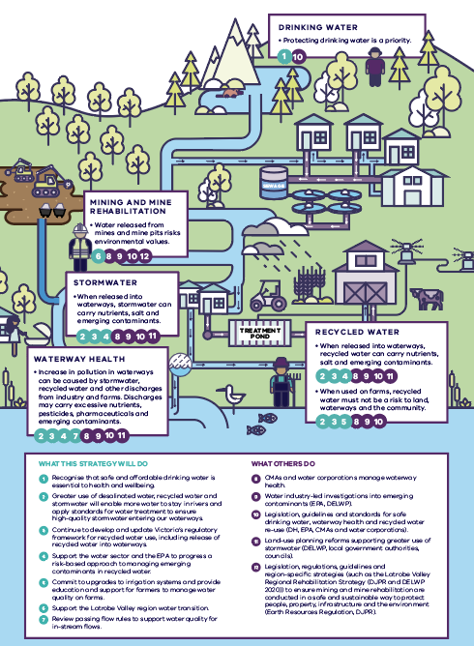
Figure 8.10. How water quality community concerns are managed through the Strategy and other avenues

A new approach to planning and delivering water supplies
A new approach will be used to deliver new manufactured water supplies in the future. We need to start planning now for a range of preferred future water supply options so that new urban water supplies are ready for delivery when they are needed, with shorter lead times. When making decisions about future water supplies, we will use a quadruple-bottom-line assessment that considers cultural, economic, environmental and social costs and benefits to maximise community benefits.

Planning for our future water supplies
Our plan
- plan, track and progress regionally significant water supply options through a new Water Grid Plan readiness framework
- develop agreed triggers to support decision-making on progressing regionally significant urban water supply options
- use quadruple-bottom-line assessments when making decisions about future urban water supplies including considering options to enable water to be returned to the environment and Traditional Owners; for regionally significant investments, this will occur through the Water Grid Plan readiness framework; for local investments, this will occur through water corporations embedding quadruple-bottom-line assessments into their own planning processes
- commence early readiness work so opportunities to return river water to the environment and Traditional Owners are well understood.

A new ‘readiness’ approach for urban water planning
The risks and complexities of maintaining a reliable supply of water for our cities and towns are increasing and involve considerable uncertainty. Water resources for our cities and towns (or urban water) within the region will need to be added to in the short, medium and long-term as our population grows, climate dries and seasonal variability increases. Modelling for the interconnected south-central grid – comprising Melbourne and nearby urban centres including Geelong – indicates that up to an extra 85 gigalitres of water per year could be needed by 2030 (under a high-climate and high-population growth scenario).
Planning needs to commence now to avoid the chronic water shortages and rushed decision-making that ultimately affects liveability and can cause major social and economic impacts, such as those experienced during the Millennium Drought.
We must plan for uncertainty and a range of plausible future water scenarios. Early investment in readiness activities, such as feasibility studies and business cases, is prudent investment for any large-scale infrastructure projects and helps reduce lead times to have new water supplies constructed and water flowing.
Key water management decisions need to be decoupled from crisis management. Entering a water crisis, where severe water restrictions are needed to address acute water shortages has significant economic implications – it was estimated that the impact of severe water restrictions cost Melbourne between $420 million to $1,500 million over a 10-year period during the Millennium Drought in the mid-1990s and early 2000s (Productivity Commission 2011). The economic impact could be amplified if a large-scale water infrastructure decision was also required in this timeframe, resulting in sudden increases in water bills and limiting the opportunity for community involvement in decisions on supply options.
The current planning framework does not support incremental investments or provide an adequate framework for upfront ‘readiness’ work to identify and robustly evaluate potential urban supply augmentation options. Further, the existing framework requires additional clarity on roles and responsibilities for addressing regionally significant water supply options across the interconnected south-central grid. These issues were recently highlighted in Victoria’s infrastructure strategy 2021-2051 (Recommendation 15 – Improve decision making for urban water investment), which identified that:
- securing Victoria’s water supplies in a climate constrained future will require collaborative and integrated planning, ongoing community engagement, and clear investment and funding arrangements’; and
- ambiguous responsibilities can impede responsive and considered investment decisions, causing delays when there is ample water supply, or rushed and potentially unwise decisions when water is scarce. The Victorian Government should clearly allocate roles and responsibilities’ (Infrastructure Victoria 2021, p. 62).
The context for adding to our water supplies has also changed over time. Options for large-scale supplies from rivers and dams have been exhausted and we are left with legacy impacts and historical injustices to Traditional Owners and the environment to redress. Also, technology for accessing other water sources is improving. This radically changes the options and decisions available to the government, water corporations and communities.
Looking forward, it is expected that new water supplies will need to be added more frequently. To have a suite of ready options available to increase supply regularly and incrementally, we need to adopt a readiness approach to water supply planning.
We have an opportunity now to improve urban water planning within the current arrangements and settings to address these issues and ensure a planned transition to greater use of manufactured water over time. We will achieve this by implementing a new ‘readiness’ approach for urban water planning.
This new readiness approach means the Victorian Government and water corporations will complete early option assessment and development well in advance of the infrastructure being needed, rather than waiting for a drought or an emergency. It will also support flexibility by creating a suite of options to choose from ensuring that options aren’t developed in a rush during a crisis. This will save time, and significant investment later. This new approach will be implemented on two levels, to allow individual water corporations to use this approach in their own areas, while also allowing coordination between water corporations and government for regionally significant projects (see box below).
Readiness approach
Regionally significant projects will be identified, planned, and tracked through a Water Grid Plan framework (detailed further below). A delegated delivery lead (urban water corporation or government department) will progress readiness activities according to clearly-defined triggers for the different stages of planning and implementation where a high level of government oversight is required.
Smaller but important local projects will be progressed by urban water corporations through urban water strategies or through the IWM forums using the same readiness approach.
In both cases, potential projects will be progressed through four planning stages: (i) adaptive planning; (ii) readiness; (iii) selection and (iv) implementation, with clearly defined decision-making points at each stage. Also, options evaluation will involve the use of quadruple-bottom-line assessments to ensure economic, environmental, social and cultural costs and benefits are considered (discussed further below).
The readiness approach involves progressing options through successive stages of planning, through to final implementation with key decision points between each stage:
- adaptive planning – this stage entails testing preliminary options with community and regulators, early assessment and shortlisting of preliminary options, leading to a conceptual investment case focussing on problem definition, initial option concepts and feasibility
- readiness – this stage entails producing preliminary business cases including investment cases and conceptual delivery cases. It builds on the previous stage by providing further and more rigorous assessment of options and identifies aspects such as technical issues, required environmental and planning approvals, schedules and budgets, etc
- selection – this stage entails producing a full business case which includes comprehensive investment and delivery plans. It confirms and finalises all the previous analysis
- implementation – this stage entails making a decision on which option(s) will actually be implemented and finalising aspects such as procurement strategies and market assessments. It also covers delivery of competitive procurement and implementation of the selected option(s).
While individual urban water corporations can progress through the readiness stages largely on their own for local projects, a different approach is needed for regionally significant projects (see box below), to allow for coordination across the multiple entities who need to be involved.
The Department of Environment, Land, Water and Planning, in collaboration, with urban water corporations has therefore developed a Water Grid Plan – a new urban water supply infrastructure readiness framework for progressing regionally significant urban water supply augmentation options. The new readiness approach combined with the Water Grid Plan will facilitate:
- targeted upfront investments in planning and readiness to create a portfolio of future-ready water supply options
- shift from crisis decision making to proactive, collaborative and integrated planning and timely decision making
- the water sector coming into line with standard good practice for critical infrastructure planning
- implementation of a new ‘business-as-usual’ monitoring and public reporting process through the Water Grid Plan
- setting out and adopting a ‘readiness approach’ to water supply planning for regionally significant projects – that is, completing early option development steps well in advance, rather than waiting for an emergency.
What does regionally significant mean?
Water supply options in the Water Grid Plan must first meet a regional significance criterion to be included in the Water Grid Plan. To meet this criterion an urban water supply option must satisfy the following:
- The option augments the interconnected south-central water grid;
- The option crosses regional and/or organisational boundaries;
- Planning and implementation of the option would require coordination between multiple partners and/or agencies; and
- Implementation of the option may require government investment.
Figure 9.1 provides further details on how water supply options will be identified and progressed.
For options meeting the regional significance criterion, planning and option progression will occur through the Water Grid Plan framework (see third column in Figure 9.1). This will define clear governance arrangements for option progression. This includes establishing a new Executive Advisory Committee that will make recommendations to government at key decision points, including recommendations on appointing delegated ‘delivery leads’ (more information on the Executive Advisory Committee can be found in the Governing and implementing the Water Grid Plan section below).
For options which are not regionally significant, individual water corporations will step through the readiness framework through their own urban water strategies or IWM forums (see second column in Figure 9.1).
In either case, progression through the readiness planning stages will winnow down the list of preferred options and provide increasingly rigorous assessments. The timing of decisions to move on from one planning stage to the next will be informed by robust, clear decision-making triggers, detailed further below.
This readiness framework will be implemented in the context of existing regulatory requirements. For example, depending on the option under consideration, part of this process may entail working through the Department of Treasury and Finance guidelines for new major water supply augmentations.
In practice, implementing the readiness framework will look different depending on the parties involved, the problem definition, and the option under consideration. Many smaller local projects will not require a full business case to proceed to implementation. However, adoption of this framework across the industry will help ensure consistency and best practice principles are applied to all investment decisions.
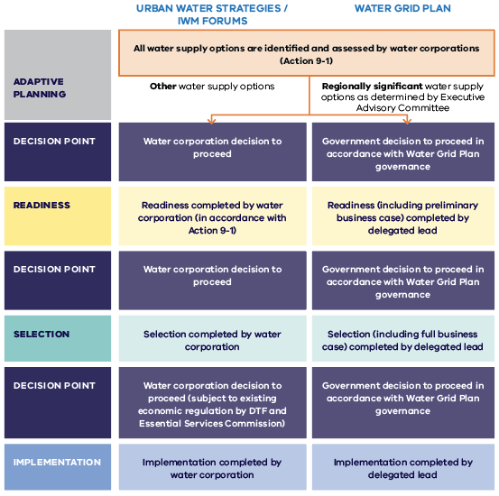
Figure 9.1. Readiness framework. Note: further detail on the Water Grid Plan and its governance is pro-vided below
Decisions around new water supplies will reflect the urban water needs of cities and towns and, for the first time, include opportunities that will enable river water to be freed up to return to the environment and Traditional Owners.
Embedded in the new readiness approach is a quadruple-bottom-line assessment process. Quadruple-bottom-line assessments will consider the potential of each potential project to deliver economic, environmental, social and cultural benefits, including identifying viable options to return water to Traditional Owners and the environment and support their further progression via appropriate decision-making and funding pathways. The box below provides further detail on how quadruple-bottom-line assessments will be undertaken within the Water Grid Plan framework.
Quadruple-bottom-line assessments consider traditional triple-bottom-line factors – such as economic sustainability and development, environmental sustainability and waterway resilience, and social values and acceptance – as well as cultural values and benefits, and opportunities for potential return of water to Traditional Owners for self-determined uses. In the future, the cultural values and benefits of returning water to Traditional Owners will be considered by applying the Cultural Benefits Framework (see Section 6.4 and the box below).
Quadruple-bottom-line assessments in the Water Grid Plan framework
The Water Grid Plan will incorporate a live portfolio of options under active consideration for augmenting urban water supplies. Over time, new options can be added to the Water Grid Plan. Some included options will progress all the way through the Water Grid Plan readiness framework to implementation, whereas others may eventually be discarded (for example, if they don’t ‘stack up’ against other options or are no longer needed or cost-effective due to a change in circumstances).
Initial quadruple-bottom-line assessments
An initial quadruple-bottom-line assessment will be required for any option proposed to be included into the Water Grid Plan.
The purpose of the initial quadruple-bottom-line review is to undertake a qualitative assessment of potential regionally significant urban water supply options against the four quadruple-bottom-line criteria, with the intent of shortlisting preferred projects to be included in the Water Grid Plan.
The initial quadruple-bottom-line review aims to identify whether options have the potential to deliver cultural, social, economic and environmental benefits. It also identifies where there are opportunities to better align a prospective project with the Cultural Benefits Framework (see Section 6.4) and government investment principles (see Section 9.4). It does not entail a comprehensive quantitative analysis.
The initial quadruple-bottom-line review process is a two-tiered approach.
Tier 1 - comprises assessing each option against a set of four filter questions:
- Will the option contribute to urban water supply security?
- Is the option ‘regionally significant’? (See box above for criteria for determining whether an option is regionally significant)
- Does the option have potential to enable return of water to Traditional Owners for self-determined uses?
- Does the option have the potential to enable return of water to the environment and improve waterway health?
For a project to be included in the Water Grid Plan options portfolio, the assessment must meet each of these filter criteria. Options which do not meet each of the four filter criteria do not progress to the Tier 2 assessment.
Tier 2 comprises an assessment against a set of detailed criteria addressing environmental, cultural, social and economic outcomes.
Further quadruple-bottom-line assessments
As options are progressed through the Water Grid Plan readiness framework, further quadruple-bottom-line assessments will be undertaken, including more detailed quantitative assessments where relevant and data is available.
The quadruple-bottom-line assessment is integrated throughout the Water Grid Plan planning stages (refer Figure 9.3 below), rather than occurring at just one stage. This means that all corresponding decision points will involve consideration of these quadruple-bottom-line assessment results. This process will confirm that shortlisted options benefit the community according to environmental, cultural, social and economic criteria, and that potential opportunities to return water to Traditional Owners and the environment are considered.
The quadruple-bottom-line assessment framework will be refined over time and used for any future regionally significant options identified. Quadruple-bottom-line assessments will be led by the Victorian Government’s grid oversight function, and incorporated into the recommendations provided by the Executive Advisory Committee to government (see below for more detail on Water Grid Plan governance).

Preparing options to return water to the environment and Traditional Owners
More work is needed to understand opportunities to free up river water to be returned to the environment and Traditional Owners so that they can be considered in detail via individual business cases. The types of readiness activities required to inform future decisions on whether or not to proceed with a given option include:
- technical studies and assessments to determine if and where it is feasible to provide water to meet Traditional Owner and environmental needs. These include consideration of substitution opportunities, and what changes to the water supply system, if any, would be required
- water resource modelling to understand the relative reliability and water quality of both new manufactured water sources and existing water sources to inform decisions about appropriate substitution options
- negotiations and decisions on the percentage or volumes that will be returned to Traditional Owners and the environment from a designated water supply option. The water sharing principles for allocating water to Traditional Owners will be applied when making these decisions (see Policy 6-1)
- agreement on cost-sharing arrangements and assessment of the net-public benefit of government investment to ensure that the chosen investment is the most effective way to achieve customer and public benefits and that it is sustainable to operate in the long-term
- assessment of mechanisms used for water sharing through the water entitlement framework. This includes new entitlements or changes to entitlements that are needed to enable substitution options. This process may require potential updates to future legislation, to support Traditional Owners’ access to water while safeguarding existing water entitlements under the Water Act
- education and literacy information to help the community understand how water will be shared and the safe uses of manufactured water sources.
As manufactured water projects progress, decisions on sharing water and costs will be based on a quadruple-bottom-line assessment that considers the investors in each project, as well as social, cultural, environmental and financial costs and benefits.
Policy 9-1: Adopt the readiness approach for urban water security planning
The Victorian Government and urban water corporations will adopt the readiness approach for urban water security.
- for regionally significant projects, the readiness approach will be implemented via the Water Grid Plan framework (see Action 9-2). The Water Grid Plan will be supported by a governance structure which clearly defines roles and responsibilities
- for other projects, the readiness approach will be implemented via the existing five yearly urban water strategies and the Melbourne Water system strategy and IWM forums.
See Action 4-2, Action 9-2, Action 9-5 and Action 9-6. Ongoing

Action 9-1: Ongoing adaptive planning activities for future water supply options
Urban water corporations will undertake adaptive planning and commence early readiness activities for future water supply options that also consider opportunities to return some river water to Traditional Owners and the environment. Readiness activities will include:
- early planning, preparatory work and feasibility studies on potential options, quantification of opportunities to improve urban water security as well as return water to rivers via substitution or reconfiguration of existing supply infrastructure.
- potential inputs to preliminary business cases as projects progress to the readiness stage either as regionally significant water options via the Water Grid Plan or via urban water strategies or IWM forums for local projects (see Figure 9.1).
See Action 4-2, Action 9-2, Action 9-5 and Action 9-6. Ongoing

The Water Grid Plan: implementing the readiness approach for regionally significant water supply projects
To address limitations in the current urban water infrastructure planning framework and implement the new readiness approach for regionally significant urban water augmentation options, the Victorian government will implement a new Water Grid Plan framework. This introduces an extra tool to ensure a coordinated approach when it is needed. The box below describes how the new Water Grid Plan fits into Victoria’s planning framework for water resources.
The Water Grid Plan framework will improve the planning process by:
- progressing regional water supply planning and decisions through a regularly updated Water Grid Plan, rather than through the development of sustainable water strategies (every 10 years)
- documenting a clear readiness approach to investment in climate-resilient urban water supplies in the Central and Gippsland Region, including shortlisting near-term options, and setting out clear progression steps linked to decision-making triggers
- ensuring alignment across the water sector on the planning, options, roles and governance for regionally significant new supplies such as desalination
- combining the concept of readiness with decision triggers to support better decision-making that will enable new climate-resilient supplies to be available when we need them
- getting the balance right between risk of investing too early and too late embedding the assessment of viable opportunities to return water to Traditional Owners and the environment into the option progression framework, for further progression via appropriate decision-making and funding pathways
- communicating the plan with the community, to support decisions around trade-offs between cost, water reliability and investments to secure urban water supplies and achieve additional outcomes related to the return of water to Traditional Owners and the environment.
How we will plan for Victoria’s water future
Figure 9.2 sets out how we will plan for Victoria’s water future using an updated framework that allows for better coordination and planning. Water for Victoria (DELWP 2016b) is the Victorian Government’s existing high-level policy for water management in Victoria, and under this policy sustainable water strategies are developed every ten years to set the strategic direction and policy settings for the region, considering all water needs (urban, agricultural, Traditional Owners, environmental and recreational).
Further, urban water strategies are developed by water corporations every five years and are a key planning tool for delivering safe and sustainable water supplies for our cities and towns. Urban water corporations consult with their communities and stakeholders to develop supply options for their regions through urban water strategies.
In addition to these existing instruments, going forward, planning for regionally significant urban water supply options will be progressed via a new Water Grid Plan. These options will be identified from urban water strategies and additional investigations undertaken by the Victorian government to meet predicted supply shortfalls and the policy directions set through this Strategy. The Victorian government’s grid oversight function will work with urban water corporations and other relevant stakeholders to take a ‘system-wide’ view, including undertaking initial investigations into regional scale options such as future desalination. The grid oversight role will drive the preparation of the inaugural Water Grid Plan and future annual updates.
The costs of delivering safe and sustainable water supplies are set out by urban water corporations in their pricing submissions which are prepared approximately every five years. These costs, including any changes to water prices, are approved through a public process led by Victoria’s independent price regulator, the Essential Services Commission.
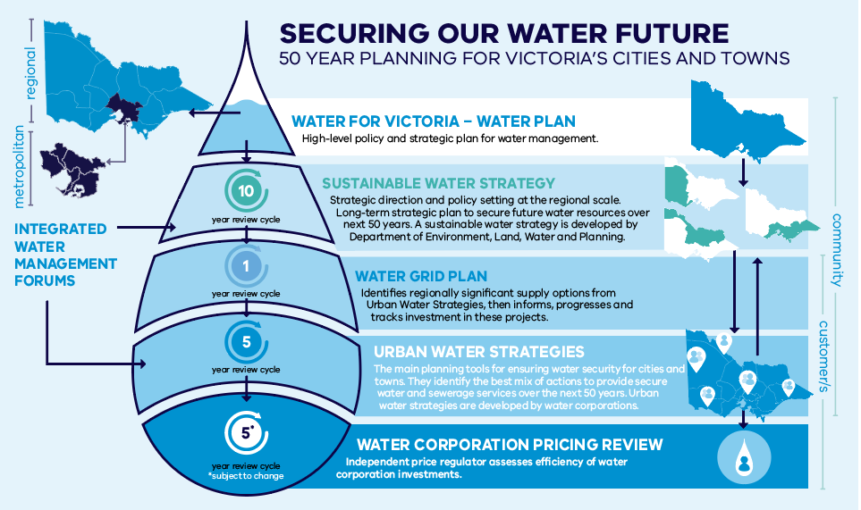
Figure 9.2. How we plan for Victoria’s water future
The inaugural Water Grid Plan will be released in 2023 (see Action 9-2). The plan will detail a portfolio of near-term regionally significant options to be investigated for increasing our urban water supplies. Going forward, the Water Grid Plan will be updated regularly. As readiness work progresses, more detail and new water supply options will be added to the Water Grid Plan.
The regularly updated Water Grid Plan will inform, progress and track investment in new climate resilient urban water supply projects and additions to the State water grid at a regional scale. This regional approach will ensure planning and investment in new major infrastructure and supplies are made at the right time so that we have the best options ready when we need them. It will provide a decision-making and governance framework for the progress of regionally significant urban water projects, and track the progress of options through from early-stage readiness planning through to implementation.

Assessing new water supply options
The Water Grid Plan will build on the work undertaken by urban water corporations to identify all future water supply options through their urban water strategies. Options included in urban water strategies reflect community feedback and willingness to pay. In the future new water supplies will largely come from manufactured water resources – desalination, treated stormwater and recycled water.

Quadruple-bottom-line assessments for the Water Grid Plan
The Victorian Government and water corporations will work with communities, Traditional Owners and waterway managers, and use quadruple-bottom-line assessments to identify which options should be included in the Water Grid Plan, and also to inform which options from the Water Grid Plan portfolio will ultimately be implemented. This means that quadruple-bottom-line assessments will be used at multiple stages to support decision-making:
- at the outset of the process, an initial quadruple-bottom-line assessment will be conducted to shortlist options for inclusion in the Water Grid Plan
- as options are progressed through the Water Grid Plan readiness framework, further quadruple-bottom-line assessments will be undertaken, including more detailed quantitative assessments where relevant and where quantitative data is available.
While the primary purpose of the Water Grid Plan is to ensure we have enough potable water for our cities and towns, regionally significant options will also be assessed for their potential to support the broader Strategy policy directions to return water to Traditional Owners and the environment. This means that, while the primary focus of the Water Grid Plan will be to identify urban water supply augmentations, there will also be an opportunity to ‘piggyback’ broader outcomes, if such benefits are identified and the government and/or water corporations are willing to bear the additional costs of pursuing broader benefits.

Towards the inaugural Water Grid Plan: options of regional significance
The Victorian government and urban water corporations have already been undertaking extensive consultation, planning and analysis to determine the best urban water supply options for further investigation to address current and future demands both at a local and regional scale. This work will help ensure that only viable options are able to address the extent and timing of projected urban water supply shortfalls (up to 85 gigalitres by 2030) are included in the inaugural Water Grid Plan for further investigation.
As at July 2022, the preliminary work to select the options for inclusion in the inaugural Water Grid Plan undertaken to date has comprised:
- identifying a ‘long list’ of potential water supply options from urban water corporations’ urban water strategies
- conducting an initial quadruple-bottom-line assessment, comprising the two-tier process set out in the box above. This work involved compiling a ‘long list’ of potential options by reviewing water supply options contained in urban water strategies, and applying the two-tier initial quadruple-bottom-line assessment process to identify a ‘short list’ for further consideration as the initial portfolio of options to be considered for inclusion in the inaugural Water Grid Plan.
- seeking endorsement from the Victorian Government to continue work on these shortlisted options through the remainder of 2022, with a view to including them in the inaugural Water Grid Plan, to be released in 2023.
Further detail on work undertaken to prepare the Water Grid Plan will be released with the plan itself in 2023.
From this process, two short- to medium-term regionally significant water supply options passed the initial quadruple-bottom-line assessment, and have been identified for further consideration in the inaugural Water Grid Plan:
- expansion of the region’s desalination capacity
- upgraded capacity of the Melbourne-to-Geelong Pipeline, from 16 gigalitres per year to 22 gigalitres per year, to enable Geelong to draw additional water from the Melbourne water supply system – including desalinated water.
These options are not mutually exclusive, and one or more options could be progressed concurrently.

Ensuring we are ready in time – triggers to support decision making
To support readiness, the Water Grid Plan will set out a framework for understanding and tracking the steps to implementation. Early-option development stages generally cost relatively little, compared to the later phases. Investing a small amount in early planning is a prudent approach that can save significant investment later. Investing in early readiness activities on multiple options at the same time ensures more options are available and allows flexibility to adapt to future change and uncertainty.
Factors to be considered during the early readiness activities could include:
- volumes of water that could be supplied
- lead times
- performance under a range of climate scenarios
- community support
- opportunities to use substitution arrangements to return some river water to the environment and Traditional Owners (see Chapter 4).
Determining when to progress option-readiness can be a complex decision. One tool that can assist with these decisions is a series of decision-making triggers that can be used to send a signal that it is time to move an option to the next stage of development. Triggers do not automatically make decisions, but they ensure that urban water corporations and the government are informed when pre-agreed risk thresholds are crossed, and a decision needs to be made. Water Grid Plan triggers will be defined in relation to the risk of failing to meet customer levels of service, particularly around whether the system is able to reliably meet customer needs during dry conditions or other critical events. For example, a decision-making trigger could be defined in relation to a specified risk threshold being exceeded, such as the risk of being unable to meet a specified level of service. Decision-making triggers will likely be different for each planning stage; in particular, because cost implications increase progressively between planning stages, and threshold for meeting decision-making triggers are also likely to increase at each progressive stage. This is consistent with one of the key objectives of this new framework, which is to better provide for less costly, early readiness work to proceed in a timely manner.
Due to the nature of the system, a single set of decision-making triggers for new urban water supplies need to be applied across the connected south-central region (Figure 9.3). While new regional urban water supply projects may enable water to be returned to Traditional Owners and the environment, the specific timing of investment will be determined on the basis of urban supply-demand projections and maintaining urban customer levels of service.

Developing supply augmentation decision-making triggers for the Water Grid Plan
The Victorian Government’s grid oversight function (embedded within the Department of Environment, Land, Water and Planning) will lead work and collaborate with Melbourne Water, Yarra Valley Water, Greater Western Water, South East Water and Barwon Water to develop a set of pre-determined quantifiable metrics, referred to as ‘decision-making triggers’, to support large-scale supply augmentation investment decisions in the south-central system.
The inaugural Water Grid Plan will set out decision points (see Figure 9.3) that indicate when an augmentation option will be reviewed to determine if it should progress to the next stage of development in the readiness planning framework. To support decision-making at these points, further work will be undertaken to:
- confirm the set of trigger indicators for each decision point; and
- further define the risk threshold or critical value for each trigger indicator.
Trigger metrics will be monitored by water corporations and government. The triggers will not automatically make decisions, but tell water corporations, government and the community when a pre-agreed risk threshold is met.
The decision-making triggers will be incorporated into the inaugural Water Grid Plan.
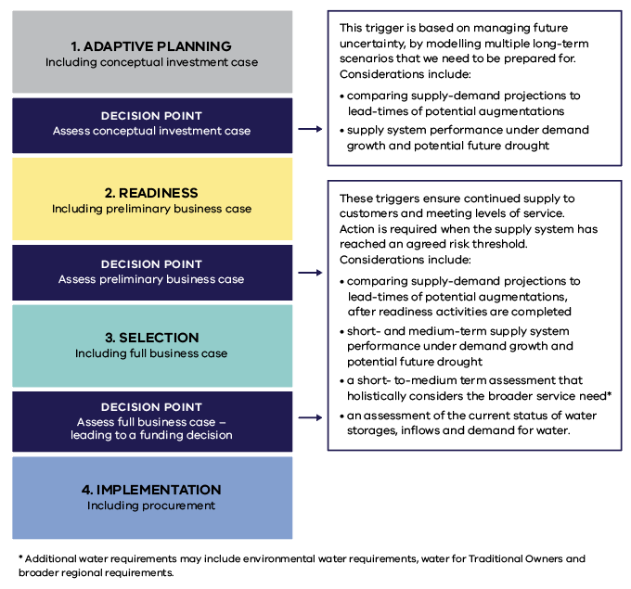
Figure 9.3. Three decision points, which each require a trigger to be met to continue

Governing and implementing the Water Grid Plan
Implementing the Water Grid Plan will require coordination across various government department and the water sector. Roles and responsibilities for each step of the readiness activities, through to implementation, is described in the governance framework (see Figure 9.4). This framework aligns with Department of Treasury and Finance guidelines and processes and supports decision-making that is more transparent, streamlined and adaptable. This will ensure that the right decisions can be made at the right time.
Government has always and will continue to take the lead responsibility for decisions on supply augmentations that are of regional significance. Water supply options within the Water Grid Plan require a greater level of government oversight than local scale options typically require. The Department of Environment, Land, Water and Planning oversees strategic regional and system-wide (across water corporation boundaries) water resource planning and investment decisions through its grid oversight function and does this in partnership with water corporations and key stakeholders. This means that the Department of Environment, Land, Water and Planning will play a coordinating role and ensure that all parties are fulfilling their agreed roles and functions in a timely and effective manner.
To support collaboration between government and the water industry, an Executive Advisory Committee, consisting of senior representatives from Department of Environment, Land, Water and Planning and Managing Directors from urban water corporations, will make recommendations to government on:
- the initial set of regionally significant water supply options that will form the options portfolio for the inaugural Water Grid Plan
- adopting Water Grid Plan decision-making triggers;
- allocating an appropriate delivery lead for each project in the Water Grid Plan portfolio;
- business cases and when to progress options to the next stage of development (that is, when decision-making triggers are met); and
- any changes to the portfolio of near-term options included in the Water Grid Plan.
Environment and Traditional Owner working groups will be established to provide iterative and ongoing advice to support decisions around projects that return water to the environment and or Traditional Owners, or where there is expected to be an impact on the environment or Traditional Owners.
Consultation with the broader community will take place at key decision points, starting with water corporations engaging with their customers on the development of their urban water strategies and before any decision is made to implement an augmentation option.
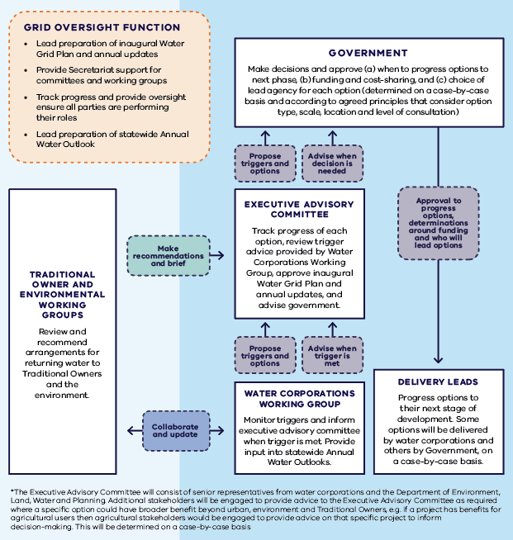
Figure 9.4. Governing and implementing the Water Grid Plan

Action 9-2: Publish a Water Grid Plan
The Victorian Government will work with urban water corporations to produce an inaugural Water Grid Plan in 2023, including decision-making triggers.
Inaugural Water Grid Plan: by 2023
Once this is in place, the Victorian Government will then work with urban water corporations to track progress of the portfolio of options included in the inaugural plan, and adaptively update a Water Grid Plan.
Annual updates: Ongoing
The Water Grid Plan (as updated annually) will identify potential future urban water supply options and guide incremental readiness investments in climate-resilient water supplies when triggers are met. It will also ensure that, as options are developed, work is completed to identify opportunities to enable a proportion of substituted water entitlements to be returned to the environment and Traditional Owners on the completion of projects.
Decision-making triggers: by end of 2022

Sharing urban water supplies in the Melbourne Supply System
Our plan
- improve water sharing arrangements for towns in the connected central region (connected to the Melbourne Supply System)
- review Melbourne Water’s diversion limit compliance method

Urban bulk water entitlements
As the region transitions towards greater use of desalinated water, and manufactured water more generally, bulk entitlements will need to be updated. Currently none of the regional urban water corporations that hold entitlements in the Melbourne Supply System hold entitlements to desalinated water. In the future, climate change and population growth will mean that the region increasingly relies on desalination. Significant policy development is needed to determine how water and costs from existing and future desalination projects will be shared between metropolitan and regional urban water corporations. This will be necessary to ensure that all cities and towns that are connected to the Melbourne Supply System can benefit from desalination water supplies and that costs are shared fairly.
To realise these benefits and optimise the use of all water resources, bulk entitlements must be flexible and reflect future needs. We are working with bulk entitlement holders in the connected Melbourne Supply System to reform existing entitlements arrangements, combining the major supply sources from the Yarra–Thomson system and the Victorian Desalination Project, to create a ‘south-central pool entitlement’. While this will not change the volume or conditions of extraction from different sources, it will increase the efficiency and flexibility of entitlement arrangements, particularly as we add additional supplies over time.
This will ensure water sharing arrangements are in place long-term, simplifying the process as both the need to introduce more manufactured water to the Melbourne system increases and the dependence on the Melbourne system by connected regional urban water corporations grows. Various aspects of the current entitlement system will also be investigated to ensure arrangements support the creation of an effective south-central pool. Feasibility assessments have revealed the absence of the fundamental conditions for an effective urban water market in south-central Victoria and will not be investigated further as part of the current investigation.
The creation of a south-central pool entitlement will also assist future returns of river water to Traditional Owners and the environment through a more simple, consistent and transparent process for sharing water from future augmentations. Any reform will be supported by transitional arrangements to ensure a smooth changeover that keeps customer impacts to a minimum.
Action 9-3: Create a south-central pooled resource and associated reforms
The Victorian Government will work with bulk entitlement holders in the connected Melbourne Supply System to reform existing entitlements arrangements to create a south-central pooled resource and appropriate supporting entitlement arrangements.
The pooled resource will combine the Yarra-Thomson system and Victorian Desalination Project, simplifying the process as both the need to introduce more manufactured water to the Melbourne system increases and the dependence on the Melbourne system by connected regional urban water corporations grows.
This action will investigate various aspects of the current system to ensure arrangements support the creation of an effective south-central pool. This will involve a work program to review:
- bulk entitlements
- existing seasonal allocation method
- current carryover rules
- sharing and trading processes
- cost sharing arrangements, for both existing supplies and new supplies
any other measures that would support the creation of an effective south-central pool.
Feasibility assessments have revealed the absence of the fundamental conditions for an effective urban water market in south-central Victoria and will not be investigated further as part of this action.
The creation of a south-central pool supports the aims of the Central and Gippsland Region Sustainable Water Strategy by assisting future returns of water to the Traditional Owners and the environment through a more simple, consistent and transparent process for sharing water. By 2025

Revise upper limit on consumptive diversions from the Melbourne Supply System
The bulk entitlements for the Melbourne Water system have an upper limit on consumptive diversions (referred as diversion limits) to protect unregulated flows and environmental, social and Traditional Owner values. In order to comply with the bulk entitlements, Melbourne Water has developed a diversion limit compliance method for consumptive diversions.,
Diversions from the Thomson, Yarra and Goulburn (Silver Creek and Wallaby Creek) systems are measured at compliance points specified in the Melbourne Water Supply System Bulk Entitlement Metering Program. Actual diversions are then compared to diversion limits which are generally estimated using hydrological models. The modelled diversion limits under the current method are set at future level of demands. Therefore, there is potential for large account credits to be accumulated against the diversion limits in the initial years before that level of demands is reached. The accumulated credits could be used to divert above the diversion limits for a number of years before the credit is exhausted and the method begins constraining diversions.
If diversions were to exceed the diversion limits this would reduce unregulated flows (spills) in the downstream waterways. Reducing unregulated flows would affect the frequency and duration of high flow events in the downstream waterways, which is likely to result in ecological impacts and potentially affect social and Traditional Owner values. It is important that diversions are managed sustainably within the diversion limits to avoid these potential impacts.
Key stakeholders will be engaged to revise the current diversion limit compliance method. The revised method will sustainably manage water resources in the system and protect environmental, social and Traditional Owner values.
Action 9-4: Revising Melbourne Water’s diversion limit compliance method
Melbourne Water will work collaboratively with the Victorian Government and other stakeholders to ensure that the revised diversion limit compliance method meets its long-term objectives. These are the sustainable management of water resources in the system, and stakeholders’ expectations, while Melbourne Water meets its other diversion limit compliance related obligations under its bulk entitlements. By 2026

Stronger community involvement in water management
Our plan
- strengthen the community’s role in water management decisions through better data and engagement on future supply options.
To prepare for a future with less water we need to make important decisions about how we use, share, and invest in water across the Central and Gippsland Region. Community involvement in those decisions is critical, including engagement with all parts of our community on any trade-offs that are needed. Engagement with this strategy from individuals, community organisations and related industries demonstrates there is strong interest in the state of our water supplies and water conservation programs as well as the condition of our waterways and bays.
We will build on that interest by improving how we share water data and information and look for opportunities to strengthen how the community can inform decisions about the region’s long-term water needs. Planned programs including ‘Changing behaviours at home’ and ‘Building community confidence in recycled water and stormwater’ are critical parts of the conversation about water security (see Chapter 3). We will complement that work with additional focus on reaching groups whose feedback has been historically under-represented including young people and culturally and linguistically diverse communities, so that we can be sure that future decisions on long-term water supply options reflect the interests of all.

Action 9-5: Building community knowledge and involvement in water management
The Victorian Government, CMAs and water corporations will commit to a program of work to improve ongoing dialogue with Victorians about meeting the region’s long-term water needs. By 2024 this will include:
- a review of public data and information sources about water.
- a review of community engagement programs.
- recommendations to build community knowledge about water and improve multi-way dialogue between the water sector, Traditional Owners and the community.
Traditional Owners will self-determine their participation in this program of work.
Ongoing

Investments to deliver water supplies
Our plan
- clarify the steps for future investments in new water supply options
- use a quadruple-bottom-line assessment when making decisions about future water supply options
- apply principles for public investment to water supply infrastructure to give greater certainty to the water industry and community around which projects could be eligible for government co-funding.
Investments to increase water supplies to meet urban water needs are primarily made by water corporations. Future investments in water supply options, especially the ones that have regional significance, will need to consider the potential for broader benefits from these new urban water supply options. Additional water supplies could enable some river water entitlements to be returned to the State for reallocation to Traditional Owners, or to the environment, boosting river health, as well as the social and recreational use of rivers (see
Chapter 4). Investments can create jobs and economic opportunities for water dependent industry and businesses, generating broader economic benefits for the region. For these reasons, future decisions about water supply options will reflect a quadruple-bottom-line assessment and may need to consider appropriate cost allocation to water customers, both present and future, and the broader community who share the benefits (see Section 9.1).
Future government co-investment in new water supply options will require the development of a full business case for government consideration. It is at this stage that details around the need for the investment, the benefits, interventions, estimated costs and the delivery process will be prepared. The implementation plan (see Appendix E) identifies where we are expecting to develop business cases in the coming decade, consistent with Department of Treasury and Finance guidelines, to secure funding to deliver these projects.
Business cases for future water supplies will need to consider how water and costs can be shared equitably to minimise any potential trade-offs. Government decision-making will be guided by the principles for public investment (see Action 9-6), availability of public funding, as well as the latest urban demand and supply projections. A quadruple-bottom-line assessment will ensure that decisions consider cultural, economic, environmental and social costs and benefits to maximise community benefits. As shown in the implementation plan (see Appendix E), additional community engagement on options will feed into this process.

Principles guiding public investment in water supply infrastructure
In most circumstances, water corporations use funds raised from customer water bills to invest in essential infrastructure. Public co-investment is considered on a case-by-case basis where there are significant community benefits and funding is available in the State Budget.
In the future, public investment in water supply infrastructure will be guided by new investment principles to give greater clarity to the water industry and community, around which projects could be eligible (see Action 9-6). Financial contributions could include infrastructure funding or funding to support vulnerable customers. Funding agreements must be consistent with relevant legislation, policies and strategies and, where applicable, business cases must be consistent with Department of Treasury and Finance guidelines. Commonwealth funding will also be sought for eligible water infrastructure projects, for example via the National Water Grid Authority.
How we share the cost of new water supplies will also shape future investment decisions. For example, larger cities and towns have a greater capacity to fund infrastructure and further work is needed to consider how costs can be shared fairly across all users who will benefit from future investments, either directly or indirectly.
Action 9-6: Apply principles for public investment in water infrastructure projects
The Victorian Government will apply the following principles for public investment in water infrastructure projects:
- Government funding will be considered where there are net public benefits such as:
  - providing water affordability for urban water customers
  - providing cultural benefits (applying the Cultural Benefits Framework) and enabling water to be returned to Traditional Owners
  - enabling water to be returned to the environment to meet identified water deficits
  - providing economic benefits to the region
  - improving environmental and climate adaptation
  - providing social, wellbeing or recreational benefits.
- The selection of water infrastructure projects will use a quadruple-bottom-line assessment, that considers cultural, economic, environmental and social costs and benefits to maximise community benefits (see Section 9.1), demonstrating that the chosen project is the most effective way to achieve customer and public benefits.
- Victorian Government funding agreements must be consistent with relevant legislation, policies and strategies.
- Where applicable, business cases must be consistent with Department of Treasury and Finance guidelines.
Ongoing

Public investment in stormwater and recycled water
In most cases, recycled water and stormwater supplies cost more than river water, due to past infrastructure decisions that were focussed on moving this ‘waste product’ away as quickly as possible, and therefore the higher cost now of treating, storing and distributing these water sources (WSAA 2020). Unlike water sourced from desalination, which can be supplied directly into the drinking water system, stormwater and recycled water require separate water distribution infrastructure (including purple pipes). This contributes to the higher costs of supplying these sources and remain a key barrier to greater use of stormwater and recycled water.
To date, the viability of recycled water schemes has been determined by customer willingness to pay and whether those costs can be attributed to water savings or to delaying major infrastructure investments. The environment also benefits from new water infrastructure that reduces stormwater and recycled water discharges into waterways. Because customers who use recycled water or stormwater are often not the only beneficiaries, the cost can mean these schemes are not financially viable for water corporations. This is despite the benefits extending beyond the customer to the broader water sector, community and the environment.
Not all public benefits are easily quantified or converted into a monetary value for the purpose of preparing a business case or completing a cost-benefit analysis. Examples of these public benefits include:
- greater resilience of the overall water system, due to the diversification of supply sources
- contribution to the circular economy from re-using different parts of wastewater – the water itself, and also by-products such as biowaste for fuel
- environmental protection and improvement through reduced discharge of stormwater pollution into local waterways
- liveable green open spaces that provide urban cooling and improve health and wellbeing.
For this reason, in many instances, stormwater and recycled water schemes or projects, which will deliver broader public benefits, require government co-investment to be viable. This is already happening through government co-investment in projects identified through the IWM forums.
Public co-investment in recycled water and stormwater schemes will continue to be supported to encourage greater use of all water sources and to reduce the region’s reliance on drinking water supplies and potentially to enable river water to be returned (see Section 4.1). Future investments will consider whether the higher treatment and delivery costs of recycled water and stormwater have broader public benefits that may not be easily quantified in an economic assessment and that warrant government co-investment (see Chapter 3).

Public investment in rural water infrastructure
Investments in rural water infrastructure can bring significant public and private benefits. Upgrades to old irrigation systems can improve water efficiency, and new rural water supplies can increase food production and productivity and improve the wellbeing of rural communities.
Public co-investment in rural water infrastructure will continue where there are significant public benefits, and the project is consistent with principles for public investment (see DELWP 2016b, Table 4-1). Water corporations can also maintain and upgrade rural water infrastructure under current cost-recovery arrangements.

Cost considerations
Although water is widely regarded as a valuable and increasingly scarce resource, water pricing doesn’t always reflect the broader costs of using water. Historically consumptive users have paid less for water as its importance to the community, environment and Traditional Owners was not fully taken into account when setting prices to access water. These broader costs are recognised, to some extent, in current water pricing, as the water sector works to minimise these impacts, for example by funding projects to offset the environmental harms caused by water extraction. In economic terms, however, it can be difficult to fully account for these costs, when comparing the cost of taking water from a river to the cost of new manufactured water sources. Current and future generations will bear the costs of addressing environmental degradation caused by past actions.
Water prices in Victoria are based on recovering the full financial cost of providing services and are regulated by the Essential Services Commission. In most circumstances water corporations recover the cost of growing demand due to population growth through fees for new customer connections and/or from their customer base. This practice is expected to continue, however the cost burden of climate change, addressing environmental degradation and restoring Traditional Owner water justice are arguably things that should be funded by the whole community. This is why we have developed the public investment principles (see Action 9-6).

Affordability
Keeping water bills affordable and easing cost of living pressures is central for decisions on the region’s future water supplies. Typical household water bills in Victoria have remained stable in recent years and Victorians pay among the lowest water bills for each size category of water corporation across Australia, from major urban to small regional (BOM 2022). Melbourne households pay, on average, the same as in Sydney and over $500 per year less than in Perth (BOM 2022). Water corporations are also required to provide financial assistance and rebates to customers who are vulnerable and experiencing hardship.
Actions within this Strategy will help keep water prices affordable and as stable as possible by:
- supporting households and businesses to use water more efficiently which can save money on water bills
- using a quadruple-bottom-line assessment when making decisions about new urban water supplies, including considering impacts to customer water bills
- considering public co-investment in new urban water supplies where a wider public benefit can be demonstrated
- helping water corporations to plan their future investments, and smooth-out any potential water price rises, by identifying a pipeline of regional-scale urban water supply projects in the Water Grid Plan.
Funding for construction of new water supply options will be subject to the outcomes of detailed business cases and is not expected to impact water bills over the next five years. Any future price changes will require community consultation by water corporations and approval from Victoria’s independent price regulator, the Essential Services Commission. Feedback from the community tells us that where additional expense is justified, water customers prefer gradual price rises over several years, rather than a large increase in a single year. The planned, incremental approach to investments in future water supplies, through the Water Grid Plan, will support this objective.

Delivering the Strategy
The Department of Environment, Land, Water and Planning will lead the implementation of the Strategy in partnership with the water sector, Traditional Owners and the community.
The Department of Environment, Land, Water and Planning will lead the implementation of the Strategy in partnership with the water sector, Traditional Owners and the community. This includes:
- implementing the actions as set out in the implementation plan (see Appendix E)
- overseeing, monitoring and evaluating the Strategy’s delivery
- Reporting progress annually
- completing a five year, mid-point assessment
- reviewing the Strategy after 10 years
A proposed timeline for all these stages is set out in Table 10.1.
Table 10-1. Timeline implementation, monitoring, evaluation and review of the Strategy
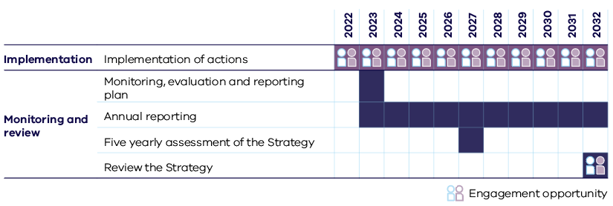

Adaptive management
An adaptive approach is essential to managing future uncertainty. The Strategy’s actions are designed to accommodate changes in climate, demand and other factors that could influence how we use and share water including environmental, technological, social, cultural and economic considerations including future treaties. For example, the Water Grid Plan will fast-track, defer or amend future urban water supply options as our water needs change and grow and as additional investigations are completed (see Chapter 9). Similarly, options for returning additional water to the environment in major rivers will be updated to reflect changes as projects progress or waterway conditions and climate changes (see Chapter 8). Some actions comprise alternative ways of achieving their desired outcome for increased flexibility, especially when further work is still needed during the Strategy’s implementation to determine the best option.

Implementation plan
The implementation plan (see Appendix E) guides the Strategy’s delivery. It sets out who is responsible for each action, indicative timeframes, and actions that require targeted community and stakeholder engagement. The roles and responsibilities for managing the region’s water resources are outlined in Figure 10.1 and form the basis for who will implement each of these actions.
Restoring Traditional Owners’ roles in waterway management and planning will be supported by new processes and engagement between the water sector and Traditional Owner groups, as well as funding for Traditional Owner groups. We will continue to work with Traditional Owner groups, recognising the obligation of Traditional Owners to care for Country and their unique and sacred knowledge of Country derived from their connection to Country.
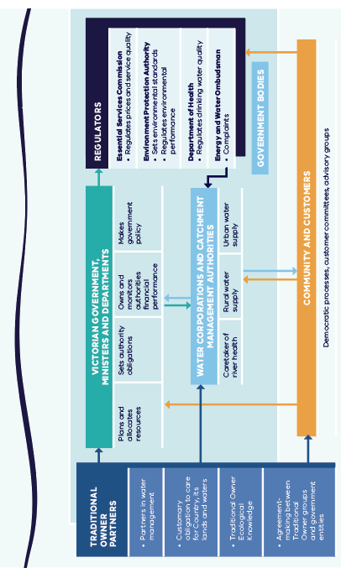
Figure 10.1. Roles and responsibilities for water regulation and management in the Central and Gippsland Region

Funding implementation
The Strategy’s implementation will require investment over the coming decades to secure water supplies across the region. The majority of actions in the Strategy are anticipated to be funded by a combination of government funded programs and water corporation contributions via their pricing determinations.

Phase one
The 2022-23 Victorian Budget invested $56.6 million to deliver the first phase of this Strategy. This funding includes:
- $10 million for waterway and catchment health projects including improving the water supply to the lower Latrobe wetlands, delivering a fishway at Maffra Weir and investigating ways to improve the health of the Moorabool River and upgrade the Werribee Diversion Weir.
- $39 million for water efficiency measures and more recycled and stormwater projects for example new recycled water supplies to irrigate green spaces. This includes $24.8 million to contribute to the Dingley Recycled Water Scheme, which will deliver 1.8 gigalitres of recycled water per year to 46 sites such as parks, nurseries, and golf courses.
- $6 million to help build the resilience of the water sector from the impacts of climate change.
- $1.6 million for considering augmentations to meet urban water needs and enable water to be returned to the environment and Traditional Owners. This includes investigating an expansion of the Melbourne-Geelong Pipeline, to better share the benefits of the desalination plant across the region.

Phase two and beyond
Many actions in the Strategy will be funded via existing arrangements in the Department of Environment, Land, Water and Planning or its delivery partners, including through programs funded from the Environment Contribution Levy. Some actions will be subject to a business case or additional investigation that will feed into future investment decision-making by government and/or water corporations for delivery. The implementation plan (see Appendix E) flags the actions that will be subject to a business case or additional investigations.
Some actions will require specific funding arrangements
- Victorian Government contributions - co-investment to be considered on a case-by-case basis and guided by principles for public investment in water supply infrastructure (see Chapter 9)
- Commonwealth contributions - funding to be sought for eligible water infrastructure projects, for example via the National Water Grid Authority.
The Victorian Government is committed to continued partnership with Traditional Owners throughout the Strategy’s implementation and to funding their involvement to support the delivery of relevant policies and actions (see Action 6-1). This includes ensuring that Traditional Owners are resourced to partner in the implementation of relevant actions and policies). For more information on cost considerations and principles guiding public investment in water supply infrastructure (see Chapter 9).

Water prices
Keeping water bills affordable and easing cost of living pressures is at the centre of all decisions on the region’s future water supplies. While we expect new manufactured sources of water will be needed within the coming decade, no business cases or firm price estimates have been completed at this stage. New manufactured water supplies will come at a higher cost than existing river water supplies creating a potential for water prices to rise across the region in future over the longer-term. However by identifying a portfolio of options to meet future water demand we can ensure that the right options are chosen at the right time, that achieve the greatest community benefits for the lowest possible cost. Commencing early planning on new water supplies will also prevent large investment decisions being rushed in a crisis which can lead to higher costs and unexpected delays. A clear, orderly plan will help keep water bills affordable and prices as stable as possible, while enabling the investment required to ensure sustainable water management and secure urban supplies across the region over the long-term. Water corporations will continue to support customers who are experiencing hardship.

Community involvement
We will continue to work with the community throughout the Strategy’s implementation. This work will include actions to improve community knowledge and involvement in water management (see Action 9-5). It will also support work with the community to change behaviour at home to save water and build confidence in recycled water and stormwater use (see Action 2-1 and Action 3-17).
Engagement with the community, Traditional Owners, key stakeholders, peak bodies, community groups, businesses and agriculture groups will continue as part of specific actions in the Strategy’s delivery. The implementation plan flags actions for which this is expected, with additional details to be made available as this action progresses.

Monitoring and review
The Department of Environment, Land, Water and Planning is committed to ongoing monitoring and evaluation of the Strategy’s delivery. A detailed monitoring, evaluation and reporting plan will be developed once the Strategy has been published.
The Department of Environment, Land, Water and Planning has a statutory requirement to report on the implementation of all sustainable water strategies in its annual report, which is tabled in Parliament.
Under the Water Act, the Minister for Water may review a sustainable water strategy at any stage and must do so after 10 years. Water for Victoria (DELWP 2016b) requires five yearly assessments of all Victoria’s sustainable water strategies to be undertaken, which after completion are publicly available on the Department of Environment, Land, Water and Planning website. These five yearly assessments are intended to serve as an intermediate progress check on each action at the mid-point prior to a full review.
This Strategy allows flexibility and an adaptive approach in selecting specific options during implementation. The five yearly assessment will be used to check that progress is being made towards meeting all of the Strategy’s objectives through implementation and that the portfolio of options being progressed at that point will enable the Strategy to be delivered as intended. If the five yearly assessment finds that progress towards the Strategy’s objectives has stalled and/or a new approach is needed to secure water for the region, the review that is required after 10 years can be brought forward so that actions in the Strategy can be updated as needed.
Action 10-1: Strengthening the five yearly assessment
The five yearly assessment will be used to check on progress against all of the Strategy’s objectives during implementation. If the five yearly assessment finds that the implementation of the Strategy is not on track to deliver its 10 year commitments, The Department of Environment, Land, Water and Planning will investigate options to bring the review of the Strategy that is required after 10 years forward so that the actions in the Strategy can be updated as needed.
By 2027

Abbreviations, Traditional Owner river names, glossary and references

Abbreviations
CMA | catchment management authority
DELWP | Department of Environment, Land, Water and Planning
DJPR | Department of Jobs, Precincts and Regions
EPA | Environment Protection Authority Victoria
EWSP | emergency water supply point
GL | gigalitre (one billion litres)
GMA | groundwater management area
IWM | integrated water management
LTWRA | Long-term water resource assessment
LVRRS | Latrobe Valley Regional Rehabilitation Strategy
ML | megalitre (one million litres)
NCC | National Construction Code
RAP | Registered Aboriginal Party
SWIOID | Snowy Water Inquiry Outcomes Implementation Deed
SWS | Sustainable Water Strategy
TSS | total suspended solids
VEWH | Victorian Environmental Water Holder
Water Act | Water Act 1989 (Vic)

Traditional Owner river names
The Traditional river names used in this Strategy have been supplied by each of the Traditional Owner Corporations as below and have been used in the Strategy as appropriate. This list is expected to grow over time.
Traditional Owner river name | Traditional Owner Corporation | Western river name
Carran Carran | Gunaikurnai Land and Waters Aboriginal Corporation | Thomson River
Wirn Wirndook Yeerung | Gunaikurnai Land and Waters Aboriginal Corporation | Macalister River
Durt-Yowan | Gunaikurnai Land and Waters Aboriginal Corporation | Latrobe River
Wangangarra | Gunaikurnai Land and Waters Aboriginal Corporation | Mitchell River – downstream of Dargo, through Mitchell River National Park and toward Lindenow
WyYung | Gunaikurnai Land and Waters Aboriginal Corporation | Mitchell River – further downstream around current-day WyYung and Bairnsdale and down to Lake King
Ber’rawn | Gunaikurnai Land and Waters Aboriginal Corporation | Tambo River
Lung Lung | Gunaikurnai Land and Waters Aboriginal Corporation | Franklin River
Birrarung | Wurundjeri Woi-wurrung Cultural Heritage Aboriginal Corporation / Bunurong Land Council Aboriginal Corporation | Yarra River
Kooyongkoot | Wurundjeri Woi-wurrung Cultural Heritage Aboriginal Corporation | Gardiners Creek
Mirrangbamurn | Wurundjeri Woi-wurrung Cultural Heritage Aboriginal Corporation / Bunurong Land Council Aboriginal Corporation | Maribyrnong River
Wirribi Yaluk | Wurundjeri Woi-wurrung Cultural Heritage Aboriginal Corporation / Bunurong Land Council Aboriginal Corporation/ Wadawurrung Traditional Owners Aboriginal Corporation | Werribee River
Moorabool Yulluk | Wadawurrung Traditional Owners Aboriginal Corporation | Moorabool River
Barre Warre Yulluk | Wadawurrung Traditional Owners Aboriginal Corporation | The great river that runs from the Barre (mountains) to the Warre (ocean). Refers to the Parwan (Barwon River), Leigh River, Yarrowee River and the Moorabool Yulluk (Moorabool River).
Parwan | Wadawurrung Traditional Owners Aboriginal Corporation | Barwon River

Glossary
Word or phrase | Meaning
Aboriginal | ‘Aboriginal’ and ‘Torres Strait Islander’ refer to different groups of peoples. ‘Aboriginal’ refers to the original peoples of mainland Australia. ‘Torres Strait Islander’ refers to the original peoples of the islands located in the Torres Strait. If describing people individually, ‘Aboriginal people’ or ‘Torres Strait Islander people’ is preferred (noting people would rather be called by their mob name). ‘Indigenous people’ can be used to describe Aboriginal and Torres Strait Islander people either individually or collectively.
Aboriginal water policy | Victoria introduced its first Aboriginal water policy as part of Water for Victoria (DELWP, 2016). It acknowledged cultural values for water and the need for economic development.
above-cap water | Water that remains in a system after limits on diversions have been reached; spills from storages and unregulated flows that cannot be kept in storage.
algal bloom | A rapid increase in the population of algae in a waterway, often caused by excess nutrients (particularly phosphorus and nitrogen).
allocation | Water available to water entitlement holders (excluding take-and-use licences) in a given water season under the terms of their entitlement.
aquifer | An underground layer of rock or unconsolidated material – gravel, sand or silt – that can store and yield very large volumes of usable water.
availability | Water available for allocation to consumptive uses or the environment through the water entitlement framework.
barrier | An artificial instream structure, such as a dam, weir, causeway or culvert, that restricts the migration and movement of fish or other biota and can interrupt transport of organic material and sediment.
baseline | Conditions regarded as a reference point for the purpose of comparison.
biodiversity | The number and variety of plants, animals and other living beings, including micro-organisms, across our land, rivers and oceans. It includes the diversity of their genetic information, the habitats and ecosystems in which they live, and their connections with other life-forms.
bore | A bore, well or excavation or any artificially constructed or improved underground cavity, used for the collection, storage or extraction of groundwater, groundwater monitoring, drainage or desalinisation of land, disposal of any matter below the surface of the ground, or the recharge of an aquifer.
bulk entitlement | A right to use and supply water in a waterway, water in storage works of a water corporation, and groundwater. The bulk entitlement sets out the amount of water that can be taken or stored under specific conditions or specifications, up to a maximum volume. Water corporations and other specified bodies defined in the Water Act can hold bulk entitlements.
cap | An upper limit on the amount of water that can be diverted from a waterway, catchment, basin or aquifer.
carryover | An arrangement that allows a water entitlement holder to take unused water allocations from one season into the next season to use or trade. Carryover rules depend on the declared system in which allocations are held.
catchment | The region within which all rainfall, other than that removed by evaporation, flows into waterways and then to the sea or a terminal lake.
catchment management authority | A statutory body established under the Catchment and Land Protection Act 1994 (Vic). Catchment management authorities have responsibilities under both that Act and the Water Act for river health; regional and catchment planning and coordination; and waterway, floodplain, salinity and water quality management.
commercial and irrigation dam | A small dam (usually on a farm) that stores water for irrigation or commercial purposes. The use of a commercial and irrigation dam must be licensed.
confined aquifer | An aquifer overlain by impermeable material that restricts the upward movement of water. Confined aquifers are under pressure: when the aquifer is penetrated by a bore, the water rises above the top of the aquifer.
consumptive uses | All extractive uses of water by individuals, households, agriculture, industry and commerce.
Country | Aboriginal culture revolves around relationships to the land and water. For Traditional Owners, Country is a part of who they are, just as they are a part of it.  Country must be respected. Traditional Owners are authorised to speak for Country and its heritage.
Country plan, Caring for Country plan, Whole-of-Country plan | Country plans are one way for Traditional Owners to articulate their priorities and aspirations for looking after Country. These can be strategic plans that encompass physical and spiritual concepts of Country, provide a strategic basis for partnerships, and identify management actions and economic opportunities.
Crown land | Land held by the Crown (the King or Queen) in right of the State of Victoria. Crown land can be reserved for a particular public use, or unreserved. Unreserved Crown land has not been set aside for a particular public use, although not all public land is Crown land.
cultural landscape | Australia forms a tapestry of interwoven cultural landscapes that are the product of the skills, knowledge and activities of Aboriginal land managers over thousands of generations. Cultural landscapes are reflections of how Aboriginal people engage with the world. The concept of a cultural landscape is a bridging tool, in this case one that aims to bridge the ontological differences between Indigenous and ‘Western’ world views, between natural resource management and caring for Country. This is required to take steps towards preventing the ongoing ontological violence that is perpetuated by the dominance of ‘Western’ approaches to managing Country.  It enables a dialogue between Traditional Owners and government land managers within a framework that does not exclude one or the other world view.
declared water system | A water system declared in accordance with section 6A of the Water Act. In a declared water system, old water rights as well as take-and-use licences have been converted into unbundled entitlements.
diversion | Removal of water from a waterway – for example, via a pump.
domestic and stock dam | A small dam (usually on a farm) that stores water for livestock, or domestic supply. Use of a domestic and stock dam does not require a licence, unlike a commercial or irrigation dam.
drought refuge | A site that acts as a refuge in areas affected by drought, by providing permanent fresh water for plants and animals.
ecosystem | A dynamic complex of plant, animal, fungal and micro-organism communities and associated non-living environment interacting as an ecological unit.
environmental entitlement | A continuing legal right to take and use water allocated under Part 4, Division 1A of the Water Act to maintain the Environmental Water Reserve and to preserve or improve the environmental values and health of water ecosystems.
environmental flow studies | The study of flow requirements needed to sustain the ecological values of water-dependent ecosystems for a particular waterway. This information is used to inform policy, management and allocation of water resources.
environmental objective | An objective for the protection and, if necessary, restoration of a priority environmental asset or ecosystem function.
environmental outcomes | Changes to the riverine, wetland or floodplain environment that occur as a result of waterway management practices, including the management of water for the environment. Beneficial environmental outcomes match the ecological objectives stated in FLOWS studies, environmental water management plans and seasonal watering plans. Examples include (i) improved water quality from flows that flush refuge pools and (ii) improvements to the structure of native fish populations due to environmental flows that benefit native fish breeding and migration.
environmental target | A target that must be met in order to achieve an ecological objective.
environmental water deficit (shortfall) | The shortfall between the volume of water required to sustain a waterway’s ecological values under current and/or future climate scenarios, and the volume of water that is actually supplied to the waterway.
environmental water manager | A catchment management authority or Melbourne Water, which decides when and how to use environmental entitlements in partnership with the Victorian Environmental Water Holder, and how to manage and protect the Environmental Water Reserve.
Environmental Water Reserve | Water set aside for the environment under Part 4A of the Water Act as an environmental entitlement, and through the operating conditions on any bulk entitlement, licence, permit, authority or management plan or via other provisions in the Water Act.  The Environmental Water Reserve helps to preserve the environmental values and health of water ecosystems, including their biodiversity, ecological function and water quality, and other uses that depend on environmental conditions.
evapotranspiration | The transfer of water from land to the atmosphere by transpiration from plants, evaporation from soil and open water surfaces, and evaporation from the wet surfaces of plants soon after rainfall.
excess stormwater | The additional runoff created by an urbanised environment, compared to that of a non-urbanised environment, particularly by impervious surfaces.
fit-for-purpose water | Water of a quality that is appropriate for its intended use.
floodplain | Low‑lying land adjacent to a river or stream, with an ecosystem dependent on inundation from floods.
flow | Water movement in a waterway.
flow regime | The pattern of flows that changes over time and is characterised by the magnitude, timing, seasonality, frequency and duration of the flow. The main components of a flow regime are cease to flow, low flow, fresh, high flow and overbank flow.
freshes | Small pulses of water; a ‘flush’ of water through a waterway. These flows exceed the low flow and last for at least several days. Freshes are a key contributor to the variability of flows.
gigalitre (GL) | One billion (1,000,000,000) litres.
groundwater | Water stored in an aquifer.
groundwater availability | The ability of an aquifer to supply water for consumptive uses and the environment.
groundwater management area (GMA) | An area that defines the extent and depth of aquifers containing usable quantities of groundwater and that are currently, or have potential to be, developed by licensed users. A GMA has permissible consumptive volumes that are set and may be declared as a water supply protection area under the Water Act.
hydrology | The scientific study of water and its movement, distribution and quality.
inflow | Water flowing into a storage or waterway.
integrated water management (IWM) | Water management that considers the urban water cycle as a single integrated system, in which all urban water flows are recognised as potential resources. IWM is practised through a collaborative and jointly planned management of all water systems – where all waters are resources and are valued and put to use.
interception activity | An activity that intercepts surface water or groundwater that would otherwise flow, directly or indirectly, into a waterway, aquifer or storage.
local management plan | A management plan developed by a water corporation for a local area, which describes the resource, management objectives and specific rules such as restrictions, carryover (if applicable) and trade in a specified area. Local management plans cannot amend licence conditions.
manufactured water | Manufactured water sources include desalinated water, recycled water and treated stormwater.
megalitre (ML) | One million (1,000,000) litres.
Millennium Drought | The drought in Victoria that began with low rainfalls in late 1996 and ended in 2010, resulting in the lowest inflows on record into many of Victoria’s catchments.
Minister | The Minister for Water in Victoria, who administers the Water Act.
passing flows | The minimum flows that an entitlement holder must allow to pass at a weir or reservoir before taking water for other purposes. Passing flow requirements are obligations on entitlement holders, who must report on compliance.
permissible consumptive volume | The total amount of water the Minister declares can be taken in a specified area or water system.
potable water | Water intended primarily for human consumption or for purposes connected with human consumption; has the same meaning as drinking water as defined under the Safe Drinking Water Act.
non-potable water | Water that is not suitable for human consumption or for purposes connected with human consumption but that may be suitable for other uses, depending on its water quality.
quadruple-bottom-line assessment | A method of evaluating performance against four criteria: cultural, economic, environmental and social. It is an extension of triple-bottom-line accounting (people, planet and profit) to include cultural needs.
Ramsar wetland | A wetland of international importance and designated under the Ramsar Convention on Wetlands of International Importance (which was signed in 1971 in the Iranian town of Ramsar).
recreational users | People who use Victorian waters for fishing, waterskiing, rowing, camping, walking, birdwatching, sports events, social gatherings and other activities on or near waterways.
recreational values | The objectives and benefits that recreational users and community members associate with the use of water, reservoirs and waterways for recreational activities. They include wellbeing and enjoyment derived from social interaction, physical activity and relaxation associated with activities such as sporting events, fishing, waterskiing and rowing, camping, walking and gathering with friends and family. These objectives and benefits also include flow‑on economic benefits to local communities from visitors to regional areas.
recycled water | Water that has been derived from sewerage systems or industry processes and treated to a standard that is appropriate for its intended use.
Registered Aboriginal Party (RAP) | A Traditional Owner group legally recognised under Victoria’s Aboriginal Heritage Act, with responsibilities for managing and protecting Aboriginal cultural heritage on Country. They are the primary guardians, keepers and knowledge holders of Aboriginal cultural heritage.
regulated system | A system in which the flow of the river is regulated by large dams or weirs.
reservoir | A natural or artificial dam or lake used to store and regulate water.
restorative justice approach to water | A return of rights that were never ceded, but were enjoyed by Settler communities and then enshrined in Western systems of law. It recognises that past practices have caused historical and continuing harm and inequities.
riparian | Land or vegetation adjoining a river, creek, estuary, wetland or lake.
salinity | The total amount of water‑soluble salts present in the soil or water.
self-determination | The United Nations Declaration on the Rights of Indigenous Peoples describes self-determination as the ability for Indigenous people to freely determine their political status and pursue their economic, social and cultural equity, based on their own values and way of life. This means that Traditional Owners have the right to make choices that best reflect them on their journey to self-determination and self-governance.
sewage | Liquid waste produced by households and businesses.
sewerage | The pipes and plants that collect, remove, treat and dispose of sewage.
shared benefits | Benefits achieved when water is managed primarily to meet the needs of the entitlement holder, but also provides secondary environmental, Traditional Owner or social benefits through decision-making, without requiring additional water.
small catchment dam | A small dam (usually on a farm) that stores water for irrigation or commerce, or for domestic and stock or aesthetic purposes. The use of a domestic and stock or personal aesthetic dam does not require a licence, unlike a commercial or irrigation dam.
sovereignty | The full power and political rights of a body or group over itself. Victorian Traditional Owners maintain that their sovereignty has never been ceded.
stormwater | Water runoff from urban areas. Urban development increases runoff because development increases surface areas that are impervious to water, such as roofs and roads.
streamflow management plan | A statutory management plan required for water supply protection areas under the Water Act. The plan defines specific rules to manage water resources of a priority unregulated waterway or groundwater resource that is under stress, or where there is demand for more development.
supply by agreement | An agreement between a water corporation and a person provided with an entitlement to water for a defined time period. Supply by agreements usually cover less reliable water sources, such as drainage water, or areas where supply is not guaranteed.
surface water | Water found on the surface of the land, in waterways (such as rivers, wetlands and estuaries) and in bodies of water (such as lakes, dams and reservoirs).
surface water availability | Water in waterways or bodies of water that can be allocated under Victoria’s water entitlement framework for consumptive uses or to the environment.
Sustainable Water Strategy (SWS) | A long-term plan to secure the water future of Victoria’s regions. The Strategy identifies and manages threats to the supply and quality of a region’s water resources and identifies ways to improve waterway health. A sustainable water strategy must also recognise Aboriginal cultural values and knowledge in water planning and management and include Traditional Owners in its processes, and also consider opportunities to provide water for economic, social and recreational values.
take-and-use licence | A fixed-term entitlement to take and use water from a waterway, runoff dam, spring, soak or aquifer. Take-and-use licences are typically held by diverters of unregulated waterways or groundwater. They can also be referred to as section 51 licences.
traditional ecological knowledge | Knowledge that incorporates the concept of biocultural diversity – the diversity of life in all its manifestations: biological, cultural and linguistic – which are interrelated (and possibly co-evolved) in a complex socio-ecological adaptive system. It is one of three types of Indigenous knowledge related to management of Country, the other two being knowledge of place, and contemporary conservation land management knowledge.
Traditional Owners | People who, through membership of a descent group or clan, are responsible for caring for particular Country. A Traditional Owner is authorised to speak for Country and its heritage.
Traditional Owner Corporation (TOC) | An incorporated group that represents the interests of Traditional Owners in a particular area. A TOC may hold rights under the Native Title Act (Cth), the Aboriginal Heritage Act (Vic) or the Traditional Owner Settlement Act (Vic) on behalf of the Traditional Owners it represents, and enter into other formal agreements.
treaty | An agreement between states, nations or governments. It can be an agreement between Indigenous peoples and governments.  There is no set form for the contents of a treaty with Indigenous peoples. Each treaty is shaped by the history between the parties and the social and political context in which it is made. In Victoria, there could be one statewide treaty or several treaties with individual Aboriginal groups.
unbundling / unbundled entitlement | A process by which an entitlement, previously called a water right (or a take-and-use licence in a declared water system), is converted into three separate entitlements: a water share; a delivery share or extraction share in a works licence; and a water-use licence.
unconfined aquifer | An aquifer whose upper groundwater surface – water table – is at atmospheric pressure (is in direct contact with the atmosphere).
unregulated system | A river system that does not have large dams or weirs to regulate flow.
Urban Water Strategy | All urban water corporations in Victoria are required to develop an Urban Water Strategy, stating how water supplies and water demands will be balanced over the long term. These strategies are the next iteration of Water Supply Demand Strategies first prepared in 2007.
Victorian Environmental Water Holder (VEWH) | An independent statutory body responsible for holding and managing Victoria’s environmental water entitlements.
Victorian Water and Climate Initiative | A four year research collaboration between the Victorian Government, Bureau of Meteorology, CSIRO and University of Melbourne into Victoria’s changing climate and hydrology, and its water future. Findings from its first four years are presented in the report Victoria’s Water in a changing climate (Victorian Water and Climate Initiative 2020). The Department of Environment, Land, Water and Planning is currently working with water industry stakeholders and research partners to design the next phase of the research program.
wastewater | Water that households and businesses wash away through the sewerage system.
Water Act | Water Act 1989 (Vic).
water balance | A summary of the flow of water into and out of a system, such as a catchment or town.
water corporation | A government-owned organisation that provides a range of water services to customers in its service area, including water supply; sewage and trade waste disposal and treatment; water delivery for irrigation, domestic and stock purposes; drainage; and salinity mitigation. Some water corporations have regulatory functions for diverting water from waterways and extracting groundwater.
water entitlement | An authorisation to take and use water depending on resource availability – it could be a water share, take-and-use licence, water allowance or supply by agreement.
water grid | Victoria’s water grid connects sources of water through a network of natural and built infrastructure to meet demand for water by people, industries and the environment. It also incorporates arrangements by which water can be purchased and sold through water markets and allocated through the water entitlement framework.
water market | A market for the trade of water on a permanent or temporary basis under certain conditions.
water quality | The chemical, physical, biological and radiological characteristics of water. It is a measure of the condition of water relative to the requirements of one or more biotic species or to any human need or purpose.
water recovery target | The volume of water to be recovered in a given flow-stressed system to maintain or improve specific environmental values.
water sector | The broad range of entities with a stake or role in water management, for example water corporations, catchment management authorities, local government and the Victorian Environmental Water Holder.
water security | The capacity of a population to access adequate quantities of acceptable-quality water to sustain life, socio‑economic development and human wellbeing.
water share | A continuing entitlement to a share of water in a declared water system. The volume of a share is the maximum amount of water that can be allocated for taking by the entitlement holder each year.
water storage | A hydrological feature that stores water. Surface water storages include natural and artificial ponds, lakes, reservoirs and lagoons, as well as weirs and dams.
water supply protection area | An area declared as such under the Water Act to protect groundwater or surface water resources through a groundwater management plan or streamflow management plan.
waterway | A river, its associated estuaries and floodplains (including floodplain wetlands) and non-riverine wetlands.
waterway health | The overall state of the main features and processes underpinning a functioning waterway ecosystem (such as species and communities, habitat, connectivity, water quality, riparian vegetation, physical form, and ecosystem processes such as nutrient cycling and carbon storage).
weir | A barrier across a river designed to alter flow characteristics.
wetland | An area, whether natural, modified or artificial, that is subject to permanent or temporary inundation and holds static or very slow-moving water and develops – or has the potential to develop – biota adapted to the aquatic environment. A wetland may be fresh or saline.
winterfill licence | A licence that permits taking of water from a waterway during the winter months only (typically July–October).
yield | The quantity of water produced by a storage or aquifer.

References
Agriculture Victoria 2022, Strategic agriculture land and development [website], https://agriculture.vici.gov.au/about/agriculture-in-victoria/strategic-agricultural-land-and-development.
Agriculture Victoria Research 2020, Lake Wellington catchment land and water-use mapping, CMI 106432, https://www.wgcma.vic.gov.au/wp-content/uploads/2022/03/Gipsland_Landuse_Technical_Report_2019-20.pdf.
Alluvium 2015, Macalister River environmental flows review, https://www.vewh.vic.gov.au/__data/assets/pdf_file/0010/371881/Macalister-River-Environmental-Flows-Review-Final-report-Part-A-to-C.pdf.
Alluvium 2016, Maribyrnong River: Maribyrnong River/Jacksons Ck updated flow recommendations 2016.
Alluvium 2019, Improving understanding to inform environmental water management and allocation: River flow changes and environmental water shortfalls in Central Gippsland.
Alluvium 2020, Environmental water requirements report: Latrobe environmental water requirements investigation.
Alluvium 2021a, Upper Barwon, Yarrowee and Leigh rivers flow study update, https://www.ccmaknowledgebase.vic.gov.au/soilhealth/maynard/view_resource.php?resource_id=4727&account=3817ce75cf365e79fc5aad26 383c6347.
Alluvium 2021b, Environmental water delivery and management report: Latrobe environmental water requirements investigation.
AquaSure 2019, Victorian desalination project environmental management plan, https://aquasure.com.au/environmental-management-plan.
Australian Human Rights Commission 2008, Chapter 6: Indigenous Peoples and water, Native Title report, https://humanrights.gov.au/our-work/aboriginal-and-torres-strait-islander-social-justice/publications/native-title-report-2008.
BOM 2022, National performance report 2020–21: urban water utilities, Part A, Bureau of Meteorology, http://www.bom.gov.au/water/npr/docs/2020-21/National_Performance_Report_2019-20_urban_water_utilities.pdf.
Central Highlands Water, City of Ballarat and Corangamite CMA, 2018, Ballarat City integrated water management plan: final summary plan, https://www.chw.net.au/mvc/k12webapi/media/education_sustainability/integrated%20water%20management/ballarat_iwm_plan_-_public_summary_final_feb_2018.pdf.
Corangamite CMA 2016, Moorabool River: environmental water management plan, https://www.ccmaknowledgebase.vic.gov.au/soilhealth/maynard/view_resource.php?resource_id=4856&account=3817ce75cf365e79fc5aad2638 3c6347.
DELWP 2016a, Victorian floodplain management strategy, Department of Environment, Land, Water and Planning, Melbourne, https://www.water.vic.gov.au/managing-floodplains/new-victorian-floodplain-management-strategy.
DELWP 2016b, Water for Victoria: water plan, Department of Environment, Land, Water and Planning, Melbourne, https://www.water.vic.gov.au/water-for-victoria.
DELWP 2017a, Plan Melbourne 2017–2050: metropolitan planning strategy, Department of Environment, Land, Water and Planning, Melbourne, https://planmelbourne.vic.gov.au/__data/assets/pdf_file/0007/377206/Plan_Melbourne_2017-2050_Strategy_.pdf.
DELWP 2017b, Port Phillip Bay environmental management plan 2017-2027, Department of Environment, Land, Water and Planning, Melbourne, https://www.marineandcoasts.vic.gov.au/__data/assets/pdf_file/0024/88710/PPB-EMP-2017-Main-Doc.pdf.
DELWP 2018, Port Phillip Bay (Western Shoreline) and Bellarine Peninsula Ramsar site management plan, Department of Environment, Land, Water and Planning, Melbourne, https://www.water.vic.gov.au/__data/assets/pdf_file/0014/203360/PPBWS-and-BP-Ramsar-Site-Management-Plan.pdf.
DELWP 2019a, Pupangarli Marnmarnepu ‘Owning our future’: Aboriginal self-determination reform strategy 2020-2025, Department of Environment, Land, Water and Planning, Melbourne, https://www.delwp.vic.gov.au/__data/assets/pdf_file/0038/483887/Pupangarli-Marnmarnepu-Owning-Our-Future-Aboriginal-Self-Determination-Reform-Strategy-2020-2025.pdf.
DELWP 2019b, Victoria in future 2019: population projections 2016 to 2056, Department of Environment, Land, Water and Planning, Melbourne, https://www.planning.vic.gov.au/land-use-and-population-research/victoria-in-future.
DELWP 2020a, Long-term water resource assessment for southern Victoria: overview report, Department of Environment, Land, Water and Planning, Melbourne, https://www.water.vic.gov.au/__data/assets/pdf_file/0025/457126/DELW0146_LTWRA_OverviewReport.pdf.
DELWP 2020b, Victorian water accounts: a statement of Victoria’s water resources 2019–20, Department of Environment, Land, Water and Planning, Melbourne, https://waterregister.vic.gov.au/images/documents/Victorian-Water-Accounts-2019-2020.pdf.
DELWP, 2021a, Bannockburn water and pollutant balance summary.
DELWP 2021b, Central and Gippsland Region Sustainable Water Strategy: draft strategy: closing the loop report, Department of Environment, Land, Water and Planning, Melbourne, https://engage.vic.gov.au/central-and-gippsland-region-sustainable-water-strategy.
DELWP 2021c, Central and Gippsland Region Sustainable Water Strategy: discussion draft, Department of Environment, Land, Water and Planning, Melbourne, https://engage.vic.gov.au/central-and-gippsland-region-sustainable-water-strategy.
DELWP 2021d, Guidelines for the development of urban water strategies, Department of Environment, Land, Water and Planning, Melbourne, https://www.water.vic.gov.au/__data/assets/pdf_file/0025/519802/Guidelines-for-the-development-of-urban-water-strategies_Final.pdf.
DELWP 2021e, Investigation into the impacts of pricing on recycled water uptake, Department of Environment, Land, Water and Planning, Melbourne, https://www.water.vic.gov.au/__data/assets/pdf_file/0023/555071/Pricing-barriers-findings-summary.pdf.
DELWP 2021f, Rivers of the Barwon (Barre Warre Yulluk) action plan, Department of Environment, Land, Water and Planning, Melbourne, https://www.water.vic.gov.au/__data/assets/pdf_file/0022/550183/Rivers-Barwon-Action-Plan-WEB.pdf.
DELWP 2021g, Victorian annual water outlook December 2021 to November 2022, Department of Environment, Land, Water and Planning, Melbourne, https://www.water.vic.gov.au/__data/assets/pdf_file/0036/551988/2021-22-Annual_Water_Outlook.pdf.
DELWP 2021h, Waterways of the west action plan, Department of Environment, Land, Water and Planning, Melbourne, https://www.water.vic.gov.au/__data/assets/pdf_file/0022/550183/Rivers-Barwon-Action-Plan-WEB.pdf.
DELWP 2021i, Werribee catchment scale integrated water management plan.
DELWP 2022a, Central and Gippsland Region Sustainable Water Strategy: what we heard report consultation on the discussion draft strategy, Mendleson Engagement and Communication Consultants, https://engage.vic.gov.au/central-and-gippsland-region-sustainable-water-strategy.
DELWP 2022b, Planning for Melbourne’s green wedges and agricultural land [website], Department of Environment, Land, Water and Planning, Melbourne, https://www.planning.vic.gov.au/policy-and-strategy/green-wedges-and-agricultural-land.
DELWP 2022c, Victorian water accounts 2020-21, Department of Environment, Land, Water and Planning, Melbourne, https://www.waterregister.vic.gov.au/images/documents/Victorian-Water-Accounts-2020-2021.pdf.
DELWP 2022d, Water cycle climate change adaptation action plan 2022–2026, Department of Environment, Land, Water and Planning, Melbourne, https://www.climatechange.vic.gov.au/__data/assets/pdf_file/0025/558421/WaterCycleAdaptationActionPlan.pdf.
DELWP 2022e, Water is life: Traditional Owner access to water roadmap, https://www.water.vic.gov.au/aboriginal-values/the-aboriginal-water-program.
DEPI 2013, Improving our waterways, Victorian waterway management strategy, https://www.water.vic.gov.au/waterways-and-catchments/rivers-estuaries-and-waterways/strategies-and-planning.
DJPR 2022, Primary production climate change adaptation action plan 2022-2026, https://agriculture.vic.gov.au/__data/assets/pdf_file/0004/838246/Primary-Production-Climate-Change-Adaptation-Action-Plan-2022-2026.pdf.
DJPR and DELWP 2020, Latrobe Valley regional rehabilitation strategy, Department of Jobs, Precincts and Regions, Melbourne, https://earthresources.vic.gov.au/__data/assets/pdf_file/0011/558884/Latrobe-Valley-Regional-Rehabilitation-Strategy.pdf.
DPC 2018, Victorian Aboriginal Affairs Framework 2018-2023, Department of Premier and Cabinet, Melbourne, https://www.firstpeoplesrelations.vic.gov.au/sites/default/files/2019-09/VAAF%20FINAL.pdf.
DSE 2006, Central Region Sustainable Water Strategy, Department of Environment, Land, Water and Planning, East Melbourne, https://www.water.vic.gov.au/planning/long-term-assessments-and-strategies/sws/central.
DSE 2009, Northern Region Sustainable Water Strategy, https://www.water.vic.gov.au/__data/assets/pdf_file/0018/63270/NRSWS-Full-Document.pdf.
DSE 2011a, Gippsland Region Sustainable Water Strategy, https://www.water.vic.gov.au/__data/assets/pdf_file/0026/52883/DSE_GRWS_accessible_linked.pdf.
DSE 2011b, Western Region Sustainable Water Strategy, https://www.water.vic.gov.au/__data/assets/pdf_file/0025/52882/WRSWS_accessible_linked_final.pdf.
DTF 2019, Investment lifecycle and high value high risk guidelines, business case, Department of Treasury and Finance, Victoria, https://www.dtf.vic.gov.au/sites/default/files/document/Investment%20Lifecycle%20and%20High%20Value%20High%20Risk%20Guidelines%20-%20Business%20Case%202019.DOCX.
DTF 2021, Corporate planning and performance reporting requirements, government business enterprises CM REF: D21/143525, Department of Treasury and Finance, Victoria, https://www.dtf.vic.gov.au/sites/default/files/document/Corporate%20Planning%20and%20Performance%20Reporting%20Requirements%20%28October%202021%29.pdf.
EarthTech 2006, Environmental flow determination for the Maribyrnong River final recommendations revision C, https://www.vewh.vic.gov.au/__data/assets/pdf_file/0005/368735/Maribyrnong_Recommendations_Final.pdf.
EarthTech 2007, Tarago-Bunyip River FLOWS study, https://www.vewh.vic.gov.au/__data/assets/pdf_file/0004/368734/03-Tarago-Bunyip-Flow-Recs-RevC-Compressed.pdf.
East Gippsland CMA 2018, Gippsland Lakes Ramsar site management plan, Bairnsdale, https://egcma.com.au/wp-content/uploads/2019/06/Gippsland-Lakes-Ramsar-Site-Management-Plan-Full.pdf.
Eastern Maar Aboriginal Corporation 2015, Meerreengeeye Ngakeepoorryeeyt (Country plan), Eastern Maar Aboriginal Corporation, https://easternmaar.com.au/wp-content/uploads/2020/01/eastern-maar-country-plan.pdf.
Ecological Associates 2005, Werribee River: flow recommendations.
EPA 1991, Publication 168: Guidelines for wastewater irrigation, Environment Protection Authority Victoria, Melbourne, https://www.epa.vic.gov.au/about-epa/publications/168.
EPA 2021a, Publication 1739.1: Urban stormwater management guidance, Environment Protection Authority Victoria, Melbourne, https://www.epa.vic.gov.au/about-epa/publications/1739-1.
EPA 2021b, Publication 1910.2: Victorian guideline for water recycling, Environment Protection Authority Victoria, Melbourne, https://www.epa.vic.gov.au/-/media/epa/files/publications/1910-2.pdf.
‘Environment Reference Standard’, Victoria Government Gazette, no. S245, 26 May 2021, http://www.gazette.vic.gov.au/gazette/Gazettes2021/GG2021S245.pdf.
ESC 2022, Average household water bills in Victoria [website], Essential Services Commission, https://www.esc.vic.gov.au/water/water-prices-tariffs-and-special-drainage/average-household-water-bills-victoria.
Greater Western Water, Melbourne Water, South East Water and Yarra Valley Water 2022, Greater Metropolitan urban water system strategy 2022, https://waterforlifestrategy.com.au/68059/widgets/334364/documents/235665.
Gunaikurnai Land and Waters Aboriginal Corporation 2015, Gunaikurnai Whole-of-Country Plan, Gunaikurnai Land and Waters Aboriginal Corporation, https://gunaikurnai.org/wp-content/uploads/2021/07/Gunaikurnai-Whole-of-Country-Plan-ONLINE.pdf.
Hale, J., Lauchlan Arrowsmith, C., Lloyd, L., Boon, P. And Vietz, G 2022, West Gippsland water recovery target review.
HARC 2021, Macalister daily flows.
HARC 2022a, Macalister daily flows: potential eflow impacts of recent Thomson Source model changes.
HARC 2022b, Macalister daily flows: environmental flow shortfalls.
Infrastructure Victoria 2021, Victoria’s infrastructure strategy 2021-2051 volume 1, https://www.infrastructurevictoria.com.au/wp-content/uploads/2021/08/1.-Victorias-infrastructure-strategy-2021-2051-Vol-1.pdf.
Institute for Sustainable Futures 2018, Evaluation of the environmental and economic impacts of the WELS scheme, prepared for Australian Government Department of Agriculture and Water Resources, https://www.waterrating.gov.au/sites/default/files/documents/evaluation-wels-scheme-final-report-2018.pdf.
Jacobs 2014, Werribee River environmental flows review, https://www.vewh.vic.gov.au/__data/assets/pdf_file/0003/544287/Werribee-River-Environmental-Flows-Review_Final-Report_Final-Version.pdf.
Jacobs 2015, Moorabool River: flow study update.
Jacobs 2017, Yarra River: Yarra River environmental water management plan.
Jacobs 2018a, Yarra River: environmental flow study review for the Yarra River.
Jacobs 2018b, Tarago and Bunyip rivers: flow study review, https://www.vewh.vic.gov.au/__data/assets/pdf_file/0019/516133/Jacobs_Tarago_Bunyip_Flows_Review_Final_Report_27_June_2018.pdf.
Jordan, P, Nathan, R, Benyon, R, Henley, B, Penman, T and Hill, P 2020, ERP25 - Review of 2008 wood and water study, Hydrology and Risk Consulting Pty Ltd for the Bushfire and Natural Hazards Cooperative Research Centre, Melbourne, https://www.delwp.vic.gov.au/__data/assets/pdf_file/0016/530026/Final-Report-Wood-and-Water-Refresh.pdf.
Lloyd et al. 2008, Werribee River estuary FLOWS report.
Lloyd et al 2012, Lower Barwon wetlands: flow study (flow/ecology relationships and scenarios for the lower Barwon wetlands environmental entitlement), https://www.ccmaknowledgebase.vic.gov.au/soilhealth/maynard/view_resource.php?resource_id=4724&account=3817ce75cf365e79fc5aad2
6383c6347.
Melbourne Water 2017, Melbourne water system strategy, Melbourne Water, Melbourne https://www.melbournewater.com.au/about/strategies-and-reports/melbourne-water-system-strategy.
Melbourne Water 2018, Healthy waterways strategy 2018, Melbourne Water, Melbourne https://www.melbournewater.com.au/media/6976/download.
Melbourne Water 2021, Water for greening and cooling program (in press).
Melbourne Water 2022, Burndap Birrarung burndap umarkoo (Yarra strategic plan), a 10-year plan for the Yarra River corridor – 2022 to 2032, Melbourne Water, Melbourne https://www.water.vic.gov.au/waterways-and-catchments/protecting-the-yarra/yarra-strategic-plan.
Melbourne Water, City West Water, Yarra Valley Water and South East Water 2021, Melbourne’s water outlook 2022, https://www.melbournewater.com.au/media/18471/download.
Murray Lower Darling Rivers Indigenous Nations (MLDRIN), Northern Basin Aboriginal Nations (NBAN) and North Australian Indigenous Land and Sea Management Alliance (NAILSMA) 2017, Dhungala Baaka: rethinking the future of water management in Australia, Prepared for the Cultural Flows Planning and Research Committee as part of the National Cultural Flows Research Project, https://www.mldrin.org.au/wp-content/uploads/2018/06/Dhungala-Baaka.pdf.
NSW Department of Industry 2018, Ten-year review of the Snowy water licence—final report, https://www.industry.nsw.gov.au/__data/assets/pdf_file/0003/209109/ten-year-review-of-the-snowy-water-licence-final-report.pdf.
O’Bryan, K 2018, The National Cultural Flows Research Project: A game changer for First Nations’ water resource management and use in Australia, Australian Environment Review, 33(7/8), 158–162, https://search.informit.org/doi/10.3316/agis.2019020600636.
O’Donnell, E, Godden, L, and O’Bryan, K, 2021 Accessing water to meet Aboriginal economic development needs project, University of Melbourne, https://www.pc.gov.au/__data/assets/pdf_file/0010/274969/subdr185-water-reform-2020-attachmentb.pdf.
Potter, NJ, Chiew, FHS, Zheng, H, Ekström, M & Zhang, L 2016, Hydroclimate projections for Victoria at 2040 and 2065, CSIRO, Australia, http://www.bom.gov.au/research/projects/vicci/docs/2016/PotterEtAl2016.pdf.
Productivity Commission 2011 Australia’s urban water sector, Report No. 55, Final inquiry report, Canberra, https://www.pc.gov.au/inquiries/completed/urban-water/report/urban-water-overview.pdf.
RDV 2022a, Barwon regional economic development strategy, Melbourne, Victoria, https://www.rdv.vic.gov.au/__data/assets/pdf_file/0009/2063907/Barwon-REDS-2022.pdf.
RDV 2022b, Central Highlands regional economic development strategy, Melbourne, Victoria, https://www.rdv.vic.gov.au/__data/assets/pdf_file/0010/2063908/Central-Highlands-REDS-2022.pdf.
RDV 2022c, Gippsland regional economic development strategy, Melbourne, Victoria, https://www.rdv.vic.gov.au/__data/assets/pdf_file/0011/2063909/Gippsland-REDS-2022.pdf.
RMCG 2021a, Analysis of the social and economic values dependent on a flowing Barwon River (through Geelong) and lower Moorabool River, Report for Corangamite CMA, https://www.ccmaknowledgebase.vic.gov.au/maynard/view_resource.php?resource_id=4897&account=3817ce75cf365e79fc5aad2
6383c6347.
RMCG 2021b, Southern Victoria irrigation development project phase 3: consolidated final report, RM Consulting Group Pty Ltd for Southern Rural Water, https://www.srw.com.au/sites/default/files/documents/2022-05/SVID3-Consolidated-Report-Final-10Sep21_1.pdf.
RMCG and Tim Cummins & Associates 2021, Water-related challenges and opportunities for agriculture in the Central and Gippsland regions of southern Victoria, https://www.water.vic.gov.au/__data/assets/pdf_file/0027/556506/20210730-Challenges-and-opportunities_Final_v3.0.pdf.
Sherwood et al 2020, Lower Barwon review 2020: issue and advice paper.
SKM 2005, Yarra River FLOWS study.
SKM 2012, Yarra River: flow study review, https://www.vewh.vic.gov.au/__data/assets/pdf_file/0007/368737/R01_Yarra-Flow-Recomendations-Report_Final.pdf.
Streamology 2020a, Thomson River environmental flows and management review: issues paper.
Streamology 2020b, Thomson River environmental flows and management review: flow recommendations paper.
Streamology 2020c, Thomson River environmental flows and management review: shortfalls and risk assessment paper.
Streamology 2020d, Thomson River environmental flows and management review: water recovery increments paper.
Traditional Owner Partnership and Alluvium 2022, Framework: Multiple benefits of ownership and management of water by Traditional Owners. Report produced for Traditional Owner Partnership, Central and Gippsland Region Sustainable Water Strategy.
VAGO 2021, Supplying and using recycled water, Victorian Auditor-General’s Office, https://www.audit.vic.gov.au/report/supplying-and-using-recycled-water?section=.
Victorian Water and Climate Initiative 2020, Victoria’s water in a changing climate, Department of Environment, Land, Water and Planning, https://www.water.vic.gov.au/__data/assets/pdf_file/0024/503718/VICWACl_VictoriasWaterInAChangingClimate_FINAL.pdf.
Wadawurrung Traditional Owners Aboriginal Corporation 2020, Paleert Tjaara Dja - Let’s make Country good together 2020-2030 - Wadawurrung Country Plan, Geelong, Victoria, https://www.wadawurrung.org.au/_files/ugd/d96c4e_72611327c6a54d3198c0499ac5c26e54.pdf.
WSAA 2019, Reducing leakage in Australia, Water Services Association of Australia, Sydney, https://www.wsaa.asn.au/sites/default/files/publication/download/leakagereportscreen.pdf.
WSAA 2020, All options on the table: urban water supply options for Australia, Water Services Association of Australia, https://www.wsaa.asn.au/publication/all-options-table-urban-water-supply-options-australia.
West Gippsland CMA 2013, Corner Inlet water quality improvement plan, https://www.wgcma.vic.gov.au/wp-content/uploads/2015/01/corner-inlet-wqipweb.pdf.
West Gippsland CMA 2018, Lake Wellington land and water management plan, https://www.wgcma.vic.gov.au/wp-content/uploads/2019/01/WGCMA-LWMP-Jan2019-FULL-final-web.pdf.
West Gippsland CMA 2019, Thomson River-Rainbow Creek waterway management plan 2020, https://www.wgcma.vic.gov.au/wp-content/uploads/2020/02/Thomson-River-Rainbow-Creek-Waterway-Management-Plan-2020.pdf.
West Gippsland CMA 2021, EC5 Wise water use and best practice annual report, unpublished.
World Economic Forum 2020, The global risks report 2020 insight report, 15th edition, https://www3.weforum.org/docs/WEF_Global_Risk_Report_2020.pdf.

Appendices

Appendix A. Available river water

Table A.1.. River water available across the basins of the Central and Gippsland Region, and its use
Basin | Total river water available (ML/year) | Cities and towns  (ML/year) | Rural use²  (ML/year) | Licensed farm dams² (ML/year) | Power generation (ML/year) | Environmental entitlement (ML/year) | Above-cap water  (ML/year) | Water for Traditional Owners  (ML/year) | Not categorised  (ML/year) | 10 year environmental water recovery target  (ML/year)
East Gippsland | 747,329 | 498 | 631 | 93 | – | – | 744,689 | – | 1,351 | –
Snowy | 770,733 | 170 | 4,088 | 407 | – | – | 765,876 | – | – | –
Tambo | 277,923 | 223 | 3,802 | 216 | – | – | 272,002 | – | 1,415 | –
Mitchell | 777,733 | 4,082 | 9,375 | 959 | – | – | 757,264 | 2,000 | 4,053 | –
Thomson | 914,072 | 142,062 | 208,454 | 889 | – | 32,776 | 519,765 | – | 12,559 | Macalister 12,600  Thomson 15,000
Latrobe | 829,757 | 72,652 | 23,751 | 1,868 | 97,205 | 13,627 | 605,341 | – | 17,058 | Latrobe 15,000  Tyers 13,400
South Gippsland | 661,577 | 7,568 | 5,693 | 4,636 | – | – | 639,515 | – | 4,120 | –
Bunyip | 360,358 | 25,753 | 8,324 | 3,336 | – | 2,299 | 323,286 | – | –2,641 | 1,300
Yarra | 884,890 | 372,646 | 53,411 | – | – | 17,004 | 405,463 | – | 36,367 | 11,000
Maribyrnong | 85,678 | 2,704 | 1,907 | 652 | – | – | 78,289 | – | 2,127 | 7,000
Werribee | 77,790 | 3,887 | 24,855 | 169 | – | 941 | 37,636 | – | 10,302 | 12,000
Moorabool | 92,100 | 26,997 | 1,633 | 1,960 | – | 1,748 | 50,295 | – | 9,466 | 7,200
Barwon | 234,766 | 25,182 | 3,559 | 2,775 | – | 1,279 | 186,640 | – | 15,331 | 5,000
Otways Coast | 563,755 | 17,042 | 2,424 | 3,586 | – | – | 539,091 | – | 3,334 | –

Appendix B. Developing the Strategy
The Water Act describes the requirements of a Sustainable Water Strategy, including its contents, how a consultative committee and panel should be appointed and their responsibilities, and public consultation.

Consultative committee
The Minister for Water appointed a consultative committee of regional stakeholders to guide and oversee the Strategy’s development. The consultative committee spent 15 days together over eight meetings between February 2021 and April with members opting in on a voluntary basis to a further two meetings to refine the Strategy. Its deliberations provided regional perspectives on the Strategy’s development.
The consultative committee was chaired by Christine Forster. Appointed members included representatives of RAPs, urban and rural water corporations, CMAs in the Central and Gippsland Region, the Victorian Environmental Water Holder and the Department of Jobs, Precincts and Regions (Table B.1). The Eastern Maar Aboriginal Corporation was also invited to join the consultative committee but decided to participate in waterway management and planning through other processes.
Table B.1. Consultative committee members who helped develop the Strategy
Organisation | Name
Independent chair | Christine Forster AM
Traditional Owner Corporations
Bunurong Land Council Aboriginal Corporation (January–September 2021) | Dr Rohan Henry
Bunurong Land Council Aboriginal Corporation (October 2021–present) | Sean Sexton
Gunaikurnai Land and Waters Aboriginal Corporation | Lisa Hocking
Wadawurrung Traditional Owners Aboriginal Corporation  (January–August 2021) | Michael Cook
Wadawurrung Traditional Owners Aboriginal Corporation  (January 2022–present) | Greg Robinson
Wurundjeri Woi-wurrung Cultural Heritage Aboriginal Corporation | Jordan Smith
Wurundjeri Woi-wurrung Cultural Heritage Aboriginal Corporation  (January–September 2021) | Karmen Jobling

Organisation | Name
Water corporations
Barwon Water | Tracey Slatter
Central Highlands Water | Jeff Haydon
Greater Western Water (previously Western Water) | Jeff Rigby
Greater Western Water (previously City West Water) | Maree Lang
Yarra Valley Water | Tiffany White
South East Water | Lara Olsen
Melbourne Water | Nerina Di Lorenzo
South Gippsland Water | Phillippe du Plessis
Westernport Water (January–July 2021) | Peter Quigley
Westernport Water (August 2021–present) | Dona Tantirimudalige
Gippsland Water | Sarah Cumming
East Gippsland Water | Lara Caplygin
Southern Rural Water | Cameron Fitzgerald
Wannon Water | Andrew Jeffers

CMA’s and Victorian Environmental Water Holder

Corangamite CMA | Helen Watts
West Gippsland CMA | Eleisha Keogh
East Gippsland CMA | Bec Hemming
Port Phillip and Westernport CMA (January–December 2021) | David Buntine
Victorian Environmental Water Holder | Paulo Lay
Government departments
Department of Jobs, Precincts and Regions | Beth Jones

Independent panel
The Minister for Water appointed an independent panel for the Strategy. It was important to seek independent review and advice on the Strategy, given the significance of the work. The panel considered comments made on the discussion draft of the Strategy during public consultation and reported its findings to the Minister, who considered the findings before finalisation of the Strategy.
The independent panel was chaired by Sally Farrier. The appointed panel members were:
- Dr Rohan Henry
- Rob Spence
- Joan Liley.

Contents of a sustainable water strategy
The legislative requirements for the contents of a Sustainable water strategy are summarised in Table B.2. The policies and actions in this Strategy meet these requirements.
Table B.2. Summary of legislative requirements of sustainable water strategies under Victoria’s Water Act
Requirement (not in any priority order) | Link to Strategy objective | Strategy chapter
Identify threats to the reliability of supply and quality of water for both environmental and consumptive uses in the region. |  | Chapter 1. Our reality  (see the discussion draft (DELWP 2021b) for additional detail)
Identify ways to improve and set priorities for improving reliability of supply and quality of water, including managing demand for water and investing in infrastructure for the supply of recycled water. |  | Chapter 2. Using water efficiently  Chapter 7. Water for agriculture
Identify ways to improve and set priorities for improving the maintenance of the Environmental Water Reserve in accordance with the Environmental Water Reserve objective. |  | Chapter 8. Healthy waterways for all
Identify ways to increase and set priorities for increasing the volume of water in the Environmental Water Reserve to improve the environmental values and health of water ecosystems. |  | Chapter 8. Healthy waterways for all
Include an implementation plan, setting out timelines or targets for implementing key actions identified by the strategy. |  | Appendix E. Implementation plan
Consider opportunities to provide for Aboriginal cultural values and uses of waterways, as well as for the social and recreational uses and values of waterways, in the region to which the strategy applies. |  | Chapter 6. Water justice for Traditional Owners  Chapter 4. Sharing water for multiple benefits
Take into account any determination of Native Title in relation to the region to which the strategy applies. |  | Chapter 6. Water justice for Traditional Owners
Take into account the long-term water resource assessment findings that relate to the region. |  | Appendix C. Long-term water resource assessment
Take into account principles of environment protection |  | Throughout the strategy. See below for inclusion in the decision-making criteria.
Give notice that an existing Sustainable Water Strategy has been revoked or amended. | - | Chapter 1. Our reality
Decisions on policies and actions for the Strategy require consideration of many values, costs, benefits and risks. Clear criteria are needed when assessing different options against the provisions of the Water Act and the objectives of the Strategy. The consultative committee adopted the following criteria to guide its decision-making:
- contributes to the strategic planning of the use of water resources in the region, as required under the Water Act
- enables proactive planning for an uncertain future and preparations for a drying climate
- protects the integrity of existing water rights and entitlements (including the restoration of Traditional Owner custodial water rights) or defines and minimises, mitigates or offsets any material impacts and requires compensation by the beneficiary
- maximises the ability of entitlement holders to exercise choice and manage their own risk
- prioritises Traditional Owner outcomes
- protects or enhances ecological values of waterways and, when considered with other actions, maximises environmental and healthy Country outcomes
- takes a precautionary approach to managing water resources
- justifies the costs for affected groups – for current and future generations
- reflects the range of community values identified through the Strategy’s consultation process
The final policies and actions included in the Strategy are consistent with these criteria.
An example of how the Strategy has taken into account the precautionary principle is the inclusion of a policy to maintain strong caps on extraction for river water and groundwater (Policy 4-1) and actions that return water to the environment to protect against environmental degradation (Chapter 8). In addition to being clear that we cannot take additional water from rivers or aquifers to meet our growing water needs across the region, the Strategy is clear that the transition towards more manufactured water supplies will contribute to meeting the significant volumes of environmental water recovery targets identified over the next decade. As river water is recovered via substitution so that additional environmental entitlements can be issued, this will have the effect of reducing the caps on extraction for consumptive purposes over time. To provide additional context on the long-term challenge of balancing environmental and consumptive uses across the region, the full environmental deficit in each of the regulated rivers has also been published, to make it clear that additional water will be required for the environment over the long term beyond the 10 year targets committed to in this Strategy.

Interdependencies with other strategies and plans
The long-term plans set out in sustainable water strategies complement and align with other plans, assessments, strategies and planning frameworks:
- Water for Victoria (DELWP 2016b) is the state’s water plan, setting the long-term direction for managing Victoria’s water resources. This Strategy follows the direction set in Water for Victoria, including policies and actions specific to the region.
- The urban water strategies and this Strategy align, with the urban water strategies including local solutions to meet urban water needs and this Strategy including regional solutions for all uses and values in the region. Metropolitan water corporations collaborate on a combined strategy for Melbourne known as the GMUWSS which identifies the preferred supply options for Melbourne.
- Long-term water resource assessments are required every 15 years and determine whether water availability has changed for farming, cities and towns and the environment. The assessment also determines whether there have been changes in waterway health. This Strategy responds to the findings of the Long-term water resource assessment for southern Victoria (DELWP 2020a).
- Victorian Waterway Management Strategy (DELWP 2013) provides detailed policy for managing Victoria’s waterways, aiming to maintain or improve the condition of our waterways and providing direction for regional decision-making, investment and management of waterways, as well as specifying the roles and responsibilities of management agencies.
- Regional waterway management strategies are single planning documents for river, estuary and wetland management in a region that follow the management approach outlined in the Victorian waterway management strategy (DEPI 2013). In consultation with communities, they use an evidence-based approach to review and change management objectives for waterways, which in turn inform the water recovery targets in this Strategy.
- IWM forums are planning collaborations that consider all elements of the water cycle, including waterways and bays, wastewater management, potable and alternative water supplies, stormwater management and water treatment. This Strategy identifies ways to overcome barries and facilitate IWM on a regional scale.
- The Climate change water cycle adaptation action plan 2022–2026 (DELWP 2022a) is helping the water sector to build resilience to our changing climate in the delivery of water, wastewater, drainage and flooding services. This Strategy compliments and aligns with the Adaptation Action Plan and has been an important vehicle to deliver on some of its actions.
The regional economic development strategies identify strategic directions to further drive growth and prosperity in regional Victoria, which is a driving force behind our state’s economic growth and prosperity. Sustainable water management will contribute to the strategic directions for the Barwon, Central Highlands and Gippsland regions (RDV 2022a, RDV 2022b and RDV 2022c).
This Strategy is also part of Victoria’s commitment to the National Water Initiative to carry out open, statutory-based water planning. The Productivity Commission provides regular assessments of the progress of the Australian, state and territory governments towards achieving the objectives and outcomes of the National Water Initiative.
Infrastructure Victoria, an independent advisory body, made a number of relevant recommendations in their infrastructure strategy (Infrastructure Victoria 2021). The policies and actions in this Strategy are consistent with their recommendations.

Appendix C. Long-term water resource assessment
A long-term water resource assessment is a formal process for considering whether:
- a long-term reduction in water availability needs to be shared more equitably between consumptive users and the environment
- water sharing arrangements need to respond to a deterioration in waterway health due to change in flow.
If a long-term water resource assessment shows that a review of water sharing arrangements is needed, this may be done as part of a review or as part of developing a new sustainable water strategy.
The Water Act requires preparation of a long-term water resource assessment every 15 years.

Assessment in southern Victoria
The first Long-term water resource assessment for southern Victoria was completed in 2020, by the Department of Environment, Land, Water and Planning in collaboration with southern Victoria’s water corporations and CMAs (DELWP 2020a).
The long-term water resource assessment found that the long-term surface (or river) water availability across southern Victoria has declined by as much as 21 per cent. Current long-term surface water availability is less than when it was last estimated for the previous sustainable Water strategies.
The long-term, water resource assessment found that the decline in water availability has not always been shared equally, and that the declines have fallen disproportionately on the environment in some basins (Latrobe, Thomson, Yarra, Maribyrnong, Werribee, Moorabool and Barwon). A smaller share of available water is now set aside for the environment than when the last sustainable water strategies were developed. The environment’s proportion would have declined even more had water for the environment not been recovered, such as by creating new environmental entitlements.
Long-term groundwater availability has declined in some areas of southern Victoria, although this has had little effect on consumptive uses. Similarly, groundwater extraction has had only a very small effect on water availability for the environment at the regional level compared with other influences, such as climate change.
The long-term water resource assessment did not clearly identify an overall deterioration in waterway health for reasons related to flow, due to a lack of available data; unfortunately, waterway health has not been monitored with consistent methods for the decades necessary to identify long-term trends. The Government’s investment in monitoring waterway health (including through the Victorian Environmental Flows Monitoring and Assessment Program) is already improving data collection for indicators of waterway health, particularly for reasons related to flow. In addition, an examination of the first long-term water resource assessment is being undertaken to provide advice for improving waterway health monitoring and methods for future instances of this recurring assessment.
Based on the findings of the long-term water resource assessment, the Minister determined that a review of water sharing arrangements is required for seven river basins (Barwon, Moorabool, Werribee, Maribyrnong, Yarra, Latrobe and Thomson), and that actions to respond to the findings of the long-term water resource assessment will be explored through this Strategy, as part of broader planning.

Responding to the findings of the long-term water resource assessment for southern Victoria
The Strategy sets out actions required to increase the volume of environmental water in the Barwon, Moorabool, Werribee, Maribyrnong, Yarra, Thomson and Latrobe basins. Across the region, a volume of 97 gigalitres per year would be required to return the proportional share of water to what it was under historical climate conditions and operations at the time of the last sustainable water strategy. The Strategy determines the action that is required to respond to the findings of the long-term water resource assessment and increase the volume of environmental water across the region. It sets out our commitment to prioritising water savings through water efficiency measures and investing in manufacturing more of our water supplies, including using more desalinated and recycled water where it is fit-for-purpose, and to better capture and use the rain that falls on our cities and towns. This will collectively help to free up river water to get better environmental outcomes and return water to Traditional Owners. The actions for each river basin are described in Chapter 8. The Strategy identifies options to recover up to 99.5 gigalitres per year over the next decade and signals that additional water recovery is likely to be required over the longer-term to maintain and improve waterway health under a drying climate.
The relatively high initial and ongoing costs of manufacturing water – compared to using existing river water and groundwater sources – means that future investment decisions to proceed with manufactured water supply options will generate additional costs. Water infrastructure projects that enable water to be returned to the environment will need to demonstrate that the chosen investment is the most effective way to achieve public benefits with the available funding.
As we transition, we have identified some actions to achieve tangible outcomes in the short-term, like returning water to the Moorabool Yulluk (Moorabool River) before new manufactured sources are developed or to the Wirribi Yaluk (Werribee River) from irrigation modernisation.
The Strategy also includes actions to undertake complementary measures, such as building fishways or managing vegetation, in addition to increasing the water available to the environment to enhance the effectiveness of available environmental water and hence maximise the overall benefit to waterway health.
This Strategy responds to the decline in the long-term water availability which the long-term water resource assessment identified had a disproportionate effect on the environmental water reserve through identifying policies and actions to recover water for the environment, investigate options to recover more water and complementary measures that improve waterway health.

Actions that respond to the findings of the long-term water resource assessment for southern Victoria
The actions identified in Table C.1 will improve waterway health in those rivers and respond to the findings of the long-term water resource assessment. Policies that support these actions, including environmental water recovery targets are detailed in Chapters 4, 7, 8 and 9 and Appendix A.
Table C.1. Actions that improve waterway health and respond to the findings of the long-term water resource assessment
Action number | Action | Barwon | Moorabool | Werribee | Maribyrnong | Yarra | Thomson (including Macalister and Avon) | Latrobe (including Tyers)
Action 3-4 | Investigating options for large-scale recycled water and treated stormwater networks in Greater Melbourne |  |  | X | X | X
Action 3-5 | Investigating options for a large-scale recycled water and treated stormwater network in the Barwon Region | X
Action 3-7 | IWM planning for regional Victoria (with Barwon and Moorabool as case studies) | X | X
Action 3-14 | Review stormwater management arrangements in the Lower Barwon | X
Action 4-1 | Investigate options to return water to the environment and Traditional Owners as regional scale manufactured water sources are planned for Greater Melbourne and Geelong | X | X | X | X | X | X | X
Action 4-2 | Commitment to consider how river entitlements can be reduced via water efficiency, IWM and substitution with manufactured water sources | X | X | X | X | X | X | X
Action 4-3 | Securing additional water for Geelong and the Moorabool Yulluk (Moorabool River) |  | X
Action 4-4 | Determine how water returned in the Moorabool Yulluk (Moorabool River) will be shared between Wadawurrung and the environment. |  | X
Action 4-6 | Streamlining temporary water trades | X | X | X | X | X | X | X
Action 4-8 | Reallocation of the Latrobe 3–4 Bench bulk entitlement |  |  |  |  |  |  | X
Action 4-10 | Reconfiguring the Werribee system |  |  | X
Action 4-13 | Review of water resource risks in small, dry, peri-urban catchments |  | X |  | X
Action 4-14 | Reviewing the Latrobe Reserve |  |  |  |  |  |  | X
Action 4-15 | Developing a ‘Vision and plan for the water future of the Latrobe Valley’ |  |  |  |  |  |  | X
Action 4-16 | Improving water management to deliver shared benefits | X | X | X | X | X | X | X
Action 7-1 | Planning for future investment in rural water infrastructure |  |  | X |  |  | X | X
Action 8-1 | Rehabilitating the Moorabool Yulluk (Moorabool River) at Batesford Quarry |  | X
Action 8-2 | Increasing understanding of water needs of the Upper Moorabool and Leigh catchments |  | X
Action 8-3 | Improving flows in Stony Creek |  | X
Action 8-4 | Improving waterway health in the Barwon River | X
Action 8-5 | Updating watering recommendations for Reedy Lake and Hospital Swamp | X
Action 8-6 | Investigating the use of recycled water and stormwater for environmental flows in the Yarrowee and Leigh rivers. | X | X
Action 8-10 | Improving fish passage in the Wirribi Yaluk (Werribee River) |  |  | X
Action 8-11 | Improving the health of the Mirrangbamurn (Maribyrnong River) |  |  |  | X
Action 8-12 | Improving the health of the Kooyongkoot (Gardiners Creek) |  |  |  |  | X
Action 8-13 | Thomson River–Rainbow Creek waterway management plan |  |  |  |  |  | X
Action 8-14 | Improve flows in the Avon River |  |  |  |  |  | X
Action 8-15 | Build the Maffra Weir fishway (Wirn Wirndook Yeerung (Macalister River)) |  |  |  |  |  | X
Action 8-16 | Improve the delivery of environmental water in the Durt-Yowan (Latrobe River) downstream of Rosedale |  |  |  |  |  |  | X
Action 8-17 | Improve flows to the lower Latrobe Wetlands |  |  |  |  |  |  | X
Action 8-18 | Improve fish passage in Tyers River |  |  |  |  |  |  | X
Action 8-22 | Develop guidelines for using recycled water for the environment | X | X | X | X | X | X | X
Action 8-23 | Stormwater for the environment | X | X | X | X | X | X | X
Action 9-1 | Ongoing adaptive planning activities for future water supply options | X | X | X | X | X | X | X
Action 9-3 | Creation of a south-central pooled resource and associated reforms | X | X | X | X | X

Appendix D. Expected outcomes from environmental water recovery targets
The process to determine the environmental water recovery targets used in this Strategy is shown in Figure D.1. This diagram shows the steps that are used to identify priority waterways, determine how much water the waterway needs to support the environmental values, and then how water to support those values is identified and recovered.
The first step shows the CMA or Melbourne Water as the waterway manager for their region. They work closely with partners and stakeholders, including Traditional Owners, to identify priority values for their waterways, primarily through the development of their Regional Waterway Strategies.
The CMAs and Melbourne Water undertake FLOWS studies and modelling to determine how much environmental water a river needs to a support the native plants and animals so they can live, feed and breed in the waterway. These scientific environmental flow recommendations tell us how much water is required to achieve specific benefits and outcomes in our rivers.
Additional work is then undertaken to determine the difference between the volume of water that is currently in the waterway and the volume required to meet the recommended environmental flows. This gives us the environmental water deficit.
The environmental water deficits are typically very large and cannot be recovered without affecting existing consumptive users. Therefore, as part of the process, waterway managers identify priority water recovery targets, based on the environmental outcomes that can be achieved by recovering certain volumes of water. The FLOWS studies and other technical reports that CMAs and Melbourne Water have used to determine the environmental water deficits and identify priority water recovery targets for this Strategy are listed in Table D.12.
For this Strategy, the water recovery targets have focussed on minimum volumes to meet critical flows and to ensure the survival of important species in the next five to 10 years (for example, 2,336 megalitres of water per year recovered in the next five years to provide minimum critical flows for water quality and important species in the Barwon River), while acknowledging the competing demands for our local waterways.
The tables below show how much water needs to be recovered in each system, to achieve certain outcomes. For example, a volume of 2,336 megalitres per year in the Barwon River provides enough water to prevent cease-to-flow events and maintain water quality. With an additional 2,664 megalitres per year (total of 5,000 megalitres per year) we can better maintain critical values over summer and have a better chance of keeping the mid-reaches of the river flowing.
These tables also show us what we risk losing if more water is not recovered over time.

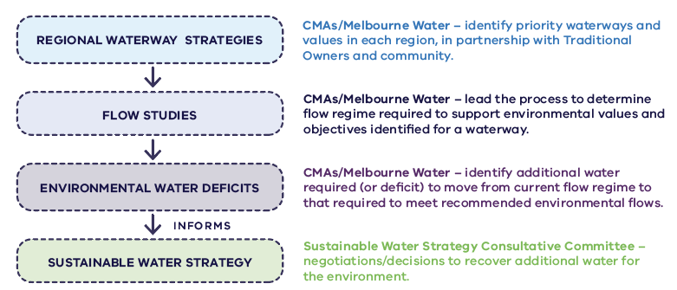
Figure D.1. Framework for decisions about environmental water recovery in Victoria

The Barwon River
The FLOWS study identified that the Barwon River below the West Barwon Reservoir needs 126,353 megalitres per year to meet the recommended environmental flows. The current flows in the river on average are 96,668 megalitres per year. Therefore, the environmental water deficit is 29,685 megalitres per year.
This is a very large volume, so the Corangamite CMA determined the critical environmental outcomes they wanted to achieve for the Barwon River as a priority (Table D.2) and the volumes of water that needed to be recovered (Table D.1) to meet these outcomes. As there is already a Barwon River Environmental Entitlement of 1,000 megalitres per year, this was subtracted from the volumes required, and the result is the water recovery targets for the Strategy. Priority target no. 2 (5,000 megalitres per year) is what the Strategy is aiming to achieve within a 10 year timeframe (see Table D.2).
Table D.1. Environmental water recovery volumes for different priority water recovery volume in the Barwon River
 | Priority target no. 1 (ML/year) | Priority target no. 2 (ML/year) | Priority target no. 3 (ML/year) | Priority target no. 4 All flow components (ML/year)
Environmental water deficits | 3,336 | 6,000 | 19,301 | 29,685
Existing environmental entitlement | 1,000 | 1,000 | 1,000 | 1,000
Environmental water recovery targets | 2,336 | 5,000 | 18,301 | 28,685

Table D.2. Environmental outcomes achieved with environmental water recovery volumes in the Moorabool Yulluk (Moorabool River)
Outcome | Cumulative water recovery volume (ML/year)
West branch:  Protect highest-priority ecological values (native fish and platypus)  Ensure that the river continues to flow and does not dry out  Provide enough water for species to survive, reducing the risk of fish deaths  Maintain water quality, and pool and riffle habitats  Trigger spawning migrations for migratory native fish species (tupong, eels, Australian grayling, galaxiids) | 2,640  under dry conditions
West branch:  Provide conditions that will enable native fish and platypus populations to thrive in wet years, in order to increase their resilience to lower flows in dry years | 6,500
East branch:  Protect highest-priority ecological values (native fish and platypus)  Ensure that the river continues to flow and does not dry out  Provide enough water for species to survive, reducing the risk of fish deaths  Maintain water quality, and pool and riffle habitats  Trigger spawning migrations for migratory native fish species (tupong, eels, Australian grayling, galaxiids) | 700

Table D.3. Environmental outcomes achieved with environmental water recovery volumes in the Barwon River
Outcome | Cumulative water recovery volume (ML/year)*
Prevent cease-to-flow events in the river and ensure more continuous river flows  Maintain water quality and provide refuge pools during summer critical for survival of species including platypus, growling grass frog, fish and bugs  Provide opportunities for fish migration and for movement of other species between reaches | 2,336
Better maintain critical values over summer and have a better chance of keeping the mid-reaches of the river flowing | 5,000
*Note: Does not include data for Lower Barwon River through Geelong or Lower Barwon wetlands.
Table D.4. Environmental outcomes achieved with environmental water recovery volumes in the Wirribi Yaluk (Werribee River)
Outcome | Cumulative water recovery volume (ML/year)
Maintain water quality and prevent blue-green algal blooms  Provide refuges for fish  Protect and increase populations of native freshwater fish species, including galaxiids | 9,607
Flush pools and prevent blue-green algal blooms  Protect and increase populations of black bream in the estuary  Maintain the platypus population  Improve water quality and maintain access to habitat for native fish, frogs and platypus  Provide enough flow for native fish to move between habitats | 11,885
Secure the long-term protection of priority environmental values | 12,183

Table D.5. Environmental outcomes achieved with environmental water recovery volumes in the Mirrangbamurn (Maribyrnong River)
Outcome | Cumulative water recovery volume (ML/year)
Flush pools to maintain water quality  Protect and increase populations of native freshwater fish species, including galaxiids  Provide for movements between habitats for small-bodied native fish, including ornate galaxias  Maintain native frog and platypus populations | 3,000
Maintain pool habitats for small-bodied fish and refuges during dry periods  Maintain self-sustaining populations of small-bodied fish  Provide best ecological and cultural outcomes for the river system | 7,000

Table D.5. Environmental outcomes achieved with environmental water recovery volumes in the Birrarung (Yarra River)
Outcome | Cumulative water recovery volume (ML/year)
Prevent loss of Australian grayling (threatened species)  Provide opportunities for platypus to move along the river  Maintain fish populations (including tupong, Macquarie perch, galaxias and eels) | 11,000

Table D.6. Environmental outcomes achieved with environmental water recovery volumes in the Bunyip/Tarago rivers
Outcome | Cumulative water recovery volume (ML/year)
Protect and increase populations of native freshwater fish species, including Australian grayling  Maintain populations of macroinvertebrates  Maintain platypus populations  Maintain water quality and increase dissolved oxygen in pools | 1,300

Table D.7. Environmental outcomes achieved with environmental water recovery volumes in the Carran Carran (Thomson River)
Outcome | Cumulative water recovery volume (ML/year)
Maintain water quality in refuge pools  Maintain connectivity for fish movement between reaches and refuge pools  Maintain minimum depths and connectivity for platypus | 8,000
Support regular breeding and recruitment of the threatened Australian grayling and other native fish  Reduce salinity in lower Latrobe estuary, increasing availability of freshwater for the lower Latrobe wetlands | 15,000

Table D.8. Environmental outcomes achieved with environmental water recovery volumes in the Wirn Wirndook Yeerung (Macalister River)
Outcome | Cumulative water recovery volume (ML/year)
Maintaining water quality in refuge pools  Maintain connectivity for fish movement between reaches and refuge pools  Maintain minimum depths and connectivity for platypus | 6,000
Support regular breeding and recruitment of the threatened Australian grayling and other native fish  Enable plant propagule dispersion  Reduce salinity in lower Latrobe estuary, increasing availability of freshwater for the lower Latrobe wetlands | 12,600

Table D.9. Environmental outcomes achieved with environmental water recovery volumes in the Durt-Yowan (Latrobe River)
Outcome | Cumulative water recovery volume (ML/year)
Benefits predominantly in reaches 3 and 5:  - Provide population expansion opportunities of species in summer and autumn  - Maintain water quality and increase habitat  - Support drought refuge  - Prevent critical loss of species | 7,300
Benefits whole of river below Lake Narracan:  - Provide population expansion opportunities for species in summer and autumn  - Maintain water quality and increase habitat  - Support drought refuge  - Prevent critical loss of species | 15,000
Benefits whole of river below Lake Narracan, incl estuary:  - Provide population expansion opportunities for species year-round  - Improve water quality and increase habitat  - Support breeding, recruitment and migration for native fish, including Australian bass and Australian grayling  - Reduce salinity in lower Latrobe estuary, increasing availability of freshwater for the wetlands | 73,000

Table D.11. Environmental outcomes achieved with environmental water recovery volumes in the Tyers River
Outcome | Cumulative water recovery volume (ML/year)
Prevent critical loss of species such as river blackfish and dwarf galaxias by providing intermittent connection of pools in summer and autumn | 3,100
Prevent critical loss of species and provide population expansion opportunities for native fish and other fauna in summer and autumn  Reduce salinity in lower Latrobe estuary, increasing availability of freshwater for the lower Latrobe wetlands | 13,400

Table D.12. Technical studies that informed environmental water recovery volumes
River system | Technical studies
Moorabool | Moorabool River: flow study update (Jacobs 2015)  Moorabool River: environmental water management plan (Corangamite CMA 2016)
Barwon | Upper Barwon, Yarrowee and Leigh rivers flow study update (Alluvium 2021a)  Lower Barwon wetlands: flow study (Flow/ecology relationships and scenarios for the lower Barwon wetlands environmental entitlement) (Lloyd et al 2012)  Lower Barwon review 2020: issue and advice paper (Sherwood et al 2020)
Werribee | Werribee River environmental flows review (Jacobs 2014)  Werribee River: flow recommendations (Ecological Associates, 2005)  Werribee River estuary FLOWS report (Lloyd et al 2008)
Maribyrnong | Maribyrnong River: Maribyrnong River/Jacksons Ck updated flow recommendations 2016 (Alluvium 2016)  Environmental Flow Determination for the Maribyrnong River Final Recommendations Revision C (EarthTech 2006)
Yarra | Yarra River FLOWS study (SKM 2005)  Yarra River: flow study review (SKM 2012)  Yarra River: Yarra River environmental water management plan (Jacobs 2017)  Yarra River: environmental flow study review for the Yarra River (Jacobs 2018a)
Bunyip/Tarago | Tarago and Bunyip rivers: flow study review (Jacobs 2018b)  Tarago-Bunyip River FLOWS study (EarthTech 2007)
Latrobe/Tyers | Environmental water requirements report: Latrobe environmental water requirements investigation (Alluvium 2020)  Environmental water delivery and management report: Latrobe environmental water requirements investigation (Alluvium 2021b)
Thomson | Thomson River environmental flows and management review: issues paper (Streamology 2020a)  Thomson River environmental flows and management review: flow recommendations paper (Streamology 2020b)  Thomson River environmental flows and management review: shortfalls and risk assessment paper (Streamology 2020c)  Thomson River environmental flows and management review: water recovery increments paper (Streamology 2020d)
Macalister | Macalister River environmental flows review (Alluvium 2015)  Water recovery targets for the Macalister River (Alluvium 2020)  Macalister daily flows (HARC 2021)  Macalister daily flows: potential eflow impacts of recent Thomson Source model changes (HARC 2022a)  Macalister daily flows: environmental flow shortfalls (HARC 2022b)
Gippsland Rivers | West Gippsland water recovery target review (Hale et al. 2022)  Improving understanding to inform environmental water management and allocation: river flow changes and environmental water shortfalls in Central Gippsland (Alluvium 2019)

Appendix E. Implementation plan
This implementation plan details how each of the Strategy’s actions will be achieved. It specifies the timeframes for delivering the actions:
Ongoing: to be implemented in the short-term and become business as usual
Short-term: by the end of 2027 (0–5 years)
Medium-term: by the end of 2032 (5–10 years)
Long-term: beyond 2032 (more than 10 years)
Each action is allocated to a lead organisation(s) that will be responsible for delivering the action. Many actions also have delivery partners – organisations and groups that will be collaborating with the lead(s) to deliver part of or the whole action. Other organisations or groups might contribute to the delivery of some actions as needed, for example, by providing information and/or participating in future discussions. They will be identified during the delivery of the actions.
Engagement with the community, Traditional Owners, stakeholders, peak bodies, community groups, businesses and agriculture groups will continue during the delivery of specific actions. The implementation plan flags the actions where this is expected, with additional details to be available during the delivery of the action.
The Victorian Government is committed to strengthening the role of Traditional Owners in water planning and management, and will continue to work in partnership with Traditional Owners throughout the implementation of this Strategy, should they self-determine to do so. Each RAP group in the region has been given the opportunity to collaborate in the delivery of relevant actions related to their Country and will be supported to deliver on agreed implementation responsibilities as required.
The Strategy has identified five objectives. This implementation plan shows how delivery of the actions will help to achieve the Strategy’s objectives.

Objectives
The Strategy’s objectives are:
- secure the region’s urban water future
- Traditional Owners
- waterway health
- agriculture
- social and recreational uses and values
Detailed decisions about the implementation and timing of actions will be made in line with standard government policy and budget processes. Many actions in the final Strategy can be funded via existing arrangements by Department of Environment, Land, Water and Planning or its delivery partners. This implementation plan flags which actions will be subject to a business case or additional investigation that will feed into future investment decision-making by government and/or water corporations for delivery. While many actions will be delivered within current programs and levels of investment, additional Government funding and/or increases in water bills may be required over the next decade for construction of new water supply options. However, this will be subject to the outcomes of detailed business cases for new water supply options and will feed into future urban water corporation pricing submissions during implementation. Water corporations will continue to engage with their customers to inform decisions about water services and their bills and affordability and cost of living pressures will be a key consideration in both water corporations’ pricing submissions and government investment decisions related to implementation of this Strategy.

Key

Future investment decisions
- Subject to a business case or additional investigation that will feed into future investment decision-making
- Funding secured or likely to be secured within existing pathways

Engagement
- No additional engagement planned: Progress on Strategy implementation will be reported in the Department of Environment, Land, Water and Planning’s annual report
- Additional engagement planned

Chapter 2: Using water efficiently

Action | Time frame | Lead | Delivery partners | Strategy objective | Engagement | Future investment decisions
Action 2-1: Changing behaviours at home  Urban water corporations, in partnership with the Victorian Government, will help people change water behaviours at home by:  - setting a new aspirational average water use target for Melbourne of 150 litres per person per day, with regional water corporations setting equivalent per capita targets reflective of local conditions  - developing and investing in water efficiency behaviour-change campaigns targeting residential users likely to generate the greatest water savings  - using new technologies, such as apps and digital water meters that provide daily usage data, to encourage behaviour change. | Short-term  By 2024 | Urban water corporations | Department of Environment, Land, Water and Planning | - secure the region’s urban water future | Led by urban water corporations | Funding secured or likely to be secured within existing pathways
Action 2-2: Water efficient buildings  The Victorian Government proposes to implement new variations to the National Construction Code, and stronger state building and plumbing regulations for water efficiency, to improve the water efficiency of all buildings, subject to a regulatory impact statement and stakeholder and community consultation. | Short-term  By 2024 | Department of Environment, Land, Water and Planning | Victorian Building Authority | - secure the region’s urban water future | Led by the Department of Environment, Land, Water and Planning | Funding secured or likely to be secured within existing pathways
Action 2-3: Better information and standards for appliances  The Victorian Government will advocate for stronger minimum Water Efficiency Labelling and Standards (WELS) scheme ratings for appliances and fixtures, and will collaborate with water corporations to increase awareness of WELS ratings and minimum standards in Victoria. | Ongoing | Department of Environment, Land, Water and Planning | Commonwealth and all states and territory governments | - secure the region’s urban water future | No additional engagement planned | Funding secured or likely to be secured within existing pathways
Action 2-4: Showerhead replacement  The Victorian Government will develop a business case to expand statewide incentives for water-efficient showerheads and implement initiatives. This could include incentives for even more efficient showerheads or offering free installation. | Short-term  By 2025 | Department of Environment, Land, Water and Planning | Urban water corporations | - secure the region’s urban water future | No additional engagement planned | Funding secured or likely to be secured within existing pathways
Action 2-5: Community rebates and community housing retrofits  Urban water corporations will continue to support customers who are vulnerable or experiencing hardship to become more water efficient and reduce their water bills through the Community Rebate and Community Housing Retrofit Programs. | Ongoing | Urban water corporations | Department of Environment, Land, Water and Planning | - secure the region’s urban water future | No additional engagement planned | Funding secured or likely to be secured within existing pathways
Action 2-6: Waterwise schools  The Victorian Government, in collaboration with water corporations, will ensure that all government schools in the Central and Gippsland Region become waterwise, by participating in the Schools Water Efficiency Program (including use of school curriculum material) or other similar digital metering and education programs, by 2030, with a mid-term target of capturing 80 per cent of government schools by the end of 2026. | Medium-term  By 2030  (with a mid-term target of 80% by end 2026) | Department of Environment, Land, Water and Planning  Yarra Valley Water | Urban water corporations | - secure the region’s urban water future | Led by Yarra Valley Water | Funding secured or likely to be secured within existing pathways
Action 2-7: Maximising water efficiency in business and industry  Urban water corporations, in partnership with the Victorian Government, will implement a targeted non-residential water efficiency program, including investigating the merits of:  - benchmarking water usage across business and industry  - re-introducing Water Management Action Plans (a tool used successfully during the Millennium Drought)  - rebates for digital water meters (for large water users not captured by other programs) or other water efficiency upgrades. | Short-term  By 2025 | Department of Environment, Land, Water and Planning | Urban water corporations | - secure the region’s urban water future | Led by the Department of Environment, Land, Water and Planning | Funding secured or likely to be secured within existing pathways
Action 2-8: Targets for reducing urban water system leaks  Urban water corporations will:  - set targets (where possible) for managing distribution system leaks and losses, which consider the broader social and environmental costs and benefits  - work with the Essential Services Commission, Bureau of Meteorology and Water Services Association of Australia to review annual leakage reporting and increase transparency and benchmarking of leakage performance. | Short-term  By 2025 | Water corporations | - | - secure the region’s urban water future | No additional engagement planned | Funding secured or likely to be secured within existing pathways

Chapter 3: Securing our water future through manufactured water
Action 3-1: Investigating options to expand the region’s desalination capacity  The Victorian Government and water corporations will undertake planning and readiness work on several near-term desalination options to ensure that the region’s desalination capacity can meet system shocks and future needs. Options will be progressed through the Water Grid Plan. |  | Ongoing |  | Department of Environment, Land, Water and Planning |  | Water corporations |  | secure the region’s urban water future |  | Significant community engagement and input will inform any future decisions |  | Subject to a business case or additional investigation that will feed into future investment decision-making
Action 3-2: Incorporating consideration of water security into Plan Melbourne  The Victorian Government will consider water security needs and the likely future expansion of desalination capacity in the review of Plan Melbourne. |  | Short-term  By 2024 |  | Department of Environment, Land, Water and Planning |  | - |  | - secure the region’s urban water future |  | Led by the Department of Environment, Land, Water and Planning |  | Funding secured or likely to be secured within existing pathways
Action 3-3: Maturing the IWM investment framework  The Victorian government, in collaboration with IWM forum partners, will improve how investments in IWM projects are made to best realise the multiple community and environmental benefits that are difficult to quantify when using all sources of water. |  | Short-term  By 2025 |  | Department of Environment, Land, Water and Planning |  | Regional and Greater Metropolitan Melbourne IWM forum partners |  | - secure the region’s urban water future  - Traditional Owners  - waterway health  - agriculture  - social and recreational uses and values |  | Led by IWM forum partners |  | Funding secured or likely to be secured within existing pathways
Action 3-4: Investigating options for large-scale recycled water and treated stormwater networks in Greater Melbourne  The Victorian Government in collaboration with Greater Metropolitan Melbourne IWM forum partners will:  - Further investigate the feasibility of large-scale recycled water and treated stormwater networks to meet a range of uses and values in Greater Melbourne focusing on five regions:  - west and north-west (Werribee and Maribyrnong Catchments)  - north (Northern Growth Area and surrounding agricultural areas)  - east (high-density redevelopments in the eastern and south-eastern suburbs and agricultural areas in Yarra Valley)  - south-east (South East Growth Area and agricultural areas in Pakenham and neighbouring regions)  - Mornington Peninsula.  - Commence development of business cases for the feasible, large-scale networks. |  | Short-term  By 2025 |  | Department of Environment, Land, Water and Planning |  | Greater Metropolitan Melbourne IWM forum partners |  | - secure the region’s urban water future  - Traditional Owners  - waterway health  - agriculture  - social and recreational uses and values |  | Led by IWM forum partners |  | Subject to a business case or additional investigation that will feed into future investment decision-making
Action 3-5: Investigating options for a large-scale recycled water and treated stormwater network in the Barwon Region  The Victorian Government will support Barwon Water to investigate, in collaboration with the Barwon IWM forum partners, the feasibility of large-scale recycled water and treated stormwater schemes in the Barwon Region, including the Moorabool Valley, Surf Coast Hinterland, South Balliang and the Bellarine Peninsula. In the long-term, opportunities to connect these schemes to create a network will also be considered. |  | Short-term  By 2025 |  | Barwon Water |  | Department of Environment, Land, Water and Planning  Barwon IWM forum partners |  | - secure the region’s urban water future  - Traditional Owners  - waterway health |  | Led by Barwon Water |  | Subject to a business case or additional investigation that will feed into future investment decision-making
Action 3-6: Developing catchment-scale IWM action plans for Greater Melbourne  The Victorian Government, through the Greater Metropolitan Melbourne IWM forums, will develop action plans in the Werribee, Maribyrnong, Yarra, Dandenong and Western Port catchments to strategically drive delivery of their catchment scale IWM plans. |  | Short-term  By 2023 |  | Department of Environment, Land, Water and Planning |  | Greater Metropolitan Melbourne IWM forum partners |  | - secure the region’s urban water future  - Traditional Owners  - waterway health  - agriculture  - social and recreational uses and values |  | Led by IWM forum partners |  | Funding secured or likely to be secured within existing pathways
Action 3-7: IWM planning for regional Victoria  The Victorian Government will explore the benefits of IWM planning at different scales using the Barwon and Moorabool basins as a case study. |  | Short-term  By 2024 |  | Department of Environment, Land, Water and Planning |  | Regional IWM forum partners |  | - secure the region’s urban water future  - waterway health  - agriculture |  | Led by IWM forum partners |  | Funding secured or likely to be secured within existing pathways
Action 3-8: Use of recycled water and stormwater for greener, open spaces  The Victorian Government will provide:  - grants to co-invest with water corporations and councils in infrastructure to use stormwater and recycled water to irrigate open spaces, facilitated through the IWM program  - one-off grants to managers of open space, to complete water use and efficiency audits for sporting grounds which identify and map opportunities to reduce, or substitute, demands on the potable water system. |  | Short-term  By 2026 |  | Department of Environment, Land, Water and Planning |  | Councils  Open space managers  Water corporations |  | - secure the region’s urban water future |  | Led by IWM forum partners |  | Funding secured or likely to be secured within existing pathways
Action 3-9: Strengthen IWM in land-use and infrastructure planning  The Victorian Government will explore ways to clarify IWM objectives and strengthen IWM criteria in planning guidance material and policies, and will explore a potential requirement for the development and use of IWM plans at different geographic scales to guide land-use decisions related to future urban developments. |  | Short-term  By 2025 |  | Department of Environment, Land, Water and Planning |  | IWM forum partners |  | - secure the region’s urban water future  - Traditional Owners  - waterway health  - agriculture  - social and recreational uses and values |  | Led by IWM forum partners |  | Funding secured or likely to be secured within existing pathways
Action 3-10: Develop template guidance for recycled water use to streamline approvals  The Victorian Government, EPA and the water industry will develop templates to help industry apply and adjust to the new Victorian recycled water guidelines by streamlining documentation for approvals. |  | Short-term  By 2023 |  | VicWater |  | Environment Protection Authority  Department of Environment, Land, Water and Planning  Water corporations |  | - secure the region’s urban water future  - agriculture |  | No additional engagement planned |  | Funding secured or likely to be secured within existing pathways
Action 3-11: Identify priority projects to contribute to state of knowledge on emerging contaminants  The Victorian Government will work with the water sector to identify priority projects to enhance our knowledge of emerging contaminants. |  | Short-term  By 2023 |  | Department of Environment, Land, Water and Planning  Environment Protection Authority |  | Water corporations |  | - secure the region’s urban water future  - waterway health  - agriculture  - social and recreational uses and values |  | No additional engagement planned |  | Funding secured or likely to be secured within existing pathways
Action 3-12: Improving stormwater regulations to support increased capture and use  The Victorian Government will work with water corporations and councils to review statewide stormwater licensing and supply arrangements and determine preferred statutory and non-statutory implementation options. |  | Short-term  By 2023 |  | Department of Environment, Land, Water and Planning |  | Water corporations  Councils  CMAs (including Melbourne Water) |  | - secure the region’s urban water future |  | No additional engagement planned |  | Funding secured or likely to be secured within existing pathways
Action 3-13: Implement Melbourne Urban Stormwater Institutional Arrangements (MUSIA)  The Victorian Government will:  - support Melbourne Water and the Municipal Association of Victoria (on behalf of local government) to implement the preferred option from the MUSIA review: the improved 60-hectare option  - embed the confirmed approach into policy or legislation. |  | Medium-term  By 2028 |  | Department of Environment, Land, Water and Planning  Melbourne Water  Municipal Association of Victoria |  | Councils |  | - secure the region’s urban water future  - waterway health |  | No additional engagement planned |  | Funding secured or likely to be secured within existing pathways
Action 3-14: Review stormwater management arrangements in the Lower Barwon  The Victorian Government will work with local government, Barwon Water and Corangamite CMA to review arrangements for managing stormwater as a resource for Geelong and the Bellarine. |  | Short-term  By 2023 |  | Department of Environment, Land, Water and Planning |  | Barwon Water  Corangamite CMA  City of Greater Geelong |  | - secure the region’s urban water future  - waterway health |  | No additional engagement planned |  | Funding secured or likely to be secured within existing pathways
Action 3-15: Develop a stormwater offsets framework  The Victorian Government will develop a stormwater offsets framework to enable robust and consistent application of offsets for developers and local government to meet stormwater requirements in the Victoria Planning Provisions. |  | Short-term  By 2024 |  | Department of Environment, Land, Water and Planning |  | Councils |  | - secure the region’s urban water future  - waterway health |  | No additional engagement planned |  | Funding secured or likely to be secured within existing pathways
Action 3-16: Embedding stormwater flow requirements  The Victorian Government will assess and explore the feasibility of options that include stormwater flow reduction targets into the Victoria Planning Provisions or other regulations. |  | Short-term  By 2024 |  | Department of Environment, Land, Water and Planning |  | Melbourne Water  Councils  CMAs (including Melbourne Water) |  | - secure the region’s urban water future  - waterway health |  | Led by the Department of Environment, Land, Water and Planning |  | Funding secured or likely to be secured within existing pathways
Action 3-17: Building community confidence in recycled water and stormwater  The Victorian Government will work with the water sector and EPA to develop and implement engagement and education programs that improve understanding of the benefits and risks of using recycled water and stormwater. |  | Short-term  By 2026 |  | Department of Environment, Land, Water and Planning |  | Environment Protection Authority  Water corporations |  | - secure the region’s urban water future  - waterway health  - agriculture |  | Led by water corporations |  | Funding secured or likely to be secured within existing pathways
Action 3-18: Clearer guidance on recycled water accounting and reporting  The Victorian Government will assess the need for clearer guidance on recycled water accounting and reporting, to increase the consistency and accuracy of recycled water data for a better understanding of its use and availability. |  | Short-term  By 2023 |  | Department of Environment, Land, Water and Planning |  | Water corporations |  | - secure the region’s urban water future |  | No additional engagement planned |  | Funding secured or likely to be secured within existing pathways
Chapter 4: Sharing our water resources for multiple benefits
Action 4-1: Investigate options to return water to the environment and Traditional Owners as manufactured water sources are planned for Greater Melbourne and Geelong  The Victorian Government, in partnership with the water industry, will investigate options to return water to the Birrarung (Yarra River), Carran Carran (Thomson River), Mirrangbamurn (Maribyrnong River), Wirribi Yaluk (Werribee River), Moorabool Yulluk (Moorabool River) and Barwon River and Traditional Owners, whose Country these rivers are part of, when new regional-scale manufactured sources of water are brought online for Greater Melbourne and Geelong. Projects will be progressed via the Water Grid Plan (see Action 9-2), and costs and water sharing arrangements will be considered on a case-by-case basis through the development of a business case using a quadruple-bottom-line assessment. |  | Ongoing |  | Department of Environment, Land, Water and Planning |  | Water corporations  CMAs (including Melbourne Water)  Victorian Environmental Water Holder  Traditional Owners |  | - Traditional Owners  - waterway health |  | Led by Department of Environment, Land, Water and Planning |  | Subject to a business case or additional investigation that will feed into future investment decision-making
Action 4-2: Commitment to consider how river entitlements can be reduced via water efficiency, IWM and substitution with manufactured water sources  Urban water corporations will consider how to reduce their reliance on river water for urban water security to enable river water to be returned to the environment and Traditional Owners across the region as they invest in water efficiency measures, IWM and reconfiguration of existing supply infrastructure, and manufactured supplies come online.  Each urban water corporation across the region will investigate options for reducing their reliance on river water, and will work with the Department of Environment, Land, Water and Planning to, by the end of 2023, identify a volume of water that could be returned by 2032. The local options and volumes proposed will be considered alongside regional options identified in the Water Grid Plan using a preliminary quadruple-bottom-line assessment by the Department of Environment, Land, Water and Planning to inform planning under Policy 9-1. The most cost-effective package of incentives across the region that will meet urban water security, Traditional Owner and environmental water needs will progress with appropriate funding sources to enable implementation from 2024-25 onwards (in line with Action 9-6). Related targets for each urban water corporation will be developed, in line with funding and financing arrangements, and embedded in the Statement of Obligations. |  | Ongoing Proposals due by 2023 |  | Department of Environment, Land, Water and Planning |  | Urban water corporations  Melbourne Water |  | - Traditional Owners  - waterway health |  | Led by urban water corporations |  | Subject to a business case or additional investigation that will feed into future investment decision-making
Action 4-3: Securing additional water for Geelong and the Moorabool Yulluk (Moorabool River)  The Victorian Government and Barwon Water will co-invest in works to enable the return of 3.7 gigalitres per year of long-term average equivalent Moorabool water entitlement to be shared between the environment, the Wadawurrung for their self-determined use and to increase urban water security for Geelong over the long-term to:  - upgrade pumps and extend the reach of the Melbourne-to-Geelong pipeline to increase capacity of the pipeline from 16 to 22 gigalitres per year by 2025  - transfer a long-term average equivalent of 3 gigalitres per year of Barwon Water’s Lal Lal bulk entitlement and 0.7 gigalitres per year of Barwon Water’s Upper East Moorabool bulk entitlement in the Bostock Reservoir to the Wadawurrung and to the Victorian Environmental Water Holder by 2025  - prioritise the creation of a south-central pooled resource and associated reforms (Action 9-3), while ensuring a short-term agreement between Barwon Water and the metropolitan water corporations is in place by 2025. This is dependent on if Action 9-3 is still in progress, which will specify water sharing such that Barwon Water can operate the augmented Melbourne-to-Geelong Pipeline at up to 22 gigalitres per year if needed once Barwon Water’s existing carryover in the Melbourne system has been used  - factor Barwon Water’s required water entitlement volume into the planning and decision-making for the south-central system’s next major augmentation, to increase Geelong’s urban water security. |  | Short-term  By 2025 |  | Barwon Water  Department of Environment, Land, Water and Planning |  | Wadawurrung Traditional Owners Aboriginal Corporation  Victorian Environmental Water Holder  Corangamite CMA  Central Highlands Water  Melbourne Water  Greater Western Water  South East Water  Yarra Valley Water |  | - secure the region’s urban water future  - Traditional Owners  - waterway health |  | No additional engagement planned |  | Subject to a business case or additional investigation that will feed into future investment decision-making
Action 4-4: Determine how water returned in the Moorabool Yulluk (Moorabool River) will be shared between Wadawurrung and the environment  The Victorian Government, in partnership with the Wadawurrung Traditional Owners Aboriginal Corporation, Victorian Environmental Water Holder and Corangamite CMA, will determine the respective share of water that will be issued to Wadawurrung and the Victorian Environmental Water Holder under Action 4-3, and remove barriers to Wadawurrung Traditional Owners Aboriginal Corporation accessing water (see actions in Section 6.5 and Section 6.6). |  | Short-term  By 2025 |  | Department of Environment, Land, Water and Planning |  | Wadawurrung Traditional Owners Aboriginal Corporation  Victorian Environmental Water Holder  Corangamite CMA |  | - Traditional Owners  - waterway health |  | No additional engagement planned |  | Funding secured or likely to be secured within existing pathways
Action 4-5: Securing Warragul and Drouin’s urban water supply  The Victorian Government will secure Warragul and Drouin’s urban water supply by increasing Gippsland Water’s access to water from Tarago Reservoir by transferring 3.33 gigalitres of entitlement in the Yarra-Thomson system to Gippsland Water. |  | Short-term  By 2023 |  | Department of Environment, Land, Water and Planning |  | Gippsland Water  Yarra Valley Water  Melbourne Water |  | - secure the region’s urban water future |  | No additional engagement planned |  | Funding secured or likely to be secured within existing pathways
Action 4-6: Streamlining temporary water trades  Central Highlands Water, the Wadawurrung Traditional Owners Aboriginal Corporation, the Victorian Environmental Water Holder and the Corangamite CMA will work together to develop agreements to support temporary water trade in the Moorabool system, when conditions allow, from Central Highlands Water to the Wadawurrung and environment, at Lal Lal Reservoir. This will include consideration of how water can be made available to the Wadawurrung Traditional Owners Aboriginal Corporation.  Lessons from this case study can be used across the region to make it easier for similar trades to occur for other rivers. |  | Short-term  By 2027 |  | Central Highlands Water |  | Wadawurrung Traditional Owners Aboriginal Corporation  Victorian Environmental Water Holder  Corangamite CMA  Department of Environment, Land, Water and Planning  Barwon Water |  | - Traditional Owners  - waterway health |  | No additional engagement planned |  | Funding secured or likely to be secured within existing pathways
Action 4-7: Guidance for decisions about unallocated water  The Victorian Government will publish guidance for licensing authorities’ decisions about unallocated water, to provide clarity and transparency on how all uses of water will be considered, including access to water for Traditional Owners. |  | Short-term  By 2023 |  | Department of Environment, Land, Water and Planning |  | Rural water corporations |  | - Traditional Owners  - waterway health  - agriculture |  | No additional engagement planned |  | Funding secured or likely to be secured within existing pathways
Action 4-8: Reallocation of the Latrobe 3 – 4 Bench bulk entitlement  The Victorian Government proposes that water from the 25 gigalitre Latrobe 3 – 4 Bench bulk entitlement will be made available to support the region’s socio-economic transition and build its resilience to climate change. Three key outcomes will be achieved using two-thirds (around 16 gigalitres) of the entitlement to:  - provide priority environmental flows to support native fish species, macroinvertebrates, and platypus as well as supporting the many values and uses of the connected Gippsland Lakes system and Ramsar-listed wetlands  - support cultural values and self-determined outcomes for Gunaikurnai Traditional Owners  - underpin the continued resilience and future growth of irrigated agriculture.  A consultative process with key stakeholders, will establish how the benefits could best be shared to maximise the outcomes of this critical resource for the community.  The remaining one-third of the entitlement (or up to 9 gigalitres) will be retained by government to provide continued flexibility to respond to emerging needs, including Victoria’s future energy needs. |  | Short-term  By 2024 |  | Department of Environment, Land, Water and Planning |  | Southern Rural Water  West Gippsland CMA  Gunaikurnai Land and Waters Aboriginal Corporation  Gippsland Water  Victorian Environmental Water Holder |  | - secure the region’s urban water future  - Traditional Owners  - waterway health  - agriculture |  | Led by the Department of Environment, Land, Water and Planning |  | Subject to a business case or additional investigation that will feed into future investment decision-making
Action 4-9: Returning water to the Wurundjeri Woi-wurrung Cultural Heritage Aboriginal Corporation  The Victorian Government supports an application to return water to the Wurundjeri Woi-wurrung Cultural Heritage Aboriginal Corporation through the transfer of a 1.4 gigalitre water licence in the Birrarung (Yarra River), formally used by the Amcor Paper Mills and now held by the Victorian Government. |  | Short-term  By 2022 |  | Department of Environment, Land, Water and Planning |  | Wurundjeri Woi-wurrung Cultural Heritage Aboriginal Corporation  Melbourne Water |  | - Traditional Owners |  | No additional engagement planned |  | Funding secured or likely to be secured within existing pathways
Action 4-10: Reconfiguring the Werribee system  The Victorian Government will confirm feasibility and the preferred infrastructure plan by mid-2023. A business case will be developed to reconfigure the Werribee system to provide more climate-resilient water sources for non-drinking purposes and make better use of all sources of water and reservoirs in the local system.  The project will consider the best combination of water supply options to meet the region’s multiple demands and, including:  - providing fit-for-purpose recycled water (including appropriate salinity levels) for the Werribee and Bacchus Marsh irrigation districts, including the opportunity for irrigation expansion  - harvesting stormwater from the Melton growth area for re-use, which will also protect local waterways  - supplying recycled water from the Western Irrigation Network’s Sunbury-to-Melton pipeline to irrigate open space and schools in the Melton growth area  - using returned river entitlements to provide for environmental water recovery; water justice to the Bunurong, Wadawurrung and Wurundjeri Woi-wurrung Traditional Owners; and urban supply  - improving waterway health through complementary works at Werribee weir (see Action 8-10). |  | Short-term  By 2024 |  | Werribee System Reconfiguration Steering Committee (Southern Rural Water, Greater Western Water, Melbourne Water, Department of Environment, Land, Water and Planning) |  | Melton City Council  Wyndham City Council  Moorabool Shire Council |  | - secure the region’s urban water future  - Traditional Owners  - waterway health  - agriculture |  | Led by project leads and delivery partners |  | Subject to a business case or additional investigation that will feed into future investment decision-making
Action 4-11 Investigating optimisation of Yarra system passing flow arrangements  The Victorian Government will investigate optimisation of passing flow arrangements for the Yarra system at Watts River below Maroondah Reservoir to identify opportunities to increase the benefits of passing flows for all users without reducing the reliability of existing entitlements. |  | Short-term  By 2024 |  | Department of Environment, Land, Water and Planning |  | Melbourne Water  Victorian Environmental Water Holder |  | - secure the region’s urban water future  - Traditional Owners  - waterway health  - agriculture  - social and recreational uses and values |  | Led by the Department of Environment, Land, Water and Planning |  | Funding secured or likely to be secured within existing pathways
Action 4-12: Reviewing management arrangements for the Wangangarra / WyYung (Mitchell River) for all water users  The Victorian Government will review the current management arrangements for the Wangangarra / WyYung (Mitchell River) to ensure that arrangements are fit-for-purpose and consistent with other systems across the state. Investigations will be made into whether additional entitlements could be made available to support additional consumptive use without compromising environmental and cultural values and where possible improve low flows during summer. |  | Short-term  By 2024 |  | Department of Environment, Land, Water and Planning |  | Southern Rural Water  East Gippsland CMA  Gunaikurnai Land and Waters Aboriginal Corporation |  | - Traditional Owners  - waterway health  - agriculture |  | Led by the Department of Environment, Land, Water and Planning |  | Funding secured or likely to be secured within existing pathways
Action 4-13: Review of water resource risks in small, dry, peri-urban catchments  Southern Rural Water will lead a project over two years to review resource risk and share evidence and reporting to build a shared understanding with communities on the risks, consequences and mitigation options we can use to address the increasing effects of small catchment dams.  This project will focus on the upper Maribyrnong and upper Moorabool catchments (including tributaries) as identified hotspots, but recommendations from this review may be relevant to other catchments. |  | Short-term  By 2024 |  | Southern Rural Water |  | Department of Environment, Land, Water and Planning |  | - secure the region’s urban water future  - Traditional Owners  - waterway health  - agriculture |  | Led by Southern Rural Water |  | Funding secured or likely to be secured within existing pathways
Action 4-14: Reviewing the Latrobe Reserve  The Victorian Government will review the future need for the Latrobe Reserve as the Latrobe Valley transitions away from coal-fired electricity generation. The timing of the review aligns with the expected closure of the Yallourn Power Station in 2028. The review will consider how to adapt to changes in water use in the Latrobe system including the consequences of the closure of power stations, and to water availability due to a drying climate. The review will make recommendations for any entitlement rule changes. |  | Medium-term  By 2028 |  | Department of Environment, Land, Water and Planning |  | Southern Rural Water  All Latrobe System bulk/environmental entitlement holders (including Gippsland Water and Victorian Environmental Water Holder)  West Gippsland CMA |  | - secure the region’s urban water future  - Traditional Owners  - waterway health  - agriculture  - social and recreational uses and values |  | Led by the Department of Environment, Land, Water and Planning and Southern Rural Water |  | Funding secured or likely to be secured within existing pathways
Action 4-15: Developing a vision and plan for the water future of the Latrobe Valley  The West Gippsland water sector and Gunaikurnai Land and Waters Aboriginal Corporation will work with the Victorian Government and the Latrobe Valley community and stakeholders to develop and implement a collaborative vision and works plan for the future of the Latrobe Valley and its waterways. The plan will determine the optimal water infrastructure arrangements to meet emerging environmental, cultural, economic and social water demands. |  | Vision and plan for short-term actions: by 2023  Plan for medium to long-term actions: by 2025  Imple-mentation: ongoing |  | Gippsland Water  West Gippsland CMA  Gunaikurnai Land and Waters Aboriginal Corporation  Southern Rural Water  Department of Environment, Land, Water and Planning |  | - |  | - secure the region’s urban water future  - Traditional Owners  - waterway health  - agriculture  - social and recreational uses and values |  | Led by project leads |  | Subject to a business case or additional investigation that will feed into future investment decision-making
Action 4-16: Improving water management to deliver shared benefits  The Victorian Government will work with Traditional Owners, water corporations, waterway managers and the Victorian Environmental Water Holder to deliver improvements to water management in rivers, to benefit the environment and to support Traditional Owner cultural values and other shared benefits.  This could be achieved through a combination of more flexible and efficient operations: the flexible use of passing flows (where appropriate), using consumptive water enroute, temporary trades (see Action 4-6) and building greater flexibility into environmental entitlements (where there are no adverse impacts on other existing entitlement holders). |  | Ongoing |  | Department of Environment, Land, Water and Planning |  | Water corporations  CMAs (including Melbourne Water)  Victorian Environmental Water Holder  Traditional Owners |  | - Traditional Owners  - waterway health  - social and recreational uses and values |  | No additional engagement planned |  | Funding secured or likely to be secured within existing pathways
Action 4-17: Tracking and improving our understanding of interception activities, including small catchment dams and plantations  The Victorian Government will track and improve the understanding of unlicensed water uses in the region, including small catchment dams and plantations by:  - continuing to monitor and report on the total volume of, and estimated take from, small catchment dams, including identification of emerging risks to water resources  - monitoring plantation and other large-scale tree-planting activities and assessing impacts on water resources. |  | Ongoing |  | Department of Environment, Land, Water and Planning |  | Department of Jobs, Precincts and Regions  Water corporations  CMAs (including Melbourne Water) |  | - secure the region’s urban water future  - Traditional Owners  - waterway health  - agriculture  - social and recreational uses and values |  | No additional engagement planned |  | Funding secured or likely to be secured within existing pathways
Action 4-18: Updating groundwater management arrangements and implementing priorities for reform  The Department of Environment, Land, Water and Planning and rural water corporations will lead a staged approach to improve statewide groundwater management and licensing for the future.  Priority areas of reform will be addressed with the active participation of Traditional Owners and key stakeholders including existing entitlement holders and the community. |  | Ongoing |  | Department of Environment, Land, Water and Planning  Rural water corporations |  | Traditional Owners  CMAs (including Melbourne Water) |  | - secure the region’s urban water future  - Traditional Owners  - waterway health |  | Led by the Department of Environment, Land, Water and Planning and rural water corporations |  | Funding secured or likely to be secured within existing pathways
Chapter 6: Water Justice for Traditional Owners
Note: The following actions will be regularly reviewed and updated in line with outcomes from the treaty process.
Action 6-1: The Victorian Government will ensure that Traditional Owners are resourced in order to partner in the implementation of the Strategy’s actions and policies in a self-determined way  Funding will be provided for Traditional Owners to partner and participate in a self-determined way in the implementation of this Strategy’s actions and policies as they relate to Mob, Country and self-determination. |  | Ongoing |  | Department of Environment, Land, Water and Planning |  | Traditional Owners |  | - Traditional Owners |  | No additional engagement planned |  | Funding secured or likely to be secured within existing pathways
Action 6-2: The Victorian Government will work with water corporations to amend their Statement of Obligations (General) to include the cultural benefits framework in water planning and management  The Water Industry Act 1994 Statements of Obligations (General) will be reviewed together with the appropriate Traditional Owner group(s) to develop amendments to resource Traditional Owner participation and inclusion of the cultural benefits framework in all water planning, management and monitoring work, for consideration by the Minister. |  | Short-term  By 2025 |  | Department of Environment, Land, Water and Planning |  | Traditional Owners  Water corporations |  | - Traditional Owners |  | No additional engagement planned |  | Funding secured or likely to be secured within existing pathways
Action 6-3: Implement a Traditional Owner led principle review process  The Victorian Government, in partnership with Traditional Owners, will ensure the Traditional Owner water sharing principles (see Policy 6-1) are being applied as intended and allow for an effective mechanism to review and update the principles as required. |  | Short-term  By 2025 |  | Department of Environment, Land, Water and Planning |  | Traditional Owners |  | - Traditional Owners |  | No additional engagement planned |  | Funding secured or likely to be secured within existing pathways
Action 6-4: The Victorian Government will work to ensure that ownership of land is not a barrier to Traditional Owners applying for, or holding, water entitlements  The Victorian Government will provide more appropriate mechanisms within the entitlement framework to support access to water for Traditional Owners for cultural use purposes. |  | Short-term  By 2025 |  | Department of Environment, Land, Water and Planning |  | Traditional Owners  Southern Rural Water  Water corporations  Melbourne Water |  | - Traditional Owners |  | No additional engagement planned |  | Funding secured or likely to be secured within existing pathways
In the interim, the Victorian Government will work with Traditional Owners and public land managers to support identification of appropriate land parcels that can be nominated for assessment and decision making on applications for section 51 licences. This may include:  - providing Traditional Owners with information on public land that can be nominated to enable the application and issuing of licences for cultural use and streamlining permissions with public land managers.  - working with Southern Rural Water and Melbourne Water to streamline the existing approval requirements to reduce red tape for Traditional Owners wanting to apply for a section 51 licence. |  | Short-term  By 2022
Action 6-5: Support Gunaikurnai Land and Waters Aboriginal Corporation applications for unallocated water, including in the Ber’rawn (Tambo River) and South Gippsland basin (including the Lung Lung (Franklin River) and Albert River)  Ensure Gunaikurnai can apply for unallocated surface and groundwater on and under Country.  This will support the government’s commitment to providing access to water for Traditional Owners. |  | Short-term  By 2022 |  | Department of Environment, Land, Water and Planning |  | Gunaikurnai Land and Waters Aboriginal Corporation  Southern Rural Water  East Gippsland Water  Gippsland Water  South Gippsland Water |  | - Traditional Owners |  | No additional engagement planned |  | Funding secured or likely to be secured within existing pathways
Action 6-6: The Victorian Government will seek to return water in the Carran Carran (Thomson River) and Durt-Yowan (Latrobe River) to Gunaikurnai Land and Waters Aboriginal Corporation  Seek opportunities to provide access to water in the Carran Carran (Thomson River) if new manufactured sources are brought online for the south-central system, to be used for self-determined purposes.  Pursue opportunities for entitlements in the Durt-Yowan (Latrobe River) as the Latrobe Valley transitions away from coal fired power generation. |  | Long-term |  | Department of Environment, Land, Water and Planning |  | Gunaikurnai Land and Waters Aboriginal Corporation  Melbourne Water  Gippsland Water  West Gippsland CMA  Victorian Environmental Water Holder  Southern Rural Water |  | - Traditional Owners |  | Through the Water Grid Plan (see Action 9-2) |  | Subject to a business case or additional investigation that will feed into future investment decision-making
Action 6-7: Evaluate opportunities to return water to Bunurong Land Council Aboriginal Corporation currently used by the Royal Botanic Gardens  Evaluate opportunities and ways to give water to Bunurong Land Council Aboriginal Corporation, including working with the City of Melbourne and the Royal Botanic Gardens to review the water entitlements given to them by Amcor for public use. |  | Short-term  By 2023 |  | Department of Environment, Land, Water and Planning |  | Bunurong Land Council Aboriginal Corporation  City of Melbourne  Royal Botanic Gardens  Melbourne Water |  | - Traditional Owners |  | No additional engagement planned |  | Funding secured or likely to be secured within existing pathways
Action 6-8: Support applications for unallocated water, including in the Powlett and Bass Rivers  Ensure Bunurong can apply for unallocated water in South Gippsland catchments that include the culturally significant Powlett and Bass Rivers and investigate other opportunities for access to surface water and groundwater in the region, as they present themselves. |  | Short-term  By 2022 |  | Department of Environment, Land, Water and Planning |  | Bunurong Land Council Aboriginal Corporation  Southern Rural Water  South Gippsland Water |  | - Traditional Owners |  | No additional engagement planned |  | Funding secured or likely to be secured within existing pathways
Action 6-9: The Victorian Government will seek to return water to the Bunurong Land Council Aboriginal Corporation on Bunurong Country  Seek opportunities to provide access to water if new manufactured sources are brought online for urban water security for the south-central system, to be used for self-determined purposes. |  | Long-term |  | Department of Environment, Land, Water and Planning |  | Bunurong Land Council Aboriginal Corporation  Melbourne Water  South Gippsland Water  Victorian Environmental Water Holder |  | - Traditional Owners |  | Through the Water Grid Plan (see Action 9-2) |  | Subject to a business case or additional investigation that will feed into future investment decision-making
Action 6-10: Evaluate opportunities to return water to Wurundjeri Woi-wurrung Cultural Heritage Aboriginal Corporation currently used by the Royal Botanic Gardens  Evaluate opportunities and ways to give water to Wurundjeri Woi-wurrung Cultural Heritage Aboriginal Corporation, including working with the City of Melbourne and the Royal Botanic Gardens to review the water entitlements given to them by Amcor for public use. |  | Short-term  By 2023 |  | Department of Environment, Land, Water and Planning |  | Wurundjeri Woi-wurrung Cultural Heritage Aboriginal Corporation  City of Melbourne  Royal Botanic Gardens  Melbourne Water |  | - Traditional Owners |  | No additional engagement planned |  | Funding secured or likely to be secured within existing pathways
Action 6-11: The Victorian Government will seek to return water in the Birrarung (Yarra River) to the Wurundjeri Woi-wurrung Cultural Heritage Aboriginal Corporation  Seek opportunities to provide access to water on the Birrarung (Yarra River) if new manufactured sources are brought online for urban water security in the south-central system, to be used for self-determined purposes. |  | Long-term |  | Department of Environment, Land, Water and Planning |  | Wurundjeri Woi-wurrung Cultural Heritage Aboriginal Corporation  Melbourne Water  Victorian Environmental Water Holder |  | - Traditional Owners |  | Through the Water Grid Plan (see Action 9-2) |  | Subject to a business case or additional investigation that will feed into future investment decision-making
Action 6-12: The Victorian Government will seek to return water to Wurundjeri Woi-wurrung Cultural Heritage Aboriginal Corporation in the Mirrangbamurn (Maribyrnong River)  Seek opportunities to provide access to water in the Mirrangbamurn (Maribyrnong River) if new manufactured sources are brought online for urban water security in the south-central system, to be used for self-determined purposes. |  | Long-term |  | Department of Environment, Land, Water and Planning |  | Wurundjeri Woi-wurrung Cultural Heritage Aboriginal Corporation  Melbourne Water  Victorian Environmental Water Holder |  | - Traditional Owners |  | Through the Water Grid Plan (see Action 9-2) |  | Subject to a business case or additional investigation that will feed into future investment decision-making
Action 6-13: Explore opportunities to return water to the Wadawurrung in Durdidwarrah wetland  Wadawurrung and Barwon Water will work together to explore opportunities to return a volume of water to the Wadawurrung in Durdidwarrah Wetland. |  | Short-term  By 2025 |  | Wadawurrung Traditional Owners Aboriginal Corporation  Barwon Water |  | Corangamite CMA  Department of Environment, Land, Water and Planning |  | - Traditional Owners |  | No additional engagement planned |  | Funding secured or likely to be secured within existing pathways
Action 6-14: The Victorian Government will seek to return water to the Wadawurrung in the Moorabool Yulluk (Moorabool River) and Parwan (Barwon River)  Seek opportunities to provide access to water in the Moorabool Yulluk (Moorabool River) and/or Parwan (Barwon River) when alternative sources are found for urban customers supplied by Barwon Water and Central Highlands Water, to be used for self-determined purposes. |  | Long-term |  | Department of Environment, Land, Water and Planning |  | Wadawurrung Traditional Owners Aboriginal Corporation  Barwon Water  Central Highlands Water  Corangamite CMA  Victorian Environmental Water Holder |  | - Traditional Owners |  | Through the Water Grid Plan (see Action 9-2) |  | Subject to a business case or additional investigation that will feed into future investment decision-making
Action 6-15: Support applications for unallocated water in the Otway Basin, including in the Gellibrand River  Ensure the Eastern Maar Aboriginal Corporation can apply for unallocated surface water and groundwater on and under their Country. This will support the Victorian Government’s commitment to providing access to water for Traditional Owners. |  | Short-term  By 2022 |  | Department of Environment, Land, Water and Planning |  | Eastern Maar Aboriginal Corporation  Southern Rural Water |  | - Traditional Owners |  | No additional engagement planned |  | Funding secured or likely to be secured within existing pathways
Action 6-16: The Victorian Government will seek to return water to the Eastern Maar in the Barwon River  Seek opportunities to provide access to water in the Barwon River when alternative sources are found for urban customers supplied by Barwon Water and Wannon Water, to be used for self-determined purposes. |  | Long-term |  | Department of Environment, Land, Water and Planning |  | Eastern Maar Aboriginal Corporation  Corangamite CMA  Barwon Water  Wannon Water  Victorian Environmental Water Holder |  | - Traditional Owners |  | Through the Water Grid Plan (see Action 9-2) |  | Subject to a business case or additional investigation that will feed into future investment decision-making
Chapter 7: Water for Agriculture
Action 7-1: Planning for future investment in rural water infrastructure  The Victorian Government will work with water corporations to provide updated guidance for the development and delivery of rural water infrastructure projects in the region, in ways that consider the benefits to irrigators, the environment, Traditional Owners and regional communities. |  | Short-term  By 2023 |  | Department of Environment, Land, Water and Planning |  | Southern Rural Water |  | - Traditional Owners  - waterway health  - agriculture |  | Led by the Department of Environment, Land, Water and Planning |  | Funding secured or likely to be secured within existing pathways
Action 7-2: Investigating opportunities for new irrigation development  The Victorian Government will continue to work with Southern Rural Water to assess the feasibility of agricultural development and infrastructure in the focus areas identified through the Southern Victoria Irrigation Development project. |  | Short-term  By 2024 |  | Department of Environment, Land, Water and Planning |  | Southern Rural Water |  | - agriculture |  | Led by Southern Rural Water |  | Subject to a business case or additional investigation that will feed into future investment decision-making
Action 7-3: Improving trade and transparency in Central and Gippsland water markets  The Victorian Government will improve transparency and trade in water markets in the Central and Gippsland Region by: |  |  |  | Department of Environment, Land, Water and Planning |  | Southern Rural Water |  | - agriculture |  | Led by Southern Rural Water |  | Funding secured or likely to be secured within existing pathways
- improving the accessibility of information about water management and trade rules across southern Victoria, all in one place |  | Short-term  By 2024
- trialling an online water market exchange that helps buyers and sellers find each other and trade in a fair and efficient way |  | Short-term  By 2023
- investigating local opportunities to make water trade rules more flexible without impacting other water users or the environment. |  | Short-term  By 2024
Chapter 8: Healthy waterways for all
Action 8-1: Rehabilitating the Moorabool Yulluk (Moorabool River) at Batesford Quarry  The Victorian Government will investigate impacts to the Moorabool Yulluk (Moorabool River) from the closure of Batesford Quarry and fund preliminary investigations to determine the best methods of restoring and rehabilitating the river and preventing flow losses. These investigations consider environmental and Wadawurrung Traditional Owner cultural values. In addition it will contribute to the resilience and liveability of the North and Western Geelong Growth Area neighbourhoods through integration of this work with the IWM Plan. |  | Short-term  By 2026 |  | Department of Environment, Land, Water and Planning |  | Corangamite CMA  Barwon Water  Wadawurrung Traditional Owners Aboriginal Corporation  City of Greater Geelong  Quarry operator |  | - Traditional Owners  - waterway health  - social and recreational uses and values |  | Led by the Department of Environment, Land, Water and Planning and quarry operator. |  | Funding secured or likely to be secured within existing pathways
Action 8-2: Increasing understanding of water needs of the Upper Moorabool and Leigh catchments  The Victorian Government, Corangamite CMA and Wadawurrung Traditional Owners Aboriginal Corporation will investigate flows required to protect environmental and Traditional Owner values for the upper Moorabool and Leigh catchments. This will also consider the relative importance of water recovery in these areas against existing water recovery targets for the Barwon catchment that includes both the Moorabool Yulluk (Moorabool River) and Leigh River. |  | Short-term  By 2027 |  | Corangamite CMA |  | Wadawurrung Traditional Owners Aboriginal Corporation  Department of Environment, Land, Water and Planning  Victorian Environmental Water Holder |  | - Traditional Owners  - waterway health |  | Led by Corangamite CMA |  | Funding secured or likely to be secured within existing pathways
Action 8-3: Improving flows in Stony Creek  The Victorian Government will work with Melbourne Water, Barwon Water, Parks Victoria and the Wadawurrung Traditional Owners Aboriginal Corporation to explore options for improving flows in Stony Creek and Little River through operational changes. This will include assessing the feasibility of providing more transparent passing of natural flows from Lower Stony Creek Reservoir into Stony Creek. |  | Short-term  By 2027 |  | Melbourne Water  Department of Environment, Land, Water and Planning |  | Wadawurrung Traditional Owners Aboriginal Corporation  Barwon Water  Parks Victoria |  | - Traditional Owners  - waterway health  - social and recreational uses and values |  | Led by Melbourne Water |  | Funding secured or likely to be secured within existing pathways
Action 8-4: Improving waterway health in the Barwon River  The Victorian Government will improve waterway health in the Barwon River, increase the effectiveness of environmental water releases and address constraints to their delivery by:  - investigating options to improve native fish migration at Buckley Falls  - restoring channel form and removing willows and reed sweet-grass from the upper Barwon River  - investigating risks of releasing higher volumes of water and prioritising works to mitigate them. |  | Short-term  By 2027 |  | Corangamite CMA |  | Department of Environment, Land, Water and Planning  Eastern Maar Aboriginal Corporation  Wadawurrung Traditional Owners Aboriginal Corporation  City of Greater Geelong  Victorian Environmental Water Holder |  | - Traditional Owners  - waterway health  - social and recreational uses and values |  | Led by Corangamite CMA |  | Funding secured or likely to be secured within existing pathways
Action 8-5: Updating watering recommendations for Reedy Lake and Hospital Swamp  The Corangamite CMA will update the watering recommendations for the Ramsar-listed Reedy Lake and Hospital Swamps, including the development of a water-salt balance model to support effective water management for the Ramsar-listed Reedy Lake and Hospital Swamps and to protect and improve these wetlands for all uses. |  | Short-term  By 2025 |  | Corangamite CMA |  | Wadawurrung Traditional Owners Aboriginal Corporation  Department of Environment, Land, Water and Planning  Victorian Environmental Water Holder |  | - Traditional Owners  - waterway health  - social and recreational uses and values |  | Led by Corangamite CMA |  | Funding secured or likely to be secured within existing pathways
Action 8-6: Investigating the use of recycled water and stormwater for environmental flows in the Yarrowee and Leigh rivers  The Victorian Government, Central Highlands Water, Corangamite CMA and Wadawurrung Traditional Owners Aboriginal Corporation will investigate options for using stormwater and recycled water from the South Ballarat Treatment Plant to improve flows and waterway health for the Yarrowee River, Leigh River and Moorabool Yulluk (Moorabool River). |  | Short-term  By 2027 |  | Department of Environment, Land, Water and Planning |  | Corangamite CMA  Central Highlands Water  Wadawurrung Traditional Owners Aboriginal Corporation  Victorian Environmental Water Holder |  | - Traditional Owners  - waterway health  - social and recreational uses and values |  | No additional engagement planned |  | Funding secured or likely to be secured within existing pathways
Action 8-7: Complete a feasibility study of the long-term management options to mitigate waterway health issues of the Anglesea River and estuary  The Victorian Government, in partnership with the local community, will continue to investigate feasible long-term management options to improve the health of the Anglesea River and estuary. |  | Short-term  By 2023 |  | Department of Environment, Land, Water and Planning |  | Corangamite CMA |  | - waterway health  - social and recreational uses and values |  | Led by the Department of Environment, Land, Water and Planning |  | Funding secured or likely to be secured within existing pathways
Action 8-8: Improving the health of Painkalac Creek  The Corangamite CMA and Barwon Water will continue to work together to achieve environmental benefits in Painkalac Creek through coordinated releases from Painkalac Creek Reservoir. |  | Ongoing |  | Barwon Water |  | Corangamite CMA  Surf Coast Shire |  | - waterway health  - social and recreational uses and values |  | No additional engagement planned |  | Funding secured or likely to be secured within existing pathways
Action 8-9: Improving summer flows in the Gellibrand River  The Victorian Government, Wannon Water, Eastern Maar Aboriginal Corporation and Corangamite CMA will continue to work together to investigate a preferred water supply augmentation option to improve critical water flows in the Gellibrand River through the summer low flow period.  This will be achieved through a combination of:  - assessing the expected environmental outcomes for each option to reduce water extraction from the Gellibrand River (independent expert report)  - completing a quadruple-bottom-line assessment of the preferred options, to identify the best way to improve flows in the Gellibrand River. |  | Ongoing |  | Wannon Water |  | Corangamite CMA  Department of Environment, Land, Water and Planning  Eastern Maar Aboriginal Corporation |  | - waterway health  - social and recreational uses and values |  | Led by Wannon Water |  | Funding secured or likely to be secured within existing pathways
Action 8-10: Improving fish passage in the Wirribi Yaluk (Werribee River)  The Victorian Government and Melbourne Water will work together to address barriers to native fish migration by undertaking detailed designs for a fishway at the lower Werribee Diversion Weir, and potential upgrades to the weir to improve the delivery of environmental water. |  | Medium-term  By 2027 |  | Melbourne Water |  | Department of Environment, Land, Water and Planning  Southern Rural Water |  | - waterway health  - social and recreational uses and values |  | Led by Melbourne Water |  | Funding secured or likely to be secured within existing pathways
Action 8-11: Improving the health of the Mirrangbamurn (Maribyrnong River)  The Victorian Government will improve the health of the Mirrangbamurn (Maribyrnong River), increase the effectiveness of environmental water releases and address constraints to their delivery by exploring options to:  - upgrade Rosslynne Reservoir outlet to allow larger releases of environmental water  - remove willows and other weeds and establish vegetation buffers in the upper catchment  - address barriers to fish movement in the upper Mirrangbamurn (Maribyrnong River). |  | Medium-term  By 2032 |  | Department of Environment, Land, Water and Planning |  | Southern Rural Water  Greater Western Water  Melbourne Water  Victorian Environmental Water Holder |  | - waterway health  - social and recreational uses and values |  | Led by Melbourne Water |  | Funding secured or likely to be secured within existing pathways
Action 8-12: Improving the health of the Kooyongkoot (Gardiners Creek)  The Victorian Government will support a co-ordinating committee to oversee improvements to the health and amenity of Kooyongkoot (Gardiners Creek) in the Yarra catchment, in partnership with Wurundjeri Woi-wurrung Cultural Heritage Aboriginal Corporation. |  | Short-term  By 2023 |  | Department of Environment, Land, Water and Planning |  | Agencies  Local governments  Community  Wurundjeri Woi-wurrung Cultural Heritage Aboriginal Corporation |  | - Traditional Owners  - waterway health  - social and recreational uses and values |  | Led by a collaboration of agencies and local government |  | Funding secured or likely to be secured within existing pathways
Action 8-13: Thomson River–Rainbow Creek waterway management plan  The Victorian Government has funded a number of high-priority actions under the Thomson River–Rainbow Creek waterway management plan 2020 and will seek to secure funding for the implementation of the remaining actions to address the risk of waterway avulsion to urban and rural water supplies and waterway health. |  | Ongoing |  | Department of Environment, Land, Water and Planning |  | West Gippsland CMA  Gunaikurnai Land and Waters Aboriginal Corporation  Southern Rural Water  Water corporations |  | - Traditional Owners  - waterway health  - social and recreational uses and values |  | Led by West Gippsland CMA |  | Funding secured or likely to be secured within existing pathways
Action 8-14: Improve flows in the Avon River  West Gippsland CMA and Gunaikurnai Land and Waters Aboriginal Corporation will review and update the environmental water needs of the Avon River to protect environmental and Traditional Owner values and will work with relevant authorities to investigate options to improve critical flows. |  | Long-term  By 2032 |  | West Gippsland CMA |  | Gunaikurnai Land and Waters Aboriginal Corporation  Southern Rural Water  Department of Environment, Land, Water and Planning |  | - Traditional Owners  - waterway health  - social and recreational uses and values |  | Led by West Gippsland CMA |  | Funding secured or likely to be secured within existing pathways
West Gippsland CMA, Gunaikurnai Land and Waters Aboriginal Corporation and Southern Rural Water will continue to work together to improve knowledge and management of flows in the Avon River and connected groundwater for all uses. |  | Ongoing
Action 8-15: Build the Maffra Weir fishway (Wirn Wirndook Yeerung (Macalister River))  The Victorian Government will work with Southern Rural Water and West Gippsland CMA to: |  |  |  | Department of Environment, Land, Water and Planning |  | West Gippsland CMA  Southern Rural Water  Gunaikurnai Land and Waters Aboriginal Corporation |  | - Traditional Owners  - waterway health  - social and recreational uses and values |  | Led by West Gippsland CMA |  | Funding secured or likely to be secured within existing pathways
- complete the detailed design of the proposed Maffra Weir fishway |  | Short-term  By 2024
- construct a fishway at Maffra Weir. This will improve native fish migration, breeding and diversity in the Wirn Wirndook Yeerung (Macalister River) and the broader Gippsland catchments and significantly improve the effectiveness of the environmental water releases, current and future. |  | Short-term  By 2027
Action 8-16: Improve the delivery of environmental water to the Durt-Yowan (Latrobe River) downstream of Rosedale  The Victorian Government, West Gippsland CMA and Gunaikurnai Land and Waters Aboriginal Corporation will investigate options to remove constraints to the delivery of water for the environment in the Durt-Yowan (Latrobe River) downstream of Rosedale and, pending the outcomes of this investigation, prioritise options for implementation. This will significantly improve the effectiveness of environmental releases into the Durt-Yowan (Latrobe River). |  | Short-term  By 2027 |  | West Gippsland CMA |  | Department of Environment, Land, Water and Planning  Southern Rural Water  Gippsland Water  Gunaikurnai Land and Waters Aboriginal Corporation  Victorian Environmental Water Holder |  | - Traditional Owners  - waterway health  - social and recreational uses and values |  | Led by West Gippsland CMA |  | Funding secured or likely to be secured within existing pathways
Action 8-17: Improve flows to the lower Latrobe wetlands  The Victorian Government will work with the West Gippsland CMA to upgrade watering infrastructure at the lower Latrobe wetlands to deliver freshwater flows into the wetlands more efficiently. This will improve the health of the wetlands in the medium-term, and allow time to plan for the long-term, in accordance with Australia’s international obligations under the Ramsar Convention. The wetlands are a priority site for Gunaikurnai Traditional Owners and the local community. |  | Short-term  By 2027 |  | West Gippsland CMA |  | Department of Environment, Land, Water and Planning  Gunaikurnai Land and Waters Aboriginal Corporation  Victorian Environmental Water Holder |  | - Traditional Owners  - waterway health  - social and recreational uses and values |  | Led by West Gippsland CMA |  | Funding secured or likely to be secured within existing pathways
Action 8-18: Improve fish passage in Tyers River  The Victorian Government will investigate options to provide fish passage in the Tyers River below Moondarra Reservoir (existing fish barriers between Moondarra and Latrobe confluence) to improve native fish migration and breeding and improve effectiveness of future environmental entitlements. |  | Short-term  By 2027 |  | West Gippsland CMA |  | Department of Environment, Land, Water and Planning  Gippsland Water  Gunaikurnai Land and Waters Aboriginal Corporation |  | - Traditional Owners  - waterway health  - social and recreational uses and values |  | Led by West Gippsland CMA |  | Funding secured or likely to be secured within existing pathways
Action 8-19: Improve flows in South Gippsland’s flow-stressed waterways  West Gippsland CMA, Gunaikurnai Land and Waters Aboriginal Corporation and Bunurong Land Council Aboriginal Corporation will investigate flows required to protect environmental and Traditional Owner values of flow stressed waterways in priority South Gippsland waterways and will work with relevant authorities to investigate options to improve critical flows in these waterways. Waterways for consideration include Merriman Creek and the Tarra, Agnes, Tarwin and Powlett rivers. |  | Medium-term  By 2032 |  | West Gippsland CMA |  | Gunaikurnai Land and Waters Aboriginal Corporation  Bunurong Land Council Aboriginal Corporation  Department of Environment, Land, Water and Planning |  | - Traditional Owners  - waterway health  - social and recreational uses and values |  | Led by West Gippsland CMA |  | Funding secured or likely to be secured within existing pathways
Action 8-20: Improve fish passage along Merriman Creek  The Victorian Government will investigate options to address constraints to fish passage in Merriman Creek to improve native fish migration and breeding. |  | Short-term  By 2027 |  | West Gippsland CMA |  | Gippsland Water  Department of Environment, Land, Water and Planning  Gunaikurnai Land and Waters Aboriginal Corporation |  | - Traditional Owners  - waterway health  - social and recreational uses and values |  | Led by West Gippsland CMA |  | Funding secured or likely to be secured within existing pathways
Action 8-21: Decommission the Nicholson River Dam  The Victorian Government, with East Gippsland Water, the East Gippsland CMA and Gunaikurnai Land and Waters Aboriginal Corporation will decommission the Nicholson River Dam to improve waterway health and flows into the Gippsland Lakes. |  | Medium-term  By 2030 |  | Department of Environment, Land, Water and Planning |  | East Gippsland CMA  East Gippsland Water  Gunaikurnai Land and Waters Aboriginal Corporation |  | - Traditional Owners  - waterway health  - social and recreational uses and values |  | Led by East Gippsland CMA |  | Funding secured or likely to be secured within existing pathways
Action 8-22: Develop guidelines for using recycled water for the environment  The Victorian Government will work with EPA to develop EPA guidelines for using recycled water for the environment, with the aim of improving the overall health of waterways while protecting human health. |  | Short-term  By 2023 |  | Environment Protection Authority |  | Department of Environment, Land, Water and Planning |  | - waterway health |  | Led by the Environment Protection Authority |  | Funding secured or likely to be secured within existing pathways
Action 8-23: Stormwater for the environment  The Victorian Government will work with Melbourne Water and other project partners to investigate harvesting and using stormwater for the environment, to improve waterway health and provide flows in stressed rivers. We will use the Sunbury and Melton growth areas to explore the possible benefits and enabling policy requirements. |  | Short-term  By 2025 |  | Department of Environment, Land, Water and Planning  Melbourne Water |  | Hume City Council  Melton City Council |  | - waterway health  - social and recreational uses and values |  | Led by Melbourne Water |  | Funding secured or likely to be secured within existing pathways
Action 8-24: Marine pollution load objectives for Port Phillip Bay and Western Port  The Victorian Government will implement plans and undertake management actions to help reach the marine pollutant load objectives specified in the Environment reference standard (Victoria Government Gazette No. S245, 2021) for Port Phillip Bay and for Western Port. |  | Ongoing |  | Department of Environment, Land, Water and Planning |  | Environment Protection Authority  Melbourne Water  Water corporations  Councils within Port Phillip Bay and Western Port catchments |  | - waterway health  - social and recreational uses and values |  | Led by the Department of Environment, Land, Water and Planning |  | Funding secured or likely to be secured within existing pathways
Action 8-25: Marine pollution load objectives for Lake Wellington  The Victorian Government will develop and implement plans to help reach the marine pollutant load objectives outlined in the Environment reference standard (Victoria Government Gazette No. S245, 2021) for Lake Wellington, including through the Lake Wellington land and water management plan (West Gippsland CMA 2018) and the Gippsland Lakes Ramsar site management plan (East Gippsland CMA 2015). |  | Ongoing |  | West Gippsland CMA |  | Environment Protection Authority  Southern Rural Water  Agriculture Victoria  Gippsland Water  Industry  Landcare  Landholders |  | - waterway health  - social and recreational uses and values |  | Led by West Gippsland CMA |  | Funding secured or likely to be secured within existing pathways
Action 8-26: Marine pollution load objectives for Corner Inlet and Nooramunga  The Victorian Government will develop and implement plans to help reach the marine pollutant load objectives outlined in the Environment reference standard (Victoria Government Gazette No. S245, 2021) for Corner Inlet and Nooramunga, including through the Corner Inlet water quality improvement plan (West Gippsland CMA 2013). |  | Ongoing |  | West Gippsland CMA |  | Environment Protection Authority  Agriculture Victoria  South Gippsland Water  Industry  Landcare  Landholders |  | - waterway health  - social and recreational uses and values |  | Led by West Gippsland CMA |  | Funding secured or likely to be secured within existing pathways
Chapter 9: A new approach to planning and delivering water supplies
Action 9-1: Ongoing adaptive planning activities for future water supply options  Urban water corporations will undertake adaptive planning and commence early readiness activities for future urban water supply options that also consider opportunities to return some river water to Traditional Owners and the environment. Readiness activities will include:  - early planning, preparatory work and feasibility studies on potential options, quantification of opportunities to improve urban water security as well as return water to rivers via substitution or reconfiguration of existing supply infrastructure.  - potential inputs to preliminary business cases as projects progress to the readiness stage either as regionally significant water options via the Water Grid Plan or via urban water strategies or IWM forums for local projects (see Figure 9.1).  See Action 4-2, Action 9-2, Action 9-5 and Action 9-6. |  | Ongoing |  | Department of Environment, Land, Water and Planning  Urban water corporations  Melbourne Water |  | - |  | - secure the region’s urban water future  - waterway health  - social and recreational uses and values |  | Through the Water Grid Plan (see Action 9-2) or urban water strategies |  | Subject to a business case or additional investigation that will feed into future investment decision-making
Action 9-2: Publish a Water Grid Plan  The Victorian Government will work with urban water corporations to produce an inaugural Water Grid Plan in 2023, including decision-making triggers. |  | Inaugural Water Grid Plan: by 2023 |  | Department of Environment, Land, Water and Planning |  | Urban water corporations  Melbourne Water  Victorian Environmental Water Holder  Traditional Owners |  | - secure the region’s urban water future  - Traditional Owners  - waterway health |  | Led by the Department of Environment, Land, Water and Planning and supported by urban water corporations and Melbourne Water |  | Subject to a business case or additional investigation that will feed into future investment decision-making
Once this is in place, the Victorian Government will then work with urban water corporations to track progress of the portfolio of options included in the inaugural plan, and adaptively update a Water Grid Plan. |  | Annual updates: Ongoing
The Water Grid Plan (as updated annually) will identify potential future urban water supply options and guide incremental readiness investments in climate-resilient water supplies when triggers are met. It will also ensure that, as options are developed, work is completed to identify opportunities to enable a proportion of substituted water entitlements to be returned to the environment and Traditional Owners on the completion of projects. |  | Decision-making triggers: by end of 2022
Action 9-3: Create a south-central pooled resource and associated reforms  The Victorian Government will work with bulk entitlement holders in the connected Melbourne Supply System to reform existing entitlements arrangements to create a south-central pooled resource and appropriate supporting entitlement arrangements.  The pooled resource will combine the Yarra-Thomson system and Victorian Desalination Project, simplifying the process as both the need to introduce more manufactured water to the Melbourne system increases and the dependence on the Melbourne system by connected regional urban water corporations grows.  This action will investigate various aspects of the current system to ensure arrangements support the creation of an effective south-central pool. This will involve a work program to review:  - bulk entitlements  - existing seasonal allocation method  - current carryover rules  - sharing and trading processes  - cost sharing arrangements, for both existing supplies and new supplies  - any other measures that would support the creation of an effective south-central pool.  Feasibility assessments have revealed the absence of the fundamental conditions for an effective urban water market in south-central Victoria and will not be investigated further as part of this action.  The creation of a south-central pool supports the aims of the Central and Gippsland Region Sustainable Water Strategy by assisting future returns of water to the Traditional Owners and the environment through a more simple, consistent and transparent process for sharing water. |  | Short-term  By 2025 |  | Department of Environment, Land, Water and Planning |  | Urban water corporations – Melbourne retailers and connected regionals  Melbourne Water  Victorian Environmental Water Holder |  | - secure the region’s urban water future |  | No additional engagement planned |  | Funding secured or likely to be secured within existing pathways
Action 9-4: Revising Melbourne Water’s diversion limit compliance method  Melbourne Water will work collaboratively with the Victorian Government and other stakeholders to ensure that the revised diversion limit compliance method meets its long-term objectives. These are the sustainable management of water resources in the system, and stakeholders’ expectations, while Melbourne Water meets its other diversion limit compliance related obligations under its bulk entitlements. |  | Short-term  By 2026 |  | Melbourne Water |  | Department of Environment, Land, Water and Planning |  | - secure the region’s urban water future  - waterway health |  | No additional engagement planned |  | Funding secured or likely to be secured within existing pathways
Action 9-5: Building community knowledge and involvement in water management  The Victorian Government, CMAs and water corporations will commit to a program of work to improve ongoing dialogue with Victorians about meeting the region’s long-term water needs. By 2024 this will include:  - a review of public data and information sources about water.  - a review of community engagement programs.  - recommendations to build community knowledge about water and improve multi-way dialogue between the water sector, Traditional Owners and the community.  Traditional Owners will self-determine their participation in this program of work. |  | Ongoing |  | Department of Environment, Land, Water and Planning |  | Water corporations  CMAs (including Melbourne Water)  Victorian Environmental Water Holder |  | - secure the region’s urban water future  - Traditional Owners  - waterway health  - agriculture  - social and recreational uses and values |  | Led by the Department of Environment, Land, Water and Planning |  | Funding secured or likely to be secured within existing pathways
Action 9-6: Apply principles for public investment in water infrastructure projects  The Victorian Government will apply the following principles for public investment in water infrastructure projects:  - Government funding will be considered where there are net public benefits such as:  - providing water affordability for urban water customers  - providing cultural benefits (applying the Cultural Benefits Framework) and enabling water to be returned to Traditional Owners  - enabling water to be returned to the environment to meet identified water deficits  - providing economic benefits to the region  - improving environmental and climate adaptation  - providing social, wellbeing or recreational benefits.  - The selection of water infrastructure projects will use a quadruple-bottom-line assessment, that considers cultural, economic, environmental and social costs and benefits to maximise community benefits (see Section 9.1), demonstrating that the chosen project is the most effective way to achieve customer and public benefits.  - Victorian Government funding agreements must be consistent with relevant legislation, policies and strategies.  - Where applicable, business cases must be consistent with Department of Treasury and Finance guidelines. |  | Ongoing |  | Department of Environment, Land, Water and Planning |  | Water corporations |  | - secure the region’s urban water future  - Traditional Owners  - waterway health  - agriculture  - social and recreational uses and values |  | No additional engagement planned |  | Funding secured or likely to be secured within existing pathways
Chapter 10: Delivering the Strategy
Action 10-1: Strengthening the five yearly assessment  The five yearly assessment will be used to check on progress against all of the Strategy’s objectives during implementation. If the 5 yearly assessment finds that the implementation of the Strategy is not on track to deliver its 10-year commitments, the Department of Environment, Land, Water and Planning will investigate options to bring the review of the Strategy that is required after 10 years forward so that the actions in the Strategy can be updated as needed. |  | Short-term  By 2027 |  | Department of Environment, Land, Water and Planning |  | - |  | - secure the region’s urban water future  - Traditional Owners  - waterway health  - agriculture  - social and recreational uses and values |  | Led by the Department of Environment, Land, Water and Planning |  | Funding secured or likely to be secured within existing pathways

All RAPs within the region were represented in the Traditional Owner Partnership, except for Eastern Maar, who self-determined to participate in waterway management and planning through other processes.
Applies to water corporations only, as catchment management authorities and the Victorian Environmental Water Holder do not have customers for whom they plan to meet demand.
Does not apply to the Victorian Environmental Water Holder, as they do not charge any fees.
Urban water demands were informed by the modelling and analysis carried out through the Greater Melbourne Urban Water and System Strategy (GMUWSS) and other urban water strategies.
In 2020, the Victorian Government returned 2 gigalitres of unallocated water in the Wangangarra / WyYung (Mitchell River) to the Gunaikurnai Land and Waters Aboriginal Corporation.
Environmental entitlements are held and managed by an independent statutory body, the Victorian Environmental Water Holder.
5,528 gigalitres is long-term average annual volume of above cap water under historical climate experienced since 1975. Adapted from Figure 42 of the Long-term water resource assessment for southern Victoria (DELWP 2020a)
Current long-term water availability was calculated as the average since 1975. Calculations of long-term water availability for the previous sustainable water strategies used all available historical data (back to the 1890s for some rivers) to calculate the long-term average. The climate of more recent decades is considered to better reflect our current climate than the full historical record.
High, medium and low climate change scenarios are based on climate projections derived from 42 global climate models. These models are used by scientists to predict the potential effects of different scenarios on the earth’s atmosphere, oceans and land including scenarios resulting from greenhouse gas emissions and concentrations over time. The medium climate change scenario represents the median (50th percentile) rainfall response from the 42 global climate models projections, while the low- and high-impact scenarios represent the wetter (10th percentile) and drier (90th percentile) rainfall responses respectively. Further details about how the future climate scenarios were derived are provided in DELWP 2020a.
Wannon Water extracts water from the Gellibrand River in the Otway Ranges to supply its customers in Warrnambool.
Estimated volume, based on analysis that used FLOWS studies for the nine major regulated rivers in the region and historical climate conditions.
The Traditional Owner Partnership consists of: Bunurong Land Council Aboriginal Corporation; Gunaikurnai Land and Waters Aboriginal Corporation; Wadawurrung Traditional Owners Aboriginal Corporation; Wurundjeri Woi-wurrung Cultural Heritage Aboriginal Corporation. Eastern Maar Aboriginal Corporation self-determined to participate through alternate ways.
Renewable Energy Certificates (RECs), also known as Renewable Energy Credits, are tradeable, non-tangible energy commodities that represent one megawatt-hour of electricity generated from a renewable energy source (as defined under legislation).
Swales are shallow, vegetated open channels that convey and treat stormwater.
Using 1975 adjusted baseline inflows this is equivalent to about 44.1% of Barwon Water’s share of Lal Lal Reservoir inflows and storage.
Using 1975 adjusted baseline inflows this is equivalent to about 15% of Barwon Water’s share of Bostock Reservoir inflows and storage.
Passing flows are an obligation in bulk entitlements held by water corporations or environmental entitlements held by the Victorian Environmental Water Holder.
Note these principles do not seek to override the required process and considerations under the Water Act for any decisions about how water is allocated.
The Department of Land, Water and Planning is committed to restoring water justice for Traditional Owners, inclusive of groups without formal recognition. While input was limited, we will continue to engage and provide support to enable Traditional Owners in the Far East Gippsland region to access the water management and ownership opportunities in the Strategy, in a self-determined way.
In addition, the Gunaikurnai Land and Waters Aboriginal Corporation is the recognised Traditional Owner entity representing Gunaikurnai people under the Traditional Owner Settlement Act. The Federal Court has also recognised that the Gunaikurnai people hold Native Title over much of Gippsland. The Eastern Maar Aboriginal Corporation manages Native Title rights for the Eastern Maar People and is currently (as of 11 May 2022) negotiating a Recognition and Settlement Agreement under the Traditional Owner Settlement Act.
All RAPs within the region were represented in the Traditional Owner Partnership, except for Eastern Maar, who self-determined to participate in waterway management and planning through other processes. Non-recognised groups in far-East Gippsland were also approached, but input was limited, however we will continue to engage and provide support to enable Traditional Owners in the Far East Gippsland region to access the water management and ownership opportunities in the Strategy, in a self-determined way.
Note: these principles do not seek to override the required process and considerations under the Water Act for any decisions about how water is allocated.
A statewide policy is being developed through Water is Life (DELWP 2022e).
Gross value of agricultural production 2017–18. This includes all of the Corangamite Natural Resource Management Region, some of which is outside of the Central and Gippsland Region (RMCG and Tim Cummins & Associates 2021).
Private dams used for irrigation purposes are licensed.
Utilising saline recycled water can cause high salinity levels in the soil, leading to increased use of costly fertiliser to offset the loss of productivity. Flow-on effects such as nutrient runoff, decreased soil permeability and other issues can arise. There are ongoing costs associated with managing soil, and additional regulatory and compliance costs that irrigators may incur with the use of recycled water.
Proposed amendments to the Victorian Planning Provisions Clause 11.01-1R Green Wedges – Metropolitan Melbourne will enhance protections for green wedges, including steps to avoid the loss or fragmentation of productive agricultural land.
Estimated volume, based on FLOWS studies for the nine major regulated rivers in the region.
Total residential water usage in Melbourne in 2020–21 was 298 gigalitres (Melbourne’s water outlook 2022 (Melbourne Water et al. 2021)).
Volume subject to independent verification and audit of water recovery.
Volume subject to independent verification and audit of water recovery.
Water recovery for the Tyers River may also help meet some of the water recovery targets for the Latrobe River below its confluence with the Tyers River. Analysis would need to be done to quantify this. It would depend on the coincidence of the flows that each target aims to achieve.
when compared to the base case/current downward trajectory
This table is an excerpt from Table 5.21 in the Environment reference standard (Victoria Government Gazette, No. S245, 26 May 2021).
This table is an excerpt from Table 5.21 in the Environment reference standard (Victoria Government Gazette, No. S245, 26 May 2021)
Such as the Corporate planning and performance reporting requirements, government business enterprises (DTF 2020) and Investment lifecycle and high value high risk guidelines, business case (DTF 2019).
Note the four water corporations across Greater Melbourne water are developing a combined strategy in 2022, known as the GMUWSS.
Processes include the Corporate planning and performance reporting requirements, government business enterprises (DTF 2020) and Investment lifecycle and high value high risk guidelines, business case (DTF 2019).
The term ‘Bulk Entitlements’ refer to the Bulk Entitlement (Yarra River – Melbourne Water) Order 2014, Bulk Entitlement (Thomson River – Melbourne Water) Order 2014, and the Bulk Entitlement (Silver & Wallaby Creeks – Melbourne Water) Order 2014.
The term ‘system’ refers to the Thomson, Yarra and Goulburn (Silver and Wallaby Creek) systems
Estimates are based on the post-1975 climate reference period and on operations as at 2017. The exceptions are Maribyrnong, Werribee, Moorabool and Barwon basins, which are based on the post-1975 climate reference period and on operations as at 2020.
These estimates assume full use of entitlements.
Water that is not categorised includes run-of-river losses and unallocated water that cannot be reasonably considered for consumptive uses or the environment. It also includes unallocated water available for new winterfill licences.
The policies and actions in this Strategy return up to these volumes to the environment within 10 years.
The Latrobe River target is a seven year target.
The negative volume reported for the Bunyip Basin represents return flows from the Bunyip Main Race.
Note: Water recovery for the Tyers River may also help meet some of the water recovery targets for the Durt-Yowan (Latrobe River) below its confluence with the Tyers River. Analysis would need to be done to quantify this. It would depend on the coincidence of the flows that each target aims to achieve.

