Long-Term Water Resource Assessment for Southern Victoria
Basin-by-Basin Results

Acknowledgment
We acknowledge and respect Victorian Traditional Owners as the original custodians of Victoria's land and waters, their unique ability to care for Country and deep spiritual connection to it. We honour Elders past and present whose knowledge and wisdom has ensured the continuation of culture and traditional practices.
We are committed to genuinely partner, and meaningfully engage, with Victoria's Traditional Owners and Aboriginal communities to support the protection of Country, the maintenance of spiritual and cultural practices and their broader aspirations in the 21st century and beyond.
© The State of Victoria Department of Environment, Land, Water and Planning 2020
This work is licensed under a Creative Commons Attribution 4.0 International licence. You are free to re-use the work under that licence, on the condition that you credit the State of Victoria as author. The licence does not apply to any images, photographs or branding, including the Victorian Coat of Arms, the Victorian Government logo and the Department of Environment, Land, Water and Planning (DELWP) logo. To view a copy of this licence, visit http://creativecommons.org/licenses/by/4.0/

Disclaimer
This publication may be of assistance to you but the State of Victoria and its employees do not guarantee that the publication is without flaw of any kind or is wholly appropriate for your particular purposes and therefore disclaims all liability for any error, loss or other consequence which may arise from you relying on any information in this publication.

Accessibility
If you would like to receive this publication in an alternative format, please telephone the DELWP Customer Service Centre on 136186, email customer.service@delwp.vic.gov.au, or via the National Relay Service on 133 677 www.relayservice.com.au. This document is also available on the internet at www.delwp.vic.gov.au and can be accessed during opening hours at DELWP offices across southern Victoria.

Table of Contents
Acknowledgment 2
Disclaimer 2
Accessibility 2
Introduction 7
East Gippsland Basin 13
Introduction 13
Water for consumptive use 21
Water for the environment 22
Has the decline in long-term water availability been shared equally? 24
Waterways and their values 24
Waterway health 25
On-ground achievements: beyond the available data 27
Has waterway health deteriorated for flow-related reasons? 27
Snowy Basin 29
Introduction 29
Long-term water availability 29
Water for consumptive use 35
Water for the environment 35
Has the decline in long-term water availability been shared equally? 37
Waterways and their values 37
Waterway health 38
Tambo Basin 41
Introduction 41
Long-term water availability 41
Water for consumptive use 46
Water for the environment 47
Waterways and their values 49
Waterway health 50
Mitchell Basin 54
Introduction 54
Long-term water availability 55
Water for consumptive use 57
Water for the environment 58
Has the decline in long-term water availability been shared equally? 59
Waterways and their values 60
Waterway health 61
Thomson Basin 64
Introduction 64
Long-term water availability 65
Water for consumptive use 70
Water for the environment 71
Have declines in long-term surface water availability been shared equally? 73
Waterways and their values 74
Waterway health 75
Latrobe Basin 78
Introduction 78
Long-term water availability 78
Water for consumptive use 81
Water for the environment 82
Waterways and their values 84
Waterway health 85
South Gippsland Basin 88
Introduction 88
Long-term water availability 88
Water for consumptive use 100
Water for the environment 101
Has the decline in long-term water availability been shared equally? 103
Waterways and their values 103
Waterway health 105
Bunyip Basin 107
Introduction 107
Long-term water availability 108
Water for consumptive use 115
Water for the environment 117
Have declines in long-term surface water availability been shared equally? 118
Waterways and their values 119
Waterway health 120
Yarra Basin 122
Introduction 122
Long-term water availability 122
Water for consumptive use 125
Water for the environment 126
Has the decline in long-term surface water availability been shared equally? 127
Waterways and their values 127
Waterway health 129
Maribyrnong Basin 131
Introduction 131
Long-term water availability 131
Water for consumptive use 134
Water for the environment 135
Have declines in long-term surface water availability been shared equally? 136
Waterways and their values 136
Waterway health 138
Werribee Basin 140
Introduction 140
Long-term water availability 140
Water for consumptive use 144
Water for the environment 145
Have declines in long-term surface water availability been shared equally? 146
Waterways and their values 146
Waterway health 148
Moorabool Basin 151
Long-term water availability 152
Water for consumptive use 156
Water for the environment 158
Have declines in long-term surface water availability been shared equally? 160
Waterways and their values 160
Waterway health 162
Barwon Basin 164
Introduction 164
Long-term water availability 164
Water for consumptive use 167
Water for the environment 169
Have declines in long-term surface water availability been shared equally? 171
Waterways and their values 171
Waterway health 173
Lake Corangamite Basin 175
Long-term water availability 175
Water for consumptive use 182
Water for the environment 182
Has the decline in long-term water availability been shared equally? 184
Waterways and their values 184
Waterway health 185
Otway Coast Basin 189
Introduction 189
Long-term water availability 189
Water for consumptive use 199
Water for the environment 200
Has the decline in long-term water availability been shared equally? 202
Waterways and their values 202
Waterway health 203
Has waterway health deteriorated for flow-related reasons? 205
Hopkins Basin 206
Introduction 206
Water availability 206
Water for consumptive use 212
Water for the environment 213
Has the decline in long-term water availability been shared equally? 214
Environmental flow provisions 215
Waterway health 215
Portland Coast Basin 219
Introduction 219
Long-term water availability 219
Water for consumptive use 227
Water for the environment 228
Has the decline in long-term water availability been shared equally? 230
Waterways and their values 230
Waterway health 231
Glenelg Basin 234
Long-term water availability 234
Water for consumptive use 237
Water for the environment 239
Has the decline in long-term water availability been shared equally? 240
Waterways and their values 240
Waterway health 242

Introduction
In a first for southern Victoria, a long-term water resource assessment (LTWRA) has been conducted to identify if water availability has changed for farming, cities, towns and our environment, and to identify changes in the health of our waterways that are due to changes in flow. The assessment will allow Victoria to develop solutions to ensure the long-term resilience of communities and healthy waterways, where there is declining water availability or deterioration in the health of our waterways because of changes in flow.
This report — Long-Term Water Resource Assessment for Southern Victoria: Basin-by-Basin Results — is a companion to the Long-Term Water Resource Assessment for Southern Victoria: Overview Report. Together, these two reports provide a comprehensive assessment of long-term change in the condition and sharing of water resources across southern Victoria.
By exploring the detailed results of the technical assessment, the Basin-by-Basin Results provide a fuller picture of the basis for the conclusions drawn in the Overview Report. Equally, the Overview Report concisely synthesises the considerable information provided in the Basin-by-Basin Results.
The purpose of the Basin-by-Basin Results is to explore in detail the findings for each of the 18 river basins assessed across southern Victoria. If you are interested in the specifics of how water availability and waterway health have changed in a given area — perhaps in your local basin — then this report provides a useful reference. The structure of this report, with standalone information presented for each river basin, allows the reader to skip straight to the area of interest.
For each basin, data are presented on long-term changes in flow and changes in water availability for different user groups, including changes in proportional sharing between consumptive users and the environment. The accompanying narrative explains how water is shared in that basin and any reforms since the last sustainable water strategy. Declines in groundwater availability and any resulting impact on flow in local waterways are discussed. Finally, the waterway health values of the river basin are explained, and results presented for the long-term changes in environmental flow patterns and indicators of waterway health.
If you are looking up your local river system, you might find some familiar patterns and themes. Bear in mind that this is a long-term assessment that looks at change over many decades; which may differ from our short-term experiences of that river in recent years. Shorter term flow patterns and case studies of current waterway health projects have been included to complete the picture.
The Department acknowledges the assistance of water corporations and Catchment Management Authorities in compiling the Basin-by-Basin Results.
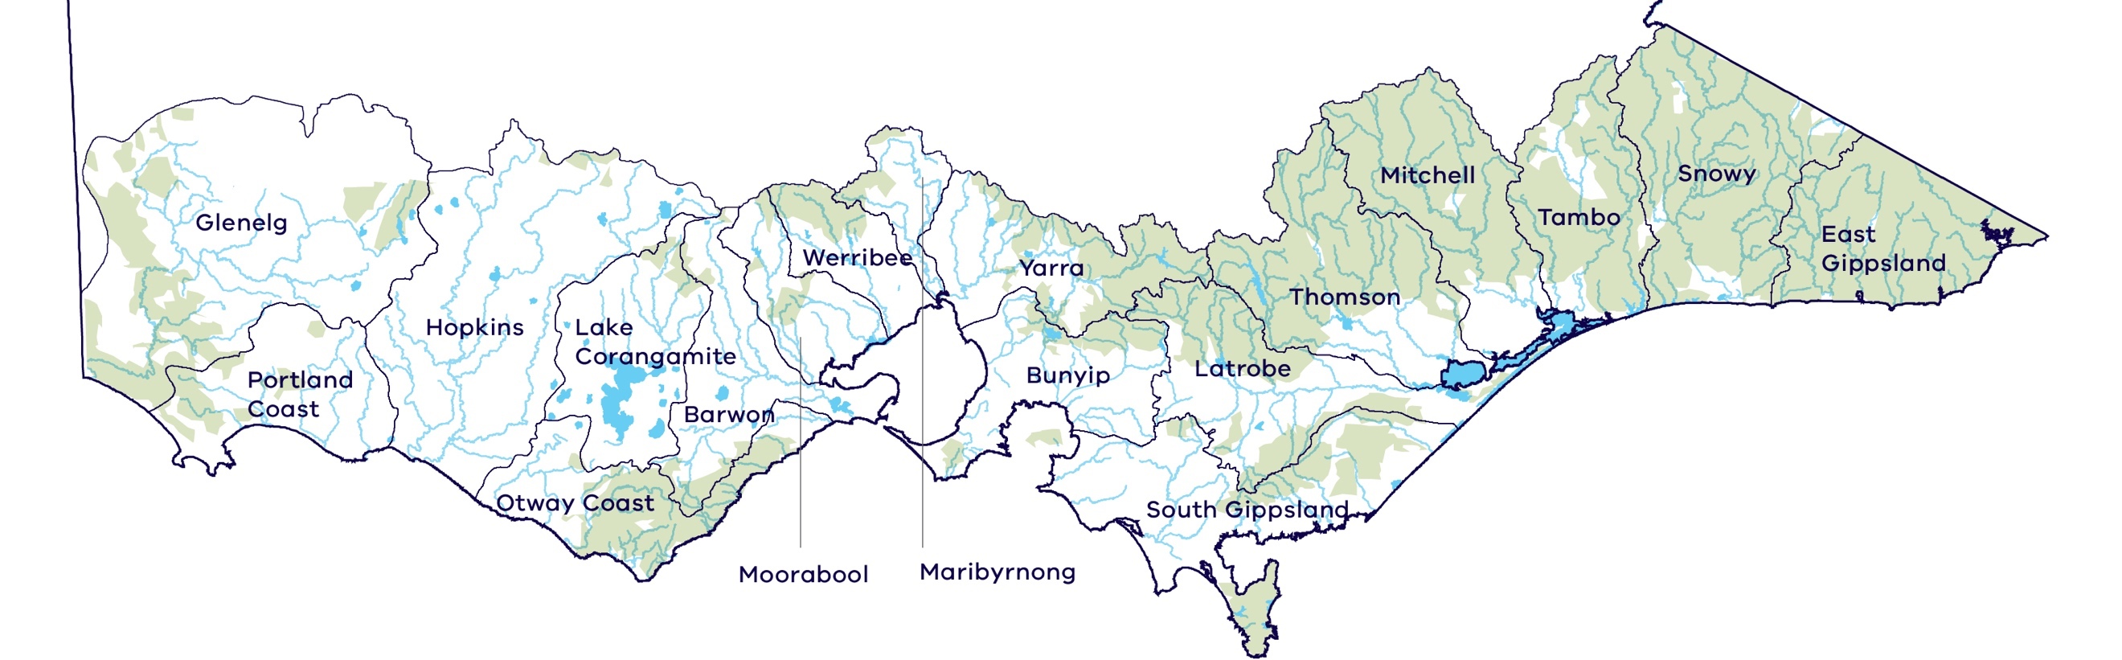

Glenelg
The basin experienced a decline in water availability. Because only a small proportion of available water is for consumptive use, with most going to the environment, there has been no disproportionate impact.
There have been improvements in several ecologically important aspects of the flow regime due, in part, to the use of water available under the environmental entitlement to create environmental flows. The improvement in water regimes in reaches that received managed environmental flows occurred despite an overall decline in water availability.
The improvement in flows was matched to improvements in several water quality indicators strongly linked to flows, such as turbidity and total phosphorus. However, no long-term flow-related trends were seen in aquatic animal indicators. Overall, the findings for waterway health are inconclusive.

Portland Coast
Most rivers in the basin experienced a decline in water availability. Because only a small proportion of available water is for consumptive use, with most going to the environment, there has been no disproportionate impact.
There have been improvements in ecologically important aspects of the flow regime, and minor improvements in some water quality indicators, although no trend was detected in aquatic animal indicators of waterway health. Overall, the findings for waterway health are inconclusive.

Hopkins
The basin experienced a decline in water availability. Because only a small proportion of available water is for consumptive use, with most going to the environment, there has been no disproportionate impact.
There have been moderate declines in ecologically important aspects of the flow regime in the Merri River. There were large differences in the trends in waterway health indicators between rivers in this basin, making it difficult to provide a basin-wide assessment. Overall, the findings for waterway health are inconclusive.

Maribyrnong
The Maribyrnong basin has experienced one of the largest declines in inflows across Victoria (17 per cent). Whether or not the environment’s share of available water has declined depends on how much of the urban water supply is sourced from within the Maribyrnong basin and how much is sourced from elsewhere.
Overall, the findings for waterway health are inconclusive.

Lake Corangamite
The Lake Corangamite basin experienced a decline in water availability, particularly in the Woady Yaloak River. There has been a decline in water available for consumptive use and the environment due to changes in climate. Because only a small proportion of available water is for consumptive use, with most going to the environment, there has been no disproportionate impact.
There have been severe declines in ecologically important aspects of the flow regime, with an increase in salinity strongly linked to flow. However, the limited availability of data meant that overall the findings for waterway health are inconclusive.

Otway Coast
Most rivers in the basin experienced a decline in water availability. However, the Otway Coast is the only basin in southern Victoria where the volume of water available to the environment has increased. This is because the amount of water ear-marked for meeting future consumptive demand has been revised down. Because only a small proportion of available water is for consumptive use, with most going to the environment, there has been no disproportionate impact.
There have been moderate declines in ecologically important aspects of the flow regime, particularly summer baseflows. While there were small improvements in some waterway health indicators, overall the findings for waterway health are inconclusive.

Barwon
The basin experienced a decline in water availability. Consumptive users have diversified their water supply options, offsetting the decline in availability. There has been a decline in the amount of water available to the environment, despite the creation of an environmental entitlement, because of a reduction in water available from unregulated inflows. There has been a disproportionate impact on the environment with its share of total resource decreasing from 86 to 84 per cent.
Ecological health indicators since 2011 show mixed results, with a deterioration in dissolved oxygen and salinity, but an improvement in turbidity and total suspended solids, all moderately linked to river flow. Overall, the findings for waterway health are inconclusive.

Moorabool
Waterways in the Moorabool basin experienced a large decline in water availability. Consumptive users have diversified their water supply options, partly offsetting the decline in availability. There has been a large decline in the amount of water available to the environment, despite the creation of an environmental entitlement, because of a reduction in water available from unregulated inflows. There has been a disproportionate impact on the environment, with its share of total resource decreasing from 68 to 63 per cent.
There have been small declines in several ecologically important aspects of the flow regime, which have been ameliorated to some degree by the use of environmental water entitlements. Overall, the findings for waterway health are inconclusive.

Werribee
The basin experienced a decline in water availability. There has been a decline in water available for consumptive use because of changes in climate, although changes in operating rules have helped to mitigate some of this impact. The decline in water available to the environment has been considerable, despite the creation of an environmental entitlement, because of a reduction in water available from spills from storage. There has been a disproportionate impact on the environment, with its share of total resource decreasing from 59 to 51 per cent.
Overall, the findings for waterway health are inconclusive.

Bunyip
The basin experienced a decline in water availability. There has been a decline in water available for consumptive use and for the environment, despite the creation of an environmental water entitlement. The decline in water availability has been shared proportionally between consumptive uses and the environment.
Ecologically important aspects of the flow regime in the Bunyip and Tarago Rivers — the two rivers in this basin with an environmental entitlement — have been maintained. However, overall the findings for waterway health are inconclusive.

Yarra
The basin experienced a decline in water availability. There has been a decline in water available for both consumptive use and the environment due to changes in climate. The decline in water available to the environment has been considerable, despite the creation of an environmental entitlement, because of a reduction in water available from unregulated inflows. There has been a disproportionate impact on the environment, with its share of total resource decreasing from 56 to 50 per cent.
Overall, the findings for waterway health are inconclusive.

Mitchell
The basin experienced a decline in water availability. Because of the small proportion of consumptive use relative to the total water available, there has been no disproportionate impact.
There has been an improvement in some water quality indicators in this time, although these are mostly not associated with flow. Overall, the findings for waterway health are inconclusive.

Tambo
Both the Tambo and Nicholson rivers experienced a decline in water availability. Because only a small proportion of available water in the basin is for consumptive use, with most going to the environment, there has been no disproportionate impact.
There were mixed results for waterway health indicators partly linked to river flow in the basin. Overall, the findings for waterway health are inconclusive.

South Gippsland
Most rivers in the basin have experienced a decline in water availability, with one experiencing a small increase. In most rivers, only a small proportion of available water is for consumptive use, with most going to the environment. Overall, there has been no change in how water is shared between consumptive uses and the environment.
The overall findings for waterway health are inconclusive.

Thomson
Both the Thomson–Macalister and Avon rivers have experienced a decline in water availability. In the Thomson basin, the volume of environmental water entitlements has been increased to meet the environmental water requirements identified by a scientific study. However, the increased volume of environmental entitlements has not changed the proportion of water available for the environment as originally intended, because it has been offset by declines in spills and unregulated inflows. Without water recovery, the environment’s proportion would have declined.
There is good short-term evidence that environmental water in this basin is helping to restore the native fish population, including the threatened Australian grayling. However, overall the findings for waterway health are inconclusive.

Snowy
The assessment only examined change in water flows from the Victorian part of the Snowy basin, where the rivers experienced a decline in water availability. Because only a small proportion of available water is for consumptive use, with most going to the environment, there has been no disproportionate impact.
There has been a deterioration in some water quality indicators, although not all of these are related to flow. Overall, the findings for waterway health are inconclusive.

East Gippsland
All rivers in the basin experienced a decline in water availability. Because only a small proportion of available water is for consumptive use, with most going to the environment, there has been no change in how water is shared.
Overall, there is no conclusive evidence for a flow-related deterioration in waterway health in the basin.

Latrobe
The basin has experienced a decline in water availability. There has been an increase in water available for consumptive use. This is due to the allocation of a previously unallocated share of flows into Blue Rock Reservoir. Water available to the environment has declined, despite the creation of an environmental entitlement, because of a reduction in water available from spills and unregulated inflows. There has been a disproportionate impact on the environment, with its share of total resource decreasing from 79 to 76 per cent.
Overall the findings for waterway health are inconclusive.

East Gippsland Basin

Introduction
The East Gippsland basin covers an area of over 6,000 square kilometres, 75 per cent of which is in the state of Victoria. The basin covers numerous river catchments including the Bemm, Cann, Wingan, Betka and Genoa Rivers, which largely rise in the south eastern parts of the Great Dividing Range and flow into Bass Strait through estuaries and inlets. The East Gippsland basin is predominantly public land, with only a few small freehold areas and townships. Private land represents just 12 per cent of the basin.
The catchments have a high proportion of native vegetation cover with extensive areas of forest and a number of national parks and reserves, including Cape Conran Coastal Park, Bemm River Scenic Reserve, Errinundra National Park, Lind National Park, Coopracambra National Park and Croajingalong National Park. Small areas in the lowlands were cleared for beef and dairy production, and tourism is an important industry.
The climate is cool temperate and influenced by altitude and proximity to the coast. Close to the coast, weather is mild year-round, with rainfall evenly distributed throughout the year. Average rainfall at Cann River township is approximately 1,000 mm/year.
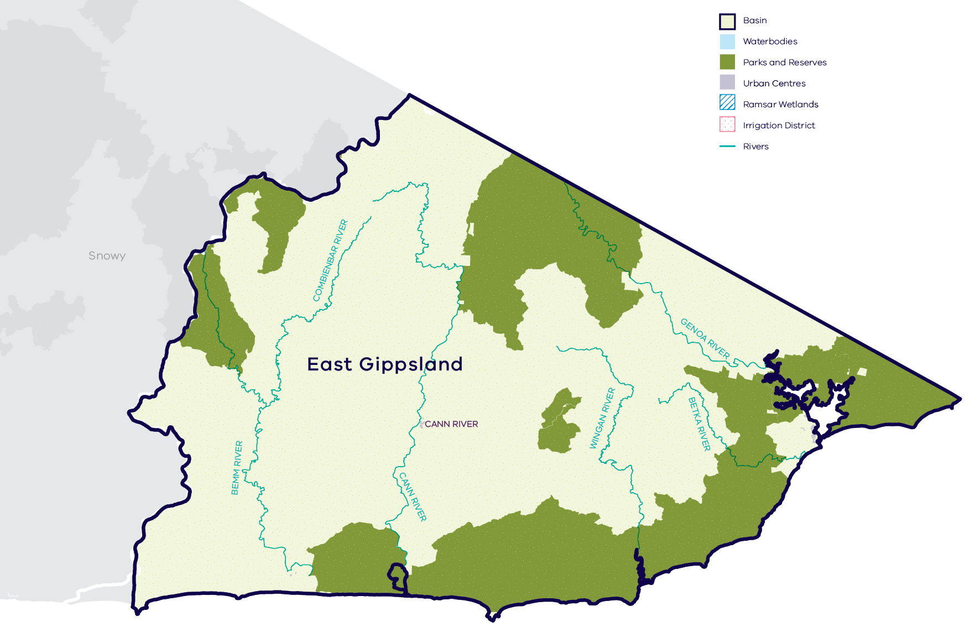
- Map of the East Gippsland basin
Long-term water availability
In 2011, the Gippsland Region Sustainable Water Strategy (SWS) calculated water availability and reviewed the balance of water sharing between consumptive users and the environment in the East Gippsland basin. Surface water availability was calculated for each river based on the average over the full historical record, using the best available data at that time. Improvements in data and computer models since the development of the Gippsland Region SWS have enabled a refined calculation of water availability over that period. The figures presented in the Gippsland Region SWS were summed across all waterways in the basin. The updated SWS estimate of historical long-term average surface water availability for the East Gippsland basin is 819.3 GL/year (Table 1).
To enable trends across different waterways to be compared, results for five individual rivers are presented below:
- Genoa River: Table 2, Figure 2
- Bemm River: Table 3, Figure 3
- Cann River: Table 4, Figure 4
- Betka River: Table 5
- Wingan River: Table 6.
Research indicates that recent decades provide a better representation of current climate than does the full historical record. Recent decades more closely reflect current atmospheric levels of greenhouse gases and have been drier and warmer than the earlier parts of the 20th century. For these reasons, the period from 1975 to the present is thought to better represent long-term water availability under current climatic conditions. It includes a wide range of natural climate variability — the severe Millennium Drought and wet years. In the East Gippsland basin, there has been a reduction in water availability across all river systems assessed. The total average water availability for East Gippsland basin over this time is 747.3GL/year, a decline of 9 per cent compared with historical water availability. The calculated decline is smaller in Bemm River and Wingan River than for the other rivers because the historical record used for the SWS was relatively shorter and more recent, and thus had a greater overlap with the period used for the LTWRA.
The period since 1997 shows a further decline in surface water availability (Figure 2; Figure 3; Figure 4), however, this period is heavily influenced by the Millennium Drought. The drier conditions experienced since 1997 may be due to natural climate variability. These years may also represent ongoing conditions due to climate change, however, it is too soon to know if this is the case.
While climate is the primary driver of the decline in water flows into the East Gippsland basin, other potential contributing factors have been assessed:
- Interception by domestic and stock dams is not significant due to small numbers of these dams in the catchment.
- There is no evidence of significant land-use change to more water-intensive activities which may contribute to the total decline.
In addition to surface water, water availability within the East Gippsland basin includes groundwater. Groundwater occurs in the East Gippsland basin in shallow aquifers and in the bedrock. There are no Groundwater Management Areas in the East Gippsland basin. However, East Gippsland Water operates groundwater bores for the town of Mallacoota which are licensed for a total of 0.2 GL/year. This relatively small volume provides an important supplementary supply during summer when flow in the Betka River is low, and holiday makers swell Mallacoota’s population.
Due to low use of groundwater, there are no groundwater observation bores in the basin. Therefore it is not possible to undertake an assessment of long-term groundwater availability in the area.
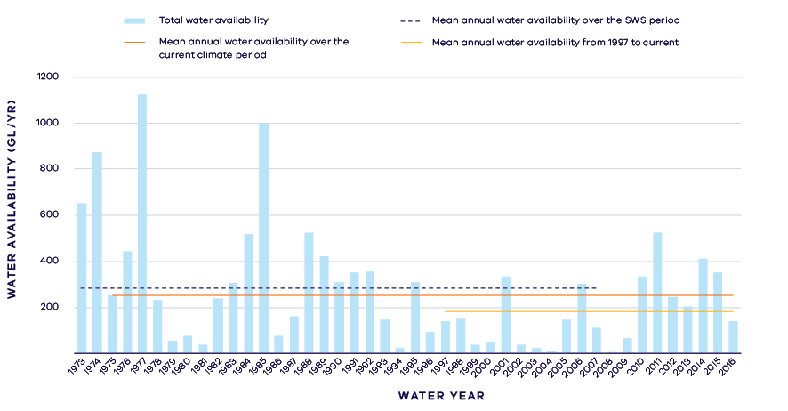
- Surface water availability in the Genoa River
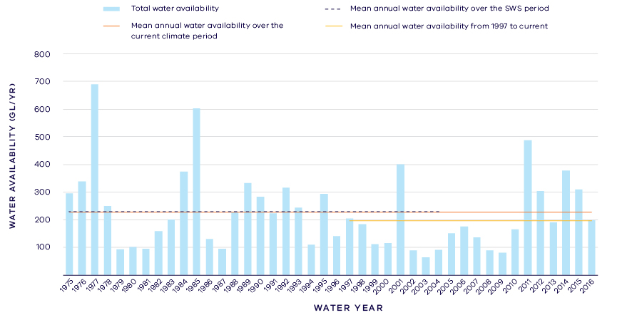
- Surface water availability in the Bemm River
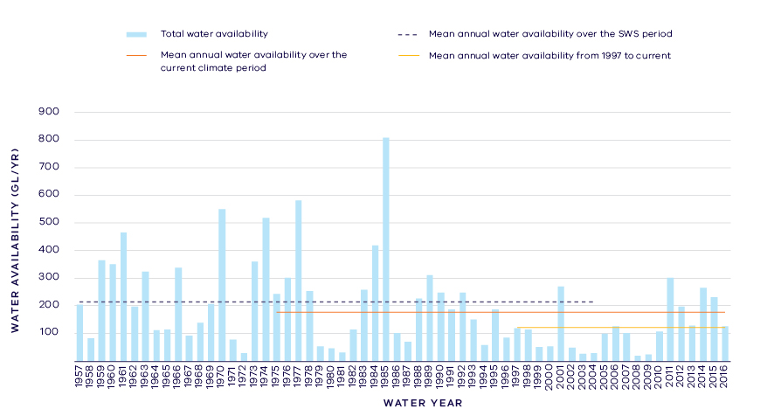
- Surface water availability in the Cann River
- Total long- term surface water availability in the East Gippsland basin (summed across rivers)
 |  |  |  | Change due to:⁵
 | Updated  SWS estimate² | Current climate period³ | Current climate period and sharing arrangements⁴ | Different climate period | Different climate period and water sharing arrangements
Long-term surface water availability¹
Total water  availability (GL/year) | 819.3 | 747.3 | 747.3 | -71.9 | -71.9
Consumptive  (GL/year)⁶ | 1.2 | 1.2 | 1.2 | 0.0 | 0.0
Environment  (GL/year) | 803.2 | 731.2 | 744.7 | -71.9 | -58.5
Not categorised  (GL/year)⁷ | 14.8 | 14.8 | 1.4 | 0.0 | -13.4
Water sharing⁸
Consumptive | 0% | 0% | 0% | 0% | 0%
Environment | 100% | 100% | 100% | 0% | 0%

- Long- term surface water availability in the Genoa River
 |  |  |  | Change due to:⁵
 | Updated SWS estimate² | Current climate period³ | Current climate period and sharing arrangements⁴ | Different climate period | Different climate period and water sharing arrangements
Long-term surface water availability¹
Total water availability (GL/year) | 283.8 | 254.6 | 254.6 | -29.2 | -29.2
Consumptive  (GL/year)⁶ | 0.1 | 0.1 | 0.1 | 0.0 | 0.0
Environment  (GL/year) | 278.9 | 249.8 | 254.0 | -29.2 | -24.9
Not categorised  (GL/year)⁷ | 4.8 | 4.8 | 0.5 | 0.0 | -4.3
Water sharing⁸
Consumptive | 0% | 0% | 0% | 0% | 0%
Environment | 100% | 100% | 100% | 0% | 0%

- Long- term surface water availability in the Bemm River
 |  |  |  | Change due to:⁵
 | Updated SWS estimate² | Current climate period³ | Current climate period and sharing arrangements⁴ | Different climate period | Different climate period and water sharing arrangements
Long-term surface water availability¹
Total water availability (GL/year) | 229.0 | 227.1 | 227.1 | -1.8 | -1.8
Consumptive  (GL/year)⁶ | 0.2 | 0.2 | 0.2 | 0.0 | 0.0
Environment (GL/year) | 224.0 | 222.2 | 226.8 | -1.8 | 2.8
Not categorised  (GL/year⁾⁷ | 4.8 | 4.8 | 0.2 | 0.0 | -4.6
Water sharing⁸
Consumptive | 0% | 0% | 0% | 0% | 0%
Environment | 100% | 100% | 100% | 0% | 0%

- Long- term surface water availability in the Cann River
 |  |  |  | Change due to:⁵
 | Updated SWS estimate² | Current climate period³ | Current climate period and sharing arrangements⁴ | Different climate period | Different climate period and water sharing arrangements
Long-term surface water availability¹
Total water availability (GL/year) | 213.1 | 177.1 | 177.1 | -36.0 | -36.0
Consumptive  (GL/year)⁶ | 0.7 | 0.7 | 0.7 | 0.0 | 0.0
Environment (GL/year) | 209.5 | 173.5 | 176.0 | -36.0 | -33.5
Not categorised  (GL/year)⁷ | 2.9 | 2.9 | 0.4 | 0.0 | -2.4
Water sharing⁸
Consumptive | 0% | 0% | 0% | 0% | 0%
Environment | 100% | 100% | 100% | 0% | 0%

- Long- term surface water availability in the Betka River
 |  |  |  | Change due to:⁵
 | Updated SWS estimate² | Current climate period³ | Current climate period and sharing arrangements⁴ | Different climate period | Different climate period and water sharing arrangements
Long-term surface water availability¹
Total water availability (GL/year) | 19.4 | 16.8 | 16.8 | -2.7 | -2.7
Consumptive  (GL/year)⁶ | 0.3 | 0.3 | 0.3 | 0.0 | 0.0
Environment (GL/year) | 18.6 | 16.0 | 16.4 | -2.7 | -2.3
Not categorised  (GL/year⁾⁷ | 0.5 | 0.5 | 0.1 | 0.0 | 0.4
Water sharing⁸
Consumptive | 0% | 0% | 0% | 0% | 0%
Environment | 100% | 100% | 100% | 0% | 0%

- Long- term surface water availability in the Wingan River
 |  |  |  | Change due to:⁵
 | Updated SWS estimate² | Current climate period³ | Current climate period and sharing arrangements⁴ | Different climate period | Different climate period and water sharing arrangements
Long-term surface water availability¹
Total water availability (GL/year) | 73.9 | 71.7 | 71.7 | -2.3 | -2.3
Consumptive  (GL/year)⁶ | 0.0 | 0.0 | 0.0 | 0.0 | 0.0
Environment (GL/year) | 72.1 | 69.8 | 71.6 | -2.3 | -0.5
Not categorised  (GL/year⁾⁷ | 1.8 | 1.8 | 0.1 | 0.0 | -1.7
Water sharing⁸
Consumptive | 0% | 0% | 0% | 0% | 0%
Environment | 100% | 100% | 100% | 0% | 0%

Notes to tables
- These estimates are long-term averages. Values are rounded to the nearest 0.1 GL. Figures might not add in columns and/or rows, due to rounding. Minor differences in values compared with graphed annual inflows arise from water intercepted by licensed farm dams being excluded from graphed historical inflows.
- The SWS estimate is based on the period 1973 – 2008 for the Genoa River, 1951 – 2005 for the Betka River, 1979 – 2008 for the Wingan River, 1957 – 2005 for the Cann River, and 1975 – 2005 for the Bemm River.
- The current climate period is 1975 – 2017.
- Refer to subsequent sections on Water for Consumptive Use and Water for the Environment for details of any changes in water sharing arrangements.
- Negative values are a decline in water available; positive values are an increase in water available.
- These estimates assume full use of entitlements and include interception by licensed farm dams.
- Not categorised water, such as run-of-river losses and unallocated water that cannot be reasonably considered as being for consumptive users or the environment. Also includes unallocated water available for new winter-fill licences.
- Water sharing is represented as a percentage of the sum of water available for the environment and consumptive use. It excludes available water that was not categorised.

Water for consumptive use
The volume of water allocated for consumptive water use in the East Gippsland basin is very low compared to the total resource available, comprising less than 0.5 per cent of the overall water available on average. There are no major water storages within the basin and entitlements consist primarily of take and use licences to divert water for agriculture, and three bulk entitlements held by East Gippsland Water that are used for urban water supply. Licensed commercial and irrigation farm dams, which have the first access to local runoff, also contribute towards consumptive use in the basin, although there is only a small number of these dams in the East Gippsland basin.
There has been no change in average annual water availability for consumptive use since water availability was assessed for the Gippsland Region SWS (Table 1). This is partly due to the Millennium Drought being taken account of in the both the SWS benchmark of water availability and in the LTWRA assessment period.
Local management rules governing access to water by private diverters were formalised through the publication of the East Gippsland Local Management Plan by Southern Rural Water in 2013. These rules provide a clear statement of water sharing arrangements between private diverters and other users at times of low flow.
Some catchments in the East Gippsland basin have not reached their sustainable diversion limit. This means that water is available during wetter months to be allocated in future to support growth in consumptive use. The Gippsland Region SWS set revised caps on the amount of unallocated surface water available for future winter-fill licences as follows: Genoa (500 ML), Cann (500 ML) and 500 ML total across other catchments. This overall reduction in the sustainable diversion limit across the basin does not represent a reduction in water availability to consumptive users because no one holds an entitlement to that water. Growth in consumptive water demands is limited by the catchments being predominantly covered by forested public land.

Water for the environment
Water can be set aside for the environment through water entitlements, passing flows and other regulatory limits on the water allocated to consumptive users. Under historical climate and system operations at the time of the SWS, most of the water available within the rivers of East Gippsland, 803.2GL/year (Table 1), was set aside for the environment using passing flows and other regulatory limits on the water allocated to consumptive users. There are no specific water entitlements held for the environment in the East Gippsland basin.
Passing flows set aside water for the environment through conditions on bulk entitlements. These conditions specify minimum passing flow requirements at offtakes. The East Gippsland Local Management Plan also specifies a passing flow for the Cann River. On average, passing flows across East Gippsland rivers are 1.5 GL/year and have not changed.
Water is also set aside for the environment through the limits placed on the allocations that can be made to consumptive users. Once all water in the system is allocated, the water remaining in the system is designated to the environment. This is known as ‘above cap water.’ Because this water is only available to the environment after all other users have taken their share, its volume varies with climatic conditions and reduces significantly when conditions become drier. At the time of the SWS, above cap water averaged 801.7 GL/year, but has decreased across the whole basin over the LTWRA assessment period.
In the East Gippsland basin, water is available during wetter months to be allocated in future to support growth in consumptive use. Since the SWS, the winter-fill sustainable diversion limits for several catchments have been revised down. Without the revision to sustainable diversion limits, the reduction in above cap water for the environment would have been greater if new licences had been issued for consumptive use.
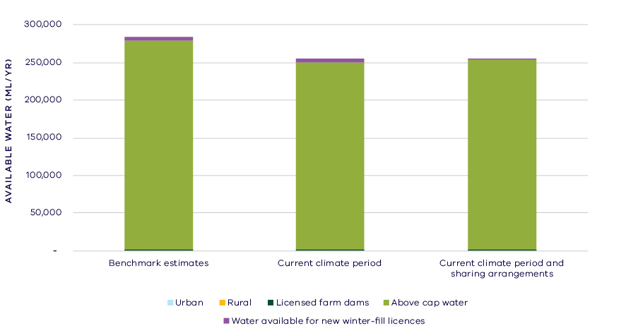
- Changes in water availability for Genoa River
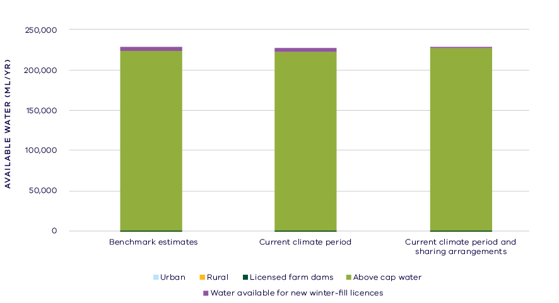
- Changes in water availability for Bemm River
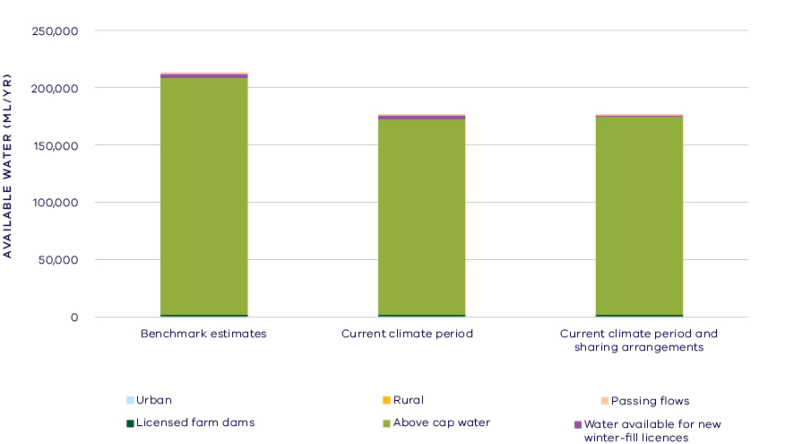
- Changes in water availability for Cann River

Has the decline in long-term water availability been shared equally?
Since water availability in East Gippsland basin was assessed for the Gippsland Region SWS, the long-term average volume of water available to the environment has declined, however consumptive users have not experienced a decline in long-term average water availability. This is due, in part, to the small volume allocated for consumptive use compared to the total inflows to this basin. In all rivers, the environment’s share of the available water is greater than 99 per cent. While there have been changes to the overall volume of water available to the environment, the share of the available resource for the environment remains unchanged (Table 1).

Waterways and their values
The intact native vegetation of the East Gippsland basin and its waterways support high environmental values, and the Genoa, Bemm, Goolengook, Arte and Errinundra Rivers have been listed as Victorian Heritage Rivers in recognition of their outstanding values. The waterways provide habitat for a large number of species including green and golden bell frog, swamp skink, Australian grayling, Cox’s gudgeon, black bittern and white-bellied sea eagles. The community values the waterways in the basin for fishing, canoeing, boating, camping, hiking, sporting activities, picnics, sightseeing and game hunting.
There are no environmental water entitlements held in the East Gippsland basin, due to there being no major storages and proportionally small consumptive use. Other water in the system contributes to environmental outcomes, such as passing flows, which are managed with conditions and rules on extraction. There are also a large number of complementary management practices in place to protect and restore the waterways of the basin. These include bank stabilisation, fencing and revegetation, reduced stock access to waterways, and programs to control pest plants (willows and blackberry). There are also estuary opening protocols in place to ensure that the values of intermittently open and closed coastal lagoons are maintained.

Environmental flow provisions
There is a large body of scientific work linking defined aspects of the flow regime with ecological understanding and impacts to waterway health. In the absence of good long-term ecological data to assess waterway health, some inferences have been drawn from analyses of changes in flow. This should not, however, be considered a direct assessment of waterway health.
There have been several changes in the average river flow conditions in the East Gippsland basin since 2011 (Figure 8). There have been some improvements in annual mean flow, high flows and low flows, which could all be expected to improve river health for instream and riparian vegetation as well as aquatic biota. There has been a decline in “zero flows”, that is there has been a decrease in the amount of time that rivers stop flowing since 2011, which also could be interpreted as a decrease in the threat to river health. The rivers of the East Gippsland basin are unregulated and not subject to large extractions, and so these changes are likely due to natural factors such as gradual recovery from the impact of bushfires on runoff to waterways.
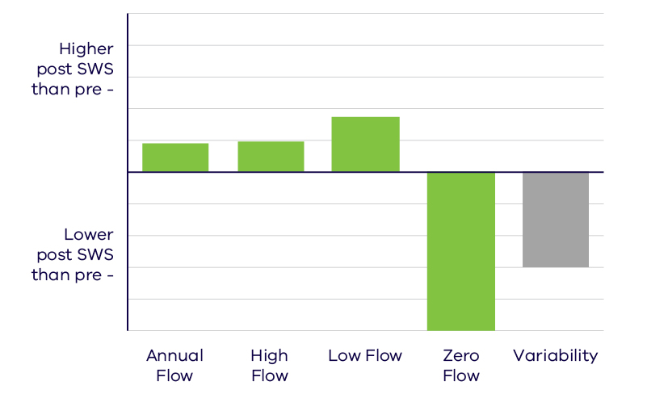
- Average change in ecologically important flow components pre SWS (prior to 2010) and post SWS (2011 – 2017). Green indicates improvement and grey unknown

Waterway health
The waterway health analysis was completed at the river basin scale, primarily because there is less data at site, reach or river scales. Although aggregating data to a basin scale allowed for better detection of statistical trends, the results might not reflect the conditions at individual river reaches within the basin.
There is no accepted simple measure for overall waterway health and while many indicators and associated datasets were considered, only a few met requirements for the Long-Term Water Resource Assessment. Most of the available datasets did not cover a sufficient time period (>20 years) to allow for analysis of changes over a long-term timeframe. The indicators presented cover water quality and macroinvertebrates and are based on the most robust data available. The data were split into three time periods:
- Prior to the LTWRA period — 1990 – 2005
- First part of the LTWRA period — 2006 – 2010. This was the worst section of the Millennium Drought
- Second part of the LTWRA period — 2011 – 2018. Post Millennium Drought.
The data were then analysed to identify any trends over time in the selected indicators. That is, whether various waterway health indicators are improving, deteriorating or there has been no change. So, while it may be possible to report, for example, an improvement in salinity within a river basin, this does not necessarily imply “good” waterway health. This is because 1) the waterways may still be high in salinity, just less so than previously; and 2) other aspects of waterway health might be deteriorating.
The LTWRA examined the impact of flow on waterway health. To this end, the effects of flow were separated from all other factors that can affect waterway health (e.g. bushfire, land use change, rehabilitation works). The individual influences of these other factors on waterway health have not been analysed in this assessment.
There has been no consistent pattern in waterway health indicators in the East Gippsland basin since 2011. As discussed in section 6.2.4 of the Overview Report, there are a number of limitations on interpreting these indicators. The possible impacts of any changes in these individual indicators on other aspects of waterway health are also described in the Overview Report.
There was an improvement in trend in dissolved oxygen (compared to before 2011), but this was not related to flow. There was an improvement in trend in phosphorus and total suspended solids (compared to before 2011) which was partially due to flow changes. There was a deterioration in trend in salinity (compared to before 2011), but this was mostly not linked to flow, and on average, levels remained within State Environment Protection Policy (SEPP) guidelines. There was a deterioration in trend in turbidity (compared to the previous time period) which was linked to changes in flow. There was a deterioration in nitrogen (as indicated by an increase in concentration), but this was not related to changes in the flow regime.
Although the analysis was not developed or implemented to examine factors other than flow, a number of other factors are known to be important in this region. Bushfires (including bushfire recovery), which occur periodically throughout the East Gippsland region, are particularly likely to influence water quality indicators such as total suspended solids and turbidity, and the associated nutrients, as well as influencing the rainfall-runoff relationship and the flow regime waterways experience.
Limited data and high natural variability prevented the detection of any trend in macroinvertebrate indicators.
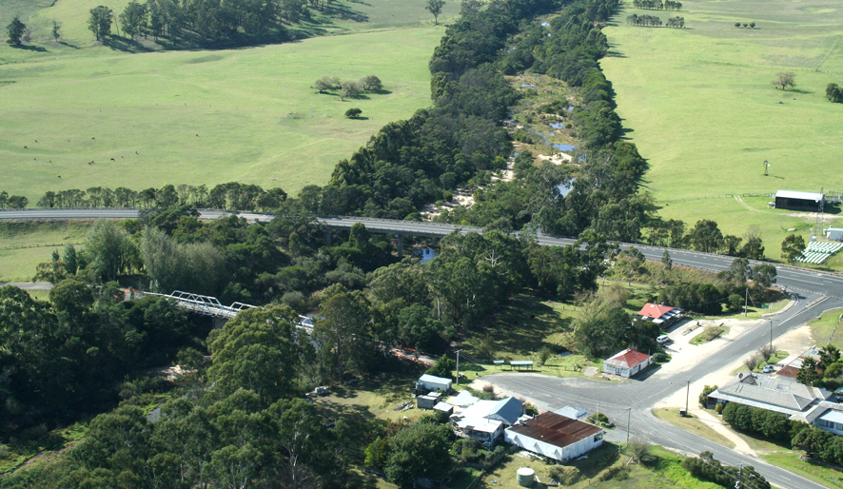
- Genoa Bridge before the historical bridge was destroyed by bushfire on New Year's Eve 2019. Image courtesy of East Gippsland CMA

On-ground achievements: beyond the available data
While the assessment needed to analyse existing datasets to answer the question set by the Water Act, further information could improve this assessment of long-term change in waterway health for reasons related to flow. Such information could come from East Gippsland’s waterways that are largely untouched by human interventions. The catchment remains largely covered in native vegetation and less than 1 per cent of catchment inflows are diverted for consumptive use. This provides a unique opportunity to evaluate “natural” variability in flow regimes and changes due to large scale drivers such as bushfires. Although the long-term assessment has shown a decline in water availability in this basin, there was some improvement in flows in the period from 2011 to early 2018. Future changes in the East Gippsland basin could provide us with valuable information about how our rivers and catchments may alter over time even without significant land use change.

Has waterway health deteriorated for flow-related reasons?
There have been, on average, substantial improvements in aspects of the flow regime with well understood ecological importance in the East Gippsland basin since the release of the Gippsland Region SWS in 2011. While there have been improvements in some water quality indicators in this time, these are only partly associated with river flow. Given the largely natural catchments and low water use, these long-term changes may reflect recovery from the Millennium Drought and the impact of regular bushfires, rather than changes due to direct human intervention. Overall, there is no conclusive evidence for a flow-related deterioration in waterway health in the East Gippsland basin.

Snowy Basin

Introduction
The Snowy basin spans two states: Victoria and New South Wales. The Victorian Snowy basin covers an area of 6,800 square kilometres. The upper parts of the Victorian Snowy basin lie within the Alpine National Park and Snowy River National Park and are covered with native forests. The lower fertile floodplains have been cleared for cattle grazing, dairy farming and vegetable growing. The Snowy River rises on the slopes of Mt Kosciusko and flows into Bass Strait at Marlo, south of Orbost. The Snowy Mountains Scheme has significantly changed the hydrology of the Snowy River. Major tributaries include the Buchan, Rodger, Murrindal, Suggan Buggan, Deddick and Delegate rivers. The Brodribb River was assessed separately from the Snowy River.
The climate is temperate and influenced by altitude and proximity to the coast. Close to the coast, weather is mild year-round, with rainfall evenly distributed throughout the year. Average rainfall at Orbost is approximately 850 mm/year.
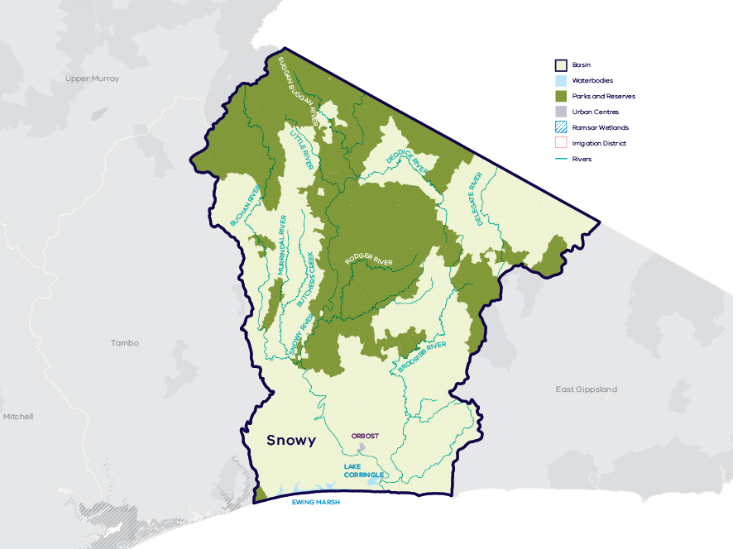
- Map of the Victorian Snowy basin

Long-term water availability
In the upper reaches of the Snowy River in New South Wales, the major dams and diversion weirs of the Snowy Mountains Hydro-electric Scheme collect, store and divert large volumes of its flow west to the Murrumbidgee River and River Murray, generating electricity in the process. The LTWRA focuses on changes in inflows to the Snowy River and tributaries from the Victorian catchments.
In recent years, substantial environmental releases from the Snowy Mountains Hydro-electric Scheme (Lake Jindabyne in New South Wales) have improved environmental flows in the Victorian reaches of the Snowy River (refer to the section on Environmental flow provisions).
In 2011, the Gippsland Region Sustainable Water Strategy (SWS) assessed water availability and reviewed the balance of water sharing between consumptive users and the environment in the Snowy basin, which includes the Snowy and Brodribb Rivers. In the Snowy River, surface water availability was calculated based on the long-term average between 1964 and 2008 and in the Brodribb River availability was calculated based on the long-term average between 1956 and 2008, using the best available data. Improvements in data since the development of the Gippsland Region SWS have enabled a refined calculation of water availability over those periods. The updated SWS estimate of long-term surface water availability is 593.4 GL/year for the Victorian section of the Snowy River (Table 2; Figure 2). This excludes water released from the Snowy Mountains Scheme and other inflows from New South Wales. Historical surface water availability for the Brodribb River is 257.8 GL/year (Table 2; Figure 2).
Research indicates that recent decades provide a better representation of current climate than does the full historical record. Recent decades more closely reflect current atmospheric levels of greenhouse gases and have been drier and warmer than the earlier parts of the 20th century. For these reasons, the period from 1975 to the present is thought to better represent long-term water availability under current climatic conditions. It includes a wide range of natural climate variability — the severe Millennium Drought and wet years. The average total surface water availability for the Victorian Snowy basin over this time is 770.7 GL/year, a decline of 9 per cent compared with historical water availability (Table 1).
The period since 1997 shows a further decline in water availability (Figure 2; Figure 3), however, this period is heavily influenced by the Millennium Drought. The drier conditions experienced since 1997 may be due to natural climate variability. These years may also represent ongoing conditions due to climate change, however it is too soon to know if this is the case.
In addition to surface water, water availability within the Snowy basin includes groundwater. Groundwater occurs in the basin in shallow aquifers and in the bedrock. In the Orbost Groundwater Management Area there is a small number of bores licensed to extract groundwater. Groundwater monitoring began in 2001, because the groundwater assessment requires data prior to 1997, there is insufficient data to perform an assessment of long-term groundwater availability in the area.
Change in climate is the primary driver of the decline in water flows into the Victorian Snowy basin since the SWS period, however other potential contributing factors have been assessed:
- Interception by domestic and stock dams is not significant due to small numbers of these dams in the catchment.
- There is evidence of minor land-use changes to more water-intensive activities which may make a small contribution to the total decline.
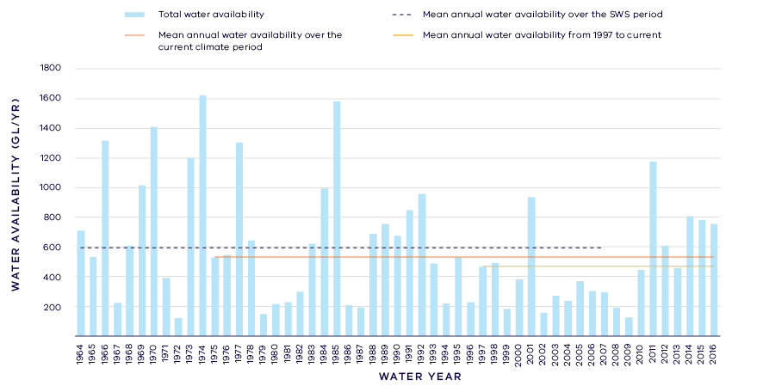
- Surface water availability in the Victorian Snowy River (excluding NSW inflows)
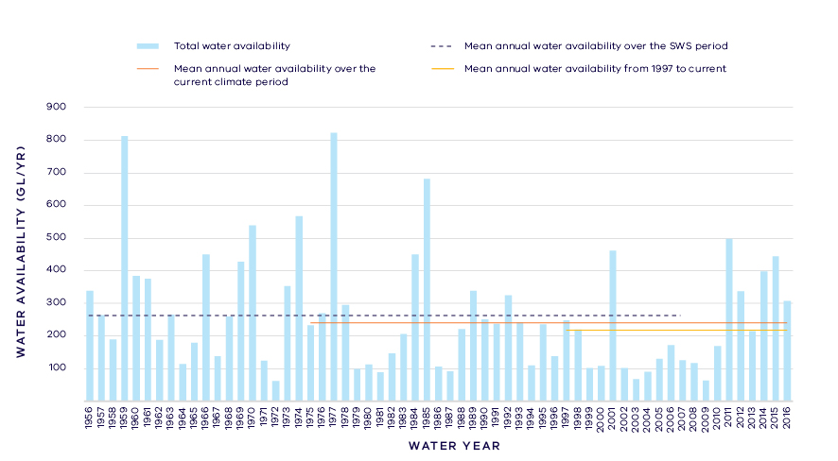
- Surface water availability in the Brodribb River
- Total Long- term surface water availability in the Victorian Snowy basin (summed across rivers)
 |  |  |  | Change due to:⁵
 | Updated SWS estimate² | Current climate period³ | Current climate period and sharing arrangements⁴ | Different climate period | Different climate period and water sharing arrangements
Long-term surface water availability¹
Total water availability (GL/year) | 851.2 | 770.7 | 770.7 | -80.4 | -80.4
Consumptive  (GL/year)⁶ | 4.7 | 4.7 | 4.7 | 0.0 | 0.0
Environment (GL/year) | 846.5 | 766.1 | 765.9 | -80.5 | -80.7
Not categorised  (GL/year)⁷ | 0.0 | 0.0 | 0.2 | 0.0 | 0.2
Water sharing⁸
Consumptive | 1% | 1% | 1% | 0% | 0%
Environment | 99% | 99% | 99% | 0% | 0%

- Long- term surface water availability in the Victorian Snowy River
 |  |  |  | Change due to:⁵
 | Updated SWS estimate² | Current climate period³ | Current climate period and sharing arrangements⁴ | Different climate period | Different climate period and water sharing arrangements
Long-term surface water availability¹
Inflows received from NSW (GL/year)* | 587.7 | 527.4 | 527.4
Total water availability VIC (GL/year) | 593.4 | 531.2 | 531.2 | -62.2 | -62.2
Consumptive VIC  (GL/year)⁶ | 4.1 | 4.2 | 4.2 | 0.0 | 0.0
Environment VIC  (GL/year) | 589.3 | 527.0 | 526.9 | -62.2 | -62.3
Not categorised  (GL/year)⁷ | 0.0 | 0.0 | 0.1 | 0.0 | 0.1
Water sharing⁸
Consumptive | 1% | 1% | 1% | 0% | 0%
Environment | 99% | 99% | 99% | 0% | 0%
* Annual average gauged flow in the Snowy River at the New South Wales-Victoria border, comprising releases from storage together with unregulated inflow from NSW portion of Snowy catchment. This water is not counted in the LTWRA and is provided for context only.
- Long- term surface water availability in the Brodribb River
 |  |  |  | Change due to:⁵
 | Updated SWS estimate² | Current climate period³ | Current climate period and sharing arrangements⁴ | Different climate period | Different climate period and water sharing arrangements
Long-term surface water availability¹
Total water availability (GL/year) | 257.8 | 239.6 | 239.6 | -18.2 | -18.2
Consumptive  (GL/year)⁶ | 0.5 | 0.5 | 0.5 | 0.0 | 0.0
Environment (GL/year) | 257.3 | 239.1 | 239.0 | -18.2 | -18.3
Not categorised  (GL/year)⁷ | 0.0 | 0.0 | 0.1 | 0.0 | 0.1
Water sharing⁸
Consumptive | 0% | 0% | 0% | 0% | 0%
Environment | 100% | 100% | 100% | 0% | 0%

Notes to tables
- These estimates are long-term averages. Values are rounded to the nearest 0.1 GL. Figures might not add in columns and/or rows, due to rounding. Minor differences in values compared with graphed annual average inflows arise from water intercepted by licensed farm dams being excluded from graphed historical inflows.
- The SWS estimate is based on the period 1964 – 2008 for the Snowy River, 1956 – 2008 in the Brodribb River.
- The current climate period is 1975 – 2017.
- Refer to subsequent sections on Water for Consumptive Use and Water for the Environment for details of any changes in water sharing arrangements. Also includes unallocated water available for new winter-fill licences.
- Negative values are a decline in water available; positive values are an increase in water available.
- These estimates assume full use of entitlements and include interception by licensed farm dams.
- Not categorised water, such as run-of-river losses that cannot be reasonably considered as being for consumptive users or the environment. Also includes unallocated water available for new winter-fill licences.
- Water sharing is represented as a percentage of the sum of water available for the environment and consumptive use. It excludes available water that was not categorised.

Water for consumptive use
Less than 1 per cent of the total water available in the Victorian Snowy basin is allocated to consumptive use. Unlike the upper reaches of the Snowy in New South Wales, the Victorian Snowy basin has no major storages and the vast majority of inflows from the Victorian catchments reach Bass Strait. Consumptive use within the basin includes licensed commercial and irrigation farm dams which have the first access to local runoff, licensed diversions for irrigation, and bulk entitlements held by East Gippsland Water to supply the towns of Orbost and Buchan.
In 2004, the Our Water Our Future White Paper established the Victorian Snowy basin was a fully allocated catchment, so no additional consumption was allowed. Then, the Gippsland Region SWS set a new total cap of 0.5 GL on the amount of unallocated surface water available for future winter-fill licences in selected catchments in East Gippsland. The LTWRA assumes that 0.2 GL out of the 0.5 GL is available for future allocation in the Snowy and Brodribb catchments.
With current climate conditions and current water sharing arrangements, average annual water availability to consumptive users has remained the same compared with historical availability at the time of the Gippsland Region SWS (Table 1).

Water for the environment
Only the water available within the Victorian component of the Snowy basin is included in this assessment. However, environmental releases from the Snowy Mountains Hydro-electric Scheme in New South Wales and also the unregulated inflows from the New South Wales portion of the Snowy basin both contribute substantially to flows in the Victorian reaches of the Snowy River, and are shown in Table 2 for completeness.
In the Victorian Snowy basin, water is provided for the environment through passing flows in bulk entitlements and limits placed on extraction by licensed diverters.
Passing flows set aside water for the environment through conditions on bulk entitlements in the Victorian Snowy basin. These conditions specify minimum passing flow requirements at offtakes to be provided for environmental purposes, and are small volumes compared with annual average streamflow.
Minimum flow thresholds below which diversions are banned are set out in the Snowy River Basin: Local Management Plan. These thresholds retain water in the river system that contributes to environmental outcomes. In the Snowy River, 22 GL/year is retained under the threshold.
Water also is set aside for the environment through the limits placed on the allocations that can be made to consumptive users. Once all water in the system is allocated, the water remaining in the system is designated to the environment. This is known as ‘above cap water’. Because this water is only available to the environment after all other users have taken their share, its volume varies with climatic conditions and reduces significantly when conditions become drier. At the time of the SWS, the total average water available for the environment in the Snowy basin was 846.5GL/year. Above cap water availability represented 824.7 GL/year (i.e. the majority of the water for the environment was from above cap water). Overall water availability for the environment has declined by 80.5 GL/year under the current climate, and since passing flows have not changed, all of this change has come from the above cap component.
The obligations on Snowy Hydro Limited to release water to the Snowy River increased in 2002 following changes to the licence and investment by the Victorian, New South Wales and Commonwealth governments to recover water for the health of the Snowy River under the Snowy Water Initiative. Targets for the Snowy Water Initiative included returning 21 per cent of average natural flows to the Snowy River through the implementation of water savings projects in Victorian and New South Wales irrigation systems that receive water from the Snowy scheme. Water recovery projects were completed in June 2012. While the additional environmental water is not accounted for directly under the LTWRA, the additional releases to the Snowy River in New South Wales have contributed to improved environmental flows in the Victorian portion of Snowy (refer to the section on Environmental flow provisions).
Changes to Snowy Mountains Hydro-electric operations are expected if the Snowy 2.0 scheme proceeds, but there are not expected to be any significant changes in the rules governing water releases to the Victorian Snowy basin.
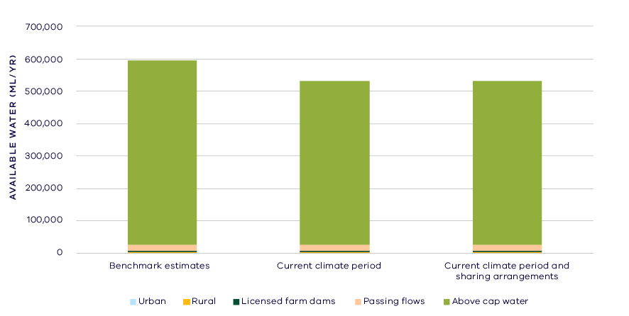
- Changes in water availability in the Victorian Snowy River
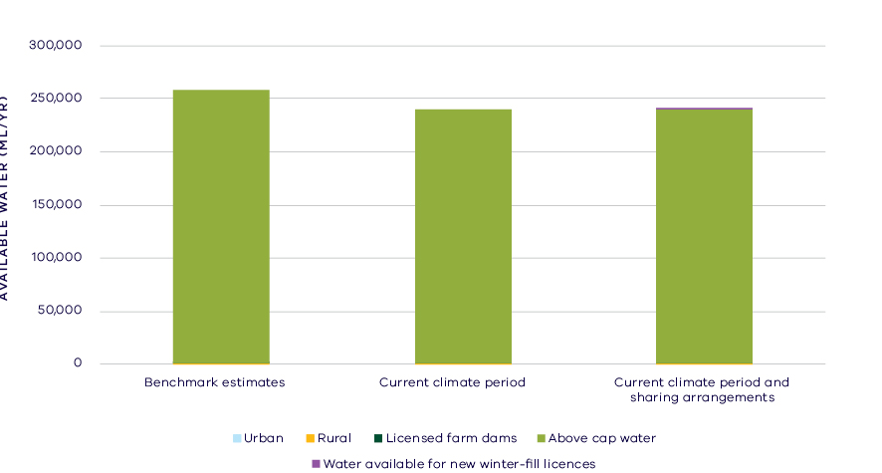
- Changes in water availability in the Brodribb River

Has the decline in long-term water availability been shared equally?
Despite reductions of 9 per cent in overall water availability, changes to climate have not changed the relative sharing of available water between consumptive users or the environment in the Victorian Snowy basin. At the time of the Gippsland Region SWS, consumptive users in Victoria had access to less than 1 per cent of the total resource within Victoria while the environment had access to almost 100 per cent of the total resource (Table 1). Changes in climate and water sharing arrangements have not altered these proportions.

Waterways and their values
The waterways of the upper catchment support significant fish populations including Australian grayling and river blackfish. Significant invertebrates, such as alpine spiny crayfish and eastern freshwater shrimp, have been recorded scattered throughout the system. The lower Snowy River supports significant vegetation communities, the nationally endangered Australasian bittern and the vulnerable green and golden bell frog. The estuarine reaches are home to estuarine perch, Australian bass and black bream.
The community values the waterways of the Victorian Snowy basin for fishing, canoeing, boating, camping, hiking, sporting activities, picnics, sightseeing and game hunting. The Snowy River and its tributaries continue to be an important place for Traditional Owners and Aboriginal Victorians, including the Gunaikurnai.
The aim of environmental flow management in the Snowy River is to restore physical and ecological processes that support aquatic habitats and productivity. The New South Wales Government is ultimately responsible for delivery of environmental flow releases from the Snowy Mountains Hydro-electric Scheme. In recognition of Traditional Owner groups, five high flow releases to the Snowy River in 2017–18 were given Aboriginal names: Djuran (running water), Waawii (water spirit), Billa bidgee kaap (big water season), Wai-garl (river blackfish) and Bundrea Nooruun Bundbararn (waterhole big lizard).

Environmental flow provisions
There is a large body of scientific work linking defined aspects of the flow regime with ecological understanding and impacts to waterway health. In the absence of good long-term ecological data to assess waterway health, some inferences have been drawn from analyses of changes in flow. This should not, however, be considered a direct assessment of waterway health.
There have been several changes in the average river flow conditions in the Victorian Snowy basin since 2011 (Figure 6). There have been moderate to good improvements in annual mean flow and low flows, which could all be expected to improve river health for instream and riparian vegetation as well as aquatic biota. There has been a decline in “zero flows”, that is there has been a decrease in the amount of time that rivers stop flowing since 2011, which also could be interpreted as an improvement in conditions for river health. These improvements partly result from environmental water releases following recovery of environmental water for the Snowy River.
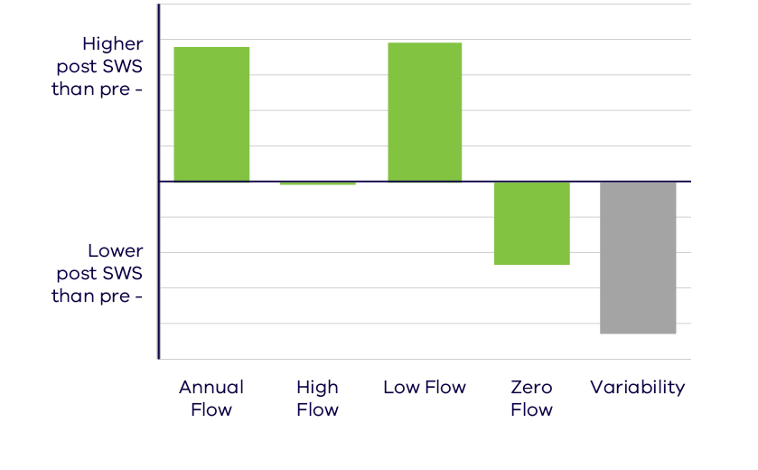
- Average change in ecologically important flow components pre SWS (prior to 2010) and post SWS (2011 – 2017). Green indicates improvement and grey unknown

Waterway health
The waterway health analysis was completed at the river basin scale, primarily because there is less data at site, reach or river scales. Although aggregating data to a basin scale allowed for better detection of statistical trends, the results might not reflect the conditions at individual river reaches within the basin.
There is no accepted simple measure for overall waterway health and while many indicators and associated datasets were considered, only a few met requirements for the Long-Term Water Resource Assessment. Most of the available datasets did not cover a sufficient time period (>20 years) to allow for analysis of changes over a long-term timeframe. The indicators presented cover water quality and macroinvertebrates and are based on the most robust data available. The data were split into three time periods:
- Prior to the LTWRA period — 1990 – 2005
- First part of the LTWRA period — 2006 – 2010. This was the worst section of the Millennium Drought
- Second part of the LTWRA period — 2011 – 2018. Post Millennium Drought.
The data were then analysed to identify any trends over time in the selected indicators. That is, whether various waterway health indicators are improving, deteriorating or unchanged. So, while it may be possible to report, for example, an improvement in salinity within a river basin, this does not necessarily imply “good” waterway health. This is because 1) the waterways may still be high in salinity, just less so than previously; and 2) other aspects of waterway health might be deteriorating.
The Long-Term Water Resource Assessment examined the impact of flow on waterway health. To this end, the effects of flow were separated from all other factors that can affect waterway health (e.g. bushfire, land use change, rehabilitation works). The individual influences of these other factors on waterway health have not been analysed in this assessment.
Despite the improvement in occurrence of ecologically important flow components, there has been a deterioration in several water quality indicators in the Victorian Snowy basin since 2011. However, as discussed in section 6.2.4 of the Overview Report, there are a number of limitations on interpreting these indicators. The possible impacts of any changes in these individual indicators on other aspects of waterway health are also described in the Overview Report.
There were deteriorations in trend in phosphorus and total suspended solids (compared to before 2011) and these changes were partially due to flow changes. There were also deteriorations in trend in salinity and nitrogen from 2011 (compared to before 2011), but these changes were not related to flow. There was an improvement in trend in dissolved oxygen (compared to before 2011) that began in 2006, which was explained by the flow regime. Turbidity has deteriorated since 1990 and is strongly linked to changes in flow.
Although the analysis was not developed or implemented to examine factors other than flow, a number of other factors are known to be important in this region. Bushfires (including bushfire recovery), which occur periodically throughout the East Gippsland region, are particularly likely to influence water quality indicators such as total suspended solids and turbidity, and the associated nutrients, as well as influencing the rainfall-runoff relationship and the flow regime waterways experience.
Limited data and high natural variability prevented detection of any trend in macroinvertebrate indicators.

On-ground achievements: beyond the available data
While the assessment needed to analyse long-term datasets to answer the question set by the Water Act, there are numerous other projects going on around the state that are improving waterway health, but which only began in recent years. In the Snowy basin, one such project is improving estuarine function with environmental flows.
Estuaries need catchment-derived nutrients to maintain and stimulate food webs. In highly regulated systems, such as the Snowy, the loss of medium and large flow pulses can starve the estuarine systems of these essential nutrients. In 2017, scientists investigated the effects of a large environmental flow in the Snowy River on the estuary. They found that the flow increased nutrients in the system and stimulated primary productivity. Flow-on effects through the food web, however, were not detected. The exercise was successful in providing valuable information on the potential for environmental water to maintain and restore estuarine ecosystems.

Has waterway health deteriorated for flow-related reasons?
There have been, on average, substantial improvements in several aspects of the flow regime with well understood ecological importance in the Victorian Snowy basin since the release of the Gippsland Region SWS in 2011. There has, however, been a deterioration in some indicators of waterway health, although not all of these are related to flow. The results should be considered in the context of longer-term trends which indicate that water availability has declined by around 9 per cent. Overall, the findings for waterway health for reasons related to flow are inconclusive.

Tambo Basin

Introduction
The Tambo basin covers an area of 4,200 square kilometres and comprises the Tambo and Nicholson Rivers as well as smaller waterways, such as Boggy Creek and Stony Creek. The major rivers of this basin flow into the Gippsland Lakes Ramsar site; the Nicholson and Tambo Rivers to Lake King, while Boggy and Stony Creeks flow into Lake Tyers. Mining and forestry have historically been significant activities across the basin, and this continues today in the upper reaches of the Tambo River. The upper catchment of the Nicholson River is public land and covered in native forest, while the lower floodplain areas of the basin are cleared for agriculture, mainly sheep and cattle grazing.
The climate is temperate and influenced by altitude and proximity to the coast. Close to the coast, whether is mild year-round, with rainfall evenly distributed throughout the year. The ranges cause significant rainshadow effects in the Tambo basin, where average rainfall at Swifts Creek is 780 mm/year, compared to over 1,000 mm/year in the upper catchment.
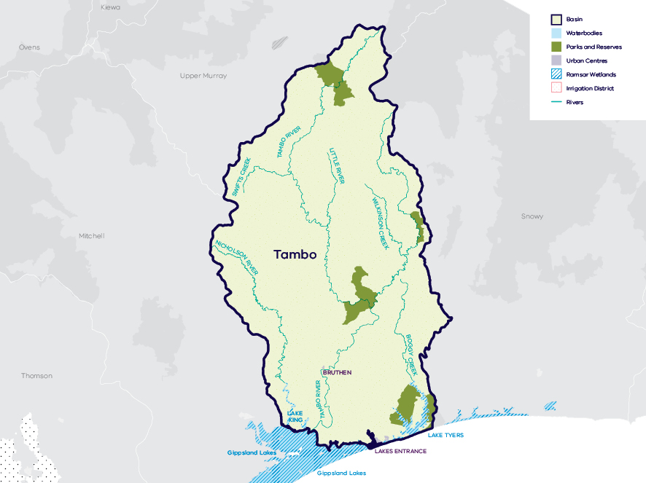
- Map of the Tambo basin

Long-term water availability
In 2011, the Gippsland Region Sustainable Water Strategy (SWS) assessed water availability and reviewed the balance of water sharing between consumptive users and the environment in the Tambo basin. In the Tambo River, surface water availability was calculated based on the long-term average between 1961 and 2008 and in the Nicholson River availability was calculated based on the long-term average between 1955 and 2007. Improvements in data and computer models since the development of the Gippsland Region SWS have enabled a refined calculation of water availability over those periods. The updated historical average surface water availability for the Tambo River is 272.3 GL/year (Table 2; Figure 2) and 51.7 GL/year for the Nicholson River (Table 3; Figure 3).
Research indicates that recent decades provide a better representation of current climate than does the full historical record. Recent decades more closely reflect current atmospheric levels of greenhouse gases and have been drier and warmer than the earlier parts of the 20th century. For these reasons, the period from 1975 to the present is thought to better represent long-term water availability under current climatic conditions. It includes a wide range of natural climate variability — the severe Millennium Drought and wet years. In the Tambo River, the average water availability over this time is 233.4 GL/year, a decline of 14 per cent compared with historical water availability. In the Nicholson River, the average water availability over this time is 44.5 GL/year, a decline of 14 per cent compared with historical water availability.
The period since 1997 shows a further decline in water availability (Figure 2; Figure 3), however, this period is heavily influenced by the Millennium Drought. The drier conditions experienced since 1997 may be due to natural climate variability. These years may also represent ongoing conditions due to climate change, however it is too soon to know if this is the case.
In addition to surface water, groundwater is also available in the Tambo basin. Groundwater primarily occurs in the Tambo basin in shallow aquifers and in the bedrock. Sedimentary and deeper confined aquifers occur at the southern end of the Tambo basin, near the Gippsland Lakes. There are a few observation bores in the alpine region, but no other bores monitoring regional resources in the basin. There is insufficient data to perform an assessment of long-term groundwater availability in the area.
While climate is the primary driver of the decline in surface water flows into the Tambo basin, other potential contributing factors have been assessed:
- Interception by domestic and stock dams is minor due to relatively small numbers of these dams in the catchment.
- There is no evidence of land-use changes to more water-intensive activities which could contribute to the total decline.
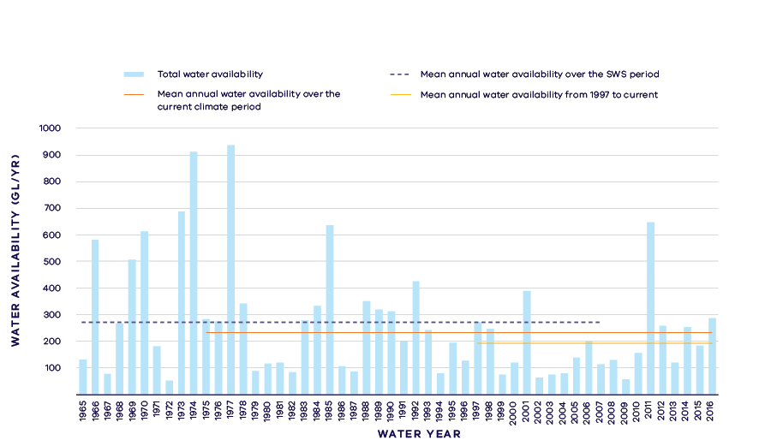
- Surface water availability in the Tambo River
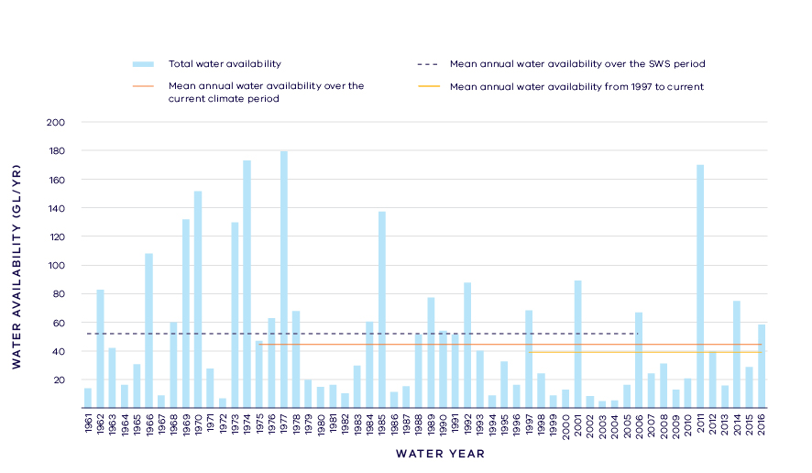
- Surface water availability in the Nicholson River
- Long- term surface water availability in the Tambo basin
 |  |  |  | Change due to:⁵
 | Updated SWS estimate² | Current climate period³ | Current climate period and sharing arrangements⁴ | Different climate period | Different climate period and water sharing arrangements
Long-term surface water availability¹
Total water availability (GL/year) | 324.0 | 277.9 | 277.9 | -46.1 | -46.1
Consumptive  (GL/year)⁶ | 4.3 | 4.2 | 4.2 | 0.0 | 0.0
Environment (GL/year) | 318.7 | 272.5 | 272.0 | -46.2 | -46.7
Not categorised  (GL/year)⁷ | 0.8 | 0.9 | 1.4 | 0.2 | 0.7
Water sharing⁸
Consumptive | 1% | 2% | 2% | 0% | 0%
Environment | 99% | 98% | 98% | 0% | 0%

- Long- term surface water availability in the Tambo River
 |  |  |  | Change due to:⁵
 | Updated SWS estimate² | Current climate period³ | Current climate period and sharing arrangements⁴ | Different climate period | Different climate period and water sharing arrangements⁴
Long-term surface water availability¹
Total water availability (GL/year) | 272.3 | 233.4 | 233.4 | -38.9 | -38.9
Consumptive  (GL/year)⁶ | 4.2 | 4.2 | 4.2 | 0.0 | 0.0
Environment (GL/year) | 267.7 | 228.6 | 227.6 | -39.1 | -40.1
Not categorised  (GL/year)⁷ | 0.3 | 0.4 | 1.4 | 0.2 | 1.2
Water sharing⁸
Consumptive | 2% | 2% | 2% | 0% | 0%
Environment | 98% | 98% | 98% | 0% | 0%

- Long- term surface water availability in the Nicholson River
 |  |  |  | Change due to:⁵
 | Updated SWS estimate² | Current climate period³ | Current climate period and sharing arrangements⁴ | Different climate period | Different climate period and water sharing arrangements⁴
Long-term surface water availability¹
Total water availability (GL/year) | 51.7 | 44.5 | 44.5 | -7.1 | -7.1
Consumptive (GL/year)⁶ | 0.1 | 0.1 | 0.1 | 0.0 | 0.0
Environment (GL/year) | 51.1 | 43.9 | 44.4 | -7.1 | -6.6
Not categorised (GL/year)⁷ | 0.5 | 0.5 | 0.0 | 0.0 | -0.5
Water sharing⁸
Consumptive | 0% | 0% | 0% | 0% | 0%
Environment | 100% | 100% | 100% | 0% | 0%

Notes to tables
- These estimates are long-term averages. Values are rounded to the nearest 0.1 GL. Figures might not add in columns and/or rows, due to rounding.
- The SWS estimate is based on the period 1961 – 2008 for the Tambo River, 1955 – 2007 for the Nicholson River.
- The current climate period is 1975 – 2017.
- Refer to subsequent sections on Water for Consumptive Use and Water for the Environment for details of any changes in water sharing arrangements.
- Negative values are a decline in water available; positive values are an increase in water available.
- These estimates assume full use of entitlements and include interception by licensed farm dams.
- Not categorised water, such as run-of-river losses and unallocated water that cannot be reasonably considered as being for consumptive users or the environment. Also includes unallocated water available for new winter-fill licences.
- Water sharing is represented as a percentage of the sum of water available for the environment and consumptive use. It excludes available water that was not categorised.

Water for consumptive use
In the Tambo basin less than 2 per cent of average annual inflow is allocated to consumptive use. Uses include supply to towns, section 51 take and use licences and registered commercial and irrigation farm dams. East Gippsland Water hold two bulk entitlements within the system; one to supply the town of Swifts Creek and one to supply the town of Nowa Nowa. The supply (Boggy Creek) to Nowa Nowa was decommissioned and a pipeline was constructed in 2008 to connect the town to the Mitchell River system, and the bulk entitlement is therefore unused and was not counted towards consumptive water availability in this assessment.
The only major storage is the Nicholson Dam (on the Nicholson River), which supplied town water to Lakes Entrance until 1995. East Gippsland Water in collaboration with East Gippsland Catchment Management Authority and DELWP are considering removing this dam, which is currently unused.
Changes in climate have not materially changed the average yearly amount of water available to consumptive users in the Tambo River. In the Nicholson River, consumptive use is negligible and changes in climate have had no impact on the amount of water available to the few consumptive users.
Since the SWS, there have been no major changes to water sharing arrangements that impact on the water availability for existing consumptive users. Local management rules governing access to water by private diverters were formalised through Southern Rural Water's 2013 publication of the Tambo River Basin Local Management Plan. These rules provide a clear statement of water sharing arrangements between private diverters and other users at times of low flow. They include rules specific to the Upper and Lower Tambo.
The Gippsland Region SWS highlighted that some water is available in the Tambo basin for new consumptive use in the wetter months under the sustainable diversion limits. As part of a balanced approach to allocating new entitlements in unregulated catchment areas, the cap on the amount of unallocated surface water available for future winter-fill licences was increased to a total of 1.5 GL. For the Nicholson River catchment, the cap was revised down, such that no new winter-fill licences can be issued. In the LTWRA, water ear-marked for future winter-fill entitlements is accounted for as being allocated to consumptive use once a diversion licence has been issued. The increase in the cap on winter-fill licences did not materially change the estimate of water availability for consumptive use because the volume of new winter-fill licences issued is very small.

Water for the environment
Under historical climate and system operations at the time of the SWS, a total of 318.7 GL/year was available to the environment across the Tambo basin (Table 1), using passing flows and other regulatory limits on the water allocated to consumptive users. This was made up of 267.7 GL/year in the Tambo River (Table 2) and 51.1 GL/year in the Nicholson River (Table 3).
Passing flows set aside water for the environment through conditions on bulk entitlements in the Tambo basin. In addition, the Tambo River Basin Local Management Plan has formalised the protection of low flows during periods of water shortage through bans and rostering of consumptive users.
Minimum passing flows average 1.5 GL/year in the Tambo River and 7.1 GL/year in the Nicholson River, and have not declined under the current climate.
Water is also set aside for the environment through the limits placed on the allocations that can be made to consumptive users. Once all water in the system is allocated, the water remaining in the system is designated to the environment. This is known as ‘above cap water’. Because this water is only available to the environment after all other users have taken their share, its volume varies with climatic conditions and reduces significantly when conditions become drier. At the time of the SWS, above cap water availability averaged 266 GL/year in the Tambo River, but has declined by 39 GL/year under current climate. In the Nicholson, the average availability of above cap water has declined by 7 GL/year under current climate.
Since the SWS, revision to the caps on water available for future allocation to winter-fill diversion licences also has changed the volume of above cap water available, although the influence of changes in caps on environmental water availability is small compared with the influence of climate.
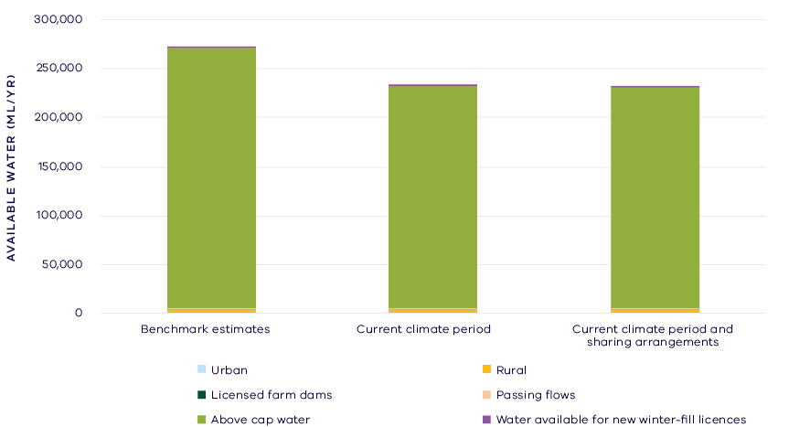
- Changes in water availability – Tambo River (excludes water not categorised)
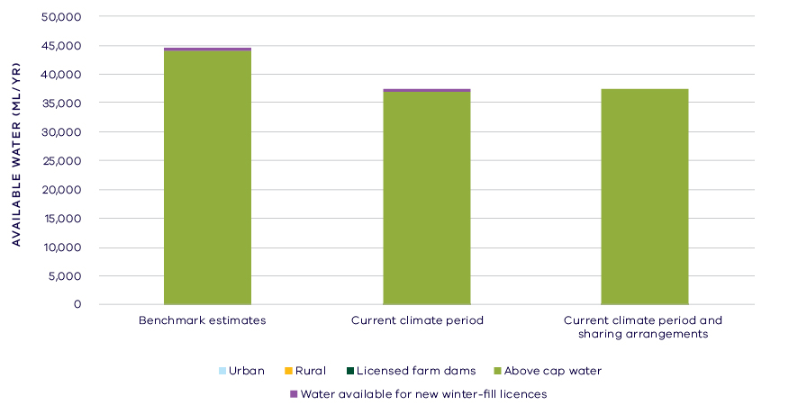
- Changes in water availability in the Nicholson River (excludes water not categorised)
Has the decline in long-term water availability been shared equally?
Changes to climate have changed the amount of water available the environment while the water available to consumptive users has remained comparatively stable. This is due to the relatively small volume allocated for consumptive use compared to the total inflows to this basin. At the time of the Gippsland Region SWS, the overall share of water between allocation to consumptive use and to the environment was 1 per cent and 99 per cent respectively, and shares have not changed materially (Table 1).

Waterways and their values
The waterways of the Tambo basin support significant fish populations including Australian grayling and river blackfish in freshwater reaches and a range of estuarine and marine opportunist species in the lower reaches and Lake Tyers. Lake Tyers is part of the Gippsland Lakes Ramsar site and is an important site for several species of waterbird including nesting little terns and fairy terns. The Tambo River delta is listed as a site of state geomorphological significance. The community values the waterways of the basin and the lakes into which it drains for fishing, canoeing, boating, camping, hiking, sporting activities, picnics, sightseeing and game hunting. The waterways of the Tambo basin continue to be important places for Traditional Owners and Aboriginal Victorians, including the Gunaikurnai.
Although there are no environmental water holdings in the Tambo basin, there is other water in the system that contributes to environmental outcomes (e.g. passing flows), which are primarily managed via rules and conditions on water diversion. There are also a large number of complementary management practices that have been put in place to protect and restore the waterways of the basin. These include bank stabilisation, fencing and revegetation, reduced stock access to waterways, and programs to control pest plants (willows and blackberry). There is also an estuary opening protocol in place for Lake Tyers to ensure that the high values, particularly habitat for beach nesting birds, are maintained.

Environmental flow provisions
There is a large body of scientific work linking defined aspects of the flow regime with ecological understanding and impacts to waterway health. In the absence of good long-term ecological data to assess waterway health, some inferences have been drawn from analyses of changes in flow. This should not, however, be considered a direct assessment of waterway health.
Figure 6 shows change in generalised flow components averaged across four gauges on the Tambo River and one gauge on the Nicholson River. On average there have been small improvements in annual mean flow and high flows and moderate improvements in low flows, which could all be expected to improve river health for instream and riparian vegetation as well as aquatic biota. There has been a decline in “zero flows”, that is, there has been a decrease in the amount of time that rivers stop flowing since 2011. The streamflow gauge records suitable for analysis covered a relatively short period, such that the 13-year Millennium Drought was influential in the pre-SWS period.
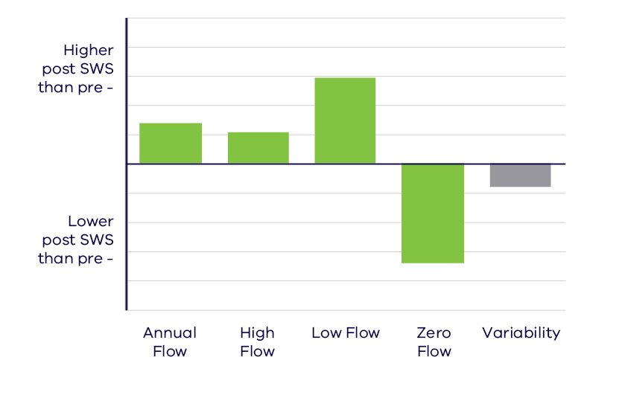
- Average change in ecologically important flow components pre SWS (prior to 2010) and post SWS (2011 – 2017). Green indicates improvement and grey unknown
The rivers of the Tambo basin are largely unregulated and not subject to large extractions, and so these changes are likely due to natural factors, for example the influence of bushfires, such as the Eastern Victoria Great Divide bushfires of 2006 – 2007.

Waterway health
The waterway health analysis was completed at the river basin scale, primarily because there is less data at site, reach or river scales. Although aggregating data to a river basin scale allowed for better detection of statistical trends, the results may not reflect the conditions at individual river reaches.
There is no accepted simple measure for overall waterway health and while many indicators and associated datasets were considered, only a few met requirements for the Long-Term Water Resource Assessment. Most of the available datasets did not cover a sufficient time period (>20 years) to allow for analysis of changes over a long-term timeframe. The indicators presented cover water quality and macroinvertebrates and are based on the most robust data available. The data were split into three time periods:
- Prior to the LTWRA period — 1990 – 2005
- First part of the LTWRA period — 2006 – 2010. This was the worst section of the Millennium Drought
- Second part of the LTWRA period — 2011 – 2018. Post Millennium Drought.
The data were then analysed to identify any trends over time in the selected indicators. That is, whether various waterway health indicators are improving, deteriorating or unchanged. So, while it may be possible to report, for example, an improvement in salinity within a river basin, this does not necessarily imply “good” waterway health. This is because 1) the waterways may still be high in salinity, just less so than previously; and 2) other aspects of waterway health might be deteriorating.
The Long-Term Water Resource Assessment examined the impact of flow on waterway health. To this end, the effects of flow were separated from all other factors that can affect waterway health (e.g. bushfire, land use change, rehabilitation works). The individual influences of these other factors on waterway health have not been analysed in this assessment.
There has been no consistent pattern in waterway health indicators in the Tambo basin since 2011. As discussed in section 6.2.4 of the Overview Report, there are a number of limitations on interpreting these indicators. The possible impacts of any changes in these individual indicators on other aspects of waterway health are also described in the Overview Report.
There was an improvement in trend in dissolved oxygen and phosphorus (compared to before 2011), and this was partly related to changes in flow. There was a deterioration in trend in salinity (compared to before 2011), and this was partially related to changes in flow, however on average, levels remained within SEPP guidelines. There was an improvement in nitrogen which was partly due to changes in flow. There was an increase in total suspended solids which was partly related to flow.
Although the analysis was not developed or implemented to examine factors other than flow, a number of other factors are known to be important in this region. Bushfires (including bushfire recovery), which occur periodically throughout the East Gippsland region, are particularly likely to influence water quality indicators such as total suspended solids and turbidity, and the associated nutrients, as well as influencing the rainfall-runoff relationship and the flow regime waterways experience.
Limited data and high natural variability prevented detection of any trend in macroinvertebrate indicators.
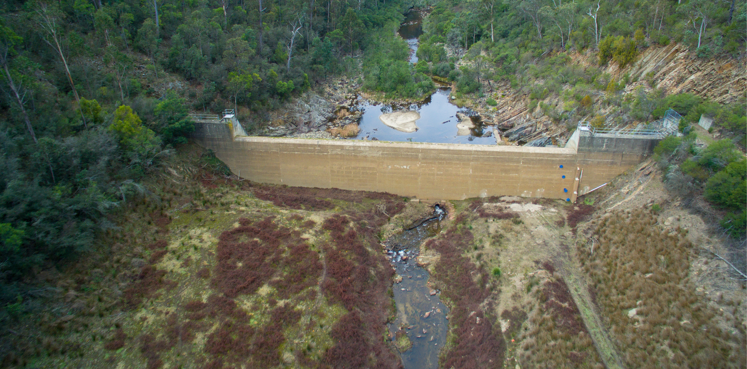
- Aerial image of Nicholson Dam facing downstream. Image courtesy of East Gippsland CMA

On-ground achievements: beyond the available data
While the assessment analysed long-term datasets to answer the question set by the Water Act, there are also opportunities to improve waterway health in the future. In the Tambo basin, one such project could be the removal of Nicholson River Dam (Figure 7).
While there are no plans yet in place, there have been investigations into the removal of the 640 ML Nicholson River Dam, which was originally commissioned in 1977 for urban water supply but is no longer used. Removing the dam from the Nicholson River would provide a unique opportunity to restore one of Victoria’s rivers to near natural condition.
The upper catchment of the Nicholson River is largely undisturbed and is managed as State Forest. Following removal, there would be unrestricted connectivity along the river between the Gippsland Lakes and the upper catchment allowing for free movement of migratory fish.
Removal of the dam would also be expected to restore habitat complexity in the downstream river reaches, through restoring sediment regimes and decreasing terrestrial vegetation encroachment into the river bed. This would benefit riverine plants, fish, invertebrates, frogs, platypus and rakali. Restoration of the Nicholson River to natural condition also has the potential to increase tourist visitation from recreational fishing, kayaking and beside water recreation such as bush walking, picnicking and bird watching; with associated benefits to the local economy.

Has waterway health deteriorated for flow-related reasons?
There have been, on average, improvements in aspects of the flow regime with well understood ecological importance since the release of the Gippsland Region SWS in 2011, despite an overall longer-term reduction in water availability across the basin. There were mixed results for waterway health indicators linked to river flow in the Tambo basin. Overall, the findings for waterway health for reasons related to flow are inconclusive.

Mitchell Basin

Introduction
The Mitchell River rises in the Great Dividing Range and flows to the Gippsland Lakes south of Bairnsdale. It is the largest unregulated river in Victoria. The basin covers an area of 4,800 square kilometres and includes the major tributaries of the Mitchell River, the Dargo and Wonnangatta Rivers, as well as some separate waterways such as Tom and Forge Creeks.
There are significant wetlands along the Mitchell River Estuary, including Macleod Morass, which forms part of the Gippsland Lakes Ramsar site. The upper catchment is predominantly public land covered in native forest. The lower floodplain of the Mitchell River is richly fertile and productive agricultural land, with the vegetable farms of the Lindenow Flats. The basin includes the urban centre of Bairnsdale and several smaller towns.
The climate is temperate and influenced by altitude and proximity to the coast. Close to the coast, weather is mild year-round, with rainfall evenly distributed throughout the year. The ranges cause significant rain shadow effects in the Mitchell basin, with average annual rainfall in the mid valley at Tabberabbera of 660 mm, compared to over 1,000 mm in the upper catchment.
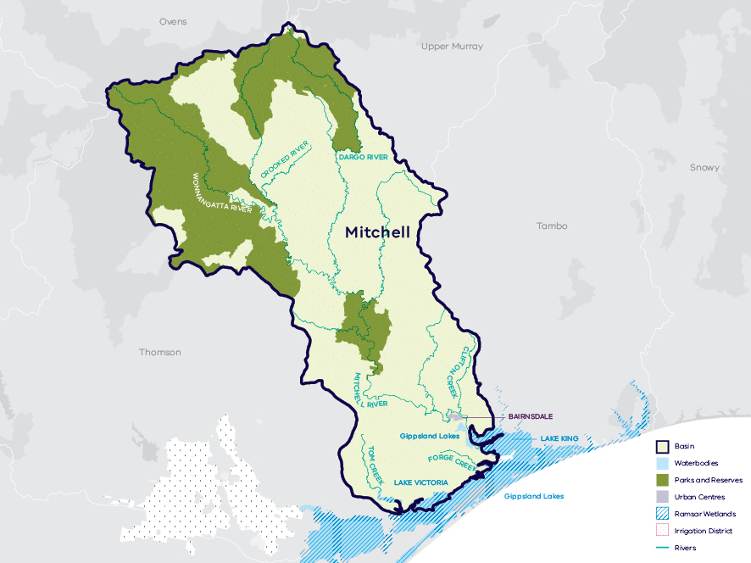
- Map of the Mitchell basin

Long-term water availability
In 2011, the Gippsland Region Sustainable Water Strategy (SWS) assessed water availability and reviewed the balance of water sharing between consumptive users and the environment in the Mitchell basin. Surface water availability was calculated based on the long-term average between 1955 and 2007, using the best available data. Improvements in data and computer models since the development of the Gippsland Region SWS have enabled a refined calculation of water availability over that period. The updated historical average surface water availability for the Mitchell River is 882.1 GL/year (Table 1; Figure 2).
Research indicates that recent decades provide a better representation of current climate than does the full historical record. Recent decades more closely reflect current atmospheric levels of greenhouse gases and have been drier and warmer than the earlier parts of the 20th century. For these reasons, the period from 1975 to the present is thought to better represent long-term water availability under current climatic conditions. It includes a wide range of natural climate variability, including wet years and periods of drought. The average water availability over this time is 777.7 GL/year — a decline of 12 per cent compared with historical water availability.
The period since 1997 shows a further decline in water availability (Figure 2), however, this period is heavily influenced by the Millennium Drought. The drier conditions experienced since 1997 may be due to natural climate variability. These years may also represent ongoing conditions due to climate change, however, it is too soon to know if this is the case.
In addition to surface water, groundwater is available in the Mitchell basin. The amount of groundwater that can be pumped by consumptive users and the amount of water that flows from aquifers into streams and wetlands are both heavily dependent on groundwater levels. If groundwater levels have stayed the same (or increased) there will not have been a reduction in the groundwater available to consumptive users or the environment. If groundwater levels have declined, then either consumptive users or the environment (or both) may have experienced reduced water availability.
Reduced water availability to the environment typically only occurs where groundwater levels have declined in an unconfined aquifer that is connected to a waterway. Reduced availability to consumptive users may occur where groundwater levels have declined in either confined or unconfined aquifers, however no restrictions or loss of access by consumptive users has been noted in this basin. Groundwater in the Mitchell basin predominantly occurs in the unconfined alluvial valley upstream of Bairnsdale in the Wy Yung Groundwater Management Area (GMA). The aquifer’s primary source of recharge is from periodic inundation from the Mitchell River. This assessment identified declines in long-term groundwater levels in this area of between 0.1 and 1 m.
Towards the coast, groundwater occurs in deep, confined aquifers. A long-term decline in groundwater levels was identified in the confined aquifers of the basin. Groundwater in the lower aquifer within the Stratford GMA has declined steadily since the 1970s at a rate of approximately 1 m/year. Declines in the deeper confined aquifers are due to dewatering around the Latrobe Valley coal mines and, near the coast, offshore oil and gas extractions which are connected to the lower aquifer. Impacts on waterways in the Mitchell River basin are unlikely because these confined aquifers are not connected to waterways.
While climate is the primary driver of the decline in surface water availability in the Mitchell basin, other potential contributing factors have been assessed:
- Interception by domestic and stock dams is unlikely to have contributed to the total decline, due to the modest overall number of these dams, which are particularly concentrated in the lower catchment area.
- There is no evidence of land-use changes to more water-intensive activities which could contribute to the decline in water availability.
- Licensed groundwater pumping in Wy Yung GMA has reduced waterway flow in the catchment by approximately 0.6 GL/year which equates to 1 per cent of the reduction in long-term surface water availability.
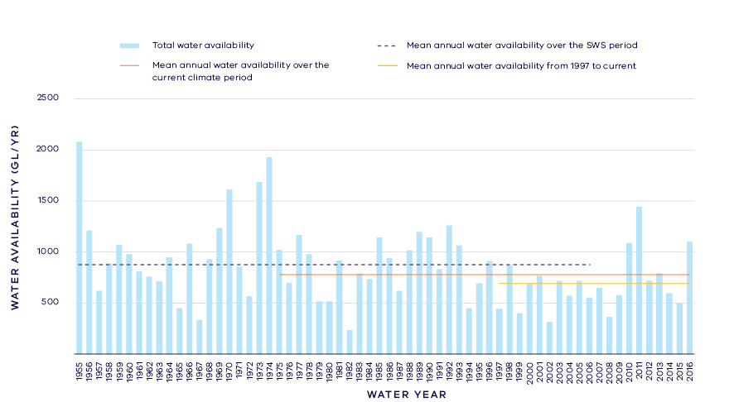
- Surface water availability in the Mitchell River
- Long- term surface water availability in the Mitchell basin
 |  |  |  | Change due to:⁵
 | Updated SWS estimate² | Current climate period³ | Current climate period and sharing arrangements⁴ | Different climate period | Different climate period and water sharing arrangements
Long-term surface water availability¹
Total water availability (GL/year) | 882.1 | 777.7 | 777.7 | -104.4 | -104.4
Consumptive  (GL/year)⁶ | 13.4 | 13.4 | 14.4 | 0.0 | 1.0
Environment (GL/year) | 867.9 | 763.5 | 757.3 | -104.4 | -110.7
Not categorised  (GL/year)⁷ | 0.8 | 0.8 | 6.1 | 0.0 | 5.3
Water sharing⁸
Consumptive | 2% | 2% | 2% | 0% | 0%
Environment | 98% | 98% | 98% | 0% | 0%

Notes to table
- These estimates are long-term averages. Values are rounded to the nearest 0.1 GL. Figures might not add in columns and/or rows, due to rounding. Minor differences in values compared with graphed annual average inflows arise from water intercepted by licensed farm dams being excluded from graphed historical inflows.
- The SWS estimate is based on the period 1955 – 2007.
- The current climate period is 1975 – 2017.
- Refer to subsequent sections on Water for Consumptive Use and Water for the Environment for details of any changes in water sharing arrangements.
- Negative values are a decline in water available; positive values are an increase in water available.
- These estimates assume full use of entitlements and include interception by licensed farm dams.
- Not categorised water, such as run-of-river losses that cannot be reasonable considered as being for consumptive users or the environment. Also includes unallocated water available for new winter-fill licences.
- Water sharing is represented as a percentage of the sum of water available for the environment and consumptive use. It excludes available water that was not categorised.

Water for consumptive use
In the Mitchell basin less than 2 per cent of average annual inflow is allocated to consumptive use. Licensed diverters are the largest user of consumptive water within the basin, supporting the local economy through irrigated agriculture that takes place on the floodplain. Consumptive use also includes licensed commercial and irrigation farm dams.
East Gippsland Water holds a bulk entitlement to provide urban water supply to the towns of Bairnsdale and Paynesville, as well as townships in the neighbouring Tambo basin.
Changes in climate have not reduced the amount of water available to consumptive users compared with historical availability (Table 1; Figure 3).
Changes in water sharing arrangements have improved water availability for consumptive users. The Gippsland Region SWS highlighted that some water is available in the Mitchell basin for new consumptive use in the wetter months. As part of a balanced approach to allocating new entitlements in unregulated catchment areas, the cap on the amount of unallocated surface water available for future winter-fill licences was increased to a total of 6 GL. This new cap took into account the freshwater needs of the Gippsland Lakes. (For LTWRA purposes, this water is “Not categorised” until an entitlement to the water is created.)
Since the SWS, the Woodglen Aquifer Storage and Recovery Scheme has been developed, enabling East Gippsland Water to divert water from the Mitchell River during periods of high flow, and to store that water underground to be used to supply urban demands during summer low-flow periods. The Scheme means that approximately 0.2 GL/year more water is now available for consumptive use. While this additional water is important for underpinning water security for Bairnsdale and surrounding townships, it is a small volume compared with annual streamflow.
Local management rules governing access to water by private diverters were formalised through the Southern Rural Water's 2014 publication of the Mitchell River Local Management Plan. These rules provide a clear statement of water sharing arrangements between private diverters and other users at times of low flow. There are rules specific to irrigation licence holders on the Mitchell River and two of its main tributaries (the Wonnangatta and Dargo Rivers).
Overall, changes to water sharing arrangements have increased the water available for consumptive users. With current climate conditions and current water sharing arrangements, water availability has increased by about 1 GL/year compared with historical availability (Table 1; Figure 3).

Water for the environment
Under historical climate and system operations at the time of the SWS, 867.9 GL/year was set aside for the environment using passing flows and other regulatory limits on the water allocated to consumptive users (Table 1; Figure 3).
Passing flows set aside water for the environment through conditions on bulk entitlements in the Mitchell basin. These conditions specify minimum passing flow requirements at offtakes to be provided for environmental purposes. In the Mitchell basin, the minimum passing flow required varies depending on the season with higher passing flows required in the winter and spring, matching natural flow patterns.
Once water is allocated to all entitlements, the water remaining in the system is assigned to the environment. This is known as ‘above cap water’. Because this water is only available to the environment after all other allocations are met, it is most at risk in drier climatic conditions. At the time of the SWS above cap water averaged 748 GL/year.
Changes in climate have reduced the amount of water available to the environment which, without any changes to water sharing would now have approximately 104.4 GL/year less water compared with historical availability.
Since the SWS, there have been no major changes to water sharing arrangements that impact on the water availability for the environment, aside from the allocation of about 1 GL/year water to consumptive uses and the increased cap on the amount of unallocated water available for winter-fill diversions.
The Long-Term Water Resource Assessment quantifies water available to the environment from natural surface water inflows. It is acknowledged that other water sources provide environmental benefits in the Mitchell river system that are not accounted for here. In particular, recycled water from Bairnsdale is used for environmental watering of Macleod Morass (refer to the section on On-ground achievements for details).
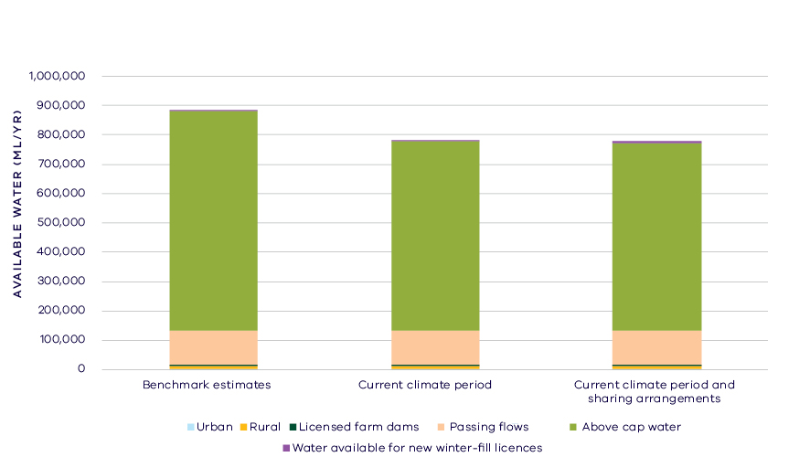
- Changes in water availability – Mitchell basin

Has the decline in long-term water availability been shared equally?
Changes to climate and water management have changed the amount of water available to both consumptive users and the environment. Consumptive users saw no change to water availability due to climate, and have experienced an overall increase in total water availability. The environment has experienced a decline in total water availability.
While there have been changes to the overall volume of water available to consumptive users and the environment, the relative sharing of the available resource remains unchanged. This is because the changes in water sharing are very small compared with the average annual water availability. At the time of the Gippsland Region SWS, consumptive users had access to 2 per cent of the total resource while the environment had access to 98 per cent of the total resource. With changes in climate and water sharing arrangements the share of the total resource available to consumptive users is still 2 per cent and the share for the environment is still 98 per cent.

Waterways and their values
The waterways of the Mitchell basin support significant fish populations including Australian grayling and regionally significant populations of river blackfish and Australian bass. Wetlands associated with the rivers (such as Macleod Morass) are important for waterbirds and frogs, with the nationally threatened Australasian bittern and green and golden bell frog both features of the system. The Mitchell River flows into Jones Bay (part of the Gippsland Lakes) through the “silt jetties” which are a significant geomorphic feature. The community values the river and the lakes into which it flows for fishing, canoeing, boating, camping, hiking, sporting activities, picnics, sightseeing and game hunting. The waterways of the Mitchell basin continue to be an important place for Traditional Owners, the Gunaikurnai.
There are no environmental water holdings in the Mitchell basin, but there is other water in the system that contributes to environmental outcomes (e.g. passing flows), which are primarily managed via rules and conditions on water diversion. There are also a large number of complementary management projects that have been put in place to protect and restore the waterways of the basin, for example there has been heavy investment into implementation of the Lower Mitchell River Rehabilitation Plan. This includes bank stabilisation, fencing and revegetation, reduced stock access to waterways, and programs to control pest plants (willows and blackberry).

Environmental flow provisions
There is a large body of scientific work linking defined aspects of the flow regime with ecological understanding and impacts to waterway health. In the absence of good long-term ecological data to assess waterway health, some inferences have been drawn from analyses of changes in flow. This should not, however, be considered a direct assessment of waterway health.
An assessment of two aspects of the environmental flow recommendations for the Mitchell basin indicated an improvement in summer baseflows and a decrease in any period event flows (which for this system equate to autumn and spring freshes) (Figure 4). Summer baseflows could be expected to maintain water quality and habitat availability during periods of low flow, while the freshes are important in the breeding and dispersal of native fish. While these results reflect the condition in the Mitchell River, an analysis of flow components in the Dargo and Wentworth Rivers indicated improvements since 2011 in annual, high and low flows in both these rivers, highlighting within-basin variability in waterway health.
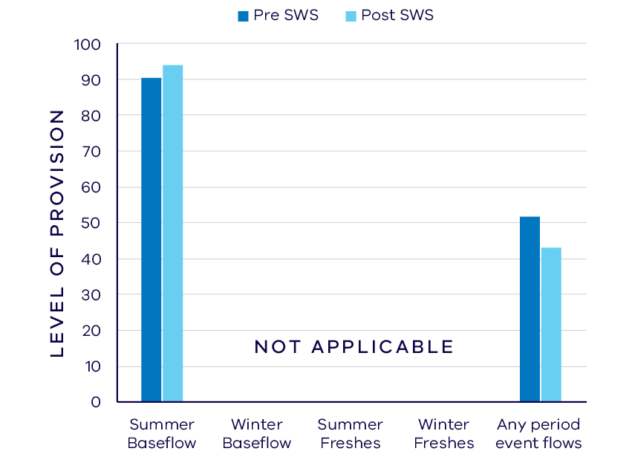
- Average change in ecologically important flow components pre SWS
(1937 – 2010) and post SWS (2011 – 2018)

Waterway health
The waterway health analysis was completed at the river basin scale, primarily because there is less data at site, reach or river scales. Although aggregating data to a basin scale allowed for better detection of statistical trends, the results might not reflect the conditions at individual river reaches.
There is no accepted measure for overall waterway health and while many indicators and associated datasets were considered, only a few met requirements for the Long-Term Water Resource Assessment. That is, most datasets, did not cover a sufficient time period (>20 years) to allow for analysis of changes over a long-term timeframe. What is presented here are the indicators for which the most robust data are available, together with an indication of whether they are improving, deteriorating or there has been no change. So, while we can report, for example, an improvement in salinity within a river basin, this does not necessarily imply “good” waterway health, as: 1. the waterways may still be high in salinity, just less so than previously; and 2. other aspects of waterway health might be deteriorating.
The LTWRA examined the impact of flow on waterway health. To this end, the effects of flow were separated from all other factors that can affect waterway health (e.g. bushfire, land use change, rehabilitation works). The individual influences of these other factors on waterway health have not been analysed in this assessment.
There has been no consistent pattern in waterway health indicators in the Mitchell basin since 2011. As discussed in section 6.2.4 of the Overview Report, there are also a number of limitations on interpreting these indicators. The possible impacts of any changes in these individual indicators on other aspects of waterway health are described in the Overview Report.
There was a deterioration in trend in phosphorus (compared to before 2011), which was partly related to changes in flow. There was also a deterioration in trend in salinity (compared to before 2011), but this was not related to changes in flow, and on average, levels remained within SEPP guidelines.
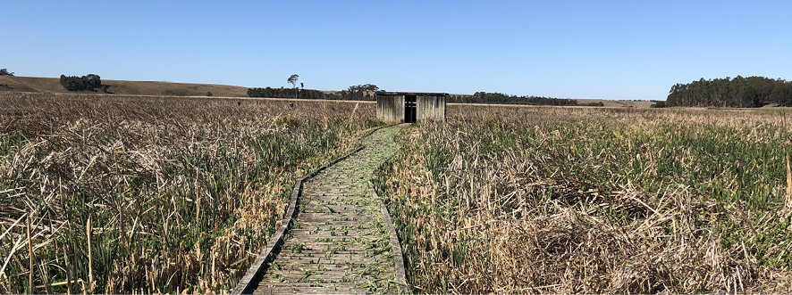
- Birdhide, Macleod Morass. Photo by Andrea Ballinger
There has been an improvement in dissolved oxygen and nitrogen, but this was not related to flow. There were improvements in trends of total suspended solids and turbidity (compared to before 2011) which were partly related to changes in flow.
Although the analysis was not developed or implemented to examine factors other than flow, a number of other factors are known to be important in this region. Bushfires (including bushfire recovery), which occur periodically throughout the East Gippsland region, are particularly likely to influence water quality indicators such as total suspended solids and turbidity, and the associated nutrients, as well as influencing the rainfall-runoff relationship and the flow regime waterways experience.
Limited data and high natural variability prevented detection of any trend in macroinvertebrate indicators.

On-ground achievements: beyond the available data
While the assessment needed to analyse long-term datasets to answer the question set by the Water Act, there are numerous other projects going on around the state that are improving waterway health, but which only began in recent years. In the Mitchell basin, one such project uses recycled water for waterway health outcomes.
Macleod Morass is a partially freshwater wetland located near Bairnsdale and within the Gippsland Lakes Ramsar Site (Figure 5). As well as an abundance of waterbirds and raptors, it is also home to a number of threatened frog species including green and golden bell frog and growling grass frog. It has been subject to increasing salt water intrusion since the opening of the permanent entrance to the sea at Lakes Entrance over 100 years ago. In 2002, East Gippsland Water completed a major construction project, which enables recycled water from the Bairnsdale wastewater treatment plant to be used to help protect the health of the morass. There are now three wetland ‘cells’ and associated structures to control water flows and levels into various sections of the morass to reproduce the natural wetting and drying cycles. Recycled water from the Bairnsdale plant enters the ‘cells’ where it is further filtered to remove bacteria and certain nutrients, such as phosphorous. It is then distributed around the wetland as required helping to maintain the ecological character of the Ramsar site and important habitat for aquatic flora and fauna.

Has waterway health deteriorated for flow-related reasons?
There have been, on average, very small changes in the specific aspects of the flow regime examined in the Mitchell basin since the release of the Gippsland Region SWS in 2011. While there have been improvements in some water quality indicators in this time, these are only partly associated with river flow. Overall, the findings for waterway health with respect to flow are inconclusive.

Thomson Basin

Introduction
The Thomson basin covers an area of 6,400 square kilometres and comprises the Thomson, Macalister and Avon rivers. The rivers rise in the alpine areas of the Great Dividing Range, and the Avon River flows directly into Lake Wellington. The Thomson River has two major tributaries in the upper reaches, the Aberfeldy and Jordan Rivers, and the Macalister River joins with the Thomson about 15 kilometres upstream of Sale. At Sale the Thomson River flows into the Latrobe River. Thomson Reservoir is located on the Thomson River and is the largest water supply for Melbourne. The upper catchment is predominantly National Park or protected water supply catchment and is covered with native forest. The floodplain area has been largely cleared for agriculture and contains the largest irrigation area in southern Victoria — the Macalister Irrigation District. The rivers flow through the outer urban areas of Heyfield, Maffra and Sale.
The climate is temperate, with cool wet winters and warm dry summers. Average annual rainfall varies across the basin from around 1,600 mm/year in high elevation northern areas to just 600 mm/year in the eastern part of the Latrobe Valley near Sale.
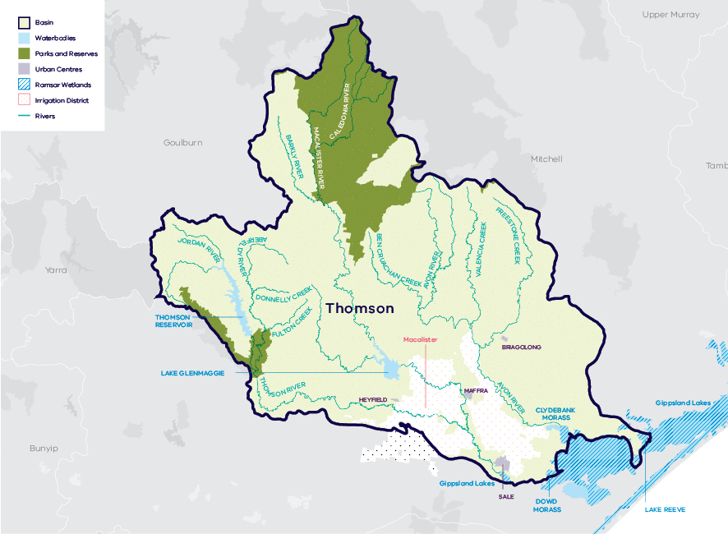
- Map of the Thomson basin

Long-term water availability
In 2011, the Gippsland Region Sustainable Water Strategy (SWS) assessed water availability and reviewed the balance of water sharing between consumptive users and the environment in the Thomson basin. Surface water availability was calculated based on the on the average over the full historical record (1955 to 2008 for the Thomson-Macalister river system). Improvements in data and computer models since the development of the Gippsland Region SWS have enabled a refined calculation of water availability over that period. The updated historical average surface water availability for the Thomson-Macalister is 861.8 GL/year (Table 1; Figure 2) and 173.8 GL/year for the Avon River (Table 3; Figure 3).
Research indicates that recent decades provide a better representation of current climate than does the full historical record. Recent decades more closely reflect current atmospheric levels of greenhouse gases and have been drier and warmer than the earlier parts of the 20th century. For these reasons, the period from 1975 to the present is thought to better represent long-term water availability under current climatic conditions. It includes a wide range of natural climate variability — the severe Millennium Drought and wet years. In the Thomson-Macalister, the average water availability over this time is 749.5 GL/yr, a decline of 13 per cent compared with historical water availability. In the Avon River, the average water availability over this time is 164.6 GL/year, a decline of 5 per cent compared with historical water availability.
The period since 1997 shows a further decline in water availability (Figure 2; Figure 3), however, this period is heavily influenced by the Millennium Drought. The drier conditions experienced since 1997 may be due to natural climate variability. These years may also represent ongoing conditions due to climate change, however it is too soon to know if this is the case.
In addition to surface water, groundwater is available in the Thomson basin. The amount of groundwater that can be pumped by consumptive users and the amount of water that flows from aquifers into streams and wetlands are both heavily dependent on groundwater levels. If groundwater levels have stayed the same (or increased) there will not have been a reduction in the groundwater available to consumptive users or the environment. If groundwater levels have declined, then either consumptive users or the environment (or both) may have experienced reduced water availability.
Reduced water availability to the environment typically only occurs where groundwater levels have declined in an unconfined aquifer that is connected to a waterway. Reduced availability to consumptive users may occur where groundwater levels have declined in either confined or unconfined aquifers. There have been no reports of lost access or restrictions to consumptive users due to declines in groundwater availability.
Groundwater predominantly is accessed in the lower reaches of the basin in the unconfined upper aquifer, as well as the middle and lower confined aquifers. None of these areas is connected to waterways or wetlands in the basin. Unconfined shallow groundwater is managed in the Denison and Wa De Lock Groundwater Management Areas (GMA). Long-term declines in water levels in these areas are low, ranging from
0.1 – 1 m. Localised impacts on streamflow in the Avon and Macalister Rivers may occur during low flow periods when groundwater is used for irrigation. Regional impacts from groundwater extractions from unconfined aquifers have been estimated as part of this study. In the confined middle aquifer, declines were identified in the Sale and Rosedale GMAs of greater than 2 m. Groundwater in the lower aquifer, within the Stratford GMA, has declined steadily since the 1970s at a rate of approximately 1 m/year. This is predominantly due to dewatering around the Latrobe Valley coal mines and, near the coast, offshore oil and gas extractions which are connected to the lower aquifer. The confined aquifers are not connected to waterways, therefore, there
is no likely impact of extractions from confined aquifers on long-term surface water availability.
While climate is the primary driver of the decline in river flows into the Thomson basin, other potential contributing factors have been assessed:
- Interception by domestic and stock dams is not significant due to small numbers of these dams, relative to the size of the basin, and being concentrated towards the bottom of the catchment.
- There is no evidence of significant land-use changes to more water-intensive activities that would contribute to the total decline.
- Licensed groundwater pumping in the Wa De Lock GMA has reduced waterway flow in the Macalister and Avon Rivers by approximately 3.9 and 3.0 GL per year, respectively, which has contributed to the decline in surface water availability.
- Licensed groundwater pumping in the Denison WSPA has reduced waterway flow by approximately 8.3 GL per year, which has contributed to the decline in surface water availability.
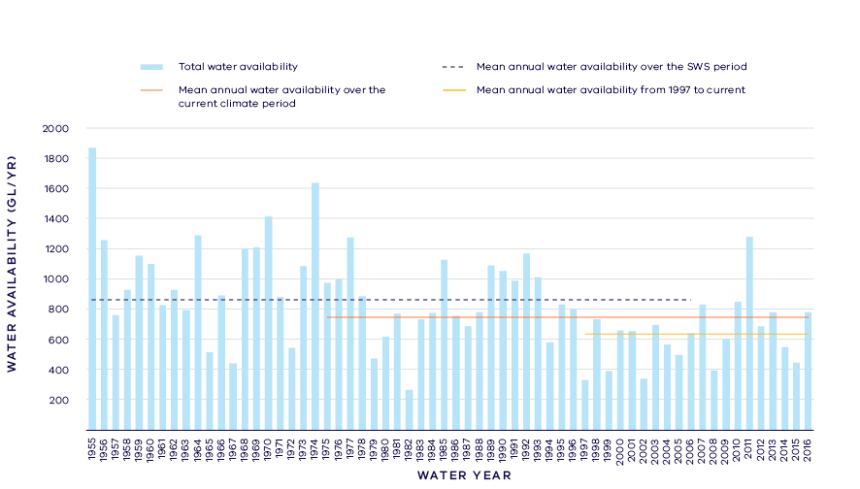
- Surface water availability in the Thomson - Macalister River
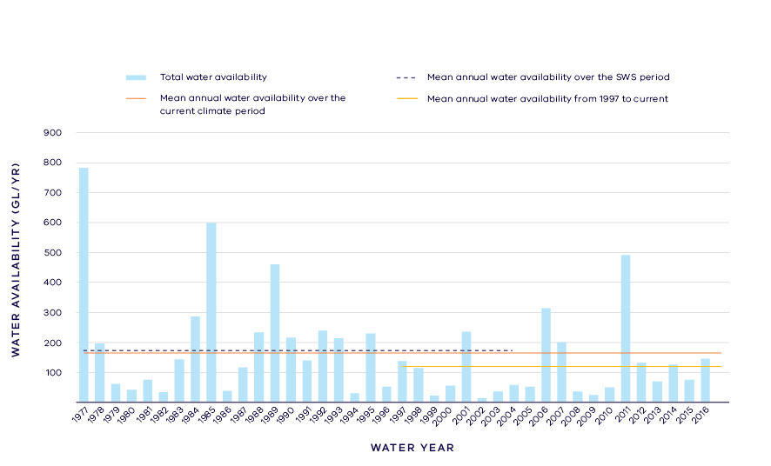
- Surface water availability in the Avon River
- Total long- term surface water availability in the Thomson basin (summed across rivers)
 |  |  |  | Change due to:⁵
 | Updated SWS estimate² | Current climate period³ | Current climate period and sharing arrangements⁴ | Different climate period | Different climate period and water sharing arrangements
Long-term surface water availability¹
Total water availability (GL/year) | 1,035.6 | 914.1 | 914.1 | -121.5 | -121.5
Consumptive  (GL/year)⁶ | 401.7 | 376.2 | 351.4 | -25.5 | -50.3
Environment (GL/year) | 626.6 | 527.2 | 552.5 | -99.3 | -74.0
Not categorised  (GL/year)⁷ | 21.8 | 21.5 | 20.9 | -0.3 | -1.0
Water sharing⁸
Consumptive | 39% | 42% | 39% | 3% | 0%
Environment | 61% | 58% | 61% | -3% | 0%

- Long- term surface water availability in the Thomson-Macalister River
 |  |  |  | Change due to:⁵
 | Updated SWS estimate² | Current climate period³ | Current climate period and sharing arrangements⁴ | Different climate period | Different climate period and water sharing arrangements⁴
Long-term surface water availability¹
Total water availability (GL/year) | 861.8 | 749.5 | 749.5 | -112.4 | -112.4
Consumptive  (GL/year)⁶ | 397.1 | 371.6 | 346.8 | -25.5 | -50.3
Environment (GL/year) | 457.8 | 367.7 | 392.5 | -90.2 | -65.4
Not categorised  (GL/year)⁷ | 21.3 | 21.0 | 20.9 | -0.3 | -0.5
Water sharing⁸
Consumptive | 46% | 50% | 47% | 4% | 1%
Environment | 54% | 50% | 53% | -4% | -1%

- Long- term surface water availability in the Avon River
 |  |  |  | Change due to:⁵
 | Updated SWS estimate² | Current climate period³ | Current climate period and sharing arrangements⁴ | Different climate period | Different climate period and water sharing arrangements⁴
Long-term surface water availability¹
Total water availability (GL/year) | 173.8 | 164.6 | 164.6 | -9.2 | -9.2
Consumptive  (GL/year)⁶ | 4.6 | 4.6 | 4.6 | 0.0 | 0.0
Environment (GL/year) | 168.7 | 159.6 | 160.1 | -9.2 | -8.7
Not categorised  (GL/year)⁷ | 0.5 | 0.5 | 0.0 | 0.0 | -0.5
Water sharing⁸
Consumptive | 3% | 3% | 3% | 0% | 0%
Environment | 97% | 97% | 97% | 0% | 0%

Notes to tables
- These estimates are long-term averages. Values are rounded to the nearest 0.1 GL. Figures might not add in columns and/or rows, due to rounding. Minor differences in values compared with graphs of annual inflows arise from water intercepted by licensed farm dams being excluded from graphed historical inflows.
- The SWS estimate is based on the period 1955 - 2008 from the Thomson-Macalister River, 1977 – 2005 for the Avon River.
- The current climate period is 1975 – 2017
- Refer to subsequent sections on Water for Consumptive Use and Water for the Environment for details of any changes in water sharing arrangements.
- Negative values are a decline in water available; positive values are an increase in water available.
- These estimates assume full use of entitlements and include interception by licensed farm dams.
- Not categorised water, such as run-of-river losses and unallocated water that cannot be reasonably considered as being for consumptive users or the environment.
- Water sharing is represented as a percentage of the sum of water available for the environment and consumptive use. It excludes available water that was not categorised.

Water for consumptive use
In the Thomson basin, consumptive water use comprises urban water supply to Melbourne (and other interconnected urban systems) and local towns, supply to the Macalister Irrigation District, licensed diversions and licensed commercial and irrigation farm dams.
Overall, 50.3 GL/year less water is available to consumptive users from the Thomson basin compared with the time of the Gippsland Region SWS (Table 1). The reduction is due to reduced river flows and changes to the way that water is managed in the Thomson-Macalister river system.
Melbourne Water holds a bulk entitlement for the Thomson River to supply the three metropolitan water corporations (City West Water, South East Water and Yarra Valley Water) and four regional urban water corporations. Primary urban water entitlements are issued to the Greater Yarra System - Thomson River Pool, recognising the integrated nature of Melbourne’s water supply system. The Thomson basin is highly connected to the surrounding river basins through the water grid, enabling water to be transferred to regional towns. The Thomson Reservoir is especially important as a drought reserve for metropolitan Melbourne and other users, including irrigators. Gippsland Water holds bulk entitlements to supply towns in the basin, including Maffra.
On average, 31.7 GL/year less water is available to Melbourne Water compared with the time of the SWS, predominantly due to reduced inflows to storages (Figure 4). Since the SWS, 3.9 per cent of inflows to the Thomson Reservoir have been transferred from consumptive use to the Thomson River environmental bulk entitlement to protect waterway health.
Melbourne’s water supply sources have diversified to include the Victorian Desalination Project, stormwater for non-potable purposes and greater connectivity between supply systems [refer to Yarra basin overview for further details]. The changes have increased the flexibility and reliability of supply to consumptive users. However, these diverse supplies are not directly accounted for in this assessment because they do not relate to water sourced from the Thomson basin’s waterways.
The volume of water available to the towns supplied by Gippsland Water has not declined when compared with the SWS assessment.
Southern Rural Water (SRW) holds a bulk entitlement in the Macalister River and Thomson River, which is used to supply water to the Macalister Irrigation District (MID), as well as to river diverters. SRW’s entitlement is subject to a climatically-variable diversion limit, recognising that the demand for water to support irrigated agriculture varies from year-to-year according to seasonal conditions.
Since the SWS, MID modernisation works have reduced the volume of water lost in delivery channels on route to farms, such as from leaks and outfalls. Some of these water savings were transferred to the Macalister River environmental entitlement. This represents a transfer of water from consumptive use to the environment without loss of on-farm production.
While the total volume of water that is allocated for irrigation supply decreased by 18.6 GL/year on average, the decrease was in the delivery losses and the irrigation outfalls. The volume available for irrigation on-farm (after losses and outfalls) has increased overall, due to some loss savings being converted to water shares and purchased by irrigators. The decline in consumptive water availability in the basin did not result in a long-term decline in irrigation supply at the farm gate.
In the Avon River, where only a relatively small volume is allocated for consumption, there has been no change in water availability to consumptive users.
Local management rules governing access to water by private diverters were formalised through the publication of local management rules for the Thomson basin in 2013 (SRW 2013). These rules provide a clear statement of water sharing arrangements between private diverters and other users at times of low flow.

Water for the environment
Under historical climate and system operations at the time of the SWS, on average 457.8 GL/year was set aside for the environment in the Thomson-Macalister river system using passing flows, policies that placed limits on the allocations to consumptive users and through water allocated to two environmental entitlements (Table 1; Figure 4).
Passing flows set aside water for the environment through conditions on bulk entitlements. These conditions specify minimum passing flow requirements at offtakes and immediately downstream of reservoirs. Passing flows along the Thomson River between the reservoir and Cowwarr Weir are set volumes, and are therefore always provided, regardless of climate conditions. However, these flows are intended to meet both environmental needs and irrigation needs. Consequently, the minimum flows are high in summer when river flows would naturally be lower. Passing flows on the Thomson River at sites downstream of Cowwarr Weir are specified as “or natural”, but with a minimum passing flow of 50 ML/d, which ensures that a share of water is always maintained for the environment, even during very low river flow conditions.
Minimum passing flows in the Macalister River below Maffra Weir are linked to both inflows to Lake Glenmaggie and the volume in held storage for consumptive users. In dry years, passing flow may be halved or matched to inflows into Lake Glenmaggie if inflows drop below 60ML/day.
A limit, called a permissible consumptive volume, has been placed on allocation of water to consumptive users in the Thomson basin. Because this above cap water is only available to the environment after all other users have taken their share, its volume varies with climatic conditions and reduces significantly when conditions become drier.
The volume of above cap water available to the environment has declined by 90.2 GL/year on average in the Thomson-Macalister (Figure 4) and by 9.2 GL/year in the Avon River (Figure 5), compared with historical availability.
At the time of the Gippsland Region SWS, there were two environmental entitlements within the Thomson basin. The Macalister River environmental entitlement was created in 2010 and, at that time, set aside 6.7 GL/year of water from Lake Glenmaggie for the environment. The Thomson River environmental entitlement was created in 2005 and, at the time the SWS was published, set aside the first 10 GL of inflow to the Thomson Reservoir every year for the environment.
Since the SWS an additional 3.9 per cent share of inflows has been allocated to the Thomson River environmental entitlement, and further water savings from the modernisation of the Macalister Irrigation District have been allocated to the Macalister River environmental entitlement.
Despite the increases in water allocated to environmental entitlements, the total volume available to the environment has still declined compared with historical availability. With current climate conditions and current water sharing arrangements, the average volume of water available to the environment in the Thomson-Macalister has decreased by 65.4 GL/year compared with historical availability.
In the Avon River, there have not been any changes in water sharing that significantly impact on water availability.
This part of the Long-Term Water Resource Assessment looks at declines in total water availability. It does not account for the benefits of being able to target environmental flow delivery. Having greater control of environmental water provides opportunities for the Victorian Environmental Water Holder (VEWH) to manage river flows to target specific waterway health outcomes. Two examples of how environmental water is managed in the Thomson-Macalister river system to best meet environmental objectives are:
- The introduction of the flexible management of passing flows provides the opportunity for the VEWH to temporarily reduce the minimum flows and ‘bank” the resultant water savings in storage for discretionary releases to better meet environmental objectives.
- Additional flexibility to manage environmental water, especially to deliver winter and spring freshes, is provided by the VEWH having a unique right to hold over water in Lake Glenmaggie between water years. However, this water is forfeited if the storage spills.
The section on Environmental flow provisions demonstrates how controlled releases from water storages can mimic natural river flows to provide important environmental functions.
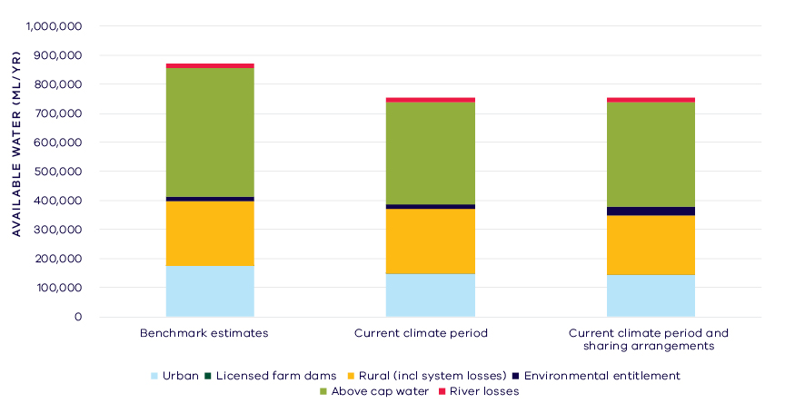
- Changes in water availability in the Thomson-Macalister River
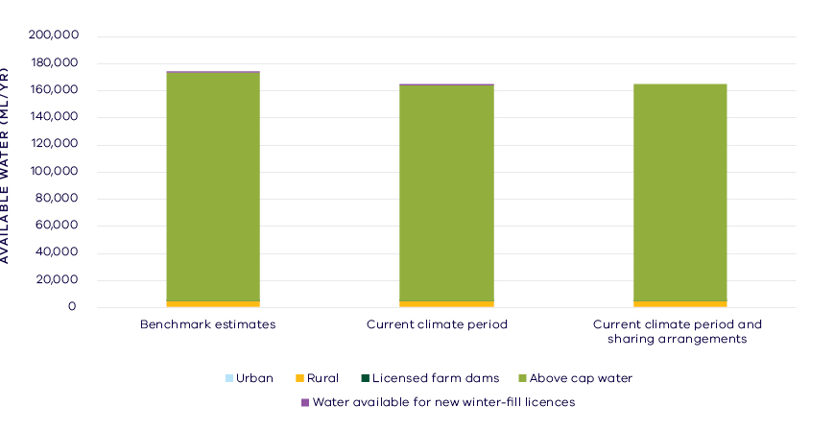
- Changes in water availability in the Avon River

Have declines in long-term surface water availability been shared equally?
For the Thomson basin overall both consumptive users and the environment have experienced a long-term decline in total water availability. While there has been a reduction in the total volume of water available, the share of the available resource between consumptive users and the environment remains unchanged with consumptive users having access to approximately 39 per cent of available water and the environment about 61 per cent (Table 1). Without changes in the way the system is managed, particularly the creation of environmental entitlements, the environment’s share of available water would have declined to 58 per cent.
A range of government initiatives are currently underway which have the potential to affect water sharing in the Thomson basin into the future. This includes the continuation of the MID2030 irrigation modernisation program, and actions under the Melbourne Water System Strategy and the urban water corporations’ urban water strategies. Enhancements to the Victorian water grid are ongoing.

Waterways and their values
The upper reaches of the Thomson River are listed as Heritage River areas and support high value vegetation and aquatic fauna including rakali, platypus and water dragon. The waterways of the Thomson basin are home to significant fish populations with six species of migratory fish, including the Australian grayling. The waterways support important recreational values, with the reaches of the Thomson River between the reservoir and Cowwarr Weir popular for camping, kayaking and canoeing. The waterways of the Thomson basin continue to be important places for Traditional Owners and Aboriginal Victorians, including the Gunaikurnai.
Environmental water is managed in the Thomson basin to protect and enhance three important ecological features:
- Restore populations of native fish, with a specific emphasis on protected species, such as Australian grayling, by providing pool habitat and flows for fish to move and to cue breeding.
- Provide scouring flows to prevent silt build-up within the river bed and improve the quality of in-stream habitat for aquatic plants and animals and to prevent encroachment of terrestrial vegetation into the stream channel.
- Improve the recruitment and growth of native streamside vegetation.

Environmental flow provisions
There is a large body of scientific work linking defined aspects of the flow regime with ecological understanding and impacts to waterway health. In the absence of good long-term ecological data to assess waterway health, some inferences have been drawn from analyses of changes in flow. This should not, however, be considered a direct assessment of waterway health.
Since the release of the Gippsland Region SWS, there has, on average, been an increase in several recommended environmental flow components in the Thomson basin (Figure 6). There have been moderate improvements in the provision of baseflows, which can help to protect against declines in water quality and maintain shallow water habitats. There have also been minor improvements in the provision of winter freshes, which facilitate sand scour of channels, improve vegetation condition and provide opportunities for fish movement. There has been a decline, particularly in the Macalister River, of summer freshes, which provide important breeding cues for several species of native fish.
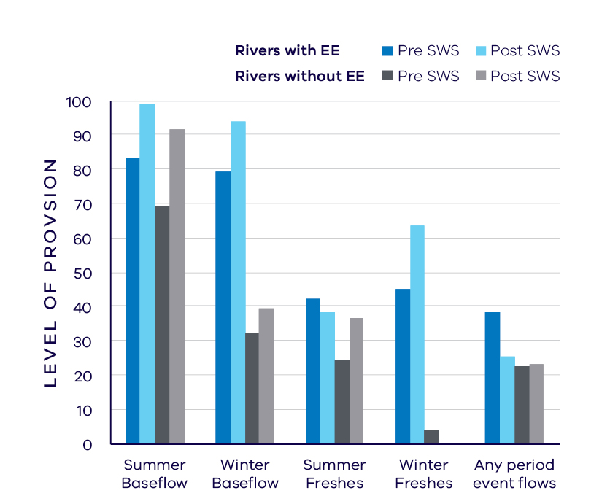
- Average change in ecologically important flow components pre SWS (1963 – 2010) and post SWS (2011 – 2017)

Waterway health
The waterway health analysis was completed at the river basin scale, primarily because there is less data at site, reach or river scales. Although aggregating data to a river basin scale allowed for better detection of statistical trends, the results might not reflect the conditions at individual river reaches.
There is no accepted simple measure for overall waterway health and while many indicators and associated datasets were considered, only a few met requirements for the Long-Term Water Resource Assessment. Most of the available datasets did not cover a sufficient time period (>20 years) to allow for analysis of changes over a long-term timeframe. The indicators presented cover water quality and macroinvertebrates and are based on the most robust data available. The data were split into three time periods:
- Prior to the LTWRA period — 1990 – 2005
- First part of the LTWRA period — 2006 – 2010. This was the worst section of the Millennium Drought
- Second part of the LTWRA period — 2011 – 2018. Post Millennium Drought.
The data were then analysed to identify any trends over time in the selected indicators. That is, whether various waterway health indicators are improving, deteriorating or unchanged. So, while it may be possible to report, for example, an improvement in salinity within a river basin, this does not necessarily imply “good” waterway health. This is because 1) the waterways may still be high in salinity, just less so than previously; and 2) other aspects of waterway health might be deteriorating.
The Long-Term Water Resource Assessment examined the impact of flow on waterway health. To this end, the effects of flow were separated from all other factors that can affect waterway health (e.g. bushfire, land use change, rehabilitation works). The individual influences of these other factors on waterway health have not been analysed in this assessment.
There is no consistent pattern of changes in waterway health indicators in the Thomson basin since 2011. As discussed in section 6.2.4 of the Overview Report, there are also a number of limitations on interpreting these indicators. The possible impacts of any changes in these individual indicators on other aspects of waterway health are described in the Overview Report.
There was an improvement in trend in dissolved oxygen (compared to before 2011), which was strongly linked to river flows. There was a deterioration in trend in salinity (compared to before 2011), which was mostly explained by changes in the flow regime. There was an improvement in trend in nitrogen, and total suspended solids (compared to before 2011) but this was not related to flow changes. However there was a deterioration in trend in phosphorus (compared to before 2011) which was also not related to flow changes. There was an improvement in trend in turbidity (compared to before 2011) which was partly explained by flow changes.
There was an improvement in macroinvertebrates from 2006 and through 2011 to 2018. This improvement, however, was only related to changes in the flow regime to a limited extent.

On-ground achievements: beyond the available data
While the assessment needed to analyse long-term datasets to answer the question set by the Water Act, there are numerous other projects going on around the state that are improving waterway health, but which only began in recent years. In the Thomson basin, one such project is facilitating the migration of Australian grayling with environmental flows.
The Australian grayling is listed as vulnerable under national legislation and has suffered a decline largely due to instream barriers reducing connectivity. Australian grayling are diadromous, that is, they migrate between fresh and marine waters to complete their breeding cycle. Environmental water has been used in the Thomson River to provide seasonal “freshes” in autumn to trigger the migration of adults downstream into the lower reaches to breed, and in spring to trigger the movement of juveniles from the ocean into the rivers and back upstream. Monitoring by the use of tagging, confirmed not only movement of Australian grayling, but long-distance migration (62 to 140 kilometres) on the downstream freshes. Subsequent monitoring of eggs and larvae confirmed that peak egg laying coincides with delivery of environmental water.
Recent completion of the Horseshoe Bend fishway on the Thomson River has opened up over 88km of the upper Thomson and Aberfeldy rivers to native fish such as Australian grayling for the first time in a century.

Has waterway health deteriorated for flow-related reasons?
There have been, on average, moderate improvements in several aspects of the flow regime with well understood ecological importance in the Thomson basin since the release of the Gippsland Region SWS in 2011 and the augmentation of the Thomson and Macalister environmental entitlements. Changes in waterway health indicators are more difficult to interpret. There were only two significant changes strongly related to river flow, an improvement with respect to dissolved oxygen and a deterioration in waterway health as indicated by a rise in salinity. There is good short-term evidence that environmental water in this basin is helping to restore the native fish population, including the threatened Australian grayling. Overall, the findings with respect to deterioration of waterway health for flow-related reasons are inconclusive.

Latrobe Basin

Introduction
The Latrobe basin covers an area of approximately 4,700 square kilometres stretching from the southern slopes of the Yarra Ranges to Lake Wellington, representing around 23 per cent of the total catchment of the Gippsland Lakes. The upper part of the catchment is largely forested through the Strzelecki Ranges and the Great Dividing Range where major tributaries such as the Tanjil, Morwell and Tyers Rivers rise and flow into the Latrobe River. Approximately 70 kilometres from its source, the Latrobe River emerges from the foothills onto the broad floodplain where land use shifts to agriculture and mining/industry and includes the urban areas of the Latrobe Valley of Moe, Morwell and Traralgon. The nation’s largest pulp and paper mill as well as a large proportion of Victoria’s power generation are within this basin.
The climate is temperate, with cool wet winters and warm dry summers. Average annual rainfall varies across the basin from around 1,600 mm/year in high elevation northern areas to 600 mm/year in the eastern part of the Latrobe Valley near Sale.
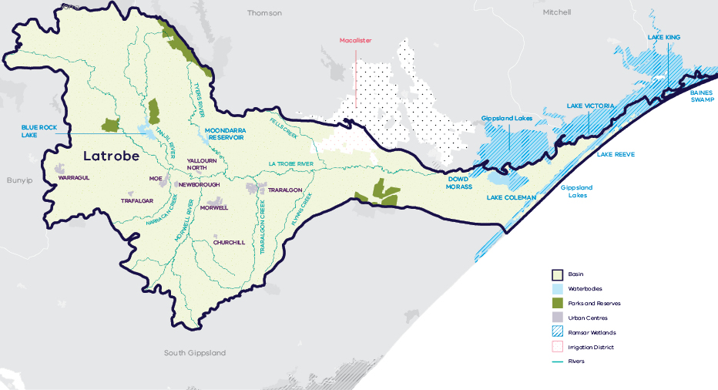
- Map of the Latrobe basin

Long-term water availability
In 2011, the Gippsland Region Sustainable Water Strategy (SWS) assessed water availability and reviewed the balance of water sharing between consumptive users and the environment in the Latrobe basin. Surface water availability was calculated based on the average over the full historical record (1957 to 2007). Improvements in data and computer models since the development of the Gippsland Region SWS have enabled a refined calculation of water availability over that period. The updated historical average surface water availability is 872.2 GL/year (Table 1; Figure 2).
Research indicates that recent decades provide a better representation of current climate than does the full historical record. Recent decades more closely reflect current atmospheric levels of greenhouse gases and have been drier and warmer than the earlier parts of the 20th century. For these reasons, the period from 1975 to the present is thought to better represent long-term water availability under current climatic conditions. It includes a wide range of natural climate variability — the severe Millennium Drought and wet years. The average water availability over this time is 829.8 GL/year, a decline of 5 per cent compared with historical water availability.
The period since 1997 shows a further decline in water availability (Figure 2), however, this period is heavily influenced by the Millennium Drought. The drier conditions experienced since 1997 may be due to natural climate variability. These years may also represent ongoing conditions due to climate change, however, it is too soon to know if this is the case.
In addition to surface-water, water availability within the Latrobe basin includes groundwater. Changes in groundwater availability are measured as long-term changes in groundwater levels. Long-term changes in groundwater levels were assessed in areas of the Latrobe basin where there are sufficient groundwater level monitoring data. In the east of the basin, this corresponds with the Denison Groundwater Management Area (GMA) where a long-term decline of less than 1 m has occurred in the upper aquifer. Groundwater levels in the deep confined aquifers have declined in some areas by > 2 m. This is observed in the west of the basin which corresponds with the Moe GMA and the area towards the coast which is covered by the Stratford GMA.
Shallow groundwater levels in the basin are also modified around the Latrobe Valley coal mines where local declines in water levels are likely to have occurred. Groundwater levels have declined in the deep aquifers associated with groundwater depressurisation of the Latrobe Valley coal mines. Groundwater in the deep aquifers is not connected to waterways and therefore, these declines are unlikely to have contributed to declining flows in rivers and streams.
While climate is the primary driver of the decline in water flows into the Latrobe basin, other potential contributing factors have been assessed:
- Interception by domestic and stock dams may have contributed to the decline in surface water availability.
- There is evidence of large-scale land-use changes to more water-intensive activities, such as forestry plantations, which is likely to have contributed to the total decline.
- Licensed groundwater pumping has reduced waterway flow across the basin by less than 0.1 GL/year in Moe GMA, which equates to a small proportion of the total reduction in long-term surface water availability.
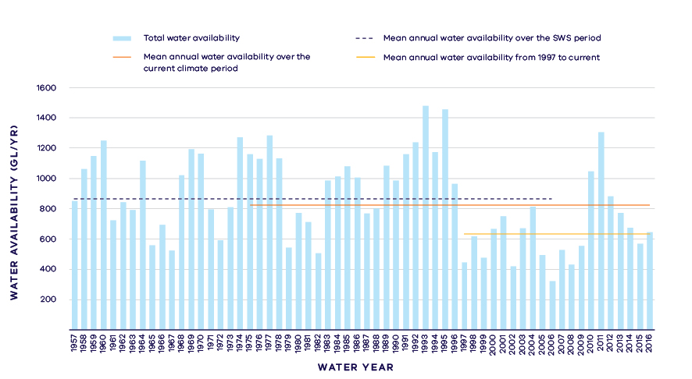
- Surface water availability in the Latrobe River
- Long- term surface water availability in the Latrobe basin
 |  |  |  | Change due to:⁵
 | Updated SWS estimate² | Current climate period³ | Current climate period and sharing arrangements⁴ | Different climate period | Different climate period and water sharing arrangements
Long-term surface water availability¹
Total water availability (GL/year) | 872.2 | 829.8 | 830.2 | -42.5 | -42.0
Consumptive  (GL/year)⁶ | 174.4 | 174.4 | 194.2 | 0.0 | 19.8
Environment (GL/year) | 667.0 | 623.9 | 619.0 | -43.0 | -48.0
Not categorised  (GL/year)⁷ | 30.8 | 31.4 | 17.1 | 0.5 | -13.8
Water sharing⁸
Consumptive | 21% | 22% | 24% | 1% | 3%
Environment | 79% | 78% | 76% | -1% | -3%

Notes to table
- These estimates are long-term averages. Values are rounded to the nearest 0.1 GL. Figures might not add in columns and/or rows, due to rounding. Minor differences in total water availability under the current climate period arise from differences in storages are managed. Minor differences in values compared with graphed annual average inflows arise from water intercepted by licensed farm dams being excluded from graphed historical inflows.
- The SWS estimate is based on the period 1957 – 2007.
- The current climate period is 1975 – 2017.
- Refer to subsequent sections on Water for Consumptive Use and Water for the Environment for details of any changes in water sharing arrangements.
- Negative values are a decline in water available; positive values are an increase in water available.
- These estimates assume full use of entitlements and include interception by licensed farm dams.
- Not categorised water, such as run-of-river losses and unallocated water that cannot be reasonably considered as being for consumptive users or the environment. This includes unused water allocated to the Blue Rock drought reserve.
- Water sharing is represented as a percentage of the sum of water available for the environment and consumptive use. It excludes available water that was not categorised.

Water for consumptive use
In the Latrobe basin, consumptive water uses are many and varied. Uses include urban water supply, irrigated agriculture, power generation, other industry, and licensed farm dams. Major entitlements to water in the Latrobe basin are specified as a percentage share of the available streamflow and reservoir storage capacity. This approach to sharing water provides flexibility for entitlement holders to manage their water to meet their diverse needs. A highly reliable water supply is critically important for power generation, other industry and urban users. The Latrobe Reserve bulk entitlement ensures that essential service industries, urban users and other entitlement holders can access additional water during drought to avoid shortfalls. Additionally, the Latrobe-Loy Yang 3/4 Bench entitlement sets aside up to 25 GL/year for future use.
Changes in water sharing arrangements have increased the volume of water available for consumptive users. The major change in the Latrobe basin since the SWS has been the allocation of the previously unallocated share of Blue Rock Reservoir. Gippsland Water purchased a 3.87 per cent share of the inflow and storage capacity in Blue Rock Reservoir, such that a larger volume of water is now allocated to urban and industrial supply. In addition, Gippsland Water’s ability to harvest more water has been influenced by shifting demand patterns, with proportionally less water supplied to industrial customers currently than at the time of the SWS, and proportionally more water supplied to urban customers. This change in customer mix means that Gippsland Water can service a greater average level of demand and therefore, harvest more water in an average year
Local management rules governing access to water by private diverters were formalised through the publication of local management rules for some streams within the basin in 2014. These rules provide a clear statement of water sharing arrangements between private diverters and other users at times of low flow.
Overall, water availability to consumptive users has increased by approximately 19.8 GL/year on average compared with historical availability at the time of the SWS, driven by greater availability to urban users (Table 1).
The Gippsland Region SWS set aside a further 1 per cent share of the inflow and storage capacity in Blue Rock Reservoir for purchase by irrigators. However, because that water has not been purchased yet, it was not included in the water available for consumptive use. (This water forms part of the non-categorised volumes shown in Table 1.)
Consumptive users also have access to additional water that is not considered in this assessment of long-term water availability. Recycled wastewater is provided for paper production from the Gippsland Water Factory.
Not all water diverted from rivers is consumed. Large volumes of water from power generation and paper production are returned to the rivers in the Latrobe basin. These return flows are allocated in equal volume to irrigators and the environment but are not considered in the assessment of long-term water availability to avoid double-counting of water.

Water for the environment
Water can be set aside for the environment through water entitlements, passing flows and other regulatory limits on the water allocated to consumptive users. Under historical climate and system operations at the time of the SWS, 667 GL/year was set aside for the environment using passing flows and policies that placed limits on the allocations to consumptive users (Table 1).
Passing flows set aside water for the environment through conditions on bulk entitlements. These conditions specify minimum passing flow requirements at offtakes and immediately downstream of reservoirs to be provided for environmental purposes. In the Latrobe basin, these passing flows are specified as ‘or natural’ which means they are heavily influenced by climate variability.
A limit, called a permissible consumptive volume, has been placed on allocation of water to consumptive users in the Latrobe basin. Because this above cap water is only available to the environment after all other users have taken their share, its volume varies with climatic conditions and reduces significantly when conditions become drier.
Climate change has reduced the amount of water available to the environment which, without any changes to water sharing would now have 43 GL/year less water compared with historical availability.
Since the Gippsland Region SWS, two environmental water entitlements have been created in the Latrobe basin.
The Blue Rock Environmental Entitlement was created during the process of allocating the previously unallocated share of inflows and storage capacity in Blue Rock Reservoir. The entitlement provides rights to just under a 10 per cent share of inflow and storage capacity in Blue Rock Reservoir which allows Victorian Environmental Water Holder, as the entitlement holder, to provide targeted environmental water deliveries.
The Lower Latrobe Wetlands entitlement was created in 2010 to provide water to the Lower Latrobe Wetlands, formalising historical practice. This entitlement does not specify a volume; instead it specifies a trigger water level in the Latrobe River which allows water to then be diverted into the wetlands.
Despite the new environmental entitlements, the volume available to the environment has declined because of reduced spills from reservoirs. With current climate conditions and current water sharing arrangements, water availability has decreased by 48 GL/year compared with historical availability.
Has the decline in long-term surface water availability been shared equally?
Since the Gippsland Region SWS, the average volume of water available to consumptive users in the Latrobe basin has increased, while the volume available to the environment has decreased on average.
At the time of the SWS, consumptive users had access to 21 per cent of the total resource while the environment had access to 79 per cent of the total resource (Table 1).
Changes in water sharing arrangements combined with changes in climate mean that consumptive users now have access to 24 per cent of the total resource and the environment has access to 76 per cent of the total resource. This is a 3 per cent increase in the proportion of the total resource for consumptive users and a corresponding 3 per cent decrease in the proportion of the total resource for the environment.
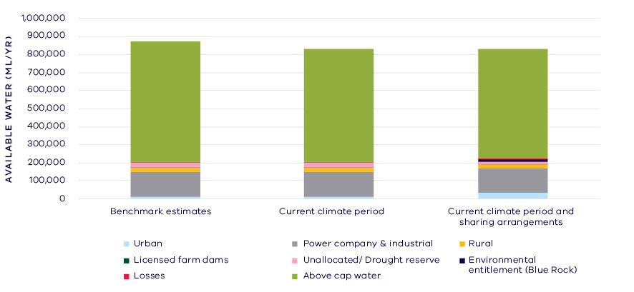
- Changes in the water availability – Latrobe basin

Waterways and their values
The waterways of the Latrobe basin are important for maintaining a diversity of plants and animals. In the upper forested areas, significant species include: barred galaxias, river blackfish, Gippsland spiny crayfish and the nankeen night heron. These upper reaches of the Latrobe also contain largely intact riparian vegetation including Damp Forest, Wet Forest and Riparian Forest. The lower reaches of the river systems support significant remnant riparian and floodplain vegetation and are important for many native fish species including the nationally threatened Australian grayling.
The Latrobe River flows into Lake Wellington, passing alongside several significant fringing wetlands such as Sale Common, Dowd and Heart Morass, all of which are part of the Gippsland Lakes Ramsar Site. These waterways support important plant and animal species including the nationally threatened green and golden bell frog, growling grass frog, and Australasian bittern, as well as the nationally vulnerable coastal saltmarsh vegetation community. The wetlands and rivers of the Latrobe basin are important sites for waterbirds, including colonial nesting species as well as international migratory shorebirds. The waterways of the Latrobe basin are also valued for their visual amenity, recreational fishing and hunting and are significant to the Traditional Owners, the Gunaikurnai.
Environmental water is delivered in the Latrobe basin to protect and enhance:
- Three priority wetlands by restoring wetting and drying cycles in Sale Common, Dowd Morass and Heart Morass — part of the Ramsar listed Gippsland Lakes.
- Riparian and instream vegetation — through delivery of flows (and complementary measures) to help stabilise river banks and improve the amount and quality of aquatic habitat.

Environmental flow provisions
There is a large body of scientific work linking defined aspects of the flow regime with ecological understanding and impacts to waterway health. In the absence of good long-term ecological data to assess waterway health, some inferences have been drawn from analyses of changes in flow. This should not, however, be considered a direct assessment of waterway health.
There has, on average, been a decrease in most of the environmental flow components in the Latrobe basin and since the release of the Gippsland Region SWS (Figure 4). There was, on average, an improvement in winter baseflow provisions in reaches that have an environmental entitlement, and a smaller decline in summer freshes compared to rivers with no active environmental water management. Summer freshes are important for providing migratory and breeding cues for fish as well as maintaining vegetation.
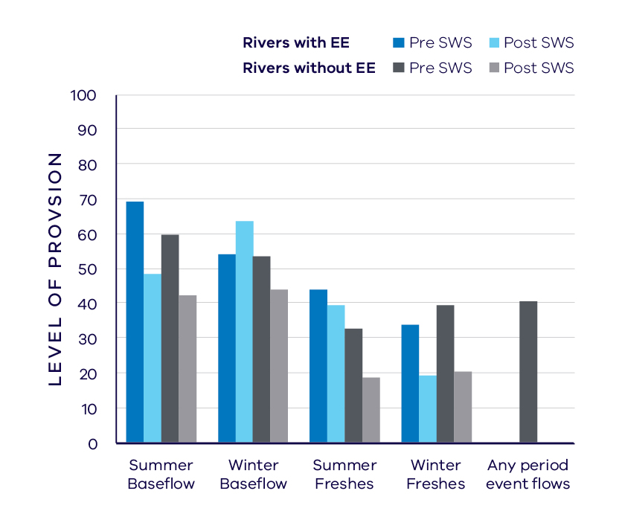
- Average change in ecologically important flow components in rivers with an environmental entitlement (EE) and without EE pre SWS (1925 – 2010) and post SWS (2011 – 2017)
These averages, however, do not reflect the situation in all rivers and reaches. For example, there has been an increase since 2011 in most environmental flow provisions in the Latrobe River between Rosedale and the confluence with the Thomson River and also in many components in the Tanjil and Morwell Rivers, but a decline in reaches of the Latrobe River upstream of Rosedale.

Waterway health
The waterway health analysis was completed at the river basin scale, primarily because there is less data at site, reach or river scales. Although aggregating data to a basin scale allowed for better detection of statistical trends, the results might not reflect the conditions at individual river reaches within the basin.
There is no simple accepted measure for overall waterway health and while many indicators and associated datasets were considered, only a few met requirements for the Long-Term Water Resource Assessment. Most of the available datasets did not cover a sufficient time period (>20 years) to allow for analysis of changes over a long-term timeframe. The indicators presented cover water quality and macroinvertebrates and are based on the most robust data available. The data were split into three time periods:
- Prior to the LTWRA period — 1990 – 2005
- First part of the LTWRA period — 2006 – 2010. This was the worst section of the Millennium Drought
- Second part of the LTWRA period — 2011 – 2018. Post Millennium Drought.
The data were then analysed to identify any trends over time in the selected indicators. That is, whether various waterway health indicators are improving, deteriorating or unchanged. So, while it may be possible to report, for example, an improvement in salinity within a river basin, this does not necessarily imply “good” waterway health. This is because 1) the waterways may still be high in salinity, just less so than previously; and 2) other aspects of waterway health might be deteriorating.
The Long-Term Water Resource Assessment examined the impact of flow on waterway health. To this end, the effects of flow were separated from all other factors that can affect waterway health (e.g. bushfire, land use change, rehabilitation works). The individual influences of these other factors on waterway health have not been analysed in this assessment.
There have mostly been improvements or no trend in available waterway health indicators in the Latrobe basin since 2011. However, as discussed in section 6.2.4 of the Overview Report, there are a number of limitations on interpreting these indicators. The possible impacts of any changes in these individual indicators on other aspects of waterway health are described in the Overview Report.
There has been an improvement in trend in dissolved oxygen which was partly related to flow. There was an improvement in trend in salinity (compared to before 2006) which was not related to changes in flow. There was an improvement in phosphorus which was partly linked to flow changes. There were improvements in trends of total suspended solids and turbidity (compared to before 2011) which were linked to flow changes. There was no change in trend in nitrogen.
Limited data and high natural variability prevented detection of any trend in macroinvertebrate indicators.

On-ground achievements: beyond the available data
While the assessment needed to analyse long-term datasets to answer the question set by the Water Act, there are numerous other projects going on around the state that are improving waterway health, but which only began in recent years. In the West Gippsland CMA region, one such project is control of invasive plants with flow regime management.
Dense stands of the native plant giant rush (Juncus ingens) colonised large areas of previously open water in Sale Common in early 2009. This dramatic vegetation change occurred during a prolonged dry period that extended from the summer of 2008 to spring 2010. The species grows best in shallowly flooded or waterlogged sediments over summer, and so was able to take advantage of the lower water levels over this period. Giant rush can provide excellent habitat for cryptic waterbird species such as bitterns, crakes and rails, and some colonial nesting species such as ibis. It can also become invasive however, creating tall dense stands that reduce overall habitat diversity.
The West Gippsland CMA, in collaboration with Parks Victoria, responded to the vegetation change by developing a management strategy aimed at ‘drowning’ the rush as the seedlings and young plants are thought to be intolerant of long-term submergence. This was to be done by maintaining high water levels from 2010 for approximately three years. Natural inundation was supplemented with artificial watering in autumn 2013. West Gippsland CMA and Parks Victoria worked closely with VicRoads during the realignment of the South Gippsland Highway in 2010 – 2011 to ensure that water was retained in the wetland while de-watering of the footings for the new road bridges occurred adjacent to the Common. The water management strategy has achieved the result it sought: a reduction in the extent and density of giant rush across Sale Common and restoring a mosaic of different vegetation types.

Has waterway health deteriorated for flow-related reasons?
There have been, on average, moderate declines in aspects of the flow regime with well understood ecological importance in the Latrobe basin since the release of the Gippsland Region SWS in 2011, although there were improvements in winter baseflows in reaches with flows delivered under the environmental entitlement. In general, less than half the recommended winter and summer freshes are achieved. These declines in aspects of the flow regime coincided with mixed trends in waterway health indicators. These results are consistent with the small (3 per cent) decline in water available for the environment. Overall, the findings for waterway health for reasons related to flow are inconclusive. These conclusions are based on analysis of data up to 2018, and therefore do not include more recent events. It is noted that dry conditions during 2018/19, low river flows, and ash from 2019 bushfire events in the catchment all present risks to the current waterway health of this basin.

South Gippsland Basin

Introduction
The South Gippsland basin comprises several discrete river systems including the Powlett, Tarwin, Franklin, Agnes, Albert, Bass and Tarra Rivers, covering an area of 6,900 square kilometres. All of these rivers flow from the Strzelecki and Hedley Ranges to Bass Strait through estuaries and coastal lagoons, with several of the major rivers flowing into the Corner Inlet Ramsar site. The Tarwin River flows into Anderson Inlet and the Bass River to Western Port Bay. The headwaters of several waterways are characterised by native vegetation and forestry, with the mid to lower reaches flowing through agricultural lands predominantly beef and dairy. In contrast, the Bass River catchment has significant urban and heavy agricultural influences throughout. The basin includes several major towns, that are on a growth trajectory including Leongatha, Inverloch and Wonthaggi.
The climate is temperate, with cool wet winters and warm dry summers. Annual rainfall is relatively high across most of the basin, averaging around 900 mm/year.
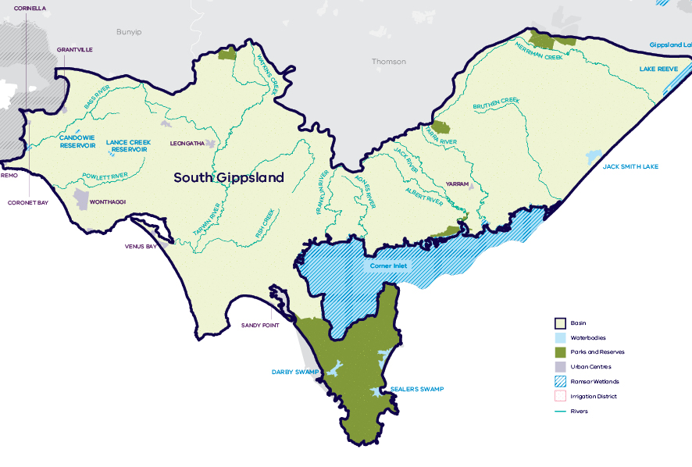
- Map of the South Gippsland basin

Long-term water availability
In 2011, the Gippsland Region Sustainable Water Strategy (SWS) assessed water availability and reviewed the balance of water sharing between consumptive users and the environment in the South Gippsland basin. Surface water availability was calculated based on the long-term average, using the best available data at that time. Improvements in data and computer models since the development of the Gippsland Region SWS have enabled a refined calculation of water availability. The figures presented in the Gippsland Region SWS were summed across all waterways in the basin. The updated historical surface water availability for the South Gippsland basin is 753.1 GL/year (Table 1).
To enable trends across different waterways to be compared, results for ten individual rivers and creeks are presented below:
- Tarwin River: Table 2; Figure 2
- Powlett River: Table 3; Figure 3
- Bass River: Table 4; Figure 4
- Merrimans Creek: Table 5
- Tarra River: Table 6
- Albert River: Table 7
- Agnes River: Table 8
- Franklin River: Table 9
- Deep Creek: Table 10).
Data availability and therefore, the period over which historical water availability was assessed, varies between waterways in the South Gippsland basin (refer to notes to tables for the assessment period for each waterway).
Research indicates that recent decades provide a better representation of current climate than does the full historical record. Recent decades more closely reflect current atmospheric levels of greenhouse gases and have been drier and warmer than the earlier parts of the 20th century. For these reasons, the period from 1975 to the present is thought to better represent long-term water availability under current climatic conditions. It includes a wide range of natural climate variability — the severe Millennium Drought and wet years. All waterways assessed showed a decline in water availability, except for the Franklin River. The total average water availability for South Gippsland basin over this time is 661.6 GL/year, a decline of 12 per cent compared with historical water availability.
The period since 1997 shows a further decline in water availability (Figure 2; Figure 3; Figure 4), however, this period is heavily influenced by the Millennium Drought. The drier conditions experienced since 1997 may be due to natural climate variability. These years may also represent ongoing conditions due to climate change, however it is too soon to know if this is the case.
In addition to surface water, water availability within the South Gippsland basin includes groundwater. Parts of the basin are underlain by unconfined and confined aquifers that provide water for domestic, agricultural and industrial use. There are four groundwater management units in the basin: Giffard Groundwater Management Area (GMA), Leongatha GMA, Tarwin GMA and Yarram Water Supply Protection Area.
The amount of groundwater that can be pumped by consumptive users and the amount of water that flows from aquifers into streams and wetlands are both heavily dependent on groundwater levels. Changes in groundwater availability are measured through considering long-term changes in groundwater levels. If groundwater levels have stayed the same (or increased) there will not have been a reduction in the groundwater available to consumptive users or the environment. If groundwater levels have declined, then either consumptive users or the environment (or both) may have experienced reduced water availability.
Reduced water availability to the environment typically only occurs where groundwater levels have declined in unconfined aquifers that are connected to waterways. Reduced availability to consumptive users may occur where groundwater levels have declined in either confined or unconfined aquifers. The unconfined aquifer is predominantly monitored in the Tarwin and Leongatha Groundwater Management Areas, where long-term water levels have remained stable. In the confined aquifer, declines were identified in the Giffard GMA of less than 1m, as well as declines in the Yarram GMA of greater than 2 m. Groundwater in the lower aquifer within the Yarram GMA has declined steadily since the 1970s at a rate of approximately 1 m/year. This is due to offshore oil and gas extractions which are connected to the lower aquifer.
While climate is the primary driver of the decline in surface water flows into the South Gippsland basin, other potential contributing factors have been assessed:
- Interception by domestic and stock dams may have a low contribution to the decline due to the concentration of these dams in the north-west of the catchment.
- There is evidence of large-scale land-use changes to more water-intensive activities, such as forestry plantations, which may have contributed to the total decline.
- Licensed groundwater pumping predominantly occurs from the confined aquifers which are not connected to surface water. Given that the watertable aquifers have remained stable, the groundwater assessment determined that there is no likely impact of extractions on long-term surface water availability.
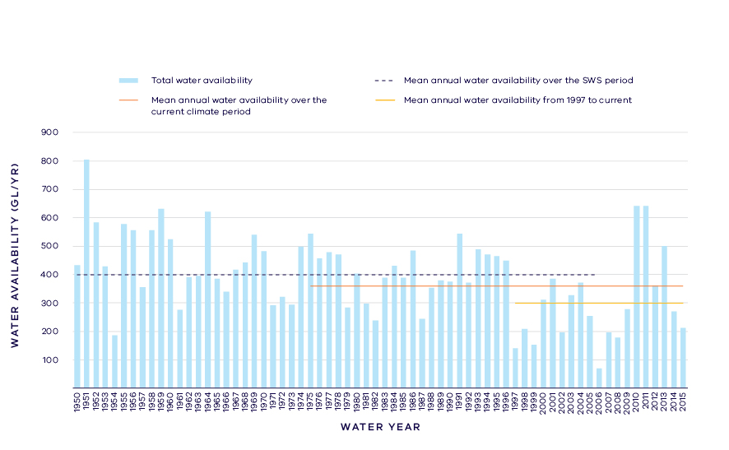
- Annual water availability in the Tarwin River

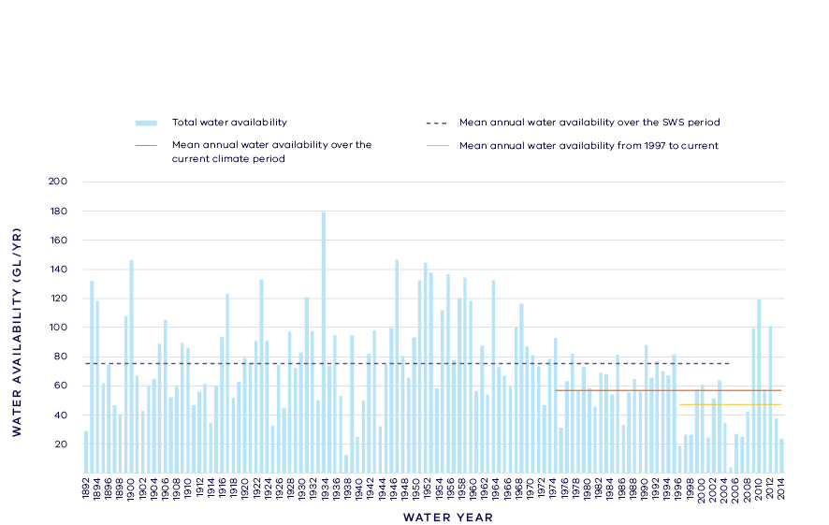
- Annual water availability in the Powlett River
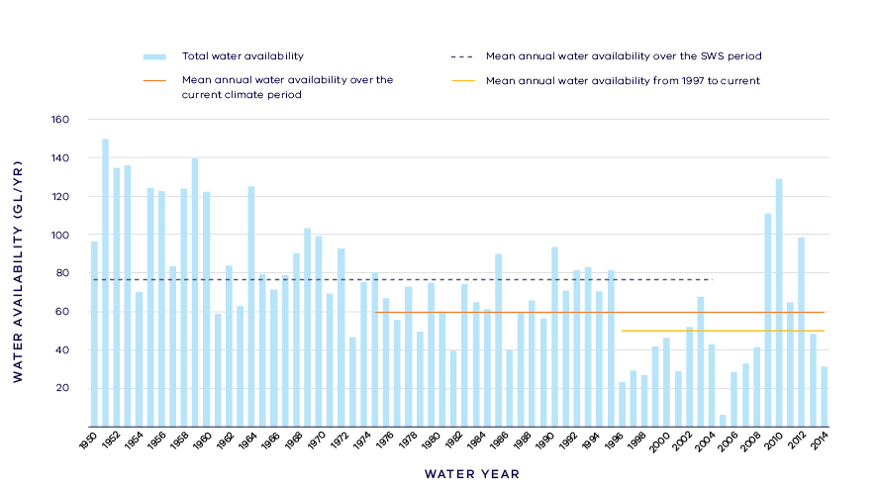
- Annual water availability in the Bass River
- Long- term surface water availability in the South Gippsland basin
 |  |  |  | Change due to:⁵
 | Updated SWS estimate² | Current climate period³ | Current climate period and sharing arrangements⁴ | Different climate period | Different climate period and water sharing arrangements
Long-term surface water availability¹
Total water availability (GL/year) | 753.1 | 661.6 | 661.5 | -91.6 | -91.6
Consumptive (GL/year)⁶ | 18.5 | 18.3 | 17.9 | -0.2 | -0.6
Environment (GL/year) | 695.7 | 604.4 | 639.5 | -91.3 | -56.2
Not categorised (GL/year)⁷ | 38.9 | 38.9 | 4.1 | 0.0 | -34.8
Water sharing⁸
Consumptive | 3% | 3% | 3% | 0% | 0%
Environment | 97% | 97% | 97% | 0% | 0%

- Long- term surface water availability in the Tarwin River
 |  |  |  | Change due to:⁵
 | Updated SWS estimate² | Current climate period³ | Current climate period and sharing arrangements⁴ | Different climate period | Different climate period and water sharing arrangements
Long-term surface water availability¹
Total water availability (GL/year) | 403.2 | 360.6 | 360.4 | -42.6 | -42.8
Consumptive  (GL/year)⁶ | 9.4 | 9.3 | 9.3 | -0.1 | -0.1
Environment  (GL/year) | 375.0 | 332.6 | 348.6 | -42.5 | -26.4
Not categorised  (GL/year)⁷ | 18.7 | 18.7 | 2.5 | 0.0 | -16.2
Water sharing⁸
Consumptive | 2% | 3% | 3% | 1% | 1%
Environment | 98% | 97% | 97% | -1% | -1%

- Long- term surface water availability in the Powlett River
 |  |  |  | Change due to:⁵
 | Updated SWS estimate² | Current climate period³ | Current climate period and sharing arrangements⁴ | Different climate period | Different climate period and water sharing arrangements
Long-term surface water availability¹
Total water availability (GL/year) | 75.7 | 54.8 | 54.8 | -20.8 | -20.9
Consumptive  (GL/year)⁶ | 2.2 | 2.2 | 2.2 | 0.0 | 0.0
Environment  (GL/year) | 66.9 | 46.1 | 52.1 | -20.8 | -14.8
Not categorised  (GL/year)⁷ | 6.6 | 6.6 | 0.5 | 0.0 | -6.1
Water sharing⁸
Consumptive | 3% | 5% | 4% | 2% | 1%
Environment | 97% | 95% | 96% | -2% | -1%

- Long- term surface water availability in the Bass River
 |  |  |  | Change due to:⁵
 | Updated SWS estimate² | Current climate period³ | Current climate period and sharing arrangements⁴ | Different climate period | Different climate period and water sharing arrangements
Long-term surface water availability¹
Total water availability (GL/year) | 76.9 | 61.1 | 61.3 | -15.8 | -15.7
Consumptive  (GL/year)⁶ | 2.8 | 2.7 | 2.6 | 0.0 | -0.2
Environment  (GL/year) | 70.1 | 54.3 | 58.7 | -15.8 | -11.3
Not categorised  (GL/year)⁷ | 4.1 | 4.1 | 0.0 | 0.0 | -4.1
Water sharing⁸
Consumptive | 4% | 5% | 4% | 1% | -1%
Environment | 96% | 95% | 96% | -1% | 1%

- Long- term surface water availability in Merrimans Creek
 |  |  |  | Change due to:⁵
 | Updated SWS estimate² | Current climate period³ | Current climate period and sharing arrangements⁴ | Different climate period | Different climate period and water sharing arrangements
Long-term surface water availability¹
Total water availability (GL/year) | 33.5 | 32.8 | 32.8 | -0.7 | -0.7
Consumptive  (GL/year)⁶ | 0.6 | 0.6 | 0.6 | 0.0 | 0.0
Environment  (GL/year) | 31.8 | 31.1 | 32.0 | -0.7 | 0.2
Not categorised  (GL/year)⁷ | 1.1 | 1.1 | 0.2 | 0.0 | -0.9
Water sharing⁸
Consumptive | 2% | 2% | 2% | 0% | 0%
Environment | 98% | 98% | 98% | 0% | 0%

- Long- term surface water availability in the Tarra River
 |  |  |  | Change due to:⁵
 | Updated SWS estimate² | Current climate period³ | Current climate period and sharing arrangements⁴ | Different climate period | Different climate period and water sharing arrangements
Long-term surface water availability¹
Total water availability (GL/year) | 11.9 | 10.6 | 10.6 | -1.2 | -1.2
Consumptive  (GL/year)⁶ | 0.5 | 0.5 | 0.4 | 0.0 | -0.1
Environment  (GL/year) | 9.6 | 8.4 | 10.2 | -1.2 | 0.6
Not categorised  (GL/year)⁷ | 1.8 | 1.8 | 0.0 | 0.0 | -1.7
Water sharing⁸
Consumptive | 5% | 6% | 4% | 1% | -1%
Environment | 95% | 94% | 96% | -1% | 1%

- Long- term surface water availability in the Albert River
 |  |  |  | Change due to:⁵
 | Updated SWS estimate² | Current climate period³ | Current climate period and sharing arrangements⁴ | Different climate period | Different climate period and water sharing arrangements
Long-term surface water availability¹
Total water availability (GL/year) | 74.7 | 68.1 | 68.1 | -6.6 | -6.6
Consumptive  (GL/year)⁶ | 1.3 | 1.3 | 1.3 | 0.0 | 0.0
Environment  (GL/year) | 70.5 | 63.9 | 66.5 | -6.5 | -4.0
Not categorised  (GL/year)⁷ | 2.9 | 2.9 | 0.3 | 0.0 | -2.6
Water sharing⁸
Consumptive | 2% | 2% | 2% | 0% | 0%
Environment | 98% | 98% | 98% | 0% | 0%

- Long- term surface water availability in the Agnes River
 |  |  |  | Change due to:⁵
 | Updated SWS estimate² | Current climate period³ | Current climate period and sharing arrangements⁴ | Different climate period | Different climate period and water sharing arrangements
Long-term surface water availability¹
Total water availability (GL/year) | 24.5 | 23.4 | 23.4 | -1.1 | -1.1
Consumptive  (GL/year)⁶ | 0.7 | 0.7 | 0.5 | 0.0 | -0.2
Environment  (GL/year) | 22.6 | 21.5 | 22.7 | -1.1 | 0.1
Not categorised  (GL/year)⁷ | 1.2 | 1.2 | 0.2 | 0.0 | -1.0
Water sharing⁸
Consumptive | 3% | 3% | 2% | 0% | -1%
Environment | 97% | 97% | 98% | 0% | 1%

- Long- term surface water availability in the Franklin River
 |  |  |  | Change due to:⁵
 | Updated SWS estimate² | Current climate period³ | Current climate period and sharing arrangements⁴ | Different climate period | Different climate period and water sharing arrangements
Long-term surface water availability¹
Total water availability (GL/year) | 28.1 | 28.5 | 28.5 | 0.4 | 0.4
Consumptive  (GL/year)⁶ | 0.6 | 0.6 | 0.6 | 0.0 | 0.0
Environment  (GL/year) | 25.4 | 25.8 | 27.6 | 0.4 | 2.2
Not categorised  (GL/year)⁷ | 2.1 | 2.1 | 0.3 | 0.0 | -1.8
Water sharing⁸
Consumptive | 2% | 2% | 2% | 0% | 0%
Environment | 98% | 98% | 98% | 0% | 0%

- Long- term surface water availability in Deep Creek
 |  |  |  | Change due to:⁵
 | Updated SWS estimate² | Current climate period³ | Current climate period and sharing arrangements⁴ | Different climate period | Different climate period and water sharing arrangements
Long-term surface water availability¹
Total water availability (GL/year) | 7.7 | 6.6 | 6.6 | -1.1 | -1.1
Consumptive  (GL/year)⁶ | 0.1 | 0.2 | 0.2 | 0.0 | 0.0
Environment  (GL/year) | 7.6 | 6.5 | 6.4 | -1.1 | -1.1
Not categorised  (GL/year)⁷ | 0.0 | 0.0 | 0.0 | 0.0 | 0.0
Water sharing⁸
Consumptive | 2% | 2% | 3% | 0% | 1%
Environment | 98% | 98% | 97% | 0% | -1%

Notes to tables
- These estimates are long-term averages. Values are rounded to the nearest 0.1 GL. Figures might not add in columns and/or rows, due to rounding. Minor differences in total water availability under the current climate period arise from differences in storages are managed. Minor differences in values compared with graphed annual average inflows arise from water intercepted by licensed farm dams being excluded from graphed historical inflows.
- The SWS estimate is based on the period 1975 – 2008 for the Merrimans Creek, 1973 – 2008 for Bruthen Creek, 1961 – 2007 for the Tarra River, 1970 – 2008 for the Albert River, 1957 – 2007 for the Agnes River, 1979 – 2008 for the Franklin River, 1963 – 2007 for Deep Creek, 1950 – 2007 for the Tarwin River, 1892 – 2007 for the Powlett River, 1950 – 2006 for the Bass River.
- The current climate period is 1975 – 2017
- Refer to subsequent sections on Water for Consumptive Use and Water for the Environment for details of any changes in water sharing arrangements. Also includes unallocated water available for new winter-fill licences.
- Negative values are a decline in water available; positive values are an increase in water available.
- These estimates assume full use of entitlements and include interception by licensed farm dams.
- Not categorised water, such as run-of-river losses that cannot be reasonably considered as being for consumptive users or the environment.
- Water sharing is represented as a percentage of the sum of water available for the environment and consumptive use. It excludes available water that was not categorised.

Water for consumptive use
In the South Gippsland basin only approximately 3 per cent of the total water available is allocated to consumptive use (Table 1). Uses include supply to towns, private diverters and licensed commercial and irrigation farm dams. A total of thirteen bulk entitlements are held in the South Gippsland basin for urban supply by Gippsland Water, South Gippsland Water and Westernport Water. Bulk entitlements in the system are specified as a share of flow and the full capacity of multiple reservoirs with an annual cap on volume that may be taken.
Since the relevant SWS, the average yearly amount of water available to consumptive users has not materially changed. This is partly because the Gippsland Region SWS assessment took into account the water shortages during much of the Millennium Drought.
Connection to the Melbourne system has been a major change since the SWS. South Gippsland Water now holds a 1 GL entitlement to water from the Melbourne supply system which is used to supplement local supply from Lance Creek to Wonthaggi, Cape Paterson and Inverloch. The extension of the interconnection to supply other towns, including Korumburra, was not complete when this assessment was undertaken. The move away from sole reliance on local supply provides more flexibility and reliability, particularly during periods of drought. Westernport Water also holds a bulk entitlement to the Melbourne supply system allowing water to be diverted directly into Westernport Water’s supply main to customers in Bass Coast Shire.
Some catchments in the South Gippsland basin have not reached their sustainable diversion limit. This means that water is available during wetter months to be allocated in future to support growth in consumptive use. The Gippsland Region SWS set revised caps on the amount of unallocated surface water available for future winter-fill licences as follows: Tarwin (2.5 GL), Powlett (500 ML), Franklin (300 ML), Albert (300 ML), Ten Mile Creek (300 ML), Dividing Creek (300 ML), Nine Mile Creek/ Shady Creek (300 ML), and 500 ML across other catchments. This overall reduction in the sustainable diversion limit across the basin does not represent a reduction in water availability to consumptive users because no one holds an entitlement to the water.
Local management rules governing access to water by private diverters were formalised through Southern Rural Water's publication of the Local Management Plan for the basin in 2013. These rules provide a clear statement of water sharing arrangements between private diverters and other users at times of low flow.

Water for the environment
Under historical climate and system operations at the time of the SWS, 695.7 GL/year was set aside for the environment using passing flows and other regulatory limits on the water allocated to consumptive users (Table 1). There are no water entitlements held for the environment in the South Gippsland basin.
Passing flows set aside water for the environment through conditions on bulk entitlements. These conditions specify minimum passing flow requirements at offtakes and immediately downstream of reservoirs. Under historical climate, passing flows averaged a total of 16 GL/year across all relevant waterways. The Westernport bulk entitlement (held by Westernport Water) includes the requirement to make water releases from Candowie Reservoir to Tennent Creek to achieve seasonally-varying minimum flows, and also winter freshening flows.
Once all other users have taken their share, the water remaining in a river system is designated to the environment. This is known as ‘above cap water.’ With relatively little diversion in the basin, most surface water flows into Bass Strait or Western Port Bay and is available for the environment as above cap water. Changes in climate and other factors have changed that amount of water available to the environment. All rivers in the basin, except for the Franklin River, have experienced a decline in water availability. The decline in water availability is due in large part to the fact that most water for the environment is provided through above cap flows which reduce significantly when conditions become drier.
Since the SWS, the cap on the amount of unallocated surface water available for future winter-fill diversions has been revised downwards in several catchments. Overall, climate change has resulted in a decline in water available to the environment, however the decline would have been even greater if these unallocated licences had been allowed to be taken up by water users.
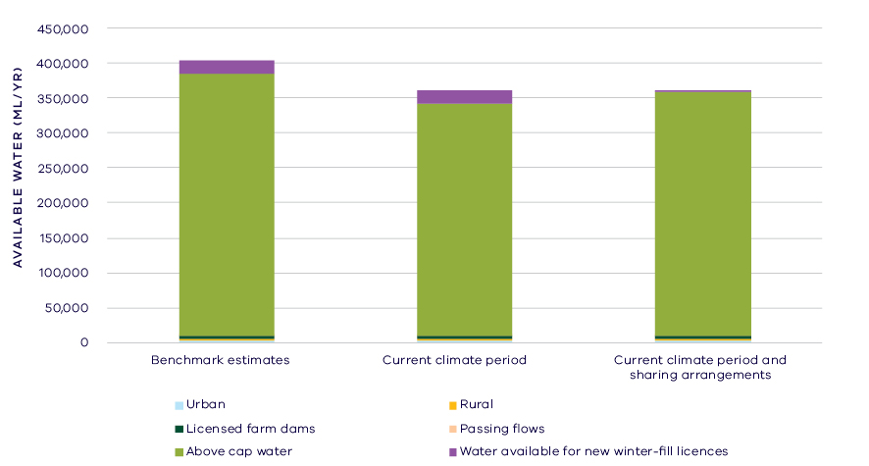
- Changes in water availability in the Tarwin River
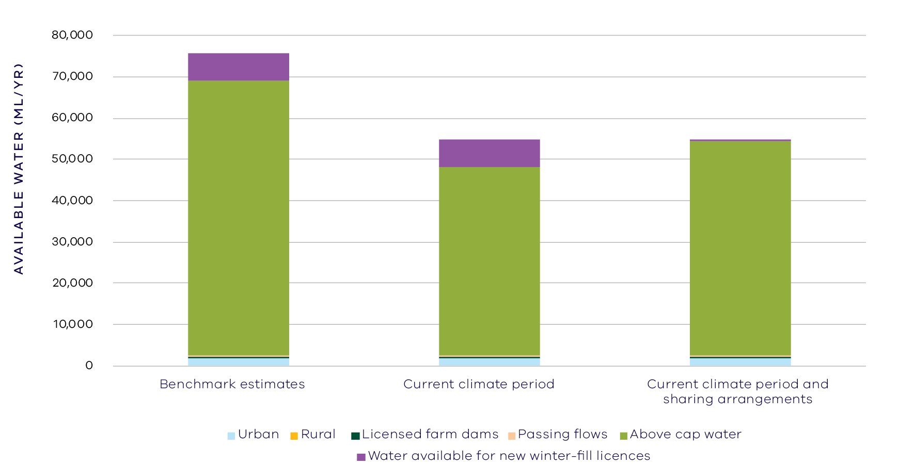
- Changes in water availability in the Powlett River
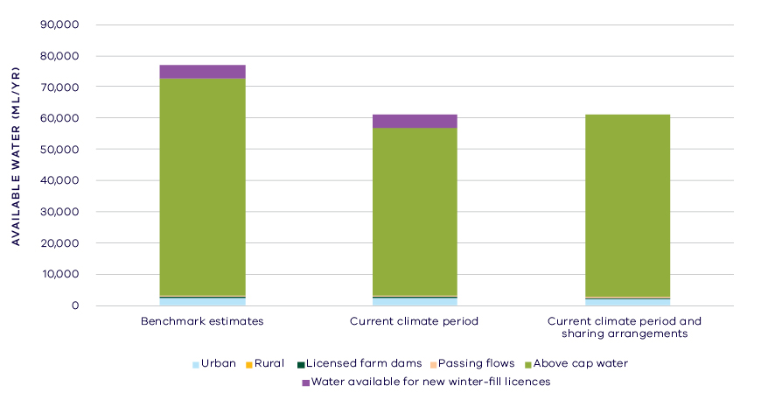
- Changes in water availability in the Bass River

Has the decline in long-term water availability been shared equally?
Since the Gippsland Region SWS, the overall volume of water available to the environment has declined in all waterways except for the Franklin River, while water availability to consumptive users has remained comparatively stable.
While there have been changes to the overall volume of water available to the environment, the share of the available resource remains essentially unchanged. This is due to the relatively small volume allocated for consumptive use compared to the total inflows to this basin. At the time of the SWS, 3 per cent of total water available in the South Gippsland basin was allocated to consumptive use and this remains the case currently (Table 1), with slight variations

Waterways and their values
The waterways of the South Gippsland basin support remnant riparian and floodplain vegetation communities and a diversity of fauna. Significant species include: Australian grayling, river blackfish and Australian whitebait. The waterways of the coastal areas, including Shallow Inlet, Anderson Inlet and Corner Inlet are important for migratory shorebirds, beach nesting birds and commercial and recreationally important fish. The waterways support important recreational values, with recreational fishing popular both on inland waterways and in the estuarine and coastal lagoons. The South Gippsland basin also includes Wilsons Promontory, which is popular for a variety of recreational pursuits such as boating, fishing, birdwatching and walking. The waterways of the South Gippsland basin continue to be an important place for Traditional Owners and Aboriginal Victorians, including two Registered Aboriginal Parties, the Gunaikurnai and the Bunurong.
Although no environmental water is held in the South Gippsland basin, there is other water in the system that contributes to environmental outcomes, such as passing flows, that is managed with a system of rules and operating processes. There are also a large number of complementary management projects that have been put in place to protect and restore the waterways of the basin. There has been a large effort put in place to restore fragmented habitats and improve water quality of river outflows.

Environmental flow provisions
There is a large body of scientific work linking defined aspects of the flow regime with ecological understanding and impacts to waterway health. In the absence of good long-term ecological data to assess waterway health, some inferences have been drawn from analyses of changes in flow. This should not, however, be considered a direct assessment of waterway health.
The assessment of environmental flow provisions for the South Gippsland basin is limited to two reaches of the Bass River, as this is where specific environmental flow component recommendations have been made that coincide with long-term stream gauge data (Figure 8). These reaches experience a moderate to high degree of environmental flow occurrence for baseflows, which are important for maintaining water quality and habitat. There has been a small decline in the provision of recommended summer freshes, and a small increase in the provision of winter freshes.
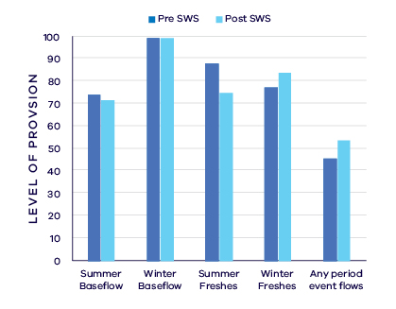
- Average change in ecologically important flow components pre SWS (1966 – 2006) and post SWS (2007 – 2018). Note analysis was based on two gauges on the Bass River only, and thus uses a Central Region SWS 2006 benchmark, unlike the other rivers in the South Gippsland basin which were within the Gippsland Region SWS

Waterway health
The waterway health analysis was completed at the river basin scale, primarily because there is less data at site, reach or river scales. Although aggregating data to a basin scale allowed for better detection of statistical trends, the results might not reflect the conditions at individual river reaches.
There is no accepted simple measure for overall waterway health and while many indicators and associated datasets were considered, only a few met requirements for the Long-Term Water Resource Assessment. Most of the available datasets did not cover a sufficient time period (>20 years) to allow for analysis of changes over a long-term timeframe. The indicators presented cover water quality and macroinvertebrates and are based on the most robust data available. The data were split into three time periods:
- Prior to the LTWRA period — 1990 – 2005
- First part of the LTWRA period — 2006 – 2010. This was the worst section of the Millennium Drought
- Second part of the LTWRA period — 2011 – 2018. Post Millennium Drought.
The data were then analysed to identify any trends over time in the selected indicators. That is, whether various waterway health indicators are improving, deteriorating or unchanged. So, while it may be possible to report, for example, an improvement in salinity within a river basin, this does not necessarily imply “good” waterway health. This is because 1) the waterways may still be high in salinity, just less so than previously; and 2) other aspects of waterway health might be deteriorating.
The Long-Term Water Resource Assessment was required to examine the impact of flow on waterway health. To this end, the effects of flow were separated from all other factors that can affect waterway health (e.g. bushfire, land use change, rehabilitation works). The individual influences of these other factors on waterway health have not been analysed in this assessment.
There is no consistent pattern of change in waterway health indicators in the South Gippsland basin since 2011. As discussed in section 6.2.4 of the Overview Report, there are also a number of limitations on interpreting these indicators. The possible impacts of any changes in these individual indicators on other aspects of waterway health are described in the Overview Report. Note that the data and analysis of indicators of waterway health occurred primarily in the Tarra and Agnes Rivers, while the separate analysis of environmentally important flow components occurred in the Bass River.
There was an improvement in dissolved oxygen that commenced in 2006 and continued through to 2018 and was strongly linked to river flow. There was a deterioration in trend in salinity (compared to before 2011) that was mostly not explained by flow. There has been a deterioration in nitrogen since 2006, strongly explained by changes to flow. There has been a deterioration in trend in phosphorus and turbidity (compared to before 2006) which is partly explained by flow changes. There has been an ongoing improvement in total suspended solids since 1990, but this is only partly related to flow changes.
Limited data and high natural variability prevented detection of any trend in macroinvertebrate indicators.

Has waterway health deteriorated for flow-related reasons?
There have been no consistent trends in the aspects of the flow regime examined nor in ecological waterway health indicators in the South Gippsland basin since the release of the Central Region SWS in 2006 and the Gippsland Region SWS in 2011. This perhaps reflects differences between rivers within this basin which make it difficult to provide a cohesive overall basin level evaluation of changes in waterway health. Overall, the findings for waterway health for reasons related to flow are inconclusive.

Bunyip Basin

Introduction
The Bunyip basin covers an area of 4,080 square kilometres and comprises several river systems including the Bunyip, Tarago and Lang Lang Rivers, as well as creek systems such as Dandenong, Cardinia, Kananook and Eumemmering Creeks. The major rivers rise in the north and eastern ranges, and flow into Western Port or Port Phillip Bay. Waterways in the lower parts of the basin formerly flowed to the Koo Wee Rup and Carrum Carrum swamps, but were diverted into man-made canals when the swamps were drained in the 1800s.
Although some forested areas remain in the upper ranges and on the Mornington Peninsula, the majority of the basin has been cleared for agriculture (dairy, beef production, poultry, horticulture) and urban development. The basin includes the eastern suburbs of Greater Melbourne, the towns, villages and vineyards of the Mornington Peninsula and the urban growth corridors of the Shire of Cardinia. The basin contains two Ramsar sites, Western Port and the Edithvale-Seaford Wetlands.
The climate is temperate, with cool wet winters and warm dry summers. Average annual rainfall over most of the area is 700 – 1,000 mm/year, with higher average falls ranging between 1,000 – 1400 mm/year in the northern, forested area and lower falls of 600 – 700 mm/year in the southern end of Mornington Peninsula.
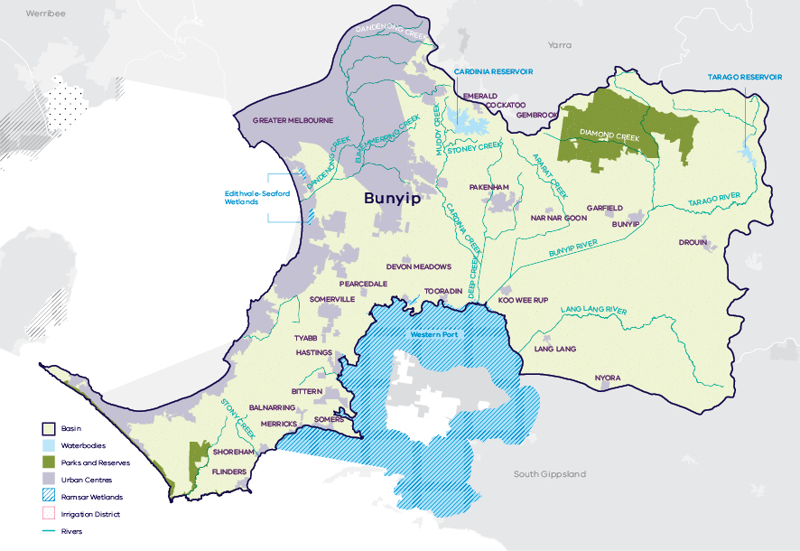
- Map of the Bunyip basin

Long-term water availability
In 2006, the Central Region Sustainable Water Strategy (SWS) assessed water availability and reviewed the balance of water sharing between consumptive users and the environment in the Bunyip basin. In the Bunyip River, surface water availability was calculated based on the long-term average over the full historical record (1913 to 2004). Improvements in data and computer models since the development of the Central Region SWS have enabled a refined calculation of water availability over that period. Surface water availability for Eumemmering, Dandenong and Cardinia creeks was not calculated at the time of the SWS but is now included in the Long-Term Water Resource Assessment (LTWRA). The updated SWS estimate of total long-term average surface water availability is 388.0 GL/year for the Bunyip basin (Table 1).
To enable trends across different waterways to be compared, results for five individual rivers and creeks are presented below:
- Bunyip River: Table 2, Figure 2, Figure 4
- Lang Lang River: Table 3, Figure 3, Figure 5
- Eumemmering Creek: Table 4
- Dandenong Creek: Table 5
- Cardinia Creek: Table 6.
Research indicates that recent decades provide a better representation of current climate than does the full historical record. Recent decades more closely reflect current atmospheric levels of greenhouse gases and have been drier and warmer than the earlier parts of the 20th century. For these reasons, the period from 1975 to the present is thought to better represent long-term water availability under current climatic conditions. It includes a wide range of natural climate variability with wet years as well as periods of drought. In the Bunyip River, the average water availability over this time is 131.4 GL/year, a decline of 14 per cent compared with historical water availability at the time of the SWS.
The period since 1997 shows a further decline in surface water availability (Figure 2; Figure 3), however, this period is heavily influenced by the Millennium Drought. The drier conditions experienced since 1997 may be due to natural climate variability. These years may also represent ongoing conditions due to climate change, however it is too soon to know if this is the case.
In addition to surface water, groundwater is available in the Bunyip basin. Groundwater levels in the Bunyip basin are mainly monitored in two Groundwater Management Areas, the Koo Wee Rup Water Supply Protection Area (WSPA) and the Nepean Groundwater Management Area (GMA). The amount of groundwater that can be pumped by consumptive users and the amount of water that flows from aquifers into streams and wetlands are both heavily dependent on groundwater levels. If groundwater levels have declined, then either consumptive users or the environment (or both) may have experienced reduced water availability.
Reduced water availability to the environment typically only occurs where groundwater levels have declined in an unconfined aquifer that is connected to a waterway. Reduced availability to consumptive users may occur where groundwater levels have declined in either confined or unconfined aquifers. The primary aquifer in the Koo Wee Rup WSPA is mostly confined with small areas where the aquifer is unconfined and potentially connected to streams. The assessment did not identify long-term declines in groundwater levels in the confined parts of the Koo Wee Rup WSPA. In the unconfined parts of the aquifer, declines were observed of 1 – 2 m. The Nepean GMA covers the unconfined sediments on the southern Mornington peninsula. Long-term declines in the Nepean GMA were observed of 1 – 2 m.
While climate is the primary driver of the decline in water flows into the Bunyip basin, other potential contributing factors have been assessed:
- Interception by domestic and stock dams is significant due to large numbers of these dams spread throughout the catchment.
- There is no evidence of significant agricultural land-use changes to more water-intensive activities which would contribute to the total decline.
- Groundwater pumping in the Koo Wee Rup WSPA has reduced waterway flow in the Lang Lang River by approximately 0.7 GL/year, which has contributed to the decline in surface water availability.
- Licensed groundwater extraction in the Nepean GMA has potentially impacted waterways by up to 1 GL/year. There are no gauges on waterways in the Nepean GMA for an assessment of long-term decline in surface water availability.
- Unlike the other catchments within the Bunyip basin, there has been an increase in the flows in the Eumemmering Creek catchment for the recent climate period compared to the historical climate. This is most likely due to the significant expansion in urban areas within this catchment, and the associated covering of previously agricultural land with paved areas, roads and house roofs which reduce infiltration into the soil and increase overall surface runoff.
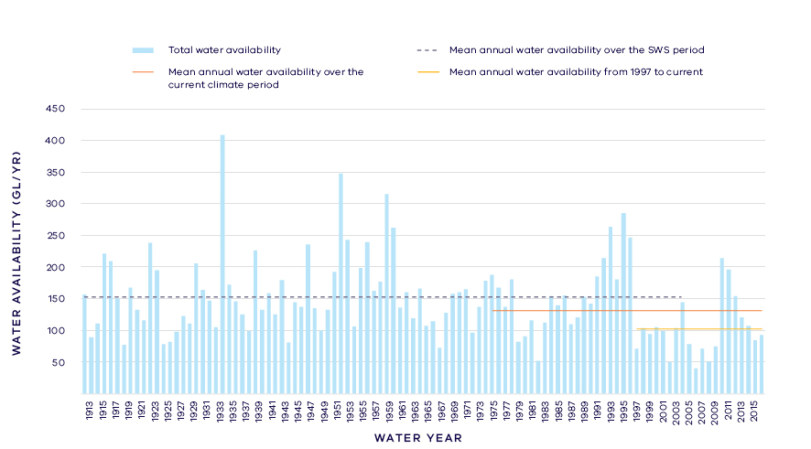
- Annual water availability for the Bunyip River (including Tarago River)
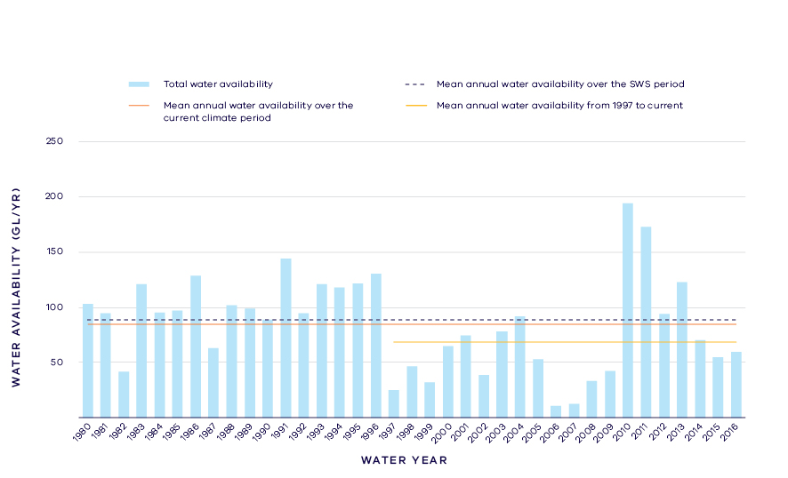
- Annual water availability for the Lang Lang River

- Total long- term surface water availability in the Bunyip basin (summed across rivers)
 |  |  |  | Change due to:⁵
 | Updated SWS estimate² | Current climate period³ | Current climate period and sharing arrangements⁴ | Different climate period | Different climate period and water sharing arrangements
Long-term surface water availability¹
Total water availability (GL/year) | 388.0 | 360.4 | 360.4 | -27.6 | -27.6
Consumptive  (GL/year)⁶ | 39.0 | 37.5 | 37.4 | -1.5 | -1.6
Environment  (GL/year) | 353.2 | 325.6 | 325.6 | -27.6 | -27.6
Not categorised  (GL/year)⁷ | -2.3 | -2.7 | -2.6 | -0.4 | -0.4
Water sharing⁸
Consumptive | 10% | 10% | 10% | 0% | 0%
Environment | 90% | 90% | 90% | 0% | 0%

- Long- term surface water availability in the Bunyip River (including Tarago River)
 |  |  |  | Change due to:⁵
 | Updated SWS estimate² | Current climate period³ | Current climate period and sharing arrangements⁴ | Different climate period | Different climate period and water sharing arrangements
Long-term surface water availability¹
Total water availability (GL/year) | 153.3 | 131.4 | 131.4 | -22.0 | -22.0
Consumptive  (GL/year)⁶ | 34.3 | 32.9 | 32.8 | -1.4 | -1.5
Environment  (GL/year) | 121.3 | 101.2 | 101.2 | -20.1 | -20.1
Not categorised  (GL/year)⁷ | -2.3 | -2.7 | -2.6 | -0.4 | -0.4
Water sharing⁸
Consumptive | 22% | 25% | 24% | 2% | 2%
Environment | 78% | 75% | 76% | -2% | -2%

- Long- term surface water availability in the Lang Lang River
 |  |  |  | Change due to:⁵
 | Updated SWS estimate² | Current climate period³ | Current climate period and sharing arrangements⁴ | Different climate period | Different climate period and water sharing arrangements
Long-term surface water availability¹
Total water availability (GL/year) | 88.6 | 84.7 | 84.7 | -3.9 | -3.9
Consumptive  (GL/year)⁶ | 1.8 | 1.8 | 1.8 | 0.0 | 0.0
Environment  (GL/year) | 86.8 | 82.9 | 82.9 | -3.9 | -3.9
Not categorised  (GL/year)⁷ | 0.0 | 0.0 | 0.0 | 0.0 | 0.0
Water sharing⁸
Consumptive | 2% | 2% | 2% | 0% | 0%
Environment | 98% | 98% | 98% | 0% | 0%

- Long- term surface water availability in the Eumemmering Creek
 |  |  |  | Change due to:⁵
 | Updated SWS estimate² | Current climate period³ | Current climate period and sharing arrangements⁴ | Different climate period | Different climate period and water sharing arrangements
Long-term surface water availability¹
Total water availability (GL/year) | 31.4 | 34.8 | 34.8 | 3.4 | 3.4
Consumptive  (GL/year)⁶ | 0.8 | 0.7 | 0.7 | 0.0 | 0.0
Environment  (GL/year) | 30.7 | 34.1 | 34.1 | 3.4 | 3.4
Not categorised  (GL/year)⁷ | 0.0 | 0.0 | 0.0 | 0.0 | 0.0
Water sharing⁸
Consumptive | 2% | 2% | 2% | 0% | 0%
Environment | 98% | 98% | 98% | 0% | 0%

- Long- term surface water availability in Dandenong Creek
 |  |  |  | Change due to:⁵
 | Updated SWS estimate² | Current climate period³ | Current climate period and sharing arrangements⁴ | Different climate period | Different climate period and water sharing arrangements
Long-term surface water availability¹
Total water availability (GL/year) | 71.9 | 68.7 | 68.7 | -3.2 | -3.2
Consumptive  (GL/year)⁶ | 0.9 | 0.9 | 0.9 | 0.0 | 0.0
Environment  (GL/year) | 71.0 | 67.8 | 67.8 | -3.2 | -3.2
Not categorised  (GL/year)⁷ | 0.0 | 0.0 | 0.0 | 0.0 | 0.0
Water sharing⁸
Consumptive | 1% | 1% | 1% | 0% | 0%
Environment | 99% | 99% | 99% | 0% | 0%

- Long- term surface water availability in the Cardinia Creek
 |  |  |  | Change due to:⁵
 | Updated SWS estimate² | Current climate period³ | Current climate period and sharing arrangements⁴ | Different climate period | Different climate period and water sharing arrangements
Long-term surface water availability¹
Total water availability (GL/year) | 42.6 | 40.7 | 40.7 | -2.0 | -2.0
Consumptive  (GL/year)⁶ | 1.2 | 1.2 | 1.2 | 0.0 | 0.0
Environment  (GL/year) | 43.4 | 39.5 | 39.5 | -3.8 | -3.8
Not categorised  (GL/year)⁷ | 0.0 | 0.0 | 0.0 | 0.0 | 0.0
Water sharing⁸
Consumptive | 3% | 3% | 3% | 0% | 0%
Environment | 97% | 97% | 97% | 0% | 0%

Notes to tables
- These estimates are long-term averages. Values are rounded to the nearest 0.1 GL. Figures might not add in columns and/or rows, due to rounding. Minor differences in values compared with graphed annual inflows arise from water intercepted by licensed farm dams being excluded from graphed historical inflows.
- The SWS estimate is based on the period 1913 – 2004 for the Bunyip River, 1980 – 2004 for the Lang Lang River, 1970 – 2004 for Eumemmering Creek, 1972 – 2004 for Dandenong Creek, 1974 – 2004 for Cardinia Creek.
- The current climate period is 1975 – 2017.
- Refer to subsequent sections on Water for Consumptive Use and Water for the Environment for details of any changes in water sharing arrangements. Small differences in total water availability over the current climate period result from changes in storage management.
- Negative values are a decline in water available; positive values are an increase in water available.
- These estimates assume full use of entitlements and include interception by licensed farm dams.
- Not categorised water, such as run-of-river losses that cannot be reasonably considered as being for consumptive users or the environment.
- Water sharing is represented as a percentage of the sum of water available for the environment and consumptive use. It excludes available water that was not categorised.

Water for consumptive use
In the Bunyip basin, consumptive water use comprises water supply for Greater Melbourne and regional urban centres, licensed private diversion of water from waterways and licensed commercial and irrigation farm dams.
Cardinia Reservoir on Cardinia Creek is Melbourne’s second largest reservoir, but primarily receives water transferred from the Yarra basin and the Victorian Desalination Plant (when in operation), rather than water sourced from within Bunyip basin.
Tarago Reservoir, on the Tarago River, is the largest reservoir supplying water harvested from within the Bunyip basin. Melbourne Water holds a bulk entitlement to supply the three metropolitan retail water corporations and four regional urban water corporations. The limit on the diversions that can take place from Tarago Reservoir or a small weir upstream are specified as a 5-year rolling average to provide some flexibility in managing against climate variability.
Gippsland Water also hold a bulk entitlement to supply the towns of Warragul and Drouin from Pederson Weir, upstream of Tarago Reservoir, as well as an entitlement to supply Neerim South from the reservoir. Gippsland Water’s entitlement is insufficient to meet its needs in most years, so Gippsland Water has an agreement with other water corporations to access an additional 0.4 GL/year water from Tarago Reservoir.
Private diverters on the Tarago and Bunyip Rivers are provided with drought security through the bulk entitlement held by Southern Rural Water which allows them to access up to an average 1.3 GL/year from Tarago Reservoir, over any five-year period.
Licensed commercial and irrigation farm dams have a total storage capacity of approximately 25 GL and have first access to local runoff, notwithstanding any upstream interception activities. This available storage, spread throughout the basin, is similar in magnitude to that available in Tarago Reservoir.
Changes in climate and other factors have reduced the amount of water available to consumptive users from the Bunyip River (including the Tarago River) by 1.4 GL/year on average compared with historical availability at the time of the SWS (Table 2). Long-term water availability from other waterways to consumptive users has not changed (Tables 3, 4, 5 & 6).
The recommissioning of Tarago Reservoir for supply to Greater Melbourne, following the construction of the Tarago Water Treatment Plant, means the management of the Bunyip basin has changed substantially since the Central Region SWS was published in 2006. Tarago Reservoir was taken offline in 1999 due to water quality problems and reconnected in 2009 at the height of the Millennium Drought. These changes are not considered an increase in water available for consumptive use in the LTWRA because they were included in the modelled estimate of water sharing for the Central Region SWS.
Local management rules governing access to water by private diverters were formalised through the publication of local management rules for some streams within the basin. These rules provide a clear statement of water sharing arrangements between private diverters and other users at times of low flow.
Other water resources provide a diversity of fit-for-purpose supply options for consumptive users. The Bunyip basin contains Melbourne’s Eastern Treatment Plant and 10 local wastewater treatment plants. Approximately 20 GL/year of recycled water is supplied from these treatment plants. This water is currently reused for processes within the treatment plants, and for agricultural, industrial, commercial and residential non-potable use. In addition to recycled water, stormwater and drainage diversion licences have been issued to divert up to approximately 2 GL/year of from various locations within the basin, including Dandenong Creek. These alternative water resources are not counted towards available water in the Long-Term Water Resource Assessment.

Water for the environment
Under historical climate and system operations at the time of the SWS, an average of 353.2 GL/year was set aside in the Bunyip basin for the environment using passing flows and other regulatory limits on the water allocated to consumptive users Table 1).
Passing flows set aside water for the environment through conditions on bulk entitlements. These conditions specify minimum passing flow requirements at offtakes and immediately downstream of reservoirs to be provided for environmental purposes. In the Bunyip basin the minimum passing flow required varies depending on the season (with higher passing flows required in the winter and spring), matching natural flow patterns.
A limit or cap, called a permissible consumptive volume, has been placed on allocation of water to consumptive users in the Bunyip basin. Because this above cap water is only available to the environment after all other users have taken their share, its volume varies with climatic conditions and reduces significantly when conditions become drier.
The volume of above cap water available to the environment has declined by 20.1 GL/year on average in the Bunyip River, compared with historical availability at the time of the SWS (Table 2).
There have been changes to the way environmental water is managed since the SWS. The Tarago and Bunyip Rivers’ environmental entitlement was created in 2009. This entitlement provides a 10.3 per cent share of inflows to Tarago Reservoir (approximately 3 GL/year) to be used for environmental purposes, as well as a share of the storage capacity in the reservoir. The environmental entitlement did not increase the overall volume of water available to the environment because water that previously spilt from storage during wet periods was converted to an environmental entitlement to enable controlled releases to meet environmental flow targets.
The overall volume available to the environment has declined compared with historical availability in all waterways assessed in the Bunyip basin, except for Eumemmering Creek.
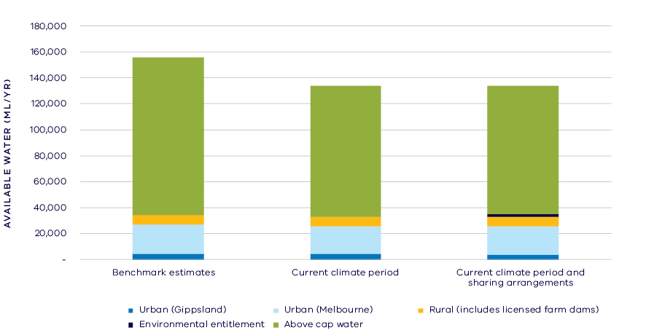
- Changes in water availability in the Bunyip River (including Tarago River)
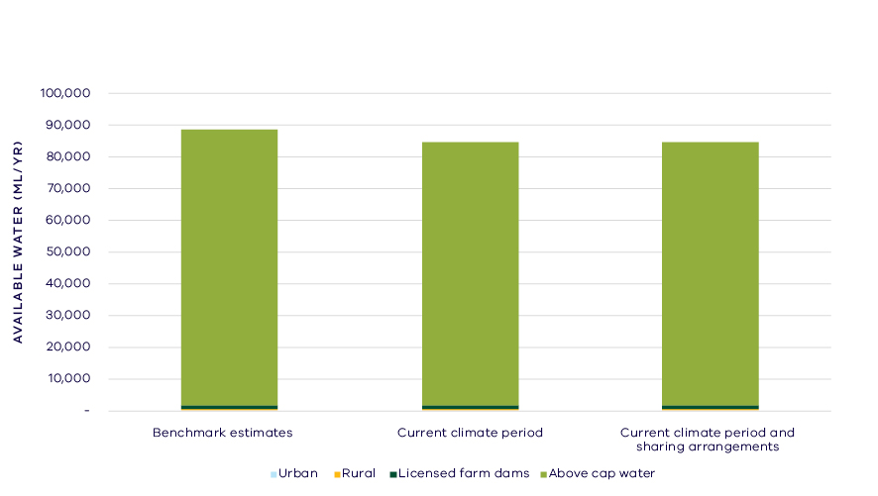
- Changes in water availability in the Lang Lang River

Have declines in long-term surface water availability been shared equally?
The Bunyip River (including Tarago River) is the primary source of water for consumptive use in the basin. Both consumptive users and the environment have experienced a long-term decline in total water availability from the Bunyip River. This decline has led to a change in the way that available water is shared between users.
At the time of the SWS, consumptive users had access to 22 per cent of available water while the environment had access to 78 per cent of available water (Table 2). Since the SWS, the proportion of the total resource available for consumptive users now represents 2 per cent more of the basin’s overall resources than at the time of the SWS with historical inflows. There has been a corresponding 2 per cent decrease in the proportion of the total resource available for the environment (Table 2).
The availability of water in the Lang Lang River, Dandenong Creek and Cardinia Creek has also declined since the SWS. In contrast, flow in Eumemmering Creek has increased slightly, possibly due to increased stormwater runoff as the catchment has become increasingly urbanised. While there have been changes to the overall volume of water available, the percentage sharing of the available resource between the environment and consumptive users remains unchanged for these waterways (Table 2–6). This is due to the relatively small volume allocated for consumptive use compared to the total annual flow in these waterways.
When results are summed across all waterways in the Bunyip basin, there has been no material change in the overall sharing of water between consumptive users and the environment (Table 1).

Waterways and their values
The waterways of the Bunyip basin support a diversity of freshwater native fish including Australian grayling, mountain galaxias, river blackfish, eastern dwarf galaxias and Yarra pygmy perch. The waterways of the coastal areas, including Western Port and the eastern shoreline of Port Phillip Bay are important for migratory shorebirds and beach nesting birds. The area also supports commercially and recreationally important fish. Edithvale-Seaford wetlands support large numbers of waterfowl and the endangered Australasian bittern. Waterways across the basin are important for platypus and rakali, particularly in the Tarago and Bunyip river systems and are home to several important freshwater invertebrate species including the rare Warragul burrowing crayfish, Gippsland spiny crayfish and Yarra spiny crayfish. The waterways support high quality vegetation. The wetlands of the region are habitat for frog populations.
The waterways support important recreational values, with recreational fishing popular both on inland waterways and in the estuarine and coastal lagoons. High amenity values are provided along waterways catering for recreation adjacent to the waterway.
The waterways of the Bunyip basin continue to be an important place for Traditional Owners and Aboriginal Victorians, including two Registered Aboriginal Parties (RAPs), the Gunaikurnai and the Bunurong.
Environmental water is delivered in the Bunyip basin to:
- improve the health and diversity of riparian vegetation
- maintain and improve habitat for platypus
- protect and increase native fish populations including threatened species (the Australian grayling and river blackfish) by providing habitat and triggers for fish to migrate and spawn
- maintain and improve macroinvertebrate populations and food webs.

Environmental flow provisions
There is a large body of scientific work linking defined aspects of the flow regime with ecological understanding and impacts to waterway health. In the absence of good long-term ecological data to assess waterway health, some inferences have been drawn from analyses of changes in flow. This should not, however, be considered a direct assessment of waterway health.
Since the release of the Central Region SWS, there has, on average, been a decline in ecologically important flows in the rivers without environmental entitlements in the Bunyip basin (grey bars, Figure 6). In contrast, ecologically important flows have been largely maintained in rivers with environmental entitlements (blue bars, Figure 6). This analysis covers nine reaches across the Tarago, Bunyip and Lang Lang Rivers and Dandenong Creek².
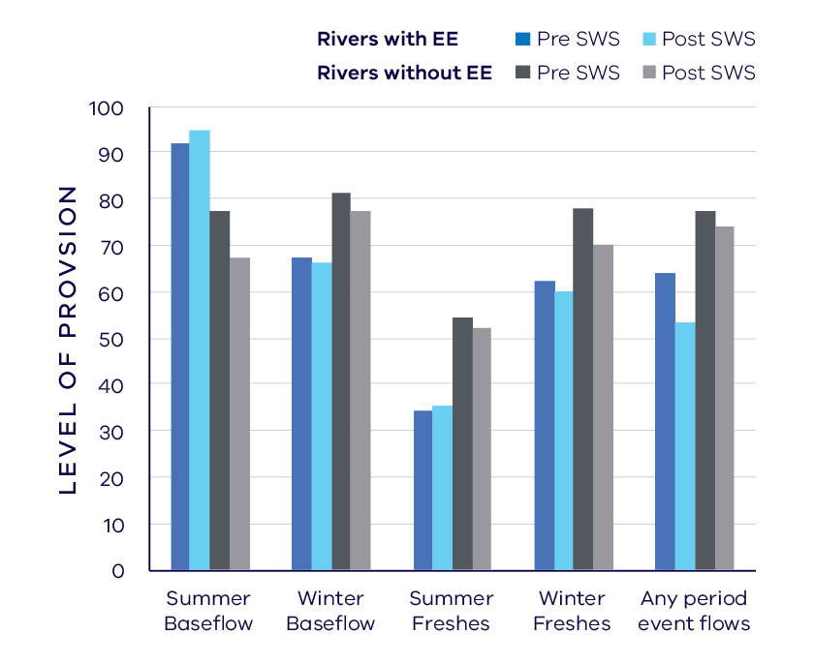
- Average change in ecologically important flow components in rivers with an environmental entitlement (EE) and without EE pre SWS (1963-2006) and post SWS (2007-2017)

Waterway health
There was insufficient long-term data available to assess the water quality, macroinvertebrate or fish waterway health indicators in this basin.

On-ground achievements: beyond the available data
While the assessment needed to analyse long-term datasets to answer the question set by the Water Act, there are numerous other projects going on around the state that are improving waterway health or discovering how improvements could occur, but which only began in recent years. In the Bunyip basin, such work is supporting native fish in the Tarago-Bunyip River.
Melbourne Water has studied the impact of water for the environment on Australian grayling’s migration patterns, with results showing a strong migration response to environmental flow releases in autumn. Studying these fish has allowed Melbourne Water to more effectively time environmental flow releases to improve outcomes for Australian grayling.
The same level of success however has not been observed for other priority species, including river blackfish. Environmental flows have the potential to influence two key threats to river blackfish: sedimentation and flow alteration. Sedimentation, due to reduced flow peaks, impacts blackfish by smothering their eggs and filling depressions and pools in the riverbed which are their preferred habitats. Recent studies in the Tarago River failed to record blackfish eggs in spawning tubes, likely due to the sedimentation of the habitat. Reduced flows in regulated rivers also mean that there is less habitat available for blackfish in the shallower and narrower waterways.
Recent flow recommendations have been updated to allow for localised movement of blackfish in the system. Within the existing environmental entitlement, these increased flow recommendations are unlikely to be actively delivered, as the delivery of these increased low flows would not leave enough water for the delivery of other priority flow components. Flows for river blackfish highlight the need for a greater allocation of water for the environment to ensure the long-term conservation of the species.

Has waterway health deteriorated for flow-related reasons?
There has been, on average, a maintenance of aspects of the flow regime with well understood ecological importance in the Bunyip and Tarago Rivers – the two rivers in this basin that have environmental entitlements – since the release of the Central Region SWS in 2006. This has occurred despite a substantive drop in water availability due to climate related factors. Our ability to directly assess changes in waterway health in this basin is constrained by low data availability. Overall, the findings for waterway health for reasons related to flow are inconclusive.

Yarra Basin

Introduction
The Yarra River rises in the Great Dividing Range near Warburton and flows to Port Phillip Bay through the City of Melbourne. The basin covers an area of around 4,050 square kilometres, more than half of which retains native vegetation. The headwaters and upper catchment are largely forested, with public access limited to protect water quality. The mid reaches include agricultural and rural areas including the vineyards of the Yarra Valley. The lower reaches flow through Melbourne’s urban and industrial areas and the estuary contains the Port of Melbourne.
The climate is temperate, with cool wet winters and warm dry summers. Rainfall varies significantly across the basin, with average annual rainfall of over 1,400 mm/year in the upper catchment, reducing to just 600 mm/year in the lower reaches.
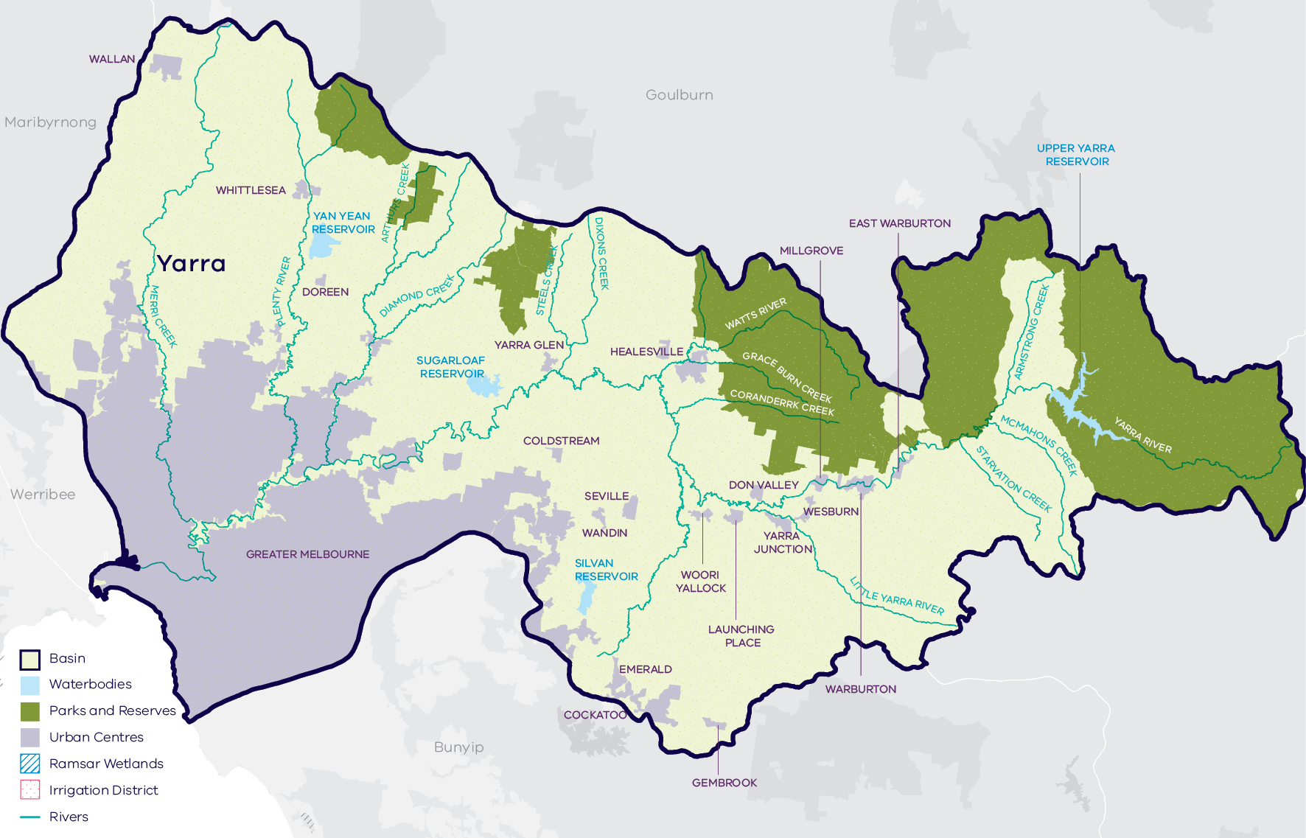
- Map of the Yarra basin

Long-term water availability
In 2006, the Central Region Sustainable Water Strategy (SWS) assessed water availability and reviewed the balance of water sharing between consumptive users and the environment in the Yarra basin. Surface water availability was calculated based on the average over the full historical record (1913 to 2005). Improvements in data and computer models since the development of the Central Region SWS have enabled a refined calculation of water availability over that period. The updated historical average surface water availability is 1,059.6 GL/year (Table 1; Figure 2).
Research indicates that recent decades provide a better representation of current climate than does the full historical record. Recent decades more closely reflect current atmospheric levels of greenhouse gases and have been drier and warmer than the earlier parts of the 20th century. For these reasons, the period from 1975 to the present is thought to better represent long-term water availability under current climatic conditions. It includes a wide range of natural climate variability — the severe Millennium Drought and wet years. The average water availability over this time is 884.9 GL/year (Table 1; Figure 2), a decline of 16 per cent compared with historical water availability.
The period since 1997 shows a further decline in water availability (Figure 2), however, this period is heavily influenced by the Millennium Drought. The drier conditions experienced since 1997 may be due to natural climate variability. These years may also represent ongoing conditions due to climate change, however it is too soon to know if this is the case.
In addition to surface water, groundwater is available in the Yarra basin. The amount of groundwater that can be pumped by consumptive users and the amount of water that flows from aquifers into streams and wetlands are both heavily dependent on groundwater levels. If groundwater levels have stayed the same (or increased) there will not have been a reduction in the groundwater available to consumptive users or the environment. If groundwater levels have declined, then either consumptive users or the environment (or both) may have experienced reduced water availability.
In the Yarra basin, groundwater predominantly occurs in alluvial sediments and fractured bedrock in the upper reaches. The Wandin Yallock Groundwater Management Area (GMA) covers a small area east of the Silvan Reservoir where groundwater is extracted from a local basalt aquifer and underlying fractured bedrock. Groundwater levels have remained relatively stable. Large drawdowns are observed in the fractured bedrock which recover during the winter and spring period of each year.
While climate is the primary driver of the decline in water flows into the Yarra, other potential contributing factors have been assessed:
- Interception by domestic and stock dams is unlikely to be contributing to the decline in surface water availability.
- There is no evidence of significant land-use changes to more water-intensive activities that would contribute to the total decline.
- The rate of licensed groundwater pumping from the unconfined aquifer is not likely to have a significant impact on waterway flow. Furthermore, the stable water levels in the basalt aquifer indicate that groundwater contribution to long-term surface water availability has not changed.
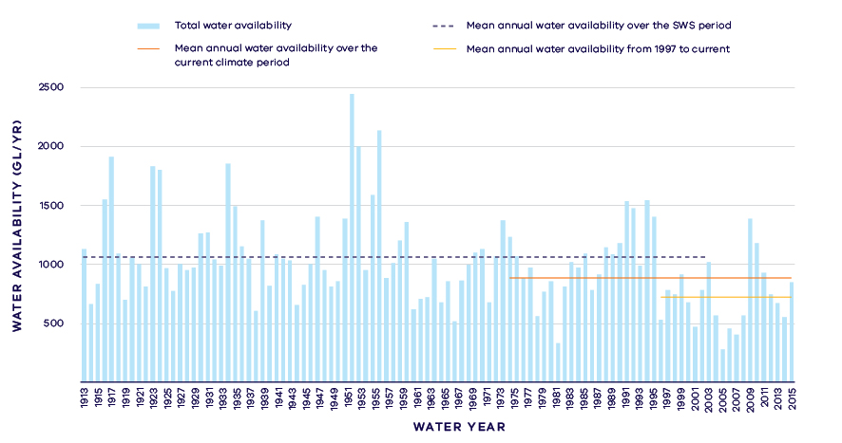
- Surface water availability in the Yarra River
- Long-term surface water availability in the Yarra basin
 |  |  |  | Change due to:⁵
 | Updated SWS estimate² | Current climate period³ | Current climate period and sharing arrangements⁴ | Different climate period | Different climate period and water sharing arrangements
Long-term surface water availability¹
Total water availability (GL/year) | 1,059.6 | 884.9 | 884.9 | -174.8 | -174.8
Consumptive  (GL/year)⁶ | 450.6 | 428.7 | 426.1 | -21.9 | -24.5
Environment (GL/year) | 583.4 | 419.7 | 422.5 | -163.8 | -161.0
Not categorised  (GL/year)⁷ | 25.7 | 36.5 | 36.4 | 10.9 | 10.7
Water sharing⁸
Consumptive | 44% | 51% | 50% | 7% | 7%
Environment | 56% | 49% | 50% | -7% | -7%

Notes to table
- These estimates are long-term averages. Values are rounded to the nearest 0.1 GL. Figures might not add in columns and/or rows, due to rounding. Minor differences in values compared with graphed annual average inflows arise from water intercepted by licensed farm dams being excluded from graphed historical inflows.
- The SWS estimate is based on the period 1913 – 2005.
- The current climate period is 1975 – 2017.
- Refer to subsequent sections on Water for Consumptive Use and Water for the Environment for details of any changes in water sharing arrangements. Small differences in total water availability over the current climate period result from changes in storage management.
- Negative values are a decline in water available; positive values are an increase in water available.
- These estimates assume full use of entitlements and include interception by licensed farm dams.
- Not categorised water, such as run-of-river losses that cannot be reasonably considered as being for consumptive users or the environment.
- Water sharing is represented as a percentage of the sum of water available for the environment and consumptive use. It excludes available water that was not categorised.

Water for consumptive use
The Yarra basin is a key source of water supply for Melbourne, such that a large proportion of the basin’s water is allocated to urban use (Figure 3). Other consumptive uses include private diversions for irrigated agriculture and licensed farm dams. The Yarra basin is highly connected to the surrounding river basins through the water grid, and water from within the basin can be used to supply towns and other users in the Werribee, Maribyrnong, South Gippsland and Barwon basins.
At the time of the SWS, 450.6 GL/year was available for consumptive use, but on average, the volume available to consumptive users has declined by 24.5 GL/year (Table 1), largely due to reduced inflows to Melbourne’s water storages (Figure 3).
The diversification of water sources has helped to mitigate the impact of reduced water availability on Melbourne’s water security. Major changes have included:
- The construction of the Victorian Desalination Project, which can provide up to 150 GL/year of additional water.
- Construction of the North-South (Sugarloaf) Pipeline, which allows the major metropolitan water corporations to access water held in the Goulburn system during severe water shortages.
- Issuing of stormwater licences allowing for access to approximately 1 GL/year of urban stormwater for non-potable uses.
These changes to water sharing arrangements have increased the flexibility and reliability of supply to consumptive users. These changes are not directly accounted for in this assessment, because they do not relate to water sourced from the Yarra basin’s waterways.

Water for the environment
Water can be set aside for the environment through water entitlements, passing flows and other regulatory limits on the water allocated to consumptive users.
There have been changes to the way environmental water is managed since the SWS to provide for targeted delivery of environmental flows. Following the Central Region SWS, the Yarra River environmental entitlement was created in 2006 and provides 17 GL/year to be used for environmental purposes. The full allocation is provided to this entitlement each year, regardless of the climatic conditions. Any unused water can be stored in system storages, meaning environmental water deliveries can be managed flexibly.
Passing flows set aside water for the environment through conditions on bulk entitlements. These conditions specify minimum passing flow requirements at offtakes and immediately downstream of reservoirs. In the Yarra basin, passing flows vary seasonally to mimic natural variation in river. At the time of the SWS, passing flows were 89 GL/year on average (Figure 3). In 2006, additional passing flow compliance points were established and passing flows were adjusted based on the Yarra River environmental flow study. These changes mean that minimum passing flows now average 100 GL/year (Figure 3).
A limit, called a permissible consumptive volume, has been placed on allocation of water to consumptive users in the Yarra basin. Because this above cap water is only available to the environment after all other users have taken their share, its volume varies with climatic conditions and reduces significantly when conditions become drier (Figure 3). The inflows to the Yarra River downstream of the reservoirs make a large contribution to the volume of above cap water.
Stream Flow Management Plans have been established for seven tributaries of the Yarra River, including Hoddles Creek, Olinda Creek, the Little Yarra and Don Rivers, Plenty River, Steels/Pauls/Dixons Creek, Stringybark Creek, and Woori Yallock Creek. These plans outline water sharing rules on local tributaries, including triggers for rostering and bans during periods of water shortage, so as to meet the minimum passing flow requirements in these local catchments.
At the time of the SWS, a total of 583.4 GL/year was set aside for the environment through passing flows and above cap water, but this has decreased by 161.0 GL/year (Table 1). Without the creation of the environmental entitlement and changes to the passing flow requirements, the decrease would have been greater.
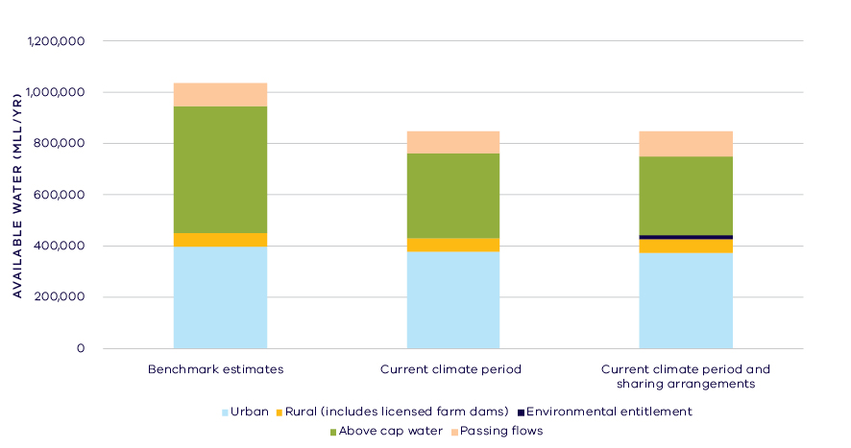
- Changes in water availability - Yarra basin

Has the decline in long-term surface water availability been shared equally?
Both consumptive users and the environment have experienced a long-term decline in total water availability. This decline has led to a change in the way that available water is shared between users.
At the time of the SWS, consumptive users had access to 44 per cent of available water while the environment had access to 56 per cent of available water (Table 1).
If no changes had been made to water sharing arrangements, over the current climate period consumptive users would have had access to 51 per cent of available water while the environment would have had access to 49 per cent of available water (Table 1).
Changes in water sharing arrangements since the SWS mean that both consumptive users and the environment are now estimated to have access to 50 per cent of available water. This is a 7 per cent increase in the proportion of the total resource for consumptive users since the SWS and a corresponding 7 per cent decrease in the proportion of the total resource for the environment (Table 1).

Waterways and their values
The waterways of the Yarra basin support a diversity of freshwater native fish including Australian grayling, freshwater catfish, eastern dwarf galaxias, Macquarie perch, Tasmanian mudfish, river blackfish and Yarra pygmy perch. The rivers and streams are important habitat for platypus and the billabongs provide important habitat for waterbirds and frogs. The Yarra River between Warburton and Warrandyte has been designated as a Victorian Heritage River in recognition of its significant recreation, nature conservation, scenic and cultural heritage values. The proximity to urban centres provides access to the waterways of the basin to a large number of people for boating, fishing and beside water recreational pursuits. The waterways of the Yarra basin continue to be an important place for Traditional Owners, represented by the Wurundjeri Land and Compensation Cultural Heritage Council Aboriginal Corporation.
Water held for the environment and actively managed in the Yarra basin is a small proportion of the total water which is needed to contribute to waterway health. The held environmental water is delivered to meet a number of long-term objectives including to:
- maintain instream geomorphology and physical habitat
- rehabilitate macroinvertebrate communities
- maintain and enhance populations of native fish such as Macquarie perch and Australian grayling
- maintain instream and riparian vegetation communities
- improve water quality and improve lateral and longitudinal connectivity.

Environmental flow provisions
There is a large body of scientific work linking defined aspects of the flow regime with ecological understanding and impacts to waterway health. In the absence of good long-term ecological data to assess waterway health, some inferences have been drawn from analyses of changes in flow. This should not, however, be considered a direct assessment of waterway health in the Yarra basin.
Since the release of the Central Region SWS, there has, on average, been little change in the provision of recommended environmental flow components in the Yarra basin (Figure 4). It should be noted that the release of the Central Region SWS coincides with the middle of the Millennium Drought and as the post-SWS analysis includes this confounding drought period, improvements post-SWS and also post-drought are not highlighted in this evaluation. A higher proportion of baseflows and freshes occurred in the Yarra River system post 2010. In addition, the basin averages mask widely different patterns between rivers within the basin. For example, there have been marked improvements in baseflows and summer freshes in the Yarra and Watts rivers where the environmental entitlement allows active management for recommended flow components, but declines in Diamond, Hoddles, and Woori Yallock creeks.
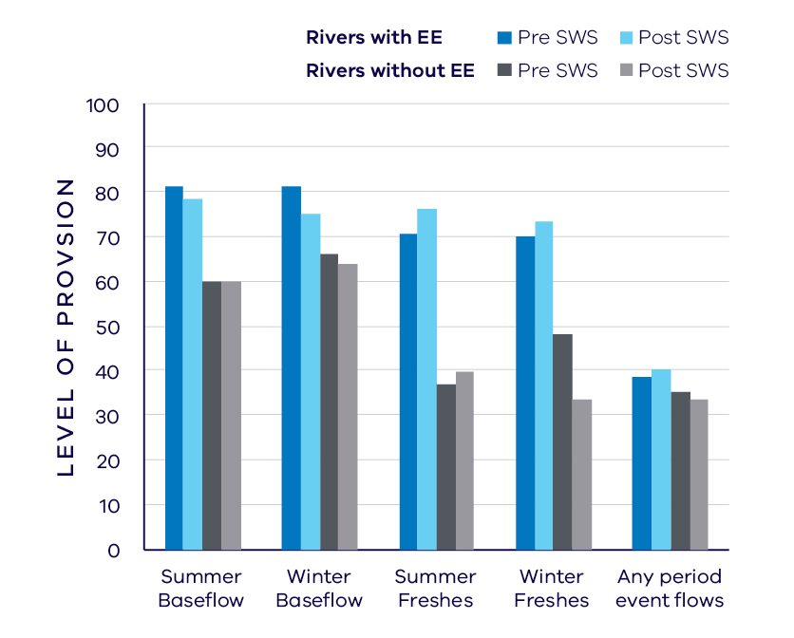
- Average change in ecologically important flow components in rivers with environmental entitlements (EE) and without pre SWS (1975 – 2006) and post SWS (2007 – 2018)

Waterway health
The waterway health analysis was completed at the river basin scale, primarily because there is less data at site, reach or individual river scales. Although aggregating data to a river basin scale allowed for better detection of statistical trends the results might not reflect the conditions at individual river reaches.
There is no accepted simple measure for overall waterway health and while many indicators and associated datasets were considered, only a few met requirements for the Long-Term Water Resource Assessment. Most of the available datasets did not cover a sufficient time period (>20 years) to allow for analysis of changes over a long-term timeframe. The indicators presented cover water quality and are based on the most robust data available. The data was split into three time periods:
- Prior to the LTWRA period — 1990 – 2005
- First part of the LTWRA period — 2006 – 2010. This was the worst period of the Millennium Drought, and many of the environmental flow changes recommended in SWS could not be implemented due to severe drought.
- Second part of the LTWRA period — 2011 – 2018. Post Millennium Drought.
The data were then analysed to identify any trends over time in the selected indicators. That is, whether various waterway health indicators are improving, deteriorating or unchanged. So, while it may be possible to report, for example, an improvement in salinity within a river basin, this does not necessarily imply “good” waterway health. This is because 1) the waterways may still be high in salinity, just less so than previously; and 2) other aspects of waterway health might be deteriorating.
The Long-Term Water Resource Assessment examined the impact of flow on waterway health. To this end, the effects of flow were separated from all other factors that can affect waterway health (e.g. bushfire, land use change, rehabilitation works). The individual influences of these other factors on waterway health have not been analysed in this assessment.
There has been an improvement in most water quality indicators in the Yarra basin since 2011. However, as discussed in section 6.2.4 of the Overview Report, there are a number of limitations on interpreting these indicators. The possible impacts of any changes in these individual indicators on other aspects of waterway health are also described in the Overview Report.
There was an improvement in trend (compared to prior to 2006) in dissolved oxygen that commenced in 2006 and continued through to 2018 and was partly linked to river flow. There was no detectable trend in salinity. There has been an improvement in nitrogen since 1990 which can be linked to flow changes. There was an improvement in trend (compared to prior to 2011) in phosphorus, turbidity and total suspended solids that can be partly linked to changes in flow. Turbidity, suspended solids and nutrients have particular limitations as indicators of overall waterway health as discussed in the Overview Report.

On-ground achievements: beyond the available data
While the assessment needed to analyse long-term datasets to answer the question set by the Water Act, much of the work around the state that is improving waterway health only began in recent years. In the Yarra basin, environmental water is delivered to the Yarra River system providing minimum passing flows, as well as timed releases to meet the requirements of the river’s environmental values. In addition to the objectives described under “Waterways and their values”, the entitlement also improves fish migration and spawning, and maintains and improves foraging habitat for platypus.
Monitoring is demonstrating the benefits of the environmental water releases, with evidence of migration and spawning of threatened species such as Australian grayling and Macquarie perch. The Yarra River’s platypus population is considered the most stable in the Port Philip Region and the catchment supports distinct vegetation communities that are in excellent condition.

Has waterway health deteriorated for flow related reasons?
There have been, on average, improvements in some aspects of the flow regime with well understood ecological importance in the Yarra basin since the release of the Central Region SWS in 2006, specifically in reaches where there is water held and managed for the environment. While there have also been improvements in some water quality indicators since 2011, these were only partly related to river flow, and there are known limitations with these indicators. Overall, the findings for waterway health for reasons related to flow are inconclusive.

Maribyrnong Basin

Introduction
The Maribyrnong basin covers 1,400 square kilometres of which just 10 per cent retains native vegetation cover. Water flows from Mount Macedon into Jacksons Creek, which joins with Deep Creek in Keilor North to form the Maribyrnong River. The river flows south through the western suburbs of Melbourne to join with the Yarra River and flows into Port Phillip Bay. The majority of the basin has been cleared for grazing and broad acre cropping, and the lower reaches are in the highly urbanised areas of Greater Melbourne.
The climate is temperate, with cool wet winters and warm dry summers. Rainfall varies significantly across the basin, with average annual rainfall of over 1,000 mm in the upper catchment, reducing to 500 mm in the lower reaches.
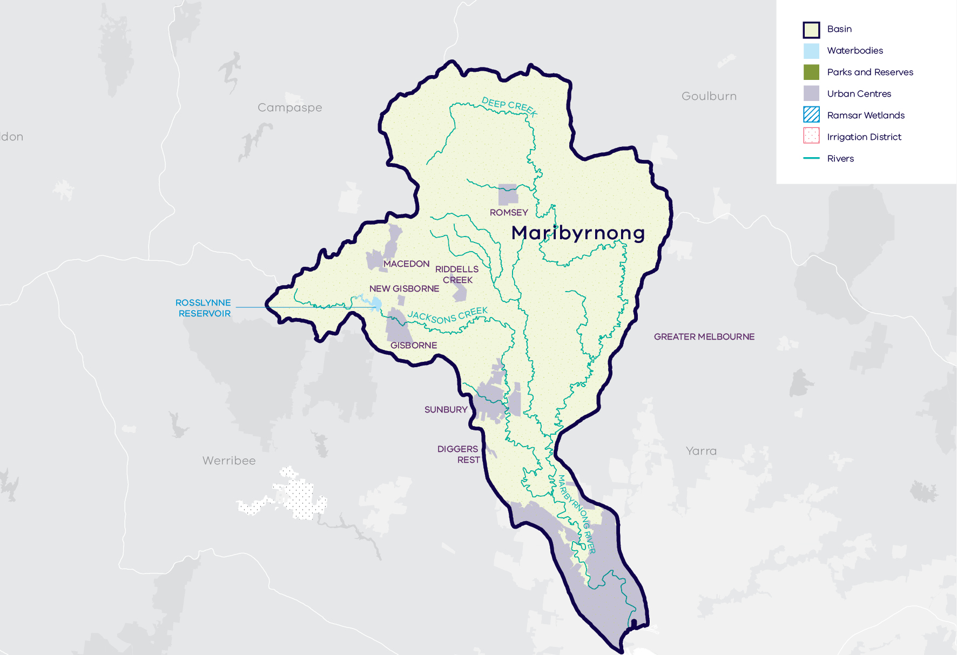
- Map of the Maribyrnong basin

Long-term water availability
In 2006, the Central Region Sustainable Water Strategy (SWS) assessed water availability and reviewed the balance of water sharing between consumptive users and the environment in the Maribyrnong basin. Surface water availability was calculated based on the long-term average between 1890 and 2004, using the best available data at that time. Improvements in data and computer models since the development of the Central Region SWS have enabled a refined calculation of water availability over that period. The updated historical average surface water availability for the Maribyrnong basin was 102.7 GL/year (Table 1; Figure 2).
Research indicates that recent decades provide a better representation of current climate than does the full historical record. Recent decades more closely reflect current atmospheric levels of greenhouse gases and have been drier and warmer than the earlier parts of the 20th century. For these reasons, the period from 1975 to the present is thought to better represent long-term water availability under current climatic conditions. It includes a wide range of natural climate variability — the severe Millennium Drought and wet years. The average water availability over this time is 85.1 GL/year, a decline of 17 per cent compared with historical water availability.
The period since 1997 shows further declines in water availability (Figure 2), however, this period is heavily influenced by the Millennium Drought. The drier conditions experienced since 1997, may be due to natural climate variability. These years may also represent ongoing conditions due to climate change, however, it is too soon to know if this is the case.
In addition to surface water, water availability within the Maribyrnong basin includes groundwater. Groundwater occurs in the unconfined and bedrock aquifers of the Maribyrnong basin. Monitoring of groundwater levels predominantly occurs in the Lancefield Groundwater Management Area (GMA) where the resource is developed. The observation bores in the Lancefield GMA were constructed in 2001. Because the groundwater assessment requires data prior to 1997, there is insufficient data to perform an assessment of long-term groundwater availability in the area. Outside of the Lancefield GMA, there is no significant groundwater pumping.
While climate is the primary driver of the decline in water flows into the Maribyrnong basin, other potential contributing factors have been assessed:
- Interception by domestic and stock dams is significant due to large numbers of these dams spread throughout the catchment.
- There is no evidence of land-use changes to more water-intensive activities which would contribute to the total decline.
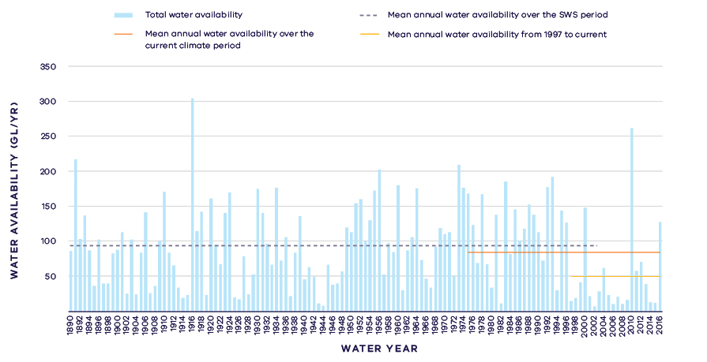
- Annual water availability in the Maribyrnong River
- Total long- term surface water availability in the Maribyrnong basin
 |  |  |  | Change due to:⁵
 | Updated SWS estimate² | Current climate period³ | Current climate period and sharing arrangements⁴ | Different climate period | Different climate period and water sharing arrangements
Long-term surface water availability¹
Total water availability (GL/year) | 102.7 | 85.1 | 85.1 | -17.6 | -17.6
Consumptive  (GL/year)⁶ | 8.1 | 7.5 | 7.2 | -0.6 | -0.8
Environment  (GL/year) | 93.0 | 75.8 | 76.2 | -17.2 | -16.9
Not categorised  (GL/year)⁷ | 1.6 | 1.8 | 1.7 | 0.1 | 0.1
Water sharing⁸
Consumptive | 8% | 9% | 9% | 1% | 1%
Environment | 92% | 91% | 91% | -1% | -1%

Notes to table
- These estimates are long-term averages. Values are rounded to the nearest 0.1 GL. Figures might not add in columns and/or rows, due to rounding. Minor differences in values compared with graphed annual average inflows arise from water intercepted by licensed farm dams being excluded from graphed historical inflows.
- The SWS estimate is based on the period 1890 – 2004 for the Maribyrnong River.
- The current climate period is 1975 – 2017.
- Refer to subsequent sections on Water for Consumptive Use and Water for the Environment for details of any changes in water sharing arrangements.
- Negative values are a decline in water available; positive values are an increase in water available.
- These estimates assume full use of entitlements and include interception by registered farm dams.
- Not categorised water, such as run-of-river losses that cannot be reasonable considered as being for consumptive users or the environment.
- Water sharing is represented as a percentage of the sum of water available for the environment and consumptive use. It excludes available water that was not categorised.

Water for consumptive use
In the Maribyrnong basin, consumptive uses include urban water supply to the towns in the interconnected Rosslynne system (including Sunbury and Gisborne), small stand-alone urban supplies (Lancefield-Romsey), take and use licences for unregulated surface water and licensed commercial and irrigation farm dams. Bulk entitlements within the basin are held by Melbourne Water, Western Water and Southern Rural Water. For some entitlements, the maximum volume of water allowed to be taken may be averaged over five years to provide flexibility to manage year-to-year variability in the availability and demand for water.
Under historical climate and system operations at the time of the SWS, 8.1 GL/year on average was available to consumptive users (Table 1; Figure 3). Changes in climate have reduced the amount of water available to consumptive users who, without any changes to water sharing, would have on average 0.6 GL/year less water compared with historical availability (Table 1).
Changes in the way water is managed since the Sustainable Water Strategy mean that more water for urban users comes from outside the Maribyrnong basin and less is sourced from the local waterways. Specifically, the Central Region Sustainable Water Strategy recognised that urban growth combined with reduced inflows to local storages created a risk of future water shortfalls. As a result, Western Water was allocated an additional 7 GL/year from the Melbourne system (i.e. Greater Yarra-Thomson Pool). This additional water is accounted for in the assessment of water availability from the Yarra and Thomson basins, rather than in the Maribyrnong basin. Water availability to consumptive users from the Maribyrnong basin sources has decreased due to climate change and changes to water sharing compared with historical availability; however, overall supply to urban users has not declined; as the necessary additional water is sourced from outside the Maribyrnong basin.

Water for the environment
Under historical climate and system operations at the time of the SWS, 93 GL/year was set aside for the environment using passing flows and policies that placed limits on the allocations to consumptive users (Table 1; Figure 3).
Passing flows set aside water for the environment through conditions on bulk entitlements. These conditions specify minimum passing flow requirements at offtakes and immediately downstream of reservoirs to be provided for environmental purposes. In the Maribyrnong basin, these passing flows are specified as ‘or natural’ which means they are heavily influenced by climate variability. Minimum passing flows also may vary depending on the volume in Western Water’s share of Rosslynne Reservoir.
Water is also set aside for the environment through a permissible consumptive volume, which is a limit placed on the allocations that could be made in bulk entitlements and take and use licences. The water remaining in the system is designated to the environment. Because this water is only available to the environment after all other users have taken their share, its volume varies with climatic conditions and reduces significantly when conditions become drier. The environment now has on average 16.9 GL/year less water compared with historical availability.
The environment also has access to additional water that is not considered as water for the environment in the assessment of long-term water availability. Since 2014, the Victorian Environmental Water Holder and Melbourne Water have worked with irrigators to purchase 300 ML/year temporary allocations to support environmental values (refer to below section on Waterways and their values). The purchase of water allocations for environmental use is opportunistic and is not guaranteed from year-to-year, and therefore this volume is accounted for as part the consumptive share of available water.
There is no formal environmental entitlement in the Maribyrnong basin. The creation of an environmental entitlement was raised in the Central Region SWS and is still under consideration. Current work, including studies into the potential use of sources such as stormwater for environmental benefit, contribute to planning for this entitlement.
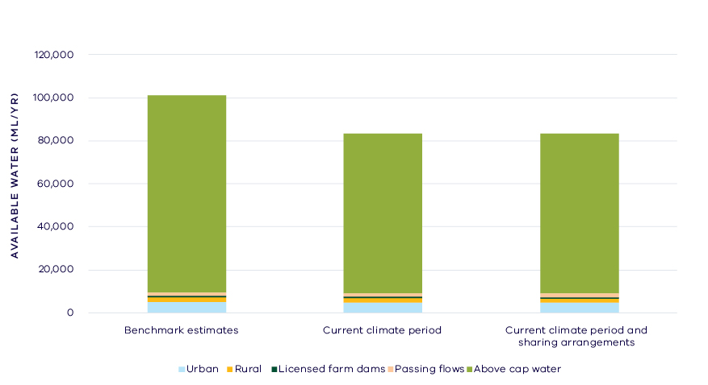
- Changes in the water availability – Maribyrnong basin

Have declines in long-term surface water availability been shared equally?
Since water availability in Maribyrnong basin was assessed for the Central Region Sustainable Water Strategy, the long-term average volume of water available to consumptive users and the environment has declined.
Changes to climate and water management operations have changed overall water availability but have not led to a change in the way that available water is shared between users. At the time of the SWS, consumptive users had access to 8 per cent of the total resource while the environment had access to 92 per cent of the total resource, and this has not changed significantly (Table 1). However, this result assumes that the water grid is operated to source supplementary urban water supplies from outside the Maribyrnong basin.

Waterways and their values
The waterways of the Maribyrnong basin are home to freshwater native fish species including Australian grayling, mountain galaxias and Yarra pygmy perch. The rivers and streams are important habitat for platypus and there is a diverse macroinvertebrate community. The proximity to urban centres provides access to waterways of the basin to a large number of people for boating, fishing and waterside recreational pursuits. The waterways of the Maribyrnong basin continue to be an important place for Traditional Owners, represented by the Wurundjeri Land and Compensation Cultural Heritage Council Aboriginal Corporation.
There is no environmental entitlement in the Maribyrnong basin. Since 2014, water for the environment has been purchased on a year-to-year basis. The usual temporary purchase is not enough to achieve all objectives, but is delivered with the aim to:
- maintain and increase feeding and breeding habitat for native fish
- protect and increase populations of small-bodied native fish, by providing flows for them to move upstream and downstream.
- maintain in-channel morphology,
- maintain instream and riparian vegetation communities,
- maintain and improve water quality for macroinvertebrates, platypus and for amenity values by preventing the development of nuisance and toxic algal blooms.

Environmental flow provisions
There is a large body of scientific work linking defined aspects of the flow regime with ecological understanding and impacts to waterway health. In the absence of good long-term ecological data to assess waterway health, some inferences have been drawn from analyses of changes in flow. This should not, however, be considered a direct assessment of waterway health.
Since the release of the Central Region SWS, there has, on average, been a decline in provision of all recommended environmental flow components in the Maribyrnong basin (Figure 4). Less than half the recommended important flows have been provided both pre- and post-SWS. It should be noted that the release of the Central Region SWS coincides with the middle of the Millennium Drought and as this post-SWS analysis includes this confounding drought period, any improvements post-SWS and also post-drought may be concealed. While the provision of environmental flow improved in the wet years such as 2010, there have still been dramatic declines in these flow components in Deep, Emu, Riddells and Jacksons creeks and in the Maribyrnong River.
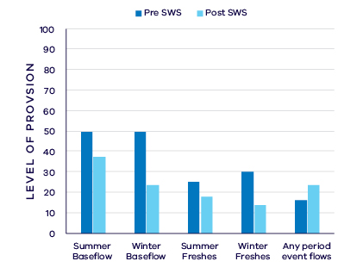
- Average change in ecologically important flow components pre SWS (1908 – 2006) and post SWS (2007 – 2018)

Waterway health
The waterway health analysis was completed at the river basin scale, primarily because there is less data at site, reach or river scales. Although aggregating data to a basin scale allowed for better detection of statistical trends, the results might not reflect the conditions at individual river reaches within the basin.
There is no simple accepted measure for overall waterway health and while many indicators and associated datasets were considered, only a few met requirements for the Long-Term Water Resource Assessment. Most of the available datasets did not cover a sufficient time period (>20 years) to allow for analysis of changes over a long-term timeframe. The indicators presented cover water quality and are based on the most robust data available. The data were split into three time periods:
- Prior to the LTWRA period — 1990 – 2005
- First part of the LTWRA period — 2006 – 2010. This was the worst period of the Millennium Drought.
- Second part of the LTWRA period — 2011 – 2018. Post Millennium Drought.
The data were then analysed to identify any trends over time in the selected indicators. That is, whether various waterway health indicators are improving, deteriorating or unchanged. So, while it may be possible to report, for example, an improvement in salinity within a river basin, this does not necessarily imply “good” waterway health. This is because 1) the waterways may still be high in salinity, just less so than previously; and 2) other aspects of waterway health might be deteriorating.
The Long-Term Water Resource Assessment examined the impact of flow on waterway health. To this end, the effects of flow were separated from all other factors that can affect waterway health (e.g. change in catchment activities or in treatment plant capacities). The individual influences of these other factors on waterway health have not been analysed in this assessment.
There is no consistent trend in water quality indicators in the Maribyrnong basin since 2011. As discussed in section 6.2.4 of the Overview Report, there are a number of limitations on interpreting these indicators. The possible impacts of any changes in these individual indicators on other aspects of waterway health are also described in the Overview Report.
There was an improvement in trend in dissolved oxygen (compared to before 2006) which was linked to changes in flow. There was a deterioration in trend in salinity (compared to before 2011) which was strongly linked to changes in river flow, but on average, levels remained within SEPP guidelines. There has been a continuing improvement in phosphorus and nitrogen since 1990 which is linked to changes in flow. There has been an improvement in trend in turbidity and total suspended solids (compared to before 2011) which is partly due to flow changes.
These results are expected in conditions of low river flows, with increasing salinity due to a concentration of salts in a smaller volume of water. Improvements in total suspended solids, phosphorus and nitrogen may reflect reduced catchment inflows and sediments and nutrients due to smaller runoff volumes. Under these conditions an improvement in these indicators is unlikely to reflect an overall improvement in waterway health.

On-ground achievements: beyond the available data
While the assessment needed to analyse long-term datasets to answer the question set by the Water Act, there is much other work going on around the state that is improving waterway health, but which only began in recent years. In the Maribyrnong basin Melbourne Water, as waterway manager, has continued to find opportune small volumes of water to deliver as a temporary entitlement. Water stored and delivered from Rosslynne Reservoir over summer periods as multi-day “freshes”, have maintained populations of small bodied native fish in the Maribyrnong system. To date five successive years of engagement with irrigators and other stakeholders have enabled between 300 and 600ML of water to be delivered to the environment each year.
Delivery of these events over successive years has demonstrated the use of environmental water can maintain critical habitats and protect stream values from extreme hot and dry weather conditions. Continued monitoring of fish populations aims to provide a useful dataset to show maintenance of current values and also to assist in demonstrating future improvements. Further efforts to identify additional water for the environment aim to achieve benefits for aquatic plants and animals.

Has waterway health deteriorated for flow-related reasons?
There have been, on average, severe to moderate declines in aspects of the flow regime with well understood ecological importance in the Maribyrnong basin since the release of the Central Region SWS in 2006 and overall only a small proportion of recommended flows are provided across all categories. These declines represent more than just the effects of the Millennium Drought; the declines are consistent with a long-term decline in water availability in this basin. There are mixed results from the water-quality indicators, and some of the improvements are likely confounded by the impact of low runoff and river flows. Overall, the findings for waterway health for reasons related to flow are inconclusive.

Werribee Basin

Introduction
The Werribee basin, west of Melbourne, covers an area of approximately 2,000 square kilometres rising in the Macedon Ranges and flowing to Port Phillip Bay. Major waterways in the Werribee basin include the Werribee and Lerderderg Rivers as well as Pyrites, Kororoit, Skeleton and Laverton creeks. The upper catchment maintains native vegetation cover in the Wombat State Forest and Lerderderg State Park, as well as other smaller areas around the catchment. Approximately 65 per cent of the basin is used for agriculture, predominantly in the mid reaches of the catchment including the important market gardens of Melbourne’s west around Bacchus Marsh and Werribee. Around 10 per cent of the basin is urban with the outskirts of Greater Melbourne in the lower reaches. To meet agricultural and urban demands for water the Werribee River system includes the storages of Pykes Creek Reservoir, Lake Merrimu and Melton Reservoir.
The climate is temperate, with cool wet winters and warm dry summers. The Werribee basin has the driest catchment in Victoria south of the dividing range, with average annual rainfall of around 890 mm/year in high elevation northern areas decreasing to 470 mm/year in the plains at Werribee.
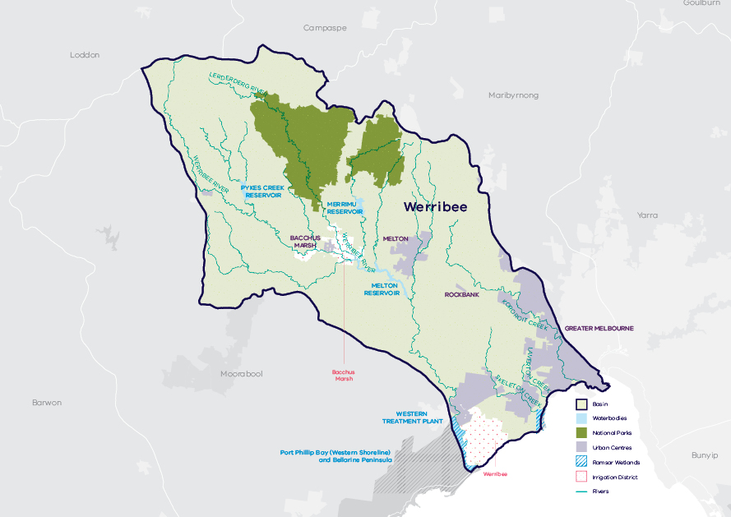
- Map of the Werribee basin

Long-term water availability
In 2006, the Central Region Sustainable Water Strategy (SWS) assessed water availability and reviewed the balance of water sharing between consumptive users and the environment in the Werribee basin. Surface water availability was calculated based on the long-term average between 1920 and 2005, using the best available data at that time. Improvements in data and computer models since the development of the Central Region SWS have enabled a refined calculation of water availability over that period. The updated historical average surface water availability is 95.4 GL/year (Table 1; Figure 2).
Research indicates that recent decades provide a better representation of current climate than does the full historical record. Recent decades more closely reflect current atmospheric levels of greenhouse gases and have been drier and warmer than the earlier parts of the 20th century. For these reasons, the period from 1975 to the present is thought to better represent long-term water availability under current climatic conditions. It includes a wide range of natural climate variability — the severe Millennium Drought and wet years. The average water availability over this time is 77.8 GL/year, a decline of 18 per cent compared with historical water availability.
The period since 1997 shows a further decline in water availability (Figure 2), however, this period is heavily influenced by the Millennium Drought. The drier conditions experienced since 1997 may be due to natural climate variability. These years may also represent ongoing conditions due to climate change. It is too soon to know if this is the case.
In addition to surface water, water availability within the Werribee basin includes groundwater. The amount of groundwater that can be pumped by consumptive users and the amount of water that flows from aquifers into streams and wetlands are both heavily dependent on groundwater levels. If groundwater levels have declined, then either consumptive users or the environment (or both) may have experienced reduced water availability.
Groundwater levels in the Werribee basin are primarily monitored in the Werribee plains where the resource is developed for agriculture. The primary resource is located on the east side of the Werribee river delta and is part of the Deutgam Groundwater Management Area (GMA). Long-term declines were identified in this area ranging from 0.1 m to 2 m. In other management areas in the basin, no decline was identified in the Merrimu GMA near Bacchus Marsh and a small decline < 1 m has occurred in the Cut Paw Paw GMA near Williamstown.
While climate is the primary driver of the decline in surface water flows into the Werribee basin, other potential contributing factors have been assessed:
- Interception by domestic and stock dams has a low likelihood of contribution to the decline in surface water availability.
- There is evidence of minor land-use changes to more water-intensive activities, however it is unlikely that this is contributing to the total decline.
- Groundwater pumping in the Deutgam GMA has reduced waterway flow in the catchment by approximately 0.4 GL/year, which makes a small contribution to the overall reduction in long-term surface water availability.
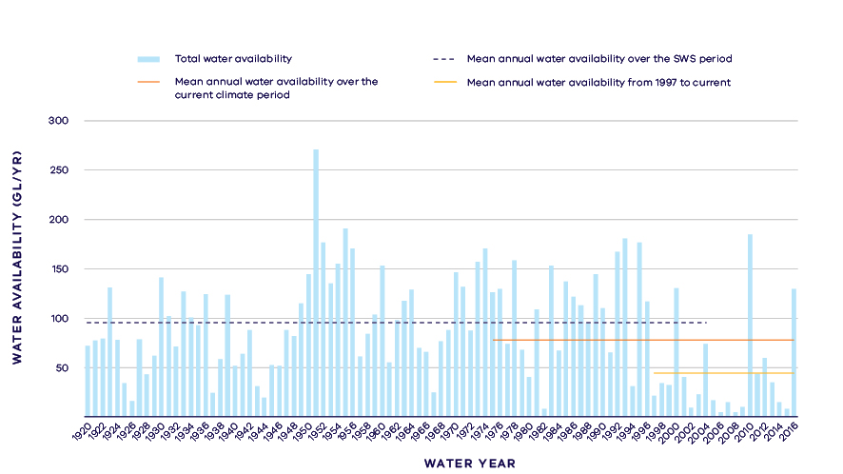
- Annual water availability in the Werribee River (including tributaries)
- Total long- term surface water availability in the Werribee basin
 |  |  |  | Change due to:⁵
 | Updated SWS estimate² | Current climate period³ | Current climate period and sharing arrangements⁴ | Different climate period | Different climate period and water sharing arrangements
Long-term surface water availability¹
Total water availability (GL/year) | 95.4 | 77.8 | 77.8 | -17.6 | -17.6
Consumptive  (GL/year)⁶ | 34.7 | 31.6 | 34.5 | -3.1 | -0.2
Environment  (GL/year) | 50.9 | 38.4 | 36.5 | -12.5 | -14.4
Not categorised  (GL/year)⁷ | 9.9 | 7.8 | 6.8 | -2.1 | -3.1
Water sharing⁸
Consumptive | 41% | 45% | 49% | 5% | 8%
Environment | 59% | 55% | 51% | -5% | -8%

Notes to table
- These estimates are long-term averages. Values are rounded to the nearest 0.1 GL. Figures might not add in columns and/or rows, due to rounding. Minor differences in values compared with graphs of annual inflows arise from water intercepted by licensed farm dams being excluded from graphed historical inflows.
- The SWS estimate is based on the period 1920 – 2005.
- The current climate period is 1975 – 2017.
- Refer to subsequent sections on Water for Consumptive Use and Water for the Environment for details of any changes in water sharing arrangements.
- Negative values are a decline in water available; positive values are an increase in water available.
- These estimates assume full use of entitlements and include interception by licensed farm dams.
- Not categorised water, such as run-of-river losses and unallocated water that cannot be reasonably considered as being for consumptive users or the environment.
- Water sharing is represented as a percentage of the sum of water available for the environment and consumptive use. It excludes available water that was not categorised.
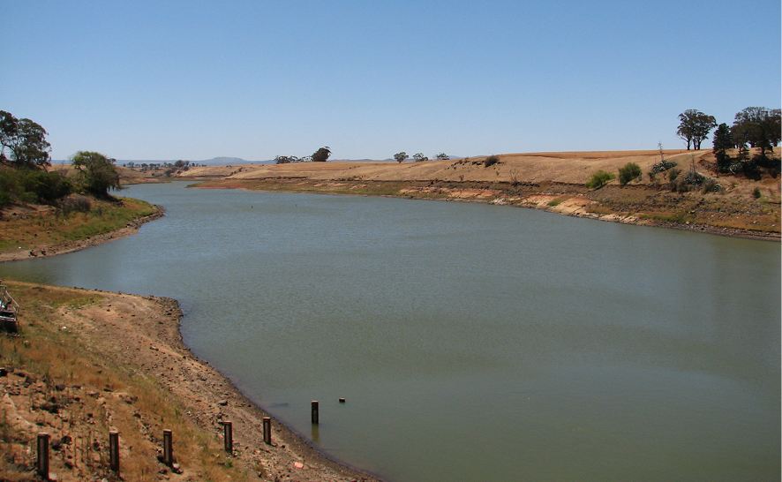
- Werribee River at Melton Reservoir. Photo credit: Lisa Lowe

Water for consumptive use
In the Werribee basin, consumptive water uses include urban water supply, licensed commercial and irrigation farm dams and supply to the Werribee and Bacchus Marsh Irrigation Districts.
Under historical climate and system operations at the time of the SWS, on average 34.7 GL/year was available for consumptive users (Table 1).
Changes in climate have changed the amount of surface water available to consumptive users who, without any changes to water sharing, would have access to 3.1 GL/year less water compared with historical availability (Table 1).
Changes in water sharing arrangements have helped to mitigate the impact of changes in climate for consumptive users. Major changes include the unbundling of entitlements and the introduction of individual carryover. Unbundling and carryover have allowed water users greater flexibility to manage the impacts of climate variability, through options to trade, increased certainty of entitlements and greater access to water earlier in the season.
With current climate conditions and current water sharing arrangements, water availability has still decreased, but only marginally compared with historical availability.
Consumptive users have access to additional water that is not directly counted in the assessment of long-term water availability. This is through connection to the Melbourne system for urban supply, and the provision of recycled water from the Western Treatment Plant for irrigation in the Werribee Irrigation District and for non-potable use in some newer residential developments.
Irrigation modernisation works in both the Werribee and Bacchus Marsh Irrigation Districts are underway. Once modernisation is complete, the water savings generated will be shared between irrigators and the Victorian Environmental Water Holder.
The Deutgam Groundwater Management Area has groundwater trigger levels set to manage the risk of sea water intrusion at the coast. Restrictions on groundwater allocations in the area have been announced in 10 seasons since 1997. While declines in level have occurred in the GMA there has been no increase in salinity in the aquifer to date. The main source of recharge to the aquifer is from irrigation accessions in the Werribee Irrigation District.

Water for the environment
Under historical climate and system operations at the time of the SWS, on average 50.9 GL/year was available for the environment using passing flows and policies that placed limits on the allocations to consumptive users (Table 1).
Passing flows set aside water for the environment through conditions on bulk entitlements. These conditions specify minimum passing flow requirements at offtakes and immediately downstream of reservoirs to be provided for environmental purposes. Passing flow rules for the Lerderderg River below the Lerderderg Weir are particularly sophisticated, and allow for episodic large freshening flows, in addition to a daily minimum flow. In the Werribee basin, passing flows are specified as ‘or natural’ and are linked to irrigation allocations, which means these flows are heavily influenced by climate variability and allocation policy.
Water is also set aside for the environment through the permissible consumptive volume, which is a limit placed on allocation of water to consumptive users. Once water is allocated to all entitlements, the water remaining in the system is assigned to the environment. Because this above cap water is only available to the environment after all other users have taken their share, its volume varies with climatic conditions and reduces significantly when conditions become drier.
Changes in climate have reduced the amount of water available to the environment which, without any changes to water sharing would now have 12.5 GL/year on average less water compared with historical availability.
Since the SWS, the Werribee River environmental entitlement has been created from a previously unallocated share of inflow to Lake Merrimu. This entitlement provides for controlled environmental releases to meet specific environmental flow targets.
Despite the environmental entitlement, the total volume available to the environment has declined further, due to the increase in the volume that can be accessed by consumptive users in the irrigation districts. With current climate conditions and current water sharing arrangements, water availability has decreased by approximately 14.4 GL/year compared with historical availability. This represents a 28 per cent decline in the average volume of water available to the environment.
This assessment did not include the water available for the environment from 0.7 GL of high and 0.4 GL of low-reliability water shares formerly belonging to the Werribee agricultural college. In recent years, Melbourne Water has used that water for environmental outcomes, particularly to improve water quality in the lower reaches of the Werribee River. In future, the water shares will be transferred to the Victorian Environmental Water Holder (VEWH) and will become part of the official Environmental Water Reserve.

Have declines in long-term surface water availability been shared equally?
The long-term decline in water availability has been borne predominantly by the environment.
Declines in inflows have led to a change in the way that available water is shared between users. At the time of the SWS, consumptive users had access to 41 per cent of the total resource while the environment had access to 59 per cent of the total resource (Table 1).
Overall, declines in inflow and changes to management of the system mean that consumptive users in the Werribee basin now have access to 49 per cent of the total resource and the environment has access to 51 per cent of the total resource. This is an 8 per cent increase in the proportion of the total water allocated for consumptive users and a corresponding 8 per cent decrease in the proportion of the total water for the environment.
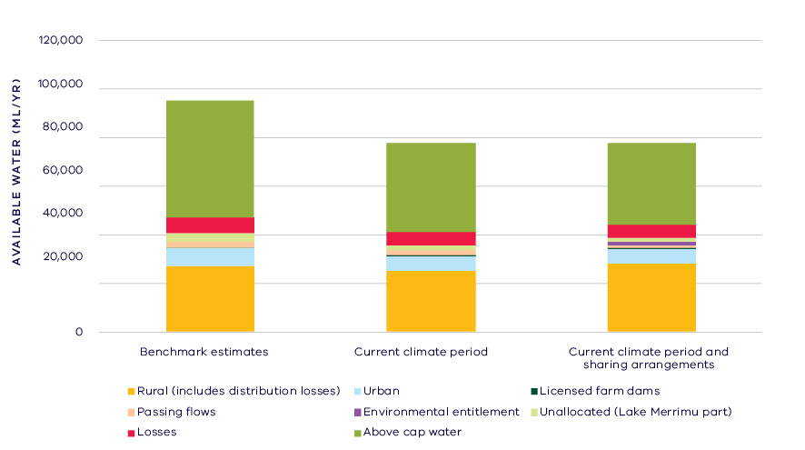
- Changes in the water availability – Werribee basin

Waterways and their values
The waterways of the Werribee basin support a range of species including several iconic and threatened species. Vegetation in the upper catchment is largely intact and waterway dependent communities include Riparian Forest, Stream Bank Shrubland and Sedgy Riparian Woodland, with a canopy of gum trees above dense understories. Vegetation in the middle and lower reaches is largely cleared with only narrow riparian strips and patchy areas remaining. The Floodplain Riparian Woodland of the mid reaches transitions to more salt tolerant communities and saltmarsh in the estuarine reaches near the discharge into Port Phillip Bay.
The lower Werribee River has a small population of platypus and the rakali is widespread along wetlands and watercourses. There are 13 species of native fish in the basin, and the Werribee River supports a significant recreational black bream fishery. Over 134 species of waterway dependent birds have been recorded in the basin, including the nationally endangered Australasian bittern. Frogs are a valued feature of waterways and there are recent records of growling grass frog.
The waterways of the Werribee basin are significant to Traditional Owners and Aboriginal Victorians, including the Wurundjeri and Wathaurung, with a high concentration of significant sites and artefacts along river corridors and around wetlands. The waterways are also highly valued by local communities with nature-based activities (hiking, picnicking) in the upper reaches and recreational fishing and boating popular pursuits in the middle to lower reaches.
Environmental water is delivered in the Werribee basin to meet a number of long-term objectives including to:
- improve macroinvertebrate and frog habitat
- increase the recruitment and growth of in-stream, riverside and estuary plants
- protect and increase populations of native fish by improving pool habitat and stimulating native fish to migrate and spawn
- promote movement of native fish between fresh and estuarine reaches
- maintain and improve water quality, for native fish, frogs, macroinvertebrates and platypus.

Environmental flow provisions
There is a large body of scientific work linking defined aspects of the flow regime with ecological understanding and impacts to waterway health. In the absence of good long-term ecological data to assess waterway health, some inferences have been drawn from analyses of changes in flow. This should not, however, be considered a direct assessment of waterway health.
Since the release of the Central Region SWS, there has, on average, been a decline in all environmental flow provisions in the Werribee basin (Figure 5). However, where there is an environmental entitlement this decline is smaller for summer baseflow, and both summer and winter freshes. A lack of baseflows could be expected to impact on water quality and habitat for macroinvertebrates, fish and platypus. The reduction in freshes would further reduce cues for spawning and migration of native fish and dispersal of platypus. It should be noted that the release of the Central Region SWS coincided with the middle of the Millennium Drought and as the post-SWS analysis includes this confounding drought period any improvements post-SWS and also post-drought may be concealed. A higher proportion of summer and winter baseflows occurred in the Werribee River system in the wetter years of 2010, 2011 and 2016.
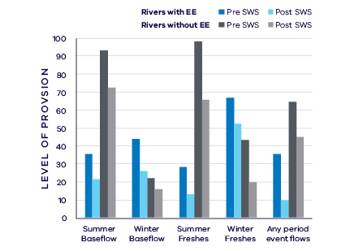
- Average change in ecologically important flow components in rivers with environmental entitlements (EE) and without pre SWS (1963 – 2006) and post SWS (2007 – 2018)

Waterway health
The waterway health analysis was completed at the river basin scale, primarily because there is less data at site, reach or river scales. Although aggregating data to a basin scale allowed for better detection of statistical trends, the results might not reflect the conditions at individual river reaches.
There is no accepted simple measure for overall waterway health and while many indicators and associated datasets were considered, only a few met requirements for the Long-Term Water Resource Assessment. Most of the available datasets did not cover a sufficient time period (>20 years) to allow for analysis of changes over a long-term timeframe. The indicators presented cover water quality and are based on the most robust data available. The data were split into three time periods:
- Prior to the LTWRA period — 1990 – 2005
- First part of the LTWRA period — 2006 – 2010. This was the worst period of the Millennium Drought, and many of the environmental flow changes recommended in SWS could not be implemented due to severe drought.
- Second part of the LTWRA period — 2011 – 2018. Post Millennium Drought.
The data were then analysed to identify any trends over time in the selected indicators. That is, whether various waterway health indicators are improving, deteriorating or unchanged. So, while it may be possible to report, for example, an improvement in salinity within a river basin, this does not necessarily imply “good” waterway health. This is because 1) the waterways may still be high in salinity, just less so than previously; and 2) other aspects of waterway health might be deteriorating.
The Long-Term Water Resource Assessment examined the impact of flow on waterway health. To this end, the effects of flow were separated from all other factors that can affect waterway health (e.g. land-use change, rehabilitation works). The individual influences of these other factors on waterway health have not been analysed in this assessment.
There is no consistent pattern of changes in water quality indicators in the Werribee basin since 2011. As discussed in section 6.2.4 of the Overview Report, there are a number of limitations on interpreting these indicators. The possible impacts of any changes in these individual indicators on other aspects of waterway health are also described in the Overview Report.
There has been an ongoing decrease in dissolved oxygen since 1990 that is partly related to the flow regime. There was a deterioration in trend in salinity (compared to before 2011) which was partly linked to changes in river flow, but on average levels remained within SEPP guidelines. There was a deterioration in trend in nitrogen (compared to before 2006) that is partly related to changes in flow. However, there were improvements in trends of phosphorus and total suspended solids (compared to before 2011) that are also partly related to changes in flow. There was also an improvement in trend in turbidity (compared to before 2011) but this was mostly not related to flow.
Turbidity, total suspended solids, phosphorus and nitrogen indicators in particular have complicated relationships with the flow regime – for example, during very dry conditions these indicators may decrease because there is no runoff to transport sediment and pollutants from the land into a waterway. This apparent “improvement” in an individual indicator linked to a lack of flow would not reflect an improvement in overall waterway health. These inconsistent patterns illustrate the complex nature of river systems and the interaction between flow and non-flow factors, such as land-use.

On-ground achievements: beyond the available data
While the assessment needed to analyse existing long-term datasets to answer the question set by the Water Act, there is other work going on around the state that is demonstrating short-term improvements in waterway health and the potential of that current work.
In the Werribee River the environmental entitlement was established in 2011 from 10 per cent of inflows into Merrimu Reservoir. This has provided a yearly average of 0.55 GL of water for the environment. Melbourne Water have also held water shares in the Werribee Irrigation District since 2013/14, which have been used to supplement the environmental entitlement for the achievement of ecological objectives.
Although small, the environmental flows delivered have been critical in helping the Werribee River and its tributaries through past dry years. Flow releases from Merrimu Reservoir into Pyrites Creek have provided drought refuges for frogs, with more species and greater abundance than in other unwatered reaches. In the lower reaches around Werribee releases of environmental water in summer have flushed toxic blue-green algae from the river and raised dissolved oxygen levels.
Fish monitoring commissioned by Melbourne Water and as part of Victorian Environmental Flows Monitoring and Assessment Program has demonstrated that individual flow events, some of them actively managed through environmental flow releases, promote the recruitment and upstream migration of native fish species, such as black bream and common galaxias. Fish numbers have been reduced in years where these flow events did not occur.
These monitoring results demonstrate the potential positive ecological responses that could be achieved if more water for Werribee River were allocated to the environmental entitlement. Species such as the iconic platypus would be beneficiaries of increased environmental flows.

Has waterway health deteriorated for flow-related reasons?
There have been, on average, substantial declines in aspects of the flow regime with well understood ecological importance in the Werribee basin since the release of the Central Region SWS in 2006, and this is likely to have had a negative impact on waterway health. There were inconsistent trends in water quality indicators and how strongly any trends were related to flow. These are difficult to interpret and do not indicate substantive overall improvement or deterioration in waterway health in this basin. Overall, the findings for waterway health for reasons related to flow are inconclusive.

Moorabool Basin
Introduction
The Moorabool basin covers an area of approximately 2,200 square kilometres rising in the Central Highlands between Ballarat and Ballan and joins the Barwon River just upstream of Geelong. The basin also includes waterways that are not connected to the Moorabool River, notably Little River and Hovells Creek, both of which flow in to Port Phillip Bay. The basin is predominately agricultural, with around 75 per cent of the area cleared for grazing, with smaller areas of horticulture, such as potatoes. The mid reaches of the river flow within confined gorges which contain remnant native vegetation. The basin includes the towns of Lara, Bannockburn and Batesford, as well as the existing and future planned urban areas west of Geelong. The Western Treatment Plant extends into the south eastern corner of the basin. It receives and treats around 50 per cent of Melbourne’s waste water, which is either recycled or discharged into Port Philip Bay. The Moorabool basin also includes part of the Port Phillip Bay (Western Shoreline) and Bellarine Peninsula Ramsar site.
The climate is temperate, with cool wet winters and warm dry summers. Annual average rainfall decreases from 700 – 1,000 mm/year in the headwaters to 500 – 600 mm/year in the middle/lower reaches.
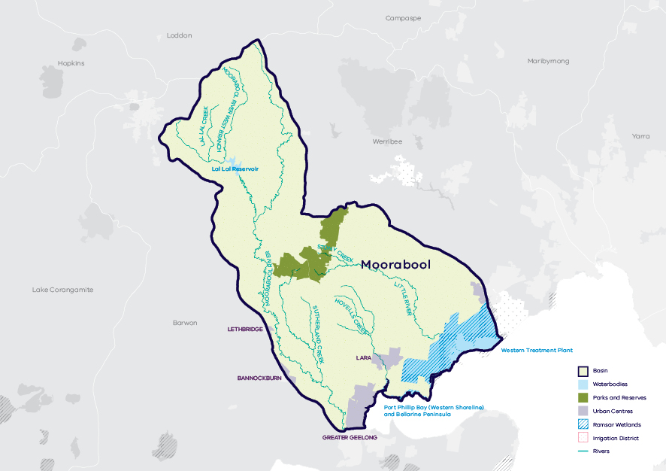
- Map of the Moorabool basin

Long-term water availability
In 2006, the Central Region Sustainable Water Strategy (SWS) assessed water availability and reviewed the balance of water sharing between consumptive users and the environment in the Moorabool basin. For the Moorabool River, surface water availability was calculated based on the long-term average over the period between 1927 and 2004, using the best available data at that time. Improvements in data and computer models since the development of the Central Region SWS have enabled a refined calculation of water availability over that period. The updated historical average surface water availability is 105.5 GL/year for the Moorabool River (Table 2; Figure 2). For the Little River, historical surface water availability is 9.1 GL/year (Table 3; Figure 3).
Research indicates that recent decades provide a better representation of current climate than does the full historical record. Recent decades more closely reflect current atmospheric levels of greenhouse gases and have been drier and warmer than the earlier parts of the 20th century. For these reasons, the period from 1975 to the present is thought to better represent long-term water availability under current climatic conditions. It includes a wide range of natural climate variability — the severe Millennium Drought and wet years. In the Moorabool River, the average water availability over this time is 85 GL/year, a decline of 19 per cent compared with historical water availability. In Little River, the average water availability over the current climate period is 7.2 GL/year, a decline of 21 per cent compared with historical water availability.
The period since 1997 shows a further decline in water availability (Figure 2, Figure 3), however, this period is heavily influenced by the Millennium Drought. The drier conditions experienced since 1997 may be due to natural climate variability. These years may also represent ongoing conditions due to climate change. It is too soon to know if this is the case.
In addition to surface water, groundwater is available in the Moorabool basin. The amount of groundwater that can be pumped by consumptive users and the amount of water that flows from aquifers into streams and wetlands are both heavily dependent on groundwater levels. If groundwater levels have stayed the same (or increased) there will not have been a reduction in the groundwater available to consumptive users or the environment. If groundwater levels have declined, then either consumptive users or the environment (or both) may have experienced reduced water availability.
Groundwater levels in the Moorabool basin are primarily monitored in the northern parts of the basin where groundwater is extracted within the Bungaree Groundwater Management Area (GMA). Long-term declines were identified in areas upstream of Moorabool Reservoir of greater than 2 m and in areas downstream of the reservoir ranging from 0.1 to greater than 2 m.
While climate is the primary driver of the decline in water flows into the Moorabool basin, other potential contributing factors have been assessed:
- Interception by domestic and stock dams is significant due to large numbers of these dams, particularly in the top of the catchment.
- There is no evidence of land-use changes to more water-intensive activities which would contribute to the decline in water availability.
- Licensed groundwater pumping in the Bungaree GMA has reduced waterway flow in the catchment by approximately 0.6 GL/year which makes a small contribution to the reduction in long-term surface water availability.
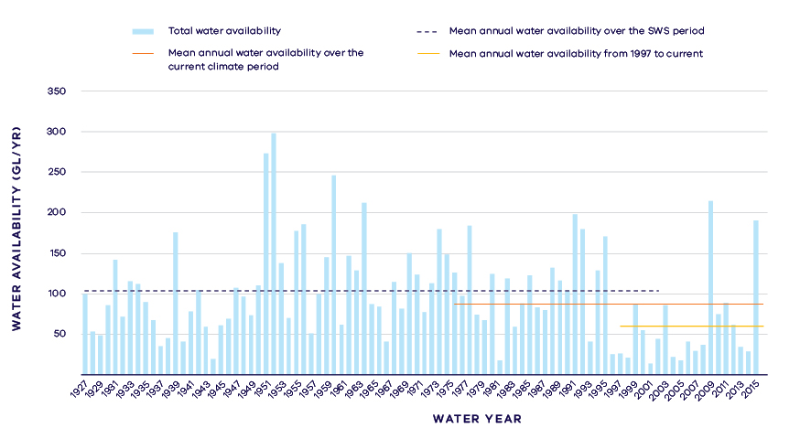
- Annual water availability in the Moorabool River
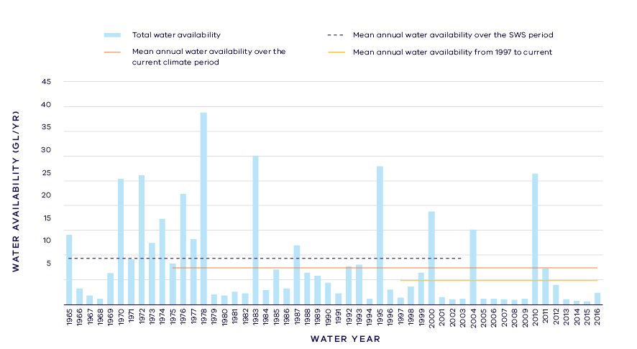
- Annual water availability in the Little River
- Total long- term surface water availability in the Moorabool basin (summed across rivers)
 |  |  |  | Change due to:⁵
 | Updated SWS estimate² | Current climate period³ | Current climate period and sharing arrangements⁴ | Different climate period | Different climate period and water sharing arrangements
Long-term surface water availability¹
Total water availability (GL/year) | 114.7 | 92.2 | 92.2 | -22.5 | -22.5
Consumptive  (GL/year)⁶ | 33.3 | 30.8 | 31.3 | -2.4 | -1.9
Environment  (GL/year) | 70.5 | 53.7 | 53.7 | -16.7 | -16.8
Not categorised  (GL/year)⁷ | 10.9 | 7.6 | 7.2 | -3.3 | -3.8
Water sharing⁸
Consumptive | 32% | 36% | 37% | 4% | 5%
Environment | 68% | 64% | 63% | -4% | -5%

- Long- term surface water availability in the Moorabool River
 |  |  |  | Change due to:⁵
 | Updated SWS estimate² | Current climate period³ | Current climate period and sharing arrangements⁴ | Different climate period | Different climate period and water sharing arrangements
Long-term surface water availability¹
Total water availability (GL/year) | 105.5 | 85.0 | 85.0 | -20.6 | -20.6
Consumptive  (GL/year)⁶ | 32.9 | 30.4 | 30.9 | -2.4 | -1.9
Environment  (GL/year) | 61.7 | 46.9 | 46.9 | -14.8 | -14.9
Not categorised  (GL/year)⁷ | 10.9 | 7.6 | 7.2 | -3.3 | -3.8
Water sharing⁸
Consumptive | 35% | 39% | 40% | 5% | 5%
Environment | 65% | 61% | 60% | -5% | -5%

- Long- term surface water availability in the Little River
 |  |  |  | Change due to:⁵
 | Updated SWS estimate² | Current climate period³ | Current climate period and sharing arrangements⁴ | Different climate period | Different climate period and water sharing arrangements
Long-term surface water availability¹
Total water availability (GL/year) | 9.1 | 7.2 | 7.2 | -1.9 | -1.9
Consumptive  (GL/year)⁶ | 0.4 | 0.4 | 0.4 | 0.0 | 0.0
Environment  (GL/year) | 8.8 | 6.8 | 6.8 | -1.9 | -1.9
Not categorised  (GL/year)⁷ | 0.0 | 0.0 | 0.0 | 0.0 | 0.0
Water sharing⁸
Consumptive | 4% | 5% | 5% | 1% | 1%
Environment | 96% | 95% | 95% | -1% | -1%

Notes to tables
- These estimates are long-term averages. Values are rounded to the nearest 0.1 GL. Figures might not add in columns and/or rows, due to rounding. Minor differences in values compared with graphed annual average inflows arise from water intercepted by licensed farm dams being excluded from graphed historical inflows
- The SWS estimate is based on the period 1927 – 2004 for the Moorabool River, 1965 – 2004 for Little River.
- The current climate period is 1975 – 2017.
- Refer to subsequent sections on Water for Consumptive Use and Water for the Environment for details of any changes in water sharing arrangements. Small differences in total water availability over the current climate period result from changes in storage management.
- Negative values are a decline in water available; positive values are an increase in water available.
- These estimates assume full use of entitlements and include interception by licensed farm dams.
- Not categorised water, such as run-of-river losses that cannot be reasonable considered as being for consumptive users or the environment.
- Water sharing is represented as a percentage of the sum of water available for the environment and consumptive use. It excludes available water that was not categorised.

Water for consumptive use
The Moorabool River joins the Barwon River upstream of Geelong. While this assessment accounts for water in the Moorabool and Barwon basins separately, water management in the two basins is integrated. Geelong and Ballarat each source water from both the Moorabool River and Barwon river system. Due to the integrated management of the basins, water availability in the Moorabool basin is influenced by water availability and demands in the neighbouring Barwon basin.
Water entitlements in the Moorabool basin provide water to Geelong and Ballarat. While urban centres represent the largest consumptive users, water is also taken for irrigation and other rural uses by diverters who hold take and use licences, and by licensed farm dams.
Primary water entitlements in the Moorabool basin typically are specified as a percentage share of available streamflow and storage capacity in reservoirs, with an associated cap on the total amount of water that can be taken. Due to the variability of water resources associated with climate, and the reliance on this system to provide for some of Victoria’s largest regional cities, water entitlements have been established with multi-year caps to provide flexibility.
Under historical climate and system operations at the time of the SWS, 33.3 GL/year on average was available to consumptive users across the basin (Table 1); comprising 32.9 GL/year from the Moorabool River (Table 2; Figure 4) and 0.4 GL/year from Little River (Table 3; Figure 5).
Reduction in inflows have changed the amount of water available to consumptive users. Without any changes to water sharing, consumptive users would have access to 2.4 GL/year less water in the Moorabool River under current climate compared with historical availability (Table 2). There has been no change to long-term average availability for consumptive users relying on the Little River (Table 3).
At the time when water availability in the Moorabool River was benchmarked for the 2006 Central Region Sustainable Water Strategy, declining inflows to Ballarat’s and Geelong’s water storages were recognised as a threat to water security. The Sustainable Water Strategy proposed actions to augment urban water supplies. For Ballarat, these comprised interconnection to the Goulburn supply system (i.e. Goldfields Superpipe), other reservoir interconnections (e.g. Cosgrove-White Swan pipeline) and provision of additional groundwater. For Geelong, the augmentations included the Melbourne-Geelong Pipeline and provisional of additional groundwater. [Refer to Barwon basin overview for additional information.] These actions have been completed.
Changes in the way water is managed since the Sustainable Water Strategy mean that more water for urban users comes from alternative sources, such as the Goldfields Superpipe. This additional water is accounted for in the assessment of water availability from the relevant source basins, rather than in the Moorabool basin.
With a reliable back-up in place, local reserves can sometimes be drawn lower, such that diversification of urban supply sources has helped mitigate the reduction in availability of Moorabool surface water under current climate.
Local management rules governing access to water by private diverters were formalised through the publication of local management rules for some streams within the basin in 2014. These rules provide a clear statement of water sharing arrangements between private diverters and other users at times of low flow. The Moorabool River now has a relatively low reliability for unregulated licence holders and is frequently on restrictions.
Since the SWS, there have been no major changes to water sharing arrangements in the Little River.

Water for the environment
Under historical climate and system operations at the time of the SWS, 61.7 GL/year on average was set aside for the environment in the Moorabool River, using passing flows and other regulatory limits on the water allocated to consumptive users (Table 2; Figure 4). In the Little River, on average 8.8 GL/year was available to the environment under historical climate (Table 3; Figure 3).
Passing flows set aside water for the environment through conditions on bulk entitlements. These conditions specify minimum passing flow requirements at offtakes and immediately downstream of reservoirs to be provided for environmental purposes. Passing flows from the Lal Lal Reservoir are determined by conditions based on the cumulative flow into the reservoir during the preceding 24-month period and are reduced with long-term declines in inflows.
Water is also set aside for the environment through the permissible consumptive volume, which is a limit placed on allocation of water to consumptive users. Once water is allocated to all entitlements, the water remaining in the system is assigned to the environment. This is known as ‘above cap water.’ Because this water is only available to the environment after all other allocations are met, it is vulnerable to drier climatic conditions.
Declining inflows have reduced the amount of water available to the environment which, without any changes to water sharing would now have 14.8 GL/year less water in the Moorabool River, and 1.9 GL/year less water in Little River compared with historical availability.
The Central Region SWS identified the need for additional water to be set aside for the environment as a key issue for the Moorabool River. In 2010, following the completion of major water-supply augmentations for Geelong and Ballarat, the Government transferred a share of the water corporations’ water entitlements to the environment. This led to establishment of the Moorabool River Environmental Entitlement 2010. The environmental entitlement comprises a 12 per cent share of capacity and inflows in Lal Lal Reservoir. This entitlement represents a transfer of water previously allocated to consumptive use (i.e. supply to Ballarat and Geelong) to the environment. However, because reliable back-up supplies are in place (such as Goldfields Superpipe and the Melbourne-Geelong pipeline), there has not been a corresponding reduction in water availability to consumptive users from the Moorabool basin.
Unregulated inflows and spills from storage make up most of the volume of water available to the environment, so the total volume of water available to the environment has declined with declining inflows, despite the creation of the environmental entitlement. The environmental entitlement did not materially increase the overall volume of water available to the environment because water that would previously spill from storage during wet periods was converted to an environmental entitlement to enable controlled releases to meet environmental flow targets.
With current climate conditions and current water sharing arrangements, the environment now has 14.9 GL/year less water available in the Moorabool River. Changes in water sharing have not changed the amount of water available to the environment in Little River.
The Long-Term Water Resource Assessment quantifies water available to the environment from natural surface water inflows. It is acknowledged that other water sources provide environmental benefits in the Moorabool and Barwon river systems. Approximately 3 GL/year of water that seeps into the Batesford Quarry from the Moorabool River is intercepted and returned to the Lower Moorabool River. Also, the Western Treatment Plant provides internationally-recognised wetland habitat for birds.
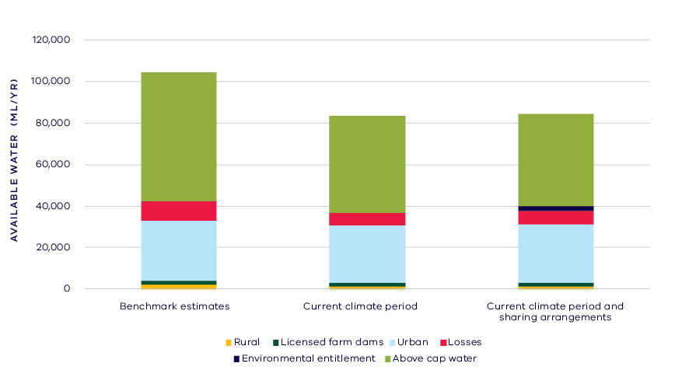
- Changes in water availability in the Moorabool River
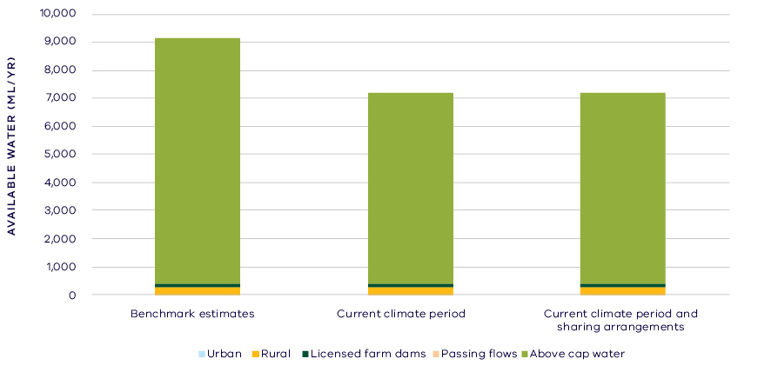
- Changes in water availability in Little River

Have declines in long-term surface water availability been shared equally?
In the Moorabool River system, both consumptive users and the environment have experienced an overall decline in total water availability. In the Little River, the decline has fallen only on the environment.
Changes to climate have not only reduced water availability but have also led to a change in the way that available water is shared between users. At the time of the SWS, consumptive users had access to 35 per cent of the total resource in the Moorabool River while the environment had access to 65 per cent of the total water (Table 2). In the Little River, 4 per cent of the total water was allocated to consumptive uses and 96 per cent was available to the environment (Table 3).
Changes in climate have changed the proportion of water available to consumptive users and the environment. Without any changes to water sharing arrangements, consumptive users would have access to 42 per cent of the total resource in the Moorabool River and 5 per cent of the total resource in Little River while the environment would have access to 58 per cent of the total resource in the Moorabool River and 95 per cent of the total resource in Little River.
Overall, declines in inflow and changes to management of the system mean that consumptive users in the Moorabool River now have access to 40 per cent of the total resource and the environment has access to 60 per cent of the total resource. This is a 5 per cent increase in the proportion of the total resource available for consumptive users and a corresponding 5 per cent decrease in the proportion of the total resource for the environment (Table 2).
In the Little River, overall there has been a 1 per cent increase in the proportion of the total resource allocated to consumptive users and a corresponding 1 per cent decrease in the proportion of the total resource for the environment (Table 3).
When the changes are summed across both rivers, there is an overall 5 per cent increase in the proportion of the total resource available for consumptive users and a corresponding 5 per cent decrease in the proportion of the total resource for the environment (Table 1).

Waterways and their values
The waterways of the Moorabool basin support a range of species including several iconic and threatened species. Native fish species supported by the waterways of the basin include: Australian grayling, river blackfish, Australian smelt, flat-headed gudgeon, southern pygmy perch, short-finned eel, spotted galaxias and tupong. Platypus, rakali and macroinvertebrates inhabit the waterways of the system.
The waterways of the Moorabool basin are significant to Traditional Owners and Aboriginal Victorians, including the Wathaurung, with a high concentration of significant sites and artefacts along river corridors and around wetlands. The waterways are highly valued by local communities with a number of regional parks, picnic sites and lookouts located along waterway corridors.
Environmental water is delivered in the Moorabool basin to meet a number of long-term objectives including to:
- maintain instream and streamside vegetation communities
- protect and increase native fish populations
- maintain abundance of macroinvertebrates and food webs
- flush silt and scour pools to maintain instream habitat
- improve water quality, particularly during summer
- Improve connection of habitat pools and opportunities for fauna movement.

Environmental flow provisions
There is a large body of scientific work linking defined aspects of the flow regime with ecological understanding and impacts to waterway health. In the absence of good long-term ecological data to assess waterway health, some inferences have been drawn from analyses of changes in flow. This should not, however, be considered a direct assessment of waterway health.
There have been several changes in the level of provision of environmental flow recommendations in the Moorabool basin since the release of the Central Region SWS in 2006 (Figure 6). While changes to important flow components in waterways that have environmental entitlements are relatively small, there has been a big decline and a very low level of summer baseflows in waterways without environmental entitlements, and also a larger reduction in summer freshes. In the Moorabool basin, data for rivers without environmental entitlements is only available for a single reach of the Moorabool River above Lal Lal Reservoir, and so is not well represented. The release of the Central Region SWS coincides with the middle of the Millennium Drought and as the post-SWS analysis includes this confounding drought period, improvements post-SWS and also post-drought may be concealed in this evaluation.
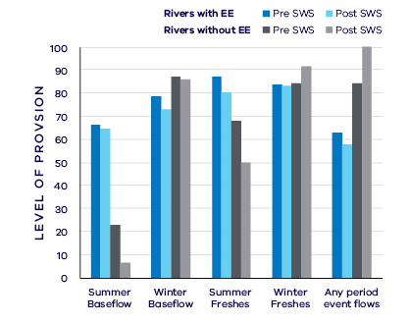
- Average change in ecologically important flow components in rivers with environmental entitlements (EE) and without EEs pre SWS (1945 – 2006) and post SWS (2007 – 2018)

Waterway health
The waterway health analysis was completed at the river basin scale, primarily because there is less data at site, reach or river scales. Although aggregating data to a basin scale allowed for better detection of statistical trends, the results might not reflect the conditions at individual river reaches within the basin.
There is no simple accepted measure for overall waterway health and while many indicators and associated datasets were considered, only a few met requirements for the Long-Term Water Resource Assessment. Most of the available datasets did not cover a sufficient time period (>20 years) to allow for analysis of changes over a long-term timeframe. The indicators presented cover water quality, macroinvertebrates and native fish and are based on the most robust data available. The data were split into three time periods:
- Prior to the LTWRA period — 1990 – 2005
- First part of the LTWRA period — 2006 – 2010. This was the worst period of the Millennium Drought, and many of the environmental flow changes recommended in SWS could not be implemented due to severe drought.
- Second part of the LTWRA period — 2011 – 2018. Post Millennium Drought.
The data were then analysed to identify any trends over time in the selected indicators. That is, whether various waterway health indicators are improving, deteriorating or unchanged. So, while it may be possible to report, for example, an improvement in salinity within a river basin, this does not necessarily imply “good” waterway health. This is because 1) the waterways may still be high in salinity, just less so than previously; and 2) other aspects of waterway health might be deteriorating.
The Long-Term Water Resource Assessment examined the impact of flow on waterway health. To this end, the effects of flow were separated from all other factors that can affect waterway health (e.g. bushfire, land use change, rehabilitation works). The individual influences of these other factors on waterway health have not been analysed in this assessment.
The results showed no consistent pattern of change in waterway health indicators in the Moorabool basin since 2011. As discussed in section 6.2.4 of the Overview Report, there are limitations on interpreting these indicators. The possible impacts of any changes in these individual indicators on other aspects of waterway health are also described in the Overview Report. There have been improvements in trends of dissolved oxygen and salinity since 2006 (compared to the previous time period) which are strongly linked to flow. There has been a deterioration in trend in nitrogen since 2006 (compared to the previous period) which is strongly linked to flow. There has been an improvement in trend in phosphorus since 2011 (compared to the previous period) which is strongly linked to flow. There have been improvements in trends of total suspended solids and turbidity since 2011 (compared to the previous time period) which are partly linked to flow.
Limited data prevented the detection of any trend in macroinvertebrate or fish indicators.
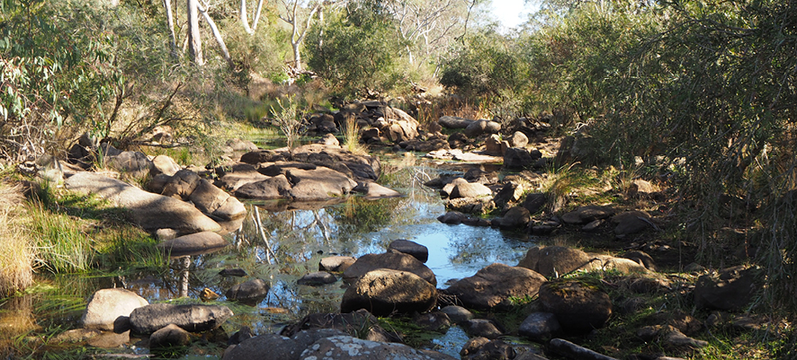
- Moorabool River downstream of Batesford. Image courtesy of Corangamite CMA.

On-ground achievements: beyond the available data
While the assessment needed to analyse long-term datasets to answer the question set by the Water Act, there are numerous other projects going on around the state that are improving waterway health, but which only began in recent years. In the Moorabool basin, one such project is a collaboration to manage the Moorabool River in dry times (Figure 7).
Corangamite CMA, working with Central Highlands Water and Barwon Water, provided fresh flushes of water down the Moorabool River coordinating environmental flows with transfer of water for urban use to improve waterway health outcomes. During extended dry periods, water quality in refuge pools in the river can decline and, without intervention, result in fish deaths. The cooperative timing of environmental release and urban water transfer boosted the total volume and length of flows and allowed fish to move into new habitat sites. Fish monitoring indicated that the water releases were effective in maintaining water quality in the remnant pools between Lal Lal Reservoir and She Oaks Weir.

Has waterway health deteriorated for flow-related reasons?
There have been, on average, small declines in several aspects of the flow regime with well understood ecological importance in the Moorabool basin since the release of the Central Region SWS in 2006. This should be viewed in the context of the significant declines (around 20 per cent) in long-term water availability. The use of environmental water entitlements appears to have ameliorated some of the effects of lower water availability in relevant waterways. There have also been mixed changes in water quality indicators from 2006 and continuing through to 2018 that are partly to strongly related to the flow regime. Aquatic animal indicators of waterway health showed no long-term trends. Overall, the findings for waterway health for reasons related to flow are inconclusive

Barwon Basin

Introduction
The Barwon basin covers an area of approximately 3,880 square kilometres and includes the Barwon River and its tributary the Leigh River. The Barwon River rises in the Otway ranges on the western margins of the basin, and flows in a generally easterly direction into Bass Strait through Reedy Lake and the Lake Connewarre wetlands complex, which form part of the Port Phillip Bay (Western Shoreline) and Bellarine Peninsula Ramsar Site. The Leigh River rises in the north near Ballarat and flows south to join with the Barwon River north-east of Winchelsea. The basin also includes several other notable wetlands including Lakes Modewarre, Wendouree and Murdeduke, the latter is part of the Western District Lakes Ramsar site. Only around 13 per cent of the basin retains native vegetation, much of which is within the Leigh River Gorge and the Otway ranges. The remainder of the basin has been cleared for grazing and includes the urban centres of Ballarat and Geelong, as well as several smaller towns.
The climate is temperate, with cool wet winters and warm dry summers. Average annual rainfall decreases from 700 – 1,000 mm in the headwaters to 500 – 600 mm in Geelong.
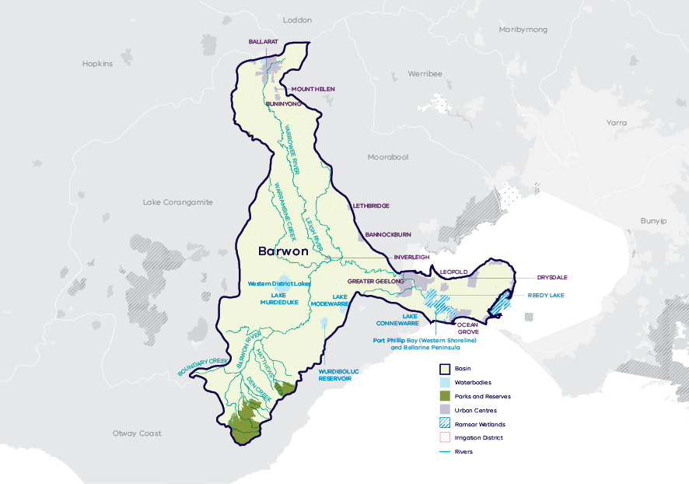
- Map of the Barwon basin

Long-term water availability
In 2006, the Central Region Sustainable Water Strategy (SWS) assessed water availability and reviewed the balance of water sharing between consumptive users and the environment in the Barwon basin. Surface water availability was calculated based on the long-term average over the period between 1927 and 2004, using the best available data at that time. Improvements in data and computer models since the development of the Central Region SWS have enabled a refined calculation of water availability over that period. The updated historical average surface water availability is 262.1 GL/year (Table 1; Figure 2).
Research indicates that recent decades provide a better representation of current climate than does the full historical record. Recent decades more closely reflect current atmospheric levels of greenhouse gases and have been drier and warmer than the earlier parts of the 20th century. For these reasons, the period from 1975 to the present is thought to better represent long-term water availability under current climatic conditions. It includes a wide range of natural climate variability — the severe Millennium Drought and wet years. The average water availability over this time is 232.5 GL/year, a decline of 11 per cent compared with historical water availability.
The period since 1997 shows further declines in water availability (Figure 2), however, this period is heavily influenced by the Millennium Drought. The drier conditions experienced since 1997 may be due to natural climate variability. These years may also represent ongoing conditions due to climate change. It is too soon to know if this is the case.
In addition to surface water, groundwater is available in the Barwon basin. Groundwater predominantly occurs in the middle and lower aquifers in the south-west near the Barwon River, and in small pockets in the upper aquifer to the north. The amount of groundwater that can be pumped by consumptive users and the amount of water that flows from aquifers into streams and wetlands are both heavily dependent on groundwater levels. If groundwater levels have declined, then either consumptive users or the environment (or both) may have experienced reduced water availability. In the upper aquifer, long-term declines in groundwater levels are mostly low (< 1 m). However, near Ballarat, long-term declines of greater than 2 m were identified. This area is partially covered by the Cardigan Groundwater Management Area (GMA). Licensed groundwater use in this area is relatively low.
Reduced water availability to the environment typically only occurs where groundwater levels have declined in an unconfined aquifer that is connected to a waterway. Reduced availability to consumptive users may occur where groundwater levels have declined in either confined or unconfined aquifers. The Gerangamete Groundwater Management Area (GMA) covers the lower aquifer where groundwater is extracted from Barwon Water’s Barwon Downs borefield. The lower aquifer is mostly confined but is also unconfined where it outcrops. Long-term declines were identified in the confined and unconfined parts of the lower aquifer of > 2 m. Large drawdowns have occurred around the area of pumping of up to 30 m that have partially recovered during periods of no pumping. In March 2019, Barwon Water formally withdrew its application to access groundwater from the Barwon Downs borefield, and announced it would remediate the environmental impacts of historical groundwater pumping.
While climate is the primary driver of the decline in surface water availability in the Barwon basin, other potential contributing factors have been assessed:
- Interception by domestic and stock dams is significant due to large numbers of these dams spread throughout the catchment.
- There is evidence of large-scale land-use changes to more water-intensive activities, such as plantation forestry, which may make a contribution to the total decline.
- Groundwater pumping from Barwon Water’s Barwon Downs borefield has reduced flow in the Barwon River by approximately 0.6 GL/year, which is a small component of the total reduction in long-term surface water availability.
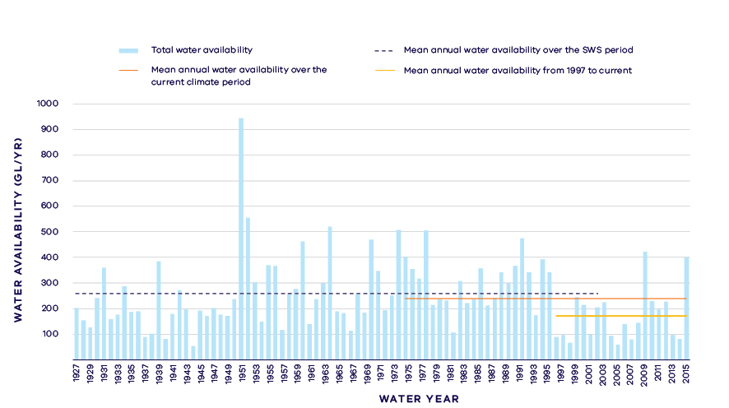
- Annual water availability in the Barwon River (including inflows from Leigh River)
- Total long- term surface water availability in the Barwon basin (summed across rivers)
 |  |  |  | Change due to:⁵
 | Updated SWS estimate² | Current climate period³ | Current climate period and sharing arrangements⁴ | Different climate period | Different climate period and water sharing arrangements
Long-term surface water availability¹
Total water availability (GL/year) | 262.1 | 232.5 | 233.2 | -29.6 | -28.9
Consumptive  (GL/year)⁶ | 36.0 | 35.0 | 36.2 | -1.1 | 0.1
Environment  (GL/year) | 212.6 | 183.1 | 183.2 | -29.5 | -29.4
Not categorised  (GL/year)⁷ | 13.4 | 14.4 | 13.9 | 1.0 | 0.5
Water sharing⁸
Consumptive | 14% | 16% | 16% | 2% | 2%
Environment | 86% | 84% | 84% | -2% | -2%

Notes to table
- These estimates are long-term averages. Values are rounded to the nearest 0.1 GL. Figures might not add in columns and/or rows, due to rounding. Minor differences in total water availability under the current climate period arise from differences in storages are managed. Minor differences in values compared with graphed annual inflows arise from water intercepted by licensed farm dams being excluded from graphed historical inflows.
- The SWS estimate is based on the period 1927 – 2004 for the Barwon River system.
- The current climate period is 1975 – 2017.
- Refer to subsequent sections on Water for Consumptive Use and Water for the Environment for details of any changes in water sharing arrangements.
- Negative values are a decline in water available; positive values are an increase in water available.
- These estimates assume full use of entitlements and include interception by licensed farm dams.
- Not categorised water, such as run-of-river losses that cannot be reasonably considered as being for consumptive users or the environment.
- Water sharing is represented as a percentage of the sum of water available for the environment and consumptive use. It excludes available water that was not categorised.

Water for consumptive use
The Moorabool River joins the Barwon River just upstream of Geelong. While this assessment accounts for water in the Barwon and Moorabool basins separately, water management in the two basins is integrated. Geelong and Ballarat each source water from both the Barwon river system and the Moorabool River. Due to the integrated management of the basins, water availability in the Barwon basin is influenced by water availability and demands in the neighbouring Moorabool basin.
In the Barwon basin, consumptive water uses include urban water supply to major urban centres of Ballarat and Geelong, licensed commercial and irrigation farm dams and private diversion of water from streams and waterways for agriculture. Barwon Water and Central Highlands Water both hold bulk entitlements within the system. Barwon Water’s entitlement allows it to access up to 96.2 per cent of the inflows and 20.1 GL of the storage capacity in West Barwon Reservoir, after providing for minimum passing flows. The allowable diversion is capped, but the diversion limit applies over a consecutive three-year period to provide a degree of flexibility for managing supply in dry years.
In the Yarrowee-White Swan supply system near Ballarat, Central Highlands Water’s bulk entitlement allows access to 100 per cent of the capacity and inflow of multiple reservoirs, including White Swan Reservoir, after providing for minimum passing flows. Similar to Barwon Water’s entitlement, the allowable diversion is capped, but the diversion limit applies over a consecutive three-year period to provide flexibility for managing supply in dry years.
Total water availability in the Barwon basin has reduced under current climate compared with historical climate; however, water availability to consumptive users has not materially changed (Table 1; Figure 3). The decline in total inflows to the Barwon basin is not as large as the decline in the neighbouring Moorabool basin.
At the time when water availability in the Barwon basin was benchmarked for the 2006 Central Region Sustainable Water Strategy, declining inflows to Geelong’s and Ballarat’s water storages were recognised as a threat to water security. The Central Region SWS proposed actions to augment urban water supplies. For Geelong, these comprised interconnection to the Melbourne supply system and provision of additional groundwater.
The provision of supplementary water supplies, through system interconnections (e.g. Melbourne-Geelong Pipeline) and access to groundwater, have provided greater flexibility in operating and more choice about when water is diverted from the Barwon system for urban use. While only surface water from within the Barwon basin is counted in this assessment, having access to back-up supplies changes the way that local catchments are managed. With a reliable back-up in place, local sources can sometimes be drawn lower than would have previously been possible.
The Central Region SWS also included an action to reinstate a diversion from Dewing Creek into the Wurdee Boluc Channel, which supplies Geelong. While Barwon Water already held an entitlement to water from Dewing Creek, the re-instatement of the diversion weir in 2013 provided access to 0.7 GL/year that was previously not accessible.
The Barwon Basin Local Management Plan [Southern Rural Water] outlines the local rules governing all private diversions from the Barwon basin. The Barwon basin is fully allocated, and no new diversion licences can be issued. The volume of private diversion licences is 13.5 GL. As part of the Local Management Plan, Southern Rural Water may implement rosters and restrictions on the take of use of water, with specific summer and winter trigger levels.
Overall, changes in the way water is managed since the Central Region SWS have maintained water availability to consumptive users from within the Barwon basin at levels close to that under historical climate (Table 1).

Water for the environment
Under historical climate and system operations at the time of the Central Region SWS, 212.6 GL/year was set aside for the environment using passing flows and other regulatory limits on the water allocated to consumptive users (Table 1; Figure 3).
Passing flows set aside water for the environment through conditions on bulk entitlements. These conditions specify minimum passing flow requirements at offtakes and immediately downstream of reservoirs to be provided for environmental purposes. Minimum passing flows in the Yarrowee-White Swan system (supplying Ballarat) are specified as “or natural”. Minimum passing flows in the Upper Barwon system (supplying Geelong) are reduced in volume when storage volumes are low. This arrangement results in both the environment and consumptive users sharing reductions in water availability during dry periods, but at the same time recognising the environment’s need for small but reliable river maintenance flows.
Water is also set aside for the environment through the limits placed on consumptive users. Once water is allocated to all entitlements, the water remaining in the system is assigned to the environment. This is known as ‘above cap water’. Because this above cap water is only available to the environment after all other users have taken their share, its volume varies with climatic conditions and reduces significantly when conditions become drier.
Changes in climate have changed the amount of water available to the environment which, without any changes to water sharing, would now have on average 29.5 GL/year less water compared with historical availability (Table 1; Figure 3).
The creation of the Upper Barwon River Environmental Entitlement was an action in the Central Region SWS that was reconfirmed in Water for Victoria. The entitlement provides a long-term average of approximately 1 GL/year for the Barwon River (by allocating a 3.8 per cent share of inflows and a 2 GL share of storage capacity in the West Barwon Reservoir to the Victorian Environmental Water Holder). The entitlement is designed to support provision of flows for targeted environmental benefits without materially impacting the availability of water to consumptive users. The total volume of water available to the environment increases only slightly following the creation of the environmental entitlement because the entitlement converts water that previously spilt from storage into a right to release water from storage when the environment needs it most.
Because unregulated inflows and spills from storages make up most of the volume of water available to the environment, the total volume of water available to the environment has declined with declining inflows, despite the creation of the environmental entitlement. Under current climate conditions and current water sharing arrangements, the environment now has on average 29.4 GL/year less water compared with historical availability. However, this part of the assessment looks only at changes in the volume of water available. It does not account for the benefits of being able to target environmental flow delivery for waterway health.
The Barwon River environmental entitlement was created in 2011 to allow watering of floodplain wetlands adjacent to the lower Barwon River. The entitlement allows flows to be diverted from the river into wetlands, such as Reedy Lake and Hospital Swamps, when river levels are above a designated threshold. Currently, no volumetric use is recorded against this entitlement, and therefore, it is not separately accounted for in the Long-Term Water Resource Assessment.
The Long-Term Water Resource Assessment quantifies water available to the environment from natural surface water inflows. It is acknowledged that other water sources provide environmental benefits in the Barwon and Moorabool river systems. For example, treated wastewater from Ballarat South provides approximately 7 GL/year flow in the Leigh River. Similarly, about 3 GL/year of water returned to the Lower Moorabool River from Batesford Quarry then augments flow in the Barwon River.
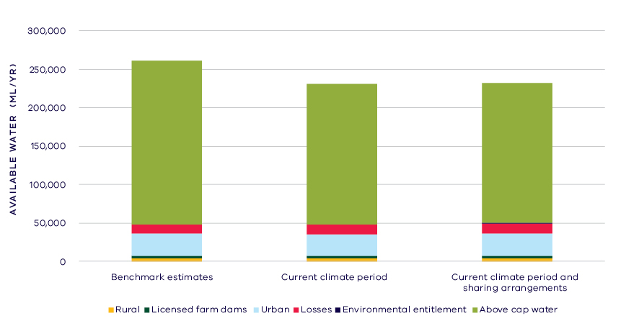
- Changes in water availability in the Barwon basin

Case study: Effective management of environmental entitlements
FLOWS studies are the scientific tools that environmental water managers use to inform how environmental water is released, such as prioritising delivery of flows to maintain habitat refuges and protect water quality during hot, dry summers. The Upper Barwon-Yarrowee Leigh FLOWS study has been updated and provides the Corangamite CMA — the environmental water manager — with current scientific information to support decision-making. Species that will benefit from an updated environmental flow strategy include fish, frogs, platypus and native vegetation. Shared benefits are considered as part of environmental water delivery planning and include actively managed or opportunistic benefits, such as providing cultural and recreational opportunities. The technical panel for the FLOWS study included Wadawurrung representatives, making it the first FLOWS study in Victoria developed so closely with a Traditional Owner group. To read more see, ‘Upper Barwon River Seasonal Watering Proposal 2019 – 20’ (CCMA, 2019).

Have declines in long-term surface water availability been shared equally?
Overall, consumptive users have experienced a slight increase in total water availability while the environment has experienced a decline in total water availability (Table 1).
Changes to climate have not only led to changes in water availability but have also led to a change in the way that available water is shared between users. At the time of the SWS, consumptive users had access to 14 per cent of the total resource while the environment had access to 86 per cent of the total resource (Table 1).
Changes in water sharing arrangements have not substantially altered this situation, with the result that consumptive users now have access to 16 per cent of the total resource while the environment has access to 84 per cent of the total resource. This is a 2 per cent increase in the proportion of the total resource for consumptive users and a corresponding 2 per cent decrease in the proportion of the total resource for the environment.

Waterways and their values
The waterways of the Barwon basin support several significant native fish species including Australian grayling and dwarf galaxias. Platypus, rakali and macroinvertebrates inhabit the waterways of the system. The wetlands of the basin, including Lake Murdeduke and the Lake Connewarre complex are significant for a large number of aquatic species including waterfowl, frogs and invertebrates. Listed species include the orange-bellied parrot, Australasian bittern and growling grass frog. The wetlands support migratory shorebirds and nesting waterfowl, as well as significant vegetation communities including the nationally vulnerable coastal saltmarsh.
The waterways of the basin are significant to Traditional Owners and Aboriginal Victorians, including the Wathaurung Aboriginal Corporation and the Eastern Maar Aboriginal Corporation. The waterways are also highly valued by local communities for fishing, boating, near-water recreation and game hunting.
At the time of this assessment, releases under the Upper Barwon environmental entitlement had not yet come into effect to provide water for the environment in the Upper Barwon River. (Environmental water releases have occurred since.) Currently, environmental water in the Barwon basin is delivered primarily to support the Lower Barwon Wetlands. Specific objectives include:
- to maintain the high diversity of wetland vegetation and increase the extent of coastal saltmarsh, herb lands and lignum shrublands
- to provide foraging and refuge habitat for wading birds, waterbirds and shorebirds
- to provide habitat and connectivity for native fish species.

Environmental flow provisions
There is a large body of scientific work linking defined aspects of the flow regime with ecological understanding and impacts to waterway health. In the absence of good long-term ecological data to assess waterway health, some inferences have been drawn from analyses of changes in flow. This should not, however, be considered a direct assessment of waterway health.
Since the release of the Central Region SWS, there has, on average, been a decline in all recommended environmental flow categories in the limited number of rivers for which there was adequate data available in the Barwon basin (Figure 4). This analysis is based on a small number of reaches of the Leigh River, Boundary and Birregurra creeks and may not be representative of the main stem of the Barwon River.
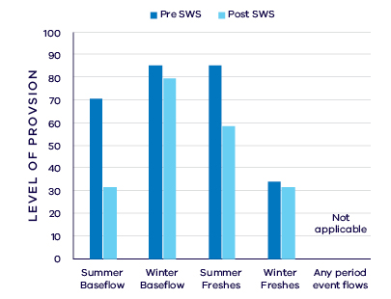
- Average change in ecologically important flow components pre SWS (1961 – 2006) and post SWS (2007 – 2017)
It does not capture efforts at restoring water regimes in the Lower Barwon Wetlands (see the section on On-ground achievements). It should also be noted that the release of the Central Region SWS coincided with the middle of the Millennium Drought. The analysis of the post-SWS period includes this very dry period, and more recent post-drought improvements may be obscured in this evaluation. A higher proportion of summer and winter baseflows and summer freshes were realised in the Leigh River in the wetter years of 2010, 2011, 2013 and 2016. The recent Upper Barwon-Yarrowee Leigh FLOWS Study provides further information on the environmental water needs of the Leigh and Barwon Rivers.

Waterway health
The waterway health analysis was completed at the river basin scale, primarily because there is less data at site, reach or river scales. Although aggregating data to a basin scale allowed for better detection of statistical trends, the results might not reflect the conditions at individual river reaches within the basin.
There is no accepted simple measure for overall waterway health and while many indicators and associated datasets were considered, only a few met requirements for the Long-Term Water Resource Assessment. Most of the available datasets did not cover a sufficient time period (>20 years) to allow for analysis of changes over a long-term timeframe. The indicators presented cover water quality and macroinvertebrates and are based on the most robust data available. The data were split into three time periods:
- Prior to the LTWRA period — 1990 – 2005
- First part of the LTWRA period — 2006 – 2010. This was the worst period of the Millennium Drought, and many of the environmental flow changes recommended in SWS could not be implemented due to severe drought.
- Second part of the LTWRA period — 2011 – 2018. Post Millennium Drought.
The data were then analysed to identify any trends over time in the selected indicators. That is, whether various waterway health indicators are improving, deteriorating or unchanged. So, while it may be possible to report, for example, an improvement in salinity within a river basin, this does not necessarily imply “good” waterway health. This is because 1) the waterways may still be high in salinity, just less so than previously; and 2) other aspects of waterway health might be deteriorating.
The Long-Term Water Resource Assessment examined the impact of flow on waterway health. To this end, the effects of flow were separated from all other factors that can affect waterway health (e.g. bushfire, land use change, rehabilitation works). The individual influences of these other factors on waterway health have not been analysed in this assessment.
The results showed no consistent pattern of change in waterway health indicators in the Barwon basin since 2011. As discussed in section 6.2.4 of the Overview Report, there are a number of limitations on interpreting these indicators. The possible impacts of any changes in these individual indicators on other aspects of waterway health are also described in the Overview Report.
Dissolved oxygen declined from 2011 to 2018, strongly related to changes in the flow regime, but on average, levels remained within SEPP guidelines. There was a deterioration in salinity, which was partially explained by flow, but on average salinity levels also remained within SEPP guidelines. There was an improvement in trend in turbidity and total suspended solids (compared to before 2011), which was strongly linked to flow. Levels of polluting nutrients have been improving since 1990, and there was no change in this trend post 2011. This was found to be partially due to flow for nitrogen but not phosphorus.
Limited data and high natural variability prevented detection of any trend in macroinvertebrate indicators.

On-ground achievements: beyond the available data
While the assessment needed to analyse long-term datasets to answer the question set by the Water Act, there are numerous other projects going on around the state that are improving waterway health, but which only began in recent years. In the Barwon basin, one such project is improving the use of water for the environment at Reedy Lake (Figure 5).
Reedy Lake is part of the Port Phillip Bay (Western Shoreline) and Bellarine Peninsula Ramsar Site. This once intermittent wetland remained predominantly inundated from the mid-1970s until recently. This permanent inundation allowed the extent of tall reed communities to more than double, reducing habitat diversity and the flora and fauna supported by the wetland.
The Corangamite CMA, together with DELWP, VEWH and community groups is currently implementing a four-year environmental water management regime at Reedy Lake that allows the system to partially dry, periodically. The new regime involves delivering water in autumn/winter and then, every few years, lowering water levels over summer until the Barwon River level increases naturally in autumn. The new regime has already reduced the coverage of reeds, allowing other types of endangered coastal saltmarsh and herbfield plants to re-establish, and helped reduce invasive carp numbers.
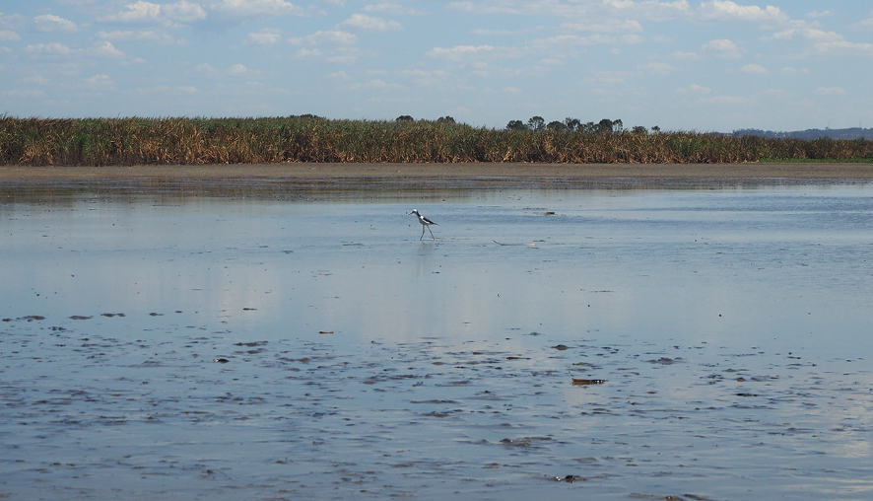
- Black-winged stilt at Reedy Lake. Image courtesy of Corangamite CMA

Has waterway health deteriorated for flow-related reasons?
There have been, on average, some declines in aspects of the flow regime with well understood ecological importance in the small number of rivers analysed in the Barwon basin since the release of the Central Region SWS in 2006, although the Millennium Drought strongly influenced the results. Waterway health indicator trends since 2011 show mixed results, with a deterioration in dissolved oxygen and salinity and an improvement in turbidity and total suspended solids, all partly linked to river flow. Overall, the findings for waterway health for reasons related to flow are inconclusive.

Lake Corangamite Basin
Introduction
The Lake Corangamite basin is a land locked basin that covers an area of approximately 4,190 square kilometres. Rivers and creeks within the basin terminate in a series of inland lakes, the largest of which is Lake Corangamite. The Woady Yaloak River flows into Lake Corangamite. There are over 700 wetlands greater than one hectare in the basin, seven of which form part of the Western District Lakes Ramsar Site. The majority of the basin has been cleared and principal agricultural land uses include dairy farming, stock grazing, cropping and intensive animal industries (piggeries).
The climate is temperate, with cool wet winters and warm dry summers. Average annual rainfall is around 700 mm in the north and south of the basin, but the middle sections are within a rainshadow and annual average rainfall is just 500 mm.
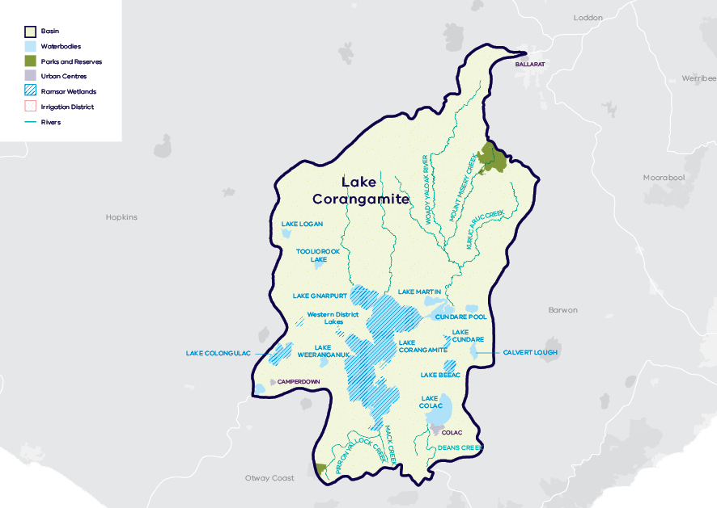
- Map of the Lake Corangamite basin

Long-term water availability
In 2011, the Western Region Sustainable Water Strategy (SWS) assessed water availability and reviewed the balance of water sharing between consumptive users and the environment in the Lake Corangamite basin. Surface water availability for Woady Yaloak River was calculated based on the long-term average between 1955 and 2008, using the best available data. Improvements in data and computer models since the development of the Western Region SWS have enabled a refined calculation of water availability over that period.
Surface water availability for Dean and Pirron Yallock creeks was not calculated at the time of the SWS but is included in the LTWRA.
Research indicates that recent decades provide a better representation of current climate than does the full historical record. Recent decades more closely reflect current atmospheric levels of greenhouse gases and have been drier and warmer than the earlier parts of the 20th century. For these reasons, the period from 1975 to the present is thought to better represent long-term water availability under current climatic conditions. It includes a wide range of natural climate variability — the severe Millennium Drought and wet years. In the Lake Corangamite basin, all streams have experienced a decline in surface water availability in the recent climate period compared with historical availability.
The period since 1997 shows a further decline in water availability (Figure 2; Figure 3; Figure 4), however, this period is heavily influenced by the Millennium Drought. The drier conditions experienced since 1997 may be due to natural climate variability. These years may also represent ongoing conditions due to climate change. It is too soon to know if this is the case.
In addition to surface water, water availability within the Lake Corangamite basin includes groundwater. The amount of groundwater that can be pumped by consumptive users and the amount of water that flows from aquifers into streams and wetlands are both heavily dependent on groundwater levels. If groundwater levels have declined, then either consumptive users or the environment (or both) may have experienced reduced water availability. Groundwater levels in the Lake Corangamite basin are primarily monitored in the areas surrounding the Western District Lakes. The Warrion Water Supply Protection Area lies to the east of Lake Corangamite where groundwater is developed by local agriculture industries. Long-term declines were identified in this area ranging from
0.1 m to 1 m.
While climate is the primary driver of the decline in water flows into the Corangamite basin, other potential contributing factors have been assessed:
- Interception by domestic and stock dams is unlikely to be contributing to the decline is surface water availability.
- There is no evidence of significant land-use changes to more water-intensive activities which would contribute to the total decline.
- Licensed groundwater pumping may have contributed to declines in groundwater levels, however no discernible impacts were observed on lake levels in the area.
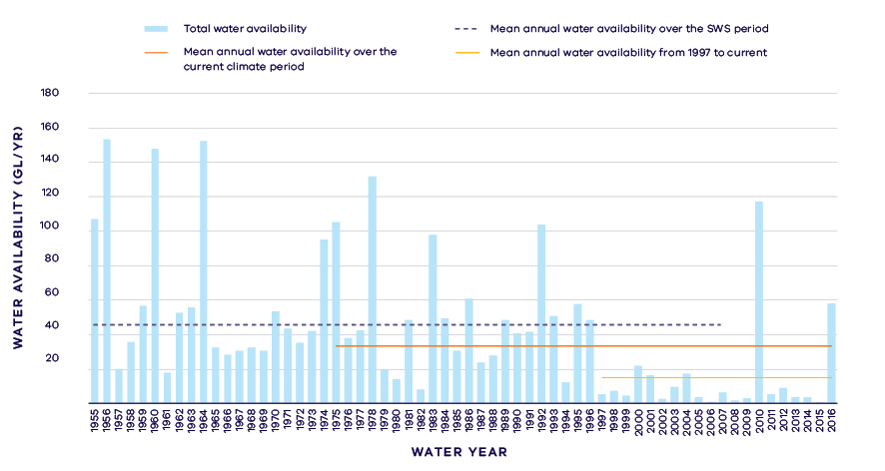
- Annual water availability in Woady Yaloak River
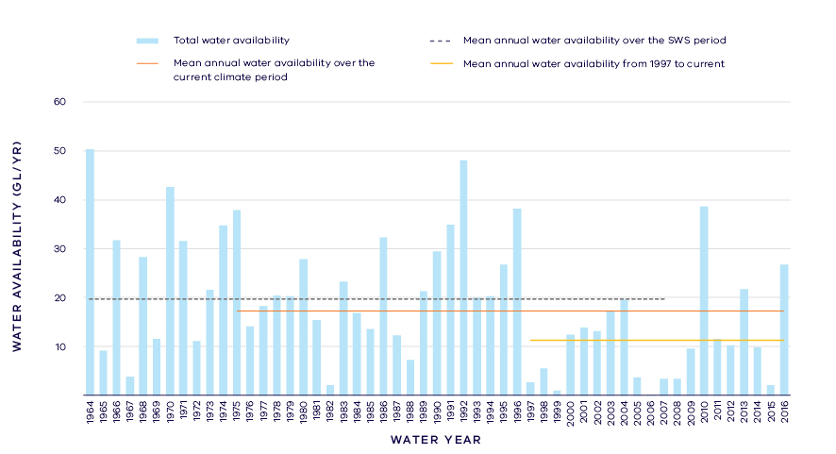
- Annual water availability in Pirron Yallock Creek
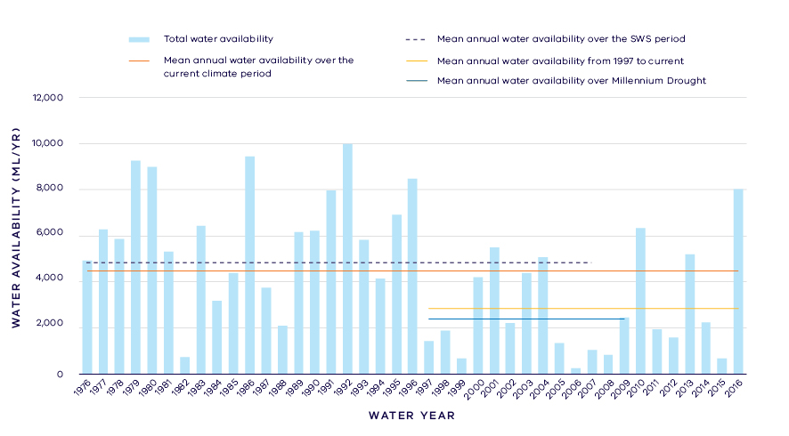
- Annual water availability in Dean Creek
- Total Long- term surface water availability in the Lake Corangamite basin (summed across rivers)
 |  |  |  | Change due to:⁵
 | Updated SWS estimate² | Current climate period³ | Current climate period and sharing arrangements⁴ | Different climate period | Different climate period and water sharing arrangements
Long-term surface water availability¹
Total water availability (GL/year) | 69.4 | 54.7 | 54.7 | -14.7 | -14.7
Consumptive  (GL/year)⁶ | 0.7 | 0.7 | 0.7 | 0.0 | 0.0
Environment  (GL/year) | 66.1 | 51.4 | 54.0 | -14.7 | -12.1
Not categorised  (GL/year)⁷ | 2.6 | 2.6 | 0.0 | 0.0 | -2.6
Water sharing⁸
Consumptive | 1% | 1% | 1% | 0% | 0%
Environment | 99% | 99% | 99% | 0% | 0%

- Long- term surface water availability in Pirron Yallock Creek
 |  |  |  | Change due to:⁵
 | Updated SWS estimate² | Current climate period³ | Current climate period and sharing arrangements⁴ | Different climate period | Different climate period and water sharing arrangements
Long-term surface water availability¹
Total water availability (GL/year) | 19.3 | 17.2 | 17.2 | -2.1 | -2.1
Consumptive  (GL/year)⁶ | 0.2 | 0.2 | 0.2 | 0.0 | 0.0
Environment  (GL/year) | 17.9 | 15.8 | 17.0 | -2.1 | -0.9
Not categorised  (GL/year)⁷ | 1.2 | 1.2 | 0.0 | 0.0 | -1.2
Water sharing⁸
Consumptive | 1% | 1% | 1% | 0% | 0%
Environment | 99% | 99% | 99% | 0% | 0%

- Long- term surface water availability in Dean Creek
 |  |  |  | Change due to:⁵
 | Updated SWS estimate² | Current climate period³ | Current climate period and sharing arrangements⁴ | Different climate period | Different climate period and water sharing arrangements
Long-term surface water availability¹
Total water availability (GL/year) | 4.8 | 4.5 | 4.5 | -0.3 | -0.3
Consumptive  (GL/year)⁶ | 0.2 | 0.2 | 0.2 | 0.0 | 0.0
Environment  (GL/year) | 4.2 | 3.9 | 4.3 | -0.3 | 0.1
Not categorised  (GL/year)⁷ | 0.4 | 0.4 | 0.0 | 0.0 | -0.4
Water sharing⁸
Consumptive | 4% | 4% | 4% | 0% | 0%
Environment | 96% | 96% | 96% | 0% | 0%

- Long- term surface water availability in the Woady Yaloak River
 |  |  |  | Change due to:⁵
 | Updated SWS estimate² | Current climate period³ | Current climate period and sharing arrangements⁴ | Different climate period | Different climate period and water sharing arrangements
Long-term surface water availability¹
Total water availability (GL/year) | 45.4 | 33.1 | 33.1 | -12.3 | -12.3
Consumptive  (GL/year)⁶ | 0.3 | 0.3 | 0.3 | 0.0 | 0.0
Environment  (GL/year) | 44.0 | 31.7 | 32.7 | -12.3 | -11.3
Not categorised  (GL/year)⁷ | 1.0 | 1.0 | 0.0 | 0.0 | -1.0
Water sharing⁸
Consumptive | 1% | 1% | 1% | 0% | 0%
Environment | 99% | 99% | 99% | 0% | 0%

Notes to tables
- These estimates are long-term averages. Values are rounded to the nearest 0.1 GL. Figures might not add in columns and/or rows, due to rounding. Minor differences in values compared with graphed annual average inflows arise from water intercepted by licensed farm dams being excluded from graphed historical inflows.
- The SWS estimate is based on the period 1964 – 2008 for Pirron Yallock Creek, 1976 – 2008 for Dean Creek, 1955 – 2008 for Woady Yaloak River.
- The current climate period is 1975 – 2017.
- Refer to subsequent sections on Water for Consumptive Use and Water for the Environment for details of any changes in water sharing arrangements.
- Negative values are a decline in water available; positive values are an increase in water available.
- These estimates assume full use of entitlements and include interception by licensed farm dams
- Not categorised water, such as run-of-river losses that cannot be reasonably considered as being for consumptive users or the environment. Also includes unallocated water available for new winter-fill licences
- Water sharing is represented as a percentage of the sum of water available for the environment and consumptive use. It excludes available water that was not categorised.

Water for consumptive use
In the Lake Corangamite basin approximately 1 per cent of average annual inflow is allocated to consumptive use. There are no major water storages within the basin. Consumptive use consists of licensed commercial and irrigation farm dams and diverters who hold take and use licences to extract water from streams and waterways. No water corporations divert water from within the basin and large towns are mostly supplied from neighbouring basins.
Some catchments in the Lake Corangamite basin have not reached their sustainable diversion limit. This means that water is available during wetter months to be allocated in future to support growth in consumptive use. The Western Region SWS set revised caps on the amount of unallocated surface water available for future winter-fill licences. The sustainable diversion limits for the Pirron Yallock Creek, Dean Creek and Woady Yaloak River catchments were revised down by 2.6 GL/year in total. This overall reduction in the sustainable diversion limit across the basin does not represent a reduction in water availability to consumptive users because no one holds an entitlement to the water.
To support future growth in consumptive demand, 2.6 GL/year is available for future allocation to winter-fill licences from other catchments within the Lake Corangamite basin; namely the Lake Colac catchment.
Since the SWS, there have been no other major changes to water availability for consumptive users.

Water for the environment
Water is set aside for the environment through the limits placed on the allocations that could be made to consumptive users. Once water is allocated to all entitlements, the water remaining in the system is assigned to the environment. This is known as ‘above cap water.’ Because this water is only available to the environment after all other users have taken their share, its volume varies with climatic conditions and reduces significantly when conditions become drier. Under historical climate and system operations at the time of the SWS, 66.1 GL/year above cap water was available, but has decreased to 51.4 GL/year across the whole basin (Table 1).
Changes in climate have reduced the amount of water available to the environment, which now has an average of 12.3 GL/year less water in Woady Yaloak River, compared with historical availability (Table 4). In Pirron Yallock Creek, water availability has decreased by 2.1 GL/year compared with historical water availability (Table 2) and in Dean Creek, water availability has decreased by 0.3 GL/year compared with historical availability, but this has been offset by a 0.4 GL/year reduction in the amount of unallocated surface water available for winter-fill licences (Table 3).
Since the SWS, the cap on the amount of unallocated surface water available for winter-fill licences has been revised downwards in several catchments. Climate change has resulted in a decline in water available to the environment, however the decline would have been even greater if these unallocated licences had been allowed to be taken up by water users.
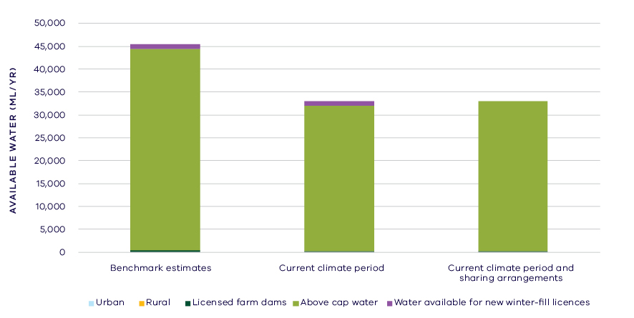
- Changes in water availability in Woady Yaloak River
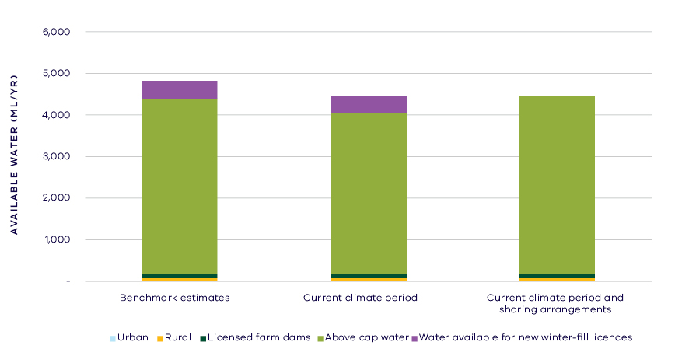
- Changes in water availability in Dean Creek
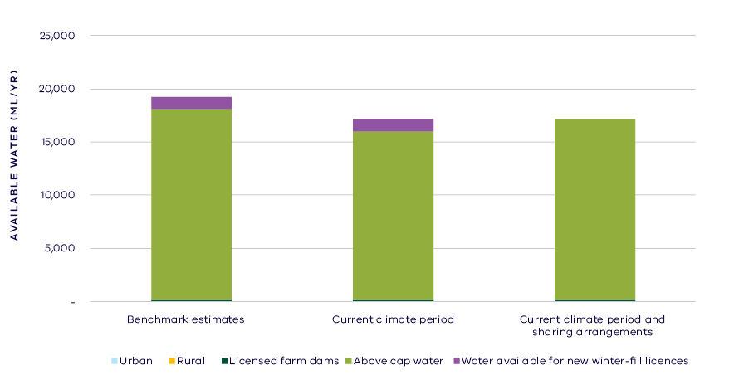
- Changes in water availability in Pirron Yallock Creek

Has the decline in long-term water availability been shared equally?
Since the Western Region SWS assessment, the volume of water available to consumptive users has not materially changed and the environment has experienced an overall decline in total water availability (Table 1). While there have been changes to the overall volume of water available, the share of the available resource between consumptive users and the environment remains unchanged with 1 per cent of water allocated to consumptive users and the remaining 99 per cent available to the environment (Table 1).

Waterways and their values
The waterways of the Lake Corangamite basin support ecological values, including freshwater fish such as golden perch, silver perch and Yarra pygmy perch. The lakes provide a mosaic of habitats for waterbirds, including large numbers of ducks and wading birds, such as banded stilts. The nationally threatened Corangamite water skink is endemic to the basin and there are several freshwater wetlands that support significant vegetation and frog communities.
The waterways of the Lake Corangamite basin remain significant to Traditional Owners and Aboriginal Victorians including the Registered Aboriginal Party (RAP) the Wathaurung. There are several significant cultural sites connected to the waterways including remnants of stone dwellings on the southern shores of Lake Corangamite and fish trap sites at Lakes Beeac, Corangamite, Cundare and Terangpom. The waterways are highly valued by local communities for fishing, boating, beside water recreation and game hunting.
There are no environmental entitlements in the Lake Corangamite basin, but there are a large number of complementary management projects that have been put in place to protect and restore the waterways of the basin. This includes stabilising gullies, pest plant and animal control, stewardship programs around wetlands and restoration of connectivity between waterways.

Environmental flow provisions
There is a large body of scientific work linking defined aspects of the flow regime with ecological understanding and impacts to waterway health. In the absence of good long-term ecological data to assess waterway health, some inferences have been drawn from analyses of changes in flow. This should not, however, be considered a direct assessment of waterway health.
Since the release of the Western Region SWS, there has, on average, been a decline in important flows in the waterways of the Lake Corangamite basin (Figure 8). The reduction in annual, low and high flows could be expected to affect a large number of ecological functions and aquatic biota. Loss of low flows can lead to poor water quality in residual pools and stranding of fish and other aquatic fauna. The reduction in high flows can affect dispersal and breeding of native fish. There has been a small reduction in zero flow days, but this was due to an improvement in one location, when other rivers in the basin experienced an increase in times of no flow. The increase in flow variability is difficult to interpret, but given the deterioration in annual, high and low flows, it may mean that the rivers have become more unpredictable which may have a negative impact on waterway health. It should also be noted that this basin is dominated by wetlands and lakes, which are not represented in the analyses.
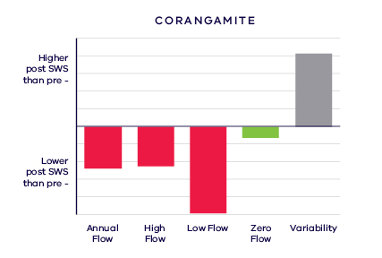
- Average change in ecologically important flow components pre SWS (1941 – 2010) and post SWS (2011 – 2017). Green indicates improvement, red deterioration and grey unknown

Waterway health
The waterway health analysis was completed at the river basin scale, primarily because there is less data at site, reach or river scales. Although aggregating data to a basin scale allowed for better detection of statistical trends, the results might not reflect the conditions at individual river reaches within the basin.
There is no simple accepted measure for overall waterway health and while many indicators and associated datasets were considered, only a few met requirements for the Long-Term Water Resource Assessment. Most of the available datasets did not cover a sufficient time period (> 20 years) to allow for analysis of changes over a long-term timeframe. The indicators presented cover water quality and macroinvertebrates and are based on the most robust data available. The data were split into three time periods:
- Prior to the LTWRA period — 1990 – 2005
- First part of the LTWRA period — 2006 – 2010. This was the worst section of the Millennium Drought
- Second part of the LTWRA period — 2011 – 2018 Post Millennium Drought.
The data were then analysed to identify any trends over time in the selected indicators. That is, whether various waterway health indicators are improving, deteriorating or unchanged. So, while it may be possible to report, for example, an improvement in salinity within a river basin, this does not necessarily imply “good” waterway health. This is because 1) the waterways may still be high in salinity, just less so than previously; and 2) other aspects of waterway health might be deteriorating.
The Long-Term Water Resource Assessment examined the impact of flow on waterway health. To this end, the effects of flow were separated from all other factors that can affect waterway health (e.g. bushfire, land use change, rehabilitation works). The individual influences of these other factors on waterway health have not been analysed in this assessment. Measures of waterway health have been derived from the single waterway in the basin with appropriate data, the Woady Yaloak River, and so the results must be viewed within that context.
There have been few changes in available waterway health indicators in the Lake Corangamite basin since 2011 that can be attributed to flow. However, as discussed in section 6.2.4 of the Overview Report, there are a number of limitations on interpreting these indicators. The possible impacts of any changes in these individual indicators on other aspects of waterway health are also described in the Overview Report.
There has been an improvement in trend (compared to before 2011) in dissolved oxygen, related not to flow, but other unknown factors. There has been a deterioration in trend (compared to before 2011) in salinity that is strongly linked to changes in the flow regime. There were improvements in trends (compared to before 2011) of turbidity and total suspended solids which were weakly or not explained by river flows. Phosphorus has been increasing since 1990, but not due to flow. There was no trend detected for nitrogen.
Limited data and high natural variability prevented the detection of any trend in macroinvertebrate indicators.
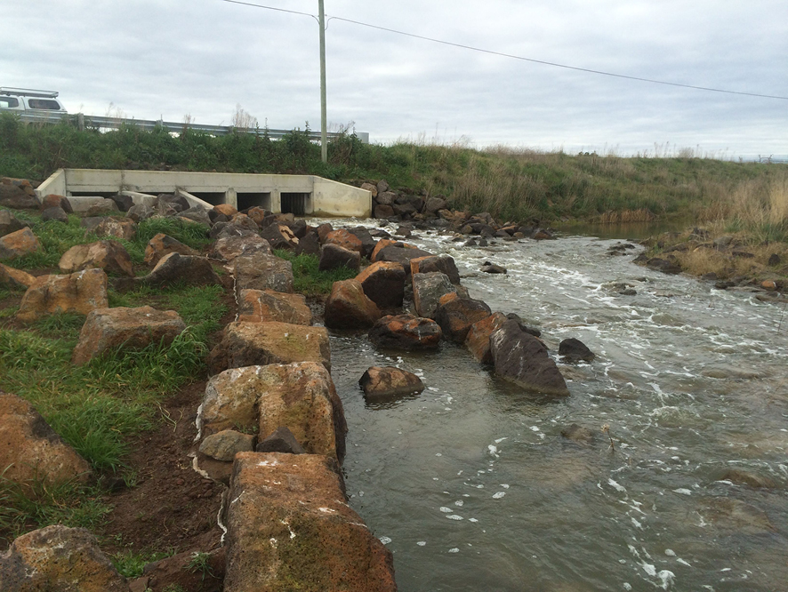
- Cundare Pool fishway. Image courtesy of Corangamite CMA

On-ground achievements: beyond the available data
While the assessment needed to analyse long-term datasets to answer the question set by the Water Act, there are numerous other projects going on around the state that are improving waterway health, but which only began in recent years. In the Lake Corangamite basin, one such project is helping fish along the way to Lake Corangamite.
From 2015 to 2017, the Corangamite CMA completed a large-scale project to help fish move between Lake Corangamite and the Woady Yaloak River. The outlet from Cundare Pool to Lake Corangamite was enlarged with new culverts allowing more water to flow through to Lake Corangamite. In February 2017 a fishway was added to the structure and allows many thousands of native fish to move from Lake Corangamite (Figure 9), which is now three times saltier than sea water, through to the fresher waters of the Cundare Pool and further upstream to the Woady Yaloak River.
https://ccma.blog/2017/08/07/helping-fish-along-the-way-to-lake-corangamite/

Has waterway health deteriorated for flow-related reasons?
There have been, on average, severe declines in aspects of the flow regime with well understood ecological importance in the Lake Corangamite basin since the release of the Western Region SWS in 2011 and a corresponding increase in salinity that was strongly linked to flow. Improvements in other water quality indicators (dissolved oxygen, turbidity and total suspended solids) were not related to river flow. These results are consistent with the assessments of water availability for the Woady Yaloak River, which has experienced a 27 per cent decline in available water. However, data availability limited the scope of the waterway health assessment, such that overall, the findings for waterway health for reasons related to flow are inconclusive.

Otway Coast Basin

Introduction
The Otway Coast basin covers an area of approximately 3,900 square kilometres. The basin is characterised by many discrete waterways. The main waterways are the Curdies, Gellibrand and Aire rivers. Around half of the basin retains native vegetation cover, mainly in the forested slopes of the Otway Ranges. The remainder of the catchment has been cleared, with dairy the most prominent agricultural land use, particularly in the west of the basin in vicinity of the Curdies River.
The climate is temperate, with cool wet winters and warm dry summers. Rainfall is highly variable across the basin, with high average annual rainfall associated with the ranges (1,000 – 2,000 mm) and lower rainfall along the coast, for example, average annual rainfall at Torquay is just 600 mm.
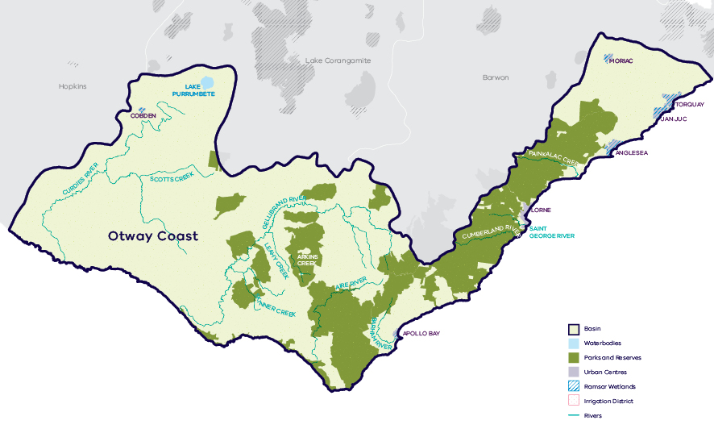
- Map of the Otway Coast basin

Long-term water availability
In 2011, the Western Region Sustainable Water Strategy (SWS) assessed water availability and reviewed the balance of water sharing between consumptive users and the environment in the Otway Coast basin. Surface water availability was calculated based on the long-term average, using the best available data at that time. Improvements in data and computer models since the development of the Western Region SWS have enabled a refined calculation of water availability over the historical period. The updated historical SWS estimate of total average surface water availability for the Otway Coast basin is 589.6 GL/year (Table 1).
The figures presented in the Western Region SWS were summed across all waterways in the basin. To enable trends across different waterways to be compared, results for seven individual rivers and creeks are presented below:
- Gellibrand River: Table 2, Figure 2
- Aire River: Table 3, Figure 3
- Curdies River: Table 4, Figure 4
- Barham River: Table 5
- Cumberland River: Table 6
- St George River: Table 7
- Painkalac Creek: Table 8).
Research indicates that recent decades provide a better representation of current climate than does the full historical record. Recent decades more closely reflect current atmospheric levels of greenhouse gases and have been drier and warmer than the earlier parts of the 20th century. For these reasons, the period from 1975 to the present is thought to better represent long-term water availability under current climatic conditions. It includes a wide range of natural climate variability — the severe Millennium Drought and wet years.
All rivers within the basin, except for Curdies River, have experienced a decline in water availability compared with historical availability. Across the basin, average total water availability has decreased from 589.6 GL/year to 565.4 GL/year — a 4 per cent decline (Table 1). For many rivers in the Otway Coast basin, there were few years of streamflow data available from years before 1975. This means that the LTWRA assessment period for water availability has considerable overlap with the SWS assessment period.
The period since 1997 shows further declines in water availability (Figure 2; Figure 3; Figure 4), however, this period is heavily influenced by the Millennium Drought. The drier conditions experienced since 1997 may be due to natural climate variability. These years may also represent ongoing conditions due to climate change. It is too soon to know if this is the case.
In addition to surface-water, water availability within the Otway Coast basin includes groundwater. Groundwater in the Otway Coast basin predominantly occurs in the regional lower aquifer which extends across multiple surface water basins. The amount of groundwater that can be pumped by consumptive users and the amount of water that flows from aquifers into streams and wetlands are both heavily dependent on groundwater levels. If groundwater levels have stayed the same (or increased) there will not have been a reduction in the groundwater available to consumptive users or the environment. If groundwater levels have declined, then either consumptive users or the environment (or both) may have experienced reduced water availability.
Shallow groundwater levels are mostly stable in the west of the Otway Coast basin around Curdies River with declines less than 1 m observed in all aquifers. Declines ranging from 1 to 2 m have occurred in the upper reaches of the Gellibrand River within the Gellibrand Groundwater Management Area (GMA), due to pumping from the Barwon Downs borefield in the neighbouring Gerangamete GMA. In the east of the basin, declines of greater than 2 m were observed around the Anglesea Coal Mine which is within the Jan Juc GMA.
While climate is the primary driver of the decline in water flows into the Otway Coast basin, other potential contributing factors have been assessed:
- Interception by domestic and stock dams has a low likelihood of contributing to the decline.
- There is evidence of large-scale land-use changes to more water-intensive activities, such as forestry plantations, which may make a considerable contribution to the total decline.
- Licensed groundwater extraction from the Gerangamete GMA in the neighbouring Barwon basin has impacted the Gellibrand River by up to 0.1 GL/year, which makes a small contribution to long-term decline in surface water availability in that river.
- Groundwater extractions at the Anglesea Coal Mine may increase the rate of loss from some creeks (Breakfast Creek, Salt Creek, Painkalac Creek), however there is insufficient surface water data to quantify this impact.
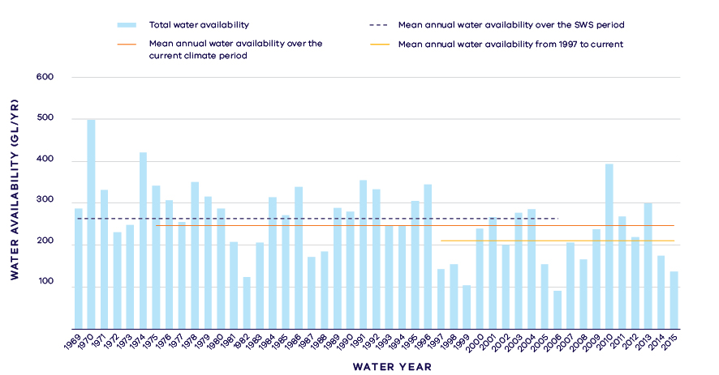
- Annual water availability in the Gellibrand River
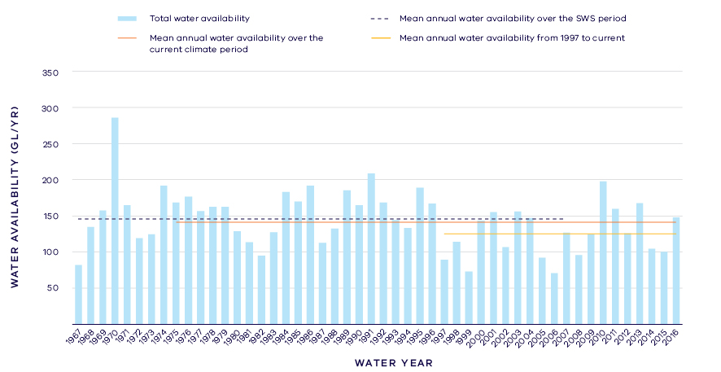
- Annual water availability in the Aire River
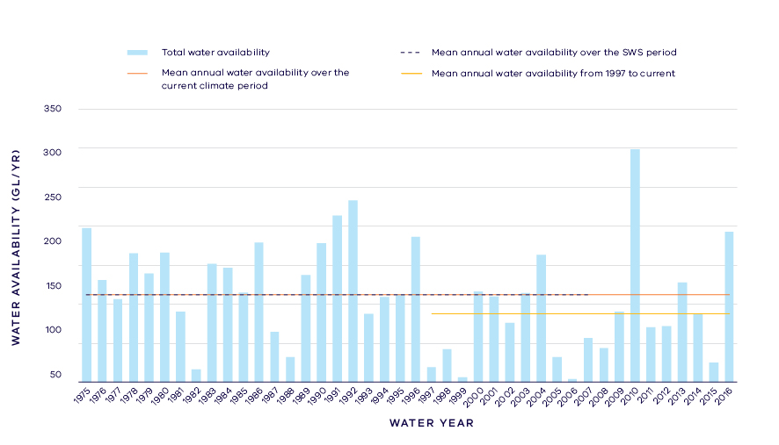
- Annual water availability in the Curdies River
- Total long- term surface water availability in the Otway Coast basin (summed across rivers)
 |  |  |  | Change due to:⁵
 | Updated SWS estimate² | Current climate period³ | Current climate period and sharing arrangements⁴ | Different climate period | Different climate period and water sharing arrangements
Long-term surface water availability¹
Total water availability (GL/year) | 589.6 | 563.8 | 565.4 | -25.9 | -24.2
Consumptive  (GL/year)⁶ | 23.9 | 23.8 | 23.1 | -0.1 | -0.8
Environment  (GL/year) | 525.5 | 499.7 | 539.1 | -25.8 | 13.6
Not categorised  (GL/year)⁷ | 40.2 | 40.2 | 3.3 | 0.0 | -36.9
Water sharing⁸
Consumptive | 4% | 5% | 4% | 0% | 0%
Environment | 96% | 95% | 96% | 0% | 0%

- Long- term surface water availability in the Gellibrand river
 |  |  |  | Change due to:⁵
 | Updated SWS estimate² | Current climate period³ | Current climate period and sharing arrangements⁴ | Different climate period | Different climate period and water sharing arrangements
Long-term surface water availability¹
Total water availability (GL/year) | 264.2 | 246.9 | 248.6 | -17.3 | -15.6
Consumptive  (GL/year)⁶ | 19.8 | 19.7 | 18.9 | -0.1 | -0.9
Environment  (GL/year) | 226.6 | 209.4 | 228.7 | -17.2 | 2.1
Not categorised  (GL/year)⁷ | 17.8 | 17.8 | 1.0 | 0.0 | -16.8
Water sharing⁸
Consumptive | 8% | 9% | 8% | 1% | 0%
Environment | 92% | 91% | 92% | -1% | 0%

- Long- term surface water availability in the Aire River
 |  |  |  | Change due to:⁵
 | Updated SWS estimate² | Current climate period³ | Current climate period and sharing arrangements⁴ | Different climate period | Different climate period and water sharing arrangements
Long-term surface water availability¹
Total water availability (GL/year) | 145.7 | 141.4 | 141.4 | -4.4 | -4.4
Consumptive  (GL/year)⁶ | 0.1 | 0.1 | 0.1 | 0.0 | 0.0
Environment  (GL/year) | 135.0 | 130.7 | 140.9 | -4.4 | 5.9
Not categorised  (GL/year)⁷ | 10.6 | 10.6 | 0.3 | 0.0 | -10.3
Water sharing⁸
Consumptive | 0% | 0% | 0% | 0% | 0%
Environment | 100% | 100% | 100% | 0% | 0%

- Long- term surface water availability in the Curdies River
 |  |  |  | Change due to:⁵
 | Updated SWS estimate² | Current climate period³ | Current climate period and sharing arrangements⁴ | Different climate period | Different climate period and water sharing arrangements
Long-term surface water availability¹
Total water availability (GL/year) | 112.2 | 112.2 | 112.2 | 0.0 | 0.0
Consumptive  (GL/year)⁶ | 2.9 | 2.9 | 2.9 | 0.0 | 0.0
Environment  (GL/year) | 101.4 | 101.4 | 107.9 | 0.0 | 6.5
Not categorised  (GL/year)⁷ | 8.0 | 8.0 | 1.4 | 0.0 | -6.5
Water sharing⁸
Consumptive | 3% | 3% | 3% | 0% | 0%
Environment | 97% | 97% | 97% | 0% | 0%

- Long- term surface water availability in the Barham River
 |  |  |  | Change due to:⁵
 | Updated SWS estimate² | Current climate period³ | Current climate period and sharing arrangements⁴ | Different climate period | Different climate period and water sharing arrangements
Long-term surface water availability¹
Total water availability (GL/year) | 30.0 | 29.7 | 29.7 | -0.3 | -0.3
Consumptive  (GL/year)⁶ | 0.3 | 0.3 | 0.4 | 0.0 | 0.1
Environment  (GL/year) | 26.8 | 26.5 | 28.9 | -0.3 | 2.0
Not categorised  (GL/year)⁷ | 2.9 | 2.9 | 0.4 | 0.0 | -2.5
Water sharing⁸
Consumptive | 1% | 1% | 1% | 0% | 0%
Environment | 99% | 99% | 99% | 0% | 0%

- Long- term surface water availability in the Cumberland River
 |  |  |  | Change due to:⁵
 | Updated SWS estimate² | Current climate period³ | Current climate period and sharing arrangements⁴ | Different climate period | Different climate period and water sharing arrangements
Long-term surface water availability¹
Total water availability (GL/year) | 21.2 | 20.0 | 20.0 | -1.2 | -1.2
Consumptive  (GL/year)⁶ | 0.0 | 0.0 | 0.0 | 0.0 | 0.0
Environment  (GL/year) | 20.7 | 19.5 | 20.0 | -1.2 | -0.8
Not categorised  (GL/year)⁷ | 0.5 | 0.5 | 0.0 | 0.0 | -0.4
Water sharing⁸
Consumptive | 0% | 0% | 0% | 0% | 0%
Environment | 100% | 100% | 100% | 0% | 0%

- Long- term surface water availability in St George River
 |  |  |  | Change due to:⁵
 | Updated SWS estimate² | Current climate period³ | Current climate period and sharing arrangements⁴ | Different climate period | Different climate period and water sharing arrangements
Long-term surface water availability¹
Total water availability (GL/year) | 11.4 | 9.9 | 9.9 | -1.5 | -1.5
Consumptive  (GL/year)⁶ | 0.5 | 0.5 | 0.4 | 0.0 | -0.1
Environment  (GL/year) | 10.5 | 9.0 | 9.4 | -1.5 | -1.1
Not categorised  (GL/year)⁷ | 0.4 | 0.4 | 0.1 | 0.0 | -0.3
Water sharing⁸
Consumptive | 4% | 5% | 4% | 1% | 0%
Environment | 96% | 95% | 96% | -1% | 0%

- Long- term surface water availability in Painkalac Creek
 |  |  |  | Change due to:⁵
 | Updated SWS estimate² | Current climate period³ | Current climate period and sharing arrangements⁴ | Different climate period | Different climate period and water sharing arrangements
Long-term surface water availability¹
Total water availability (GL/year) | 4.9 | 3.7 | 3.7 | -1.2 | -1.2
Consumptive  (GL/year)⁶ | 0.3 | 0.3 | 0.3 | 0.0 | 0.0
Environment  (GL/year) | 4.4 | 3.3 | 3.3 | -1.2 | -1.1
Not categorised  (GL/year)⁷ | 0.1 | 0.1 | 0.1 | 0.0 | -0.1
Water sharing⁸
Consumptive | 7% | 9% | 8% | 2% | 2%
Environment | 93% | 91% | 92% | -2% | -2%

Notes to tables
- These estimates are long-term averages. Values are rounded to the nearest 0.1 GL. Figures might not add in columns and/or rows, due to rounding. Minor differences in values compared with graphed annual average inflows arise from water intercepted by licensed farm dams being excluded from graphed historical inflows. In the Gellibrand model, minor differences in total water available under the current climate period and sharing arrangements are due to inflows from Olangolah Creek, West Gellibrand River and the Gellibrand River were replaced with the Gellibrand River inflow at Upper Gellibrand (gauge 235202), extracted from the Barwon-Moorabool model for consistency across water resource models.
- The SWS estimate is based on the period 1969 – 2006 for the Gellibrand, 1955 – 2007 for the Curdies, 1974 – 2007 for the Painkalac, 1966 – 2008 for the St George, 1966 – 2007 for the Cumberland, 1977 – 2008 for the Barham, 1967 – 2007 for the Aire.
- The current climate period is 1975 – 2017.
- Refer to subsequent sections on Water for Consumptive Use and Water for the Environment for details of any changes in water sharing arrangements.
- Negative values are a decline in water available; positive values are an increase in water available.
- These estimates assume full use of entitlements and include interception by licensed farm dams.
- Not categorised water, such as run-of-river losses that cannot be reasonable considered as being for consumptive users or the environment. Also includes unallocated water available for new winter-fill licences.
- Water sharing is represented as a percentage of the sum of water available for the environment and consumptive use. It excludes available water that was not categorised.

Water for consumptive use
In the Otway Coast basin less than 4 per cent of average annual inflow is allocated to consumptive use. Uses include; supply to towns, private diverters and licensed commercial and irrigation farm dams. Barwon Water and Wannon Water hold bulk entitlements to supply towns within the basin such as Apollo Bay and Lorne, as well as water supply for towns outside the basin, including Colac and Warrnambool.
Under historical climate and system operations at the time of the SWS, on average 23.9 GL/year of surface water was available to consumptive users. Reduction in river flows have not made a material change to the amount of water available to consumptive users supplied from the Otway Coast basin (Table 1; Figure 5; Figure 6; Figure 7).
A range of actions have occurred that changed water sharing arrangements since the publication of the Western Region SWS in November 2011.
Recently, Colac has been connected to the Geelong system via a pipeline. This enables Colac to obtain water from multiple sources, not just the Gellibrand River, providing greater flexibility and security of supply. Because water sourced from outside the Otway Coast basin is not counted towards available water here, the volume available to consumptive users from the Gellibrand River appears to have declined slightly from 19.8 GL/year to 18.9 GL/year (Table 2), even though overall water availability to Colac has not declined.
Aireys Inlet and Fairhaven were supplied from Painkalac Creek at the time of the SWS. In 2016, these townships were connected to the Geelong system via a pipeline. Because Barwon Water still holds an entitlement to take up to 0.32 GL/year from Painkalac Creek, this water is still counted as allocated to consumptive use in this assessment.
There has been no material change in water availability to consumptive users for any other waterway (Table 3 – Table 8).
Local management rules governing access to water by private diverters were formalised through the publication of Southern Rural Water’s 2014 Local Management Plan for the Otway Coast basin. The rules provide a clear statement of the percentages of daily allowance licensees can take from the waterways, and were implemented to satisfy requirements of the Western Region SWS.
In the Otway Coast basin, water is available during wetter months to be allocated in future to support growth in consumptive use. Previously, approximately 40.3 GL/year of unallocated surface water was available for the winter-fill period under the sustainable diversion limits that existed before the Western Region SWS. The SWS reduced the amount of unallocated surface water available for winter-fill diversions to 3.4 GL/year (Figure 5; Figure 6; Figure 7). In the Long-Term Water Resource Assessment, water ear-marked for future winter fill entitlements is accounted for as being allocated to consumptive use once a diversion licence has been issued. For this reason, a large change is seen in the volume of “Not Categorised” water, rather than in the volume available to consumptive users (Table 1).

Water for the environment
In the Otway Coast basin water is set aside for the environment using passing flows and other regulatory limits on the water allocated to consumptive users. There are no water entitlements held for the environment in the Otway Coast basin.
Passing flows set aside water for the environment through conditions on bulk entitlements. These conditions specify minimum passing flow requirements at offtakes and immediately downstream of reservoirs. Passing flows make up about 5 per cent of water for the environment in the Gellibrand River.
A limit, called a permissible consumptive volume, has been placed on allocation of water to consumptive users in the Otway Coast basin. Water is also set aside for the environment through the limits placed on the allocations that could be made to consumptive users. Because this above cap water is only available to the environment after all other users have taken their share, its volume varies with climatic conditions and reduces significantly when conditions become drier.
At the time of the SWS, the total water available to the environment historically across the Otway Coast basin averaged 525.5 GL/year but this reduced to 499.7 GL/year under current climate (Table 1).
Since the SWS, the caps on the amount of unallocated surface water available during the wetter months for future winter-fill licences has been revised downwards in several catchments, including in the Gellibrand River catchment by 16.8 GL/year, the Curdies River catchment by 6.5 GL/year and the Aire River by 10.3 GL/year. By reducing the amount of water ear-marked to meet future consumptive demand, the SWS effectively increased the volume available to the environment (Figure 5; Figure 6; Figure 7). While changes in water availability vary slightly between rivers, overall, the total volume available to the environment has increased from an average of 525.5 GL/year at the time of the SWS to 539.1 GL/year (Table 1).
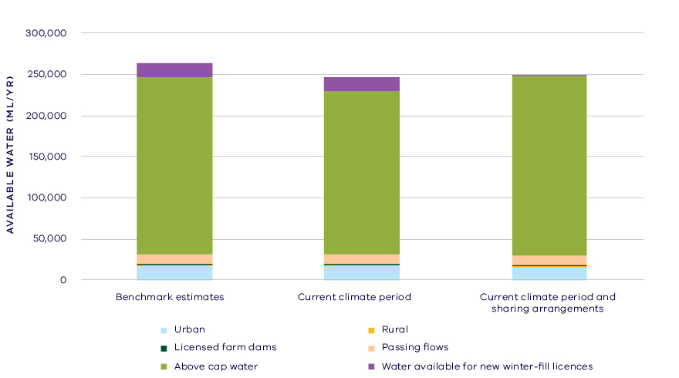
- Changes in water availability in the Gellibrand River
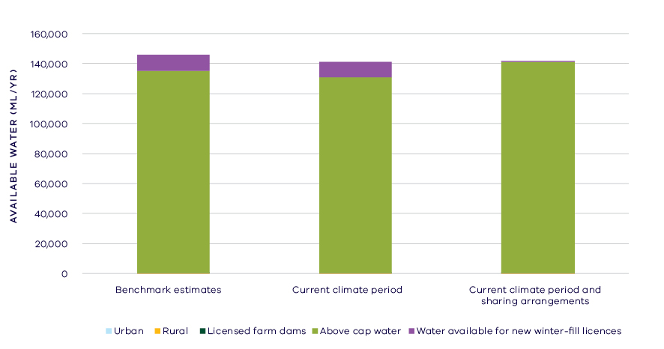
- Changes in water availability in the Aire River
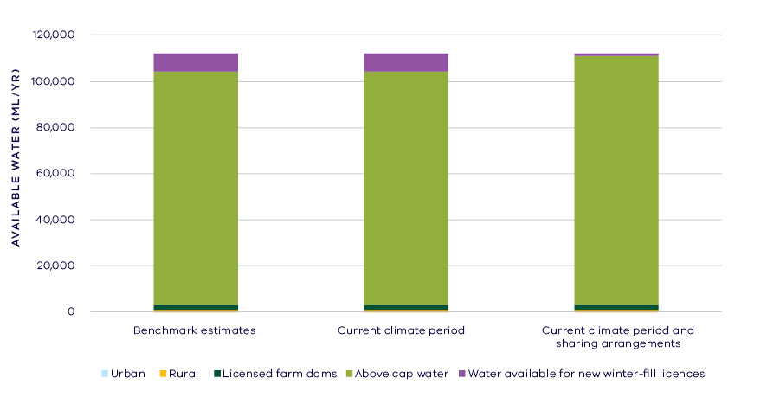
- Changes in water availability in the Curdies River

Has the decline in long-term water availability been shared equally?
Changes to climate and other factors, especially the reduction in the winter-fill sustainable diversion limits, have changed the amount of water available to both consumptive users and the environment (Table 1).
While there have been changes to the overall volume of water available to consumptive users and the environment, the relative sharing of the available resource remains unchanged in all waterways assessed (except for Painkalac Creek) and for the basin as a whole. This is due to the relatively small volume allocated for consumptive use compared to the total inflows to this basin. Painkalac Creek showed a small increase in the percentage share of water allocated to consumptive use; however, the bulk entitlement to divert water from Painkalac Creek for supply to Aireys Inlet and Fairhaven is currently inactive.

Waterways and their values
The waterways of the Otway Coast basin are home to native fish including Australian grayling, river blackfish, Tasmanian mudfish and mountain galaxias. Waterbirds are associated with waterways and estuaries and platypus occur in the Aire River and smaller streams along the coast. The basin contains two nationally significant wetlands; the Princetown Swamps on the lower Gellibrand and the Lower Aire System, comprising the estuary and mouth of the Aire River. The lower section of the Aire River has been listed as a Victorian Heritage River in recognition of its social, cultural and ecological values.
The waterways of the Otway Coast basin are significant to Traditional Owners and Aboriginal Victorians, including the Wathaurung, with several significant cultural sites connected to the waterways. The waterways are highly valued by local communities for fishing, boating and beside water recreation.
There are no formal environmental entitlements in the Otway Coast basin, but there is other water in the system that contributes to environmental outcomes, such as passing flows, which are managed with conditions and rules on extraction. There are also a large number of complementary management projects that have been put in place to protect and restore the waterways of the basin. This includes stabilising banks, improving instream habitat, riparian restoration and improving fish passage.

Environmental flow provisions
There is a large body of scientific work linking defined aspects of the flow regime with ecological understanding and impacts to waterway health. In the absence of good long-term ecological data to assess waterway health, some inferences have been drawn from analyses of changes in flow. This should not, however, be considered a direct assessment of waterway health.
Since the release of the Western Region SWS, there has, on average, been a decrease in most of the recommended environmental flow components in the Otway Coast basin (Figure 8). This analysis aggregated results from gauging stations on the Gellibrand River, as well as Love, Kennedys and Painkalac Creeks. Of note is the continued reduction in summer baseflows across all of these gauges. These low flows have been identified as being particularly important in this system for maintaining healthy fish populations and the estuary mouth. There is no held environmental water in this basin, and innovative solutions have been trialled to try and address this problem (see the section on On-ground achievements). In addition, there have been improvements in occurrence of specific environmental flow components in individual waterways in the basin, such as Painkalac Creek.
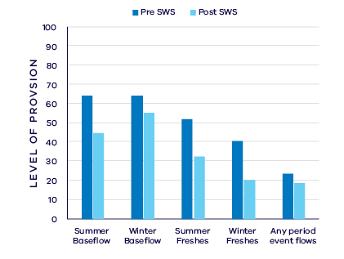
- Average change in ecologically important flow components pre SWS (1964 – 2010) and post SWS (2011 – 2018)

Waterway health
The waterway health analysis was completed at the river basin scale, primarily because there is less data at site, reach or river scales. Although aggregating data to a river basin scale allowed for better detection of statistical trends, the results might not reflect the conditions at individual river reaches within the basin.
There is no accepted simple measure for overall waterway health and while many indicators and associated datasets were considered, only a few met requirements for the Long-Term Water Resource Assessment. Most of the available datasets did not cover a sufficient time period (>20 years) to allow for analysis of changes over a long-term timeframe. The indicators presented cover water quality and macroinvertebrates and are based on the most robust data available. The data were split into three time periods:
- Prior to the LTWRA period — 1990 – 2005
- First part of the LTWRA period — 2006 – 2010. This was the worst section of the Millennium Drought
- Second part of the LTWRA period — 2011 – 2018 Post Millennium Drought.
The data were then analysed to identify any trends over time in the selected indicators. That is, whether various waterway health indicators are improving, deteriorating or unchanged. So, while it may be possible to report, for example, an improvement in salinity within a river basin, this does not necessarily imply “good” waterway health. This is because 1) the waterways may still be high in salinity, just less so than previously; and 2) other aspects of waterway health may be deteriorating.
The Long-Term Water Resource Assessment examined the impact of flow on waterway health. To this end, the effects of flow were separated from all other factors that can affect waterway health (e.g. bushfire, land use change, rehabilitation works). The individual influences of these other factors on waterway health have not been analysed in this assessment.
There have been few changes in available water quality indicators in the Otway Coast basin since 2011. As discussed in section 6.2.4 of the Overview Report, there are a number of limitations on interpreting these indicators. The possible impacts of any changes in these individual indicators on other aspects of waterway health are also described in the Overview Report.
Dissolved oxygen has been deteriorating since 1990, but this was mostly not related to river flow, and on average, levels have remained within SEPP guidelines. There was an improvement in trend in turbidity and total suspended solids (compared to before 2011) which was related to river flows. However, at very low flows, an improvement in these indicators is unlikely to reflect an overall improvement in waterway health. There was no detectable trend in salinity, phosphorus or nitrogen.
There has been an improvement in macroinvertebrates, as indicated by the SIGNAL2 score, however this was not related to river flows, but rather to other factors not explored in this analysis. No suitable data was available for fish.
On-ground achievements: beyond the available data
While the assessment needed to analyse long-term datasets to answer the question set by the Water Act, there are numerous other projects going on around the state that are improving waterway health, but which only began in recent years. In the Otway Coast basin, one such project is the Gellibrand estuary opening (Figure 9).
The inundation of the Gellibrand estuary floodplain due to the closure of the river mouth is a natural process and one that is important for supporting vegetation communities, fish recruitment and ecosystem processes. Under certain conditions, low levels of dissolved oxygen can result and while this is a natural occurrence, increased periods of low flow can result in longer periods of mouth closure, longer or more frequent low oxygen events, and increased risk of impacts including fish deaths. Allowing additional flow can assist in opening the mouth, reducing these events and reducing the associated risks. Higher flows also increase available habitat important for invertebrates and fish populations and allow passage of native fish between deeper pools.
Corangamite CMA, Southern Rural Water and Wannon Water collaborate in coordinating timing of reductions in pumping and extraction to allow these higher flows. The CMA and water corporations also collaborate on the Gellibrand Summer Flows Improvement Project, including working with a stakeholder reference group that allows community to contribute and improve project outcomes.
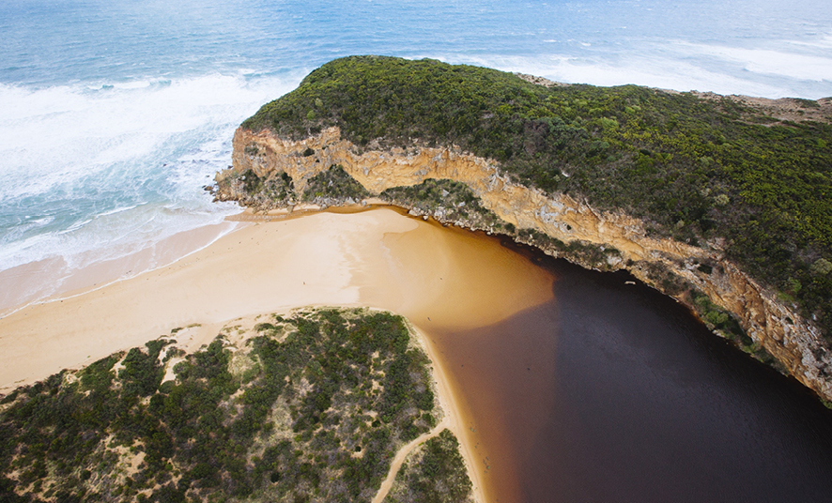
- Gellibrand Estuary. Image courtesy of Corangamite CMA

Has waterway health deteriorated for flow-related reasons?
There have been, on average, moderate declines in aspects of the flow regime with well understood ecological importance, particularly summer baseflows, in the Otway Coast basin since the release of the Western Region SWS in 2011. While there have been some very small improvements in some ecological waterway health indicators in this time, the results are largely inconclusive. Overall, the findings for waterway health for reasons related to flow are inconclusive.

Hopkins Basin

Introduction
The Hopkins basin is a large basin covering an area of just over 10,000 square kilometres. The major waterway, the Hopkins River, rises in the ranges near Ararat and flows into the Southern Ocean at Warrnambool. The basin also includes the tributaries of the Hopkins such as Brucknell Creek, Mt Emu Creek and Fiery Creek, and the separate river system of the Merri River. There are very small areas of remnant forest and grassland, but the basin has been mostly cleared for grazing and broad acre cropping. The basin contains the urban areas of Ararat and Warrnambool, as well as many smaller towns; however, little water is sourced for towns from waterways within the Hopkins basin. Supply for major urban centres comes from surface water or groundwater sources in neighbouring basins.
The climate is temperate, with cool wet winters and warm dry summers. Average annual rainfall is 700 – 1,000 mm in the far north and south of the Hamilton Highway, but the large central area only receives from 500 – 700 mm.
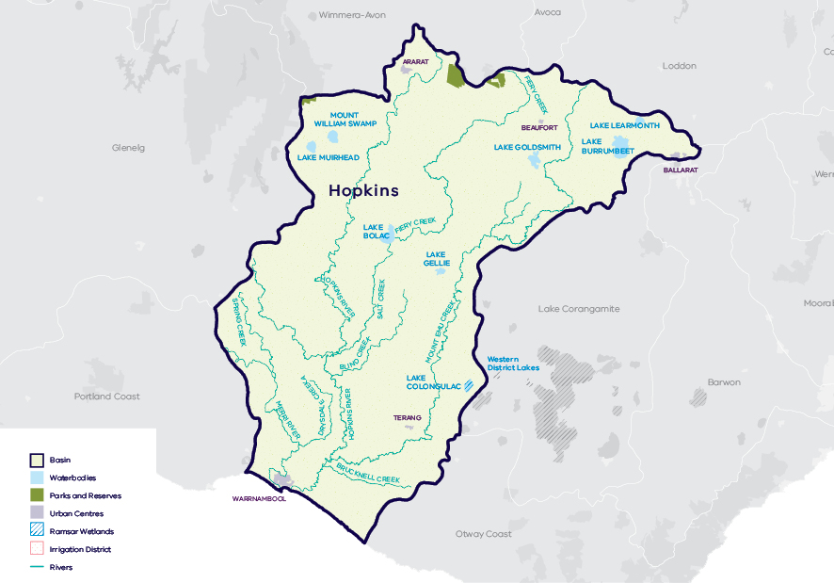
- Map of the Hopkins basin

Water availability
In 2011, the Western Region Sustainable Water Strategy (SWS) assessed water availability and reviewed the balance of water sharing between consumptive users and the environment in the Hopkins basin. In the Hopkins River and its tributaries, surface water availability was calculated based on the long-term average between 1964 and 2008 and in the Merri River availability was calculated based on the long-term average between 1965 and 2006, using the best available data. Improvements in data since the development of the Western Region SWS have enabled a refined calculation of water availability over the historical period. The updated historical water availability for the Hopkins River is 231.6 GL/year and 60.9 GL/year for the Merri River, and 28.0 GL/year for Brucknell Creek.
Research indicates that recent decades provide a better representation of current climate than does the full historical record. Recent decades more closely reflect current atmospheric levels of greenhouse gases and have been drier and warmer than the earlier parts of the 20th century. For these reasons, the period from 1975 to the present is thought to better represent long-term conditions. It includes a wide range of natural climate variability — the severe Millennium Drought and wet years. In the Hopkins River, the average water availability over this time is 213.5 GL/year, a decline of 8 per cent compared with historical water availability. In the Merri River, the average water availability over the current climate period is 59.9 GL/year, a decline of 2 per cent compared with historical water availability, while water availability in Brucknell Creek was 27.2 GL/year, a decline of 3 per cent. For the Hopkins basin, the historical assessment of water availability was based on data available from the in the mid-1960s onwards. This means that the LTWRA assessment period for water availability has considerable overlap with the SWS assessment period.
The period since 1997 shows a further decline in water availability (Figure 2; Figure 3), however, this period is heavily influenced by the Millennium Drought. The drier conditions experienced since 1997 may be due to natural climate variability. These years may also represent ongoing conditions due to climate change. It is too soon to know if this is the case.
In addition to surface water, groundwater is available in the Hopkins basin. The amount of groundwater that can be pumped by consumptive users and the amount of water that flows from aquifers into streams and wetlands are both heavily dependent on groundwater levels. If groundwater levels have stayed the same (or increased) there will not have been a reduction in the groundwater available to consumptive users or the environment. If groundwater levels have declined, then either consumptive users or the environment (or both) may have experienced reduced water availability.
Reduced water availability to the environment typically only occurs where groundwater levels have declined in unconfined aquifers that are connected to waterways. Reduced availability to consumptive users may occur where groundwater levels have declined in either confined or unconfined aquifers. Groundwater occurs in the Hopkins basin in unconfined and confined aquifers. In the unconfined aquifer, long-term declines range from 0.1 to 2 m. A small area of greater than 2 m was identified in the lower reach of the basin, however this was determined to be a local impact of pumping rather than a regional decline. Long-term declines in the confined aquifer are less than 1 m in the south of the basin and between 1 and 2 m in the north.
While climate is the primary driver of the decline in water flows to the Hopkins basin, other potential contributing factors have been assessed:
- Interception by domestic and stock dams has a low likelihood of contributing to the decline in surface water availability.
- There is evidence of large-scale land-use changes to more water-intensive activities, such as forestry plantations, which has a moderate likelihood of contribution to the total decline.
- Groundwater pumping mostly occurs in the limestone aquifer in the lower reaches of the basin. However, the assessment determined that there was low likelihood of licensed groundwater extractions contributing to the total decline in surface water availability.
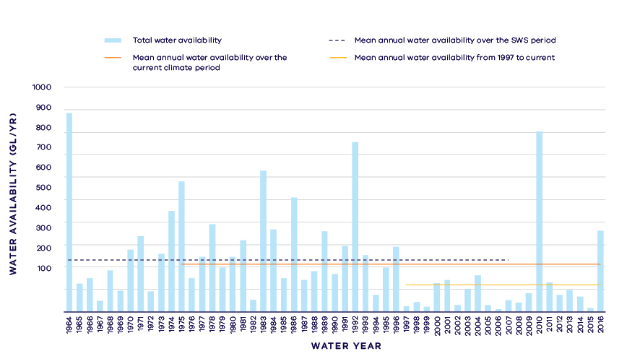
- Annual water availability in the Hopkins River
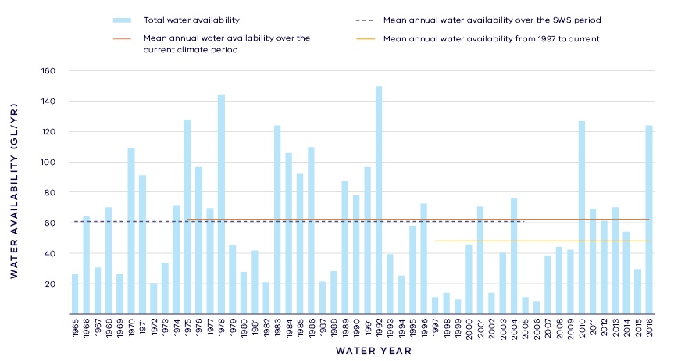
- Annual water availability in the Merri River

- Total long- term surface water availability in the Hopkins basin (summed across rivers)
 |  |  |  | Change due to:⁵
 | Updated SWS estimate² | Current climate period³ | Current climate period and sharing arrangements⁴ | Different climate period | Different climate period and water sharing arrangements
Long-term surface water availability¹
Total water availability (GL/year) | 320.5 | 300.6 | 300.6 | -19.9 | -19.9
Consumptive  (GL/year)⁶ | 8.7 | 8.6 | 9.0 | 0.0 | 0.3
Environment  (GL/year) | 305.8 | 288.6 | 291.7 | -17.2 | -14.1
Not categorised  (GL/year)⁷ | 3.4 | 3.4 | 0.2 | 0.0 | -3.1
Water sharing⁸
Consumptive | 3% | 3% | 3% | 0% | 0%
Environment | 97% | 97% | 97% | 0% | 0%

- Long- term surface water availability in the Hopkins River
 |  |  |  | Change due to:⁵
 | Updated SWS estimate² | Current climate period³ | Current climate period and sharing arrangements⁴ | Different climate period | Different climate period and water sharing arrangements
Long-term surface water availability¹
Total water availability (GL/year) | 231.6 | 213.5 | 213.5 | -18.1 | -18.1
Consumptive  (GL/year)⁶ | 2.8 | 2.7 | 2.7 | -0.1 | -0.1
Environment  (GL/year) | 228.8 | 210.8 | 210.8 | -18.0 | -18.0
Not categorised  (GL/year)⁷ | 0.0 | 0.0 | 0.0 | 0.0 | 0.0
Water sharing⁸
Consumptive | 1% | 1% | 1% | 0% | 0%
Environment | 99% | 99% | 99% | 0% | 0%

- Long- term surface water availability in the Merri River
 |  |  |  | Change due to:⁵
 | Updated SWS estimate² | Current climate period³ | Current climate period and sharing arrangements⁴ | Different climate period | Different climate period and water sharing arrangements
Long-term surface water availability¹
Total water availability (GL/year) | 60.9 | 59.9 | 59.9 | -1.0 | -1.0
Consumptive  (GL/year)⁶ | 4.5 | 4.5 | 4.8 | 0.0 | 0.4
Environment  (GL/year) | 51.9 | 53.5 | 55.2 | 1.6 | 3.2
Not categorised  (GL/year)⁷ | 1.9 | 1.9 | 0.2 | 0.0 | -1.6
Water sharing⁸
Consumptive | 8% | 8% | 8% | 0% | 0%
Environment | 92% | 92% | 92% | 0% | 0%

- Long- term surface water availability in the Brucknell Creek
 |  |  |  | Change due to:⁵
 | Updated SWS estimate² | Current climate period³ | Current climate period and sharing arrangements⁴ | Different climate period | Different climate period and water sharing arrangements
Long-term surface water availability¹
Total water availability (GL/year) | 28.0 | 27.2 | 27.2 | -0.8 | -0.8
Consumptive  (GL/year)⁶ | 1.4 | 1.4 | 1.4 | 0.0 | 0.0
Environment  (GL/year) | 25.1 | 24.3 | 25.8 | -0.8 | 0.7
Not categorised  (GL/year)⁷ | 1.5 | 1.5 | 0.0 | 0.0 | -1.5
Water sharing⁸
Consumptive | 5% | 6% | 5% | 0% | 0%
Environment | 95% | 94% | 95% | 0% | 0%

Notes to tables
- These estimates are long-term averages. Values are rounded to the nearest 0.1 GL. Figures might not add in columns and/or rows, due to rounding. Minor differences in values compared with graphed annual average inflows arise from water intercepted by licensed farm dams being excluded from graphed historical inflows.
- The SWS estimate is based on the period 1964 – 2007 for the Hopkins River, 1965 – 2005 for Brucknell Creek, 1965 – 2005 for the Merri River.
- The current climate period is 1975 – 2017.
- Refer to subsequent sections on Water for Consumptive Use and Water for the Environment for details of any changes in water sharing arrangements.
- Negative values are a decline in water available; positive values are an increase in water available.
- These estimates assume full use of entitlements and include interception by licensed farm dams.
- Not categorised water, such as run-of-river losses that cannot be reasonable considered as being for consumptive users or the environment. Also includes unallocated water available for new winter-fill licences.
- Water sharing is represented as a percentage of the sum of water available for the environment and consumptive use. It excludes available water that was not categorised.

Water for consumptive use
In the Hopkins basin, consumptive water uses include urban water supply to Beaufort, licensed commercial and irrigation farm dams and supply for agriculture. The Hopkins basin does not contain any major storages and water used for irrigation and other purposes is diverted directly from the Hopkins and Merri Rivers and their tributaries by land holders under the provisions of take and use licences. Licensed commercial and irrigation farm dams have first access to catchment runoff.
In the Hopkins basin, changes in climate have not materially changed the amount of water available to consumptive users.
Some catchments in the Hopkins basin have not reached their sustainable diversion limits. This means that water is available during wetter months to be allocated in future to support growth in consumptive use. The Western Region SWS identified 590 ML/year available for future allocation to winter-fill licences under the sustainable diversion limits for the Merri River. In 2016, Southern Rural Water successfully auctioned entitlements to 350 ML of this water. The resulting 350 ML/year increase in the volume of private diversion licences is seen as a corresponding increase in the volume available for consumptive use.

Water for the environment
Water is set aside for the environment through the limits placed on the allocations that could be made to consumptive users. Once all water in the system is allocated, the water remaining in the system is designated to the environment. This is known as ‘above cap water.’ Because this water is only available to the environment after all other users have taken their share, its volume varies with climatic conditions and reduces significantly when conditions become drier. At the time of the SWS, above cap water averaged 305.8 GL/year, but decreased to 288.6 GL/year across the whole basin under current climate.
Since the SWS, the cap on the amount of unallocated surface water available for winter-fill licences has been revised downwards in several catchments, including in the Merri River catchment by 1.6 GL/year and Brucknell Creek catchment by 1.5 GL/year. Overall, climate change has resulted in a decline in water available to the environment, however the decline would have been even greater if these unallocated licences had been allowed to be taken up by water users.
In 2009, Southern Rural Water published the local management rules for two tributaries of the Hopkins River, Mt Emu Creek and Cudgee Creek. The plan outlined restriction triggers for these systems that start when flows in either creek are low. Southern Rural Water has also published a local management plan for the Merri River.
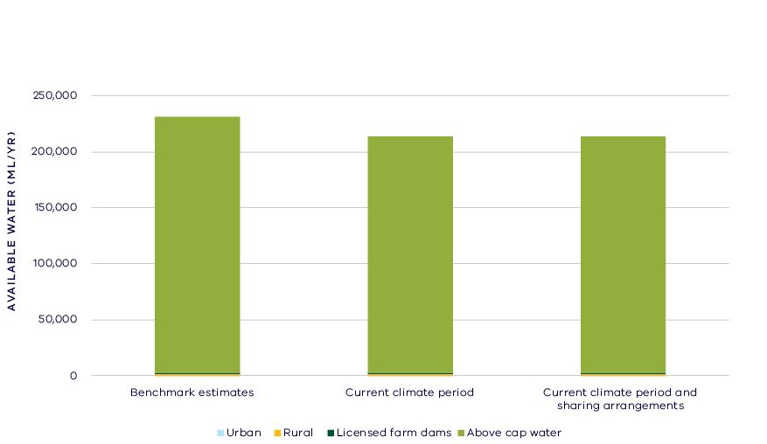
- Changes in the water availability – Hopkins River
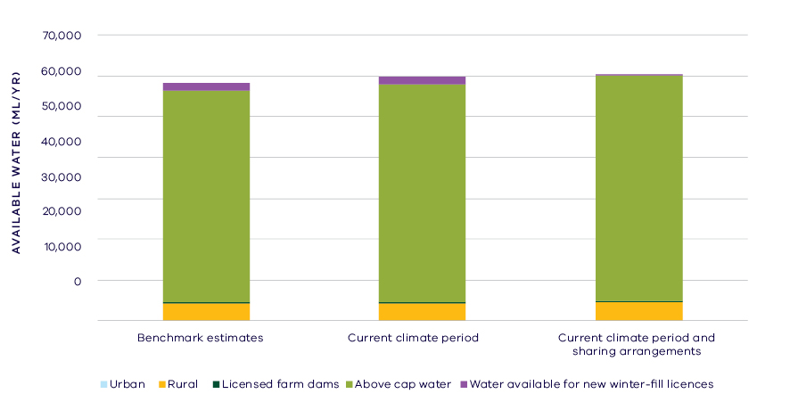
- Changes in the water availability – Merri River

Has the decline in long-term water availability been shared equally?
Since the SWS assessment, across the Hopkins basin, the volume of water available to consumptive users has not materially changed and the environment has experienced an overall decline in total water availability (Table 1).
While there have been changes to the overall volume of water available to consumptive users and the environment, the sharing of the available resource between these groups remains unchanged with 3 per cent allocated to consumptive users and the remaining 97 per cent of water available to the environment (Table 1).
Waterways and their values
The waterways of the Hopkins basin flow through grasslands, with few riparian trees remaining. The waterways support native fish, including Australian grayling, river blackfish, dwarf galaxias and Yarra pygmy perch. The wetlands on the lower Merri River are habitat for orange-bellied parrots and migratory shorebirds. The upper reaches of rivers are home to platypus and growling grass frog. The basin also contains several important wetlands that support waterbird populations including Lake Bookar, part of the Ramsar recognised Western District Lakes, Lake Muirhead, Mt William Swamp and Cockajemmy lakes as well as a number of shallow, seasonal herbaceous wetland systems.
The waterways of the Hopkins basin are important for Traditional Owners, which include the Gunditj Mara, Kirrae Whurrong and Tjap Whurrong people. The waterways are also highly valued by local communities for fishing, boating and beside water recreation. In particular the estuaries of the Merri and Hopkins Rivers are highly valued for recreational fishing.
There are no environmental water entitlements held in the Hopkins basin, but there is other water in the system that contributes to environmental outcomes, such as flow protected by restriction triggers on diversion licences. There are also a large number of complementary management projects that have been put in place to protect and restore the waterways of the basin. These include riparian fencing, revegetation and weed control, establishing stewardship agreements with landholders, establishing buffer zones and improving fish passage.

Environmental flow provisions
There is a large body of scientific work linking defined aspects of the flow regime with ecological understanding and impacts to waterway health. In the absence of good long-term ecological data to assess waterway health, some inferences have been drawn from analyses of changes in flow. This should not, however, be considered a direct assessment of waterway health.
Environmental flow recommendations have only been established for the Merri River system in the Hopkins basin and with no held environmental entitlement, there are limited mechanisms to achieve these flow recommendations. Since the release of the Western Region SWS, there has, on average, been a decline in most of the environmental flow recommendations in the Hopkins basin (Figure 6). This includes a decline in baseflows, which could be expected to affect water quality and habitat availability for aquatic species. Similarly, there has been a decline in the provision of summer and winter freshes, which provide important cues for fish breeding and migration as well as dispersal of platypus. The results presented here are consistent with the assessment of changes in generalised flow components in the Hopkins River, which also saw a decline in annual median flow, low flows and high flows.
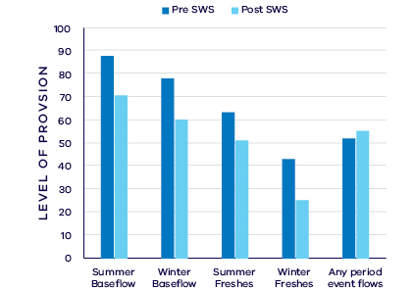
- Average change in ecologically important flow components pre SWS (1966 – 2010) and post SWS (2011 – 2017)

Waterway health
The waterway health analysis was completed at the river basin scale, primarily because there is less data at site, reach or river scales. Although aggregating data to a basin scale allowed for better detection of statistical trends, the results might not reflect the conditions at individual river reaches within the basin.
There is no accepted simple measure for overall waterway health and while many indicators and associated datasets were considered, only a few met requirements for the Long-Term Water Resource Assessment. Most of the available datasets did not cover a sufficient time period (>20 years) to allow for analysis of changes over a long-term timeframe. The indicators presented cover water quality and macroinvertebrates and are based on the most robust data available. The data were split into three time periods:
- Prior to the LTWRA period — 1990 – 2005
- First part of the LTWRA period — 2006 – 2010. This was the worst section of the Millennium Drought
- Second part of the LTWRA period — 2011 – 2018 Post Millennium Drought.
The data were then analysed to identify any trends over time in the selected indicators. That is, whether various waterway health indicators are improving, deteriorating or unchanged. So, while it may be possible to report, for example, an improvement in salinity within a river basin, this does not necessarily imply “good” waterway health. This is because 1) the waterways may still be high in salinity, just less so than previously; and 2) other aspects of waterway health might be deteriorating.
The Long-Term Water Resource Assessment examined the impact of flow on waterway health. To this end, the effects of flow were separated from all other factors that can affect waterway health (e.g. bushfire, land use change, rehabilitation works). The individual influences of these other factors on waterway health have not been analysed in this assessment.
The results showed no consistent pattern of change in waterway health indicators in the Hopkins Basin since 2011. As discussed in section 6.2.4 of the Overview Report, there are a number of limitations on interpreting these indicators. The possible impacts of any changes in these individual indicators on other aspects of waterway health are also described in the Overview Report.
There was a deterioration in trend for salinity (compared to the previous time period), which was partially linked to changes in the flow regime. There has been an improvement in trend for nitrogen since 2006 (compared to the previous time period) which was partly related to flow. There has also been an improvement in trend for phosphorus since 2006 (compared to the previous time period) but this was not linked to flow changes. There was a deterioration in trend in total suspended solids since 2006 (compared to the previous time period) which was partly related to flow. However, there was an improvement in trend in turbidity (compared to the previous time period) which was partly related to flow. There was an ongoing decrease in dissolved oxygen since 1990, which was partly due to flow, however, on average, levels remained within SEPP guidelines.
Limited data and high natural variability prevented the detection of any trend in macroinvertebrate indicators. No suitable data was available for fish.
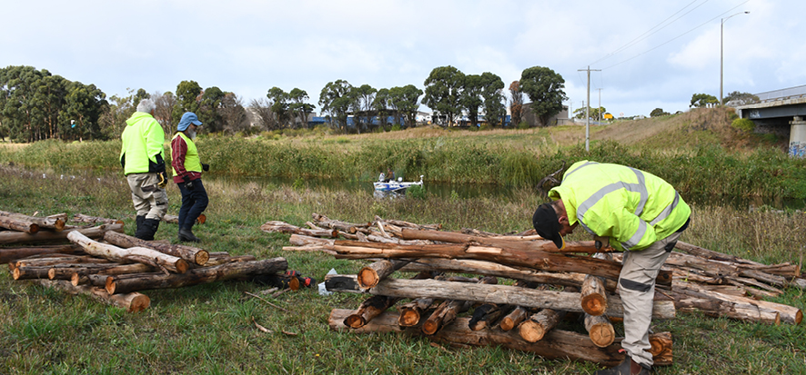
- Volunteers constructing fish hotels on the banks of the Merri River in Warrnambool. Image courtesy of Glenelg Hopkins CMA.

On-ground achievements: beyond the available data
While the assessment needed to analyse long-term datasets to answer the question set by the Water Act, there are numerous other projects going on around the state that are improving waterway health, but which only began in recent years. In the Hopkins basin, one such project is the Merri River Habitat Hotspot Project.
The Merri River Habitat Hotspot Project involved the continued restoration of fish habitat into the Merri River through Warrnambool. 114 pieces of habitat have been placed into the urban reaches of the Merri River. These habitat pieces include fish hotels, lay down snags, rootballs and rocks.
The most recent works have been completed in financial partnership with Ozfish Unlimited SW chapter. Glenelg Hopkins CMA coordinated several fish hotel building workshops attended by volunteers from Conservation Volunteers Australia and Ozfish Unlimited (Figure 7). Using a new construction technique, fish hotels could be constructed on the banks of the Merri River without specialist equipment. This allowed for construction to be completed entirely by volunteers. With this new partnership and building technique, it is hoped these volunteer groups will be empowered to continue fish habitat works in Warrnambool.
These activities are complemented by riparian restoration works being carried out by the CMA which will further improve the habitat values of the river. Monitoring carried out in November 2018 revealed estuary perch making use of the fish hotels. This is the first officially recorded occurrence of estuary perch in this section of the river in over a decade.
Overall this has been a fantastic project involving a number of community organisations working together to achieve a great result for fish and river health in an urban environment.

Has waterway health deteriorated for flow-related reasons?
There have been, on average, moderate declines in aspects of the flow regime with well understood ecological importance in the Merri River part of the Hopkins basin since the release of the Western Region SWS in 2011. There were mixed results in the trends in waterway health indicators between rivers in this basin, making it difficult to provide a cohesive all-of-basin assessment of the effects of flow on waterway health. Overall, the findings for waterway health for reasons related to flow are inconclusive.

Portland Coast Basin

Introduction
The Portland Coast basin covers just over 3,960 square kilometres and comprises four main river systems: the Moyne, Eumeralla-Shaw system, Darlot Creek-Fitzroy River system and the Surrey River. These are all relatively short and drain immediately inland areas to the Southern Ocean. While there are areas of State forest in the upper Fitzroy and Surrey River systems, the remainder of the basin is largely cleared for grazing and broad acre cropping. The towns of Koroit, Port Fairy, Heywood and Portland are within this basin.
The climate is temperate, with cool wet winters and warm dry summers. Average annual rainfall is lowest (600 – 700 mm/year) in the north-eastern half of the basin and higher in the south (700 – 1,000 mm/year).
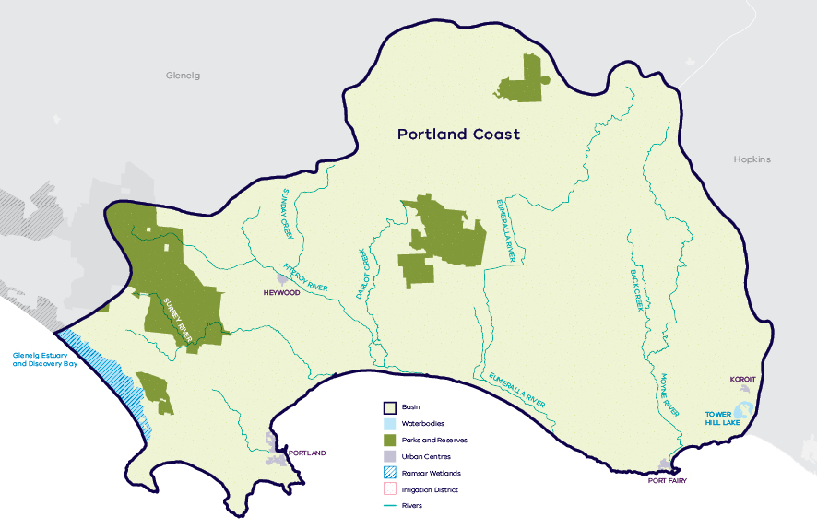
- Map of the Portland Coast basin

Long-term water availability
In 2011, the Western Region Sustainable Water Strategy (SWS) assessed water availability and reviewed the balance of water sharing between consumptive users and the environment in the Portland Coast basin. Surface water availability was calculated based on the long-term average, using the best available data at that time. Improvements in data since the development of the Western Region SWS have enabled a refined calculation of water availability. Surface water availability for Darlot, Fitzroy and Surrey Rivers was not calculated at the time of the SWS but is now included in the LTWRA. The updated historical surface water availability for the Portland Coast basin is 431.9 GL/year (Table 1).
To enable trends across different waterways to be compared, results for five individual rivers are presented below
- Darlot River: Table 2, Figure 2, Figure 5
- Fitzroy River: Table 3, Figure 3, Figure 6
- Eumeralla River: Table 4, Figure 4, Figure 7
- Moyne River: Table 5
- Surrey River: Table 6).
Research indicates that recent decades provide a better representation of current climate than does the full historical record. Recent decades more closely reflect current atmospheric levels of greenhouse gases and have been drier and warmer than the earlier parts of the 20th century. For these reasons, the period from 1975 to the present is thought to better represent long-term water availability under current climatic conditions. It includes a wide range of natural climate variability — the severe Millennium Drought and wet years. Four of the five rivers assessed showed a decline in water availability, with the Fitzroy River experiencing the largest decline of 26 per cent. The Eumeralla River has experienced a very small increase of 1 per cent in water availability. The total average water availability for Portland Coast basin over this time is 380.0 GL/year, a decline of 12 per cent compared with historical water availability.
The period since 1997 shows a further decline in water availability, however, this period is heavily influenced by the Millennium Drought (Figure 2, Figure 3, Figure 4). The drier conditions experienced since 1997 may be due to natural climate variability. These years may also represent ongoing conditions due to climate change. It is too soon to know if this is the case.
In addition to surface water, groundwater within the Portland basin is a significant resource for consumptive use. Groundwater occurs in the Portland Coast basin in unconfined and confined aquifers. The amount of groundwater that can be pumped by consumptive users and the amount of water that flows from aquifers into streams and wetlands are both heavily dependent on groundwater levels. If groundwater levels have stayed the same (or increased) there will not have been a reduction in the groundwater available to consumptive users or the environment. If groundwater levels have declined, then either consumptive users or the environment (or both) may have experienced reduced water availability.
Reduced water availability to the environment typically only occurs where groundwater levels have declined in an unconfined aquifer that is connected to a waterway. Reduced availability to consumptive users may occur where groundwater levels have declined in either confined or unconfined aquifers. The long-term decline of groundwater level in the unconfined aquifer is low, ranging from 0.1 to – 1 m. In the confined aquifers, groundwater levels are mostly stable except in some areas where declines greater than 2 m were identified. These areas include the Condah Groundwater Management Area and a small area near the town of Portland.
While climate is the primary driver of the decline in inflow to the Portland Coast basin, other potential contributing factors have been assessed:
- Interception by domestic and stock dams has a low likelihood of contribution to the total decline.
- There is evidence of large-scale land-use changes to more water-intensive activities, such as commercial forestry plantations, which may make a significant contribution to the total decline.
- Licensed groundwater pumping in the Portland basin is mostly from the confined aquifers which are not connected to surface water. Therefore, these extractions are unlikely to impact on long-term surface water availability.
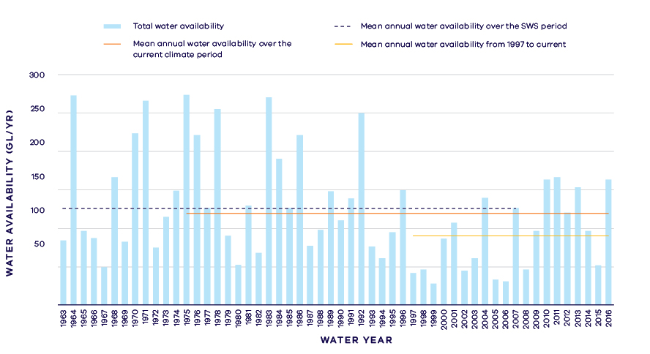
- Annual water availability in the Darlot River
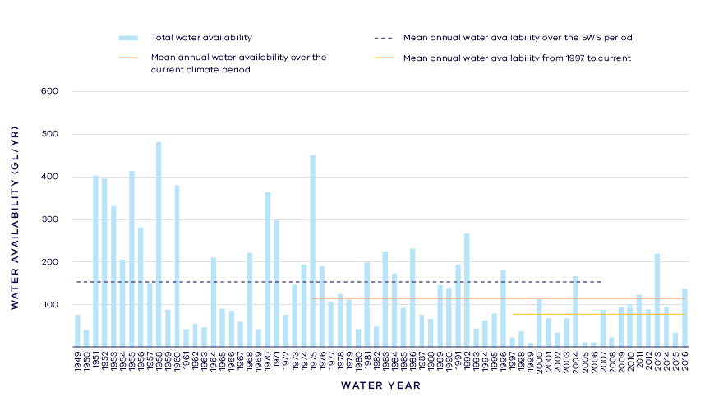
- Annual water availability in the Fitzroy River
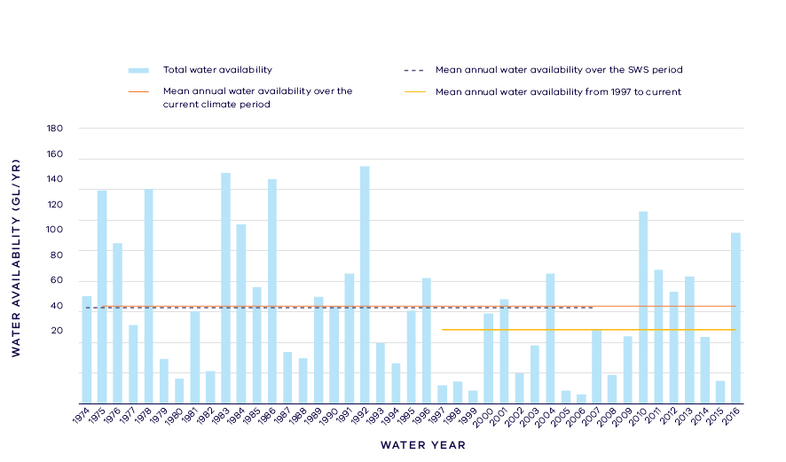
- Annual water availability in the Eumeralla River
- Total long- term surface water availability in the Portland Coast basin (summed across rivers)
 |  |  |  | Change due to:⁵
 | Updated SWS estimate² | Current climate period³ | Current climate period and sharing arrangements⁴ | Different climate period | Different climate period and water sharing arrangements
Long-term surface water availability¹
Total water availability (GL/year) | 431.9 | 380.0 | 380.0 | -51.9 | -51.9
Consumptive  (GL/year)⁶ | 1.7 | 1.7 | 1.7 | 0.0 | 0.0
Environment  (GL/year) | 399.4 | 347.5 | 374.8 | -51.9 | -24.5
Not categorised  (GL/year)⁷ | 30.8 | 30.8 | 3.4 | 0.0 | -27.4
Water sharing⁸
Consumptive | 0% | 0% | 0% | 0% | 0%
Environment | 100% | 100% | 100% | 0% | 0%

- Long- term surface water availability in the Darlot River
 |  |  |  | Change due to:⁵
 | Updated SWS estimate² | Current climate period³ | Current climate period and sharing arrangements⁴ | Different climate period | Different climate period and water sharing arrangements
Long-term surface water availability¹
Total water availability (GL/year) | 124.8 | 119.3 | 119.3 | -5.5 | -5.5
Consumptive  (GL/year)⁶ | 0.8 | 0.8 | 0.8 | 0.0 | 0.0
Environment  (GL/year) | 115.7 | 110.2 | 117.3 | -5.5 | 1.6
Not categorised  (GL/year)⁷ | 8.3 | 8.3 | 1.2 | 0.0 | -7.1
Water sharing⁸
Consumptive | 1% | 1% | 1% | 0% | 0%
Environment | 99% | 99% | 99% | 0% | 0%

- Long- term surface water availability in the Fitzroy River
 |  |  |  | Change due to:⁵
 | Updated SWS estimate² | Current climate period³ | Current climate period and sharing arrangements⁴ | Different climate period | Different climate period and water sharing arrangements
Long-term surface water availability¹
Total water availability (GL/year) | 150.7 | 113.6 | 113.6 | -37.1 | -37.1
Consumptive  (GL/year)⁶ | 0.8 | 0.8 | 0.8 | 0.0 | 0.0
Environment  (GL/year) | 141.6 | 104.5 | 111.6 | -37.1 | -30.0
Not categorised  (GL/year)⁷ | 8.4 | 8.4 | 1.3 | 0.0 | -7.1
Water sharing⁸
Consumptive | 1% | 1% | 1% | 0% | 0%
Environment | 99% | 99% | 99% | 0% | 0%

- Long- term surface water availability in the Eumeralla River
 |  |  |  | Change due to:⁵
 | Updated SWS estimate² | Current climate period³ | Current climate period and sharing arrangements⁴ | Different climate period | Different climate period and water sharing arrangements
Long-term surface water availability¹
Total water availability (GL/year) | 62.7 | 63.4 | 63.4 | 0.7 | 0.7
Consumptive  (GL/year)⁶ | 0.1 | 0.1 | 0.1 | 0.0 | 0.0
Environment  (GL/year) | 56.8 | 57.5 | 62.9 | 0.7 | 6.0
Not categorised  (GL/year)⁷ | 5.8 | 5.8 | 0.5 | 0.0 | -5.3
Water sharing⁸
Consumptive | 0% | 0% | 0% | 0% | 0%
Environment | 100% | 100% | 100% | 0% | 0%

- Long- term surface water availability in the Moyne River
 |  |  |  | Change due to:⁵
 | Updated SWS estimate² | Current climate period³ | Current climate period and sharing arrangements⁴ | Different climate period | Different climate period and water sharing arrangements
Long-term surface water availability¹
Total water availability (GL/year) | 58.3 | 50.5 | 50.5 | -7.8 | -7.8
Consumptive  (GL/year)⁶ | 0.1 | 0.1 | 0.1 | 0.0 | 0.0
Environment  (GL/year) | 55.1 | 47.2 | 50.5 | -7.8 | -4.6
Not categorised  (GL/year)⁷ | 3.2 | 3.2 | 0.0 | 0.0 | -3.2
Water sharing⁸
Consumptive | 0% | 0% | 0% | 0% | 0%
Environment | 100% | 100% | 100% | 0% | 0%

- Long- term surface water availability in the Surrey River
 |  |  |  | Change due to:⁵
 | Updated SWS estimate² | Current climate period³ | Current climate period and sharing arrangements⁴ | Different climate period | Different climate period and water sharing arrangements
Long-term surface water availability¹
Total water availability (GL/year) | 35.3 | 33.1 | 33.1 | -2.2 | -2.2
Consumptive  (GL/year)⁶ | 0.0 | 0.0 | 0.0 | 0.0 | 0.0
Environment  (GL/year) | 30.2 | 28.0 | 32.6 | -2.2 | 2.4
Not categorised  (GL/year)⁷ | 5.1 | 5.1 | 0.5 | 0.0 | -4.6
Water sharing⁸
Consumptive | 0% | 0% | 0% | 0% | 0%
Environment | 100% | 100% | 100% | 0% | 0%

Notes to tables
- These estimates are long-term averages. Values are rounded to the nearest 0.1 GL. Figures might not add in columns and/or rows, due to rounding. Minor differences in values compared with graphed annual average inflows arise from water intercepted by licensed farm dams being excluded from graphed historical inflows.
- The SWS estimate is based on the period 1963 – 2008 for the Darlot River, 1949 – 2008 for the Fitzroy River, 1964 – 2008 for the Eumeralla River, 1948 – 2008 for the Moyne River, 1970 – 2008 for the Surrey River.
- The current climate period is 1975 – 2017.
- Refer to subsequent sections on Water for Consumptive Use and Water for the Environment for details of any changes in water sharing arrangements. Also includes unallocated water available for new winter-fill licences.
- Negative values are a decline in water available; positive values are an increase in water available.
- These estimates assume full use of entitlements and include interception by licensed farm dams.
- Not categorised water, such as run-of-river losses that cannot be reasonably considered as being for consumptive users or the environment. Also includes unallocated water available for new winter-fill licences.
- Water sharing is represented as a percentage of the sum of water available for the environment and consumptive use. It excludes available water that was not categorised.

Water for consumptive use
In the Portland Coast basin less than 1 per cent of the average water available in river systems is allocated to consumptive use. Use consists of licensed commercial and irrigation farm dams and diverters who hold take and use licences. No water corporations divert surface water from within the basin, and large towns are mostly supplied from groundwater reserves in the Dilwyn Aquifer.
Current average annual water availability for consumptive users in the rivers in the Portland Coast basin is approximately 1.7 GL/year and has not changed materially compared with historical availability (Table 1).
Since the Western Region SWS was published in 2011, local management rules governing access to water by private diverters have been formalised through the publication of the Local Management Plan for the Portland Basin by Southern Rural Water in 2013. However, this has not altered water availability.
Some catchments in the Portland Coast basin have not reached their sustainable diversion limits. This means that water is available during wetter months to be allocated in future to support growth in consumptive use. The Western Region SWS set revised caps on the amount of unallocated surface water available for future winter-fill licences. This reduction in the sustainable diversion limit across the basin does not represent a reduction in water availability to consumptive users because no one holds an entitlement to the water.

Water for the environment
Water is set aside for the environment through the limits placed on the allocations that could be made to consumptive users. Once all water in the system is allocated, the water remaining in the system is designated to the environment. This is known as ‘above cap water.’ Because this water is only available to the environment after all other users have taken their share, its volume varies with climatic conditions and reduces significantly when conditions become drier.
All rivers within the basin have experienced a decline in above cap water availability, except for the Eumeralla River. The largest decrease in water availability for the environment is in the Fitzroy River which has had a 37.1 GL/year decline. At the time of the SWS, total above cap water in the Portland Coast basin averaged 399.4 GL/year, but this decreased to 347.5 GL/year under current climate.
In 2011, the Western Region SWS revised the volume of surface water available under sustainable diversion limits for future allocation to winter-fill diversion licences from 30.8 GL to 3.4 GL. This represents a transfer of water to the environment. Overall, climate change has resulted in a decline in water available to the environment, however the decline would have been even greater if these unallocated licences had been allowed to be taken up by water users.
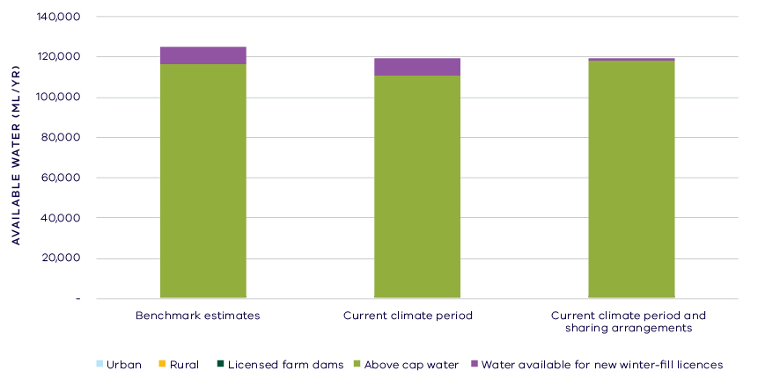
- Changes in the water availability in the Darlot River
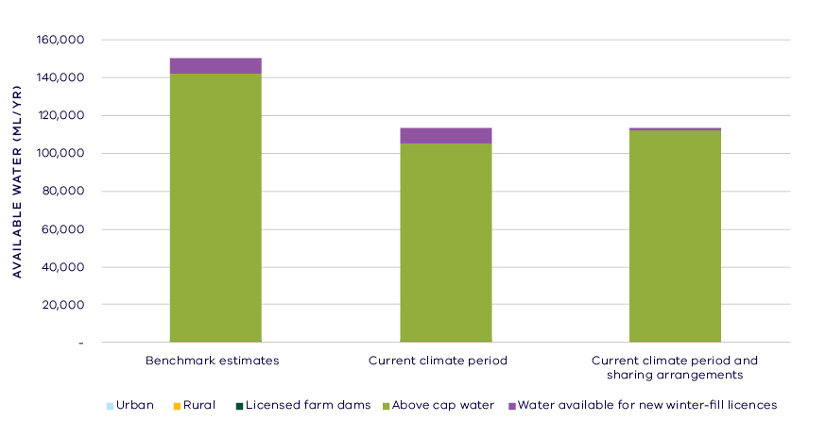
- Changes in the water availability in the Fitzroy River
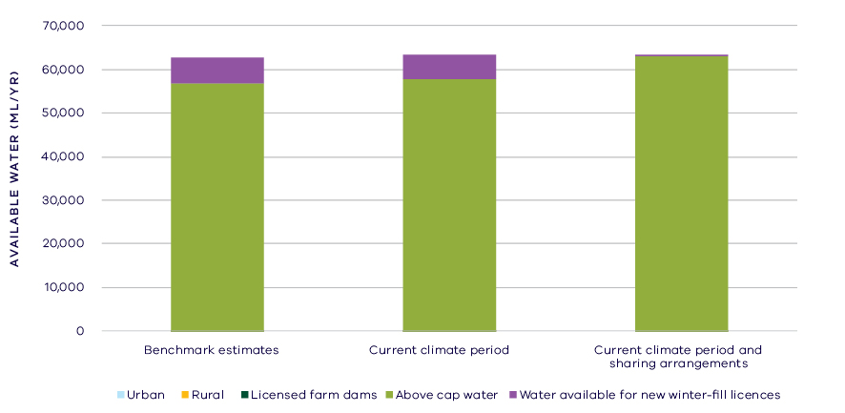
- Changes in the water availability in the Eumeralla River

Has the decline in long-term water availability been shared equally?
Changes in the water availability vary from river-to-river. Overall, the volume of water available to the environment has declined, however consumptive users have not experienced a decline in average annual water availability (Table 1). While there have been changes to the overall volume of water available to the environment, the sharing of the available resource between the environment and consumptive users remains unchanged (Table 1). This is due to the small volume allocated for consumptive use compared to the total inflows to this basin.

Waterways and their values
The waterways of the Portland Coast basin flow through grasslands, with few riparian trees remaining. The waterways support native fish species, including Australian grayling, river blackfish, eastern dwarf galaxias and Yarra pygmy perch. The estuarine reaches of the rivers support waterbirds including Australasian bittern, great knot and intermediate egret. The Lower Eumeralla River and Yambuk Lake is listed as a wetland of national importance.
The waterways of the Portland Coast basin are important for traditional owners, represented by the Gunditj Mirring Traditional Owners Aboriginal Corporation. Of particular note is the Budj Bim National Heritage Landscape, home to a 6,600 year-old aquaculture system. The basalt fish traps, channels, weirs and ponds were used to manage flow from Lake Condah and systematically farm and trap short-finned eels. The waterways in general and particularly the estuarine reaches are highly valued by local communities for fishing, boating and beside water recreation.
There are no environmental water entitlements held in the Portland Coast basin, but there is other water in the system that contributes to environmental outcomes, such as flow protected by restriction triggers on diversion licences. There are also a large number of complementary management projects that have been put in place to protect and restore the waterways of the basin. These include riparian fencing, revegetation and weed control, establishing stewardship agreements with landholders, implementing best practice pasture and dairy management and improving fish passage.

Environmental flow provisions
There is a large body of scientific work linking defined aspects of the flow regime with ecological understanding and impacts to waterway health. In the absence of good long-term ecological data to assess waterway health, some inferences have been drawn from analyses of changes in flow. This should not, however, be considered a direct assessment of waterway health.
There have been improvements in average river flow conditions in the Portland Coast basin since 2011 compared to the long-term record (Figure 8). There have been improvements in annual mean flow, high flows and low flows, which could all be expected to improve river health for instream and riparian vegetation as well as aquatic biota. There has been a decline in “zero flows”, that is there has been a decrease in the amount of time that rivers stop flowing since 2011, which also could be interpreted as beneficial to river health. The rivers of the Portland Coast basin are unregulated and not subject to large extractions, and so these changes are likely due to natural factors and improved water availability following the end of the Millennium Drought in 2010.
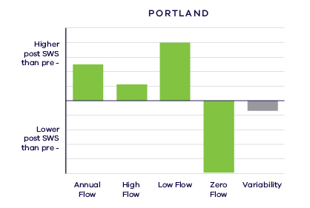
- Average change in ecologically important flow components pre SWS (prior to 2010) and post SWS (2011 – 2017). Green indicates improvement and grey unknown

Waterway health
The waterway health analysis was completed at the river basin scale, primarily because there is less data at site, reach or river scales. Although aggregating data to a river basin scale allowed for better detection of statistical trends, the results might not reflect the conditions at individual river reaches within the basin.
There is no simple accepted measure for overall waterway health and while many indicators and associated datasets were considered, only a few met requirements for the Long-Term Water Resource Assessment. Most of the available datasets did not cover a sufficient time period (>20 years) to allow for analysis of changes over a long-term timeframe. The indicators presented cover water quality and macroinvertebrates and are based on the most robust data available. The data were split into three time periods:
- Prior to the LTWRA period — 1990 – 2005
- First part of the LTWRA period — 2006 – 2010. This was the worst section of the Millennium Drought
- Second part of the LTWRA period — 2011 – 2018 Post Millennium Drought.
The data were then analysed to identify any trends over time in the selected indicators. That is, whether various waterway health indicators are improving, deteriorating or unchanged. So, while it may be possible to report, for example, an improvement in salinity within a river basin, this does not necessarily imply “good” waterway health. This is because 1) the waterways may still be high in salinity, just less so than previously; and 2) other aspects of waterway health might be deteriorating.
The Long-Term Water Resource Assessment examined the impact of flow on waterway health. To this end, the effects of flow were separated from all other factors that can affect waterway health (e.g. bushfire, land use change, rehabilitation works). The individual influences of these other factors on waterway health have not been analysed in this assessment.
The results showed no consistent pattern of change in waterway health indicators in the Portland Coast basin since 2011. As discussed in section 6.2.4 of the Overview Report, there are a number of limitations on interpreting these indicators. The possible impacts of any changes in these individual indicators on other aspects of waterway health are also described in the Overview Report.
There has been an improvement in trend in salinity since 2006 (compared to the previous time period), which was strongly related to river flow. There was an improvement in trend in nitrogen since 2006 (compared to the previous time period) but this was not explained by flow. Dissolved oxygen has deteriorated since 1990, with a strong link to flow. However, on average, levels remained within SEPP guidelines. Phosphorus has increased since 1990, but this is mostly not linked to changes in flow. There were improvements in trends of both turbidity and total suspended solids (compared to before 2011) and these are partly explained by changes in flow.
Limited data and high natural variability prevented detection of any trend in macroinvertebrate indicators. No suitable data was available for fish.
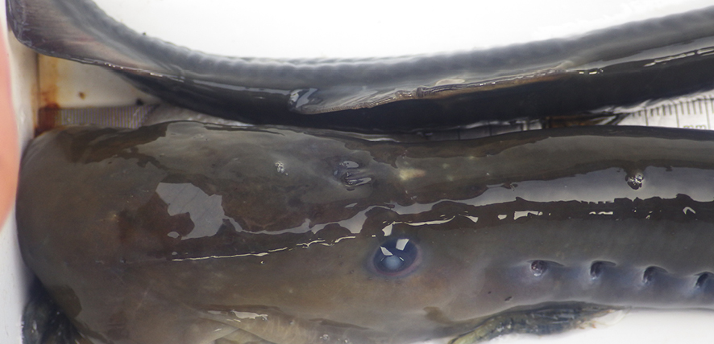
- Pouched lamprey sampled in the Fitzroy River. Photographer N. Whiterod, Aquasave Consultants

On-ground achievements: beyond the available data
While the assessment needed to analyse long-term datasets to answer the question set by the Water Act, there are numerous other projects going on around the state that are improving waterway health, but which only began in recent years. In the Portland Coast basin, one such project involves controlling invasive willow and promoting revegetation to benefit endangered species.
The Fitzroy River flows through the nationally significant Budj Bim landscape and enters the ocean near Tyrendarra. The Fitzroy was always known to hold a range of threatened and endangered species including the Glenelg spiny freshwater crayfish. However, only recently has the full importance of this river as a refuge been understood. A recent survey yielded a staggering 72 Glenelg spiny freshwater crayfish, along with a diverse mix of fish species (Figure 9). Among the fish surveyed was a pouched lamprey – the first time it has been recorded here in almost 30 years.
On the back of these survey results, the Tyrendarra Streamside Reserve was successfully set up as demonstration site for willow treatment and riverbank rehabilitation works through the Budj Bim connections project. This site has directly influenced the establishment of three works agreements to continue to treat willow infestations in the Tyrendarra region. Additionally, it has been the site of a tremendously positive revegetation event with Narrawong Primary School. An online video was produced during this event (YouTube video here: https://youtu.be/WlALb2Rrj9k).

Has waterway health deteriorated for flow-related reasons?
There have been, on average, moderate to substantial improvements in aspects of the flow regime with well understood ecological importance since the end of the Millennium Drought, which coincided with the release of the Western Region SWS in 2011, in comparison to the preceding decades. There have also been small improvements in some water quality indicators linked to river flow in the Portland Coast basin. However, no trend was detected in aquatic animal indicators of waterway health. Overall, the findings for waterway health for reasons related to flow are inconclusive.

Glenelg Basin
Introduction
The Glenelg basin is a large area covering nearly 12,000 square kilometres. The basin is dominated by the Glenelg River (the largest river in south-west Victoria) and its major tributaries including the Wannon, Chetwynd, Stokes, Crawford and Wando Rivers. The rivers rise in the western edges of the Grampians and flow to the Southern Ocean. The steep uplands retain native vegetation of low forest and heathland scrub. Two thirds of the basin, however, has been cleared and major land uses include grazing, timber production. The upper Glenelg is regarded as one of the most severely eroded catchments in Victoria. This erosion has deposited four to eight million cubic metres of sand into the Glenelg River and its tributaries.
The climate is temperate, with cool wet winters and warm dry summers. Most of the basin receives a low average annual rainfall (500 – 700 mm) with higher rainfall (700 – 1,000 mm/year) southwest of Casterton.
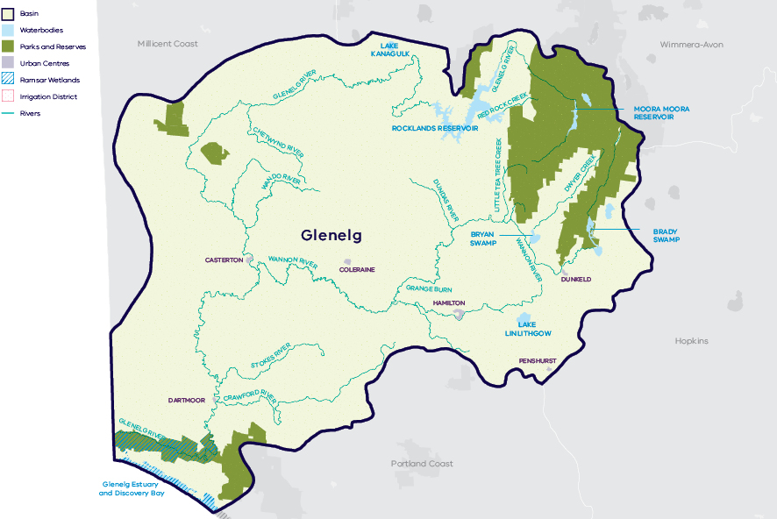
- Map of the Glenelg basin

Long-term water availability
In 2011, the Western Region Sustainable Water Strategy (SWS) assessed water availability and reviewed the balance of water sharing between consumptive users and the environment in the Glenelg basin. Surface water availability was calculated based on the long-term average between 1965 and 2009, using the best available data at that time. Improvements in data and computer models since the development of the Western Region SWS have enabled a refined calculation of water availability over that period. The updated historical surface water availability is 510.5 GL/year (Table 1; Figure 2).
Research indicates that recent decades provide a better representation of current climate than does the full historical record. Recent decades more closely reflect current atmospheric levels of greenhouse gases and have been drier and warmer than the earlier parts of the 20th century. For these reasons, the period from 1975 to the present is thought to better represent long-term water availability under current climatic conditions. It includes a wide range of natural climate variability — the severe Millennium Drought and wet years. The average water availability over this time is 481.6 GL/year, a decline of 6 per cent compared with historical water availability. For the Glenelg basin, the historical assessment of water availability was based on data available from the late 1960s onwards. This means that the LTWRA assessment period for water availability has considerable overlap with the SWS assessment period.
The period since 1997 shows further declines in water availability (Figure 2), however, this period is heavily influenced by the Millennium Drought. The drier conditions experienced since 1997 may be due to natural climate variability. These years may also represent climate change. It is too soon to know if this is the case, especially as there have been concurrent changes in land use in the Glenelg basin.
In addition to surface water, groundwater is available in the Glenelg basin. The amount of groundwater that can be pumped by consumptive users and the amount of water that flows from aquifers into streams and wetlands are both heavily dependent on groundwater levels. If groundwater levels have declined, then either consumptive users or the environment (or both) may have experienced reduced water availability.
Reduced water availability to the environment typically only occurs where groundwater levels have declined in an unconfined aquifer that is connected to a waterway. Reduced availability to consumptive users may occur where groundwater levels have declined in either confined or unconfined aquifers. Groundwater levels in the Glenelg basin are mostly stable in the unconfined aquifer, with a small area north of the Glenelg River where declines greater than 2 m were identified. In the confined aquifer, long-term water level declines in the west of the basin were identified ranging from 0.1 to 2 m.
While climate is the primary driver of the decline in water flows into the Glenelg basin, other potential contributing factors have been assessed:
- Interception by domestic and stock dams is unlikely to contribute to the total decline in water availability.
- There is evidence of large-scale land-use changes to more water-intensive activities, such as plantation forestry, which may make a considerable contribution to the total decline.
- There is no significant groundwater pumping occurring in the basin which could contribute to the total decline.
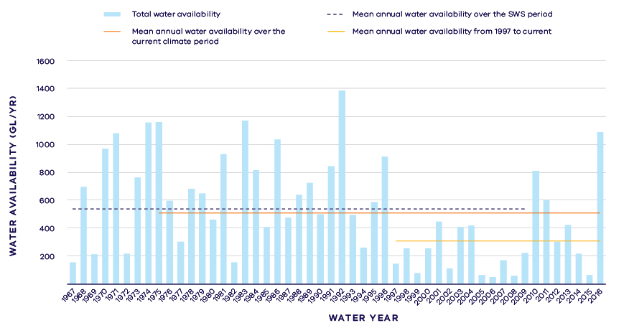
- Annual water availability in the Glenelg River
- Long- term surface water availability in the Glenelg basin
 |  |  |  | Change due to:⁵
 | Updated SWS estimate² | Current climate period³ | Current climate period and sharing arrangements⁴ | Different climate period | Different climate period and water sharing arrangements
Long-term surface water availability¹
Total water availability (GL/year) | 510.5 | 481.6 | 488.4 | -28.9 | -22.0
Consumptive  (GL/year)⁶ | 12.7 | 12.2 | 12.1 | -0.5 | -0.6
Environment  (GL/year) | 419.9 | 399.2 | 402.4 | -20.8 | -17.6
Not categorised  (GL/year)⁷ | 77.9 | 70.3 | 74.0 | -7.6 | -3.9
Water sharing⁸
Consumptive | 3% | 3% | 3% | 0% | 0%
Environment | 97% | 97% | 97% | 0% | 0%

Notes to table
- These estimates are long-term averages. Values are rounded to the nearest 0.1 GL. Figures might not add in columns and/or rows, due to rounding. Minor differences in total water availability under the current climate period arise from differences in storages are managed. Minor differences in values compared with graphed annual average inflows arise from water intercepted by licensed farm dams being excluded from graphed historical inflows. Transfers to the Wimmera basin are accounted for in that basin.
- The SWS estimate is based on the period 1965 – 2009 for the Glenelg River.
- The current climate period is 1975 – 2017.
- Refer to subsequent sections on Water for Consumptive Use and Water for the Environment for details of any changes in water sharing arrangements. Small differences in total water availability over the current climate period result from changes in storage management, including changes in transfers to the Wimmera basin.
- Negative values are a decline in water available; positive values are an increase in water available.
- These estimates assume full use of entitlements and include interception by licensed farm dams
- Not categorised water, such as run-of-river losses that cannot be reasonably considered as being for consumptive users or the environment.
- Water sharing is represented as a percentage of the sum of water available for the environment and consumptive use. It excludes available water that was not categorised.

Water for consumptive use
The upper Glenelg and Wannon Rivers form part of the Wimmera and Glenelg Rivers headworks in the Grampians. The storages in the upper Glenelg are connected to the Wimmera basin via channels. The connectivity between the Glenelg and Wimmera basins is reflected in the bulk entitlements for the Grampians region, which are issued for the combined Wimmera and Glenelg Rivers headworks system rather than an individual river basin. Due to the integrated management of the basins, water availability to many consumptive users in the Glenelg basin is influenced by water availability and demands in the neighbouring Wimmera basin. Water uses in the Glenelg basin include supply for Hamilton and other urban centres, commercial, irrigation and other rural demands, as well as registered farm dams.
Entitlements in the Glenelg basin are an important source of water for towns in the region such as Hamilton. Annual caps are specified on all of these entitlements. In practice, current demands are well below the annual entitlement volume.
In addition to local entitlements in the Glenelg basin, Hamilton and surrounding townships are supplied by water from the Wimmera and Glenelg Rivers headworks. Wannon Water is able to carryover water between years, managing supply to Hamilton under climate variability.
Some of the urban entitlements in the Glenelg basin are no longer actively used for urban supply and reflect a long-term shift towards supply from more reliable water sources. These include the surface water supplies to Coleraine, Casterton and Sandford, which are now supplied from groundwater. This assessment did not include small, disused entitlements.
Flows in rivers may have shared benefits. The Glenelg River compensation flow provides for up to 3.3 GL/year to be released from Rocklands Reservoir to the Glenelg River from November to May each year. In this assessment, water released under the compensation flow is considered allocated to consumptive use because that water is primarily intended for stock and domestic use. However, the compensation flow is managed by Grampians Wimmera Mallee Water, in consultation with Glenelg Hopkins Catchment Management Authority and the Victorian Environmental Water Holder, to provide complementary environmental and social benefits.
Changes in climate have changed the amount of water available to consumptive users who, without any changes to water sharing, would have access to approximately 0.5 GL/year — equivalent to 4 per cent — less water compared with historical availability (Table 1).
At the time that water availability in the Glenelg basin was benchmarked for the Western Region Sustainable Water Strategy, new bulk entitlements to water in the Wimmera and Glenelg Rivers headworks (including the major water storages in the Glenelg basin) had been recently created. The purpose of the new entitlements was to formally recognise changes in system operation and to distribute water-savings enabled by the completion of the Wimmera-Mallee Pipeline. Since that time, the rules about how the water-supply system is managed have been reviewed twice. Refinements to the water entitlements and system operations stemming from those reviews have influenced how water is managed in the Glenelg basin.
For example, following the completion of the 2013 – 2014 Bulk and Environmental Entitlements Operations Review, the maximum operating level of Rocklands Reservoir was increased from 261.5 GL to 296 GL, with the intent to improve the operational flexibility of the system while reducing uncontrolled spills and seeking to retain efficient storage characteristics.
Access to water by private diverters was regulated through the publication of local management rules for some streams within the basin in 2013. These rules provide a clear statement of water sharing arrangements between private diverters and other users at times of low flow.
Changes to water sharing arrangements since the SWS have not materially altered the long-term annual availability of water to consumptive users in the Glenelg basin.

Water for the environment
Under historical climate, 419.9 GL/year was set aside for the environment in the Glenelg basin (Table 1). This was set aside by the Wimmera and Glenelg Rivers environmental entitlement, passing flows, limits on the volumes and timing of water extraction by entitlement holders and by the Murray-Darling Basin Cap.
The 42 GL/year Wimmera and Glenelg Rivers environmental entitlement was in place at the time of the Western Region Sustainable Water Strategy. This entitlement covers water in the shared Wimmera and Glenelg Rivers headworks system, rather than water in a specific river basin. This shared entitlement is currently managed to provide environmental flows in the Glenelg River using 40 per cent of the water available under the entitlement, with the remaining 60 per cent of the water used to generate environmental flows in the neighbouring Wimmera basin.
The Wimmera-Mallee environmental entitlement specifies minimum passing flow requirements at offtakes and immediately downstream of reservoirs to be provided for environmental purposes. In the Glenelg basin, minimum flows are required below Rocklands Reservoir on the Glenelg River, and downstream of diversion points in the Wannon River. These passing flows are specified as set daily flows, however in dry periods when inflows fall below the minimum specified passing flow rate, the natural flow must be passed downstream. This means that minimum flows are heavily influenced by climate variability. Passing flows are also restricted when storage levels in the Wimmera and Glenelg Rivers headworks are low.
The Murray-Darling Basin Cap also protects some water in the Glenelg basin for the environment by placing an upper limit on consumptive take from the Glenelg River upstream of and including Rocklands Reservoir.
Reduced river inflows have changed the amount of water available to the environment which, without any changes to water sharing would now have 20.8 GL/year — equivalent to 5 per cent — less water compared with historical availability (Table 1).
Since the SWS, changes to the management of the Wimmera and Glenelg Rivers headworks have influenced water availability in the Glenelg basin. The entitlement for the former Wimmera Irrigation District has been transferred to the Commonwealth Environmental Water Holder. Because the Commonwealth entitlement typically is used to provide environmental flows from the Wimmera basin storages, there has been an associated reduction in inter-basin transfers from the Glenelg basin. The outcome in terms of water availability for the Glenelg River is complex. Because less water is drawn out of Rocklands Reservoir, we might expect the dam to spill more often. However, following the completion of the 2013 – 2014 Bulk and Environmental Entitlements Operations Review, the maximum operating level of Rocklands Reservoir was increased, thereby reducing spills. More water in storage means higher allocations against the Wimmera and Glenelg Rivers’ environmental entitlement and, hence, slightly more water available for controlled environmental releases.
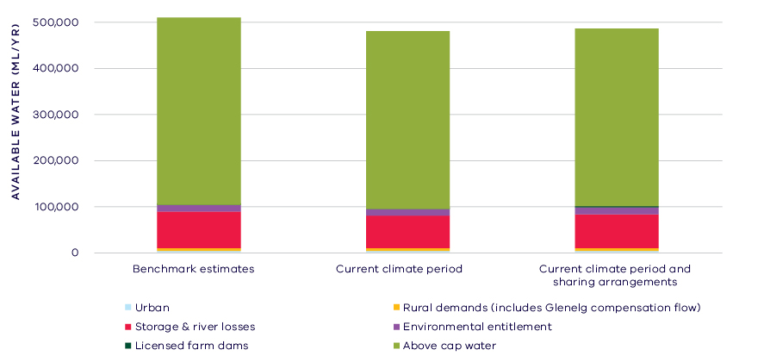
- Changes in water availability in the Glenelg basin

Has the decline in long-term water availability been shared equally?
Declines in inflow have reduced the amount of water available to both consumptive users and the environment in the Glenelg basin. However, how water is shared between consumptive users and the environment has not materially changed. At the time of the SWS, 97 per cent of water in the Glenelg basin was available to the environment with 3 per cent allocated to consumptive uses (Table 1). Under current climate and water sharing arrangements, the ratio of water sharing between the environment and consumptive users is still 97 per cent to 3 per cent (Table 1).

Waterways and their values
The Glenelg River supports a variety of riparian vegetation communities including the endangered Wimmera bottlebrush. The waterways of the Glenelg basin support native fish, including variegated pygmy perch, little galaxias, river blackfish, eastern dwarf galaxias and Yarra pygmy perch. The rare and threatened Glenelg spiny crayfish and the Glenelg freshwater mussel are endemic to the basin. The wetlands and lakes of the upper catchment include the Dergholm (Youpayang) wetland complex, Beniagh Swamp, Victoria Lagoon, which act as important drought refuges and support several key species including brolga, Australasian bittern and blue-billed duck. The Glenelg Estuary and Discovery Bay Coastal Park has recently been listed as a Ramsar site. The site includes the Long Swamp and Bridgewater Lakes wetland complexes and supports a diversity of aquatic flora and fauna.
The waterways of the Glenelg basin are highly valued by the local community and are especially important for recreational fishing, with several annual fishing competitions held throughout the year. Other recreational activities include: waterside recreation, boating and birdwatching. Waterways in the Glenelg basin continue to be important places for Traditional Owners and Aboriginal Victorians, including the Gunditj Mirring Traditional Owners Aboriginal Corporation, the Barengi Gadjin Land Council and the Boandik people.
Environmental water held in the Glenelg basin is used to maintain and restore many waterway values and functions including to:
- protect and increase populations of native fish, by providing triggers for native fish movement and spawning to increase populations
- maintain and increase resident platypus population by providing feeding and breeding habitat and opportunities for juveniles to disperse
- promote recruitment and growth of riparian and instream vegetation
- maintain a wide range and large number of macroinvertebrates to provide energy, break down organic matter and support the river’s food chain
- maintain water quality for native fish, macroinvertebrates, aquatic vegetation and other water-dependant species
- move built-up sand on the river bed to provide healthy habitat pools for native fish, platypus, Glenelg spiny crayfish and Glenelg freshwater mussel.

Environmental flow provisions
There is a large body of scientific work linking defined aspects of the flow regime with ecological understanding and impacts to waterway health. In the absence of good long-term ecological data to assess waterway health, some inferences have been drawn from analyses of changes in flow. This should not, however, be considered a direct assessment of waterway health.
Since the release of the Western SWS, there has, on average, been an increase in most of the environmental flow provisions in the Glenelg basin (Figure 4). There have been substantial improvements in the provision of baseflows, which help to protect against declines in water quality and maintain shallow water habitats. There have also been substantive improvements in the provision of winter freshes, which facilitate sand scour of channels, improve vegetation condition and provide opportunities for fish movement. Although all of the reaches included in the analysis are those with an environmental entitlement, not all reaches realised improvements. In the Glenelg River below the Wannon River confluence, for example, there has been a decline in the environmental flow provisions across all components, predominantly due to declining inflows outweighing the influence of increased environmental releases.
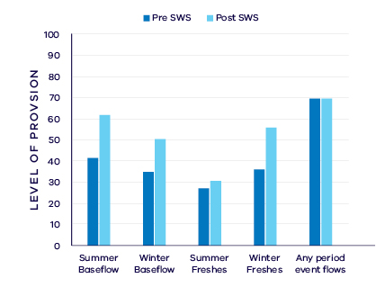
- Average change in ecologically important flow components pre SWS (1941 – 2010) and post SWS (2011 – 2017)

Waterway health
The waterway health analysis was completed at the river basin scale, primarily because there is less data at site, reach or river scales. Although aggregating data to a basin scale allowed for better detection of statistical trends, the results might not reflect the conditions at individual river reaches within the basin.
There is no accepted simple measure for overall waterway health and while many indicators and associated datasets were considered, only a few met requirements for the Long-Term Water Resource Assessment. Most of the available datasets did not cover a sufficient time period (>20 years) to allow for analysis of changes over a long-term timeframe. The indicators presented cover water quality, native fish and macroinvertebrates and are based on the most robust data available. The data were split into three time periods:
- Prior to the LTWRA period — 1990 – 2005
- First part of the LTWRA period — 2006 – 2010. This was the worst section of the Millennium Drought
- Second part of the LTWRA period — 2011 – 2018 Post Millennium Drought.
The data were then analysed to identify any trends over time in the selected indicators. That is, whether various waterway health indicators are improving, deteriorating or there has been no change. So, while it may be possible to report, for example, an improvement in salinity within a river basin, this does not necessarily imply “good” waterway health. This is because 1) the waterways may still be high in salinity, just less so than previously; and 2) other aspects of waterway health might be deteriorating.
The Long-Term Water Resource Assessment examined the impact of flow on waterway health. To this end, the effects of flow were separated from all other factors that can affect waterway health (e.g. bushfire, land use change, rehabilitation works). The individual influences of these other factors on waterway health have not been analysed in this assessment.
There have been mostly improvements in the available water quality indicators in the Glenelg basin since 2011. However, as discussed in section 6.2.4 of the Overview Report, there are a number of limitations on interpreting these indicators. The possible impacts of any changes in these individual indicators on other aspects of waterway health are also described in the Overview Report.
There was an improvement in trend in dissolved oxygen (compared to before 2011), but this was not related to changes in flow. Salinity has been improving since 2006 however this was not linked to flow. There were improvements in trends of both turbidity and phosphorus (compared to before 2011) which were strongly linked to changes in the flow regime. Nitrogen has been deteriorating since 1990, however this was not linked to flow. There was no change detected for total suspended solids.
Despite having sufficient data to detect a trend if it were to occur, there was no trend in macroinvertebrate indicators. Limited data and high natural variability prevented detection of any trends in fish indicators.
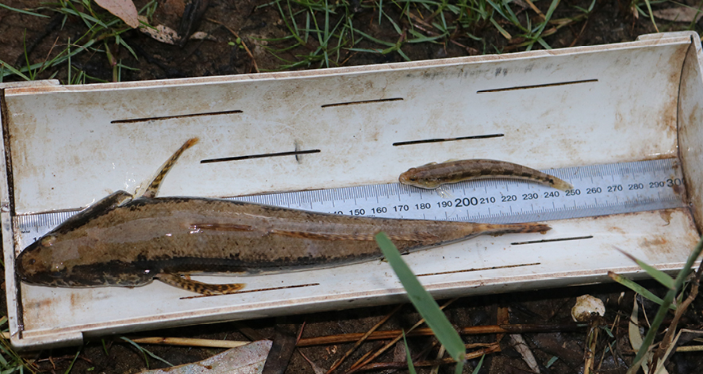
- Adult and juvenile Tupong captured during monitoring on the Glenelg River in summer 2018. Image courtesy of Glenelg Hopkins CMA

On-ground achievements: beyond the available data
While the assessment needed to analyse long-term datasets to answer the question set by the Water Act, there are numerous other projects going on around the state that are improving waterway health, but which only began in recent years. In the Glenelg basin, one such project is supporting tupong populations with water for the environment. Tupong are small migratory native fish that inhabit slow-moving waters of estuaries, creeks and rivers, including the Glenelg River (Figure 5). Flow is thought to be a major factor influencing the health of the species, as they require access to different parts of coastal rivers to complete their lifecycle.
Increases in river flow in summer and autumn are thought to stimulate the movement of young tupong from the ocean into coastal rivers and further upstream into freshwater reaches. Maintaining suitable habitat in these upper reaches is critical to ensure the fish have enough habitat and food resources to feed, grow and breed. The adults then migrate back to the estuary to spawn on large spring freshes.
As illustrated in Figure 6, tupong numbers have increased substantially in recent years. Record numbers were recorded moving upstream from the estuary to the freshwater reaches of the Glenelg River in fish surveys undertaken during an environmental water release in summer 2019, indicating they are recruiting, surviving and thriving.
These outcomes reflect improvements in habitat availability (with reinstatement of woody habitat) and migration opportunities (with removal of fish barriers) supported by the targeted release of water for the environment in the Glenelg River.
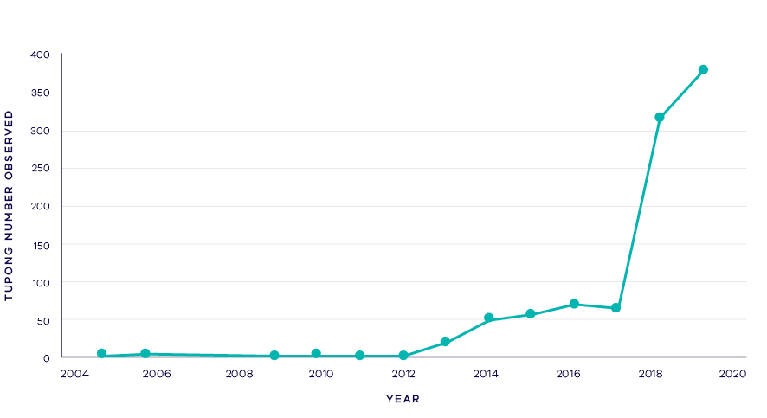
- Tupong numbers in the Glenelg River 2005-2019

Has waterway health deteriorated for flow-related reasons?
There have been, on average, improvements in several aspects of the flow regime with well understood ecological importance in the Glenelg basin since the release of the Western Region SWS in 2011. The improvement in water regimes in reaches that have environmental entitlements occurred despite an overall decline in water availability. The improvement in flows was matched to improvements in several water quality indicator trends. Improvements in turbidity and total phosphorus were strongly linked to river flows, while no long-term flow-related trends were seen in aquatic animal indicators. Overall, the findings for waterway health for reasons related to flow are inconclusive.

The Thurra River has not been included in this assessment due to insufficient data.
The Millennium Drought period is defined as 1996/97 to 2009/10.
The LTWRA assessment period ends at 30 June 2017 and therefore, this assessment does not take account of the water shortages experienced in 2018/19.
New winter-fill licences only permit water to be extracted from the waterway over the period 1 July to 31 October in any year.
http://www.egcma.com.au/what-we-do/336/#Artificial-openings
State Environment Protection Policy (Waters) 2018 http://www.gazette.vic.gov.au/gazette/Gazettes2018/GG2018S499.pdf. In all cases results are compared to the most stringent guideline for the relevant basin.
The Millennium Drought period is defined as 1996/97 to 2009/10.
New winter-fill licences only permit water to be extracted from the waterway over the period 1 July to 31 October in any year.
Southern Rural Water, January 2014
Stoessel, D., Marshall, S., Sharley, D., and Fairbrother, P. (2018). The effect of an environmental flow on nutrients and selected water parameters of the Snowy River estuary. Unpublished Client report for the East Gippsland Catchment Management Authority, Department of Environment, Land, Water and Planning, Heidelberg, Victoria
New winter-fill licences only permit water to be extracted from the waterway over the period 1 July to 31 October in any year.
In Table 1, the proportion of water available to consumptive users is reported as increasing from 1% to 2% when rounded to the nearest whole percentage. The actual change is from 1.3% (rounded down to 1%) to 1.5% (rounded up to 2%). For the purposes of determining whether there has been a change in water sharing, the difference is calculated based on the unrounded percentages (i.e. a difference of 0.2%, which is less than the 1% threshold for recognising a change in water sharing).
State Environment Protection Policy (Waters) 2018 http://www.gazette.vic.gov.au/gazette/Gazettes2018/GG2018S499.pdf. In all cases results are compared to the most stringent guideline for the relevant basin.
New winter-fill licences only permit water to be extracted from the waterway over the period 1 July to 31 October in any year.
State Environment Protection Policy (Waters) 2018 http://www.gazette.vic.gov.au/gazette/Gazettes2018/GG2018S499.pdf. In all cases results are compared to the most stringent guideline for the relevant basin.
The Thomson basin also was assessed earlier for the Central Region Sustainable Water Strategy; however, water availability is assessed against the most recent SWS benchmark.
In Table 1, the proportion of water available to consumptive users is reported as decreasing from 39% to 38% when rounded to the nearest whole percentage. The actual change is from 38.5% (rounded up to 39%) to 38.3% (rounded down to 38%). For the purposes of determining whether there has been a change in water sharing, the difference is calculated based on the unrounded percentages (i.e. a difference of 0.2%, which is less than the 1% threshold for recognising a change in water sharing).
Melbourne Water Corporation (2017). Melbourne Water System Strategy
Department of Environment, Land, Water and Planning (2018). Enhancing the grid: Victoria’s Water Grid Partnership in 2018.
DELWP (2016) Benefits of environmental water - Migration of Australian Grayling in four coastal rivers Fact sheet 2 – Migration of Australian Grayling to spawn.
The Macalister irrigation district is supplied from Thomson basin.
The Latrobe basin also was assessed earlier for the Central Region Sustainable Water Strategy; however, water availability is assessed against the most recent SWS benchmark.
The Bass River was assessed under the Central Region Sustainable Water Strategy in 2006. For consistency, the Bass River results is assessed here using the Central Region SWS period.
New winter-fill licences only permit water to be extracted from the waterway over the period 1 July to 31 October in any year.
From the 2015-16 Victorian Water Accounts
Koster, W.M., Dawson, D.R., and Crook, D.A. (2013). Downstream spawning migration by the amphidromous Australian grayling (Prototroctes maraena) in a coastal river in south-eastern Australia. Marine and Freshwater Research 64, 31–41. doi:10.1071/MF12196; Koster, W.M., Amtstaetter, F., Dawson, D.R., Morrongiello, J.R., and Reich, P. (2017). Provision of environmental flows promotes spawning of a nationally threatened diadromous fish. Marine and Freshwater Research 68, 159–166. doi:10.1071/MF15398
Koster, 2017, unpublished data
Koster W.M. and Raadik T.A. (2018). Status, threats, ecology and potential direction for recovery of River Blackfish in Melbourne Water catchments, Client report for Melbourne Water
Jacobs. (2018). Environmental Flow Study Review for the Tarago and Bunyip Rivers. Jacobs Engineering Group, Bendigo, Australia
Victorian Water Register, accessed January 2019
Refer to Western Water’s 2017 Urban Water Strategy for a discussion of low water availability in the Maribyrnong catchment in recent years, and how this is built into planning for water security.
In Table 1, the proportion of water available to consumptive users is reported as increasing from 8% to 9% when rounded to the nearest whole percentage. The actual change is from 8.0% (rounded down to 8%) to 8.7% (rounded up to 9%). For the purposes of determining whether there has been a change in water sharing, the difference is calculated based on the unrounded percentages (i.e. a difference of 0.7%, which is less than the 1% threshold for recognising a change in water sharing).
State Environment Protection Policy (Waters) 2018 http://www.gazette.vic.gov.au/gazette/Gazettes2018/GG2018S499.pdf. In all cases results are compared to the most stringent guideline for the relevant basin.
Exactly how carryover influences water availability depends on how entitlement holders overall choose to use their carryover. This is difficult to model accurately because of the relatively short time since carryover was introduced.
State Environment Protection Policy (Waters) 2018 http://www.gazette.vic.gov.au/gazette/Gazettes2018/GG2018S499.pdf. In all cases results are compared to the most stringent guideline for the relevant basin.
http://www.ccma.vic.gov.au/admin/file/content2/c7/Upper_Barwon_Yarrowee_Leigh_FLOWS_study_update.pdf
State Environment Protection Policy (Waters) 2018 http://www.gazette.vic.gov.au/gazette/Gazettes2018/GG2018S499.pdf. In all cases results are compared to the most stringent guideline for the relevant basin.
Ibid.
New winter-fill licences only permit water to be extracted from the waterway over the period 1 July to 31 October in any year.
New winterfill licences only permit water to be extracted from the waterway over the period 1 July to 31 October in any year.
The permissible consumptive volume includes an allowance for future allocation to new winter-fill diversion licences, in accordance with sustainable diversion limits.
State Environment Protection Policy (Waters) 2018 http://www.gazette.vic.gov.au/gazette/Gazettes2018/GG2018S499.pdf. In all cases results are compared to the most stringent guideline for the relevant basin.
Brucknell Creek was not assessed at the time of the Western Region SWS but is included in the LTWRA for completeness.
New winter-fill licences only permit water to be extracted from the waterway over the period 1 July to 31 October in any year.
State Environment Protection Policy (Waters) 2018 http://www.gazette.vic.gov.au/gazette/Gazettes2018/GG2018S499.pdf. In all cases results are compared to the most stringent guideline for the relevant basin.
New winter-fill licences only permit water to be extracted from the waterway over the period 1 July to 31 October in any year.
An additional 1.8 GL/year remains available for new winter-fill licences in the six coastal catchments between the Eumeralla River and Darlots Creek, and around Portland and Cape Bridgewater.
State Environment Protection Policy (Waters) 2018 http://www.gazette.vic.gov.au/gazette/Gazettes2018/GG2018S499.pdf. In all cases results are compared to the most stringent guideline for the relevant basin.
Excludes 26 GL/year transferred to Wimmera basin.

