Western Region Sustainable Water Strategy
Context for Traditional Owners
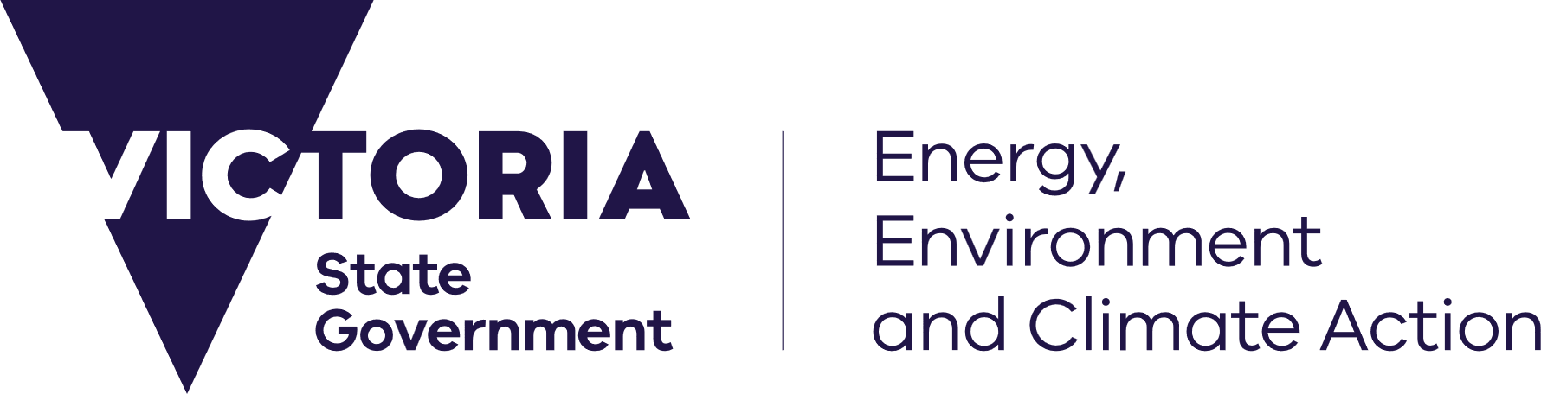
deeca.vic.gov.au



Partnering with Traditional Owners in the new Western Region Sustainable Water Strategy (SWS)
The Victorian Government is committed to addressing the historical and ongoing exclusion of Traditional Owners, from holding and managing water, through a restorative justice approach. DEECA recognises that Traditional Owners are central to water planning and seeks to embed the deep connection between water, culture and Country in the new Western Region SWS.
The new strategy provides an opportunity for Traditional Owners to partner with DEECA on developing actions and policies to improve access to water for Traditional Owner groups and progress Water is Life: Traditional Owner Access to Water Roadmap outcomes across western Victoria.
The Central and Gippsland Region Sustainable Water Strategy, completed in 2022, included a Traditional Owner Partnership where Traditional Owners worked alongside government and water sector representatives to guide the development of the strategy.
This collaboration resulted in the creation of Chapter 5: Healthy Country, Healthy Mob — a stand-alone chapter written entirely by Traditional Owners. It sets out their vision and expectations for water management in the region.
Following this, Chapter 6: Water Justice for Traditional Owners outlines the next steps toward achieving water justice for Traditional Owner groups in the region.
Key commitments include:
- Continuing to identify and pursue opportunities to return water to Traditional Owners as it becomes available.
- Removing barriers to water ownership and access for Traditional Owners.
- Strengthening the role of Traditional Owners in water resource planning and management.
The development process for the new Western Region SWS will begin in early 2026 with early discussions with Traditional Owner groups to understand the level of

involvement they would like in the process and identify any resourcing requirements to support participation.
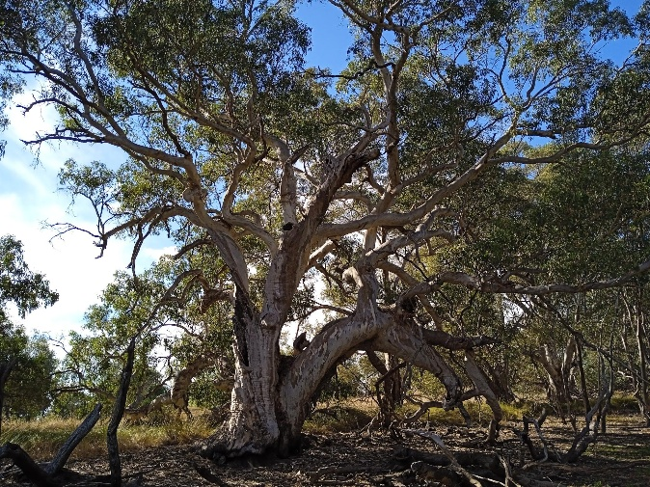
This could include:
- Refining the scope of the new Western Region SWS through identifying key policy issues, challenges and opportunities.
- Collaborating on options for draft policy positions and actions to be incorporated in the new Western Region SWS.
- Refining the context in addition to information in Country Plans and other relevant Traditional Owner-authored documents.
This could be through:
- Participation in working groups and other governance and consultation processes.
- Providing information directly to DEECA.
- Other ways identified as more suitable for the Traditional Owner group.
Traditional Owner information and knowledge will be respected and protected. Traditional Owners will remain in control of their products and any written material they develop as part of the Western Region SWS. It will be consistent with DEECA’s Pathway towards an Indigenous Data Sovereignty Policy.

Traditional Owner outcomes from the 2011 Western Region SWS
A range of groups were consulted in the 2011 version of the strategy. The key priorities from Traditional Owners were:
- the importance of the health of Country
- ensuring that Traditional Owners are active participants in managing water.
Action 3.24 focused on Traditional Owner outcomes, looking at improving education, training and capacity building Traditional Owners were invited to nominate young leaders to be involved in a:
- scholarship for a post-graduate qualification in waterway health or natural and cultural resource management, or
- cadet position with the DEECA, a water corporation or catchment management authority.
The intent of that action has been achieved given there has been increased resourcing for Traditional Owners to build capacity particularly through funding Aboriginal Water Officer positions in the region.
There has also been more progress in water and waterway management outcomes for Traditional Owners in western Victoria such as through Water is Life: Traditional Owner Access to Water Roadmap. This included returning 2.5 GL of unallocated water in Palawarra (Fitzroy River) to Gunditj Mirring Traditional Owners Aboriginal Corporation.
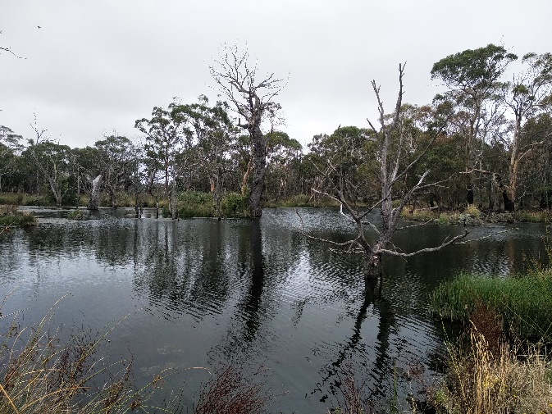
Further information
For further information please contact the Western Region SWS team at sws.team@deeca.vic.gov.au or by calling 136 186.
Additional information about SWSs, including the Western Region SWS and the Traditional Owner Partnership developed as part of the Central and Gippsland SWS is available at https://www.water.vic.gov.au/our-programs/long-term-water-resource-assessments-and-strategies/sustainable-water-strategies.

We acknowledge Victorian Traditional Owners and their Elders past and present as the original custodians of Victoria’s land and waters and commit to genuinely partnering with them and Victoria’s Aboriginal community to progress their aspirations.
© The State of Victoria Department of Energy, Environment and Climate Action, December 2025.
Creative Commons
This work is licensed under a Creative Commons Attribution 4.0 International licence, visit the Creative Commons website (http://creativecommons.org/licenses/by/4.0/).
You are free to re-use the work under that licence, on the condition that you credit the State of Victoria as author. The licence does not apply to any images, photographs or branding, including the Victorian Coat of Arms, and the Victorian Government and Department logos.
Disclaimer
This publication may be of assistance to you but the State of Victoria and its employees do not guarantee that the publication is without flaw of any kind or is wholly appropriate for your particular purposes and therefore disclaims all liability for any error, loss or other consequence which may arise from you relying on any information in this publication.
Accessibility
To receive this document in an alternative format, phone the Customer Service Centre on 136 186, email customer.service@delwp.vic.gov.au, or contact National Relay Service on 133 677. Available at DEECA website (www.deeca.vic.gov.au).

