Goulburn Broken
Strategic directions statement
September 2018

Department of Health
Acknowledgement of Victoria’s Aboriginal communities
The Victorian Government proudly acknowledges Victoria's Aboriginal communities and their rich culture and pays its respects to their Elders past and present. The government also recognises the intrinsic connection of Traditional Owners to Country and acknowledges their contribution to the management of land, water and resources.
We acknowledge Aboriginal people as Australia’s first peoples and as the Traditional Owners and custodians of the land and water on which we rely. We recognise and value the ongoing contribution of Aboriginal people and communities to Victorian life and how this enriches us. We embrace the spirit of reconciliation, working towards the equality of outcomes and ensuring an equal voice.
© The State of Victoria Department of Environment, Land, Water and Planning 2018
This work is licensed under a Creative Commons Attribution 4.0 International licence. You are free to re-use the work under that licence, on the condition that you credit the State of Victoria as author. The licence does not apply to any images, photographs or branding, including the Victorian Coat of Arms, the Victorian Government logo and the Department of Environment, Land, Water and Planning (DELWP) logo. To view a copy of this licence, visit Creative Commons <creativecommons.org/licenses/by/4.0/>
Printed by Finsbury Green, Melbourne
ISBN 978-1-76077-341-0 (Print)
ISBN 978-1-76077-342-7 (pdf/online/MS word)
Disclaimer
This publication may be of assistance to you but the State of Victoria and its employees do not guarantee that the publication is without flaw of any kind or is wholly appropriate for your particular purposes and therefore disclaims all liability for any error, loss or other consequence which may arise from you relying on any information in this publication.
Accessibility
If you would like to receive this publication in an alternative format, please telephone the DELWP Customer Service Centre on 136 186 or email the DELWP Customer Service Centre <customer.service@delwp.vic.gov.au> or via the National Relay Service on 133 677, or at the National Relay Service website <www.relayservice.com.au>.
This document is also available on the internet at the DELWP website <www.delwp.vic.gov.au>

Contents
Foreword 7
At a glance 8
Vision 8
Strategic outcomes: 8
IWM opportunities 9
Region wide opportunities 10
Chapter 1 The way forward 11
Introduction 11
Enduring collaboration 12
Chapter 2 IWM in the region 16
Vision and outcome areas for the Goulburn Broken IWM Forum Region 17
Regional context 19
The case for IWM in the region 21
The case for IWM in the region 23
Success stories 23
Chapter 3 IWM opportunities 25
State-wide and region specific initiatives 25
IWM opportunities: How were they selected? 26
Impact of priority and committed projects/strategies on strategic outcomes 28
IWM project & strategy opportunities – overview 29
Priority Portfolio of IWM projects and strategies 31

Integrated Water Management is a collaborative approach to water planning and management that brings together organisations with an interest in all aspects of the water cycle.
It has the potential to provide greater value to our communities by identifying and leveraging opportunities to optimise outcomes.

Foreword
The Goulburn Broken Integrated Water Management (IWM) Forum was established in May 2017. It was the first of the IWM Forums established across the state. This Forum meets quarterly and is leading the way towards systematically embedding IWM across the region.
The Forum has gained quick momentum by aligning with the Goulburn Broken Senior Combined Partners Forum, which is a long‑standing network established by the Goulburn Broken Catchment Management Authority. This meant that the Goulburn Broken IWM Forum was able to unite around a productive group of regional leaders representing Traditional Owners, Local Councils, statutory authorities and government agencies.
The Goulburn Broken IWM Forum covers both Yorta Yorta and Taungurung Country, whose ancestors and their descendants are the traditional owners of this country. Yorta Yorta lands include the northern plains of the Goulburn and Murray Rivers, while Taungarung Country is set to the south of the region, including the mountains and rivers around the Great Divide.
The Goulburn Broken Strategic Directions Statement has been developed in collaboration with:
The quarterly meetings of the Forum were supplemented by two practitioner workshops and many individual meetings with project sponsors to develop initiatives from ideas into mature project themes. Collaboration and cross-pollination has been a key outcome of the Forum, with ideas being shared and improved by input from project partners.
Steve McKenzie
Chair of the Goulburn Broken IWM Forum

- Benalla Rural Council
- Campaspe Shire Council
- Department of Environment, Land, Water and Planning
- Greater Shepparton City Council
- Goulburn Valley Water
- Goulburn Murray Water
- Goulburn Broken Catchment Management Authority
- Mansfield Shire Council
- Murrindindi Shire Council
- Mitchell Shire Council
- Moira Shire Council
- Parks Victoria
- Strathbogie Shire Council
- Taungurung Clans Aboriginal Corporation
- Yorta Yorta Nation Aboriginal Corporation

At a glance
The Goulburn Broken IWM Strategic Directions Statement highlights the key challenges in the region and also identifies collaborative IWM opportunities that can improve resilience and liveability in cities and towns in the region.

Vision
Working together through sustainable water management to enhance urban landscapes and maximise amenity, environment, and economic outcomes for our communities.

Strategic outcomes:
- Safe secure and affordable supplies in an uncertain future
- Effective and affordable wastewater systems
- Avoided or minimised existing and future flood risks
- Healthy and valued waterways, wetlands and lakes.
- Healthy and valued urban and rural waterways
- Community values reflected in place-based planning
- Jobs, economy and innovation

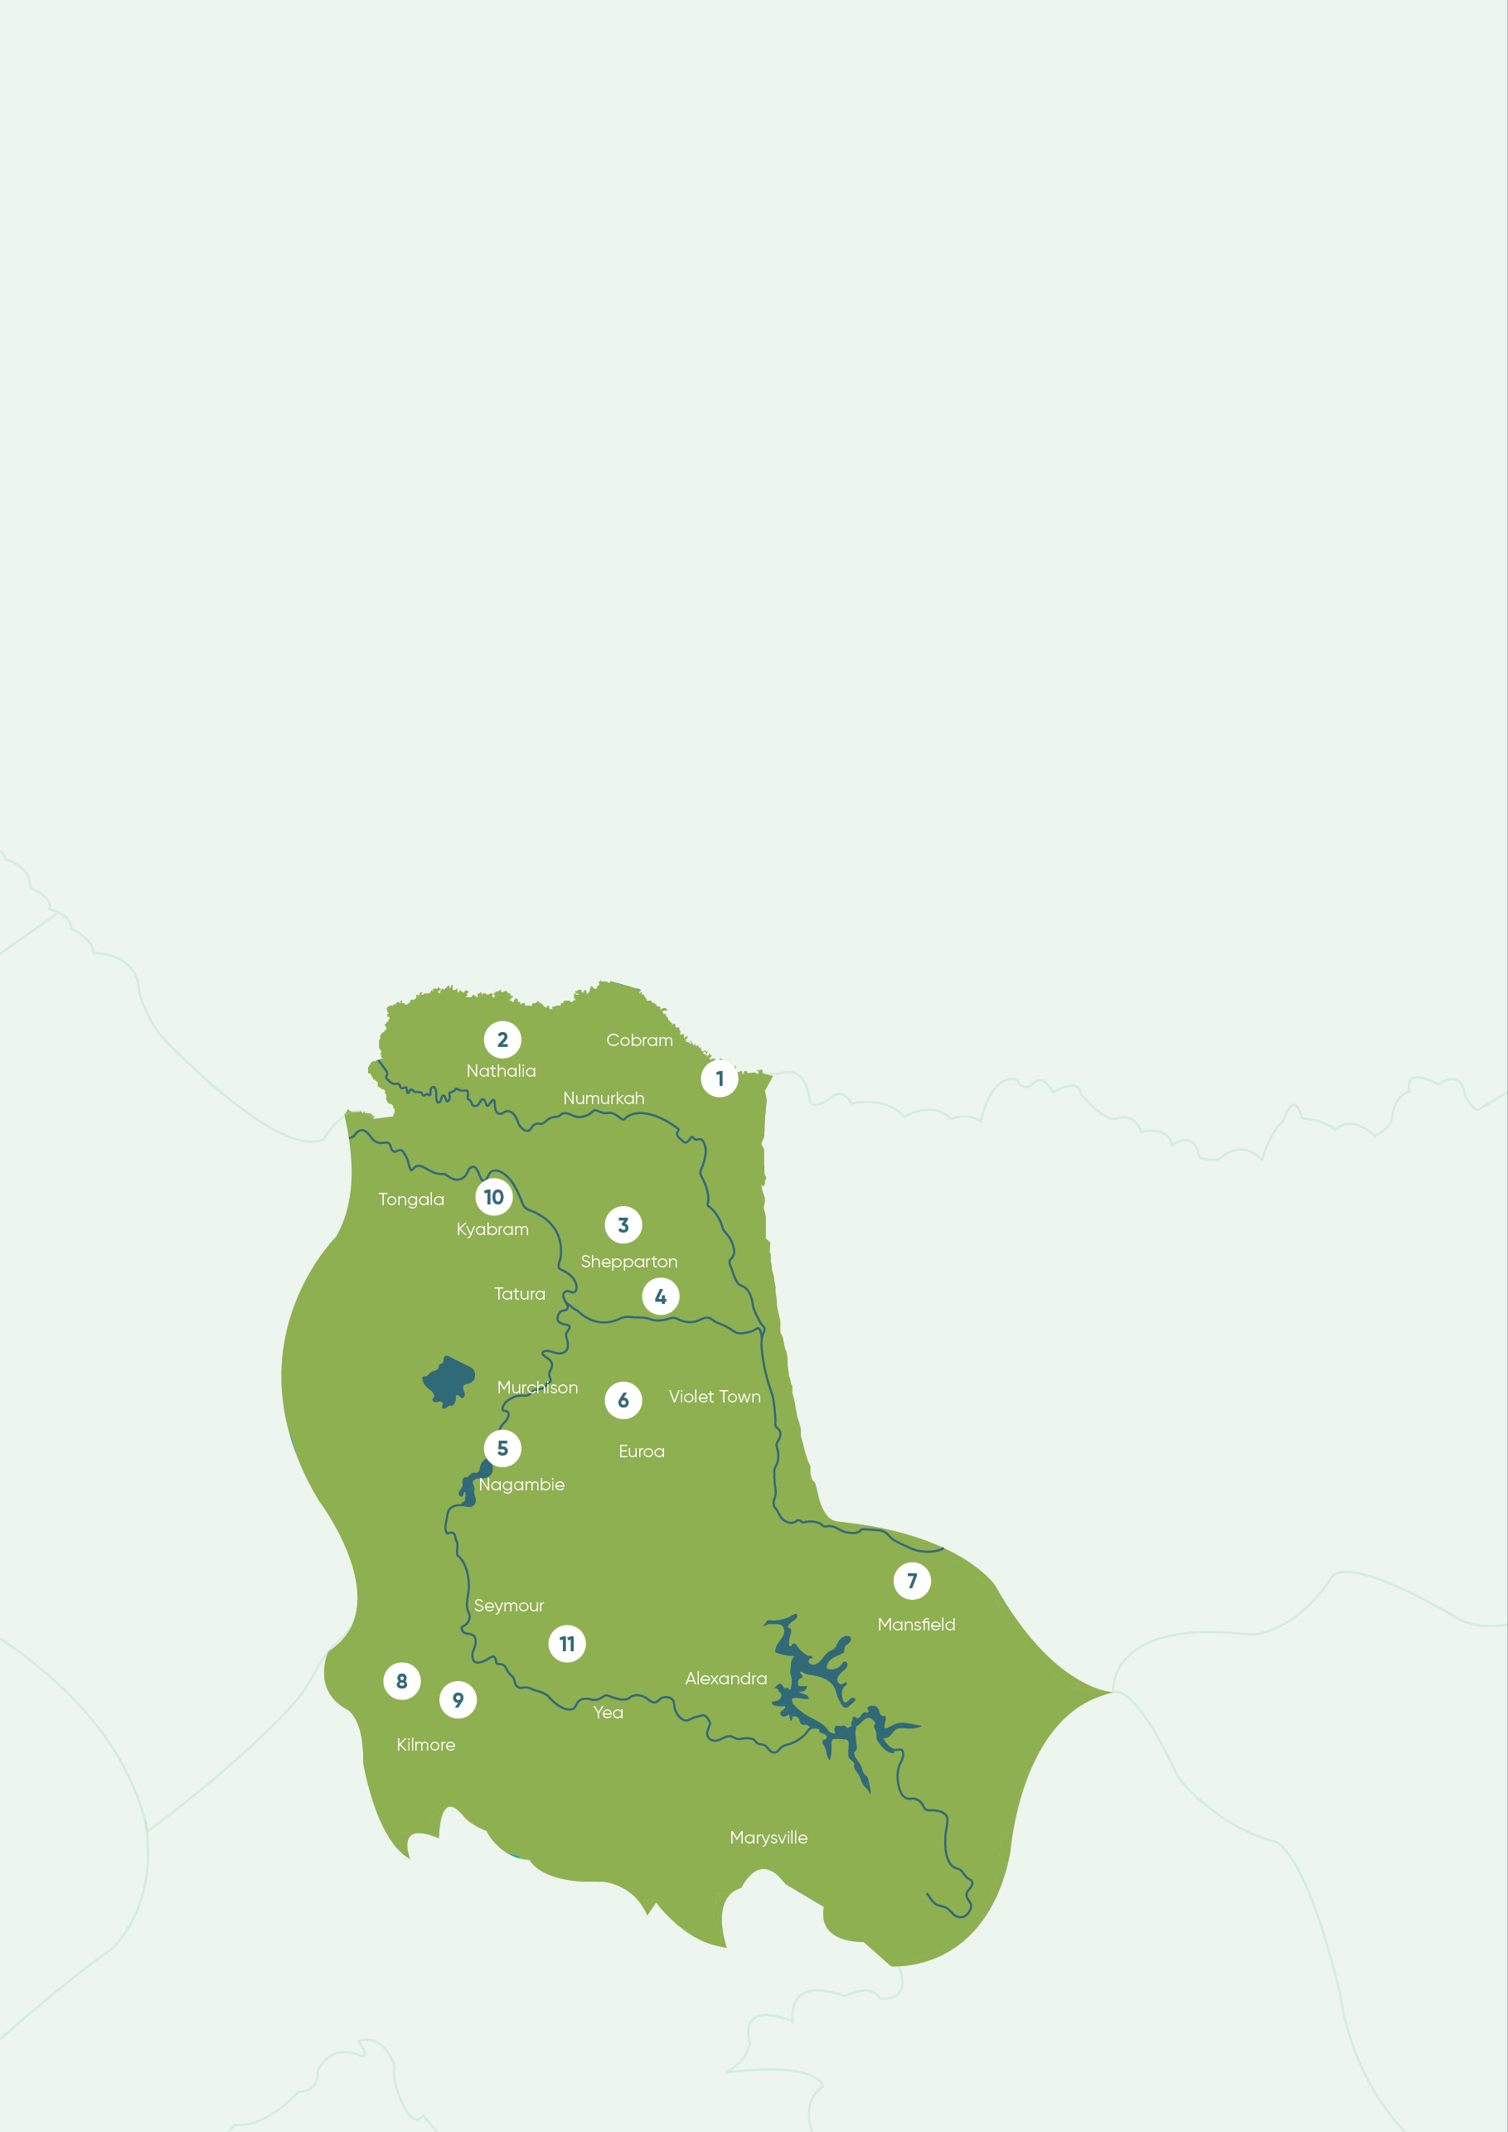

IWM opportunities
Partners of the Forum are committing their best endeavours to ensure priority projects and strategies are progressed in line with the shared vision and strategic outcomes of the Goulburn Broken IWM Forum. The key IWM opportunities include (in no priority order):
- Murray RiverConnect
A community project which aims to see the Murray River recognised as the life and soul of the region’s northern border. The project will initially look at the successful Goulburn/Broken RiverConnect Framework and identify how a similar model can be applied to the Moira & Campaspe sections of the Murray River.
- Liveable Nathalia
The township of Nathalia is a key community within Moira Shire with a well-established community who are supported by local resources, the arts, education and sports. To facilitate growth, a holistic plan is proposed to investigate current opportunities and constraints relating to the urban water cycle. This plan will ultimately become a key strategic document in driving improved amenity outcomes, local greening and health initiatives as well as engineering infrastructure solutions.
- Water Supporting an Active Shepparton (Munarra Centre for Regional Excellence)
The project will provide a water sensitive masterplan that will improve the amenity and water quality of an existing drainage channel, enable alternate water use for irrigation, and provide a framework for an integrated social and cultural hub.
- Eastbank Lake Revitalisation
The project seeks to revitalise an underused section of the Goulburn River, reconnecting the Shepparton community to the river and providing an environmentally sustainable and cultural focused community area.
- Nagambie Alternative Water Supply
An investigation into the feasibility of an alternative water supply for the growing township of Nagambie.
- Seven Creeks Flow Investigation
A holistic options assessment of the flow stressed Seven Creeks: an unregulated system with urban and rural consumptive water demands and critical ecological values.
- Mansfield Water Quality Offsets
This project will apply learnings from the Kilmore Water Quality Offsets project to the township of Mansfield, where an augmentation of the Wastewater Treatment Plant is needed. The study will also look at the Mansfield water cycle to provide an IWM Plan that considers a strategic framework for growth, streetscape improvements, and alternative water sources.
- Greening Kilmore
A masterplan to facilitate future growth of Kilmore and the greening of the township. The study will pave the way for sustainable growth and the long term management of Kilmore Creek.
- Kilmore Recycled Water Scheme
One of many potential sub-projects that will be referenced through the Greening Kilmore Plan. With excess recycled water supply predicted in the region, a feasibility study is underway to assess the viability of a recycled water network to provide a secure and climate resilient water source for the growing town of Kilmore.
- Campaspe Shire Strategic IWM Framework
A pilot project for the entire Campaspe municipality which will aim to embed IWM practices across the Shire. The project will involve considerable engagement across industry and the wider community to inform a strategic direction for Council.
- Horseshoe Lagoon Cultural Revitalisation
The revitalisation of a culturally significant Nature Conservation Reserve 15 km southeast of Seymour. The project aims to see flows restored to Horseshoe Lagoon to enhance and protect species of cultural significance, both flora and fauna.

Region wide opportunities
- Place-based Small Town Wastewater Management
A region-wide study that will investigate a range of potential alternative solutions, including planning controls and infrastructure, for the management of wastewater in small towns.
- Nature and Health
A strategic initiative to foster partnership between water and the health sector. A memorandum of understanding between Goulburn Valley Health and Goulburn Broken CMA is the first step, with the Forum to consider the potential for health sector involvement in IWM opportunities.

Chapter 1
The way forward
An unprecedented opportunity to progress water cycle planning and management in Victoria through collaboration.

Introduction
The Integrated Water Management (IWM) Framework for Victoria (September 2017) is designed to help regional stakeholders to work together, ensuring the water cycle contributes to the liveability of towns and cities in Victoria, with communities at the centre of decision making.
The central premise of an IWM approach is the overall acceptance that managing urban liveability and resilience is a shared responsibility and that water is a key enabler to achieving these shared aims.
To facilitate this, IWM Forums have been established across the state to identify, prioritise and oversee the implementation of critical collaborative opportunities. This Strategic Directions Statement has been produced by the Goulburn Broken IWM forum to capture and communicate those opportunities.
IWM seeks to build on existing partnerships and planning processes. In the Goulburn Broken region regional stakeholders - such as Local Government Authorities, Goulburn Broken Catchment Management Authority, Goulburn Valley Water and Goulburn Murray Water, engage with their communities regularly to improve service delivery and urban planning. Community aspirations are embedded in the overarching natural resource management strategy for the Region (the Goulburn Broken Regional Catchment Strategy, 2013-19), and in strategies and operational plans for organisations throughout the region. These aspirations reflect a desire for liveable and productive places and vibrant communities. The way in which we plan and use water is fundamental to ensuring these aspirations are realised.
IWM in the region is also underpinned by the recently signed Goulburn Broken Catchment Partnerships Agreement (Feb. 2018), an initiative under the Government’s Our Catchments, Our Communities Integrated Catchment Management Strategy for Victoria (2016-19).

What is a Strategic Directions Statement?
This Strategic Directions Statement (SDS) articulates the regional context, the shared vision and the strategic water-related outcomes for the Goulburn Broken IWM Forum region.
This SDS includes a list of IWM opportunities, including projects and strategies, developed in collaboration by the Goulburn Broken IWM Forum partners.
Partners of the Forum are committing their organisations to apply their best endeavours to:
- Ensure priority projects and strategies are progressed in line with the shared vision and strategic outcomes of the Goulburn Broken IWM Forum; and to
- Support DELWP to progress priority strategic enablers for IWM in Victoria.
It is envisaged that the SDS will be a living document which will be updated to reflect the current Goulburn Broken IWM Forum’s priorities and opportunities.

Integrated Water Management
IWM is a collaborative approach to water planning that brings together organisations that influence all aspects of the water cycle. It has the potential to provide greater value to our communities by identifying and leveraging opportunities to optimise the outcomes of water cycle.

Enduring collaboration

How we’re working together
The Goulburn Broken IWM Forum identifies, coordinates and prioritises areas that would most benefit from collaborative and place-based water management planning and delivery.
To ensure IWM is successful and enduring across the region, the Goulburn Broken IWM Forum partners have committed to the promotion of a collaborative and shared values culture within their own organisations and beyond through their work with key water cycle delivery partners and local communities.
The Goulburn Broken IWM Forum is governed by an open and transparent IWM planning process. This process assumes a holistic, whole-of-cycle approach to determining water cycle solutions, considering regulatory accountabilities and service delivery responsibilities.
Each organisation has an important role to play in the decision-making and management of the water, resources and assets for the entire catchment.
Collaboration across IWM Forum partners will ensure balanced consideration of the complex economic, environmental, cultural and community benefits and impacts associated with the range of proposed IWM projects and work programs.
The Goulburn Broken IWM Forum partners will continue to work together to build inter-organisational trust and develop productive, enduring relationships to realise the shared vision for the region.
Further information on the IWM Forum’s governance and planning framework is outlined in the Integrated Water Management Framework for Victoria, available at the DELWP website Integrated Water Management Framework for Victoria page <https://www.water.vic.gov.au/liveable/resilient-and-liveable-cities-and-towns/iwm-framework>

Recognising Aboriginal values in water planning and management
The Goulburn Broken IWM Forum is committed to working in partnership with Aboriginal Victorians across landscapes, communities and natural resources.
The Forum recognises that Traditional Owners throughout the region, including the Yorta Yorta and Taungurung people, are unique to Country and their involvement in IWM planning will be specific to each planning area.
Organisations involved in IWM have obligations to involve Traditional Owners and consider Aboriginal values in their organisational activities. The Forum will continue to work with Traditional Owner groups to determine the appropriate approach and level of involvement in the broader IWM planning process for each Forum Area.

IWM planning governance structure.
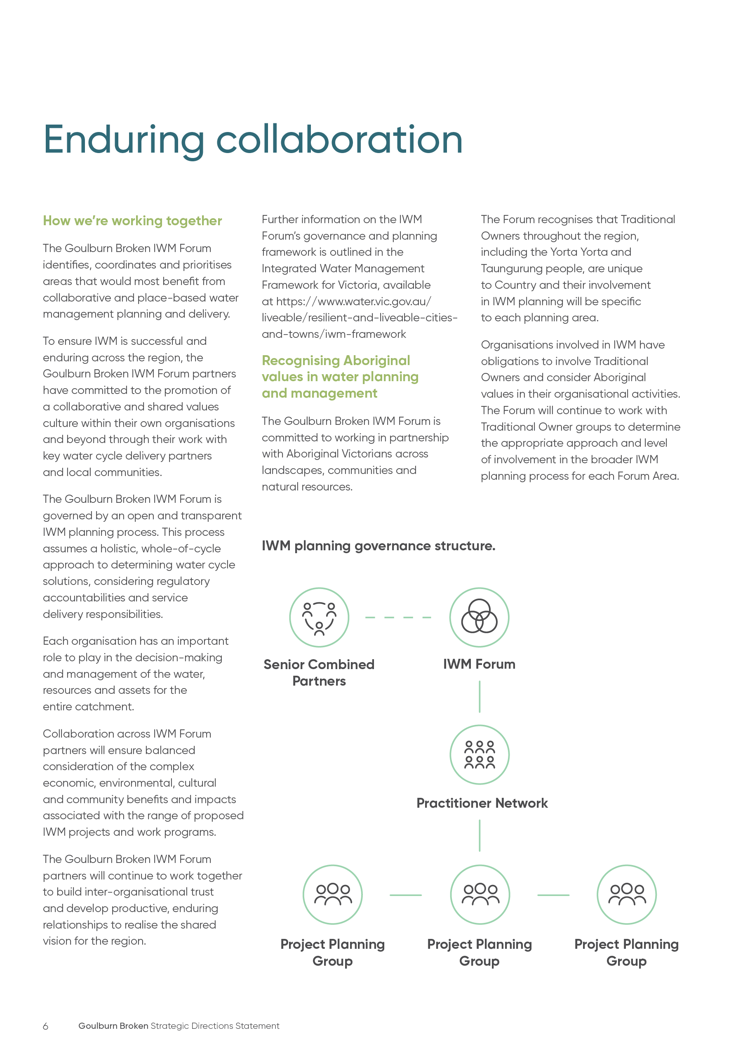

Phase I | Phase I Outcomes | Phase I Participants
Establish  Organisational leaders come together in collaborative IWM Forums and Practitioner Workshops to discuss integrated water management challenges, opportunities and priorities for each region | Preliminary work on regional characterisation and collaborative governance  Agree vision, objectives and goals  Agree criteria for selection and prioritisation of IWM opportunities  IWM opportunities identified and prioritised  Collaboratively develop and endorse Strategic Directions Statement for each region | Local governments  Catchment Management Authorities  Water corporations  Traditional Owners  Department of Environment, Land, Water and Planning  Chair  Others as relevant

Phase II | Phase II Outcomes | Phase II Participants
Plan and Develop  IWM Project Groups form to develop an implementation approach for prioritised projects | IWM Project Groups determine a pathway to collaboratively deliver prioritised opportunities  Technical and economic analysis; cost allocation; business case development as required  IWM Project Groups report progress to IWM Forums | Collaborative Partners  DELWP  Relevant stakeholders
Incorporate  Collaborative Partner organisations incorporate relevant elements of IWM in their own plans, guidelines or frameworks | IWM Project Groups to take IWM commitments (projects and strategies) to their Board or Councils for endorsement  IWM Project Groups to incorporate elements into their own organisational planning systems, e.g. Council and corporate plans, Construction Guidelines, etc.  Report back to IWM Forum and prepare for delivery | Individual organisations who have committed to a project

Phase III | Phase III Outcomes | Phase III Participants
Deliver  IWM Project Groups progress with delivery of projects and strategies | IWM projects, strategies/plans are implemented  Additional community value added through participatory planning  Monitoring and evaluation of key measures and outcomes  Application of practical IWM tools and innovative approaches  Economic savings through shared resources, costs, etc.  Improved resilience and liveability of cities and towns  IWM Project Groups prepare for next round of opportunity identification and prioritisation | Individual organisations who have committed to a project  Community representatives  DELWP  Others as relevant

Chapter 2
IWM in the region
Understanding why an integrated approach to water planning and management is critical for the Goulburn Broken IWM Region now and for the future.

Vision and outcome areas for the Goulburn Broken IWM Forum Region
Working together through sustainable water management to enhance urban landscapes and maximise amenity, environment, and economic outcomes for our communities.
The region is seeking to achieve seven key outcomes through IWM. Each of these will have a significant role in shaping the liveability, prosperity and resilience of our cities and towns. These outcome areas provide indicators to assess the effectiveness of the various IWM opportunities, recognising that these outcomes are in themselves co-dependant.
Low-emission solutions
IWM opportunities that minimise the release of greenhouse gas (GHGs) emissions will be considered by the Forum as solutions are evaluated for implementation.
 | Outcome  Safe, secure and affordable supplies in an uncertain future | Outcome  Effective and affordable wastewater systems | Outcome  Avoided or minimised existing and future flood risks | Outcome  Healthy and valued waterways, wetlands and lakes | Outcome  Healthy and valued urban and rural waterways | Outcome  Community values reflected in place-based planning | Outcome  Jobs, economy and innovation
Objectives | A diverse range of fit for purpose water supplies and resources are utilised | Meets public health and environmental standards | Appropriate levels of flood protection to the region’s towns and cities | Waterway health is maintained and improved | Urban landscapes retain moisture for cooler, greener cities and towns | Diverse urban landscapes that reflect local conditions and community values | Jobs and economic growth supported by water
Objectives | Water quality meets regulatory standards and community expectations | Effective and innovative sewerage systems | Community and property resilient to local flood risk | Waterways accessible as valuable open space | Aboriginal cultural values associated with urban landscapes are understood, protected and enhanced | Empowered and engaged community | Innovative planning and operation
Objectives | Efficiently managed water and demand | Optimised small towns domestic wastewater | Efficient and effective urban drainage that enhances urban landscapes | Aboriginal cultural values associated with waterways, wetlands and lakes are understood, protected and enhanced | Traditional Owner and Aboriginal values associated within agricultural, rural and urban landscapes are protected. | Local water related risks and issues understood and managed | Actions in Water for Victoria with specific regard to Traditional Owner consultation, engagement, employment and economic development have been comprehensively implemented
Objectives | Secure water supply for region’s industry and the economy | Maximise waste-to- resource opportunities |  | Waterways are managed to provide for community values including recreation |  | Traditional Owner and Aboriginal values are understood and recognised early and included in project planning and delivery
Objectives | Water available to maintain valued green community assets | A risk-based approach to sewerage and wastewater management adopted |  | Traditional Owner and Aboriginal values, knowledge and practices are integrated and protected in waterway management and planning

Regional context
The Goulburn Broken IWM Forum region covers an area of approximately 2.1 million hectares, extending north from Wallan, near the outskirts of Melbourne, to the Murray River on the border with New South Wales.
The landscape and climate of the region varies significantly between the alpine country and the floodplains along the Murray River. A majority of the land in the Goulburn-Broken catchment area is used for agricultural purposes (66 per cent).

Population
The region has an estimated population of 175,000, which is forecast to grow by around 3,950 people each year. It is expected to reach 270,000 by 2040.
This growth will be felt across a majority of the major urban centres of the region, with the highest growth predicted in Kilmore, Shepparton/ Mooroopna, Echuca and Mansfield. Regional centres in this area are typically surrounded by agricultural land, and as the urban fringe develops and irrigated land becomes subdivided there are challenges at the interface of rural and urban water management to be addressed, including water supply and drainage.

Climate change
The Goulburn Broken Region faces a warmer and drier future. By 2065, average daily temperatures across the region are projected to rise by between 2˚C to 3˚C. This will be amplified in urban centres due to the prevalence of darker and harder surfaces, leading to environmental and human health impacts. Ensuring the provision of fit for purpose water for the region’s urban greening will be a key priority in enhancing liveability and resilience for the community and environment.
The average annual rainfall is predicted to decrease by 4 per cent by 2065 (median value) – primarily impacting the ‘cool’ season – while there is also an expectation of a year-round increase in temperatures. This presents a challenge for the region, as there will be an increased demand for urban water resulting from population growth together with a hotter drier climate.
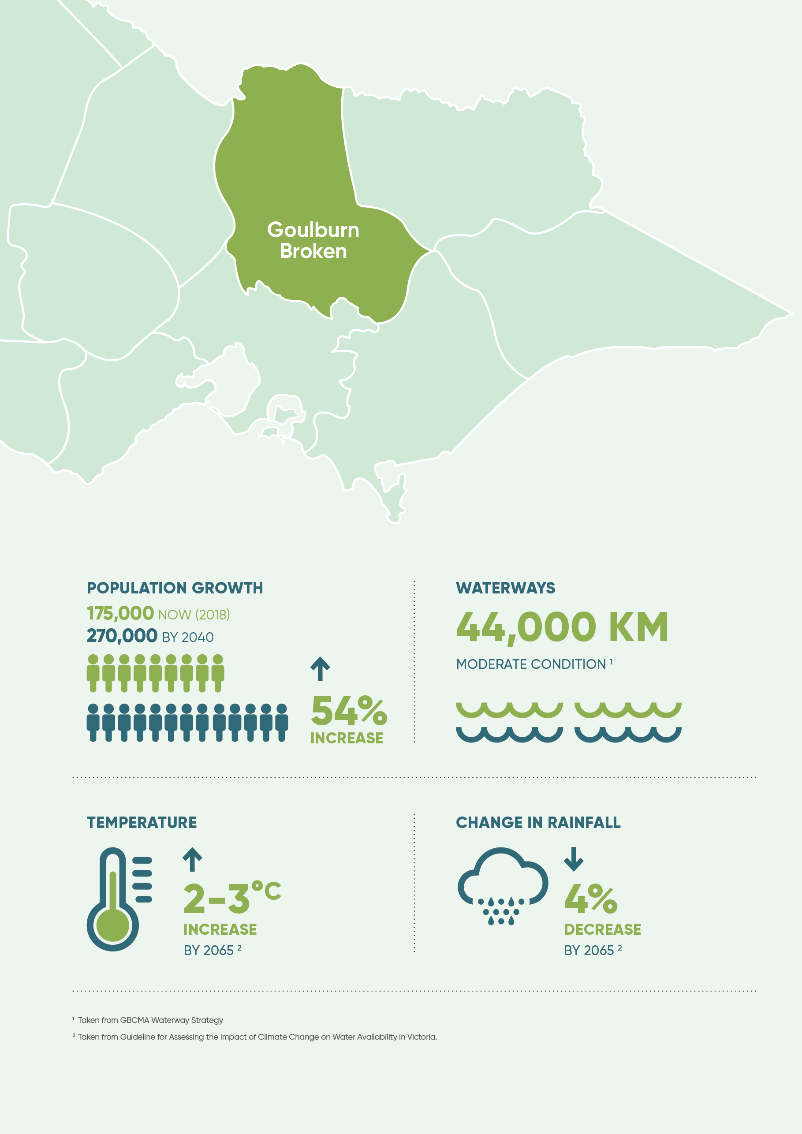

The case for IWM in the region
Safe, secure and affordable supplies in an uncertain future
The average annual rainfall varies significantly across the region. The high country to the south east of the region receives approximately 1600 mm annually, while in the north west of the region it is as low as 400 mm.
The urban water supply for Goulburn Broken is relatively secure. The major regulated supplies from the Goulburn and Murray systems are secure until 2065. Supply shortfalls are expected in the shorter term in some of the smaller systems including Sunday Creek (supplying Broadford and Kilmore) and Seven Creeks (supplying Euroa).
Currently drinking water services are provided to 54 cities and towns in the region from 13 water supply systems. Many of these are supplied from waterways in the area, which also provide water for agriculture. Urban water demands are forecast to increase by 16,000 ML from 2016 to 2065.
Water generated from the urban catchments is currently in the order of 20,000 ML, with 10,000ML being treated wastewater and the remaining being urban stormwater excess. Of this, the majority of urban stormwater excess is returned to the regions waterways via stormwater systems. The treated wastewater generated is either harnessed as an alternative water source and supplied to a nearby irrigation demands or released to waterways.

Effective and affordable wastewater systems
There are reticulated sewage systems in 31 cities and towns in the region. These systems collect and treat sewage at 23 lagoon based and three trickling filter based Wastewater Management Facilities. In addition to these facilities there are many small towns in the region which typically use onsite septic systems to treat their wastewater. Small towns wastewater management is a common issue across the region from an environmental, health, technical, governance and financial perspective.
Several wastewater management facilities are predicted to reach capacity due to increased sewage volumes as a result of population growth. Eight upgrades are planned for the next five years.
The Kilmore Wastewater Management Facility is taking a highly innovative and cost-effective approach to meeting environment compliance through Victoria’s first offset program. A similar approach to the Kilmore offsets program is proposed for the Mansfield Wastewater Management Facility in 2021.

Avoided or minimised existing and future flood risks
Floodplains are a valued part the ecosystem in the Goulburn Broken region. The ‘flooding’ process provide essential nutrients to the region’s agricultural land.
In an urban context, flooding is more of a challenge. Most of the major urban centres are located on river floodplains and are therefore subject to flooding. It is essential to manage the economic, social, environmental and cultural values from floodplains in a balanced way whilst also having regard for their inherent disadvantages and risks. This will be particularly relevant in the context of increased extreme rainfall events, urban growth and increased imperviousness in catchments.

Healthy and valued waterways, wetlands and lakes
The Goulburn and Broken River basin areas encompass over 44,000 km of waterways. These waterways and waterbodies are embraced by the urban communities for their aesthetic, recreational, cultural, tourism and restorative appeal. Key tourism and recreation locations include the Murray
River, Nagambie Lakes, Waranga Basin and Lake Eildon.
The region’s riverine assets also support a large range of biodiversity, including threatened species such as the Murray Cod, Silver Perch and Macquarie Perch. Increased water demands from a range of users may impact on the amount of water that is available to maintain and enhance ecosystem health in some river systems.
These pressures are further intensified by climate change. By 2065, stream flow reductions of 13.7 per cent in the Goulburn System and 16.8 per cent in the Broken system are predicted (under a median climate change scenario). Ensuring that waterways can continue to support a variety of values will be a key challenge for the region. There are a range of programs that facilitate the active support of waterway health by the community, including Waterwatch. Local councils have also invested in local stormwater management initiatives to reduce the impact of urban stormwater runoff on waterways.

Healthy and valued urban and rural landscapes
Healthy urban landscapes are highly valued in the Goulburn Broken region. Outdoor and sporting precincts are a critical part of the region’s social fabric. Examples include the Euroa Arboretum and the Victoria Park Lake in Shepparton. The region will need to manage the sharing of water in an equitable manner during times of drought, including aspects such as the irrigation of public open space.
The rural landscape is also very important to the area. Goulburn Valley is often referred to as the “Food Bowl of Australia,” with around 25 per cent of the total value of Victoria’s agricultural production generated in the region. The Food Bowl is supported by expansive arterial irrigation and drainage infrastructure, such as the East Goulburn Main Channel.

Community values are reflected in place-based planning
The Goulburn Broken region covers the traditional lands of Yorta Yorta and Taungurung people, and the many rivers in the area contain a rich and diverse range of important cultural heritage sites. Examples of this are scar trees and middens along the Goulburn River.
The relationship between public health and wellbeing, and the environment is becoming increasingly recognised as an area of importance. For example, it is recognised that the increased frequency and intensity of heatwaves will adversely impact on public health and wellbeing which will lead to stresses on the region’s health and emergency services.
In addition, the region has above average indicators for both obesity and mental health issues. Water and urban planning can play a role in addressing both of these issues.
The project RiverConnect incorporates community values into planning for the Goulburn and Broken rivers around Shepparton-Mooroopna.

The case for IWM in the region
Jobs, economy and innovation
The region includes peri-urban towns, such as Kilmore, which are predicted to grow considerably because of their proximity to Melbourne. These growth areas will need to have resilient water services that do not adversely impact other parts of the community and catchment.
Major industries in the Goulburn Broken region include manufacturing (e.g. food processing), and agriculture. Many of Australia’s largest food processing companies such as SPC-Ardmona, Fonterra, Unilever, Tatura Milk industries, Murray Goulburn, GrainCorp and Campbells are all based in the Goulburn Broken region.
Industry in the area is supported by major irrigation districts including the Shepparton Irrigation Region (SIR). The SIR covers approximately 500,000 hectares, uses around 1.5 million megalitres of water annually, and is the irrigation region which contributes most to the Victorian economy. The flow on effects to the other sectors in the regional economy result of these industries results in a Gross Value of Production annually of approximately $5.5 Billion.
To maintain resilient irrigation supplies and ongoing economic prosperity for the region’s industries, it is critical to consider adaptation pathways for managing the impacts of increased agricultural water demand, increased temperatures, heatwaves, bushfire risk, evapotranspiration, a reduction in rainfall, and compliance with the Murray-Darling Basin Plan.
Despite the strong presence of these industries, there are high ABS Labour Force Survey unemployment rates (6.7 per cent in Shepparton) compared to the rest of Victoria (5.6 per cent).
There is also a significant tourism and recreation economy in the region which are strongly linked to the health and amenity provided by the region’s waterways, lakes and towns.

Success stories
There has been a lot of great work over the years by state and local government, regional agencies, communities, planning bodies and boards to identify what we need to do to address the challenges and opportunities in the region. Two recent case studies are outlined below.

Kilmore Environmental Offsets Project
The Kilmore Environmental Offsets Project is the first of its kind in Victoria. The project uses an innovative and alternative approach to the management of treated effluent at the Kilmore Wastewater Management Facility (WMF).
The township of Kilmore is within the Melbourne growth corridor and is expected to double in size over the next 20 years. To cater for this growth, a traditional engineering upgrade of the wastewater management facility would have seen Goulburn Valley Water (GVW) expand and upgrade their wastewater irrigation system for an estimated total cost of $50 million. The conventional approach would have also required compulsory land acquisition and would result in high energy usage and chemical consumption.
The proposed environmental offsets concept will instead see a combination of riparian zone improvements, stormwater management and low energy treatment improvements that will cater for future growth. This takes a whole of catchment approach to provide an overall net benefit to the environment. The estimated capital cost of the offset approach is less than $10 million, representing an 80 per cent reduction in cost to achieve superior environmental and community outcomes.
An EPA Works Approval for the project has been issued and GVW is currently working with the Goulburn Broken Catchment Management Authority (GBCMA) towards the commencement of riparian zone improvement works during 2018. GBCMA will manage the delivery of the in-stream works for the offsets project and are looking at implementing it through local organisations such as Landcare and indigenous communities.
GVW are now exploring an offsets solution in Mansfield, which would again see multiple benefits delivered to the catchment at a fraction of the cost of conventional methods.
More information can be found at the Environmental Protection Authority website: <http://www.epa.vic.gov.au/our-work/publications/publication/2018/march/1690>
Water quality offsets are a regulatory tool which can enable EPA to apply less stringent discharge limits in a wastewater discharge licence if the proponent can demonstrate that equivalent or greater environmental benefits can be achieved by carrying out alternative measures. Such measures may result in an improved environmental outcome at a lower cost to the community.

RiverConnect
RiverConnect is a program that aims to see the Goulburn and Broken Rivers recognised as the life and soul of the Shepparton-Mooroopna communities. It is co-funded by the GBCMA and Greater Shepparton City Council, however many other organisations are involved in activities and planning, including Parks Victoria, Yorta Yorta Nation Aboriginal Corporation, Rumbalara Aboriginal Cooperative and various Landcare Groups.
The program encompasses the river frontages and forest floodplains of the Goulburn and Broken Rivers in the Shepparton Mooroopna area. The four main objectives of the program are: connecting community, connecting environment, connecting aboriginal people and connecting education. The program is about redirecting and reprioritising existing funding and resources to achieve outcomes and to attract external funding.
Actions range from improving the water quality of the rivers, to installing interpretive signage and pathways, engagement events, and school education programs (including individual schools being ‘responsible’ for their reach of the river).

Chapter 3
IWM opportunities
A portfolio of IWM projects and strategies for which IWM collaborative partners have committed themselves to applying their best endeavours to progress.

State-wide and region specific initiatives
This document outlines priority IWM opportunities for the Goulburn Broken region. These include both strategies that will direct IWM in the region and specific projects that will deliver on-the-ground outcomes. To ensure IWM opportunities are successful and delivered efficiently, work is also being done at a state‑wide level.
Across Victoria, IWM Forum members are identifying a range of strategic policy and framework enablers to address barriers to integrated water management and planning and achieve water related benefits in priority areas.
The DELWP Water and Catchments Group is responsible for addressing these barriers to implementation in a holistic manner alongside relevant government organisations involved in land use planning and land management.
Advisory groups drawing on industry and independent expertise support DELWP in the development and implementation of strategic initiatives to fill knowledge gaps and address issues identified through the IWM Forum process.
Barriers to IWM are reviewed, with local implications and potential state-wide resolutions discussed. These discussions will help DELWP determine potential options for policy reform and associated areas of impact for industry sectors and organisations.
Advisory groups provide advice regarding areas where planning, water, local government and other arms of government need to work more collaboratively to maintain and enhance the liveability and resilience of Victoria’s cities and towns.

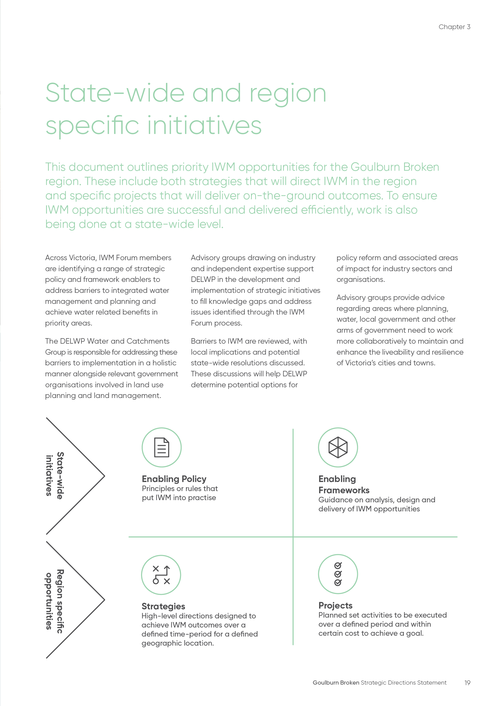

IWM opportunities: How were they selected?
IWM opportunities that link to and address IWM challenges for the region were identified and developed by the nominated practitioners of participating organisations. The process was an iterative, transparent and inclusive approach, as outlined below.

Continued Success through Collaboration
IWM is an evolving process that seeks to coordinate and balance many views and interests in the water sector around common goals and agreed outcomes. The Forum acknowledges that this is a dynamic list of IWM opportunities and is subject to further assessment by the IWM Forum Members.
By co-delivering a range of water planning and management initiatives, the Forum seeks to build on the strengths of the community, the water sector and governments to achieve better value and long term shared benefits for the region.
With advice from the Resilient Cities and Towns Reference Group and support from DELWP, it is anticipated that the IWM Forum collaborative partners will continue to use their best endeavours to advance priority IWM initiatives through regular meetings and future Forums.

The IWM opportunity prioritisation process
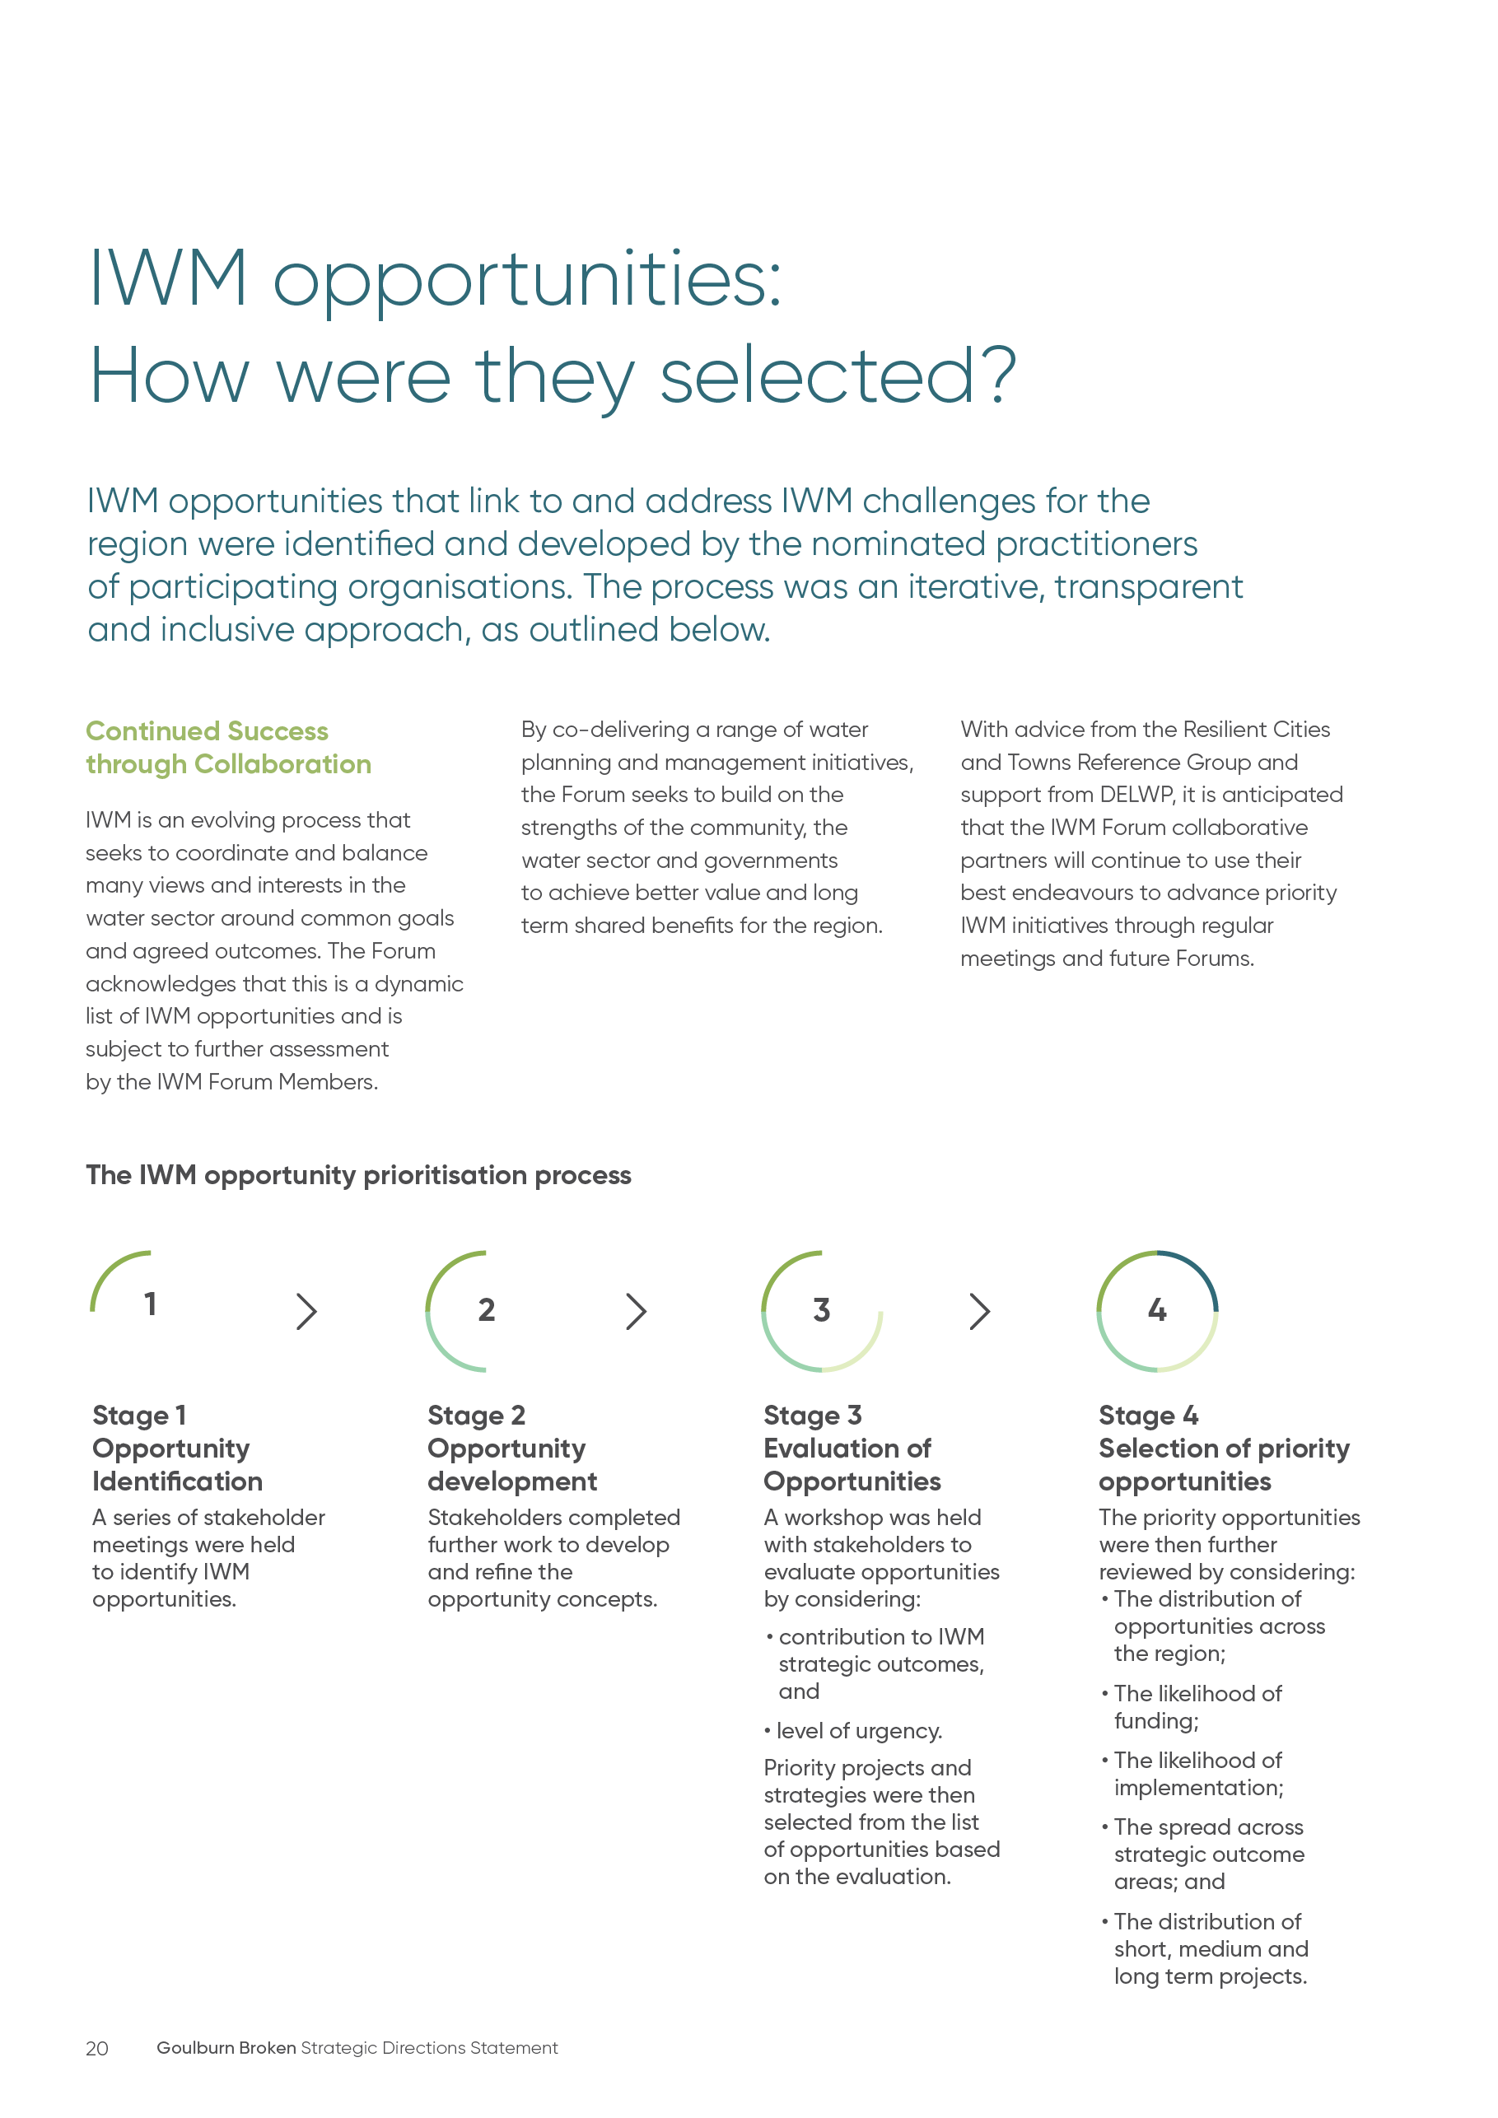

Impact of priority and committed projects/strategies on strategic outcomes
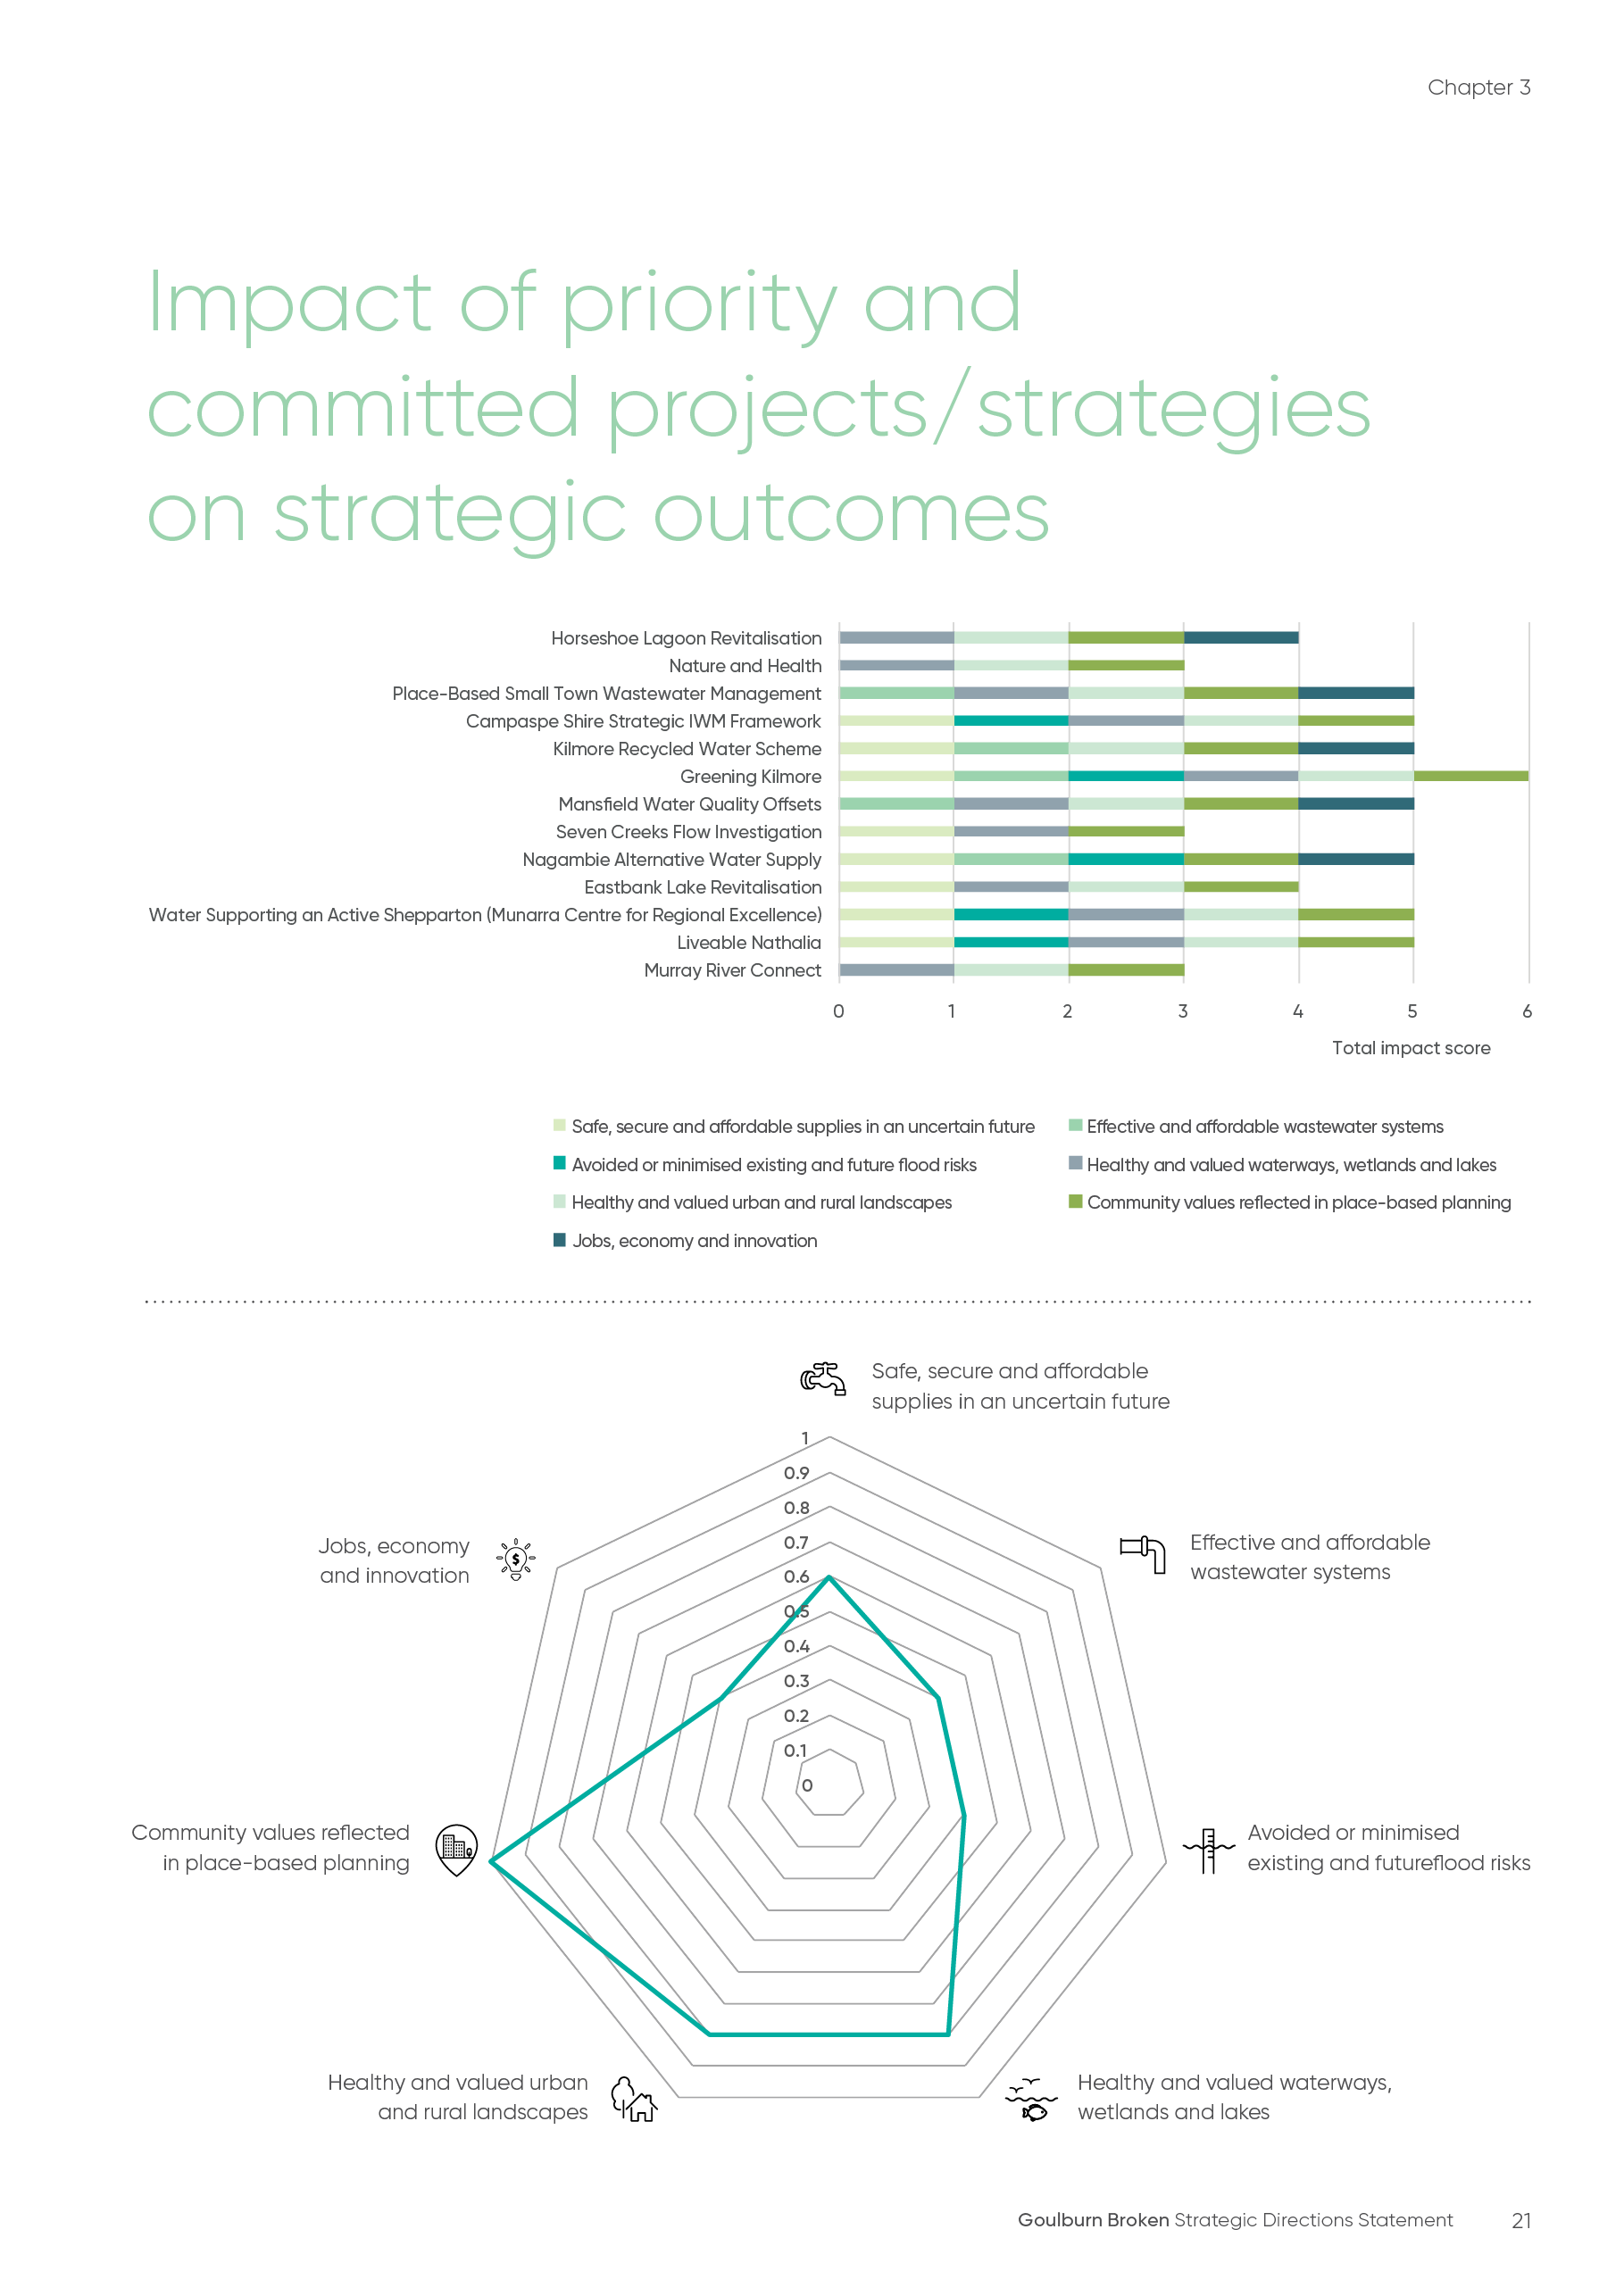

IWM project & strategy opportunities – overview
A summarised list of priority IWM opportunities is shown in the table below, with more detail in the following section. Please note that this list is dynamic and will continue to be updated to reflect the current GBIWM Forum’s priorities and opportunities. Partners of the Forum are committing their best endeavours to ensure priority projects and strategies are progressed in line with the shared vision and strategic outcomes of the Goulburn Broken IWM Forum.
IWM opportunity | Strategic outcomes  Safe, secure and affordable supplies in an uncertain future | Strategic outcomes  Effective and affordable wastewater systems | Strategic outcomes  Avoided or minimised existing and future flood risks | Strategic outcomes  Healthy and valued waterways, wetlands and lakes | Strategic outcomes  Healthy and valued urban and rural waterways | Strategic outcomes  Community values reflected in place-based planning | Strategic outcomes  Jobs, economy and innovation | Location | Scale | Lead agency for collaborative opportunity | Status
Murray RiverConnect | No impact | No impact | No impact | Impact | Impact | Impact | No impact | Moira and Campaspe sections of the Murray River | Green wedge | Moira Shire Council | 1,2
Liveable Nathalia | Impact | No impact | Impact | Impact | Impact | Impact | No impact | Nathalia | Greenfield subdivision | Moira Shire Council | 1
Water Supporting an Active Shepparton (Munarra Centre for Regional Excellence) | Impact | No impact | Impact | Impact | Impact | Impact | No impact | Shepparton | Lot scale | Greater Shepparton City Council | A,B,C
Eastbank Lake Revitalisation | Impact | No impact | No impact | Impact | Impact | Impact | No impact | Shepparton | Lot scale | Greater Shepparton City Council | A,B
Nagambie Alternative Water Supply | Impact | Impact | Impact | No impact | No impact | Impact | Impact | Nagambie | Greenfield subdivision | Strathbogie Shire Council | A
Seven Creeks Flow Investigation | Impact | No impact | No impact | Impact | No impact | Impact | No impact | Seven Creeks Catchment (Euroa) | Green wedge | Goulburn Broken CMA | 1
Mansfield Water Quality Offsets | No impact | Impact | No impact | Impact | Impact | Impact | Impact | Mansfield | Greenfield subdivision | Mansfield Shire Council | 1,2,3
Greening Kilmore | Impact | Impact | Impact | Impact | Impact | Impact | No impact | Kilmore | Greenfield subdivision | Mitchell Shire Council | 1,2
Kilmore Recycled Water Scheme | Impact | Impact | No impact | No impact | Impact | Impact | Impact | Kilmore | Greenfield subdivision | Mitchell Shire Council | A
Campaspe Shire Strategic IWM Framework | Impact | No impact | Impact | Impact | Impact | Impact | No impact | Campaspe Shire Council | Inter-forum | Campaspe Shire Council | 1,2
Horseshoe Lagoon Cultural Revitalisation | No impact | No impact | No impact | Impact | Impact | Impact | Impact | Trawool | Lot scale | Taungurung Clans Aboriginal Corporation | A
Place-based Small Town Wastewater Management | No impact | Impact | No impact | Impact | Impact | Impact | Impact | GB IWM Forum Region | Inter-forum Forum area | Goulburn Valley Water | 1
Nature and Health | No impact | No impact | No impact | Impact | Impact | Impact | No impact | GB IWM Forum Region | Forum area | Goulburn Broken CMA | 1
The status of each IWM opportunity included in the Priority Portfolio reflects the phase of work to be undertaken in this time period.
Project opportunity status
Concept & feasibility = A, Business case = B, Detailed design + C, Implementation = D, Commission = E, Benefit realisation = F.
Strategy opportunity status
Concept = 1, Commitment = 2, Prepare draft = 3, Consult & finalise = 4, Implement = 5, Evaluate = 6.

Priority Portfolio of IWM projects and strategies

Action GB1

Murray RiverConnect
This project will build on the successful RiverConnect project in Shepparton and surrounds to determine a similar model can be applied to the Moira and Campaspe sections of the Murray River. The output will be a scoped proposal for the Murray RiverConnect to seek ongoing funding.
There are three major urban environments along this stretch of the river: Cobram, Yarrawonga and Echuca, with rural areas in between.
The current RiverConnect program has four main objectives: Connecting Community, Connecting Environment, Connecting Aboriginal People and Connecting Education.

Next steps
- Finalise commitment and funding from project partners
- Undertake the scoping study to determine feasibility and design of a ‘RiverConnect’ approach
- Final Recommendations Report delivered
 | Strategic outcome  Safe, secure and affordable supplies in an uncertain future | Strategic outcome  Effective and affordable wastewater systems | Strategic outcome  Avoided or minimised existing and future flood risks | Strategic outcome  Healthy and valued waterways, wetlands and lakes | Strategic outcome  Healthy and valued urban and rural waterways | Strategic outcome  Community values reflected in place-based planning | Strategic outcome  Jobs, economy and innovation
Impact status | No impact | No impact | No impact | Impact | Impact | Impact | No impact

Subject | Details
Status | 1,2
Lead Agency | Moira Shire Council
Implementation Partners | gbcma, Campaspe Shire Council, Parks Victoria, yynac
Location | Moira & Campaspe sections of the Murray river
Timeframe | 3-6 Months (2018-19 FY)
Scale | Green wedge
Project opportunity status
Concept & feasibility = A, Business case = B, Detailed design + C, Implementation = D, Commission = E, Benefit realisation = F.
Strategy opportunity status
Concept = 1, Commitment = 2, Prepare draft = 3, Consult & finalise = 4, Implement = 5, Evaluate = 6.

Action GB2

Liveable Nathalia (Nathalia IWM Plan)
This project recognises the need for integrated water management to improve Nathalia’s resilience to flooding as well as investing in the long term liveability and growth. It will leverage the long term growth of the town and builds on recent investment in improvements to existing road and drainage infrastructure.
Positive health impacts may be realised from improvements to the existing landscape by integrating the township with the Broken Creek through defined pedestrian linkages and wayfinding strategies. In addition, the introduction of a high amenity, green landscape area could have positive health impacts. The project has the potential to empower local schools, indigenous and community groups.

Next steps
- Finalise commitment and funding from project partners
- Commission work and undertake consultation
- Final Recommendations report delivered
- Implementation of recommendations
 | Strategic outcome  Safe, secure and affordable supplies in an uncertain future | Strategic outcome  Effective and affordable wastewater systems | Strategic outcome  Avoided or minimised existing and future flood risks | Strategic outcome  Healthy and valued waterways, wetlands and lakes | Strategic outcome  Healthy and valued urban and rural waterways | Strategic outcome  Community values reflected in place-based planning | Strategic outcome  Jobs, economy and innovation
Impact status | Impact | No impact | Impact | Impact | Impact | Impact | No impact

Subject | Details
Status | 1
Lead Agency | Moira Shire Council
Implementation Partners | GVW, gbcma, gmw, local community groups and Nathalia community
Location | Nathalia
Timeframe | 6-12 Months (2018-19 FY)
Scale | Greenfield Subdivision
Project opportunity status
Concept & feasibility = A, Business case = B, Detailed design + C, Implementation = D, Commission = E, Benefit realisation = F.
Strategy opportunity status
Concept = 1, Commitment = 2, Prepare draft = 3, Consult & finalise = 4, Implement = 5, Evaluate = 6.

Action GB3

Water Supporting an Active Shepparton (Munarra Centre for Regional Excellence)
This project will develop a water sensitive masterplan for the Shepparton Sporting and Community Precinct. The detailed design has the potential to deliver multiple benefits to the regionally significant sporting hub by:
- Enabling water re-use and decreasing the use of potable water for irrigation
- Integrating with the proposed Munarra Centre for Regional Excellence (CRE), a state-of-the-art educational, sporting, cultural and community centre for local Aboriginal people.
- Improving the amenity of the GMW Main Drain #3 to create a landscaped asset. The landscape improvements can illustrate traditional owner values reinforcing the values of nurturing the land.
- Creating the drainage infrastructure to allow the future expansion of the precinct to the north.
Council has already undertaken a Drainage Analysis of the site and developed a high-level concept plan.

Next steps
- Finalise commitment and funding from project partners to complete study.
- Commission Detailed Design of Integrated Water Management Solution.
- Implementation of Final Recommendations (to be aligned with Munarra CRE as much as possible).
 | Strategic outcome  Safe, secure and affordable supplies in an uncertain future | Strategic outcome  Effective and affordable wastewater systems | Strategic outcome  Avoided or minimised existing and future flood risks | Strategic outcome  Healthy and valued waterways, wetlands and lakes | Strategic outcome  Healthy and valued urban and rural waterways | Strategic outcome  Community values reflected in place-based planning | Strategic outcome  Jobs, economy and innovation
Impact status | Impact | No impact | Impact | Impact | Impact | Impact | No impact

Subject | Details
Status | A,B,C
Lead Agency | Greater Shepparton City Council
Implementation Partners | Rumbalara Football and Netball Club, University of Melbourne, GBCMA, GMW, GVW, Yorta Yorta Nation Aboriginal Corporation
Location | Shepparton
Timeframe | 6 months (2018-19 fy)
Scale | Lot scale
Project opportunity status
Concept & feasibility = A, Business case = B, Detailed design + C, Implementation = D, Commission = E, Benefit realisation = F.
Strategy opportunity status
Concept = 1, Commitment = 2, Prepare draft = 3, Consult & finalise = 4, Implement = 5, Evaluate = 6.

Action GB4

Eastbank Lake Revitalisation
The Eastbank Lake project will provide Shepparton with a new, attractive, community focussed area on a currently disused anabranch of the Goulburn River. It will include a new stormwater harvesting, treatment and reuse system for Shepparton. It is estimated that 35ML of stormwater will be treated and harvested annually from two major stormwater outlets which drain around 10% of the Shepparton CBD.
By using treated stormwater to irrigate local parks and gardens, the project will inject new life into the area. It will also connect the Shepparton Central Business District to the Goulburn River making it a sought-after destination for both locals and tourists.
The project has been in development for over four years, with earlier phases having been supported by both GVW and GBCMA. This includes the development of a Concept Report and Plan (Sept 2014) and a Functional Design & Economic Analysis Report (Sept 2016).

Next steps
- Undertake further studies to determine stability of bank and impact on turtles to assist in informing the development of a business case.
- Development of Business Case
- Detailed Design
- Staged construction of on ground works
 | Strategic outcome  Safe, secure and affordable supplies in an uncertain future | Strategic outcome  Effective and affordable wastewater systems | Strategic outcome  Avoided or minimised existing and future flood risks | Strategic outcome  Healthy and valued waterways, wetlands and lakes | Strategic outcome  Healthy and valued urban and rural waterways | Strategic outcome  Community values reflected in place-based planning | Strategic outcome  Jobs, economy and innovation
Impact status | Impact | No impact | No impact | Impact | Impact | Impact | No impact

Subject | Details
Status | A,B
Lead Agency | Greater Shepparton city council
Implementation Partners | GVW, GBCMA, GMW, YYNAC, Parks Victoria, RiverConnect, Shepparton Landcare Group
Location | Shepparton
Timeframe | 12-18 Months (2018-2020)
Scale | Lot scale
Project opportunity status
Concept & feasibility = A, Business case = B, Detailed design + C, Implementation = D, Commission = E, Benefit realisation = F.
Strategy opportunity status
Concept = 1, Commitment = 2, Prepare draft = 3, Consult & finalise = 4, Implement = 5, Evaluate = 6.

Action GB5

Nagambie Alternative Water Supply
This project will investigate the feasibility of implementing an alternative water scheme for the growing township of Nagambie. Strathbogie Shire Council are committed to resolving a flooding issue at an existing industrial area to the east of Nagambie. To do this, Council propose to pump the stormwater from the industrial area into a Council owned burrow pit. This scheme presents a number of IWM opportunities for Nagambie. Some initial ideas include:
- Using the harvested stormwater as an urban supply
- Using the nearby recycled water supply, located to the east of the town, to supplement the harvested stormwater. This could defer the need to expand the irrigation area to meet environmental requirements

Next steps
- Finalise commitment and funding from project partners
- Commission work and undertake feasibility study
- Depending on the outcomes of item 2, a detailed design and business case may follow.
 | Strategic outcome  Safe, secure and affordable supplies in an uncertain future | Strategic outcome  Effective and affordable wastewater systems | Strategic outcome  Avoided or minimised existing and future flood risks | Strategic outcome  Healthy and valued waterways, wetlands and lakes | Strategic outcome  Healthy and valued urban and rural waterways | Strategic outcome  Community values reflected in place-based planning | Strategic outcome  Jobs, economy and innovation
Impact status | Impact | Impact | Impact | No impact | No impact | Impact | Impact

Subject | Details
Status | A
Lead Agency | Strathbogie Shire Council
Implementation Partners | GVW, GMW, GBCMA
Location | Nagambie
Timeframe | 3-6 Months (2018)
Scale | Greenfield Subdivision
Project opportunity status
Concept & feasibility = A, Business case = B, Detailed design + C, Implementation = D, Commission = E, Benefit realisation = F.
Strategy opportunity status
Concept = 1, Commitment = 2, Prepare draft = 3, Consult & finalise = 4, Implement = 5, Evaluate = 6.

Action GB6

Seven Creeks Flow Investigation
Seven Creeks is a priority waterway in the Goulburn-Broken catchment which is unregulated, has high ecological values and important consumptive uses. The Creek is flow stressed because of water extraction and climate change. Without appropriate flow in the waterway, endangered species – the Macquarie Perch and Trout Cod – may be impacted.
The proposed project will investigate potential ways to resolve this and provide greater reliability of the minimum flow requirements in the creek to support fish populations.
With considerable investment potentially occurring in the catchment, the study will look at ways to leverage this to deliver multiple benefits to the community.
The proposed scope of the project involves two key steps: a workshop with key stakeholders to understand and confirm the key values and drivers for the study area, and; an options assessment into potential viable ways to increase flows to the creek.

Next steps
- Undertake workshop with key stakeholders to determine a common vision and potential options to investigate
- Commission and undertake options analysis
- Detailed Design and Implementation
 | Strategic outcome  Safe, secure and affordable supplies in an uncertain future | Strategic outcome  Effective and affordable wastewater systems | Strategic outcome  Avoided or minimised existing and future flood risks | Strategic outcome  Healthy and valued waterways, wetlands and lakes | Strategic outcome  Healthy and valued urban and rural waterways | Strategic outcome  Community values reflected in place-based planning | Strategic outcome  Jobs, economy and innovation
Impact status | Impact | No impact | No impact | Impact | No impact | Impact | No impact

Subject | Details
Status | 1
Lead Agency | Goulburn Broken CMA
Implementation Partners | GVW, Strathbogie Shire Council, GMW, Taungurung Clans Aboriginal Corporation, Yorta Yorta Nation Aboriginal Corporation
Location | Seven Creeks catchment (key area is upstream of Euroa)
Timeframe | 12 months (2018-19 FY)
Scale | Green wedge
Project opportunity status
Concept & feasibility = A, Business case = B, Detailed design + C, Implementation = D, Commission = E, Benefit realisation = F.
Strategy opportunity status
Concept = 1, Commitment = 2, Prepare draft = 3, Consult & finalise = 4, Implement = 5, Evaluate = 6.

Action GB7

Mansfield Water Quality Offsets
This project will see an Integrated Water Management Plan for Mansfield developed.
With the town’s wastewater system operating at capacity, consideration of water quality offset measures, which can potentially deliver multiple benefits to the community, will be a key component of the study.
GVWs Urban Water Strategy indicates that Mansfield will face a water supply shortage under all climate scenarios by 2030. A plan that looks at all available sources of supply is critical for the town, to ensure that regional economic growth can be maintained whilst protecting healthy community assets.
The IWM Plan has been co-funded by Mansfield Shire Council, Goulburn Valley Water and DELWP.

Next steps
- Undertake IWM Plan in collaboration with key partners
- Detailed design of key recommendations
- Implementation
 | Strategic outcome  Safe, secure and affordable supplies in an uncertain future | Strategic outcome  Effective and affordable wastewater systems | Strategic outcome  Avoided or minimised existing and future flood risks | Strategic outcome  Healthy and valued waterways, wetlands and lakes | Strategic outcome  Healthy and valued urban and rural waterways | Strategic outcome  Community values reflected in place-based planning | Strategic outcome  Jobs, economy and innovation
Impact status | No impact | Impact | No impact | Impact | Impact | Impact | Impact

Subject | Details
Status | 1,2,3
Lead Agency | Mansfield Shire Council
Implementation Partners | GVW, GBCMA, GMW, EPA, UP2US Landcare Alliance, Taungurung Clans Aboriginal Corporation
Location | Mansfield
Timeframe | 6 months (2018)
Scale | Greenfield Subdivision
Project opportunity status
Concept & feasibility = A, Business case = B, Detailed design + C, Implementation = D, Commission = E, Benefit realisation = F.
Strategy opportunity status
Concept = 1, Commitment = 2, Prepare draft = 3, Consult & finalise = 4, Implement = 5, Evaluate = 6.

Action GB8

Greening Kilmore
The township of Kilmore is a major growth town within Mitchell Shire, with the population set to increase by over 50 per cent by 2036. To facilitate this growth Council has prepared a Kilmore Structure Plan, which highlights the need for an IWM Plan to be developed. In addition, the Kilmore Creek is currently in poor condition and there is no clear plan to manage predicted urban growth and ensure the waterway remains an environmental and social asset for town.
This IWM Plan will consider potential key strategic actions for the township, for example:
- A masterplan for long term management of Kilmore Creek and township greening.
- An alternative water strategy utilizing wastewater for non-potable purposes
- Future growth areas drainage and WSUD strategy

Next steps
- Finalise commitment and funding from project partners
- Commission work and undertake strategy
- Final Recommendations Report delivered
- Implementation of recommendations
 | Strategic outcome  Safe, secure and affordable supplies in an uncertain future | Strategic outcome  Effective and affordable wastewater systems | Strategic outcome  Avoided or minimised existing and future flood risks | Strategic outcome  Healthy and valued waterways, wetlands and lakes | Strategic outcome  Healthy and valued urban and rural waterways | Strategic outcome  Community values reflected in place-based planning | Strategic outcome  Jobs, economy and innovation
Impact status | Impact | Impact | Impact | Impact | Impact | Impact | No impact

Subject | Details
Status | 1,2
Lead Agency | Mitchell Shire Council
Implementation Partners | GVW, GBCMA, Taungurung Clans Aboriginal Corporation
Location | Kilmore
Timeframe | 6 months (2018)
Scale | Greenfield Subdivision
Project opportunity status
Concept & feasibility = A, Business case = B, Detailed design + C, Implementation = D, Commission = E, Benefit realisation = F.
Strategy opportunity status
Concept = 1, Commitment = 2, Prepare draft = 3, Consult & finalise = 4, Implement = 5, Evaluate = 6.

Action GB9

Kilmore Recycled Water Scheme
A Kilmore recycled water scheme is one of many potential sub-projects that will be referenced through the Greening Kilmore Plan (Action GB8).
With excess recycled water supply predicted in the region, a feasibility study is underway to assess the viability of a recycled water network to provide a secure and climate resilient water source for key industries in Kilmore whilst assisting GVW to meet environmental requirements.
The Kilmore recycled water scheme would leverage the existing Kilmore Offsets program (detailed in success stories) and future plan for trunk infrastructure to service current and future non-potable demands for Kilmore.

Next steps
- Finalise feasibility study
- Secure funding for Kilmore Recycled Water Scheme
- Detailed Investigation and Design for Scheme
- Staged construction
 | Strategic outcome  Safe, secure and affordable supplies in an uncertain future | Strategic outcome  Effective and affordable wastewater systems | Strategic outcome  Avoided or minimised existing and future flood risks | Strategic outcome  Healthy and valued waterways, wetlands and lakes | Strategic outcome  Healthy and valued urban and rural waterways | Strategic outcome  Community values reflected in place-based planning | Strategic outcome  Jobs, economy and innovation
Impact status | Impact | Impact | No impact | No impact | Impact | Impact | Impact

Subject | Details
Status | A
Lead Agency | Mitchell Shire Council
Implementation Partners | GVW, GBCMA
Location | Kilmore
Timeframe | 12 months (2018-19 FY)
Scale | Greenfield Subdivision
Project opportunity status
Concept & feasibility = A, Business case = B, Detailed design + C, Implementation = D, Commission = E, Benefit realisation = F.
Strategy opportunity status
Concept = 1, Commitment = 2, Prepare draft = 3, Consult & finalise = 4, Implement = 5, Evaluate = 6.

Action GB10

Campaspe Shire Strategic IWM Framework
This Framework will establish a strategic direction and engagement process with the intent to embed integrated water management across Campaspe Shire Council.
The strategic framework will provide the local link between the state government’s direction set in Water for Victoria and providing a voice for the community and delivery of placed based initiatives.
The project scope will achieve the following:
- Identify projects that meet the Council’s strategic direction and provide outcomes that improve the liveability for the community
- Provide a prioritised IWM project list to be budgeted and delivered by Campaspe Shire Council and key partners
- Align Council’s strategic processes, policies, services, capital delivery and asset management processes with IWM
- Work with key agencies and authorities to consider their role in the leadership of IWM Planning and Delivery
- Embed the value of IWM within the Shire and its key stakeholders by focusing on education.

Next steps
- Finalise commitment and funding from project partners, including GVW, Coliban Water, GBCMA and NCCMA.
- Commission work and develop framework
- Incorporate recommendations and prioritised projects into Council and other key stakeholder processes
 | Strategic outcome  Safe, secure and affordable supplies in an uncertain future | Strategic outcome  Effective and affordable wastewater systems | Strategic outcome  Avoided or minimised existing and future flood risks | Strategic outcome  Healthy and valued waterways, wetlands and lakes | Strategic outcome  Healthy and valued urban and rural waterways | Strategic outcome  Community values reflected in place-based planning | Strategic outcome  Jobs, economy and innovation
Impact status | Impact | No impact | Impact | Impact | Impact | Impact | No impact

Subject | Details
Status | 1,2
Lead Agency | Campaspe Shire Council
Implementation Partners | GVW, GBCMA, COLIBAN WATER, NORTH CENTRAL CMA, MOIRA SHIRE COUNCIL
Location | Campaspe Shire Council (Entire municipality)
Timeframe | 9-12 Months (2018-2019)
Scale | Inter-forum
Project opportunity status
Concept & feasibility = A, Business case = B, Detailed design + C, Implementation = D, Commission = E, Benefit realisation = F.
Strategy opportunity status
Concept = 1, Commitment = 2, Prepare draft = 3, Consult & finalise = 4, Implement = 5, Evaluate = 6.

Action GB11

Horseshoe Lagoon Cultural Revitalisation
Horseshoe Lagoon is a small billabong on the Goulburn River, located approximately 15 km southeast of Seymour. The area is managed by Parks Victoria and includes a public camping and fishing spot beside
the Goulburn River.
An Aboriginal Waterway Assessment of Horseshoe Lagoon recognised that the largest threat to aboriginal cultural values and overall wetland health was river flow alteration.
Due to regulation at Lake Eildon, natural flows no longer pass through Horseshoe Lagoon, with rainfall being the sole source. This has contributed to a decline in the abundance and health of species of cultural significance, both flora and fauna.
This project aims to revitalise the site, and by doing so enhance the amenity and increase the cultural awareness associated with the Horseshoe Lagoon. The project will provide an opportunity for inter-organisational learnings and upskilling within Taungurung CAC. It is intended that the project will provide a platform for Taungurung CAC to be able to manage similar sites elsewhere.

Next steps
- Undertake a comprehensive cultural and environmental assessment
- Options assessment to improve flows from the Goulburn River
- Ongoing management of present weed species through contemporary and traditional methods including cultural burning.
- Ongoing maintenance of native habitat to encourage more wildlife.
- Explore options to develop walking paths and cultural interpretation and signage.
 | Strategic outcome  Safe, secure and affordable supplies in an uncertain future | Strategic outcome  Effective and affordable wastewater systems | Strategic outcome  Avoided or minimised existing and future flood risks | Strategic outcome  Healthy and valued waterways, wetlands and lakes | Strategic outcome  Healthy and valued urban and rural waterways | Strategic outcome  Community values reflected in place-based planning | Strategic outcome  Jobs, economy and innovation
Impact status | No impact | No impact | No impact | Impact | Impact | Impact | Impact

Subject | Details
Status | A
Lead Agency | Taungurung Clans Aboriginal Corporation
Implementation Partners | Goulburn Broken CMA, Parks Victoria
Location | Trawool
Timeframe | 2018-19
Scale | Lot scale
Project opportunity status
Concept & feasibility = A, Business case = B, Detailed design + C, Implementation = D, Commission = E, Benefit realisation = F.
Strategy opportunity status
Concept = 1, Commitment = 2, Prepare draft = 3, Consult & finalise = 4, Implement = 5, Evaluate = 6.

Action GB12

Place-based Small Town Wastewater Management
- This study is a focused investigation that will set up a long term plan to coordinate the improvement of wastewater management for towns with septic systems across the Goulburn Broken IWM region. Failing septic systems pose a significant health and environmental risk in the region.
- These improvements will consider technical, governance and financial solutions and will provide a framework for other councils and water corporations across the state with a focus on innovative solutions for small towns.
- The project will explore how Integrated Water Management principles can provide potential additional value to technical outcomes by considering alternative water opportunities, improved waterway outcomes, improved local amenity or improved drainage design.
- In additional to GVW, Goulburn Broken IWM Forum LGAs and North East Water have committed to provide funding to undertake the study.

Next steps
- Finalise commitment and funding from project partners
- Ensure buy-in from key organisations such as EPA and DELWP
- Commission and undertake work
 | Strategic outcome  Safe, secure and affordable supplies in an uncertain future | Strategic outcome  Effective and affordable wastewater systems | Strategic outcome  Avoided or minimised existing and future flood risks | Strategic outcome  Healthy and valued waterways, wetlands and lakes | Strategic outcome  Healthy and valued urban and rural waterways | Strategic outcome  Community values reflected in place-based planning | Strategic outcome  Jobs, economy and innovation
Impact status | No impact | Impact | No impact | Impact | Impact | Impact | Impact

Subject | Details
Status | 1
Lead Agency | Goulburn Valley Water
Implementation Partners | All LGA’s in gbiwm forum and North East water
Location | Goulburn Broken IWM forum region
Timeframe | 12 months (2018-19 FY)
Scale | Inter-forum  Forum area
Project opportunity status
Concept & feasibility = A, Business case = B, Detailed design + C, Implementation = D, Commission = E, Benefit realisation = F.
Strategy opportunity status
Concept = 1, Commitment = 2, Prepare draft = 3, Consult & finalise = 4, Implement = 5, Evaluate = 6.

Action GB13

Nature and Health
- This is a long term initiative which will aim to foster partnership between the water and health sector.
- By strategic collaboration this initiative will aim to achieve improved mental and physical health in the community, reduced healthcare costs and a reduction to the heat island effect.
- Research continues to suggest that maintaining the health of green spaces and increasing community connection with them is likely to have a positive impact on public health and wellbeing for the broader community.
- The initial phases of this initiative will include the development of a Memorandum of Understanding (MoU) between GBCMA and Goulburn Valley Health and identification of potential opportunities to collaboratively deliver.
- The Forum will also consider the potential for health sector involvement in other IWM opportunities outlined in the GB IWM SDS.

Next steps
Finalise MoU between GBCMA and Goulburn Valley Health
Explore strategic opportunities to collaborate and align the water and health sector
 | Strategic outcome  Safe, secure and affordable supplies in an uncertain future | Strategic outcome  Effective and affordable wastewater systems | Strategic outcome  Avoided or minimised existing and future flood risks | Strategic outcome  Healthy and valued waterways, wetlands and lakes | Strategic outcome  Healthy and valued urban and rural waterways | Strategic outcome  Community values reflected in place-based planning | Strategic outcome  Jobs, economy and innovation
Impact status | No impact | No impact | No impact | Impact | Impact | Impact | No impact

Subject | Details
Status | 1
Lead Agency | Goulburn Broken CMA
Implementation Partners | Goulburn Valley Health & other local health services, local government, dhhs and parks Victoria
Location | Goulburn Broken iwm Forum region
Timeframe | Ongoing
Scale | Forum area
Project opportunity status
Concept & feasibility = A, Business case = B, Detailed design + C, Implementation = D, Commission = E, Benefit realisation = F.
Strategy opportunity status
Concept = 1, Commitment = 2, Prepare draft = 3, Consult & finalise = 4, Implement = 5, Evaluate = 6.

