Barwon
  - Strategic Directions Statement
  - 2022

Acknowledgements
The Barwon Integrated Water Management Forum proudly acknowledges Victoria's Aboriginal communities and their rich culture, and pays its respects to their Elders past and present.
The forum also recognises the intrinsic connection of Traditional Owners to Country and acknowledges their contribution to the management of land, water and resources. We acknowledge Aboriginal people as Australia’s first peoples and as the Traditional Owners and custodians of the land and water on which we rely. We recognise and value the ongoing contribution of Aboriginal people and communities to Victorian life and how this enriches us. We embrace the spirit of reconciliation, working towards the equality of outcomes and ensuring an equal voice.
This Strategic Directions Statement has been developed by the Barwon Integrated Water Management Forum, which includes the following organisations:
- Eastern Maar Aboriginal Corporation
- Wadawurrung Traditional Owners Aboriginal Corporation
- Borough of Queenscliff
- City of Greater Geelong
- Colac Otway Shire
- Golden Plains Shire
- Surf Coast Shire
- Barwon Water
- Corangamite Catchment Management Authority
- Department of Environment, Land, Water and Planning
- Department of Health and Human Services
- Southern Rural Water

The State of Victoria Department of Environment, Land, Water and Planning 2022
This work is licensed under a Creative Commons Attribution 4.0 International licence. You are free to re-use the work under that licence, on the condition that you credit the State of Victoria as author. The licence does not apply to any images, photographs or branding, including the Victorian Coat of Arms, the Victorian Government logo and the Department of Environment, Land, Water and Planning (DELWP) logo. To view a copy of this licence, visit http://creativecommons.org/licenses/by/4.0/
Printed by Finsbury Green, Melbourne
ISBN 978-1-76105-991-9 (print)
ISBN 978-1-76105-992-6 (pdf/online/MS Word)
Disclaimer
This publication may be of assistance to you but the State of Victoria and its employees do not guarantee that the publication is without flaw of any kind or is wholly appropriate for your particular purposes and therefore disclaims all liability for any error, loss or other consequence which may arise from you relying on any information in this publication.
Accessibility
If you would like to receive this publication in an alternative format, please telephone the DELWP Customer Service Centre on 136186, email customer.service@delwp.vic.gov.au or via the National Relay Service on 133 677 www.relayservice.com.au. This document is also available on the internet at www.delwp.vic.gov.au.

Contents
Foreword 3
Executive summary 5
Building resilience to challenges 5
IWM opportunities 6
Prioritising IWM action in towns and urban centres 6
Delivering regional benefits 6
Delivering multiple benefits to towns and natural places 6
Barwon Integrated Water Management Forum 8
Strategic Directions Statement 2022 summary 8
Better together: integrating water management across Victoria 11
The first water custodians 11
Pressures emerge and evolve 11
What is IWM? How can it help address challenges? 12
Barwon IWM Forum 14
Our vision 14
Our purpose 14
Our focus areas 14
How are we delivering IWM state- wide? 14
Strategic outcomes 16
Strategic Directions Statement – how IWM is happening in the region 17
Relevant plans and strategies in place in the region 17
Water in the Barwon region 20
Snapshot of key climate, land use and populations statistics for the Barwon region. 21
Progress so far 24
Case study 25
Winchelsea IWM Plan – a first for the region’s small towns 25
Case study 26
Northern and Western Geelong Growth Areas IWM Plan – setting the precedent for IWM 26
IWM opportunities 28
Bannockburn IWM Plan 28
City of Greater Geelong IWM Plan 29
Queenscliff IWM Plan 31
Avalon Corridor IWM Plan 32
Implementation of Northern and Western Geelong Growth Areas IWM Plan through Precinct Structure Planning Process 33
Kitjarra-dja-bul Bullarto langi-ut (formerly Barwon River Parklands project) 34
Recycled Water on the Bellarine Peninsula – Stage 3 36
Recycled Water on the Bellarine Peninsula – Stage 4 37
Investigate Feasibility of Staged Large-scale Stormwater and Recycled Water Networks 38
Recycled Water to the Surf Coast Hinterland 39
Delivering Actions from the Winchelsea IWM Plan 41
Concept and Functional Design Study for Colac Botanic Pathway and Green Spine 42
Birregurra Sustainable Communities 43
Recycled Water for Bannockburn Township 44
Delivery of Forrest Wastewater Project 45
Elliminyt Wetlands 46
Jan Juc Creek Daylighting – Stage 2 47
Ecological Restoration of Waurn Ponds Creek and Creation of a Biodiversity Corridor at Deakin University's Waurn Ponds Campus 48
Review of Catchment Stormwater Arrangements for Karaaf Wetlands 50

Foreword
Water is life; it is vital to maintaining community health and wellbeing, the liveability of our cities and towns, Indigenous culture, the environment and the economy.
In the Barwon region, demand and competition for water is continuing to grow – whether that be for drinking, cultural purposes, agriculture and manufacturing, environmental flows or public amenity and recreation.
Much of this demand is driven by the popularity of our region. The Barwon region continues to grow rapidly, and this trend is expected to continue. Geelong has the fastest growing population out of Australia’s largest 20 cities. In both 2019-20 and 2020-21 Geelong experienced the highest 5-year and 1-year population growth rates.While the long-term effects of the COVID-19 pandemic are yet to be seen, population trends to date have indicated a clear migration from Melbourne to regional Victoria, with the Surf Coast having one the strongest growth rates across all of regional Australia in 2020-21.
Unfortunately, our rivers, wetlands and estuaries are under significant pressure. The combination of a drying climate and continued extraction of water for consumptive purposes means declining environmental health is evident for both the Moorabool and Barwon Rivers which, as a result, are among the most flow-stressed rivers in Victoria.
As we heard clearly from the community through Barwon Water’s Water for Our Future engagement process, it is imperative that we manage this fundamental but finite resource in a holistic way and shift to sources of water that are climate resilient. With less water and more people, integrated water management (IWM) has never been more vital to our region’s ongoing health and prosperity.
To help tackle this issue, the Barwon IWM Forum formed in 2018, driving a collaborative and integrated approach to water management to enable sustainable environmental, social, cultural and community prosperity for the region. The forum comprises regional leaders representing Traditional Owners, local governments, statutory authorities and government agencies.
To help guide the ongoing direction and priorities of the forum, our Strategic Directions Statement (SDS) has been updated. This refreshed SDS celebrates our achievements and articulates the forum’s principles, vision and outcomes for IWM and identifies the opportunities looking ahead. In the new SDS, we have identified 19 priority opportunities of different scales to progress. Our opportunities cover a range of planning and capital projects spread throughout the Barwon region. Over the next phase of effort covered by this SDS, we have intentionally started to increase the investment into capital projects as we implement the outcomes of strategic planning undertaken since the forum’s first SDS. The use of climate-independent alternative water sources – such as recycled water and stormwater – feature strongly in this next phase of work.
Since our first SDS, the forum has achieved some tremendous outcomes such as the completion of the region’s Recycled Water Plan, Deakin University’s Waurn Ponds Campus IWM Plan, the Northern and Western Geelong Growth Areas IWM Plan, and the provision of recycled water to northern Geelong’s Stead Park sporting complex, which will enable the precinct to further expand.
As chair of the forum, I am pleased to present this updated Barwon IWM Strategic Directions Statement and look forward to working collaboratively with all our partners to implement it.
Seamus Butcher
Chair, Barwon IWM Forum

Executive summary
The Integrated Water Management Framework for Victoria (2017) is designed to help water managers and stakeholders work together to improve how the water cycle contributes to the liveability of towns and cities in Victoria, with communities at the centre of decision making.
The Barwon Integrated Water Management Forum is one of 10 regional integrated water management (IWM) forums across Victoria that are realising the local implementation of the framework.
The forum’s vision is for integrated, collaborative management of the water cycle that enables sustainable environmental, social, cultural and community prosperity for the Barwon region.
The forum brings together regional leaders in sustainable water management, representing Traditional Owners, local governments, statutory authorities and government agencies.
This Strategic Directions Statement (SDS) articulates the collaborative intent and shared agreement of all stakeholders involved in the forum. It describes the water security challenges and opportunities in the region, sets the strategic direction for the next three to five years, and outlines the ways in which IWM is and will be applied through joint projects that connect water back into the water cycle.
As IWM is an iterative process, this SDS also provides the first update on progress since the initial SDS (2018) and includes case studies exemplifying how IWM is happening in the region.
This SDS has been developed to complement the Central and Gippsland Sustainable Water Strategy, Barwon Water’s Water for Our Future Strategy, the Corangamite Regional Catchment Strategy and strategic plans of forum member organisations.

Building resilience to challenges
The forum’s experience since establishment has highlighted the need to focus IWM efforts on key challenges of:
- population growth, with more people moving to and visiting the Barwon region
- climate change, which is already impacting the region through extreme weather, reduced rainfall and hotter temperatures
- reducing our reliance on climate-dependent sources of water by finding alternative solutions to meet the demand.
The forum’s IWM opportunities have been designed to meet these challenges.

IWM opportunities
Nineteen opportunities have been identified across the region, the locations of which are shown in Figure 1 and can be grouped in the following themes.

Prioritising IWM action in towns and urban centres
- Bannockburn IWM Plan
- City of Greater Geelong IWM Plan
- Queenscliff IWM Plan

Delivering regional benefits
- Avalon Corridor IWM Plan
- Implementation of Northern and Western Geelong Growth Areas IWM Plan through Precinct Structure Planning Process
- Kitjarra-dja-bul Bullarto langi-ut (formerly known as the Barwon River Parklands project)
- Recycled Water on the Bellarine Peninsula – Stage 3
- Recycled Water on the Bellarine Peninsula – Stage 4
- Investigate Feasibility of Staged Large-scale Stormwater and Recycled Water Networks
- Recycled Water to the Surf Coast Hinterland

Delivering multiple benefits to towns and natural places
- Delivering Actions from the Winchelsea IWM Plan
- Concept and Functional Design Study for Colac Botanic Pathway & Green Spine
- Birregurra Sustainable Communities
- Recycled Water for Bannockburn Township
- Delivery of Forrest Wastewater Project
- Elliminyt Wetlands
- Jan Juc Creek Daylighting – Stage 2
- Ecological Restoration of the Waurn Ponds Creek and Creation of a Biodiversity Corridor at Deakin University's Waurn Ponds Campus
- Review of Catchment Stormwater Arrangements for Karaaf Wetlands

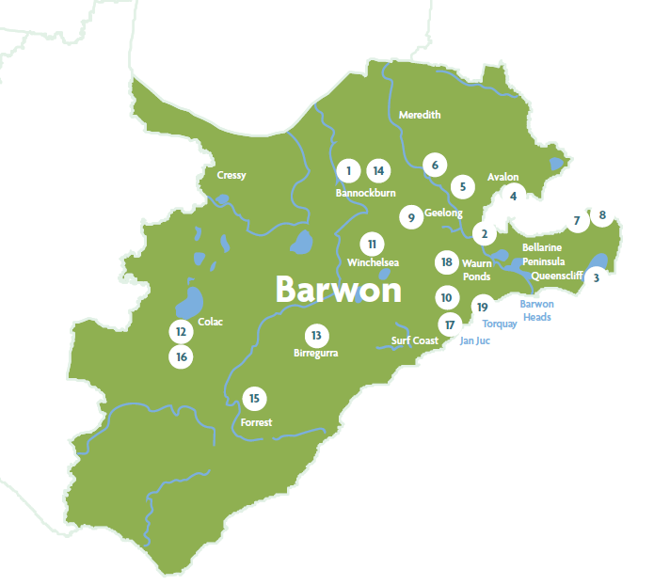
Figure 1: Locations of IWM opportunities across the Barwon region. Locations are approximate.

Barwon Integrated Water Management Forum

Strategic Directions Statement 2022 summary
We work collaboratively with partners across the water cycle to find new ways to share resources and conserve water for multiple community and environmental benefits.
We work to meet the water needs of a changing region.
- Bannockburn IWM Plan
Increased use of diverse water and better IWM practices in new greenfield areas i.e., Bruce Creek.
- City of Greater Geelong IWM Plan
Bringing together organisations to adapt to population growth, optimise waterway health, and foster economic growth and climate resilience.
- Queenscliff IWM Plan
Developing an IWM plan for the Borough of Queenscliffe with a focus on stormwater.
- Avalon Corridor IWM Plan
Servicing the proposed Avalon Employment Precinct and nearby agricultural properties with sustainable and diverse water supplies.
- Implementation of Northern and Western Geelong Growth Areas IWM Plan through Precinct Structure Planning Process
Implementing the plan to enable new water- sensitive precincts for a growing population.
- Kitjarra-dja-bul Bullarto langi-ut (formerly known as the Barwon River Parklands project)
Developing a masterplan of the lower Moorabool and Barwon Rivers to enhance the user experience of the unique environmental, cultural and recreational values of this important river corridor.
- Recycled Water on the Bellarine Peninsula – Stage 3
Improving the quality of recycled water in the existing Bellarine Peninsula scheme.
- Recycled Water on the Bellarine Peninsula – Stage 4
Supplying more low-salinity recycled water across more of the Bellarine Peninsula.
- Investigate Feasibility of Staged Large-scale Stormwater and Recycled Water Networks
Exploring the feasibility of the staged implementation of large-scale water networks to enhance connections between diverse local sources of water and regional beneficial use locations.
- Recycled Water to the Surf Coast Hinterland
Exploring feasibility of supplying recycled water for agricultural, horticultural and other productive uses.
- Delivering Actions from the Winchelsea IWM Plan
Improving the quality of the township’s stormwater outflows entering the Barwon River catchment.
- Concept and Functional Design Study for Colac Botanic Pathway & Green Spine
Creating a continuous recreational pathway to connect key natural assets in Colac.
- Birregurra Sustainable Communities
A place-based and community partnership approach to sustainable water use.
- Recycled Water for Bannockburn Township
Providing recycled water to reduce the reliance on potable water to irrigate public open spaces.
- Delivery of Forrest Wastewater Project
Proposes a whole-of-town wastewater solution.
- Elliminyt Wetlands
Upgrading an underperforming retarding basin draining to the Elliminyt Wetlands.
- Jan Juc Creek Daylighting – Stage 2
Returning a highly-disturbed urban waterway to a more natural state.
- Ecological Restoration of the Waurn Ponds Creek and Creation of a Biodiversity Corridor at Deakin University's Waurn Ponds Campus
Revegetating Waurn Ponds Creek and providing a biodiversity corridor through the centre of the campus.
- Review of Catchment Stormwater Arrangements for Karaaf Wetland
Applying an IWM approach to understanding and responding to the impacts of urban stormwater on the Karaaf Wetlands.

Better together: integrating water management across Victoria

The first water custodians
The clans of the First Nations have been living in balance with the natural environment in Victoria, practising their culture, caring for Country and waterways and maintaining sophisticated water management systems for tens of thousands of years.
The Barwon region is abundant in Aboriginal cultural sites, most of which are found near waterways and the coast. The forum acknowledges the Traditional Owners – Wadawurrung and Eastern Maar – who have managed land and water sustainably over thousands of generations, and maintain an active connection to Country.

Pressures emerge and evolve
European settlement and the gold rush of the 1800s saw thousands of people flock to Victoria to seek their fortunes. The local environment struggled to keep up with human use and the waste from the growing population. The rapid planning and construction of sewerage and sanitation systems at the turn of the century saw the end of widespread diphtheria, typhoid, cholera and dysentery.
Victoria’s regional towns and cities have thrived with the provision of drinking water and sanitation services. Agriculture and farming have also grown. Wool exports allowed Australia’s economy to ‘ride the sheep’s back’ in the post-war era. Today, Victoria is the nation’s largest exporter of food and fibre, and much of the water flowing into the Murray-Darling Basin System – underpinning agriculture in several states – comes from the Victorian high country.
The complex challenges of water management in Victoria continue: we have lived through the Millennium Drought and experienced flooding, bushfires and extreme weather. We have seen the consequences of overusing water in one area affecting the availability or quality of water in another.
Water managers are now operating in an increasingly complex and uncertain environment. The drivers of change are both social and environmental. They include population growth, climate change, shifting migration patterns associated with the coronavirus pandemic, economic challenges and policy changes. But our beautiful state remains a wonderful place in which to live, and we continue to see our population increase. Regional Victoria is expected to grow from 1.5 million people in 2015 to 2.2 million over the next 30 years.
The liveability of our regional towns and cities and the health of our environment and economy depend on the availability of water. Access to water is also important for social wellbeing and holds intrinsic cultural values for Traditional Owners. The value of green spaces for wellbeing has been further accentuated during the coronavirus pandemic, with a growing population seeking outdoor recreation and access to nature. We need an integrated and collaborative approach to adapt to change and maximise value across the whole water cycle.

What is IWM? How can it help address challenges?
Integrated water management considers all parts of the water cycle as an integrated system to optimise the environmental, cultural, social and economic outcomes for our communities.
The current water supplies and liveability of towns and cities owe much to the collaborative work done to date by water corporations, local and state government, planning and development authorities, communities and, in recent decades, catchment management authorities. While we face the challenges of population growth, climate change and natural disasters, we can also build on the benefits of past experiences and established relationships. Together, we can make decisions today that we will celebrate in the future.
While everyone has a responsibility to conserve and protect water, there are several key groups charged with making decisions about water within each region. These groups include Traditional Owner groups, who have a deep knowledge of and connection to the region’s waterways and other water resources; water corporations, which manage water storage, water supply, and wastewater services; local governments, which make planning decisions that consider the intersection of land, water and biodiversity in planning. The decisions these groups make individually, can have significant impacts on the quality and availability of the water for others in the catchment and further downstream. So, it makes sense they collaborate towards common goals to maximise water saving and re-use, and share the benefits (Figure 2). IWM is an approach that can be applied to water planning from the scale of the local park, right up to and inclusive of the whole catchment.
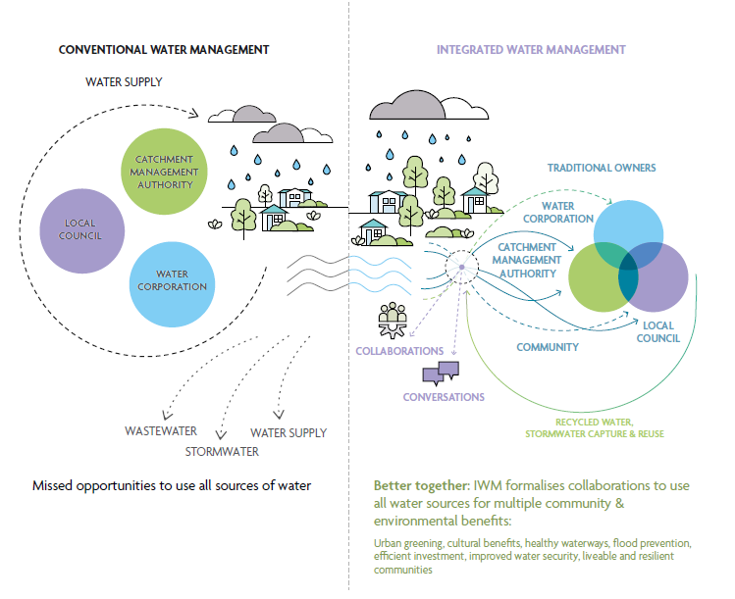
Figure 2: How does IWM work? Conventional water management saw a more siloed approach to water management, with a single supply source and two discharge systems to move stormwater and wastewater away as quickly as possible, resulting in missed opportunities to use all sources of water. The IWM approach brings water managers together to plan and deliver new opportunities to provide broader benefits to the community. Listening to and consulting with Victorian communities about how they want water managed is critical to informing IWM decision making. Communities are directly consulted on IWM plans and through existing catchment management authority, water corporation and local government strategies.

Barwon IWM Forum

Our vision
Integrated, collaborative management of the water cycle that enables sustainable environmental, social, cultural and community prosperity for the Barwon region.

Our purpose
The purpose of the Barwon IWM Forum is to provide a collaborative platform for overseeing, supporting and, where necessary, facilitating water’s contribution to community prosperity, resilience and liveability in the Barwon region.

Our focus areas
The forum is governed by a set of principles developed by the forum:
- water management across the region must be sustainable and ensure that there will be secure supply of quality water available to meet environmental, cultural and societal needs for the future
- sustainable management of water will enable economic prosperity
- water management includes ensuring healthy communities and healthy environments exist across the region, enabling communities to experience, enjoy and actively participate in outdoor recreation and cultural practices
- IWM is underpinned by regional collaboration.

How are we delivering IWM state- wide?
To facilitate IWM across Victoria, the Victorian Government’s Department of Environment, Land, Water and Planning (DELWP) supported the establishment of 10 IWM forums across regional Victoria (Figure 3). These forums bring together leaders of the local water sector to explore, prioritise and oversee the development of local IWM opportunities. Prioritised opportunities are managed and implemented by dedicated Working Groups and are captured within individual IWM plans. Where appropriate, the forums involve other organisations and groups that are not part of the water sector but have direct or indirect interests in water management and land use planning, such as community and Indigenous groups, planning authorities, Department of Transport, developers, educational institutions, or large landholders.
Being collaborative, IWM builds on existing partnerships and planning processes, and aims to break down silos between independently operating water decision-makers – encouraging forum members to consider the water cycle of their own service delivery, and the interdependencies or overlaps with other members (Figure 2). Forum members consider waters in rivers, streams and bays, wastewater, drinking water, stormwater and water treatment processes.
While collaboration can take more time and effort, working together achieves better outcomes for the environment, society, and the economy by finding mutually beneficial ways to share water, assets and costs.

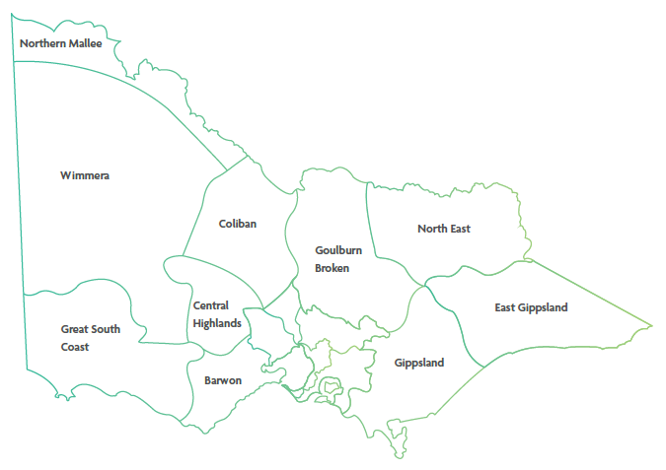
Figure 3: IWM forum regions of Victoria, which are based around water corporation boundaries

Strategic outcomes
The Integrated Water Management Framework for Victoria (2017) proposed several strategic water-related outcomes that will deliver on the vision in the State water plan, Water for Victoria (2016), to ‘build resilient and liveable cities and towns’. These strategic outcomes provide a way to identify the multiple economic, social and environmental benefits that can come from a single initiative. The original framework included five such strategic outcomes that have since been expanded to seven. The identification of strategic outcomes will continue to evolve as the water management context changes and the sector innovates.
Proposed project opportunities are assessed and prioritised against how well and how many of these strategic outcomes they meet.
The strategic outcomes are:
- safe, secure and affordable supplies in a changing future – indicated by the amount of water conserved or alternative water volume supplied to meet an identified demand.
- effective and affordable wastewater systems – ensuring environmental and public health standards are met, and maximising resource recovery.
- manage flood risks – resilience to existing and future flood risk.
- healthy and valued waterways and waterbodies – indicated by the ecological health of riparian areas, hydrology and water quality.
- healthy and valued landscapes – maximising the connectivity, accessibility, greening and vegetation, cooling, aesthetic and/or recreational values of landscapes.
- Traditional Owner and community values reflected in place-based planning – ensuring that different communities are considered and included in planning and design, and provided with water-systems literacy to enable involvement.
- jobs, economic opportunity and innovation – recognising that water management is an integral part of economic growth.
To find out more about how Victoria is applying IWM through the Integrated Water Management Framework for Victoria (2017), visit: www.water.vic.gov.au

Strategic Directions Statement – how IWM is happening in the region
This SDS articulates the collaborative intent and shared agreement of all stakeholders involved in the forum. It describes the water security challenges and opportunities in the region, sets the strategic direction for the next few years, and outlines the ‘best endeavours’ or ways in which IWM is and will be applied through opportunities that are proposed, in-progress or completed in the region.
This is the first update to the Barwon SDS produced in 2018, and includes:
- an update on progress to date
- case studies illustrating IWM in the region
- details of planned and potential opportunities designed to meet the strategic outcomes and key challenges over the next three to five years.
This SDS has been developed to complement the other plans and strategies that apply to the region for water, climate change, First Nations’ rights and catchment management.
The key related policies, strategies and plans for the Barwon region are listed below, and displayed visually in Figure 4.

Relevant plans and strategies in place in the region
Water for Victoria
State government strategic plan for management of our water resources, now and into the future.
Integrated Water Management Framework for Victoria
Whole-of-catchment water planning and management to maintain and enhance the liveability, prosperity and resiliency of Victoria’s cities and towns. Applied through five metropolitan and 10 regional IWM forums.
2022 Barwon IWM Forum SDS
A revised statement of agreement between Forum members of urban and peri-urban IWM priorities and collaborative projects.
Barwon Water’s Water for our Future Program
Developing an Urban Water Strategy: the long term plan to ensure sustainable, affordable and reliable water for community and environment.
Caring for Country Plans: Wadawurrung Country Plan, Eastern Maar Country Plan
Guiding and promoting awareness, investment and the rights of Indigenous people and culture, working together now and for future benefits.
Central and Gippsland Region Sustainable Water Strategy
Long-term plans and statutory processes for state-wide water resource planning to secure the water future of Victoria's regions.
Corangamite Regional Catchment Strategy
Guides actions to improve and protect the catchment’s natural resources (water, land, biodiversity). Looking after these precious natural resources underpins the social, cultural and economic wellbeing of the diverse communities that make up the catchment.
Local government plans and strategies
Various strategies, plans, guidelines and other documents that have connections to the water cycle. Examples include open-space plans, local climate change adaptation strategies, and natural disaster management plans.

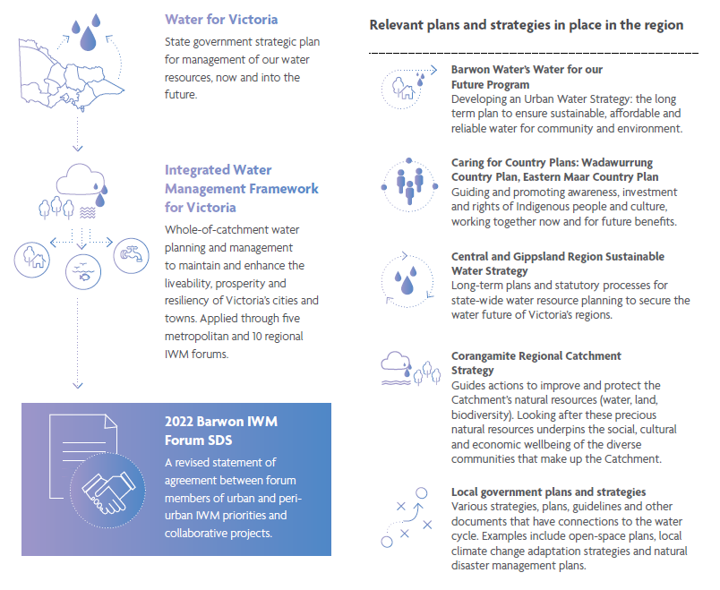
Figure 4: The SDS and related water policies, strategies and plans of the region

Water in the Barwon region
The Barwon region is located in regional Victoria, to the west and south west of the Melbourne metropolitan area. It spans Country of both Wadawurrung and Eastern Maar, who are the traditional custodians of the land.
For the Wadawurrung people, in the east of the Barwon region, waterways connect the people to stories, and provide a cultural way of travel and connection to other tribes. The diverse water on Country – rivers, creeks, waterholes and ocean – provide food sources and nourishes the wellbeing of all life. Without access to Country and water, their role and ability to care for Country would be limited.
In the west of the Barwon region, the contemporary Eastern Maar nation traces an unbroken line of descent back to ancestors over many thousands of years6. They survive as their Country’s First People and, despite colonial history, continue to maintain economic, traditional, cultural, familial and spiritual ties to their homeland. Through the leadership and authority of Elders, Eastern Maar are practicing laws and customs, strengthening their system of governance and nurturing connection to Country6.
With areas of significant natural beauty, the Barwon region is an increasingly popular tourist and holiday destination. But it is also known for the quality of its lifestyle and its vibrant economy based on food and wine, health services, education and advanced manufacturing.
Prior to the coronavirus pandemic, the Barwon region was already experiencing higher than projected growth. Now, with people moving out of Melbourne, spurred on by the pandemic, the region looks as if it will continue to outpace projections. Greater Geelong – Victoria’s second largest city and major economic hub – grew by 2.6% per annum between 2015 and 2020 and projections suggest the city will welcome an extra 100,000 residents by 2036 (an increase of about 1.6% per year). The region's coastal and inland towns are some of the state's fastest growing locations, with many of the small towns experiencing a boom in domestic tourism.
The Barwon region faces many challenges due to this population growth, climate change, changing community needs and expectations, and the continued need to support economic growth and development. To help ensure the wellbeing of the increasing amount of people who live and work in the region, it is more important than ever to provide healthy waterways and access to green, open spaces for recreation and to improve liveability. The impact of these challenges on the water cycle is complex and varies across the region.
The Barwon River, Moorabool River and their tributaries are valuable natural assets to be protected and enhanced for future generations. They play a key role in supporting the liveability, amenity and recreational opportunities for the growing population, as well as diverse agricultural and horticultural production, and an expanding economy.
The Barwon catchment contains some of the state’s most flow-stressed waterways. Significant population growth and a changing climate are expected to place increasing pressures on the health of the catchment’s waterways and natural landscapes. These pressures, and others that will emerge, will increase the stress on the health of the waterways and natural landscapes, requiring a long-term but iterative strategic response. The Victorian Government has released the Rivers of the Barwon (Barre Warre Yulluk) Action Plan (2021), which lays out steps to protect it and ensure its assets can be enjoyed by future generations. Visit: www.water.vic.gov.au
Barwon Water’s Water for our Future strategy provides a 50-year plan to ensure a sustainable water future and return water to the environment. It aims to balance the challenges we face to achieve a secure water future and is a keystone to the region’s strategic response.

Snapshot of key climate, land use and populations statistics for the Barwon region.
Population
- Population in 2021 – 343,700
- Population in 2036 – 448,600
- Population increase – 30.5%
Land use
- Agricultural land and plantations – 67%
- National parks and conservation – 12%
- Urban areas – 8%
Catchment and waterway condition
- Catchment size – 8,950 Km²
- Condition of the Barwon catchment
- Good – 4%
- Moderate – 37%
- Poor – 41%
- Very Poor – 17%
- Condition of the Moorabool catchment
- Good – 4%
- Moderate – 37%
- Poor – 41%
- Very Poor – 17%
Climate
- Change in rainfall – by 2040, a decrease by 14% with more intense rainfall
- Change in temperature – by 2040, an increase of 0.6 to 1.5 degrees Celsius
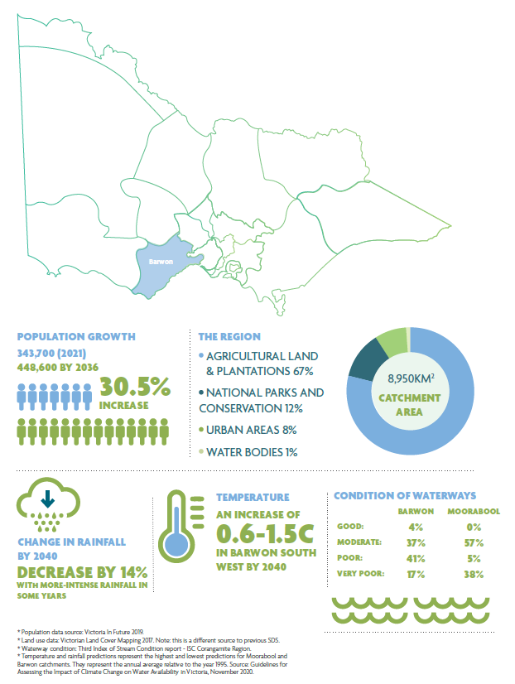
Figure 5: Key climate, land use and populations statistics for the Barwon region.

Progress so far
The first Barwon IWM Forum SDS was published in 2018. It articulated the regional context, the shared vision and the strategic water-related objectives for the region. It also listed IWM opportunities as ‘ready to advance’ projects developed in collaboration by the forum partners. It can be viewed online at www.water.vic.gov.au
The forum members have IWM at the forefront of their thinking and several are implementing IWM projects independently. The projects – past, current and future – listed in this SDS and endorsed by the forum members are those that benefit from a collaborative, multi-party approach.
The first SDS identified 15 projects that reflected the Barwon IWM Forum’s priorities at the time. The priority opportunities ranged from IWM planning processes (12 projects) such as the Winchelsea IWM Plan, to infrastructure projects such as delivering recycled water to the Stead Park sporting complex in Geelong. The focus on IWM strategic planning projects in the first SDS reflected the early stage of the forum’s development at the time.
Between 2018 and 2022, forum members worked collaboratively with partners and delivered 10 of the original 15 projects. Of the five remaining projects, three are underway and one is pending external funding (Colac Botanic Pathway and Green Spine). The remaining project, Regional Recycled Water Plan, was re- defined and included in this SDS as the Investigate Feasibility of Staged Large-scale Stormwater and Recycled Water Networks project (see page 38). To find out more about our progress, and progress across the state, view the Integrated Water Management Progress Report (2022) online at: www.water.vic.gov.au
IWM opportunities that were not identified in the first SDS were also pursued when they arose, with considerable progress made in the delivery of fit-for-purpose recycled water at Deakin University’s Waurn Ponds Campus and for the Bellarine Peninsula’s agricultural industry.

Case study

Winchelsea IWM Plan – a first for the region’s small towns
Winchelsea, with a population of around 2,000 people, has become the region’s first small township to develop its own IWM plan.
With an emphasis on creative solutions such as tree plantings and stormwater recycling, the plan seeks to maximise Winchelsea’s water management in ways that are valued by the town – helping to navigate the pressures posed by climate change and a growing local population.
'We were able to leverage the existing vision developed for the township and consider how integrated water management could play a role in realising its objectives,' says Sean Keown, the project leader and Climate and Sustainability Officer at the Surf Coast Shire.
Stakeholders met in a series of workshops to discuss the challenges and opportunities facing water management in the township. Discussions involved representatives from government and water services, as well as community interest groups, residents and consultation with Traditional Owners.
Together, it identified five priority portfolios that would benefit from an IWM approach. The portfolios sought to:
- enhance the Barwon River’s health and amenity
- create cooler streetscapes
- capture and re-use stormwater for greening the golf course
- generate recycled water suitable for greening public spaces
- use recycled water to keep Barwon Park Mansion and surrounds green for visitors.
A key success of the planning consultation process, Sean says, was the conversations that emerged. ‘By getting together, the group seeded ideas from discussions that might not have otherwise happened.’
One such idea started with the group Growing Winchelsea, who, out of the process, grew their idea for Winchelsea’s own arboretum – a museum of trees to line a path around the town and provide an attraction for visitors. Further development of the arboretum is now being pursued by community members and it is seen as a key project that could attract visitors to the township.
The IWM plan also initiated discussions around the water requirements for Barwon Park – a 19th century bluestone mansion which is National Trust heritage listed and draws tourists and events to Winchelsea. The IWM consultation process kickstarted the owners’ thoughts about their requirements for water – particularly for keeping the grounds green. They are now looking into options for using recycled water onsite.
Find out more and see the plan at www.surfcoast.vic.gov.au

Case study

Northern and Western Geelong Growth Areas IWM Plan – setting the precedent for IWM
One of the largest urban areas in regional Victoria is planned for the outskirts of Geelong. It is set to accommodate about 110,000 residents, and the planning process is making sure that the Northern and Western Geelong Growth Areas (NWGGA) is ready to use every drop of water it captures from when the first building is pegged out.
Barwon Water has collaborated with the City of Greater Geelong, DELWP, Southern Rural Water, Traditional Owners and commercial developers to generate an IWM plan for the NWGGA, which makes use of options to reduce potable water demand while diversifying and increasing alternative water use. This includes use of recycled water throughout the development, increased harvesting of stormwater, and employing water sensitive urban design throughout. With options that are being explored, once complete, the project could save up to 6 gigalitres each year – close to seven Olympic-sized swimming pools per day.
‘NWGGA will have an exemplary integrated water management system with water as the enabler of clever and creative neighbourhoods that build regional resilience, while supporting local economies, healthier lifestyles and a thriving environment,’ says project leader Rhys Bennett, Co-ordinator Network Planning at Barwon Water.
The project creates a pathway for a ‘net positive potable water balance’, meaning that the area has the potential to produce more alternative water (i.e. stormwater and recycled water) than it uses (drinking water). ‘It’s a way to make our urban areas more resilient to climate change,’ he says.
Other features, such as passively irrigated trees, will divert stormwater runoff from paved surfaces. At the same time, it will reduce stormwater flows and associated pollutants entering local waterways. This is also the key to ensuring the nearby wetlands do not receive too much water, which can be detrimental to their health.
Part of the plan also involves returning much-needed environmental flows to the Moorabool River – Victoria’s most flow-stressed river. With the Batesford Quarry in the western area scheduled for closure, options will be investigated to rehabilitate the degraded concrete diversion channel in that section of the Moorabool River and reduce water losses in that reach of the river. Interim water supply options will also be explored to support flows in the Moorabool River.
Over time, as the levels of harvested stormwater and recycled water build up in the development, those water sources could be used to supplement the Moorabool’s flows, accelerate the Quarry’s filling to eventually create a lake, and/or be provided to agricultural customers in the Moorabool Valley.

IWM opportunities
Opportunities that link to and address IWM challenges for the region were identified and developed by nominated practitioners of organisations participating in the forum.
A summary of the priority IWM opportunities are detailed in the following section. This list is dynamic and will continue to be updated to reflect the forum’s priorities and opportunities as they arise.
Partners are committing their ‘best endeavours’ to ensure priority projects and strategies are moved forward, in line with the shared vision and strategic outcomes of the forum.

Bannockburn IWM Plan
Bannockburn is the largest township in the Golden Plains Shire and is growing rapidly at 8.5% per annum. This growth is likely to accelerate with the adoption of the Victorian Planning Authority’s Bannockburn Growth Plan in 2021. This growth, combined with a relatively low annual rainfall, makes water security an increasingly significant issue for the township.
The Bannockburn IWM Plan would consider both the existing township, areas under development and potential future growth areas, to ensure water is managed efficiently now and into the future. The plan would look at: options at a range of scales (household through to precinct), costs, complexities and include both public and private land. It will support residents and organisations to improve water management in town and maximise the benefits that integrated water use can bring. The plan would also find alternatives to current potable water use and look for opportunities for future developments to use diverse water sources.

Table 1: A summary of the impact that the Bannockburn IWM Plan opportunity has towards achieving the IWM outcomes.
IWM outcome | Impact status
safe, secure and affordable supplies in a changing future | Impact
effective and affordable wastewater systems | Impact
manage flood risks | Impact
healthy and valued waterways and waterbodies | Impact
healthy and valued landscapes | Impact
Traditional Owner and community values reflected in place-based planning | Impact
jobs, economic opportunity and innovation | Impact
Table 2: A summary of key details for the Bannockburn IWM Plan opportunity.
Subject | Details
Status | Concept
Lead organisation | Golden Plains Shire
Implementation partners | Barwon Water, DELWP, Wadawurrung Traditional Owners Aboriginal Corporation
Location | Bannockburn

City of Greater Geelong IWM Plan
A Municipal IWM Plan will be developed for Greater Geelong to integrate urban planning, rainwater, stormwater, wastewater, recycled water and drinking water management. The plan will improve alignment of the city’s existing strategies, Barwon Water’s Water for our Future and the Victorian Water Plan. It will consider: stormwater harvesting and usage; strategic investments into stormwater management systems; prioritising regional catchment health; and water sensitive urban design – all with the emphasis on partnerships across agencies.
Bringing together all organisation with a role in the water cycle, and considering these services together can result in more cost- effective outcomes, targeted environmental benefits and a more holistic approach to water management.
Table 3: A summary of the impact that the City of Greater Geelong IWM Plan opportunity has towards achieving the IWM outcomes.
IWM outcome | Impact status
safe, secure and affordable supplies in a changing future | Impact
effective and affordable wastewater systems | Impact
manage flood risks | Impact
healthy and valued waterways and waterbodies | Impact
healthy and valued landscapes | Impact
Traditional Owner and community values reflected in place-based planning | Impact
jobs, economic opportunity and innovation | Impact
Table 4: A summary of key details for the City of Greater Geelong IWM Plan opportunity.
Subject | Details
Status | Concept
Lead organisation | City of Greater Geelong
Implementation partners | DELWP, Barwon Water, Corangamite Catchment Management Authority, Southern Rural Water, Wadawurrung Traditional Owners Aboriginal Corporation
Location | Geelong

Queenscliff IWM Plan
The Borough of Queenscliff is located on an isolated peninsula in a fragile, unique environment, with Port Phillip Bay Marine National Park on one side and Swan Bay Ramsar wetland on the other side. Yet, at present, it has no stormwater or IWM plan. This project will develop an IWM plan for the Borough of Queenscliff.
Table 5: A summary of the impact that the Queenscliff IWM Plan opportunity has towards achieving the IWM outcomes.
IWM outcome | Impact status
safe, secure and affordable supplies in a changing future | No Impact
effective and affordable wastewater systems | No Impact
manage flood risks | Impact
healthy and valued waterways and waterbodies | Impact
healthy and valued landscapes | Impact
Traditional Owner and community values reflected in place-based planning | Impact
jobs, economic opportunity and innovation | No Impact
Table 6: A summary of key details for the Queenscliff IWM Plan opportunity.
Subject | Details
Status | Concept
Lead organisation | Borough of Queenscliff
Implementation partners | Bellarine Catchment Network, Barwon Water, City of Greater Geelong
Location | Queenscliff

Avalon Corridor IWM Plan
The draft Avalon Corridor Strategy identifies the proposed Avalon Employment Precinct as an opportunity to foster future jobs and employment for the Greater Geelong region. It is strategically located next to several state-significant assets such as Avalon Airport and the Melbourne Water Western Treatment Plant. However, the draft Avalon Corridor Strategy also recognises the need to balance any new development against objectives to protect important cultural and environmental values of the region and to maintain a ‘green break’ between greater Geelong and metropolitan Melbourne.
This IWM Plan will respond to objectives of the draft Avalon Corridor Strategy by considering options for servicing the future Avalon Employment Precinct and nearby agricultural properties, with a particular focus on secure, sustainable and diverse water supplies. It will also consider options for managing potential impacts of industrial and commercial development on sensitive ecosystems, such as the adjacent Port Phillip Bay (western shoreline) and Bellarine Peninsula Ramsar wetland site, as well as opportunities to enhance local waterways and landscapes
Table 7: A summary of the impact that the Avalon Corridor IWM Plan opportunity has towards achieving the IWM outcomes.
IWM outcome | Impact status
safe, secure and affordable supplies in a changing future | Impact
effective and affordable wastewater systems | Impact
manage flood risks | Impact
healthy and valued waterways and waterbodies | Impact
healthy and valued landscapes | Impact
Traditional Owner and community values reflected in place-based planning | Impact
jobs, economic opportunity and innovation | Impact

Table 8: A summary of key details for the Avalon Corridor IWM Plan opportunity.
Subject | Details
Status | Early scoping
Lead organisation | City of Greater Geelong
Implementation partners | Barwon Water, DELWP, Victorian Planning Authority, Wadawurrung Traditional Owners Aboriginal Corporation
Location | Avalon

Implementation of Northern and Western Geelong Growth Areas IWM Plan through Precinct Structure Planning Process
The Northern and Western Geelong Growth Areas (NWGGA) is the largest green-field planning project in regional Victoria, with the capacity to accommodate more than 110,000 new Geelong residents. The area will exemplify Geelong’s transformation as a clever and creative city by building diverse, localised and sustainable neighbourhoods. Water will play a critical role in achieving this vision. The IWM Plan has been developed by Barwon Water working collaboratively with our project partners, City of Greater Geelong, DELWP and other key stakeholders including Traditional Owners, Corangamite Catchment Management Authority, Southern Rural Water, Victorian Planning Authority and developer representatives.
The NWGGA IWM Plan has been endorsed by the City of Greater Geelong and Barwon Water. The Precinct Structure Planning process has been identified as the primary mechanism for delivering the IWM Plan. The first two of nine Precinct Structure Plans are currently under development by City of Greater Geelong, with the IWM plan being utilised as a key resource. Through this process, the outcomes of the IWM Plan will be embedded into the NWGGA Precinct Structure Plans, the first two of which are due for completion in 2022/23.

Table 9: A summary of the impact that the NWGGA IWM Plan opportunity has towards achieving the IWM outcomes.
IWM outcome | Impact status
safe, secure and affordable supplies in a changing future | Impact
effective and affordable wastewater systems | Impact
manage flood risks | Impact
healthy and valued waterways and waterbodies | Impact
healthy and valued landscapes | Impact
Traditional Owner and community values reflected in place-based planning | Impact
jobs, economic opportunity and innovation | Impact
Table 10: A summary of key details for the NWGGA IWM Plan opportunity.
Subject | Details
Status | Implement
Lead organisation | City of Greater Geelong, Barwon Water
Implementation partners | Corangamite Catchment Management Authority, Southern Rural Water, Traditional Owners, developers
Location | Geelong

Kitjarra-dja-bul Bullarto langi-ut (formerly Barwon River Parklands project)
Meaning 'places of many stories' in Wadawurrung language, this project (previously named the Barwon River Parklands project) will collaboratively develop a comprehensive master plan for the lower Barwon and Moorabool Rivers to increase the user experience of the unique environmental, cultural and recreational values of this important river corridor.
The masterplan will cover the Lower Moorabool River and Lower Barwon River corridor from Meredith in the north, through Geelong to the Estuary at Barwon Heads. Through an extensive consultation process, the masterplan will confirm an overall vision for this important river corridor, develop project ideas consistent with the vision, prioritise projects, develop costings and conceptual design for high-priority projects, and assess governance and on-going funding models for the project long-term. The masterplan is due for completion in late 2022.
Table 11: A summary of the impact that the Kitjarra-dja-bul Bullarto langi-ut opportunity has towards achieving the IWM outcomes.
IWM outcome | Impact status
safe, secure and affordable supplies in a changing future | No Impact
effective and affordable wastewater systems | No Impact
manage flood risks | No Impact
healthy and valued waterways and waterbodies | Impact
healthy and valued landscapes | Impact
Traditional Owner and community values reflected in place-based planning | Impact
jobs, economic opportunity and innovation | Impact
Table 12: A summary of key details for the Kitjarra-dja-bul Bullarto langi-ut opportunity.
Subject | Details
Status | Progressing to implementation
Lead organisation | Corangamite Catchment Management Authority
Implementation partners | Wadawurrung Traditional Owners Aboriginal Corporation, Barwon Coast, Barwon Water, City of Greater Geelong, DELWP, Department of Families Fairness and Housing, Department of Jobs Precincts and Regions, G21 Regional Alliance, Golden Plains Shire Council, Parks Victoria, Tourism Greater Geelong and the Bellarine
Location | Barwon and Moorabool catchment

Recycled Water on the Bellarine Peninsula – Stage 3
The project will improve the quality of recycled water in the existing Bellarine Peninsula scheme by reducing the salinity to 600 mg/L total dissolved solids (TDS). It will provide 450 ML per year of high-quality recycled water to support agriculture and horticulture including wineries, cellar door and farm gate tourism, and help grow the regional economy.
Additionally, the project will help maintain the unique rural landscapes of the Bellarine by supporting high-value agriculture and horticulture with a climate-independent water supply. This should reduce the use of drinking water for agriculture, ensure the region’s long-term sustainability and help manage the threats from climate change.
The main outcome will be a reverse osmosis plant and associated works at the Portarlington Water Reclamation Plant.
Table 13: A summary of the impact that the Recycled Water on the Bellarine Peninsula (Stage 3) opportunity has towards achieving the IWM outcomes.
IWM outcome | Impact status
safe, secure and affordable supplies in a changing future | Impact
effective and affordable wastewater systems | Impact
manage flood risks | No Impact
healthy and valued waterways and waterbodies | No Impact
healthy and valued landscapes | Impact
Traditional Owner and community values reflected in place-based planning | No Impact
jobs, economic opportunity and innovation | Impact

Table 14: A summary of key details for the Recycled Water on the Bellarine Peninsula (Stage 3) opportunity.
Subject | Details
Status | Construction
Lead organisation | Barwon Water
Implementation partners | City of Greater Geelong, State and Commonwealth Governments
Location | Bellarine

Recycled Water on the Bellarine Peninsula – Stage 4
This project would supply about 1,000 ML per year of low- salinity recycled water (600 mg/L TDS) across greater areas of the Bellarine Peninsula including Portarlington, Clifton Springs, Curlewis, Drysdale, Bellarine and Swan Bay.
The project would involve bringing additional sewage to Portarlington Water Reclamation Plant from Drysdale, Clifton Springs, Curlewis, Drysdale, Bellarine and Swan Bay.
The project would involve bringing additional sewage to Portarlington Water Reclamation Plant from Drysdale, Clifton Springs and Curlewis, to produce low salinity recycled water, then distributing it across the northern and central Bellarine Peninsula.

Table 15: A summary of the impact that the Recycled Water on the Bellarine Peninsula (Stage 4) opportunity has towards achieving the IWM outcomes.
IWM outcome | Impact status
safe, secure and affordable supplies in a changing future | Impact
effective and affordable wastewater systems | Impact
manage flood risks | No Impact
healthy and valued waterways and waterbodies | No Impact
healthy and valued landscapes | Impact
Traditional Owner and community values reflected in place-based planning | No Impact
jobs, economic opportunity and innovation | Impact
Table 16: A summary of key details for the Recycled Water on the Bellarine Peninsula (Stage 4) opportunity.
Subject | Details
Status | Concept
Lead organisation | Barwon Water
Implementation partners | City of Greater Geelong, State and Commonwealth Governments
Location | Bellarine

Investigate Feasibility of Staged Large-scale Stormwater and Recycled Water Networks
The project will investigate the feasibility of the staged implementation of large-scale recycled water and treated stormwater networks in the Barwon region, including the Moorabool Valley, Surf Coast Hinterland and the Bellarine. The project seeks to unlock the potential of agriculture and primary industry, promote the growth, sustainability and resilience of the regional economy, and provide for environmental and cultural needs. These large-scale water networks have the potential to build on many of the location-based recycled water and stormwater priorities highlighted in this SDS and will help deliver greater regional benefits by better linking diverse sources of water with locations of beneficial use.
Table 17: A summary of the impact that the Staged Large-scale Stormwater and Recycled Water Networks opportunity has towards achieving the IWM outcomes.
IWM outcome | Impact status
safe, secure and affordable supplies in a changing future | Impact
effective and affordable wastewater systems | Impact
manage flood risks | No Impact
healthy and valued waterways and waterbodies | Impact
healthy and valued landscapes | Impact
Traditional Owner and community values reflected in place-based planning | Impact
jobs, economic opportunity and innovation | Impact
Table 18: A summary of key details for the Staged Large-scale Stormwater and Recycled Water Networks opportunity.
Subject | Details
Status | Concept and feasibility
Lead organisation | Barwon Water
Implementation partners | Surf Coast Shire, City of Greater Geelong, Golden Plains Shire, Southern Rural Water, Corangamite Catchment Management Authority, DELWP
Location | Eastern Barwon

Recycled Water to the Surf Coast Hinterland
This project explores the feasibility of supplying recycled water from the Black Rock Water Reclamation Plant for agricultural, horticultural and other productive uses. Recycled water could potentially be provided to the Anglesea River to improve stream flows and for filling the decommissioned Anglesea Coal Mine. The project involves upgrading the Black Rock Water Reclamation Plant and constructing other infrastructure to be able to service private landowners and businesses in the Thompson Creek valley and wider Surf Coast hinterland.
Feasibility assessment has commenced. Any infrastructure roll- out is likely to be staged, with timeframes and supply area subject to funding, approvals and market demand.
Table 19: A summary of the impact that the Recycled Water to the Surf Coast Hinterland opportunity has towards achieving the IWM outcomes.
IWM outcome | Impact status
safe, secure and affordable supplies in a changing future | Impact
effective and affordable wastewater systems | Impact
manage flood risks | No Impact
healthy and valued waterways and waterbodies | Impact
healthy and valued landscapes | Impact
Traditional Owner and community values reflected in place-based planning | Impact
jobs, economic opportunity and innovation | Impact
Table 20: A summary of key details for the Recycled Water to the Surf Coast Hinterland opportunity.
Subject | Details
Status | Concept and feasibility
Lead organisation | Barwon Water
Implementation partners | Surf Coast Shire, State and Commonwealth Governments
Location | Surf Coast

Delivering Actions from the Winchelsea IWM Plan
Surf Coast Shire adopted the Winchelsea IWM Plan in September 2019. The plan addresses potential future water management challenges in Winchelsea and identifies solutions that support the broader strategic vision for Winchelsea. The plan identifies several IWM opportunities. These include three site-based works:
- Cooler Country Streetscapes trial project
- Lions Park gross pollutant trap
- Hesse Street river access raingarden feature.
All three projects aim to significantly improve the quality of the township’s stormwater outflows entering the Barwon River catchment. In addition, the Cooler Country Streetscapes project will establish a trial location that uses streetscape stormwater infrastructure to offer cooling and greening benefits – an increasingly important requirement in Winchelsea with the impacts of climate change.
Table 21: A summary of the impact that the Winchelsea IWM Plan opportunity has towards achieving the IWM outcomes.
IWM outcome | Impact status
safe, secure and affordable supplies in a changing future | Impact
effective and affordable wastewater systems | Impact
manage flood risks | No Impact
healthy and valued waterways and waterbodies | Impact
healthy and valued landscapes | Impact
Traditional Owner and community values reflected in place-based planning | Impact
jobs, economic opportunity and innovation | Impact

Table 22: A summary of key details for the Winchelsea IWM Plan opportunity.
Subject | Details
Status | Progressing to implementation
Lead organisation | Surf Coast Shire
Implementation partners | Potential partners: Barwon Water, DELWP, Winchelsea Land and River Care, Growing Winchelsea, Traditional Owner groups
Location | Winchelsea

Concept and Functional Design Study for Colac Botanic Pathway and Green Spine
This project investigates creating a continuous recreational pathway to connect key natural assets in Colac, such as Lake Colac, Barongarook Creek and Deans Creek – helping to turn Colac into a more connected and liveable regional city.
The initiative prepares for the city’s projected growth to the year 2050 – particularly to the west, where the opportunity exists to embrace the Deans Creek corridor and manage flooding issues through IWM strategies.
Table 23: A summary of the impact that the Colac Botanic Pathway and Green Spine opportunity has towards achieving the IWM outcomes.
IWM outcome | Impact status
safe, secure and affordable supplies in a changing future | No Impact
effective and affordable wastewater systems | No Impact
manage flood risks | Impact
healthy and valued waterways and waterbodies | Impact
healthy and valued landscapes | Impact
Traditional Owner and community values reflected in place-based planning | Impact
jobs, economic opportunity and innovation | Impact

Table 24: A summary of key details for the Colac Botanic Pathway and Green Spine opportunity.
Subject | Details
Status | Concept
Lead organisation | Colac Otway Shire
Implementation partners | DELWP, developers and private landowners
Location | Colac

Birregurra Sustainable Communities
The Birregurra Sustainable Communities – Water program is a unique place-based and community partnership approach to sustainable water use in Birregurra.
The objectives are to collaborate with the local community to: understand their annual drinking water consumption patterns; involve the community in initiatives to use water more sustainability; improve water literacy; use technology as an enabler to drive behaviour change to reduce waste; and improve affordability for customers.
The program focuses on behaviour change, water literacy, early leak-detection and repair, water efficiency measures, grants and opportunities to use recycled water.

Table 25: A summary of the impact that the Birregurra Sustainable Communities opportunity has towards achieving the IWM outcomes.
IWM outcome | Impact status
safe, secure and affordable supplies in a changing future | Impact
effective and affordable wastewater systems | Impact
manage flood risks | No Impact
healthy and valued waterways and waterbodies | No Impact
healthy and valued landscapes | No Impact
Traditional Owner and community values reflected in place-based planning | Impact
jobs, economic opportunity and innovation | No Impact
Table 26: A summary of key details for the Birregurra Sustainable Communities opportunity.
Subject | Details
Status | Implementation
Lead organisation | Barwon Water
Implementation partners | Barwon Water, Colac Otway Shire, Birregurra community including residential, business and agricultural customers, Birregurra Community Group, Birregurra Landcare Group, Birregurra Primary School
Location | Birregurra

Recycled Water for Bannockburn Township
The project would provide recycled water for the Bannockburn township to support green infrastructure and public open space including Victoria Park and surrounds. The project aim is to reduce the reliance on potable water to irrigate the sporting fields.
Table 27: A summary of the impact that the Recycled Water for Bannockburn Township opportunity has towards achieving the IWM outcomes.
IWM outcome | Impact status
safe, secure and affordable supplies in a changing future | Impact
effective and affordable wastewater systems | Impact
manage flood risks | No Impact
healthy and valued waterways and waterbodies | No Impact
healthy and valued landscapes | Impact
Traditional Owner and community values reflected in place-based planning | Impact
jobs, economic opportunity and innovation | No Impact
Table 28: A summary of key details for the Recycled Water for Bannockburn Township opportunity.
Subject | Details
Status | Concept
Lead organisation | Barwon Water
Implementation partners | Golden Plains Shire, State and Commonwealth Governments
Location | Bannockburn

Delivery of Forrest Wastewater Project
Wastewater systems in the town of Forrest are below standard, with many septic systems considered to be failing and impacting on public health and the environment. Improvements to the wastewater system will make Forrest a more desirable place for people to live, visit and invest in, which will have flow-on economic benefits.
This project proposes a whole-of-town wastewater solution, which upgrades/replaces existing onsite systems and includes an additional centralised system.
Table 29: A summary of the impact that the Forrest Wastewater Project opportunity has towards achieving the IWM outcomes.
IWM outcome | Impact status
safe, secure and affordable supplies in a changing future | Impact
effective and affordable wastewater systems | Impact
manage flood risks | No Impact
healthy and valued waterways and waterbodies | Impact
healthy and valued landscapes | No Impact
Traditional Owner and community values reflected in place-based planning | Impact
jobs, economic opportunity and innovation | Impact
Table 30: A summary of key details for the Forrest Wastewater Project opportunity.
Subject | Details
Status | Business case
Lead organisation | Barwon Water
Implementation partners | Colac Otway Shire
Location | Forrest

Elliminyt Wetlands
This project is to upgrade an existing, but underperforming, retarding basin into the Elliminyt Wetlands – a water sensitive urban design solution assisting to service the needs of a growing population in the region. This wetland development will unlock land to create approximately 300 residential lots in the area upstream of the basin, as well as servicing existing residential development, and is an excellent example of water-sensitive urban design. The wetlands and adjacent green open space will also add much-needed amenity and recreation value for surrounding residents, and improve water quality entering local waterways. Colac Otway Shire has secured funding for construction of the wetland component of the project.
Table 31: A summary of the impact that the Elliminyt Wetlands opportunity has towards achieving the IWM outcomes.
IWM outcome | Impact status
safe, secure and affordable supplies in a changing future | No Impact
effective and affordable wastewater systems | No Impact
manage flood risks | Impact
healthy and valued waterways and waterbodies | Impact
healthy and valued landscapes | Impact
Traditional Owner and community values reflected in place-based planning | No Impact
jobs, economic opportunity and innovation | Impact
Table 32: A summary of key details for the Elliminyt Wetlands opportunity.
Subject | Details
Status | Implementation
Lead organisation | Colac Otway Shire
Implementation partners | Barwon Water, Department of Environment Land Water and Planning, Colac Racecourse, developers and private landowners
Location | Colac

Jan Juc Creek Daylighting – Stage 2
The Jan Juc Creek Daylighting project will return a highly disturbed urban waterway to a more natural state. It includes recreating biodiversity, habitat and amenity values as well as delivering significant stormwater quality improvements to an older urban catchment that drains to a popular beach.
Stage 1 has already restored a 230 m section, which was completed in 2015. It involved decommissioning and modifying the existing underground drainage, returning stormwater flows to the surface of the creek, building a sedimentation basin, reshaping creek banks and planting thousands of indigenous plants. Stage 2 will involve removing an old, low-flow drainage pipe and constructing a wetland and sediment basin that will provide treatment of creek flows.
Table 33: A summary of the impact that the Jan Juc Creek Daylighting (Stage 2) opportunity has towards achieving the IWM outcomes.
IWM outcome | Impact status
safe, secure and affordable supplies in a changing future | No Impact
effective and affordable wastewater systems | No Impact
manage flood risks | No Impact
healthy and valued waterways and waterbodies | Impact
healthy and valued landscapes | Impact
Traditional Owner and community values reflected in place-based planning | No Impact
jobs, economic opportunity and innovation | No Impact
Table 34: A summary of key details for the Jan Juc Creek Daylighting (Stage 2) opportunity.
Subject | Details
Status | Implementation
Lead organisation | Potential to partner with Wadawurrung Traditional Owners Aboriginal Corporation, Friends of Jan Juc Creek, Torquay Landcare
Implementation partners | Surf Coast Shire
Location | Jan Juc

Ecological Restoration of Waurn Ponds Creek and Creation of a Biodiversity Corridor at Deakin University's Waurn Ponds Campus
Deakin University’s Climate Ready Campus vision for the Waurn Ponds Campus in Geelong establishes a roadmap to mitigate impacts on climate change, adapt to climate hazards, address sustainable water use and enhance the campus biodiversity. As a part of that vision, in 2020, Deakin University developed an IWM plan, which identified two key projects that will significantly enhance biodiversity outcomes for the region, enhance climate change resilience, improve ecological values, and offer teaching, research and partnership opportunities:
- The Waurn Ponds Creek revegetation project with buffer zone will significantly advance revegetation efforts and habitat conservation at the interface between Waurn Ponds Creek and Deakin University’s Waurn Ponds Campus. There is also potential for a future walking trail that follows Waurn Ponds Creek to link the campus with the wider community.
- The Biodiversity Corridor project will plant a sedgy/swampy woodland corridor through the centre of the campus to act as a bio-link to the newly constructed wetland system. The corridor will include overstory trees as a connected canopy cover, understory tree layers, and extensive shrub and groundcover layers that are passively irrigated.
Table 35: A summary of the impact that the Deakin University opportunity has towards achieving the IWM outcomes.
IWM outcome | Impact status
safe, secure and affordable supplies in a changing future | No Impact
effective and affordable wastewater systems | No Impact
manage flood risks | Impact
healthy and valued waterways and waterbodies | Impact
healthy and valued landscapes | Impact
Traditional Owner and community values reflected in place-based planning | Impact
jobs, economic opportunity and innovation | No Impact

Table 36: A summary of key details for the Deakin University opportunity.
Subject | Details
Status | Concept and feasibility
Lead organisation | Deakin University
Implementation partners | Wadawurrung Traditional Owners Aboriginal Corporation, Barwon Water
Location | Waurn Ponds

Review of Catchment Stormwater Arrangements for Karaaf Wetlands
Surf Coast Shire is undertaking a program of projects to understand the impacts of urban stormwater on the Karaaf wetlands. This will include various studies of existing conditions of both the wetland and stormwater processes, and will provide guidance and clarity for future works, roles and responsibilities in relation to stormwater.
Council is engaging with organisations including Wadawurrung Traditional Owners Aboriginal Corporation, Parks Victoria, DELWP, Barwon Water and The Sands Torquay Resort across four projects which are expected to be completed by December 2022.
Table 37: A summary of the impact that the Catchment Stormwater Arrangements for Karaaf Wetlands opportunity has towards achieving the IWM outcomes.
IWM outcome | Impact status
safe, secure and affordable supplies in a changing future | No Impact
effective and affordable wastewater systems | No Impact
manage flood risks | Impact
healthy and valued waterways and waterbodies | Impact
healthy and valued landscapes | Impact
Traditional Owner and community values reflected in place-based planning | Impact
jobs, economic opportunity and innovation | No Impact

Table 38: A summary of key details for the Catchment Stormwater Arrangements for Karaaf Wetlands opportunity.
Subject | Details
Status | Concept and feasibility
Lead organisation | Surf Coast Shire
Implementation partners | Wadawurrung Traditional Owners Aboriginal Corporation, Parks Victoria, DELWP, Barwon Water, Corangamite Catchment Management Authority, The Sands Torquay Resort
Location | Torquay

. www.blog.id.com.au/2021/population/population-trends/the-50-largest-cities-in-australia-2021-update
. www.blog.id.com.au/2020/population/population-trends/the-50-largest-cities-and-towns-in-australia-by-population-2020-update
. www.djpr.vic.gov.au/priority-industries-sectors/food-and-fibre
. Victoria in Future 2019
. Wadawurrung Traditional Owners Aboriginal Corporation, 2020. Paleert Tjaara Dja – let’s make country good together 2020-2030, Wadawurrung Country Plan.
. www.glenelghopkins.rcs.vic.gov.au/themes/community/traditional-owners/eastern-maar-aboriginal-corporation
. www.corangamite.rcs.vic.gov.au/themes/communities/eastern-maar
. www.rdv.vic.gov.au/victorias-regions/geelong

