delwp.vic.gov.au

|  |
| --- |
| Non-residential subdivisions  Stormwater planning requirements: development scenario |

|  |  |
| --- | --- |
|  |  |

|  |
| --- |
| Acknowledgment  We acknowledge and respect Victorian Traditional Owners as the original custodians of Victoria's land and waters, their unique ability to care for Country and deep spiritual connection to it. We honour Elders past and present whose knowledge and wisdom has ensured the continuation of culture and traditional practices.  We are committed to genuinely partner, and meaningfully engage, with Victoria's Traditional Owners and Aboriginal communities to support the protection of Country, the maintenance of spiritual and cultural practices and their broader aspirations in the 21st century and beyond. |
| © The State of Victoria Department of Environment, Land, Water and Planning 2020  LogoThis work is licensed under a Creative Commons Attribution 4.0 International licence. You are free to re-use the work under that licence, on the condition that you credit the State of Victoria as author. The licence does not apply to any images, photographs or branding, including the Victorian Coat of Arms, the Victorian Government logo and the Department of Environment, Land, Water and Planning (DELWP) logo. To view a copy of this licence, visit <http://creativecommons.org/licenses/by/4.0/>  **ISBN** 978-1-76105-231-6 **(pdf/online/MS word)**  Disclaimer  This publication may be of assistance to you but the State of Victoria and its employees do not guarantee that the publication is without flaw of any kind or is wholly appropriate for your particular purposes and therefore disclaims all liability for any error, loss or other consequence which may arise from you relying on any information in this publication.  Accessibility  If you would like to receive this publication in an alternative format, please telephone the DELWP Customer Service Centre on 136186, email [customer.service@delwp.vic.gov.au](mailto:customer.service@delwp.vic.gov.au) or via the National Relay Service on 133 677 [www.relayservice.com.au](http://www.relayservice.com.au). This document is also available on the internet at [www.delwp.vic.gov.au](http://www.delwp.vic.gov.au). |

Contents

Introduction 1

Planning requirements 1

Objectives of Clause 53.18 3

Standards 3

Worked example 5

A: Proposed development description 5

B: Hydrology and hydraulics 10

C: Design for cooling and amenity 14

D: Design for best practice stormwater quality improvement 14

E: Concept design considerations 20

F: Site management plan – interim works 22

G: Asset maintenance program 26

Introduction

This development scenario is a support tool for those complying with stormwater planning requirements. The intended audience is both design practitioners submitting applications, as well as council planners assessing development applications.

A checklist indicates the minimum information that should be included in a stormwater report lodged with the planning application. This worked example for an industrial subdivision development demonstrates how an application should be designed to satisfy the objectives and standards of the relevant clauses. The right column of the example (green boxes ) indicate which sections of the report respond to which checklist items. The call out text boxes (blue boxes ) offer resources and links for both designers and assessors.

## Planning requirements

The example is for an industrial land subdivision. The required provisions for the works in this example regarding stormwater management are covered by Clause 53.18-4 (Stormwater management objectives for subdivision) and Clause 53.18-6 (Site management objectives).

This example can be used for other non-residential subdivisions, such as commercial and industrial subdivisions. In this example the site is a large industrial development. It can be adapted for smaller industrial and commercial developments following a similar approach.

The development will need to meet all planning scheme requirements for the land and the development type. This may include local controls. Applicants are encouraged to check with their local council if they are not sure which planning scheme provisions apply and complete a site layout plan before starting the stormwater report.

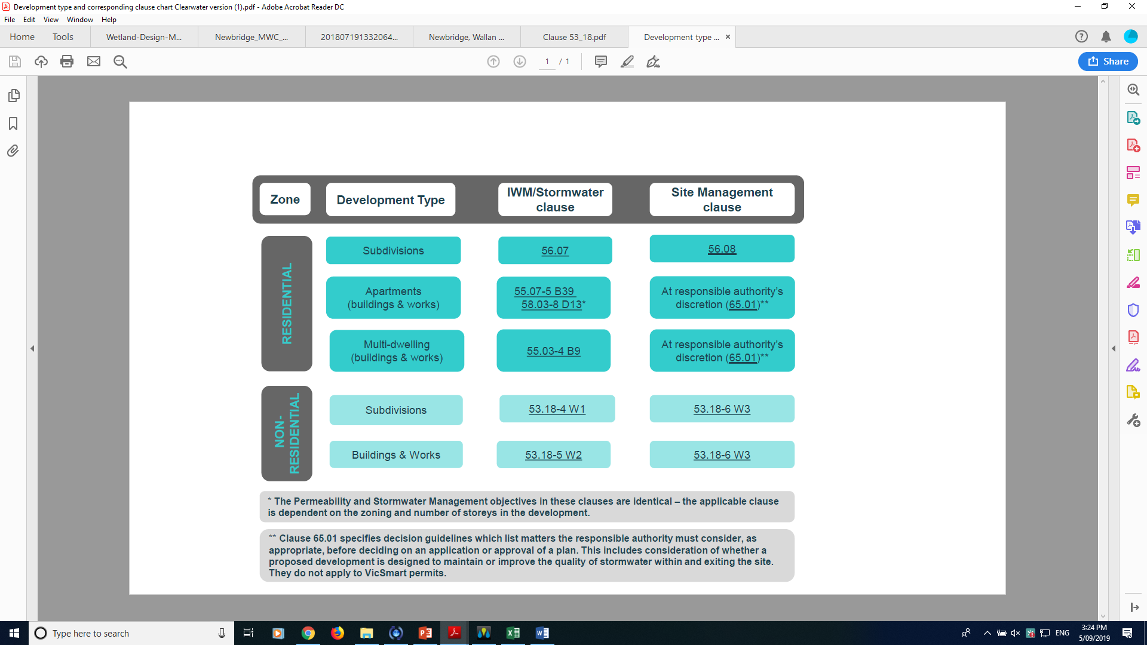

## Objectives of Clause 53.18

### 53.18-4 Stormwater management objectives for subdivision

* To minimise damage to properties and inconvenience to the public from stormwater.
* To ensure that the street operates adequately during major storm events and provides for public safety.
* To minimise increases in stormwater and protect the environmental values and physical characteristics of receiving waters from degradation.
* To encourage stormwater management that maximises the retention and reuse of stormwater.
* To encourage stormwater management that contributes to cooling, local habitat improvements and provision of attractive and enjoyable spaces.

### 53.18-6 Site management objectives

* To protect drainage infrastructure and receiving waters from sedimentation and contamination.
* To protect the site and surrounding area from environmental degradation prior to and during construction of subdivision works.

## Standards

The requirements for Standard W1 and W3 are listed below.

|  |  |  |
| --- | --- | --- |
| CLAUSE | | Standards |
| 53.18-4 | Standard W1:  The stormwater management system should be:   * Designed and managed in accordance with the requirements and to the satisfaction of the relevant drainage authority. * Designed and managed in accordance with the requirements and to the satisfaction of the water authority where reuse of stormwater is proposed. * Designed to meet the current best practice performance objectives for stormwater quality as contained in the *Urban Stormwater - Best Practice Environmental Management Guidelines* (Victorian Stormwater Committee, 1999). * Designed to ensure that flows downstream of the subdivision site are restricted to pre-development levels unless increased flows are approved by the relevant drainage authority and there are no detrimental downstream impacts. * Designed to contribute to cooling, improving local habitat and providing attractive and enjoyable spaces.   The stormwater management system should be integrated with the overall development plan including the street and public open space networks and landscape design.  For all storm events up to and including the 20% Average Exceedance Probability (AEP) standard:   * Stormwater flows should be contained within the drainage system to the requirements of the relevant authority. * Ponding on roads should not occur for longer than 1 hour after the cessation of rainfall.   For storm events greater than 20% AEP and up to and including 1% AEP standard:   * Provision must be made for the safe and effective passage of stormwater flows. * All new lots should be free from inundation or to a lesser standard of flood protection where agreed by the relevant floodplain management authority. * Ensure that streets, footpaths and cycle paths that are subject to flooding meet the safety criteria da Vave< 0.35m2/s (where da = average depth in metres and Vave = average velocity in metres per second).   The design of the local drainage network should:   * Ensure stormwater is retarded to a standard required by the responsible drainage authority. * Ensure every lot is provided with drainage to a standard acceptable to the relevant drainage authority. Wherever possible, stormwater should be directed to the front of the lot and discharged into the street drainage system or legal point of discharge. * Ensure that inlet and outlet structures consider the effects of obstructions and debris build up. Any surcharge drainage pit should discharge into an overland flow in a safe and predetermined manner. * Include water sensitive urban design features to manage stormwater in streets and public open space. Where such features are provided, an application must describe maintenance responsibilities, requirements and costs.   Any flood mitigation works must be designed and constructed in accordance with the requirements of the relevant floodplain management authority. | |
| **53.18-6** | **Standard W3:**  An application should describe how the site will be managed prior to and during the construction period and may set out requirements for managing:   * Erosion and sediment. * Stormwater. * Litter, concrete and other construction wastes. * Chemical contamination. | |

All applications must be accompanied by details of the proposed stormwater management system, including drainage works and retention, detention and discharges of stormwater to the drainage system.

Worked example

The stormwater management strategy presented by the applicant should provide all the information listed in the checklist.

This example is conceptual level and focuses on the elements required to satisfy the relevant criteria of Clauses 53.18-4 and 53.18-6 (standards W1 and W3) only. Councils will require further engineering detail and proof of calculation (generally through a functional design report) for aspects of the stormwater network design than presented here. The schematic is not intended as an accurate representation of all other planning requirements for a development of this nature.

Information requirements regarding the delivery of the Water Sensitive Urban Design (WSUD) measures (including Quality Assurance and hold points, contractual details, and staging details indicating timing of drainage works relating to subdivision build, etc.) will vary depending on the site location. Within the Melbourne Water region, these are covered through the relevant Development Services Scheme (DSS), where applicable. Sites outside DSS areas will need to check the requirements of their local authority.

## A: Proposed development description

The developer is proposing a subdivision and development of eight industrial parcels within a 11.4ha site. The site is located within an approved Precinct Structure Plan. The site context for this subdivision is shown in **Figure 1** and **Figure 2**.

**Figure 3** and **Figure** **8** contain further site layouts.

The east draining portion of the greater development contains the proposed parcels 1 to 8. The west catchment contains future stages and is not the subject of this report. This catchment currently drains down a steep valley escarpment to a flood refuge pocket of a nearby creek (given the fictional name ‘Disappearing Creek’ in this example).

The topography of the area is characterised by highly undulating profile and steep waterway valley escarpments. The high value creek escarpment and (fictionally named) Flora and Fauna Reserve National Park borders the site to the east. The creek, and its tributaries, have been identified as having significant geomorphologic and vegetation values, with many reaches subject to a significant increased risk of erosion in the post development scenario. Measures incorporated into the stormwater management design mitigate the risk of waterway erosion and enhance the environmental values of the waterways and their escarpments.

There are no direct downstream landholders that may be affected by increased frequency or magnitude or runoff, so no permissions details are included here. The development outflows are managed by a constructed wetland as further discussed below.

|  |
| --- |
| A: Proposed development description |
| * **A1**: Describe the proposed development e.g. describe the site context, relevant design considerations and environmental controls, land use, etc. * **A5**: Description of outfall and management of downstream impacts, i.e. flooding and frequent flows, and requirement for affected landowner acceptances. |

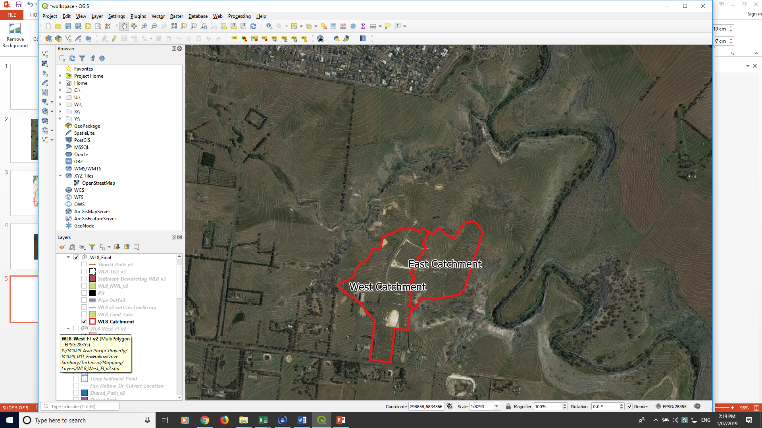

Figure 1: Subdivision site greater context – East Catchment

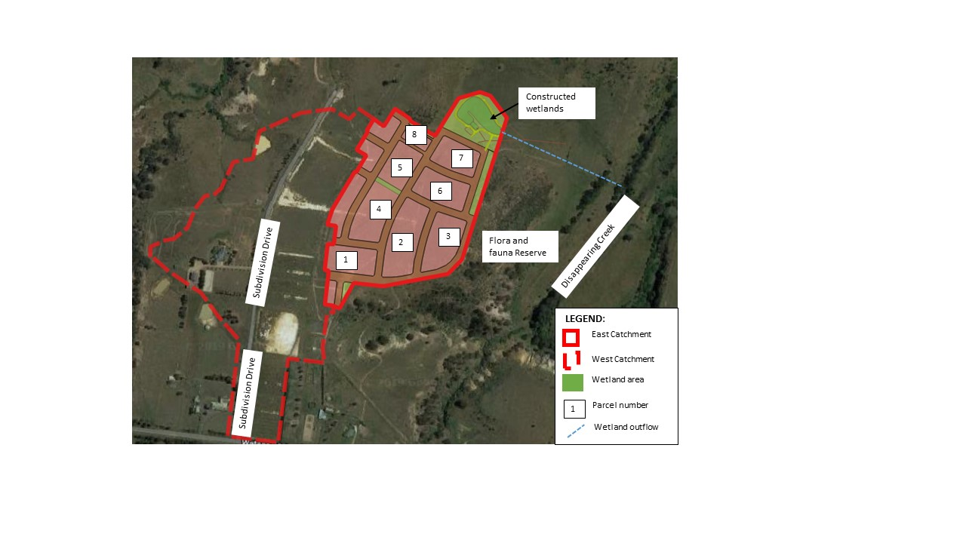

Figure 2: Proposed subdivision layout – East Catchment (*note: all names used are fictional*)

|  |
| --- |
| A: What is proposed? |
| * **A2**: Site layout plan, including sub-divided lots and location of WSUD. |

A summary of the catchments and the proposed land use is provided in **Table 1** and **Figure 2**:

Table 1: Land use summary

| Land use summary | Catchment area (ha) | Fraction impervious |  |
| --- | --- | --- | --- |
| Industrial | 7.4 | 0.75 |  |
| Open space | 0.5 | 0.1 |  |
| Road reserve | 3.5 | 0.6 |  |
| **TOTALS** | 11.4 | 68% |  |

### 

### What is proposed?

### Design response summary

The strategy for servicing future development of the subject land will consist of:

* Underground pipe drainage system for conveyance of low flows;
* Roadways, a culvert crossing and waterway tributaries for conveyance of high flows;
* All stormwater from industrial lots managed for toxicants and industrial pollutants to EPA best practice standards;
* Stormwater quality treatment for whole of subdivision catchment runoff in constructed wetlands;
* Streetscape tree plantings to create a cooler, more aesthetically pleasing urban landscape;
* Wetlands with landscaping to provide amenity and cooler urban landscapes;
* Outfall works consisting of pipes, pits and diversion structures;
* Interim works may be required to service development stages until such a time that ultimate works are delivered.

|  |
| --- |
| A: What is proposed? |
| * **A3**: Summary table of land use, catchment area and fraction impervious. * **A4**: Descriptive summary of design response. |

### Design response plan

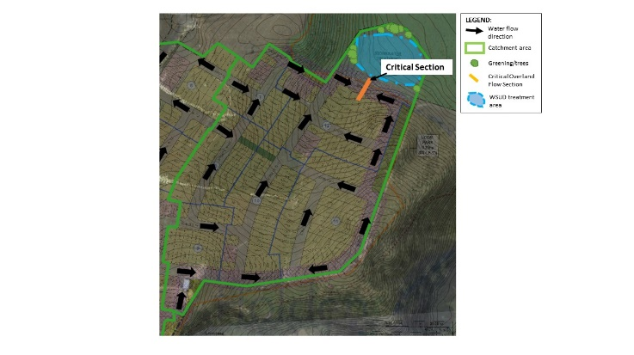

Figure 3: Design response plan

|  |
| --- |
| B: Hydraulic calculations |
| * **B4:** Design response plan showing, flow paths and critical infrastructure. * **B5:** The design of the local drainage network should: * Ensure stormwater is retarded to a standard required by the responsible drainage authority. * Ensure every lot is provided with drainage to a standard acceptable to the relevant drainage authority. * Ensure that inlet and outlet structures consider the effects of obstructions and debris build up. Any surcharge drainage pit should discharge into an overland flow in a safe and predetermined manner. * Include water sensitive urban design features to manage stormwater in streets and public open space. Where such features are provided, an application must describe maintenance responsibilities, requirements and costs. |

## B: Hydrology and hydraulics

The flows generated by the catchment which drain to the treatment wetland for both pre and post developed conditions are based on the Rational Method formula and ARR 2016 IFDs. A summary of the flows for a range of storm events is provided in **Table 2** and calculations are provided in the accompanying Functional Design Report (*note: these are standard engineering requirements and therefore are expected to be included in a report but are not included in this example*). These values are used throughout this document to inform design and assessment.

Table 2: Catchment flow summary

| Location | Development | AEP | Flow, m3/s |  |
| --- | --- | --- | --- | --- |
| **Proposed WL (catchment outlet)** | Pre | 1% | 0.53 |  |
| Post | 1% | 3.53 |  |
| 20% | 1.40 |  |
| 4EY | 0.34 |  |

### Minor drainage system

The minor drainage system has been designed in accordance with the requirements of Council and will consist of a subsurface pipe network designed to capture and convey all stormwater runoff generated from the catchment for rainfall events up to and including the 20% Annual Exceedance Probability (AEP) design storm for lot and road catchments. Terrain and surface modelling has been undertaken to ensure all areas within the development are drained up to the 20% AEP event, with pipe networks achieving required grade and cover throughout and no ponding on roads occurs. Modelling has used conservative assumptions to account for blockages and debris. Details of the pipe network modelling and surface model can be seen in the calculations in the accompanying Functional Design Report (*note****:*** *these are standard engineering requirements and therefore are expected to be included in a report but are not included in this example*).

|  |
| --- |
| B: Hydraulic calculations |
| * + - **B1:** Provide a description of calculation methodology and assumptions. * **B2**: Provide a summary of design flows used for system design. * **B3**: Describe the design to meet minor drainage system standard of: ‘For all storm events up to and including the 20% Average Exceedance Probability (AEP) standard: * Stormwater flows should be contained within the drainage system to the requirements of the relevant authority. * Ponding on roads should not occur for longer than one hour after the cessation of rainfall. |

### Major drainage system

The primary objective of the major drainage system is to provide flood protection for the allotments based on the 1% AEP storm event and to ensure the overland flow can be safely conveyed through the development.

### Overland flow paths

Flows up to and including the 1% AEP storm event are managed throughout the site via a series of overland flow paths. Road reserves are to be designed to safely convey the gap flow in accordance with DELWP’s overland flow flood safety criteria.

The Melbourne Water website gives guidance on appropriate flood safety criteria to adopt for residential streets acting as an overland flow path. The applicable criteria are:

1. da Vave  must be less than 0.35m;
2. da must be less than 0.3m

where Vav and da is the average velocity and average depth of flow through the critical road cross section, respectively.

The critical road cross sections and direction of overland flows are identified in **Figure 3** above. The critical road cross sections are selected based on where the gap flow is expected to be greatest. This approach ensures the most conservative results when assessing against floodway safety criteria.

A typical 16m wide road cross section has been created in HEC-RAS[1] with a Manning’s roughness coefficient of 0.02 for the roadway and 0.05 for nature strip. A 3.5m wide single lane road pavement is assumed for each direction with an average crossfall of 5% and kerb height of 180mm. A longitudinal grade of 1% is assumed. Adoption of this sample road geometry is considered very conservative for assessing floodway safety criteria as the actual road cross sections are likely to be considerably larger.

|  |
| --- |
| B: Hydraulic calculations |
| * **B6**: Describe the design to meet major drainage system standard of: ‘For storm events greater than 20% AEP and up to and including 1% AEP standard: * Provision must be made for the safe and effective passage of stormwater flows. * All new lots should be free from inundation or to a lesser standard of flood protection where agreed by the relevant floodplain management authority. * Ensure that streets, footpaths and cycle paths that are subject to flooding meet the safety criteria da Vav< 0.35m2/s (where da = average depth in metres and Vave = average velocity in metres per second). |

### Overland flood way - critical section

The identified critical road cross section for the catchment draining to the wetland is proposed as a standard 16m wide road cross section. The peak 1% AEP flow at this location will not exceed 3.53m3/s. The underground pipe drainage system is sized to convey the 20% AEP flow of 1.4m3/s, leaving a maximum of 2.13m3/s overland flow. **Figure 4** shows the results of the HEC-RAS model.

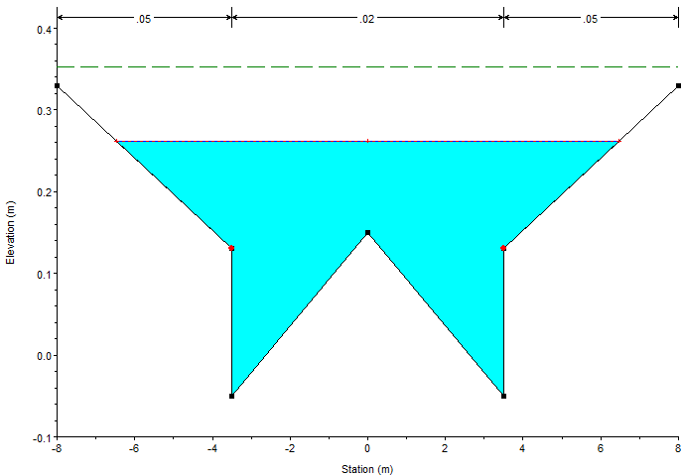

Figure 4: Critical road cross section 2 results

The calculated values for cross section 2 are:

* Flow depth = 0.26m
* Flow velocity = 1.13m/s
* Depth x velocity = 0.29m2/s

Therefore, all flood safety criteria are met for the east draining portion of the subject site.

.

|  |
| --- |
| Relevant links  * Guidelines for Development in Flood Affected Areas (DELWP) - refer Section 8 ‘Flood Safety’: <https://www.water.vic.gov.au/__data/assets/pdf_file/0025/409570/Guidelines-for-Development-in-Flood_finalAA.pdf>   The following (or similar) software may be used to perform design checks on critical sections:   * PC-Convey (Integrity Software): <http://www.integritysoftware.com.au/> * <HEC-RAS> (US Army Corps of Engineers Hydrologic Engineering Center) <https://www.hec.usace.army.mil/software/hec-ras/download.aspx>) |

### Requirements for retardation

As per the Precinct Structure Plan, no flood retarding basins are required to service development of the subject site. This is due to substantial flood flow capacity available in the receiving waterways of the creek.

Detention of regular flow events will be provided via extended detention in the proposed wetland. This detention, along with regular flow bypass pipes, ensures the risk of erosion to local waterway tributaries is maintained to an acceptable level and ecological values are maintained and enhanced where possible. This is addressed in detail below.

No retardation basins or stormwater harvesting is proposed for this development and all design has been carried out according to the requirements of the relevant authorities.

.

|  |
| --- |
| B: Hydraulic calculations |
| * **B7:** Provide a description of design to meet standard requirement: ’Designed to ensure that flows downstream of the subdivision site are restricted to pre-development levels unless increased flows are approved by the relevant drainage authority and there are no detrimental downstream impacts’. * **B8:** Statement of stormwater compliance: ‘Designed and managed in accordance with the requirements and to the satisfaction of the relevant drainage authority’. * **B9:** Statement of re-use compliance ‘Designed and managed in accordance with the requirements and to the satisfaction of the water authority where reuse of stormwater is proposed’. |

## C: Design for cooling and amenity

The streetscape design includes a minimum of one canopy tree per lot frontage, which is designed to contribute to nearby cooling, providing local habitat to encourage wildlife and providing attractive and enjoyable spaces for the workers in the subdivision, in line with urban greening targets.

The wetlands at the north-eastern corner of the development, are designed to meet the water quality improvement targets, but also to act as an aesthetically pleasing community space. This element of the stormwater management system will be integrated with the overall development through landscape design, walkways and seating and tables – to provide a cool green urban space where people can enjoy lunch or a break.

## D: Design for best practice stormwater quality improvement

Under Clause 53.18-4, development is required to be designed to meet the current best practice performance objectives for stormwater quality as contained in the *Urban Stormwater - Best Practice Environmental Management Guidelines* (Victorian Stormwater Committee, 1999) (BPEM). BPEM is currently defined as post-development reductions in the following contaminants:

* Total suspended solids (TSS) – 80%
* Total phosphorus (TP) – 45%
* Total nitrogen (TN) – 45%
* Litter – 70%

The proposed ultimate stormwater quality treatment works consist of a constructed wetland as shown in **Figure 5** below.

|  |
| --- |
| C: Cooling and amenity |
| * **C1:** Describe design contribution to local cooling, improving local habitat outcomes and providing attractive/ enjoyable spaces, and integration with open space and landscape design. |

|  |
| --- |
| D: Design for BPEM for stormwater quality improvement |
| * **D1:** Designed to meet the current best practice performance objectives for stormwater quality as contained in the Urban Stormwater - *Best Practice Environmental Management Guidelines* (Victorian Stormwater Committee, 1999).  . |

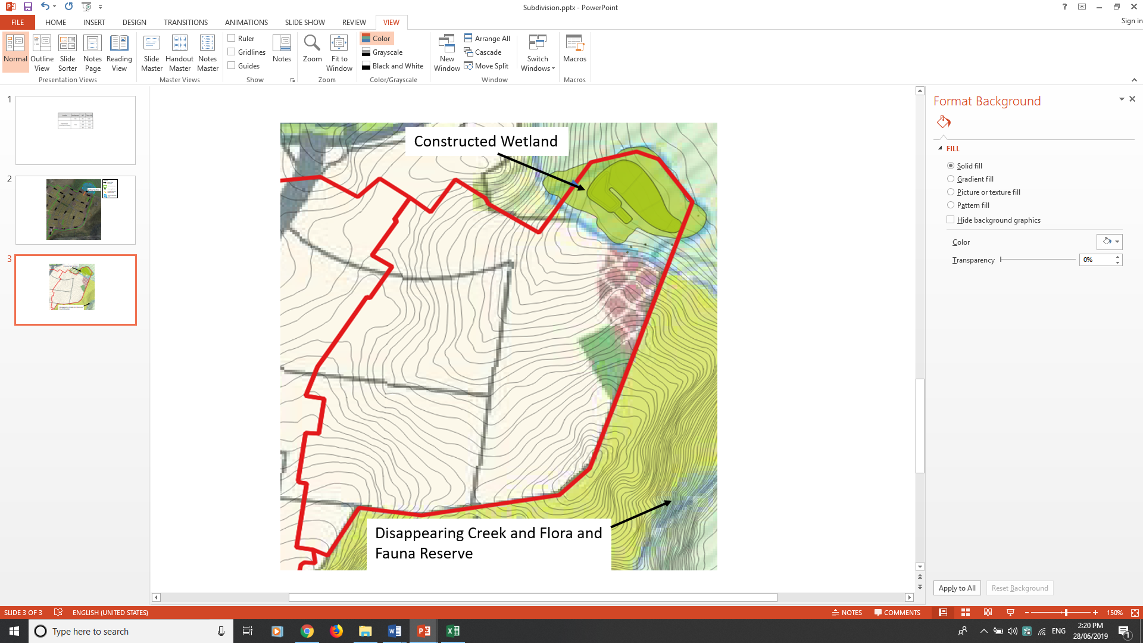

Figure 5: Constructed wetland location

|  |
| --- |
| D: Design for BPEM for stormwater quality improvement |
| * **D2:** Site plan showing location of WSUD infrastructure. |

### Stormwater quality modelling

The treatment of the catchment runoff is achieved by construction of a treatment wetland within the area shown in **Figure 5**. A preliminary functional design of the proposed wetland asset has been completed. Calculations and MUSIC modelling was undertaken to size the treatment components and configure the layout of the asset. The design meets all functional requirements specified in Melbourne Water’s Constructed Wetlands Design Manual (2016).

Performance of the wetland with regards to meeting BPEM requirements is verified by the associated MUSIC model. An earthworks model has been produced in 12D to verify the asset footprint and includes consideration of batters back to natural surface level at a maximum 1 in 5 slope. Care has been taken to ensure an efficient treatment asset is proposed that:

* Provides adequate treatment to meet all BPEM target reductions;
* Services the whole catchment to the asset, including future development of adjacent land;
* Maximises the adjacent property owners’ developable area; and
* Meets the objectives of the relevant Precinct Structure Plan.

|  |
| --- |
| Relevant links  * MUSIC software (eWater): <https://ewater.org.au/products/music/> * MUSIC Guidelines (Melbourne Water): <https://www.melbournewater.com.au/sites/default/files/2018-02/Music-tool-guidelines-2018.pdf> |

|  |
| --- |
| D: Design for BPEM for stormwater quality improvement |
| * **D3:** Description of modelling approach. * **D4:** Table of MUSIC model inputs. |

The MUSIC model treatment performance for the wetland is shown in **Table 3** below.

Table 3: MUSIC modelling compliance results

|  | Sources | Residual load | % Reduction |
| --- | --- | --- | --- |
| **Flow (ML/yr)** | 57.6 | 51.9 | 10 |
| **Total suspended solids (kg/yr)** | 11400 | 2260 | 80.2 |
| **Total phosphorus (kg/yr)** | 23.4 | 7.06 | 69.8 |
| **Total nitrogen (kg/yr)** | 163 | 80 | 50.9 |
| **Gross pollutants (kg/yr)** | 2280 | 28.4 | 98.8 |

**Table 4** shows design features of the wetland with associated calculations and further detailed specifications in the accompanying Functional Design Report. The design plan for the wetland asset is shown in the functional design section.

Table 4: Wetland WL2 Design Summary

| Wetland design parameters | | | | | |
| --- | --- | --- | --- | --- | --- |
| Total footprint area | | 1.4 | | Ha | |
| Catchment area | | 11.4 | | Ha | |
| **Inlet pond** | | | | | |
| Normal Water Level (NWL) | | 170.95 | | m AHD | |
| Top Extended Detention (TED) | | 171.3 | | m AHD | |
| Inlet pond volume | | 150 | | m3 | |
| Inlet surface area | | 200 | | m2 | |
| Permanent Pond Depth, Dp | | 1.5 | | M | |
| **Macrophyte zone** | | | | | |
| Normal Water Level (NWL) | 170.95 | | m AHD | |
| Top Extended Detention (TED) | 171.3 | | m AHD | |
| Macrophyte zone treatment area | 4000 | | m2 | |
| Permanent Treatment Depth, Dp | 0.4 | | M | |
| Shallow marsh area | 1773 | | m2 | |
| Deep marsh area | 1588 | | m2 | |
| Deep pool area | 882 | | m2 | |

|  |
| --- |
| D: Design for BPEM for stormwater quality improvement |
| * **D5:** MUSIC treatment performance results that meets best practice performance for stormwater pollutant load reductions: TSS 80%; TP 45%; TN 45%; Litter 70%. * **D6**: Tabulated WSUD asset design parameters. * **D7**: Check MUSIC file using the MUSIC auditor (https://www.musicauditor.com.au/). * **D8**: The applicant should submit a copy of the MUSIC file (.sqz) used to generate treatment performance. |

The BPEM design response assumes that detailed responses for the management of toxicants generated from the individual lots is dealt with in the detailed design for each lot. It is therefore assumed that runoff from the development site treated by the wetland can be considered to have the same pollutant characteristics of an average urban catchment.

All toxicants are isolated from interaction with runoff through the use of roofing, bunding, capture and disposal – as per the following diagram:

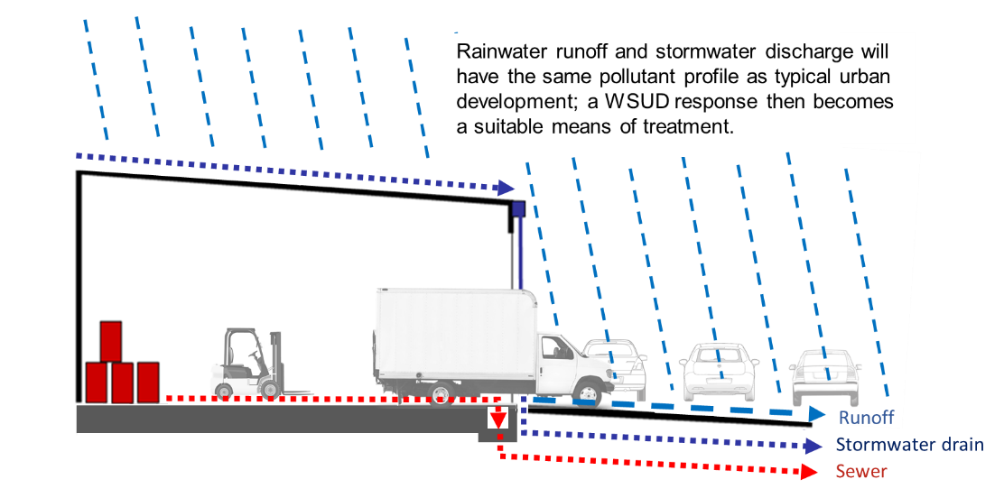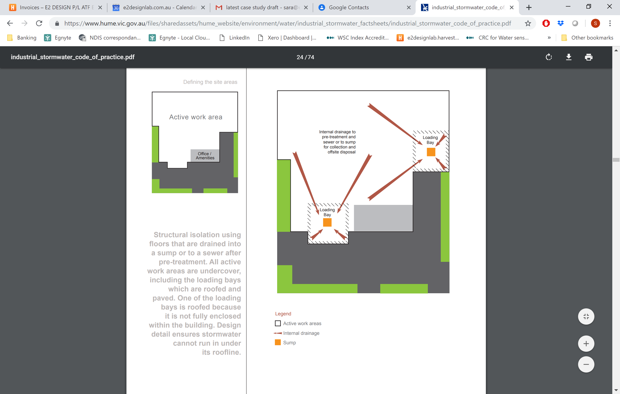

Figure 6: Structural isolation design for management of industrial toxicants

|  |
| --- |
| Relevant links  * WSUD Engineering Procedures Stormwater (Melbourne Water): <https://www.publish.csiro.au/book/4974/#contents> * Infrastructure Design Manual (IDM) (Local Government Infrastructure Design Association): <https://www.designmanual.com.au/download-idm> * Trees for Cooler and Greener Streetscapes - Guidelines for Streetscape Planning and Design (DELWP) <https://www.planning.vic.gov.au/policy-and-strategy/planning-for-melbourne/plan-melbourne/cooling-greening-melbourne/trees-for-cooler-and-greener-streetscapes> * Designing for a cool city – Guidelines for passively irrigated landscapes (CRC for Water Sensitive Cities): <https://watersensitivecities.org.au/content/designing-for-a-cool-city-guidelines-for-passively-irrigated-landscapes/>   A useful reference for suitable streetscape WSUD plant species is Moreland City Council’s *WSUD streetscape raingarden and tree pit design package* (refer to *Planting Palette Extract*) located at:   * <https://www.moreland.vic.gov.au/environment-bins/environment/water/wsud-design-package/>   As part of the assessment of the planning application the assessor should review the MUSIC file submitted.   * The MUSIC Auditor tool can be accessed at: <https://www.musicauditor.com.au/>   In order to use the MUSIC Auditor tool:   * Register as a user or login at <https://www.musicauditor.com.au/user/register> * Create a summary report from your MUSIC model – find help on how to do this at <https://musicauditor.com.au/FAQ> * Upload your summary report file by using the ‘Choose File’ radio button and press ‘Submit’. * Download the pdf report to review. |

## E: Concept design considerations

Note: This is not a functional design report. Concept and functional design details of varying levels will be required by different approval authorities. These may be submitted with the planning application, or else the information is to be provided as a condition of permit. Check with your approval authority for advice on which applies.

Note: Under Clause 53.18 all applications must be accompanied by details of the proposed stormwater management system, including drainage works and retention, detention and discharges of stormwater to the drainage system.

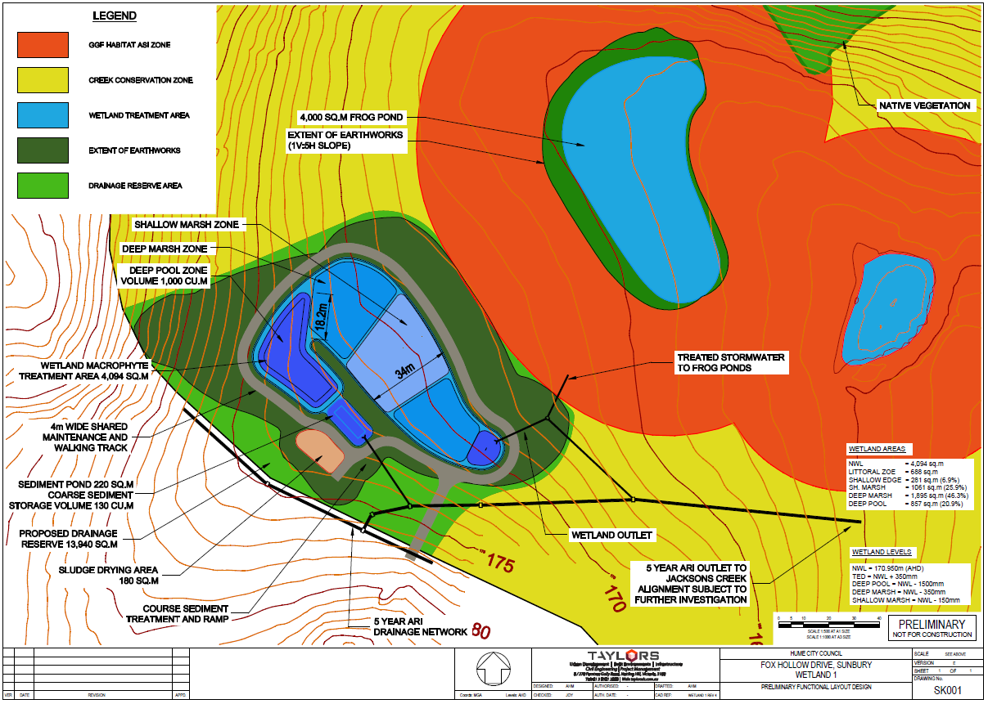

**5-YEAR ARI OUTLET TO CREEK**

Figure 7: Wetland concept design plan

|  |
| --- |
| E: Functional design considerations |
| * **E1:** Plan showing asset functional detail as required by permit, including: WSUD system elements, relationship between the development, local drainage system, and WSUD system, space requirements (including impact on dedicated open space and landscaping areas). * **E2:** Plan showing hydraulic function; e.g. low flow flow-path and high flow diversion, control and management of velocities and erosion risk to receiving drainage system downstream. |

Table 5: Plant species preferences

| Recommendations for plant types* | |
| --- | --- |
| **Ephemeral batter** | *Baumea rubiginosa* (Soft Twig-rush) *Carex appressa* (Tall Sedge) *Juncus flavidus* (Yellow Rush) *Poa labillardierei* (Common Tussock) *Lomandra longifolia* (Spiny-headed Matt-rush) |
| **Shallow marsh** | *Bolboschoenus medianus* (Marsh Club-rush) *Eleocharis acuta* (Common Spike-rush) *Schoenoplectus tabernaemontani* (River Club-rush) |
| **Deep marsh** | *Baumea articulata* (Jointed Club-rush) *Bolboschoenus medianus* (Marsh Club-rush) S*choenoplectus tabernaemontani* (River Club-rush) |

For a development of this size a density of 2-6 plants/m2 is proposed. For purposes of aesthetics other species may also be used to add variety. The planting list in the Melbourne Water *Constructed Wetland Design Manual* should be used to develop a planting list with species, the wetland zone and planting densities all summarised within a table.

|  |
| --- |
| Relevant links  * [WSUD Engineering Procedures: Stormwater](https://www.publish.csiro.au/book/4974) (CSIRO): <https://www.publish.csiro.au/book/4974/#contents> * Constructed Wetland Design Manual (Melbourne Water): <https://www.melbournewater.com.au/building-and-works/developer-guides-and-resources/standards-and-specifications/constructed-wetlands> * Functional Design guidance (Melbourne Water):  <https://www.melbournewater.com.au/planning-and-building/stormwater-management/functional-design> * Standard drawings and guidelines (Melbourne Water):  <https://www.melbournewater.com.au/planning-and-building/developer-guides-and-resources/guidelines-drawings-and-checklists> * Infrastructure Design Manual (IDM) (Local Government Infrastructure Design Association): <https://www.designmanual.com.au/download-idm> |

|  |
| --- |
| E: Site management plan |
| * **E3:** Plan to indicate any structural issues, consideration for public safety, and maintenance requirements (e.g. access for staff/ machinery, slope). * **E4:** Levels for each WSUD treatment including surface level, extended detention depth, filter layers and depth, under drain systems, levels of inlet and outlet structures. (refer to Functional Design Report). * **E5:** Plant species and planting densities to be used in any vegetated treatment systems. |

## F: Site management plan – interim works

All construction activities relating to subdivision development will be carried out under the guidance of a detailed interim site management plan (an excerpt is included below). Consideration has been given to protecting downstream waterways from sediment and topsoil that may leave the site during construction due to wind, rainfall and runoff.

Site management plans help you record the way you manage risk and may help with your planning. If a pollution incident happens, they may also help demonstrate to Environment Protection Authority (EPA) Victoria what steps you have taken to meet your [general environmental duty](https://www.epa.vic.gov.au/about-epa/laws/new-laws/general-environmental-duty) (from 1 July 2021) by reducing or eliminating the risk of harm to human health and the environment. The EPA Victoria website also provides information about following a risk-based approach to preventing and minimising impacts from erosion and sedimentation.

Development progress and asset delivery timing has been considered to ensure that interim and ultimate works are delivered to meet stormwater conveyance, retention and treatment requirements in line with construction activity. It is proposed to stage the construction of the wetland system in line with development progress. This ensures that adequate treatment of stormwater is achieved both during and after construction of the proposed industrial estate, protecting the receiving waterway and downstream system from excessive erosion risk and pollutant loads, as well as protecting the wetland from excessive sediment loads during build out of the subdivision.

It is intended that the vegetated wetland be completed (excavated and planted out) only after 75% of on lot building and works are completed. Each lot is bound by Clause 53.18-5 (Stormwater management objectives for buildings and works) which requires a site construction plan for the minimisation of sediment and erosion risk.

The interim drainage solution diverts the low flows generated by the development (up to 1EY) into the sediment basin (using the location and excavation for the proposed constructed wetland for treatment). High flows (>1EY) exit the sediment pond via a high flow bypass pipe into Disappearing Creek. This arrangement is considered appropriate for the timescale of the build out (proposed to be less than 1 year) remembering that flow retardation criteria are not required for this outfall. **Figure 8** represents the location and layout of the interim sedimentation basin. The full site risk assessment and interim design response is included in the Functional Design Report (not included in this example).

References to templates are listed in the reference box at the end of this section.

|  |
| --- |
| F: Site management plan |
| * **F1:** Statement outlining the construction measures to protect the receiving environment during the construction phase. |

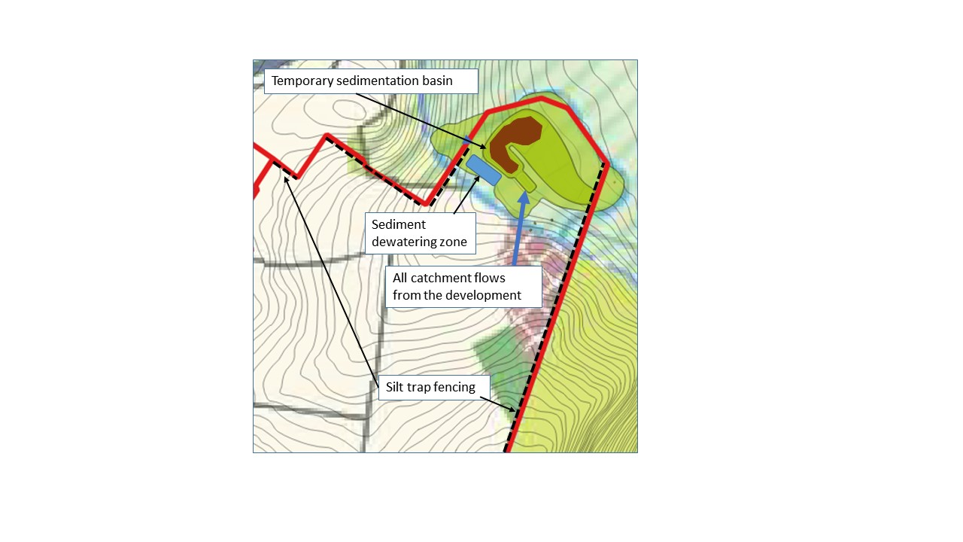

Figure 8: Temporary retarding basin and sediment treatment

### Sedimentation basin sizing

A sediment pond is located temporarily in the base of the proposed wetland to remove coarse sediments generated by the development. The sediment pond is sized using the Fair and Geyer Equation and will remove at least 95% of coarse sediments from the 4EY flow. Design calculations are provided below. The cost of constructing and maintaining these works is to be borne by the developer and will enable the developer to progress with development whilst ensuring adequate protection is provided to the receiving waterways.

|  |
| --- |
| F: Site management plan |
| * **F2:** Construction measures shown on a plan. |

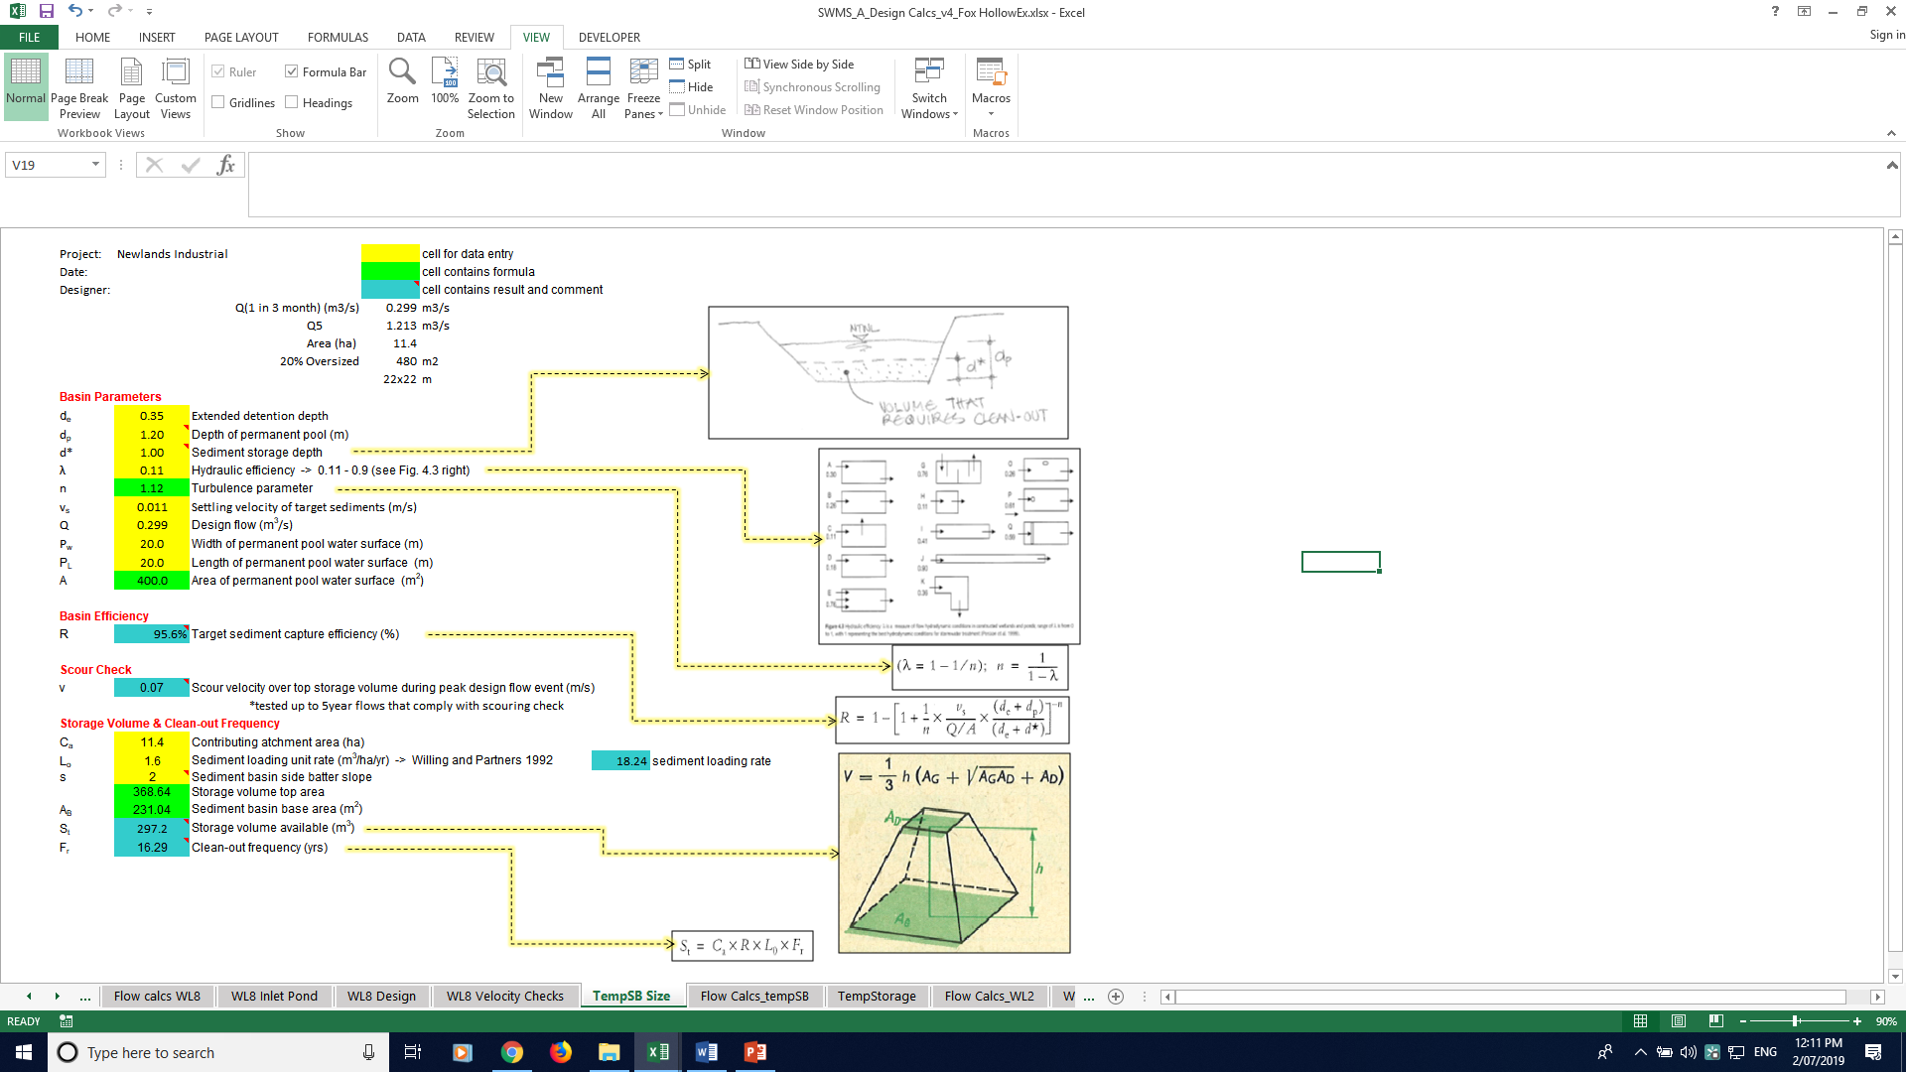

Figure 9: Design calculations for sedimentation basin sizing

|  |
| --- |
| F: Site management plan |
| * **F3:** Design calculations showing sedimentation basin sizing. |

|  |
| --- |
| Relevant links For larger scale developments (10 or more dwellings or over 1000m2), consider developing a site management plan that addresses environmental risk, or an Environmental Management Plan (EMP) – guidelines are available at:   * Environmental Management Plan Guidelines (Commonwealth of Australia): <https://www.environment.gov.au/system/files/resources/21b0925f-ea74-4b9e-942e-a097391a77fd/files/environmental-management-plan-guidelines.pdf>   Other useful resources include:   * Site Environmental Management Plan kit (Melbourne Water): <https://www.melbournewater.com.au/planning-and-building/developer-guides-and-resources/standards-and-specifications/develop-site> * Guidance on reducing erosion and sedimentation risk (EPA Victoria): <https://www.epa.vic.gov.au/for-business/find-a-topic/erosion-and-sediment/advice-for-businesses> * Assessing and controlling risk: A guide for business – EPA publication 1695 (EPA Victoria): <https://www.epa.vic.gov.au/about-epa/publications/1695-1> This guide is also available in languages other than English. * Construction techniques for sediment pollution control – EPA publication 275 (EPA Victoria): <https://www.epa.vic.gov.au/about-epa/publications/275> * Construction – Guide to preventing harm to people and the environment – EPA publication 1820 (EPA Victoria):   [https://www.epa.vic.gov.au/about-epa/publications/1820](https://www.epa.vic.gov.au/about-epa/publications/1820%0d)  Outlines how to manage risks in construction, provides an outline of your legal obligations, what actions you can take to comply with the new laws, and contains a list of common hazards and information about how to manage waste. The guide does not tell you about the controls to put in place to suit your circumstances.   * Civil construction, building and demolition guide – EPA publication 1834 (EPA Victoria):   <https://www.epa.vic.gov.au/about-epa/publications/1834>  Supports industry to eliminate or reduce the risk of harm to human health and the environment through good environmental practice. It provides an overview of the duties under the new laws, outlines a risk based approach for assessing and managing risks, and includes information on controls that you can put in place to manage your risks. |

## G: Asset maintenance program

An asset maintenance program is a requirement under this standard. Different councils may require different levels of detail regarding maintenance; including inspection of WSUD assets, schedule of maintenance, and responsibilities (i.e. depending on the development arrangement it may be future tenants, owner/body corporate, Council or other authority, etc.). In order to protect our waterways and enhance the function, aesthetics and amenity associated with WSUD, it is important that these assets are maintained so they continue to operate as designed.

**Figure 10** below indicates the key elements to be regularly inspected and maintained in the treatment wetland.

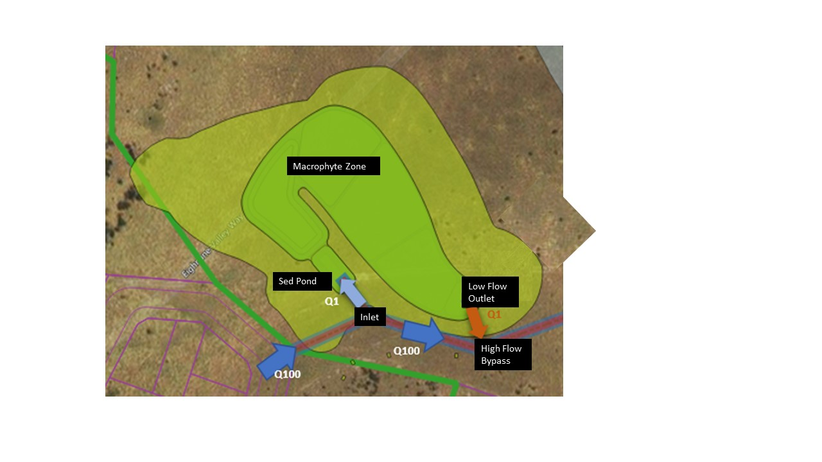

Figure 10: Wetland maintenance requirements

|  |
| --- |
| G: Asset maintenance program |
| * **G1:** A clear diagram with labels to identify key elements to be regularly inspected and maintained.   + **G2:** A checklist summarising key treatment elements, and inspection and maintenance tasks and frequency.   + **G3:** Outline of who is going to own and maintain the WSUD assets and the associated costs.   + **G4**: Detail regarding asset handover arrangements, where appropriate, including defect liability and timeframes. |

The constructed wetland asset will be owned and operated by Council after the defects liability period is satisfactorily completed. **Table 6** below summarises the inspection and maintenance tasks and frequency for the on-going maintenance of the wetland.

Useful reference material regarding construction checklists, hold-points, asset handover and maintenance scheduling are included at the end of this section.

Table 6: Maintenance tasks and frequency (adapted from Melbourne Water’s [Constructed Wetland Maintenance Checklist](https://www.melbournewater.com.au/media/664/download): <https://www.melbournewater.com.au/media/664/download)>

| Inspection task | Frequency (post defects liability period) | Maintenance action required |
| --- | --- | --- |
| Litter accumulation within gross pollutant trap (cleanout required)? | Every 3 months | Cleanout as required |
| Sediment accumulation at inflow points? | Every 6 months | “ |
| Sediment accumulation within inlet zone (record depth, remove if > 2/3 full)? | Every 6 months | “ |
| Litter or debris within inlet structure? | Every 6 months | “ |
| Litter within inlet or aquatic plant (macrophyte) zone? | Every 6 months | " |
| Overflow structure integrity satisfactory? | yearly | Repair as required |
| Outlet structure free of debris? | Every 6 months | Cleanout as required |
| Maintenance drain operational? | yearly | “ |
| Settling or erosion of bunds or batters present? | yearly | Track changes to determine the cause, remediate as required |
| Terrestrial vegetation condition satisfactory? (density, weeds, disease, pest infection, stunted growth or dead plants) | Every 6 months | Weeding, replanting, report any issues with vegetation or pests, develop a remediation plan and execute over time |
| Aquatic vegetation condition satisfactory? (density, weeds, disease, pest infection, stunted growth or dead plants) | Every 6 months | “ |
| Replanting required? | Every 6 months | “ |
| Evidence of damage or vandalism? | yearly | Report and repair |
| Evidence of dumping (building waste, oils etc.) | yearly | “ |
| Evidence of algal scums? | yearly | Track changes to determine the cause , remediate as required |
| Evidence of odours? | yearly | “ |

An in-depth inspection and maintenance checklist is included in the Appendices.

Within the defects liability period, the construction contractors (the proponents of the application) will be responsible for all maintenance tasks. Within this period, all maintenance inspections (and subsequent actions) shall occur at a minimum frequency of once every three months. This is particularly important in the establishment phase for vegetation to ensure dead plants are replaced quickly so weeds do not have a chance to dominate. The defects liability period will last one year from practical completion of the wetland construction. Within this period, the wetland should be proven to be operating successfully according to design, without defects, before handover to Council ownership occurs.

Prior to the full plant out of the wetland, the excavation will serve as a sediment basin to protect downstream waterways. Within this time period, it is the responsibility of the proponent to ensure maintenance of the sediment basin and sediment removal occurs at a frequency to successfully protect downstream waterways from sediment loads. The cleanout frequency is dictated by the design as well as feedback from inspections. This is described further in the ‘Interim Design’ section in this example.

*Note: Where stormwater treatment assets are proposed to remain in private ownership, it is suggested that councils recommend to property owners that they record the location and details of their buried on-site stormwater devices and attach it to property title documents. Councils should also consider recording information about the location of buried stormwater infrastructure on private land where required as part of a planning permit, to support future asset management and/or enforcement.*

|  |
| --- |
| Relevant links  * WSUD Maintenance Guidelines (Melbourne Water): <https://www.melbournewater.com.au/media/636/download> * WSUD Audit Guidelines (Stormwater Victoria): <https://www.musicauditor.com.au/node/36> * Construction and Handover - hold points information (Melbourne Water): <https://www.melbournewater.com.au/planning-and-building/stormwater-management/construction-and-handover> * WSUD Maintenance resources (Blacktown City Council): <https://www.blacktown.nsw.gov.au/Plan-build/Stage-2-plans-and-guidelines/Developers-toolkit-for-water-sensitive-urban-design-WSUD/WSUD-maintenance-resources> |

delwp.vic.gov.au

1. HEC-RAS is the Hydrological Engineering Center River Analysis System.