Water for Victoria
WATER PLAN

The Premier of Victoria
The Minister for Water
Water is central to every community, powering our industries and economy, improving our quality of life, and nurturing our natural environment.
Over the past 18 months, the Victorian Government has been talking and working with communities around Victoria to understand what they want to see from a future of a sustainable and secure water supply.
Victoria has a long and proud history of effectively managing our water resources, particularly through the years of the Millennium Drought. Now we are facing increasing pressure on our water supplies from climate change and a growing population.
Over the long term, climate change will mean more extreme climatic events, less rainfall, and potentially 50 per cent reduction in streamflow by 2065. Victoria’s population will almost double by 2051 placing further demand on scarce water resources. Our challenge is to do more with less water.
Water for Victoria is our strategic plan for management of our water resources, now and into the future. We will ensure we manage water to support a healthy environment, a prosperous economy and thriving communities.
To meet the challenges of climate change and population growth, the government will take action to ensure that our water system is efficient and innovative.
We will make better use of alternative water resources – like recycled water and stormwater – to reduce the impact on our rivers and environment.
We will recognise that water plays many roles in our communities, and will seek to make the most of our water, including for agriculture, the environment, Aboriginal communities and recreation.
We recognise that water has cultural importance for Traditional Owners and Aboriginal people, and will provide opportunities for greater Aboriginal participation in water planning and management.
I would like to thank the Reference Group, the Stakeholder Group and all Victorians who helped inform the development of Water for Victoria.
By managing water together, we will find smarter ways of ensuring water security for all Victorians.
The Hon. Daniel Andrews MP Premier of Victoria
The Hon. Lisa Neville MP Minister for Water

ABORIGINAL ACKNOWLEDGEMENT
The Victorian Government proudly acknowledges Victoria’s Aboriginal community and their rich culture and pays respect to their Elders past and present.
We acknowledge Aboriginal people as Australia’s first peoples and as the Traditional Owners and custodians of the land and water on which we rely. We recognise and value the ongoing contribution of Aboriginal people and communities to Victorian life and how this enriches us. We embrace the spirit of reconciliation, working towards the equality of outcomes and ensuring an equal voice.

CONTENTS

1. Sharing Victoria’s water 5
2 Climate change 26
3. Waterway and catchment health 37
4. Water for agriculture 56
5. Resilient and liveable cities and towns 73
6. Recognising and managing for Aboriginal values 84
7. Recognising recreational values 94
8. Water entitlements and planning 103
9. Realising the potential of the grid and markets 122
10. Jobs, economy and innovation 140
Appendix Implementation plan 154
Appendix Key Victorian Government initiatives 164
Glossary 166
Endnotes 173

1. Sharing Victoria’s water

VISION
Water is fundamental to our communities. We will manage water to support a healthy environment, a prosperous economy and thriving communities, now and into the future.
Water is absolutely critical to our economy, environment and our communities. A healthy environment and safe, affordable and reliable water services are essential for people, jobs and a thriving economy.
Water is a primary input to a range of industries, including agricultural production, aquaculture, manufacturing and processing, and the energy and mining sectors. Agriculture is the largest water user in the state and a major employer in regional Victoria. The state’s primary production of food and fibre is worth $12.6 billion per year (2013-14). The food and fibre industry chain, including farms and factories, employs over 190,000 people.
The water industry itself is a large sector in the Victorian economy and provides almost 6,000 jobs in its own right.
Significantly, water provides an opportunity to improve the wellbeing and economic self-determination of the Traditional Owners of our land. Of course, a healthy environment underpins healthy and prosperous communities.
For each and every one of us, access to safe and reliable drinking water supplies and sanitation is critical for our health. Water also supports community wellbeing, keeping our trees and gardens alive, our sporting fields and parks green, and providing a multitude of water-related recreational opportunities.
Victoria is a vibrant, attractive place to live, to work and to visit, but we face two big challenges – climate change and population growth. Victoria is becoming warmer and drier, and is now the fastest growing state in the nation. Already there is less water available and most water resources are at their sustainable limits.
The impacts of climate change are likely to be felt most intensely by the people in our communities who can least afford to bear them.
So we are planning a future with less water, and reduced reliance on traditional drinking water sources. We are preparing Victoria for the decades to come, acting now, building on past experience and making a leap into new, smarter ways of doing more with less, and importantly, bringing all of the community with us. We will make the right decisions to meet everyone’s needs.
Community expectations have changed, which is why Water for Victoria considers all values of water. Communities expect healthy rivers, lakes and bays and they want to enjoy these places for recreation, particularly at priority sites, as do the many visitors to our state. The viability of industries, particularly the agriculture, manufacturing, energy and mining industries depends on water. Victorians want liveable cities and towns with trees and green spaces to cool the urban landscape. Traditional Owners want their values of water to be recognised and expect to be involved in planning and management. Aboriginal Victorians also seek opportunities for economic development as part of self-determination.
Water for Victoria is a plan for everyone.

Victoria’s climate change adaptation plan for water
Water for Victoria is the Victorian Government’s adaptation response to the impacts of climate change on our water resources and on the availability of water in the future. These impacts are set out in Figure 1.1.
Victoria’s temperature has steadily increased since the 1970s and overall streamflows have decreased by around 50 per cent or more over the last 20 years. In recent years, we have had low rainfall overall and catchments are dry. The Millennium Drought brought with it a seasonal shift in rain toward less rainfall during the cooler times of the year, April to October, when runoff is greatest and our storages usually fill. Climate science predicts this is the new reality with more extreme events likely to happen too, such as floods and droughts and bushfires.
In Australia, we accept that drought is part of life and many parts of Victoria have experienced drought conditions over the past decade. The Millennium Drought was a wake-up call for many Victorians about taking water for granted, the importance of water security and the need to build resilience to drought. The Millennium Drought’s severity has been linked to human-induced climate change¹.

A growing population
In 2015, Victoria became the fastest growing state in Australia. Victoria’s population is projected to reach 10.1 million people by 2051 – almost double what it is today.² Figure 1.2 sets out the distribution of population growth in the next few decades. Melbourne and the major regional centres Ballarat, Bendigo and Geelong are expected to almost double. The western suburbs of Melbourne will have an extra 1 million people. This population growth increases the demand for water, and rapid urbanisation increases stormwater, which adversely impacts our waterways unless it’s treated and used.
Figure 1.1 – Aspects of climate change adaptation for the water sector
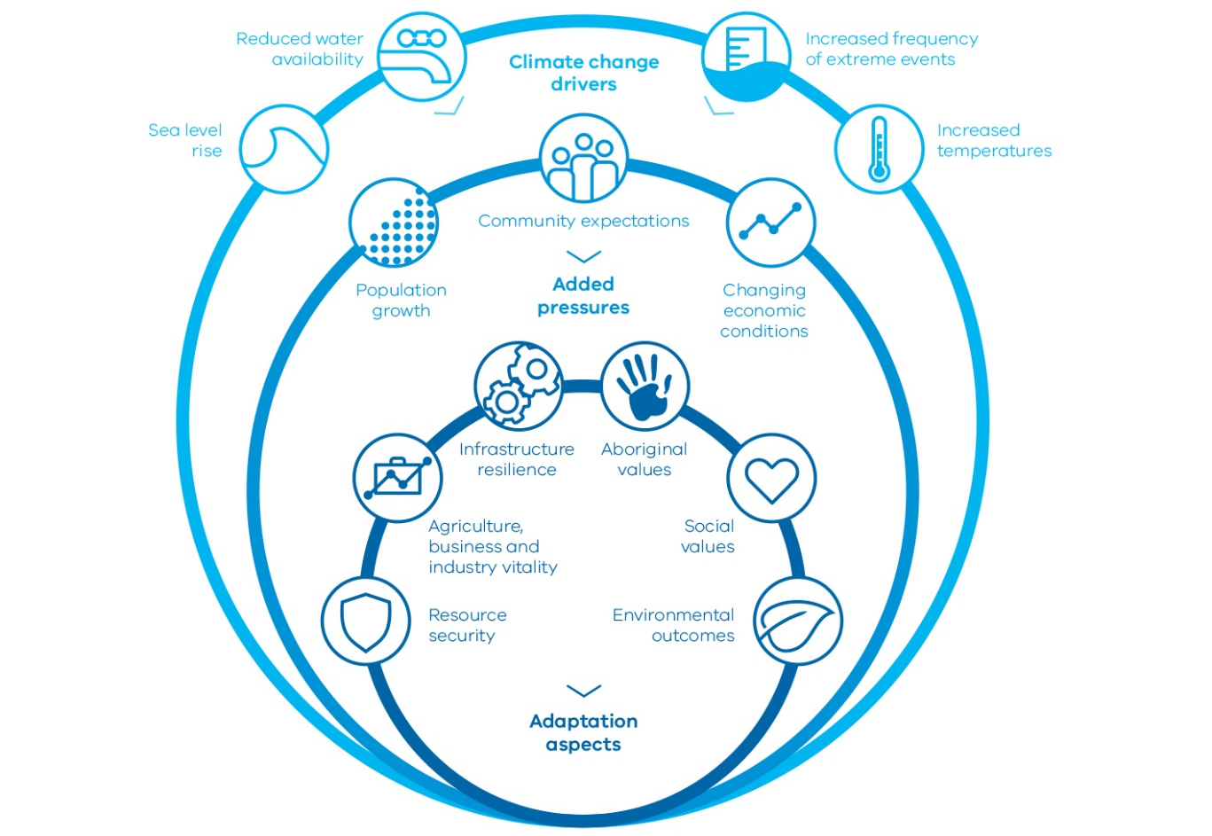

Climate change drivers
Sea level rise
Reduced water availability
Increased frequency of extreme events
Increased temperatures

Added pressures
Population growth
Community expectations
Changing economic conditions

Adaptation aspects
Resource security
Agriculture, business and industry vitality
Infrastructure resilience
Aboriginal values
Social values
Environmental outcomes
Figure 1.2
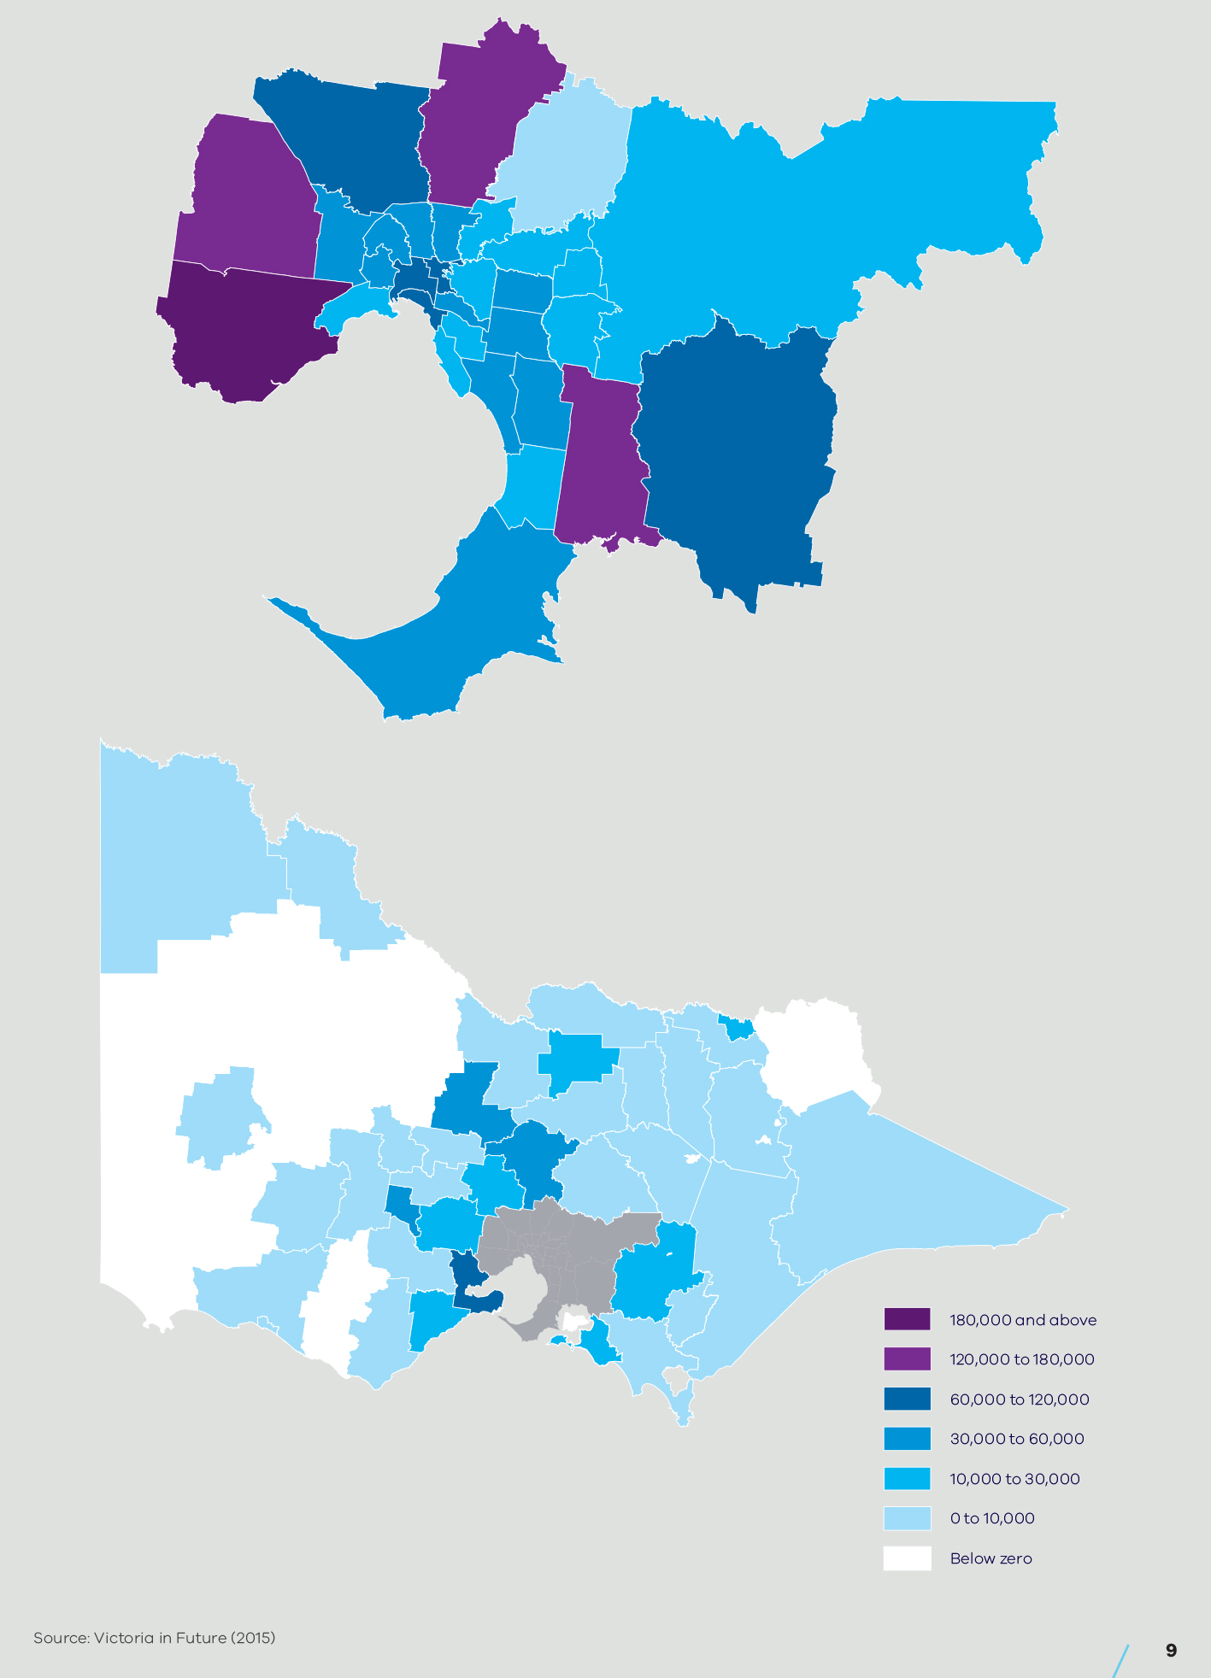

What we have learned from the Millennium Drought
Victorians learned many hard lessons during this drought – the most severe drought experienced in Victoria in over 200 years.
It drove home that climate is variable and we can’t rely on the past 100 years of rainfall patterns to estimate future water availability.
To industry and communities, it piqued increased interest in using alternative sources of water. It devastated some rural businesses and farming enterprises; some farmers mitigated the damage by using water markets to trade water; others contracted their businesses, waiting it out. It put enormous stress on some of our water catchments and waterways. Some ecosystems are yet to fully recover.
Victoria’s water grid was rapidly expanded in response to the very real prospect of towns running out of water. For example, the Goldfields Superpipe ensured that Bendigo and Ballarat met basic water needs. The Victorian Desalination Project was commissioned and now provides security for Melbourne.
Water restrictions tested cities and towns and impacted on community morale as trees died, gardens and parks dried up, and sports fields became unusable.
The Millennium Drought also led to positive changes in water management. For example, it transformed industries and management practices – practices that endure and provide a sound platform for adapting to future climatic uncertainties. The experience of managing through the drought served to reinforce the relevance of Victoria’s water entitlements and planning framework. We learned important lessons too about collaboration and sharing water under extreme conditions.

How we will do it
To meet the challenges of climate change and population growth, the government is taking action so that our water system is modern and efficient, innovative, future-focused and affordable.

Modern and efficient
The government is investing significantly to protect the health of our waterways, through riparian works and investments in water efficiency projects that mean less water is taken from our environment. Our modern and efficient water system will make better use of alternative, fit-for-purpose supplies, including recycled water and stormwater, to reduce our call on rivers and to protect our environment. The Victorian Desalination Project also ensures that as Melbourne continues to grow, or as we experience prolonged dry conditions, water is taken from the sea, not from our waterways.
This Water for Victoria plan is the government’s climate change adaptation plan for the state’s water. Water corporations will also lead the way in climate change mitigation, pledging clear and sustainable pathways to net-zero greenhouse gas emissions.
Through water markets, the infrastructure connecting many parts of the state will enable, within practical bounds, water to be moved around to where it is most needed.
The water sector must understand the customers and community that it serves. Government will be looking for water corporations, catchment management authorities and the Victorian Environmental Water Holder to bring the community closer to decision- making. This will be achieved by better understanding the services the community wants, what the community is willing to pay for, and where the community is willing to make trade-offs.
Farming is a competitive business, efficiency is essential. There’s a trend for fewer farmers operating larger farms, producing more in both dryland and irrigated agriculture. Local communities benefit where development occurs but they’re required to adapt where production falls.
Victoria’s agricultural production will continue to grow despite water scarcity. We will continue to work with rural and regional communities to enable agricultural development and to support change.
It is also important that our water corporations and catchment management authorities reflect the communities they serve. It is for this reason that the government is taking active steps to ensure gender equity and cultural diversity within these institutions. Water corporations and catchment management authorities will also explore new ways to contribute to economic self-determination for Traditional Owners and Aboriginal Victorians.
The government has committed to invest strategically to deliver real change on the ground.

Innovative
Victoria’s water sector will continue its focus on innovation.
Our water corporations and catchment management authorities will work collaboratively with local government and the private sector so that suburbs of the future are resilient and liveable in the face of climate change, drought and other extreme events.
Victoria will continue to invest in climate and water research to identify trends and ensure that we are ready to meet future challenges.
We will foster a culture of innovation by making more information available to the community to reveal future opportunities. The right information will be shared with the right people at the right time.
Community expectations about access to information have changed – people want information quickly.This trend is likely to continue as digital technologies develop. The water sector will deliver more timely and user-friendly reporting about water management so that communities can better understand what we’re doing and why. New technologies and pathways such as apps on digital devices can provide timely and targeted information.
Victoria’s expertise in water resource management is well regarded internationally. We will look for opportunities to export our growing expertise. Partnerships between the public sector, including the water corporations and catchment management authorities, and the private sector will be required to realise these opportunities. This will position Victoria for a future where the efficient use of water becomes a growing industry, creating new and sustainable jobs for Victorians.
Innovation can improve efficiency and can help maintain affordability. Technological innovation will continue to improve service and delivery.
Community engagement and increasing gender equity and cultural diversity in the water sector will help build a culture open to new ideas.

Future-focused
To prepare Victoria for the challenges of climate change and population growth, we must keep our focus on the future. This means being prepared for a range of possible climate futures and being able to adapt quickly and effectively when faced with unexpected events.
We will take a long-term view of our resources and understand that we must take action to adapt in the face of a diminishing resource. Our planning processes will allow sufficient time to explore all options and we will meaningfully engage the community.
We will also keep an eye to short-term emerging trends and risks to identify the next water supply augmentation before crisis hits.
We will strengthen Victoria’s water entitlements and planning framework so we can adapt to changing water availability and the changing values of water. In doing so, we will maintain the existing legal rights and obligations of entitlement holders. Our robust framework will continue to create confidence to support investment.
Within the water entitlements and planning framework, our approach to water management will be open to new ideas. As usual, we will consider environmental, economic and domestic uses of water in our planning, but in a way that delivers broader community benefit such as liveability, recreational and Aboriginal values, now and in future. This will be achieved by sharing the benefits of our limited water resources.

Affordable
Water services must remain affordable for all customers in the face of climate change and population growth. Our modern, efficient, innovative, future-focused approach, together with greater collaboration, an improved governance and performance framework and better community engagement, has been designed to keep our water services affordable.
The governance and regulation of the water sector assures the provision of affordable, high-quality services. The water sector will continue to develop good practice in dealing with hardship, including actions to accommodate situations where domestic violence has created financial insecurity.
The government has also committed to reduce the overall burden of regulation in Victoria by 25 per cent. In line with this, we will identify opportunities to reduce red tape and streamline processes to keep costs down.
We will reduce barriers to agricultural development and adapt irrigation district infrastructure so that it remains affordable and attractive to new business.

Investing in sustainable water management
The Victorian Government has committed to a fourth tranche of the Environmental Contribution to support the delivery of this Water for Victoria plan. The fourth tranche will invest $537 million over four years in initiatives that promote the sustainable management of water or address the environmental impacts associated with water use. There are some unallocated funds.
The 2016-17 Victorian Budget has already allocated $447.5 million of Environmental Contribution investment to a range of programs and projects designed to achieve the objectives of Water for Victoria over the next four years. These include:
- $222 million to improve the health of waterways and catchments
- $59.6 million to support irrigation modernisation projects and help irrigators improve on-farm water use
- $58 million for rural water system upgrades in Wedderburn, Werribee and Bacchus Marsh
- $25 million to prepare Victorians for floods and emergencies
- $4.7 million to ensure Aboriginal values and knowledge are included in Victoria’s water management
- $14.1 million in additional funding to deal with rising groundwater in Bendigo
- $30 million to extend the water grid in South Gippsland
- $33 million to invest in practical programs to kick- start improvements to how we use Victoria’s water resources, such as preparing for climate change and drought, better water resource information and assessment, improving urban water management, the use of the water grid, and better recognising recreational water values.
Together with the $20 million committed from the Agriculture Infrastructure and Jobs Fund for further modernisation of Macalister Irrigation District, this brings the total 2016-17 Budget allocation for water programs and infrastructure to $468 million.
We now have a blueprint for further investment in sustainable water management. The progressive delivery and implementation of the objectives and actions in this plan over the next four years will be supplemented by the further allocation of remaining Environmental Contribution funding through state budget processes.
Improved governance, monitoring, evaluation and reporting of Environmental Contribution expenditure will ensure that investments are strategically targeted to achieve maximum benefits and the objectives of Water for Victoria.

Victoria’s water entitlements and planning
Victoria’s robust water entitlement framework is established under the Water Act 1989 and provides the basis for how our water resources are shared.
The framework is set out in Figure 1.3 and has developed over time to allow specified private rights to take and use water, with the government retaining the overall right to the use, flow and control of Victoria’s surface water and groundwater resources. The key elements of the entitlement framework are:
- secure entitlements with tenure that is certain and protected, including bulk entitlements, environmental entitlements, water shares, section 51 licences, and contractual agreements to supply
- limits on water entitlements, that is, specified volumes, extraction rates and locations, diversion rules and sharing arrangements
- seasonal water allocation rules that respond to water availability over time
- clear consultative processes before entitlements can be changed
- ability to trade, using markets to facilitate efficient movement of water, giving users the flexibility to buy and sell water
- private rights (section 8) enabling individuals to take water for domestic and stock purposes in certain circumstances without a licence.
One of the key principles of the water entitlement framework is that individual entitlement holders are responsible for managing the risks of water scarcity within their own contexts and systems.
Figure 1.3 – Management of the water entitlement framework
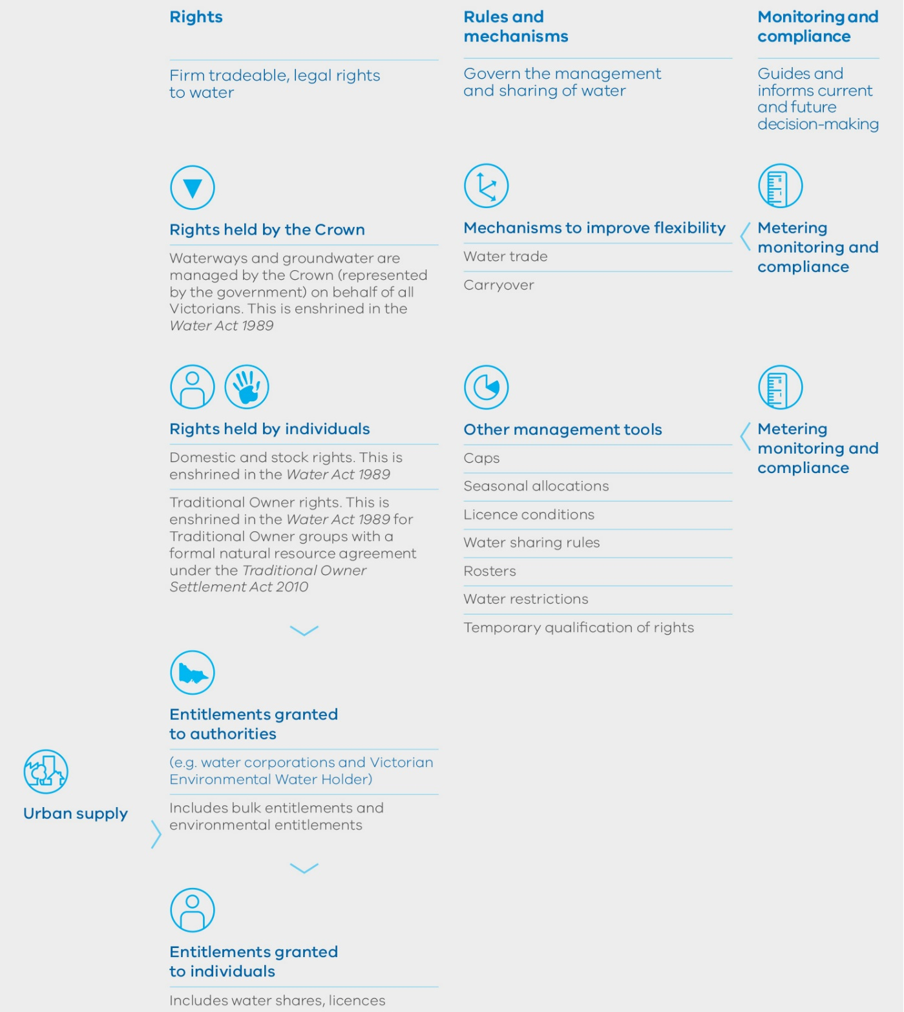

Rights (Firm tradeable, legal rights to water)
- Rights held by the Crown
- Waterways and groundwater are managed by the Crown (represented by the government) on behalf of all Victorians. This is enshrined in the Water Act 1989
- Rights held by individuals
- Domestic and stock rights. This is enshrined in the Water Act 1989
- Traditional Owner rights. This is enshrined in the Water Act 1989 for Traditional Owner groups with a formal natural resource agreement under the Traditional Owner Settlement Act 2010
- Entitlements granted to authorities (e.g. water corporations and Victorian Environmental Water Holder)
- Includes bulk entitlements and environmental entitlements
- Entitlements granted to individuals
- Includes water shares, licences

Rules and mechanisms (Govern the management and sharing of water)
- Mechanisms to improve flexibility
- Water trade
- Carryover
- Other management tools
- Caps
- Seasonal allocations
- Licence conditions
- Water sharing rules
- Rosters
- Water restrictions
- Temporary qualification of rights

Monitoring and compliance (Guides and informs current and future decision-making)
- Metering monitoring and compliance
- Metering monitoring and compliance

Sharing the benefits of our limited water resources
The water sector will work with communities and other agencies to explore opportunities to maximise shared or complementary benefits of all water uses, without compromising the needs of the environment, agriculture, towns and businesses.
By sharing benefits from the storage, delivery and use of water, we can optimise a limited resource and meet some of the objectives of key groups in the community, such as Traditional Owners and Aboriginal Victorians, and recreational users.
Figure 1.4 sets out the shared benefits concept. For example, water corporations will consider shared benefits in storage management and river operation decisions, and catchment management authorities and the Victorian Environmental Water Holder will consider shared benefits in environmental watering decisions. Environmental watering in Victoria inherently provides shared benefits because improving the condition of a waterway benefits all uses of the waterway.
Through consistent two-way community engagement, the water sector will understand the values and uses of water that may be achieved through shared benefits. Where significant trade-offs are required, the options should be considered in a sustainable water strategy.
Water corporations, catchment management authorities and the Victorian Environmental Water Holder will report annually on outcomes achieved through shared benefits.
Figure 1.4 – Shared benefits
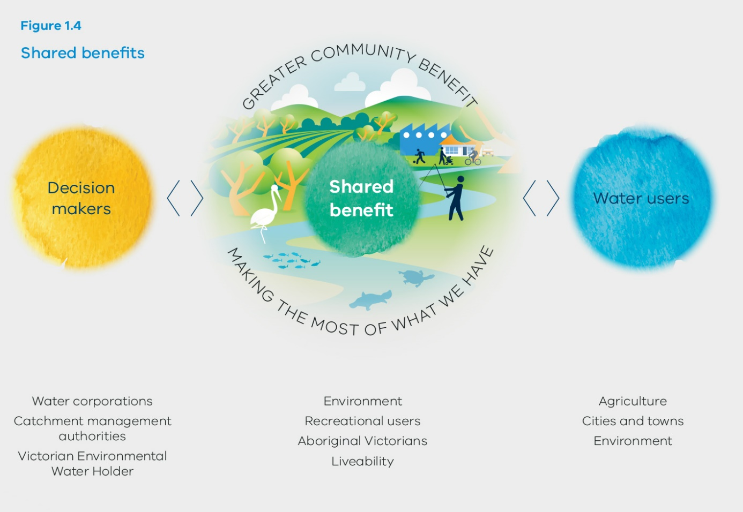

Greater Community Benefit – Making the Most of What We Have
- Decision makers
- Water corporations
- Catchment management authorities
- Victorian Environmental Water Holder
- Shared benefit
- Environment
- Recreational users
- Aboriginal Victorians
- Liveability
- Water users
- Agriculture
- Cities and towns
- Environment

Water sector institutional arrangements
Water makes an important contribution to the economy of Victoria. We have an obligation to ensure the costs of water services remain affordable and meet the needs of our communities.
Under the Water Act 1989, rural water corporations are required to provide irrigation, drainage and storage services. These services are critical for agricultural water users and underpin on-farm investment decisions. They are also responsible for administering the diversion of water from waterways and the extraction of groundwater on behalf of the Minister.
Urban water corporations manage water resources and deliver water supply and sanitation services within our cities and towns. Ninety-five per cent of total water corporation expenditure is spent by the urban water sector to provide these services. The forecast growth in urban population will increase pressure on our existing water systems, placing growing demand on current assets, infrastructure, water supply and wastewater services.
The Victorian Environmental Water Holder relies on the services of storage managers to deliver environmental water where it is required.
We must make the best use of our existing infrastructure, that capital and operational investment is appropriate to meet current and future challenges, and that the water sector, on behalf of its customers, is managing risks appropriately, without over or under investing in water infrastructure.
The Victorian economic regulation framework, established under the Essential Services Commission Act 2001 and the Water Industry Act 1994, guides water corporation pricing and investment decisions. This economic regulatory framework is overseen by the Essential Services Commission. The quality of water supplied by water corporations is independently regulated by the Department of Health and Human Services in accordance with the Safe Drinking Water Act 2003 and the environmental performance of water corporations is independently regulated by the Environment Protection Authority Victoria in accordance with the Environment Protection Act 1970.
Victoria has a well-established catchment management framework to conserve our environment while maintaining and increasing productivity from our land and water resources. The Catchment and Land Protection Act 1994 is the legislative basis for catchment management in Victoria.
It provides for 10 catchment management authorities across the state that each develop a regional catchment strategy for their area. It also establishes the Victorian Catchment Management Council to advise on state-wide matters.
Figures 1.5, 1.6 and 1.7 show the urban and rural water corporation and catchment management authority boundaries.
Figure 1.5 – Urban water corporations
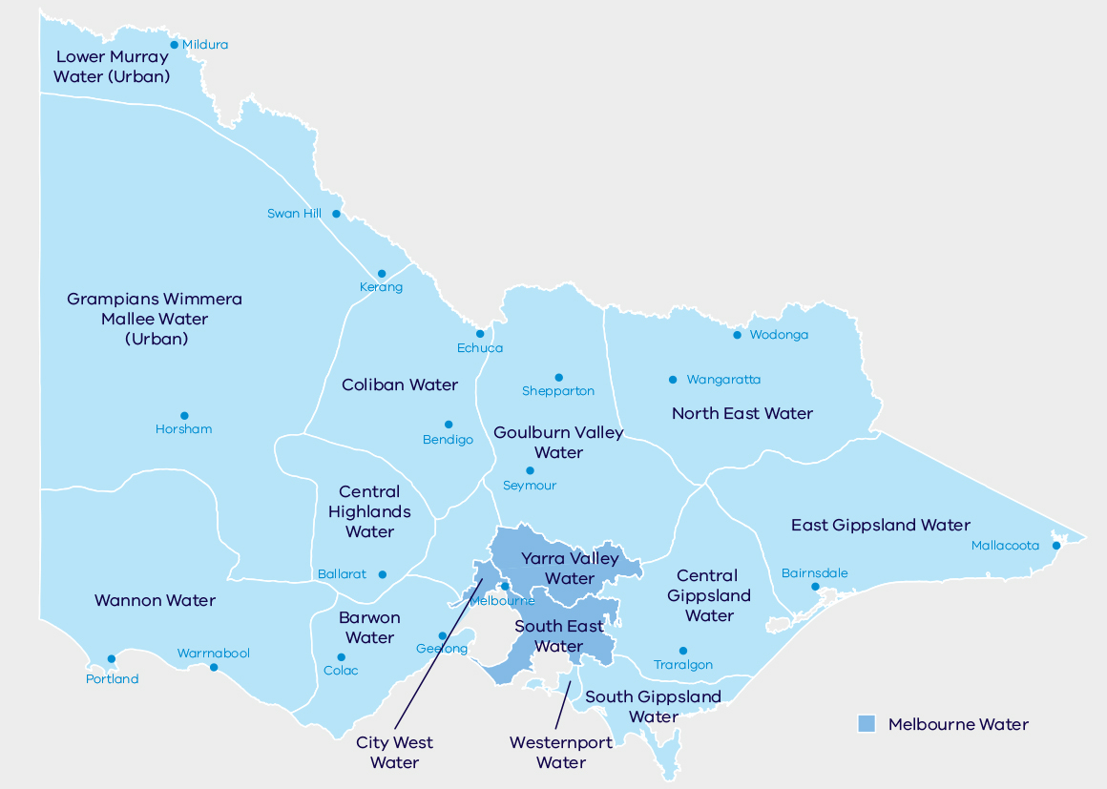
- Grampians Wimmera Mallee Water (Urban)
- Wannon Water
- Coliban Water
- Central Highlands Water
- Barwon Water
- Goulburn Valle Water
- North East Water
- East Gippsland Water
- Central Gippsland Water
- South Gippsland Water
- City West Water
- Yarra Valley Water
- South East Water
- Westernport Water
Figure 1.6 – Rural water corporations
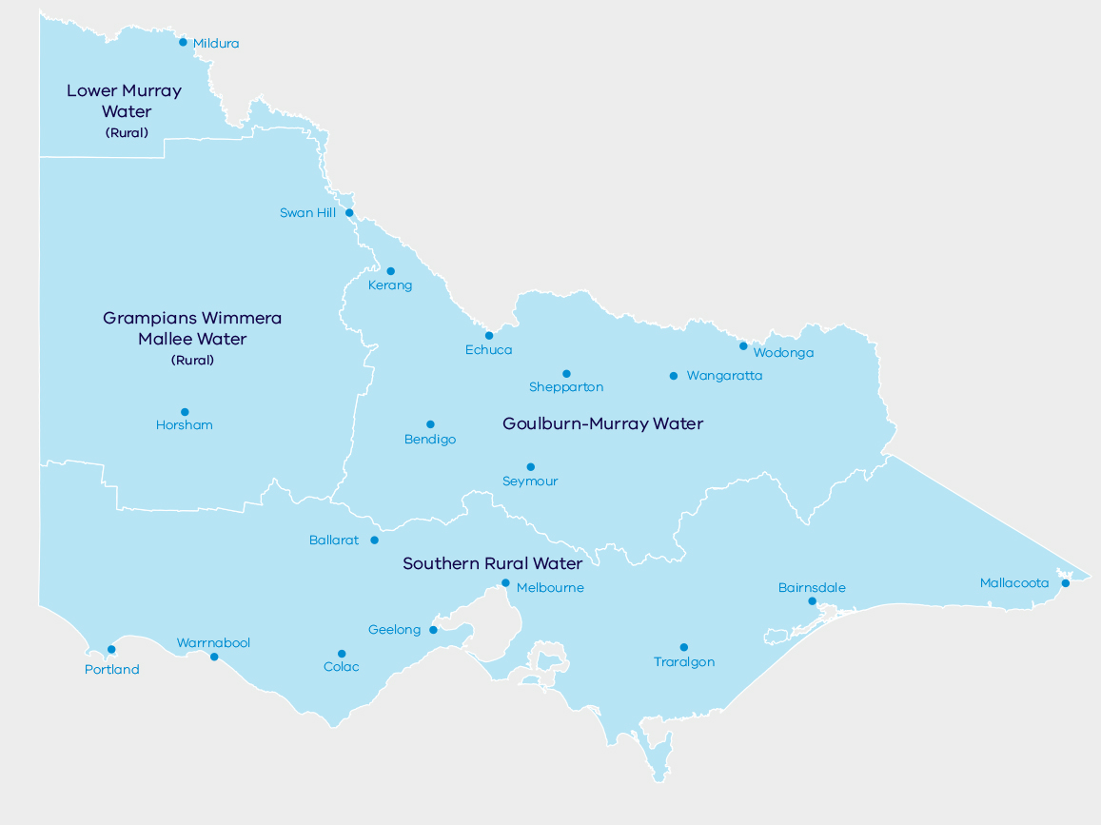
- Lower Murray Water (Rural)
- Grampians Wimmera Mallee Water (Rural)
- Goulburn-Murray Water
- Southern Rural Water
Figure 1.7 – Catchment management authorities
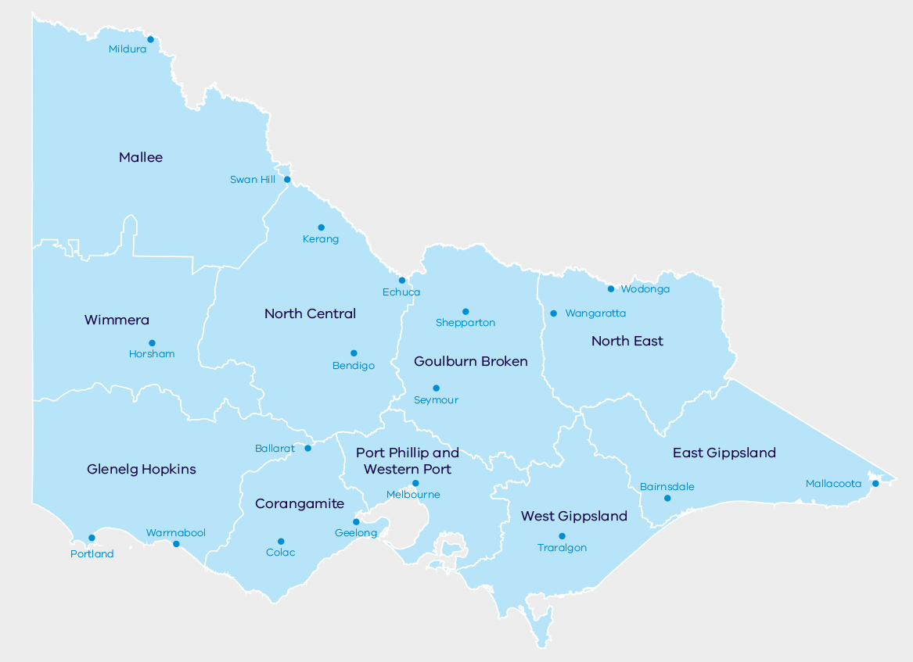
- Wimmera
- North Central
- Goulburn Broken
- North East
- East Gippsland
- West Gippsland
- Port Phillip and Western Port
- Corangamite
- Glenelg Hopkins

The way forward – managing water together
Our challenge, and our opportunity, is to do more with less water and to reduce our reliance on traditional water sources.
The government will partner with the community, industries, business, the Traditional Owners, non- government organisations and the private sector to deliver better results for everyone.
Together, we will build the capacity and capability of the Victorian community to engage in an ongoing conversation about water. Open, transparent and accessible information will be crucial.
Everyone has a role to play – cities, towns, regional and rural, farmers, industries and businesses.
By managing water together in Victoria – across our communities in cities and towns and rural areas, farmers in dryland and irrigated areas, across industry sectors, and in our environment – we will thrive and prosper. The Victorian Government has confidence in the water sector and in the ability of Victorians to collaborate, and to embrace water efficiency, stronger planning, strategic investment and smarter ways of doing more with less water.
Water for Victoria is our plan to meet the challenges of climate change and population growth to support a healthy environment, a prosperous economy and thriving communities, now and into the future.

The Murray-Darling Basin Plan
The Murray-Darling Basin Plan formally commenced in November 2012. The Basin Plan aims to achieve a healthy, working Murray-Darling Basin that includes communities with access to sufficient and reliable water supplies, productive and resilient water-dependent industries, and healthy and resilient ecosystems.
The Basin Plan sets limits on the amount of water that can be extracted from the Basin and comes into effect in 2019. The sustainable diversion limits are set to recover 2750 gigalitres of water for the environment. This water will be used to help improve the environmental health of Basin rivers, wetlands and floodplains and the habitats of plants and animals that rely on the river system.
Victoria’s share of this target is 1075 gigalitres. We are making excellent progress towards this target, having already transferred 711 gigalitres to the environment. The Victorian Government is committed to balancing its obligations under the Basin Plan with any associated impacts on Victorian industries and communities (see Chapter 4: Water for agriculture).
The Basin Plan also supports engagement with Indigenous communities in water resource planning and the consideration of Indigenous values and uses. Victoria will need to prepare water resource plans to manage Basin water resources in the long-term.

What this plan means for Victoria’s regions

Greater Melbourne
- Yarra River – priority waterway for long-term investment
- Yarra River Protection Project (Birrarung)
- 2015 environmental water recovery targets for Werribee and Maribyrnong Rivers
- Aboriginal Water Program – mapping Wurundjeri cultural values on Yarra River
- Invest $16 million in Werribee and Bacchus March irrigation modernisation
- $300,000 Federal Government funding – Coldstream Recycled-Water Pipeline feasibility study
- $91,500 Federal Government funding – South East Melbourne Regional Water Plan pre-feasibility study
- Reactivate Target 155 for Melbourne
- South central Victoria market trial
- Green priority spaces for community health and wellbeing using stormwater and recycled water
- Better designed suburbs and new developments to support liveable communities
- Integrated water management forums for Werribee, Maribyrnong, Yarra, Dandenong and Westernport
- Improved planning arrangements, linking to Plan Melbourne and Yarra River Protection Project
- Commence long-term water resource assessment for southern Victoria in 2018
- Review the Central Region Sustainable Water Strategy in late 2016

North west Victoria
- Merbein Common Wetlands – priority waterway for long-term investment
- Integrated catchment project – Lake Tyrrell to Birchip in Southern Mallee Waterways
- Aboriginal Water Program – scoping six Aboriginal Waterway Assessments
- $1.7 million Federal Government funding – Sunraysia Modernisation Project Stage Two feasibility study
- Support viability in Mildura pump districts
- Continued salinity management
- Emergency water supply points for dryland farmers
- Green priority spaces for community health and wellbeing using stormwater and recycled water
- Better designed suburbs and new developments to support liveable communities
- ‘Target Your Water Use’ program for regional Victoria
- Regional integrated water management forums
- $1 million partnership between catchment management authorities and recreational anglers
- Regional floodplain management strategy led by Mallee Catchment Management Authority
- Regional flood mapping – Avoca River and Charlton
- Riparian works led by Mallee Catchment Management Authority
- Implement Murray-Darling Basin Plan
- Align the long-term water resource assessment for northern Victoria with Murray-Darling Basin planning
- Focus on open and transparent water markets and use of trade rules to manage constraints

Western Victoria
- Upper Wimmera River – priority waterway for long-term investment
- Aboriginal Water Program – Barengi Gadjin Wimmera River Project Stage One
- $760,000 Victorian Government funding – East Grampians West Wimmera feasibility study
- $180,000 Federal Government funding – Moonambel Water Supply feasibility study
- Continued salinity management
- Emergency water supply points for dryland farmers
- Green priority spaces for community health and wellbeing using stormwater and recycled water
- Better designed suburbs and new developments to support liveable communities
- ‘Target Your Water Use’ program for regional Victoria
- Regional integrated water management forums
- $10 million Drought Support Fund – invest in Donald Weir Pool, Taylors Lake and Green Lake
- Grampians Wimmera Mallee Water management plan for Lake Marma to support recreation
- $1 million partnership between catchment management authorities and recreational anglers
- Regional floodplain management strategy led by Wimmera Catchment Management Authority
- Regional flood mapping – Lower Wimmera River
- Regional flood mitigation project – Donald
- Riparian works led by Wimmera Catchment Management Authority
- Five yearly assessment of Western Region Sustainable Water Strategy in 2017
- Focus on open and transparent water markets and use of trade rules to manage constraints

South west Victoria
- Moorabool River – priority waterway for long-term investment
- Budj Bim Landscape – priority waterway for long-term investment
- Integrated catchment project – new information technology
- Deliver additional 1 gigalitre in environmental flows for Barwon River
- Aboriginal Water Program – Gunditj Mirring and Barenji Gadjin cultural flows project
- Geelong-Melbourne Pipeline providing additional water security for Geelong
- $540,000 Federal Government funding – Agriculture and Job Growth feasibility study
- $100,000 Federal Government funding – Dilwyn Aquifer Infrastructure feasibility study
- Continued salinity management
- Emergency water supply points for dryland farmers
- Green priority spaces for community health and wellbeing using stormwater and recycled water
- Better designed suburbs and new developments to support liveable communities
- ‘Target Your Water Use’ program for regional Victoria
- Regional integrated water management forums
- $1 million partnership between catchment management authorities and recreational anglers
- Regional floodplain management strategies led by Glenelg Hopkins and Corangamite Catchment Management Authorities
- Regional flood mapping – Heywood, Fitzroy River, Darlot Creek, Deans Creek and Barongarook Creek
- Regional flood mitigation projects – North Warrnambool
- Riparian works led by Glenelg Hopkins and Corangamite Catchment Management Authorities
- Commence long-term water resource assessment for southern Victoria in 2018

Northern Victoria
- Campaspe, Strathbogie and King River – priority waterways for long-term investment
- Aboriginal Water Program – three projects underway: Barapa Barapa Water for Country (ongoing), Dja Dja Wurrung Bendigo Creek capacity building, Dhudhuroa and Waywurru Aboriginal Waterways Assessment
- Aboriginal Water Program – scoping six Aboriginal Waterway Assessments
- Goulburn-Murray Water Connections Project
- Invest $40 million in South West Loddon Rural Water Supply Project
- $750,000 Federal Government funding – Mitiamo Reticulated Water Supply feasibility study
- Emergency water supply points for dryland farmers
- Further $14 million investment to help manage Bendigo’s rising groundwater
- Continued salinity management
- Green priority spaces for community health and wellbeing using stormwater and recycled water
- Better designed suburbs and new developments to support liveable communities
- ‘Target Your Water Use’ program for regional Victoria
- Regional integrated water management forums
- $1 million partnership between catchment management authorities and recreational anglers
- Regional floodplain management strategies led by North Central, Goulburn Broken and North East Catchment Management Authorities
- Regional flood mapping – Loddon, Upper Ovens, and Upper Murray Rivers, and Granite Creek
- Regional flood mitigation projects – Charlton, Numurkah, Rochester and Violet Town
- Riparian works led by North Central, Goulburn Broken and North East Catchment Management Authorities
- Implement Murray-Darling Basin Plan
- Align the long-term water resource assessment for northern Victoria with Murray-Darling Basin planning
- Five-yearly assessment of Northern Region Sustainable Water Strategy
- Focus on open and transparent water markets and use of trade rules to manage constraints

Gippsland
- Thomson River and Cann River – priority waterways investment
- $10 million to improve health of Gippsland Lakes
- Deliver additional 8 gigalitres of environmental water for Thomson River
- $30 million to Korumburra, Poowong, Loch and Nyora to improve water security
- Invest $20 million for Macalister Irrigation District modernisation, including $675,000 Federal Government funding for Macalister Irrigation District 2030 Phase 2 Development feasibility study
- $677,160 Federal Government funding – Southern Victorian Irrigation Development feasibility study
- $554,400 Federal Government funding – Lindenow Valley Water Security feasibility study
- $50,000 Victorian Government funding – Yanakie Secure Water Supply feasibility study
- Continued salinity management
- Green priority spaces for community health and wellbeing using stormwater and recycled water
- Better designed suburbs and new developments to support liveable communities
- ‘Target Your Water Use’ program for regional Victoria
- Regional integrated water management forums
- $1 million partnership between catchment management authorities and recreational anglers
- Regional floodplain management strategies led by West Gippsland and East Gippsland Catchment Management Authorities
- Regional flood mapping – Avon River and Snowy River
- Riparian works led by West Gippsland and East Gippsland Catchment Management Authorities
- Commence five-yearly assessment of the Gippsland Sustainable Water Strategy in 2017
- Commence long-term water resource assessment for southern Victoria in 2018

2 Climate change

OBJECTIVE
Our water sector will be a leader in the state’s climate change mitigation and adaptation actions, equipped with the most up-to-date understanding of climate change and associated risks to water resources. Climate change considerations will be embedded in all operational decisions.
We know that over recent decades our catchments have become drier and temperatures have increased. Climate modelling indicates that Victoria will become warmer and drier in the coming decades, with more extreme events including drought, floods and heatwaves. Average annual streamflow reductions of around 50 per cent could occur in some catchments by the year 2065.
We need to act now, building, but not resting, on the good work done to get Victoria through the Millennium Drought. The Victorian Government is taking action to mitigate climate change and adapt to changing conditions. This will reduce the impact and costs of later responses. Water for Victoria is our state’s climate change adaptation response for water.

What we will do
- Achieve net-zero emissions in the water sector
- Understand and apply climate science to water management
- Lead climate change adaptation across Victoria’s water system
Water for Victoria is our climate change adaptation plan for the water sector.
We will invest $1.6 million in 2016-17 in climate science and continue to invest in research and partnerships. The water sector will lead the way with an ambitious target to achieve net-zero emissions before 2050.

Key challenges and opportunities
As Victoria becomes warmer and drier, there will be less runoff entering rivers, streams and dams, and reduced groundwater recharge. This decrease in rainfall and reduction in water availability has serious consequences for everyone – households, industry, agriculture, recreation, cultural values, and liveability – and for waterway health and our environment. With the current trend of decreasing cool season rainfall likely to continue, the number and variety of native plants and animals may also decrease.
Victoria can expect more extreme events including drought, floods and heatwaves, and rising sea levels, with increased threats to water quality and reduced water infrastructure life spans. To successfully adapt water resource planning and maintain and improve waterway health, we need to collaborate with other sectors, including agriculture, local government and land use planning.
The water sector emits almost 1 million tonnes of carbon dioxide equivalents each year. Figure 2.1 sets out the greenhouse gas emissions from various government activities. Estimates suggest the water sector is responsible for approximately one quarter of emissions. The largest proportion of water sector emissions are direct emissions from sewerage treatment. By acting now and investing smartly, we will be well-placed to tackle climate change and reduce emissions. This will help us avoid more drastic and costly action later.
While research shows it is highly likely that Victoria will be drier in the future, there is still uncertainty about precisely how the shift to a drier climate will occur. More research will help us understand what to expect.
See breakout box: What does climate change mean for our water resources?

Climate change policy in Victoria
The 2015 Paris Climate Conference made an international accord to transform the world’s fossil fuel-driven economy within decades to limit global warming to well below two degrees Celsius. The Federal Government now has a greenhouse gas emissions reduction target of 26–28 per cent below 2005 levels by 2030.

Victoria’s emissions reduction target
The Victorian Government has committed to legislating a long-term target of net-zero greenhouse gas emissions from Victoria by 2050. A net-zero target means that by 2050 Victoria’s greenhouse gas emissions will be reduced as far as possible and any remaining emissions will be offset through activities such as planting trees. The Victorian Government will set interim targets every five years to 2050.

Victoria’s renewable energy targets
Victoria’s renewable energy targets will make a major contribution to reducing the state’s emissions. The government will ensure that at least 25 per cent of the state’s electricity comes from Victorian-built renewable generation by 2020, and 40 per cent by 2025. Achieving Victoria’s targets will see around $2.5 billion invested in the Victorian renewable energy sector.
Renewable energy is crucial to the renewal of Victoria’s economy, with the potential to create many thousands of new jobs in the development, manufacture, installation and management of renewable energy technologies including wind and solar. By transitioning to renewables now, Victoria will enjoy the economic and environmental benefits sooner and avoid bigger costs later.
Figure 2.1 – The water sector is responsible for the largest proportion of government emissions
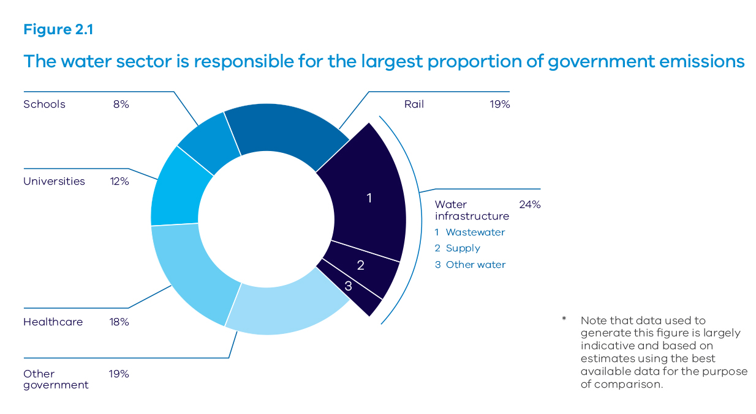
Schools 8%
Universities 12%
Healthcare 18%
Other government 19%
Rail 19%
Water infrastructure 24%
* Note that data used to generate this figure is largely indicative and based on estimates using the best available data for the purpose of comparison.

2.1 Achieving net-zero emissions in the water sector
The government will achieve net-zero emissions for Victoria by 2050. We will work with the water sector to agree appropriate timelines and pathways to achieve net-zero emissions, considering price impacts for customers and making sure we reduce emissions cost-effectively.
The water sector emits greenhouse gases through two key pathways:
- indirect emissions through its use of energy to pump water around and treat water to safe standards
- direct emissions, particularly from sewerage treatment.
The water sector is already reducing emissions by developing more energy-efficient equipment, capturing biogas for energy generation, investing in renewable energy generation, and purchasing renewable energy and carbon offsets. The sector is well placed to continue on this path to emissions reduction and focus on reducing its own emissions as a priority. The sector will also collaborate and invest in research and innovation to develop a shared understanding of the issues and opportunities of emissions reduction and to help it reach net-zero emissions over suitable timeframes.
Green bonds are a possible source of funding to help water corporations reduce emissions. They are used to finance new and existing projects that offer climate change and environmental benefits. In July 2016, Treasury Corporation Victoria issued $300 million in green bonds, making the Victorian Government the first in Australia to issue green bonds and the world’s first state or national government to issue bonds with the international Climate Bond Certification. Water corporations can borrow money from green bond investors through Treasury Corporation Victoria to fund initiatives that reduce emissions.
Victoria’s catchment management authorities are finalising their regional natural resource management plans for climate change, which identify opportunities for carbon sequestration and climate change adaptation across Victoria’s regions. Opportunities include increasing carbon sequestration in wetlands and coastal ecosystems, revegetation, and voluntary grazing system changes by private landholders. Partnerships with Traditional Owners may also offer additional opportunities for carbon sequestration.

Action 2.1 – Achieve net-zero emissions in the water sector
The water sector, including water corporations and catchment management authorities, will contribute to climate change mitigation by reaching net-zero emissions.
- Water corporations will pledge to government a pathway for net-zero emissions; this will be adopted in the Statement of Obligations by July 2017 to align with water corporation pricing submission processes, with a priority on reducing their own emissions.
- The four metropolitan water corporations will examine an early path to achieve net-zero emissions by 2030.
- The water sector will adopt renewable energy use targets of at least 25 per cent by 2020 and 40 per cent by 2025.
- The Department of Environment, Land, Water and Planning will work with water corporations, catchment management authorities and regulatory bodies to:
- develop principles to guide mitigation
- evaluate the costs and benefits of emissions reduction activities
- agree on carbon accounting methodologies
- plan pathways for emissions reduction.
- The Department of Environment, Land, Water and Planning will continue to explore opportunities for catchment management authorities to provide carbon offsets. Catchment management authorities will consider partnerships with Traditional Owners for carbon sequestration.

TAKE2 Pledge
The Victorian Government has launched a state-wide pledging system for all levels of government, business and community to pledge contributions to cut emissions and help achieve our 2050 target.
The TAKE2 Pledge Program will showcase the great work already being done across state and local government, business and the community to reduce emissions. Government will lead by example by committing to mandatory pledges across departments and key emissions-producing sectors.

Review of the Climate Change Act 2010
In 2015, the government commissioned an independent review of the Climate Change Act 2010. The review’s key recommendations are to create world-leading and transformational law by amending the Act, and introduce a target of net-zero emissions by 2050 and a comprehensive emissions reduction pledge program.
Consideration of climate change will be embedded across all government policy-making.

Victoria’s Climate Change Adaptation Plan
The government is developing its second Climate Change Adaptation Plan, due by 31 December 2016. The actions in this Adaptation Plan will complement the directions set out in Water for Victoria by:
- setting a clear pathway for how the government will respond to climate change adaptation challenges and opportunities
- defining the government’s role in working with the community, business, state government authorities and local government to adapt to climate change impacts at local and regional levels
- setting out short and medium-term actions to transition Victoria to being climate-ready in key areas such as infrastructure, water services and catchment management.

Case study – Portland Renewable Energy Project
Wannon Water is constructing a wind generator at Portland’s new water reclamation plant. The generator will provide clean renewable energy for the city’s energy-intensive water and sewage treatment facilities.
The project will significantly reduce energy costs and create savings that will be passed on to its customers. It will also improve Wannon Water’s environmental performance, reducing its overall greenhouse gas emissions a further 8 per cent a year in addition to the 23 per cent reduction achieved since 2006-07. The project provides an important, practical step towards reaching Wannon Water’s overall goal of carbon neutrality.
Once the project is completed in mid-2017, Portland will become the first Australian city to achieve net-zero emissions for its water and wastewater systems through on-site renewable power generation.

2.2 Improving our understanding of climate science and how it applies to water management
Government has a key role in applying research to water management policy, planning and practice. Our investment in the Victorian Climate Initiative, in partnership with the Bureau of Meteorology and CSIRO, means that our understanding of climate change and its impacts on our water resources has grown substantially in recent years.
We will build on this understanding by continuing to invest in research and working with partners including community groups, local government, Traditional Owners, research organisations and the water sector.
Improving our ability to apply this research to water management policy, planning and practice is also vital. Tools for modelling and scenario planning will help inform decisions about options for action in a future with climate change.
The Department of Environment, Land, Water and Planning will continue to assess and report on changes in water resources, including changes in rainfall, streamflow and groundwater to inform adaptation and evaluation of actions.

Action 2.2 – Understand and apply climate science to water management
We will continue to build our understanding of how climate change will affect our water resources.
- The government will invest $1.6 million in research on climate change in 2016-17 and then identify future research needs.
- The Department of Environment, Land, Water and Planning will build partnerships with communities, local government, Traditional Owners, research institutions, and the water sector to share knowledge and apply research to policy, planning and practice.

2.3 Leading climate change adaptation across Victoria’s water system
Climate change adaptation is a priority so that Victorians can continue to have safe and reliable water systems, and to optimise our investments in environmental outcomes. The water sector has a long history of dealing successfully with the resource challenges of a variable and sometimes extreme climate. But adaptation is related to much more than water availability. For example, sea level rise could threaten important coastal infrastructure and affect drainage. We may need to alter design and requirements for new infrastructure to account for increased flooding (see Victorian Floodplain Management Strategy, and Chapter 10: Jobs, economy and innovation).
We must make sure our water planning, assets and services are able to adapt quickly to changes in conditions from climate change.
The water sector is an ideal exemplar to lead implementation of state climate change adaptation policies as it has a long history of agility and innovation. The sector will consider climate change adaptation across all operations including resource, asset and risk management. Evidence-based decision making and monitoring will be important in leading climate change adaptation.
The actions in Water for Victoria set the direction for the water sector’s climate change adaptation for the coming decades.

Action 2.3 – Lead climate change adaptation across Victoria’s water system
Water for Victoria will set the direction for the water sector’s climate change adaptation for the coming decades. The water sector will lead climate change adaptation actions arising from Victoria’s second Climate Change Adaptation Plan and review of the Climate Change Act 2010.
The government will monitor and evaluate climate change adaptation measures and report on progress as set out throughout Water for Victoria.
In the short-term, water corporations will apply the Guidelines for Assessing the Impact of Climate Change on Water Supplies in Victoria developed by the Department of Environment, Land, Water and Planning when undertaking water supply planning.
Figure 2.2 – Annual mean temperature anomalies for Victoria have followed global trends
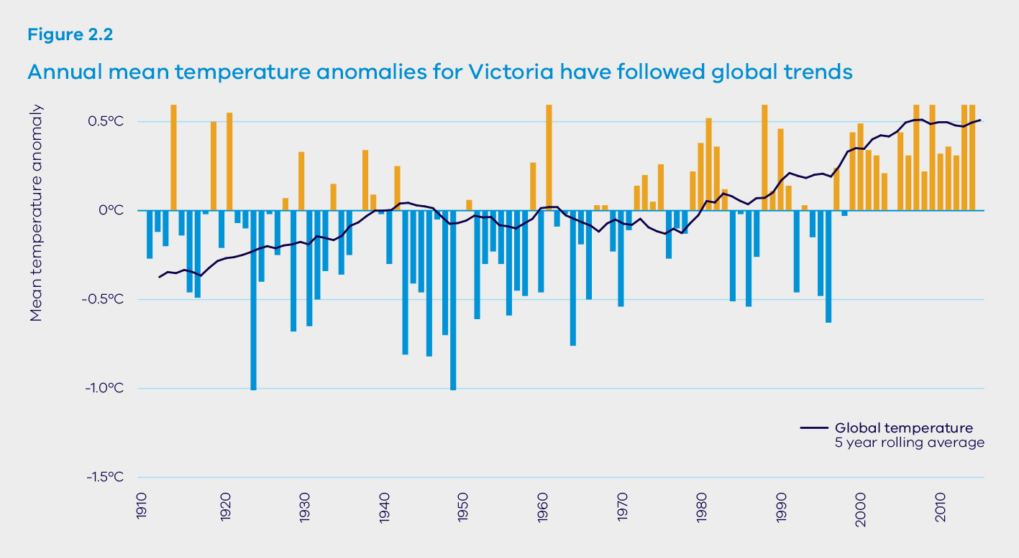

What does climate change mean for our water resources?

An increasing influence of climate change
Victoria’s climate has been following a drying and warming trend for several decades. Research now tells us that human-induced climate change is likely to be a significant part of this trend. For example, the severity of the Millennium Drought – a drought unprecedented in duration and intensity – has been linked to human-induced climate change1.
Projections of future climate are based on assessing the results from multiple global and regional climate models. The majority of climate models project Victoria will become hotter and drier. Human-induced climate change is expected to have an increasing influence on our climate in the coming decades.

Step changes in climate
Scientists have observed that climate changes can occur as either gradual or step changes. Step changes have been observed on a global scale, where sharp increases in temperature have occurred over short time periods.
While there has been a drying and warming trend in Victoria’s climate over recent decades, the rate of change has not been constant. Evidence suggests that step changes may have occurred in the mid-1970s and again post-1997².

Increasing temperatures
Figure 2.23 shows that Victoria’s temperature has steadily increased since the 1970s, consistent with global increases in temperature. In 2015, global average surface temperatures broke all previous records by a large margin⁴. Fifteen of the 16 hottest years on record have all been this century⁵. This year is on track to top 2015 as the world’s hottest year on record⁶. Global temperatures are expected to continue to rise with ongoing increases in greenhouse gas levels in the atmosphere.

Seasonal shifts and decreases in rainfall
The Millennium Drought brought with it a seasonal shift in rainfall, with proportionally less rainfall in the cooler months⁷. Figure 2.3⁸ shows this trend in rainfall reductions has continued in much of Victoria since the end of the drought. Studies by the Bureau of Meteorology and CSIRO have linked this with human-induced climate change⁹. The observed reductions in rainfall during the cooler months are expected to continue, and possibly intensify over time leading to a likely reduction in average annual rainfall⁹. We may still have years when rainfall during the cooler months is higher than average – such as how 2016 is currently tracking – but these will occur less often.
These seasonal shifts and decreases in rainfall are a result of the expanding tropics. This is in response to increased greenhouse gas concentrations and temperature increases. This expansion toward the poles means that the cold fronts and low pressure systems that have been the dominant source of Victoria’s rainfall during the cooler months are moving south and more often missing the state10.
How the likely shift to a drier climate will occur, and extent of reductions in rainfall is uncertain¹¹. However, the change to a drier climate is expected to significantly reduce inflows for our storages. Victoria may experience some increase in rainfall during the warmer months but this is not expected to compensate for the reductions in rainfall during the cooler months, especially since rainfall during warmer months does not usually generate sustained inflows to storages.
Figure 2.3 – Rainfall received during the cooler months of the year (April–October) has declined across Victoria
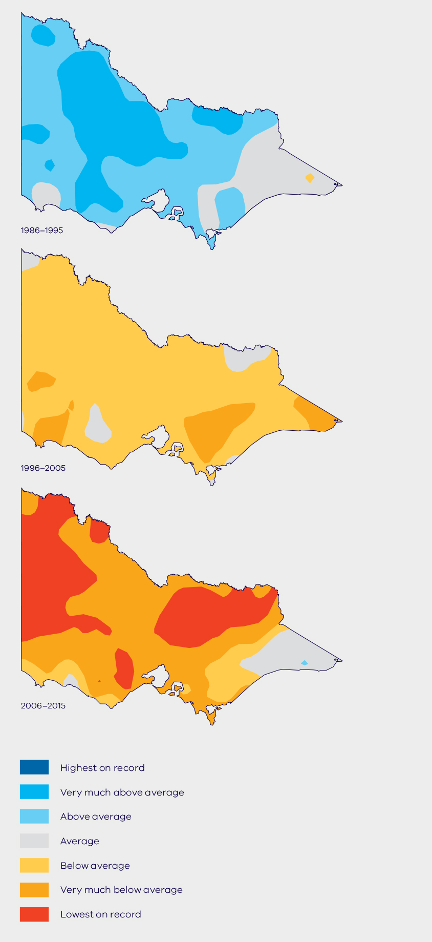
Figure 2.4 – Projected changes in runoff for 2065 under medium climate change
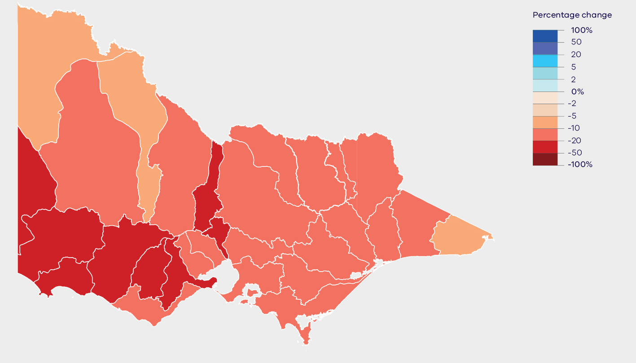

Reduced streamflows
Across the state, streamflows are projected to decrease by a greater proportion than rainfall, due to the interaction between rainfall and catchment hydrology. Models indicate the largest reductions are expected in Victoria’s south west. Figure 2.4¹² shows projected changes in runoff under medium climate change and highlights that it is possible that average annual streamflow will reduce by approximately 50 per cent in some catchments by 2065¹³. Reductions in streamflows of this scale would have serious consequences for water availability across Victoria.
It is possible we may see changes in streamflow sooner than projected by the models, and reductions may be more severe. For most water supply catchments in Victoria, there have been very few times during the last 20 years where inflows have exceeded the long- term annual average. Figure 2.5¹⁴ shows that many catchments in Victoria have recorded streamflow reductions of around 50 per cent or greater over the last 20 years, relative to the longer-term record. Some of the rainfall changes in recent decades, including the reductions in rainfall during the cooler months of the year, have been linked to human-induced climate change. Further research will help to better understand the timing and severity of future reductions and how these relate to the reductions experienced over the past 20 years.
Figure 2.5 – Streamflows have declined across Victoria in the past two decades
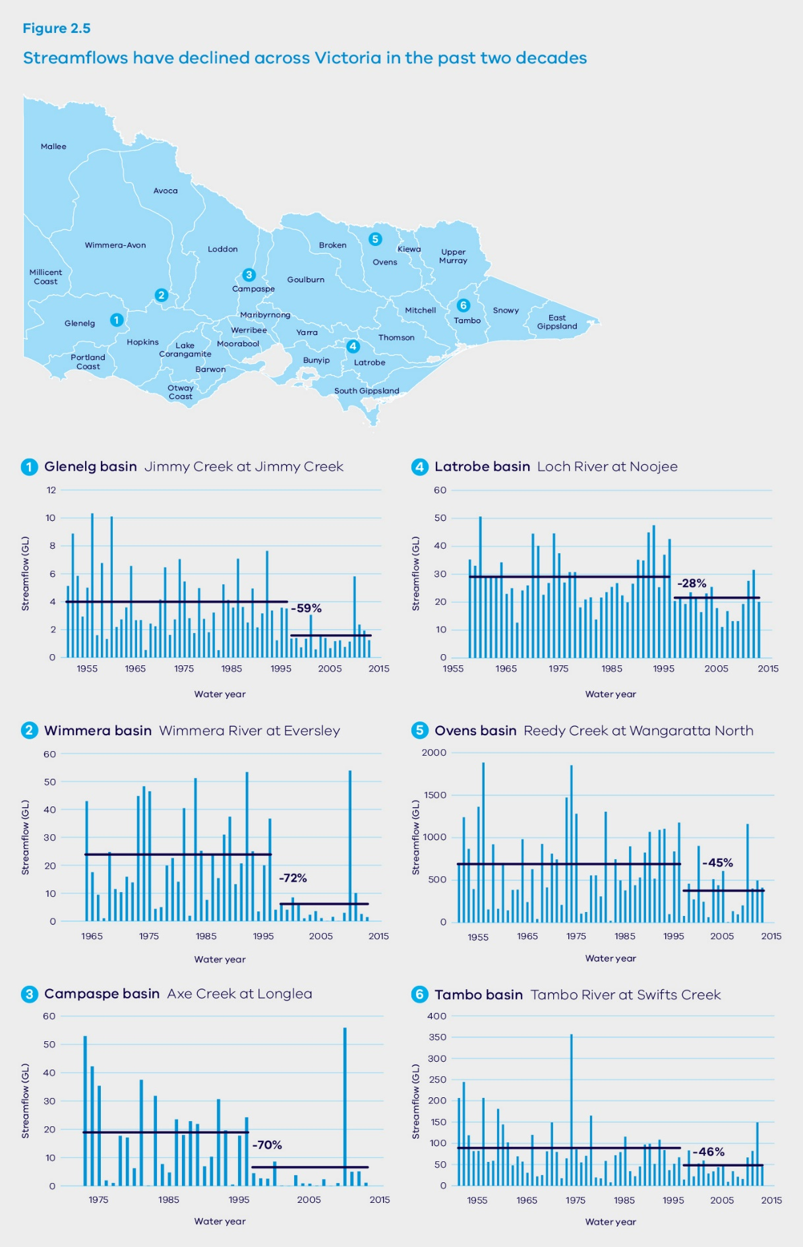
Glenelg basin (Jimmy Creek at Jimmy Creek) -59%
Wimmera basin Wimmera River at Eversley -72%
Campaspe basin Axe Creek at Longlea -70%
Latrobe basin Loch River at Noojee -28%
Ovens basin Reedy Creek at Wangaratta North -45%
Tambo basin Tambo River at Swifts Creek -46%

Waterway health impacts
Average annual streamflow reductions of around 50 per cent could occur in some catchments by the year 2065. Climate change also poses potential risks to water quality. Higher air temperatures, reduced streamflows and more extreme events such as flood and bushfire could have short and longer-term impacts on water temperature, turbidity and frequency and severity of algal blooms. Ecological impacts are also likely. The species that live in and around our waterways rely on well-established flow patterns for successful feeding, breeding and movement throughout the landscape. Changes in streamflow patterns have knock-on effects to both the health of waterways and ecosystems that rely on groundwater¹⁵.

Increased frequency and severity of extreme events
Warmer and drier conditions mean our bushfire threat is constantly increasing. As our climate continues to change we can expect more severe bushfires. Bushfires threaten the safety of our communities and can also affect the quantity and quality of water flowing into our storages for many years after they occur.
Climate change is likely to have broader implications for the water sector as a result of rising sea levels and increases in storm surges. This may damage water infrastructure, or its function may be limited in these changed operating conditions. Essential water and wastewater services will be disrupted more often by extreme events such as flooding.

Changes in water demands and catchment water use
Higher temperatures increase evaporation rates. These changes may impact water demands and water use in catchments. Farmers may need more water for stock and to irrigate crops to offset increased evaporation. The amount of rainfall needed by catchment vegetation is likely to increase, causing reduced streamflows into storages. Demand for human uses is also expected to grow as the temperature rises, including through higher peak demands during heatwaves.

Broader impacts on the community
Climate change may also impact on our communities. Less water and more extreme events threaten the liveability of our cities and towns.
Increased temperatures and less water flowing in our waterways may cause more harmful algae blooms in waterways. This could affect the safety of our water supplies for drinking, supporting stock, and recreation. The risk of water supply contamination may also increase with water shortages and increased flooding¹⁶.

3. Waterway and catchment health

OBJECTIVE
We will protect waterways and their catchments from the adverse impacts of future human use. We will improve the health of priority waterways and their catchments to support our environmental, social, cultural and economic needs and values now and into the future.
The health, wellbeing and prosperity of our Victorian communities depend on healthy rivers, wetlands, floodplains, estuaries, and water catchments – they are part of our natural capital, along with geology, soil, air and all living things, and must be protected.
We rely on healthy rivers and water storages for our drinking water, and for other purposes such as farming and industry. Healthy waterways and catchments make our cities and towns liveable and provide a variety of opportunities for recreation. Traditional Owners have strong connections to Country, which includes land and water. Healthy waterways and their catchments support a diverse range of native plants and animals, and provide important ecosystem services, such as carbon filtration. Figure 3.1 shows the different types of waterways, their values and uses.
The health of waterways across Victoria has been affected by inappropriate, historical land use. Climate change and drought, along with extreme events, such as floods, bushfires and heatwaves, are also likely to impact waterway health. The trend of decreasing cool season rainfall is likely to continue and in some catchments we may see average annual streamflow reductions of about 50 per cent by 2065. Climate change also poses risks to water quality. Higher temperatures, reduced streamflows and more extreme events could have short and longer-term impacts on water temperature, clarity and the frequency and severity of algal blooms. This could reduce the number and variety of native plants and animals. If we plan, act and invest smartly we will be well-placed to tackle climate change and protect our environment.
Protecting and improving the health of waterways and their catchments is a critical task for the decades to come. Investing in protection is more cost-effective than paying to restore health. Over the next four years, the Victorian Government will invest $200 million to improve waterway health and $22 million to strengthen catchment management.

What we will do
- Improve planning arrangements for urban waterways
- Protect water quality through the State Environment Protection Policy
- Invest in integrated catchment management
- Provide long-term investment to improve waterway health
- Improve environmental water management in a changing climate
- Better monitor and report on the benefits of environmental watering
- Ensure clear and transparent charging arrangements
- Support community partnerships and citizen science
- Improve knowledge and information about waterways and catchments
We will invest $222 million over four years in waterway and catchment health, our largest ever investment in river health.
This will help improve water quality and protect our environment.

Key challenges and opportunities
As we prepare for a warmer and drier future, we need to find the best investment opportunities to improve waterway health. We can do this by increasing our capability to do predictive modelling and scenario planning and ensuring we have the best information ready to make future decisions. Making the best use of water recovered for the environment will become even more important. We are already making a major investment in riparian restoration to connect and increase resilience of waterways.
Population and urban growth pose real challenges for protecting the environmental, social, cultural and economic values of waterways. Victoria needs stronger links between the state planning system and catchment and waterway management, and better community engagement in planning at the local level.
We need to understand that improving the environmental condition of waterways can take decades and needs long-term investment, large-scale projects and ongoing monitoring to demonstrate results.
Figure 3.1 – Types of waterways depending on their values, condition and typical uses
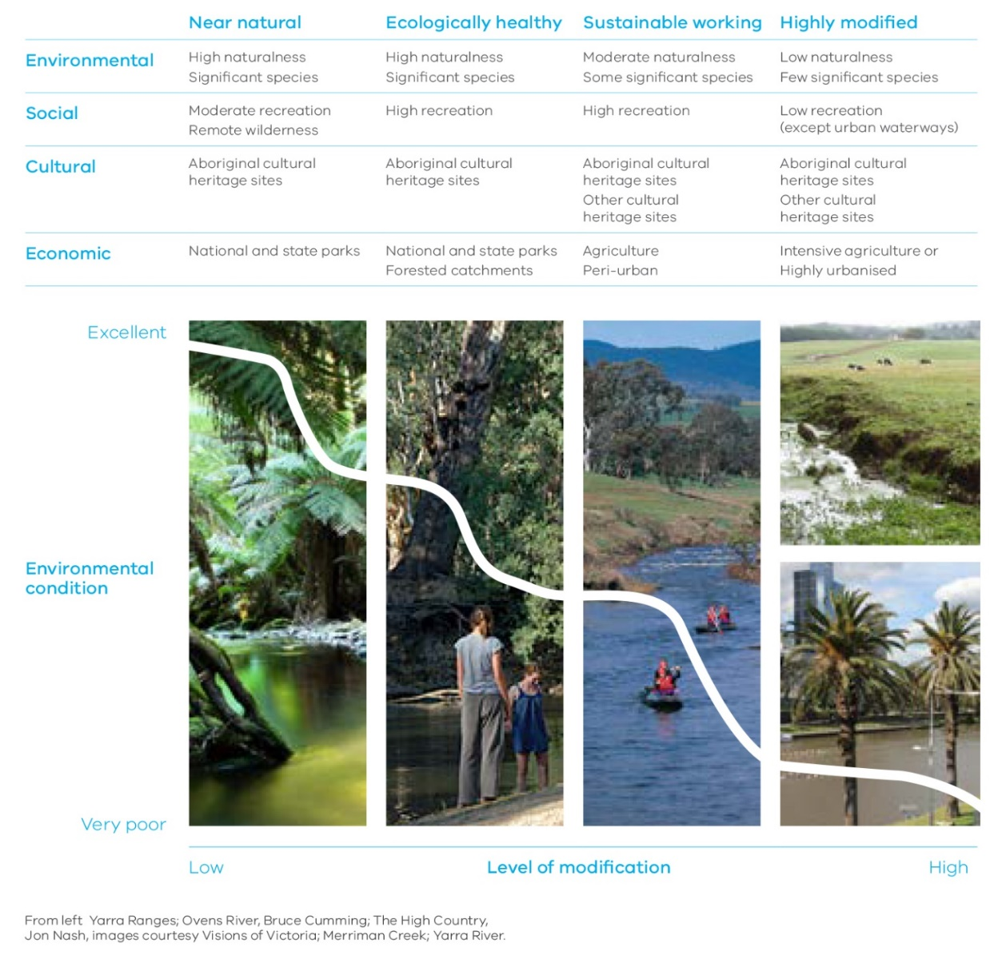
 | Near natural | Ecologically healthy | Sustainable working | Highly modified
Environmental | High naturalness  Significant species | High naturalness  Significant species | Moderate naturalness  Some significant species | Low naturalness  Few significant species
Social | Moderate recreation  Remote wilderness | High recreation | High recreation | Low recreation (except urban waterways)
Cultural | Aboriginal cultural heritage sites | Aboriginal cultural heritage sites | Aboriginal cultural heritage sites  Other cultural heritage sites | Aboriginal cultural heritage sites  Other cultural heritage sites
Economic | National and state parks | National and state parks  Forested catchments | Agriculture  Peri-urban | Intensive agriculture or  Highly urbanised

Protecting the Yarra River
Stronger links between waterway and catchment management and the state planning system will help protect waterways. One example is the recent change to the State Planning Policy Framework, which sets clear objectives for preventing overshadowing, limiting building height, increasing setbacks, and riparian and canopy vegetation protection in the Yarra River corridor.
These new standards will be applied through new and revised Design and Development, and Significant Landscape Overlays in the local planning schemes between Richmond and Warrandyte.
These new planning controls will support more consistent decision-making across local government boundaries and will protect the Yarra River’s character and environmental values from inappropriate development.
The Yarra River is a key focus of the government. The Yarra River Protection Ministerial Advisory Committee was established in December 2015 to provide independent advice to government about improving governance arrangements for protecting the river.

3.1 Protecting our waterways and their catchments
Under the Water Act 1989, Victoria has a water entitlement framework that limits how much water we can take for human use. It also requires licences for any works on waterways. Where applicable, planning controls are used to define the way land may be used or developed. Within a planning scheme, overlays can be used to show land that has particular values, such as significant environmental features. The Environment Protection Act 1970 protects water quality for both surface and groundwater.
Our regional waterway strategies and regional catchment strategies identify environmental, social, cultural and economic values in partnership with communities to achieve common objectives. Regional catchment strategies guide strategic land use planning to protect and improve catchment values.

Protecting our waterways through the planning system
In urban areas, integrated water management plans will find holistic ways to protect environmental values of waterways. In urban and regional areas, we need to better align planning to achieve common objectives. There are opportunities to use planning tools, such as Environmental Significance Overlays, to protect areas with riparian vegetation and other native plants and animals that support land and water habitat and quality (see Chapter 5: Resilient and liveable cities and towns).

Action 3.1 – Improve planning arrangements for urban waterways
The government will protect the Yarra River corridor by responding to the Yarra River Protection Ministerial Advisory Committee recommendations. The government will consider applying the agreed recommendations to other major urban waterways.

Protecting water quality
Water quality supports a range of different uses, such as water for drinking, water for recreation and water suitable for native plants and animals. The Environment Protection Act requires policies to set out specific values or beneficial uses, and related water quality objectives and indicators for protecting those values across Victoria’s diverse environments. The new State Environment Protection Policy (Waters) will provide a modern risk-based approach to protect water quality.
Environmental offsets are an innovative way to improve water quality that may provide a better, overall environmental outcome for least cost. For example, we may be able to reduce the amount of nutrients entering a waterway upstream by improving on-farm nutrient practices, rather than upgrading a wastewater treatment plant.

Action 3.2 – Improve planning arrangements for urban waterways
The government will protect beneficial uses of water across Victoria through a new State Environment Protection Policy (Waters) that aligns with government’s response to the Independent Inquiry into the Environment Protection Authority by:
- confirming the beneficial uses of Victorian groundwater and surface water, and where these uses apply
- setting water quality indicators and objectives to protect beneficial uses
- establishing a modern, risk-based framework to manage unlicensed point and diffuse pollution sources in rural and urban areas
- developing regional target settings and plans to improve water quality
- ensuring water quality offsets can be used within catchments to maintain regulatory compliance within waterways.
The Department of Environment, Land, Water and Planning and the Environment Protection Authority Victoria will work with water corporations to look into using water quality offsets more broadly to achieve better environmental outcomes for least community cost by 2018.

3.2 Stronger catchment management and long-term investment in waterway health

Strengthening integrated catchment management across Victoria
Integrated catchment management is a holistic way of managing land, water and biodiversity from the top to the bottom of a catchment. Improving integrated catchment management will provide significant benefits for our waterways. Figure 3.2 explains the principles and practices of integrated catchment management in more detail.
Our Catchments, Our Communities is the first state-wide strategy for integrated catchment management in Victoria. The strategy will achieve more effective community engagement, better connections between different levels of planning, and strengthened regional catchment strategies. The strategy will also clarify roles, strengthen accountabilities and coordination, and improve monitoring, evaluation and reporting.
Catchment management authorities will lead 10 new integrated catchment management projects across the state from 2016 to 2019, in collaboration with catchment management partners. Projects are under development in each region.
The first projects to be developed are:

Mallee
Lake Tyrrell to Birchip in the Southern Mallee Waterways

Wimmera
Enhancing the health, environment and liveability of the Wimmera Catchment

Corangamite
New information technology and integrated catchment management.
Catchment management authorities are developing the remaining projects, which will be rolled-out over the next four years.

Regional projects

East Gippsland
Our Catchments, Our Communities in East Gippsland

Goulburn Broken
Resilient landscapes – vibrant communities

Glenelg Hopkins
Rivers, floodplains and wetlands – integrated catchment management

North Central
Leveraging integrated catchment management across the North Central

North East
Keeping productive landscapes resilient

Port Phillip and Westernport
Our Catchments, Our Communities in the Port Phillip and Westernport region

West Gippsland
People, place and partnerships

Action 3.3 – Invest in integrated catchment management
The government will invest $22 million over four years to strengthen integrated catchment management across Victoria and implement the actions in Our Catchments, Our Communities by 2019.
Catchment management authorities will lead 10 new integrated catchment management projects across the state from 2016 to 2019.

Successful waterway and catchment projects with long-term funding
There are some examples where government provided multi-year funding for catchment management projects. In these cases, catchment management authorities took an integrated, long-term approach to planning and delivery and were able to demonstrate the benefits of their investment. These projects include:
- Snowy Rehabilitation Project—active since 2004 and has seven integrated sub-projects to improve the health, resilience and ecology of the Snowy River system
- Goulburn River Large Scale River Restoration Project—delivered from 2008 to 2012 and comprised sub-projects that made environmental improvements to the Goulburn River and its floodplain
- Loddon Stressed River Project—delivered from 2003 to 2013 and provided integrated river restoration and community engagement activities
- Wimmera Catchment Large Scale River Restoration Project—delivered from 2008–09 to 2011–12 and included activities to manage the threats to and values of the Wimmera River Catchment.

Long-term investment in waterway health
Protecting and improving waterway health is a long-term commitment. Figure 3.3 shows the percentage of Victoria’s river length in good to excellent health. The most recent surveys (2013) of the state’s river health show there is still lots of work to be done. The Victorian Waterway Management Strategy provides the framework for government to work in partnership with communities to improve the condition of rivers, estuaries and wetlands to support environmental, social, cultural and economic values for all Victorians.
Regional waterway strategies identify priorities for waterway management, as required under the Water Act 1989. These strategies were developed by the nine regional catchment management authorities and Melbourne Water (the waterway managers) in consultation with regional agencies and boards, Traditional Owners, regional communities and other key stakeholders.
Of these priority waterways, 36 waterways have since been identified by the waterway managers as the focus of 30-year plus large-scale projects. These are shown in Figure 3.5. A focus on large-scale, long-term projects across Victoria provides the opportunity to trial and communicate a state-wide monitoring approach.
We need to understand that we may not see the full benefits of our strategic long-term investments in waterway health for 30 years or more. Figure 3.4 shows the phases of long-term, large-scale waterway projects.
As well as the long-term projects, we will continue to invest in priority waterways identified in the regional waterway strategies and the Regional Riparian Action Plan. We will also invest in activities upstream if this is threatening downstream waterway values.

Action 3.4 – Provide long-term investment to improve waterway health
The government is investing $90 million over four years to implement regional waterway strategies and improve waterway health by focusing our effort on large-scale projects for 36 waterways. As an initial trial, we are choosing 10 of our 36 projects to track progress and report back to communities, using citizen science as part of this.
The government is investing $30 million over four years to implement the Regional Riparian Action Plan and speed up riparian works across regional Victoria. This builds on the initial $10 million invested in 2015-16.
The government is investing $10 million over four years to support the Gippsland Lakes Coordinating Committee and deliver onground environmental works and community engagement. This builds on the initial $2.5 million invested in 2015-16.
Figure 3.2 – Integrated catchment management
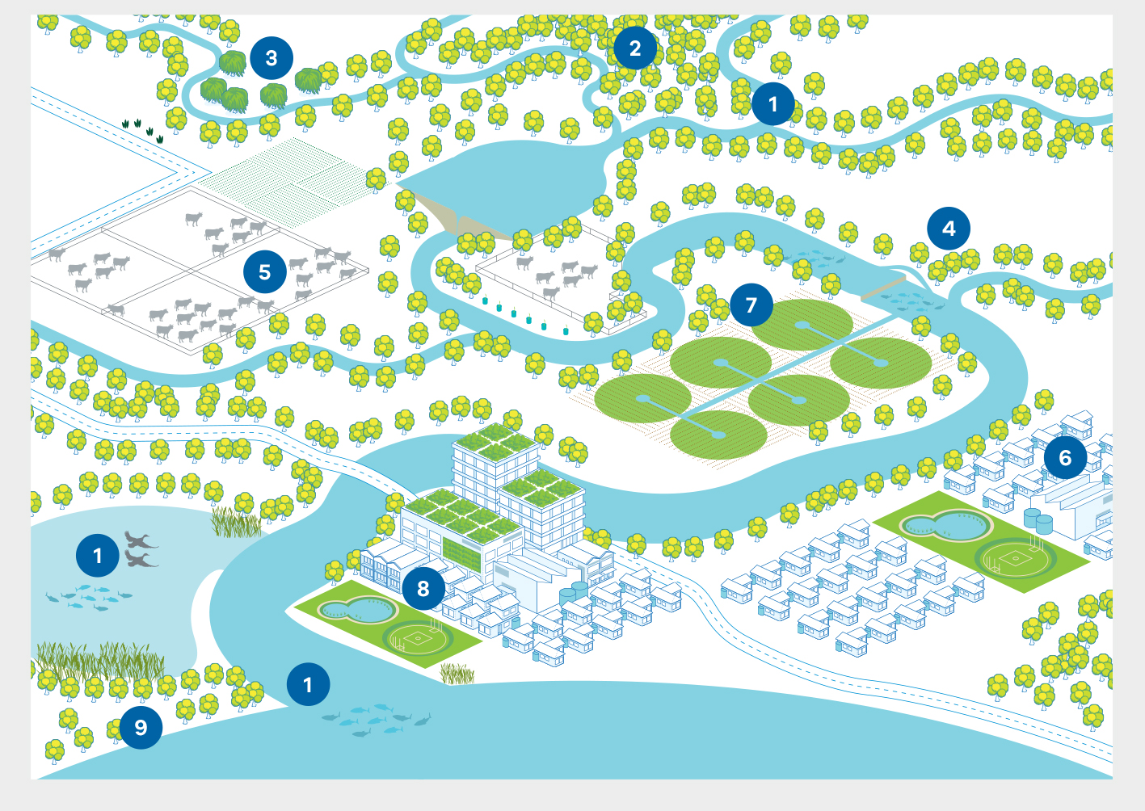
Integrated catchment management (ICM) is a holistic approach to managing connected systems of land, water and biodiversity from the top of a catchment to the receiving waters.
ICM coordinates actions that deliver shared benefits and reduce perverse outcomes for communities, the environment and regional economies. It requires local coordination and collaboration between partners and long-term relationships to be successful.
- Waterways, wetlands and estuaries
Management of waterways, wetlands and estuaries improves water quality; secures water for the environment, irrigation and consumption; provides habitat and refuges; store carbon; and contributes to significant cultural, economic, primary production, recreation and tourism benefits.
- Native forests and vegetation
Forests and intact native vegetation on public and private land contribute to water yield and improved water quality for consumptive and non-consumptive uses, provide habitat for native species, recreational use, and store carbon.
- Pest management
Pest management reduces impacts to water quality and land productivity and improves aquatic and terrestrial habitat.
- Riparian land
Improving condition of riparian land contributes to better water quality for urban and rural supplies and provides habitat for native species.
- Sustainable agriculture and land management
Improved land management practices reduce nutrients into waterways and improve agricultural productivity.
- Land use planning and development
Appropriate strategic and statutory land use planning contributes to catchment health through protection of significant environment features and can reduce flood and fire risks to people and property.
- Sustainable irrigation
Improved irrigation practices reduce water use and nutrient runoff into waterways and provide economic benefits to irrigators.
- Integrated water management
Integrated water management improves water quality, liveability and delivers economic savings.
- Coastal management
Coastal management provides significant economic benefits through tourism and recreation. Coastal management protects and enhances environmental features and native habitat.
Figure 3.3 – Waterway health in Victoria
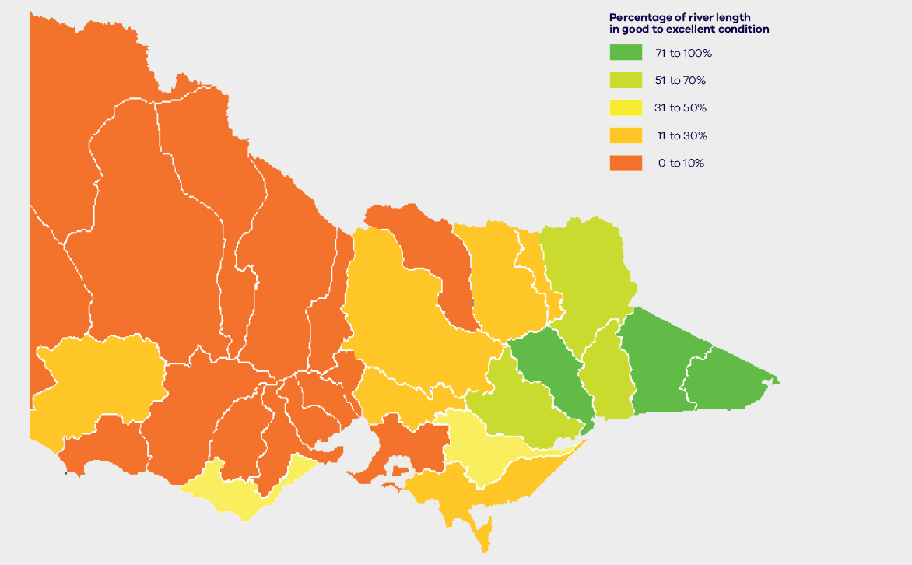
Figure 3.4 – Four phases of waterway health programs
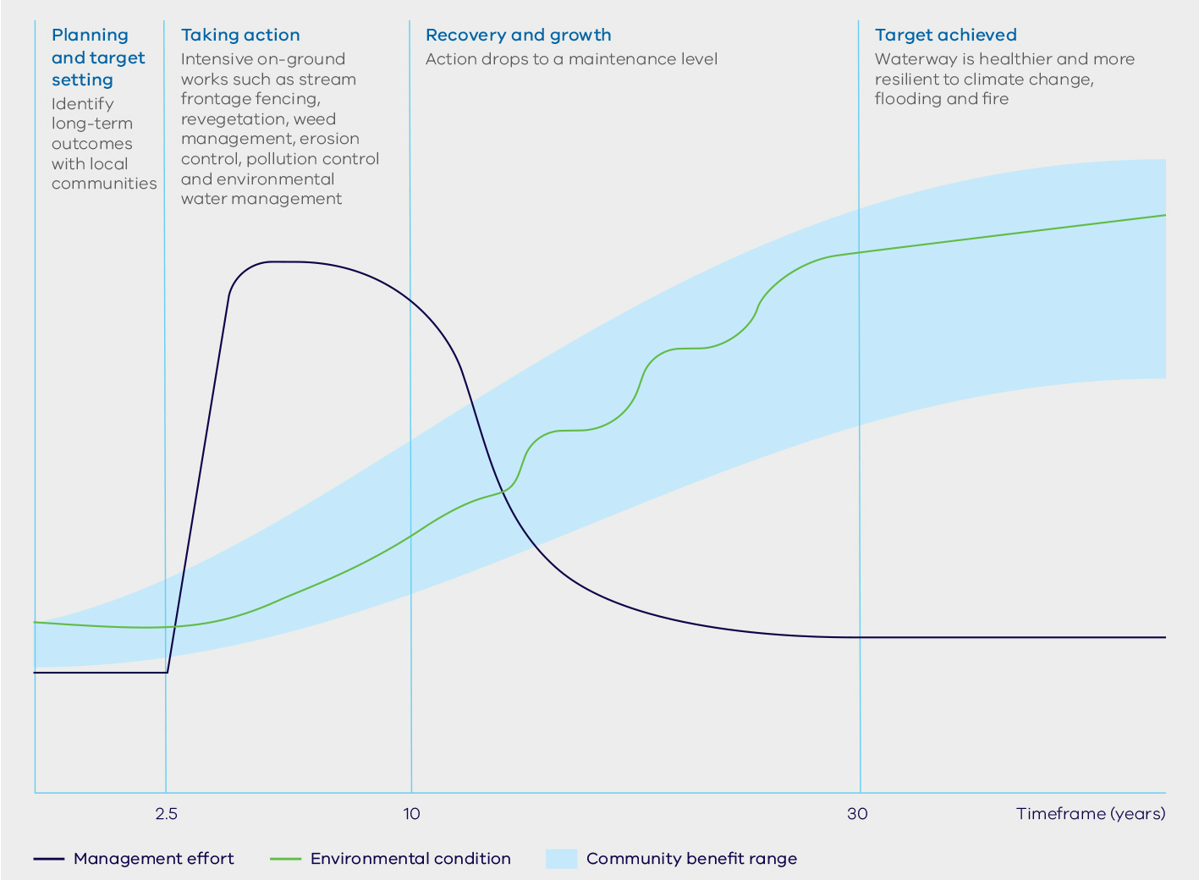
- Planning and target setting
- Identify long-term outcomes with local communities
- Taking action
- Intensive on-ground works such as stream frontage fencing, revegetation, weed management, erosion control, pollution control and environmental water management
- Recovery and growth
- Action drops to a maintenance level
- Target achieved
- Waterway is healthier and more resilient to climate change, flooding and fire
Figure 3.5 – Priority waterways from regional waterway to strategies and 36 large-scale projects
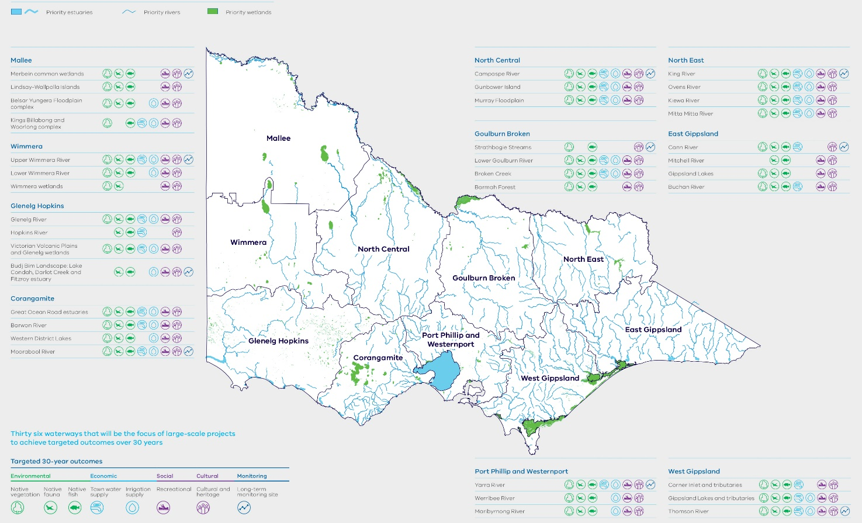
Government will continue to invest in priority waterways identified in the 10 regional waterway strategies developed by catchment management authorities and Melbourne Water in consultation with partners and the community.

3.3 Environmental water management in a changing climate
Environmental water is critical to protect the plants, animals and overall health of rivers, wetlands, floodplains and estuaries. It also has social, cultural and economic benefits. Environmental watering can increase recreational activities, sustain healthy Country for Traditional Owners and improve water quality for farmers.
In the future we are likely to see less runoff entering our waterways. This will affect the availability of environmental water and the ecological objectives we can achieve. Similar to water users in the urban and rural water sectors, there are a range of tools that
environmental water managers can use to help manage variable water availability. Tools such as carryover, trade and structural works to improve efficiency will become increasingly important in responding to climate change impacts, to reduce the risks of low environmental water availability and to improve environmental outcomes.

Future focus for environmental water management
In some waterways, we may need to recover more environmental water as a result of climate change. We are already starting to collect the information we need to understand change to water availability by updating our water models to include future climate change scenarios. We are also looking into climate change impacts for environmental water availability and meeting ecological objectives. For example, we are modelling climate change scenarios for the Thomson River and looking at how they affect ecological objectives in our current environmental flow studies. This information will help us make decisions about future environmental water recovery through sustainable water strategies (see Chapter 8: Water entitlements and planning).
Environmental entitlements that can deliver environmental water are only available in large, regulated water systems. However, we may be able to use stormwater, recycled water and the water grid to achieve environmental water outcomes at a more local level. We will explore this through integrated water management planning, discussed more in Chapter 5: Resilient and liveable cities and towns.
Works and measures are vital to make the best use of existing environmental water entitlements. The Murray-Darling Basin Plan provides an opportunity to invest in more environmental works in the southern-connected Basin. Victoria has developed nine proposals for environmental works under the Basin Plan. These proposals build on The Living Murray program, which uses environmental works and water to achieve environmental outcomes at six icon sites, including the Gunbower Forest and Hattah Lakes.
Environmental works such as pumps, regulators and pipes help to water sites in the absence of natural floods. This means that less water is needed to connect the river to its floodplain. Works also provide a way to target sites that cannot be watered due to the risk of third-party impacts. When there is limited environmental water available, environmental works can enable this water to be used more effectively to protect high-value floodplains and wetlands.
Environmental water must be managed together with other complementary works such as protecting drought refuges, improving habitat connectivity for fish, improving landholder management practices and stronger integrated catchment management. This will help achieve real improvements in waterway health, especially in a predicted drier and warmer future climate.
Modelling can combine information about future predicted species distributions, climate and the costs and benefits of different management activities to make decisions about trade-offs and investment. This information can also help set achievable objectives or provide evidence for when objectives might need to be changed in the future.

Action 3.5 – Improve environmental water management in a changing climate
The government will continue to invest in environmental works and measures for priority watering sites to better use existing environmental water.
The government will deliver on existing commitments for environmental water recovery by mid-2017, including:
- the additional 8 gigalitres of environmental water for the Thomson River
- the additional 1 gigalitre of environmental water for the Barwon River
- investigating options for meeting the 2015 environmental water recovery targets for the Moorabool, Werribee and Maribyrnong Rivers with local communities and stakeholders as part of the review of the Central Region Sustainable Water Strategy.
The government will look into the need for future environmental water recovery through sustainable water strategies, taking into account the findings of long-term water resource assessments. Sustainable water strategies will rely on evidence-based principles, priorities and community input.
The Department of Environment, Land, Water and Planning will review and strengthen the Victorian Environmental Water Holder to build on achievements made in the first five years of operation and secure future environmental outcomes in the face of climate change.

Monitoring and reporting on the benefits of environmental watering
The primary objective of environmental water entitlements is to protect the environment. The way we manage environmental water provides shared or complementary benefits for other water users. Environmental watering may support Aboriginal values with water that can be used for cultural purposes, and may increase opportunities for recreational activities including fishing and boating. In regulated water systems, storage managers can provide shared benefits by releasing water in ways to optimise other uses. Our planning will continue to look for opportunities to provide shared benefits through environmental watering. Better monitoring and reporting will provide communities with information about outcomes they value.

Action 3.6 – Better monitor and report on the benefits of environmental watering
The government will increase monitoring and reporting back to communities on progress towards expected environmental outcomes from environmental watering, with a focus on digital reporting from 2017.
- The Victorian Environmental Water Holder will report annually on where environmental watering has achieved shared benefits.
- The Commissioner for Environmental Sustainability will:
- report on the outcomes of environmental watering in Victoria, as part of the five-yearly State of the Environment Report; a requirement under Section 8 of the Commissioner for Environmental Sustainability Act 2003
- recommend ways to improve future public reporting, consistent with the objectives of the Commissioner set out in Section 7 of the Commissioner for Environmental Sustainability Act 2003.

Charging arrangements for environmental water
The government requires environmental water holders to pay applicable charges for the costs incurred by storage and system operators to store and deliver environmental water. Victorian Environmental Water Holder costs for head works, delivery and carryover charges in 2015-16 were $5 million across the state. The Victorian Environmental Water Holder, Commonwealth Environmental Water Holder and Murray-Darling Basin Authority collectively paid $12 million in 2014-15. While charges have been applied to all environmental water entitlements since 1 July 2014, there are varying approaches to charging across different water corporations.
There may be different levels of service provided for environmental water, most often in water delivery systems. We need to consider the revenue requirements of water corporations to maintain future infrastructure needs. A fair and reasonable contribution to system costs should be made by all users in line with the level of service received. A collaborative planning process that involves all relevant parties will allow environmental water holders to engage in the process of cost allocation, and provide transparency and accountability.
The Essential Services Commission is responsible for approving the price proposals of water corporations, consistent with policy set by government. This is in line with pricing processes for other water users. For example, in the Wimmera region, Grampians Wimmera Mallee Water has established charges for water storage and delivery. Taking into account the broader public benefit of the recreational water entitlement and the high cost of water delivery, Grampians Wimmera Mallee Water went through a process to seek water customer agreement to contribute to a subsidised rate for charges applicable to water used for recreation. Approval was received from the Essential Services Commission. The recovery of costs for providing recreational benefits is discussed more in Chapter 7: Recognising recreational values.
The following principles will apply to charging arrangements for environmental water:
- prices for services to environmental water holders will reflect costs
- prices to reflect the level of services received
- prices to provide signals for the efficient and sustainable use of water infrastructure
- prices will not deter environmental watering.

Action 3.7 – Ensure clear and transparent charging arrangements
Water corporations will work with the Department of Environment, Land, Water and Planning and environmental water holders to ensure clear, transparent and equitable charging arrangements (service levels and prices) in line with the above principles.

Case study – A win-win – water quality in the Wimmera River and Horsham’s Kanamaroo Festival
A key attraction of Horsham’s annual Kanamaroo Festival is a water-skiing display on the Wimmera River. High water levels are needed in the Horsham weir pool to safely host the event. In the lead-up to the 2014 festival, the outlook was not good. Rainfall over winter had been well below average and the region was experiencing its driest spring in decades. The Wimmera River’s water quality was poor with the Wimmera Catchment Management Authority planning to release a series of freshening flows to avoid fish and plant deaths.
In a great win-win, the Wimmera Catchment Management Authority agreed to store the environmental water in the Horsham weir pool to keep water levels high enough to accommodate water-skiing and to delay delivery of the spring freshes down the river until after the event. The upside for the river was that the freshes could be delivered as sharper peaks, making them more effective at improving water quality. The catchment management authority looks forward to working with Horsham Rural City Council again to investigate further opportunities to deliver shared benefits.

Case study – Cutting-edge water management at Gunbower – a win for environment and fishers
In an Australian first, Victoria is leading the way with a combination of new works and environmental water providing shared benefits for anglers, irrigators and the environment in north- central Victoria.
Cutting-edge technology will be trialled in Gunbower Creek to reduce the loss of native fish, including key angling species, to irrigation channels, and also potentially through pumps. Research in the Gunbower area indicates that 20 per cent of native fish leave the main river and enter irrigation channels where they cannot breed or return to the natural river system, becoming isolated from the broader fish population. There are also many local anecdotes of fish, platypus and turtles blocking irrigation diversion pumps and being killed. This is recognised as a significant issue across the world and in Australia, particularly across the Murray-Darling Basin.
A low-maintenance, self-cleaning irrigation channel screen will be tested to see how well it prevents our native fish and other animals from entering an irrigation channel off the Cohuna weir pool. The Gunbower area is an ideal demonstration site as it has a large irrigation industry, high-value tourism and significant natural assets.
Improving the sustainability of the irrigation system will benefit the Gunbower Creek and surrounding environment and also support increased recreational fishing and tourism, protect stocked fish populations, and prevent pump blockage for irrigators. The Victorian Environmental Water Holder is contributing up to $1 million for the project, which the North Central Catchment Management Authority will deliver in partnership with local irrigators, Goulburn-Murray Water, Fisheries Victoria and the Arthur Rylah Institute.
If additional funding becomes available, this would provide an opportunity to test a greater range of channel screens, as well as a range of pump screens.

3.4 Strengthening community engagement and participation
Improving waterway and catchment health requires community support, particularly in the face of climate change. By working in partnership with individuals and community-based natural resource management groups, we can achieve better, more lasting change.
Victoria is a strong supporter of community-based natural resource management through programs including Landcare, Waterwatch and EstuaryWatch. These programs allow community groups to work on areas of local priority, which might not necessarily be a priority for state-level investment. These programs
achieve environmental outcomes and significant social and economic benefits for individuals and communities. Recreational users of waterways such as anglers and hunters also have a strong history of working to conserve and restore habitat for native fish and game.
Catchment management authorities bring regional partners and communities, including Traditional Owners, together in the management of waterways and catchments, to promote land and water resources, and their sustainable use, conservation and rehabilitation.

Action 3.8 – Support community partnerships and citizen science
The government is supporting community partnerships over the next four years through Landcare, Waterwatch, Estuary Watch, and other citizen science initiatives to address local waterway priorities.
As part of the $30 million investment in the Regional Riparian Action Plan, the government is investing around $1 million in partnerships between catchment management authorities and recreational anglers to deliver riparian improvement works in areas of local priority for anglers.

Case study – Fishers drive river health activities in Goulburn Broken Catchment
Recreational fishing is one of the most popular recreational pursuits in Victoria, and the Goulburn River and Eildon are preferred inland fishing locations.
The Goulburn Broken Catchment Management Authority recognises many anglers have a long and strong connection to their favourite fishing spots, and have seen first-hand how changes in climate, land and water use, and pests affect fish habitat and their numbers. This is why the catchment management authority continues to work closely with recreational anglers to support activities that improve the health of waterways, and the plants, animals and people that rely on them.
For example, the catchment management authority partnered with Toolamba Fishing Club members to place more than 1200 cubic metres of hardwood stumps along almost 2.5 kilometres of the Goulburn River to improve fish populations.
Working with fishing groups has also been critical to raising broader community awareness of the importance of healthy rivers. A ‘Fish Circus’ held in Avenel in September 2015 in partnership with agencies and groups, including Native Fish Australia and Nagambie Angling Club, attracted hundreds of people who learned how activities to improve habitat for threatened Macquarie perch in Hughes Creek also improved water quality, reduced erosion and supported other native fish and animals.
A planting day in June 2016 involving the Mansfield and District Fly Fishers Club, the Australian Trout Foundation, Up2Us Landcare Alliance and Mansfield Shire revegetated a section of the Delatite River, highlighting the importance of native riparian vegetation for shading streams and providing fish habitat.
Representatives from fishing groups and fishing-related tourism and industry sectors, along with local landholders, are also consulted during the development of the catchment management authority’s annual environmental watering plans. This advice and feedback is critical in planning the timing, volume and duration of environmental flows. For example, on advice from fishing groups, the timing of the annual spring environmental flow along the Goulburn River is now slightly earlier; it is now completed well before the start of Cod opening in December.

3.5 Improving information and knowledge through monitoring and research
Good management of waterway and catchment health depends on evidence-based decision-making and adaptive management. Communities appreciate clear reporting on environmental achievements, which may also include social and economic benefits. Information about waterway condition will help sustainable water management, and will feed into processes, such as the long-term water resource assessments and sustainable water strategies (see Chapter 8: Water entitlements and planning).
The Victorian Catchment Management Council is responsible for reporting every five years on the environmental condition and management of Victoria’s land and water resources. The Council is working with partner agencies, such as the Office of the Commissioner for Environmental Sustainability, to develop more consistent and better aligned environmental reporting. Victoria has well-established resource condition monitoring programs to report on the overall health of our waterways and to guide regional priorities for investment. A greater focus is required on monitoring the changes that result from our waterway management actions and on coordinated, strategic research to support adaptive management. Investment achievements need to be explicitly demonstrated to communities.
Environmental-Economic Accounting gathers environmental, social and economic statistics in a clear and consistent way to inform policy, planning and investment decisions affecting the environment. The adoption of best practice Environmental-Economic Accounts by the government could improve reporting and decision-making for waterway and catchment program investments. This approach may help us understand the synergies and trade-offs among water, carbon and biodiversity outcomes, described as multiple benefits. Implementation of Our Catchments, Our Communities will deliver consistent monitoring and reporting on the condition and management of catchments.

Action 3.9 – Improve knowledge and information about waterways and catchments
The government is investing $20 million over the next four years in monitoring, evaluation and reporting for waterways. More coordinated, strategic research and monitoring will improve information and knowledge about catchments and waterways from 2017 and help with adaptive management, continuous improvement and better reporting back to communities.
The government will:
- establish a waterway research hub to support more coordinated, strategic research and monitoring both within the Department of Environment, Land, Water and Planning and across relevant government stakeholders and research providers, and include mechanisms for independent science oversight and knowledge brokering
- review and improve Victoria’s existing waterway health monitoring programs to have a greater focus on monitoring the changes that result from management actions, including changes in social and economic indicators
- investigate Environmental-Economic Accounting to demonstrate multiple benefits (water, carbon and biodiversity) from catchment and waterway management, including environmental watering. This will support reporting by the Commissioner for Environmental Sustainability in 2018.
The government is also investing in a better understanding of traditional Aboriginal ecological knowledge. This is discussed further in Chapter 6: Recognising and managing for Aboriginal values.

4. Water for agriculture

OBJECTIVE
Victoria’s water management arrangements will enable farmers to maximise the value of agricultural production with the available water, while supporting farming communities to adjust to change in a warmer and drier future.
The Victorian Government recognises agriculture’s significant contribution to the state and national economy. Victoria’s primary production of food and fibre was worth $12.6 billion in 2013–14, the highest of any state or territory. Irrigated agriculture in Victoria was worth $4.4 billion in 2013–141. The food and fibre industry chain, including farming and manufacturing, employs over 190,000 people.
The future export potential of our agricultural sector is promising. We have competitive advantages, including a diversity of products, a long history of excellence in research and development, and strong food safety and biosecurity systems.
Water and its management are vital for this development. The sector is adapting to long-term shifts in climate as well as new technologies, changing costs and global market forces. Water infrastructure is adapting to such changes. The government recognises that water supports the economy and also families, communities and regions.
The value of Victoria’s agricultural production is increasing, as shown in Figure 4.12. The government will provide flexibility for agriculture to continue to adapt to change and maximise its value – to help the sector do more with less water.

What we will do
- Support regional development and change
- Invest in rural infrastructure
- Help irrigation districts adapt
- Reduce barriers to change and support communities in irrigation districts
- Improve water delivery efficiency in irrigation districts
- Manage salinity, waterlogging and water quality
- Manage irrigation development
- Improve salinity management in the Mallee
- Improve management of emergency water supply
- Develop a rural drainage strategy
- Balance water recovery for the Murray-Darling Basin
We will provide flexibility and support to farmers and communities to help them adapt and expand production with less water.
The Victorian Government will invest $81.19 million, in partnership with the community, in infrastructure to support water security.

Key challenges and opportunities
Victoria is getting warmer and drier. With climate change, the trend to a drier future is likely to continue. The volume of water available for agriculture has decreased in many parts of the state. Water trading and water market prices are increasing and there is more investment in water efficiency measures.
There are opportunities for farm businesses to lift the value of Victoria’s agricultural production. For example, productivity gains can be made by continuing to improve on-farm water use efficiency, and investing in better water services to the farm gate. Sources of water previously thought to be uneconomic could be viable for use on high-value crops, and new land uses explored to maximise the value of available water.
Significant new agricultural developments are already occurring in Victoria. Further development is possible, based on our understanding of water availability and climate change. Suitable water, particularly recycled water, can be a reliable source of supply and may become an increasingly attractive source for some farm businesses.
Victoria’s water entitlement framework provides secure rights to water to enable future agricultural production (see Chapter 8: Water entitlements and planning). Water markets exist in many parts of the state. Farmers can buy water to meet their needs in connected water systems (see Chapter 9: Realising the potential of the grid and markets). Those considering new agricultural development need to be aware of the water supply arrangements and requirements at the location of interest.
The government promotes regional development and helps communities adapt as the economy responds to various influences. The government will make sure that Victoria’s water management framework assists agriculture to develop and adapt despite increasing water scarcity.
Figure 4.1 – Gross value of irrigated agriculture
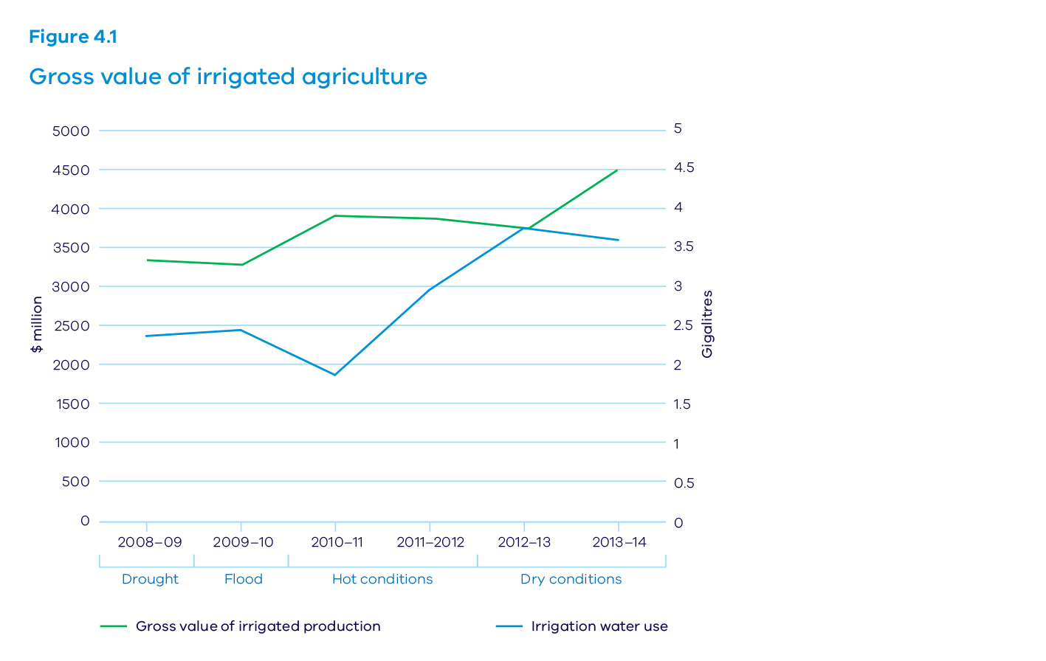

Farming trends and development and change
Farming is a competitive business. There is a long-term trend for fewer farmers operating larger farms and producing more in dryland and irrigated agriculture. For example, the Victorian dairy industry has developed strongly, but with significant change. The number of dairy farms has reduced by about 65 per cent since 1979-80 but the average herd size has nearly tripled and total milk production has doubled.³
Significant changes are also occurring in the types of farming enterprises. For example, wool production has declined as cropping has increased. In irrigation areas, horticulture has expanded while grazing enterprises have contracted.
These shifts and trends are caused by farmers responding to the demands and opportunities of competitive international agricultural markets and the need to improve productivity.
Local rural communities benefit where development occurs, but must adapt in areas where local primary production declines. The forecast increase in the frequency and severity of droughts will increase the volatility of on-farm and public water supplies and will require farmers and rural communities to plan, invest and adapt to maintain our comparative advantage in agriculture.

4.1 Enabling agricultural development and supporting change

Planning for future development and investment
When planning new agricultural developments, it is important to consider water-related needs and how to meet them, early in the process. Otherwise, businesses often experience frustrating delays and have to rework their proposals. Coordinated information and approvals for changing land and water use can help developers avoid these problems.
Potential agricultural developers need to consider water-related issues, including:
- whether water is available in their preferred locations at a suitable yield and quality
- the need to acquire water entitlements and understand the reliability of different entitlements
- the costs of developing or connecting to existing water supply or drainage infrastructure
- the risk that it may not be possible to deliver water because of insufficient system reserves, system capacity constraints or extended dry periods (see Chapter 8: Water entitlements and planning)
- the conditions on applying water to land and the requirements of irrigation development guidelines (see section 4.3).
Water corporations are the primary contact point for water issues for new agricultural development. Potential opportunities to maximise water infrastructure and resources for agriculture are identified by water corporations, based on what is understood of water availability, climate change, and the agricultural demands in their region.
Water corporations will participate in regional forums with local government, catchment management authorities, and Traditional Owners to inform regional visions, priorities and plans.

Action 4.1 – Support regional development and change
Water corporations will inform regional development processes about water resource opportunities and constraints including water infrastructure projects for agriculture.

Facilitating agricultural development
The government is trialling a new approach to facilitating agribusiness, led by Regional Development Victoria and drawing on expertise across government, including Agriculture Victoria Invest Assist and the water sector. Agribusiness Development Facilitation is overcoming regulatory barriers faced by business and ultimately facilitating investment and export opportunities.4 It is designed to save time and reduce the uncertainty associated with getting information and approvals.
The service is helping existing agribusinesses considering new developments to find the right locations, and to understand approvals processes. The service connects developers and relevant agencies, such as water corporations, catchment management authorities and local government.
These agencies are providing information to help developers understand the regulatory requirements for specific locations and water supply options. Landholders need to find relevant private expertise to understand the costs and benefits to their business of various water supply options.

Case study – Great South Coast Group Food and Fibre Strategy
Agriculture is the biggest private sector revenue generator and employer in the south west of Victoria. In February 2016, the Great South Coast Group, a peak body representing the region, released its Food and Fibre Strategy and Action Plan. The strategy identifies issues limiting agricultural development and possible solutions.
Actions include a pre-feasibility study of a private irrigation scheme and investigating the opportunities for better use of the deep groundwater resource – the Dilwyn Aquifer.
Southern Rural Water is now investigating the development of bores and distribution infrastructure to access the Dilwyn Aquifer, with $100,000 in Federal Government funding. Southern Rural Water will also assess preferred ownership options for the infrastructure and water entitlements.

Investment in infrastructure
Rural water infrastructure is vital to support agriculture and its future growth. Successive governments have invested in irrigation districts; the focus has been on reducing the amount of water required to operate the irrigation systems and enabling increased value of agricultural production. Governments, in partnership with communities, have also built modern stock and domestic supply systems in drier parts of the state. The Wimmera Mallee system is the largest of these supply systems.
Climate change will increase the need for existing infrastructure to be more efficient and for new infrastructure that gives communities access to the water grid. For these reasons, the Victorian Government is investing $81.19 million with the community, along with an additional $45.6 million committed from the Federal Government, in areas such as Mitiamo, South West Loddon, and Werribee Irrigation District.
Water corporations can expand rural water infrastructure under current cost-recovery arrangements. The government may also choose to invest in rural water infrastructure in partnership with communities if business cases demonstrate that the project will provide wider benefit to the public and if funding is available. Principles for government investment are set out in Table 4.1. The government will also consider investing in feasibility studies where there is significant community and industry support, and it is consistent with the investment principles.
Before investing in new infrastructure, farmers and local communities should consider their ability to purchase additional water from the market, and fund all associated on-farm costs and future delivery and maintenance costs. Farmers and local communities will be better informed by engaging with water corporations. In areas where a connection to the regulated supply is an option, these local decisions can also be informed by the new water grid oversight function (see Action 9.1 in Chapter 9: Realising the potential of the grid and markets).
The government’s preference is that private irrigation systems are fully funded by private investors. It is not the government’s role to take on the risk of commercial businesses by subsidising ongoing operations. Water users enjoy the benefits and bear the risks of future viability.

Action 4.2 – Invest in rural infrastructure
The government will consider future investment in rural water infrastructure guided by the principles in Table 4.1, which recognise climate change, regional plans and the health of the environment.
Table 4.1 – Principles for public investment in rural water infrastructure projects, subject to available funds

Long-term viability
- Net benefits will be achieved under a range of future water availability scenarios
- User demand and support for the proposed service is demonstrated, including commitment to meet all future operation and maintenance costs, and costs to source water through the new infrastructure
- It is consistent with regional strategic plans, regional growth plans, regional catchment strategies and land use planning
- It is consistent with any relevant land use suitability assessments and agricultural policy

Net public benefit
- No adverse impact on reliability and capacity to deliver existing entitlements The health of the environment must be maintained or improved
- Net public benefits to the Victorian economy and community values must be demonstrated

Value for money
- It has undergone a positive cost-benefit analysis of social, cultural, economic and environmental outcomes, including water savings and market value of water, economic growth and environmental sustainability
- Cost-share with proponents for construction is proportionate to the public and the private benefits (‘user pays’ principle)

4.2 Enabling prosperous irrigation districts
The major irrigation districts in Victoria include the Goulburn-Murray Irrigation District and the Sunraysia Irrigation District in the north, and the Macalister, Werribee and Bacchus Marsh Irrigation Districts in the south. They service the majority of irrigation enterprises in Victoria.
Irrigation districts offer opportunities for agricultural development. Investment in irrigation districts has increased flow rates and reduced ordering times, with year-round service in some locations. The impacts of irrigation are already well-managed in these areas.

Adapting to change
Landholders, local planners and rural water corporations must adjust to the changing demand and availability of water to provide competitive services that enable existing irrigators to maximise the value of their produce and to attract new development to districts.
Water users in irrigation districts share the costs of operating and maintaining irrigation delivery infrastructure. Many of these costs are fixed and if the number of district customers declines, the charges to remaining irrigators increase. Termination fees are designed to stop excessive costs falling on the remaining irrigators.
Farmers need clear price signals of the costs to operate and maintain water infrastructure, and transparent cost-sharing arrangements. Maintaining districts as attractive and affordable places to farm requires rural water corporations to plan for and actively respond to the changing needs of their customers. Rural water corporations must focus on providing levels of service that support modern irrigation practices. There is also a need to progressively rationalise underused and oversized delivery infrastructure. Customers require information about the costs to maintain district assets so they can participate in infrastructure decisions to contain future costs.
In northern Victoria, the volume of water delivered to the irrigation districts has declined. However, farmers are choosing to continue paying for delivery services because the charges associated with terminating delivery services are high in comparison. Because delivery shares are not being surrendered, they create a barrier for existing farmers who want to exit the industry or make their practices more efficient.

Adaptive irrigation districts
Irrigation distribution systems must adapt over time as farm businesses respond to changing climate, competition for water and market demands.
In 2010, the Campaspe community led the decision to close their irrigation district. The community considered future prices to maintain the irrigation system under a climate of low water availability and compared that with the cost of a reticulated domestic and stock pipeline. A number of existing Campaspe district irrigators moved to alternative irrigation supply arrangements sourced from the Goulburn system to maintain their production.

Goulburn-Murray Water Connections Project
The Connections Project is creating a world-leading water delivery system in the Goulburn-Murray Irrigation District and is the nation’s largest water recovery project. The Victorian and Federal Governments are investing over $2 billion in upgrading the irrigation delivery system to recover 429 gigalitres of water to benefit irrigators and the environment.
In 2016, the Connections Project was reset to enable better water recovery on target and within budget. This reset provides a clear way forward to maximise savings from this once-in-a-generation project and so that it secures the future of irrigated agriculture in the Goulburn-Murray Irrigation District for generations to come.
The key component of the reset is changing the way the project engages with landowners and provides a channel-by-channel approach with local people contributing their knowledge to identify practical solutions.
When completed, all water users in the region will benefit from a world-class automated water delivery system that will drive improved productivity, and provide greater security for irrigators and real water savings.
The project is a key part of Victoria’s contribution to implementing the Murray-Darling Basin Plan in a way that minimises any socio-economic impacts. The project recovers water which is provided to environmental water holders to protect and improve waterway health to support fish, vegetation and water quality.
Already, the project has decommissioned 899 kilometres of channel, remediated another 219 kilometres, installed a further 6155 meters and achieved 249 gigalitres of water savings per year.

Action 4.3 Help irrigation districts adapt
Rural water corporations will actively respond to the changing needs of their customers so that irrigation districts remain affordable and attractive to new businesses. Rural water corporations will:
- engage with existing customers
- engage with key stakeholders such as catchment management authorities, local government and Traditional Owners (see section 4.1)
- review the future use of delivery shares in the Goulburn-Murray and Sunraysia Irrigation Districts by June 2018, to consider how tariffs and price signals can be used to assist irrigation districts respond to changing customer needs
- set out service plans in their corporate plans.

Reducing barriers to change and supporting communities
Smaller district farmers can find it difficult to afford water to maintain and grow their businesses and manage in drought. While some farms are growing and expanding production, many smaller irrigators are effectively drying-off large proportions of their properties, particularly in northern Victoria. Farmers have the right to buy and sell land and water to meet the needs of their businesses. These changes can have negative consequences for local communities if they do not adapt at the same pace.
The government will ease the impacts of change by providing services, such as rural financial counselling and hardship polices for water bills to ease the immediate pressures on local communities. Individual farmers will also have access to farm planning advice, so they can adjust to changing conditions over the longer term.
Properties that have been dried-off provide an opportunity for redevelopment by existing or new farm businesses. Streamlining the aggregation of small land parcels in the irrigation districts to viable sizes will also help reduce barriers to redevelopment in irrigation districts. This will require relevant parties to align their plans and processes (see section 4.1).

Action 4.4 – Reduce barriers to change and support communities in irrigation districts
The government will reduce barriers to change and enable agricultural development in irrigation districts by:
- investing in the Sustainable Irrigation Program with $59 million over four years, which includes grants for decision support and property planning to enable change in irrigation districts
- identifying opportunities to increase the efficiency of water-related regulation, such as termination fees
- reducing unnecessary administrative barriers for development, in particular to consolidate land parcels in irrigation districts.

Accounting for water efficiency
The water sector is focused on increasing the efficiency of distribution systems and on-farm practices in irrigation districts to make the most of our water resources. Governments have invested in upgrading irrigation districts to generate water savings and improve levels of services to water users. These water savings have provided significant public benefits, such as water recovery for the environment.
Water savings made from the shared assets of irrigation districts are estimated using formal, independently verified protocols before being converted into permanent water entitlements.
It is important that rural water corporations and farmers operate irrigation distribution systems to maximise water efficiency. Investment in irrigation modernisation has demonstrated how irrigation delivery systems can run more efficiently. Innovation in spatial technologies will enable benchmarking, monitoring and reporting of on-farm water use to drive future improvements in water efficiency.

Action 4.5 – Improve water delivery efficiency in irrigation districts
The government will:
- implement rigorous water savings protocols to estimate water savings from district assets prior to converting savings into entitlements
- require rural water corporations to report on delivery system efficiency
- improve monitoring and reporting of farm water use efficiency in irrigation districts.

Case study – Whole farm planning supports change in irrigation districts
The sustainable irrigation program provides district farmers with independent advice and incentives to plan for their future business needs, improve their water use efficiency and manage the impacts of irrigation. Tools such as a ‘whole farm plan’ help farmers to adapt to change. A whole farm plan is a tangible farm design to manage irrigation water and drainage in the most efficient and environmentally responsible way for the individual farm. These plans help irrigators make informed decisions on the future of their farms, which is particularly relevant for properties in districts undergoing modernisation.
Historically, take up of whole farm plans has been well supported by farmers. In the Macalister Irrigation District around 60 per cent of whole farm plans undertaken since 2000-01 have been put into practice. In the Goulburn-Murray Irrigation District, whole farm plans have helped farmers participate in the Farm Water Program, which helps improve on-farm irrigation systems to achieve water savings.
“These types of programs are good for farming, good for the sustainability of the industry and mean we can adapt more easily to (weather and market) challenges.”
Farm water program participant

4.3 Managing salinity, waterlogging and water quality
Agricultural activities have the potential to cause salinity and water quality problems in neighbouring areas. Victoria’s management responses have made significant progress, particularly in irrigation areas, which has supported agricultural development. Continued government investment is needed to manage the ongoing risks. This gives developers the confidence to invest, and supports the green credentials of Victorian agriculture in global markets.
It is important that farmers understand and manage their drainage risks. Rural water corporations also need to manage their surface and sub-surface irrigation drainage networks to deal with excess water when on-farm management systems are overwhelmed by extreme rainfall events.
The Victorian Irrigation Drainage Program has successfully mitigated the most severe waterlogging, salinity, water quality and drainage risks in irrigation landscapes. The floods of 2010-2011 demonstrated the need for an ongoing program when heavy rains caused rapid increases in groundwater levels and renewed salinity threats.
The program is moving away from extending the irrigation drainage networks and is now focusing on farm drainage measures and coordination activities and ensuring that natural drainage courses are not inadvertently blocked.

Case study – Modernising Werribee and Bacchus Marsh irrigation districts
The Werribee basin has seen a significant decline in water availability and long periods of salinisation in the lower reaches of the Werribee River.
Southern Rural Water is modernising its Werribee and Bacchus Marsh Irrigation Districts to reduce water losses, improve the levels of service to its customers and improve the health of the Werribee River. The aim is to increase productivity and create new jobs in the area.
The Victorian Government is investing $11.35 million in the Werribee Irrigation District and $5 million in the Bacchus Marsh Irrigation District. This investment, along with investment from irrigators, will deliver shared benefits for irrigators and the local community. Water savings will improve water security and increase production in the irrigation districts, and also create an additional environmental entitlement for the Werribee River.

Action 4.6 – Manage salinity, waterlogging and water quality
The government, in partnership with water corporations and catchment management authorities, will:
- invest in water quality and salinity management and monitoring activities in irrigation and dryland farming areas
- develop priorities for the Victorian Irrigation Drainage Program for the next five years in consultation with landholders and other stakeholders
- ensure Victoria complies with its interstate salinity and water quality commitments set out in the Murray-Darling Basin Agreement (Basin Salinity Management 2030) and the Murray-Darling Basin Plan.

Managing irrigation developments
The salinity and water quality risks of agricultural intensification in existing areas and development in new areas must be managed. New problems can be prevented by guiding new developments to appropriate sites and the use of best management practices.
Under the Water Act 1989, the offsite impacts of irrigation activities are regulated through water-use licences or take and use licences. These licences are tied to the land and set out the conditions to minimise the effects of water use on others.
Irrigation practices have changed significantly since water-use licences were introduced in 2007. For example, farmers have greatly increased water use efficiency. There are trends towards growing higher value crops, and the intensification of agriculture, such as glasshouse developments. Our understanding of the risks to third parties and the environment from irrigation has also continued to improve. Irrigation development guidelines need to be contemporary to provide streamlined risk management of emerging trends in irrigation development.
Water-use licences can be cancelled when irrigation properties have dried-off for a lengthy period. A review of the timeframe for cancellation of a water-use licence will consider the rapid pace of agricultural change and opportunities for significant redevelopment of irrigation properties.
In the Mallee region, uncontrolled irrigation can force saline groundwater into the Murray River causing unacceptable increases in salinity. After consulting the local community, a salinity impact zoning policy was introduced in 1994. Salinity charges are designed to steer development from high to low impact zones. Revenue raised is used to fund initiatives that support agricultural water use and offset the salinity impact. The government will update the setting of salinity charges to make it consistent with the new salinity management framework, Basin Salinity Management 2030.

Action 4.7 – Manage irrigation development
Over the next four years, the government, in partnership with water corporations and catchment management authorities, will:
- ensure that regional irrigation development guidelines are contemporary to emerging knowledge and risks, and are applied across the state to new irrigation developments and significant redevelopments
- ensure water-use licence conditions remain relevant to current and future risks at a regional level, and are effectively enforced to manage the potential offsite impacts of irrigation
- review the timeframe when water-use licences may be cancelled or modified.
Figure 4.2 shows that salinity impact zones and charges in the Mallee have enabled 33,265 hectares of new irrigation development in low-salinity impact areas, while protecting the Murray River and downstream water users. In the highest salinity impact zone, water use has reduced. It is timely to review these arrangements and if current water use is manageable within Victoria’s Murray River obligations.
Figure 4.2 – Mallee salinity impact
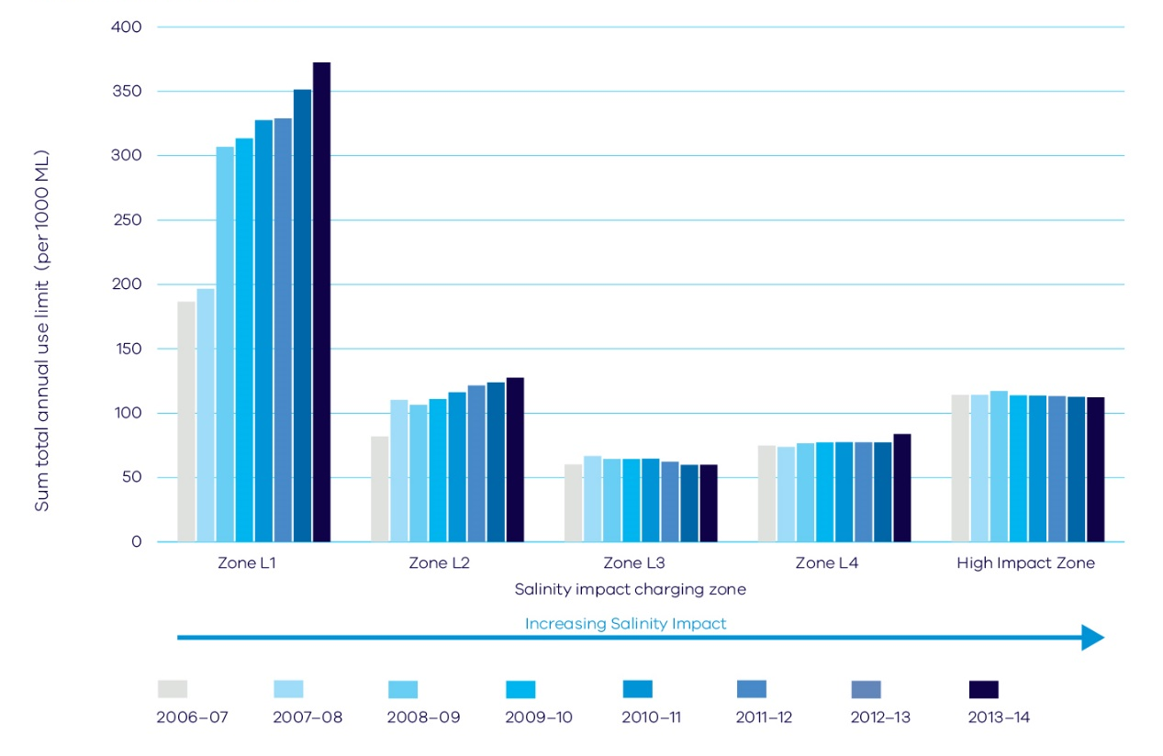

Action 4.8 – Improve salinity management in the Mallee
The government will continue to improve the current approach to managing salinity in the Mallee and will:
- invest revenue from salinity charges on an annual basis to update contemporary knowledge of the Victorian Mallee salinity impacts and the cost of offsets consistent with Basin Salinity Management 2030
- establish an independent review process to oversee how salinity charges are set by 2019
- review policies for the high impact zone in the Mallee to support modernisation of the Sunraysia Irrigation District by December 2019
- work with the Murray-Darling Basin Authority to ensure a level playing field across Basin states in the joint management of salinity.

4.4 Enabling prosperous irrigation outside irrigation districts
Significant irrigation occurs outside the public irrigation systems. These irrigators, known as private diverters, are found across the state and may hold:
- water shares in regulated systems and irrigate from regulated rivers such as the Murray and Goulburn rivers
- take and use licences to divert water, either all year round or in winter, from unregulated rivers such as the Mitchell and Yarra rivers
- take and use licences to take water from groundwater systems.
Private diverters own and pay all of the costs of water harvesting assets, such as pumps, on-farm dams and groundwater bores, and the distribution assets.
Where take and use licences are still available outside irrigation districts, water corporations will work with regional agencies and stakeholders to identify potential opportunities for irrigated agriculture (see Action 4.1).
Levels of demand and willingness to pay drive decisions to invest in unallocated water where it is available in unregulated and groundwater systems, or to purchase water on the water market.

4.5 Water management in dryland areas
Dryland farmers have the right to access water that falls on, or flows under, their land under stock and domestic provisions in the Water Act. They can also access entitlements and agreements managed by water corporations.
Reduced water availability poses a significant threat to Victorian livestock farmers. Stock water shortages may require farmers to cart water and reduce production and productivity.
Dryland farmers manage their own on-farm water supplies including the risks of droughts and climate change. There is no statutory obligation for all rural properties to have access to a water supply. To manage the risks of drought and climate change farmers may choose to invest in a reticulated local pipeline for domestic and stock use. While this improves their water security, it increases business costs.
The government will work in partnership with communities to inform their water supply decisions, in particular:
- The Department of Economic Development, Jobs, Transport and Resources will continue to provide information to help individual landholders to assess their stock water requirements and water management options.
- Water corporations will identify potential opportunities for water infrastructure projects that can improve water security, based on what is understood of water availability and climate change and demand in their region (see Actions 4.1 and 4.2).
The water sector will continue to work with the Department of Economic Development, Jobs, Transport and Resources and the agricultural industry, including the Victorian Farmers Federation, to encourage and assist farmers to adapt to, and mitigate, the risks of reduced water availability from traditional stock water sources, such as runoff dams and groundwater bores.

Carting water during droughts
Drought-affected farmers may sometimes need to cart water from distant sources to care for their animals.
Local government authorities and water corporations own and manage water supply points to provide water supplies for water carting during drought. Some of these supply points have not been maintained between droughts and require costly refurbishment at the start of each new drought. Ongoing work is needed so that water carting supply points have a basic care and maintenance program or are mothballed so they can be cost-effectively recommissioned when the next drought occurs.

Action 4.9 – Improve management of emergency water supply
The government, in partnership with local government and water corporations, will improve information on the availability of emergency water supply points. This will require:
- clarifying the roles and responsibilities of local government and water corporations in the management and communication of emergency water supply points
- clarifying pricing principles for emergency water supplies with local government and water corporations by December 2017
- evaluating the emergency water supply point network and, where necessary, work with emergency water supply point managers to upgrade and take ongoing responsibility for sites, consistent with roles and responsibilities.

Rural drainage
Across Victoria, approximately 130 rural drainage schemes service around 1.5 million hectares of dryland farming. These schemes manage flooding and waterlogging, and are different from the public drainage schemes in irrigation districts.
Many of the schemes fell into disrepair during the Millennium Drought. Fees and charges are no longer collected and basic maintenance programs have been dropped.
Some rural drainage schemes drain wetlands, clear natural waterways and discharge poor quality water into streams. Flood waters can also be moved from one property to the next causing conflicts between neighbours.
The floods of 2010-11 and 2013 reminded landholders of the purposes of these drainage schemes, but highlighted problems with the current management arrangements.
The 2013 Environment and Natural Resources Committee’s parliamentary inquiry into rural drainage infrastructure identified significant policy gaps in rural drainage, which are detrimental to farm productivity and the environment. The inquiry made 32 recommendations regarding management and governance issues, including the recommendation that the government develop a Victorian Rural Drainage Strategy.

Action 4.10 – Develop a rural drainage strategy
The government, working with local government, catchment management authorities, the Victorian Farmers Federation, coastal and catchment councils and the community, will develop a Victorian Rural Drainage Strategy. It will be prepared through an open and consultative process by 2017.

4.6 Balancing outcomes of the Murray-Darling Basin Plan
The Murray-Darling Basin Plan has set a water recovery target of 2750 gigalitres and Victoria’s share of this target is 1075 gigalitres. Up to 650 gigalitres of the 2750 gigalitres may be achieved through offsets from environmental works and measures or operational rule changes which deliver equivalent environmental outcomes without the need for more water (see Chapter 3: Waterway and catchment health).
The government will prioritise investment in water recovery through modernising irrigation delivery systems and improving farm water use efficiency, as well as maximising the environmental offsets. Figure 4.3 shows there has been some progress on achieving the water recovery targets for the Murray-Darling Basin.
Work is underway to determine the feasibility of options to overcome constraints at six sites in the southern Murray-Darling Basin to deliver increased environmental flows. Each potential site is dependent on other constraints in the system and a better understanding of these interactions is needed. Any relaxation of constraints needs to consider third-party flooding- related risks. The government will not intentionally inundate private land without the agreement of land holders. Basin Ministers have agreed there will be close community and landholder involvement in the examination of options.
The government recognises the need to properly assess and understand social and economic impacts, particularly on local irrigation-dependent communities. The criteria of neutral or positive socio-economic impacts need to be rigorously applied to any proposals to recover water over and above the 2750 gigalitres target.

Action 4.11 – Balance water recovery for the Murray-Darling Basin
The government, in partnership with water corporations and catchment management authorities, will work to achieve balanced outcomes from implementing the Murray-Darling Basin Plan in Victoria by:
- continuing to prioritise projects to help meet its 1075 gigalitres obligation under the Basin Plan with water savings and environmental offsets, rather than further reducing the consumptive pool
- publishing a yearly online update on Victoria’s progress toward meeting Basin Plan water recovery targets
- working with the Federal Government, other Basin jurisdictions and the Murray-Darling Basin Authority to ensure effective governance of the process to deliver environmental offsets
- undertaking its own socio-economic analysis into the impact of water recovery to inform discussions with the Federal Government and make sure that any further water recovery above 2750 gigalitres from Victoria is based on robust evidence that it can be done with neutral or positive social and economic impacts
- participating in a coordinated interstate process to investigate the feasibility of addressing constraints to environmental water delivery in the southern Murray-Darling Basin, with strong community involvement.
Figure 4.3 – Progress towards basin plan recovery
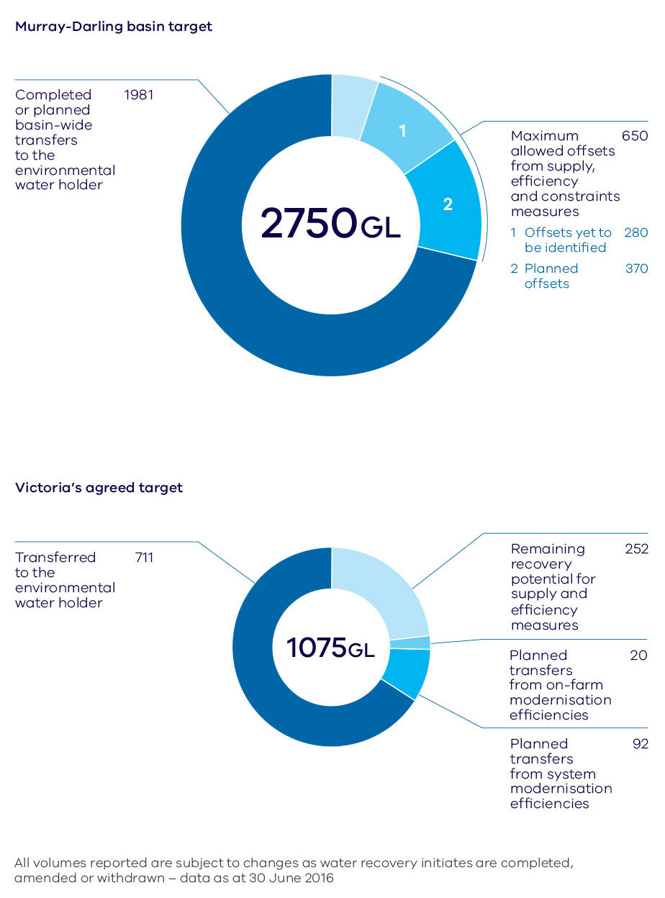
The Commonwealth aims to achieve 3200 gigalitres of water for the environment. The government does not support further recovery of water for the environment above the 2750 gigalitre target unless it can be demonstrated that the criteria or neutral or positive socio-economic effects has been rigorously applied.
In 2015–16 Victoria submitted nine business cases for environmental works and four operational rule change proposals to be assessed for offsets.

Case Study – South West Loddon Rural Water Supply Project
In early 2016, the Victorian Government committed $41.4 million to stage 2 of the South West Loddon Rural Water Supply Project, in addition to $20 million of Federal Government funding. The project aims to deliver by pipeline a reliable water supply to over 600 rural properties across 160,000 hectares to support a severely drought-affected community.
Consistent with the investment principles in Table 4.1, landholders will pay for the water, contribute to connection costs and assume all ongoing costs.

5. Resilient and liveable cities and towns

OBJECTIVE
We will help transform Victorian cities and towns into the most resilient and liveable in the world. We will include all elements of the urban water cycle in the way we plan and manage water so that Victorian communities can continue to thrive in all climates.
In Victoria, we expect our cities and towns to be liveable and productive places that support vibrant communities. The urban water sector provides services that are fundamental to the health and wellbeing of Victorians who live in cities and towns. These services include providing safe and secure drinking water, managing and treating wastewater, and managing water to protect the urban environment from floods.
Victorians are very aware of the impact drought and flood can have on our cities and towns. During the Millennium Drought we saw the limits of water availability in many urban areas. Severe water restrictions in many areas meant that people could not enjoy their local parks, gardens and public open spaces. Many sports grounds were unusable. As detailed in Chapter 2: Climate change, climate modelling predicts more extreme events in the future.
By managing water well, we can achieve benefits including healthy waterways and greener, cooler urban spaces. The government’s approach to urban water management links all aspects of the water cycle and water services planning, and aligns this with land use planning. Better management will help us achieve benefits more efficiently and contribute to an affordable urban water sector. We will make the most of all water sources, including recycled water and stormwater, which is also essential for water security.
We will renew our focus on water efficiency, manage water to achieve the multiple benefits set out in Figure 5.1, and engage the community through local water planning. Victoria will use the best mix of traditional and local solutions to get the most out of infrastructure and investment. The government is investing $8.8 million in 2016-17 on a package of initiatives to strengthen urban water policy frameworks and delivery of integrated water management.

What we will do
- Use diverse water sources to protect public spaces
- Better urban water planning to address key challenges
- Reinvigorate water efficiency programs for Melbourne and regional Victoria
- Make the most of our investment in wastewater
- Improve stormwater management for greener environments and healthier waterways
- Work across government for healthy and resilient urban landscapes
- Represent community values and local opportunities in planning
- Put integrated water management into practice
Water for Victoria makes better use of all our water sources so our communities can enjoy parks, gardens, sporting fields and recreational activities.
We will make decisions locally and use water efficiently so that our cities, towns and regional areas are liveable and resilient.

Key challenges and opportunities
Victoria’s population is projected to reach 10.1 million by 2051. The populations of Melbourne and the major regional centres of Ballarat, Bendigo and Geelong are expected to almost double1. This will place enormous demands on our water services.
Climate modelling indicates that Victoria will become drier and warmer. Drought, urban flooding, bushfires and heatwaves will likely happen more often. Drought and reduced rainfall will further impact on the water available to keep cities and towns cool and green. Rapid urban growth and increasing stormwater flows will degrade urban waterways unless we improve the way we manage stormwater.
Integrated water management allows us to prepare for, and respond to, shocks from extreme events, and the challenges associated with climate change and population growth. Central to this approach is aligning water and land use planning, and making sure that investment decisions take into account non-market benefits including flood mitigation, urban cooling and a healthy environment.
Figure 5.1 – Water’s role in resilient and liveable cities and towns

Safe, secure and affordable supplies in an uncertain future
- A diverse range of water supplies and sources
- Water quality meets regulatory standards and community expectations
- Manage water efficiency and demand
- Secure water supply for Victorian industry and the economy
- Water available to maintain valued green community assets including for climate change

Effective and affordable wastewater systems
- Meets public health and environmental standards
- Effective sewerage systems
- Optimised onsite domestic wastewater
- Maximise waste-to-resource opportunities

Effective stormwater management protects our urban environment
- Waterway health is maintained and improved
- Community and property resilient to local flood risk
- Appropriate levels of flood protection in new development

Healthy and valued urban landscapes
- Water is prominent in the urban landscape
- Urban landscapes retain moisture for cooler, greener cities and towns
- Waterways accessible as valuable open space
- Aboriginal cultural values associated with waterways are protected

Community values reflected in place based planning
- Diverse urban landscapes that reflect local conditions and community values
- Empowered engaged community
- Local water related risks and issues understood and managed

5.1 Using diverse water sources to achieve secure water supplies
Water availability is important for the liveability of cities and towns. In addition to meeting our basic drinking water needs and providing confidence to industry, water is essential for cool, green urban areas. Using diverse water sources will lessen pressure on drinking water supplies, increase urban water security, and help to keep our cities and towns liveable through drought.
The Victorian Desalination Project has significantly contributed to our water security by providing a rainfall-independent source of water that does not take water from our river systems. The water grid allows areas outside Melbourne to benefit from the desalination plant, and from other key water sources, as it can be used to carry water to where it is most needed (see Chapter 9: Realising the potential of the grid and markets). Despite the significant recent investment in our water infrastructure, and without further action, we may need our next major supply augmentation for Melbourne sooner rather than later due to population growth and climate change. As shown in Figure 5.2, under the median climate change scenario, we may need to add to Melbourne’s supplies by 2035. Figure 5.2 also shows the water supply mix in 2015 (part A) and the potential diverse mix of supplies needed in 2050 (part B).

Identifying needs and potential water sources
In a drying climate, it will be important to make the best use of all fit-for-purpose sources of water, including recycled water and stormwater.
Urban growth increases stormwater runoff and wastewater in quantities roughly the same as the amount of drinking water we use. This provides significant opportunities to diversify our water sources. These sources can be used for different purposes, for example, to irrigate public gardens and sporting grounds, and to make sure that valuable parkland is not lost during drought. Keeping water in the landscape and soils also provides cooler, greener urban places, which supports health and wellbeing. This will be even more important as we face increased and prolonged periods of heat. Using alternative water sources has the added benefit of protecting our urban waterways and bays from stormwater and treated wastewater discharges.
The government will continue to support the use of diverse water sources that are safe and suitable to improve water security and the resilience and liveability of our cities and towns. For example, we will use stormwater and recycled water to support urban greening and reduce pressure on our precious drinking water supplies.
Significant progress has been made in the use of recycled water in cities and towns over the last decade. However, opportunities to use more recycled water remain and will continue to grow as our cities and towns grow. The Department of Environment, Land, Water and Planning will work with water corporations and the Essential Services Commission to investigate mechanisms to increase the uptake of recycled water, in both urban and agricultural areas. This investigation will look at pricing mechanisms, innovation and infrastructure as well as incentive programs.
Water corporations will continue to work with water users to understand their needs including working with local government to identify areas of heat stress and promote urban cooling in priority areas.
The government will maintain public confidence in recycled water and stormwater schemes through strong regulation, research, and community engagement.
Figure 5.2 – Potential future supply and demand scenario for Melbourne
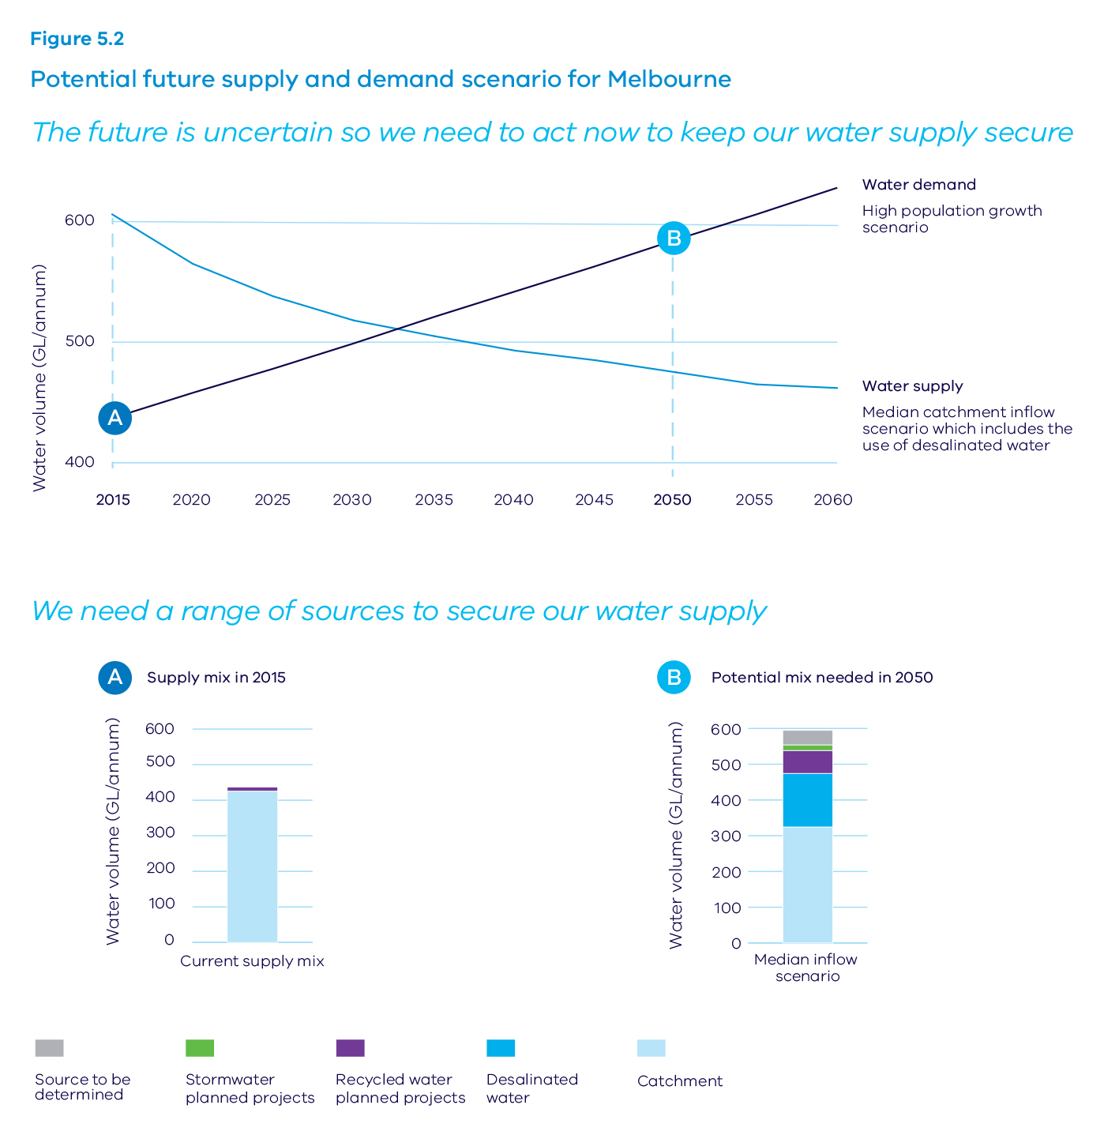

Action 5.1 –Use diverse water sources to protect public spaces
Water corporations will work with local government and other public open space managers to identify water sources to maintain community assets, such as sporting facilities, public gardens and street trees during drought to enhance community health, wellbeing and liveability.
Water corporations, local government, catchment management authorities and community leaders will work together to enhance public spaces through integrated water management in our existing and new urban environments. This will be achieved by:
- selecting priority parks, gardens, public open spaces and playing fields to look after during drought by 31 March 2017
- seeking opportunities to promote urban cooling
- building a shared understanding of the costs of water restrictions to the community and community expectations about restrictions, and using this to inform water supply and demand management decisions.
The Department of Environment, Land, Water and Planning in partnership with the Environment Protection Authority and the Department of Health and Human Services will clarify and improve the regulatory arrangements for recycled water and stormwater.

Planning by urban water corporations
Urban water corporations have a vital role in urban water security by managing the supply of their water to meet the needs of their customers. Urban water corporations, other than Melbourne Water, must develop an urban water strategy based on a long-term outlook of 50 years that looks at a range of climate change scenarios and future demands (see Chapter 8: Water entitlements and planning).
The urban water strategies will include drought preparedness planning. We must actively prepare for drought, not just respond to it. In developing these plans, water corporations will work with their communities to find the best way of securing supply for each system during drought. By being involved, the community will better understand the likely water security risks over coming years.
Urban water corporations will continue to track the status of water supplies and demands as well as their projections for the year ahead. This information is released each year on 1 December in an annual water resource outlook. The Department of Environment, Land, Water and Planning will prepare a state-wide outlook drawing on the water corporation outlooks. The newly developed water grid oversight role will inform the urban water strategies and state-wide outlook (see Chapter 9: Realising the potential of the grid and markets). These will provide valuable information on supply and demand, and guide integrated water management.

Action 5.2 – Better urban water planning to address key challenges
Urban water corporations will develop urban water strategies that include:
- climate and population projections that are comparable across water corporations
- drought preparedness planning
- looking at all drinking and non-drinking water sources and the appropriate use of each source to protect human health.

Continued role for water efficiency
The community and industry have an essential role in urban water and our culture of water efficiency. This was demonstrated during the Millennium Drought. The contribution made by communities and businesses in reducing water use during this time has been widely attributed as the reason Melbourne did not run out of water. This included the Target 155 program, a voluntary water efficiency program to encourage Melbourne households to limit their water use to 155 litres per person per day.
As part of the next stage of water efficiency initiatives, the government and the water sector will develop materials to help communities better understand the urban water cycle, the importance of water in the urban environment, and challenges we face.

Action 5.3 – Reinvigorate water efficiency programs for Melbourne and regional Victoria
We will help communities better understand urban water challenges and what they can do to achieve results by:
- rolling out the next generation of the Target 155 program for Melbourne, and developing the ‘Target Your Water Use’ program for regional Victoria, to help people understand the importance of water and manage their water use
- making sure water corporations continue to work actively with industries that use a lot of water to find ways to improve water efficiency
- building on the Schools Water Efficiency Program by increasing the number of schools in the program and expanding it to other areas, such as government buildings
- promoting the water corporations’ ‘Choose Tap’ campaign (or similar), which provides readily available drinking water that supports public health and reduces waste.

T155 Program and Target Your Water Use

Target 155
The Melbourne metropolitan water corporations will roll out the next generation of the Target 155 program ahead of the 2016–17 summer.
The program will be implemented locally by each water corporation. Initial actions will focus on advice and education to help the community understand efficient water use and how to aim for the annual target of 155 litres per person per day.
Actions will be reviewed each season and will be adjusted depending on storage levels, rainfall and what customer and stakeholder research is telling us.

Target Your Water Use
To complement the Target 155 program, the regional urban water corporations will develop and implement a regional water efficiency program called ‘Target Your Water Use’.
Water use across Victoria varies a lot due to the different urban environments, diverse landscapes and climate variation. Water use per person for regional water corporations ranges from 120 litres per day to almost 500 litres per day. In some parts of Victoria a per person target of 155 litres per day would affect the liveability of the regional cities and towns.
The Target Your Water Use program recognises the wide variation of water use across Victoria. This program will link to the Target 155 program and focus on efficient water use for each region. As with the Target 155 program, the regional program will be rolled out locally by regional water corporations.

Case study – Schools Water Efficiency Program
The Schools Water Efficiency Program has saved participating Victorian schools more than 2.1 billion litres of water through the early identification of leaks, faulty appliances and inefficient practices. This water would have cost more than $7.7 million over the last four years.
Using data loggers to monitor daily school water use at 15-minute intervals, every participating school has been able to better understand its water use and identify at least one problem that may not have been recognised as quickly, or at all, without this program.
This world-class and internationally recognised program is available to every Victorian school. The program provides subsidised data loggers, a dedicated website, specialist advice and curriculum materials to manage and monitor water use and continue water efficiency education of school children. Importantly, the program delivers water, electricity and solar use data in a way that is meaningful to users from primary school students to principals.

5.2 Strategic investment in wastewater
Discharges of treated wastewater have increased as our population has grown. This affects the health of our waterways and bays. These discharges will continue to increase with population growth. Historically, we have managed treated wastewater for a single purpose – reducing the spread of disease. With a stronger focus on the environment, we can achieve healthier urban waterways and improve our parks and gardens while continuing to protect public health.
In developing their urban water strategies, water corporations will consider treated wastewater’s role in the urban water cycle, including for recycling and environmental outcomes. Water corporations spend a lot of money on sewerage management. By including wastewater in long-term water planning, water corporations can achieve better results for the community and the environment.
In unsewered urban areas, we can adopt more innovative approaches to on-site domestic wastewater management, and address legacy issues in areas that are not meeting required standards.

Action 5.4 – Make the most of our investment in wastewater
We will better manage our wastewater by:
- requiring Melbourne Water to produce a long-term bulk sewerage strategy, considering climate change and population growth scenarios
- requiring water corporations to include long-term bulk sewerage planning in their urban water strategies
- working with local government to prioritise actions to improve on-site domestic wastewater management
- working with water corporations to explore opportunities for resource recovery from wastewater or other sources of organics.

5.3 Better stormwater management for a healthy and resilient urban environment
Urban waterways are important community assets and their health and amenity values are key contributors to liveability. Urban growth has increased discharges of stormwater to the environment through the connection of the stormwater system to our urban waterways. The most recent science tells us that how we manage stormwater today will not protect our waterways as urban development and population growth continues. Stormwater also contributes to localised urban flooding, which damages property and puts community safety at risk.
Traditionally, we have managed stormwater with a focus on urban drainage, seeking to remove it from the landscape as quickly as possible. Now we know that keeping stormwater in the landscape and managing discharges to our stormwater systems can help to reduce the impact of erosion and pollution of our urban waterways. By better managing stormwater we can build our resilience to floods and make more water available for urban vegetation.
Clause 56.07-4 of the Victoria Planning Provisions contains stormwater management requirements for new residential subdivisions. This has helped reduce stormwater pollution.
However, the coverage of Clause 56.07-4 is limited and does not apply to many developments likely to have negative stormwater impacts. Recognising the limits of the current provisions, a number of local councils have implemented local policies for Water Sensitive Urban Design that extend the principles of Clause 56.07-4 and best practice stormwater management.
Now is the time to review Clause 56.07-4 and other planning and building rules to improve the way we manage stormwater and improve environmental and liveability outcomes. There is now wide recognition that stormwater management is best improved through a mix of tools, including incentives and education as well as regulation.

Action 5.5 – Improve stormwater management for greener environments and healthier waterways
The Department of Environment, Land, Water and Planning will improve stormwater management by:
- preparing and consulting widely on proposals to amend the Victoria Planning Provisions and related building regulations aimed at improving stormwater management and associated outcomes
- leading the development of local place- based targets for stormwater management
- finding the best mix of legislative, regulatory, financial and market-based incentives to complement the use of the Victoria Planning Provisions and building regulations.

5.4 Working across government to support healthy and resilient urban landscapes
We need to better align water management, drainage, urban design and planning to deliver broader resilience and liveability results for our communities. The Victoria Planning Provisions set out state land use planning policy, and contain some provisions that support integrated water management. However, we need to strengthen the link between land use planning and water management to realise opportunities and prevent urban growth from harming our waterways.
The government is already taking action, recognising the link between better water management and diverse results for communities. For example, the refresh of Plan Melbourne 2014 strengthens the focus on the city’s response to climate change through the creation of a more resilient and environmentally sustainable Melbourne. The government is also protecting the Yarra River’s amenity for the benefit and enjoyment of future generations.
There are also opportunities to better align water with other relevant portfolios, such as environment (biodiversity), land use planning, local government and suburban development. A systematic approach to integrated water management planning can bring stakeholders together to consider opportunities and challenges across different policy areas.
By working together, we can better allocate resources and invest more efficiently. This will help ensure consistent standards across the state and provide a level playing field for operating in the sector.

Action 5.6 – Work across government for healthy and resilient urban landscapes
The government will strengthen links across portfolios to better align land use and water management planning by making sure that:
- planning for water-related benefits is part of all future major projects and relevant government strategies and initiatives, including Plan Melbourne, Metropolitan Open Space Strategy, and the Yarra River Protection Project, and those arising from the new Suburban Development portfolio
- urban land use planning instruments, standards and guidelines, such as state and local planning frameworks and Environmentally Sustainable Development performance standards for buildings, are progressively aligned with the water-related benefits that support resilient and liveable cities and towns.

5.5 Local planning through integrated water management
Integrated water management promotes collaborative planning and management of water, land and related services to maximise economic, social and ecological benefits to the community. This planning is based on local values and priorities, with a focus on opportunities to efficiently achieve results across the five benefit areas shown in Figure 5.1.
Integrated water planning is already being used to varying extents. There is an opportunity to use it more systematically across the state to enhance the resilience and liveability of our cities and towns and guide place-based decisions.
Integrated water management supports ‘green and blue infrastructure’ such as parks, wetlands, streams and urban vegetation, and can deliver multiple benefits including flood mitigation, urban cooling, clean air, healthy streams and increased biodiversity, as well as contributing to recreation and amenity.
The government will implement integrated water planning across Melbourne and regional Victoria. The outcomes of this planning will be included in the urban water strategies of all water corporations and in the Melbourne Water Systems Strategy prepared by Melbourne Water (see also Chapter 8: Water entitlements and planning).
The new integrated water management planning framework will guide the development of place-based integrated water management plans to provide integrated water services and support liveable and resilient urban places. Broad-scale forums including people from different agencies and people from a variety of disciplines (for example, urban planning and engineering), will be convened to identify priority locations for the development of integrated water management plans.
Water corporations will generally lead the development of integrated water management plans, working with local government, catchment management authorities and other partners, as well as the local community. However, other organisations may lead the process if they are better placed to do so.

Action 5.7 – Represent community values and local opportunities in planning
The government will adopt a systematic approach to integrated water management planning by:
- facilitating integrated water management forums to identify and prioritise places that would most benefit from a place-based plan—in Melbourne these will be based on five waterway catchments and in regional areas on the boundaries of the regional urban water corporations
- requiring the development of place-based integrated water management plans, with water corporations leading the development of these plans, unless it makes sense for another organisation to do so
- supporting the development of agreements between participants about who is responsible for actions
- requiring water corporations to incorporate integrated water management in all their planning, including urban water strategies, and the strategies prepared by Melbourne Water for water, sewerage, waterway health and flood management.
The integrated water management forum and plan development process will identify challenges and opportunities for achieving water-related benefits in priority areas. The plans will outline what needs to be done to meet these challenges and opportunities, and will allocate actions to relevant organisations. The agreements entered into by implementation partners are an important part of this new planning approach and will address key implementation issues, such as responsibilities for the maintenance of relevant assets.
Figure 5.3 sets out Victoria’s approach to integrated water planning which enables us to consistently identify place-based priorities and actions across the state that align with the water-related benefits. It also helps guide action at the local level. Organisations will be able to clearly identify their role in delivering water-related benefits while linking to existing business planning frameworks, such as local government strategic plans.
Central to this new approach is a strong focus on the multiple benefits set out in Figure 5.1 above which can be achieved through integrated solutions. Traditionally these benefits have not been effectively considered as many are difficult to quantify. A common evaluation framework will assist water corporations, local government and other partners to make investment decisions that take account of these multiple benefits.
Figure 5.3 – Integrated water management planning
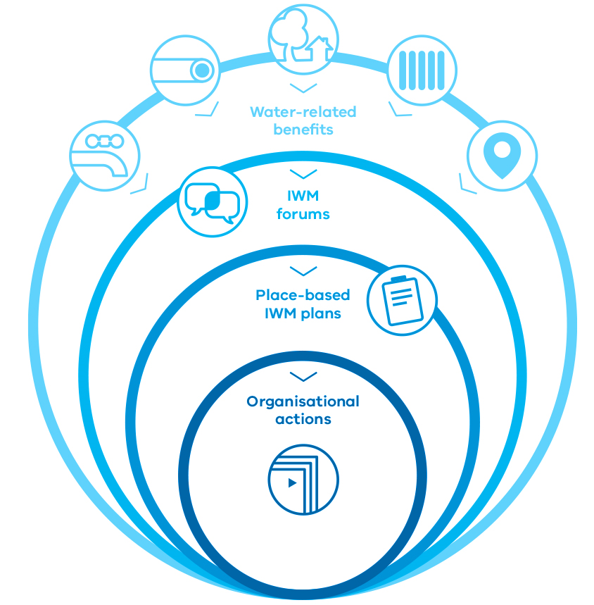

Action 5.8 – Put integrated water management into practice
The government will support implementation of integrated water management planning by:
- working with water corporations to develop a common economic evaluation framework, which can account for different planning scales, local conditions and the multiple benefits of proposed investments
- promoting exemplar projects to demonstrate the benefits of integrated water management and foster collaboration across water corporations, local government and the community
- building the capacity of the water sector to participate in integrated water management through targeted training and development programs
- supporting local government to participate in integrated water planning, with some capability funding provided on a needs basis
- sharing information, undertaking research, and developing and distributing guidelines and tools
- making sure the role of water corporations and catchment management authorities in integrated water management planning is reflected within their governance frameworks
- working with industry to develop and publish information about costs of services for water supply, sewerage, flood protection and waterway management; this will help the water sector identify servicing solutions with lowest community costs
- continuing research into water quality management to protect public health and maintain community confidence.

6. Recognising and managing for Aboriginal values

OBJECTIVE
We will recognise the values that water has for Traditional Owners and Aboriginal Victorians. The water sector will support Aboriginal participation in Victorian water planning and management frameworks through consultative structures that address the rights and interests of Victoria’s Traditional Owners.
Victorian Traditional Owners have cultural, spiritual and economic connections to land, water and resources through their associations and relationship with Country. They have managed land and water sustainably over thousands of generations. Connectedness to land, waters and resources on Country is important for Aboriginal health and wellbeing.
Collaborating with Traditional Owners in water planning and management is an aspect of maintaining access to Country and its resources. The Victorian Government is committed to understanding Aboriginal water values and uses by working in respectful partnership with Traditional Owners. The water sector will incorporate Aboriginal customary knowledge, where appropriate, into water management, and assist Traditional Owners to plan for, and adapt to, the impacts of climate change.
Improving access to water for Traditional Owners and Aboriginal Victorians provides opportunities for economic development. Water-related Aboriginal enterprises can contribute to economic self-determination for Traditional Owners.

What we will do
- Recognise Aboriginal values and objectives of water
- Include Aboriginal values and traditional ecological knowledge in water planning
- Support Aboriginal access to water for economic development
- Build capacity to increase Aboriginal participation in water management
For the first time, we have a clear roadmap to deliver water for Aboriginal cultural, spiritual and economic values.
The Victorian Government will invest $9.7 million to support Aboriginal participation in water management and improve outcomes for Aboriginal Victorians.

Key challenges and opportunities
Victoria’s Traditional Owners and Aboriginal Victorians have had very limited involvement in decision-making in Victoria’s water planning and management framework. There are many reasons why these processes have not been accessible to Aboriginal people, including historical factors and cycles of intergenerational trauma, and past and present experiences of Aboriginal people with mainstream services1. As a result, Aboriginal water values and uses have not always been protected, and traditional ecological knowledge has not benefited Victoria’s water management and planning.
Traditional Owners and Aboriginal Victorians want to be part of discussions and alerted to opportunities to engage in water planning and management. Aboriginal leaders have interests and responsibilities across all sectors and levels of society, and many demands on their time. Good engagement takes time and support. It also requires agreed protocols that have been developed collaboratively with locally relevant Traditional Owners and Aboriginal groups.
Recently, Victorian Aboriginal peak bodies issued a statement to articulate their vision for water management in Victoria. The government is committed to working in partnership with Traditional Owners towards this vision.

A vision for water management in Victoria
Our vision is for an equitable and sustainable water management regime which recognises the rights of Victorian Traditional Owners to use, develop and control water resources on and under our Country.
In practice this means having access to the consumptive and non-consumptive pools, enabling us to fulfil our cultural responsibilities and to provide for the cultural, spiritual, social and economic wellbeing of current and future generations - while at the same time promoting the conservation of water resources and delivering benefits to the wider Victorian community.
Statement from the Victorian delegates of Murray Lower Darling Rivers Indigenous Nations and the Federation of Victorian Traditional Owners Natural Resource Management Committee joint meeting, held on 11th July 2016 in Melbourne².
The government recognises that Aboriginal values and uses of water are dynamic because they are part of a living culture. In some cases, reconnecting Traditional Owners to water will revive culture and contribute to an improved sense of identity

Legislative requirements
The Commonwealth Native Title Act 1993 and Victorian Traditional Owner Settlement Act 2010 formally recognise the rights and interests in land and water that Victoria’s Traditional Owners have sustained for many thousands of years. The Traditional Owner Settlement Act, in particular, recognises that access to water is a Traditional Owner right. This is reflected in section 8a of the Water Act 1989.
Five Native Title determinations and two Recognition and Settlement Agreements between the state and Traditional Owners have been made to date, and more settlement agreements are expected to be finalised in the coming years. These settlement agreements place specific legal obligations on both parties and it is important that the rights of Traditional Owner groups with settlement agreements are respected.
The water sector is required to play its part in strengthening relationships between the state and Traditional Owners to deliver these agreements. The water sector will adopt an inclusive engagement approach with Traditional Owners and Aboriginal Victorians.
The various pathways to address the full range of Aboriginal values, uses and objectives of water are set out in Figure 6.1. These pathways are discussed below.
Figure 6.1 – How can we address Aboriginal water values and uses?
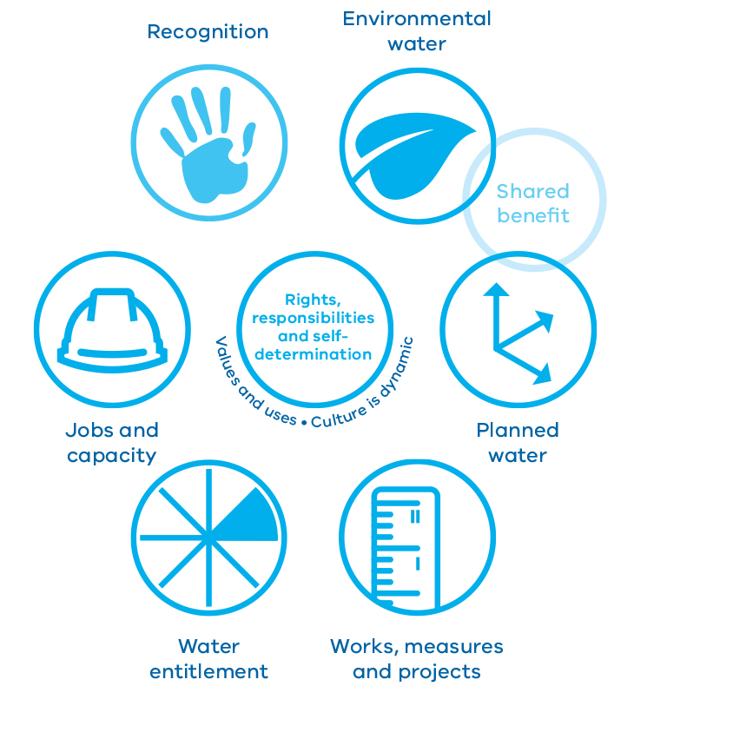
- Values and uses – culture is dynamic (rights, responsibilities and self-determination)
- Recognition
- Environmental water
- Planned water
- Works, measures and projects
- Water entitlement
- Jobs and capacity

6.1 Better recognising and understanding Aboriginal water values
The government will invest $4.7 million to establish a state-wide Aboriginal Water Program to better understand Aboriginal water values, uses, objectives and outcomes, including intangible cultural heritage such as stories, art, ceremonies and innovations.
The Department of Environment, Land, Water and Planning will work in collaboration with Traditional Owners and the water sector to develop and deliver the program. An important component of the program will be creating an Aboriginal Water Reference Group, with representation from Traditional Owners with knowledge of water management.
The Reference Group will advise on:
- the design, implementation and evaluation of local projects funded through the Aboriginal Water Program
- water management for Aboriginal values through shared benefits and access to water for cultural purposes
- initiatives to build capacity and engagement for Aboriginal participation in the water sector.
Local projects will bring Traditional Owners together to spend time engaging on Country, as demonstrated by the examples in Figure 6.2. To the extent deemed appropriate by Traditional Owners, their values and objectives will be articulated and documented for consideration by water planners.

Action 6.1 – Recognise Aboriginal values and objectives of water
The government will invest $4.7 million over four years to establish the Aboriginal Water Program, a state-wide approach to incorporate Aboriginal values and expertise into water management.
The Department of Environment, Land, Water and Planning and the Aboriginal Water Reference Group will co-design the Aboriginal Water Program.
This will include investment in local projects across the state to identify local Aboriginal water values, uses and objectives.
Figure 6.2 – Working with Traditional Owners and Aboriginal Victorians
Examples of local projects that incorporate cultural objectives into Victorian water management and planning
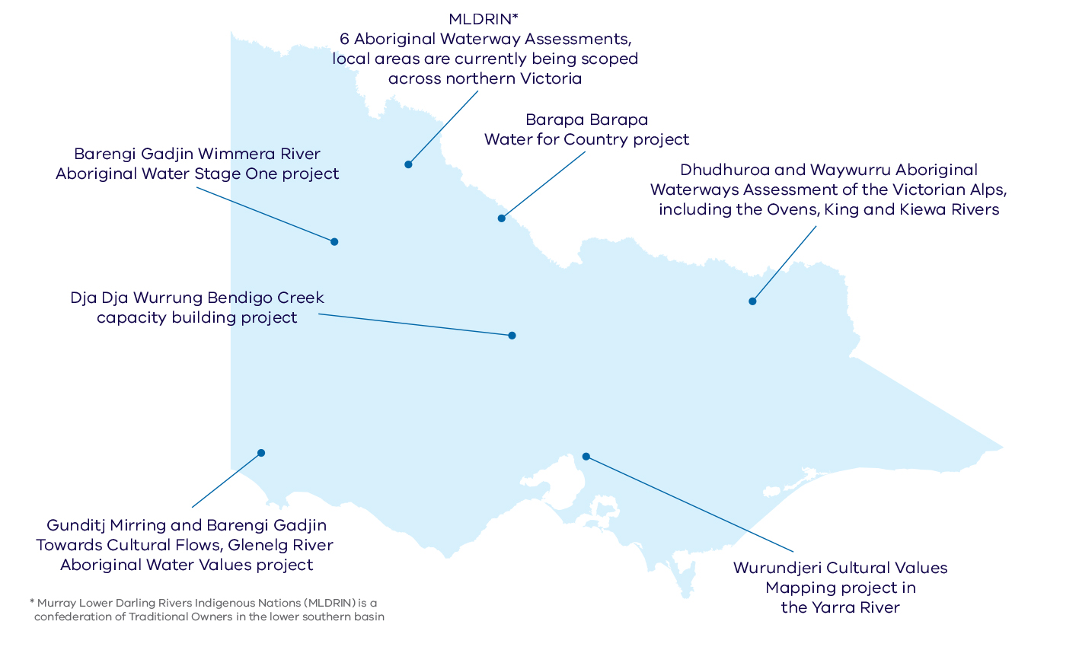
- MLDRIN* 6 Aboriginal Waterway Assessments, local areas are currently being scoped across northern Victoria
- Barapa Barapa Water for Country project
- Dhudhuroa and Waywurru Aboriginal Waterways Assessment of the Victorian Alps, including the Ovens, King and Kiewa Rivers
- Wurundjeri Cultural Values Mapping project in the Yarra River
- Gunditj Mirring and Barengi Gadjin Towards Cultural Flows, Glenelg River Aboriginal Water Values project
- Dja Dja Wurrung Bendigo Creek capacity building project
- Barengi Gadjin Wimmera River Aboriginal Water Stage One project
* Murray Lower Darling Rivers Indigenous Nations (MLDRIN) is a confederation of Traditional Owners in the lower southern basin

6.2 Considering Aboriginal values in water planning and management

Sharing benefits
There are opportunities for water corporations, catchment management authorities and the Victorian Environmental Water Holder to work in partnership with Traditional Owners to deliver shared benefits. The concept of shared benefits is explained in Chapter 1: Sharing Victoria’s water.
The Victorian Environmental Water Holder is already working with Traditional Owners to build capacity to deliver shared benefits. Informed by local projects, the Victorian Environmental Water Holder is working to include Aboriginal environmental outcomes in its seasonal watering plans. Aboriginal environmental outcomes are tangible physical benefits that arise from healthier rivers and wetlands, such as increased fish populations, more reeds for harvest and more bird breeding events.
Local Aboriginal objectives could also be met through water held by other water users. For example, water corporations might be able to time water releases from storages for customary or spiritual purposes.
To achieve shared benefits, the water sector will notify Traditional Owners of their planning cycles, and engage on areas of interest to Traditional Owners.

Case study – Barapa Barapa Water for Country project

Following on from the Barapa Barapa cultural mapping of the Lower Gunbower Forest and the Barapa Barapa cultural flows projects in 2014-15, the Barapa Barapa Water for Country project will help build a framework for determining culturally-informed environmental watering proposals to achieve shared benefits.
The project is running from June 2015 to July 2017 with the aim of understanding cultural values to improve the outcomes and management of environmental water on Gunbower Island. In identifying cultural objectives for scarred trees, the project is looking for opportunities to maintain their health through environmental flows. Funding is provided by North Central Catchment Management Authority and the Department of Environment, Land, Water and Planning, with support from the Murray-Darling Basin Authority.

Informing water planning
Aboriginal Victorians have managed land and water sustainably over thousands of generations. The traditional ecological knowledge they developed over time could benefit future water strategies, policies and plans. By engaging with Traditional Owners, water resource managers will seek to incorporate this knowledge, where appropriate, into Victoria’s water management approach, thereby giving government an opportunity to recognise and protect Aboriginal water values and improve the sustainable management of our water resources. This will also provide more opportunities to support Traditional Owners in their implementation of Country Plans.
Victoria’s water planning and management frameworks, including the waterway management strategies, sustainable water strategies and the State Environment Protection Policy (Waters), have taken initial steps towards recognising Aboriginal values and knowledge. It is important that we improve our ability to include and incorporate local knowledge in these processes.
As the custodians of traditional ecological knowledge, the intellectual property of Traditional Owners will be protected. The Department of Environment, Land, Water and Planning’s Aboriginal Inclusion Plan 2016-2020, Munganin-Gadhaba ‘Achieve Together’, takes a best practice approach towards recognition and protection of Aboriginal customary knowledge.

Action 6.2 – Include Aboriginal values and traditional ecological knowledge in water planning
The water sector will partner with Traditional Owners to include Aboriginal values and knowledge in water resource planning. To do this, the sector will:
- make sure that the legislated objectives of the Victorian Environmental Water Holder consider identified Aboriginal water-related environmental outcomes
- incorporate traditional ecological knowledge into water planning and management using Aboriginal Waterway Assessments and other tools developed by Traditional Owners
- notify and engage with Traditional Owners to achieve shared benefits
- establish Aboriginal water officers in regional Victoria.

6.3 Aboriginal access to water for economic development
Under section 8a of the Water Act 1989, Traditional Owners have the right to take and use water for traditional purposes. Traditional Owners and Aboriginal Victorians can also access water by securing a water entitlement.
Access to water entitlement has the potential to generate new economic opportunities for Traditional Owners and Aboriginal Victorians. The government is committed to supporting Aboriginal economic development and has recently established the Victorian Aboriginal Economic Board. The Board will develop an ambitious work program including facilitating Industry Agreements, Landmark and Place-Based Projects. The 2016-17 Victorian Budget also provided $6.6 million for the Aboriginal Business Strategy to promote the diversity and entrepreneurship of the Victorian Aboriginal business sector.
This is consistent with the government’s commitment to advance self-determination for Traditional Owners and Aboriginal Victorians.
Victoria’s water entitlement and planning processes have evolved over many years. Other water users have developed confidence to secure water entitlement to meet their objectives by using the water market, participating in water auctions and investing in efficiency projects. Traditional Owners and Aboriginal Victorians also want to participate in these water allocation processes and infrastructure decisions.
There are options for Traditional Owners to access water entitlements within the existing framework, including:
- buying water from entitlement holders on the water market in areas where entitlements or use is capped at sustainable limits
- acquiring water entitlements from water corporations in areas where this is allowable within sustainable limits, including access to unallocated water resources
- investing in water savings projects that create new entitlements.
These processes do not affect the rights and obligations of existing entitlement holders.
Aboriginal water objectives may also be achieved through investment in works and measures to deliver water to specific areas of importance to Traditional Owners. Any investment in infrastructure, works and measures will need to be consistent with Country Plans and the Aboriginal Heritage Act 2006.

Action 6.3 – Support Aboriginal access to water for economic development
The government will invest $5 million and work in partnership with Traditional Owners and Aboriginal Victorians to develop a roadmap for access to water for economic development.
Water corporations will notify Traditional Owners when opportunities to access water entitlement arise.
Sustainable water strategies will consider opportunities for access to water for economic development for Aboriginal Victorians.
The government will continue to partner with Traditional Owners and Aboriginal Victorians to identify seed funding and seek business finance opportunities for Aboriginal enterprises to invest in water.

Case study – A vision for the future at Lake Condah
Lake Condah, or Tae Rak, as it is traditionally known, is part of the Budj Bim National Heritage Landscape listed in 2004. The Gunditjmara people likened the seasonal rising and falling of water in Tae Rak to the beating heart of the Budj Bim landscape. The stone eel trap systems used by the Gunditjmara for thousands of years are the oldest example of freshwater aquaculture in the world; the landscape is therefore recognised as an internationally significant site. Unfortunately, the construction of a rural drainage scheme in 1954 damaged this vital place.
After 40 years of effort, a weir constructed in 2010 restored the lake, bringing healing to the Gunditjmara cultural values of the Budj Bim landscape. A key part of the weir construction was the promotion of Aboriginal employment.
The Federal Government provided resources to support the employment of local Gunditjmara and Aboriginal and Torres Strait Islander people on the construction team. Reactivation of the eel trap systems now provides commercial opportunities along the Budj Bim landscape and at Lake Condah through cultural tourism.

6.4 Building jobs and capacity

Economic development
The government is committed to increasing Aboriginal employment, building capability and strengthening Aboriginal prosperity through improved economic participation3. Aboriginal enterprises are around 100 times more likely to employ Aboriginal people than non-Aboriginal enterprises, so strengthening Aboriginal business will have a significant flow-on impact on Aboriginal employment.
The water sector will develop its collective knowledge of Aboriginal culture and will make sure it is culturally safe and inclusive. It will also provide cross-cultural learning, training and employment consistent with the Department of Environment, Land, Water and Planning’s Aboriginal Inclusion Plan 2016-2020 Munganin-Gadhaba ‘Achieve Together’. This is discussed further in Chapter 10: Jobs, economy and innovation.

Learning by doing
Bringing together different perspectives on water management takes time. The water sector and Traditional Owners have much to learn from each other. The government is committed to building capacity for increased Aboriginal participation in water management. This will require open discussions that enable collaboration, time for relationships to strengthen and flexibility as our knowledge grows.
The government recognises the need to pilot different ways to address Aboriginal values and uses of water, reflect on these and build these lessons into future action. The National Cultural Flows Research Project also provides case studies we can learn from.

Aboriginal Participation Guidelines for Victoria’s catchment management authorities
Guidelines have been developed to help catchment management authorities strengthen their engagement and partnerships with Traditional Owners. These guidelines describe key principles and actions the organisation, its staff and contractors should follow to support Aboriginal participation and inclusion. They also recognise that each region is different. Each catchment management authority, through participation and negotiation with relevant Traditional Owners, is encouraged to develop and document locally relevant ways to apply the guidelines.

Action 6.4 – Build capacity to increase Aboriginal participation in water management
The Department of Environment, Land, Water and Planning and the Aboriginal Water Reference Group will co-design a capacity building program to increase Aboriginal participation and inclusive practices in water management, as part of the Aboriginal Water Program.
The water sector and Traditional Owners will look for opportunities to trial different ways of providing access to water and shared benefits.

Case study – Aboriginal participation in water resource planning in the Murray-Darling Basin
There are some 75,000 Indigenous people in the Murray-Darling Basin, and most of these people belong to one of the 40 Traditional Owner groups, or nations. Murray Lower Darling Rivers Indigenous Nations is a confederation of Traditional Owners in the lower southern part of the Basin. When preparing water resource plans as part of the Murray-Darling Basin Plan, the Victorian Government must consult with Murray Lower Darling Rivers Indigenous Nations and other relevant Aboriginal organisations to ensure it has appropriately identified Aboriginal water objectives and outcomes, and has considered Aboriginal values and uses of water. Murray Lower Darling Rivers Indigenous Nations is developing guidance for water planners to inform their processes and content of water resource plans.
This guidance is framed around three concepts of justice:
- procedural justice is about making and implementing decisions according to fair processes that support active and informed participation for Aboriginal people and documentation and evaluation of the results
- distributive justice is about giving all members of society a fair share of the benefits of the resources available, by including strategies to give effect to Indigenous objectives and outcomes
- representative justice is about the inclusion of historically under-represented communities in water planning decision-making roles, including Aboriginal appointments on boards and committees, Aboriginal employees and advisory structures.

7. Recognising recreational values

OBJECTIVE
We will support the wellbeing of rural and regional communities who enjoy the recreational benefits our regional waterways provide. We will consider these values in the way we manage water.
Connection to nature through water storages, lakes, wetlands, rivers and streams in regional Victoria is important for our health and wellbeing and the social fabric of communities. Victorians and other visitors appreciate and seek these benefits through fishing, water skiing, rowing, camping, walking, bird watching, sporting events, social gatherings and other activities on or near waterways.
Water has recreational values which depend on the type of activities possible at a waterway, the environmental health of the waterway, water quality, accessibility, facilities and safety.
Prime recreational sites in regional areas provide opportunities for tourism and hospitality with visitors from cities and towns, interstate and overseas. In small rural towns, a local waterway can be the lifeblood of a community, attracting and retaining people in the area, and providing an income for local businesses.
Recreational users already benefit from our water management system – some water storages already support a variety of water-related activities that visitors enjoy. Environmental water management and works to improve the condition of our waterways and wetlands also support recreational fishing, camping, walking and other social activities at these sites.
During the Millennium Drought recreational activities such as boating, fishing and swimming were severely affected by low lake and water storage levels and low river flows. Many water storages and lakes were dry and some have only recovered in the last few years. Climate modelling predicts a warmer, drier future with more droughts, floods and bushfires.

What we will do
- Include recreational values in water and waterway planning
- Help communities understand how to achieve their recreational objectives
- Support recreation at water storages through infrastructure and better information
Our rivers, lakes and bays provide places for recreation and connection to nature, which is important for the health and wellbeing of our communities.
Recreation is also important for regional tourism and jobs and provides great places to live and work.

Key challenges and opportunities
We are preparing for a warmer, drier future with less water available, and more extreme events. Dry conditions regularly affect the north and west of the state. In dry conditions and in drought, less water is available for all uses and recreational uses of our waterways are naturally limited. Yet it is at these times that the presence of water and recreational opportunities provide relief and can become even more important for communities. Understandable concern can arise when water is scarce.
In regulated water systems we capture and hold water for entitlement holders in water storages, and move that water to where it is needed via rivers and channels. In these systems, we may be able to move water in a way that provides recreational benefits without affecting existing entitlement holders. But we cannot guarantee this, especially in dry times. In unregulated systems we cannot control how water moves. This means that recreation is significantly impacted in dry conditions.
The water entitlements and planning framework makes sure we meet the needs of cities and towns, and supply water for agriculture, industry and the environment (see Chapter 8: Water entitlements and planning). We will continue to work within this framework to find ways to meet recreational objectives.
While there are many activities at waterways that people can enjoy regardless of water levels, some activities such as boating and fishing require a minimum water level or a consistent presence of water. There will be times when there is not enough water to support all recreational activities at all locations. This is likely to happen more often with climate change.
There are already limits to some activities such as boating on some water storages to maintain safety and security of supply. We need to manage access to water storages according to risk, particularly at storages used for drinking water supply, which will continue to be managed in accordance with the requirements of the Safe Drinking Water Act 2003.
Recreational users and regional communities often want to improve certainty of water supply, create new facilities or expand access to favourite sites. They may have a clear objective, but require support to make it happen.

7.1 Considering recreational values in water and waterway management
Water management in Victoria provides significant recreational benefits, but we are not always able to provide them because of limits to the water available. Recreational benefits will become less certain as climate change leads to drier conditions. However, we will make the best of what we have by thinking about recreational values in how we manage water. We will strive to keep a range of benefits with the water that is available. Chapter 1: Sharing Victoria’s water, describes how we can take into account a broader range of benefits in the way we manage water and waterways, including for recreation (see Figure 1.4 in that chapter).
We can increase the likelihood of achieving shared benefits by improving the way we consider recreational values. Figure 7.1 describes different ways we can better manage water throughout the system to maintain and improve recreational values. To date, incorporation of recreational values in water planning has been inconsistent and community engagement on water and waterway management activities has not always had recreation in mind. We need to better understand how communities want to use water for recreation and include recreational objectives in our water planning. We will improve our understanding by including communities in conversations about water and waterway planning. We will collaborate with water users, including the community, while still supplying water to entitlement holders and meeting environmental water and waterway health objectives. We need to be transparent about our processes and explain why we make certain decisions.
There may be times when investment in infrastructure or extra water is needed to meet recreational goals. There may also be management requirements that are outside the role of the water sector. The water sector will provide better information about what it can and can’t do, and point people in the right direction for assistance, as well as find ways to support recreational benefits.
The sustainable water strategies are key forums to identify and manage threats to the supply and quality of the state’s water resources, and identify the potential to improve waterway health. These regionally-based forums provide an opportunity for communities to discuss how to achieve shared benefits for recreational users without compromising the rights of entitlement holders. We will actively encourage recreational users to take part in these processes.
It is important that recreational users have information to help them plan their activities. Boat owners may want to know which reservoirs have enough water for water skiing, or tourists may like to know if there is water in a river next to their favourite camping ground. Sometimes this information is difficult to find or requires a high level understanding of complex, technical issues about water flows and water levels. This information needs to be much easier to understand, current, user-friendly and easy to find. By collaborating across the water sector, we can find smarter ways of presenting this information.

Action 7.1 – Include recreational values in water and waterway planning
The government will explicitly incorporate recreational values in state-wide and regional water planning processes.
Water corporations, catchment management authorities and the Victorian Environmental Water Holder will plan for and provide water services that explicitly consider recreational values within our existing frameworks and with awareness of the realities of dry conditions and climate change.
Water corporations, catchment management authorities and the Victorian Environmental Water Holder will engage with the community to identify and prioritise opportunities to deliver recreational outcomes. They will seek input from recreational users and regional and rural community members. They will report back on what is agreed and what has been done.
For recreational values to be appropriately considered we will invest to understand what those values are, including their social and economic value.
We will provide easily accessible and user-friendly information to recreational users on river, storage and lake conditions to help them plan activities.
Figure 7.1 – Water management opportunities for recreational values
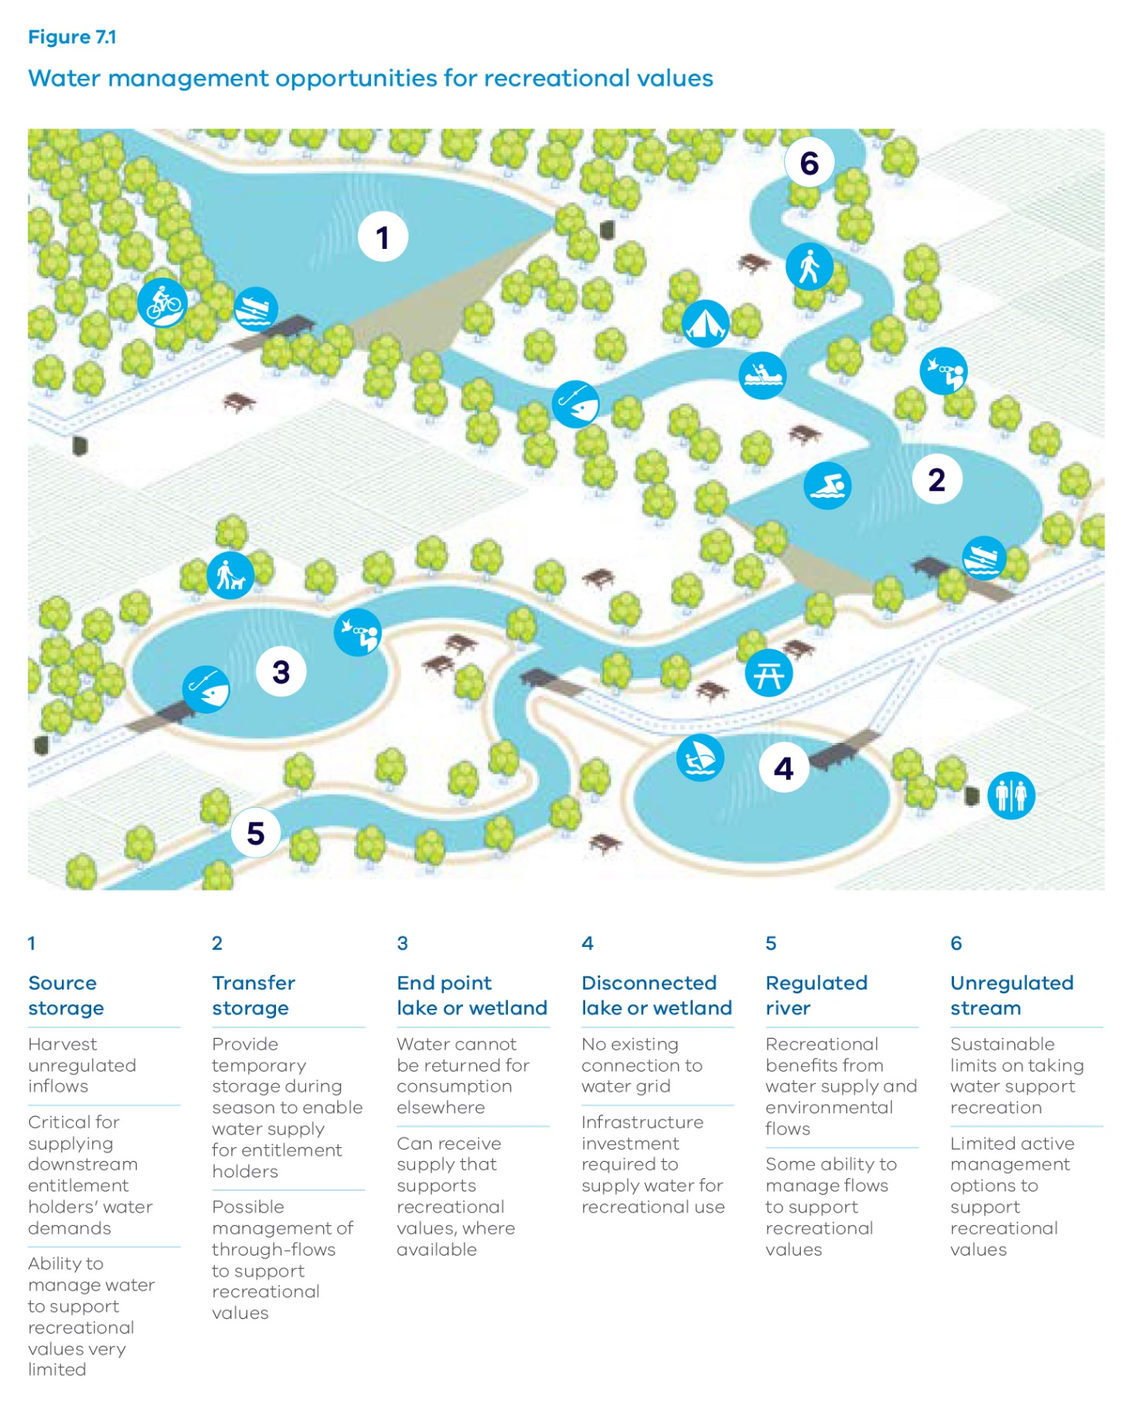

1 Source storage
- Harvest unregulated inflows
- Critical for supplying downstream entitlement holders’ water demands
- Ability to manage water to support recreational values very limited
2 Transfer storage
- Provide temporary storage during season to enable water supply for entitlement holders
- Possible management of through-flows to support recreational values
3 End point lake or wetland
- Water cannot be returned for consumption elsewhere
- Can receive supply that supports recreational values, where available
4 Disconnected lake or wetland
- No existing connection to water grid
- Infrastructure investment required to supply water for recreational use
5 Regulated river
- Recreational benefits from water supply and environmental flows
- Some ability to manage flows to support recreational values
6 Unregulated stream
- Sustainable limits on taking water support recreation
- Limited active management options to support recreational values

7.2 Helping community members understand how to achieve recreational objectives
People may have new ideas about how to meet their recreational objectives that cannot be achieved in the day-to-day management of water and waterways. For example, recreational users could buy entitlements to improve the certainty of having water for recreation or by completing works like building a bridge or removing rubbish to improve enjoyment of activities, or develop tourism strategies to attract visitors. But they may not know how to progress their ideas or who can assist.
Many agencies can help, including the water sector (see Table 7.1), but sometimes it is difficult for community members to know where to start. The water sector has a lot of knowledge it can share to help people find ways to meet their recreational goals. Water corporations will share information about water levels and availability to help tourism operators plan events or fisheries agencies make decisions about where to stock fish.
Land managers for waterways can help communities get in touch with the right agencies to discuss their ideas or proposals. The government expects its agencies to work collaboratively to explore these requests and communicate outcomes of efforts made. For water storages, water corporations are the right organisation to lead this. Land managers include Committees of Management for Crown land, local government, Parks Victoria, and the Department of Environment, Land, Water and Planning. The land manager may be a water corporation responsible for a water storage location, or a catchment management authority responsible for managing Crown land.
Buying water or building facilities, like toilet blocks or water infrastructure, can require significant funds. Recreational groups and communities can pay, but this is not always possible. The people benefiting from investment in recreation should cover the costs. These users may be diverse depending on the site and activities. Users could be local people or businesses; visitors from other regions, interstate or internationally; and recreational club members. Sites of high social and economic regional importance may benefit people across an entire region.
There are existing ways of recovering costs from people who benefit from recreational services, such as through fishing licence fees, camping fees and boating registration fees. These can support recreational objectives at waterways. The availability of funds will depend on criteria for investment and funding priorities. Land managers may have their own ways of recovering costs spent on activities for recreational use of the waterways they manage. Collaboration across government agencies is essential to facilitate access to investment opportunities and increase the likelihood of achieving recreational objectives.

Action 7.2 – Help communities understand how to achieve their recreational objectives
Public land managers will help recreational users connect with the right people including local government, tourism boards and potential investing bodies to progress actions relating to visitor experience at valued waterways. For water storages, water corporations are the right organisation to lead this.
The water sector will share knowledge, user-friendly information and expertise with community members, land managers and potential investors to help achieve recreational objectives.
The water sector will share information about community recreational objectives relating to waterways with organisations seeking to prioritise investment in regional development, recreation, community wellbeing and tourism objectives.
Table 7.1 – Roles and responsibilities for recreational proposals at waterways
Role | Who
Driver of recreational objectives for waterways | Local community members, recreational clubs, peak recreational bodies, land managers
Approvals for works on land or waterway | Catchment management authorities, Department of Environment, Land, Water and Planning, land managers
Information about water availability, water supply and trade | Water corporations
Information about water and waterway management, infrastructure and access | Rural water corporations, urban water corporations, catchment management authorities, Victorian Environmental Water Holder
Potential investors in recreational objectives | Local community members, land managers, recreational clubs, peak recreational bodies, private investors, local government, Regional Development Victoria, Tourism Victoria

Case study – Community, land manager and government work together to achieve recreational outcomes
Historically, Lake Marma at Murtoa in western Victoria provided water supply to the Murtoa township. In 2010, the Wimmera Mallee stock and domestic pipeline was constructed and Lake Marma was no longer required for water supply to the town. However, the lake remained a significant recreational asset for the town, for walking, fishing and boating.
Lake Marma was selected to receive water under Grampians Wimmera Mallee Water’s recreational water entitlement following a prioritisation process with the Wimmera community. Building on this, the Lake Marma Committee of Management worked with local user and community groups to develop a management plan for the lake, and obtained funding from state and local government and the local community for its implementation. Local groups, such as the Progress Association, RSL, Murtoa Lions, Tennis and Angling clubs, provided financial and in-kind contributions.
Through this initiative, Lake Marma is now an even more important recreational setting and regional tourism attraction for Murtoa.

Case study – Investing in water projects to help protect sport and recreation in dry times
As part of the $10 million Drought Support Fund announced in November 2015 for the most drought affected areas in north west Victoria, the Victorian Government made $2.98 million available for community sport and recreation projects. This provides grants, via the Sustainable Water Fund – Community Sport and Recreation Program, for local councils, sporting clubs, recreation facility managers and schools to find better solutions for water access and supply. It also funds projects to increase certainty of recreational opportunities at lakes and weirs through drought periods. There are three recreational water projects:
- Donald Weir Pool – investigations and works to provide water supply at a weir pool on the Richardson River at Donald
- Taylors Lake – improved access and recreational facilities at this water storage which is a priority recreational lake for the area
- Green Lake near Sea Lake – studies and business case for a solution to address seepage issues preventing delivery of recreational water to this site.
The government recognises the vital role of sport and recreation in rural communities and is helping to reduce the severe impacts of low rainfall on sporting and recreational activities that rely on water. These projects align with drought preparedness and response principles and investment criteria. For example, rather than providing short-term relief, these sport and recreational water projects will provide greater community benefits through long-term drought resilience.

7.3 Infrastructure and facilities to support recreational objectives at water storages
Water corporations can provide infrastructure and facilities at water storages that are a priority site for recreational users. First, water corporations need to understand the recreational objectives for these sites and the benefits for communities. Objectives may range from providing a site for recreational enjoyment to creating a site of regional economic significance through tourism.
Water corporations can draw on the expertise of other government agencies including local government, Regional Development Victoria and Tourism Victoria, or peak bodies such as Victorian Recreational Fishing or Field and Game Australia, to develop proposals at water storages. Collaboration is essential to bring together this expertise and agree on responsibilities for action. Some water corporations already do this as part of management plans for land and recreation at priority water storages.
The money water corporations spend to provide recreational infrastructure and facilities should be paid for by the people who benefit. Some water corporations recover costs of land and recreation management functions relating to water storages via fees paid by urban water customers. Grampians Wimmera Mallee Water collects a recreation contribution charge from its customers. This offsets the cost of delivering recreational water which reduces charges for water delivery to priority recreational lakes and weirs, and to recreational and sporting clubs in the region.
There may be opportunities for additional funding through fees recovered from recreational users or specific government funding for recreation, tourism and regional development.
Costs that water corporations recover from individual or urban water corporation customers should be based on what is required for ongoing management and capital works. This should be identified by collaborating with all relevant agencies, community members, and recreational users. If it is proposed that customers pay costs to meet recreational objectives, they should be involved in the process and made aware of what services they are paying for.
Any investment by the water sector in recreational activities will need to be clearly targeted and take into account the long-term benefits, particularly as we face drier conditions that may limit recreation at some sites.

Action 7.3 – Support recreation at water storages through infrastructure and better information
Water corporations will maintain infrastructure and facilities to support recreational objectives at their water storages under existing arrangements.
Water corporations will prepare land and recreation management plans for all major water storages of recreational value. In preparing and implementing the plan they will:
- work closely with the community and stakeholders
- consider the short, medium and long-term water resource management purposes and arrangements for the storage
- define agreed actions including the responsible agency and funding arrangements
- provide public progress reporting on the implementation of these plans and actions.

8. Water entitlements and planning

OBJECTIVE
Secure rights to water and a responsive planning framework will enable us to adapt to climate change and the changing values and uses of water, as well as protect the environment.
In Victoria, water is shared and managed in a way that provides both certainty and flexibility in an increasingly variable climate. Our robust water entitlement and water resource planning frameworks provide certainty of legal rights and obligations, and flexibility for entitlement holders to manage their own risks and make decisions about how they use water to meet their needs.
The strength of our water entitlement and planning frameworks was reinforced during Victoria’s driest 13 years, the Millennium Drought. Together with the water market and water supply infrastructure, these entitlement and planning frameworks provide security and create confidence for communities, the environment, and business, industry and investment growth. Good quality and timely water resource management information provides a strong foundation for our planning frameworks.

What we will do
- Ensure a strong and responsive water entitlement system
- Provide greater flexibility and choice for licence-holders
- Investigate increased flexibility for taking water under winter-fill licences
- Better record and report on emerging significant uses of water
- Ensure a modern compliance regime that works
- Commence the long-term water resource assessment process
- Commence sustainable water strategy reviews
- Align the sustainable water strategy and long-term water resource assessment processes
- Improve rural water supply planning
- Provide clear information about water resources to the community
- Improve water resource information to support planning and decisions
We will strengthen our entitlement and planning systems to adapt to the impacts of climate change and population growth.
Our long-term water planning will consider all values of water and engage more with communities.

Key challenges and opportunities
Climate change, population growth and changing uses and values for water mean the supply of water and demand for it will continue to evolve. We need to understand, manage within, and plan for changing water availability, and patterns of demand and use.
The government recognises that water is critical for cities and towns, farm businesses and industry. Secure rights to water enable agricultural production and future industry growth.
Providing sufficient water for the environment is fundamental to the health of our river systems. Water has particular values for Victoria’s Traditional Owners, and water is important in delivering liveability and recreational outcomes. All of these values can be considered in the way we manage water.
While our water entitlement and planning frameworks are robust, the government will continue to strengthen them to deal with the challenges ahead. We will protect the rights of existing entitlement holders. There are opportunities to make regulation and processes more transparent and to improve access to information.

8.1 Strengthening the water entitlement framework
Victoria’s water resource and system management arrangements, as set out in the Water Act 1989, have developed over time in response to specific needs and the increased complexity in the roles of water corporations. There is no single instrument in a given area that draws together all relevant rules and obligations. Arrangements are spread across multiple regulatory instruments, such as bulk entitlements, trading rules and storage and resource management appointments.
There are now inconsistencies and duplication in the obligations, roles and responsibilities of the water corporations. This limits the transparency of water resource management and makes it difficult for water managers, water users and the community to understand the arrangements, and rights and obligations. This makes it difficult to get the community involved in improving water resource management. More information about different values of water is provided in Chapter 6: Recognising and managing for Aboriginal values, and in Chapter 7: Recognising recreational values.

Action 8.1 – Ensure a strong and responsive water entitlement system
The Department of Environment, Land, Water and Planning will work with water corporations and the Victorian Environmental Water Holder to review and streamline regulatory instruments to improve transparency, and clarify roles and responsibilities to reduce red tape and improve water literacy. The first phase of this work is to:
- clarify roles and responsibilities set out in bulk entitlements and associated instruments for the management of water systems, and ensure consistency, transparency and accountability to water users and the community
- rationalise and simplify existing regulatory instruments
- investigate opportunities to increase community involvement in system management arrangements and achieve shared benefits for Traditional Owners and recreational users.

8.2 Investigating increased flexibility and choice for licence-holders

Greater flexibility and choice for licence-holders
Victoria has undertaken significant reform of water entitlements in most regulated water systems. In these systems, water rights have been converted into water shares, delivery shares and water-use licences and registrations. This provides more flexibility and choice for entitlement holders on how they use and manage their water. Entitlement holders may mortgage or lease their water share, and trade more efficiently. This flexibility helped some entitlement holders get through the Millennium Drought.
In future, climate change means less rainfall and more frequent droughts. We will have to do more with less water at different times. Take and use licences in unregulated surface water systems or groundwater systems have not been converted into water shares and associated products. Conversion of these licences could provide similar flexibility and trade opportunities (see Chapter 9: Realising the potential of the grid and markets), enabling users to better respond to the challenges of climate change. Issues specific to unregulated surface water and groundwater systems will need to be resolved before making a decision to convert take and use licences into water shares in any particular water system. However, given the potential benefits, this issue deserves further investigation.

Action 8.2 – Provide greater flexibility and choice for licence-holders
The Department of Environment, Land, Water and Planning will investigate the merits of converting take and use licences (section 51 licences under the Water Act) in unregulated surface water and groundwater systems into water shares and other related products. The department will work with key stakeholders to investigate this proposal, and further work will depend on the outcome.

Greater flexibility for taking water under winter-fill licences
Since 2004, all new licences to take water from unregulated water systems have required landowners to harvest all of their water between July and October. This arrangement is based on known historical rainfall patterns and the needs of the environment. We need to continually monitor and periodically review these rules given changes in rainfall patterns resulting from climate change. We have experienced a seasonal shift with less rainfall during the cool season when dams and storages usually fill. The challenge is to provide flexible management options that do not adversely impact the environment or third parties. The long-term water resource assessment and reviews of the sustainable water strategies provide an opportunity to review the water harvesting arrangements.
One immediate option in unregulated surface water systems is to change the timing of when water is taken under winter-fill licences. Opportunities may exist to provide controlled access to high flows outside of the traditional winter-fill period but still within current entitlement volumes. This could increase the reliability of supply to individuals. Key considerations include the potential adverse impacts on the environment or third parties, administrative costs, and long-term viability.

Action 8.3 – Investigate increased flexibility for taking water under winter-fill licences
The Department of Environment, Land, Water and Planning will explore opportunities for individuals with winter-fill licences to extract water during high-flow periods in some systems within the sustainable limits of the resource. This option will not increase entitlement volumes but may increase the reliability of supply based on the timing of when water is taken.

8.3 Accounting for significant uses of water

Better recording, monitoring and accounting for significant uses of water
A number of emerging significant water uses are not accurately accounted for, monitored or reported. As competition for water increases, managing efficient allocation of water in the system becomes more critical.
Under the section 8 private rights provisions of the Water Act, water can be taken and used for domestic and stock purposes. Currently there are limited ways to monitor and report on the volume of water used under these rights. The introduction of ‘reasonable use’ limits would improve accountability for the volume of water taken from the system under this right.
The volume of water taken under the section 8 private rights provisions is growing and this trend will continue with the growth in population, subdivisions, and farm dams and bores. This can impact on water availability for existing water users and the environment.
Large-scale changes in land use can also affect water availability by intercepting water than would otherwise reach streams and aquifers. This can affect the water resource, entitlement holders and the environment.
Better information and data about domestic and stock water use under the section 8 rights and land use changes will inform the reviews of long-term water resource assessments and sustainable water strategies about the risks to water resources and whether action is required to mitigate impacts.
This action could range from better recording to increased regulation. These reviews will need to take into account Victoria’s commitments under the Murray-Darling Basin Plan to ensure that we comply with its requirements.

Action 8.4 – Better record and report on emerging significant uses of water
The Department of Environment, Land, Water and Planning will:
- investigate the introduction of a reasonable use limit for domestic and stock rights under section 8 of the Water Act to ensure consistency and fairness in access to water resources in consultation with the community and relevant stakeholders
- monitor and report on the impact of water use on other users and the environment, and report on significant uses of water in the annual Victorian Water Accounts
- periodically review the long-term risks to Victoria’s water resources through mechanisms such as long-term water resource assessments and sustainable water strategies.

Strengthening and modernising compliance arrangements
Victoria’s water resource compliance and enforcement framework is designed to protect the environment and existing entitlement holders from illegal take and use of water.
Compliance with conditions of water entitlements is vital to maintain entitlement reliability and market integrity (see Chapter 9: Realising the potential of the grid and markets) and to give stakeholders and the community confidence in how water is being managed. Victoria’s water corporations are responsible for managing compliance of individuals; approaches to compliance vary across the state.
The compliance and enforcement regime in the Water Act is outdated. The government will modernise the enforcement regime to align with best practice regulation.

Action 8.5 – Ensure a modern compliance regime that works
Water corporations will adopt a consistent risk-based approach to manage compliance and enforcement with improved oversight and reporting.
The government will modernise the compliance and enforcement regime for water corporations to reflect best practice regulation.

8.4 Improving state-wide water resource planning and risk assessment
The government will make sure the current planning framework remains adaptive and robust to respond to the challenges ahead.
Victoria’s water resource regulations and planning processes operate across various landscape scales and timeframes with many different organisations and stakeholders. Responsibility for implementing the framework lies with water corporations or government, depending on the function of the planning process. Important elements of this framework include:
- long-term water resource assessment and planning at the state and regional scale via long-term water resource assessments and sustainable water strategies
- water planning by rural water corporations focusing on water resource management and supply
- water planning focusing on urban water supply and waste disposal (see Chapter 5: Resilient and liveable cities and towns)
- environmental water planning and resource management (see Chapter 3: Waterway and catchment health).
Good quality and timely water resource management information provides a strong foundation for the planning framework, which is set out in Figure 8.1.
Urban water corporations will develop urban water strategies every five years that incorporate sewerage strategies and drought preparedness planning, and link to local integrated water management plans (see Chapter 5: Resilient and liveable cities and towns).
The community will be consulted about opportunities to achieve shared benefits for Traditional Owners and for recreational users. For example, planning processes will include Traditional Owners. Consultation is further discussed in Chapter 6: Recognising and managing for Aboriginal values, and in Chapter 7: Recognising recreational values.
Victoria’s long-term planning arrangements as set out in the Water Act have been designed to:
- provide stable and secure water supplies over time
- acknowledge and cater for regional variability in water supplies and water sources
- ensure stakeholders have tools available to make the most effective decisions about their water resources and to allow intervention if assumptions about water supply are no longer valid
- ensure appropriate governance for independent oversight of resource assessment and the need for any corrective action
- involve community and stakeholders in all stages of long-term planning.
Victoria’s framework for state-wide water resource planning has two key elements:
- long-term water resource assessments, which are broader in scale and determine whether resource availability has changed and, if so, the severity of the impact on consumptive and environmental use
- sustainable water strategies, which are regionally focused and identify and manage threats to the supply and quality of water resources, ensure entitlement holders have the tools including trade and carryover to manage their own risks and identify the potential to improve waterway health.
The government will maintain the integrity of the state-wide planning process and ensure that the process is streamlined and avoids ‘consultation fatigue’.
Figure 8.1 – Water resource planning framework
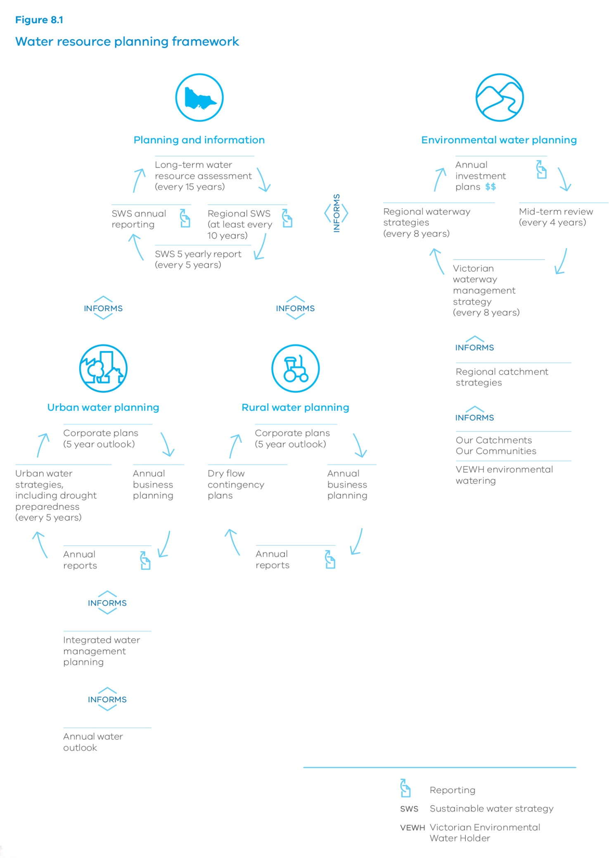

Planning and information
- Long‑term water resource assessment (every 15 years)
- Regional Sustainable water strategy (at least every 10 years)
- Sustainable water strategy 5 yearly report (every 5 years)
- Sustainable water strategy annual reporting
Informed by:

Urban water planning
- Corporate plans (5 year outlook)
- Annual business planning
- Annual reports
- Urban water strategies, including drought preparedness (every 5 years)
Informed by Integrated water management planning
Informed by Annual water outlook
Informed by:

Rural water planning
- Corporate plans (5 year outlook)
- Annual business planning
- Annual reports
- Dry flow contingency plans

Environmental water planning
- Annual investment plans
- Mid-term review (every 4 years)
- Victorian waterway management strategy (every 8 years)
- Regional waterway strategies (every 8 years)
Informed by Regional catchment strategies
Informed by:
- Our Catchments Our Communities
- Victorian Environmental Water Holder environmental watering

Long-term water resource assessments
Long-term planning is essential for security of supply for cities and towns, industry and the environment. Long-term water resource assessments are a key tool to monitor the state of Victoria’s water resources. These assessments determine whether long-term resource availability has changed, and if so, whether there has been a disproportionate impact on water available for consumptive use or the environment. The assessments may determine that waterway health has declined for flow-related reasons.
A review is required if an assessment identifies that either of these issues has occurred. This open, consultative review must consider social, environmental and economic matters, and determine how to restore the balance between consumptive and environmental use. This may include a permanent qualification of rights, a provision in the Water Act for the Minister to change the water sharing arrangements under existing entitlements in a given area. The government will ensure that permanent qualifications of rights will only be used as a last resort.
Long-term water resource assessments are required every 15 years. Since they were established in legislation, the north of the state has undergone significant rebalancing of entitlements as part of the implementation of the Murray-Darling Basin Plan and state-initiated programs to return water to the environment. These processes must complement each other and avoid duplication.

Action 8.6 – Commence the long-term water resource assessment process
The government will:
- commence a long-term water resource assessment for southern Victoria in 2018
- seek to amend legislation to align the long-term water resource assessment for northern Victoria with the Murray-Darling Basin Plan review, scheduled to take place in 2026.

Sustainable water strategies
Sustainable water strategies identify and manage threats to the supply and quality of the state’s water resources, and identify the potential to improve waterway health. The process provides a mechanism for methodical and thoughtful engagement to set priorities and directions in the regions. Between 2006 and 2011, four sustainable water strategies were developed across the state in the central, northern, Gippsland and western regions. The Water Act requires the strategies to be comprehensively reviewed at least every 10 years. The first of the strategies to be developed, the Central Region Sustainable Water Strategy, is due for review beginning in late 2016.
The reviews of the sustainable water strategies will be informed by an appropriate range of climate change scenarios. A sustainable water strategy’s consultative committee, with participation of Traditional Owners, will ensure that the reviews consider opportunities for achieving shared benefits for Aboriginal values of water (see Chapter 6 Recognising and managing for Aboriginal values). The consultative committee will also consider the recreational values of water, as discussed in Chapter 7: Recognising recreational values.
The government will also require the department to undertake an assessment of the sustainable water strategies at the five-year mark. These assessments will be informed by annual monitoring and reporting and information generated by the newly developed oversight function for the water grid (see Chapter 9: Realising the potential of the grid and markets). The Water Act also requires a report each year on the implementation of the strategies. These annual reports and five-yearly assessments will identify any key trends and issues to be taken up for the 10-year reviews, and will inform the methodology of long-term water resource assessments.

Action 8.7 – Commence sustainable water strategy reviews
The government will:
- begin the review of the Central Region Sustainable Water Strategy in late 2016
- undertake the five-yearly assessments of the sustainable water strategies, beginning in 2017 with the Gippsland and Western Sustainable Water Strategies.
The Department of Environment, Land, Water and Planning will:
- ensure an appropriate range of climate change scenarios are used to inform future sustainable water strategies
- consider opportunities for achieving shared benefits, including those related to recreational values, in reviews of sustainable water strategies
- include representation of Traditional Owners in consultative committees for sustainable water strategies.

Interaction between long-term water resource assessments and sustainable water strategies
The current legislative requirements for reviews of sustainable water resource strategies and long-term water resource assessments and reviews (section 22B and section 22V of the Water Act) are potentially confusing and may overlap.
We need a streamlined and sensible process that does not lose original intent, with community and stakeholder involvement that avoids consultation fatigue. The government recognises this need and the importance of also maintaining independent oversight of planning arrangements.
Streamlined processes developed for the south and the north of the state are set out in Figures 8.2 and 8.3. The timing for the process in the south is influenced by current legislative timeframes, whereas the timing for the north takes account of the timelines for implementing and reviewing the Murray-Darling Basin Plan.

Action 8.8 – Align the sustainable water strategy and long-term water resource assessment processes
The government will ensure that processes to review sustainable water strategies and to undertake long-term water resource assessments and any resulting reviews are streamlined as set out in Figures 8.2 and 8.3.
Figure 8.2 – Long-term sustainable water strategies South
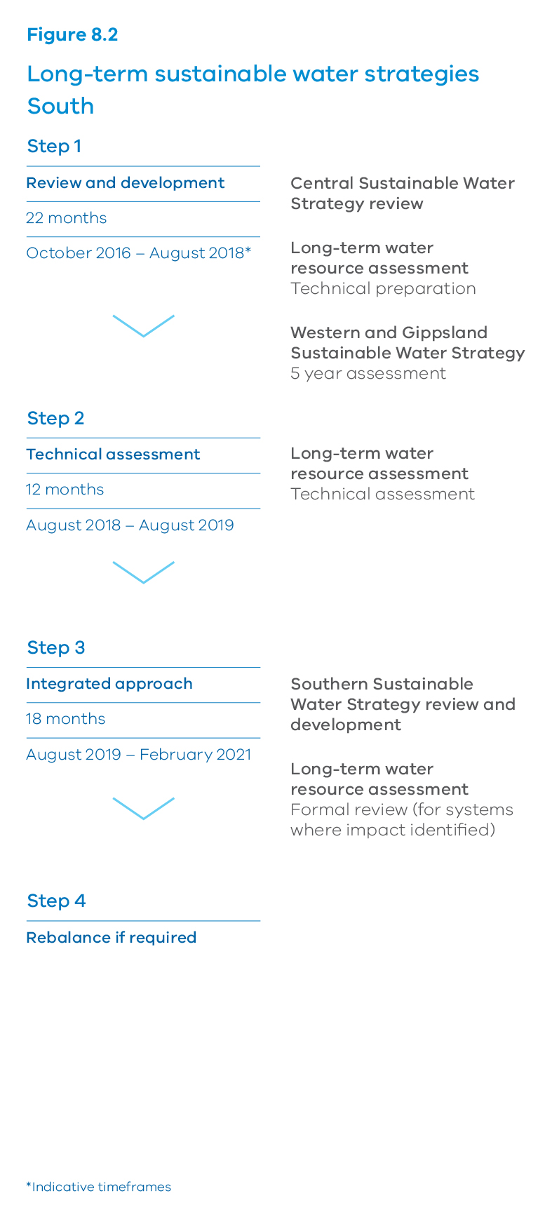

Step 1 – Review and development
- 22 months – October 2016 – August 2018*
- Central Sustainable Water Strategy review
- Long-term water resource assessment Technical preparation
- Western and Gippsland Sustainable Water Strategy 5 year assessment

Step 2 – Technical assessment
- 12 months – August 2018 – August 2019
- Long-term water resource assessment Technical assessment

Step 3 – Integrated approach
- 18 months – August 2019 – February 2021
- Southern Sustainable Water Strategy review and development
- Long-term water resource assessment Formal review (for systems where impact identified)

Step 4 – Rebalance if required
*Indicative timeframes
Figure 8.3 – Long-term sustainable water strategies North
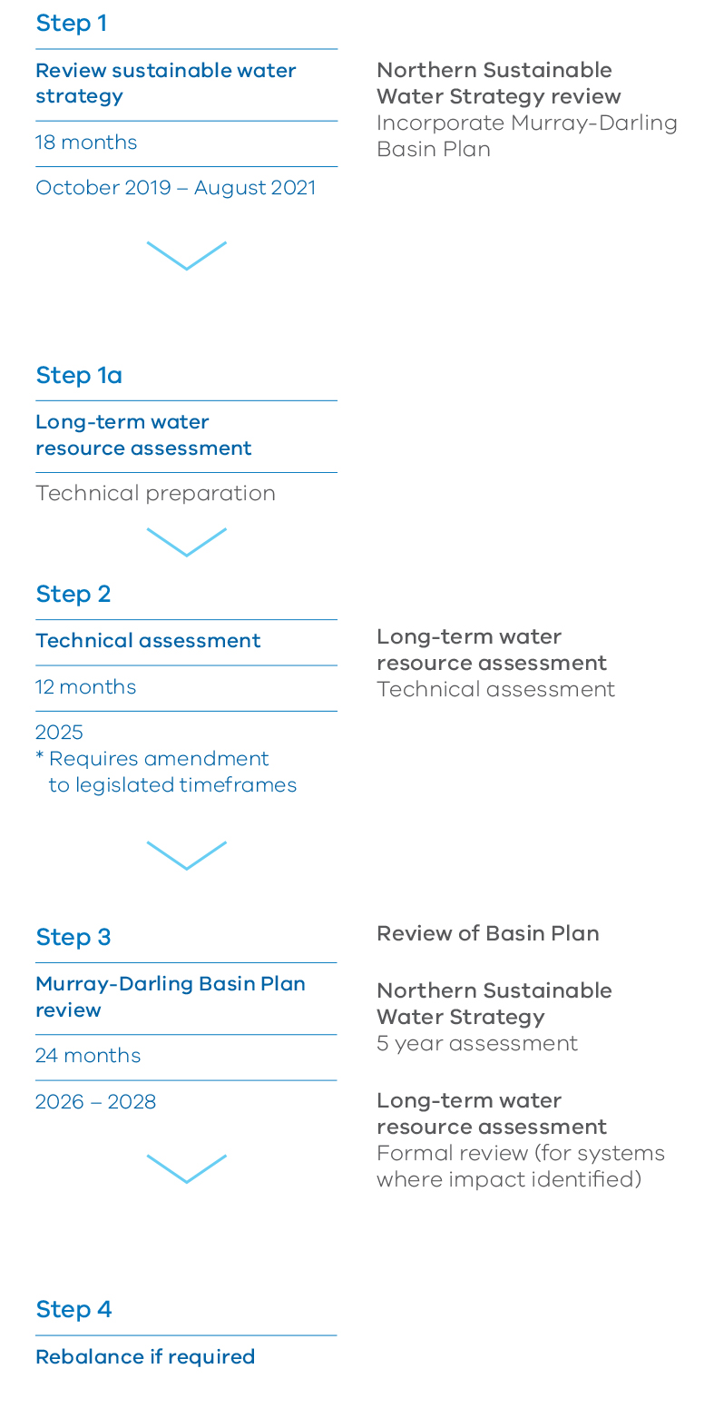

Step 1 – Review sustainable water strategy
- 18 months – October 2019 – August 2021
- Northern Sustainable Water Strategy review
- Incorporate Murray‑Darling Basin Plan

Step 1a – Long-term water resource assessment
- Technical preparation

Step 2 – Technical assessment
- 12 months – 2025 *Requires amendment to legislated timeframes
- Long‑term water resource assessment
- Technical assessment

Step 3 – Murray-Darling Basin Plan review
- 24 months – 2026 – 2028
- Review of Basin Plan
- Northern Sustainable Water Strategy
5 year assessment
- Long-term water resource assessment
Formal review (for systems where impact identified)

Step 4 – Rebalance if required

8.5 Improving rural water supply planning
In regulated water systems, system operators are responsible for managing the available water resource on behalf of entitlement holders: the urban water corporations, the Victorian Environmental Water Holder and individuals.
Each year, system operators plan for the management of their systems to supply the specified entitlements. In future, they will be required to consult more broadly in the development of these plans, and to consider the potential for shared benefits for Traditional Owners and recreational uses. Early reserve policies in some systems are used to manage the risk of not being able to operate irrigation systems because of insufficient reserves.
System operators must also develop low-flow contingency plans for managing severe water shortages. These plans must be developed in consultation with urban water corporations. System operators will be required to consult more broadly with all entitlement holders and the community in developing and reviewing these contingency plans.
System operators provide regular information to entitlement holders to assist with their planning. In future, this information will need to be easier to understand and available to the broader community. This will help different groups understand the opportunities that may be available through shared benefits, and it will also help to inform the newly created grid oversight function (see Chapter 9: Realising the potential of the grid and markets).
Planning in unregulated surface and groundwater systems generally involves developing the management arrangements so that available resources are managed equitably and sustainably. The management arrangements set out the triggers for rosters, restrictions and bans on extractions during low-flow periods.
Processes for statutory planning for unregulated streams and groundwater set out in the Water Act are complex, resource intensive and frustrate stakeholders. A single planning process for unregulated surface water and groundwater would significantly reduce red tape and unnecessary delays, while ensuring appropriate consultation requirements and ministerial oversight.
Historically, the planning for groundwater and unregulated surface water resources has taken place separately while still taking into account the known interactions between the resources. The government will continue to invest in work to better understand the interactions, to inform future combined planning. Development of a streamlined process will facilitate future combined planning for groundwater and surface water resources.

Action 8.9 – Improve rural water supply planning
The government will improve rural water supply planning processes by:
- as part of the review of the sustainable water strategies, examining the early reserve rules to ensure they continue to meet the needs of the system and entitlement holders
- requiring system operators to develop low-flow contingency plans in consultation with other entitlement holders and the community, and considering shared benefits
- ensuring that guidelines for the development of low-flow contingency plans include an appropriate range of climate scenarios
- requiring rural water corporations to improve the provision of water resource availability information to all water entitlement holders and make regular water outlooks easier to understand and available to the broader community
- seeking amendments to legislation to enable development of streamlined unregulated surface water and groundwater management plans ensuring that adequate consultative processes and ministerial oversight are retained
- continuing to invest in understanding where groundwater and surface water interactions have a significant impact to inform future combined management plans.

8.6 Improving public reporting on water availability and use

User-focused information and reporting
The current reporting on water availability and use is trusted and accurate, but it is not widely available or easy to understand for general audiences. The government is committed to improving the clarity and transparency of information about the condition and use of Victoria’s water resources. Improved public reporting on Victoria’s water availability and use will be supported by accurate, user-friendly, readily available information. Figure 8.4 sets out the approach to improve water availability and use reporting.

Action 8.10 – Provide clear information about water resources to the community
The Department of Environment, Land, Water and Planning will provide clear and transparent information on the condition and use of Victoria’s water resources through accurate, trusted and timely information that is widely accessible and targeted to user needs. This will be done by:
- working across government to improve and coordinate public reporting on the condition and use of Victoria’s water resources
- using new technologies and pathways for providing timely, targeted and fit-for-purpose water resource information
- improving comprehensive water resources reporting through accessible weekly and monthly updates on the resource, aligning long-term trend reporting with user needs.

Water resource information supports planning and decisions
Water resource information includes basic water quality and quantity data from Victoria’s key surface and groundwater collection networks.
This ongoing monitoring from Victoria’s key gauging stations and groundwater observation bores improves understanding of long-term trends in the state’s water resources. It is vital for long-term and short-term planning and licensing decisions, compliance and enforcement, and it will also support the newly created grid oversight function (see Chapter 9: Realising the potential of the grid and markets).
Water resource modelling and analysis provides water managers with crucial insights for making operational and policy decisions. Modelling and analysis are fundamental tools to ensure water resource decisions are made in an objective and informed way. These tools provide water managers and water users with insights that are essential for understanding the resource, including longer-term water availability outlooks and climate change projections.

Action 8.11 – Improve water resource information to support planning and decisions
The Department of Environment, Land, Water and Planning will work with water corporations and catchment management authorities to:
- continue to invest in ongoing state-wide surface water and groundwater monitoring networks
- improve the quality and accuracy of monitoring data through investment in infrastructure upgrades and new
- technologies to receive more timely data
- strengthen water resource assessments and modelling by including up-to-date information on catchment characteristics to better understand water availability, use and climate change.
This action underpins many other actions that require water resource information, particularly those related to climate change (Chapter 2), water entitlements and planning (Chapter 8) and realising the potential of the grid and markets (Chapter 9).
Figure 8.4 – Improving Victoria’s water information and reporting
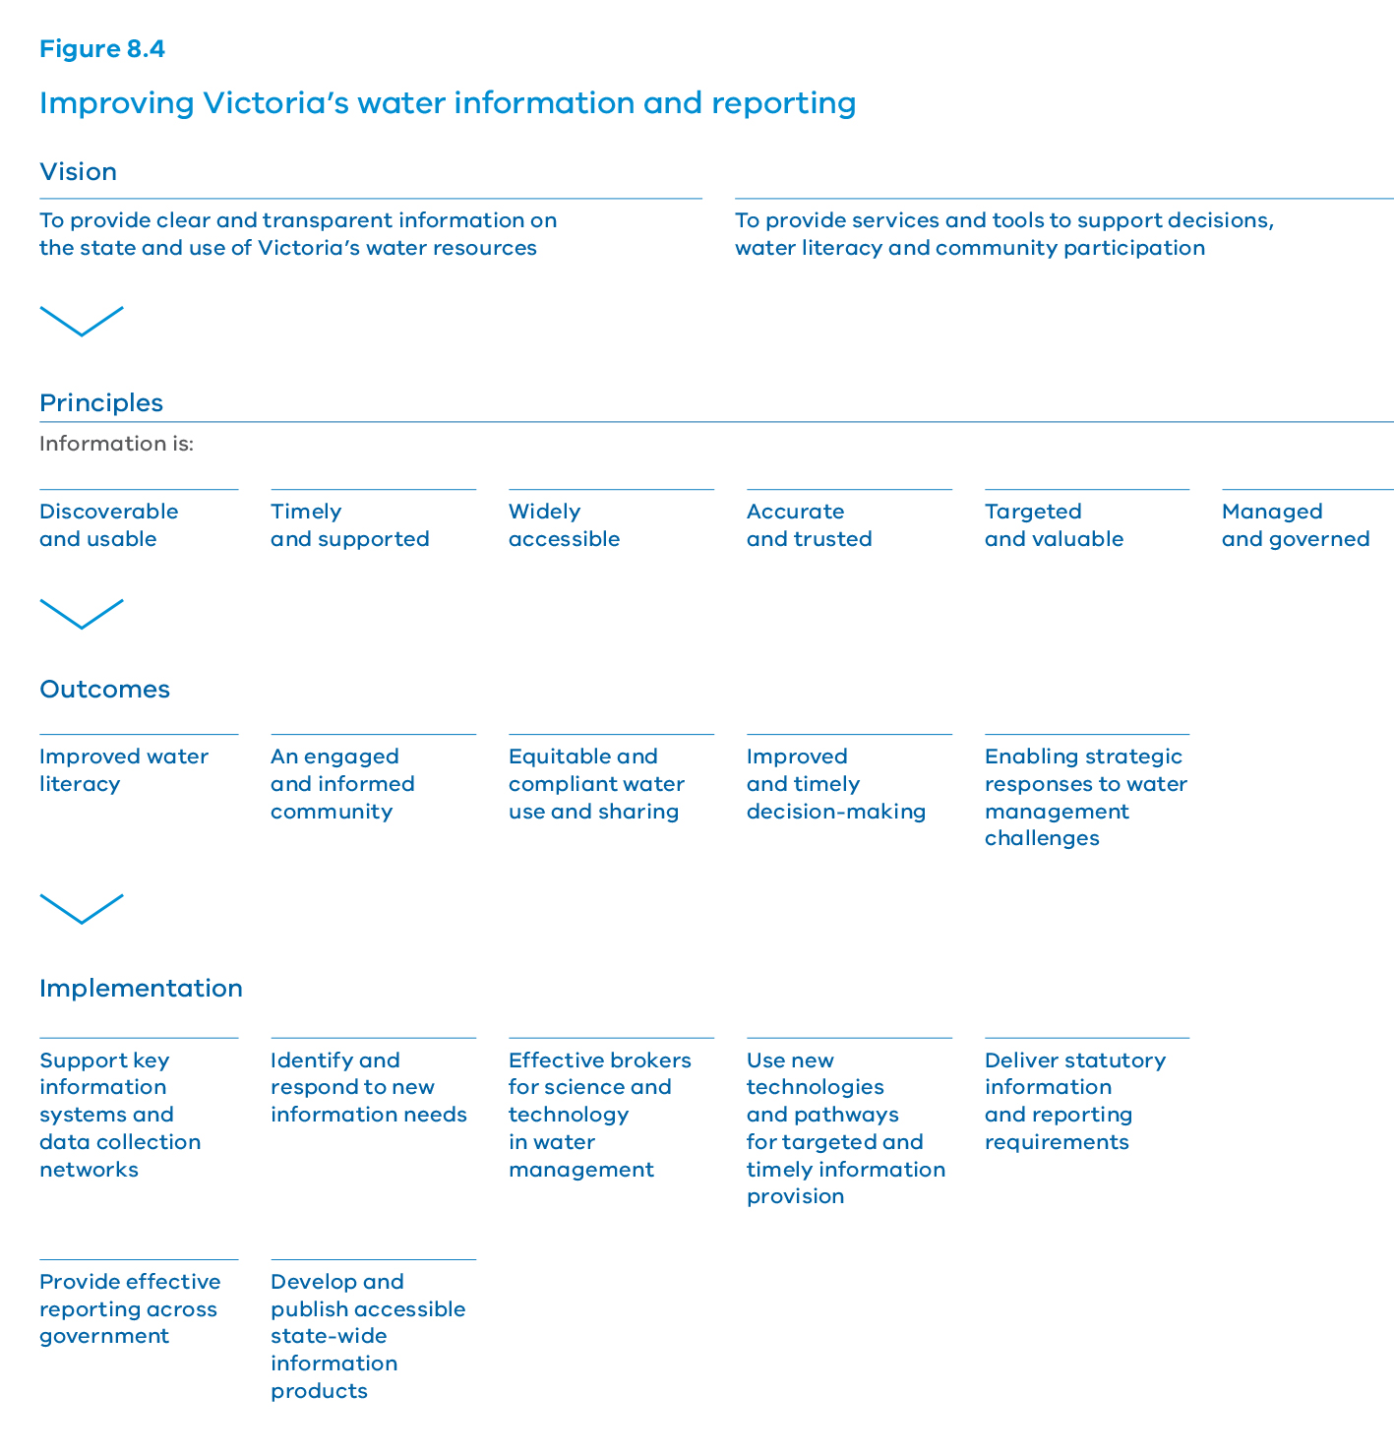

Vision
- To provide clear and transparent information on the state and use of Victoria’s water resources
- To provide services and tools to support decisions, water literacy and community participation

Principles
Information is:
- Discoverable and usable
- Timely and supported
- Widely accessible
- Accurate and trusted
- Targeted and valuable
- Managed and governed

Outcomes
- Improved water literacy
- An engaged and informed community
- Equitable and compliant water use and sharing
- Improved and timely decision-making
- Enabling strategic responses to water management challenges

Implementation
- Support key information systems and data collection networks
- Identify and respond to new information needs
- Effective brokers for science and technology in water management
- Use new technologies and pathways for targeted and timely information provision
- Deliver statutory information and reporting requirements
- Provide effective reporting across government
- Develop and publish accessible state-wide information products

9. Realising the potential of the grid and markets

OBJECTIVE
Victoria’s water grid and markets will help us realise the greatest benefit from our valuable water resources.
Victoria’s water grid works much like our road network, connecting sources, such as dams, reservoirs and the desalination plant via infrastructure including pipes and pumps and natural elements like rivers. Water markets allow users to move water in connected systems to where it is most valued.
Local, regional and state-wide networks operate both independently and together to allow water to be moved from where it is captured and stored to where it is required. Figure 9.1 shows Victoria’s water grid and markets.
Over the last decade, investment in the water grid has included:
- Goldfields Superpipe (connecting Ballarat and Bendigo to the northern water system)
- Melbourne-Geelong Pipeline
- Tarago-Warragul-Moe Pipeline
- Wimmera Mallee Pipeline
- Sugarloaf (North-South) Pipeline
- Hamilton Grampians Interconnector
- Victorian Desalination Project.
This investment has enhanced our water security. At the peak of the Millennium Drought, the Goldfields Superpipe ensured that Bendigo and Ballarat met basic water needs. Melbourne’s water security is now underpinned by the Victorian Desalination Project, which can deliver an additional 150 gigalitres of water per year into the Melbourne system. This rainfall-independent source of water provides security for Melbourne.
Victoria’s water markets allow farmers, the Victorian Environmental Water Holder and water corporations to buy and sell water entitlements and seasonal allocations, so they can manage their own risk according to their willingness to pay. The water markets allow us to share water security benefits in ways that are equitable, responsive and transparent.

What we will do
- Develop a grid oversight function
- Plan for future water grid augmentations
- Improve the effectiveness of water markets
- Increase water market transparency and information sharing
- Develop the water market in south central Victoria
- Improve trading rules in northern Victoria
- Develop trading rules in other water systems
As we learn more about the capacity of our water grid over time, there will be more options for Victorians to share water across the state.
Our water markets will be more open and transparent and we will make long-term investment decisions carefully.
Figure 9.1 – Victoria’s water grid and markets A schematic
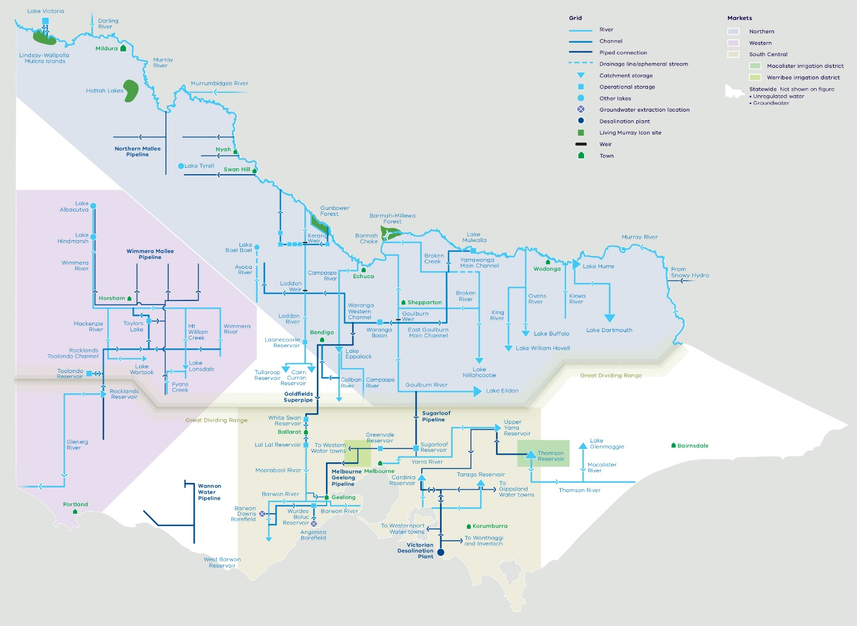

Key challenges and opportunities
Victorians must get the most value from all sources of water and existing infrastructure. This becomes all the more important as we deal with the challenges of climate change and population growth, with less water available. New investment in the water grid may also be necessary.
The water grid already gives us a greater level of water security and provides water users with more options to manage risks and secure their supplies. We have an opportunity to improve the way we use the infrastructure and to continue to build effective and efficient ways for buying and selling water.
The enhanced connectivity of the grid allows areas outside Melbourne to benefit from the increased water security provided by the desalination plant. We have an opportunity to share the benefits of this water security and to build drought resilience. All benefits, costs and risks need to be recognised and assessed.
Moving water around the grid or transacting water trades must not result in adverse impacts on the environment or third parties. This is a challenge for greater use of the grid and water markets.

9.1 Strategic oversight of the water grid
The significant investment in the grid across the state over the past decade builds on a legacy of work. For example, most of northern Victoria has been highly inter-connected across water systems and water corporation boundaries for decades, to enable access to water in the southern Murray-Darling Basin. Across the state, the grid provides increasing connectivity between water corporation boundaries.

Developing an oversight and facilitation function
We need to get the best results for the community from our investments in the water grid, which must be affordable and contribute to water security. The government is developing a water grid oversight function and role to help make sure this occurs. The objective of the new function is to inform strategic regional and system-wide (across water corporation boundaries) water resource planning and investment decisions.
The new grid oversight function will operate centrally in an open and transparent way, monitoring potential opportunities and risks across the water grid. It will draw on system-wide information to assist water resource planning and investment decisions by water corporations and government. This may also facilitate private sector investment via third party access (see Chapter 10: Jobs, economy and innovation) It will also provide advice to government on policy and planning.
Information will be collated and shared to coordinate with, and inform, the development of long-term water resource assessments every 15 years and the reviews of sustainable water strategies every 10 years (see Chapter 8: Water entitlements and planning). The grid oversight function will also coordinate with, and in no way duplicate or diminish, the robust regional planning and investment by water corporations with their local communities.
The government will work in partnership with water corporations and other key stakeholders to build trust, understanding and confidence in this oversight role. The government will work with stakeholders to define institutional and governance details of the oversight function.
The new function will create a forum where decision-making at both the strategic and operational level can be tested. This will help maintain the affordability of water across the state. The first priority of the water grid oversight function will be to look at southern Victoria where systems are less well integrated, and to complement existing activities in northern Victoria.

Action 9.1 – Develop a grid oversight function
The Department of Environment, Land, Water and Planning will develop a grid oversight function (2017-2019) to inform strategic regional and system-wide (across water corporations’ boundaries) water resource planning and investment decisions.
This function will be developed in partnership with the water corporations and key stakeholders, with activities to include:
- developing the overarching planning, information and operational rules and processes
- coordinating the publication of a biennial statement that includes:
- a forward view of water availability, demand, risks and level of water security
- a portfolio of potential future grid augmentation options.

Coordinated planning for future augmentations to the grid
The grid oversight function will regularly share information with the public on the outlook and potential future augmentation options for the grid so that water corporations, the private sector and broader government can understand where the greatest return on investment can be delivered. Figure 9.2 sets out the proposed activities for sharing oversight and facilitating water grid functions. These include sharing information and data, building understanding of the system and planning to align with policies as well as the reporting practices adopted.
Water corporations regularly engage with rural and regional communities, customers and government to explore opportunities to realise the potential of the water grid. Further additions will be informed by strategic needs identified as part of the state’s water planning framework (see Chapter 8: Water entitlements and planning) and through information gathered by the grid oversight function. Input from the new central southern market development trial (discussed later in this chapter) will also be valuable.
Evaluation and risk analysis will test the comparative advantages of regional solutions through connection to the grid compared with local water supply options. This analysis will bear in mind that a connection to the grid neither creates water nor grants an entitlement to use water, and that access to water via markets must also be considered. The government will consider options in light of the principles for government investment outlined in Chapter 4: Water for agriculture. As opportunities for new infrastructure are identified, it will be necessary to meet all regulatory approvals and legislative requirements. The government will comply with the legislative requirements of the Aboriginal Heritage Act 2006 and will consult with Traditional Owners and Registered Aboriginal Parties.
During the Millennium Drought, Victoria made large investments in the state’s water security. The Victorian Desalination Project (see Box 9.1) was commissioned, $1 billion was invested in upgrading the Goulburn-Murray Irrigation District, and the water grid was expanded, including building the Sugarloaf Pipeline.
As a consequence of these investments, the Victorian Government has determined that up to an additional 75 gigalitres per year be available for use in northern Victoria. This will support industry and farmers, particularly during dry conditions.
The government made a commitment to consider the feasibility of using the Sugarloaf Pipeline to provide water security to towns and communities in both directions. The work has shown that it is technically feasible to pump water north with additional works to existing infrastructure. It would require additional capital investment and it is an option that government will continue to explore.
The new grid oversight role will ensure that options, such as the reversing of the Sugarloaf Pipeline, are investigated and remain up-to-date so that we have the information to act where and when this is required.

Action 9.2 – Plan for future water grid augmentations
The Department of Environment, Land, Water and Planning will explore options for additional connections to better use the state water grid to more broadly share the water security benefits.
Figure 9.2 – Strategic oversight and facilitation function for the water grid
Proposed activities
Share information and data | Source, collate and publish information describing the extent, capacity and operation of the grid | Monitoring of system-wide capacity and risks | Assist communities to maintain the affordability of water, by sharing information on grid capacity and future augmentation options
Understand system modelling using data and information | Developing understanding of system-wide grid using appropriate modelling | Understand system-wide implications of climate change scenarios | Examine and understand arrangements around resource and storage managers
Water resource planning consistent with policies and informing investment | Forward view of water availability and risks to inform decision-making | Collate and share information associated with water planning processes of water corporations | Synthesise portfolio of potential future augmentation options
Provide policy advice | Understand system-wide water security under different scenarios | Stress test assumptions under different scenarios, including under prolonged drought and climate change conditions | Framework for connection arrangements and funding principles for grid infrastructure and water augmentations, including local, regional and system-wide considerations
Reporting | Biennial statement with:  - forward view of water availability, demand and risks to meet all uses and values  - portfolio of potential future grid augmentation options

The Victorian Desalination Project
The Victorian Desalination Project is a rainfall-independent source of water capable of supplying up to 150 gigalitres a year. This is around one third of Melbourne’s annual water consumption.
The project includes an 84-kilometre underground transfer pipeline to connect the plant to the Melbourne network through a delivery point at Berwick and transfer main to Cardinia Reservoir.
The Victorian Desalination Project pipeline also has six other connection points for the three water corporations adjacent to the pipeline – South East Water, Westernport Water and South Gippsland Water. This will enable Cowes, Wonthaggi, Inverloch and Cape Patterson to be supplied water from the Melbourne system or the plant. In the future, Korumburra, Poowong, Loch and Nyora will also be connected to the Melbourne water system via this pipeline.
Geelong has already taken water from the Melbourne system and, subject to trades between water corporations, can just as easily be supplied with desalinated water in the future. The rapidly growing populations of Sunbury and Melton, already connected to the Melbourne system, can also be supplied with desalinated water.
The Victorian Desalination Project was constructed to boost water security, end stage 3a restrictions and avoid the need for stage 4 restrictions. The plant was commissioned in 2012. Many of its key components have a 50 to 100-year life.
The plant uses reverse osmosis, the most energy-efficient method of desalinating water, and includes energy recovery devices to reduce power consumption. All operational energy is offset by renewable energy certificates.
Diversifying and boosting Melbourne’s water supplies has complemented work to improve the health of our rivers.

9.2 Strategic oversight of open and efficient water markets

Continuous improvement of the framework and regulations
Markets provide an equitable and efficient way to allow access and sharing of finite water resources. Government defines the appropriate regulations and rules for the design and operation of water markets so they function effectively, ensuring that all participants and the broader community have confidence in them.
Figure 9.3 shows the government’s approach to water market design and operation. The government balances oversight and consistency with an ability to design each water market to be fit-for-purpose, based on the context and characteristics of water resources and market participants.
The government establishes market arrangements to apply to all participants who seek to buy and sell water. These participants may include individual entitlement holders, market brokers and intermediaries, and organisational entitlement holders, such as water corporations, environmental water entitlement holders and private organisations. Roles and responsibilities in water markets in Victoria are described in Box 9.2.
The Victorian Environmental Water Holder produces an annual trade strategy (see Chapter 3: Waterway and catchment health). This trading strategy provides an overview of the water holder’s potential trade activity during the year, addresses some of the requirements of the Murray-Darling Basin Plan water trading rules and aims to avoid market impacts. Some urban water corporations also produce annual trade strategies.
Victorian water markets have evolved over time; performance has improved based on experience. More recently, we have seen more transactions within markets, and faster changes in the distribution of water use and mix of market participants. The government will make sure that arrangements and regulations continue to support effective markets. Victoria will continue to work with other states and agencies including the Murray-Darling Basin Authority, Australian Competition and Consumer Commission and Productivity Commission. The government is focused on maintaining the integrity of caps, entitlements and markets and ensuring compliance with the Council of Australian Governments’ principles and agreements, including the Murray-Darling Basin Plan.
The government will expand current water markets reporting to include a review of how well markets are operating. The areas for improvement and refinement recommended by the water markets review will direct the work program for the Department of Environment, Land, Water and Planning across the state and within specific water markets. The review will provide an ongoing means to examine appropriate regulation of market participants, including brokers and other market intermediaries, and also ensure there is no market distortion via participants misusing market power.

Action 9.3 – Improve the effectiveness of water markets
The Department of Environment, Land, Water and Planning will actively monitor water markets so they continue to operate effectively.
The Department of Environment, Land, Water and Planning will expand current water markets reporting (beginning in 2017) to include a review of how well they are operating against the elements of an effective water market set out in Figure 9.3. The steps for the review are to:
- define the scope, information requirements, and indicators for recommendations to improve market effectiveness
- complete and share results and recommendations to inform:
- the need for refinement of market regulations, rules or mechanisms
- information for market participants and the public
- incorporate recommendations into the relevant work program(s) for action across the state and within specific water markets as needed.

Greater transparency and information sharing
The government provides accessible and transparent information for water users, planners and managers. Good information is essential if all potential and existing market participants are to understand water markets. Good information builds market participant capability and community literacy about markets. Clear and accessible information is critical to the efficient operation of water markets and to efficient investment in the infrastructure of the water grid. Elements of an effective water market are set out in Figure 9.3. They include caps, entitlements, compliance and information.
The government will review public information on:
- trading, including information about the volume and number of trades, prices, geographic water movement and processing time
- entitlements, allocation and use summarising water entitlement volumes and use in water systems across the state
- volume of entitlements owned privately and by water corporations and the environment.
The Victorian Water Register provides water users with essential information about water entitlements, seasonal allocations, trade and transfers. The water register is the authoritative record of water entitlements, and facilitates the transactions that underpin Victoria’s water markets.
Ongoing maintenance and development of the register is critical to:
- enable government to fulfil its statutory obligations
- support market development and water corporation strategic planning
- provide information to water resource managers and the public.
The government will continually improve water market information and reduce system red tape, including that associated with the Victorian Water Register. This includes making transactions simpler, quicker and cheaper for users, and better integrating with water corporation operations to meet the levels of service expected by water corporations and water market participants.

Action 9.4 – Increase water market transparency and information sharing
The Department of Environment, Land, Water and Planning will:
- improve water market information and systems by moving applications online, through enhancements to the Victorian Water Register
- revise the current water markets reporting (and combine with the review in Action 9.3) to improve the relevance and accessibility for the public
- continue to ensure water market information and systems support effective markets by implementing relevant recommendations from the review in Action 9.3.
Figure 9.3 – Elements of an effective water market
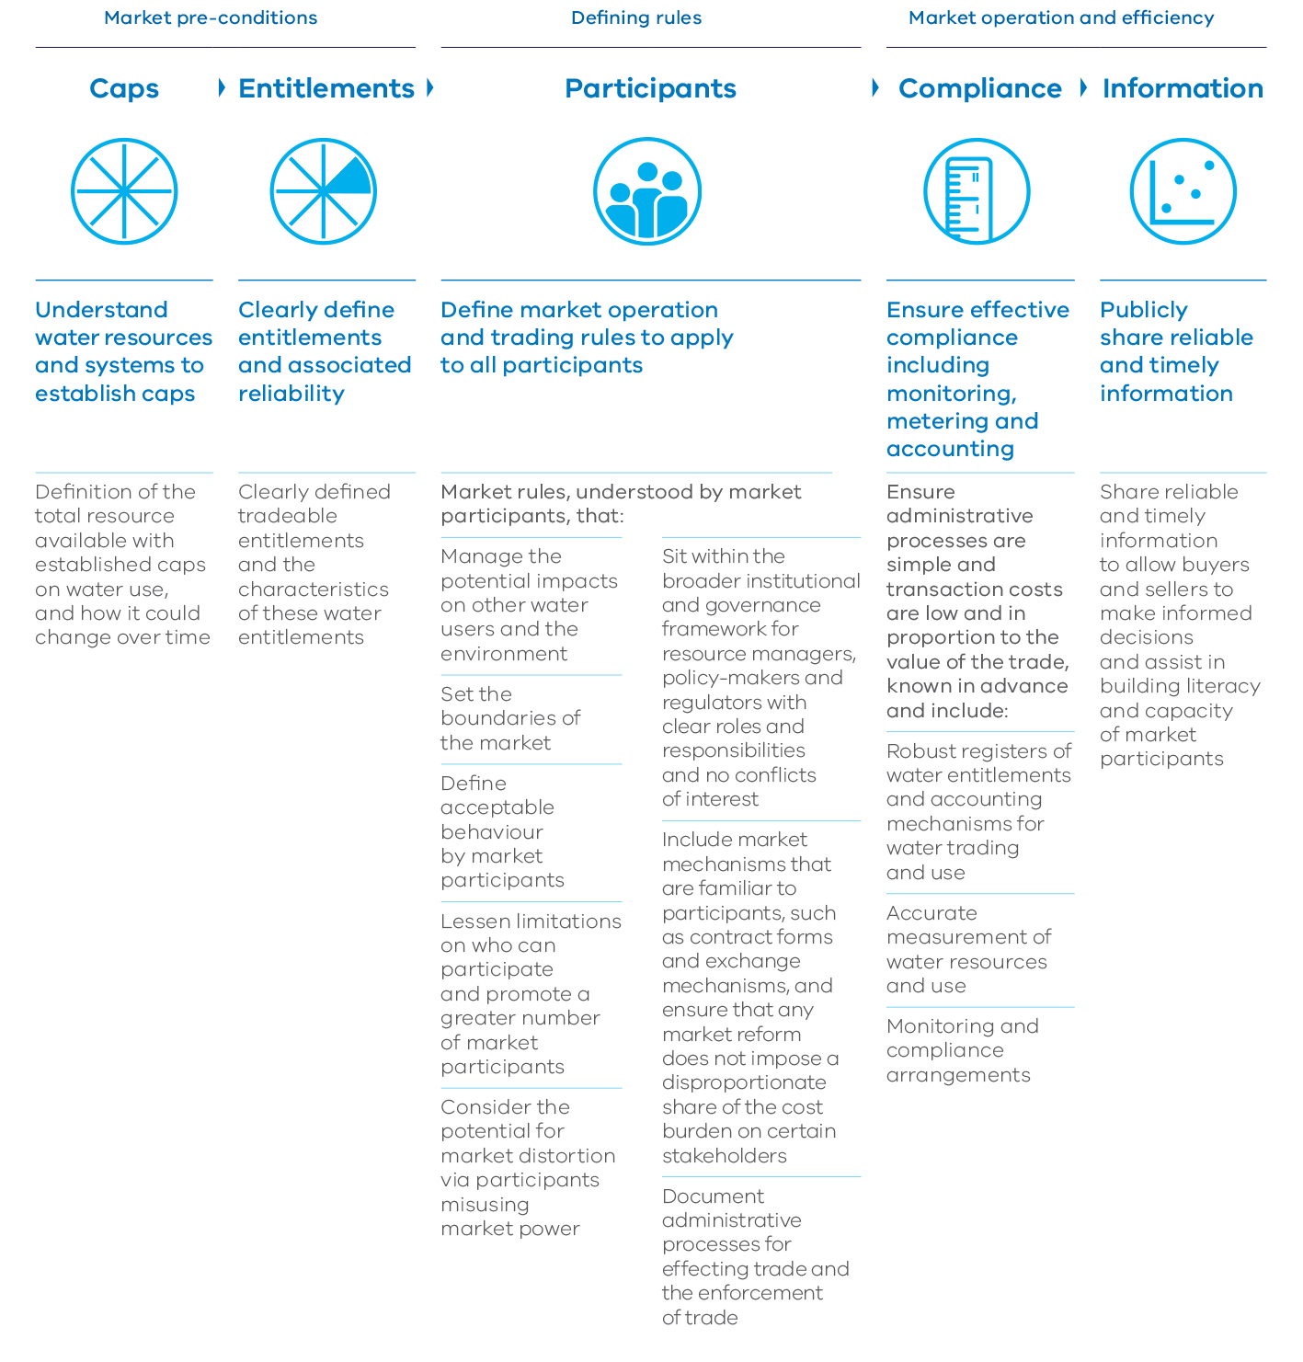

Market pre-conditions

Caps
- Understand water resources and systems to establish caps
- Definition of the total resource available with established caps on water use, and how it could change over time

Entitlements
- Clearly define entitlements and associated reliability
- Clearly defined tradeable entitlements and the characteristics of these water entitlements

Defining rules

Participants
- Define market operation and trading rules to apply to all participants
Market rules, understood by market participants, that:
- Manage the potential impacts on other water users and the environment
- Set the boundaries of the market
- Define acceptable behaviour by market participants
- Lessen limitations on who can participate and promote a greater number of market participants
- Consider the potential for market distortion via participants misusing market power
- Sit within the broader institutional and governance framework for resource managers, policy-makers and regulators with clear roles and responsibilities and no conflicts of interest
- Include market mechanisms that are familiar to participants, such as contract forms and exchange mechanisms, and ensure that any market reform does not impose a disproportionate share of the cost burden on certain stakeholders
- Document administrative processes for effecting trade and the enforcement of trade

Market operation and efficiency

Compliance
- Ensure effective compliance including monitoring, metering and accounting
- Ensure administrative processes are simple and transaction costs are low and in proportion to the value of the trade, known in advance and include:
- Robust registers of water entitlements and accounting mechanisms for water trading and use
- Accurate measurement of water resources and use
- Monitoring and compliance arrangements

Information
- Publicly share reliable and timely information
- Share reliable and timely information to allow buyers and sellers to make informed decisions and assist in building literacy and capacity of market participants

Who has roles and responsibilities in water markets?

Victorian Government
- overall responsibility for elements of market design as set out in Figure 9.3, including compliance with all national and interstate regulations and rules
- ensure there are no impacts on third parties or the environment

Murray-Darling Basin Authority
- ensure compliance with Murray-Darling Basin Plan
- aim to remove artificial barriers to trade, prevent insider trading and discrimination on who can trade

Australian Competition and Consumer Commission
- fair trading provisions
- consumer appeals for unfair trading

Productivity Commission
- independent advice to the Federal Government regarding the Murray-Darling Basin Plan and progress towards achieving the objectives and outcomes of the National Water Initiative

Water corporations
- responsible (delegated authority) for assessing applications for trade of water shares and licences
- compliance with regulations and rules governing water market transactions
- disclosure of true and accurate information
- must comply with Murray-Darling Basin Plan trading rules

Market intermediaries or brokers
- subject to consumer law that outlines protections for buyers and sellers
- compliance with regulations and rules governing water market transactions
- disclosure of true and accurate information

Buyers and sellers
- compliance with regulations and rules governing water market transactions
- disclosure of true and accurate information

Victorian Environmental Water Holder
- must comply with Murray-Darling Basin Plan trading rules
- compliance with regulations and rules governing water market transactions
- disclosure of true and accurate information

Commonwealth Environmental Water Holder
- must comply with Murray-Darling Basin Plan trading rules and act in accordance with the Commonwealth environmental water trading framework
- compliance with regulations and rules governing water market transactions
- disclosure of true and accurate information
Figure 9.4 – Overview of the south central market trial
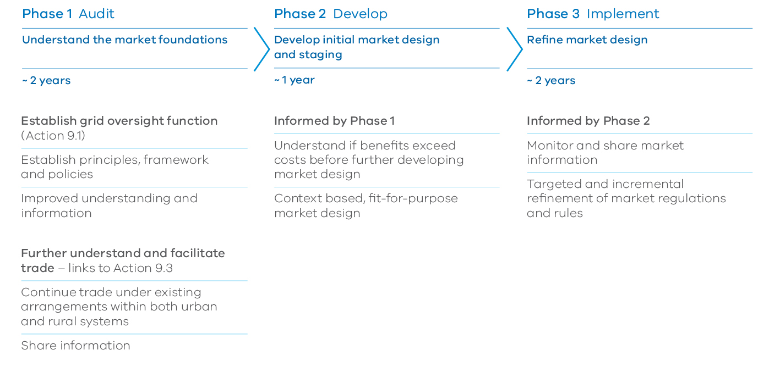

Phase 1 Audit

Understand the market foundations – ~ 2 years
- Establish grid oversight function (Action 9.1)
- Establish principles, framework and policies
- Improved understanding and information
- Further understand and facilitate trade – links to Action 9.3
- Continue trade under existing arrangements within both urban and rural systems
- Share information

Phase 2 Develop

Develop initial market design and staging – ~ 1 year
- Informed by Phase 1
- Understand if benefits exceed costs before further developing market design
- Context based, fit-for-purpose market design

Phase 3 Implement

Refine market design– ~ 2 years
- Informed by Phase 2
- Monitor and share market information
- Targeted and incremental refinement of market regulations and rules

9.3 Establishing a south central Victoria water market trial
A major new initiative by the government is a five-year trial beginning in 2017 to develop a new water market in south central Victoria. This trial builds on the increased connectivity of the grid over the last decade and access to water from the Victoria Desalination Project.
The water resources and market participants of the south central water market are different to other markets across the state. The south central water market is dominated by urban water corporations, tasked with providing safe, secure supplies to metropolitan Melbourne, and rapidly growing regional centres, such as Geelong.
This new market will provide significant opportunities to trade water and delay or avoid costly additions to the water grid. It could also help to further free up water trading within the southern irrigation districts and water for environmental outcomes. The trial will need to balance the trade opportunities with the need for water security during long periods of drought.
The south central market trial will be staged and collaborative to build understanding and confidence. The government will work closely with stakeholders to define institutional arrangements and governance.
The objectives of the south central market trial are to:
- better understand the current physical and regulatory opportunities and limits in south central urban and rural markets
- better understand the breadth and depth of market participants and their specific incentives, including urban and rural users
- ultimately inform decisions on whether to, and how to, proceed with future market development about:
- timing, with staging and transition steps clearly defined
- regulations and rules for the operation of the market
- implications of operation of the market under different climate change scenarios and during periods of scarcity of water.
Initially, the trial will focus on more clearly understanding trade opportunities and barriers. It will be important to build understanding of the grid through improved system information and modelling. This work will be completed as part of the oversight function for the grid (see Action 9.1). The trial will also be informed by the water markets oversight function (see Action 9.3). The links between the new water grid oversight role, the water markets review and the south central market trial are shown in Figure 9.4.

Action 9.5 – Develop the water market in south central Victoria
The Department of Environment, Land, Water and Planning will catalyse the development of the water market in south central Victoria in a trial beginning in 2017.
The Department of Environment, Land, Water and Planning will work with stakeholders to define the institutional arrangements, governance and appropriate stages for the trial including:
- building an understanding of the implications of market operation under different climate change scenarios and during periods of resource scarcity
- considering market rules, the role of the Victorian Desalination Project, entitlement structures, pricing, allocation policies, and storage and delivery charges
- sharing information during and on completion of the trial, including a review of the outcomes.

9.4 Maximising the effectiveness of the grid and markets across the state
The regulated surface water market operating in northern Victoria is the longest established market in the state. The northern Victoria water market has a value of over $4 billion1 and is highly complex with interstate considerations. Similar markets operate on much smaller scales in southern Victoria, such as in the Macalister and Werribee systems. Western Victoria has water markets that have operated for many years.
Many unregulated surface water and groundwater systems are small in volume and physically isolated, with less market participation and lower demand than in the northern regulated systems. Designing and operating suitable markets must consider these factors.
A focus on fit-for-purpose markets is critical so that benefits exceed the costs of operating them, including transaction costs. Fit-for-purpose markets consider the value of the market and the risks that could occur if there was a market failure.
The effectiveness of existing markets in Victoria in the context of the ‘elements of an effective water market’ is outlined in Figure 9.5. Markets in regions assessed as medium or low are targeted for further action. The recommendations from the review of market effectiveness will guide future actions.

Water grid and markets in northern Victoria
Northern Victoria is part of the Murray-Darling Basin and the southern-connected Murray system. Water trade occurs across the southern-connected market including with NSW and Victoria. For six of the last eight years Victoria has been a net importer of water. The Murray-Darling Basin Plan trading rules, which came into effect in July 2014, apply to water markets in northern Victoria. In this context, the government facilitates and resolves water resource planning and investment decisions between broader Murray-Darling Basin considerations and regional water corporations and their local communities.
The agricultural landscape in northern Victoria has changed markedly in recent years. Individuals and business have responded to commodity prices, export arrangements, consumer demand and other economic factors coupled with scarcer water resources. From 2010-15 approximately 600 gigalitres of high-reliability water shares in northern Victoria were traded from irrigation holdings to environmental holdings as part of the Murray-Darling Basin Plan. Over the same period the volume of water allocation traded doubled, from about 400 gigalitres to over 800 gigalitres per year.
Water prices have increased as demand for water exceeds supply. Implications for rural communities and the links to water management in these areas are examined in Chapter 4: Water for agriculture.
These actions will help resilient water users adapt to change, and give them the capacity to exit when needed.
The government’s actions include:
- providing a well-functioning water market, with appropriate monitoring, transparency, frameworks and regulations, to help people adapt to change (Action 9.3)
- making sure that infrastructure remains viable and understanding the implications for the management of irrigation districts (see Chapter 4: Water for agriculture)
- building awareness of water availability and delivery challenges and risks so people can make informed decisions and adapt (see Chapter 8: Water entitlements and planning).
Within the interstate water market in northern Victoria, as water movement increases, pressure on different parts of the grid can change. Trading rules may need to be refined over time to reflect this.
The government will continue to examine broader system operational issues, including changes resulting from environmental water holdings and delivery, and changing patterns of land and water use in the agricultural sector. An example of a system operational issue is the Barmah Choke – a natural feature which limits water delivery capacity on the Murray River. Any refinement of trading rules in the north must also be consistent with the requirements of the Murray- Darling Basin Plan.

Action 9.6 – Improve trading rules in northern Victoria
The Department of Environment, Land, Water and Planning will:
- ensure trading rules in northern Victoria are appropriate given physical and operational constraints
- work with the Murray-Darling Basin Authority to:
- provide appropriate and timely information for northern Victorian water users about the risk of congestion in the southern-connected Murray system
- improve transparency in applying water trading rules in the southern connected system.
Specific actions will be guided by the relevant recommendations from the review completed as part of Action 9.3.

Water grid and markets in western Victoria
Western Victoria already has several interconnected supply systems, with pipelines from Gellibrand to Warrnambool, the Hamilton to Grampians interconnection and integration of groundwater bores in supply systems. Regional economic development opportunities could be enhanced by improving access to the grid.
While market activity is limited in regulated surface water systems in this part of Victoria, these markets are considered fit-for-purpose. Most irrigation is supported by groundwater. Trade is sparse as most users have sufficient entitlements to meet their needs. However, market participants are increasingly seeking to move water over large areas across western Victoria with improved trading rules that make transactions simpler and faster. For example, water corporations on behalf of water users in their systems or the Victorian Environmental Water Holder.
A better understanding of market opportunities will lead to targeted improvements and better use of regional water resources and infrastructure.

Water markets in unregulated systems
In most unregulated surface water systems, there is very little water traded annually due to the small number of potential buyers and sellers and the limited demand for extra water. The government will review water trading rules for these systems, in consultation with water corporations and key stakeholders, to identify opportunities to develop water markets.
This will be part of the broader review of water trading and markets described earlier in this chapter. Other related initiatives are described in Chapter 8: Water entitlements and planning, and include exploring the merits of converting take and use licences to water shares and opportunities to streamline unregulated surface water management plans.
In some unregulated surface water systems, the total licensed volume is still less than the limit on entitlements that can be issued. In these systems, water users can apply to the relevant rural water corporation for new entitlements. We can improve our understanding of the potential impact of climate change on water resources in these systems through initiatives such as the long-term water resource assessments outlined in Chapter 8: Water entitlements and planning.

Water markets in groundwater systems
In most groundwater systems, each water market has relatively few buyers and sellers, low demand and the economic value of water is low.
In the Campaspe and Loddon systems in northern Victoria and in parts of the south west, management plans support trade between groundwater trading zones. Demand in these areas is driven by a significant reduction in regulated surface water availability and recognition of the greater reliability of groundwater. This demand has led to vibrant groundwater water markets. However, in most other groundwater systems there are limited markets due to factors including conditions on the use of the resource and relatively few buyers and sellers.
The government, in close consultation with water corporations and key stakeholders, will examine the factors limiting groundwater market development. This will not impact on existing entitlement holders, the environment and groundwater resources. This review will be undertaken in the context of Action 9.3 and related initiatives described in Chapter 8: Water entitlements and planning, particularly investigating the merits of converting take and use licences to water shares and opportunities to streamline groundwater management plans.
In some groundwater systems, the total licensed volume is still less than the cap (generally also known as permissible consumptive volumes). In these systems, water users can apply to the relevant rural water corporation for new entitlements. Again, the long-term water resource assessments can improve our understanding of the potential impact of climate change on water resources in these systems.

Action 9.7 – Develop trading rules in other water systems
The Department of Environment, Land, Water and Planning will:
- continue to refine trading rules and explore opportunities to further develop markets in western Victoria
- review state-wide unregulated surface water trading rules to improve trading opportunities
- develop policy to facilitate trade in groundwater systems and investigate the potential for trade where groundwater and surface water is connected.
Specific actions will be guided by the relevant recommendations from the review completed as part of Action 9.3.
Figure 9.5 – Level of current market development against the elements of effective water markets
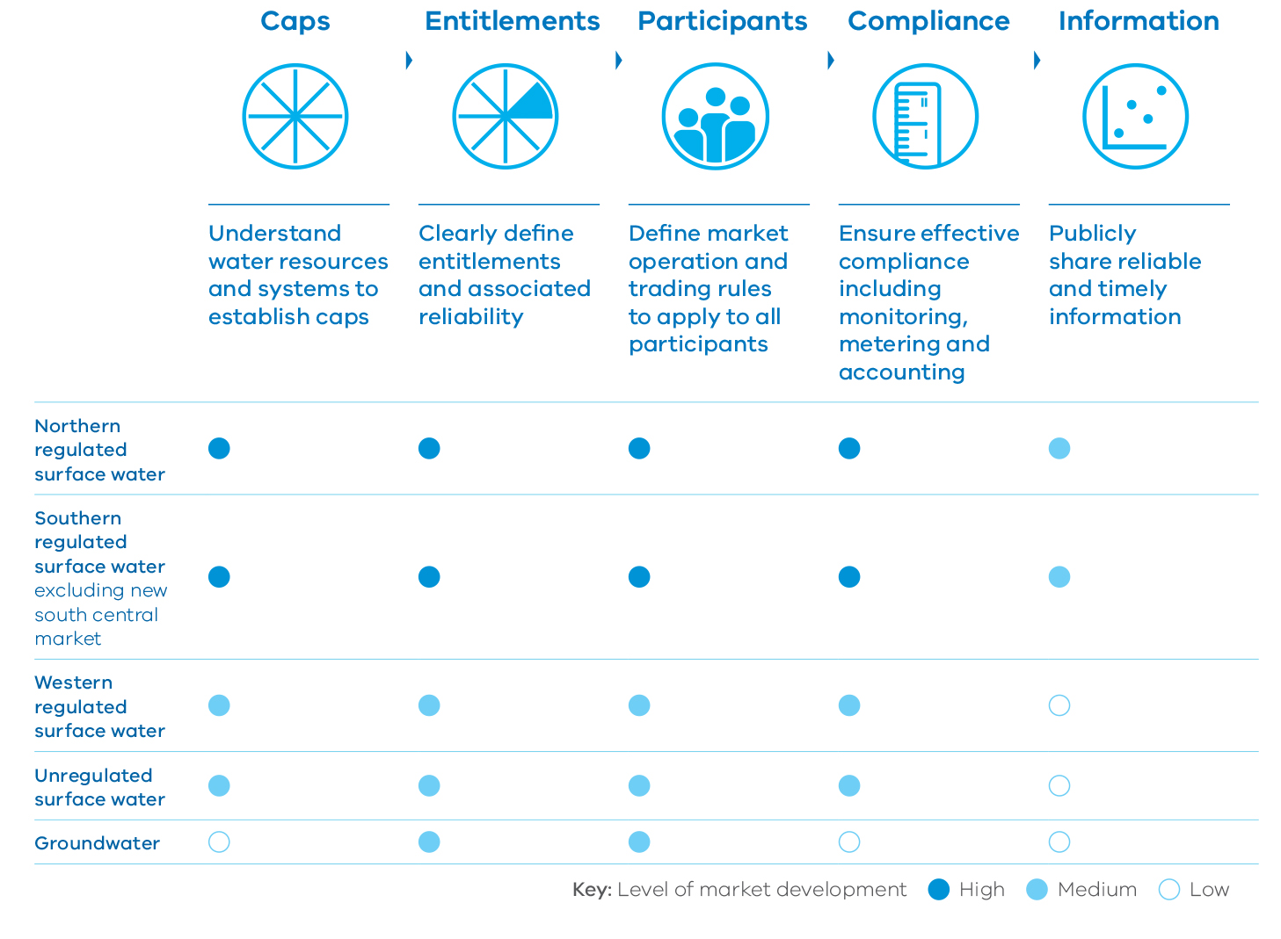
 | Caps | Entitlements | Participants | Compliance | Information
 | Understand water resources and systems to establish caps | Clearly define entitlements and associated reliability | Define market operation and trading rules to apply to all participants | Ensure effective compliance including monitoring, metering and accounting | Publicly share reliable and timely information
Northern regulated surface water | High | High | High | High | Medium
Southern regulated surface water  excluding new south central market | High | High | High | High | Medium
Western regulated surface water | Medium | Medium | Medium | Medium | Low
Unregulated surface water | Medium | Medium | Medium | Medium | Low
Groundwater | Low | Medium | Medium | Low | Low

10. Jobs, economy and innovation

OBJECTIVE
Victoria’s water sector will support jobs, economic growth, the environment, and our health and wellbeing by continuing to deliver efficient services with a focus on innovation, performance and affordability.
The Victorian water sector provides water, wastewater and environmental services that are critical for human health, a prosperous economy, a healthy environment and our overall quality of life.
The viability of industries, particularly the agriculture, manufacturing, energy and mining industries depends on water. As shown in Figure 10.1, water is an important input to many industries that generate significant direct benefits through jobs and economic activity¹. They also create indirect economic and social benefits bringing together the community in regional and rural areas.

What we will do
- Improve engagement with customers and the broader community
- Consult business on future needs and provide information to support investment
- Promote innovation in the water sector
- Build capacity and capability in the water sector
- Provide third-party access to existing infrastructure
- Drive strong governance and performance
- Promote gender equity in the water sector
- Increase Aboriginal inclusion in the water sector
- Support economic development through Aboriginal participation
- Respond to the Royal Commission into Family Violence
- Find ways to cut red tape
- Improve emergency management capability Deliver Water for Victoria
Water for Victoria will help water corporations and catchment management authorities deliver better outcomes for the state.
Our water sector will be innovative, inclusive and provide efficient and affordable water services to support jobs, our economy and our diverse communities.
As discussed in Chapter 4: Water for agriculture, the agriculture sector is highly dependent on water. Water and wastewater services are fundamental requirements for processing food and fibre. The mining and extractive industries rely on water availability and security for ore processing, mine stability, dust control, drilling and rehabilitation. Energy production depends on water, which is used in power generation and in the extraction, transport and processing of fuels.
Together, the industrial sector contributed approximately $50.4 billion to Victoria’s economy in 2015 – around 14 per cent of the state’s total production – and employed 387,000, or one in eight Victorians, making a significant contribution to the prosperity of metropolitan, regional and rural areas.
Manufacturing contributed $26.5 billion to the Victorian economy in 2015 and employed more than 270,000 people. Food and beverage manufacturing is the largest manufacturing sector in Victoria, accounting for around 20 per cent of the state’s manufacturing, and generates approximately 30 per cent of Australia’s total food processing output.
Mining and extractive industries also interact with our water system. As an example, water management will be considered in the Latrobe Valley Regional Rehabilitation Strategy, as part of the Hazelwood Fire Mine Inquiry: Victorian Government Implementation Plan.

The water sector – a significant employer across Victoria
The Victorian water sector, made up of water corporations, catchment management authorities and the Victorian Environmental Water Holder, is one of the largest sectors in the Victorian economy.
The total asset base of Victoria’s water corporations is around $40 billion. In 2014-15, the water corporations reported a combined revenue of $5.53 billion, invested $1.24 billion in capital and had borrowings of $10.3 billion. Victoria’s water corporations employ approximately 5700 Victorians across the state.
Victoria’s water corporations and catchment management authorities play a particularly important role in many regional communities. In addition to those employed directly, water corporations and catchment management authorities prioritise use of locally-based goods and services for project delivery.
For example, over the next four years, an estimated $280 million will be injected into regional economies via the catchment management authorities as part of the government’s commitment to improving waterway health. The success of this program will require the engagement of regional businesses to undertake construction and maintenance activities such as fencing, weed control, revegetation planting and engineering works. This also has flow-on effects to other businesses in regions, such as local nurseries, engineering consultants, and fencing manufacturers.
Figure 10.1 – Water consumption by sector 2013–2014¹
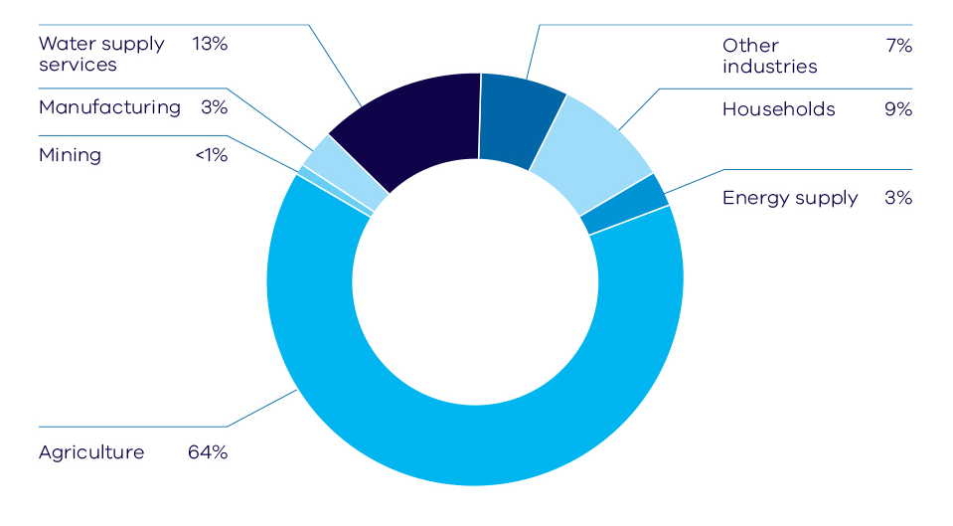
Water supply services 13%
Manufacturing 3%
Mining <1%
Agriculture 64%
Other industries 7%
Households 9%
Energy supply 3%

Key challenges and opportunities
Jobs and economic growth in Victoria must keep pace with our rapidly growing population. Water is a key input for many industries. Limits on access to reliable, safe and affordable water and wastewater services can significantly impact business viability, with knock-on effects for jobs and the economy.
Victoria’s water sector plays an important role supporting the state’s economic performance. The importance of this role will increase as we face the challenges of climate change and population growth.
We will require innovative new approaches to meet these challenges. This will also create new opportunities to export our expertise nationally and internationally. Partnerships between the public sector, including the water corporations and catchment management authorities, and the private sector will be required to realise these opportunities. A better understanding of customer and community needs, together with good governance, will ensure that our water sector continues to provide high quality water services.
In the longer-term, a better approach to community engagement and enhanced planning processes will make sure the community is consulted on new infrastructure investment and that there are no price shocks for customers.

Affordability
Water, wastewater and environmental services must remain affordable for all customers as we meet the challenges of climate change and population growth.
Urban and regional water corporation bills in Victoria are generally below the Australian average. The government expects bills to remain stable in the coming years. The efficiencies underpinning the current government water rebate and reductions in water corporation debt will be the starting point for setting prices for July 2018 onwards.
Investment in infrastructure to provide services to homes and businesses, to deliver environmental protection and recreational benefits, and to adapt to climate change, will create upward pressure on costs. This will be balanced by downward pressure on cost as the water sector continues to deliver efficiency through shared services and smarter procurement, innovative lower-cost technologies and processes, greater interconnection of water resources and reduced red tape.
An improved governance and performance framework will make sure the sector finds further opportunities to control cost.

The Regional Statement and Regional Partnerships
Victoria’s Regional Statement, Your Voice, Your Region, Your State, is the Victorian Government’s acknowledgment of the enormous contribution regional Victoria makes to the state’s economic strength and way of life. It’s about creating jobs, providing a better start for young people, and supporting a brighter future for families and communities.
Every region is different. They range from dryland to irrigated farming areas and from big cities to small towns and their economies rely variously on food and fibre, tourism, manufacturing and natural resources. We understand that some regions are experiencing significant population growth, while others are facing population adjustment and decline. Regional communities have their own character, their own aspirations, and their own understanding of the challenges and opportunities.
Victoria’s Regional Statement sets a new approach that will change the way government works with regional Victorians. The centrepiece is the establishment of nine new Regional Partnerships across the state to direct regional priorities straight into the heart of government. The partnerships will look at strategic priorities identified by regional communities – about economic, social and environmental issues – and oversee implementation of the top priorities on a year-by-year basis. This is about working directly with local communities to build on regional Victoria’s strengths and tackle the issues that matter most.

10.1 Better understanding the needs of water customers and the community
It is important that Victoria’s water sector understands and meets the needs of water customers and the broader community.
The Essential Services Commission acknowledged this in its recent position paper, A New Model for Pricing Services in Victoria’s Water Sector (May 2016). The position paper proposes changes to the existing regulated pricing approach to place greater focus on delivering better results for customers. An important part of this process is improved engagement with customers and the community to better understand their needs. Good engagement provides an informed view by customers on their preferred balance between price and service. Prices should reflect the efficient cost of providing the desired level of service.
Previous chapters in Water for Victoria set out specific initiatives to better meet the water needs of the environment, farmers, cities and towns, Traditional Owners and recreational water users. Improved customer and community engagement is an important thread across all components of this water plan.

Action 10.1 – Improve engagement with customers and the broader community
To deliver better outcomes, the water sector will:
- continue to improve engagement with customers and the broader community, including households, farmers, Traditional Owners and Aboriginal Victorians, business and industry to better understand their water needs
- participate in regionally-based forums in partnership with local government, the Department of Economic Development, Jobs, Transport and Resources, industry and Traditional Owners and Aboriginal Victorians to inform the Regional Partnerships on strategic water-related economic opportunities.
The water needs of business customers can be diverse, varying significantly from one business to another. Different businesses need different volumes and quality of water supply and create different volumes and quality of wastewater. During the Millennium Drought, many businesses reduced their water use as part of the state-wide water saving effort. As discussed in Chapter 5: Resilient cities and towns, the water sector will continue to work with industry on water efficiency programs.
Business requires a degree of comfort when making investment decisions about new capacity or facilities, which has flow-on consequences for jobs and communities. The water sector is responsible for providing cost-effective water supply and wastewater treatment. This should enhance, not constrain, economic development.

Action 10.2 – Consult business on future needs and provide information to support investment
Water corporations will:
- consult business customers on future needs as part of resource and service planning
- provide information about the best available supply and service options to new business customers to assist their investment decisions.

10.2 Enabling an innovative water sector
Victoria’s water corporations are strong performers both by national and international standards. They already demonstrate strong examples of innovation, such as using space technology ground-penetrating radar imagery to detect leaks underground and check the integrity of pipes, as well as asset and energy optimisation initiatives and the use of big data systems.
The water corporations have taken strides to improve both operational and capital investment efficiencies. This is being achieved through initiatives, such as shared services, joint procurement and partnerships with the private sector. They are also seeing the benefit of using the comparative strengths of their fellow water corporations.
We will need innovative ways of providing reliable, safe and affordable water services to respond to population growth and climate change. Technological innovation is important to deliver improved service, efficiency and optimise a limited resource that will have greater demands put on it. In an increasingly connected world, innovation in customer service and engagement is also important.
Victoria can be a lead provider and exporter of water knowledge, technology and services. The government will foster innovation in the water sector, supporting programs that deliver value. We will build on existing initiatives, such as the Intelligent Water Networks Program and the Cooperative Research Centre for Water Sensitive Cities. Innovation in the water sector will continue to develop expertise and capabilities in water and wastewater management.

Liveability Victoria International
Victoria has established Liveability Victoria International to promote and support the export of Victorian services and expertise in liveability, particularly to growing economies in Asia.
Melbourne is consistently rated as one of the world’s most liveable cities and Victorian expertise is being sought to inform development of liveable cities internationally. Liveability Victoria International will focus on our strengths in water resource management; environment protection and clean-tech; and planning and urban design. Liveability Victoria International will bring government, industry and universities together to establish effective relationships in key international markets.
To stay at the forefront of water management internationally, Victoria must also look beyond our own expertise and learn from others. This will be increasingly important as the impacts of climate change and population growth increase pressure on our water supplies and affect the water security of neighbouring countries.

Action 10.3 – Promote innovation in the water sector
The government will enable innovation in the water sector by:
- supporting existing programs, including Intelligent Water Networks in which all urban water corporations will participate
- establishing a Ministerial Innovation Award to promote and recognise innovation in the water sector
- continued participation by the Department of Environment, Land, Water and Planning in the Cooperative Research Centre for Water Sensitive Cities.

Victoria as a global citizen
Victoria recognises its role as a global citizen and will provide regional leadership by assisting developing countries with water security and sanitation needs. This will contribute to the United Nations Sustainable Development Goals on ‘clean water and sanitation’ and ‘sustainable cities and communities’.
The Victorian and Timor-Leste Governments have shared a relationship based on friendship and mutual respect since 2002, working together to build the capacity of the Timorese Government in ways that match Timorese needs with Victorian capacity.
Victoria and Timor-Leste have partnered on a broad range of areas, such as vocational education and training, commerce, land management and planning, information technology, and the establishment of municipal government. In the water sector, Melbourne Water and Yarra Valley Water, along with the Department of Environment, Land, Water and Planning, partnered with the Timorese Government to prepare a Masterplan for Sanitation and Drainage in Dili, which is currently being implemented by the Timor-Leste Government. The Victorian and Timor-Leste Governments are examining new opportunities through a refreshed Victorian Government Timor-Leste Strategy.
The Victorian Government will encourage knowledge exchange with relevant jurisdictions and academic institutions. We will continue to support the Cooperative Research Centre for Water Sensitive Cities, which has a partnership with the Asian Development Bank, to help developing cities in the Asia-Pacific region transition to sustainable and resilient cities.
The Department of Environment, Land, Water and Planning has joined the Australian Water Partnership, which aims to ensure water security in the Indo-Pacific region.

Building the capacity and capability of the Victorian water sector
The Victorian water sector employs approximately 5700 people across Victoria. The right skills, expertise, capacity and capability are vital to meet future challenges, enable innovation and support jobs.

Action 10.4 – Build capacity and capability in the water sector
The water sector will work with delivery partners to identify skills gaps and develop programs to build the right skills and capacity. This may include apprenticeships, traineeships and other programs.

Vocational education and training
Melbourne Water looked at opportunities to build its workforce’s skills and capabilities. Its assessment identified construction, conservation and land management, and water operations as areas for improvement.
Melbourne Water has developed a vocational education and training strategy, including a program of 40 new traineeships and apprenticeships with Chisholm Institute and Holmesglen Institute. Melbourne Water’s commitment to developing this capacity is part of its broader drive for continuous improvement and efficiency.

10.3 Access to infrastructure
Infrastructure held by water corporations, such as pipes and sewers, can be impractical or too costly for other potential service providers to duplicate. There will be times when these service providers may need the infrastructure to deliver an alternative service and it makes sense to use existing infrastructure. This approach can open up a wider range of options for customers by making it feasible for private sector businesses (and water corporations other than the incumbent) to deliver services where they may have an advantage through service, cost or innovation. Benefits may arise from developing new sources of water, such as through recycling or sharing the cost by using excess capacity in existing infrastructure.
Frameworks for third-party access already exist in New South Wales and South Australia. The oversight of a formal framework will make sure that we maintain the integrity of our water management system, and protect existing and new water customers. It also provides assurances to all parties involved including the community. Ownership of the infrastructure still remains in government hands. Water corporations will be obliged to respond to requests by third parties for access to infrastructure to service non-household customers, and to negotiate in good faith. Water corporations will also be required to give businesses accessible information, such as technical standards for infrastructure.
There will be a provision to seek arbitration. It is not intended to introduce licensing for access seekers at this time because arrangements will be handled on a contractual basis.

Action 10.5 – Provide third-party access to existing infrastructure
The government will establish a basic third-party access regime for other potential service providers to use existing infrastructure. A formal framework with oversight will make sure that we maintain the integrity of Victoria’s water management system, protect existing and new water customers, and provide assurances to all parties involved.
We will collaborate with the water corporations to develop the regime. The government will issue guidance and water corporations will make their technical standards for infrastructure available to third parties.

10.4 Improving governance and performance
Good governance and regulation of the Victorian water sector is important for providing reliable, safe and affordable water services that meet the needs of customers and the community. The sector’s financial sustainability relies on the cost of services being recovered from customers.
We have already taken significant steps to improve the governance of the Victoria water sector. In 2015, the government refreshed the boards of the water corporations and catchment management authorities to make sure they are best placed, from a governance and financial perspective, to deal with the challenges of changing rainfall patterns, climate change and rapid population growth.
To support ongoing performance improvements, the government will regularly communicate clear expectations to the water sector. We will strengthen water sector (water corporations, catchment management authorities and the Victorian Environmental Water Holder) governance and performance by setting clear expectations, priorities, performance measures, and appropriate benchmarking. Strengthening the performance frameworks will support a culture of continuous improvement and provide greater transparency and accountability.
Water corporations will continue to find operational and capital investment efficiencies to keep costs down through initiatives such as shared services and shared procurement. The Essential Services Commission’s proposed approach to pricing introduces incentives for good performance on efficiency and service by water corporations.
Community engagement and increasing diversity in water sector leadership will help build a culture open to new ideas and reflecting communities served.

Action 10.6 – Drive strong governance and performance
The government will support the governance and performance of water corporations, catchment management authorities and the Victorian Environmental Water Holder by:
- maintaining a focus on skills-based boards
- setting clear expectations and priorities
- employing performance measures and benchmarking that are appropriate to their particular functions, and outcomes delivered
- supporting a culture of continuous improvement through improved transparency and accountability for performance.

Water sector organisations reflecting the communities they serve
Victoria’s diversity means that our communities’ needs and values differ across the state. To understand these needs and values we must ensure that our institutions represent our diverse communities.
There are clear benefits to having gender and cultural diversity in the boards and management of the water sector, such as providing a range of perspectives, driving efficient and innovative service delivery, and making sure that water sector leadership reflects the communities it serves.
The recent appointment of Victoria’s new water sector boards demonstrate the government’s commitment to diversity, with:
- women accounting for over half of all new water corporation and catchment management authority board members and half the Victorian Catchment Management Council
- appointments including a number of Aboriginal Victorians.
Continuing to lift representation of Aboriginal Victorians on boards and committees is a government priority.
There are additional opportunities to ensure that our water corporations and catchment management authorities reflect the needs of our diverse communities.

Gender equity

Action 10.7 – Promote gender equity in the water sector
The government will continue to promote gender equity within the water sector by:
- maintaining a focus on gender diverse boards
- requiring water corporations and catchment management authorities to focus on gender equity in executive leadership positions across the sector, and to develop and implement action plans
- partnering with the water sector and peak industry bodies to establish a Women in Water Leadership Program to train senior women in the sector
- establishing an annual leadership award for women in water.

Aboriginal inclusion
The government recognises the Aboriginal people as Australia’s first peoples, and as the Traditional Owners and custodians of the land on which we work and live. The government also recognises and values the ongoing contribution of Aboriginal people to Victoria. Additionally, there are legislative obligations to those Traditional Owners that have made agreements with the state.
Traditional Owners have managed land and water sustainably over many thousands of generations. Incorporating this knowledge into the way we manage water in Victoria represents an opportunity to improve the sustainable management of our water systems.
Across the water sector, there are opportunities to partner with Aboriginal Victorians in water planning and policy development, service delivery, governance and representation on boards and committees. In turn, these partnerships will increase opportunities for Aboriginal employment, cultural wellbeing and economic self-determination.

Action 10.8 – Increase Aboriginal inclusion in the water sector
The Department of Environment, Land, Water and Planning will develop a program, in partnership with Traditional Owners and the water sector to build the capacity of Victoria’s Traditional Owners to participate on the boards of the water corporations and catchment management authorities.
The government will appoint an Aboriginal Victorian as a fourth commissioner of the Victorian Environmental Water Holder.
The water sector will develop its collective knowledge of Aboriginal culture and will make sure it is culturally safe and inclusive.
Water corporations and catchment management authorities will be required to report to government on their plans for Aboriginal inclusion, participation, engagement and employment.
The Department of Environment, Land Water and Planning and the water sector will sponsor Aboriginal people in relevant study and training courses, including scholarships, vocational education and traineeships.

Action 10.9 – Support economic development through Aboriginal participation
The government, in partnership with Traditional Owners, will support increased Victorian Aboriginal self-determination by requiring the water sector to:
- explore and develop opportunities for business arrangements with Traditional Owners and Aboriginal enterprises to deliver value for money catchment and water services
- provide opportunities for cross-cultural learning in the water sector, as well as skills training and employment for Aboriginal Victorians.
As an example, Melbourne Water is reviewing its policies and procedures to identify barriers to Aboriginal businesses supplying it with goods and services. Melbourne Water is also developing a list of potential supplier businesses.
The Department of Environment, Land, Water and Planning’s Aboriginal Inclusion Plan 2016-2020 – Munganin-Gadhaba ‘Achieve Together’ sets out the Department’s approach to working in partnership with Aboriginal Victorians and Traditional Owners.

Improved support for victims of family violence
The government has committed to implement all recommendations of the Royal Commission into Family Violence, which were tabled in Parliament on 30 March 2016. The government wants to make sure the water sector continues to develop good practice in dealing with hardship, including actions to accommodate situations where domestic violence has created financial insecurity.
Specifically, Recommendation 109 of the report recommended that government work with the Essential Services Commission to:
- amend the Customer Service Code—Urban Water Businesses to list minimum eligibility criteria for access to hardship programs and include family violence as an explicit eligibility criterion
- develop industry guidelines for energy and water retailers to require comprehensive and ongoing training of customer service staff to help them identify customers experiencing family violence and financial hardship
- publicise the availability of dispute resolution mechanisms for people affected by family violence.
Water corporations will work with the Essential Services Commission to develop and implement family violence policies.

Action 10.10 – Respond to the Royal Commission into Family Violence
The Essential Services Commission and the water sector will amend the Customer Service Code and develop industry guidelines to implement Recommendation 109 of the Royal Commission into Family Violence.

Streamlining regulation and administration
The government will improve legislative and regulatory frameworks by finding opportunities to reduce red tape and streamline processes, as part of the commitment to reduce the overall burden of regulation in Victoria by 25 per cent. This will require a mechanism to identify, capture and act on instances of unnecessary burden. Business and planning processes will be a particular focus.
Opportunities to reduce red tape will be part of initiatives including the use of offsets to maintain regulatory compliance (Action 3.2), the Rural Drainage Strategy (Action 4.11) and the review and streamlining of regulatory instruments for water entitlements (Action 8.1).

Action 10.11 – Find ways to cut red tape
The Department of Environment, Land, Water and Planning and the water sector will collaborate to find opportunities to reduce red tape and develop a reporting mechanism to identify, capture and assess instances of red tape on a continuous basis.
The government will review administrative practices and make legislative amendments where appropriate.

10.5 Managing exceptional circumstances

Emergency management
The government is moving to implement an ‘all-hazards, all-agencies’ approach to emergency management. Water corporations and catchment management authorities are a key part of the emergency response and recovery framework. The government will work with water corporations and catchment management authorities to clarify their role in emergency response and recovery to make sure it is consistent with their skills, resources and capabilities.
The government will strengthen risk management arrangements and assurance processes to support water sector business continuity and manage the risks and challenges of emergencies and extreme events.

Action 10.12 – Improve emergency management capability
The government will improve the emergency management capability and resilience of the water sector by:
- making relevant legislative changes to clarify the roles of water corporations and catchment management authorities in emergency management
- continuing to work with the water sector to enhance capacity and capability building
- enhancing information systems and processes to monitor, evaluate, communicate and continuously improve the management of water sector risks.

Floodplain Management Strategy
The Victorian Floodplain Management Strategy was released in April 2016. The strategy encourages increasing the awareness of Victorian communities, businesses and government agencies about their flooding risks, and enabling active management of their risks to minimise the consequences to life, property, community wellbeing and the economy.
The strategy sets out accountabilities for various government authorities across local government, and the Victorian and Federal Governments.
Cost-sharing principles and arrangements are also outlined for investment in flood mitigation activities.
The government has committed to implement the strategy in collaboration with local governments, catchment management authorities, water corporations, the Victoria State Emergency Service, and Emergency Management Victoria.
Catchment management authorities will facilitate the preparation of regional floodplain management strategies, a primary component in implementing the Victorian Floodplain Management Strategy.

10.6 Governance of Water for Victoria funding and implementation
Since its establishment, the Environmental Contribution has been pivotal in helping Victorians manage water resources more sustainably. It accounts for the environmental costs of providing water services and the costs of managing a limited resource. Under the Water Industry Act 1994, funds collected through the Environmental Contribution must be spent on initiatives ‘that seek to promote the sustainable management of water or address adverse water-related impacts’.
Evaluation of this investment demonstrates the significant outcomes and return on investment the Environmental Contribution has achieved over the past decade to promote more sustainable water management in Victoria. The achievements have been significant, and the government wants to make sure that Environmental Contribution investment will continue to achieve significant results. Recent reviews have recommended improving strategic focus, governance and oversight mechanisms.
Consistent with the government’s commitment in establishing the fourth tranche of the Environmental Contribution, the objectives, directions and actions outlined in Water for Victoria provide a renewed strategic blueprint to drive, prioritise and monitor the effectiveness of Environmental Contribution investment into the future.
The Department of Environment, Land, Water and Planning will implement the key recommendations from recent evaluations and reviews to enhance governance arrangements of the Environmental Contribution. The aim is to ensure that investments continue to align with the enduring purpose and objectives of the Environmental Contribution. This will be achieved by improved transparency, accountability and decision-making.

Action 10.13 – Deliver Water for Victoria
The Department of Environment, Land, Water and Planning will establish a dedicated project office to:
- oversee, monitor and evaluate the implementation of initiatives funded by the Environmental Contribution
- track delivery of Water for Victoria
- report publicly on progress and achievements.

Appendix Implementation plan

Chapter 2 Climate change
Action | Responsibility | Delivery partners | Timeframe
Action 2.1 Achieve net-zero emissions in the water sector | Department of Environment, Land, Water and Planning | Water corporations, catchment management authorities, Environment Protection Authority, government agencies, Aboriginal Victorians | Ongoing
Action 2.2 Understand and apply climate science to water management | Department of Environment, Land, Water and Planning | Water corporations, catchment management authorities, local government, research institutions, Traditional Owners and Aboriginal Victorians, industry | July 2017
Action 2.3 Lead climate change adaptation across Victoria’s water system | Department of Environment, Land, Water and Planning | Water corporations, catchment management authorities, local government | End 2020

Chapter 3 Waterway and catchment health
Action | Responsibility | Delivery partners | Timeframe
Action 3.1 Improving arrangements for urban waterways | Department of Environment, Land, Water and Planning | To be confirmed – Will reflect government response to the Yarra River Protection Ministerial Advisory Committee | Mid 2017
Action 3.2 Protect water quality through the State Environment Protection Policy | Department of Environment, Land, Water and Planning | Water corporations, catchment management authorities, Environment Protection Authority, local government, Traditional Owners and Aboriginal Victorians | Mid 2018
Action 3.3 Invest in integrated catchment management | Department of Environment, Land, Water and Planning, catchment management authorities | Water corporations, local government, Traditional Owners and Aboriginal Victorians, communities | 2016-2019
Action 3.4 Provide long-term investment to improve waterway health | Department of Environment, Land, Water and Planning, catchment management authorities | Water corporations, local government, Traditional Owners and Aboriginal Victorians, communities | 2016-2019
Action 3.5 Improve environmental water management in a changing climate | Department of Environment, Land, Water and Planning | Water corporations, catchment management authorities, local government, Traditional Owners and Aboriginal Victorians, communities, Victorian Environmental Water Holder | 2016-2019
Action 3.6 Better monitor and report on the benefits of environmental watering | Department of Environment, Land, Water and Planning, Victorian Environmental Water Holder | Water corporations, catchment management authorities, Traditional Owners and Aboriginal Victorians, recreational users | 2016-2019
Action 3.7 Ensure clear and transparent charging arrangements | Water corporations | Victorian Environmental Water Holder, Department of Environment, Land, Water and Planning, Essential Services Commission | 2017
Action 3.8 Support community partnerships and citizen science | Catchment management authorities | Landcare groups, angling groups, Traditional Owners and Aboriginal Victorians, communities | 2016-2019
Action 3.9 Improve knowledge and information about waterways and catchments | Department of Environment, Land, Water and Planning, catchment management authorities | Researchers | 2016-2019

Chapter 4 Water for agriculture
Action | Responsibility | Delivery partners | Timeframe
Action 4.1 Supporting regional development and change | Department of Environment, Land, Water and Planning | Water corporations, catchment management authorities | Ongoing
Action 4.2 Invest in rural water infrastructure | Department of Environment, Land, Water and Planning | Water corporations, catchment management authorities, local government, Department of Economic Development, Jobs, Transport and Resources | Ongoing
Action 4.3 Help irrigation districts adapt | Rural water corporations | Catchment management authorities, local government, Traditional Owners and Aboriginal Victorians, Department of Economic Development, Jobs, Transport and Resources, Department of Environment, Land, Water and Planning | Ongoing
Action 4.4 Reduce barriers to change and support communities in irrigation districts | Department of Environment, Land, Water and Planning | Rural water corporations catchment management authorities, Department of Economic Development, Jobs, Transport and Resources | 2016 - 2020
Action 4.5 Improve water delivery efficiency in irrigation districts | Department of Environment, Land, Water and Planning | Rural water corporations, Department of Economic Development, Jobs, Transport and Resources, catchment management authorities | 2016-2020
Action 4.6 Manage salinity, waterlogging and water quality | Department of Environment, Land, Water and Planning | Water corporations, catchment management authorities, Department of Economic Development, Jobs, Transport and Resources | 2016-2020
Action: 4.7 Manage irrigation developments | Department of Environment, Land, Water and Planning | Water corporations, catchment management authorities, Department of Economic Development, Jobs, Transport and Resources | 2016-2020
Action 4.8 Improve salinity management in the Mallee | Department of Environment, Land, Water and Planning | Lower Murray Water and Mallee Catchment Management Authority | 2016-2020
Action 4.9 Improve management of emergency water supply | Department of Environment, Land, Water and Planning | Water corporations, local government | By December 2017
Action 4.10 Develop a rural drainage strategy | Department of Environment, Land, Water and Planning | Catchment management authorities, local government | Draft early 2017  Final strategy late 2017
Action 4.11 Balance water recovery for the Murray-Darling Basin | Department of Environment, Land, Water and Planning | Water corporations and catchment management authorities | Until completion

Chapter 5 Resilient and liveable cities and towns
Action | Responsibility | Delivery partners | Timeframe
Action 5.1 Use diverse water sources to protect public spaces | Department of Environment, Land, Water and Planning, water corporations, local government, public open space managers | Victorian Building Authority, VicWater, Environment Protection Authority, Department of Health and Human Services | End 2017 Ongoing
Action 5.2 Better urban water planning to address key challenges | Urban and regional water corporations | Department of Environment, Land, Water and Planning, Department of Health and Human Services | March 2017
Action 5.3 Reinvigorate water efficiency programs for Melbourne and regional Victoria | Department of Environment, Land, Water and Planning, urban water corporations | Department of Education and Training, schools, local government, community organisations | Ongoing
Action 5.4 Make the most of our investment in wastewater | Urban water corporations, Melbourne Water | Department of Environment, Land, Water and Planning, local government | September 2018 (Sewerage strategy)  Ongoing (waste to resource opportunities)
Action 5.5 Improve stormwater management for greener environments and healthier waterways | Department of Environment, Land, Water and Planning | Water corporations, catchment management authorities, Environment Protection Authority, local government, development industry | March 2017
Action 5.6 Work across government for healthy and resilient urban landscapes | Department of Environment, Land, Water and Planning | Catchment management authorities, local government, Victorian Planning Authority, government departments such as the new Suburban Development portfolio, Traditional Owners and Aboriginal Victorians | Ongoing (proposed amendments and best mix of tools)
Action 5.7 Represent community values and local opportunities in planning | Department of Environment, Land, Water and Planning, water corporations | Catchment management authorities, local government, Victorian Planning Authority, government departments, Traditional Owners and Aboriginal Victorians, Municipal Association of Victoria, Vicwater, Clearwater | Ongoing
Action 5.8 Put integrated water management into practice | Department of Environment, Land, Water and Planning, water corporations | Water corporations, catchment management authorities, local government, Victorian Planning Authority, government departments, Traditional Owners and Aboriginal Victorians, Municipal Association of Victoria, Vicwater, Clearwater | Ongoing

Chapter 6 Recognising and managing for Aboriginal values
Action | Responsibility | Delivery partners | Timeframe
Action 6.1 Recognise Aboriginal values and objectives of water | Department of Environment, Land, Water and Planning, co-design with the Aboriginal Water Reference Group | Traditional Owners, water corporations, catchment management authorities, Victorian Environmental Water Holder | 2016-2020
Action 6.2 Include Aboriginal values and traditional ecological knowledge in water planning | Department of Environment, Land, Water and Planning, oversight role for the Aboriginal Water Reference Group | Traditional Owners, water corporations, catchment management authorities and Victorian Environmental Water Holder | 2016-2020
Action 6.3 Support Aboriginal access to water for economic development | Department of Environment, Land, Water and Planning, Department of Premier and Cabinet, Department of Economic Development, Jobs, Transport and Resources | Traditional Owners, water corporations | 2016-2020
Action 6.4 Build capacity to increase Aboriginal participation in water management | Department of Environment, Land, Water and Planning, co-design with the Aboriginal Water Reference Group | Traditional Owners, water corporations, catchment management authorities, Victorian Environmental Water Holder | 2016-2020

Chapter 7 Recognising recreational values
Action | Responsibility | Delivery partners | Timeframe
Action 7.1 Include recreational values in water and waterway planning | Department of Environment, Land, Water and Planning | Water corporations, catchment management authorities, Victorian Environmental Water Holder | 2017 and Ongoing
Action 7.2 Help communities understand how to achieve their recreational objectives | Department of Environment, Land, Water and Planning | Water corporations, catchment management authorities, land managers | 2017 and Ongoing
Action 7.3 Support recreation at water storages through infrastructure and better information | Water corporations | Local government, Regional Development Victoria, Fisheries, VRFish, Tourism Victoria, tourism boards, peak recreational bodies, community groups and clubs | 2017 and Ongoing

Chapter 8 Water entitlements and planning
Action | Responsibility |  | Delivery partners |  | Timeframe
Action 8.1 Ensure a strong, responsive water entitlement system | Department of Environment, Land, Water and Planning |  | Rural water corporations, Melbourne Water, Victorian Environmental Water Holder, Traditional Owners, communities |  | Mid 2016-2021
Action 8.2 Provide greater flexibility and choice for licence-holders | Department of Environment, Land, Water and Planning |  | Southern Rural Water, Goulburn-Murray Water, Grampians Wimmera Mallee Water, Melbourne Water, Victorian Water Registrar |  | End 2017
Action 8.3 Investigate increased flexibility for taking water under winter-fill licences | Department of Environment, Land, Water and Planning |  | Southern Rural Water, Goulburn-Murray Water, Grampians Wimmera Mallee Water, Melbourne Water |  | Mid 2017
Action 8.4 Better record and report on emerging significant uses of water | Department of Environment, Land, Water and Planning |  | Southern Rural Water, Goulburn-Murray Water, Grampians Wimmera Mallee Water, Melbourne Water |  | Ongoing  Reasonable domestic and stock limits.  End 2017
Action 8.5 Ensure a modern compliance regime that works | Department of Environment, Land, Water and Planning |  | Water corporations, Department of Premier and Cabinet |  | Ongoing
Action 8.6 Commence the long-term water resource assessment process | Department of Environment, Land, Water and Planning | Water corporations, Victorian Environmental Water Holder |  | Complete 2028
Action 8.7 Commence sustainable water strategy reviews | Department of Environment, Land, Water and Planning | Water corporations, catchment management authorities, Victorian Environmental Water Holder, Traditional Owners |  | Ongoing
Action 8.8 Align the sustainable water strategy and long-term water resource assessment processes | Department of Environment, Land, Water and Planning | Department of Premier and Cabinet (Office of Parliamentary Counsel) |  | End 2017
Action 8.9 Improve rural water supply planning | Department of Environment, Land, Water and Planning | Southern Rural Water, Goulburn-Murray Water, Grampians Wimmera Mallee Water, Melbourne Water, Department of Premier and Cabinet (Office of Parliamentary Counsel) |  | Ongoing
Action 8.10 Provide clear information about water resources to the community | Department of Environment, Land, Water and Planning | Water corporations, Environment Protection Authority, Victorian Water Registrar |  | Ongoing
Action 8.11 improve water resource information to support planning and decisions | Department of Environment, Land, Water and Planning | Water corporations, catchment management authorities |  | Ongoing

Chapter 9 Realising the potential of the grid and markets
Action | Responsibility | Delivery partners | Timeframe
Action 9.1 Develop a grid oversight function | Department of Environment, Land, Water and Planning | Water corporations, Traditional Owners | 2017-2021
Action 9.2 Plan for future grid augmentations | Department of Environment, Land, Water and Planning | Water corporations, Traditional Owners | 2017-2021
Action 9.3 Improve the effectiveness of water markets | Department of Environment, Land, Water and Planning | Water corporations, Murray-Darling Basin Authority, Australian Competition and Consumer Commission | 2017-2021
Action 9.4 Increase water market transparency and information sharing | Department of Environment, Land, Water and Planning | Water corporations, Traditional Owners | 2017-2020
Action 9.5 Develop the water market in south central Victoria | Department of Environment, Land, Water and Planning | Water corporations | 2017-2021
Action 9.6 Improve trading rules in northern Victoria | Department of Environment, Land, Water and Planning | Water corporations, Murray-Darling Basin Authority | 2017-2021
Action 9.7 Develop trading rules in other water systems | Department of Environment, Land, Water and Planning | Water corporations, Traditional Owners | 2019-2021

Chapter 10 Jobs, economy and innovation
Action | Responsibility | Delivery partners | Timeframe
Action 10.1 Improve engagement with customers and the broader community | Water corporations | Department of Environment, Land, Water and Planning, Traditional Owners and Aboriginal Victorians, local government, Department of Economic Development, Jobs, Transport and Resources, Victorian Business and industry, communities | Ongoing
Action 10.2 Consult business on future needs and provide information to support investment | Water corporations | Department of Environment, Land, Water and Planning, community, Traditional Owners and Aboriginal Victorians | Ongoing
Action 10.3 Promote innovation in the water sector | Department of Environment, Land, Water and Planning, water corporations | Water corporations, catchment management authorities, Cooperative Research Centre for Water Sensitive Cities, communities | Ongoing
Action 10.4 Build capacity and capability in the water sector | Department of Environment, Land, Water and Planning, water corporations, catchment management authorities | Traditional Owners | Ongoing
Action 10.5 Provide third party access to existing infrastructure | Department of Environment, Land, Water and Planning | Water corporations, Essential Services Commission | Framework designed and agreed by end 2018
Action 10.6 Drive strong governance and performance | Department of Environment, Land, Water and Planning | Water corporations, Essential Services Commission, catchment management authorities, Victorian Environmental Water Holder | Pilot statements of expectations to water corporations– November 2016 Ongoing
Action 10.7 Promote gender equity in the water sector | Department of Environment, Land, Water and Planning | Water corporations, catchment management authorities, Victorian Environmental Water Holder | Ongoing
Action 10.8 Increase Aboriginal inclusion in the water sector | Department of Environment, Land, Water and Planning | Traditional Owners, water corporations, catchment management authorities, Victorian Environmental Water Holder | Ongoing
Action 10.9 Support economic development through Aboriginal participation | Traditional Owners, Department of Environment, Land, Water and Planning | Water corporations, catchment management authorities, Aboriginal Victorians | 2016-2020
Action 10.10 Respond to the Royal Commission into Family Violence | Essential Services Commission | Water corporations, catchment management authorities, communities | By March 2017
Action 10.11 Find ways to cut red tape | Department of Environment, Land, Water and Planning | Water corporations, catchment management authorities, communities | Ongoing
Action 10.12 Improve emergency management capability | Department of Environment, Land, Water and Planning | Water corporations, catchment management authorities, Emergency Management Victoria, Department of Justice and Regulation, Traditional Owners and Aboriginal Victorians, local government, Victoria State Emergency Service, Bureau of Meteorology | Ongoing
Action 10.13 Deliver Water for Victoria | Department of Environment, Land, Water and Planning | All water plan key delivery partners, includes partnerships with Traditional Owners | Ongoing

Appendix Key Victorian Government initiatives
Policy, strategy or plan | Description
Climate Change Framework | The Victorian Government has committed to restoring Victoria as a leader in climate change action; action that will protect and enhance Victorian’s health and wellbeing, increase skills and jobs and modernise our economy, reduce air pollution, conserve our natural environment and ensure our towns and cities remain great places to live into the future. The Victorian Climate Change Framework will bring together these actions. See Chapter 2: Climate change for further information on the Victorian Government’s climate change initiatives.
Biodiversity Strategy | The Victorian Government is developing a new Biodiversity Strategy to help us build a greater understanding of the complex interactions between our environment and the millions of plants and animals that call Victoria home. The strategy will not only recognise the intrinsic value of nature, but also the importance of a healthy natural environment for people and prosperity.
Plan Melbourne Refresh | The Victorian Government is undertaking a refresh of Plan Melbourne. The revised document will provide a framework to enhance Melbourne’s productivity, move jobs closer to where people live and create great new urban areas that accommodate Melbourne’s growth. This will optimise benefits from investment in infrastructure and maintain what we value about Melbourne.
Protecting the Yarra River (Birrarung) | The Victorian Government has committed to protecting the Yarra River’s amenity and significance to ensure this valuable asset is protected for the benefit and enjoyment of future generations. A Ministerial Advisory Committee has been formed to assess planning rules governing the Yarra River and advise on a new Yarra River Protection Act to legislate for the river’s long-term protection. See Chapter 3: Waterway and catchment health for further information.
Future Industries | The Victorian Government has identified six priority sectors that have potential for extraordinary economic growth and the capacity to create high-skill, high wage jobs: medical technologies and pharmaceuticals; new energy technologies; food and fibre; transport, defence and construction technologies; professional services and international education. The $200 million Future Industries Fund will support high growth, high value industries. For more information visit: http://www.business. vic.gov.au/support-for-your-business/future-industries.
Food and Fibre Sector Strategy | The Victorian Government’s Food and Fibre Sector Strategy sets priorities for the sector to support future growth and development of this priority sector.
Review of the Local Government Act | The Victorian Government is conducting the first comprehensive review of the Local Government Act 1989 in response to calls from the local government sector for legislative reform after over 90 amending acts have resulted in hundreds of individual amendments to the Act in the past 25 years.
Victorian Public Health and Wellbeing Plan | The Victorian Public Health and Wellbeing Plan 2015-2019 outlines the government’s key priorities over the next four years to improve the health and wellbeing of all Victorians, particularly the most disadvantaged. For more information visit: https://www2.health.vic.gov.au/about/health-strategies/ public-health-wellbeing-plan.
Infrastructure Strategy | Infrastructure Victoria is an independent statutory authority established to provide expert advice to the Victorian Government and guide decision-making on Victoria’s infrastructure needs and priorities. Infrastructure Victoria is undertaking the first ever 30-year infrastructure strategy for Victoria.
Regional Statement | The Regional Statement, Your Voice, Your Region, Your State, is the Victorian Government’s acknowledgment of the enormous contribution regional Victoria makes to Victoria’s economic strength and way of life. The statement is about creating jobs, providing a better start for young people, and supporting a brighter future for families and communities. See Chapter 10: Jobs, economy and innovation for further information.
Renewable Energy Roadmap | The Victorian Government is rebuilding Victoria’s reputation as the nation’s leader for renewable energy. Victoria’s Renewable Energy Roadmap outlines a set of initiatives to accelerate the development of renewable energy projects and create sustainable jobs in Victoria.
Energy Efficiency and Productivity Statement | The Victorian Government released the Energy Efficiency and Productivity Statement: Saving energy, growing jobs. The statement outlines a vision and priorities to deliver an energy efficient and productive economy for Victoria. Development of an Energy Efficiency and Productivity Strategy is now underway. The strategy will set out a detailed plan of action to expand upon the high level priorities outlined in the statement.
LaunchVic | The Victorian Government has established a start-up company called LaunchVic, and committed $60 million, to support the ecosystem for local start-up businesses and the rapidly growing start-up sector in Victoria. For more information visit: http://launchvic.org/.
Marine and Coastal Act | The Victorian Government is creating a new Marine and Coastal Act to protect marine and coastal environments and meet future long-term challenges such as impacts from climate change, population growth and ageing coastal structures.
More information on these initiatives is available at www.delwp.vic.gov.au, www.climatechange.vic.gov.au, www.economicdevelopment.vic.gov.au and www.agriculture.vic.gov.au

Glossary
Allocation | Water that is actually available to use or trade in any given year, including new allocations and carryover. The water that is actually in the dam in any given year is allocated against water shares. The seasonal allocation is the percentage of water share volume available under current resource conditions, as determined by the resource manager.
Aboriginal Victorians | An Aboriginal Victorian is a person of Aboriginal descent who identifies as an Aboriginal and is accepted as such by the Victorian Aboriginal community in which he or she lives.
Aquifer | An underground layer of rock or sediment that holds water and allows water to flow through it.
Assets | Assets are resources that provide benefit. This includes, for example, infrastructure such as treatment plants, pipes and pumps, water assets such as dams, bores and wetlands, and community assets such as sporting facilities, public gardens and street trees. Natural assets are assets of the natural environment, for example waterways and vegetation, also known as natural capital.
Augmentation | Increase in size and/or number, for example of assets in a water supply system.
Biodiversity | The numbers and variety of plants, animals and other living beings, including micro-organisms, across our land, rivers and oceans. It includes the diversity of their genetic information, the habitats and ecosystems in which they live and their connections with other life forms.
Bulk entitlement | The right to water held by water corporations and specified entities defined in the Water Act 1989. The bulk entitlement defines the amount of water that an authority is entitled to from a river, water storage or aquifer, and may include the rate at which it may be taken and the reliability of the entitlement.
Cap | An upper limit for the diversion of water from a waterway, catchment, basin or aquifer.
Capital works | Construction activities, like building and engineering, that create an asset.
Carbon capture and storage | The capture of carbon dioxide from industrial emissions and injecting it under pressure into rock formations that can store it so that it doesn’t enter the atmosphere.
Carryover | Allows entitlement holders to retain ownership of unused water allocated or purchased from the current season into the following season (according to specified rules).
Catchment | An area where water falling as rain is collected by the landscape, eventually flowing to a body of water such as a creek, river, dam, lake, ocean, or into a groundwater system.
Catchment management authorities | The Catchment and Land Protection Act 1994 established 10 catchment and land protection regions, each with a catchment management authority responsible for the integrated planning and coordination of land, water and biodiversity management.
Climate change | A change in global or regional climate patterns.
Climate models | Mathematical representations of the earth’s climate system based on the laws of physics. They are used to understand our future climate.
Community | Includes individuals, public and private landholders, community groups and business owners.
Consumption | Water that is provided for all human uses, that is non-environmental water.
Country | Aboriginal culture revolves around relationships to the land and water. For Traditional Owners, Country is a part of who they are, just as they are a part of it.
Country Plans | Country Plans are one way for Traditional Owners to articulate their priorities and aspirations for looking after Country. They can be strategic plans that encompass physical and spiritual concepts of Country, provide a strategic basis for partnerships, and identify management actions and economic opportunities.
Delivery share | An entitlement to have water delivered to land in an irrigation area. It gives access to a share of the available capacity in the channel or piped network that supplies water to the property. Delivery share is tied to the land and stays with the property if it is bought or sold. It also stays with the property if the water share is sold separately.
Desalination | Removing salt from water sources, often for drinking purposes.
Diversions | The removal of water from a waterway, for example via a pump.
Domestic and stock | Water used in households and for pets, other animals, fire prevention, and for irrigating a kitchen garden.
Drought Support Fund | A $10 million cross-government initiative to provide support to drought-affected farmers.
Ecosystem | A dynamic complex of plant, animal, fungal and microorganism communities and the associated non-living environment interacting as an ecological unit.
Environmental water | Water to support environmental values and ecological processes.
Environmental water holder | A body established to hold and manage environmental entitlements.
Environmental water reserve | The share of water resources set aside to maintain the environmental values of a water system.
Fit-for-purpose | Water of a quality that is appropriate for its intended use.
Floodplain | Low-lying land adjacent to a river or stream with unique ecosystems dependent on inundation from flood events.
Freshes | Small and short peaks in flows; a ‘flush’ of water through a waterway, which occurs generally in the summer and spring months.
Gigalitre (GL) | One billion (1,000,000,000) litres.
Green and blue infrastructure | Green infrastructure refers to key vegetation features such as street trees, parklands, grassed sports fields and vegetated walls. Blue infrastructure refers to key waterways, wetlands, recreational lakes, stormwater retarding basins, or other water body features. Green-blue infrastructure brings these assets together through integrated approaches to deliver community benefits.
Groundwater | All subsurface water, generally occupying the pores and crevices of rock and soil.
High-reliability water share | Legally recognised, secure entitlement to a defined share of water. Water shares are classed by their reliability, which is defined by how often full seasonal allocations are expected to be available. Allocations are made to high-reliability water shares before low-reliability shares.
Hydrology | The scientific study of water and its movement, distribution and quality.
Inflows | Water flowing into a storage or waterway.
In-kind contributions | Non-monetary contributions in the form of goods or services.
Instream | The component of a river within the river channel, including pools, riffles, woody debris, the river bank and benches along the bank.
Integrated catchment management | The coordinated management of land, water and biodiversity resources based on catchment areas. It incorporates environmental, social, cultural and economic considerations. This approach seeks to ensure the long-term viability of natural resource systems and human needs across current and future generations.
Integrated water management | A collaborative approach to planning that brings together all elements of the water cycle including sewage management, water supply, stormwater management and water treatment, considering environmental, economic and social benefits.
Irrigation Development Guidelines | These provide guidance to both irrigation developers and government agencies on the approval process and matters for consideration to obtain or modify a licence to use water for irrigation.
Megalitre (ML) | One million (1,000,000) litres.
Millennium Drought | The drought in Victoria spanning from 1997 to 2009.
National Water Initiative | Agreed to and signed at the 2004 meeting of the Council of Australian Governments, with the agreed imperative of increasing the productivity and efficiency of water use and the health of river and groundwater systems in Australia.
Natural capital | The various resources provided by nature that are essential for human survival and economic activity. Natural capital includes minerals, soil, air, water and all living things from which we derive not only material or financial value, but also ecosystem services.
Non-residential water use | Water used in industry, commercial/institutional buildings, open spaces, such as parks and gardens, and the water distribution system.
Passing flow | Flows that a water corporation must allow to pass at a dam or weir before it can take any water for consumptive use.
Permissible consumptive volume | The volume of water permitted to be taken from a discrete area or water system over a specified period of time.
Point source | Any single identifiable source of pollution from which pollutants are discharged such as a pipe, ditch, ship or factory smokestack.
Potable | Water of suitable quality for drinking.
Qualification of rights | The Minister for Water declares a water shortage and qualifies existing water entitlements to reallocate water to priority uses.
Rainwater | Water that has fallen as rain or has been collected from rainfall.
Ramsar wetlands | Wetlands of international importance, designated under the Ramsar Convention.
Recreational benefits or recreational values | The objectives and benefits that recreational users and community members associate with the use of water, reservoirs and waterways for recreational activities. These objectives and benefits include wellbeing and enjoyment, derived from social interaction, physical activity and relaxation associated with activities including sporting events, fishing, water skiing and rowing, camping, walking and gathering with friends and family. It also includes flow-on economic benefits to local communities from visitors to regional areas to make the most of these opportunities.
Recreational fishing | Fishing of aquatic animals (mainly fish) for pleasure or competition.
Recreational users | Victorians and other visitors that use Victorian waters for fishing, water skiing, rowing, camping, walking, bird watching, sporting events, social gatherings and other activities on or near waterways.
Recreational water | Water allocated in a regulated water system for recreational purposes.
Recycled water | Water derived from sewerage systems or industry processes that is treated to a standard appropriate for its intended use.
Regulated systems | Systems where the flow of the river is regulated through the operation of large dams or weirs.
Reliability of supply | Represents the frequency with which water that has been allocated under a water entitlement is expected to be supplied in full.
Reservoir | Natural or artificial dam or lake used for the storage and regulation of water.
Riparian | Land or vegetation that adjoins a river, creek, estuary, wetland or lake.
River basin | The land into which a river and its tributaries drain.
Salinity | The total amount of water-soluble salts present in the soil or a stream.
Seasonal determination | The percentage of water share volume available under current resource conditions determined by the resource manager for unbundling systems. Since 1 July 2012 the resource manager has used seasonal determination instead of the previously used term, seasonal allocation. This is to distinguish between water available under current resource conditions and the water customers have available because of carryover.
Sewage | Wastewater produced from households and industry.
Sewerage | The pipes and plants that collect, remove, treat and dispose of liquid urban waste.
Shared benefits | Shared benefits are achieved when water is managed primarily to meet the needs of the entitlement holder, but also provides other types of benefits through decision-making that deliberately targets other outcomes.
Statement of Obligations | Statements made under section 41 of the Water Industry Act 1994 that specify the obligations of Victoria’s water corporations in relation to the performance of their functions and the exercise of their powers.
Stormwater | Runoff from urban areas. The net increase in runoff from urban development due to water not being able to seep into the ground because of impervious surfaces, such as roofs and roads.
Streamflow management plan | Prepared for a water supply protection area to manage the surface water resources of the area.
Surface water | Water on the surface of the planet, including streams, rivers, lakes, wetlands and oceans.
Sustainable water strategies | Regional long-term planning documents legislated under the Water Act 1989, to address threats to, and identify opportunities to improve water security and river health outcomes.
Traditional ecological knowledge | For thousands of years Aboriginal people survived in the Australian landscape relying on their intricate knowledge of the land and its plants and animals. Aboriginal people have important knowledge of ecological processes and land and water management practices.
Traditional Owners | People who, through membership of a descent group or clan, are responsible for caring for Country. Aboriginal people with knowledge about traditions, observances, customs or beliefs associated with a particular area. A Traditional Owner is authorised to speak for Country and its heritage.
Unbundle or unbundling | Separation of traditional entitlements previously called water rights or take and use licences in declared water systems into a water share, delivery share or a water-use licence.
Unregulated systems | River systems with no large dams or weirs to regulate flow.
Urban water cycle | The cycle of water through urban environments. Distinguished from the natural urban water cycle by the transfer of water through built infrastructure and the high runoff rates generated by impervious surfaces.
Urban water strategies | All urban water corporations in Victoria are required to develop these strategies, which detail how water supplies and water demands will be balanced over the long-term. These are the next iteration of Water Supply Demand Strategies first prepared in 2007.
Victorian Desalination Project | The formal name of the Wonthaggi desalination plant and associated infrastructure – made up of the plant, underground pipeline and dedicated power supply.
Victorian Environmental Water Holder | An independent statutory body responsible for holding and managing Victoria’s environmental water entitlements.
Wastewater | Water that has had its quality affected by human influence, deriving from industrial, domestic, agricultural or commercial activities.
Water corporations | Government owned organisations who provide a range of water services to customers within their service areas including water supply, sewage and trade waste disposal and treatment, water delivery for irrigation and domestic and stock purposes, drainage, and salinity mitigation services. Some water corporations have a regulatory function for the diversion of water from waterways and the extraction of groundwater. Formerly known as water authorities.
Water entitlement | A right to receive water allocations, depending on resource availability. An unbundled water entitlement is a water share. A bundled water entitlement may be one of several types; most commonly take and use licences, water allowances, and supply by agreements.
Water infrastructure | Facilities, services and installations needed for the functioning of a water system.
Water market | Market in which the trade of permanent and temporary water is allowed under certain conditions.
Water quality | Refers to the chemical, physical, biological, and radiological characteristics of water. It is a measure of the condition of water relative to the requirements of one or more biotic species and or to any human need or purpose.
Water sector | The broad range of entities with a stake or role in water management. For example water corporations, catchment management authorities, local government and environmental water holders.
Water security | The capacity of a population to access adequate quantities of acceptable quality water to sustain life, socio-economic development and human wellbeing.
Water sensitive city | Resilient, liveable, productive and sustainable cities that interact with the urban hydrological cycle to provide water security, healthy watercourses and wetlands, mitigate flood risk, create healthy spaces and contribute to biodiversity, urban heat island reduction and carbon sequestration.
Water sensitive urban design | Integrating the urban water cycle into urban design to minimise environmental damage and improve recreational and aesthetic outcomes.
Water storages | A hydrological feature in which water is stored. Surface water storages include natural and artificial ponds, lakes, reservoirs and lagoons, also the bodies of water held behind weirs and dams.
Water systems | All sources of water supply including centralised and decentralised sources and structural or non-structural options, including planning, regulatory or pricing measures.
Water-use licence (including annual use limit) | Authorises the use of water on land for irrigation, with prescribed conditions of use to avoid or minimise the off-site impacts of irrigation.
Waterways | Rivers and streams, their associated estuaries and floodplains (including floodplain wetlands) and non-riverine wetlands.
Waterway condition or waterway health | Waterway condition (or waterway health) is an umbrella term for the overall state of key features and processes that underpin functioning waterway ecosystems (such as species and communities, habitat, connectivity, water quality, riparian vegetation, physical form, and ecosystem processes such as nutrient cycling and carbon storage).
Waterway managers | Authorities with a waterway management district under the Water Act 1989 – these are the nine regional catchment management authorities and Melbourne Water in the metropolitan region.
Weirs | A barrier across a river designed to alter flow characteristics.
Wetlands | Wetlands are areas, whether natural, modified or artificial, subject to permanent or temporary inundation, that hold static or very slow moving water and develop, or have the potential to develop, biota adapted to inundation and the aquatic environment. Wetlands may be fresh or saline.
Winter-fill licence | A licence that permits taking water from a waterway only during the winter months (typically July– October).
Yield | The quantity of water that a storage or aquifer produces.

Endnotes

Chapter 1 Sharing Victoria’s water
- CSIRO Climate and water availability in south-eastern Australia: A synthesis of findings from Phase 2 of the South Eastern Australian Climate Initiative (SEACI), CSIRO, Australia, September 2012
- DELWP Victoria in Future 2016: Population and household projections to 2051, July 2016

Chapter 2 Climate change
- CSIRO 2012 Climate and water availability in south-eastern Australia: A synthesis of findings from Phase 2 of the South Eastern Australian Climate Initiative (SEACI), CSIRO, Australia, September 2012.
- Jones RN (2012), Detecting and attributing nonlinear anthropogenic regional warming in south-eastern Australia, J. Geophys. Res., 117, D04105, doi:10.1029/2011JD016328.
- Victorian temperature data sourced from Bureau of Meteorology, global temperature data sourced from World Meteorological Organisation.
- WMO Statement on the Status of the Global Climate in 2015. WMO-No. 1167 World Meteorological Organization, 2016.
- WMO Press release number 2, Published 25 January 2016. ‘2015 is hottest year on record’.
- WMO Press release number 8, Published 21 July 2016. ‘Global climate breaks new records January to June 2016’.
- CSIRO 2012 Climate and water availability in south-eastern Australia: A synthesis of findings from Phase 2 of the South Eastern Australian Climate Initiative (SEACI), CSIRO, Australia, September 2012, pp. 41.
- Source: Bureau of Meteorology, through the Victorian Climate Initiative (VicCI). Maps are based on data from the April-to October period only, and are relative to the long-term record.
- Hope, P., Timbal, B., Hendon, H. and Ekström, M. (eds.) 2015 Victorian Climate Initiative annual report 2014–15. Bureau Research Report – 005. Bureau of Meteorology, October 2015.
- CSIRO 2012 Climate and water availability in south-eastern Australia: A synthesis of findings from Phase 2 of the South Eastern Australian Climate Initiative (SEACI), CSIRO, Australia, September 2012, pp. 41.
- CSIRO 2012 Climate and water availability in south-eastern Australia: A synthesis of findings from Phase 2 of the South Eastern Australian Climate Initiative (SEACI), CSIRO, Australia, September 2012, pp. 41.
- Source: Potter NJ, Chiew FHS, Zheng H, Ekström M and Zhang L (2016) Hydroclimate projections for Victoria at 2040 and 2065. CSIRO, Australia. Map shows mid-range projections for predicted streamflow changes for 2065, from hydrological modelling informed by future climate projections from global climate models for a high emissions scenario.
- Potter NJ, Chiew FHS, Zheng H, Ekström M and Zhang L (2016) Hydroclimate projections for Victoria at 2040 and 2065. CSIRO, Australia.
- Source: Bureau of Meteorology. Streamflow gauging sites selected from the Bureau of Meteorology’s Hydrographic Reference Stations. Percentage reductions for the period since 1996 are relative to period of data available prior to 1996 for the site.
- Victorian Environmental Water Holder (2015), Environmental Flows, web resource: http://www.vewh.vic.gov.au/ environmental-water.
- Hughes, L. and McMichael, T. (2011) The Critical Decade: Climate change and health, Commonwealth of Australia – Climate Commission (Department of Climate Change and Energy Efficiency).

Chapter 4 Water for agriculture
- Australian Bureau of Statistics 2015. Catalogue No. 4610.0.55.008 – Gross Value of Irrigated Agricultural Production, 2013–14.
- State Government of Victoria Department of Environment, Land Water and Planning. Victorian Water Accounts 2008-09, 2009-10, 2010-11, 2011-12, 2012-13 and 2013-14, accessed from waterregister.vic.gov.au/ water-availability-and-use.
- Dairy Australia. Australian Dairy Industry in Focus 2015, accessed from Dairy Australia. Australian Dairy Industry in Focus 2015, http://www.dairyaustralia.com.au/~/media/Documents/Publications/Australian%20Dairy%20 Industry%20In%20Focus%202015.pdf.
- Regional Development Victoria, Agribusiness Development Facilitation, accessed from Regional Development Victoria, 2016, https://www.rdv.vic.gov.au/investment-and-trade/ agribusiness-facilitation.

Chapter 5 Resilient and liveable cities and towns
- DELWP Victoria in Future 2016: Population and household projections to 2051, July 2016

Chapter 6 Recognising and managing for Aboriginal values
- Victorian Government Aboriginal Affairs Report 2014-15, accessed 7 August 2016 from http://www.dpc.vic.gov.au/ index.php/aboriginal-affairs/aboriginal-affairs-policy/ victorian-aboriginal-affairs-framework.
- Statement from the Victorian delegates of Murray Lower Darling Rivers Indigenous Nations and the Federation of Victorian Traditional Owners Natural Resource Management Committee joint meeting, held on 11th July 2016 in Melbourne, accessed from http://haveyoursay.delwp.vic.gov. au/water-for-victoria.
- Munganin-Gadhaba ‘Achieve Together’ Department of Environment, Land, Water and Planning Aboriginal Inclusion Plan 2016-2020, accessed 7 August 2016 from http:// delwp.vic.gov.au/__data/assets/pdf_file/0005/321098/ DELWP-Aboriginal-Inclusion-Plan.pdf.

Chapter 9 Realising the potential of the grid and markets
- Victorian Water Register 2015, Department of Environment, Land, Water and Planning.

Chapter 10 Jobs, economy and innovation
- Australian Bureau of Statistics, Australian Government, 2013-14 ABS 4610.0. Note: water supply services consumption is the amount of water used by water supply organisations including mains flushing and other non-revenue water, and water used on parks and gardens operated by councils that supplied water.

© The State of Victoria Department of Environment, Land, Water and Planning 2016
This work is licensed under a Creative Commons Attribution 4.0 International licence. You are free to re-use the work under that licence, on the condition that you credit the State of Victoria as author. The licence does not apply to any images, photographs or branding, including the Victorian Coat of Arms, the Victorian Government logo and the Department of Environment, Land, Water and Planning (DELWP) logo. To view a copy of this licence, visit http://creativecommons.org/ licenses/by/4.0/
Printed by Impact Digital, Brunswick ISBN 978-1-76047-347-1 (Print)
ISBN 978-1-76047-348-8 (pdf/online)

Disclaimer
This publication may be of assistance to you but the State of Victoria and its employees do not guarantee that the publication is without flaw of any kind or is wholly appropriate for your particular purposes and therefore disclaims all liability for any error, loss or other consequence which may arise from you relying on any information in this publication.

Accessibility
If you would like to receive this publication in an alternative format, please telephone the DELWP Customer Service Centre on 136186, email customer.service@delwp.vic. gov.au, or via the National Relay Service on 133 677 www.relayservice.com.au. This document is also available on the internet at www.delwp.vic.gov.au.

